June 2021

# Northern WA/NT Drought Resilience Adoption and Innovation Hub

## Charles Darwin University (CDU) leads the Northern WA/NT Hub. The hub will transform the drought resilience of farmers, traditional owners and communities in the Northern Territory and Western Australian tropical Top End and rangelands. This will be achieved by focusing on pastoral, broadacre, horticulture and forestry systems and water management.

## Funding

* Australian Government Future Drought Fund: $8 million over 4 years.
* Co-contributions from hub partners: $13.9 million over 4 years.

## Locations

The core site is at Charles Darwin University in Darwin. Nodes are in Katherine, Broome, AliceSprings, and Perth.Hub partners will also have a presence in Douglas-Daly, Tennant Creek, Kidman Springs, Port Headland, Carnarvon, Karratha and Kununurra.

Map 1 Top End NT/WA Hub locations

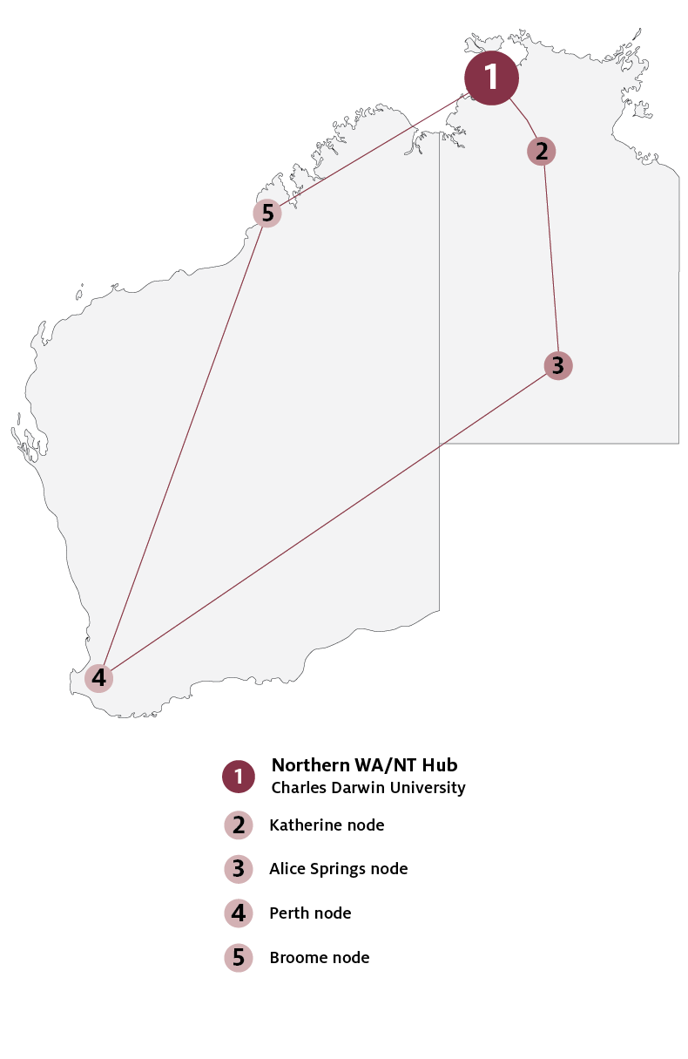

## Key industries

## *Key industries include pastoral, broadacre, horticulture, forestry and Indigenous enterprises.*

## Major focus

Stakeholders will co-design innovative tools to achieve greater drought preparedness. The hub will improve their social, economic and environmental resilience to future droughts.

## Northern WA/NT Hub leaders

Director: Jed Matz

Interim Knowledge Broker: Jed Matz

## Hub members

Kimberley Pilbara Cattlemen’s Association, NT Cattlemen’s Association, NT Department of Industry, Tourism and Trade, NT Farmers Association Inc, Rangelands Natural Resource, Management Coordinating Group Inc, Regional Development Australia NT Inc, Territory Natural Resource Management Inc, WA Department of Primary Industries and Regional Development.

## Further information

For more information, see [Future Drought Fund.](https://www.agriculture.gov.au/ag-farm-food/drought/future-drought-fund) You can also register for updates at [haveyoursay.awe.gov.au/future-drought-fund](https://haveyoursay.awe.gov.au/future-drought-fund).

© Commonwealth of Australia 2021. This work is copyright. It may be reproduced in whole or in part subject to the inclusion of an acknowledgement of the source and no commercial usage or sale.