April 2021

# South Australian Drought Resilience Adoption and Innovation Hub

The SA Hub is led by the University of Adelaide (UoA). It is a partnership between farmers, government agencies, traditional owners, industry and business.

The hub will help mixed farmers adopt innovative tools to become more drought resilient.

## Funding

The Australian Government will contribute $8 million over 4 years through the Future Drought Fund. Hub partners will provide co-contributions of $11.47 million over 4 years.

## Locations

UoA’s Roseworthy campus will house the Hub headquarters, interacting with Waite and North Terrace campuses. Hub nodes are in Minnipa, Port Augusta, Orroroo, Loxton and Struan.

The nodes will be a shopfront where farmers can connect with drought resilience expertise to increase the adoption of drought-resilience practices across the state.

Map 1 SA Hub and node locations

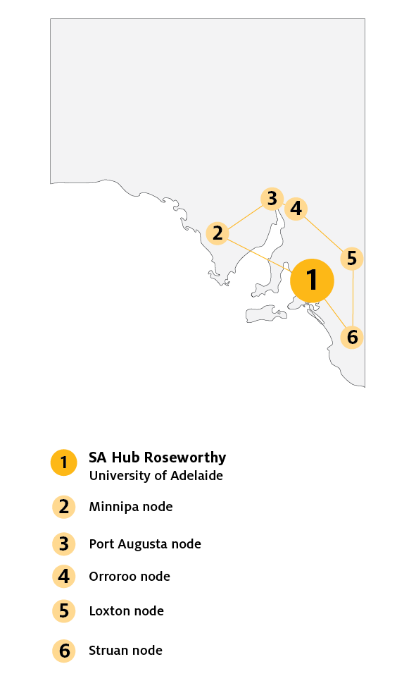

## Key industries

## *Key industries include an initial focus on the mixed farming sector with expansion to other sectors.*

## Major focus

Stakeholders will co-design and deliver demand-driven activities that focus on innovation and adoption. This includes projects that will increase the social resilience of farmers and communities.

The SA Hub's long-term vision is to grow future investment in drought resilience and innovation.

The SA Hub will engage with all sectors including horticulture and viticulture through peak industry bodies.

## SA Hub leaders

Director: Professor Chris Preston

Knowledge Broker: Tony Randall

## Hub members

### Grower Groups

* + Ag Excellence Alliance (Ag Ex)
  + Agricultural Innovation & Research Eyre Peninsula (AIR EP)
  + Agricultural Bureau of South Australia
  + Barossa Improved Grazing Group (BIGG)
  + Buckleboo Farm Improvement Group (BFIG)
  + HART Field Site Group (HART)
  + MacKillop Farm Management Group (MFMG)
  + Mallee Sustainable Farming (MSF)
  + Murray Plains Farmers Group
  + Upper North Farming Systems (UNFS)

### Universities

* + The University of Adelaide (UoA)
  + Flinders University (Flinders)
  + University of South Australia (UniSA)
  + UniHub Spencer Gulf

### Government

* + Bureau of Meteorology
  + Commonwealth Scientific and Industrial Research Organisation (CSIRO)
  + Department of Primary Industries and Regions (PIRSA)
  + Indigenous Land and Sea Corporation (ILSC)
  + Landscape South Australia including Eyre Peninsula, Hills and Fleurieu, Kangaroo Island, Limestone Coast, Murraylands and Riverland and Northern and Yorke
  + Legatus Group
  + Local Government Association (LGA)
  + Outback Communities Authority (OCA)
  + Regional Development Australia (RDA) - RDA Far North and RDA Whyalla & EP
  + South Australian Department for Environment and Water (DEW)

### Agribusinesses

* + AgCommunicators
  + Australian Grain Technologies (AGT)
  + FarmMap Analytics
  + Naracoorte Seeds
  + Rural Business Support (RBS)
  + South Australian No-Till Farmers Association (SANTFA)
  + Elders Rural Services including Thomas Elder Institute (TEI)

### Industry RD&E Partners

* + Meat Livestock Australia (MLA)
  + South Australian Cattle Industry Fund
  + South Australian Grain Industry Trust (SAGIT)
  + South Australian Sheep Industry Fund

### Peak Industry bodies

* + Primary Producers SA (PPSA)
  + Grain Producers SA (GPSA)
  + Livestock SA

### Industry Organisations

* + Landcare Australia
  + Murray Darling Association (MDA)
  + Australian Society of Soil Science
  + Southern Australia Livestock Research Council (SALRC)

## Further information

For more information, see [Future Drought Fund.](https://www.agriculture.gov.au/ag-farm-food/drought/future-drought-fund) You can also register for updates at [haveyoursay.awe.gov.au/future-drought-fund](https://haveyoursay.awe.gov.au/future-drought-fund).

© Commonwealth of Australia 2021. This work is copyright. It may be reproduced in whole or in part subject to the inclusion of an acknowledgement of the source and no commercial usage or sale.