April 2021

# Southern New South Wales Drought Resilience Adoption and Innovation Hub

## The Southern NSW Hub is led by Charles Sturt University. The hub will support southern NSW farmers and communities from the Far West, the Riverina, the Monaro and coastal plains become more drought resilient.

## Funding

The Australian Government will contribute $8 million over 4 years through the Future Drought Fund. Hub partners will provide co-contributions of $11.9 million over 4 years.

## Location

The Hub’s primary shopfront will be Charles Sturt’s AgriPark in Wagga Wagga. It will be a ‘hub and spoke’ model, with resources spread throughout southern NSW via the Hub’s consortia partners.

Map SNSW Hub location

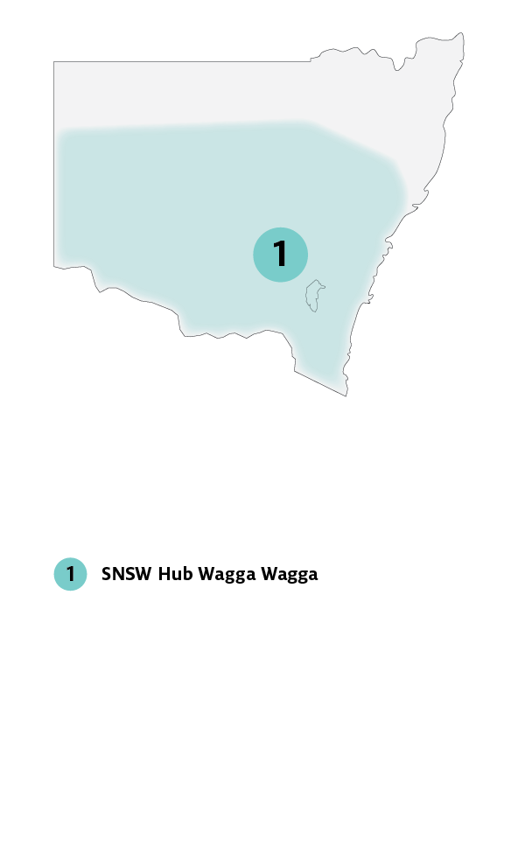

## Key industries

## *Key industries include livestock, dairy, wool, cropping, rice, cotton, inland aquaculture and perennial horticulture (including viticulture).*

## Major focus

The Hub’s focus will be on water management, food security and farming systems. It will help farmers and communities adopt a long-term perspective on drought. The hub will give them the innovative tools and techniques to build drought-resilient businesses.

The Hub will encourage stakeholders, end-users and the public to have a voice in hub activities, collaborate with experts, gain access to resources and participate in extension programs such as workshops, seminars and field days.

The Southern NSW Hub will also focus on agribusiness, community building, regional development and the environment.

## SNSW Hub leaders

Director: Cindy Cassidy

## Interim Knowledge Broker: Dale Stringer

## Hub members

Australian National University, Farming Systems Group Alliance, First Nations Governance Circle, Local Land Services, NSW Department of Primary Industries, Rural Aid, University of Canberra, University of Wollongong.

## Further information

For more information, see [Future Drought Fund](https://www.agriculture.gov.au/ag-farm-food/drought/future-drought-fund). You can also register for updates at [haveyoursay.awe.gov.au/future-drought-fund](https://haveyoursay.awe.gov.au/future-drought-fund).

© Commonwealth of Australia 2021. This work is copyright. It may be reproduced in whole or in part subject to the inclusion of an acknowledgement of the source and no commercial usage or sale.