April 2021

# Southern Queensland/Northern New South Wales Drought Resilience Adoption and Innovation Hub

The Southern QLD/Northern NSW Hub is led by the University of Southern Queensland (USQ).

## Funding

The Australian Government will contribute $10 million over 4 years through the Future Drought

Fund. Hub partners will provide co-contributions of $10.8 million over 4 years.

## Locations

The core site is at USQ in Toowoomba. Hub nodes are in Longreach, Roma, Stanthorpe, Lismore and Narrabri. The University of New England will host a dedicated node in Armidale to service Northern NSW.

Map 1 Southern QLD/Northern NSW Hub and node locations

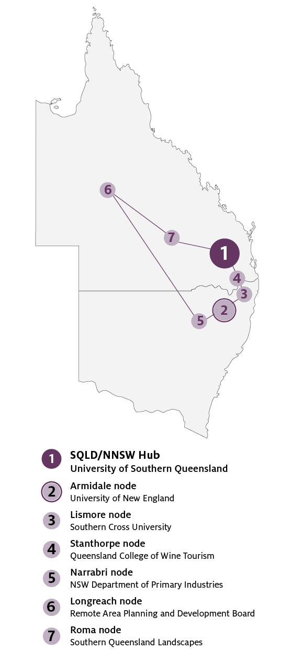

## Key industries

*Key industries include horticulture and viticulture, grains, grazing, sugarcane, tree crops, livestock and cotton.*

## Major focus

The hub will engage with farmers, traditional owners,agribusinesses, and mental health services. The hubwill empower stakeholders and existing service providers to co-design droughtpreparedness activities for the region. Hub memberswill apply proven drought-resilience research on theground. The hub will improve innovation and adoptionacross agriculture, industry and the community**.**

## Southern QLD/Northern NSW Hub leaders

Director: Professor Roger Stone

Knowledge Broker: Dr Ann Starasts

## Hub members

## University of New England, Queensland College of Wine Tourism (University of Southern Queensland), The University of Newcastle, The Regenerative Agriculture Alliance & Farming Together (Southern Cross University), TAFE Queensland, Queensland Department of Agriculture and Fisheries, New South Wales DPI (through the Department of Regional NSW), Central Western Queensland Remote Area Planning and Development Board (RAPAD), Healthy Land and Water Ltd, Southern Gulf NRM Ltd, Local Land Services (NSW), Southern Queensland Landscapes, Australian Meat Processor Corporation, Sugar Research Australia, Agri-Business Development Institute, Willis Towers Watson, AgRee Commodities, Landcare Farming Program (on behalf of National Landcare Network).

### Network partners

## Queensland Farmers’ Federation, Australian Organic Ltd, ThinkPlace Australia, Beanstalk/Impact Innovation Group Ltd, Celsius Pro (Australia) Pty Ltd, Growcom and Canegrowers Queensland.

### Supporters

## Australian Red Cross, The University of Queensland, Toowoomba and Surat Basin Enterprises, Queensland Cropping Research, Meat & Livestock Australia, GreenCollar Group, Sunshot Energy Pty Ltd, CRC for High Performance Soils, Bureau of Meteorology, LGAQ, AgForce, GRDC, Agrifood Connect, the proposed ONE Basin CRC and the World Meteorological Organisation.

## Further information

For more information, see [Future Drought Fund.](https://www.agriculture.gov.au/ag-farm-food/drought/future-drought-fund) You can also register for updates at [haveyoursay.awe.gov.au/future-drought-fund](https://haveyoursay.awe.gov.au/future-drought-fund).

© Commonwealth of Australia 2021. This work is copyright. It may be reproduced in whole or in part subject to the inclusion of an acknowledgement of the source and no commercial usage or sale.