April 2021

# Tasmanian Drought Resilience Adoption and Innovation Hub

The Tasmanian Hub is led by the University of Tasmania (UTAS). The hub will build the capabilities of farmers and rural communities to better prepare for drought. It will do this by bringing together researchers, farmers, industry, natural resource managers and traditional owners to co-design relevant and useful innovative solutions.

## Funding

* Australian Government Future Drought Fund: $8 million over 4 years.
* Co-contributions from hub partners: $13.2 million over 4 years.

## Locations

The core site is at UTAS’ Hobart campus. Hub nodes in Launceston, Burnie, Forthside and Elliot will provide places for collaboration where farmers can connect with drought resilienceexpertise to increase the adoption of drought-resilience practices.

Map 1 Tasmanian Hub and node locations

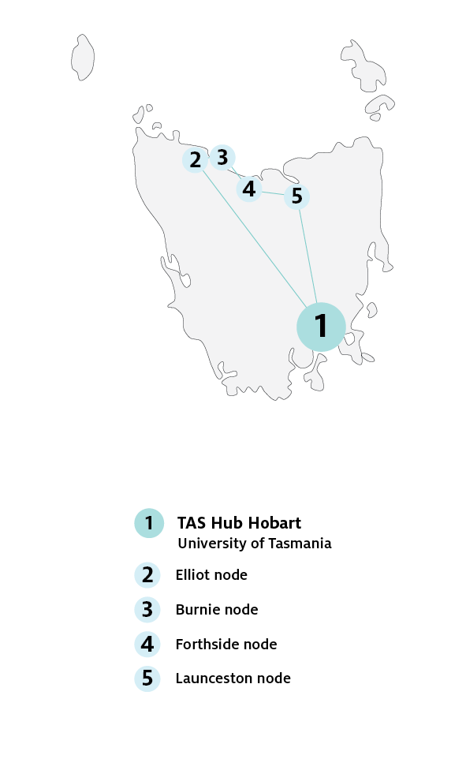

## Key industries

## *Key industries include dairy, livestock, wool, vegetables, fruit, agro-forestry and various field crops.*

## Major focus

Competing demands for water intensify duringdroughts. The hub will empower farmers, watermanagers and other service providers to embracenew technology and practices to build droughtresilience. The hub will see Tasmania’s high-value,clean, green image sustained internationally.

## Tasmanian Hub leaders

Director: Associate Professor Katherine Jeanne Evans

Knowledge Broker: To be appointed

## Hub members

## Beanstalk Agtech, Bush Heritage Australia, Cape Herbert and Highland Conservation, Cradle Coast Authority, Definium Technologies, Horticulture Innovation Australia, Hydro‑Electric Corporation, Northern Tasmanian Natural Resource Management Association, Private Forests Tasmania, Rural Business Tasmania , Soils for Life, Southern Cross University, Southern Regional Natural Resource Management Association, Tasmanian Farmers and Graziers Association, Tasmanian Irrigation, Tasmanian Land Conservancy, Tasmanian Women in Agriculture.

## Further information

For more information, see Future Drought Fund. You can also register for updates at haveyoursay.awe.gov.au/future-drought-fund.

© Commonwealth of Australia 2021. This work is copyright. It may be reproduced in whole or in part subject to the inclusion of an acknowledgement of the source and no commercial usage or sale.