April 2021

# Tropical North Queensland Drought Resilience Adoption and Innovation Hub

The Tropical North Queensland (TNQ) Hub is led by James Cook University (JCU). The hub will support farmers and communities to become more drought resilient.

## Funding

* Australian Government Future Drought Fund: $8 million over 4 years.
* Co-contributions from hub partners: $18.5 million over 4 years.

## Locations

The core site is at the JCU Ideas Lab in Cairns.Hub nodes are in Gulf of Carpentaria, Gulf Savannah, Fitzroy**,** Burdekin, Mackay and the Whitsundays.

Map 1 TNQ Hub and node locations

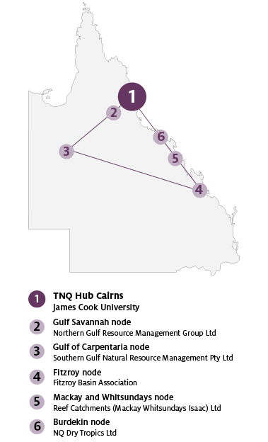

## Key industries and communities

Drought has significant impact on the wellbeingof people and communities across Tropical North Queensland.Drought affects all industries but particularly TropicalNorth Queensland agriculture industries including sugar,beef, dairy, vegetable, citrus and tropical fruit.

## Major focus

Through the hub, farmers, Indigenous landholders,communities, researchers and business will cometogether to co-design approaches and solutions fordrought resilience in Tropical North Queensland.

Innovative approaches will be explored that translateinto to the Tropical North Queensland context andknowledge will be made available, shared and curatedto ensure approaches and solutions are well informed.

The hub will also input into building critical skills as a key input in building resilience to drought and leveraging new tools, approaches and technology.

## TNQ Hub leaders

Director: Dan Christie

Knowledge Broker: Dr Rachel Hay

## Hub members

Enterprise Management Group Pty Ltd, Fitzroy Basin Association, Landcare Australia Ltd, Northern Gulf Resource Management Group Ltd, NQ Dry Tropics Ltd, Reef Catchments (Mackay Whitsundays Isaac) Ltd, Sensand Technologies Pty Ltd, Southern Gulf Natural Resource Management Pty Ltd, Sugar Research Australia Ltd, Torres Cape Indigenous Council Alliance Inc, University of Queensland.

## Further information

For more information, see Future Drought Fund. You can also register for updates at our haveyoursay.awe.gov.au/future-drought-fund.

© Commonwealth of Australia 2021. This work is copyright. It may be reproduced in whole or in part subject to the inclusion of an acknowledgement of the source and no commercial usage or sale.