April 2021

# South-West WA Drought Resilience Adoption and Innovation Hub

The South-West WA Hub is led by the Grower Group Alliance. The hub will develop farmer-centred drought innovation and adoption practices in South-West Western Australia.

## Funding

* Australian Government Future Drought Fund: $8 million over 4 years.
* Co-contributions from hub partners: More than $12 million over 4 years.

## Locations

The core site is at the Merredin Dryland ResearchInstitute. Hub nodes are in Carnarvon, Geraldton,Northam, Bunbury, Manjimup, Albany, Katanningand Esperance.

Map South-West WA Hub locations

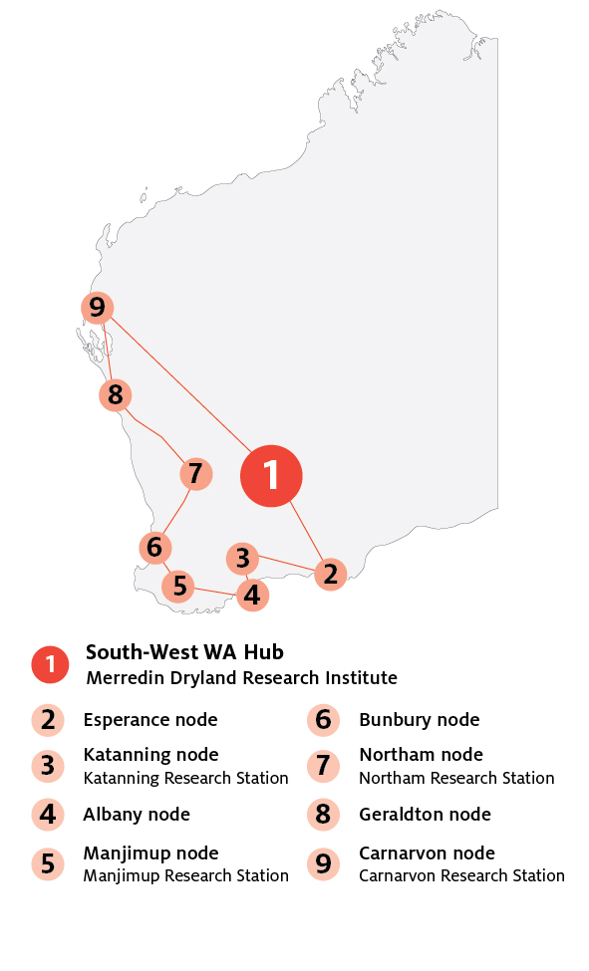

## Key industries

## *Key industries include grain, sheep, beef, dairy, viticulture and horticulture.*

## Major focus

The South-West WA Hub will focus ondrought-resilience activities that use innovativetechnology to transform farming systems.The hub will put farmers and communities at thecentre of agrifood innovation. It will create pathwaysfor producers to input into how research is appliedon the ground. This will speed up innovationand adoption, making Western Australia moreresilient, productive and competitive in the face offuture drought.

## South-West WA Hub leaders

Hub Director: Tom Davidson

Knowledge Broker: Tanya Kilminster

## Hub members

Agricultural Women Wheatbelt East, Australian Export Grains Innovation Centre Ltd, Bruce Rock Land Conservation District Committee, Bureau of Meteorology, College of Extension, Co‑operative Bulk Handling Ltd, Corrigin Farm Improvement Group, CSIRO, Curtin University, Department of Primary Industries and Regional Development, Edith Cowan University, Facey Group, Farmanco Management Consultants Pty Ltd, Farmers2Founders, Fitzgerald Biosphere Group Inc, Goldfields-Esperance Development Commission, Great Southern Development Commission, Grower Group Alliance, Intergrain Pty Ltd, Irrigation Australia, Liebe Group Inc, Living Farm, Merredin and Districts Farm Improvement Group, Mid-West Development Commission, Mingenew Irwin Group, Murdoch University, Muresk Institute, Noongar Land Enterprise Group, NRM WA, Nyabing Farm Improvement Group, Oil Mallee Assoc., Peel Development Commission, Pome West,Premium Grains, Regional Development Australia Goldfields Esperance, Regional Development Australia Midwest Gascoyne, Regional Development Australia Wheatbelt, Rural Edge, Soils West, South East Premium Wheat Growers’ Association, South West Development Commission, Southern Cross University, Southern Dirt Inc, Southern Rangelands Pastoral Alliance, Stirlings to Coast Farmers, Thomas Elder Institute (Elders Ltd), University of Western Australia, Value Creators, WA Citrus, WA Farmers, WA Hemp Growers’ Co-op Ltd, WA No Tillage Farmers Association (WANTFA), West Midlands Group Inc, Western Beef Association Inc, Wheatbelt Development Commission, Yuna Farm Improvement Group.

## Further information

For more information, see [Future Drought Fund.](https://www.agriculture.gov.au/ag-farm-food/drought/future-drought-fund) You can also register for updates at our [haveyoursay.awe.gov.au/future-drought-fund](https://haveyoursay.awe.gov.au/future-drought-fund).

© Commonwealth of Australia 2021. This work is copyright. It may be reproduced in whole or in part subject to the inclusion of an acknowledgement of the source and no commercial usage or sale.