# Future Drought Fund – key achievements

## What is the Future Drought Fund?

* The Future Drought Fund (FDF) is an enduring investment to help farmers and communities prepare for future drought. Not in-drought support.
* FDF will provide $100 million each year for drought resilience activities.
* An Expert Consultative Committee advises on the Plan and programs, in consultation with the community.

## What are we trying to achieve?

* We want to give farmers and communities the tools and capabilities they need to prepare for, and live through, times of drought.
* FDF will help reduce drought impacts and the need for drought support.
* FDF triple-bottom line objectives focus on increasing economic, environmental and social resilience to drought.

## How will we ensure the FDF is working?

* We have a Monitoring, Evaluation and Learning (MEL) Framework.
* We will measure and report on changes in drought resilience, the impact of each program and the Fund.
* We will conduct annual public reporting and regular evaluation, feeding into decisions about future programs.
* We will seek regular stakeholder feedback and input.
* Productivity Commission reviews will occur every 4 years, starting 2023-24.

## Where is the Fund up to?

* Funding Plan to guide investment started in June 2020.
* First round of foundational programs progressively rolled out since 1 July 2020.
* Second round of programs announced in Budget 2021-22 and rolled out in the second half of 2021.
* Foundational systems have been developed (governance, monitoring and evaluation).

## Future Drought Fund Themes

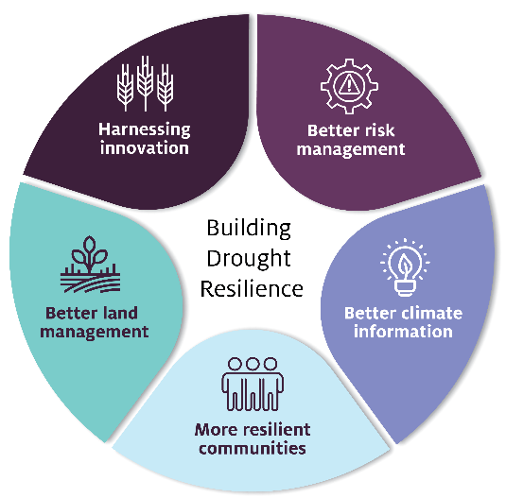

### Theme 1: Harnessing innovation – driving adoption of new drought resilient technologies and practices

#### Funding:

* $121.06 million to 2023-24.

#### What we have done so far:

* 8 Adoption and Innovation Hubs around the country announced in April 2021, funded for 4 years.
* Research and Adoption Investment Plan in development.

#### What’s next:

* Hubs are co-designing detailed activity plans.
* Innovation grants.
* Each Hub supported to have adoption officers.

#### Programs:

* Drought Resilience Research and Adoption.

### Theme 2: Better risk management – helping farmers and regions plan for drought

#### Funding:

* $116.82 million to 2023-24.

#### What we have done so far:

* Each state and territory has designed programs to deliver to local context.

#### What’s next:

* Extend the programs to reach 1500 farmers nationwide in the first year.
* Small grants to take forward priority actions identified in regional plans.
* State and territory governments rolling out a first round of support.

#### Programs:

* Farm Business Resilience.
* Regional Drought Resilience Planning.

### Theme 3: Better climate information – making climate information accessible and useful

#### Funding:

* $25 million to 2023-24.

#### What we have done so far:

* Extensive end-user engagement in 4 pilot regions underway to help understand information needs.
* Prototype Climate Services Platform and Self-Assessment Tool now live.

#### What’s next:

* Functionality of the platform and tool progressively developed, including expansion beyond pilot regions to ultimately achieve national coverage.

#### Programs:

* Climate Services for Agriculture.
* Drought Resilience Self-Assessment Tool.

### Theme 4: More resilient communities – building social capital to drive change and support resilient communities

#### Funding:

* $19.2 million to 2023-24.

#### What we have done so far:

* Partnered with Australian Rural Leadership Foundation (ARLF) and Foundation for Rural and Regional Renewal (FRRR) to design programs to support leadership development, mentoring networks, community networks and organisations.

#### What’s next:

* FRRR first round of projects announced in October 2021.
* ARLF recruiting for leadership development and mentoring.
* Design next phase learning from early implementation experience.

#### Programs:

* Drought Resilience Leaders.
* Networks to Build Drought Resilience.

### Theme 5: Better land management – trial and adoption of land management practices that support landscape resilience

#### Funding:

* $36.42 million to 2023-24.

#### What we have done so far:

* 80 projects commencing now.

#### What’s next:

* Funding round opened in late 2021 $23 million over 3 years.
* Targeting innovation and transformation.

#### Programs:

* Drought Resilient Soils and Landscapes.
* Drought Resilience Natural Resource Management – Grants and Landscapes.