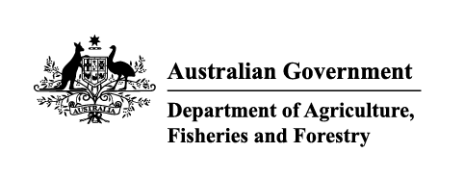

Instrument revoking a holding order under section 15(2) of the Imported Food Control Act 1992
The listed holding orders, having satisfied the circumstances under which the orders will be revoked, are revoked under section 15(2) of the Imported Food Control Act 1992 (the Act).
The circumstances being that the Secretary or delegate is satisfied that the basis for the order no longer applies.
Holding order number | Date revoked
13460 | 01/02/2026
16817 | 01/02/2026
17135 | 01/02/2026
17879 | 01/02/2026
17922 | 01/02/2026
18414 | 01/02/2026
18472 | 01/02/2026
18554 | 01/02/2026
18770 | 01/02/2026
18816 | 01/02/2026
18868 | 01/02/2026
18878 | 01/02/2026
18879 | 01/02/2026
18889 | 01/02/2026
18891 | 01/02/2026
18918 | 01/02/2026
18919 | 01/02/2026
18920 | 01/02/2026
18921 | 01/02/2026
18924 | 01/02/2026
18925 | 01/02/2026
18931 | 01/02/2026
18932 | 01/02/2026
18936 | 01/02/2026
18937 | 01/02/2026
18942 | 01/02/2026
18945 | 01/02/2026
18949 | 01/02/2026
18950 | 01/02/2026
18955 | 01/02/2026
18956 | 01/02/2026
18958 | 01/02/2026
18959 | 01/02/2026
18960 | 01/02/2026
18961 | 01/02/2026
18962 | 01/02/2026
18965 | 01/02/2026
18966 | 01/02/2026
18967 | 01/02/2026
18968 | 01/02/2026
18979 | 01/02/2026
18980 | 01/02/2026
18982 | 01/02/2026
18983 | 01/02/2026
18984 | 01/02/2026
18985 | 01/02/2026
18988 | 01/02/2026
REC24001 | 01/02/2026
REC24001 | 01/02/2026
17551 | 02/02/2026
18484 | 02/02/2026
18977 | 02/02/2026
19581 | 10/02/2026
19659 | 10/02/2026
19792 | 10/02/2026
19856 | 10/02/2026
19470 | 12/02/2026
19683 | 12/02/2026
20172 | 20/02/2026
16128 | 24/02/2026
17538 | 24/02/2026
18855 | 24/02/2026
19768 | 24/02/2026
19822 | 24/02/2026
19973 | 24/02/2026
19998 | 24/02/2026
20114 | 24/02/2026
20143 | 24/02/2026
Delegate position number | Date
100091 | 24/03/2026
Delegate of the secretary for the purposes of section 15(2) of the Act.

