Agriculture inputs outlook – February 2022

Elevated global energy prices have increased farm production costs for direct and indirect inputs, particularly fertilisers. Energy prices and input costs are expected to remain high throughout 2022 and 2023

Rising energy costs
- A sharp rebound in global energy demand, geopolitical developments and a lack of investment in new oil and gas supplies have caused a steep rise in energy prices.
- Between 1 July 2020 and 1 March 2022, oil prices rose by 158% (US$40/barrel to US$103/barrel), coal prices by 530% (US$50/tonne to US$315/tonne) and natural gas by 165% (US$1.67/MMBtu to US$4.57/MMBtu).
- It is likely that escalation of the Russia-Ukraine crisis will lead to further energy price increases.
- Agricultural production is energy intensive, either directly through farm operations such as tilling or irrigation, or indirectly through inputs such as fertilisers, herbicides and pesticides. This means production costs and farm profits are sensitive to changes in energy prices.
- The effects of high energy prices vary across commodities. Crop production is typically more energy intensive than livestock production due to higher fertiliser consumption and more mechanised farming operations. For crops like oats, wheat, and barley, energy and fertiliser make up approximately half of total operating costs.
Figure 1 Spot price energy index (1 January 2020 to 18 February 2022)
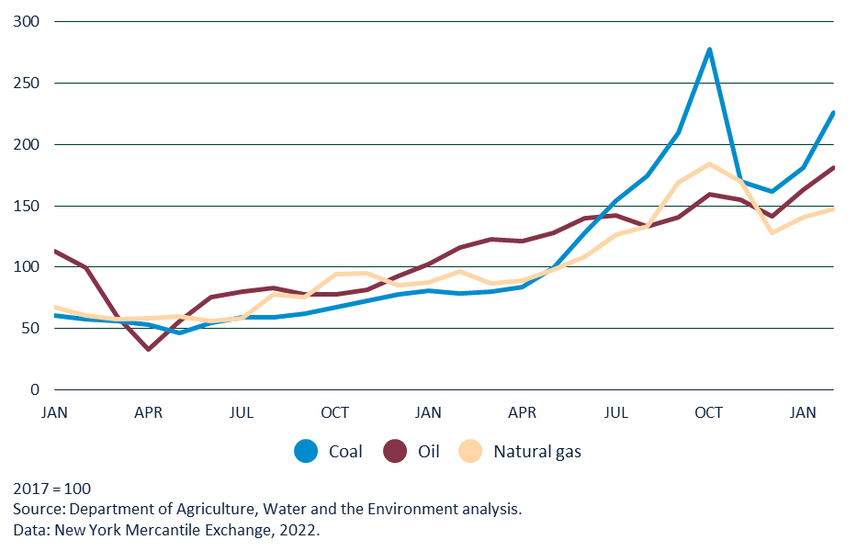

Fertiliser overview
- Rising global energy prices have caused fertiliser prices to substantially increase. For example, the Free on Board (FOB) price of fertiliser imports into Australia have risen by 128%, from $380/tonne in January 2021 to $867/tonne in December 2021.
  - Prices have continued to rise in January and February 2022.
- In 2021, Russia and China introduced export restrictions on fertiliser to secure domestic supply. This has further contributed to global fertiliser price rises.
- Good seasonal conditions, leading to increased plantings, and increased prices caused the value of Australian fertiliser imports to rise from $1.65 billion in 2017 to $3.75 billion in 2021.
Figure 2 Australian fertiliser FOB imports price (January 2021 to December 2021) 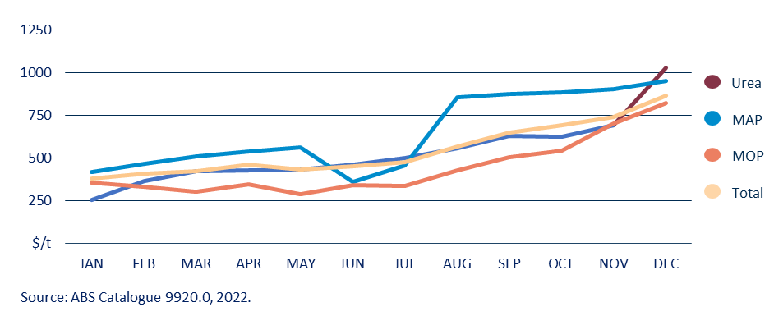

Outlook for inputs
- The United States Energy Information Administration expects energy prices to remain at current levels throughout 2022, before falling slightly in 2023.
- Farmers around the world are experiencing higher input costs. If sustained, this will affect farm profitability and place upward pressure on international food prices.
- Elevated fertiliser costs will lead to reduced fertiliser use and the adoption of variable rate technology to maximise fertiliser productivity.
- The impact of higher input costs will be realised by Australian producers during the summer 2021-22 and winter 2022-23 cropping seasons.

