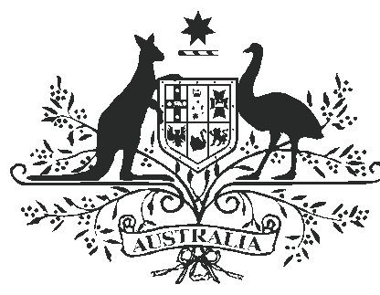

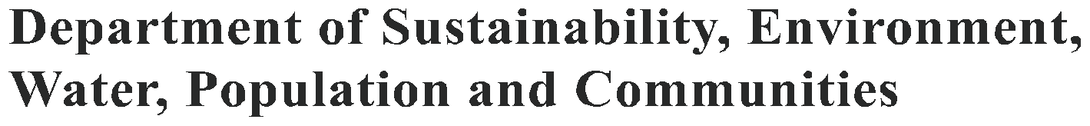

FERAL HORSE (EQUUS CABALLUS) AND FERAL DONKEY (EQUUS ASINUS)

Australia has an estimated 400 000 feral horses and millions of feral donkeys, mainly in central and northern Australia. Both species cause erosion, spread weeds and compete for pasture with native animals and livestock. Feral horses pose a particularly complex management problem because they can have economic and cultural value, and debate continues about the best way to manage their populations
in Australia.

History

Horses arrived with the First Fleet in 1788. Shipments of working farm horses followed, and the first record of horses either escaping into the bush or being abandoned was in 1804. Much of the country was initially grazed without fences, so escape was common. As machines gradually
replaced horses in a range of tasks, many horses were released to join the already established feral herds.

Donkeys arrived in Australia in 1866 to serve as pack animals and in haulage teams. They were particularly useful in the Kimberley, Western Australia and in Victoria River in the Northern Territory, where a toxic plant affected horses. Motorised transport replaced donkeys throughout the early 1900s, and feral herds were first reported in the 1920s. By 1949 the donkey was sufficiently numerous to be declared a pest in Western Australia.
Most of the estimated 400 000 feral horses occur in the extensive cattle production areas of the Northern Territory, Queensland and some parts of Western Australia and South Australia. Scattered populations are also found in New South Wales
and Victoria, mainly in alpine and sub-alpine areas. Australia also has as many as five million feral donkeys in arid central Australia, the Kimberley in Western Australia and the Top End in the Northern Territory.
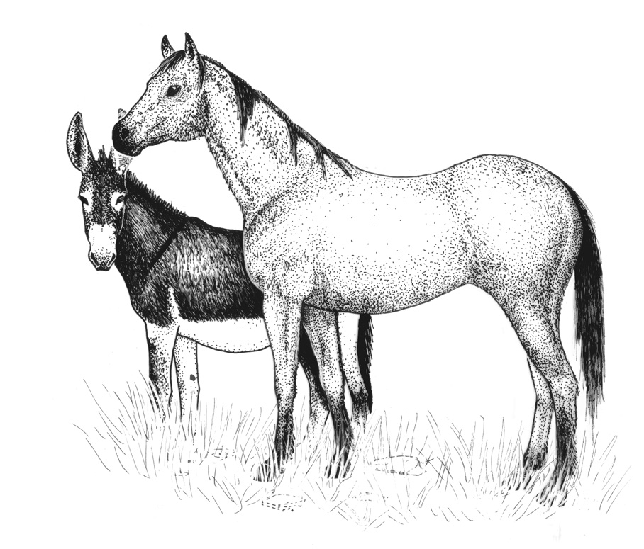

Distribution of feral horses in Australia

Distribution of feral horses in Australia. Adapted from: Clarke GM et al (2000). Environmental Pest Species in Australia. Internal report, Department of the Environment and Heritage, Canberra.

Ecology

Feral horses inhabit a variety of country: semiarid plains and rocky ranges, tropical grasslands and wetlands, temperate ranges, subalpine forests and small offshore islands. They prefer grassland and shrubland with plentiful water and pasture. Feral donkeys prefer tropical savannas and arid hill country. Drought and severe bushfires are the only significant natural threats to feral horses and donkeys. Left unmanaged it is estimated that populations will increase at a rate of 20 per cent per year.

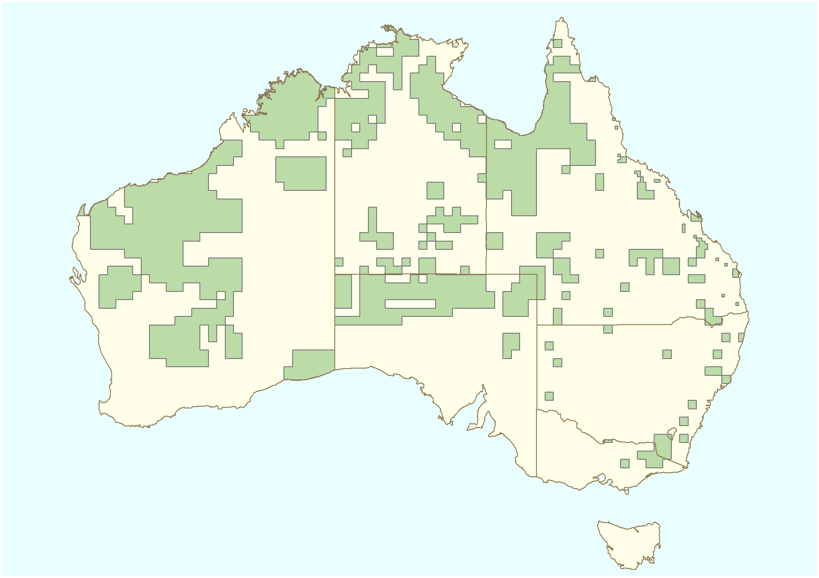

Feral horses and donkeys form small social units of either a dominant stallion accompanying one
to three mares and their offspring, or a bachelor group. The groups of mares, offspring and a stallion favour areas near permanent water and have loose territories, while bachelor groups range more widely. Home ranges can be up to 88 square kilometres in the central Australian ranges.

Donkeys eat coarser vegetation than horses. Both species generally drink regularly, although donkeys can survive in areas without surface water. Both can travel further than cattle to water.

Feral horses breed in spring to summer and have a gestation period of about 11 months. They can produce one foal every two years. Feral donkeys produce one foal a year if conditions are favourable.

Impact

Feral horses and donkeys are serious environmental pests, causing erosion and damaging vegetation with their hard hoofs. They damage and foul waterholes, and introduce weeds through seeds carried in their dung, manes and tails. Feral horses and donkeys may also compete for food and water with native animals.

In central Australia, feral horses overgraze large areas because they can travel up to 50 kilometres from water in search of food. This can force native wildlife from its favoured habitats. The impact of feral horses and donkeys on native grasses, herbs, shrubs and drinkable water is most pronounced during drought. They can quickly degrade areas close to remote waterholes and natural springs, which during a drought become refuges critical
to the survival of many native animals and plants. Without these refuges, native plants and animals may become locally extinct.

Feral horses and donkeys also have an impact on the productivity of farming land. Feral horses eat pasture grasses, destroy fences, and during a muster can cause cattle to scatter. They can
carry exotic diseases such as equine influenza and
African horse sickness, which are serious threats to domestic horses. They can also carry tick fever, which can infect domestic horses and cattle.
Control

Drought has a severe impact on feral horses: old horses, juveniles and mares with young are the most vulnerable. During drought many horses can die, mainly from starvation, lack of water and eating toxic plants that they usually avoid. They gather round waterholes where they are often culled for humane reasons.

Feral horses can be controlled using a number of conventional control techniques providing strict animal welfare guidelines are followed.

Herds are often mustered and usually some of the younger horses are kept for saddle horses or pets. Trapping may be less stressful to feral horses than mustering, but there are animal welfare concerns about the handling of feral horses in traps and during transport to abattoirs.

In terrain where mustering on horseback or on motorbikes is not possible, helicopters have
been used. Aerial culling by properly trained and accredited shooters using approved procedures
is considered to be a humane way to reduce feral horse numbers over large areas. The process is quick and eliminates the stresses of mustering, yarding and transportation for slaughter.

Fertility control is a non-lethal approach to feral horse management but it is currently of limited use. Fertility control techniques are difficult to administer to large numbers of unyarded feral horses and
the treatment would need to be repeated often to be effective. It is not yet known whether such techniques can reduce the environmental damage caused by a population of feral horses in an area of high conservation value.

Further reading:

Dobbie WR, Berman D McK and Braysher ML (1993). Managing Vertebrate Pests: Feral Horses. Bureau of Resource Sciences, Canberra.
For further information, contact:

Department of Sustainability, Environment, Water, Population and Communities
GPO Box 787
Canberra ACT 2601
Phone: 1800 803 772
Web site www.environment.gov.au/biodiversity/
invasive/html

InvasiveSpecies@environment.gov.au

BIO149.0610

Photo credits in order: Illustration of feral horse and donkey (Karina Hansen McInnes and Sharyn Wragg), Wild horse in the
Musgrave Ranges near Umuwa, SA (Mike Jensen & DSEWPaC), Donkeys in vegetation (Denis O’Byrne/ANTphoto.com.au),
Wild donkeys near Umuwa, SA (Mike Jensen & DSEWPaC), Feral horses destroying waterhole and vegetation (QLD Environmental
Protection Agency).

© Commonwealth of Australia 2011

This work is copyright. You may download, display, print and reproduce this material in unaltered form only (retaining this notice) for your personal, non-commercial use or use within your organisation. Apart from any use as permitted under the Copyright Act 1968, all other rights are reserved. Requests and inquiries concerning reproduction and rights should be addressed to Commonwealth Copyright Administration, Attorney General’s Department, Robert Garran Offices, National Circuit, Barton ACT 2600 or posted at www.ag.gov.au/cca.

Disclaimer

The views and opinions expressed in this publication are those of the authors and do not necessarily reflect those of the Australian Government or the
Minister for Sustainability, Environment, Water, Population and Communities.

