Aquatic animal diseases significant to Australia: identification field guide 5th edition
March 2020

© Commonwealth of Australia
Ownership of intellectual property rights
Unless otherwise noted, copyright (and any other intellectual property rights, if any) in this publication is owned by the Commonwealth of Australia (referred to as the Commonwealth).
Creative Commons licence
All material in this publication is licensed under a Creative Commons Attribution 4.0 International Licence except content supplied by third parties, logos and the Commonwealth Coat of Arms.
Inquiries about the licence and any use of this document should be emailed to copyright@agriculture.gov.au.

Cataloguing data
This publication (and any material sourced from it) should be attributed as: Department of Agriculture, Water and the Environment 2020, Aquatic Animal Diseases Significant to Australia: Identification Field Guide, 5th Edition, Australian Government Department of Agriculture, Water and the Environment, Canberra. CC BY 4.0.
ISBN 978-1-76003-235-7
Internet
Aquatic Animal Diseases Significant to Australia: Identification Field Guide, 5th Edition is available at agriculture.gov.au/aadfieldguide
Inquiries regarding the licence and any use of this document should be sent to copyright@agriculture.gov.au.
The design concepts were developed and produced by Government Division, Australian Government Department of Agriculture, Water and the Environment, with scientific editing by DigsFish Services Pty Ltd.
Copies of the USB are available by contacting the Department of Agriculture, Water and the Environment Aquatic Animal Health Program.
Disclaimer
The Australian Government acting through the Department of Agriculture, Water and the Environment has exercised due care in the preparation and compilation of the information in this publication. Notwithstanding, the Department of Agriculture, Water and the Environment, its employees and advisers disclaim all liability, including liability for negligence, for any loss, damage, injury, expense or cost incurred by any person as a result of accessing, using or relying upon any of the information in this publication to the maximum extent permitted by law.

Foreword
The Australian Government Department of Agriculture, Water and the Environment is pleased to introduce the fifth edition of this field guide.
The field guide and its accompanying phone application aims to help people recognise diseases of significance to aquaculture and fisheries in Australia. This edition incorporates new and updated information gathered from an extensive review of the fourth edition. It now covers 53 aquatic animal diseases of significance to Australia that affect species of finfish, crustaceans, molluscs and amphibians.
Early recognition and reporting of suspected disease outbreaks is critical to protecting our unique aquatic biodiversity, and fisheries and aquaculture sectors. It can permit a rapid disease response to contain outbreaks, increasing the opportunity for disease eradication and thereby limiting potential impacts on aquatic animal industries and the environment. People who work closely with aquatic animals are usually the first to notice signs of a significant disease event. This field guide provides guidance for these people—aquaculture workers, commercial fishers, recreational fishers, quarantine staff, scientists, conservationists and students—to recognize significant aquatic animal diseases, should they occur.
Many people and institutions have contributed to the field guide, including fish health experts from industry, research organisations, state and territory governments, and government agencies of the Asia–Pacific region (including New Zealand), Canada, Denmark, Norway, the Netherlands, the United Kingdom and the United States of America.
Drawing extensively on experience and research activities in aquatic animal health management, both in Australia and abroad, the guide and its phone application complements the growing body of practical knowledge published for aquaculture and fisheries in Australia. On behalf of the Australian Government, I thank all contributors to this production for their efforts and commend this field guide to you.
Dr Mark Schipp
Australian Chief Veterinary Officer

Acknowledgements
The department would like to thank all contributors of new material to this fifth edition of the field guide, including Dr Craig Boys (NSW Department of Primary Industries), Dr James Brock (Aquatic Farms, Hawaii), Dr Ryan Carnegie (Virginia Institute of Marine Science), Dr Ben Diggles (DigsFish Services), Dr Ha Thanh Dong (King Mongkut’s University of Technology, Thailand), Professor Tim Flegel (Mahidol University, Thailand), Dr Melinda Gabor and Dr Cheryl Jenkins (NSW Department of Primary Industries), Justin Graham (HuxburyQuinn), Dr Ian Jerrett (Agriculture Victoria Research), Professor Lester Khoo (Mississippi State University), Dr An Martel and Dr Frank Pasmans (Ghent University), Dr Juhasz Tamas (Budapest, Hungary), and Dr Trude Vrålstad (Norwegian Veterinary Institute).
The current publication has built upon the contributions made to previous editions of this guide and we recognise and thank all who have contributed information in the past, including Dr Rob Adlard (Queensland Museum), Dr Ellen Ariel and Dr Lee Berger (James Cook University), Dr Franck Berthe (IFREMER), Dr Rachel Bowater (Queensland Department of Primary Industries and Fisheries), Dr Susan Bower (Fisheries and Oceans Canada), Dr Tracey Bradley (Victorian Department of Primary Industries), Dr David Bruno (Marlab, Aberdeen, Scotland), Dr Nicky Buller (Department of Agriculture and Food, Western Australia), Dr Jeremy Carson (University of Tasmania), Dr Supranee Chinabut (Thailand Department of Fisheries), Dr Mark Crane (CSIRO Australian Animal Health Laboratory), Dr Melanie Crockford (Department of Agriculture and Food, Western Australia), Dr Marty Deveney (South Australian Research and Development Institute, South Australian Government), Dr Ben Diggles (DigsFish Services, Australia), Dr Ralph Elston (Aqua Technics Inc., United States of America), Dr Kevin Ellard and Dr Judith Handlinger (Tasmanian Department of Primary Industries, Parks, Water and Environment), Dr Susan Gibson-Keuh (Murdoch University), Dr Jeffrey Go (University of Sydney), Professor Larry Hanson (College of Veterinary Medicine, Mississippi State University), Dr Ron Hedrick (University of California, Davis), Dr Paul Hick (New South Wales Department of Primary Industries), Professor Brian Jones (Western Australia Department of Fisheries), Dr Michael Kent (Oregon State University), Dr Cedric Komar (Intervet Norbio Singapore), Dr Malcolm Lancaster (Primary Industries Research Victoria), Professor Bob Lester (University of Queensland), Professor Don Lightner (Arizona State University), Dr Tor Atle Mo (National Veterinary Institute, Oslo), Dr Nick Moody (CSIRO Australian Animal Health Laboratory), Dr James Moore (California Department of Fish and Game), Dr James Munro (University of Adelaide), Dr Kazuhiro Nakajima (Fisheries Research Agency, Japan), Dr Niels Jørgen Olesen (Danish Veterinary Institute), Dr Shane Raidal (Murdoch University), Dr Melba Reantaso (Food and Agriculture Organization of the United Nations), Dr AS Sahul Hameed (Abdul Hakeem College, India), Dr Glenn Schipp (Department of Resources—Fisheries, Northern Territory Government), Dr Lee Skerratt (James Cook University), Dr Fran Stephens (Murdoch University), Dr M Sano (National Research Institute of Aquaculture, Japan), Dr Michael Snow (Department of Fisheries, Western Australia), Dr David Stone (Centre for Environment, Fisheries and Aquaculture Science), Dr Peter Walker (CSIRO Australian Animal Health Laboratory), Professor Richard Whittington (University of Sydney), Dr Jim Winton (United States Geological Survey) and Dr Shi Zhengli (Chinese Academy of Sciences, People’s Republic of China).
Members of the Australian Government Department of Agriculture—Aquatic Animal Health Program coordinated the production of this fifth edition including Dr Cian Foster-Thorpe and Dr Ingo Ernst. Alistair Herfort is recognised as co-ordinator of the first three editions of the field guide.

International photographic contributors
Dr David Alderman (Centre for Environment, Fisheries and Aquaculture Science, United Kingdom)
Dr Isabelle Arzul (French Research Institute for Exploration of the Sea—IFREMER)
Dr Jerri Bartholomew (Oregon State University)
Dr Susan Bower (Fisheries and Oceans Canada)
Dr Sandra Bravo (Universidad Austral de Chile)
Dr James Brock (Aquatic Farms, Hawaii)
Professor Eugene Burreson (retired—Virginia Institute of Marine Science)
Dr Ryan Carnegie (Virginia Institute of Marine Science)
Dr Ha Thanh Dong (King Mongkut’s University of Technology, Thailand)
Dr Dianne Elliott (United States Geological Survey)
Professor Tim Flegel (Mahidol University, Thailand)
Dr John Fryer (deceased—Oregon State University)
Dr AS Sahul Hameed (Department of Zoology, C Abdul Hakeem College, Tamil Nadu, India)
Professor Larry Hanson (College of Veterinary Medicine, Mississippi State University)
Professor Tore Håstein (National Veterinary Institute, Oslo)
Dr Naoki Itoh (Tohoku University, Japan)
Dr Huang Jie (Yellow Sea Fisheries Institute, China)
Dr Brian Jones (retired—Western Australia Department of Fisheries)
Dr Erik Johnson (Private Practitioner, Johnson Veterinary Services, Georgia)
Dr Somkiat Kanchanakhan (Department of Fisheries, Thailand)
Professor Lester Khoo (College of Veterinary Medicine, Mississippi State University)
Dr Gael Kurath (United States Geological Survey)
Professor Don Lightner (retired—University of Arizona)
Dr An Martel (Ghent University)
Professor Tor Atle Mo (National Veterinary Institute, Oslo)
Dr James Moore (California Department of Fish and Game)
Dr Kazuhiro Nakajima (Fisheries Research Agency, Yokohama)
Dr Ronald Pascho (Western Fisheries Research Center, Seattle)
Dr Frank Pasmans (Ghent University)
Dr Trygve Poppe (Norwegian School of Veterinary Science, Oslo)
Dr Liang Qiu (Yellow Sea Fisheries Institute, China)
Dr Sarah Ridgeway (née Kleeman; formerly Australian Government Department of Agriculture, Water and the Environment)
Dr Hans Jürgen Schlotfeldt (European Association of Fish Pathologists)
Dr Juhasz Tamas (Budapest, Hungary)
Dr Trude Vrålstad (Norwegian Veterinary Institute)
Dr Jim Winton (United States Geological Survey)
Dr Oded Zmora (University of Maryland, Baltimore)

Australian photographic contributors
Dr Stella Bastianello (Gribbles Veterinary Pathology)
Dr Lee Berger (James Cook University)
Dr Rachel Bowater (Queensland Department of Primary Industries and Fisheries)
Dr Craig Boys (NSW Department of Primary Industries)
Dr Richard Callinan (formerly New South Wales Department of Primary Industries)
Dr Jeremy Carson (University of Tasmania)
Dr Ben Diggles (DigsFish Services)
Dr Kevin Ellard (Tasmanian Department of Primary Industries, Parks, Water and Environment)
Dr Melinda Gabor (NSW Department of Primary Industries)
Dr Jeffrey Go (University of Sydney)
Dr John Humphrey (retired—Northern Territory Department of Industry, Fisheries and Mines)
Dr Cheryl Jenkins (NSW Department of Primary Industries),
Dr Ian Jerrett (Agriculture Victoria Research)
Dr Clive Jones (Queensland Department of Primary Industries and Fisheries)
Dr Matt Landos (Future Fisheries Australia)
Professor Barry Munday (deceased—University of Tasmania)
Professor Leigh Owens (James Cook University)
Dr Mark Porter (University of Tasmania)
Dr Howard Prior (Queensland Department of Primary Industries and Fisheries)
K Scott
Dr Rick Speare (deceased—James Cook University)
Dr Greg Storie (Queensland Department of Primary Industries and Fisheries)
Dr Patrick Tully (New South Wales Department of Primary Industries)
Professor Richard Whittington (University of Sydney)
Staff at the CSIRO Australian Animal Health Laboratory
Staff at New South Wales Department of Primary Industries
Staff at The University of Sydney
Staff at Victorian Department of Primary Industries
Contents
Foreword iii
Acknowledgements iv
Introduction 1
Using the field guide Error! Bookmark not defined.
Signs of disease 4
Host range 5
Presence in Australia 5
Epidemiology 6
Differential diagnosis 6
1. Anatomy 7
Finfish 7
Molluscs 10
Crustaceans 13
Amphibians 17
2. Diseases of finfish 19
Viral diseases of finfish 19
Channel catfish virus disease (CCVD) 19
Epizootic haematopoietic necrosis (EHN) 23
European catfish virus (ECV) and European sheatfish virus (ESV) 27
Grouper iridoviral disease 31
Infection with HPR-deleted or HPR0 infectious salmon anaemia virus (ISAV) 35
Infection with infectious spleen and kidney necrosis virus (ISKNV)-like viruses 40
Infection with salmonid alphavirus (SAV) 46
Infectious haematopoietic necrosis (IHN) 50
Infectious pancreatic necrosis (IPN) 55
Koi herpesvirus disease (KHVD) 59
Red sea bream iridoviral disease (RSIVD) 63
Spring viraemia of carp (SVC) 68
Tilapia lake virus (TiLV) disease 72
Viral encephalopathy and retinopathy (VER) 77
Viral haemorrhagic septicaemia (VHS) 84
Bacterial diseases of finfish 92
Bacterial kidney disease (BKD) 92
Enteric red mouth disease (ERMD) 99
Enteric septicaemia of catfish 105
Furunculosis 112
Infection with Aeromonas salmonicida—atypical strains 118
Piscirickettsiosis 126
Parasitic diseases of finfish 131
Infection with Gyrodactylus salaris 131
Whirling disease 135
Other diseases of finfish 142
Infection with Aphanomyces invadans 142
3. Diseases of molluscs 148
Viral diseases of molluscs 148
Abalone viral ganglioneuritis (AVG) 148
Infection with ostreid herpesvirus-1 microvariant (OsHV-1 µvar) 154
Iridoviroses 159
Bacterial diseases of molluscs 162
Infection with Xenohaliotis californiensis 162
Parasitic diseases of molluscs 168
Infection with Bonamia exitiosa 168
Infection with Bonamia ostreae 174
Infection with Bonamia species 178
Infection with Marteilia refringens 182
Infection with Marteilia sydneyi 187
Infection with Marteilioides chungmuensis 199
Infection with Mikrocytos mackini 202
Infection with Perkinsus marinus 209
Infection with Perkinsus olseni 214
4. Diseases of crustaceans 221
Viral diseases of crustaceans 221
Infection with gill-associated virus (GAV) 221
Infection with infectious hypodermal and haematopoietic necrosis virus (IHHNV) 225
Infection with infectious myonecrosis virus (IMNV) 235
Infection with Macrobrachium rosenbergii nodavirus (MrNV) 240
Infection with shrimp haemocyte iridescent virus (SHIV) 244
Infection with Taura syndrome virus (TSV) 251
Infection with white spot syndrome virus (WSSV) 261
Infection with yellowhead virus genotype 1 (YHV1) 272
Bacterial diseases of crustaceans 280
Acute hepatopancreatic necrosis disease (AHPND) 280
Infection with Hepatobacter penaei 286
Parasitic diseases of crustaceans 295
Infection with Enterocytozoon hepatopenaei (EHP) 295
Other diseases of crustaceans 300
Infection with Aphanomyces astaci 300
Monodon slow growth syndrome (MSGS) 306
5. Diseases of amphibians 310
Viral diseases of amphibians 310
Infection with ranavirus 310
Other diseases of amphibians 316
Infection with Batrachochytrium dendrobatidis (Bd) 316
Infection with Batrachochytrium salamandrivorans (Bsal) 321
Appendix A: Scientific names 325
Appendix B: Reporting suspected disease 325
Appendix C: Further reading 340

Introduction
This field guide provides ready access to information on the aquatic animal diseases significant to Australia. These diseases have potential to disrupt Australia’s aquatic animal biodiversity, fisheries and aquaculture productivity, and international trade.
The diseases covered here are in Australia’s national list of reportable diseases of aquatic animals, which includes those reportable through the regional Quarterly Aquatic Animal Disease reporting program (managed by the Network of Aquaculture Centres in Asia-Pacific, the Food and Agriculture Organization of the United Nations and World Organisation for Animal Health), as well as other diseases of national significance.
The field guide is aimed at fishery and aquaculture managers, their field staff, veterinary workers and students of aquatic animal health. The publication is also relevant to people in the seafood processing and retail industry, recreational and commercial fishers, and the general public. For people participating in national surveillance and monitoring for aquatic animal disease, the field guide is a valuable disease reference. For the casual reader, the field guide gives an informative and often graphic account of the diseases and organisms that threaten Australia’s fisheries and expanding aquaculture industries.
The marine and freshwater environments in Australia are rich with many types of animals. The field guide focuses on fish, molluscs (such as oysters), crustaceans (such as prawns) and amphibians (such as frogs). It is not possible to list every disease for every species in a publication of this type. The emphasis is on infectious diseases found on Australia’s National List of Reportable Diseases of Aquatic Animals, significant to our aquaculture industries, fisheries and environment.

Nature of disease
The diseases described in this field guide are caused by infectious agents—viruses, bacteria, fungi or parasites. Diseases with non-infectious causes are outside its scope. Non-infectious causes of disease in the aquatic environment are often attributable to the environment itself: morbidity and mortality can result from natural or human influenced events that lead to oxygen depletion, production of aquatic toxins, or changes in water temperature or salinity. However, disease will not occur simply because an infectious agent is present. The likelihood of disease being expressed is determined by the specific interactions between the host (the aquatic animal), the infectious agent or pathogen, and the environment (Figure 1).
Figure 1 Relationship between host, pathogen and the environment in disease outbreaks
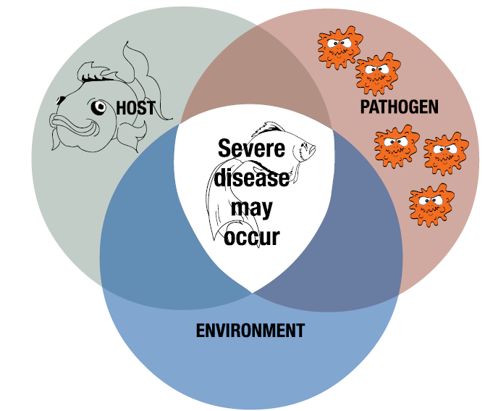

Laboratory tests and sampling
Photographs of gross disease signs, such as those in this field guide, can help an investigator to create a preliminary list of possible disease agents (differential diagnosis list) for the case under investigation. However, although gross signs narrow the search for possible agents, they are not adequate for definitive diagnosis; representative samples from the diseased animal(s) and the environment in which they live need to be taken for analysis. Several publications offering information about sampling are available.
- The World Organisation for Animal Health (OIE) Manual of diagnostic tests for aquatic animals provides standard diagnostic methods for OIE-listed diseases.
- Asia diagnostic guide to aquatic animal diseases provides diagnostic guidelines for the pathogens and diseases listed in the Quarterly Aquatic Animal Disease Reporting System.
- The website of the Australian Government Department of Agriculture, Water and the Environment (DAWE) provides information on the management of inland water quality.

Reporting disease
Fishery and aquaculture industry managers, as well as farmers and their staff, should be aware of their responsibilities to rapidly report any suspicion of diseases on Australia’s national list of reportable diseases of aquatic animals to local authorities.
To prepare for possible disease incursion, fishery and aquaculture industry managers should develop an emergency management plan, in consultation with farmers and appropriate extension staff.
If you identify signs of disease in a culture system, contact your aquatic animal health officer. If your observation is of wild aquatic animals, contact a wildlife or fisheries officer.
A national emergency animal disease watch hotline number has been established to assist early reporting of suspicious disease events. Call 1800 675 888 (free call and available 24 hours).
Current contact details for state and territory governments are provided in appendix B. Call to report your find or ask further questions on the observations you have made. You will be directed to an expert on diseases of aquatic animals within your state or territory.
Follow the directions and advice provided by the officer you contact. This field guide will help you find the information the officer needs.

Using the field guide
This field guide begins with coverage of the anatomy (section 1) of finfish, molluscs, crustaceans and amphibians, including images and illustrations. These are to help the reader describe lesions when reporting a suspected disease. It follows with descriptions for each infectious disease present in Australia’s national list of reportable diseases of aquatic animals. These are presented alphabetically, and classified into infectious diseases affecting finfish, molluscs (such as oysters), crustaceans (such as prawns) and amphibians (such as frogs).
This field guide is available both as a PDF document and as a downloadable phone app. The field guide phone app (listed as the Aquatic disease field guide) can be downloaded free for iOS and android devices at the relevant iTunes or app store outlets. For more information, see the Aquatic animal diseases significant to Australia: Identification field guide mobile application introductory video.
In both the PDF document and phone app, each disease page describes the:
- signs of disease (at the farm/tank/pond level and gross and microscopic pathological signs)
- disease agent
- host species that carry the disease agent
- presence of the disease in Australia
- epidemiology of the disease
- other diseases in the field guide that may have similar signs
- sample collection and reporting of disease outbreaks.
The disease pages also include photographs of animals with gross signs of disease and/or histological images detailing the typical tissue changes present.
Diagnosing diseases of aquatic animals is a structured process, which begins with making detailed observations, then asking the right questions. The primary aim of this process is to create a broad list of possible diseases that may account for the observed signs. This list can be further refined by targeted questioning and diagnostic tests.
Questions to ask may include:
- Which species, age class, sizes and sex of animals are involved?
- What specifically have you observed—for example, behavioural changes, changes in feed intake (reduced or increased), changes in faecal output?
- Are there obvious gross lesions (such as colour changes, ulcers or spots)?
- Does disease result in morbidity only, or are there mortalities?
- What level of mortality has been observed?
- Do animals show signs of recovery?
- At what rate did you observe disease (sudden death or chronic progression of disease)?
- Is this the first occurrence of disease with this presentation in your facility?
- Are any neighbouring properties or facilities reporting diseases?
- Have there been recent introductions to the facility or any changes in practice?
After making your initial observations, go to the ‘signs of disease’ section of the disease entries. Look up the diseases listed that match your observations, and you will find photographs and further information to help you narrow the search for the cause of the disease. For example, you might have observed disease in a marine fish, but then find that the listed disease with similar presenting signs affects only freshwater species—in this way, you can eliminate the unlikely, and your list of differential diagnoses will be shorter. In all cases, however, laboratory tests would be required for a definitive diagnosis. Local authorities with responsibility for aquatic animal health can advise on further courses of action should you suspect any disease listed in the field guide.

Signs of disease
Diagnostic information based on disease signs at the farm, tank or pond level, and gross pathological signs (abnormalities that can be seen with the naked eye) are important. However, in most cases, it is impossible to arrive at a definitive diagnosis on the basis of these signs alone. Although some users will not have experience in histological examination, or the equipment required for such examination in the field, the field guide also lists microscopic pathological disease signs.

Mass mortality
A fish kill involving a range of species is more likely caused by an environmental problem, such as toxicity or oxygen depletion. Deaths limited to one species (where other species are also present) are more likely a result of an infectious agent.

Behavioural changes
All species of aquatic animals have characteristic protection, food-gathering and breeding behaviours. Abnormal behaviour, such as a decrease in feeding, could indicate stress from disease. Some behavioural changes can occur across groups of species, or even across different phyla. In molluscs, few behavioural differences are observed such as gaping or delayed closing (in oysters) and decreased feeding or adhesion to vertical surfaces (in abalone). Finfish often gather at water inlets or gasp for air at the surface if the water is depleted of oxygen. If irritated by skin parasites, they may scrape themselves on hard surfaces. Whirling or ‘corkscrew’ swimming could indicate disease from an infectious agent or aquatic toxins. In both finfish and crustaceans, gathering at the surface or pond edges can often be a sign of disease.

Gross signs
Gross pathological changes may indicate the presence of infectious disease. Careful observation and further laboratory investigation is required to make a definitive diagnosis because many of the signs are not singularly pathognomonic (characteristic for a specific disease) and may be common pathological changes associated with multiple infectious agents. The table below describes some of the more commonly observed visible signs and the groups of aquatic animals dealt with in this field guide for which these are most often observed.
Table 1 Potential gross signs of disease
Sign | Finfish | Molluscs | Crustaceans | Amphibians
Changes in the colour, texture and opacity of flesh | * | * | * | *
Tissue necrosis and lesions | * | * | * | *
Retraction of gill margins | na | * | na | na
Pustules | * | * | na | na
External spots | * | na | * | na
Changes in surface colour | * | na | * | *
Secondary fungal or bacterial growth | * | * | * | *
Deformities and tumours | * | na | * | *
Swollen or discoloured organs or faecal castes | * | * | * | *
White midgut line | na | na | * | na
Broken or damaged appendages | na | na | * | na
Erosion of shell | na | na | * | na
Lesions or ulcers on skin or gills | * | na | * | *
Haemorrhaging with associated anaemia | * | na | na | *
Granulomas | * | na | * | na
Exophthalmos (popeye) | * | na | na | na
Ascites (accumulation of fluid in peritoneal cavity) | * | na | na | *
Petechial haemorrhages (pinpoint bleeding in skin and mucous membranes) | * | na | na | *
Ecchymotic haemorrhages (bleeding or bruising beneath the skin or mucous membranes) | * | na | na | *
Excessive mucus on gills and skin | * | * | na | na
Dropsy (accumulation of fluid in body tissues) | * | na | na | *
Protrusion of scales | * | na | na | na
* Potential gross sign of disease. na Sign is not applicable to the taxonomic grouping.

Host range
A list of species known to be susceptible to the infectious agent is provided. Species are further classified as either naturally susceptible (diseased animals have been identified in the wild) or experimentally susceptible. Lists of susceptible species reflect the information available at the time of publishing. However, with further understanding and sampling, it is expected that such lists will expand and/or require refining. Both common and scientific names for hosts are provided.

Presence in Australia
Information on the national distribution of diseases listed in the field guide is based on formal reporting through the regional Quarterly Aquatic Animal Disease reporting program. This program is managed by the Network of Aquaculture Centres in Asia–Pacific (NACA), Food and Agriculture Organisations of the United Nations (FAO) and the World Organisation for Animal Health (OIE). Australia has been an active participant since 1998.
Where a listed disease has been reported under the program to have been present, a map illustrating where it occurred in Australia is included. States or territories having reported disease are listed, and shown in orange in the distribution map. It is important to note that, although a map may identify a state or territory as having reported a disease, this implies neither that it is present at the time of publication nor that it occurs across the entire state or territory.
Readers should consult the World Animal Health Information Database (WAHID) interface for current information on global distribution of diseases outside Australia.

Exotic diseases
Diseases in this field guide described as exotic are those that do not occur in Australian aquatic animal populations. Diseases present in Australia may still be listed as exotic if they are subject to an ongoing emergency disease response to contain and eradicate the disease.

Endemic diseases
Endemic (enzootic) diseases are those that have established in Australian aquatic animal populations. They might be native to Australia or might have been introduced in the past.

Epidemiology
The field guide describes epidemiological factors that are important to each disease. The key to describing the epidemiology of a disease involves understanding the relationship between the infectious agent, the host/s and the environment. Factors relating to the infectious agent include its life cycle (direct transmission or a requirement for intermediate host stages), survival outside the host (carriage on fomites, passage in wastewater) and sensitivity to certain temperatures or salinities.
Host factors may include the susceptible species, ages, sexes and sizes involved. Environmental factors include seasonal and non-seasonal variations in temperature, food availability, salinity, available oxygen, species movement and exposure to different environments (for example, migrations or gathering for breeding). These factors can affect disease agent survivability and host immune competence.

Differential diagnosis
The list of similar diseases at the bottom of each disease page refers only to the diseases covered by this field guide. Gross signs observed might well be representative of a wider range of diseases not included here. Therefore, these diagnostic aids should not be used as a guide to a definitive diagnosis, but rather as a tool to help identify the diseases included in this field guide that most closely account for the observed gross signs. Further diagnostic testing will be required to confirm either presence or freedom from a suspected disease.

Anatomy

Finfish
The external and internal anatomy of finfish varies considerably across species. Specific adaptations to predator–prey interactions, aquatic habitat variability and dietary preferences can explain these differences. One example is the short intestinal length of carnivorous fish compared with the relatively long intestine of herbivorous fish. Another, is the ventrally directed mouth of bottom-feeding species such as European carp (Cyprinus carpio) compared with the upward oriented mouth of the surface-feeding saratoga (Scleropages leichardti).
Figure 2 Mature male Atlantic salmon (Salmo salar)
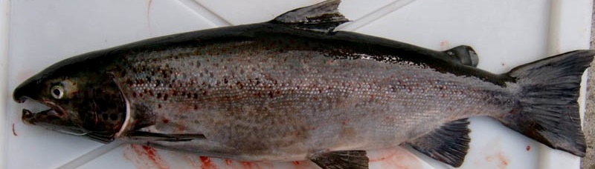
Note: Typical hooked mouth.
Source: M Porter
Figure 3 Gravid female Atlantic salmon (Salmo salar)
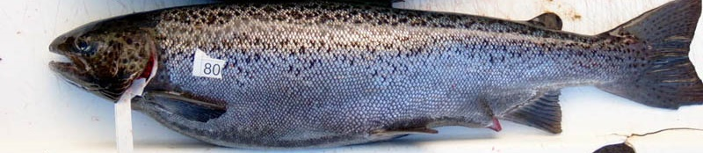
Note: Distended abdomen and protruding spawning vent.
Source: M Porter
Figure 4 Anatomy of female juvenile salmon
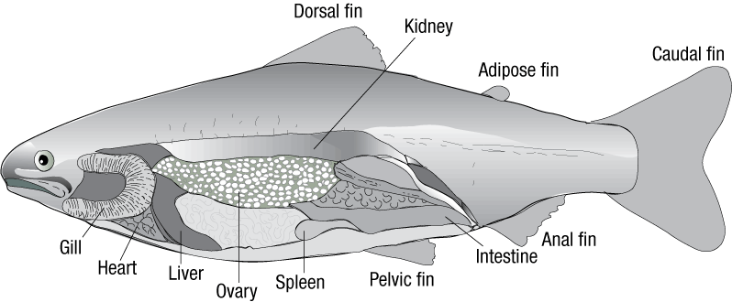
Source: Australian Government Department of Agriculture, Water and the Environment
Figure 5 Stomach cavity of gravid female Atlantic salmon (Salmo salar)
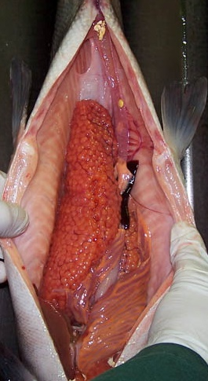
Note: Stomach cavity dominated by ovary. Compare the relative size of ovary with the rest of the internal organs.
Source: K Nelson
Figure 6 Internal organs of gravid female Atlantic salmon (Salmo salar)
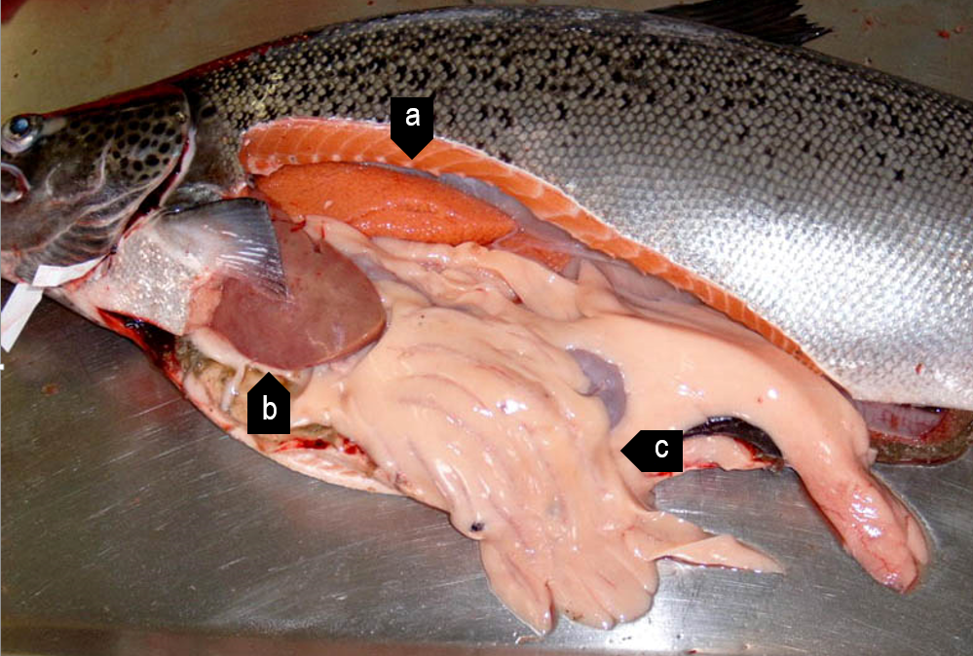
Note: Ovary (a) is positioned between the liver (b) and intestines (c) and the vertebrae.
Source: M Porter
Figure 7 Degenerative eggs in old female Atlantic salmon (Salmo salar)
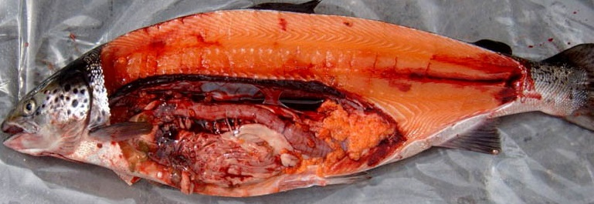
Source: M Porter
Figure 8 Golden perch (Macquaria ambigua)
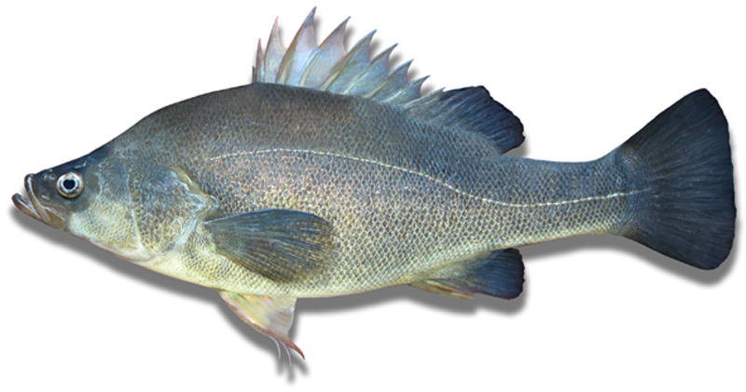
Note: Compare morphology to silver perch (Bidyanus bidyanus) in Figure 9
Source: New South Wales Department of Primary Industries
Figure 9 Silver perch (Bidyanus bidyanus)
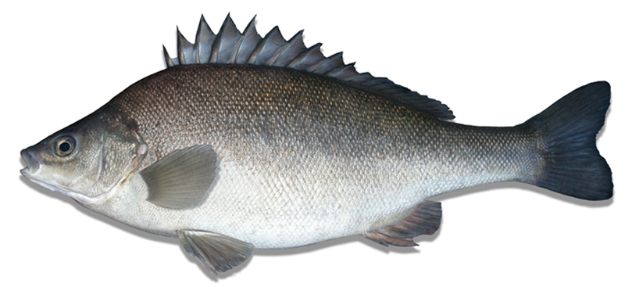
Note: Compare morphology to golden perch (Macquaria ambigua) in Figure 8.Figure 9
Source: New South Wales Department of Primary Industries
Figure 10 Internal anatomy of silver perch (Bidyanus bidyanus)
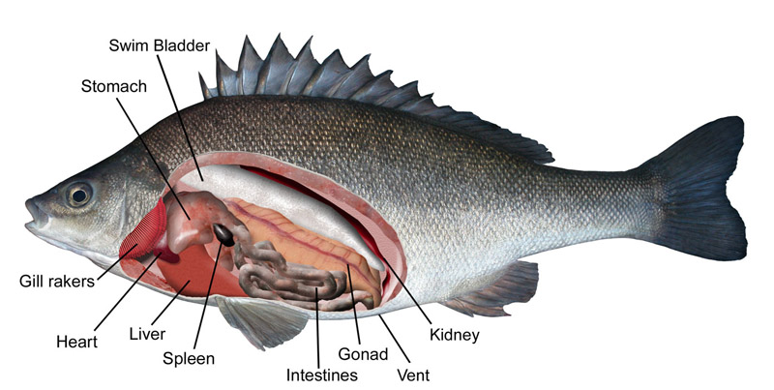
Source: New South Wales Department of Primary Industries

Molluscs

Abalone
Figure 11 Anatomy of abalone (Haliotis sp.)—ventral view
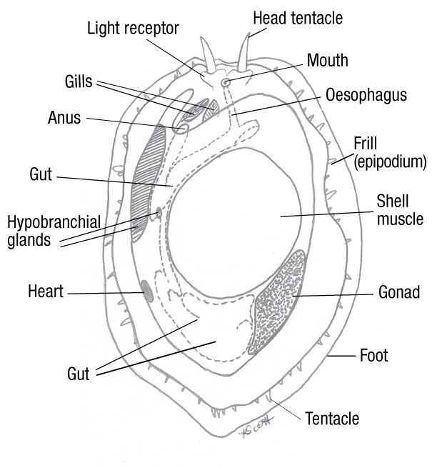
Source: K Scott
Figure 12 Anatomy of abalone (Haliotis sp.)—dorsal view
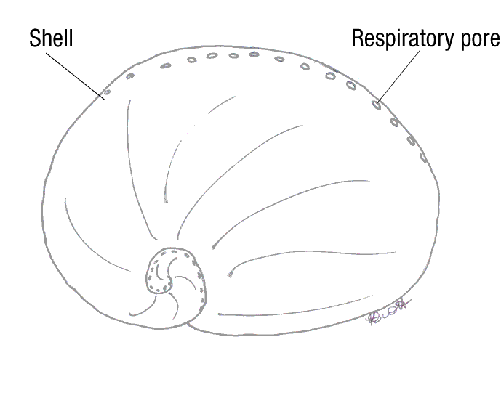
Source: K Scott
Figure 13 Abalone variations—ventral view
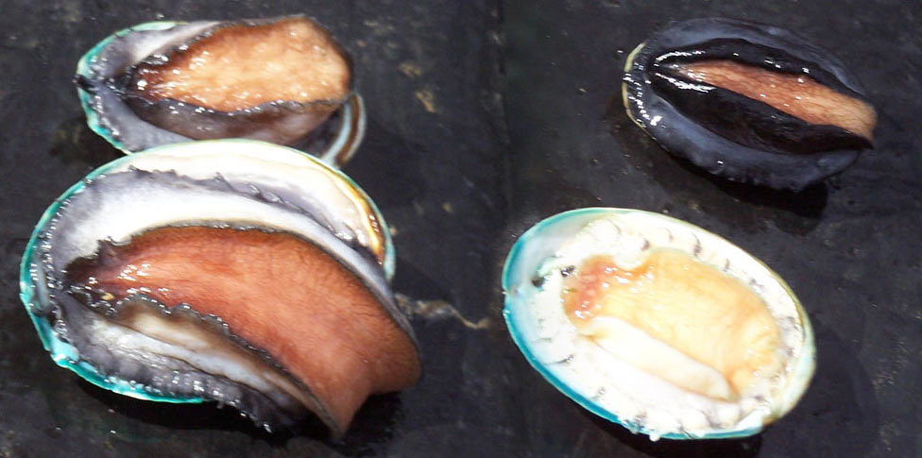
Note: Greenlip abalone, Haliotis laevigata (left). Blacklip abalone, Haliotis rubra (top right). Hybrid tiger abalone, Haliotis laevigata × H. rubra (bottom right).
Source: K Scott

Oysters
Figure 14 General anatomy of oyster (Ostrea sp.)
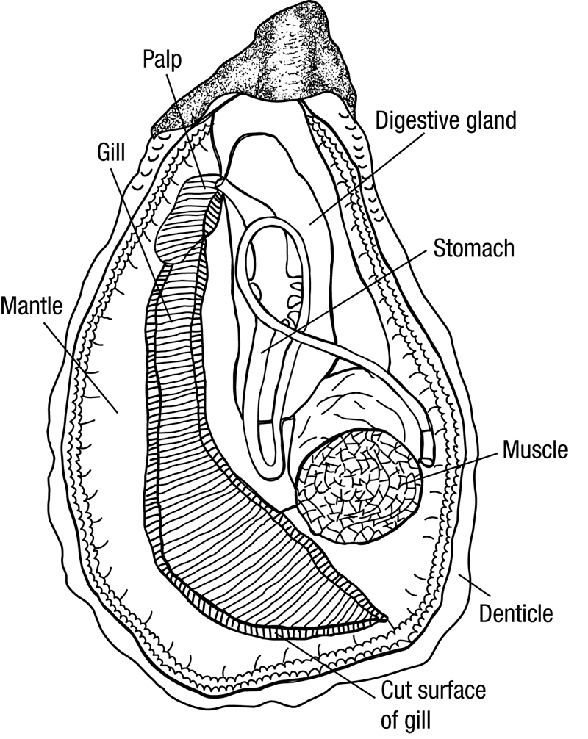
Source: Australian Government Department of Agriculture, Water and the Environment
Figure 15 Healthy European flat oyster (Ostrea edulis)
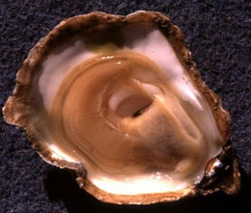
Source: I Arzul, French Research Institute for Exploration of the Sea

Crustaceans

Prawns
The common names ‘prawn’ and ‘shrimp’ are often used synonymously for the same crustaceans in different parts of the world. This field guide uses the terms most commonly used in Australia. Where Australian species of crustaceans are primarily involved in the disease, they are referred to as prawns. However, where the species of crustacean involved in the disease are exotic to Australia, they are referred to as shrimp.
Figure 16 External anatomy of prawn 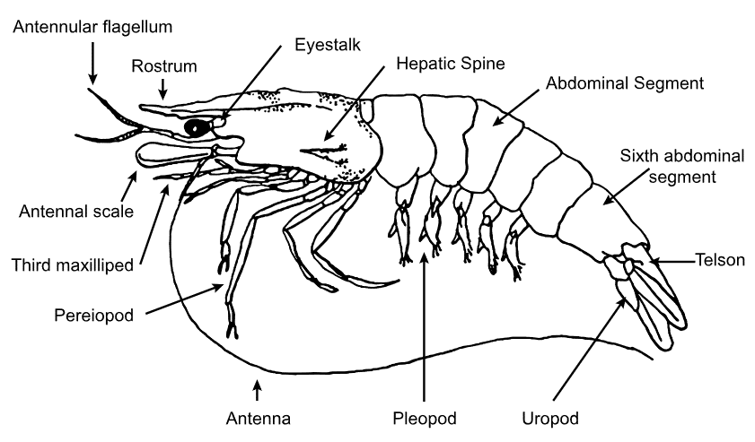
Source: R Bowater, Queensland Department of Primary Industries and Fisheries
Figure 17 Black tiger prawn (Penaeus monodon)
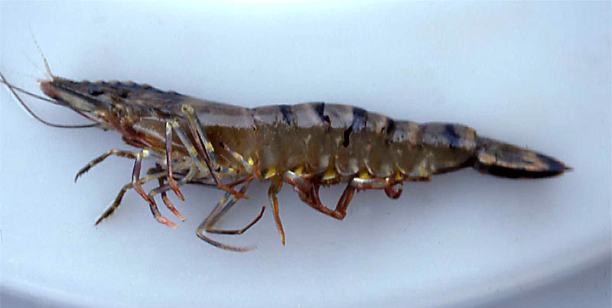
Source: Australian Government Department of Agriculture, Water and the Environment

Crabs
Figure 18 External anatomy of crab
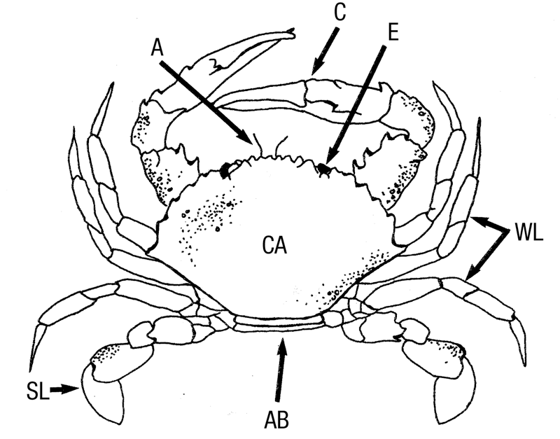
A antenna. AB abdomen (underneath). C claw. CA carapace. E eye. SL swimming leg. WL walking leg.
Source: R Bowater, Queensland, Department of Primary Industries and Fisheries
Figure 19 Internal anatomy of crab—saggital section
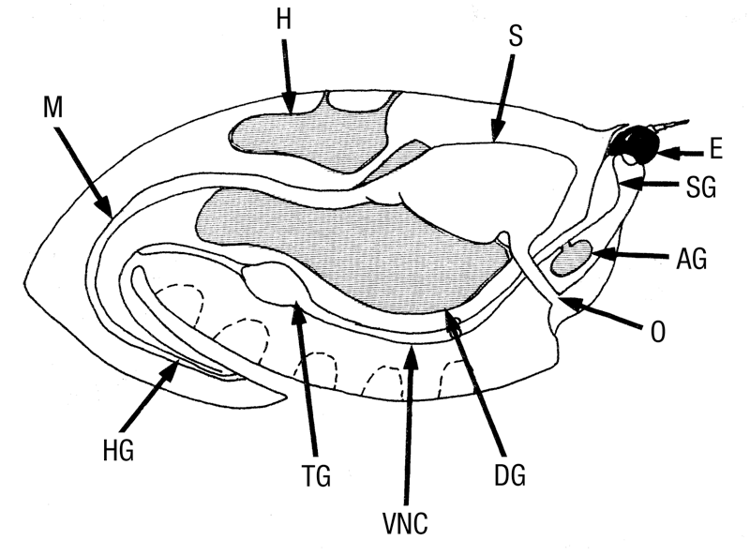
AG antennal gland. DG digestive gland (hepatopancreas). E eye. H heart. HG hindgut. M midgut. O oesophagus. S stomach. SG supraoesophageal ganglion. TG thoracic ganglion. VNC ventral nerve cord.
Source: R Bowater, Queensland Department of Primary Industries and Fisheries
Figure 20 Internal anatomy of blue swimmer crab (Callinectes sapidus)
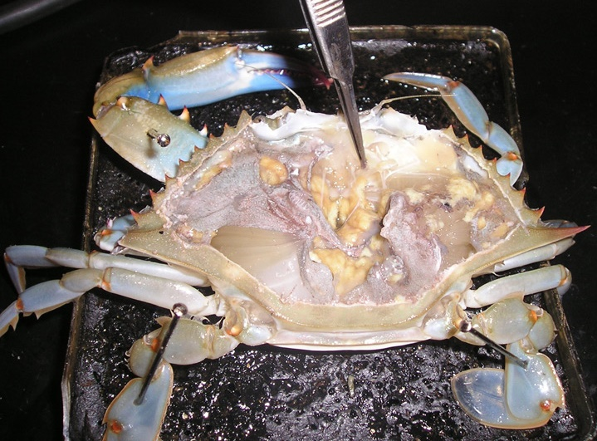
Source: O Zmora

Crayfish
Figure 21 External anatomy of freshwater crayfish
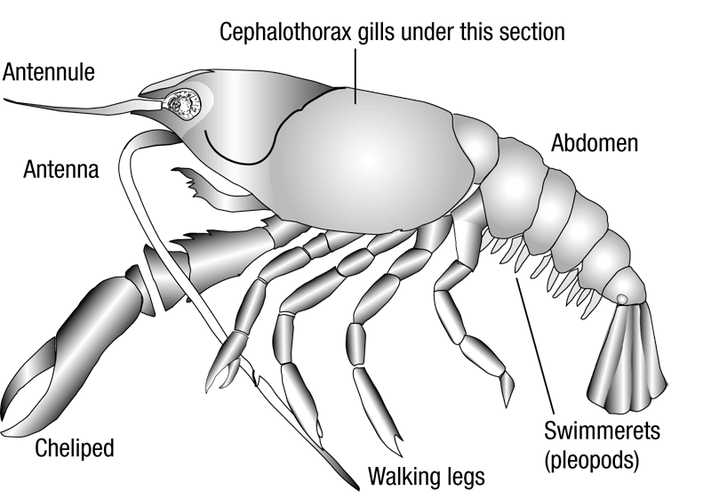
Source: Australian Government Department of Agriculture, Water and the Environment
Figure 22 Internal anatomy of freshwater crayfish—sagittal section
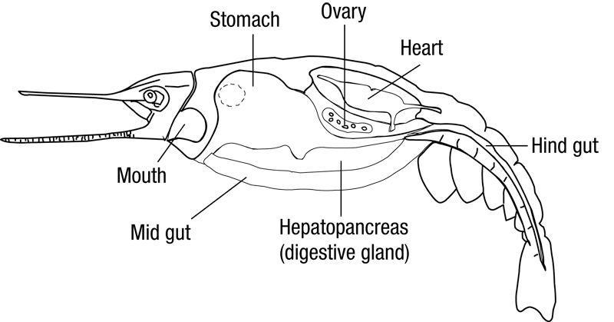
Source: Australian Government Department of Agriculture, Water and the Environment
Figure 23 Redclaw crayfish (Cherax quadricarinatus)
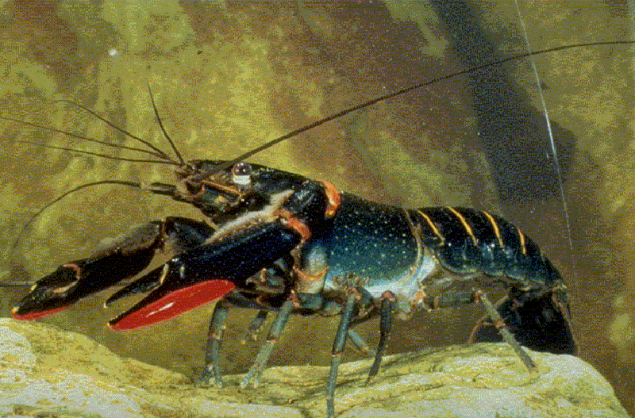
Source: C Jones
Figure 24 Gills of redclaw crayfish (Cherax quadricarinatus)
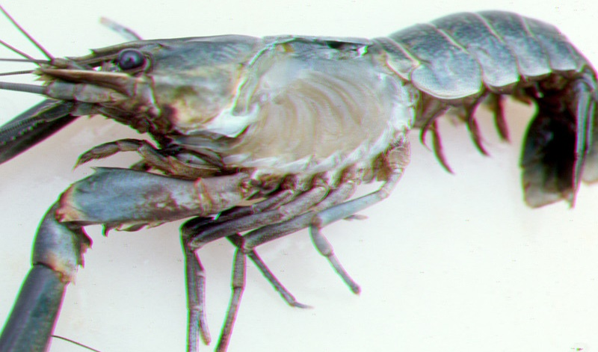
Source: C Jones

Amphibians
Amphibians are comprised of the orders Anura (frogs and toads), Caudata (including salamanders, newts and sirens) and Gymnophiona (caecilians). In Australia, we are primarily concerned with the health of anurans.
Amphibians undergo a metamorphosis that is unique among vertebrates; from a juvenile, obligatory aquatic form with gills (tadpoles) to a semi-aquatic adult form with lungs. Adult amphibians also have the unique ability to breathe transdermally (through the skin), meaning changes to the skin through disease, trauma or mishandling can have significant health impacts.
Early recognition and a deep understanding of the significant diseases affecting amphibians will be crucial to halting the current decline in species biodiversity seen in Australia. Although not of great commercial interest in Australia, native amphibians act as sentinels of change in aquatic environments. The anatomical descriptions in Figure 25 and Figure 26 are not exhaustive but are intended to help field guide users communicate the location and extent of gross external anatomical changes.
Figure 25 External anatomy of frog—left lateral view
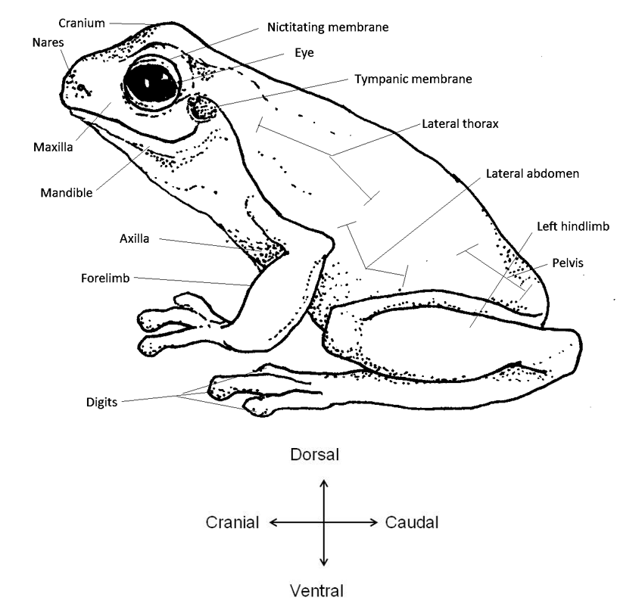
Source: Australian Government Department of Agriculture, Water and the Environment
Figure 26 External anatomy of frog—dorsal view
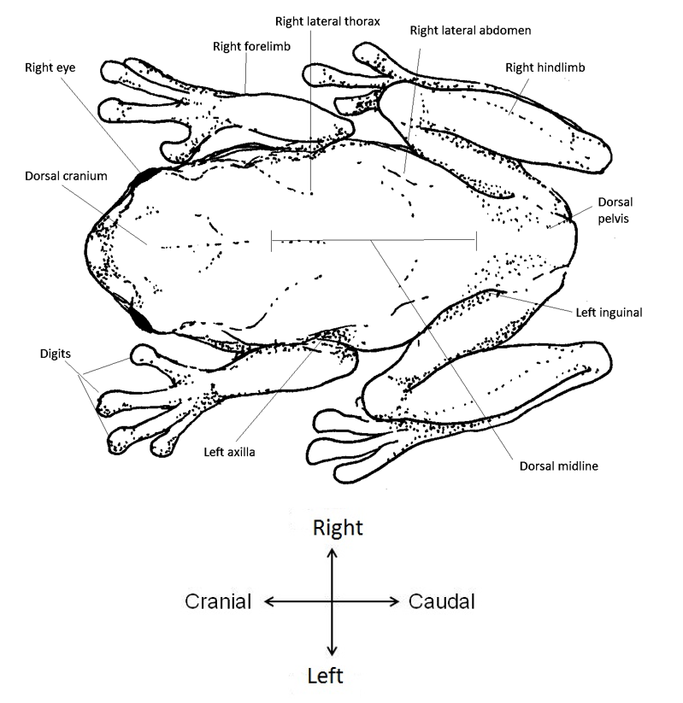
Source: Australian Government Department of Agriculture, Water and the Environment

Diseases of finfish

Viral diseases of finfish

Channel catfish virus disease (CCVD)
Also known as infection with Ictalurid herpesvirus 1
Exotic disease
Figure 27 Channel catfish (Ictalurus punctatus) fingerling showing signs of CCVD
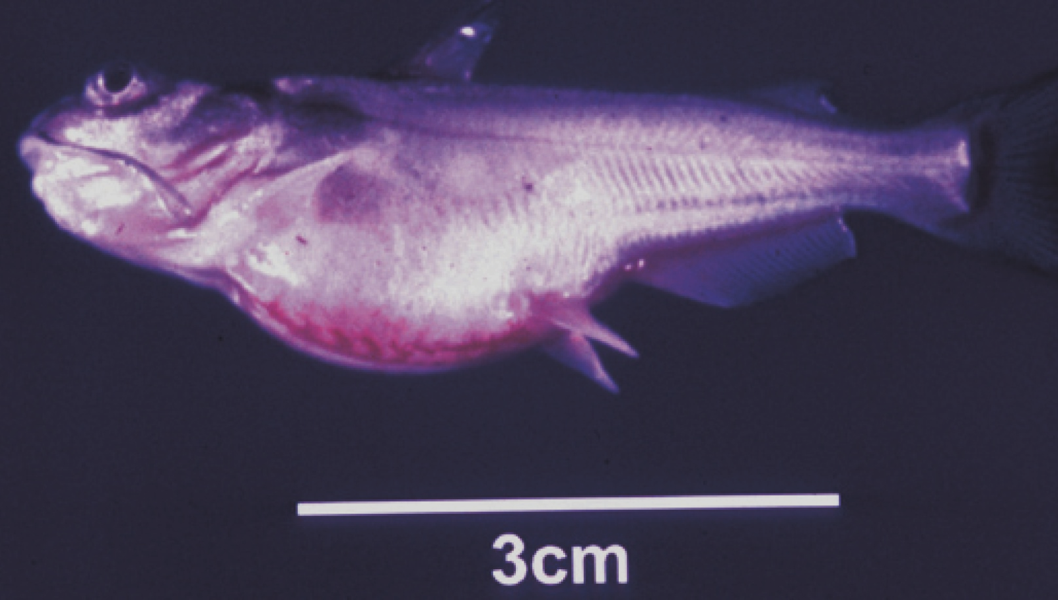
Note: Swollen abdomen and popeye.
Source: LA Hanson
Figure 28 Channel catfish (Ictalurus punctatus) with CCVD
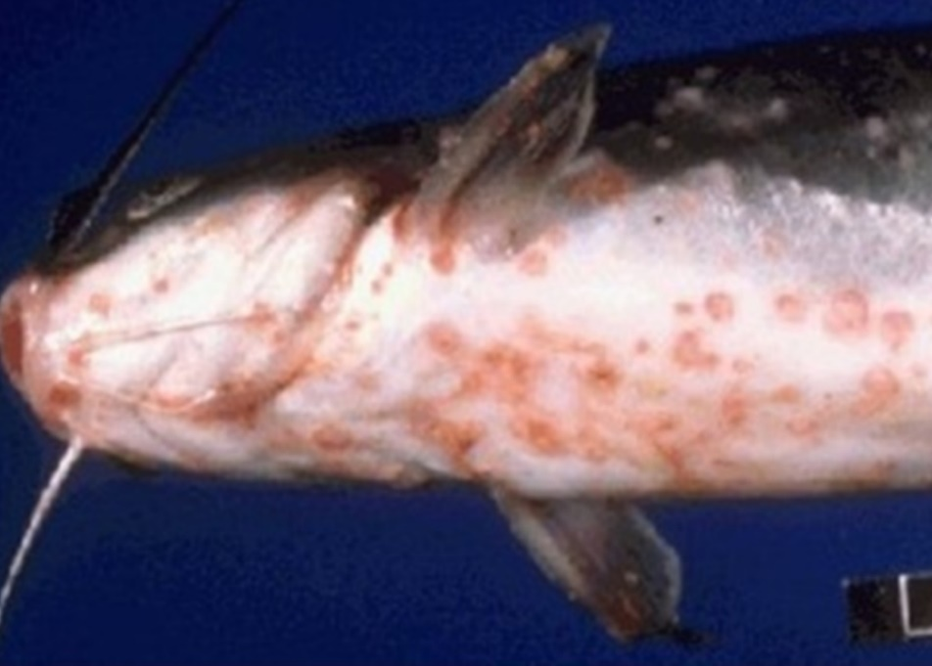
Note: Haemorrhages present on the base of the body, gills and fins.
Source: United States Department of Agriculture

Signs of disease
Important: Animals with this disease may show one or more of these signs, but the pathogen may still be present in the absence of any signs.
Disease signs at the farm, tank or pond level are:
- decreased feeding activity (usually the first sign of disease)
- high mortality in fry and juvenile catfish
- erratic swimming
- brief episodes of hyperactivity when fish are disturbed, followed by extended periods of lethargy
- large congregations of fish at the sides of hatching troughs or ponds, motionless in a head-up tail-down position.
Gross pathological signs are:
- swollen abdomen
- exophthalmos (popeye)
- haemorrhaging of fins and ventral abdomen
- haemorrhaging of the musculature, liver and kidneys
- dark and enlarged spleen
- fluid in the abdominal cavity
- pale, enlarged kidneys, which may be the only internal indication of disease in infected fish.
Microscopic pathological signs are:
- extensive necrosis of renal tubules and interstitial tissues of the kidney.

Disease agent
CCVD is caused by infection with Ictalurid herpesvirus 1, a double stranded DNA herpes virus classified within the genus Ictalurivirus, from the family Alloherpesviridae.

Host range
CCVD has been reported from blue catfish, channel catfish and channel catfish hybrids cultured in the USA, as well as Pangasius (Basa) catfish cultured in Asia. Ictalurid herpesvirus 1 has also been isolated from crucian carp (Carassius carassius) and common carp (Cyprinus carpio) not exhibiting disease signs. It is currently unknown if they act as reservoirs for the virus.
Table 2 Species known to be susceptible to CCVD
Common name | Scientific name
Blue catfishª | Ictalurus furcatus
Channel catfishª | Ictalurus punctatus
Common carp and koi carp | Cyprinus carpio
Crucian carp | Carassius carassius
Striped catfish or Traª | Pangasianodon hypophthalmus
a Naturally susceptible. Note: Other species have been shown to be experimentally susceptible.

Presence in Australia
Exotic disease—not recorded in Australia.
Map 1 Presence of CCVD, by jurisdiction
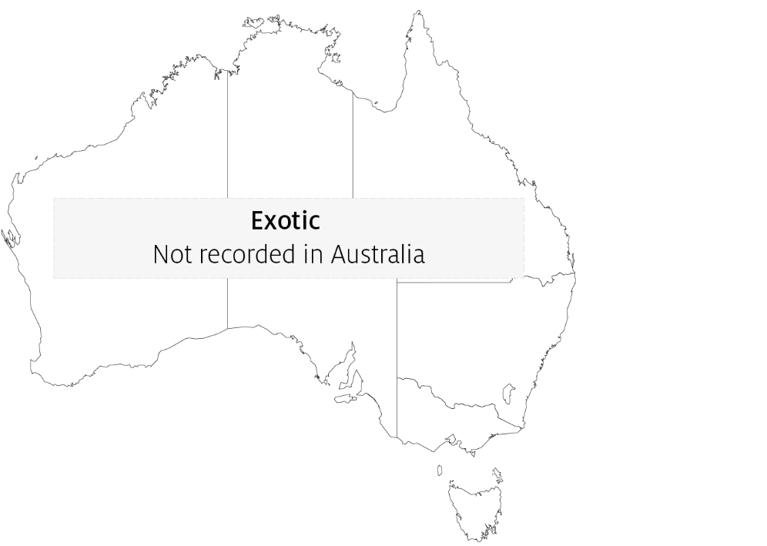

Epidemiology
- Horizontal transmission occurs directly from virus shed in water, and from virus carried by animal vectors and on fomites.
- Vertical transmission (from parent to offspring via eggs) is believed to be common.
- Mortality rates in exposed fish can exceed 95%. Survivors of CCVD may experience short-term reductions in feed conversion (reduced weight gain). Generally, these fish appear normal but become carriers of the virus.
- Susceptibility appears to vary according to the strain of the virus.
- The disease occurs almost exclusively in fish that are less than 1 year old (fry and fingerlings) or smaller than 15cm in length. The majority of occurrences are in fish less than 4 months old.
- Mortality rates are highest where water temperature exceeds 27°C and declines with a reduction in temperature. Mortality rates are negligible at water temperatures lower than 18°C.

Differential diagnosis
The list of similar diseases in the next section refers only to the diseases covered by this field guide. Gross pathological signs may also be representative of diseases not included in this guide. Do not rely on gross signs to provide a definitive diagnosis. Use them as a tool to help identify the listed diseases that most closely account for the observed signs.

Similar diseases
Enteric septicaemia of catfish, European catfish virus (ECV) and European sheatfish virus (ESV), and infection with Aeromonas salmonicida—atypical strains.

Sample collection
Only trained personnel should collect samples. Using only gross pathological signs to differentiate between diseases is not reliable, and some aquatic animal disease agents pose a risk to humans. If you are not appropriately trained, phone your state or territory hotline number and report your observations. If you have to collect samples, the agency taking your call will advise you on the appropriate course of action. Local or district fisheries or veterinary authorities may also advise on sampling.

Emergency disease hotline
See something you think is this disease? Report it. Even if you’re not sure.
Call the Emergency Animal Disease Watch Hotline on 1800 675 888. They will refer you to the right state or territory agency.

Further reading
CABI Invasive Species Compendium Channel catfish virus disease
Camus, AC 2004, Channel catfish virus disease, Southern Regional Aquaculture Centre
CEFAS International Database on Aquatic Animal Diseases Channel catfish virus disease

Epizootic haematopoietic necrosis (EHN)
Also known as infection with epizootic haematopoietic necrosis virus (EHNV)
Figure 29 Mass mortality of redfin perch (Perca fluviatilis) due to EHN
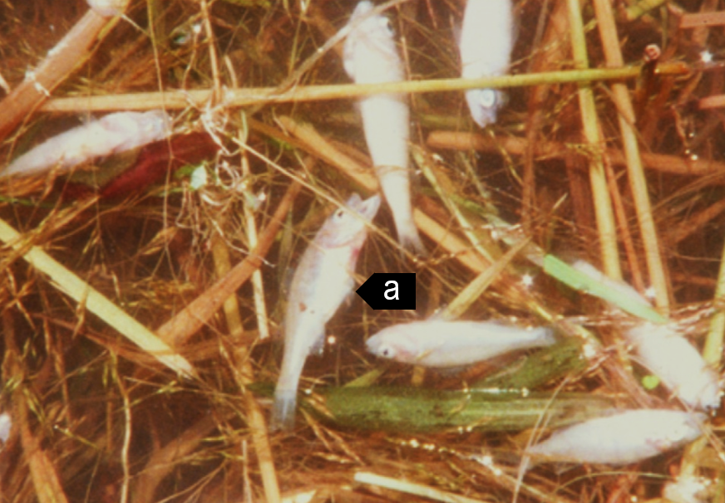
Note: Affected individuals showing signs of EHN including swollen abdomen (a) and small size.
Source: J Humphrey
Figure 30 Redfin perch (Perca fluviatilis) experimentally infected with EHNV
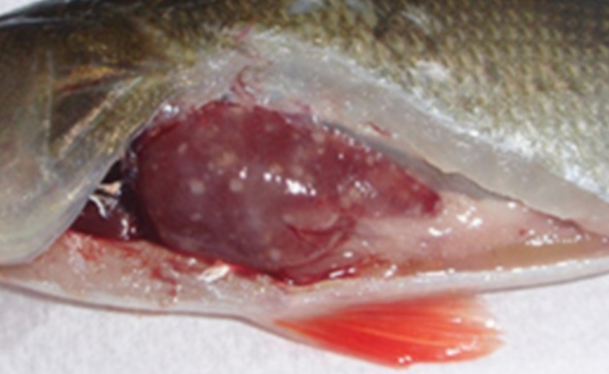
Note: Grossly visible multifocal necrotic foci in the liver.
Source: R Whittington

Signs of disease
Important: Animals with this disease may show one or more of these signs, but the pathogen may still be present in the absence of any signs.
Disease signs at the farm, tank or pond level are:
- hundreds or thousands of small (less than 10cm long), dead fish found on the downwind bank of the water body
- large numbers of fish-eating birds (such as seagulls) at the water surface
- loss of appetite
- juveniles (less than 25mm long) swimming in a disorientated fashion at the surface
- occasional adults affected when the disease first arrives in an area.
Gross pathological signs are:
- swollen abdomen
- darkened skin colour
- petechial (pinpoint) haemorrhages at the base of the fins
- haemorrhaging of the gills
- dead fish
- enlargement of the kidney, liver and spleen
- focal white to yellow liver lesions.
Microscopic pathological signs are:
- coagulative or liquefactive necrosis of the liver, kidney and spleen
- necrotic lesions in the heart, pancreas, gastrointestinal tract and gills
- small numbers of basophilic intracytoplasmic inclusion bodies surrounding necrotic areas of the liver and kidney.

Disease agent
EHN is caused by infection with epizootic haematopoietic necrosis virus (EHNV), belonging to the genus Ranavirus within the family Iridoviridae. Closely related ranaviruses cause similar systemic necrotising iridovirus syndromes in sheatfish and catfish in Europe (European sheatfish virus and European catfish virus; also in this guide).

Host range
Table 3 Species known to be susceptible to EHNV
Common name | Scientific name
Macquarie perch | Macquaria australasica
Mosquito fish | Gambusia affinis
Mountain galaxias | Galaxias olidus
Murray codª | Maccullochella peelii
Rainbow trout^{b} | Oncorhynchus mykiss
Redfin or European perch^{b} | Perca fluviatilis
Silver perch | Bidyanus bidyanus
Piscivorous birds | Various genera and species
a Demonstrated to carry EHNV subclinically. b Naturally susceptible. Note: Other species have been shown to be experimentally susceptible.

Presence in Australia
EHN has been officially reported from the Australian Capital Territory, New South Wales, South Australia and Victoria.
Map 2 Presence of EHN, by jurisdiction
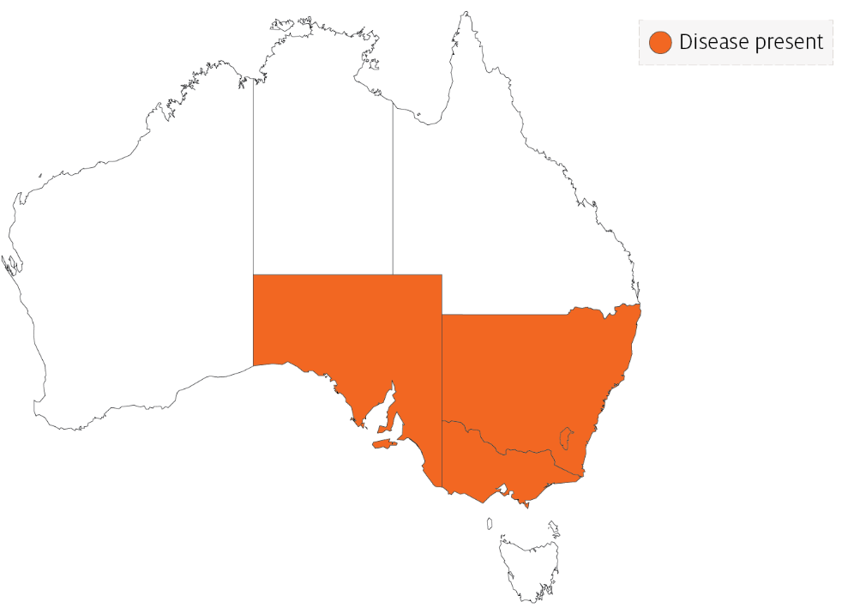

Epidemiology
- EHN is usually seen in Australia as large kills of small redfin perch. High mortality can also occur among older perch in newly affected areas.
- Clinical outbreaks are typically seen in fingerlings and juvenile fish, associated with poor water quality and/or certain water temperatures (between 11°C and 17°C in rainbow trout and above 12°C in redfin perch).
- Mortalities occur over a short period (several weeks) in summer, and then the disease may disappear from an area for years.
- Low mortality rates over a period of months have been reported in young, farmed rainbow trout.
- Infectivity is less severe in rainbow trout than in redfin perch, with the disease mainly affecting fingerlings less than 125mm long.
- Low-grade mortalities with covert EHNV infection can also occur in juvenile fish. Care must be taken when moving redfin perch and rainbow trout from the known geographical range of EHNV to areas where it is exotic, unless freedom from disease can be adequately demonstrated.
- EHN is a resistant virus, surviving for months in water, persisting in frozen fish tissues for more than two years and in frozen fish carcases for at least one year.
- EHNV may be carried on equipment including nets and boats, in fish (live or dead) used for bait and via the gut, feathers, feet and bill of piscivorous birds.

Differential diagnosis
The list of similar diseases in the next section refers only to the diseases covered by this field guide. Gross pathological signs may also be representative of diseases not included in this guide. Do not rely on gross signs to provide a definitive diagnosis. Use them as a tool to help identify the listed diseases that most closely account for the observed signs.

Similar diseases
Enteric red mouth disease, furunculosis, infection with HPR-deleted or HPR0 infectious salmon anaemia virus, infectious haematopoietic necrosis (IHN), infectious pancreatic necrosis (IPN), viral haemorrhagic septicaemia (VHS) and whirling disease.

Sample collection
Only trained personnel should collect samples. Using only gross pathological signs to differentiate between diseases is not reliable, and some aquatic animal disease agents pose a risk to humans. If you are not appropriately trained, phone your state or territory hotline number and report your observations. If you have to collect samples, the agency taking your call will advise you on the appropriate course of action. Local or district fisheries or veterinary authorities may also advise on sampling.

Emergency disease hotline
See something you think is this disease? Report it. Even if you’re not sure.
Call the Emergency Animal Disease Watch Hotline on 1800 675 888. They will refer you to the right state or territory agency.

Further reading
CEFAS International Database on Aquatic Animal Diseases Epizootic Haematopoietic Necrosis
World Organisation for Animal Health Manual of diagnostic tests for aquatic animals

European catfish virus (ECV) and European sheatfish virus (ESV)
Exotic disease
Figure 31 Skin lesions on brown bullhead (Ameiurus nebulosus) with ECV infection
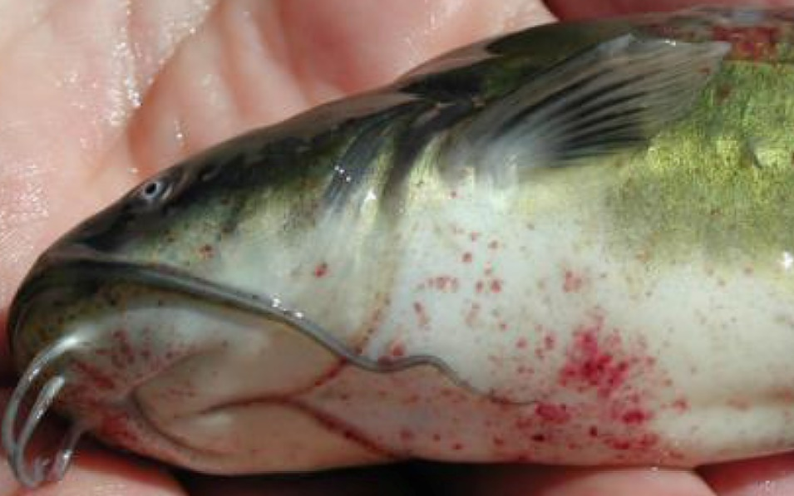
Note: Haemorrhagic skin lesions on the abdomen.
Source: J Tamás
Figure 32 Fin lesion on brown bullhead (Ameiurus nebulosus) with ECV infection
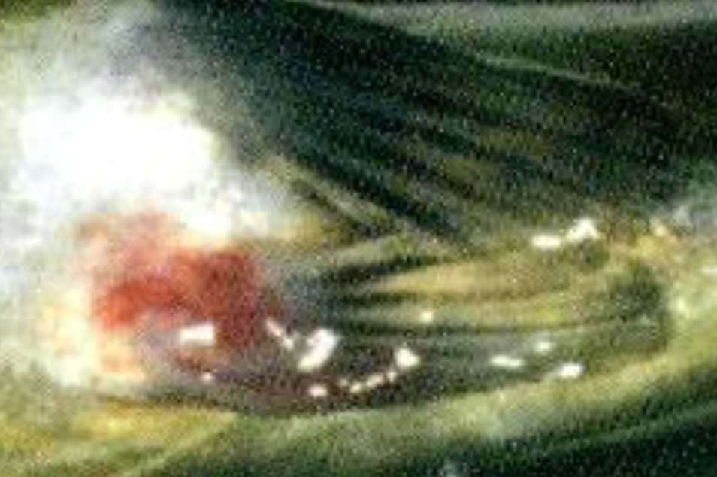
Note: Haemorrhagic skin lesions on the pelvic fin.
Source: J Tamás

Signs of disease
Important: Animals with this disease may show one or more of these signs, but the pathogen may still be present in the absence of any signs.
Disease signs at the farm, tank or pond level are:
- sudden high mortality rates (up to 100%) in juvenile fish in aquaculture or in the wild
- losses of up to 30% of adult sheatfish
- loss of appetite 1 to 2 days before mortalities occur
- erratic spiral swimming at the water surface
- lethargy.
Gross pathological signs are:
- swollen abdomen (ascites)
- darkened skin colour
- petechial (pinpoint) haemorrhages around the base of paired fins and in the viscera
- haemorrhagic areas on the skin
- pale gills
- many dead fish.
Microscopic pathological signs are:
- coagulative or liquefactive necrosis of the liver, spleen and especially the kidney
- destruction of haematopoietic tissues
- necrotic lesions in the heart, pancreas, gastrointestinal tract and gills.

Disease agent
ECV and ESV are classified as members of the genus Ranavirus within the family Iridoviridae. Other closely related ranaviruses such as epizootic haematopoietic necrosis virus (EHNV), grouper iridovirus (GIV) or Ranavirus maxima from European turbot cause similar systemic necrotising iridovirus syndromes in a range of fish species (EHNV and GIV are also in this guide).

Host range
ECV and ESV have been detected only in Europe. The pathogen has triggered epizootics in cultivated sheatfish in Germany and wild black bullheads in France, Italy and Hungary. Experimental ESV infection causes high mortality in pike, but black bullhead and rainbow trout appear to be unaffected, although viral replication has been detected. Juvenile pike perch may be susceptible to infection under certain conditions. These viruses may also be carried via the gut, feathers, feet and bill of piscivorous birds.
Table 4 Species known to be susceptible to ECV and ESV
Common name | Scientific name
Black bullhead or European catfishª | Ameiurus melas
Brown bullheadª | Ameiurus nebulosus
Pike | Esox lucius
Pike perch | Sander lucioperca
Rainbow trout | Oncorhynchus mykiss
Wels catfish or sheatfishª | Silurus glanis
Piscivorous birds | Various genera and species
a Naturally susceptible. Note: Other species have been shown to be experimentally susceptible.

Presence in Australia
Exotic disease—not recorded in Australia.
Map 3 Presence of ECV and ESV, by jurisdiction

Epidemiology
- ESV was the first fish ranavirus to be isolated in Europe, when it was obtained from moribund sheatfish (Silurus glanis) fry experiencing 100% mortalities in Germany in 1989.
- Clinical outbreaks of sudden mass mortalities are typically seen in fingerlings and juvenile fish, though adult fish may also be affected.
- Transmission is horizontal and can occur by cohabitation resulting in up to 100% mortality within 11 days.
- Disease outbreaks may be associated with high summer water temperatures and/or poor water quality.
- Ranaviruses are resistant viruses, surviving for months in water, persisting in frozen fish tissues for more than two years and in fish carcasses for at least one year.
- Ranaviruses may be carried on equipment including nets and boats, in fish (live or dead) used for bait and via the gut, feathers, feet and bill of piscivorous birds.

Differential diagnosis
The list of similar diseases in the next section refers only to the diseases covered by this field guide. Gross pathological signs may also be representative of diseases not included in this guide. Do not rely on gross signs to provide a definitive diagnosis. Use them as a tool to help identify the listed diseases that most closely account for the observed signs.

Similar diseases
Channel catfish virus disease (CCVD), enteric septicaemia of catfish and epizootic haematopoietic necrosis (EHN).

Sample collection
Only trained personnel should collect samples. Using only gross pathological signs to differentiate between diseases is not reliable, and some aquatic animal disease agents pose a risk to humans. If you are not appropriately trained, phone your state or territory hotline number and report your observations. If you have to collect samples, the agency taking your call will advise you on the appropriate course of action. Local or district fisheries or veterinary authorities may also advise on sampling.

Emergency disease hotline
See something you think is this disease? Report it. Even if you’re not sure.
Call the Emergency Animal Disease Watch Hotline on 1800 675 888. They will refer you to the right state or territory agency.

Further reading
CABI Invasive Species Compendium Isolation of ranavirus causing mass mortality in brown bullheads (Ameiurus nebulosus) in Hungary
World Organisation for Animal Health Manual of diagnostic tests for aquatic animals

Grouper iridoviral disease
Also known as sleepy grouper disease, grouper iridovirus of Taiwan (TGIV) and Singapore grouper iridovirus (SGIV)
Exotic disease
Figure 33 Gross signs of secondary infection in estuary cod (Epinephelus tauvina) infected by grouper iridovirus
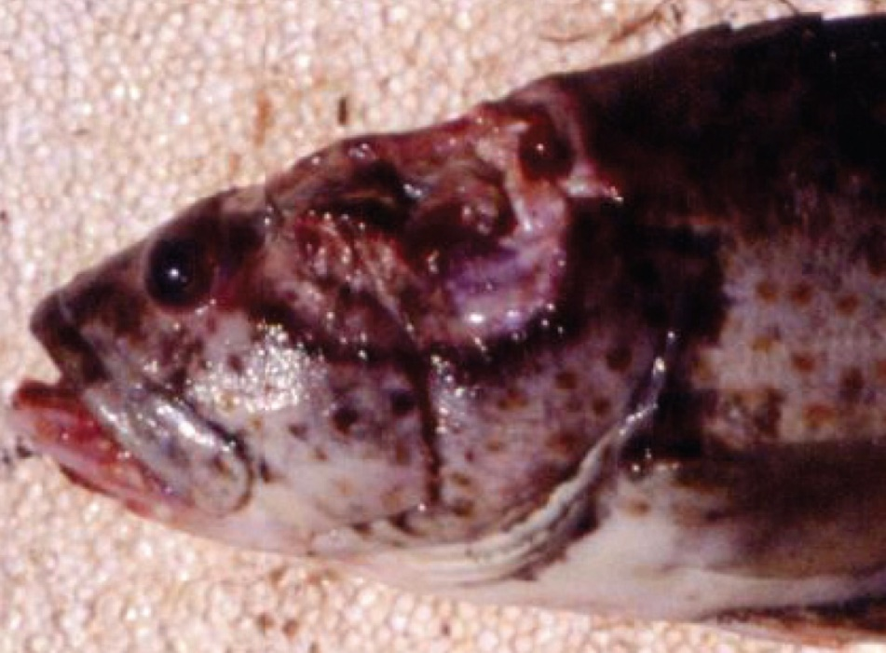
Note: Deep ulceration in muscular tissue of the head.
Source: S Kanchanakhan
Figure 34 Gross signs of secondary infection in estuary cod (Epinephelus tauvina) infected by grouper iridovirus
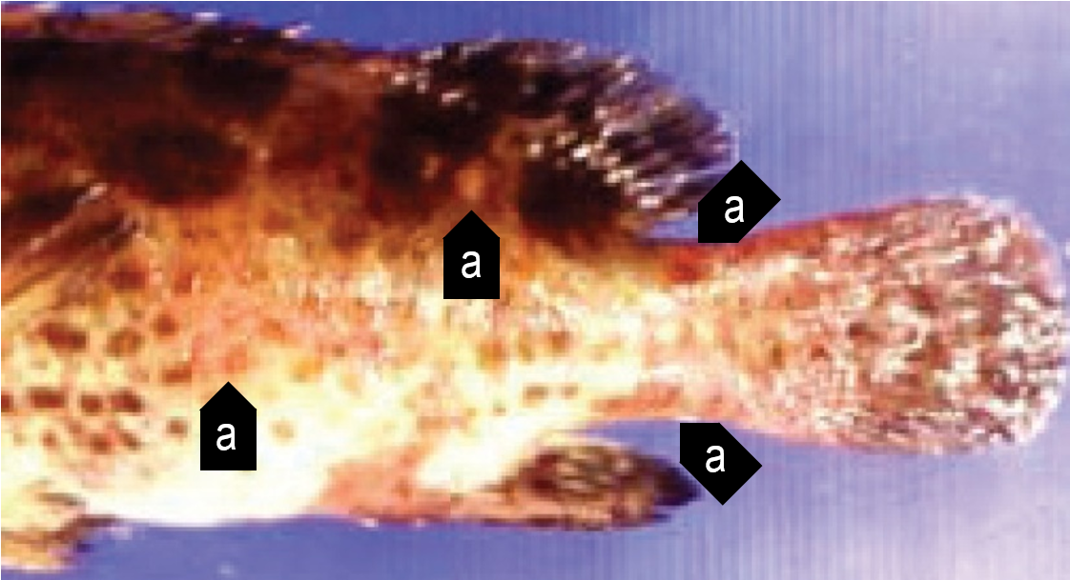
Note: Haemorrhagic red boils (a) on the body surface.
Source: S Kanchanakhan

Signs of disease
Important: Animals with this disease may show one or more of these signs, but the pathogen may still be present in the absence of any signs.
Disease signs at the farm, tank or pond level are:
- typically high mortalities, with many dead and moribund fish
- high mortality of young grouper
- loss of appetite
- lethargic swimming
- rapid opercular movements and dashing to the surface for air (in the terminal phase).
Gross pathological signs are:
- darkened body colour, pale gills and enlarged spleen
- signs of secondary infection such as deep ulceration or papular lesions.
Microscopic pathological signs are:
- necrosis of the splenic pulp, and myocardium
- necrosis and reduction of haematopoietic tissue of the kidney in the absence of marked cell hypertrophy.

Disease agent
Grouper iridovirus disease is caused by infection with grouper iridovirus (GIV), belonging to the genus Ranavirus within the family Iridoviridae. Synonyms include grouper iridovirus of Taiwan (TGIV) and Singapore grouper iridovirus (SGIV).

Host range
Table 5 Species known to be naturally susceptible to GIV
Common name | Scientific name
Brown marbled grouper | Epinephelus fuscoguttatus
Coral trout | Plectropomus leopardus
Estuary cod | Epinephelus tauvina
Giant grouper | Epinephelus lanceolatus
Grouper and estuary cod | Epinephelus spp.
Malabar grouper | Epinephelus malabaricus
Spotted coralgrouper | Plectropomus maculatus
Tiger grouper hybrid | Epinephelus fuscoguttatus × E. lanceolatus
Yellow grouper | Epinephelus awoara
Note: Other species have been shown to be experimentally susceptible.

Presence in Australia
Exotic disease—not recorded in Australia.
Map 4 Presence of grouper iridoviral disease, by jurisdiction

Epidemiology
- Grouper iridoviral disease causes losses in fry and juvenile grouper, and in 1 to 2-year-old market-sized grouper (a highly priced product in tropical mariculture).
- Clinical disease and highest mortalities are usually seen in 3 to 4-month-old fish after stocking into sea cages.
- Older diseased fish typically appear lethargic due to anaemia.
- Horizontal contact and waterborne transmission appear to be the principal mechanisms for virus spread.

Differential diagnosis
The list of similar diseases in the next section refers only to the diseases covered by this field guide. Gross pathological signs may also be representative of diseases not included in this guide. Do not rely on gross signs to provide a definitive diagnosis. Use them as a tool to help identify the listed diseases that most closely account for the observed signs.

Similar diseases
Infection with Aphanomyces invadans (EUS), infection with infectious spleen and kidney necrosis virus (ISKNV)-like viruses, red sea bream iridoviral disease (RSIVD) and viral encephalopathy and retinopathy (VER).

Sample collection
Only trained personnel should collect samples. Using only gross pathological signs to differentiate between diseases is not reliable, and some aquatic animal disease agents pose a risk to humans. If you are not appropriately trained, phone your state or territory hotline number and report your observations. If you have to collect samples, the agency taking your call will advise you on the appropriate course of action. Local or district fisheries or veterinary authorities may also advise on sampling.

Emergency disease hotline
See something you think is this disease? Report it. Even if you’re not sure.
Call the Emergency Animal Disease Watch Hotline on 1800 675 888. They will refer you to the right state or territory agency.

Further reading
Hazeri M, Hassan MD, Abba Y, Omar AR, Allaudin ZN, Soltani M, Hamdan RH, Mohamad NF 2017, Molecular characterisation of grouper iridovirus isolates from Peninsular Malaysia, Journal Veterinar Malaysia
Ma H, Peng C, Su Y, Feng J, Guo Z 2016, ‘Isolation of a Ranavirus-type grouper iridovirus in mainland China and comparison of its pathogenicity with that of a Megalocytivirus-type grouper iridovirus’, Aquaculture
Network of Aquaculture Centres in Asia–Pacific Grouper iridoviral disease: Disease card

Infection with HPR-deleted or HPR0 infectious salmon anaemia virus (ISAV)
Also known as infectious salmon anaemia (ISA)
Exotic disease
Figure 35 Atlantic salmon (Salmo salar) with ISA
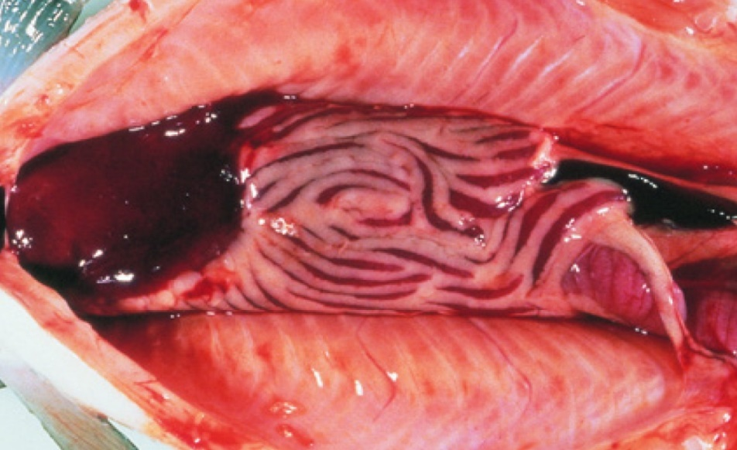
Note: Gross internal signs of ISA include dark liver, ascites and enlarged spleen.
Source: T Poppe

Signs of disease
Important: Animals with this disease may show one or more of these signs, but the pathogen may still be present in the absence of any signs.
Disease signs at the farm, tank or pond level are:
- mortality rate up to 100%
- fish congregating near the surface
- fish gasping at the surface
- lethargy
- loss of appetite.
Gross pathological signs are:
- pale gills and heart
- swollen abdomen
- exophthalmos (popeye), bleeding eyes
- fin rot
- ecchymotic (bruise-like) skin haemorrhages
- scale-pocket oedema
- swollen and dark liver, kidney and spleen (early sign); liver may be almost black
- petechial (pinpoint) haemorrhages in internal fat, peritoneum and skeletal muscle
- dark red intestinal wall mucosa
- ascites (fluid in the abdominal cavity)
- surface haemorrhages on liver.
Microscopic pathological signs are:
- renal interstitial haemorrhage and tubular necrosis
- branchial lamellar and filamental congestion
- congestion of the intestine and pyloric caecae
- perivascular inflammation and focal necrosis in liver.

Disease agent
ISA is caused by infection with the pathogenic highly polymorphic region (HPR)-deleted infectious salmon anaemia virus (ISAV), or the non-pathogenic HPR0 (non-deleted HPR) ISAV, a single stranded RNA virus classified within the genus Isavirus within the family Orthomyxoviridae. Infection with HPR-deleted ISAV may cause severe disease in Atlantic salmon (Salmo salar). However, Detection of HPR0 ISAV has never been associated with clinical signs of disease in Atlantic salmon.

Host range
The only species known to display clinical signs of ISA is the Atlantic salmon (Salmo salar). Several other fish species have been confirmed to be asymptomatic carriers of the virus.
Table 6 Species known to display clinical signs of ISA
Common name | Scientific name
Atlantic salmon | Salmo salar
Table 7 Species known to be asymptomatic carriers or vectors of ISAV
Common name | Scientific name
Arctic char | Salvelinus alpinus
Atlantic cod | Gadus morhua
Atlantic herring | Clupea harengus
Brown troutª | Salmo trutta
Coalfish or pollock | Pollachius virens
Coho salmonª | Oncorhynchus kisutch
Masu salmonª | Oncorhynchus masou
Rainbow troutª | Oncorhynchus mykiss
Salmon louse | Lepeophtheirus salmonis and Caligus coryphaenae
a Naturally susceptible. Note: Other species have been shown to be experimentally susceptible.

Presence in Australia
Exotic disease—not recorded in Australia.
The distantly related pilchard orthomyxo-like virus (POMV) has been reported from wild caught pilchards and cultured Atlantic salmon in Tasmania, but infectious salmon anaemia caused by infection with HPR-deleted or HPR0 ISAV has not been recorded in Australia and is considered exotic.
Map 5 Presence of ISAV, by jurisdiction

Epidemiology
- ISA occurs mainly in the northern hemisphere in spring and early winter (water temperatures from 3°C to above 15°C).
- The disease has caused major epizootics and severely impacted Atlantic salmon aquaculture production in Norway, Scotland, Canada and Chile.
- Mortality rates vary from 15% to 100%; mortality may occur over a prolonged period, not necessarily as acute outbreaks.
- ISA is mainly transmitted horizontally through the water column, but also by vectors (sea lice and populations of asymptomatic wild fish carriers).
- Experimental infection demonstrated mortalities within 15 days of exposure to ISAV.
- Spread of the disease has occurred with the movement of live juvenile salmonids between fish farms, with the discharge of organic waste from fish processing plants into the marine environment and via water movement.
- The majority of natural outbreaks seem to occur in salmonid post-smolts.
- ISA has been the subject of extensive eradication campaigns in several countries. These can be successful, but require vigilance to maintain 'free' status.
- It appears that stressors such as husbandry practices (including treatment against salmon lice or infectious diseases), rising or falling temperatures, and poor water quality can predispose salmon to outbreaks of ISA.

Differential diagnosis
The list of similar diseases in the next section refers only to the diseases covered by this field guide. Gross pathological signs may also be representative of diseases not included in this guide. Do not rely on gross signs to provide a definitive diagnosis. Use them as a tool to help identify the listed diseases that most closely account for the observed signs.

Similar diseases
Bacterial kidney disease (BKD), enteric red mouth disease (ERMD), infection with Aeromonas salmonicida atypical strains, infection with salmonid alphavirus (SAV), infectious haematopoietic necrosis (IHN), infectious pancreatic necrosis (IPN) and piscirickettsiosis.

Sample collection
Only trained personnel should collect samples. Using only gross pathological signs to differentiate between diseases is not reliable, and some aquatic animal disease agents pose a risk to humans. If you are not appropriately trained, phone your state or territory hotline number and report your observations. If you have to collect samples, the agency taking your call will advise you on the appropriate course of action. Local or district fisheries or veterinary authorities may also advise on sampling.

Emergency disease hotline
See something you think is this disease? Report it. Even if you’re not sure.
Call the Emergency Animal Disease Watch Hotline on 1800 675 888. They will refer you to the right state or territory agency.

Microscope images
Figure 36 Histopathology of liver of Atlantic salmon (Salmo salar) with ISA
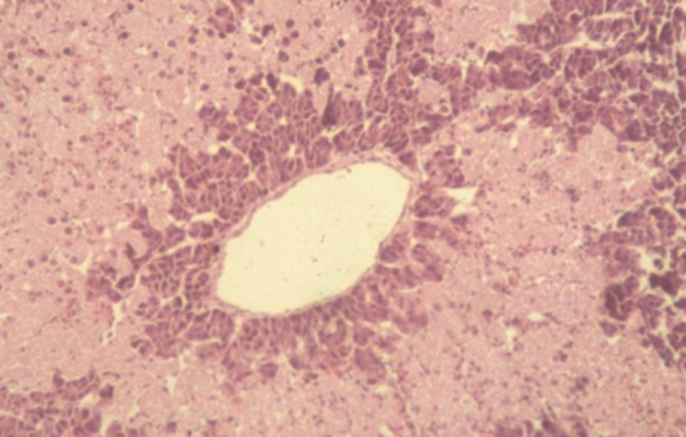
Note: Multifocal bridging necrosis, leaving viable tissue around smaller veins.
Source: T Poppe.
Figure 37 Histopathology of kidney of Atlantic salmon (Salmo salar) with ISA
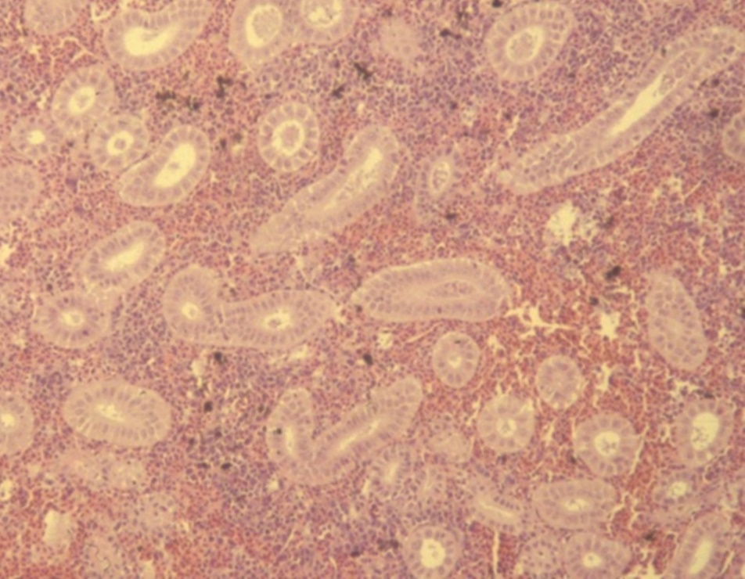
Note: Renal interstitial haemorrhage.
Source: T Poppe

Further reading
Department of Agriculture, Water and the Environment AQUAVETPLAN disease strategy manual: Infectious salmon anaemia
World Organisation for Animal Health Manual of diagnostic tests for aquatic animals

Infection with infectious spleen and kidney necrosis virus (ISKNV)-like viruses
Exotic disease
Figure 38 Dwarf gourami (Colisa lalia) infected with an ISKNV-like iridovirus
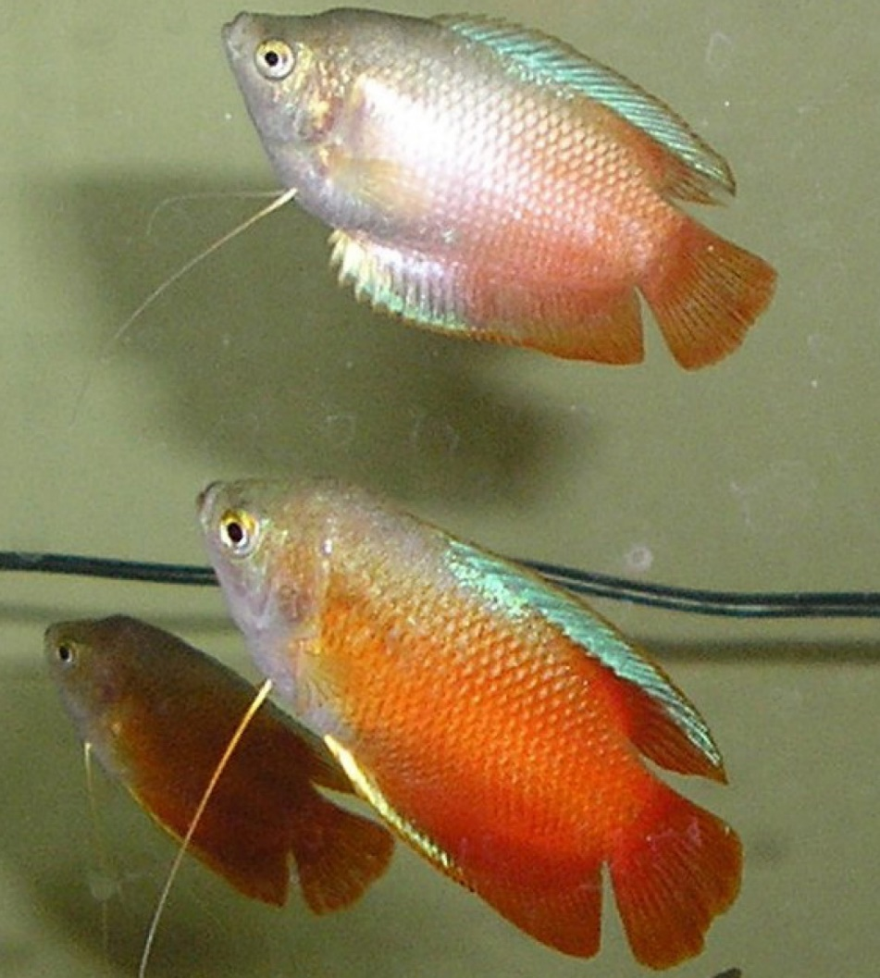
Note: Pale colouration of diseased fish (top) compared with normal colours of unaffected fish (bottom).
Source: J Go
Figure 39 Murray cod (Maccullochella peelii) fingerling experimentally infected with an ISKNV-like iridovirus
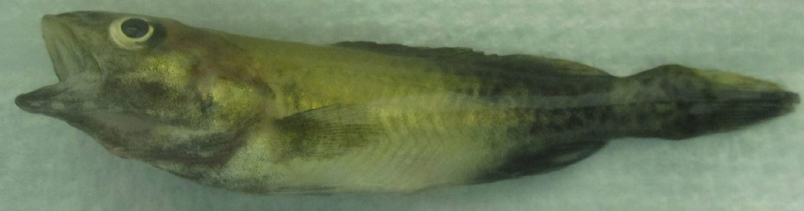
Note: Discolouration around the front of the body (normal colouration evident near the tail) and signs of respiratory distress at time of death (flared opercula).

Signs of disease
Important: Animals with this disease may show one or more of these signs, but the pathogen may still be present in the absence of any signs.
Disease signs at the farm, tank or pond level are:
- mortalities between 50% and 100%
- fish remaining on bottom of tank and not feeding well
- lethargy
- respiratory distress (rapid movement of opercula).
Gross pathological signs are:
- changes in body colour (darkening or lightening)
- exophthalmos (popeye)
- abdominal distension (due to fluid or enlargement of organs).
Microscopic pathological signs are:
- basophilic hypertrophied cells throughout numerous body tissues, but especially the haematopoietic tissues of the kidney and spleen
- some virus affected cells may resemble amoebae in appearance.

Disease agent
ISKNV-like viruses are classified in the genus Megalocytivirus, family Iridoviridae. Viruses of this group are related to ranaviruses and predominantly cause disease in freshwater fish (particularly cichlids, gouramis and poeciliids). ISKNV-like megalocytiviruses that are genetically distinct from red seabream iridovirus (listed separately in this guide) (RSIV) are also being increasingly isolated from various species of euryhaline and/or estuarine fish, particularly within the orders Perciformes and Pleuronectiformes.

ISKNV-like megalocytiviruses
ISKNV-like viruses from cichlids (all fish belonging to the family Cichlidae):
- Angelfish iridovirus
- Cichlid iridovirus (includes ram cichlid and chromide cichlid. Although currently uncharacterised, based on histopathology, cichlid iridoviruses are considered to be megalocytiviruses)
- Iridovirus in Apistogramma spp.
- Iridovirus in oscars
- Iridovirus in rainbow krib
- Iridovirus in curviceps.
ISKNV-like viruses from gouramis (fish of the subfamilies Luciocephalinae and Macropodinae, family Osphronemidae):
- Dwarf gourami iridovirus (DGIV)
- Pearl gourami iridovirus
- Iridovirus in thick-lipped gourami, three-spot gourami and silver gourami
- Iridovirus in paradise fish.
ISKNV-like viruses from poeciliids (all fish belonging to the family Poeciliidae):
- African lampeye iridovirus (all fish belonging to the subfamily Aplocheilichthyinae, family Poeciliidae)
- Swordtail iridovirus (based on histopathology, swordtail iridovirus and other iridoviruses identified in the family Poeciliidae are considered to be megalocytiviruses)
- Iridovirus in mollies and platys
- Iridovirus in guppies.
ISKNV-like viruses from euryhaline or estuarine fish:
- Iridovirus in Chinese mandarin fish
- Iridovirus in tiger grouper hybrids
- Flatfish infected with turbot reddish body iridovirus (TRBIV)
- Iridovirus in barramundi with scale drop disease syndrome.

Host range
Table 8 Species known to be susceptible to ISKNV-like viruses
Common name | Scientific name
African lampeye killifishª | Aplocheilichthys normani
Amberjack | Seriola dumerili
Angelfishª | Pterophyllum scalare
Banggai cardinalfishª | Pterapogon kauderni
Barramundiª | Lates calcarifer
Blue tilapia | Oreochromis aureus
Chinese perch or mandarin fishª | Siniperca chuatsi
Curvicepsª | Laetacara curviceps
Dwarf cichlidsª | Apistogramma spp.
Dwarf gouramiª | Trichogaster lalius
Floundersª | Paralichthyidae, all species
Giant grouper | Epinephelus lanceolatus
Golden perch | Macquaria ambigua
Grass carp | Ctenopharyngodon idella
Grouper and estuary codª | Epinephelus spp.
Guppyª | Poecilia reticulata
Japanese parrotfish | Oplegnathus fasciatus
Japanese yellowtailª | Seriola quinqueradiata
Largemouth bass | Micropterus salmoides
Large yellow croaker | Larimichthys crocea
Macquarie perch | Macquaria australasica
Malabar grouperª | Epinephelus malabaricus
Mango tilapia | Sarotherodon galilaeus
Marble gobyª | Oxyeleotris marmorata
Mollyª | Poecilia sphenops
Murray codª | Maccullochella peelii
Nile tilapiaª | Oreochromis niloticus
Orange chromideª | Etroplus maculatus
Orange spotted grouperª | Epinephelus coioides
Orbiculate batfishª | Platax orbicularis
Oscarª | Astronotus ocellatus
Paradise fishª | Macropodus opercularis
Pearl gouramiª | Trichogaster leerii
Rainbow kribª | Pelvicachromis pulcher
Ram cichlidª | Mikrogeophagus ramirezi
Red drumª | Sciaenops ocellatus
Redbelly tilapia | Coptodon zilli
Red sea breamª | Pagrus major
Sailfin molliesª | Poecilia latipinna
Sea bassª | Plectranthias yamakawai
Sea mulletª | Mugil cephalus
Silver gouramiª | Trichogaster microlepis
Snapper | Pagrus auratus
Southern platyfish or red wagtail platyª | Xiphophorus maculatus
Southern pygmy perch | Nannoperca australis
Spangled emperor | Lethrinus nebulosus
Striped beakfishª | Oplegnathus fasciatus
Swordtail or green swordtailª | Xiphophorus helleri
Thick-lipped gouramiª | Colisa labiosa
Three-spot gouramiª | Trichogaster trichopterus
Tiger grouper hybridª | Epinephelus fuscoguttatus × E. lanceolatus
Tilapias | Cichlidae, various genera and species
Tilapia hybrids | Oreochromis niloticus × O. aureus
Turbotª | Scophthalmus maximus
Zebrafish | Danio rerio
a Naturally susceptible. Note: Other species have been shown to be experimentally susceptible. Some native Australian fish species included (such as Murray cod, Maccullochella peelii) are known to be highly susceptible to ISKNV-like viruses.

Presence in Australia
Exotic disease—not recorded in Australia.
ISKNV-like viruses have not been recorded from wild fish in Australia. However, these viruses are regularly detected in ornamental fish in quarantine at the international border, and in retail pet shops.
Map 6 Presence of ISKNV-like viruses, by jurisdiction

Epidemiology
- ISKNV-like viruses are prone to inactivation by desiccation or heat at temperatures above 50°C, but are stable in water at 4°C for extended periods.
- ISKNV-like viruses have been found to cause disease in a wide variety of species (may lack strict host specificity).
- Horizontal transmission via cohabitation, water, ingestion of excreta or cannibalism is likely (based on experimental transmission studies).
- There is evidence that some species may be long-term asymptomatic carriers of ISKNV-like viruses and that prevalence in infected populations may be high.

Differential diagnosis
The list of similar diseases in the next section refers only to the diseases covered by this field guide. Gross pathological signs may also be representative of diseases not included in this guide. Do not rely on gross signs to provide a definitive diagnosis. Use them as a tool to help identify the listed diseases that most closely account for the observed signs.

Similar diseases
Epizootic haematopoietic necrosis (EHN), grouper iridoviral disease and red sea bream iridoviral disease (RSIVD).

Sample collection
Only trained personnel should collect samples. Using only gross pathological signs to differentiate between diseases is not reliable, and some aquatic animal disease agents pose a risk to humans. If you are not appropriately trained, phone your state or territory hotline number and report your observations. If you have to collect samples, the agency taking your call will advise you on the appropriate course of action. Local or district fisheries or veterinary authorities may also advise on sampling.

Emergency disease hotline
See something you think is this disease? Report it. Even if you’re not sure.
Call the Emergency Animal Disease Watch Hotline on 1800 675 888. They will refer you to the right state or territory agency.

Further reading
Biosecurity Australia 2014, Importation of freshwater ornamental fish: review of biosecurity risks associated with gourami iridovirus and related viruses—provisional final import risk analysis report
Fu X, Li N, Liu L, Lin Q, Wang F, Lai Y, Jiang H, Pan H, Shi C, Wu S 2011, ‘Genotype and host range analysis of infectious spleen and kidney necrosis virus (ISKNV)’, Virus Gene

Infection with salmonid alphavirus (SAV)
Also known as infection with salmon pancreas disease virus (SPDV), salmon pancreas disease (SPD), pancreas disease (PD) and sleeping disease (SD)
Exotic disease
Figure 40 Atlantic salmon (Salmo salar) chronically infected with SAV
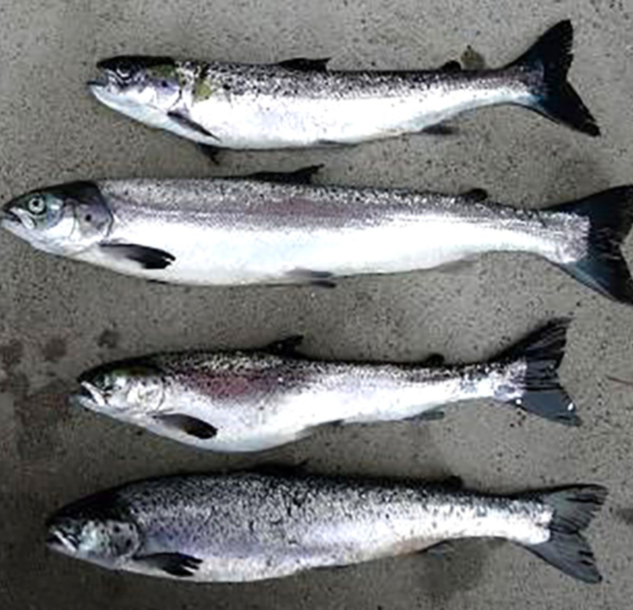
Note: Very thin carrier fish in poor condition a few months after infection.
Source: T Poppe

Signs of disease
Important: Animals with this disease may show one or more of these signs, but the pathogen may still be present in the absence of any signs.
Disease signs at the farm, tank or pond level are:
- Lack of appetite a week or two before a disease outbreak
- clinically diseased fish may swim against the current close to the surface or corners of the cage, or be found resting at the bottom of the tank or cage (sleeping)
- one to several months after the onset of mortality, a portion of the survivors usually fail to grow and become thin and slender (runts).
Gross pathological signs are:
- yellow mucoid gut contents
- petechiae in pyloric fat, pale hearts and/or haemopericardium due to heart rupture
- scale pocket oedema
- exophthalmos
- ascites
- atrophy of red skeletal muscle in chronic cases.
Microscopic pathological signs are:
- the development of necrosis of exocrine pancreas shortly before cardiomyocytic necrosis
- severe or total loss of exocrine pancreas, myocarditis and skeletal muscle necrosis, degeneration and myositis
- damage, primarily of the pancreas, and severe cardiac and skeletal myopathies.

Disease agent
SPD is caused by infection with salmonid alphavirus (SAV), a member of the family Togaviridae in the genus Alphavirus. Various genetic subtypes of the virus have been detected. SPD first emerged in Scotland and subsequently recognised in France, Ireland, England, Norway, Germany, Italy and Spain.

Host range
Clinical signs of salmon pancreas disease have been reported in Atlantic salmon, sea-reared rainbow trout, brown trout and Arctic char. Wild fish (such as flatfish and wrasses) can be subclinically infected and may act as potential vectors or reservoirs of infection.
Table 9 Species known to be susceptible to SAV
Common name | Scientific name
American plaiceª | Hippoglossoides platessoides
Arctic charª | Salvelinus alpinus
Atlantic salmonª | Salmo salar
Brown trout | Salmo trutta
Dabª | Limanda limanda
Plaiceª | Pleuronectes platessa
Rainbow troutª | Oncorhynchus mykiss
Wrasseª | Labrus bergylta
a Naturally susceptible. Note: Other species have been shown to be experimentally susceptible.

Presence in Australia
Exotic disease—not recorded in Australia.
Map 7 Presence of SAV, by jurisdiction

Epidemiology
- SAV is horizontally transmitted, via water and water currents, transport of infected fish, contaminated equipment, well boats and other vehicles. The virus can survive for extended periods in seawater.
- Vertical transmission is considered unlikely but has not been ruled out.
- Water temperature may affect the duration and level of mortality.
- Subtypes 1, 2, 3, 4, 5 and 6 may have different virulence in different hosts.
- All marine life stages of Atlantic salmon are susceptible to disease, from smolts to adult fish. Different strains of Atlantic salmon may have different susceptibility to SAV.
- Farmed rainbow trout in fresh water and salt water are susceptible to disease at all stages of production.
- Mortality varies significantly, from negligible to over 50% in severe cases. Up to 15% of surviving fish will develop into long, slender fish (runts).
- Management and environmental factors that induce stress in fish probably increase mortality significantly.
- Natural reservoirs of SAV may include wild fish. SAV has been detected in some wild flatfish species in Scotland and in wrasses used for sealice management in Ireland.

Differential diagnosis
The list of similar diseases in the next section refers only to the diseases covered by this field guide. Gross pathological signs may also be representative of diseases not included in this guide. Do not rely on gross signs to provide a definitive diagnosis. Use them as a tool to help identify the listed diseases that most closely account for the observed signs.

Similar diseases
Infection with HPR-deleted or HPR0 infectious salmon anaemia virus and infectious pancreatic necrosis (IPN).

Sample collection
Only trained personnel should collect samples. Using only gross pathological signs to differentiate between diseases is not reliable, and some aquatic animal disease agents pose a risk to humans. If you are not appropriately trained, phone your state or territory hotline number and report your observations. If you have to collect samples, the agency taking your call will advise you on the appropriate course of action. Local or district fisheries or veterinary authorities may also advise on sampling.

Emergency disease hotline
See something you think is this disease? Report it. Even if you’re not sure.
Call the Emergency Animal Disease Watch Hotline on 1800 675 888. They will refer you to the right state or territory agency.

Further reading
World Organisation for Animal Health Manual of diagnostic tests for aquatic animals

Infectious haematopoietic necrosis (IHN)
Also known as infection with infectious haematopoietic necrosis virus (IHNV)
Exotic disease
Figure 41 Chinook salmon fry (Oncorhynchus tshawytscha) with IHN
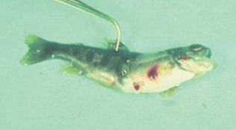
Note: Characteristic darkening from the tail region, swollen abdomen and haemorrhaging at base of the fins.
Source: J Fryer
Figure 42 Rainbow trout fry (Oncorhynchus mykiss) with and without IHN
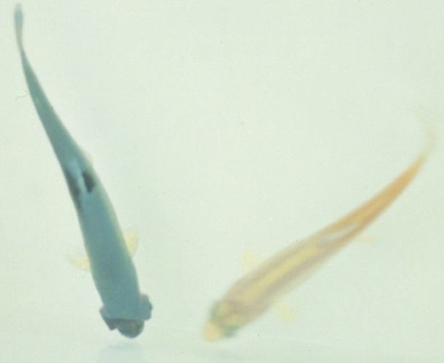
Note: Infected fish (left) shows darker colouring and exopthalmia compared to the uninfected fish (right)
Source: G Kurath

Signs of disease
Important: Animals with this disease may show one or more of these signs, but the pathogen may still be present in the absence of any signs.
Disease signs at the farm, tank or pond level are:
- mass mortality
- lethargic swimming with intermittent bouts of frenzied, abnormal activity (spiral swimming and flashing).
Gross pathological signs are:
- numerous yolk sac haemorrhages in the fry of rainbow trout and salmon
- darkening of the skin and pale gills
- haemorrhages on the abdomen and around the pupil of the eye
- exophthalmos (popeye) and a swollen abdomen
- trailing white faecal cast
- bleeding at the base of the fins
- stomach empty of food but distended with a gelatinous substance
- pale internal organs
- petechial (pinpoint) haemorrhages in the fatty tissue and muscle surrounding the organs and stomach wall
- spinal deformities in surviving fish.
Microscopic pathological signs are:
- necrosis of eosinophilic granular cells in the intestinal wall
- degenerative necrosis in haematopoietic tissues.

Disease agent
IHN is caused by infection with salmonid Novirhabdovirus, also known as infectious haematopoietic necrosis virus (IHNV). This virus is an enveloped single-stranded, negative-sense RNA virus classified within the family Novirhabdoviridae, and is closely related to other important fish rhabdoviruses such as viral haemorrhagic septicaemia virus (VHSV) and spring viraemia of carp virus (SVCV). Molecular analysis suggests that IHNV was originally endemic to the Pacific coast of North America, and was spread to Europe and Asia through translocations of salmonid eggs or fry.

Host range
Table 10 Species known to be susceptible to IHN
Common name | Scientific name
Amago salmonª | Oncorhynchus rhodurus
Arctic char | Salvelinus alpinus
Atlantic codª | Gadus morhua
Atlantic salmonª | Salmo salar
Ayu | Plecoglossus altivelis
Brook troutª | Salvelinus fontinalis
Brown troutª | Salmo trutta
Burbot | Lota lota
Chinook salmonª | Oncorhynchus tshawytscha
Chum salmonª | Oncorhynchus keta
Coho salmonª | Oncorhynchus kisutch
Cutthroat troutª | Oncorhynchus clarkii
Gilt-head sea bream | Sparus aurata
Grayling | Thymallus thymallus
Lake trout | Salvelinus namaycush
Masu salmonª | Oncorhynchus masou
Pacific herring | Clupea pallasii
Pacific salmonª | Oncorhynchus spp.
Pike | Esox lucius
Pile perch | Rhacochilus vacca
Pink salmonª | Oncorhynchus gorbuscha
Rainbow trouta | Oncorhynchus mykiss
Shiner perch | Cymatogaster aggregata
Sockeye salmonª | Oncorhynchus nerka
Tubesnout | Aulorhynchus flavidus
Turbot | Scophthalmus maximus
Whitespotted char | Salvelinus leucomaenis
White sturgeon | Acipenser transmontanus
a Naturally susceptible. Note: Other species have been shown to be experimentally susceptible.
Table 11 Non-fish carriers
Common name | Scientific name
Gill lice | Salmincola spp.
Leeches | Piscicola spp.
Mayfly | Callibaetis spp.
Piscivorous birds | Various genera and species

Presence in Australia
Exotic disease—not recorded in Australia.
Map 8 Presence of IHN, by jurisdiction

Epidemiology
- IHN is a cold-water disease. Clinical signs typically occur at temperatures between 8°C and 15°C. Outbreaks rarely occur once water temperatures reach more than 15°C.
- IHN is typically found in young, farmed trout and salmon fry or fingerlings, and in adults during or just following spawning.
- Mass mortalities of up to 90% can occur in hatcheries, typically with 100% of the population infected.
- Mortality also occurs in wild populations of Pacific salmon infected with IHNV. Survivors can be the source of infection of farmed stock.
- Susceptibility to infection varies between individuals of the same species and appears to be largely age dependent, with younger individuals being more susceptible.
- Fish that survive IHN are potential carriers of the virus for a period that depends on environmental conditions (such as temperature).
- The virus is shed into the water from infected fish through faeces, urine, spawning fluids and external mucous.
- Transmission is generally horizontal, with the virus entering fish through the gills and skin. Some blood-sucking parasites such as gill lice (Salmincola spp.) and leeches may serve as vectors.
- Virus can be transferred to new areas via the movement of infected fish or eggs, and by other sources such as contaminated equipment, water, birds or insects such as mayflies.
- Outbreaks are most likely to occur around the time of spawning, with increased levels of virus released into the environment with spawning fluids.
- It is believed that the spread of IHNV from the west coast of North America to Asia and Europe has been principally via the shipment of infected fish and eggs, suggesting some degree of vertical transmission. The risk of such egg-associated transmission is significantly reduced by the common practice of egg surface disinfection, but is not eliminated.

Differential diagnosis
The list of similar diseases in the next section refers only to the diseases covered by this field guide. Gross pathological signs may also be representative of diseases not included in this guide. Do not rely on gross signs to provide a definitive diagnosis. Use them as a tool to help identify the listed diseases that most closely account for the observed signs.

Similar diseases
Enteric red mouth disease, epizootic haematopoietic necrosis (EHN), furunculosis, infectious pancreatic necrosis (IPN), infection with HPR-deleted or HPR0 infectious salmon anaemia virus, viral haemorrhagic septicaemia (VHS) and whirling disease.

Sample collection
Only trained personnel should collect samples. Using only gross pathological signs to differentiate between diseases is not reliable, and some aquatic animal disease agents pose a risk to humans. If you are not appropriately trained, phone your state or territory hotline number and report your observations. If you have to collect samples, the agency taking your call will advise you on the appropriate course of action. Local or district fisheries or veterinary authorities may also advise on sampling.

Emergency disease hotline
See something you think is this disease? Report it. Even if you’re not sure.
Call the Emergency Animal Disease Watch Hotline on 1800 675 888. They will refer you to the right state or territory agency.

Further reading
CEFAS International Database on Aquatic Animal Diseases Infectious Haematopoietic Necrosis
World Organisation for Animal Health Manual of diagnostic tests for aquatic animals

Infectious pancreatic necrosis (IPN)
Also known as infection with infectious pancreatic necrosis virus (IPNV)
Exotic disease
Figure 43 IPN in rainbow trout (Oncorhynchus mykiss)
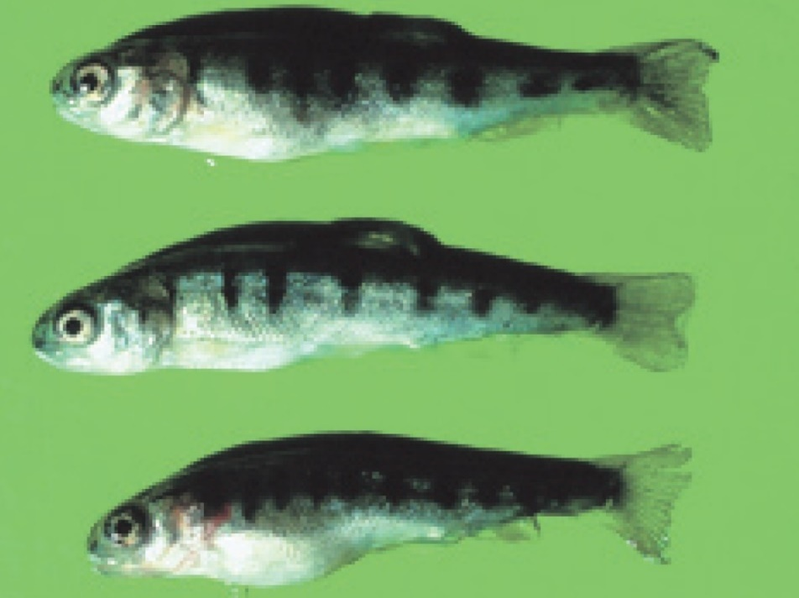
Note: Abdominal distension and darkened body colour.
Source: T Håstein

Signs of disease
Important: Animals with this disease may show one or more of these signs, but the pathogen may still be present in the absence of any signs.
Signs of disease described are representative of IPN in salmonids.
Disease signs at the farm, tank or pond level are:
- sudden and progressive increase in mortality at first feeding of fry, particularly in faster growing individuals
- cumulative mortality rates from 10% to 90%
- low persistent mortality
- fish lying still on the bottom of tanks or ponds
- fish swimming with a spiralling, corkscrew motion.
Gross pathological signs are:
- long, thin, whitish trailing faecal casts
- swollen abdomen
- darkening body colour
- typically pale gills
- exophthalmos (popeye)
- lesions and ulcers in pancreas, oesophagus and stomach
- haemorrhages sometimes present in ventral areas, including the ventral fins
- abnormally pale spleen, kidney, liver and heart of fry
- intestines empty or filled with clear mucus.
Microscopic pathological signs are:
- extensive and/or severe necrosis of acinar pancreatic cells
- focal or generalised necrosis of liver
- sloughing of intestinal mucosa with characteristic McKnight cells in the lumen (eosinophilic and hyaline epithelial cells.

Disease agent
IPN is caused by infection with infectious pancreatic necrosis virus (IPNV), a double stranded RNA virus classified within the genus Aquabirnavirus (family Birnaviridae). Several genogroups have been identified and are described by their different hosts and geographical origins. The most frequently found and highly virulent strain of IPNV is the Sp serotype in genogroup 5.

Host range
A wide range of marine and freshwater fish species are susceptible to IPNV. The disease agent can be spread naturally by mechanical vectors such as piscivorous birds (including passage through the bird digestive system), blood feeding parasites and filter feeding molluscs (such as common European scallop Pecten maximus).
Table 12 Fish species likely to be severely affected by IPNV
Common name | Scientific name
American eelª | Anguilla rostrata
Atlantic cod | Gadus morhua
Atlantic halibut | Hippoglossus hippoglossus
Atlantic salmonª | Salmo salar
Brook troutª | Salvelinus fontinalis
Brown troutª | Salmo trutta
Coho salmon | Oncorhynchus kisutch
Eelsª | Anguillidae, all species
European eel | Anguilla anguilla
Japanese eel | Anguilla japonica
Pacific salmon | Oncorhynchus spp.
Rainbow troutª | Oncorhynchus mykiss
Shortfin eel | Anguilla australis
Turbot | Scophthalmus maximus
Wrasses | Labridae, all species
a Naturally susceptible. Note: Other species likely to be susceptible or have been shown to be experimentally susceptible.
Table 13 Non-fish carriers
Common name | Scientific name
Common European scallop | Pecten maximus
European flat oyster | Ostrea edulis
Fish louse | Argulus foliaceus
Molluscs | Various genera and species
Piscivorous birds | Various genera and species
Salmon louse | Lepeophtheirus salmonis and Caligus coryphaenae

Presence in Australia
Exotic disease—not recorded in Australia.
Other aquabirnaviruses, distinct from IPNV, are present in Australia and New Zealand.
- Tasmanian aquabirnavirus in farmed Atlantic salmon and rainbow trout.
- Victorian trout aquabirnavirus in farmed rainbow trout.
- New Zealand birnavirus in diseased turbot and asymptomatic sea-run chinook salmon.
Map 9 Presence of IHN, by jurisdiction

Epidemiology
- IPNV is highly contagious and fish that survive infection are presumed to become carriers. Asymptomatic carrier fish represent a risk for introduction of disease to healthy stocks.
- Viral transmission can occur horizontally (the virus enters fish through the gills or gastrointestinal tract) and vertically (transmitted via eggs of infected carrier broodfish).
- IPNV is shed in faeces, urine, spawning fluids and external mucus. Spawning favours the transmission of IPN virus with increased levels of virus excreted in spawning fluids.
- Outbreaks of disease are most likely to occur when fish are stressed. Factors raising physiological stress levels include first feeding, high stocking densities, fluctuations in water temperature and salinity and management practices requiring handling of fish. Outbreaks are known to occur at water temperatures as low as 4°C and as high as 18°C.
- The disease can cause high mortalities (70%) in young trout, with cumulative mortalities of 10% to 90%.
- The highest mortality rates usually occur in freshwater hatcheries in fry less than 6 months of age. However, IPN is known to affect rainbow trout and post-smolt Atlantic salmon after transfer from freshwater to seawater.
- IPNV can survive in both freshwater and saltwater environments. It is quite stable and resists destruction by disinfection, enabling it to persist in a range of environmental conditions on equipment such as nets and containers.
- Virus may be spread and healthy stocks exposed via contaminated transport water, infected eggs and blood feeding parasites. Piscivorous birds and molluscs are also known vectors of IPNV.

Differential diagnosis
The list of similar diseases in the next section refers only to the diseases covered by this field guide. Gross pathological signs may also be representative of diseases not included in this guide. Do not rely on gross signs to provide a definitive diagnosis. Use them as a tool to help identify the listed diseases that most closely account for the observed signs.

Similar diseases
Infection with HPR-deleted or HPR0 infectious salmon anaemia virus, infection with salmonid alphavirus (SAV), infectious haematopoietic necrosis (IHN) and viral haemorrhagic septicaemia (VHS).

Sample collection
Only trained personnel should collect samples. Using only gross pathological signs to differentiate between diseases is not reliable, and some aquatic animal disease agents pose a risk to humans. If you are not appropriately trained, phone your state or territory hotline number and report your observations. If you have to collect samples, the agency taking your call will advise you on the appropriate course of action. Local or district fisheries or veterinary authorities may also advise on sampling.

Emergency disease hotline
See something you think is this disease? Report it. Even if you’re not sure.
Call the Emergency Animal Disease Watch Hotline on 1800 675 888. They will refer you to the right state or territory agency.

Further reading
CABI Invasive Species Compendium Infectious Pancreatic Necrosis
CEFAS International Database on Aquatic Animal Diseases Infectious Pancreatic Necrosis

Koi herpesvirus disease (KHVD)
Also known as carp interstitial nephritis, gill necrosis virus, infection with koi herpesvirus (KHV) and infection with cyprinid herpesvirus 3 (CyHv3)
Exotic disease
Figure 44 Koi carp (Cyprinus carpio) with gross lesions associated with KHVD
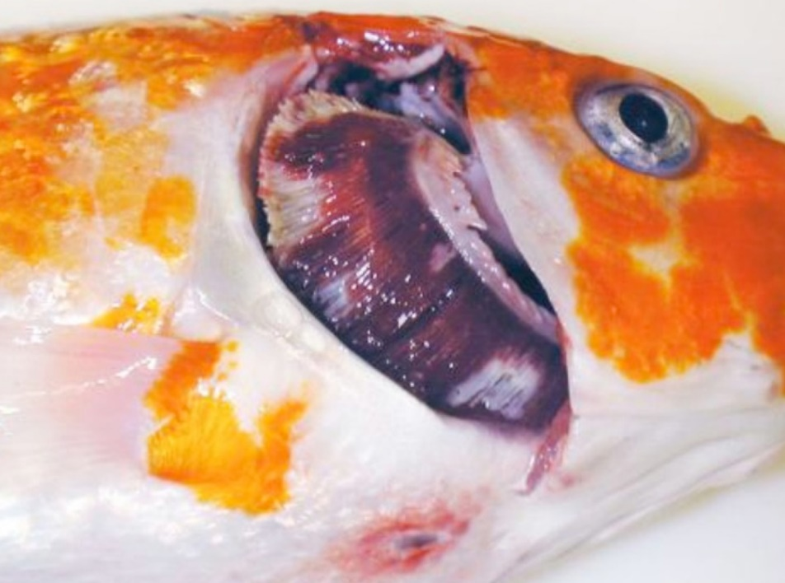
Note: Operculum is removed showing mottled red (haemorrhage) and white (necrosis) gill, sunken eyes and a single ulcer on the ventral skin.
Source: E Johnson

Signs of disease
Important: Animals with this disease may show one or more of these signs, but the pathogen may still be present in the absence of any signs.
Disease signs at the farm, tank or pond level are:
- mass mortalities, with many dead and moribund fish floating at the surface
- disorientation and erratic swimming behaviour (sometimes hyperactivity)
- fish coming to the surface and gasping
- fish separated from the shoal.
Gross pathological signs are:
- pale patches on the skin
- overproduction or underproduction of mucous on the skin and gills
- superficial branchial (gill) and skin haemorrhages
- endophthalmia (sunken eyes), erosion of the fins (occasionally), and blistering of the skin
- severe gill necrosis and/or erosion, seen as red and white patches
- focal or generalised loss of skin
- adhesions in the abdominal cavity and abnormal colouration of internal organs (lighter or darker or mottled)
- enlargement and surface haemorrhages of the kidney and liver.
Microscopic pathological signs are:
- inflammation and necrosis of gill tissues, and adhesion of gill filaments
- nuclear swelling, margination of chromatin and pale eosinophilic intranuclear inclusions of the epithelium
- non-specific inflammation and necrosis in other organs.

Disease agent
KHVD is caused by infection with koi herpesvirus (KHV), also known as cyprinid herpesvirus 3 (CyHv3), a virus classified as a member of the family Alloherpesviridae within the genus Cyprinivirus.

Host range
Naturally occurring KHV infections have only been recorded from common carp (Cyprinus carpio) and varieties of this species (such as koi carp). Goldfish × common carp hybrids, produced by hybridising male goldfish with female carp, have been reported to show some susceptibility to KHV infection.
Several fish species have been described as asymptomatic carrier species. These show no clinical signs of KHVD after natural or experimental exposure to KHV, but carry viral DNA, allowing them to potentially act as vectors of the disease. Viral DNA has been also been detected in two non-fish species, amphipods (Gammarus pulex) and swan mussels (Anodonta cygnea), making them potential vectors.
Table 14 Species known to be naturally susceptible to KHVD
Common name | Scientific name
Common carp and koi carp | Cyprinus carpio
Table 15 Potential carriers
Common name | Scientific name
Atlantic sturgeon | Acipenser oxyrinchus
Common roach | Rutilus rutilus
Crucian carp | Carassius carassius
Eurasian ruffe | Gymnocephalus cernua
Goldfish or shubunkin | Carassius auratus
Grass carp | Ctenopharyngodon idella
Ide | Leuciscus idus
Redfin or European perch | Perca fluviatilis
Russian sturgeon | Acipenser gueldenstaedtii
Silver carp | Hypophthalmichthys molitrix
Tench | Tinca tinca
Table 16 Non-fish carriers
Common name | Scientific name
Amphipods | Gammarus pulex
Swan mussels | Anodonta cygnea

Presence in Australia
Exotic disease—not recorded in Australia.
KHV has not been recorded from Australia, and is considered exotic. The potential use of KHV as a biological control for introduced populations of European carp is being investigated.
Map 10 Presence of KHV, by jurisdiction

Epidemiology
- An outbreak of KHVD in Japan during the spring of 2004 occurred in wild carp populations in water temperatures of 15 to 16°C. Most of the dead fish were adult. In the field, it appears that adult carp are more susceptible than juveniles.
- The virus may survive at low temperatures (5°C), but the temperature range for disease outbreaks is primarily between 16°C and 25°C. Mortalities commonly appear between 22°C and 25°C, with few at temperatures above 30°C.
- The disease affects all age classes of common and koi carp, occurring in fingerlings, juveniles and adults.
- Moving infected fish from cool (13°C) to warm (23°C) water results in rapid onset of mortality.
- Mortality rates can vary between 70% and 100%.
- Reservoirs of KHV are clinically infected fish and covert carriers. Virus is shed via faeces, urine, gills and skin mucus.
- Transmission of KHV is horizontal, mainly via water, but possibly via animal vectors and fomites.
- Vertical transmission cannot be excluded as a possible transmission route.
- Secondary gill infections (including Flavobacterium columnare and Aeromonas spp.) are often associated with KHV infection.

Differential diagnosis
The list of similar diseases in the next section refers only to the diseases covered by this field guide. Gross pathological signs may also be representative of diseases not included in this guide. Do not rely on gross signs to provide a definitive diagnosis. Use them as a tool to help identify the listed diseases that most closely account for the observed signs.

Similar diseases
Infection with Aeromonas salmonicida—atypical strains, infection with Aphanomyces invadans (EUS) and spring viraemia of carp (SVC).

Sample collection
Only trained personnel should collect samples. Using only gross pathological signs to differentiate between diseases is not reliable, and some aquatic animal disease agents pose a risk to humans. If you are not appropriately trained, phone your state or territory hotline number and report your observations. If you have to collect samples, the agency taking your call will advise you on the appropriate course of action. Local or district fisheries or veterinary authorities may also advise on sampling.

Emergency disease hotline
See something you think is this disease? Report it. Even if you’re not sure.
Call the Emergency Animal Disease Watch Hotline on 1800 675 888. They will refer you to the right state or territory agency.

Further reading
CABI Invasive Species Compendium Koi herpesvirus disease
CEFAS International Database on Aquatic Animal Diseases Koi herpesvirus disease
World Organisation for Animal Health Manual of diagnostic tests for aquatic animals

Red sea bream iridoviral disease (RSIVD)
Also known as infection with red sea bream iridovirus (RSIV)
Exotic disease
Figure 45 Red sea bream (Pagrus major) from South Korea infected with RSIV
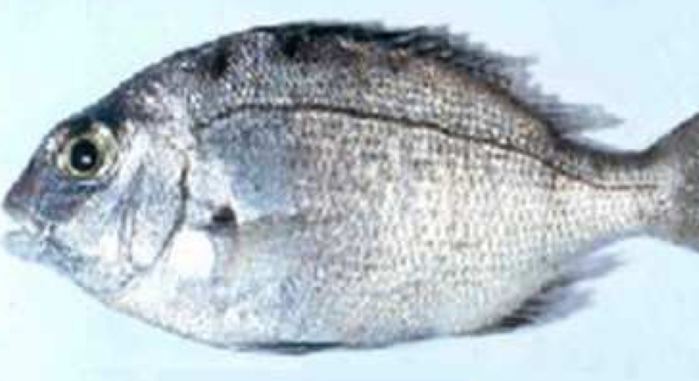
Note: Swollen abdomen due to enlargement of internal organs and fluid accumulation. P. major is a close relative of the Australian snapper.
Source: S I Park.

Signs of disease
Important: Animals with this disease may show one or more of these signs, but the pathogen may still be present in the absence of any signs.
Disease signs at the farm, tank or pond level are:
- low to high mortality
- lethargic swimming
- obvious opercular movement (increased respiratory effort).
Gross pathological signs are:
- dark skin (change in skin colour is a significant gross sign)
- petechial (pinpoint) haemorrhage of the gills
- pale gills and enlarged spleen.
Microscopic pathological signs are:
- enlarged cells, deeply giemsa positive, in the spleen, heart, kidney, liver and gills of infected fish, which are characteristic of this disease
- small dark spots within fresh wet mounts of gill lamellae (melano-macrophage centres).

Disease agent
RSIVD is caused by infection with red sea bream iridovirus (RSIV), from the genus Megalocytivirus within the family Iridoviridae.

Host range
Table 17 Species known to be naturally susceptible to RSIV
Common name | Scientific name
Amberjack | Seriola dumerili
Barramundi | Lates calcarifer
Black rockfish | Sebastes schlegelii
Black sea bream or black porgy | Acanthopagrus schlegelii
Brown marbled grouper | Epinephelus fuscoguttatus
Chicken grunt | Parapristipoma trilineatum
Chinese emperor | Lethrinus haematopterus
Chinese perch or mandarin fish | Siniperca chuatsi
Chub mackerel | Scomber japonicus
Cobia | Rachycentron canadum
Coral trout | Plectropomus leopardus
Crescent sweetlips | Plectorhinchus cinctus
Crimson seabream | Evynnis japonica
Large yellow croaker | Larimichthys crocea
Devil stinger | Inimicus japonicus
Estuary cod | Epinephelus tauvina
Giant grouper | Epinephelus lanceolatus
Girella or rudderfish | Girella punctata
Japanese flounder | Paralichthys olivaceus
Japanese horse mackerel | Trachurus japonicus
Japanese parrotfish | Oplegnathus fasciatus
Japanese seabass | Lateolabrax japonicus
Japanese spanish mackerel | Scomberomorus niphonius
Japanese yellowtail | Seriola quinqueradiata
Largemouth bass | Micropterus salmoides
Longtooth grouper | Epinephelus bruneus
Malabar grouper | Epinephelus malabaricus
Northern bluefin tuna | Thunnus thynnus
Orange-spotted grouper | Epinephelus coioides
Red sea bream | Pagrus major
Red-spotted grouper or Hong Kong grouper | Epinephelus akaara
Samson fish | Seriola hippos
Seabass | Lateolabrax spp.
Seven-band grouper | Hyporthodus septemfasciatus
Silver trevally | Pseudocaranx dentex
Six-bar grouper | Epinephelus sexfasciatus
Snapper | Chrysophrys auratus
Snubnose dart | Trachinotus blochii
Spangled emperor | Lethrinus nebulosus
Spotted coralgrouper | Plectropomus maculatus
Spotted halibut | Verasper variegatus
Spotted knifejaw | Oplegnathus punctatus
Tiger grouper hybrid | Epinephelus fuscoguttatus × E. lanceolatus
Tiger puffer | Takifugu rubripes
Yellow grouper | Epinephelus awoara
Yellowback seabream | Evynnis tumifrons
Yellowfin seabream | Acanthopagrus latus
Yellowtail kingfish | Seriola lalandi

Presence in Australia
Exotic disease—not recorded in Australia.
Map 11 Presence of RSIV, by jurisdiction

Epidemiology
- RSIVD is highly contagious.
- Juveniles are more susceptible to disease than adults.
- Mortality is highly variable (0% to 100%) and can depend on water temperature, with higher mortalities occurring at higher water temperatures.
- Transmission is horizontal, via the water column from other infected fish. Vertical transmission has yet to be confirmed.
- Outbreaks of disease occur at water temperatures greater than 20°C, with viral multiplication increasing with water temperatures up to at least 28°C.
- The virus is stable within tissue to –80°C, and can be inactivated by ether, chloroform and formalin.

Differential diagnosis
The list of similar diseases in the next section refers only to the diseases covered by this field guide. Gross pathological signs may also be representative of diseases not included in this guide. Do not rely on gross signs to provide a definitive diagnosis. Use them as a tool to help identify the listed diseases that most closely account for the observed signs.

Similar diseases
Epizootic haematopoietic necrosis (EHN), grouper iridoviral disease, infection with infectious spleen and kidney necrosis virus (ISKNV)-like viruses and Tilapia lake virus (TiLV) disease.

Sample collection
Only trained personnel should collect samples. Using only gross pathological signs to differentiate between diseases is not reliable, and some aquatic animal disease agents pose a risk to humans. If you are not appropriately trained, phone your state or territory hotline number and report your observations. If you have to collect samples, the agency taking your call will advise you on the appropriate course of action. Local or district fisheries or veterinary authorities may also advise on sampling.

Emergency disease hotline
See something you think is this disease? Report it. Even if you’re not sure.
Call the Emergency Animal Disease Watch Hotline on 1800 675 888. They will refer you to the right state or territory agency.

Microscope images
Figure 46 Giemsa positive staining of enlarged cells within tissue section of spleen of fish with RSIVD
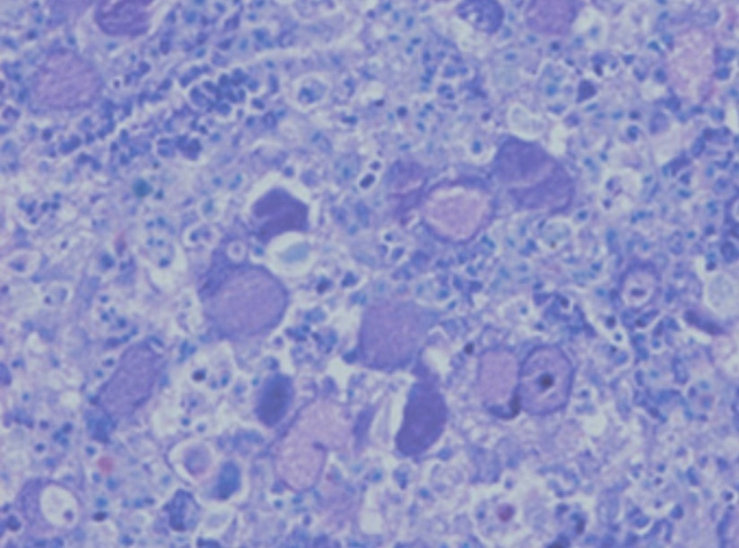
Note: Enlarged cells are characteristic of the disease.
Source: K Nakajima.

Further reading
CABI Invasive Species Compendium Red Sea Bream Iridoviral Disease
CEFAS International Database on Aquatic Animal Diseases Red Sea Bream Iridoviral Disease
World Organisation for Animal Health Manual of diagnostic tests for aquatic animals

Spring viraemia of carp (SVC)
Also known as infection with spring viraemia of carp virus (SVCV)
Exotic disease
Figure 47 SVC in common carp (Cyprinus carpio)
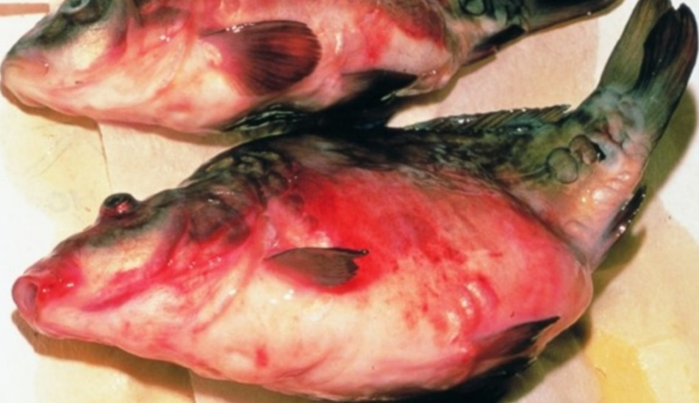
Note: Characteristic haemorrhagic skin, swollen stomach and exophthalmos (popeye).
Source: H J Schlotfeldt.

Signs of disease
Important: Animals with this disease may show one or more of these signs, but the pathogen may still be present in the absence of any signs.
Disease signs at the farm, tank or pond level are:
- mortality rates of 30 to 100%
- lethargy
- separation from shoal
- lethargic swimming
- accumulation of fish at the water inlet and sides of the pond.
Gross pathological signs are:
- exophthalmos (popeye)
- swollen abdomen and a protruding vent
- possibly a trailing white or yellowish faecal cast
- petechial (pinpoint) haemorrhages of skin, gills and eyes
- haemorrhages on skin and base of fins and around the vent
- darker body colour, with pale gills
- diffuse swelling and haemorrhage of internal organs and degeneration of gill lamellae
- ascites (fluid in abdominal cavity)
- intestines containing mucous instead of food.
Microscopic pathological signs are:
- liver hyperaemia and oedematous perivasculitis
- pericarditis and infiltration of the myocardium
- hyaline degeneration and vacuolation of the renal tubules, which are clogged with casts
- inflammatory and hyperaemic changes in all major organs.

Disease agent
SVC is caused by infection with spring viraemia of carp virus (SVCV), a rhabdovirus classified within the genus Sprivivirus. SVCV is closely related to infectious haematopoietic necrosis virus (IHNV) and viral haemorrhagic septicaemia virus (VHSV).

Host range
SVCV infects a range of fish species and has been detected infecting amphibians (newts) imported from Asia into the USA, as well as on several non-fish carriers.
Table 18 Species known to be susceptible to SVCV
Common name | Scientific name
Breamª | Abramis brama
Bighead carpª | Hypophthalmichthys nobilis
Common carp and koi carpª | Cyprinus carpio (species most susceptible)
Common roach | Rutilus rutilus
Crucian carpª | Carassius carassius
Goldfishª | Carassius auratus
Grass carpª | Ctenopharyngodon idella
Guppy | Poecilia reticulata
Ide or orfeª | Leuciscus idus
Largemouth bass | Micropterus salmoides
Pikeª | Esox lucius
Pumpkinseed | Lepomis gibbosus
Rainbow troutª | Oncorhynchus mykiss
Silver carpª | Hypophthalmichthys molitrix
Tenchª | Tinca tinca
Wels catfish or sheatfishª | Silurus glanis
Zebrafish | Danio rerio
a Naturally susceptible. Note: Other species have been shown to be experimentally susceptible.
Table 19 Non-fish carriers
Common name | Scientific name
Chinese fire belly newt | Cynops orientalis
Salamanders, newts and sirens | Order Caudata
Fish louse | Argulus foliaceus
Grey heron | Ardea cinerea
Leeches | Piscicola spp.
Piscivorous birds | Various genera and species

Presence in Australia
Exotic disease—not recorded in Australia.
Map 12 Presence of SVCV, by jurisdiction

Epidemiology
- SVC is very contagious among common carp.
- Clinical disease is linked closely to environmental disturbances.
- Mortality rate is usually less than 40% but can range from 5% to 100%, with younger fish less than 1 year old more susceptible.
- Fry are susceptible to disease at temperatures up to 23°C. However some SVCV strains from Asia replicate in-vitro at up to 28°C and can cause disease at water temperatures up to 26°C.
- Disease may also occur in older fish (greater than 1 year), usually when water temperatures are between 11°C and 17°C (associated with the stress of an abnormally cold spring in Europe, and possibly due to cold temperatures weakening the fish's immune system during the spring).
- Fish that survive SVC are presumed to carry the virus.
- Outbreaks are most likely to occur with increased stress levels, such as around the time of spawning, and coincide with increased levels of virus excreted with spawning fluids.
- Transmission of the virus to uninfected fish is horizontal, and the virus enters fish through the gills and skin.
- The virus enters the water in faeces, urine and spawning fluids. Transport of live infected fish, contaminated water and contaminated eggs of infected fish (suggestive of vertical transmission) contributes to disease spread.
- The virus also infects and causes disease in some salamanders.
- Blood-sucking parasites such as fish louse and leeches can transmit the virus from fish to fish. Piscivorous birds can also spread the disease.
- Stressors (such as overcrowding) can trigger an outbreak in apparently healthy populations.
- The virus can remain viable outside the host for 5 weeks in river water at 10°C or more than 6 weeks in pond mud at 4°C.

Differential diagnosis
The list of similar diseases in the next section refers only to the diseases covered by this field guide. Gross pathological signs may also be representative of diseases not included in this guide. Do not rely on gross signs to provide a definitive diagnosis. Use them as a tool to help identify the listed diseases that most closely account for the observed signs.

Similar diseases
Enteric redmouth disease (ERMD), enteric septicaemia of catfish, infection with Aeromonas salmonicida—atypical strains and koi herpesvirus disease (KHV).

Sample collection
Only trained personnel should collect samples. Using only gross pathological signs to differentiate between diseases is not reliable, and some aquatic animal disease agents pose a risk to humans. If you are not appropriately trained, phone your state or territory hotline number and report your observations. If you have to collect samples, the agency taking your call will advise you on the appropriate course of action. Local or district fisheries or veterinary authorities may also advise on sampling.

Emergency disease hotline
See something you think is this disease? Report it. Even if you’re not sure.
Call the Emergency Animal Disease Watch Hotline on 1800 675 888. They will refer you to the right state or territory agency.

Further reading
CEFAS International Database on Aquatic Animal Diseases Spring Viraemia of Carp
World Organisation for Animal Health Manual of diagnostic tests for aquatic animals

Tilapia lake virus (TiLV) disease
Also known as syncytial hepatitis of tilapia (SHT)
Exotic disease
Figure 48 Nile tilapia (Oreochromis niloticus) infected with TiLV
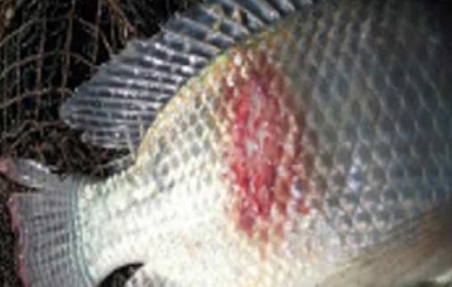
Note: Haemorrhagic skin lesion on flank.
Source: Worldfish
Figure 49 TiLV disease in Nile tilapia (Oreochromis niloticus) fingerlings
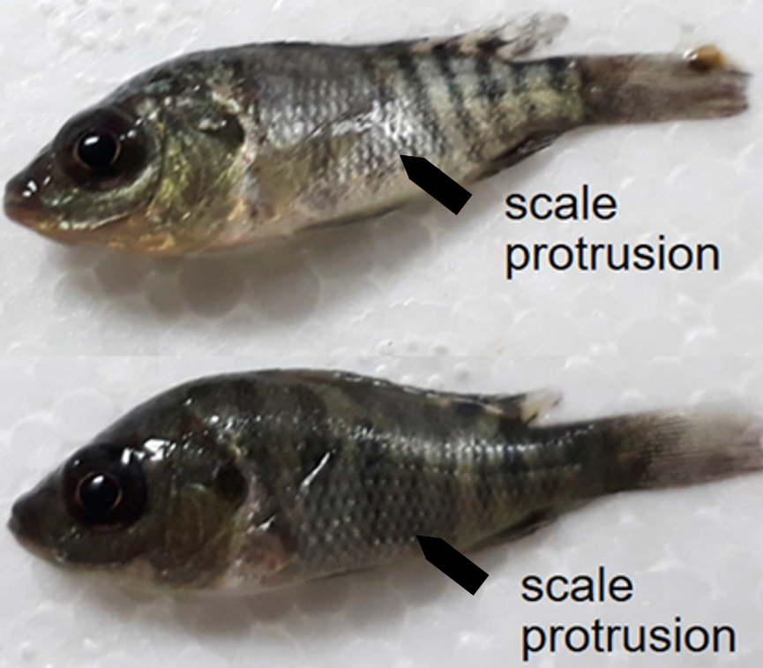
Note: Naturally infected fish exhibiting discolouration and scale protrusion.
Source: HT Dong.

Signs of disease
Important: Animals with this disease may show one or more of these signs, but the pathogen may still be present in the absence of any signs.
Disease signs at the farm, tank or pond level are:
- sudden unexpected increase in mortalities (greater than 2% per day) over several days during the summer months
- cumulative mortality up to 90% within 1 month of stocking fingerlings into freshwater or brackish water ponds
- high mortalities in 1 to 50g fish, lower mortalities (approximately 10%) in medium or large fish
- lethargy, loss of appetite, and respiratory distress (breathing at surface).
Gross pathological signs are:
- changes in body colour (darkening or lightening)
- skin erosion resulting in haemorrhagic dermal lesions
- scale protrusion
- exophthalmos (popeye) and opacity of the eye lens (cataract)
- abdominal distension (due to fluid or enlargement of spleen and other organs).
Microscopic pathological signs are:
- lesions in the brain including oedema, focal haemorrhages in the leptomeninges, and capillary congestion in both the white and grey matter and neural degeneration
- congestion of internal organs (liver, kidney, spleen, brain, gills) with foci of gliosis and perivascular cuffing of lymphocytes in the brain cortex, and melanomacrophage proliferation in liver and spleen
- formation of syncytia in the epithelium of hepatocytes (syncytial hepatitis of the liver)
- ocular inflammation including endophthalmitis and cataractous changes of the lens.

Disease agent
Tilapia lake virus disease, or syncytial hepatitis of tilapia (SHT), is caused by infection with tilapia lake virus (TiLV). TiLV is an enveloped, negative-sense, single-stranded RNA virus that has been classified as a relative of the Orthomyxoviridae family of viruses.
TiLV was first officially documented in Ecuador and Israel in 2013 and 2014, respectively. However, it is believed to have been responsible for mass mortalities in farmed tilapia in Israel since 2009. The disease agent has since been found in Thailand, Malaysia and the USA, and may have been spread to many other parts of Asia and Africa due to translocation of live tilapia for aquaculture.

Host range
Table 20 Species known to be susceptible to TiLV
Common name | Scientific name
Blue tilapiaª | Oreochromis aureus
Cichlids | Cichlidae, all species
Malaysian red hybrid tilapiaª | Oreochromis niloticus × O. mossambicus
Mango tilapiaª | Sarotherodon galilaeus
Nile tilapiaª | Oreochromis niloticus
Redbelly tilapiaª | Tilapia zilli
Tilapias | Various genera and species
Tilapia hybridsª | Oreochromis niloticus × O. aureus
Tinfoil barbª | Barbonymus schwanenfeldii
Tvarnun simonª | Tristramella simonis
a Naturally susceptible. Note: Other species have been shown to be experimentally susceptible.

Presence in Australia
Exotic disease—not recorded in Australia.
Map 13 Presence of TiLV, by jurisdiction

Epidemiology
- TiLV appears to cause disease mainly in tilapia and tilapia hybrids (Oreochromis spp., Tilapia spp.), but has also been detected causing disease in other wild cichlids (Sarotherodon galilaeus, Tristramella spp.) in Israel and tinfoil barbs (Barbonymus schwanenfeldii) in Malaysia.
- TiLV viral particles are sensitive to organic solvents (ether and chloroform), due to their lipid membrane. Other orthomyxoviruses similar to TiLV can be inactivated by desiccation or heat at temperatures above 56°C for 5 minutes, but are stable in water for extended periods.
- Horizontal transmission (via the water and cohabitation) and vertical transmission have both been demonstrated. Transmission via cannibalism is likely.
- Duration of viral survival outside the host has not been determined.
- Tilapia that survive experimental infection show immunity to disease upon subsequent challenge.

Differential diagnosis
The list of similar diseases in the next section refers only to the diseases covered by this field guide. Gross pathological signs may also be representative of diseases not included in this guide. Do not rely on gross signs to provide a definitive diagnosis. Use them as a tool to help identify the listed diseases that most closely account for the observed signs.

Similar diseases
Infection with Aphanomyces invadans (EUS), infection with infectious spleen and kidney necrosis virus (ISKNV)-like viruses, red sea bream iridoviral disease (RSIVD) and viral encephalopathy and retinopathy (VER).

Sample collection
Only trained personnel should collect samples. Using only gross pathological signs to differentiate between diseases is not reliable, and some aquatic animal disease agents pose a risk to humans. If you are not appropriately trained, phone your state or territory hotline number and report your observations. If you have to collect samples, the agency taking your call will advise you on the appropriate course of action. Local or district fisheries or veterinary authorities may also advise on sampling.

Emergency disease hotline
See something you think is this disease? Report it. Even if you’re not sure.
Call the Emergency Animal Disease Watch Hotline on 1800 675 888. They will refer you to the right state or territory agency.

Microscope images
Figure 50 Histopathology of liver of Nile tilapia (Oreochromis niloticus) infected with TiLV
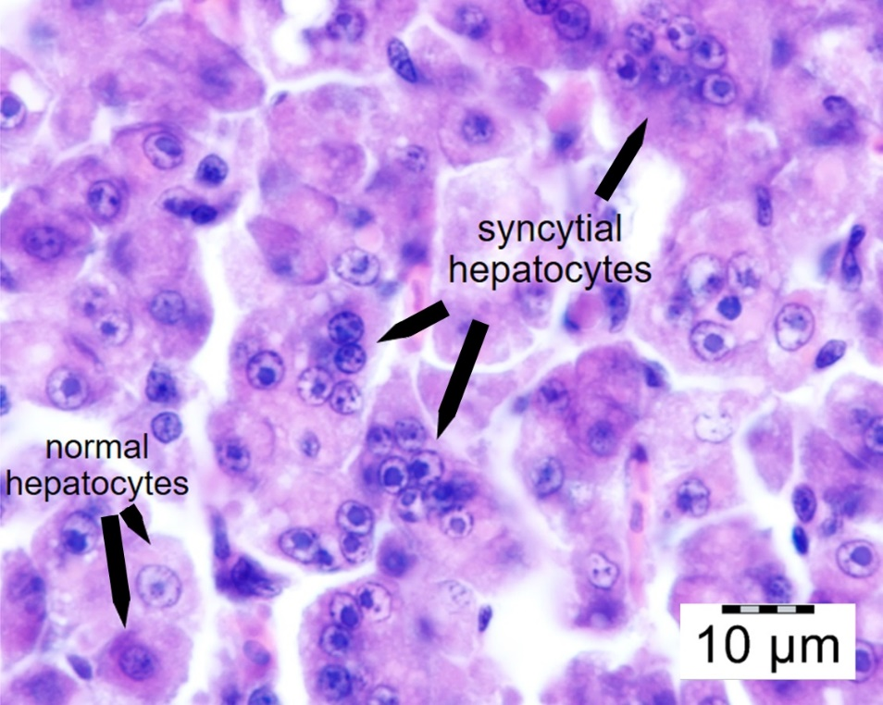
Note: Multifocal areas of syncytial hepatitis. Scale bar = 10µm.
Source: HT Dong

Further reading
Jansen MD and Mohan CV 2017, Tilapia lake virus (TiLV): Literature review, Penang, Malaysia: CGIAR Research Program on Fish Agri-Food Systems
Network of Aquaculture Centres in Asia-Pacific Tilapia Lake Virus (TiLV)—A novel orthomyxo-like virus

Viral encephalopathy and retinopathy (VER)
Also known as viral nervous necrosis (VNN)
Figure 51 Darkened colouration in seven-band grouper (Hyporthodus septemfasciatus) with VER
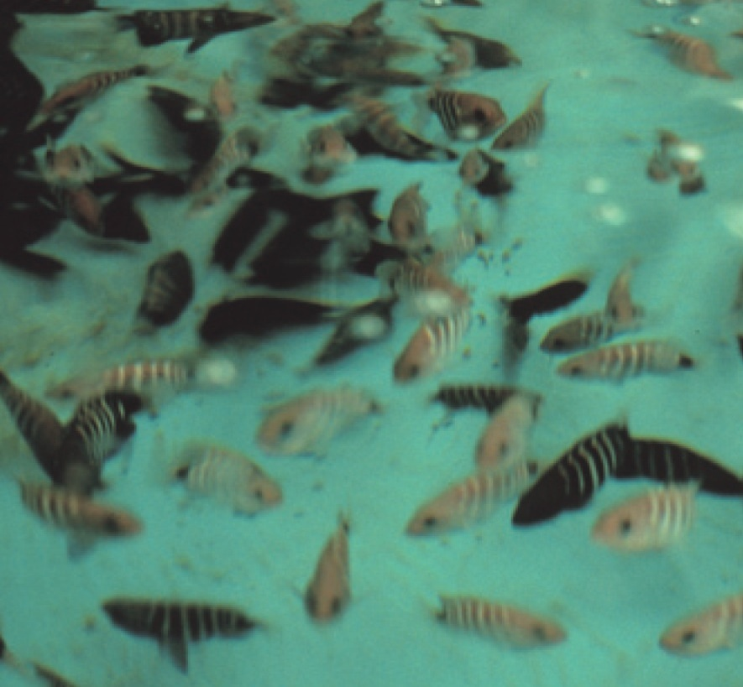
Note: Dark groupers are diseased, light fish are normal. Change in colouration is an important indicator for VER (species differ in what colour change occurs; diseased barramundi become lighter).
Source: B Munday

Signs of disease
Important: Animals with this disease may show one or more of these signs, but the pathogen may still be present in the absence of any signs.
Disease signs at the farm, tank or pond level are:
- 50% to 100% cumulative mortality over a period of 48 hours to several weeks
- higher mortalities in larvae and juvenile fish (9 to 28 days old), although older fish (greater than 28 days) may also be affected
- anorexia
- abnormal swimming behaviours, including erratic, uncoordinated darting, spiral and/or looping swim pattern, corkscrew swimming
- fish resting belly-up (loss of equilibrium)
- hyperactivity
- sporadic protrusion of the head from the water.
Gross pathological signs are:
- colour change
  - affected fish may become lighter ( such as larval barramundi) or darker (such as larval groupers), depending on the species affected and their environment
- blindness
- abrasions
- emaciation
- over-inflated swim bladder (the only significant internal gross pathological sign).
Microscopic pathological signs are:
- vacuolation of central nervous tissues, including retina
- intracytoplasmic inclusions in brain tissues as crystalline arrays or aggregates.

Disease agent
VER or VNN is a disease caused by a Betanodavirus, in the family Nodaviridae. In Australia, VER was formerly referred to as barramundi picorna-like virus.

Host range
Table 21 Species known to be susceptible to VER
Common name | Scientific name
Amberjackª | Seriola dumerili
Atlantic halibutª | Hippoglossus hippoglossus
Archer fish | Toxotes chatareus
Atlantic salmon^{b} | Salmo salar
Australian bassª | Macquaria novemaculeata
Banded archerfishª | Toxotes jaculatrix
Barcoo grunter | Scortum barcoo
Barfin flounderª | Verasper moseri
Barramundiª | Lates calcarifer
Brown-marbled grouperª | Epinephelus fuscoguttatus
Chinese catfishª | Silurus asotus
Cobiaª | Rachycentron canadum
Convict surgeonfish | Acanthurus triostegus
Coral trout | Plectropomus leopardus
Crimson snapperª | Lutjanus erythropterus
Common soleª | Solea solea
Dusky grouper | Epinephelus marginatus
Eastern freshwater codª | Maccullochella ikei
Estuarine rockcodª | Epinephelus tauvina
Estuary catfish | Cnidoglanis macrocephalus
European eelª | Anguilla anguilla
European seabassª | Dicentrarchus labrax
Floundersª | Paralichthyidae
Giant grouperª | Epinephelus lanceolatus
Gilt-head sea breamª | Sparus aurata
Golden grey mulletª | Chelon auratus
Golden perch | Macquaria ambigua
Grouper and estuary codª | Epinephelus spp.
Haddockª | Melanogrammus aeglefinus
Humpback grouperª | Cromileptes altivelis
Japanese flounderª | Paralichthys olivaceus
Japanese parrotfishª | Oplegnathus fasciatus
Japanese seabassª | Lateolabrax japonicus
Japanese tilefish | Branchiostegus japonicus
Longtooth grouperª | Epinephelus bruneus
Luderick | Girella tricuspidata
Macquarie perch | Macquaria australasica
Malabar grouperª | Epinephelus malabaricus
Mangrove jackª | Lutjanus argentimaculatus
Milkfish | Chanos chanos
Mulletsª | Mugilidae, all species
Mulloway | Argyrosomus japonicus
Murray cod | Maccullochella peelii
Narrowstripe cardinalfish | Pristiapogon exostigma
Nile tilapia | Oreochromis niloticus
Orange-spotted grouperª | Epinephelus coioides
Permitª | Trachinotus falcatus
Red drumª | Sciaenops ocellatus
Red mullet | Mullus barbatus
Red-spotted grouperª or Hong Kong grouper | Epinephelus akaara
Russian sturgeonª | Acipenser gueldenstaedtii
Samson fish | Seriola hippos
Senegalese soleª | Solea senegalensis
Seven-band grouperª | Hyporthodus septemfasciatus
Shi drumª | Umbrina cirrosa
Silver perch | Bidyanus bidyanus
Silver trevallyª | Pseudocaranx dentex
Six bar grouper | Epinephelus sexfasciatus
Sleepy cod | Oxyeleotris lineolata
Snubnose dartª | Trachinotus blochii
Spotted coral grouper | Plectropomus maculatus
Spotted knifejawª | Oplegnathus punctatus
Spotted wolffish | Anarhichas minor
Striped trumpeterª | Latris lineata
Thread-sail filefishª | Stephanolepis cirrhifer
Tiger grouper hybrid | Epinephelus fuscoguttatus × E. lanceolatus
Tiger pufferª | Takifugu rubripes
Tilapias | various genera and species
Turbotª | Scophthalmus maximus
White grouperª | Epinephelus aeneus
White seabassª | Atractoscion nobilis
Winter flounderª | Pseudopleuronectes americanus
Winter whiting | Sillago maculata
Yellowfin bream | Acanthopagrus australis
Yellowtail kingfish | Seriola lalandi
a Naturally susceptible. b Experimentally susceptible to disease via intraperitoneal injection. Note: Other species have been shown to be experimentally susceptible.
Table 22 Non-fish carriers
Common name | Scientific name
Molluscs | Various genera and species
Polychaetes | Nereis spp.

Presence in Australia
VER has been officially reported from New South Wales, the Northern Territory, Queensland, South Australia, Tasmania and Western Australia. It is primarily reported to affect larvae or fry.
Map 14 Presence of VER, by jurisdiction
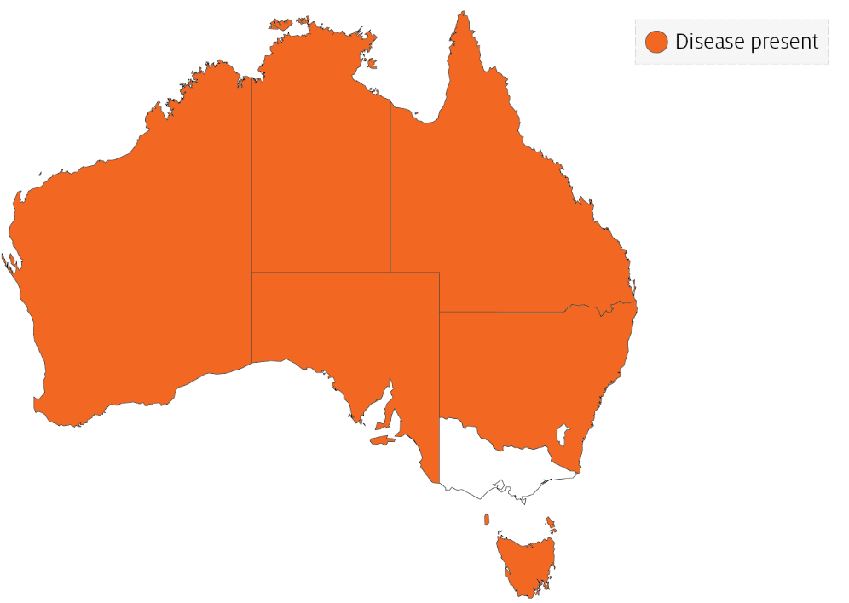

Epidemiology
- VER has occured in at least 70 species of marine fish from 16 families, and has been diagnosed in all inhabited continents.
- Most fish are affected as larvae or juveniles. However, in recent years, mortalities have occurred in older fish up to harvest size, particularly in European seabass, groupers (Epinephelus spp.) and Atlantic halibut. Disease incidence in the groupers and seabass has been associated with high water temperatures.
- Susceptibility and mortality are age dependent. Onset of clinical disease in younger fish of some species results in higher mortality.
- Batches of barramundi larvae for aquaculture are now routinely screened for this disease in Australia.
- The incubation period for the disease in barramundi is 4 days, with typical disease onset 9 to 28 days after hatching, rarely occurring in older fish (50 to 60 days old). In silver trevally, disease onset is 1 day after hatching.
- Transmission is believed to occur both horizontally through the water column (via mouth, gills and skin), and vertically (parent to offspring). The rate of transmission may be influenced by stressors, including handling, repeated spawning, high stocking densities, high ambient temperature and virulence of the particular Betanodavirus strain. Sand worms of the family Nereidae, genus Nereis, and bivalves collected in proximity to infected farms have had positive detection of Betanodavirus.
- The virus can survive for 1 year in the right environmental conditions (pH 2 to 9 and 15°C) and can persist subclinically in infected live fish. Therefore, fish products and by-products may facilitate the spread of virus to unaffected areas.
- Cumulative mortality at 1 month is typically 50% to 100% in barramundi and 100% in silver trevally. In Australian hatcheries, 100% mortality in less than 3 days in larval fish is typical.

Differential diagnosis
The list of similar diseases in the next section refers only to the diseases covered by this field guide. Gross pathological signs may also be representative of diseases not included in this guide. Do not rely on gross signs to provide a definitive diagnosis. Use them as a tool to help identify the listed diseases that most closely account for the observed signs.

Similar diseases
Grouper iridoviral disease and Tilapia lake virus (TiLV) disease.

Sample collection
Only trained personnel should collect samples. Using only gross pathological signs to differentiate between diseases is not reliable, and some aquatic animal disease agents pose a risk to humans. If you are not appropriately trained, phone your state or territory hotline number and report your observations. If you have to collect samples, the agency taking your call will advise you on the appropriate course of action. Local or district fisheries or veterinary authorities may also advise on sampling.

Emergency disease hotline
See something you think is this disease? Report it. Even if you’re not sure.
Call the Emergency Animal Disease Watch Hotline on 1800 675 888. They will refer you to the right state or territory agency.

Microscope images
Figure 52 Transverse histological section through head of larval (20 day old) barramundi (Lates calcarifer) with VER
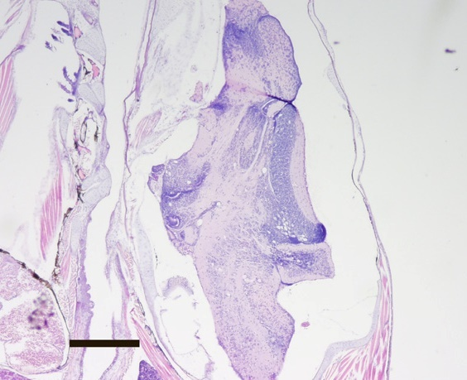
Note: Vacuoles associated with VER infection are readily visible in the brain. Haematoxylin and eosin stain. 20x magnification, scale bar = 300µm
Source: B Jones

Further reading
CEFAS International Database on Aquatic Animal Diseases Viral Encephalopathy and Retinopathy
Department of Agriculture, Water and the Environment AQUAVETPLAN disease strategy manual: Viral encephalopathy and retinopathy
World Organisation for Animal Health Manual of diagnostic tests for aquatic animals

Viral haemorrhagic septicaemia (VHS)
Also known as infection with viral haemorrhagic septicaemia virus (VHSV)
Exotic disease
Figure 53 VHS in rainbow trout (Oncorhynchus mykiss)
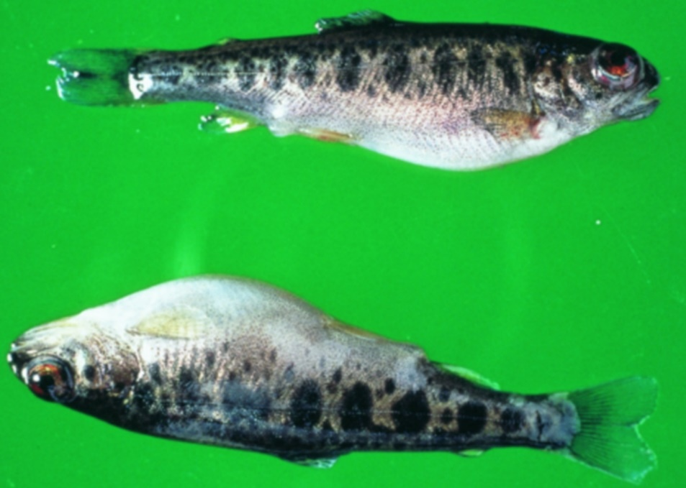
Note: Swollen stomach and exophthalmos (popeye).
Source: T Håstein
Figure 54 Internal organs of rainbow trout (Oncorhynchus mykiss) with VHS
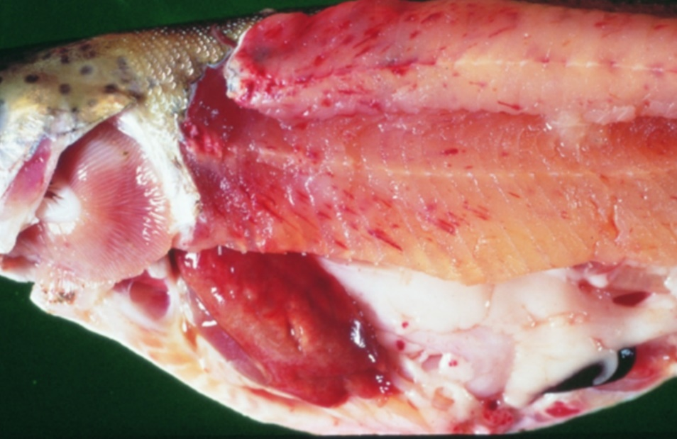
Note: Pale colour of stomach region, pinpoint haemorrhages in fillet and fatty tissue and pale gills.
Source: T Håstein

Signs of disease
Important: Animals with this disease may show one or more of these signs, but the pathogen may still be present in the absence of any signs.
Disease signs at the farm, tank or pond level are:
- acute infection
  - rapid onset of high mortality
  - lethargic swimming
  - separation from shoal
  - loss of appetite
  - crowding at pond edges.
- chronic infection
  - significant cumulative mortality (protracted)
  - uncoordinated swimming (ataxia) with rotating movement around body axis (spinning).
- neurological form
  - low mortality
  - severe abnormal swimming behaviour (flashing and spiralling).
Gross pathological signs are:
- general
  - exophthalmos (popeye)
  - haemorrhages under the skin, around the base of pectoral and pelvic fins and in the eyes
  - swollen abdomen
  - pale gills, with or without petechial (pinpoint) haemorrhages.
- acute infection
  - slight darkening of the body colour
  - exophthalmos (popeye)
  - bleeding around the eyes
  - bleeding under the skin around the base of the pectoral and pelvic fins
  - skin ulceration
  - swollen abdomen with ascites (fluid in the abdominal cavity)
  - pale gills with petechial (pinpoint) haemorrhages
  - petechial (pinpoint) haemorrhages in the fatty tissue, intestine, gonads, liver, swim bladder and muscle
  - dark-red kidneys.
- chronic infection
  - often an absence of external signs
  - intense darkening of the skin
  - exophthalmos (popeye)
  - pale gills (anaemic)
  - pale abdominal organs
  - pale and mottled liver (evidence of haemorrhages on surface)
  - pale gastrointestinal tract that is empty of food.
Microscopic pathological signs are:
- accumulation of erythrocytes in skeletal muscle fibres
- extensive focal necrosis in the liver, kidney and spleen
- VHS virus-positive endothelial cells in vascular system evident from immunohistochemistry.

Disease agent
VHS is caused by infection with viral haemorrhagic septicaemia virus (VHSV). VHSV is a rhabdovirus classified within the genus Novirhabdovirus, closely related to infectious haematopoietic necrosis virus (IHNV) and spring viraemia of carp virus (SVCV).
Several genogroups or genotypes of the virus have been identified from different environments in different parts of the world:
- type I, continental Europe—freshwater group, trout farms (highly pathogenic to rainbow trout)
- type II, European marine strain (Baltic Sea)—marine strain affecting wild and cultured marine and freshwater species (has low pathogenicity in rainbow trout)
- type III, north Atlantic marine group (Flemish Cap to Norway, including North Sea near the British Isles)
- type IVa, west coast of North America and east Asian group—marine group affecting a range of free-living marine and cultured species (highly pathogenic in Pacific herring; rainbow trout appear refractory to infection with this genotype)
- type IVb, Great Lakes region-significant mortalities in wild freshwater species in the Great Lakes of North America

Host range
VHSV has been isolated from a broad range of marine and freshwater fish in Europe and the north Pacific, including cod, sprats, herring, haddock and turbot.
Table 23 Species known to be susceptible to VHSV
Common name | Scientific name
American eel | Anguilla rostrata
Armoured weaselfish | Hoplobrotula armata
Atlantic cod | Gadus morhua
Atlantic halibut | Hippoglossus hippoglossus
Atlantic herring | Clupea harengus
Atlantic salmon | Salmo salar
Black crappie | Pomoxis nigromaculatus
Black sea bream or black porgy | Acanthopagrus schlegelii
Bluegill | Lepomis macrochirus
Blue whiting | Micromesistius poutassou
Bluntnose minnow | Pimephales notatus
Brook trout | Salvelinus fontinalis
Brown bullhead | Ameiurus nebulosus
Brown trout | Salmo trutta
Burbotª | Lota lota
Channel catfish | Ictalurus punctatus
Chinook salmon | Oncorhynchus tshawytscha
Chub mackerel | Scomber japonicus
Coho salmon | Oncorhynchus kisutch
Dab | Limanda limanda
Eels | Anguillidae, all species
Emerald shiner | Notropis atherinoides
English sole | Parophrys vetulus
Eulachonª | Thaleichthys pacificus
European eel | Anguilla anguilla
European seabass | Dicentrarchus labrax
European sprat | Sprattus sprattus
Flounder | Platichthys flesus
Fourbeard rockling | Enchelyopus cimbrius
Freshwater drumª | Aplodinotus grunniens
Gilt-head sea bream | Sparus aurata
Gizzard shad | Dorosoma cepedianum
Golden trout | Oncorhynchus aguabonita
Grayling | Thymallus thymallus
Greenland halibut | Reinhardtius hippoglossoides
Haddock | Melanogrammus aeglefinus
Hairtail | Trichiurus lepturus
Hong Kong grouper | Epinephelus akaara
Hybrid (rainbow trout × coho salmon) | Oncorhynchus mykiss × O. kisutch
Iberian nase | Pseudochondrostoma polylepis
Japanese eel | Anguilla japonica
Japanese flounderª | Paralichthys olivaceus
Japanese yellowtail | Seriola quinqueradiata
Korean flounder | Glyptocephalus stelleri
Lake trout | Salvelinus namaycush
Lake whitefish | Coregonus clupeaformis
Largemouth bass | Micropterus salmoides
Lesser argentine | Argentina sphyraena
Sea Mullet | Mugil cephalus
Mummichogª | Fundulus heteroclitus
Muskellungeª | Esox masquinongy
Norway pout | Trisopterus esmarkii
Pacific cod | Gadus macrocephalus
Pacific hakeª | Merluccius productus
Pacific herringª | Clupea pallasii
Pacific salmon | Oncorhynchus spp.
Pacific sand eel | Ammodytes personatus
Pacific sand lance | Ammodytes hexapterus
Pacific sardineª | Sardinops sagax
Pacific tomcod | Microgadus proximus
Pikeª | Esox lucius
Plaice | Pleuronectes platessa
Poor cod | Trisopterus minutus
Pumpkinseed | Lepomis gibbosus
Rainbow troutª | Oncorhynchus mykiss
River lamprey | Lampetra fluviatilis
Rock bass | Ambloplites rupestris
Rockfish | Sebastes spp.
Round gobyª | Neogobius melanostomus
Sablefishª | Anoplopoma fimbria
Sand eel | Ammodytes spp.
Sand goby | Pomatoschistus minutus
Senegalese sole | Solea senegalensis
Shiner perch | Cymatogaster aggregata
Shortfin eel | Anguilla australis
Shorthead redhorse | Moxostoma macrolepidotum
Silver pomfret | Pampus argenteus
Silver redhorse | Moxostoma anisurum
Smallmouth bassª | Micropterus dolomieu
Snapper | Chrysophrys auratus
Splake (lake trout × brook trout) | Salvelinus namaycush × S. fontinalis
Spottail shiner | Notropis hudsonius
Striped bass | Morone saxatilis
Surf smeltª | Hypomesus pretiosus
Three-spined stickleback | Gasterosteus aculeatus
Trout-perch | Percopsis omiscomaycus
Tubesnout | Aulorhynchus flavidus
Turbotª | Scophthalmus maximus
Walleye pollock or Alaska pollockª | Gadus chalcogramma
White bass | Morone chrysops
Whitefish (Muksun) | Coregonus muksun
Whitefish (Peled) | Coregonus peled
White perch | Morone americana
Whiting | Merlangius merlangus
Yellowback seabream | Evynnis tumifrons
Yellow perchª | Perca flavescens
a Naturally susceptible. Note: Other species have been shown to be experimentally susceptible.
Table 24 Non-fish carriers
Common name | Scientific name
Leeches | Piscicola spp.
Piscivorous birds | Various genera and species

Presence in Australia
Exotic disease—not recorded in Australia.
Map 15 Presence of VHS, by jurisdiction

Epidemiology
- Variant strains of VHSV are responsible for disease in different geographical locations.
- Marine and freshwater species are susceptible to VHSV infection. Younger fish are generally more susceptible to disease.
- Rainbow trout appear to be less susceptible to infection by marine strains of the virus.
- Water temperatures in an outbreak are generally near 10°C. At water temperatures between 15°C and 18°C, the disease generally takes a shorter course with a modest accumulated mortality, but transmission can occur at water temperatures up to 22°C. Mortality and morbidity have rarely been documented when water temperatures are above 18°C, although VHS virus genotype IV has caused at least one fish kill at 20 to 22°C, and some isolates can replicate in vitro at temperatures up to 25°C.
- Transmission is horizontal directly through the water, from virus shed in faeces, urine (predominantly) and sexual fluids of clinically infected or carrier fish. The virus can also be spread by birds that have consumed infected fish, via blood-feeding vectors such as leeches, and on equipment that has been in contact with water from infected fish. The virus gains entry via the gills, skin wounds, oral exposure (predation) and possibly through the skin.
- Once infected, survivors are lifelong carriers of the virus, with intermittent shedding. Stressors (including overcrowding, extreme temperatures and overfeeding) will greatly reduce an animal's resistance to infection.
- Mortality rate can range from 10% to 80%, depending on the VHSV isolate, environmental variables (temperature), age, species, route of exposure and presence of additional stressors. The highest mortality rates occur with acute infection, and lowest mortality rates in the neurological form.
- VHSV is thought to have existed in the marine environment before its apparent transfer to fresh water, where it first became virulent in trout.
- It has been suggested that the European freshwater strains of VHSV originated from fish in the northern Pacific and Atlantic oceans. The mechanism of transfer was possibly through the feeding of marine fish to cultured freshwater species.

Differential diagnosis
The list of similar diseases in the next section refers only to the diseases covered by this field guide. Gross pathological signs may also be representative of diseases not included in this guide. Do not rely on gross signs to provide a definitive diagnosis. Use them as a tool to help identify the listed diseases that most closely account for the observed signs.

Similar diseases
Enteric red mouth disease (ERMD), epizootic haematopoietic necrosis (EHN), infection with Aphanomyces invadans (EUS), infectious haematopoietic necrosis (IHN), infectious pancreatic necrosis (IPN) and whirling disease.

Sample collection
Only trained personnel should collect samples. Using only gross pathological signs to differentiate between diseases is not reliable, and some aquatic animal disease agents pose a risk to humans. If you are not appropriately trained, phone your state or territory hotline number and report your observations. If you have to collect samples, the agency taking your call will advise you on the appropriate course of action. Local or district fisheries or veterinary authorities may also advise on sampling.

Emergency disease hotline
See something you think is this disease? Report it. Even if you’re not sure.
Call the Emergency Animal Disease Watch Hotline on 1800 675 888. They will refer you to the right state or territory agency.

Further reading
CABI Invasive Species Compendium Viral haemorrhagic septicaemia
Department of Agriculture, Water and the Environment AQUAVETPLAN disease strategy manual: Viral haemorrhagic septicaemia
World Organisation for Animal Health Manual of diagnostic tests for aquatic animals

Bacterial diseases of finfish

Bacterial kidney disease (BKD)
Also known as infection with Renibacterium salmoninarum
Exotic disease
Figure 55 Ventral view of adult chinook salmon (Oncorhynchus tshawytscha) infected with Renibacterium salmoninarum
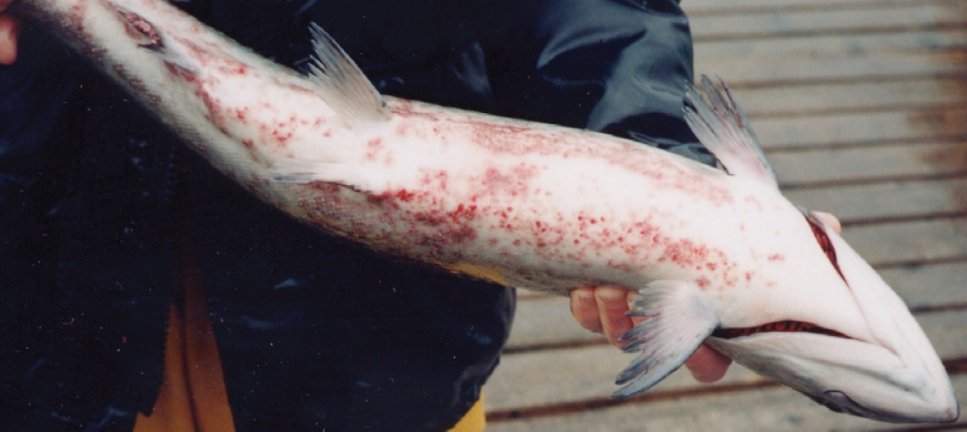
Note: Dermatitis (spawning rash) typical of BKD on bottom of fish.
Source: R Pascho and D Elliott
Figure 56 Kidneys of Juvenile chinook salmon (Oncorhynchus tshawytscha) affected by BKD
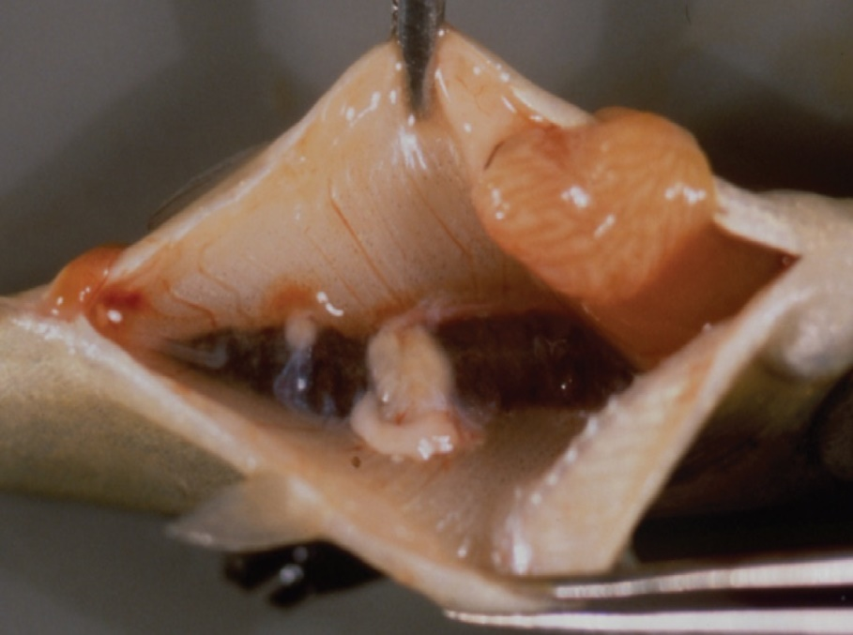
Note: Multiple kidney lesions.
Source: R Pascho and C O’Farrell

Signs of disease
Important: Animals with this disease may show one or more of these signs, but the pathogen may still be present in the absence of any signs.
Disease signs at the farm, tank or pond level are:
- lethargy
- Increasing mortality.
Gross pathological signs are:
- exophthalmos (popeye)
- swollen abdomen and skin blisters (spawning rash) or shallow ulcers (remnants of ruptured blisters)
- darkening of skin and pale gills
- haemorrhages at the base of the fins or at the vent
- creamy-white, granulomatous, nodular lesions in the kidney and sometimes in the liver and spleen, which may be encapsulated
- ascites (fluid in the abdominal cavity)
- haemorrhages on the abdominal wall and in the viscera
- diffuse, white membranous layer on one or more internal organs
- enlarged spleen
- cystic cavities in skeletal muscle.
Microscopic pathological signs are:
- focal or diffuse granulomatous reaction in the kidneys, liver and spleen
- small, rod-shaped bacteria (Renibacterium salmoninarum) in histological sections of skin lesions.

Disease agent
BKD is caused by infection with R. salmoninarum, a member of the family Micrococcaceae. BKD is a slow, progressive and frequently fatal infection of cultured and wild salmonids in both fresh and marine waters.

Host range
Table 25 Species of salmonid fish known to be susceptible to BKD
Common name | Scientific name
Arctic char | Salvelinus alpinus
Atlantic salmonª | Salmo salar
Black sea salmon | Salmo labrax
Brook troutª | Salvelinus fontinalis
Brown troutª | Salmo trutta
Chinook salmonª | Oncorhynchus tshawytscha
Chum salmon | Oncorhynchus keta
Coho salmonª | Oncorhynchus kisutch
Cutthroat troutª | Oncorhynchus clarkii
Danube salmonª | Hucho hucho
Masu salmonª | Oncorhynchus masou
Pink salmonª | Oncorhynchus gorbuscha
Rainbow troutª | Oncorhynchus mykiss
a Naturally susceptible. Note: Other species have been shown to be experimentally susceptible.
Table 26 Species of non-salmonid fish known to be susceptible to BKD
Common name | Scientific name
Ayu | Plecoglossus altivelis
Burbot | Lota lota
Common shiner | Luxilus cornutus
Fathead minnow | Pimephales promelas
Grayling | Thymallus thymallus
Pacific herring | Clupea pallasii
Sablefish | Anoplopoma fimbria
Sea lamprey | Petromyzon marinus
Shiner perch | Cymatogaster aggregata
Table 27 Non-salmonid carriers
Common name | Scientific name
Bartail flathead | Platycephalus indicus
Greenling | Hexagrammos otakii
Japanese scallop | Patinopecten yessoensis

Presence in Australia
Exotic disease—not recorded in Australia.
Map 16 Presence BKD, by jurisdiction

Epidemiology
- The causative bacterium is likely to persist only within salmonids and not in the environment. However, as R. salmoninarum is often endemic in wild salmon populations, hatcheries can be constantly exposed to bacteria shed into the water by wild fish upstream.
- Other non-salmonid species have been demonstrated susceptible to infection with R. salmoninarum, but only when raised in proximity to highly infected salmonids.
- The bacterium is transmitted both horizontally (between fish via the water) and vertically (parent to offspring via eggs). Surface disinfection of eggs does not prevent vertical transmission.
- Advanced infection becomes apparent only after the first year of the fish's life.
- Coho (Oncorhynchus kisutch) and chinook (O. tshawytscha) salmon are the most important worldwide sources of infection.

Differential diagnosis
The list of similar diseases in the next section refers only to the diseases covered by this field guide. Gross pathological signs may also be representative of diseases not included in this guide. Do not rely on gross signs to provide a definitive diagnosis. Use them as a tool to help identify the listed diseases that most closely account for the observed signs.

Similar diseases
Piscirickettsiosis and viral haemorrhagic septicaemia (VHS).

Sample collection
Only trained personnel should collect samples. Using only gross pathological signs to differentiate between diseases is not reliable, and some aquatic animal disease agents pose a risk to humans. If you are not appropriately trained, phone your state or territory hotline number and report your observations. If you have to collect samples, the agency taking your call will advise you on the appropriate course of action. Local or district fisheries or veterinary authorities may also advise on sampling.

Emergency disease hotline
See something you think is this disease? Report it. Even if you’re not sure.
Call the Emergency Animal Disease Watch Hotline on 1800 675 888. They will refer you to the right state or territory agency.

Microscope images
Figure 57 Histological section of skin lesion of juvenile chinook salmon (Oncorhynchus tshawytscha) infected with Renibacterium salmoninarum
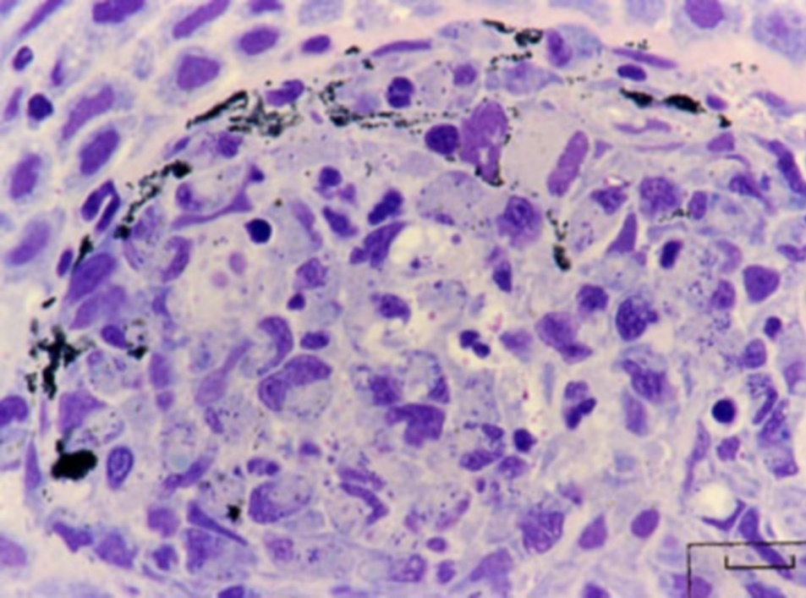
Note: Most of the small, rod-shaped R. salmoninarum are visible within the cytoplasm of macrophages. In this Giemsa-stained preparation, bacteria are purple–blue and melanin granules are black.
Source: R Pascho
Figure 58 Histological section of granulomas of juvenile chinook salmon (Oncorhynchus tshawytscha) affected by BKD
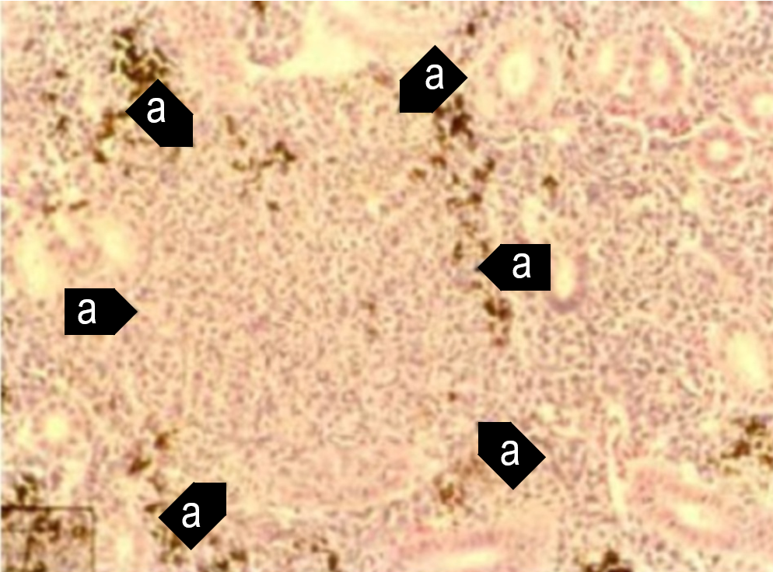
Note: Focal granulomatous inflammation (a).
Source: R Pascho and C O’Farrell
Figure 59 Histological section of granulomas of juvenile chinook salmon (Oncorhynchus tshawytscha) affected by BKD
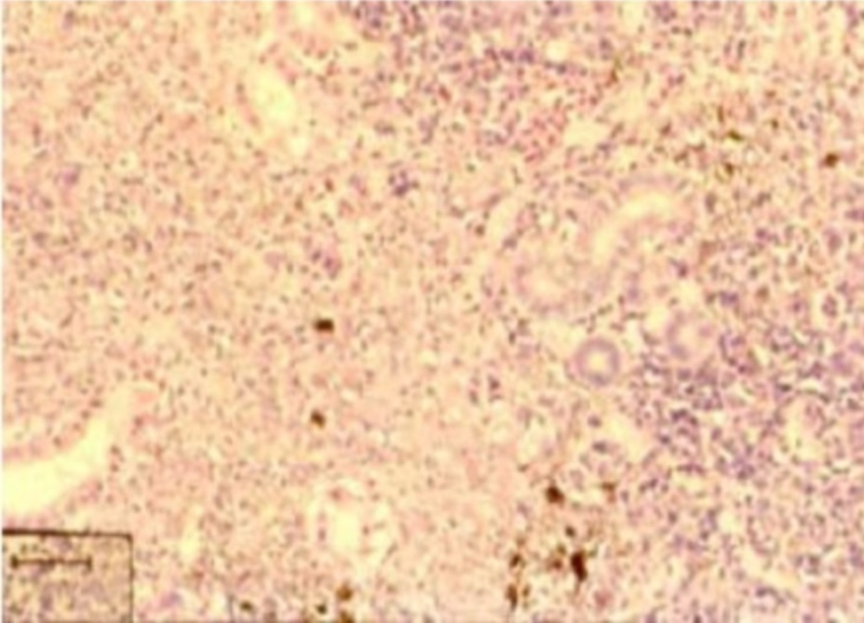
Note: Diffuse granulomatous inflammation.
Source: R Pascho and C O’Farrell
Figure 60 Gram-stained histological section of pancreatic tissue of juvenile chinook salmon (Oncorhynchus tshawytscha) with systemic BKD
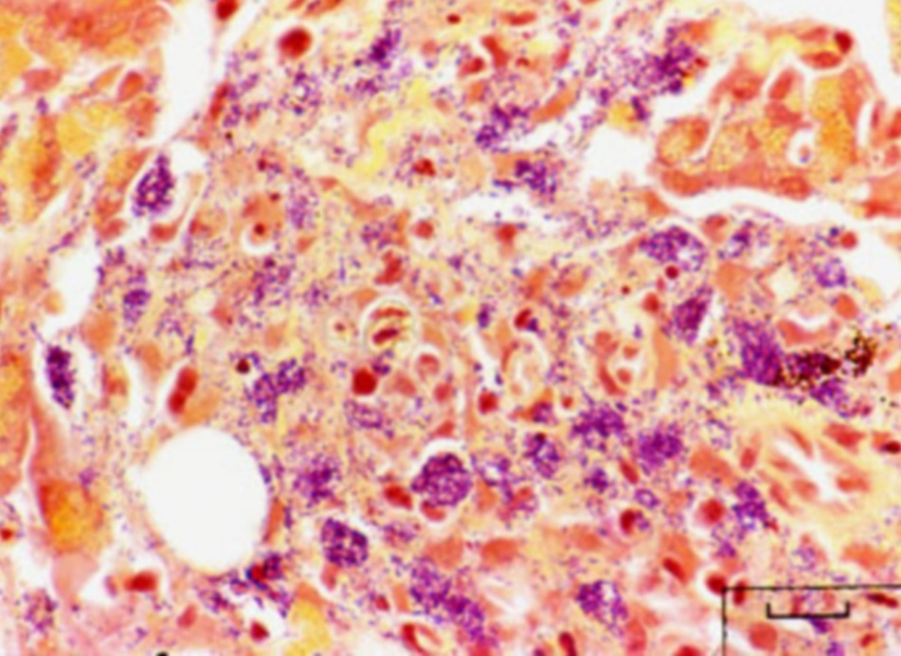
Note: Gram-positive (purple–blue) cells of R. salmoninarum are present extracellularly and intracellularly within macrophages, in contrast to brown–black melanin granules.
Source: R Pascho

Further reading
CABI Invasive Species Compendium ‘Renibacterium salmoninarum’
CEFAS International Database on Aquatic Animal Diseases Bacterial Kidney Disease (‘Renibacterium salmoninarum’)
World Organisation for Animal Health Manual of diagnostic tests for aquatic animals

Enteric red mouth disease (ERMD)
Also known as infection with Yersinia ruckeri
Exotic disease
Figure 61 Characteristic red mouth from ERMD in rainbow trout (Oncorhynchus mykiss)
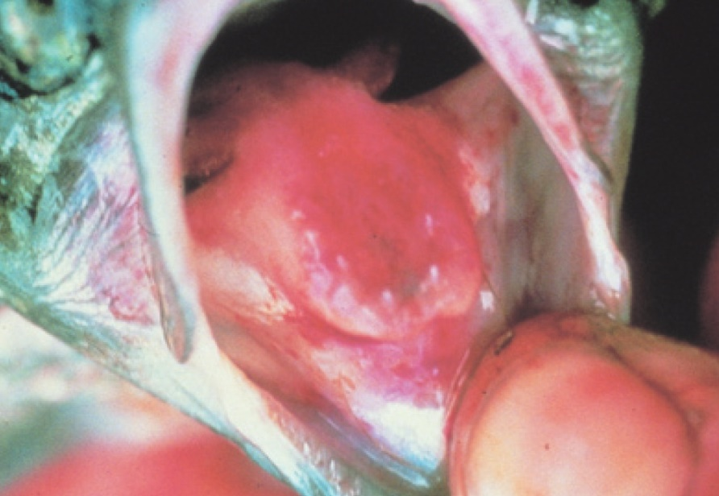
Note: Reddened mouth and tongue.
Source: HJ Schlotfeldt
Figure 62 ERMD in rainbow trout (Oncorhynchus mykiss)
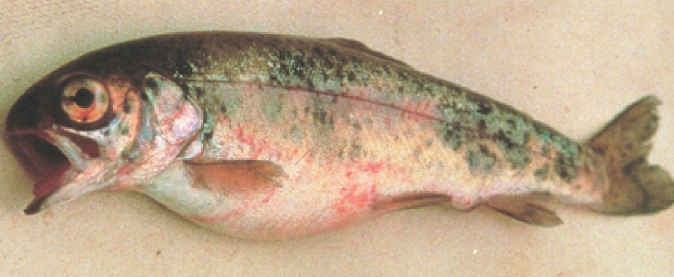
Note: Skin and eye haemorrhages, and swollen abdomen.
Source: HJ Schlotfeldt

Signs of disease
Important: Animals with this disease may show one or more of these signs, but the pathogen may still be present in the absence of any signs.
Disease signs at the farm, tank or pond level are:
- separation from other fish
- occasional nervous signs
- acute infections in fingerlings (fish of all ages may be affected, usually with sustained low-level mortalities).
Gross pathological signs are:
- dark body colour (seen in atypical infections)
- haemorrhages at base of paired fins and vent
- reddening (subcutaneous haemorrhages) of gill cover, corners of mouth, gums, palate and tongue
- exophthalmos (popeye) and orbital haemorrhages
- loss of appetite
- swollen abdomen
- ascites (fluid in the abdominal cavity)
- petechial (pinpoint) haemorrhages may occur on the surfaces of the liver, pancreas, pyloric caeca, swim bladder and in the lateral musculature
- enlarged, friable spleen is often almost black in colour
- inflamed lower intestine containing thick yellow fluid.
Microscopic pathological signs are:
- generalised haemorrhagic septicaemic inflammatory response of all tissues
- bacterial colonisation of well-vascularised tissue (spleen, liver, heart, gills, kidney)
- necrosis of haematopoietic tissue in the kidney and spleen.

Disease agent
ERMD is caused by infection with Yersinia ruckeri (Hagerman strain), a member of the family Enterobacteriaceae. There are several serotypes of the bacterium, and classification systems can be based upon whole-cell typing as well as individual cell-wall antigen groupings. The serotype responsible for ERMD is the Hagerman strain, serotype O1a, is considered to be the most virulent.
The enteric red mouth strain of Y. ruckeri (serotype O1a) is exotic to Australia. However, a virulent form of Y. ruckeri (serotype O1b) is endemic in Australia. Serotype O1b produces a septicaemic condition in Atlantic salmon (Salmo salar) known as yersiniosis. A characteristic of this form of the disease is exophthalmia (popeye) and the formation of pronounced haemorrhages in the eye that give rise to the description of blood spot disease. Signs typical of classical ERMD—prominent reddening of the corners of the mouth, gums and palate—do not normally occur in yersiniosis.

Host range
Table 28 Species found in Australia known to be naturally susceptible to ERMD
Common name | Scientific name
Atlantic salmon | Salmo salar
Brown trout | Salmo trutta
Brook trout | Salvelinus fontinalis
Common carp and koi carp | Cyprinus carpio
Goldfish | Carassius auratus
Rainbow trout | Oncorhynchus mykiss
Table 29 Species not commonly found in Australia known to be naturally susceptible to ERMD
Common name | Scientific name
Salmonids
Arctic char | Salvelinus alpinus
Chinook salmon | Oncorhynchus tshawytscha
Coho salmon | Oncorhynchus kisutch
Cutthroat trout | Oncorhynchus clarkii
Sockeye salmon | Oncorhynchus nerka
Whitefish | Coregonus spp.
Whitefish (Muksun) | Coregonus muksun
Whitefish (Peled) | Coregonus peled
Non-salmonids
Bighead carp | Aristichthys nobilis
Burbot | Lota lota
Channel catfish | Ictalurus punctatus
Cisco | Coregonus artedi
Common sole | Solea solea
Emerald shiner | Notropis atherinoides
European eel | Anguilla anguilla
Fathead minnow | Pimephales promelas
Pike | Esox lucius
Siberian sturgeon | Acipenser baerii
Silver carp | Hypophthalmichthys molitrix
Turbot | Scophthalmus maximus
Table 30 Non-fish carriers
Common name | Scientific name
Freshwater crayfish | Various genera and species

Presence in Australia
Exotic disease—not recorded in Australia.
A related disease known as yersiniosis or blood spot disease occurs in Australia.
Map 17 Presence of ERMD, by jurisdiction

Epidemiology
- Many other aquatic species are potential carriers but show no signs (some crustaceans, including freshwater crayfish).
- Transmission can be horizontal, via direct contact with infected fish or carriers. Carriers are particularly important sources of infection under stressful situations (such as increasing water temperature).
- Yersinia ruckeri can survive in the environment, with some strains able to form biofilms.
- Vertical transmission (fish to egg) is suggested by the presence of Y. ruckeri DNA in ovarian fluids and unfertilized eggs.
- ERMD causes septicaemia (bacteria are spread through the body via the blood).
- Fish of all ages are affected, and outbreaks usually begin with low mortalities that slowly escalate. The severity of the outbreak depends on the strain and presence of stressors.

Differential diagnosis
The list of similar diseases in the next section refers only to the diseases covered by this field guide. Gross pathological signs may also be representative of diseases not included in this guide. Do not rely on gross signs to provide a definitive diagnosis. Use them as a tool to help identify the listed diseases that most closely account for the observed signs.

Similar diseases
Infection with HPR-deleted or HPR0 infectious salmon anaemia virus, infectious haematopoietic necrosis (IHN), spring viraemia of carp (SVC), viral haemorrhagic septicaemia (VHS) and whirling disease.

Sample collection
Only trained personnel should collect samples. Using only gross pathological signs to differentiate between diseases is not reliable, and some aquatic animal disease agents pose a risk to humans. If you are not appropriately trained, phone your state or territory hotline number and report your observations. If you have to collect samples, the agency taking your call will advise you on the appropriate course of action. Local or district fisheries or veterinary authorities may also advise on sampling.

Emergency disease hotline
See something you think is this disease? Report it. Even if you’re not sure.
Call the Emergency Animal Disease Watch Hotline on 1800 675 888. They will refer you to the right state or territory agency.

Microscope images
Figure 63 Skeletal muscle of rainbow trout (Oncorhynchus mykiss) naturally infected with Yersinia ruckeri
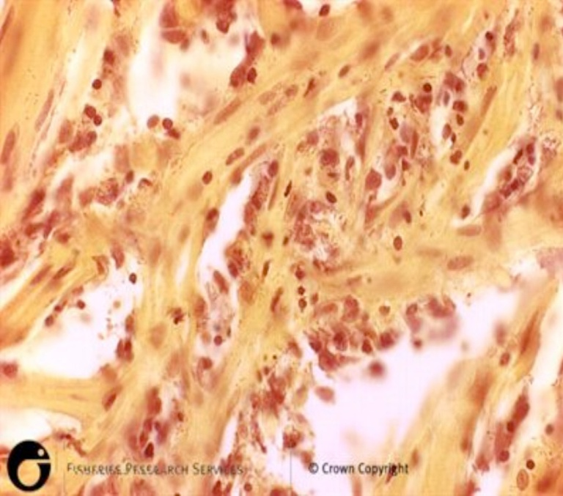
Note: Diffuse haemorrhage evident in sections of skeletal muscle.
Source: Scottish Government
Figure 64 Kidney of rainbow trout (Oncorhynchus mykiss) naturally infected with Yersinia ruckeri
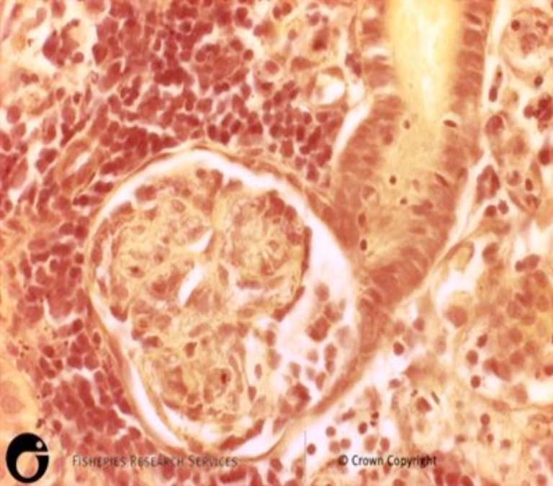
Note: Diffuse haemorrhage evident in sections of kidney.
Source: Scottish Government

Further reading
CEFAS International Database on Aquatic Animal Diseases Entric Redmouth
Glenn RA, Taylor PW, Pelton EH, Gutenberger SK, Ahrens MA, Marchant LM, Hanson KC 2015, Genetic evidence of vertical transmission and cycling of ‘Yersinia ruckeri’ in hatchery-origin fall chinook salmon ‘Oncorhynchus tshawytscha’, Journal of Fish and Wildlife Management.
Kumar G, Menanteau-Ledouble S, Saleh M, El-Matbouli M 2015, ‘Yersinia ruckeri’, the causative agent of enteric red mouth disease in fish, Veterinary Research.

Enteric septicaemia of catfish
Also known as infection with Edwardsiella ictaluri, edwardsiellosis and hole-in-the-head disease
Figure 65 Ulcer in channel catfish (Ictalurus punctatus) with chronic enteric septicaemia of catfish
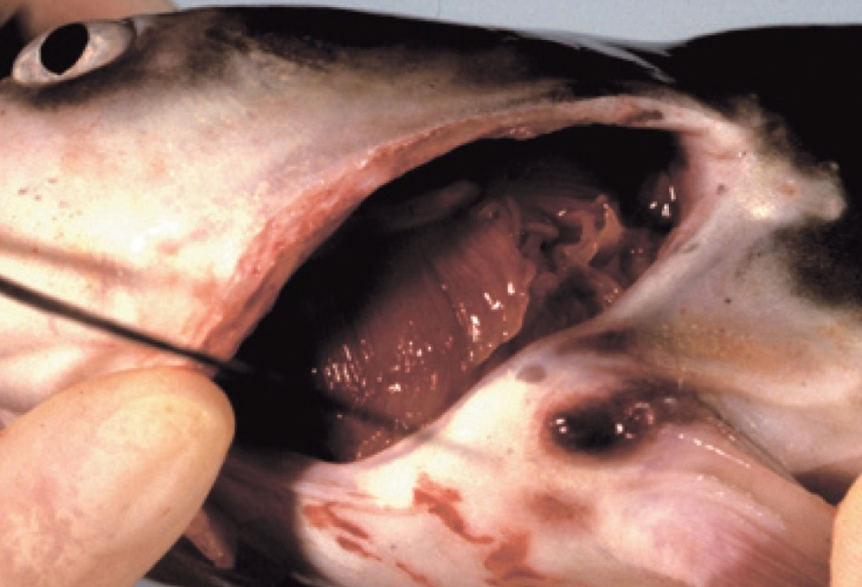
Note: Ulcerative lesions in the joints of the pectoral or dorsal spines.
Source: L A Hanson
Figure 66 Cranial ulcer in channel catfish (Ictalurus punctatus) with enteric septicaemia of catfish
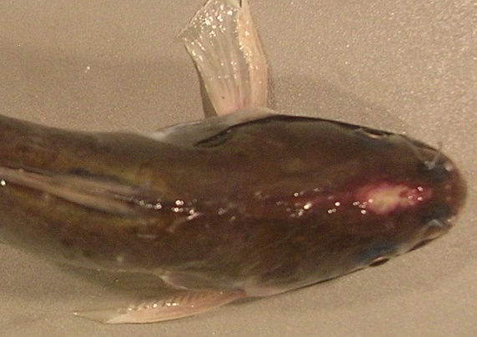
Note: Cranial ulcer, also known as a hole-in-the-head lesion.
Source: L Khoo
Figure 67 Internal organs of channel catfish (Ictalurus punctatus) with enteric septicaemia of catfish
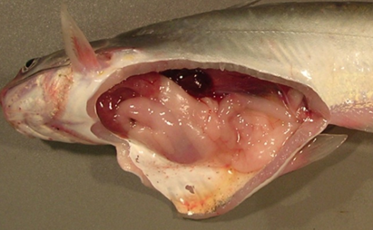
Note: Signs of infection with Edwardsiella ictaluri include swollen posterior kidney, enlarged spleen, gastro-intestinal haemorrhage and ascites fluid.
Source: L Khoo

Signs of disease
Important: Animals with this disease may show one or more of these signs, but the pathogen may still be present in the absence of any signs.
Disease signs at the farm, tank or pond level are:
- lethargic swimming
- abnormal behaviour (alternating listlessness and chaotic swimming)
- disorientation and swimming in spirals
- loss of appetite
- surfing, with head protruding from water.
Gross pathological signs are:
- chronic encephalitic form
  - swelling on top of the head, occasionally progressing to the erosion of connective tissue and exposure of the brain (a hole-in-the-head lesion)
  - granulomatous inflammation of the brain
- acute septicaemic form
  - pale gills
  - darkening of the skin (observed in species other than channel catfish)
  - multiple small white spots on the skin
  - raised skin patches progressing to shallow ulcers on the flanks and head
  - haemorrhage at the base of the fins, around the mouth, and on the throat, operculum (gill cover) and abdomen
  - exophthalmos (popeye)
  - swollen abdomen (pot-belly)
  - ascites (fluid in the abdominal cavity)
  - lesions on the liver and other internal organs
  - intestines frequently bloody, but may be transparent or clear yellow
  - red, swollen anal region with trailing faecal casts (observed in infected barramundi)
  - soft and pale spleen, anterior kidney or posterior kidney, with petechial (pinpoint) haemorrhages.
Microscopic pathological signs are:
- gram-negative rods in histological sections (muscle, kidney)
- locally extensive cellulitis in the head region
- necrotising myositis.

Disease agent
. Enteric septicaemia of catfish (or edwardsiellosis) is caused by infection with the bacterium Edwardsiella ictaluri, belonging to the family Enterobacteriaceae.

Host range
Enteric septicaemia of catfish is a highly infectious bacterial disease of the catfish families Ictaluridae, Plotosidae, Clariidae, Siluridae, Pangasiidae and Ariidae.Ictalurids are particularly suceptible. Several non-catfish species are also susceptible, including salmonids.
Table 31 Species known to be susceptible to Edwardsiella ictaluri
Common name | Scientific name
Ayuª | Plecoglossus altivelis
Barramundi | Lates calcarifer
Berney’s catfish | Neoarius berneyi
Black bullheadª | Ameiurus melas
Black catfish | Neosilurus ater
Blue catfishª | Ictalurus furcatus
Brown bullheadª | Ameiurus nebulosus
Channel catfishª | Ictalurus punctatus
Chinook salmon | Oncorhynchus tshawytscha
Glass knifefishª | Eigenmannia virescens
Rainbow trout | Oncorhynchus mykiss
Rosy barbª | Puntius conchonius
Sind danioª | Danio devario
Sutchi catfishª | Pangasius hypophthalmus
Tadpole madtomª | Noturus gyrinus
Toothless catfish | Anodontiglanis dahlia
Walking catfishª | Clarias batrachus
Wet tropics tandanª | Tandanus tropicanus
White catfishª | Ameiurus catus
Yellow bullheadª | Ameiurus natalis
Yellow catfishª | Pelteobagrus fulvidraco
Zebrafishª | Danio rerio
a Naturally susceptible. Note: Other species have been shown to be experimentally susceptible.

Presence in Australia
Edwardsiella ictaluri has been isolated from healthy wild wet-tropics tandan catfish, from the Tully River valley in north Queensland, at a prevalence of 40%.
Enteric septicaemia of catfish has also been officially reported in Australia from imported aquarium fish (danios, rosy barbs) held in contained facilities in the Northern Territory and Tasmania. In 2010 and 2011, native black catfish, toothless catfish and Berney’s catfish held near imported aquarium fish in a facility in the Northern Territory became infected, resulting in mortalities. There have been no detections of the disease in the wild in the Northern Territory or Tasmania.
Map 18 Presence of Edwardsiella ictaluri, by jurisdiction
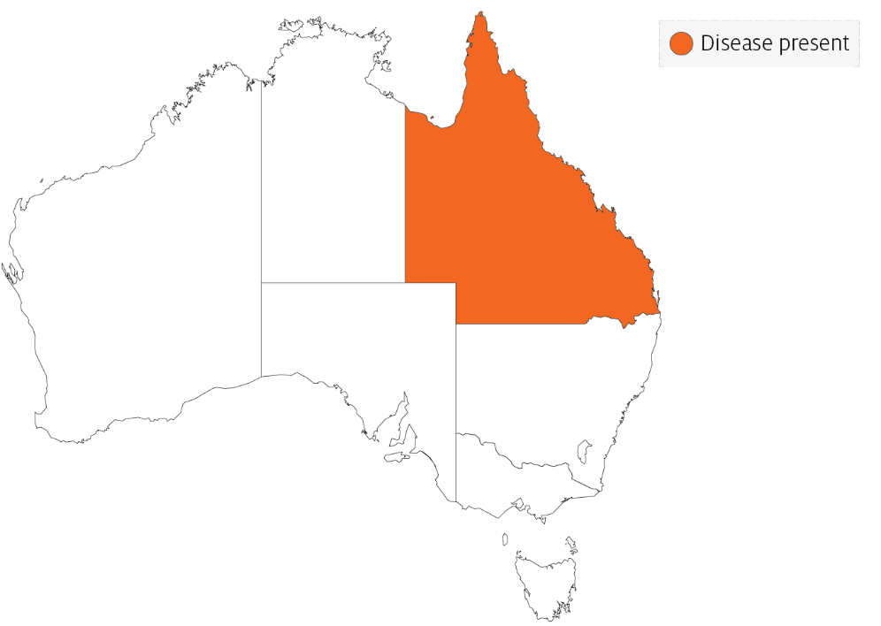

Epidemiology
- Edwardsiella ictaluri has been linked to disease outbreaks in barramundi (also known as Asian seabass) and Pangasius (basa catfish).
- Enteric septicaemia of catfish was originally considered primarily a disease of channel catfish. However, the bacterium has since been reported to cause disease in other catfish and non-catfish species. Most of the epidemiological knowledge about the disease is based on its occurrence in channel catfish.
- Horizontal transmission is via the faecal-oral route, cannibalism, and contact with contaminated water and materials used in handling infected fish.
- Faeces are the main source of shedding and dissemination. The disease may also be spread via dead fish and contaminated equipment such as fishing nets and sorting devices.
- The intestinal tract is the primary site of infection for the acute septicaemic form. The chronic encephalitic form is thought to establish after entering fish via the olfactory epithelium.
- Surviving catfish carry the bacterium, which also seems to be able to survive in the intestinal tracts of other fish species.
- Disease occurs primarily at water temperatures between 18°C and 28°C, making spring and autumn the most common times for outbreaks. Stress is often a predisposing factor.
- The bacterium can survive 3 to 4 months in pond water, mud and vegetation.
- Environmental stressors can influence the expression of clinical signs and extend the incubation period.
- Morbidity and mortality can be high in heavily stocked ponds.

Differential diagnosis
The list of similar diseases in the next section refers only to the diseases covered by this field guide. Gross pathological signs may also be representative of diseases not included in this guide. Do not rely on gross signs to provide a definitive diagnosis. Use them as a tool to help identify the listed diseases that most closely account for the observed signs.

Similar diseases
Channel catfish virus disease, European catfish virus and European sheatfish virus, infection with Aphanomyces invadans and spring viraemia of carp.

Sample collection
Only trained personnel should collect samples. Using only gross pathological signs to differentiate between diseases is not reliable, and some aquatic animal disease agents pose a risk to humans. If you are not appropriately trained, phone your state or territory hotline number and report your observations. If you have to collect samples, the agency taking your call will advise you on the appropriate course of action. Local or district fisheries or veterinary authorities may also advise on sampling.

Emergency disease hotline
See something you think is this disease? Report it. Even if you’re not sure.
Call the Emergency Animal Disease Watch Hotline on 1800 675 888. They will refer you to the right state or territory agency.

Microscope images
Figure 68 Histopathological section of skeletal muscle of channel catfish (Ictalurus punctatus) with enteric septicaemia of catfish
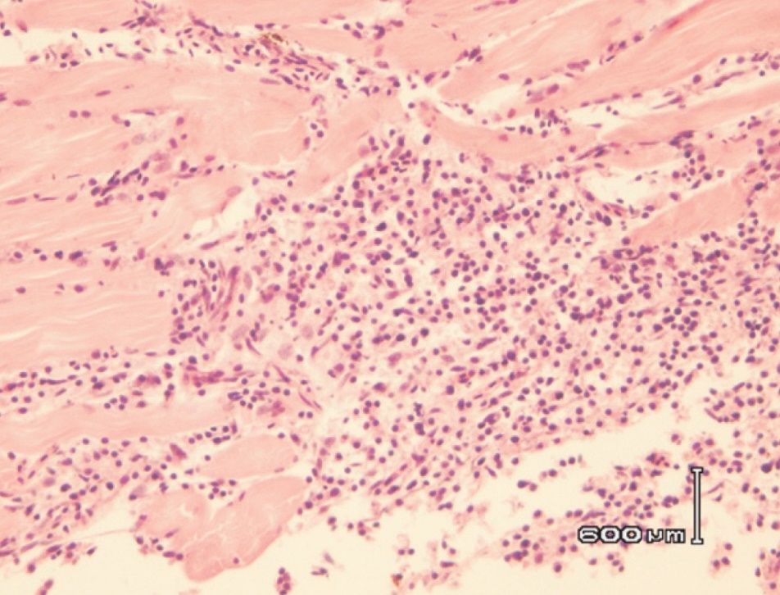
Note: Necrotising myositis in the skeletal muscle. Scale bar = 600µm.
Source: G Storie and H Prior
Figure 69 Histopathological section of head of channel catfish (Ictalurus punctatus) with enteric septicaemia of catfish
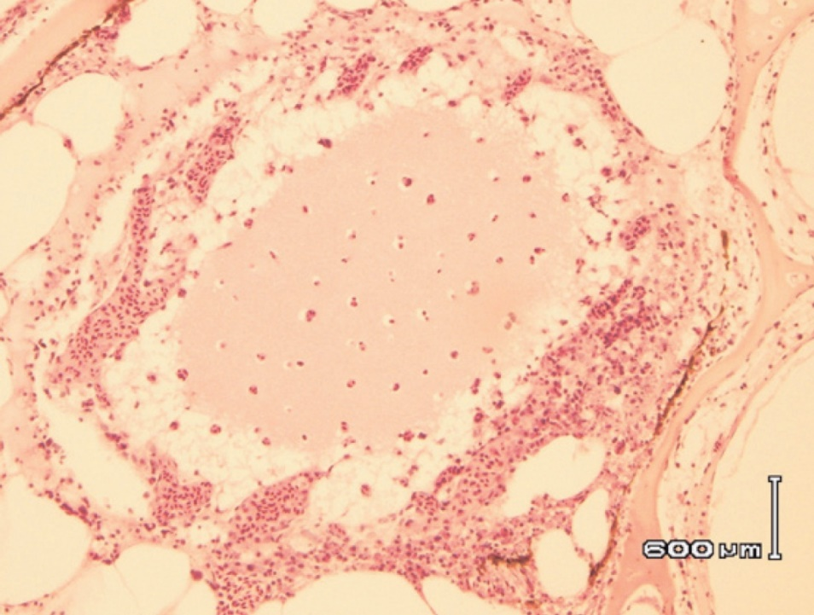
Note: Locally extensive cellulitis involving connective tissue surrounding cranial bones and cartilage. Scale bar = 600µm.
Source: G Storie and H Prior
Figure 70 Gram staining of histopathological section from kidney of channel catfish (Ictalurus punctatus) with enteric septicaemia of catfish
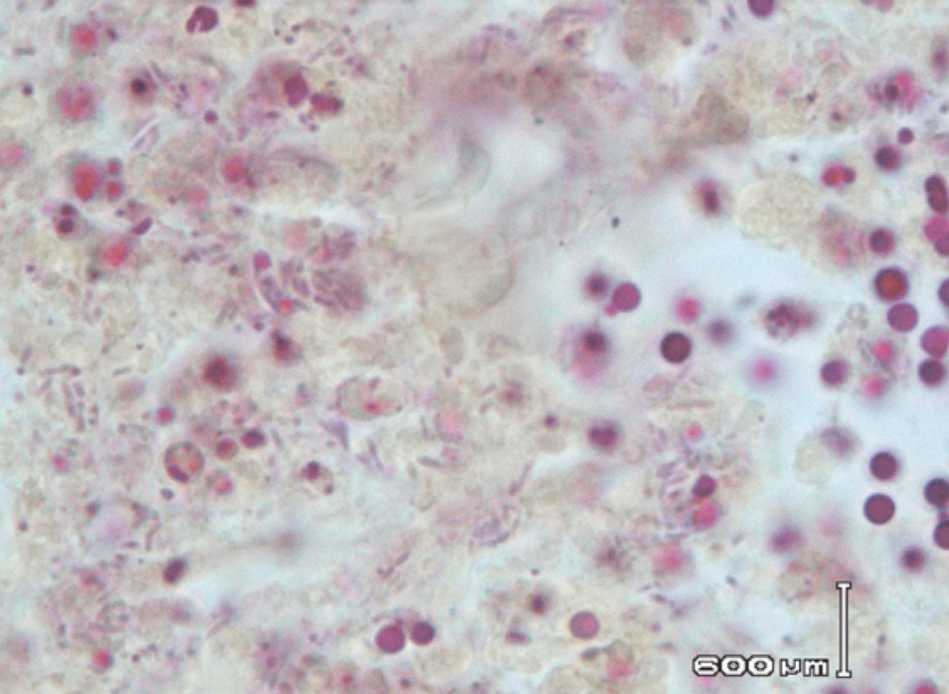
Note: Gram-negative rods are Edwardsiella ictaluri. Scale bar = 600µm.
Source: G Storie and H Prior
Figure 71 Gram staining of histopathological section from skeletal muscle of channel catfish (Ictalurus punctatus) with enteric septicaemia of catfish
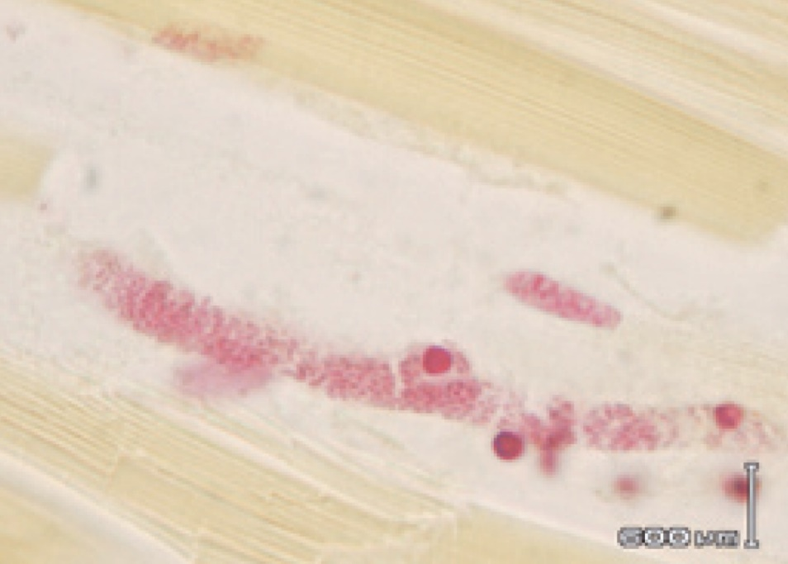
Note: Gram-negative rods of Edwardsiella ictaluri. Scale bar = 600µm.
Source: G Storie and H Prior

Further reading
CABI Invasive Species Compendium Enteric septicaemia of catfish
CEFAS International Database on Aquatic Animal Diseases Enteric Septicaemia of Catfish (Edwardsiellosis)

Furunculosis
Also known as infection with Aeromonas salmonicida subsp. salmonicida
Exotic disease
Figure 72 Furunculosis in Atlantic salmon (Salmo salar)
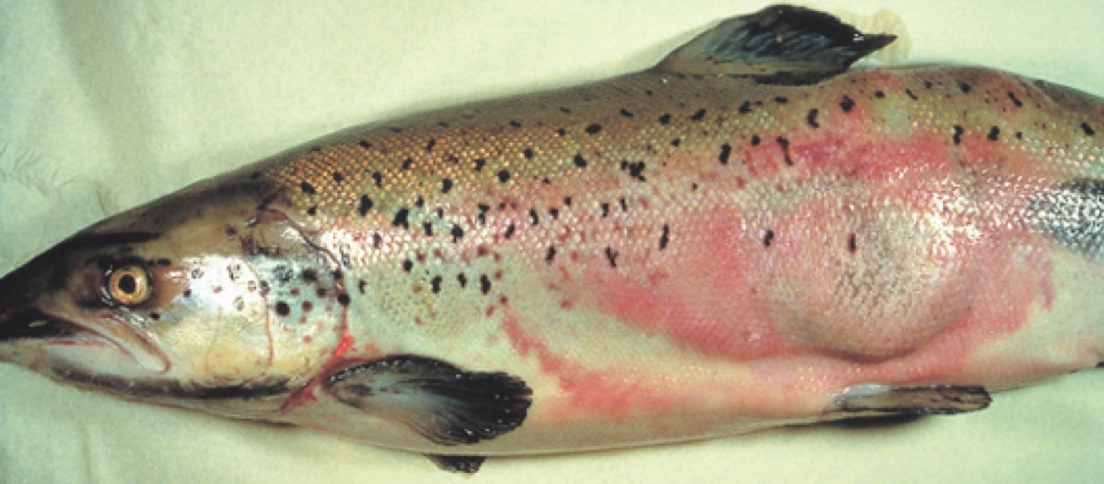
Note: Large furuncle (boil) on side of fish.
Source: T Håstein
Figure 73 Atlantic salmon (Salmo salar) with furunculosis boil exposed below the surface of the skin
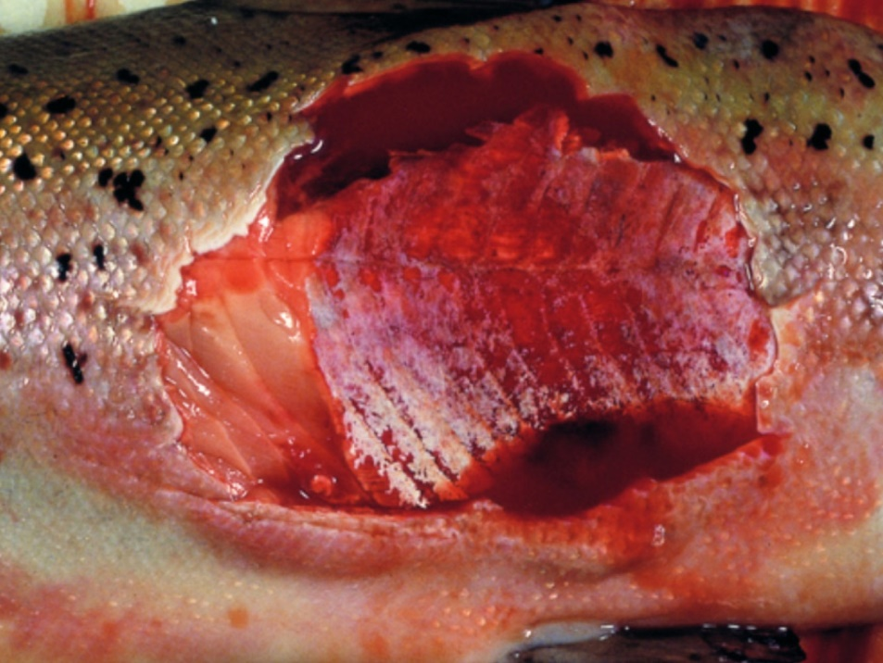
Note: Furuncle has been cut away to show underlying necrotic tissue.
Source: T Håstein

Signs of disease
Important: Animals with this disease may show one or more of these signs, but the pathogen may still be present in the absence of any signs.
Disease signs at the farm, tank or pond level are:
- sudden death, perhaps with slight exophthalmos (popeye)
- often no clinical signs in young fish with peracute form of the disease
- death within days of initial clinical signs of disease in growing fish with acute furunculosis
- high mortality
- lethargic swimming or swimming just below the surface
- loss of appetite
- respiratory distress and jumping from the water immediately before an outbreak.
Gross pathological signs are:
- furuncles (boils) involving skin and/or muscle, progressing to crater lesions (usually restricted to the subacute or chronic phase in adult salmon)
- haemorrhages on the skin, mouth and fin bases (mainly of paired fins)
- darkening of body colour and pale gills
- bloody discharge from nares and/or vent
- exophthalmos (popeye)
- haemorrhages in muscle and internal organs
- enlarged spleen and focal necrosis of the liver
- stomach filled with mucus, blood and sloughed epithelial cells
- congested intestine
- death without any clinical signs other than darkening of the skin (occurs only in peracute infections in juvenile salmon).
Microscopic pathological signs are:
- fusion of gill lamellae, with necrosis of the epithelium
- eosinophilic inflammatory changes in gills
- bacterial colonies in many tissues
- sloughing of renal tubular cells into the renal tubular lumen
- sloughing of intestinal epithelial cells into the intestinal lumen.

Disease agent
Furunculosisis caused by infection with the bacterium Aeromonas salmonicida subsp. salmonicida, a member of the family Enterobacteriaceae. The bacterium is intracellular and so may avoid some host immune defences after infection. During infection, the bacterium produces extracellular toxins that may play a significant role in the pathogenesis of the disease. There are four other subspecies of A. salmonicida; these ‘atypical’ strains are considered to cause a different disease syndrome, infection with Aeromonas salmonicida—atypical strains, which is also discussed in this guide.

Host range
All salmonids and eels are believed to be susceptible to A. salmonicida subsp. salmonicida. Species known to be susceptible are listed in Table 32. The bacterium has also been isolated from sea lice infecting lesions on fish and can be spread by piscivorous birds.
Table 32 Species known to be susceptible to Aeromonas salmonicida subsp. salmonicida
Common name | Scientific name
Amago salmonª | Oncorhynchus rhodurus
American eelª | Anguilla rostrata
Arctic char | Salvelinus alpinus
Atlantic codª | Gadus morhua
Atlantic salmonª | Salmo salar
Atlantic wolfishª | Anarhichas lupus
Ayu | Plecoglossus altivelis
Black sea salmon | Salmo labrax
Brook troutª | Salvelinus fontinalis
Brown troutª | Salmo trutta
Bull trout | Salvelinus confluentus
Bullhead | Cottus gobio
Chinook salmon | Oncorhynchus tshawytscha
Chum salmon | Oncorhynchus keta
Cisco | Coregonus artedi
Coho salmon | Oncorhynchus kisutch
Common shiner | Luxilus cornutus
Cutthroat trout | Oncorhynchus clarkii
Danube salmon | Hucho hucho
Eels | Anguillidae all species
European eel | Anguilla anguilla
Galaxiids | Galaxiidae all species
Gila trout | Oncorhynchus gilae
Gilt-head sea bream | Sparus aurata
Golden trout | Oncorhynchus aguabonita
Grayling | Thymallus thymallus
Hybrid (rainbow trout × coho salmon) | Oncorhynchus mykiss × O. kisutch
Japanese eel | Anguilla japonica
Lake trout | Salvelinus namaycush
Lake whitefish | Coregonus clupeaformis
Masu salmon | Oncorhynchus masou
Mountain whitefish | Prosopium williamsoni
Pacific halibutª | Hippoglossus stenolepis
Pacific salmonª | Oncorhynchus spp.
Pike | Esox lucius
Pike perch | Sander lucioperca
Pink salmonª | Oncorhynchus gorbuscha
Rainbow troutª | Oncorhynchus mykiss
Salmonids (all presumed susceptible)ª | Salmonidae all species
Sea lampreyª | Petromyzon marinus
Shortfin eel | Anguilla australis
Sockeye salmonª | Oncorhynchus nerka
Splake (lake trout × brook trout) | Salvelinus namaycush × S. fontinalis
Turbot | Scophthalmus maximus
Whitefish (Muksun) | Coregonus muksun
Whitefish (Peled) | Coregonus peled
Whitespotted char | Salvelinus leucomaenis
Wrasses | Labridae all species
a Naturally susceptible. Note: Other species likely to be susceptible or shown to be experimentally susceptible.
Table 33 Non-fish carriers
Common name | Scientific name
Salmon louse A (Lepeophtheirus spp.) | Lepeophtheirus salmonis
Salmon louse B (Caligus spp.) | Caligus elongatus
Piscivorous birds | Various genera and species

Presence in Australia
Exotic disease—not recorded in Australia.
The strain of Aeromonas causing furunculosis in salmonids overseas (typical strain) is not present in Australia. However, atypical strains are present (see Infection with Aeromonas salmonicida—atypical strains).
Map 19 Presence of furunculosis, by jurisdiction

Epidemiology
- Furunculosis is highly contagious and affects fish of all ages.
- The disease is one of the most commercially significant salmonid diseases, occurring in freshwater and marine salmonid aquaculture in all countries except Australia and New Zealand.
- Overseas, this disease must be controlled on farms by medication or vaccination.
- Outbreaks typically occur at temperatures above 10°C. However outbreaks can occur in very young fish and at temperatures as low as 2 to 4°C. Disease may be precipitated by endogenous stressors (such as smoltification or spawning) and exogenous stressors (such as temperature fluctuations or poor water quality).
- Australia's relatively warm water temperatures may favour the establishment of A. salmonicida subsp. salmonicida.
- Rainbow trout are relatively resistant to the disease, but are still considered susceptible.
- Horizontal transmission occurs via the water column, but also through direct fish-to-fish contact and animal vectors (birds and invertebrates such as sea lice).
- Aeromonas salmonicida subsp. salmonicida has been detected on the surface of fertilised eggs. Surface decontamination using iodine is effective in preventing vertical transmission (passage of infection from parent to offspring).
- Aeromonas salmonicida subsp. salmonicida can survive for months in some environments.
- Non-salmonids may become infected by ingesting tissue of infected salmonids. Transmission to non-salmonids can occur where fish caught for feed are taken from waters near an outbreak.
- Susceptibility to the disease increases with damaged mucous and skin, such as occurs when fish are handled with nets.
- Fish surviving disease outbreaks are recognised as carriers of the disease. Carriers may continue to infect the remaining population without themselves showing any outward signs of infection. Stress may precipitate disease in subclinical carriers.

Differential diagnosis
The list of similar diseases in the next section refers only to the diseases covered by this field guide. Gross pathological signs may also be representative of diseases not included in this guide. Do not rely on gross signs to provide a definitive diagnosis. Use them as a tool to help identify the listed diseases that most closely account for the observed signs.

Similar diseases
Epizootic haematopoietic necrosis (EHN), infection with Aeromonas salmonicida—atypical strains and infectious haematopoietic necrosis (IHN).

Sample collection
Only trained personnel should collect samples. Using only gross pathological signs to differentiate between diseases is not reliable, and some aquatic animal disease agents pose a risk to humans. If you are not appropriately trained, phone your state or territory hotline number and report your observations. If you have to collect samples, the agency taking your call will advise you on the appropriate course of action. Local or district fisheries or veterinary authorities may also advise on sampling.

Emergency disease hotline
See something you think is this disease? Report it. Even if you’re not sure.
Call the Emergency Animal Disease Watch Hotline on 1800 675 888. They will refer you to the right state or territory agency.

Further reading
CEFAS International Database on Aquatic Animal Diseases Furunculosis
Department of Agriculture, Water and the Environment AQUAVETPLAN disease strategy manual: Furunculosis

Infection with Aeromonas salmonicida—atypical strains
Also known as infection with atypical strains of Aeromonas salmonicida, marine aeromonad disease of salmonids (MAS), goldfish ulcer disease, carp erythrodermatitis and ulcer disease of flounder, eel and salmon
Figure 74 Goldfish ulcer disease in goldfish (Carassius auratus)
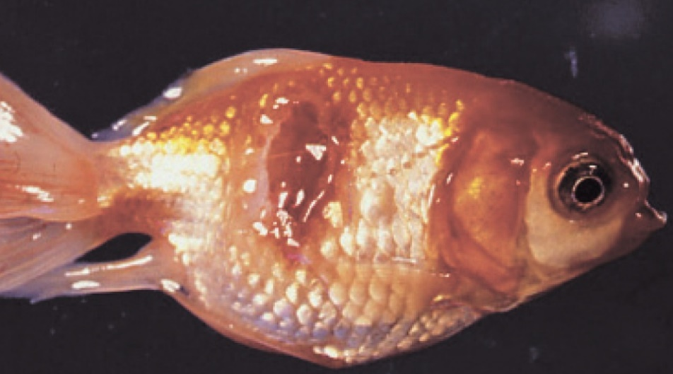
Note: Characteristic ulcers on the body.
Source: J Carson
Figure 75 Greenback flounder (Rhombosolea tapirina) infected with greenback flounder strain of Aeromonas salmonicida
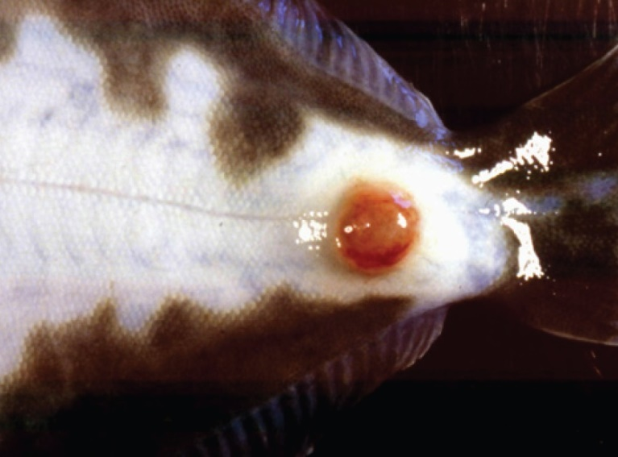
Note: Ulcer on ventral side of body.
Source: J Carson.
Figure 76 Infection with atypical Aeromonas salmonicida in silver perch (Bidyanus bidyanus)
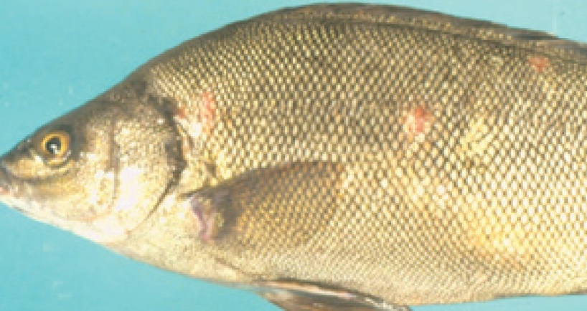
Note: Ulcers on body.
Source: M Landos
Figure 77 Infection with Aeromonas salmonicida biovar Acheron in Atlantic salmon (Salmo salar)
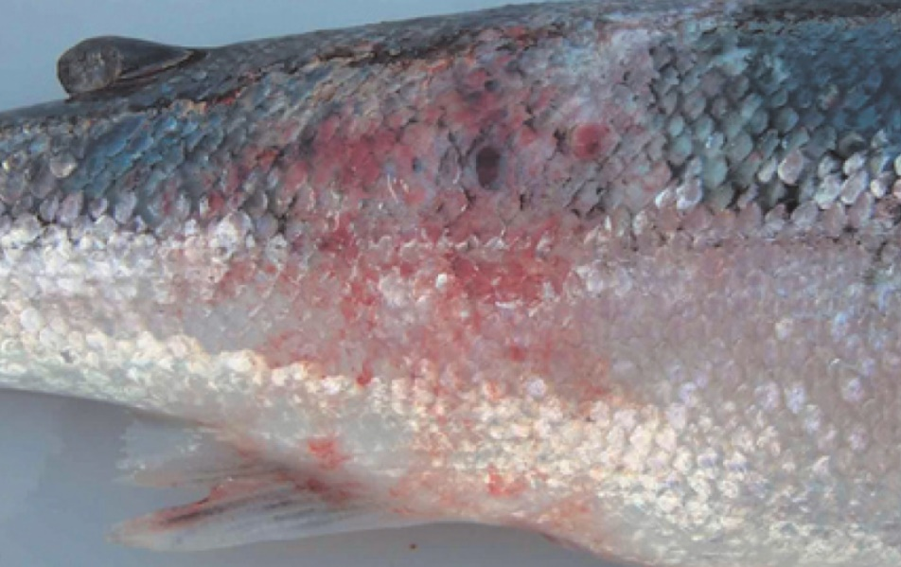
Note: Haemorrhagic lesion on the flank typical of MAS.
Source: K Ellard
Figure 78 Atlantic salmon (Salmo salar) with blood filled MAS ulcerations
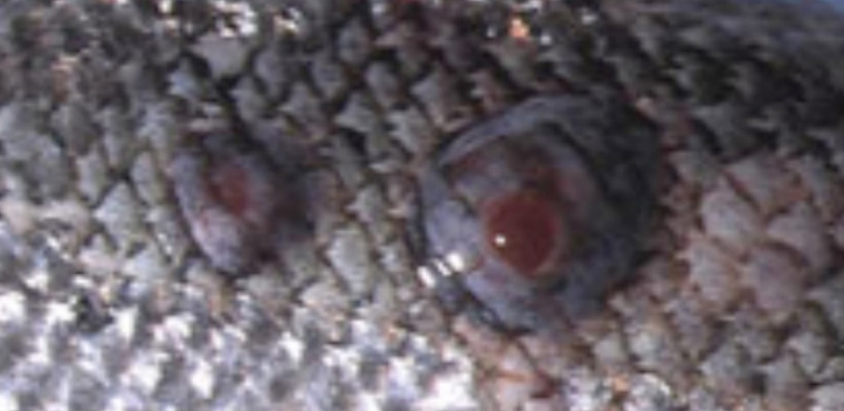
Note Blood-filled furuncles in MAS are rarely noted, because they rupture easily.
Source: K Ellard
Figure 79 Atlantic salmon (Salmo salar) with MAS ulcer exposed below the surface of the skin
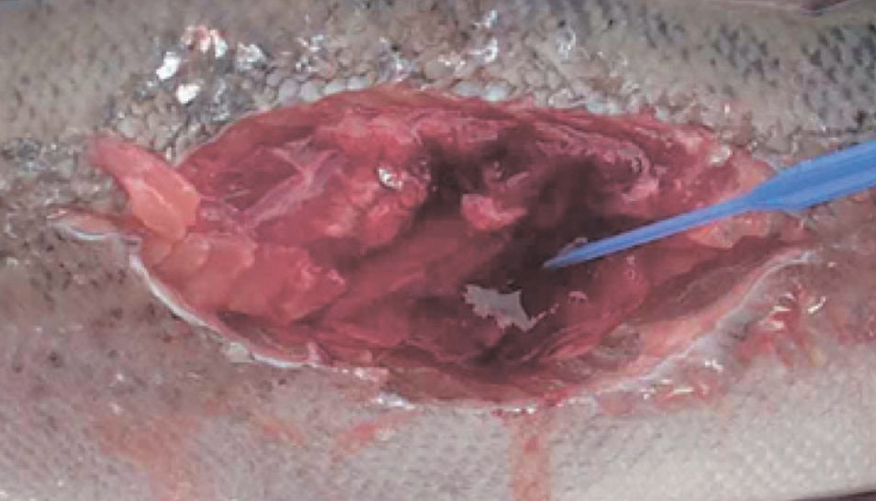
Note: The MAS lesion extends into the underlying muscle.
Source: K Ellard
Figure 80 Atlantic salmon (Salmo salar) infected with greenback flounder strain of atypical A. salmonicida after cohabitation with infected flounder
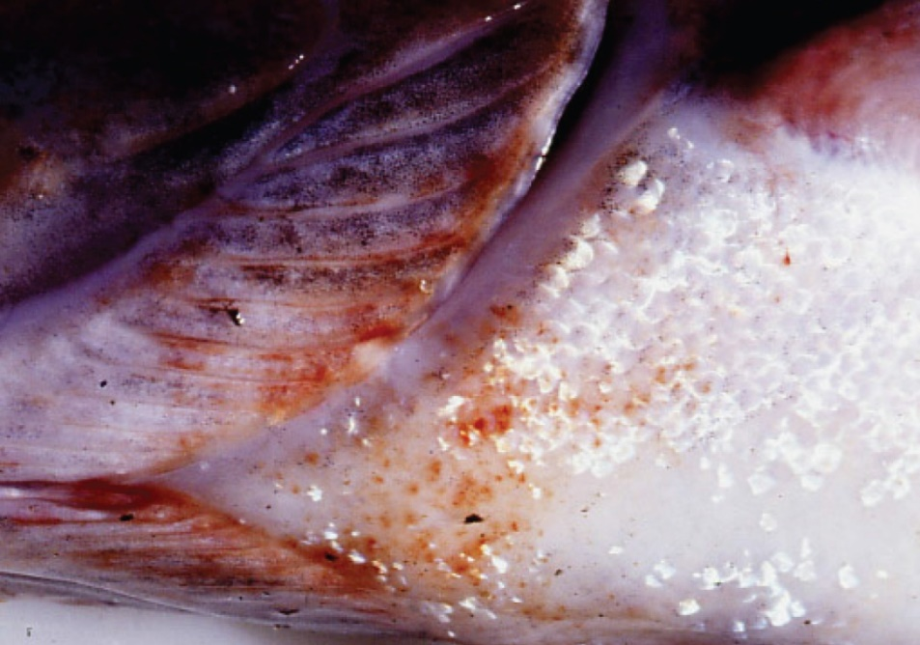
Note: Haemorrhagic lesions around the isthmus and branchiostegal membranes.
Source: J Carson

Signs of disease
Important: Animals with this disease may show one or more of these signs, but the pathogen may still be present in the absence of any signs.
Disease signs at the farm, tank or pond level are:
- lethargic swimming
- abnormal swimming and disorientation
- loss of appetite
- increased mortality.
Gross pathological signs are:
- white raised patches on the skin that progress to ragged-edged red ulcers
- haemorrhages on the skin and fin bases (usually the paired fins)
- fingernail-sized ulcers found anywhere on the fish, most often on the upper side of the lateral line behind the head or at the base of the tail fin
- pale gills with petechial (pinpoint) haemorrhages
- intestinal protrusion through the abdominal wall following severe ulceration
- haemorrhages in muscle and internal organs
- swollen kidneys and spleen.
Microscopic pathological signs are:
- hyperplasia of the gills, which may contain bacterial colonies
- ulcerated areas that show oedema, hyperaemia, leukocyte infiltration and considerable degenerative changes
- hyperaemia and haemorrhage in the spleen and kidneys
- fibroblast-like cells, which may produce granulomas in the dermis, spleen and kidney.

Disease agent
Atypical strains of the Aeromonas salmonicida bacterium within the family Enterobacteriaceae differ from the typical strain causing furunculosis in salmonids. Atypical strains affect mainly non-salmonids (wild and cultured, marine and freshwater). Infection with atypical A. salmonicida does not necessarily result in the acute mortality and septicaemia that are characteristic of the typical furunculosis strain, but manifests more as external lesions and ulceration, often involving secondary infection. An exception is MAS in Tasmania; in such cases, Atlantic salmon are most commonly affected, and clinical presentation is similar to furunculosis.
There are five subspecies of A. salmonicida. A. salmonicida salmonicida is known as the typical strain and is the only one to cause furunculosis (listed separately in this guide). The other four subspecies (achromogenes, masoucida, smithia and pectinolytica) are referred to as atypical A. salmonicida and are recognised worldwide. All except A. salmonicida pectinolytica cause disease in fish.
A. salmonicida biovar Acheron is a new atypical strain recently described in Australia (Tasmania), causing MAS in Atlantic salmon.

Host range
Laboratory experiments indicate that all trout and salmon species, as well as many non-salmonids, are potentially susceptible to atypical strains of A. salmonicida. For example, Atlantic salmon and striped trumpeter can be infected by cohabitation with infected flounder.
Rainbow trout are relatively resistant to atypical strains.
Table 34 Species known to be susceptible to atypical strains of Aeromonas salmonicida
Common name | Scientific name
Amago salmonª | Oncorhynchus rhodurus
American eelª | Anguilla rostrata
American plaice | Hippoglossoides platessoides
Arctic char | Salvelinus alpinus
Atlantic codª | Gadus morhua
Atlantic herringª | Clupea harengus
Atlantic salmonª | Salmo salar
Ayu | Plecoglossus altivelis
Black sea salmon | Salmo labrax
Black rockfishª | Sebastes schlegelii
Brook troutª | Salvelinus fontinalis
Brown troutª | Salmo trutta
Bull trout | Salvelinus confluentus
Chubª | Leuciscus cephalus
Chinook salmon | Oncorhynchus tshawytscha
Chum salmonª | Oncorhynchus keta
Coho salmon | Oncorhynchus kisutch
Common carp and koi carpª | Cyprinus carpio
Common roachª | Rutilus rutilus
Crucian carpª | Carassius carassius
Cutthroat trout | Oncorhynchus clarkii
Dabª | Limanda limanda
Daceª | Leuciscus leuciscus
Danube salmon | Hucho hucho
Eels | Anguillidae all species
European eel | Anguilla anguilla
Flounderª | Platichthys flesus
Fourbeard rocklingª | Enchelyopus cimbrius
Freshwater breamª | Abramis brama
Gila trout | Oncorhynchus gilae
Golden trout | Oncorhynchus aguabonita
Goldfishª | Carassius auratus
Goldsinnyª | Ctenolabrus rupestris
Graylingª | Thymallus thymallus
Great sandeelª | Hyperoplus lanceolatus
Greenback flounderª | Rhombosolea tapirina
Haddockª | Melanogrammus aeglefinus
Hybrid (rainbow trout × coho salmon) | Oncorhynchus mykiss × O. kisutch
Japanese eel | Anguilla japonica
Japanese flounderª | Paralichthys olivaceus
Lake trout | Salvelinus namaycush
Lake whitefish | Coregonus clupeaformis
Lesser sand eel | Ammodytes tobianus
Masu salmonª | Oncorhynchus masou
Minnowª | Phoxinus phoxinus
Pacific halibutª | Hippoglossus stenolepis
Pacific salmonª | Oncorhynchus spp.
Pike | Esox lucius
Pink salmon | Oncorhynchus gorbuscha
Plaiceª | Pleuronectes platessa
Rainbow troutª | Oncorhynchus mykiss
Redfin or European perch | Perca fluviatilis
Ruddª | Scardinius erythrophthalmus
Sablefish | Anoplopoma fimbria
Salmonids (all presumed susceptible)ª | Salmonidae all species
Shortfin eel | Anguilla australis
Shotted halibutª | Eopsetta grigorjewi
Shubunkinª | Carassius sp.
Silver breamª | Blicca bjoerkna
Silver perchª | Bidyanus bidyanus
Smallmouth bassª | Micropterus dolomieu
Sockeye salmonª | Oncorhynchus nerka
Splake (lake trout × brook trout) | Salvelinus namaycush × S. fontinalis
Spotted wolfishª | Anarhichas minor
Striped trumpeterª | Latris lineata
Tomcodª | Gadus microgadus
Turbotª | Scophthalmus maximus
Viviparous blennyª | Zoarces viviparus
Whitefish (Muksun) | Coregonus muksun
Whitefish (Peled) | Coregonus peled
Whitefish | Coregonus spp.
Whitespotted char | Salvelinus leucomaenis
Whitingª | Merlangius merlangus
Wrasseª | Labrus bergylta
Wrasses | Labridae all species
Yellow bassª | Morone mississippiensis
a Naturally susceptible. Note: Other species likely to be susceptible.

Presence in Australia
Atypical A. salmonicida has been officially reported from New South Wales, Queensland, South Australia, Victoria (goldfish ulcer disease only) and Tasmania (greenback flounder biovar and Acheron biovar only). Movement controls are in place to prevent the spread of goldfish ulcer disease to Western Australia and Tasmania. The Acheron biovar has been reported only from Tasmania and is limited to an isolated production area.
Map 20 Presence of atypical strains of Aeromonas salmonicida, by jurisdiction
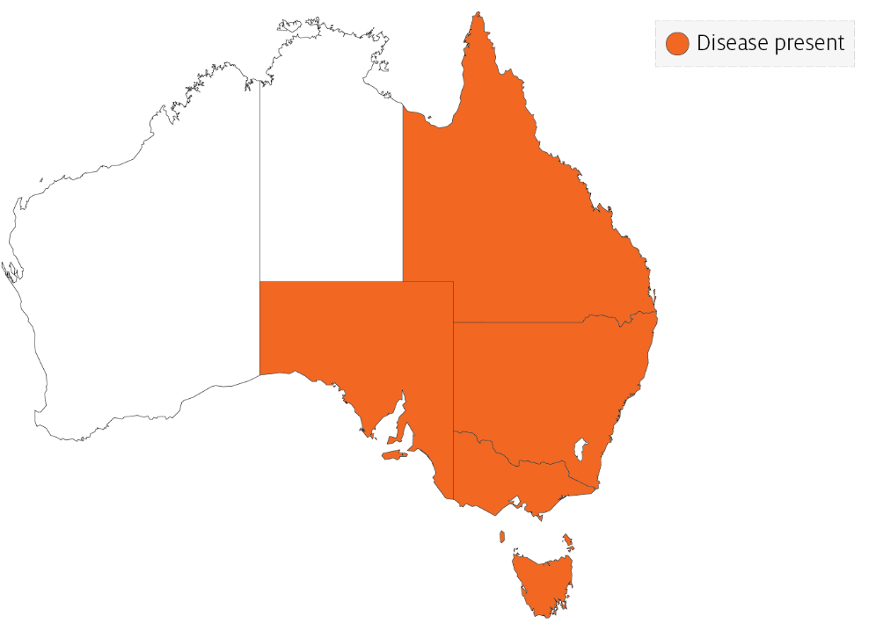

Epidemiology
- Transmission occurs horizontally (between fish via the water).
- Susceptibility to the disease increases with damaged mucus and skin, which occurs when fish are handled with nets.
- Outbreaks are expected to occur at water temperatures above 10°C (summer months in southern waters of Australia) and may be precipitated by stress (such as handling, overpopulation and rapid temperature fluctuations).
- Secondary infection with other bacteria often occurs.
- Fish that survive disease outbreaks are recognised as carriers of the disease. Carriers may continue to infect the remaining population without themselves exhibiting signs of infection.
- Diagnosis based on clinical or external signs of disease is difficult because clinical signs vary and skin ulcers are often infected with opportunistic bacteria and fungi. A definitive diagnosis requires laboratory examination.

Differential diagnosis
The list of similar diseases in the next section refers only to the diseases covered by this field guide. Gross pathological signs may also be representative of diseases not included in this guide. Do not rely on gross signs to provide a definitive diagnosis. Use them as a tool to help identify the listed diseases that most closely account for the observed signs.

Similar diseases
Channel catfish virus disease (CCVD), furunculosis, infection with Aphanomyces invadans (EUS), koi herpesvirus disease (KHV) and spring viraemia of carp (SVC).

Sample collection
Only trained personnel should collect samples. Using only gross pathological signs to differentiate between diseases is not reliable, and some aquatic animal disease agents pose a risk to humans. If you are not appropriately trained, phone your state or territory hotline number and report your observations. If you have to collect samples, the agency taking your call will advise you on the appropriate course of action. Local or district fisheries or veterinary authorities may also advise on sampling.

Emergency disease hotline
See something you think is this disease? Report it. Even if you’re not sure.
Call the Emergency Animal Disease Watch Hotline on 1800 675 888. They will refer you to the right state or territory agency.

Further reading
Menanteau-Ledouble S, Kumar G, Saleh M, El-Matbouli M 2016, ‘Aeromonas salmonicida’: updates on an old acquaintance, Diseases of Aquatic Organisms
Whittington RJ, Djordjevic SP, Carson J, Callinan RB 1995, Restriction endonuclease analysis of atypical ‘Aeromonas salmonicida’ isolates from goldfish ‘Carassius auratus’, silver perch ‘Bidyanus bidyanus’, and greenback flounder ‘Rhombosolea tapirina’ in Australia, Diseases of Aquatic Organisms

Piscirickettsiosis
Also known as infection with Piscirickettsia salmonis, salmonid rickettsial septicaemia
Exotic disease
Figure 81 Piscirickettsiosis in Atlantic salmon (Salmo salar)
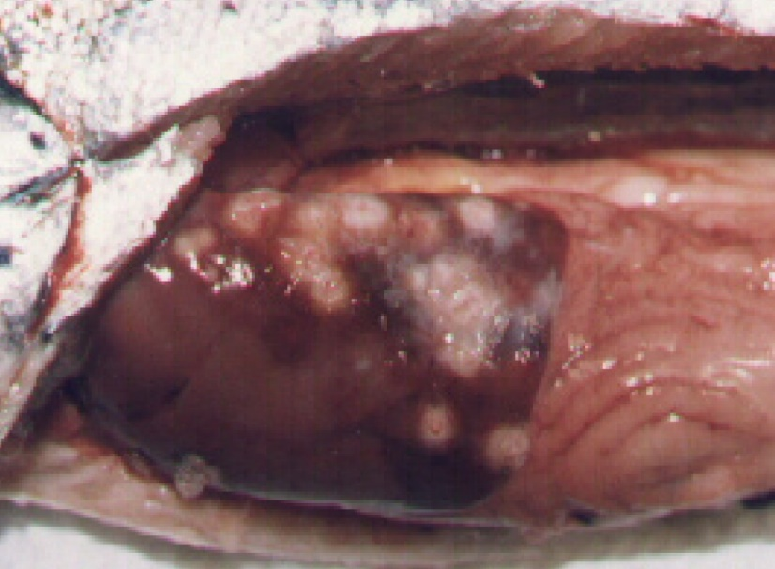
Note: Pale circular granulomas in liver and pinpoint haemorrhaging in pyloric caeca.
Source: S Bravo

Signs of disease
Important: Animals with this disease may show one or more of these signs, but the pathogen may still be present in the absence of any signs.
Disease signs at the farm, tank or pond level are:
- increased mortality
- loss of appetite
- emaciation
- lethargic swimming
- circling
- swimming near the surface or at the sides of the net or pens.
Gross pathological signs are:
- progressive skin lesions that range from areas of raised scales, to white raised plaques, to shallow ulcers on flanks and head
- darkening of skin and pale gills
- swollen abdomen
- grey, swollen spleen and kidney
- mottled liver (due to diffuse haemorrhages) or ring-shaped white to pale-yellow lesions (granulomas and areas of necrosis)
- ascites (fluid in the abdominal cavity)
- signs of peritonitis, including generalised diffuse inflammation of abdominal organs, adhesions and increased volume of free abdominal fluid
- petechial (pinpoint) haemorrhages of the gastrointestinal tract, swim bladder and visceral fat.
Microscopic pathological signs are:
- vasculitis and necrosis of the liver and kidney; inflammatory macrophage infiltration
- Rickettsia-like organisms in macrophages and epithelial cells.

Disease agent
Piscirickettsiosis (also known as salmonid rickettsial septicaemia) is caused by infection with the bacterium Piscirickettsia salmonis, a member of the gammaproteobacteria, family Piscirickettsiaceae.

Host range
Table 35 Species known to be susceptible to piscirickettsiosis
Common name | Scientific name
Atlantic salmonª | Salmo salar
Black spot grouper | Epinephelus melanostigma
Chinook salmonª | Oncorhynchus tshawytscha
Coho salmonª | Oncorhynchus kisutch (most susceptible)
European seabassª | Dicentrarchus labrax
Masu salmonª | Oncorhynchus masou
Muskellunge | Esox masquinongy
Pink salmonª | Oncorhynchus gorbuscha
Rainbow troutª | Oncorhynchus mykiss
Tilapias | Various genera and species
White seabass | Atractoscion nobilis
Yellow perch | Perca flavescens
a Susceptible to infection by Piscirickettsia salmonis. Note: Other species listed are infected by Piscirickettsia-like organisms.

Presence in Australia
Exotic disease—not recorded in Australia.
Piscirickettsiosis caused by P. salmonis has never been recorded in Australia and is considered exotic. However, Atlantic salmon cultured in seacages in Tasmania have been infected by a Piscirickettsia-like organism (Tas-RLO).
Map 21 Presence of Piscirickettsia salmonis, by jurisdiction

Epidemiology
- Salmonid rickettsial septicaemia describes diseases of salmonids caused by Rickettsia-like organisms, including P. salmonis. Piscirickettsiosis refers to the disease specifically caused by the bacterium P. salmonis. Related Piscirickettsia-like organisms can infect and cause disease in a range of fish species including cultured salmonids in Australia and New Zealand, tilapias cultured in waters up to 26°C in several countries, and white seabass and muskellunge in the USA.
- Outbreaks usually occur after fish are introduced to saltwater pens at water temperatures between 12°C and 18°C.
- Transmission is mainly horizontal (fish to fish). However, P. salmonis has been isolated from the reproductive organs of salmonids, and vertical transmission may explain outbreaks of this disease in freshwater areas following return of adult salmon from the sea to spawn.
- Bacteria are assumed to gain entry by breaching the physical barriers of the skin or gills. The invading bacteria then spread throughout the body via the blood (haematogenous spread), resulting in septicaemia.
- Mortality rates typically range between 10% and 30%, but have been recorded at 90% in seawater-raised coho salmon from Chile.

Differential diagnosis
The list of similar diseases in the next section refers only to the diseases covered by this field guide. Gross pathological signs may also be representative of diseases not included in this guide. Do not rely on gross signs to provide a definitive diagnosis. Use them as a tool to help identify the listed diseases that most closely account for the observed signs.

Similar diseases
Bacterial kidney disease (BKD) and infection with HPR-deleted or HPR0 infectious salmon anaemia virus.

Sample collection
Only trained personnel should collect samples. Using only gross pathological signs to differentiate between diseases is not reliable, and some aquatic animal disease agents pose a risk to humans. If you are not appropriately trained, phone your state or territory hotline number and report your observations. If you have to collect samples, the agency taking your call will advise you on the appropriate course of action. Local or district fisheries or veterinary authorities may also advise on sampling.

Emergency disease hotline
See something you think is this disease? Report it. Even if you’re not sure.
Call the Emergency Animal Disease Watch Hotline on 1800 675 888. They will refer you to the right state or territory agency.

Microscope images
Figure 82 Piscirickettsiosis in Atlantic salmon (Salmo salar)
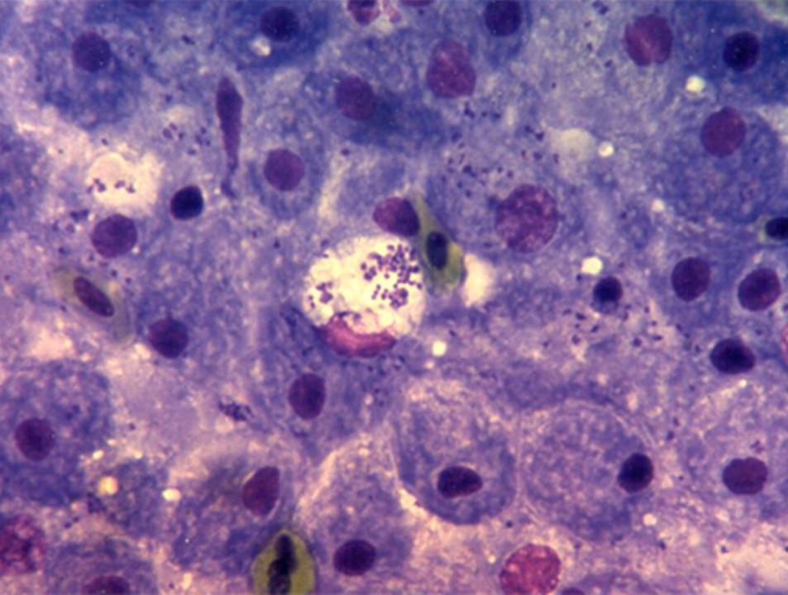
Note: Many bacteria (P. salmonis) evident in the tissue imprint.
Source: European Association of Fish Pathologists
Figure 83 Stained blood smear from Atlantic salmon (Salmo salar) with piscirickettsiosis
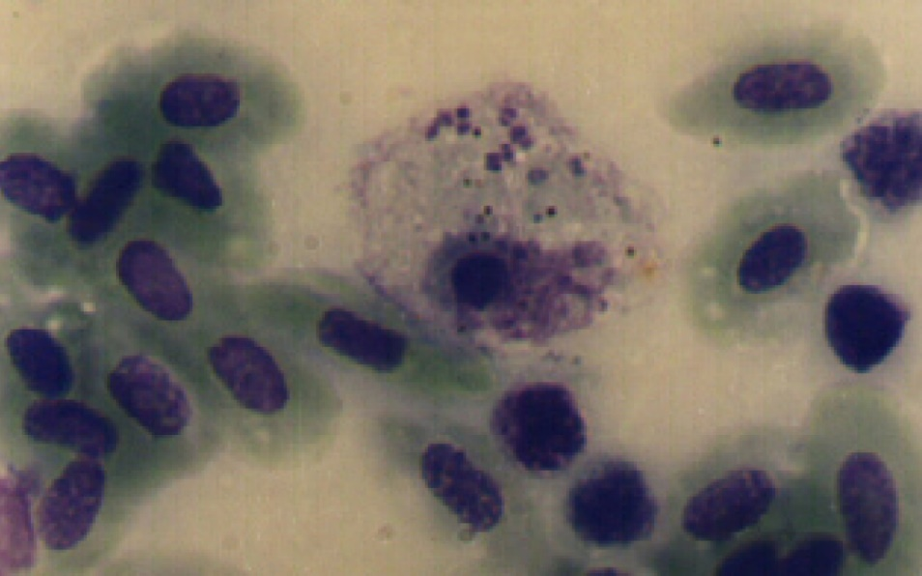
Note: Several P. salmonis bacteria evident in the cytoplasm of an inflammatory cell.
Source: S Bravo
Figure 84 Stained blood smear from Atlantic salmon (Salmo salar) with piscirickettsiosis
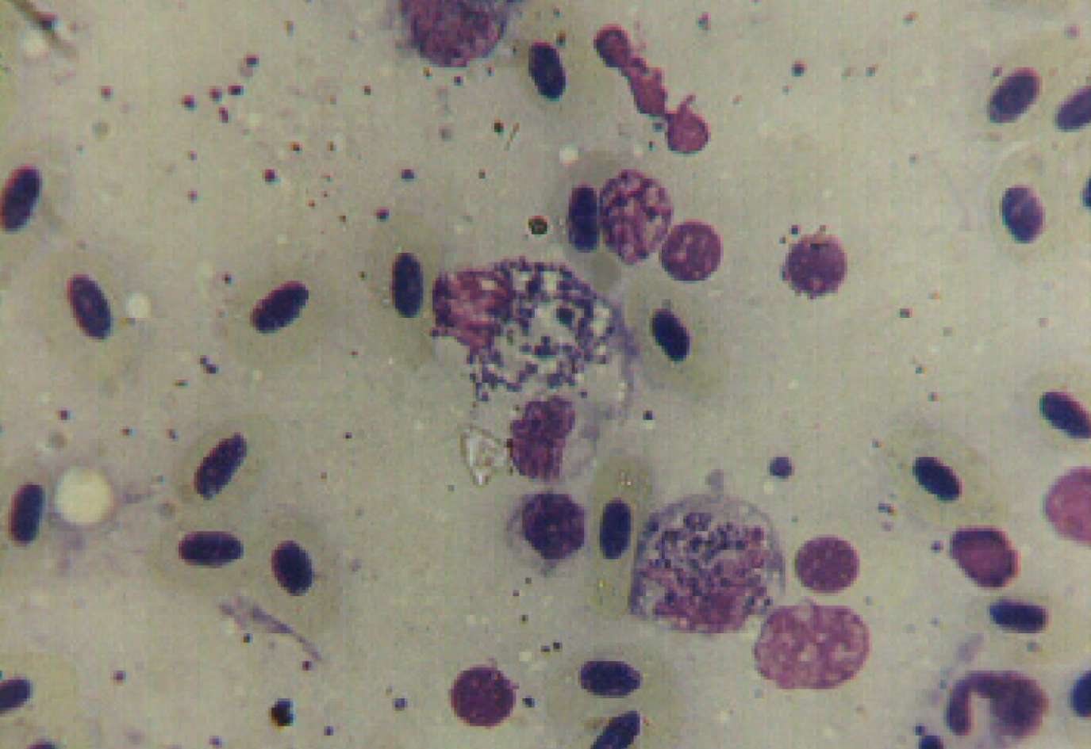
Note: Large numbers of P. salmonis evident within several inflammatory cells.
Source: S Bravo

Further reading
CABI Invasive Species Compendium Piscirickettsiosis
CEFAS International Database on Aquatic Animal Diseases Piscirickettsiosis
Department of Agriculture, Water and the Environment AQUAVETPLAN disease strategy manual: Piscirickettsiosis

Parasitic diseases of finfish

Infection with Gyrodactylus salaris
Also known as gyrodactylosis
Exotic disease
Figure 85 Juvenile Atlantic salmon (Salmo salar) infected with Gyrodactylus salaris
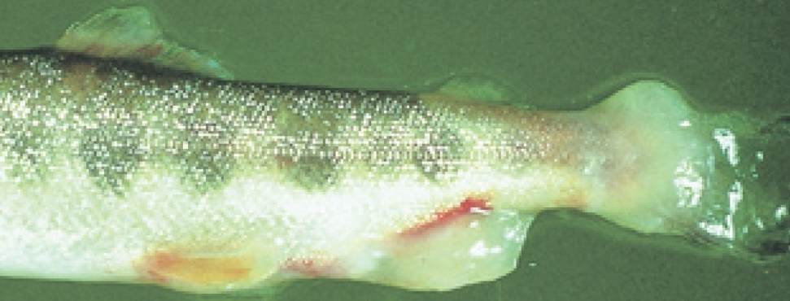
Note: Excessive mucous and peeling of skin, especially around the tail.
Source: T Håstein

Signs of disease
Important: Animals with this disease may show one or more of these signs, but the pathogen may still be present in the absence of any signs.
Disease signs at the farm, tank or pond level are:
- lethargy
- high mortality in Atlantic salmon (Salmo salar)
- scrubbing (rubbing against objects in response to skin irritation) and flashing (darting and twisting of fish and erratic swimming)
- gathering in low-current waters when heavily infected.
Gross pathological signs are:
- ulcers
- sloughing of the skin
- greyish appearance; as disease progresses, dorsal and pectoral fins may have a whitish appearance due to thickening of the epidermis
- excess mucus on skin
- frayed fins.
There are no definitive microscopic pathological signs. Most waters have many types of monogenean flukes that are parasitic on fish gills and skin. Any evidence of infestation with these parasites beyond what is visible to the naked eye requires identification by a parasitologist experienced in identifying Gyrodactylus species.

Disease agent
Gyrodactylosis is caused by infection with Gyrodactylus salaris, an obligate freshwater ectoparasitic flatworm (Platyhelminthes) belonging to the family Gyrodactylidae (class Monogenea). G. salaris occurs in Europe, mainly around the Baltic Sea and Norway.

Host range
All species of salmonids should be considered potentially susceptible to infection by G. salaris, unless future testing suggests otherwise.
Table 36 Species known to be naturally susceptible to Gyrodactylus salaris
Common name | Scientific name
Arctic char | Salvelinus alpinus
Atlantic salmon | Salmo salar
Brook trout | Salvelinus fontinalis
Brown troutª | Salmo trutta
Grayling | Thymallus thymallus
Lake trout | Salvelinus namaycush
Rainbow trout | Oncorhynchus mykiss
Salmonids (all presumed susceptible) | Salmonidae, all species
a Susceptibility of brown trout is very low; G. salaris will usually only establish in a brown trout population co-existing with infected salmonids. Note: Other species not listed have been shown to be experimentally susceptible.

Presence in Australia
Exotic disease—not recorded in Australia.
Map 22 Presence of Gyrodactylus salaris, by jurisdiction

Epidemiology
- Gyrodactylus salaris may be present for years in farmed salmonids, especially rainbow trout, without the fish showing any clinical signs of disease.
- Gyrodactylus salaris is a freshwater parasite that cannot survive in seawater. However, it can survive a few days at salinity of up to 20 ppt.
- The parasite can survive 5 to 6 days detached from the host but cannot survive drying out.
- Transmission is horizontal (directly via the water column) by contact between infected and uninfected fish, or by contact between host fish and detached parasites on the substrate.
- Mortality in susceptible farmed Atlantic salmon can reach 100%.
- The parasite is readily spread between farms and countries through the transport of infected fish.

Differential diagnosis
The list of similar diseases in the next section refers only to the diseases covered by this field guide. Gross pathological signs may also be representative of diseases not included in this guide. Do not rely on gross signs to provide a definitive diagnosis. Use them as a tool to help identify the listed diseases that most closely account for the observed signs.

Similar diseases
Many diseases listed in this field guide appear similar to infection with G. salaris. Further laboratory diagnosis is required for any presumptive diagnosis.

Sample collection
Only trained personnel should collect samples. Using only gross pathological signs to differentiate between diseases is not reliable, and some aquatic animal disease agents pose a risk to humans. If you are not appropriately trained, phone your state or territory hotline number and report your observations. If you have to collect samples, the agency taking your call will advise you on the appropriate course of action. Local or district fisheries or veterinary authorities may also advise on sampling.

Emergency disease hotline
See something you think is this disease? Report it. Even if you’re not sure.
Call the Emergency Animal Disease Watch Hotline on 1800 675 888. They will refer you to the right state or territory agency.

Microscope images
Figure 86 Scanning electron micrograph of Gyrodactylus salaris attached to skin of juvenile Atlantic salmon (Salmo salar)
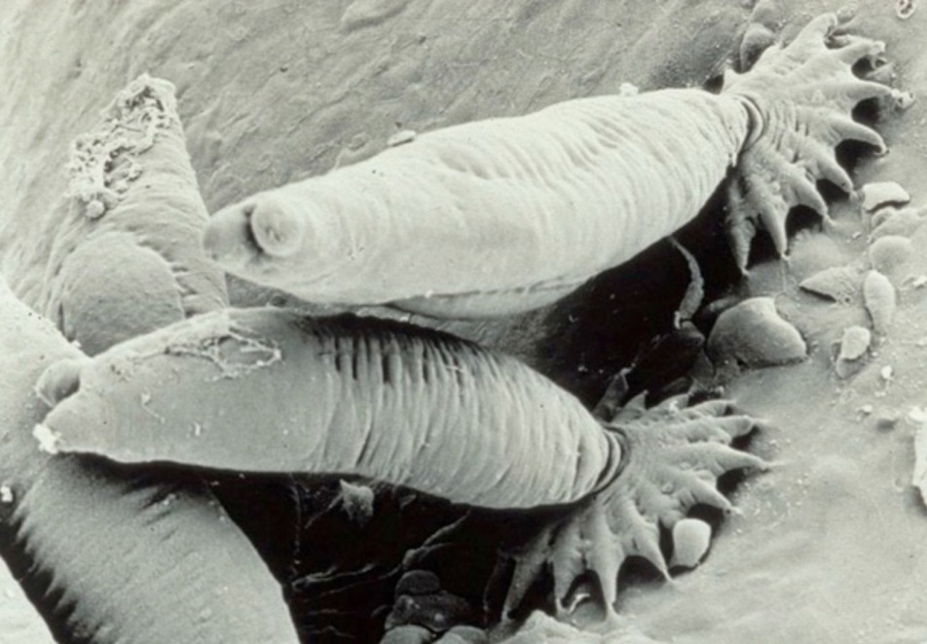
Note: Several parasites attached to the fish skin with their posterior attachment organ (opisthaptor).
Source: TA Mo

Further reading
CABI Invasive Species Compendium ‘Gyrodactylus salaris’
World Organisation for Animal Health Manual of diagnostic tests for aquatic animals

Whirling disease
Also known as infection with Myxobolus cerebralis
Exotic disease
Figure 87 Skull deformity in rainbow trout (Oncorhynchus mykiss) with whirling disease
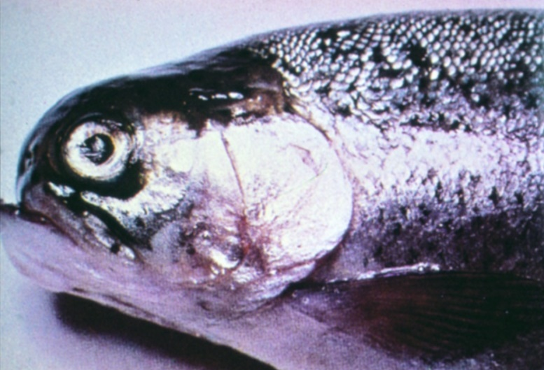
Note: Deformed skull resulting from long-term infection.
Source: T Håstein
Figure 88 Skeletal deformities in rainbow trout (Oncorhynchus mykiss) with whirling disease
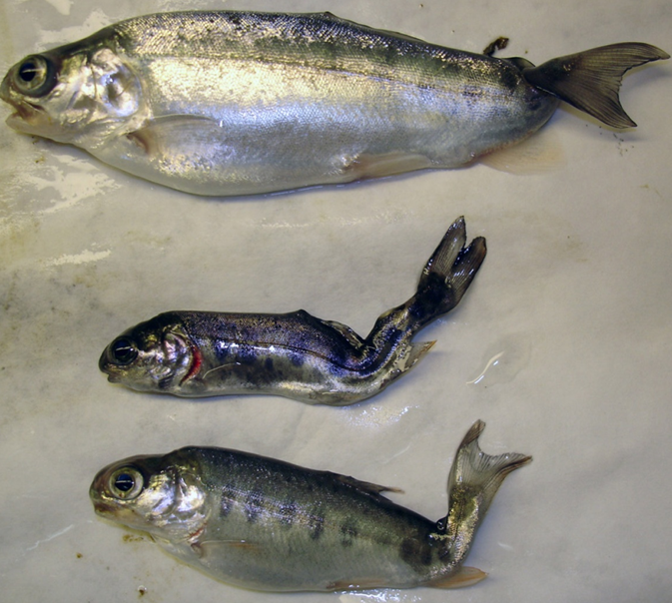
Note Typical skeletal deformities caused by infection with Myxobolus cerebralis.
Source: J Bartholomew
Figure 89 Discolouration of rainbow trout (Oncorhynchus mykiss) with whirling disease
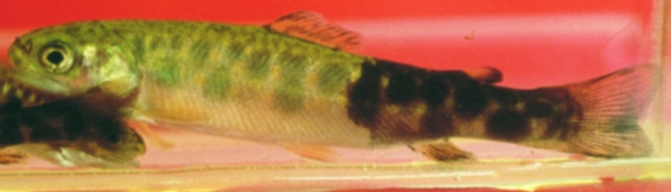
Note: Classic darkening of the skin from vent to tail.
Source: T Poppe
Figure 90 Discolouration of rainbow trout (Oncorhynchus mykiss) with whirling disease
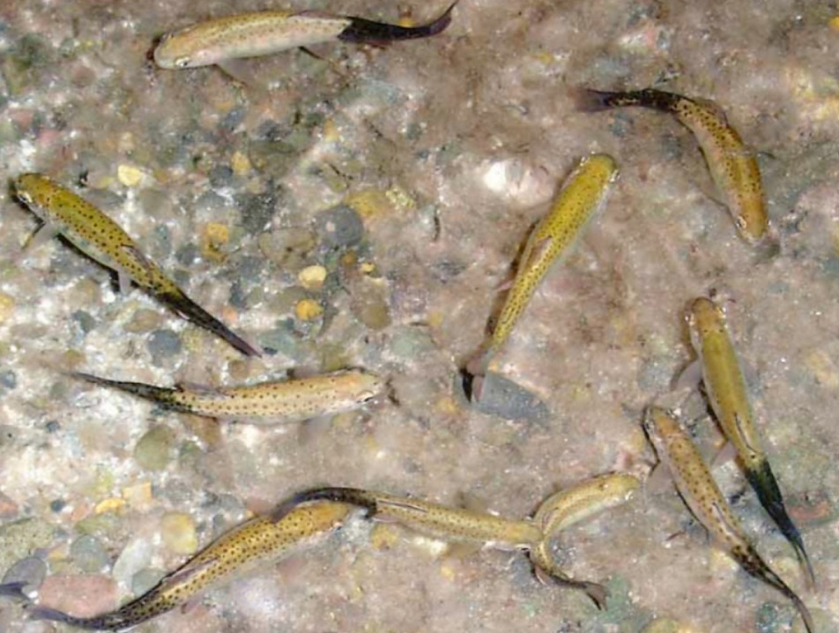
Note Classic darkening of the skin from vent to tail.
Source: J Bartholomew

Signs of disease
Important: Animals with this disease may show one or more of these signs, but the pathogen may still be present in the absence of any signs.
Disease signs at the farm, tank or pond level are:
- mass mortalities in fry
- convulsive movements
- increased respiratory rate
- jerking backwards movements
- swimming with a whirling motion (tail chasing)
- erratic, nervous darting movements until exhausted.
Gross pathological signs are:
- darkening of the skin from the vent to the tail (blacktail)
- spinal curvature, skull deformation and shortened gill plates.
Microscopic pathological signs are:
- myxospores and other developmental stages within the cartilage of the cranium and axial skeleton of juvenile fish.

Disease agent
Whirling disease is caused by infection with Myxobolus cerebralis, a parasitic myxosporean that affects salmonids. Myxosporean parasites are multicellular disease agents related to cnidarians, most of which have a multi-host lifecycle including fish (or amphibians) and aquatic invertebrate hosts (particularly annelids).

Life cycle
- Myxobolus cerebralis has a complex life cycle (Figure 91) involving two hosts: fish (trout or salmon species) and an intermediate host, the tiny bottom-dwelling tubifex mud worm (Tubifex tubifex).
- Myxobolus spores (myxospores) develop in infected fish and are released into the environment when the fish dies. The myxospores are very persistent and can survive in moist environments for many years.
- Myxospores are ingested from the environment by tubifex mud worms. The spores rapidly multiply in the worm's intestine.
- A fragile waterborne spore stage of the parasite (triactinomyxon stage) is released from an infected intermediate host and infects a definitive host (fish). This must occur within the survival window of the triactinomyxon stage (over 2 weeks at 15°C). The parasite then migrates through the fish skin into the central nervous system, and ultimately into the cartilage.
- Following death and decomposition of infected fish, myxospores are released into the environment and the life cycle continues.
- Spores survive passing through the digestive tract of predators (such as piscivorous birds), and can be transferred from place to place on muddy boots, waders and other equipment.
Figure 91 Life cycle of Myxobolus cerebralis
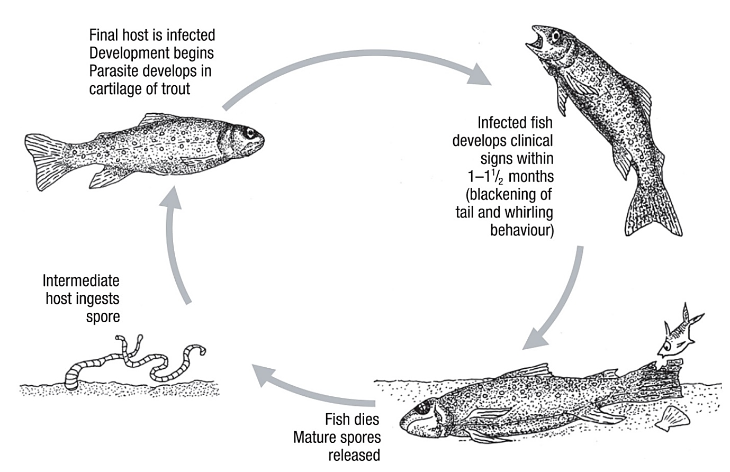
Note: The lifecycle of M. cerebralis is indirect and requires a tubificid worm as the intermediate host.

Host range
Rainbow trout are considered to be the species most susceptible to whirling disease.
The presence of clinical signs depends on many factors, particularly the age of the primary host of the initial infection. For example, infected rainbow trout older than 9 weeks will generally show no clinical signs and chinook salmon do not exhibit clinical signs of disease beyond the age of 3 weeks.
Tubifex worms (T. tubifex) are known intermediate hosts that are present in Australia.
Table 37 Species of fish known to be naturally susceptible to whirling disease
Common name | Scientific name
Atlantic salmon | Salmo salar
Brook trout | Salvelinus fontinalis
Brown trout | Salmo trutta
Bull trout | Salvelinus confluentus
Chinook salmon | Oncorhynchus tshawytscha
Coho salmon | Oncorhynchus kisutch
Cutthroat trout | Oncorhynchus clarkii
Danube salmon | Hucho hucho
Gila trout | Oncorhynchus gilae
Golden trout | Oncorhynchus aguabonita
Mountain whitefish | Prosopium williamsoni
Rainbow troutª | Oncorhynchus mykiss (most susceptible)
Sockeye salmon | Oncorhynchus nerka
Note: Other species not listed have been shown to be experimentally susceptible.
Table 38 Non-fish carriers
Common name | Scientific name
Annelids | Various genera and species
Tubifex wormsª | Tubifex tubifex
Piscivorous birds | Various genera and species
a Required intermediate host.

Presence in Australia
Exotic disease—not recorded in Australia.
Myxobolus cerebralis has not been recorded in Australia, and is considered exotic. However, various other species of Myxobolus have been recorded in marine and freshwater fish.
Map 23 Presence of whirling disease, by jurisdiction

Epidemiology
- Whirling disease is chronic and primarily affects young fish.
- Susceptibility is influenced by water temperature, age and species.
- Young fish are highly susceptible because the parasite attacks their soft cartilage, resulting in nerve damage, skeletal deformities and sometimes death.
- Clinical signs of the disease are not evident until fish are approximately 7cm long.
- When fish are 8 to 10cm long, cartilage forms into bone and they are no longer susceptible to disease; however they remain carriers of the parasite.
- The intermediate host, the annelid worm T. tubifex, is found in Australia.
- Because Tubifex worms live in mud, the disease can be partly controlled in trout farms by growing young fish in concrete raceways.
- The parasite spreads mainly through the stocking of infected fish and through the alimentary tracts of fish-eating migratory birds.
- Myxobolus cerebralis is highly resistant in the myxospore stage. The myxospore released from the fish can withstand freezing and desiccation, and may survive in a stream for up to 30 years with appropriate environmental conditions. However, the triactinomyxon infective stage released from the worm is short lived (up to 2 to 3 weeks at 15°C) and susceptible to standard disinfection procedures.

Differential diagnosis
The list of similar diseases in the next section refers only to the diseases covered by this field guide. Gross pathological signs may also be representative of diseases not included in this guide. Do not rely on gross signs to provide a definitive diagnosis. Use them as a tool to help identify the listed diseases that most closely account for the observed signs.

Similar diseases
Enteric red mouth disease (ERMD), infectious haematopoietic necrosis (IHN) and viral haemorrhagic septicaemia (VHS).

Sample collection
Only trained personnel should collect samples. Using only gross pathological signs to differentiate between diseases is not reliable, and some aquatic animal disease agents pose a risk to humans. If you are not appropriately trained, phone your state or territory hotline number and report your observations. If you have to collect samples, the agency taking your call will advise you on the appropriate course of action. Local or district fisheries or veterinary authorities may also advise on sampling.

Emergency disease hotline
See something you think is this disease? Report it. Even if you’re not sure.
Call the Emergency Animal Disease Watch Hotline on 1800 675 888. They will refer you to the right state or territory agency.

Microscope images
Figure 92 Phase micrograph of Myxobolus cerebralis myxospores from infected rainbow trout (Oncorhynchus mykiss) cranial cartilage
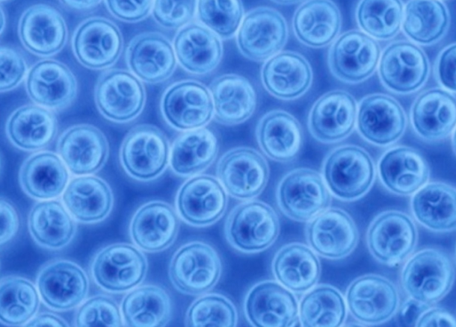
Note Spores measure approximately 10μm in diameter. Extracted by the pepsin trypsin digest method.
Source: J Bartholomew

Further reading
CABI Invasive Species Compendium ‘Myxobolus cerebralis’ (whirling disease agent)
Department of Agriculture, Water and the Environment AQUAVETPLAN disease strategy manual: Whirling disease
Elwell LC, Stromberg KE, Ryce EK, Bartholomew JL 2009, ‘Whirling disease in the United States: a summary of progress and research and management 2009’, Trout Unlimited

Other diseases of finfish

Infection with Aphanomyces invadans
Also known as epizootic ulcerative syndrome (EUS), red spot disease (RSD), ulcerative mycosis (UM) and mycotic granulomatosis
Figure 93 EUS in golden perch (Macquaria ambigua)
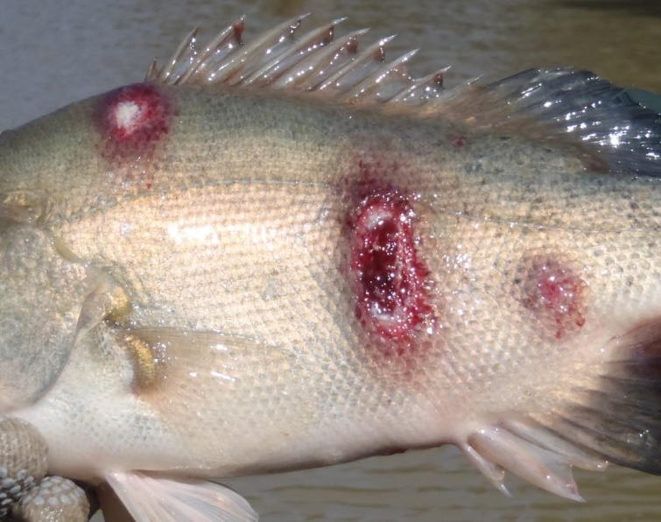
Note: Multiple ulcerative lesions on flanks caused by infection with Aphanomyces invadans.
Source: C Boys
Figure 94 EUS in spangled perch (Leiopotherapon unicolour)
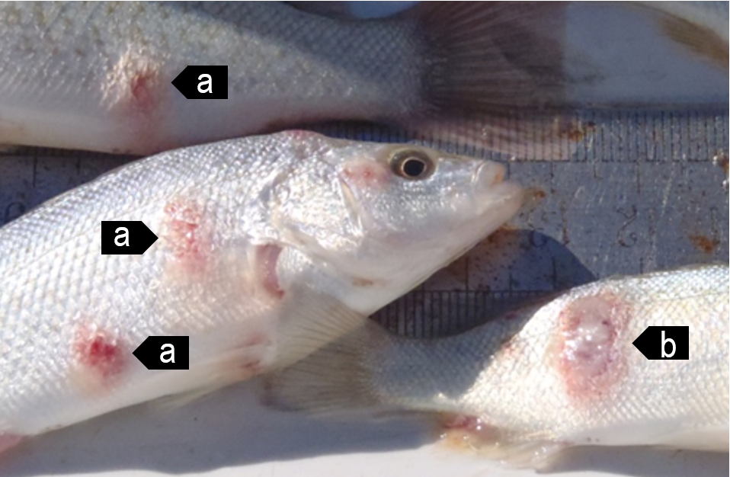
Note Focal haemorrhagic ulcerative lesions (a) will progress to a deep ulcer (b).
Source: C Boys
Figure 95 EUS in sand whiting (Sillago ciliata)
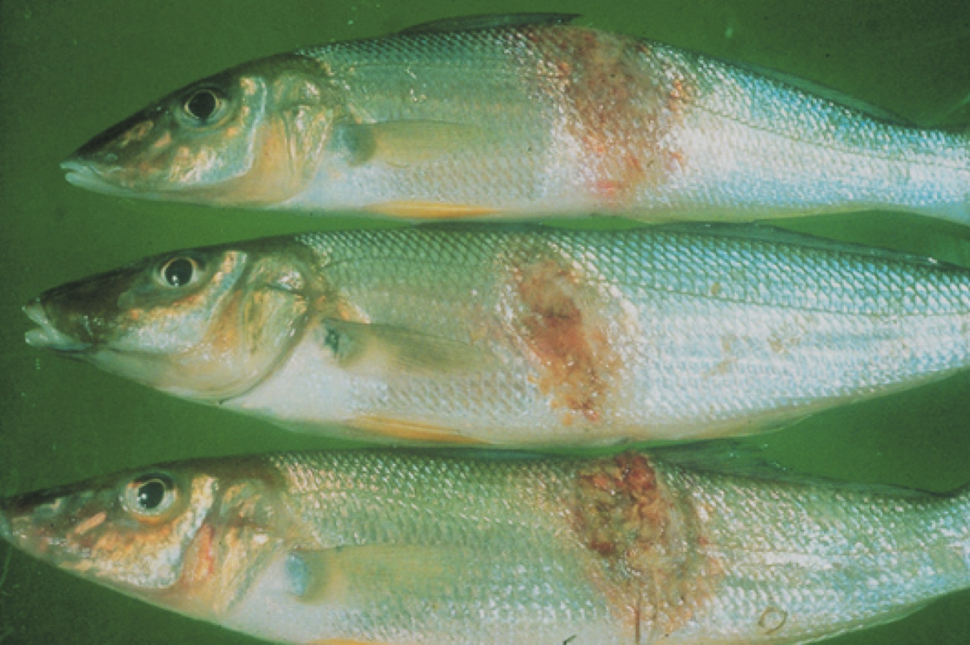
Note: Progression of red lesion (top) to deep ulcer (bottom) of classical red sores on the body.
Source: NSW Department of Primary Industries

Signs of disease
Important: Animals with this disease may show one or more of these signs, but the pathogen may still be present in the absence of any signs.
Disease signs at the farm, tank or pond level are:
- loss of appetite
- dark body colour
- mass mortality
- erratic swimming
- rubbing on the surfaces of tanks
- increased respiratory rate and effort.
Gross pathological signs are:
- lesions on the body showing as red spots, black burn-like marks or deeper ulcers with red centres and white rims
- progressive lesions
  - lesions start as reddening under a single scale but quickly spread to involve adjacent scales
  - lesions continue to widen and deepen, forming ulcers that erode underlying tissues to expose (depending on infection location) skeletal musculature, vertebrae, brain or viscera.
- unilateral or bilateral clouding of the eye (particularly in barramundi).
Microscopic pathological signs are:
- erythematous dermatitis
- hyphae (fungal threads) associated with granulomatous tissue, sometimes extending into visceral organs
- liquefactive necrosis of muscle tissue.

Disease agent
Infection with the oomycete fungus Aphanomyces invadans causes a disease called epizootic ulcerative syndrome (EUS); also known as red spot disease (RSD), ulcerative mycosis (UM) or mycotic granulomatosis. Although previously regarded as a fungus, the genus Aphanomyces is now classified with diatoms and brown algae in a group called Stramenopiles or Chromista.

Host range
More than 100 estuarine and freshwater species of fish are known to be susceptible to infection with A. invadans.
Table 39 Species in Australia known to be susceptible to Aphanomyces invadans
Common name | Scientific name
Australian bassª | Macquaria novemaculeata
Archerfishª | Toxotes chatareus
Banded archerfishª | Toxotes jaculatrix
Barcoo grunterª | Scortum barcoo
Barramundiª | Lates calcarifer
Bony breamª | Nematalosa erebi
Chanda perchª | Ambassis agassizii
Cichlidsª | Cichlidae
Climbing perchª | Anabas testudineus
Cyprinidsª | Cyprinidae
Dusky flatheadª | Platycephalus fuscus
Eastern freshwater cod | Maccullochella ikei
Eels | Anguillidae all species
Estuarine rockcodª | Epinephelus tauvina
Flathead gobyª | Glossogobius giuris
Fork-tailed catfish | Arius spp.
Froggatt’s catfish | Cinetodus froggatti
Giant glassfishª | Parambassis gulliveri
Giant grouper | Epinephelus lanceolatus
Giant gudgeonª | Oxyeleotris selheimi
Goldfish | Carassius auratus auratus
Golden perch | Macquaria ambigua
Grouper and estuary codª | Epinephelus spp.
Long tomª | Strongylura krefftii
Mangrove jackª | Lutjanus argentimaculatus
Mouth almightyª | Glossamia aprion
Sea mulletª | Mugil cephalus
Mulletsª | Mugilidae
Murray cod | Maccullochella peelii
Nurseryfish | Kurtus gulliveri
Primitive archer fishª | Toxotes lorentzi
Rainbow fishª | Melanotaenia splendida
Rainbow trout | Oncorhynchus mykiss
Saratogaª | Scleropages jardini
Scatª | Scatophagus argus
Shortfin eelª | Anguilla australis
Silver perchª | Bidyanus bidyanus
Silver trevallyª | Pseudocaranx dentex
Sleepy codª | Oxyeleotris lineolatus
Striped grunterª | Amniataba percoides
Spangled perchª | Leiopotherapon unicolor
Triangular shield catfishª | Neoarius leptaspis
Tropical two-winged flying fishª | Exocoetus volitans
Whitingª | Sillago ciliata
Yellowfin breamª | Acanthopagrus australis
a Naturally susceptible. Note: Other species have been shown to be experimentally susceptible. A current list of known susceptible species found both within and outside of Australia is included in the World Organisation for Animal Health Manual of diagnostic tests for aquatic animals.

Presence in Australia
EUS is endemic in many freshwater catchments and estuaries in Australia. The disease has been officially reported from New South Wales, the Northern Territory, Queensland, Victoria, South Australia and Western Australia.
Map 24 Presence of Aphanomyces invadans, by jurisdiction
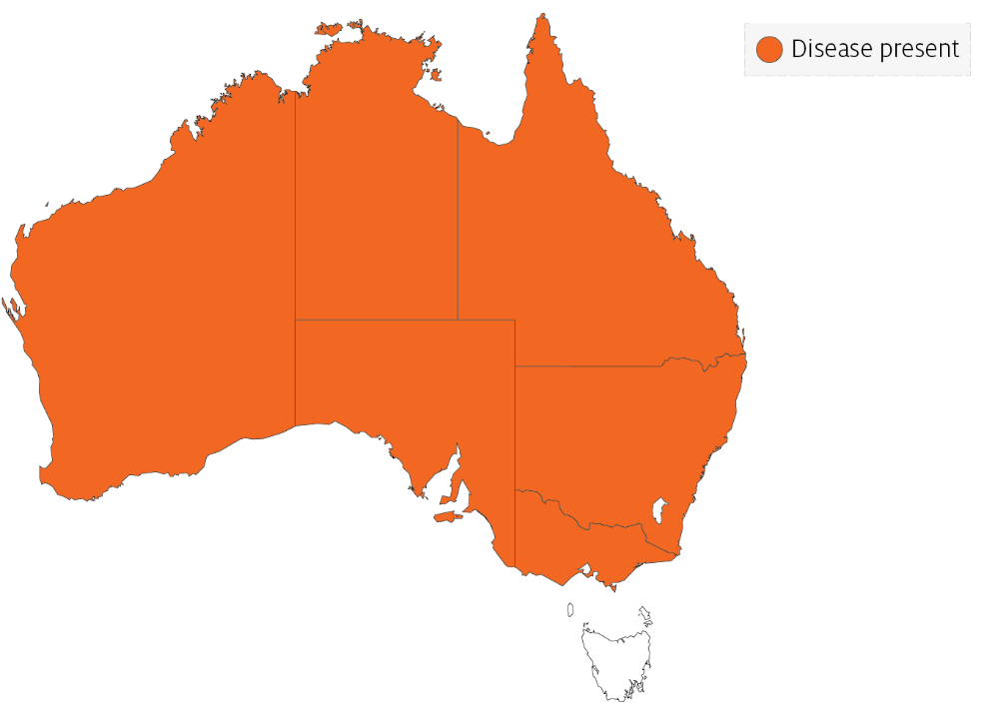

Epidemiology
- The disease is seen in more than 100 freshwater and estuarine species of fish and infection has spread rapidly throughout Asia, associated with the movement of ornamental fish.
- Predisposing factors leading to skin damage (such as parasites, bacterial or viral infection, physical trauma or acidic water) are normally required to allow the Aphanomyces oomycete to initiate clinical signs of EUS. Secondary opportunistic infections are also a common finding.
- Disease is often associated with acid water run-off and can appear after heavy rains (particularly after a long dry period) with water temperatures of 18°C to 22°C favouring sporulation.
- Disease transmission is through zoospore transfer in freshwater, direct contact between fish and skin contamination (penetration assisted by damage to skin).
- Zoospores can encyst if they do not find a host, and can survive for at least 19 days.
- Water salinity above 2 ppt can stop the spread of this obligate freshwater disease agent.

Differential diagnosis
The list of similar diseases in the next section refers only to the diseases covered by this field guide. Gross pathological signs may also be representative of diseases not included in this guide. Do not rely on gross signs to provide a definitive diagnosis. Use them as a tool to help identify the listed diseases that most closely account for the observed signs.

Similar diseases
Enteric septicaemia of catfish, grouper iridoviral disease, infection with Aeromonas salmonicida—atypical strains, koi herpesvirus disease (KHV), viral haemorrhagic septicaemia (VHS) and tilapia lake virus (TiLV) disease.

Sample collection
Only trained personnel should collect samples. Using only gross pathological signs to differentiate between diseases is not reliable, and some aquatic animal disease agents pose a risk to humans. If you are not appropriately trained, phone your state or territory hotline number and report your observations. If you have to collect samples, the agency taking your call will advise you on the appropriate course of action. Local or district fisheries or veterinary authorities may also advise on sampling.

Emergency disease hotline
See something you think is this disease? Report it. Even if you’re not sure.
Call the Emergency Animal Disease Watch Hotline on 1800 675 888. They will refer you to the right state or territory agency.

Further reading
CABI Invasive Species Compendium Epizootic ulcerative syndrome
Network of Aquaculture Centres in Asia–Pacific Epizootic ulcerative syndrome: Disease card
World Organisation for Animal Health Manual of diagnostic tests for aquatic animals

Diseases of molluscs

Viral diseases of molluscs

Abalone viral ganglioneuritis (AVG)
Also known as infection with abalone herpesvirus (AbHV), infection with haliotid herpesvirus 1 (HaHV-1) and abalone viral mortality
Figure 96 Greenlip abalone (Haliotis laevigata) with AVG
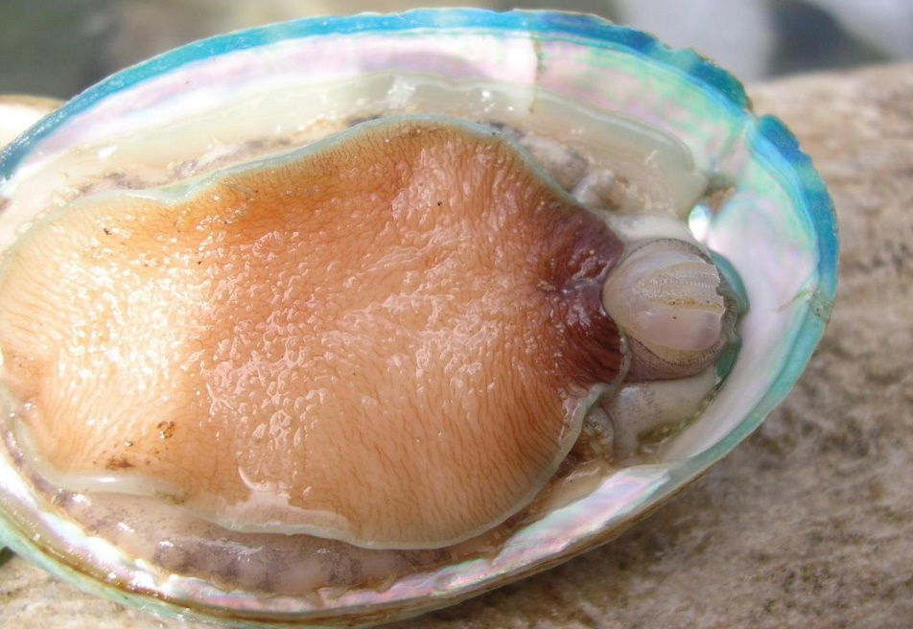
Note: Swollen and protruding mouth parts, particularly the prominent radula (toothed chitinous ribbon). The retracted (curled) foot margins expose bare shell beneath.
Source: Victorian Department of Primary Industries
Figure 97 Healthy greenlip abalone (Haliotis laevigata)
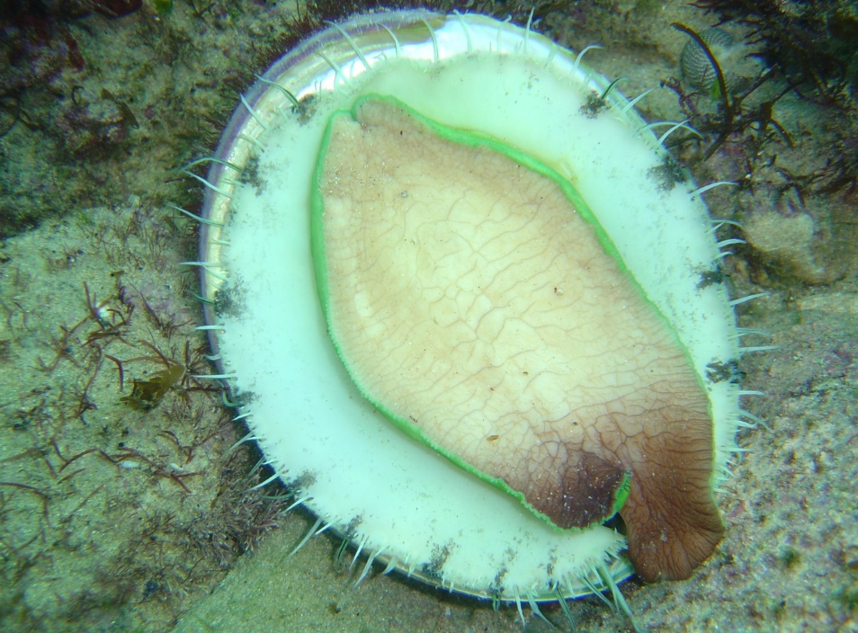
Note: No evidence of any protruding mouth parts or foot curl.
Source: Victorian Department of Primary Industries
Figure 98 Foot of tiger hybrid greenlip × blacklip abalone (Haliotis rubra × H. laevigata) with AVG
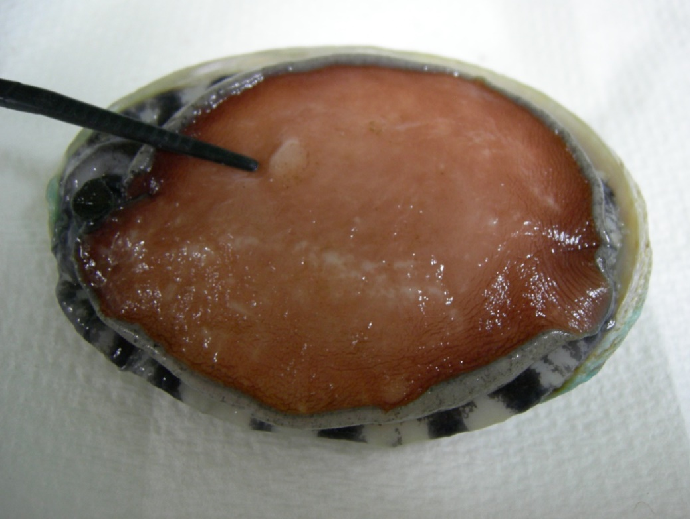
Note: Blistering of foot (lesion near forceps).
Source: L Williams, CSIRO Australian Animal Health Laboratory

Signs of disease
Important: Animals with this disease may show one or more of these signs, but the pathogen may still be present in the absence of any signs.
Disease signs at the farm, tank or pond level are:
- rapid and high cumulative mortality of up to 90%
- inability to adhere to the substrate
- inability of individuals to right themselves when upside down.
Gross pathological signs are:
- swollen and protruding mouth parts
- reduced activity of the pedal muscle
- edges of the foot curled inwards, leading to exposure of clean, shiny shell
- tetany or 'hard foot', sometimes with blistering
- excessive mucous production
- abnormal spawning and bloating.
Microscopic pathological signs are:
- inflammation and necrosis of neural tissue.

Disease agent
AVG is caused by infection with abalone herpesvirus (AbHV), also known as haliotid herpesvirus 1 or HaHV-1. The virus is a member of the Haliotivirus genus in the family Malacoherpesviridae.

Host range
Several species of abalone are known to be susceptible to infection with AbHV. However, the New Zealand paua (Haliotis iris) appears highly resistant to infection.
Table 40 Species known to be naturally susceptible to infection with AbHV
Common name | Scientific name
Blacklip abaloneª | Haliotis rubra
Brownlip abalone | Haliotis conicopora
Disc abaloneª | Haliotis discus hannai
Diversicolor or jiukong abaloneª | Haliotis diversicolor
Greenlip abaloneª | Haliotis laevigata
Pink abalone | Haliotis corrugata
Tiger abaloneª | Haliotis rubra × laevigata
a Naturally susceptible. Note: Other species have been shown to be experimentally susceptible.

Presence in Australia
Victoria and Tasmania have officially reported the presence of AVG. In Victoria, AVG has been observed in farmed and wild abalone.
In Tasmania, the disease has not been observed in wild abalone populations. However, AbHV has been detected in wild abalone and the disease has been observed in abalone held in holding facilities and aquaculture facilities.
Map 25 Presence of AbHV, by jurisdiction
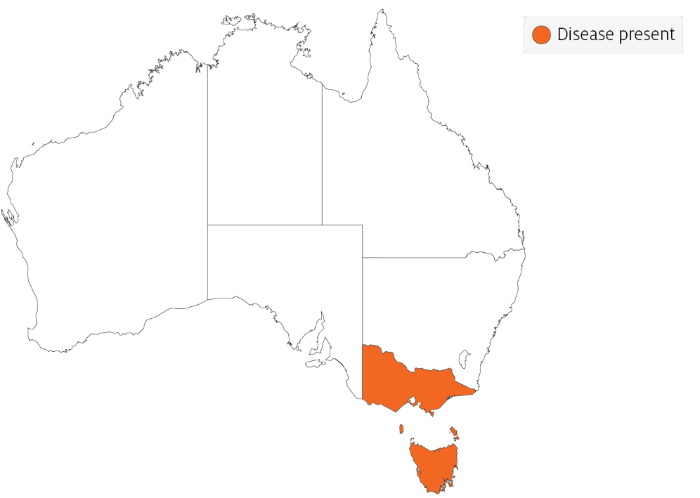

Epidemiology
- AVG affects the nervous system of abalone.
- AVG affects abalone of all ages.
- Horizontal transmission has been demonstrated by:
  - exposing healthy abalone to water containing diseased abalone in the same tank, but without direct contact between the diseased and healthy abalone
  - placing healthy abalone in water that was previously inhabited by diseased abalone
  - intramuscular injection of healthy abalone with a filtered tissue homogenate from diseased abalone.
- Mortality can occur within 4 days of infection and within 1 to 2 days following the onset of clinical signs.
- Apparently healthy wild-caught abalone subjected to sensitive molecular diagnostic tests have tested positive for the virus.
- At least 5 variants of AbHV have been identified: Vic1, Tas1, Tas2, Tas3 and Tas4. All virus variants cause disease and mortality in all Australian native abalone stocks tested to date.

Differential diagnosis
The list of similar diseases in the next section refers only to the diseases covered by this field guide. Gross pathological signs may also be representative of diseases not included in this guide. Do not rely on gross signs to provide a definitive diagnosis. Use them as a tool to help identify the listed diseases that most closely account for the observed signs.

Similar diseases
No diseases in this field guide are similar to Abalone viral ganglioneuritis.

Sample collection
Only trained personnel should collect samples. Using only gross pathological signs to differentiate between diseases is not reliable, and some aquatic animal disease agents pose a risk to humans. If you are not appropriately trained, phone your state or territory hotline number and report your observations. If you have to collect samples, the agency taking your call will advise you on the appropriate course of action. Local or district fisheries or veterinary authorities may also advise on sampling.

Emergency disease hotline
See something you think is this disease? Report it. Even if you’re not sure.
Call the Emergency Animal Disease Watch Hotline on 1800 675 888. They will refer you to the right state or territory agency.

Microscope images
Figure 99 Electron micrograph of AbHV responsible for causing AVG
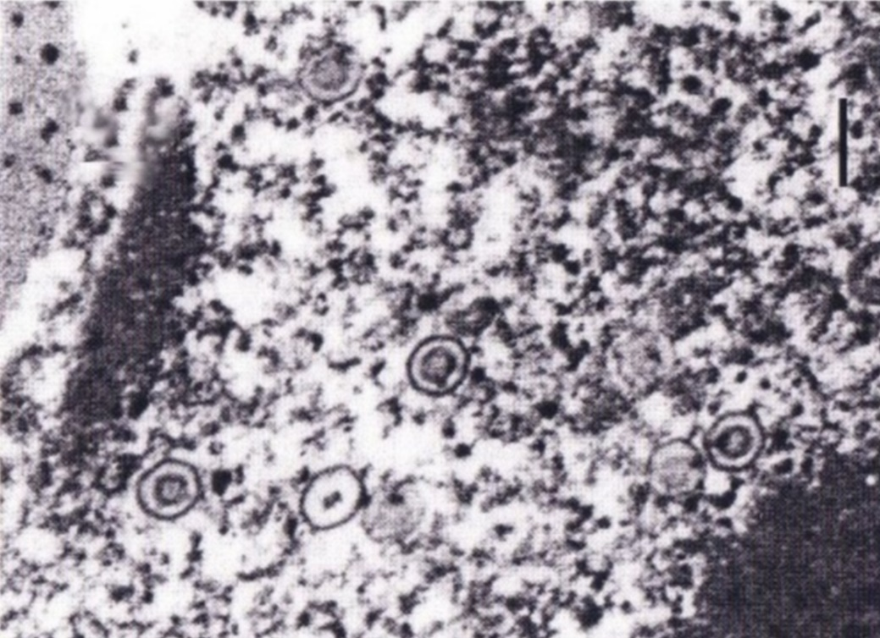
Note: Several enveloped herpesvirus particles are visible.
Source: CSIRO Australian Animal Health Laboratory
Figure 100 Histological section of foot of abalone with clinical AVG
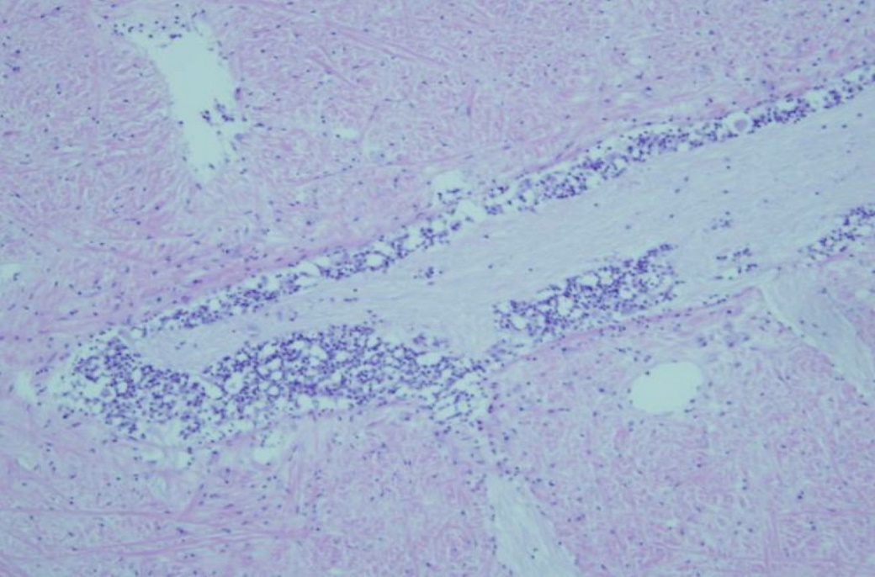
Note: Florid inflammatory response (darker spots) around the nerve ganglia is typical of clinical AVG.
Source: Victorian Department of Primary Industries
Figure 101 Higher magnification histological section of foot of abalone with clinical AVG
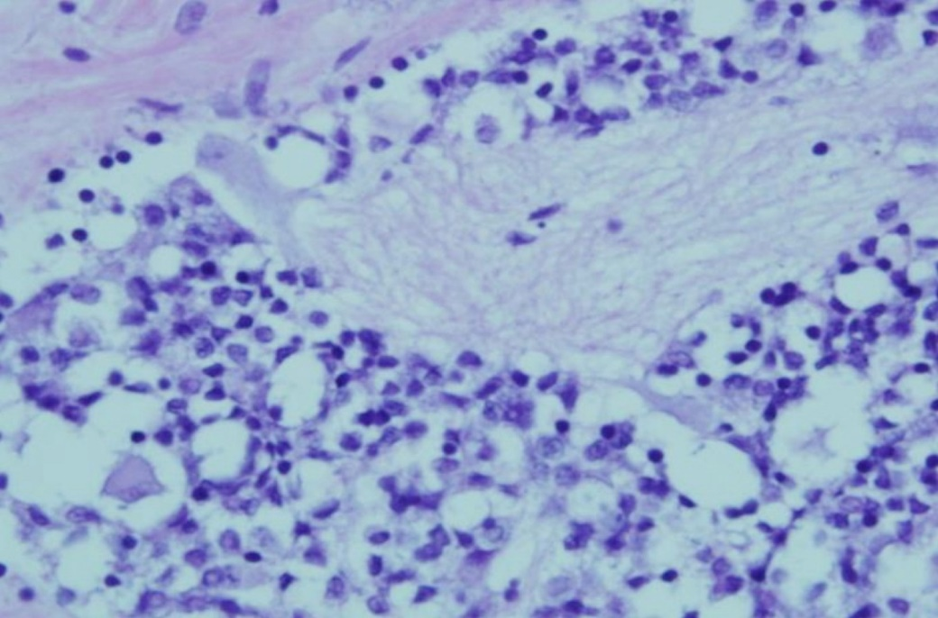
Note: Higher magnification of bottom left quadrant of Figure 100. Shows numerous inflammatory cells surrounding the affected nerve ganglion.
Source: Victorian Department of Primary Industries

Further reading
CEFAS International Database on Aquatic Animal Diseases Infection with abalone herpesvirus
Department of Agriculture, Water and the Environment AQUAVETPLAN disease strategy manual: Abalone viral ganglioneuritis
World Organisation for Animal Health Manual of diagnostic tests for aquatic animals

Infection with ostreid herpesvirus-1 microvariant (OsHV-1 µvar)
Also known as Pacific oyster mortality syndrome (POMS)
Figure 102 Juvenile Pacific oysters (Crassostrea gigas) infected with OsHV-1 μvar
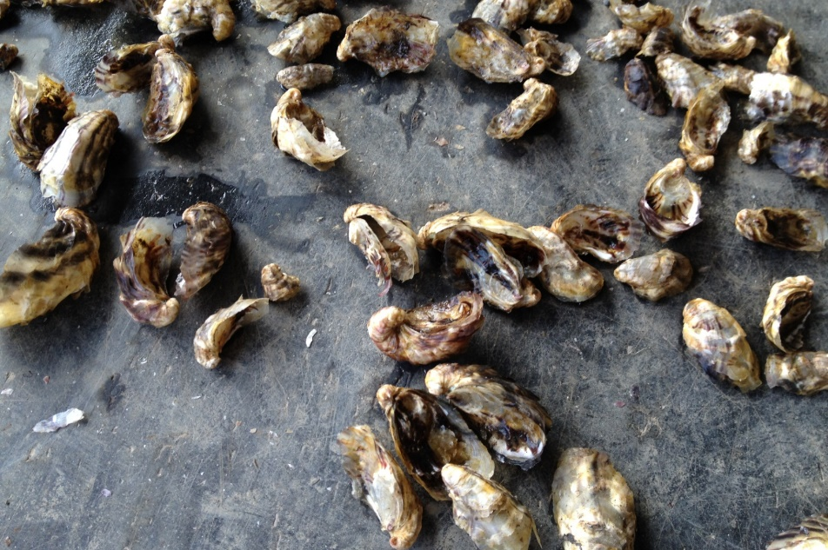
Note: Large number of dead juvenile oysters resulting from mass mortality due to infection with OsHV-1 μvar.
Source: The University of Sydney

Signs of disease
Important: Animals with this disease may show one or more of these signs, but the pathogen may still be present in the absence of any signs.
Disease signs at the farm, tank or pond level are:
- rapid and high cumulative mortalities in Pacific oysters, approaching 100% within 8 to 10 days of infection.
Gross pathological signs are:
- cessation of feeding and swimming by larvae, which exhibit velar lesions
- gaping in adults
- pale digestive gland in spat and older oysters.
Microscopic pathological signs are:
- ulcerative and erosive lesions in the connective tissue of mantle, gills, labial palps and digestive tissue
- nuclear hypertrophy, nuclear chromatin margination and pyknosis
- inflammatory changes ranging from mild and localised, to severe and extensive.

Disease agent
POMS is caused by infection with a microvariant genotype of ostreid herpesvirus-1 (OsHV-1 µvar).The virus is the only member of the genus Ostreavirus (family Malacoherpesviridae, order Herpesvirales).

Host range
Pacific oysters and Portuguese oysters are known to be susceptible to infection with OsHV-1 µvar. Multiple bivalve species (cupped oysters, flat oysters, clams, scallops) are known to be susceptible to other genotypes of OsHV-1. Several of these may also act as carriers and reservoirs for the microvariant strains.
Table 41 Species known to be susceptible to infection with OsHV-1 µvar
Common name | Scientific name
Blue mussel | Mytilus edulis
Hairy mussels | Trichomya hirsuta
Mediterranean mussel | Mytilus galloprovincialis
Pacific oysterª | Crassostrea gigas
Portuguese oysterª | Crassostrea angulata
Sydney cockle or mud arc | Anadara trapezia
Sydney rock oyster | Saccostrea glomerata
a Naturally susceptible. Note: Other species have been shown to be potential reservoir hosts.
Table 42 Non-bivalve carriers
Common name | Scientific name
Barnacles | Balanus spp.
Mud whelks | Pyrazus spp., Batillaria spp.

Presence in Australia
Outbreaks of POMS due to infection with OsHV-1 μvar have been officially reported from oyster growing areas in several regions of New South Wales and Tasmania. Pacific oysters infected with OsHV-1 μvar have also been reported from wild Pacific oysters in Port Adelaide in South Australia.
Map 26 Presence of OsHV-1 μvar, by jurisdiction
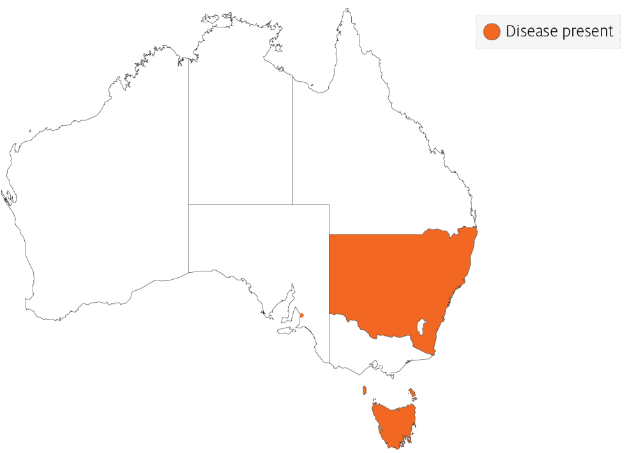

Epidemiology
- The disease can affect all age groups of susceptible oysters. There may be higher mortality in the younger life stages.
- Higher mortality appears to be associated with higher water temperature and crowding.
- Infected adult oysters may be a source of infection for larvae or spat. However, it is not certain if true vertical transmission occurs. Horizontal transmission has been demonstrated.
- Some adult Crassostrea gigas may survive with subclinical OsHV-1 infections, and act as carriers of the virus.
- The introduction of OsHV-1 µvar into new areas is thought to be due to introduction of infected hosts or carriers in biofouling on shipping, often followed by human movements of subclinically infected oysters.
- Water filtration reduces risk of disease entry into hatcheries, suggesting spread of the disease within a water body may be due to movements of infected oyster larvae or free virus adhered to plankton or other particles.

Differential diagnosis
The list of similar diseases in the next section refers only to the diseases covered by this field guide. Gross pathological signs may also be representative of diseases not included in this guide. Do not rely on gross signs to provide a definitive diagnosis. Use them as a tool to help identify the listed diseases that most closely account for the observed signs.

Similar diseases
Iridoviroses.

Sample collection
Only trained personnel should collect samples. Using only gross pathological signs to differentiate between diseases is not reliable, and some aquatic animal disease agents pose a risk to humans. If you are not appropriately trained, phone your state or territory hotline number and report your observations. If you have to collect samples, the agency taking your call will advise you on the appropriate course of action. Local or district fisheries or veterinary authorities may also advise on sampling.

Emergency disease hotline
See something you think is this disease? Report it. Even if you’re not sure.
Call the Emergency Animal Disease Watch Hotline on 1800 675 888. They will refer you to the right state or territory agency.

Microscope images
Figure 103 Histological section of Pacific oyster (Crassostrea gigas) infected with OsHV-1 μvar
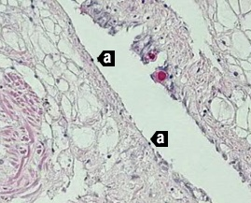
Note: High viral load causing multifocal to coalescing ulceration with attenuation of epithelium and pyknotic nuclei (a). 20x magnification.
Source: M Gabor
Figure 104 In-situ hybridisation of gill of Pacific oyster (Crassostrea gigas) infected with OsHV-1 µvar
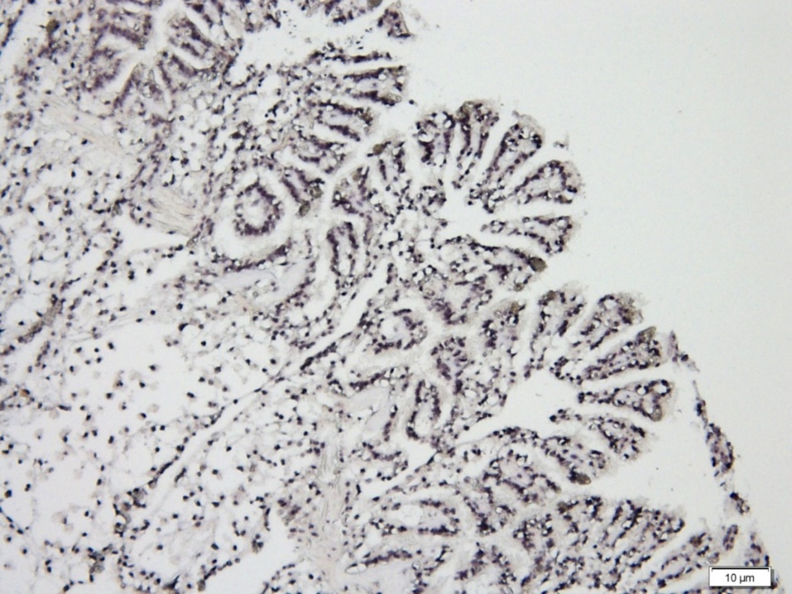
Note: Massive infection of epithelia and connective tissues (black staining). Scale bar 10µm.
Source: C Jenkins
Figure 105 In-situ hybridisation of gonad of Pacific oyster (Crassostrea gigas) infected with OsHV-1 µvar
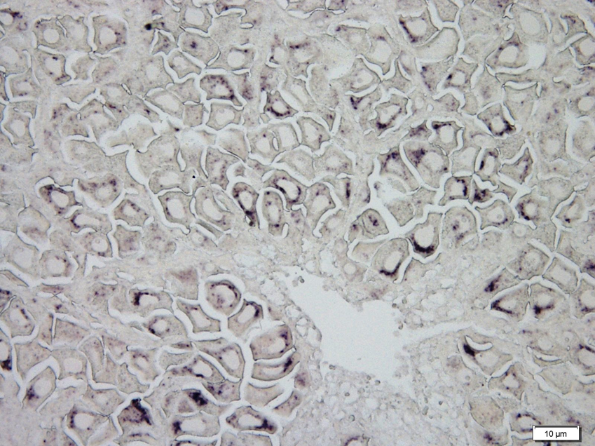
Note: Viral infection (black staining) in many eggs. Scale bar 10µm.
Source: C Jenkins

Further reading
CEFAS International Database on Aquatic Animal Diseases Infection with ostreid herpesvirus 1 microvariant
Department of Agriculture, Water and the Environment AQUAVETPLAN disease strategy manual: Ostreid herpesvirus 1 microvariant
World Organisation for Animal Health Manual of diagnostic tests for aquatic animals

Iridoviroses
Including gill necrosis virus, oyster velar virus disease, gill disease of Portuguese oysters and blister disease
Exotic disease
Figure 106 Gill necrosis virus in oyster
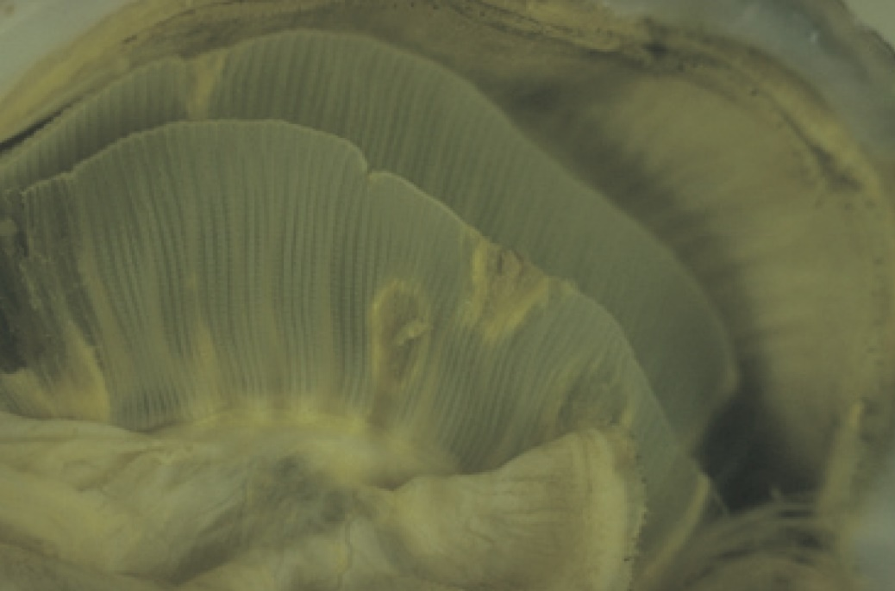
Note: Visible multifocal necrotic yellow or brown lesions in the gill tissue.
Source: D Alderman

Signs of disease
Important: Animals with this disease may show one or more of these signs, but the pathogen may still be present in the absence of any signs.
Disease signs at the farm, tank or pond level are:
- high mortality.
Gross pathological signs are:
- yellow or green pustules on mantle or adductor muscle
- yellow spots on gills and labial palps that spread as the disease progresses
- spots that increase in size and develop brown centres as the tissue dies, leaving a hole in the gill structure.
Microscopic pathological signs are:
- necrosis of gill or labial palp tissue
- massive haemocytic cellular infiltration around lesions
- basophilic cytoplasmic inclusions found in most lesions.

Disease agent
Iridoviroses are diseases caused by infection with one of several iridoviruses. Infections include gill necrosis virus, an icosahedral deoxyribonucleic acid (DNA) virus with affinities with the Iridoviridae.

Host range
Various species of oysters are known (or suspected) to be susceptible to infection with iridoviruses. It is reasonable to assume that the Sydney rock oyster (Saccostrea glomerata) is susceptible.
Table 43 Species known or suspected to be susceptible to infection with iridoviruses
Common name | Scientific name
European flat oysterª | Ostrea edulis
Pacific oysterª | Crassostrea gigas
Portuguese oysterª | Crassostrea angulata
Sydney rock oyster | Saccostrea glomerata
a Naturally susceptible. Note: Other species are suspected to be susceptible.

Presence in Australia
Exotic disease—not recorded in Australia.
Map 27 Presence of iridoviroses, by jurisdiction
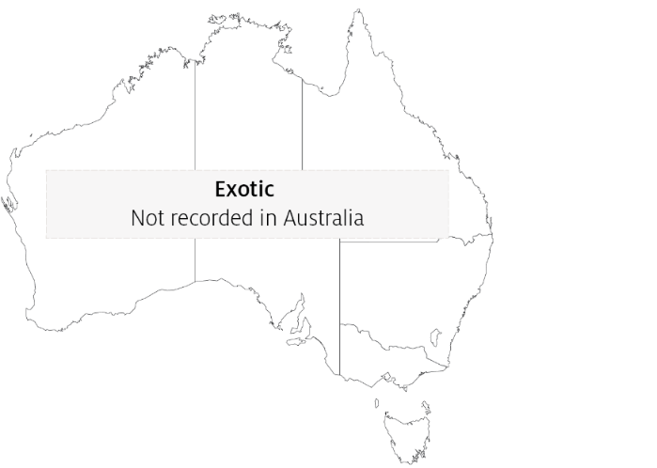

Epidemiology
- A number of iridoviruses that cause disease in oysters have been identified. Not all are associated with gill necrosis and some affect oysters at different life stages.
- Horizontal transmission occurs directly via the water column through the surface of the gills.
- Little is known about the distribution of the organisms responsible for this condition. However, molluscan iridoviruses are generally considered to be distributed in oceans worldwide.
- A protist, Thankatostrea polymorpha in the phylum Sarcomastigophora, has also been associated with this disease.
- Outbreaks usually occur in spring and sometimes in summer.
- Surviving oysters do not repair perforated gill structures and are potential carriers of the virus.

Differential diagnosis
The list of similar diseases in the next section refers only to the diseases covered by this field guide. Gross pathological signs may also be representative of diseases not included in this guide. Do not rely on gross signs to provide a definitive diagnosis. Use them as a tool to help identify the listed diseases that most closely account for the observed signs.

Similar diseases
Infection with ostreid herpesvirus-1 microvariant (OsHV-1 µvar).

Sample collection
Only trained personnel should collect samples. Using only gross pathological signs to differentiate between diseases is not reliable, and some aquatic animal disease agents pose a risk to humans. If you are not appropriately trained, phone your state or territory hotline number and report your observations. If you have to collect samples, the agency taking your call will advise you on the appropriate course of action. Local or district fisheries or veterinary authorities may also advise on sampling.

Emergency disease hotline
See something you think is this disease? Report it. Even if you’re not sure.
Call the Emergency Animal Disease Watch Hotline on 1800 675 888. They will refer you to the right state or territory agency.

Further reading
CEFAS International Database on Aquatic Animal Diseases Infection with Irido-like virosis
Fisheries and Oceans Canada Gill disease of Portuguese oyster
Fisheries and Oceans Canada Oyster velar virus disease

Bacterial diseases of molluscs

Infection with Xenohaliotis californiensis
Also known as withering syndrome of abalone (WS)
Exotic disease
Figure 107 Healthy red abalone (Haliotis rufescens), compared with atrophy of specimen with WS
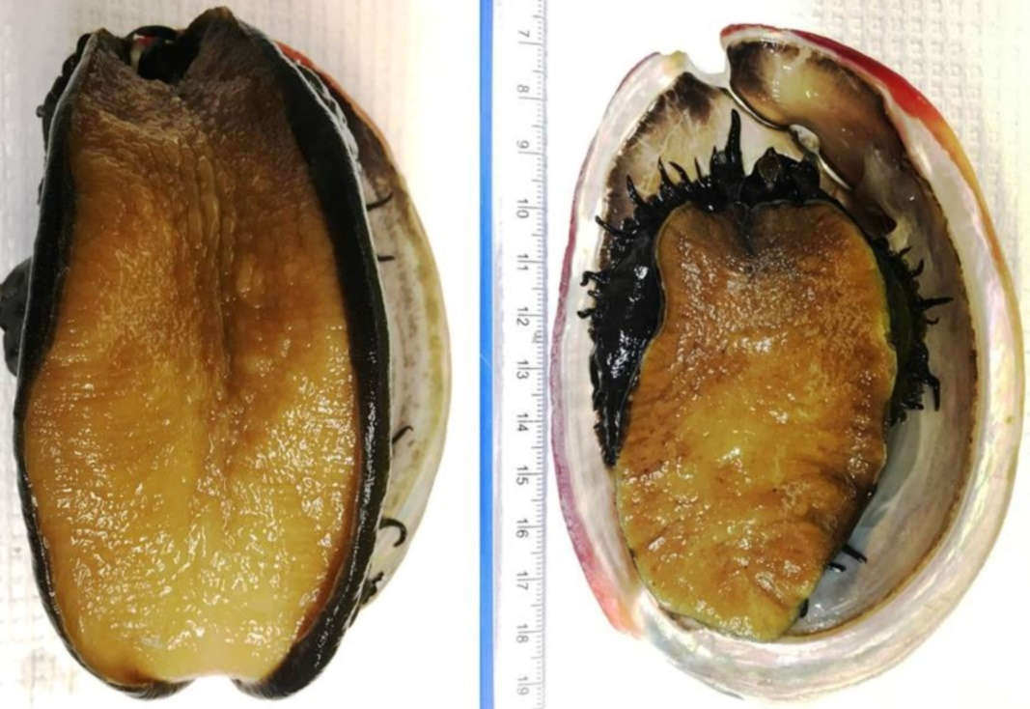
Note: Infected abalone (right) shows severe atrophy or withering of foot muscle and retraction of mantle.
Source: J Moore

Signs of disease
Important: Animals with this disease may show one or more of these signs, but the pathogen may still be present in the absence of any signs.
Disease signs at the farm, tank or pond level are:
- reduced feeding
- inability of individuals to right themselves when upside down
- weakness and lethargy (clinging to horizontal surfaces rather than to vertical or inverted)
- inability to adhere to the substrate
- increased mortality.
Gross pathological signs are:
- wasting of body mass
- retraction of mantle
- atrophy of the foot muscle
- decreased response to tactile stimuli
- diminished reproductive output
- mottling of digestive gland (dark brown with small foci of tan-coloured tissue).
Microscopic pathological signs are:
- presence of intracellular bacteria in the cells of the digestive epithelia
- atrophy of digestive tubules
- increase in connective tissue, inflammation and metaplasia of the digestive gland.

Disease agent
WS is caused by the obligate intracellular bacterium Xenohaliotis californiensis. The bacterium is closely related to the Neorickettsia genus. It is the ancestral form of the family Anaplasmataceae, within the order Rickettsiales.

Host range
Five Haliotis species native to the Californian coast are known to be susceptible to infection with X. californiensis. Disease susceptibility profiles of other Haliotis species (including Australian species) to infection with X. californiensis has not been assessed, but appears likely. Assume that all Australian species of Haliotis are susceptible.
Table 44 Species known to be susceptible to infection with Xenohaliotis californiensis
Common name | Scientific name
Black abaloneª | Haliotis cracherodii
Blacklip abalone | Haliotis rubra
Brownlip abalone | Haliotis conicopora
European abaloneª | Haliotis tuberculata
Flat abalone | Haliotis wallalensis
Green abaloneª | Haliotis fulgens
Greenlip abalone | Haliotis laevigata
Japanese abalone | Haliotis discus hannai
Pink abaloneª | Haliotis corrugata
Red abaloneª | Haliotis rufescens
Small abaloneª | Haliotis diversicolor supertexta
Tiger abalone | Haliotis rubra x laevigata
White abaloneª | Haliotis sorenseni
a Naturally susceptible. Note: Other species likely to be susceptible or shown to be experimentally susceptible.

Presence in Australia
Exotic disease—not recorded in Australia.
Map 28 Presence of Xenohaliotis californiensis, by jurisdiction
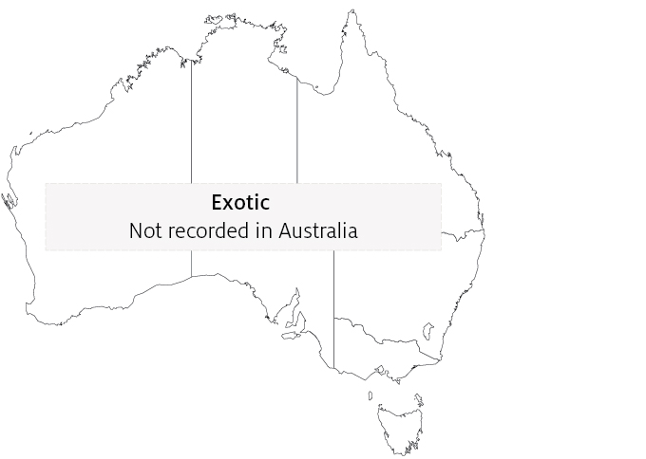

Epidemiology
- The pathogen X. californiensis occurs in marine waters.
- The bacterium attacks the lining of the digestive tract, causing metaplastic cellular changes and apparently obstructing the production of digestive enzymes. As a result, the abalone starve and catabolise their musculature. This causes withering of the foot, which impairs their ability to adhere to substrates and makes them vulnerable to predation.
- Abalone not eaten by predators usually die from starvation.
- Susceptibility varies between species of abalone (99% cumulative decline in black abalone and 30% in red abalone since the disease was first observed in 1986).
- Abalone can be infected with the bacterium without developing the disease.
- Transmission occurs horizontally by cohabitation with infected abalone (via the faecal–oral route).
- Environmental stressors, such as elevated water temperature, may predispose carriers of the bacterium to disease. Survivors can remain carriers of the bacterium.
- The disease can be treated with antibiotics. Severity of the disease may be reduced by infection of X. californiensis with hyperparasitic bacteriophages, which can give the rickettsial inclusions a distinctively altered (pleomorphic) appearance.

Differential diagnosis
The list of similar diseases in the next section refers only to the diseases covered by this field guide. Gross pathological signs may also be representative of diseases not included in this guide. Do not rely on gross signs to provide a definitive diagnosis. Use them as a tool to help identify the listed diseases that most closely account for the observed signs.

Similar diseases
No diseases in this field guide are similar to infection with Xenohaliotis californiensis.

Sample collection
Only trained personnel should collect samples. Using only gross pathological signs to differentiate between diseases is not reliable, and some aquatic animal disease agents pose a risk to humans. If you are not appropriately trained, phone your state or territory hotline number and report your observations. If you have to collect samples, the agency taking your call will advise you on the appropriate course of action. Local or district fisheries or veterinary authorities may also advise on sampling.

Emergency disease hotline
See something you think is this disease? Report it. Even if you’re not sure.
Call the Emergency Animal Disease Watch Hotline on 1800 675 888. They will refer you to the right state or territory agency.

Microscope images
Figure 108 Histological section of postoesophagus tissue from farmed black abalone (Haliotis cracherodii) infected with Xenohaliotis californiensis
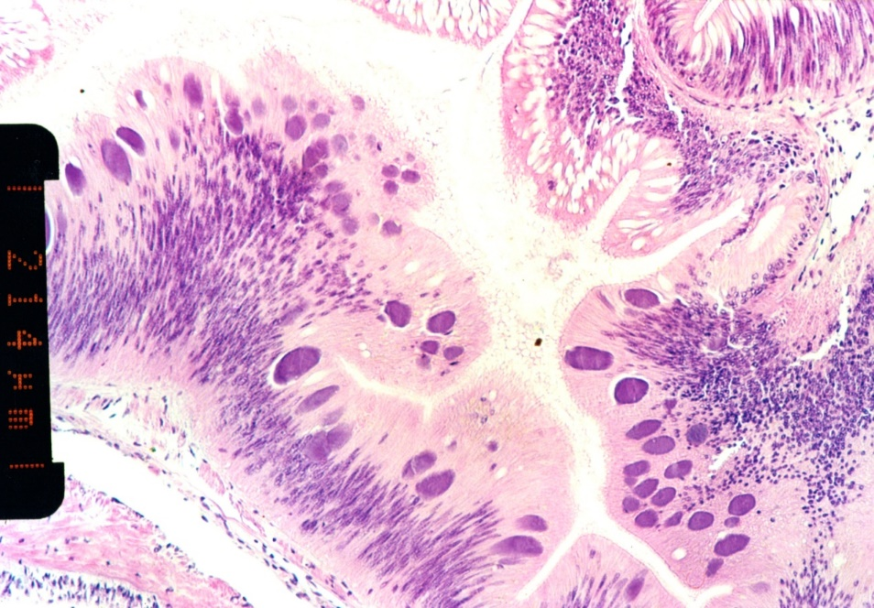
Note: Numerous basophilic inclusions in epithelial cells, each containing thousands of individual bacteria. Scale bar =214 µm.
Source: B Diggles
Figure 109 High power micrograph of epithelium of postoesophagus of red abalone (Haliotis rufescens) infected with Xenohaliotis californiensis
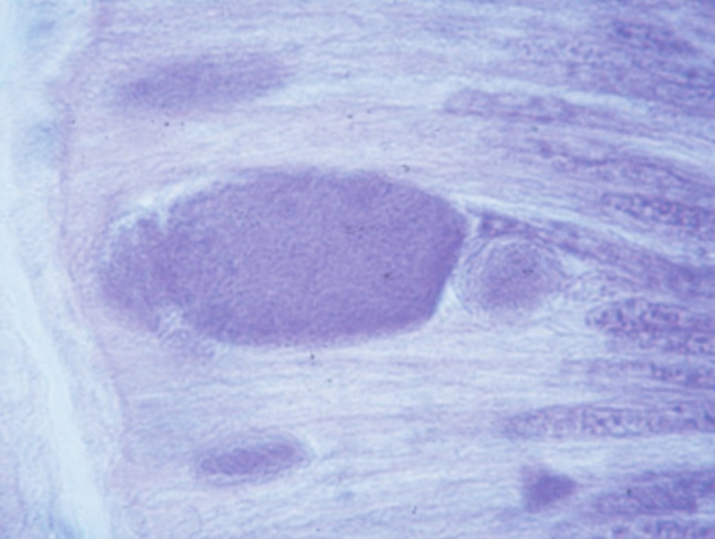
Note: Large basophilic cytoplasmic inclusion filled with X. californiensis.
Source: J Moore
Figure 110 Histological section of postoesophagus tissue of red abalone (Haliotis rufescens)
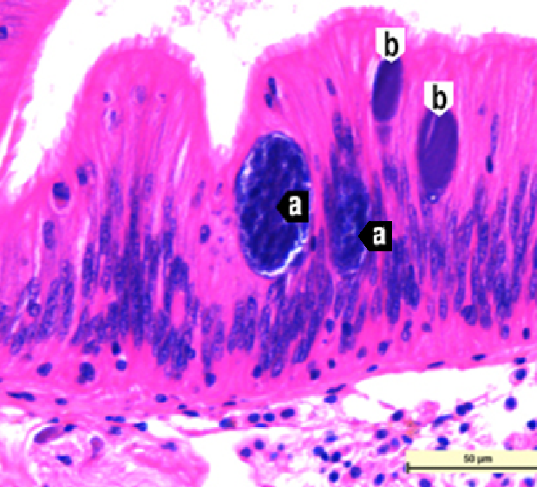
Note: The 2 larger pleomorphic Xenohaliotis californiensis inclusions (a) are infected by a bacteriophage. The 2 smaller inclusions (b) are normal. 40x magnification, scale bar = 50µm.
Source: J Moore

Further reading
CABI Invasive Species Compendium ‘Xenohaliotis californiensis’
CEFAS International Database on Aquatic Animal Diseases Infection with ‘Xenohaliotis californiensis’
World Organisation for Animal Health Manual of diagnostic tests for aquatic animals

Parasitic diseases of molluscs

Infection with Bonamia exitiosa
Also known as bonamiosis
Figure 111 Australian flat oysters (Ostrea angasi) infected with Bonamia exitiosa
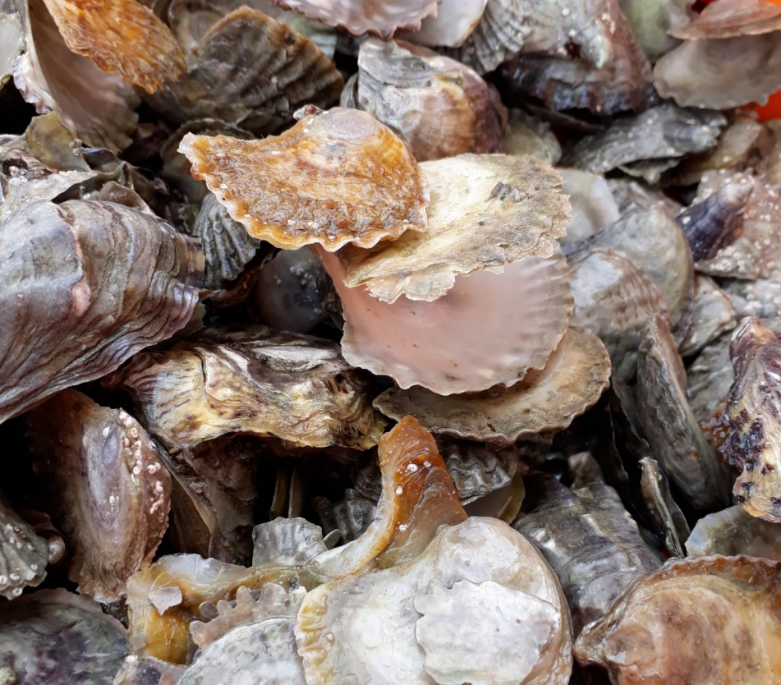
Note: Gaping of oysters and high mortality rate due to infection with Bonamia exitiosa.
Source: B Diggles
Figure 112 New Zealand dredge oysters (Ostrea chilensis) with digestive gland sectioned
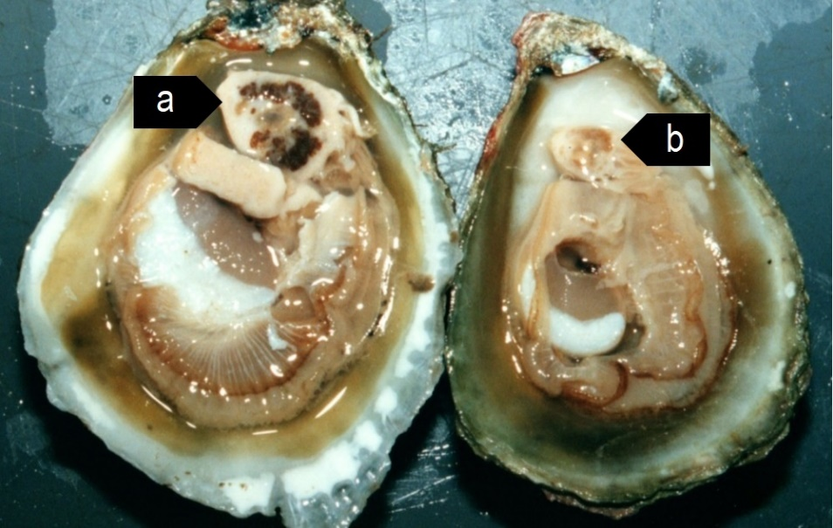
Note: Normal healthy oyster gland (a) compared with pale atrophied digestive gland of oyster with heavy Bonamia exitiosa infection (b).
Source: B Diggles

Signs of disease
Important: Animals with this disease may show one or more of these signs, but the pathogen may still be present in the absence of any signs.
Diseases caused by any of the microcell species are similar. In cases of light infection, few signs or no clinical or gross signs are present. Concurrent infections with more than one species of Bonamia may also occur. Definitive identification of Bonamia or Mikrocytos species requires histological laboratory examination and molecular diagnostic techniques.
Disease signs at the farm, tank or pond level are:
- dead or gaping oysters
- increased mortality.
Gross pathological signs are:
- stunted growth and poor condition
- weakened shell closure, leading to slight gaping
- watery flesh, pale atrophied digestive gland in clinically diseased oysters
- algae-covered shell lips after the mantle shrinks and no longer reaches the edges
- deformities of the gill margins.
Infection with Bonamia exitiosa rarely results in gross pathological signs of disease in oysters under natural conditions—most infections are asymptomatic.
Microscopic pathological signs are:
- microcell parasites within haemocytes and vesicular connective tissues (especially the gill or mantle)
- individual microcells are basophilic, spherical or ovoid parasites, 2 to 3µm in diameter
- microcells of B. exitiosa tend to be larger than those of B. ostreae when both occur in the same host
- In Australian flat oysters (Ostrea angasi), apparently low numbers of parasites cause massive focal haemocyte aggregation with necrotic foci.

Disease agent
Bonamiosis is caused by infection with Bonamia exitiosa. This is an intrahaemocytic protist classified in the order Haplosporidia (class Ascetosporea). It causes lethal infection of flat oysters. Recent evidence confirms that B. exitiosa that infects Australian flat oysters is the same species that infects dredge oysters (O. chilensis) in New Zealand.

Host range
Bonamia exitiosa is mainly a parasite of flat oysters. However, microcells that are occasionally visible in Pacific oysters have been confirmed to be B. exitiosa by PCR analysis. Sydney rock oysters may also occasionally be subclinical carriers of B exitiosa and appear to harbour very low numbers of these parasites.
Table 45 Species known to be naturally susceptible to infection with Bonamia exitiosa
Common name | Scientific name
American eastern oyster | Crassostrea virginica
Argentinian flat oyster | Ostrea puelchana
Dwarf oyster | Ostrea stentina
European flat oyster | Ostrea edulis
New Zealand dredge oyster | Ostrea chilensis
Olympia oyster | Ostrea lurida
Pacific oyster | Crassostrea gigas
Southern mud oyster or Australian flat oyster | Ostrea angasi
Sydney rock oyster | Saccostrea glomerata

Presence in Australia
Bonamia exitiosa has been recorded in flat oysters in Victoria and New South Wales as well as in a very low percentage of Sydney rock oysters in New South Wales. It is likely that Bonamia spp. previously recorded in flat oysters in Tasmania, South Australia and Western Australia are also B. exitiosa.
Bonamia ostreae and other Bonamia spp. are exotic to Australia, so any differential diagnosis of Bonamia spp. infection in Australian oysters requires specific confirmation using molecular diagnostic techniques to differentiate between the endemic B. exitiosa and exotic B. ostreae and Bonamia spp.
Map 29 Presence of Bonamia exitiosa, by jurisdiction
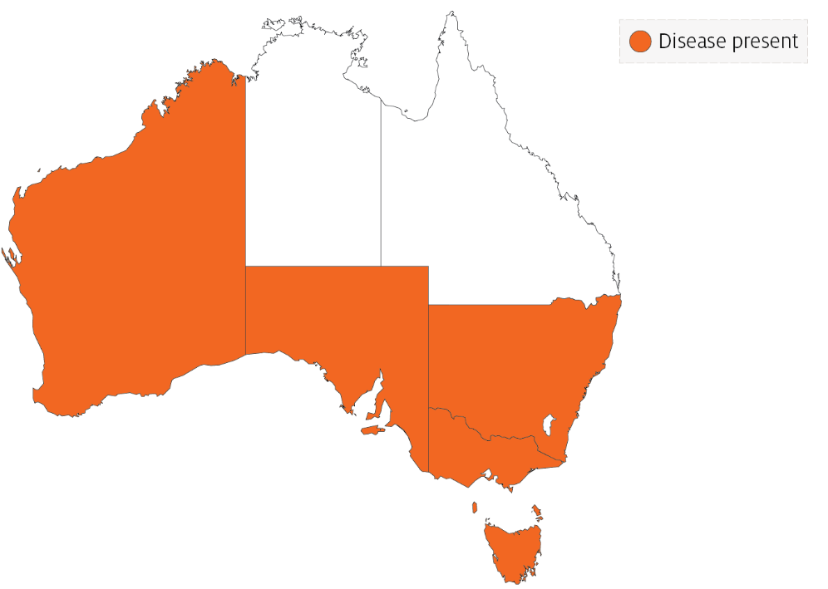

Epidemiology
- Mortalities can occur all year, but the highest prevalence is in mid to late summer after the host spawns.
- The disease dynamics of B. exitiosa in the New Zealand dredge oyster can be affected by exposure to temperature extremes (below 7°C or above 26°C), high salinity (40ppt), starvation (prolonged holding in filtered seawater), handling (vigorous stirring 4 times per day) or heavy coinfection with apicomplexan protists.
- Cohabitation of infected and uninfected oysters in holding tanks facilitates horizontal transmission of infection to the uninfected oysters.
- A seasonal pattern of disease has been observed in New Zealand since 1964. Separate epizootics in 1985 to 1991 and 1998 to 2003 resulted in cumulative mortality of more than 90% in wild populations of New Zealand dredge oysters.
- Transmission is thought to occur from host to host via infective stages that are carried from one oyster bed to another by water currents.
- The introduction of B. exitiosa into New Zealand and Australia is thought to be due to introduction of infected hosts carried in biofouling on shipping, followed by human movements of subclinically infected oysters.

Differential diagnosis
The list of similar diseases in the next section refers only to the diseases covered by this field guide. Gross pathological signs may also be representative of diseases not included in this guide. Do not rely on gross signs to provide a definitive diagnosis. Use them as a tool to help identify the listed diseases that most closely account for the observed signs.

Similar diseases
Infection with Bonamia ostreae, infection with Bonamia spp. and infection with Mikrocytos mackini.
There are few or no visual cues to the presence of these diseases other than poor condition, shell gaping and increased mortality. Consequently, it is impossible to use gross signs alone to differentiate between infecion by Bonamia species and Mikrocytos. Concurrent infections with more than one species of Bonamia may also occur. Any presumptive diagnosis requires further laboratory examination.
Light microscopy can contribute diagnostic information, but further laboratory examination and molecular diagnostic techniques are required for a definitive diagnosis.

Sample collection
Only trained personnel should collect samples. Using only gross pathological signs to differentiate between diseases is not reliable, and some aquatic animal disease agents pose a risk to humans. If you are not appropriately trained, phone your state or territory hotline number and report your observations. If you have to collect samples, the agency taking your call will advise you on the appropriate course of action. Local or district fisheries or veterinary authorities may also advise on sampling.

Emergency disease hotline
See something you think is this disease? Report it. Even if you’re not sure.
Call the Emergency Animal Disease Watch Hotline on 1800 675 888. They will refer you to the right state or territory agency.

Microscope images
Figure 113 Stained heart imprint from New Zealand dredge oyster (Ostrea chilensis)
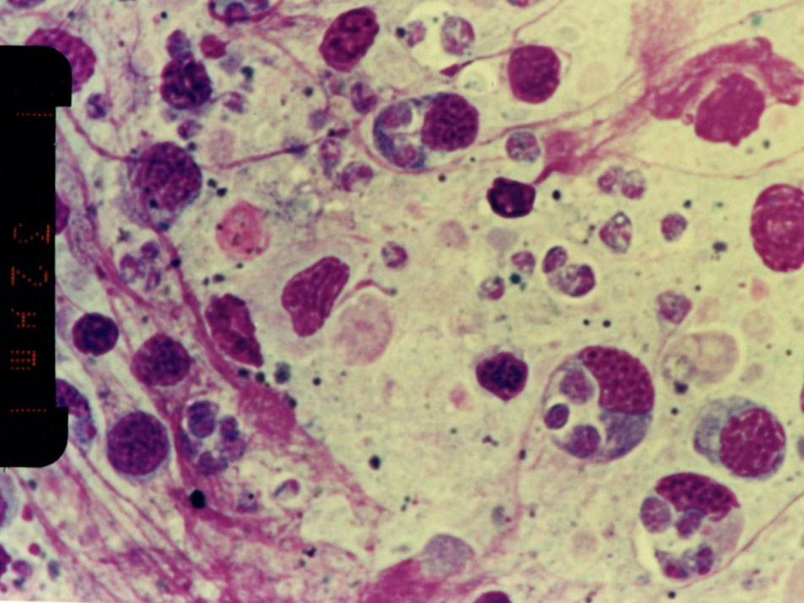
Note: Several microcells of Bonamia exitiosa within and outside haemocytes. Scale bar = 32µm.
Source: B Diggles
Figure 114 Histological section of heavy Bonamia exitiosa infection in vesicular connective (leydig) tissue of gonad of New Zealand dredge oyster (Ostrea chilensis)
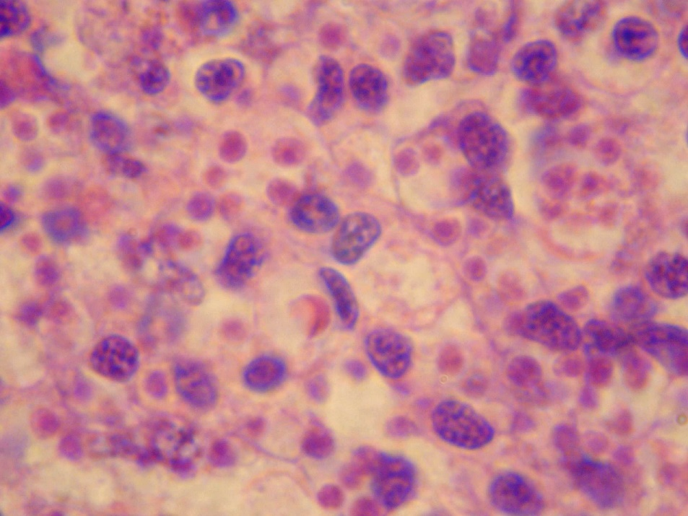
Note: The pink spherical microcells of B. exitiosa are smaller than the basophilic host cell nuclei.
Source: B Diggles
Figure 115 Histological section through vesicular connective (leydig) tissue of New Zealand dredge oyster (Ostrea chilensis)
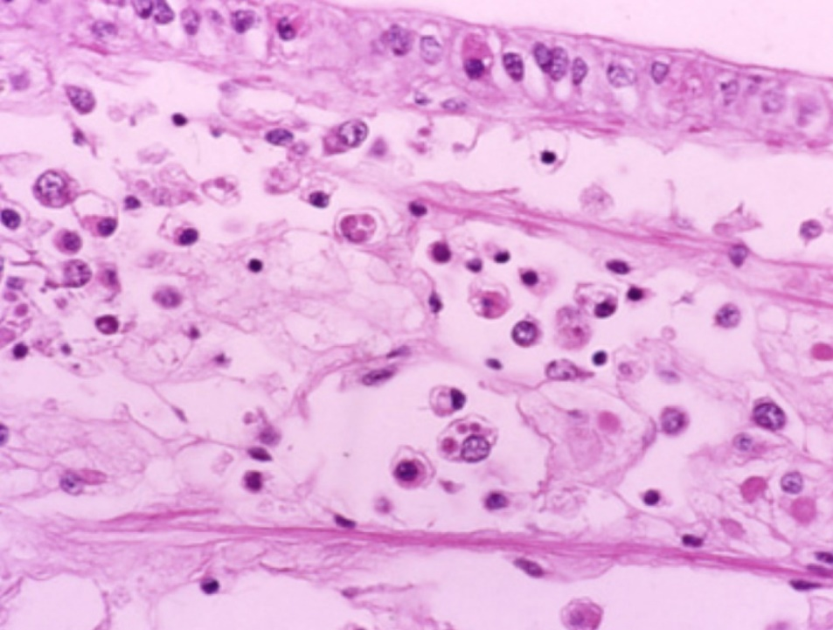
Note: Numerous circulating haemocytes, many containing Bonamia exitiosa (the small pink spheres in the haemocyte cytoplasm, smaller than a nucleus).
Source: B Jones

Further reading
CABI Invasive Species Compendium Bonamiosis (‘Bonamia exitiosa’)
CEFAS International Database on Aquatic Animal Diseases Infection with ‘Bonamia exitiosa’
World Organisation for Animal Health Manual of diagnostic tests for aquatic animals

Infection with Bonamia ostreae
Also known as bonamiosis
Exotic disease
Figure 116 Mortality of European flat oysters (Ostrea edulis) infected with Bonamia ostreae
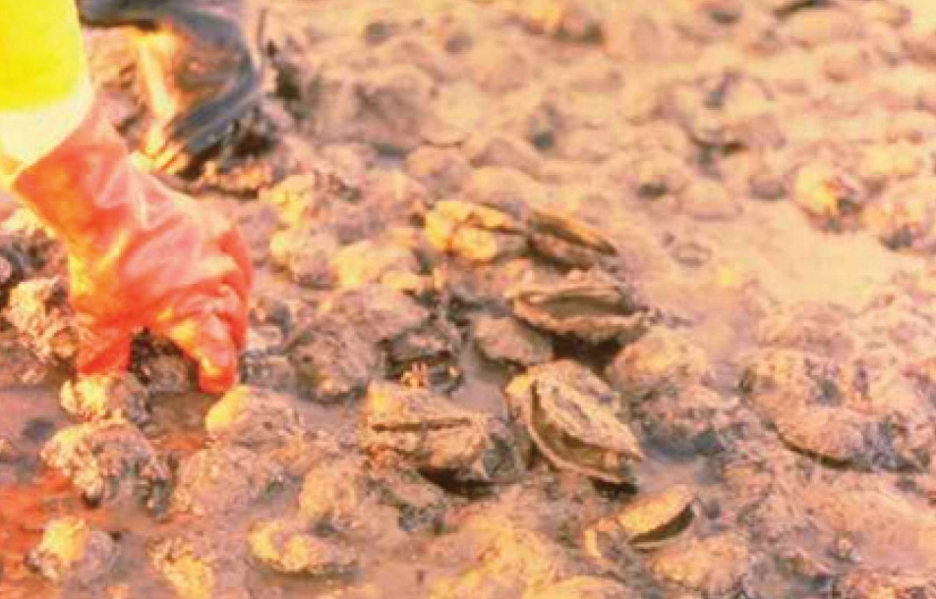
Note: Classic gaping of diseased oysters.
Source: D Alderman

Signs of disease
Important: Animals with this disease may show one or more of these signs, but the pathogen may still be present in the absence of any signs.
Diseases caused by any of the microcell species are similar. In cases of light infection, few or no clinical or gross signs are present. Concurrent infections with more than one species of Bonamia may also occur. Definitive identification of Bonamia or Mikrocytos species requires histological laboratory examination and molecular diagnostic techniques.
Disease signs at the farm, tank or pond level are:
- dead or gaping oysters
- increased mortality.
Gross pathological signs are:
- generally poor condition
- gills appearing eroded
- yellow discolouration of the gills and mantle.
Infection with Bonamia ostreae rarely results in gross pathological signs of disease in oysters. Often the only sign is increased mortality.
Microscopic pathological signs are:
- dense infiltrations of haemocytes, some containing microcell parasites in the connective tissue of the gill and mantle and in the vascular sinuses around the stomach and intestine
- extensive lesions, including perforated ulcers in the connective tissue of the gills, mantle and digestive gland.

Disease agent
Bonamiosis is caused by infection with Bonamia ostreae, an intrahaemocytic protist classified in the order Haplosporidia (class Ascetosporea). B. ostreae causes lethal infection of flat oysters.

Host range
B. ostreae is mainly a parasite of European flat oysters (Ostrea edulis). Australian flat oysters reared in France have been shown to be susceptible to B. ostreae. Microcells of B. ostreae are also occasionally detectable in cupped oysters (Pacific oysters, Portuguese oysters and Suminoe oysters) that co-occur in areas where B. ostreae epizootics occur in O. edulis.
Table 46 Species known to be naturally susceptible to infection with Bonamia ostreae
Common name | Scientific name
Argentinian flat oyster | Ostrea puelchana
Asiatic oyster | Ostrea denselammellosa
European flat oyster | Ostrea edulis
New Zealand dredge oyster | Ostrea chilensis
Pacific oyster | Crassostrea gigas
Portuguese oyster | Crassostrea angulata
Southern mud oyster or Australian flat oyster | Ostrea angasi
Suminoe oyster | Crassostrea ariakensis

Presence in Australia
Exotic disease—not recorded in Australia.
Bonamia ostreae has not been recorded and is considered exotic to Australia. Any differential diagnosis of Bonamia spp. infection in Australian oysters requires specific confirmation using molecular diagnostic techniques to discriminate between the endemic B. exitiosa and exotic B. ostreae and Bonamia spp.
Map 30 Presence of Bonamia ostreae, by jurisdiction

Epidemiology
- The critical host age for development of disease appears to be 2 years. However, other age classes are susceptible to infection.
- Significant mortalities usually occur at water temperatures of 12 to 20°C.
- Systemic infection of haemocytes effectively starves the oyster of energy required for survival. The infected animal eventually dies from exhaustion and starvation.
- Some studies suggest that prevalence and intensity of infection increase during late winter and autumn. However, the disease may occur at any time during the year.
- The pre-patent period is up to 5 months.
- Horizontal transmission of the parasite can occur directly from host to host and indirectly between oyster beds via the water.
- Bonamia ostreae is thought to have spread from California to Europe by human movement of infected oysters. It has also been detected in New Zealand (including in concurrent infections with B. exitiosa) and was possibly introduced by infected hosts carried in biofouling on shipping.

Differential diagnosis
The list of similar diseases in the next section refers only to the diseases covered by this field guide. Gross pathological signs may also be representative of diseases not included in this guide. Do not rely on gross signs to provide a definitive diagnosis. Use them as a tool to help identify the listed diseases that most closely account for the observed signs.

Similar diseases
Infection with Bonamia exitiosa, infection with Bonamia spp. and infection with Mikrocytos mackini.
There are few or no visual cues to the presence of this disease other than poor condition, shell gaping and increased mortality. Consequently, it is impossible to use gross signs alone to differentiate between infection by Bonamia species and Mikrocytos species. Concurrent infections with more than one species of Bonamia may also occur. Any presumptive diagnosis requires further laboratory examination.
Light microscopy can contribute diagnostic information, but further laboratory examination and molecular diagnostic techniques are required for a definitive diagnosis.

Sample collection
Only trained personnel should collect samples. Using only gross pathological signs to differentiate between diseases is not reliable, and some aquatic animal disease agents pose a risk to humans. If you are not appropriately trained, phone your state or territory hotline number and report your observations. If you have to collect samples, the agency taking your call will advise you on the appropriate course of action. Local or district fisheries or veterinary authorities may also advise on sampling.

Emergency disease hotline
See something you think is this disease? Report it. Even if you’re not sure.
Call the Emergency Animal Disease Watch Hotline on 1800 675 888. They will refer you to the right state or territory agency.

Further reading
CABI Invasive Species Compendium ‘Bonamia ostreae’
CEFAS International Database on Aquatic Animal Diseases Infection with ‘Bonamia ostreae’
World Organisation for Animal Health Manual of diagnostic tests for aquatic animals

Infection with Bonamia species
Also known as bonamiosis
Exotic disease

Signs of disease
Important: Animals with this disease may show one or more of these signs, but the pathogen may still be present in the absence of any signs.
Diseases caused by any of the microcell species are similar. In cases of light infection, few signs or no clinical or gross signs may be present. Concurrent infections with more than one species of Bonamia may also occur. Definitive identification of infection with Bonamia or Mikrocytos species requires histological laboratory examination and molecular diagnostic techniques.
Disease signs at the farm, tank or pond level are:
- dead or gaping oysters
- increased mortality.
Gross pathological signs are:
- stunted growth and poor condition
- weakened shell closure, leading to slight gaping
- watery flesh, pale atrophied digestive gland in clinically diseased oysters
- algae-covered shell lips after the mantle shrinks and no longer reaches the edges
- deformities to the gill margins.
Infection with Bonamia spp. rarely results in gross pathological signs of disease in oysters under natural conditions.—Most infections are asymptomatic.
Microscopic pathological signs are:
- microcell parasites in or near epithelia-may be in very low numbers
- microcells may also occur within haemocytes and vesicular connective tissues (especially the gill or mantle)
- individual microcells are basophilic, spherical or ovoid parasites, 2 to 3µm in diameter
- some species of exotic Bonamia spp. produce spores (such as B. perspora).

Disease agent
Bonamiosis is caused by infection with Bonamia spp., intrahaemocytic protists classified in the order Haplosporidia (class Ascetosporea). Both flat and cupped oysters may become infected.
This disease listing includes B. perspora and unidentified Bonamia spp., but excludes B. exitiosa and B. ostreae, which are addressed in separate disease listings.

Host range
Table 47 Species known to be naturally susceptible to infection with Bonamia spp.
Common name | Scientific name
Crested oyster | Ostrea equestris
Dwarf oyster | Ostrea stentina
European flat oyster | Ostrea edulis
Hawaiian oyster | Dendostrea sandvicensis
New Zealand dredge oyster | Ostrea chilensis
Pacific oyster | Crassostrea gigas
Southern mud oyster or Australian flat oyster | Ostrea angasi

Presence in Australia
Exotic disease—not recorded in Australia.
Bonamia exitiosa has been recorded from flat oysters in Victoria and New South Wales, and in a very low percentage of Sydney rock oysters in New South Wales. It is likely that Bonamia spp. previously recorded in flat oysters in Tasmania, South Australia and Western Australia are also B. exitiosa.
Bonamia ostreae and other Bonamia spp. are exotic to Australia, so any differential diagnosis of Bonamia spp. infection in Australian oysters requires specific confirmation using molecular diagnostic techniques to differentiate between the endemic B. exitiosa and exotic B. ostreae and Bonamia spp.
Map 31 Presence of Bonamia spp. (excluding B. exitiosa), by jurisdiction

Epidemiology
- Mortalities may occur all year, but usually happen in spring and summer.
- In most cases, oysters are lightly infected without mortalities. Factors that contribute to disease outbreaks are often unclear.
- Bonamia spp. are thought to be spread by human movements of subclinically infected oysters, and via infected hosts carried in biofouling on shipping.

Differential diagnosis
The list of similar diseases in the next section refers only to the diseases covered by this field guide. Gross pathological signs may also be representative of diseases not included in this guide. Do not rely on gross signs to provide a definitive diagnosis. Use them as a tool to help identify the listed diseases that most closely account for the observed signs.

Similar diseases
Infection with Bonamia exitiosa, infection with Bonamia ostreae and infection with Mikrocytos mackini.
There are few or no visual cues to the presence of this disease other than poor condition, shell gaping and increased mortality. Consequently, it is impossible to use gross signs alone to differentiate between infection by Bonamia species and Mikrocytos species. Concurrent infections with more than one species of Bonamia may also occur. Any presumptive diagnosis requires further laboratory examination.
Light microscopy can contribute diagnostic information (such as in the case of B. perspora infection when spores are present), but further laboratory examination and molecular diagnostic techniques are required for a definitive diagnosis.

Sample collection
Only trained personnel should collect samples. Using only gross pathological signs to differentiate between diseases is not reliable, and some aquatic animal disease agents pose a risk to humans. If you are not appropriately trained, phone your state or territory hotline number and report your observations. If you have to collect samples, the agency taking your call will advise you on the appropriate course of action. Local or district fisheries or veterinary authorities may also advise on sampling.

Emergency disease hotline
See something you think is this disease? Report it. Even if you’re not sure.
Call the Emergency Animal Disease Watch Hotline on 1800 675 888. They will refer you to the right state or territory agency.

Microscope images
Figure 117 Histological section of digestive gland of crested oyster (Ostrea equestris) with Bonamia perspora sporocysts
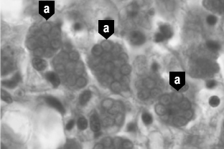
Note: Sporocysts of B. perspora (a).
Source: R Carnegie
Figure 118 Histological section of digestive gland of crested oyster (Ostrea equestris) with Bonamia perspora spores
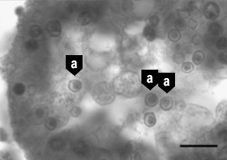
Note: Individual spores of B. perspora (a) released into the lumen of the digestive gland tubule. Scale bar = 10µm.
Source: R Carnegie

Further reading
Australia and New Zealand standard diagnostic procedure Bonamiosis in Australian ‘Ostrea angasi’
CEFAS International Database on Aquatic Animal Diseases Bonamiosis

Infection with Marteilia refringens
Also known as marteiliosis and Aber disease
Exotic disease
Figure 119 European flat oyster (Ostrea edulis) infected with Marteilia refringens
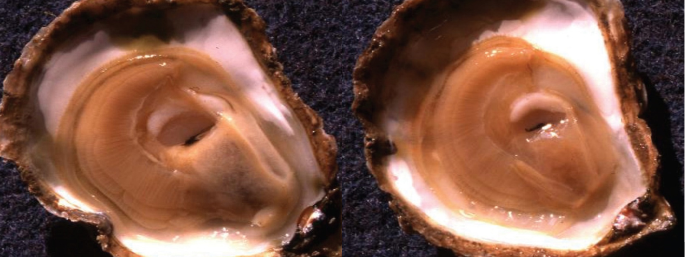
Note: A healthy oyster (left) with full, creamy-coloured digestive gland. The infected oyster (right) has a translucent, watery, shrunken digestive gland.
Source: French Research Institute for Exploration of the Sea

Signs of disease
Important: Animals with this disease may show one or more of these signs, but the pathogen may still be present in the absence of any signs.
Disease signs at the farm, tank or pond level are:
- high mortality
- reduced growth rate
- gaping shells.
Gross pathological signs are:
- poor condition and emaciation
- pale, watery digestive gland
- inhibited gonad development.
Microscopic pathological signs are:
- tissue necrosis
- massive infection of the digestive gland tubule epithelium with sporogenic stages.

Disease agent
Marteiliosis (or Aber disease) is caused by infection with Marteilia refringens. This is a protozoan parasite (order Paramyxida, class Ascetosporea) that affects the digestive system of multiple bivalve species, including oysters, mussels, cockles and clams. Other closely related species of Marteilia may cause similar diseases, including M. pararefringens in oysters and mussels, M. cochillia in cockles, M. octospora in razor shells and M. sydneyi in Sydney rock oysters.

Host range
Table 48 Species known to be susceptible to infection with Marteilia refringens
Common name | Scientific name
American eastern oysterª | Crassostrea virginica
Argentinian flat oyster | Ostrea puelchana
Asiatic oysterª | Ostrea denselammellosa
Blue musselª | Mytilus edulis
Calico scallop | Argopecten gibbus
Common cockleª | Cerastoderma edule
Dwarf oyster | Ostrea stentina
European flat oysterª | Ostrea edulis
European razor clamª | Solen marginatus
Mediterranean musselª | Mytilus galloprovincialis
New Zealand dredge oysterª | Ostrea chilensis
Olympia oysterª | Ostrea conchaphila
Pacific oyster | Crassostrea gigas
Rock oysterª | Saccostrea cucullata
Small brown mussel | Xenostrobus securis
Southern mud oyster or Australian flat oyster | Ostrea angasi
Striped venus clamª | Chamelea gallina
Planktonic copepodsª | Paracartia grani
a Naturally susceptible. Note: Other species have been shown to be experimentally susceptible.

Presence in Australia
Exotic disease—not recorded in Australia.
Marteilia refringens has never been recorded in Australia and is considered exotic. However, related species of Marteilia have been detected in various oyster species in Queensland, New South Wales and Western Australia.
Map 32 Presence of Marteilia refringens, by jurisdiction

Epidemiology
- Marteilia refringens infections result in high cumulative mortality (50 to 90%) and is associated with sporulation of the parasite in the epithelial cells of the digestive tubules.
- Highest cumulative mortalities usually occur during summer and autumn.
- Earlier stages of sporulation occur in epithelia of the digestive ducts and possibly the gills.
- Several intermediate hosts or a free-living stage are thought to be required during the life cycle of M. refringens. The planktonic copepod Paracartia grani is one intermediate host and may be involved in transmission of M. refringens between bivalves.
- Marteilia refringens can exist in a carrier state in apparently healthy oysters, which can be potential reservoirs of infection.
- Factors triggering a pathogenic host response are not clearly established. Factors may include environmental stresses and differences in susceptibility to disease between different host populations.
- The temperature threshold for parasite sporulation and transmission is 17°C. However, this is thought to vary with other environmental factors.

Differential diagnosis
The list of similar diseases in the next section refers only to the diseases covered by this field guide. Gross pathological signs may also be representative of diseases not included in this guide. Do not rely on gross signs to provide a definitive diagnosis. Use them as a tool to help identify the listed diseases that most closely account for the observed signs.

Similar diseases
Infection with Marteilia sydneyi.
The clinical signs of infection with M. refringens are almost identical to those of infection with other Ascetosporea. These include high mortalities associated with colourless and translucent tissue, poor condition, pale digestive gland and a shrunken body. Any presumptive diagnosis requires further laboratory examination. Light microscopy can contribute diagnostic information, but further laboratory examination and molecular diagnostic techniques are required for a definitive diagnosis.

Sample collection
Only trained personnel should collect samples. Using only gross pathological signs to differentiate between diseases is not reliable, and some aquatic animal disease agents pose a risk to humans. If you are not appropriately trained, phone your state or territory hotline number and report your observations. If you have to collect samples, the agency taking your call will advise you on the appropriate course of action. Local or district fisheries or veterinary authorities may also advise on sampling.

Emergency disease hotline
See something you think is this disease? Report it. Even if you’re not sure.
Call the Emergency Animal Disease Watch Hotline on 1800 675 888. They will refer you to the right state or territory agency.

Microscope images
Figure 120 Stained digestive gland imprint from European flat oyster (Ostrea edulis) infected with Marteilia refringens
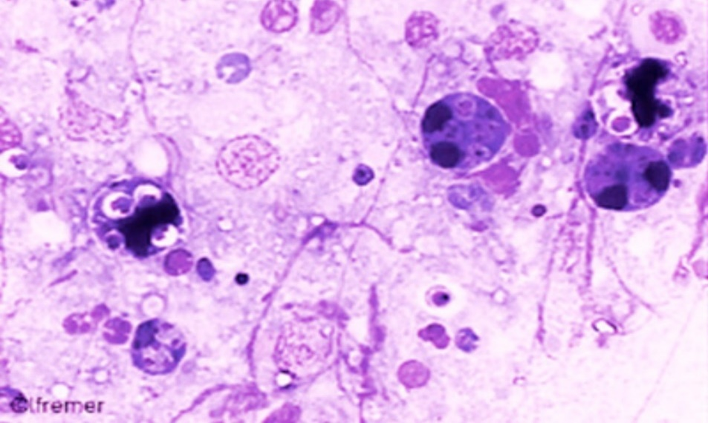
Note: Several dark-staining M. refringens sporonts containing pairs of spores. 120x magnification.
Source: French Research Institute for Exploration of the Sea
Figure 121 Histological section through digestive gland of European flat oyster (Ostrea edulis)
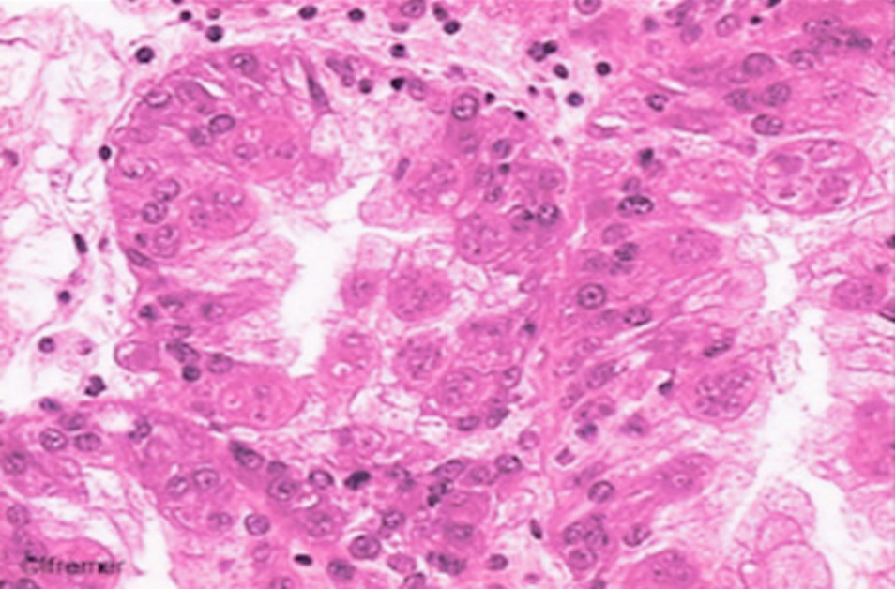
Note: Large numbers of sporogenic stages of M. refringens in the tubule epithelium. 80x magnification.
Source: French Research Institute for Exploration of the Sea
Figure 122 Histological section through digestive gland of European flat oyster (Ostrea edulis)
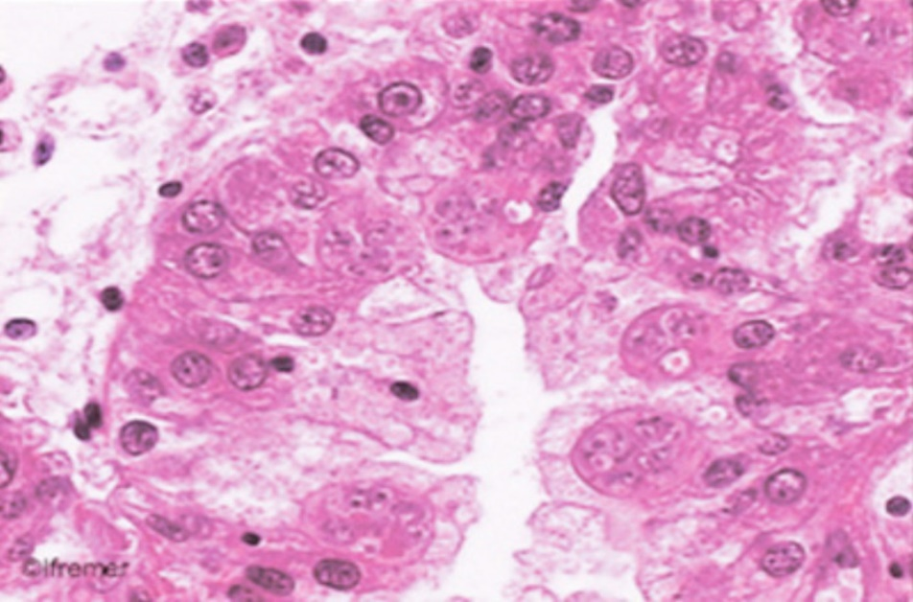
Note: Sporogenic stages of M. refringens in the tubule epithelium. 120x magnification.
Source: French Research Institute for Exploration of the Sea

Further reading
CABI Invasive Species Compendium Infection with ‘Marteilia refringens’
CEFAS International Database on Aquatic Animal Diseases Infection with ‘Marteilia refringens’
World Organisation for Animal Health Manual of diagnostic tests for aquatic animals

Infection with Marteilia sydneyi
Also known as Marteiliosis and QX disease
Figure 123 Sydney rock oysters (Saccostrea glomerata) infected with Marteilia sydneyi
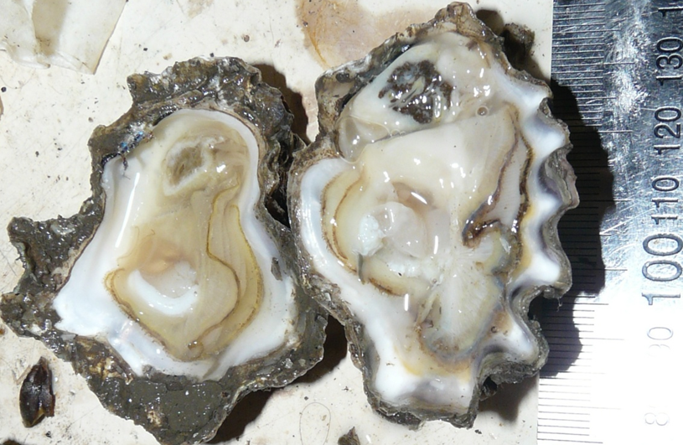
Note: Shrunken, pale yellowish, watery digestive gland typical of oyster infected with QX disease (left). Normal digestive gland of oyster is darker (right).
Source: B Diggles

Signs of disease
Important: Animals with this disease may show one or more of these signs, but the pathogen may still be present in the absence of any signs.
Disease signs at the farm, tank or pond level are:
- reduced growth rate
- gaping shells
- high cumulative mortalities of up to 100%.
Gross pathological signs are:
- shrunken, watery body
- generally poor condition
- death often within 60 days of infection
- colourless and translucent tissue because the gonad is completely resorbed
- digestive gland (usually a deep green or brown colour) becomes pale yellow or brown.
Microscopic pathological signs are:
- focal haemocytic inflammation of the gills
- hyperplasia of the connective tissue and gill epithelium, with fusion of gill filaments
- massive infection of the digestive gland tubule epithelium with sporogenic stages.

Disease agent
Marteiliosis (also known as QX disease) is caused by infection with Marteilia sydneyi. This protozoan parasite (order Paramyxida, class Ascetosporea) infects the digestive system of Sydney rock oysters and mud dwelling polychaete worms. Other closely related species of Marteilia may cause similar diseases, including M. pararefringens in oysters and mussels, M. cochillia in cockles, M. octospora in razor shells, and M. refringens in oysters, mussels, cockles and clams.

Host range
Marteilia sydneyi has an indirect life cycle. Mud-dwelling polychaetes are one known intermediate host, but there may be others.
Table 49 Species known to be naturally susceptible to infection with Marteilia sydneyi
Common name | Scientific name
Rock oyster | Saccostrea cucullata
Sydney rock oyster | Saccostrea glomerata
Polychaete | Nephtys australiensis

Presence in Australia
Infection with M. sydneyi is responsible for losses in the Sydney rock oyster industry on the east coast of Australia. The parasite and disease are present in Queensland and New South Wales. A related species of Marteilia has been detected in apparently healthy Australian flat oysters (Ostrea angasi) in New South Wales. A Marteilia sp. (probably M. sydneyi) was officially reported in 1994, associated with disease in the coral rock oyster (Saccostrea cucullata) in Western Australia.
Map 33 Presence of Marteilia sydneyi, by jurisdiction
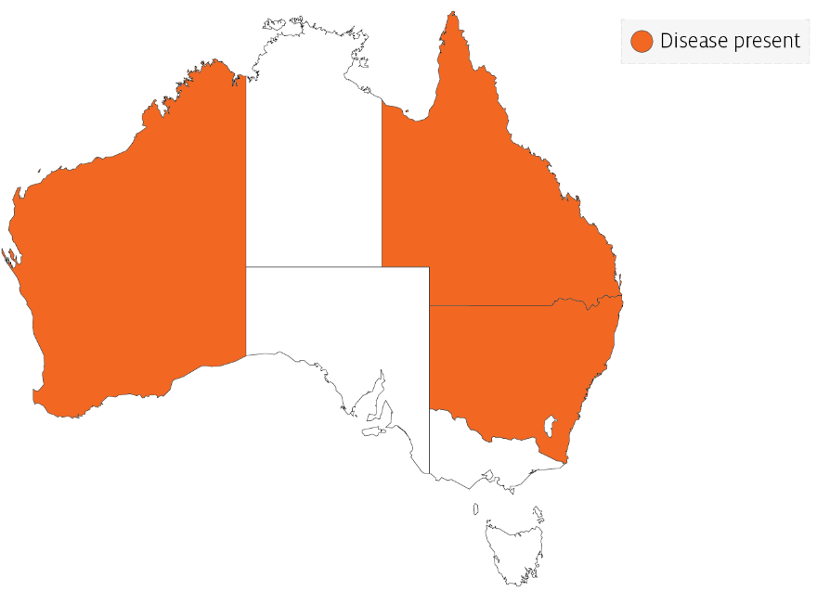

Epidemiology
- The presence of the Marteilia sydneyi in eastern Australian estuaries is not always accompanied by QX disease. Most of the estuaries that are free of QX disease have less anthropogenic disturbance in the catchment.
- Oysters may be subjected to infection for a period of as little as 2 weeks per year.
- Outbreaks of disease occur in summer and autumn. Warm temperatures favour parasite development, leading to greatest mortality at the end of summer.
- Onset of the disease is often associated with immunosuppression of oysters due to stressors such as flooding or low salinity, high water temperature and excessive sedimentation.
- Transmission is horizontal. The pathogen passes from the environment into the epithelium of the palps and gills, where it proliferates without forming spores. In advanced infections, spores are formed in the digestive gland epithelium.
- Oysters that carry low levels of M. sydneyi infections can shed the parasite and make a full recovery.
- The life cycle of M. sydneyi is indirect but not fully understood. Intermediate hosts are required to complete the life cycle. Benthic mud-dwelling polychaetes such as Nephtys australiensis are one of possibly several intermediate hosts.
- Increased virulence of M. sydneyi in degraded estuaries compared to historical times may be due to a combination of several factors. These include increased immunosuppression of the host due to declining water quality together with increased abundance of polychaete intermediate hosts that are favoured by sedimentation, eutrophication and other anthropogenic changes derived from catchment development.

Differential diagnosis
The list of similar diseases in the next section refers only to the diseases covered by this field guide. Gross pathological signs may also be representative of diseases not included in this guide. Do not rely on gross signs to provide a definitive diagnosis. Use them as a tool to help identify the listed diseases that most closely account for the observed signs.

Similar diseases
Infection with Marteilia refringens.
The clinical signs of infection with M. sydneyi are almost identical to those of infection with other Ascetosporea. These include high mortalities associated with colourless and translucent tissue, poor condition, pale digestive gland and a shrunken body. Any presumptive diagnosis requires further laboratory examination. Light microscopy can contribute diagnostic information, but further laboratory examination and molecular diagnostic techniques are required for a definitive diagnosis.

Sample collection
Only trained personnel should collect samples. Using only gross pathological signs to differentiate between diseases is not reliable, and some aquatic animal disease agents pose a risk to humans. If you are not appropriately trained, phone your state or territory hotline number and report your observations. If you have to collect samples, the agency taking your call will advise you on the appropriate course of action. Local or district fisheries or veterinary authorities may also advise on sampling.

Emergency disease hotline
See something you think is this disease? Report it. Even if you’re not sure.
Call the Emergency Animal Disease Watch Hotline on 1800 675 888. They will refer you to the right state or territory agency.

Microscope images
Figure 124 Hypothetical development of Marteilia sydneyi in Sydney rock oyster (Saccostrea glomerata)
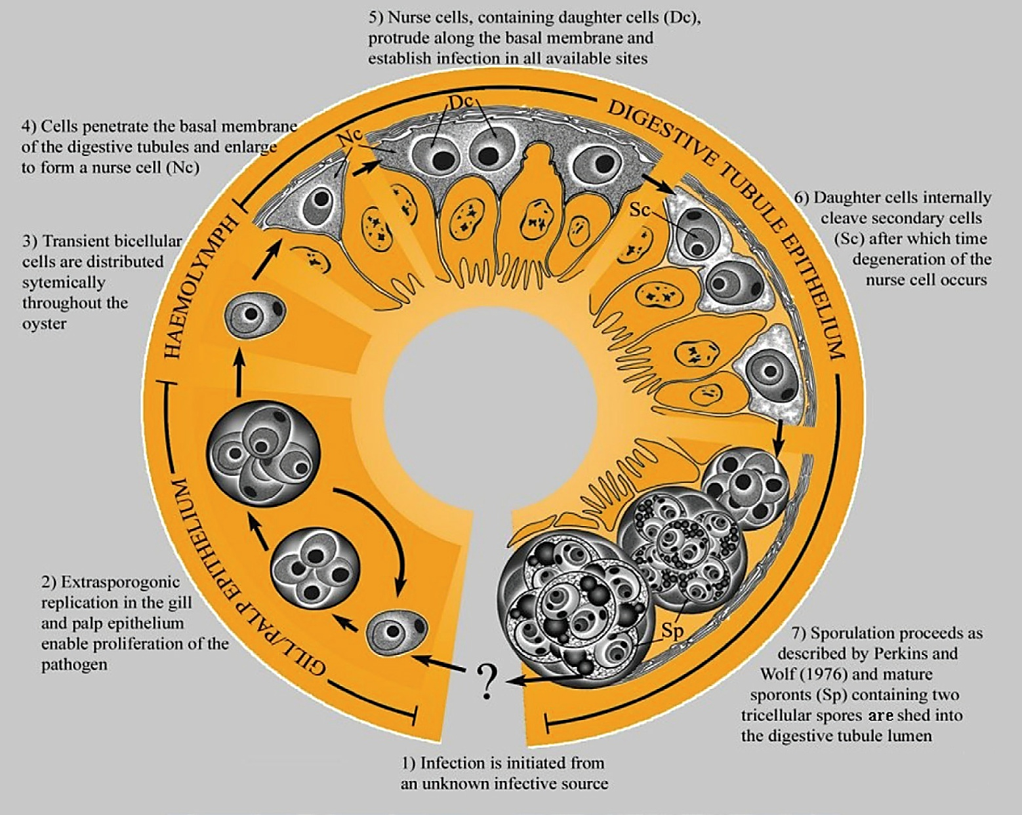
Note: Migration of M. sydneyi infective stages, from gills and palps to digestive gland tubule epithelium where sporulation occurs.
Source: S Ridgeway
Figure 125 Unstained wet smear of digestive gland of Sydney rock oyster (Saccostrea glomerata) with QX disease
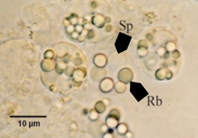
Note: M. sydneyi sporonts with refractile bodies (Rb) and spores (Sp). Scale bar = 10µm.
Source: S Ridgeway
Figure 126 Unstained wet smear of digestive gland of Sydney rock oyster (Saccostrea glomerata) showing Marteilia sydneyi sporonts viewed under interference contrast optics
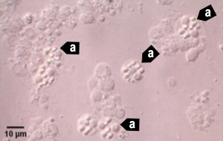
Note: Many M. sydneyi sporonts (a) visible. Scale bar = 10µm.
Source: S Ridgeway
Figure 127 Hemacolor (Merck)-stained tissue imprint of digestive gland of Sydney rock oyster (Saccostrea glomerata) infected with Marteilia sydneyi in multiple life stages
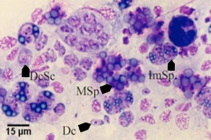
Note: Various life cycle stages, including daughter cells (Dc), daughter cells containing secondary cells (DcSc), immature sporonts (ImSp) and mature sporonts (MSp). The various stages observed are often ruptured from their enclosing cells (the nurse cells or sporangiosori).Scale bar = 15µm.
Source: S Ridgeway
Figure 128 Histopathology of gills of Sydney rock oyster (Saccostrea glomerata) infected with Marteilia sydneyi
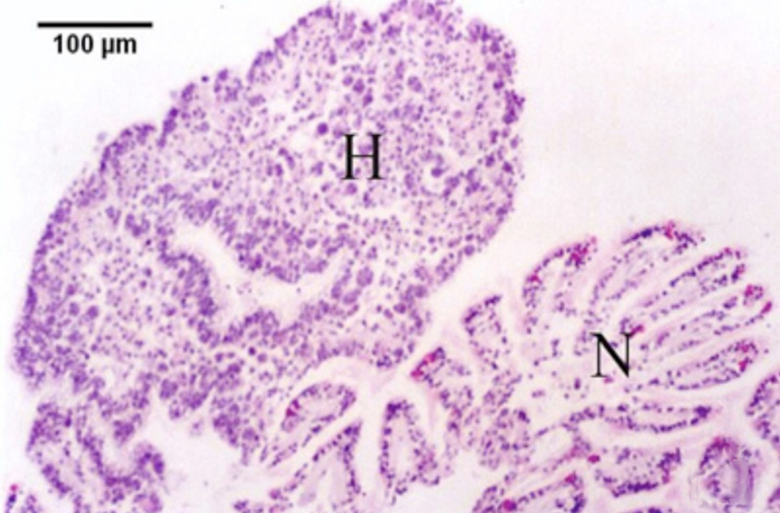
Note: Reaction of S. glomerata to the presence of numerous M. sydneyi extrasporogonic stages in the epithelium of the gills. Consisting of epithelial and connective tissue haemocytosis (H) and fusion of filaments. Contrasted with relatively normal-looking gill tissue (N). Scale bar = 100µm.
Source: S Ridgeway
Figure 129 Histopathology of palp epithelium of Sydney rock oyster (Saccostrea. glomerata) infected with Marteilia sydneyi
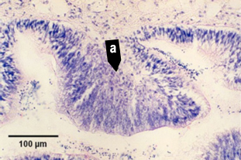
Note: Replicating stages of M. sydneyi in the palp epithelium causing hypertrophy of epithelial cells in the presence of proliferating parasites (a). Scale bar = 100µm.
Source: S Ridgeway
Figure 130 High power magnification of the epithelium of gills of Sydney rock oyster (Saccostrea glomerata)
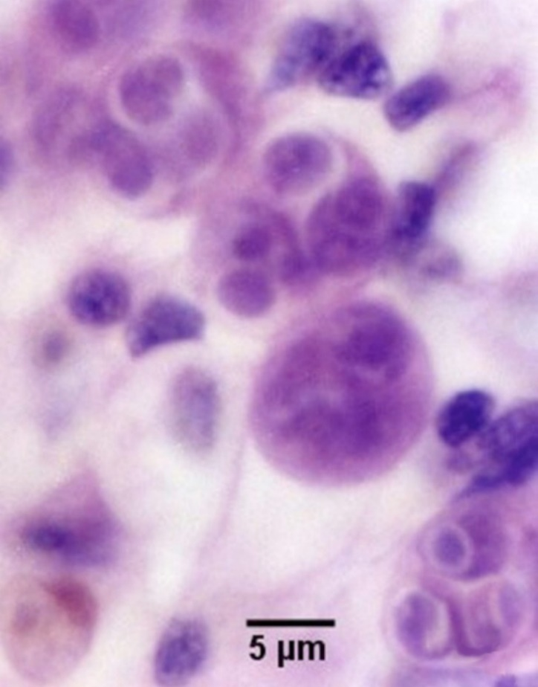
Note: Extrasporogonic stages (see phase 2 in Figure 124). Scale bar = 5µm
Source: S Ridgeway
Figure 131 Serial sections of haemocytic infiltration of connective tissue surrounding infected digestive gland tubules
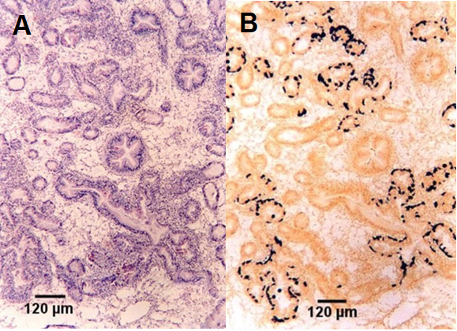
Note: Comparison of histopathological section (A) and in situ hybridisation section (B). Location of presporulating nurse cell stages in digestive gland tubule epithelia show stained black in B. Scale bar = 120µm
Source: S Ridgeway
Figure 132 Nurse cell stained black by in situ hybridisation
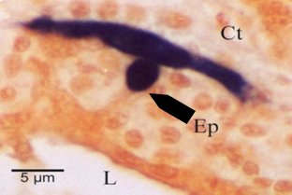
Note: Stain shows extent of the pseudopodial extensions along basal membrane of digestive tubule epithelium (Ep). This feature is not evident with haematoxylin and eosin staining. Other labelled features are connective tissue (Ct) surrounding the tubule and lumen (L) of the tubule. Scale bar = 5µm.
Source: S Ridgeway
Figure 133 Histological section of digestive gland of Sydney rock oyster (Saccostrea glomerata) with Marteilia sydneyi nurse cell
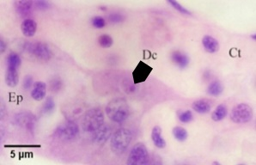
Note: Nurse cell containing one daughter cell (Dc) along basal membrane of tubule between connective tissue (Ct) surrounding the tubules and tubule epithelium (Ep). Scale bar = 5µm.
Source: S Ridgeway
Figure 134 Two photos of same tissue section at different focal planes, demonstrating budding of daughter cell
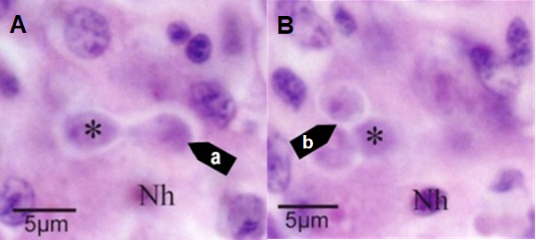
Note: The new daughter cell (a) budding within the nurse cell is visible only in one focal plane (A). Another daughter cell (asterisk), and the host cell nucleus (Nh) are visible in each figure. Two additional daughter cells (b) within the nurse cell visible only in the second focal plane (B). Scale bar = 5µm.
Source: S Ridgeway
Figure 135 Histological section of digestive gland of Sydney rock oyster (Saccostrea glomerata) with daughter cells of Marteilia sydneyi
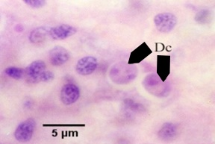
Note: Nurse cell of M. sydneyi containing 2 daughter cells (Dc) (see phase 5 in Figure 124). Scale bar = 5µm.
Source: S Ridgeway
Figure 136 Histological section of digestive gland of Sydney rock oyster (Saccostrea glomerata) with bicellular daughter cells of Marteilia sydneyi
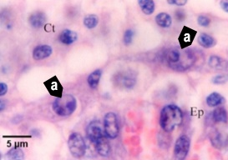
Note: Nurse cells of M. sydneyi containing bicellular daughter cells (a) along the basal membrane between tubule epithelium (Ep) and connective tissue (Ct) that contains numerous infiltrating haemocytes (see phase 6 in Figure 124). Scale bar = 5µm
Source: S Ridgeway
Figure 137 Histological section of digestive gland of Sydney rock oyster (Saccostrea glomerata) with primary and secondary cells of Marteilia sydneyi
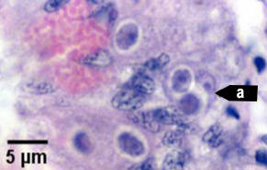
Note: Primary cell (a) containing 2 secondary cells (sporont primordia) just before sporulation (see initiation of phase 7 in Figure 124). Scale bar = 5µm.
Source: S Ridgeway
Figure 138 Histological section of digestive gland of Sydney rock oyster (Saccostrea glomerata) with Marteilia sydneyi sporulating stages
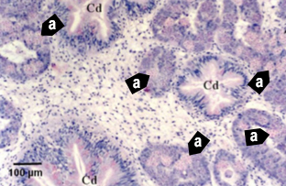
Note: Numerous sporulating stages (a) in the digestive gland tubules. Sporulation does not occur in the ciliated ducts (Cd) of the digestive gland. Scale bar = 100µm
Source: S Ridgeway
Figure 139 Histological section of digestive gland of Sydney rock oyster (Saccostrea glomerata) with Marteilia sydneyi sporonts
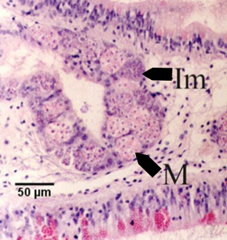
Note: Immature sporonts (Im) and mature sporonts (M) within sporangiosori in a digestive gland tubule. The epithelium of the tubule is almost completely replaced by M. sydneyi. Scale bar = 50µm.
Source: S Ridgeway

Further reading
CABI Invasive Species Compendium Infection with ‘Marteilia sydneyi’
CEFAS International Database on Aquatic Animal Diseases Marteiliosis

Infection with Marteilioides chungmuensis
Also known as marteilioidosis
Exotic disease
Figure 140 Pacific oyster (Crassostrea gigas) infected with Marteilioides chungmuensis
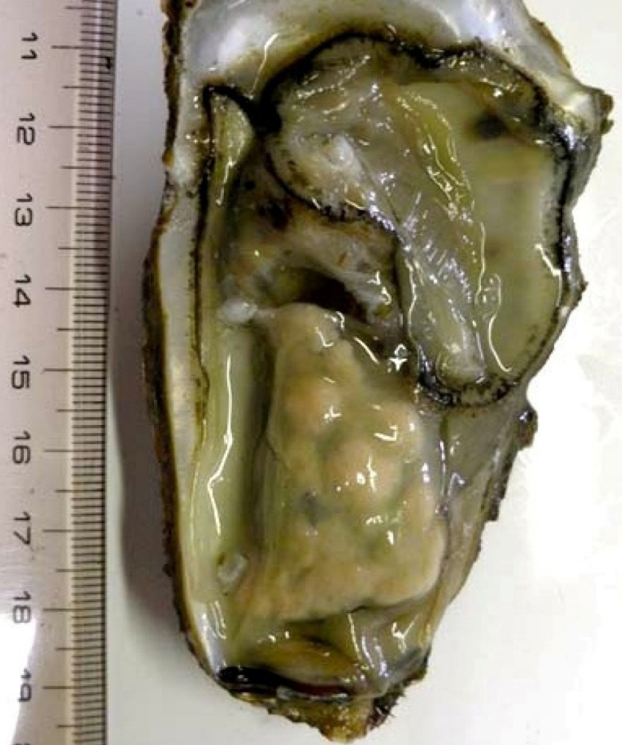
Note: Nodular yellowish lesions visible in the gonad.
Source: N Itoh

Signs of disease
Important: Animals with this disease may show one or more of these signs, but the pathogen may still be present in the absence of any signs.
Disease signs at the farm, tank or pond level are:
- spawning failure
- high mortalities.
Gross pathological signs are:
- visible distension of the mantle surface due to infected eggs retained within the follicle
- nodule-like structures on the gonad surface.
Microscopic pathological signs are:
- paramyxean parasites within oocytes.

Disease agent
Marteilioidosis is caused by infection with Marteilioides chungmuensis, a protozoan parasite (order i, class Ascetosporea) that infects the oocytes of oysters.

Host range
Table 50 Species known to be susceptible to infection with Marteilioides chungmuensis
Common name | Scientific name
Iwagaki oyster | Crassostrea nippona
Pacific oysterª | Crassostrea gigas
a Naturally susceptible. Note: Other species have been shown to be experimentally susceptible.

Presence in Australia
Exotic disease—not recorded in Australia.
Marteilioides chungmuensis has not been recorded in Australia and is considered exotic. Other species of Marteilioides have been reported in the ovary of Saccostrea echinata from the Northern Territory and Western Australia. The related M. branchialis causes focal lesions in the gill lamellae of Sydney rock oysters in northern New South Wales.
Map 34 Presence of Marteilioides chungmuensis, by jurisdiction

Epidemiology
- Marteilioides chungmuensis infects the cytoplasm of mature oocytes and can affect a substantial proportion of eggs.
- Prolonged spawning activity of infected oysters has been observed, resulting in nutritional wasting and mortality.
- Prevalence of infection increases during spawning in summer and decreases after spawning in winter.
- Infected oysters lose their marketability, due to their abnormal appearance.
- Mode of transmission is unknown. However, as for other paramyxeans, intermediate hosts may be involved in the life cycle of the parasite.

Differential diagnosis
The list of similar diseases in the next section refers only to the diseases covered by this field guide. Gross pathological signs may also be representative of diseases not included in this guide. Do not rely on gross signs to provide a definitive diagnosis. Use them as a tool to help identify the listed diseases that most closely account for the observed signs.

Similar diseases
No diseases listed in this field guide are similar to infection with Marteilioides chungmuensis.

Sample collection
Only trained personnel should collect samples. Using only gross pathological signs to differentiate between diseases is not reliable, and some aquatic animal disease agents pose a risk to humans. If you are not appropriately trained, phone your state or territory hotline number and report your observations. If you have to collect samples, the agency taking your call will advise you on the appropriate course of action. Local or district fisheries or veterinary authorities may also advise on sampling.

Emergency disease hotline
See something you think is this disease? Report it. Even if you’re not sure.
Call the Emergency Animal Disease Watch Hotline on 1800 675 888. They will refer you to the right state or territory agency.

Microscope images
Figure 141 Histological section of ovary of Pacific oyster (Crassostrea gigas)
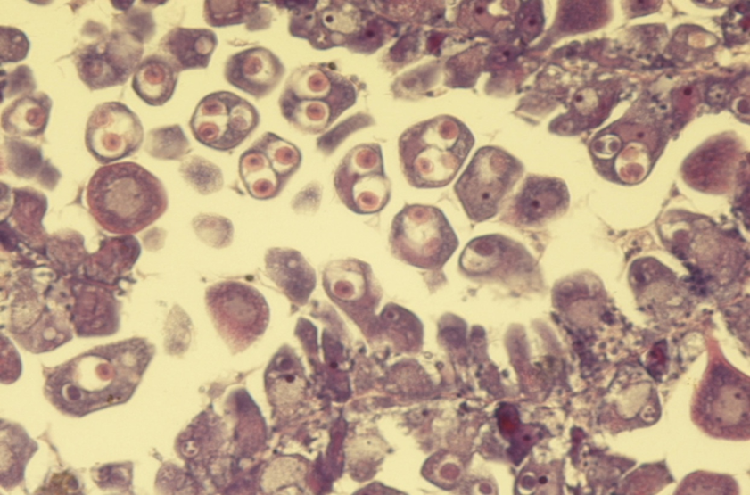
Note: Intracellular (within oocytes) Marteilioides chungmuensis parasites.
Source: N Itoh

Further reading
European Union Reference Laboratory for Molluscs Diseases ‘Marteilioides chungmuensis’
Fisheries and Oceans Canada ‘Marteilioides chungmuensis’ of oysters

Infection with Mikrocytos mackini
Also known as Denman Island disease
Exotic disease
Figure 142 Pacific oysters (Crassostrea gigas) removed from shell showing focal lesions characteristic of infection with Mikrocytos mackini
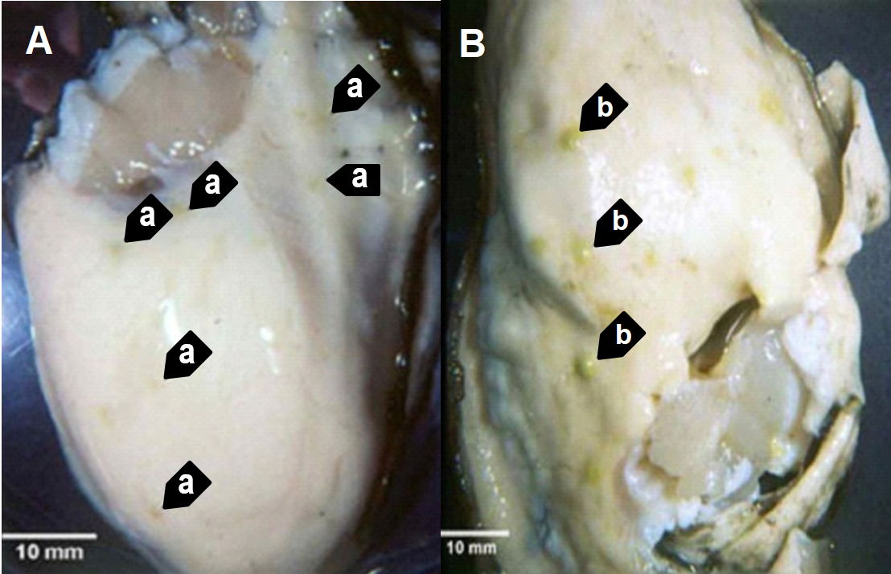
Note: Oyster ( left) shows lesions (a) typical of early infections. Oyster (right) shows lesions (b) typical of advanced stages of the disease, when M. mackini typically can no longer be found in the lesions.
Source: S Bower
Figure 143 European flat oyster (Ostrea edulis) with lesions caused by infection with Mikrocytos mackini
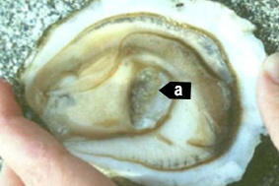
Note: Numerous lesions in the adductor muscle (a) caused by M. mackini (experimental infection).
Source: S Bower

Signs of disease
Important: Animals with this disease may show one or more of these signs, but the pathogen may still be present in the absence of any signs.
Diseases caused by any of the microcell species are similar. In cases of light infection, few or no clinical or gross signs are present. Concurrent infections with more than one species of Bonamia may also occur. Definitive identification of Bonamia or Mikrocytos species requires histological laboratory examination and molecular diagnostic techniques.
Disease signs at the farm, tank or pond level are:
- dead or gaping oysters
- increased mortality.
Gross pathological signs are:
- focal yellow or green lesions up to 5mm in diameter within the body wall or on surfaces of the gonad, labial palps, gills or mantle
- brown scars on the shell adjacent to lesions on the mantle surface
- gaping oysters due to impaired adductor muscle contraction.
Microscopic pathological signs are:
- focal intracellular infection, mainly of vesicular connective tissue (leydig) cells, resulting in haemocyte infiltration and tissue necrosis
- intracellular and extracellular microcell protozoa, 2 to 3µm in diameter, in vesicular connective tissue cells immediately adjacent to lesions.

Disease agent
Denman Island disease is caused by infection with Mikrocytos mackini, an intracellular protozoan parasite that causes lethal infection of certain species of oysters. M. mackini is classified in the order Mikrocytida within the class Ascetosporea, and is not closely related to Bonamia spp.
Mikrocytids are a highly divergent group of protists that infect a range of aquatic invertebrates including bivalve molluscs, decapod crustaceans and annelids.

Host range
Table 51 Species known to be susceptible to infection with Mikrocytos mackini
Common name | Scientific name
American eastern oysterª | Crassostrea virginica
European flat oyster | Ostrea edulis
Olympia oysterª | Ostrea lurida
Pacific oysterª | Crassostrea gigas
a Naturally susceptible. Note: Other species have been shown to be experimentally susceptible.

Presence in Australia
Exotic disease—not recorded in Australia.
Map 35 Presence of Mikrocytos mackini, by jurisdiction

Epidemiology
- Severe infections appear to be restricted to oysters over 2 years old.
- The disease is associated with low temperature and high salinity. Most mortalities occur during April to May (spring in the northern hemisphere). There is a 3 to 4 month pre-patent period when temperatures are less than 10°C.
- The Pacific oyster appears to be more resistant to the disease than other species challenged experimentally under laboratory and field conditions.

Differential diagnosis
The list of similar diseases in the next section refers only to the diseases covered by this field guide. Gross pathological signs may also be representative of diseases not included in this guide. Do not rely on gross signs to provide a definitive diagnosis. Use them as a tool to help identify the listed diseases that most closely account for the observed signs.

Similar diseases
Infection with Bonamia ostreae, infection with Bonamia exitiosa and infection with Bonamia spp.
There are few or no visual cues to the presence of this disease other than poor condition, shell gaping and increased mortality. Consequently, it is impossible to use gross signs alone to differentiate between infection by M. mackini and Bonamia species. Any presumptive diagnosis requires further laboratory examination.
Light microscopy can contribute diagnostic information, but further laboratory examination and molecular diagnostic techniques are required for a definitive diagnosis.

Sample collection
Only trained personnel should collect samples. Using only gross pathological signs to differentiate between diseases is not reliable, and some aquatic animal disease agents pose a risk to humans. If you are not appropriately trained, phone your state or territory hotline number and report your observations. If you have to collect samples, the agency taking your call will advise you on the appropriate course of action. Local or district fisheries or veterinary authorities may also advise on sampling.

Emergency disease hotline
See something you think is this disease? Report it. Even if you’re not sure.
Call the Emergency Animal Disease Watch Hotline on 1800 675 888. They will refer you to the right state or territory agency.

Microscope images
Figure 144 Proposed developmental cycle of Mikrocytos mackini
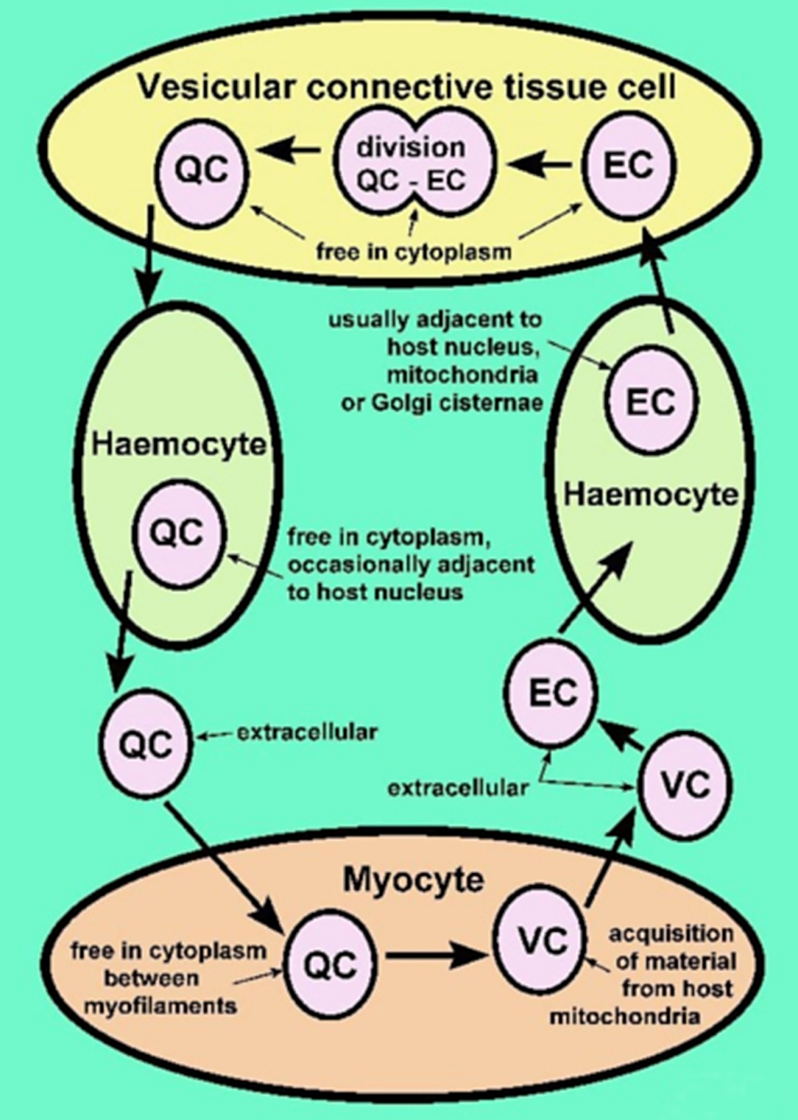
Note: Host cell type and host organelle affiliation for the three recognised morphological forms: quiescent cell (QC), vesicular cell (VC) and endosomal cell (EC).
Source: S Bower
Figure 145 Section through lesion caused by Mikrocytos mackini in the mantle of Pacific oyster (Crassostrea gigas)
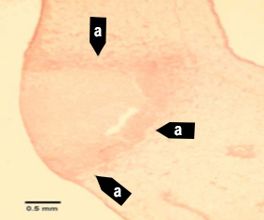
Note: The intracellular protozoan (not visible at this magnification) usually occurs in the intact vesicular connective tissue cells immediately surrounding the periphery of the lesion (a). Haematoxylin and eosin stain. Scale bar = 500µm.
Source: S Bower
Figure 146 Section through lesion in the vesicular connective tissue of Pacific oyster (Crassostrea gigas)
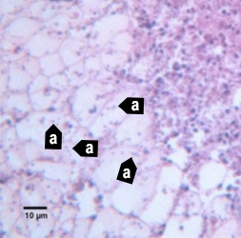
Note: Many Mikrocytos mackini (a) within vesicular connective tissue (leydig) cells next to a lesion characterised by an accumulation of haemocytes and necrotic cells. Haematoxylin and eosin stain. Scale bar = 10µm.
Source: S Bower
Figure 147 Oil immersion magnification of Mikrocytos mackini within the cytoplasm of vesicular connective tissue cells of Pacific oyster (Crassostrea gigas)
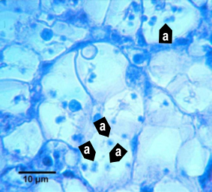
Note: Because of the small size of this parasite, it is very difficult to visualise and photograph in histological preparations. Haematoxylin and eosin stain. Scale bar = 10µm.
Source: S Bower
Figure 148 Mikrocytos mackini within fibres of adductor muscle of Pacific oyster (Crassostrea gigas)
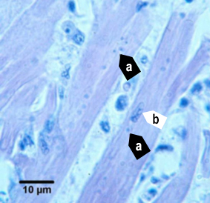
Note: Several M. mackini microcells (a) are located close to the nucleus (b) of a muscle cell. Haematoxylin and eosin stain. Scale bar = 10µm.
Source: S Bower
Figure 149 Electron micrograph of vesicular connective tissue cell from Pacific oyster (Crassostrea gigas)
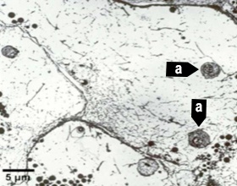
Note: Two M. mackini (a) in the cytoplasm of the cell. Uranyl acetate and lead citrate stain. Scale bar = 5µm.
Source: S Bower
Figure 150 Electron micrograph of two Mikrocytos mackini microcells
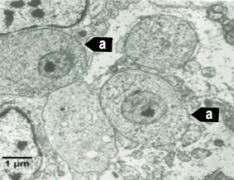
Note: Two M. mackini microcells (a) each containing a nucleus with a pronounced nucleolus and lacking mitochondria. Uranyl acetate and lead citrate stain. Scale bar = 1µm.
Source: S Bower

Further reading
CABI Invasive Species Compendium ‘Mikrocytos mackini’
CEFAS International Database on Aquatic Animal Diseases Infection with ‘Mikrocytos mackini’
European Union Reference Laboratory for Molluscs Diseases ‘Mikrocytos mackini’
World Organisation for Animal Health Manual of diagnostic tests for aquatic animals

Infection with Perkinsus marinus
Also known as perkinsosis and dermo disease
Exotic disease
Figure 151 American oyster (Crassostrea virginica) showing gross signs of infection with Perkinsus marinus
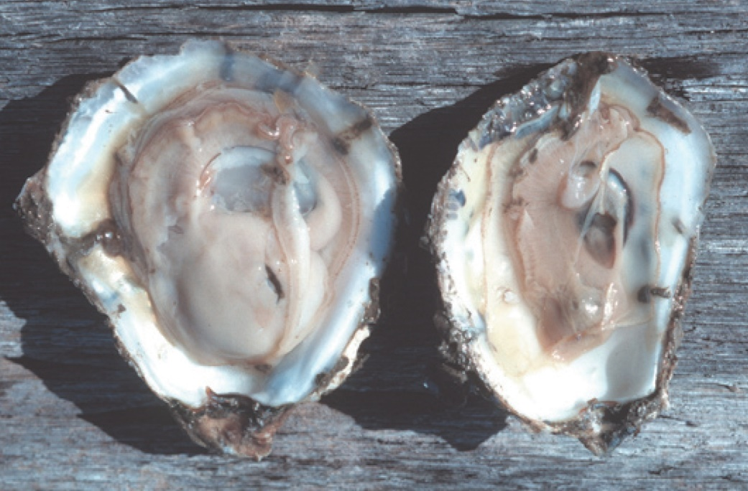
Note: A healthy oyster (left). The infected oyster (right) is thin and watery, typical gross signs of infection with P. marinus.
Source: E Burreson

Signs of disease
Important: Animals with this disease may show one or more of these signs, but the pathogen may still be present in the absence of any signs.
Disease signs at the farm, tank or pond level are:
- gaping
- retarded growth
- poor condition or emaciation
- increased mortality.
Gross pathological signs are:
- shrinkage of mantle away from the outer edge of the shell
- occasional lesions in soft tissue
- pale digestive gland
- thin, watery tissue.
Microscopic pathological signs are:
- large, multifocal lesions in the gut epithelium or connective tissue of organs containing P. marinus cells
- haemocyte infiltration and phagocytosis of P. marinus cells
- destruction of the gut epithelium.

Disease agent
Perkinsosis (or dermo disease) is caused by infection with Perkinsus marinus, an alveolate protest in the family Perkinsidae. P. marinus has been placed nominally in the order Dinoflagellida, but its higher taxonomy is subject to scientific debate. Several other species of the genus Perkinsus infect molluscs such as oysters, mussels, clams and abalone worldwide.

Host range
Table 52 Species known to be susceptible to infection with Perkinsus marinus
Common name | Scientific name
American eastern oysterª | Crassostrea virginica
Baltic macoma | Macoma balthica
Blue mussel | Mytilus edulis
Cortez oysterª | Crassostrea corteziensis
Mangrove oysterª | Crassostrea rhizophorae
Pacific oysterª | Crassostrea gigas
Soft shelled clam | Mya arenaria
Suminoe oysterª | Crassostrea ariakensis
a Naturally susceptible. Note: Other species have been shown to be experimentally susceptible.

Presence in Australia
Exotic disease—not recorded in Australia.
Map 36 Presence of Perkinsus marinus, by jurisdiction

Epidemiology
- Water temperatures above 20°C encourage proliferation of the parasite. This results in systemic disruption of connective tissue and epithelial cells and leads to high mortalities.
- Reduced salinity levels (below 9ppt) can prevent clinical disease resulting from P. marinus infection, even in warm water (above 20°C).
- Cumulative American oyster mortalities of up to 95% have been observed in the first summer following transfer of naïve stock to an area where the disease is known to be present.
- Transmission is horizontal.
- Infection levels increase during spawning and under the stress of oxygen depletion.
- Prevalence and intensity of infection are greatest in oysters more than 1 year old and at depths greater than 90cm.
- Exposure to pollutants will increase the prevalence of infection.

Differential diagnosis
The list of similar diseases in the next section refers only to the diseases covered by this field guide. Gross pathological signs may also be representative of diseases not included in this guide. Do not rely on gross signs to provide a definitive diagnosis. Use them as a tool to help identify the listed diseases that most closely account for the observed signs.

Similar diseases
Infection with Perkinsus olseni.
The clinical signs of infection with P. marinus are similar to those of infection with other species of Perkinsus. These include occasional pustules in soft tissue, pale digestive gland, poor condition, emaciation, shrinkage of mantle and retarded growth. It is therefore difficult to make a presumptive diagnosis based on gross signs alone. Any presumptive diagnosis requires further laboratory examination.

Sample collection
Only trained personnel should collect samples. Using only gross pathological signs to differentiate between diseases is not reliable, and some aquatic animal disease agents pose a risk to humans. If you are not appropriately trained, phone your state or territory hotline number and report your observations. If you have to collect samples, the agency taking your call will advise you on the appropriate course of action. Local or district fisheries or veterinary authorities may also advise on sampling.

Emergency disease hotline
See something you think is this disease? Report it. Even if you’re not sure.
Call the Emergency Animal Disease Watch Hotline on 1800 675 888. They will refer you to the right state or territory agency.

Microscope images
Figure 152 Histopathology of American oyster (Crassostrea virginica) infected with Perkinsus marinus
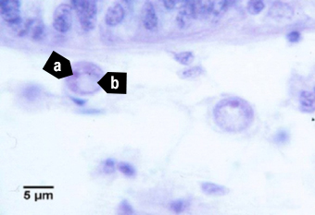
Note: Trophozoite of P. marinus with nucleus (a) and distinctive eccentric vacuole (b). Scale bar = 5µm.
Source: E Burreson
Figure 153 Histopathology of American oyster (Crassostrea virginica) infected with Perkinsus marinus
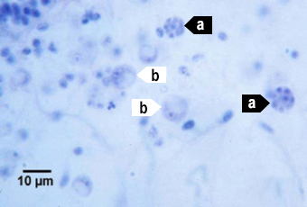
Note: P. marinus 16-cell tomont (a) stages containing immature trophozoites. Maturing trophozoites (b) are also visible. Scale bar = 10µm.
Source: E Burreson
Figure 154 Histopathology of American oyster (Crassostrea virginica) infected with Perkinsus marinus
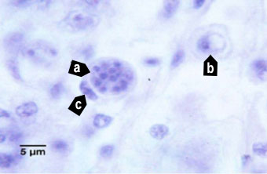
Note: A 16-cell tomont (a) of P. marinus containing developing trophozoites. This tomont is contained within a haemocyte (c indicates the nucleus of the phagocytic cell). A maturing trophozoite (b) is nearby. Scale bar = 5µm.
Source: E Burreson

Further reading
CABI Invasive Species Compendium Infection with ‘Perkinsus marinus’
CEFAS International Database on Aquatic Animal Diseases Infection with ‘Perkinsus marinus’
World Organisation for Animal Health Manual of diagnostic tests for aquatic animals

Infection with Perkinsus olseni
Also known as perkinsosis and Perkinsus disease
Figure 155 Cross-section of foot of greenlip abalone (Haliotis laevigata) infected with Perkinsus olseni
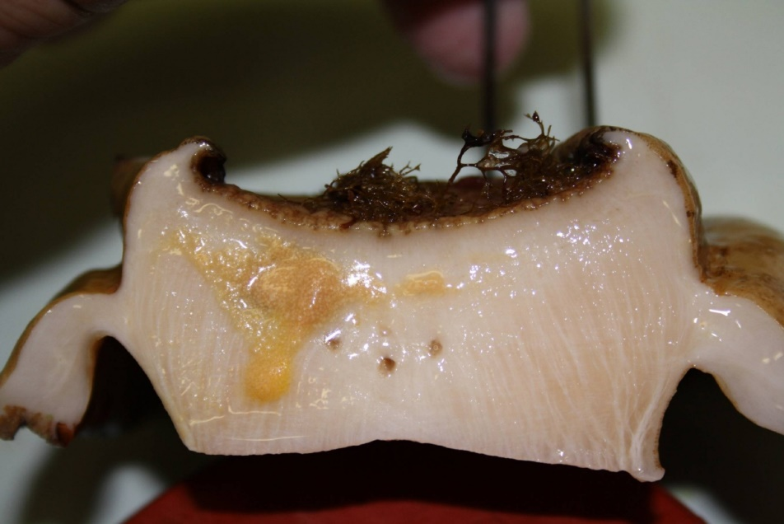
Note: Yellow and smaller brown pustular lesions within the body tissue infected with P. olseni.
Source: N Moody, CSIRO Australian Animal Health Laboratory

Signs of disease
Important: Animals with this disease may show one or more of these signs, but the pathogen may still be present in the absence of any signs.
Disease signs at the farm, tank or pond level are:
- morbidity observed in cultured greenlip (Haliotis laevigata) and blacklip (H. rubra) abalone
- gaping in bivalve species
- increased mortality.
Gross pathological signs are:
- spherical brown abscesses up to 8mm in diameter containing a caseous creamy-brown or yellow deposit in the foot and mantle of blacklip and greenlip abalone (affecting marketability)
- thin, watery tissue with a pale digestive gland
- nodules in the mantle or gills.
Microscopic pathological signs are:
- large focal or multifocal necrotic lesions in connective tissue. These contain haemocyte aggregations around individuals or groups of crescent- or signet-ring-shaped Perkinsus cells with eccentric vacuoles.

Disease agent
Perkinsosis is caused by infection with Perkinsus spp., alveolate protists in the family Perkinsidae. P. olseni has been placed nominally in the order Dinoflagellida, but its higher taxonomy is subject to scientific debate. Several species of the genus Perkinsus infect molluscs such as oysters, mussels, clams and abalone worldwide.
Perkinsus olseni is the main species known to cause this disease in the Asia–Pacific region and is responsible for perkinsosis in abalone, clams and pearl oysters in Australia. P. atlanticus is a junior synonym of P. olseni. Another species, P. chesapeaki, has been detected in wild mud arks (Anadara trapezia) in Moreton Bay, Queensland.

Host range
P. olseni appears to have low host specificity and can infect a wide range of bivalve and gastropod molluscs.
Table 53 Species known to be susceptible to infection with Perkinsus olseni
Common name | Scientific name
Akoya pearl oysterª | Pinctada martensii
Asian littleneck clamª | Venerupis philippinarum
Blacklip abaloneª | Haliotis rubra
Blacklip pearl oysterª | Pinctada margaritifera
Crocus clamª | Tridacna crocea
Elongated giant clam or rugose giant clamª | Tridacna maxima
European aurora venus clamª | Venerupis aurea
Giant clamª | Tridacna gigas
Greenlip abaloneª | Haliotis laevigata
Green-lipped musselª | Perna canaliculus
Grooved carpet shell or venerid clamª | Ruditapes decussatus
Japanese pearl oysterª | Pinctada fucata
Kumamoto oyster | Crassostrea sikamea
Manila clamª | Ruditapes (Venerupis) philippinarum
New Zealand ark shellª | Barbatia novaezelandiae
New Zealand cockleª | Austrovenus stutchburyi
New Zealand pauaª | Haliotis iris
New Zealand pipiª | Paphies australis
New Zealand scallopª | Pecten novaezelandiae
Pacific oysterª | Crassostrea gigas
Pearl oysterª | Pinctada sugillata
Pullet carpet shellª | Venerupis corrugata
Sand cockle | Katelysia rhytiphora
Silverlip pearl oysterª | Pinctada maxima
Southern mud oyster or Australian flat oysterª | Ostrea angasi
Staircase abaloneª | Haliotis scalaris
Suminoe oysterª | Crassostrea ariakensis
Sydney cockle or mud arkª | Anadara trapezia
Venerid clamª | Ruditapes decussatus
Venerid commercial clamª | Pitar prostrata
Venus clam | Protothaca jedoensis
Wedge shell | Macomona liliana
Whirling abaloneª | Haliotis cyclobates
a Naturally susceptible. Note: Other species have been shown to be experimentally susceptible.

Presence in Australia
Perkinsus olseni has been reported in Queensland, New South Wales, South Australia and Western Australia; and in Australian flat oysters from Victoria. P. olseni was originally described from wild abalone in South Australia, but has since been detected in a wide variety of molluscs, including clams and pearl oysters.
Map 37 Presence of Perkinsus olseni, by jurisdiction
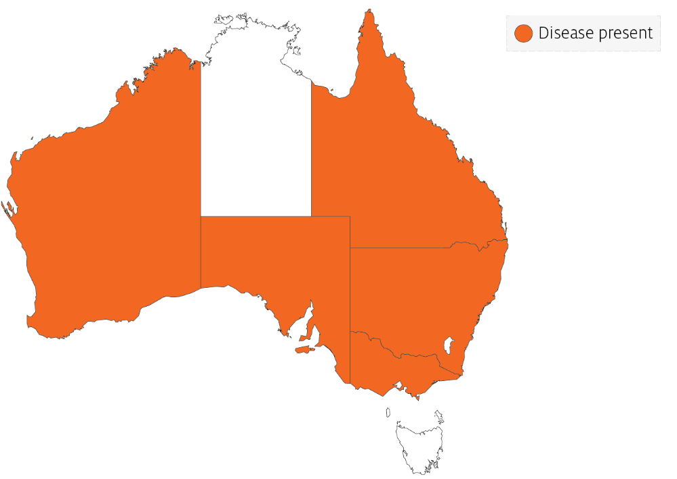

Epidemiology
- Perkinsus olseni has been associated with mass mortality of Haliotis spp. (blacklip and greenlip abalone) in the Gulf of St Vincent, South Australia, and coastal New South Wales (mostly blacklip abalone).
- Horizontal transmission occurs directly from host to host. Some environmental conditions (temperature and salinity) can promote a lifelong carrier state. Higher water temperatures (greater than 20°C) can cause disease and mortalities in temperate species such as abalone.
- Infection intensity increases with the age of the host.
- Prezoosporangia that escape from necrotic pustules or decaying dead abalone undergo further development to zoosporangia in seawater.
- Within 9 days at 20°C and 3 days at 28°C, hundreds of motile, biflagellated zoospores (about 3µm by 5µm) exit from the zoosporangium. The zoospores are infective to abalone and other molluscs.
- P. olseni can survive in salt water for several weeks at –20°C. However, the parasite cannot survive below 15ppt salinity.

Differential diagnosis
The list of similar diseases in the next section refers only to the diseases covered by this field guide. Gross pathological signs may also be representative of diseases not included in this guide. Do not rely on gross signs to provide a definitive diagnosis. Use them as a tool to help identify the listed diseases that most closely account for the observed signs.

Similar diseases
Infection with Perkinsus marinus.
The clinical signs of infection with P. olseni are similar to those of infection with other species of Perkinsus. These include occasional pustules in soft tissue, pale digestive gland, poor condition, emaciation, shrinkage of mantle and retarded growth. It is therefore difficult to make a presumptive diagnosis based on gross signs alone. Any presumptive diagnosis requires further laboratory examination.

Sample collection
Only trained personnel should collect samples. Using only gross pathological signs to differentiate between diseases is not reliable, and some aquatic animal disease agents pose a risk to humans. If you are not appropriately trained, phone your state or territory hotline number and report your observations. If you have to collect samples, the agency taking your call will advise you on the appropriate course of action. Local or district fisheries or veterinary authorities may also advise on sampling.

Emergency disease hotline
See something you think is this disease? Report it. Even if you’re not sure.
Call the Emergency Animal Disease Watch Hotline on 1800 675 888. They will refer you to the right state or territory agency.

Microscope images
Figure 156 Tissue of New Zealand cockle (Austrovenus stutchburyi) infected with Perkinsus olseni
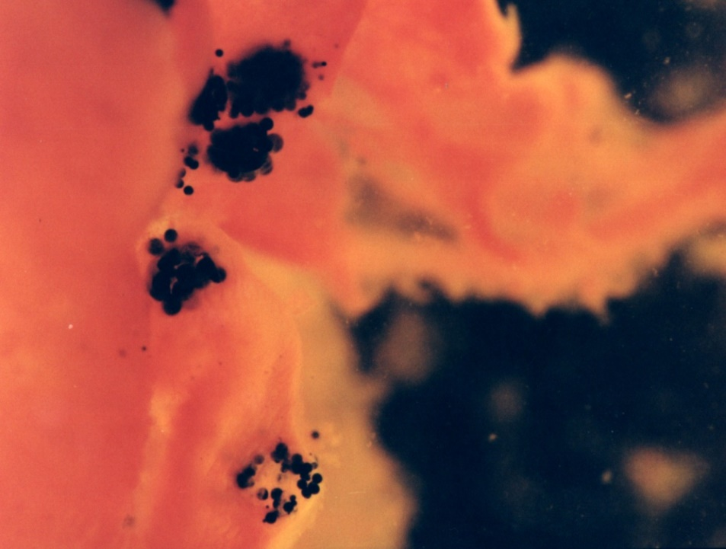
Note: Greatly enlarged individual trophozoites (also called hypnospores) of P. olseni. Sample was stained black by Lugol’s iodine after infected tissue was incubated in Ray’s fluid thioglycollate medium. Stained tissue is visible with the naked eye.
Source: B Diggles
Figure 157 Histopathology of New Zealand cockle (Austrovenus stutchburyi) infected with Perkinsus olseni
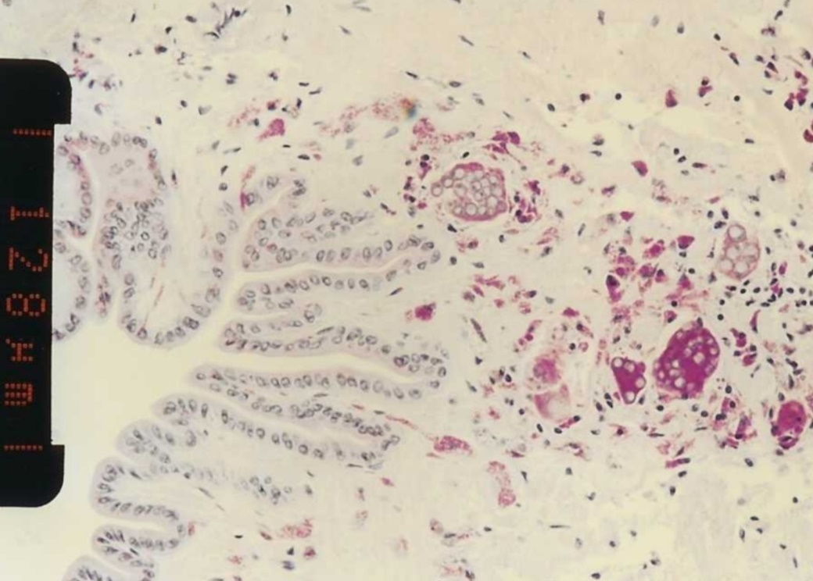
Note: Clusters of developing P. olseni trophozoites surrounded by a strongly eosinophilic periodic acid-Shiff positive amorphous matrix and a host response. Scale bar = 128µm.
Source: B Diggles
Figure 158 Histopathology of clam (Ruditapes sp.) infected with Perkinsus olseni
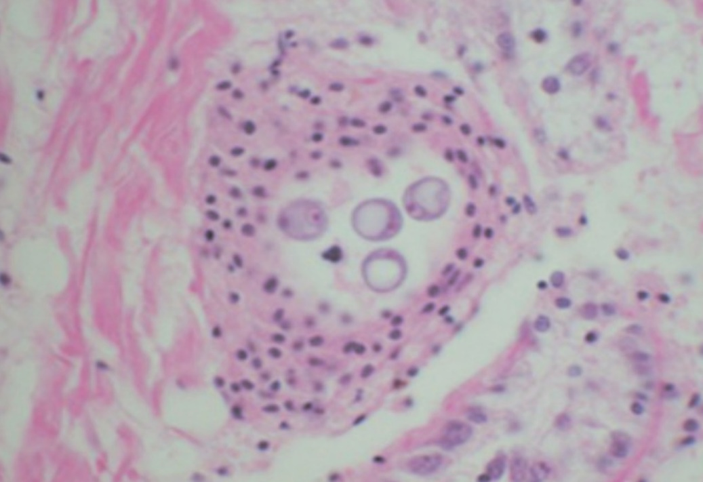
Note: A cluster of signet-ring-shaped P. olseni trophozoites surrounded by an encapsulating host response.
Source: E Burreson
Figure 159 Pedal tissue of greenlip abalone (Haliotis laevigata) infected with Perkinsus olseni
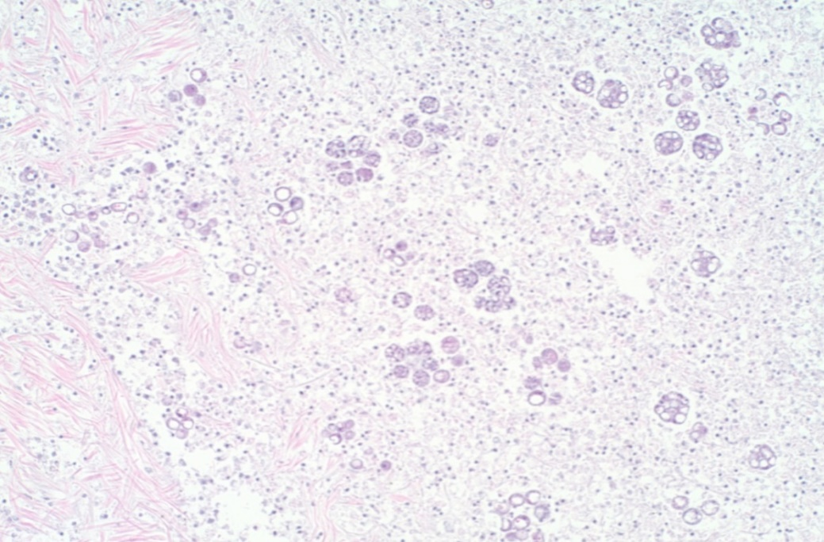
Note: The lesion contains multilocular P. olseni clusters among haemocytes and floccular debris. Haematoxylin and eosin stain. 100x magnification.
Source: S Bastianello
Figure 160 Pedal tissue of greenlip abalone (Haliotis laevigata) infected with Perkinsus olseni
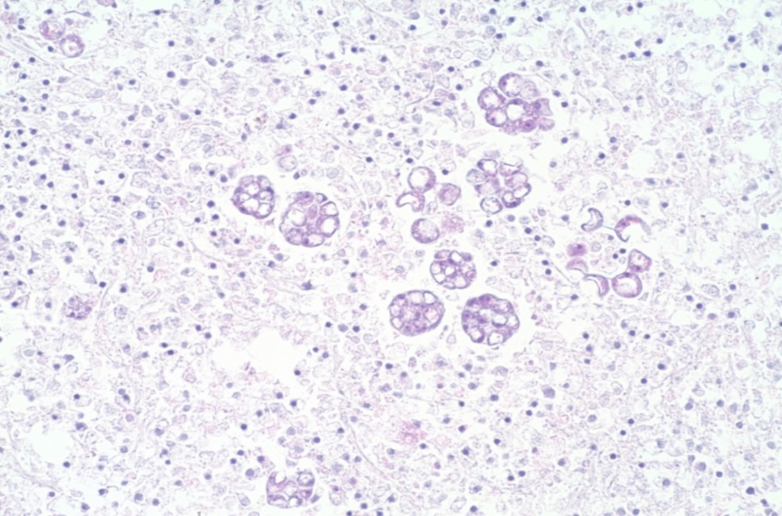
Note: Higher magnification view of Figure 100. Multilocular P. olseni clusters, and more mature signet-ring-shaped organisms among haemocytes and floccular debris. Haematoxylin and eosin stain. 200x magnification.
Source: S Bastianello

Further reading
CABI Invasive Species Compendium Infection with ‘Perkinsus olseni’
CEFAS International Database on Aquatic Animal Diseases Infection with ‘Perkinsus olseni’
World Organisation for Animal Health Manual of diagnostic tests for aquatic animals

Diseases of crustaceans

Viral diseases of crustaceans

Infection with gill-associated virus (GAV)
Also known as mid-crop mortality syndrome and infection with yellowhead virus genotype 2 (YHV2)
Figure 161 Black tiger prawn (Penaeus monodon) infected with GAV
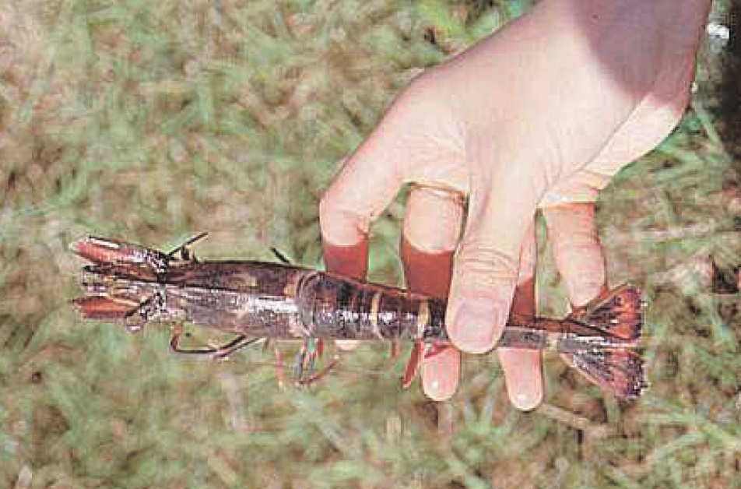
Note: Red colouration of prawn appendages and tail.
Source: D Callinan

Signs of disease
Important: Animals with this disease may show one or more of these signs, but the pathogen may still be present in the absence of any signs.
- Disease signs at the farm, tank or pond level are:
- high mortality (up to 80%)
- moribund prawns aggregating near the surface at pond edges
- initial increase in feeding at an abnormally high rate, followed by a sudden decline.
- Gross pathological signs are:
- reddening of body and appendages
- biofouling with exoparasites
- emaciation
- pink to yellow colouration of the gills.
- Microscopic pathological signs are:
- lymphoid organ necrosis (hypertrophied nuclei, marginated chromatin and vacuolation).

Disease agent
GAV is also known as YHV2, which is genotype 2 of at least 10 genotypes in the yellowhead complex of viruses. GAV is the type species of the genus Okavirus, in the family Roniviridae and order Nidovirales.
Comparison of DNA sequences indicates that GAV and yellowhead virus genotype 1 (YHV1) are closely related but have distinctly different genotypes, sharing 85% of their genetic material. Natural genetic recombination between GAV and other genotypes in the yellowhead complex has been reported outside Australia.
Other known genotypes in the complex (genotypes 3 to 10) occur in Penaeus monodon in East Africa, Asia and Australia. Most are rarely or never associated with disease.

Host range
Table 54 Species known to be susceptible to infection with GAV
Common name | Scientific name
Black tiger prawnª | Penaeus monodon
Brown tiger prawn | Penaeus esculentus
Gulf banana prawn | Penaeus (Fenneropenaeus) merguiensis
Kuruma prawn | Penaeus (Marsupenaeus) japonicus
a Naturally susceptible. Note: Other species have been shown to be experimentally susceptible.

Presence in Australia
GAV has been officially reported from New South Wales, Queensland, the Northern Territory and Western Australia. Other genotypes within the yellowhead complex are known to occur in Australia, including YHV6 and YHV7.
Map 38 Presence of GAV, by jurisdiction
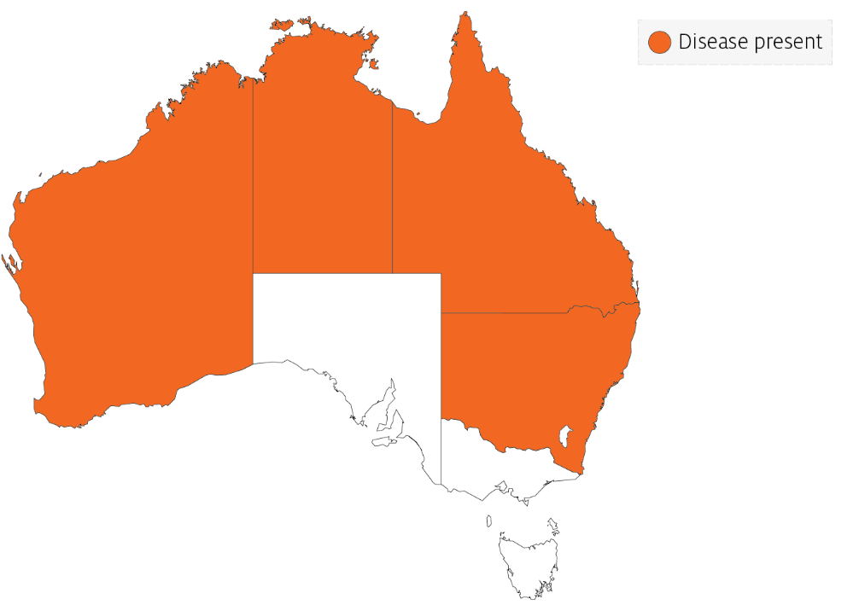

Epidemiology
The epidemiology of GAV is thought to be very similar to that of yellowhead virus:
- Transmission can be horizontal, directly from the water column and through ingestion of infected material.
- Vertical transmission can occur via surface contamination or infection of tissue surrounding the fertilised egg.
- Viral multiplication and disease appear to be induced by environmental stress.
- Mortality usually occurs among early to late juvenile stages in rearing ponds.
- Experimental infections with GAV indicate that larger (approximately 20g) Kuruma prawns are less susceptible to disease than smaller (approximately 6 to 13g) prawns of the same species.
- GAV has been associated with mortalities of up to 80% in black tiger prawn ponds in Australia.
GAV genotypes YHV2 and YHV7 occur commonly as a chronic infection in healthy broodstock and farmed black tiger prawns in eastern Australia. YHV2 has also been associated with acute infections and disease outbreaks in ponds, causing high mortality. However, it produces gross signs and patterns of tissue tropism that differ from those for yellowhead virus genotype 1.

Differential diagnosis
The list of similar diseases in the next section refers only to the diseases covered by this field guide. Gross pathological signs may also be representative of diseases not included in this guide. Do not rely on gross signs to provide a definitive diagnosis. Use them as a tool to help identify the listed diseases that most closely account for the observed signs.

Similar diseases
Infection with yellowhead virus genotype 1 (YHV1).
GAV and YHV1 are closely related viruses, so molecular testing is required to discriminate between the two disease agents and between other YHV genotypes that are endemic to Australia (YHV6 and YHV7).

Sample collection
Only trained personnel should collect samples. Using only gross pathological signs to differentiate between diseases is not reliable, and some aquatic animal disease agents pose a risk to humans. If you are not appropriately trained, phone your state or territory hotline number and report your observations. If you have to collect samples, the agency taking your call will advise you on the appropriate course of action. Local or district fisheries or veterinary authorities may also advise on sampling.

Emergency disease hotline
See something you think is this disease? Report it. Even if you’re not sure.
Call the Emergency Animal Disease Watch Hotline on 1800 675 888. They will refer you to the right state or territory agency.

Microscope images
Figure 162 Histopathology of lymphoid organ of black tiger prawn (Penaeus monodon) infected with GAV
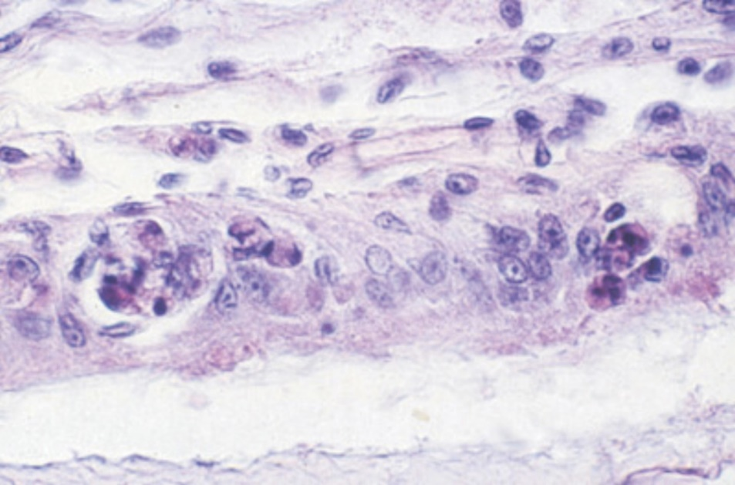
Note: Lymphoid necrosis includes signs such as hypertrophied nuclei, marginated chromatin and vacuolation.
Source: L Owens

Further reading
CABI Invasive Species Compendium Gill-associated virus
World Organisation for Animal Health Manual of diagnostic tests for aquatic animals

Infection with infectious hypodermal and haematopoietic necrosis virus (IHHNV)
Also known as infectious hypodermal and haematopoietic necrosis (IHHN), infection with Penaeus stylirostris densovirus (PstDNV) and runt deformity syndrome (RDS)
Figure 163 Infection with IHHNV in juvenile Pacific blue shrimp (Penaeus (Litopenaeus) stylirostris)
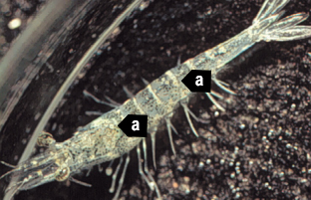
Note: White to buff lesions under carapace (a).
Source: DV Lightner
Figure 164 Runt deformity syndrome due to infection with IHHNV in juvenile black tiger prawn (Penaeus monodon)
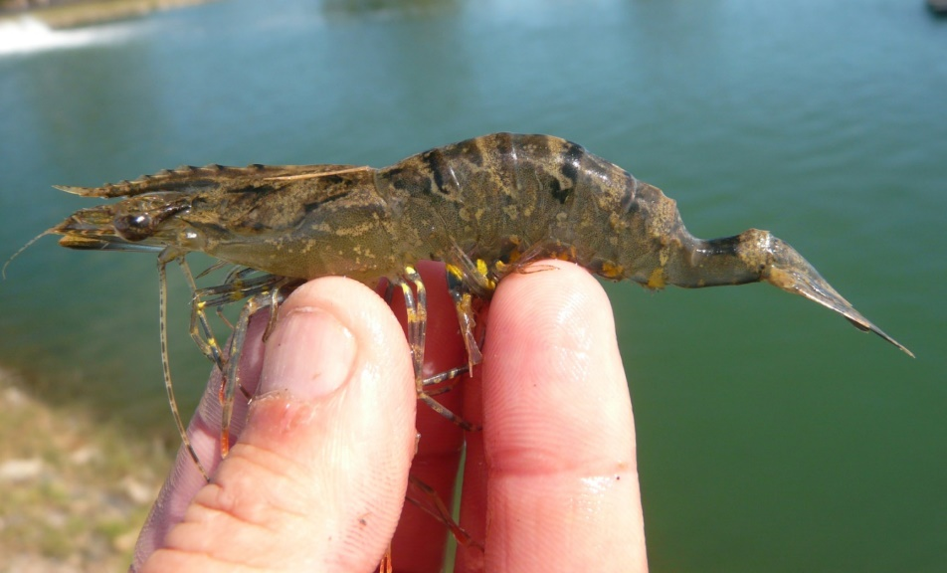
Note: Deformity of the sixth abdominal segment.
Source: B Diggles
Figure 165 Runt deformity syndrome in juvenile Pacific blue shrimp (Penaeus (Litopenaeus) stylirostris) infected with IHHNV
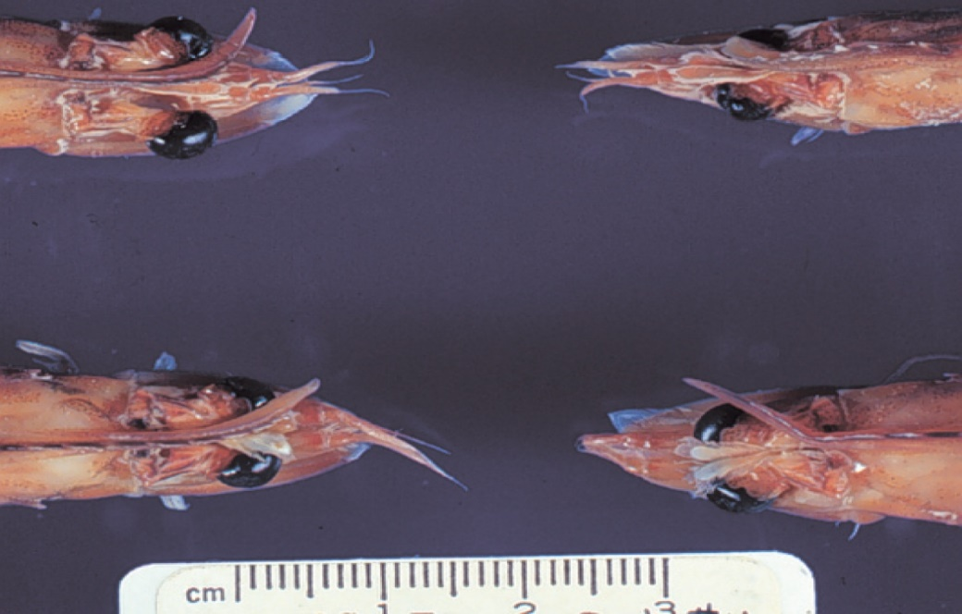
Note: Classic rostrum deformation.
Source: DV Lightner

Signs of disease
Important: Animals with this disease may show one or more of these signs, but the pathogen may still be present in the absence of any signs.
Disease signs at the farm, tank or pond level are:
- reduced food consumption
- cannibalism
- repeatedly floating slowly to the water surface, rolling over and then sinking to the bottom
- morbidity or mortality
- poor hatching success of eggs
- poor survival of larvae and postlarvae.
Gross pathological signs are:
- opaque abdominal musculature
- white to buff lesions under the carapace.
In Pacific blue shrimp, Pacific white shrimp and black tiger prawns, additional gross pathological signs are:
- blue appearance of moribund prawns
- runt deformity syndrome, the effects of which include
  - reduced and irregular growth in juveniles and subadults
  - deformed rostrums growing to one side
  - deformed sixth abdominal segment.
In Pacific blue shrimp, further gross pathological signs are:
- cuticular roughness
- cuticular deformities
- white to buff mottling of the shell, especially at the junction of abdominal shell plates.
Microscopic pathological signs are:
- eosinophilic to pale basophilic intranuclear inclusion bodies (Cowdry type A inclusions) within tissues of ectodermal and mesodermal origin. These inclusion bodies may be easily confused with developing intranuclear inclusion bodies caused by white spot disease.

Disease agent
IHHNV causes runt deformity syndrome (RDS). IHHNV is a densovirus belonging to the family Parvoviridae (subfamily Densovirinae, genus Brevidensovirus). At least 3 distinct genotypes of IHHNV have been identified, but only 2 are known to be infectious to either Pacific white shrimp (Penaeus (Litopenaeus) vannamei) or black tiger prawns (Penaeus monodon). Homologues of portions of the IHHNV genome have been reported from the genomes of host prawns.

Host range
Table 55 Species known to be susceptible to IHHNV
Common name | Scientific name
Argentine stiletto shrimp | Artemesia longinaris
Black tiger prawnª | Penaeus monodon
Brush clawed shore crab | Hemigrapsus penicillatus
Chinese white shrimpª | Penaeus (Fenneropenaeus) chinensis
Cuata swimcrab | Callinectes arcuatus
Giant freshwater prawnª | Macrobrachium rosenbergii
Green tiger prawn or grooved tiger prawnª | Penaeus semisulcatus
Gulf banana prawn | Penaeus (Fenneropenaeus) merguiensis
Indian banana prawn | Penaeus (Fenneropenaeus) indicus
Kuruma prawnª | Penaeus (Marsupenaeus) japonicus
Louisiana swamp crayfishª | Procambarus clarkii
Northern brown shrimp | Penaeus (Farfantepenaeus) aztecus
Northern pink shrimp | Penaeus (Farfantepenaeus) duorarum
Northern white shrimp | Penaeus (Litopenaeus) setiferus
Pacific blue shrimpª | Penaeus (Litopenaeus) stylirostris
Pacific white shrimpª | Penaeus (Litopenaeus) vannamei
Southern white shrimpª | Penaeus (Litopenaeus) schmitti
Western white shrimpª | Penaeus (Litopenaeus) occidentalis
Yellow-leg shrimpª | Penaeus (Farfantepenaeus) californiensis
a Naturally susceptible.

Presence in Australia
IHHNV has been officially reported in black tiger prawns from the Northern Territory and Queensland.
Map 39 Presence of IHHNV, by jurisdiction
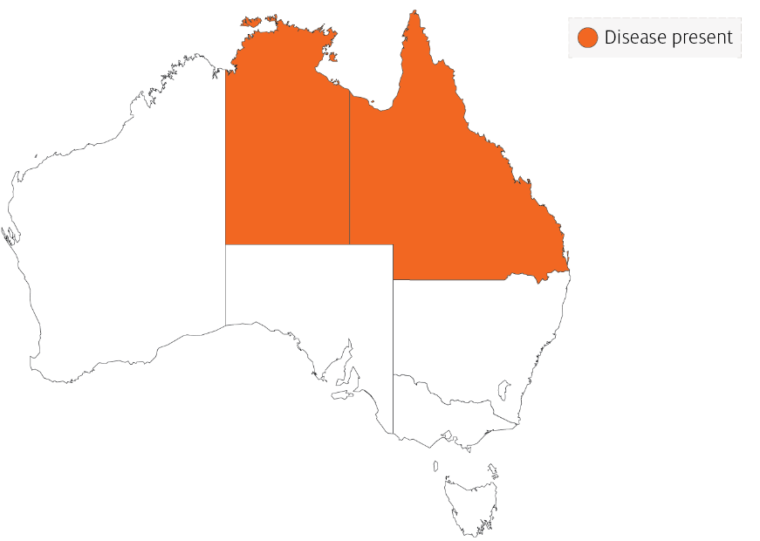

Epidemiology
- Gross signs of disease in an infected animal become evident from about 35 days into postlarval development.
- IHHNV-resistant prawns and early life stages are carriers, and may transfer the virus to more susceptible species and life stages.
- The typical gross signs of runt deformity syndrome may be observed in juveniles and subadults.
- Mortality events seldom occur in infected adult prawns.
- IHHNV suppresses the prawn’s immune system, allowing infection by other disease agents.
- Infected tissue remains infectious after 5 years of storage at –20°C, after 10 years at –80°C, and after storage in 50% glycerine.
- IHHNV infection can result in cumulative mortalities as high as 90% in postlarvae and juveniles.
- Transmission of IHHNV can be via horizontal or vertical routes. Horizontal transmission has been demonstrated by cannibalism or through contaminated water. Vertical transmission has been demonstrated via infected eggs.

Differential diagnosis
The list of similar diseases in the next section refers only to the diseases covered by this field guide. Gross pathological signs may also be representative of diseases not included in this guide. Do not rely on gross signs to provide a definitive diagnosis. Use them as a tool to help identify the listed diseases that most closely account for the observed signs.

Similar diseases
Infection with white spot syndrome virus (WSSV).

Sample collection
Only trained personnel should collect samples. Using only gross pathological signs to differentiate between diseases is not reliable, and some aquatic animal disease agents pose a risk to humans. If you are not appropriately trained, phone your state or territory hotline number and report your observations. If you have to collect samples, the agency taking your call will advise you on the appropriate course of action. Local or district fisheries or veterinary authorities may also advise on sampling.

Emergency disease hotline
See something you think is this disease? Report it. Even if you’re not sure.
Call the Emergency Animal Disease Watch Hotline on 1800 675 888. They will refer you to the right state or territory agency.

Microscope images
Figure 166 Cuticular epithelium and subcuticular connective tissue near heart of juvenile Pacific blue shrimp (Penaeus (Litopenaeus) stylirostris) with severe acute IHHN
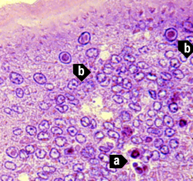
Note: Section stained with haematoxylin and eosin. Numerous necrotic cells with pyknotic nuclei (a) or with pathognomonic eosinophilic intranuclear inclusion bodies (Cowdry type A) (b).
Source: DV Lightner
Figure 167 Gills of juvenile Pacific blue shrimp (Penaeus (Litopenaeus) stylirostris) with severe acute IHHN
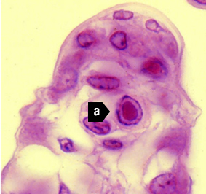
Note: Numerous necrotic cells (a) with pathognomonic eosinophilic intranuclear inclusion bodies (Cowdry type A) that are pathognomonic for IHHNV infection. 1800x magnification.
Source: DV Lightner
Figure 168 Gill lamella with diagnostic IHHNV Cowdry type A inclusions
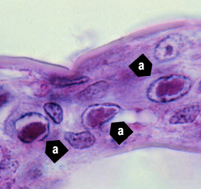
Note: Light micrograph shows 3 adjacent cells with diagnostic IHHNV Cowdry type A inclusions (a) in hypertrophied nuclei. 1800x magnification.
Source: DV Lightner
Figure 169 IHHNV Cowdry type A inclusion in nucleus of gill epithelial cell
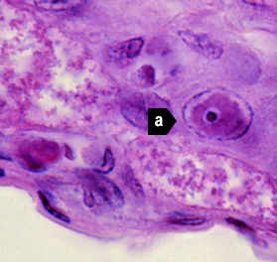
Note: Light micrograph shows a chromatin process within the inclusion body (a). 1800x magnification.
Source: DV Lightner
Figure 170 Midsagittal section of ventral nerve cord of juvenile Pacific white shrimp (Penaeus (Litopenaeus) vannamei) with IHHN
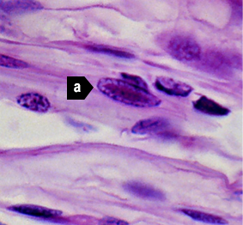
Note: Cowdry type A inclusions take the shape of the host cell nucleus (a). In the nerve cord, they are often elliptical and appear slightly different from Cowdry type A inclusions in other tissue. 1800x magnification.
Source: DV Lightner
Figure 171 Photomicrograph of vas deferens of adult Pacific white shrimp (Penaeus (Litopenaeus) vannamei) with IHHN
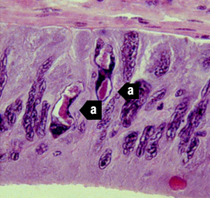
Note: Cowdry type A inclusions in the vas deferens may be unusually shaped (a) because they take on the shape of the nuclei of the tissue. 700x magnification.
Source: DV Lightner
Figure 172 Gills of juvenile Pacific blue shrimp (Penaeus (Litopenaeus) stylirostris) with IHHN
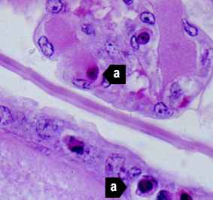
Note Section stained with haemotoxylin and eosin. Although necrotic cells with pyknotic nuclei are numerous (a), no diagnostic Cowdry type A inclusions are apparent 700x magnification.
Source: DV Lightner
Figure 173 Gills of juvenile Pacific blue shrimp (Penaeus (Litopenaeus) stylirostris) with IHHN
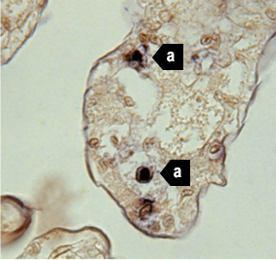
Note: In situ hybridisation section. Several IHHNV-infected cell nuclei have reacted with the digoxigenin labelled probe (a), although no diagnostic Cowdry type A inclusions are apparent. 700x magnification.
Source: DV Lightner
Figure 174 Haematopoietic tissue from juvenile Pacific blue shrimp (Penaeus (Litopenaeus) stylirostris) with IHHN
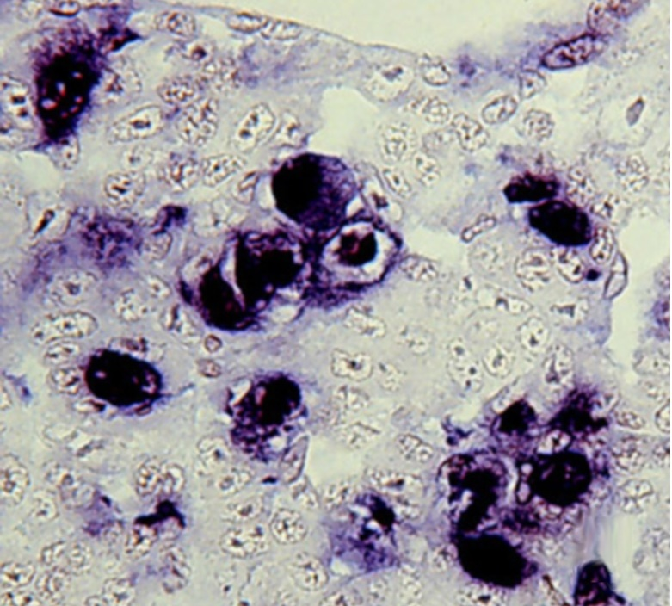
Note: In situ hybridisation section. Digoxigenin (DIG)-labelled probe shows abundant DIG-positive cells where cellular debris or haemolymph have a high content of IHHNV. 700x magnification.
Source: DV Lightner
Figure 175 Midsagittal section of juvenile white shrimp (Penaeus (Litopenaeus) vannamei) with IHHN
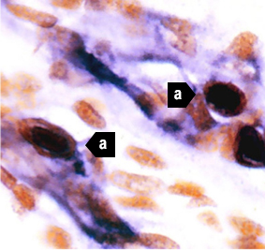
Note: The digoxigenin-labelled probe has reacted with several Cowdry type A inclusions (a) and with cellular debris or haemolymph with a high content of IHHNV. 600x magnification.
Source: DV Lightner

Further reading
CABI Invasive Species Compendium Infectious hypodermal and haematopoietic necrosis
CEFAS International Database on Aquatic Animal Diseases Infectious hypodermal and haematopoietic necrosis
World Organisation for Animal Health Manual of diagnostic tests for aquatic animals

Infection with infectious myonecrosis virus (IMNV)
Also known as infectious myonecrosis
Exotic disease
Figure 176 Gross signs of infectious myonecrosis in naturally infected farmed Pacific white shrimp (Penaeus (Litopenaeus) vannamei)
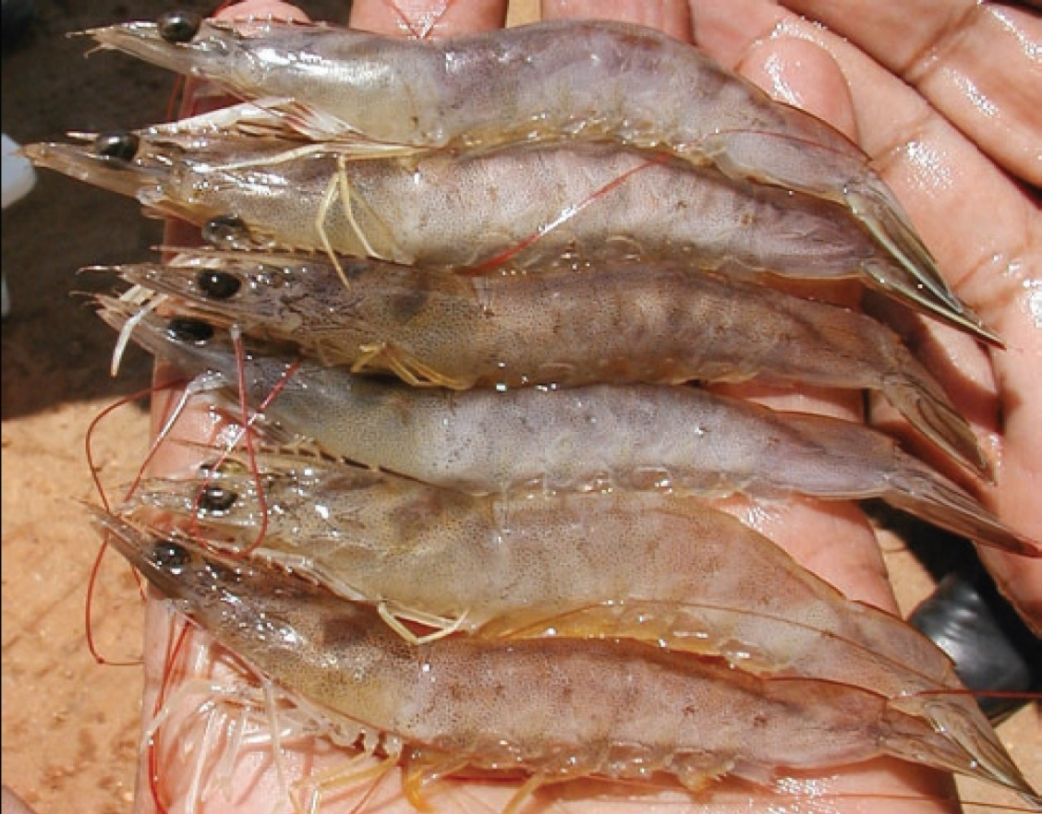
Note: Various degrees of skeletal muscle necrosis, visible as an opaque, whitish discolouration of the abdomen.
Source: DV Lightner
Figure 177 Gross signs of infectious myonecrosis in naturally infected farmed Pacific white shrimp (Penaeus (Litopenaeus) vannamei)
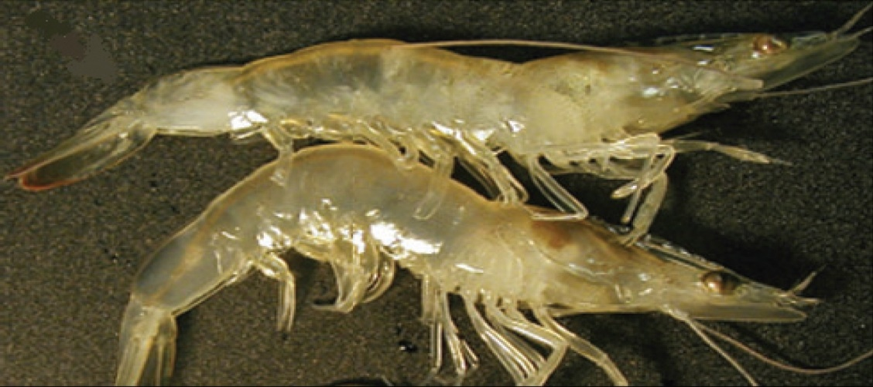
Note: Reddened tail, and skeletal muscle necrosis visible as an opaque, whitish discolouration of the abdominal segments.
Source: DV Lightner

Signs of disease
Important: Animals with this disease may show one or more of these signs, but the pathogen may still be present in the absence of any signs.
Disease signs at the farm, tank or pond level are:
- lethargy
- large numbers of moribund animals and significant mortalities (up to 70%), during or following stressful events
- The acute form of the disease produces gross signs and elevated mortalities, but disease progresses to a chronic phase with persistent low-level mortalities.
Gross pathological signs are:
- focal to extensive white necrotic areas in the striated muscle commonly observed in distal abdominal segments
- necrotic and reddened tail fan
- lymphoid organs increased to 3 to 4 times normal size
- moribund prawns with a full stomach because affected individuals may continue to feed until death.
Microscopic pathological signs are:
- coagulative necrosis of skeletal muscle by haemocytic infiltration and fibrosis.

Disease agent
Infectious myonecrosis is caused by infection with infectious myonecrosis virus (IMNV), a putative totivirus. Phylogenetic analysis based on its RNA-dependent RNA polymerase gene coding sequence groups IMNV most closely with Giardia lamblia virus, a member of the family Totiviridae.

Host range
Table 56 Species known to be susceptible to IMNV
Common name | Scientific name
Black tiger prawn | Penaeus monodon
Brown tiger prawn | Penaeus esculentus
Gulf banana prawn | Penaeus (Fenneropenaeus) merguiensis
Pacific blue shrimp | Penaeus (Litopenaeus) stylirostris
Pacific white shrimpª | Penaeus (Litopenaeus) vannamei
Southern brown shrimp | Penaeus (Farfantepenaeus) subtilis
a Naturally susceptible.

Presence in Australia
Exotic disease—not recorded in Australia.
Map 40 Presence of IMNV, by jurisdiction

Epidemiology
- IMNV was originally identified in northeastern Brazil in cultured Penaeus (Litopenaeus) vannamei. The virus has since been reported in South-East Asia, including Indonesia, India and Sri Lanka.
- Clinical signs may have sudden onset following stressful events (such as capture by net, reduced feeding or sudden changes in temperature or salinity).
- Affected life stages include juveniles and subadults. Significant mortalities occur in juvenile and subadult pond-reared populations.
- Horizontal transmission has been demonstrated via cannibalism. Vertical transmission (direct passage from parents to offspring via eggs or sperm) is likely but not confirmed.

Differential diagnosis
The list of similar diseases in the next section refers only to the diseases covered by this field guide. Gross pathological signs may also be representative of diseases not included in this guide. Do not rely on gross signs to provide a definitive diagnosis. Use them as a tool to help identify the listed diseases that most closely account for the observed signs.
The clinical signs described and shown here may also be symptomatic of other bacterial or viral infections or poor water quality. Further laboratory examination is needed for a definitive diagnosis.

Similar diseases
Infection with Macrobrachium rosenbergii nodavirus (MrNV) and infection with shrimp haemocyte iridescent virus (SHIV).

Sample collection
Only trained personnel should collect samples. Using only gross pathological signs to differentiate between diseases is not reliable, and some aquatic animal disease agents pose a risk to humans. If you are not appropriately trained, phone your state or territory hotline number and report your observations. If you have to collect samples, the agency taking your call will advise you on the appropriate course of action. Local or district fisheries or veterinary authorities may also advise on sampling.

Emergency disease hotline
See something you think is this disease? Report it. Even if you’re not sure.
Call the Emergency Animal Disease Watch Hotline on 1800 675 888. They will refer you to the right state or territory agency.

Microscope images
Figure 178 Skeletal muscle of Pacific white shrimp (Penaeus (Litopenaeus) vannamei) infected with IMNV
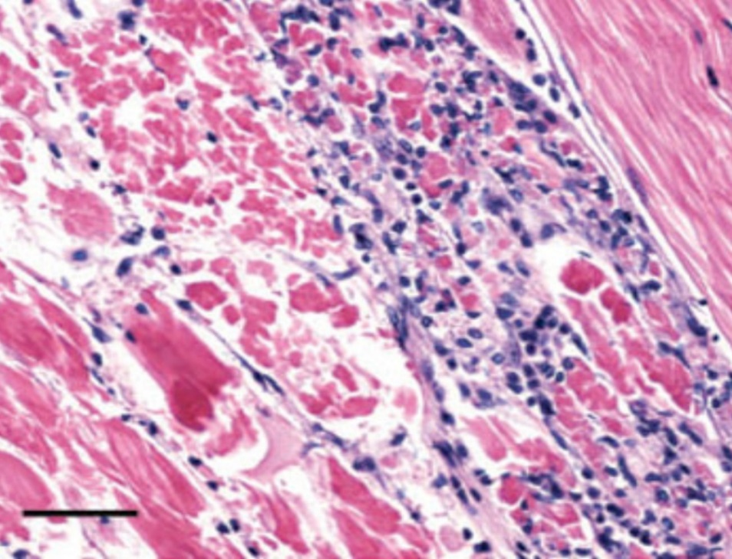
Note: Coagulative necrosis of skeletal muscle accompanied by haemocytic infiltration and fibrosis. Normal skeletal muscle can be observed in the upper right corner. Haematoxylin and eosin stain Scale bar = 50μm.
Source: DV Lightner
Figure 179 Muscle cells of Pacific white shrimp (Penaeus (Litopenaeus) vannamei) infected with IMNV
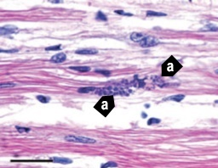
Note: Perinuclear pale basophilic to dark basophilic inclusion bodies in a group of muscle cells (a).Haematoxylin and eosin stain. Scale bar = 20μm.
Source: DV Lightner
Figure 180 In situ hybridisation of skeletal muscle tissue using a digoxigenin-labelled IMNV probe
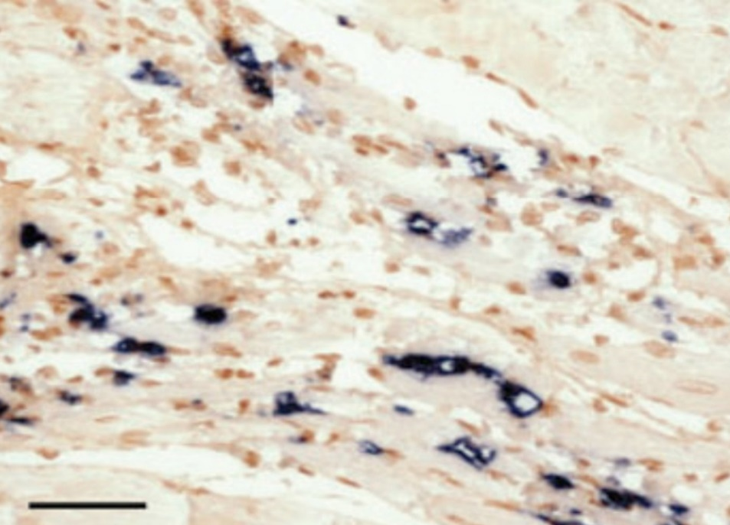
Note: Black precipitate is present in areas where probe has hybridised with target virus. Bismarck brown counterstain. Scale bar = 50μm.
Source: DV Lightner

Further reading
CABI Invasive Species Compendium Infectious myonecrosis
CEFAS International Database on Aquatic Animal Diseases Infectious myonecrosis
World Organisation for Animal Health Manual of diagnostic tests for aquatic animals

Infection with Macrobrachium rosenbergii nodavirus (MrNV)
Also known as white tail disease and white muscle disease
Figure 181 White tail disease in giant freshwater prawn (Macrobrachium rosenbergii) postlarvae infected with MrNV
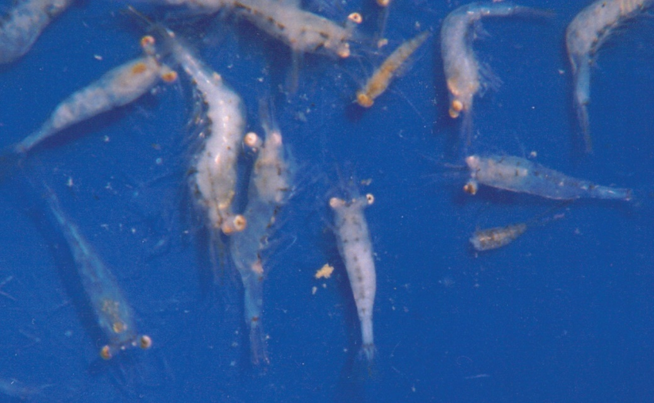
Note: Compare opaque musculature of affected prawns with the more transparent healthy prawns.
Source: AS Sahul Hameed

Signs of disease
Important: Animals with this disease may show one or more of these signs, but the pathogen may still be present in the absence of any signs.
Disease signs at the farm, tank or pond level are:
- whitish postlarvae
- lethargy
- mortality occurring 2 to 3 days after infection of the first postlarva in larval rearing tanks
- mortality of up to 95% within 5 days after the appearance of the first gross signs.
Gross pathological signs are:
- particularly milky and opaque abdomen (tail), starting at the tail extremity (telson region) and gradually progressing towards the head
- appearance in the tanks of abnormal floating moults that resemble mica flakes
- degeneration of telson and uropods (in severe cases)
- white colouration of abdominal muscle.
Microscopic pathological signs are:
- acute Zenker's necrosis of striated muscles, characterised by severe hyaline degeneration, necrosis and muscular lysis
- pathognomonic basophilic intracytoplasmic inclusion bodies in infected muscle tissues.

Disease agent
Also known as white tail disease or white muscle disease, this disease is caused by infection with Macrobrachium rosenbergii nodavirus (MrNV) and extra small virus (XSV). MrNV is a member of the family Nodaviridae. MrNV and XSV are both associated with the disease, but their respective roles are uncertain. These viruses are known to occur in fresh and brackish water.

Host range
MrNV causes disease mainly in giant freshwater prawns (Macrobrachium rosenbergii). However, several species of penaeids and red claw crayfish may be asymptomatic carriers of the virus, and Artemia and various species of aquatic insects are known vectors that can carry MrNV.
Table 57 Species known to be susceptible to infection with MrNV
Common name | Scientific name
Black tiger prawn | Penaeus monodon
Giant freshwater prawnª | Macrobrachium rosenbergii
Indian banana prawn | Penaeus (Fenneropenaeus) indicus
Kuruma prawn | Penaeus (Marsupenaeus) japonicus
Pacific white shrimp | Penaeus (Litopenaeus) vannamei
Penaeids | Various genera and species
Red claw crayfish | Cherax quadricarinatus
a Naturally susceptible. Note: Other species are known carriers or potential carriers of the virus.
Table 58 Non-decapod crustacean carriers
Common name | Scientific name
Aquatic insectsª | Various genera and species
Brine shrimp | Artemia salina
a Naturally susceptible. Note: Other species have been shown to be experimentally susceptible.

Presence in Australia
White tail disease has been officially reported in giant freshwater prawns in north Queensland.
Map 41 Presence of MrNV, by jurisdiction
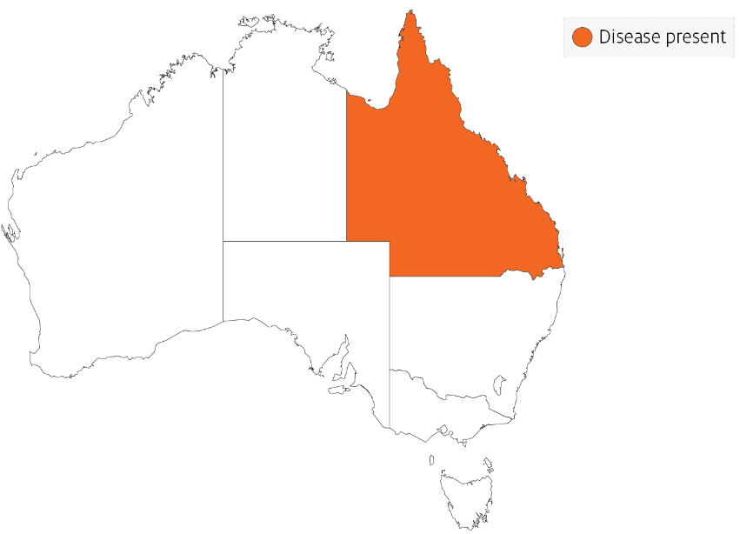

Epidemiology
- Very few postlarvae showing the clinical signs of white tail disease survive. Those that survive seem to grow normally in grow-out ponds.
- Outbreaks most commonly occur in larvae, postlarvae and early juveniles. Adult life stages are resistant and act as carriers.
- Transmission is both vertical (direct passage from parents to offspring via eggs) and horizontal (from virus present in the water surrounding susceptible prawns or direct contact with an infected prawn).
- Mortality rates are variable and reach up to 95%.
- Some penaeid shrimp, crayfish, Artemia and aquatic insects are vectors of white tail disease.

Differential diagnosis
The list of similar diseases in the next section refers only to the diseases covered by this field guide. Gross pathological signs may also be representative of diseases not included in this guide. Do not rely on gross signs to provide a definitive diagnosis. Use them as a tool to help identify the listed diseases that most closely account for the observed signs.
The clinical signs described and shown here may also be symptomatic of other bacterial or viral infections, or poor water quality. Further laboratory examination is needed for a definitive diagnosis.

Similar diseases
Infection with infectious myonecrosis virus (IMNV) and infection with shrimp haemocyte iridescent virus (SHIV).

Sample collection
Only trained personnel should collect samples. Using only gross pathological signs to differentiate between diseases is not reliable, and some aquatic animal disease agents pose a risk to humans. If you are not appropriately trained, phone your state or territory hotline number and report your observations. If you have to collect samples, the agency taking your call will advise you on the appropriate course of action. Local or district fisheries or veterinary authorities may also advise on sampling.

Emergency disease hotline
See something you think is this disease? Report it. Even if you’re not sure.
Call the Emergency Animal Disease Watch Hotline on 1800 675 888. They will refer you to the right state or territory agency.

Further reading
CABI Invasive Species Compendium White tail disease
CEFAS International Database on Aquatic Animal Diseases White tail disease
World Organisation for Animal Health Manual of diagnostic tests for aquatic animals

Infection with shrimp haemocyte iridescent virus (SHIV)
Also known as white head disease (WHD), Decapod iridescent virus 1 (DIV1) and Cherax quadricarinatus iridovirus (CQIV)
Exotic disease
Figure 182 Gross signs of Pacific white shrimp (Penaeus (Litopenaeus) vannamei) infected with SHIV
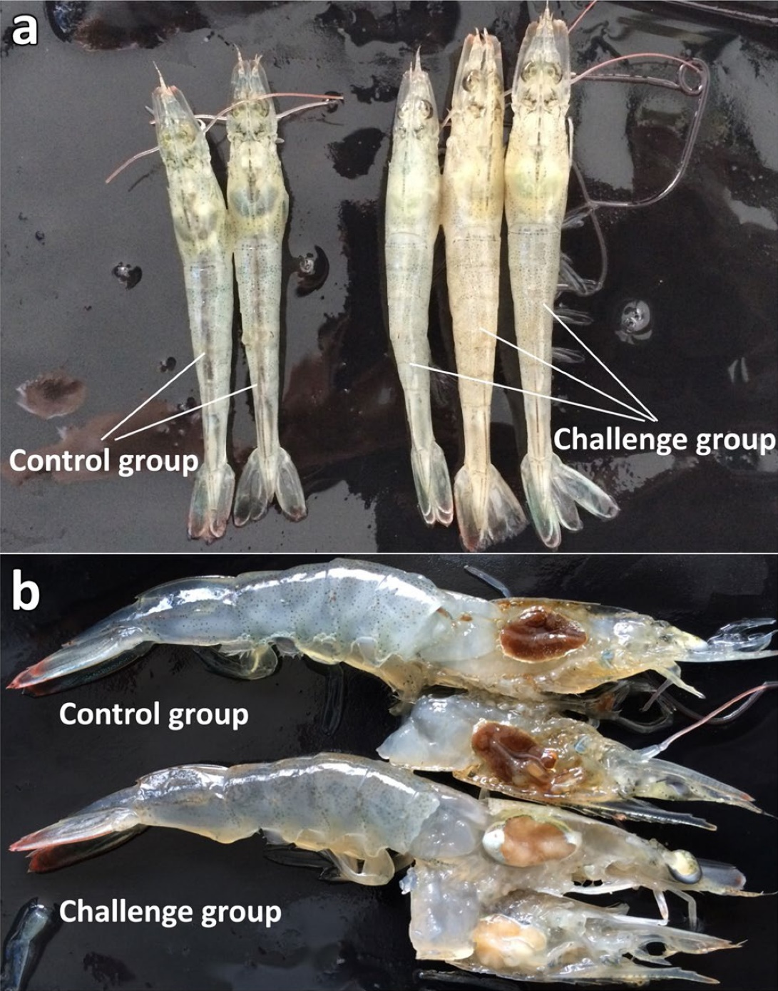
Note: When compared with healthy shrimp (control group), shrimp infected with SHIV (challenge group) have a whitish to yellowish head (a) caused by the pale necrotic hepatopancreas (b) and a slightly iridescent appearance of the carapace.
Source: Qiu et al. 2017

Signs of disease
Important: Animals with this disease may show one or more of these signs, but the pathogen may still be present in the absence of any signs.
Disease signs at the farm, tank or pond level are:
- lethargy
- cessation of feeding
- diseased shrimp sinking to the bottom of the pond
- sudden onset of high mortalities in late-postlarvae, juvenile or subadult prawns.
Gross pathological signs are:
- empty stomach and gut
- soft shell
- damaged antennae
- whitish to yellowish coloured head caused by a pale atrophied hepatopancreas
- white triangle under the carapace at the base of the rostrum in Macrobrachium rosenbergii
- slightly reddish body colour in approximately one third of affected shrimp.
Microscopic pathological signs are:
- many necrotic cells with pyknotic nuclei in the haematopoietic tissue and circulating haemocytes in the gills, hepatopancreas and haemolymph sinuses
- dark eosinophilic inclusions and pyknosis in haematopoietic tissue
- basophilic intracytoplasmic inclusions in haemocytes and other affected cells
- TEM shows many icosahedral non-enveloped virions in arrays within the cytoplasm of haemocytes found in the haemal sinuses, haematopoietic tissue, hepatopancreas and muscle.

Disease agent
SHIV, also known as Decapod iridescent virus 1 (DIV1), is an iridescent virus with a double stranded DNA genome, classified within the proposed genus Decapodiridovirus within the family Iridoviridae. SHIV emerged in China around 2014, causing high mortalities and significant economic losses in cultured Penaeus (Litopenaeus) vannamei and Macrobrachium rosenbergii. Genome sequencing has revealed that SHIV and Cherax quadricarinatus iridovirus (CQIV), identified from freshwater red claw crayfish Cherax quadricarinatus, are likely to be different strains of the same virus species.

Host range
Table 59 Species known to be susceptible to SHIV
Common name | Scientific name
Pacific white shrimp | Penaeus (Litopenaeus) vannamei
Table 60 Non-penaeids known to be susceptible to SHIV
Common name | Scientific name
Giant freshwater prawnª | Macrobrachium rosenbergii
Louisiana swamp crayfishª | Procambarus clarkii
Oriental freshwater shrimpª | Macrobrachium nipponense
Oriental prawn | Exopalaemon carinicauda
Redclaw crayfishª | Cherax quadricarinatus
a Naturally susceptible.
Table 61 Potential carriers of SHIV
Common name | Scientific name
Chinese white shrimp | Penaeus (Fenneropenaeus) chinensis
Superb freshwater shrimp | Macrobrachium superbum
Cladocerans (water fleas) | Order Cladocera

Presence in Australia
Exotic disease—not recorded in Australia.
Map 42 Presence of SHIV, by jurisdiction

Epidemiology
- Infection with SHIV has been responsible for high mortalities (over 80%) in farmed P. vannamei and M. rosenbergii populations in China since 2014.
- Infection is horizontal via cannibalism of infected shrimp or through contact with infected faeces. Per os and reverse gavage infection experiments in P. vannamei resulted in 100% cumulative mortality within 2 weeks.
- Injection challenges exposing P. vannamei, C. quadricarinatus, and Procambarus clarkii to SHIV also resulted in 100% cumulative mortalities.
- Infected M. rosenbergii exhibit distinctive clinical signs called white head disease, characterised by a distinct white triangle area under the carapace at the base of the rostrum. This effect is a result of the pale colouration of diseased haematopoietic tissue.
- The virus is found mainly in haematopoietic tissue located above the stomach and at the base of antennae, pereiopods and other appendages. However, SHIV infection is systemic and the virus is also found in the haemocytes, gills, hepatopancreas, pereiopods, and muscle.
- qPCR tests show that the highest levels of virus in infected crustaceans are found in the haematopoietic tissue and haemocytes. The lowest viral levels are in the muscle.

Differential diagnosis
The list of similar diseases in the next section refers only to the diseases covered by this field guide. Gross pathological signs may also be representative of diseases not included in this guide. Do not rely on gross signs to provide a definitive diagnosis. Use them as a tool to help identify the listed diseases that most closely account for the observed signs.

Similar diseases
Acute hepatopancreatic necrosis disease (AHPND), gill associated virus disease (GAV), infection with infectious myonecrosis virus (MrNV), infection with Macrobrachium rosenbergii nodavirus, infection with white spot syndrome virus (WSSV) and infection with yellowhead virus genotype 1 (YHV1).

Sample collection
Perinuclear pale basophilic to dark basophilic inclusion bodies are evident in this group of muscle cells (arrows point at some examples).

Emergency disease hotline
See something you think is this disease? Report it. Even if you’re not sure.
Call the Emergency Animal Disease Watch Hotline on 1800 675 888. They will refer you to the right state or territory agency.

Microscope images
Figure 183 Haematopoietic tissue of Pacific white shrimp (Penaeus (Litopenaeus) vannamei) infected with SHIV
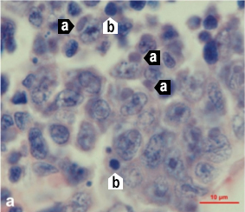
Note: Haemocytes and hepatopancreas cells with dark basophilic cytoplasmic inclusions (a) and numerous necrotic cells with pyknotic nuclei (b). Histological section with haematoxylin and eosin stain. Scale bar = 10 µm.
Source: Qiu et al. 2017
Figure 184 Gills of Pacific white shrimp (Penaeus (Litopenaeus) vannamei) infected with SHIV
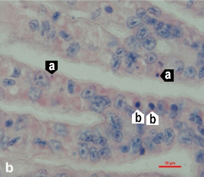
Note: Haemocytes and hepatopancreas cells with dark basophilic cytoplasmic inclusions (a) and numerous necrotic cells with pyknotic nuclei (b). Histological section with haematoxylin and eosin stain. Scale bar = 10 µm.
Source: Qiu et al. 2017
Figure 185 Hepatopancreas of Pacific white shrimp (Penaeus (Litopenaeus) vannamei) infected with SHIV
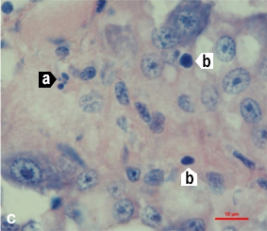
Note: Haemocytes and hepatopancreas cells with dark basophilic cytoplasmic inclusions (a) and numerous necrotic cells with pyknotic nuclei (b). Histological section with haematoxylin and eosin stain. Scale bar = 10 µm.
Source: Qiu et al. 2017
Figure 186 Periopods of Pacific white shrimp (Penaeus (Litopenaeus) vannamei) infected with SHIV
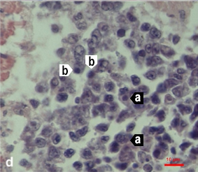
Note: Haemocytes and hepatopancreas cells with dark basophilic cytoplasmic inclusions (a) and numerous necrotic cells with pyknotic nuclei (b). Histological section with haematoxylin and eosin stain. Scale bar = 10 µm.
Source: Qiu et al. 2017

Further reading
Qiu L, Chen MM, Wan XY, Li C, Zhang QL, Wang RY, Cheng DY, Dong X, Yang B, Wang XH, Xiang JH, and Huang J 2017, ‘Characterization of a new member of Iridoviridae, Shrimp haemocyte iridescent virus (SHIV), found in white leg shrimp (Litopenaeus vannamei)’, Scientific Reports.
Qiu L, Chen X, Zhao RH, Li C, Gao W, Zhang QL, Huang J 2019, ‘Description of a natural infection with Decapod iridescent virus 1 in farmed giant freshwater prawn, Macrobrachium rosenbergii’, Viruses.
Xu L, Wang T, Li F, Yang F 2016, ‘Isolation and preliminary characterization of a new pathogenic iridovirus from redclaw crayfish Cherax quadricarinatus’, Diseases of Aquatic Organisms.

Infection with Taura syndrome virus (TSV)
Also known as Taura syndrome and red tail disease
Exotic disease
Figure 187 Acute Taura syndrome in Pacific white shrimp (Penaeus (Litopenaeus) vannamei)
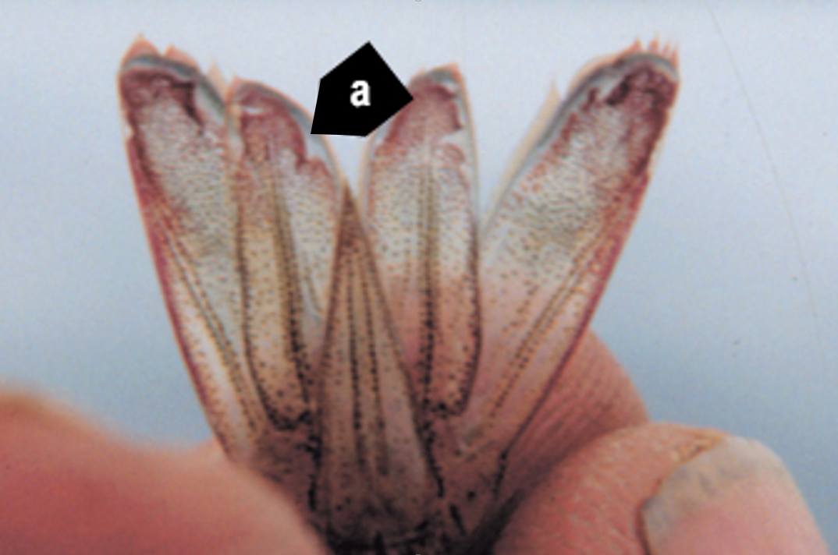
Note: Distinctive red tail fan. Rough edges around cuticular epithelium in the uropods (tail fin) are common signs of infection and suggest focal necrosis of the epithelium at those sites (a).
Source: DV Lightner
Figure 188 Taura syndrome in surviving Pacific white shrimp (Penaeus (Litopenaeus) vannamei)
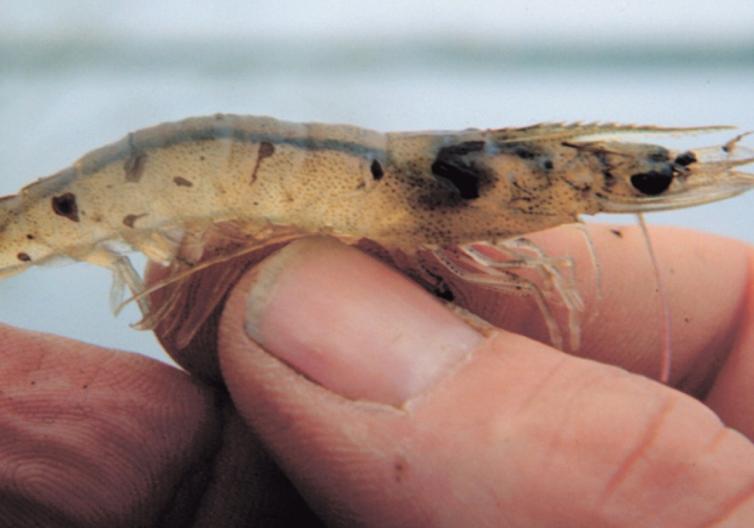
Note: Dark melanised lesions on carapace from a transitional phase infection.
Source: DV Lightner
Figure 189 Moribund, juvenile pond-reared Pacific white shrimp (Penaeus (Litopenaeus) vannamei) in peracute phase of Taura syndrome
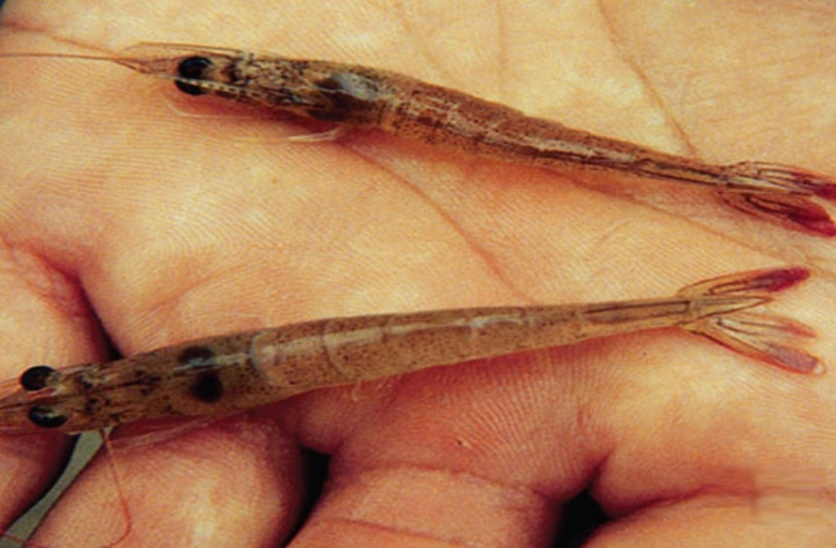
Note: Infected shrimp are lethargic and have soft shells and distinctive red tail fans.
Source: DV Lightner
Figure 190 Juvenile pond-reared Pacific white shrimp (Penaeus (Litopenaeus) vannamei) in chronic or recovery phase of Taura syndrome
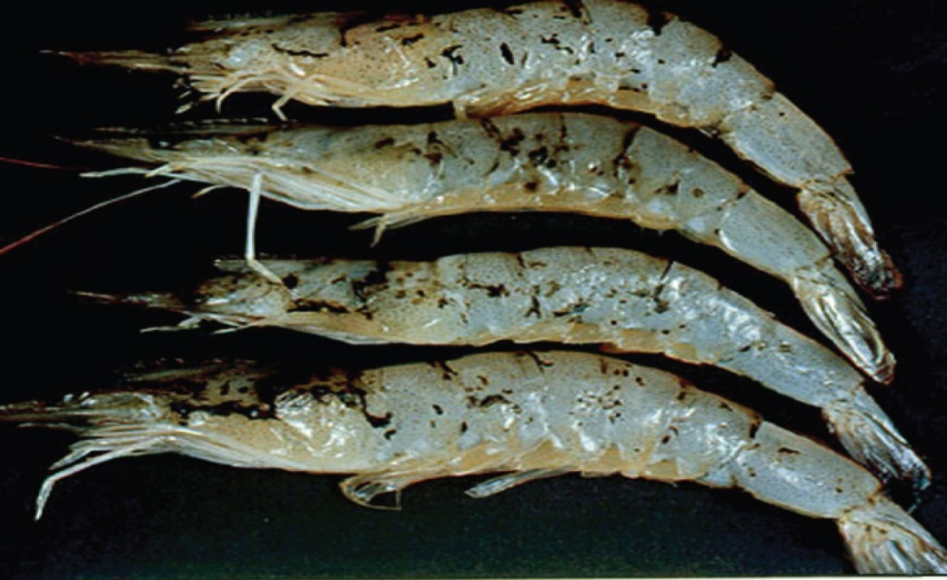
Note: Multiple melanised (dark) foci mark sites of resolving cuticular epithelium necrosis caused by TSV infection.
Source: DV Lightner

Signs of disease
Important: Animals with this disease may show one or more of these signs, but the pathogen may still be present in the absence of any signs.
Disease signs at the farm, tank or pond level are:
- lethargy
- cessation of feeding
- animals gathering at the pond edge when moribund
- sudden increase in presence of seabirds fishing in ponds
- sudden onset of high mortalities in late-postlarvae, juvenile or subadult prawns.
Gross pathological signs are:
- acute phase
  - empty stomach and pale red body surface and appendages
  - red tail fan and pleopods due to the expansion of red chromatophores
  - soft shell
- transition phase
  - multiple, irregularly shaped and randomly distributed melanised (dark) cuticular lesions
  - death, usually at moulting.
There are no obvious gross pathological signs of disease in the chronic phase.
Microscopic pathological signs are:
- necrosis of the cuticular epithelium of appendages
- multifocal lesions in the cuticular epithelium (transition phase)
- abundant pyknotic and karyorrhectic nuclei that give Taura syndrome lesions a pathodiagnostic peppered or buckshot-riddled appearance.

Disease agent
Taura syndrome is caused by infection with Taura syndrome virus (TSV), a small picorna-like RNA virus that belongs to the genus Aparavirus in the family Dicistroviridae.

Host range
A wide range of penaeid prawns (Table 62) and non-penaeid carriers (Table 63) are known to be susceptible to this virus.
Table 62 Species known to be susceptible to TSV
Common name | Scientific name
Black tiger prawnª | Penaeus monodon
Chinese white shrimp | Penaeus (Fenneropenaeus) chinensis
Gulf banana prawn | Penaeus (Fenneropenaeus) merguiensis
Indian banana prawn | Penaeus (Fenneropenaeus) indicus
Kuruma prawn | Penaeus (Marsupenaeus) japonicus
Northern brown shrimp | Penaeus (Farfantepenaeus) aztecus
Northern pink shrimp | Penaeus (Farfantepenaeus) duorarum
Northern white shrimpª | Penaeus (Litopenaeus) setiferus
Pacific blue shrimpª | Penaeus (Litopenaeus) stylirostris
Pacific white shrimpª | Penaeus (Litopenaeus) vannamei
Red endeavour (greasyback) prawnª | Metapenaeus ensis
Southern white shrimpª | Penaeus (Litopenaeus) schmitti
a Naturally susceptible. Note: Other species have been shown to be experimentally susceptible.
Table 63 Non-penaeid carriers
Common name | Scientific name
Acorn and gooseneck barnaclesª | Chelonibia spp., Octolasmis spp.
Fiddler crab | Uca vocans
Freshwater prawn | Macrobrachium lanchesteri
Giant freshwater prawn | Macrobrachium rosenbergii
Mud crabª | Scylla serrata
Mysid shrimp | Palaemon styliferus
Parasitic copepods | Ergasilus manicatus
Piscivorous birds | Various genera and species
Red crab | Sesarma mederi
a Naturally susceptible. Note: Other species have been shown to be experimentally susceptible.

Presence in Australia
Exotic disease—not recorded in Australia.
Map 43 Presence of TSV, by jurisdiction
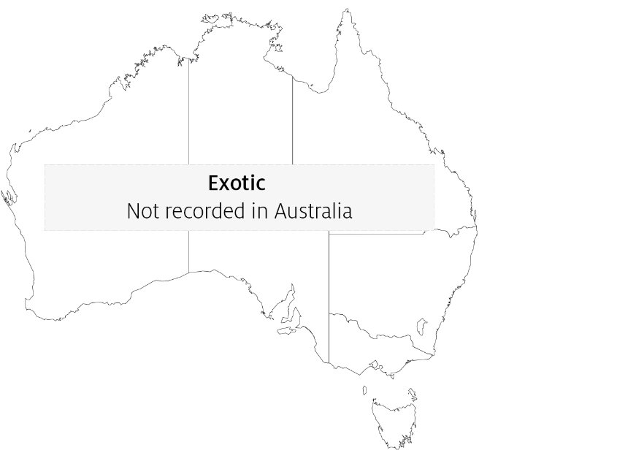

Epidemiology
- Taura syndrome is a disease mainly of the nursery phase of Penaeus (Litopenaeus) vannamei. It usually occurs within 14 to 40 days of stocking postlarvae into grow-out ponds or tanks and results in mortality rates of 40% to more than 90%.
- TSV has been documented in postlarvae, juvenile and adult life stages.
- Survivors of infection with TSV may become lifelong carriers.
- Transmission is horizontal through ingestion. Vertical transmission is suspected, but it has not been experimentally confirmed.
- Migratory birds, aquatic insects and humans are likely mechanical vectors of the virus. Birds may be an important route of transmission. TSV has been demonstrated to remain infectious for up to 48 hours in the faeces of sea gulls that have ingested infected prawn carcasses.
- Resistance of Penaeus monodon and Penaeus (Marsupenaeus) japonicus to TSV is unclear, but they appear to be more resistant than P. vannamei.
- TSV-resistant stocks of P. vannamei and Penaeus (Litopenaeus) stylirostris are commercially available. TSV-resistant stocks have shown survival rates of up to 100% following laboratory challenge.

Differential diagnosis
The list of similar diseases in the next section refers only to the diseases covered by this field guide. Gross pathological signs may also be representative of diseases not included in this guide. Do not rely on gross signs to provide a definitive diagnosis. Use them as a tool to help identify the listed diseases that most closely account for the observed signs.

Similar diseases
Infection with white spot syndrome virus (WSSV) and infection with yellowhead virus genotype 1 (YHV1).

Sample collection
Only trained personnel should collect samples. Using only gross pathological signs to differentiate between diseases is not reliable, and some aquatic animal disease agents pose a risk to humans. If you are not appropriately trained, phone your state or territory hotline number and report your observations. If you have to collect samples, the agency taking your call will advise you on the appropriate course of action. Local or district fisheries or veterinary authorities may also advise on sampling.

Emergency disease hotline
See something you think is this disease? Report it. Even if you’re not sure.
Call the Emergency Animal Disease Watch Hotline on 1800 675 888. They will refer you to the right state or territory agency.

Microscope images
Figure 191 Histological section through stomach of juvenile Pacific white shrimp (Penaeus (Litopenaeus) vannamei) with peracute Taura syndrome
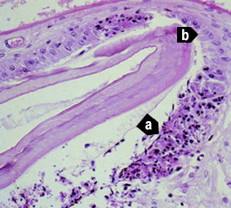
Note: Prominent areas of necrosis in cuticular epithelium (a), which secretes the overlying acellular cuticle. Adjacent to the focal lesions are normal-looking epithelial cells (b). 300x magnification.
Source: DV Lightner
Figure 192 Characteristic lesion in peracute phase of Taura syndrome
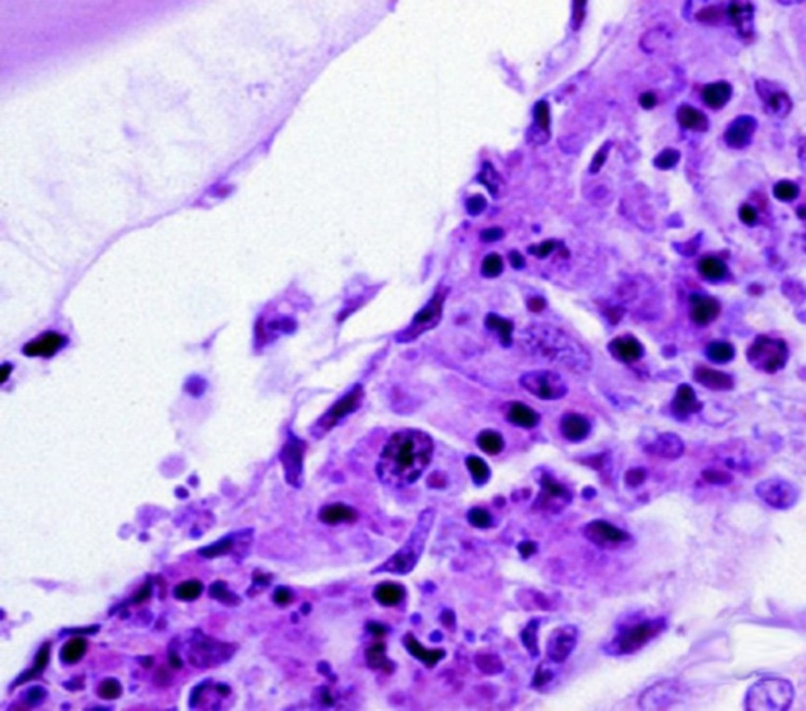
Note: Higher magnification of Figure 191, bottom right (a). Classic Taura syndrome lesions consist of necrotic cuticular epithelial and subcuticular connective tissue cells with pyknotic and karyorrhectic nuclei; a generally increased cytoplasmic eosinophilia; and very numerous, variably staining cytoplasmic inclusions. Cytoplasmic inclusions and pyknotic and karyorrhectic nuclei give the lesion a pathodiagnostic peppered or buckshot-riddled appearance. Absence of haemocytes in or near the lesion suggest lesion is peracute. 900x magnification.
Source: DV Lightner
Figure 193 Pathognomonic focal Taura syndrome virus lesions in cuticular epithelium and subcutis of carapace of juvenile Pacific white shrimp (Penaeus (Litopenaeus) vannamei) with peracute Taura syndrome
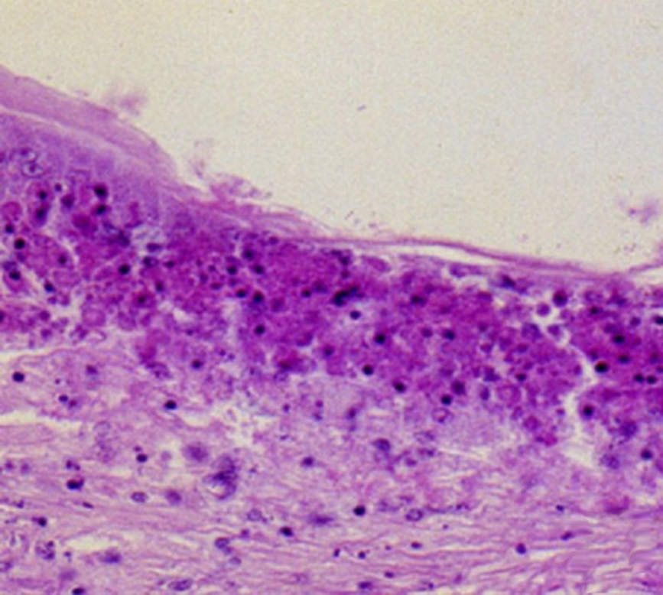
Note: Large numbers of pyknotic and karyorrhectic nuclei. 450x magnification.
Source: DV Lightner
Figure 194 Pathognomonic focal Taura syndrome virus lesions in gills of juvenile Pacific white shrimp (Penaeus (Litopenaeus) vannamei)
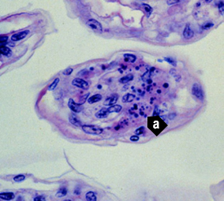
Note: Distinguishing characteristics of the lesions include nuclear pyknosis and karyorrhexis, increased cytoplasmic eosinophilia, and an abundance of variably staining and generally spherical cytoplasmic inclusions (a). 900x magnification.
Source: DV Lightner
Figure 195 Unstained wet mount of uropod of experimentally infected postlarval Pacific white shrimp (Penaeus (Litopenaeus) vannamei) with peracute Taura syndrome
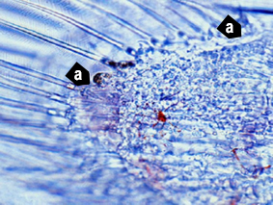
Note: Postlarva in the D4 stage of moult cycle, shown by the old cuticle separated from the new cuticle by a space. Approximate margins (a) of a focal area of necrosis in the cuticular epithelium. Area of necrosis is evidenced by vacant zone under the cuticular epithelium (where cuticular epithelium should be) and by refractile spheres (pyknotic and karyorrhectic nuclei) near periphery of lesion. Expanded red chromatophores are apparent in the subcuticular connective tissues of the uropod. 300x magnification.
Source: DV Lightner
Figure 196 Histological section of resolving cuticular lesion in juvenile Pacific white shrimp (Penaeus (Litopenaeus) vannamei)
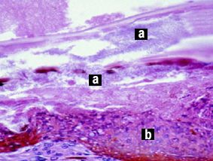
Note: Perforated cuticle is heavily colonised with masses of bacteria (a). Thick, melanised, haemocytic ‘plug’ (b) has formed basal to the cuticular epithelium to temporarily close wound from the outside. Basal to haemocyte plug (b), connective tissue elements and additional infiltrating haemocytes provide basal support for regeneration of cuticular epithelium. Pathognomonic Taura syndrome lesions in recovery or chronic phase of Taura syndrome are usually few, relative to the resolving lesions shown here, and are often entirely absent. 600x magnification.
Source: DV Lightner
Figure 197 Midsagittal section of lymphoid organ of experimentally infected juvenile Pacific white shrimp (Penaeus (Litopenaeus) vannamei) in chronic or recovery phase of Taura syndrome
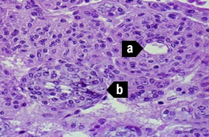
Note: TSV induces some significant lesions in the lymphoid organ (LO), but never pathognomonic Taura syndrome lesions of the type seen in the cuticular epithelium. Normal-looking LO cords or tissue is characterised by multiple layers of sheath cells around a central haemolymph vessel (a). Interspersed are accumulations of disorganised LO cells that form LO ‘spheroids’ (LOS). LOS lack a central vessel and consist of cells that show karyomegaly and large, prominent cytoplasmic vacuoles and other cytoplasmic inclusions (b). 450x magnification.
Source: DV Lightner
Figure 198 In situ hybridisation of appendage from postlarval Pacific white shrimp (Penaeus (Litopenaeus) vannamei) with peracute Taura syndrome
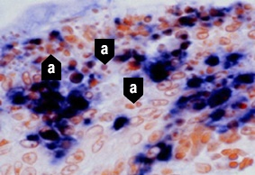
Note: Digoxigenin-labelled cDNA probe reacts with TSV-infected cells, staining cytoplasm of infected cuticular epithelial cells and subcuticular connective tissue. Probe does not react with pyknotic and karyorrhectic nuclei (a) because TSV is only cytoplasmic. These nuclear remnants contribute to ‘peppered’ or ‘buckshot-riddled’ appearance of TSV lesions. 900x magnification.
Source: DV Lightner

Further reading
CABI Invasive Species Compendium Taura syndrome
CEFAS International Database on Aquatic Animal Diseases Taura syndrome
World Organisation for Animal Health Manual of diagnostic tests for aquatic animals

Infection with white spot syndrome virus (WSSV)
Also known as white spot disease (WSD)
Exotic disease—restrictions apply
Figure 199 WSD in giant black tiger prawn (Penaeus monodon)
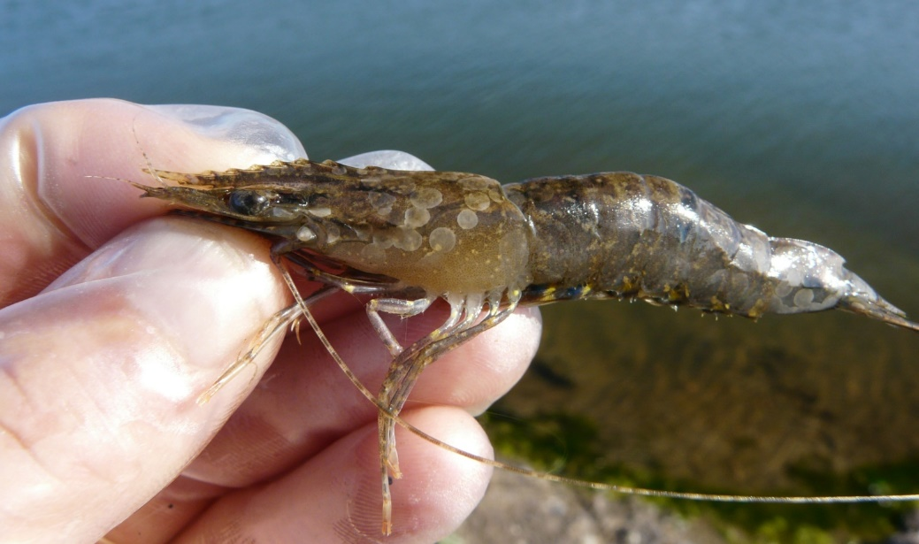
Note: White spots on carapace are typical of infection following acute phase of infection.
Source: B Diggles
Figure 200 WSD in giant black tiger prawn (Penaeus monodon)
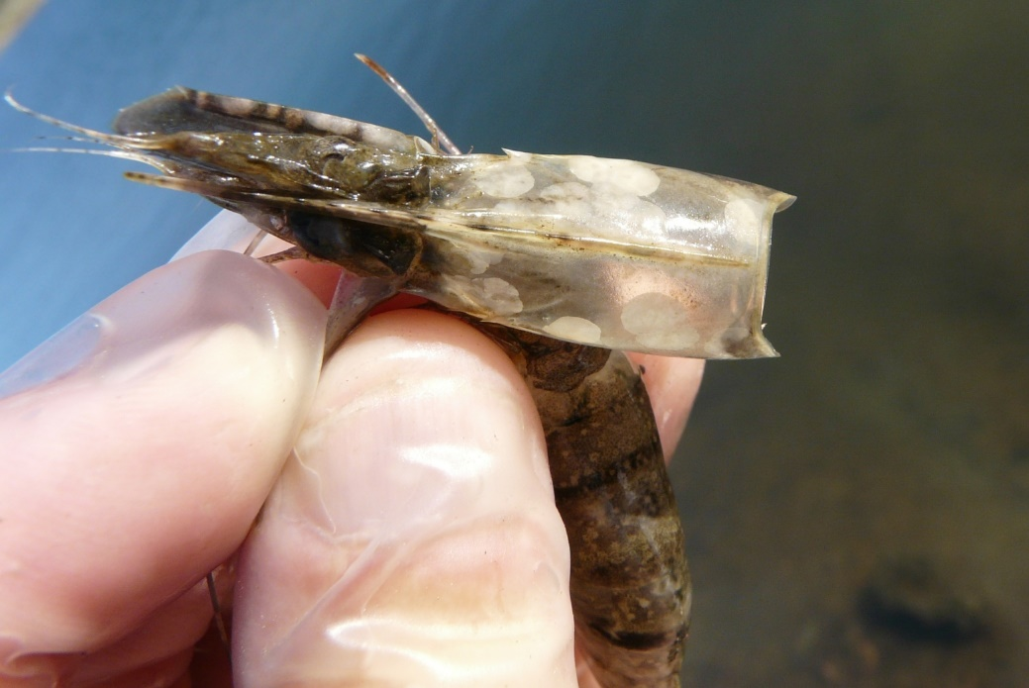
Note: Carapace is loose and when removed, large smooth-edged white spots are evident. Numerous smaller white spots are also evident on the abdominal segments.
Source: B Diggles
Figure 201 Five juvenile black tiger prawns (Penaeus monodon) infected with WSSV lacking classical white spots
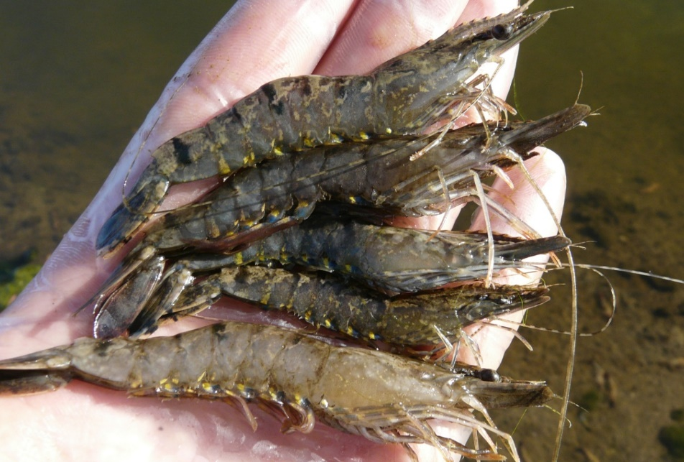
Note: Prawns exhibit few, if any, white spots. Prawns infected with WSSV can present as ‘normal’ prawns.
Source: B Diggles

Signs of disease
Important: Animals with this disease may show one or more of these signs, but the pathogen may still be present in the absence of any signs.
Disease signs at the farm, tank or pond level are:
- rapid onset of mass mortality (80% or more) in farmed penaeid prawns during the grow-out period
- lethargy
- cessation of feeding
- aggregations of moribund prawns near the water surface at the edge of the rearing pond or tank.
Gross pathological signs are:
- loose carapace
- high degree of colour variation, with a predominance of darkened (red, brown or pink) body surface and appendages
- heavy fouling of the surface and gills by external parasites
- white midgut line through the abdomen of severely affected larvae and postlarvae
- delayed (or completely absent) clotting reaction of the haemolymph of infected shrimp
- white calcium deposits embedded in the shell, causing white spots 0.5 to 3.0mm in diameter.
Prawns with WSD may not show distinctive clinical signs. If present, shell lesions can range from minute spots to discs several millimetres in diameter, and may coalesce into larger white plates. Spots are most easily observed by removing the cuticle over the cephalothorax, scraping away any attached tissue with the thumbnail and holding the cuticle up to the light. However, white spots in the cuticle are unreliable for even preliminary diagnosis of WSD. Similar spots can be produced by some bacteria, high alkalinity and other infectious agents or environmental conditions.
Microscopic pathological signs are:
- hypertrophied nuclei in gills and/or cuticular epithelium
- viral aggregates (shown as small reflective spots) in unstained smear preparations of the haemolymph by dark-field microscopy
- pathognomonic inclusion bodies in histological sections in target tissues.

Disease agent
WSD is caused by infection with white spot syndrome virus (WSSV), a large DNA virus assigned as the only member of the genus Whispovirus (family Nimaviridae). The virus only infects crustaceans and appears not to be related to any other known viruses. It is not related to white spot disease of finfish, which is caused by parasitic ciliate protozoans. WSSV is known to occur in fresh, brackish and marine water.

Host range
All decapod crustaceans (order Decapoda) are considered susceptible to infection, including prawns, lobsters and crabs from marine, brackish or freshwater environments (Table 64). The disease has mainly been a problem in farmed penaeid (family Penaeidae) prawns.
Carriers of the virus (Table 65) include rotifers, marine molluscs, polychaete worms and non-decapod crustaceans such as Artemia salina, copepods, non-crustacean arthropods and aquatic insect larvae. Birds can also spread the virus.
Table 64 Species known to be susceptible to infection with WSSV
Common name | Scientific name
All decapod crustaceans | Decapoda—all species
Aloha prawn | Penaeus marginatus
American lobster | Homarus americanus
Argentine stiletto shrimp | Artemesia longinaris
Asian freshwater shrimpª | Macrobrachium dayanum
Barred estuarine shrimpª | Palaemon serrifer
Black tiger prawnª | Penaeus monodon
Brown tiger prawnª | Penaeus esculentus
Brush clawed shore crab | Hemigrapsus penicillatus
Chinese mitten crabª | Eriocheir sinensis
Chinese white shrimpª | Penaeus (Fenneropenaeus) chinensis
Crayfish (native to Europe)ª | Astacus spp.
Crayfish (native to North America)ª | Orconectes spp.
Cuata swimcrab | Callinectes arcuatus
Daggerblade grass shrimp | Palaemon pugio
European river crab | Potamon potamios
European shore crab | Carcinus maenas
Fiddler crab | Uca vocans
Freshwater crayfishª | Cherax spp.
Freshwater prawn | Macrobrachium lanchesteri
Giant crayfish (native to Australia) | Astacopsis spp.
Giant freshwater prawnª | Macrobrachium rosenbergii
Giant Tasmanian crayfish | Astacopsis gouldi
Gippsland spiny crayfish | Euastacus kershawi
Green tiger prawn or grooved tiger prawnª | Penaeus semisulcatus
Greentail prawnª | Metapenaeus bennettae
Gulf banana prawnª | Penaeus (Fenneropenaeus) merguiensis
Indian banana prawnª | Penaeus (Fenneropenaeus) indicus
Japanese crayfish | Cambaroides japonicus
Jelly prawnsª | Acetes spp.
Kuruma prawnª | Penaeus (Marsupenaeus) japonicus
Louisiana swamp crayfishª | Procambarus clarkii
Mangrove swimming crabª | Thalamita crenata
Marbled crayfish | Procambarus fallax. f. virginalis
Mississippi grass shrimp | Palaemonetes kadiakensis
Mud crabª | Scylla serrata
Mysid shrimp | Palaemon styliferus
Noble crayfish | Astacus astacus
Northern brown shrimpª | Penaeus (Farfantepenaeus) aztecus
Northern pink shrimpª | Penaeus (Farfantepenaeus) duorarum
Northern white shrimpª | Penaeus (Litopenaeus) setiferus
Oriental freshwater shrimpª | Macrobrachium nipponense
Oriental prawn | Exopalaemon carinicauda
Pacific blue shrimpª | Penaeus (Litopenaeus) stylirostris
Pacific white shrimpª | Penaeus (Litopenaeus) vannamei
Red claw crayfishª | Cherax quadricarinatus
Red crab | Sesarma mederi
Red endeavour (greasyback) prawnª | Metapenaeus ensis
Sand crabª | Portunus pelagicus
Signal crayfish | Pacifastacus leniusculus
Smooth crayfish | Geocherax spp.
Southern brown shrimp | Penaeus (Farfantepenaeus) subtilis
Southern white shrimp | Penaeus (Litopenaeus) schmitti
Spiny crayfish | Euastacus spp.
Stone crayfish | Austropotamobius torrentium
Sunda river prawn | Macrobrachium sintangene
Superb freshwater shrimp | Macrobrachium superbum
Three spot swimming crabª | Portunus sanguinolentus
Tropical spiny lobster | Panulirus spp.
Turkish crayfish | Astacus leptodactylus
Western white shrimp | Penaeus (Litopenaeus) occidentalis
White-clawed crayfish | Austropotamobius pallipes
Yellow-leg shrimp | Penaeus (Farfantepenaeus) californiensis
Yabbies (freshwater) | Cherax destructor
a Naturally susceptible. Note: Other species are likely to be susceptible or shown to be experimentally susceptible.
Table 65 Non-decapod crustacean carriers
Common name | Scientific name
Annelids | Various genera and species
Aquatic insects | Various genera and species
Brine shrimp | Artemia salina
Molluscs | Various genera and species
Parasitic copepods | Ergasilus manicatus
Piscivorous birds | Various genera and species
Planktonic copepods | Paracartia grani
Polychaetes | Various genera and species
Rotifers | Various genera and species

Presence in Australia
Exotic disease—under official control.
WSD was confirmed in South East Queensland in December 2016. An emergency response to contain and eradicate the disease is ongoing.
Map 44 Presence of WSSV, by jurisdiction
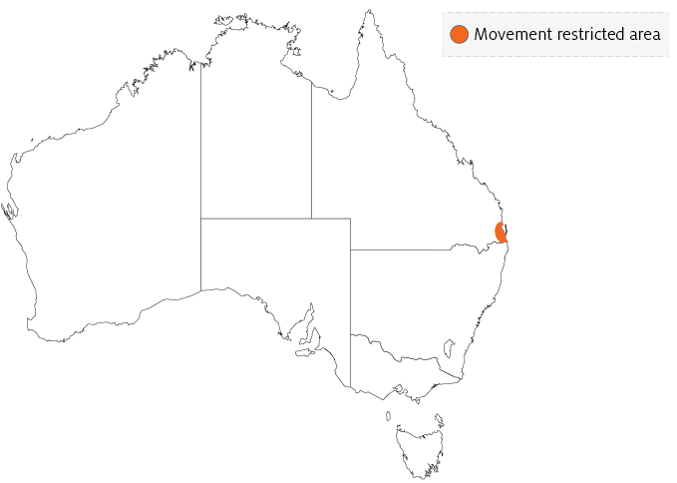

Epidemiology
- WSD is mainly a disease of farmed penaeid prawns, but many species of crustaceans are susceptible to infection with WSSV.
- Rapid mortalities of up to 80% or more within 3 to 10 days have been reported in many countries.
- Prawn farm productivity falls to about 40% of normal rate for 2 years, and then recovers to about 70% over the long term.
- Some of the species listed in the host range section (such as Penaeus monodon) are extremely susceptible to WSSV. Others may be infected but are more resistant to disease.
- Infection may be low level and chronic (lifelong carriers are possible) in healthy crustaceans, or acute infection with disease and mortalities.
- Viral multiplication and disease appears to be induced by environmental and handling stress. Stressors include eye-stalk ablation, spawning, moulting, high stocking densities, changes in salinity, temperature and pH, and plankton blooms. Imposing such stressors on suspect populations can be a useful diagnostic method for detecting the virus.
- All life stages are susceptible, from eggs to broodstock.
- Vertical transmission occurs from infected broodstock.
- Horizontal transmission of disease is usually via cannibalism of sick or dying prawns, or directly through contaminated water.
- Vectors of the virus include rotifers, marine molluscs, polychaete worms and non-decapod crustaceans including Artemia salina, copepods, non-crustacean arthropods and insect larvae.
- Birds can transmit the disease from pond to pond by releasing caught prawns over neighbouring ponds.
- White spot syndrome virus can persist and retain infectivity in seawater at 30°C for at least 30 days (under laboratory conditions) and for at least 4 days in ponds.

Differential diagnosis
The list of similar diseases in the next section refers only to the diseases covered by this field guide. Gross pathological signs may also be representative of diseases not included in this guide. Do not rely on gross signs to provide a definitive diagnosis. Use them as a tool to help identify the listed diseases that most closely account for the observed signs.

Similar diseases
Acute hepatopancreatic necrosis disease (AHPND), infection with Hepatobacter penaei (NHP), infection with infectious hypodermal and haematopoietic necrosis virus (IHHNV), infection with shrimp haemocyte iridescent virus (SHIV), infection with Taura syndrome virus (TSV) and infection with yellowhead virus genotype 1 (YHV1).

Sample collection
Only trained personnel should collect samples. Using only gross pathological signs to differentiate between diseases is not reliable, and some aquatic animal disease agents pose a risk to humans. If you are not appropriately trained, phone your state or territory hotline number and report your observations. If you have to collect samples, the agency taking your call will advise you on the appropriate course of action. Local or district fisheries or veterinary authorities may also advise on sampling.

Emergency disease hotline
See something you think is this disease? Report it. Even if you’re not sure.
Call the Emergency Animal Disease Watch Hotline on 1800 675 888. They will refer you to the right state or territory agency.

Microscope images
Figure 202 Photomicrograph of histological section from stomach of juvenile black tiger prawn (Penaeus monodon) with WSD
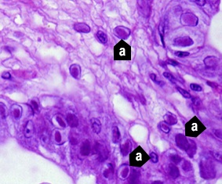
Note: Prominent intranuclear inclusion bodies are abundant in cuticular epithelium and subcuticular connective tissue of the organ (a). Cells in different phases of infection display intranuclear inclusion bodies. Early-phase inclusion bodies in this section are centronuclear and eosinophilic. These are separated from nuclear membrane and marginated chromatin by an artefactual halo. 900x magnification.
Source: DV Lightner
Figure 203 Histological section of stomach of juvenile Chinese white shrimp (Penaeus (Fenneropenaeus) chinensis) with advanced WSD
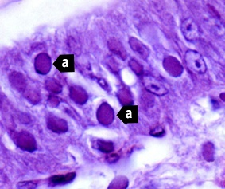
Note: Fully developed WSSV intranuclear inclusion bodies (a) are more basophilic, appear granular in texture and nearly fill affected hypertrophied nucleus. 1300x magnification.
Source: DV Lightner
Figure 204 Histological section of gills from juvenile Chinese white shrimp (Penaeus (Fenneropenaeus) chinensis) with WSD
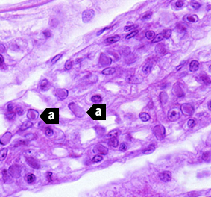
Note: Nearly one-quarter of cells are infected, as indicated by developing and fully developed intranuclear inclusion bodies (a). 900x magnification.
Source: DV Lightner
Figure 205 Histological section of stomach of Pacific blue shrimp (Penaeus (Litopenaeus) stylirostris) experimentally infected with WSSV
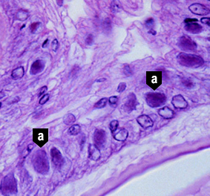
Note: Severe grade 4 infection evidenced by classic WSD intranuclear inclusion bodies (a). 900x magnification.
Source: DV Lightner
Figure 206 Histological section of stomach of Pacific white shrimp (Penaeus (Litopenaeus) vannamei) experimentally infected with WSSV
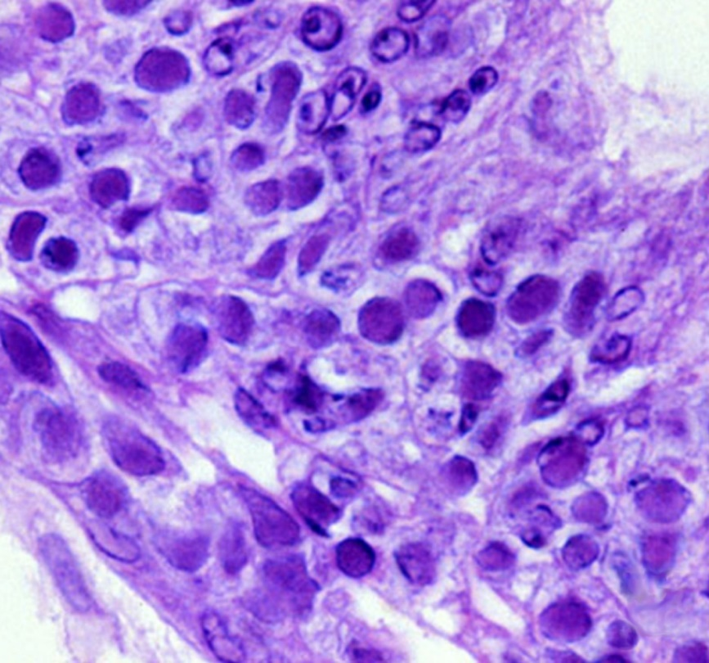
Note: Severe grade 4 infection with many classic WSD intranuclear inclusion bodies. 900x magnification.
Source: DV Lightner
Figure 207 In situ hybridisation of histological section of stomach of juvenile Pacific white shrimp (Penaeus (Litopenaeus) stylirostris) with WSD
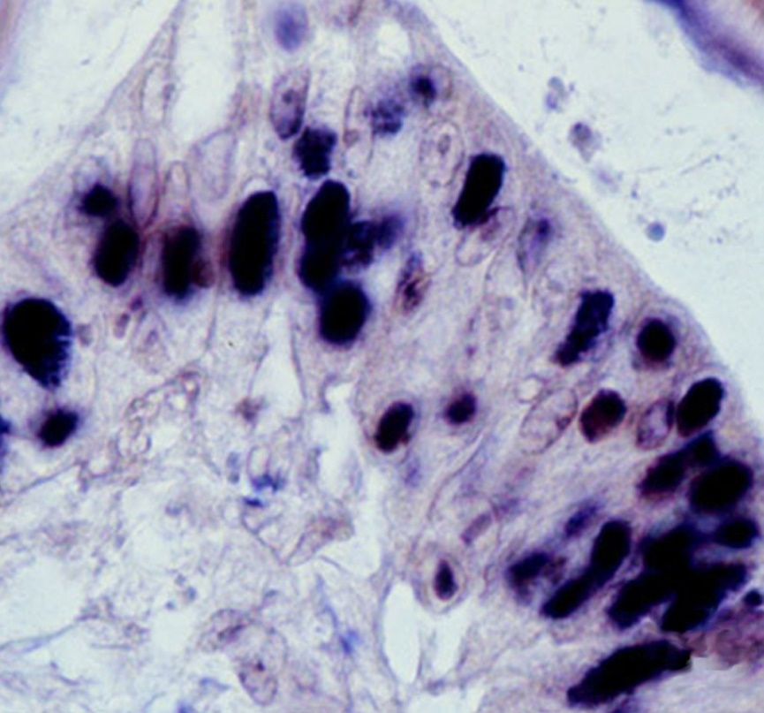
Note: Intranuclear inclusion bodies in the cuticular epithelium of stomach reacting to digoxygenin-labelled DNA probe. 900x magnification.
Source: DV Lightner

Further reading
CABI Invasive Species Compendium White spot disease
CEFAS International Database on Aquatic Animal Diseases White spot disease
Department of Agriculture, Water and the Environment AQUAVETPLAN disease strategy manual: White spot disease of prawns
World Organisation for Animal Health Manual of Diagnostic tests for aquatic animals

Infection with yellowhead virus genotype 1 (YHV1)
Also known as yellowhead disease
Exotic disease
Figure 208 Yellowhead disease in giant black tiger prawns (Penaeus monodon)
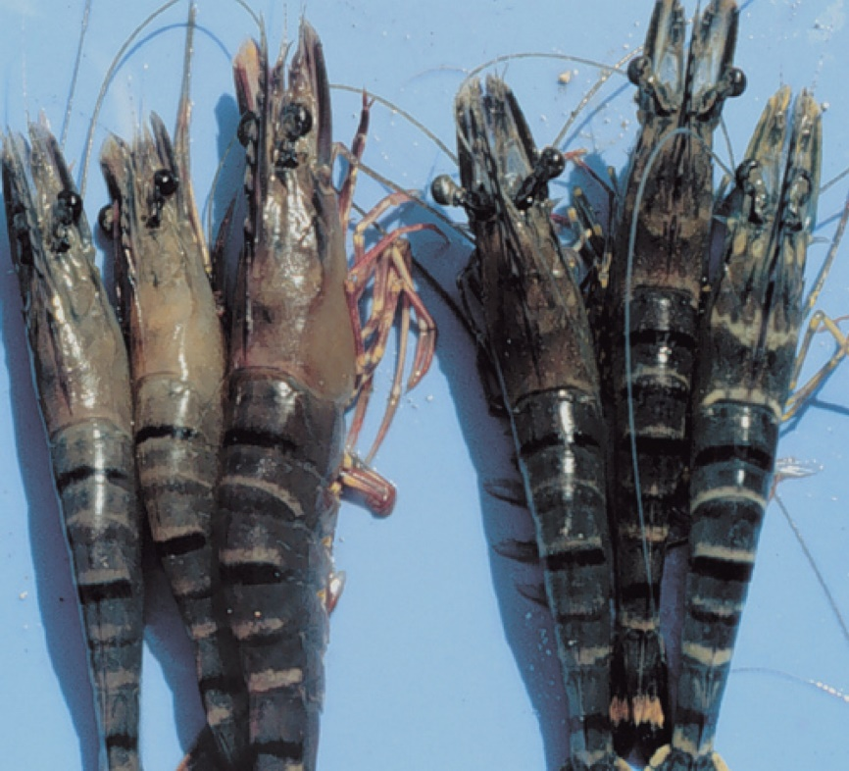
Note: Infected prawns (left) show pale yellow heads.
Source: DV Lightner

Signs of disease
Important: Animals with this disease may show one or more of these signs, but the pathogen may still be present in the absence of any signs.
Disease signs at the farm, tank or pond level are:
- aggregations of moribund prawns near the water surface at the edge of the rearing pond or tank
- abnormally high feeding rate of infected 5g to 15g prawns for several days and then cessation of feeding
- mass mortality (up to 100%) occurring 2 to 4 days after cessation of feeding.
Gross pathological signs are:
- yellowing of the cephalothorax and general bleaching of the body
- white, yellow or brown gills
- exceptionally soft digestive gland compared with normal
- yellow, swollen digestive gland, making the head appear yellow.
Microscopic pathological signs are:
- moderate to large numbers of deeply basophilic, evenly stained, spherical, cytoplasmic inclusions within tissues of ectodermal and mesodermal origin.

Disease agent
Yellowhead disease is caused by infection with yellowhead virus genotype 1 (YHV1), a corona-like RNA virus in the genus Okavirus, family Roniviridae and order Nidovirales. YHV1 is one of at least 10 genotypes in the yellowhead complex of viruses and is the only known agent of yellowhead disease. Gill-associated virus (GAV) is designated as genotype 2 (covered separately within the field guide). Several other known genotypes in the complex (genotypes 3 to 10) occur commonly in black tiger prawns (Penaeus monodon) in East Africa, Asia and Australia. Most of these other genotypes are rarely or never associated with disease.

Host range
YHV1 is highly infectious for most known species of cultivated penaeid prawns. There are variations in the susceptibility of different species to disease. Laboratory trials have shown that YHV1 can cause high mortality in black tiger prawns, Pacific white shrimp, Pacific blue shrimp, northern brown shrimp, northern pink shrimp, Sunda river prawns, mysid shrimp and barred estuarine shrimp. Until proven otherwise, it should be assumed that most penaeid prawns worldwide are susceptible to infection with YHV1.
Table 66 Species known to be susceptible to infection with YHV1
Common name | Scientific name
Barred estuarine shrimp | Palaemon serrifer
Black tiger prawnª | Penaeus monodon
Brown tiger prawn | Penaeus esculentus
Daggerblade grass shrimp | Paleamon pugio
Giant freshwater prawn | Macrobrachium rosenbergii
Greentail prawn | Metapenaeus bennettae
Gulf banana prawnª | Penaeus (Fenneropenaeus) merguiensis
Jelly prawnsª | Acetes spp.
Kuruma prawnª | Penaeus (Marsupenaeus) japonicus
Mississippi grass shrimp | Palaemon kadiakensis
Mysid shrimpª | Palaemon styliferus
Northern brown shrimp | Penaeus (Farfantepenaeus) aztecus
Northern pink shrimp | Penaeus (Farfantepenaeus) duorarum
Northern white shrimpª | Penaeus (Litopenaeus) setiferus
Pacific blue shrimp | Penaeus (Litopenaeus) stylirostris
Pacific white shrimp | Penaeus (Litopenaeus) vannamei
Red endeavour (greasyback) prawnª | Metapenaeus ensis
Sunda river prawn | Macrobrachium sintangene
a Naturally susceptible. Note: Other species shown to be experimentally susceptible.

Presence in Australia
Exotic disease—not recorded in Australia.
YHV1 is the most virulent genotype within the yellowhead complex, and the only known agent to cause yellowhead disease. It has never been recorded in Australia and is considered exotic. Other genotypes are known to occur in Australia, including YHV2 (gill associated virus), YHV6 and YHV7.
Map 45 Presence of YHV1, by jurisdiction
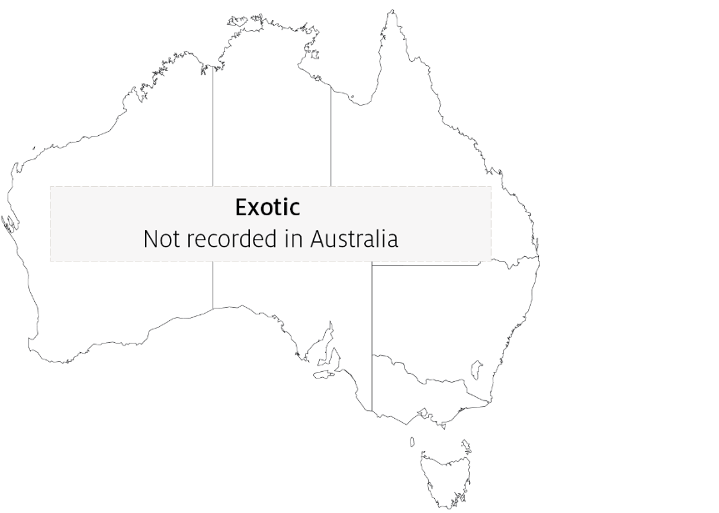

Epidemiology
- Penaeus monodon suffers acute epizootics, with mortality reaching 100% within 3 to 5 days of the first appearance of gross signs of infection.
- YHV1 can be transmitted horizontally by injection, ingestion of infected tissue, immersion in membrane-filtered tissue extracts or cohabitation with infected shrimp. Transmission has also been demonstrated by injection of extracts of jelly prawns (Acetes spp.) collected from infected ponds.
- Vertical transmission occurs from both male and female parents, possibly via surface infection or contamination of tissue surrounding fertilised eggs.
- Penaeus monodon younger than 15 days postlarvae are resistant to YHV1. Those from postlarval days 20 to 25 to subadult are highly susceptible.
- Mortalities usually occur during the early to late juvenile stages in rearing ponds.
- There are at least 10 genotypes of virus in the yellowhead virus group. YHV1 is the only genotype known to cause yellowhead disease.

Differential diagnosis
The list of similar diseases in the next section refers only to the diseases covered by this field guide. Gross pathological signs may also be representative of diseases not included in this guide. Gross signs should not be relied on to provide a definitive diagnosis. They should be used as a tool to help identify the listed diseases that most closely account for the observed signs.

Similar diseases
Gill associated virus disease (GAV), infection with Hepatobacter penaei (NHP), infection with shrimp haemocyte iridescent virus (SHIV) and infection with Taura syndrome virus (TSV).

Sample collection
Only trained personnel should collect samples. Using only gross pathological signs to differentiate between diseases is not reliable, and some aquatic animal disease agents pose a risk to humans. If you are not appropriately trained, phone your state or territory hotline number and report your observations. If you have to collect samples, the agency taking your call will advise you on the appropriate course of action. Local or district fisheries or veterinary authorities may also advise on sampling.

Emergency disease hotline
See something you think is this disease? Report it. Even if you’re not sure.
Call the Emergency Animal Disease Watch Hotline on 1800 675 888. They will refer you to the right state or territory agency.

Microscope images
Figure 209 Histological section of lymphoid organ of juvenile giant black tiger prawn (Penaeus monodon) with severe acute yellowhead disease
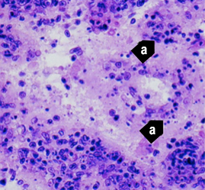
Note: Generalised, diffuse necrosis of lymphoid organ (LO) cells with pyknotic and karyorrhectic nuclei (a). Necrosis in acute yellowhead disease distinguishes it from infection due to Taura syndrome virus, which produces similar cytopathology in other target tissues, but not in the LO. 525x magnification.
Source: DV Lightner
Figure 210 Histological section of lymphoid organ of juvenile giant black tiger prawn (Penaeus monodon) with severe acute yellowhead disease
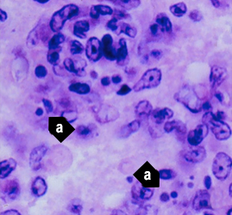
Note: Same sample as Figure 209. Single or multiple perinuclear inclusion bodies, ranging from pale to darkly basophilic, are apparent in some affected cells (a). 1700x magnification.
Source: DV Lightner
Figure 211 Histological section of the gills from a juvenile black tiger prawn (Penaeus monodon) with yellowhead disease
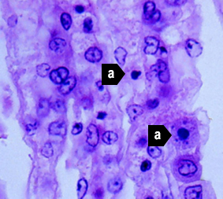
Note: Generalised, diffuse necrosis of cells in the gill lamellae, affected cells displaying pyknotic and karyorrhectic nuclei (a). A few large, conspicuous, generally spherical cells with basophilic cytoplasm are present in the section. These cells may be immature haemocytes, released prematurely in response to a yellowhead virus–induced haemocytopaenia. 1000x magnification.
Source: DV Lightner
Figure 212 Histological section of lymphoid organ of juvenile Pacific white shrimp (Penaeus (Litopenaeus) vannamei) experimentally infected with YHV1
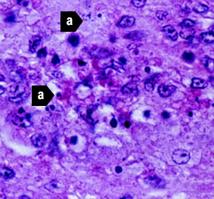
Note: Severe (grade 3–4) diffuse to multifocal necrosis, characterised by cells with increased eosinophilic cytoplasm, pyknotic or karyorrhectic nuclei (a) and pale to densely basophilic perinuclear inclusions. 1000x magnification.
Source: DV Lightner
Figure 213 Histological section of lymphoid organ of northern brown shrimp (Penaeus (Farfantepenaeus) aztecus) experimentally infected with YHV1
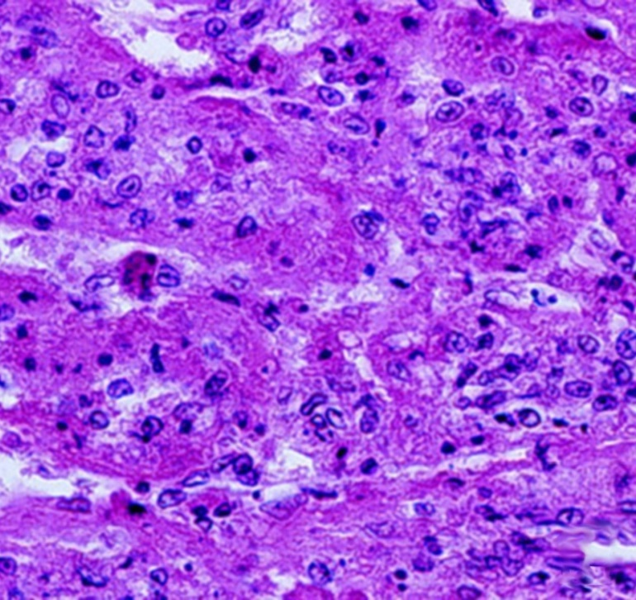
Note: Severe (grade 3–4) diffuse to multifocal necrosis, characterised by cells with increased eosinophilic cytoplasm, pyknotic or karyorrhectic nuclei and pale to densely basophilic perinuclear inclusions. 525x magnification.
Source: DV Lightner
Figure 214 Histological section of gills of juvenile northern pink shrimp (Penaeus (Farfantepenaeus) duorarum) experimentally infected with YHV1
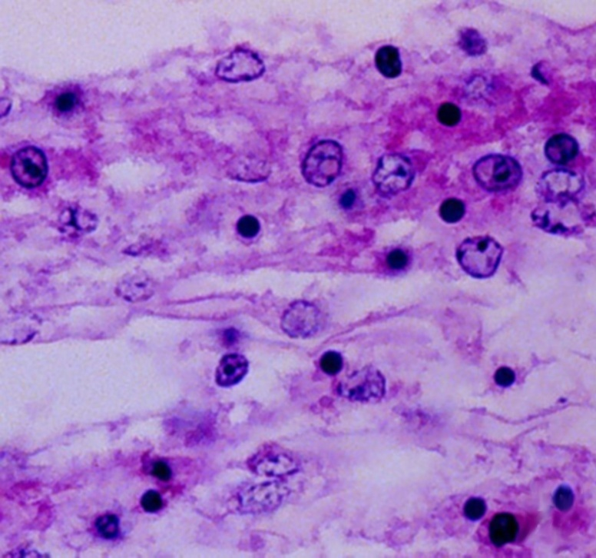
Note: Severe (grade 4) diffuse to multifocal necrosis, characterised by cells with increased eosinophilic cytoplasm, pyknotic or karyorrhectic nuclei, and pale to densely basophilic perinuclear inclusions. 1000× magnification.
Source: DV Lightner
Figure 215 Histological section of oesophagus of Pacific white shrimp (Penaeus (Litopenaeus) vannamei) experimentally infected with YHV1
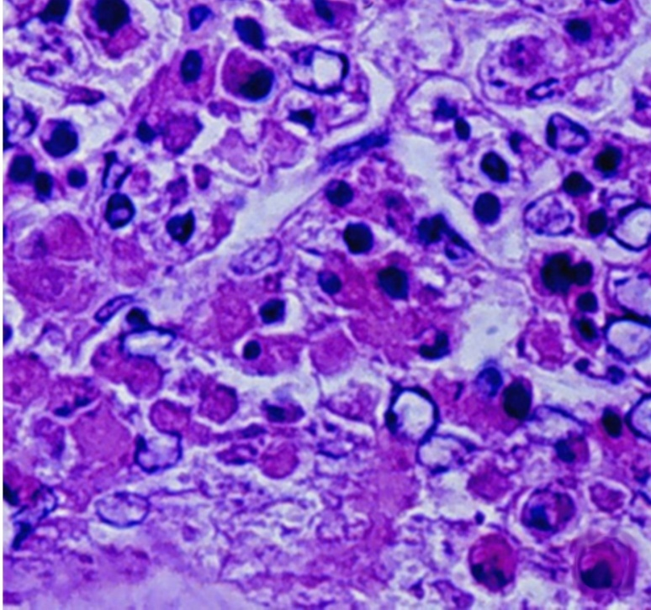
Note: Severe (grade 4) diffuse to multifocal necrosis is present, characterised by cells with increased eosinophilic cytoplasm, pyknotic or karyorrhectic nuclei, and pale to densely basophilic perinuclear inclusions. 1000x magnification.
Source: DV Lightner

Further reading
CABI Invasive Species Compendium Yellow head disease
CEFAS International Database on Aquatic Animal Diseases Yellowhead disease
World Organisation for Animal Health Manual of diagnostic tests for aquatic animals

Bacterial diseases of crustaceans

Acute hepatopancreatic necrosis disease (AHPND)
Also known as early mortality syndrome (EMS)
Exotic disease
Figure 216 Pacific white shrimp (Penaeus (Litopenaeus) vannamei) with AHPND
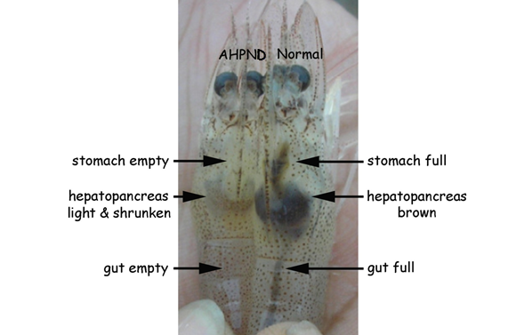
Note: Infected shrimp shows empty stomach and gut and a paler and shrunken hepatopancreas. Healthy shrimp shows a full stomach and gut and brown hepatopancreas.
Source: DV Lightner
Figure 217 Black tiger prawn (Penaeus monodon) with AHPND
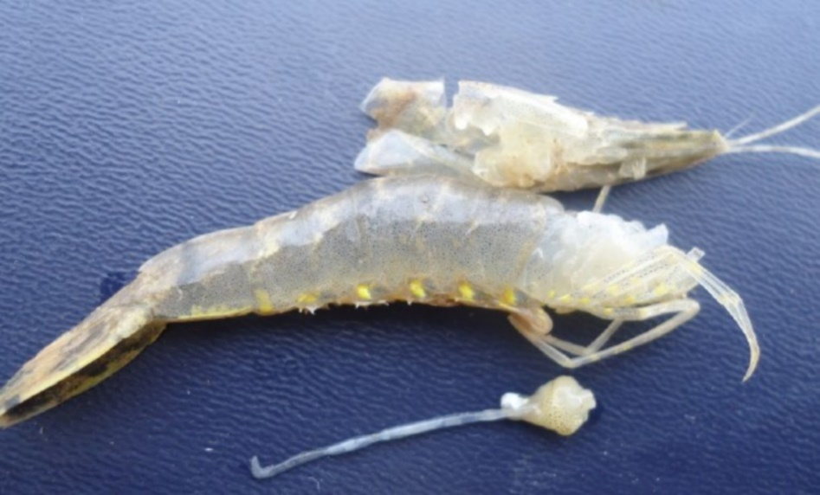
Note: Pale colour and small size of excised, atrophied hepatopancreas.
Source: DV Lightner

Signs of disease
Important: Animals with this disease may show one or more of these signs, but the pathogen may still be present in the absence of any signs.
Disease signs at the farm, tank or pond level are:
- pale to white hepatopancreas due to pigment loss in the connective tissue capsule
- moribund prawns sink to bottom
- onset of clinical signs and mass mortality up to 100% starting as early as 10 days post stocking and usually within 30 to 35 days.
Gross pathological signs are:
- soft shell
- guts with discontinuous contents or no contents
- black (melanised) spots or streaks visible within the hepatopancreas
- atrophy (shrinkage) of the hepatopancreas
- hepatopancreas does not squash easily between thumb and forefinger.
Microscopic pathological signs are:
- acute phase
  - massive and progressive degeneration of the hepatopancreas tubules from proximal to distal
  - significant rounding and sloughing of hepatopancreas tubule epithelial cells into the tubule lumens, collecting ducts and posterior stomach
- terminal phase
  - massive secondary bacterial infection (Vibrio spp.) in the sloughed cells
  - complete destruction of the hepatopancreas.
The only definitive histopathology is in the acute stage with the massive sloughing of hepatopancreas tubule epithelial cells in the absence of bacteria.

Disease agent
AHPND is also known as early mortality syndrome (EMS), and is caused by infection with Vibrio parahaemolyticus (Vp_{AHPND}). Vp_{AHPND} contains a plasmid (pVA1) of an approximately 70-kbp with genes that encode homologues of the Photorhabdus insect-related (Pir) toxins PirA and PirB. There are reports of the isolation of other Vibrio species from clinical cases of AHPND. However, only Vp_{AHPND} has been demonstrated to cause AHPND.

Host range
This disease affects mainly Penaeus (Litopenaeus) vannamei and Penaeus monodon. It may also be problematic in Penaeus (Fenneropenaeus) chinensis. Kuruma prawns are unaffected but may act as carriers. Live polychaete worms may also act as vectors for specific virulent strains of Vibrio parahaemolyticus when used to feed broodstock prawns.
Table 67 Species known to be susceptible to AHPND
Common name | Scientific name
Black tiger prawnª | Penaeus monodon
Chinese white shrimpª | Penaeus (Fenneropenaeus) chinensis
Kuruma prawn | Penaeus (Marsupenaeus) japonicus
Pacific white shrimpª | Penaeus (Litopenaeus) vannamei
a Naturally susceptible.
Table 68 Non-crustacean carriers of AHPND
Common name | Scientific name
Polychaetesª | Various genera and species
a Naturally susceptible.

Presence in Australia
Exotic disease—not recorded in Australia.
Vibrio parahaemolyticus is known to occur in Australia. However, specific strains containing the plasmid (pVA1) of approximately 70-kbpwith genes that encode homologues of the Photorhabdus insect-related (Pir) toxins, PirA and PirB have not been recorded.
Map 46 Presence of AHPND, by jurisdiction

Epidemiology
- AHPND was first reported in 2009 as a novel disease of unknown aetiology in cultured prawns and was initially named early mortality syndrome (EMS). A more descriptive term for the syndrome, acute hepatopancreatic necrosis syndrome (AHPNS), was later adopted.
- With the aetiological agents now identified, the current disease name is AHPND.
- AHPND is transmitted horizontally by the oral route and cohabitation.
- Water sources with low salinity (less than 20ppt) seem to reduce the incidence of the disease.
- Other factors that may lead to AHPND in areas where these specific bacterial strains are present include overfeeding, poor seed quality, poor water quality, poor feed quality, algal blooms or algal crashes.
- The hatchery practice of feeding live polychaete worms to broodstock to increase nauplii production presents a significant biosecurity risk and is a possible source of AHPND.
- It may be possible to reduce AHPND outbreaks by changing the design of rearing ponds, and through changes in husbandry practices.

Differential diagnosis
The list of similar diseases in the next section refers only to the diseases covered by this field guide. Gross pathological signs may also be representative of diseases not included in this guide. Do not rely on gross signs to provide a definitive diagnosis. Use them as a tool to help identify the listed diseases that most closely account for the observed signs.

Similar diseases
Infection with Enterocytozoon hepatopenaei (EHP), infection with Hepatobacter penaei (NHP) and infection with shrimp haemocyte iridescent virus (SHIV).

Sample collection
Only trained personnel should collect samples. Using only gross pathological signs to differentiate between diseases is not reliable, and some aquatic animal disease agents pose a risk to humans. If you are not appropriately trained, phone your state or territory hotline number and report your observations. If you have to collect samples, the agency taking your call will advise you on the appropriate course of action. Local or district fisheries or veterinary authorities may also advise on sampling.

Emergency disease hotline
See something you think is this disease? Report it. Even if you’re not sure.
Call the Emergency Animal Disease Watch Hotline on 1800 675 888. They will refer you to the right state or territory agency.

Mocroscope images
Figure 218 Low-magnification photomicrograph of hepatopancreas of juvenile Pacific white shrimp (Penaeus (Litopenaeus) vannamei) with acute AHPND
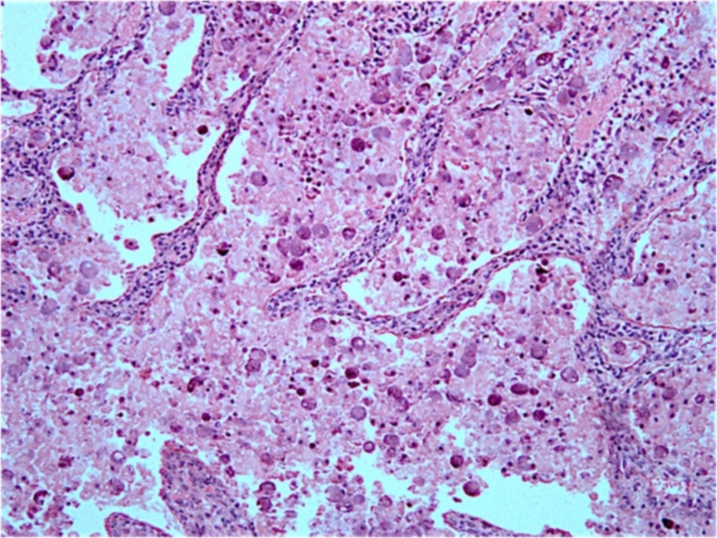
Note: Massive necrosis and sloughing of the tubule epithelial cells into the tubule lumen.
Source: J Brock
Figure 219 High magnification photomicrograph of hepatopancreas of juvenile Pacific white shrimp (Penaeus (Litopenaeus) vannamei) with acute AHPND
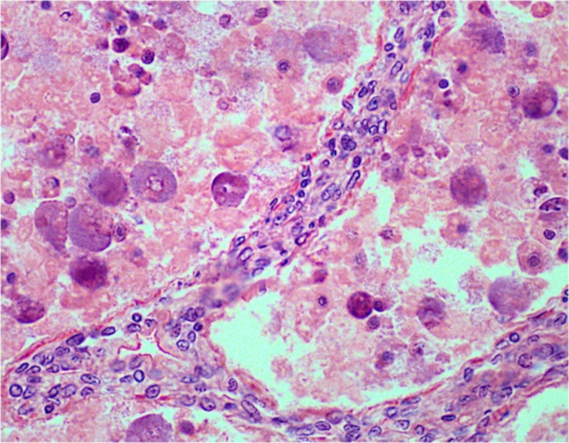
Note: Massive necrosis, sloughing and rounding up of tubule epithelial cells as they disintegrate into the tubule lumen in the absence of obvious bacterial infection.
Source: J Brock
Figure 220 Low magnification photomicrograph of hepatopancreas of juvenile Pacific white shrimp (Penaeus (Litopenaeus) vannamei) with terminal AHPND
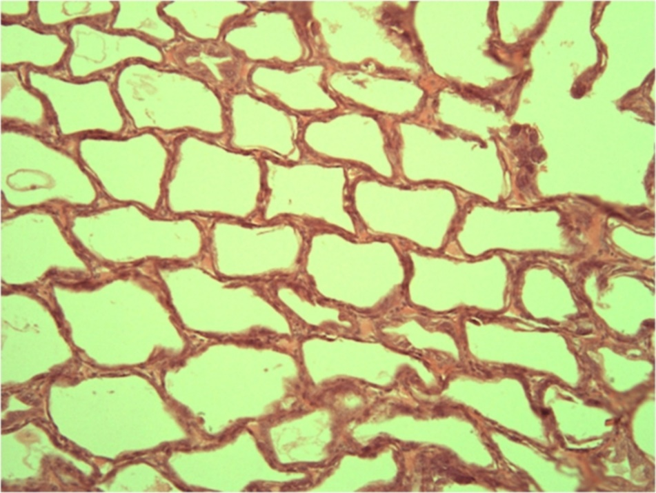
Note: Severe atrophy of the hepatopancreas tubules with almost complete loss of epithelium.
Source: J Brock

Further reading
CABI Invasive Species Compendium Acute hepatopancreatic necrosis disease
Network of Aquaculture Centres in Asia-Pacific Acute hepatopancreatic necrosis: disease card
World Organisation for Animal Health Manual of diagnostic tests for aquatic animals

Infection with Hepatobacter penaei
Also known as necrotising hepatopancreatitis (NHP)
Exotic disease
Figure 221 Pacific white shrimp (Penaeus (Litopenaeus) vannamei) infected with Hepatobacter penaei
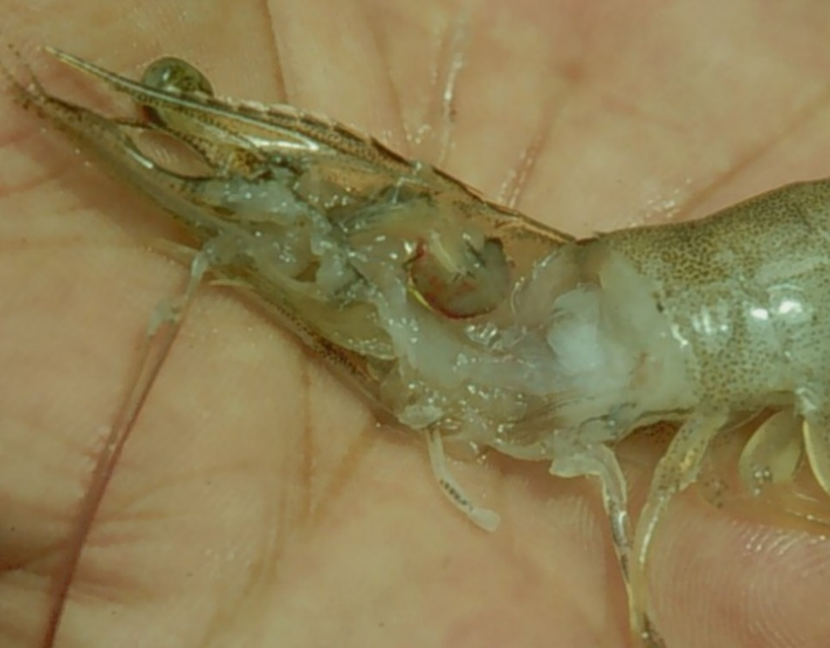
Note: Marked reduction in size and pale colour of hepatopancreas.
Source: DV Lightner
Figure 222 Swimmerets of a Pacific white shrimp (Penaeus (Litopenaeus) vannamei) infected with Hepatobacter penaei
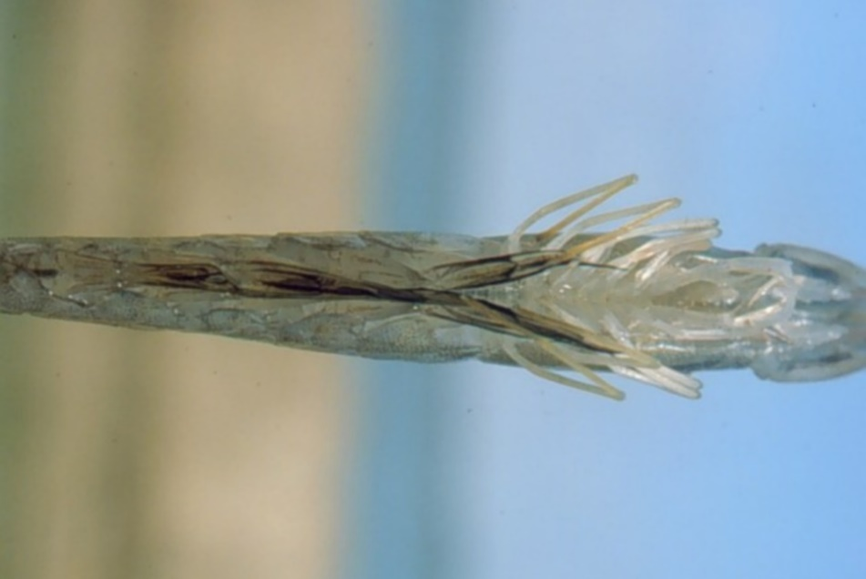
Note: Darkening at base of swimmerets, giving a fouled, ‘dirty’ appearance.
Source: DV Lightner

Signs of disease
Important: Animals with this disease may show one or more of these signs, but the pathogen may still be present in the absence of any signs.
Disease signs at the farm, tank or pond level are:
- lethargy
- emaciation
- heavy protozoan or bacterial fouling
- reduced growth rate.
Gross pathological signs are:
- soft shell
- flaccid body
- black gills
- empty intestinal tract
- degenerated or atrophied digestive gland (hepatopancreas), which appears pale to white
- black (melanised) streaks in the hepatopancreas.
Microscopic pathological signs are:
- multifocal granulomatous lesions in hepatopancreatic tubules, with atrophy of adjacent hepatopancreatic tubule epithelial cells
- tubular cells within the granulomatous lesions that can be hypertrophied and contain basophilic organisms within the cytoplasm
- sloughing of tubule epithelial cells
- severe haemocytic inflammation of the intratubular spaces.

Disease agent
NHP is caused by infection with Hepatobacter penaei, a Gram-negative, intracytoplasmic species of alphaproteobacterium that infects the hepatopancreas of prawns. H. penaei is also referred to as the NHP bacterium.
H. penaei exists in two morphological forms:
- rod-shaped, nonflagellated rickettsia-like organism
- helical flagellated form.

Host range
Table 69 Species known to be susceptible to Hepatobacter penaei
Common name | Scientific name
Aloha prawn | Penaeus marginatus
American lobster | Homarus americanus
Black tiger prawn | Penaeus monodon
Gulf banana prawn | Penaeus (Fenneropenaeus) merguiensis
Northern brown shrimpª | Penaeus (Farfantepenaeus) aztecus
Northern pink shrimpª | Penaeus (Farfantepenaeus) duorarum
Northern white shrimpª | Penaeus (Litopenaeus) setiferus
Pacific blue shrimpª | Penaeus (Litopenaeus) stylirostris
Pacific white shrimpª | Penaeus (Litopenaeus) vannamei
Yellow-leg shrimpª | Penaeus (Farfantepenaeus) californiensis
a Naturally susceptible.

Presence in Australia
Exotic disease—not recorded in Australia.
Map 47 Presence of Hepatobacter penaei, by jurisdiction

Epidemiology
- NHP outbreaks are often preceded by lengthy periods of high water temperatures (29°C to 31°C) and elevated salinity (up to 40ppt).
- Mortalities usually occur midway through the grow-out phase and can reach 90% to 95% within 30 days.
- NHP appears to be transmitted by direct ingestion of carrier prawns (survivors of H. penaei infections may carry the bacteria for life) and through contaminated water.
- Hepatobacter penaei may also be shed in faeces and contribute to disease transmission.

Differential diagnosis
The list of similar diseases in the next section refers only to the diseases covered by this field guide. Gross pathological signs may also be representative of diseases not included in this guide. Do not rely on gross signs to provide a definitive diagnosis. Use them as a tool to help identify the listed diseases that most closely account for the observed signs.

Similar diseases
Acute hepatopancreatic necrosis disease (AHPND) and infection with Enterocytozoon hepatopenaei (EHP).

Sample collection
Only trained personnel should collect samples. Using only gross pathological signs to differentiate between diseases is not reliable, and some aquatic animal disease agents pose a risk to humans. If you are not appropriately trained, phone your state or territory hotline number and report your observations. If you have to collect samples, the agency taking your call will advise you on the appropriate course of action. Local or district fisheries or veterinary authorities may also advise on sampling.

Emergency disease hotline
See something you think is this disease? Report it. Even if you’re not sure.
Call the Emergency Animal Disease Watch Hotline on 1800 675 888. They will refer you to the right state or territory agency.

Microscope images
Figure 223 Photomicrograph of hepatopancreas of juvenile Pacific white shrimp (Penaeus (Litopenaeus) vannamei) with severe subacute (grade 3–4) NHP
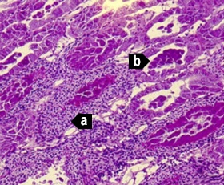
Note: Principal histopathological changes due to the disease include severe haemocytic inflammation (with some melanised foci) of the intratubular spaces (a) in response to necrosis, cytolysis and sloughing of hepatopancreas tubule epithelial cells (b). 150x magnification.
Source: DV Lightner
Figure 224 Photomicrograph of hepatopancreas of juvenile Pacific white shrimp (Penaeus (Litopenaeus) vannamei) with severe subacute (grade 3–4) NHP
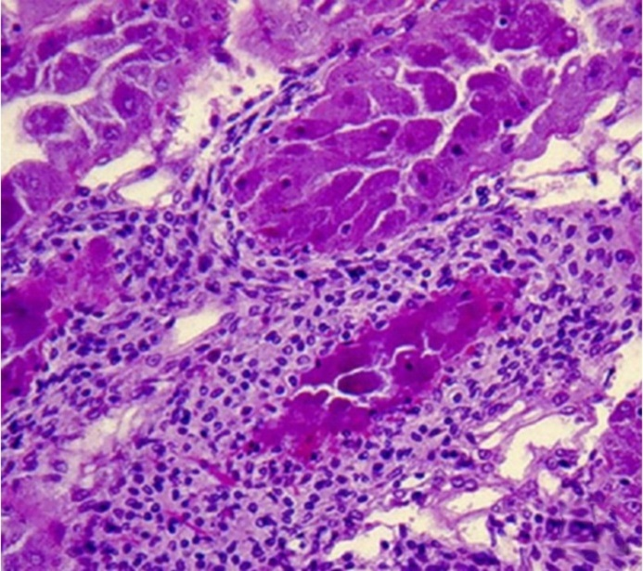
Note: Higher magnification of upper left of Figure 223. 300x magnification.
Source: DV Lightner
Figure 225 Photomicrograph of hepatopancreas of juvenile Pacific white shrimp (Penaeus (Litopenaeus) vannamei) with severe subacute (grade 3–4) NHP
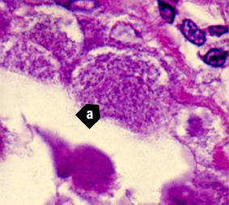
Note: Higher magnification view of Figure 223 and Figure 224. Tubule epithelial cells have no cytoplasmic lipid droplets. Instead, they contain masses of the tiny, non-membrane bound intracytoplasmic H. penaei (a). 1700x magnification.
Source: DV Lightner
Figure 226 Photomicrograph of hepatopancreas of juvenile Pacific white shrimp (Penaeus (Litopenaeus) vannamei) with severe chronic NHP
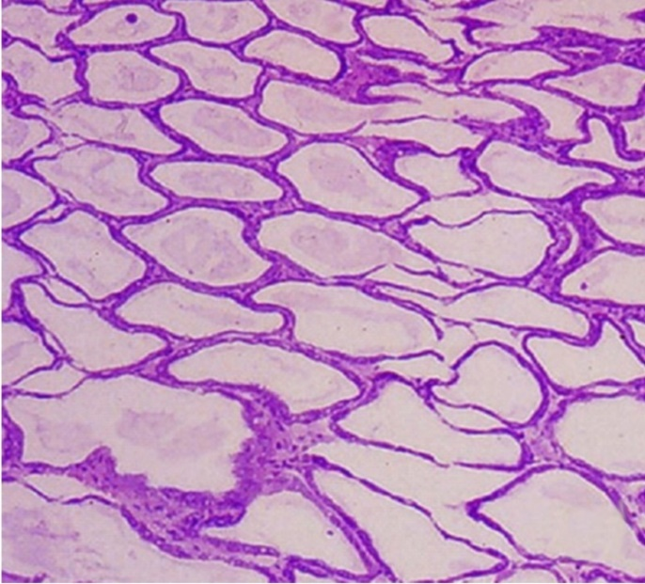
Note: Hepatopancreas tubule epithelium is markedly atrophied, resulting in the formation of large oedematous (fluid-filled or ‘watery’) areas. 100x magnification
Source: DV Lightner
Figure 227 Photomicrograph of atrophied hepatopancreas from juvenile Pacific white shrimp (Penaeus (Litopenaeus) vannamei) with chronic NHP
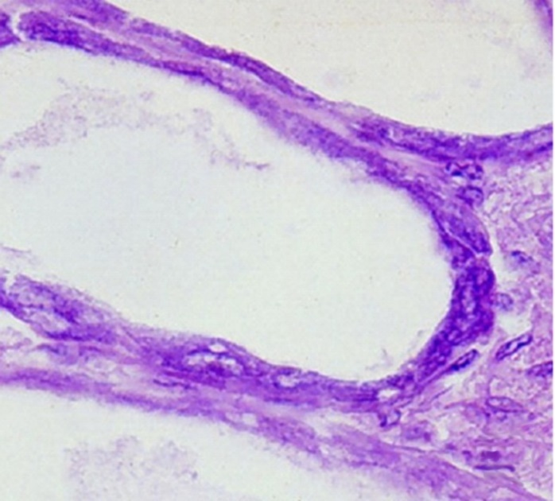
Note: In contrast to the subacute phase of NHP, chronic-phase NHP shows no, or only occasional, foci of haemocytic inflammation of the necrotic or degenerating hepatopancreatic tubules. NHP bacteria may be found in the cytoplasm of an occasional hepatopancreocyte. 900x magnification.
Source: DV Lightner
Figure 228 Hepatopancreocyte containing cytoplasmic masses of the NHP bacterium
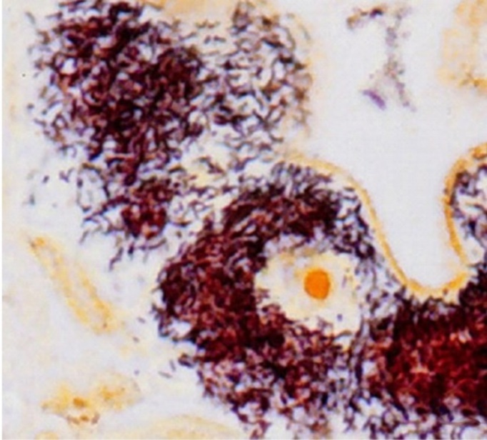
Note: Silver stain has been used to show individual bacteria as brown or black. Unaffected cells and nuclei are pale brown. 1600x magnification.
Source: DV Lightner
Figure 229 Transmission electron microscope micrograph of a hepatopancreocyte of a juvenile Pacific white shrimp (Penaeus (Litopenaeus) vannamei) with NHP
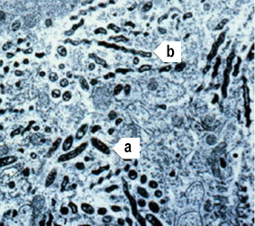
Note: The micrograph shows many intracellular rod-shaped forms (a) and helical forms (b) of the NHP bacterium in the cytoplasm. 10,000× magnification
Source: DV Lightner
Figure 230 Hepatopancreas of juvenile Pacific white shrimp (Penaeus (Litopenaeus) vannamei) with NHP
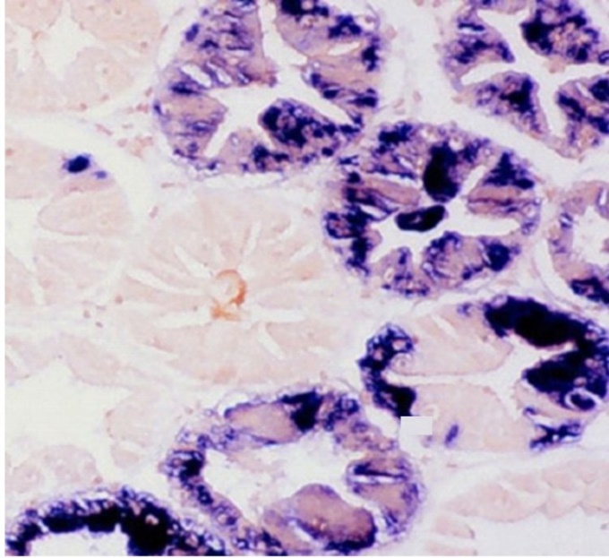
Note: The digoxigenin-labelled DNA probe marks cytoplasmic masses of Hepatobacter penaei blue-black. 250x magnification.
Source: DV Lightner
Figure 231 Hepatopancreas of juvenile Pacific white shrimp (Penaeus (Litopenaeus) vannamei) with NHP
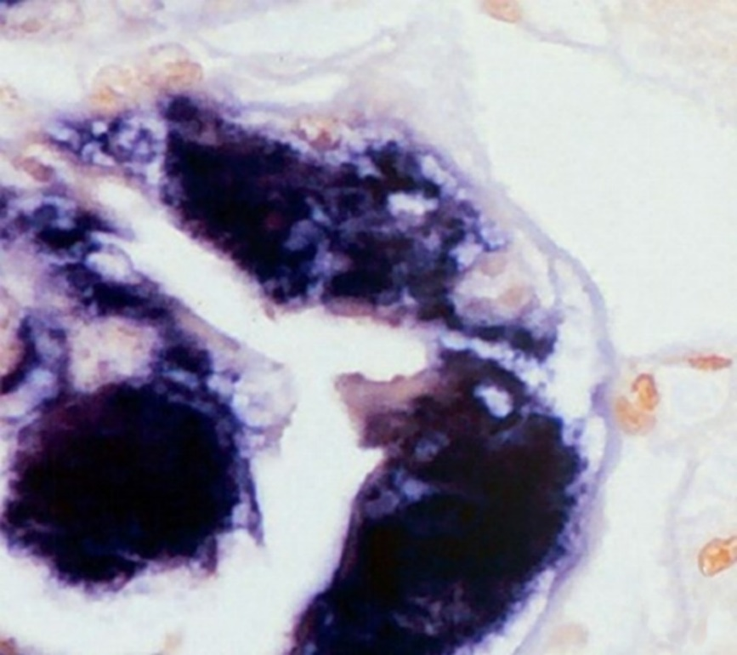
Note: The digoxigenin-labelled DNA probe marks cytoplasmic masses of H. penaei blue-black. 1000x magnification.
Source: DV Lightner

Further reading
CABI Invasive Species Compendium Necrotising hepatopancreatitis
CEFAS International Database on Aquatic Animal Diseases ‘Hepatobacter penaei’ (Necrotising hepatopancreatitis)
World Organisation for Animal Health Manual of diagnostic tests for aquatic animals

Parasitic diseases of crustaceans

Infection with Enterocytozoon hepatopenaei (EHP)
Also known as hepatopancreatic microsporidosis
Exotic disease

Signs of disease
Important: Animals with this disease may show one or more of these signs, but the pathogen may still be present in the absence of any signs.
Disease signs at the farm, tank or pond level are:
- unusually retarded growth in the absence of other gross signs of disease.
There are no specifically distinctive gross signs of infection by EHP.
Microscopic pathological signs are:
- the presence of basophilic, cytoplasmic inclusions (microsporidian sporocysts) containing clusters of elliptical to somewhat ovoid spores of 1.1 ± 0.21µm by 0.6–0.7 ± 0.1µm in haematoxylin and eosin stained tissue sections of hepatopancreas tubule epithelial cells
- free spores released from lysed cells occasionally observable in the tubule lumens.

Disease agent
Hepatopancreatic microsporidosis is caused by infection with Enterocytozoon hepatopenaei (EHP), a microsporidian parasite classified within the family Enterocytozoonidae. It was first discovered in Penaeus monodon in Thailand in 2004.

Host range
Species known to be susceptible to E. hepatopenaei are listed in Table 70 and Table 71. A similar microsporidian has been reported to infect kuruma prawns in Queensland, but the taxonomic affinities of that parasite are unclear. E. hepatopenaei has also been detected in frozen Artemia biomass and live polychaetes.
Table 70 Species known to be susceptible to EHP
Common name | Scientific name
Black tiger prawnª | Penaeus monodon
Pacific white shrimpª | Penaeus (Litopenaeus) vannamei
Pacific blue shrimp | Penaeus (Litopenaeus) stylirostris
a Naturally susceptible.
Table 71 Non-crustacean carriers
Common name | Scientific name
Brine shrimpª | Artemia salina
Polychaetesª | Various genera and species
a Naturally susceptible.

Presence in Australia
Exotic disease—not recorded in Australia.
EHP is considered exotic to Australia. However, other microsporidians have been reported to infect kuruma prawns (Penaeus (Marsupenaeus) japonicus) in Queensland.
Map 48 Presence of Enterocytozoon hepatopenaei, by jurisdiction

Epidemiology
- EHP is known to infect only the tubule epithelial cells of the hepatopancreas of prawns.
- EHP should therefore not be confused with other microsporidians with different tissue trophism, such as Agmasoma penaei that infects muscle tissue and connective tissue leading to the gross signs of 'cotton shrimp disease' or 'white back' disease.
- EHP can be transmitted horizontally among prawns cohabiting in rearing ponds.
- Heavily infected prawns may display white faeces that are packed with microsporidian spores.
- Infection with EHP may be a significant risk factor in the development of acute hepatopancreatic necrosis disease (AHPND).

Differential diagnosis
The list of similar diseases in the next section refers only to the diseases covered by this field guide. Gross pathological signs may also be representative of diseases not included in this guide. Do not rely on gross signs to provide a definitive diagnosis. Use them as a tool to help identify the listed diseases that most closely account for the observed signs.

Similar diseases
Acute hepatopancreatic necrosis disease (AHPND) and infection with Hepatobacter penaei (NHP).

Sample collection
Only trained personnel should collect samples. Using only gross pathological signs to differentiate between diseases is not reliable, and some aquatic animal disease agents pose a risk to humans. If you are not appropriately trained, phone your state or territory hotline number and report your observations. If you have to collect samples, the agency taking your call will advise you on the appropriate course of action. Local or district fisheries or veterinary authorities may also advise on sampling.

Emergency disease hotline
See something you think is this disease? Report it. Even if you’re not sure.
Call the Emergency Animal Disease Watch Hotline on 1800 675 888. They will refer you to the right state or territory agency.

Microscope images
Figure 232 Histopathology of hepatopancreas of Pacific white shrimp (Penaeus (Litopenaeus) vannamei) infected with Enterocytozoon hepatopenaei
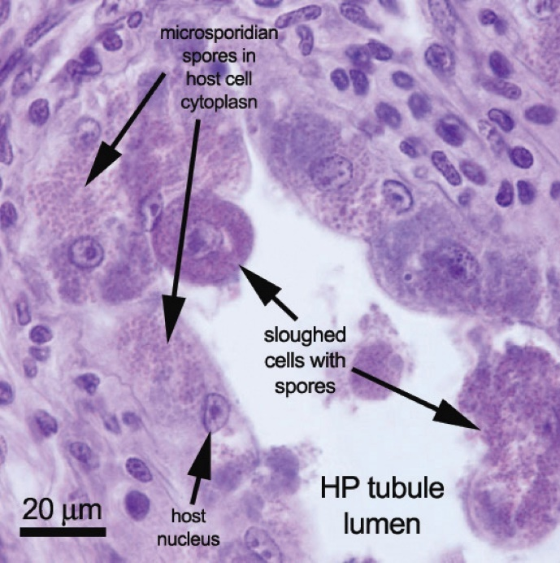
Note: Sloughed tubule epithelial cells containing many microsporidian spores in the cytoplasm. Scale bar = 20µm.
Source: T Flegel
Figure 233 Histopathology of hepatopancreas of Pacific white shrimp (Penaeus (Litopenaeus) vannamei) infected with Enterocytozoon hepatopenaei
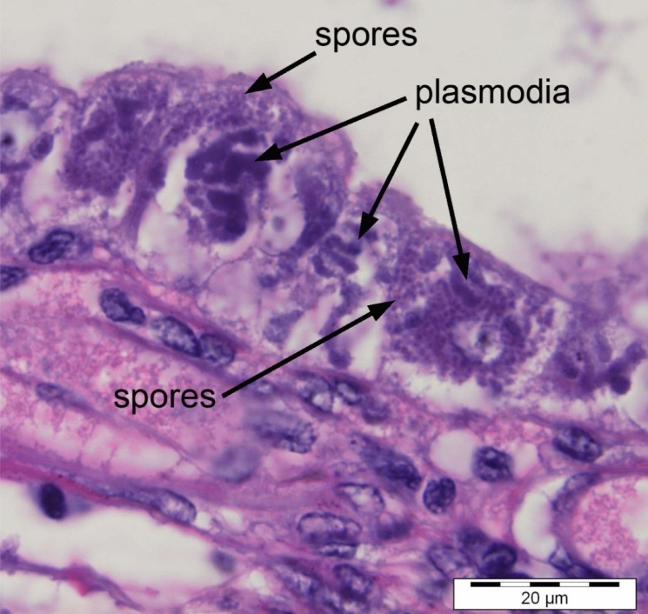
Note: Numerous spores inside sporocysts (plasmodia). Scale bar = 20µm.
Source: T Flegel
Figure 234 Electron micrograph of spore of Enterocytozoon hepatopenaei
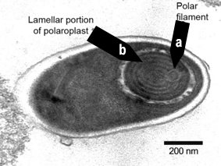
Note: Polar filament (a) with 5 or 6 coils, in lamellar portion of polarplast (b). Scale bar = 200nm
Source: T Flegel
Figure 235 Electron micrograph cross-section of polar filament in Enterocytozoon hepatopenaei spore
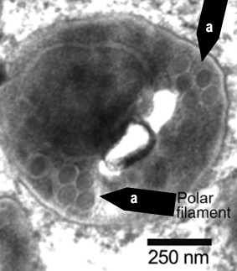
Note: Cross-sections of coils (a) of the polar filament. Scale bar = 250nm
Source: T Flegel

Further reading
Network of Aquaculture Centres in Asia-Pacific Hepatopancreatic microsporidosis caused by infection with ‘Enterocytooon hepatopenaei’: disease card

Other diseases of crustaceans

Infection with Aphanomyces astaci
Also known as crayfish plague
Exotic disease
Figure 236 Dorsal surface of signal crayfish (Pacifastacus leniusculus) resistant to crayfish plague
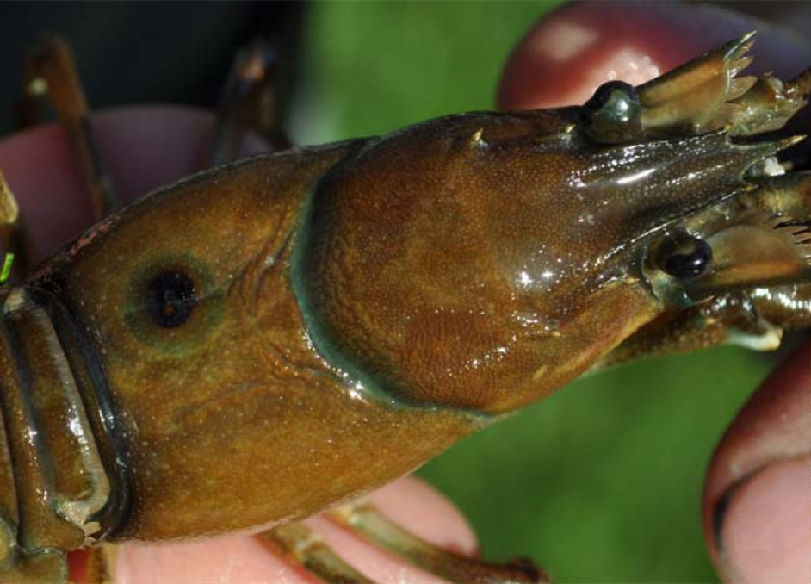
Note: Focal melanised spot on upper carapace due to infection by Aphanomyces astaci.
Source: T Vrålstad
Figure 237 Ventral surface of signal crayfish (Pacifastacus leniusculus) resistant to crayfish plague
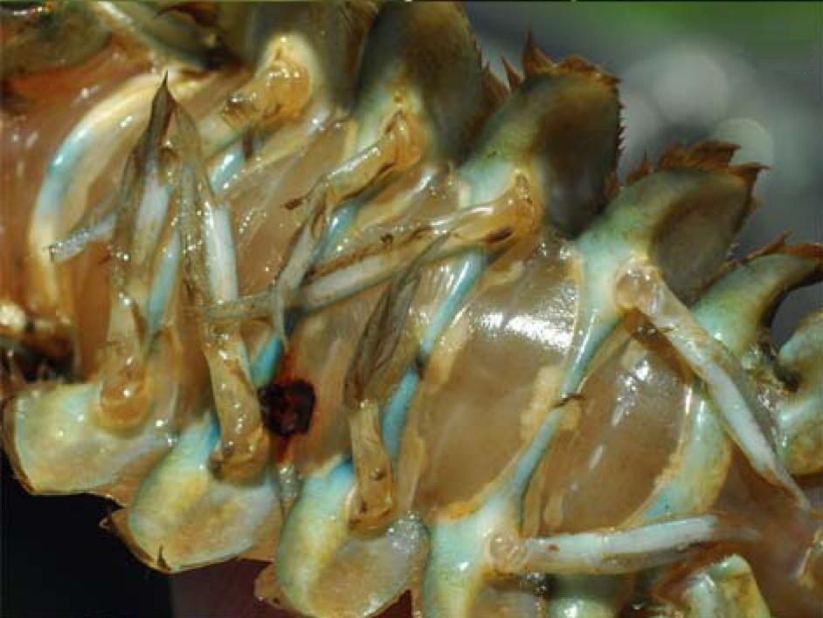
Note: Focal melanised spot on abdominal segment due to infection by Aphanomyces astaci.
Source: T Vrålstad
Figure 238 Signs of crayfish plague in body of susceptible stone crayfish (Austropotamobius torrentium)
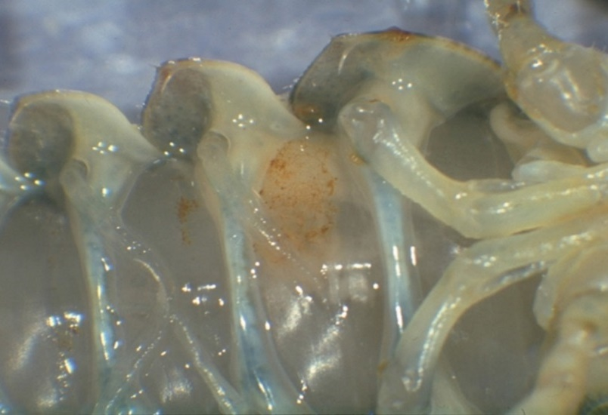
Note: Typical brown markings on an abdominal segment are caused by infection with Aphanomyces astaci. Healthy muscle tissue is present on either side of the affected segment.
Source: D Alderman
Figure 239 Signs of crayfish plague in leg of susceptible stone crayfish (Austropotamobius torrentium)
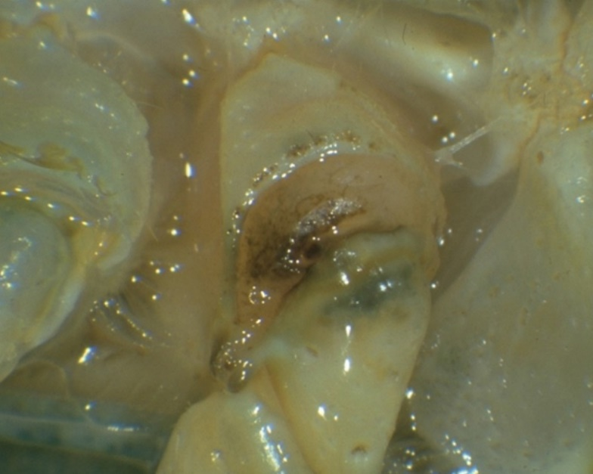
Note: Classic darkening at base of walking legs is caused by infection with Aphanomyces astaci.
Source: D Alderman

Signs of disease
Important: Animals with this disease may show one or more of these signs, but the pathogen may still be present in the absence of any signs.
Disease signs at the farm, tank or pond level are:
- high mortality at the time of the initial outbreak (usually near 100%)
- many dead or weak crayfish floating or lying in watercourses or ponds (mortalities may go unnoticed in the wild)
- crayfish in open water during daylight hours
- unsteady and raised gait ('walking on stilts')
- weakened, rapid tail escape response
- crayfish unable to remain upright (more evident when out of water)
- progressive paralysis
- crayfish trying to scratch or pinch themselves (occasionally seen).
- Gross pathological signs are:
- fungal growth on soft, non-calcified parts of the carapace
- brown or black spots on the carapace, where fungal hyphae proliferate
- fine black lines on the soft shell underneath the tail
- melanised (black) shell in chronically infected individuals
- death occurring within days or weeks of the initial infection (particularly in European crayfish, Astacus sp.)
- white and necrotic musculature in the tail.
- Microscopic pathological signs are:
- aseptate hyphae on the cuticle.

Disease agent
Crayfish plague is caused by infection with the oomycete Aphanomyces astaci. Although previously regarded as a fungus, the genus Aphanomyces is now classified with diatoms and brown algae in a group called Stramenopiles or Chromista. This pathogen is known to occur in freshwater only.

Host range
Table 72 Species known to be susceptible to crayfish plague
Common name | Scientific name
Asian freshwater shrimpª | Macrobrachium dayanum
Chinese mitten crabª | Eriocheir sinensis
Crayfish (native to Europe)ª | Astacus spp.
Crayfish (native to North America)ª | Orconectes spp.
European river crab | Potamon potamios
Freshwater crayfishª | Cherax spp.
Giant crayfish (native to Australia) | Astacopsis spp.
Giant Tasmanian crayfish | Astacopsis gouldi
Gippsland spiny crayfish | Euastacus kershawi
Japanese crayfishª | Cambaroides japonicus
Louisiana red swamp crayfishª | Procambarus clarkii
Marbled crayfishª | Procambarus fallax. f. virginalis
Noble crayfishª | Astacus astacus
Redclaw crayfishª | Cherax quadricarinatus
Signal crayfishª | Pacifastacus leniusculus
Smooth crayfish (native to Australia) | Geocherax spp.
Spiny crayfish (native to Australia) | Euastacus spp.
Stone crayfishª | Austropotamobius torrentium
Turkish crayfishª | Astacus leptodactylus
White-clawed crayfishª | Austropotamobius pallipes
Yabbies (freshwater, native to Australia)ª | Cherax destructor
a Naturally susceptible.
Table 73 Non-crustacean vectors of crayfish plague
Common name | Scientific name
Piscivorous birds | Various genera and species

Presence in Australia
Exotic disease—not recorded in Australia.
Map 49 Presence of crayfish plague, by jurisdiction

Epidemiology
- Mortalities of up to 100% have occurred in Europe, with local extinction of susceptible populations.
- North American crayfish (signal crayfish, Louisiana red swamp crayfish, Orconectes sp.) can be infected without showing clinical signs or succumbing to the disease. This allows them to become carriers of the disease agent and a source of transmission to less resistant species of crayfish.
- The disease was introduced into Europe by American freshwater crayfish and has decimated European crayfish stocks (wild and cultured). Until recently, there was no evidence of development of resistance to the disease among European species. There is now evidence of latent subclinical Aphanomyces astaci infections in some European crayfish, including noble crayfish (Astacus astacus) and Turkish crayfish (Astacus leptodactylus).
- Crayfish plague can occur at any time of year but is more likely in the summer months.
- Death occurs between 5 and 50 days (or more) from initial infection, depending on water temperature and initial number of zoospores. As little as one zoospore may be sufficient to initiate a lethal infection in susceptible crayfish species.
- Aphanomyces astaci releases motile zoospores directly to the water column when crayfish die. This is the primary transmission mechanism; motile zoospores of A. astaci swim actively in the water column and show positive movement towards other crayfish.
- Zoospores emerging from spores can swim for up to 5 days at 20°C but are capable of encystment and re-emergence up to 3 times, extending the period of their infective viability to several weeks.
- Translocation and migration of fish, birds and other wildlife can allow them to act as vectors, transporting the disease agent into previously unexposed waters.
- Aphanomyces astaci can be introduced to a new susceptible crayfish population on contaminated ropes, traps, fishing gear, boots, nets and other equipment.
- Infection with A. astaci may be suspected when mortalities are observed to be limited to highly susceptible species of freshwater crayfish (where all other flora and fauna, particularly other crustaceans, are normal and healthy).
- The known host range for A. astaci has expanded as more ornamental crayfish species are examined. There have been several instances where Australian crayfish species have been infected with A. astaci after intermingling with North American or European crayfish species within the ornamental trade.

Differential diagnosis
The list of similar diseases in the next section refers only to the diseases covered by this field guide. Gross pathological signs may also be representative of diseases not included in this guide. Do not rely on gross signs to provide a definitive diagnosis. Use them as a tool to help identify the listed diseases that most closely account for the observed signs.

Similar diseases
None of the other diseases in this field guide result in the rapid mortality of crayfish or other gross signs of crayfish plague. In Australia, infection with the microbial parasite Thelohania (or porcelain disease) may cause similar gross signs. Initial misdiagnosis has occurred when pollution has resulted in mortality of aquatic crustaceans where other species have survived. In a few cases, examination by light microscopy can further define a diagnosis. However, further laboratory examination is always required for a definitive diagnosis.

Sample collection
Only trained personnel should collect samples. Using only gross pathological signs to differentiate between diseases is not reliable, and some aquatic animal disease agents pose a risk to humans. If you are not appropriately trained, phone your state or territory hotline number and report your observations. If you have to collect samples, the agency taking your call will advise you on the appropriate course of action. Local or district fisheries or veterinary authorities may also advise on sampling.

Emergency disease hotline
See something you think is this disease? Report it. Even if you’re not sure.
Call the Emergency Animal Disease Watch Hotline on 1800 675 888. They will refer you to the right state or territory agency.

Further reading
CEFAS International Database on Aquatic Animal Diseases Crayfish plague
Department of Agriculture, Water and the Environment AQUAVETPLAN disease strategy manual: Crayfish plague
World Organisation for Animal Health Manual of diagnostic tests for aquatic animals

Monodon slow growth syndrome (MSGS)
Including infection with Laem-Singh virus (LSNV)
Exotic disease
Figure 240 Deformity of Penaeus monodon with MSGS
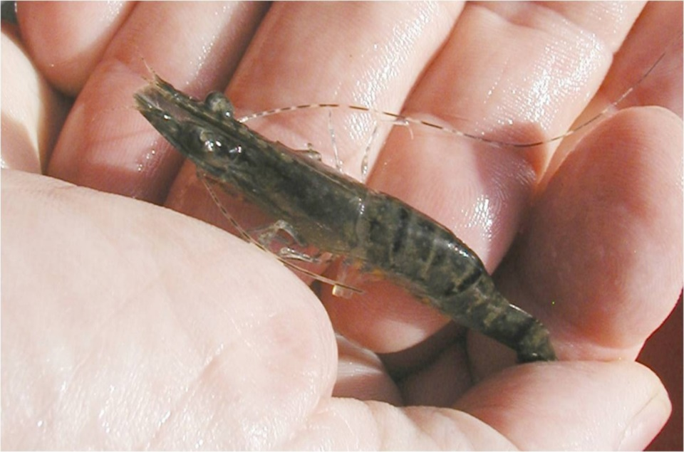
Note: Stunted growth and bamboo shaped abdominal segments.
Source: DV Lightner
Figure 241 Hepatopancreas of Penaeus monodon with MSGS
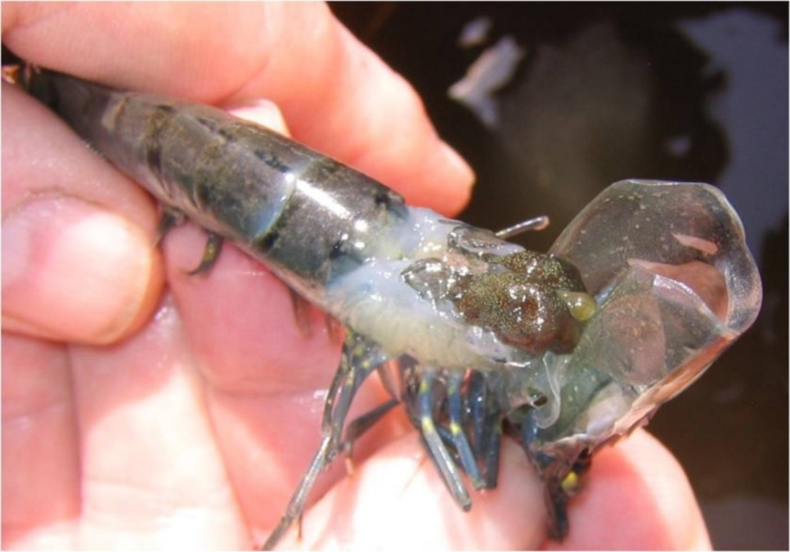
Note: Carapace lifted to show abnormal hepatopancreas.
Source: DV Lightner
Figure 242 Unusual markings on carapace of Penaeus monodon with MSGS
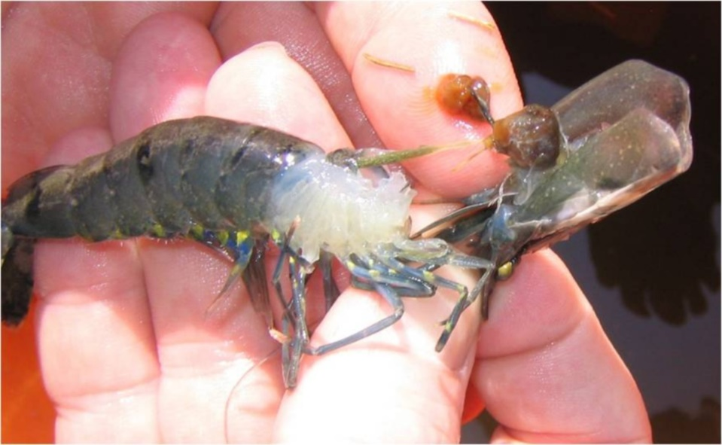
Note: Bright yellow markings on near legs.
Source: DV Lightner

Signs of disease
Important: Animals with this disease may show one or more of these signs, but the pathogen may still be present in the absence of any signs.
Disease signs at the farm, tank or pond level are:
- abnormally slow growth, resulting in irregularly sized prawns
- low average daily weight gain of less than 0.1g/day at 4 months of age.
- Gross pathological signs are:
- unusually dark colour
- unusually bright yellow markings
- brittle antennae
- bamboo-shaped abdominal segments.
There are no definitive microscopic pathological signs.

Disease agent
MSGS is a disease associated with the Laem-Singh virus (LSNV). The complete aetiology for MSGS is uncertain and there is no clear case definition for this syndrome. A working case definition for surveillance and data gathering purposes is listed in the epidemiology section. A key component is the positive detection of LSNV by RT-PCR; LSNV is considered a necessary but insufficient component cause. Known pathogens are unlikely to be the cause of MSGS. Previous trials have indicated that a filterable infectious agent is involved.

Host range
Table 74 Species known to be susceptible to MSGS
Common name | Scientific name
Black tiger prawn | Penaeus monodon
a Naturally susceptible.

Presence in Australia
Exotic disease—not recorded in Australia.
Map 50 Presence of MSGS, by jurisdiction

Epidemiology
- The cause of MSGS is uncertain, but a working case definition allows for suspected case data to be collected if the population:
  - tests positive for Laem-Singh virus
  - has a coefficient of variation of more than 35% by weight
  - is free from hepatopancreatic parvovirus infection or any other hepatopancreatic infection
  - shows 3 of the signs of disease listed here.
- In countries where the Pacific white shrimp (Penaeus (Litopenaeus) vannamei) has already been introduced, Pacific white shrimp and black tiger prawns (Penaeus monodon) should be reared separately. This is particularly important at the maturation and hatchery phases.

Differential diagnosis
The list of similar diseases in the next section refers only to the diseases covered by this field guide. Gross pathological signs may also be representative of diseases not included in this guide. Do not rely on gross signs to provide a definitive diagnosis. Use them as a tool to help identify the listed diseases that most closely account for the observed signs.

Similar diseases
No diseases listed in this field guide are similar to Monodon slow growth syndrome.

Sample collection
Only trained personnel should collect samples. Using only gross pathological signs to differentiate between diseases is not reliable, and some aquatic animal disease agents pose a risk to humans. If you are not appropriately trained, phone your state or territory hotline number and report your observations. If you have to collect samples, the agency taking your call will advise you on the appropriate course of action. Local or district fisheries or veterinary authorities may also advise on sampling.

Emergency disease hotline
See something you think is this disease? Report it. Even if you’re not sure.
Call the Emergency Animal Disease Watch Hotline on 1800 675 888. They will refer you to the right state or territory agency.

Further reading
Network of Aquaculture Centres in Asia-Pacific ‘Monodon’ slow growth syndrome and Laem-Singh virus retinopathy: disease card
Poornima, M, Seetang-Nun, Y, Alavandi, SV & Dayal, J 2012, Laem-Singh virus: A probable etiological agent associated with Monodon slow growth syndrome in farmed black tiger shrimp (‘Penaeus monodon’), Indian Journal of Virology, vol. 23.

Diseases of amphibians

Viral diseases of amphibians

Infection with ranavirus
Also known as frog virus 3 (FV-3), Bohle iridovirus (BIV), Ambystoma tigrinum virus (ATV), and Mahaffey Road virus (MHRV)
Figure 243 Hindlimb of magnificent tree frog (Litoria splendida) infected with Mahaffey Road virus
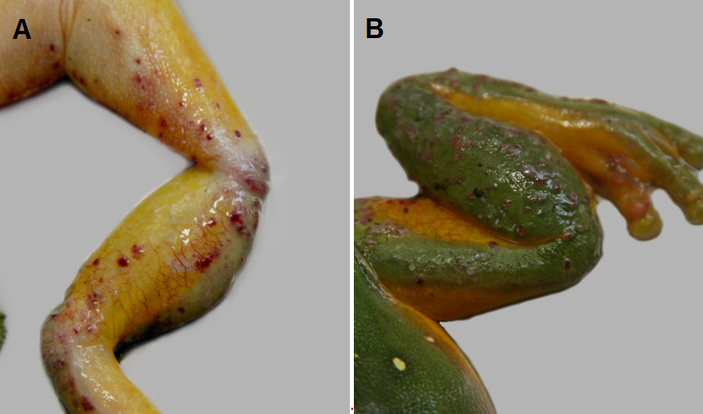
Note: Haemorrhagic skin papules and subcutaneous oedema of the ventral surface (A). Skin papules and erosions on the dorsal surface (B).
Source: Ian Jerrett
Figure 244 Ornate burrowing frog (Platyplectrum ornatus) metamorphs infected with Bohle iridovirus
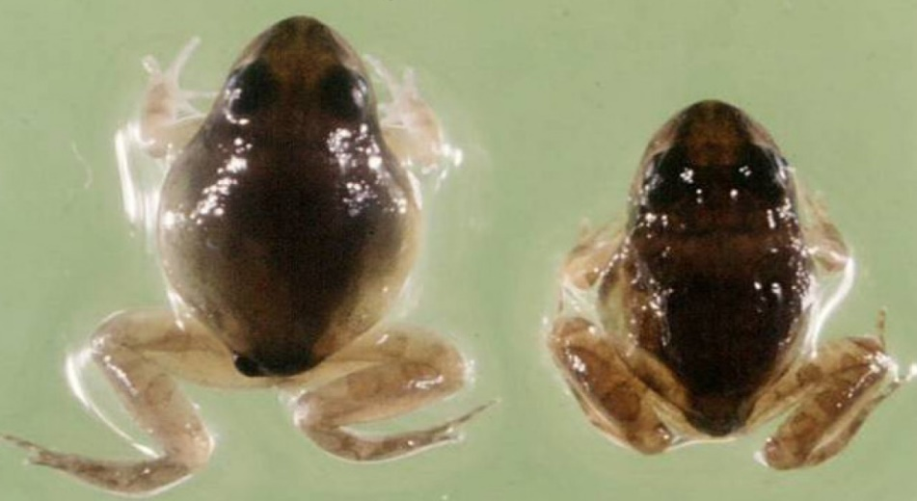
Note: Varying levels of ascites.
Source: R Speare
Figure 245 Green tree frog (Litoria caerulea) infected with Mahaffey Road virus
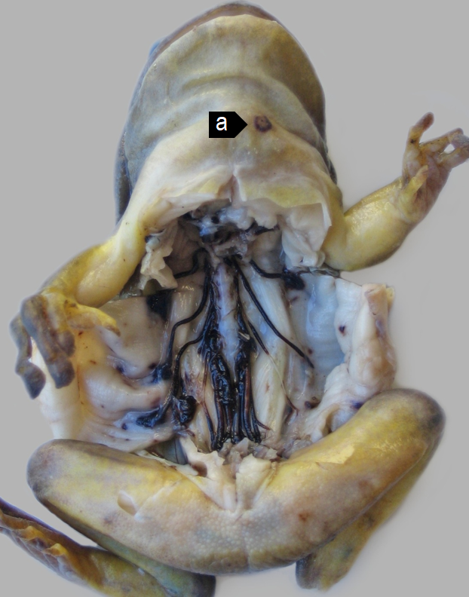
Note: Haemorrhagic perineural tissue and spinal nerves together with petechiation of the parietal coelomic serosa. A skin ulcer (a) is evident on the ventral neck.

Signs of disease
Important: Animals with this disease may show one or more of these signs, but the pathogen may still be present in the absence of any signs.
Disease signs at the farm, tank or pond level are:
- erratic swimming
- lethargy
- loss of equilibrium
- buoyancy problems
- morbidity
- rapid severe mortality events.
Gross pathological signs are:
- poor body condition
- lordosis (abnormal forward curvature of the spine).
In tadpoles and metamorphs, additional gross pathological signs are:
- ascites (free fluid in the abdominal cavity)
- generalised oedema (fluid swelling) of tissues
- focal haemorrhages.
In adults, additional gross pathological signs are:
- skin ulcers, papules and/or erosions
- focal and systematic haemorrhages
- enlargement of the spleen or liver
- oedema of subcutaneous tissue (particularly around the jaw and head, with the tongue protruding).
Microscopic pathological signs are:
- severe renal, pulmonary, hepatic, splenic and haematopoietic necroses and haemorrhages
- basophilic intracytoplasmic inclusion bodies
- erosion, ulceration and hyperplasia of epithelial epidermal cells.

Disease agent
This disease is caused by infection with members of the genus Ranavirus (family Iridoviridae). Viruses infecting amphibians include frog virus 3 (FV-3), Bohle iridovirus (BIV), Ambystoma tigrinum virus (ATV), and Mahaffey Road virus (MHRV). There are many other tentative species in this genus. Bohle iridovirus and Mahaffey Road virus are known from northern Australia in native frogs and cane toads.

Host range
Amphibians (all members of the class Amphibia) are considered to be susceptible to infection with ranavirus. Natural infections are known from most of the major families of the orders Anura (frogs and toads) and Caudata (salamanders, newts and sirens).
Infection with ranaviruses in fish and reptiles can result in asymptomatic infections through to epizootics, depending on species, stress and environmental factors.
In challenge experiments, species acutely susceptible to Bohle iridovirus were:
- juvenile green tree frogs (Litoria caerulea)
- striped burrowing frogs (Cyclorana alboguttata)
- short-footed frogs (Cyclorana brevipes)
- red-backed toadlets (Pseudophryne coriacea).
Species less susceptible in trials were:
- adult red tree frogs (Litoria rubella)
- bumpy rocketfrog (Litoria inermis)
- adult green tree frogs(Litoria caerulea)
- ornate nursery frogs (Cophixalus ornatus)
- sharp-snouted day frogs (Taudactylus acutirostris)
- cane toads (Bufo marinus).
Table 75 Species known to be susceptible to ranavirus
Common name | Scientific name
Frogs and toads | Order Anura
Bumpy rocket frogª | Litoria inermis
Cane toadª | Rhinella marina
Great barred frog | Mixophyes fasciolatus
Green tree frogª | Litoria caerulea
Magnificent tree frogª | Litoria splendida
Ornate burrowing frogª | Platyplectrum ornatus
Ornate nursery frogª | Cophixalus ornatus
Red tree frog | Litoria rubella
Red-backed toadletª | Pseudophryne coriacea
Sharp-snouted day frogª | Taudactylus acutirostris
Short-footed frog | Cyclorana brevipes
Striped burrowing frogª | Cyclorana alboguttata
Salamanders newts and sirens | Order Caudata
Alpine newt | Ichthyosaura alpestris
Blue tailed fire belly newt | Cynops cyanurus
Chiang Mai crocodile newt | Tylototriton uyenoi
Chinese firebelly newt | Cynops orientalis
Clouded salamander | Hynobius nebulosus
Eastern newt | Notophthalmus viridescens
European cave salamander | Speleomantes spp.
Fire salamander | Salamandra salamandra
French cave salamander | Hydromantes strinatii
Italian newt | Lissotriton italicus
Japanese clawed salamander | Onychodactylus japonicas
Japanese fire belly newt | Cynops pyrrhogaster
Lesser siren | Siren intermedia
North African fire salamander | Salamandra algira
Northern crested newt | Triturus cristatus
Northern spectacled salamander | Salamandrina perspicillata
Rough skinned newt | Taricha granulosa
Sardinian brook salamander | Euproctus platycephalus
Siberian salamander | Salamandrella keyserlingii
Smooth newt | Lissotriton vulgaris
Spanish ribbed newt | Pleurodeles waltl
Sword tailed newt | Cynops ensicauda
Vietnamese crocodile newt | Tylototriton vietnamensis
Vietnamese salamander | Paramesotriton deloustali
Wenxian knobby newt | Tylototriton wenxianensis
Yellow spotted newt | Neurergus crocatus
Zeigler’s crocodile newt | Tylototriton ziegleri
a Naturally susceptible. Note: other species likely to be susceptible or shown to be experimentally susceptible.

Presence in Australia
Infection with ranavirus has been officially reported in Australia. Bohle iridovirus was originally isolated from tadpoles of ornate burrowing frogs (Platyplectrum ornatus) in far north Queensland. It has since been isolated from moribund green tree frogs and captive juvenile red-backed toadlets. Another ranavirus, Mahaffey Road virus, was reported from moribund tree frogs in Darwin, Northern Territory. There is serological evidence of ranavirus infection in cane toads across northern Australia.
Map 51 Presence of ranavirus, by jurisdiction
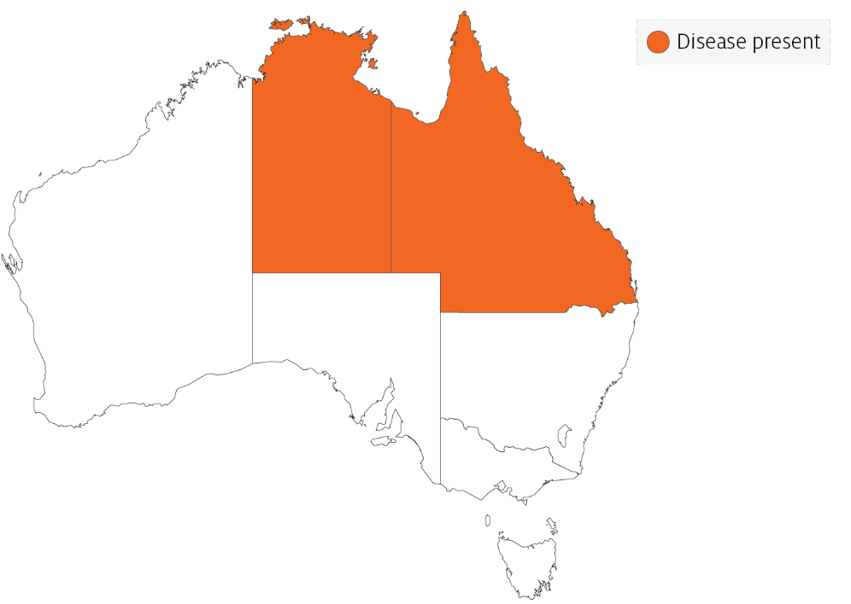

Epidemiology
- Two syndromes in frogs are associated with ranavirus infection: ulcerative syndrome and haemorrhagic syndrome.
- The most common presentation is a rapid, severe mortality event with death due to peracute systemic haemorrhagic disease. However, in Australia, morbidity is more common.
- Mortality and morbidity vary from species to species (0-100%), and may be variable depending on virus type, and age and health status of the host.
- Horizontal transmission occurs via contaminated water, animal-to-animal contact and predation or cannibalism.
- These viruses can be spread between widely separated river systems and impoundments. This suggests viral persistence and the existence of transmission mechanisms other than direct horizontal transmission.
- Vertical transmission is considered likely, but has not been experimentally documented.
- Possible vectors include nets, boats and other equipment, or amphibians used for bait by recreational fishers. Birds are potential mechanical vectors.
- Temperature is considered a likely factor influencing disease outbreaks, with the prevalence or severity of outbreaks greater during warmer months.

Differential diagnosis
The list of similar diseases in the next section refers only to the diseases covered by this field guide. Gross pathological signs may also be representative of diseases not included in this guide. Do not rely on gross signs to provide a definitive diagnosis. Use them as a tool to help identify the listed diseases that most closely account for the observed signs.

Similar diseases
No diseases in this field guide are similar to infection with ranavirus.

Sample collection
Only trained personnel should collect samples. Using only gross pathological signs to differentiate between diseases is not reliable, and some aquatic animal disease agents pose a risk to humans. If you are not appropriately trained, phone your state or territory hotline number and report your observations. If you have to collect samples, the agency taking your call will advise you on the appropriate course of action. Local or district fisheries or veterinary authorities may also advise on sampling.

Emergency disease hotline
See something you think is this disease? Report it. Even if you’re not sure.
Call the Emergency Animal Disease Watch Hotline on 1800 675 888. They will refer you to the right state or territory agency.

Further reading
Wildlife Health Australia Ranaviral disease in wild Australian amphibians
World Organisation for Animal Health Manual of Diagnostic Tests for Aquatic Animals

Other diseases of amphibians

Infection with Batrachochytrium dendrobatidis (Bd)
Also known as chytridiomycosis, cutaneous chytridiomycosis and amphibian chytrid fungus
Figure 246 Great barred frog (Mixophyes fasciolatus) with severe infection with Batrachochytrium dendrobatidis
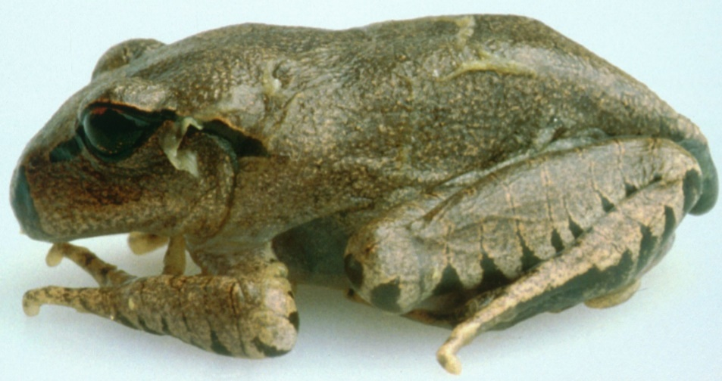
Note: Pieces of shedding skin on the body.
Source: L Berger

Signs of disease
Important: Animals with this disease may show one or more of these signs, but the pathogen may still be present in the absence of any signs.
Disease signs at the farm, tank or pond level are:
- lethargy
- ataxia
- paralysis
- loss of flee response
- loss of righting reflex
- abnormal sitting posture
- tetanic spasms
- nocturnal species emerging during daylight
- burrowing species remaining outside of burrows.
Gross pathological signs are:
- erythema (redness) of the ventral surface
- lesions ranging from no obvious change to sloughing (as small flakes of skin).
Gross changes to the skin may be seen in severe infections. However, these are not specific to the disease.
Microscopic pathological signs are:
- loss of pigmented jaw sheaths and teeth rows in tadpoles' mouthparts
- zoosporangia in the outer epidermal layers that are seen on fresh pieces of shed skin and in histological sections
- hyperkeratosis of the epidermis in areas where zoosporangia occur.

Disease agent
Chytridiomycosis is caused by infection with the parasitic chytrid fungus, Batrachochytrium dendrobatidis (Bd), of the class Chytridiomycota, order Rhizophydiales. Recent evidence suggests that B. dendrobatidis originated in Southeast Asia and was spread worldwide through international trade of amphibians.

Host range
Most, if not all, amphibians appear to be susceptible to infection with B. dendrobatidis. This includes all members of the orders Anura (frogs and toads), Caudata (including salamanders, newts and sirens) and Gymnophiona (caecilians).
Amphibian species differ in degree of susceptibility; some are naturally resistant, while others are extremely susceptible with B. dendrobatidis infection, greatly increasing extinction risk in some isolated populations. In Australia, B. dendrobatidis has been directly implicated in the extinction of at least four native frog species and the decline of many others.
Table 76 Species known to be susceptible to Batrachochytrium dendrobatidis
Common name | Scientific name
Caecilians | Order Gymnophiona
Frogs and toads | Order Anura
Bumpy rocket frog | Litoria inermis
Cane toad | Bufo marinus
Great barred frog | Mixophyes fasciolatus
Green tree frog | Litoria caerulea
Magnificent tree frog | Litoria splendida
Ornate burrowing frog | Limnodynastes ornatus
Ornate nursery frog | Cophixalus ornatus
Red tree frog | Litoria rubella
Red-backed toadlet | Pseudophryne coriacea
Sharp-snouted day frog | Taudactylus acutirostris
Short-footed frog | Cyclorana brevipes
Striped burrowing frog | Cyclorana alboguttata
Salamanders newts and sirens | Order Caudata
Alpine newt | Ichthyosaura alpestris
Blue tailed fire belly newt | Cynops cyanurus
Chiang Mai crocodile newt | Tylototriton uyenoi
Chinese firebelly newt | Cynops orientalis
Clouded salamander | Hynobius nebulosus
Eastern newt | Notophthalmus viridescens
European cave salamander | Speleomantes spp.
Fire salamander | Salamandra salamandra
French cave salamander | Hydromantes strinatii
Italian newt | Lissotriton italicus
Japanese clawed salamander | Onychodactylus japonicas
Japanese fire belly newt | Cynops pyrrhogaster
Lesser siren | Siren intermedia
North African fire salamander | Salamandra algira
Northern crested newt | Triturus cristatus
Northern spectacled salamander | Salamandrina perspicillata
Rough skinned newt | Taricha granulosa
Sardinian brook salamander | Euproctus platycephalus
Siberian salamander | Salamandrella keyserlingii
Smooth newt | Lissotriton vulgaris
Spanish ribbed newt | Pleurodeles waltl
Sword tailed newt | Cynops ensicauda
Vietnamese crocodile newt | Tylototriton vietnamensis
Vietnamese salamander | Paramesotriton deloustali
Wenxian knobby newt | Tylototriton wenxianensis
Yellow spotted newt | Neurergus crocatus
Zeiglers crocodile newt | Tylototriton ziegleri

Presence in Australia
Infection with B. dendrobatidis has been officially reported across Australia in Queensland, New South Wales, the Australian Capital Territory, Victoria, South Australia, Tasmania and Western Australia. It does not occur in arid inland areas.
Map 52 Presence of Batrachochytrium dendrobatidis, by jurisdiction
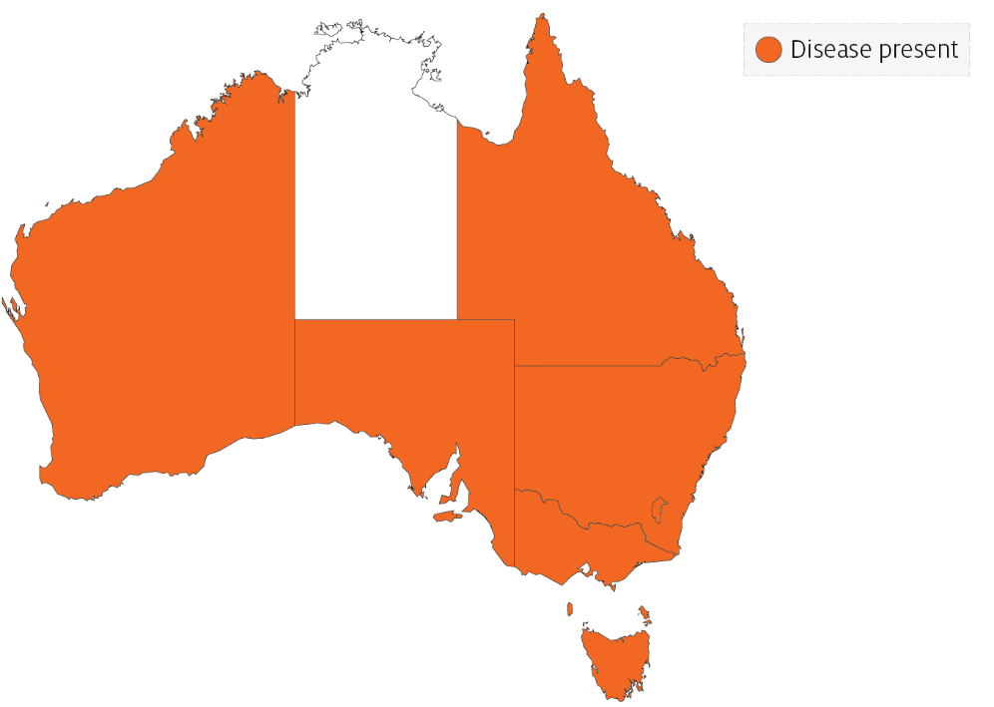

Epidemiology
- All age classes, except eggs, are known to be susceptible to infection. Mortality has only rarely been reported in tadpoles.
- Batrachochytrium dendrobatidis infects only keratinised tissues (skin of metamorphosed amphibians or the mouthparts of tadpoles). In contrast, B. salamandrivorans in salamanders infects only epidermal tissues, causing ulceration.
- Optimal temperature for growth of the fungus is between 17°C and 25°C. The sporangia die in temperatures of 32°C or higher. The pathogen can persist in very low host densities.
- Incubation times vary from about 14 to more than 70 days. Mortalities usually occur within 2 to 3 days of the first clinical signs and have approached 100% in some Australian amphibians.
- Horizontal transmission is via waterborne, motile zoospores and is likely to be by direct animal-to-animal contact. Vertical transmission via eggs has not been demonstrated.
- Outbreaks may be associated with seasons (cooler months), altitude (most declines are generally restricted to high-altitude populations) and breeding habitat.
- Large-scale mortality of newly metamorphosed amphibians may indicate infection, as some species appear to be most susceptible at this time.

Differential diagnosis
The list of similar diseases in the next section refers only to the diseases covered by this field guide. Gross pathological signs may also be representative of diseases not included in this guide. Do not rely on gross signs to provide a definitive diagnosis. Use them as a tool to help identify the listed diseases that most closely account for the observed signs.

Similar diseases
Infection with Batrachochytrium salamandrivorans.

Sample collection
Only trained personnel should collect samples. Using only gross pathological signs to differentiate between diseases is not reliable, and some aquatic animal disease agents pose a risk to humans. If you are not appropriately trained, phone your state or territory hotline number and report your observations. If you have to collect samples, the agency taking your call will advise you on the appropriate course of action. Local or district fisheries or veterinary authorities may also advise on sampling.

Emergency disease hotline
See something you think is this disease? Report it. Even if you’re not sure.
Call the Emergency Animal Disease Watch Hotline on 1800 675 888. They will refer you to the right state or territory agency.

Further reading
Department of the Environment and Energy Infection of amphibians with chytrid fungus resulting in chytridiomycosis (2016)
Imperial College London Global Bd mapping project
World Organisation for Animal Health Manual of Diagnostic Tests for Aquatic Animals

Infection with Batrachochytrium salamandrivorans (Bsal)
Also known as Bsal chytridiomycosis and salamander chytrid disease
Exotic disease
Figure 247 Adult fire salamander (Salamandra salamandra) infected by Batrachochytrium salamandrivorans
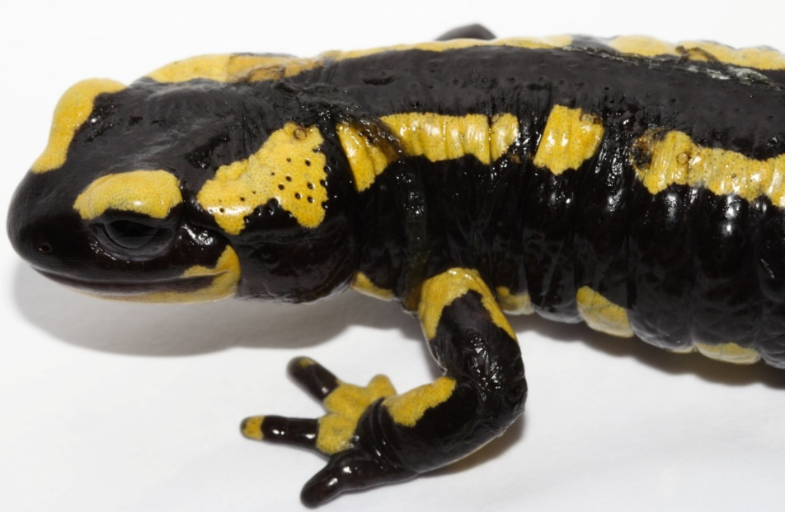
Note: Lesions consist of multifocal erosions with a black margin and dysecdysis.
Source: F Pasmans

Signs of disease
Important: Animals with this disease may show one or more of these signs, but the pathogen may still be present in the absence of any signs.
Disease signs at the farm, tank or pond level are:
- anorexia
- apathy
- ataxia
- high levels of mortality at temperatures below 25°C.
Gross pathological signs are:
- discolouration and/or roughening of the skin, with excessive skin sloughing
- focal or multifocal skin ulcerations with significant degradation of the epidermis, impairment of vital skin functions, and subsequent death.
Microscopic pathological signs are:
- lesions consisting of focal necrotic epidermal ulcerations with high numbers of colonial thalli of B. salamandrivorans, bordered by keratinocytes containing intracellular fungal thalli.

Disease agent
Bsal chytridiomycosis is caused by infection with the parasitic chytrid fungus, Batrachochytrium salamandrivorans (Bsal) of the class Chytridiomycota, order Rhizophydiales. B. salamandrivorans was first detected in wild salamanders in the Netherlands and Belgium in 2013/14, and was subsequently found in captive salamanders and newts in Germany, and the UK. Investigations suggest B. salamandrivorans probably originated in southeast Asia, where it has been found in Japan, Thailand, Vietnam and China.

Host range
A range of salamanders, newts and sirens (order Caudata) appear to be highly susceptible to infection with B. salamandrivorans. Members of the families Salamandridae, Plethodontidae, Hynobiidae and Sirenidae can carry the pathogen, often without showing any clinical signs. Species endemic to Asia appear to be more resistant to disease but may be asymptomatic carriers of the fungus.
Table 77 Species known to be susceptible to Batrachochytrium salamandrivorans
Common name | Scientific name
Alpine newt | Ichthyosaura alpestris
Blue tailed fire belly newt | Cynops cyanurus
Chiang Mai crocodile newt | Tylototriton uyenoi
Clouded salamander | Hynobius nebulosus
Eastern newt | Notophthalmus viridescens
European cave salamanders | Speleomantes spp.
Fire salamander | Salamandra salamandra
French cave salamander | Hydromantes strinatii
Italian newt | Lissotriton italicus
Japanese clawed salamander | Onychodactylus japonicas
Japanese fire belly newt | Cynops pyrrhogaster
Lesser siren | Siren intermedia
North African fire salamander | Salamandra algira
Northern crested newt | Triturus cristatus
Northern spectacled salamander | Salamandrina perspicillata
Rough skinned newt | Taricha granulosa
Sardinian brook salamander | Euproctus platycephalus
Siberian salamander | Salamandrella keyserlingii
Smooth newt | Lissotriton vulgaris
Spanish ribbed newt | Pleurodeles waltl
Sword tailed newt | Cynops ensicauda
Vietnamese crocodile newt | Tylototriton vietnamensis
Vietnamese salamander | Paramesotriton deloustali
Wenxian knobby newt | Tylototriton wenxianensis
Yellow spotted newt | Neurergus crocatus
Zeigler’s crocodile newt | Tylototriton ziegleri

Presence in Australia
Exotic disease—not recorded in Australia.
Map 53 Presence of Batrachochytrium salamandrivorans, by jurisdiction

Epidemiology
- Batrachochytrium salamandrivorans infects epidermal tissue causing multifocal ulcerations.
- Optimal temperature for growth of the fungus is 15°C and optimal salinity is 0ppt (freshwater). Desiccation is fatal for all life stages of the fungus.
- Horizontal transmission is via waterborne, motile zoospores and is likely to be by direct animal-to-animal contact.
- Mortality occurs 12 to 18 days after exposure to infective zoospores at 15°C, and within 22 to 27 days when susceptible animals are placed in contact with infected animals.
- Zoospores can remain viable in water for up to 3 weeks.
- Batrachochytrium salamandrivorans has been eliminated from wild salamanders by exposure to greater than 25°C for at least 10 days, or a synergistic treatment with antifungals.
- Disease outbreaks in wild populations may be seasonal (during the cooler months), and can cause significant population declines that may lead to extinction.

Differential diagnosis
The list of similar diseases in the next section refers only to the diseases covered by this field guide. Gross pathological signs may also be representative of diseases not included in this guide. Do not rely on gross signs to provide a definitive diagnosis. Use them as a tool to help identify the listed diseases that most closely account for the observed signs.

Similar diseases
Infection with Batrachochytrium dendrobatidis.

Sample collection
Only trained personnel should collect samples. Using only gross pathological signs to differentiate between diseases is not reliable, and some aquatic animal disease agents pose a risk to humans. If you are not appropriately trained, phone your state or territory hotline number and report your observations. If you have to collect samples, the agency taking your call will advise you on the appropriate course of action. Local or district fisheries or veterinary authorities may also advise on sampling.

Emergency disease hotline
See something you think is this disease? Report it. Even if you’re not sure.
Call the Emergency Animal Disease Watch Hotline on 1800 675 888. They will refer you to the right state or territory agency.

Microscope images
Figure 248 Hematoxylin and eosin stained section of skin of fire salamander (Salamandra salamandra) infected by Batrachochytrium salamandrivorans
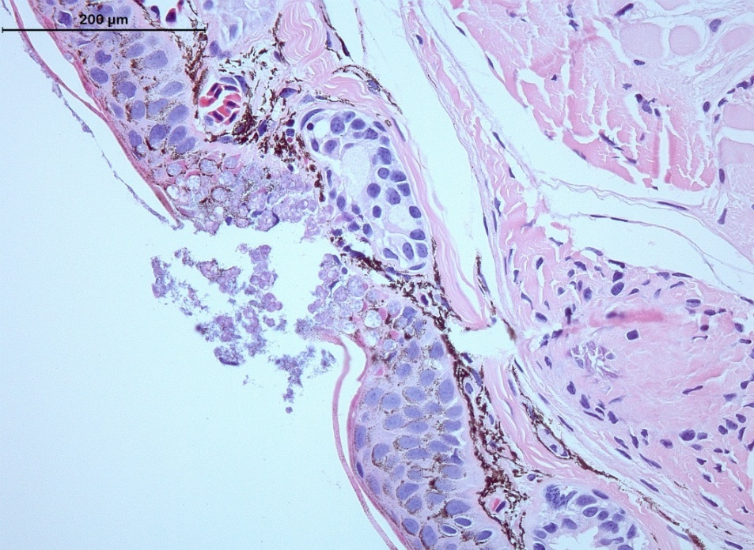
Note: Histopathological lesions consist of multifocal epidermal erosions, with numerous colonial chytrid thalli inside epidermal cells and bacterial overgrowth. Scale bar = 200µm
Source: A Martel

Further reading
European Food Safety Authority Scientific and technical assistance concerning the survival, establishment and spread of ‘Batrachochytrium salamandrivorans’ (Bsal) in the EU
World Organisation for Animal Health, ‘Batrachochytrium salamandrivorans’ disease card

Appendix A: Species’ common and scientific names

Finfish
Table A1 Common and scientific names of non-salmonid finfish
Common name | Scientific name
Freshwater bream | Abramis brama
Yellowfin bream | Acanthopagrus australis
Yellowfin seabream | Acanthopagrus latus
Black sea bream or black porgy | Acanthopagrus schlegelii
Convict surgeonfish | Acanthurus triostegus
Siberian sturgeon | Acipenser baerii
Russian sturgeon | Acipenser gueldenstaedtii
Atlantic sturgeon | Acipenser oxyrinchus
White sturgeon | Acipenser transmontanus
Chanda perch | Ambassis agassizii
Rock bass | Ambloplites rupestris
White catfish | Ameiurus catus
Black bullhead or European catfish | Ameiurus melas
Yellow bullhead | Ameiurus natalis
Brown bullhead | Ameiurus nebulosus
Pacific sand lance | Ammodytes hexapterus
Pacific sand eel | Ammodytes personatus
Sand eel | Ammodytes spp.
Lesser sand eel | Ammodytes tobianus
Striped grunter | Amniataba percoides
Climbing perch | Anabas testudineus
Atlantic wolfish | Anarhichas lupus
Spotted wolffish | Anarhichas minor
European eel | Anguilla anguilla
Shortfin eel | Anguilla australis
Japanese eel | Anguilla japonica
American eel | Anguilla rostrate
Toothless catfish | Anodontiglanis dahlia
Sablefish | Anoplopoma fimbria
Dwarf cichlids | Apistogramma spp.
African lampeye killifish | Aplocheilichthys normani
Freshwater drum | Aplodinotus grunniens
Lesser argentine | Argentina sphyraena
Mulloway | Argyrosomus japonicus
Bighead carp | Aristichthys nobilis
Fork-tailed catfish | Arius spp.
Oscar | Astronotus ocellatus
White seabass | Atractoscion nobilis
Tubesnout | Aulorhynchus flavidus
Tinfoil barb | Barbonymus schwanenfeldii
Silver perch | Bidyanus bidyanus
Silver bream | Blicca bjoerkna
Japanese tilefish | Branchiostegus japonicus
Goldfish or shubunkin | Carassius auratus
Crucian carp | Carassius carassius
Milkfish | Chanos chanos
Golden grey mullet | Chelon auratus
Snapper | Chrysophrys auratus
Cichlids or Tilapias | Cichlidae
Froggatt’s catfish | Cinetodus froggatti
Walking catfish | Clarias batrachus
Atlantic herring | Clupea harengus
Pacific herring | Clupea pallasii
Estuary catfish | Cnidoglanis macrocephalus
Thick-lipped gourami | Colisa labiosa
Redbelly tilapia | Coptodon zilli
Bullhead | Cottus gobio
Humpback grouper | Cromileptes altivelis
Goldsinny | Ctenolabrus rupestris
Grass carp | Ctenopharyngodon idella
Shiner perch | Cymatogaster aggregata
Cyprinids | Cyprinidae
Common carp and koi carp | Cyprinus carpio
Sind danio | Danio devario
Zebrafish | Danio rerio
European seabass | Dicentrarchus labrax
Gizzard shad | Dorosoma cepedianum
Glass knifefish | Eigenmannia virescens
Fourbeard rockling | Enchelyopus cimbrius
Shotted halibut | Eopsetta grigorjewi
White grouper | Epinephelus aeneus
Red-spotted grouper or Hong Kong grouper | Epinephelus akaara
Yellow grouper | Epinephelus awoara
Longtooth grouper | Epinephelus bruneus
Orange-spotted grouper | Epinephelus coioides
Brown marbled grouper | Epinephelus fuscoguttatus
Tiger grouper hybrid | Epinephelus fuscoguttatus × E. lanceolatus
Giant grouper | Epinephelus lanceolatus
Malabar grouper | Epinephelus malabaricus
Dusky grouper | Epinephelus marginatus
Black spot grouper | Epinephelus melanostigma
Six-bar grouper | Epinephelus sexfasciatus
Grouper and estuary cod | Epinephelus spp.
Estuarine rockcod | Epinephelus tauvina
Pike | Esox lucius
Muskellunge | Esox masquinongy
Orange chromide | Etroplus maculatus
Crimson seabream | Evynnis japonica
Yellowback seabream | Evynnis tumifrons
Tropical two-winged flying fish | Exocoetus volitans
Mummichog | Fundulus heteroclitus
Walleye pollock or Alaska pollock | Gadus chalcogramma
Pacific cod | Gadus macrocephalus
Tomcod | Gadus microgadus
Atlantic cod | Gadus morhua
Mountain galaxias | Galaxias olidus
Galaxiids | Galaxiidae all species
Mosquito fish | Gambusia affinis
Amphipods | Gammarus pulex
Three-spined stickleback | Gasterosteus aculeatus
Girella or rudderfish | Girella punctata
Luderick | Girella tricuspidata
Mouth almighty | Glossamia aprion
Flathead goby | Glossogobius giuris
Korean flounder | Glyptocephalus stelleri
Eurasian ruffe | Gymnocephalus cernua
Greenling | Hexagrammos otakii
American plaice | Hippoglossoides platessoides
Atlantic halibut | Hippoglossus hippoglossus
Pacific halibut | Hippoglossus stenolepis
Armoured weaselfish | Hoplobrotula armata
Great sandeel | Hyperoplus lanceolatus
Surf smelt | Hypomesus pretiosus
Silver carp | Hypophthalmichthys molitrix
Seven-band grouper | Hyporthodus septemfasciatus
Blue catfish | Ictalurus furcatus
Channel catfish | Ictalurus punctatus
Devil stinger | Inimicus japonicus
Nurseryfish | Kurtus gulliveri
Wrasses | Labridae all species
Wrasse | Labrus bergylta
Curviceps | Laetacara curviceps
River lamprey | Lampetra fluviatilis
Japanese seabass | Lateolabrax japonicus
Seabass | Lateolabrax spp.
Barramundi | Lates calcarifer
Striped trumpeter | Latris lineata
Spangled perch | Leiopotherapon unicolor
Pumpkinseed | Lepomis gibbosus
Bluegill | Lepomis macrochirus
Chinese emperor | Lethrinus haematopterus
Spangled emperor | Lethrinus nebulosus
Chub | Leuciscus cephalus
Ide or orfe | Leuciscus idus
Dace | Leuciscus leuciscus
Dab | Limanda limanda
Burbot | Lota lota
Mangrove jack | Lutjanus argentimaculatus
Crimson snapper | Lutjanus erythropterus
Common shiner | Luxilus cornutus
Eastern freshwater cod | Maccullochella ikei
Murray cod | Maccullochella peelii
Golden perch | Macquaria ambigua
Macquarie perch | Macquaria australasica
Australian bass | Macquaria novemaculeata
Paradise fish | Macropodus opercularis
Haddock | Melanogrammus aeglefinus
Rainbow fish | Melanotaenia splendida
Whiting | Merlangius merlangus
Pacific hake | Merluccius productus
Pacific tomcod | Microgadus proximus
Blue whiting | Micromesistius poutassou
Smallmouth bass | Micropterus dolomieu
Largemouth bass | Micropterus salmoides
Ram cichlid | Mikrogeophagus ramirezi
White perch | Morone americana
White bass | Morone chrysops
Yellow bass | Morone mississippiensis
Striped bass | Morone saxatilis
Silver redhorse | Moxostoma anisurum
Shorthead redhorse | Moxostoma macrolepidotum
Sea mullet | Mugil cephalus
Mullets | Mugilidae, all species
Red mullet | Mullus barbatus
Southern pygmy perch | Nannoperca australis
Bony bream | Nematalosa erebi
Berney’s catfish | Neoarius berneyi
Triangular shield catfish | Neoarius leptaspis
Round goby | Neogobius melanostomus
Black catfish | Neosilurus ater
Emerald shiner | Notropis atherinoides
Spottail shiner | Notropis hudsonius
Tadpole madtom | Noturus gyrinus
Japanese parrotfish | Oplegnathus fasciatus
Spotted knifejaw | Oplegnathus punctatus
Blue tilapia | Oreochromis aureus
Nile tilapia | Oreochromis niloticus
Tilapia hybrids | Oreochromis niloticus × O. aureus
Malaysian red hybrid tilapia | Oreochromis niloticus × O. mossambicus
Sleepy cod | Oxyeleotris lineolata
Marble goby | Oxyeleotris marmorata
Giant gudgeon | Oxyeleotris selheimi
Snapper | Pagrus auratus
Red sea bream | Pagrus major
Silver pomfret | Pampus argenteus
Striped catfish or tra | Pangasianodon hypophthalmus
Sutchi catfish | Pangasius hypophthalmus
Flounders | Paralichthyidae
Japanese flounder | Paralichthys olivaceus
Giant glassfish | Parambassis gulliveri
Chicken grunt | Parapristipoma trilineatum
English sole | Parophrys vetulus
Yellow catfish | Pelteobagrus fulvidraco
Rainbow krib | Pelvicachromis pulcher
Yellow perch | Perca flavescens
Redfin or European perch | Perca fluviatilis
Trout-perch | Percopsis omiscomaycus
Sea lamprey | Petromyzon marinus
Minnow | Phoxinus phoxinus
Bluntnose minnow | Pimephales notatus
Fathead minnow | Pimephales promelas
Orbiculate batfish | Platax orbicularis
Flounder | Platichthys flesus
Dusky flathead | Platycephalus fuscus
Bartail flathead | Platycephalus indicus
Ayu | Plecoglossus altivelis
Crescent sweetlips | Plectorhinchus cinctus
Sea bass | Plectranthias yamakawai
Spotted coral grouper | Plectropomus maculatus
Plaice | Pleuronectes platessa
Sailfin mollies | Poecilia latipinna
Guppy | Poecilia reticulata
Molly | Poecilia sphenops
Coalfish or pollock | Pollachius virens
Sand goby | Pomatoschistus minutus
Black crappie | Pomoxis nigromaculatus
Narrowstripe cardinalfish | Pristiapogon exostigma
Silver trevally | Pseudocaranx dentex
Iberian nase | Pseudochondrostoma polylepis
Winter flounder | Pseudopleuronectes americanus
Banggai cardinalfish | Pterapogon kauderni
Angelfish | Pterophyllum scalare
Rosy barb | Puntius conchonius
Cobia | Rachycentron canadum
Greenland halibut | Reinhardtius hippoglossoides
Pile perch | Rhacochilus vacca
Greenback flounder | Rhombosolea tapirina
Pike perch | Sander lucioperca
Pacific sardine | Sardinops sagax
Mango tilapia | Sarotherodon galilaeus
Rudd | Scardinius erythrophthalmus
Scat | Scatophagus argus
Red drum | Sciaenops ocellatus
Saratoga | Scleropages jardini
Chub mackerel | Scomber japonicus
Japanese spanish mackerel | Scomberomorus niphonius
Turbot | Scophthalmus maximus
Barcoo grunter | Scortum barcoo
Black rockfish | Sebastes schlegelii
Rockfish | Sebastes spp.
Amberjack | Seriola dumerili
Samson fish | Seriola hippos
Yellowtail kingfish | Seriola lalandi
Japanese yellowtail | Seriola quinqueradiata
Whiting | Sillago ciliata
Winter whiting | Sillago maculata
Chinese catfish | Silurus asotus
Wels catfish or sheatfish | Silurus glanis
Chinese perch or mandarin fish | Siniperca chuatsi
Senegalese sole | Solea senegalensis
Common sole | Solea solea
Gilt-head sea bream | Sparus aurata
European sprat | Sprattus sprattus
Thread-sail filefish | Stephanolepis cirrhifer
Long tom | Strongylura krefftii
Tiger puffer | Takifugu rubripes
Wet tropics tandan | Tandanus tropicanus
Eulachon | Thaleichthys pacificus
Northern bluefin tuna | Thunnus thynnus
Redbelly tilapia | Tilapia zilli
Tench | Tinca tinca
Archerfish | Toxotes chatareus
Banded archerfish | Toxotes jaculatrix
Primitive archer fish | Toxotes lorentzi
Snubnose dart | Trachinotus blochii
Permit | Trachinotus falcatus
Japanese horse mackerel | Trachurus japonicus
Hairtail | Trichiurus lepturus
Dwarf gourami | Trichogaster lalius
Pearl gourami | Trichogaster leerii
Silver gourami | Trichogaster microlepis
Three-spot gourami | Trichogaster trichopterus
Norway pout | Trisopterus esmarkii
Poor cod | Trisopterus minutus
Tvarnun simon | Tristramella simonis
Shi drum | Umbrina cirrosa
Barfin flounder | Verasper moseri
Spotted halibut | Verasper variegatus
Swordtail or green swordtail | Xiphophorus helleri
Southern platyfish or red wagtail platy | Xiphophorus maculatus
Viviparous blenny | Zoarces viviparus
Table A2 Common and scientific names of salmonid finfish
Common name | Scientific name
Cisco | Coregonus artedi
Lake whitefish | Coregonus clupeaformis
Whitefish (Muksun) | Coregonus muksun
Whitefish (Peled) | Coregonus peled
Whitefish | Coregonus spp.
Danube salmon | Hucho hucho
Golden trout | Oncorhynchus aguabonita
Cutthroat trout | Oncorhynchus clarkii
Gila trout | Oncorhynchus gilae
Pink salmon | Oncorhynchus gorbuscha
Chum salmon | Oncorhynchus keta
Coho salmon | Oncorhynchus kisutch
Masu salmon | Oncorhynchus masou
Rainbow trout | Oncorhynchus mykiss
Hybrid (rainbow trout × coho salmon) | Oncorhynchus mykiss × O. kisutch
Sockeye salmon | Oncorhynchus nerka
Amago salmon | Oncorhynchus rhodurus
Pacific salmon | Oncorhynchus spp.
Chinook salmon | Oncorhynchus tshawytscha
Coral trout | Plectropomus leopardus
Mountain whitefish | Prosopium williamsoni
Black sea salmon | Salmo labrax
Atlantic salmon | Salmo salar
Brown trout | Salmo trutta
Arctic char | Salvelinus alpinus
Bull trout | Salvelinus confluentus
Brook trout | Salvelinus fontinalis
Brook trout | Salvelinus fontinalis
Whitespotted char | Salvelinus leucomaenis
Lake trout | Salvelinus namaycush
Splake (lake trout × brook trout) | Salvelinus namaycush × S. fontinalis
Grayling | Thymallus thymallus

Molluscs
Table A3 Common and scientific names of molluscs
Common name | Scientific name
Sydney cockle or mud arc | Anadara trapezia
Calico scallop | Argopecten gibbus
New Zealand cockle | Austrovenus stutchburyi
Barnacles | Balanus spp.
New Zealand ark shell | Barbatia novaezelandiae
Common cockle | Cerastoderma edule
Striped venus clam | Chamelea gallina
Portuguese oyster | Crassostrea angulata
Suminoe oyster | Crassostrea ariakensis
Cortez oyster | Crassostrea corteziensis
Pacific oyster | Crassostrea gigas
Iwagaki oyster | Crassostrea nippona
Mangrove oyster | Crassostrea rhizophorae
Kumamoto oyster | Crassostrea sikamea
American eastern oyster | Crassostrea virginica
Hawaiian oyster | Dendostrea sandvicensis
Brownlip abalone | Haliotis conicopora
Pink abalone | Haliotis corrugata
Black abalone | Haliotis cracherodii
Whirling abalone | Haliotis cyclobates
Disc or Japanese abalone | Haliotis discus hannai
Diversicolor or jiukong abalone | Haliotis diversicolor
Small abalone | Haliotis diversicolor supertexta
Green abalone | Haliotis fulgens
New Zealand paua | Haliotis iris
Greenlip abalone | Haliotis laevigata
Blacklip abalone | Haliotis rubra
Tiger abalone | Haliotis rubra × laevigata
Red abalone | Haliotis rufescens
Staircase abalone | Haliotis scalaris
White abalone | Haliotis sorenseni
European abalone | Haliotis tuberculata
Flat abalone | Haliotis wallalensis
Sand cockle | Katelysia rhytiphora
Baltic macoma | Macoma balthica
Wedge shell | Macomona liliana
Soft shelled clam | Mya arenaria
Blue mussel | Mytilus edulis
Mediterranean mussel | Mytilus galloprovincialis
Southern mud oyster or Australian flat oyster | Ostrea angasi
New Zealand dredge oyster | Ostrea chilensis
Olympia oyster | Ostrea conchaphila
Asiatic oyster | Ostrea denselammellosa
European flat oyster | Ostrea edulis
Crested oyster | Ostrea equestris
Olympia oyster | Ostrea lurida
Argentinian flat oyster | Ostrea puelchana
Dwarf oyster | Ostrea stentina
New Zealand pipi | Paphies australis
Japanese scallop | Patinopecten yessoensis
Common European scallop | Pecten maximus
New Zealand scallop | Pecten novaezelandiae
Green-lipped mussel | Perna canaliculus
Japanese pearl oyster | Pinctada fucata
Blacklip pearl oyster | Pinctada margaritifera
Akoya pearl oyster | Pinctada martensii
Silverlip pearl oyster | Pinctada maxima
Pearl oyster | Pinctada sugillata
Venerid commercial clam | Pitar prostrata
Venus clam | Protothaca jedoensis
Mud whelk | Batillaria spp.
Mud whelk | Pyrazus spp.
Manila clam | Ruditapes (Venerupis) philippinarum
Grooved carpet shell or venerid clam | Ruditapes decussatus
Rock oyster | Saccostrea cucullata
Sydney rock oyster | Saccostrea glomerata
European razor clam | Solen marginatus
Hairy mussels | Trichomya hirsuta
Crocus clam | Tridacna crocea
Giant clam | Tridacna gigas
Elongated giant clam or rugose giant clam | Tridacna maxima
European aurora venus clam | Venerupis aurea
Pullet carpet shell | Venerupis corrugata
Asian littleneck clam | Venerupis philippinarum
Small brown mussel | Xenostrobus securis

Crustaceans
Table A4 Common and scientific names of crustaceans
Common name | Scientific name
Jelly prawns | Acetes spp.
Argentine stiletto shrimp | Artemesia longinaris
Brine shrimp | Artemia salina
Giant Tasmanian crayfish | Astacopsis gouldi
Giant crayfish | Astacopsis spp.
Noble crayfish | Astacus astacus
Turkish crayfish | Astacus leptodactylus
Crayfish | Astacus spp.
White-clawed crayfish | Austropotamobius pallipes
Stone crayfish | Austropotamobius torrentium
Cuata swimcrab | Callinectes arcuatus
Japanese crayfish | Cambaroides japonicus
European shore crab | Carcinus maenas
Acorn barnacle | Chelonibia spp.
Gooseneck barnacle | Octolasmis spp.
Yabbies (freshwater) | Cherax destructor
Redclaw crayfish | Cherax quadricarinatus
Freshwater crayfish | Cherax spp.
Parasitic copepods | Ergasilus manicatus
Chinese mitten crab | Eriocheir sinensis
Gippsland spiny crayfish | Euastacus kershawi
Spiny crayfish | Euastacus spp.
Oriental prawn | Exopalaemon carinicauda
Smooth crayfish | Geocherax spp.
Brush clawed shore crab | Hemigrapsus penicillatus
American lobster | Homarus americanus
Asian freshwater shrimp | Macrobrachium dayanum
Freshwater prawn | Macrobrachium lanchesteri
Oriental freshwater shrimp | Macrobrachium nipponense
Giant freshwater prawn | Macrobrachium rosenbergii
Sunda river prawn | Macrobrachium sintangene
Superb freshwater shrimp | Macrobrachium superbum
Greentail prawn | Metapenaeus bennettae
Red endeavour (greasyback) prawn | Metapenaeus ensis
Crayfish | Orconectes spp.
Signal crayfish | Pacifastacus leniusculus
Mississippi grass shrimp | Palaemon kadiakensis
Daggerblade grass shrimp | Palaemon pugio
Barred estuarine shrimp | Palaemon serrifer
Mysid shrimp | Palaemon styliferus
Mississippi grass shrimp | Palaemonetes kadiakensis
Daggerblade grass shrimp | Paleamon pugio
Tropical spiny lobster | Panulirus spp.
Planktonic copepods | Paracartia grani
Northern brown shrimp | Penaeus (Farfantepenaeus) aztecus
Yellow-leg shrimp | Penaeus (Farfantepenaeus) californiensis
Northern pink shrimp | Penaeus (Farfantepenaeus) duorarum
Southern brown shrimp | Penaeus (Farfantepenaeus) subtilis
Chinese white shrimp | Penaeus (Fenneropenaeus) chinensis
Indian banana prawn | Penaeus (Fenneropenaeus) indicus
Gulf banana prawn | Penaeus (Fenneropenaeus) merguiensis
Western white shrimp | Penaeus (Litopenaeus) occidentalis
Northern white shrimp | Penaeus (Litopenaeus) setiferus
Pacific blue shrimp | Penaeus (Litopenaeus) stylirostris
Pacific white shrimp | Penaeus (Litopenaeus) vannamei
Kuruma prawn | Penaeus (Marsupenaeus) japonicus
Brown tiger prawn | Penaeus esculentus
Aloha prawn | Penaeus marginatus
Black tiger prawn | Penaeus monodon
Green tiger prawn or grooved tiger prawn | Penaeus semisulcatus
Sand crab | Portunus pelagicus
Three spot swimming crab | Portunus sanguinolentus
European river crab | Potamon potamios
Louisiana swamp crayfish | Procambarus clarkii
Marbled crayfish | Procambarus fallax. f. virginalis
Mud crab | Scylla serrata
Red crab | Sesarma mederi
Mangrove swimming crab | Thalamita crenata
Fiddler crab | Uca vocans

Amphibians
Table A5 Common and scientific names of amphibians
Common name | Scientific name
Cane toad | Bufo marinus
Ornate nursery frog | Cophixalus ornatus
Striped burrowing frog | Cyclorana alboguttata
Short-footed frog | Cyclorana brevipes
Blue tailed fire belly newt | Cynops cyanurus
Sword tailed newt | Cynops ensicauda
Chinese firebelly newt | Cynops orientalis
Japanese fire belly newt | Cynops pyrrhogaster
Sardinian brook salamander | Euproctus platycephalus
French cave salamander | Hydromantes strinatii
Clouded salamander | Hynobius nebulosus
Alpine newt | Ichthyosaura alpestris
Ornate burrowing frog | Limnodynastes ornatus
Italian newt | Lissotriton italicus
Smooth newt | Lissotriton vulgaris
Green tree frog | Litoria caerulea
Bumpy rocket frog | Litoria inermis
Red tree frog | Litoria rubella
Magnificent tree frog | Litoria splendida
Great barred frog | Mixophyes fasciolatus
Yellow spotted newt | Neurergus crocatus
Eastern newt | Notophthalmus viridescens
Japanese clawed salamander | Onychodactylus japonicas
Vietnamese salamander | Paramesotriton deloustali
Ornate burrowing frog | Platyplectrum ornatus
Spanish ribbed newt | Pleurodeles waltl
Red-backed toadlet | Pseudophryne coriacea
Cane toad | Rhinella marina
North African fire salamander | Salamandra algira
Fire salamander | Salamandra salamandra
Siberian salamander | Salamandrella keyserlingii
Northern spectacled salamander | Salamandrina perspicillata
Lesser siren | Siren intermedia
European cave salamanders | Speleomantes spp.
Rough skinned newt | Taricha granulosa
Sharp-snouted day frog | Taudactylus acutirostris
Northern crested newt | Triturus cristatus
Chiang Mai crocodile newt | Tylototriton uyenoi
Vietnamese crocodile newt | Tylototriton vietnamensis
Wenxian knobby newt | Tylototriton wenxianensis
Zeigler’s crocodile newt | Tylototriton ziegleri

Other
Table A6 Common and scientific names of other species in this field guide
Common name | Scientific name
Grey heron | Ardea cinerea
Fish louse | Argulus foliaceus
Salmon louse | Caligus coryphaenae
Salmon louse | Caligus elongatus
Mayfly | Callibaetis spp.
Salmon louse | Lepeophtheirus salmonis
Polychaete | Nephtys australiensis
Polychaetes | Nereis spp.
Leeches | Piscicola spp.
Common roach | Rutilus rutilus
Gill lice | Salmincola spp.
Tubifex worms | Tubifex tubifex

Appendix B: Reporting suspected disease
If you see any unusual symptoms in wild or farmed aquatic animals, play it safe and report it immediately. Don’t worry about how insignificant it may be—small signs may be an early indication of a serious disease problem.

National 24 hour emergency animal disease watch hotline: 1800 675 888 (freecall)
Each state or territory can also be contacted if you suspect a disease. Table 78 shows the state and territory government agencies responsible for aquatic health, and provides points of contact.
Table 78 State and territory government contact details for reporting aquatic animal disease
State or territory | Government agency | Internet site | State telephone
Australian Capital Territory | Environment Planning and Sustainable Development Directorate | www.environment.act.gov.au | 132 281
New South Wales | Department of Primary Industries | www.dpi.nsw.gov.au | 1800 043 536 (fishwatch)
Northern Territory | Department of Environment and Natural Resources | nt.gov.au | 1800 891 136 (fishwatch) 0413 381 094
Queensland | Department of Agriculture and Fisheries | www.daf.qld.gov.au | 13 25 23 or 07 3404 6999
South Australia | Department of Primary Industries and Regions SA | www.pir.sa.gov.au | 1800 065 522 (fishwatch 24 hours)
Tasmania | Department of Primary Industries, Parks, Water and Environment | www.dpipwe.tas.gov.au | 1300 368 550
Victoria | Department of Jobs, Precincts and Regions | agriculture.vic.gov.au | 136 186
Western Australia | Department of Primary Industries and Regional Development | www.fish.wa.gov.au | 1800 815 507 (fishwatch)

Appendix C: Further reading
These hyperlinks were correct at the time of publication.

General
CABI Invasive Species Compendium (search by disease)
CEFAS International Database on Aquatic Animal Diseases
Department of Agriculture, Water and the Environment AQUAVETPLAN disease strategy manuals
World Organisation for Animal Health Manual of diagnostic tests for aquatic animals

Finfish
Biosecurity Australia 2014, Importation of freshwater ornamental fish: review of biosecurity risks associated with gourami iridovirus and related viruses—provisional final import risk analysis report
Camus, AC 2004, Channel catfish virus disease, Southern Regional Aquaculture Centre
Elwell LC, Stromberg KE, Ryce EK, Bartholomew JL 2009, ‘Whirling disease in the United States: a summary of progress and research and management 2009’, Trout Unlimited
Fu X, Li N, Liu L, Lin Q, Wang F, Lai Y, Jiang H, Pan H, Shi C, Wu S 2011, ‘Genotype and host range analysis of infectious spleen and kidney necrosis virus (ISKNV)’, Virus Gene
Glenn RA, Taylor PW, Pelton EH, Gutenberger SK, Ahrens MA, Marchant LM, Hanson KC 2015, Genetic evidence of vertical transmission and cycling of ‘Yersinia ruckeri’ in hatchery-origin fall chinook salmon ‘Oncorhynchus tshawytscha’, Journal of Fish and Wildlife Management.
Hazeri M, Hassan MD, Abba Y, Omar AR, Allaudin ZN, Soltani M, Hamdan RH, Mohamad NF 2017, Molecular characterisation of grouper iridovirus isolates from Peninsular Malaysia, Journal Veterinar Malaysia
Jansen MD and Mohan CV 2017, Tilapia lake virus (TiLV): Literature review, Penang, Malaysia: CGIAR Research Program on Fish Agri-Food Systems
Kumar G, Menanteau-Ledouble S, Saleh M, El-Matbouli M 2015, ‘Yersinia ruckeri’, the causative agent of enteric red mouth disease in fish, Veterinary Research.
Ma H, Peng C, Su Y, Feng J, Guo Z 2016, ‘Isolation of a Ranavirus-type grouper iridovirus in mainland China and comparison of its pathogenicity with that of a Megalocytivirus-type grouper iridovirus’, Aquaculture
Menanteau-Ledouble S, Kumar G, Saleh M, El-Matbouli M 2016, ‘Aeromonas salmonicida’: updates on an old acquaintance, Diseases of Aquatic Organisms
Network of Aquaculture Centres in Asia–Pacific Epizootic ulcerative syndrome: disease card
Network of Aquaculture Centres in Asia–Pacific Grouper iridoviral disease: disease card
Network of Aquaculture Centres in Asia-Pacific Tilapia Lake Virus (TiLV)—A novel orthomyxo-like viru: disease card
Whittington RJ, Djordjevic SP, Carson J, Callinan RB 1995, Restriction endonuclease analysis of atypical ‘Aeromonas salmonicida’ isolates from goldfish ‘Carassius auratus’, silver perch ‘Bidyanus bidyanus’, and greenback flounder ‘Rhombosolea tapirina’ in Australia, Diseases of Aquatic Organisms

Molluscs
Australia and New Zealand standard diagnostic procedure Bonamiosis in Australian ‘Ostrea angasi’
European Union Reference Laboratory for Molluscs Diseases ‘Marteilioides chungmuensis’
European Union Reference Laboratory for Molluscs Diseases ‘Mikrocytos mackini’
Fisheries and Oceans Canada ‘Marteilioides chungmuensis’ of oysters
Fisheries and Oceans Canada Gill disease of Portuguese oyster
Fisheries and Oceans Canada Oyster velar virus disease

Crustaceans
Network of Aquaculture Centres in Asia-Pacific ‘Monodon’ slow growth syndrome and Laem-Singh virus retinopathy: disease card
Network of Aquaculture Centres in Asia-Pacific Acute hepatopancreatic necrosis: disease card
Network of Aquaculture Centres in Asia-Pacific Hepatopancreatic microsporidosis caused by infection with ‘Enterocytooon hepatopenaei’: disease card
Poornima, M, Seetang-Nun, Y, Alavandi, SV & Dayal, J 2012, Laem-Singh virus: A probable etiological agent associated with Monodon slow growth syndrome in farmed black tiger shrimp (‘Penaeus monodon’), Indian Journal of Virology, vol. 23.

Amphibians
Department of the Environment and Energy Infection of amphibians with chytrid fungus resulting in chytridiomycosis (2016)
European Food Safety Authority Scientific and technical assistance concerning the survival, establishment and spread of ‘Batrachochytrium salamandrivorans’ (Bsal) in the EU
Imperial College London Global Bd mapping project
Wildlife Health Australia Ranaviral disease in wild Australian amphibians
World Organisation for Animal Health, ‘Batrachochytrium salamandrivorans’ disease card

