# 

# Final Report on the Northern Connectivity Event (April – July 2018)

# Brewarrina Weir and fishway during operation of the Northern Connectivity Event

# Summary

As a result of the Barwon-Darling ceasing-to-flow for an extended period, native fish and other aquatic life were under considerable stress in early 2018. The Northern Connectivity Event (NCE) ran between April and July 2018. Water for the environment was released from Glenlyon and Copeton dams near the Queensland / NSW border. Connectivity between waterholes was achieved to the Menindee Lakes, near Broken Hill. In total, over 2,000 km of the Gwydir, Mehi, Dumaresq, Macintyre and Barwon-Darling rivers benefited from the flow. The water for the environment was contributed by both the Commonwealth (16.6 GL) and New South Wales (6.6 GL). River operators delivered releases in a coordinated way from the two dams, which arrived at Collarenebri on the Barwon River at about the same time. The observed flows and timing were similar to forecasts. The NCE followed an unregulated flow event that flowed to just downstream of Wilcannia in February and March 2018, from rainfall in southern Queensland.

Outcomes of the NCE include:

* improvement in a range of water quality parameters
* enhancement of the quality of river habitat
* opportunities for iconic native species, like golden perch, to move between river pools

Right along the river system the condition of river habitat and water quality improved as a result of the NCE. Golden perch were observed to move between Louth and Tilpa as the NCE flowed through the system.

There was strong community interest in the NCE. Towns along the river looked forward to the arrival of the flow. The focus of engagement moved downstream with the flows. Engagement activities were successful and included an event at historic Bourke Wharf arranged with considerable support from the Bourke Shire Council and a later event at Wilcannia organised by the community. Community ‘drop-in’ sessions that moved downstream with the flows were attended by around 150 community members. A series of eight updates[1] were prepared. These updates included information on flow, ecological response and social aspects of the flow. These updates were widely distributed through networks of irrigators, fishers, Aboriginal groups and local catchment managers, including Local Land Services in NSW.

The NCE provided an innovative opportunity for government agencies to work together. Queensland and NSW protected the flow along the Border Rivers by not allowing any other licence holder to take water from the flow. NSW protected the flow in the Barwon-Darling by placing a temporary restriction, or ‘embargo’, on the flow and by the newly formed Natural Resource Access Regulator having a strong presence on the ground. The Commonwealth Environmental Water Office (CEWO) arranged a number of community ‘drop-in’ sessions. NSW and Queensland agencies, as well as the Murray-Darling Basin Authority (MDBA), attended several of the community sessions to share information with the community.

NSW commissioned an independent review of the inter-agency processes used in the flow event, which found that the NCE was well managed. This review provided recommendations for the management of future flow events.

Whilst flow events such as the NCE are not expected or possible in many years, the NCE provides an example of what is possible under the Basin Plan.

# Introduction

## Background and context

The northern Murray-Darling Basin[2] includes the catchments of the Macquarie, Namoi, Gwydir, Macintyre, Condamine-Balonne and Warrego rivers. The native fish community of the northern Basin is highly significant: it has five species that are listed as vulnerable or endangered and the fish community overall is listed as endangered in NSW.

There has been increasing concerns that, in recent decades, flows along the Barwon-Darling have declined[3] and stopped more often and for longer. For example, the Darling River has ceased-to-flow at Wilcannia significantly more often in the last two decades than in the preceding three decades, as illustrated by the pink vertical lines in Figure 1-1 below. The contributing factors include drought, upstream diversions, and tighter river operations. In addition to environmental implications, the river ceasing-to-flow is highly significant from a social and cultural perspective.

**Figure 1-1:** Frequency of cease-to-flow periods

Figure 1.1 Frequency of cease to flow periods

This figure shows the increase in the Darling River ceasing to flow at Wilcannia. The pink bars illustrate periods of cease to flow at Wilcannia.

There has been an increasing emphasis on connectivity between the northern rivers and the Barwon-Darling in Basin annual environmental watering priorities published by the MDBA. This reflects that it has been particularly dry and demonstrates an increasing awareness[4] that native fish need to move opportunistically at a regional and, for some species, at a basin-scale to complete their life cycles by finding new habitat, dispersing, spawning and recruiting. There is also an increasing awareness of the connectivity between the native fish communities in the north and the south of the Basin.

## The lead-up to the Northern Connectivity Event

In January 2018 over 1,000 km of the Barwon-Darling River downstream of Brewarrina ceased-to-flow. As a result, water was only found in stagnant isolated waterholes (Figure 1-2). Water quality also deteriorated and blue-green algae alerts escalated to amber and red alert levels. The likelihood of deaths of native fish and other riverine animals increased. Shire councils and communities along the Barwon-Darling expressed significant concern.

**Figure 1-2:** Darling River downstream of Bourke: March to April

|  |  |  |
| --- | --- | --- |
| A series of three images showing stagnant waterholes along the Darling River | A series of three images showing stagnant waterholes along the Darling River | A series of three images showing stagnant waterholes along the Darling River |

In April 2018 Commonwealth and NSW water for the environment was made available for delivery in a Northern Connectivity Event (NCE). The NCE occurred after extensive planning, community consultation and discussions with NSW and Queensland agencies. The NSW Water Minister agreed to protect this flow from pumping for irrigation along the Barwon-Darling. The NCE was the first time the NSW Government had placed a temporary restriction on pumping in the Barwon-Darling for environmental purposes. The temporary restriction did not apply to diversion for town water supply and stock and domestic purposes. The newly formed NSW Natural Resource Access Regulator[5] had a strong presence on the ground to ensure compliance.

The NCE involved extensive coordination of water policy agencies, environmental water holders, natural resource regulators, and river operators from NSW, the Commonwealth, and Queensland. An intergovernmental advisory group was established to facilitate coordination. With support from the CEWO, NSW appointed an independent reviewer[6] to provide feedback on coordination. The NCE provided an opportunity for State and Commonwealth water agencies to coordinate their work in new ways. The NCE had the support of groups in the community including the Bourke Shire Council and the Gwydir ECAOAC[7].

The NCE built on the previous unregulated flow in the preceding months and provided connectivity across multiple river systems to protect and support native fish. The NCE was an innovative flow event in an unregulated river, the Barwon-Darling, using water from regulated sources, the Gwydir and Border Rivers. At the start of the NCE, it was expected that between 25-30 GL[8] of water for the environment would be used. The actual volume used depended on the progression of the preceding unregulated flow event, observed losses in the rivers and other environmental considerations. The actual volume used was 23.2 GL, with 16.6 GL from Commonwealth accounts, and 6.6 GL from NSW accounts.

## Purpose of the Northern Connectivity Event

The purpose of the NCE was to benefit native fish and other aquatic life along several rivers in the northern Murray-Darling Basin by providing longitudinal connectivity between refugial waterholes. This connectivity would provide access to food sources and opportunities for native fish to move and disperse to better aquatic habitats. Coordinating environmental flows originating from two dams and associated activities, including the monitoring of flows and ecology, and engagement, was a complex task that spanned over 2,000 km of river and occurred over several months.

## Risks considered when designing the NCE

The primary risks considered prior to the event:

* That stratified waterholes may become rapidly de-stratified when the flow arrived, which could have resulted in deoxygenation through the water profile and ultimately in fish kills.
* There was some risk that shallow flows in the heat of summer and early autumn could potentially mix layered pools and inundate organic matter from hot, dry river beds, resulting in very low dissolved oxygen levels.

The timing of the NCE was decided after much consideration of advice from technical experts. To reduce these risks, the NCE was timed for the flows to reach the Darling by late May and early June when temperatures were lower. No fish kills were recorded along the river, either from the unregulated flow event that preceded the NCE (when the risk was higher) or during the NCE.

## Monitoring

To evaluate the outcomes of the NCE, extensive monitoring of flows, habitat condition, water quality, and fish responses was undertaken. Monitoring of flows was also undertaken by the MDBA with the use of remote sensing[9](satellite imagery) and by utilising the NSW Government’s stream gauging network[10]. Sampling was conducted before, during and after the flow had passed through the system.

Monitoring in the Border Rivers and Gwydir by electrofishing and bait trapping was also undertaken during the NCE. This monitoring was conducted by the NSW Department of Primary Industries (Fisheries) and the Queensland Department of Agriculture and Fisheries. Forty-eight golden perch (yellowbelly) were collected and tagged for tracking of their movement in response to the flows.

Environmental monitoring of ‘before’ and ‘during’ testing of habitat and water quality from Walgett to downstream of Wilcannia was also undertaken.

Data were also drawn from other established monitoring programs, such as Long Term Intervention Monitoring at the Warrego/Darling junction and the Basin Plan Environmental Outcome Monitoring.

## Purpose, structure and scope of this report

The purpose of this report is to summarise the NCE: the flows (chapter 2), the environmental response (chapter 3) and the community response (chapter 4).

Flows and environmental responses within the Menindee Lakes, and downstream of them are out of scope for this report. Also, this report does not include consideration of the independent review of agency processes in the NCE[11].

# Flows

## Conditions preceding the flows

Flows in the Barwon-Darling were low in the winter and spring of 2017. With the onset of summer temperatures increased and flows declined further in the upper (Collarenebri), mid (Bourke) and lower (Wilcannia) parts of the system. By the end of January 2018, the Darling River at both Bourke and Wilcannia as well as in between had ceased-to-flow. No flow conditions continued until late March at Bourke and early May at Wilcannia (see Figure 2-1).

**Figure 2-1**: Daily flow at Collarenebri on the Barwon River as well Bourke and Wilcannia on the Darling River 2017-18

Rainfall across the upper sections of the Moonie, Condamine-Balonne and Border Rivers systems in February and March 2018 resulted in a small unregulated flow in the Barwon-Darling. On 8 March 2018, the NSW Department of Industry - Water announced temporary restrictions on A, B and C class water access licenses in the Barwon-Darling to protect the low flows within the river for social outcomes. The restrictions were announced under Section 324 of the NSW *Water Management Act* *2000*. The initial announcement period was extended from 29 March to 28 April 2018. This unregulated flow event passed just downstream of Wilcannia. For the unregulated flow, the peak was greater at Bourke than at Collarenebri due to the inflow from the Culgoa River.

The occurrence of blue-green algal blooms in the Barwon-Darling is related to thermal stratification of in-stream pools. Stratification typically occurs between October and March when temperatures are higher. Increasing the volume and frequency of flows can prevent thermal stratification by mixing pools and also reduce ingress of groundwater inflow, particularly downstream of Bourke where salinity can be extremely high or dilute its impact.

Work by Mitrovic et al (2006)[12] identified critical velocities and discharges required to mix water within pools and suppress blooms from forming. The key flow rates identified were 510 ML/d at Brewarrina, 450 ML/d at Bourke and 350 ML/d at Wilcannia. These critical discharge rates correspond to a velocity of 0.04 m/s at each location. It is estimated that it takes 12 days with flows below this threshold for weir pools to stratify. The duration that flows were below the identified thresholds prior to being exceeded by the early autumn flow pulse at Brewarrina and Bourke are provided in Table 2.

**Table 1-1**: Flows required to suppress algal bloom (source: Mitrovic et al (2006)

|  |  |  |
| --- | --- | --- |
| **Flow rates to suppress algal blooms** | **Spell –time since target flow rate exceeded** | **Duration flow exceeded target flow rate** |
| Brewarrina (510 ML/d) | 101 days | 8 days |
| Bourke (450 ML/d) | 98 days | 16 days |

The preceding flow pulse resulting from rain in Queensland provided sufficient flows to mix water within pools located between Brewarrina and Bourke. However, the flow pulse that preceded the NCE did not exceed the threshold identified for Wilcannia of 350 ML/d.

## Description of flows in the Northern Connectivity Event

In response to the potential benefit of delivering water for the environment, the Commonwealth Environmental Water Holder (CEWH) in partnership with the NSW Office of Environment and Heritage[13] delivered 23.2 GL (18.9 GL from the Gwydir system and 4.3 GL from the Border Rivers) of water for the environment (Figure 2-2). Water releases commenced from the Border Rivers (Glenlyon Dam) and Gwydir River (Copeton Dam) on 17 April 2018. The managed event built on the natural unregulated inflows described in the preceding section and provided connectivity across multiple river systems to protect and support native fish. Flows from the Gwydir arrived at Collarenebri via the Mehi River and Carole Creek on the 3 May, while flow from the Macintyre River arrived 5 days later.

**Figure 2-2:** Daily flow at Brewarrina on the Barwon River, and Bourke and Wilcannia on the Darling River: January - July 2018.

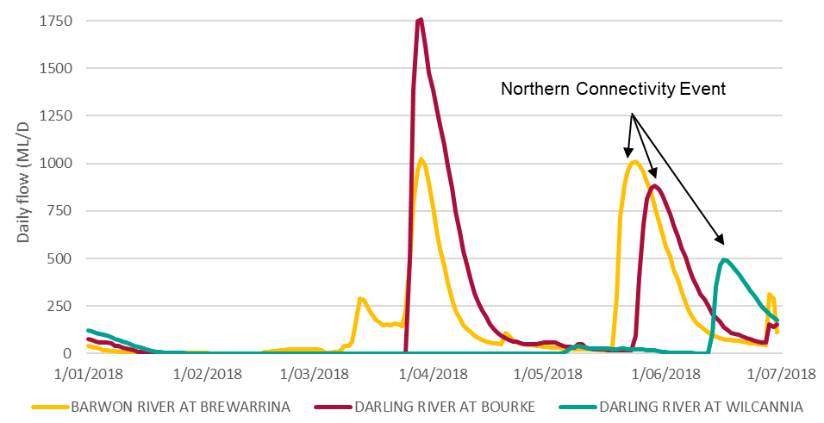

Unregulated flow

The orders placed with river operators were:

The orders placed with river operators were:

* 400 ML/d from water against Queensland entitlements held by the Commonwealth in the Border Rivers system, delivered to the Barwon River at Mungindi for 10 days – to add to the flow peak.
* Flows near channel capacity for the Mehi and Carole / Gil Gil systems for around 20 days from both Commonwealth and NSW environmental water entitlements – to provide the body of the flow event.

The hydrological aims of the NCE was to achieve flow targets of:

* 500 ML/d for a duration of 14 days at Bourke.
* 150 ML/d for 10 days at Wilcannia. The observed flows at Collarenebri, Bourke and Wilcannia from the NCE are shown in Figure 2.3 (these are the average daily flows at each gauge).

Restrictions in the form of a Section 324 order were put in place by NSW to protect the NCE. These restrictions were established along part of the Barwon-Darling between 27 April – 22 June 2018 and restricted access for A, B and C class licenses across the entire length of the Barwon-Darling.

The pattern of releases was designed to meet particular environmental benefits in both the tributaries and the Barwon-Darling. The flow ordered to Mungindi was 400 ML/d, to ensure the event inundated particular habitats along the lower Macintyre River, providing benefits to streambank and riparian vegetation, and in-stream life. Whereas, the flow ordered to the Mehi and Carole / Gil Gil systems was to maximise the duration of connection between the Gwydir and Barwon systems. From a Barwon-Darling perspective, a water order at Mungindi of 285 ML/d for the duration of the flow target at Bourke (14 days) would have increased the likelihood of achieving a flow of greater than 500 ML/d for two weeks. Although, the duration of flows above 500 ML/d at Bourke was less than the target of 14 days, the higher peak of the event and the gradual recession provided adequate time for native fish movement opportunities and connectivity along the Barwon-Darling. The ecological outcomes that were expected to be achieved in the Darling were also met in the Lower Macintyre River.

The NCE exceeded the flow rates required to provide sufficient mixing and de-stratification within pools located between Brewarrina, and Wilcannia. Observed flows in the Border and Gwydir systems, and subsequently in the Barwon-Darling, were close to those estimated by WaterNSW. This was a significant achievement, given the uncertain nature of seepage, evaporation and weather conditions in the months between releases from upstream storages and its arrival at a downstream point. In particular, the flows at Wilcannia exceeded expectations. This experience gives increased confidence that reasonable estimates of flows and volumes passing gauges can be made under a range of hydrological conditions.

## Evaluation of the flows

Outcomes from the NCE provide valuable information on flow management, operational requirements and characterisation of the hydrological thresholds for the respective environmental flow targets in the Barwon-Darling, which will be important considerations in any future environmental watering action of this kind.

* Whilst there are challenges in meeting downstream flow orders when there is little other flow in the river and when it is desirable to reduce the flows quickly to conserve water in storage, the flows through the Mehi and Gil Gil systems were close to channel capacity as intended and the river operator did well in managing flows.
* The water needed to replenish waterholes and for seepage is much greater if a river has ceased-to-flow and there are dry antecedent conditions, when compared to when it is still flowing.
* Development and communication of guidelines for reasonable stock and domestic access during an environmental watering event are important to progress.
* Flows along the northern system met or exceeded expectations and targets, however, the duration of releases should reflect the duration of flow targets. In this instance it would have been more suitable from a Barwon-Darling (Bourke) perspective for the order at Mungindi to be 285 ML/d for the duration of the flow target (14 days) rather than 400 ML/d for 10 days. However, the higher flow in the Border Rivers accessed more habitat, also satisfying some ecological requirements of the Macintyre River, and resulted in a higher flow at Bourke for a few days.
* Within catchment needs should be balanced with broader system needs when scarce environmental water is allocated. Drawing on Commonwealth environmental water from the Namoi was considered for this event. The NCE did not include water from the Namoi[14] as the Commonwealth currently holds modest water entitlements there, and there are strong upcoming environmental demands (e.g. sustaining a population of endangered silver perch).
* Achieving greater connectivity between the Barwon-Darling and its northern tributaries[15] is expected to be reflected in annual priorities set by the MDBA, and an ongoing consideration in CEWO portfolio management plans[16].
* The degree of coordination exhibited by managing and protecting the NCE may prove to be a precursor to establishing future arrangements for ‘active management’[17] of environmental flow events without Section 324 orders. Coordination of the event was also underpinned by strong support from irrigators, local governments, and communities, which was important and appreciated. The community response was positive.
* Ordering water from the Macquarie River in early 2018 would have been inefficient given little of the water would have reached the Barwon. There was an earlier event targeting the connectivity between the Macquarie and Barwon rivers in the wetter autumn of 2017.
* The river operations were simpler in this case than they could have been as there was no unregulated flow event that occurred concurrently with the ‘regulated’ flow from upstream storages. If there had been an unregulated event, the finalisation and implementation of an operational protocol to allow irrigators some access would have been required. The operational protocol and systems should be practical and provide confidence to all water users. There is the likelihood of improvements to metering and hydrometric systems that would underpin the implementation of such an operational protocol.

**Figure 2-3:** Cease-to-flow period, flows during the natural/unregulated event and flows during the NCE at Collarenebri, Bourke, Tilpa and Wilcannia. River lengths sourced from profiles developed by the MDBA[18]

|  |
| --- |
| **Collarenebri** (125 km downstream of Mungindi)    **1 /01/2018 1/02/2018 1/03/2018 1/04/2018 1/05/2018 1/06/2018 1/07/2018**    **NCE**  **Unregulated flow** |

|  |
| --- |
| **Bourke** (500 km downstream of Collarenebri)    **1 /01/2018 1/02/2018 1/03/2018 1/04/2018 1/05/2018 1/06/2018 1/07/2018** |
|  |
| **Tilpa** (345 km downstream of Bourke)    **1 /01/2018 1/02/2018 1/03/2018 1/04/2018 1/05/2018 1/06/2018 1/07/2018** |
| **Wilcannia** (120 km downstream of Tilpa)  Figure 2-3 shows the reduction of the peak from Bourke to Wilcannia was 1,700 ML/day in the unregulated event  compared to 390 ML/day when the waterholes were connected.   Regarding the volume for the unregulated flow event, there was a 19.5 GL difference in the flow volume between Bourke and Wilcannia.  While the flow volume difference between Bourke and Wilcannia for the Northern Connectivity Event was 5.5GL.  **1 /01/2018 1/02/2018 1/03/2018 1/04/2018 1/05/2018 1/06/2018 1/07/2018** |

**Peak flow**: the reduction of the peak from Bourke to Wilcannia was 1,700 ML/d in the unregulated event (when there was disconnection between waterholes) compared to 390 ML/d when the waterholes were connected. Some of the water in the first event was used to replenish waterholes between towns.

**Volume**: for the unregulated flow event, there was a 19.5 GL difference in the flow volume between Bourke and Wilcannia. While the flow volume difference between Bouke and Wilcannia for the NCE was 5.5 GL. This gives an indication of the amount of water used to replenish waterholes and for seepage and evaporation under a range of antecedent conditions.

**Travel time**: the head of the flow in the NCE took approximately 21 days to move from Bourke to Wilcannia, compared to 41 days for the preceding unregulated event. Travel times can be significantly longer when the river channel is dry and the flow is low because each waterhole needs to be filled up before the flow can move the next waterhole.

### Use of satellite images

Throughout the NCE flows were monitored in a number of ways: visual observation with photographs taken; measurements of flows made available through the stream gauging network operated by WaterNSW; and via the review of satellite imagery (Sentinel[19] and Landsat[20]). The discharge data obtained from the stream gauging network enabled the determination of whether target thresholds derived from habitat survey (see below) were achieved. Selected images were included in the published NCE updates[21]. This data also proved invaluable in assisting with compliance operations undertaken by staff from the Natural Resource Access Regulator.

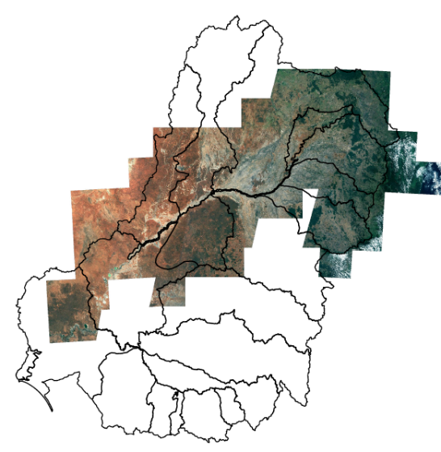**Figure 2-4**: Satellite data used for interpretation (MDBA)

For example, a total of 92 images were available covering the time period of the event and the spatial extent of the flow. The spatial extent covered by the satellite images along the Border Rivers, Gwydir and the Barwon-Darling that were collected are shown on the map at Figure 2-4.

**Figure 2.5**: Sentinel image of Darling River at Toorale on 26 May 2018 (A) and on 5 July 2018 (B) with NDWI (normalised difference water index) filter applied. The blue line in image B shows the NCE flows.

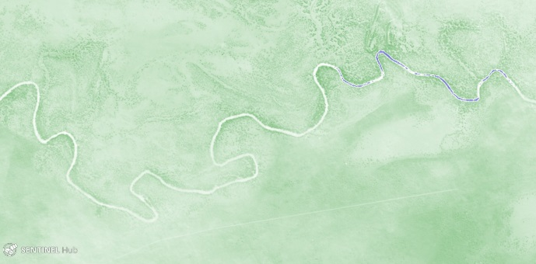

A

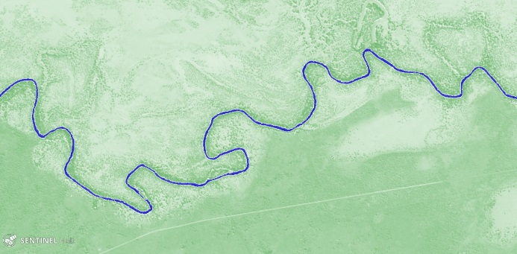

B

There was pumping for basic landholder rights and stock and domestic purposes from the NCE. There was no significant pumping for irrigation reported from the NCE. The compliance effort, including the significant effort by the Natural Resource Access Regulator, was effectively conducted relying on on-ground and remotely sensed surveillance tools.

**Location of stream monitoring gauges and algal monitoring sites

Figure 2-6 shows a map including stream monitoring gauges and algal monitoring sites along the Barwon and Darling Rivers, upstream of Wilcannia. Flow gauges are located at Mungindi, Presbury Weir, Mogil Mogil, Collarenebri, Tara, Dangar Bridge near Walgett, Boorooma, Geera, Brewarrina, Breemery, Warraweena, Bourke, Louth, Tilpa and Wilcannia.

Blue Green algal monitoring sites are located at Mungindi, Collarenebri, Brewarrina, North Bourke, Rose Isle, Louth, Tilpa, Trevallyn, Wilcannia and Caulpaulin.Figure 2-6**: Location of stream monitoring gauges and algal monitoring sites

**WaterNSW blue green algal monitoring sites**

|  |  |
| --- | --- |
| 1 Mungindi | 6 Louth |
| 2 Collarenebri | 7 Tilpa |
| 3 Brewarrina | 8 Trevallyn |
| 4 North Bourke | 9 Wilcannia |
| 5 Rose Isle | 10 Caulpaulin |

1

2

3

4

5

6

7

8

9

10

1

|  |  |  |  |
| --- | --- | --- | --- |
| **Gauge Number** | | **Description** | |
| 416001 | | Barwon River at Mungindi | |  |  |
| 416050 | | Barwon River upstream of Presbury Weir | | 422002 | Barwon River at Brewarrina |
| 422004 | | Barwon River at Mogil Mogil | | 422028 | Barwon River at Beemery |
| 422003 | | Barwon River at Collarenebri | | 425039 | Darling River at Warraweena |
| 422025 | | Barwon River at Tara | | 425003 | Darling River at Bourke |
| 422001 | | Barwon River at Dangar Bridge (Walgett) | | 425004 | Darling River at Louth |
| 422026 | | Barwon River at Boorooma | | 425900 | Darling River at Tilpa |
| 422027 | | Barwon River at Geera | | 425008 | Darling River at Wilcannia |
|  |  | |
|  | |  | |
|  | |  | |
|  | |  | |
|  | |  | |
|  | |  | |
|  | |  | |
|  | |  | |

# Environmental response

**Overview**

In addition to existing environmental flow monitoring programs undertaken along the Barwon-Darling and its tributaries, several short-term monitoring programs were undertaken to analyse the response of the environment to the NCE.

The work undertaken included in-stream habitat assessment, water quality sampling, invertebrate sampling and monitoring of fish condition and movement.

This short term work supports ongoing, work such as Basin Plan Environmental Outcome Monitoring[22], Long Term Intervention Monitoring[23], and the NSW hydrographic monitoring network[24].

Achieving greater connectivity between the Barwon-Darling and its northern tributaries is expected to be reflected in annual priorities set by the MDBA, and an ongoing consideration in CEWO portfolio management plans. In summary, the flow events in early 2018 provided information on flows and significant learnings that will be important in the future.

## Monitoring and results

### Habitat availability

In-channel flow events are vital for rivers such as the Barwon-Darling as they:

* replenish and connect isolated waterholes
* provide critical drought habitat
* allow dispersal of aquatic organisms
* assist in maintaining water quality in ranges suitable for aquatic biota
* maintain riparian vegetation health by replenish soil moisture of riparian areas.

The NCE used Commonwealth and NSW environmental water released from headwater storages in the Gwydir and Border Rivers systems. The use of water for the environment meant that instream waterholes located between Mungindi and Wilcannia and beyond were replenished, leading to an improvement to instream dissolved oxygen concentrations and the preservation of habitat. Migration opportunities would be provided for native fish and other aquatic life.

Information on key in-stream habitats in the Barwon-Darling is provided in Box 3-1.

|  |
| --- |
| **Box 3-1:** Information on key in-stream habitats in the Barwon-Darling  This image shows  a conceptual model of waterhole behaviour during low flow.Flow provides access to different habitats in the Barwon-Darling. A conceptual model of waterhole behaviour occurring during low flow phase and flow pulses is provide below. (see Characterising the ecological effects of changes in the ‘low-flow hydrology’ of the Barwon-Darling River (Sheldon 2017)[25]  This image shows  a conceptual model of waterhole behaviour during a flow pulse. Habitat mapping was completed along the 1,100 km reach between Walgett and Wilcannia in 2015 as a component of the Fish and Flows in the Northern Basinproject (NSW DPI, 2015)[26]. The project documents commence-to-inundate heights for key habitat features, including instream benches and large woody habitat. Woody habitat is a major ecological and structural element of waterways, providing hiding and resting places for fish out the main flow of the river, and spawning sites and territorial markers for several native fish species. As instream wood breaks down it also provides food for benthic algae, invertebrates and microorganisms that form a large part of the food web for fish species.  Benches are identified as areas of relatively flat sections within the main channel that play an important function in the aquatic environment by enhancing the diversity of habitat and contributing to productivity processes. Benches also store carbon, releasing it for sequestration to other parts of the aquatic ecosystem when inundation occurs, playing an important role in primary production and condition aspects for aquatic biota.  Inundation height and associated flow rates for key habitat features were related to representative gauges along the Barwon-Darling. |

The NCE inundated habitat features along the river bed and partially up the banks in the Macintyre, Mehi and Gil Gil systems and then across the river bed in the Barwon-Darling.

Inundation information for large woody habitat along the Barwon-Darling was compared against flow data from the NCE in Table 3-1. The habitat made available and the duration of this availability in the Barwon-Darling varied across locations as the NCE moved downstream.

**Table 3-1**: Large woody habitat inundation (using data from the Fish and Flows in the Northern Basin project).

|  |  |
| --- | --- |
| Reach | Large woody habitat inundated |
| Walgett - Brewarrina | 48% |
| Brewarrina - Bourke | 23% |
| Bourke – Tilpa | 27% |
| Tilpa - Wilcannia | 11% |

## Water quality (including blue-green algae)

Water quality data was obtained from the current WaterNSW network and measurements were also taken at a number of waterholes as part of the NCE. Water quality monitoring is continuing to improve our understanding of the frequency, magnitude and duration of in-channel pulses that are required to maintain the condition of waterhole refuges. For example, dissolved oxygen was monitored, as levels can be low when waterholes disconnect and/or become stratified. This stratification can reduce the volume within a pool where fish can live and can lead to threats to survival.

Sampling for water quality indicators was also undertaken to assess the contribution of water for the environment to the quality of water entering the Barwon – Darling and the Gwydir River system Selected Areas (Figure 3-1). It also assessed patterns of metabolism (aquatic primary production) at sites within the Gwydir and Mehi, Warrego and Darling rivers.

Deployment of water quality loggers, Darling River

Photograph of water quality loggers being deployed in the Darling River.**Figure 3-1**: Deploying water quality loggers Darling River just before the arrival of the NCE (Eco Logical Australia)

The NCE delivered water for the environment during the base flow period in autumn 2018, which led to significant improvements in dissolved oxygen concentrations in sites monitored within two days of the arrival of the flow.

Dissolved oxygen was measured in Collarenebri weir (Figure 3.2). Water quality at the end of summer 2018 was generally good. With dissolved oxygen levels in the range of 4 - 6 milligrams per litre for the majority of the weir pool, concentrations were well above the level at which time fish become stressed. Spot sampling in May 2018 suggested there was good mixing of the water in the weir pool with dissolved oxygen concentrations increasing to around 6.5 milligrams per litre for the entire weir pool.

**Figure 3.2**: Plot showing increase in dissolved oxygen as NCE reached Collarenebri weir



Fish stress zone – an issue in summer, OK in autumn

February

May

Longer term logger data from Collarenebri weir pool suggested there was still a little water at the bottom of the weir pool with low dissolved oxygen. This had not affected the majority of the weir pool or the river downstream and did not present a risk to fish.

As the flow moved downstream, the number of waterholes diluted and mixed by the NCE increased, and the volume of water remaining in the event (due to evaporation and seepage) decreased. As a result, water quality significantly improved more so in the upstream reaches.

Both nitrogen and phosphorus were at levels above the ANZECC[27] guidelines for lowland rivers, which is consistent with Long Term Intervention Monitoring[28] over the last 4 years. This may be reflective of the longer-term transport of nutrient rich sediments from upland areas of the catchment.

There was limited evidence of the mobilisation of sediment during the flow. This was not expected as the flow was relatively shallow compared to the channel depth.

Algal concentrations, as reflected by algal cell bio volume, was highest before the NCE event and showed a significant decrease as the flow moved through the system.

All the algal alerts between Bourke and the Menindee Lakes (Figure 3.3 below) were amber or red in March prior to the NCE, however by mid-July, after flows had filled and mixed the waterholes downstream of Bourke, no alerts were issued by WaterNSW[29] as concentrations were below alert concentration levels (white cells). For locations of sampling sites refer to Figure 2.6 above.

Alerts are declared where algal cell numbers exceed the triggers identified in the Guidelines for Managing Risk in Recreational Waters[30] published by the National Health and Medical Research Council. The lowering of the alert status is also a result of lower water temperatures experienced over the winter months.

**Figure 3.3**: Blue-green algae alerts pre and post NCE Mungindi to d/s Wilcannia (courtesy WaterNSW)

NCE arrives Mungindi

NCE arrives Wilcannia

|  |  |  |  |  |  |  |  |  |  |  |
| --- | --- | --- | --- | --- | --- | --- | --- | --- | --- | --- |
|  | **13/9/18** | **23/8/18** | **2/8/18** | **19/7/18** | **8/7/18** | **18/6/18** | **7/6/18** | **17/5/18** | **5/4/18** | **29/3/18** |
| Barwon River at Mungindi |  |  |  |  |  |  |  |  | Green | Green |
| Barwon River at Collarenebri |  |  |  |  |  | Amber | Amber | Green | Amber | Amber |
| Barwon River at Brewarrina | Amber |  |  |  |  |  |  | Amber | Red | Red |
| Darling River at North Bourke Bridge (Boat Ramp) | Green |  |  |  |  |  |  | Amber | Amber | Amber |
| Darling River at Rose isle |  |  |  |  |  |  |  |  | Red | Red |
| Darling River at Louth |  |  |  |  |  |  |  |  | Amber | Green |
| Darling River at Wilcannia |  |  |  |  | Amber | Red | Red | Red | Red | Red |
| Darling River at Tilpa |  |  |  |  |  |  |  | Amber | Amber | Amber |
| Darling River at Trevallyn |  |  |  |  |  |  |  |  | Red | Red |
| Darling River at Caulpaulin |  |  |  |  |  |  |  |  | Red | Red |

Note: Blank cell denotes no alert issued by WaterNSW as bio volume concentrations were below alert level.

### Invertebrates

Sampling of both microinvertebrates and macroinvertebrates was undertaken throughout the NCE as a component of the Long Term Intervention Monitoring program, and also as part of habitat monitoring component of the NCE (Figure 3-4). Invertebrate density relates to both flows and water temperature. The NCE occurred during autumn and winter, during months when water temperatures were cooling.

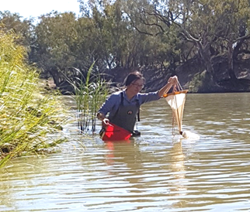**Figure 3.4**: Sampling microinvertebrates in the Darling River (Eco Logical Australia)

Monitoring showed that increases in invertebrate density did not occur during or directly after the watering action. The natural flow pulse that occurred in the months prior to the pre NCE event sampling may have temporarily reduced the richness of invertebrate communities that had established during the previously low flow conditions. The NCE was a further disturbance to the invertebrate communities, and they were still re-establishing by the post NCE survey time. Increases in numbers, however, occurred later. These increases coincided with warmer temperatures during the post environmental water and natural base flow period, supported by increased nutrient loads delivered from upstream during environmental water periods. These increased densities would have provided food resources of native fish, waterbirds and frogs. This response highlights the potential ecological significance of the timing of environmental flow events.

### Fish

Monitoring by electrofishing and bait trapping in the Border Rivers, Gwydir and Barwon-Darling was undertaken in both the short term and also during the NCE, as well as through other existing programs such as Long Term Intervention Monitoring and Basin Plan Environmental Outcomes Monitoring.

The NCE – Native Fish Condition and Movement in the Barwon–Darling project aimed to determine fish responses to environmental watering actions in the northern Murray-Darling Basin by assessing community composition, condition, and movement of native fish, before, during and after the event. The project focussed on the fish community in the Barwon-Darling.

Nine sites were selected on the basis that they provided suitable flow conditions, access, and the availability of a sufficient length of fishable water. Two rounds of sampling were then undertaken:

* Round 1: Before NCE. Sampling was undertaken between 9-13 April 2018, with data collected at all nine sampling sites to establish fish community condition pre-flow release.
* Round 2: Post NCE. Sampling was undertaken between 12-16 September 2018, with data collected at the same nine sites to establish if there were changes in the fish community post-release.

Key findings have concluded that:

* Monitoring in the Darling in April 2018 indicated a high diversity of fish species, but low numbers.
* Fish sampled in April 2018 were stressed where the Darling had ceased-to-flow. Approximately a third of the fish sampled at one site downstream of Wilcannia had a health condition such as raised or discoloured scales and the presence of parasites such as anchor worm.
* Sampling in the Border Rivers in May 2018 found large numbers of Murray cod and freshwater catfish recruits, as well as a number of olive perchlet.
* Monitoring in the Gil Gil creek in late May 2018 sampled bony bream and young spangled perch.
* Data in the Darling River between Tilpa and Louth illustrated that a third of the 48 golden perch (yellowbelly) tagged for the NCE were detected moving along the river past the receiver, despite the water temperature being lower than when movement usually occurs. This finding suggests golden perch may have been more opportunistic than expected during flow events.

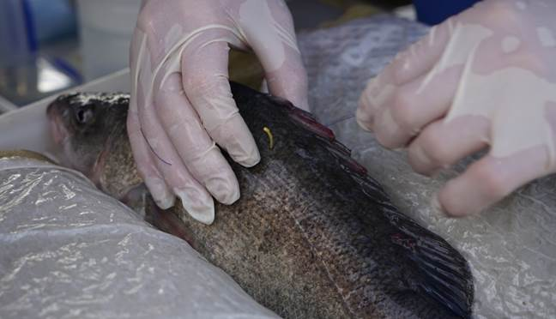**Figure 3.5**: Golden perch with acoustic tag (NSW DPI Fisheries)

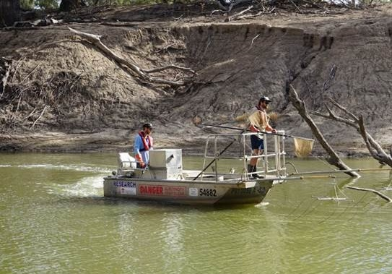**Figure 3.6**: Electrofishing on the Darling (NSW DPI Fisheries)

**Figure 3.7:** Golden Perch movement during the NCE (NSW DPI Fisheries)

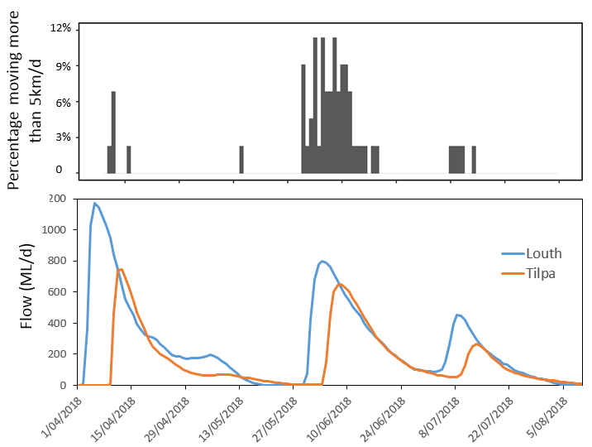

This indicates fish movement

Results from the NCE show how native fish such as golden perch (yellowbelly, or ‘dhagaay’ in the local Gomileroi language) can move and disperse when there is a suitable flow. The NCE reached Louth and Tilpa in June 2018. Awaiting the flow were 48 golden perch which had transmitters attached in April 2018. During that flow, several of these fish moved over 5 kilometres in a single day. Over the flow event of approximately one month, most fish moved tens of kilometres. Some fish moved upstream to weirs which blocked their progress.

Northern connectivity event

# Community response

Sharing the NCE and gauging the response of the community was a priority. Water for the environment is a valuable public asset. There was considerable community interest in the NCE, particularly along the rivers where it flowed. Many in the community were interested to learn more about native fish and the ecosystem of rivers. Presenting this information in a timely, visual and relevant way was important.

The following is an overview engagement undertaken during the event.

## Face-to-face engagement activities

From mid-May to early June 2018, engagement functions were held at Mungindi, Collarenebri, Walgett, Brewarrina, and Bourke. In total, around 150 community members attended these functions, including school groups. NSW and Commonwealth agency representatives also attended. In addition to these functions organised by the CEWO, a community celebration[31] of the flows was organised by the Wilcannia community, and included music, dancing and art. Many government agencies were represented at a community forum at Bourke Wharf, where the opportunity was taken to share information about NSW initiatives, including the Water Reform Action Plan and information on native fish.

Engagement functions moved downstream with the flows. The community was interested to discuss what was happening in the river, rather than what happened in the past or may happen in the future. The CEWO’s Local Engagement Officers, Neal Foster and Jason Wilson, reported that feedback on engagement during the NCE was overwhelmingly positive. Conversations focussed on what the flow was doing along their river. Key themes of the community feedback were:

* strong support for the NCE and amazement at its spatial scale
* concerns around compliance and interest in recent changes (such as the recent on-ground presence of the Natural Resource Access Regulator)
* discussion on what is being and can be achieved under the Basin Plan
* 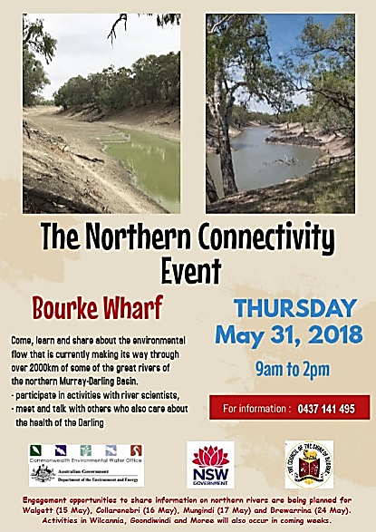a suggestion that the NCE should be a more regular flow event.

Figure 4.1 shows the community information day at Bourke

**Figure 4.1** Community information day at Bourke

## Key Messages

The face-to-face engagement was also an important opportunity to manage expectations. The NCE was unusual in that it resulted in flows passing from storages in regulated water sources (the Border Rivers and the Gwydir) to an unregulated water source. There was an opportunity to use water stored in the wet spring of 2016 in public dams and tributaries to provide longitudinal connectivity in the tributaries and the Barwon-Darling in the very dry summer and autumn of 2017-18. Occasionally, if there is sufficient water available, there may be an opportunity to use regulated entitlements held by the Commonwealth and NSW in the northern Basin tributary dams in a targeted way to improve water quality and aquatic habitats in the Barwon-Darling. In addition to planned environmental water under water resource plans, regulated and unregulated entitlements provide water for the environment across the northern Basin by contributing in-channel flows.

Many groups and peak bodies were engaged with regarding the NCE. There were several media releases at the commencement of the flow event. Some community groups advised they were not engaged with as early or as fully as they could have been. An Aboriginal community group was not advised of the NCE when it first commenced. Additional efforts will be made to reach out to as many community groups as possible that may be interested in the future. There could have been more communication of information on the event through local media, such as newspapers and radio.

## Sharing of written information

A series of 8 ‘updates’[32] were prepared and distributed throughout the NCE. In these updates, initial results were shared in a timely, informative and non-technical way. These updates were also posted on the CEWO website and shared through established networks. The social media platform Twitter was also used to inform subscribers when the flow reached milestone locations and when updates were released.

Whilst water for the environment is used to protect and restore environmental values, the updates provided an opportunity to acknowledge important social dimensions associated with the flow, such as:

* the relationship of Aboriginal communities with the river
* river navigation and transport near Wilcannia
* ‘The Song of the Darling River’, a poem by Henry Lawson from his experiences.

Acknowledgement of, and information on, these social dimensions was well received.

## Ideas for future engagement

Based on experience from the NCE, ideas for future engagement include:

* making greater use of local media (including social media and local radio) to advertise functions
* operating river trips (buses) or short cruises (the paddlesteamer ‘Jandra’ at Bourke) to allow more people to see the event
* assisting people to access flow data in real-time by including links to relevant websites in updates
* increasing the number of activities for landholders and students. For example, water quality sampling/riparian assessment/discussing cultural perspectives/art;
* collating and sharing community footage as the flow progresses.

1. <http://www.environment.gov.au/water/cewo/northern-rivers>
2. <https://www.mdba.gov.au/discover-basin/landscape/geography>
3. http://www.environment.gov.au/system/files/resources/bb774e1f-d7fa-4825-8851-cb5e5f1b3f51/files/characterising-eco-effects-changes-low-flow-barwon-darling.pdf
4. <https://www.mdba.gov.au/publications/mdba-reports/barwon-darling-ecological-needs-hydrology>
5. <https://www.industry.nsw.gov.au/natural-resources-access-regulator>
6. <https://www.industry.nsw.gov.au/__data/assets/pdf_file/0008/237077/Independent-Observer-Report-Northern-Connectivity-Event.pdf>
7. Environmental Contingency Allowance Operational Advisory Committee
8. A gigalitres, or GL, is 1,000 megalitres or ML.
9. <https://www.mdba.gov.au/publications/mdba-reports/compliance-monitoring-using-satellite-imagery>
10. <https://realtimedata.waternsw.com.au/>
11. <https://www.industry.nsw.gov.au/__data/assets/pdf_file/0008/237077/Independent-Observer-Report-Northern-Connectivity-Event.pdf>
12. <https://onlinelibrary.wiley.com/doi/abs/10.1002/rra.875>
13. <https://www.environment.nsw.gov.au/news/connecting-the-northern-rivers>
14. <https://www.environment.gov.au/water/cewo/catchment/namoi>
15. <http://www.environment.gov.au/water/cewo/catchment/northern-unregulated-rivers>
16. <https://www.environment.gov.au/water/cewo/publications/portfolio-mgt-plan-barwon-darling-2019-20>
17. <https://www.industry.nsw.gov.au/water-reform/better-management-of-environmental-water>
18. <https://www.mdba.gov.au/publications/mdba-reports/geographic-profile-maps-basin-catchments>
19. <https://sentinel.esa.int/web/sentinel/home>
20. <https://www.geoimage.com.au/satellite/landsat-8>
21. <http://www.environment.gov.au/water/cewo/northern-rivers>
22. <https://www.mdba.gov.au/sites/default/files/pubs/Basin-Plan-Evaluation-Framework-2019-2.pdf>
23. <http://www.environment.gov.au/water/cewo/publications/cewo-ltim-standard-methods>
24. <https://realtimedata.waternsw.com.au/>
25. <https://www.environment.gov.au/water/cewo/publications/characterising-eco-effects-changes-barwon-darling-2017>
26. <https://www.mdba.gov.au/publications/independent-reports/fish-flows-northern-basin-responses-fish-changes-flows-northern>
27. Australian and New Zealand Environment and Conservation Council 
28. <http://www.environment.gov.au/water/cewo/publications/cewo-ltim-warrego-darling>
29. <https://www.waternsw.com.au/water-quality/algae>
30. <https://www.nhmrc.gov.au/sites/default/files/images/guidelines-for-managing-risks-in-recreational-water.pdf>
31. <http://www.maarima.com.au/uploads/Wilcannia-Newsletters/Maari-Ma-Wilcannia-Newsletter-June-2018-web.pdf>
32. <http://www.environment.gov.au/water/cewo/northern-rivers>