# First Review of the Water for the Environment Special Account

Report to Commonwealth Minister for Water Resources as required under Section 86AJ of the *Water Act 2007*

March 2020

**Independent panel:**

Sally Farrier, Simon Lewis AO PSM and Merran Kelsall

# First Review of the Water for the Environment Special Account

Report to Commonwealth Minister for Water Resources as required under Section 86AJ of the *Water Act 2007*

March 2020

© Commonwealth of Australia 2020

**Ownership of intellectual property rights**

Unless otherwise noted, copyright (and any other intellectual property rights) in this publication is owned by the Commonwealth of Australia (referred to as the Commonwealth).

**Creative Commons licence**

All material in this publication is licensed under a [Creative Commons Attribution 4.0 International Licence](https://creativecommons.org/licenses/by/4.0/legalcode) except content supplied by third parties, logos and the Commonwealth Coat of Arms.

Inquiries about the licence and any use of this document should be directed to [www.agriculture.gov.au/about/contact](http://www.agriculture.gov.au/about/contact)

C:\Documents and Settings\west merryn\Local Settings\Temporary Internet Files\Content.Word\by.png

**Cataloguing data**

This publication (and any material sourced from it) should be attributed as: Australian Government 2020, First Review of the Water for the Environment Special Account, Canberra. CC BY 4.0.

ISBN 978-1-76003-268-5 Comms to provide new ISBN number

This publication is available at <https://haveyoursay.agriculture.gov.au/wesa>

The Australian Government acting through the Water for the Environment Special Account Review Panel, which is appointed by the Minister for Resources, Water and Northern Australia under section 86AJ of the Water Act 2007 (Cth) and is supported by Australian Government employees, has exercised due care and skill in preparing and compiling the information and data in this publication. Notwithstanding, the Water for the Environment Special Account Review Panel and its supporting Australian Government employees and advisers disclaim all liability, including liability for negligence and for any loss, damage, injury, expense or cost incurred by any person as a result of accessing, using or relying on any of the information or data in this publication to the maximum extent permitted by law.

## Letter to Minister

24 March 2020

The Hon. Keith Pitt MP

Minister for Resources, Water and Northern Australia

PO Box 6022

House of Representatives

Parliament House

Canberra ACT 2600

Dear Minister

**REPORT OF FIRST REVIEW OF THE WATER FOR THE ENVIRONMENT SPECIAL ACCOUNT**

As the panel appointed to undertake the first independent review of the Water for the Environment Special Account (the Special Account), we are pleased to present you with our report. We were appointed by your predecessor, the Hon David Littleproud MP, on 15 August 2019 and agreed to provide our report by early 2020.

The terms of reference for our review reflect the requirements set out in Section 86AJ of the *Water Act 2007*. This section of the Act also requires that a second independent review of the Special Account be conducted in 2021. As such, this review reflects a milestone assessment at this point in time.

The report sets out our findings and observations and explains the data and evidence on which these are based, including input from stakeholders. We would like to take this opportunity to acknowledge the input and support we received from the Department of Agriculture, Water and the Environment and other government agencies in conducting this review.

We would be happy to meet with you to discuss this report further and answer any questions.

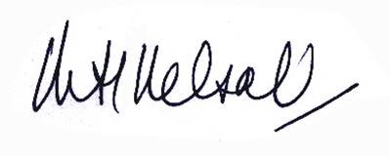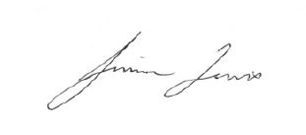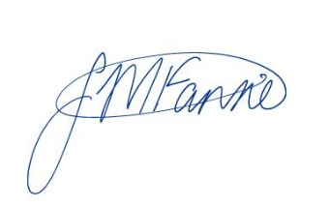Yours sincerely

Sally Farrier Simon Lewis AO PSM Merran Kelsall

Panel Chair Panel Member Panel Member

## Terms of reference

1. Section 86AJ of the *Water Act 2007* (the Act) requires that the Minister for Water Resources must cause two independent reviews to be conducted into the Water for the Environment Special Account (WESA) provided for by Part 2AA of the Act. This document sets out the review panel’s terms of reference for the first of these reviews.
2. The review panel must conduct a review into whether the amount standing to the credit of, and to be credited to, the Water for the Environment Special Account is sufficient to
   1. increase, by 30 June 2024, the volume of the Basin water resources that is available for environmental use by 450 GL, and
   2. ease or remove constraints identified by the Murray–Darling Basin Authority (MDBA) on the capacity to deliver environmental water to the environmental assets of the Murray–Darling Basin (Basin).
3. In conducting this review, the panel must also consider:
   1. the progress that has been, and is anticipated to be, made towards increasing the volume of the Basin water resources that is available for environmental use, and
   2. whether the design of projects in relation to which payments have been made under section 86AD is likely to be effective in increasing the volume by 450 GL of the Basin water resources that is available for environmental use.
4. In addition, the panel may undertake consultations to inform the review, which may include invitation for submissions, discussions with a range of stakeholders, meetings with peak bodies and engagement with all Basin states.
5. The panel is to provide the Minister a written report of the first review by early 2020.

Contents

Letter to Minister iii

Terms of reference iv

1 Summary 1

1.1 Panel’s findings 1

1.2 Panel’s observations 3

1.3 Report structure 4

2 Panel’s approach to the review 5

2.1 Our methodology 5

2.2 Our data and information collection, analysis and validation process 7

3 Context for the review 9

3.1 Water for the Environment Special Account 11

3.2 Efficiency measures 11

3.3 Constraints measures 12

3.4 Roles of Australian and Basin state governments 13

4 Increasing volume of environmental water by 450 GL 17

4.1 Only 1.9 GL recovered to date 17

4.2 Up to 90 GL associated with prospective projects 18

4.3 Up to 60 GL potentially recoverable given combined effect of key limiting factors 19

4.4 Special Account allocation will not be fully expended at 30 June 2024 26

4.5 Special Account could fund around one-third of current cost to deliver 450 GL 27

5 Easing constraints on delivering environmental water 31

5.1 Constraints projects progressing very slowly 32

5.2 Advancing constraints projects to implementation will take time 33

5.3 Special Account allocation sufficient for expenditure to 30 June 2024 35

5.4 Total available funding is broadly similar to current cost estimates 37

Appendix A: Consultation 38

Written submissions 38

Attendees at the Stakeholder Roundtables (8 November 2019 and 28 November 2019) 39

Individual meetings 40

Appendix B: Cost range for historical irrigation efficiency projects 41

Appendix C: Overview of constraints projects 42

Glossary 44

References 45

**Figures**

Figure 1 Water recovery under the Basin Plan 10

Figure 2 Governance of efficiency and constraints measures programs in the Basin 16

Figure 3 Impact of key limiting factors on volume recoverable by 2024 20

Figure 4 Estimated range for technical potential for further water recovery in northern and southern Basin 21

Figure 5 Project lead times, compared to time remaining until 30 June 2024 23

Figure 6 Cumulative planned, actual and projected expenditure on efficiency measures as at November 2019 27

Figure 7 Southern Basin water prices since 1 July 2012 28

Figure 8 Overview of constraints projects 32

Figure 9 Cumulative planned, actual and projected expenditure on constraints measures as at November 2019 37

**Boxes**

Box 1 Current reviews of other aspects of Basin water reforms 8

Box 2 Difference between GL LTAAY and GL of entitlement 10

Box 3 Water Efficiency Program 12

Box 4 Constraints measures program 13

Box 5 Panel’s considerations and assumptions in reviewing recovery of 450 GL 18

Box 6 Factors that influence an efficiency measures program’s attractiveness to participants 26

Box 7 Panel’s considerations and assumptions in reviewing delivery of constraints measures 31

Box 8 Constraints Management Strategy implementation process 33

Box 9 Other reviewers’ and stakeholders’ views on timeframe for constraints projects 36

## Summary

The Water for the Environment Special Account (Special Account) was established by Part 2AA of the *Water Act 2007* (Cth) (the Water Act). The object of this part is to enhance the environmental outcomes that can be achieved by the *Basin Plan 2012* (Basin Plan). This object is to be achieved by:

* increasing the volume of Murray–Darling Basin (Basin) water resources available for environmental use by 450 gigalitres (GL), and
* easing or removing constraints on delivering environmental water to the environmental assets of the Basin.

The Special Account sets aside $1.775 billion of Commonwealth funding to pay for projects that help deliver these outcomes over the period 1 July 2014 to 30 June 2024. The Australian Government’s commitments in relation to this funding are detailed in the *Intergovernmental Agreement on Implementing Water Reform in the Murray–Darling Basin* (Intergovernmental Agreement). Under this agreement:

* $1.575 billion is allocated to recovering the 450 GL through efficiency measures programs. Accountability for designing and delivering these programs sits with the Australian Government Department of Agriculture, Water and the Environment (department).
* $200 million is allocated to easing the priority constraints through a constraints measures program. Under this program, Basin state governments are responsible for delivering agreed projects in their jurisdiction at a local level, overseen by the Murray–Darling Basin Ministerial Council (Ministerial Council).

The Water Act requires independent reviews of the Special Account to be conducted in 2019 and 2021. We were appointed as the panel to conduct the first review in August 2019. As required by our terms of reference we have examined whether the amounts credited or to be credited to the Special Account are sufficient to deliver the 450 GL and the constraints measures program by the account’s legislated end date of 30 June 2024.

This report outlines our review findings and explains how and why we reached these findings. Given the Special Account and associated programs are active, the report also includes observations where we consider they may be helpful to the Minister in considering the Australian Government’s response to the findings and other basin reform matters. All references to GL in the report mean GL long term average annual yield (LTAAY) unless otherwise indicated.

### Panel’s findings

The panel’s overall conclusion is that neither the 450 GL nor the constraints measures program will be delivered in full by 30 June 2024, and the rate of progress will be such that the Special Account will be in credit at that date. Our supporting findings (sections 1.1.1 and 1.1.2) reflect our consideration of:

* analysis commissioned for this review, findings from other reviews, published information, and views provided by stakeholders
* current social, political, market and climatic conditions in the Basin, and how these affect interest in and delivery of the efficiency measures and constraints measures programs.

Our findings also rely on the assumptions we made for the purposes of the review—particularly that the legislated provisions of the Special Account and the current arrangements and accountabilities for the efficiency measures and constraints measures programs will not materially change before 30 June 2024.

#### 450 GL will not be recovered by 30 June 2024

The panel finds that:

* **The volume of water recovered through efficiency measures programs and transferred to the Commonwealth at 30 June 2024 will be well short of 450 GL.** Our reasons are that:
  + Only 1.9 GL, or less than 1% of the required volume, has been recovered to date (as at February 2020). To recover almost the entire 450 GL in the less than 4.5 years remaining, the rate of recovery would need to accelerate to more than 100 GL per year, starting immediately. The panel does not consider that this is realistic at this stage.
  + Information provided by the department suggests that up to 90 GL might be recovered by 2024 through efficiency projects being discussed with potential partners or participants (as at February 2020). However, the recovery of this volume is uncertain, as the projects are still in the pre-application phase and may not progress to formal application, approval and implementation.
  + Analysis commissioned for this review indicates that the potential volume that can feasibly be recovered by 2024 is up to 60 GL, due to the combined impact of key limiting factors—including current time constraints; current social views, government policies and political positions; and the current program’s attractiveness to potential participants.
* **Because the volume recovered by 30 June 2024 will be well short of 450 GL, the Special Account allocation of $1.575 billion will not be fully expended at this date.**
* **Based on current water market prices and the current program’s funding formula, the Special Account allocation would cover around one-third of the cost to recover 450 GL by 30 June 2024.**

#### Constraints measures program will not be delivered by 30 June 2024

The panel finds that:

* **The constraints measures program will not be delivered by 30 June 2024.** Our reasons are that:
  + MDBA’s most recent Basin Plan report card indicates the constraints projects are progressing very slowly and are at risk of delay. With less than 4.5 years remaining until the Special Account’s end date, the projects are still in the feasibility phase (as defined in the *Constraints Management Strategy 2013 to 2024*).
  + Advancing the projects to implementation requires substantial effort and coordination across many work streams, including undertaking additional modelling to inform community consultations and reaching individual agreements with the thousands of affected landholders. This work will involve significant time. The effect of this is that the program’s implementation timeframe will need to extend beyond 30 June 2024 to ensure successful implementation.
* **Because the constraints measures program will not be delivered by 30 June 2024, and the Special Account is not the only source of funding available, the account’s allocation of $200 million is sufficient to cover expenditure on the program to this date.** Most of the constraints projects are also designated supply projects under the sustainable diversion limit adjustment mechanism, and therefore have access to funds available for these projects until 30 June 2024.
* **The total funds available for both constraints and supply projects from all sources is broadly in line with the current estimate of their total cost.** However, the estimated constraints projects’ costs are considered approximate only. More reliable cost estimates are expected to be available in 2022 and 2023, when the Basin states are due to provide final business cases for the projects.

The panel recognises that the provisions and arrangements for implementing the efficiency measures and constraint measures programs, and the broader environment in which they are being delivered, could change—and change quickly. For this reason, our findings on the volume recoverable by 30 June 2024, and their full delivery cost, are not intended to be ‘predictions’. Rather, these findings highlight the size of the gap between where the programs are currently heading and their planned outcomes by this date.

### Panel’s observations

In the course of this review, the panel engaged with many stakeholders and listened to many divergent views. We also commissioned and considered a range of analysis and information. On this basis, we offer these observations:

* The challenges of recovering the additional 450 GL for the environment and easing or removing constraints on delivering environmental water are intertwined with the broader challenges in the Basin, which are reflected in the suite of measures, initiatives and numerous reviews associated with the Basin. In conducting our review, we focussed on the tasks in our terms of reference but could not ignore these linkages. In addition, many stakeholders commented on ‘consultation fatigue’ among Basin communities. We expect that government responses to our review will, likewise, need to take this intertwining and review fatigue into account.
* Irrigators and their associated communities are neither universally interested in, nor universally opposed to, additional water recovery in the Basin. In part, the diversity of views reflects differing priorities and appetites for risk. This diversity of views is relevant to the nature, scope and timing of any responses to our review, and how any actions are communicated.
* Stakeholders have noticed the different messages from governments about the efficiency measures and constraints measures programs and are particularly alert to inconsistent and conflicting messages. To the maximum extent possible, it will be important to achieve and communicate a consensus among Basin Ministers on any responses to this review, and to achieve consistency between responses to this review and other reviews of water management in the Basin that are currently underway.
* The arrangements for the current efficiency measures program (the Water Efficiency Program) have tighter project scope requirements and more onerous project application, public scrutiny and approval processes than many previous initiatives. These are, at least in part, driven by the socio-economic impact test requirements, and the delivery partner model. While these arrangements were conscious decisions, the Australian Government, in collaboration with other Basin governments, has the option to introduce other delivery arrangements and include additional measures to improve the chances of achieving the Special Account’s objectives by 30 June 2024.

### Report structure

The rest of this report provides more detailed discussion of our review, findings and evidence base:

* Chapter 2 explains the panel’s approach to address our terms of reference
* Chapter 3 outlines the key context for the review
* Chapters 4 and 5 discuss our findings and supporting evidence on increasing water for the environment by 450 GL and easing constraints on delivering environmental water, respectively.

## Panel’s approach to the review

The terms of reference for this review reflect the provisions in the Water Act. They require the panel to review whether the money allocated to the Special Account is sufficient, by 30 June 2024, to:

* increase the volume of Basin water resources available for environmental use by 450 GL, and
* ease or remove the constraints identified by the Murray–Darling Basin Authority (MDBA) on the capacity to deliver environmental water to the environmental assets of the Basin.

In reaching our findings on these matters, the terms of reference require the panel to consider the progress that has been made and is anticipated to be made towards recovering the 450 GL, and whether the design of projects funded by the Special Account to date is likely to be effective in achieving this outcome.

The following sections outline the methodology we used to address these terms of reference, and the process we followed to collect, analyse and validate the data, information and results we relied on.

### Our methodology

The approach to be used in conducting independent reviews of the Special Account is not specified in the terms of reference or the provisions of the Water Act. Therefore, the panel’s first task was to develop a fit-for-purpose methodology for this first review. In doing so, we aimed to ensure the review focused on evidence, reduced the risk of confirmation bias and, where possible, exposed learnings or insights on the matters we were required to consider.

As a first step, we identified the component parts of the 2 review matters and examined these components independently. Then we brought this analysis together to assess the combined impacts in respect to each matter.

In relation to the 450 GL, we examined:

* **Whether it is technically possible to recover the required 450 GL.** Due to the limited progress to date (section 4.1), we considered it important to first establish the technical potential for further water recovery through efficiency measures. We commissioned analysis to estimate the volume of efficiency gains across the Basin potentially recoverable through the current efficiency measures program. This analysis factored in the program’s eligibility criteria, but ignored all other limiting factors, including the time and budget constraints imposed by the Special Account.
* **Whether the 450 GL can be recovered by 30 June 2024.** To gauge how much of the technical potential could be recovered in the less than 4.5 years remaining, we commissioned analysis on the lead time required to progress efficiency projects from inception to completion. We looked at how the designs of the Special Account and the current efficiency measures program affect the critical path for recovering the 450 GL. We also considered the progress that has been made towards recovering 450 GL to date, and the department’s view on the progress that might be made in the available time.
* **Whether the 450 GL can be recovered for the $1.575 billion Special Account allocation.** The cost of recovering water through efficiency projects varies depending on the type of project, and the location and type of entitlement involved. Under the current efficiency measures program, the amount of money paid to water entitlement holders is based on the prevailing water market price and is set as a multiple of that price. We commissioned analysis to estimate the current total cost to recover 450 GL under a “feasible scenario” for the mix of project types, regions and entitlement types, and the prevailing market prices.
* **The range of factors influencing interest in the current efficiency measures program** **and the potential to recover 450 GL** within the available time and budget. We considered stakeholder comments on these factors, as well as the stated positions of Basin governments. We also commissioned analysis on the extent to which certain specific factors influence this potential, including:
  + changes in water and commodity markets since the Special Account was established
  + changes in the Basin agricultural sector, and how these may have changed the perceived value of holding water entitlements
  + the drought conditions that have affected most of the NSW, Queensland and South Australian parts of the Basin since early 2017 and which, despite recent rain, persisted at the time of writing this report (BOM 2020)
  + views on climate change
  + the design of the current efficiency measures program, and particularly its funding formula.

To bring the analysis together, we identified key factors limiting how much of the technical potential can feasibly be recovered by 30 June 2024. We commissioned analysis on the combined impact of these key factors, as an exercise at this point in time.

In relation to the constraints measures, we examined:

* **Whether the constraints measures program can be delivered in full by 30 June 2024.** We assessed the reported progress on the agreed constraints projects, and the nature and extent of the remaining tasks to be completed. We also considered the views of stakeholders and other reviewers on the challenges in implementing the projects.
* **Whether the $200 million Special Account allocation is adequate.** We considered whether this allocation is sufficient to cover expenditures on the remaining tasks at 30 June 2024, based on the anticipated rate of progress. Because additional funding for constraints projects is available from other sources, we also compared their current cost estimate to the total available funding.

We hope that the methodology and analysis is useful input to future independent reviews of the Special Account required under the Water Act.

### Our data and information collection, analysis and validation process

To collect and validate the required data and information, the panel engaged with a range of stakeholders. We also requested information, commissioned research and analysis, and reviewed publicly available information.

To support our conversations with and input from stakeholders, we:

* **Released a discussion paper in November 2019** that explained the purpose, scope and key issues of the review and invited interested parties to contribute their views by making a written submission or completing a survey on a ‘Have your Say’ website. We received 27 submissions and 8 survey responses.
* **Met directly with stakeholders** who are active participants in the Basin Plan or the water sector between August 2019 and January 2020—including representatives from Basin state government agencies, delivery partners in Commonwealth efficiency measures programs and other stakeholders.
* **Visited some sites** where efficiency projects have been implemented or may be implemented, to gain firsthand understanding of these projects.
* **Held 2 roundtable meetings** with invited representatives from 24 community, environment and industry organisations in November 2019.

(A list of stakeholders involved in our consultations is in Appendix A.)

To obtain and verify information and evidence, the panel:

* **Requested background information, and a formal submission from the department** addressing the terms of references and related issues. The department provided background information throughout the review, and its [formal submission](https://www.agriculture.gov.au/water/mdb/policy/wesa-review) in November 2019.
* **Commissioned specified analysis from Marsden Jacob and Associates** (Marsden Jacob), including the analysis outlined in section 2.1. To inform this work, Marsden Jacob interviewed Australian Government managers responsible for current and previous water efficiency programs, current and previous delivery partners, and water market intermediaries from across the Basin. For its quantitative analysis, it drew on a range of datasets, including from the Australian Bureau of Statistics, Australian Bureau of Agricultural and Resource Economics and Sciences, MDBA, state government water registers, and WaterFlowTM. (For more information see [Review of the Water for the Environment Special Account](https://www.agriculture.gov.au/water/mdb/policy/wesa-review).)

**Reviewed relevant reports by other reviewers**—including the Productivity Commission, Ernst & Young and the Independent Expert Panel appointed by the NSW and Victorian governments—and other publicly available information. In addition, we monitored the status of other reviews currently underway in relation to water management in the Basin, including those listed in Box 1.

Box 1 Current reviews of other aspects of Basin water reforms

The [Australian Competition and Consumer Commission’s water markets inquiry](https://www.accc.gov.au/focus-areas/inquiries-ongoing/murray-darling-basin-water-markets-inquiry) is examining options to improve markets for tradable water rights, including ways to enhance their operations, transparency, regulation, competitiveness and efficiency.

The [Keelty review of management of Murray–Darling Basin water resources](https://haveyoursay.agriculture.gov.au/inquiry-murray-darling-basin) is examining the impact of changing distribution of inflows to the southern Basin on state shares under the Murray–Darling Basin Agreement. It is also examining how reserves required under the Murray–Darling Basin Agreement may affect state water shares.

The [Social and Economic Assessment Panel is examining](https://www.mdba.gov.au/publications/independent-reports/independent-assessment-social-economic-conditions-basin) the social and economic impact of environmental water recovery on communities in the Basin.

The [Senate Select Committee Inquiry into the Multi-Jurisdictional Management and Execution of the Murray–Darling Basin Plan](https://www.aph.gov.au/Parliamentary_Business/Committees/Senate/Management_and_Execution_of_the_Murray_Darling_Basin_Plan/MurrayDarlingBasinPlan) is examining the responsibilities for Australian, state and territory governments arising out of the Murray–Darling Basin Plan. It is also considering the effects of the different approaches Basin states use to manage water resources in the Basin.

## Context for the review

The Murray–Darling Basin is the largest, most complex river system in Australia, and covers most of NSW, Victoria and the ACT, as well as parts of Queensland and South Australia. It supports intensive agriculture and irrigated cropping, which in turn underpin regional industries, economies and communities. It also supports important ecosystems, including river wetlands that provide shelter and breeding grounds to migratory birds and native fish.

The health of the river system has declined over time, due to increasing human intervention and consumptive use of its water resources. In 2012, Basin governments agreed a plan was needed to bring consumptive use back to a sustainable level while continuing to support industries and communities, and the Basin Plan was signed into law under the Water Act.

The Basin Plan sets limits on how much surface water and groundwater water can be taken from Basin water resources to ensure that enough remains to sustain natural ecosystems (sustainable diversion limits). To meet these limits, the plan requires 2,750 GL of surface water to be recovered from the consumptive pool across the Basin to achieve specific environmental outcomes. In addition, it provides for the actual volume recovered to be increased or decreased through:

1. **efficiency measures** that recover an additional 450 GL of surface water with neutral or improved socio-economic outcomes to pursue enhanced environmental outcomes (as listed in Schedule 5 of the Basin Plan)
2. **constraints measures** that ease or remove some of the impediments on the capacity to deliver environmental water in the southern Basin
3. **supply measures** that allow equivalent environmental outcomes to be achieved with less water therefore decrease the volume of water to be recovered for the environment in the southern Basin
4. **toolkit measures** to ensure effective management of environmental water in the northern Basin.

The first two types of measures—the efficiency and constraints measures—are funded by the Special Account, which is the focus of this review. Together with supply measures, they form a package of measures that Basin governments agreed to deliver by 30 June 2024 to enable adjustments to the sustainable diversion limits (and thus to the environmental water recovery target). Under the current policy settings, if the supply measures are not delivered by this date, further water recovery from the consumptive pool will be required.

Figure 1 provides an overview of water recovery under the Basin Plan, and how the additional 450 GL from efficiency measures programs funded by the Special Account fits in.

The following sections briefly explain the Special Account, efficiency measures and constraints measures, the programs in place to implement these measures, and the roles of the Australian and Basin state governments in this implementation.

As Chapter 1 noted, all references to GL in this report mean GL long term annual average yield (LTAAY) except when specified as GL of entitlement. Box 2 describes what LTAAY is and how it is calculated.

Figure 1 Water recovery under the Basin Plan

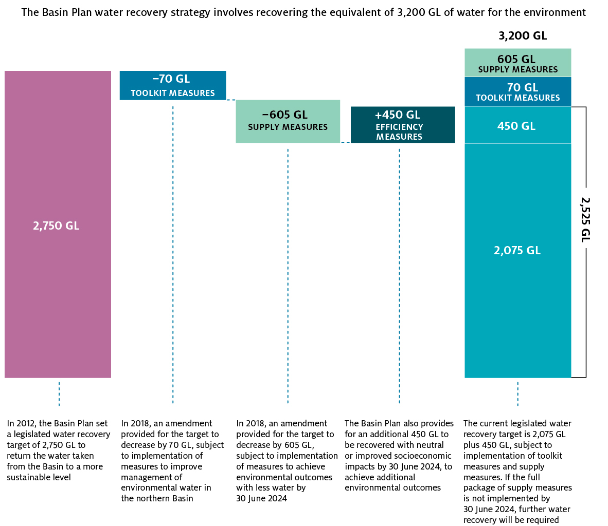

Box 2 Difference between GL LTAAY and GL of entitlement

LTAAY is a method used to standardise the calculation of expected water recoveries from the 150 different water access entitlement categories and across catchments in the Basin. For example:

* 100 GL of NSW Murrumbidgee high security entitlement represents 97.7 GL LTAAY, whereas
* 100 GL of Victorian Goulburn low reliability entitlement represents 58.3 GL LTAAY.

LTAAY is relevant for measuring progress of water recovery towards meeting the sustainable diversion limits set out in the Basin Plan.

The panel notes that MDBA and Basin state governments use the term long term diversion limit equivalent (LTDLE) rather than LTAAY. This measure is used to calculate the average annual yield for Basin resource units, based on the LTDLE factors agreed by the Ministerial Council.

We understand that LTAAY and LTDLE are interchangeable for the purpose of this review.

### Water for the Environment Special Account

The Water for the Environment Special Account was established by the Australian Parliament through an amendment to the Water Act in 2013. It appropriates $1.775 billion of Commonwealth funding, of which:

* $1.575 billion is allocated to recovering 450 GL through efficiency measures
* $200 million is allocated to easing constraints through constraints measures.

The provisions in the Water Act and the Intergovernmental Agreement specify that the Special Account is be used to fund projects that help achieve these outcomes over the 10 years from 1 July 2014 to 30 June 2024. After this time, the Special Account cannot pay any funds towards efficiency projects or constraints projects. Any change to this condition would require an explicit decision by the Australian Government, presumably in consultation with Basin state governments, and amendment to legislation.

### Efficiency measures

When water is transported for use in farming, manufacturing and urban water supply, some water is lost due to leaks or evaporation. In addition, more water may be delivered than is optimal for the intended use, or the timing of water delivery may not be optimal. Efficiency measures aim to reduce the volume of water lost or ‘surplus’ water delivered so that, for example, the same or greater levels of production can be achieved with lower volumes of water extracted from the consumptive pool. The net ‘efficiency gain’ resulting from these measures can potentially be recovered for the environment.

Efficiency measures programs provide Commonwealth funding for eligible efficiency projects on an entitlement holder’s property in return for a share of the resulting efficiency gain. These projects typically involve replacing existing water infrastructure with new infrastructure that reduces the overall volume of water needed. On-farm projects can involve upgrading irrigation systems, and off-farm projects can involve lining water delivery channels, to reduce evaporation, leaks or seepage. In manufacturing and urban water management, they can involve constructing, replacing, installing, upgrading, improving or refurbishing stormwater and waste-water reuse infrastructure to reduce water losses.

The funding contracts for efficiency projects require entitlement holders to transfer the entitlement for an agreed volume of the expected efficiency gain to the Commonwealth Environmental Water Holder (CEWH) at a specified stage of the contract—either at the start of the project or when the efficiency gain is realised. If the actual efficiency gain is higher than expected, the entitlement holder keeps the additional volume.

To be approved for funding, an efficiency project must contribute to the recovery of 450 GL by 2024 and have positive or neutral socio-economic outcomes for Basin communities and industries. Translating this ‘gateway’ from a concept to a specific test, with agreed parameters and processes, has been problematic. In 2018, the Ministerial Council agreed to adopt a set of socio-economic criteria which are to be applied to all efficiency measures projects prior to any approval of projects (MDB Ministerial Council 2018a).

An overview of the current efficiency measure program, the Water Efficiency Program, is provided in Box 3.

Box 3 Water Efficiency Program

The current Water Efficiency Program was launched in July 2019 and remains open. This program provides funding to eligible Basin water entitlement holders for 5 types of efficiency measures project—urban water, industrial water, metering, off-farm and on-farm projects.

For projects costing more than $1 million, entitlement holders and Basin states can apply directly for funding as project partners. For projects under $1 million, a program delivery partner must apply for funding on behalf of the entitlement holder. (Delivery partners are organisations or local or state governments that help entitlement holders design and deliver their projects.)

The maximum amount of funding available per project is determined with reference to prevailing water market prices and using a market multiple of 1.75. This multiple represents the maximum premium the Australian Government is willing to ‘pay’ per ML of entitlement transferred as a result of the project (that is, 1.75 times the prevailing market price for the same type of entitlement at the time of project approval).

To be eligible for funding, the entitlement holder must have owned their entitlement for 3 years, and the entitlement must:

* provide rights to exclusive access to a share of the surface water resources of a water resource plan area or other water management area
* be able to be permanently traded or transferred to the Commonwealth Environmental Water Holder (CEWH)
* be suitable for use by the CEWH to achieve environmental benefits
* be free from encumbrances when the rights would be transferred
* be located within a water resource plan area identified in the Basin Plan.

To be approved for funding, a project must have neutral or positive socio-economic impacts, as assessed using criteria agreed by the Ministerial Council on 14 December 2018. In Queensland and the ACT, the Australian Government undertakes this assessment in consultation with the relevant state government. In NSW, Victoria and South Australia, the state government undertakes the assessment.

### Constraints measures

Under the Basin Plan, a constraint is something that limits the volume of environmental water that can be delivered to the environmental assets of the Basin or the timing of this delivery. Constraints can include physical structures as well as river management practices and operational limits for river heights. Removing or relaxing constraints can allow better outcomes to be achieved with environmental water.

As required under the Basin Plan, the MDBA developed a Constraints Management Strategy in 2013 that identifies key areas in the Basin where options for addressing constraints need to be investigated (MDBA 2013). Broadly in line with this strategy, Basin governments have agreed to deliver a constraints measures program that involves 6 constraints projects (Box 4).

Five of these projects are also designated ‘supply measures projects’. Therefore, these projects can also be funded from Commonwealth funding for supply measures. However, like the Special Account, this supply funding is currently available until 30 June 2024 only. The remaining constraints project—Goulburn River—is being funded solely from the $200 million allocation in the Special Account.

Box 4 Constraints measures program

The 6 constraints projects currently being progressed by the Basin states involve investigating opportunities to overcome physical barriers and change river operating practices and rules to enable water managers to deliver higher flows in specified river sections. Typically, the work to scope, develop and deliver each of the projects involves:

* assessing the potential effects of the targeted higher or changed flows on councils, landholders and public land managers
* engaging and consulting with communities and affected parties on options to mitigate or address any potential adverse effects
* reaching formal agreements with individual landholders regarding how any unacceptable effects will be addressed—for example, through measures such as easements, and/or changes to infrastructure (e.g. crossings, culverts or bridges)
* undertaking any agreed works and establishing any agreed easements on property titles.

The location of the 6 constraints projects and the associated responsible state(s) are:

* Murray River, from Hume and Yarrawonga (NSW and Victoria)
* Murray River, from Yarrawonga to Wakool Junction (NSW)
* Murrumbidgee River (NSW)
* Lower Darling River (NSW)
* Goulburn River (Victoria)
* River Murray in South Australia (South Australia).

More information on the constraints projects is provided in Chapter 5.

### Roles of Australian and Basin state governments

The Basin water reforms, including the Basin Plan, are being led by the Australian Government and delivered in partnership with Basin state governments. As the Australian Government agency with water policy and program functions, the Department of Agriculture, Water and the Environment is responsible for administering the funds in the Special Account and authorising payments for efficiency measures and constraints measures programs. Responsibility for developing and delivering these programs is shared by the Australian Government with Basin state and territory governments, and contracted to other parties, in accordance with the Intergovernmental Agreement and other service agreements (Figure 2).

#### Arrangements for efficiency measures programs

The department is responsible for developing and delivering efficiency measures programs, on behalf of the Australian Government. Under the Intergovernmental Agreement, the Commonwealth has committed to consult closely with Basin states on the design of these programs, and the arrangements for their delivery and implementation (COAG 2013).

At the June 2018 Ministerial Council meeting, Basin ministers agreed that officials would develop an efficiency measures work plan through to 2024, consistent with the COAG Plan. They indicated that they expected a range of efficiency projects to be forthcoming from Basin state and territory governments including:

* a range of off-farm and urban projects to be developed by NSW in consultation with industry, community and the Commonwealth
* opportunities for efficiency measures that benefit the northern Basin to be investigated in Queensland
* urban and industrial efficiency measure opportunities to be investigated in South Australia, together with further on-farm projects to recover 2–5 GL
* channel upgrading, improved system viability, and pipelining for stock and domestic supplies in Victoria to recover up to 9 GL, and
* a proposed urban water initiative in the ACT to integrate water security and waterway improvement activities, with potential to recover 15 GL (MDB Ministerial 2018b).

Ministers agreed that the “first priority was to recover the 62 GL required by June 2019” to ensure the full 605 GL adjustment for supply measures (Figure 1) came into effect. (The Basin Plan limits the total amount by which the sustainable diversion limits can be adjusted up or down by 5%. As the agreed 605 GL adjustment to the water recovery target for supply measures exceeds this limit, further water recovery of 62 GL was required through efficiency measures to enable the full adjustment to be made in 2019.)

Water entitlements recovered through funded efficiency projects are transferred to the CEWH, which is responsible for managing and delivering the Commonwealth environmental water holdings in a manner consistent with the Basin-wide watering strategy.

#### Arrangements for constraints measures program

Under the Intergovernmental Agreement, the Australian and Basin state governments committed to implementing a package of constraints that will be pursued through a joint work program developed by the Basin Officials Committee and MDBA. They subsequently agreed to pursue the 6 projects listed in Box 4.

Basin states are responsible for delivering these constraints projects at a local level, including consultation with communities, detailed project design and implementation, by 30 June 2024. The Ministerial Council provides oversight, with advice from the Basin Officials Committee, consistent with the Water Act and the MDB Agreement 2008.

As noted above, 5 of these projects are also designated supply projects. The agreed package of supply projects (including these constraints projects) is equivalent to 605 GL of water recovery. If the package and outcomes are delivered in full by 30 June 2024, the water recovery target will be offset by this volume. If it is not, the shortfall will need to be addressed through further water recovery from the consumptive pool, or alternative means.

In addition to developing the Constraints Management Strategy, MDBA is responsible for reconciling the states’ constraints projects, monitoring their delivery, and verifying that they will achieve the desired outcomes. It also reports on progress in its periodic Basin Plan report card.

**Panel’s observation on challenges of the Special Account, efficiency measures and constraints measures programs**

The panel observes that the challenges of recovering 450 GL and easing constraints through efficiency measures and constraints measures programs are intertwined with the broader challenges in the Murray–Darling Basin.

These challenges are reflected in the suite of measures, initiatives and numerous reviews associated with the Basin. They arise from multiple factors, such as the condition of the river system’s natural resources, competing and changing government policies at both state and federal levels, the impact of drought on water entitlement holders and users, and water market behaviours. In addition, some result from current conditions, while others stem from the limited nature of Basin water resources and trade-offs between competing priorities.

In forming their views on these challenges, many stakeholders don’t distinguish between those specific to the efficiency measures and constraints measures programs and those that are broader Basin challenges. Neither do they appear to consider the interlinkages between these programs and other aspects of the Basin Plan—nor the consequences that failure to deliver the programs by 2024 will have for the sustainable diversion limits or Basin Plan outcomes.

In conducting this review, the panel focussed on the tasks in our terms of reference but could not ignore these linkages. In addition, many stakeholders commented on ‘consultation fatigue’ among Basin communities. We expect that government responses to our review will, likewise, need to take this intertwining and review fatigue into account.

Figure 2 Governance of efficiency and constraints measures programs in the Basin

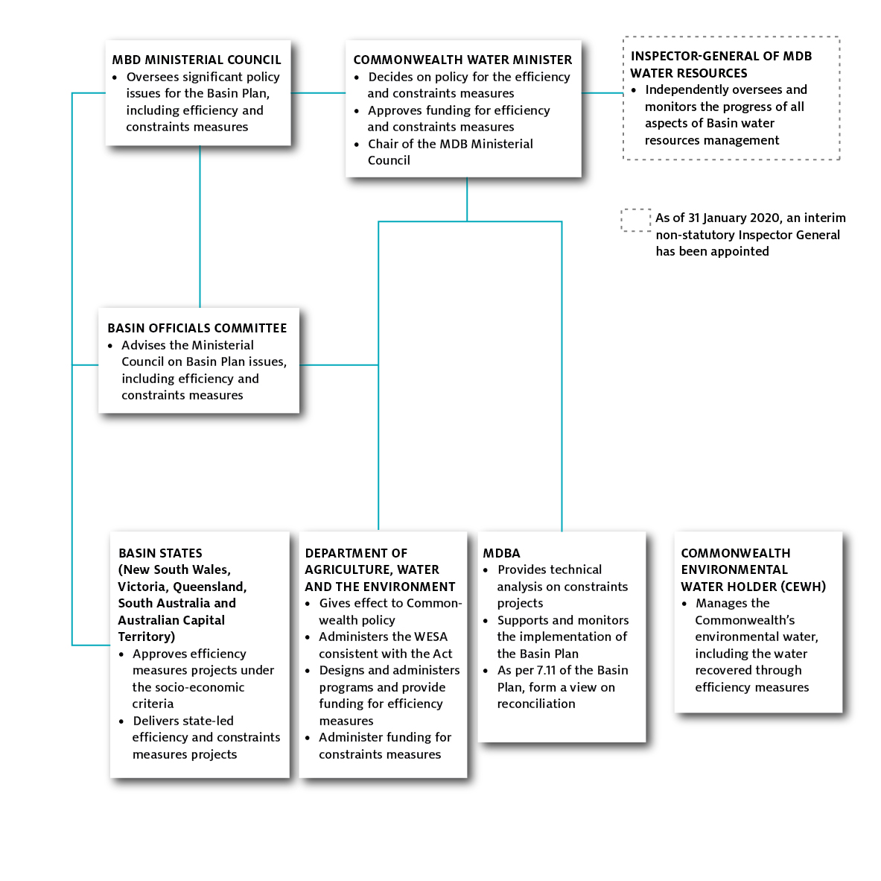

## Increasing volume of environmental water by 450 GL

In reviewing whether the $1.575 billion Special Account allocation is sufficient to recover 450 GL for the environment by 30 June 2024, the panel considered the analysis and made the assumptions outlined in Box 5. On this basis, the panel finds that:

* **The volume of water recovered through efficiency measures programs and transferred to the Commonwealth at 30 June 2024 will be well short of 450 GL.** Our reasons are that:
  + only 1.9 GL, or less than 1% of the required volume, has been recovered to date (as at February 2020)
  + information provided by the department suggests that up to 90 GL might be recovered through efficiency projects being discussed with potential partners or participants (as at February 2020)
  + analysis commissioned for this review indicates the potential volume that is feasibly recoverable by 2024 is up to 60 GL—due to the combined impact of current time constraints; current social views, government policies and political positions; and the current program’s attractiveness to potential participants.
* **Because the volume recovered at 30 June 2024 will be well short of 450 GL, the Special Account allocation of $1.575 billion will not be fully expended at this date.**
* **Based on current water market prices and the current program’s funding formula, the Special Account allocation would fund around a third of the cost to recover 450 GL by 30 June 2024.**

The following sections outline the analysis and evidence that support these findings.

### Only 1.9 GL recovered to date

Since the first appropriation of funds to the Special Account in 2014-15, the department has implemented and expended monies on 3 efficiency measures programs:

* the South Australian pilot of the Commonwealth On-Farm Further Irrigation Efficiency (COFFIE) program (September 2016 to October 2018)
* the Murray–Darling Basin Water Infrastructure Program (July 2018 to December 2018)
* the Water Efficiency Program (from July 2019).

The COFFIE program recovered 1.9 GL through the 66 projects funded under this program (DAWE 2020). This represents 0.4% of the required 450 GL.

The Murray–Darling Basin Water Infrastructure Program recovered zero GL as it was paused 5 months after its launch, when the Ministerial Council decided that additional socio-economic criteria should be incorporated into the program. These additional criteria were agreed in December 2018.

Box 5 Panel’s considerations and assumptions in reviewing recovery of 450 GL

To reach our findings on whether the Special Account allocation is sufficient to recover 450 GL through efficiency measures programs by 30 June 2024, the panel considered the following analysis and information:

* analysis commissioned from Marsden Jacob for this review
* information provided by the department on progress made and anticipated to be made through efficiency measures programs, and expenditure on those programs to date
* publicly available information, including reports of previous reviews, media releases and Ministerial Council Communiques
* the views expressed by stakeholders during our consultation process.

Our findings reflect the following assumptions:

* payments from the Special Account cannot be made after 30 June 2024 to honour funding commitments for any efficiency projects that are in progress but not completed at that date
* the department will continue to be accountable for the design and delivery of efficiency measures programs
* NSW, Victoria and South Australia will continue to assess the socio-economic impact of prospective projects in those states, with the Commonwealth assessing this impact in the other Basin states, and all Basin states making final decisions on the projects that can proceed in their jurisdictions
* the design of the current efficiency measures program (the Water Efficiency Program) will not materially change (e.g. the project types eligible for funding, and the funding formula)
* additional approaches for recovering the 450 GL will not become available (e.g. buybacks).

The program was redesigned and relaunched as the Water Efficiency Program in July 2019 and remains open. As at February 2020, this program has recovered around 0.015 GL through 2 small on-farm projects.

Given no material progress has yet been made, delivering 450 GL by 30 June 2024 would require almost the entire volume to be recovered in less than 4.5 years. To do this, more than 100 GL would need to be recovered per year, starting immediately. The panel does not consider this is realistic at this stage.

In considering the design of the projects to which payments have been made under section 86AD of the Water Act to date, the panel notes that this design was effective in increasing the volume of the Basin water resources available for environmental use. However, as discussed above, the increase was small, representing less than 1% of 450 GL.

### Up to 90 GL associated with prospective projects

The panel asked the department for information on the volume potentially recoverable from its pipeline of prospective efficiency projects under the Water Efficiency Program. As at February 2020, it estimates that this volume is 92.3 GL of entitlements. The pipeline includes projects that it is discussing with Basin states, project partners and delivery partners, but for which a formal funding application is yet to be submitted. The projects include:

* urban and industrial projects with a potential recovery volume of 60.5 GL of entitlement
* on-farm projects with a potential recovery volume of 8.8 GL of entitlement (with the volume from one of these projects still to be estimated)
* off-farm projects with a potential recovery volume of 24.5 GL of entitlement.

The panel considers the actual recovery of the estimated volume associated with these prospective projects is uncertain, given the projects are still in the pre-application phase and both their scope and recovery volumes may change. Based on earlier programs, it is likely only some will progress to formal application and approval (although new project opportunities may also emerge). In addition, in LTAAY terms, the recovered volume would be less than 90 GL after taking account of the reliability characteristics of the project entitlements.

In its formal submission to the panel (November 2019), the department indicated that it is “confident that the rate of progress will improve” if it can “engage with prospective applicants to seek participation” in the Water Efficiency Program. That submission projected that around 40 GL would be recovered through the program in 2019-20. The panel notes that almost none of this projected volume has been recovered to date as at February 2020.

### Up to 60 GL potentially recoverable given combined effect of key limiting factors

To form our own view on the potential volume recoverable through the Water Efficiency Program by 30 June 2024, the panel reviewed the various factors influencing this volume. We commissioned and considered a range of analysis by Marsden Jacob and drew on submissions and engagement with stakeholders. We determined that, for the purposes of this review and analysis, the key factors limiting this volume are:

* the technical potential for further water recovery in the Basin through the Water Efficiency Program
* the time constraints imposed by the Special Account’s legislated end date
* current social views, government policies and political positions on further water recovery in the Basin, and
* the program’s current attractiveness as a business proposition to potential participants.

To some extent these factors are related. Therefore, to gauge their combined impact on the potential volume recoverable, they must be accounted for simultaneously.

To assess this combined impact, we asked Marsden Jacob to first estimate the technical potential for further water recovery through the Water Efficiency Program (taking account of the types of efficiency project eligible under the program but ignoring other constraints). We then asked it to estimate and factor in the impact of other limiting factors, as a point-in-time exercise. As Figure 3 illustrates, this analysis indicates that:

* the technical potential for water recovery through the Water Efficiency Program is around 600 GL to 650 GL—more than the required 450 GL
* but the potential volume recoverable decreases to around 185 GL to 195 GL when the impact of time constraints is factored in—less than half the required 450 GL
* and it decreases to around 110 GL to 120 GL when the impact of current social views, government policies and political positions is also factored in
* and it decreases to 60 GL or less when the impact of the program’s current attractiveness to potential participants is also factored in.

Figure 3 Impact of key limiting factors on volume recoverable by 2024

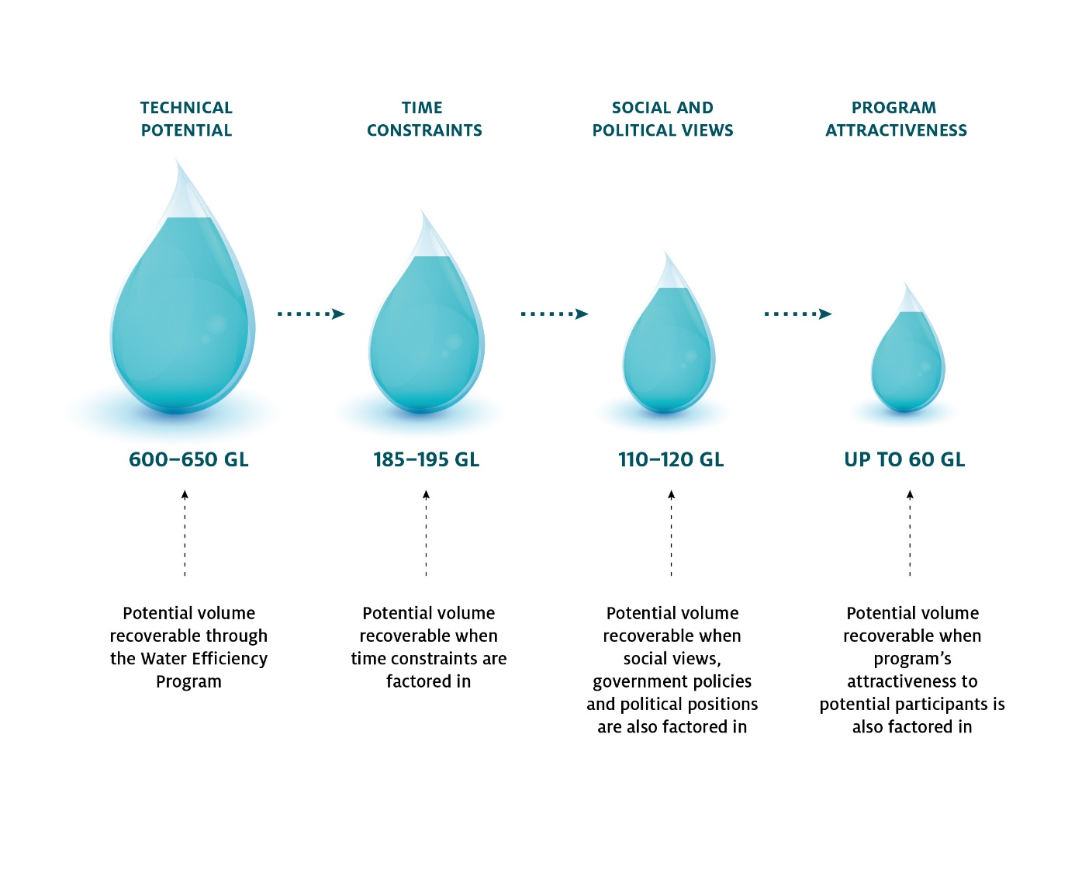

#### Technical potential for water recovery through Water Efficiency Program is around 600–650 GL

To estimate the technical potential for water recovery through the Water Efficiency Program, Marsden Jacob first estimated the total volume of surface water entitlements in the Basin that are technically available and eligible for program funding. This resulted in an estimate of around 8,200 GL (in LTAAY terms). (This excludes environmental holdings, groundwater entitlements and non-tradable entitlements, such as NSW stock and domestic water, and other specific purpose entitlements.)

It then estimated the potential efficiency gains recoverable through each of the main project types eligible for funding—off-farm, on-farm, urban and industrial projects—in each region in the Basin. (It did not estimate the potential savings from standalone metering projects; however, the panel understands that very little water is expected to be recovered through this project type.)

In forming this estimate, Marsden Jacob took into account:

* the size of the eligible entitlement pool in the region
* the LTAAY equivalent of this entitlement
* the water efficiency projects that have already been undertaken in the region
* the extent to which further efficiency projects might be possible in the region.

Marsden Jacob drew on a range of information sources, including data on previous irrigation efficiency projects provided by the department, and interviews with departmental officials, delivery partners in previous and current efficiency programs, and water brokers. It also cross-checked how its total estimate of the potential efficiency gains compared to the total volume of entitlements technically available and eligible for funding.

This resulted in an estimated range for the technical potential for further water recovery of 600 GL to 650 GL across the Basin. As Figure 4 shows, most of this potential is:

* located in the southern Basin, where Marsden Jacob estimates the potential gains range from 455 GL to 505 GL, and
* from on-farm projects, which Marsden Jacob estimates could recover up to 350 GL.

The panel notes that the upper bound of the estimated range of 600 GL to 650 GL across the Basin broadly aligns with Ernst & Young’s 2018 estimate of the maximum volume of water that could be recovered though efficiency projects, which was 692 GL (EY2018).

Figure 4 Estimated range for technical potential for further water recovery in northern and southern Basin

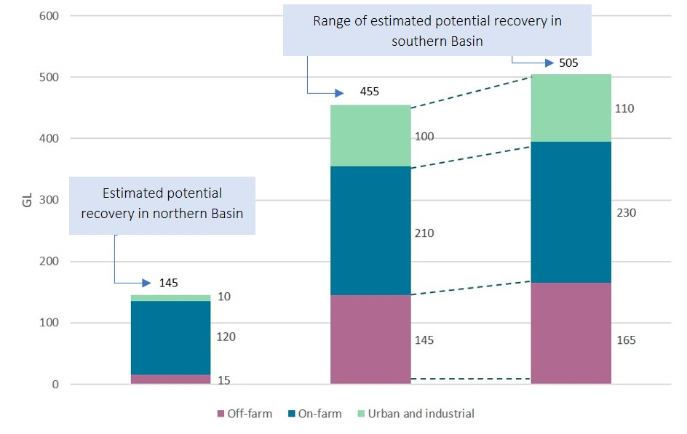Source: Marsden Jacob analysis

#### Time constraints decrease volume recoverable to around 185–195 GL

Under the Special Account’s establishment arrangements, payments for efficiency projects funded through the Water Efficiency Program cannot be made after 30 June 2024. Given that efficiency projects can be years in gestation and years in delivery, and final payments are typically not made until a project is complete, this condition means time is a critical constraint on how much of the technical potential of 600‒650 GL can feasibly be recovered by 30 June 2024.

To assess the impact of this constraint, the panel asked Marsden Jacob to investigate the typical lead times for eligible efficiency projects, including both pre- and post-application activities (from project conception through to application, commencement and closure). Based on historical program data provided by the department on previous Commonwealth-funded water infrastructure efficiency projects, Marsden Jacob estimates that the lead times for:

* off-farm projects range from around 6 months to more than 14 years, with an average of around 5.5 years
* on-farm projects range from less than 3 months to more than 8 years, with an average for tranches of projects of around 4.5 years
* urban and industrial projects range from 1.5 years and 10 years, with an average of around 5.5 years (Figure 5).

These lead times suggest that, simplistically, if all the potential projects included in Figure 4 started their pre-application activities immediately, less than half the off-farm, urban and industrial projects and around half the tranches of on-farm projects could be completed by 30 June 2024.

However, if these projects did start immediately and progressed to formal application, the department and Basin states would need to assess and process all their applications at the same time, so that they could all commence without delay. If the department does not have sufficient processing capacity, this could further constrain the potential volume recoverable.

The risk of processing capacity constraints is greatest for on-farm project applications. Based on the average volume recovered from previous on-farm projects, Marsden Jacob estimates that more than 600 projects would need to be completed each year to 2024 to recover half the potential volume shown on Figure 4. In comparison, the department’s past performance indicates a maximum processing capacity of up to 250 on-farm project applications per year.

Figure 5 Project lead times, compared to time remaining until 30 June 2024

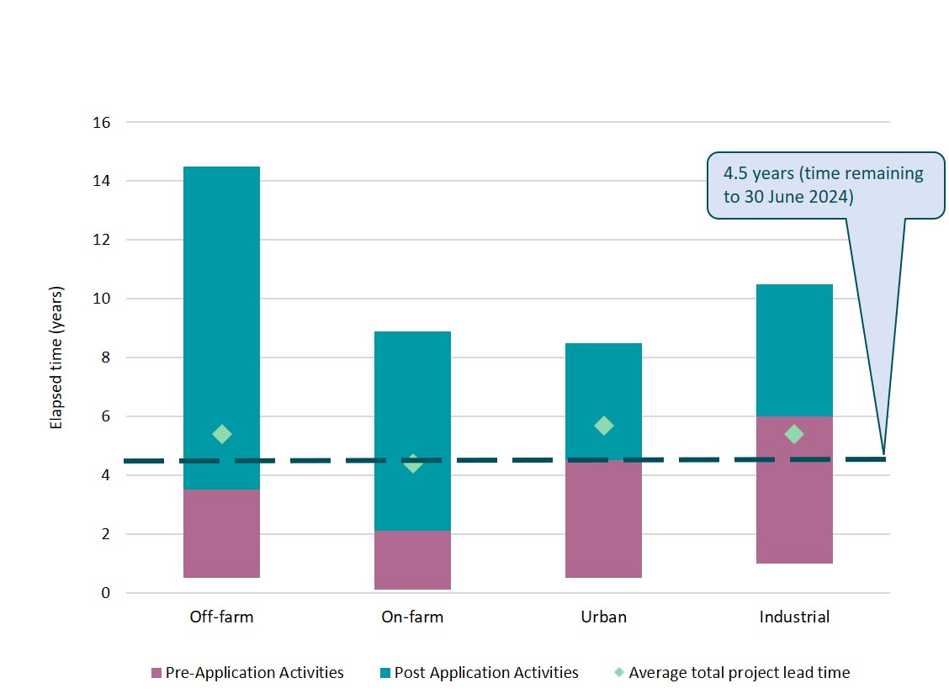

Marsden Jacob made the following adjustments to the estimated technical potential for water recovery through the Water Efficiency Program to account for the impact of time constraints:

* reduced the potential volume from off-farm, urban and industrial projects shown on Figure 4 by 60%, on the basis that this volume could not be recovered before 30 June 2024
* reduced the potential volume from on-farm projects shown on Figure 4 by 40% on the same basis
* further reduced the potential volume from on-farm projects to reflect its estimate of the department’s maximum annual application processing capacity (the potential volume from off-farm projects was also reduced slightly to reflect this capacity).

This decreased the potential volume recoverable to 185–195 GL, which is less than half the required 450 GL.

In considering this analysis, the panel notes that average lead times for pre-application activities under the Water Efficiency Program could be longer than under previous programs, due to the requirements of the socio-economic assessment. We also note that the ‘hard close’ of the Special Account on 30 June 2024 could discourage program participants from applying for large, multiyear projects unless they are certain of completion – and therefore payment - by this date. At the margin, this payment risk reduces the volume potentially recoverable from large projects.

Given the number of timing challenges, panel considers Marsden Jacob’s assumption that 40% of the potential volume from off-farm, urban and industrial project opportunities could be recovered by 2024 is probably optimistic.

#### Social views, government policies and political positions decrease volume recoverable to around 110-120 GL

Stakeholder statements in the public domain and in consultations for this review indicate there is a common (though not universal) perception that the recovery of an additional 450 GL for the environment will have detrimental social and economic impacts on local communities—particularly when water allocations are low due to drought.

The perception is more prevalent in some regions of the Basin, and this is reflected in the Basin state governments’ differing levels of support for and focus on meeting their commitments on this element of the Basin Plan. For example, in December 2019:

* The NSW Minister for Water announced that the state “will not contribute to the additional 450 GL”. The Deputy Premier also claimed “NSW has done all the heavy lifting when it comes to delivering the Basin Plan” and expecting regional communities to contribute to the additional 450 GL “at a time when we are experiencing the worst drought in living memory is ludicrous” (Pavey 2019).
* The Victorian Minister for Water stated in a press release that Victoria’s government will not support water recovery towards the additional 450 GL unless “there are positive socio-economic impacts” (Neville 2019).

Some irrigation infrastructure operators also share this view. For instance, Murray Irrigation Limited submitted that it “strongly opposes recovery of an additional 450 GL for the environment”. It considered that the Basin “is already experiencing very negative impacts, ecological and social, as a result of environmental water recovery to date. The process of recovering and using even more water beyond this runs the real risk of pushing our communities beyond their sustainable tipping point”.

These perceptions and positions affect participation in the Water Efficiency Program. For example, the National Irrigators Council submitted that farmers “remain very interested in improving their efficiency”, but those who take up Government-funded efficiency programs at this stage “would not be supported by their communities”. Similarly, delivery partners interviewed by Marsden Jacob commented that, currently, participating in these programs has a degree of social stigma in many regions.

Based on the statements discussed above, for this exercise, Marsden Jacob made the following adjustments to its estimate of the potential volume recoverable by 30 June 2024:

* reduced the potential volume from on-farm projects in NSW and Victoria to zero, and
* reduced the potential volume from off-farm projects in the NSW Murray region to zero.

As a result, its estimate of the potential volume recoverable through the Water Efficiency Program by 30 June 2024 is 110–120 GL when the impact of current social views, government policies and political positions is factored in.

The panel considers the assumption that none of the potential volume from on-farm projects in NSW and Victoria could be recovered may be too pessimistic. However, even if a portion of this volume could be recovered, the overall result would essentially remain the same.

The panel also notes there are strongly held views contrary to those highlighted in the discussion above. In our consultations, a range of stakeholders impressed upon us the importance of recovering the additional 450 GL for achieving improved environmental outcomes in the Basin.

#### Program attractiveness decreases volume recoverable to 60 GL or less

For entitlement holders to participate in the Water Efficiency Program, the trade-off between the money they will receive and the water entitlements they will transfer to the Commonwealth must make business sense to them. This will depend on a range of factors, which vary according to their specific circumstances and can be complex for them to assess (Box 6).

At the minimum, the project must be financially viable from their point of view. That is, the amount of funding they receive through the Water Efficiency Program must cover the cost of implementing their efficiency project. Under the program’s funding formula, this amount is capped at the current price for the type and volume of entitlements they will transfer multiplied by 1.75.

To assess the impact of the program’s current attractiveness, Marsden Jacob considered the financial viability of the project opportunities included in its estimate of the potential volume recoverable after time constraints and social views, government policies and political positions are factored in. It based this assessment on:

* its analysis of current entitlement prices for this review (section 4.5)
* historical data on on-farm and off-farm project implementation costs per ML recovered (Appendix B), and
* its previous analysis on the implementation costs of urban and industrial projects.

Its findings indicated that currently many of these potential off-farm, urban and industrial projects would not be financially viable. In line with these findings, Marsden Jacob made the following adjustments to its estimate of the potential volume recoverable by 30 June 2024:

* reduced the potential volume from the remaining off-farm projects by almost 50%
* reduced the potential volume from the remaining urban and industrial projects to around 11 GL.

This resulted in an estimated potential volume recoverable through the Water Efficiency Program by 30 June 2024 of up to 60 GL after the combined impact of all key limiting factors is factored in. This volume comes from opportunities for on-farm projects in South Australia and Queensland, some off-farm projects in the Murrumbidgee, Victorian Murray/Goulburn and Queensland, and urban and industrial projects in the ACT.

After considering [Marsden Jacob’s](https://www.agriculture.gov.au/water/mdb/policy/wesa-review) overall analysis, the panel’s view on the potential volume recoverable by 2024 accords with the result of this analysis. While some of the assumptions used may be too optimistic and others too pessimistic, on balance, we consider that without material change to the program’s eligibility criteria and the key limiting factors discussed above, the volume recoverable by the Special Account’s end date will be in the vicinity of 60 GL or less.

Box 6 Factors that influence an efficiency measures program’s attractiveness to participants

As section 4.3.4 discussed, a range of factors influence whether participating in an efficiency measures program is an attractive business proposition for potential participants. In addition to current entitlement prices and the program’s funding formula, these factors include:

* Demand for entitlements in the market. When this demand (and the price of entitlements) is high, entitlement holders may see more value (and less risk) in retaining their entitlements.
* Availability of water. When allocations are low, entitlement holders may prefer to retain their entitlements rather than risk further lowering their allocation.
* Potential impacts of future growth, drought or climate change. For example, if these impacts reduce the reliability of an urban water utility’s future water supply, and thus its ability to meet its water demand, participation in the program may bring forward expensive supply augmentation.
* Balance sheet impact. If entitlement holders perceive that they will be replacing an appreciating asset (water entitlements) with depreciating assets (water infrastructure), participation will mean the asset base on their balance sheet will reduce over time. This can affect their ability to secure loans from financial service providers.
* Tax implications. Under certain conditions, the funds received under a program may be treated as income with associated tax implications.

Source: Marsden Jacob

### Special Account allocation will not be fully expended at 30 June 2024

Because the potential volume recoverable through efficiency measures programs by 30 June 2024 will be well short of 450 GL, the Special Account allocation of $1.575 billion will not be fully expended at this date.

As at February 2020, cumulative expenditure on these programs was less than $15 million, leaving more than $1.560 billion unspent (Figure 6). The panel asked Marsden Jacob to calculate the cost to recover the potential 60 GL (discussed in section 4.3.4) through the Water Efficiency Program based on current water market prices. This calculation gave an estimated cost of around $630 million, which is well below the remaining account allocation.

Figure 6 Cumulative planned, actual and projected expenditure on efficiency measures as at November 2019

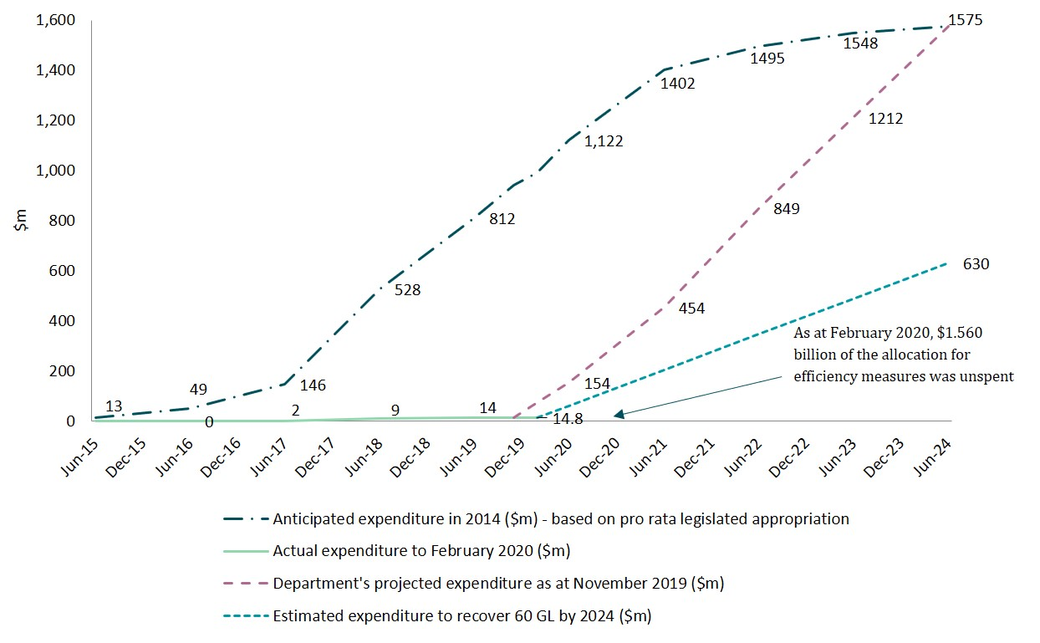

### Special Account could fund around one-third of current cost to deliver 450 GL

To assess the sufficiency of the Special Account allocation to recover the additional 450 GL, the panel asked Marsden Jacob to estimate what this would currently cost through Water Efficiency Program (assuming it were feasible). Marsden Jacob estimated this cost to be around $4.8 billion—or around 3 times the $1.575 billion allocation—based on:

* its analysis of current and projected water prices across the Basin, which shows that current prices are significantly higher than they were when the Special Account allocation was set
* a feasible scenario for recovering 450 GL that represents its ‘best estimate’ of where and how this volume could be recovered across the Basin through the Water Efficiency Program.

#### Current prices higher than when Special Account allocation was set

To recover 450 GL through the Water Efficiency Program within the Special Account allocation of $1.575 billion, an average recovery price of $3,500 per ML is required. This price reflects an average market price of $2,000 per ML and the program’s market multiple of 1.75.

This average market price of $2,000 per ML is consistent with prevailing market prices around the time the Special Account was established. As Figure 7 shows, in 2013-14 and 2014-15, this price was between $1,500 and $1,800 per ML of entitlement for high security water entitlements across the southern Basin. Given the LTAAY factors for this type of entitlement ranged from 0.9 to 1.0, this translates to $1,580 to $1,900 ML—below the required market price of $2000 per ML.

However, as Figure 7 also shows, the average market price for high security entitlements have increased significantly since then. In late 2019, it reached around $6,000 per ML of entitlement. Average prices for general security and low reliability entitlements across this area have also increased, but to a lesser degree.

[Marsden Jacobs](https://www.agriculture.gov.au/water/mdb/policy/wesa-review) projected ranges for water prices to 2024. Based on these projections, its view is that prices for high reliability/security entitlements are likely to remain substantially higher than the $1,880 per ML of entitlement that prevailed when the Special Account allocation was set. In many locations, the projected market price for general security entitlements is also likely to remain higher than $1,880 per ML of entitlement.

Figure 7 Southern Basin water prices since 1 July 2012

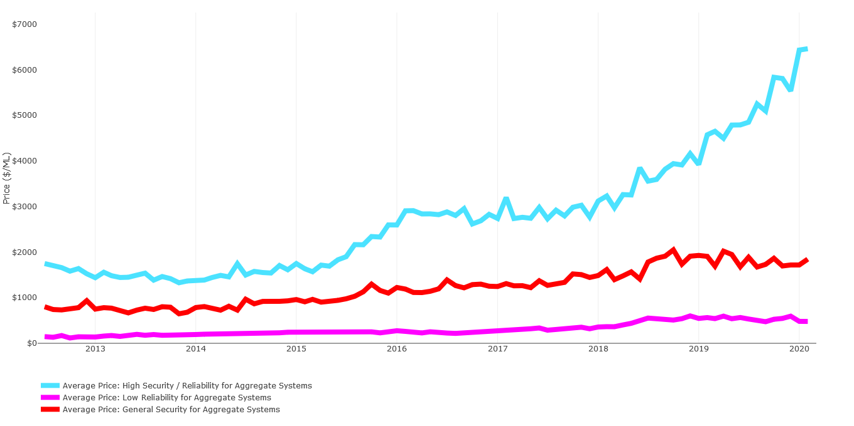

Source: Marsden Jacob Waterflow™

#### Current cost of scenario to recover 450 GL is around $4.8 billion

To determine how current market water prices might flow through to the cost of water recovery through efficiency measures, the panel asked Marsden Jacob to develop a feasible scenario under which 450 GL could be recovered through the Water Efficiency Program.

As its starting point, [Marsden Jacob](https://www.agriculture.gov.au/water/mdb/policy/wesa-review) took the analysis it used in estimating the technical potential recovery of 600–650 GL through the eligible project types. As section 4.3.1 discussed, this estimate was based on a region-by-region assessment of the available opportunities for efficiency gains from off-farm, on-farm, urban and industrial projects, and was informed by stakeholder feedback gathered through interviews, insights from previous research projects, and expert opinion on where in the Basin project opportunities are most likely to exist. It then identified the most likely mix of project types, regions and entitlement types to recover 450 GL based on the same feedback, insight and opinion.

Marsden Jacob estimated that the current cost to recover 450 GL under this scenario would be around $4.8 billion, based on market prices as at November 2019 and the program’s funding formula. In comparison, the panel notes that the current cost to purchase enough entitlements from the market to recover 450 GL would be around $2.74 billion under the same scenario (assuming enough entitlement holders were willing to sell to the Commonwealth at prevailing market prices). The panel also notes that in 2018, the Productivity Commission estimated the cost to recover 450 GL under a range of scenarios was between $2.0 billion and $2.3 billion, based on market prices at that time (PC 2018).

**Panel observations on current social views, government policies and political positions and current program attractiveness**

[1] The panel observes that irrigators and their associated communities are not universally interested in or universally opposed to additional water recovery in the Basin. In part, the diversity of views reflects differing priorities and appetites for risk. For example, in our consultations:

* some stakeholders were enthusiastic about the opportunities for infrastructure investment and increased efficiency
* some stakeholders (mainly irrigators) were concerned about any reduction in the consumptive pool
* others claimed not to be aware of the current water efficiency program.
* This diversity of views is relevant to the nature, scope and timing of any responses to our review, and how any actions are communicated.

[2] Stakeholders have noticed the different messages from governments about the efficiency measures and constraints measures programs and are particularly alert to inconsistent and conflicting messages. For example:

* The Intergovernmental Agreement came into effect on 5 June 2013. It has since been amended 5 times, including as recently as 9 August 2019 (COAG 2019). Progress on delivering the efficiency measures and constraints measures programs is slower than contemplated in this agreement.
* The 8 June 2018 Ministerial Council Communique stated that “Ministers agreed that the first priority for efficiency measures is to recover the 62 gigalitres required by June 2019 to ensure that the full 605-gigalitre supply adjustment comes into effect. However, as at 20 February 2020, state governments have not yet implemented any water efficiency projects to recover this critical first 62 GL (as part of the 450 GL) (MDB Ministerial Council 2018b).
* The December 2019 Ministerial Council Communique highlighted the diversity of the Basin states’ positions:
* “Queensland provided advice to the Commonwealth Minister regarding opportunities to complete the water recovery task in Queensland.”
* “New South Wales noted that due to the severe and extended drought, it was not able to contribute any further water under the 450 GL efficiency measures.”
* “Victoria advised it had not changed its position. Victoria does not support any further water recovery unless it can be shown there are no negative socio-economic impacts as per the agreed criteria.”
* “The ACT advised the Council that the territory remains committed to bringing forward projects under the water recovery program to secure water for the ACT community and to support environmental flows across the Basin.”
* “South Australia noted no position on the 450 GL was put formally to the Council regarding any changes to the plan and no approval or endorsement was provided for any state to not contribute to all aspects of the plan.” (MDB Ministerial Council 2019)

To the maximum extent possible, it will be important to achieve and communicate a consensus among Basin Ministers on any response to this review.

[3] In relation to program attractiveness to potential participants, the panel observes that the arrangements for the Water Efficiency Program have tighter project scope requirements and more onerous project application, public scrutiny and approval processes than many previous initiatives. These are, at least in part, driven by the socio-economic impact test requirements, and the delivery partner model. For instance:

* The socio-economic criteria assessment, including the requirement for public consultation, imposes a significant workload on applicants, adds to pre-application lead times, and introduces new risks.
* While the project funding arrangements (including the funding formula) provide robust controls, they limit negotiation outside those parameters.
* The funding formula’s market multiple of 1.75 is lower than that used to recover water through projects funded under historical infrastructure efficiency programs in the Basin, especially off-farm projects.
* The COFFIE program (a pilot efficiency measures program in South Australia) funded non-water efficiency recovery activities that are not eligible for funding under the current program.
* The delivery partners believe they are disproportionately bearing the risks of upfront project management costs and the risks of water not being recovered.

While these arrangements were conscious decisions, the Australian Government, in collaboration with other Basin governments, has the option to review and adjust program parameters and include other measures to increase the chances of achieving the Special Account’s objectives by 30 June 2024.

## Easing constraints on delivering environmental water

In reviewing whether the Special Account allocation of $200 million is sufficient to deliver the constraints measures program by 30 June 2024, the panel considered the analysis and made the assumptions outlined in Box 7. On this basis, the panel finds that:

* **The constraints measures program will not be delivered in full by 30 June 2024.** Our reasons are that:
  + MDBA’s most recent Basin Plan report card indicates the constraints projects are progressing very slowly and are at risk of delay.
  + Advancing the projects to implementation will require substantial effort and coordination across many work streams. This work will involve significant time. The effect of this is that the program’s implementation timeframe will need to extend beyond 30 June 2024 to ensure successful implementation.
* **Because the constraints measures program will not be delivered by 30 June 2024, and the Special Account is not the only source of funding available, the account’s allocation of $200 million is sufficient to cover expenditure on the program to this date.**
* **The total funds available for both constraints and supply projects from all sources is broadly in line with the current estimate of their total cost.** However, the estimated constraints projects’ costs are approximate only.

The following sections discuss the analysis and evidence underpinning these findings. Figure 8 provides an overview of the constraints projects and Appendix C describes each project in more detail.

Box 7 Panel’s considerations and assumptions in reviewing delivery of constraints measures

To reach our findings on whether the Special Account allocation is sufficient to deliver the constraints measures program by 30 June 2024, the panel considered the following information and analysis:

* the status of the constraints projects as reported in MDBA annual reports and report cards
* other publicly available information, including MDBA’s website, the report by the NSW and Victorian Ministers’ Independent Expert Panel on Basin constraints modelling, and the business cases for constraints projects prepared for the feasibility phase of the Constraints Management Strategy
* analysis of the time required to reach agreements with landholders
* the views expressed by stakeholders through our consultation process.

The panel’s findings reflect the following assumptions:

* payments from the Special Account cannot be made after 30 June 2024 to honour funding commitments for contracted constraints projects
* the current roles, accountabilities and approach for the constraints measures program will continue without material change.

Figure 8 **Overview of constraints projects**

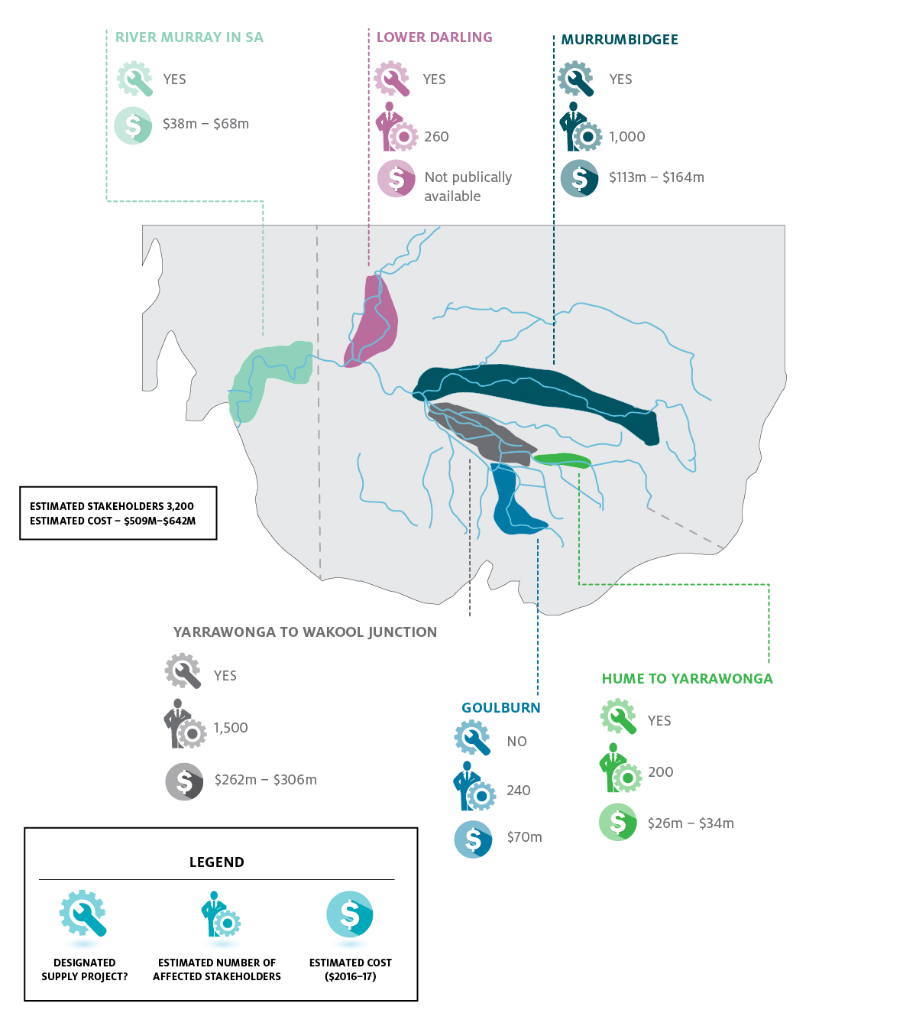

### Constraints projects progressing very slowly

In its December 2019 Basin Plan report card, MDBA’s assessment was that the constraints projects “are progressing very slowly” and “are at risk of delay” (MDBA 2019). More than halfway through the Special Account’s 10-year term, the 6 constraints projects remain in the feasibility phase—the second of 3 phases set out in the Constraints Management Strategy (Box 8). Under this strategy, the projects were expected to enter the final implementation phase (when most of the investment was expected to commence) in mid-2016 (MDBA 2013). This puts them at least 3 years behind the original schedule.

MDBA’s submission to this review said the constraints measures program was “progressing more slowly than anticipated” and noted that “this is a reflection of the complexity of the projects”. It also noted that the projects are being advanced “under a coordinated plan with progress monitored by the Ministerial Council”.

The slowness of progress was also noted in the Murray Darling Basin Royal Commission Report (SA 2019) and by the Productivity Commission in its MDB 5-year assessment (PC 2018).

Box 8 Constraints Management Strategy implementation process

In this report, we have compared progress on the constraints projects to the 3-phase process and timetable for implementation of the Constraints Management Strategy. While this process and timetable were proposed only and are out of date, they nevertheless provide an indication of how progress is tracking:

* **Phase 1: Pre-feasibility (2013 to 2014).** Compile an information base to allow a first pass Basin-scale assessment of constraints that warrant further investigation. Work includes investigating opportunities to address constraints and doing preliminary assessments of risks to water users and landholders and benefits in terms of the environmental outcomes.
* **Phase 2: Feasibility assessment – business case development and Basin-scale prioritisation (2015 to mid-2016).** Assess feasibility of projects and develop detailed proposals. Work includes ongoing engagement with the local community, entitlement holders and industry, more thorough development of options and mitigation costings, detailed design and costs in the case of infrastructure projects, and a property-by-property assessment of landholder impacts and mitigation options. This work will inform the confirmation of the package of work to be agreed by Basin governments as adjustment measures by December 2015.
* **Phase 3: Planning and implementation (2016 to 2024).** Commence majority of investment following the completion of the feasibility assessment and operation of the SDL adjustment in mid-2016.

Source: Constraints Management Strategy 2013 to 2020

### Advancing constraints projects to implementation will take time

As several other reviews have noted, substantial analytical and consultation work is required to advance the constraints projects to implementation. Key tasks that remain to be done include (but are not limited to):

* undertaking further modelling and other work to provide necessary information and evidence to determine the projects’ impacts on affected landholders and local communities, and to engage meaningfully with them to build community confidence in the projects
* reaching individual agreements with the thousands of affected landholders on easements, mitigation work and/or compensation to address unacceptable impacts.

This work will involve significant time. The effect of this is that the implementation timeframe for the constraints measures program will need to extend beyond the deadline of 30 June 2024 to ensure successful implementation.

#### Time for further modelling to determine project impacts and inform engagement

In its submission, MDBA indicated that while the constraints measures program is technically feasible, “comprehensive consultation and engagement with the community, and negotiations with affected landholders, are necessary to secure a social licence for the CMP” to deliver it. The importance of this engagement has been recognised from the outset—by Basin governments in the Intergovernmental Agreement and by MDBA in the Constraints Management Strategy. More recently, in agreeing to progress the Constraints Measures Coordinating Work Plan, the Ministerial Council noted that “community engagement and co-design” in implementing the work plan “will be fundamental to its successful delivery” (MDB Ministerial Council 2018a).

However, an independent expert panel appointed by the Victorian and NSW governments to review the existing models and modelling results for the constraints projects found that the available modelling does not provide the information and evidence required to understand the projects’ impacts on individual landholders, local governments and infrastructure managers in the Basin.

The existing modelling was undertaken at an aggregate scale for planning purposes. As such, it does not provide the necessary information to determine the flooding risks associated with the higher targeted river flows under the projects for individual landholders’ property.

Therefore, that independent expert panel concluded that additional modelling was needed to (among other things) support detailed project design, and in turn support meaningful community engagement, consultation on mitigation options, and broader communication (Wilson et al. 2019).

We recognise that the full extent of the constraints projects’ impacts does not need to be determined before meaningful engagement with communities and landholders can begin. However, the further modelling, engagement and other work required to build community confidence in the projects will involve significant time.

#### Time for reaching individual agreements with landholders

Under the current approach for delivering the constraints measures program, no changes to flows will occur until all third-party impacts have been resolved in consultation with affected communities. The Victorian Government has ruled out flooding private land without the landholder’s consent and compulsory acquisition of land or easements.

The Basin states are responsible for negotiating securing agreements with landholders affected by the constraints projects within their jurisdiction. MDBA submitted that more than 3,000 properties are involved with these projects in some way, and agreement with each landholder is required. To negotiate this agreement, the impacts of the higher targeted flows on the landholder’s property must be understood, and the responses to avoid or mitigate these impacts must be agreed (e.g. event-based payments, infrastructure, or legal easements recognised on the property title) (NSW Government 2016).

Past experiences in negotiating similar outcomes suggests that reaching these agreements will require more time than the less than 4.5 years available to 30 June 2024, particularly given the large number of landholders involved. For example, the Productivity Commission noted that negotiations in the 2000s to secure the right to release 25,000 ML/day from Hume Dam took almost 8 years to complete. These negotiations involved establishing easements on property title with only 103 landholders from Hume to Yarrawonga (PC 2018).

The experience in Queensland’s coal seam gas industry provides another relevant benchmark. Coal seams are sometimes located in aquifers that provide water to many landholders. Gas companies are required to assess the impacts of their activities on the capacity of each affected landholder’s water bore. The landholder must review information about these impacts and negotiate an agreement for compensation. A survey of 56 such agreements found that the median time to negotiate an agreement, after the bore assessment was completed, was around 9 months. The shortest time for an agreement was 7 days and the longest around 3.5 years (Gasfields Commission Queensland 2019).

Using an optimistic estimate of 6 months for the time required to negotiate an agreement related to a constraints project, around 430 agreements would need to be completed every 6 months for the next 3.5 years to secure the 3,000 plus agreements required. The panel considers this is unrealistic. In addition, it assumes that all landholders are willing negotiators, and that negotiations could start immediately, which also seems unrealistic.

The panel notes that our findings on the constraints projects are consistent with the views of other reviewers and stakeholders (Box 9).

### Special Account allocation sufficient for expenditure to 30 June 2024

When the Special Account was established in 2013, the initial estimate of the cost of easing the identified priority constraints in the southern Basin was $200 million, and this amount was set aside in the Special Account. Since then, the estimate has been revised twice:

* In 2014, MDBA estimated the potential costs of the projects as part of the prefeasibility phase of the Constraints Management Strategy. It found the total cost of the 6 projects ranged from $200 to $267 million (MDBA 2014).
* In 2016 and 2017, the Basin states estimated the costs of these projects as part of the ‘concept’ business cases they developed for the feasibility phase of the strategy. The total estimated costs in the business cases for 5 of the 6 projects ranged from $509 to $643 million. The sixth project—the Lower Darling constraints project—is part of a larger Menindee Lakes project, which has an estimated cost of around $152 million. The share of this cost to be allocated to the constraints component is not known (Marsden Jacob 2020).

Based on these business case estimates, the total cost of the constraints projects is more than 2 to 3 times the amount allocated in the Special Account. Nevertheless, the panel considers the remaining $195 million of this amount (Figure 9) is sufficient to cover expenditures to 30 June 2024 because:

* the timeframe for implementing the constraints measures program will extend beyond 30 June 2024, and therefore the expenditure profile will also extend beyond this date
* only 1 project is to be solely funded from the Special Account—the Goulburn River project in Victoria—and its current cost estimate of around $70 million is less than half of the remaining amount
* the other 5 projects are also designated supply projects, so the $1.004 billion of Commonwealth funds set aside for supply projects can be drawn on to cover expenditures on these 5 projects to 2024 if necessary.

Box 9 Other reviewers’ and stakeholders’ views on timeframe for constraints projects

In the Joint Basin government response to the Productivity Commission’s MDB five-year assessment, governments acknowledged there could be practical issues with implementation of some projects and that delivery of some projects by 2024 will be challenging (DOA 2019).

The Productivity Commission noted that the 2024 deadline for these projects appears “highly ambitious, if not unrealistic” (PC 2018).

The MDB Royal Commission Report noted “With such minimal progress since 2013, there can presently be little (if any) confidence that that deadline will be met….” (SA 2019).

In submissions to this review, stakeholders generally considered that meeting the deadline for implementing the constraints projects will be difficult. For example:

* Ricegrowers Association of Australia and Leeton Shire Council both noted that “Regulatory constraints include the need for flood easements on private properties to accommodate the anticipated higher flow rates. This requires voluntary flood easements agreements with 3,000 landholders along the Murray River and its tributaries. It is unrealistic to think this many agreements can be negotiated before 2024, or any time soon after”.
* Victoria Farmers Federation put the view that “the timetable of 2024 to achieve the constraints project is totally unrealistic”.
* ACT Government Environmental Planning and Sustainable Development Directorate said that “the detailed design, consultation and approval processes [for the constraints projects] are likely to be significant and may affect delivery timeframes”.
* A stakeholder who made a confidential submission noted that “given community angst” about the constraints projects, and the significant community consultation, negotiation and resourcing required, the timelines will be difficult to achieve.

At our industry roundtable consultations, participants suggested that landholder resistance based on concern about how the projects will affect their property would be a major impediment to delivering the constraints measures program by 30 June 2024.

Figure 9 Cumulative planned, actual and projected expenditure on constraints measures as at November 2019

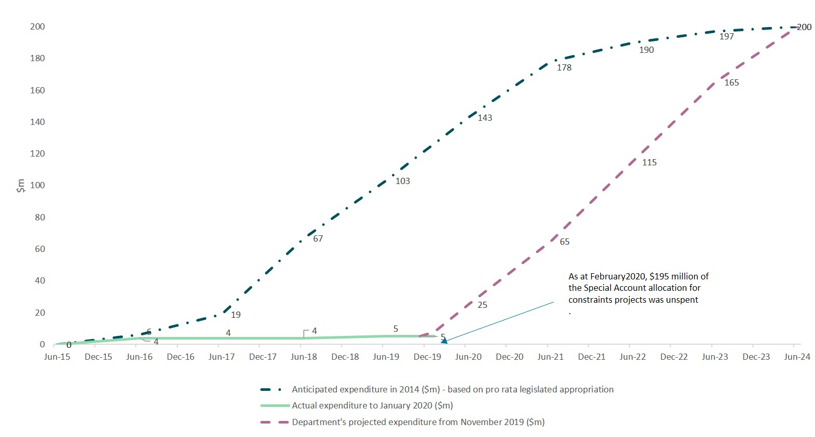

### Total available funding is broadly similar to current cost estimates

As section 5.3 noted, additional Commonwealth funds of $1.004 billion are available for the 5 constraints projects that are also designated supply projects. Further additional funds are available for one of these projects—the Lower Darling project, which is part of the larger Menindee Lakes Water Savings Project in NSW. When the remaining Special Account allocation is included, a total of around $1.32 billion is available to deliver all constraints and supply projects.

The panel notes that the total available funds are broadly in line with current estimates of the total costs of these projects:

* Under the 2019 *Project Agreement for Stage 1 Funding for SDL Adjustment Supply and Constraints Measures in the Murray–Darling Basin,* the Commonwealth’s total financial contribution to the Basin states for Stage 1 activities for these projects is estimated to be $132 million. The agreement states that this amount represents 10% of the current estimate of the total cost of the full implementation of the relevant measures (CFFR 2019).
* The department has advised that Basin states are seeking approximately $1.328 billion for all supply and constraints measure projects. This amount reflects current cost estimates, which include considerable allowances for contingencies.

The panel notes the current cost estimates were prepared for business cases in the feasibility phase, and as such are approximate costs only. MDBA submitted that the final business cases for the constraints projects will provide detailed costings, and these will determine whether the combined funding from the Special Account and the supply measures budget is adequate. The Basin states are due to provide the final business cases in 2022 and 2023.

## Appendix A: Consultation

### Written submissions

In response to the review discussion paper, released in November 2019, the panel received 27 written submissions.

| Number | Submitter name |
| --- | --- |
| 1 | Australian Capital Territory Department of Environment Planning and Sustainable Development |
| 2 | Australian Dairy Industry Council |
| 3 | Australian Government Department of Agriculture, Water and the Environment |
| 4 | Community and Public Sector Union |
| 5 | Cotton Australia |
| 6 | Goulburn Murray Irrigation Water Leadership |
| 7 | Inland Rivers Network |
| 8 | Leeton Shire Council |
| 9 | Lifeblood Alliance |
| 10 | Murray–Darling Basin Authority |
| 11 | Murray Irrigation Limited |
| 12 | Murrumbidgee irrigation |
| 13 | Murrumbidgee Valley Food and Fibre |
| 14 | National Farmers Federation |
| 15 | National Irrigators Council |
| 16 | NSW Farmers' Association |
| 17 | Ricegrowers’ Association of Australia |
| 18 | South Australian Department for Environment and Water |
| 19 | South Australian Murray–Darling Basin Natural Resources Management Board |
| 20 | Victoria Department of Environment, Land, Water and Planning |
| 21 | Victorian Farmers Federation |
| 22 | Waterfind |
| 23 | Wentworth Group of Concerned Scientists |
| 24–27 | Confidential submissions |

### Attendees at the Stakeholder Roundtables (8 November 2019 and 28 November 2019)

The panel held roundtable meetings on 8 November 2019 and 28 November 2019. Attendees included representatives from 24 different community, environment and industry organisations.

| Number | Organisation |
| --- | --- |
| 1 | ADIC Water Taskforce |
| 2 | Aurecon |
| 3 | Australian Grape and Wine |
| 4 | Australian Water Brokers Association |
| 5 | Basin Community Committee |
| 6 | Cotton Australia |
| 7 | Dairy Australia |
| 8 | GHD |
| 9 | Ricegrowers’ Association of Australia |
| 10 | Mallee Catchment Management Authority |
| 11 | Marsden Jacob Associates |
| 12 | Murray Darling Association |
| 13 | Murray Irrigation Limited |
| 14 | Murrumbidgee Irrigation |
| 15 | National Farmers’ Federation |
| 16 | National Landcare Network |
| 17 | National Rural Women's Coalition |
| 18 | National Irrigators Council |
| 19 | NSW Farmers Association |
| 20 | NSW Irrigators Council |
| 21 | Rubicon Water |
| 22 | South Australian Murray Irrigators |
| 23 | The Wentworth Group of Concerned Scientists |
| 24 | West Corurgan Private Irrigation |

### Individual meetings

The panel met directly with stakeholders who are active participants in the Basin Plan or the water sector between August 2019 and January 2020.

|  | Individuals and Organisations the Panel met directly with |
| --- | --- |
| 1 | Alluvium |
| 2 | Australian Bureau of Agricultural and Resource Economics (ABARES) |
| 3 | Australian Capital Territory Environment and Sustainable Development Directorate |
| 4 | Australian Government Department of Agriculture, Water and the Environment |
| 5 | Bureau of Meteorology |
| 6 | Commonwealth Environmental Water Office |
| 7 | Dairy Farmer near Murray Bridge South Australia |
| 8 | Ernst & Young (EY) |
| 9 | GMID Water Leadership Forum |
| 10 | Goulburn Murray Water (GMW) |
| 11 | Grape Grower near Langhorne Creek South Australia |
| 12 | Horticulture Farmer near Griffith |
| 13 | Hunter H20 |
| 14 | Landholders from West Berrigan |
| 15 | Murray–Darling Basin Authority |
| 16 | Murray Irrigation Limited |
| 17 | Murray Irrigation Limited Farmer Representatives |
| 18 | Murray Regional Strategy Group |
| 19 | Murrumbidgee Irrigation |
| 20 | NSW Department of Planning, Industry and Environment |
| 21 | Productivity Commission |
| 22 | Rice Farmer near Griffith |
| 23 | SA Department for Environment and Water |
| 24 | SA Murray–Darling Basin Natural Resource Management Board |
| 25 | Queensland Department of Natural Resources, Mines and Energy |
| 26 | Victorian Department of Environment, Land, Water and Planning |
| 27 | Waterfind |

## Appendix B: Cost range for historical irrigation efficiency projects

Table 1 is based on Marsden Jacob’s analysis of more than 2,690 projects funded under the previous irrigation efficiency programs (see notes)

Table 1 Cost range for irrigation efficiency projects, including market multiple ($/ML)

|  |  |  |  |  |
| --- | --- | --- | --- | --- |
| Project type | Project | Minimum | Median project price | Maximum |
| Metering | Metering/telemetry | 2,958 | 3,290 | 3,621 |
| Off-farm | Channels/drains/pipes/pumps | 1,650 | 3,642 | 13,979 |
| Dam/storage | 502 | 2,933 | 3,344 |
| Drip/spray irrigation | 1,650 | 3,500 | 4,587 |
| In-field | 1,650 | 2,300 | 4,400 |
| Metering/telemetry | 7,040 | 7,040 | 7,040 |
| Overhead sprinkler | 2,500 | 2,500 | 2,500 |
| Retirement from irrigation | 36 | 300 | 730 |
| Unspecified/off-farm | 1,359 | 5,361 | 10,687 |
| On-farm | Automation | 1,292 | 3,500 | 5,500 |
| Channels/drains/pipes/pumps | 780 | 3,491 | 7,350 |
| Dam/storage | 664 | 3,932 | 6,177 |
| Drip/spray irrigation | 653 | 3,494 | 7,202 |
| In-field | 750 | 2,875 | 6,289 |
| Metering/telemetry | 5,400 | 5,400 | 5,400 |
| Overhead sprinkler | 1,443 | 3,100 | 6,177 |
| Unspecified/off-farm | 3,220 | 3,281 | 4,259 |

Source: Marsden Jacob

Note: Programs include:

* Australian Government On-Farm Further Irrigation Efficiency Program
* Goulburn Murray Water Connections
* Healthy Headwaters Water Use Efficiency Project
* Irrigated Farm Modernisation
* Northern Victoria Irrigation Renewal Project Two (On-Farm)
* NSW Basin Pipe
* NSW Metering Pilot
* NSW Southern Valleys Metering Project
* On-Farm Irrigation Efficiency Program
* Private Irrigation Infrastructure Operators Program in NSW
* Private Irrigation Infrastructure Program for South Australia
* South Australia River Murray Sustainability Program
* Sunraysia Modernisation Program
* Victorian Farm Modernisation Program.

## Appendix C: Overview of constraints projects

| Constraints project | State responsible | Estimated landholders affected | Details |
| --- | --- | --- | --- |
| Yarrawonga to Wakool | NSW | 1,500 | This project involves investigation of opportunities to address physical and policy constraints to enable the delivery of higher flows (up to 30,000 ML/day downstream of Yarrawonga Weir, with a buffer for flows up to 50,000 ML/day). NSW will consult communities on mitigation options to address unacceptable impacts (including easements and/or infrastructure) to allow the delivery of these flows to support improved river and wetland health outcomes. |
| Murrumbidgee constraints | NSW | 1,000 | This project involves investigation of opportunities to address physical and policy constraints to the delivery of higher regulated flows (up to 40,000 ML/day at Wagga Wagga). Investigations will include the potential effects of higher flows on third parties and mitigation options to address unacceptable impacts (including easements and/or infrastructure) to allow the delivery of these flows (to support improved river and wetland health outcomes). |
| River Murray | SA | Not estimated | This project involves investigation of opportunities to address physical and policy constraints to the delivery of higher regulated flows up to 80,000 ML/day at the SA border. Higher flows are important for maintaining longitudinal connectivity from the border to the Coorong, Lower Lakes and Murray Mouth and promoting lateral connectivity to deliver water to the wetlands, floodplains, creeks and anabranches connected to the main river channel. The main impact from these flows is the likely inundation of private land comprising mostly shack communities downstream of Morgan. |
| Lower Darling | NSW | 260 | As part of the Menindee Lakes Water Savings Project, the Lower Darling key focus area investigates opportunities to address physical and policy constraints to the delivery of higher regulated flows (up to 14,000 ML/day at Weir 32). Investigations will include the potential effects of higher flows on third parties and mitigation options to address unacceptable impacts (including easements and/or infrastructure) to allow the delivery of these flows (to support improved river and wetland health outcomes). |
| Hume to Yarrawonga | NSW, VIC |  | This project involves investigation of opportunities to address physical and policy constraints to the delivery of higher regulated flows (up to 40,000 ML/day from Hume Dam). Investigations will include the potential effects of higher flows on third parties and mitigation options to address unacceptable impacts (including easements and/or infrastructure) to allow the delivery of these flows to support improved river and wetland health outcomes. |
| River Murray | SA | Not estimated | This project involves investigation of opportunities to address physical and policy constraints to the delivery of higher regulated flows up to 80,000 ML/day at the SA border. Higher flows are important for maintaining longitudinal connectivity from the border to the Coorong, Lower Lakes and Murray Mouth and promoting lateral connectivity to deliver water to the wetlands, floodplains, creeks and anabranches connected to the main river channel. The main impact from these flows is the likely inundation of private land comprising mostly shack communities downstream of Morgan. |

Source: https://www.mdba.gov.au/basin-plan-roll-out/sustainable-diversion-limits/sdl-adjustment-proposals-state-projects

## Glossary

| Term | Definition |
| --- | --- |
| Appropriation | Law made by the Australian Parliament that authorises the expenditure of government funds. The Australian Government cannot spend money without an appropriation |
| Basin | Murray–Darling Basin |
| Basin Plan | [Basin Plan 2012 (Cth)](https://www.legislation.gov.au/Details/F2018C00451) |
| Basin states | State and territory governments in the Murray Darling Basin: Queensland; New South Wales; the Australian Capital Territory; Victoria; and South Australia |
| Constraints projects | Projects that aim to overcome some of the physical barriers that impact delivering water in the system. Constraints projects can include changes to physical features such as crossings and bridges. They can also change river operating practices and rules. They could allow water managers more flexibility in releasing and moving water through the system |
| Delivery partner | A delivery partner is an organisation, or a local or state or territory government which helps people design and deliver their projects under the Water Efficiency Program |
| Department | Australian Government Department of Agriculture, Water and the Environment |
| Efficiency projects | Activities that change water use practices and save water for the environment.  Projects can include upgrading irrigation systems, lining water delivery channels or installing water meters, along with water productivity improvements in manufacturing or irrigated agriculture, or changes to urban water management practices to reduce water  Efficiency projects aim to provide 450 GL more water for the environment. These projects need to have positive or neutral socio-economic impacts on Basin communities and industries |
| Intergovernmental Agreement | *Intergovernmental Agreement on Implementing Water Reform in the Murray–Darling Basin* |
| LTAAY | Long Term Average Annual Yield. LTAAY is a method used to standardise the calculation of expected water recoveries in the Murray–Darling Basin from different water access entitlement categories and catchments. All water recovery targets in the Basin Plan are expressed in GL LTAAY |
| Market multiple | The cost of water yield to the Australian Government compared with the prevailing market price for the same entitlement at the time of the project approval |
| Ministerial Council | Murray–Darling Basin Ministerial Council |
| Panel | Independent panel appointed by the Minister to conduct the first WESA review |
| Special Account | Water for the Environment Special Account, as described in Part 2AA of the *Water Act 2007* (Cth) |
| SDL | Sustainable diversion limit Limits of water that can be taken from the Basin’s water resources for consumptive uses as specified in the Basin Plan |
| SDL Adjustment Mechanism | Mechanism in the Basin Plan to adjust sustainable diversion limits in the southern Basin. It requires a suite of efficiency projects, constraints projects and supply projects to be implemented. |
| Supply projects | Improved ways to manage the Basin’s rivers to more efficiently deliver water. Supply projects complement efficiency projects by increasing the supply of consumptive water while achieving equivalent environmental outcomes. Examples of supply measure projects include environmental works, such as building or improving river or water management structures and changes to river operating rules. |
| Water Act | [*Water Act 2007* (Cth)](https://www.legislation.gov.au/Details/C2019C00312) |

## References

Bureau of Meteorology (BOM), 2020, [Drought Rainfall deficiencies and water availability](http://www.bom.gov.au/climate/drought/), accessed 11 March 2020

CFFR (Council on Federal Financial Relations) 2019, [*Project Agreement for Stage 1 Funding for SDLAdjustment Supply and Constraints Measures in the Murray-Darling Basin*](http://www.federalfinancialrelations.gov.au/content/npa/environment/project-agreement/PA_for_Stage_1_SDL_Adjustment.pdf), accessed 26 February 2020

COAG (Council of Australian Governments) 2013, [*Intergovernmental Agreement on Implementing Water Reform in the Murray Darling Basin*](https://www.coag.gov.au/sites/default/files/agreements/Intergovernmental-Agreement-on-Implementing-Water-Reform-in-the-Murray-Darling-Basin-June-2013-signed.pdf).

—— 2019, [*Intergovernmental Agreement on Implementing Water Reform in the Murray Darling Basin*](https://www.coag.gov.au/sites/default/files/agreements/iga-on-implementing-water-reform-mbd-9-august-2019.pdf)

Department of Agriculture 2019 [*Improving implementation of the Murray–Darling Basin Plan Joint Basin government response to the Productivity Commission inquiry report: Murray–Darling Basin Plan: Five-year assessment*](https://www.pc.gov.au/inquiries/completed/basin-plan/basin-plan-government-response.pdf)*,* accessed 25 February 2020

Department of Agriculture, Water and Environment. 2020 [*COFFIE program South Australian pilot implementation review, Commonwealth On-Farm Further Irrigation Efficiency Program*](https://www.agriculture.gov.au/sites/default/files/documents/coffie-program-sa-pilot-implementation-review.pdf), accessed 11 March 2020

EY (Ernst & Young) 2018, [*Analysis of Efficiency Measures in the Murray-Darling Basin*](https://www.mdba.gov.au/sites/default/files/Analysis-of-Efficiency-Measures-Final-Report-v2.pdf), Canberra.

Gasfields Commission, 2019, [*Shared Landscapes Industry Trends*](https://gasfieldscommissionqld.org.au/assets/pdf/shared-landscapes/GasFields_Commission_Qld_Shared_Landscapes_Online.pdf)*,* accessed on 11 March 2020

MJA (Marsden Jacob Associates) 2020, *Water for the Environment Special Account – independent review advice to the independent WESA review panel*

Murray-Darling Basin Authority (MDBA) 2013, [*Constraints Management Strategy 2013 to 2024*](https://www.mdba.gov.au/sites/default/files/pubs/Constraints-Management-Strategy.pdf), accessed 25 February 2020

—— 2014, [*Cost estimates report, Constraints Management Strategy Prefeasibility*,](https://www.mdba.gov.au/sites/default/files/pubs/CMS-Cost-estimates-report.pdf) accessed 25 February 2020

—— 2019, [*December 2019 Report Card*](https://www.mdba.gov.au/sites/default/files/pubs/MDBA-Eoy-report-card-2019_0.pdf)*,* Canberra, accessed 25 February 2020

MDB Ministerial Council (MDB Ministerial Council) 2018a, [*Communique: Murray-Darling Basin Ministers meet in Melbourne*](https://www.mdba.gov.au/media/mr/murray-darling-basin-ministers-meet-melbourne), Media release, 14 December, Melbourne, accessed 24 February 2020

——2018b, [*Communique: Murray-Darling Basin Ministers meet in Canberra*](https://www.mdba.gov.au/media/mr/communique-murray-darling-basin-ministers-meet-canberra), Media release, 08 June, Canberra, accessed 24 February 2020

—— 2019, [*Communique: Murray-Darling Ministerial Council communique*,](https://www.mdba.gov.au/media/mr/murray-darling-ministerial-council-communique-20-dec-2019) Media release, 20 December, Brisbane, accessed 24 February 2020

Neville L, 2019, [*Standing Up For Victorian Irrigators*](https://www.premier.vic.gov.au/wp-content/uploads/2019/12/191203-Standing-Up-For-Victorian-Irrigators.pdf), Media release, 3 December, accessed 24 February 2020.

NSW Government 2016 [*Constraints management strategy Murrumbidgee River Constraints Measure Concept Proposal Business Case*](https://www.industry.nsw.gov.au/__data/assets/pdf_file/0020/165134/Murrumbidgee-River-Constraints-Measure-Business-case.pdf), accessed 25 February 2020

Pavey, M, 2019 [*NSW Changes Course of Basin Plan and Puts Regional Communities First*](http://melindapavey.com.au/nsw-changes-course-of-basin-plan-and-puts-regional-communities-first/), Media release, 17 December, accessed 24 February 2020

Productivity Commission 2018, [*Murray-Darling Basin Plan: Five-year assessment*](https://www.pc.gov.au/inquiries/completed/basin-plan/report), Final Report no. 90, Canberra

South Australia (SA), 2019, [*Murray-Darling Basin Royal Commission Report*](https://www.environment.sa.gov.au/topics/river-murray/about-the-river/murray-darling-basin-commission)*,* accessed 25 February 2020

Wilson, G, Fitzpatrick, and Warne G 2019 [*Murray-Darling Basin constraints modelling,*](https://www.industry.nsw.gov.au/__data/assets/pdf_file/0011/285626/Murray-Darling-Basin-constraints-modelling-report.pdf) Report by the NSW and Victorian Minister’ Independent Expert Panel