# Imported food inspection data: January to December 2020

Imported Food Inspection Scheme



© Commonwealth of Australia 2021

**Ownership of intellectual property rights**

Unless otherwise noted, copyright (and any other intellectual property rights) in this publication is owned by the Commonwealth of Australia (referred to as the Commonwealth).

**Creative Commons licence**

All material in this publication is licensed under a [Creative Commons Attribution 4.0 International Licence](https://creativecommons.org/licenses/by/4.0/legalcode) except content supplied by third parties, logos and the Commonwealth Coat of Arms.

Inquiries about the licence and any use of this document should be emailed to [copyright@awe.gov.au](mailto:copyright@awe.gov.au).



**Cataloguing data**

This publication (and any material sourced from it) should be attributed as: DAWE 2021, *Imported food inspection data: January to December 2020*, Department of Agriculture, Water and the Environment, Canberra. CC BY 4.0.

ISBN 978-1-76003-422-1

This publication is available at [agriculture.gov.au/import/goods/food/inspection-compliance/inspection-data](https://www.agriculture.gov.au/import/goods/food/inspection-compliance/inspection-data).

Department of Agriculture, Water and the Environment

GPO Box 858 Canberra ACT 2601

Telephone 1800 900 090

Web [awe.gov.au](https://www.awe.gov.au/)

**Disclaimer**

The Australian Government acting through the Department of Agriculture, Water and the Environment has exercised due care and skill in preparing and compiling the information and data in this publication. Notwithstanding, the Department of Agriculture, Water and the Environment, its employees and advisers disclaim all liability, including liability for negligence and for any loss, damage, injury, expense or cost incurred by any person as a result of accessing, using or relying on any of the information or data in this publication to the maximum extent permitted by law.

Contents

Introduction 1

Imported Food Inspection Scheme 2

Legislation 2

Food classification 2

Inspection rates 2

IFIS inspection and testing summary 3

Results of inspection and testing 4

Compliance rates against all tests conducted 4

Labelling compliance 5

Analytical testing data 6

Results by commodity group 9

Other test data 10

Comparing inspection data reports since 2016 12

Appendix A: Analytical tests applied to food 14

Glossary 16

**Tables**

Table 1 All tests, product compliance rates, 2020 4

Table 2 Analytical test, compliance rates, 2020 7

Table 3 Chemical test, product compliance rates, 2020 7

Table 4 Composition analytical test, product compliance rates, 2020 8

Table 5 Contaminant test, product compliance rates, 2020 8

Table 6 Microbiological test, product compliance rates, 2020 9

Table 7 Inspection and test data, by commodity group, 2020 9

Table 8 Bovine spongiform encephalopathy certificate check, compliance rates, 2020 11

Table 9 Visual assessment, compliance rates, 2020 11

Table 10 Number of inspections, by country of origin, 2020 11

Table A1 Analytical tests applied to food, 2020 14

**Figures**

Figure 1 Non-compliant test results, by test type, 2020 5

Figure 2 Non-compliant labelling, by information type, 2020 6

Figure 3 Percentage of tests applied, by commodity group, 2020 10

Figure 4 Inspection activity, January 2016 to December 2020 13

Figure 5 Tests conducted, January 2016 to December 2020 13

.

## Introduction

Foods imported into Australia are subject to the:

* *Biosecurity Act 2015* – which addresses biosecurity concerns
* *Imported Food Control Act 1992* (IFC Act) – which ensures compliance with Australian food standards and requirements for food safety.

Under the IFC Act, importers are legally responsible for ensuring the foods they import comply with the standards that apply to their products and do not pose a risk to human health.

The Department of Agriculture, Water and the Environment monitors the compliance and safety of imported food at the border through the [Imported Food Inspection Scheme](https://www.agriculture.gov.au/import/goods/food/inspection-compliance/inspection-scheme) (IFIS), a risk-based border inspection program. Foods are referred for inspection and testing under the IFIS based on whether they have been classified as risk or surveillance foods. The rate of inspection is lowered or tightened depending on a history of compliance.

Every month, we publish a [list of failed foods](https://www.agriculture.gov.au/import/goods/food/inspection-compliance/failing-food-reports) on our website. These are imported foods that have failed analytical testing under the IFIS.

This annual report provides summary data from imported food inspections conducted under the IFIS from 1 January to 31 December 2020.

## Imported Food Inspection Scheme

### Legislation

The *Imported Food Control Act 1992* provides for the department to administer the Imported Food Inspection Scheme (IFIS), a risk-based border inspection scheme for imported foods. Under this scheme, we monitor importers’ compliance with sourcing food that meets Australia’s food standards and food safety requirements. Importers are responsible for ensuring that imported food complies with the IFC Act.

The Imported Food Control Regulations 2019 set out how the IFIS operates, including the rates that foods are referred for inspection. Under the IFIS, foods are either classified as ‘risk food’ and are scheduled in the Imported Food Control Order 2019 (Order), or as ‘surveillance food’ or ‘compliance agreement food’.

### Food classification

Food is classified as risk food if it is considered to pose a medium or high risk to human health. Food that is not classified as risk food is surveillance food unless it is compliance agreement food. Compliance agreement food is imported by a business under a Food Import Compliance Agreement (FICA). FICAs offer food importers an alternative regulatory arrangement to inspection and testing of their products under the IFIS. This involves the department auditing an importer’s existing documented food safety management system. Foods that are imported under a compliance agreement are not referred to the IFIS.

Food is classified as risk if the minister agrees to amend the Order to list a particular food as risk, based on advice from Food Standards Australia New Zealand (FSANZ) that the food has the potential to pose a medium or high risk to public health. FSANZ is an independent statutory authority that develops and maintains the Australia New Zealand Food Standards Code. Another function of FSANZ is to develop assessment policies for food imported into Australia.

### Inspection rates

Food classified as risk food is initially referred for inspection and analysis at a rate of 100% of consignments. This inspection rate is reduced to 25% following 5 consecutive passes and may be reduced to 5% of consignments after a further 20 consecutive passes. Surveillance food is referred for inspection and analysis at an initial rate of 5% of consignments.

When imported food fails inspection, we undertake follow-up action such as treatment of the food to bring it into compliance, destruction or export. Subsequent imports of the same food (same product, producer and country of origin) are subject to inspection at the rate of 100% of consignments until a history of compliance is demonstrated.

We use electronic profiles in the Department of Home Affairs Integrated Cargo System (ICS) to identify foods of interest and appropriate rates of referral. Once food is referred, our systems apply relevant tests and inspection rates based on the risk the food may pose and, for some food, the compliance history of the food producer.

The tests applied to [risk food](https://www.agriculture.gov.au/import/goods/food/inspection-compliance/risk-food) and [surveillance food](https://www.agriculture.gov.au/import/goods/food/inspection-compliance/tests-applied-to-surveillance-category-foods) are published on our website and listed at Appendix A.

## IFIS inspection and testing summary

From 1 January to 31 December 2020, the compliance rate for all food inspected was 97.9%.

During this period:

* 25,132 entries of imported food were referred for inspection or analysis
* 50,941 lines of these entries were inspected. Of these lines
  + 19.7% were risk food
  + 74.7% were surveillance food
  + 5.6% were surveillance food subject to a Holding Order
* 152,289 tests (including label and visual checks) were conducted on the food, comprising
  + 65,053 label and composition assessments
  + 24,677 analytical tests
  + 62,559 other tests.

For detailed analysis of data see Results of inspection and testing.

See the Glossary for terms used in this document.

## Results of inspection and testing

The results of inspection and testing from January to December 2020 cover:

* compliance rates against all tests conducted
* labelling compliance
* analytical testing data
* results by commodity group.

### Compliance rates against all tests conducted

In 2020, 97.9% of all imported foods inspected under the IFIS complied with the test applied (Table 1).

Table 1 All tests, product compliance rates, 2020

| Test group | Tests applied (no.) | Compliant (no.) | Non-compliant (no.) | Compliant (%) |
| --- | --- | --- | --- | --- |
| Analytical | 24,677 | 24,310 | 367 | 98.5 |
| Labelling | 65,053 | 62,491 | 2,562 | 96.1 |
| Other | 62,559 | 62,338 | 221 | 99.6 |
| **Total** | 152,289 | 149,139 | 3,150 | **97.9** |

Note: ‘Other’ includes tests such as certification checks (BSE certification, raw milk cheese certification), composition and visual assessment.

Source: AIMS database

In 2020 non-compliant labelling accounted for most non-compliance (81.3%). Figure 1summarises the reasons for non-compliant results (n=3,150).

Figure 1 Non-compliant test results, by test type, 2020

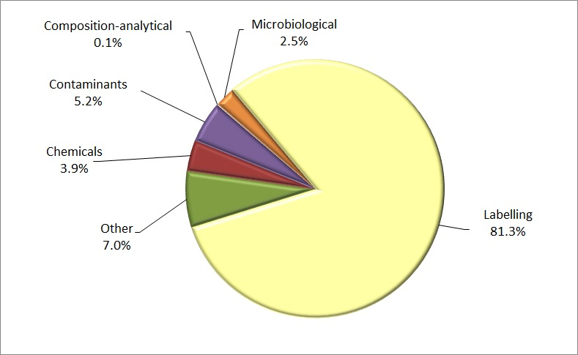

Note: ‘Other’ includes tests such as certification checks (BSE certification, raw milk cheese certification), composition and visual assessment.

Source: AIMS database

### Labelling compliance

In 2020 most non-compliance under the IFIS was for labels that did not comply with Australian food standards (Figure 2). Most notably:

* 38.8% of labels lacked or listed either incomplete or incorrect nutritional details
* 18.4% of labels lacked or listed either incomplete or incorrect ingredient lists
* 16.6% of labels were non-compliant with country of origin labelling requirements
* 12.4% of labels lacked importer details.

Figure 2 Non-compliant labelling, by information type, 2020

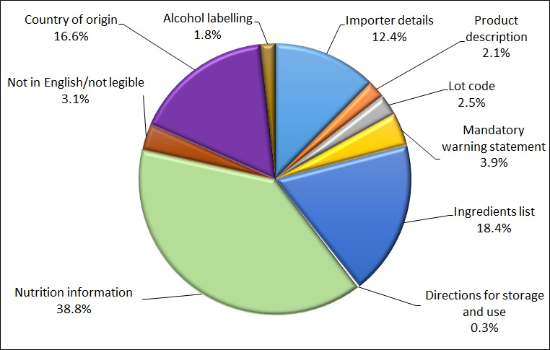

Source: AIMS database

### Analytical testing data

Analytical tests (Table 2) are grouped into 4 main types:

1. Chemical.
2. Composition (analytical assessment).
3. Contaminant.
4. Microbiological.

Within each category, different tests are applied depending on the food type.

The number of lines of food referred for inspection under IFIS and the number of tests applied to food may differ. This is because food subject to inspection is sampled and analysed based on the number of:

* batches and lots within each batch of food on the line referred for inspection
* test types applied to each sample of that food taken during inspection.

For example, a line of cooked and processed meat product may be referred for inspection under the IFIS. The line contains 2 batches of the product, each with 1 lot. An officer will take 1 sample from each batch and apply the test relevant to this food. The tests applied to cooked and processed meat products are for *Listeria monocytogenes* and *Salmonella*. As a result, 2 samples are taken from this 1 line of imported food with 2 microbiological tests applied to each sample. This would be reported as 1 line, with 4 separate test results.

Table 2 shows that, of the 24,677 analytical tests applied in 2020, 98.5% were compliant. Only 367 tests (1.5%) were non-compliant. The tests applied for each category are detailed in Table 3, Table 4, Table 5 and Table 6.

Table 2 Analytical test, compliance rates, 2020

| Test type | Tests applied (no.) | Compliant (no.) | Non-compliant (no.) | Compliant (%) |
| --- | --- | --- | --- | --- |
| Chemical | 6,032 | 5,909 | 123 | 98 |
| Composition | 141 | 139 | 2 | 98.6 |
| Contaminant | 9,504 | 9,341 | 163 | 98.3 |
| Microbiological | 9,000 | 8,921 | 79 | 99.1 |
| **Total** | **24,677** | 24,310 | 367 | **98.5** |

Source: AIMS database

Table 3 Chemical test, product compliance rates, 2020

| Chemical | Food type | Tests applied (no.) | Compliant (no.) | Non-compliant (no.) | Compliant (%) |
| --- | --- | --- | --- | --- | --- |
| Cannabidiol | Hemp seed and hemp seed products | 7 | 7 | – | 100 |
| Cephalosporins | Meat | 814 | 814 | – | 100 |
| Fluoroquinolones | Meat  Farmed fish and prawns | 1,236 | 1,231 | 5 | 99.6 |
| Fruit and vegetable residue screen | Fruit and vegetables | 2,403 | 2,291 | 112 | 95.3 |
| Malachite green | Farmed fish | 341 | 341 | – | 100 |
| Nitrofurans | Farmed prawns | 72 | 66 | 6 | 91.7 |
| Quinolones | Farmed fish | 338 | 338 | – | 100 |
| Total THC | Hemp seed and hemp seed product | 7 | 7 | – | 100 |
| Virginiamycin | Meat | 814 | 814 | – | 100 |
| **Total** | **–** | 6,032 | 5,909 | 123 | 98.0 |

Source: AIMS database

Table 4 Composition analytical test, product compliance rates, 2020

| Microbial agent | Food type | Tests applied (no.) | Compliant (no.) | Non-compliant (no.) | Compliant (%) |
| --- | --- | --- | --- | --- | --- |
| Allergen – Dairy | Coconut drinks and coconut powders | 21 | 21 | – | 100 |
| C4 adulteration | Honey | 42 | 42 | – | 100 |
| Moisture content | Honey | 39 | 39 | – | 100 |
| Reducing sugar content | Honey | 39 | 37 | 2 | 94.9 |
| **Total** | – | 141 | 139 | 2 | 98.6 |

Source: AIMS database

Table 5 Contaminant test, product compliance rates, 2020

| Contaminant | Food type | Tests applied (no.) | Compliant (no.) | Non-compliant (no.) | Compliant (%) |
| --- | --- | --- | --- | --- | --- |
| Aflatoxins | Nuts | 1,233 | 1,182 | 51 | 95.9 |
| Arsenic total | Cereal grains, cereal flours and processed cereals | 1,601 | 1,600 | 1 | 99.9 |
| Carbon monoxide | Tuna and barramundi fillets | 3 | 3 | – | 100 |
| Domoic acid | Bivalve molluscs | 506 | 506 | – | 100 |
| Erucic acid | Edible plant oils | 540 | 540 | – | 100 |
| Histamine | Fish | 2,822 | 2,756 | 66 | 97.7 |
| Hydrocyanic acid | Cassava chips | 117 | 101 | 16 | 86.3 |
| Inorganic arsenic | Seaweed (hijiki) | 8 | 6 | 2 | 75.0 |
| Iodine | Seaweed (brown algae) | 172 | 154 | 18 | 89.5 |
| Lead | Cereal grains, cereal flours, processed cereals, canned and preserved fruit | 1,966 | 1,957 | 9 | 99.5 |
| PSP toxin | Bivalve molluscs | 404 | 404 | – | 100 |
| Tin | Canned fruit | 132 | 132 | – | 100 |
| **Total** | **–** | 9,504 | 9,341 | 163 | 98.3 |

Source: AIMS database

Table 6 Microbiological test, product compliance rates, 2020

| Microbial agent | Food type | Tests applied (no.) | Compliant (no.) | Non-compliant (no.) | Compliant (%) |
| --- | --- | --- | --- | --- | --- |
| *Bacillus cereus* | Bean curd, tofu | 160 | 147 | 13 | 91.9 |
| Coagulase-positive staphylococci | Cooked crustaceans | 498 | 498 | – | 100 |
| *Escherichia coli* | Beef products, water, seafood, cheese, fruit and vegetables | 717 | 707 | 10 | 98.6 |
| *Listeria* *monocytogenes* | Cheese, ready-to-eat seafood, processed meats | 2,043 | 2,026 | 17 | 99.2 |
| *Listeria monocytogenes-*enumerated | Cheese, RTE finfish, slow-cured ham | 882 | 882 | – | 100.0 |
| *Salmonella* | Processed meats, seafood, dried coconut, dried paprika, pepper, capsicum and chilli, sesame seeds, cheese | 3,739 | 3,715 | 24 | 99.4 |
| Standard plate count | Cooked crustaceans | 475 | 461 | 14 | 97.1 |
| *Vibrio cholerae* | Cooked prawns | 486 | 485 | 1 | 99.8 |
| **Total** | **–** | **9,000** | 8,921 | 79 | **99.1** |

Source: AIMS database

### Results by commodity group

Table 7 provides the number of tests applied to particular food commodity groups. The results indicate the commodities that are most often tested but are not indicative of the volume of trade in particular commodities.

Commodity groups that contain more risk food or are imported more frequently will have a higher representation under the inspection activity.

Appendix A provides an overview of the analytical tests applied to the commodity groups.

The commodity group ‘other’ represents the largest group tested because it captures a range of tariff codes. These include many processed foods such as cereals, canned vegetables, vegetable oils, spices, confectionery, biscuits, coffee and tea.

Table 7 Inspection and test data, by commodity group, 2020

| Commodity group | Tests applied (no.) | Compliant (no.) | Non-compliant (no.) | Compliant (%) |
| --- | --- | --- | --- | --- |
| Beverages | 15,470 | 15,100 | 370 | 97.6 |
| Cereals, flours and milled products | 7,915 | 7,768 | 147 | 98.1 |
| Dairy | 5,786 | 5,749 | 37 | 99.4 |
| Eggs | 54 | 53 | 1 | 98.1 |
| Honey | 207 | 202 | 5 | 97.6 |
| Horticulture | 20,136 | 19,763 | 373 | 98.1 |
| Meat | 5,349 | 5,334 | 15 | 99.7 |
| Other (incl. processed food) | 76,605 | 74,745 | 1,860 | 97.6 |
| Seafood | 20,767 | 20,425 | 342 | 98.4 |
| **Total** | 152,289 | 149,139 | 3,150 | 97.9 |

Note:‘Other’ captures a range of tariff codes, including processed foods such as cereals, canned vegetables, vegetable oils, spices, confectionery, biscuits, coffee and tea.

Source: AIMS database

#### Test data, by commodity group

Figure 3 shows (excluding the ‘other’ category) that seafood was the commodity subject to the most testing (13.6%) in 2020. This commodity includes fresh, chilled, frozen and processed seafood products. Horticulture (including fresh and processed fruit and vegetables) was also subject to high levels of testing (13.2%).

Figure 3 Percentage of tests applied, by commodity group, 2020

The pie chart shows that the other category accounted for 50.3% of tests applied to commodity groups, seafood 13.6%, horticulture 13.2%, beverages 10.2%, cereals 5.2%, dairy 3.8%, meat 3.5%, 
honey less than 0.1%, and
eggs less than 0.1%.

Note: ‘Other’ captures a range of tariff codes, including processed foods such as cereals, canned vegetables, vegetable oils, spices, confectionery, biscuits, coffee and tea.

Source: AIMS database

### Other test data

In addition to labelling and analytical testing, other testing applied from January to December 2020 included composition assessments, bovine spongiform encephalopathy (BSE) government certificate checks and visual assessments.

#### Composition assessments

These assessments check the labels for additives or ingredients that are not permitted. Of the 65,053 assessments conducted in 2020, 201 labels were found to be non-compliant with Australian food standards.

#### Bovine spongiform encephalopathy certificate checks

Food containing beef is inspected to ensure it is covered by the appropriate government certification. A fail is recorded when a food containing beef is not covered by the appropriate government certification. In 2020, of the 847 certificate checks conducted, 846 (99.9%) were covered by the appropriate government certification. Only 1 (0.1%) of the certificate checks conducted found non-compliance (Table 8).

Table 8 Bovine spongiform encephalopathy certificate check, compliance rates, 2020

| Test type | Tests applied (no.) | Compliant (no.) | Non-compliant (no.) | Compliant (%) |
| --- | --- | --- | --- | --- |
| BSE government certificate | 847 | 846 | 1 | 99.9 |
| **Total** | 847 | 846 | 1 | 99.9 |

Source: AIMS database

#### Visual assessments

At each inspection, food is visually assessed to determine whether it is unsafe or unsuitable (for example, it contains foreign objects or shows signs of deterioration). In 2020, of the 61,247 visual assessments conducted, only 19 were non-compliant (Table 9).

Table 9 Visual assessment, compliance rates, 2020

| Type of test | Tests applied (no.) | Compliant (no.) | Non-compliant (no.) | Compliant (%) |
| --- | --- | --- | --- | --- |
| Visual | 61,247 | 61,228 | 19 | 99.97 |
| **Total** | 61,247 | 61,228 | 19 | 99.97 |

Source: AIMS database

#### Results, by country of origin

Under the IFIS, food is inspected irrespective of the country of export. The exception is where a food has previously failed inspection. Future consignments of that food from the producer in the particular country are inspected and analysed at a 100% rate of inspection and analysis until a history of compliance is re-established for the producer of the food.

The number of inspections by country of origin is provided in Table 10. Note that the countries where importers frequently source food will have more lines referred and therefore have a higher representation in inspection data.

Table 10 Number of inspections, by country of origin, 2020

| Country of origin | Lines inspected (no.) | Lines inspected (%) |
| --- | --- | --- |
| China | 6,449 | 12.7 |
| India | 3,825 | 7.5 |
| Japan | 3,710 | 7.3 |
| Italy | 3,678 | 7.2 |
| Thailand | 3,529 | 6.9 |
| Korea, Republic of | 3,093 | 6.1 |
| United States | 2,808 | 5.5 |
| Malaysia | 1,786 | 3.5 |
| Taiwan | 1,779 | 3.5 |
| France | 1,764 | 3.5 |
| Other | 18,520 | 36.4 |
| **Total** | **50,941** | **100** |

Source: AIMS database

From 1 January to 31 December 2020:

* food from China, India and Japan were subject to the most inspections
* 63.6% of food inspections were conducted on food from 10 countries; the remaining 36.4% concerned food from 134 countries.

A significant proportion of food imports are from New Zealand, but very few are subject to the *Imported Food Control Act 1992*. The Act exempts food imported from New Zealand unless the Order indicates that it applies. Currently, the Order specifies that beef, beef products, ready-to-eat cassava chips and brown seaweed are foods to which the Act applies. The exemption in the Act for food imported from New Zealand was included following the signing of the Trans-Tasman Mutual Recognition Arrangement between Australia and New Zealand. Under the arrangement, food produced by or imported into either country that meets one country’s food standards may be legally sold in the other country.

### Comparing inspection data reports since 2016

We have published IFIS data reports since 2006. Initially, reports were published every 6 months. Since 2017 we have published the reports annually.

Since 2016 the number of entries referred have increased by 31% and the number of lines inspected by 63% (Figure 4). This is likely to be a result of an increased volume of food imported.

Figure 4 Inspection activity, January 2016 to December 2020

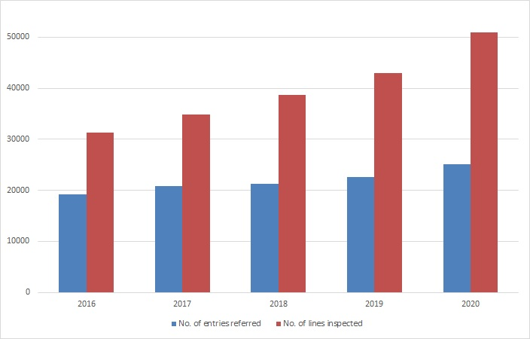

Source: AIMS database

Figure 5 summarises the number of tests applied at inspection in each calendar year. Since 2016 the number of analytical tests applied have increased by 26% and the number of labelling tests applied by 72%. The increase in the proportion of labelling tests applied reflects an increase in the volume of food imported (we check the labelling of all food referred to IFIS).

Figure 5 Tests conducted, January 2016 to December 2020

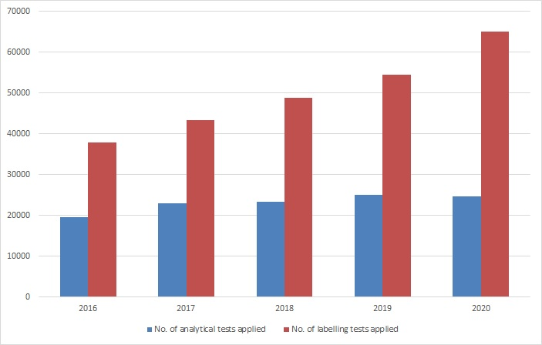

Source: AIMS database

## Appendix A: Analytical tests applied to food

Table A1 Analytical tests applied to food, 2020

| Food group | Risk or surveillance test | Analytical test |
| --- | --- | --- |
| Coconut milk drinks | Surveillance | Beta-lactoglobulin  Casein  Total milk |
| Dairy products | Risk | *Listeria* *monocytogenes* |
| Surveillance | *Listeria* *monocytogenes* (enumerated)  *Salmonella* |
| Edible plant oils | Surveillance | Erucic acid |
| Fruit and vegetables | Surveillance | Fruit and vegetable residue screen  *E. coli* (ready to eat berries, sweet/sugar snap peas, fresh baby corn, fresh chillies, sun-dried and semi-dried tomatoes) |
| Fruit – canned and preserved | Surveillance | Lead  Tin (canned only) |
| Fruit juices | Surveillance | Fruit and vegetable residue screen |
| Herbs and spices | Risk | *Salmonella* |
| Surveillance | *Salmonella* (dried and powdered herbs) |
| Honey | Surveillance | C4 Adulteration  Moisture content  Reducing sugar content |
| Meat | Risk | Government certification for bovine spongiform encephalopathy  Coagulase-positive staphylococci  *E. coli*  *Listeria* *monocytogenes*  *Salmonella* |
| Surveillance | *Listeria* *monocytogenes (enumerated)*  *E. coli*  *Salmonella*  Cephalosporins  Fluoroquinolones  Virginiamycin |
| Nuts and nut products | Risk | *Salmonella* (coconut)  Aflatoxin |
| Surveillance | *Salmonella* (chilled or frozen shredded coconut) |
| Seafood | Risk | Histamine  *Listeria* *monocytogenes*  Coagulase-positive staphylococci  *E. coli*  *Salmonella*  Standard plate count  Paralytic shellfish poison (PSP)  Domoic acid  *Vibrio cholerae* |
| Surveillance | Fluoroquinolones  Malachite green  Nitrofurans  Quinolones  Carbon monoxide (tuna and barramundi fillets) |
| Plant-based products | Risk | *Salmonella* (sesame seed and dried coconut)  Inorganic arsenic (hijiki seaweed)  Iodine (seaweed – brown algae)  Hydrocyanic acid (cassava chips) |
| Surveillance | Fruit and vegetable residue screen  *Bacillus cereus* (tofu, soybean curd or soy milk curd)  Arsenic total (cereal grains, ready-to-eat cereal flours and processed cereals)  Cannabidiol, total THC (hemp seed and hemp seed products) |

## Glossary

| Term | Definition |
| --- | --- |
| AIMS | Computer system that receives data on imported goods from the Integrated Cargo System (ICS) and processes entries for imported food and biosecurity purposes. |
| Australia New Zealand Food Standards Code | Details food standards applicable to food for human consumption in Australia. See the [Food standards code](https://www.foodstandards.gov.au/code/Pages/default.aspx). |
| batch | Food of a particular kind, made or packed in a distinct manner that may include one or more lots. |
| entry | Department of Home Affairs electronic document generated using the ICS. An entry may contain one or more lines or food. |
| food | Under section 3 of the [Imported Food Control Act 1992](https://www.legislation.gov.au/Series/C2004A04512),  (1) Food includes  (a) any substance or thing of a kind used, capable of being used, or represented as being for use, for human consumption (whether it is live, raw, prepared or partly prepared); and  (b) any substance or thing of a kind used, capable of being used, or represented as being for use, as an ingredient or additive in a substance or thing referred to in paragraph (a); and  (c) any substance used in preparing a substance or thing referred to in paragraph (a); and  (d) chewing gum or an ingredient or additive in chewing gum, or any substance used in preparing chewing gum; and  (e) any substance or thing declared to be a food under a declaration in force under section 6 of the *Food Standards Australia New Zealand Act 1991*.  (It does not matter whether the substance, thing or chewing gum is in a condition fit for human consumption.)  (2) However, food does not include a therapeutic good within the meaning of the *Therapeutic Goods Act 1989.*  (3) To avoid doubt, food may include live animals and plants. |
| FSANZ | Food Standards Australia New Zealand is a bi-national government agency responsible for developing food standards and administering the Australia New Zealand Food Standards Code. FSANZ conducts the food risk assessment and advises the Department of Agriculture, Water and the Environment on food that poses a medium or high risk to public health. |
| holding order | An order made under section 15 of the *Imported Food Control Act 1992* that increases the rate of inspection of a surveillance food that has failed an imported food inspection. This targets the specific food from the specific producer in a specific country at a rate of 100% of consignments. |
| ICS | Integrated Cargo System, a computer system managed by the Department of Home Affairs. |
| Imported Food Inspection Scheme | IFIS was established under the Imported Food Control Regulations 2019. It provides for inspection of food at the border to assess importer compliance with sourcing food that does not pose a risk to human health and meets Australian food standards. |
| inspection | Includes inspection (visual and label assessment) or inspection and analysis (samples taken and sent for analysis) as required. |
| line | Items of food being imported are recorded in the ICS as lines within the import entry. An import entry may consist of one or more lines of products. |
| lot | A quantity of a food prepared or packed under the same conditions (ordinarily from a particular preparation or packing unit and during a particular time, ordinarily not exceeding 24 hours). |
| lot code | A unique code that identifies a lot (quantity of food) and can be used for recall purposes if necessary. |
| risk food | Food that is classified as risk food in the Imported Food Control Order 2019. This kind of food is referred to AIMS by the ICS for inspection at the rate of 100% of consignments. The rate is reduced in accordance with a history of compliance. |
| surveillance food | All other food not classified as risk food. This kind of food is referred to AIMS by the ICS for inspection at the rate of 5% of consignments. |