Cost recovery implementation statement: fish and egg exports 2024–25
© Commonwealth of Australia 2024
Ownership of intellectual property rights
Unless otherwise noted, copyright (and any other intellectual property rights) in this publication is owned by the Commonwealth of Australia (referred to as the Commonwealth).
Creative Commons licence
All material in this publication is licensed under a Creative Commons Attribution 4.0 International Licence except content supplied by third parties, logos and the Commonwealth Coat of Arms.

Cataloguing data
This publication (and any material sourced from it) should be attributed as: DAFF 2024, Cost recovery implementation statement: fish and egg exports 2024–25, Department of Agriculture, Fisheries and Forestry, Canberra, July. CC BY 4.0.
This publication is available at agriculture.gov.au/about/fees/cost-recovery-2024-25
Department of Agriculture, Fisheries and Forestry
GPO Box 858 Canberra ACT 2601
Telephone 1800 900 090
Web agriculture.gov.au
Disclaimer
The Australian Government acting through the Department of Agriculture, Fisheries and Forestry has exercised due care and skill in preparing and compiling the information and data in this publication. Notwithstanding, the Department of Agriculture, Fisheries and Forestry, its employees and advisers disclaim all liability, including liability for negligence and for any loss, damage, injury, expense or cost incurred by any person as a result of accessing, using or relying on any of the information or data in this publication to the maximum extent permitted by law.
Acknowledgement of Country
We acknowledge the Traditional Custodians of Australia and their continuing connection to land and sea, waters, environment and community. We pay our respects to the Traditional Custodians of the lands we live and work on, their culture, and their Elders past and present.
Contents
Summary 1
1 Policy and statutory authority to cost recover 2
1.1 About the department 2
1.2 Government policy approval to cost recover 2
1.3 Statutory authority to apply fees and charges 2
1.4 Payment of regulatory services 3
2 Risk assessment 4
3 Stakeholder consultation 5
3.1 Stakeholder engagement strategy 5
4 Cost recovery arrangement for fish and egg exports 7
4.1 Description of the regulatory activity 7
4.2 Cost base assumptions 8
4.3 Projected cost base 8
5 Design of regulatory charges 11
5.1 Fish and egg exports fees and charges 11
5.2 Revenue variability 12
6 Financial estimates 13
6.1 Financial estimates 13
6.2 Cost recovery reserve 13
7 Financial and non-financial performance 14
7.1 Financial performance 14
7.2 Summary financial performance 2022–23 14
7.3 Non-financial performance 15
8 Key dates and events 17
9 CRIS approval and change register 18
Appendix A: Additional fees and charges that may apply 19
Organics – application and audit 19
Outside ordinary hours 19
Appendix B: Cost recovery model 20
Outputs and business processes of the regulatory charging activity 20
Costs of regulatory charging activity 21
Description of cost model activities 23
Assurance activities 24
Incident management activities 24
Intervention activities 24
Appendix C: Summary of stakeholder feedback 26
Appendix D: Government approval to cost recover 27

Tables
Table 1 Regulatory charging stakeholder engagement approach 6
Table 2 Cost base for fish and egg exports cost recovery arrangement, 2024–25 9
Table 3 Cost type breakdown for fish and egg exports cost recovery arrangement, 2024–25 10
Table 4 Fees, charges and volumes for fish and egg exports cost recovery arrangement, 2024–25 11
Table 5 Financial estimates for fish and egg exports cost recovery arrangement 13
Table 6 Financial performance for fish and egg exports cost recovery arrangement, 2019–20 to 2022–23 14
Table 7 Fish and egg export arrangement summary of financial position, 2022–23 14
Table 8 Key forward dates and events 17
Table 9 CRIS approval and change register 18
Table A1 Organics fees and charge 19
Table A2 Outside ordinary hours fees 19
Table C1 stakeholder feedback for the 2024–25 CRIS. 26
Table D1 Government approval for regulatory charging for agricultural export activities 27

Figures
Figure 1 Engagement process 6
Figure B1 Outputs and business processes of the department’s regulatory charging activity 20
Figure B2 Categories of activities 22

Activities
Key activity 1 Support sector productivity, resilience and growth through science, policy and partnership 15
Key activity 2 Maintain and expend exports and access to international markets 15
Key activity 3 Streamline export regulations and compliance arrangements 15

Summary
This cost recovery implementation statement (CRIS) provides information on how the department implements cost recovery for the fish and egg export cost recovery arrangement.
The department performs a range of regulatory activities in support of our producers and exporters who take their high-quality products to global markets. Australian agriculture, fisheries and forestry is a substantial part of the Australian economy, with exports contributing around $1.6 billion every week (total $83 billion in 2022–23).
We implement cost recovery for fish and egg export activities through:
- Fees are charged when regulation is provided directly to an individual or organisation for the delivery of regulatory activities such as inspections of goods, audit of registered premises, or assessment of export certification.
- Cost recovery levies or charges are applied when regulation is imposed on an industry sector rather than directly to a specific individual or organisation. These charges recover the costs of maintaining regulatory infrastructure and integrity through program management and administration, assurance and incident management activities.
This version of our CRIS will describe the final stepped increase in prices that was implemented through the Busting Congestion for Agricultural Exporters (PDF 211 KB) package in the 2020–21 Federal Budget. It sets out the assumptions, costs, volumes and prices for regulatory activities in 2024–25. It describes the method of cost allocation used in determining prices for activities. It also reports financial and non-financial information of past performance of the arrangement.
The budget measure Securing the future of agricultural trade (PDF 308 KB), describes the Australian Government’s investment to ensure Australia’s regulatory export and trade system remains able to meet both the needs of our exporters and the expectations of our trading partners, while supporting industry to achieve its goals now and into the future.
As part of this measure, $3.7 million has been provided over 3 years, across all 7 agriculture export arrangements, to enable the development of an ongoing sustainable export funding model. This will enable the department to remain appropriately resourced to carry out its agricultural trade and exports functions into the future.

Policy and statutory authority to cost recover

About the department
Our vision is a more sustainable and prosperous Australia through biosecurity, agricultural production and trade.
We maintain and create agricultural export opportunities, to provide gains for Australian agriculture, fishing and forestry. We manage biosecurity risks to Australia to protect our multi-billion-dollar industries and our way of life. We engage with international counterparts to reinforce Australia’s role in shaping how the global agriculture and fibre sector addresses food security, productivity, trade, sustainability and the impacts of climate change.
As a regulator, we enforce laws relating to agricultural goods exported from Australia. We are also responsible for administration of export controls on agricultural, fisheries and forestry industries products.
By working together with industry and our state and territory partners, our objective is to safeguard and grow sustainable agriculture, fisheries and forestry for all Australians.

Government policy approval to cost recover
Policy authority for cost recovery for export regulatory activities was reaffirmed in the 2023–24 Mid-year Economic and Fiscal Outlook through the government’s Securing the future of agricultural trade measure. This measure announced a $91.8 million over 2 years to sustain delivery of key department export trade and regulatory functions and to ensure departmental services continue to meet the demands of Australia’s agriculture and food product export industries.
A further $3.7 million under the measure has been provided to enable development of an ongoing sustainable funding model over three years. Development of this model will ensure the department is appropriately resourced through both cost recovery and appropriation funding to undertake it’s export regulatory activities, trade, national coordination, and leadership activities.
Further information on previous government authority for regulatory charging can be found at Appendix D.

Statutory authority to apply fees and charges
The Export Control Act 2020 Section 399 Fees and other rules for fee-bearing activities, states the rules may prescribe fees that may be charged in relation to fee‑bearing activities carried out by, or on behalf of, the Commonwealth in the performance of functions or the exercise of powers under the Act. The specific fees and price points are set out in the Export Control (Fees and Payments) Rules 2021.
Cost recovery charges are imposed under the:
- Export Charges (Imposition – General) Act 2015
- Export Charges (Imposition – Customs) Act 2015
- Export Charges (Imposition – Excise) Act 2015.
Details of specific price points and charges payable are included in the:
- Export Charges (Imposition – General) Regulations 2021
- Export Charges (Imposition – Customs) Regulations 2021.

Payment of regulatory services
The department cost recovers regulatory charges from participants in the fish and egg export supply chain, including exporters, manufacturers and storage facilities.
Additional information on services provided and the entities are outlined in section 4.1.

Risk assessment
In accordance with the Australian Government Charging Policy, the department has undertaken a Charging Risk Assessment (CRA) involving the ongoing assessment and management of risk at each phase of the cost recovery process. The CRA for the fish and egg exports cost recovery arrangement is rated at medium, which is based on an assessment of each component, including:
- a low-risk rating for the expected percentage change in total annual revenue (less than 10%)
- a low-risk rating for the expected change in total value of annual revenue (less than $10 million)
- a low-risk rating for the highest percentage increase in price a payer may experience (less than 5%)
- a medium-risk rating as the changes proposed apply to both fees and levies
- a low-risk rating as the proposal relates to a change in the level of existing regulatory charges only
- a low-risk rating due to the level of change in legislative arrangements (no legislative changes required)
- a low-risk rating due to the level of impact of cost recovery on payers
- a low-risk rating due to the level of complexity in working with other government entities to deliver regulatory functions
- a low-risk rating due to the ongoing consultation with stakeholders on the changes.
The department provided the Office of Impact Analysis (OIA) with an Australian Government Impact Analysis Preliminary Assessment. The OIA has determined that a detailed impact analysis is not required, based on an assessment of the following components:
- Regulatory prices for export cost recovery arrangements were developed in 2021 and stepped price increases were set over a 4-year period covering the 2022–23 to 2025–26 financial years.
- Consultation was undertaken in both 2021–22 and 2022–23 on the prices, which were subsequently enacted in legislation.
- Legislated increases for 2024–25 are to be implemented on 1 July 2024.

Stakeholder consultation
The department engages with fish and egg industry representatives on charging arrangements through the Seafood Export Consultative Committee (SECC) and annual public communications. The 2021–22 CRIS explained the approach for gradually increasing prices and what those prices would be each year, including 2024–25.
Consultation with stakeholders on the 2022–23 CRIS occurred in July and August 2022.
Public consultation feedback for the 2024–25 CRIS is included in Appendix C.

Stakeholder engagement strategy

Purpose
This stakeholder engagement strategy for the cost recovery of fish and egg exports regulatory activities outlines the engagement principles, method and approach. The purpose of the strategy is to work with industry to update the CRIS as needed and provide information on the performance of the cost recovery arrangement.
This strategy helps the department to plan, design, undertake and evaluate stakeholder engagement activities.
It has been designed to meet the requirements of the:
- Australian Government Charging Framework
- Australian Government Guide to Regulation
- Australian Public Service Framework for Engagement and Participation.

Principles
The department’s principles for engagement are to listen and engage meaningfully by:
- clearly explaining the objective and context of stakeholder engagement
- communicating what is yet to be decided and what has already been decided
- providing sufficient time for stakeholders to engage in consultation processes
- ensuring information that is essential to participant’s roles is made available to them
- providing feedback on how stakeholder consultation has been taken into consideration.

Method
The department, throughout the annual CRIS reviews plans to consult on, implement, monitor and review regulatory charging.
The department will also design revised fees and charges in the CRIS documents as needed.
Figure 1 Engagement process
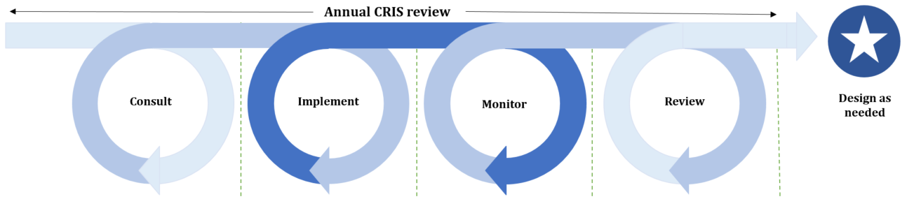
Throughout this process, the department used 2 different levels of engagement:
- share – when government needs to tell the public about an initiative
- consult – when government gathers feedback from specific industry groups about a problem or a solution.

Approach
The department’s engagement approach is outlined in Table 1.
Table 1 Regulatory charging stakeholder engagement approach
Category | Consult annually | Implement annually | Monitor annually | Review | Design as needed
Objective | Public consultation to seek feedback on annual updates to the proposed cost base, fees and charges in the draft CRIS. | Publish public information to prepare stakeholders for upcoming changes to regulatory charging. | Publish information on prior year financial and non-financial performance of regulatory charging. | Consultation to seek feedback on regulatory charging performance and stakeholder engagement. | Targeted consultation to seek advice and input on behalf of their industries to develop volume, expense and pricing models.
Level of engagement | Consult | Share | Share | Consult | Consult
Timing | Annually in first quarter of the year. | Annually in June. | Annually in October. | As needed or for the Portfolio Charging Review in 2024. | As needed.
Stakeholders | - Industry consultative committees (ICCs).  - All industry participants.  - Peak industry bodies. | - All industry participants.  - Peak industry bodies. | - Industry consultative committees (ICCs).  - All industry participants.  - Peak industry bodies. | - Industry consultative committees (ICCs).  - All industry participants.  - Peak industry bodies. | - Industry consultative committees (ICCs).  - Peak industry bodies
Method | - Online – Have Your Say.  - Face-to-face/virtual meetings. | - Industry advice notices (IANs).  - Online – department website. | - Online – department website. | - Online – Have Your Say. | - Face-to-face.  - Teleconference.

Cost recovery arrangement for fish and egg exports
The Australian Government Cost Recovery Policy requires that regulators recover some or all of the efficient costs of the effort required to deliver their services, unless the government has decided to fund that activity.
The modelling of fees and charges in 2021–22 endeavoured to forecast Consumer Prince Index (CPI) growth in costs and increased demand for regulatory activities for fish and egg exports. Stepped increases were planned to return export cost recovery arrangements back to full cost recovery by 2023–24. Prices were legislated for these stepped increases from 2021–22 through to 2024–25.
In recent years, the rate of change in Australia’s export trade landscape has accelerated. Our market access requirements are changing, and the global agricultural trade environment is becoming more complex. It has become clear that the modelling and assumptions used to form the prices now in legislation differs from reality.
The department is acting on these issues in 2 ways.
- Regulatory pricing for 2024–25 will continue at the rates set out in legislation to give certainty to industry and maintain the stepped increase in prices that has previously been consulted on.
- The department has been provided $3.7 million over 3 years to enable the development of an ongoing sustainable funding model. This will enable the department to remain appropriately resourced to carry out its agricultural trade and exports functions into the future.
Industry will be engaged, through the development of a sustainable model, to gain views and feedback on more modern ways of providing an efficient and sustainable model of cost recovery for regulatory activities.

Description of the regulatory activity
Fish and egg exports are regulated in accordance with Export Control Act 2020 and associated legislative framework (see section 1.3).
To certify a product’s compliance with Australia’s export requirements and the importing country requirements, the department undertakes a range of activities, including:
- developing, implementing and monitoring of operational policy and systems that ensure compliance with Australian export controls and any importing country requirements. These activities serve to maintain the eligibility of commodities for export from Australia and to protect and promote Australia’s reputation for premium agricultural goods, while maintaining existing, and seeking increased, market access opportunities
- providing inspection, auditing, verifying, and enforcement activities to ensure that the production, storage, handling and transportation of fish and egg products intended for export comply with the conditions of Australian export controls and any additional requirements imposed by an importing country
- issuing permits, export certification and other documentation necessary to confirm compliance with the Australian export controls and any additional importing country requirements
- managing quota allocation and quota certification to enable exporters to access tariff rate concessions offered under trade agreements
- providing support through the department’s overseas counsellors relating to detained consignments, government certification and other issues which result in goods being held at the border
- managing the National Residue Survey (NRS) which supports Australia’s primary producers and agricultural industries by confirming Australia’s status as a producer of clean food and facilitating access to export markets
- enforcing regulation of certified organic goods exported from Australia.
For more information, see Export goods controlled by the department.

Cost base assumptions
The greater part of the department’s regulatory activity cost is employee related. External suppliers and operating support for our export IT systems makes up other major direct costs. The time and effort spent on regulatory activities, such as permits, and assessment-based output has been reflected in the fees and charges.
The cost base was modelled to reflect the full costs to deliver regulatory services to support the fish and egg industry. The 2021–22 CRIS model was used as the starting point for determining the cost base applied in this CRIS and advised to industry in previous versions of this document. Assumptions made in the modelling were:
- inflation of 1.7% per annum, in line with the Department of Finance’s inflation estimate
- a decreased wage price index (WPI) applied to employee expenses from 2.0% to 1.7% per annum, reflecting reasonable estimates of wage increments in line with the Australian Public Service Workplace Bargaining Policy 2020
- additional depreciation from new assets anticipated to be recognised over the period
- adjustments for future fee-related activities to reflect expected changes in volume.
Our market access requirements are changing, and the global agricultural trade environment is becoming more complex. The assumptions underlying the 2021–22 cost base increases are no longer valid and extensive work is required to reset the cost recovery arrangement for fish and egg exports.
Following the comprehensive review currently underway, the department will undertake an annual review process to evaluate regulatory effort, costs, and the charges based on those costs, to ensure pricing remains consistent with costs and sustainable to maintain regulatory activities.

Projected cost base
The department allocates employee, supplier, system and corporate costs to each type of regulatory activity (see Appendix B).

Direct costs
Direct costs are primarily the costs of employees who provide regulatory activities. In addition to the costs of employees, it also includes supplier cost such as direct capital expenses. Direct costs are allocated to the regulatory activity that best reflects the activity undertaken.

Indirect costs
Indirect costs are enabling costs that cannot be attributed to a specific activity or output. These include information and communications technology, maintenance, office accommodation, and finance and corporate services costs. The department includes indirect expenses in the cost base to reflect the systems and processes that exist to help with efficient administration, which the cost-recovered arrangements benefit from. Indirect costs are allocated using cost drivers such as headcount and fulltime equivalent (FTE), in line with the department’s cost allocation policy.

Capital costs
Capital costs included in the operating costs of business processes are depreciation of property, plant and equipment (including furniture, IT hardware and infrastructure), amortisation of IT systems and software, non-capital software development costs, and accommodation.
A description of cost activities and the methodology for attributing costs to these activities, is provided at Appendix B.
Table 2 shows the fish and egg arrangement cost base for 2024–25.
The cost base of $4.0 million is made up of:
- $3.5 million in charge-related activities
- $0.5 million in fee-related activities.
A description of cost activities and the methodology for attributing costs to these activities, is provided at Appendix B.
Table 2 Cost base for fish and egg exports cost recovery arrangement, 2024–25
Charge type | Activity | Expense ($) | Cost recovery charges
Charge | - Program management and administration  - Workforce and business administration  - Business system administration  - Stakeholder engagement  - Policy and instructional material  - Business improvement  - Assurance  - Risk management  - Verification  - Surveillance  - Incident management  - Incident management  - Investigative support  - Corrective action | 3,568,824 | Annual registration, export documentation, throughput, application and organic certification
Fee-for-service | Intervention – assessment | 89,215 | Assessment
 | Intervention – inspection | 15,780 | Inspection
 | Intervention – audit | 417,357 | Audit
Total cost base | – | 4,091,176 | –
Table 3 Cost type breakdown for fish and egg exports cost recovery arrangement, 2024–25
Category | Expense | Forecast ($)
Direct | Employee | 2,125,886
 | Operating | 539,591
 | Other | 80,752
 | Subtotal | 2,746,230
Indirect | Assurance and legal | 22,042
 | Corporate and Business Services | 65,339
 | Export support | 66,611
 | Finance | 268,793
 | Information services | 477,207
 | People services | 142,535
 | Property | 302,418
 | Subtotal | 1,344,946
Total | – | 4,091,176

Design of regulatory charges
This CRIS provides for a mix of fee-for-service and levy (charges) regulatory activities, implemented under the Export Control (Fees and Payments) Rules 2021.
Fees are charged when regulation is provided directly to an individual or organisation for the delivery of regulatory activities such as inspections of goods, audit of registered premises, or assessment of export certification (see Intervention activities)
Cost recovery levies or charges are applied when regulation is imposed on an industry sector rather than directly to a specific individual or organisation. These charges recover the costs of maintaining regulatory infrastructure and integrity through program management and administration, assurance and incident management activities (see Appendix B).

Fish and egg exports fees and charges
No changes to the types of fees and charges or charge points are proposed in this CRIS.
The fees and charges have been legislated in the Export Control (Fees and Payments) Rules 2021 to increase each year on 1 July 2024.
The amount payable for 2024–25 is shown in Table 4.
Table 4 Fees, charges and volumes for fish and egg exports cost recovery arrangement, 2024–25
Type of charge | Cost recovery charges | Unit | Price ($) | Estimated volume | Estimated revenue ($)
Charges | Storage establishment – seafood | Annual | 2,106 | 125 | 263,250
 | Vessel (preparation not direct export) | Annual | 1,404 | 8 | 11,232
 | Vessel (preparation direct export) | Annual | 2,807 | 112 | 314,384
 | Land establishment – live only | Annual | 1,404 | 57 | 80,028
 | Land establishment – processing | Annual | 2,807 | 178 | 499,646
 | Egg establishment | Annual | 2,106 | 57 | 120,042
 | Electronic permit – fish | Per document | 31 | 31,242 | 968,502
 | Electronic health certificate – fish | Per document | 31 | 28,454 | 882,074
 | Electronic permit – egg | Per document | 31 | 360 | 11,160
 | Electronic health certificate – egg | Per document | 31 | 328 | 10,168
 | Registration application | Per application | 689 | 46 | 31,694
Fees – audit and inspection | Audit | Per quarter hour | 57 | 6,734 | 383,838
 | Inspection | Per quarter hour | 57 | 268 | 15,276
Fees – documentation | Electronic health certificates | Per document | 7 | 28,782 | 201,474
 | Electronic permit | Per document | 7 | 31,602 | 221,214
 | Manual health certificates | Per document | 115 | 148 | 17,020
 | Manual permit | Per document | 115 | – | –
 | Replacement certificate | Per document | 574 | 150 | 86,100
Organics a | Organic certifying body | Annual (charged quarterly) | 8,608 | 1 | 8,608
Total | – | – | – | – | 4,125,710
Note: Prices have been rounded. The annual charge will be rounded upwards to the nearest dollar. a Organic certifiers support a small number of exporters in all of the export arrangements (excluding Live Animal Exports) and therefore the expense has been reflected in each CRIS.

Revenue variability
Complexity, materiality and sensitivity are considered in assessing the risk of variation in revenue from cost-recovered activities. Each of these factors applies to the export arrangements in varying degrees. For example, in relation to the department’s regulatory activity, the variability in demand and climatic events both contribute to the complexity of projecting revenue from fees and charges.
The demand for the department’s activities, and therefore our revenue stream, is sensitive to market fluctuations. The applications for new registrations and permits are initiated by industry and are beyond the department’s control. They can vary depending on government policy settings, demand for Australian products overseas and broader economic and climatic conditions.

Financial estimates

Financial estimates
The financial estimates of the fish and egg exports cost recovery arrangement are provided in Table 5.
There will be no change to the cost recovery reserve and the deficit is intended to be carried forward until a government decision is taken to address it.
Table 5 Financial estimates for fish and egg exports cost recovery arrangement
Finance element | 2022–23 ($) ª | 2023–24 ($) ^{b} | 2024–25 ($) ^{b} | 2025–26 ($) ^{b}
Revenue = X | 3,866,257 | 4,030,333 | 4,125,710 | 4,125,710
Expenses = Y | 3,896,911 | 4,016,883 | 4,091,176 | 4,130,573
Balance = X – Y | (30,654) | 13,450 | 34,534 | (4,863)
Appropriation funding | 17,021 | n/a | n/a | n/a
Balance after appropriation | (13,633) | 13,450 | 34,534 | (4,863)
Forecast opening balance | 814,797 | 801,165 | 814,615 | 849,149
Transfer | (13,633) | 13,450 | 34,534 | (4,863)
Forecast closing balance | 801,165 | 814,615 | 849,149 | 844,286
Note: numbers in brackets are negative. a Actual. b Forecast. n/a Not applicable.

Cost recovery reserve
We maintain a cost recovery reserve to assist with managing the alignment of revenue and expenses and variations to forecast volumes. The reserve reflects the accumulated results of the arrangement since its inception. Our cost recovery reserve policy requires that a balance of up to 5% of annual program expense be maintained.
Regulatory charging is set to recover reasonable costs. However, several factors can affect the difference between revenue and expenses. These factors include volume variances and changes in expenses based on risk profiles. Demand for commodities, overseas economic factors, and climatic events can all impact regulatory effort, costs and volumes of activities.
Under-recoveries will result in the arrangement not recovering the costs of regulatory activities. This results in the arrangement operating at a loss, and adversely impacts the reserve balance for the arrangement at year’s end. Ongoing under recovery will lead to the need for further review of the regulatory charging arrangement to ensure its return to sustainable recovery for all regulatory costs.
Once a fee or charge is paid by industry, it becomes government revenue. We will consult with industry on any under-recovery or over-recovery. Subject to agreement between the department and industry, over-recoveries may be managed through remittance or investment initiatives.

Financial and non-financial performance
This section presents information on the financial and non-financial performance of the fish and egg exports cost recovery arrangement. This is intended to provide an overview of the department’s performance in recovering forecast costs and meeting regulatory objectives.

Financial performance
The financial performance for the fish and egg cost recovery arrangement is provided in Table 6.
Table 6 Financial performance for fish and egg exports cost recovery arrangement, 2019–20 to 2022–23
Finance element | 2019–20 ($) | 2020–21 ($) | 2021–22 ($) | 2022–23 ($)
Revenue = X | 3,698,001 | 3,460,073 | 3,563,906 | 3,866,257
Expenses = Y | 3,698,227 | 3,467,543 | 3,818,425 | 3,896,911
Balance = X – Y | (226) | (7,470) | (254,519) | (30,654)
Remissions, rebates and adjustments = Z | n/a | n/a | n/a | 17,021
Net balance = balance + Z | (226) | (7,470) | (254,519) | (13,633)
Balance | (814,796) | (814,796) | (814,796) | (801,165)

Summary financial performance 2022–23
The fish and egg exports 2022–23 CRIS forecast a $52,018 surplus. Actual expenditure totalled $3.89 million offset by revenue of $3.87 million, resulting in a $30,654 deficit in .
Table 7 Fish and egg export arrangement summary of financial position, 2022–23
Category | Actual ($) | CRIS ($) | Variance ($) | Variance (%)
Revenue | 3,866,257 | 3,995,597 | (129,340) | (3)
Expenses | 3,896,911 | 3,943,579 | (46,668) | (1)
Net surplus/(deficit) | (30,654) | 52,018 | (82,672) | (159)
Appropriation | 17,021 | 0 | 17,021 | (100)
Balance | 801,164 | 814,797 | (13,633) | 0

Busting congestion measure
The government announced the Busting Congestion for Agricultural Exporters package as part of the 2020–21 Budget. The package froze export certification fees and charges in 2020–21 and increased prices in steps to reach full cost recovery in 2023–24. The package was also to ensure that for the duration of the measure, the arrangement’s cost recovery reserve balance would not decrease (see Table 6). However, it did not cover the full shortfall in 2022–23, resulting in a movement in the reserve balance.

Non-financial performance
Our Annual report 2022–23 provides comprehensive information on performance measures and performance results. It is not intended to duplicate this information in this document but rather to draw attention to the key objectives relevant to export cost recovery arrangements. Non-financial performance measures are given as high-level objectives and are not reported at a level specific to each cost recovery arrangement.

Objective 1 Industry growth
Support industry to grow towards a $100 billion agriculture, fisheries and forestry industry by 2030 amid changing global market conditions.
Key activity 1 Support sector productivity, resilience and growth through science, policy and partnership
Measure IG–01 | Greater growth in average agricultural productivity (adjusted for climate and weather effects) for the past 10 years, compared to average annual market sector productivity growth over the same period.
Measure type | Effectiveness.
Target | Greater than or equal to 0% difference over past 10 years.
Result | Not achieved – market sector growth rate was 0.27% higher than the agricultural productivity growth rate.
Tolerances | Achieved: Average annual growth in the agricultural productivity (climate-adjusted) series exceeds average annual market sector productivity growth over the same period.  Partially achieved: Not applicable.  Not achieved: Average annual growth in the agricultural productivity (climate-adjusted) series is lower than average annual market sector productivity growth over the same period.
Key activity 2 Maintain and expend exports and access to international markets
Measure IG–04 | Decrease in the number of point-of-entry failures of agricultural exports where the department’s actions have caused the failure. Measured via meat and meat products commodity as a proxy for all agricultural trade.
Measure type | Efficiency and regulatory.
Target | Decrease from the previous year in the number of point-of-entry failures from agricultural exports. Measured via meat and meat products commodity as a proxy for all agricultural trade.
Result | Achieved – 0 instances of point-of-entry failures as a result of departmental action.
Tolerances | Achieved: Reduction in number of point-of-entry failures where the department is responsible compared with 2021–22.  Partially achieved: No change in number of point-of-entry failures where the department is responsible compared with 2021–22.  Not achieved: Increase in number of point-of-entry failures where the department is responsible compared with 2021–22.
Key activity 3 Streamline export regulations and compliance arrangements
Measure IG–05 | Increase in the number of electronic certificates for export issued (moving to paperless trade).
Measure type | Effectiveness and regulatory.
Target | Establish a baseline.
Result | Baseline established (61,237 electronic certificates issued).
Tolerances | Achieved: 100%.  Partially achieved: 50% to 99%.  Not achieved: 0% to 49%.
Note: For a complete picture of our performance, see Part 1: Annual performance statements – Our performance measures, of the Annual report 2022–23.

Key dates and events
Regular reviews of financial performance are undertaken, and regular stakeholder engagement activities are conducted throughout the CRIS cycle in line with the stakeholder engagement strategy documented in section 3.1. Key forward dates for regulatory charging for the fish and egg exports regulatory activities are documented in Table 8.
Table 8 Key forward dates and events
Key forward events schedule | Next scheduled update
Stakeholder engagement | April 2024
Updated fees and charges implemented | 1 July 2024
Annual CRIS updates to financial and non-financial performance for 2023–24 | November 2024
Annual CRIS update to forward estimates | February 2025
Updated fees and charges implemented | 1 July 2025
Annual CRIS updates to financial and non-financial performance for 2024–25 | October 2025
Annual CRIS update to forward estimates | February 2026
Updated fees and charges implemented | July 2026

CRIS approval and change register
Table 9 tracks the changes to the CRIS as a result of changes to the regulatory charging activity.
Table 9 CRIS approval and change register
Date of CRIS Change | CRIS Change | Approver | Basis for change
TBA | Certification of the CRIS | Secretary, Department of Agriculture, Fisheries and Forestry | New regulatory charging activity and revalidation of cost model
TBA | Approval of CRIS | Minister of Agriculture, Fisheries and Forestry | Communication and distribution of the new regulatory charging activity and revalidation of cost model

Appendix A: Additional fees and charges that may apply

Organics – application and audit
The prices for application for and audit of organic certifying entity are as indicated in Table A1.
Table A1 Organics fees and charge
Type of charge | Cost recovery charges | Unit | Price ($)
 |  |  | 2023–24 | 2024–25 | 2025–26
Charge | Application charge for organic goods certification operations | Per application | 675 | 689 | 704
Fees | Assessment of applications or approvals | Per quarter hour | 38 | 39 | 40
 | Audit fee for organic good certification operations | Per quarter hour | 38 | 39 | 40

Outside ordinary hours
The additional fees payable for fee-bearing activity for certain goods by Commonwealth authorised officers outside ordinary hours of duty are as indicated in Table A2.
Outside ordinary hours fees for goods other than prescribed livestock, prescribed live animals, prescribed reproductive material, and prescribed meat and prescribed meat products
Table A2 Outside ordinary hours fees
Type of charge | Time of service | Unit | Price ($)
 |  |  | 2023–24 | 2024–25 | 2025–26
Fee – OOH | On a weekday, immediately before or after a fee-bearing activity | Per quarter hour | 15 | 15 | 15
 | On a weekday, in any other case | Any period up to 30 minutes | 30 | 30 | 30
 |  | Per quarter hour after first 30 minutes | 15 | 15 | 15
 | Saturday, Sunday or a public holiday | Any period up to 30 minutes | 40 | 40 | 40
 |  | Per quarter hour after first 30 minutes | 20 | 20 | 20

Appendix B: Cost recovery model

Outputs and business processes of the regulatory charging activity
The key policy objectives for the department’s cost recovery arrangements are to:
- safeguard Australia’s animal and plant health status to maintain overseas markets and protect the economy and environment from the impact of exotic pests and diseases, through risk assessment, inspection and certification, and the implementation of emergency response arrangements for Australian agricultural, food and fibre industries
- support more sustainable, productive, internationally competitive and profitable Australian agricultural, food and fibre industries through policies and initiatives that promote better resource management practices, innovation, self-reliance and improved market access.
The department’s cost recovery arrangements describe how we use resources (such as people, IT, property and equipment) to undertake business processes (regulatory activities), which enable the department to provide outputs that meet the department’s policy objectives (Figure B1).
Figure B1 Outputs and business processes of the department’s regulatory charging activity
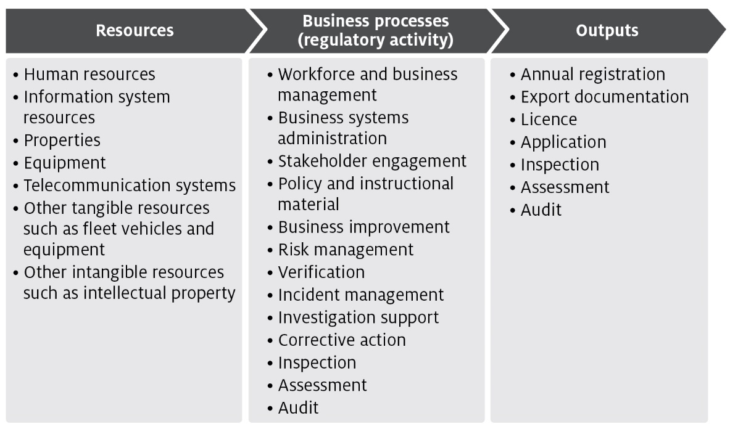
The processes listed in Figure B2 are grouped into 4 categories of activities.
- Program management and administration – administrative activities that support and deliver the department’s export regulatory activity commitments.
- Assurance – activities that mitigate risks to collective user groups by assessing departmental controls of systems and processes to ensure they operate in accordance with their intended design.
- Incident management – activities that respond to incidents concerning alleged breaches of Australian regulation or international import conditions.
- Intervention – activities provided directly to an individual, business or organisation to meet export regulatory activity requirements.

Costs of regulatory charging activity

Cost allocation process
To determine the cost of regulatory activities, the department uses an activity-based costing (ABC) system. The ABC system allows for complex cost allocation calculations while also being efficient and effective to administer.
The 2 expense categories are:
- Direct expenses – these can be directly attributed to the provision of an activity, for example, inspections. They comprise of staff salaries and supplier costs including direct capital expenses.
- Indirect expenses – these are not directly linked to an activity provided by us. Indirect expenses include corporate employee salaries and overheads such as information technology, finance, human resources costs, and indirect capital expenses.
The cost allocation process apportions the costs of support functions (indirect expense) and direct expense to the processes/activities defined in Description of cost model activities. The department includes indirect expenses in the cost base to reflect the systems and processes that exist to help with efficient administration, which the cost-recovered arrangements benefit from. This is the same methodology employed for allocation of indirect costs to appropriated activities, in line with the department’s cost allocation policy.
The ABC system allocates costs in a staged approach.

Stage 1
Indirect costs such as property, finance, information technology, human resources and divisional executives are allocated to direct cost centres using a cost driver that estimates the relative usage of each of the corporate services. Cost drivers for corporate services include:
- Work points – distributes costs based on space occupied, with the work point count reflecting the space where a person may be able to work.
- FTE – distributes costs based on each programme’s full-time equivalent staff numbers.
- PC count/IT assets – distributes costs based on the number of IT assets in a program.
- Transactions – distributes costs based on the number of transactions incurred over a period. This driver is used to allocate expenses related to the functions of accounts receivable and accounts payable.
- Headcount – allocates costs based on the number of staff that a program area has as a proportion of the number of staff that are on the department’s total staff.
- Custom drivers – allocate costs to specific cost centres, primarily based on usage for shared program resources.
- Cost drivers are reviewed on an annual basis, or as required. Changes to cost drivers are substantiated through effort or other data.

Stage 2
Direct costs (including the indirect costs allocated in Stage 1) are allocated to the activity and cost-recovered arrangements that best reflects the activity undertaken. Time recording systems allow the accurate allocation of effort to specific activities and arrangements, particularly to intervention activities.
The primary variable used in the allocation of costs to activities is effort. As a result, cost estimates vary with changes in activity. If actual activity levels change during a financial year, the costs allocated to arrangements would require adjustment to align with that effort. The department monitors this throughout the year and adjust where necessary.
For example, food safety auditors undertake audits across multiple arrangements. The department forecasts the number of audits and average time for an audit for each arrangement. The associated costs are allocated to the arrangements and audit function based on total audit hours.

Stage 3
Activity/arrangement costs (from Stage 2) are allocated to charge points which identifies the cost associated with that charge. The department uses a combination of cost recovery fees and charges. Figure B2 shows how the department categorises cost-recovered charge and fee activities and outputs.
Figure B2 Categories of activities
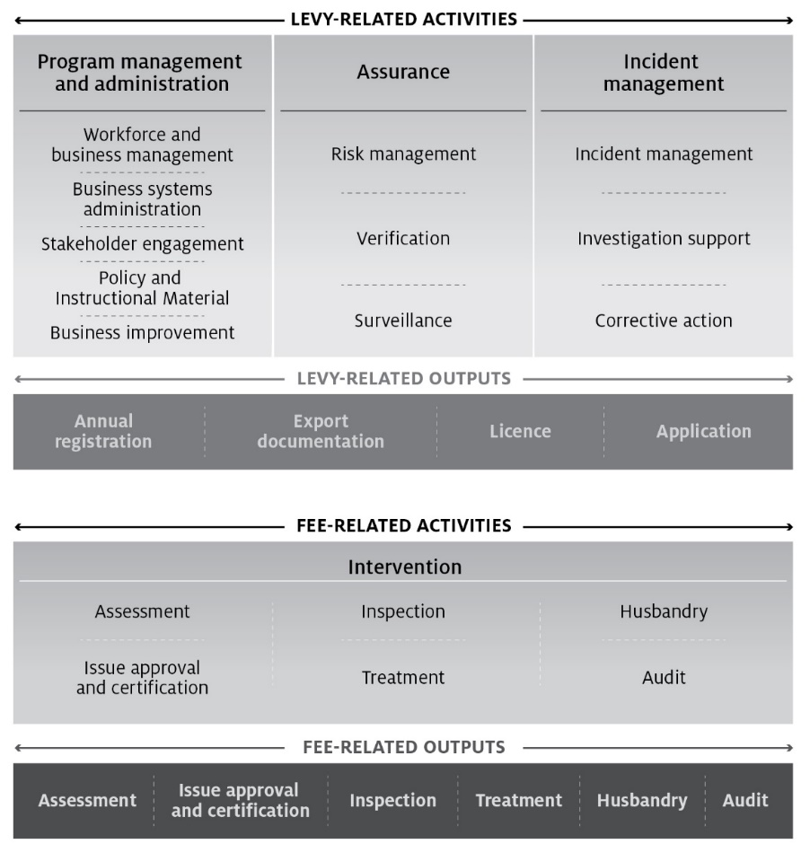

Description of cost model activities
The following provides details of the cost model activities undertaken in the department’s cost recovery arrangements.

Program management and administration activities

Workforce and business management
This activity has 4 categories:
- Workforce management activities – staff supervision, allocating workforce resources, managing employee performance, leave, training and other conditions, managing work, health and safety requirements, recruitment and termination.
- Business management activities – business planning and continuity; requesting legal advice; procurement and contracts; program and project administration, assurance, design and management; management of fixtures, facilities, equipment, supplies and logistics.
- Financial management activities – billing and accounting, budgeting, charges and payments, collections and receivables, debt management, financial accounts, reporting and policy development.
- Information management activities – data management, information and records management, and information sharing and collaboration.

Business systems administration
Includes developing, acquiring, testing, implementing and supporting applications and business systems. This includes technical support and maintenance of all business systems including information and communications technology.

Stakeholder engagement
Involves proactive engagement with any person, business, or organisation including any associated travel. This includes, engaging with peak industry bodies, secretariat support and attendance at industry consultative committee meetings, consultation on new standards and requirements, publishing website content and other information.

Policy and instructional material
Includes developing, maintaining and communicating the department’s policy and instructional material, such as operational and corporate policies, scientific advice, departmental guidelines and work instructions, and associated training development and delivery. Examples include responding to changes in importing country requirements, developing or revising policy processes and instructional material.

Business improvement
Includes assessment, monitoring and management of business performance. Examples include adjustments to improve regulatory activity, against business performance reports against Key Performance Indicator’s (KPI) and similar activities.

Assurance activities

Risk management
Involves assessing and managing the risks posed to Australia’s ability to maintain market access. This includes communicating results of risk analysis, modelling and forecasting to operational areas and the collection, receipt and use of reliable compliance data to meet the departments compliance objectives. This work also includes any associated travel and regulated entity assistance work. For example, organising, involvement in and responding to overseas government’s systems-based audits.

Verification
Includes assurance activities to provide stakeholders and departmental executive with confidence that departmental controls of its systems and processes are operating in accordance with their intended design and associated documentation. For example, verification of certification activity internally and by state regulators.

Surveillance
Includes formal and informal monitoring to detect issues that may affect onshore production for export, such as changes in Australia’s pest or disease status or food safety concerns. Surveillance differs from an inspection because it is not done for a specific client.

Incident management activities

Incident management
The coordination and management of any incident including post border detection and export incidents. This includes all associated pre-and post-work, travel and regulated entity assistance in relation to an incident, government certification and other issues which result in goods being held at the border. For example, this includes managing and responding to food safety incidents where food may have been exported.

Investigation support
Involves providing support for enforcement activities relating to an alleged breach of portfolio legislation, including any related regulated entity assistance and travel. This also includes enforcement activities that ensure compliance with Australian regulation and international import conditions such as investigations and engagement with regulated entities about compliance.

Corrective action
Includes actions taken in response to non-compliance or contravention of legislation or procedures that are managed without a formal investigation by an enforcement officer. Corrective action activities include all pre and post work, travel and regulated entity assistance in relation to the enforcement process.

Intervention activities

Assessments
Involves assessing information to determine if it meets the department and the importing country requirements. This includes all preparatory work (such as confirming importing country or export requirements) and post work (such as assessment report preparation) travel and regulated entity assistance in relation to the assessment. Examples include assessments of licences, permits, registrations, accreditations, and exemptions.

Issue approvals and certification
Includes issuing of a decision in relation to an assessment for cargo, vessels, plants, animals, food, biological and genetic material. This includes the work from the end of the assessment period to the completion of the decision notification process to support issuance of appropriate export documentation.

Inspections
Involves the physical examination (and supervision of a physical examination) of export food commodities to determine compliance with export and importing country requirements.

Treatments
Includes the physical treatment of cargo, vessels, plants, animals, food, biological and genetic material, other conveyances or premises to prevent an adverse biosecurity outcome from occurring and to meet relevant importing country requirements.

Husbandry
Includes activities relating to the care of plants and animals that the department is responsible for, including transport of plants and animals, housing, daily monitoring, feeding, cleaning of facilities, administering of medication, bookings and regulated entity assistance.

Audit
Includes the systematic and functionally independent examination to determine whether activities and related results comply with legislative or documented requirements. This includes all pre and post-work, travel and regulated entity assistance in relation to the audit. Examples include audit to verify compliance with an export registered establishment’s approved arrangement.

Appendix C: Summary of stakeholder feedback
Table C1 stakeholder feedback for the 2024–25 CRIS
Key theme | Department response
- Concern with Establishment Registrations for small exporters forcing some exporters to close their facilities and use other establishments for packing and exporting goods. All establishment registration fees should be looked at and changes made to ensure Australia’s competitiveness in a global market. | This response has been passed to the Sustainable Trade Funding Taskforce for consideration in the development of CRIS for 2025–26
- Industry continues to experience delays in accessing certificates in a timely manner. Industry would like to see increased effort to have e-certificates issued and cost minimised. | This response has been passed to the Sustainable Trade Funding Taskforce for consideration in the development of CRIS for 2025–26
- Industry considers it is critically important to consider the effectiveness and the application of the DAFF cost recovery model and the impact it has on the agricultural industry’s efficiency. | This response has been passed to the Sustainable Trade Funding Taskforce for consideration in the development of CRIS for 2025–26
- Industry supports cost recovery as a mechanism to provide key services not covered through Government consolidated revenue, this is based on being provided with access to information and engagement with DAFF that provides satisfaction the cost is balanced by the provision of an effective and efficient service. | This response has been passed to the Sustainable Trade Funding Taskforce for consideration in the development of CRIS for 2025–26
- Understanding the value proposition of the DAFF fees and services is important to Industry and it is proposed DAFF as part of the sustainable export funding model consider processes to monitor and measure DAFF’s services remain efficient and cost effective. | This response has been passed to the Sustainable Trade Funding Taskforce for consideration in the development of CRIS for 2025–26

Appendix D: Government approval to cost recover
Table D1 describes key government approvals for continued and expanded regulatory charging for agricultural exports since 2015.
Table D1 Government approval for regulatory charging for agricultural export activities
Date | Government decision | Details
2023–24 | Securing the future of agricultural trade | In the 2023–24 Mid-Year Economic and Fiscal Outlook, the Australian Government committed $91.8 million over 2 years to ensure Australia’s regulatory export and trade system remains able to meet the needs of both our exporters and the expectations of our trading partners, while supporting industry to achieve its goals now and into the future.  $3.7 million over 3 years was also provided for the development of an ongoing sustainable funding model to support the department’s export regulatory and trade activities.
2020–21 | Busting Congestion For Agricultural Exporters | Policy authority for export regulatory charging was reaffirmed in the 2020–21 Budget when the then government announced the Busting Congestion for Agricultural Exporters package.  The package consisted of reforms for the Australian agricultural sector as part of the Economic Recovery Plan to rebuild the economy and recover from the COVID-19 recession. This included $71.1 million to improve the financial sustainability of export certification services, supporting a stepped return to full cost recovery, and enabling reforms to be rolled out while maintaining existing systems.
2020 | Introduction of the Export Control Act 2020 | The Export Control Act 2020 and related rules and charging regulations for exported commodities, set out the overarching legislative framework for the regulation of exported goods, including food and agricultural products, from Australian territory. A fundamental aspect of this framework is the recovery of costs from exporters for regulatory activities carried out by the department.
2018–19 | Expanded Cost Recovery | In the May 2018 Budget, the government confirmed continuing cost recovery from industry through the Expanded Cost Recovery Measure, commencing 1 July 2019, and included:  - Enforcement activities that ensure compliance with Australian regulation and international import conditions. Activities that will be cost recovered include investigations and engagement with clients about compliance but will not include the costs of infringement notice schemes or undertaking litigation.  - Provision of scientific and technical advice to improve or maintain existing export markets. Examples include the provision of scientific or technical advice to re-open or maintain market access following a pest or disease incursion or change in import conditions; and improving existing market access by seeking to reduce import requirements or simplify certification processes.  - Services provided by overseas counsellors relating to detained consignments, government certification and other issues which result in goods being held at the border.
2015 | Department of Agriculture and Water Resources – Comprehensive Review of Cost Recovery | Over the period 2014–15, the department redesigned its cost recovery arrangements as part of a funding strategy for its biosecurity and export certification activities. The review sought to streamline existing frameworks to address inequities, ensure all costs are recovered and reduce the complexity of the department’s fees and charges. Outcomes of the review were implemented 1 December 2015.

