Fish and Flows Intervention Monitoring in the Border Rivers

Final Report

Prepared for the Department of the Environment and Energy

September 2019

**Publication title:** *Fish and flows intervention monitoring in the Border Rivers – Final report 2019*

**Acknowledgements:** This project was funded by the Commonwealth of Australia as represented by the Department of the Environment and Energy (DoEE), and was undertaken by the lead agency of NSW Department of Primary Industries in partnership with Queensland Department of Agriculture and Fisheries.

A cross-jurisdictional project team was established, including Steven Brooks (Qld DAF), Gavin Butler (NSW DPI Fisheries), Daniel Smith (Qld DAF), and Anthony Townsend (NSW DPI Fisheries).

The project team would like to gratefully acknowledge the services of Michael Peat, Katrina Cousins, and Elizabeth Webb (DoEE), for advice and assistance throughout the project.

The contents of this publication do not purport to represent the position of NSW Department of Primary Industries in any way and are presented for the purpose of informing and stimulating discussion for improved management of Basin's natural resources.

To the extent permitted by law, the copyright holders (including its employees and consultants) exclude all liability to any person for any consequences, including but not limited to all losses, damages, costs, expenses and any other compensation, arising directly or indirectly from using this report (in part or in whole) and any information or material contained in it.

Front cover image: Aquatic habitat in the Border Rivers, highlighting the presence of undercut banks in the region that are utilised for spawning sites by the threatened Murray Cod (photo credit – Steven Brooks).

**CONTENTS**

1. Introduction 1

2. Background 1

3. Project aims and objectives 3

4. Flows in the Border Rivers during the project period 4

4.1 Antecedent conditions in the Border Rivers 4

4.2 Water for the environment in the Dumaresq River 2017-18 6

4.3 Water for the environment in the Severn River 2017-18 6

4.4 Post-water for the environment conditions in the Border Rivers 6

4.5 Habitat inundation during the project period 9

4.6 Water quality during the project period 10

5. Sampling methods 12

5.1 Sampling sites 12

5.2 Fish monitoring protocol 14

5.3 Data Analysis 15

6. Results 17

6.1 Abundance 17

6.2 Biomass 21

6.3 Length-Frequency 22

6.4 Health indicators 27

7. Discussion 30

8. Management recommendations 33

9. Research recommendations 33

10. References 35

**Executive Summary**

In spring 2017, a total of 3,252 megalitres of Commonwealth water for the environment was delivered down the Dumaresq River to provide stable base flows for native fish with the aim to enhance recruitment outcomes, provide access to habitat and food and allow movement along the reach. During the same period a separate but related release of 8,864 ML of water for the environment (8,000 ML NSW Planned Environmental Water entitlement; 864 ML Commonwealth entitlement) was delivered down the Severn River to prime the system and provide opportunities for increased access to food and habitat to facilitate recruitment.

These flows followed variable antecedent conditions, and were designed to support water requirements needed by a range of native fish during peak periods of reproduction including threatened species such as Murray Cod, Freshwater Catfish, and Olive Perchlet, as well as Murray-Darling Rainbowfish and Carp Gudgeon, whilst minimising risks relating to cold water pollution.

The *Fish and flows intervention monitoring in the Border Rivers region* project aimed to determine fish responses to environmental watering actions in the Border Rivers valley that are focused on supporting reproduction and recruitment of key fish species. This project was funded by the Department of the Environment and Energy, Commonwealth Environmental water Office (CEWO) and was undertaken by the lead agency of NSW Department of Primary Industries in partnership with Queensland Department of Agriculture and Fisheries.

Monitoring the ecological response of native fish to water management activities in the Border Rivers involved sampling in the Dumaresq, Macintyre and Severn rivers before and after managed releases using standard methods for riverine fish, including electrofishing and bait traps. Larval trapping was also undertaken in the Severn River following the release of water for the environment; however high flow events and the timing of sampling limited the amount and effectiveness of trapping.

Results from the *Fish and flows intervention monitoring in the Border Rivers* project indicate that the release of water for the environment contributed to an improvement in the native fish community in the Border Rivers. Low flow events in the Dumaresq, including water for the environment released in late 2017 inundated a large proportion of key habitat features in the system and contributed to improving overall fish condition in the Dumaresq and Macintyre rivers in early 2018. Similarly, the release of water for the environment in the Severn in late winter 2017 to prime the system and support movement, habitat inundation, productivity, and recruitment led to an improvement in overall fish condition in late 2017 and early 2018.

The release of water for the environment in the Severn and Dumaresq rivers during late winter/early spring in 2017 also contributed to specific responses from target species, including:

* Increased numbers of Murray Cod young-of-year in both the Macintyre and Dumaresq systems.
* Increased Freshwater Catfish nests and recruits in both the Dumaresq and Severn rivers, with larval trapping in the Severn River confirming successful breeding and larval recruitment of Freshwater Catfish.
* The abundance of Unspecked Hardyhead and Murray-Darling Rainbowfish generally increased following the release of water for the environment.
* The release of water for the environment during the sampling period also benefited Carp Gudgeon, and although populations for this species were highly variable, spawning and recruitment responses were observed following flow events.
* There was also an absence of Common Carp recruits over the 4 years of monitoring; suggesting conditions were not suitable for the breeding and/or recruitment of this species during the sampling period.

The project has demonstrated that the management of water for the environment in the Border Rivers region during late 2017 has had a positive effect on recruitment and the maintenance of habitat and fish communities, with no notably negative impacts apparent. These flows provided increased inundation of key features in all regulated systems of the Border Rivers, whilst also providing greater localised connectivity and movement opportunities for fish. The timing of these type of flow deliveries in the future need to consider any potential negative impacts, such as potentially disrupting spawning of species such as Murray Cod and Freshwater Catfish, and affecting water quality through thermal pollution.

Recommendations for agencies and stakeholders responsible for managing water for the environment in the Border Rivers include:

*Management*

1. Water managers should recognise the value that current Held Environmental Water and Planned Environmental Water entitlements provide for achieving native fish condition and recruitment outcomes in the Border Rivers. Considered planning and management of water for the environment should use natural events as cues where possible to provide complementary fresh or low flow events that maximise habitat inundation to support recruitment, movement and condition outcomes for native fish.
2. Government agencies, including Commonwealth, NSW and Queensland, and stakeholders should continue to work collaboratively in managing the relatively small entitlements in the Border Rivers to maximise ecological outcomes. This includes combining resources where possible, such as adding Commonwealth entitlement to the NSW stimulus flow in the Severn River to extend outcomes, as was achieved in 2017. Establishment of an Environmental Water Advisory Group for the Border Rivers with appropriate representation of all interested stakeholder groups (as proposed in the draft Water Resource Plan (WRP) package for the NSW Border Rivers) (NSW DOI 2018) would be beneficial to collaborative planning and delivery of water for the environment in the valley.
3. Rules associated with water for the environment provisions should be reviewed so as to maximise its protection and outcomes it achieved in the Border Rivers and beyond. This includes consideration of active management to protect held water for the environment as it moves between systems (as proposed in the draft WRP package for the NSW Border Rivers) (NSW DOI 2018), including from the Severn to the Macintyre and into the Barwon River, as well as extending the length of waterway that the stimulus flow is protected to and the season that it can be used in to allow greater flexibility in achieving ecological outcomes.

*Research and Monitoring*

1. Continued long-term monitoring of fish communities in the Border Rivers valley would provide information to assess additional long-term outcomes, including changes in native fish diversity, abundance and population structure.
2. Continued monitoring and evaluation of managing water for the environment in the Border Rivers to inform long-term responses of fish communities to flow. This information will be critical to guide adaptive management in the valley, contributing to achieving the objectives and targets of the Commonwealth’s portfolio management plans, Water Sharing Plans, Long Term Water Plans, and ultimately the Basin Plan and associated Basin-wide Watering Strategy outcomes.
3. Detailed investigation relating to the differences identified in the Severn River fish community compared to the Dumaresq and Macintyre rivers, including the lack of Murray Cod recruits. These investigations should focus on movement studies and habitat association for key species, as well as water quality considerations to inform future management in the system including the mitigation of cold water pollution from Pindari Dam.
4. Detailed investigation into the lack of Golden Perch and Silver Perch recruits detected in the Border Rivers using innovative research methodologies and techniques, such as genetics or collaborating with existing projects using techniques such as otolith microchemistry analysis and fish movement studies to inform future management actions in the Border Rivers, including water management and fish passage needs. Future research should be undertaken on the biology of both Golden Perch and Silver Perch in this region, and the interaction with other populations in the Northern Basin. This work would assist in determining potential source populations of particular species and equip water managers with better information for flow requirements and connections required to support meta-populations of native fish.
5. Continuation of mapping aquatic habitat features in the Border Rivers, including in the Macintyre, and section of the Dumaresq and Severn systems, would add value to the habitat mapping work already undertaken, and provide valuable information that can be used for future revision of water for the environment requirements needed to achieve ecological objectives. Improved information on the location and commence to inundate thresholds for key habitat features would enhance links to nutrient and carbon transfer from benches and floodplain/anabranch connection, nesting and nursery habitat for native fish, and help to identify key refuge sites for protection. Further the persistence, draw-down times and fish communities of refuge sites could also be determined as feasible when conditions allow.

# Introduction

The following document outlines the results from sampling undertaken for the *Fish and flows intervention monitoring in the Border Rivers* during the 2016/17, 2017/18 and 2018/19 seasons. The project aimed to determine fish responses to environmental watering actions in the Border Rivers valley that are focused on supporting reproduction and recruitment of key fish species. The final four (4) rounds (2017/18 and 2018/19) were completed under Contract Number 3600000612. This component of the project has been carried out by NSW Department of Primary Industries (DPI) in partnership with Queensland Department of Agriculture and Fisheries (DAF) on behalf of the Commonwealth of Australia as represented by the Department of the Environment and Energy (DoEE).

# Background

**General**

The many rivers and streams across the Border Rivers region provide diverse habitat for aquatic organisms including the river channel, in-stream features such as bars, benches, riparian areas and low level wetlands (SKM 2009). Environmentally significant rivers within the Border Rivers region that can potentially be targeted with Commonwealth water for the environment include the Dumaresq, Macintyre and Severn rivers (Figure 1). The region supports a relatively rich native fish fauna. Sixteen native species have been recorded, including a number of threatened species or populations, such as Murray Cod, Silver Perch, Southern Purple Spotted Gudgeon, Olive Perchlet, and Freshwater Catfish (NSW DPI 2015). Assessments by NSW DPI (NSW DPI 2016) and the Sustainable Rivers Audit (Davies et al. 2012) concluded that overall the Border Rivers fish community was in “Moderate”health, ranking it among the better catchments in the Murray-Darling Basin for native fish. While there have been no detailed assessments on the causal relationships for this, the SRA audit did find that the physical form of the valley was in also in “Moderate” condition and that the hydrology rated even higher at “Good” (Davies et al. 2012). Both of these factors are potentially having a positive influence on the habitat and flow conditions needed by native fish in the Border Rivers.

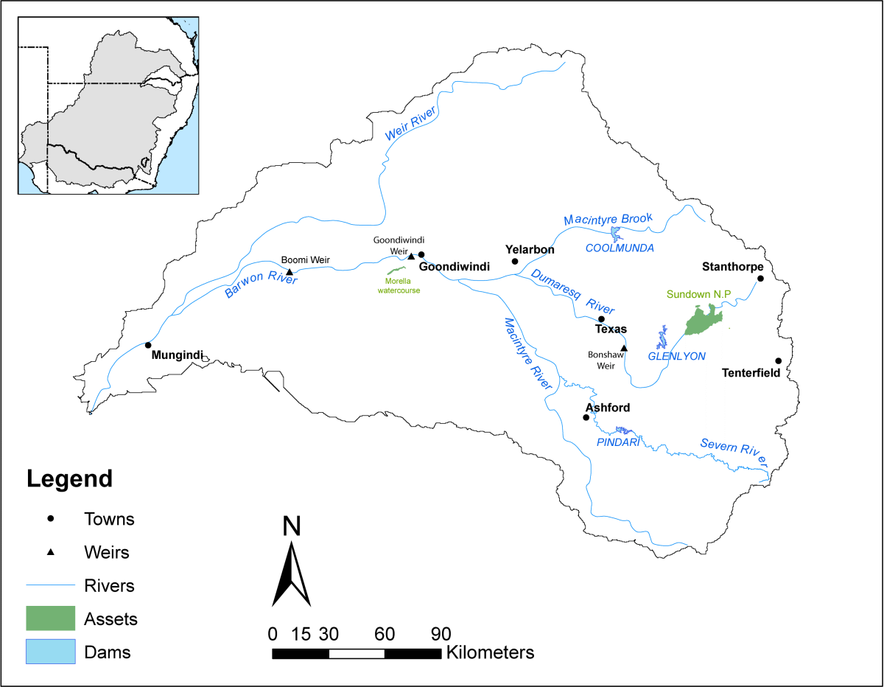

**Figure 1:** Location and extent of the Border Rivers valley (CEWO, 2018).

**Assets and Water Holdings**

Environmental assets and associated objectives and outcomes for the Border Rivers have been identified in the Basin-wide Watering Strategy (BWS), an assessment of in-stream water for the environment requirements by the MDBA (2012), and state-based investigations to inform water resource plans. Based on these strategies and findings, the Commonwealth Environmental Water Office (CEWO) has identified key demands and outcomes in their planning documents to target water for the environment in the Border Rivers using their holdings, which are shown in Table 1.

**Table 1:** Summary of Commonwealth water for the environment holdings for the Border Rivers (at 30 June 2019 <https://www.environment.gov.au/water/cewo/about/water-holdings>).

|  |  |  |  |  |  |
| --- | --- | --- | --- | --- | --- |
| **Security** | **Registered entitlements (ML)** | **Carryover from 2017-18 (ML)** | **New allocations/use in 2018-19 (ML)** | **Water available for use in 2018-19 (ML)** | **Estimated current balance (ML)** |
| Medium (Qld) | 15,540 | 8,879 | - | 7,400 | 1,294 |
| Unsupplemented (Qld) | 19,986 | - | - | - | - |
| Supplementary (NSW) | 1,437 | 0 | 0 | 0 | 0 |
| General (NSW) | 2,806 | 896 | 0 | 0 | 896 |
| **Total** | **39,769** | **9,775** | **0** | **0** | **2,191** |

**Note:** For Qld medium and NSW general security, ‘water available for use’ is the estimated account balance, adjusted for annual use limit (207 ML) in Macintyre Brook (Coolmunda Dam).

For native fish, key demands include the *provision of* *flows in the Severn, Dumaresq, Macintyre and Barwon rivers that improve habitat conditions and support different life stages, including migration, spawning, recruitment, and refuge* (CEWO 2018).

Priority water for the environment demands for assets in the Border Rivers catchment based on antecedent and prevailing conditions include the following river channel flows:

1. Demand for a large pulse in the lower Macintyre River to improve available habitat, bring nutrients and carbon into the river and connect to the Barwon – Darling system and low level wetlands.
2. Demand for a medium to large pulse in late winter–early spring in the Dumaresq River to stimulate fish movement and breeding and to scour the riverbed to provide a stimulus to food webs. A flow of this type would also be beneficial in the NSW Severn River.
3. Demand for a long stable low flow in spring to early summer to support the completion of breeding and dispersal of large fish and to provide breeding and recruitment opportunities for small fish that spawn in low flows.
4. Demand for replenishment flows in the Dumaresq, NSW Severn and lower Macintyre river reaches to maintain in-stream habitat, native fish resilience and water quality during low to no flow conditions.

**Monitoring background**

The CEWO funded two programs focussed on understanding eco-hydrological response to the provision of water for the environment from 2014 to 2019; the Long Term Intervention Monitoring (LTIM) project which was focussed on describing the patterns of response to the ongoing delivery of Commonwealth water for the environment across the Basin, and the Environmental Water Knowledge and Research (EWKR) project focussed on understanding the ecological processes underlying these response patterns. Collectively, these programs provide important outputs to inform how to best manage the overall portfolio of water for the environment, but due to limitations in geographical coverage and type of watering actions examined (e.g. different type of flow components delivered), these programs will not always be able to evaluate the ecological response to specific watering actions. The focus valleys for these two programs did not include the Border Rivers.

Additional State-based projects evaluating flow related responses of ecological assets in the Border Rivers valley include;

* *Stable low flow spawning fish* project being led by the Queensland Department of Natural Resources, Mines and Energy (DNRME), which is investigating environmental flow requirements for fish.
* *Building a stronger, more resilient and sustainable Murray Cod fishery in NSW* project (investigating the movement and breeding of Murray Cod in the Dumaresq and Macintyre rivers), led by NSW DPI.
* *Pindari Stimulus Flow: Fish and Flows 15/16 project*, led by NSW DPI.

The *Fish and Flows intervention monitoring in the Border Rivers* project is focussed on the short and medium term ecological response to managed delivery actions from water for the environment that may occur in the Border Rivers valley. A specific emphasis of the project is on the ecological response of fish functional groups, i.e. those species that have similar flow related attributes, to assist in answering the outcomes being sought as part of CEWO’s portfolio management in the Border Rivers. The findings of this project will complement insights from the CEWO funded programs from across other parts of the Basin and the State-based projects looking at stable low flow spawning fish and Murray Cod populations.

# Project aims and objectives

The *Fish and flows intervention monitoring in the Border Rivers region* project aimed to determine fish responses to the management of water for the environment in the Border Rivers region that are focused on supporting reproduction and recruitment of key species.

The project value-added to fish response monitoring that was completed by NSW DPI as part of the Pindari stimulus flow event in 2015/16, which included monitoring in the Severn, Macintyre and Dumaresq systems. Monitoring in the Dumaresq in 2015/16 provided data for a ‘control’ system where there was no managed water for the environment delivery, for comparison to the Severn River, which received a water for the environment delivery to facilitate Murray Cod recruitment. The monitoring project provided a further comparison of outcomes in the Dumaresq River under conditions related to the management of water for the environment.

Repeating the fish response monitoring enabled both short-term responses to proposed watering events to be examined, as well as longer term (1 to 5 years) recruitment and population dynamics outcomes to be assessed. This will greatly enhance knowledge of fish responses to both managed and natural watering events in the Border Rivers region, and will improve the base from which to plan and refine future water management and watering actions.

Monitoring of fish communities, including the different life history stages of both moderate to long lived and short lived threatened and socially important species will assess the response of native fish reproduction, recruitment and condition to the delivery of water for the environment in the Border Rivers valley under the specific antecedent and natural flow conditions.

***Project objectives***

* Establish baseline information on the fish communities by undertaking electrofishing surveys in the Dumaresq, Macintyre and Severn to (identify species present, abundance, population structure).
* Determine native fish condition by measuring length and weight of fish collected and checking for signs of disease and stress. Fish condition is a key factor influencing reproductive fitness and success of native fish. The management of water for the environment can have positive or negative effects on fish condition (e.g. by improving food availability through stimulating productivity; cold water releases may have negative impacts on fish condition).
* Assess reproduction and recruitment outcomes for representative species from different reproductive functional groups in the three rivers where appropriate sample size allows.
* Assess water quality at the fish community sampling sites. Along with flow and availability of suitable food, water quality is an important factor influencing native fish condition, and spawning and recruitment success.
* Verify whether the hydrological targets of water for the environment releases (e.g. flows required to inundate habitat such as back water areas, benches and macrophyte beds) were achieved in practice and to confirm or refine these flow thresholds for future water actions.

The project has been developed following the guiding principles of the Environmental Outcomes Framework (CEWO 2013) underpinning the management of Commonwealth water for the environment. The sampling regime adopted provides an opportunity to examine both short-term responses, and long-term outcomes of managing water for the environment, adding to data and information collected as part of monitoring undertaken during 2015/16, as well as any possible future monitoring activities. Continued long-term monitoring of fish communities in the Border Rivers valley would provide information to assess additional long-term outcomes, including changes in native fish diversity, abundance and population structure.

The following document outlines the results from four (4) rounds of sampling undertaken for the *Fish and flows intervention monitoring in the Border Rivers* during the 2017/18 seasons, as well as the inclusion of data collected during 2015 and 2016.

# Flows in the Border Rivers during the project period

## 4.1 Antecedent conditions in the Border Rivers

Flows across the Border Rivers region varied greatly during the project period (2017-18), and in the preceding seasons (Figure 1). This variability differed between the three study reaches, with for example, large freshes experienced in the Dumaresq and Macintyre rivers during the 2014-15 and 2015-16 seasons peaking at 9,000 ML/day, whilst the Severn River experienced relatively low flows that remained under 1,000 ML/day during the same period (Figure 2).

Part of the flows in the Severn River during this time resulted from the use of the stimulus flow[1] from Pindari Dam. Trigger conditions related to the use of this Planned Environmental Water entitlement were met for 2015 and with carryover there was 6,000 ML available for use in the stimulus flow account. The stimulus flow entitlement was intended to be used to mirror a natural event in the NSW Severn River and provide cues for ecological processes such as fish breeding and regular inundation of riparian areas downstream of the dam. Following relatively low flows in the Severn River, the stimulus flow was delivered in October 2015 as a long duration flow with a low peak that would inundate suitable habitat such as low flow bench and back water areas, whilst reducing potential impacts of cold water pollution and avoiding bulk water releases in mid-late November (Figure 2). The primary purpose of the flow was to facilitate recruitment of Murray Cod in the system, with secondary benefits of improved movement opportunities, habitat access, and some productivity outcomes.

**Largest inflows since 2013**

**Project Period**

**Severn Stimulus Flow 2015**

**Figure 2:** Hydrological conditions in the Border Rivers valley from July 2014 to December 2018, highlighting the current project period, previous sampling events analysis (orange circles), sampling rounds completed as part of the current project (red circles), and key flow events (source: http://realtimedata.water.nsw.gov.au/water.stm).

Following these variable seasons the Border Rivers region experienced the largest flow events since January 2013, with peaks over 45,000 ML/day experienced in the Dumaresq River in September 2016 and approximately 25,000 ML/day in the Severn River in April 2017 (Figure 2). These flows immediately preceded Round 1 (2017a) sampling for the current project (Figure 3), and helped to meet a number of environmental demands identified as part of water management planning, including potentially providing conditions conducive for breeding of native flow-dependent (e.g. Golden Perch) and in-channel specialists fish (e.g. Murray Cod). River discharge quickly receded back to low flow conditions, with both the Dumaresq and Severn systems dropping below flows of 100 ML/day for periods between July and September 2017. The conditions experienced at the start of the 2017-18 season were considered to potentially be limiting opportunities for native fish recruitment, as well as potentially impacting the survival of young fish, triggering planning to deliver long stable low flows during spring and summer to consolidate reproduction and recruitment outcomes.

## 4.2 Water for the environment in the Dumaresq River 2017-18

Planning for Commonwealth regulated holdings in the Border Rivers for the 2017-18 season involved providing a fish breeding and recruitment flow in the Dumaresq River. Between October 2nd and 26th 2017, a total of 3,252 ML of Commonwealth water for the environment was delivered to the Dumaresq River (Figure 3). The purpose of the water delivery was to provide stable base flows for native fish outcomes (e.g. access to habitat and food during reproduction). In particular, this action was designed to support flows needed by a range of native fish during peak periods of reproduction including threatened Murray Cod, Freshwater Catfish, and Olive Perchlet, as well as Murray-Darling Rainbowfish and Carp Gudgeon, whilst minimising risks of cold water pollution. Commonwealth water for the environment was delivered as a stable baseflow (up to 160 ML/day) for three weeks, in conjunction with some small natural inflows in the system.

## 4.3 Water for the environment in the Severn River 2017-18

As part of planning for 2017-18, NSW and Commonwealth governments considered options for undertaking a stimulus flow from Pindari Dam in the NSW Border Rivers catchment. Trigger conditions related to the use of the Planned Environmental Water entitlement were met for 2016-17 and with carryover there was up to 8,000 ML available for use in the stimulus flow account. Between August 21st and October 16th 2017, a total of 8,000 ML of NSW held water for the environment, and 684 ML of Commonwealth water for the environment were delivered to the NSW Severn River (Figure 3). The purpose of the water delivery was initially to provide opportunities for increased access to food and habitat to facilitate fish recruitment, followed by a stable baseflow to maintain access to core habitat. In particular, this action was based on 2016-17 monitoring which suggested that Murray Cod had not successfully bred since 2013, when a priming pulse was provided.

NSW contribution began on 21st August 2017 and peaked at 2,079 ML/day (Pindari Dam) on 23rd August. After this brief pulse, there was an extended period of stable base-flow (approximately 50ML/day) until mid-October 2017. Commonwealth water for the environment was delivered on the 24th September to extend base-flows and this delivery occurred in conjunction with ‘translucency flow’ provisions of the NSW water sharing plan. The event replicated previous similar natural events in the Severn system, and had the primary aim of stimulating productivity and movement outcomes, with extended duration allowing continued access to habitat and spawning and recruitment outcomes for native fish species. Round 2 (2017b) monitoring was undertaken shortly after these managed events and just before natural flow events in the Border Rivers valley (Figure 3).

## 4.4 Post-water for the environment conditions in the Border Rivers

Sampling for Round 3 (2018a) of the current project was undertaken in April 2018 following these events, with flow conditions in the Severn and Macintyre zones relatively low and stable (Figure 3). Following this round of sampling, additional water for the environment was released in April 2018 down the Dumaresq/Macintyre system using Commonwealth entitlements as part of the Northern Connectivity Event (NCE; Figure 3).

Between May 4th and 20th 2018, a total of 4,000 ML of Commonwealth water for the environment was delivered to Mungindi which is considered the end of system for the Border Rivers. The purpose of the water delivery was to provide a connecting flow to the Barwon-Darling, as well as improve tributary conditions to maintain native fish populations in the Dumaresq and Macintyre systems. An initial small peak was provided for three days, followed by a stable pulse for seven days and then a short recession. This delivery reached Mungindi on 4th May 2018, 17 days after the initial release from Glenlyon Dam. Stable flows were provided between 380-430 ML/day for the majority of the watering action, providing native fish with opportunities to move and disperse throughout the upper Barwon, Dumaresq and lower Macintyre reaches.

Sampling for Round 4 (2018b) of the current project was undertaken in November 2018, which coincided with a series of small increases in flow in both the Severn and Macintyre zones due to rainfall and operational releases (Figure 3).

**Severn Stimulus Flow 2017**

**Dumaresq Action**

**NCE Action**

**Severn Stimulus Flow 2017**

**Dumaresq Action**

**NCE Action**

**Figure 3:** Hydrological conditions in the Border Rivers valley during the project period, highlighting sampling rounds included in analysis (red circles), and managed flow events that used water for the environment, with detail for each event provided in the inset hydrograph (source: http://realtimedata.water.nsw.gov.au/water.stm).

## 4.5 Habitat inundation during the project period

Detailed habitat mapping was undertaken along a 190 km reach of the Dumaresq in 2017 as part of a separate but complementary project from the Pike Creek junction downstream to its confluence with the Macintyre River (NSW DPI, 2018). The purpose of the mapping project was to document the extent and condition of aquatic and riparian habitat features of the Dumaresq River, with commence-to-inundate flow thresholds for select habitat features calculated where feasible. This included thresholds for benches, cobble/riffle runs, wetlands entry/exit points, aquatic macrophytes, large woody habitat, and bank overhangs, and significantly improved understanding of the proportion of habitat made available during particular flow conditions (Table 2 and 3).

**Table 2:** Summary of flow components, stage height and mean daily flow range for Roseneath Flow Gauging Zone (FGZ), and the habitat features inundated during each flow component (source: NSW DPI, 2018).

|  |  |  |  |  |  |  |  |
| --- | --- | --- | --- | --- | --- | --- | --- |
| **Component of flow regime** | **Stage height (m)** | **Mean daily flow range (ML/day)** | **LWH inundated** | **Rootballs** | **Bank overhangs** | **No. (and area) of benches inundated** | **No. of wetlands connected** |
| CTF | 0.5 | 0 | 867 | 93 | 76 | 2 (0.0648) | 43 |
| Base flows | 0.5 – 0.8 | 0 – 163 | 884 | 93 | 76 | 23 (1.1417) | 44 |
| Small Pulse | 0.80 – 1.0 | 163 – 1,040 | 971 | 94 | 77 | 67 (4.0567) | 46 |
| Large Pulse1 | 1.0 – 1.7 | 1,040 – 6,250 | 1050 | 116 | 87 | 291 (32.1442) | 70 |
| Large Pulse2 | 1.0 – 2.9 | 1,040 – 19,000 | 1276 | 148 | 90 | 700 (141.7924) | 120 |
| Bankfull | 2.9 | 19,000 | 1276 | 148 | 90 | 700 (141.7924) | 120 |
| Overbank | 2.9 – 10.6 | 19,000 – 291,000 | 1489 | 169 | 91 | 810 (173.1474) | 132 |
| 1 Large flow pulse targeted under a managed environmental flow  2 Large flow pulse under a natural flow event | | | | | | | |

**Table 3**: Summary of flow components, stage height and mean daily flow range for Glenarbon Weir FGZ, and the habitat features inundated during each flow component (source: NSW DPI, 2018).

|  |  |  |  |  |  |  |  |
| --- | --- | --- | --- | --- | --- | --- | --- |
| **Component of flow regime** | **Stage height**  **(m)** | **Mean daily flow range (ML/day)** | **LWH inundated** | **Rootballs** | **Bank overhangs** | **No. (and area) of benches inundated** | **No. of wetlands connected** |
| CTF | -2.0 | 0 | 1805 | 178 | 78 | 0 | 16 |
| Base flows | -2.0 - 0.35 | 0 – 136 | 1809 | 178 | 78 | 20 (0.429) | 17 |
| Small Pulse | 0.35 – 0.55 | 136 – 1,310 | 1818 | 178 | 78 | 46 (1.8359) | 18 |
| Large Pulse1 | 0.55 – 1.1 | 1,130 – 7,300 | 1856 | 192 | 80 | 197 (18.2884) | 30 |
| Large Pulse2 | 0.55 – 3.86 | 1,130 – 53,054 | 2228 | 322 | 82 | 544 (85.758) | 88 |
| Bankfull | 3.86 | 53,054 | 2228 | 322 | 82 | 544 (85.758) | 88 |
| Overbank | 3.86 – 5.98 | 53,054 – 125,357 | 2487 | 340 | 82 | 545 (85.788) | 96 |
| 1 Large flow pulse targeted under a managed environmental flow  2 Large flow pulse under a natural flow event | | | | | | | |

Commonwealth water for the environment was delivered as a baseflow (up to 160 ML/day) for three weeks during the project period in October 2017 (Figure 2). The purpose of the water use was to provide low stable flows in the Dumaresq River reach for native fish outcomes, and resulted in an extensive proportion of key aquatic habitat features inundated in the Dumaresq River, including:

* Large woody habitat – up to 59% in the Roseneath Flow Gauging Zone, and 72% in the Glenarbon Flow Gauging Zone
* Overhangs – up to 95% in the Roseneath Flow Gauging Zone, and 84% in the Glenarbon Flow Gauging Zone
* Rootballs – up to 58% in the Roseneath Flow Gauging Zone, and 52% in the Glenarbon Flow Gauging Zone
* Wetland entry/exit points – up to 35% in the Roseneath Flow Gauging Zone, and 17% in the Glenarbon Flow Gauging Zone
* Benches – up to 7% in the Roseneath Flow Gauging Zone, and 1% in the Glenarbon Flow Gauging Zone (see NSW DPI 2018 for extent of Flow Gauging Zones).

It was envisioned that the use of water for the environment in the Dumaresq would provide opportunities for breeding, enhancing recruitment outcomes, as well as access to habitat and food, with the proportion of habitat inundated expected to have contributed to these outcomes.

## 4.6 Water quality during the project period

The importance of water quality, not just water quantity, needs to be considered when developing and delivering water requirements for native fish, with water temperature in particular driving life history responses for the majority of native species, whilst clarity, dissolved oxygen and productivity (related to chemical, nutrient and plankton composition) also play an important role in maximising spawning, recruitment and general health (Jenkins and Boulton, 2003; Górski et al. 2013; Zampatti and Leigh, 2013; Mallen-Cooper and Zampatti, 2015). During the project water temperature was monitored using existing gauging infrastructure to assess ecological implications and to inform planning so as to minimise the risk of potential thermal pollution associated with the release of held water (Figure 4).

During the delivery of water for the environment in late winter and spring of 2017, the temperature of released water ranged from 12°C to 25°C in the Dumaresq River, and from 12°C to 22°C in the Severn River (Figure 4). The increase in temperature appeared to follow natural seasonal patterns in the valley, with water temperatures in the Severn River at Strathbogie, which is above Pindari Dam, also showing a similar increase in temperatures during the late August to end of October period in 2017 (Figure 4). The water temperatures experienced during the release of water for the environment in 2017 are within the range of temperatures required to satisfy spawning response from most native fish species, including Golden Perch (>17°C), Murray Cod (>18°C), Freshwater Catfish (>20°C), and Carp Gudgeon (>20°C; NSW DPI 2015).

Whilst water temperatures followed similar patterns above and below Pindari Dam in the Severn River, it is worth noting that there was a dramatic drop in water temperature below Pindari Dam during summer releases in 2017, with up to a 13.7°C difference in water temperature above and below Pindari Dam (Figure 4). Cold water pollution primarily impacts the life-cycles of fish by changing the range and distribution of species, reducing the opportunity for effective reproduction, reducing body growth and condition, and reducing recruitment success, all of which have the opportunity to influence the objectives and outcomes of managing water releases for the environment.

**Severn Stimulus Flow 2017**

**NCE Action**

**Dumaresq Action**

**Figure 4:** Water temperature conditions in the Border Rivers valley during the project focusing on the period when water for the environment was delivered in the Border Rivers (source: http://realtimedata.water.nsw.gov.au/water.stm).

# Sampling methods

## 5.1 Sampling sites

The study area was partitioned into three zones in the Severn, Macintyre and Dumaresq rivers, aligning with the sampling design used during the *Pindari Stimulus Flow 15/16* project. Five sites were sampled in the Severn and Macintyre rivers zones and six sites in the Dumaresq River zone (Figure 5; Table 4).

**Zone 1 -** Severn River (Pindari Dam to confluence with Macintyre River): 5 sites

**Zone 2 -** Macintyre River (confluence with Severn River to confluence with Dumaresq River): 5 sites

**Zone 3 -** Dumaresq River (Glenlyon Dam to Goondiwindi): 6 sites

Sample sites in all three sub-catchments were typical of the waterways found throughout the highland reaches of the Northern Murray-Darling Basin. The waters at all sites across all three hydrological zones tended to be relatively shallow (less than 2 m deep). There were also distinct pool/run/riffle zones present within many of the sites. In the Severn River, the river channel tended to be narrower, averaging approximately 30 m in width and approximately 1.5 m in depth. The majority of sites in the Dumaresq and Macintyre were wider, being approximately 50 m or greater, and in the most part deeper than the Severn system, being approximately 1.5 - 2 m.

In-stream habitat was dominated by exposed rock in the Severn River, and by submerged woody habitat at the majority of sites in both the Dumaresq and Macintyre rivers. All sites contained large sections of undercut bank. The substratum at most sites was typically gravel and sand; however, mud and silt substrates were also present in some areas.

In general, the majority of sites were highly disturbed as a result of anthropogenic influences such as agriculture, altered flows, and terrestrial and aquatic exotic species. Nearly all sites were adjacent to either improved pastures or irrigated or dryland cropping land.

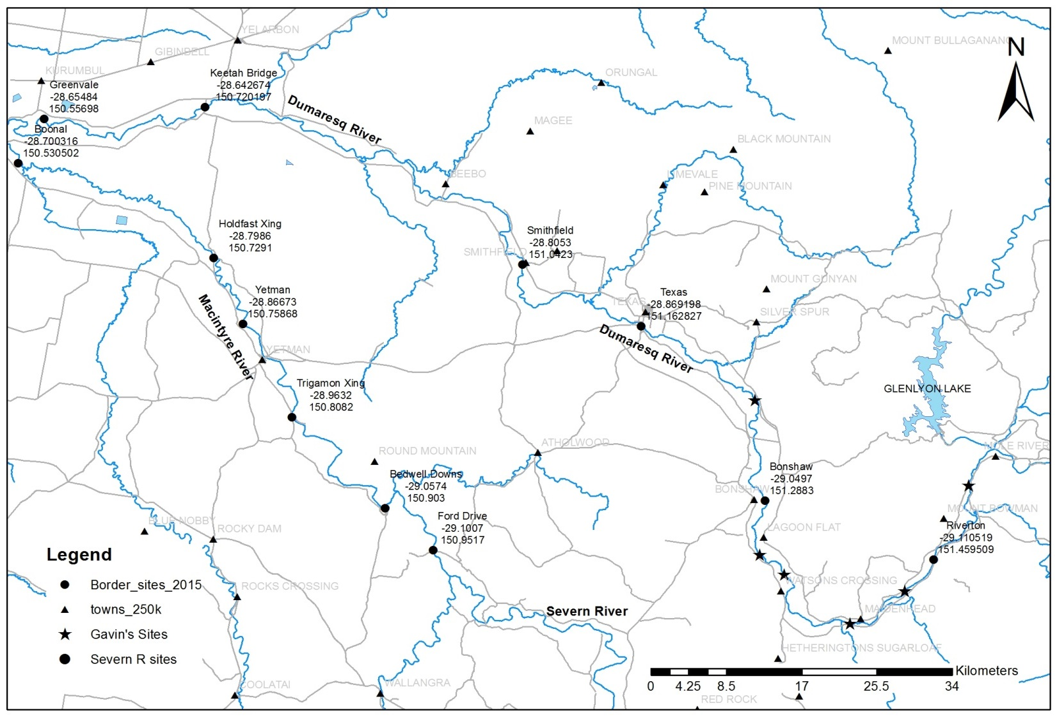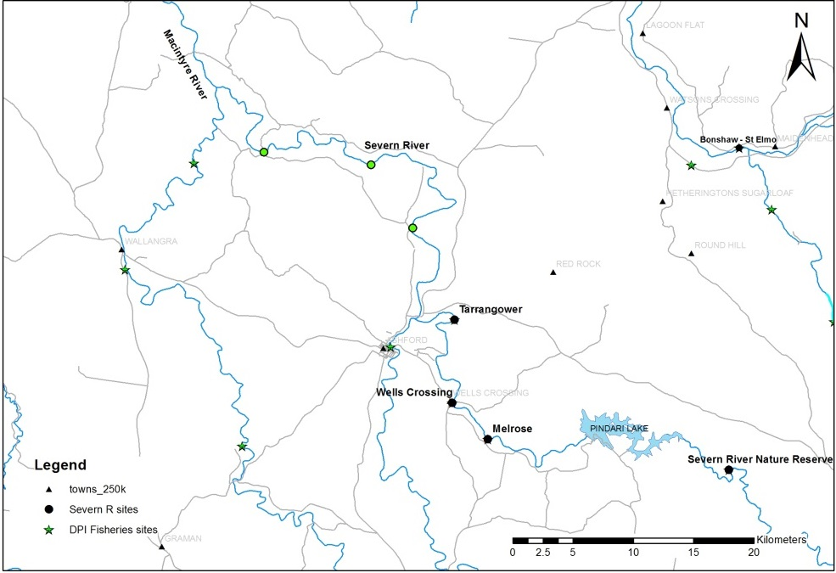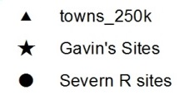

**Citizen Science Study Sites**



**Zone 1 Severn River sites**

**Zone 3 Dumaresq River Sites**

**Zone 2 Macintyre River sites**

**Previous Severn River Sites**

**Figure 5:** Location of sample sites used as part of the *Fish and flows intervention monitoring in the Border Rivers* project 2017-2018.

**Table 4:** Location of sample sites within each of the three systems sampled as part of *Fish and flows intervention monitoring in the Border Rivers* project 2017-2018.

|  |  |  |  |
| --- | --- | --- | --- |
| **Site Name** | **River** | **Latitude** | **Longitude** |
| Melrose | Severn River | -29.38972 | 151.17019 |
| Wells Crossing | Severn River | -29.36358 | 151.14502 |
| Tarrangower | Severn River | -29.30078 | 151.14633 |
| Power Station TSR | Severn River | -29.23701 | 151.11561 |
| Tumbledown | Severn River | -29.17801 | 151.09699 |
|  |  |  |  |
| Riverton (Zappas) | Dumaresq River | -29.11052 | 151.45951 |
| Bonshaw | Dumaresq River | -29.04970 | 151.28830 |
| Texas | Dumaresq River | -28.86920 | 151.16283 |
| Smithfield | Dumaresq River | -28.80530 | 151.04230 |
| Keetah Bridge | Dumaresq River | -28.64269 | 150.72019 |
| Greenvale | Dumaresq River | -28.65647 | 150.55730 |
|  |  |  |  |
| Bedwell Downs | Macintyre River | -29.05724 | 150.90291 |
| Trigamon | Macintyre River | -28.96366 | 150.80830 |
| Yetman | Macintyre River | -28.86673 | 150.75868 |
| Holdfast Crossing | Macintyre River | -28.79860 | 150.72910 |
| Boonal | Macintyre River | -28.70031 | 150.53050 |

## 5.2 Fish monitoring protocol

Sampling followed the standard methods for riverine fish, as developed for the Sustainable Rivers Audit (Davies et al. 2012), consisting of boat electrofishing (*n* = 12 operations, each consisting of 90 seconds ‘on-time’), and collapsible concertina-style bait traps (*n* = 10, minimum soak time 1.5hrs). Successive operations of the boat electrofishing were undertaken on alternate banks while moving in an upstream direction. All boat electrofishing utilized a 7.5 kW Smith-Root electrofisher and was undertaken by three operators.

During each electrofishing ‘shot’ or operation, stunned fish were netted and held in an aerated live-well. Upon completion of each shot, captured fish were identified to species level, measured to the nearest mm), weighed to the nearest gram if > 100mm total length (TL), checked for visual parasites or wounds and released onsite unharmed. When an individual or individuals could not be positively identified in the field, a voucher specimen was retained for laboratory identification.

Length measurements (to the nearest mm) were taken as fork length for species with forked tails and total length for all other species. Only a sub-sample of individuals were measured for each gear type where large catches of an individual species occurred. The sub-sampling procedure consisted of firstly measuring all individuals in each operation until at least 50 had been measured in total. The remainder of individuals in that operation were also measured but any individuals of that species from subsequent operations of that gear type were only counted. Fish that escaped capture, but could be positively identified were also counted and recorded as ’observed’.

## 5.3 Data Analysis

**Fish community**

Electrofishing and bait trapping data were combined for statistical analyses. Non-parametric multivariate analysis of variances (PERMANOVA) was used to determine if there were differences between the fish assemblages in each of the three hydrological zones within and between samples (PRIMER 6 & PERMANOVA; Anderson et al. 2008). Prior to analyses, the data were fourth root transformed and the results used to produce a similarity matrix using the Bray-Curtis resemblance measure. Where differences were identified by PERMANOVA, pair-wise comparisons were used to determine which groups differed. Similarity percentage (SIMPER) tests were used to identify individual species contributions to average dissimilarities among groups. All tests were considered significant at *P* <0.05.

Non-parametric Kolmogorov-Smirnov Z tests were used to determine if there were differences in the lengths of the most abundant small- and large-bodied native species in each of the three sub-catchments both within and between years. Only zones and years where >50 individuals were sampled were included in the analyses. *P*-values were adjusted to account for increasing experiment-wise error rates associated with multiple comparisons (Ogle 2015). Species included were: Murray Cod (large bodied), and Carp-Gudgeon (small bodied).

**Health Metrics**

*Reference Condition*

The predicted pre-European fish community of the Border Rivers was derived using the Reference Condition for Fish (RC-F) approach used by the Sustainable Rivers Audit (SRA) and NSW Monitoring, Evaluation and Reporting (MER) programs (Table5). The RC-F process involves using available historical and contemporary data, museum collections and expert knowledge to estimate the probability of collecting each species at any randomly selected site within an altitude zone if it were sampled using the standard sampling protocol prior to 1770 (Davies et al. 2008). Rare species were allocated a RC-F probability of capture of 0.1 (collected at 0 < 0.2 of samples), occasional species (collected at 0.21 < 0.7 of samples) an RC-F of 0.45, and common species (collected at 0.71 < 1.0 samples) an RC-F of 0.85 (RC-F scores being the median capture probability within each category; Table 5).

The definition of a recruit was derived using a similar process as that applied in the SRA and MER programs (D. Gilligan, unpublished data). For large-bodied and generally longer lived species (greater than three years), an individual was considered to be a recruit if its body length was less than that of a one-year-old of the same species. For small-bodied and generally short-lived species that reach sexual maturity in less than one year, recruits were considered to be those individuals that were less than the species known average length at sexual maturity. The recruitment lengths used for both large- and small-bodied species were derived from published scientific literature or by expert opinion (Table 6). Recruitment lengths for Murray Cod were validated through the ageing of several fish from both the Macintyre and Dumaresq rivers as part of a separate project.

*Metrics, Indicators and the Overall Fish Condition Index*

Eight fish metrics were derived from the data collected at each site using the methods described by Robinson (2012). The eight metrics were then aggregated to produce three fish condition indicators and these indicators were then used to derive an overall Fish Condition Index (*SRA ndxFS*). Metric and indicator aggregation was done using Expert Rules analysis in the Fuzzy Logic toolbox of MatLab (The Mathworks Inc. USA) using the rules sets developed by Davies et al. (2010).

The Expectedness Indicator (*SR-FIe*) represents the proportion of native species that are now found within the basin, compared to that which was historically present. The Expectedness Indicator is derived from two input metrics; the observed native species richness over the expected species richness at each site, and the total native species richness observed within the zone over the total number of species predicted to have existed within the zone historically (Robinson 2012). The two metrics were aggregated using the Expectedness Indicator Expert Rule set (Carter 2012).

The Nativeness Indicator (*SR-FIn*) represents the proportion of native versus alien fishes within the river. The Nativeness Indicator is derived from three input metrics; proportion native biomass, proportion native abundance, and proportion native species (Robinson 2012). The three metrics were aggregated using the Nativeness Indicator Expert Rule set (Carter 2012).

The Recruitment Indicator (*SR-Fir*) represents the recent reproductive activity of the native fish community within each altitude zone. The Recruitment Indicator is derived from three input metrics; the proportion of native species showing evidence of recruitment at a minimum of one site within a zone, the average proportion of sites within a zone at which each species captured was recruiting (RC-F corrected), and the average proportion of total abundance of each species that are new recruits (Robinson 2012). The three metrics were aggregated using the Recruitment Indicator Expert Rule set (Carter 2012).

The three indicators were combined using the Fish Index Expert Rule set (Carter 2012) to calculate an overall Fish Condition Index (*ndxFS*). The Fish Index Expert Rules analysis is weighted as Expectedness (*SR-FIe*) *>* Recruitment (*SR-FIr*) *>* Nativeness (*SR-FIn*). The output generated by the Expert Rules analysis is scaled between 0 and 100, with higher values representing a ‘healthier’ fish community. The index was then partitioned into five equal bands to rate the condition of the fish community; “Good” (81-100), “Moderate” (61-80), “Poor” (41-60), “Very Poor” (21-40), or “Extremely Poor” (0-20).

**Table 5:** Native freshwater fish species predicted to have occurred across the Dumaresq, Macintyre and Severn catchments prior to European colonisation (pre 1770).

|  |  |  |  |  |
| --- | --- | --- | --- | --- |
|  |  | |  | |
| **Species** | | **Common name** | | **Predicted Occurrence** |
|  | |  | |  |
| *Ambassis agassizii*\* | | Olive Perchlet | | Rare |
| *Bidyanus bidyanus*\***^** | | Silver Perch | | Occasional |
| *Craterocephalus amniculus* | | Darling River Hardyhead | | Rare |
| *Craterocephalus stercusmuscarum fulvus* | | Unspecked Hardyhead | | Occasional |
| *Gadopsis marmoratus* | | River Blackfish | | Rare |
| *Galaxias olidus* | | Mountain Galaxias | | Rare |
| *Hypseleotris* sp. | | Carp Gudgeon | | Common |
| *Leiopotherapon unicolor* | | Spangled Perch | | Common |
| *Melanotaenia fluviatilis* | | Murray-Darling Rainbowfish | | Common |
| *Mogurnda adspersa*\* | | Southern Purple Spotted Gudgeon | | Rare |
| *Nematolosa erebi* | | Bony Herring | | Common |
| *Maccullochella peelii*^ | | Murray Cod | | Occasional |
| *Macquaria ambigua* | | Golden Perch | | Common |
| *Retropinna semoni* | | Australian Smelt | | Occasional |
| *Tandanus tandanus* (MDB)* | | Freshwater Catfish | | Common |
| **Note:*Listed as threatened species and/or population under *NSW Fisheries Management Act* 1994**  **^Listed as threatened species under the Federal *Environment Protection and Biodiversity Conservation Act* 1999** | | | | |
|  |  | | |  |

**Table 6:** Lengths (mm) used to distinguish recruits for species likely to be sampled across the Dumaresq, Macintyre and Severn catchments. Values represent the length at 1 year of age for longer-lived species or the age at sexual maturity for species that reach maturity within 1 year.

|  |  |
| --- | --- |
| Species | Estimated size at 1 year old or at sexual maturity (fork or total length) |
| *Native species* |  |
| Olive Perchlet* | 26 mm (Pusey et al. 2004) |
| Silver Perch*^ | 75 mm (Mallen-Cooper 1996) |
| Darling River Hardyhead | 40 mm (expert opinion) |
| Unspecked Hardyhead | 38 mm (Pusey et al. 2004) |
| Carp Gudgeon | 35 mm (Pusey et al. 2004) |
| Spangled Perch | 68 mm (Leggett and Merrick 1987) |
| Murray-Darling Rainbowfish | 45 mm (Pusey et al. 2004: for *M. duboulayi*) |
| Southern Purple Spotted Gudgeon* | 40 mm (Pusey et al. 2004) |
| Bony Herring | 67 mm (Cadwallader 1977) |
| Murray Cod^ | 222 mm (Gavin Butler *unpublished data*) |
| Golden Perch | 75 mm (Mallen-Cooper 1996) |
| Australian Smelt  Freshwater Catfish* | 40 mm (Pusey et al. 2004)  92 mm (Davis 1977) |
| *Alien species* |  |
| Common Carp | 155 mm (Vilizzi and Walker 1999) |
| Gambusia | 20 mm (McDowall 1996) |
| Common Goldfish | 127 mm (Lorenzoni et al. 2007) |
| Note:*Listed as threatened species and/or population under *NSW FM Act* 1994  ^Listed as threatened species under the Federal *EPBC Act* 1999 | |

# Results

## 6.1 Abundance

In total 16,289 fish were caught (*n* = 10,924) or observed (*n* = 5,365) across all sample rounds, sites and for all methods combined. The community composition comprised 15 species; 12 native and three exotic species (Figure 7; Table 7).

Five threatened species were captured during the current project, including:

* Murray Cod, which was among the most common species and were recorded at all sites (*n* = 1,161).
* Freshwater Catfish was reasonably common and also present at all sites (*n* = 122).
* Silver Perch were only recorded within the Severn River (*n* = 27), aside from a single individual recorded in the Macintyre River during the last sampling event.
* Olive Perchlet was collected in both the Dumaresq (*n* = 10) and Macintyre rivers (*n* = 1).
* Only one Southern Purple Spotted Gudgeon was caught in total in the Dumaresq River at the Riverton site (Figure 6).

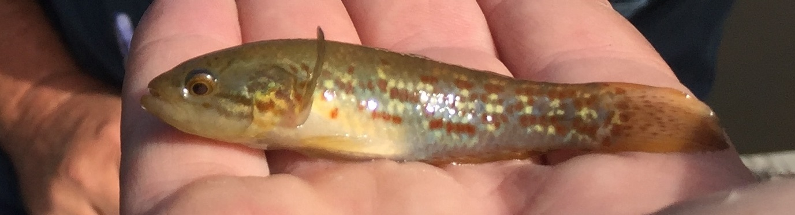

**Figure 6:** Southern Purple Spotted Gudgeon collected in the Dumaresq River April 2017.

The highest overall catches were recorded in the Dumaresq River, with 4,520 fish (observed = 2,992) captured comprising 14 species across the six sites sampled, followed by 4,032 (observed = 1,508) among ten species from the five sites sampled in the Severn River, and 2,372 (observed = 1,508) among 14 species and the five sites sampled in the Macintyre River (Figure 7; Table 7).

Bony Herring were individually the most abundant large bodied species (>100 mm) captured within the Dumaresq and Macintyre rivers but none were captured in the Severn River, while Murray Cod was the most abundant large-bodied native species present across all zones combined. Among the small-bodied species, Carp Gudgeon (*n* = 5,053) were the most abundant across all zones combined. By number, Carp Gudgeon comprised more than 70% of the catch in the Severn River, with only one other small-bodied native recorded, the Australian Smelt. Within the remaining zones the next most abundant small-bodied species were Murray-Darling Rainbowfish (*n* = 803) followed by Unspecked Hardyhead (*n* = 489).

Overall, there was a significant interaction between zones and sampling events in the structure and abundance of the fish community (Pseudo-F10,95 = 1.60, P<0.05; Figure 8). Pair-wise comparisons revealed significant differences between the Severn River and both the Dumaresq and Macintyre rivers over all sampling events. However, excluding 2016 and 2017a, there was no significant difference in abundance among the fish community between the Dumaresq and Macintyre rivers in all other sampling events. SIMPER analysis suggests that the differences (>10% contribution) in fish abundances between the Severn River and the Dumaresq and Macintyre rivers was primarily because of the absence of Bony Herring, Murray-Darling Rainbowfish, Unspecked Hardyhead, and extremely low numbers of Common Carp in the Severn River.

Differences between the Dumaresq and Macintyre rivers during 2016 were the result of greater numbers of Gambusia (contribution = 18.96%), Carp Gudgeon (contribution = 17.75%), and Unspecked Hardyhead (contribution = 12.25%) in the Dumaresq River. During the 2017a sampling event, differences were a result of higher abundances of Carp Gudgeon (contribution = 12.68%) and Freshwater Catfish (contribution = 11.80%) in the Dumaresq River, and higher abundances of Unspecked Hardyhead (contribution = 14.02) in the Macintyre River.

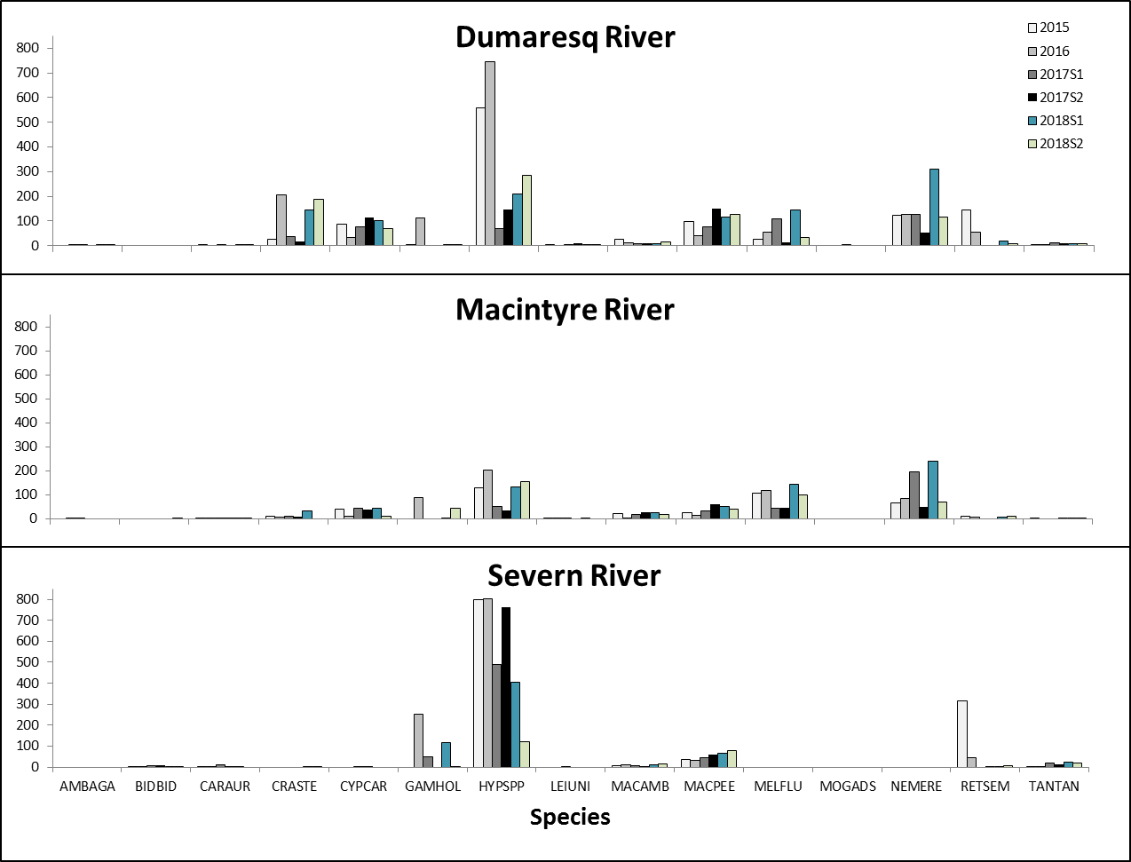

Catch

**Figure 7:** Catch per site per year for the 15 fish species sampled in the Border Rivers over six sampling events between 2015 and 2018 (see Table 5 for species names).

**Table 7:** Total catch numbers across all sites combined for the six samples undertaken (2015-2018) in the Dumaresq (*n* = 6), Macintyre (*n* = 5) and Severn (*n* = 5) rivers of the Border Rivers Region north-western NSW/south-western Qld.

|  |  |  |  |  |  |  |  |  |  |  |  |  |  |  |  |  |  |
| --- | --- | --- | --- | --- | --- | --- | --- | --- | --- | --- | --- | --- | --- | --- | --- | --- | --- |
|  |  | **Species** | | | | | | | | | | | | | | |  |
|  | **Sample** | **Olive Perchlet** | **Silver Perch** | **Goldfish** | **Un-specked Hardyhead** | **Carp** | **Gambusia** | **Carp Gudgeon** | **Spangled Perch** | **Golden Perch** | **Murray Cod** | **MD Rainbowfish** | **Purple Spotted Gudgeon** | **Bony Herring** | **Australian Smelt** | **Freshwater Catfish** | **Total** |
| **Dumaresq**  **River** | 2015 | 0 | 0 | 1 | 6 | 86 | 1 | 320 | 4 | 24 | 97 | 26 | 0 | 121 | 59 | 5 | **750** |
| 2016 | 3 | 0 | 0 | 27 | 32 | 25 | 512 | 0 | 10 | 41 | 30 | 0 | 112 | 3 | 2 | **797** |
| 2017a | 2 | 0 | 3 | 37 | 76 | 0 | 67 | 1 | 7 | 77 | 110 | 1 | 126 | 0 | 11 | **518** |
| 2017b | 0 | 0 | 2 | 16 | 112 | 3 | 147 | 8 | 10 | 151 | 14 | 0 | 54 | 0 | 8 | **525** |
| 2018a | 1 | 0 | 1 | 145 | 100 | 4 | 209 | 1 | 9 | 114 | 146 | 0 | 310 | 19 | 8 | **1067** |
| 2018b | 4 | 0 | 5 | 187 | 70 | 3 | 284 | 1 | 13 | 134 | 31 | 0 | 117 | 7 | 7 | **863** |
|  | **Total** | **10** | **0** | **12** | **418** | **476** | **36** | **1539** | **15** | **73** | **614** | **357** | **1** | **840** | **88** | **41** | **4520** |
|  |  | | | | | | | | | | | | | | | |  |
| **Macintyre River** | 2015 | 0 | 0 | 1 | 8 | 38 | 0 | 129 | 3 | 20 | 26 | 106 | 0 | 66 | 8 | 3 | **408** |
| 2016 | 0 | 0 | 3 | 5 | 11 | 0 | 39 | 0 | 4 | 15 | 11 | 0 | 80 | 0 | 0 | **168** |
| 2017a | 1 | 0 | 2 | 8 | 43 | 0 | 50 | 2 | 17 | 32 | 44 | 0 | 196 | 0 | 0 | **395** |
| 2017b | 0 | 0 | 4 | 7 | 37 | 0 | 34 | 0 | 25 | 61 | 45 | 0 | 50 | 0 | 3 | **266** |
| 2018a | 0 | 0 | 2 | 32 | 44 | 1 | 132 | 3 | 25 | 51 | 143 | 0 | 241 | 7 | 3 | **684** |
| 2018b | 0 | 1 | 1 | 11 | 44 | 0 | 153 | 0 | 19 | 41 | 97 | 0 | 70 | 11 | 3 | **451** |
|  | **Total** | **1** | **1** | **13** | **71** | **217** | **1** | **537** | **8** | **110** | **226** | **446** | **0** | **703** | **26** | **12** | **2372** |
|  |  | | | | | | | | | | | | | | | |  |
| **Severn**  **River** | 2015 | 0 | 2 | 3 | 0 | 0 | 0 | 797 | 0 | 8 | 38 | 0 | 0 | 0 | 315 | 1 | **1164** |
| 2016 | 0 | 4 | 1 | 0 | 0 | 58 | 404 | 0 | 10 | 32 | 0 | 0 | 0 | 1 | 1 | **511** |
| 2017a | 0 | 7 | 9 | 0 | 2 | 50 | 489 | 1 | 7 | 45 | 0 | 0 | 0 | 0 | 17 | **627** |
| 2017b | 0 | 9 | 3 | 0 | 5 | 0 | 761 | 0 | 6 | 61 | 0 | 0 | 0 | 2 | 11 | **858** |
| 2018a | 0 | 2 | 4 | 0 | 0 | 116 | 406 | 0 | 9 | 66 | 0 | 0 | 0 | 1 | 22 | **627** |
| 2018b | 0 | 2 | 0 | 0 | 1 | 0 | 120 | 0 | 16 | 79 | 0 | 0 | 0 | 7 | 17 | **245** |
|  | **Total** | **0** | **26** | **20** | **0** | **8** | **224** | **2977** | **1** | **56** | **321** | **0** | **0** | **0** | **326** | **69** | **4032** |

Figure 8: non-metric multi-dimensional scaling (nMDS) ordination plot derived from the abundance of fish assemblages sampled at sites in the Dumaresq (n = 6), Macintyre (n = 5) and Severn (n = 5) rivers across all sampling events (2015, 2016, April 2017a, November 2017b, April 2018a and November 2018b). 

**Figure 8:** non-metric multi-dimensional scaling (nMDS) ordination plot derived from the abundance of fish assemblages sampled at sites in the Dumaresq (*n* = 6), Macintyre (*n* = 5) and Severn (*n* = 5) rivers across all sampling events (2015, 2016, April 2017a, November 2017b, April 2018a and November 2018b).

## 6.2 Biomass

Based on estimated and measured weights, in total 7,973.154 kg of fish were sampled across all sites and for all methods combined. Common Carp had the highest overall biomass (3,466.273 kg) followed by Murray Cod (2,738.406 kg), Bony Herring (766.096 kg), and Golden Perch (578.15 kg). Among the small-bodied fishes, Carp Gudgeon (1.517 kg) had the highest biomass followed by Murray-Darling Rainbowfish (1.071kg), and Unspecked Hardyhead (0.232 kg).

There was a significant difference in the overall biomass of fish among zones for all years (Pseudo-F2,95 = 55.692, P<0.01; Figure 9). Pair-wise comparisons revealed significant differences between the Severn and both the Dumaresq and Macintyre rivers for all sampling events. However, there was no significant difference in the biomass of the fish community in the Dumaresq and Macintyre rivers over all sampling events, excluding 2016 and 2017a. SIMPER analysis suggested differences (>10% contribution) in the biomass of fish species between the Macintyre and Severn rivers was primarily a result of a higher biomass of Common Carp (contribution = 24.95%), Bony Herring (contribution = 19.85%), and Golden Perch (contribution = 10.03%) in the Macintyre River, and higher biomass of Freshwater Catfish (contribution = 11.74%) in the Severn River. Differences between the Dumaresq and the Severn rivers was a result of higher biomass of Common Carp (contribution = 28.39%) and Bony Herring (contribution = 21.06%) in the Dumaresq River, and a higher biomass of Freshwater Catfish (contribution = 10.71%) in the Severn River.

There was a significant difference in the overall biomass of fish among years within all three catchments (Pseudo-F5,95 = 4.39, P<0.01; Figure 8). Pair-wise comparisons revealed significant dissimilarity in biomass within the Macintyre River between 2015 and 2016 (t=1.69, P< 0.05), and between 2016 and each of the later events, 2017a through to 2018b (t=2.15, P<0.01; t=2.95, P<0.01; t=2.94, P<0.01 and t=2.60, P<0.01, respectively). An identical pattern was found in the Dumaresq River, with significant dissimilarity in biomass between 2015 and 2016 (t=1.81, P< 0.05), and between 2016 and each of the later events, 2017a through to 2018b (t=1.87, P<0.05; t=2.17, P<0.01; t=1.90, P<0.05 and t=1.80, P<0.05, respectively). Whilst the biomass was also significantly dissimilar within the Severn River between 2016 and each of the later events 2017a through to 2018b (t=1.91, P<0.05; t=1.88, P<0.05; t=2.30, P<0.01 and t=2.25, P<0.01, respectively), there were also differences between 2015 and 2017a, 2018a and 2018b (t=1.44, P<0.05; t=1.58, P<0.01 and t=1.62, P<0.01, respectively)

The differences (>10% contribution) in fish biomass between 2016 and all years between 2017a and 2018b in all catchments was primarily a result of greater biomass of Common Carp and Bony Herring in both the Macintyre and Dumaresq rivers, and a higher biomass of Freshwater Catfish in the Severn River.

Figure 9: nMDS ordination plot derived from the biomass of the fish assemblages sampled at sites in the Dumaresq (n = 6), Macintyre (n = 5) and Severn (n = 5) rivers (2015, 2016, April 2017a, November 2017b, April 2018a, and November 2018b).

**Figure 9:** nMDS ordination plot derived from the biomass of the fish assemblages sampled at sites in the Dumaresq (*n* = 6), Macintyre (*n* = 5) and Severn (*n* = 5) rivers (2015, 2016, April 2017a, November 2017b, April 2018a, and November 2018b).

## 6.3 Length-Frequency

The four most abundant large bodied species had consistent population structures within some rivers across sampling events, whilst in others there was less consistency, alternating between populations dominated by adults to those dominated largely by juveniles (Figure 10). Murray Cod populations in the Macintyre and Dumaresq rivers were very similar across all sampling events (Table 6 and Table 7). Both populations were dominated by fish <550mm in length, with young-of-year present in both rivers during all sampling events. In contrast, the Murray Cod population in the Severn River was significantly different to the Dumaresq River during all sampling events, as well as in the Macintyre River after 2016 (Table 8 and 9). This difference was largely driven by the absence of recruits in most years and the presence of greater numbers of larger >550mm fish in the Severn River compared to the other two systems.

The population structure of Bony Herring in the Dumaresq and Macintyre rivers was highly variable across samples. Bony Herring were not sampled in the Severn River during the project. In April 2018 the population of Bony Herring in the Macintyre was largely dominated by fish <125mm, compared to November 2017, as well as in 2015 in the Dumaresq Rivers, where the population was dominated by fish >250mm. Golden Perch and Common Carp population structures were similar in most years in river systems, with both populations dominated by adults and no or only small numbers of new recruits (Figure 10).

**Table 8:** Kolmogorov-Smirnov test results of length-frequency comparisons between the Dumaresq River (Zone 1), Macintyre River (Zone 2) and Severn River (Zone 3) over the six sampling events. NB. Dark shading indicates significant difference <0.05.

|  |  |  |  |  |  |
| --- | --- | --- | --- | --- | --- |
| **Sampling Event** | **Species** | ***P*** | **Hydrological Zone** | | |
| **1 vs 2** | **1 vs 3** | **2 vs 3** |
| 2015 | Murray Cod | P |  | <0.01 |  |
| Carp Gudgeon | P | <0.01 | <0.01 | <0.05 |
| 2016 | Murray Cod | P |  | <0.01 |  |
| Carp Gudgeon | P |  | <0.01 |  |
| 2017a | Murray Cod | P |  | <0.01 | <0.01 |
| Carp Gudgeon | P |  |  |  |
| 2017b | Murray Cod | P |  | <0.01 | <0.01 |
| Carp Gudgeon | P | <0.01 | <0.01 |  |
| 2018a | Murray Cod | P |  | <0.01 | <0.01 |
| Carp Gudgeon | P |  |  |  |
| 2018b | Murray Cod | P | <0.05 | <0.01 | <0.01 |
| Carp Gudgeon | P |  | <0.01 | <0.01 |

**Table 9:** Kolmogorov-Smirnov test results for length-frequency comparisons of fish between sampling events for all hydrological zones combined (Dumaresq, Macintyre and Severn rivers). NB. Dark shading indicates significant difference <0.05.

|  |  |  |
| --- | --- | --- |
| **Sampling Event** | **Murray Cod** | **Carp Gudgeon** |
| ***p*** | ***p*** |
| 2015 vs 2016 |  |  |
| 2015 vs 2017a | <0.01 | <0.01 |
| 2015 vs 2017b | <0.05 | <0.01 |
| 2015 vs 2018a | <0.01 | <0.01 |
| 2015 vs 2018b | <0.05 | <0.01 |
| 2016 vs 2017a |  | <0.01 |
| 2016 vs 2017b |  | <0.01 |
| 2016 vs 2018a |  | <0.01 |
| 2016 vs 2018b |  | <0.01 |
| 2017a vs 2017b |  | <0.01 |
| 2017a vs 2018a |  | <0.01 |
| 2017a vs 2018b |  | <0.05 |
| 2017b vs 2018a |  |  |
| 2017b vs 2018b |  |  |
| 2018a vs 2018b |  |  |

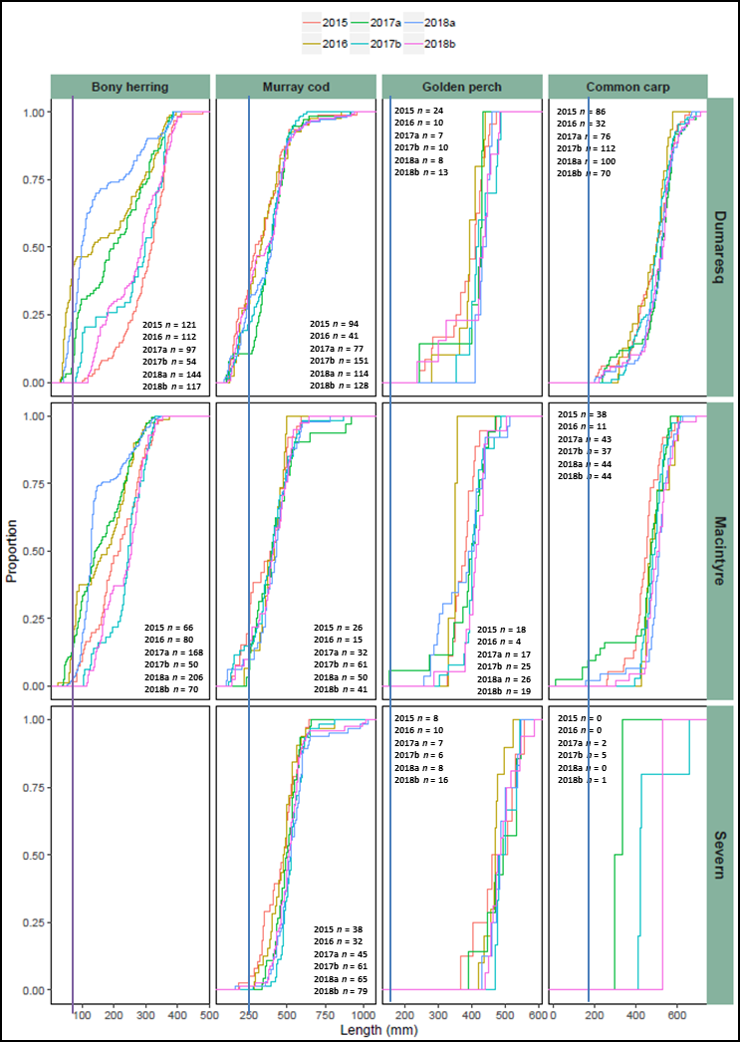

**Figure 10:** Length-frequency distribution (proportion - %) of large-bodied fish, Bony Herring, Murray Cod, Golden Perch and Common Carp sampled in the Border Rivers between 2015 and 2018. NB. Vertical lines represent estimated size of one year old fish.

The population structure of the three most abundant small-bodied species varied between rivers and sampling events (Figure 11). Both Unspecked Hardyhead and Murray-Darling Rainbowfish had highly variable population structures, with minimal or no recruitment in some years followed by relatively large increases in recruits and overall population numbers (Figure 11). Sampling in April 2017 failed to record any juvenile Murray-Darling Rainbowfish, suggesting that spawning and/or recruitment was minimal during 2016 in both the Macintyre and Dumaresq rivers. These conditions also impacted on the spawning and/or recruitment of Unspecked Hardyhead during the same period. Carp Gudgeon were recorded in all river reaches and in sufficient numbers to allow further analysis of the length frequency data. Whilst these populations were predominantly comprised of juveniles, the basic structure of the population tended to shift on a year-by-year basis. Exceptions to this were 2015 and 2016, and again between 2017b and 2018b, where no significant differences were observed. The population within the Dumaresq River was the most variable, with a major decline in recruitment observed after the flows in 2016 followed by an increase in population numbers over the following sampling events.

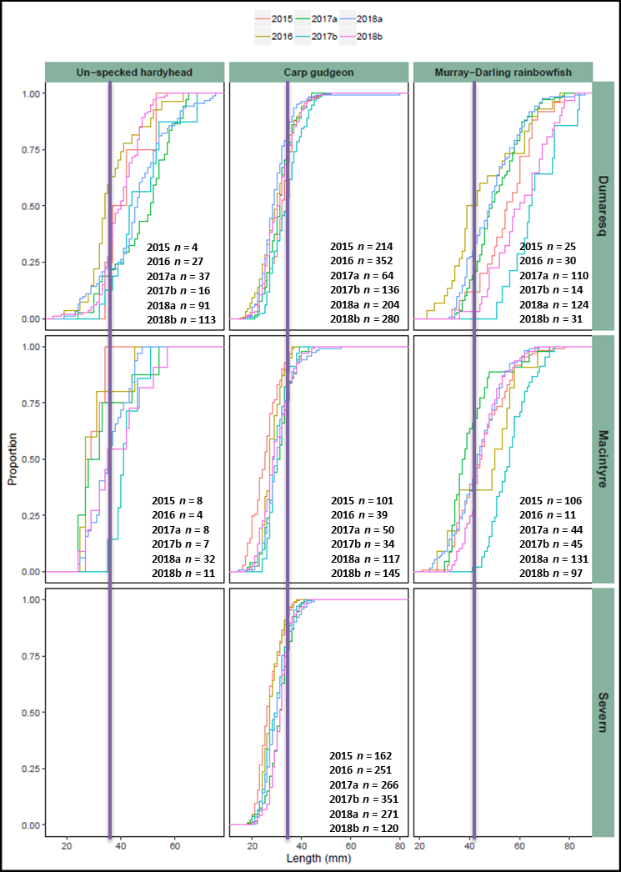

**Figure 11:** Length frequency distribution (proportion -%) of small-bodied fish, Unspecked Hardyhead, Carp Gudgeon, and Murray-Darling Rainbowfish sampled in the Border Rivers between 2015 and 2018. **NB.** Vertical lines represent estimated size of one year old fish.

## 6.4 Health indicators

*Expectedness*

Of the 15 native fish species that potentially could have been sampled across the Border Rivers, 12 were recorded during the current surveys. The species not recorded were River Blackfish, Mountain Galaxias, and Darling River Hardyhead. The predicted occurrence of all these species was considered as *rare* so it is was not unexpected that they were not collected. Additionally, distinguishing between the two species of Hardyhead is difficult for specimens less than 20 mm, so it is possible that smaller specimens of the Darling River Hardyhead were present but were misidentified and pooled with the more common Unspecked Hardyhead during processing.

In both the Dumaresq and Macintyre rivers, 11 species were recorded, albeit with slightly different species compositions. Silver Perch were not recorded in the Dumaresq River, but were recorded in the Macintyre River, whilst the opposite was the case for Southern Purple Spotted Gudgeon, which was recorded in the Macintyre River and not the Dumaresq.

Of the three rivers sampled, the Dumaresq River scored the highest rating for *Expectedness* with an overall rating of “Good” across all events (Figure 12). Whilst on average *Expectedness* was also “Good” for the Macintyre River, in 2016 and 2017b the river scored a “Poor” and a “Moderate” rating, respectively. The *Expectedness* rating in the Severn River was generally “Poor”, with exceptions being the 2016b and 2017a sampling events where the system scored as “Moderate”.

*Nativeness*

Three exotic species were recorded within all three river zones, Common Carp, Goldfish, and Gambusia. Common Carp had not been recorded in the Severn River before this current monitoring program commenced. The first Carp were recorded at the Wells Crossing sampling site during April 2017, followed by several more at the same site in November 2017. No further Common Carp were captured in the Severn River in subsequent rounds except for a single individual sampled at the Power Station TSR site in November 2018.

Despite the small numbers recorded in the Severn River, Common Carp were the most abundant exotic species recorded at all sites in the Dumaresq and Macintyre rivers, with the highest catches in the Dumaresq River (*n* = 476) followed by the Macintyre River (*n* = 217). Numerically Gambusia were the next most abundant (*n* = 261), being most common in the Severn River (*n* = 224) although this tended to be seasonal, followed by the Dumaresq River (*n* = 36), with only a single specimen recorded in the Macintyre River. Goldfish were the most consistently sampled exotic fish, having been captured in all rivers across the majority of sampling events but only in relatively low numbers. The majority of Goldfish were captured in the Severn River (*n* = 20) followed by the Macintyre and Dumaresq rivers, with 13 and 12, respectively.

Overall the *Nativeness* scores for all rivers over all sampling events remained relatively stable (Figure 12). The Severn River had the highest average *Nativeness* score rating as “Good”, with the lowest rating occurring in November 2017 (96.98 ± 6.69), when a number of Common Carp were captured, and the highest rating of 99.98 (± 0.27) recorded in November 2018 (Figure 10). Both the Dumaresq and Macintyre rivers had overall *Nativeness* scores of “Moderate”. Similar to the Severn River, the lowest score in the Dumaresq River was in November 2017 at 61.05 (± 8.61) and the highest of 73.25 (± 15.79) in November 2018. In contrast the highest score in the Macintyre River was November 2017 with a score of 74.16 (± 9.18) and the lowest in November 2018 at 65.84 (± 11.48; Figure 12).

*Recruitment*

The *Recruitment* indicator scores were highly variable between sampling events as well as among river systems (Figure 12). *Recruitment* rated as generally “Extremely Poor” in the Severn River, and varied between “Poor” and “Extremely Poor” in the Dumaresq River, and “Poor” to “Very Poor” in the Macintyre River (Figure 12).

Overall there was a decline in the *Recruitment* score within the Severn River, from a high in 2015 of 21.4 down to 11 in November 2018. Whilst both the Dumaresq and Macintyre rivers showed very similar patterns for the *Recruitment* indicator, the highest in both systems was in 2016 with 58.6 and 58.3 respectively, and the lowest in November 2017 at 14 and 29.2 respectively. The *Recruitment* indicator scores were the lowest within all catchments during November 2017, with a general improvement in all catchments after that (Figure 12).

Overall, 48.1% (*n* = 3,519) of the total catch of native fish was made up of recruits. The highest proportion were recorded in the Severn River (65.2%), followed by the Dumaresq River (43.6%) and lowest in the Macintyre River (38.7%). The small-bodied fishes made up the largest proportion of recruits within the Border Rivers (92.1%). Recruits of most species were sampled across all rivers and all sampling events, excluding Southern Purple Spotted Gudgeon, where only a single specimen was captured.

Among the large-bodied fishes, recruitment generally represented low overall numbers and tended to be sporadic in occurrence in all systems. No young-of-year were captured for either Silver Perch or Golden Perch during this sampling. The highest numbers of recruits for large-bodied fishes were Murray Cod, representing 14% of the total catch of this species. The highest numbers of recruits for Murray Cod were captured in the Dumaresq River representing 22.3% (*n =* 135) of the total catch of this species, whilst 10.2% (or 23 individuals) were recorded in the Macintyre River, and less than 1% (*n =* 3) in the Severn River. Murray Cod recruits were sampled in every event in the Dumaresq River and in all but one event in the Macintyre River, but were rarely encountered in the Severn River. Low numbers of Freshwater Catfish recruits were also recorded in both the Severn and Dumaresq rivers, but were absent in the Macintyre River. Recruitment levels of both these species increased in the latter sampling events.

Despite high abundance and biomass in both the Dumaresq and Macintyre rivers, and in later samples in the Severn River, virtually no Common Carp recruits were captured or observed during this monitoring.

*Overall Condition*

The *Overall Condition* scores in both the Dumaresq and Macintyre rivers improved through 2018 after a low in November 2017, and increased slightly over the entire period of sampling within the Severn River (Figure 12). In the Dumaresq River the *Overall Condition* for 2015, 2016 and April 2018 rated as “Moderate”, whilst fish condition was “Poor during” April 2017, and November 2017 and 2018. In the Macintyre River the *Overall Condition* rated as “Poor” during 2015, 2016, and again in both November 2017 and 2018, whilst it rated as “Moderate” during April in 2017 and 2018. The *Overall Condition* in the Severn River was much lower, rating as “Very Poor” over all sampling events, except for November 2017 and April 2018 when it rated as “Poor”, with the rating driven largely by low recruitment numbers throughout the project.

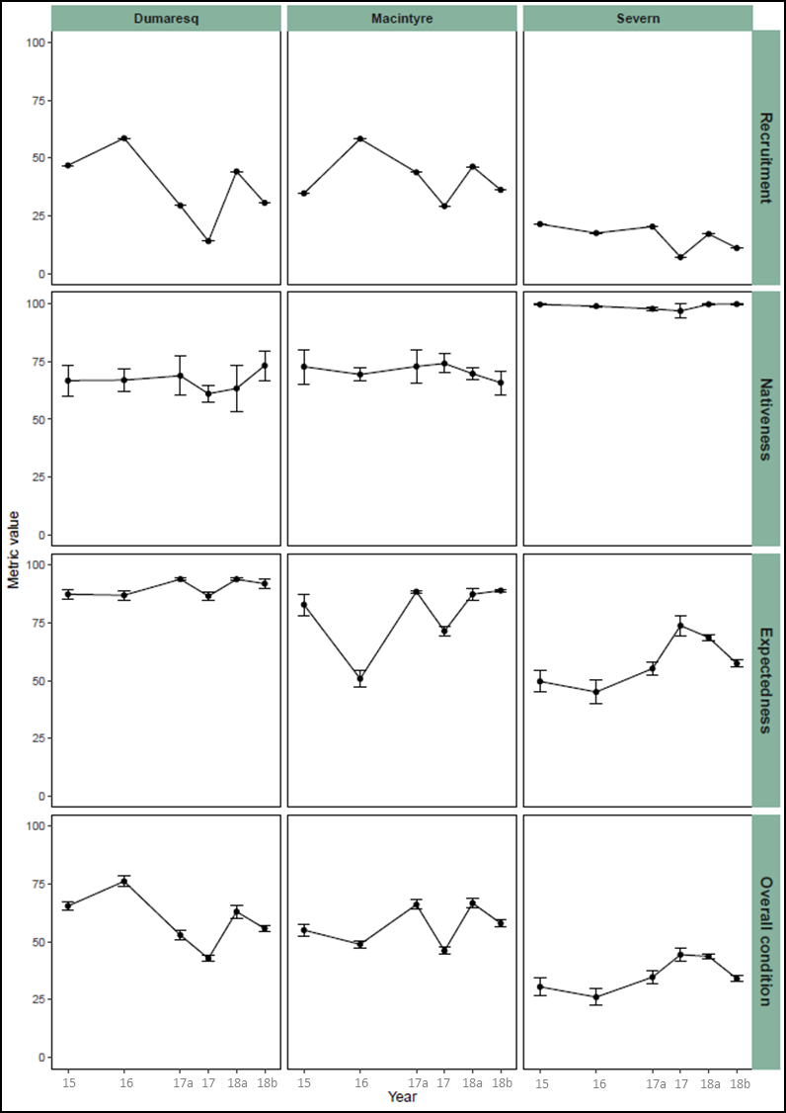

**Figure 12:** *Recruitment*, *Nativeness*, *Expectedness* and *Overall Condition* indicator values for fish in the Severn, Macintyre and Dumaresq rivers 2015 through 2018.

# Discussion

The current project focussed on the short and medium term ecological response of key native fish species, with an emphasis on supporting reproduction and recruitment in relation to the delivery of water for the environment in the Border Rivers region. Three separate environmental watering events were undertaken during the project period; one in the Severn River during late winter/early spring 2017 that involved NSW Planned Environmental Water (stimulus flow) and CEWO entitlements; an event in the Dumaresq/Macintyre River in spring 2017 using CEWO entitlements, and; one in the Dumaresq/Macintyre River during autumn 2018 using CEWO entitlements to contribute water to the Barwon-Darling whilst targeting valley outcomes. These events followed the use of the stimulus flow in the Severn River during spring 2015, and significant flow events across the Border Rivers valley in spring 2016 and autumn 2017. The results of this study have implications for the long-term management of water in the Border Rivers region, including helping to inform the implementation of the Water Sharing Plan and Long Term Water Plan, and the management of CEWO’s portfolio, to maximise ecological outcomes in the Border Rivers.

A range of natural, operational and environmental flows were experienced across the Border Rivers region during and preceding the project period. Monitoring of fish communities, including the different life history stages of both moderate to long-lived and short-lived species, allows the assessment of the responses of native fish to the delivery of water for the environment in the Border Rivers valley under the specific antecedent and natural flow conditions. This greatly enhances the knowledge of fish responses to both managed and natural watering events in the Border Rivers region, and provides a basis from which to plan and refine future water management and watering actions going forward.

**Border Rivers fish community**

Results from the sampling for the *Fish and flows intervention monitoring in the Border Rivers* project suggests that the fish community of the Border Rivers valley is in relatively good condition, with 12 of the 15 native fish species expected to occur in the valley captured. The fish assemblages in the Dumaresq and Macintyre systems were similar (across sampling events), but a distinct fish assemblage was observed in the Severn River. In comparison to the Dumaresq and Macintyre, the fish community in the Severn River was comparatively low in species richness, with only seven native species recorded. Similarly, Butler et al. (2015) recorded only five native fish species within the Severn River upstream of Pindari Dam. This is to be somewhat expected as generally, species diversity decreases with increasing altitude. To compound this, a series of waterfalls located at the junction of the Severn and Macintyre rivers represents a substantial natural barrier to the upstream dispersal of fish.

The *Overall Condition* of native fish in the Border Rivers region was found to be the lowest in the Severn River, which scored an overall rating of ”Very Poor” to “Poor” across the sampling period. This is despite an apparent dominance by native species and the relatively low numbers and biomass of exotic species in the system. These findings were driven by consistently low *Recruitment* and *Expectedness* values, which are likely a result of a range of factors including habitat condition, water quality and water management practices.

Low flows were experienced in the system during the 2014-16 seasons, which corresponded to the poorest fish condition for the project period. However, subsequent large flow events in the system over autumn 2017, complemented with the release of water for the environment in late winter 2017 resulted in a general improvement in *Overall Fish Condition* in late 2017 and early 2018, and an increase in recruitment. However, the return to drier conditions and lower flows during the last sampling round saw a reduction in the majority of health metrics. This highlights the need for careful water management in association with complementary actions, such as habitat rehabilitation, water quality management, and connectivity, to protect fish in the Severn during periods of low flow.

The fish communities and associated metrics were similar between the Dumaresq and Macintyre, with both systems rating as either “Poor” or “Moderate” throughout the project period. However variable flows, including large fresh events during the 2014-16 seasons appear to have resulted in different responses between the two systems. The Dumaresq River had its highest *Overall Fish Condition* in 2016, driven by higher recruitment, and whilst the Macintyre similarly displayed a positive recruitment response to these flows, the system ultimately rated as “Poor” for *Overall Fish Condition* in 2016 due largely to the low number of species caught compared to what was expected to be in the system. The lowest *Overall Fish Condition* was recorded in late 2017, following a season of very high flows down the Dumaresq and Macintyre rivers that appear to have caused major disruption to the systems, especially recruitment of native fish. Low flow events in 2017-18, including the use of Commonwealth entitlement appear to have helped improved *Overall Fish Condition* in the Dumaresq and Macintyre rivers; however similar to the Severn River, there was a reduction in key fish community metrics during the last sampling round as drought and low flows returned to the Border Rivers region.

The release of water for the environment in the Severn and Dumaresq rivers during late winter/early spring in 2017 appears to have been effective in priming and maintaining habitat. The release also led to increased connectivity throughout the wider Border Rivers region further contributing to positive native fish outcomes. There were also a number of species specific responses:

* Post environmental flow release monitoring found increased numbers of Murray Cod young-of-year in both the Macintyre and Dumaresq systems; whilst in the Severn River only three Murray Cod young-of-year were recorded.
* Freshwater Catfish were recorded in all systems, with variable catch numbers among sampling events. Freshwater catfish is known to breed and recruit during low flow periods (Pusey et al. 2004), though during this monitoring period Freshwater Catfish nests and recruits were observed, and increased after fresh events, including those contributed to by the release of water for the environment, in both the Dumaresq and Severn rivers. Larval trapping undertaken in the Severn River during November 2017 further confirmed this, yielding two Freshwater Catfish larvae; however circumstances limited the amount of larval trapping that could be undertaken.
* The abundance of Unspecked Hardyhead and Murray-Darling Rainbowfish increased in seasons following the release of water for the environment.
* The release of water for the environment during the sampling period also benefited *Generalist* species such as Bony Herring and Carp Gudgeon, with increased spawning and recruitment observed following environmental flow releases.

Three exotic species were recorded during project period. Of these, Common Carp contributed more to the total biomass of fish than any other species present, despite being largely restricted to only two of the three waterways sampled. Of the exotic species present, Common Carp is likely having the greatest impact on native fish condition in the Border Rivers. However, most notable was the absence of Carp recruits over the four years of monitoring; suggesting conditions were not suitable for the recruitment of this species during the sampling period. Future management of water for the environment in the Border Rivers region should aim to ensure that releases of water minimise the opportunity for Common Carp to spawn and ultimately recruit.

**Flows and habitat in the Border Rivers**

The river systems surveyed in this project all contain habitat types and conditions suitable for the native fish species present in the region. This is particularly the case for Murray Cod, with ideal spawning and recruitment habitat such as large woody habitat and undercut banks abundant in the Severn, Dumaresq and Macintyre rivers. Observations of the preferred spawning habitat for Murray Cod in the Dumaresq River have found that most fish in this river largely use bank overhangs (G. Butler, unpublished data). Habitat in both the Macintyre and Severn rivers is similar to the Dumaresq River and it is expected that Murray Cod would be using similar habitat in these systems.

It was noted during the current study that during periods of extremely low flow many of these overhangs were partially exposed, and were most likely not able to be utilised during the spawning season unless a small flow event occurred to fill and raise pools, particularly in the Severn River. However flows in the system, including those released as part of managing water for the environment inundated considerable proportions of key aquatic habitat features along the main systems, including up to 72% of large woody habitat and 95% of overhangs in the Dumaresq during held water for the environment release. This again highlights the holistic and broad reaching contribution of water for the environment in building native fish resilience and ultimately recovery.

The recruitment of all small-bodied species was increased after flow releases in the three systems. This was particularly the case once macrophyte beds in the waterways, a key habitat feature for small-bodied species, had recovered following losses resulting from previous large flow events. The stimulus flows delivered in 2017 appeared to benefit the macrophyte beds by maintaining and cleansing them of old growth and detritus prior to new spring growth. These beds are critical for the continued survival of many of the small-bodied fishes, most notably the threatened Olive Perchlet, which was most commonly encountered among macrophyte beds in the Dumaresq River during the current study.

**Limitations of the study**

Due to the lack of appropriate sample size (minimum *n* = 20) for young of year fish for target species, otolith analysis to back calculate day-of-spawning could not be undertaken as part of the current project. Daily aging allows the construction of length-at-age growth functions by examining and enumerating daily growth rings in otoliths. In the absence of this, known length-age relationships were used to determine the presence of new recruits in the Border Rivers; however otolith analysis should still be included in future monitoring activities, especially in relation to targeted larval/young-of-year monitoring sampling. This will help to enhance spawning and recruitment knowledge in the Border Rivers region, which is currently poorly understood for most species.

Similarly, whilst freshwater decapods (shrimp and yabbies) were caught during the project, they were in relatively low numbers, as such limiting the ability to assess the contribution of water for the environment to their relative abundance and diversity. This was a relatively minor component of the project that aimed to potentially provide some insights into productivity and food web interactions in the project area, which can be key pieces of information that may guide the use of water for the environment; however, sampling of the fish community was the main focus for the project to achieve this. A more comprehensive productivity based monitoring component could be included in future monitoring activities to inform system productivity, fish condition, and links to native fish outcomes.

**Overall conclusion**

The project has demonstrated that the management of water for the environment in the Border Rivers region during late 2017 had a positive effect on recruitment, maintenance of habitat and fish communities, with no negative impacts identified. The events were primarily targeted at priming the system to support pre-spawning condition of native fish, taking cues from preceding natural events and antecedent conditions. These flows provided increased inundation of key habitat features that contribute to primary productivity including benches and some low-lying wetland entry points in all regulated systems of the Border Rivers, whilst also providing localised connectivity and movement opportunities for fish. The future delivery of environmental flows should also always consider any potential negative impacts, such as disrupting nesting sites of species such as Murray Cod and Freshwater Catfish, and potentially affecting vulnerable eggs, larval and juvenile fishes as a result of cold-water releases from impoundments.

# Management recommendations

1. Water managers should recognise and promote the value that current Held Environmental Water and Planned Environmental Water entitlements provide for achieving native fish condition and recruitment outcomes in the Border Rivers. These outcomes complement spawning, movement and productivity outcomes provided by natural fresh events in the valley, which are usually of volumes greater than the volume of water for the environment. Considered planning and management of water for the environment should use these natural events as cues where possible to provide complementary fresh or low flow events that maximise habitat inundation to support recruitment, movement and condition outcomes for native fish.
2. Government agencies should continue to work collaboratively in managing the relatively small entitlements in the Border Rivers so as to maximise ecological outcomes. This includes combining resources where possible, such as adding Commonwealth entitlement to the NSW stimulus flow in the Severn River to extend outcomes, as was achieved in 2017. Rules associated with these provisions should also be reviewed so as to maximise the protection of water for the environment and the outcomes it achieves in the Border Rivers region and beyond. This includes consideration of active management to protect held water for the environment as it moves between systems, including from the Severn to the Macintyre and into the Barwon River, as well as extending the length of waterway that the stimulus flow is protected to and the season that it can be used in to allow greater flexibility in achieving ecological outcomes for the valley. Establishment of an Environmental Water Advisory Group for the Border Rivers with appropriate representation of all relevant stakeholder groups would be beneficial for the planning and delivery of water for the environment in the valley (as proposed in the draft WRP package for the NSW Border Rivers) (NSW DOI 2018).
3. Rules associated with water for the environment provisions should be reviewed so as to maximise its protection and outcomes it achieved in the Border Rivers and beyond. This includes consideration of active management to protect held water for the environment as it moves between systems, including from the Severn to the Macintyre and into the Barwon River, as well as extending the length of waterway that the stimulus flow is protected to and the season that it can be used in to allow greater flexibility in achieving ecological outcomes (as proposed in the draft WRP package for the NSW Border Rivers) (NSW DOI 2018).

# Research recommendations

1. Continued long-term monitoring of fish communities in the Border Rivers valley would provide information to assess additional long-term outcomes, including changes in native fish diversity, abundance and population structure.
2. Continued monitoring and evaluation of the Border Rivers fish community to inform long-term responses in relation to flow. This should especially focus on Held Environmental Water entitlements and Planned Environmental Water provisions, with future monitoring aiming to gain further understanding of the ideal duration, peak events, and rate of rise and fall of flows. This information will be critical to guide adaptive management in the valley, which will contribute to achieving the objectives and targets of the Commonwealth’s portfolio management plans, Water Sharing Plans, Long Term Water Plans, and ultimately the Basin Plan and associated Basin-wide Watering Strategy outcomes.
3. A detailed investigation is required into the differences found in the fish community in the Severn River in comparison to the other major systems of the Border Rivers, including the lack of Murray Cod recruits. This should focus on movement studies and habitat association for key species, as well as water quality issues including cold water pollution. It is well known that thermal pollution is a major issue with water releases from both Glenlyon and Pindari dams, but the impacts of thermal pollution on recruitment of native fish species is poorly understood. It appears that thermal pollution is in all probability contributing to the low levels of recruitment observed for the large bodied species such as Murray cod and Freshwater Catfish within the Severn River. This issue, and effective release strategies to minimise these impacts should be included in any future research.
4. Detailed investigation into the lack of Golden Perch, Silver Perch and Spangled Perch recruits across the Border Rivers should be considered a priority. In conjunction with routine monitoring, innovative research and collaborating with existing projects using techniques such as otolith microchemistry analysis and fish movement studies should be considered as a way forward. Complementary activities such as improving and addressing water management and fish passage needs should also be considered a priority. No recruits were captured for any of the three species during the current project despite the occurrence of natural flow events that were considered suitable for eliciting spawning in these species (e.g. April 2017, and January to February 2018). Silver Perch were only caught in the Severn River, and while the number of adults increased marginally in number across years, with a likely spawning aggregation observed during November 2017, no recruits or young-of-year were detected. Future research should be undertaken on the biology of all three species across this region, and the interaction with other populations in the Northern Basin. This work would assist in determining potential source populations of each species and equip water managers with better information for the flow and connectivity requirements required to support meta-populations of native fish.
5. Continuation of mapping aquatic habitat features in the Border Rivers would add value to the habitat mapping work already undertaken, as well as provide valuable information that could be used for future revision of water for the environment requirements needed to achieve ecological objectives. Improved information on the location and commence to inundate thresholds for key habitat features would enhance links to nutrient and carbon transfer from benches and floodplain/anabranch connection, nesting and nursery habitat of native fish, and key refuge sites for protection during extended periods of low flow. The methodology for efficiently and effectively mapping aquatic habitats has been developed and successfully implemented in reaches across five valleys in the NSW MDB, including the Border Rivers. Extending the range of this information to key remaining sections of the valley would increase certainty and improve strategic decision making. Linking biological needs to system-specific ecological information to enhance management actions will also improve the ecological benefits of water management over the long-term. Priority reaches include the Severn River (Pindari Dam to the Dumaresq River confluence approximately 180 km, and the Macintyre River (Dumaresq River confluence to Mungindi, approximately 340 km).

# References

Beheregaray L.B., Pfeiffer L.V., Attard C.R.M., Sandoval-Castillo J., Domingos F.M.B.C, Faulks L.K., Gilligan D.M, and Unmack P.J (2017). Genome-wide data delimits multiple climate-determined species ranges in a widespread Australian fish, the golden perch (*Macquaria ambigua*). Molecular Phylogenetics and Evolution 111(2017):65–75.

Butler, G.L., Brooks, S. and Smith, D. (2015). Building a stronger, more resilient and sustainable Murray Cod fishery in NSW: Summary Report Event One Severn River, Northern NSW. NSW Department of Primary Industries, Grafton.

Cadwallader, P. L. (1977). J.O. Langtry’s 1949-50 Murray River Investigations. Fisheries and Wildlife Paper No.13. Fisheries and Wildlife Division, Victoria.

Commonwealth Environmental Water Office (2018). Commonwealth Environmental Water Portfolio Management Plan: Border Rivers 2016–17, Commonwealth of Australia, 2018.

Commonwealth Environmental Water Office (2013).Commonwealth Environmental Water – The Environmental Water Outcomes Framework, Commonwealth Environmental Water Office V1.0

Davis, T.L.O (1977). Age determination and growth of the freshwater catfish *Tandanus tandanus* Mitchell, in the Gwydir River, Australia. Australian Journal of Marine and Freshwater Research 28(2):159-169.

Davies, P., Stewardson, M., Hillman, T., Roberts, J. and Thoms, M. (2012). Sustainable Rivers Audit 2: the ecological health of rivers in the Murray-Darling Basin at the end of the Millenium Drought (2008-2010) volume 2. Murray-Darling Basin Authority, Canberra.

Department of Environment (2016). Commonwealth environmental water portfolio management plan 2016-17: Border Rivers. Commonwealth of Australia, Canberra.

Gorski, K., Collier, K., Duggan, I., Taylor, C. and Hamilton, D. (2013). [Connectivity and complexity of floodplain habitats govern zooplankton dynamics in a large temperate river system](http://onlinelibrary.wiley.com/doi/10.1111/fwb.12144/full). *Freshwater Biology* **58**: 1458-1470

Jenkins, K. and Boulton, A. (2003). [Connectivity in a dryland river: short-term aquatic microinvertebrate recruitment following floodplain inundation](https://scholar.google.com.au/citations?view_op=view_citation&hl=en&user=iyKuSesAAAAJ&citation_for_view=iyKuSesAAAAJ:u5HHmVD_uO8C). *Ecology* **84**: 2708-2723.

Leggett, R. and Merrick, J.R. (1987). Australian Native Fishes for Aquariums. J.R. Merrics Publication, Artarmon, NSW. 241pp.

Lorenzoni, M., Corboli, M., Ghetti, L., Pedicillo, G., Carosi, A. (2007). Growth and reproduction of the goldfish *Carassius auratus*: a case study from Italy. In: Gherardi F (ed) Freshwater Bioinvaders: Profiles, Distribution, and Threats, Springer, Berlin, pp 259–273, doi:10.1007/978-1- 4020-6029-8_13

Mallen-Cooper, M. (1996). Fishways and freshwater fish migration in south-eastern Australia. University of Technology, Sydney. 429pp.

Mallen-Cooper, M. and Zampatti, B. (2015). Background paper: use of life history conceptual models of fish in flow management in the Murray-Darling Basin. Murray-Darling Basin Authority, Canberra.

McDowall, R.M (1996). Freshwater fishes of south-eastern Australia. Second Edition. Reed Books, Sydney.

Murray-Darling Basin Authority (2012). Assessment of environmental water requirements for the proposed Basin Plan: lower Border Rivers (in-channel flows). Murray-Darling Basin Authority, Canberra.

NSW Department of Industry (2018). NSW Border Rivers surface water resource plan. SW16 NSW Border Rivers Surface Water Resource Plan area. NSW Department of Industry, Sydney.

NSW Department of Primary Industries (2015). Fish and Flows in the Northern Basin: responses of fish to changes in flow in the Northern Murray-Darling Basin – Valley Scale Report. Final report prepared for the Murray-Darling Basin Authority. NSW Department of Primary Industries, Tamworth.

NSW Department of Primary Industries (2016). NSW Fish Community Status Project. Final report prepared for the Commonwealth Government. NSW Department of Primary Industries, Wollongbar.

NSW Department of Primary Industries and Queensland Department of Agriculture and Fisheries (2017). Fish and flows intervention monitoring in the Border Rivers – Interim report 2016/17. Report prepared for the Commonwealth of Australia as represented by the Department of the Environment and Energy. NSW Department of Primary Industries, Tamworth.

Pusey, B.J, Kennard, M.J. and Arthington, A.H. (2004). Freshwater fishes of north-eastern Australia. CSIRO Publishing, Collingwood, Victoria.

SKM (2009). Environmental watering priorities for the northern Murray Darling Basin. Sinclair Knight Merz. Final Report to the Department of the Environment, Water, Heritage and the Arts.

Vilizzi, L. and K.F. Walker (1999). Age and growth of common carp, *Cyprinus carpio*, in the River Murray, Australia: validation, consistency of age interpretation and growth models. Environmental Biology of Fishes 54:77-106.

Zampatti, B. and Leigh, S. (2013).  Effects of flooding on recruitment and abundance of Golden Perch (*Macquaria ambigua ambigua*) in the lower River Murray. *Ecological Management and Restoration* **14**: 135–143.

1. The *Water Sharing Plan for the NSW Border Rivers Regulated River Water Source* provides for 4,000 ML to be reserved at the start of each year for a ‘stimulus flow’; a pulse of water released from Pindari Dam to stimulate downstream ecological processes. The water becomes available if inflows into Pindari Dam exceed 1,200 ML on any day between April and August and is required to be released between 1 August and 1 December of the same year. Unused water can be carried over to a maximum of 8,000 ML.