FITZGERALD BIOSPHERE RECOVERY PLAN

A landscape approach to threatened species and ecological communities for recovery and biodiversity conservation
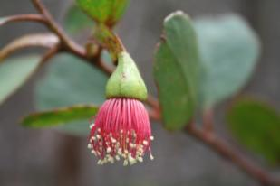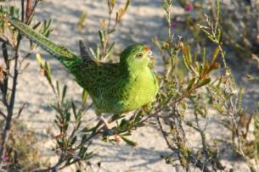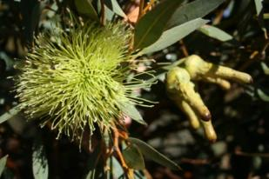

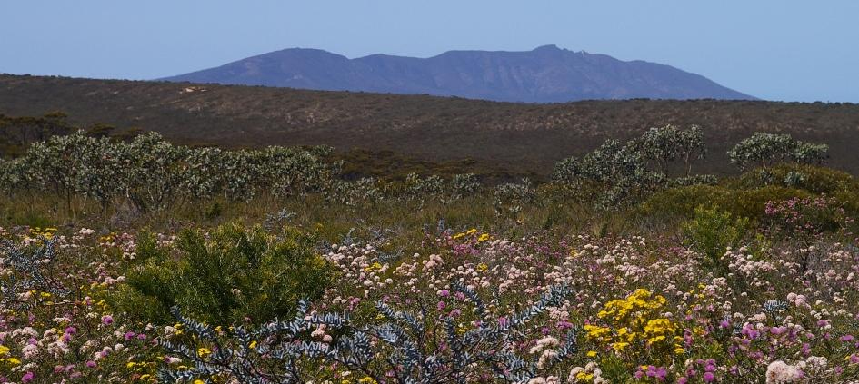

South Coast Region
Department of Environment and Conservation



This Fitzgerald Biosphere Recovery Plan has been prepared by Janet Newell, Sarah Comer and Deon Utber for the Western Australian Department of Environment and Conservation.

This Plan should be cited as follows:
Department of Environment and Conservation, (2012). Fitzgerald Biosphere Recovery Plan: A Landscape Approach to Threatened Species and Ecological Communities Recovery and Biodiversity Conservation, Western Australian Department of Environment and Conservation, Albany.

Cover photos: top left – Eucalyptus nutans (Sarah Barrett)
top middle – Western Ground Parrot (Brent Barrett)
top right – Eucalyptus burdettiana (Sarah Barrett)
bottom – Fitzgerald River National Park (Sarah Comer)

Department of Environment and Conservation
South Coast Region
120 Albany Highway
Albany WA 6330.

Forward

This Fitzgerald Biosphere Recovery Plan constitutes the formal national regional recovery plan for 11 flora species and provides recovery guidance for the remaining species and ecological communities largely endemic to the Fitzgerald Biosphere on the south coast of Western Australia that are listed under the Commonwealth Environment Protection and Biodiversity Conservation Act 1999 (EPBC Act).

The Fitzgerald River National Park (FRNP) was designated a Biosphere Reserve under the UNESCO Man and the Biosphere (MAB) Programme in 1978, and is recognised for its relatively pristine state and high biological diversity, especially its flora.

For the purpose of this plan, the term ‘Fitzgerald Biosphere’ or ‘Biosphere’ refers to the combination of the core Biosphere area as recognised by MAB and the buffer and transition zones as defined by catchment boundaries as shown in figure 1. Accordingly, this Recovery Plan applies to the threatened species and ecological communities occurring within the core area and the buffer and transition zones. However, the plan does not constitute an EPBC Act management plan for the MAB Biosphere.

The Biosphere includes 41 threatened species/communities listed by the State of WA, 33 of which are also listed by the Commonwealth.

The Plan presents a landscape approach to identifying the recovery actions and management practices necessary to ensure the long-term viability of the threatened and priority species and ecological communities and the overall biodiversity of the Fitzgerald Biosphere.
The attainment of this Plan’s objectives and the provision of funds necessary to implement actions are subject to budgetary and other constraints affecting the parties involved, as well as the need to address other priorities. Recovery Plans do not necessarily represent the views or the official positions of individuals or organisations represented on the Recovery Team.

It is intended that this Recovery Plan will be implemented over a 10-year period. The information in this Plan is accurate at March 2011.

This Fitzgerald Biosphere Recovery Plan is presented in two documents. This document is the main body of the Plan, while the second document contains profiles of the threatened species and ecological communities represented by this plan (Appendix 2).

Acknowledgements

This Recovery Plan was prepared by a project team of Deon Utber (Regional Nature Conservation Leader), Sarah Comer (Regional Ecologist) and Janet Newell (Recovery Planner) of the Western Australian Department of Environment and Conservation, South Coast Region.

The development of the Plan was guided by a Steering Committee of:
Peter Latch Director, Recovery Planning and Implementation Section, DSEWPaC
Mike Shephard District Manager, Albany District, DEC
Tony Friend Research Scientist, Science Division, DEC
Ken Atkins Species and Communities Branch, DEC
Neil Riches Commonwealth NRM
Rob Edkins CEO, South Coast NRM Inc.
Amanda Keesing Gondwana Link
Gillian Craig President, Friends of the Fitzgerald River NP
Nathan McQuoid Community member

Many additional people have been involved in the development of this Plan. Thank you to the following people and organisations for their contributions to this Plan:
Simon Nally, Bruce McLaren and Kåren Watson (DSEWPaC), Abby Berryman, Sarah Barrett, Greg Broomhall, Peter Collins, Anne Cochrane, Saul Cowan, Val English and Ian Herford (DEC), Raana Scott (Birds Australia), Anne Sparrow (Fitzgerald Biosphere Group), Paula Deegan (Gondwana Link), Justin Bellanger and Alison Lullfitz (South Coast NRM Inc.), Rodger Walker (RAIN), Sandra Gilfillan and John Blyth (community members).

Also, thank you to those who contributed ideas and information through the community consultation process undertaken as part of the preparation of this Plan.

Table of Contents
Forward 3
LIST OF TABLES 3
LIST OF FIGURES 4
1 General Information 5
Background 5
Scope of Plan 5
Interaction with Other Planning and Management Processes 6
International Obligations 6
Biodiversity Benefits and Impacts 7
Social and Economic Impacts and Benefits 7
Affected Interests 8
Indigenous Interests 8
2 Fitzgerald Biosphere 10
Biosphere Reserves 10
Fitzgerald Biosphere Reserve 10
Biodiversity of the Fitzgerald Biosphere 11
Landscape Units of the Fitzgerald Biosphere 11
The Fitzgerald Biosphere Community 13
3 Threatened and Priority Species and Ecological Communities 15
Threatened and Priority Fauna of the Fitzgerald Biosphere 16
Threatened and Priority Flora of the Fitzgerald Biosphere 17
Threatened and Priority Ecological Communities of the Fitzgerald Biosphere 19
4 Habitat Critical and Priority Areas 20
Habitat Critical in the Fitzgerald Biosphere 20
Priority Areas in the Fitzgerald Biosphere 19
Macro Corridors in the Fitzgerald Biosphere 20
5 Threatening Processes 22
Risk of the Threatening Processes in the Fitzgerald Biosphere 22
Method of Determining Risk for Threatened Species and Ecological Communities 22
Threatened Fauna 23
Threatened Flora and Ecological Communities 24
Landscape Units 25
Threatening Processes in the Fitzgerald Biosphere 27
Inappropriate Fire Regimes 27
Phytophthora cinnamomi and Other Plant Diseases 27
Predation by Feral Cats and Foxes 28
Environmental Weeds 29
Loss, Fragmentation and Degradation of Habitat 29
Competition and Habitat Modification by Invasive Fauna 30
Salinisation or Altered Hydrology 30
Stochastic Events 31
Climate Change 31
6 Existing Conservation Measures 32
Current Recovery Planning for the Fitzgerald Biosphere 32
Recovery Plans 32
Recovery Teams 33
Past and current recovery activities in the Fitzgerald Biosphere 35
Threatened and Priority Mammals 35
Threatened and Priority Birds 36
Threatened and Priority Flora 37
Feral Cat and Fox Control 37
Fire Management 37
Phytophthora Dieback Management 38
7 Objectives and Performance Criteria 39
Objectives 39
Performance Criteria 40
Implementation of the Plan 41
Guide for Implementation of this Plan 41
Evaluation of the Plan 41
8 Recovery Actions and Management Practices 42
Recovery Actions 42
Coordination and Planning 42
Community Appreciation and Participation 43
Abatement of Threatening Processes 45
Monitoring and Survey 46
Translocations and Ex-situ Conservation 47
Research 48
Management Practices 49
Guide for Decision Makers 51
Appendix 1: Stakeholders 52
Appendix 2: Species Profiles 53
Appendix 3: Distribution of Threatened and Priority Species and Ecological Communities across the Landscape Units of the Fitzgerald Biosphere 54
Appendix 4: Priority Species Criteria 56
Appendix 5: Threatened Species and Ecological Communities Density Grids 58
Appendix 6: Miradi Criteria 65
Appendix 7: Threatened Species and Ecological Communities Action Summary 67
Appendix 8: Research 69
References 70

LIST OF TABLES
Table 1: The characteristics of the Landscape Units of the Fitzgerald Biosphere as described by Nathan McQuoid in 2009 and percentage (%) of the Biosphere each unit represents. These landscape units are shown in Figure 2. 12
Table 2: The percentage (%) of the Fitzgerald Biosphere that is Freehold or a Pastoral Lease, Crown Reserve (including National Parks and Nature Reserves) or Unallocated Crown Land (UCL). 13
Table 3: The number of species and ecological communities of the Fitzgerald Biosphere that are listed as Threatened under State or Commonwealth (EPBC Act) legislation or Priority by the Department of Environment and Conservation (as of June 2010) or are locally extinct. In brackets are the numbers of those species or ecological communities that are endemic to the Biosphere. 15
Table 4: The threatened fauna species that occur in the Fitzgerald Biosphere, their State and Commonwealth (EPBC Act) conservation status and their distribution category for the Biosphere (sorted on EPBC conservation status). 16
Table 5: The priority fauna species that occur in the Fitzgerald Biosphere, their conservation status (Appendix 4) and their distribution category for the Biosphere. 16
Table 6: The threatened flora species that occur in the Fitzgerald Biosphere, their State and Commonwealth (EPBC Act) conservation status and which species are endemic to the Biosphere (sorted on EPBC conservation status). 17
Table 7: The flora species that are listed by the Department of Environment and Conservation as Priority that occur in the Fitzgerald Biosphere (Appendix 4). * indicates the species endemic to the Biosphere. 18
Table 8: The threatened and priority ecological communities that occur in the Fitzgerald Biosphere, indicating which of these are endemic to the Biosphere. 19
Table 9: Risk ratings for each of the threatened fauna species to each of the most significant threats in the Fitzgerald Biosphere over then next 10 years, as determined using Miradi (CMP 2009). These ratings are based on three criteria: Scope, Severity and Irreversibility (Appendix 6). Blank = not considered a significant threat to that species. 23
Table 10: Risk ratings for each of the threatened flora species and the ecological community to each of the most significant threatening processes in the Fitzgerald Biosphere over then next 10 years, as determined using Miradi (CMP 2009). These ratings are based on three criteria: Scope, Severity and Irreversibility (Appendix 6). Blank = not considered a significant threat. 24
Table 11: The most significant threatening processes and susceptibility to these threats of each of the Landscape Units of the Fitzgerald Biosphere. 26
Table 12: The recovery plans for species that are endemic or have part distributions in the Fitzgerald Biosphere. 33
Table 13: Summary table of the recovery actions from current recovery plans and interim recovery plans that relate to threatened species in the Fitzgerald Biosphere. 34

LIST OF FIGURES
Figure 1: The land tenure of the Fitzgerald Biosphere (approximately 1.3 million hectares) on the south coast of Western Australia. Nominal buffer and transitional zones are characterised by adjacent crown reserve (Unallocated Crown Land, Unmanaged Reserve and Shire Reserves) and freehold lands respectively. 9
Figure 2: The Landscape Units of the Fitzgerald Biosphere (developed by Nathan McQuoid, 2009). Note: the North West mosaic does not occur within the Biosphere. The characteristics of these landscape units are described in Table 1. 14
Figure 3: The merged habitat critical for all threatened fauna within the Fitzgerald Biosphere. This shows the distribution of the habitat critical across the Biosphere and where there is overlap between the species. 21
Figure 4: The merged habitat critical for all threatened flora within the Fitzgerald Biosphere. This shows the distribution of the habitat critical across the Biosphere and where there is overlap between the species. 22
Figure 5: The five Priority Areas for threatened species in the Fitzgerald Biosphere. 20
Figure 6: The macro corridors in the Fitzgerald Biosphere as identified by the South Coast Macro Corridor Project (Wilkins et al. 2006). These are the existing large scale corridors (mapped with 3x3km grid cells) connecting the larger areas of remnant vegetation with significant conservation value. Some of the corridors are relatively continuous while others, such as the Forest to Fitzgerald Corridor, are fragmented. 21
Figure 7: The known distribution (as of March 2010) of Phytophthora species in the Fitzgerald River National Park (mapped by Malcolm Grant and Greg Freebury). 28
Figure 8: The distribution and density (number of species) of THREATENED FAUNA across the Fitzgerald Biosphere, displayed using a Threatened Species Density Grid (1km grid squares). 59
Figure 9: The distribution and density (number of species) of PRIORITY FAUNA across the Fitzgerald Biosphere, displayed using a Threatened Species Density Grid (1km grid squares). 60
Figure 10: The distribution and density (number of species) of THREATENED FLORA across the Fitzgerald Biosphere, displayed using a Threatened Species Density Grid (1km grid squares). 61
Figure 11: The distribution and density (number of species) of PRIORITY FLORA across the Fitzgerald Biosphere, displayed using a Threatened Species Density Grid (1km grid squares). 62
Figure 12: The distribution and density (number of communities) of THREATENED and PRIORITY ECOLOGICAL COMMUNITIES (TEC and PEC) across the Fitzgerald Biosphere, displayed using a Threatened Species Density Grid (1km grid squares). The only TEC in the Biosphere, Eucalyptus acies mallee heath, occurs on Thumb Peak, Mid Mount Barren and Woolburnup Hill (the grids near the coast in central FRNP). 63

1 Information

1.1 Background
A South Coast Threatened Species and Ecological Communities Regional Strategic Management Plan (Gilfillan et al. 2009b) was recently developed as part of an Australia-wide program to trial threatened species recovery planning at a regional scale. This strategic management plan covers the South Coast NRM Region, an area of 9.7 million hectares that includes 189 threatened species and ecological communities. It outlines a strategic approach for the region to improving the integration of threatened species recovery and threat abatement in order to increase the effectiveness and efficiency of threatened species recovery and decrease the need for individual species plans.

One of the recommendations of the strategic management plan is to develop recovery plans for smaller priority areas for threatened species conservation in the region. This current plan, the Fitzgerald Biosphere Recovery Plan, is the first of such plans for Western Australia to take a landscape approach to threatened species recovery and threat abatement planning. This Plan also incorporates broader biodiversity conservation issues into recovery planning.

The Fitzgerald River National Park (FRNP) on the south coast of Western Australia, was designated a Biosphere Reserve under the UNESCO Man and the Biosphere (MAB) Programme in 1978, and is recognised for its relatively pristine state and high biological diversity, especially its flora (Figure 1). Between 1978 and the present there have been a number of formal additions to the Park area and these are recognised by UNESCO as included within the designated Biosphere. A periodic review of Australia’s biosphere reserves in 2003 led to a recommendation from the MAB Bureau for a formal expansion to the Biosphere to take in areas where local landcare groups and landowners were already working in cooperation with the National Park managers, an approach which accords with the modern biosphere reserve concept.

Although the area beyond the core area (FRNP) has been not been formally extended to include buffer and transition zones, these zones have been nominally recognised in the IUCN journal Parks (Watson and Sanders, 1997) and are being managed to conserve biodiversity and promote sustainable development based on local community efforts and sound science. The recommendation to formalise the expansion has only recently been pursued through the formation of the community driven Biosphere Implementation Group. The combined area of the core area and buffer and transition zones encompasses approximately 1.3 million hectares, and collectively is called the Fitzgerald Biosphere for the purpose of this Plan.

1.2 Scope of Plan
This Fitzgerald Biosphere Recovery Plan meets the Commonwealth Environment Protection and Biodiversity Conservation Act 1999 (EPBC Act) requirements for a recovery plan for 11 flora species listed as threatened under the EPBC Act that are endemic to the Fitzgerald Biosphere. In addition, this Plan will provide recovery guidance for the further 29 threatened species/communities (21 of which are listed under the EPBC Act) that also occur in the Fitzgerald Biosphere. These species and ecological communities are listed in Section 2.

This Plan does not replace the 13 existing recovery and interim recovery plans that are relevant to some species and ecological communities that occur in the Fitzgerald Biosphere (Section 6.1), but complements them by incorporating the management of the species into a broader landscape context. When these single species recovery plans are next reviewed, it will be considered whether individual plans better meet the requirements or whether this plan adequately covers the species. This Plan is designed to meet the recovery plan needs of each threatened and priority species in the Fitzgerald Biosphere, although single species recovery plans may still be developed for individual species that are determined to need one.

In this Plan the term ‘threatened species and ecological communities’ refers to taxa or ecological communities that are listed under either or both the Western Australian Wildlife Conservation Act 1950 as ‘rare or likely to become extinct’ (fauna) or ‘rare (extant)’ (flora) and the EPBC Act as ‘critically endangered’, ‘endangered’ or ‘vulnerable’.

This Plan also considers the species and ecological communities in the Western Australian Department of Environment and Conservation (DEC) priority list that occur in the Fitzgerald Biosphere. These are species and communities thought to be threatened but do not meet the adequacy of survey criteria for listing, but are rare and in need of monitoring, or are conservation dependent. This includes 253 species/ecological communities that although not protected under legislation are identified as priority for survey and research. This Plan does not include actions for any specific priority species, but the assumption has been made that their conservation will be addressed through the landscape scale actions.

This Plan does not include marine species or ecosystems as there is little information on the distribution of threatened marine fauna in the region, the importance of the South Coast marine habitat to these species or whether threatening processes impacting on these species on a national or global scale are also impacting on the species within the region.

This plan does not constitute a plan for managing a biosphere reserve pursuant to the provisions of the Environment Protection and Biodiversity Conservation Act 1999.

1.3 Interaction with Other Planning and Management Processes
The Fitzgerald Biosphere Recovery Plan has been developed following on from the South Coast Threatened Species and Ecological Communities Regional Strategic Management Plan (Gilfillan et al. 2009b). This Plan will operate in conjunction with the single or multi species recovery plans and threat abatement plans that are relevant to the species and ecological communities represented by this Plan (Section 6.1). This Plan complements these existing plans by incorporating them into a broader landscape conservation context for the Fitzgerald Biosphere.

There is also a range of existing management plans and programs that are relevant to the recovery of threatened species, biodiversity conservation and natural resource management in the Fitzgerald Biosphere. This Plan is intended to complement these other plans and refers to the documents where relevant.

1.4 International Obligations
This Recovery Plan complements the designation of the Fitzgerald River National Park (FRNP) Biosphere Reserve under the international UNESCO Man and the Biosphere (MAB) Program. It supports cooperative biodiversity conservation of the regional ecosystems and landscapes - a primary theme encouraged of Biosphere Reserves (Section 2). Maintaining the current core area of the Biosphere with additional buffer zones and zones of cooperation is important to protect the many species and ecological communities which occur in the FRNP.

This Plan is fully consistent with the aims and recommendations of the Convention on Biological Diversity, ratified by Australia in June 1993, and will assist in implementing Australia’s responsibilities under that Convention.

Several bird and mammal species that are resident or occasional visitors to the Fitzgerald Biosphere are listed under international conventions and agreements to which Australia is also participant (i.e. CITES, ROKAMBA 2007, CAMBA 1998, JAMBA 1981 and Bonn 1979). The actions in this Recovery Plan are consistent with these international conventions and agreements.

1.5 Biodiversity Benefits and Impacts
The most important strategy of this Plan for threatened species recovery and management is the abatement of threatening processes. This will also have significant benefits for the biodiversity and functioning of ecological functions of the Biosphere. The implementation of the actions in this Plan is expected to result in improved health of the ecosystems of the Biosphere.

Biodiversity in the Fitzgerald Biosphere will benefit from this Plan through:
- an increased understanding and appreciation of landscape characteristics and management requirements,
- a reduction of the impacts of threatening processes,
- maintenance or restoration of the roles that current threatened species play in the functioning of the ecosystems, and
- improved community participation and awareness of biodiversity conservation.

No adverse impacts to biodiversity are expected as a result of implementing actions in the Plan.

1.6 Social and Economic Impacts and Benefits
The Fitzgerald Biosphere Recovery Plan represents the suite of threatened and priority species and ecological communities in the region as described in Section 3. The Plan aims to ensure that the limited resources available in the region for threatened species recovery are used efficiently.

The Plan is focused on promoting partnerships and voluntary participation in threatened species and biodiversity management. Implementation of the actions under the plan will aim to avoid significant adverse social or economic impacts, and the greater social and economic benefits to the community of implementing the plan will become apparent in long term.

However, there will be initial and ongoing social and economic impacts as a result of implementing some of the actions in the Plan. For example, the enhancement of the Phytophthora dieback hygiene and management practices across the Biosphere will entail some inconvenience and impact to local communities, such as:
- Cost of community awareness programs and improvements to signage and infrastructure.
- Restricted access to some areas of the Biosphere particularly susceptible to dieback and further restrictions to access during wet conditions.
- Increased costs of road maintenance and other earth moving activities through the requirement for strict vehicle hygiene and the sourcing of dieback-free materials.

However, a benefit resulting from this may be the potential for new business opportunities such as vehicle wash down facilities in strategic locations.

The long term benefits of such actions will outweigh the costs. If dieback were to become widespread across the region, it may result in the loss of species and the collapse of entire ecological communities in the Biosphere. This would dramatically increase the economic costs of controlling and eradicating dieback. Loss of important aesthetic values such as the bush and wildflowers would pose a significant reduction of tourism to the Region, and generate disappointment and loss within the local community fabric.

Implementation of the Fitzgerald Biosphere Recovery Plan has the potential to greatly benefit the local communities of the area both socially and economically. A key aim of this Plan is to foster greater community appreciation and stewardship of the unique biodiversity, threatened species and ecological communities of the Fitzgerald Biosphere, and motivate greater community participation in conservation programs. This is turn will lead to increased health and sustainability of the ecosystems of the Biosphere.

Such longer term benefits may include:
- Healthy ecosystems,
- Pride and stewardship in the local community for their natural asset,
- Increased tourism to the area to appreciate natural values, and
- New business opportunities.

1.7 Affected Interests
This Plan has been developed by staff from the South Coast Region of the Department of Environment and Conservation (DEC), in consultation with the Australian Government Department of Sustainability, Environment, Water, Population and Communities (DSEWPaC) (formally Department of the Environment, Water, Heritage and the Arts), other staff in DEC, South Coast NRM Inc. and Friends of the Fitzgerald River National Park.

The implementation of this Plan will require support and collaboration from a diverse group of stakeholders within the Biosphere, including other State Government agencies, regional natural resource management bodies, local governments, conservation groups, and the community. These stakeholders are listed in Appendix 1.

1.8 Indigenous Interests
The Indigenous people of the Fitzgerald Biosphere are the Noongar people of the Goreng and Wudjari tribes (Jarvis 1979 in Abbott 2009). Many members of the local Aboriginal community continue to have a strong connection with the Biosphere and its fauna and flora. The indigenous names of each threatened species covered by this plan are included in the Species Profiles (Appendix 2). In Western Australia these indigenous names are used by the general community for some species e.g. Chuditch, Woylie.

Consultation for this Plan included a presentation to and discussion with the Albany Aboriginal Heritage Reference Group. Further consultation with local Indigenous groups will be conducted before the implementation of specific actions from this Plan as required.

Some of the actions in this Plan provide opportunities for inclusion of Noongar culture in threatened species recovery, threat abatement and education programs. These may build on existing programs or networks in the Region, such as South Coast NRM’s Restoring Connections project, Gondwana Link’s Caring for Country program and the Bremer Bay to Stirlings Walking Trail Working Group. These are community-driven projects that engage Noongar communities across the South Coast in natural resource management and heritage projects.

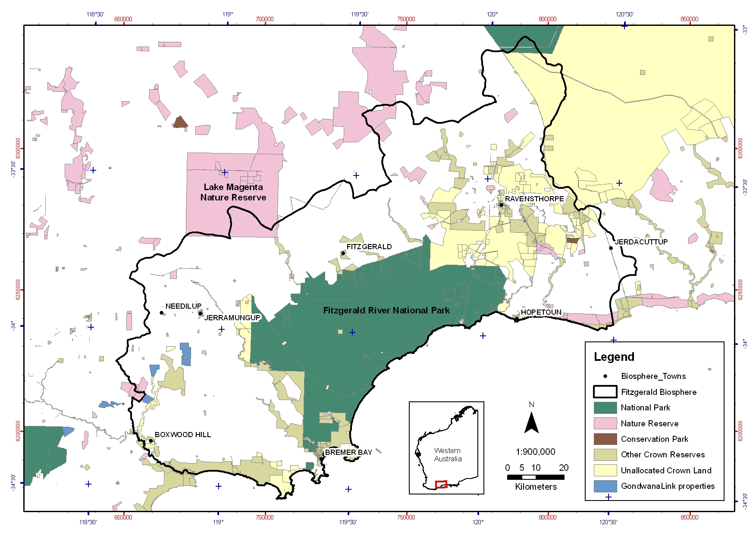
Figure 1: The land tenure of the Fitzgerald Biosphere (approximately 1.3 million hectares) on the south coast of Western Australia. Nominal buffer and transitional zones are characterised by adjacent crown reserve (Unallocated Crown Land, Unmanaged Reserve and Shire Reserves) and freehold lands respectively.

2 Fitzgerald Biosphere

2.1 Biosphere Reserves
Biosphere reserves are an international designation made by the United Nations Educational Scientific and Cultural Organisation (UNESCO) as part of the intergovernmental Man and the Biosphere (MAB) Programme since 1970. This world network of reserves, which remain under jurisdiction of their own country, perform three main roles (UNESCO's MAB 2001):
- Conservation in situ of natural and semi-natural ecosystems and landscapes, as well as the diversity there within;
- The establishment of demonstration areas for ecologically and socio-culturally sustainable (land and) resource use; and
- The provision of logistic support for research, monitoring, education and training.

Biosphere reserves are developed following a landscape planning and management model which consists of three zones: a core area, buffer zone and a zone of cooperation (UNESCO's MAB 2001). The core area is a zone with minimal human activities (except for research and monitoring) aimed at protecting the landscape, ecosystems and species it contains. The surrounding zone acts as a buffer for the core and accommodates collaborative and sustainable human activities such as research, environmental education and training as well as tourism and recreation. The outer ‘zone of cooperation’ serves to liaise with the larger region in which the biosphere lies, and promotes in particular sustainable development activities such as applied research, traditional use or rehabilitation, human settlements, agriculture and fisheries.

2.2 Fitzgerald Biosphere Reserve
In 1954 the present Fitzgerald River National Park (FRNP) was classified as a ‘C’ class reserve for the conservation of flora and fauna, then upgraded to a ‘A’ class National Park in 1973 following the threat of potential mining operations (Jenkins 1980; Newbey & Chapman 1995).

In 1978 the FRNP was designated as one of 12 Australian biosphere reserves because of its relatively pristine state and high biological diversity, especially its flora (Sanders 1997). Since the 1980’s the MAB’s biosphere objectives have been applied to a wider area of approximately 1.3 million hectares which also includes the catchments surrounding the National Park (Watson & Sanders 1997), including part of the Pallinup River catchment and all of the Bremer, Gairdner, Fitzgerald, Hamersley, West, Phillips, Steere and Jerdacuttup River catchments. The National Park (329,000 hectares) is the formal core area of the Biosphere, but is surrounded by a buffer zone consisting of about 130,000 hectares of vegetated reserves, privately owned remnant vegetation, and extended corridors along the coast and up the adjoining river systems (Robinson 1997). This ‘zone of cooperation’ includes the upper catchments of all the river systems that pass through or around the core area. This zone (895,000 hectares) is primarily privately owned and modified farmland containing substantial areas of remnant vegetation.

For the purpose of this plan, the term ‘Fitzgerald Biosphere’ or ‘Biosphere’ refers to the formal core area (FRNP) as recognised by MAB together with the nominal extended buffer and transition zones. This wider concept of the Fitzgerald Biosphere is also used by South Coast NRM Inc. and Fitzgerald Biosphere Group (Figure 1). While the boundary that pertains to this plan will remain static, it should be recognised that the notional biosphere boundary may need to allow for the evolution of landcare and ‘social’ catchment groups (Watson & Sanders 1997) and may change through formalisation of any expansion.

2.3 Biodiversity of the Fitzgerald Biosphere
The Fitzgerald Biosphere is internationally and nationally recognised for its high biodiversity richness, species endemism and high level of threats, as it is part of the international Southwest Biodiversity Hotspot (Myers et al. 2000) and includes the National Biodiversity Hotspot ‘Fitzgerald River Ravensthorpe’.

The Fitzgerald Biosphere includes a great complexity of geology and associated soils and vegetation communities. It has a Mediterranean climate with cool wet winters and hot dry summers. The average annual rainfall varies from 360 mm in the north to over 600 mm in the south west coast. The landscape units of the biosphere are explained below in Section 2.

The Biosphere is particularly significant for its plant diversity with over 2500 described vascular flora species, over 100 of which are endemic to the Biosphere. The FRNP and Ravensthorpe Range are floristic hotspots within this area.

As with most Mediterranean areas, the diversity of vertebrate taxa in the Fitzgerald Biosphere is not as rich as its flora diversity, with 29 mammal, 51 reptiles, 14 frogs and 209 bird species (DEC 2009). However, FRNP supports more vertebrate species than any other conservation reserve in south-western Australia. The FRNP is at a faunal crossroads in a north-south and east-west direction and includes both arid and mesic adapted species (Chapman et al. 1995). Only one vertebrate species, the skink (Lerista viduata), is endemic to the Biosphere.

Little is known about other components of the Fitzgerald Biosphere biodiversity, such as invertebrates and fungi. As part of a south coast inventory survey for fungi and short-range endemic invertebrates in 2006/07, 181 species of fungi (Syme 2008) and over 70 species of terrestrial invertebrates (Framenau et al. 2008; Harvey & Leng 2008) were recorded in the Biosphere. However, these surveys were not extensive and there remains much to be learnt about the biodiversity of the Biosphere.

The Fitzgerald Biosphere retains just over half (51%) of its native (or remnant) vegetation. The most regionally significant areas are:
- Fitzgerald River National Park,
- Ravensthorpe Range and its link between FRNP and Southern Goldfields,
- Coastal reserve system between FRNP and Pallinup River (which continues further west towards Albany),
- Lake Magenta Nature Reserve and the Fitzgerald River corridor link to FRNP,
- Corackerup/Peniup area and its links to Pallinup River,
- Jerdacuttup Lakes Nature Reserve.
(RAP 1997; Watson & Wilkins 1999)

2.4 Landscape Units of the Fitzgerald Biosphere
The Fitzgerald Biosphere represents a wide range of ecosystems with different physical characteristics and biodiversity. These diverse ecosystems respond differently to threatening processes and management practices, although these differences are in general poorly understood. It is therefore useful to divide the region into units with common denominators that can be used to help interpret complex natural systems where information is incomplete.

In 2004 Nathan McQuoid, a local ecologist, developed the concept of ‘ecozones’ for the south coast of Western Australia, dividing the region into ecozones based on similarities in physical and biological patterns of geology, climatic history, drainage patterns, major soil systems, and existing native vegetation types (McQuoid 2004). These ecozones (referred to in this Plan as Landscape Units) have been refined by Nathan McQuoid in 2009 for the Fitzgerald Biosphere (Table 1, Figure 2). They contextualise the physiographical patterning of the Biospheres ecosystems and vegetation communities, and address the foundations for the presence of the biota, its distribution patterns and the physical forces that support its existence.

Further details on the Landscape Units can be found in McQuoid (in prep.), Barrett et al. (2009) and McQuoid (2004).

Table 1: The characteristics of the Landscape Units of the Fitzgerald Biosphere as described by Nathan McQuoid in 2009 and percentage (%) of the Biosphere each unit represents. These landscape units are shown in figure 3.
Landscape Units | Landscape Units Characteristics | % of Area / Distribution
Albany Fraser Coastal | The coastal granite features of the Bremer peninsulas with granite rock vegetation communities, kwongan heath, and fringing mallee and banksia shrublands. This unit contains many vegetation communities and taxa that are endemic, localized or restricted. | 0.3% / coastal
Depositional Dynamic | The most recently formed landscape units including drainage lines, flood plains, wetlands, coastal dunes, swales and estuary edges. The most dynamic landscape units with common ground disturbance from water movement and nutrient deposition, where vegetation communities are relatively resilient to more frequent disturbances. These systems are prone to weed invasion due to their disturbance disposition. | 18.0%  / coastal, drainage lines
Depositional Eocene | Valley floor depositional spongolite and clay soil systems. A relatively dynamic landscape unit, although less than Depositional Dynamic, with mallet and moort woodland vegetation systems somewhat resilient to disturbances. | 4.1%  / drainage lines
Esperance Sandplain | Mallee and banksia shrubland dominate with interspersed kwongan heath on sand, sandy gravel and sandy clay plains, shallow wetland palusplains, and saline and freshwater lake systems. | 5.0%  / southeast corner
Estuary | Dynamic aquatic systems with fringing chenopod low shrubs on saltpans. | 0.2%
Greenstone | The Ravensthorpe Range and nearby associated hills. Is a hotspot for plant diversity with high level of endemism. Primarily mallee and proteaceous heath communities on gravel and sandy gravel soils with down-slope woodlands of mallet on depositional soils. It contains intense mineralization and as such is subject to exploration and mining activity. | 3.3%  / Ravensthorpe Range
Marine Plain | Overlaying Eocene sediments with plains of several duplex soils that support a great diversity of vegetation types. It includes a variety of kwongan heaths and mallee and banksia shrublands. A stable landscape unit that is poorly adapted to frequent disturbances. | 10.9%  /southern
Quartzite Range | Metamorphosed sedimentary rocks that began as prehistoric river deltas, later turned to rock by the rifting of Australia and Antarctica and have since resisted weathering to remain standing as the jagged low mountains known as the Barrens. Is primarily mountain thicket, heaths and mallee-heath vegetation. Refugial in nature, the barrens supports high numbers of endemic and threatened taxa. | 7.6% / the Barrens
Yilgarn Block East | A complex mix of soil systems underlying a climatic transition zone supporting many different vegetation types, including tall woodlands, semi-arid mallee banksia shrubland and rich kwongan heathlands. | 50.6% /northern

2.5 The Fitzgerald Biosphere Community
The Fitzgerald Biosphere covers four local shires; all of Jerramungup Shire, half of Ravensthorpe Shire and small portions of Lake Grace and Kent Shires, and the towns of Ravensthorpe, Jerramungup, Hopetoun and Bremer Bay.

In 2008 the estimated resident population of Jerramungup and Ravensthorpe Shires was 3,675, up from the previously static population of around 2,700 before 2005 (source: ABS Estimated Resident Population). This recent population growth was in the Ravensthorpe Shire due to the development of the BHP Ravensthorpe Nickel operations. There are also other mining interests in the Biosphere area, primarily in the Ravensthorpe and Wellstead areas, and so the population will potentially continue to grow.

The Biosphere was settled in the late 1800s following the discovery of minerals in the Ravensthorpe area, and then in the late 1950s with the release of land for Soldier Settlement and Conditional Purchase for agricultural purposes. Over the years a little over half of the Biosphere has been released for agricultural purposes (Table 2). Just over one third of the Biosphere is National Park and other crown reserves, with a further 11% Unallocated Crown Land (UCL). There are a number of areas of UCL, in particular in the Ravensthorpe Range, that have been endorsed as proposed conservation reserves (CALM 1992), but for a number of reasons these proposed changes in tenure vesting have not been implemented.

Agricultural land use is predominantly winter cereal production and grazing. Wheat and barley are the main cereal crops, grown in rotation with lupins, canola and subterranean or medic pasture. Other industries in the Biosphere are predominately tourism and mining.

Table 2: The percentage (%) of the Fitzgerald Biosphere that is Freehold or a Pastoral Lease, Crown Reserve (including National Parks and Nature Reserves) or Unallocated Crown Land (UCL).

Land Tenure | % of the Biosphere
Freehold land or Pastoral Leases | 54%
Crown Reserves | 35%
Unallocated Crown Land (UCL) | 11%

There are several non-profit and community organisations and catchment groups that are actively involved in conservation and natural resource management across the Fitzgerald Biosphere. The groups most directly involved in threatened species recovery or biodiversity conservation include the Malleefowl Preservation Group, Friends of the Fitzgerald River National Park and Gondwana Link. The Fitzgerald Biosphere Group (FBG), Ravensthorpe Agricultural Initiative Network (RAIN), South Coast NRM Inc. and catchment groups are significant groups in supporting sustainable natural resource management and best practise agricultural practices.

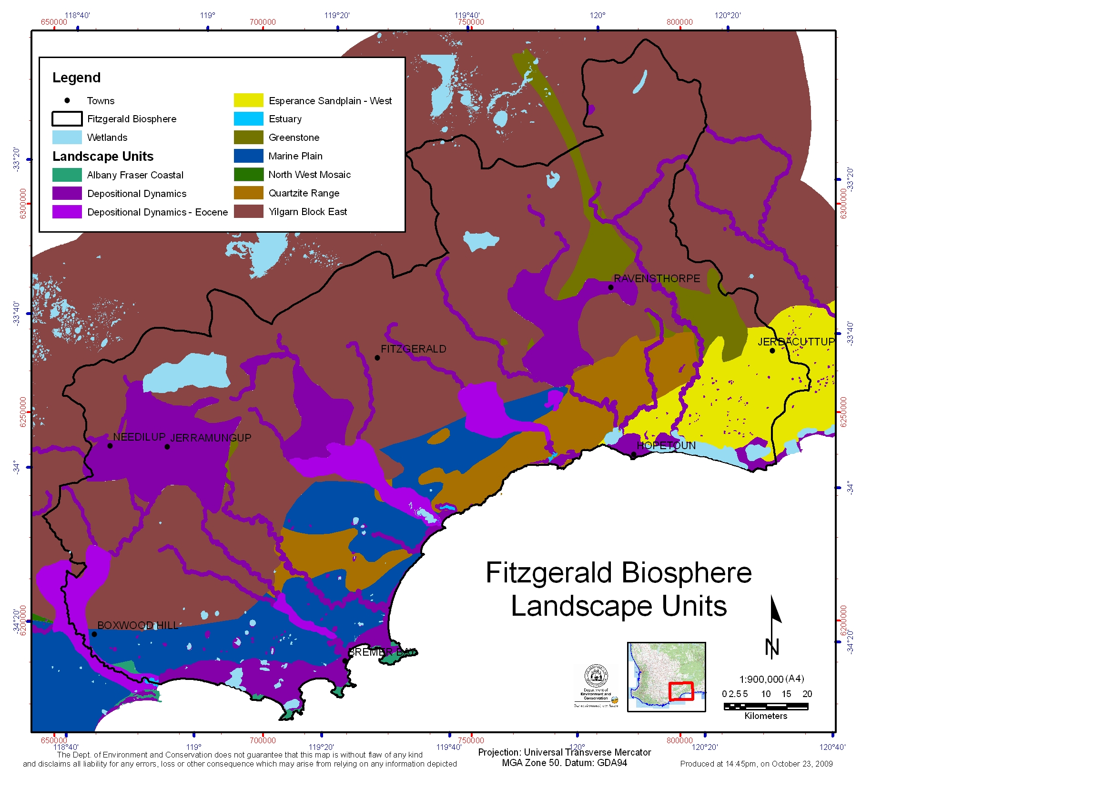
Figure 2: The Landscape Units of the Fitzgerald Biosphere (developed by Nathan McQuoid, 2009). Note: the North West mosaic does not occur within the Biosphere. The characteristics of these landscape units are described in Table 1.

3 Threatened and Priority Species and Ecological Communities

This Plan represents all terrestrial threatened fauna, flora and ecological communities listed either by the State or under Commonwealth legislation that occur in the Fitzgerald Biosphere. There are 41 species/communities listed as threatened by the State, 33 of which are also listed by the Commonwealth (Table 3). Of the State listed species/communities, 19 are endemic to the Biosphere.

Information on the biology, ecology, habitat requirements and distribution of each of these threatened species and the one ecological community are included in the species profiles (Appendix 2). The occurrence of these species/communities across the landscape units of the Biosphere are shown in Appendix 3.

This Plan also considers the terrestrial fauna, flora and ecological communities that are listed by the Department of Environment and Conservation (DEC) as ‘Priority’ (Appendix 4) that occur in the Fitzgerald Biosphere. These species/communities are a priority for further survey and research to determine their conservation status, or which are rare and require ongoing monitoring, or are conservation dependent. This includes 253 species/ecological communities, 63 of which are endemic to the Biosphere (Table 3).

Table 3: The number of species and ecological communities of the Fitzgerald Biosphere that are listed as Threatened under State or Commonwealth (EPBC Act) legislation or Priority by the Department of Environment and Conservation (as of June 2010) or are locally extinct. In brackets are the numbers of those species or ecological communities that are endemic to the Biosphere.
 | Threatened |  | Priority | Locally Extinct
 | WA | EPBC | Priority | Locally Extinct
Fauna | 9 | 9 | 18  (2 endemic) | 6
Flora | 31  (18 endemic) | 24  (12 endemic) | 227  (56 endemic) | -
Ecological Community | 1  (1 endemic) | 0 | 8  (5 endemic) | -

There are historic records of 6 ‘critical weight-range’ mammals in the Fitzgerald Biosphere which are presumed to be locally extinct (Table 3). These include Woylie (Bettongia penicillata ogilbyi), Boodie (Bettongia lesueur), Banded Hare-wallaby (Lagostrophus fasciatus), Bilby (Macrotis lagotis), Western Ringtail Possum (Pseudocheirus occidentalis) and Western Barred Bandicoot (Perameles bougainville) (Abbott 2008). These species have not been included in the list of threatened species in the Biosphere, although these species are considered in this Plan as future surveys may rediscover these species, or because the Biosphere may provide potential sites for their reintroduction. Two extinct ‘critical weight-range’ mammals also occurred in the Biosphere, Broad-faced Potoroo (Potorous platyops) and Crescent Nailtail Wallaby (Onychogalea lunata) (Abbott 2008).

3.1 Threatened and Priority Fauna of the Fitzgerald Biosphere
There are nine threatened fauna species that occur in the Fitzgerald Biosphere, none of which are endemic to the Biosphere (Table 4). The Western Ground Parrot (Pezoporus wallicus flavientris) is the only fauna species that is listed as Critically Endangered (under State legislation).

Two of the 18 Priority fauna species (Table 5) are endemic to the Biosphere: Eula’s planthopper (Budginmaya eulae) which is only know from one specimen from Bandalup Hill and the skink (Lerista viduata) which is endemic to the Ravensthorpe Range.

Table 4: The threatened fauna species that occur in the Fitzgerald Biosphere, their State and Commonwealth (EPBC Act) conservation status and their distribution category for the Biosphere (sorted on EPBC conservation status).
Common Name | Scientific Name | Conservation Status |  | Dist. Cat.#
Common Name | Scientific Name | WA | EPBC | Dist. Cat.#
Threatened Species
Carnaby’s Black-Cockatoo | Calyptorhynchus latirostris | EN | EN | 3
Dibbler | Parantechinus apicalis | EN | EN | 2
Western Ground Parrot | Pezoporus wallicus flaviventris | CR | EN | 3
Red Tailed Phascogale | Phascogale calura | EN | EN | 4
Western Bristlebird | Dasyornis longirostris | VU | VU | 3
Chuditch | Dasyurus geoffroii | VU | VU | 3
Malleefowl | Leipoa ocellata | VU | VU | 3
Numbat | Myrmecobiuys fasciatus | VU | VU | *
Heath Mouse | Pseudomys shortridgei | VU | VU | 3
* Reintroduced population only
# Distribution Categories: 1 - Endemic to Fitzgerald Biosphere; 2 - Near-endemic (>80%) of distribution within Biosphere; 3 - Non-endemic with significant sub-populations within Biosphere; 4 - Non-endemic.

Table 5: The priority fauna species that occur in the Fitzgerald Biosphere, their conservation status (Appendix 4) and their distribution category for the Biosphere.
Common Name | Scientific Name | Conservation Status | Dist. Cat.#
Eula’s planthopper | Budginmaya eulae | P1 | 1
Skink | Lerista viduata | P1 | 1
Terrestrial mollusc | Bothriembryon brazieri | P2 | 4
Southern Death Adder | Acanthophis antarcticus | P3 | 4
Bee | Hylaeus globuliferus | P3 | 4
Bush Stone-curlew | Burhinus grallarius | P4 | 4
Rufous Fieldwren (western wheatbelt) | Calamanthus campestris montanellus | P4 | 3
Hooded Plover (western) | Thinornis rubricollis | P4 | 4
Water Rat | Hydromys chrysogaster | P4 | 4
Shy Heathwren (western) | Hylacola cauta whitlocki | P4 | 3
Western Brush Wallaby | Macropus irma | P4 | 3
Carpet Python | Morelia spilota imbricate | P4 | 4
Crested Bellbird (southern) | Oreoica gutturalis gutturalis | P4 | 3
White-browed Babbler (western wheatbelt) | Pomatostomus superciliosus ashbyi | P4 | 4
Western Mouse | Pseudomys occidentalis | P4 | 3
Western Whipbird (western mallee) | Psophodes nigrogularis oberon | P4 | 3
Quenda | Isoodon obesulus fusciventer | P5 | 4
Tammar Wallaby | Macropus eugenii derbianus | P5 | 3
# Distribution Categories: 1 - Endemic to Fitzgerald Biosphere; 2 - Near-endemic (>80%) of distribution within Biosphere; 3 - Non-endemic with significant sub-populations within Biosphere; 4 - Non-endemic.

3.2 Threatened and Priority Flora of the Fitzgerald Biosphere
There are 31 threatened flora species that occur in the Fitzgerald Biosphere, 18 of which are endemic to the Biosphere (Table 6). A further 227 species are Priority, 56 of which are endemic to the Biosphere (Table 7).

Table 6: The threatened flora species that occur in the Fitzgerald Biosphere, their State and Commonwealth (EPBC Act) conservation status and which species are endemic to the Biosphere (sorted on EPBC conservation status).
Scientific Name | Common Name | Conservation Status |  | Dist. Cat.#
Scientific Name | Common Name | WA | EPBC | Dist. Cat.#
^Acacia rhamphophylla | Kundip Wattle | CR | EN | 1
^Adenanthos dobagii | Fitzgerald Woollybush | VU | EN | 1
Anigozanthos bicolor subsp. minor | Small Two-coloured Kangaroo Paw | VU | EN | 3
^Boronia clavata | Bremer Boronia | EN | EN | 1
Caladenia bryceana subsp. bryceana | Dwarf Spider Orchid | EN | EN | 3
Conostylis lepidospermoides | Sedge Conostylis | VU | EN | 4
^Coopernookia georgei | Mauve Coopernookia | EN | EN | 1
^Daviesia megacalyx | Long-sepalled Daviesia | EN | EN | 1
Daviesia obovata | Paddle-leaved Daviesia | EN | EN | 3
Eremophila subteretifolia | Lake King Eremophila | CR | EN | 4
^Eucalyptus burdettiana | Burdett Gum | EN | EN | 1
^Grevillea infundibularis | Fan-leaved Grevillea | VU | EN | 1
Marianthus mollis | Hairy-fruited Marianthus | VU | EN | 2
Ricinocarpos trichophorus | Barrens Wedding-bush | VU | EN | 3
^Verticordia pityrhops | Mt Barren Featherflower | EN | EN | 1
^Adenanthos ellipticus | Oval-leaved Adenanthos | VU | VU | 1
Eremophila denticulata subsp. denticulata | Fitzgerald Eremophila | VU | VU | 2
^Eucalyptus coronata | Crowned Mallee | EN | VU | 1
Lepidium aschersonii | Spiny Peppercress | VU | VU | 3
Myoporum cordifolium | Jerramungup Myoporum | EN | VU | 2
^Stylidium galioides | Yellow Mountain Triggerplant | VU | VU | 1
Thelymitra psammophila | Sandplain Sun-orchid | VU | VU | 4
^Verticordia crebra | Crowded Featherflower | VU | VU | 1
Verticordia helichrysantha | Coast Featherflower | VU | VU | 3
*Calochilus pruinosus | Hopetoun Beard Orchid | CR |  | 2
Hibbertia abyssa | Bandalup Buttercup | CR |  | 1
Kunzea similis subsp. mediterranea |  | EN |  | 1
Beyeria cockertonii |  | VU |  | 1
Eucalyptus nutans | Red-flowered Moort | VU |  | 1
Eucalyptus purpurata |  | VU |  | 1
Kunzea similis subsp. similis |  | VU |  | 1
# Distribution Categories: 1 - Endemic to Fitzgerald Biosphere; 2 - Near-endemic (>80%) of distribution within Biosphere; 3 - Non-endemic with significant sub-populations within Biosphere; 4 - Non-endemic.
* Calochilus pruinosus was only listed as threatened under State legislation in August 2010. The habitat critical and risk of threats (Section 4 and 5) of this species are yet to be determined.
^ Species that meet the Commonwealth Environment Protection and Biodiversity Conservation Act 1999 (EPBC Act) requirements for a recovery plan. Noting that under Section 269 AA of the EPBC Act, a decision was made that Boronia clavata does not require a recovery plan. Therefore this plan will not be adopted for this species.

Table 7: The flora species that are listed by the Department of Environment and Conservation as Priority that occur in the Fitzgerald Biosphere (Appendix 4). * indicates the species endemic to the Biosphere.
Priority 1 | Priority 2 | Priority 3 | Priority 4
*Acacia sp. Ravensthorpe Range (B.R. Maslin 5463)  Austrofestuca littoralis  *Banksia corvijuga  Caladenia longifimbriata  *Calothamnus roseus  Chorizema circinale  Conospermum coerulescens subsp. coerulescens  *Cryptandra craigiae  Dillwynia acerosa  Eucalyptus calyerup  *Eucalyptus retusa  Gnephosis intonsa  *Grevillea sulcata  Guichenotia anota  *Guichenotia apetala  *Gyrostemon sp. Ravensthorpe (G. Cockerton & N. Evelegh 9467)  Hakea cygna subsp. needlei  *Hibbertia abyssa  *Hibbertia atrichosepala  *Kunzea acicularis  *Lasiopetalum sp. Desmond (N. McQuoid 653)  Lissanthe synandra  *Melaleuca sophisma  Microcorys sp. Boxwood (K.R. Newbey 4200)  Philotheca gardneri subsp. globosa  *Pultenaea craigiana  *Pultenaea wudjariensis  Rinzia longifolia  Schoenus sp. Grey Rhizome (K.L. Wilson 2922)  Tetratheca applanata  Trymalium litorale  Trymalium myrtillus subsp. pungens  Xanthoparmelia subimitatrix | *Acacia sp. Ravensthorpe Range (B.R. Maslin 5463)  Austrofestuca littoralis  *Banksia corvijuga  Caladenia longifimbriata  *Calothamnus sp. Kundip (A.S. George & E.G.H. Oliver ASG 17657)  Chorizema circinale  Conospermum coerulescens subsp. coerulescens  *Cryptandra craigiae  Dillwynia acerosa  Eucalyptus calyerup  *Eucalyptus retusa  Gnephosis intonsa  *Grevillea sulcata  Guichenotia anota  *Guichenotia apetala  *Gyrostemon sp. Ravensthorpe (G. Cockerton & N. Evelegh 9467)  Hakea cygna subsp. needlei  *Hibbertia abyssa  *Hibbertia sp. Ravensthorpe Range (E. Tink 335)  *Kunzea acicularis  *Lasiopetalum sp. Desmond (N. McQuoid 653)  Lissanthe synandra  *Melaleuca sp. Kundip (G.F. Craig 6020)  Microcorys sp. Boxwood (K.R. Newbey 4200)  Philotheca gardneri subsp. globosa  *Pultenaea craigiana  *Pultenaea wudjariensis  Rinzia longifolia  Schoenus sp. Grey Rhizome (K.L. Wilson 2922)  Tetratheca applanata  Trymalium litorale  Trymalium myrtillus subsp. pungens  Xanthoparmelia subimitatrix | *Acacia bifaria  Acacia brachyphylla var. recurvata  Acacia declinata  *Acacia disticha  Acacia durabilis  Acacia errabunda  Acacia improcera  Acacia laricina var. crassifolia  Acacia newbeyi  Acacia singula  *Acacia subtiliformis  Agonis undulata  Allocasuarina hystricosa  Andersonia echinocephala  Astartea sp. Hopetoun area (A.S. George 10594)  Asteridea gracilis  Astroloma microphyllum  Astroloma recurvum  Banksia calophylla  Banksia lullfitzii  Banksia rufa subsp. chelomacarpa  Banksia xylothemelia  Beyeria sulcata var. truncata  Boronia oxyantha var. brevicalyx  *Bossiaea concinna  Bossiaea spinosa  Calectasia obtusa  Calycopeplus marginatus  Calytrix nematoclada  Centrolepis cephaloformis subsp. murrayi  Chorizema carinatum  Cryptandra polyclada subsp. polyclada  Dampiera sericantha  Desmocladus biformis  Dielsiodoxa leucantha  Eucalyptus arborella  Eucalyptus famelica  Eucalyptus microschema  Eucalyptus newbeyi  Eucalyptus quaerenda  Eucalyptus semiglobosa  Gastrolobium cruciatum  Gastrolobium stenophyllum  Gonocarpus trichostachyus  Goodenia trichophylla  Grevillea coccinea subsp. lanata  Grevillea fastigiata  *Grevillea fulgens  Gyrostemon prostratus  Gyrostemon sessilis  Hakea brachyptera  Hakea lasiocarpha  *Hibbertia fitzgeraldensis  Hibbertia hamata  Hopkinsia adscendens  Isolepis australiensis  Lasiopetalum fitzgibbonii  Lasiopetalum monticola  Lasiopetalum parvuliflorum  Lechenaultia acutiloba  Lepidosperma gahnioides  Leucopogon blepharolepis  Leucopogon florulentus  Lissanthe pleurandroides  Melaleuca polycephala  Melaleuca sculponeata  *Melaleuca stramentosa  *Microcorys longiflora  Microcorys pimeleoides  *Micromyrtus navicularis  Mirbelia densiflora  Mitreola minima  Opercularia rubioides  *Parmeliopsis macrospora  Persoonia brevirhachis  Pultenaea adunca  Pultenaea calycina subsp. calycina  Pultenaea daena  Pultenaea indira subsp. monstrosita  Pultenaea vestita  Sarcocornia globosa  Schoenus benthamii  Sphaerolobium validum  Spyridium mucronatum subsp. recurvum  Spyridium oligocephalum  *Stylidium clavatum  Stylidium pseudohirsutum  Synaphea drummondii  Synaphea platyphylla  Thomasia pygmaea  Thysanotus gageoides  Trachymene croniniana  *Verticordia longistylis  *Xanthosia peduncularis | Acacia aemula subsp. aemula  *Acacia argutifolia  Acacia dictyoneura  Acacia empelioclada  Acacia grisea  Acacia moirii subsp. dasycarpa  Acacia pinguiculosa subsp. pinguiculosa  *Acacia simulans  Acacia trulliformis  Acrotriche parviflora  *Adenanthos labillardierei  Anthocercis fasciculata  Asplenium aethiopicum  Banksia laevigata subsp. laevigata  Banksia porrecta  Bentleya spinescens  *Beyeria villosa  Bossiaea divaricata  Caladenia arrecta  Caladenia integra  Caladenia plicata  Calothamnus affinis  Chorizema ulotropis  Corybas limpidus  Dampiera deltoidea  Eremophila serpens  Eucalyptus acies  *Eucalyptus calcicola subsp. unita  Eucalyptus deflexa  Eucalyptus desmondensis  Eucalyptus melanophitra  Eucalyptus praetermissa  *Eucalyptus proxima  Eucalyptus stoatei  *Eucalyptus x bennettiae  Eucalyptus x erythrandra  Goodenia phillipsiae  *Goodenia stenophylla  Grevillea aneura  *Grevillea fistulosa  Grevillea prostrata  Gyrostemon ditrigynus  *Hakea hookeriana  Hemigenia platyphylla  Jacksonia compressa  Lechenaultia superba  Lepidium pseudotasmanicum  Leucopogon compactus  Leucopogon denticulatus  Melaleuca araucarioides  Melaleuca fissurata  Melaleuca papillosa  *Philotheca gardneri subsp. gardneri  Pimelea physodes  Pleurophascum occidentale  Pterostylis sp. Ongerup (K.R. Newbey 4874)  *Pultenaea calycina subsp. proxena  Regelia cymbifolia  Rinzia affinis  Siegfriedia darwinioides  *Spyridium glaucum  Stachystemon vinosus  Tecticornia uniflora  Thysanotus glaucus  Thysanotus parviflorus  Verticordia integra  Verticordia vicinella

3.3 Threatened and Priority Ecological Communities of the Fitzgerald Biosphere
Ecological communities are naturally occurring biological assemblages that occur in a particular type of habitat. There is one threatened and eight priority ecological communities in the Fitzgerald Biosphere, five of which are endemic (Table 8). No Fitzgerald Biosphere ecological communities are listed under Commonwealth legislation.

The threatened ecological community (TEC), Eucalyptus acies mallee heath, is restricted to the central Barren Ranges in the FRNP. The Priority ecological communities (PEC) (Appendix 4) are in the Ravensthorpe Range/Bandalup Hill area, except for the Swamp Yate (Eucalyptus occidentalis) woodland which is in the Yellilup Swamp area, the Tallerack (Eucalyptus pleurocarpa) mallee-heath near Boxwood Hill, and the Scrub heath of the Esperance Sandplain.

Table 8: The threatened and priority ecological communities that occur in the Fitzgerald Biosphere, indicating which of these are endemic to the Biosphere.
Community Name | WA Conservation Status | Endemic
Threatened
Thumb Peak - Mid-Mount Barren - Woolburnup Hill (Central Barren Ranges) Eucalyptus acies mallee heath | Vulnerable | 1
Priority
Banksia laevigata/ Beaufortia orbifolia community | Priority 1 | 1
Eucalyptus megacornuta mallet woodland | Priority 1 | 1
Eucalyptus purpurata woodlands (Bandalup Hill) | Priority 1 | 1
Heath on Komatiite at Bandalup Hill | Priority 1 | 1
Swamp Yate (Eucalyptus occidentalis) woodland in seasonally-inundated basins (South Coast) | Priority 1
Tallerack (Eucalyptus pleurocarpa) mallee-heath on seasonally-inundated soils | Priority 1
Melaleuca sp. Kundip (GF Craig 6020) heath | Priority 1 | 1
Scrub heath on deep sand with Banksia and Lambertia, and Banksia scrub heath on Esperance Sandplain. | Priority 3

4 Habitat Critical and Priority Areas

4.1 Habitat Critical in the Fitzgerald Biosphere
‘Habitat critical to the survival of a species or ecological community’ under the EBPC Act can comprise:
- Sites to meet essential life cycle requirements (e.g. foraging, breeding, nesting),
- Sites of refuge for times of environmental stress (e.g. droughts, fire, flood),
- Essential travel routes between the above sites,
- Sites necessary for seed dispersal mechanisms to operate or to maintain populations of species essential to the threatened species or ecological communities (e.g. pollinators),
- The habitat used by important populations,
- Habitat that is required to maintain genetic diversity,
- Areas that may not be occupied by the species and/or ecological community but are essential for the maintenance of those areas where they do occur (e.g. the catchment of a wetland community).

This habitat critical can include (a) currently occupied habitat for core or important populations and (b) potential habitat which may currently be unoccupied but present opportunities for dispersal to or for reintroductions.

Habitat critical to the survival of each of the threatened species in the Fitzgerald Biosphere was identified using all available distribution records, habitat descriptions and other data sources such as vegetation mapping. A description of the known habitat requirements and a map of habitat critical for each of the threatened species and ecological communities are included in the species profiles in Appendix 2. The habitat critical for the threatened fauna and flora were merged together to show areas where the habitat critical overlapped between species (Figure 3 and Figure 4).

This mapping of habitat critical is preliminary for most of the species. The degree to which the habitat critical could be identified was dependant on the level of knowledge of the distribution and habitat requirements of each species and the suitability of the currently available GIS layers for identifying habitats. More accurate mapping of habitat critical will require increased knowledge and documentation of habitat requirements and further detailed vegetation and landscape mapping.

Most of the remnant vegetation in the Biosphere is habitat critical for at least one threatened fauna species, as some of the species are relatively widespread, in particular Carnaby’s Black-Cockatoo and Malleefowl (Figure 3). Concentrations of fauna species are across northern FRNP to Ravensthorpe Range.

Most of the threatened flora species have relatively restricted ranges (Figure 4). The highest densities of these species occur on the Barren Ranges (Quartzite Range landscape unit) and Ravensthorpe Range (Greenstone landscape unit).

Habitat critical was not determined for the one Threatened Ecological Community, Eucalyptus acies mallee heath. However, the current distribution of this community has been mapped. The community is restricted to three mountain tops (Thumb Peak, Mid-Mount Barren and Woolburnup Hill) in the central Barren Ranges (Appendix 5).

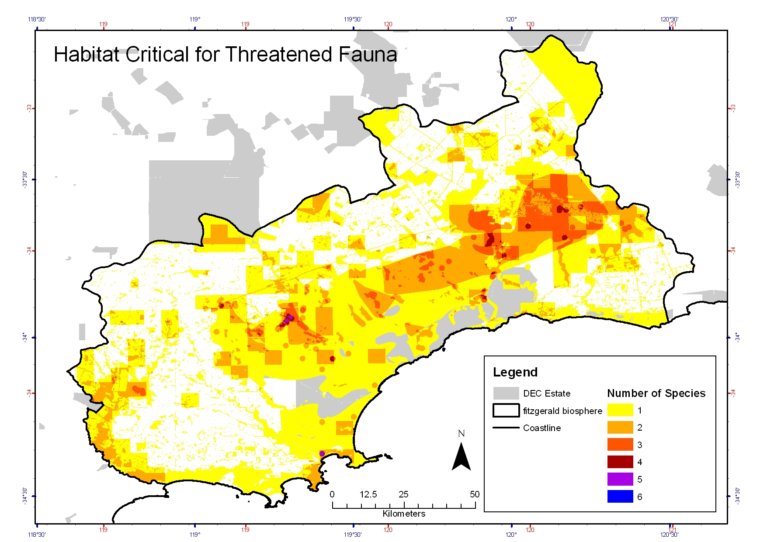
Figure 3: The merged habitat critical for all threatened fauna within the Fitzgerald Biosphere. This shows the distribution of the habitat critical across the Biosphere and where there is overlap between the species.
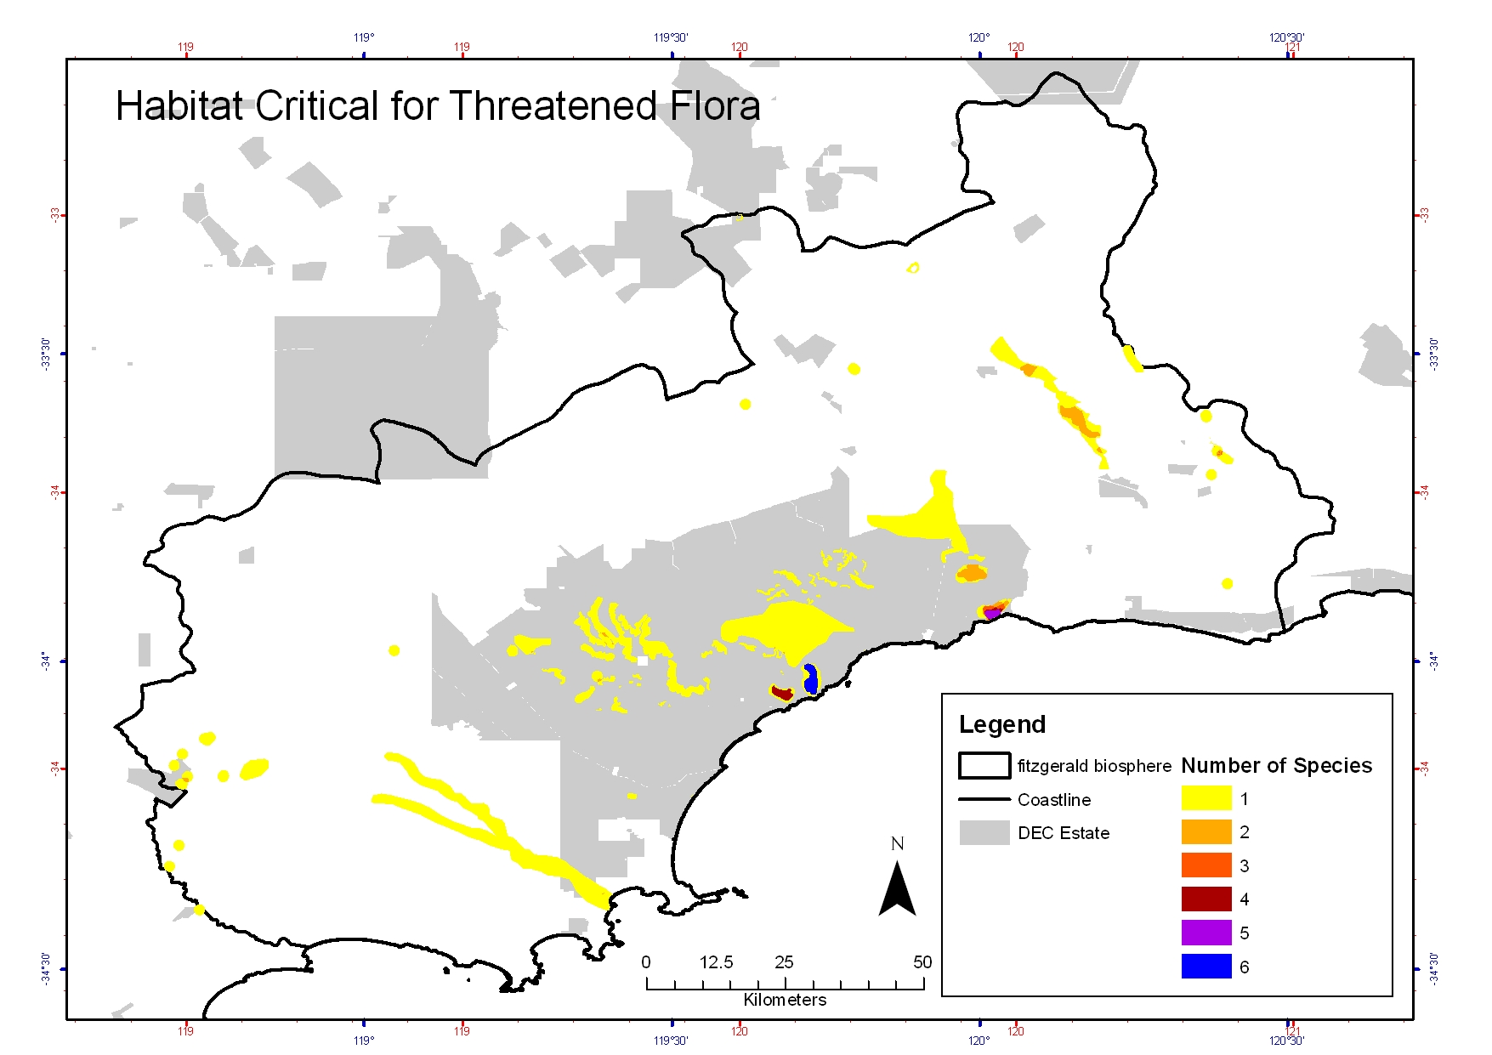
Figure 4: The merged habitat critical for all threatened flora within the Fitzgerald Biosphere. This shows the distribution of the habitat critical across the Biosphere and where there is overlap between the species.

4.2 Priority Areas in the Fitzgerald Biosphere
Five priority areas for threatened and priority species and ecological communities management and recovery were identified for the Fitzgerald Biosphere as areas of high species density using the habitat critical (Figure 3 and Figure 4) and Threatened Species Density Grids as were developed for the Regional Strategic Management Plan (Gilfillan et al. 2009b) (Appendix 5).

These priority areas will be the primary focus for the management and recovery of threatened species in the Biosphere, but do not preclude recovery and management actions from being implemented in other areas of the Biosphere as required. These five priority areas, as shown Figure 5, are described below.

Barren Ranges
The Barren Ranges refers to a chain of rugged quartzite ranges and hills scattered across the coastal plain of the FRNP. The most prominent features of these ranges are the East, Mid and West Mount Barrens. The Barren Ranges is a priority area as it supports a high number of threatened species, particularly flora and ecological communities. Nine threatened flora species and the one TEC are restricted to the range. The Barren Ranges is part of the Quartzite landscape unit and is significant for its refugial habitat and therefore supports high numbers of endemic species.

Cocanarup
The woodlands of the Cocanarup Timber Reserve and surrounding UCL make up a priority area as it supports breeding habitat for the Carnaby’s Black-Cockatoo and as a reintroduction site for Numbats. This area is primarily a Depositional Dynamic landscape in the catchment for the Phillip River that is in association with the Greenstone landscape unit of the Ravensthorpe Range.

Northern FRNP
The northern Fitzgerald River National Park is a priority area as it is significant habitat for many threatened fauna species. This area includes Depositional Dynamic and Eocene landscape units and is the interface between the Yilgarn Block in the north and the Marine Plain to the south. This complex landscape provides a diverse range of habitat types.

Ravensthorpe Range
The Ravensthorpe Range and nearby Bandalup Hill is a priority area as a high number of threatened and priority flora and ecological communities occur there. The only fauna species endemic to the Biosphere, the skink (Lerista viduata), is restricted to the Ravensthorpe Range. This area is the Greenstone landscape unit and is significant for its high diversity of flora species and high level of endemism. The Range has a high diversity of vegetation communities due to its varied geology, soils and terrain. As this area contains intense mineralization, mining and exploration activities are a significant threat to the threatened species and ecological communities.

Pallinup/Bremer Bay
The Pallinup River forms the western boundary of the Fitzgerald Biosphere. This area includes significant areas of native vegetation that form a key connectivity to the coastal corridor (Figure 6). This area is primarily a Depositional Eocene landscape which supports a number of threatened and priority species.

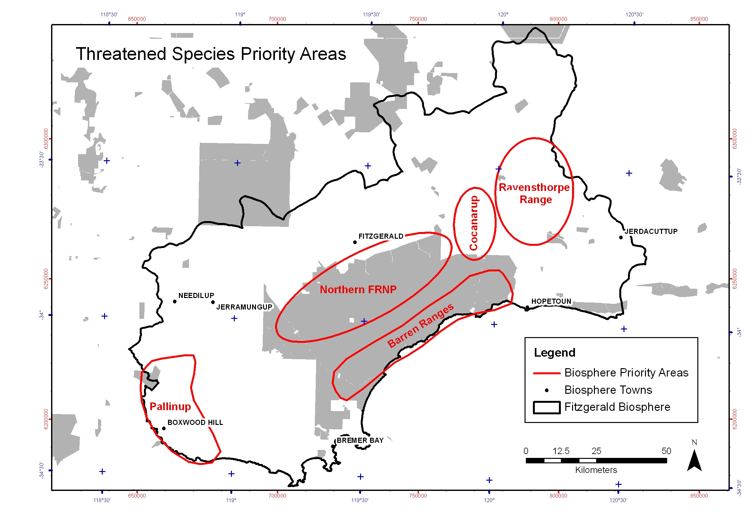
Figure 5: The five Priority Areas for threatened species in the Fitzgerald Biosphere.

Macro Corridors in the Fitzgerald Biosphere
Connectivity of remnant vegetation across a landscape is extremely important for threatened species as it allows for movement between remnant vegetation patches. The Western Australian South Coast Macro Corridor Project (Wilkins et al. 2006) identifies the macro corridors and their nature conservation values for the south coast, as shown for the Fitzgerald Biosphere in Figure 6. The most significant corridors in the Fitzgerald Biosphere are:
- Coastal Corridor: relatively intact except around the towns of Hopetoun and Bremer Bay
- Forest to Fitzgerald Corridor: generally not well connected and currently exists as a series of stepping stones. The Gondwana Link project is focused on restoring ecological connections between the Stirling Range and Fitzgerald River National Parks (Gondwana Link 2008).
- Fitzgerald River Corridor: corridor of small reserves along the Fitzgerald River connects FRNP and Lake Magenta NR.
- Ravensthorpe Range: remnant vegetation (primarily UCL) forms a corridor between FRNP and the Southern Goldfields region.

These corridors identify the broad areas where protection of remnant vegetation and revegetation projects should be focused, to retain and enhance vegetation connectivity across the Biosphere.

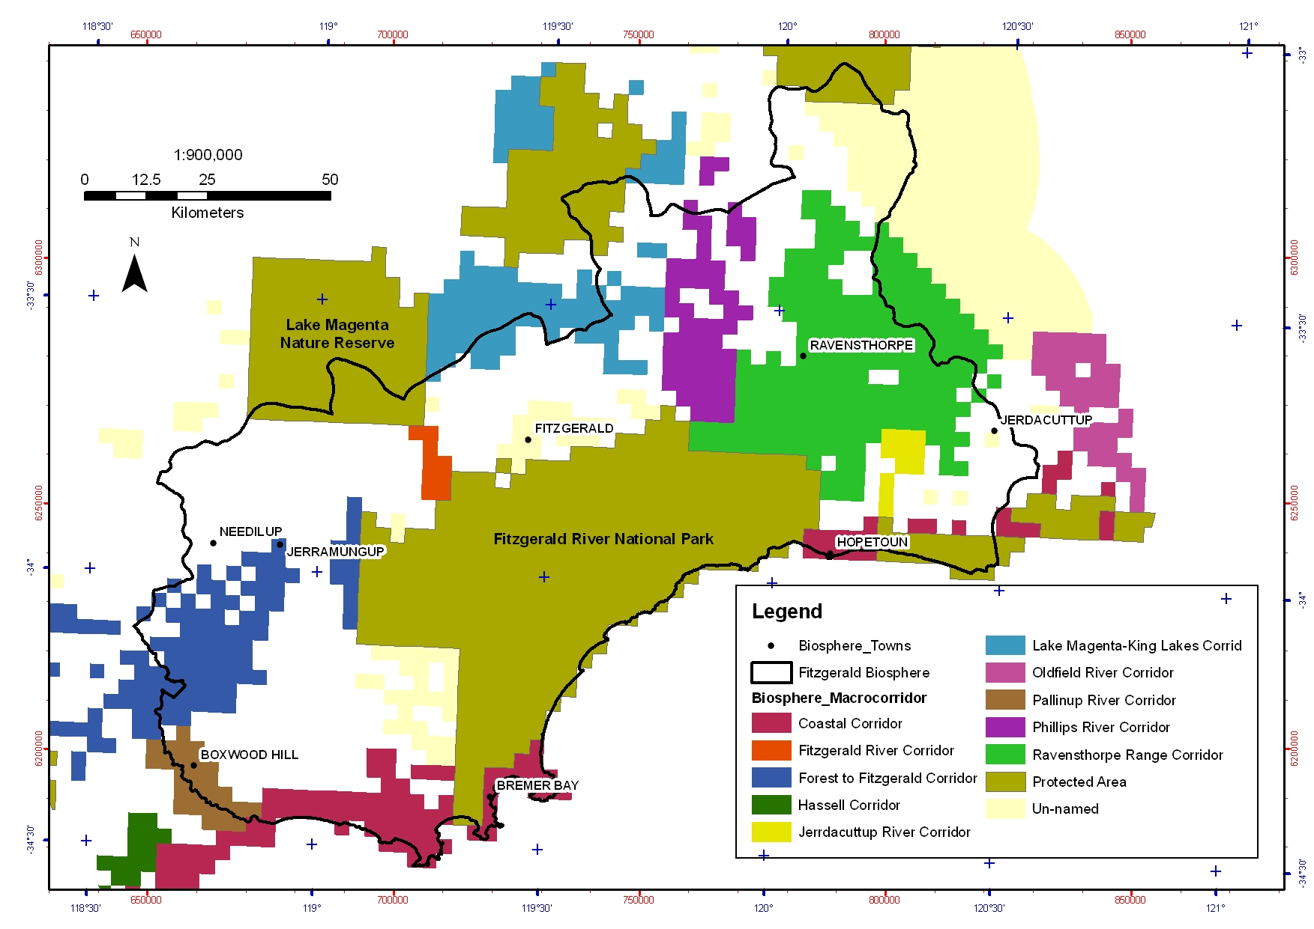
Figure 6: The macro corridors in the Fitzgerald Biosphere as identified by the South Coast Macro Corridor Project (Wilkins et al. 2006). These are the existing large scale corridors (mapped with 3x3km grid cells) connecting the larger areas of remnant vegetation with significant conservation value. Some of the corridors are relatively continuous while others, such as the Forest to Fitzgerald Corridor, are fragmented.

Threatening Processes

Under the EPBC Act a threatening process is defined as a factor that threatens or may threaten the survival, abundance or evolutionary development of a native species or ecological community. The threatening processes that are currently of most significant concern in the Fitzgerald Biosphere were identified through a combination of expert opinion, public consultation and published literature.

The threatening processes of most significant concern to threatened species and ecological communities in the Fitzgerald Biosphere are:
- Inappropriate fire regimes
- Phytophthora cinnamomi and other plant diseases
- Predation by feral cats and foxes
- Environmental weeds
- Loss, fragmentation and degradation of habitat
- Competition and habitat modification by invasive fauna
- Salinisation or altered hydrology
- Stochastic (chance) events
- Climate change

Section 5 discusses how each of these threatening processes affects the threatened species and ecological communities in the Fitzgerald Biosphere. Specific threats to each individual species are included in the Species Profiles in Appendix 2.

Three additional factors were identified as currently hampering the efficient and effective implementation of recovery efforts for threatened species and threat abatement in the Biosphere:
- insufficient resources,
- lack of appreciation of the values of the Biosphere amongst the community and
- incomplete ecological knowledge.

5.1 Risk of the Threatening Processes in the Fitzgerald Biosphere
The risk of each of the threatening processes on the threatened species and ecological communities and the landscape units of the Fitzgerald Biosphere was determined to allow the recovery actions and management practices of this Plan to be focused where they are most needed.

Method of Determining Risk for Threatened Species and Ecological Communities
Analysis and ranking of the risk of threatening processes on the threatened species and ecological communities was undertaken using the Open Standards of the Practice of Conservation guidelines and the adaptive management software Miradi (CMP 2009). This involved assessing the risk of each of the threatening processes for each of the threatened species/communities over the next 10 years based on three criteria:
- Scope (proportion of population expected to be affected),
- Severity (the degree to which the population is expected to be affected), and
- Irreversibility (degree to which the effects can be reversed).

Further details of this ranking process using Miradi is included in Appendix 6. The analysis and ranking of threats was based on best available knowledge and current understanding of impacts from individual threatening processes upon the threatened species and ecological communities.

The risk ratings for each of the threatened fauna, flora and ecological community to each of the threats in the Fitzgerald Biosphere are shown in Table 9 and Table. These ratings relate to the magnitude of the threat to the species/communities and its reversibility over the 10 year timeframe of this Plan.

Threatened Fauna
The risk ratings show that inappropriate fire regimes and predation by feral cats and foxes are the most significant threats to threatened fauna in the Biosphere, followed by loss of habitat, fragmentation and degradation, stochastic events and climate change (Table 9).

Phytophthora cinnamomi is ranked as a low threat for most of the threatened fauna species, except the Dibbler for which it is a medium threat as it occurs in habitat dominated by susceptible flora species. P. cinnamomi is not considered a threat to the Red-tailed Phascogale or Numbat. However, P. cinnamomi is considered a very significant threat in the Biosphere due to its significant impact to biodiversity overall and because it cannot be eradicated.

Overall these risk ratings show that all the threatened fauna species were ranked as high to very high risk in the Fitzgerald Biosphere, except the Chuditch and the Numbat which have a medium rating. The Western Ground Parrot is the most at risk due to its small population size.

Table 9: Risk ratings for each of the threatened fauna species to each of the most significant threats in the Fitzgerald Biosphere over then next 10 years, as determined using Miradi (CMP 2009). These ratings are based on three criteria: Scope, Severity and Irreversibility (Appendix 6). Blank = not considered a significant threat to that species.
Threats  Species | Invasive fauna | Inappropriate fire regimes | Phytophthora cinnamomi | Cats & foxes | Weeds | Salinisation/ altered hydrology | Climate change | Loss & fragmentation of habitat | Stochastic (chance) events | Summary Risk Rating
Carnaby's  B-Cockatoo | High | Medium | Low |  | Low | Low | Low | High | Medium | High
Chuditch | Low | Medium | Low | High |  | Low | Low | Low | Low | Medium
Red Tailed Phascogale | Low | High |  | High | Low | Low | Medium | Low | Low | High
Dibbler |  | High | Medium | High |  | Low | Medium | Low | Low | High
Heath Mouse | Low | High | Low | High |  | Low | Medium | Low | Low | High
Malleefowl | Medium | Medium | Low | High | Low | Medium | High | High | Low | High
Numbat | Low | Medium |  | High |  | Low | Medium | Low | Medium | Medium
Western Bristlebird |  | High | Low | High | Low |  | High | Low | High | High
W. Ground Parrot | Low | Very High | Low | Very High | Low |  | High | Medium | High | Very High
Summary Risk Rating | Medium | Very High | Low | Very High | Low | Low | High | High | High

Threatened Flora and Ecological Communities
The risk ratings show that inappropriate fire and climate change are the most significant threats to threatened flora and the ecological community in the Biosphere (Table 10). Climate change is a significant threat for many of the flora species due to small population sizes, and that they rely on specific habitats (e.g. the tops of the hills of the Barren Range) that are likely to be highly impacted by any changes in temperature or rainfall.

Phytophthora cinnamomi is ranked as a low to high threat and is not a threat for nine of the threatened flora species. These rankings were made with the assumption that P. cinnamomi will not become widespread in the Biosphere in the next 10 years, but because it cannot be eradicated from where it does spread, it is considered a very significant threat in the Biosphere.

The risk of the threatening processes in the Fitzgerald Biosphere are unknown for Conostylis lepidospermiodes and Lepidium aschersonii, as these species have not been seen in the Fitzgerald Biosphere in recent years (Appendix 2).

Table10: Risk ratings for each of the threatened flora species and the ecological community to each of the most significant threatening processes in the Fitzgerald Biosphere over then next 10 years, as determined using Miradi (CMP 2009). These ratings are based on three criteria: Scope, Severity and Irreversibility (Appendix 6). Blank = not considered a significant threat.
Threats  Species/  Communities | Invasive fauna | Inappropriate fire regimes | Phytophthora cinnamomi | Weeds | Salinisation/ altered hydrology | Climate change | Loss & fragmentation of habitat | Stochastic (chance) events | Summary Risk Rating
Acacia rhamphophylla |  | High | Low | Low | Low | Medium | Medium | High | High
Adenanthos dobagii |  | Low | High |  |  | Medium |  | Low | Medium
Adenanthos ellipticus |  | Low | Medium |  |  | High |  | Low | Medium
Anigozanthos bicolor subsp. minor | Medium | Medium | Low | Low | Low | Low | Medium | Low | Medium
Beyeria cockertonii |  | Low | Low |  | Medium | Medium | Medium | Medium | Medium
Boronia clavata | Low | Low |  | Medium | Low | Medium | Medium | Low | Medium
Conostylis lepidospermiodes | Not known | Not known | Not known | Not known | Not known | Not known | Not known | Not known | Not known
Caladenia bryceana subsp. bryceana | Low | Medium |  | Medium |  | Medium | Medium | High | Medium
Coopernookia georgei |  | Low | Low |  |  | High |  | Medium | Medium
Daviesia megacalyx |  | Low | Medium |  |  | Medium | Low | Medium | Medium
Daviesia obovata |  | Low | Medium |  |  | High |  | Medium | Medium
Eremophila denticulata subsp. denticulata | Low | Low |  | Low |  | Medium | Low | Low | Low
Eremophila subteretifolia |  | Low |  |  | Medium | Medium |  | Low | Medium
Eucalyptus burdettiana |  | Low | Low |  |  | High |  | Low | Medium
Eucalyptus coronata |  | Low | Low |  |  | High |  | Low | Medium
Eucalyptus nutans |  | High |  |  |  | High |  | Low | High
Eucalyptus purpurata |  | High |  |  | High | Medium | High | Low | High
Grevillea infundibularis |  | Low | Medium |  |  | Medium |  | Low | Medium
Hibbertia abyssa |  | Low | Medium | Low | Medium | Medium | High | Low | Medium
Kunzea similis subsp. similis |  | Very High | High |  |  | High |  | High | Very High
Kunzea similis subsp. mediterranea |  | Low | High |  | High | Medium | High | Low | High
Lepidium aschersonii | Not known | Not known | Not known | Not known | Not known | Not known | Not known | Not known | Not known
Marianthus mollis |  | Low | Low |  |  | Low | Low | Low | Low
Myoporum cordifolium |  | Low |  |  |  | Low |  | Low | Low
Ricinocarpos trichophorus |  | Low |  |  |  | Low |  | Low | Low
Stylidium galioides |  | Low | Low |  |  | High |  | Medium | Medium
Thelymitra psammophila | Low | Low |  | Medium | Low | Medium | Low | Low | Medium
Verticordia crebra |  | Low | Low |  |  | Medium |  | Medium | Medium
Verticordia helichrysantha |  | Medium | Medium |  |  | High |  | Medium | Medium
Verticordia pityrhops |  | Very High | High |  |  | High |  | High | Very High
Eucalyptus acies mallee heath |  | High | High |  |  | Medium |  | High | High
Summary Risk Rating | Low | Very High | High | Medium | High | Very High | High | High

Landscape Units
Susceptibility of the Landscape Units of the Fitzgerald Biosphere to significant threats are summarised in Table11. Risk of the threats were not ranked using Miradi due to the complexity of the Landscape Units. Each Landscape Unit responds differently to threatening processes due to different physical characteristics and these differences need to be understood when considering threat abatement.

Table11: The most significant threatening processes and susceptibility to these threats of each of the Landscape Units of the Fitzgerald Biosphere.

Landscape Units | Threats specific to Landscape Unit  (including current level of threat within landscape units plus potential threats based on specific susceptibility of the unit to threat)
Albany Fraser Coastal | Stable system - sensitive to frequent disturbance  - Climate change (species at edge of range, restricted, endemic)  - Phytophthora (highly susceptible flora and vegetation communities)
Depositional Dynamics | Highly dynamic system - adapted to frequent ground disturbance  - Weed infestation  - Salinisation  - Erosion  - Siltation of waterways
Depositional Eocene | Relatively dynamic system - resilient to disturbance to some degree  - Weed infestation  - Frequent fire (in particular the mallet and moort communities)
Esperance Sandplain | Relatively stable system - sensitive to frequent disturbance  - Phytophthora (highly susceptible Banksia communities)  - Climate change (species at edge of range)  - Fragmentation of habitat  - Salinisation (saline and freshwater lake systems)  - Development and recreation impacts  - Insecure tenure
Greenstone | Patchily stable system - sensitive to frequent disturbance  - Inappropriate fire (many fire sensitive vegetation communities)  - Phytophthora (susceptible proteaceous heath).  - Mining activity (clearing, changed hydrology)  - Climate change- high levels of endemism due to unique geology, species at ends of range and relictual species (e.g. invertebrates).  - Invasive fauna (feral bees, rabbits)  - Recreation impacts  - Insecure tenure
Marine Plain | Relatively stable system - sensitive to frequent disturbance  - Inappropriate fire (mallet and moort vegetation communities)  - Phytophthora (highly susceptible species and communities)  - Invasive fauna (rabbits in deep sands, feral bees in breakaways)  - Climate change- endemic communities, spongelite breakaways (i.e. isolated communities)  - Weed invasion in deep sands
Quartzite Range | Relatively stable system - sensitive to frequent disturbance  - Inappropriate fire (relictual species that require long unburnt habitat)  - Phytophthora (highly susceptible communities: mountain thicket, heath and mallee-heath)  - Climate change (refugial habitats and relictual species)
Yilgarn Block East | Stable system - sensitive to frequent disturbance  - Susceptible to disturbance (slow regeneration, fragile biological soil crusts, nutrient poor)  - Salinisation (susceptible habitats (salt lakes, low-lying woodlands)  - Phytophthora (susceptible species and habitats)  - Fragmentation of habitat  - Highly erodible  - Inappropriate fire (woodland communities)

5.2 Threatening Processes in the Fitzgerald Biosphere

Inappropriate Fire Regimes
Fire is a natural part of the Fitzgerald Biosphere and is one of the major evolutionary forces affecting the structure and function of the landscapes. The flora and fauna have adapted to particular fire regimes (frequency, intensity and season) and so a species is threatened if the fire regime is inappropriate for that particular species.

Inappropriate fire regimes is a significant threat to all the threatened species and ecological communities of the Fitzgerald Biosphere, in particular those with restricted populations, low dispersal ability or require long-unburnt habitat (Table 9 and Table 10). No fire regime is optimal for all species, but large scale, intense fires present the greatest threat.

Barrett et al. (2009) recently collated the fire ecology information for the South Coast Region and identified the fire sensitive systems in the landscape. These included vegetation dominated by serotinous obligate seeders (e.g. mallet woodlands, proteaceous shrublands and mallee over Melaleuca shrublands), wetland and riparian systems, peat and organic soil systems, cryptogram communities and areas with refugial fauna and other short range endemic species. Barrett et al. (2009) developed recommendations and guidelines for the management and monitoring of these systems.

Phytophthora cinnamomi and Other Plant Diseases
Phytophthora dieback caused by the root-rot fungus (Phytophthora cinnamomi) (CALM 2003; Environment Australia 2001) is listed as a key threatening process under the EPBC Act. Phytophthora cinnamomi is one of the most significant potential threats to the biodiversity of the Fitzgerald Biosphere, not only because many of the vegetation communities are dominated by plant families that are susceptible, but also because there is currently no known method to eradicate P. cinnamomi from an area once introduced. Regular application of Phosphite (phosphonate) to susceptible plants boosts the plant's natural defences, allowing them to survive within a P. cinnamomi infestation. However this is only a relatively short term and small scale solution as the Phosphite needs to be reapplied at regular intervals. Therefore the prevention of the spread of P. cinnamomi is extremely important.

Most of the Biosphere is currently free from P. cinnamomi, although it does occur along some roadsides, in particular east of FRNP, and therefore is a significant threat as it has the potential to be spread into the Park (South Coast NRM 2009). Until recently there was only one infestation in FRNP, a small internal catchment along Bell Track, however recently additional infestations have been found within Susetta Creek and along Pabelup Drive (Figure 7).

The susceptibility of most of the threatened flora species in the Biosphere to P. cinnamomi has not been tested. However, as the plant families of many of these species are generally not susceptible, P. cinnamomi is probably not a threat or only a low threat for many of these threatened species (Table10). However, plant families that are particularly susceptible to P. cinnamomi (i.e. Proteaceae, Ericaceae, Papilionaceae, and Xanthorrhoea species) are important components of many of the vegetation communities in the Fitzgerald Biosphere and therefore P. cinnamomi is considered one of the most significant threats to the Biosphere.

Phytophthora cinnamomi is only ranked as a low to medium threat for the threatened fauna (Table9), but the impacts of P. cinnamomi infestation on fauna are not well understood. Potential impacts include direct (e.g. seeds, pollen) or indirect (e.g. invertebrates) loss of food sources, loss of habitat through changes in vegetation structure and floristics and increased risk of predation due to loss of cover (Nichols 1998; Wilson et al. 1994).
Other native species of Phytophthora (e.g. P. citricola, P. megasperma, and P. nicotianeae) that cause dieback have been recorded in the Biosphere (Figure 7), although the impact of these species does not seem to be as significant as P. cinnamomi. There are also other plant pathogens of concern present in the Fitzgerald Biosphere including aerial cankers, rust fungi and Armillaria luteobubalina. Aerial cankers are native fungi that attach to the foliage and stems of plants causing stem death. Although these are native pathogens, there is growing concern they may impact on many threatened flora species in the Biosphere.

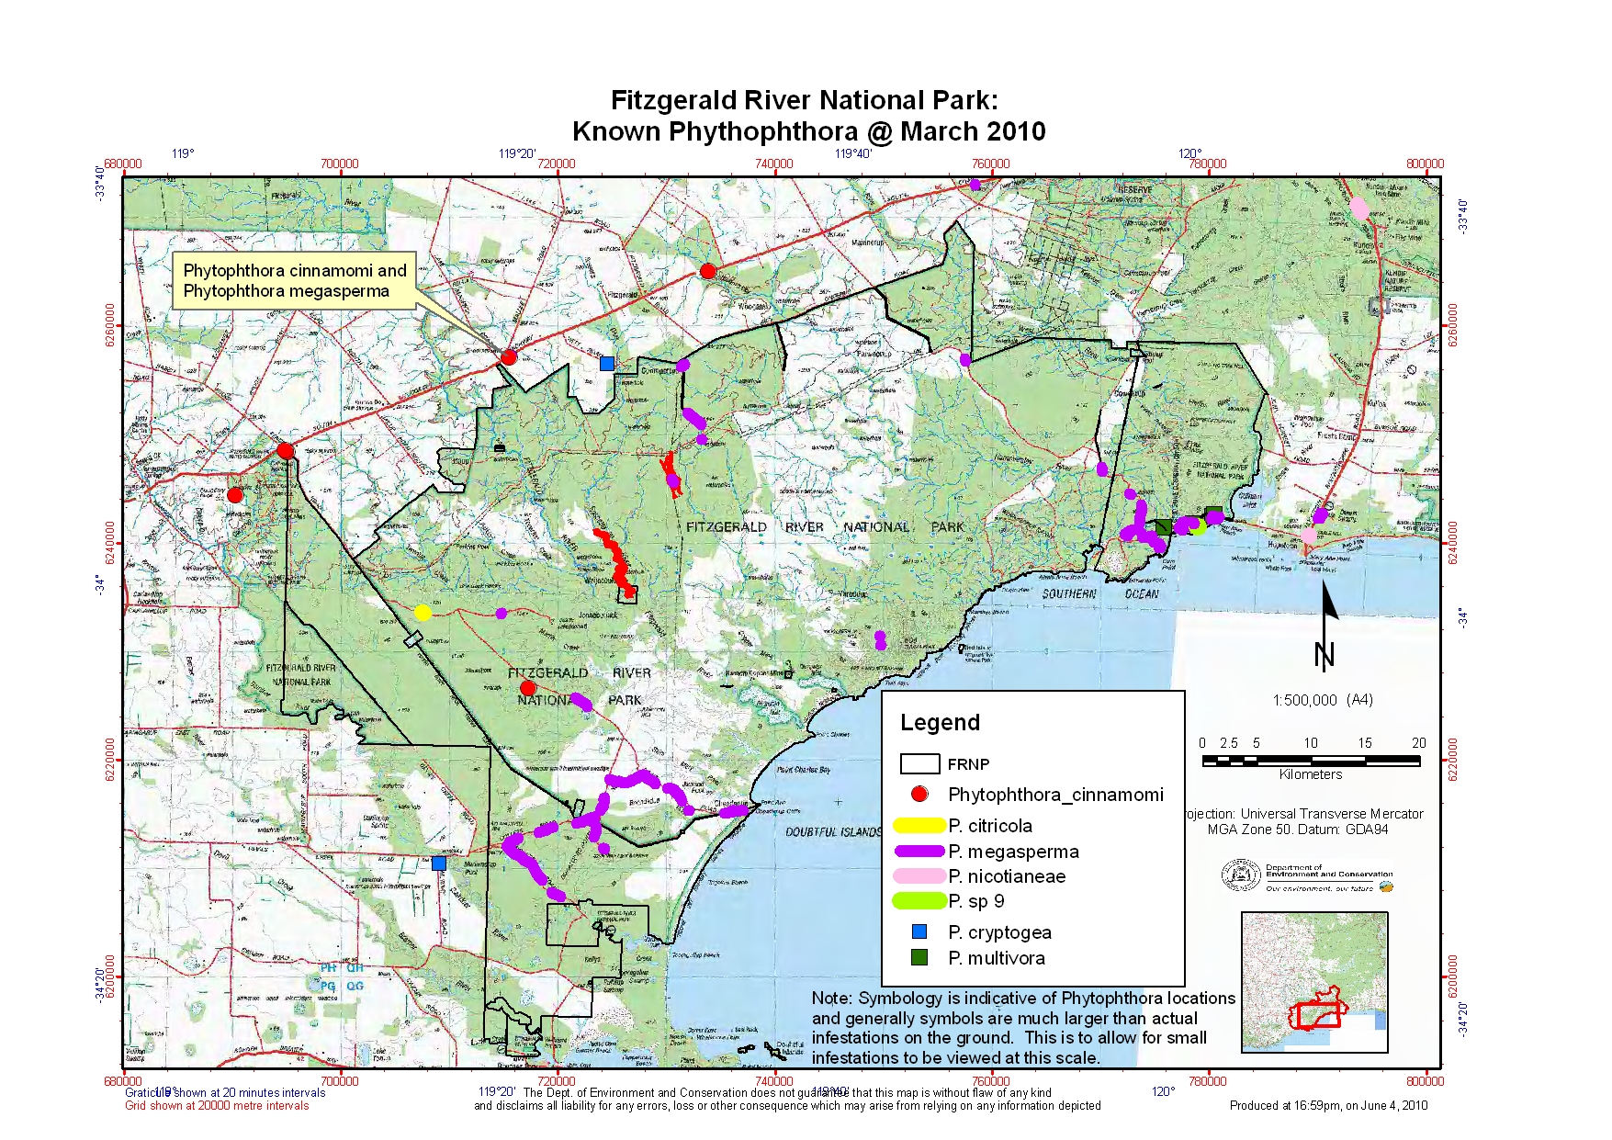
Figure 7: The known distribution (as of March 2010) of Phytophthora species in the Fitzgerald River National Park (mapped by Malcolm Grant and Greg Freebury).

Predation by Feral Cats and Foxes
European Red Foxes (Vulpes vulpes) and Feral Cats (Felis catus) are widespread across the Fitzgerald Biosphere. Predation by these introduced species is considered one of the most significant causes of the decline of many of the threatened fauna species across the region, and the presumed local extinction of critical-weight mammals such as the Woylie (Bettongia penicillata ogilbyi), Bilby (Macrotis lagotis) and Western Barred Bandicoot (Perameles bougainville) (Abbott 2008). It is ranked as a high or very high threat for all the threatened fauna species except for Carnaby’s Black-Cockatoo. Predation by feral cats and foxes are both listed as key threatening processes under the EPBC Act (DEWHA 2008c, 2008d, 2008g, 2008h).

In the Fitzgerald Biosphere, many private properties and over 410,000 hectares of conservation reserves are regularly fox-baited (further information in Section 6.2). However, there is limited monitoring of its success.
The non-target impacts of fox baiting need to be carefully monitored. Research into the effects of foxes and fox baiting on Chuditch in the Jarrah forest of southwest Western Australia found that although the Chuditch sometimes consumed the baits, they were not affected in terms of survival or breeding (Orell & Morris 1994). Chuditch numbers were found to increase following fox baiting but whether this was a result of reduced predation or competition from foxes remains unknown.

Interactions between the feral cats and foxes need to be considered as part of control programs. There is growing evidence that in some areas reducing fox numbers could be leading to an increase in feral cat numbers (known as meso-predator release) (Saunders & McLeod 2007). This is currently of concern in the FRNP where it has been hypothesised that predation by feral cats is the primary factor in the current decline of Western Ground Parrots (Sarah Comer pers. comm. 2010).

Interactions between feral cats and foxes and other invasive species (e.g. rabbits) also need to be considered as part of a control program. For example, eradication of cats from some islands (e.g. Macquarie Island) led to an increase in the rabbit population, resulting in extreme environmental damage, including increased destruction of seabird nesting sites and landslips (DEWHA 2008g). Therefore, understanding and consideration of these interactions is important.

Environmental Weeds
Invasion of environmental weeds (exotic plants that have become naturalised) is potentially a significant issue for the Fitzgerald Biosphere, particularly for areas that have been disturbed or degraded such as road sides and small remnants. Over 100 weed species occur in the Fitzgerald Biosphere (Moore et al. 1991). Although weed infestation in the FRNP is currently not extensive, some weed species have the potential to become serious problems in the long-term if not controlled, including Bridal Creeper (Asparagus asparagoides), African Lovegrass (Eragrostis curvula) and Boxthorn (Lycium ferocissimum).

The impacts of environmental weeds can include direct competition, change in the composition and structure of habitat, and altering fuel loads. Weeds may have additional ecological effects such as gene-mixing with endemic varieties through cross-pollination with closely related introduced species (CALM 1992).

The risk ratings (Section 5.1) suggest that weeds are not currently considered a threat or are ranked as only a low threat to most of the threatened species and ecological community in the Biosphere. However, they are a medium threat to Boronia clavata, Caladenia bryceana subsp. bryceana and Thelymitra psammophila. Boronia clavata is being affected by riverine weed species (including Bridle Creeper and Boxthorn), while Caladenia bryceana subsp. bryceana and Thelymitra psammophila are being affected by agricultural and roadside herb and grass weeds.

Loss, Fragmentation and Degradation of Habitat
Land clearance is listed as a key threatening process under the EPBC Act. Large scale clearing of native vegetation no longer occurs in the Fitzgerald Biosphere, but smaller scale clearing still occurs for a number of purposes, primarily for mining and exploration activities, urban development, road and track maintenance and farming activities.

There are also a number of other factors that cause, or have the potential to cause, loss or degradation of habitat. The most significant of these factors in the Biosphere are impacts from recreational activities (i.e. trampling, spread of Phytophthora cinnamomi and weeds), mining and exploration activities and grazing of remnant vegetation. The Fitzgerald Biosphere community are currently particularly concerned about the impacts of uncontrolled off-road driving in the conservation reserves.

The current fragmentation of the remnant vegetation in the Fitzgerald Biosphere is also a significant threat, as isolated populations of threatened species are vulnerable to edge effects, stochastic events (e.g. fire), loss of genetic variation and increased inbreeding, and the Allee effect (which induces a lower, unstable population size or critical density that has the capacity to accelerate decline in populations) (Hobbs & Yates 2003). Just over half (51%) of the Biosphere is covered by vegetation, with the Yilgarn Block landscape most highly fragmented. The Biosphere does however contain some significant large areas of remnant vegetation (e.g. FRNP, Ravensthorpe Range, Lake Magentia NR) and there is some connectivity between these areas.

Fragmentation and degradation of habitat is ranked as a high threat to the Carnaby’s Black-Cockatoo and Malleefowl due to their wide distributions across the Biosphere. Loss and degradation of habitat is ranked as a high threat for Eucalypus purpurata, Hibbertia abyssa, and Kunzea similis subsp. mediterranea as these threatened flora species are restricted to Bandalup Hill near Ravensthorpe Range, which is currently the site of a mine.

Competition and Habitat Modification by Invasive Fauna
There are a number of invasive fauna species that pose a threat to threatened species and ecological communities in the Fitzgerald Biosphere. These include rabbits, feral bees, feral pigs, feral goats and invasive native species. Competition and land degradation by rabbits (DEWHA 2008a, 2008e) and unmanaged goats (DEWHA 2008b, 2008f), and predation, habitat degradation, competition and disease transmission by feral pigs are listed as key threatening processes under the EPBC Act.

European Rabbits (Oryctolagus cuniculus) are widespread across the Biosphere, although they are more of a problem in the deep sands of the Marine Plain landscape and in riparian and wetland vegetation than other areas. Rabbits are a threat as they overgraze and inhibit the regeneration of native vegetation, compete with native fauna for food resources and indirectly cause soil erosion (DEWHA 2008a). Habitat modification by rabbits is ranked as a medium threat to Malleefowl in the Biosphere. Grazing by rabbits (and other herbivores such as kangaroos) is ranked a low to medium threat for the threatened flora species Anigozanthos bicolor subsp. bicolor, Boronia clavata, Caladenia bryceana subsp. bryceana, Eremophila denticulata subsp. denticulata and Thelymitra psammophila.

Colonies of feral Honey Bees (Apis mellifera) have become widespread across the Fitzgerald Biosphere, in particular in breakaways and rocky outcrops. Little is known about their interactions with native flora and fauna, though this may include competition for nectar resources, affecting seed production and competition for hollows with hollow-nesting fauna (Paton 1996). In the Biosphere, competition with bees (and invasive native hollow-nesting species such as Galahs (Eolophus roseicapillus)) for hollows is ranked a high threat for the hollow-nesting Carnaby’s Black-Cockatoo.

There are small populations of Feral Pigs (Sus scrofa) in the Fitzgerald Biosphere, mainly along the Pallinup River and its tributaries as far north as Jerramungup. Pigs are a threat through destruction of habitat (widespread soil disturbance, damaging plants through foraging), spreading of weeds and Phytophthora cinnamomi, and direct competition with some native fauna for food resources.

Salinisation or Altered Hydrology
It is estimated that about 12% of the farmland in the Fitzgerald Biosphere is already affected by salinisation, with the possibility that this may increase to 25% over the next 15 years unless appropriate action is taken (Furby 1998; RAP 1997). Most susceptible areas to salinisation include low-lying areas in the landscape. The Depositional Dynamics and Eocene landscape units are most vulnerable to salinity or altered hydrology. Waterlogging, wind and soil erosion also affect substantial percentages of farmland in some upper catchments in the Biosphere (Robinson 1997).

Salinisation and altered hydrology is ranked a high threat for two threatened flora species (Eucalyptus purpurata and Kunzea similis subsp. mediterranea) and a medium to low threat for seven other species. Habitat modification caused by salinisation was ranked a low to medium threat for all the threatened fauna species except the Western Bristlebird and Western Ground Parrot.

Stochastic Events
Stochastic events including novel diseases, wildfires, climatic extremes and severe weather events can directly threaten species in the Fitzgerald Biosphere. Stochastic events are generally unpredictable, and therefore cannot be managed pre-emptively. They can be of particular threat to species with restricted distributions and limited population size. For example, extreme hot weather in January 2010 was found to be the primary cause of an unusual mass mortality event in over 150 Carnaby’s Black-Cockatoos in the Hopetoun area. Such climatic extremes may become more frequent due to climate change.

Climate Change
‘Loss of terrestrial climatic habitat caused by anthropogenic emissions of greenhouse gases’ is listed under the EPBC Act as a key threatening process. In addition to the kind of stochastic weather event described above, the Fitzgerald Biosphere region has experienced a trend of decreased winter rainfall and increased summer rainfall since the mid-20th century and predictions are that these trends may continue (Gilfillan et al. 2009b; IOCI 2005). There is high rainfall variation in the region, making it difficult to detect short-term trends.

The South Coast Regional Strategic Management Plan (Gilfillan et al. 2009b) identified that the best management option for climate change in relation to threatened species recovery are to build the resilience of threatened species populations, thus improving the capacity of the populations to adapt as best they can to an altering climate. Resilience can be built through:
- Improving landscape connectivity,
- Maximising population viability; and
- Reducing the impact of other threatening processes.

6 Existing Conservation Measures

In Western Australia threatened species and ecological communities are protected under both Commonwealth and State legislation. The key State legislation pertaining to threatened species is the Wildlife Conservation Act 1950. All threatened species are specially protected under this Act and to ‘take’ listed flora or fauna is an offence without a permit. The Department of Environment and Conservation (DEC) is responsible for the implementation of this Act and leads the conservation of threatened species in the State. DEC works closely with other agencies, including NRM groups, community groups and other stakeholders to deliver conservation and recovery actions for threatened species and ecological communities.

There is no current State legislation for the listing of threatened ecological communities. TECs are endorsed by the Minister for Environment, which provides the TECs with protection through the Environmental Protection Act 1986. TECs are recognised in State government policies.

Most State-listed threatened species and ecological communities are also listed as threatened under the Environment Protection and Biodiversity Conservation Act 1999. A joint program is currently in place to align the Commonwealth and State threatened species lists.

A brief summary of existing recovery planning and activities for the protection of threatened species and ecological communities in the Fitzgerald Biosphere is provided below.

6.1 Current Recovery Planning for the Fitzgerald Biosphere

Recovery Plans
In Western Australia, recovery plans are developed as either Interim Recovery Plans (IRPs) or full recovery plans to provide information and guidance for the management and protection of certain threatened species/communities. A National Recovery Plan may be developed for any species that is listed as vulnerable, endangered or critically endangered under the EPBC Act. A National Recovery Plan is often an adopted version of the original WA plan.

There are 12 recovery plans or IRPs (as of April 2010) for individual species that are endemic or have part distributions in the Fitzgerald Biosphere (six fauna, six flora) (Table 12). The State multi-species recovery plan for South Coast Threatened Birds (Gilfillan et al. 2009a) represents the Western Ground Parrot, Western Bristlebird and Western Whipbird (western mallee) within the Biosphere. Of the species currently represented by recovery plans, only Acacia rhamphophylla, Daviesia megacalyx and Hibbertia abyssa are endemic to the Fitzgerald Biosphere. A summary of the general actions in these plans is given in Table 13.

Threatened and priority flora of the DEC Albany (Robinson & Coates 1995), Esperance (Craig & Coates 2001) and Great Southern (formally Katanning) (Graham & Mitchell 2000) districts are subject of wildlife management programs that provide a brief summary of each species, their threatening processes and the management and research requirements for each of these species.

All of the recovery plans specify actions for monitoring of currently known populations, surveys of potential habitat for new populations, public awareness and research (Table 13). All the plans also include actions for threat abatement, primarily for fire, Phytophthora cinnamomi and feral cats and foxes. All the plans for flora species include an action for seed collection, and many of the plans for fauna species include captive breeding and/or translocation actions.

Table 12: The recovery plans for species that are endemic or have part distributions in the Fitzgerald Biosphere.
No. | Recovery Plan | Life of Plan | Reference
36 | Carnaby’s Black-Cockatoo (Calyptorynchus latirostris) Recovery Plan | 2002-2012 | Cale (2002)
13 | Chuditch Recovery Plan | 1992-2001 | Orell & Morris (1994)
38 | Dibbler (Parantechinus apicalis) Recovery Plan | 2003-2013 | Friend (2004)
 | National Recovery Plan for Malleefowl | 2000 | Benshemesh (2000)
18 | Recovery Plan for the Numbat (Myrmecobius fasciatus) | 1995-2004 | Friend (1994)
44 | South Coast Threatened Birds Recovery Plan | 2009-2018 | Gilfillan et al. (2009a)
203 | Kundip Wattle (Acacia rhamphophylla) Interim Recovery Plan | 2005-2010 | Hartley & Barrett (2005)
223 | Small Two-coloured Kangaroo Paw (Anigozanthos bicolor subsp. minor) Interim Recovery Plan | 2006-2011 | Patten et al. (2006)
39 | Dwarf Spider Orchid (Caladenia bryceana subsp. bryceana) Interim Recovery Plan | 1999-2002 | Holland et al. (1999)
209 | Long-sepalled Daviesia (Daviesia megacalyx) Recovery Plan | 2005-2010 | Hartley & Barrett (2008b)
112 | Lake King Eremophila (Eremophila subteretifolia ms) Interim Recovery Plan | 2002-2005 | Phillimore et al. (2002)
204 | Hairy-fruited Marianthus (Marianthus mollis) Recovery Plan | 2008-2013 | Hartley & Barrett (2008a)
 | Hibbertia abyssa Interim Recovery Plan (Draft) | 2010-2015 | Luu et al. (in prep.)

Recovery Teams
The implementation of these recovery plans are overseen by nine recovery teams:
- Carnaby’s Cockatoo Recovery Team
- Chuditch Recovery Team
- Dibbler Recovery Team
- National Malleefowl Recovery Team
- Numbat Recovery Team
- South Coast Threatened Birds Recovery Team
- Albany District Threatened Flora Recovery Team
- Esperance District Threatened Flora Recovery Team
- Great Southern District Threatened Flora Recovery Team

The ‘critical-weight range’ mammals that are presumed locally extinct from the Biosphere are also represented by recovery plans and teams. These include: Woylie (Bettongia penicillata ogilbyi) (Start et al. 1995), Bilby (Macrotis lagotis) (Pavey 2006), and Western Barred Bandicoot (Perameles bougainville) (Short 1995). These recovery plans and teams are relevant to this Plan, as the Biosphere may include potential sites for reintroductions.

Table 13: Summary table of the recovery actions from current recovery plans and interim recovery plans that relate to threatened species in the Fitzgerald Biosphere.
Threatened Species | Monitoring current pops | Surveys for further pops | Map habitat critical | Research | Translocation\ reintroduction | Seed collection | Captive breeding | Liaise with land managers | Community awareness | Fire management | Phytophthora cinnamomi | Environmental weeds | Fragment. /loss of habitat | Feral cats & foxes | Invasive fauna | Salinisation | Other threat abatement | Protection of land | Management planning
Carnaby’s Black-Cockatoo | X |  | X |  |  |  |  | X | X |  |  |  | X |  | X |  |  | X | X
Chuditch | X | X |  | X | X |  | X |  | X |  |  |  |  | X
Dibbler | X | X |  | X | X |  | X |  | X | X | X
Malleefowl | X | X | X | X |  |  |  | X | X | X |  |  | X | X | X | X |  | X | X
Numbat | X |  |  | X | X |  | X |  | X |  |  |  |  | X |  |  |  |  | X
Western Bristlebird | X | X | X | X |  |  |  |  | X | X | X |  |  | X
Western Whipbird (western mallee) | X | X | X | X |  |  |  |  | X | X | X |  |  | X
Western Ground Parrot | X | X | X | X | X |  | X |  | X | X | X |  |  | X
Acacia rhamphophylla | X | X | X | X |  | X |  | X | X | X
Anigozanthos bicolor subsp. minor | X | X | X | X |  | X |  | X | X |  |  |  |  |  |  |  | X | X
Caladenia bryceana subsp. bryceana | X | X |  | X | X | X |  |  | X | X |  | X
Daviesia megacalyx | X | X | X | X |  | X |  | X | X | X
Eremophila subteretifolia | X |  |  | X |  | X |  | X | X | X |  |  |  |  | X |  | X
Hibbertia abyssa | X | X | X | X |  | X |  | X | X | X |  |  |  |  |  |  |  | X
Marianthus mollis | X | X | X | X |  | X |  | X | X | X

6.2 Past and current recovery activities in the Fitzgerald Biosphere
The conservation and recovery of threatened fauna has until recent years been species focused, with little coordination between the single-species programs. There has been more coordination across the South Coast Region for threatened flora and ecological communities as planning is overseen by district recovery teams.

Effort for a more coordinated approach is occurring as shown by the development of the South Coast Threatened Species and Ecological Communities Regional Strategic Management Plan (Gilfillan et al. 2009b), the multi-species South Coast Threatened Birds Recovery Team and Recovery Plan (Gilfillan et al. 2009a), the Integrated Predator Management Program and the development of this Plan.

When threatened species or threatened ecological communities are identified on land not managed by DEC, the department will advise the landowner/manager of their responsibilities under State law and of any schemes that may assist them to ensure the conservation of the species or community concerned. Any known individuals or organisations whose activities may affect the species or community, will also be notified of these matters.

A brief summary of existing recovery activities in the Fitzgerald Biosphere is provided below. There are many other conservation and sustainable land use programs in the Fitzgerald Biosphere that also indirectly benefit the conservation of threatened species/communities. An example of this is the Gondwana Link program (Gondwana Link 2008). This program is working to reconnect the landscape across south-western Australia and has a priority area of focus between the Fitzgerald River National Park and the Stirling Ranges. As a part of this program, Bush Heritage Australia and Greening Australia have purchased four properties totalling over 4000 ha in the Fitzgerald Biosphere for remnant vegetation protection and revegetation. Gondwana Link is also active in supporting improved land management and restoration of bushland. More information on such programs can be obtained through South Coast NRM Inc., Fitzgerald Biosphere Group and the Ravensthorpe Agricultural Initiative Network.

In 2004/2005 the Fitzgerald Biosphere Group developed a Fitzgerald Biosphere bibliography database to document the biological studies relating to nature conservation that had occurred in the Fitzgerald Biosphere. This database is an important collation of data and information for the Biosphere.

Threatened and Priority Mammals
Specific recovery actions for threatened and priority mammals in the Fitzgerald Biosphere has primarily focused on Dibblers and the reintroduction of Numbats. There has also been a couple of general small to medium mammal surveys (e.g. FRNP in 1985-87 (Chapman & Newbey 1995) and FRNP and the buffer zone of the Biosphere in 1993-97 (Sanders 1996)), and regular monitoring near Twertup and along Moir Track in the FRNP and in Corackerup Nature Reserve as part of the Western Shield monitoring program since 1997. Gondwana Link also conducts regular monitoring for small to medium-sized mammals on their properties. In recent years there have also been detailed studies on Heath Mouse and Chuditch in the Biosphere.

Dibblers have been specifically surveyed for in the FRNP since 1996 (Tony Friend pers. comm. 2010). This has included several research projects into the Dibbler’s home range, habitat preferences, and genetic and reproductive studies to compare the FRNP populations with the Jurien Bay island populations. In 2000, Dibblers were taken from FRNP to source a captive breeding population at Perth Zoo. This captive population has since supplied animals for translocations to the Stirling Range National Park and proposed Peniup Nature Reserve.

Numbats probably occurred patchily across the Fitzgerald Biosphere, but disappeared from the region in the mid-1900’s. Captive-bred and wild caught Numbats from Dryandra were reintroduced into the woodland areas of Cocanarup Timber Reserve in 2006 (following a vegetation assessment and termite sampling showing the habitat as suitable) (Tony Friend pers. comm. 2010). Further individuals have been released annually up to 2010. This reintroduction project has been regularly monitored using radio-tracking by DEC staff and volunteers from the Friends of the Fitzgerald River National Park. The first successful breeding and sightings of wild born young were in 2008. No further releases are planned for this population, which will be regularly monitored to determine its success.

Tammar (P5) and Western Brush (P4) Wallabies are being used as indicators of the success of fox baiting and habitat restoration within the Gondwana Link program, which is creating a habitat link between FRNP and the Stirling Range National Park by protecting remnant vegetation and restoring native vegetation (Gondwana Link 2008). These two priority species, will indicate whether the program’s management actions will also benefit other threatened and priority species impacted by the same threatening processes.

Threatened and Priority Birds
Threatened bird conservation and recovery in the Fitzgerald Biosphere has concentrated on the Western Ground Parrot, Western Bristlebird, Carnaby’s Black-Cockatoo and Malleefowl. Opportunistic surveys are periodically conducted of the other threatened and priority bird species. Hooded Plovers are monitored annually during breeding season by volunteers from Birds Australia for a state-wide project.

The Western Ground Parrot was first recorded in the Fitzgerald region in 1965 (Watkins 1985 in Burbidge et al. 1997). The presence of Western Ground Parrots was a major justification for the addition of approximately 100,000ha of land to the northern boundary of the FRNP in 1988. The FRNP Management Plan does not specify management guidelines for this species, but the general prescriptions (i.e. fire management, fox baiting program) were formulated with the conservation of the Western Ground Parrot as a major objective (Burbidge et al. 1997). The first population estimate for the FRNP was made in 1990. Since 2004, DEC (in conjunction with South Coast NRM Inc., Friends of the Western Ground Parrot community group and volunteers) has coordinated a program for the species including annual monitoring of known populations, surveys for new populations and potential habitat, and studies of breeding activity (Abby Berryman pers. comm. 2010).

The Western Bristlebird currently occurs in two areas: Two Peoples Bay Nature Reserve to Bluff Creek and FRNP. The Western Bristlebirds in the FRNP have been regularly surveyed since 1980 (Gilfillan et al. 2009a).

Carnaby’s Black-Cockatoo conservation is coordinated by the Birds Australia Carnaby’s Black-Cockatoo Recovery program. In the Fitzgerald Biosphere this has included population surveys, reporting of nesting trees and documenting of foot plants.

Malleefowl conservation in the Biosphere has largely been coordinated by the community group, Malleefowl Preservation Group. This is a very active group, who organise community education programs (e.g. the “Malleefowl Magic” school program, displays at country shows and field days, and a regular newsletter), and a sightings scheme whereby members of the public are encouraged to report their Malleefowl sightings. They also work with local land managers and other community groups to assist threat abatement such as in the control of foxes (Dennings 2009; Short & Parsons 2008). The group is also active in gaining funding for Malleefowl conservation and coordinating research programs.

Threatened and Priority Flora
The conservation and recovery of threatened flora across the Biosphere is in general coordinated by DEC and includes primarily monitoring of current populations, surveys for additional populations and seed collection (Sarah Barrett pers. comm. 2010). Populations on roads and major tracks are marked with permanent Declared Rare Flora (DRF) markers, yellow posts that mark the general location of threatened flora along roads and tracks to ensure that these species are not accidently impacted on during road maintenance.

Seeds have been collected and stored in DEC’s Threatened Flora Seed Centre from 21 (72%) of the threatened species and 59 (26%) of the priority species from the Biosphere (Anne Cochrane pers. comm. 2010). New populations of threatened or priority flora species and undiscovered species are still occasionally located by DEC staff, interested community members or consultant botanist doing surveys for mining exploration.

Feral Cat and Fox Control
Western Shield is a state-wide fauna conservation program managed by DEC that began in 1996. The program undertakes ground and aerial baiting for fox control, reintroduction programs for threatened fauna and related monitoring and research. In the Fitzgerald Biosphere, over 410,000 hectares of FRNP, Ravensthorpe Range, Peniup (proposed) Nature Reserve, and Lake Magenta, and Corackerup Nature Reserves is ground and aerial baited with 1080 fox baits. The success of the fox baiting is monitored at four sites in the FRNP and Corackerup Nature Reserve.

Control of cats and foxes (e.g. fox baiting, shooting) is also conducted by many land managers on private property. However, there are no records kept of where control has been conducted on private property, or monitoring of its success, apart from records of purchase of baits.

A community based feral animal control program ‘Red Card for Rabbits and Red Foxes’ operates across the agricultural regions of Western Australia. It is a coordinated control program (primarily shooting and baiting) run by local community groups, sporting clubs, local governments and individual land holders. The level of activity of this program within the Fitzgerald Biosphere varies from year to year.

DEC began a landscape conservation program for integrated predator control in the FRNP in 2009 (Sarah Comer pers. comm. 2010). Western Ground Parrot populations have significantly declined over the last five years in the FRNP, despite the control in the threatening processes of fire, foxes and Phytophthora cinnamomi. It has been hypothesised that the predation by feral cats is the primary factor in this decline. The objective of this project is to halt the decline of ‘critical weight-range’ mammals and birds in FRNP and Cape Arid National Park. Although the focus of this project is Western Ground Parrots, it is anticipated that the project will result in improved ecosystem health of the project areas and benefit other threatened species including the Dibbler, Red-tailed Phascogale and Chuditch. The first stage of this adaptive management project is the trialling of the cat baits ERADICAT™ using a Before After Control Impact (BACI) framework.

Fire Management
Fire management of the FRNP is guided by the ‘South Coast Regional Fire Management Plan 2009-2014’ (DEC 2009), the FRNP Management Plan (Moore et al. 1991), the FRNP Wilderness Fire Management Strategy (DEC 1995) and discussion paper (DEC draft). Implementation of these plans for the FRNP is overseen by a fire advisory group. The FRNP has had a history of large scale bushfires. Therefore current fire management for the Park is focused on creating and maintaining a spatial mosaic of fuel ages and has made significant progress towards achieving this (Barrett et al. 2009). It also includes a focus on protecting habitat critical for threatened species and ecological communities.

Barrett et al. (2009) recently collated the fire ecology information for the South Coast Region and identified the fire sensitive systems in the landscape. The document developed recommendations and guidelines for the management and monitoring of these systems.

Phytophthora Dieback Management
As the FRNP is one of the largest patches of native vegetation in the southwest of Western Australia that is relatively dieback-free, there has been a significant focus on dieback control in the Fitzgerald Biosphere by DEC and South Coast NRM. The dieback management of the FRNP is managed under the FRNP Management Plan (Moore et al. 1991), while South Coast NRM developed a strategic plan for managing dieback external to the Park (South Coast NRM 2009).

There are three small dieback infestations in FRNP, an internal catchment along Bell Track, Susetta Creek and in the Pabelup area (Figure 7). DEC is trying to prevent the further spread of these infestations (e.g. the Bell Track has been fenced to prevent spread by animals) and trialling novel eradication methods. To date these infestations are not a significant threat to any threatened or priority species in the Park, however further spread through the Park would have a devastating impact on many of the vegetation communities and threatened species.

Research is currently being conducted in the FRNP on the impact of aerial cankers as there is growing concern they may have significant impacts on the vegetation communities and many of the threatened and priority flora species in the Biosphere (Sarah Comer pers. comm. 2010).

7 Objectives and Performance Criteria

7.1 Objectives
The long-term objective of this Plan is to improve the conservation status of all threatened and priority species and ecological communities in the Fitzgerald Biosphere to ensure their long-term preservation, and ensure that all other biodiversity in the region is also conserved.

The specific objectives for the 10 year timeframe of this Plan are to:

- Maintain or increase population size and range of threatened and priority species and ecological communities in situ in the Fitzgerald Biosphere through the abatement of threatening processes following an adaptive management framework.

- Maintain or improve the habitat for threatened and priority species and ecological communities within the Fitzgerald Biosphere.

- Ensure efficient use of available resources for recovery action implementation and data management within the Fitzgerald Biosphere across institutions and land tenures.

- Improve community appreciation and respect for the biodiversity assets and associated threatening processes in the Fitzgerald Biosphere, and foster participation in activities that protect threatened species and ecological communities.

- Increase the number, size and/or range of threatened species populations through the use of ex-situ programs, if required.

- Monitor and evaluate population trends of threatened species and ecological communities in the Fitzgerald Biosphere and their responses to threatening processes, and use this information to inform adaptive management through the application of conservation action planning principles.

- Increase knowledge of the biodiversity and ecosystem processes of the Fitzgerald Biosphere, with emphasis on the threatened and priority species and ecological communities in an adaptive management framework.

7.2 Performance Criteria
The performance criteria against which success in achieving the objectives of this Plan will be measured are:
 | Performance Criteria | Timeframe | Relevant Actions
Coordination | - The size and range of populations of at least half of the currently threatened species and ecological communities have remained the same or increased. | 10 years | All
Coordination | - The South Coast Threatened Species and Ecological Communities Regional Recovery Team is established. | 1 year | 1
Coordination | - The spatial data in DEC’s Threatened fauna, flora and ecological communities databases for the Fitzgerald Biosphere is updated within 6 months of data collection and includes data from all relevant stakeholders. | Ongoing | 4-5
Community Appreciation | - Participation in volunteer conservation work has increased | Ongoing | 15-16
Community Appreciation | - Number of community education events that include threatened species has increased. | Ongoing | 7-8
Community Appreciation | - Number of media articles relating to threatened species management has increased | Ongoing | 7-8, 10
Abatement of Threatening Processes | - There has not been a bushfire greater than 20,000 hectares. | Ongoing | 18-19
Abatement of Threatening Processes | - The area of vegetation within the FRNP that is 10 years or less yeats since last burnt (YSLB) has reduced from 46% to less than 40% (Barrett et al. 2009). | Ongoing | 18-19
Abatement of Threatening Processes | - The area of Phytophthora cinnamomi infestation has not increased by more than 10% of 2010 levels. | Ongoing | 20-23
Abatement of Threatening Processes | - Indices of feral cat and fox activity have decreased within the FRNP. | 5 years | 24-28, 45
Abatement of Threatening Processes | - Fauna population trends, as measured by the Western Shield program, have maintained stable or increased numbers of native fauna species. | Ongoing | 24
Abatement of Threatening Processes | - High priority weed infestations have been reduced or eradicated. | Ongoing | 12, 32
Abatement of Threatening Processes | - The connectivity of the most significant corridors has increased (as measured by methods used by macro-corridor project (Wilkins et al. 2006)). | Ongoing | 33
Translocations & Ex-situ | - Translocated populations of Dibblers in Peniup and Numbats in Cocanarup are self-sustaining. | 5 years | 49
Translocations & Ex-situ | - The feasibility of reintroductions of Woylies, Greater Bilbies and Western Barred Bandicoots into the Fitzgerald Biosphere has been investigated. | 5 years | 51
Translocations & Ex-situ | - Seeds are stored in the Threatened Flora Seed Centre for >90% of the threatened flora species from populations in the Fitzgerald Biosphere. | 5 years | 53
Re-search | - A Research Advisory Group for the Fitzgerald Biosphere has been established and meets regularly. | 5 years | 54
Re-search | - Research results have informed threatened species recovery management actions. | Ongoing | 55

7.3 Implementation of the Plan
The implementation of this Plan will be overseen by a ‘South Coast Regional Recovery Team’ which will be established to oversee the implementation of the South Coast Regional Strategic Management Plan, this Plan for the Fitzgerald Biosphere and future such plans for other priority areas in the South Coast. This recovery team will consist of a cross-section of stakeholders.

This Plan does not provide costing for the recovery actions, as it is not practicable to determine meaningful costings for the wide scope of the actions. The implementation of the actions will be subject to the availability of funding. Where actions refer to lands other than those managed by DEC, permission has been or will be sought from the managers prior to the recovery actions being undertaken.

Guide for Implementation of this Plan
Each of the Landscape Units of the Fitzgerald Biosphere (Section 2.4) responds differently to threatening processes and management practices due to differences in their physical characteristics. When implementing actions from this Recovery Plan, these characteristics of the Landscape Units should be taken into account.

7.4 Evaluation of the Plan
This Plan will be implemented over a ten-year period and subject to a review after five years. DEC, in conjunction with the South Coast Regional Recovery Team will regularly evaluate the performance of this Recovery Plan against the performance criteria.

8 Recovery Actions and Management Practices

The recovery actions and management practices of this Plan will be implemented within an adaptive management framework, with monitoring and research results being used to assess the success of, and improve, the actions.

8.1 Recovery Actions
The following recovery actions provide for the management and research necessary to support the recovery of the threatened species and ecological communities in the Fitzgerald Biosphere over the next 10 years. Although these actions have a threatened species focus, all the actions have been developed to also support the conservation of the region’s biodiversity.

These recovery actions are presented in six broad categories: coordination and planning, community appreciation and participation, abatement of threatening processes, monitoring and survey, translocations and ex-situ conservation, and research.

A scale (e.g. Biosphere Region, Specific threatened species) and priority is included for each action. The specific threatened species or ecological community that each of these actions is relevant for is summarised in Appendix 7.

Coordination and Planning

Actions | Scale and Priority
- Establish the South Coast Threatened Species and Ecological Communities Regional Recovery Team (as recommended in the South Coast Regional Strategic Management Plan (Gilfillan et al. 2009b)). In relation to this Plan, the Team will be responsible for:  - Coordination, prioritisation and implementation of this Plan.  - Planning investment and seeking funding opportunities.  - Facilitate links between Regional Recovery Team and single and multi-species recovery teams  - Liaise with other stakeholders.  - Review the progress and outcomes of implementation of this Plan.  - Develop and support partnerships between departments, agencies, community groups and other stakeholders to encourage coordinated cross-tenure management for threatened species recovery.  - Review any plans relevant to threatened species and ecological communities in the Fitzgerald Biosphere. | South Coast Region, High priority
- Investigate the practicality, and implement if feasible, the use of an conservation management planning software such as Miradi (CMP 2009) to improve implementation of threatened species and ecological communities recovery in the Fitzgerald Biosphere and facilitate adaptive management. | Region, Medium priority
- Identify threatened species or ecological communities that are endemic or have significant populations in the Biosphere that may require an individual State recovery plan and prepare the plan if required. | Specific, Medium priority
- Collate threatened species and ecological communities data and input into DEC’s Threatened fauna, flora and ecological communities databases. DEC to liaise with other departments, NRM organisations and community groups to gain access to any relevant spatial data. | Region, High priority
- Validate all current spatial data and regularly input new spatial data for the Fitzgerald Biosphere into DEC’s Threatened fauna, flora and ecological communities database. | Region, High priority
- Undertake a review of proposed reserves in the Biosphere and progress the formal creation of these reserves where appropriate, in particular in areas that contain habitat critical for threatened species and ecological communities. | Proposed reserves, Medium priority

Community Appreciation and Participation

Actions | Scale and Priority
- Collaborate with community education initiatives to promote awareness of the threatened species and ecological communities of the Biosphere, with particular focus on schools, Indigenous groups and visitors to the region and land managers. | Region, Medium priority
- Collaborate with community education initiatives to promote awareness of Phytophthora cinnamomi hygiene protocols and the importance of preventing its introduction and spread, with particular focus on land managers, council workers, researchers, tourists and recreational users. | Region, High priority
- Include information on threatened species and ecological communities and the importance of Phytophthora cinnamomi hygiene into visitor interpretation in FRNP. | FRNP, High priority
- Collaborate with local visitor resource centres to include information on threatened species and ecological communities and the importance of Phytophthora cinnamomi hygiene into visitor interpretation in Ravensthorpe Range. | Ravensthorpe Range, High priority
- Continue to formally notify land managers of the presence of a threatened species or ecological community on their land, their associated legal obligations and advice on how to manage for this species or community. | Specific, Medium priority
- Provide on-ground advice to land managers and community groups on threatened species management and threat abatement (e.g. weed management, fox and cat control, etc). | Region, Medium priority
- Provide advice to land managers to develop and implement fire management plans for the protection of habitat critical for threatened and priority species and ecological communities. | Region, Low priority
- Encourage reporting of road kills and sightings DEC of threatened species through actions 11 -13. | Region, Medium priority
- Encourage community group and volunteer involvement in threatened species recovery or threat abatement programs. | Region, Medium priority
- Encourage the inclusion of Noongar culture in threatened species recovery, threat abatement and education programs. Where possible, build on existing programs or networks (e.g. South Coast NRM Restoring Connections). | Region, Medium priority

Abatement of Threatening Processes

Actions | Scale and Priority
- Update the analysis of threatening processes risks for the threatened species and ecological community of the Fitzgerald Biosphere using Miradi (Section 5) as new data becomes available. Complete the Miradi analysis for the priority species and ecological communities. | Region, Low priority
- Provide input into the Fitzgerald River National Park Fire Management Strategy Paper regarding the fire regime requirements of the threatened and priority species and ecological communities (Action 45). Undertake annual reviews of this strategy paper. | FRNP, High priority
- Ensure up-to-date GIS spatial data of threatened and priority species and ecological communities and their habitat critical is available to Incident Management Teams in the event of a bushfire. | Region, High priority
- Undertake a risk assessment of Phytophthora cinnamomi introduction or further spread through human activity across the Biosphere, in particular relating to habitat critical. Use these results to inform actions and management. | Region, High priority
- Install or upgrade, and maintain hygiene infrastructure at key locations across the Fitzgerald Biosphere. | Region, High priority
- Regularly survey and mapping of the extent of Phytophthora sp. across the Biosphere. | Region, High priority
- Continue to trial and implement containment and eradication methods for Phytophthora cinnamomi infestations at known infestations within the FRNP. | FRNP, High priority
- Continue and expand the Western Shield fox baiting program so that all habitat critical on conservation land for threatened fauna is included. | Region, High priority
- Continue the Integrated Fauna Recovery Program to trial the use of Eradicat™ baits for cat control, with a focus on Western Ground Parrot habitat critical. Include monitoring for impacts on non-target species, in particular Chuditch and Dibbler. | FRNP, High priority
- Commence the use of Eradicat™ baits (subject to the registration of the baits) in the Western Shield Program across the Fitzgerald Biosphere with a focus on fauna habitat critical, in particular for Western Ground Parrot. | Region, High priority
- Provide advice to land managers, community groups (e.g. catchment groups) and kangaroo shooters undertaking cat and fox control (e.g. baiting, shooting). | Region, Medium priority
- Develop and implement a coordinated approach to fox and cat control across all tenures. | Region, High priority
- Control rabbits using best-practice methods across all tenures, particularly for habitat critical for threatened and priority species and ecological communities. | Region, Medium priority
- Implement control measures for feral bees if research indicates this is feasible. | Region, Medium priority
- Control feral pigs along the Pallinup River and its tributaries. | Pallinup River, Low priority
- Identify and remove weeds using appropriate methods from habitat critical for populations of Boronia clavata, Caladenia bryceana subsp. bryceana and Thelymitra psammophila that are currently being threatened by weeds and as required in areas where other threatened or priority species or ecological communities become threatened by weeds (as indicated by monitoring (Action 39)). | Specific, Medium priority
- Implement off-reserve revegetation projects to link and enhance habitat critical for species that are highly susceptible to fragmentation (e.g. Carnaby’s Black-Cockatoo, Malleefowl), with emphasis on the priority areas identified the South Coast Macro-corridor project (Wilkins et al. 2006). | Specific, High priority
- Provide advice and incentives to landholders to fence remnant vegetation. | Region, Low priority
- Provide advice on mining and exploration applications to the Department of Mines and Petroleum, and where applicable, mining companies, about how to avoid or minimise impacts on threatened species and communities, and biodiversity. | Region, High priority
- Continue to use DRF markers to mark the locations of known populations of threatened flora along roadsides. | Specific, Medium priority
- Undertake appropriate rehabilitation/avoidance measures for salinisation, particularly for habitat critical for threatened and priority species and ecological communities. | Region, High priority
- Implement measures to minimise loss of threatened birds foraging on roadsides (e.g. Carnaby’s Black-Cockatoo, Malleefowl). | Road verges, Medium

Monitoring and Survey

Actions | Scale and Priority
- Implement a program of monitoring (at appropriate frequency and scale for the species) of known populations of threatened species and communities, including aspects such as population size, extent and potential threatening processes (e.g. weeds). | Region, High priority
- Undertake surveys to determine the distribution and potential habitat across the Fitzgerald Biosphere of threatened species for which this is unknown. | Specific, Medium priority
- Undertake survey and data analysis for priority species and ecological communities across the Biosphere to confirm conservation status. | Region, Medium priority
- Stimulate germination and monitor seedling recruitment for threatened and priority flora species which have low recruitment due to lack of appropriate disturbance (e.g. Anigozanthos bicolor subsp. minor (Patten et al. 2006) and Eremophila subteretifolia (Phillimore et al. 2002)). | Specific, Low priority
- Update the mapping of habitat critical to the survival of threatened species within the Biosphere biennially. | Region, Low priority
- Improve the vegetation mapping for the Biosphere with an emphasis on areas containing habitat critical. | Region, Medium priority
- Further develop and implement pre- and post-fire monitoring programs for threatened and priority species and ecological communities (see Barrett et al. 2009). | Region, Medium priority
- Develop and implement coordinated monitoring programs to determine feral cat and fox numbers (Action 28) across agencies and land tenures. | Region, High priority
- For threatened and priority species that are highly susceptible to salinisation, monitor salinity levels in the soil around populations and its impact on the species (Action 37). | Specific, Medium priority
- Monitor the number of threatened birds (i.e. Malleefowl and Carnaby’s Black-Cockatoo) foraging on roadsides on grain spilt during road transport (Action 38). | Specific, Low priority

Translocations and Ex-situ Conservation

Actions | Scale and Priority
- Continue regular monitoring and maintenance of current reintroduced populations with consideration of expansion where feasible (Dibblers in Peniup and Numbats in Cocanarup). | Specific, High priority
- Continue the Western Ground Parrot breeding program as required, and if possible include individuals from the FRNP to maintain genetic diversity. | Specific, High priority
- Investigate the feasibility of, and implement reintroductions of currently locally extinct species (e.g. Woylie, Greater Bilby, Western Barred Bandicoot) into the Fitzgerald Biosphere. | Specific, Low priority
- Continue seed collection and storage of the seeds in the Threatened Flora Seed Centre for the threatened and priority flora species in the Fitzgerald Biosphere. | Specific, High priority
- Consider translocations of flora species if required and implement if feasible. | Specific, Medium priority

Research

Actions | Scale and Priority
- Establish a Research Advisory Group for the Fitzgerald Biosphere to coordinate and prioritise an integrated program of research in the Fitzgerald Biosphere. | Region, High priority
- Conduct priority research for threatened and priority species and ecological communities in the Biosphere (listed in Appendix 8). | Region, High priority
- Maintain and regularly update the Fitzgerald Biosphere Group’s Fitzgerald Biosphere bibliography database. | Region, Low priority

8.2 Management Practices

Management practices are broad guidelines or strategies that are not specific actions for the recovery of the threatened and priority species and ecological communities in the Fitzgerald Biosphere which also contribute to the long-term conservation of these species and communities in the Biosphere.

Threatening Processes & Key Planning Documents | Management Practices and Strategies
General
- South Coast Regional Strategy for NRM 2004-2009 (SCRIPT 2005)
- South Coast Region DEC Nature Conservation Service Plan 2009-2014
- Fitzgerald River National Park Management Plan 1991-2001 (Moore et al. 1991)
- South Coast Threatened Species and Ecological Communities Strategic Management Plan (Gilfillan et al. 2009b)
- Catchment management plans
Fire Regimes  - South Coast Regional Management Plan 2009-2014 (DEC 2009)  - FRNP Fire Management Strategy Paper (Action 18) | - Fire management in the Fitzgerald Biosphere should aim to create and maintain a spatial mosaic of fuel ages with inter-fire periods sufficient to maintain species richness and biodiversity (Barrett et al. 2009).
- Threatened and priority species and ecological communities requirements should be considered in all fire management planning for the Fitzgerald Biosphere, including:
- the location of habitat critical for threatened species/communities,
- patch size for the habitat requirements of threatened species/communities,
- inter-fire periods to sustain population viability
- connectivity of vegetation communities, and
- the habitat value of long unburnt vegetation.
 | - Phytophthora cinnamomi hygiene must be implemented as a high priority during all fire management operations in the Fitzgerald Biosphere.
 | - To achieve the objectives of DEC fire policy 19, an Environmental Officer should be involved in incident management teams for all DEC and FESA/LGA managed fires to ensure that potential impacts of fire suppression actions on threatened and priority species and ecological communities are considered.
 | - Pre-fire suppression activities must be implemented in response to landscape unit characteristics and conservation requirements.
Phythophthora cinnamomi  - Phytophthora Dieback Management Plan for the South Coast Region 2008-2015 (South Coast NRM Inc 2009b)  - Managing External Dieback Threats to the Fitzgerald River National Park (South Coast NRM 2009)  - Bell Track Response Plan | - Implement the strict Phytophthora cinnamomi hygiene protocols for the FRNP as detailed in the Parks 1991-2001 Management Plan (Moore et al. 1991) and any subsequent revisions to prevent further spread into currently uninfested areas.
 | - Implement the ‘Managing External Dieback Threats to the Fitzgerald River National Park’ (South Coast NRM 2009) recommended actions across the Biosphere where feasible.
 | - Ensure Phytophthora cinnamomi hygiene protocols are strictly implemented for road maintenance and other earth moving projects in the Fitzgerald Biosphere.
 | - Continue to require all individuals working in or conducting research on DEC managed estate to undertake an environmental ‘Green Card Induction’ from DEC South Coast Region to ensure awareness of the regional biodiversity assets and how to manage risks to these (in particular Phytophthora dieback hygiene procedures).
Weeds  - South Coast NRM weed prioritisation project  - DEC regional weed analysis project | - Encourage community groups and land managers to conduct weed control in remnant vegetation.
Loss and Fragmentation of Habitat  - Living with the Land: Guidelines for the Fitz-Stirling (Sanders 2008)  - The Western Australian South Coast Macro Corridor Network (Wilkins et al. 2006) | - Ensure pre-development and Environmental Impact Statement surveys are conducted using appropriate expertise and survey methods.
 | - Promote off-reserve conservation programs (e.g. conservation covenants, Land for Wildlife) and the development of further mechanisms, such as environmental stewardship programs.
 | - Encourage sustainable agricultural practices that minimise threatening processes impacting on remnant vegetation, particularly areas that are habitat critical.
 | - Liaise with LGA’s to develop strategies and policies that manage the impacts of domestic cats.
Salinisation | - Salinisation management planning across the Biosphere should include consideration of biodiversity conservation.
Climate Change  - Climate Change: Whole of Landscape Analysis of the Impacts and Options for the South Coast Region (South Coast NRM Inc 2009a) | - Build the resilience of populations of threatened and priority species and ecological communities of the Fitzgerald Biosphere to allow them to adapt as best they can to an altering climate through improving landscape connectivity, maximizing population viability, and reducing the impact of other threatening processes (Gilfillan et al. 2009b).

8.3 Guide for Decision Makers

Under the Commonwealth Environment Protection and Biodiversity Conservation Act 1999 (EPBC Act), or other national environmental legislation as may apply at the time an activity is proposed, any person proposing to undertake actions which may have a significant impact on any listed threatened species or ecological community should refer the action to the Commonwealth Minister for the Environment. The Minister will determine whether the action requires EPBC Act assessment and approval. Further advice on the EPBC Act is available from the Department of Sustainability, Environment, Water, Population and Communities (SEWPaC).

Actions within habitat critical that could result in any of the following may result in a significant impact on threatened species and ecological communities of the Fitzgerald Biosphere:
- Removal or disturbance of native vegetation that is used by a threatened species or that form a corridor between areas of habitat;
- Spread of Phytophthora cinnamomi into areas of native vegetation;
- Introduction of fire into habitat used by threatened species;
- Introduction of novel weed species to the Biosphere;
- Introduction or increase of introduced animals to the Biosphere;
- Introduction of a chemical into habitat used by threatened species that may affect the species;
- Altered hydrology or salinity;
- Disturbance of native vegetation within 1 km of a threatened ecological community;
- Removal or disturbance of nesting trees for the Carnaby’s Black-Cockatoo.

Appendix 1: Stakeholders

Stakeholders in Biodiversity Conservation in Fitzgerald Biosphere
International | UNESCO (Man and Biosphere programme)
Commonwealth Government | Department of Sustainability, Environment, Water, Population and Communities (formally Department of the Environment, Water, Heritage and the Arts)
State Government | Dept. of Environment and Conservation  Dept. of Agriculture and Food  Dept. of Water  Dept. of Mines and Petroleum  Dept. of Indigenous Affairs  Forest Products Commission  Fire and Emergency Services Authority (FESA) and Fire Brigades  Tourism Western Australia
Local Government/ Shires | Shire of Jerramungup  Shire of Ravensthorpe  Shire of Lake Grace (on edge of region)  Shire of Kent (on edge of region)
NRM | South Coast NRM Inc.  Fitzgerald Biosphere Group  RAIN (Ravensthorpe Agricultural Initiative Network)  Catchment Groups: Bedford Harbour, Bremer River, Culham Inlet, Fitzgerald River, Oldfield River, Phillips River, Wellstead Estuary, West River, Yallobup Creek.
Community Groups | Friends of the Fitzgerald River National Park  Fitzgerald River NP Advisory Group  Fitzgerald River NP Fire Advisory Group  Ravensthorpe Wildflower Society  Friends of Western Ground Parrot  Project Numbat  Malleefowl Preservation Group
Non-Government Environmental Organisations | Gondwana Link (participating groups in Gondwana Link include: Bush Heritage Australia, Fitzgerald Biosphere Group, Friends of the Fitzgerald River NP, Greening Australia, Green Skills, The Nature Conservancy and The Wilderness Society)  Greening Australia  Bush Heritage Australia  Green Skills  Birds Australia  WWF Australia
Indigenous Groups | Albany Aboriginal Heritage Reference Group  South West Aboriginal Land & Sea Council  Goldfields Aboriginal Land & Sea Council
Recovery Teams | South Coast Threatened Species and Ecological Communities Regional Recovery Team (yet to be formed)  District, individual and multi-species Recovery Teams (listed in Section 6.1)
Research Institutes | Museum of Western Australia  Universities (e.g. Curtin University, University of Western Australia, Murdoch University)
Mining Companies | Mining companies with tenements in the Biosphere
Local Community | Landholders  Local Residents  Local schools  Local businesses  Recreational Users (e.g. bushwalking, wildflowers, 4WD, motor bikes, fishermen, tourists)

Appendix 2: Species Profiles

The species profiles for the threatened species and ecological communities of the Fitzgerald Biosphere represented by this recovery plan are provided in the supporting document, ‘Appendix 2: Species Profiles’.

Appendix 3: Distribution of Threatened and Priority Species and Ecological Communities across the Landscape Units of the Fitzgerald Biosphere

The occurrence of each of the Fitzgerald Biosphere threatened species and ecological communities in each of the landscape units (Section 2.4) is shown in the below tables.

Threatened and Priority Fauna

Fauna Species | Landscape Units
Fauna Species | Albany Fraser Coastal | Depositional Dynamics | Depositional Eocene | Esperance Sandplain | Greenstone | Marine Plain | Quartzite Range | Yilgarn Block East
Threatened
Pezoporus wallicus flaviventris |  | X | X | X | X | X | X | X
Calyptorhynchus latirostris |  | X | X | X | X | X |  | X
Parantechinus apicalis |  | X | X | X |  | X | X | X
Phascogale calura |  | X |  |  |  |  |  | X
Dasyornis longirostris |  | X | X |  |  | X | X | X
Dasyurus geoffroii |  | X | X |  | X | X | X | X
Leipoa ocellata |  | X | X | X | X | X | X | X
Myrmecobius fasciatus |  | X |  |  | X |  |  | X
Pseudomys shortridgei |  | X |  |  | X | X | X | X
Priority (number of species)
P1 |  | 1 |  |  | 1 |  | 1 | 1
P2 |  |  |  |  |  |  | 1
P3 |  |  | 1 |  | 1 |  | 1
P4 |  | 9 | 5 | 1 | 6 | 4 | 6 | 8
P5 |  | 2 | 1 |  | 2 |  | 1 | 2
Total Priority | 0 | 12 | 7 | 1 | 8 | 4 | 10 | 11
Total EPBC threatened spp | 0 | 9 | 6 | 4 | 6 | 7 | 6 | 9

Threatened and Priority Ecological Communities

Ecological Communities | Landscape Units
Ecological Communities | Albany Fraser Coastal | Depositional Dynamics | Depositional Eocene | Esperance Sandplain | Greenstone | Marine Plain | Quartzite Range | Yilgarn Block East
Threatened

Thumb Peak – Mid-Mount Barren – Woolburnup Hill (Central Barren Ranges) Eucalyptus acies mallee heath |  |  |  |  |  |  | X
Priority (number of species)

P1 |  |  |  |  | 6 | 2
P3 |  |  |  | 1

Threatened and Priority Flora

Flora Species | Landscape Units
Flora Species | Albany Fraser Coastal | Depositional Dynamics | Depositional Eocene | Esperance Sandplain | Greenstone | Marine Plain | Quartzite Range | Yilgarn Block East
Threatened
Acacia rhamphophylla |  |  |  |  | X
Adenanthos dobagii |  | X |  |  |  | X | X
Adenanthos ellipticus |  |  |  |  |  | X | X
Anigozanthos bicolor subsp. minor |  | X |  | X |  | X |  | X
Boronia clavata |  | X | X |  |  | X | X
Caladenia bryceana subsp.bryceana |  | X | X |  |  |  |  | X
Conostylis lepidospermoides |  |  |  |  | X
Coopernookia georgei |  |  |  |  |  |  | X
Daviesia megacalyx |  |  |  |  | X |  |  | X
Daviesia obovata |  |  |  |  |  |  | X
Eremophila denticulata subsp.denticulata |  | X |  |  |  |  |  | X
Eremophila subteretifolia |  | X |  |  |  |  |  | X
Eucalyptus burdettiana |  |  |  |  |  |  | X
Eucalyptus coronata |  |  |  |  |  |  | X
Eucalyptus nutans |  |  |  |  |  | X
Eucalyptus purpurata |  |  |  |  | X
Grevillea infundibularis |  |  |  |  |  |  | X
Kunzea similis subsp. mediterranea. |  |  |  |  | X
Kunzea similis subsp. similis |  |  |  |  |  |  | X
Lepidium aschersonii |  |  |  |  |  |  |  | X
Marianthus mollis |  |  |  |  | X
Myoporum cordifolium |  |  | X |  |  |  | X | X
Ricinocarpos trichophorus |  | X | X |  |  |  |  | X
Stylidium galioides |  |  |  |  |  |  | X
Thelymitra psammophila |  | X |  |  |  |  |  | X
Verticordia crebra |  |  | X |  |  | X | X | X
Verticordia helichrysantha |  |  |  |  |  | X
Verticordia pityrhops |  |  |  |  |  |  | X
Priority (number of species)
P1 | 2 | 14 | 3 | 3 | 13 | 5 | 3 | 17
P2 |  | 23 | 13 | 4 | 6 | 9 | 30 | 32
P3 | 2 | 48 | 18 | 8 | 27 | 22 | 31 | 60
P4 |  | 43 | 16 | 11 | 24 | 21 | 35 | 40
Total Priority | 4 | 128 | 50 | 26 | 70 | 57 | 99 | 149
Total EPBC threatened spp | 0 | 8 | 5 | 1 | 6 | 7 | 13 | 10

Appendix 4: Priority Species Criteria

Department of Environment and Conservation Priority Flora and Fauna Lists
Possibly threatened species that do not meet survey criteria are added to the Department of Environment and Conservation (DEC) Priority Flora and Priority Fauna Lists under Priorities 1, 2 or 3. These three categories are ranked in order of priority for survey and evaluation of conservation status so that consideration can be given to their declaration as threatened flora or fauna. Species that are adequately known, are rare but not threatened, or meet criteria for Near Threatened, or that have been recently removed from the threatened list for other than taxonomic reasons, are placed in Priority 4. These species require regular monitoring. Conservation Dependent species are placed in Priority 5.

Priority One: Poorly-known species
Species that are known from one or a few collections or sight records (generally less than five), all on lands not managed for conservation, e.g. agricultural or pastoral lands, urban areas, Shire, Westrail and Main Roads WA road, gravel and soil reserves, and active mineral leases and under threat of habitat destruction or degradation. Species may be included if they are comparatively well known from one or more localities but do not meet adequacy of survey requirements and appear to be under immediate threat from known threatening processes.

Priority Two: Poorly-known species
Species that are known from one or a few collections or sight records (generally less than five), some of which are on lands not under imminent threat of habitat destruction or degradation, e.g. national parks, conservation parks, nature reserves, State forest, vacant Crown land, water reserves, etc. Species may be included if they are comparatively well known from one or more localities but do not meet adequacy of survey requirements and appear to be under threat from known threatening processes.

Priority Three: Poorly-known species
Species that are known from collections or sight records from several localities not under imminent threat, or from few but widespread localities with either large population size or significant remaining areas of apparently suitable habitat, much of it not under imminent threat. Species may be included if they are comparatively well known from several localities but do not meet adequacy of survey requirements and known threatening processes exist that could affect them.

Priority Four: Rare, Near Threatened and other species in need of monitoring
(a) Rare. Species that are considered to have been adequately surveyed, or for which sufficient knowledge is available, and that are considered not currently threatened or in need of special protection, but could be if present circumstances change. These species are usually represented on conservation lands.
(b) Near Threatened. Species that are considered to have been adequately surveyed and that do not qualify for Conservation Dependent, but that are close to qualifying for Vulnerable.
(c) Species that have been removed from the list of threatened species during the past five years for reasons other than taxonomy.

Priority Five: Conservation Dependent species
Species that are not threatened but are subject to a specific conservation program, the cessation of which would result in the species becoming threatened within five years.

Department of Environment and Conservation Priority Ecological Community List
Possible threatened ecological communities that do not meet survey criteria or that are not adequately defined are added to the Priority Ecological Community Lists under Priorities 1, 2 and 3.
These three categories are ranked in order of priority for survey and/or definition of the community, and evaluation of conservation status, so that consideration can be given to their declaration as threatened ecological communities. Ecological Communities that are adequately known, and are rare but not threatened or meet criteria for Near Threatened, or that have been recently removed from the threatened list, are placed in Priority 4. These ecological communities require regular monitoring. Conservation Dependent ecological communities are placed in Priority 5.

Priority One: Poorly-known ecological communities
Ecological communities with apparently few, small occurrences, all or most not actively managed for conservation (e.g. within agricultural or pastoral lands, urban areas, active mineral leases) and for which current threats exist. Communities may be included if they are comparatively well-known from one or more localities but do not meet adequacy of survey requirements, and/or are not well defined, and appear to be under immediate threat from known threatening processes across their range.

Priority Two: Poorly-known ecological communities
Communities that are known from few small occurrences, all or most of which are actively managed for conservation (e.g. within national parks, conservation parks, nature reserves, State forest, unallocated Crown land, water reserves, etc.) and not under imminent threat of destruction or degradation. Communities may be included if they are comparatively well known from one or more localities but do not meet adequacy of survey requirements, and/or are not well defined, and appear to be under threat from known threatening processes.

Priority Three: Poorly known ecological communities
(i) Communities that are known from several to many occurrences, a significant number or area of which are not under threat of habitat destruction or degradation or;
(ii) communities known from a few widespread occurrences, which are either large or within significant remaining areas of habitat in which other occurrences may occur, much of it not under imminent threat, or;
(iii) communities made up of large, and/or widespread occurrences, that may or not be represented in the reserve system, but are under threat of modification across much of their range from processes such as grazing by domestic and/or feral stock, and inappropriate fire regimes.
Communities may be included if they are comparatively well known from several localities but do not meet adequacy of survey requirements and/or are not well defined, and known threatening processes exist that could affect them.

Priority Four: Ecological communities that are adequately known, rare but not threatened or meet criteria for Near Threatened, or that have been recently removed from the threatened list. These communities require regular monitoring.
(a) Rare. Ecological communities known from few occurrences that are considered to have been adequately surveyed, or for which sufficient knowledge is available, and that are considered not currently threatened or in need of special protection, but could be if present circumstances change. These communities are usually represented on conservation lands.
(b) Near Threatened. Ecological communities that are considered to have been adequately surveyed and that do not qualify for Conservation Dependent, but that are close to qualifying for Vulnerable.
(c) Ecological communities that have been removed from the list of threatened communities during the past five years.

Priority Five: Conservation Dependent ecological communities
Ecological communities that are not threatened but are subject to a specific conservation program, the cessation of which would result in the community becoming threatened within five years.

Appendix 5: Threatened Species and Ecological Communities Density Grids

The Threatened Species Density Grids (1km grid squares), developed for the South Coast Regional Strategic Management Plan (Gilfillan et al. 2009b) were used to map the distribution and density of records of threatened and priority species and ecological communities in the Fitzgerald Biosphere (Section 4.2). In the interpretation of these grids, consideration needs to be given to uneven survey effort across the Biosphere, in that some patterns of distribution may be more representative of survey effort rather than the actual distribution of species.

The Threatened Species Density Grids for threatened and priority flora and fauna, and for ecological communities are shown in Figures 8 to 12. Records of both threatened and priority flora and fauna are scattered across the Biosphere, with concentrations in the FRNP and Ravensthorpe Range. For flora this reflects that these are hotspots within the biosphere containing high species diversity and endemism. The only threatened ecological community (Eucalyptus acies mallee heath) occurs in the Fitzgerald River National Park, while the priority ecological communities are primarily in the Ravensthorpe Range.

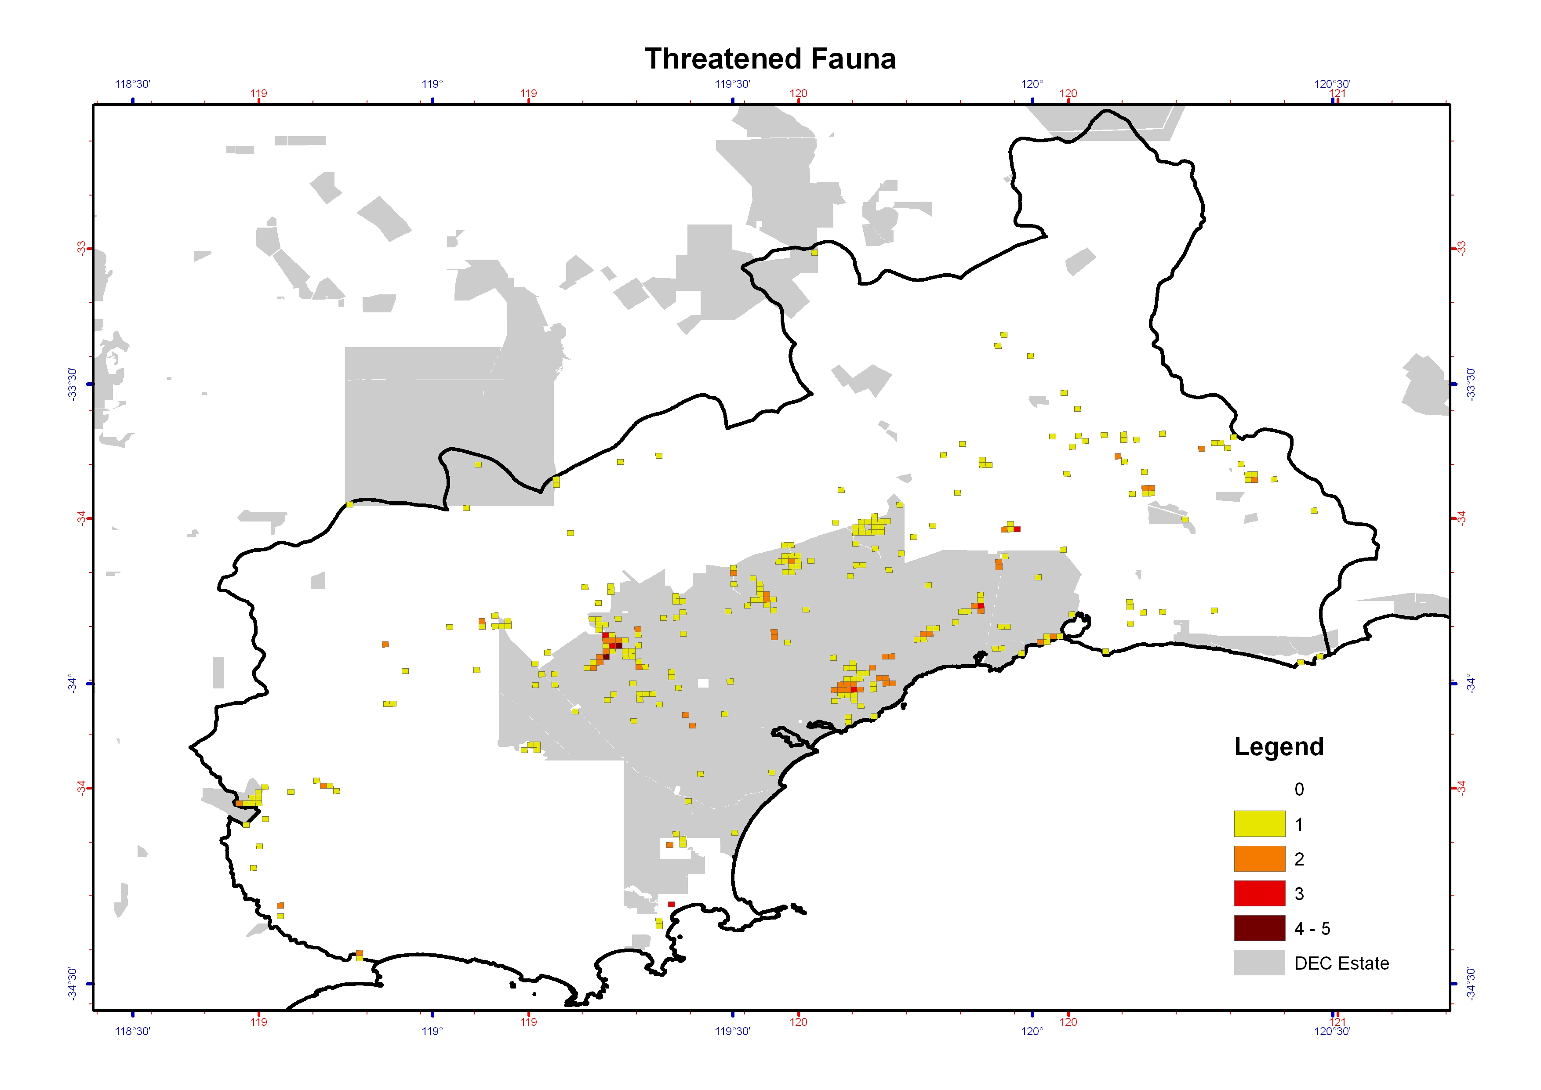
Figure 8: The distribution and density (number of species) of THREATENED FAUNA across the Fitzgerald Biosphere, displayed using a Threatened Species Density Grid (1km grid squares).
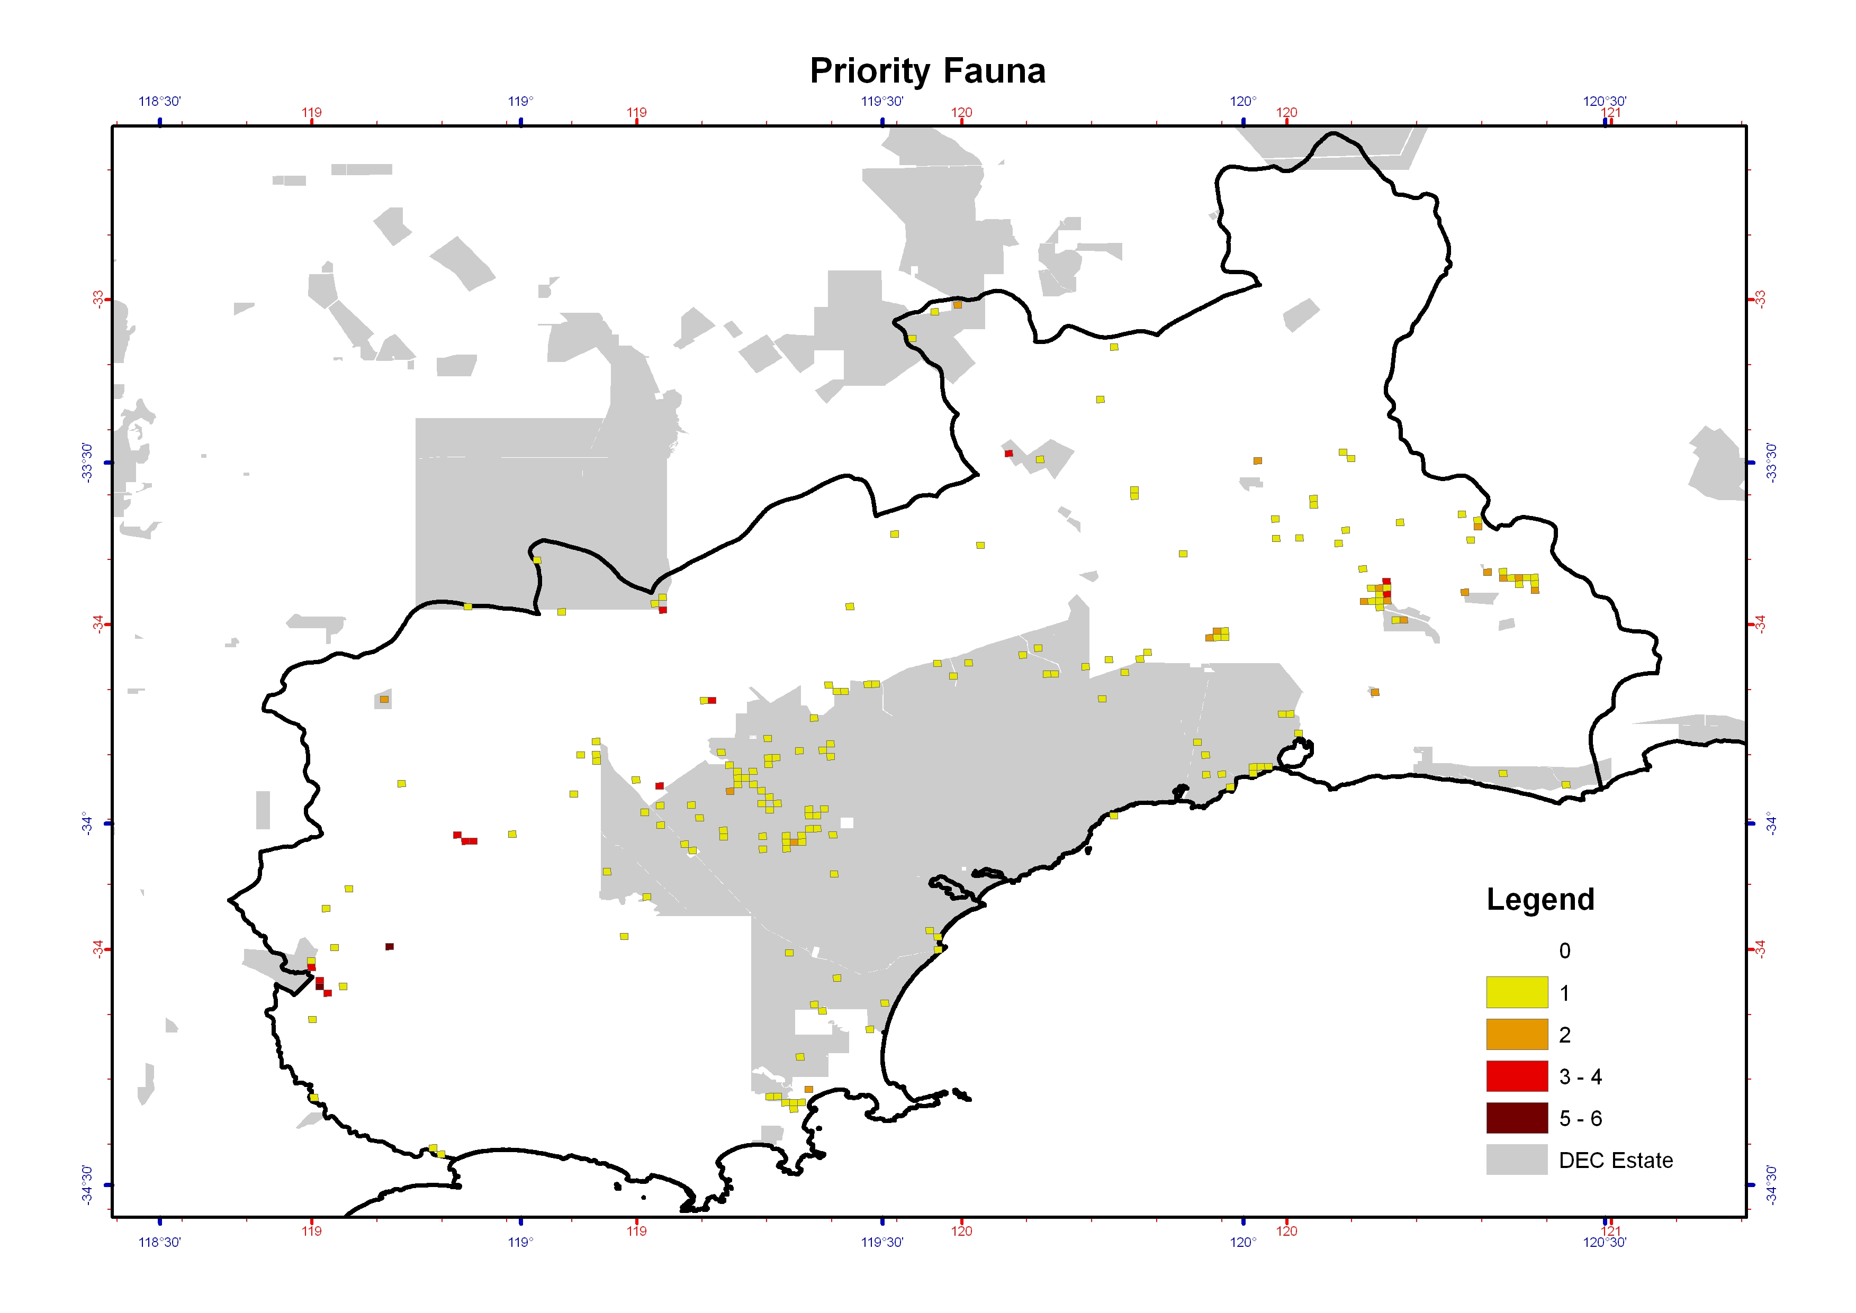
Figure 9: The distribution and density (number of species) of PRIORITY FAUNA across the Fitzgerald Biosphere, displayed using a Threatened Species Density Grid (1km grid squares).
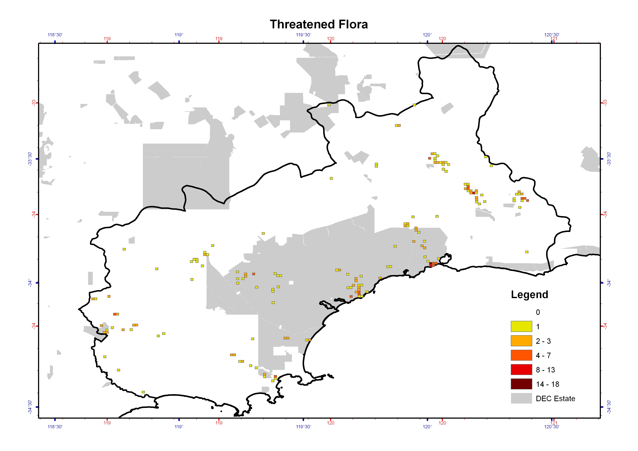
Figure 10: The distribution and density (number of species) of THREATENED FLORA across the Fitzgerald Biosphere, displayed using a Threatened Species Density Grid (1km grid squares).
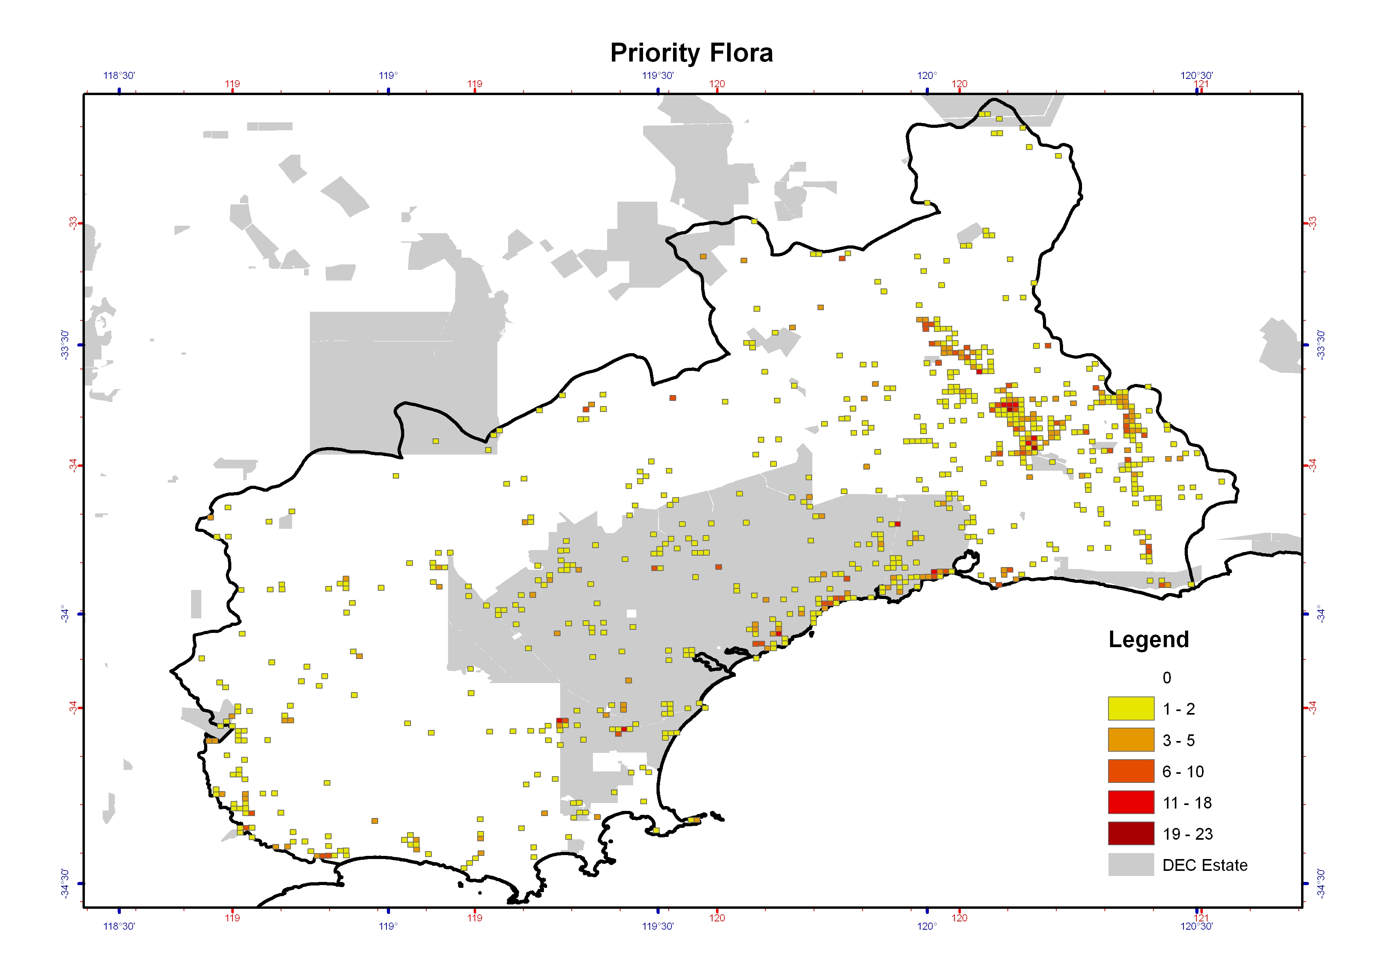
Figure 11: The distribution and density (number of species) of PRIORITY FLORA across the Fitzgerald Biosphere, displayed using a Threatened Species Density Grid (1km grid squares).
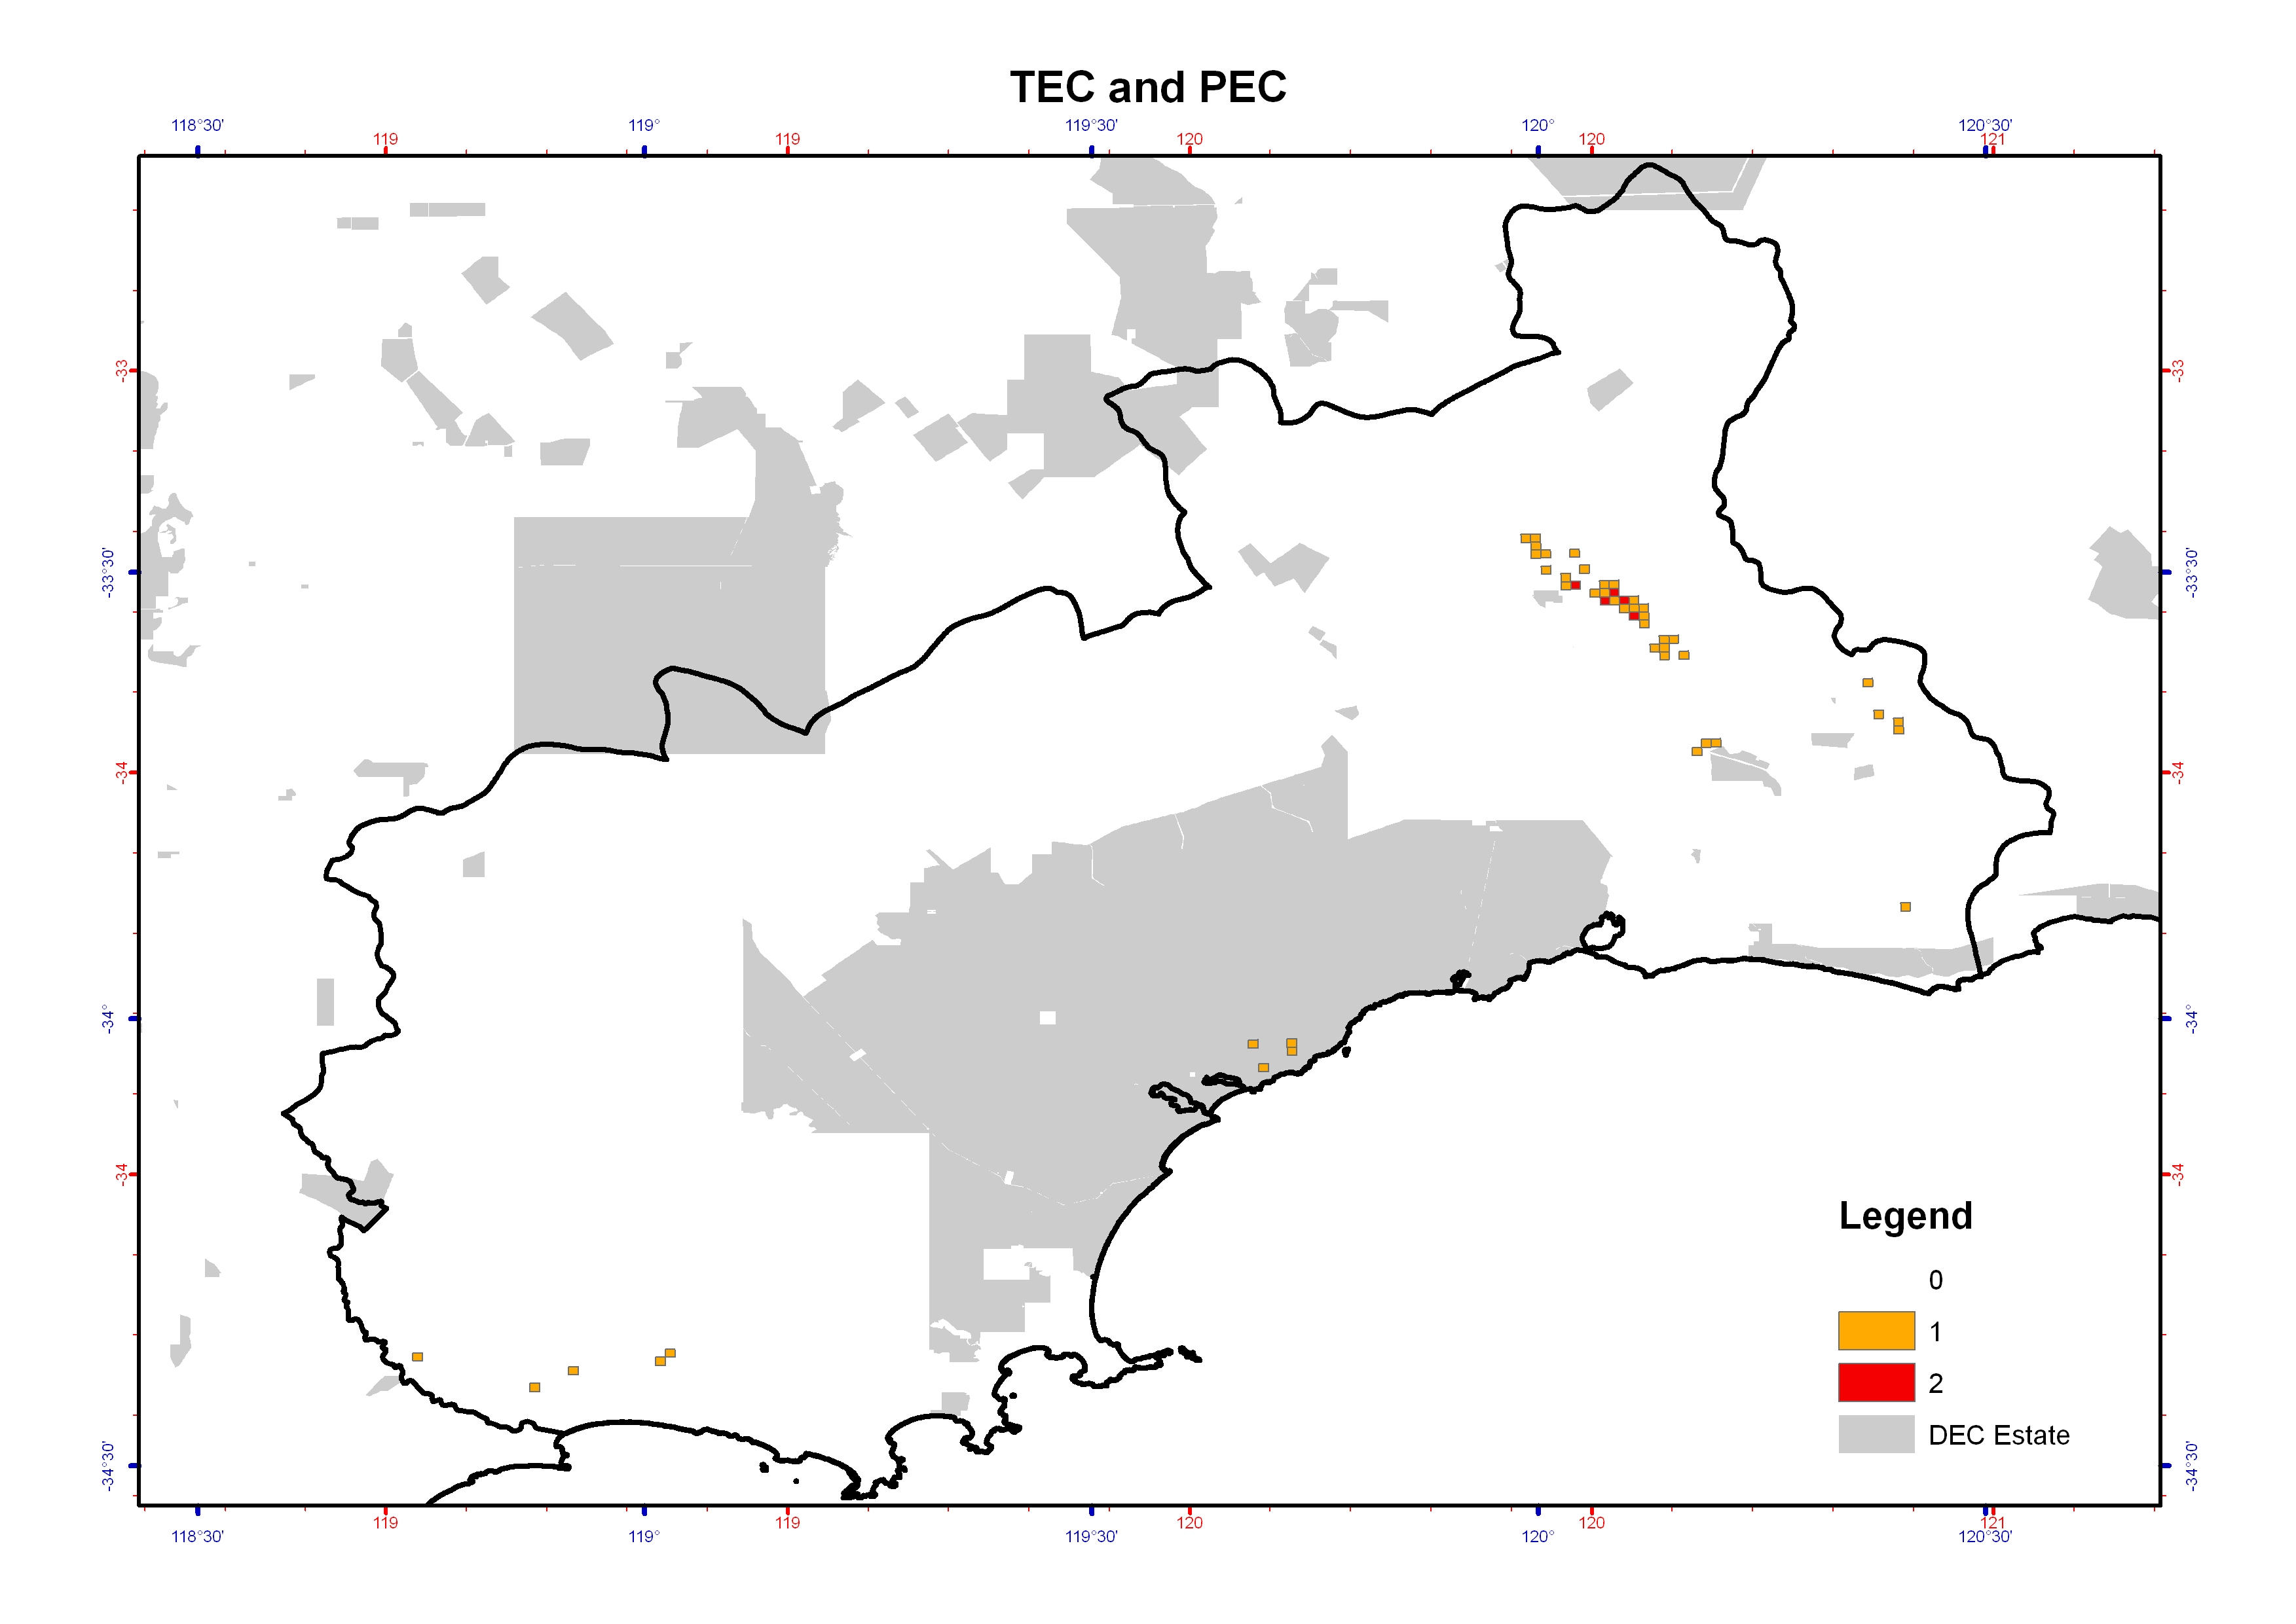
Figure 12: The distribution and density (number of communities) of THREATENED and PRIORITY ECOLOGICAL COMMUNITIES (TEC and PEC) across the Fitzgerald Biosphere, displayed using a Threatened Species Density Grid (1km grid squares). The only TEC in the Biosphere, Eucalyptus acies mallee heath, occurs on Thumb Peak, Mid Mount Barren and Woolburnup Hill (the grids near the coast in central FRNP).

Appendix 6: Miradi Criteria

Analysis and rating of the risk of the threatening processes on the threatened species and ecological communities was completed with the Open Standards of the Practice of Conservation guidelines and using the adaptive management software Miradi (CMP 2009). This analysis and ranking was completed by DEC staff Sandra Gilfillan, Sarah Barrett, Sarah Comer, Tony Friend and Janet Newell, based on best available knowledge and the current understanding of the impacts of individual threatening processes on threatened species and ecological communities.

The ratings are was based on the following three criteria (WWF 2007):
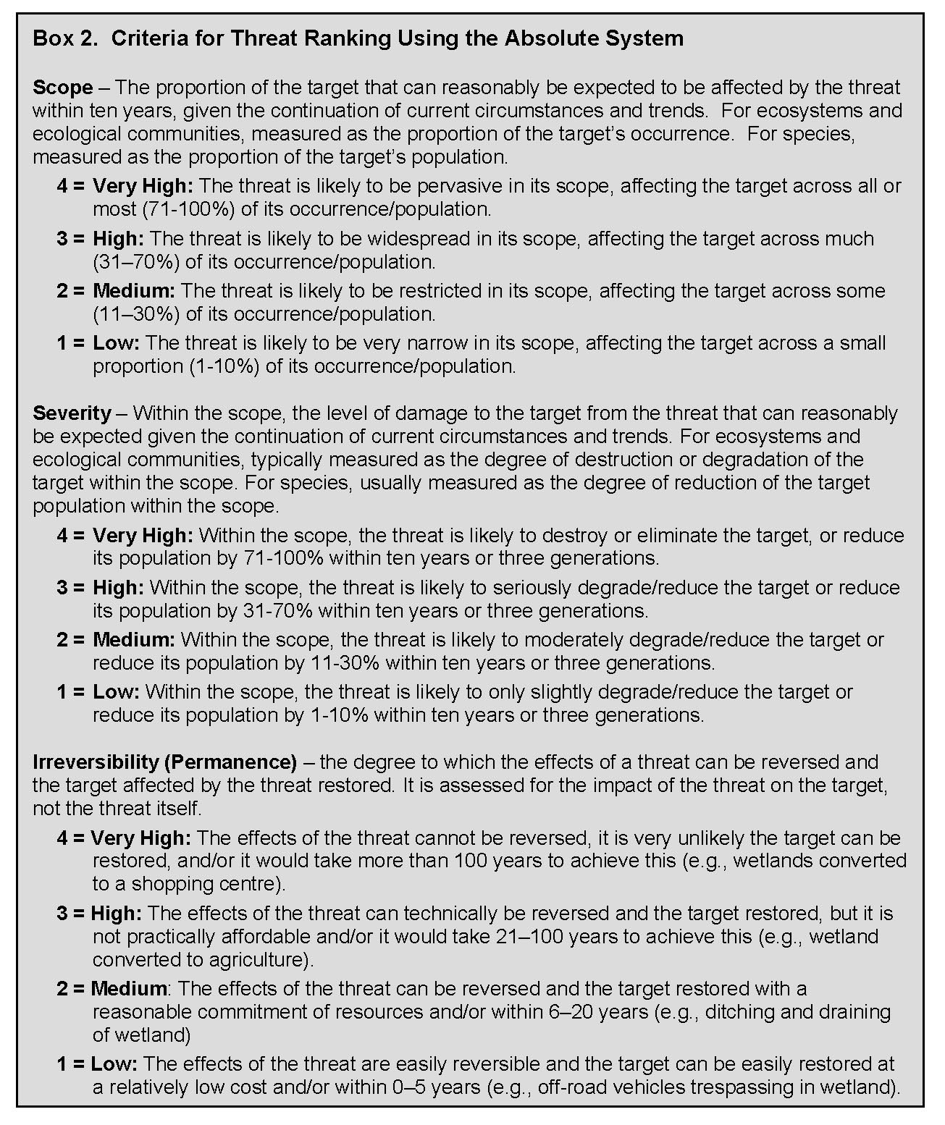

The Miradi software (CMP 2009) calculates the risk ratings using the below rules to first combine the Scope and Severity variables to get a Threat Magnitude, which is then combined with Irreversibility to get the ratings.

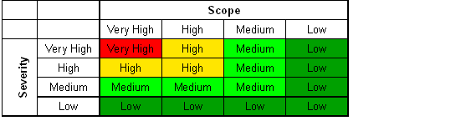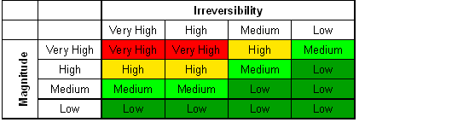

The summary risk ratings are calculated in Miradi by using a combination of rules for rolling up ratings across species/communities and threats.
- 3-5-7 Rule
3 High rated threats are equivalent to 1 Very High-rated threat;
5 Medium rated threats are equivalent to 1 High-rated threat;
7 Low rated threats are equivalent to 1 Medium-rated threat
- 2-Prime Rule
After the 3-5-7 rule has been applied, the 2-prime rule is used to determine the rolled up rating for a target, a threat, or for the whole project. This rule requires the equivalent of two ratings at a certain level for the end result to be that level.
- Majority Override
The Majority Override rule ensures that the overall rating is not reduced too much by the other rules. Normally, the overall rating is a rollup of the threat ratings, using the rules above. However, if a majority of the targets have a rating higher than that computed rollup, then that majority rating is used instead.

Appendix 7: Threatened Species and Ecological Communities Action Summary

This table summarises which recovery actions address the management and recovery of each of the threatened species and ecological communities. Regional actions (e.g. Action 1) that are relevant to all the species and communities are not included in this table.
Threatened Species and Ecological Community | Plan |  | Community |  |  |  | Threat Abatement
Threatened Species and Ecological Community | 3. Recovery plans | 6. Proposed reserves | 9. FRNP Interp. | 10. Ravy Range Interp. | 13. Advice on fire plans | 14. Reporting road kills | 18. FRNP Fire Strategy Plan | 20. P.c. risk assessment | 22. P.c. survey & map | 23-26. Cat & fox baiting | 29, Rabbit control | 30. Feral bee control | 32. Weed control
Carnaby’s Black-Cockatoo |  | x | x | x | x | x | x | x | x |  |  | x | x
Western Bristlebird |  | x | x | x | x | x | x | x | x | x |  |  | x
Chuditch |  | x | x | x | x | x | x | x | x | x | x
Malleefowl |  | x | x | x | x | x | x | x | x | x | x |  | x
Numbat |  | x |  |  | x | x |  |  |  | x |  |  | x
Dibbler |  | x | x | x | x | x | x | x | x | x
Western Ground Parrot |  |  | x |  |  | x | x | x | x | x |  |  | x
Red Tailed Phascogale | x | x | x | x | x | x | x |  |  | x |  |  | x
Heath Mouse | x | x | x | x | x | x | x | x | x | x
Acacia rhamphophylla |  | x |  | x |  |  |  | x | x |  |  | x | x
Adenanthos dobagii | x |  | x |  |  |  | x | x | x |  |  | x
Adenanthos ellipticus | x |  | x |  |  |  | x | x | x |  |  | x
Anigozanthos bicolor subsp. minor |  | x | x |  | x |  | x | x | x |  | x | x | x
Beyeria cockertonii | x | x |  | x |  |  |  | x | x |  |  | x
Boronia clavata | x | x | x |  | x |  | x |  |  |  |  | x | x
Caladenia bryceana subsp. bryceana | x | x |  |  | x |  |  |  |  |  | x | x | x
Conostylis lepidospermoides | x | x |  |  | x |  |  | x | x |  | x | x | x
Coopernookia georgei | x |  | x |  |  |  | x | x | x |  |  | x
Daviesia megacalyx | x | x |  | x |  |  |  | x | x |  |  | x
Daviesia obovata | x |  | x |  |  |  | x | x | x |  |  | x
Eremophila denticulata subsp. denticulata | x | x | x |  | x |  | x |  |  |  | x | x | x
Eremophila subteretifolia |  | x |  |  | x |  |  |  |  |  | x | x
Eucalyptus burdettiana | x |  | x |  |  |  | x | x | x |  |  | x
Eucalyptus coronata | x |  | x |  |  |  | x | x | x |  |  | x
Eucalyptus nutans | x | x |  |  | x |  |  |  |  |  |  | x
Eucalyptus purpurata | x | x |  | x | x |  |  |  |  |  |  | x
Grevillea infundibularis |  |  | x |  |  |  | x | x | x |  |  | x
Hibbertia abyssa | x | x |  | x |  |  |  | x | x |  |  | x | x
Kunzea similis subsp. mediterranea | x | x |  | x |  |  |  | x | x |  |  | x
Kunzea similis subsp. similis | x |  | x |  |  |  | x | x | x |  |  | x
Lepidium aschersonii | x | x |  |  | x |  |  | x | x |  | x | x | x
Marianthus mollis |  | x |  | x |  |  |  | x | x |  |  | x
Myoporum cordifolium | x | x | x |  | x |  | x |  |  |  | x | x
Ricinocarpos trichophorus | x |  | x |  |  |  | x |  |  |  | x | x
Stylidium galioides | x |  | x |  |  |  | x | x | x |  |  | x
Thelymitra psammophila | x | x |  |  | x |  |  |  |  |  | x | x | x
Verticordia crebra | x |  | x |  |  |  | x | x | x |  |  | x
Verticordia helichrysantha | x |  | x |  |  |  | x | x | x |  |  | x
Verticordia pityrhops | x |  | x |  |  |  | x | x | x |  |  | x
Eucalypthus acies mallee-heath | x |  | x |  |  |  | x | x | x |  |  | x

Threatened Species and Ecological Community | Threat Abatement |  |  |  |  |  | Monitoring |  |  | Ex-Situ
Threatened Species and Ecological Community | 33-34. Revegetation | 35. Mining and exploration | 36. DRF markers | 37. Salinisation abatement | 38. Minimise roadside foraging | 42. Stimulate germination | 46. Cat & fox monitoring | 47. Salinisation monitoring | 48. Monitor roadside foraging | 49-50. Current reintroductions | 52. Seed collection | 43. Flora translocations
Carnaby’s Black-Cockatoo | x | x |  | x | x |  |  | x | x
Western Bristlebird | x | x |  |  |  |  | x
Chuditch | x | x |  | x |  |  | x | x
Malleefowl | x | x |  | x | x |  | x | x | x
Numbat | x | x |  | x |  |  | x | x |  | x
Dibbler | x | x |  | x |  |  | x | x |  | x
Western Ground Parrot |  |  |  | x |  |  | x | x
Red Tailed Phascogale | x | x |  | x |  |  | x | x
Heath Mouse | x | x |  | x |  |  | x | x
Acacia rhamphophylla |  | x | x | x |  |  |  | x |  |  | x | x
Adenanthos dobagii |  |  | x |  |  |  |  |  |  |  | x | x
Adenanthos ellipticus |  |  | x |  |  |  |  |  |  |  | x | x
Anigozanthos bicolor subsp. minor | x | x | x | x |  | x |  | x |  |  | x | x
Beyeria cockertonii |  | x | x | x |  |  |  | x |  |  | x | x
Boronia clavata | x | x | x | x |  |  |  | x |  |  | x | x
Caladenia bryceana subsp. bryceana | x | x | x |  |  |  |  |  |  |  | x | x
Conostylis lepidospermoides | x | x | x |  |  |  |  |  |  |  | x | x
Coopernookia georgei |  |  | x |  |  |  |  |  |  |  | x | x
Daviesia megacalyx |  | x | x |  |  |  |  |  |  |  | x | x
Daviesia obovata |  |  | x |  |  |  |  |  |  |  | x | x
Eremophila denticulata subsp. denticulata | x | x | x |  |  |  |  |  |  |  | x | x
Eremophila subteretifolia | x | x | x | x |  | x |  | x |  |  | x | x
Eucalyptus burdettiana |  |  | x |  |  |  |  |  |  |  | x | x
Eucalyptus coronata |  |  | x |  |  |  |  |  |  |  | x | x
Eucalyptus nutans | x | x | x |  |  |  |  |  |  |  | x | x
Eucalyptus purpurata | x | x | x | x |  |  |  | x |  |  | x | x
Grevillea infundibularis |  |  | x |  |  |  |  |  |  |  | x | x
Hibbertia abyssa |  | x | x | x |  |  |  | x |  |  | x | x
Kunzea similis subsp. mediterranea |  | x | x | x |  |  |  | x |  |  | x | x
Kunzea similis subsp. similis |  |  | x |  |  |  |  |  |  |  | x | x
Lepidium aschersonii | x | x | x |  |  |  |  |  |  |  | x | x
Marianthus mollis |  | x | x |  |  |  |  |  |  |  | x | x
Myoporum cordifolium | x | x | x |  |  |  |  |  |  |  | x | x
Ricinocarpos trichophorus |  |  | x |  |  |  |  |  |  |  | x | x
Stylidium galioides |  |  | x |  |  |  |  |  |  |  | x | x
Thelymitra psammophila | x | x | x |  |  |  |  |  |  |  | x | x
Verticordia crebra |  |  | x |  |  |  |  |  |  |  | x | x
Verticordia helichrysantha |  |  | x |  |  |  |  |  |  |  | x | x
Verticordia pityrhops |  |  | x |  |  |  |  |  |  |  | x | x
Eucalypthus acies mallee-heath |  |  | x |  |  |  |  |  |  |  | x | x

Appendix 8: Research

The following areas of research are suggested as priority for the Fitzgerald Biosphere in order to support the conservation of the Biospheres threatened and priority species and ecological communities.
Areas of Research | Research Questions
Fire Ecology  For further details see Barrett et al. (2009) | - Population and seed bank dynamics of key functional plant species.  - Chronosequence (space for time) studies in key systems to investigate the effects of fire regimes on plant community composition and structure.  - The effect of fire regimes on the habitat and populations dynamics of key fauna species such as Western Ground Parrot, Western Bristlebird, Western Whipbird (western mallee), Carnaby’s Black Cockatoo, Dibbler, Western Heath Mouse and Chuditch.  - The effect of fire on fungal diversity and leaf litter ecology.  - Fuel load, flammability and risk of ignition in priority systems in relation to time since fire.  - Investigation into the population dynamics and soil seed bank dynamics of Verticordia pityhrops, V. crebra, V. helichrysantha and Kunzea similis  - Investigation into the population dynamics and canopy seed bank dynamics of Eucalyptus nutans.
Fire Management | - The impacts of firefighting foams and retardants on biodiversity.  - Does firefighting foams (Class A) and fire retardants (Phos-chek G-75) kill Phytophthora sp. in water? Using water from an infected water source during firefighting operations is a potential way Phytophthora is spread. If foams and/or retardants kill Phytophthora, their use could be used to prevent this potential spread.
Phytophthora cinnamomi and other diseases | - Susceptibility of threatened and priority flora species (Adenanthos dobagii, A. ellipticus, Verticordia pityhrops, V. crebra, Grevillea infundibularis, Daviesia obovata (FRNP genotype)) to Phytophthora species and aerial canker.  - Effects of habitat modification as a result from Phytophthora on threatened fauna species such as Western Ground Parrot, Western Bristlebird, Western Whipbird (western mallee), Dibbler and Western Heath Mouse.
Invasive Species | - The nature of interactions between foxes, feral cats, wild dogs and rabbits to effectively integrate the control of all four species.  - The importance of rabbits for maintaining feral cat and fox numbers, and the potential effects of the removal of predators, so that control of these species can be integrated to minimise risks to native species (DEWHA 2008e).  - The interaction between Dibblers and House Mice.  - The impacts of feral bees on threatened flora species.  - Develop control methods for feral bees.
Climate Change | - Install and monitor weather/climate stations at significant sites for threatened species or areas considered at high risk of climate change (e.g. Barrens, Ravensthorpe Range, Western Ground Parrot habitat) as part of a comprehensive network across the South Coast.  - Biological and ecological knowledge of threatened species and ecological communities that will enable greater understanding and management of the impacts of climate change on these species/communities.  - Long term research and monitoring programs that could identify the impacts of climate change.  - investigate water relations, effect of drought on Verticordia pityhrops, Kunzea similis and Adenanthos ellipticus which co-occur at East Mt Barren on shallow sand on quartzite.
Genetics | - Investigate genetic variation in relation to morphological variation / vegetative polymorphism observed.  - Investigate hybridisation (speciation) with Grevillea nudiflora
Floristic Analysis | - Analyse floristic survey data for FRNP to determine rare and threatened ecological communities.

References

Abbott, I. (2008). Historical perspectives of the ecology of some conspicuous vertebrate species in south-west Western Australia. Conservation Science Western Australia, 6(3), 1-214.

Abbott, I. (2009). Aboriginal names of bird species in south-west Western Australia, with suggestions for their adoption into common usage. Conservation Science Western Australia, 7(2), 213-278.

Barrett, S., Comer, S., McQuoid, N., Porter, M., Tiller, C., & Utber, D. (2009). Identification and Conservation of Fire Sensitive Ecosystems and Species of the South Coast Natural Resource Management Region. Department of Environment and Conservation, South Coast Region, Western Australia.

Benshemesh, J. (2000). National Recovery Plan for Malleefowl. Department for Environment and Heritage, South Australia.

Burbidge, A. H., Blyth, J., Danks, A., Gillen, K., & Newbey, B. (1997). Western Ground Parrot Interim Recovery Plan 1996 to 1999, Interim Recovery Plan No. 6. Department of Conservation and Land Management, Perth.

Cale, B. (2002). Carnaby's Black-Cockatoo (Calyptorhynchus latirostris) Recovery Plan 2002-2012, Wildlife Management Program No. 36. Department of Conservation and Land Management, Perth.

CALM (1992). South Coast Region Regional Management Plan 1992-2002, Management Plan No. 24. Department of Conservation and Land Management, Perth.

CALM (2003). Phytophthora cinnamomi and the diseases caused by it, Volume 1 - Management Guidelines. Department of Conservation and Land Management, Perth.

Chapman, A., Newbey, B., Newbey, K., & Moir, M. A. (1995). A biological survey of the Fitzgerald area, Western Australia. Part 9: General conclusions and implications for management. CALMScience Supplement, 3, 113-114.

Chapman, A., & Newbey, K. R. (1995). A biological survey of the Fitzgerald area, Western Australia. Western Australian Journal of Conservation and Land Management, Supplement 3, 1-258.

CMP (2009). Miradi 3.0: Conservation Measures Partnership, http://miradi.org.

Craig, G. F., & Coates, D. J. (2001). Declared Rare and Poorly Known Flora in the Esperance District, Western Australian Wildlife Management Program No. 21. Department of Conservation and Land Management, Perth.

DEC (1995). Fire Management Strategy for the Wilderness Zone of the Fitzgerald River National Park, 1999-2001, Fitzgerald River National Park Management Plan Amendment. Department of Environment and Conservation, Albany.

DEC (2009) NatureMap: Mapping Western Australia's Biodiversity. Department of Environment and Conservation, http://naturemap.dec.wa.gov.au/, Access: July 2009.

DEC (2009). South Coast Regional Fire Management Plan 2009-2014. South Coast Region, Department of Environment and Conservation, Albany.

DEC (draft). Fire Management in the Fitzgerald River National Park - Discussion Paper. Department of Environment and Conservation, Albany.

DEC (in prep.). Hopetoun Beard Orchid (Calochilus pruinosus) Interim Recovery Plan 2010-2015 (Draft). Department of Environment and Conservation, Perth.

Dennings, S. (2009). The Malleefowl Momentum. Wingspan, 19(1).

DEWHA (2008a). Background Document for the Threat Abatement Plan for Competition and Land Degradation by Rabbits. Department of the Environment, Water, Heritage and the Arts, Canberra.

DEWHA (2008b). Background Document for the Threat Abatement Plan for Competition and Land Degradation by Unmanaged Goats. Department of the Environment, Water, Heritage and the Arts, Canberra.

DEWHA (2008c). Background Document for the Threat Abatement Plan for Predation by Feral Cats. Department of the Environment, Water, Heritage and the Arts, Canberra.

DEWHA (2008d). Background Document for the Threat Abatement Plan for Predation by the European Red Fox. Department of the Environment, Water, Heritage and the Arts, Canberra.

DEWHA (2008e). Threat Abatement Plan for Competition and Land Degradation by Rabbits. Department of the Environment, Water, Heritage and the Arts, Canberra.

DEWHA (2008f). Threat Abatement Plan for Competition and Land Degradation by Unmanaged Goats. Department of the Environment, Water, Heritage and the Arts, Canberra.

DEWHA (2008g). Threat Abatement Plan for Predation by Feral Cats. Department of the Environment, Water, Heritage and the Arts, Canberra.

DEWHA (2008h). Threat Abatement Plan for Predation by the European Red Fox. Department of the Environment, Water, Heritage and the Arts, Canberra.

Environment Australia (2001). Threat Abatement Plan for Dieback Caused by the Root-rot Fungus Phytophthora Cinnamomi. Environment Australia, Canberra.

Framenau, V. W., Moir, M. L., & Harvey, M. S. (2008). Terrestrial Invertebrates of the South Coast NRM Region of Western Australia: Short-range Endemics in Gondwanan Relictual Habitats. Western Australian Museum, Perth.

Friend, T. (1994). Recovery Plan for the Numbat (Myrmecobius fasciatus), Wildlife Management Program No. 18. Department of Conservation and Land Management, Albany.

Friend, T. (2004). Dibbler (Parantechinus apicalis) Recovery Plan, Wildlife Management Program No. 38. Department of Conservation and Land Management, Albany.

Furby, S. (1998). Mapping Salinity in the Fitzgerald Biosphere Region. CSIRO Mathematical and Information Sciences, Perth.

Gilfillan, S., Comer, S., Burbidge, A., Blyth, J., Danks, A., & Newell, J. (2009a). South Coast Threatened Birds Recovery Plan. Department of Environment and Conservation, Albany.

Gilfillan, S., Mitchell, P., Newell, J., Danks, A., & Comer, S. (2009b). South Coast Threatened Species and Ecological Communities Strategic Management Plan. Department of Environment and Conservation, Albany.

Gondwana Link (2008). Fitz-Stirling Functional Landscape Plan. Gondwana Link, Albany.

Graham, M., & Mitchell, M. (2000). Declared Rare and Poorly Known Flora in the Katanning District, Western Australian Wildlife Management Program No. 25. Department of Conservation and Land Management, Perth.

Hartley, R., & Barrett, S. (2005). Kundip Wattle (Acacia rhamphophylla) Interim Recovery Plan. Department of Conservation and Land Management, Albany

Hartley, R., & Barrett, S. (2008a). Hairy-fruited Marianthus (Marianthus mollis) Recovery Plan. Department of Environment and Conservation, Albany.

Hartley, R., & Barrett, S. (2008b). Long-sepalled Daviesia (Daviesia megacalyx) Recovery Plan. Department of Environment and Conservation, Albany.

Harvey, M. S., & Leng, M. C. (2008). The Short-range Endemic Invertebrate Fauna of the Ravensthorpe Range. WA Museum, Perth.

Hobbs, D. A., & Yates, C. J. (2003). Turner Review No. 7. Impacts of ecosystem fragmentation on plant populations: generalising the idiosyncratic. Australian Journal of Botany, 51, 471-488.

Holland, E., Brown, A., & Kershaw, K. (1999). Dwarf Spider Orchid (Caladenia bryceana subsp. bryceana ms) Interim Recovery Plan, Interim Recovery Plan No. 39. Department of Conservation and Land Management, Wanneroo, Western Australia.

IOCI (2005). New Suite of Climate Change Simulations. IOCI bulletin 6, Indian Ocean Climate Inititiative, www.ioci.org.au/publications/pdf/IOCI_Bulletin6.pdf, accessed 1 August 2006.

Jenkins, C. F. H. (1980). The National Parks of Western Australia. National Parks Anthority of Western Australia, Crawley, Western Australia.

Luu, R., Rathbone, D., Barrett, S., & Brown, A. (in prep.). Hibbertia abyssa Interim Recovery Plan 2010-2015 (Draft). Department of Environment and Conservation, Perth.

McQuoid, N. (2004). The Natural Patterns and Eco-Zones of the WA South Coast Natural Resource Management Region, Background Paper Nine, Southern Prospects 2004-2009. SCRIPT, Albany.

McQuoid, N. (in prep.). The Natural Patterns of the South Coast Natural Resource Management Region of Western Australia.

Moore, S., Cavana, M., Gillen, K., Hart, C., Hopper, S., Orr, K., & Schmidt, W. (1991). Fitzgerald River National Park Management Plan 1991-2001. Department of Conservation and Land Management, Perth.

Myers, N., Mittermeier, R. A., Mittermeier, C. G., de Fonseca, G. A. B., & Kent, J. (2000). Biodiversity hotpots for conservation priorities. Nature, 403, 853-858.

Newbey, K. R., & Chapman, A. (1995). A biological survey of the Fitzgerald area, Western Australia. Part 1: Introduction. CALMScience Supplement, 3, 3-8.

Nichols, O. G. (1998). Impacts of dieback-induced vegetation changes on native faunal communities in south-western Australia, Control of Phytophthora cinnamomi and Diplodina Canker in Western Australia: Final Report to the Threatened Species and Communities Unit, Biodiversity Group, Environment Australia. Department of Conservation and Land Management, Como, Western Australia.

Orell, P., & Morris, K. (1994). Chuditch Recovery Plan, Wildlife Management Program No. 13. Western Australian Department of Conservation and Land Management, Perth.

Paton, D. C. (1996). Overview of Feral and Managed Honeybees in Australia: Distribution, Abundance, Extent of Interactions with Native Biotia, Evidence of Impacts and Future Research. The University of Adelaide for Australian Nature Conservation Agency, Canberra.

Patten, J., Butler, R., Stack, G., & Brown, A. (2006). Small Two-coloured Kangaroo Paw (Anigozanthos bicolor subsp. minor) Interim Recovery Plan, Interim Recovery Plan No. 223. Department of Conservation and Land Management, Kensington.

Pavey, C. (2006). National Recovery Plan for the Great Bilby Macrotis lagotis. Northern Territory Department of Natural Resources, Environment and the Arts.

Phillimore, R., Stack, G., & Brown, A. (2002). Lake King Eremophila (Eremophila subteretifolia ms) Interim Recovery Plan, Interim Recovery Plan No. 112. Department of Conservation and Land Management, Wanneroo, Western Australia.

RAP (1997). South Coast Regional Land and Water Care Strategy: the Fitzgerald-Biosphere Sub-region. South Coast Regional Assessment Panel (RAP) and South Coast Regional Initiative Planning Team (SCRIPT), Albany.

Robinson, C. J. (1997). Integrated Vegetation Management Plan for Fitzgerald Biosphere Reserve Zone of Cooperation. Report to Environment Australia and Western Australian Department of Conservation and Land Management, Albany.

Robinson, C. J., & Coates, D. J. (1995). Declared Rare and Poorly Known Flora in the Albany District, Western Australian Wildlife Management Program No. 20. Department of Conservation and Land Management, Perth.

Sanders, A. (1996). Conservation Value of Fitzgerald Biosphere Reserve Buffer/Transition Zone Phases I-IV. Department of Conservation and Land Management, Albany.

Sanders, A. (1997). Fitzgerald River National Park. Landscope, 13(1), 28-35.

Sanders, A. (2008). Living with the Land: Guidelines for the Fitz-Stirling. Compiled by A. Sanders for Greening Australia WA and Bush Heritage Australia.

Saunders, G., & McLeod, L. (2007). Improving fox management strategies in Australia. Bureau of Rural Sciences, Canberra.

SCRIPT (2005). Southern Prospects 2004-2009: South Coast Regional Strategy for NRM. South Coast Regional Initiative Planning Team, Albany.

Short, J. (1995). Interim Recovery Plan for the Western Barred Bandicoot (Perameles bougainville. CSIRO Division of Wildlife & Ecology, Perth.

Short, J., & Parsons, B. (2008). Malleefowl Conservation - Informed and Integrated Community Action. Report to WWF Australia and Avon Catchment Council by Wildlife Research and Management Pty Ltd.

South Coast NRM (2009). Managing External Dieback Threats to the Fitzgerald River National Park. Prepared by Steady State Consulting (Viv Read) for South Coast NRM Inc.

South Coast NRM Inc (2009a). Climate Change: Whole of Landscape Analysis of the Impacts and Options for the South Coast Region. Prepared by Coffey Environments for South Coast NRM, Albany.

South Coast NRM Inc (2009b). Managing External Dieback Threats to the Fitzgerald River National Park. Prepared by Steady State Consulting (Viv Read) for South Coast NRM Inc.

Start, T., Burbidge, A., & Armstrong, D. (1995). Woylie Recovery Plan, Wildlife Management Program No. 16. Department of Conservation and Land Management, Como, Western Australia.

Syme, K. (2008). Fungi Survey of the South Coast Natural Resource Management Region 2006-7. Department of Environment and Conservation, Albany.

UNESCO's MAB (2001). Special Meeting on Biosphere Reserve Integrated Monitoring (BRIM), United Nations Educational Scientific and Cultural Organisation's Man and Biosphere Programme, www.fao.org/gtos/doc/brim1.pdf, accessed 1 July 2009.

Watson, J., & Sanders, A. (1997). Fitzgerald River National Park Biosphere Reserve 1978-1997: the evolution of integrated protected area management. Parks, 7(1), 9-19.

Watson, J., & Wilkins, P. (1999). The Western Australian South Coast Macro Corridor Project - a bioregional strategy for nature conservation. Parks, 9(3), 7-16.

Wilkins, P., Gilfillan, S., Watson, J., & Sanders, A. (2006). The Western Australian South Coast Macro Corridor Network - a Bioregional Strategy for Nature Conservation. Department of Conservation and Land Management, and South Coast Regional Initiative Planning Team, Albany, Western Australia.

Wilson, B. A., Newell, G., Laidlaw, W. S., & Friend, G. (1994). Impact of plant diseases on faunal communities. Journal of the Royal Society of Western Australia, 77, 139-143.

WWF (2007). Resources for Implementing the WWF Project & Programme Standards: Step 1.4 Define: Threat Ranking, WWF, http://wwf.panda.org/what_we_do/how_we_work/programme_standards/#define, accessed 1 March 2010.

