FITZGERALD BIOSPHERE RECOVERY PLAN
A landscape approach to threatened species and ecological communities for recovery and biodiversity conservation

APPENDIX 2: Species Profiles

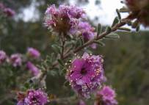
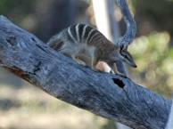

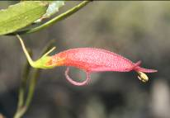

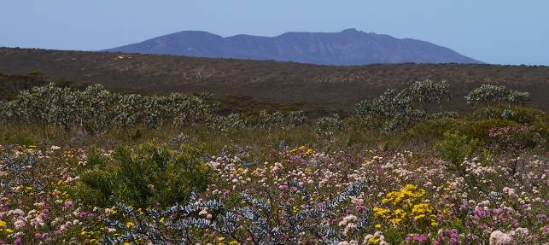

South Coast Region
Department of Environment and Conservation



Cover photos: top left – Kunzea similis subsp. mediterranea (Stephen Kern)
top middle – Numbat (Stephanie Hill)
top right – Eremophila denticulata subsp. denticulata (Sarah Barrett)
bottom – Fitzgerald River National Park (Sarah Comer)

Department of Environment and Conservation
South Coast Region
120 Albany Highway
Albany WA 6330.

FORWARD

This Appendix 2: Species Profiles is the supporting document for the Fitzgerald Biosphere Recovery Plan. This Plan constitutes the formal national regional recovery plan for the threatened species and ecological communities of the Fitzgerald Biosphere on the south coast of Western Australia under the Commonwealth’s Environment Protection and Biodiversity Conservation Act 1999 (EPBC Act).

The Fitzgerald Biosphere is a designated Biosphere Reserve under the UNESCO Man and the Biosphere (MAB) program, recognised for its relatively pristine state and high biological diversity, especially flora. It is approximately 1.3 million hectares including the Fitzgerald River National Park and surrounding catchments. The Biosphere includes 41 threatened species/communities listed by the State, 33 of which are also listed by the Commonwealth.

These Species Profiles provide information on the biology, ecology, habitat requirements, distribution and threatening processes for each of the 41 threatened species and ecological communities of the Fitzgerald Biosphere.

Information contained in the species profiles on distribution, habitat critical to survival, habitat, important populations and threats is based on current knowledge of habitat occupied or used, and only relevant to the Biosphere, and may not be comprehensive for the entire range of the species.

The information in these Species Profiles is accurate at March 2011.

ACKNOWLEDGEMENTS

These threatened species profiles were prepared by Saul Cowen for DEC South Coast Region.

The following people assisted in the preparation of these profiles:
Sarah Barrett DEC Threatened Flora Officer, South Coast Region
Sarah Comer DEC Regional Ecologist, South Coast Region
Sandra Gilfillan Ecologist
Janet Newell DEC Recovery Planner, South Coast Region
Deon Utber DEC Regional Leader Nature Conservation, South Coast Region

Thanks also to those who contributed knowledge and advice in the preparation of individual species profiles.

Grateful thanks is extended to all those who contributed photographs. All photographs are copyright and may not be reproduced by a Third Party without prior permission of the photographer or DEC (where appropriate).

CONTENTS

Fauna
- Carnaby’s Black-Cockatoo ▪ Calyptorhynchus latirostris 1
- Western Bristlebird ▪ Dasyornis longirostris 3
- Chuditch ▪ Dasyurus geoffroii 5
- Malleefowl ▪ Leipoa ocellata 7
- Numbat ▪ Myrmecobius fasciatus 9
- Dibbler ▪ Parantechinus apicalis 11
- Western Ground-Parrot ▪ Pezoporus wallicus flaviventris 13
- Red-tailed Phascogale ▪ Phascogale calura 15
- Heath Mouse ▪ Pseudomys shortridgei 17
Flora
- Acacia rhamphophylla 19
- Adenanthos dobagii 21
- Adenanthos ellipticus 23
- Anigozanthos bicolor (subsp. minor) 24
- Beyeria cockertonii 26
- Boronia clavata 27
- Caladenia bryceana (subsp. bryceana) 28
- Calochilus pruinosus 30
- Conostylis lepidospermoides 31
- Coopernookia georgei 32
- Daviesia megacalyx 33
- Daviesia obovata 34
- Eremophila denticulata (subsp. denticulata) 35
- Eremophila subteretifolia 36
- Eucalyptus burdettiana 37
- Eucalyptus coronata 39
- Eucalyptus nutans 40
- Eucalyptus purpurata 41
- Grevillea infundibularis 42
- Hibbertia abyssa 43
- Kunzea similis (subsp. mediterranea) 45
- Kunzea similis (subsp. similis) 46
- Lepidium aschersonii 47
- Marianthus mollis 48
- Myoporum cordifolium 50
- Ricinocarpos trichophorus 52
- Stylidium galioides 53
- Thelymitra psammophila 54
- Verticordia crebra 55
- Verticordia helichrysantha 56
- Verticordia pityrhops 60
Communities
- Eucalyptus acies mallee-heath 61

ABBREVIATIONS

DEC ▪ Western Australia Department of Environment and Conservation
FRNP ▪ Fitzgerald River National Park
IUCN ▪ International Union for the Conservation of Nature and Natural Resources
Mt ▪ Mount
NP ▪ National Park
NR ▪ Nature Reserve
NSW ▪ New South Wales
NT ▪ Northern Territory
SA ▪ South Australia
spp. ▪ multiple species belong to single genus
subsp. ▪ subspecies
TR ▪ Timber Reserve
UCL ▪ Unallocated Crown Land
VIC ▪ Victoria
WA ▪ Western Australia

Carnaby’s Black-Cockatoo ▪ Calyptorhynchus latirostris (Psittacidae)
(White-tailed or Short-billed Black-Cockatoo, Ngolak, Ngoolya)

Conservation Status
IUCN Red List 2010: Endangered
- Environment Protection & Biodiversity Conservation Act 1999: Endangered
- Western Australian Wildlife Conservation Act 1950: Endangered
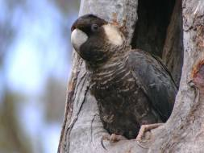
Photo: © Raana Scott
Description
A large black cockatoo (53-58cm), with a white cheek patch and white interior to tail feathers. Males distinguishable by a black (rather than grey) bill and red (not grey) eye-ring. Heavy bill structure differs slightly from the very similar Baudin’s Black-Cockatoo (C. baudinii) in that the upper mandible is shorter. Being gregarious, these birds form large flocks outside the breeding season.

Distribution and Habitat
Occurs patchily throughout much of the south-west land division, from the Murchison River in the north-west to the Esperance region in the south-east. Moves to higher-rainfall coastal areas outside breeding season.
Mainly occurs in uncleared or remnant eucalypt woodland or heath.

Important Populations
Carnaby’s Cockatoo exists as a single population. Several important nesting

sites known within the Fitzgerald Biosphere, and large flocks of cockatoos
are regularly seen feeding throughout the Biosphere.

Habitat Critical
- Breeding, feeding and watering sites used during the breeding period; and
- Woodland and Mallee heath, and other areas where the cockatoos feed in the non-breeding period; and
- Areas currently used for nocturnal roosts in the non-breeding period; and
- Woodland sites known to have supported past breeding activities which could also be used in the future once food resources are re-established.

Biology and Ecology
Generalist seed-eaters, feeding on a wide range of both native and introduced flora. Usually arboreal but will occasionally feed on the ground. Will also feed on the nectar of native Proteaceae, as well as extracting insect larvae from the fruits and flowers of Banksia species.
Socially monogamous, pairs retain strong pair bonds for the duration of their reproductive lives (>4-5 yrs for females). Requires suitably-sized hollows (25 to 250+cm deep) for breeding.

Threats
Loss of breeding and feeding habitat including suitable nest-hollow trees; Fragmentation of habitat through clearing and degradation of habitat from the effects of Phytophthora dieback, salinisation, intense bushfires and mining activities; Competition for nesting hollows with other hollow-nesting birds and feral Honey Bees (Apis mellifera); Illegal harvesting of nestlings for the cage-bird trade; Illegal shooting; Climate change; Stochastic events (e.g. disease, climate events); Vehicle collision.

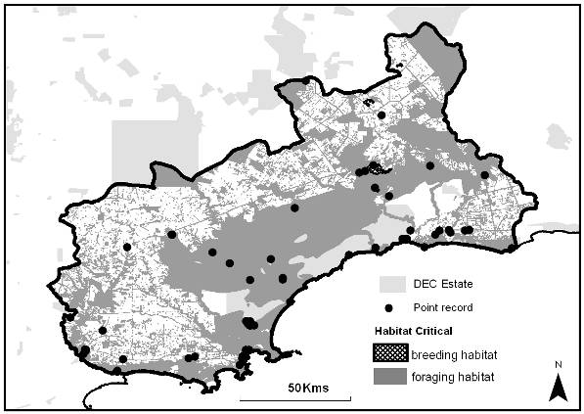

References
BirdLife International (2009) Species factsheet: Calyptorhynchus latirostris. http://www.birdlife.org - Accessed 16/2/2010
Cale, B. (2003) Carnaby’s Black-Cockatoo (Calyptorhynchus latirostris) Recovery Plan 2002-2012. Department of Conservation and Land Management, Perth, Western Australia.
DEWHA (2010) Calyptorhynchus latirostris in Species Profile and Threats Database, Department of the Environment, Water, Heritage and the Arts, Canberra. http://www.environment.gov.au/sprat - Accessed 23/2/2010

Western Bristlebird ▪ Dasyornis longirostris (Dasyornidae)
(Booderitj)

Conservation Status
- IUCN Red List 2010: Vulnerable
- Environment Protection & Biodiversity Conservation Act 1999: Vulnerable
- Western Australian Wildlife Conservation Act 1950: Vulnerable
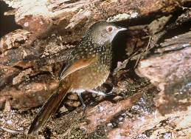
Photo: © Ray Smith
Description
Medium-sized (c.17cm) ground-dwelling bird with short wings and long, graduated tail. Colouration is generally rufous-brown with fine dark-brown scalloping. The underparts brownish-grey. An elusive species and often difficult to observe.

Distribution and Habitat
Endemic to south-west WA and occurs in two disjunct areas: from Two Peoples’ Bay NR to Cheynes Beach and in the FRNP as far east as East Mt Barren. Not recorded between these populations, which are themselves fragmented.
Favours diverse areas of closed coastal heathland, usually with abundant sedges and low sparse eucalypt thickets. May reoccupy burnt areas 2-3 yrs post-fire but in drier areas it may take 11-14 yrs.

Important Populations
The FRNP is one of the two secure populations of this species.

Habitat Critical to Survival
- That area of current occupancy of known populations; and
- Nearby similar habitat nearby used as dispersal corridors; and
- Potential habitat into which the species could disperse or be translocated.

Biology and Ecology
Ground-foraging species with diet consisting mainly of seeds and invertebrates. Weak flier and generally terrestrial but will occasionally make short flights.
Song is distinctive and antiphonal, i.e. ‘male’ call is answered by ‘female’ call. Little is known of breeding biology but pairs appear to hold territories together.

Threats
Fragmentation of habitat through clearing of native vegetation; Degradation of habitat from the effects of Phytophthora dieback, hard-hoofed introduced animals, intense and high frequency bushfires and weed invasion; Predation by feral cats and foxes; Stochastic events; Small population size (genetic issues) exacerbated by fragmented and isolated populations, Climate Change.

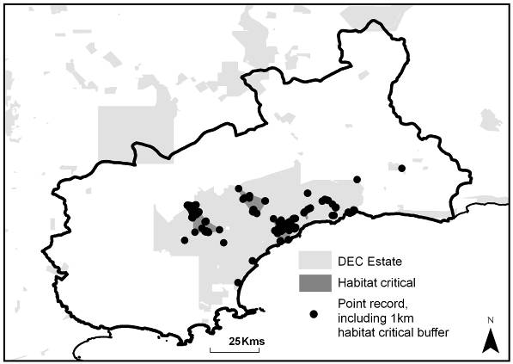

References
BirdLife International (2009) Species factsheet: Dasyornis longirostris. Downloaded from http://www.birdlife.org - 23/2/2010
DEWHA (2010) Dasyornis longirostris in Species Profile and Threats Database, Department of the Environment, Water, Heritage and the Arts, Canberra. http://www.environment.gov.au/sprat - Accessed 23/2/2010
Gilfillan, S., Comer, S., Burbidge, A., Blyth, J., Danks, A. & Newell, J. (2009) South Coast Threatened Birds Recovery Plan 2009-2018. Department of Environment and Conservation, Albany, Western Australia.

Chuditch ▪ Dasyurus geoffroii (Dasyuridae)
(Western Quoll, Djooditj, Ngooldjangit)

Conservation Status
- IUCN Red List 2010: Near Threatened
- Environment Protection & Biodiversity Conservation Act 1999: Vulnerable
- Western Australian Wildlife Conservation Act 1950: Vulnerable
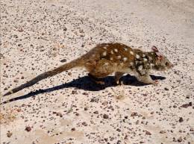
Photo: © Cameron Tiller (DEC)
Description
One of Australia’s largest mainland carnivorous marsupial, with mature adults reaching the size of a small domestic cat and weighing up to 1.3kg. Pelage is reddish-brown with white spots, and the long tail graduates to black at distal end.

Distribution and Habitat
Formerly occupied up to 70% of Australian mainland but since mid-20th century has been confined to south-western WA. The species has been translocated to various sites between Cape Arid and Kalbarri NPs and ranges widely so exact distribution is difficult to assess. However, appears to occurs patchily throughout the south-west land division using a wide range of habitats from sclerophyll woodlands to beaches and deserts. Riparian systems may support higher than normal densities.

Important Populations
An important population of the species occurs in the Ravensthorpe Range through to the northern marine plain of the FRNP.

Habitat Critical to Survival
Has historically been present in a wide variety of habitats and is not possible to list specific habitat characteristics that should be conserved. However, some key aspects for survival in an area include:
- Adequate den resources (hollow logs, burrows or rock crevices); and
- Adequate prey resources (particularly large invertebrates); and
- sizeable areas (>20,000ha) to accommodate large home ranges.

Biology and Ecology
Opportunistic omnivore and consumes large invertebrates as well as small birds, mammals and reptiles. Plant material (e.g. Zamia (Macrozamia riedlei) seed pulp) occasionally eaten and may also scavenge from humans. Mainly terrestrial and nocturnal but will occasionally climb trees and forage diurnally.
Males and females reach sexual maturity in first year and rarely live longer than four years. Both sexes are promiscuous. Young spent first 2 months in pouch, after which they reside in a den.

Threats
Loss and fragmentation of habitat; Degradation of habitat including loss of den sites (e.g. hollow logs); Inappropriate fire regime (e.g. high frequency); Competition with and predation by feral cats, foxes, and dingoes; Conflict with humans (e.g. trapping, illegal shooting, poisoning); Vehicle collisions.

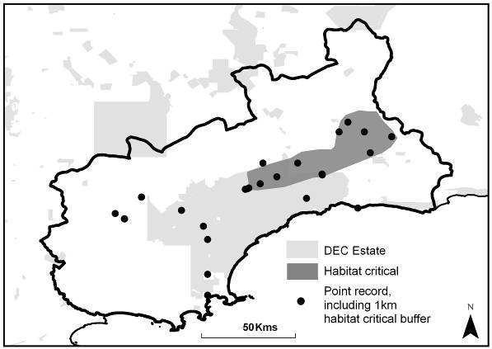

References
DEWHA (2010) Dasyurus geoffroii in Species Profile and Threats Database, Department of the Environment, Water, Heritage and the Arts, Canberra. http://www.environment.gov.au/sprat.- Accessed 23/2/2010
Morris, K., Burbidge, A. & Hamilton, S. (2008) Dasyurus geoffroii. IUCN 2009. IUCN Red List of Threatened Species. Version 2009.2. http://www.iucnredlist.org - Accessed 23/2/2010.
Orell, P. & Morris, K. (1994) Chuditch Recovery Plan (1992-2001). Department of Conservation and Land Management, Perth, Western Australia.

Malleefowl ▪ Leipoa ocellata (Megapodiidae)
(Ngow, Ngowo)

Conservation Status
- IUCN Red List 2010: Vulnerable
- Environment Protection & Biodiversity Conservation Act 1999: Vulnerable
- Western Australian Wildlife Conservation Act 1950: Vulnerable
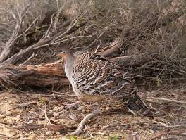
Photo: © Alan Danks
Description
A large, ground-dwelling bird up to 60cm long and 2.5kg in weight. Adult birds have grey necks with black medial stripe and upperparts are chestnut brown with mottled brown, black and white ocellations on the wings.

Distribution and Habitat
In Australia, occurs in a wide distribution (approximately 900,000km²) from the Great Dividing Range in the east to Shark Bay in the west. In WA, occurs south-west of a line from Carnarvon to Eyre Bird Observatory, often patchily especially in remnant bush in the Wheatbelt. It is absent from far south-west.

Important Populations
There is no information to specify that any population is more under threat than any other, nor are there any locations where the species can be confidently regarded as secure. However, it is regularly seen throughout the FNRP.

Habitat Critical to Survival
Habitat requirements are poorly understood, but a sandy substrate and abundant leaf litter are clear requirements for the construction of nests. In WA, the Malleefowl occurs mainly in arid mallee and shrubland habitats on sandy soils.

Biology and Ecology
Generalist foragers and will consume invertebrates, a variety of plant material (especially seeds) as well as fungi but may also use artificial sources of food (e.g. spilt grain. Usually forage around dawn and dusk.
A mound-nester, it builds mounds 4-5m in diameter and 1m high. Pairs may raise 8-10 chicks per year. Sexually mature at 4-5 yrs and the average lifespan may be c.15 yrs.

Threats
Loss, fragmentation and degradation of habitat from land clearing, environmental weeds and effects of altered hydrology; Predation by cats and foxes; Vehicle collision while foraging for spilt grain along roadsides; Inappropriate fire regimes (e.g. large-scale or high frequency fire events); Small population sizes (genetic issues) exacerbated by fragmented and isolated populations; Competition from grazing herbivores; Climate change.

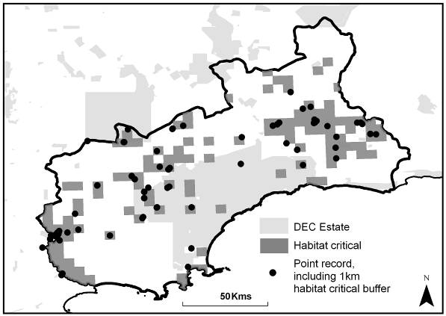

References
Benshemesh, J. (2007). National Recovery Plan for Malleefowl. Department for Environment and Heritage, South Australia.
BirdLife International (2009) Species factsheet: Leipoa ocellata. Downloaded from http://www.birdlife.org on 23/2/2010
DEWHA (2010) Leipoa ocellata in Species Profile and Threats Database, Department of the Environment, Water, Heritage and the Arts, Canberra. http://www.environment.gov.au/sprat.- Accessed 23/2/2010
Short, J. & Parson, J. (2008) Malleefowl Conservation – informed and integrated community action. A final report to WWF Australia and Avon Catchment Council.

Numbat ▪ Myrmecobius fasciatus (Myrmecobiidae)
(Noombat, Wioo)

Conservation Status
- IUCN Red List 2010: Endangered
- Environment Protection & Biodiversity Conservation Act (1999): Vulnerable
- Western Australian Wildlife Conservation Act (1950): Vulnerable
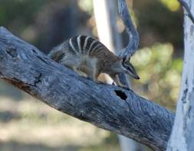
Photo: © Stephanie Hill (DEC)
Description
A small marsupial, with distinctive white transverse stripes on the lower back and rump over the reddish-brown pelage. Has large brush-like tail and single black and white lateral stripe on either side of the head between the eye and lower jaw. Mature adult body length is around 200-250mm, with the tail adding 150-180mm.

Distribution and Habitat
Formerly widespread across semi-arid and arid southern Australia from western NSW and southern NT to the south-west of WA.
Just two natural populations remain, at Dryandra Woodland (near Narrogin) and Perup NR (near Manjimup). Translocated populations now exist in a number of reserves throughout the south-west, including Cocanarup TR in the Fitzgerald Biosphere.
Historically, habitat preferences were varied but currently the species is restricted to eucalypt woodland areas, e.g. Salmon Gum (Eucalyptus salmonophloia) in Cocanarup TR.

Important Populations
The translocated population in Cocanarup TR in the Fitzgerald Biosphere.

Habitat Critical to Survival
- The area of occupancy of the translocated population; and
- Similar habitat that currently does not contain the species but may be suitable for translocations.

Biology and Ecology
Feeds almost exclusively on termites (Isoptera), extracted by digging to intercept galleries (rather than nests) and using its extremely long tongue, coated with adhesive saliva. Unusually for a small marsupial, it is a diurnal species. Solitary and territorial, females raise young in burrows until mature enough to forage further afield. May live up to 5 yrs, reaching sexual maturity in the first year for females and second yr for males.

Threats
Predation by cats, foxes and native avian predators; Inappropriate fire regimes (frequency and intensity); Loss of woodland habitat, Stochastic events, Climate change.

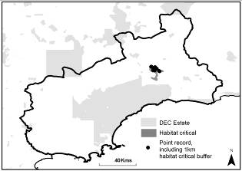

References
DEWHA (2010) Myrmecobius fasciatus in Species Profile and Threats Database, Department of the Environment, Water, Heritage and the Arts, Canberra. http://www.environment.gov.au/sprat - Accessed 1/4/2010
Friend, J.A. (1989) Fauna of Australia Volume 1B (Mammalia) Chapter 22 Myrmecobiidae, Published by AGPS, Canberra, Australia.
Friend, J.A. (1994) Recovery Plan for the Numbat (Myrmecobius fasciatus) 1995-2004, Department Conservation and Land Management, Albany, Western Australia.
Friend, T. & Burbidge, A. (2008) Myrmecobius fasciatus. IUCN 2010. IUCN Red List of Threatened Species. Version 2010.1. http://www.iucnredlist.org - Accessed 1/4/2010
McKenzie, N.L., May, J.E. & McKenna, S. (Eds) (2002) Bioregional Summary of the 2002 Biodiversity Audit for Western Australia. Department of Conservation and Land Management, Perth, Western Australia.

Dibbler ▪ Parantechinus apicalis (Dasyuridae)
(Southern Dibbler, Dibla)

Conservation Status
- IUCN Red List 2010: Endangered
- Environment Protection & Biodiversity Conservation Act (1999): Endangered
- Western Australian Wildlife Conservation Act (1950): Endangered
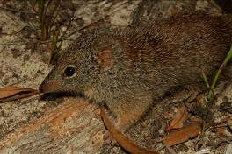
Photo: © Tim Button (DEC)
Description
A small marsupial (<14cm length) with grizzled grey-brown pelage above and grey-white below, as well as distinctive white orbital ring and unusually tapering hairy tail. Males about 25% heavier than females and may weigh up to 100g.

Distribution and Habitat
Historically occurred throughout south-west WA and in the Eyre Peninsula, SA and was thought to be extinct until 1967. Presently it occurs naturally in the FRNP and on Boullanger and Whitlock Islands off Jurien Bay. Translocated populations are found on Escape Island, at Peniup NR near Jerramungup and Stirling Range NP.
Likely to exploit a wide range of habitats over its range but in Fitzgerald Biosphere its occurrence is associated with long-unburnt heathland, particularly with sandy or lateritic substrates, with a dense canopy >1m high.

Important Populations
Approximately 90% of the total population of Dibblers occur in the FRNP. This population is especially important as it is only remaining naturally occurring mainland population.

Habitat Critical to Survival
- The area of occupancy of the known populations; and
- Similar habitat that currently does not contain the species but may be suitable for translocations.

Biology and Ecology
A carnivorous marsupial, it feeds primarily on invertebrates as well as small reptiles, birds and mammals. Will also consume vegetable matter and has been recorded on flowering Banksia species.
Mainly crepuscular and during inactive periods rests either above or below ground. Females may live for up to 4 yrs and male life expectancy varies from 1 to 3+ yrs depending on the incidence of ‘facultative male die-off’ which may be experienced in some populations. Sexually mature at 10-11 months and produce one litter per year in spring.

Threats
Predation by feral cats and foxes; Inappropriate fire regimes (e.g. high frequency and intensity fires); Loss of habitat; Degradation of habitat (loss of structural diversity) from the effects of Phytophthora dieback; Competition with the house mouse, Climate change.

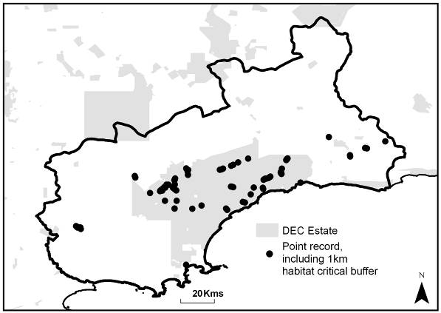

References
DEWHA (2010) Parantechinus apicalis in Species Profile and Threats Database, Department of the Environment, Water, Heritage and the Arts, Canberra. http://www.environment.gov.au/sprat.- Accessed 1/4/2010
Friend, J.A. (2003) Dibbler Recovery Plan July 2003-2013, Department of Conservation and Land Management, Albany, Western Australia.
Friend, T., Burbidge, A. & Morris, K. 2008. Parantechinus apicalis. IUCN 2010. IUCN Red List of Threatened Species. Version 2010.1. http://www.iucnredlist.org - Accessed 1/4/2010

Western Ground Parrot ▪ Pezoporus wallicus flaviventris (Psittacidae)
(Kyloring)

Conservation Status
- IUCN Red List 2010: Not Listed*
- Environment Protection & Biodiversity Conservation Act (1999): Endangered
- Western Australian Wildlife Conservation Act (1950): Critically Endangered
* IUCN assessment of conservation status pending review of this taxon’s specific status.
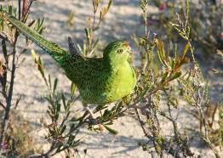
Photo: © Brent Barrett (DEC)
Description
A medium-small parrot with bright green plumage and long strongly graduated tail. Extensive barring on head, wings, tail and belly. Mature adults have a crimson frond. Recent taxonomic work has shown that this subspecies is sufficiently distinct from Eastern Ground Parrot (P. w. wallicus) and to be recognised as a distinct species (Murphy et al. 2010). Main distinguishing feature from P. w. wallicus is yellow hue to belly. Rarely seen except when flushed has distinctive zigzag flight on stiff wing-beats.

Distribution and Habitat
Formerly widespread in coastal heathland throughout south-west WA from Israelite Bay to near Dongara. Now confined to FRNP and Cape Arid NP (and adjacent areas of Nuytsland NR). Waychinicup NP population not recorded since 2003 and presumed extinct.
Requires long-unburnt (5-40+ yrs) near-coastal heathland with high floristic diversity. Vegetation is usually low (<1m high) with abundant sedges (>40% cover). May use more recently burnt habitat if long-unburnt habitat exists nearby.

Important Populations
Only two populations of this species are known to be extant. The FRNP populaton is the smaller of the two, having declined dramatically in recent years. This population is considered to be important.

Habitat Critical to Survival
- The current area of occupancy; and
- Any possible other areas used as dispersal corridors; and
- Potential habitat into which the species could disperse or be translocated.

Biology and Ecology
Generalist herbivore, consuming seeds, fruits and flowers of a range of native flora species and foraging on ground or on low shrubs. Diurnal but peak calling and flight activity before dawn and after dusk. Vocalisations distinctive series of high-pitched whistles, often combined with other discrete call types. Generally solitary but forms pairs during breeding season (July to December).

Threats
Predation by feral cats and foxes; Inappropriate fire regimes (e.g. intense and high frequency fires); Degradation of habitat from the effects of Phytophthora dieback, hard-hoofed introduced animals and weed invasion; Fragmentation of habitat through clearing of native vegetation; Altered hydrology; Stochastic events; Small population size (genetic issues) exacerbated by fragmented and isolated populations, Climate change.

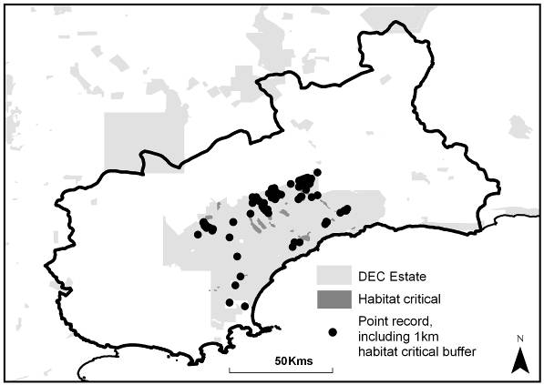

References
Burbidge, A.H., Blyth, J., Danks, A., Gillen, K., Newbey, B. (1997) Western Ground Parrot Interim Recovery Plan 1996-1999. Department of Conservation and Land Management, Perth, Western Australia.
Gilfillan, S., Comer, S., Burbidge, A., Blyth, J., Danks, A. & Newell, J. (2009) South Coast Threatened Birds Recovery Plan 2009-2018. Department of Environment and Conservation, Albany, Western Australia.
Murphy, S.A., Joseph, L., Burbidge, A.H. & Austin, J. (Unpublished) A Cryptic And Critically Endangered Species Revealed By Mitochondrial DNA Analyses – The Western Ground Parrot.
Red-tailed Phascogale ▪ Phascogale calura (Dasyuridae)
(Wambenger, Kingo)

Conservation Status
- IUCN Red List 2010: Near Threatened
- Environment Protection & Biodiversity Conservation Act (1999): Endangered
- Western Australian Wildlife Conservation Act (1950): Endangered
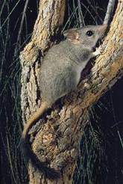
Photo: © Babs & Bert Wells (DEC)
Description
A small, arboreal marsupial, ash-grey above and cream-white below. Male body length can be up to 12.2cm, with females reaching 10.5cm in body length. The distinctive tail is reddish on its proximal half, and black and brush-like on the distal half and may reach a length of 14.5cm.

Distribution and Habitat
Formerly widespread across much of arid and semi-arid Australia from western NSW to central NT and south-west WA. Now restricted to isolated reserves and remnant bushland in the WA wheatbelt from Ravensthorpe to Beverley.
In the Fitzgerald Biosphere, it prefers Allocasuarina woodland but is also found in Moort (E. platypus) woodland. It is most abundant in areas unburnt for 20+ yrs. Tree hollows are used as refuge from fire.

Important Populations
Little is known about the populations of this species in Fitzgerald Biosphere so all known and extant populations are considered important.

Habitat Critical to Survival
- The area of occupancy of the known populations; and
- Any possible other areas used as dispersal corridors; and
- Potential habitat (Allocasuarina woodland and Moort (E. platypus) woodland) into which the species could disperse or be translocated.

Biology and Ecology
Opportunistic carnivores and will consume a range of invertebrates, small birds and mammals. They are nocturnal and despite their arboreal habits, will often forage on the ground.
Breeding occurs from July to October and young reach sexual maturity by May to June of following year. As with some other small dasyurids, males exhibit seasonal die-offs after the mating period and females may live up to 3 yrs. Its population dynamics are believed to be strongly correlated to rainfall within the previous 12 months, i.e. high numbers are associated with high rainfall.

Threats
Predation from feral cats and foxes; Inappropriate fire regimes (high frequency and intensity fires); Loss, degradation and fragmentation of habitat associated with land clearing; Climate change effects particularly those associated with reduction in rainfall; Vehicle collision.

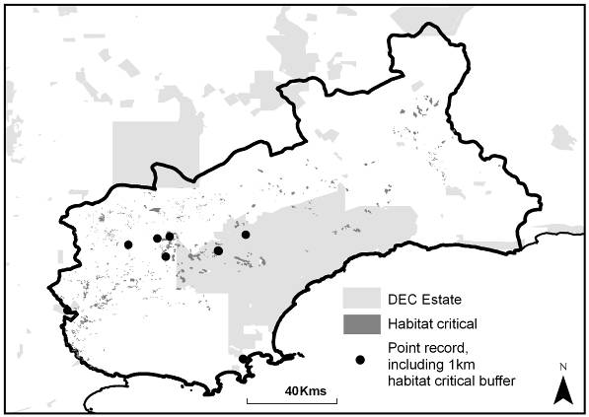

References
DEWHA (2010) Phascogale calura in Species Profile and Threats Database, Department of the Environment, Water, Heritage and the Arts, Canberra. http://www.environment.gov.au/sprat - Accessed 6/4/2010
Friend, T. (2008) Phascogale calura. IUCN 2010. IUCN Red List of Threatened Species. Version 2010.1. http://www.iucnredlist.org - Accessed 6/4/2010
Heath Mouse ▪ Pseudomys shortridgei (Muridae)
(Heath Rat, Dayang)

Conservation Status
- IUCN Red List 2010: Near Threatened
- Environment Protection & Biodiversity Conservation Act (1999): Vulnerable
- Western Australian Wildlife Conservation Act (1950): Vulnerable
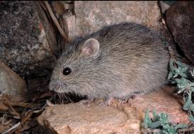
Photo: © Greg Harold
Description
A small grey-brown rodent, superficially similar to more common and widespread Rattus spp., but distinguished by scales on tail which do not occur in ring formation. Its pelage is flecked with buff and black above and paler below. Tail is bicoloured (dark on top, pale below).

Distribution and Habitat
Formerly distributed in coastal heathland and mallee on the west and south coasts of WA as well as south-west VIC and south-east SA (including Kangaroo Island). The Heath Mouse was previously thought extinct in WA but was rediscovered in 1987. Currently known in WA from populations at Ravensthorpe Range, Lake Magenta NR, Dragon Rocks NR and the FRNP along with a few sites in mainland SA and VIC.
In WA, inhabits long unburnt (30+ yrs) mallee scrub and ‘mixed’ scrub (e.g. Banksia spp.) on loamy soils.

Important Populations
Little is known about the populations of this species in Fitzgerald Biosphere so all are considered important.

Habitat Critical to Survival
- The area of occupancy of the known populations; and
- Similar habitat within 1km of all species distribution records that provides a potential habitat buffer for the species.

Biology and Ecology
Based on studies of the species in VIC, is mainly herbivorous and will feed on diverse vegetable matter (flowers, seeds, fruits etc) with a preference for leaves and stems of monocotyledonous plants. May also feed on subterranean fungi (truffles).
Breeding occurs in late spring/summer and up to two litters of usually three young are produced. Females are sexually mature at 10-12 months.

Threats
Loss and fragmentation of habitat; Inappropriate fire regimes (e.g. regime that does not create mosaics of differing fire ages); Predation by feral cats, foxes and native avian predators.

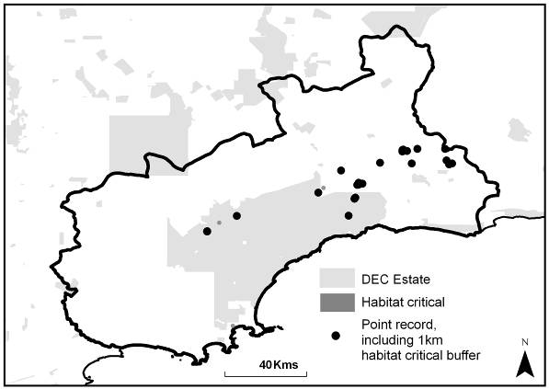

References
Cockburn A., (1995) Heath Rat Pseudomys shortridgei. The Mammals of Australia, edited by R. Strahan, pp617-618. Reed New Holland, Sydney, Australia.
DEWHA (2010) Pseudomys shortridgei in Species Profile and Threats Database, Department of the Environment, Water, Heritage and the Arts, Canberra. http://www.environment.gov.au/sprat - Accessed 6/4/2010
Menkhorst, P. & Morris, K. (2008) Pseudomys shortridgei. IUCN 2010. IUCN Red List of Threatened Species. Version 2010.1. http://www.iucnredlist.org - Accessed 6/4/2010

Acacia rhamphophylla (Fabaceae)
(Kundip Wattle)

Conservation Status
- Environment Protection & Biodiversity Conservation Act (1999): Endangered
- Western Australian Wildlife Conservation Act (1950): Critically Endangered
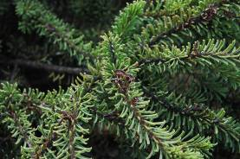
Photo: © Anne Cochrane (DEC)
Description
A low spreading shrub, 200-400cm high with globular yellow flowers (2.5-3mm) and dense greyish-green phyllodes (11-17mm long) which are prominently grooved with round ends but have short points below the tips. Stems appear black due to short hairs and recurved bristly stipules. Seed pods are 10-15mm and are hard, thin, brittle and blackish in colouration.

Distribution and Habitat
Discovered in Ravensthorpe Range in 1992, the single population occupies approximately 5ha comprising c.1,500 mature plants.
Occurs in open shrub mallee vegetation on stony slopes in well-drained sandy clay. Associated geology is on or near points of contact between serpentine and banded iron formation. Most common in disturbed areas but will occur in more mature vegetation types.

Important Populations
Ravensthorpe Range population is the single known population of the species and is therefore considered important for the long-term recovery and survival of the species.

Habitat Critical to Survival
- The area of occupancy of the known population; and
- Similar habitat within 200m of the known population that provides potential habitat for recruitment; and
- Remnant vegetation that may link future populations; and
- Nearby occurrences of similar habitat that currently does not contain the species but may be suitable for translocations.

Biology and Ecology
Flowers prolifically August to September. Juvenile period unknown. Regenerates well after disturbance and fire and is thought to be capable of producing large numbers of viable seed. Significant deaths of mature individuals may be linked to senescence, suggesting a need for germination stimulants (e.g. fire). Resistance to Phytophthora cinnamomi is unknown although the majority of Acacia spp. is resistant.

Threats
Impacts from mining activities (e.g. loss of habitat, soil compaction, dust, introduction of weeds or pathogens, potential for introduction of poisonous chemicals); Inappropriate fire regimes; Small population size; Stochastic events; Climate change.

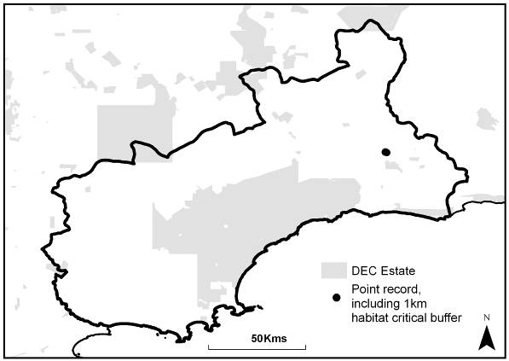

References
Hartley, R. & Barrett, S. (2005) Kundip Wattle (Acacia rhamphophylla) Interim Recovery Plan 2005-2010. Department of Conservation and Land Management, Albany, Western Australia.
Adenanthos dobagii (Proteaceae)
(Fitzgerald Woollybush or Jugflower)

Conservation Status
- Environment Protection & Biodiversity Conservation Act (1999): Endangered
- Western Australian Wildlife Conservation Act (1950): Vulnerable
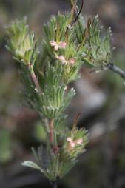
Photo: © Sarah Barrett (DEC)
Description
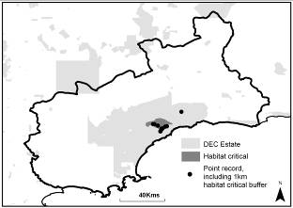
A diffuse shrub, up to 50cm high. Leaves are silvery, have three segments and are concentrated at ends of branchlets. Branches are covered in flattened hairs. Flowers small (11mm long) and cream or pale pink in groups of three. Similar to Adenanthos flavidiflorus which also occurs in the FRNP.

Distribution and Habitat
Endemic to the FRNP and restricted to seven populations in the south-central region of the park, numbering c.125,000 individual plants. The estimated area of occupancy is c.21.9km².
All populations appear to be stable in the absence of bushfire. Good regeneration observed following bushfire in 1998 and 2008.
Occurs in low-lying areas of sandy soils among low shrubby open heath or open mallee vegetation.

Important Populations
All known and extant populations as the species has a restricted range (endemic to the FRNP).

Habitat Critical to Survival
- The area of occupancy of the known populations; and
- Similar habitat within 1km of all species distribution records that provides a potential habitat buffer for the species.

Biology and Ecology
Flowers Aug-Nov. Lacks lignotuber; is killed by fire and regenerates from seed. Thought to be susceptible to Phytophthora cinnamomi. Juvenile period is 4 yrs.

Threats
Inappropriate fire regimes (frequent and extensive fire); Degradation of habitat from track maintenance; Phytophthora dieback, Climate change.

References
Barrett, S., Comer, S., McQuoid, N., Porter, M., Tiller, C. & Utber, D. (2009) Identification and Conservation of Fire Sensitive Ecosystems and Species of the South Coast Natural Resource Management Region. Department of Environment and Conservation, South Coast Region, Western Australia.
DEWHA (2010). Adenanthos dobagii in Species Profile and Threats Database, Department of the Environment, Water, Heritage and the Arts, Canberra. http://www.environment.gov.au/sprat - Accessed 7/4/2010
Robinson, C.J. & Coates, D.J. (1995) Declared Rare and Poorly Known Flora in the Albany District, Wildlife Management Program No 20. Department of Conservation and Land Management, Perth, Western Australia.
Threatened Species Scientific Committee (2008). Commonwealth Conservation Advice on Adenanthos dobagii (Fitzgerald Woollybush). Department of the Environment, Water, Heritage and the Arts. http://www.environment.gov.au/biodiversity/threatened/species/pubs/21253-conservation-advice.pdf - Accessed 7/4/2010
Adenanthos ellipticus (Proteaceae)
(Oval-leaved Adenanthos)

Conservation Status
- Environment Protection & Biodiversity Conservation Act (1999): Vulnerable
- Western Australian Wildlife Conservation Act (1950): Vulnerable
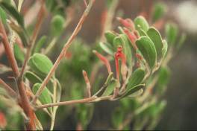
Photo: © Sarah Barrett (DEC)
Description
An erect, tall and open shrub that grows to 5m. Leaves 2-5cm long, 5-15mm wide, some with lobular tips. Flowers solitary, 2-5cm long, cream to orange-red in colour and held on 8mm stalks in leaf axils.

Distribution and Habitat
Endemic to the FRNP, with three known populations in the vicinity of East and West Mts Barren and Thumb Peak. Occurs over approximately 89km² although the area of occupancy is probably <0.31km² with c.40,000 mature flowering plants.
Favours shallow, siliceous humus-rich soils over quartzite outcrops and dense shrubland.

Important Populations
All known populations as the species has a restricted range (endemic to the FRNP).

Habitat Critical to Survival
- The area of occupancy of the known populations; and
- Similar habitat within 1km of all species distribution records that provides a potential habitat buffer for the species.

Biology and Ecology
Flowers August to January and April to May (possibly all year round). Lacks lignotuber, is killed by fire but regenerates from soil-stored seed. Juvenile period is ±4 yrs. May hybridise with A. cuneatus. Presumed susceptible to Phytophthora cinnamomi.

Threats
Inappropriate fire regimes (high frequency and/or intensity fires); Phytophthora dieback; degradation of habitat from road maintenance, Climate change.

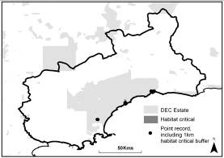

References
Barrett, S., Comer, S., McQuoid, N., Porter, M., Tiller, C. & Utber, D. (2009) Identification and Conservation of Fire Sensitive Ecosystems and Species of the South Coast Natural Resource Management Region. Department of Environment and Conservation, South Coast Region, Western Australia.
DEWHA (2010) Adenanthos ellipticus in Species Profile and Threats Database, Department of the Environment, Water, Heritage and the Arts, Canberra. http://www.environment.gov.au/sprat - Accessed 7/4/2010
Robinson, C.J. & Coates, D.J. (1995) Declared Rare and Poorly Known Flora in the Albany District, Wildlife Management Program No 20. Department of Conservation and Land Management, Perth, Western Australia.
Threatened Species Scientific Committee (2008). Commonwealth Conservation Advice on Adenanthos ellipticus (Oval-leaf Adenanthos). Department of the Environment, Water, Heritage and the Arts. http://www.environment.gov.au/
biodiversity/threatened/species/pubs/4570-conservation-advice.pdf - Accessed 7/4/2010.
Anigozanthos bicolor (subspecies minor) (Haemodoraceae)
(Small Two-coloured Kangaroo Paw)

Conservation Status
- Environment Protection & Biodiversity Conservation Act (1999): Endangered
- Western Australian Wildlife Conservation Act (1950): Vulnerable
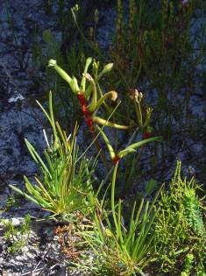
Photo: © Mike Fitzgerald (DEC)
Description
Small rhizomatous perennial herb. Leaves flattened and 5-10cm long. Flowers hairy and held on 5-20cm high scapes, with green perianth, 30-45mm long and strongly constricted in middle, with red ovary. Usually has several scapes with solitary flowers. Four subspecies of A. bicolor recognised and A. b. minor can be distinguished by its strong perianth constriction and relatively short leaves.

Distribution and Habitat
Known from 14 populations on the south coast of WA between FRNP, Lake King and Condingup Peak (290km range). Nine of these populations within the Fitzgerald Biosphere. Many locations are unconfirmed or have not been resighted since initial discovery. Distribution is disjunct from other subspecies of A. bicolor.
Favours moist sandy soils in heathland communities but also occurs in shallow soils over granite outcrops.

Important Populations
All known populations of this species.

Habitat Critical to Survival
- The area of occupancy of the known populations; and
- Similar habitat within 1km of distribution records that provides potential habitat buffer for the species; and
- The local catchment area where the species occurs; and
- Additional areas of similar habitat that may contain the species or suitable for translocations.

Biology and Ecology
Flowers from August to October. Flowers once in the first year and then disappears, making difficult to survey. Fire is presumed the primary germination stimulus but other stimuli may include washouts caused from heavy rain and runoff.
Hermaphroditic flowers, observed to be pollinated by honeyeaters. Juvenile period from 1-2 yrs. Presumed not susceptible to Phytophthora cinnamomi but is susceptible to other fungal pathogens e.g. Alternaria alternata.

Threats
Lack of disturbance to stimulate germination (e.g. fire); Loss of habitat (e.g. clearance for farmland); Inappropriate fire regimes; Modification of habitat by Rabbits; Grazing by stock and other herbivores; Salinisation and altered hydrology; Environmental weeds.

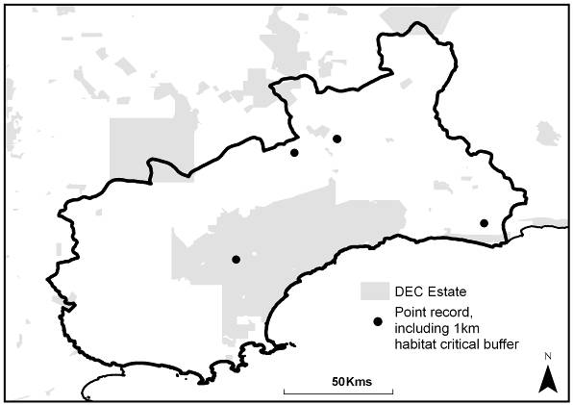

References
Barrett, S., Comer, S., McQuoid, N., Porter, M., Tiller, C. & Utber, D. (2009) Identification and Conservation of Fire Sensitive Ecosystems and Species of the South Coast Natural Resource Management Region. Department of Environment and Conservation, South Coast Region, Western Australia.
Patten, J., Butler, R., Stack, G. & Brown, A. (2008) Small Two-coloured Kangaroo Paw (Anigozanthos bicolor subsp. minor) Recovery Plan 2006-2011. Interim Recovery Plan No. 223. Department of Conservation and Land Management, Kensington, Western Australia
Western Australian Herbarium (1998) Florabase - The Western Australia Flora, Anigozanthos bicolor subsp. minor (Benth.) Hopper. http://florabase.calm.wa.gov.au/browse/profile/12102 - Accessed on 7/4/2010
Beyeria cockertonii (Euphorbiaceae)

Conservation Status
- Environment Protection & Biodiversity Conservation Act (1999): Not Listed
- Western Australian Wildlife Conservation Act (1950): Vulnerable
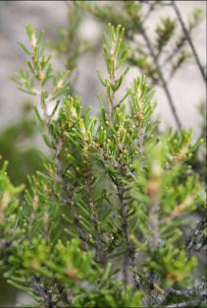
Photo: © Sarah Barrett (DEC)
Description
A small under-shrub to 25cm high with upright stems. New growth yellow and resinous with short glandular hairs, older growth with grey tessellated bark. Leaves 6-7mm long and held upright with recurved margins. Flowers yellow, solitary and 1-2mm in diameter. Fruit dark-green and glabrous with three lobes.

Distribution and Habitat
Restricted to two populations south-west of Bandalup Hill near Ravensthorpe. Area of occupancy of these populations is estimated at 17.2ha within mining tenement. Overall population estimated at 318,000 plants.
Grows in mallee-heath in smectite clay over komatiite geology on rocky slopes and hilltops.

Important Populations
All known populations are considered important as the species has a restricted range (endemic to Bandalup Hill).

Habitat Critical to Survival
- The area of occupancy of the known populations; and
- Similar habitat within 1km of distribution records that provides potential habitat buffer for the species.

Biology and Ecology
Killed by fire and regenerates from soil-stored seed. Stands are typically uneven-aged suggesting some inter-fire recruitment occurs.

Threats
Loss and degradation of habitat from mining activities and salinisation, Stochastic events, Climate change.

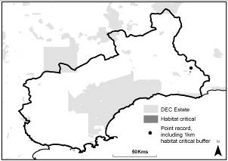

References
Cockerton, G. & Evelegh, N. (2005) Habitats, Vegetation and Flora of the Ravensthorpe Nickel Operation Tenements for BHP Biliton Ltd, Perth, Western Australia.
DEC (2009a) Priority Ecological Communities for Western Australia. Species and Communities Branch, Department of Environment and Conservation, Perth, Western Australia.
DEC (2009b) SAP 1. Beyeria sp. Bandalup Hill (G. Cockerton 7553) Department of Environment and Conservation, Perth, Western Australia. (Unpublished)
Boronia clavata (Rutaceae)
(Bremer Boronia)

Conservation Status
- Environment Protection & Biodiversity Conservation Act (1999): Endangered
- Western Australian Wildlife Conservation Act (1950): Endangered
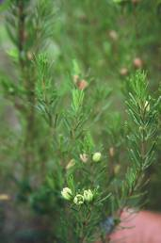
Photo: © Sarah Barrett (DEC)
Description
An upright, slender shrub, 0.5-1.5m (up to 2.1m) high. Leaves 10-20mm long on short stem and flowers yellow-green.

Distribution and Habitat
Endemic to the Bremer Bay area of the south coast of WA. Known from five populations all within 18km of each other in a continuous area of uncleared vegetation, with all but one population on UCL or within FRNP. Extent of occurrence is approximately 76km² and area of occupancy unknown but predicted to be <5km². Total of 97 mature plants known to exist.
Favours alluvial sand and loam on floodplains and is associated with shrubby thickets. It is largely confined to alluvial flats on Bremer River between spongolite cliffs, where populations remain healthy.

Important Populations
All known populations as the species has a small known population size.

Habitat Critical to Survival
- The area of occupancy of the known populations; and
- The alluvial flats of Bremer River as is potential habitat for the species.

Biology and Ecology
Flowers August to October. Germination may be stimulated by flooding, when scarification (removal of hard coating) of the seed takes place. Susceptibility to salinity unknown. Floral structure suggests it is an insect-pollinated species. Presumed not to be susceptible to Phytophthora cinnamomi.

Threats
Habitat loss and fragmentation; Salinity or altered hydrology; Competition with environmental weeds; Climate change.

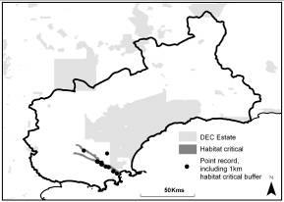

References
DEWHA (2010). Boronia clavata in Species Profile and Threats Database, Department of the Environment, Water, Heritage and the Arts, Canberra. http://www.environment.gov.au/sprat - Accessed 7/4/2010
Robinson, C.J. & Coates, D.J. (1995) Declared Rare and Poorly Known Flora in the Albany District, Wildlife Management Program No 20. Department of Conservation and Land Management, Perth, Western Australia.
Threatened Species Scientific Committee (TSSC) (2008). Commonwealth Conservation Advice on Boronia clavata. Department of the Environment, Water, Heritage and the Arts. http://www.environment.gov.au
/biodiversity/threatened/species/pubs/5538-conservation-advice.pdf - Accessed 7/4/2010
Caladenia bryceana (subspecies bryceana) (Orchidaceae)
(Dwarf Spider Orchid)

Conservation Status
- Environment Protection & Biodiversity Conservation Act (1999): Endangered
- Western Australian Wildlife Conservation Act (1950): Endangered
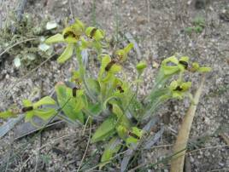
Photo: © Sarah Barrett (DEC)
Description
One of the smallest spider orchids in WA, rarely exceeds 5cm in height. Leaves 4-6cm long; broadly lanceolate and semi-prostrate. Flowers are usually borne singly on erect stems, 1-1.5cm wide and generally green although occasionally apricot in colour. A glossy, dark, globular band of calli run down the centre of the labellum. Its colour and size make this species difficult to survey.

Distribution and Habitat
Known from 10+ populations spanning a range of 190km between Boyup Brook and Boxwood Hill. Eight populations occur within the Fitzgerald Biosphere totalling approximately 330 plants.
Habitat varies across its range but it appears to favour sandy clay to red loam over granite geology. General habitat preference is open woodland in association with species including Allocasuarina huegeliana, Eucalyptus occidentalis, E. wandoo and Acacia acuminata, as well as other low shrubs, grasses and sedges.

Important Populations
The species has a small known population size, therefore all known populations of the species are considered important to its survival.

Habitat Critical to Survival
- The area of occupancy of the known populations; and
- Similar habitat within 1km of all species distribution records that provides a potential habitat buffer for the species; and
- Areas of habitat that historically contained the species and may be suitable for translocation.

Biology and Ecology
Flowers August to September. Pollinated by male Thynnine wasps (Tiphiidae) through sexual attraction cues. Seeds dispersed by wind. Germination requires specific soil-borne fungi and the number of years from seedling to maturity varies with growing conditions. Killed by fire during growing season. Presumed not susceptible to Phytophthora cinnamomi.

Threats
Small population sizes and risks associated with low genetic diversity; Fragmentation, loss and degradation of habitat; Competition and modification of habitat by environmental weeds; Inappropriate fire regimes (during Spring growing period, high frequency); Grazing by native and invasive fauna; Stochastic events; Altered hydrology, Climate change.

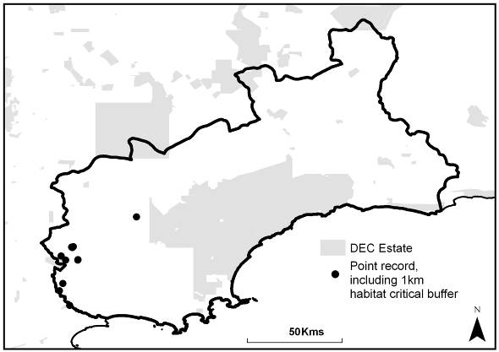

References
Department of Environment and Conservation (2009). Dwarf Spider Orchid (Caladenia bryceana subsp. bryceana) Recovery. Commonwealth Department of the Environment, Water, Heritage and the Arts, Canberra.
Holland, E., Brown, A. & Kershaw, K. (1999) Dwarf Spider Orchid (Caladenia bryceana subsp. bryceana ms) Interim Recovery Plan 1999-2002. Department of Conservation and Land Management, Perth, Western Australia.
Calochilus pruinosus (Orchidaceae)
(Hopetoun Beard Orchid)

Conservation Status
- Environment Protection & Biodiversity Conservation Act (1999): Not listed
- Western Australian Wildlife Conservation Act (1950): Critically Endangered
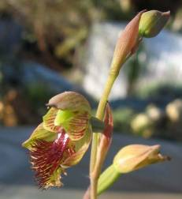
Photo: © John Tucker
Description
A orchid with small (14-19mm long) pinkish-green to pinkish brown coloured, pruinose (white powdery coating) flowers. Leaf absent, replaced by a basal sheathing bract.

Distribution
Currently only known from three populations near Hopetoun. Historically recorded from three further sites: south of Stirling Range, west of Hopetoun and south-east of Cocklebiddy near Eyre Bird Observatory.

Habitat critical to survival
- The known area of occupancy of important populations.
- Areas of similar habitat surrounding important populations that may provide natural range extension and corridors for pollinators of the species.

The species occurs in deep well drained sands in mallee shrubland and woodland.

Biology and Ecology
Species of Calochilus from south-west WA have flowers that mimick female wasps to attact males. All Calochilus self-pollinate if insect pollination does not occur.

Important populations
All known populations are considered important populations for survival of the species.

Threats
Habitat degradation (road or firebreak maintenance, trampling); weeds; habitat loss (clearing for housing developments); inappropriate fire regimes (during Spring growing period); small population size; poor recruitment.

References
DEC (in prep.) Hopetoun Beard Orchid (Calochilus pruinosus) Interim Recovery Plan 2010-2015, Department of Environment and Conservation, Perth.

Conostylis lepidospermoides (Haemodoraceae)
(Sedge Conostylis)

Conservation Status
- Environment Protection & Biodiversity Conservation Act (1999): Endangered
- Western Australian Wildlife Conservation Act (1950): Vulnerable
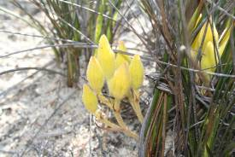
Photo: © Mike Fitzgerald (DEC)
Description
Tufted, sedge-like, rhizomatous perennial up to 35cm high and 40cm wide. Leaves 20-35cm long, flat and narrow, yellow-green and edged with two rows of short, dark bristles. Up to six lemon yellow flowers held in loose inflorescence on a 1-4cm long stalk. Floral whorl is up to 20mm long and the flowers are among the largest of this genus.

Distribution and Habitat
Recorded from 17 populations from Ravensthorpe north to 90 Mile Tank in southern WA. The single population known from the Fitzgerald Biosphere has not been seen in recent years. The extent of occurrence is approximately 4,400km².
The population in the Biosphere occurs in verges adjacent to cleared farmland on flat or gently undulating plains in yellow or grey sand over laterite clay.
Grows in low heath or sedge communities with scattered emergent shrubs on yellow or grey sand over laterite clay.
Important Populations
There are no populations considered important in the Fitzgerald Biosphere.

Habitat Critical to Survival
- The area of occupancy of the known population; and
- Similar habitat within 1km of distribution records that provides potential habitat buffer for the species.

Biology and Ecology
Flowers September to October. Pollinated by both birds and insects.

Threats
Threats unknown in Biosphere as species not seen in recent years but likely to be: Loss and degradation of habitat (road maintenance, clearing for agriculture or gravel extraction); Competition from environmental weeds; Grazing by invasive fauna (especially Rabbits); Altered hydrology (e.g. waterlogging).

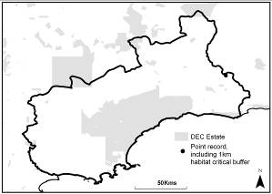

References
DEWHA (2010). Conostylis lepidospermoides in Species Profile and Threats Database, Department of the Environment, Water, Heritage and the Arts, Canberra. http://www.environment.gov.au/sprat - Accessed 7/4/2010
Threatened Species Scientific Committee (2008). Commonwealth Conservation Advice on Conostylis lepidospermoides (Sedge Conostylis). Department of the Environment, Water, Heritage and the Arts. http://
www.environment.gov.au/biodiversity/threatened/species/pubs/9254-conservation-advice.pdf - Accessed 7/4/2010
Coopernookia georgei (Goodeniaceae)
(Mauve Coopernookia)

Conservation Status
- Environment Protection & Biodiversity Conservation Act (1999): Endangered
- Western Australian Wildlife Conservation Act (1950): Endangered
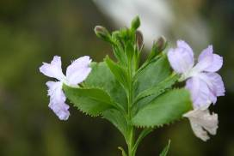
Photo: © Sarah Barrett (DEC)
Description
A slender, erect shrub up to 1.5m high. Leaves 2-5cm long and shallowly denticulate. Flowers solitary, up to 2cm long, varying from mauve to pink or blue in colouration and held in leaf axils at the ends of branches. The two outer petals more deeply split than middle three.

Distribution and Habitat
Endemic to FRNP with four known populations comprising <500 mature individuals. Extent of occurrence is approximately 65km² and area of occupancy predicted to be <0.2ha. Populations appear to be stable and fire may stimulate recruitment.
Occurs in thick scrub in shallow siliceous soils over quartzite geology in stony gullies.

Important Populations
As the species has a restricted range (endemic to FRNP), all known populations are considered important populations.

Habitat Critical to Survival
- The area of occupancy of the known populations; and
- Similar habitat within 1km of distribution records that provides potential habitat buffer for the species.

Biology and Ecology
Flowers September to October. Germinates after fire from soil-stored seed-bank. Susceptibility to Phytophthora cinnamomi unknown.

Threats
Inappropriate fire regime (high frequency and/or intensity fires); Phytophthora dieback; Stochastic events, Climate change.

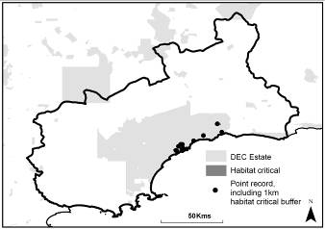

References
Threatened Species Scientific Committee (2008). Commonwealth Conservation Advice on Coopernookia georgei (Mauve Coopernookia). Department of the Environment, Water, Heritage and the Arts. http://www.environment.gov.au
/biodiversity/threatened/species/pubs/21218-conservation-advice.pdf - Accessed 7/4/2010
Daviesia megacalyx (Fabaceae)
(Long-sepalled Daviesia)

Conservation Status
- Environment Protection & Biodiversity Conservation Act (1999): Endangered
- Western Australian Wildlife Conservation Act (1950): Endangered
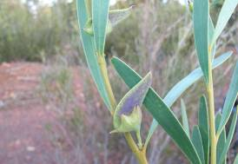
Photo: © Stephen Kern (DEC)
Description
An erect, bushy shrub to 1.5m high. Branches angular and leaves are dull green, 4-8cm long, flat, broad and erect. Flowers have yellow standard petals with yellow centre, surrounded by red keel and are 1cm long arranged in clusters in leaf axils. Fruits are triangular; 1.5cm long with large calyx that becomes black and remains long after pods are shed.

Distribution and Habitat
Restricted to Ravensthorpe Range, occurs over a range approximately 25km with estimated area of occupancy of 85ha. Total population is estimated at <109,477 mature plants in nine populations.
Confined to heavy red gravely-clay over laterite geology on slopes and ridges, in mallee-heath.

Important Populations
All known populations considered important due to restricted range (endemic to Ravensthorpe Range).

Habitat Critical to Survival
- The area of occupancy of the known populations; and
- Similar habitat within 1km of distribution records that provides potential habitat buffer for the species.

Biology and Ecology
Flowers July to September and has a juvenile period of ±4 yrs. Presumed to be hermaphroditic and bee-pollinated consistent with other Daviesia spp. which also set seed around three months after flowering. Seed is high in starch and oil content and attractive to animals. Killed by fire and regenerates from soil-stored seed after disturbance events. Such regeneration can be prolific. Susceptibility to Phytophthora cinnamomi is unknown but related Daviesia spp. are known to be susceptible.

Threats
Inappropriate fire regimes (insufficient intervals between disturbance events for seed bank regeneration); Habitat loss and degradation from mining activities; Phytophthora dieback; Small population size; Stochastic events (e.g. drought); Climate change.

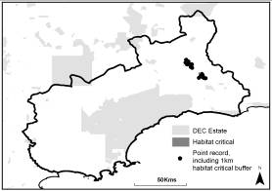

References
Hartley, R. & Barrett, S. (2005) Long-sepalled Daviesia (Daviesia megacalyx) Recovery Plan. Department of Conservation and Land Management, Albany, Western Australia.
Daviesia obovata (Fabaceae)
(Paddle-leaved Daviesia)

Conservation Status
- Environment Protection & Biodiversity Conservation Act (1999): Endangered
- Western Australian Wildlife Conservation Act (1950): Endangered
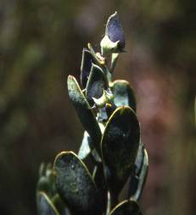
Photo: © Sarah Barrett (DEC)
Description
A distinctive, erect, slender shrub up to 1.5m high. Leaves erect and paddle-shaped. Flowers yellow and black. Fruits woody.

Distribution and Habitat
Endemic to South Coast region of WA and known from 11 small populations in Stirling Range NP and FRNP. Two of these populations occur in the Fitzgerald Biosphere on Thumb Peak, and Mid Mt Barren in FRNP, together comprising c.500 mature plants. Extent of its occurrence is approximately 500km² and the area of occupancy is estimated at 0.3km².
Favours stony or sandy loam but also grows on hill-slopes and outcrops.

Important Populations
Due to limited information on populations, all populations are considered important.

Habitat Critical to Survival
- The area of occupancy of the known populations; and
- Similar habitat within 1km of distribution records that provides potential habitat buffer for the species.

Biology and Ecology
Flowers September to October. Presumed to be hermaphroditic and bee-pollinated as for other Daviesia spp. which also set seed around three months after flowering. Seed is high in starch and oil content and attractive to animals. May resprout after fire but also recruits from seed. Known to be susceptible to Phytophthora cinnamomi.

Threats
Phytophthora dieback; Inappropriate fire regime (insufficient intervals between fires to allow seed bank regeneration); Small population size and risks associated with low genetic diversity; Stochastic events; Climate change.
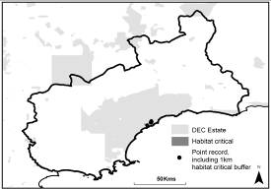

References
DEWHA (2010). Daviesia obovata in Species Profile and Threats Database, Department of the Environment, Water, Heritage and the Arts, Canberra. http://www.environment.gov.au/sprat - Accessed 8/4/2010
Threatened Species Scientific Committee (TSSC) (2008). Commonwealth Listing Advice on Daviesia obovata. Department of the Environment, Water, Heritage and the Arts. http://www.environment.gov.au
/biodiversity/threatened/species/pubs/17311-listing-advice.pdf - Accessed 8/4/2010
Eremophila denticulata (subspecies denticulata) (Scrophulariaceae)
(Fitzgerald Eremophila)

Conservation Status
- Environment Protection & Biodiversity Conservation Act (1999): Vulnerable
- Western Australian Wildlife Conservation Act (1950): Vulnerable
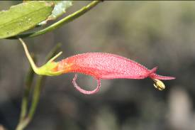
Photo: © Damien Rathbone (DEC)
Description
An erect shrub to 2.5m high. Leaves (50mm long) and stem resinous. Buds are orange-yellow and mature flowers are carmine-red, tubular and arranged on S-shaped stalks. Sepals 3.5-9mm long and lower corolla lip reflexed. Fruits ovoid (10-11 x 8-9mm) with 1-2 seeds. Leaf margins denticulate and the fruit prominently ‘beaked’, distinguishing it from E. denticulata subsp. trisulcata.

Distribution and Habitat
The nominate form is known from four populations to the south and east of Ravensthorpe, three of which occur in the Fitzgerald Biosphere. Approximate extent of occurrence is 70km² comprising of c.5,000 mature plants, although this is likely to fluctuate with fire (S. Barrett, pers. comm.).
Recorded growing on both alluvial soils along riverbanks and sandy clay loam plains over granite geology. It occurs in tall open woodland over shrubland.

Important Populations
All known populations are considered important as the species has a relatively restricted range.

Habitat Critical to Survival
- The area of occupancy of the known populations; and
- Similar habitat within 1km of distribution records that provides potential habitat buffer for the species.

Biology and Ecology
Flowers October to January. Plants begin to senesce after 10 years. Regenerates in large numbers from soil-stored seed-bank after fire. Presumed not susceptible to Phytophthora cinnamomi.

Threats
Grazing and trampling by native and invasive fauna; Competition from environmental weeds; Inappropriate fire regime (insufficient intervals between fires to allow seed bank regeneration); Degradation of habitat from road maintenance, Climate change.

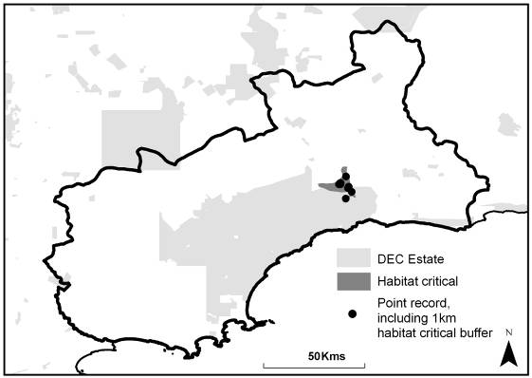

References
Craig, G.F. & Coates, D.J. (2001) Declared and Poorly Known Flora in the Esperance District, Wildlife Management Program No 21. Department of Conservation and Land Management, Perth, Western Australia.
Robinson, C.J. & Coates, D.J. (1995) Declared Rare and Poorly Known Flora in the Albany District, Wildlife Management Program No 20. Department of Conservation and Land Management, Perth, Western Australia.
Threatened Species Scientific Committee (2008). Commonwealth Conservation Advice on Eremophila denticulata subsp. denticulata. Department of the Environment, Water, Heritage and the Arts. http://www.environment.gov.au
/biodiversity/threatened/species/pubs/64569-conservation-advice.pdf - Accessed 8/4/2010
Eremophila subteretifolia (Scrophulariaceae)
(Lake King Eremophila)

Conservation Status
- Environment Protection & Biodiversity Conservation Act (1999): Endangered
- Western Australian Wildlife Conservation Act (1950): Critically Endangered
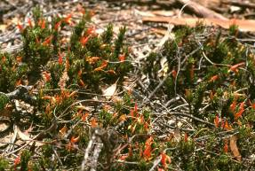
Photo: © Sarah Barrett (DEC)
Description
A prostrate, mat-like plant up to 10cm high and 1.5m in diameter. Leaves glossy green, flowers erect and orange in colouration.

Distribution and Habitat
Known from eight populations in Lake King-Ravensthorpe area, one of which occurs in the Fitzgerald Biosphere. Extent of occurrence approximately 530km² comprising <50 mature individuals. Area of occupancy estimated at 2ha.
Occurs in slightly saline, light, sandy loam over clay and favours open woodland over open scrub and low sedge on margins of samphire flats and salt lakes. It occurs under a range of Eucalyptus spp.

Important Populations
As the species has a small population size, all known populations are considered important.

Habitat Critical to Survival
- The area of occupancy of the known populations; and
- Similar habitat within 1km of distribution records that provides potential habitat buffer for the species.

Biology and Ecology
Flowers July to March, (possibly throughout year). Probably a disturbance opportunist. Presumed to be killed by fire and regenerates from soil-stored seed-bank.

Threats
Inappropriate fire regimes for recruitment and regeneration; Salinisation and altered hydrology; Loss and degradation of habitat (trampling from recreational activities, road maintenance); Climate change.

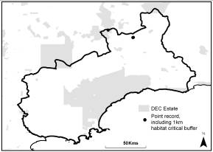

References
Graham, M & Mitchell, M. (2000) Declared Rare Flora in the Katanning District. Department of Conservation and Land Management, Perth, Western Australia.
Phillimore, R., Stack, G. & Brown, A. (2002) Lake King Eremophila (Eremophila subteretifolia ms) Interim Recovery Plan 2002-2005. Department of Conservation and Land Management, Perth, Western Australia.
Threatened Species Scientific Committee (2008). Commonwealth Conservation Advice on Eremophila sp. subteretifolia (K.R.Newbey 10924) WA Herbarium. Department of the Environment, Water, Heritage and the Arts. http://www.environment.gov.au/biodiversity/threatened/species/pubs/82039-conservation-advice.pdf - Accessed 8/4/2010
Eucalyptus burdettiana (Myrtaceae)
(Burdett Gum)

Conservation Status
- Environment Protection & Biodiversity Conservation Act (1999): Endangered
- Western Australian Wildlife Conservation Act (1950): Endangered
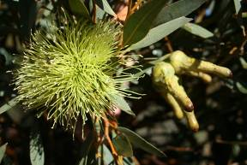
Photo: © Sarah Barrett (DEC)
Description
A multi-stemmed mallee or shrub to 4m high. Bark dark-grey over dark orange. Mature leaves (6-9 x 1-1.7cm) glossy green to blue-green, have a dense vein network and numerous small oil glands. Buds (4-5 x 0.7-1cm) have erect stamens. Flowers usually arranged in sessile clusters of 7-11 (on flattened peduncle with unfused hypanthia and long horn-shaped opercula) and are cream to yellow in colouration. Valves of fruit often united at tip and seeds black, irregular or ovoid in shape or sometimes flat or flanged.

Distribution and Habitat
Known from a single population in FRNP comprising of 4,000 individuals.
Occurs in shallow sandy soils over quartzite geology and grows in association with other mallee species (Eucalyptus spp.). Occurs on slopes and ridges of mountains, with one sub-population occurring on a roadside verge.

Important Populations
The single known FRNP population in considered important

Habitat Critical to Survival
- The area of occupancy of the known populations; and
- Similar habitat within 1km of distribution records that provides potential habitat buffer for the species.

Biology and Ecology
Flowers intermittently throughout the year, often January to March and July to August. Resprouts from lignotubers after fire or disturbance. Seedlings not observed to date. Susceptibility to Phytophthora cinnamomi unknown.

Threats
Inappropriate fire regimes; Climate Change.

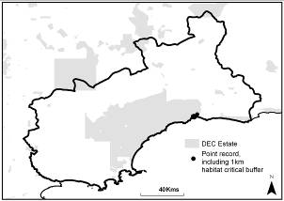

References
Robinson, C.J. & Coates, D.J. (1995) Declared Rare and Poorly Known Flora in the Albany District, Wildlife Management Program No 20. Department of Conservation and Land Management, Perth, Western Australia.
Threatened Species Scientific Committee (2008). Commonwealth Conservation Advice on Eucalyptus burdettiana. Department of the Environment, Water, Heritage and the Arts, http://www.environment.gov.au/ biodiversity/threatened/species/pubs/13505-conservation-advice.pdf - Accessed 8/4/2010.
Eucalyptus coronata (Myrtaceae)
(Crowned Mallee)

Conservation Status
- Environment Protection & Biodiversity Conservation Act (1999): Vulnerable
- Western Australian Wildlife Conservation Act (1950): Endangered
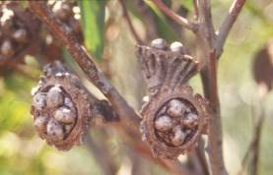
Photo: © Sarah Barrett (DEC)
Description
A multi-stemmed mallee or shrub to 2.5m high. Leaves blue-green and 12 x 3cm. Buds 5cm long and 3cm in diameter, strongly ribbed and in threes on a broad flattened stalk 1.5cm long. Fruits are large (5cm long) with a broad disc crown-like protruding valves.

Distribution and Habitat
Known from three populations in the FRNP with an estimated 2,000 individuals occurring over 47km², although total numbers have fluctuated with occurrence of bushfire.
Favours shallow soils over quartzite geology on slopes and summits of peaks in the east of FRNP.
Important Populations
As the species is restricted to the FRNP, the three known populations are considered important.

Habitat Critical to Survival
- The area of occupancy of the known populations; and
- Similar habitat within 1km of distribution records that provides potential habitat buffer for the species.

Biology and Ecology
Flowers July to August. Resprouts from lignotubers following fire. Seedlings not observed to date. Susceptibility to Phytophthora cinnamomi unknown.

Threats
Inappropriate fire regimes; Climate change.

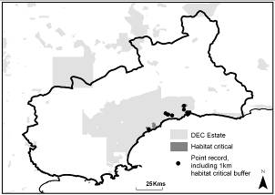

References
Robinson, C.J. & Coates, D.J. (1995) Declared Rare and Poorly Known Flora in the Albany District, Wildlife Management Program No 20. Department of Conservation and Land Management, Perth, Western Australia.
Threatened Species Scientific Committee (2008). Commonwealth Conservation Advice on Eucalyptus coronata. Department of the Environment, Water, Heritage and the Arts. http://www.environment.gov.au
/biodiversity/threatened/species/pubs/2308-conservation-advice.pdf - Accessed 8/4/2010
Eucalyptus nutans (Myrtaceae)
(Bremer or Red-flowered Moort)

Conservation Status
- Environment Protection & Biodiversity Conservation Act (1999): Not Listed
- Western Australian Wildlife Conservation Act (1950): Vulnerable
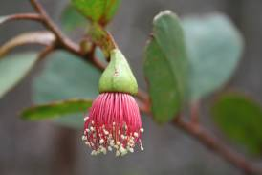
Photo: © Sarah Barrett (DEC)
Description
An erect mallet to 10m high. Leaves (52-73 x 34-48mm) ovate or orbicular and glossy dark green. Buds (9-15 x 4-5mm) obtusely conical and slightly warty with a broad, strap-like down-curved peduncle. Flowers red (rarely cream). Fruit sessile and four-winged with descending valves in a wheel-like arrangement. Seed black and compressed, obovoid to ovoid.
Has only recently been described as a separate species from Eucalyptus cernua. It is known to hybridise with Eucalyptus occidentalis.

Distribution and Habitat
Restricted to a single wild population near Bremer Bay in South Coast region of WA, with c.20,000 plants over several hectares. Has been cultivated elsewhere in WA (e.g. Perth and Albany).
Occurs naturally on gravelly-clay over spongolitic marine sediments near the coast at Bremer Bay.

Important Populations
The single wild population near Bremer Bay is considered important for the survival of this species.

Habitat Critical to Survival
- The area of occupancy of the known populations; and
- Similar habitat within 1km of distribution records that provides potential habitat buffer for the species.

Biology and Ecology
Flowers November to April. Non-lignotuberous and is killed by fire, regenerating from canopy-stored seed (serotinous). Juvenile period unknown.
Known to hybridise with Eucalyptus occidentalis.

Threats
Inappropriate fire regime (e.g. insufficient intervals between fires to allow seed bank regeneration), Climate change.

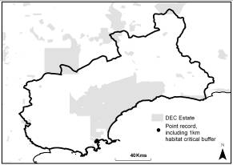

References
McQuoid, N.K. & Hopper, S.D. (2007) The rediscovery of Eucalyptus nutans F. Muell. from the south coast of Western Australia, Journal of the Royal Society of Western Australia, 90: 41-45.
Eucalyptus purpurata (Myrtaceae)

Conservation Status
- Environment Protection & Biodiversity Conservation Act (1999): Not Listed
- Western Australian Wildlife Conservation Act (1950): Vulnerable
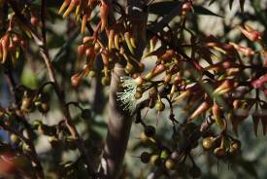
Photo: © Anne Cochrane (DEC)
Description
An erect mallet to 10m high. Bark dull grey over cream, smooth, decorticating into long strips. Flowers cream. Recently recognised as distinct species from Eucalyptus argyphea and differs by red-purple new growth and smaller buds and fruits.

Distribution and Habitat
Restricted to single population in four areas around Bandalup Hill near Ravensthorpe with an extent of occurrence of 16.5ha. Age classes of this population vary from c.19 to c.124 yrs.
Grows on white powdery loam over magnesite geology on eastern/north-eastern slopes and ridges.

Important Populations
The single known populations restricted to the Bandalup Hill area is considered important to the survival of the species.

Habitat Critical to Survival
- The area of occupancy of the known populations; and
- Similar habitat within 1km of distribution records that provides potential habitat buffer for the species.

Biology and Ecology
Flowers November. Fire sensitive species that regenerates from canopy-stored seed (serotinous).

Threats
Inappropriate fire regimes; Degradation and loss of habitat from mining activities, Altered hydrology, Climate change.

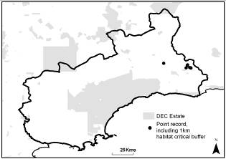

References
CALM (2004) Proposed Change to the Database of Threatened Ecological Communities (TECs) – Eucalyptus purpurata woodlands on magnesite soils of the ridge-tops and upper slopes of the Ravensthorpe Range. Department of Conservation and Land Management, Perth, Western Australia. (Unpublished)
Nicolle, D. (2002) Two new species of silver mallet (Eucalyptus – Myrtaceae) of very restricted distribution in south-western Western Australia. Nuytsia 15(1): 77-83.
Western Australian Herbarium (1998) Florabase - The Western Australia Flora, Eucalyptus purpurata D.Nicolle - http://florabase.calm.wa.gov.au/browse/profile/20050 - Accessed 8/4/2010
Grevillea infundibularis (Proteaceae)
(Fan- or Funnel-leaved Grevillea)

Conservation Status
- Environment Protection & Biodiversity Conservation Act (1999): Endangered
- Western Australian Wildlife Conservation Act (1950): Vulnerable
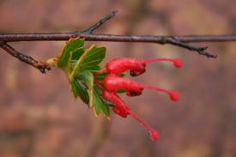
Photo: © Sarah Barrett (DEC)
Description
A sprawling or decumbent shrub to 1m high. Leaves are 3cm wide and hemispherical to fan-shaped, almost lacking stalks with the leaf-base clasping the stem with new leaves conical in shape. Leaves denticulate with eight large, short-pointed teeth on each leaf and are prominently veined. Flowers bright red and irregular, forming small terminal raceme. Two forms of the species may be distinguished which differ in habitat preferences as the dune form has cuneate (not stem-clasping) leaves and a prostrate shape.

Distribution and Habitat
Endemic to central coastal region of the FRNP around Mid Mt Barren and Thumb Peak in two populations comprising c.5,500 mature plants.
Prefers shallow sandy or loamy soils amongst quartzite boulders, in open shrub-mallee.

Important Populations
The species is restricted to the FRNP, so all populations are considered important.

Habitat Critical to Survival
- The area of occupancy of the known populations; and
- Similar habitat within 1km of distribution records that provides potential habitat buffer for the species.

Biology and Ecology
Flowers irregularly throughout the year. Killed by fire and regenerates from soil-stored seed-bank. Juvenile period of ±4 yrs. Susceptibility to Phytophthora cinnamomi unknown.

Threats
Inappropriate fire regimes; Phytophthora dieback, Climate change.

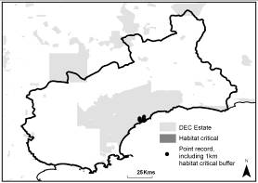

References
Australian Biological Resources Study (1995-2000) Flora of Australia, Volumes 16, 17A & 17B, Commonwealth of Australia. http://www.anbg.gov.au/abrs/online-resources/flora/stddisplay.xsql?pnid=2753 – Accessed 8/4/2010
Barrett, S., Comer, S., McQuoid, N., Porter, M., Tiller, C. & Utber, D. (2009) Identification and Conservation of Fire Sensitive Ecosystems and Species of the South Coast Natural Resource Management Region. Department of Environment and Conservation, South Coast Region, Western Australia.
Robinson, C.J. & Coates, D.J. (1995) Declared Rare and Poorly Known Flora in the Albany District, Wildlife Management Program No 20. Department of Conservation and Land Management, Perth, Western Australia.
Threatened Species Scientific Committee (2008). Commonwealth Conservation Advice on Grevillea infundibularis. Department of the Environment, Water, Heritage and the Arts. http://www.environment.gov.au
/biodiversity/threatened/species/pubs/5772-conservation-advice.pdf - Accessed 8/4/2010
Hibbertia abyssa (Dilleniaceae)
(Bandalup Buttercup)

Conservation Status
- Environment Protection & Biodiversity Conservation Act (1999): Not Listed
- Western Australian Wildlife Conservation Act (1950): Critically Endangered
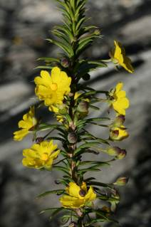
Photo: © Damien Rathbone (DEC)
Description
An erect shrub up to 1.2m high and can be single or multi-stemmed. Leaves linear to subulate with strongly recurved margins and pungent tips. Young branchlets have distinct glabrous ribs but are covered in dense hairs between. Flowers bright yellow with five stamens on one side of carpals and held on slender and glabrous stalks (6-14mm long). Sepal surface has hooked and branched hairs. This species may be confused with similar Hibbertia mucronata and H. atrichosepala.

Distribution and Habitat
Restricted to Bandalup Hill area near Ravensthorpe Range, where part of one population was cleared in 2008 through mining activity.
Occurs in shallow red-brown light clay in open mallee-shrubland.

Important Populations
All known populations as the species has a restricted range to around Bandalup Hill.

Habitat Critical to Survival
- The area of occupancy of the known populations; and
- Similar habitat within 1km of all species distribution records that provides a potential habitat buffer for the species.

Biology and Ecology
Flowers have been recorded in October, November and March. Observations suggest that it regenerates after fire from soil-stored seed. Susceptibility to Phytophthora cinnamomi unknown, but other Hibbertia spp. can be susceptible.

Threats
Loss and degradation of habitat, Dust impacts and changes to hydrology from mining activities; Inappropriate fire regimes; Post-fire competition from environmental weeds; Phytophthora dieback, Climate change.

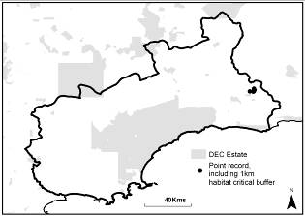

References
Luu, R., Rathbone, D., Barrett, S & Cochrane, A. (2010) Hibbertia abyssa Interim Recovery Plan 2010-2015 (Draft). Department of Environment and Conservation, Perth, Western Australia.
Wege, J. & Markey, A. (2009) A new, rare Hibbertia discovered on Bandalup Hill. Information Sheet 31/2009. Department of Environment and Conservation, Perth, Western Australia.
Wege, J.A. & Thiele, K.R. (2009) Two new species of Hibbertia (Dilleniaceae) from near Ravensthorpe in Western Australia. Nutysia 19(2): 303-310.
Kunzea similis (subspecies mediterranea) (Myrtaceae)

Conservation Status
- Environment Protection & Biodiversity Conservation Act (1999): Not Listed
- Western Australian Wildlife Conservation Act (1950): Endangered
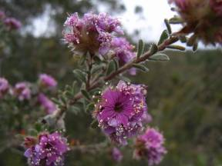
Photo: © Stephen Kern (DEC)
Description
A woody shrub to 3m high with several stiffly erect main stems, moderately to little branched. Basal branches prostrate and usually without flowers. Young branches densely covered in silky hairs. Flowers pink with prominent stamens and striking pale anthers. This subspecies is distinguished from the nominate form by larger bracteoles (3.8-4.4mm) and with (usually) exposed apex often longer than hypanthium.

Distribution and Habitat
Confined to one population on Bandalup Hill, east of Ravensthorpe with extent of occurrence of 21.9ha. Surveys in 2007 found c.350,000 mature plants. Mining has removed 6% of population.
Favours grey loamy sandy soil over laterite geology in open shrub mallee and dense heath.

Important Populations
The single known population is considered important as it is has a restricted range (endemic to Bandalup Hill).

Habitat Critical to Survival
- The area of occupancy of the known population; and
- Similar habitat within 1km of distribution records that provides potential habitat buffer for the species.

Biology and Ecology
Flowers September to November and is pollinated by native bees. Killed by fire and regenerates from soil-stored seed.

Threats
Loss and degradation of habitat from mining activities; Inappropriate fire regimes; Phytophthora dieback; Climate change.

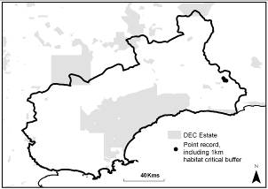

References
DEC (2008) SAP 2008 Kunzea similis subsp. mediterranea. Department of Environment and Conservation, Perth, Western Australia. (Unpublished)
Toelken, H.R. & Craig, G.F. (2007) Kunzea acicularis, K. strigosa and K. similis subsp mediterranea (Myrtaceae) – new taxa from near Ravensthorpe, Western Australia. Nutysia 17: 385-396.
Western Australian Herbarium (1998) Florabase - The Western Australia Flora - Kunzea similis subsp. mediterranea Toelken & G.F.Craig. http://florabase.calm.wa.gov.au/browse/profile/31151 - Accessed 9/4/2010
Kunzea similis (subspecies similis) (Myrtaceae)

Conservation Status
- Environment Protection & Biodiversity Conservation Act (1999): Not Listed
- Western Australian Wildlife Conservation Act (1950): Vulnerable
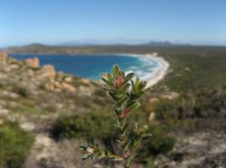
Photo: © Sarah Barrett (DEC)

Description
A woody shrub to 1.5m. Similar to K. similis (subsp. mediterranea) but differs with smaller bracteoles (3.2-3.7mm) hidden between flowers and usually shorter than hypanthium.

Distribution and Habitat
Restricted to single location in FRNP on East Mt Barren near Hopetoun, with a mature population of c.3,600 individuals.
Occurs in fine sandy-clay soil on quartzite wave-cut bench on lower slopes of East Mt Barren in low heath.

Important Populations
The single known FRNP population is considered important for the survival of this species.

Habitat Critical to Survival
- The area of occupancy of the known populations; and
- Similar habitat within 1km of distribution records that provides potential habitat buffer for the species.

Biology and Ecology
Flowers September to October. Killed by fire and regenerates from soil-stored seed. Poor regeneration observed after fire in 2006. Presumed susceptible to Phytophthora cinnamomi. Drought stress observed in February 2010 (S. Barrett & S. Cowen pers. obs.).

Threats
Inappropriate fire regime (insufficient intervals between fires to allow seed bank regeneration); Degradation of habitat from road maintenance; Phytophthora dieback; Altered Hydrology; Stochastic events (e.g. drought), Climate change.

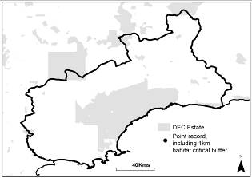

References
Toelken, H.R. & Craig, G.F. (2007) Kunzea acicularis, K. strigosa and K. similis subsp mediterranea (Myrtaceae) – new taxa from near Ravensthorpe, Western Australia. Nutysia 17: 385-396.
Lepidium aschersonii (Brassicaceae)
(Spiny Peppercress)

Conservation Status
- Environment Protection & Biodiversity Conservation Act (1999): Vulnerable
- Western Australian Wildlife Conservation Act (1950): Vulnerable

Photograph not available

Description
Small, erect, perennial herb up to 30cm with intricate branched, erect stems covered in deflexed hairs. Branches become woodier and spinier with age or in dry conditions. Basal leaves (up to 12cm) are fleshy and pinnately lobed but rarely persist and the stem leaves are lanceolate to narrowly tapering, hairy, becoming smaller with increasing height. Flowers small with four 0.8mm long sepals and are greenish in colour. Fruit (3.5-4.5 x 2.5-3mm) ovate to obovate two chambered pod borne on 2-4mm pedicel (hairy above, hairless below).

Distribution and Habitat
Occurs in fragmented populations in NSW and VIC where it was previously more widespread. It was considered extinct in WA (when last recorded from Pallinup River in 1903) until 1976 when it was reported from Corackerup Creek.
In eastern states this is a wetland species preferring heavy black or clay soils in swamps and salt-marshes.

Important Populations
The last record of this species in WA was from Corackerup Creek in the 1970’s. Although it has been absent from this location since that time, should the population reoccur, it would be considered important.

Habitat Critical to Survival
- Similar habitat within 1km of distribution records that provides potential habitat buffer for the species.

Biology and Ecology
Flowers spring to autumn. Tolerant of a range of saline conditions. Highly productive seeder and regenerates prolifically during drought conditions, possibly due to greater soil exposure. May tolerate some levels of grazing pressure.

Threats
Threats unknown in Biosphere as species not seen in recent years but likely to be: Loss and degradation of habitat; Grazing by invasive herbivores; Competition from environmental weeds; Salinisation and altered hydrology.

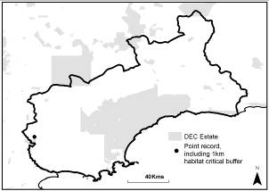

References
DSE (2009) Spiny Peppercress Lepidium aschersonii, Action Statement – Flora and Fauna Guarantee Act 1988 No.111. Department of Sustainability and Environment, Melbourne, Victoria.
Robinson, C.J. & Coates, D.J. (1995) Declared Rare and Poorly Known Flora in the Albany District, Wildlife Management Program No 20. Department of Conservation and Land Management, Perth, Western Australia.
Western Australian Herbarium (1998) Florabase - The Western Australia Flora – Lepidium aschersonii Thell. http://florabase.calm.wa.gov.au/browse/profile/3019 - Accessed 9/4/2010
Marianthus mollis (Pittosporaceae)
(Hairy-fruited Marianthus)

Conservation Status
- Environment Protection & Biodiversity Conservation Act (1999): Endangered
- Western Australian Wildlife Conservation Act (1950): Vulnerable
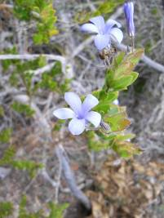
Photo: © Stephen Kern (DEC)
Description
A low, spreading shrub up to 50cm high. Stems reddish-brown with white hairs when young but in mature plants are grey and hairless. Leaves (2 x 1.1cm) also lose their hairs with age (except on margins and mid-rib) and are almost sessile. Flowers usually solitary, deep blue in colouration with 3-4 distinct lines on each petal and pale throat, and held on slender stalks (1.5-2.5cm long) in leaf axils.

Distribution and Habitat
Confined to an area of approximately 30ha of Ravensthorpe Range and eastwards along the rabbit proof fence, possibly sharing the same underlying geological feature. Six populations comprise >50,000 individuals and area of occupancy is estimated at 12ha.
Is not highly specific in its habitat requirements but favours gravely sands over laterite or ironstone geology and sand over laterite, preferring open mallee-heath with disturbed areas of soil.

Important Populations
All known populations are considered important to the survival of this species.

Habitat Critical to Survival
- The area of occupancy of the known populations; and
- Similar habitat within 1km of distribution records that provides potential habitat buffer for the species.

Biology and Ecology
Flowers August to September, but also recorded flowering in summer. Regenerates prolifically after fire from soil-stored seed. Juvenile period is ≤3 yrs. Since flowers are small, self- or insect-pollination is most likely. Seed is dispersed by animals. Probably a soil-disturbance opportunist. Presumed not susceptible to Phytophthora cinnamomi.

Threats
Loss and degradation of habitat from mining activities (e.g. loss of habitat, soil compaction, dust, weeds and pathogen introduction, and potential for introduction of poisonous chemicals); Inappropriate fire; Small population size; Stochastic events.

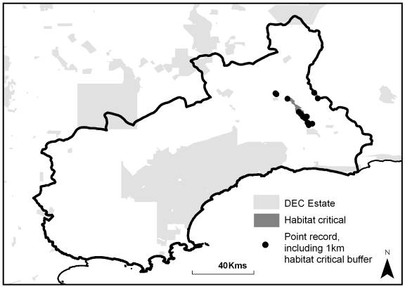

References
Barrett, S., Comer, S., McQuoid, N., Porter, M., Tiller, C. & Utber, D. (2009) Identification and Conservation of Fire Sensitive Ecosystems and Species of the South Coast Natural Resource Management Region. Department of Environment and Conservation, South Coast Region, Western Australia.
Hartley, R. & Barrett, S. (2005) Hairy-fruited Marianthus (Marianthus mollis) Recovery Plan. Department of Conservation and Land Management, Albany, Western Australia.
Myoporum cordifolium (Scrophulariaceae)
(Jerramungup Myoporum)

Conservation Status
- Environment Protection & Biodiversity Conservation Act (1999): Vulnerable
- Western Australian Wildlife Conservation Act (1950): Endangered
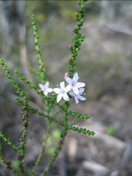
Photo: © Sarah Barrett (DEC)
Description
A twiggy, spreading shrub up to 1m high. Leaves very small (2mm), dark green and heart-shaped. Stem warty and resinous. White solitary flowers with corolla tubes growing up to 5mm long with 5 lobes, which have prominent purple spotting. Fruit (1.5-2.5 x 1-2.2mm) brown or green and ovoid-oblong. Seed tiny, ovoid and white. Has a unique habit and shape within the genus Myoporum.

Distribution and Habitat
Occurs between Ongerup and Jerramungup on south coast of WA. Extent of occurrence is approximately 1,550km². Seven populations comprising c.9,000 individuals occur in the Fitzgerald Biosphere.
Favours disturbed, open habitats, including road verges, over sandy loam or clay loam in mallee or moort areas where, prior to disturbance, open Eucalyptus spp. existed over an open or tall shrub understorey. Can be scattered through mallee by flood events.

Important Populations
All known populations are considered important populations.

Habitat Critical to Survival
- The area of occupancy of the known populations; and
- Similar habitat within 1km of distribution records that provides potential habitat buffer for the species.

Biology and Ecology
Usually flowers June to November, but has been observed flowering in February 2010 in FRNP, 2 yrs after bushfire (S. Barrett, S. Comer & S. Cowen pers. obs.). Juvenile period c.3 yrs. Short-lived (c.10 yrs) disturbance opportunist with fire, flood or other disturbance (e.g. ‘chaining’ for fire management/suppression) stimulating germination. Longevity of soil-stored seed is suggested to be >30 yrs.

Threats
Inappropriate fire regimes (or other disturbance events).

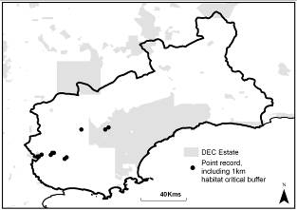

References
Barrett, S., Comer, S., McQuoid, N., Porter, M., Tiller, C. & Utber, D. (2009) Identification and Conservation of Fire Sensitive Ecosystems and Species of the South Coast Natural Resource Management Region. Department of Environment and Conservation, South Coast Region, Western Australia.
Chinnock, R.J. (2007) Eremophila and Allied Genera: a monograph of the plant family Myoporaceae – 30: Myoporum cordifolium, pp156-159 – Rosenberg Publishing, Dural, New South Wales, Australia.
Department of the Environment, Water, Heritage and the Arts (2010). Myoporum cordifolium in Species Profile and Threats Database, Department of the Environment, Water, Heritage and the Arts, Canberra. http://www.environment.gov.au/sprat - Accessed 9/4/2010
Threatened Species Scientific Committee (2008). Commonwealth Conservation Advice on Myoporum cordifolium. Department of the Environment, Water, Heritage and the Arts. http://www.environment.gov.au/biodiversity/threatened/species/pubs/24223-conservation-advice.pdf - Accessed 9/4/2010
Ricinocarpos trichophorus (Euphorbiaceae)
(Barrens Wedding-bush)

Conservation Status
- Environment Protection & Biodiversity Conservation Act (1999): Endangered
- Western Australian Wildlife Conservation Act (1950): Vulnerable
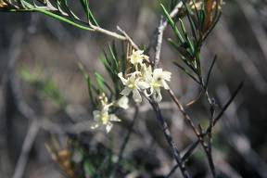
Photo: © Sarah Barrett (DEC)
Description
Erect, openly branching shrub up to 1.6m high. Leaves (25-80 x 1.5mm) dark green above and grey below. Stem covered in grey felt-like hairs. Buds also covered in dense ferruginous hairs. Flowers creamy-yellow to white, arranged in groups of 6-10 on a 2cm stalk at the end of a branch.

Distribution and Habitat
Occurs in disjunct populations along the south coast of WA, from the FRNP to Lake Tay (east of Frank Hann NP) and Mts. Beaumont and Heywood, north-east of Esperance. There are five populations in Fitzgerald Biosphere comprising 4,500 individuals.
Favours sandy-clay loam along breakaways or watercourses among sandstone rocks.

Important Populations
All known populations are considered important to the survival of this species.

Habitat Critical to Survival
- The area of occupancy of the known populations; and
- Similar habitat within 1km of distribution records that provides potential habitat buffer for the species.

Biology and Ecology
Flowers March to May and August to November. Killed by fire and regenerates from soil-stored seed. Thought to take 4 yrs to flower and seed although it was observed to be reproductive only 2 yrs post-fire in FRNP in February 2010 (S. Barrett & S. Cowen, pers. obs.). Also observed to be affected by drought. Susceptibility to Phytophthora cinnamomi unknown.

Threats
Inappropriate fire regimes; Climate change.

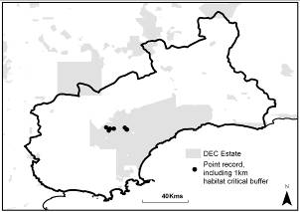

References
Threatened Species Scientific Committee (2008). Commonwealth Conservation Advice on Ricinocarpos trichophorus. Department of the Environment, Water, Heritage and the Arts. http://www.environment.gov.au
/biodiversity/threatened/species/pubs/19931-conservation-advice.pdf - Accessed 9/4/2010
Western Australian Herbarium (1998) Florabase - The Western Australia Flora - Ricinocarpos trichophorus Muell.Arg. http://florabase.calm.wa.gov.au/browse/profile/4702 - Accessed 9/4/2010
Stylidium galioides (Stylidiaceae)
(Yellow Mountain or Yellow Fitzgerald Triggerplant)

Conservation Status
- Environment Protection & Biodiversity Conservation Act (1999): Vulnerable
- Western Australian Wildlife Conservation Act (1950): Vulnerable
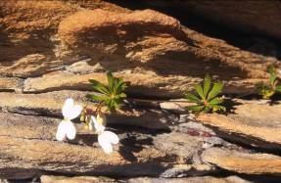
Photo: © Sarah Barrett (DEC)

Description
A creeping to semi-scandent perennial herb up to 30cm high and spreading to 50cm diameter. Leaves (2.5-40 x 0.7-6mm) in whorls of 8+ at base and on trailing stems, the latter of which may be rooted at nodes. Inflorescences racemose and flowers pale-yellow and clustered at branch ends.

Distribution and Habitat
Restricted to three populations in FRNP with an estimated 3000 mature plants (E. Hickman pers. obs.) occurring over approximately 9km². Populations believed to be stable.
Favours in shallow gravelly soils over and among quartzite geology on slopes and summits, in heath, mallee and shrubland.

Important Populations
All three known populations are considered important to the survival of the species.

Habitat Critical to Survival
- The area of occupancy of the known populations; and
- Similar habitat within 1km of distribution records that provides potential habitat buffer for the species.

Biology and Ecology
Flowers Sep-Jan. Killed by fire and regenerates from soil-stored seed. Susceptibility to Phytophthora cinnamomi unknown. Juvenile period is <4 yrs.

Threats
Inappropriate fire regimes; degradation of habitat due to recreational activities; Phytophthora dieback, Climate change.

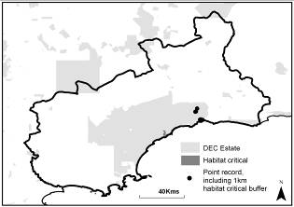

References
Barrett, S., Comer, S., McQuoid, N., Porter, M., Tiller, C. & Utber, D. (2009) Identification and Conservation of Fire Sensitive Ecosystems and Species of the South Coast Natural Resource Management Region. Department of Environment and Conservation, South Coast Region, Western Australia.
Threatened Species Scientific Committee (2008). Commonwealth Conservation Advice on Stylidium galioides. Department of the Environment, Water, Heritage and the Arts. http://www.environment.gov.au/biodiversity/threatened/species/pubs/4666-conservation-advice.pdf - Accessed 9/4/2010
Western Australian Herbarium (1998) Florabase - The Western Australia Flora - Stylidium galioides C.A.Gardner. http://florabase.dec.wa.gov.au/browse/profile/7730 - Accessed 9/4/2010
Thelymitra psammophila (Orchidaceae)
(Sandplain Sun-orchid)

Conservation Status
- Environment Protection & Biodiversity Conservation Act (1999): Vulnerable
- Western Australian Wildlife Conservation Act (1950): Vulnerable
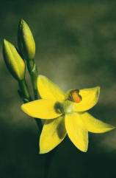
Photo: © Andrew Brown (DEC)
Description
A small, herbaceous perennial up to 25cm high. Leaves narrow and up to 8cm long. Flowers lemon-yellow and 18mm wide with two to four on each plant in a loose raceme. Column yellow with two triangular, brown, lateral lobes. Backs of perianth segments tinged with red.

Distribution and Habitat
Restricted to 12 populations between Stirling Range NP and Ravensthorpe with an extent of occurrence of 10,000km².
Eight populations occur in Fitzgerald Biosphere comprising c.400 individuals.
Favours in wet sandy-clay soils in open heath and sedge.

Important Populations
All known populations in the Fitzgerald Biosphere are considered important populations.

Habitat Critical to Survival
- The area of occupancy of the known populations; and
- Similar habitat within 1km of distribution records that provides potential habitat buffer for the species.

Biology and Ecology
Flowers September to October. Tuberous in association with a mycorrhizal fungus. Presumed not susceptible to Phytophthora cinnamomi. Vulnerable to fire during growing season.

Threats
Loss and degradation of habitat through changes in land use, fire suppression and road maintenance; Competition with environmental weeds; Grazing by domestic stock; Inappropriate fire regimes (including season), Climate change (i.e. drought).

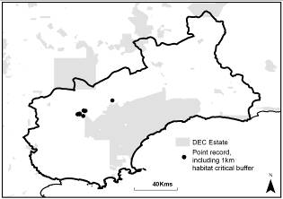

References
Barrett, S., Comer, S., McQuoid, N., Porter, M., Tiller, C. & Utber, D. (2009) Identification and Conservation of Fire Sensitive Ecosystems and Species of the South Coast Natural Resource Management Region. Department of Environment and Conservation, South Coast Region, Western Australia.
DEWHA (2010). Thelymitra psammophila in Species Profile and Threats Database, Department of the Environment, Water, Heritage and the Arts, Canberra. http://www.environment.gov.au/sprat - Accessed 12/4/2010
Graham, M. & M. Mitchell (2000). Declared Rare Flora in the Katanning District. Western Australia Department of Conservation and Land Management.. http://www.dec.wa.gov.au
/pdf/nature/flora/flora_mgt_plans/katanning/katanning_drf_mp25.pdf - Accessed 12/4/2010
Robinson, C.J. & Coates, D.J. (1995) Declared Rare and Poorly Known Flora in the Albany District, Wildlife Management Program No 20. Department of Conservation and Land Management, Perth, Western Australia.
Threatened Species Scientific Committee (2008). Commonwealth Conservation Advice on Thelymitra psammophila. Department of the Environment, Water, Heritage and the Arts. http://www.environment.gov.au
/biodiversity/threatened/species/pubs/4908-conservation-advice.pdf - Accessed 12/4/2010
Verticordia crebra (Myrtaceae)
(Crowded or Twertup Featherflower)

Conservation Status
- Environment Protection & Biodiversity Conservation Act (1999): Vulnerable
- Western Australian Wildlife Conservation Act (1950): Vulnerable
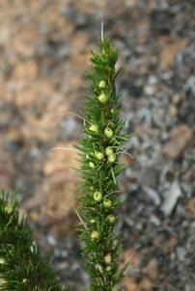
Photo: © Sarah Barrett (DEC)
Description
A small, spreading shrub to 75cm. Leaves 15mm long, dark-green and fine. Flowers yellow with 3mm long petals and unusually prominent yellow style and are held in leaf axis towards ends of branches.

Distribution and Habitat
Endemic to Fitzgerald River NP and known from 4 populations with an estimated total population of 7,000. Approximate extent of occurrence is 150km². 1 population not surveyed since 1981 and number of plants not recorded then.
Prefers heavy red-loam over spongolite on or above breakaways and drainage lines in open areas surrounded by scrub and mallee.

Important Populations
As the species is endemic to the FRNP, all populations are considered important.

Habitat Critical to Survival
- The area of occupancy of the known populations; and
- Similar habitat within 1km of distribution records that provides potential habitat buffer for the species.

Biology and Ecology
Flowers May to October. Killed by fire and regenerates from soil-stored seed. Presumed to be susceptible to Phytophthora cinnamomi. Juvenile period is 29 months.

Threats
Inappropriate fire regimes (insufficient intervals between fires to allow seed bank regeneration); Phytophthora dieback; Climate change (i.e. drought).

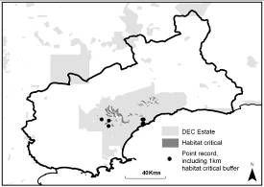

References
Barrett, S., Comer, S., McQuoid, N., Porter, M., Tiller, C. & Utber, D. (2009) Identification and Conservation of Fire Sensitive Ecosystems and Species of the South Coast Natural Resource Management Region. Department of Environment and Conservation, South Coast Region, Western Australia.
Environment Australia (EA) (2001). Threat Abatement Plan for Dieback Caused by the Root-rot Fungus Phytophthora cinnamomi. http://www.environment.gov.au
/biodiversity/threatened/publications/tap/phytophthora.html - Accessed 12/4/2010
Robinson, C.J. & Coates, D.J. (1995) Declared Rare and Poorly Known Flora in the Albany District, Wildlife Management Program No 20. Department of Conservation and Land Management, Perth, Western Australia.
Threatened Species Scientific Committee (2008). Commonwealth Conservation Advice on Verticordia crebra. Department of the Environment, Water, Heritage and the Arts. http://www.environment.gov.au/biodiversity/threatened/species/pubs/55678-conservation-advice.pdf - Accessed 12/4/2010
Verticordia helichrysantha (Myrtaceae)
(Coast Featherflower)

Conservation Status
- Environment Protection & Biodiversity Conservation Act (1999): Vulnerable
- Western Australian Wildlife Conservation Act (1950): Vulnerable
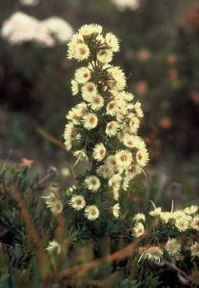
Photo: © Sarah Barrett (DEC)
Description
A small, sprawling shrub up to 20cm high. Leaves small (6mm long), linear with revolute margins. Flowers (7mm diameter) pale-yellow with minutely-dentate oval petals, a hairy calyx tube (3mm long) and long, prominent, slightly hooked pale-pink style (15mm long).

Distribution
Known from five current populations on south coat of WA, one of which occurs in Fitzgerald Biosphere, in FRNP, comprising c.35,000 plants.
Occurs in grey-brown sandy soils over laterite gravel over spongolite geology in low coastal heath.

Important Populations
All five known populations are considered important for the long-term survival of this species.

Habitat Critical to Survival
- The area of occupancy of the known populations; and
- Similar habitat within 1km of distribution records that provides potential habitat buffer for the species.

Biology and Ecology
Flowers Sep-Oct. Killed by fire and regenerates from soil-stored seed. However, regenerates poorly after other disturbance. Presumed to be susceptible to Phytophthora cinnamomi. Juvenile period is >4 yrs.

Threats
Inappropriate fire regimes (high frequency); Phytophthora dieback; Climate change (i.e. drought).

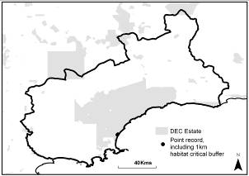

References
Barrett, S., Comer, S., McQuoid, N., Porter, M., Tiller, C. & Utber, D. (2009) Identification and Conservation of Fire Sensitive Ecosystems and Species of the South Coast Natural Resource Management Region. Department of Environment and Conservation, South Coast Region, Western Australia.
Environment Australia (EA) (2001). Threat Abatement Plan for Dieback Caused by the Root-rot Fungus Phytophthora cinnamomi. http://www.environment.gov.au/biodiversity/threatened/publications/tap/phytophthora.html - Accessed 12/4/2010
Robinson, C.J. & Coates, D.J. (1995) Declared Rare and Poorly Known Flora in the Albany District, Wildlife Management Program No 20. Department of Conservation and Land Management, Perth, Western Australia.
Threatened Species Scientific Committee (2008). Commonwealth Conservation Advice on Verticordia helichrysantha. Department of the Environment, Water, Heritage and the Arts. http://www.environment.gov.au
/biodiversity/threatened/species/pubs/8204-conservation-advice.pdf - Accessed 12/4/2010
Verticordia pityrhops (Myrtaceae)
(Mount Barren Featherflower)

Conservation Status
- Environment Protection & Biodiversity Conservation Act (1999): Endangered
- Western Australian Wildlife Conservation Act (1950): Endangered
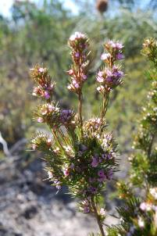
Photo: © Saul Cowen (DEC)
Description
An erect, single stemmed shrub up to 150cm high. Leaves 14mm, dark-green and fine. Flowers small and range from white to bright pink in colour with finely fringed sepals and petals and a honey-like scent.

Distribution and Habitat
Single population restricted to southern slopes of East Mt Barren, near Hopetoun in FRNP. Approximately 3,000 mature individuals occur in this area.
Occurs in white sandy soil over and among quartzite geology on wave-cut bench approximately 100m above sea-level, in an open heath and shrubland community.

Important Populations
The single population in FRNP is considered important.

Habitat Critical to Survival
- The area of occupancy of the known populations; and
- Similar habitat within 1km of all species distribution records that provides a potential habitat buffer for the species.

Biology and Ecology
Flowers February to June. Killed by fire and regenerates very slowly from soil-stored seed, e.g. no regeneration seen after 2006 in fire age vegetation (S. Barrett & S. Cowen pers. obs.). Juvenile period is 7 yrs. Presumed to be susceptible to Phytophthora cinnamomi.

Threats
Inappropriate fire regimes (high frequency); Phytophthora dieback; Stochastic events; Climate change.

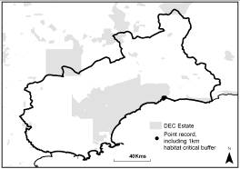

References
Barrett, S., Comer, S., McQuoid, N., Porter, M., Tiller, C. & Utber, D. (2009) Identification and Conservation of Fire Sensitive Ecosystems and Species of the South Coast Natural Resource Management Region. Department of Environment and Conservation, South Coast Region, Western Australia.
Robinson, C.J. & Coates, D.J. (1995) Declared Rare and Poorly Known Flora in the Albany District, Wildlife Management Program No 20. Department of Conservation and Land Management, Perth, Western Australia.
Threatened Species Scientific Committee (2008). Commonwealth Conservation Advice on Verticordia pityrhops. Department of the Environment, Water, Heritage and the Arts. http://www.environment.gov.au
/biodiversity/threatened/species/pubs/55798-conservation-advice.pdf - Accessed 12/4/2010
Eucalyptus acies mallee-heath (Community)
(Central Barren Ranges – Fitzgerald River NP)

Conservation Status
- Environment Protection & Biodiversity Conservation Act (1999): Not listed
- Western Australian Wildlife Conservation Act (1950): Vulnerable
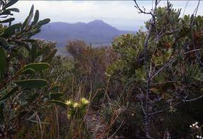
Photo: © Sarah Barrett (DEC)
Description
Mallee-heath dominated by Eucalyptus acies (Woolbernup Mallee), a straggly shrub or low mallee (up to 3m high) with broad, thick sub-opposite leaves, angular branchlets and rigidly down-curved inflorescences.

Distribution and Habitat
Restricted to Central Barren Ranges in FRNP, specifically Thumb Peak, Mid-Mt Barren and Woolbernup Hill.
Occurs on sandy skeletal soils on quartzite hills. Associated Declared Rare Flora species are Coopernookia georgei (Endangered), Daviesia obovata (Endangered) and Grevillea infundibularis (Vulnerable). E. acies listed as Priority 4.

Important Populations
All of the known distribution of the TEC is considered important.

Habitat Critical to Survival
- The current distribution of the TEC.

Biology and Ecology
Community is highly vulnerable to infestation by the pathogen Phytophthora cinnamomi as is dominated by highly susceptible plant spp.
Also dominated by serotinous obligate seeders and therefore sensitive to frequent fire.

Threats
Inappropriate fire regimes; Phytophthora dieback, Stochastic events, Climate change.

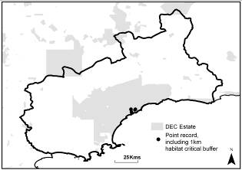

References
Brooker, M.I.H, Slee, A.V. & Connors, J.R. (2002) EUCLID – Eucalypts of Southern Australia (second edition). CSIRO Publishing, Melbourne, Victoria, Australia.
Shearer, B.L., Crane, C.E., Barrett, S. & Cochrane, A. (2007) Phytophthora cinnamomi invasion, a major threatening process to conservation of flora diversity in the South-west Botanical Province of Western Australia.
Western Australian Herbarium (1998) Florabase - The Western Australia Flora - Eucalyptus acies Brooker. http://florabase.calm.wa.gov.au/browse/profile/5546 - Accessed 12/4/2010
Wilkins, P., Gilfillan, S., Watson, J. and Sanders, A. (ed). (2006) The Western Australian South Coast Macro Corridor Network – a bioregional strategy for nature conservation, Department of Conservation and Land Management (CALM) and South Coast Regional Initiative Planning Team (SCRIPT), Albany, Western Australia.

