**FLIGHTLINES**

Newsletter of the Australian Bird and Bat Banding Scheme (ABBBS)

Number 34 – July 2019

Edited by Naomi Clarke

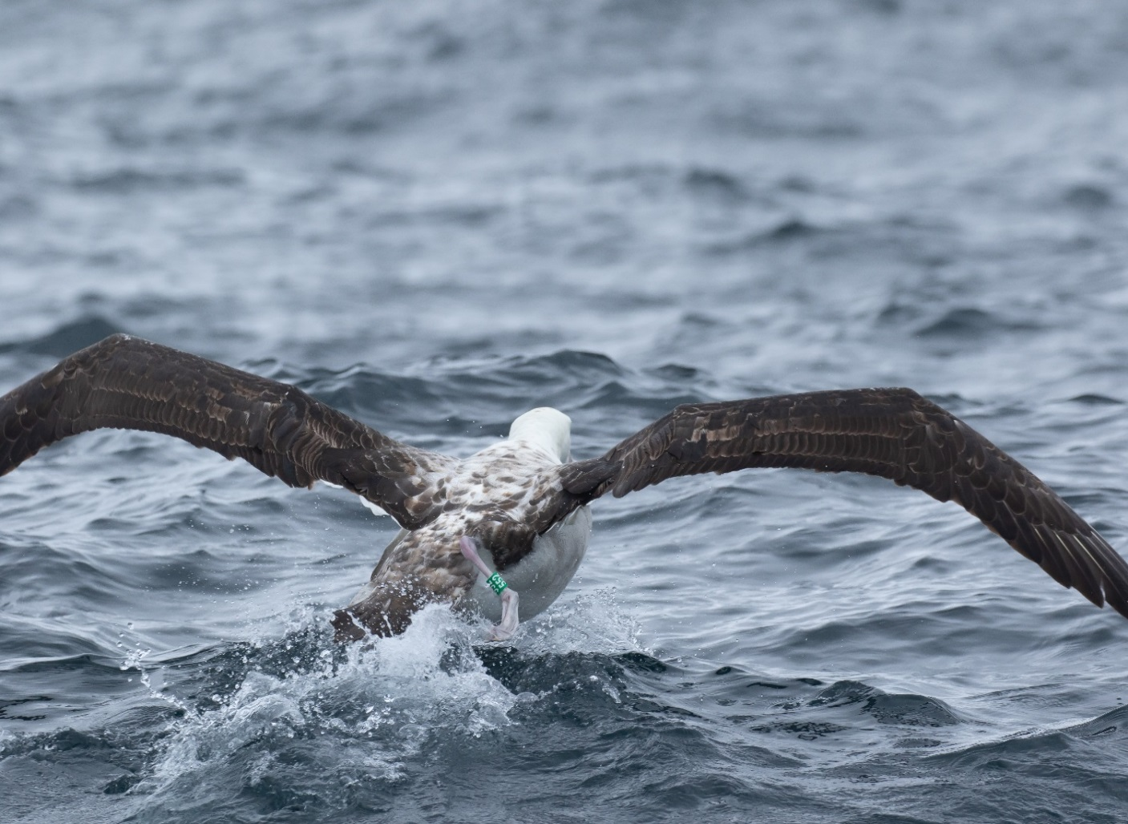

INDEX

BANDING OFFICE UPDATE……………………………………………………………………………..3  
 Staff Changes…………………………………………………………………………….....3  
 Regional Organisers Changes………………………………………………………….....3

REMINDERS………………………………………………………………………………………………..4  
 Mortality Reporting…………………..……………………………………………………...4  
 Referee Reports/Authority/Upgrades…………………………………………………......4  
 Locode Registration Requests………………………………………………………….....4  
 Requisition for Banding Supplies……………………………………………………….....4  
 Project Applications…………………………………………………………………………4  
 Banding Office Email Address……………………………………………………………..5  
 ABBBS Website……………………………………………………………………………..5  
 Copies of Journal Articles…………………………………………………………………..5  
 Licencing and Approvals……………………………………………………………………5

RENEWALS AND REPORTS…………………………………………………………………………….6  
 Annual Renewals……………………………………………………………………………6  
 Update of Contact Details and Permissions……………………………………………...6  
 Annual Project Reports……………………………………………………………………..6

DATA MANAGEMENT…………………………………………………………………………………….6  
 Electronic Submission of all Banding and Retrap Data…………………………………6  
 Bands and Band Design……………………………………………………………………7

BANDER CODE OF CONDUCT............…………………………………………………………………7

BILLBOARD.………………………………………………………………………………………………..8  
 Band Wear Study – Baylis et al 2018……………………………………………………..8  
 Excitement All Round……………………………………………………………………….8  
 Looking to Band African Birds – An Invitation……………………………………………9  
 Fairy Tern Longevity ‘Pipped” by 19 Days……………………………………………….10  
  
  
  
FAREWELL LETTER FROM DAVID…………………………………………………………………….11

CURRENT ADDRESS AND CONTACT DETAILS…………………………………………………….12

## 

## BANDING OFFICE UPDATE

### 

### Staff Changes There has been one momentous change to staffing in the ABBBS since the last issue of Flightlines.

After 23 years of working in the Banding Office, David has moved on to bigger and better (?) things, taking up a promotional role with the Department's IT area. David has shared a long and productive relationship with many of you over the years. The Banding Office is sorry to see him go and wishes him all the very best in his new endeavours.

Naomi now has responsibility for managing all project and colour marking applications, data requests, banding authority applications and general queries.

The Banding Office welcomes Madeleine into the team. Maddii now manages all data submissions, public recoveries and general enquiries.

The Banding Office is located in the John Gorton Building in Parkes, ACT (opposite the Australian National Gallery). Due to security arrangements in this building, visitors must be signed in and escorted by a staff member. If you would like to visit the banding office, please let us know in advance so we can make the necessary arrangements.

**REGIONAL ORGANISERS UPDATE**

**Alan Leishman** recently stepped down from the role of Regional Organiser for NSW. I would like to personally extend my thanks to Alan for his commitment to the banding community and the role of ABBBS Regional Organiser for NSW. For many years Alan has provided training, guidance and support to many people within the banding community, both new and experienced banders. I know Alan will continue to be active within the banding community and share his skills and knowledge.

**Tony Hunt** has agreed to fill Alan’s, rather large, shoes as the Regional Organiser for NSW and I am confident that Tony will be up to the task. The Banding Office looks forward to working with Tony in this capacity as the ABBBS and the banding community move into the future. Contact details for Tony are available from the Banding Office and our website under the Regional Organiser's page:

http://www.environment.gov.au/science/bird-and-bat-banding/regional-organisers

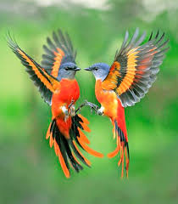

### \\UPVVIRTCLUS04FS\Users$\A10032\Documents\My Pictures\dont forget.jpg\\UPVVIRTCLUS04FS\Users$\A10032\Documents\My Pictures\dont forget.jpg REMINDERS

|  |
| --- |
| **MORTALITY REPORTING**  Any mortalities that occur during or immediately after a banding expedition must be reported to:   * The ABBBS within seven days. If required, additional details can be provided after the original notification. Additional details can be forwarded within fourteen days. You can request a longer time frame for additional information with justification as to why this follow up report will be delayed (ie awaiting autopsy report). * The applicable Ethics Committee within its stipulated time frame. |

**Referee Reports / Authority Upgrades**

When completing referee reports please remember to use the *Referee Report* template as a guide. Referees should always provide additional page/s detailing the experience of, and what you have observed/taught/shared with, the individual bander who is requesting an upgrade. ABBBS staff are not on the ground with you and this detail provides us with a solid base to assess banding and endorsement applications.

We recommend you maintain a bander diary of your banding experience and to provide a copy with your application to upgrade your banding authority or endorsement. Please encourage all trainee banders (both C and R class) to maintain a trainee diary as this will make completing the report easier as you will have access to banding activity details of what, when, how and with whom.

**Locode Registration Requests**

Locodes are currently entered manually by the Banding Office, so ensure that the *Location Code Registration* form is used. The Banding Office can provide a copy of the locodes you already have (you can also access this via the Secure Client Portal). Ensure all required information is included. The Banding Office does not create these for you. It is the responsibility of the project holder to provide this information.

### Requisitions for Banding Supplies All requests for bands and pliers must be made on the *Requisition for Banding Supplies* form available on the ABBBS website. Requests by phone or contained within an email message will not be actioned.

Please ensure that you provide a valid postal address, and provide the metal types as well as the sizes required. The new *Recommended Band Size List* has metal types recorded for each band size recommendation, as well a complete list of band specifications. If in doubt, please contact the Banding Office before making a request.

Please allow a two to three week lead time, more if you are sending your request form by postal mail. It takes up to eight (8) business days for any parcel to arrive and even express post has no guarantee of overnight arrival.

**Project Applications**

New or revised project applications should include:

* *Project Proposal Application* form.
* Research plan/project.
* Ethics application.
* *Colour Marking Authority Application* form. If you intend on colour banding/marking or using geo locators/radio transmitters you will need to include this completed form.
* Ethics approval and State/Territory Permit/Licenses should be forwarded to the ABBBS as soon as they are issued to allow final project approval.

### Banding Office Email Address: A reminder that all email correspondence must be directed to [abbbs@environment.gov.au](mailto:abbbs@environment.gov.au). Emails sent directly to Banding Office staff will be returned to the sender and not actioned.

### ABBBS Website The ABBBS website address remains unchanged: <http://www.environment.gov.au/science/bird-and-bat-banding>

All ABBBS forms are available from the website, as well as access to the Secure Client Portal.

There are also links to State and Territory Wildlife Management Agency licencing sections, ABSA for additional banding supplies and Interex a colour band supplier.

We also have access to a PDF version of the Banders Aid (Rogers et al 1986), including Supplement Number One (Rogers et al 1990). Our thanks to Ken, Annie and Danny Rogers for making this available.

**Copies of Journal Articles**  
  
Please send the ABBBS a copy of any journal article that you publish that includes information generated from your banding studies. You can include them with your annual project reports. Electronic copies in PDF format are preferred, if possible. Having copies of your papers help us to illustrate the value of the ABBBS and banding in general.

In addition to this request, we also ask that banders acknowledge the ABBBS in these papers for provision of support for the project. Many thanks to the banders who have already sent papers in, including those that have acknowledged the assistance of the ABBBS.

## Licensing and Approvals ANIMAL ETHICS AND STATE/TERRITORY APPROVALS

It is the responsibility of the project holder to ensure that applicable State/Territory and ethics approvals for all states and /or territories in which the project is being carried out are current; and that a copy is forwarded to the Banding Office.

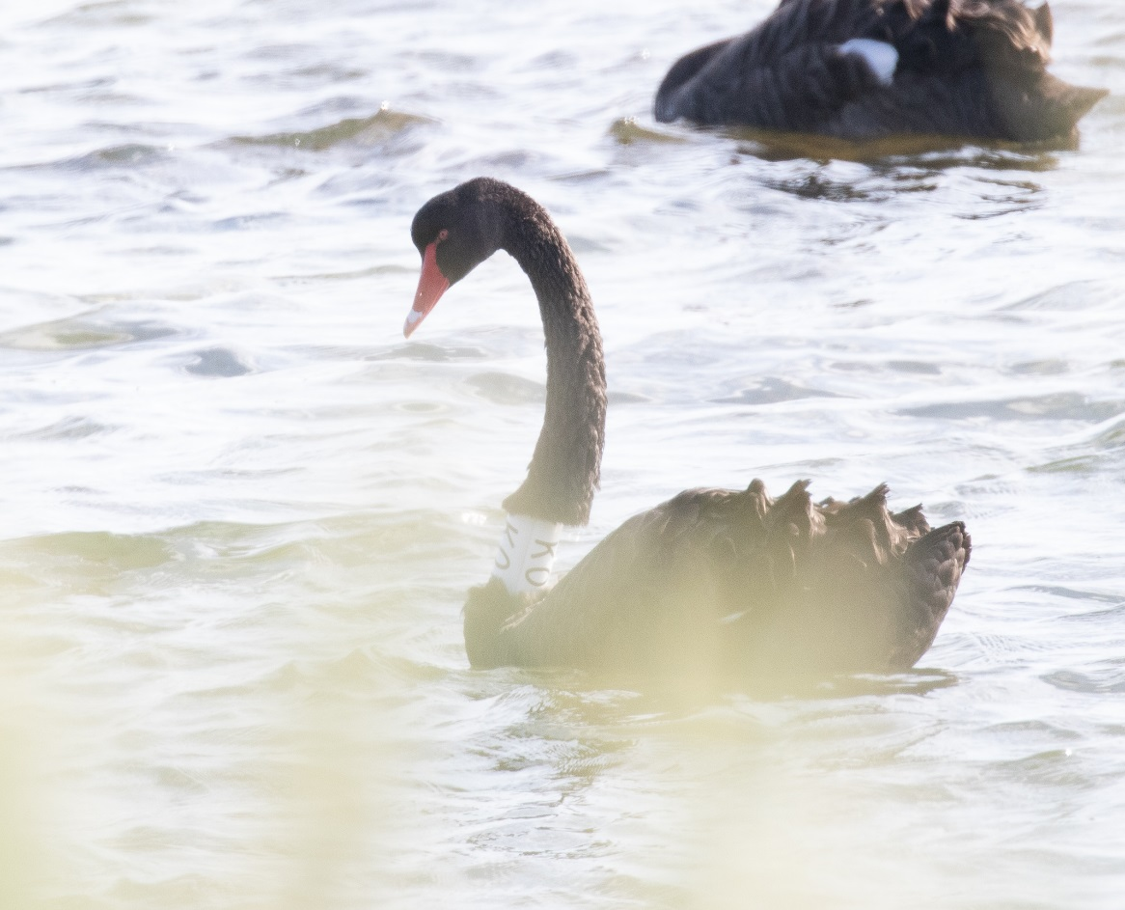

### \\UPVVIRTCLUS04FS\Users$\A10032\Documents\My Pictures\report.png

### RENEWALS AND REPORTS

### Annual Renewals

All banding authorities have been renewed until 31 July 2020, and yours is enclosed with this newsletter.

If you no longer require a banding authority, please let the Banding Office know and we will arrange to cancel it. If you resign your authority you are required to return all unused bands and outstanding banding data. Any bander that resigns their authority is able to reactivate it at any time within the following five years without any further requirement for assessment.

If you relocate, please remember to update your postal address with Banding Office, using the *Current Address and Contact Details* form on the website. A copy of this form can also be found on page 12 of this Newsletter, this ensures your authority remains valid and you keep receiving your copy of Flightlines and authority renewals.

### Request for Updated Contact Details and Permissions

CONTACT DETAILS  
The Banding Office requires a current postal address for all banders, If your address changes you should use the *Current Address and Contact Details* form, for ease and quick return you will find a copy on the last page. If your mail is returned to the Banding Office unopened, your authority will be cancelled.

PERMISSSIONS

The *Current Address and Contact Details* form contains a section on permissions. It is important that banders set their permissions to ensure that we are aware of your preferences with regard to personal contact information.

CONFIDENTIALITY

Unless you specifically request confidentiality on the *Current Address and Contact Details* form, data collected under your project is freely available to whoever requests it under our Creative Commons Attribution arrangement.

**Annual Project Reports**

ABBBS annual project reports are due by 31 July each year. Banders failing to report on the progress of their banding projects may have support for their projects withdrawn.

* Your banding and re-trap data must be validated and submitted via the Secure Client Portal on our website.
* All project annual reports and data submissions are due by 31 July. Contact us **today** if you believe you will not submit your report and data by this date .

## DATA MANAGEMENT

### Electronic Submission of all Banding and Retrap Data

A reminder that all data must be submitted in approved electronic format via our Secure Client Portal. The Secure Client Portal can be accessed through the Department’s website at:

<https://secure.environment.gov.au/deh/biodiversity/science/abbbs/index.html>

Please note, only current A-class banders may access the portal. However, we encourage all R and C class banders to undergo training with their supervisor(s) on how to prepare, validate and submit data for the ABBBS. A high level of competency in these areas will be required for any banding authority upgrades.

Guidelines for banders on the preparation of banding data for electronic submission can be accessed through the Department’s webpage at:

<http://www.environment.gov.au/science/abbbs/publications/guidelines-banders-2015>

Please contact the ABBBS if you have any queries, or would like further guidance on how to use the Secure Client Portal.

## BANDS AND BAND DESIGN

There are no new band designs to report in this edition. If you feel that your study birds need a more suitable marking method, please contact the Banding Office to discuss your concerns and requirements. Banders are also asked to continue to send in *Trial of Band Size* forms when bands other than those in the recommended band size list are used. This information is used to update our recommended band sizes. The *Trial of Band Size* form is available on our website.

**BANDER'S CODE**

Banders have an ethical and scientific responsibility to avoid or minimise adverse impacts on their study animal. It is essential to consider the potential impacts of the planned project on the study species. Below is an outline of the principles the ABBBS expects authorised banders to uphold:

• Capturing, handling and banding birds is a privilege and carries with it responsibilities.

• Banders must hold appropriate certification, ethics approvals and permits.

• Banders are responsible for the safety of the birds in their care, ensuring birds are released in good condition, at the site of capture, and with minimal disruption to their lives.

• The welfare of the bird is paramount.

• Only catch as many birds as are required for the purpose of your study.

• Handle each bird carefully, gently, quietly with respect and for the shortest possible time.

• DO NOT operate more trapping/catching equipment than you can properly manage. Ensure all traps are removed after use.

• Capture and process only as many birds as you can safely handle.

• DO NOT allow unqualified persons to use your equipment capture or handle birds, or fit bands except under direct supervision.

• DO NOT attempt to capture birds in conditions that could result in birds becoming severely stressed, subject to potential injury, death or abandonment of nests or young.

• Regularly check nets, traps and site conditions according to target species.

• Treat all bird injuries in the most humane way.

• Keep careful and accurate records of all banding activities including injuries and mortalities and submit reports to all appropriate authorities.

• Banders should continually assess their own work to ensure that it is beyond reproach, look for ways to improve your techniques and advise the ABBBS of improved methods.

• Reassess your methods and approach whenever any injury or mortality occurs and enact changes to prevent repeated occurrences.

• Banders should ask for, and offer, constructive assessment of skills and techniques to maintain the highest standards possible.

**BILLBOARD**

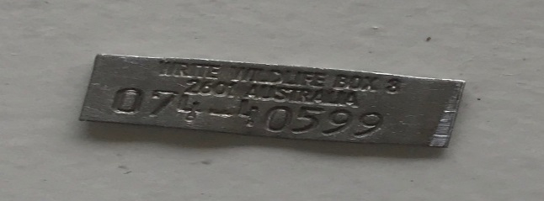

**BAND WEAR STUDY** Baylis et al 2018 Journal of Field Ornithology:

Analysis: Just how long do our bands last in the wild?  
  
As banders, we're well aware of the need for reliable, rugged bands that will stay on birds for their whole lifespan. Band loss can bias our scientific estimates, and worn-out or misapplied bands can result in entanglement and death for the birds we study, so it's worth paying close attention to how well our bands stand up to being worn in the field over years or decades.  
  
In that vein, the ABBBS has maintained an archive of returned, worn bands since the inception of the scheme - mostly recovered from freshly-dead birds and returned to the banding office by diligent banders. Working with researchers from Monash University, we have published a broad-scale analysis of band wear rates across 173 species, five band metals, and 236 unique combinations of species, band metal, and band size. Our band archive includes all returned bands, without any pre-judgement about which bands are most likely to wear out, so our analyses show the 'typical' patterns of band wear. In contrast, it seems likely that many other published papers on band wear were written because someone noticed rapid wear on their species, and thought that other banders should be warned - useful information, but with the side-effect that the published literature on wear rates tends to reflect unusually-rapid wear rates, rather than typical wear rates.  
  
The study is available in the Journal of Field Ornithology

[<https://onlinelibrary.wiley.com/doi/pdf/10.1111/jofo.12268>], and the raw data and analysis scripts are available on

github [<https://github.com/SMBaylis/BandWear_JFO>].

You can contact Shane by email [shane.m.baylis@gmail.com](mailto:shane.m.baylis@gmail.com), if you would like to discuss this study.

**EXCITEMENT ALL ROUND**

Steve, from Mission Beach Wildcare Inc, reported watching Great Frigatebirds, *Frigata minor,* flying up the coast on Wednesday 30 January. Five days later he received a call regarding a large bird seemingly unwell and struggling to move. Steve followed up the call and found a Great Frigatebird, bearing ABBBS band 210-03689, up above the shoreline unable to use one wing and very weak. Sadly the bird had to be euthanised.

This recovery is now the longest time elapsed between banding and recovery, for this species, that we have on record.

It turned out that this individual was banded by Barry Baker at Coringa Islet in 1985. At the time of banding the bird was recorded as a +3 year old bird. Its 5 February 2019 recovery places the age of the bird at around 34 years.   
  
Of the total 479 individuals of this species banded by Australian banders, we have only received four recovery/resighting reports and none have been more than 4 years between banding and resighting. If you are interested in the excitement this recovery created, follow the link to the Mission Beach Wildcare Inc Facebook report:

<https://m.facebook.com/story.php?story_fbid=2087212754834435&id=1597704477118601>

**LOOKING TO BAND AFRICAN BIRDS** – Please find below an invitation from Dr H. Dieter Oschadleus

|  |
| --- |
| African Ringing Expeditions (Biodiversity and Development Institute) is setting up a long-term bird monitoring site near Cape Town, South Africa. We want this to grow to become the first “bird observatory” in southern Africa. The chosen site is an hour’s drive from Cape Town International Airport. The ringing site itself is amazing, on a wine farm that uses neither pesticides nor herbicides. The accommodation is superb, in an attractive valley.  Our aim is to cumulatively build a long-term database which can be used for a variety of research studies. Selected species will be colour-ringed to study survival and other aspects (eg territory sizes and interactions). Primary moult is being recorded for all species to study variation in timing and duration of moult (annually and in different habitats). More projects will be developed as more ringers visit. A wide variety of species has already been ringed at the site, and there is potential for many more species to be ringed.  Two blog posts describe the details of a very successful ringing expedition held recently:  <http://thebdi.org/blog/2019/03/04/establishing-a-long-term-bird-ringing-site-part-1-the-place/>  <http://thebdi.org/blog/2019/03/05/establishing-a-long-term-bird-ringing-site-part-2-some-birds/>  Also there is a species list of birds ringed at  <http://weavers.adu.org.za/newstable.php?id=834>  Please forward to anyone you know that may be interested in going on this expedition - details are at <http://thebdi.org/about/african-ringing-expeditions/> or send me an email, [doschadleus@gmail.com](mailto:doschadleus@gmail.com), |

Dupont, Bernard (2016), Lilac-breasted Roller (Coracias caudate) (Picture was given frame)

Keats, Derek (2018), Southern Yellow-billed Hornbill, Tockus leucomelas at Marakele National Park, Limpopo, South Africa (Picture was given frame)

Dupont, Bernard (2016), Lesser Masked Weaver (Ploceus intermedius) male flying away with a strip of leaf for its nest (Picture was given frame)

All photos made possible with freeforcommercial.org

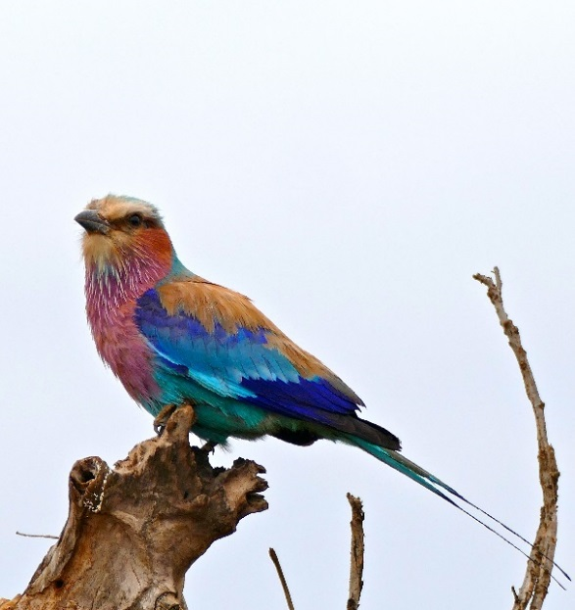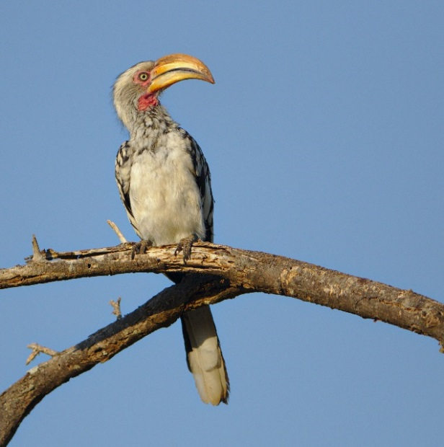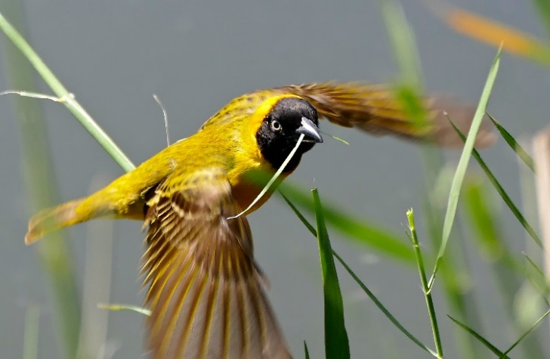

**FAIRY TERN LONGEVITY ‘PIPPED’ BY 19 DAYS**

Many of you will remember the photo below from the ABBBS Christmas card. The full story behind this photo is below.

Seemingly in competition with each other, two Fairy Terns (*Sternula nereis*) who were banded as chicks on Tern Island, Western Australia on 17 January 1997, were resighted late last year within a couple of weeks of each other at Breakwater Parade, Mandurah WA. This resighting took the record for the maximum time elapsed between banding and resighting for this species. Both birds were banded by Nic Dunlop.

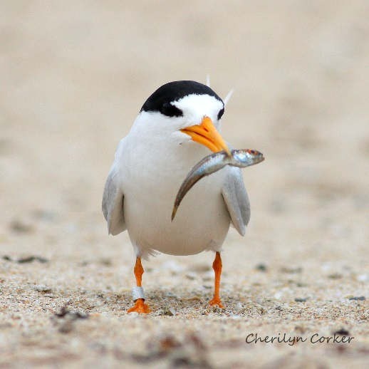“Max”, wearing band 040-78646, was sighted strutting his stuff on 18 November 2018 and created some excitement by being the oldest Fairy Tern on our records at 21 years 10 months and 5 days.

“Pip”, wearing band 040-78624, was not to be outdone. Pip posed for a photo opportunity almost three weeks later on 11 December 2018, upping the longevity to 21 years 10 months and 24 days – “Pipping” Max at the post by 19 days.

Photo Cherilyn Corker 20181211 “Pip”

The competition then expanded to include a Silver Gull (*Chroicocephalus novaehollandiae*) bearing 210-03689. This silver gull was banded at Spectacle Island, Tasmania, on 10 December 1988 aged at 2+ years, under the ANPWS_DOE Coral Sea Project.  
  
After being found on 28 November 2018 tangled in fishing line at South Brisbane, Queensland, this hardy bird was rehabilitated and released alive at an age of 30years +. The maximum time elapsed between banding and recovery was 29 years 11 months and 18 days.

A great way to close the 2018/2019 banding year.

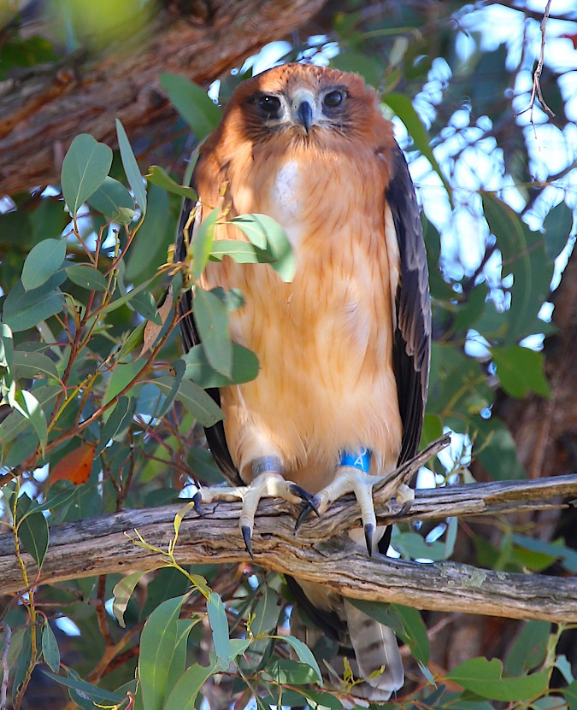

Banded Little Eagle Photo Credit: Jerry Olsen

**Farewell to the ABBBS from Dave**

As many of you now know, I have taken up a promotion to become our Department's ‘Data Librarian’ working across the entire agency to understand what data we have and how it is used & managed. It was a difficult decision to leave the ABBBS, as this has been without a doubt the most incredibly enjoyable and rewarding journey. Not only did I get to learn about birds & bats every day from the world’s best scientific minds, I also got to interact and collaborate with a wonderful, kind, generous and good humoured group of likeminded people – the banders. Indeed, the banders are the main reason I stayed in the ABBBS for 23 years.

Some of the best experiences of my life have been work trips – and I don’t know many people that can say that! Of particular note were multiple trips to Indonesia to conduct bander training in collaboration with the Indonesian Institute of Sciences. This program would not have been possible without the dedication, hard work, enthusiasm and support from quite a number of banders – in particular Mark Clayton, Alan Leishman, Richard Noske, Bill Rutherford & Anthony Overs. I am eternally grateful and indebted to all of you. We visited some places that I would have never had the chance to visit and see, handle and band birds of species that I would never have dreamed of when I started in the ABBBS in 1995. Although I did miss the Satanic Nightjar! I also had magic banding trips to Christmas Island, Hungary, Broome, Perth, Rotamah Island, Clouds Creek, Sale, Warraderry, West Wyalong, New Chums, at sea off Wollongong and even the Botanic Gardens here in Canberra. I learnt something new every time I went out with banders, who were always willing to pass on their incredible knowledge.

It is funny to think that when I first started I had no knowledge of birds at all – even to the point that all small brown birds were sparrows!! Which of course I now know are LBJ’s.

I’d like to thank all of you for making my time in the ABBBS so enjoyable – in particular the Regional Organiser network both past and present who have provided considered advice and support for my entire career. I have been able to call on many banders over the years for advice and the willingness in which this is given is like nothing else I have ever experienced.

I have also had the chance to work with some fantastic public servants over the years that I have learnt a huge amount from (and may have picked up some bad habits from as well!). In particular Lisa Hardy, Barry Baker, Narelle Montgomery, Tom Scotney (RIP), Belinda Dettmann, Fiona Bartlett, Mark Carey, Sylvana Maas, Peter Benson, Naomi Clarke, Ashley Leedman, Jason Ferris, Karen Arthur, Tony Rosling, Emily Vermeulen (RIP) and Andrew McNee amongst many others.

The one positive that has come out of this change is that now when I go banding it is purely for enjoyment and helping out other researchers. So I hope to get out banding more often when I am not strutting my stuff on the stage in the various bands I play in.

If you are ever in Canberra I’d love to see you. My work email address has remained the same so just get in touch and we can go do some birding in Canberra!

All the best

Dave

## CURRENT ADDRESS AND CONTACT DETAILS

**Title**: ____ **Initials:**  _____ **Preferred first name**:____________________ **Surname: __________________**

**ABBBS Authority no:** __________

**Address**: _______________________________________________________________________________

_______________________________________________________________________________

_______________________________________________________________________________ **Postcode _**__________

**Telephone: home** ( )_______________________  **mobile:** _______________________

**work** ( )_______________________  **Facsimilie:**_____________________

**eMAIL:____________________________________________________________________**

## PERMISSION TO RELEASE NAME AND ADDRESS

I hereby give permission to ABBBS to provide my name and address to the following people or organisations:

|  |  |  |  |
| --- | --- | --- | --- |
|  | **Circle Responses**  Street address Phone Email | | |
| OTHER BANDERS | YES/NO | YES/NO | YES/NO |
| GOVT. RESEARCH ORGANISATIONS (EG CSIRO) | YES/NO | YES/NO | YES/NO |
| NON-GOVT. RESEARCH ORGANISATIONS (EG BIRDLIFE) | YES/NO | YES/NO | YES/NO |
| INDIVIDUAL RESEARCHERS | YES/NO | YES/NO | YES/NO |
| OTHER INTERESTED PERSONS | YES/NO | YES/NO | YES/NO |
| INDIVIDUALS INTERESTED IN BECOMING BANDERS | YES/NO | YES/NO | YES/NO |
| PUBLISH NAME AND CONTACT DETAILS ON ABBBS WEB SITE | YES/NO | YES/NO | YES/NO |

## REQUEST FOR CONFIDENTIALTY OF BANDING DATA

The Department has adopted the Australian Government Open Access and Licensing (AusGOAL) framework, where all data are freely available to any interested parties that request it, with due acknowledgement for the original collector. Banders may request confidentiality for data they have collected. Any request for confidentiality must be accompanied by a business case, and will be granted for a maximum of 3 years. In the absence of a confidentiality request, all data will be freely available. Please note that only project supervisors that have been issued bands are able to make this request. If you are assisting on a project, please speak with your supervisor to make this request.

**Circle response**

NO DATA TO BE RELEASED WITHOUT REFERENCE TO ME YES / NO

If so, please provide justification:

_________________________________________________________________________________________

_________________________________________________________________________________________

_________________________________________________________________________________________

Signature _________________________________________________ Date ______________