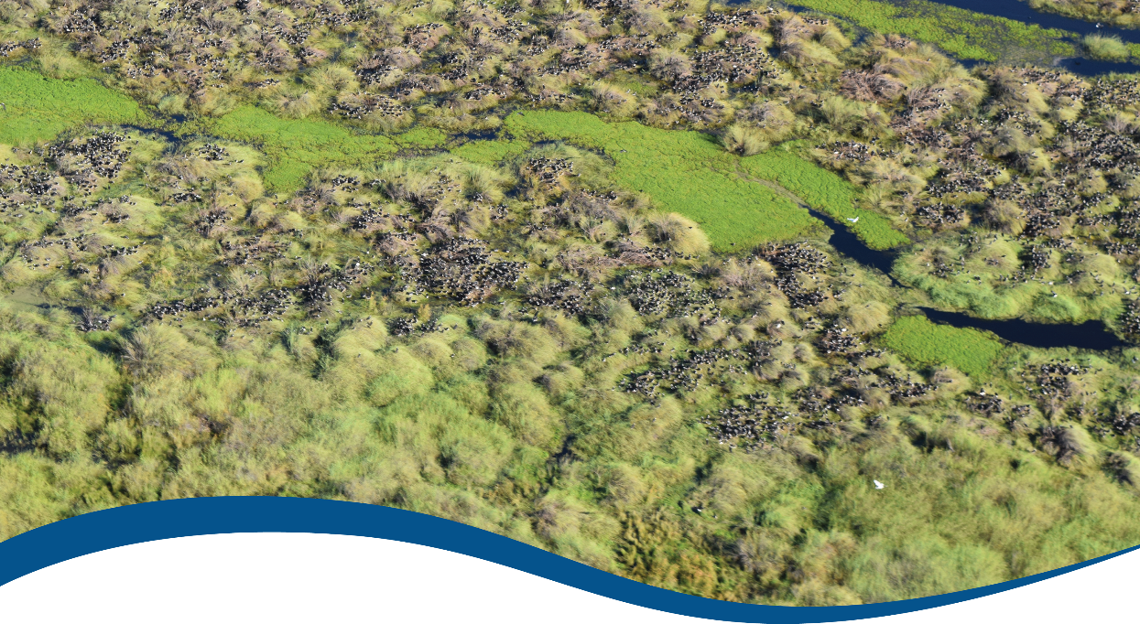

Flow-MER Basin-scale Annual Report 2020
  - Commonwealth Environmental Water Office (CEWO):
Monitoring, Evaluation and Research Program

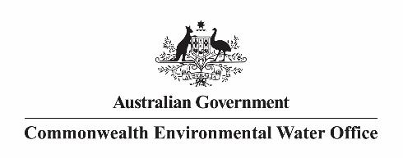
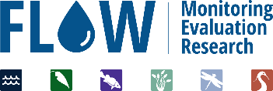
The Flow-MER Program
Flow-MER is the Commonwealth Environmental Water Office’s (CEWO) on-ground Monitoring, Evaluation and Research Program. The Program’s objective is to monitor and evaluate the delivery of Commonwealth environmental water in the Murray-Darling Basin. It provides the CEWO with evidence to inform our understanding of how water for the environment is helping maintain, protect, and restore the ecosystems and native species across the Murray-Darling Basin. This work will support environmental water managers, demonstrate outcomes, inform adaptive management, and fulfil the legislative requirements associated with managing Commonwealth owned environmental water.
The Flow-MER Basin-scale Project is being undertaken from 2019 to 2022 and is led by CSIRO in partnership with the University of Canberra, and collaborating with Charles Sturt University, Deakin University, University of New England, SARDI, Arthur Rylah Institute, NSW Department of Primary Industry, Australian River Restoration Centre and Brooks Ecology & Technology. The Program delivers to the Commonwealth Environmental Water Office, Department of Agriculture, Water and the Environment.
ISBN:
Citation
Pollino C, Thompson R and Flett D (2020) Flow-MER Basin-scale Annual Report 2020. Flow-MER Program. Commonwealth Environmental Water Office (CEWO): Monitoring, Evaluation and Research Program, Department of Agriculture, Water and the Environment, Australia.
Contributors
Joanne Bennett, Shane Brooks, Cherie Campbell, Tanya Doody, Fiona Dyer, James Hitchcock, Galen Holt, Rebecca Lester, Paul McInerney, Luke Lloyd-Jones, Ashley Macqueen, Heather McGinness, Martin Nolan, Darren Ryder, Danial Stratford, Ivor Stuart, Jason Thiem, Charles Todd, Zeb Tonkin, Skye Wassens, Brenton Zampatti.
Cover photograph
Aerial view of Straw-necked ibis colonies in the Booligal Wetlands.
Credit: Will Higgisson (University of Canberra)
Copyright
 © Commonwealth of Australia 2020
With the exception of the Commonwealth Coat of Arms, partner logos and where otherwise noted, all material in this publication is provided under a Creative Commons Attribution 4.0 International Licence https://creativecommons.org/licenses/by/4.0/. The Flow-MER Program requests attribution as ‘© Commonwealth of Australia (Flow-MER Program, https://flow-mer.org.au)’.
Important disclaimer
The information contained in this publication comprises general statements based on scientific research. The reader is advised and needs to be aware that such information may be incomplete or unable to be used in any specific situation. No reliance or actions must therefore be made on that information without seeking prior expert professional, scientific and technical advice. To the extent permitted by law, the Flow-MER Program (including its partners and collaborators) excludes all liability to any person for any consequences, including but not limited to all losses, damages, costs, expenses and any other compensation, arising directly or indirectly from using this publication (in part or in whole) and any information or material contained in it.
The Flow-MER Program is committed to providing web accessible content wherever possible. If you are having difficulties with accessing this document please contact enquiries@flow-mer.org.au.

Executive Summary
This report describes outcomes of the first year of the Basin-scale Evaluation and Research Project (Flow-MER). Flow-MER provides the CEWO with evidence to inform our understanding of how water for the environment is helping maintain, protect, and restore the ecosystems and native species across the Murray-Darling Basin. This evidence exists in the form of data, model outputs and reports. A research portfolio has been designed to enhance this evidence base.
Flow-MER Research commenced in July 2019. This report details outcomes from the initial phases of this Research. Research and evaluation enhance the understanding of environmental outcomes from Commonwealth environmental water and provide knowledge to inform adaptive management.
The overall program is structured around five themes; Hydrology, Fish, Vegetation, Biodiversity and Water Quality and Food Webs, with four cross cutting activities in the areas of Modelling, Data Management and Visualisation, Communication and Engagement (including Indigenous Engagement) and Reporting and Synthesis. There has been an emphasis on co-design of research across themes and with Selected Areas in order to achieve integration across scale and taxa.
A research prioritisation process included input from research partners, Selected Areas, an external Science Advisory Group and the Commonwealth Environmental Water Office (CEWO). Researchers from the Long-Term Intervention Monitoring (LTIM) and Environmental Watering Knowledge and Research (EWKR) projects were consulted to ensure continuity of knowledge.
A planning, prioritisation and review process allocated funding across 10 research projects across the themes, with additional support for two cross-cutting activities.
The research projects are:
- Refugia – Identification, characterisation and management of refuge habitat.
- Flow-ecology relationships – Developing flow-ecology relationships for evaluation modelling.
- Ecosystem energetics – Developing an environmental water energetics response model.
- Fish populations – Fish population models to inform Commonwealth environmental watering.
- Fish movement – Flow, movement and fish population dynamics in the Murray-Darling Basin.
- Non-woody plant responses – Developing condition benchmarks for non-woody vegetation.
- Remote sensing vegetation – Remote sensing trends and temporal condition responses of woody vegetation to environmental water.
- Waterbird movement tracking – Spatial and temporal scales and drivers of waterbird movements and site use across the Basin.
- Resilience – Influence of ecosystem condition on resilience.
- Scaling – Developing an approach to scaling for evaluating ecosystem diversity.

Contents
Executive Summary i
1 Introduction 1
1.1 Commonwealth Environmental Water 1
1.2 The Flow-MER Program 1
1.3 The Basin-scale Flow-MER Project 3
1.4 Flow-MER Research 3
2 Hydrology 7
3 Fish 8
3.1 Fish Theme 8
3.2 Research Focus 9
3.3 Fish populations 9
3.4 Fish movement 11
4 Vegetation 13
4.1 Vegetation Theme 13
4.2 Research Focus 13
4.3 Non-woody plant responses 14
4.4 Remote sensing vegetation 15
5 Biodiversity 18
5.1 Ecosystem and Species Diversity Themes 18
5.2 Research Focus 18
5.3 Waterbird movement tracking 19
5.4 Refugia 21
5.5 Resilience 23
5.6 Scaling 25
6 Water Quality and Food Webs 27
6.1 Water Quality and Food Webs Theme 27
6.2 Research Focus 27
6.3 Ecosystem energetics 28
7 Modelling and data visualisation 31
7.1 Overview of modelling 31
7.2 Flow-ecology relationships 32
7.3 Integrative modelling 33
7.4 Visualisation 35

Figures
Figure 1 Selected Areas established for long-term monitoring of the effects of environmental watering under the LTIM and Flow-MER programs (2015–present) 2
Figure 2 The Flow-MER Project timeline 3
Figure 3 Hydrology Theme activities across the three years of the Flow-MER Program 7
Figure 4 Fish Theme activities across the three years of the Flow-MER Program 8
Figure 5 Fish populations project activities across the three years of the Flow-MER Program 11
Figure 6 Fish movement project activities across the three years of the Flow-MER Program 12
Figure 7 Vegetation Theme activities across the three years of the Flow-MER Program 13
Figure 8 Non-woody plant responses project activities across the three years of the Flow-MER Program 15
Figure 9 Remote sensing vegetation project activities across the three years of the Flow-MER Program 17
Figure 10 Ecosystem and Species Diversity Theme activities across the three years of the Flow-MER Program 18
Figure 11 Waterbird movement tracking project activities across the three years of the Flow-MER Program 21
Figure 12 Refugia project activities across the three years of the Flow-MER Program 23
Figure 13 Resilience project activities across the three years of the Flow-MER Program 24
Figure 14 Scaling project activities across the three years of the Flow-MER Program 26
Figure 15 Water Quality and Food Webs Theme activities across the three years of the Flow-MER Program 27
Figure 16 Ecosystem energetics project activities across the three years of the Flow-MER Program 30
Figure 17 Modelling and Data Visualisation Theme activities across the three years of the Flow-MER Program 31
Figure 18 Flow-ecology relationships research project activities across the three years of the Flow-MER Program 33
Figure 19 Integrative basin modelling research project activities across the three years of the Flow-MER Program 35
Figure 20 Visualisation project activities across the three years of the Flow-MER Program 36

Tables
Table 1 Mapping of activities and themes from LTIM and EWKR into the Flow-MER Program 4
Table 2 Flow-MER research projects mapped to project Themes, with key leadership personnel shown 5
Table 3 Flow-MER cross-cutting projects mapped to project themes, with key leadership personnel shown 6

Abbreviations and acronyms
Abbreviation/acronym | Definition
ANAE | Australian National Aquatic Ecosystem
CEWH | Commonwealth Environmental Water Holder
CEWO | Commonwealth Environmental Water Office
EWKR | Environmental Water Knowledge and Research Project (2014-2019)
Flow-MER | The CEWO Monitoring, Evaluation and Research Program (2019-2022)
LTIM | Long-Term Intervention Monitoring Project (2015-2019)
MER | Monitoring, Evaluation and Research Program (2019-2022)

Introduction

Commonwealth Environmental Water
The Commonwealth Environmental Water Holder (CEWH) is responsible under the Water Act 2007 for managing Commonwealth environmental water holdings. The holdings must be managed to protect or restore the environmental assets of the Murray-Darling Basin, and other areas where the Commonwealth holds water, so as to give effect to relevant international agreements. The Water Act 2007 sets out obligations on the CEWH to report on the contribution of Commonwealth environmental water to the environmental objectives of the Basin Plan (2012).
The Basin Plan sets out the principles for monitoring and evaluating the effectiveness of the Plan. These principles are reflected in the Commonwealth Environmental Water - Monitoring, Evaluation, Reporting and Improvement Framework. Monitoring, evaluation and research support the efficient and effective use of environmental water and assist in demonstrating environmental outcomes from watering activities.

The Flow-MER Program
The Commonwealth Environmental Water Office (CEWO) invests in monitoring, evaluation and research activities delivered through an integrated program called the Monitoring, Evaluation and Research (Flow-MER) Program. This program builds on work undertaken through the Long-Term Intervention Monitoring (LTIM) and Environmental Water Knowledge and Research (EWKR) Projects (2014–2020) to monitor and evaluate the contribution of Commonwealth environmental water to environmental outcomes in the Murray-Darling Basin.
The Flow-MER Program:
- Monitors and evaluates ecological responses to Commonwealth environmental water in seven Selected Areas and at basin-scale using established metrics and methodologies.
- Undertakes best-practice science in seven (7) Selected Areas (Figure 1) and at basin-scale to research ecological processes and thus improve capacity to understand and predict how ecosystems respond to water management.
- Demonstrates outcomes from Commonwealth environmental water and documents these via a regular reporting schedule and engagement and extension activities.
- Facilitates a regular, timely and effective transfer of relevant knowledge to meet the adaptive management information requirements of Commonwealth environmental water decision-makers.
Flow-MER monitoring, evaluation and research is undertaken for six (6) Basin Themes based on ecological indicators developed for the LTIM project and described in the Environmental Water Outcomes Framework. This framework describes the scientific rationale for the selection of ecological indicators to address the environmental objectives contained within Chapter 8 of the Basin Plan and addressed in the Basin-wide Environmental Watering Strategy. Each Theme has a set of foundation or evaluation questions that are outlined in Foundation Reports.
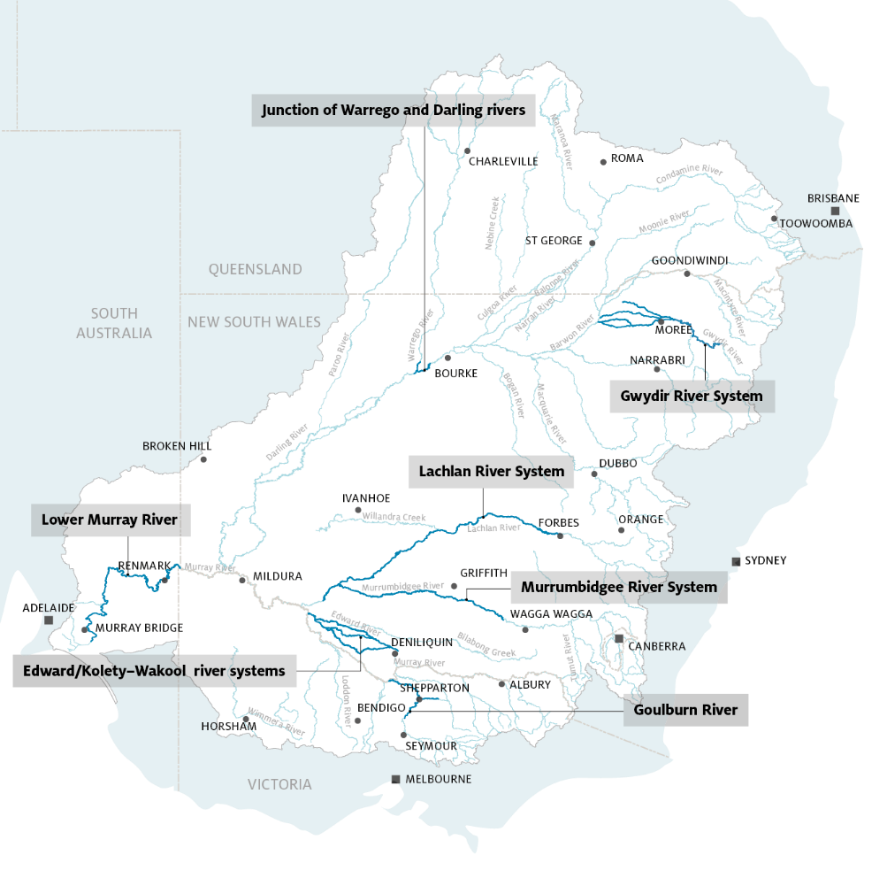
Figure 1 Selected Areas established for long-term monitoring of the effects of environmental watering under the LTIM and Flow-MER programs (2015–present)

The Basin-scale Flow-MER Project
The Basin-scale Flow-MER Project is a three-year $7.7 million investment in evaluation and research to enable reporting on the outcomes of Commonwealth environmental water and support adaptive environmental flow management over time. The purpose of the project is to:
- Demonstrate the outcomes of Commonwealth environmental water across the Basin
- Support adaptive management of Commonwealth environmental water
- Support the Commonwealth Environmental Water Holder to fulfil legislative requirements under the Basin Plan.
The Basin-scale Flow-MER project integrates the Basin-scale Evaluation (formerly the LTIM Project) with the Flow-MER research (formerly the EWKR Project).
The Evaluation is undertaken in conjunction with the Flow-MER Selected Area-scale projects. These Projects provide data at the Selected Area-scale that is used in the Basin-scale Evaluation. Basin-scale evaluations have been undertaken by the LTIM Project up to and including the evaluation of environmental outcomes from environmental watering undertaken during 2018/19.
The Basin-scale Project invests in new and ongoing research to support environmental water management and inform and enhance Basin-scale Evaluation. Basin-scale research under Flow-MER commenced in July 2019. The research portfolio continues EWKR research and invests in new projects designed to improve our scientific understanding of ecological responses to environmental watering. Research is being undertaken throughout the Basin. An outline of activities can be found in Figure 2.
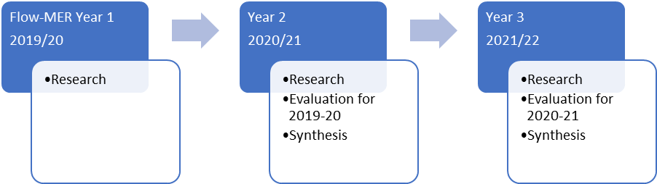
Figure 2 The Flow-MER Project timeline

Flow-MER Research
The Flow-MER Program is the primary means by which the CEWO undertakes research to deliver improved methods and a richer evaluation of environmental outcomes from Commonwealth environmental water. Research undertaken at the basin-scale is complemented by research undertaken at Selected Areas.
Flow-MER Research aims to improve basin-scale understanding of the contribution of Commonwealth environmental water within and outside of Selected Areas, develop new approaches to evaluating outcomes, support adaptive management and develop a richer understanding of ecological processes and responses to Commonwealth environmental water. The Research Plan has evolved from the LTIM and builds on the EWKR research priorities together with a large body of previous work (Table 1).
Table 1 Mapping of activities and themes from LTIM and EWKR into the Flow-MER Program
 | Previous programs |  | Current program
 | LTIM | EWKR | Flow-MER
Activities | Selected Area Monitoring |  | Selected Area Monitoring
Activities | Selected Area Monitoring |  | Selected Area Research
Activities | Basin-scale Evaluation | Basin-scale Research | Basin-scale Evaluation
Activities | Basin-scale Evaluation | Basin-scale Research | Basin-scale Research
Theme | Hydrology |  | Hydrology
Theme | Metabolism and Water Quality | Food Webs | Water Quality and Food Webs
Theme | Vegetation Diversity | Vegetation | Vegetation
Theme | Fish | Fish | Fish
Theme | Ecosystem Diversity |  | Ecosystem Diversity
Theme | Generic Diversity | Waterbirds | Species Diversity

Requirements for the research portfolio of projects included:
- Continuation and leveraging of research being undertaken in the Murray-Darling Basin, most notably EWKR
- Ensuring a pathway for projects to inform the evaluation, in evaluating the benefits of Commonwealth environmental water
- Building on and complementing strong networks, particularly across Selected Areas
- Focussing outputs on integration, across physical scales as well as across themes of activities.
A research prioritisation and planning exercise was undertaken in Stage 1 during the first half of 2019. From this, a project portfolio was derived, across Themes. In Stage 2, a phased approach was used to further define the projects within the portfolio. This involved:
- Review and assessment of research undertaken through EWKR and other programs.
- Consultation with Selected Area teams.
- Development of Draft Research Project Plans for assessment.
- Ranking and prioritisation of Draft Research Project Plans.
- Consultation with Selected Areas teams and CEWO.
- Development of Research Plans for review by the external Science Advisory Group.
- Finalisation of Research Plans, development of Operational Plans through a two-stage process and revision of the project ‘Basin Flow-MER Evaluation and Research Plan’.
- Appointment of dedicated research staff.
The Basin-scale Research Plan has been developed to enhance evaluation by improving approaches and methods, better scaling outcomes across Selected and non-Selected Areas in the Basin, using approaches that can explore synergies of outcomes between Themes and provide a richer understanding of outcomes of Commonwealth environmental watering. Research projects are listed in Table 2 and Table 3.
Table 2 Flow-MER research projects mapped to project Themes, with key leadership personnel shown
Theme and leader(s) | Project and leader(s) | Research summary
Biodiversity  Heather McGinness | Refugia  Joanne Bennett | Identification, characterisation and management of refuge habitat  This research team seeks to understand how ecological refugia are distributed across the Basin and the potential for management of these critical areas to support diversity.
Biodiversity  Heather McGinness | Waterbird movement tracking  Heather McGinness | Spatial and temporal scales and drivers of waterbird movements and site use across the Basin  This project quantifies spatial and temporal scales of waterbird movements and habitat selection across the Murray-Darling Basin. It will use satellite tracking technology and analysis approaches to investigate relationships between waterbird movements, habitat selection, environmental watering, flooding and other variables, building on EWKR waterbird datasets.
Biodiversity  Heather McGinness | Resilience  Shane Brooks  Joanne Bennett | Influence of ecosystem condition on resilience  This project identifies ecosystem condition attributes that help to explain watering outcomes in different ecosystem types. The aim is to identify measures of ecosystem condition that can be used to adjust expected outcomes and tailor evaluation to better match the context under which water is being delivered.
Biodiversity  Heather McGinness | Scaling  Shane Brooks  Joanne Bennett  James Hitchcock | Developing an approach to scaling for evaluating ecosystem diversity  This project is developing approaches for scaling up evaluation of watering outcomes from individual habitat patches to the whole Basin. The aim is to develop a multi-scale approach to evaluate diversity at spatial scales aligned to the scale of watering actions.
Vegetation  Tanya Doody | Non-woody plant responses  Cherie Campbell  Fiona Dyer | Developing condition benchmarks for non-woody vegetation  This research is developing a framework of hierarchical condition benchmarks and a process for evaluating success of outcomes for non-woody vegetation at a Basin-scale.
Vegetation  Tanya Doody | Remote sensing vegetation  Tanya Doody | Remote sensing trends and temporal condition responses of woody vegetation to environmental water  This project is determining the critical thresholds of remotely sensed water use to assess the influence of environmental water; determine relationships between vegetation response and water regimes; inform prioritisation of environmental water for woody vegetation; and, quantify links between vegetation change and hydrology.
Fish  Ivor Stuart | Fish populations  Charles Todd | Fish population models to inform Commonwealth environmental watering  Fish population processes are highly complex and related not just to river flows but many other factors such as habitats, connectivity, fish density and water quality. Population models aim to clearly demonstrate the benefits of environmental water to fish populations.
Fish  Ivor Stuart | Fish movement  Brenton Zampatti  Jason Thiem | Flow, movement and fish population dynamics in the Murray-Darling Basin  This project is developing new models and refining existing models for fish movement of a small number of fish species in the Murray-Darling Basin to inform population level responses to management of flows.
Water Quality and Food webs  Darren Ryder  Paul McInerney | Ecosystem energetics  Darren Ryder  Paul McInerney  James Hitchcock | Developing an environmental water energetics response model  This project is developing a bioenergetic model for how food webs respond to flow, initially focussing on refuge habitats, then extend those models to wetlands and flowing water habitats.

Table 3 Flow-MER cross-cutting projects mapped to project themes, with key leadership personnel shown
Theme and leader(s) | Project and leader(s) | Research summary
Modelling and visualisation  Danial Stratford  Linda Merrin | Flow ecology relationships  Danial Stratford  Luke Lloyd-Jones | Developing flow-ecology relationships for evaluation modelling  This project is undertaking data analysis to understand flow-ecology responses and develop these into a scientifically sound modelling method to support Flow-MER evaluation. This project is linked to the Hydrology Theme.
 | Visualisation  Martin Nolan | Cross theme resources for data visualisation  This project is integrating data from across Themes to develop data visualisation products for communicating the outcomes of basin-scale monitoring, evaluation and research. The goal is to develop optimum means of presenting raw and processed data, modelling outputs and research results to inform policy and decision making.
 | Integrative modelling  Rebecca Lester  Galen Holt  Ashley Macqueen | Integrative Basin Modelling Research  The research project is developing an integrative framework and systems thinking for integration across Themes and the Basin. This framework will be developed with a clear line-of-sight to future use as a management tool for both evaluation and research.

Hydrology
The Hydrology Theme has a primary focus on evaluation. This theme is core to evaluating the contribution of Commonwealth environmental water to the restoration of the flow regime and connectivity throughout the Murray-Darling Basin. The focus is on hydrological restoration and connectivity outcomes across the Basin for a watering year, with an assessment of cumulative outcomes achieved over successive years.
The Hydrology Theme undertakes four key activities: data coordination; modelling; analysis; and reporting. The Hydrology Foundation Report sets the scope of activities. The theme contributes outputs to research projects in the ecology Themes and will contribute to research being undertaken on data visualisation and data modelling (described in later sections of this report). The Flow-MER Hydrology Theme will continue directly from the LTIM Project, commencing in July 2020. An outline of activities is summarised in Figure 3.
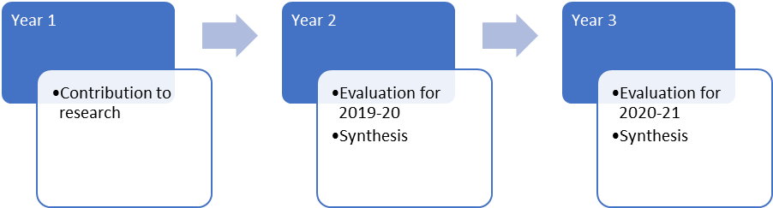
Figure 3 Hydrology Theme activities across the three years of the Flow-MER Program

Fish

Fish Theme
The Murray-Darling Basin historically supported a unique and vibrant fish community with a diverse array of sizes and species of native fish. Since European settlement, the distribution and abundance of native species has declined and over half are now listed as threatened or of conservation concern. A vision of restored fish populations highlights the importance of recovering riverine ecosystems which also helps maintain strong connections between Australians and their rivers.
Freshwater fish are important indicators of ecosystem health and have critical life history processes linked to hydrology and influenced by hydraulics. They are affected by flow both directly through cues to migration and reproduction and indirectly through effects on water quality and habitat and through biotic interactions such as competition and predation.
The Fish Theme is evaluating the contribution of Commonwealth environmental water to fish population diversity and abundance across the Murray-Darling Basin. The Fish Foundation Report sets the scope of activities, noting this Foundation Report is now under review as part of the transition to Flow-MER. In particular, the Fish Theme is investigating key population processes, such as movement, spawning, reproduction and survival to improve environmental water outcomes. The outcome of this theme is an improved understanding of how Commonwealth environmental water contributes to native fish, considering populations, reproduction and survival. An outline of activities is summarised in Figure 4.
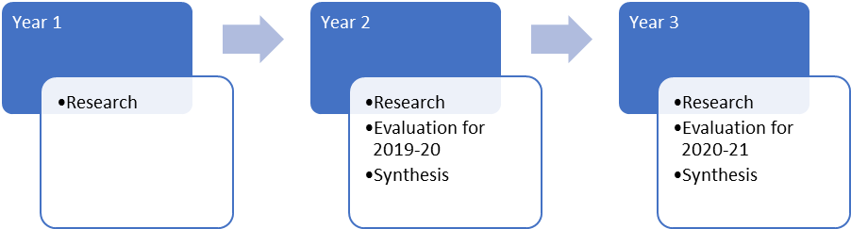
Figure 4 Fish Theme activities across the three years of the Flow-MER Program

Research Focus
Fish population responses to flow events vary among regions, species, and years. Hence, the Fish Theme focuses on the critical life history processes (growth, spawning, recruitment, survival, migration and dispersal) and their intrinsic links to hydrology. This research program is structured around two distinct research projects.
Fish populations develops population models for a suite of native fish species in the Basin, to allow a better quantitative understanding of population-level responses to flow management. These models are critical starting points to allow an understanding of the role of environmental water in determining spatial and temporal patterns of fish diversity and abundance at a basin-scale. The fish populations project builds on the existing evaluation dataset, and other data on fish populations, to construct fish population models to test the benefits of environmental water at local, regional and valley scales.
Flow movement. Fish movements for dispersal, spawning, feeding and survival ultimately contribute to healthy fish populations. This fish movement project applies an existing otolith and acoustic tag datasets to analyse local and regional fish movements in relation to environmental flows in the Murray-Darling Basin. This data will be integrated with ongoing monitoring data derived from traditional fish surveys, such as boat electrofishing and netting. This combination of techniques can answer where and why fish move and how best to provide environmental water to support these key life-history processes. This work is a continuation from the EWKR Project.
Both research projects are integrated to provide a strong innovative direction in demonstrating the role of environmental watering in generating improved fish population outcomes. Knowledge provided by the Theme will inform adaptive management of the strategic use of environmental water. This includes developing a strong evidence base to apply environmental water over a range of spatial scales to support fish movement, breeding and population restoration in northern and southern basin rivers.

Fish populations

Fish population models to inform Commonwealth environmental watering
Fish population models are a basin-scale tool for assisting water management and are useful in evaluating different watering scenarios, in evaluating the likely outcomes and in helping to set monitoring targets. While population models have been used for the past 10 years to predict fish responses to a range of management scenarios, this research will explicitly link flow management to whole-of-lifecycle responses for a suite of native fish species. Fish population processes are highly complex and related not just to river flows but many other factors such as habitats, connectivity, fish density and water quality. Population models aim to clearly demonstrate the benefits of environmental water to fish populations.
One of the major challenges of riverine science is to generate transferable flow-ecology relationships to unmonitored sites. A strength of the population models is their ability to be applied beyond monitoring areas for predicting fish population responses to flow events. A capacity for predictive modelling sets this project apart in terms of its potential to support decision-making for environmental flows. This project aims to enhance our abilities to predict outcomes at the basin scale. Models are in development for Murray cod, Golden perch and Bony herring to determine the benefits of Commonwealth environmental water at local and regional scales. This will improve evaluation methods for analysis of population outcomes.

Research questions
- What is the contribution of Commonwealth environmental water to key native fish population processes including movement, reproduction and survival at the selected area scale?
- How could this contribution be improved to enhance native fish populations?

Research outcomes
Three population models are being developed: a Selected Area scale model for Murray cod, and Golden perch and Bony herring models at the basin scale.

Project description
Fish population dynamics can be incredibly complex, operating over decades and at a variety of spatial scales. Over the past decade, sophisticated fish population models have been developed for native fish to assist in prioritising investment in recovery actions, such as environmental water, re-snagging and fish passage. The insights provided by population models can be targeted at local, regional or basin scale and usually requires construction of a species-specific framework. To answer the research questions three fish species have been selected: Murray cod, Golden perch and Bony herring, and customised population models are being developed for each. Data used to build these models integrates existing information as well as agency research data.
For Murray cod, new population models will be built for each of the Selected Area monitoring sites to predict responses to a range of environmental flow regimes at a local scale. Flow-MER is expanding on an existing generic Murray-Darling Basin Murray cod population model but tailoring this to the Selected Areas for each local hydrological regime. For Golden perch, the population model will be for whole of Murray-Darling Basin, expanded from the current 6 to 15 meta-populations which is a major step forward in terms of understanding population dynamics and the effects of varying flow regimes. The field data required has already been collected from the Selected Area monitoring sites.
The life-history of Bony herring has never previously been consolidated and so the new meta-population model seeks to provide major new insights into flow-ecology knowledge for this species. Bony herring were selected as candidates for a fish population model for three major reasons. Firstly, Bony herring are an important component of the food chain in riverine/floodplain systems and form a major part of the diet of predatory fish, such as Golden perch and Murray cod and predatory birds, such as Egrets and Spoonbills. Consequently, modelling Bony herring populations informs the Murray cod and Golden perch population models and also forms the energy/carbon transfer link between lower trophic and higher levels. Secondly, Bony herring are a major responder to flows with major population increases observed after flow events. Because Bony herring are very common, they bring great statistical power to demonstrating the link between flows and fish responses. In some cases, large-bodied fish (e.g. Murray cod) numbers are low but Bony herring form the major component of native fish biomass in many of the Selected Areas. Finally, the LTIM Selected Area monitoring has been collecting considerable quantities of bony herring population data (relative abundance, larvae, length, age) for the past 5 years so population modelling is the next logical step in adding value-for-money to this investment.

Work to date
This research project commenced in January 2020. A three-day research meeting was held in February 2020 to set project objectives, summarise contemporary knowledge and elicit knowledge for the three focal species: Murray cod, Golden perch and Bony herring. This information has enabled the project team to construct the model framework, prioritise the watering scenarios to be tested and identify links to other projects. Work on the population models are now progressing with the Murray cod model underway. An outline of activities is summarised in Figure 5.
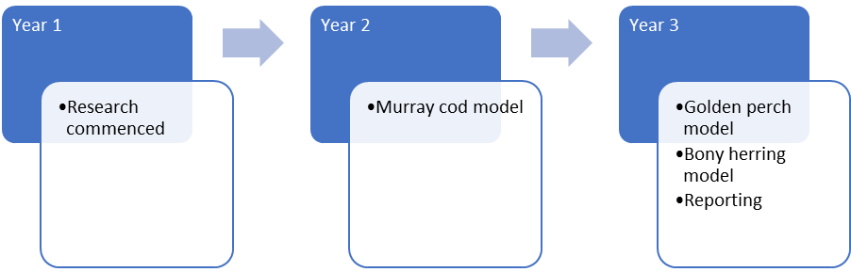
Figure 5 Fish populations project activities across the three years of the Flow-MER Program

Fish movement

Flow, movement and fish population dynamics in the Murray-Darling Basin
Flows underpin native fish ecology and the fish movement project is evaluating flow triggers for local and regional scale fish movement to help standardise environmental water among fish species and regions in the Murray-Darling Basin. EWKR formalised linkages between flows and ecological outcomes including fish spawning, recruitment and dispersal within individual regions. This project will scale-up these responses to determine whether they are repeatable and transferable at the population level, then this will be used to develop a predictive tool to inform ecological outcomes in unmonitored regions. This research project is using otolith microchemistry and fish movement datasets (from acoustic tags) to build a statistical model to determine fish movement, spawning and survival rates in relation to environmental watering. Models are being developed for a small number of fish species to inform population level responses to management of flows.

Research questions
- Are single species movement responses on daily or weekly time-steps repeatable to standardised flows within a river system, and how does this vary among species?
- What is the role of river hydrology in driving emigration and immigration rates in fishes in Murray-Darling Basin rivers, and how does this vary by life-history stage and species?

Research outcomes
Collation of an integrated time-series fish movement dataset and analysis of the influence of flow on the movement life-histories of fish at basin scale.

Project description
Understanding the response of fish to flow is fundamental to the conservation and rehabilitation of populations. A key challenge in managing river flows for fish outcomes is to understand when, where and why fish move, and the importance of these movements to population dynamics. The research team is using existing data to generate transferable flow-ecology relationships to unmonitored sites to answer the key research questions for the Murray-Darling Basin.
The fish movement project has two components: (i) an acoustic tag database for several thousand Murray cod and golden perch from across the Murray-Darling Basin, and (ii) an otolith microchemistry database for 1250 Murray cod and golden perch. The otolith microchemistry component explores the role of flow on the large-scale movements of golden perch, and potential inter-regional movements of Murray cod. These movement data can be retrospectively related to flow and other environmental variables (e.g. water temperature) in a spatially reconciled manner at any point in a fish’s life, from birth to death. Using this data, the research team is quantifying local movements and emigration and immigration rates for key rivers in the Murray-Darling Basin.

Work to date
This research project commenced in January 2020. A two-day research meeting was held in February 2020 to set project objectives, summarise acoustic tag and otolith data, and determine the analytical approach. Work on the project is now progressing, with the consolidation of data to develop an acoustic tag database and development of a method for analysis of otolith data. An outline of activities is summarised in Figure 6.
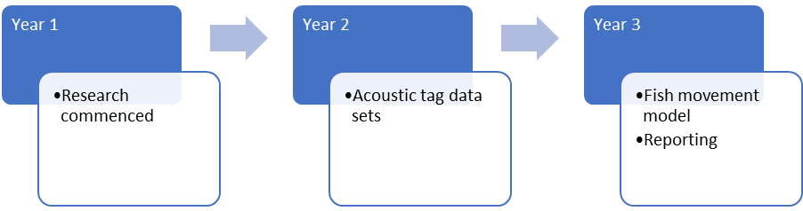
Figure 6 Fish movement project activities across the three years of the Flow-MER Program

Vegetation

Vegetation Theme
The Vegetation Theme aims to assess the contribution of Commonwealth environmental water to achieving vegetation species and community diversity outcomes across wetland, floodplain and riverine habitats of the Murray-Darling Basin. The focus of the evaluation is on the diversity, community composition and structure (e.g. height) of plants and how those attributes change in response to Commonwealth environmental water. The Vegetation Diversity Foundation Report sets the scope of activities.
Composition and structure are important components of vegetation diversity. Vegetation diversity is considered through all phases of the flow regime relevant to a riparian, wetland or floodplain ecosystem (i.e. dry, base flow, fresh, bank-full, overbank). Changes in flow regimes are therefore likely to significantly impact vegetation diversity across multiple scales, from the presence and abundance of local plant species to vegetation composition and structure at landscape scales.
The Vegetation Theme is evaluating the contribution of Commonwealth environmental water to the diversity and condition of non-woody vegetation like aquatic macrophytes, herbs, sedges and rushes across the Murray-Darling Basin. The evaluation activities are being complemented by research, by improving our understanding of how best to use Commonwealth environmental water to achieve outcomes for both non-woody and woody vegetation, which includes tree species such as River red gum and Black box. An outline of activities is summarised in Figure 7.
Figure 7 Vegetation Theme activities across the three years of the Flow-MER Program

Research Focus
Given the unique and heterogeneous response of non-woody vegetation, basin-scale evaluation aims to characterise the diversity of responses recognising the uniqueness and complexity of vegetation ecosystems but to also seek patterns and predictions. The vegetation research program focuses on providing an improved ability to evaluate and predict responses to Commonwealth environmental water for both woody (trees) and non-woody (groundcover) vegetation across the Murray-Darling Basin. This is achieved through two projects: ‘non-woody plant responses’ and ‘remote sensing vegetation’.
Non-woody plant responses is developing a framework of condition benchmarks, and a process for evaluating success of outcomes for non-woody vegetation at a basin-scale, to inform the basin-scale evaluation.
Remote sensing vegetation. Maintaining the extent and condition of native woody floodplain vegetation are key objectives of the use of Commonwealth environmental water. The remote sensing project is developing methods to assess the response and condition of woody vegetation populations to environmental water, to underpin basin-scale prioritisation of environmental watering actions and evaluation of outcomes from watering actions.

Non-woody plant responses

Developing condition benchmarks for non-woody vegetation
This research aims to develop a framework of hierarchical condition benchmarks and a process for evaluating success of outcomes for non-woody vegetation at a basin-scale. This research will build on the conceptual ideas developed in the EWKR project around vegetation responses at different levels of organisation. It will expand on these ideas to develop benchmarks at different levels of organisation to help determine a point of reference against which to evaluate good condition.

Research questions
- How can we improve the evaluation of outcomes for non-woody vegetation at a basin-scale?
- Can we develop benchmarks against which to evaluate outcomes for non-woody vegetation?
- Can we extrapolate outcomes to unmonitored areas?

Research outcomes
Basin-wide assessment of non-woody vegetation responses to environmental watering.

Project description
Wetland and floodplain vegetation are critical components of river-floodplain ecosystems. They provide habitat for a large array of animals and support a wide range of functions, from the provision of food and refuge to the regulation of climate, water and soil processes. Wetland and floodplain vegetation have attributes that underpin ecological, cultural, recreational, aesthetic and economic values.
Basin-scale monitoring and research projects are providing insights into just how diverse, unique and complex wetland and floodplain plant communities are at a landscape scale. Given the unique and heterogeneous response of non-woody vegetation, research is needed to characterise the diversity of responses in such a way as to recognise the uniqueness and complexity but seek patterns and predictions. The challenge is to develop a basin-scale process for evaluating non-woody vegetation outcomes that incorporates diversity and variability of responses, has clear links to the functions and values supported and can predict expected outcomes in unmonitored areas.
The research is undertaking a literature review and using existing data and expert elicitation to develop model relationships – both qualitatively and quantitatively. The project is using Basin-scale Models, Integrated Outcome Response Models and Modelling of LTIM/Flow-MER monitoring data to inform the creation of an outcomes framework.
Outcomes from this research seek to inform basin-scale evaluation as well as reporting and evaluation requirements for other basin-scale and regional organisations. It is adding to the knowledge base by improving our understanding of relationships between vegetation response, function and flow. It seeks to improve communication of vegetation outcomes and their value in response to environmental watering.

Work to date
This research project commenced in January 2020 as a PhD project through the University of Canberra. A research plan has been developed and work has begun on the literature review. Workshops with environmental water managers and other scientists, planned for March 2020, have been postponed until a later date as a result of COVID-19 enforced travel restrictions. In the interim, information exchange has been undertaken by email. An outline of activities is summarised in Figure 8.
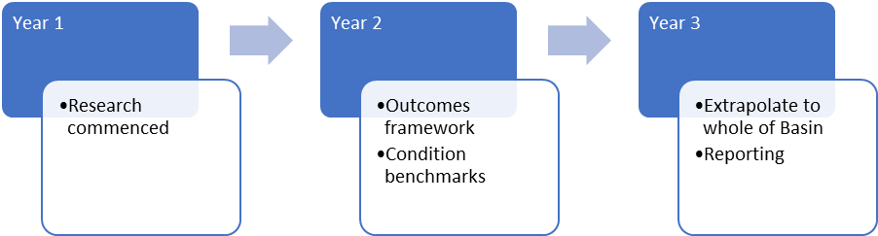
Figure 8 Non-woody plant responses project activities across the three years of the Flow-MER Program

Remote sensing vegetation

Remote sensing trends and temporal condition responses of woody vegetation to environmental water
The remote sensing vegetation project aims to understand how native woody vegetation responses are related to hydrology across scales, including the basin-scale, and using remote sensing, based on tree water use field studies. This project is being undertaken to determine critical thresholds of remotely sensed water use to assess the influence of environmental water; determine relationships between vegetation response and water regimes; inform prioritisation of environmental water for woody vegetation; and, quantify relationships between vegetation change and hydrology.

Research questions
- What do existing remotely sensed models tell us about the antecedent and current condition of long-lived woody floodplain vegetation at regional and basin-scales?
- How can we translate remotely sensed evapotranspiration into basin-wide condition metrics and identification of key thresholds?
- How are vegetation condition and trends related to hydrology across scales including basin-scale?
- What was the condition of long-lived woody floodplain vegetation prior to the involvement of Commonwealth environmental water and how has this changed?

Research outcomes
Basin-wide assessment of potential for remote sensing approaches to assess relationships between woody vegetation condition and environmental watering.

Project description
Native woody vegetation in the Murray-Darling Basin contribute important resources and services to support ecosystem function of rivers, wetlands and floodplains. These tree species include the iconic River red gum (Eucalyptus camaldulensis), Black box (E. largiflorens) and Coolibah (E. coolibah) and the lesser known River cooba or Native willow (Acacia stenophylla).
Environmental water can be allocated to ensure that tree condition of key tree species in the Basin is maintained and restored in more degraded areas. However, it is difficult to measure tree responses and determine the benefit of Commonwealth environmental water in unmonitored regions. This research project aims to investigate long-term ecological responses of trees to water availability to develop new knowledge to aid in decision making and evaluation of environmental flow management. A broad-scale remote sensing model related to tree water use and underpinned by field measurements, has been developed for River red Gum in non-saline areas. Tree water use is governed by canopy condition and is thus a surrogate for tree condition. This research project is extending existing models used to determine water use trends and temporal responses in saline and non-saline regions for both River red gum and Black box.

Work to date
This project commenced in July 2019. A workshop was held with key collaborators and study locations have been identified where water history is complete and includes Commonwealth water. For each case study location, MDB-FETa (Murray-Darling Basin-Floodplain Actual Evapotranspiration) remote sensing data has been extracted from the database and there has been investigation in how to convert field measured tree evaporative losses or evapotranspiration (an indicator of tree condition) into a condition metric applicable across the Basin for River red Gum and Black box trees. MDB-FETa provides Basin wide, weekly tree response information for both species for the last 20 years. This contributes to an improved understanding of how vegetation responds to water availability (including environmental watering) and identify water requirement thresholds to inform environmental flow management to benefit vegetation and floodplain, wetland and river ecosystems. Further research to develop a new fine-scale method (30 m pixel) to map tree canopy cover and biomass has also commenced. This product is important to ensure the remote sensing evapotranspiration data is as accurate as possible. An outline of activities is summarised in Figure 9.
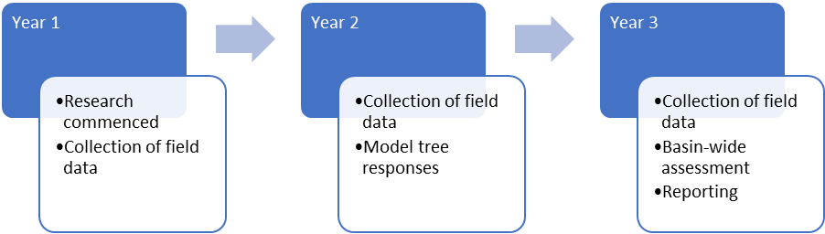
Figure 9 Remote sensing vegetation project activities across the three years of the Flow-MER Program

Biodiversity

Ecosystem and Species Diversity Themes
Australia’s aquatic ecosystems support many nationally and internationally significant plant and animal species. The Biodiversity Theme is evaluating the importance of Commonwealth environmental watering actions for maintaining these ecosystems and the biodiversity that depends on them. The sub-themes use information gathered at a range of scales to assess which habitats and species are being supported by water for the environment.
Biodiversity examines both ecosystem diversity and species diversity, both important components of biodiversity as a whole. Many water-dependent species and ecosystems found in Australia are adapted to and require natural cycles of wetting and drying. Important reproduction and movement cues are often tightly linked to water regime. In a climate of increasing pressures on water resources, environmental watering can play a crucial role in maintaining species and ecosystem diversity. An outline of activities is summarised in Figure 10.
Figure 10 Ecosystem and Species Diversity Theme activities across the three years of the Flow-MER Program

Research Focus

Species Diversity
The Species Diversity Theme aims to assess the contribution of Commonwealth environmental water to achieving species diversity outcomes. The focus of the evaluation is on major faunal groups not covered by the Vegetation and Fish Themes (e.g. waterbirds, frogs, turtles and mammals), and particularly threatened and endangered species that would be expected to respond to environmental watering actions. The Biodiversity Foundation Report sets the scope of activities.
Waterbird movement tracking. Principles of ecosystem management suggest that a focus on protecting or restoring ecosystems also preserves valued species, habitats, and critical processes within them in addition to critical ecosystem services that they may provide. Researching responses of targeted species can test these assumptions and demonstrate focused responses, to show how environmental water contributes to biodiversity.
Refugia. Species and communities can be dependent on flow and water regimes for all or parts of their lifecycles. Most of the biota within the Murray-Darling Basin are adapted to cycles of wetting and drying, with many important breeding, migration or germination cues linked to water regime, and persistence related to the presence and functioning of refugia.

Ecosystem Diversity
The Ecosystem Diversity Theme aims to assess the contribution of Commonwealth environmental water to the protection and restoration of water-dependent ecosystems throughout the Murray-Darling Basin. The Ecosystem Diversity Foundation Report sets the scope of activities. The outcome of this evaluation is an improved understanding of how Commonwealth environmental water contributes to ecosystem diversity, through habitat heterogeneity and associated flora and fauna responses. This component is structured around two research projects.
Resilience. Environmental watering outcomes are likely to vary between different ecosystem types, and the types of ecosystems that receive water vary from year to year in response to water availability and river conditions.
Scaling. Ecosystem diversity evaluation assesses outcomes of Commonwealth environmental water to monitored and unmonitored areas, intersecting across hydrology and water-dependent ecosystems.

Waterbird movement tracking

Spatial and temporal scales and drivers of waterbird movements and site use across the Basin.
This research aims to identify drivers of waterbird movements and habitat use across the Murray-Darling Basin. The project team are quantifying spatial and temporal scales of waterbird movements and habitat selection. The team use satellite tracking technology and novel analytical approaches to investigate relationships between waterbird movements, habitat selection, environmental watering, flooding and other factors. Research is building on waterbird data collected for the EWKR Project.

Research questions
- How do waterbirds move across the Murray-Darling Basin and beyond? Are they moving in response to environmental water or flooding? What does this mean for our perceptions and predictions of waterbird responses to environmental water management?
- Where are birds feeding, roosting and nesting, when and why? What movement and habitat cues, preferences and limitations should we be taking into account in water planning for waterbirds?
- How connected are Australian waterbird populations, spatially and temporally? What are the implications for environmental water management to prevent further population declines?

Research outcomes
- New information describing waterbird movements and habitat use across the Murray-Darling Basin and implications for environmental water and wetland management and policy.
- Spatial and temporal movement and habitat selection information for waterbird species of concern to water and wetland managers and policy makers.

Project description
Waterbird diversity, populations, and breeding, foraging and refuge sites are managed through decisions affecting water, habitat and other pressures. While increasing waterbird populations and maintaining waterbird diversity are important targets for water management and policy in Australia, long-term knowledge gaps exist that affect our ability to manage water and wetlands for waterbird populations at appropriate scales. Broadly, these can be summarised as:
- Spatial and temporal scales and drivers of waterbird movements and site use and implications for site to national management and policy. How are site scale responses and drivers linked to Basin and national scale responses and drivers?
- Understanding of life cycle requirements and demographics to inform actions and policies to increase or maintain populations and explain waterbird responses (or lack of response).
These knowledge gaps exist even for common and conspicuous taxa that are often thought to be relatively well-understood (e.g. Spoonbills). They are particularly severe for threatened, cryptic and uncommon species (e.g. Bitterns). They require long-term, multi-scale and multi-disciplinary research.
The project is employing satellite-tracking to study the movements of waterbirds and analysing the data to discover relationships between movements, habitat use and environmental variables including environmental water. New knowledge will assist managers to better understand waterbird requirements and implications for water and wetland management and policy.
Information about waterbird movements helps us to understand fluctuations in the diversity and numbers of birds present or breeding both at particular sites and across the Basin, including why waterbirds may not have responded to environmental watering events. It also helps with planning and adaptively managing basin-wide environmental watering and coordination among sites.

Work to date
The project commenced in July 2019. The project team have completed the first season of fieldwork, focusing on fitting transmitters to waterbirds for satellite tracking. Ten Straw-necked ibis and one Royal spoonbill were fitted with transmitters over the 2019-20 spring-summer, despite unfavourable conditions, and an additional seven birds are still being tracked from EWKR deployments. Further transmitter deployment targeting Australasian bitterns, Royal spoonbills, Yellow-billed spoonbills, Straw-necked ibis or possibly other species is planned for the 2020-2021 season.
With recent flooding and environmental watering in the northern Basin, fieldwork will be undertaken in key locations where significant waterbird breeding occurs. Birds captured for satellite tracking are photographed, weighed and measured and have samples taken for complementary research, including feathers, swabs, and blood. These samples and measurements are used in future or complementary projects to assess toxins, diseases, genetics and trophic/energy status and requirements. An outline of activities is summarised in Figure 11.
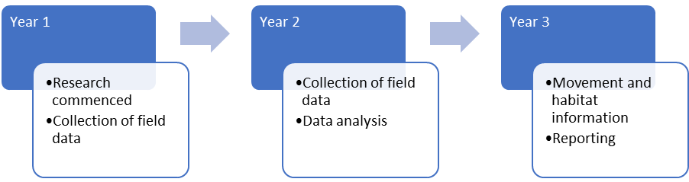
Figure 11 Waterbird movement tracking project activities across the three years of the Flow-MER Program

Refugia

Identification, characterisation and management of refuge habitat
This project seeks to understand how ecological refugia are distributed across the Basin and the potential for management of these critical areas to support diversity. The aim of the Refugia Project is to understand more about aquatic refugia habitats, their characteristics and the species they support. The work is focussing on the short (months) and long (years) time frames, so that we can learn more about how refuge habitats change over time and which species use them.

Research questions
- What are the characteristics that define, identify and describe refugia habitats across the Basin?
- What are the biogeochemical processes and food web dynamics of refugia and how do these change over time with disconnection, contraction and then reconnection?
- What are patterns of refuge use and habitat suitability for water dependent species such as fish, turtles, frogs, fisher bats and waterbirds?

Research outcomes
- A literature review to synthesis definitions of refugia across the Basin
- Map of key refugia in parts of the Murray-Darling Basin
- Quantification of occupancy predictors for refugia dependent species
- Identify refugia dependent species and communities and the flow dependencies that support them
- Recommend flow requirements to maintain and improve refuge availability, access and quality for key biota.

Project description
The prioritisation of environmental watering for the maintenance of refugia habitat may be an effective management strategy to support the survival and recovery of ecological communities experiencing pulse disturbances such as drought. Drought refugia are areas of higher resource availability and/or habitat quality compared to elsewhere in the landscape, which support plants and animals in times of drought. Refugia can include a range of habitats, for example off-channel permanent water bodies or in channel waterholes. Temporal and spatial variability in hydrology along with topography regulates the characteristics of refugia such as habitat quality, habitat area, and connectedness.
The long-term persistence of populations under disturbance is not only determined by their ability to persist (resistance) but also their ability to recover (resilience). Refugia habitat that facilitate resilience as well as resistance are likely to be those where resource availability is consistently high compared to other areas. This is because these areas enable individuals to persist during drought and then increase their reproduction to potentially re-colonize the surrounding landscape when conditions improve.
The ability of refugia to provide appropriate conditions for taxa at higher trophic levels such as fish is in part dependent on the rates of primary and microbial production in both the supply of basal resources and the maintenance of water quality parameters within ideal ranges (e.g. dissolved oxygen). If this resource quality is available, refugia may be key breeding grounds for many taxa including important fish species. Thus, an understanding of the relationship between flow, refugia types, and food web processes are particularly needed to inform the use of environmental water for the maintenance of these processes.
What habitat will act as refugia for a given organism will depend on the species’ traits, especially life history and dispersal traits. Dispersal ability will facilitate a species ability to reach refugia during periods of contraction and their recolonization following reconnection. Dispersal ability is related to other easily collated traits such as body size, which in turn can inform us about other important ecological traits such as a trophic position. Examples of life-history traits that will be important for the classification of refugia for a specific organism will include generation time and life cycle. For example, species with long generation times will take longer to respond to environmental water and are likely to need multiple watering events to complete their life cycle. Furthermore, species with distinct life stages may require multiple refugia habitats to complete their life cycle.

Work to date
This project commenced in March 2020, with the appointment of the project leader (Joanne Bennett). Two reviews are underway 1) a review of habitat condition metrics and biodiversity data in the Basin and 2) a systematic literature review seeking to develop definitions of refugia that are consistent with existing definitions used by the states and other management authorities. In parallel to the literature reviews a process of stakeholder engagement with managers and researchers working on refugia in the Murray-Darling Basin to develop consistent definitions of refugia has begun. An outline of activities is summarised in Figure 12.
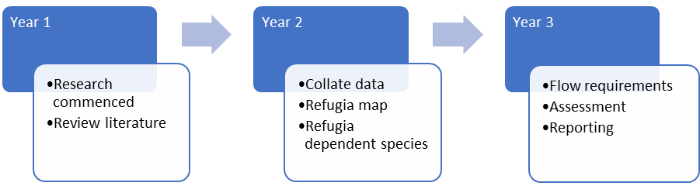
Figure 12 Refugia project activities across the three years of the Flow-MER Program

Resilience

Influence of ecosystem condition on resilience
This project examines how ecosystem condition influences the resilience of basin ecosystems. Research is linking species outcomes to the ecosystems that support them and explores how the starting condition of those ecosystems influences outcomes from water for the environment.

Research questions
- How does condition of an ecosystem influence responses to environmental water?
- What are the critical indicators of ecosystem condition with respect to different targets (fish, vegetation, food webs, waterbirds, and frogs)?
- Do we need to understand condition as an ecosystem integrity measure or is it sufficient to understand the antecedent “state” of ecosystems?
- When does condition need to be evaluated over a long duration versus in the present only?
- What are the critical elements to consider in evaluating the contribution of Commonwealth environmental water to the resilience of water-dependent ecosystems?

Research outcomes
- Framework for assessment of condition and resilience
- Potential ecosystem condition indicators
- Relationships between environmental watering, condition and resilience of ecosystems.

Project description
This project is identifying ecosystem condition attributes that help to explain watering outcomes in different ecosystem types. Drought stressed ecosystems are often a target for environmental water delivery however they may not achieve intended outcomes if critical ecosystem processes and functions are compromised or target species are not present at the right life stage or physical condition to recover.
Condition metrics may also have value as surveillance tools to identify and prioritise water delivery to ecosystems in most need. The Australian National Aquatic Ecosystem (ANAE) classification of wetlands and rivers in the Basin has been identified for use as a spatial template for extrapolating monitoring outcomes within ecosystem types to similar watering actions and ecosystems elsewhere in the Basin. Condition indices complement this approach by helping to define the contexts under which extrapolation of monitored outcomes to other areas is valid, leading to more robust evaluation of responses to environmental water at the basin-scale.
This project examines how ecosystem ‘condition’ or ‘patch quality’ influences watering outcomes across a range of targets (e.g. different species groups, vegetation communities) and explores whether ecosystem types can be used for extrapolating monitored outcomes to unmonitored areas. At present, the ANAE classification used to quantify ecosystem diversity is a static template. Inclusion of patch quality/starting condition may provide a way to parameterise variability for modelling outcomes from environmental water management and contribute to evaluating Basin Plan objectives for maintaining and improving resilience to climate change and extreme events such as drought.

Work to date
This project was initiated in September 2019 and research activities commenced in April 2020. Research is integrating across all Themes. A review of condition metrics and data in the Basin has commenced. An outline of activities is summarised in Figure 13.
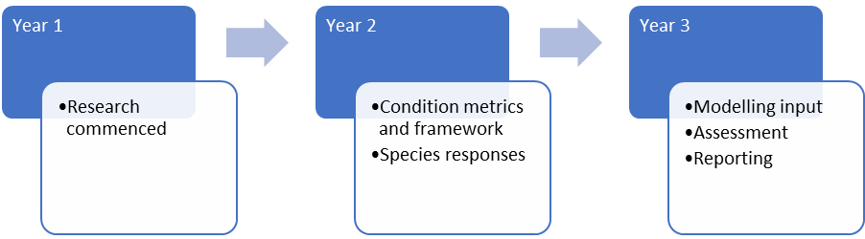
Figure 13 Resilience project activities across the three years of the Flow-MER Program

Scaling

Developing an approach to scaling for evaluating ecosystem diversity
This project is developing a multi-scale approach to evaluate diversity at spatial scales aligned to the scale of watering actions. For example, small scales which occur at individual wetlands, up to large scales where the entire river system is impacted by large volumes of water being used to flush rivers and fill adjacent wetlands. This work seeks to enable us to evaluate basin-scale ecosystem diversity at different scales and spatial arrangements of management actions in the Basin. This is intended to help researchers improve the relevance of management advice according to the scale of the ecosystems being focused on.

Research questions
- How diverse are the sampling locations from which we are drawing inference about the role of Commonwealth environmental water in supporting biodiversity in the Murray-Darling Basin?
- Does the spatial scale at which ecosystem diversity is defined change our perception of outcomes from water delivery at local versus catchment scales?
- Can ecosystem types be aggregated to larger spatial scales to improve evaluation of environmental water delivered to wetland and floodplain complexes (i.e. developing a framework for evaluating within and between “patch” diversity where patches can be defined at multiple scales)?
- Is ecosystem diversity, as represented by the ANAE ecosystem mapping, suited for evaluating environmental water contributions to diversity objectives at local scales and catchment scales?
- Does incorporation of the duration of inundation, and time between inundation events change our perception of ecosystem diversity outcomes from different environmental water actions?

Research outcomes
- Multiscale ecosystem diversity metrics that link to the ANAE classification mapping.
- Improved inundation mapping that captures watering action information.

Project description
This project examines the importance of scaling for evaluating the influence of environmental water on ecosystem diversity. The project team are developing a multi-scale approach for integrating ecosystem types to larger patches (or catchments) to evaluate ecosystem diversity outcomes from watering actions at different scales. The project team is incorporating temporal aspects of environmental water management into evaluation (timing of delivery, duration of inundation).
The research activities are:
- Evaluating how representative the distribution of sampling locations are within LTIM/MER and EWKR research sites with respect to ecosystem diversity, watering regime and other landscape attributes.
- Examining the scientific literature to identify novel approaches for characterising landscape heterogeneity at multiple scales for application to hierarchically organised river and wetland systems. These would be applied to the ANAE mapping to determine whether there are critical scales that should be used in basin-scale evaluation of diversity outcomes.
- Incorporating timing and duration into mapping of inundation extents and develop an appropriate framework for incorporating temporal dynamics into the Ecosystem Diversity evaluation.

Work to date
This project was initiated in September 2019 and research activities commenced in April 2020. The research is integrating across all Themes. An initial outcome is a data framework for combining information on watering action objectives, timing and duration with inundation extent mapping to improve resolution of spatial and temporal scales of water delivery in the Basin. This new data framework will be used for the Flow-MER evaluation starting June 2020. An outline of activities is summarised in Figure 14.
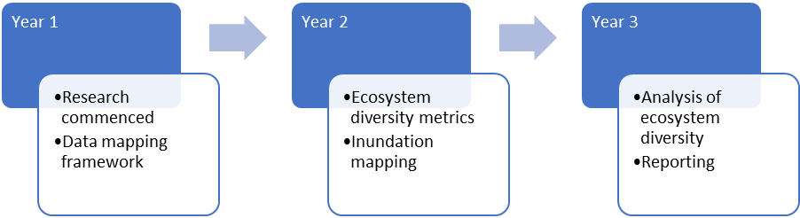
Figure 14 Scaling project activities across the three years of the Flow-MER Program

Water Quality and Food Webs

Water Quality and Food Webs Theme
Water for environment is often used to support native fish recruitment and successful waterbird breeding. But how many fish and waterbirds can be sustained by a flow event? And for how long? To answer these questions, we seek to understand how water for the environment can provide the right water quality and food resources of the right quality in the right abundances for these native animals to thrive.
The Water Quality and Food Webs Theme aims to understand and quantify how Commonwealth environmental water influences water quality (nutrients, light, salinity), which in turn regulates rates of metabolism and productivity (energy availability) and how this energy fuels the trophic carrying capacity of food webs that support fish and waterbird recruitment. The Stream Metabolism and Water Quality Foundation Report sets the scope of activities.
Water quality and stream metabolism provide the oxygen and environment for aquatic plants and animals to thrive, and both respond to flow management to provide the energy that fuels riverine food webs. Food webs show how plants and animals are connected through the energy pathways that link food resources such as microbes, algae and reeds with consumers such as waterbugs, fish and waterbirds. The Theme is investigating how water for the environment impacts food webs and water quality in rivers, floodplains and wetlands of the Murray-Darling Basin.
Our research seeks to inform the efficient and strategic use of water for the environment to deliver the water quality and food webs to support thriving and sustainable communities of plants, native fish and waterbirds that are an essential part of life in the Murray-Darling Basin. An outline of activities is summarised in Figure 15.
Figure 15 Water Quality and Food Webs Theme activities across the three years of the Flow-MER Program

Research Focus
Conceptual models of river ecosystems propose food webs as a critical ecosystem function. However, our knowledge of the influence of flow on food webs is not robust enough to make specific predictions about how flow may influence the basal production that fuels successful recruitment of larval fish and waterbird fledglings. We aim to build on the model produced by the EWKR Food Web Theme in order to link management decisions about environmental watering to energy flow and potential trophic carrying capacity.
Energy is a fundamental requirement for all organisms. Without energy organisms have no capacity for growth or reproduction. Food webs describe the pathways along which energy is transferred from resource to consumer, and the strength and direction of these pathways are sensitive to impacts from changes to river flows. Food web studies identify components of an ecosystem that influence energy production and transfer and in turn influence the population size and structure of native fish and waterbirds.
The production and transfer of energy in an ecosystem begins with nutrient and light availability driving primary production. Primary production in turn creates basal resources that are transferred along myriad pathways to higher order consumers. The production and transfer of energy within an ecosystem (ecosystem energetics) is a key functional process, fundamental to determining population and community structure and productivity. Quantity alone is not enough. Resource quality is equally, if not more important in determining trophic carrying capacity. Food resource quality can be determined by the concentration of some essential nutrients necessary for survival and growth of consumers. For healthy consumer growth, function and reproduction, sufficient quantity and quality (essential micro and macronutrients) of food must be accessible to consumers.
Ecosystem energetics is developing an energetics response model to allow us to predict the trophic carrying capacity of rivers and wetlands in response to environmental water delivery. This research addresses the question: what did Commonwealth environmental water contribute to the production of energy, quality of basal food resources and their transfer through food webs in river channel and floodplain wetland environments to support native fish and water bird recruitment?
Research activities undertaken by the Theme are seeking to provide knowledge to:
- Inform adaptive management by contributing to enduring environmental change through strategic use of water set aside for environmental outcomes in the Murray-Darling Basin, and
- Enhance the capacity to evaluate watering outcomes.

Ecosystem energetics

Developing an environmental water energetics response model
This project is undertaking research to develop an energetics response model to predict the trophic carrying capacity of rivers and wetlands in response to environmental water delivery. The project team is developing a bioenergetic model for how food webs respond to flow, initially focussing on refuge habitats, then extending these models to wetlands and flowing water habitats. The research is designed to fill gaps identified in the development of the EWKR food web model and to improve the certainty of scientific predictions for ecological outcomes.

Research questions
- How does environmental watering influence the flow of energy through to vertebrate consumers such as fish and birds?
- How can energetics response model support prediction of the trophic carrying capacity of rivers and wetlands in response to environmental water delivery?

Research outcomes
The project is developing a bioenergetic model which relates the effects of environmental flows to carrying capacity for vertebrate consumers such as fish and waterbirds.

Project description
Research spans four key areas:
Building channel and wetland scale food web structures. Review of existing data, molecular ecology and environmental-DNA analyses of trophic resources and food web dynamics in wetlands, flood channels and rivers. To assess the health of zooplankton and fish and the nutritional quality of their diets the project team is using stable isotope analyses and interrogate fatty acid dynamics in zooplankton, juvenile fish and their food items, to compare how patterns differ between floodplain wetlands, flood channel/refuges and the river channel at sites in the Gwydir, Darling and Lachlan Selected Areas. This will improve understanding of how environmental water can promote the transfer of energy through food webs.
Trophic transfer efficiencies: energetic requirements of key biota. Small scale laboratory experiments are being undertaken to determine growth rates and ingestion/clearance rates for zooplankton and juvenile fish. Rates determined from these experiments will inform the development of the energetics model.
Response of basal resources and their quality to food webs. The research is using in-situ responses of basal resources (microbes/fungi, algae, cyanobacteria, diatoms, biofilm, DOC, macrophytes) and their quality (Fatty acids as food ‘quality’ biomarkers) to food webs to watering. Work carried out in EWKR showed that floodplain habitats could provide higher quality basal food resources for fish larvae than the river channel. Knowledge gaps remain, however, in our understanding of how managed flows can be manipulated to maximise these food resources. Catchment derived carbon and nutrient material and leachates are being added to mesocosm enclosures to mimic the effects of environmental water delivery. This will allow better elucidation of how primary productivity and food webs respond to basal resource changes.
Developing energy (carbon) budgets at reach, catchment and basin scales. By incorporating data generated from the above activities, the research team is developing a bioenergetic food web model. The model will be used to demonstrate rates of carbon transfer and production in the food web under different environmental flows to illustrate the changes in productivity and fish outcomes. The model will allow managers to predict (with defined assumptions and levels of uncertainty) the trophic carrying capacity (e.g. successful fish recruitment) of river channels and floodplain wetlands in response to Commonwealth environmental water delivery. The model will be built such that new information can be incorporated into the framework as it is generated.

Work to date
This project was initiated in September 2019 and research activities commenced in April 2020. Research is integrating across all Themes. A review of outputs from EWKR is underway, with the view to adoption into the Basin-scale Flow-MER Project. Existing modelling frameworks are also being evaluated for their suitability in the project. An outline of activities is summarised in Figure 16.
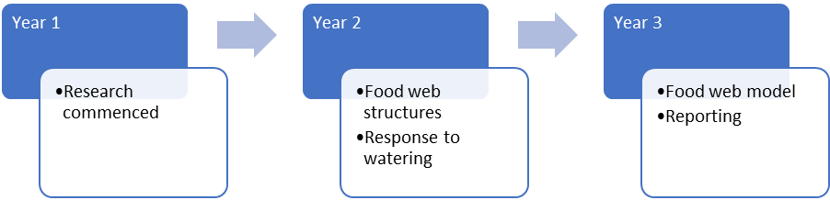
Figure 16 Ecosystem energetics project activities across the three years of the Flow-MER Program

Modelling and data visualisation

Overview of modelling
Requirements for successful integration of monitoring, evaluation and research programs are: (1) clear framing of the problem being addressed and criteria for measuring success of the evaluation and research, (2) integration methods and models that have scientific rigour and sufficiently represent complex, real world problems and, (3) new knowledge and outcomes of research and evaluation that are used in stakeholder engagement and communication and are an input to decision-making.
At the basin scale, Flow-MER modelling and data visualisation effort integrates across monitoring, evaluation and research to build a cohesive approach to the evaluation and communication of outcomes from environmental watering across Themes. The outcomes of this integration are an improved demonstration of the contribution of Commonwealth environmental water to basin-scale outcomes, to support adaptive management, and to deliver scientific rigour to enable stakeholders to have confidence in, and utilise, the information collected through the project.
The Basin-scale Flow-MER Project achieves integration through an over-arching integrative modelling framework at the basin scale to synthesise and generate new knowledge to inform the management of Commonwealth environmental water. Modelling approaches for evaluating outcomes to Commonwealth environmental water, are taking approaches developed in the EWKR Project and continued here to develop flow-ecology relationships across the Murray-Darling Basin. Data visualisation research activities will develop spatial and temporal visualisation methods to enhance the value of data and model outcomes.
Basin-scale modelling seeks to provide a basis to:
- Identify knowledge gaps and recommendations on how to address these
- Enable integration of hydrological information with ecological models for evaluating ecological outcomes for a range of scenarios, and
- Extend predictive approaches to areas of the Murray-Darling Basin outside of Selected Areas.
An outline of activities is summarised in Figure 17.
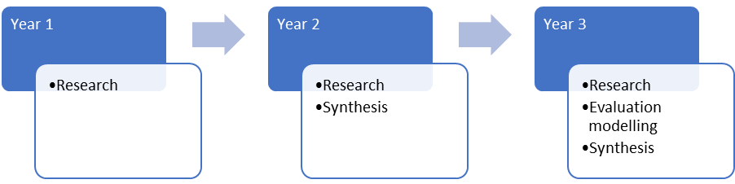
Figure 17 Modelling and Data Visualisation Theme activities across the three years of the Flow-MER Program

Flow-ecology relationships

Use of flow-ecology relationships to predict responses to watering scenarios
The research team is undertaking data analysis to understand flow-ecology responses and develop these into a scientifically sound modelling method to support Flow-MER evaluation.

Research questions
- What are the relationships between flow and ecological outcomes?
- How can these relationships be conceptualised and expressed in a common framework for use across Selected Areas and between Themes with suitable indicators, parameters and input data?
- What model features, components and structures are required for a common method to be fit-for purpose (considering data inputs, desired outputs and spatial and temporal scales)?

Research outcomes
- Understanding through statistical analysis key flow ecology relationships for selected Flow-MER Themes.
- Development of a modelling method to be used to support evaluation modelling that quantifies the relative environmental outcomes under flows both with and without Commonwealth environmental water.

Project description
The modelling research seeks to understand flow-ecology relationships for the purpose of developing a scientifically sound modelling method to support Flow-MER evaluation. The modelling methods developed in this research seeks to provide an ‘environmental counterfactual’, linking to the hydrology counterfactual described in the Hydrology Foundation Report. This is being done by understanding the relative environmental outcomes under flows both with and without Commonwealth environmental water, considering the relative environmental outcomes associated with differences in the magnitude, duration and timing of flow events between the scenarios.
The objectives for the development of the modelling method are:
- Enable integration of the Flow-MER Themes into a common modelling framework, incorporating new science and knowledge of the system
- Enable extrapolation to unmonitored locations within the Basin, and scaling to the basin
- Provide the ability to understand the relative benefit of environmental water considering flows both with and without Commonwealth environmental water, and
- Facilitate transparency and communication of environmental decision making and outcomes.
This research project seeks to understand flow-ecology responses and use these to develop a modelling method based on existing modelling approaches. For use in Flow-MER, several aspects of existing modelling methodology require development and testing. This is to ensure the suitability of method sensitivity to hydrology over shorter time periods, its ability for extrapolation across the Basin, as well the need to integrate new knowledge and assets associated with the Flow-MER Program with consideration of appropriate indicator selection to align with basin-scale objectives.

Work to date
This project was initiated in September 2019 and commenced research activity in early 2020. Research is integrating across all Themes. An evaluation of an existing modelling framework has been undertaken to review its suitability for use in the modelling of an ecological counterfactual for application in Basin-scale Flow-MER Evaluation. A review of methods for analysis of LTIM data has been undertaken and exploratory data analyses are being implemented, with a focus on the Vegetation Theme. An outline of activities is summarised in Figure 18.
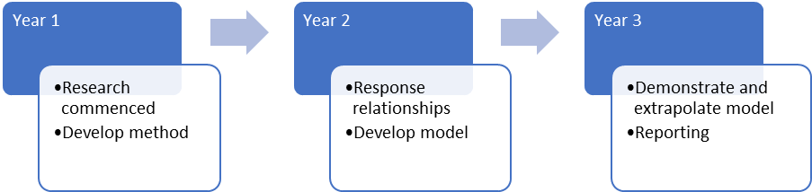
Figure 18 Flow-ecology relationships research project activities across the three years of the Flow-MER Program

Integrative modelling

Integrative Basin Modelling Research
This project is developing an integrative framework and systems thinking for integration across Themes and the Murray-Darling Basin. This framework is being developed with a clear line-of-sight to future use as a management tool for both evaluation and research.

Research questions
- How can we characterise the interactions that occur among different species effectively and efficiently?
- What set of variables (e.g. satellite data) will enable us to predict patterns in ecological response to environmental watering at the basin scale?
- Are there individual variables (or a small subset) that summarise responses across multiple species to integrate and simplify assessment of ecological response at the basin scale?
- What is the best method to extrapolate known responses at Selected Areas during monitored times to other locations and other times?
- How can we capture and express uncertainty in our predictions?
- How well does our extrapolation match other data sources?

Research outcomes
Demonstrated framework to model ecological response to environmental watering at the basin scale including:
- Basic variables needed
- Species responses and interactions
- Validated extrapolation method
- Simplifying variables to summarise response of multiple species.

Project description
The research project is generating an Integrative Basin Model (IBM) framework to combine knowledge and scale across Themes and Selected Areas. A consistent modelling framework integrates across desired outcomes at the basin scale, laying the foundation for future tools for evaluating the value and outcomes of environmental water, explore scenarios, and help understand the reasons for those outcomes.
This research builds on work undertaken in EWKR and develops understanding of the interactions between different Themes and locations to create synthesised metrics that combine information in space and time, as well as across biotic groups. In previous tools, responses have been calculated assuming that each species is independent of others, and often also that all locations are similar or independent. Research aims to better represent the complex responses to environmental watering and identify unifying metrics that synthesise outcomes over different groups, in space and through time.
There are four main components to research:
- Defining outcomes relevant at the basin scale to inform management. Designing a framework with management relevance at the basin scale requires accounting for a range of management goals. The basin is heterogeneous, and so the overall basin-scale outcomes should integrate over variable conditions within the Murray-Darling Basin as well as multiple target groups.
- Developing an integrative modelling framework to enable environmental drivers (using hydrology as a starting point in combination with new remote-sensing products that are now available) as well as biotic groups and other management targets to be incorporated.
- Developing an appropriate method for considering and integrating time and space across the heterogeneity of the Murray-Darling Basin.
- Identifying a small number of metrics that integrate across species to provide a simpler and more robust analysis of the effects of environmental watering events and other management actions.
The framework seeks to enable both evaluation and research, as both rely on comparisons of responses under different conditions, and the ability to investigate the reasons for those responses. An initial application, to compare environmental watering to a counterfactual over a 5-year timeframe, is guiding the framework development, but the use of the framework will likely occur beyond the life of Flow-MER.

Work to date
This project was initiated in September 2019 and commenced research activity in early 2020. Research is integrating across all Themes and is currently focused on developing a simplified but working example of the framework to identify challenges and complexities but also provide examples of possible output for consideration by CEWO. An outline of activities is summarised in Figure 19.
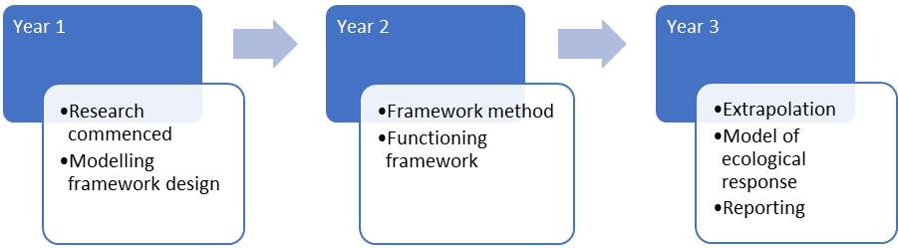
Figure 19 Integrative basin modelling research project activities across the three years of the Flow-MER Program

Visualisation
This work integrates data from across Themes to develop data visualisation products for communicating the outcomes of basin-scale monitoring, evaluation and research. The goal is to develop optimum means of presenting raw and processed data, modelling outputs and research results to inform decision making.

Outcomes
- Visualisations for summary reports
- Web-based interactive mapping and data explorer tool

Project description
This project is developing data visualisation products for communicating outputs of the basin-scale monitoring, evaluation and research. This involves integrating data from across Themes and the results of the basin-scale evaluation and modelling.
Large volumes of data are collected by LTIM and Flow-MER and methods of maximising the benefit of the collected data is being explored through visualisation. This research addresses how best to communicate results of basin-scale monitoring, evaluation and research. The goal of the research is to develop optimum means of presenting raw and processed data, modelling outputs and research results to inform the management of environmental water.
The focus of this project is on visualisations for incorporation into Theme and Basin-scale reports and web-based presentation. A synthesis of current approaches of LTIM theme and basin-scale reporting is underway. Currently the LTIM monitoring data is being explored and methods of visualising the results are being prototyped. This will support visualisation of basin-scale evaluation outcomes.

Work to date
This project commenced in early 2020 and is integrating across all Themes. A dashboard of spatial data and preliminary visualisations of LTIM data have been trialled. An outline of activities is summarised in Figure 20.
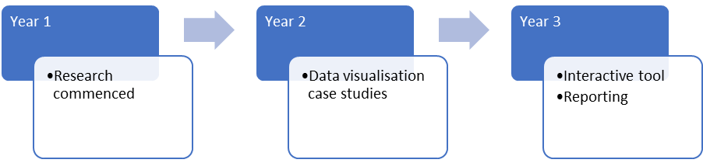
Figure 20 Visualisation project activities across the three years of the Flow-MER Program

https://flow-mer.org.au
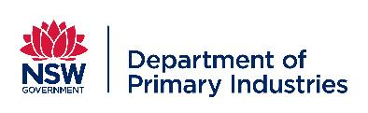
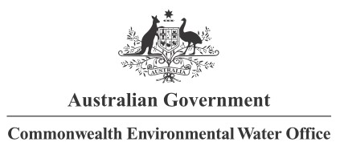
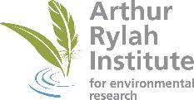

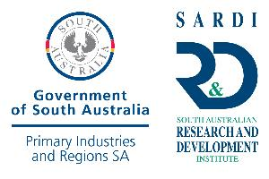



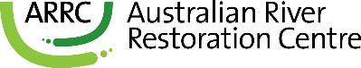

Partners

Collaborators

https://www.environment.gov.au/ewater/publications/ewater-monitoring-evaluation.html
https://www.environment.gov.au/water/cewo/publications/environmental-water-outcomes-framework
https://www.mdba.gov.au/publications/mdba-reports/basin-wide-environmental-watering-strategy
https://www.environment.gov.au/water/cewo/monitoring/ltim-project
https://www.environment.gov.au/water/cewo/monitoring/ltim-project
Stewardson and Guarino (2019) The Hydrology Foundation Report https://www.environment.gov.au/water/cewo/publications/cewo-ltim-basin-matter-hydrology-2019
King (2019) Fish Foundation Report https://www.environment.gov.au/water/cewo/publications/cewo-ltim-basin-matter-fish-2019
Capon, Campbell and Wolfenden (2019) Vegetation Diversity Foundation Report https://www.environment.gov.au/water/cewo/publications/cewo-ltim-basin-matter-vegetation-2019
Hale, 2019, Biodiversity Foundation Report https://www.environment.gov.au/water/cewo/publications/basin-matter-aggregation-selected-area-biodiversity-outcomes-2019
Brooks, 2019, Ecosystem Diversity Foundation Report https://www.environment.gov.au/water/cewo/publications/cewo-ltim-basin-matter-ecosystem-diversity-2019
Grace (2019) Stream Metabolism and Water Quality Foundation Report https://www.environment.gov.au/water/cewo/publications/cewo-ltim-basin-matter-stream-metabolism-water-quality-2019
Stewardson and Guarino, 2019 The Hydrology Foundation Report https://www.environment.gov.au/water/cewo/publications/cewo-ltim-basin-matter-hydrology-2019

