FARM MANAGEMENT DEPOSITS SCHEME STATISTICS – April 2026
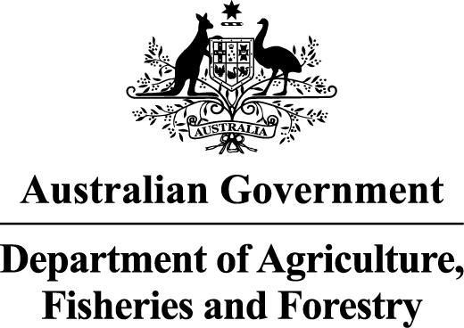
INDUSTRY DESCRIPTION | NSW |  | VIC |  | QLD |  | SA |  | WA |  | TAS |  | ACT & NT |  | NATIONAL TOTALS
INDUSTRY DESCRIPTION | No. of FMD accounts | Value of deposits ($’000) | No. of FMD accounts | Value of deposits ($’000) | No. of FMD accounts | Value of deposits ($’000) | No. of FMD accounts | Value of deposits ($’000) | No. of FMD accounts | Value of deposits ($’000) | No. of FMD accounts | Value of deposits ($’000) | No. of FMD accounts | Value of deposits ($’000) | No. of FMD accounts | Value of deposits ($’000)
HORTICULTURE | 855 | 129,569 | 789 | 131,184 | 846 | 150,888 | 707 | 108,508 | 260 | 48,656 | 125 | 18,567 | 24 | 3,279 | 3,606 | 590,652
SUGAR | 107 | 10,410 | * | * | 1,233 | 178,792 | * | * | * | * | * | * | * | * | 1,340 | 189,202
CROPS | 707 | 100,357 | 439 | 51,748 | 603 | 93,807 | 342 | 46,364 | 113 | 17,382 | 44 | 4,993 | * | * | 2,248 | 314,650
GRAIN | 1,358 | 237,840 | 1,882 | 321,991 | 773 | 152,439 | 1,572 | 269,599 | 993 | 212,790 | * | * | * | * | 6,578 | 1,194,659
GRAIN-SHEEP/BEEF | 2,581 | 372,676 | 2,287 | 348,810 | 876 | 142,647 | 1,409 | 223,066 | 1,300 | 253,160 | 79 | 11,318 | * | * | 8,532 | 1,351,677
BEEF | 1,886 | 210,664 | 1,648 | 174,895 | 2,834 | 523,006 | 291 | 35,188 | 324 | 47,565 | 193 | 28,087 | 28 | 4,688 | 7,204 | 1,024,092
SHEEP-BEEF | 961 | 101,463 | 900 | 103,318 | 401 | 48,697 | 374 | 48,063 | 108 | 13,073 | 62 | 8,681 | * | * | 2,806 | 323,294
SHEEP | 973 | 106,199 | 940 | 97,137 | 79 | 10,165 | 361 | 39,056 | 191 | 23,345 | 65 | 7,600 | * | * | 2,609 | 283,503
PIG | 48 | 9,639 | * | * | 21 | 2,747 | 29 | 4,733 | * | * | * | * | * | * | 98 | 17,119
INTENSIVE LIVESTOCK | 591 | 74,489 | 330 | 34,283 | 441 | 68,794 | 172 | 21,125 | 62 | 6,369 | 62 | 6,486 | * | * | 1,658 | 211,546
DAIRY | 301 | 39,733 | 1,715 | 256,970 | 196 | 21,086 | 96 | 12,238 | 54 | 8,234 | 97 | 15,881 | * | * | 2,459 | 354,141
FORESTRY & FISHING | 125 | 10,411 | 89 | 7,241 | 151 | 15,921 | 141 | 15,768 | 139 | 19,434 | 40 | 4,103 | * | * | 685 | 72,878
OTHER | 52 | 3,098 | * | * | * | * | * | * | * | * | * | * | * | * | 52 | 3,098
STATE/TERRITORY TOTAL  # | 10,545 | 1,406,549 | 11,019 | 1,527,577 | 8,454 | 1,408,988 | 5,494 | 823,709 | 3,544 | 650,006 | 767 | 105,715 | 52 | 7,966 | 39,875 | 5,930,511
#Note: The total number of accounts may not indicate the number of primary producers participating in the FMD Scheme as a primary producer may hold multiple FMD accounts, including with different ADIs. If an FMD holder has more than one account in the same industry with a financial institution, only one account is recorded in the published data. If that FMD holder also has an account in a different industry, one count for each industry is included in the published data. In addition, the value of deposits reported may be greater than the actual level of FMDs as primary producers may choose not to claim a tax deduction for all deposits held in FMD accounts.
* The following state/territory industry FMD accounts and holdings have been aggregated with the respective New South Wales industry FMD accounts and holdings where there are less than 20 accounts for
privacy reasons:
- Victoria – Sugar, Pig and Other
- Queensland –Other
- South Australia –Sugar and Other
- Western Australia – Sugar, Pig and Other
- Tasmania – Sugar, Grain, Pig and Other
- Australian Capital Territory and Northern Territory – Sugar, Crops, Grain, Grain-Sheep/Beef, Sheep-Beef, Sheep, Pig, Intensive Livestock, Dairy, Forestry & Fishing and Other
These monthly FMD statistics are derived from data provided by Authorised Deposit-taking Institutions (ADIs) (such as banks and credit unions). These statistics may, due to the complex nature of FMDs, include a level of discrepancy, leading to a minor overstatement or understatement of the actual holdings eligible for the FMD taxation concessions. The Australian Government, acting through the Department of Agriculture, Fisheries and Forestry, has exercised due care in compiling this information. Notwithstanding, the department, its employees and advisers disclaim all liability, including liability for negligence, for any loss, damage, injury, expense or cost incurred by any person as a result of accessing, using or relying upon any of the information or data on FMDs to the maximum extent permitted by law.

