FARM MANAGEMENT DEPOSITS SCHEME STATISTICS – february 2014
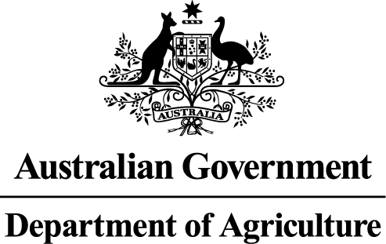
INDUSTRY DESCRIPTION | NSW |  | VIC |  | QLD |  | SA |  | WA |  | TAS |  | ACT & NT |  | NATIONAL TOTALS
INDUSTRY DESCRIPTION | No. of FMD accounts | Value of deposits ($’000) | No. of FMD accounts | Value of deposits ($’000) | No. of FMD accounts | Value of deposits ($’000) | No. of FMD accounts | Value of deposits ($’000) | No. of FMD accounts | Value of deposits ($’000) | No. of FMD accounts | Value of deposits ($’000) | No. of FMD accounts | Value of deposits ($’000) | No. of FMD accounts | Value of deposits ($’000)
HORTICULTURE | 912 | 77,866 | 986 | 92,939 | 1,039 | 109,234 | 827 | 67,375 | 321 | 39,385 | 150 | 12,639 | 8 | 736 | 4,243 | 400,174
SUGAR | 74 | 3,791 | 5 | 475 | 1,398 | 101,920 | 0 | 0 | 0 | 0 | 0 | 0 | 0 | 0 | 1,477 | 106,186
CROPS | 596 | 41,435 | 413 | 24,979 | 489 | 41,258 | 284 | 15,227 | 78 | 6,429 | 49 | 2,251 | * | * | 1,909 | 131,579
GRAIN | 1,551 | 131,660 | 1,704 | 118,686 | 690 | 66,227 | 2,381 | 216,396 | 1,192 | 156,919 | 17 | 897 | 5 | 821 | 7,540 | 691,606
GRAIN-SHEEP/BEEF | 2,856 | 194,966 | 2,538 | 171,510 | 719 | 56,120 | 2,015 | 160,815 | 1,193 | 144,507 | 54 | 5,298 | 5 | 1,535 | 9,380 | 734,751
BEEF | 1,524 | 84,068 | 1,039 | 55,397 | 2,418 | 208,753 | 217 | 14,879 | 230 | 19,381 | 162 | 9,917 | 14 | 917 | 5,604 | 393,312
SHEEP-BEEF | 1,229 | 69,860 | 792 | 42,093 | 403 | 32,054 | 469 | 36,018 | 144 | 11,241 | 114 | 6,142 | 5 | 125 | 3,156 | 197,533
SHEEP | 1,081 | 61,270 | 970 | 54,970 | 106 | 9,155 | 498 | 32,689 | 237 | 17,520 | 85 | 6,152 | 5 | 96 | 2,982 | 181,852
PIG | 37 | 2,702 | 24 | 2,450 | 49 | 3,567 | 37 | 3,160 | 12 | 370 | ** | ** | 0 | 0 | 159 | 12,249
INTENSIVE LIVESTOCK | 480 | 32,938 | 332 | 20,152 | 327 | 26,026 | 167 | 10,262 | 74 | 4,637 | 20 | 712 | * | * | 1,400 | 94,727
DAIRY | 367 | 26,407 | 1,962 | 129,681 | 338 | 21,149 | 149 | 12,527 | 54 | 5,070 | 116 | 7,145 | 0 | 0 | 2,986 | 201,979
FORESTRY & FISHING | 269 | 12,454 | 205 | 12,769 | 192 | 13,260 | 123 | 9,383 | 159 | 15,628 | 39 | 1,957 | 0 | 0 | 987 | 65,451
OTHER | 11 | 243 | 20 | 720 | 9 | 326 | *** | *** | *** | *** | *** | *** | 0 | 0 | 40 | 1,289
STATE/TERRITORY TOTAL  # | 10,987 | 739,660 | 10,990 | 726,821 | 8,177 | 689,049 | 7,167 | 578,731 | 3,694 | 421,087 | 806 | 53,110 | 42 | 4,230 | 41,863 | 3,212,688
#Note: The total number of accounts does not indicate the number of primary producers participating in the FMD Scheme as a primary producer may hold multiple FMD accounts.
* Northern Territory and Australian Capital Territory crops and intensive livestock industries FMD accounts and holdings have been aggregated with the respective New South Wales FMD accounts and holdings for privacy reasons.
** Tasmanian pig industry FMD accounts and holdings have been aggregated with the respective New South Wales FMD accounts and holdings for privacy reasons.
*** South Australian, Western Australian and Tasmanian other industry FMD accounts and holdings have been aggregated with the respective Victorian FMD accounts and holdings for privacy reasons.

