FARM MANAGEMENT DEPOSITS SCHEME STATISTICS – JUNE 2014
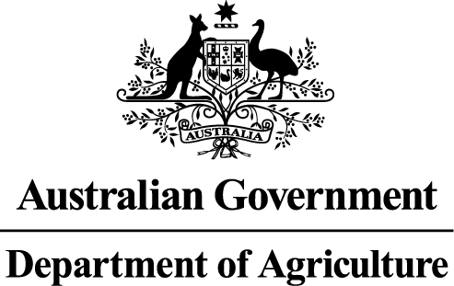
INDUSTRY DESCRIPTION | NSW |  | VIC |  | QLD |  | SA |  | WA |  | TAS |  | ACT & NT |  | NATIONAL TOTALS
INDUSTRY DESCRIPTION | No. of FMD accounts | Value of deposits ($’000) | No. of FMD accounts | Value of deposits ($’000) | No. of FMD accounts | Value of deposits ($’000) | No. of FMD accounts | Value of deposits ($’000) | No. of FMD accounts | Value of deposits ($’000) | No. of FMD accounts | Value of deposits ($’000) | No. of FMD accounts | Value of deposits ($’000) | No. of FMD accounts | Value of deposits ($’000)
HORTICULTURE | 1,013 | 104,447 | 1,117 | 124,804 | 1,156 | 138,735 | 858 | 78,931 | 329 | 46,052 | 138 | 13,946 | 10 | 1,555 | 4,621 | 508,470
SUGAR | 75 | 3,797 | 5 | 475 | 1,366 | 113,161 | 0 | 0 | 0 | 0 | 0 | 0 | 0 | 0 | 1,446 | 117,433
CROPS | 634 | 50,936 | 453 | 33,979 | 561 | 53,443 | 348 | 21,870 | 100 | 8,158 | 53 | 2,502 | * | * | 2,149 | 170,888
GRAIN | 1,973 | 193,874 | 1,866 | 159,982 | 761 | 79,141 | 2,610 | 272,785 | 1,604 | 260,194 | 21 | 1,395 | 5 | 776 | 8,840 | 968,147
GRAIN-SHEEP/BEEF | 3,017 | 257,902 | 2,625 | 215,898 | 704 | 62,243 | 2,283 | 217,923 | 1,597 | 231,195 | 54 | 5,860 | 5 | 1,535 | 10,285 | 992,556
BEEF | 1,501 | 95,291 | 1,161 | 68,230 | 2,443 | 231,908 | 272 | 20,108 | 377 | 34,470 | 190 | 12,446 | 14 | 962 | 5,958 | 463,415
SHEEP-BEEF | 1,254 | 79,492 | 814 | 49,108 | 451 | 35,638 | 493 | 42,545 | 170 | 12,795 | 107 | 6,331 | 6 | 271 | 3,295 | 226,180
SHEEP | 1,136 | 74,305 | 945 | 62,064 | 115 | 10,209 | 510 | 36,237 | 253 | 24,729 | 87 | 7,068 | 6 | 91 | 3,052 | 214,703
PIG | 37 | 2,791 | 29 | 2,885 | 42 | 4,523 | 42 | 4,404 | 11 | 608 | 5 | 381 | 0 | 0 | 166 | 15,592
INTENSIVE LIVESTOCK | 496 | 38,323 | 311 | 20,474 | 303 | 27,795 | 172 | 11,500 | 71 | 4,407 | 23 | 982 | * | * | 1,376 | 103,481
DAIRY | 389 | 32,076 | 2,406 | 191,141 | 326 | 22,939 | 186 | 17,625 | 65 | 6,702 | 148 | 11,833 | 0 | 0 | 3,520 | 282,316
FORESTRY & FISHING | 229 | 13,251 | 184 | 11,658 | 187 | 14,098 | 154 | 13,121 | 167 | 19,845 | 39 | 1,985 | 0 | 0 | 960 | 73,958
OTHER | 11 | 330 | 14 | 491 | 6 | 371 | 6 | 310 | 5 | 265 | ** | ** | 0 | 0 | 42 | 1,767
STATE/TERRITORY TOTAL  # | 11,765 | 946,815 | 11,930 | 941,189 | 8,421 | 794,204 | 7,934 | 737,359 | 4,749 | 649,420 | 865 | 64,729 | 46 | 5,190 | 45,710 | 4,138,906
#Note: The total number of accounts does not indicate the number of primary producers participating in the FMD Scheme as a primary producer may hold multiple FMD accounts.
* Northern Territory and Australian Capital Territory crops and intensive livestock industries FMD accounts and holdings have been aggregated with the respective New South Wales FMD accounts and holdings for privacy reasons.
** Tasmanian other industry FMD accounts and holdings have been aggregated with the respective Victorian FMD accounts and holdings for privacy reasons.

