

NPI Fuel and Organic Liquid Storage
TANKS User Manual


Australian Government
Department of Sustainability, Environment, Water, Population and Communities

October 2011

Project No.3011-139a

NPI Fuel and Organic Liquid Storage
TANKS User Manual

Prepared for:
Australian Government
Department of Sustainability, Environment, Water, Population and Communities
Prepared By:
KMH Environmental
Level 12, South Tower
1-5 Railway Street
Chatswood NSW 2067

PO Box 5487
West Chatswood NSW 1515

Phone: (02) 9468 9300
Fax: (02) 8008 1600

Document Control Log
Revision No. | Amendment | Date | Prepared By | Checked By | Approved By
A | Draft for internal review | 22/9/2011 | OE | KM | KM
B | Draft for internal review | 6/10/2011 | OE | KM | KM
0 | Draft for client review | 6/10/2011 | OE | KM | GL
1 | Final submission to client post feedback | 30/01/2012 | OE | GL | GL

© KMH Environmental 2011
The information contained in this document produced by KMH Environmental is solely for the use of the Client identified on the cover sheet for the purpose for which it has been prepared and KMH Environmental undertakes no duty to or accepts any responsibility to any third party who may rely upon this document.
All rights reserved. No section or element of this document may be removed from this document, reproduced, electronically stored or transmitted in any form without the written permission of KMH Environmental.

TABLE OF CONTENTS
Glossary and Abbreviations iii
1. About Tanks 4
2. Where and How to Download 4
3. Accessing and Saving Databases 5
3.1. To restore the Tank Database 5
3.2. To restore the Client Database 5
3.3. To save/backup the Client and Tank Database 5
4. Site Information Required Prior to Use 6
4.1. Tank Information 6
4.2. Location Information 7
4.3. Substance Information 9
5. Conversion From Metric to Imperial 10
6. Entering Data 11
6.1. Using default tank records 11
6.2. Creating a new tank record 11
6.3. Tank Records 11
7. Default Tank Types and Parameters 15
7.1. External floating roof tank 15
7.2. Horizontal fixed roof tanks 16
7.3. Internal floating roof tanks 17
7.4. Underground horizontal tank 17
7.5. Vertical fixed roof tanks 17
8. Generating Reports 17
8.1. Generating a report using the Report menu 18
8.2. Generating a report while viewing a tank record 19
9. Conversion from Imperial to Metric for NPI Reporting. 20

FIGURES

Figure 1 Confirmation message for correctly restoring databases 5
Figure 2 Map of Australia showing breakup of default regions 8
Figure 3 Meteorological data input screen 8
Figure 4 Identification tab 11
Figure 5 Physical Characteristics tab 12
Figure 6 Site Selection tab 13
Figure 7 Tank Contents tab 14
Figure 8 Monthly Calculations tab 15
Figure 9 Report selection screen from report menu 18
Figure 10 Report selection screen from tank record 19

TABLES
Table 1 Essential tank information required for use of TANKS 4.09d 6
Table 2 Default variables for input into TANKS 4.09d 6
Table 3 Default regions and their corresponding geographical locations 7
Table 4 Metric / imperial conversions 10
Table 5 Data requirements for tank types 12
Table 6 Default parameters for external floating roof tanks 16
Table 7 Default parameters for horizontal fixed roof tanks 16
Table 8 Default parameters for internal floating roof tanks 17
Table 9 Default parameters for underground horizontal tanks 17
Table 10 Default parameters for vertical fixed roof tanks 17
Table 11 Example of a brief emissions report for an external floating roof tank 18

Glossary and Abbreviations
BOM | Australian Bureau of Meteorology
E | External Floating Roof Tank
H | Horizontal Fixed Roof Tank
HAP | Hazardous air pollutant
NPI | National Pollution Inventory
OAQPS | United States Office of Air Quality Planning and Standards
R | Internal Floating Roof Tank
RVP | Reid Vapour Pressure
U | Underground Horizontal Tank
US EPA | United States Environmental Protection Agency
V | Vertical Fixed Roof Tank
VOC | Volatile Organic Compound

- About Tanks
TANKS 4.09d is a Windows-based computer software program that estimates volatile organic compound (VOC) and hazardous air pollutant (HAP) emissions from horizontal and vertical, fixed- and floating-roof storage tanks. The United States Environmental Protection Agency’s (US EPA) Office of Air Quality Planning and Standards (OAQPS) develops and maintains emissions estimating tools to support Federal, State, and local agencies, consultants, and industry with estimating air emissions from various sources.
TANKS 4.09d allows users to enter specific information about a storage tank (dimensions, construction, paint condition, etc.), the liquid contents (chemical components and liquid temperature), and the location of the tank (nearest city, ambient temperature, etc.), and generate an air emissions report. Report features include estimates of monthly, annual, or partial year emissions for each chemical or mixture of chemicals stored in the tank. For National Pollutant Inventory (NPI) purposes only annual reports are required.
- Where and How to Download
At the time of this report, TANKS 4.09D is available to download from the US EPA website.
http://www.epa.gov/ttnchie1/software/tanks/
The software is provided free of charge along with a comprehensive user manual US EPA User Guide to Tanks that should be used in conjunction with this manual as a technical guide.
  - Installation
To setup TANKS 4.09d on a personal computer, double-click on the downloaded file. The installation utility will guide the user through the setup process. Once the program is installed on the computer, it may be started by opening the file in the destination folder.
  - Downloading Australian Databases
As TANKS 4.09d is designed for use in the US, the databases provided with the software are not applicable for Australian users. Therefore alternative databases have been provided by NPI and provide information relevant to the Australian climate including meteorological data for major cities and regions, such as:
- Average, maximum and minimum temperature,
- Average wind speed,
- Annual average solar insulation factor; and,
- Atmospheric pressure
These databases are available to download from the NPI website
http://www.npi.gov.au/publications/emission-estimation-technique/fols.html

In addition to downloading TANKS 4.09d, it is necessary to download:
- The NPI TANKS Database: The “Tank Database” contains the chemical, meteorological, fitting, rim seal, deck seam, and profile information for the Australian context.
- The NPI Client Database: The “Client Database” stores the information used during data entry for each tank record. The data will be copied to the file location selected. This database is not required, however it does provide examples of default tanks at different locations around Australia

- Accessing and Saving Databases
Once the NPI Tank database and client database (as required) have been downloaded it is necessary to ‘restore’ the databases in the TANKS 4.09d. To do this, follow the steps below:
To restore the Tank Database
- Open TANKS 4.09d
- Click on the ‘Backup’ drop down menu -> Restore Tank Database From Backup
- Select the ‘NPI TANKS Database’ file that you previously downloaded from the NPI website and press open
- If this has been done correctly the message in Figure 1 will be displayed.
Figure 1 Confirmation message for correctly restoring databases
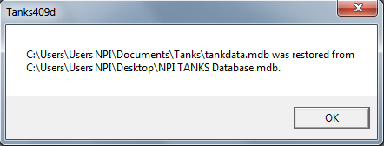

To restore the Client Database
- Click on the ‘Backup’ drop down menu -> Restore Client Database from Backup
- Select the ‘NPI Client Database’ file that you previously downloaded from the NPI website and press open.
- Again, if this was done correctly you should receive a message similar to Figure 1
To save/backup the Client and Tank Database
- Click on the ‘Backup’ drop down menu -> Backup Client or Tank Database

- Site Information Required Prior to Use
Prior to using TANKS 4.09d to estimate emissions, you will need to gather the following information about the type of tank, geographical location and substances stored in the tank.
Tank Information
TANKS 4.09d is designed to calculate the estimates VOC and HAP emissions from the following types of tanks:
- External floating roof tank
- Horizontal tank
- Internal floating roof tank
- Underground horizontal tank
- Vertical fixed roof tank
The matrix below shows the information required for each tank type regarding the size and condition of tank is required prior to using TANKS 4.09d to estimate emissions:
Table 1 Essential tank information required for use of TANKS 4.09d
 | External floating roof tank | Horizontal Tank | Internal floating roof tank | Underground horizontal tank | Vertical fixed roof tank
Shell length
Tank diameter
Tank volume
Turnovers per year
Note that TANKS requires inputs in imperial units. See Section 5 for further details.
The table below lists the default values that should be used in TANKS if no information is available. While these variables do affect the outcome of the report the extent is marginal when compared to the parameters above.
Table 2 Default variables for input into TANKS 4.09d
 | External floating roof tank | Horizontal Tank | Internal floating roof tank | Underground horizontal tank | Vertical fixed roof tank
Internal Shell Condition | Gunite Lining | N/A | Gunite Lining | N/A | N/A
External Shell Colour/Shade | White/White | White/White | White/White | White/White | White/White
External Shell Condition | Good | Good | Good | Good | Good
Roof Colour/Shade | N/A | N/A | White/White | N/A | White/White
Roof Paint Conditions | N/A | N/A | Good | N/A | Good
Roof Type | Pontoon | N/A | N/A | N/A | Cone
Roof Fitting Category | Typical | N/A | N/A | N/A | N/A
Is tank heated | No | No | No | No | No
Vacuum Vent Setting | N/A | -0.03 | N/A | -0.03 | -0.3
Pressure Vent Setting | N/A | 0.03 | N/A | 0.03 | 0.3
Primary Seal | Liquid Mounted | N/A | Liquid Mounted | N/A | N/A
Secondary Seal | Rim mounted | N/A | None | N/A | N/A
Deck Type | Welded | N/A | Welded | N/A | N/A
Deck Fitting Category | N/A | N/A | Typical | N/A | N/A

Location Information
As discussed in Section 3, NPI has provided a database that lists the meteorological information for many major cities and regions around Australia.
In addition, for users who are not located in the close vicinity of a major city, the average meteorological data has been compiled for specific major climatic zones in Australia (Table 3 and Figure 2).
Table 3 Default regions and their corresponding geographical locations
Name | Location
Region 01 | South Australia South
Region 02 | Western Australia South
Region 03 | Western Australia Central
Region 04 | Australia North
Region 05 | Australia Central
Region 06 | Queensland Far North East
Region 07 | Queensland Central North
Region 08 | Queensland Central
Region 09 | Queensland South
Region 10 | New South Wales
Region 11 | Victoria
Region 12 | Tasmania

Figure 2 Map of Australia showing breakup of default regions
Alternatively, it is possible to enter the meteorological information for the specific location of the tank. In some cases it is possible to obtain this data from Australian Bureau of Meteorology (BOM). If this approach is to be taken, the following information will be required.
- Daily Average Ambient Temperature (F)
- Annual Average Maximum Temperature (F)
- Annual Average Minimum Temperature (F)
- Average Wind Speed (mph)
- Annual Average Solar Insulation Factor (Btu/(ft’ft’day))
- Atmospheric Pressure (psia)
Figure 3 Meteorological data input screen
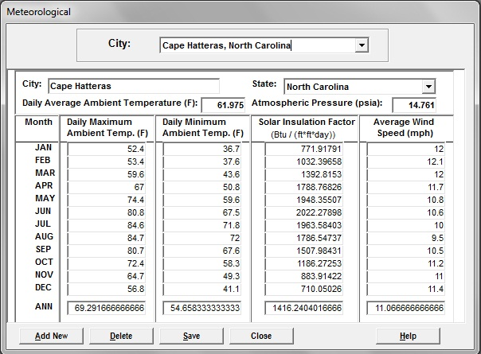
Substance Information
Finally, the liquid content of the tank is required. As with the meteorological data, information on the vast majority of fuels and organic liquids have been added to the databases and it will simply be a case of selecting the appropriate liquid from the dropdown. However, please note that if this is not the case, it may be necessary to manually enter information regarding the chemical into tanks. In this situation, please see Section 4.5 of the US EPA User Guide to Tanks.

- Conversion From Metric to Imperial
As TANKS 4.09d was originally designed for use in the US it is necessary to convert all measurements from metric to imperial prior to entering details of the tank and substance into the program.
It is expected that for the majority of cases, the only measurements that will need to be converted are:
- Length, height, width – from meters (m) to feet (ft)
- Volume – from litres (L) to US gallon (Gal)
- Temperature – from Celsius to Fahrenheit
- Pressure - hPa to psi
The table below provides conversion rates for all the units required in TANKS 4.09d.
Table 4 Metric / imperial conversions
To convert from | To convert to | Multiply by
Mass
Kilogram (kg) | Pound (lb) | 2.204
Pound (lb) | Kilogram (kg) | 0.454
Volume
US Gallons (gal) | Litres (L) | 3.785
Litres (L) | US Gallons (gal) | 0.2642
Length
Metres (m) | Foot (ft) | 3.280
Foot (ft) | Metres (m) | 0.304
Temperature
Celsius (°C) | Fahrenheit (°F) | 9/5 × °C + 32
Fahrenheit (°F) | Celsius (°C) | (°F – 32) × 5/9
Pressure
lb per square inch (psi) | Hectopascal (hPa) | 69
Hectopascal (hPa) | lb per square inch (psi) | 0.01450
Millibar | Hectopascal (hPa) | 1
Note:
- The unit psi is either psig (pound per square inch gauge) or psia (pounds per square inch absolute). Gauge is in reference to 1 atmosphere pressure (14.7 psia or 1013 hPa)
- Note US gallons are not the same UK gallons.In relation to any work involving TANKS the unit gallon or gal refers to the US gallons.

- Entering Data
TANKS 4.09d requires specific information about a storage tank (dimensions, construction, paint condition, etc.), the liquid contents (chemical components and liquid temperature), and the location of the tank (nearest city, ambient temperature, etc.) to generate an air emissions report. This information is entered into and stored in a tank record.
Users have the option of creating an entirely new tank record or, alternately, they can edit default tank records that the NPI has developed.
Using default tank records
To open a default tank record select Data -> Tanks -> Edit Record -> Choose the appropriate record from the drop down list -> Edit
Creating a new tank record
To create a new tank record select Data -> Tanks -> New record -> Select the appropriate tank type
Tank Records
Tank records contain all the parameters for a specific tank such as its size, location, contents and condition. These details must be correctly entered prior to running an emission report.
    - Identification
Information contained within the Identification section is user-defined and is designed to provide a reference for users with multiple tank types. Each tank can be identified by five data fields: identification number, description, city, state and company. Information entered into this section of the Tank record does not affect the emission report.
Figure 4 Identification tab
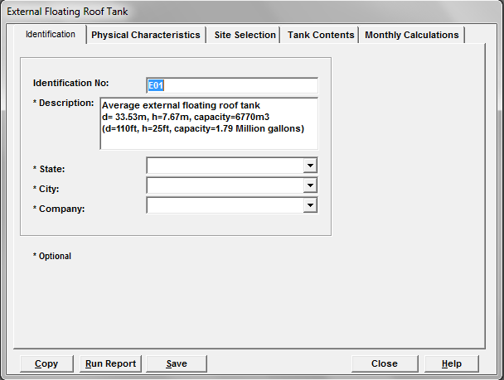

    - Physical Characteristics
The physical characteristics required by TANKS 4.09d to produce an emission report varies depending on the type of tank. The default entries should be left if the actual value/answer is unknown.
Figure 5 Physical Characteristics tab
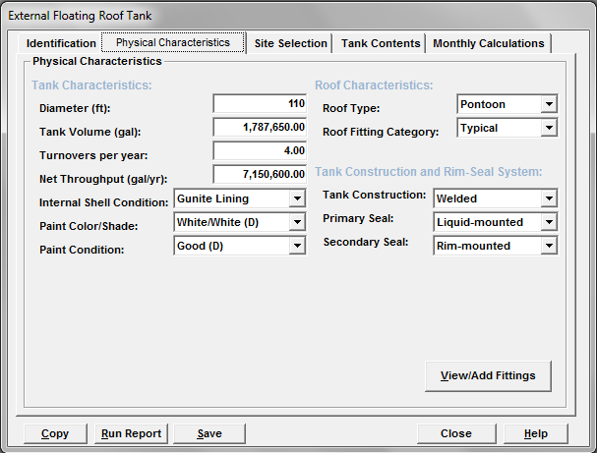
The table below details the required physical characteristics for each tank type.
Table 5 Data requirements for tank types
External floating roof tank | Horizontal Tank | Internal floating roof tank | Underground horizontal tank | Vertical fixed roof tank
Diameter (ft) | Shell Length (ft) | Diameter (ft) | Shell Length (ft) | Shell Height (ft)
Tank Volume (gal) | Shell Diameter (ft) | Tank Volume (gal) | Shell Diameter (ft) | Shell Diameter (ft)
Turnovers per year | Working Volume (gal) | Turnover per year | Working Volume (gal) | Maximum Liquid Height (ft)
Net Throughput (gal/yr) | Turnovers per Year | Net Throughput (gal/yr) | Turnovers per Year | Average Liquid Height (ft)
Internal Shell Condition | Net Throughput (gal/yr) | Self-Supporting Roof? | Net Throughput (gal/yr) | Working Volume (gal)
Paint Colour/Shade | Is Tank Heated? | Number of Columns | Is Tank Heated? | Turnovers per Year
Paint Condition | Is the Tank Underground | Effective Column diameter | Is the Tank Underground | Net Throughput (gal/yr)
Roof Type | Shell Colour/Shade | Internal Shell Condition | Vacuum Settings (psig) | Is Tank Heated?
Roof Fitting Category | Shell Condition | External Shell Colour/Shade | Pressure Settings (psig) | Shell Colour/Shade
Tank Construction | Vacuum Setting (psig) | External Shell Condition |  | Shell Condition
Primary Seal | Pressure Setting (psig) | Roof Colour/Shade |  | Roof Colour/Shade
Secondary Seal |  | Roof Paint Condition |  | Roof Condition
 |  | Primary Seal |  | Roof Type
 |  | Secondary Seal |  | Roof Height
 |  | Deck Type |  | Roof Slope (ft/ft) (Cone)
 |  | Deck Fitting Category |  | Vacuum Setting (psig)
 |  |  |  | Pressure Setting (psig)

For further information and descriptions of each requirement please see Section 4.2 of the US EPA User Guide to Tanks.
    - Site Selection
The Site Selection screen is identical in all five tank types. As discussed in Section 3 and 5.2, the NPI database provided contains meteorological information for the major cities of Australia and also average data for 12 regions of Australia such as temperatures, wind speed, and solar insolation factors. If the user wishes to use one of the predetermined locations, it is simply a case of selecting the relevant one from the dropdown list.
Figure 6 Site Selection tab
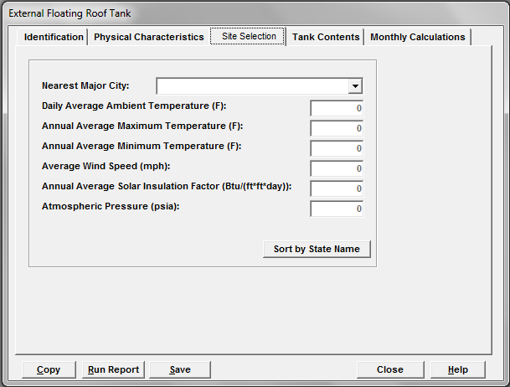
Alternatively, if more accurate or relevant information is available (such as BOM data), it is possible for users to create or edit a meteorological record. For more information on creating and editing meteorological data please see Section 6.2 of the US EPA User Guide to Tanks.

    - Tank Contents
The fields shown on this screen vary according to the type of tank, whether the tank is heated, and the liquid contents.
Figure 7 Tank Contents tab
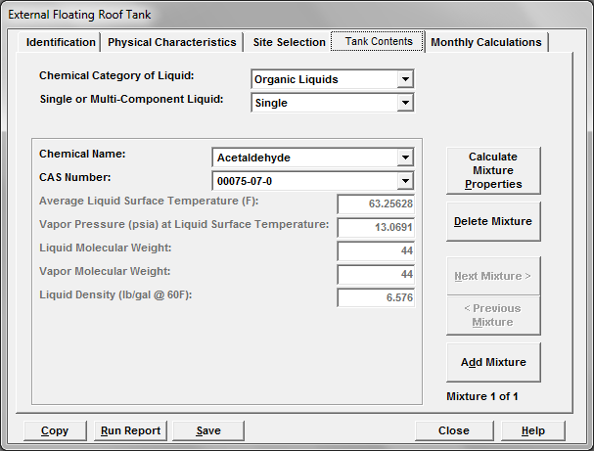
Chemical Category of Liquid
There are three chemical categories
- Petroleum Distillates – Unleaded petrol, diesel, jet fuels, AV gas etc.
- Crude oils – unrefined petroleum stocks
- Organic Liquids – All organic compounds and mixtures
Single – or Multi-Component Liquid
This field indicates whether the liquid stored in the tank consists of a single component or a mixture of components.
Petroleum distillates and crude oils may be entered as single-component liquids if the emissions estimates for individual chemicals are not needed. If a breakdown of emissions by underlying components is needed enter the liquid data as a Multi-Component Liquid. Note a breakdown is required if the mixture contains any NPI-listed chemicals (e.g., benzene emissions from storing petroleum).
Speciation Options
When a Multi-Component liquid is selected the Speciation Option field is displayed which gives 4 options to choose from as follows:
Full Speciation: This option can be used if you know the names of each substance in the mixture and their concentrations. The details of each substance can be added using the ‘Add/View Components’ option. The program will calculate the vapour pressure and other data for the entire mixture.
Partial Speciation: The TANKS program provides generic speciation profiles for fuels which can be used with the partial speciation option only to calculate emissions. The relevant fuel type or mixture should be selected from the mixture name option (e.g. Distillate fuel oil no 2). Then the ‘Copy Speciation Profile’ button can be used to access a drop down menu where the generic fuel data can be selected and added (e.g. diesel). The percent of total liquid weight if known can be adjusted by using the ‘View/Add Components’ option. Substance data can also be added or removed if required in this Specify Components screen.
Vapour Weight Speciation: This option is similar to the partial speciation option but requires that the percentage of the total vapour weight is added for all individual substances.
None: This option allows you to add specific chemical data for the mixture but will not give emissions for individual components/substances.
For more information on single and multiple speciations please see Section 4.5 of the US EPA User Guide to Tanks

    - Monthly Calculations
The final tab of the Tank Record provides an option for calculating the emissions for particular months of the year. For the purpose of NPI reporting, annual emission data is required so it is important to make sure all months are selected.
Figure 8 Map of Australia showing breakup of default regions
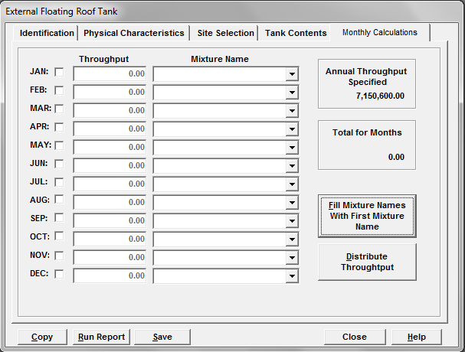
- Default Tank Types and Parameters
As mentioned in Section 5.1, TANKS 4.09d is designed to measure the emissions from five different types of tanks:
- External Floating Roof Tank (E)
- Horizontal Fixed Roof Tanks (H)
- Internal Floating Roof Tank (R)
- Underground Horizontal Tank (U)
- Vertical Fixed Roof Tanks (V)
The Australian tanks database has a number of default tanks programmed into it. The default tank type entries can be used as a basis for entering site-specific tank data, but it is recommended that users should avoid using these measurements unless no information on tank size is available. Tank size plays a significant role in determining the extent of emissions and therefore using incorrect measurements has the potential to under or overestimate emissions.
External floating roof tank
This type of tank consists of a cylindrical steel shell equipped with a roof that floats on the surface of the stored liquid.

Table 6 Default parameters for external floating roof tanks
Tank ID | Description | Diameter |  | Height |  | Volume
Tank ID | Description | (m) | (ft) | (m) | (ft) | (m³) | (gal)
E01 | External Floating Roof Tank | 33.53 | 110 | 7.67 | 25 | 6,770 | 1.79M

Horizontal fixed roof tanks
These tanks are constructed above-ground with the axis parallel to the foundation. Horizontal fixed roof shells may be steel, steel with a fiberglass overlay, or fiberglass-reinforced polyester. These tanks may be specified as “heated” in TANKS 4.0
Table 7 Default parameters for horizontal fixed roof tanks
Tank ID | Description | Diameter |  | Length |  | Volume
Tank ID | Description | (m) | (ft) | (m) | (ft) | (m³) | (gal)
H01 | Horizontal Fixed Roof Tank | 3.0 | 9.8 | 14.85 | 48.7 | 100 | 26,417

Internal floating roof tanks
This type of tank has both a permanent fixed roof and a floating deck.
Table 8 Default parameters for internal floating roof tanks
Tank ID | Description | Diameter |  | Height |  | Volume
Tank ID | Description | (m) | (ft) | (m) | (ft) | (m³) | (gal)
R01 | Internal Floating Roof Tank | 26.55 | 87 | 15.3 | 50 | 8,470 | 2.24M

Underground horizontal tank
These tanks are underground with the axis parallel to the foundation. Horizontal fixed roof shells may be steel, steel with a fiberglass overlay, or fiberglass-reinforced polyester. These tanks may be specified as “heated” in TANKS 4.0
Table 9 Default parameters for underground horizontal tanks
Tank ID | Description | Diameter |  | Length |  | Volume
Tank ID | Description | (m) | (ft) | (m) | (ft) | (m³) | (gal)
U01 | Underground Horizontal Tank | 3.0 | 9.8 | 14.85 | 48.7 | 100 | 26,417
Vertical fixed roof tanks
These tanks consist of cylindrical shells with permanently affixed roofs; the tank axis is perpendicular to the foundation. The fixed roof may be dome-shaped or cone shaped. Vertical fixed roof tank shells are usually constructed of steel. These tanks may be specified as “heated” in TANKS 4.0
Table 10 Default parameters for vertical fixed roof tanks
Tank ID | Description | Diameter |  | Height |  | Volume
Tank ID | Description | (m) | (ft) | (m) | (ft) | (m³) | (gal)
V01 | Vertical Fixed Roof Tank | 26.55 | 87 | 15.55 | 51 | 8,470 | 2.24M
- Generating Reports
TANKS 4.09d is designed so reports can be tailored to provide as little or as much information as required. For the purpose of NPI reporting, it is recommended that the Brief Report option be used. This report provides emission totals for the fuel stored in the tanks as well as a breakdown of the emissions of the related compounds.

Table 11 Example of a brief emissions report for an external floating roof tank
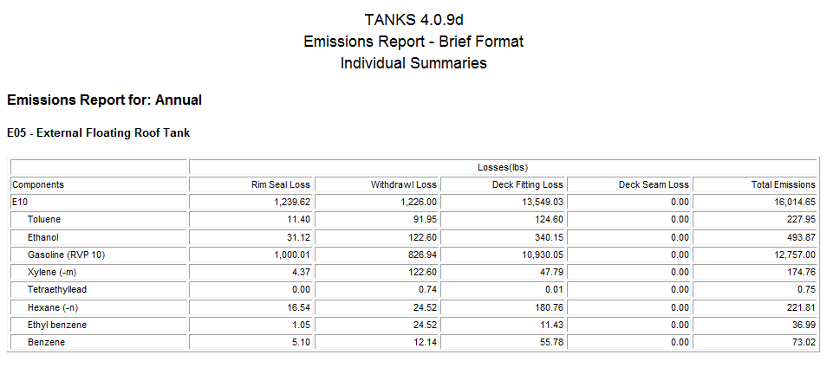
There are two ways to generate an emissions report using TANKS 4.0. You may use the Report menu on the main menu or you may run an emissions report while viewing a tank record. The advantage of using the Report option from the main menu is that you may generate reports for more than one tank at a time. The advantage of running reports from within the Tank Records data entry/edit screens is that you may immediately correct errors in the data.
Generating a report using the Report menu
This option is advantageous as it allows you to run a report for multiple tanks. However, prior to running a report using the report menu, the user must have previously entered the specific information for the tank e.g. location, substance etc. For instructions on how to do this, see Section 7 of this manual.
Figure 9 Report selection screen from report menu
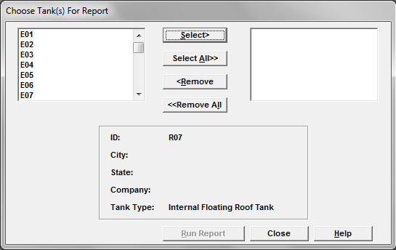
- Choose Report menu -> Annual ->Brief
- Select the tank(s) for which you wish to generate a report and press ‘Run Report’
- Chose File -> Ok -> Windows/Printer -> Ok.
Note: for ease of use it is recommended that users chose to view data in Windows/Printer. However, it is also possible to save the report as an excel file.

Generating a report while viewing a tank record
This option allows the user to run a report directly from the tank record and is useful as it allows users to conduct a final check that all the data entered in the tank record is accurate prior to running the report.
Figure 10 Report selection screen from tank record
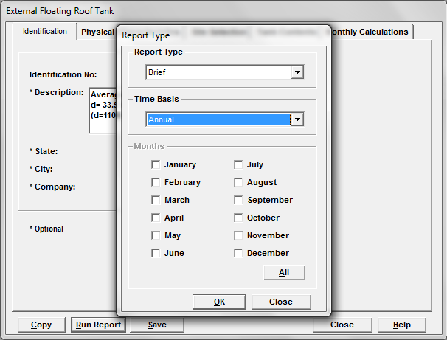
- Chose ‘Run Report’ from the Tank Record.
- For report type select ‘Brief’
- For the time basis select ‘Annual’
- Chose File -> Ok -> Windows/Printer -> Ok.
Note: for ease of use it is recommended that users chose to view data in Windows/Printer. However, it is also possible to save the report as an excel file.

- Conversion from Imperial to Metric for NPI Reporting.
For NPI reporting purposes, it is necessary to convert the emission totals produced in the report from pounds (lb) to kilograms (kg).

E _{(lb)} × 2.204 = E _{(kg)}

E _{(lb)} = Emission total in pounds (lb)
E _{(kg)} = Emission total in kilograms (kg)

