
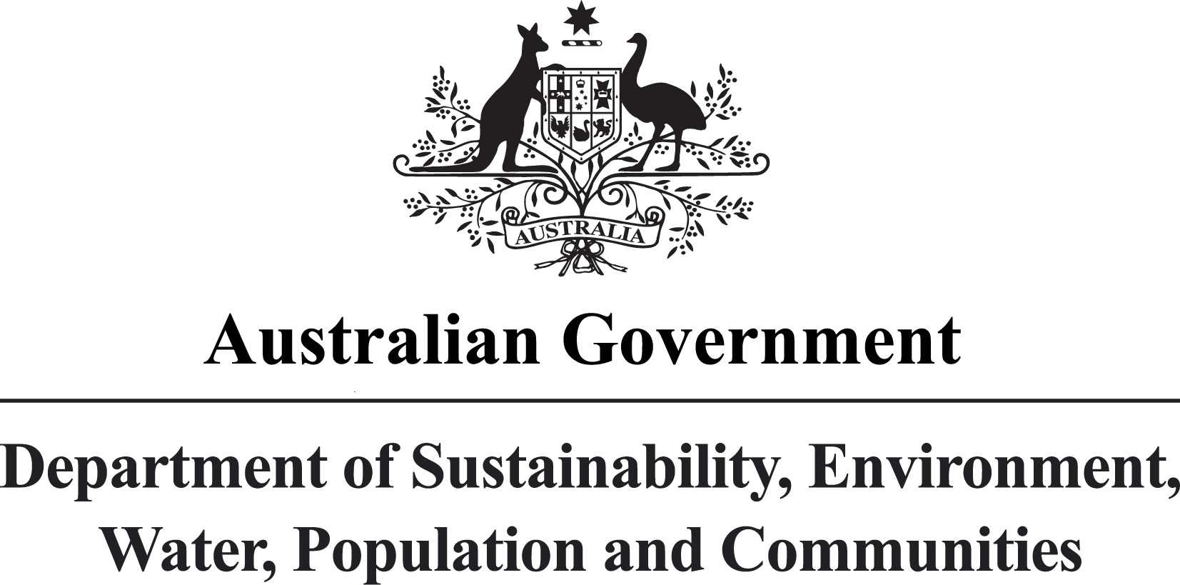
Prepared by
institute for sustainable futures, uts
For
the department of sustainability, environment, water, population and communities (DSEWPaC)
June 2011
National Food Waste Assessment
FINAL REPORT
LEAH MASON
THOMAS BOYLE
JULIAN FYFE
TANZI SMITH
dana cordell

Disclaimer
The views and opinions expressed in this publication are those of the authors and do not necessarily reflect those of the Australian Government or the Minister for Sustainability, Environment, Water, Population and Communities.
While reasonable efforts have been made to ensure that the contents of this publication are factually correct, the Commonwealth does not accept responsibility for the accuracy or completeness of the contents, and shall not be liable for any loss or damage that may be occasioned directly or indirectly through the use of, or reliance on, the contents of this publication.

about the authors
Institute for Sustainable Futures, UTS
The Institute for Sustainable Futures (ISF) was established by the University of Technology, Sydney in 1996 to work with industry, government and the community to develop sustainable futures through research and consultancy. Our mission is to create change toward sustainable futures which protect and enhance the environment, human well-being and social equity. We seek to adopt an inter-disciplinary approach to our work and engage our partner organisations and clients in a co-operative process that emphasises strategic decision-making. For further information visit www.isf.uts.edu.au

citation
Mason, L., Boyle, T., Fyfe, J., Smith, T., Cordell, D. (2011). National Food Waste Data Assessment: Final Report. Prepared for the Department of Sustainability, Environment, Water, Population and Communities, by the Institute for Sustainable Futures, University of Technology, Sydney: Sydney.

Disclaimer
While all due care and attention has been taken to establish the accuracy of the material published, UTS/ISF and the authors disclaim liability for any loss that may arise from any person acting in reliance upon the contents of this document.

Acknowledgements
The authors would like to thank the food charities Foodbank, FareShare, SecondBite and OzHarvest for donating their time to assist with this research. The authors would also like to thank other organisations that assisted with data collection and shared their views of challenges and opportunities related to food waste data collection, including Justin Lang (Zero Waste South Australia), Angela McClowry (AFGC), Anne Prince (APC), Jon Dee (Do Something), and the many other stakeholders that provided information.

Executive summary
The increased generation of food waste is a global and national problem. It has several facets, all of which can benefit from a clear understanding of the size and nature of food waste generated across all phases of the food production and consumption cycle. Of most concern to many stakeholders is the impact food waste has on the generation of greenhouse gas emissions such as methane and carbon dioxide. However, there are also growing concerns about the economic and environmental viability of existing food waste disposal systems, as well as interest in food waste as a resource input to agriculture.
Many studies have been undertaken to assess food waste in Australia. This data assessment project has collated and reviewed the quality and nature of 1262 such studies, ranging from regional waste management authority reporting and research papers to national studies, and presented the results in the form of an extensive spreadsheet database and this report. While many of these studies may be of sufficient quality and relevance for their intended purpose (e.g. a physical waste audit of a specific company undertaken to inform a waste management strategy for that company), it is not possible to aggregate the data from all such studies to make sufficiently accurate conclusions about food waste data at the national (or even state) level. This view has been formed on the basis that the available data is extremely variable in terms of what is being studied (packaging, food waste, ‘green waste’, non-specified or ‘other’ waste), geographical coverage, methodology and sampling approaches.
When considered together, existing studies related to food waste data (e.g. proportion of putrescible waste in residential solid waste streams) indicate that Australian data on food waste generation and fate (e.g. landfill, recovered, collected for charitable redistribution) is on the whole scarce, fragmented and disaggregated. This research has confirmed that for most phases of the food production cycle this characterisation is accurate.
Although the absence of rigorously measured and verifiable data presents an uncomfortable degree of uncertainty for policy development processes, the implications of different approaches can be explored on a theoretical basis using existing estimates. For example, preliminary evaluations of several studies by federal and state government indicate that existing food waste management practices are contributing to Australia’s greenhouse gas burden and creating opportunity costs from lost productivity.
Policy developed to respond to these and other challenges will require a much larger and more consistent base of data if confident progress in these areas is to be achieved.

A New Understanding of Australian Food Waste DATA
The majority of data sources identified in this research relate to post-consumer food waste that has been measured at the point of disposal by local government authorities and waste management contractors. This report provides substantial information about existing waste audit resources held by auditing consultants and councils or regional waste management organisations. Early audits focus upon recyclables, while more recent audits have increasingly focused on characterising and differentiating between different types of organic wastes generated by households (kitchen waste and green waste). This data differs in its methodology of collection and classification, due to the different levels of development in waste auditing across different Australian states and territories.
This report also provides information about large amounts of ‘avoidable’ pre-consumer food waste collected by a number of food charities and a major supermarket group. For example, Foodbank alone collected and redistributed 10 000 tonnes of edible food in 2009–10. This data, aggregated by broad industry sector categories, represents a significant improvement in our understanding of the food waste stream in the pre-consumer segments of the food production chain.

New Understandings of Gaps
Gaps in the availability of food waste data across Australia appear to mirror the gaps that have been identified in data sets for other waste streams. For instance, waste auditing undertaken for local governments in Tasmania and the Northern Territory appears to be much less extensive than in other states. Significant gaps have also been identified in data associated with different phases of the food production chain. These relate to three main areas:
- Pre-farm gate: avoidable and unavoidable food wastes
Very small amounts of public data relating to quantities of organic waste materials (crop waste, manure, abattoir waste) have been identified during this research.
- Post-farm gate to check-out: avoidable and unavoidable food wastes
Avoidable waste is comparatively well monitored when compared to unavoidable wastes generated during the pre-consumer segments of the food production chain. This gap appears largest with respect to the food manufacturing and processing sectors, but also applies to the retail sector.
- Check-out to post-consumer: avoidable food wastes
Distinctions between avoidable food wastes (edible food) and unavoidable food wastes are not as well understood once food has been sold to consumers. Thus far, the majority of data related to avoidable food waste has been derived from estimates of the amount of money householders have spent on food that they have not eaten (i.e. disposed edible food).

Data Quality
While numerous waste audits are undertaken around Australia each year, this assessment project has confirmed that there are significant differences in the collection methods and characterisations of food waste in existing waste audit data. Indeed, this view is presented in a number of reports from regional waste management boards, waste auditors, academics, and consultants on environmental or economic issues surrounding food or food waste. Most recently, the lack of standard auditing guidelines across the states and territories has been raised in the WME journal of the Waste Management Association of Australia. Section 3 of this report provides an overview of the geographical distribution and methodologies used in existing waste data, as well as some discussion of the issues raised by the use of different audit methodologies across states and territories. Recommendations for further research and development in this area have also been made in Section 5.

Stakeholder Interviews
Communication with key stakeholders has provided valuable information for this research, allowing a wide range of auditing activity to be mapped and collated in a central database. Stakeholder interviews have also confirmed the fragmentation of food waste data across different areas of the food production chain. Stakeholders have also raised different concerns and interests regarding food waste and food waste data, and these have been used to frame the conclusions and recommendations that arise from this assessment of Australian food waste data.

Conclusions and Recommendations
This report concludes that while there are many existing food waste studies, they are highly variable, both in terms of geographical relevance and methodology. Much of this data is also difficult to access without negotiating with a large number of data holders with different concerns about privacy and confidentiality. For some parts of the waste stream there is a lack of sufficient data. Without a more comprehensive understanding of the food waste being generated, it is very difficult to improve the environmental performance of our waste management systems, or improve our ability to make the most use of increasingly scarce resources.
A national approach to managing and recovering resources from food waste will need to address the existing fragmentation of waste data and facilitate the development of national guidelines for food waste monitoring and reporting across each segment of the food production chain. Key priority actions resulting from this study include:
Action 1: Identify a set of common waste collection definitions, standards and objectives that can be incorporated in all state waste data collection guidelines.
Action 2: Investigate opportunities to improve data collection and reporting on pre- and post-consumer food waste by businesses and food charities.
This action should include consultation with food charities and industry sectors that have made contributions to food charities or other organic waste recovery facilities (such as biodigestion), with a view to understanding:
- Which aspects of businesses within different industry categories might be the most meaningful for understanding the impact of their food waste
- Incentives that might be developed to encourage food charities to incorporate more extensive food waste reporting into their operations.
Action 3: Investigate opportunities to improve data collection and reporting on pre-consumer food waste contained in the Commercial & Industrial (C&I) waste stream. This might also consider methods for distinguishing between pre- and post-consumer food waste in industries where these wastes might be combined, such as hotels, cafes, restaurants and take-away food outlets.
Action 4: Consider a comprehensive compilation of existing Australian municipal solid waste data, including the most reliable data from physical audits of households and businesses.
Action 5: Evaluate the benefits of using waste levies in states and territories where these are not already in place to provide resources for consistent data collection at the LGA level.
Action 6: Evaluate existing data related to the use of agricultural waste, including animal production and meat processing in South Australia, as the basis for a larger national survey of opportunities to undertake these kinds of resource recovery in other states and territories.
Action 7: Develop an Australian waste characterisation for municipal solid waste (MSW), commercial and industrial C&I and construction & demolition (C&D) waste streams that can be used to more accurately evaluate the impact of waste in key areas such as greenhouse gas (GHG) and resource recovery.

Table of contents
Executive summary 5
Table of contents 9
1 INTRODUCTION: SETTING THE SCENE 1
1.1.1 Costs 1
1.1.2 Environmental and other impacts 2
2 RESEARCH APPROACH 4
2.1 Objectives and outcomes 4
2.2 scope 4
2.3 Outline of methodology 6
3 RESEARCH RESULTS 6
3.1 Characteristics of food waste 6
3.2 CHARACTERISTICS OF FOOD WASTE DATA 8
3.2.1 Food waste data by industry (ANZSIC) code 8
3.2.2 Food waste data by knowledge producer 8
3.2.3 Food waste data by publication frequency 8
3.2.4 Food waste data by methodology 9
3.2.5 Food waste data by state 10
3.2.6 Food Waste data by stage in food production and consumption chain 11
3.3 The nature of Australian food waste data 11
3.4 The quality of Australian waste data 13
3.4.1 Reliability by state and stage in the food system 15
3.4.2 Analysis of national and state food waste data quality 17
3.5 Australian food waste: what do we know now? 26
3.5.1 Pre-farm gate (agricultural production) 26
3.5.2 Farm gate to check-out 26
3.5.3 Check-out to consumer 28
3.5.4 Consumer/bin to landfill, redistribution or recycling (pre- and post-consumer) 31
3.6 PACKAGING WASTE AND FOOD 38
4 CONCLUSIONS 38
4.1 Data Availability and Quality 38
4.2 Impacts 41
4.2.1 Pre-Farm Gate 41
4.2.2 Post-Farm Gate 42
5 WHERE TO NOW? 42
5.1 Key actions required 42
5.2 Challenges for management of food waste in Australia 43
5.2.1 Harmonising data collection and classification 43
5.2.2 Understanding institutional barriers to improving food waste data 44
5.3 An integrated approach to managing food waste in Australia 44
5.3.1 Moving from a chain to a cycle 46
APPENDIX A: KNOWLEDGE CUSTODIANS BY CATEGORY i
APPENDIX B: PROJECT METHODOLOGY ix
B.1 Australian food system framework ix
B.2 Data collection and review x
B.2.1 Desktop search xi
B.2.2 Citation mapping xi
B.2.3 Citation map outcomes xiii
B.2.4 Knowledge holder and stakeholder interviews xiv
B.3 Data screening and prioritisation xv
B.3.1 Proximity to system boundary xv
B.3.2 Knowledge holders and data source hierarchy xv
B.3.3 Apparent methodology xvi
B.3.4 Significance of waste stream xvi
B.4 Data quality assessment xvii
B.5 Methodology Glossary xx
APPENDIX C: Stakeholder engagement xxi
APPENDIX D: Metadata descriptions for Australian Food Waste Data Inventory xxii
APPENDIX E: AUSTRALIAN WASTE DATA SPREADSHEET xxv

List of tables

Table 1: average reliability scores for each criterion. 14
Table 2: Analysis of NSW food waste data. 18
Table 3: Analysis of SA food waste data. 19
Table 4: Analysis of VIC food waste data. 20
Table 5: Analysis of QLD food waste data. 21
Table 6: Analysis of WA food waste data 22
Table 7: Analysis of NT food waste data. 23
Table 8: Analysis of TAS food waste data 24
Table 9: Analysis of ACT food waste data 25
Table 10: Examples of industry sectors currently making contributions to food charities 30
Table 11: Tonnes of edible food recovered by major Australian food charities (2007–08 to 2009–10) 31
Table 12: Categories used by food charities to monitor donations 33
Table 13. Examples of food waste types at different stages of the food production and consumption system. 45
Table 14: scores assigned to each possible answer. xviii
Table 15: Final quality assessment criteria xix
Table 16: Determination of actions required xix
Table 17: Food waste data metadata xxii

List of figures

Figure 1: The hidden cost of food waste 2
Figure 2. Data categories by sector: agricultural production (yellow), food manufacturing & transport (green), food consumption (blue), waste disposal or reuse (brown). 5
Figure 3. Food waste data sources by ANZSIC Division. 8
Figure 4. Food waste data sources by publishing sector hierarchy. 8
Figure 5. Food waste data sources by publishing frequency. 9
Figure 6: Food waste data sources by apparent methodology. 9
Figure 7: Breakdown of data sources collated by methodology. 9
Figure 8: Food waste data sources by State. 11
Figure 9. Food waste data sources by food production chain category. 11
Figure 10: Frequency distribution of reliability of food waste studies. 14
Figure 11: Quality assessment matrix: reliability of food waste data by State and stage in the food system. Colour indicates reliability, while values indicate number of studies in each State addressing that part of the food system. 16
Figure 12: Total sample of 31 supermarket stores (metropolitan and regional). 29
Figure 13: Donations to Foodbank 2003–04 TO 2009–10. 32
Figure 14: Food donations to FareShare by industry sector (2009–10). 32
Figure 15: Donations to Foodbank by product category 2005–06 to 2009–10. 33
Figure 16: Food donated to SecondBite by product category in 2009–10. 34
Figure 17: Foodbank staple foods by mass for 2005–06 to 2009–10. 33
Figure 18: Organic wastes biodigested at EarthPower facility (2006–2010) 37
Figure 19. Food waste flows in the Australian food production and consumption system. Source: adapted from Cordell, D. & White, S. (2010), Securing a Sustainable Phosphorus Future for Australia, Farm Policy Journal, Vol. 7 No.3, August, 2010, p.1-17. x
Figure 20. Data snowballing process. xii
Figure 21 Data Snowballing and citation mapping process. xiii
Figure 22. Hierarchy approach for collecting data. xvi

glossary of terms and abbreviations
The following glossary of terms and abbreviations are specific to this report.
AVOIDABLE WASTE | Food waste that could be avoided in the first place through improved efficiency and planning to reduce spillages, spoilage and unnecessary disposal.
C&D | Construction and demolition sector
C&I | Commercial and industrial sector
DATA | Information (qualitative or quantitative)
DATA OBJECT | A report, data set, data series, case-study
DATA POINT | A specific piece of information about a clearly identified study subject.
DSEWPaC | Department of Sustainability, Environment, Water, Population and Communities
FOOD WASTE | Organic waste produced during the post-harvest production and consumption of food
INTERIM REPORT | The Interim Report prepared for this project in December 2010 (ISF, 2010)
ISF | Institute for Sustainable Futures, University of Technology, Sydney
KNOWLEDGE HOLDER | A knowledge holder could be a commissioner of research, a publisher of research or a conductor of research activities: these entities are best understood as having an ongoing physical or contractual relationship with a data source.
METADATA | Information about data (e.g. frequency of data collection, research funding)
MSW | Municipal solid waste
ORGANIC WASTE | Waste in any part of the food production and consumption chain that is organic in nature (including crop residues, manures, food processing waste, restaurant food waste)
PUTRESCIBLE WASTE | Organic waste material with sufficient moisture, carbon and nitrogen to decompose anaerobically, usually emitting foul odours and which can attract vermin
SPADEABILITY | Criteria used by DSEWPaC to determine if waste is solid or liquid (if it physically sits on a spade, it is classed as solid)
UNAVOIDABLE WASTE | Food waste that cannot be avoided (e.g. banana peels), hence must be managed through resource recovery (e.g. composting or anaerobic digestion for use as fertilisers or energy).
WASTE CHARACTERISATION | The process of identification and analysis of chemical or microbiological composition of different waste streams.

INTRODUCTION: SETTING THE SCENE
Increased generation of food waste is both a global and national problem, with an estimated 50 per cent of food wasted between ‘field and fork’ globally. Studies undertaken in Australia on different aspects of food waste (e.g. proportion of putrescible waste in residential solid waste streams) indicate that Australian data on food waste generation and its ultimate fate (e.g. landfill, recovered, collected for charitable redistribution) is scarce, fragmented and disaggregated.
While there are numerous studies and reports that may be drawn upon to make the case for tackling the problem, actual data on food waste generation, avoidance and management are sparse and difficult to verify. This is due to a range of factors related to the context and process of solid waste data generation, such as:
- Food waste is currently considered as general waste which has no value and is therefore not separated or measured in a consistent way
- Where food waste and other organic waste (such as green waste) are differentiated from other general wastes they are often considered together, making it difficult to calculate the proportion of this waste that is food only
- Physically measuring food waste can pose practical difficulties, as well as health and safety risks
- Mandatory reporting of waste generally only applies to mixed solid waste streams at the point of disposal, or, in the case of controlled or hazardous wastes, transport and disposal.
Historically, the most frequently raised questions in waste management have focused on the costs of managing waste, while studies of cost have tended to focus on the costs of recovery compared to the costs of disposal. Such conversations have encouraged a range of initiatives to assess options for cost-effective waste management, but the true cost of waste at the national level is difficult to determine on the basis of existing data. However, a series of indicative estimates about the likely impacts of current waste generation and waste management practices can be calculated from several existing studies.

Costs
Two studies of the cost of food waste in households undertaken in Australia provide an illustration of the money that is wasted when food is thrown away.
What a waste (TAI, 2005) asked 1644 members of households across Australia what they believed was spent on food that was not eaten during that year (2004). Based on these responses, the study estimated that approximately $5.2 billion was spent nationally in 2004 on food that was not consumed. A sense of the lost opportunities this figure represents is perhaps best understood by applying it to alternative uses. For example, at current prices, $5.2 billion would pay for the installation of 315L solar hot water systems on 960 000 homes.
More recently, the Food Waste Avoidance Benchmark Study (2009) asked similar questions of 12 000 households in New South Wales as part of the NSW government’s “Love Food Hate Waste” program. This study estimated that NSW households spent approximately $2.5 billion on food that was not consumed.
This cost only accounts for lost opportunities for more productive spending by households. It does not include spending by businesses, energy costs, costs of lost labour and materials, or the costs associated with other liabilities and risks. Figure 1 (below) provides an overview of the full life-cycle costs of waste.
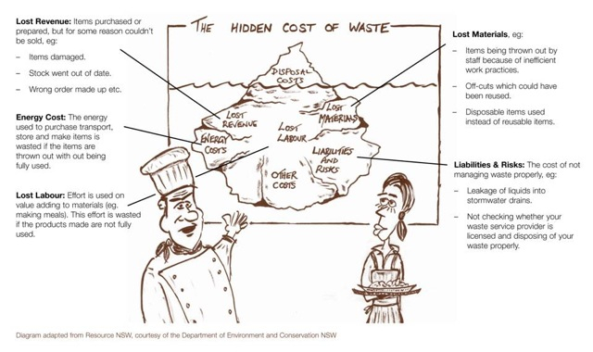
Figure 1: The hidden cost of food waste
(Image sourced from Toolbox Talks fact sheet “Waste Wise Catering” produced by Sustainability Victoria. This publication attributes the diagram to Resource NSW, courtesy of the Department of Environment and Conservation)
As noted in this diagram, liabilities and risks (bottom right) as environmental impacts of waste management can become economic impacts through fines and other regulatory actions. Managing food waste has several other important sustainability implications. For example, the decomposition of organic matter (including food waste) in landfills constitutes a considerable source of greenhouse gas emissions.,

Environmental and other impacts
A further two studies, focusing this time on the amount (in tonnes) of food waste generated, provide some sense of the environmental impacts arising from existing waste management practices.
The National Waste Report, which collates a range of data (including estimates for areas with less developed waste data gathering programs) from state-based authorities, estimates that food waste makes up approximately one-third of Municipal Solid Waste (MSW) and approximately one-fifth of Commercial and Industrial (C&I) waste streams. Together, these streams amount to 7.5 million tonnes of food waste generated in 2008–09. Using greenhouse gas emission factors published by the Australian Government Department of Climate Change and Energy Efficiency (2010), it is possible to calculate the amount of carbon dioxide equivalent (CO2-e) that is generated by sending this waste to landfill – around 6.8 million tonnes of CO2-e.
Other estimates of environmental benefits from diverting food waste from landfill have been made, with an example provided by one of Australia’s smaller food charities, FareShare, which has used a calculator developed by Hyder Consulting to evaluate their impact. The most recent report on FareShare’s contribution indicated that 254 tonnes of food recovered and distributed by FareShare in the 2007–08 financial year “saved around 381 tonnes…CO2 equivalent, and over 14 million litres of water”.
Finally, and perhaps most importantly, food waste contains valuable resources. As several reports on food production and consumption in Australia have noted, it is very difficult to take advantage of the resources contained in food waste if there is insufficient information about how and where they are being generated, or where they can be processed and used.
The Australian Bureau of Agricultural and Resource Economics has noted that $3174 million was spent on fertilisers in 2008–09, approximately 40 per cent of which were imported. Nitrogen, potassium and phosphorus fertilisers are essential to Australian agricultural production and prices for these materials have increased by 100 per cent within the past decade. Phosphorus, an essential plant nutrient that can be recovered from food waste for reuse as fertiliser, will become more important as the world’s main source of phosphorus – phosphate rock – becomes increasingly scarce and expensive.
Other valuable resources, including energy, can be recovered from food waste via composting (aerobically or anaerobically) or incinerated energy generation. Uncontaminated sludge and ash from these processes can also be used as fertilisers or soil conditioners.
The information provided by this report addresses the current state of Australian food waste data, including the different systems that produce the data, the nature and qualities of existing food waste data and key gaps. The National Food Waste Assessment indicates that Australian food waste data is not well or consistently documented across the food production and consumption cycle. Turning negative impacts of food ‘waste’ into opportunities for positive benefits requires more knowledge than we currently possess.

RESEARCH APPROACH

Objectives and outcomes
The Institute for Sustainable Futures has been commissioned by the Department of Sustainability, Environment, Water, Population and Communities (DSEWPaC) to undertake the National Food Waste Assessment project. The objectives of this project are to:
- Collate relevant information about food waste data in Australia
- Identify the key knowledge holders and producers
- Assess quality of available data against a set of quality criteria
- Identify links between food waste and food packaging
- Identify key gaps and recommend priority actions required.
Specifically, the outcomes should assist DSEWPaC in the implementation of Strategy 16 (data and reporting), Strategy 9 (greenhouse and waste recycling-related initiatives), and Strategy 10 (commercial and industrial waste) of the National Waste Policy.
The specific methodology and approach used in this research are outlined in Appendices B, C and D of this report. A further research output is an electronic spreadsheet database of existing studies and data sources that contains information used in the assessment of data quality for each item within the database.

scope
Defining the term ‘food waste’ is key to effective and consistent analysis. The food waste data compiled for this report illustrates the extent to which definitions used in waste management have changed over time, and discussion of this follows in section 3. For the purposes of defining the scope of this project, food waste is considered to be a subset of organic waste and excludes liquid wastes (i.e. wastewater associated with the consumption and excretion of food) . This approach recognises that the component of food waste that becomes a part of the liquid waste stream typically ends up in the sewerage system and is thus the responsibility of water and wastewater service providers and associated policy makers.
Defining the ‘system boundary’ of the analysis is also important, and for this reason the agriculture and food commodity production system has been divided into five main sections, as shown in figure 2 (below). These sections reflect the main aspects of food production, consumption and disposal.
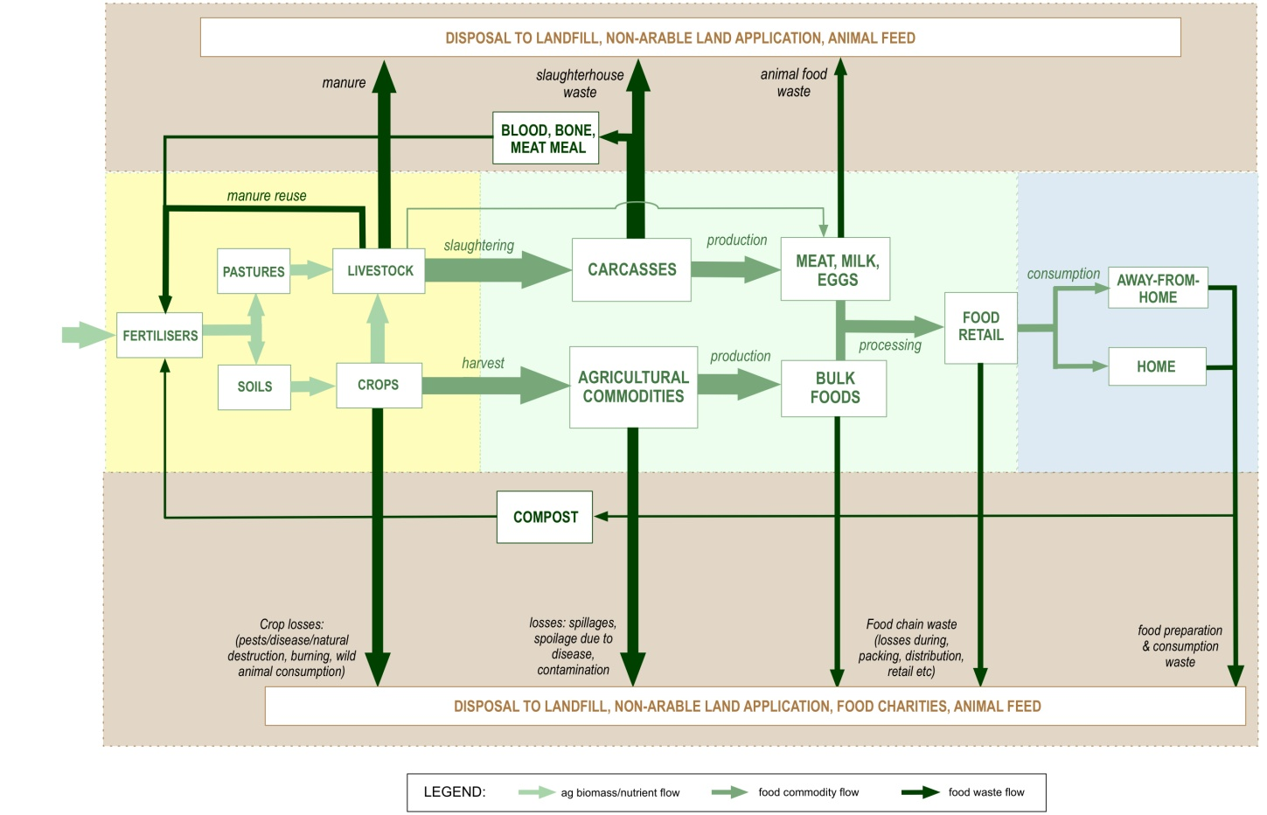
Figure 2. Data categories by broad sector of production, consumption and disposal
Source: adapted from Cordell, D. & White, S. (2010), Securing a Sustainable Phosphorus Future for Australia, Farm Policy Journal, Vol. 7 No.3, August, 2010, p.1-17.
As illustrated in Figure 2 (above) the first section, referred to here as ‘pre-farm gate’ (indicated in yellow) concerns inputs to agricultural production, and extends to the ‘farm gate’ where agricultural produce enters a food processing, packaging and transport phase.
The second section is referred to here as ‘farm gate to checkout’ (indicated in green) and extends from the ‘farm gate’ to the point of sale at a food retailer. This includes both food processing and transport activities.
The third section refers to the consumption of foods, and extends from the ‘check-out’ to the point at which a consumer disposes of food that has not been consumed (indicated in blue). Disposal of unconsumed food purchased by a consumer may occur within the home or ‘away from home’ and this has implications for how food waste is managed and measured.
The final sections (indicated in brown) refer to those waste flows in the agriculture and food commodity chain between the farm gate and disposal/reuse and form the largest part of the available data.

Outline of methodology
The data collection process comprised four distinct but inter-related components:
a) Desktop search
b) Citation collection and mapping
c) Quality assessment
d) Stakeholder interviews.
New data sources and candidates for stakeholder interviews were continually identified as the research progressed. Data objects were also progressively screened and prioritised and then assessed for reliability based on multiple criteria, including the way in which the data was gathered, the frequency of data gathering activities and the extent to which the data gathering can be verified through publicly available documents. A detailed methodology is outlined in Appendix B. The methodology for the quality assessment of reliability is documented in Appendix D.

RESEARCH RESULTS
This section provides an overview of the terms and definitions used in managing food waste and a summary of the characteristics exhibited by the data collated during this research.

Characteristics of food waste
The terms used to define waste of different types have evolved over time, with new waste types emerging as the focus of public policy makers shifts to new areas. Within the past two decades, waste managers have been encouraged to remove substantial amounts of solid waste from the general waste category as interest in making more productive use of packaging has gained ground.
Food waste is one of the last items to be removed from this category, and the terms used to describe this type of organic waste are still being negotiated. For example, existing terms for organic waste reflect historical terms for household waste such as ‘kitchen waste’ (now food organics) and ‘green waste’ (now garden organics). These terms also have use in understanding the different impacts of food and garden organic wastes, as garden waste is more likely to include plant matter that takes longer to break down than most food waste.
Another important and newly emerging distinction is whether or not unconsumed food waste is ‘avoidable’ or ‘unavoidable’. Both terms can be applied to food that is sent for disposal by producers and consumers of food products; however, there are very clear differences in how they might be interpreted in these contexts. For example, food waste can be avoided by producers through changes to processes or equipment design that ensures more of their raw food materials are converted to food that can be consumed. Producers can also work with those who distribute their products to ensure that food products reach consumers in a state that is consistent with the consumers’ needs.
In contrast, householders have a very different set of circumstances in which to understand whether the food that goes unconsumed is avoidable. The “Love Food, Hate Waste” campaign (pioneered in the United Kingdom and now being implemented in NSW) has identified ‘avoidable’ food waste as food that has been disposed of because it has become inedible for one of several reasons, including overestimation of need and poor storage. The term ‘unavoidable’ is used by the campaign to describe components of food that would not be considered edible under any circumstances. The example provided by the “Love Food, Hate Waste” campaign is banana peels, but items such as the hard shells from various nuts would also fall into this category.
The value of these distinctions often relates to the different options for managing and measuring what is currently being disposed of as ‘waste’. An example of this is provided in section 3.5, where the work of food charities in rescuing edible food that will not be sold is highlighted.
Similarly, where food is consumed makes a difference to how waste food can be managed. Pre-consumer waste makes up a large part of commercial and industrial food waste, but there are many businesses that manage post-consumer waste. These include restaurants, cafes and take-away food outlets. Some of these businesses will have less control over managing waste because members of the public are involved in disposing of it through waste bins available in public areas. An example of this can be seen in shopping centre food courts, where members of the public are encouraged to clear the tables of waste to nearby waste bins.
Further complication in measuring and managing food waste arises from other characteristics and the terms that are used by food waste generators, food waste managers, and food waste ‘rescuers’. For instance, the term ‘fresh’ applies to food products that are also ‘perishable’ - a term that relates to the comparatively short shelf life of ‘fresh’ foods. The term putrescible applies to food, and other organic matters, once they have become part of the waste stream.

CHARACTERISTICS OF FOOD WASTE DATA

Food waste data by industry (ANZSIC) code
As shown in Figure 3, the majority of the data collated in this research has been generated at the point of disposal by the waste services sector. Eighty-three per cent of food-related waste data comes from Division D (electricity, gas, water and waste services) in the ANZSIC industry code. Division A (agriculture, forestry and fishing), Division C (manufacturing) and Division G (retail) are the second-largest contributors, providing 4 per cent in total.
Figure 3. Food waste data sources by ANZSIC Division.
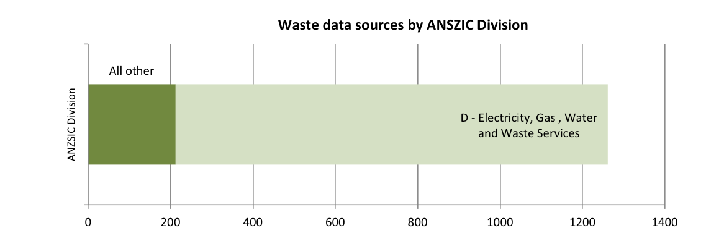

Food waste data by knowledge producer
As shown in Figure 4 (below), the majority of the data collated in this research (over 70 per cent) have come from federal, state or local government sources. One fifth of data sources have come from industry peak groups, while about 4 per cent have come from an individual business. Publications, or data sources, published by universities or non-government organisations (NGOs) also comprised about 4 per cent of the total.
Figure 4: Food waste data sources by publishing sector hierarchy.
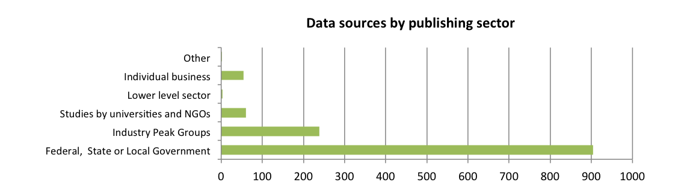

Food waste data by publication frequency
Figure 5 shows that only 7 per cent of the data collated in this research is part of a regularly published series with a comparable methodology. The majority of data sources are either stand-alone surveys or have been conducted using methodologies that make them difficult to compare to other surveys or audits. Methodologies are discussed in more detail in section 3.1.4 of this report.
Figure 5: Food waste data sources by publishing frequency.
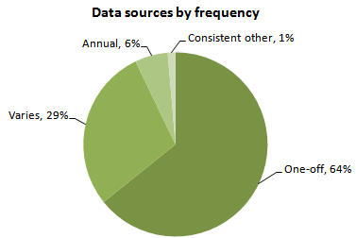

Food waste data by methodology
As illustrated in Figure 6 (below), 82 per cent of the data collated in this research contains or refers to primary data (measured). Of this, 91 per cent is audit data that has employed visual or physical audits (Figure 7A). Eleven per cent of the data sources used data from other sources (derived).
Figure 6: Food waste data sources by apparent methodology.
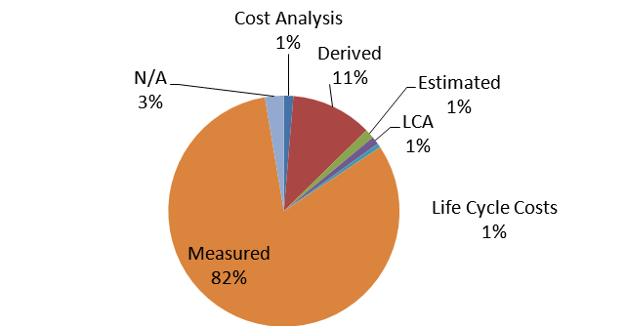

Figure 7: Breakdown of data sources collated by methodology.
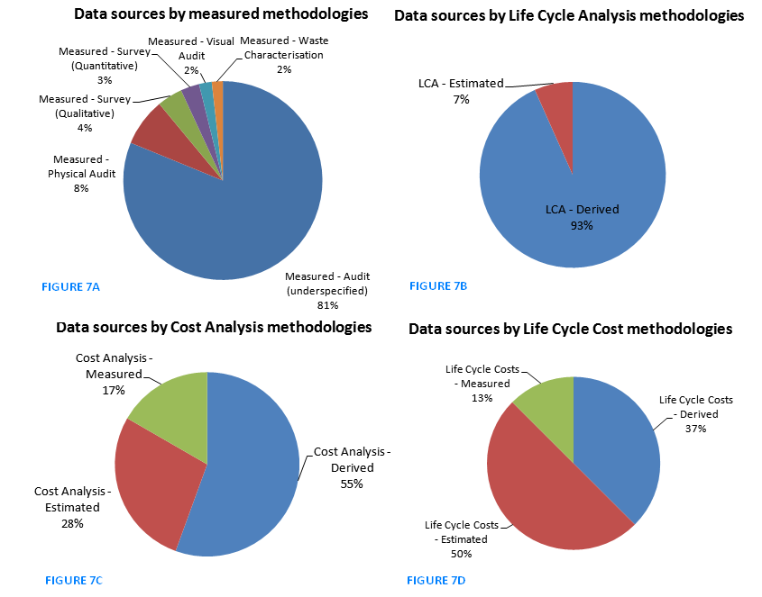

Food waste data by state
As illustrated in figure 8 (below), the majority of data collated in the first and second phases of this research is geographically relevant to NSW, followed by Victoria, then the national level. This is most likely to reflect the historical interest in understanding litter and household recycling potential in highly populated areas. More importantly, it should be noted that while a large number of audits have been undertaken in NSW, the long period of time over which auditing has taken place reduces the potential for the data to be considered as a data series.
An example of a high-quality data series identified by this research is the household audit of 1130 households undertaken using the South Australia kerbside waste audit guidelines. This audit represents one of the largest studies undertaken in Australia, and involved two audits of the households at different times of the year.
Figure 8: Food waste data sources by state.
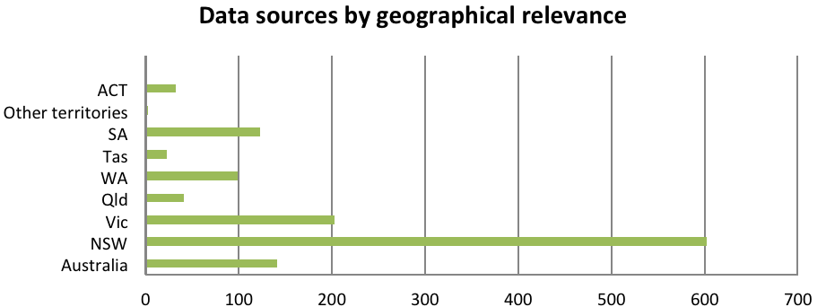

Food Waste data by stage in food production and consumption chain
Figure 9 (below), shows that 87 per cent of the data collated in the first and second phases of the research concerns post-consumer food waste. Other food system categories represent less than 7 per cent each.
Figure 9: Food waste data sources by food production chain category.
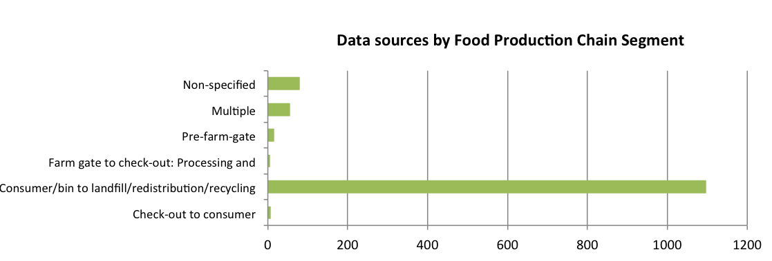

The nature of Australian food waste data
Food waste data collated for the final report has come primarily from the municipal solid waste sector, and relates to food waste that occurs after food has been purchased for consumption. While this report has focused primarily on waste that occurs between the farm gate and disposal, to provide some sense of context this report also outlines an understanding of the available data across the food production cycle. Specific discussion of data that has been identified in each segment of the food production chain has been provided in Section 3.4.
Pre-Farm Gate
Organic waste in the pre-farm gate stage of the Australian food system mainly takes the form of crops, crop residues, manure and abattoir waste (blood, bone, offal etc.). The causes of such organic waste generation include:
- Crop and livestock abandonment due to prolonged extreme weather events (e.g. drought)
- Failure to meet quality control measures
- Damage from pest and disease (crops and meat products)
- By-products not intended for food production (e.g. crop residues, manure).
There are few data sources that specifically address the magnitude and nature of organic waste generated at the pre-farm gate stage. However, key governmental, industry and scientific data sources from which the magnitude and nature of pre-farm gate organic waste data can be derived includes:
- Australian Bureau of Agricultural and Resource Economics (ABARE)
- Department of Agriculture, Forests and Fisheries (DAFF)
- Australian Bureau of Statistics (ABS)
- ALFA/MLA
- United Nations Food and Agriculture Organisation (FAOStats)
Post-Farm Gate
The majority of post-farm gate data is also post-consumer. There is a large area between the farm gate and consumers, in which raw materials from agricultural producers are transported to manufacturers who transform them into products that are then transported to distribution centres and retail outlets. This sector is largely undocumented. For this reason, this study has focused upon post-farm gate transactions that have been documented in greater detail, notably data provided by food charities that collect edible food from a wide range of national and local businesses. It should be noted that this data does not represent the total amount of food donated to charities, nor does it represent all of the edible food that cannot be sold by wholesalers and retailers.
Data for businesses is currently limited to food waste that is considered to be avoidable. This data has been gathered from charitable organisations that collect edible food that cannot be sold, but can be utilised by welfare organisations. This data is gathered and stored in different ways by the different organisations involved, with the result that this data is also quite variable.
While it is understood that individual businesses are also beginning to undertake waste auditing to improve the cost-effectiveness of their waste management, gaining access to this data requires a significant investment of time and resources to address privacy concerns.

The quality of Australian waste data
Before discussing the results of the quality assessment of Australian food waste data, it is important to note that national data for waste is primarily derived from collations of state waste data, which is collected using a range of different methodologies and at varying frequencies. At time of publication, several states and territories have yet to develop or adopt a standard methodology for auditing food waste. The aim of this assessment has been to provide an indication of the extent to which the available data could be used to provide an accurate and reliable national picture of food waste. It does not provide any judgement about the quality of data sources in terms of their original purpose (e.g. to help an individual company improve their waste management).
As with other waste data in Australia, food waste data is highly variable, with a range of methodologies for undertaking audits in different sectors (i.e. municipal, commercial and industrial, construction and demolition) and different states or territories. The largest numbers of easily accessible data sources collected for this assessment have been generated by local governments or regional waste management boards, and relate to households (single and multi-unit dwellings). This data appears to have been increasing in recent years, both in terms of the detail provided and the geography represented.
Quality has been assessed on the basis of reliability for the purposes of creating an accurate national accounting of food waste. This analysis has compiled reliability scores from weighted averages of ratings assigned to several criteria. The main criteria considered are methodology (e.g. physical audit versus back-of-the-envelope), transparency (publicly available versus confidential), frequency of data collection (e.g. consistent data that can be compiled as a time series) and data format (e.g. peer-reviewed research article versus self-reporting by a business).
In total, 1262 studies were reviewed and scored for each quality criteria. Of these, 1193 received an overall reliability score, with the remainder missing one or more quality criteria ratings.
It should be noted that a rating of ‘questionable’ does not necessarily mean the data sources are of poor quality. Rather, it may indicate that this research has not been able to verify the quality (i.e. uncertainty about one or more criteria is high). Further investigation of these data sources may resolve this uncertainty and change the score for various criteria.
The graph below (figure 10) presents the frequency distribution of data reliability scores overlaying the reliability rating scale. Robust (green zone) data implies data that is reliable and rigid, derived by methodologically sound means, where room for error is likely to be minor. Satisfactory data (yellow zone) implies data is somewhat sufficient but the potential exists for error or loss of data. Questionable (red zone) implies data is either unreliable, or reliability is uncertain and potential for errors is high. The large majority of studies were assessed to be of questionable reliability, and this is largely a result of study details being difficult to obtain, as well as the low or highly intermittent frequency of data gathering.
Figure 10: Frequency distribution of reliability of food waste studies.
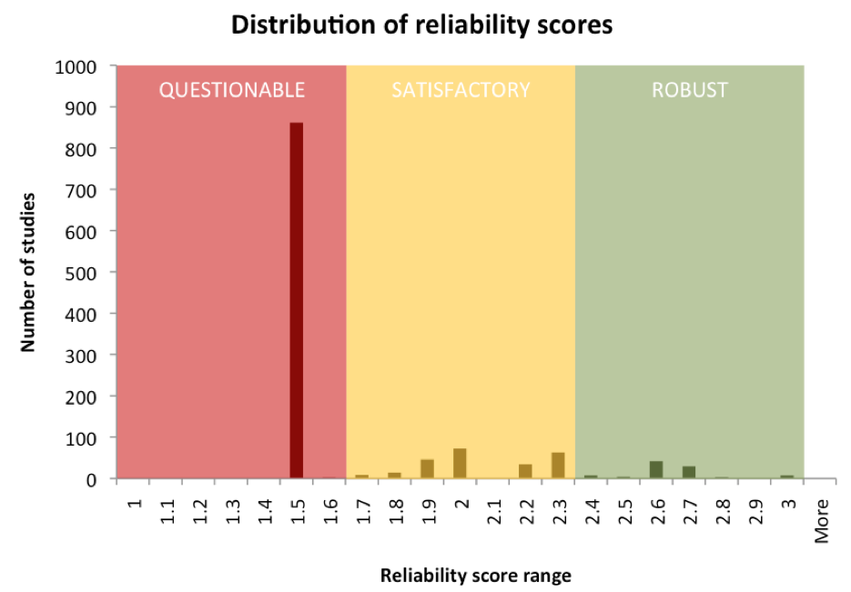
Table 1 (below), presents the reliability scores assigned to each quality criteria. Food waste data are, on the whole, reported in a rigorous format and/or have a relatively strong degree of accountability, as indicated by the high data format score. The main limitations of the food waste data reviewed are associated with under-specified or inadequate methodologies and the frequency with which data is collected.
Table 1: average reliability scores for each criterion.
Criteria | Average score
Methodology | 1.3
Frequency | 1.1
Transparency | 1.5
Aggregation | 2.8
Data format | 2.9
Overall reliability | 1.7

Most of the data sources reviewed in this assessment (1023) contained measured audit data, which would suggest that reliability scores would be higher. However, the vast majority of those studies (908) had methodologies that were under-specified, with the result that a judgment on the rigour of the methodology could not be accurately made. Thus an individual data source could be of a high standard but there was no means by which to determine this. Only 93 of the measured audit data studies were publicly available, but these studies had a higher average methodology score (2.1) due to a lower proportion of under-specified methodologies. Accordingly, the low average reliability score for measured audit data methodologies (1.2) may reflect a lack of clarity about the methodology of many data sources rather than a lack of methodological rigour in their approach.
Measured data had a low average frequency score (1.1), indicating that most studies were not conducted as part of a regular data collection. The 69 studies that reported on data collected annually, or more frequently, had a higher methodology score (1.8), suggesting that frequency and methodological rigour are correlated.
Estimated and derived data methodologies were used in 29 and 183 studies respectively. Most of these studies were publicly available (26 and 153 respectively). Twenty-seven cost studies were identified, only four of which used measured figures. Fifteen studies included life cycle analyses, 14 of which were based on derived data.
Most data reviewed was classified as research (1168), producing the high average data format score. Interestingly, only 211 of the research studies were publicly available. Performance and institutional governance reports only amounted to 20 of the studies reviewed, of which 18 were publicly available.

Reliability by state and stage in the food system
The matrix in figure 11 indicates the reliability of food waste data by state and stage in the food system. Coloured cells indicate reliability of the data as described above, with grey denoting data that is not scored.
The values given in the matrix cells indicate the number of studies in each state addressing that part of the food system. The matrix indicates that, for example, while most Australian Capital Territory data appears of robust quality, there are very few studies. Note that the total number of data in this table (1371) is higher than the number of studies reviewed (1262) due to some studies covering multiple geographic regions and/or food system stages.
As illustrated in Figure 10 (below), data relating to the stage of the food chain between consumption/disposal and landfill or redistribution or recycling is largely unreliable, or of uncertain reliability, across most states and territories. The most likely explanation for this is the high number of studies undertaken in this section of the food production and consumption chain, and the extended period of time that these studies represent. A large number of studies were undertaken prior to the development of audit guidelines in any Australian state. The combined effect of infrequent collection and highly variable methodology has caused the skew towards unreliability in the distribution of reliability scores.
Figure 11: Quality assessment matrix: reliability of food waste data by state and stage in the food system
LEGEND: | Questionable | Satisfactory | Robust
NOTE: Colour indicates reliability, while values indicate number of studies in each state addressing that part of the food system.

Analysis of national and state food waste data quality
Food waste and organics have become a focus for data collection within the past 10 years in Australia, with the result that most data prior to this period is difficult to evaluate. For the most part, historical information about organic wastes is not distinguished from general waste. More recent studies of recycling may provide some information about food and organic waste as a contaminant, while studies undertaken within the past several years are more likely to address food or organic wastes as the primary focus.
The data collected for this report indicates that while some areas have been surveyed or audited a number of times between 1993 and 2010, the methodology used has changed several times over this period. Such changes may have reduced the comparability of the audits to such an extent that each might be better regarded as a stand-alone snapshot rather than an element of a time-series. Further research into the extent to which various audit methodologies used during the past 10 years are comparable will be required if the data collected to date can be used effectively.
As has been noted in many reports on the generation of waste in Australia, there are significant gaps in the availability of waste data in some states and territories. NSW and SA have the longest established kerbside waste audit methodologies, and Western Australia is proposing to adopt the SA guidelines (as of 2008) with some slight variations. Victoria established its own guidelines for kerbside audits of household waste and C&I waste in 2009.
Waste data for the Northern Territory and Tasmania is possibly the most significant in terms of unknown waste qualities and quantities, with little or no data available for any wastes other than those that represent a significant hazard to human health.
Australia’s external territories such as Christmas Island are also poorly represented in terms of waste data.
A more detailed discussion of food waste data in NSW, SA, Victoria, Queensland, WA, NT, Tasmania and the ACT (Canberra) follows in sections 3.3.2.1 – 3.3.2.7.

New South Wales
GUIDELINES and Methodology Notes
NSW has had guidelines for household kerbside waste auditing since 1997. They were revised in 2008 and are currently undergoing a further revision as at December 2010. NSW guidelines for kerbside auditing differ from those being developed in a number of other states, which have begun to align their auditing methodology with that of SA. The main points of difference relate to the size of the sample (larger than other states), collection method, the number of sub-categories under which waste is characterised (62 rather than 32-40), and sampling method. While NSW has not published guidelines for Commercial & Industrial (C&I) waste surveys, two such surveys were conducted in 2003 and in 2008 using a combination of different audit techniques, including visual assessment of collection vehicle loads and sampling of bagged waste.

Table 2: Analysis of NSW food waste data.
Total number of studies | 602
Overall reliability rating | Satisfactory
Measured - Physical Audit | 4%
Measured - Audit (under-specified) | 88%
Other | 7%
 | 100%
Post-2001 | 50%
Pre-2001 | 48%
Non-specified | 2%
 | 100%
Data series/data set | 95%
Other | 5%
 | 100%
Research origin
Federal | 76%
Industry Peak Bodies | 17%
Universities/NGOs | 1%
Individual Business | 5%
Lower level sector | -
Other | -
 | 100%
GAPs
As noted in table 2 (above), a large number of audits have been undertaken in NSW. However, many of these were conducted prior to the establishment of state auditing guidelines in 1997, a circumstance that raises questions about the ultimate utility of these audits for the purposes of this research. More recent audits of municipal solid waste funded by local government, or undertaken as part of the Waste Service Performance Improvement Payment (WSIP) program of sustainability grants, might prove a useful resource if they can be obtained. Waste auditing by individual businesses taking part in the NSW Sustainability Advantage program could also be of use if suitable permissions can be negotiated.

South Australia
GUIDELINES and Methodology Notes
SA has also had guidelines for household kerbside waste auditing since 2007. They do not appear to have undergone a major revision and have been used in a range of short-term and long-term studies of household organics and food waste.

Table 3: Analysis of SA food waste data.
Total number of studies | 123
Overall reliability rating | Satisfactory
Measured - Physical Audit | 5%
Measured - Audit (under-specified) | 81%
Other | 14%
 | 100%
Post-2001 | 57%
Pre-2001 | 43%
Non-specified | -
 | 100%
Data series/data set | 91%
Other | 9%
 | 100%
Research origin
Federal | 87%
Industry Peak Bodies | 11%
Universities/NGOs | 2%
Individual Business | 1%
Lower level sector | -
Other | -
 | 100%
GAPs
SA has a long-established auditing methodology and has a significant body of household waste audits undertaken over a number of years in metropolitan areas. Business waste is not understood in the same way, with the Zero Waste SA website noting that data from landfill studies shows that “food waste represents a quarter of the total commercial and industrial waste stream received” and that it is the “highest contributor to landfill from this sector”. Businesses are also being provided with assistance to undertake waste auditing through several programs including the Recycle Right at Work (small to medium businesses across metropolitan Adelaide) and the Resource Efficiency Assistance Program (REAP) which assists medium to large businesses.

Victoria
GUIDELINES and Methodology Notes
Victoria has recently developed guidelines for municipal kerbside auditing and provides guidelines for characterising solid industrial waste (as of 2009). It is worth noting that Victoria appears to include Construction and Demolition (C&D) waste in the Commercial and Industrial (C&I) waste category.

Table 4: Analysis of VIC food waste data.
Number of studies | 205
Overall reliability rating | Satisfactory
Measured - Physical Audit | 15%
Measured - Audit (underspecified) | 59%
Other | 26%
 | 100%
Post-2001 | 42%
Pre-2001 | 53%
Non-specified | 5%
 | 100%
Data series/data set | 15%
Other | 85%
 | 100%
Research origin
Federal | 59%
Industry Peak Bodies | 30%
Universities/NGOs | 8%
Individual Business | 3%
Lower level sector | -
Other | -
 | 100%
GAPs
Victoria has two distinct groups managing municipal waste, with regional and metropolitan waste management groups taking on slightly different roles. While audit data was available for a number of local government areas, the Metropolitan Waste Management Group (which includes the City of Melbourne and 29 other LGAs) does not manage waste auditing, nor does it collate waste audit data. Further research should thus approach each LGA within the Metropolitan Waste Management Group’s jurisdiction. Business waste is another gap that is actively being filled through the Beyond Waste Fund (previously known as the Waste Reduction Fund), which was launched in December 2010.

Queensland
GUIDELINES and Methodology Notes
A strategy to improve Queensland’s performance with respect to waste was published by the Queensland Department of Environment and Resources (DERM) in December 2010. The foreword of this document notes that Queensland is “one of largest generators of waste in Australia” with an estimated 32 million tonnes of waste produced by households and businesses every year. The strategy also notes that only a third of recoverable waste is recycled and that business waste is of particular concern, as this represents approximately two-thirds of the state’s waste burden.

Table 5: Analysis of QLD food waste data.
Number of studies | 41
Overall reliability rating | Satisfactory
Measured - Physical Audit | 2%
Measured - Audit (under-specified) | 78%
Other | 20%
 | 100%
Post-2001 | 44%
Pre-2001 | 51%
Non-specified | 5%
 | 100%
Data series/data set | 90%
Other | 10%
 | 100%
Research origin
Federal | 76%
Industry Peak Bodies | 22%
Universities/NGOs | 2%
Individual Business | -
Lower level sector | -
Other | -
 | 100%
GAPS
The strategy notes that Queensland will be conducting composition audits on municipal waste, developing standard methodology for measuring and reporting on waste disposal and resource recovery, as well as public place and event recycling. It is anticipated that progress will be “measured every three years against the 2008 base case”. This means it will be several years before measured and methodologically consistent data is likely to be available for Queensland. Food waste from households and businesses has been identified as a priority, with business food waste given additional priority on the basis of volume and likely impact in the area of greenhouse gas emissions and leachate.

Western Australia
GUIDELINES and Methodology Notes
Food waste data in WA is typically generated by local government auditing of the municipal solid waste. This process is often facilitated by regional organisations of local government. WA is currently in the process of adopting, with slight variations, the kerbside waste auditing guidelines used by SA.
Table 6: Analysis of WA food waste data
Number of studies | 100
Overall reliability rating | Questionable
Measured - Physical Audit | 5%
Measured - Audit (under-specified) | 81%
Other | 14%
 | 100%
Post-2001 | 74%
Pre-2001 | 23%
Non-specified | 3%
 | 100%
Data series/data set | 86%
Other | 14%
 | 100%
Research origin
Federal | 72%
Industry Peak Bodies | 22%
Universities/NGOs | 1%
Individual Business | 5%
Lower level sector | -
Other | -
 | 100%
GAPS
WA data on waste is currently heavily reliant on estimates. The second draft of WA’s Waste Strategy has identified the need to “to upgrade some data collection systems” and anticipates that systems for measuring performance against the final strategy will be in place by 2012.

Northern Territory
GUIDELINES and Methodology Notes
The NT does not have established waste auditing guidelines.

Table 7: Analysis of NT food waste data.
Total number of studies | 3
Overall reliability rating | Questionable
Measured - Physical Audit | -
Measured - Audit (under-specified) | -
Other | -
Post-2001 | -
Pre-2001 | -
Non-specified | -
Data series/data set | -
Other | -
Research origin
Federal | -
Industry Peak Bodies | -
Universities/NGOs | -
Individual Business | -
Lower level sector | -
Other | 100%
 | 100%
GAPs
As noted in surveys of waste management and periodical assessments of waste generation and disposal (ABS), very little data on waste of any kind is available from the NT. A complicating factor for the development of improved data is the extent to which communities of less than 1000 persons are made responsible for their own waste management.

Tasmania
GUIDELINES and Methodology Notes
Tasmania does not have established waste auditing guidelines but is developing a more strategic approach to waste management.

Table 8: Analysis of TAS food waste data
Number of studies | 23
Overall reliability rating | Satisfactory
Measured - Physical Audit | 13%
Measured - Audit (underspecified) | 65%
Other | 22%
 | 100%
Post-2001 | 48%
Pre-2001 | 43%
Non-specified | 9%
 | 100%
Data series/data set | 78%
Other | 22%
 | 100%
Research origin
Federal | 61%
Industry Peak Bodies | 22%
Universities/NGOs | 13%
Individual Business | 4%
Lower level sector | -
Other | -
 | 100%
GAPs
As noted in the Draft Waste Management Strategy for Tasmania Background Report (2007), Tasmania has not, until very recently, been active in gathering waste data:
“Tasmania lags behind other Australian states in developing an understanding of the quantity and type of waste generated and disposed to landfills across the state. At the time of reporting, landfill data had recently been provided to DTAE by only 11 of the 17 landfills in operation, and much of this data is of questionable accuracy due to the variability in the methodologies used in collecting the data.…..”.
However, the presence of food production industries has generated information about managing food waste, and a more intensive effort to evaluate the waste auditing activities undertaken by individual businesses or particular industry segments in Tasmania may yield useful information.

Australian Capital Territory
GUIDELINES and Methodology Notes
The ACT has invested time and effort in understanding the nature and potential of its waste stream for resource recovery. Although the ACT does not appear to have specified a particular audit methodology, the same auditors, using a similar methodology, have undertaken much of the work over the past decade. They have noted that this is consistent with the Department of Environment and Climate Change NSW’s Guidelines for Conducting Household Kerbside Residual Waste, Recycling and Garden Organics Audits in NSW Local Government Areas, 2008.

Table 9: Analysis of ACT food waste data
Number of studies | 33
Overall reliability rating | Satisfactory
Measured - Physical Audit | 39%
Measured - Audit (under-specified) | 42%
Other | 18%
 | 100%
Post-2001 | 91%
Pre-2001 | 9%
Non-specified | -
 | 100%
Data series/data set | 82%
Other | 18%
 | 100%
Research origin
Federal | 91%
Industry Peak Bodies | 3%
Universities/NGOs | 6%
Individual Business | -
Lower level sector | -
Other | -
 | 100%
GAPs
While information about food waste generated by businesses remains difficult to assess due to the time and effort required to collect and collate individual waste audits from individual businesses, the ACT has conducted several surveys of its landfills, recycling facilities and waste collection services in the past decade. There have also been a number of kerbside audits and at least one large trial of food waste recovery. The ACT is currently developing a waste management strategy and the draft ACT Sustainable Waste Strategy 2010–2025 notes that sorting food waste from the commercial and household waste streams would reduce waste to landfill by approximately 30 per cent.

Australian food waste: what do we know now?
Although there are still large gaps in our knowledge of food waste in Australia, this report provides a better understanding of where these gaps lie.

Pre-farm gate (agricultural production)
This area of the food production chain is difficult to understand because it is the area in which resource recovery can be achieved either on-site or through informal producer networks. The fate of organic waste is either: crop and pasture soils, farm bedding, non-agricultural soils, inland or coastal waters, landfills, recycled or exported in agricultural commodities. Organic waste can be recycled in a number of ways; for example, crop residues are commonly ploughed back in to soils following harvest, fresh dung falling on pastures is mineralised and returned to pasture soil, or abattoir waste is converted to ‘blood and bone’ fertiliser.
Australia is a net food exporter, feeding approximately 60-70 million people, hence a large part of our agricultural products are exported, and thus the opportunity for recovering the associated organic waste and the valuable nutrients (phosphorus, nitrogen, potassium) they contain is limited. This is particularly the case for live export of sheep, cattle and goats, which results in a permanent export of approximately 19 000 tonnes of phosphorus from the Australian food system (since non-meat parts of the carcass – such as offal, blood, fat, bones – cannot be reused within the Australian food system, nor can the phosphorus in meat food waste and human excreta be recovered domestically).

Farm gate to check-out
This section of the food production chain extends between agricultural producers and processors or manufacturers of food products, as well as between these groups and those businesses that sell the food products. This section has been divided into two sub-sections to ensure that the different circumstances of relevant businesses are adequately recognised. The first sub-section relates to businesses that are primarily involved in manufacturing food products that are distributed through contracts with logistics businesses, wholesaling or retailing businesses. The second sub-section relates to businesses that are primarily involved with the distribution of food products.

FooD Processing and Manufacturing
While food processing and manufacturing businesses have been active in increasing the share of recyclable materials diverted from landfill, there has been less encouragement for business to make similar reductions in the area of food waste. Despite this, processors and manufacturers have begun to take action in the area of reducing avoidable food waste by evaluating and redesigning their production processes (see the Arnott’s case study) and by donating increasing amounts of edible food to organisations that can put these resources to more productive use.
CASE STUDY – Process EVALUATIon And Redesign
Arnott’s and Zero Waste SA
CASE STUDY: EFFICIENCY, PRODUCTIVITY & RECYCLING

Arnott’s Biscuits Limited has embraced waste reduction as part of its Campbell Arnott’s Manufacturing Strategy, significantly reducing solid waste removal from its Marleston site and obtaining real financial savings.

Prior to 2003, the Arnott’s Marlestone facility disposed of almost all of its waste to landfill. Initiatives to reduce product variation and introduce leaner production led to extensive savings, including reducing waste from one biscuit making line by 61 per cent (2006–2007) through efficient use of ingredients, processes and equipment providing annual savings up to $250 000 each year on that line.

Sixty per cent of all solid waste generated at this site is seen as a resource by other companies and is collected free of charge or as a purchase, with high quality food waste purchased by animal feed companies. Lower grade food waste is collected free of charge by composting operations.

Along with the recycling of other waste, such as cardboard, these initiatives divert 75 per cent of the total waste from the site away from landfill, generating significant savings, and reducing food waste generated by the site by 37 per cent between July 2006 and June 2007, despite a slight increase in production over that time.

This case study has been excerpted from material developed by Zero Waste South Australia, and illustrates the outcomes of a grant from the Resource Efficiency Assistance Program. The full case study can be downloaded at http://www.zerowaste.sa.gov.au/at-work/reap/arnotts-and-zero-waste-sa

The majority of the information available on the diversion efforts of businesses in food processing and manufacturing has been provided by food charities such as Foodbank, Secondbite, Fareshare and OzHarvest. An indication of what this sector is achieving can be seen in the donations made by processors and manufacturers to Foodbank, the food charity that currently manages the highest volume of food ‘rescued’ from disposal to landfill. Figures provided by Foodbank indicate that businesses in food processing and manufacturing donated more than 10 000 tonnes of edible food in 2009–10, and that this figure has increased by more than 5000 tonnes since 2003–04. Other food charities also receive donations from food processors and manufacturers, indicating that this a conservative estimate of the contributions made by this sector.
A further contribution made by businesses in the food processing and manufacturing sector can be seen in the relationship between Foodbank, manufacturers and 2900 welfare agencies that source their food from Foodbank. In an arrangement that Foodbank refers to as ‘collaborative supply’, partner processors and manufacturers collaborate to produce a regular supply of key, high demand staple foods to Foodbank that are then distributed to welfare agencies for the cost of transporting and storing the product.
More detail on avoidable food waste in the commercial and industrial sector is provided in section 3.5.4.1.
Importantly, this research did not identify significant amounts of public or easily accessible data on unavoidable food waste in this sector. It may be possible to develop a clearer picture through a collection and collation of waste audit data currently used to track progress with recycling targets; however, this will require a substantial investment of time and effort.

Transport and Distribution
Relevant data in this segment would relate to losses of agricultural product while in transit, through poor containment or storage conditions. It would also relate to losses that occur during food storage and unloading and stocking of pre-consumer food at retail outlets.
As noted above, transportation of food can be undertaken under a variety of arrangements that affect the availability of data regarding losses. Further investigations into the relationships between processors, manufacturers, logistics providers, distribution centres and wholesale and retail outlets would need to be undertaken to establish the extent to which such losses are tracked.

Check-out to consumer
Food waste that is generated between the check-out and the waste disposal and recovery system is distributed across a much broader area than in earlier segments of the food production chain. Food waste generated by a consumer can be found in municipal, as well as in commercial and industrial, waste streams. Food waste may be disposed of by consumers in different places, creating some complexity to the understanding of Commercial and Industrial waste as ‘pre-consumer’. Consumers may prepare, consume and dispose of food at home, or consume food at a business (such as a café or restaurant where the waste will enter the commercial and industrial waste stream), workplaces, at school or in a public place.
This research has identified and collated information from food charities and supermarkets, which provides some sense of what can be diverted from landfill prior to purchase. This information is a limited sample and should only be seen as indicative. There may be some value in contrasting the amount of products purchased by retailers with the amount of product subsequently purchased by consumers, to get a more accurate sense of the composition of food and packaging waste entering the municipal solid waste stream.

supermarkets (pre-consumer)
Avoidable food waste
Data provided by a number of food charities, including the largest receivers of edible food from retailers and other food distribution points, indicates that supermarkets are reducing avoidable food waste by donating tonnes of edible food to charities. For example, in the 2008–09 financial year, over 2900 tonnes of food were diverted from supermarkets to Foodbank.
Avoidable and unavoidable food waste
Many large supermarkets are now involved in several environmental and corporate social responsibility programs that require or encourage them to monitor and report on their efforts to reduce waste. Much of this activity is focused on improving performance with respect to recycling targets, but in the course of collecting data on recycling, some data about organic waste is also gathered. Waste data that is being increasingly collected by supermarkets can be seen in the following example provided by one of the largest supermarkets currently operating in Australia. This supermarket conducts an annual waste audit process in 31 stores across 10 self-defined regions in Australia. Audit data for these stores, categorised as putrescible, non-putrescible and liquid and hazardous waste, has been provided in Figure 12(below).
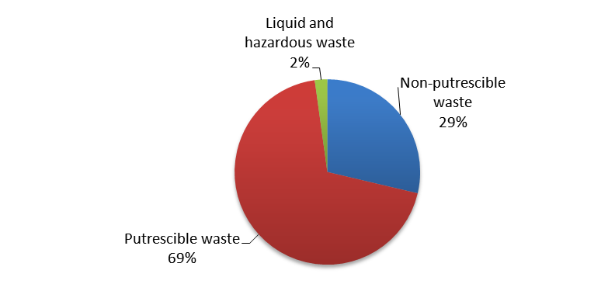
Figure 12: Total sample of 31 supermarket stores (metropolitan and regional).
Figure 12 illustrates the relative contribution of three different wastes in the stores sampled. As noted elsewhere in this report, it is important to note that different waste contractors undertake audits in different states with the result that methodology may differ.
Further detail regarding non-avoidable food waste is provided in relation to putrescible waste sent to composting and bio-digestion facilities in Section 3.4.4.4.

Other Commercial and Industrial (pre– and post- consumer)
This research has identified and collated limited data on avoidable and unavoidable food waste from the commercial and industrial sector. As noted earlier, avoidable food waste is increasingly well understood as more businesses divert edible food to charities. This food comes from donors in a wide range of industry sectors, several of which have been identified by stakeholders as important to understanding the potential for improving food waste diversion from landfill. However, while data (in kilograms or tonnes) could theoretically be gathered from food charities on the basis of industry sector of the donors, this is currently not an established practice. Table 10 (below) provides a preliminary analysis of the industry sectors currently making donations to the largest food charities.
Table 10: Examples of industry sectors currently making contributions to food charities
Division C - Manufacturing
C118 - Sugar and Confectionary Manufacturing, C11 – Food Product Manufacturing
Division F - Wholesale
F36 - Grocery, Liquor and Tobacco Product Wholesaling
Division G - Retail
G41 - Food Retailing, G412 - Specialised Food Retailing
Division H - Accommodation and Food Services
H45 - Food and Beverage Services, H4513 - Catering Services
Division I- Transport, Postal and Warehousing
I48 - Water Passenger Transport, I51 - Postal and Courier Pick-up and Delivery Services
Division J - Information Media and Telecommunications
J56 - Broadcasting (except internet), J541 - Newspaper, Periodical, Book and Directory Publishing
Division K - Financial and Insurance Services
Division L -
L672 - Real Estate Services
Division M -
M69 - Professional, Scientific and Technical Services (Except Computer System Design and Related
M693 - Legal and Accounting Services
M694 - Advertising Services
M696 - Management and Related Consulting Services
M699 - Professional Photographic Services
Division N -
N721 - Employment Services
N729 - Other Administrative Services (includes function and convention centres)
Division O -
077 - Correctional and Detention Services, 076 – Defence, 0753 - Local Government Administration
0752 - State Government Administration, 0751 - Central Government Administration
Division P -
P80 - Preschool and School Education , P81 - Tertiary Education
Division Q -
Q87 - Social Assistance Services, Q84 - Hospitals
Division R - Arts and Recreation Services
R89 - Heritage Activities (includes museums and art galleries), R91 - Sports and Recreation Activities(sporting grounds)
Division S -
S94 - Religious Services, S955 - Civic, Professional and Other Interest Groups
Categorising donations by industry sector is seen as useful in understanding where progress in reducing food waste is being made. However, the existing distinctions are more difficult to apply when donations are drawn from other food processing and manufacturing businesses. Many of the businesses that currently make donations to food charities may fit under two or more industry categories. This is particularly evident with respect to bakeries, many of which are manufacturers (factory or non-factory), wholesalers, retailers and /or places where food and beverages are served.
See Section 3.5.4.1 for more information about avoidable food waste data.

Consumer/bin to landfill, redistribution or recycling (pre- and post-consumer)
The Australian Food Waste Assessment Interim Report noted that local governments have collected the majority of food waste data through contracts with waste disposal and recovery service providers. This post-consumer data has been collected under a variety of methodologies over different periods of time.
Data compiled in this study provides information about both post-consumer waste collected by local governments and pre-consumer food waste recovery sourced through several food charities.

Food Charities (pre–consumer)
Food donated to food charities can be eaten, either by humans or other animals, and is therefore categorised as avoidable food waste. Edible food donated to food charities is also often referred to as ‘rescued’, as it has been diverted from landfill and used as food by a range of welfare groups.
Foodbank, FareShare, OzHarvest and SecondBite are the largest food charities in Australia and each operates in one or more states. Foodbank operates across all states and territories and is distinguished from other food charities by the large volume of food recovered (see table 10), as well as the significant volume of food it recovers from the food-manufacturing sector. Donations to all food charities appear to be growing, as can be seen in Table 11 (below):
Table 11: Tonnes of edible food recovered by major Australian food charities (2007–08 to 2009–10)
Food charity | Coverage | Food recovered (tonnes)
Food charity | Coverage | 2007–08 | 2008–09 | 2009–10 | Total
Foodbank | NSW, ACT, Qld, SA, Vic, WA, NT, TAS | 16,236 | 17,573 | 18,983 | 52,792
FareShare | Vic, NSW | - | 250 | 682 | 932
OzHarvest | NSW, ACT, SA | 711 | - | - | 711
SecondBite | Vic, Tas | 144 | Approx. 702 | Approx. 880 | 1,582
Source: Figures for individual financial years obtained from annual reports.
As can be seen in figure 13(below), donations in each of the broad industry categories have increased each year, as have total donations.
Figure 13: Donations to Foodbank 2003–04 to 2009–10.
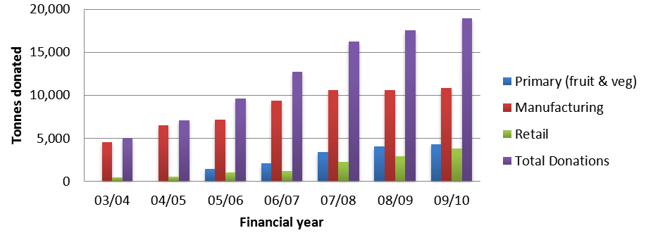
*Note that prior to 2005–06 Foodbank manufacturing figures include primary (fruit & veg) donations.
Source: Foodbank 2011

A more detailed view of industry sector involvement in diverting avoidable food waste from landfill can be seen in the data provided by FareShare for the 2009–10 financial year. A comparison of Figure 13 (above) and Figure 14 (below) demonstrates the variation in the industry sector of donors to different food charities. Figure 14 indicates that food retailers were the largest donors for FareShare during 2009–10.
Figure 14: Food donations to FareShare by industry sector (2009–10).
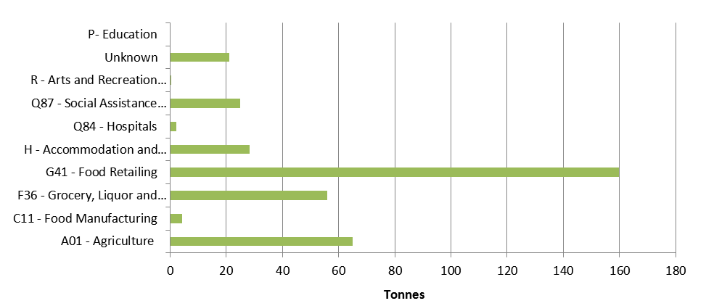 Source: FareShare 2011

Composition of foods donated to food charities
Different food charities categorise donations in different ways, making judgements about the composition of the total donations imprecise at best. Table 12 (below) provides an overview of the variations.
Table 12: Categories used by food charities to monitor donations
Organisation | Categories | Metric
Foodbank | Two main categories that are subdivided:  1. Staple Foods - Fresh Food, Chilled Product, Dry & Long life Products, Frozen Product.  2. Other Donations | Kg/tonnes
SecondBite | Fruit and vegetables, Prepared foods, Extras, Drinks, Breads and cereals, Milk and dairy, Meat, fish and eggs. | Kg/tonnes
Fareshare* | Fruit, Vegetables, Cheese, Milk, Eggs, Pastry, Muffins, Bread, Pies, Red meat, Chicken, Seafood, Sandwiches and rolls, Desserts, Chocolates, Fruit juice, Soup, Misc, Biscuits, Pasta, Condiments | Kg/tonnes
OzHarvest | Fresh fruit and vegetables, Cooked food, Processed food, Pre-prepared food, Dry goods and Frozen goods | Items
*This group doesn’t appear to have higher-level categories but tracks a variety of food types depending on what is donated each month.

Donations to Foodbank in the two high-level categories of ‘staple’ and ‘other’ donations have been compared in Figure 15 (below):

Figure 15: Donations to Foodbank by product category 2005–06 to 2009–10.
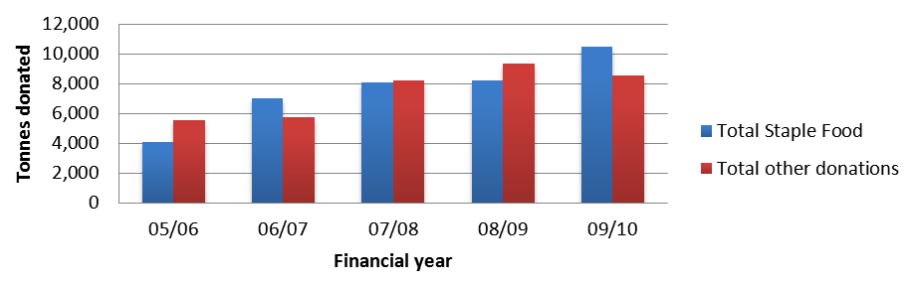
Source: Foodbank 2011 NOTE: ‘other’ donations include food produced for Foodbank by a ‘collaborative
In 2009–2010 (shown in the last column in Figure 15 above), Foodbank’s collection of staple foods is comprised of approximately 47 per cent fresh foods, of which fruit and vegetables makes up of approximately 4300 tonnes.

Figure 16: Foodbank staple foods by mass for 2005–06 to 2009–10.
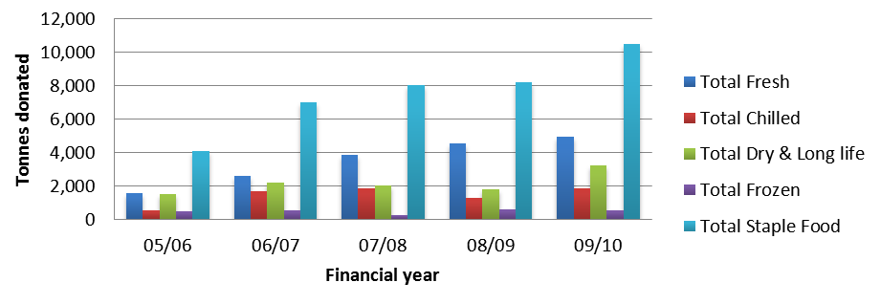
Source: Foodbank 2011
In contrast, Figure 17 (below) shows that SecondBite donations primarily consist of fruit and vegetables.
Figure 17: Food donated to SecondBite by product category in 2009–10.
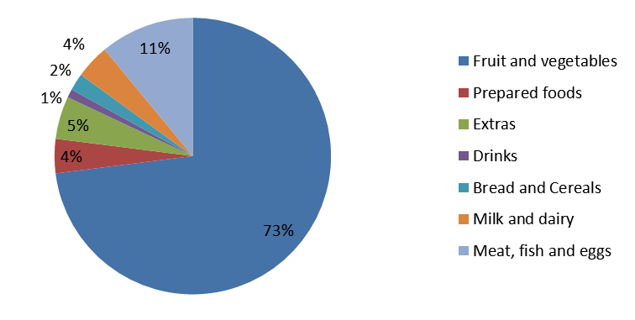
Source: SecondBite Annual Report 2010
It is worth noting that while donations to food charities must be edible it does not follow that they are fit for human consumption. For example, of the total amount of food collected by SecondBite in 2010, approximately 1 per cent (7,571kg) was not fit for human consumption and was redistributed to a pig farmer.

CASE STUDY – Reverse Logistics
Woolworths/Foodbank Food Rescue Scheme
Woolworths’s relationship with Foodbank was established many years ago with donations of products from distribution centres (DCs). Twelve months ago this was extended to incorporate the “reverse logistics" of collecting non-saleable products from stores and providing these to Foodbank via the DCs. The program involves the collection of food and grocery items ‘fit for use’ but not suitable for sale (i.e. close to end date) at individual Woolworths stores (575 metro stores and 250 country town stores) and sending these items back to their major distribution centres (DCs) in trucks that would otherwise be travelling empty.

The process involved engagement at high levels with policy determined at Woolworths’s head office, and all program partners were involved in developing the process. This included Woolworths Head office, DCs, stores and Foodbank.

An analysis of the program’s success undertaken by Foodbank indicates that ‘key supporting factors’ include:
- Woolworths’s policy of zero waste by 2015
- Good Samaritan laws introduced
- Australia has ‘use by’ and ‘best before’ dates that helps identify higher risk items
- No high risk items included
- No added cost to supermarket
- No claim against suppliers - covered by ‘ullage’ allowance
- No packaging - use banana cartons at store
- All parties involved in development and trial
- Maintain communications with stores – recognition / appreciation

Other more subtle factors that have been seen as important in establishing the program are quality of the existing relationship between Woolworths and Foodbank, and the role that Foodbank plays as part of the solution to Woolworths achieving its ‘zero waste’ target. It is also worth noting the degree of engagement between management groups in both organisations: Woolworths sits on the State Foodbank Board.

Results for 2009–10 financial year:
  - 1034 tonnes collected from warehouses
  - 1289 tonnes collected from individual metro stores
  - Total 2322 tonnes collected
Compared to 1278 tonnes for the previous year, this represents an 82 per cent increase in edible food waste diverted.
This case study has been excerpted from material developed by Foodbank.

Residential Food Waste (Post-Consumer)
While significant numbers of residential waste audits have been identified by this assessment, both through contact with consultants that have undertaken audits or through local government bodies, this research has not attempted to create a comprehensive collation of this data, and it is likely that further audit data could be retrieved if sufficient resources were directed to this task.

What can be concluded from the audit data that has been collated, at this stage, is that there is a high level of variability in the methodology used in different states and territories, at different times. Until very recently, and with SA and NSW as notable exceptions, most states and territories have not had clear guidelines for undertaking residential kerbside auditing. Further complexity arises from the fact that many studies are one off or undertaken so infrequently that changes to methodology may have a significant impact on whether they could be sensibly compared to previous audits. Despite this variability, the increasing number of physical audits (in which waste is sorted and weighed) that have been undertaken in the past three to five years are likely to provide a valuable base of information about the character and density of Australian MSW in general, as well as the mass of food and organics waste that is present in this waste stream.
As has been the case with waste data more broadly, the largest gaps in information about household food waste occur in Tasmania and the NT. This study has identified a very small number of audits from these states/territories. Larger numbers of household-level audits have been identified in Queensland and WA, but the largest numbers of audits have been undertaken in NSW, SA and Victoria.
The most reliable data on household level waste auditing may be found in SA and NSW, where methodologies for undertaking such audits have been in place for longer periods. SA has also been undertaking audits in particular areas with a frequency that is likely to provide a higher level of comparability than is available in other states.

Landfill (pre – and post- consumer)
Historically, the majority of existing waste data has been directly or indirectly derived or estimated based on information collected at the point of disposal in a landfill facility.
This data is extensively covered in state-based waste data reporting, which is the basis for national reporting via the ABS. The extent to which this data is useful for understanding the impact or significance of food waste data is determined by the ability or willingness of these facilities to monitor and report on these wastes in a consistent way.
A number of reports from regional waste management boards and local government have noted a lack of coherence in reporting standards or requirements for landfill. Significant gaps in the amount and detail provided by landfill facilities in different states and territories has also been noted in routine regional, state and national surveys of Australian waste generation.

Composting and BioDigestion Facilities (pre – and post- consumer)
Composting and biodigestion have been a major focus of new developments in managing food waste. Composting refers to several processes that occur at different scales from the household compost bin to large facilities.
This research has identified several studies of composting from food waste that may be useful in understanding the contribution that food waste could make to improvement of soils. For example, there are several trials of household food waste collection and processing which have indicated that useful products can be obtained by diverting this waste from landfill. A study undertaken in Chifley (ACT) during 2000 found that the food waste content significantly improved nutrient levels in the compost produced (compared to composted ‘green waste’), and that when tested against the Australian Standard, it was considered to be a high quality product.
Other trials undertaken within the last decade have also indicated that there are benefits from diverting food waste to composting facilities, and it may be very useful to compile these studies as the basis for a more comprehensive investigation of the environmental and productivity goals that could be achieved by more concerted efforts in this area.
EarthPower (NSW)
There are several examples of businesses and institutions providing their organic waste to dedicated biodigestion facilities. An example found in NSW illustrates the potential for food waste to be diverted from landfill and used for generating energy and soil enhancement materials. Figure 18 (below) shows the amount of organic waste contributed by stores from just one large supermarket chain in the Sydney metropolitan area.
Figure 18: Organic wastes biodigested at EarthPower facility (2006–2010)
Source: EarthPower
Smaller businesses are also utilising composting and biodigestion facilities as they become available. For example, Canossa Hospital, which operates an aged care facility at Oxley in Queensland, has used the opportunity provided by planned refurbishment work, and the opening of a nearby bioenergy facility, to improve its environmental performance in the area of waste.
Halve Waste Business Biodigestion Trial Proposal (NSW and Victoria)
Further potential for supermarket outlets to divert unavoidable food waste from landfill is being explored in a ‘food feasibility study’ for the C&I waste stream. Landfill operators reporting to Albury City Council have identified approximately 2305 tonnes of packaged food waste being sent to landfill, with around 630 tonnes of this material received for special burial from food manufacturers. The report also notes that approximately 3000 tonnes of ‘food slops’ and other food from a range of other businesses would be available for use in a trial .

PACKAGING WASTE AND FOOD
Food waste is a comparatively new area of interest relative to the other waste streams and this is reflected in the waste information that has been collected by all levels of government, as well as businesses. Recycling of packaging materials has been a major focus for waste auditing and data collection for almost two decades, and many of the audits that have been collected as part of this research have been undertaken with the purpose of understanding the amount of packaging that exists in the waste stream. Many of these audits have also looked at the costs involved with reclaiming packaging materials, and general waste – which includes food waste and green waste – has been identified in many of these studies as an impediment to cost-effective recycling.

As recycling technology has improved, organic waste contamination has become less of an issue for implementing recycling programs, and reporting of this material has declined. However, as concerns about water contamination and greenhouse gases from landfill have become more prominent, organic wastes have begun to appear as specific items of interest in auditing activities. This shift in direction has changed the roles played by packaging and food/organics in previous discussions about reducing waste. With reducing food and organic waste as the emerging focus of waste management, packaging has become a contaminant in food waste streams for programs and initiatives that seek to make productive use of the nutrients or energy that are available in food/organics wastes.

Data provided by food charities indicates that a significant amount of donated food is packaged in some way, with the result that this packaging waste is also removed from these donors’ waste streams.

CONCLUSIONS

Data Availability and Quality
This research has confirmed that the majority of useful food waste data comes from organisations and groups that currently dispose of this resource. A number of projects have attempted to collate Australian waste data, including the Australian Waste Database, which started an extensive collation of some key waste streams in Australia. However, these have been undertaken as part of short-lived programs and these initiatives have not been sustained. The quality assessment undertaken in this study indicates that while there have been numerous studies undertaken on disparate aspects of food waste in Australia, the majority of such data is not robust enough for use at the national level.
Currently, post-consumer food waste data is collected via a variety of methodologies, such as waste audits, which do not lend themselves to an easy comparison across states. This lack of a consistent approach has been identified by previous studies, and reports that have argued for a national approach that “… would support…states and territories to create consistent goals and to implement strategies to achieve those goals”.
Existing studies, surveys and reports have noted a lack of consistency in data gathering, including differences in units of measurement (e.g. mass or tonnages versus volumes and counts), sampling and collection methods, as well as approaches to defining representative study areas.
Long-established waste auditor APC Environmental Management has also called for a national approach to waste auditing, and has supported the standard set by waste management groups in SA on the basis of cost-effectiveness, safety and a need to “accommodate future trends in data requirements for AWT planning and NGERS reporting”. This view is understandable from the perspective of the waste management industry, but may not be sufficient to the needs of other stakeholders, such as local, state and federal government agencies.
For this reason, it will be important to consult a wide range of stakeholders about how existing standards and guidelines can be harmonised to achieve a consistent national picture of food waste in Australia.
Action 1: Identify and implement a national standard for waste data collection, including standard definitions, methods and objectives that can be incorporated in all state waste data collection guidelines.

Several stakeholders indicated that there are significant waste data gaps in sections of the food production chain including:
- Distribution centres and other points in the supermarket supply chain
- Food manufacturing (highly processed foods)
- Restaurants, cafes and other food service businesses
- Fresh food markets (permanent and temporary)
- Small fresh fruit and vegetable businesses
- Independent food and grocery outlets.
These and other stakeholders indicated that the waste sector and food charities are likely to be the most extensive sources of current food waste data for pre-consumer phases of the food production chain, and data provided by several food charities has proven very useful for this assessment. However, this can only deliver limited information about the avoidable food waste stream, and existing waste data gathering activities by food charities does not currently extend to categorising the donors by industry sectors. Stakeholders in this area have indicated that this information is not useful to them, and that there are a number of donors that do not fit neatly into a single industry sector. Further consultation would be required to establish new reporting formats and to provide incentives for food charities to provide this data.
Action 2: Consult with businesses and food charities as part of an investigation of opportunities to improve data collection and reporting on both avoidable and unavoidable pre-consumer food waste.

Unavoidable food waste in pre-consumer segments of the food production chain is more difficult to assess without a significant improvement in monitoring this waste within the Commercial & Industrial waste stream. Improving data in this area has been identified in recent reviews of C&I waste, including a survey undertaken in NSW, which noted that food waste was increasing substantially.
Action 3: Investigate opportunities to improve data collection and reporting on pre- and post- consumer food waste contained in the Commercial & Industrial waste stream.

Stakeholders involved in reducing municipal solid waste believe there may be a great deal of largely unused or underutilised food waste data that is emerging from measurement and analysis of kerbside waste and recycling and other auditing activities being undertaken by local governments. Over the past 10 years, household waste audit data has increasingly been collected in most Australian states and territories and now may now present an opportunity to begin creating a waste characterisation that relates more closely to Australian definitions and practices.
Action 4: Evaluate the costs and benefits of compiling existing Australian municipal solid waste data, against the costs and benefits of undertaking a national baseline audit of households and businesses.
Stakeholders at the local government level indicated that smaller councils have limited resources to undertake auditing activity. The absence of waste levies to provide these resources has been identified as one reason for the absence of household waste auditing activity in states such as Queensland. An additional impetus for evaluating the benefits of implementing landfill levies is that this can assist with “increasing existing research and development funding for food waste minimisation technologies”.
Action 5: Evaluate the benefits of using waste levies in states and territories, where these are not already in place, to provide resources for consistent data collection at the LGA level.

Impacts
This section provides a discussion of the impacts of the disposal of food waste in terms of the economic costs associated with the loss of resources from the food system. Prioritisation of actions to collect food waste data should ideally consider not only the reliability of current data, but the magnitude and impact of that part of the waste stream (i.e. such that larger and higher-impact waste streams are prioritised). An assessment of environmental and economic impacts was initially considered to be an achievable outcome of this research; however, the lack of consistency in data gathering has limited the conclusions that can be drawn from the existing data. In the absence of reliable data, it has not been possible to evaluate the magnitude of food waste from the data collated within the scope of this study.

Pre-Farm Gate
The economic value of waste occurring prior to the farm gate is currently difficult to estimate. Understanding this would require significantly more extensive data than is currently available, and would go beyond measuring the amount of waste materials generated for disposal. Additional information, including the purchase price of resources, the value that is derived from them in use, and the efficiency of that use would also be key elements of such an assessment.
In a similar way, assessing the potential resource value of food waste, for agriculture or energy generation, requires more information than the weight or volume of waste. Cordell and colleagues estimated the phosphorus fertiliser content available in organic and food waste streams throughout the Australian food system, including 15 000 tonnes of P in food waste alone. However, these nutrient resources can only be reclaimed from waste flows if facilities and markets for the products (fertiliser, soil amendment materials, animal feed) are also in place.
Action 6: Evaluate existing data related to the use of agricultural waste, including animal production and meat processing in South Australia, as the basis for a larger national survey of opportunities to undertake these kinds of resource recovery in other states and territories.

Post-Farm Gate
As with pre-farm gate food waste, data collection in the post-farm gate segment of the food production chain is highly variable and this makes estimates of economic value, productivity or environmental impacts difficult to undertake with any degree of accuracy.
However, residential waste audit data identified by this research could address a significant gap in our understanding of both the nutrient value and productivity potential of the municipal solid waste, and a more accurate view of the environmental impacts of continuing with existing approaches to managing food waste. Currently, studies of waste in Australia use a characterisation developed over several years by the United States Environmental Protection Agency, ignoring the difference in basic definitions of municipal solid waste used in Australia and the US. In Australia, municipal solid waste refers only to household waste, whereas in the US this term refers to both household waste and waste coming from businesses. Similarly, differences in systems of measurement and product composition (for instance the size and composition of common food packaging) create additional problems for estimating environmental and economic impacts from waste. The Australian Waste Database was developed to provide standard data, but this has been discontinued, as discussed earlier.
It may be possible to begin a similar characterisation of C&I waste using existing data collected by well-established physical waste auditing programs. Specifically, characterisation refers to standardised parameters for density, moisture content etc.
Action 7: Develop an Australian waste characterisation for MSW, C&I and C&D waste streams that can be used to more accurately evaluate the impact of waste in key areas such as GHG and resource recovery.

WHERE TO NOW?
This section identifies priority actions required, policy implications and challenges embedded in the bigger picture of sustainable management of food waste in Australia.

Key actions required
Action 1: Identify a set of common waste collection definitions, standards and objectives that can be incorporated in all state waste data collection guidelines.
Action 2: Investigate opportunities to improve data collection and reporting on pre-consumer food waste by businesses and food charities.
This action should include consultation with food charities and industry sectors that have made contributions to food charities or other organic waste recovery facilities (such as composting or biodigestion), with a view to understanding:
- Aspects of businesses, that operate within different industry categories, that might be the most meaningful for understanding the impact of their food waste
- Incentives that might be developed to encourage food charities to incorporate more extensive food waste reporting into their operations.
Action 3: Investigate opportunities to improve data collection and reporting on pre- and post- consumer food waste contained in the Commercial & Industrial waste stream. This might also consider methods for distinguishing between pre- and post-consumer food waste in industries where these wastes might be combined, such as hotels cafes, restaurants and take-away food outlets.
Action 4: Consider a comprehensive compilation of existing Australian municipal solid waste data, including the most reliable data from physical audits of households and businesses.
Action 5: Evaluate the benefits of using waste levies in states and territories where these are not already in place to provide resources for consistent data collection at the LGA level.
Action 6: Evaluate existing data related to the use of agricultural waste, including animal production and meat processing in SA, as the basis for a larger national survey of opportunities to undertake these kinds of resource recovery in other states and territories.
Action 7: Develop an Australian waste characterisation for MSW, C&I and C&D waste streams that can be used to more accurately evaluate the impact of waste in key areas such as GHG and resource recovery.

Challenges for management of food waste in Australia
This section discusses some challenges to moving forward towards better food waste data collection and management.

Harmonising data collection and classification
Recommendations for improvements to the consistency of data gathering and reporting make regular appearances in studies of Australian waste, and the appeal of harmonising existing data collection and classification systems across all states and territories is broad. Such calls can be found in studies of waste packaging reduction programs, routine waste management reporting by regional waste boards, and academic research on fruit and vegetable consumption. An example from the discussion of an annual survey undertaken by the Barwon Regional Waste Management Group:
“Data recording inconsistencies continue to be problematic. Coupling and categorizing of data is a significant weakness in the recording. While the researcher was able to collect accurate data for both municipal and commercial waste, the data recording methods used by the landfill operators are still inconsistent. The materials collection site operators differed in how they categorized the different types of waste and whether their records differentiated between commercial and municipal waste. This made the comparison of data difficult. This issue has been noted in last five surveys and it remains a priority recommendation that all Council operated landfills and transfer stations in the Barwon Region commit to consistent data recording categories.”
As noted earlier in this report, classifying food waste is important, as it has implications for designing a successful and sustainable management response. For example, an extensive UK study by WRAP found that at least half of household food waste was edible and could be diverted from the waste stream under the right circumstances. The distinction between food waste that could be ‘avoided’ (reducing spillage or the amount of food that passes its expiry date before it is used), and ‘unavoidable’ food waste (such as banana peels) can be useful in reducing this waste stream.
Avoidable waste can be addressed through demand-management measures within the appropriate sector, such as improved household meal planning to reduce disposal of edible food, or improved efficiency in food processing operations to reduce spillages and unnecessary losses. Unavoidable wastes can be managed by recovering resources for their fertiliser, energy and soil conditioning properties. Hence gaining an understanding of food waste types/classification at all key stages from harvest to retail and final consumption helps researchers and policy makers gauge the true costs and potential value of food waste resources and design the most appropriate waste management strategy.

Understanding institutional barriers to improving food waste data
Improving the management of food waste is not only about understanding the size, nature and impacts of the waste streams. Effective policy will need to consider institutional arrangements, including the roles and responsibilities of stakeholders affected by food waste management.
Existing institutional arrangements fragment the management of organic waste between the agricultural sector (for crop and other organic wastes), commercial and industrial sector (solid food waste from food manufacturing and distribution), residential sector (solid food waste and other organics) and the water and sanitation sector (for liquid waste). This fragmentation makes it difficult to assess the size and precise nature, or impact, of existing food waste streams. Furthermore, stakeholders interviewed prior to this interim report have indicated that a standardised set of national guideline for auditing waste, including food waste, would be one way improve the quality of data that is collected under existing regulation and programs.

An integrated approach to managing food waste in Australia
Criticisms of the model of a food production chain as “simplistic” and therefore incapable of adequately “capturing …economic, social and environmental context” in which this model operates are supported by an analysis of the wide variety of losses incurred at varies points in the production, distribution and consumption cycle. Table 11 provides a broad overview of these losses:
Table 13. Examples of food waste types at different stages of the food production and consumption system.
Food chain stage | Examples of wastage
Agricultural production, fishing and hunting | Crop abandonment due to prolonged extreme weather events (e.g. drought), stringent quality control measures, damage from pest and disease (crops and meat products)
Transport and storage | Spoilage, pest damage and unsold foods during transport and storage
Manufacturing, processing and packaging | Processing wastage (e.g. cut offs, leftovers, damaged during processing)
Wholesale and distribution | Unsold wholesale foods, spoilage during transport and storage
Food retailing | Unsold fresh produce and packaged foods in food retail stores; food purchased speculatively to meet forecasted customer demand and perceived expectations (e.g. presentation, quantity, quality)
Food service industries | Food purchased in excess of patrons’ requirements; food purchased in excess to meet potential patron demand and expectations (in terms of presentation, quantity, quality)  Neglected/unprepared food and ingredients past use-by date; improper food storage; confusion over ‘use-by’ and ‘best-before’ dates  Uneaten foods suitable for charitable or discounted redistribution  Disposal of foods in landfill which could otherwise be captured for nutrient and embodied energy and water recovery (e.g. composting)
Disposal | Food waste to landfill instead of nutrient recovery
Source: Riedy, C., Herriman, J., Dovey, C., Boyle, T., 2010, Reducing Commercial and Industrial Food Waste: Literature Review and Options. Prepared for the Department of Environment, Climate Change and Water (NSW) by the Institute for Sustainable Futures, University of Technology, Sydney.
Currently, knowledge about the size, nature and impacts of food waste generated in the majority of these categories is scarce, hence further data collection will be required if evidence-based management policies are to be developed. This may extend to data collection in what are currently considered to be unrelated areas. Recommendations for a broader understanding of the food system have encompassed national nutrition and waste surveys:
“…supporting the private sector to function more efficiently and guiding a cultural shift to increase population-wide appreciation for healthy eating... Recommendations for a broader understanding of the economic factors that affect the viability of Australia’s food production industry have also been put forward, including a failure to recognise the need for improved communication across different segments of the food production and consumption cycle.
As waste management moves from waste disposal to resource recovery, accurate data collection becomes significantly more important. Existing data provides both a sense of what the impacts of continuing existing waste management strategies may be, and an indication of the opportunities to create environmental and economic benefit from materials that are currently treated as ‘waste’.
However, currently this data collection is undertaken by a limited number of organisations, at different intervals, using a variety of methods. This research has provided an opportunity to identify where data has been collected, but more resources will be required to undertake a comprehensive collation of data and to examine the results to identify their implications for environmental and economic impacts.
A national program of waste data collection across all phases of the food production cycle will be required if an accurate picture of the impacts is to be formed and successful strategies designed.

Moving from a chain to a cycle
Existing data from states and territories that have evaluated the potential for food waste to be utilised as an input for energy generation and soil enhancement indicates that there may be great value in harnessing these resources as conventional fuels and fertilisers become more expensive. However, there appears to be significant variability in the ability of different states and territories to take advantage of these resources.
Morgan has noted that existing views of food production as a chain that does not include consumption and disposal limits our understanding of the ‘food system’. She points to collaborations between government agencies responsible for agriculture and those responsible for reducing energy use as part of a strategy to understand the role played by food production. This approach is also being looked at in SA, Victoria and WA.
Similarly, economic approaches to informing the development of the grocery industry indicate that improved communication between the production, distribution and consumption segments of the food system are valuable. Morgan’s work, and a report prepared for the Department of Agriculture, Fisheries and Forestry, have both pointed to market failure as a result of the current lack of communication:
“The grocery retail market is well serviced with information that allows ready analysis of the changes occurring in demand. On the other hand, the foodservice sector, which deals with the supply of food and meals eaten out of the home, is extremely diverse and poorly serviced with information. The study noted only one sector—the dairy industry—with an arrangement to collate data on foodservice value and volume.” - FoodMap: A comparative analysis of Australian food distribution channels
For these and other reasons, including increasing concerns about fuel and energy involved in the food system, it may be valuable to change the existing model of a food production chain to a food production and consumption cycle that reflects the broader view of a food system.

APPENDIX A: KNOWLEDGE CUSTODIANS BY CATEGORY
The following list includes those stakeholders who own or produce food waste data in Australia, and have been collated in the database. These have been listed by category: that is, government, research centres, high-level peak group, low-level sectors and individual companies.

Federal, state or local government entity
Select Committee on Agricultural and Related Industries
Standing Committee on Environment Communications and the Arts
Auditor-General of ACT
Australian Bureau of Agricultural and Resource Economics
Australian Bureau of Statistics
Australian Government National Land and Water Resources Unit
Commonwealth Industrial and Scientific Research Organisation (CSIRO)
Department of Defence
Department of Sustainability, Environment, Water, Population and Communities
Industry Commission
Productivity Commission
Rural Industries Research and Development Corporation
Sustainable Infrastructure Australia
Avon Midland Waste Advisory Committee**
ACT Jurisdictional Recycling Group
ACT Urban Affairs
Adelaide City Council
Adelaide Hills Council
Albury City Council
Armadale Council
Ashfield Council
Auburn City Council
Audit Office of New South Wales
Auditor-General of NSW
Auditor-General of Victoria
Ballina Council
Bankstown City Council
Banyule Council
Barossa Council
Barwon Regional Waste Management Group
Bassendean Council
Batavia Regional Organisation of Councils
Bayside Council
Bayswater Council
Bega Valley Shire Council
Blacktown City Council
Blue Mountains City Council
Boroondara Council
Botany Bay Council
Brimbank Council
Brisbane City Council
Burnside City Council
Burwood Council
Byron Shire Council
Calder Waste Management Group
Cambridge Council
Camden Council
Campbelltown Council
Canning Council
Canterbury City Council
Cardinia Council
Casey City Council
Central Queensland Local Government Association
Cessnock Council
Charles Sturt City Council
Chittering Council
City of Canada Bay
City of Casey
City of Charles Sturt
City of Greater Geelong
City of Nedlands
City of North Sydney
City of Onkaparinga
City of Port Hedland
City of Prospect
City of Shoalhaven
City of Sydney
Clarence Council
Clarence Valley Council
Coffs Harbour City Council
Corangamite Shire Council
Council of Glenelg Shire
Cradle Coast Authority
Dalwallinu Council
Dandaragan Council
Darebin City Council
Department of Agriculture Fisheries and Forestry (NSW)
Department of Employment, Economic Development and Innovation (QLD)
Department of Environment and Conservation (WA)
Department of Environmental Protection (WA)
Department of Environment and Conservation (WA)
Department of Environment and Resource Management (Qld)
Department of Environment Climate Change and Water (NSW)
Department of Primary Industries (Vic)
Department of Primary Industries Water and Environment (Tas)
Department of Public Works and Services (NSW)
Department Of Territory and Municipal Services (ACT)
Desert Fringe Regional Waste Management Group
District Council of Mount Barker
Dungog Council
Eastern Metropolitan Regional Council
Environmental Protection Agency (QLD)
Environmental Protection Authority (NSW)
Environmental Protection Authority (SA)
Environmental Protection Authority (Vic)
Environmental Protection Authority (Victoria)
Fairfield Council
Frankston Council
Fremantle Council
Gawler Council
Gingin Council
Gippsland Regional Waste Management Group
Glen Eira Council
Glenelg Shire Council
Glenorchy Council
Gold Coast City Council
Goomalling Council
Gosford City Council
Government of Western Australia
Grampians Regional Waste Management Group
Greater Dandenong Council
Highlands Regional Waste Management Group
Hobart City Council
Holdfast Bay Council
Holroyd City Council
Hornsby Council
Hume Council
Hunters Hill Council
Hunter Waste Board
Hurstville Council
Inner Sydney Waste Board
Joondalup Council
Kalamunda Council
Kangaroo Island Council
Kiama Municipal Council
Kingston City Council
Knox Council
Kogarah Council
Ku-ring-gai Council
Kyogle Council
Lake Macquarie City Council
Lane Cove Council
Launceston Council
Leichhardt Municipal Council
Liverpool Council
Lord Howe Island Board
Macarthur Regional Organisation of Councils
Maitland Council
Manly Council
Maribyrnong Council
Marion Council
Maroochy Shire Council
Maroondah Council
Marrickville Council
Melbourne City Council
Melton Council
Mitcham Council
Monash City Council
Moonee Valley Council
Moora Council
Moreland Council
Moreton Bay Regional Council
Mornington Peninsula Shire
Mosman Municipal Council
Mount Barker District Council
Mount Gambier Council
Moyne Shire Council
Mundaring Council
Murray Bridge Council
Nedlands Council
Newcastle City Council
NSW Government
Nillumbik Council
Norfolk Island Government
Northern Sydney Waste Board
North East Waste Forum
North Sydney City Council
Office of the Commissioner for Sustainability and Environment (ACT)
Office of the Minister for the Environment NSW
Olympic Co-ordination Authority
Parramatta City Council
Penrith Council
Perth City Council
Pilbara Regional Council
Pine Rivers Council
Pittwater Council
Playford Council
Port Hedland City Council
Port Phillip Council
Port Stephens Council
Prospect Council
Randwick Council
Recycle NSW
Redcliffe Council
Redland Shire Council
Regional Development Victoria (Dept of Business and Innovation)
Resource NSW
ResourceSmart
Riverina Eastern Regional Organisation of Councils (REROC)
Richmond Valley Council
Roads and Traffic Authority (NSW)
Rockdale Council
Rockingham Council
Ryde City Council
Salisbury Council
Scenic Rim Regional Council
Shellharbour Council
Shoalhaven City Council
Singleton Council
Southern Grampians Shire Council
South West Waste Management Group
Southern Sydney Waste Board
Sustainability Victoria
State Library of NSW
State Rail Authority of NSW
Strathfield Council
Sunshine Coast Council
Sutherland Shire Council
Swan City Council
Sydney Ports Corporation
The Hills Shire Council
Townsville City Council
Tweed Shire Council
Upper Hunter Shire Council
VicHealth
Victorian Local Governance Association
Victoria Park Council
Victoria Plains Council
Victorian Eco-Innovation Lab
Walkerville Council
Wanneroo Council
Warraber Council
Warringah Council
Warrnambool City Council
Waste Management Board WA
Western Sydney Waste Board
West Torrens Council
Whitehorse Council
Whittlesea Council
Whyalla City Council
Willoughby City Council
Wingecarribee Council
Wollondilly Shire Council
Wollongong City Council
Wongan-Ballidu Council
Woollahra Council
Woollahra Municipal Council
Wyong Shire Council
Yarra City Council
Yarra Ranges Council
Yarra Ranges Shire Council
Zero Waste SA

NGO, university or other research centre
Australian Conservation Foundation
CERES
Clean Up Australia
Do Something!
Keep Australia Beautiful Victoria (KABV)
Keep South Australia Beautiful
Planet Ark
The Boomerang Alliance
FareShare
Foodbank
OzHarvest
Resource Work Co-operative Society Limited
SecondBite
The Australia Institute
CRC for Waste Management and Pollution Control Ltd
Centre for Design RMIT University
Centre for Integrated Sustainability Analysis
Charles Sturt University
Curtin University
Edith Cowan University
Faculty of Health and Behavioural Sciences University of Wollongong
Flinders University
Institute for Rural Futures
Institute for Sustainable Futures
Newcastle University Union
Recycled Organics Unit
RMIT University
School of Exercise and Nutrition Sciences Deakin University
University of South Australia - School of Marketing
Urban Research Centre, University of Western Sydney
Wollongong University

High-level peak group (e.g. industry association)
Beverage Industry Environment Council
Beverage Industry Environment Council Tasmania
Biological Farmers of Australia
Horticulture Australia Limited
Litter and Recycling Research Association Victoria
National Packaging Covenant Council
Waste Management Association of Australia
Australian Council of Recyclers
Australian Farm Institute
Australian Food and Grocery Council
Australian Packaging Covenant Council
Packaging Council of Australia
Meat and Livestock Australia

Individual business
Allen Consulting Group
All Environmental Concepts
AMP Capital Shopping Centres
Anglo Coal
APC Environmental Management Consulting (APrince Consulting)
BDA Group
Bio Intelligence Service S.A.S.
Blue Environment Pty Ltd
Bush's Pet Foods
Cardno
Community Change Consultants (Emma Williams, Rob Curnow, Peter Streker)
DemoDAIRY Co-operative Limited
Econtech Pty Ltd
EC Sustainable
EnviroCom Australia
Food Chain Intelligence
Freshlogic
GHD Australia
Global Renewables Limited
Hyder Consulting
In-Sink-Erator
JAC Comrie Pty Ltd
Lloyd Consulting
McGregor Tan Research
MS2 - Martin Stewardship & Management Strategies Pty Ltd
Myer Grace Bros
Naiad Pty Ltd trading as Dallywater Consulting
Nolan ITU
Richard Bain & Associates
Roy Morgan Research
SITA Environmental Solutions
SMS Municipal Services
St Ives Shopping Village Centre Management
Szencorp
Truscott Research
URS
Waste Audit & Consultancy Services Pty Ltd
Wastemin Pty Ltd
WCS Market Intelligence
Wesfarmers
Wimmera Worms & Casts

APPENDIX B: PROJECT METHODOLOGY
This project involved collecting and assessing food waste data from a broad range of disparate sources from across Australia. This section describes the process that has been adopted to ensure that the research coverage is appropriate, and that the assessment produces a clear depiction of the state of food waste data in Australia. It should be noted that while the methodology is presented in a linear format, the process was iterative and some tasks occurred in parallel.

B.1 Australian food system framework
Establishing a framework within which to understand food waste data provides structure, consistency and coherency in locating and interpreting the information. The Australian food flows analysis (Figure 8) is the conceptual core of this project. The purpose of such a flow diagram is to clearly indicate the food or food waste inputs, outputs and accumulations within each key sector and process in the Australian food system. This will:
- Allow the identification and prioritisation of the key food waste flows (e.g. data for major/large flows can be more readily prioritised than minor/insignificant flows)
- Allow the calculation of food waste data through mass balances to either triangulate data or fill in a data gap
- Facilitate the identification of system inter-linkages (e.g. implications of reducing ‘upstream’ waste generation on food waste available for recovery downstream) and
- Quickly and effectively orient the user with respect to the place of data within the whole food production and consumption system.
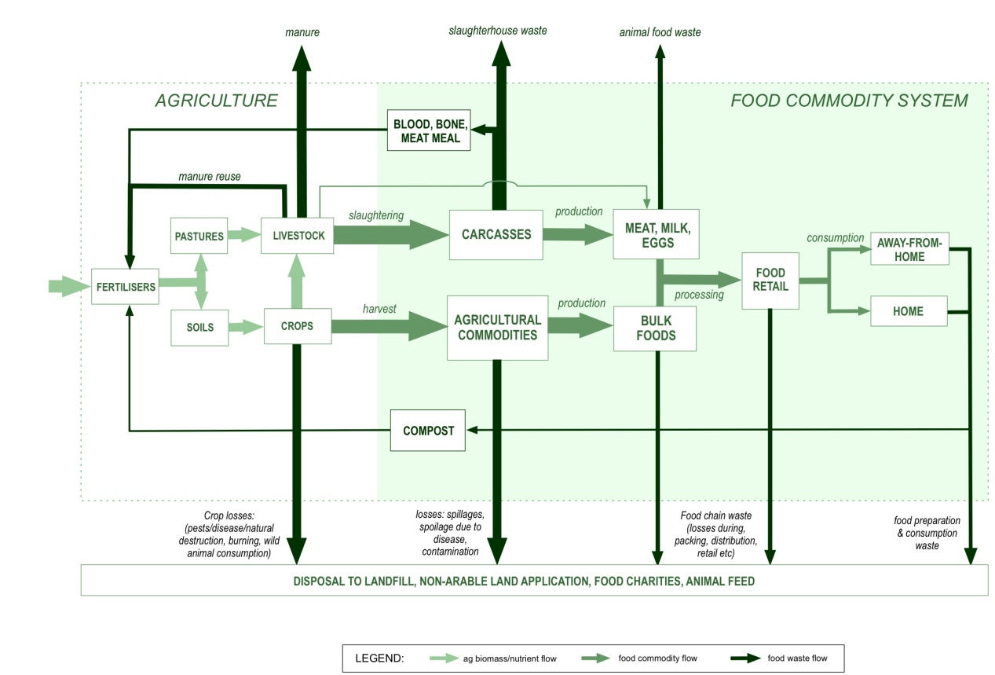
Figure 19. Food waste flows in the Australian food production and consumption system. Source: adapted from Cordell, D. & White, S. (2010), Securing a Sustainable Phosphorus Future for Australia, Farm Policy Journal, Vol. 7 No.3, August, 2010, p.1-17.

B.2 Data collection and review
The data collection process comprises three distinct but interrelated components: 1. a desktop search, 2. citation collection and mapping, and 3. stakeholder interviews.
The desktop search covered documents and data that were available in the public domain and academic literature. The citation mapping attempted to both expand and refine the desktop search by examining the references cited in the documents found in the desktop search. The stakeholder interviews were designed to provide further insight into the generation and analysis of food waste data in Australia, and further to uncover published materials not already identified in the desktop search as well as unpublished data or ‘grey’ literature. A ‘snowballing’ approach was taken to the collection process whereby data/documents collected through searches and interviews were reviewed as they were collected to identify references to other data sources that may subsequently be included in the collection.
New data sources and candidates for stakeholder interviews were continually identified as the research progressed. Data was also progressively screened and prioritised as it was collected (described in Section B.3).

B.2.1 Desktop search
The first phase of data collection was a desktop sweep of data and documents immediately available in the public domain and in academic literature. The search targeted websites of organisations associated with food waste, or food waste projects, as well using internet search engines, Google Scholar and proprietary academic publication databases such as Web of Science, Science Direct.
This first stage yielded approximately 100 documents that were catalogued using a limited meta-data (data about data) set. This included the following:
- Data/document title
- Publisher
- Position of publisher in knowledge holder hierarchy (see Appendix A)
- Location of data within the Australian food production & consumption chain
- ANSIC division or code of the sector producing/recording the data
- Frequency of data collection (i.e. is the data part of a regularly published series?)
- Availability (i.e. is the data publicly available?)
- Contact details for the knowledge holder.
The documents collected were then reviewed in terms of methodology (if any was apparent) and the references that the document cited (see A and B in Figure 9 below).

B.2.2 Citation mapping
All of the collected data/documents were then reviewed for the purpose of mapping their reliance on significant or common references in a process that we have characterised as a type of ‘citation or cross-reference mapping’. The aim of this process is to identify interdependencies between reported food waste data and to distinguish the primary from the secondary sources of data, while also identifying additional data sources for the Australian food waste database.
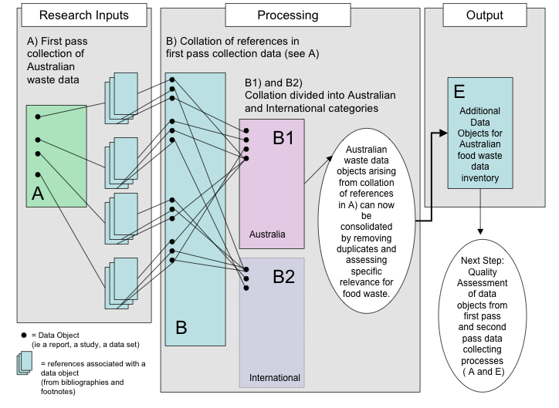
Figure 20. Data snowballing process.
The first stage involved using the bibliographies, and any footnote references, for documents collected in the original phase of desktop research to expand the pool of potentially useful data sources. Items contained in bibliographies or footnote references were catalogued against each of the original documents that they appeared in, and were identified as either Australian or international (B1 and B2).
Relevant data sources from this ‘snowballing’ process (E) were then added to the initial collection of Australian food waste data (A), and given a numerical identification that allows them to be cross-referenced against other items in the database (see Figure 10).
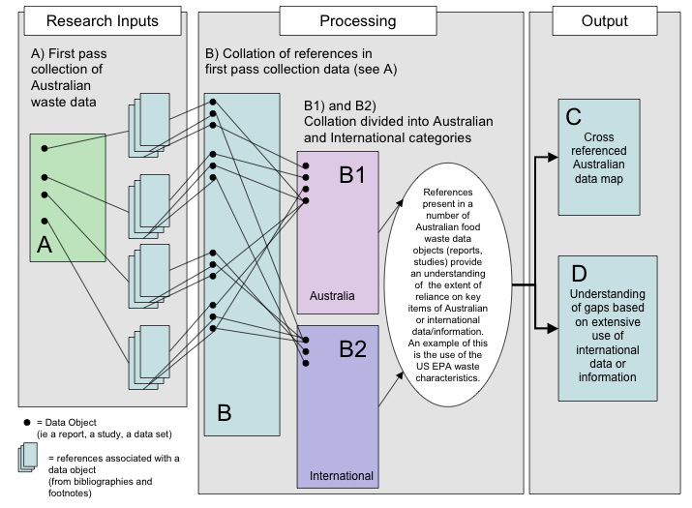
Figure 21 Data Snowballing and citation mapping process.
All new data sources were then checked for relevance to Australian food waste and duplicate references to original documents were eliminated. International items were also identified and their appearance in one or more Australian waste data sources noted. This information will help inform our assessment of significant gaps in Australian food waste data.

B.2.3 Citation map outcomes
In the interim report on food waste data, a citation mapping was undertaken to establish the reliance of more recent publications on food waste on a small pool of studies. The citation mapping indicated that this was not the case, with 107 documents reviewed in the first phase of data collection indicating that cross-referencing between documents may be quite limited. A preliminary assessment indicated that the data source most often cited (seven citations) in publicly available reports on food waste is a discussion paper entitled Wasteful consumption in Australia. The Australia Institute paper was based on data gathered from 1644 respondents to a nationwide email and postal survey of households conducted in 2004. The survey asked respondents to estimate their expenditure on 17 different types of goods and services (including food) they purchase but do not use. The Waste Management Service Survey 2002–03 used administrative by-product data on quantities of waste received and disposed of at landfills from state and territory government departments to understand the nature and volumes of waste streams.
Wasteful consumption in Australia is followed by several documents, each of which is cited in four or five other surveyed documents:
- Waste management service survey 2002–03
- Australian Recycling Values: a net benefits assessment
- Management of Australia's waste streams (including consideration of the Drink Container Recycling Bill 2008)
- South Australian Government Waste Strategy 2005–2010
- Towards Zero Waste Strategy
- Australian Social Trends 2007
- Waste and recycling in Australia: Final report
- Waste Avoidance and Resource Recovery Progress Report.
With two exceptions, a state or federal government commissioned the documents listed here. Data collected in the second phase of this research consists largely of waste audits.
Further citation mapping could not be undertaken at prior to the completion of the current report, however, common assumptions underlying analysis within the waste audits should be assessed as part of further research.

B.2.4 Knowledge holder and stakeholder interviews
DSEWPaC suggested a range of knowledge holders and stakeholders to be consulted as part of this research. Additional knowledge holders and stakeholders have been suggested during these consultations, as well as through the initial desktop review of publicly available documents and data sources.
Key knowledge holders were interviewed to determine:
- What type of food waste knowledge they hold and the scope and format of the data
- Whether the data/information is published or grey literature
- Whether the data can be made accessible to the public, and if not, whether a data agreement can be drawn up to ensure the original data will be de-identified or aggregated in a way that is meaningful for the project yet remains confidential
- Which other knowledge holders should be consulted (snowball technique).
The full set of interview questions is included in Appendix C, which includes an overview of the individuals and organisations interviewed for the research.

B.3 Data screening and prioritisation
The collection and assessment of food waste data was designed to be as extensive and strategic as possible. To ensure that the collection process and data are useful and relevant to a diverse range of project stakeholders, the data/documents collected were screened and prioritised according to the following criteria:
- Proximity to the primary system boundary (post farm gate through to the solid waste disposal system was prioritised)
- Hierarchy of knowledge holders/data sources (Government, university-based research and non-government organisation-commissioned research was prioritised)
- Significance of waste flow (including magnitude, impacts and relevance to nominated policy areas)
- Apparent methodology (Is the methodology evident? What is the methodology?)
The rationale and detail behind the screening and prioritisation criteria are outlined below.

B.3.1 Proximity to system boundary
The first criterion is based on the system boundary defined in Section 2.2. Anything falling outside this boundary has been de-prioritised in the data inventory process.

B.3.2 Knowledge holders and data source hierarchy
Waste data exists in a number of forms at different levels within government, industry and the research community. In order to make the most efficient survey of relevant data, the focus was on five main data source categories (and knowledge holders), as shown in Figure 11.
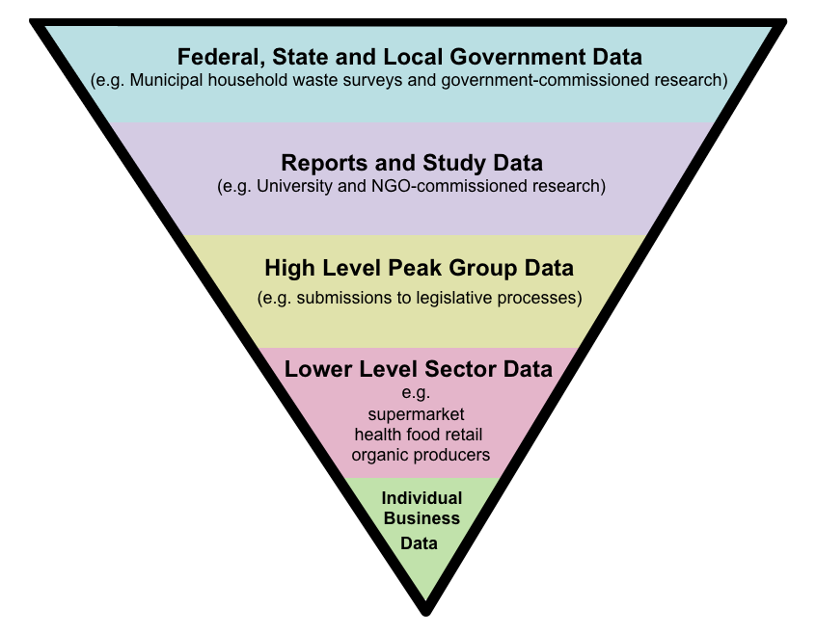

Figure 22. Hierarchy approach for collecting data.
While the majority of data sources were sought from government and industry, data and metadata (information about the data) was also available in studies and reports undertaken by universities and non-government organisations (NGOs). Individual business data may relate to individual food producers or to private waste auditors. This is the most disaggregated form of food waste data and therefore the lowest priority.

B.3.3 Apparent methodology
For data identified through the hierarchy outlined above to undergo quality assessment (see Section B.4 below) it is necessary to at least report a methodology used to generate the data, whether it is based on raw data such as surveys or audits, or an analysis of more synthesised data. If a methodology is not apparent, this is noted as ‘methodology unspecified’ and the data/document is not regarded as reliable as those that do provide details of their methodology.
This approach has been taken to ensure that any headline data used in the final report is based on research of an adequate standard, and whose validity and assumptions can be assessed.

B.3.4 Significance of waste stream
Within the hierarchy outlined above, the focus was on ‘significant’ data. The significance of the waste data referred to in the Australian food waste data inventory was characterised for the purposes of this research as waste data that is important to the implementation of Strategy 16 (data and reporting), Strategy 9 (greenhouse and waste-recycling related initiatives) and Strategy 10 (commercial and industrial waste) of the National Waste Policy. To this end we have identified the following as key concerns:
- Large waste streams (e.g. measured in thousands of tonnes/year)
- Waste streams with high environmental/economic/social impact and
- Waste streams with high dollar values or high potential as inputs to new food production.
Note that these significance criteria are not the same as those used in the quality assessment. The criteria here were used to guide judgement rather than a systematised evaluation of metadata.

B.4 Data quality assessment
The quality assessment of the approximately 1260 data points (presented in the database associated with this study) was undertaken by the following key steps:
- Developing a suitable quality index based on relevant criteria
- Applying relative weightings to each criterion
- Applying a score (1, 2 or 3) to each possible answer against each criterion, where 1 is robust, 2 is satisfactory and 3 is questionable
- Aggregating the scores to yield a final score or index of Reliability for each data point (i.e. each study or report will be labelled Robust, Satisfactory or Questionable)
- Further aggregating the reliability index into themes of ANZSIC codes, stages in the food system, etc.
These steps are explained in more detail in the following sections.
1. Developing index of quality
The index of quality involved developing an index of Reliability, based on multiple criteria:
- Methodology – an important measure of quality is the way in which the data were derived; for example, a physical audit is more reliable than a back-of-the-envelope estimate
- Frequency – the more frequent the data are collected, the more reliable the data set are likely to be, as they account for trends and changes over time, and potentially anomalous years to be identified
- Transparency – generally, if data is transparent not only in terms of whether it is publicly available, but also the assumptions and calculations, then it can be more easily scrutinised for relevance and appropriateness
- Data Form – the form in which the data is presented can also be an indicator of reliability; for example, a peer-reviewed research article can potentially be seen as more reliable than self-reporting from a company in the form of an annual report because the quality has been scrutinised by a third party.
An index of significance was also identified, based on criteria of magnitude (e.g. relative tonnages of the waste), and impact (e.g. environmental impact or economic value of the food waste). However, it was not possible to apply this significance index in this project due to the lack of information about relative tonnages and environmental/economic impact. It is recommended that this be considered in new research, to aid prioritisation of new food waste data collection.
2. Relative weightings for criteria
The Reliability index was developed based on the following algorithm:
Reliability = (3*Methodology + 2*Frequency + 2*Transparency + 2*DataForm)/9
The coefficient in front of each criterion indicates the weighting or importance of that criterion as an indicator of reliability. That is, methodology is considered the most important indicator of reliability. Frequency, transparency and data form are all considered of equal importance.
3. Scores assigned to each possible answer
The scores attributed to each possible answer are provided in Table 12.
Table 14: scores assigned to each possible answer.
Criterion | Possible answers | Point score (1,2,3)
Methodology  weighting = 3 | Measured - Physical Audit | 3
Methodology  weighting = 3 | Measured - Visual Audit | 2
Methodology  weighting = 3 | Measured - Waste Characterisation | 2
Methodology  weighting = 3 | Measured - Audit | 3
Methodology  weighting = 3 | Derived | 2
Methodology  weighting = 3 | Estimated | 1
Methodology  weighting = 3 | Unspecified | 1
Methodology  weighting = 3 | Measured - Survey (Qualitative) | 2
Methodology  weighting = 3 | Measured - Survey (Quantitative) | 1
Methodology  weighting = 3 | Measured - Audit (under-specified) | 2
Methodology  weighting = 3 | Cost Analysis - Measured | 3
Methodology  weighting = 3 | Cost Analysis - Derived | 2
Methodology  weighting = 3 | Cost Analysis - Estimated | 1
Methodology  weighting = 3 | LCA - Derived | 2
Methodology  weighting = 3 | LCA - Estimated | 1
Methodology  weighting = 3 | Life Cycle Costs - Measured | 3
Methodology  weighting = 3 | Life Cycle Costs - Derived | 2
Methodology  weighting = 3 | Life Cycle Costs - Estimated | 1
Frequency  weighting = 2 | Daily | 3
Frequency  weighting = 2 | Monthly | 3
Frequency  weighting = 2 | Quarterly | 3
Frequency  weighting = 2 | Bi-annually | 3
Frequency  weighting = 2 | Annually | 3
Frequency  weighting = 2 | Biennial | 2
Frequency  weighting = 2 | Triennial | 2
Frequency  weighting = 2 | One-off | 1
Frequency  weighting = 2 | Varies | 1
Transparency  weighting = 2 | Publicly available | 3
Transparency  weighting = 2 | May be available on request | 1
Transparency  weighting = 2 | Available with confidentiality agreement | 2
Transparency  weighting = 2 | Data not available | 1
Data format  weighting = 2 | Research – peer-reviewed article | 3
Data format  weighting = 2 | Research - Literature Review | 2
Data format  weighting = 2 | Research - data series | 3
Data format  weighting = 2 | Research - data set | 3
Data format  weighting = 2 | Research - case study | 3
Data format  weighting = 2 | Performance report (CSR/GRI/ Sustainability Report) | 2
Data format  weighting = 2 | Waste Strategy or Policy document | 2
Data format  weighting = 2 | Government Inquiry or Review | 2
Data format  weighting = 2 | Institutional governance report (Annual report) | 1

4. Aggregating scores for each data point
Each data point in the database was given a final reliability score (based on the algorithm in 2 and score card in 3). Table 13 indicates the meaning of the final answer (1, 2 or 3) and associated colour code.
Table 15: Final quality assessment criteria
Index | Question/Description | Answer | Colour Code
Reliability | How reliable is the data?  A compound index based on criteria of: methodology, frequency, transparency, aggregation and data format. | 1 = Robust | GREEN
Reliability |  | 2 = Satisfactory | ORANGE
Reliability |  | 3 = Questionable | RED

5. Aggregating Reliability scores for industry sectors and stages in the food chain
Additionally, the reliability index was aggregated to the industry level (using ANZSIC code) and stages in the food system. The purpose of this is to inform the development of actions required for overcoming data shortcomings or gaps as per Table 14 (below).
Table 16: Determination of actions required
Reliability Colour code | Action required
Robust | New data desirable, but not urgent
Satisfactory | New and improved data required (priority for significant waste flows)
Questionable | New and much improved data required (urgent/ high priority for significant flows)

B.5 Methodology Glossary
Measured | Primary data collected directly by a service provider, contractor or directly obtained from a monitoring device. For example, electricity invoices, contractor receipts, emissions monitoring equipment, incident reports, consultants’ reports etc (National Waste Policy, 2010).
Derived | Secondary data collected and analysed via detailed calculations, mass balances, use of physical/chemical properties, use of co-efficient and emission factors etc (National Waste Policy, 2010).
Estimated | Back-of-the envelope calculations (calculated guess) (National Waste Policy, 2010).
Cost Analysis | Assessment of economic costs associated with food waste.
Life Cycle Costs | Assessment of costs of food waste across the production and consumption chain (broader than a narrow cost analysis).
Life Cycle Analysis | Life cycle energy costs across the production and consumption chain.
Robust | Data that is reliable and rigid, derived by methodologically sound means, where room for error is likely to be minor (National Waste Policy, 2010).
Satisfactory | Data that is somewhat sufficient, however potential exists for error or loss of data (National Waste Policy, 2010).
Questionable | Data is not reliable and was not derived from clear and sound methodological approach; uncertainty and potential for errors are high (National Waste Policy, 2010).
Significance | An index of the importance of data, derived from multiple criteria: magnitude (e.g. relative tonnages of the waste), and impact (e.g. environmental impact or economic value of the food waste).
Reliability | An index of the quality of data, derived from multiple criteria: methodology, frequency, transparency, aggregation and data format
Physical Audit | Formal methodology for collecting waste data that involves physically sorting waste into appropriate categories (e.g. different waste streams – organic waste, plastics, metal etc), and measuring by weight or volume.
Visual Audit | Methodology for collecting waste data that involves visual inspection of waste from which estimates of the volume of waste by different categories.
Survey | Methodology for collecting waste data that involves completing questionnaires with relevant participants to collect qualitative information (e.g. stakeholder attitudes or views on food waste) or quantitative information (e.g. estimates of waste tonnages generated by the respondent’s organisation). Can be undertaken via phone, email, internet, in person or mail.
Waste characterisation | Methodology for collecting waste data that involves physical inspection of waste and categorising by count (e.g. number of plastic items, number of food waste items).

APPENDIX C: Stakeholder engagement
Stakeholder Engagement | Questions addressed
Federal Government  - National Food Plan Unit – Agricultural Productivity Division  - Department of Agriculture, Fisheries & Forestry (DAFF)  State Government  - NSW Department of Environment, Climate Change and Water (DECCW)  - EPA Victoria - Environment Protection Authority  - Sustainability Victoria  - Zero waste SA  Regional Government/Waste Groups  - Barwon RWMG (Vic)  - Central Murray RWMG (Vic)  - Desert Fringe RWMG (Vic)  - Gippsland RWMG (Vic)  - Grampians RWMG (Vic)  - Highlands RWMG (Vic)  - Mildura RWMG (Vic)  - Waste Reduction Group (South West RWMG) (Vic)  - Metropolitan Waste Management Group (Vic)  - Eastern Metropolitan Regional Council (WA)  - Tamala Park Regional Council (WA)  NGOs  - OzHarvest  - FareShare  - SecondBite  - Foodbank  - Do Something!  Peak Industry Groups  - Australian Food and Grocery Council (AFGC)  Individual Business  - Woolworths  - Coles  - APC Environmental Consulting  - GHD Australia | Broad data/opinion questions:  - What are the big gaps in food waste data in your experience?  - What are the most important gaps to fill as a priority?  - Who do you think is best placed to fill those gaps?  - What are the implications of not improving the data on food waste?  Questions about waste data sources:  - What waste data does your organisation have?  - Is it publicly available? Published? Unpublished?  - Is the waste data referring to high, medium, or low amounts of waste? (tonnage/mass or volume data is fine)  - What geographical reference point is relevant to this data? Is it Australia-wide, state-wide, something else?  - Who collected/collects the data?  - Who funded the data collection?  - How was the data collected? (Was it an audit? Was it estimated? Was it modelled?)  - Is the data aggregated?  - Confidentiality clause required?

APPENDIX D: Metadata descriptions for Australian Food Waste Data Inventory
Table 17: Food waste data metadata
Metadata | Description | Data entry field
- Name of data source | By what name is this data source known? | [free text]
- Magnitude | Is the waste data referring to high, medium, or low amounts of waste?  (select amounts from either volumes or tonnages/mass options) | a. volume – high, medium, low  b. tonnage/mass – high, medium, low
- Impact | What impact does this waste data represent for key areas of food waste management? Choose any that are applicable. | a. productivity data – high dollar value of waste  b. productivity data – medium dollar value of waste  c. productivity data – low dollar value of waste  a. productivity data – high value of waste as a potential input to further production activities  b. productivity data – medium value of waste as a potential input to further production activities  c. productivity data – low value of waste as a potential input to further production activities  a. environmental data – high contribution to pollution  b. environmental data – medium contribution to pollution  c. environmental data – low contribution to pollution  a. environmental data – high contribution to GHG emissions  b. environmental data – medium contribution to GHG emissions  c. environmental data – low contribution to GHG emissions
- Food Production Cycle Classification | Where does this data fit into the food production cycle? | a. Pre-farm-gate  b. Farm gate to check-out: Processing and Manufacturing  c. Farm gate to check-out: Transport and Distribution  d. Check-out to consumer  e. Consumer/bin to landfill/redistribution/recycling
- Geographical coverage | What is the geographical coverage of this data? | Australia  ACT  NSW  Northern Territory  Queensland  South Australia  Tasmania  Victoria  Western Australia  Torres Strait Islands  Christmas Islands  Australian Antarctic Territory  Norfolk Island
- Publishing Sector | Which sector/s is responsible for publishing this data? | a. Federal, state or local government  b. Universities  c. NGO  d. Industry peak group  e. Lower level sector  f. Individual business
- Data form | In what form does this data appear? | a. Institutional governance report (Annual report)  b. Performance report (CSR/GRI/ Sustainability Report)  c. Research - case study  d. Research data set  e. Research data time series  f. Published research (e.g. journal article or report)
- Sector Data Source (ANZSIC code) | What ANZIC code describes the waste referred to by this data? | [ANZIC Division, Subdivision, Group or Class code]
- Collector | Who gathers the data? | [org name, contact name, phone and email details]
- Custodianship | Who holds the data? | [org name, contact name, phone and email details]
- Funder | Who funded the data collection? | [org name, contact name, phone and email details]
- Research Dates | What period of time does the data cover? | [year/s]
- Published Date | Year of publication? | [year]
- Methodology | How was the data collected? | a. measured (primary data) (h)  b. derived (secondary data) (m)  c. estimated (secondary data) (l)  d. unspecified (default and blocks access to methodology notes and headline data notes)
- Frequency | How often is the data gathered? | a. monthly (h)  b. annually (m)  c. one-off (l)  d. varies
- Transparency | Is the data available to the public? | a. publicly available  b. available on request  c. available with confidentiality agreement  d. data not made available
- Aggregation | How is the data aggregated? | a. no aggregation  b. local government area  c. State
- Additional aggregation |  | a. product  b. industry sector  c. demography  d. business type  e. business location
- Confidentiality Agreement Requirement? | Has a confidentiality agreement been negotiated with the relevant knowledge holders? | a. Confidentiality agreement required  b. Confidentiality agreement not required
- Primary research focus | What is the main topic addressed? | [enter free text]

APPENDIX E: AUSTRALIAN WASTE DATA SPREADSHEET

This report is accompanied by a machine-readable database of 1261 records collated during the course of this assessment project.

Smil, V. (2000), Feeding the World: A Challenge for the 21st Century, The MIT Press, Cambridge.
The use of these studies should not be interpreted as an assessment of their methodology or conclusions.
$5399 is the estimated cost including Installation for DUX system 315L electric boosted system.
Department of Climate Change, 2009, Australia’s national greenhouse accounts ‐ National Greenhouse Gas Inventory accounting for the KYOTO target, published by DCC, May 2009
WRAP, 2008, The Food We Waste, Waste and Resources Action Programme, UK
Hyder Environmental Benefits Report - Updated for 2010, Hyder Consulting , 2010, http://www.fareshare.net.au/userfiles/Summary%20of%20environmental%20benefits%20(2).doc
Phosphorus can also be reclaimed from human and other animal wastes.
Cordell, D. (2010). The Story of Phosphorus: Sustainability implications of global phosphorus scarcity for food security, Doctoral thesis. Collaborative PhD between the Institute for Sustainable Futures, University of Technology, Sydney (UTS) and Department of Water and Environmental Studies, Linköping University, Sweden. Linköping University Press, ISBN 978-91-7393-440-4, Linköping, http://urn.kb.se/resolve?urn=urn:nbn:se:liu:diva-53430
While recovering and reusing nutrients and energy in excreta is important, it is currently the responsibility of the water and wastewater service providers and associated policy makers, and so it is not core to the National Waste Policy. Similarly, pre-harvest organic waste (generated in the agricultural sector) is also important from a sustainability and integrated systems perspective but it is not the priority of the National Waste Policy. Hence it will be discussed and links between the food and agricultural sector will be highlighted, but not prioritised.
ABARE (2009), The value of the red meat industry to Australia, ABARE research report 09.13 June 2009, Sally Fletcher, Ben Buetre and Kristopher Morey, ABARE report for the Australian Government Department of Agriculture, Fisheries and Forestry, Commonwealth of Australia, Canberra. ACIL Tasman (2009), Australian Live Sheep Exports: Economic analysis of Australian live sheep and sheep meat trade, report prepared for the World Society for the Protection of Animals.
Commonwealth of Australia (2001), Australian Agriculture Assessment 2001, National Land and Water Resources Audit c/o Land & Water Australia, http://www.anra.gov.au/topics/agriculture/pubs/national/agriculture_contents.html Canberra.
ABS (1996), 4606.0 - Sustainable Agriculture in Australia, 1993-94 Australian Bureau of Statistics (ABS), available: http://www.abs.gov.au/AUSSTATS/abs@.nsf/mf/4606.0, Canberra. ABS (2007), Agricultural Commodities, Australia - 7121.0, 2006-07, Australian Bureau of Statistics, Canberra. ABS (2008), Population Projections, Australia - 3222.0, Australian Bureau of Statistics, Released at 11:30 AM (CANBERRA TIME) 04/09/2008 Canberra.
ALFA/MLA (2007), ALFA/MLA Feedlot Survey, Australian Lot Feeders' Association (ALFA) and Meat and Livestock Australia (MLA) National Accredited Feedlot Survey, Sydney.
These definitions are based on those outlined in the National Waste Policy (2010).
http://www.zerowaste.sa.gov.au/at-home/food-waste
See http://www.epa.vic.gov.au/waste/
Queenland’s Waste Reduction and Recycling Strategy 2010-2020, Waste Reform Division Department of Environment and Resource Management © State of Queensland (Department of Environment and Resource Management) December 2010
http://www.zerowastewa.com.au/adminpages/disclaimer/
Waste Strategy for Western Australia, March 2010 , Western Australian Waste Authority
Draft Waste Management Strategy for Tasmania Background Report (2007).
Domestic Waste Audit 2009, Prepared by APC Environmental Management for ACT NOWaste.
ABS 1996, '4606.0 - Sustainable Agriculture in Australia, 1993-94 '. Canberra, Australian Bureau of Statistics (ABS), available: http://www.abs.gov.au/AUSSTATS/abs@.nsf/mf/4606.0;
Cordell, D. & White, S. (2010), Securing a Sustainable Phosphorus Future for Australia, Farm Policy Journal. Vol 7, Number 3, August 2010, Australian Farm Institute, ISSN: 1449-2210.
ISF (2010), Australian Food Waste Assessment, Interim Report, Dec 2010, Prepared by the Institute for Sustainable Futures, University of Technology Sydney, for the Department of Sustainability, Environment, Water, Population and Communities.
Foodbank data provided by Foodbank. Includes recovered staple foods only. Between 2005 and 2010 staple foods comprised, on average, 50% of total foods donated to Foodbank.
FareShare data provided by FareShare. Figures ‘collected and distributed only’ i.e. do not include food collected and turned into meals
OzHarvest data provided by OzHarvest. Data for 2008/09 and 2009/10 not available at time of publication.
SecondBite data provided by SecondBite. This figure is for the 2010 calendar year.
SecondBite, 2010, Annual Report 2009/10, Melbourne
Household Organic Material Collection Trial Chifley August 2000 - June 2001 p.21
Figures provided by EarthPower to waste generator and used with permission from waste generator.
Waste Wise Queensland Fact Sheet – Canossa Hospital – “Waste minimisation – Canossa Hospital The perfect cure for an ailing waste system” - QLD EPA p.2
Pre-consumer food waste recovery – feasibility study, A proposal, Albury City Council , August 2010.
http://awd.csiro.au
Emily Morgan, Fruit and vegetable consumption and waste in Australia, VicHealth and Deakin University 2009 (p2-3)
Final Report National Packaging Covenant Gap Analysis (2005) National Packaging Covenant Industry Association, Prepared by Martin Stewardship & Management Strategies Pty Ltd and New Resource Solutions Pty Ltd (p. 29)
Booth, J. (2010) “Kick waste to the kerb” in WME Magazine, Waste Management
Booth, J. (2010) “Kick waste to the kerb” in WME Magazine, Waste Management
Booth, J. (2010) “Kick waste to the kerb” in WME Magazine, Waste Management
NSW Department of Environment, Climate Change and Water (2008), Disposal based survey of commercial and industrial waste stream in Sydney
Morgan, E. (2009) Fruit and vegetable consumption and waste in Australia, VicHealth and Deakin University (pp. 2-3)
Cordell, D. & White, S. (2010), Securing a Sustainable Phosphorus Future for Australia, Farm Policy Journal. Vol 7, Number 3, August 2010, Australian Farm Institute, ISSN: 1449-2210.
Review of On-Farm Disposal Treatment Risks and the Potential for Recycling of Wastes Produced from Commercial Chicken Farms and Processors, prepared for the Environment Protection Agency by PPK Environment & Infrastructure Pty Ltd November 1999
Final Report National Packaging Covenant Gap Analysis (2005) National Packaging Covenant Industry Association, Prepared by Martin Stewardship & Management Strategies Pty Ltd and New Resource Solutions Pty Ltd (p. 29)
BARWON REGIONAL WASTE SURVEY 2008-2009, Barwon Regional Waste Management Group, May 2010 (p28)
Emily Morgan, Fruit and vegetable consumption and waste in Australia VicHealth and Deakin University 2009 (p.2)
WRAP, 2010, Waste Arising in the Supply of Food and Drink to UK Households, Waste and Resources Action Programme, UK
Foster et al. in: Morgan, 2009 Emily Morgan, Fruit and vegetable consumption and waste in Australia VicHealth and Deakin University 2009
Emily Morgan, Fruit and vegetable consumption and waste in Australia VicHealth and Deakin University 2009 (p.2-3)
Emily Morgan, Fruit and vegetable consumption and waste in Australia VicHealth and Deakin University 2009.
Spencer, S & Kneebone, M 2007, FoodMap: A comparative analysis of Australian food distribution channels, Australian Government Department of Agriculture, Fisheries and Forestry, Canberra. (p2)
Emily Morgan, Fruit and vegetable consumption and waste in Australia VicHealth and Deakin University 2009 (p.7)
The Australia Institute, 2005
The Australia Institute, 2005
Australian Bureau of Statistics, 2004
Australian Council of Recyclers, July 2008
Senate Standing Committee on Environment, Communication and the Arts, 2008
Victorian Government, September 2005
Australian Bureau of Statistics, 2007
Department of Environment, Water, Heritage and the Arts, 2008
NSW Department of Environment, Climate Change and Water, 2008

