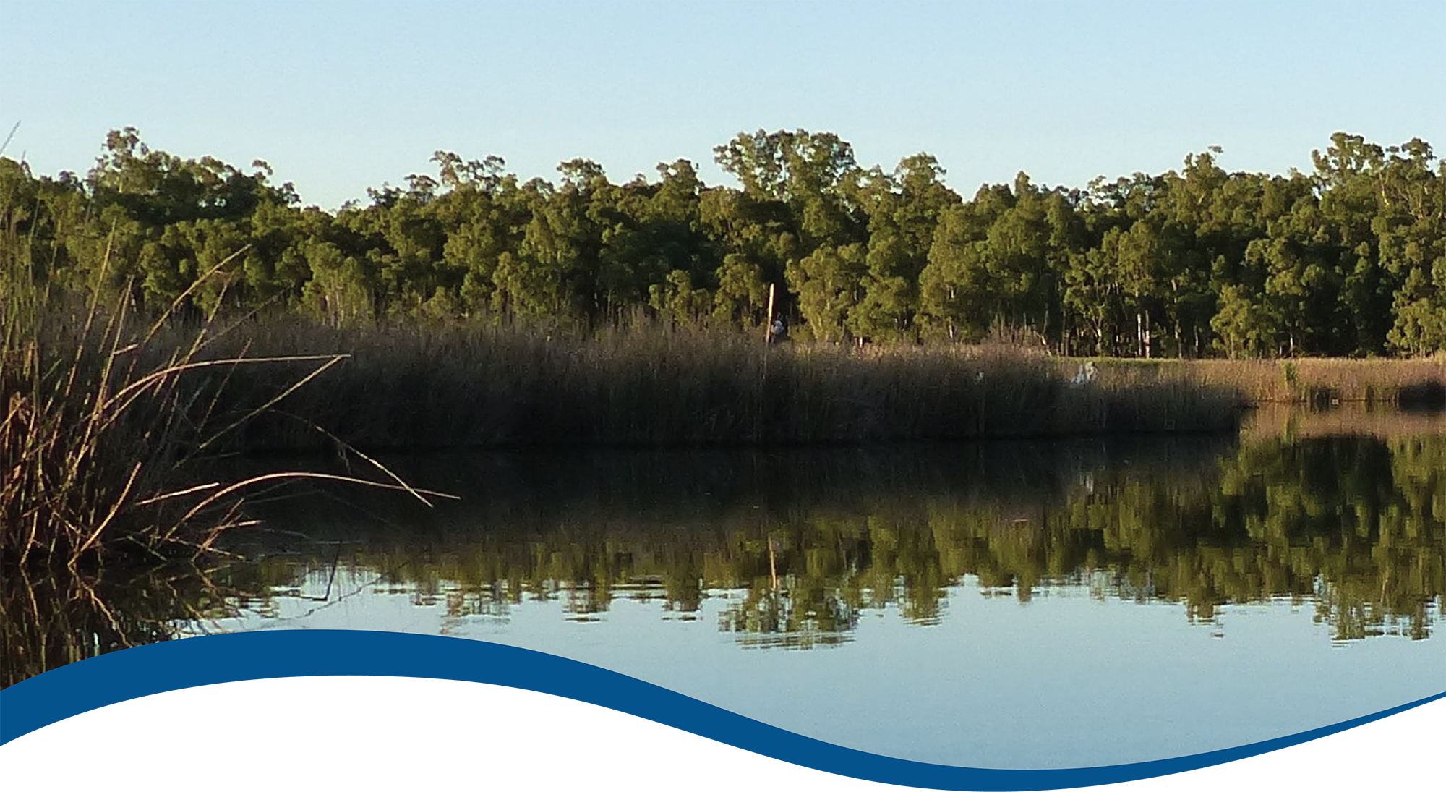

Foundation Report Update 2020: Ecosystem Diversity

Commonwealth Environmental Water Office (CEWO):   
Monitoring, Evaluation and Research Program

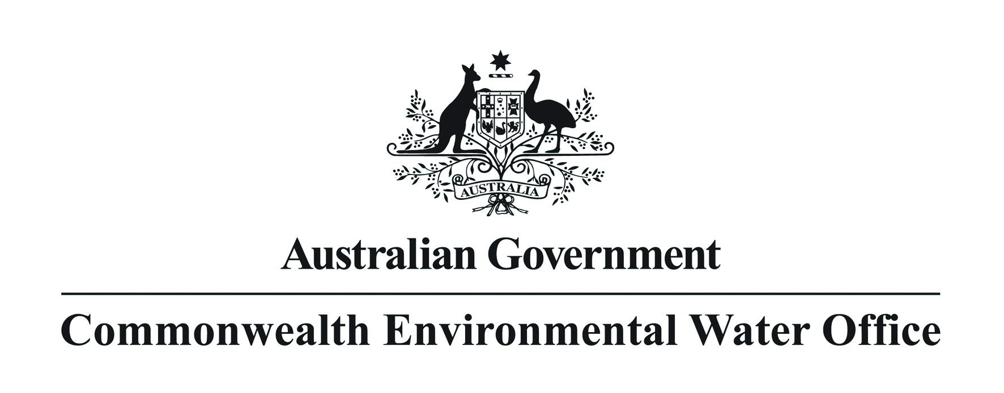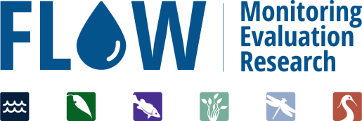

The Flow-MER Program

Flow-MER is the Commonwealth Environmental Water Office’s (CEWO) on-ground Monitoring, Evaluation and Research Program. The Program’s objective is to monitor and evaluate the delivery of Commonwealth environmental water in the Murray-Darling Basin. It provides the CEWO with evidence to inform our understanding of how water for the environment is helping maintain, protect, and restore the ecosystems and native species across the Murray-Darling Basin. This work will support environmental water managers, demonstrate outcomes, inform adaptive management, and fulfil the legislative requirements associated with managing Commonwealth owned environmental water.

The Flow-MER Program is being undertaken from 2019 to 2022 and is led by CSIRO in partnership with the University of Canberra, and collaborating with Charles Sturt University, Deakin University, University of New England, SARDI, Arthur Rylah Institute, NSW Department of Primary Industry, Australian River Restoration Centre and Brooks Ecology & Technology. The Program delivers to the Commonwealth Environmental Water Office, Department of Agriculture, Water and the Environment.

ISBN:

Citation

Brooks S (2020) Foundation Report Update 2020: Ecosystem Diversity. Flow-MER Program. Commonwealth Environmental Water Office (CEWO): Monitoring, Evaluation and Research Program, Department of Agriculture, Water and the Environment, Australia.

Cover photograph

Reed beds at Millewa Forest.   
Photo credit: Heather McGinness (CSIRO)

Copyright

Creative Commons [logo] © Commonwealth of Australia 2020  
With the exception of the Commonwealth Coat of Arms, partner logos and where otherwise noted, all material in this publication is provided under a Creative Commons Attribution 4.0 International Licence <https://creativecommons.org/licenses/by/4.0/>. The Flow‑MER Program requests attribution as ‘© Commonwealth of Australia (Flow‑MER Program, [https://flow-mer.org.au](https://flow-mer.org.au/))’.

Important disclaimer

The information contained in this publication comprises general statements based on scientific research. The reader is advised and needs to be aware that such information may be incomplete or unable to be used in any specific situation. No reliance or actions must therefore be made on that information without seeking prior expert professional, scientific and technical advice. To the extent permitted by law, the Flow-MER Program (including its partners and collaborators) excludes all liability to any person for any consequences, including but not limited to all losses, damages, costs, expenses and any other compensation, arising directly or indirectly from using this publication (in part or in whole) and any information or material contained in it.

The Flow-MER is committed to providing web accessible content wherever possible. If you are having difficulties with accessing this document please contact [enquiries@flow-mer.org.au](mailto:enquiries@flow-mer.org.au).

Foundation Report Update 2020

This report was prepared for the Commonwealth Environmental Water Office as part of the Flow-MER Program. It is to be read in conjunction with the published [Basin Matter Foundation Report](https://www.environment.gov.au/water/cewo/publications/cewo-ltim-basin-matter-ecosystem-diversity-2019) (Brooks, 2019). The Report Updates outline key changes in the adopted Evaluation approach for the Flow-MER Program. Unless otherwise stated, the Evaluation is conducted as reported in Brooks (2019).

Changes in approach have only been adopted where there have been significant advances in methodology and available data, or where unmonitored areas were not previously evaluated. In all other cases, the approach is intended to be consistent with the Evaluation conducted under the Long-Term Intervention Monitoring Project (LTIM).

Contents

Foundation Report Update 2020 i

1 Introduction 1

2 Why 2

3 What 2

4 How 2

5 Risks 3

References 3

Abbreviations and acronyms

| **Abbreviation/acronym** | **Definition** |
| --- | --- |
| ANAE | Australian National Aquatic Ecosystem |
| CEWO | Commonwealth Environmental Water Office |
| Flow-MER | The CEWO Monitoring, Evaluation and Research Program (2019-2022) |
| LTIM | Long-Term Intervention Monitoring Project (2015-2019) |
| MER | Monitoring, Evaluation and Research Program (2019-2022) |

# Introduction

The Commonwealth Environmental Water Office Monitoring Evaluation and Research Basin-scale Project (Flow-MER) builds on the evaluation developed for the Long-Term Intervention Monitoring (LTIM) project. Foundation reports were produced under LTIM for six themes: (1) Hydrology; (2) Ecosystem Diversity; (3) Species Diversity; (4) Vegetation; (5) Fish; and (6) Stream Metabolism and Water Quality. The reports provide a summary of why these themes are used to evaluate the effectiveness of Commonwealth Environmental Water; the criteria used for evaluating short and long-term outcomes; the approach adopted in the evaluation; as well as any anticipated risks for the evaluation process.

The Foundation Report Updates 2020 have been produced under Flow-MER to report on any changes to the original Foundation Reports 2019 developed in LTIM. Updates are provided to reflect the focus on including unmonitored areas across the basin-scale evaluation, as well as advances in available methods and data. The updates provide consistency with the Flow-MER Evaluation and Research Plan.

A summary of updates for the Ecosystem Diversity Theme is provided in Table 1.

Table Summary of updates for the Ecosystem Diversity Foundation Report Update 2020

| **Section** | **Updates** |
| --- | --- |
| Why | No change to rationale. Consistent with 2019 Foundation Report. |
| What | Annual evaluation consistent with 2019 Foundation Report  Cumulative evaluation will include LTIM data beginning 2014/15 but using updated 2020 ANAE ecosystem mapping.  2019/20 cumulative evaluation to include a qualitative summary of changes to outcomes reported in previous years that arise from changes in the revised 2020 ANAE classification and mapping. |
| **How** | Method unchanged from previous Ecosystem Diversity evaluation noting that the evaluation is basin-scale and not constrained to Selected Areas.  Updated data sources:   * 2020 revision of the ANAE ecosystem mapping for the Basin. * 2014/15 LTIM inundation mapping has been recompiled using the method used in subsequent years in LTIM and in Flow-MER * Evaluation of ecosystem diversity in the managed floodplain as demonstrated in the 2018-19 LTIM evaluation will be repeated (not specified in the 2019 foundation report) |
| **Risks** | * Consistent with 2019 Foundation Report the Flow-MER Ecosystem Diversity evaluation is entirely dependent on inundation mapping of Commonwealth environmental water produced by the Flow-MER Hydrology Theme. Risks to completion are low as inundation mapping was successfully compiled for all years of the LTIM project and no additional impediments have been identified for Flow-MER. * The evaluation is independent of Selected Area outputs (no additional risks or dependencies identified) * Use of the updated ANAE mapping will revise reported ecosystems areas inundated by Commonwealth environmental water that have been previously published by LTIM. This will need to be carefully explained to reduce risk of inappropriate comparisons. To mitigate such risks all LTIM data will be reprocessed and re-presented in the Flow-MER cumulative evaluation so that readers will not need to refer to past reports. |

# Why

The rationale for the Flow-MER Ecosystem Diversity evaluation is unchanged from the 2019 LTIM Foundation report (Brooks, 2019).

# What

The Flow-MER evaluation will continue using the approach demonstrated in the LTIM year 5 Ecosystem Diversity evaluation report (Brooks, 2020) including both annual and cumulative evaluation at the whole of Basin scale. The LTIM Year 5 evaluation also compared the ecosystems receiving Commonwealth environmental water at basin-scale to the managed floodplain as defined by the Basin-wide watering strategy (MDBA, 2014, 2019) and this will be repeated for Flow-MER.

# How

Two significant data updates in 2020 are:

1. The Australian National Aquatic Ecosystem (ANAE) mapping for the Murray-Darling Basin is currently being updated and will be available in time for the 2019-20 Flow-MER project evaluation. The revised ANAE mapping changes the number and type of aquatic ecosystems mapped in NSW in areas that are regularly watered by Commonwealth environmental water (the Macquarie Marshes and the Junction of the Warrego and Darling Rivers Selected Area in particular).
2. The 2014-15 water year Commonwealth environmental water inundation mapping has been revised to be consistent with subsequent years, reducing previously identified over-estimation of the extent of Commonwealth environmental water inundation in this first year of LTIM monitoring.

These data updates require the re-analysis of all Ecosystem Diversity data for all five years of LTIM (2014-2019) in order to support a consistent cumulative evaluation in Flow-MER using the full duration of the monitoring data available.

The first Flow-MER evaluation (2021 evaluation of the 2019-20 water year ) will (1) highlight significant changes in the Ecosystem Diversity reporting compared to past reports that result from these data updates, and (2) explain why the reported ecosystem areas supported by Commonwealth environmental water are different.

# Risks

The Flow-MER Ecosystem Diversity evaluation will report different inundation extents to that previously reported by LTIM for the same years. To reduce the risk of readers making inappropriate comparisons among Flow-MER and LTIM reporting, all LTIM Ecosystem Diversity data will be reanalysed using the 2020 ANAE mapping and re-reported as part of the Flow-MER cumulative analysis. Each evaluation will stand-alone and reduce or negate the need for readers to refer to past reports.

The 2019 Ecosystem Diversity foundation reports indicates a risk that floodplain inundation modelling is unreliable and that the evaluation would focus instead on measured inundation data within Selected Areas. This is no longer considered a significant risk with advances in inundation mapping developed during LTIM allowing the evaluation to be conducted at a whole of Basin scale.

References

Brooks S (2019) Long Term Intervention Monitoring Basin Matter – Ecosystem diversity foundation report- revision 2019. Final Report prepared for the Commonwealth Environmental Water Office by The Murray-Darling Freshwater Research Centre, La Trobe publication 205/2018, 11pp.

Brooks S (2020) Murray*–*Darling Basin Long Term Intervention Monitoring Project — 2018–19 Basin-scale evaluation of Commonwealth environmental water – Ecosystem Diversity. Report prepared for the Department of Agriculture, Water and the Environment, Commonwealth Environmental Water Office by La Trobe University, Centre for Freshwater Ecosystems, CFE Publication 248 May 2020 54p.

MDBA (2014) Basin-wide environmental watering strategy. Murray-Darling Basin Auth. Canberra.

MDBA (2019) Basin-wide environmental watering strategy (No. 42/19). Murray–Darling Basin Authority, Canberra, ACT

[**https://flow-mer.org.au**](https://flow-mer.org.au)

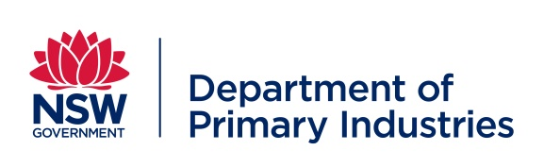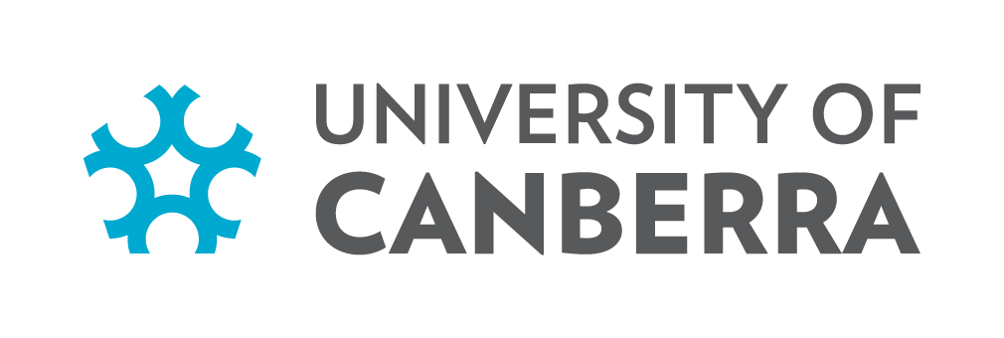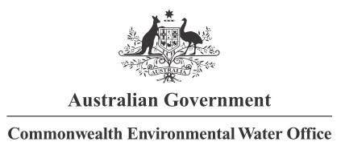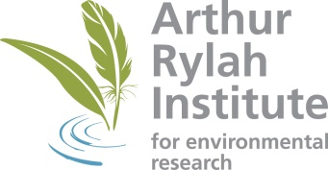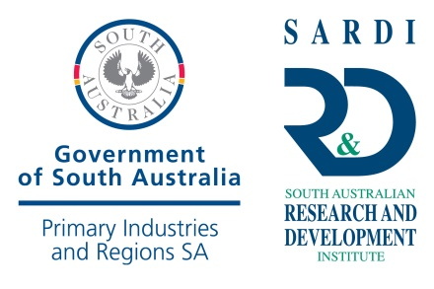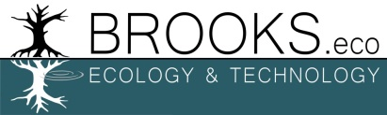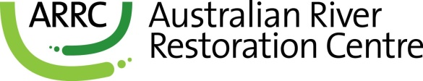

**Partners**

**Collaborators**