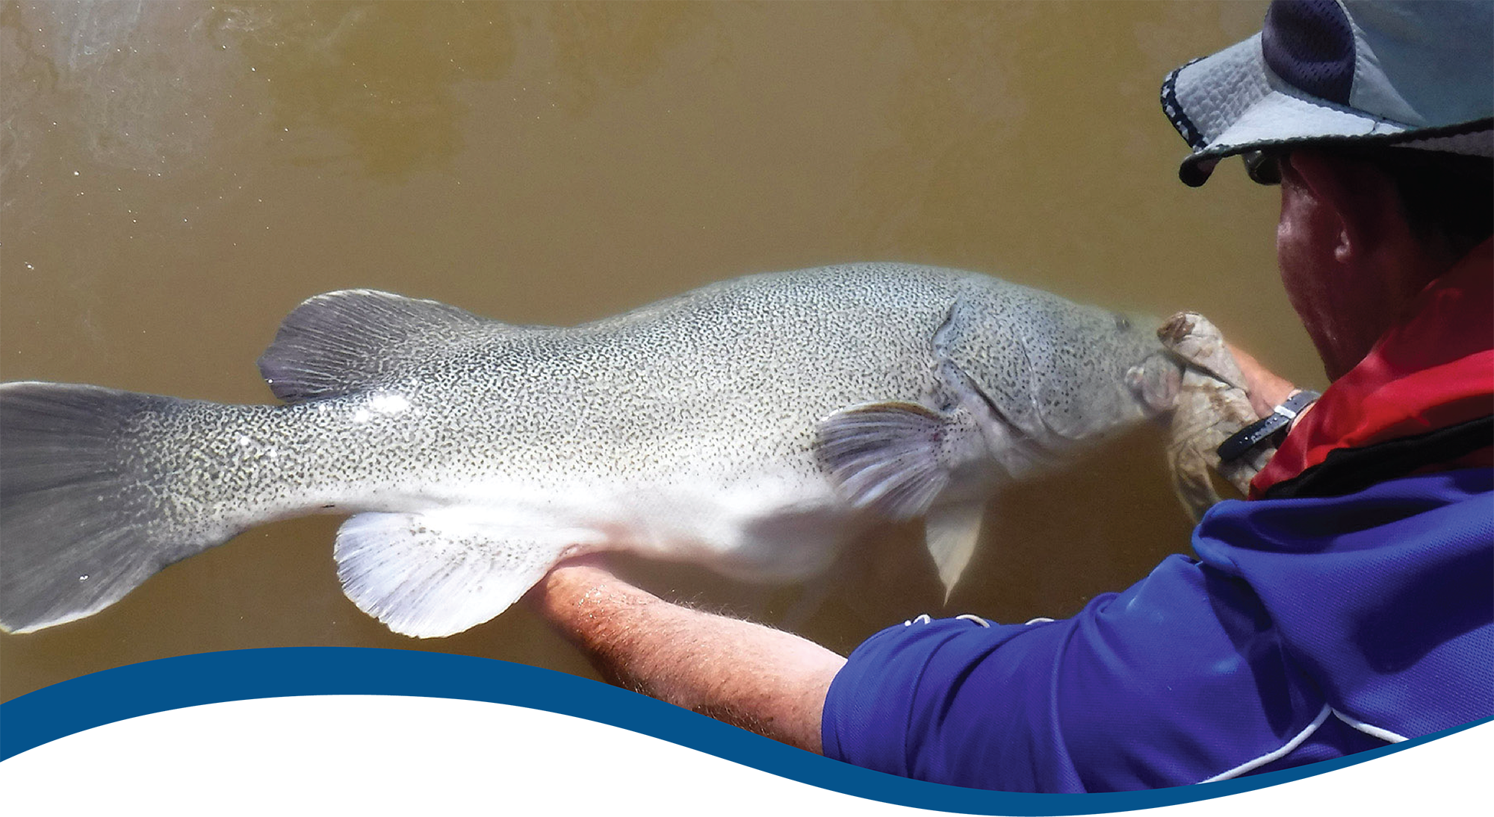

Foundation Report Update 2020: Fish

Commonwealth Environmental Water Office (CEWO):   
Monitoring, Evaluation and Research Program

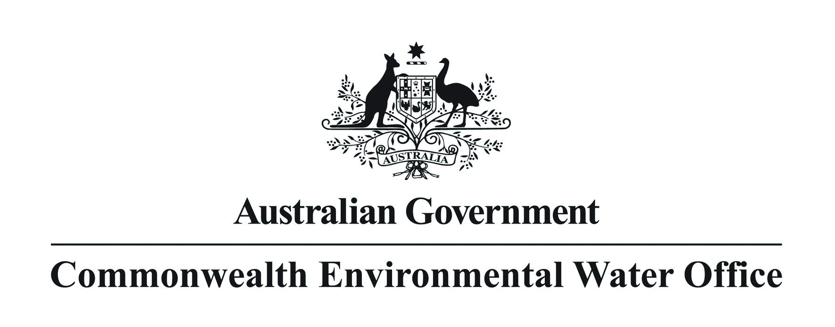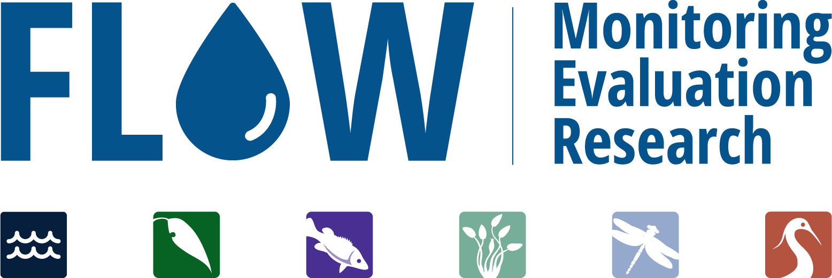

The Flow-MER Program

Flow-MER is the Commonwealth Environmental Water Office’s (CEWO) on-ground Monitoring, Evaluation and Research Program. The Program’s objective is to monitor and evaluate the delivery of Commonwealth environmental water in the Murray-Darling Basin. It provides the CEWO with evidence to inform our understanding of how water for the environment is helping maintain, protect, and restore the ecosystems and native species across the Murray-Darling Basin. This work will support environmental water managers, demonstrate outcomes, inform adaptive management, and fulfil the legislative requirements associated with managing Commonwealth owned environmental water.

The Flow-MER Program is being undertaken from 2019 to 2022 and is led by CSIRO in partnership with the University of Canberra, and collaborating with Charles Sturt University, Deakin University, University of New England, SARDI, Arthur Rylah Institute, NSW Department of Primary Industry, Australian River Restoration Centre and Brooks Ecology & Technology. The Program delivers to the Commonwealth Environmental Water Office, Department of Agriculture, Water and the Environment.

ISBN:

Citation

Stuart I, Bice C, Baumgartner L, Butler G, Hladyz S, Koster W, Lyon J, Thiem J, Todd C, Tonkin Z, Ye Q, Yen J and Zampatti B. (2020) Foundation Report Update 2020: Fish. Flow-MER Program. Commonwealth Environmental Water Office (CEWO): Monitoring, Evaluation and Research Program, Department of Agriculture, Water and the Environment, Australia.

Cover photograph

Releasing a Murray cod.   
Photo credit: Arthur Rylah Institute

Copyright

Creative Commons [logo] © Commonwealth of Australia 2020  
With the exception of the Commonwealth Coat of Arms, partner logos and where otherwise noted, all material in this publication is provided under a Creative Commons Attribution 4.0 International Licence <https://creativecommons.org/licenses/by/4.0/>. The Flow‑MER Program requests attribution as ‘© Commonwealth of Australia (Flow‑MER Program, [https://flow-mer.org.au](https://flow-mer.org.au/))’.

Important disclaimer

The information contained in this publication comprises general statements based on scientific research. The reader is advised and needs to be aware that such information may be incomplete or unable to be used in any specific situation. No reliance or actions must therefore be made on that information without seeking prior expert professional, scientific and technical advice. To the extent permitted by law, the Flow-MER Program (including its partners and collaborators) excludes all liability to any person for any consequences, including but not limited to all losses, damages, costs, expenses and any other compensation, arising directly or indirectly from using this publication (in part or in whole) and any information or material contained in it.

The Flow-MER is committed to providing web accessible content wherever possible. If you are having difficulties with accessing this document please contact [enquiries@flow-mer.org.au](mailto:enquiries@flow-mer.org.au).

Foundation Report Update 2020

This report was prepared for the Commonwealth Environmental Water Office as part of the Flow-MER Program. It is to be read in conjunction with the published Basin Matter Foundation Reports 2016; 2019 (see references for links). The Report outlines key changes in the adopted Evaluation approach for the Flow-MER Program. Unless otherwise stated, the Evaluation is conducted as reported in the original Foundation Report (Stoffels et al. 2016).

In most cases, the approach is intended to be consistent with the Evaluation conducted under the Long-Term Intervention Monitoring Project (LTIM; Stoffels et al. 2016; King 2019; King et al. 2020). However, we have proposed some changes to better meet reporting requirements and objectives. Those changes in approach have only been adopted where there have been significant advances in methodology, analytical methods, and available data, or where unmonitored areas were not previously evaluated.

Contents

Foundation Report Update 2020 i

1 Introduction 1

2 Learnings from LTIM 3

3 Why 4

4 What 5

5 How 6

6 Risks 7

References 8

Abbreviations and acronyms

| **Abbreviation/acronym** | **Definition** |
| --- | --- |
| CEWO | Commonwealth Environmental Water Office |
| Flow-MER | The CEWO Monitoring, Evaluation and Research Program (2019-2022) |
| GLM | Generalised Linear Model |
| LTIM | Long-Term Intervention Monitoring Project (2015-2019) |
| Flow-MER | Monitoring, Evaluation and Research Program (2019-2022) |

# Introduction

The Commonwealth Environmental Water Office Monitoring Evaluation and Research Basin-scale Program (2019-2022) (Flow-MER) builds on the evaluation process developed for the Long-Term Intervention Monitoring (LTIM) project (2014-2019). Foundation reports were produced under LTIM for six themes: (1) Hydrology; (2) Ecosystem Diversity; (3) Species Diversity; (4) Vegetation; (5) Fish; and (6) Stream Metabolism and Water Quality. The reports provide a summary of why these themes are used to evaluate the effectiveness of Commonwealth Environmental Water; the criteria used for evaluating short and long-term outcomes; the approach adopted in the evaluation; as well as any anticipated risks and uncertainties for the evaluation process.

The Foundation Report Updates 2020 have been produced under Flow-MER to report on any changes to the original Foundation Reports 2019 developed in LTIM. Updates are provided to reflect the focus on some improvements including unmonitored areas across the basin-scale evaluation, as well as advances in available methods and data. The Updates provide consistency with the Flow-MER Evaluation and Research Plan. A summary of updates for the Fish Theme is provided in Table 1.

Table 1 Summary of updates for the Fish Theme Foundation Report Update 2020

| **Section** | **Updates** |
| --- | --- |
| **Why** | Modest changes, largely consistent with Foundation Report 2019 |
| **What** | Updated tasks and analytical outputs to determine the effects of environmental flows on native fish |
| **How** | Updates to:   1. Data inputs with 2020 Selected Area field monitoring data potentially available for analysis 2. Slightly revised analytical approach to review hydrological and fish community/composition/spawning/recruitment metrics to identify the most ecologically sensitive and meaningful relationships, informed by recent similar analyses for Victorian VEFMAP program and other long-term datasets 3. Investigate Selected Area sites (i.e. Warrego/Darling) that have traditionally been excluded from Category 1 analyses to determine if novel modelling approaches can better incorporate these 4. Over the next 2 years, investigate a framework for high level Evaluation-theme models that investigate fish responses at the basin scale, such as distribution models or estimates of occurrence probabilities by Selected Area, with targeted delivery in 2021/22 5. Ordination analysis of multi-species fish community structure 6. Analyses of fish body condition across Selected Area sites and improved intersection with Flow-MER Food Web and Hydrology themes 7. Preliminary exploratory analyses of age-length population demography among Selected Area sites as precursor to survival analyses in future years (i.e. 2021/2022) |
| **Risks** | 1. Where 2020 Selected Area field data is unavailable then this will be added to 2021 analytical pathway 2. Identification of additional sensitive/meaningful hydrological and fish community/composition/ spawning/recruitment metrics and datasets has no inherent risk 3. Investigation of including all Selected Area sites in global analyses may not be possible but has no additional risk 4. No additional risk of developing a high-level Selected Area model framework but may not be able to be extrapolated over basin scale, need to continue to investigate model validation processes 5. No additional risk for ordination analysis of multi-species fish community structure 6. No additional risk for fish body condition analysis 7. No additional risk for fish age-length analysis though length-age modelling can provide variable results for species with highly variable growth rates (e.g. golden perch) |

# Learnings from LTIM

The original LTIM program was designed at a site scale (i.e. Selected Area; Stoffels et al. 2016) and thus analyses were employed to develop links between fish response and local flow events. There was less ability to infer response at a basin scale. New knowledge, however, demonstrates that there are regional and inter-catchment dependencies, from hydrological, food web and fish perspectives. Hence, increasing our ability to demonstrate flow and fish dependencies at a variety of spatial scales will ultimately improve the CEWO’s ability to deliver water for maximum environmental benefit.

From the Fish theme perspective, prior learnings have indicated that analyses of fish response to environmental water benefit from each subsequent year of Selected Area data available for analysis. By defining nested hypotheses which link the project objectives to the relevant analyses, more targeted flow-ecology insights might be gained. For example, if the 2020 field data is available for the analyses, deeper and more consistent analyses across the basin can be conducted. This includes using historic LTIM hydrological metrics (i.e. ML/d) but also incorporating learnings concerning new hydrological indicators (i.e. magnitude and variation of spring discharge for individual rivers) and/or examining the Flow-MER fish age data to inform recruitment rates. This approach was recently highlighted by another investigation of Murray cod response to environmental water (Tonkin et al. 2020).

In addition, past analytical approaches have not been able to consistently integrate hydrology and fish metrics from very different ecosystems, such as the Murray and Warrego rivers (i.e. perennial versus ephemeral systems) or where there have been vastly different hydrological conditions (i.e. major floods versus long periods of low flows). In some cases, analyses have been limited by low population abundance of some fish species. However, new analytical approaches may be able to overcome these limitations and further exploration is proposed here. Quantitative evaluation of the outcomes of the Commonwealth environmental flows is also dependent on the Flow-MER program developing improved integration of counter-factual hydrological data into analytical models against which the intervention of environmental watering data can be compared (Gawne et al. 2020). This process will occur within the Research theme of Flow-MER (i.e. F1: Fish population models).

# Why

As more data become available from the Selected Areas and complementary work occurs on other programs, there is an opportunity to deliver the standard (i.e. LTIM) analyses but also expand to deliver slightly revised Flow-MER fish and flow metrics/analyses to take advantage of new knowledge, expanded data sets and novel analytical techniques (Praskievicz and Luo 2020). Specifically, employing generalised linear mixed models (GLMM) with appropriate link functions for different data types will be a strong direction for forthcoming analyses. An assessment of this approach will be undertaken in 2020/21 and then as targeted delivery in 2021/22.

By incorporating a broad range of flow metrics and other long-term datasets, the analyses can more transparently deal with uncertainty thereby enabling incorporation of this uncertainty into decision-making. The broader range of flow metrics and datasets may also provide an increased confidence in understanding the effects and benefits of Commonwealth environmental flows in preserving functional fish populations.

To highlight this point, a series of broad-scale flow metrics and datasets from unmonitored areas will be required for golden perch (*Macquaria ambigua*) whose populations operate at regional and inter-regional scale. This aspect will also be addressed within the research theme of Flow-MER (i.e. F1: Fish population models), which will then guide future Commonwealth environmental water planning. By incorporating a cross-cutting validation process within the Research theme (F1: Fish population models), there will also be an opportunity to identify any limitations in the current design (i.e. evaluating the need for flow event-based monitoring). This process could greatly increase the CEWO’s ability for optimal environmental flow delivery and largely constitutes modest changes, largely consistent with prior Foundation Reports (2016) and (2019).

# What

There is significantly improved knowledge of the relationship between fish and flows appearing in the literature (for example: Zampatti et al. 2018; Shams et al. 2020; Stuart and Sharpe 2020; Tonkin et al. 2020; Watts et al. 2020; Wright et al. 2020) from which to further inform the conceptual and analytical approach. Of particular note is the spatial scale over which many ecological processes occur (e.g. hydrology, food webs and fish population dynamics) where revised conceptual and analytical approaches are required.

The Fish Theme tasks, analytical approach and outputs will be updated to:

* Provide standard and updated analyses of the effects and benefits of native fish within Selected Areas that receive Commonwealth environmental water at site and at a Basin scale.
* Provide improved integration of all Selected Area sites into analyses for better estimating and illustrating the benefits of environmental water by identifying the most meaningful hydrological and ecological metrics and indicators, at appropriate spatial scales.
* Explore methods to consistently analyse data from all Selected Area sites including strongly linking the Flow-MER Fish Evaluation and Research themes where modelling of monitored and potentially unmonitored sites will be undertaken.
* Provide improved synchronisation of Fish theme and other Flow-MER themes (i.e. Food Webs and Hydrology) concerning intersection analyses and cross-cutting.
* Over the next 2-years continue to develop frameworks for high level models that investigate fish responses at the basin scale, such as distribution models or estimates of occurrence probabilities by Selected Area, likely to require integration of other long-term datasets and validation of model predictions or 2021/22.

# How

Flow-MER program biometricians from the Arthur Rylah Institute have examined the available datasets and past approaches to analyses to determine the benefits of environmental water to native fish populations. Prior techniques were evaluated as sound (King 2019; King et al. 2020). In particular, the general focus on predictive models, counterfactuals and GLM based analyses will be retained. In addition, Flow-MER samples of fish age will be examined to determine survival rates (i.e. recruitment) of long-lived fish (e.g. golden perch) among Selected Areas, in relation to flows.

However, additional Selected Area data are now available which will improve analytical power and inference ability for examining the influence of environmental flows on fish populations. Streamlining hydrological metrics and analyses also provides a strong linkage to high level predictive modelling for monitoring and unmonitored areas via the Flow-MER Fish Research program. Incorporating other long-term datasets may help resolve any data issues (i.e. few data during high flows) and also provide a platform for validation of model predictions and transparent acknowledgement of limitations.

We propose seven updates to the tasks/analyses, as summarised in Table 1, including:

1. Data inputs with 2020 Selected Area field monitoring data potentially available for analysis.
2. Slightly revised analytical approach to review hydrological and fish community/composition/spawning/recruitment metrics to identify the most ecologically sensitive and meaningful relationships, informed by recent similar analyses for Victorian VEFMAP program and other long-term datasets.
3. Investigate Selected Area sites (i.e. Warrego/Darling) that have traditionally been excluded from Category 1 analyses to determine if novel modelling approaches can better incorporate these.
4. Over the next 2 years, investigate a framework for high level Evaluation-theme models that investigate fish responses at the basin scale, such as distribution models or estimates of occurrence probabilities by Selected Area, with targeted delivery in 2021/22.
5. Ordination analysis of multi-species fish community structure.
6. Analyses of fish body condition across Selected Area sites and improved intersection with Flow-MER Food Web and Hydrology themes.
7. Preliminary exploratory analyses of age-length population demography among Selected Area sites as precursor to survival analyses in future years (i.e. 2021/2022).

# Risks

In addition to the risks linked to the new tasks/analyses outlined in Table 1, the major risk is that the 2020 field data are not available for analysis within the current reporting period. Where site‑scale data (i.e. Selected Areas) cannot provide reliable insight into fish population dynamics and the relationship to environmental flows then State Agency data may be integrated. Access to State or Commonwealth agency data are dependent on permission from the relevant data custodians.

References

Gawne B, Hale J, Stewardson MJ, Webb JA, Ryder DS, Brooks SS, Campbell CJ, Capon SJ, Everingham P, Grace MR and Guarino F (2020). Monitoring of environmental flow outcomes in a large river basin: The Commonwealth Environmental Water Holder's long‐term intervention in the Murray–Darling Basin, Australia. River Research and Applications, 36(4), 630-644.

King A (2019). Long Term Intervention Monitoring Basin Matter - Fish foundation report. Final Report prepared for the Commonwealth Environmental Water Office by The Centre for Freshwater Ecosystems, 206/2018, 8pp.

King AJ, McPhan L, Bond N, Thurgate N (2020). Murray–Darling Basin Long Term Intervention Monitoring Project — 2018–19 Basin-scale evaluation of Commonwealth environmental water – Fish Report. Report prepared for the Department of Agriculture, Water and the Environment, Commonwealth Environmental Water Office by La Trobe University, Centre for Freshwater Ecosystems, CFE Publication 250, 82pp. https://www.environment.gov.au/system/files/resources/d8142f55-a763-4c3b-bd95-4791a6340bb9/files/2018-19-basin-evaluation-fish.pdf

Praskievicz S and Luo C. (2020). Assessment of flow–ecology relationships for environmental flow standards: a synthesis focused on the southeast USA. Hydrological Sciences Journal, 65(4), 571-582.

Shams F, Dyer F, Thompson R, Duncan RP, Thiem JD, Enge TG and Ezaz T (2020). Multiple lines of evidence indicate limited natural recruitment of golden perch (*Macquaria ambigua*) in the highly regulated Lachlan River. Water, 12(6), 1636.

Stoffels R, Bond N, Pollino C, Broadhurst B, Butler G, Kopf RK, Koster W, McCasker N, Thiem J, Zampatti B and Ye Q (2016). Long Term Intervention Monitoring Basin Matter - Fish foundation report. Final Report prepared for the Commonwealth Environmental Water Office by The Murray-Darling Freshwater Research Centre, MDFRC Publication 65/2015, 11pp. https://www.environment.gov.au/system/files/resources/66f1dfe7-6c9c-416c-85ac-9463fcfc99ee/files/ltim-foundation-report-fish.docx

Stuart IG and Sharpe CP (2020). Riverine spawning, long distance larval drift, and floodplain recruitment of a pelagophilic fish: A case study of golden perch (*Macquaria ambigua*) in the arid Darling River, Australia. Aquatic Conservation: Marine and Freshwater Ecosystems, 30(4) 675-690.

Tonkin Z, Yen , Lyon J, Kitchingman A, Koehn JD, Koster WM, Lieschke J, Raymond S, Sharley J, Stuart I and Todd C (2020). Linking flow attributes to recruitment to inform water management for an Australian freshwater fish with an equilibrium life-history strategy. Science of The Total Environment, p.141863.

Watts, R.J., Dyer, F., Frazier, P., Gawne, B., Marsh, P., Ryder, D.S., Southwell, M., Wassens, S.M., Webb, J.A. and Ye, Q., 2020. Learning from concurrent adaptive management in multiple catchments within a large environmental flows program in Australia. River Research and Applications, 36(4), pp.668-680.

Wright DW, Zampatti BP, Baumgartner LJ, Brooks S, Butler GL, Crook DA, Fanson BG, Koster W, Lyon J, Strawbridge A and Tonkin Z (2020). Size, growth and mortality of riverine golden perch (*Macquaria ambigua*) across a latitudinal gradient. Marine and Freshwater Research.

Zampatti BP, Strawbridge A, Thiem JD, Tonkin Z, Mass R, Woodhead J and Fredberg J (2018). Golden perch (*Macquaria ambigua*) and silver perch (*Bidyanus bidyanus*) age demographics, natal origin and migration history in the River Murray, Australia. SARDI Aquatic Sciences.

[**https://flow-mer.org.au**](https://flow-mer.org.au)

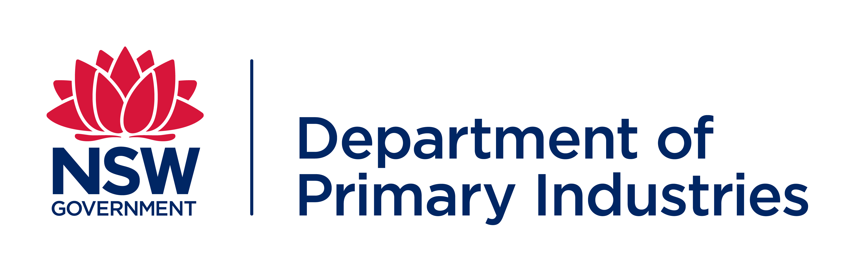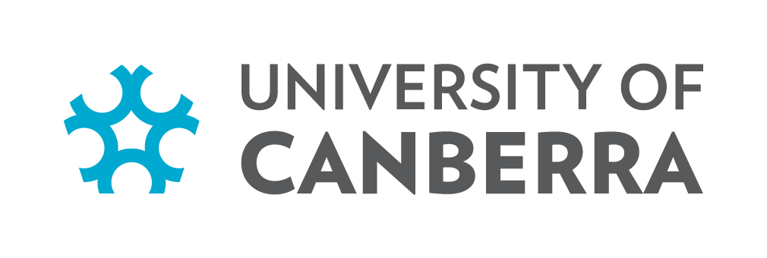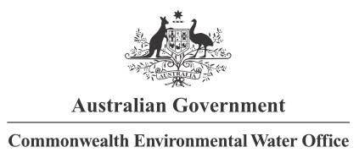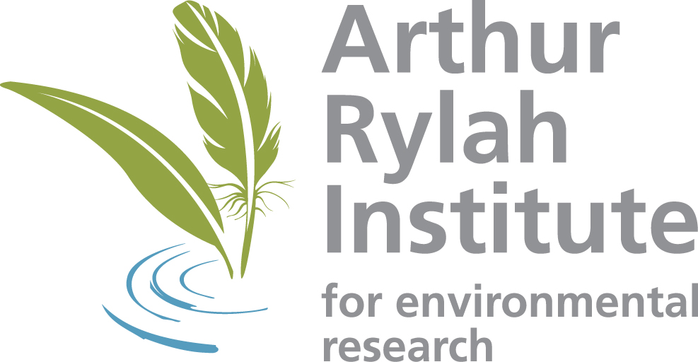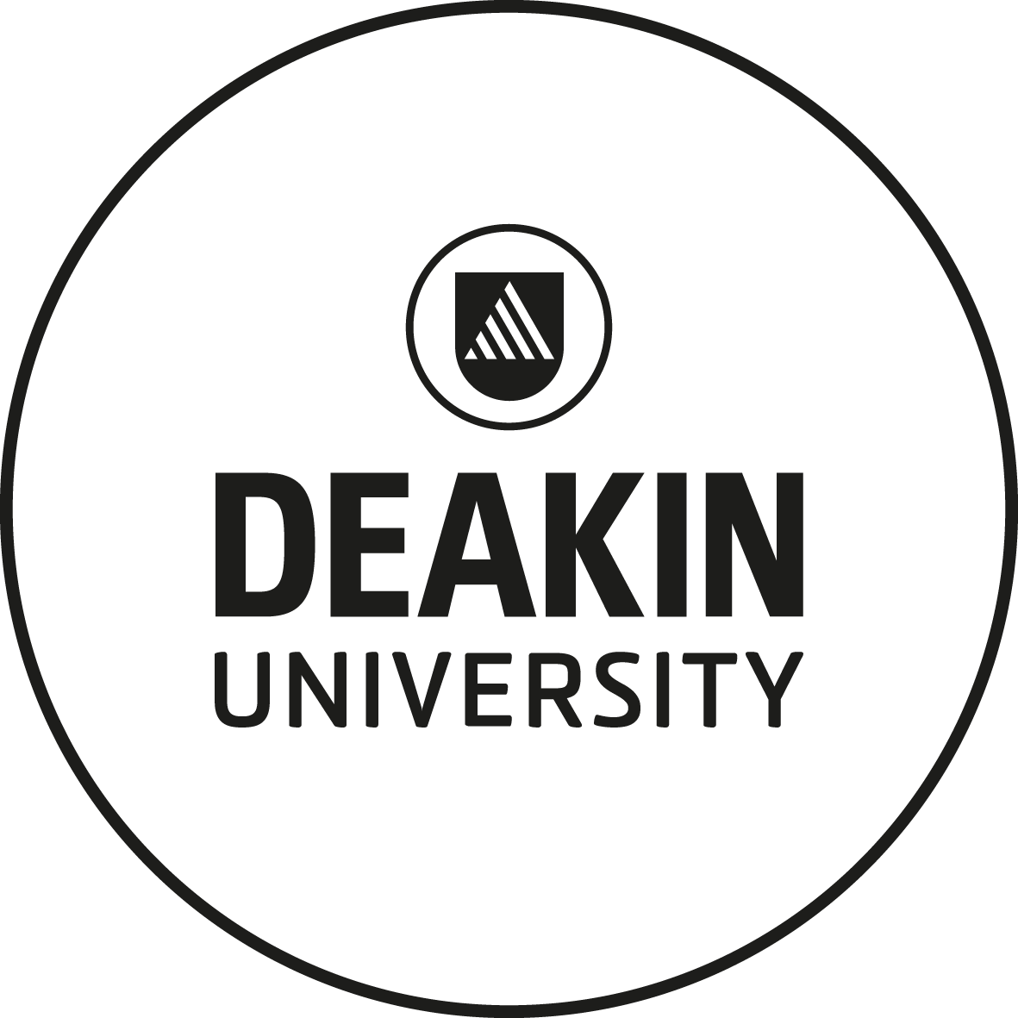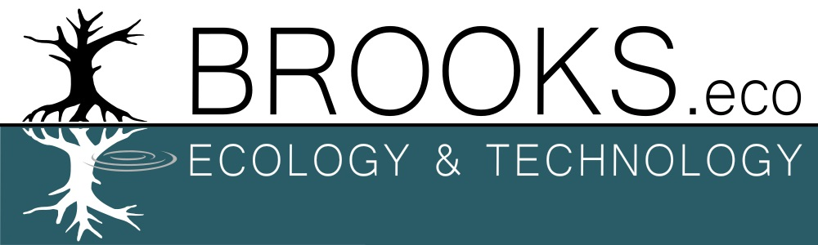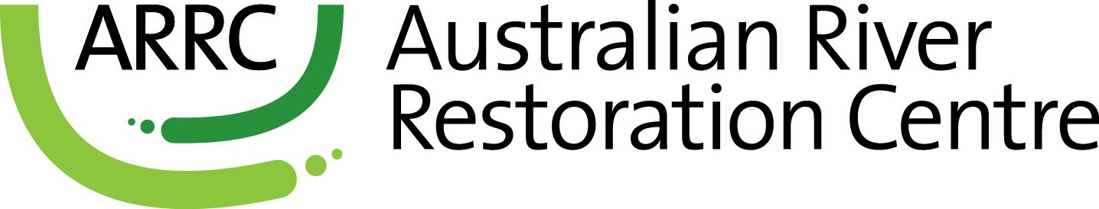

**Partners**

