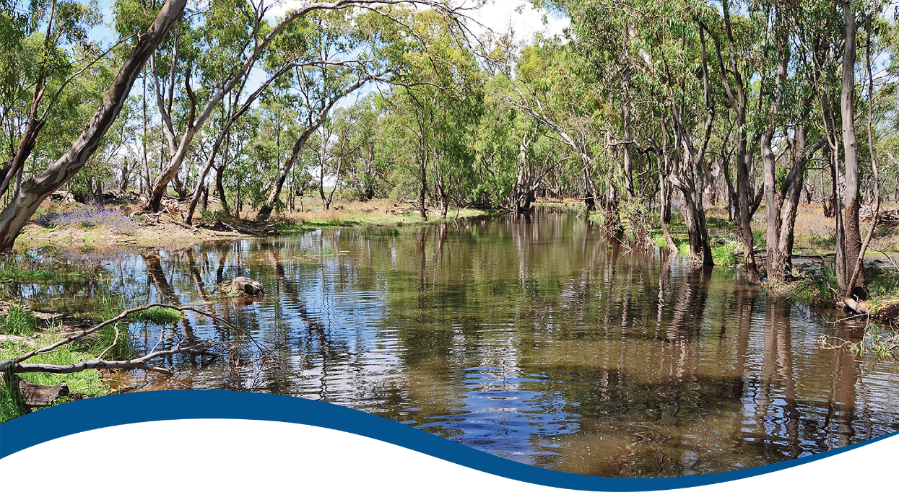

Foundation Report Update 2020: Hydrology

Commonwealth Environmental Water Office (CEWO):   
Monitoring, Evaluation and Research Program

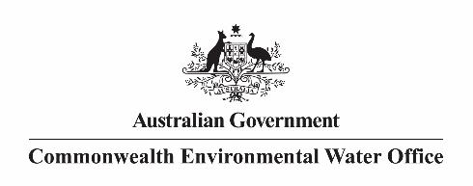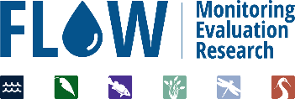

The Flow-MER Program

Flow-MER is the Commonwealth Environmental Water Office’s (CEWO) on-ground Monitoring, Evaluation and Research Program. The Program’s objective is to monitor and evaluate the delivery of Commonwealth environmental water in the Murray-Darling Basin. It provides the CEWO with evidence to inform our understanding of how water for the environment is helping maintain, protect, and restore the ecosystems and native species across the Murray-Darling Basin. This work will support environmental water managers, demonstrate outcomes, inform adaptive management, and fulfil the legislative requirements associated with managing Commonwealth owned environmental water.

The Flow-MER Program is being undertaken from 2019 to 2022 and is led by CSIRO in partnership with the University of Canberra, and collaborating with Charles Sturt University, Deakin University, University of New England, SARDI, Arthur Rylah Institute, NSW Department of Primary Industry, Australian River Restoration Centre and Brooks Ecology & Technology. The Program delivers to the Commonwealth Environmental Water Office, Department of Agriculture, Water and the Environment.

ISBN:

Citation

Guarino F and Sengupta A (2020) Foundation Report Update 2020: Hydrology. Flow-MER Program. Commonwealth Environmental Water Office (CEWO): Monitoring, Evaluation and Research Program, Department of Agriculture, Water and the Environment, Australia.

Cover photograph

Flooded creek in Yanga National Park, NSW.   
Photo credit: Tanya Doody (CSIRO)

Copyright

Creative Commons [logo] © Commonwealth of Australia 2020  
With the exception of the Commonwealth Coat of Arms, partner logos and where otherwise noted, all material in this publication is provided under a Creative Commons Attribution 4.0 International Licence <https://creativecommons.org/licenses/by/4.0/>. The Flow‑MER Program requests attribution as ‘© Commonwealth of Australia (Flow‑MER Program, [https://flow-mer.org.au](https://flow-mer.org.au/))’.

Important disclaimer

The information contained in this publication comprises general statements based on scientific research. The reader is advised and needs to be aware that such information may be incomplete or unable to be used in any specific situation. No reliance or actions must therefore be made on that information without seeking prior expert professional, scientific and technical advice. To the extent permitted by law, the Flow-MER Program (including its partners and collaborators) excludes all liability to any person for any consequences, including but not limited to all losses, damages, costs, expenses and any other compensation, arising directly or indirectly from using this publication (in part or in whole) and any information or material contained in it.

The Flow-MER is committed to providing web accessible content wherever possible. If you are having difficulties with accessing this document please contact [enquiries@flow-mer.org.au](mailto:enquiries@flow-mer.org.au).

Foundation Report Update 2020

This report was prepared for the Commonwealth Environmental Water Office as part of the Flow-MER Program. It is to be read in conjunction with the published [Basin Matter Foundation Reports 2019](https://www.environment.gov.au/water/cewo/publications/cewo-ltim-basin-matter-hydrology-2019). The Report Updates outline key changes in the adopted Evaluation approach for the Flow-MER Program. Unless otherwise stated, the Evaluation is conducted as reported in the original Foundation Reports 2019.

Changes in approach have only been adopted where there have been significant advances in methodology and available data, or where unmonitored areas were not previously evaluated. In all other cases, the approach is intended to be consistent with the Evaluation conducted under the Long-Term Intervention Monitoring Project (LTIM).

Contents

Foundation Report Update 2020 i

1 Introduction 1

2 Why? 2

3 What? 3

4 How? 4

5 Risks 5

Abbreviations and acronyms

| **Abbreviation/acronym** | **Definition** |
| --- | --- |
| CEWO | Commonwealth Environmental Water Office |
| Flow-MER | The CEWO Monitoring, Evaluation and Research Program (2019-2022) |
| LTIM | Long-Term Intervention Monitoring Project (2015-2019) |
| MDBA | Murray-Darling Basin Authority |
| MER | Monitoring, Evaluation and Research Program (2019-2022) |

# Introduction

The Commonwealth Environmental Water Office Monitoring Evaluation and Research Basin-scale Project (Flow-MER) builds on the evaluation process developed for the Long-Term Intervention Monitoring (LTIM) project. Foundation reports were produced under LTIM for six themes: (1) Hydrology; (2) Ecosystem Diversity; (3) Species Diversity; (4) Vegetation; (5) Fish; and (6) Stream Metabolism and Water Quality. The reports provide a summary of why these themes are used to evaluate the effectiveness of Commonwealth Environmental Water; the criteria used for evaluating short and long-term outcomes; the approach adopted in the evaluation; as well as any anticipated risks for the evaluation process.

The Foundation Report Updates 2020 have been produced under Flow-MER to report on any changes to the original Foundation Reports 2019 developed in LTIM. Updates are provided to reflect the focus on including unmonitored areas across the basin-scale evaluation, as well as advances in available methods and data. The Updates provide consistency with the Flow-MER Evaluation and Research Plan. The hydrology foundation report is largely unchanged, where changes have been made these are edits to bring the document in line with the revised project operations and management.

**Table 1 Summary of updates for the Hydrology Foundation Report Update 2020**

| Section | Updates |
| --- | --- |
| Why | No change to rationale. Consistent with 2019 Foundation Report. |
| What | Annual evaluation consistent with 2019 Foundation Report  Cumulative evaluation will include LTIM data beginning 2014/15. |
| How | Method unchanged from previous hydrology evaluation noting that the evaluation is basin-scale and not constrained to Selected Areas. |
| Risks | Consistent with 2019 Foundation Report the risk to this component is that Government agencies are not able to provide modelled streamflow under the with and without Commonwealth environmental water scenarios. As was the case with LTIM, the project owner will manage this risk by developing a transition strategy to gradually increase the hydrological information available using river operator model data to support the hydrological evaluation. |

# Why?

The rationale for the Flow-MER hydrology theme remains unchanged from the 2019 LTIM Foundation report (Guarino and Stewardson, 2019).

# What?

The Flow-MER hydrology evaluation will continue to use the approaches demonstrated in the LTIM year 5 hydrology foundation report (Guarino and Stewardson, 2019).

# How?

There are no significant updates to the process.

# Risks

The major risk to this component is that the MDBA has not been able to provide model scenarios for streamflow or attribute these models to actual floodplain inundation. A second risk is that the models required to convert hydrological information into hydraulic outcomes at the Area scale are not available or not fit for purpose. If this should happen, we will rely on existing hydrology information and inundation extents.

References

Guarino, F and Stewardson, M.J (2019). Flow-MER Program. Commonwealth Environmental Water Office (CEWO): Monitoring, Evaluation and Research Program, Department of Agriculture, Water and the Environment, Australia

[**https://flow-mer.org.au**](https://flow-mer.org.au)

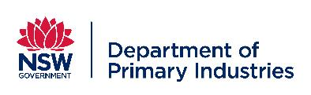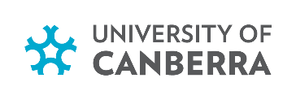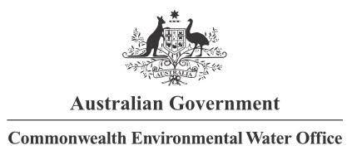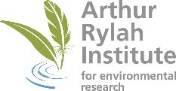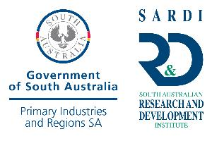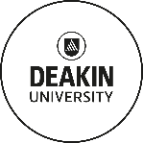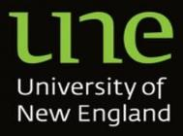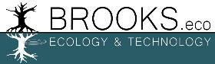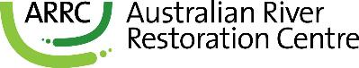

**Partners**

**Collaborators**