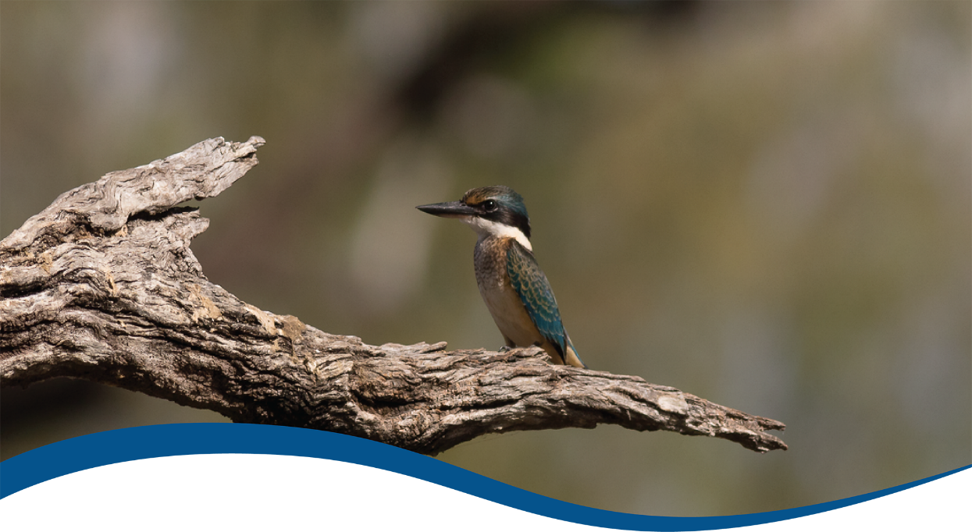

Foundation Report Update 2020: Species Diversity

Commonwealth Environmental Water Office (CEWO):   
Monitoring, Evaluation and Research Program

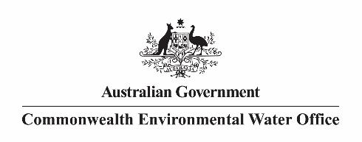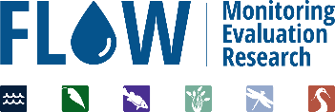

The Flow-MER Program

Flow-MER is the Commonwealth Environmental Water Office’s (CEWO) on-ground Monitoring, Evaluation and Research Program. The Program’s objective is to monitor and evaluate the delivery of Commonwealth environmental water in the Murray-Darling Basin. It provides the CEWO with evidence to inform our understanding of how water for the environment is helping maintain, protect, and restore the ecosystems and native species across the Murray-Darling Basin. This work will support environmental water managers, demonstrate outcomes, inform adaptive management, and fulfil the legislative requirements associated with managing Commonwealth owned environmental water.

The Flow-MER Program is being undertaken from 2019 to 2022 and is led by CSIRO in partnership with the University of Canberra, and collaborating with Charles Sturt University, Deakin University, University of New England, SARDI, Arthur Rylah Institute, NSW Department of Primary Industry, Australian River Restoration Centre and Brooks Ecology & Technology. The Program delivers to the Commonwealth Environmental Water Office, Department of Agriculture, Water and the Environment.

ISBN:

Citation

Wassens S, Brooks S and McGinness H (2020) Foundation Report Update 2020: Species Diversity. Flow-MER Program. Commonwealth Environmental Water Office (CEWO): Monitoring, Evaluation and Research Program, Department of Agriculture, Water and the Environment, Australia.

Cover photograph

Sacred Kingfisher in the Gwydir.  
Photo credit: CEWO

Copyright

Creative Commons [logo] © Commonwealth of Australia 2020  
With the exception of the Commonwealth Coat of Arms, partner logos and where otherwise noted, all material in this publication is provided under a Creative Commons Attribution 4.0 International Licence <https://creativecommons.org/licenses/by/4.0/>. The Flow‑MER Program requests attribution as ‘© Commonwealth of Australia (Flow‑MER Program, [https://flow-mer.org.au](https://flow-mer.org.au/))’.

Important disclaimer

The information contained in this publication comprises general statements based on scientific research. The reader is advised and needs to be aware that such information may be incomplete or unable to be used in any specific situation. No reliance or actions must therefore be made on that information without seeking prior expert professional, scientific and technical advice. To the extent permitted by law, the Flow-MER Program (including its partners and collaborators) excludes all liability to any person for any consequences, including but not limited to all losses, damages, costs, expenses and any other compensation, arising directly or indirectly from using this publication (in part or in whole) and any information or material contained in it.

The Flow-MER is committed to providing web accessible content wherever possible. If you are having difficulties with accessing this document please contact [enquiries@flow-mer.org.au](mailto:enquiries@flow-mer.org.au).

Foundation Report Update 2020

This report was prepared for the Commonwealth Environmental Water Office as part of the Flow-MER Program. It is to be read in conjunction with the published [Basin Matter Foundation Reports 2019](https://www.environment.gov.au/water/cewo/publications/basin-matter-aggregation-selected-area-biodiversity-outcomes-2019). The Report Updates outline key changes in the adopted Evaluation approach for the Flow-MER Program. Unless otherwise stated, the Evaluation is conducted as reported in the original Foundation Reports 2019.

Changes in approach have only been adopted where there have been significant advances in methodology and available data, or where unmonitored areas were not previously evaluated. In all other cases, the approach is intended to be consistent with the Evaluation conducted under the Long-Term Intervention Monitoring Project (LTIM).

Contents

Foundation Report Update 2020 i

1 Introduction 1

2 What 2

3 How 3

4 Risks 5

Appendix A Summary of Monitoring, Evaluation and Research Activities within Selected Areas 6

Tables

Table 1 Summary of updates for the Diversity theme Foundation Report Update 2020 1

Table 2 Summary of monitoring, evaluation and research activities related to species diversity across the selected area (see appendix A for details) 2

Abbreviations and acronyms

| **Abbreviation/acronym** | **Definition** |
| --- | --- |
| CEWO | Commonwealth Environmental Water Office |
| DPE | Department of Planning and Environment |
| Flow-MER | The CEWO Monitoring, Evaluation and Research Program (2019-2022) |
| LTIM | Long-Term Intervention Monitoring Project (2015-2019) |
| MER | Monitoring, Evaluation and Research Program (2019-2022) |
| NSW | New South Wales |

# Introduction

The Commonwealth Environmental Water Office Monitoring Evaluation and Research Basin-scale Project (Flow-MER) builds on the evaluation process developed for the Long-Term Intervention Monitoring (LTIM) project. Foundation reports were produced under LTIM for six themes: (1) Hydrology; (2) Ecosystem Diversity; (3) Diversity; (4) Vegetation; (5) Fish; and (6) Stream Metabolism and Water Quality. The reports provide a summary of why these themes are used to evaluate the effectiveness of Commonwealth Environmental Water; the criteria used for evaluating short and long-term outcomes; the approach adopted in the evaluation; as well as any anticipated risks for the evaluation process.

The Foundation Report Updates 2020 have been produced under Flow-MER to report on any changes to the original Foundation Reports 2019 developed in LTIM. Updates are provided to reflect the focus on including unmonitored areas across the basin-scale evaluation, as well as advances in available methods and data. The Updates provide consistency with the Flow-MER Evaluation and Research Plan.

A summary of updates for the Diversity theme is provided in Table 1.

Table 1 Summary of updates for the Diversity theme Foundation Report Update 2020

| **Section** | **Updates** |
| --- | --- |
| Why | No change, consistent with Foundation Report 2019 |
| What | Updated to:  The summary of Selected Area activities relevant to the Diversity Theme  Data inputs and outputs  Scope of reporting |
| How | Updates to:  Data inputs and outputs  Scope of reporting |
| Risks | Additional risks have been added |

# What

The summary of Selected Area activities relevant to the Diversity Theme have been updated to reflect changes in activities being undertaken by Selected Areas under the Flow-MER program and are presented in Table 2 and Appendix A.

Monitoring at the Selected Area level covers a range of indicators, with fish and vegetation monitored across all selected areas, while monitoring and evaluation of CEWO watering actions varies across selected areas for waterbirds, frog and turtles (Table 2). Monitoring effort varies between selected areas (Appendix A), although there is general alignment of survey methods in most instances.

Table 2 Summary of monitoring, evaluation and research activities related to species diversity across the selected area (see appendix A for details)

|  | **Waterbird diversity** | **Waterbird breeding\*** | **Frogs** | **Turtles** | **Fish** | **Vegetation** |
| --- | --- | --- | --- | --- | --- | --- |
| Warrego-Darling | X | X* | X | X* | X | X |
| Gwydir | X | X* | X* | X* | X | X |
| Lachlan |  | X* |  |  | X | X |
| Murrumbidgee | X | X* | X | X | X | X |
| Edward/Kolety Wakool |  |  |  | X | X | X |
| Goulburn-Broken |  |  |  |  | X | X |
| Lower Murray |  |  |  |  | X | X |

*Event based contingency. There are no annual provisions for monitoring this indicator, instead it only occurs when a colonial bird breeding event occurs.

The following text has been removed from this section of the Foundation Report 2019 as it is no longer relevant to works being undertaken under the Flow-MER program;

Data collected varies across groups and Selected Areas, but includes a list of species with some associated records of abundance (e.g. cover, catch per unit effort, calls per unit time), and in some instances breeding (e.g. nests, eggs, larvae) and recruitment. (e.g. young of year fish). It is possible that observations of non-target species will also be made and could include bats (southern myotis; Myotis macropus) or aquatic mammals (e.g. platypus - Ornithorhynchus anatinus; rakali - Hydromys chrysogaster) and floodplain dependent mammals (e.g.brush-tailed phascogale - Phascogale tapoatafa) and yellow-footed antechinus- Antechinus flavipes).

# How

Section 3 has been updated to reflect changing monitoring and research activities being undertaken under the new Flow-MER program within the seven Selected Areas. Steps associated with the development of conceptual models (section 3.1 point 2) have been removed as these activities have already been completed as part of the LTIM program (2014-19). The updated text clarifies the delineation of reporting on diversity outcomes between the Diversity (this document), ecosystem diversity, vegetation and fish themes a basin-scale and considers both an annual evaluation and long-term evaluation.

**Text now reads**

There are three steps involved in the evaluation of generic diversity for groups of species NOT covered by other Basin Matter Evaluations (waterbirds, frogs, turtles, mammals):

1. Identification of key species (with a focus on threatened species) that benefited from Commonwealth environmental water for sites that were monitored;
2. Collating the outputs of the Ecosystem Diversity Basin Matter to identify:
   1. Ecosystem types that Commonwealth environmental water at which key species were observed to have benefited;
   2. Ecosystems types that were watered but not monitored
3. Collating the outputs of the Hydrology Basin Matter to identify likely water regimes at ecosystems that benefited from Commonwealth environmental water.
4. Predicting the likely responses for key and threatened species at sites that were watered but not monitored based on known habitat requirements and spatial distributions.

**Evaluation approach for vegetation, fish and ecosystem diversity**

Vegetation, fish and ecosystem diversity are covered by other Basin matter evaluations. To avoid duplication of effort, the outputs of the evaluation of these matters will be synthesised with respect to Commonwealth environmental water effects on diversity, threatened species and nationally and internationally important wetlands.

# Risks

There is a risk that responses to the provision of environmental water may not be detected due to:

* Variability in monitoring effort across the Selected Areas
* Low sensitivity of some indicators to change at the spatial and temporal scale being assessed
* Responses occurring outside of monitored areas.

Summary of Monitoring, Evaluation and Research Activities within Selected Areas

This section tabulates the evaluation questions, distribution of survey sites and survey methods being employed by the Selected Area teams to evaluate outcomes for Turtles, Frogs and Waterbirds. Information is summarized from the Selected Area Monitoring Evaluation and research Plans (Commonwealth Environmental Water Office 2019a; Commonwealth Environmental Water Office 2019b; Dyer, et al. 2019; Commonwealth Environmental Water Office 2019c; Wassens, et al. 2019; Watts, et al. 2019; Webb, et al. 2019).

* 1. Waterbird diversity (See also Selected area Monitoring Evaluation and research Plans: Commonwealth Environmental Water Office 2019a; Commonwealth Environmental Water Office 2019b; Dyer, et al. 2019; Commonwealth Environmental Water Office 2019c; Wassens, et al. 2019; Watts, et al. 2019; Webb, et al. 2019)

| **Selected Area** | **Evaluation questions** | **Sites** | **Method** |
| --- | --- | --- | --- |
| Warrego-Darling | -What did Commonwealth water for the environment contribute to waterbird survival?  -What did Commonwealth water for the environment contribute to waterbird populations?  -What did Commonwealth water for the environment contribute to waterbird species diversity? | Boera Dam, Booka Dam and Peebles Dam/Ross Billabong and opportunistically on the Western Floodplain and Darling River | Biannual ground surveys  Surveys are undertaken for at least 20 minutes but no more than 1 hour at each wetland  February and May |
| Gwydir | Gwydir-Gingham (aligned with NSW DPE monitoring sites?) | Tri annual ground surveys  Surveys are undertaken for at least 20 minutes but no more than 1 hour at each wetland  Surveys will typically occur in spring (October to November), January and autumn (March to April) (responsive to conditions). |
| Lachlan | NA | NA | NA |
| Murrumbidgee | -What did Commonwealth environmental water contribute to waterbird species diversity?  -What did Commonwealth environmental water contribute to waterbird abundance? | 42 wetland sites through the Lowbidgee and mid-Murrumbidgee floodplain  (aligned with NSW DPE monitoring sites) | Biannual ground surveys October & February  Standard method NSW DPIE (Cat 2)  Two surveys (am-pm) undertaken for least 20 minutes but no more than 1 hour at each wetland  Quarterly surveys 12 sites (20 mins) September, November, January, March |
| Edward/Kotely Wakool | NA | NA | NA |
| Goulburn-Broken | NA | NA | NA |
| Lower Murray | NA | NA | NA |

* 1. Waterbird breeding (See also Selected area Monitoring Evaluation and research Plans: Commonwealth Environmental Water Office 2019a; Commonwealth Environmental Water Office 2019b; Dyer, et al. 2019; Commonwealth Environmental Water Office 2019c; Wassens, et al. 2019; Watts, et al. 2019; Webb, et al. 2019)

| **Selected area** | **Evaluation questions** | **Sites** | **Method** |
| --- | --- | --- | --- |
| Warrego-Darling | -Rookery areas will be the target of event- contingency monitoring | Surveys of colonial bird breeding events and fledging success are proposed using standard methods | Event based  Cat 2 method |
| Gwydir |
| Lachlan |
| Murrumbidgee |
| Edward/Kotely Wakool | NA | NA |  |
| Goulburn-Broken | NA | NA |  |
| Lower Murray | NA | NA |  |

* 1. Frogs (See also Selected area Monitoring Evaluation and research Plans: Commonwealth Environmental Water Office 2019a; Commonwealth Environmental Water Office 2019b; Dyer, et al. 2019; Commonwealth Environmental Water Office 2019c; Wassens, et al. 2019; Watts, et al. 2019; Webb, et al. 2019)

| **Selected Area** | **Evaluation questions** | **Sites** | **Method** |
| --- | --- | --- | --- |
| Warrego-Darling | -What did Commonwealth water for the environment contribute to other vertebrate condition?  -What did Commonwealth water for the environment contribute to vertebrate reproduction?  What did Commonwealth water for the environment contribute to other vertebrate community resilience?  -What did Commonwealth water for the environment contribute to other vertebrate species diversity? | Warrego River zone, Boera Dam, Booka Dam and Peebles Dam/Ross Billabong and opportunistically on the Western Floodplain depending on inundation. | A 2x20 minute visual encounter (person minutes) transects and a 6 x 1 minute audio survey  February and May  Initial frog surveys will occur twice between July and December 2019 |
| Warrego (Event based contingency) | -What did Commonwealth environmental water contribute to other aquatic vertebrates (fish, frogs, turtle reptile) diversity and populations? | Junction wetlands Warrego Darling | Event based  General surveys – frogs, reptiles, turtles |
| Gwydir  (Event based contingency) | -What did Commonwealth environmental water contribute to other aquatic vertebrates (fish, frogs, turtle reptile) diversity and populations? | Gingham, Lower Gwydir and Mallowa | Event based  General surveys – frogs, reptiles, turtles |
| Lachlan | NA | NA | NA |
| Murrumbidgee | -What did Commonwealth environmental water contribute to the provision of habitat to support breeding and recruitment of other vertebrates?  -What did Commonwealth environmental water contribute to other aquatic vertebrates (frog and turtle) diversity and populations?  -What did Commonwealth environmental water contribute to the maintenance of refuge habitats? | Mid-Murrumbidgee wetlands (River red gum oxbow lagoons (4 sites)  Nimmie-Caira (4 sites), Redbank south (4 sites) | Four surveys per year (Sep, Nov, Jan, Mar)  Tadpoles 2 replicates sets double winged large and small fyke nets  40 minute nocturnal transect surveys  Record snout-vent length of target species (20 individuals per transect),  3 x 2 minute audio surveys (taken at 10 minute intervals) |
| Edward/Kotely Wakool | NA | NA | NA |
| Goulburn-Broken | NA | NA | NA |
| Lower Murray | NA | NA | NA |

* 1. Turtles (See also Selected area Monitoring Evaluation and research Plans: Commonwealth Environmental Water Office 2019a; Commonwealth Environmental Water Office 2019b; Dyer, et al. 2019; Commonwealth Environmental Water Office 2019c; Wassens, et al. 2019; Watts, et al. 2019; Webb, et al. 2019)

| **Selected Area** | **Evaluation questions** | **Sites** | **Method** |
| --- | --- | --- | --- |
| Warrego-Darling | -What did Commonwealth environmental water contribute to other aquatic vertebrates (fish, frogs, turtle reptile) diversity and populations? | Western Floodplain biodiversity  Junction of the Warrego and Darling Rivers | Event based contingency  General surveys – frogs, reptiles, turtles |
| Gwydir | -What did Commonwealth environmental water contribute to other aquatic vertebrates (fish, frogs, turtle reptile) diversity and populations? | Gingham, Lower Gwydir and Mallowa | Event based contingency  General surveys – frogs, reptiles, turtles |
| Lachlan | NA | NA | NA |
| Murrumbidgee | -What did Commonwealth environmental water contribute to the provision of habitat to support breeding and recruitment of other vertebrates?  -What did Commonwealth environmental water contribute to other aquatic vertebrates (frog and turtle) diversity and populations?  -What did Commonwealth environmental water contribute to the maintenance of refuge habitats? | Mid-Murrumbidgee wetlands (River red gum oxbow lagoons (4 sites). Nimmie-Caira (4 sites), Redbank south (4 sites) | Four surveys per year (Sep, Nov, Jan, Mar)  Tadpoles and turtles. 2 replicates sets double winged large and small fyke nets  Turtles record species and carapace length |
| Edward/Kotely Wakool | -How does connectivity of wetlands, driven by environmental water, affect turtle distribution, movement, and body condition? | At each sites – river and connected wetlands EKW | (Research) Determine turtle distributions through up to four trapping sessions, in October 2019, December 2019, February 2020, and April 2020. |
| Goulburn-Broken | NA | NA |  |
| Lower Murray | NA | NA |  |

References

Commonwealth Environmental Water Office (2019)a Monitoring, Evaluation and Research Program: Gwydir Selected Area. In: Monitoring, Evaluation and Research Plan (2019-2022) Commonwealth of Australia Canberra.

Commonwealth Environmental Water Office (2019)b Monitoring, Evaluation and Research Program: Junction of the Warrego and Darling Rivers Selected Area (2019-2022). Commonwealth of Australia Canberra.

Commonwealth Environmental Water Office (2019)c Lower Murray Monitoring, Evaluation and Research Plan (2019–2022). Commonwealth of Australia Canberra.

Dyer F., Broadhurst B., Tschierschke A., Thompson R., Clear R., Driver P., Bowen S., Lenehan J., Thomas R., Thurtell L., Packard P., Wright D., Thiem J. and Brandis K. (2019) Lachlan Selected Area Monitoring, Evaluation and Research Plan (2019-2022) Prepared for the Commonwealth Environmental Water Office. Commonwealth of Australia Canberra.

Wassens S., Michael D. R., Spencer J., Thiem J., Kobayashi T., Bino G., Thomas R., Brandis K., Hall A. and Amos C. (2019) Murrumbidgee Monitoring, Evaluation and Research Plan. Prepared for the Commonwealth Environmental Water Office. Commonwealth of Australia Canberra.

Watts R. J., McCasker N., Howitt J., Liu X., Trethewie J., Allan C., Thiem J., Duncan M., Healy S., Bond N., Van Dyke J., Vietz G. and Donges M. (2019) Edward-Wakool Monitoring, Evaluation and Research Plan (2019-2022). Prepared for the Commonwealth Environmental Water Office. Commonwealth of Australia Canberra.

Webb A., Treadwell S., Lakhanpal G., Baker B., Casanelia S., Grace M., Koster W., Lovell D., Morris K., Pettigrove V., Tonkin Z. and Vietz G. (2019) Lower Goulburn River Selected Area Monitoring, Evaluation and Research Plan (2019-2022). Prepared for the Commonwealth Environmental Water Office. Commonwealth of Australia Canberra.

[**https://flow-mer.org.au**](https://flow-mer.org.au)

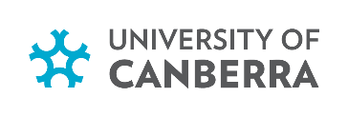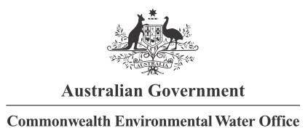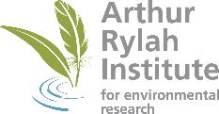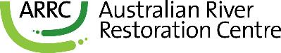

**Partners**

**Collaborators**