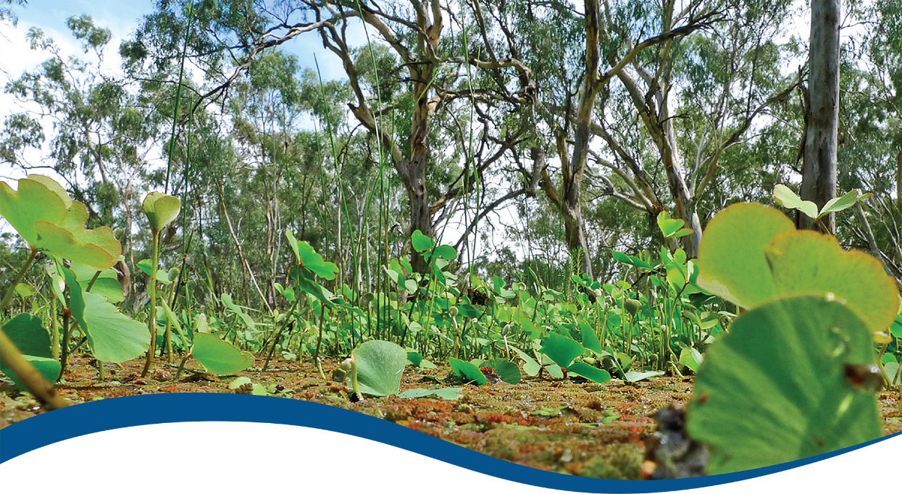

Foundation Report Update 2021: Vegetation Diversity

Commonwealth Environmental Water Office (CEWO):   
Monitoring, Evaluation and Research Program

August 2021

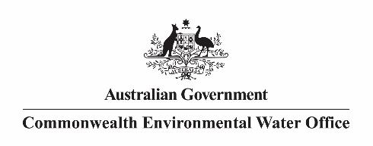

Citation

Dyer F, Campbell C, Doody T (2021) Foundation Report Update 2021: Vegetation Diversity. Flow-MER Program. Commonwealth Environmental Water Office (CEWO): Monitoring, Evaluation and Research Program, Department of Agriculture, Water and the Environment, Australia.

Acknowledgement

The project team and the Commonwealth Environmental Water Office (CEWO) respectfully acknowledge the traditional owners of the land on which this work is conducted, their Elders past and present, their Nations of the Murray–Darling Basin, and their cultural, social, environmental, spiritual and economic connection to their lands and waters.

Copyright

Creative Commons [logo] © Commonwealth of Australia 2021  
With the exception of the Commonwealth Coat of Arms, partner logos and where otherwise noted, all material in this publication is provided under a Creative Commons Attribution 4.0 International Licence <https://creativecommons.org/licenses/by/4.0/>. The Flow‑MER Program requests attribution as ‘© Commonwealth of Australia (Flow‑MER Program, <https://flow-mer.org.au)>’.

Document submission history

|  |  |
| --- | --- |
| 24 August 2021 | Final draft |
|  |  |
|  |  |

Cover photograph

Nardoo growth at Yanga National Park, NSW during the 2010-2012 flood period.   
Photo credit: Tanya Doody (CSIRO)

Important disclaimer

The information contained in this publication comprises general statements based on scientific research. The reader is advised and needs to be aware that such information may be incomplete or unable to be used in any specific situation. No reliance or actions must therefore be made on that information without seeking prior expert professional, scientific and technical advice. To the extent permitted by law, the Flow-MER Program (including its partners and collaborators) excludes all liability to any person for any consequences, including but not limited to all losses, damages, costs, expenses and any other compensation, arising directly or indirectly from using this publication (in part or in whole) and any information or material contained in it.

The Flow-MER is committed to providing web accessible content wherever possible. If you are having difficulties with accessing this document please contact [enquiries@flow-mer.org.au](mailto:enquiries@flow-mer.org.au).

Overview of Flow-MER

Flow-MER is the Commonwealth Environmental Water Office’s (CEWO) Monitoring, Evaluation and Research Program. Its objective is to monitor and evaluate the ecological responses to the delivery of Commonwealth environmental water in the Murray–Darling Basin. It provides the CEWO with evidence to inform our understanding of how water for the environment is helping maintain, protect, and restore the ecosystems and native species across the Basin. This work will support environmental water managers, demonstrate outcomes, inform adaptive management and fulfil the legislative requirements associated with managing Commonwealth-owned environmental water.

The Program runs from 2019 to 2022 and consists of 2 components: monitoring and research in 7 Selected Areas (Selected Area projects); and Basin-scale evaluation and research (the Basin-scale project) (Figure 1 The 7 Selected Areas and 25 valleys established for long-term monitoring of the effects of environmental watering under the LTIM Project and Flow-MER Program (2014–15 to present)Figure 1). The Basin-scale project is led by CSIRO in partnership with the University of Canberra, and collaborating with Charles Sturt University, Deakin University, University of New England, South Australian Research & Development Institute, Arthur Rylah Institute, NSW Department of Planning, Industry and Environment, Australian River Restoration Centre and Brooks Ecology & Technology.

It builds on work undertaken through the Long Term Intervention Monitoring (LTIM) (2014–2019) and Environmental Water Knowledge and Research (EWKR) (2014–2019) projects.

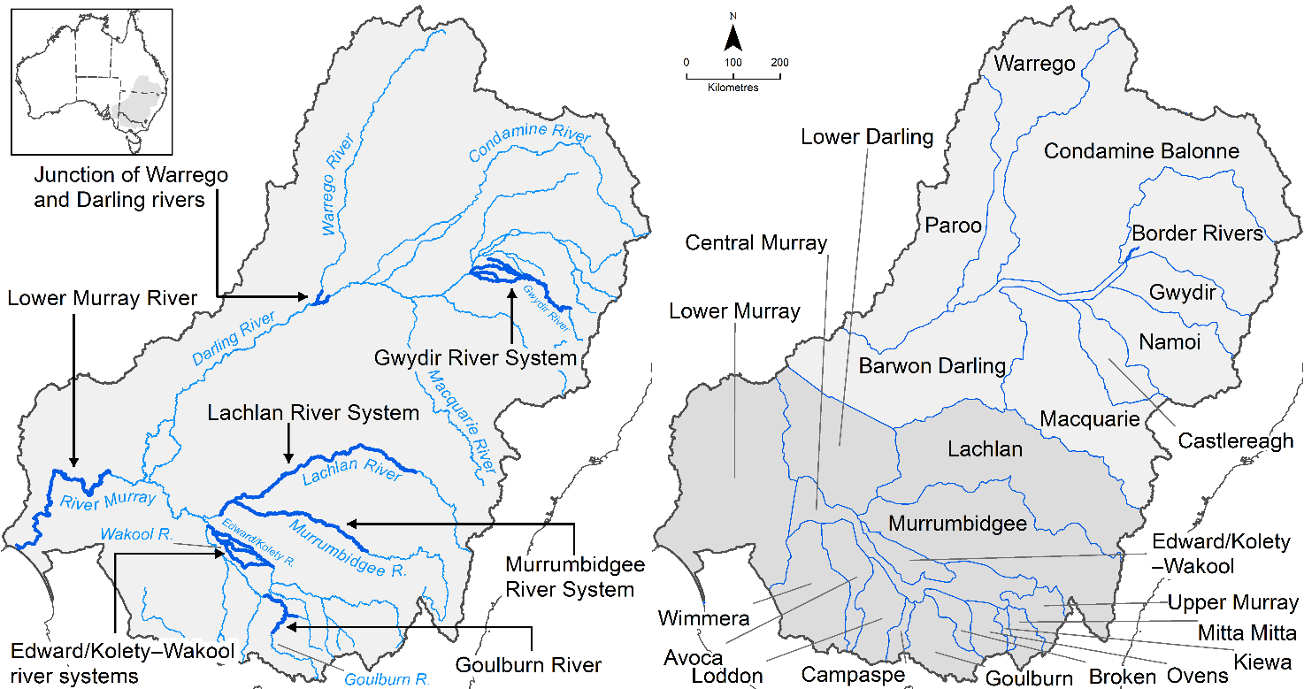

Figure The 7 Selected Areas and 25 valleys established for long-term monitoring of the effects of environmental watering under the LTIM Project and Flow-MER Program (2014–15 to present)

The Flow-MER evaluation adopts an adaptive management framework to acknowledge the need for collectively building the information, networks, capacity and knowledge required to manage environmental water at Basin scale. While knowledge of ecological response to instream flow and inundation has advanced significantly in recent years, substantive challenges remain in understanding the similarities and differences in species’ response across time and space, as well as the interaction between species at a community and ecosystem scale.

The Basin-scale evaluation is being undertaken across 6 Basin Themes (Figure 2) based on ecological indicators developed for the LTIM Project and described in the [Environmental Water Outcomes Framework](https://www.environment.gov.au/water/cewo/publications/environmental-water-outcomes-framework). It is undertaken in conjunction with the Selected Area projects, which provide data, research and knowledge for ecological outcomes within the 7 Selected Areas. The Basin-scale evaluation integrates across Selected Areas, themes, datasets, approaches and different types of knowledge.Graphical user interface, application

Figure Basin-scale Project evaluation reports on Commonwealth environmental water outcomes for the 6 Basin Themes as well as a high-level Basin-scale synthesis

The evaluation is informed by Basin-scale research projects, stakeholder engagement and communication, including Indigenous engagement, visualisation and modelling, as well as the 7 Selected Area projects

Foundation Report Update 2021

This report was prepared for the Commonwealth Environmental Water Office as part of Monitoring Evaluation and Research Basin-scale Project (Flow-MER) Program. It is to be read in conjunction with the published [Basin Matter Foundation Reports 2019](https://www.environment.gov.au/water/cewo/publications/cewo-ltim-basin-matter-hydrology-2019) and [Foundation Report Updates 2020](https://www.environment.gov.au/water/cewo/publications/foundation-report-update-2020). This report for Vegetation accompanies the overview of updates for all themes published as Foundation Report Updates 2021. Unless otherwise stated, the Evaluation is conducted as reported in the original Foundation Reports 2019, and Foundation Report Updates 2020.

Changes in approach have only been adopted where there have been significant advances in methodology and available data, or where unmonitored areas were not previously evaluated. In all other cases, the approach is intended to be consistent with the Evaluation conducted under the Long-Term Intervention Monitoring Project (LTIM), which the Flow-MER program builds on.

Contents

Overview of Flow-MER iii

Foundation Report Update 2021 v

1 Introduction 1

2 Learnings from LTIM 2

3 Why 3

4 What 5

5 How 8

5.1 Vegetation data 8

5.2 Hydrological metrics 8

5.3 Other variables 8

5.4 Analyses 8

5.5 Data products 11

5.6 Activities 12

5.7 Integration 13

6 Risks 15

References 19

Figures

Figure 1 An illustration of the spatial and temporal relationships between elements of the vegetation objectives hierarchy. The yellow boxes represent aspects of the Level 3 vegetation objective for which cause-effect diagrams have been developed. From Gawne et al. (2013) 9

Tables

Table 1 Summary of updates for the Vegetation theme Foundation Report Update 2020 1

Table 2 Summary of vegetation diversity and vegetation community structure data to be collected at each Selected Area as part of the Flow-MER project 6

Table 3 Risk assessment for the Evaluation component of the Flow-MER Vegetation theme 15

Abbreviations and acronyms

| **Abbreviation/acronym** | **Definition** |
| --- | --- |
| ALA | Atlas of Living Australia |
| ANAE | Australian National Aquatic Ecosystem |
| CEWO | Commonwealth Environmental Water Office |
| EWKR | Environmental Water Knowledge and Research Project (2014-2019) |
| Flow-MER | The CEWO Monitoring, Evaluation and Research Program (2019-2022) |
| LTIM | Long-Term Intervention Monitoring Project (2015-2019) |
| MDB | Murray-Darling Basin |
| MER | Monitoring, Evaluation and Research Program (2019-2022) |
| NSW | New South Wales |
| OEH | Office of Environment and Heritage |
| TLM | The Living Murray |

# Introduction

The Commonwealth Environmental Water Office Monitoring Evaluation and Research Basin-scale Project (Flow-MER) builds on the evaluation process developed for the Long-Term Intervention Monitoring (LTIM) project. Foundation reports were produced under LTIM for 6 themes:

* Hydrology
* Ecosystem Diversity
* Species Diversity
* Vegetation
* Fish
* Stream Metabolism (food webs) and Water Quality.

The reports provide a summary of why these themes are used to evaluate the effectiveness of Commonwealth environmental water; the criteria used for evaluating short and long-term outcomes; the approach adopted in the evaluation; as well as any anticipated risks for the evaluation process.

The Foundation Report Updates 2021 are provided to reflect advances in available methods and data. The Updates provide consistency with the Flow-MER Evaluation and Research Plan.

A summary of updates for the Vegetation theme is provided in Table 1.

Table 1 Summary of updates for the Vegetation theme Foundation Report Update 2020

|  |  |
| --- | --- |
| **Section** | **Updates** |
| **Learnings** | New section detailing the lessons learnt from LTIM and EWKR and how these are being incorporated into the Flow-MER program |
| **Why** | Additional context in relation to:   * Recognition of Australia’s Indigenous population and their culturally significant relationship with plant species and vegetation communities * Basin-scale objectives for vegetation from the MDBA Basin Watering Strategy, including an explanation of the timing of the development of the Basin Watering Strategy objectives and the LTIM evaluation questions * Contextual framing with reference to relevant vegetation information in LTIM development documents such as the Logic and Rationale document (Gawne et al. 2013) and Cause and Effect diagrams (MDFRC 2013) |
| **What** | * Updated summary of sampling at each Selected Area * Inclusion of the Lower Murray Selected Area as part of the Vegetation Theme for the Flow-MER program |
| **How** | Updates to:   * Data inputs * Analyses * Data products * Specific activities to be undertaken as part of the Flow-MER program * Integration |
| **Risks** | Updated risk section |

# Learnings from LTIM

The Flow-MER project builds on work undertaken as part of the Long-Term Intervention Monitoring (LTIM) project and the Murray-Darling Basin (MDB) Environmental Water Knowledge Research (EWKR) project. Key learnings from those projects have been incorporated into foundational and development tasks to be undertaken as part of the Flow-MER project and have informed our annual and cumulative evaluation approach.

A key learning from these past projects is that the Basin supports high plant and community diversity and non-woody vegetation responses are unique and heterogeneous. Variability in vegetation responses is due to differences in location; recent flow conditions (such as water depth, time-since-last inundation, proportion time wet); vegetation structure; and medium to long-term flow regimes. As responses are highly heterogeneous, trade-off decisions will be required between spatial and temporal scales. Watering large spatial areas is likely to increase Basin-scale diversity, while temporal (repeat) watering at a location is likely to increase site-specific resilience and condition. Other key learnings highlight the need to:

1. identify statistical approaches to tackle issues associated with different sampling methods
2. identify species and functional groupings in order to
   1. simplify the response patterns from 600+ species
   2. identify species or groupings which may resonate with the broader public
   3. provide links to species-specific objectives in the Basin Watering Strategy (MDBA 2014)
3. define objectives and outcomes at different levels of ecological organisation (e.g. species, communities, mosaics of communities)
4. improve our understanding of good or improved condition through the development of benchmarks and links to function and value.

The Flow-MER project, through a combination of foundational and development tasks, annual evaluation, multi-year modelling and research, will address some of the needs highlighted above and will continue to build our knowledge base regarding vegetation responses to flow regimes to adaptively inform watering decisions.

# Why

Australia’s floodplains, wetlands and riverine ecosystems are characterised by unique, diverse and often iconic vegetation. From ancient red gum forests fringing wide lazy rivers to sedges and grasses emerging from open wetlands, vegetation shapes our landscapes and provides a range of ecological, cultural and economic services.

The vegetation that is found along rivers, floodplains and wetlands provides food and habitat for a wide variety of species, often within otherwise dry landscapes. It also provides organic matter to rivers, contributing important basal resources to biota and many ecosystem processes.

For tens of thousands of years, Australia’s Indigenous people used the incredible diversity of floodplain and wetland plants to provide themselves with food, shelter, fibre and medicines. We see echoes of their presence in the scar trees that dot the banks of our inland rivers. European settlers were similarly drawn to rivers, floodplains and wetlands for the resources they provided.

The combination of land-clearing, grazing and water use have fundamentally changed the nature and condition of vegetation across rivers, floodplains and wetlands of the Basin. There has been widespread loss of vegetation and what remains is often in poor condition. For the period 2008–2010, the Sustainable Rivers Audit assessed the condition of the riverine vegetation as very poor to moderate across the majority of regulated rivers in the Murray–Darling Basin (MDBA 2012). In contrast, many unregulated rivers were assessed as being in better condition. One of the main causes of decline has been changes to the frequency, duration and timing of water received by a wide variety of vegetation communities.

Environmental water is used throughout the Murray–Darling Basin to support diversity and condition of vegetation – both woody (trees) and non-woody (groundcover) vegetation, including a wide range of shrubs from tangled lignum to floating ferns such as azolla. The Basin Watering Strategy (MDBA 2014) expects that environmental water will be used to ‘maintain the extent and to improve the condition of water dependent vegetation on the parts of the floodplain that can be actively managed’. Outcomes for vegetation defined within the Basin Watering Strategy (MDBA 2014) are framed within the context of specific vegetation structural groups (forests and woodlands, shrublands and non-woody vegetation, Box 1).

At the time the initial LTIM program was established, the Basin Watering Strategy was still under development. The LTIM program thus used the objectives of the Murray-Darling Basin Plan to develop a suite of expected outcomes for vegetation (Gawne et al. 2013) based on the scientific understanding of flow and ecological responses at the time (MDFRC 2013). Gawne et al. (2013) and MDFRC (2013) established the priorities for monitoring for the LTIM program, which are continued as part of Flow-MER. The expected outcomes for vegetation were nested within objectives for Biodiversity within the Basin Plan (Basin Plan Section 8.05) and were focussed on the use of environmental water to support vegetation diversity within the Basin. Further, at the time of LTIM program establishment, it was assumed that outcomes for forests, woodlands, and shrublands would be evaluated through other MDBA and state programs. Thus, the Basin Scale Vegetation Theme focus is to evaluate the outcomes from using environmental water to support the diversity of non-woody vegetation. This remains the focus of the Basin Scale Vegetation Theme evaluation for the Flow-MER program.

Box 1. Expected Basin Watering Strategy outcomes for Basin vegetation groups (MDBA 2014)

Forests and woodlands. The expected outcomes for forests and woodlands in the Basin are:

* to maintain the current extent of forest and woodland vegetation including approximately [1]:
  + 360,000 ha of river red gum
  + 409,000 ha of black box
  + 310,000 ha of coolibah
* no decline in the condition of river red gum, black box and coolibah across the Basin [2]
* by 2024, improved condition of river red gum in the Lachlan, Murrumbidgee, Lower Darling, Murray, Goulburn–Broken and Wimmera–Avoca
* by 2024, improved recruitment of trees within river red gum, black box and coolibah communities—in the long term achieving a greater range of tree ages. (River red gum, black box and coolibah communities are presently primarily older trees; which places them at risk.)

Shrublands. The outcomes expected for shrubland vegetation are:

* to maintain the current extent of extensive lignum shrubland areas within the Basin
* by 2024, improvement in the condition of lignum shrublands.

These outcomes apply to lignum communities across the following regions (at a minimum): Lower Lachlan, Lower Murrumbidgee, Lower Darling, Lower Condamine–Balonne (including Narran Lakes), Lower Gwydir, Macquarie Marshes, Lower Border Rivers and the River Murray from the junction of Wakool River to downstream of Lock 3 (including Chowilla and Hattah Lakes).

There are not enough data to measure areas of lignum at a Basin scale. However, information is available at a regional scale and Basin states are encouraged to quantify this vegetation type within their catchments.

Non-woody vegetation. The outcomes for non-woody vegetation are:

* to maintain the current extent of non-woody vegetation
* by 2024, increased periods of growth for communities that:
  + closely fringe or occur within the main river corridors
  + form extensive stands within wetlands and low-lying floodplains including Moira grasslands in Barmah–Millewa Forest; common reed and cumbungi in the Great Cumbung Swamp and Macquarie Marshes; water couch on the floodplains of the Macquarie Marshes and Gwydir Rivers; and marsh club-rush sedgelands in the Gwydir
* a sustained and adequate population of Ruppia tuberosa in the south lagoon of the Coorong, including:
  + by 2019, *R. tuberosa* to occur in at least 80% of sites across at least a 50 km extent
  + by 2029, the seed bank to be sufficient for the population to be resilient to major disturbances [3].

[1] The areas specified for river red gum, black box and coolibah are within a range of plus or minus 10%.

[2] Limitations in the data available in many areas of the Basin, particularly in the north, mean that it is not yet possible to specify the current condition of river red gum, black box and coolibah. As additional data become available it will be possible to accurately calculate the condition at 2014 and to describe the expected outcomes for these species across the Basin.

[3] Advice suggests that this would require at least 10,000 seeds/m2 within the bed of the core population of R. tuberosa.

# What

The evaluation questions and approach will remain broadly similar to that outlined in Capon et al. (2018). Data collected by monitoring and evaluation teams at the Selected Areas will be collated and analysed by the Basin Vegetation team to evaluate the effects of Commonwealth environmental water on the diversity of plants and vegetation communities with respect to:

1. *species level responses:* responses to environmental water of individual plant species across Selected Areas including changes to species presence, distribution and abundance;
2. *community level responses:* responses to environmental water of particular vegetation communities within specific habitat types (e.g. ANAE vegetation types) across Selected Areas including changes in species richness, composition and structure; and
3. *landscape level responses:* responses to environmental water of vegetation communities across the Selected Areas including changes in the presence, distribution and diversity of particular vegetation communities.

Both annual evaluation and longer-term evaluation (using LTIM data from 2014) will be conducted. Evaluation data will continue to be collected from the same Selected Areas with the addition of data collected from the Lower Murray Selected Area. A summary of vegetation diversity sampling at Selected Areas is presented in Table 2. Outcomes from analysing these datasets will be used to infer responses at unmonitored locations.

Table 2 Summary of vegetation diversity and vegetation community structure data to be collected at each Selected Area as part of the Flow-MER project

|  |  | **SAMPLING DESIGN** | | | | | | **VEGETATION DIVERSITY METRICS** | | **COMMUNITY STRUCTURE METRICS** | | | | | |
| --- | --- | --- | --- | --- | --- | --- | --- | --- | --- | --- | --- | --- | --- | --- | --- |
| Selected Area | Veg type1 | Timing of sampling | # Zones 2 | # Sites per zone | # Quadrats /Transects per site | Quadrat / Transect description | Sampling unit description | % Cover by species | # Tree seedlings/saplings  3 classes (20-50cm; 50-130cm; 1.3-3m ) | % Canopy cover  (>5 m tall) | % Understorey cover  (1-5 m tall) | % Groundcover  (<1 m tall) | % Litter cover | % Wood cover | % Bare ground |
| Riverbank Selected Areas | | | | | | | | | | | | | | | |
| Edward/ Kolety-Wakool | Rb | bi-monthly between Sept & Mar (monthly for non-id metrics) | 4 | 5 | 1 | transects perpendicular to channel, sampling from 5 permanent markers along 25m transects parallel to water, points every 50 cm along | % cover values calculated for each elevation on each transect  (point-intercept method) | ✓ |  | ✓ | ✓ | ✓ | ✓ | ✓ | ✓ |
| Goulburn | Rb | before & after Oct Spring Fresh | 1 | 4 | 16 | transects perpendicular to channel, sampling every 1m along 2m lengths, points every 10cm.  (point-intercept method) | % cover values calculated for each elevation on each transect  (point-intercept method) | ✓ | ✓  (in 3 1m x 1m quadrats at top, middle and bottom of bank) | ✓ | ✓ | ✓ | ✓ | ✓ | ✓ |
| Lower Murray | Rb |  |  |  |  |  |  |  |  |  |  |  |  |  |  |
| Wetland and floodplain Selected Areas | | | | | | | | | | | | | | | |
| Gwydir | Fr | before & after CEW (Aug/Oct & Mar/Apr) | 1 | 1 | 2 | transects with observations recorded every 1m | % cover values for each 1m x 1m quadrat | ✓ | ✓ |  |  | ✓ |  |  | ✓ |
| Gwydir | Fl | before & after CEW (Aug/Oct and Mar/Apr) | 2 | 13 | 3 | 0.04ha plots nested within 0.1ha plots | % cover values for 0.04ha plot (N.B. Canopy cover recorded for 0.1ha plot) | ✓ | ✓ | ✓ | ✓ | ✓ | ✓ | Length of fallen timber >10 cm | ✓ |
| Lachlan | Fr | before & after CEW (Mar/April and 3 months after 1st fill) | 5 | 1-4 | 2-3 | 100m transects with observations recorded every 1m | % cover values for each 1m x 1m quadrat | ✓ |  |  |  |  | ✓ | Length of fallen timber >10 cm | ✓ |
| Lachlan | Fl |  | 5 | 2-5 | 2-4 | 0.04ha plots nested within 0.1ha plots | % cover values for 0.04ha plot (N.B. Canopy cover recorded for 0.1ha plot) | ✓ | ✓ | ✓ | ✓ | ✓ | ✓ | ✓ | ✓ |
| Murrum-bidgee | Fl |  | 3 | 4 | 2-3 | 1 x 10m quadrats | % cover values for each 10m quadrat | ✓ | ✓ | ✓ | ✓ | ✓ | ✓ | ✓ | ✓ |
| Warrego-Darling | Fl | before & after CEW (Aug/Oct & Mar/Jun) | 1 | 8 | 3 | 0.04ha (20m x 20m) quadrats | % cover values for 0.04ha quadrat | ✓ | ✓ | ✓ | ✓ | ✓ | ✓ | ✓ | ✓ |

# How

## Vegetation data

Monitoring of vegetation diversity occurs across all Selected Areas using area specific methods (Category II methods, (Hale et al. 2013). Data are collected from a range of fixed wetland, floodplain and riverine sites, at multiple times throughout the year (at a minimum twice per year). There is variation in the methods used to collect the data across the Selected Areas because each area has tailored their approach to address Selected Area evaluation questions.

The data collected includes records of species (presence, cover and height) and measures of vegetation structure (canopy cover, litter cover, bare ground) (see also Table 2).

Unlike Capon et al. (2018), we do not expect to complement the vegetation data collected by the Selected Area teams with datasets such as those collected under previous monitoring programs. During the LTIM Basin Evaluation, it was found that the data from other monitoring programs were not easily comparable, nor was time available to manage the additional datasets and transform them into a useable format.

## Hydrological metrics

Site scale hydrological metrics are collected across all Selected Areas using a range of methods that vary in spatial and temporal resolution. These include antecedent inundation conditions as well as metrics relevant at the time of sampling (water depth and soil moisture). Where possible, data will be leveraged from the Flow-MER Basin scale hydrology work as it progresses.

## Other variables

Weather conditions and land management activities that are likely to affect vegetation diversity responses to the provision of water, may be used to supplement the hydrology data and contribute to understanding vegetation responses to environmental water.

## Analyses

Evaluation at a Basin scale will adopt a combination of aggregated area scale evaluation and Basin-wide evaluation considering annual and multi-year evaluation and is based on the approaches of Capon et al. (2018). It is expected that as the length of the temporal dataset increases, so will our capacity to evaluate outcomes. The original framing for the LTIM project (Gawne et al. 2013) expected that outcomes for vegetation diversity would become apparent at a time scale of greater than 10 years (Figure 3).

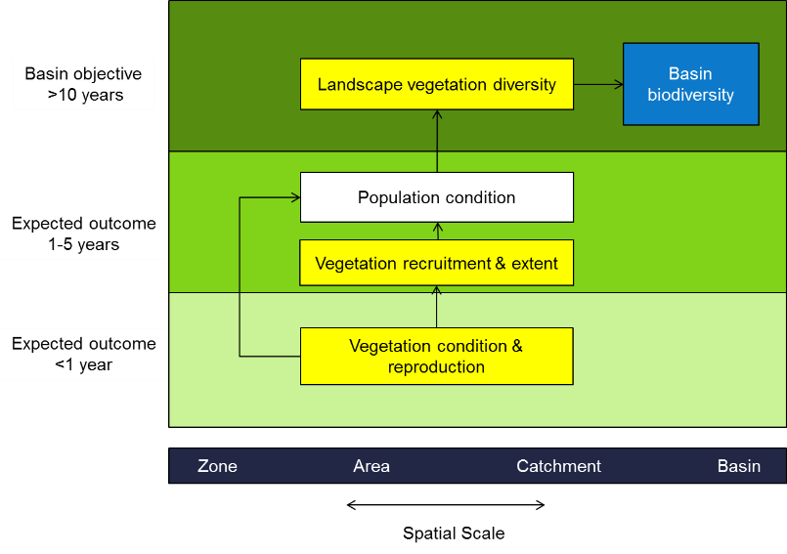

Figure 3 An illustration of the spatial and temporal relationships between elements of the vegetation objectives hierarchy. The yellow boxes represent aspects of the Level 3 vegetation objective for which cause-effect diagrams have been developed. From Gawne et al. (2013)

Evaluation builds on the approaches described in Capon et al. (2018) and is described in more detail below.

#### Attributing responses to environmental water

In attributing responses to environmental water, the evaluation will consider responses to all inundation events that include Commonwealth environmental water. In most cases, it is expected that Commonwealth environmental water comprises the greater part of the environmental water used, but may also include other types of environmental water including state holdings of environmental water. This is because of the collaborative approach used in the delivery of environmental water across the Basin between different environmental water holders.

Evaluation uses vegetation monitoring data from each of 7 Selected Areas across the Basin and focuses on describing broad patterns in vegetation responses at sample points with and without environmental water (annual evaluation) and between different hydrological groups that are supported to varying degrees by the delivery of environmental water (6-year evaluation). The focus on broad patterns in responses rather than a more rigorous quantitative (statistical) evaluation is for the following reasons:

* Vegetation monitoring and Basin-scale evaluation as part of LTIM demonstrated the heterogeneity, uniqueness and variability of vegetation assemblages at the Basin scale (based on data from 6 Selected Areas from 2014–20) across multiple years, with vegetation assemblages differing both spatially and temporally (Capon and Campbell 2019; Capon and James 2020). The number of Selected Areas from which we have data are insufficient for detecting a generalised response to watering because of the magnitude of the natural differences in vegetation between Selected Areas. A weight-of-evidence approach considering a combined set of outcomes is a more robust way of assessing responses to environmental watering.
* The monitoring data have been collected to address the needs of the Selected Areas, rather than addressing Basin-wide questions. Aside from differences in sampling approaches within each of the Selected Areas, this means that the sampling design does not take into account the combined influence of habitat/ecosystem type and hydrological regime. Areas and monitoring locations chosen within Selected Areas are not stratified according to ecosystem type or hydrological regime and there is limited replication within these groupings. Both hydrological regime and ecosystem type are now known to be key drivers of vegetation response, and the original sampling design means that these drivers cannot be controlled for in a statistical analysis.
* The surface expression of riverine, floodplain and wetland vegetation is the result of a complex set of interacting factors that includes recent and long-term hydrological conditions, such as season, depth and duration of inundation, time since last inundation, as well as weather conditions (rainfall and temperature), soil types, local geomorphic and landscape position, and land use. The monitoring data available are records of the vegetation species present at points in time. Testing the extant species composition only in relation to recent hydrological conditions (including environmental water) without considering the longer term drivers or other environmental factors is problematic and there are not sufficient data points to be able to do this. Annual evaluation is therefore best presented as descriptions of patterns and observations rather than a more formal statistical analysis.

While we are not able to assign statistical causality or definitively predict vegetation responses in the absence of environmental water, responses are inferred by:

* comparing monitoring locations with and without environmental water (annual evaluation)
* comparing monitoring locations that are classified into different hydrological groups which reflect varying degrees of environmental water delivery (multi-year evaluation).

Differences between sites with different environmental watering regimes are interpreted as being the result of environmental water use, although direct causation cannot be attributed because of the nature of the study design.

Table 5.1 Logic used to attribute vegetation responses to environmental water

|  |  |
| --- | --- |
| **Response phrase** | **Logic** |
| Supported  *‘Environmental water has supported species …’* | For many of the wetland and floodplain sample points, environmental water has made a substantial contribution to the inundation of the sample point either within the current water year (annual evaluation) or over multiple years and, in some cases, it is the only source of inundation. As such, we assert that environmental water is part (or all) of the water regime that has resulted in the surface expression of the plants we observe and as such has supported the species that are present. |
| Maintained  *‘Environmental water has maintained species richness …’* | Species that are classified as aquatic, amphibious or damp-loving require inundation to be able to complete part of their life cycle. These species are highly unlikely to be present without water. Thus, if environmental water is part of the inundation regime received by sample points that display aquatic, amphibious or damp-loving species, environmental water is considered to have maintained species richness at those sample points. |

#### Aggregated area scale, annual evaluation

Species presence/absence and cover data from Selected Areas will be analysed to identify vegetation outcomes (changes in species presence, abundance and cover) to watering actions by comparing observed outcomes to outcomes predicted to occur in the absence of environmental flow. The counterfactual (absence of environmental flow), will draw on information from sites that did not receive environmental water in combination with information provided by the hydrology theme (annual extent of Commonwealth environmental water inundation) and Selected Area knowledge (likelihood of inundation in the absence of Commonwealth environmental water). In contrast to Capon et al. (2018), the aggregated area scale annual evaluation will focus less on responses within and between individual Selected Areas (given the LTIM findings of high heterogeneity) and more on aggregate learning through the comparison of similar watering objectives in broad habitat types (e.g. river bank, wetland and floodplain) and ANAE vegetation types. Expanding on the methods in Capon et al. (2018), the presence/absence and cover of species from particular functional/classification groups and culturally significant species, will be analysed in relation to Commonwealth environmental water.

#### Basin-scale, annual evaluation

For unmonitored sites, likely outcomes of annual water actions will be based on species, communities and assemblages that have received water across the Basin. If generalised responses (such as changes in the number/cover of species) are apparent from the aggregated area scale evaluation, these will be used to infer specific responses at unmonitored sites. Analysis will focus on functional groupings of species to account for spatial heterogeneity of species distributions. Unlike Capon et al. (2018), for Basin-scale evaluation we do not expect to complement the vegetation data collected by the Selected Area teams with other datasets. Additional to Capon et al. (2018), the coincidence of Basin-wide annual watering actions with the occurrence of example species of Basin-wide cultural significance, will be determined to establish the likely benefit of Basin-wide environmental watering. Basin-scale inferences have greater uncertainty than aggregated area responses.

#### Aggregated area scale, cumulative evaluation

For Selected Areas, this will assess the cumulative outcomes from water actions over the relevant time-frame on the basis of hydrological groups.

For the cumulative evaluation, the inundation regimes of the floodplain–wetland sample points will be used to identify hydrological groups on the basis of the presence or absence of inundation at each floodplain–wetland sample point using field-based observations and remote-sensing information. A sample point will be considered inundated if any plot or transect had surface water present in that 3-month quarter. Inundation will be attributed to environmental water or natural flooding (or both) generating 2 inundation datasets: with and without environmental water.

The hydrological groups ‘with environmental water’ will be linked to the observed vegetation assemblage and the resulting hydrology/vegetation associations used to predict the vegetation assemblage that would occur ‘without environmental water’.

#### Basin scale, cumulative evaluation

This assessment will build on the annual Basin-scale evaluation and area scale cumulative evaluations, to describe the likely cumulative outcomes of water actions compared with counterfactual scenario(s). As for the annual evaluation, Basin-scale inferences have greater uncertainty than aggregated area responses.

Vegetation theme evaluation will be supported by outcomes from Ecosystem Diversity, Hydrology, Modelling and Visualisation themes.

## Data products

Data products will include:

1. Combined dataset of groundcover wetland vegetation
2. Map of the vegetation community types that received Commonwealth environmental water
3. List/map of groundcover vegetation species from Selected Area datasets that have responded to Commonwealth environmental water
4. List/map of example culturally significant species from Selected Area datasets that have responded to Commonwealth environmental water. This aspect is an addition to Capon et al. (2018)

## Activities

The activities described below have been added (Foundational and development activities) or updated (Annual Evaluation, Communication and collaboration) for the Flow-MER project. Evaluation of vegetation diversity as part of Flow-MER involves 3 activity streams. The first includes a series of foundational and development tasks that will enable the Basin-scale evaluation of groundcover vegetation diversity responses to environmental water. Second, is the annual evaluation which occurs in 2020–21 and 2021–22 using the combined LTIM and Flow-MER data. Third is a series of communication and collaboration tasks.

Foundational and development activities

There are 4 tasks that provide the foundation for the on-going evaluation. These commenced during year 1, and have been refined during evaluation in years 2 and 3 where needed. The tasks are:

1. Development of appropriate statistical techniques for combining datasets that are collected at different degrees of sampling intensity.

Groundcover data collected by each of the Selected Areas have been collected with differing sampling intensity and thus, current evaluation approaches are confined to an analysis of presence/absence data. Techniques have been developed to enable the evaluation of species cover responses to environmental water. This work is now complete.

1. Review of functional group classification approaches

Numerous approaches exist to classify groundcover vegetation into functional groups and debate exists as to the relative usefulness in environmental water planning and evaluation. A review has been undertaken to identify an appropriate classification approach to be used in evaluating the use of environmental water for groundcover vegetation outcomes. This work is complete, and may be further refined.

1. Selection and mapping of Basin-wide culturally significant species

The selection of species of Basin-wide cultural significance involved liaison with Selected Area teams to define a candidate species list and advice from Brad Moggridge as to the example species used in analysis. Current spatial data (such as the ALA, TLM, EWKR, LTIM datasets and State-based monitoring programs – e.g. NSW OEH) has been used to develop occurrence maps of key species used for evaluation. This may be refined to focus more on case study species.

Annual evaluation

Evaluation will be undertaken in years 2 and 3 of the Flow-MER project using data from both the LTIM program and data collected in years 1 and 2 of the Flow-MER project. Evaluation involves two main tasks:

1. Compilation and review of data and Selected Area reports

During the LTIM program, considerable effort was invested in ensuring the combined vegetation dataset is clean and free of errors. This is expected to be an ongoing task, which requires less time as the dataset is continually improved. Once the combined (both the annual data and the long-term dataset) dataset is finalised, the data will be summarised, visualised and mapped.

Selected Area reports will be interrogated to determine key messages that occur across the Basin to help support both annual and long-term evaluation.

1. Analysis and evaluation

Analysis to support the evaluation at the Basin-scale involves a combination of aggregated area scale evaluation and Basin-wide evaluation as described in the analysis section above.

Communication and collaboration

1. Reporting

The main mechanism by which the evaluation will be communicated to the CEWO, the Selected teams and other scientists and water managers is the annual evaluation report for the Vegetation Theme.

1. Stories

In addition to the technical report, the Vegetation Theme will provide the Basin-scale Communication and Engagement theme with a story highlighting the key findings of the Basin Scale vegetation evaluation in years 2 and 3.

1. Collaborative activities

It is expected that the Basin-scale evaluation team will attend the annual Flow-MER forum, a theme-based workshop (see integration with Selected Areas below) and an annual Basin-scale meeting. In addition, it is expected that the team will work with Brad Moggridge to develop culturally relevant reporting for vegetation outcomes based on our evaluation of response of culturally significant species to watering. It is expected that at least one member of the team will be required to attend a further collaboration meeting during each year.

## Integration

Links to other Basin Matters were identified in Capon et al. (2018) and are expanded more explicitly here.

With Selected Areas

Basin-scale evaluation is reliant on data collected from Selected Areas. There is considerable expertise within Selected Areas in relation to vegetation responses to water. We have been working and will continue to work collaboratively with Selected Areas to share ideas and approaches. At a minimum, an annual workshop will be held to progress areas of mutual interest to the Basin and Selected Area evaluation. This initially included a review of conceptual models of wetland vegetation responses to inundation, within a framework of hydrological predictability and has subsequently included discussions on functional traits that were subsequently used in the year 1 reporting.

We will also work collaboratively with Selected Area vegetation leads to ensure key messages raised in Selected Area reports are synthesised and highlighted in Basin-scale reporting. Particular emphasis will be given to messages that are consistent between Selected Areas and/or habitat types (e.g. impacts of grazing, invasive species, seasonal timing of freshes etc.).

To inform whole-of-Basin scale evaluation

Basin-scale evaluation will require broad scale inundation data from the Basin Hydrology Theme as well as mapping of ANAE classes across the Basin. It is expected that the coincidence of inundation and ANAE classes will be a joint output from the Hydrology Theme, the Ecosystem Diversity Theme and the Vegetation Theme.

The diversity of floodplain and wetland plants are critical to numerous supporting and regulating functions for a range of biota which are also targeted by Commonwealth environmental water. Thus, the vegetation diversity analysis will involve collaboration with:

1. the Ecosystem Diversity Theme – providing information that may inform the interpretation of Basin wide responses by other biota
2. the Food Web Theme – providing information about potentially relevant drivers of carbon inputs to streams and wetlands.

# Risks

The main risks associated with the Basin-scale evaluation of vegetation diversity concern dependencies on organisational and staff capability and the timing and availability of data. A detailed breakdown of risks, including control measures, is available in the Flow-MER Basin Scale Vegetation Theme Operational Plan (Doody et al. 2020) and in Table 2.

Table 2 Risk assessment for the Evaluation component of the Flow-MER Vegetation Theme

| **ASSESS the risks of the activities** | | | | | | | | | |
| --- | --- | --- | --- | --- | --- | --- | --- | --- | --- |
| **CONSEQUENCE (credible risk)** | |  | **LIKELIHOOD** | |  | **IMPACT** |  | **RISK SCORE** | |
| Significant | Fatality, permanent/severe impairment  Whole site/significant multiple equipment damage  Long term damage from toxic pollutants  Significant legal breach, loss of licences |  | Almost Certain | > 90% chance of the risk occurring or  Has occurred in the last year or is expected to occur in the next year |  | to indiv |  | Severe | Authorisation by **Senior Manager** to proceed |
| Major | Permanent/major impairment  Whole building/major multiple equipment damage  Prolonged damage from toxic pollutants  Major legal breach, loss of one licence |  | Likely | 60-90% chance of the risk occurring or Has occurred in the last 2 years or is expected to occur in the next 2 years |  |  | Very High | Authorisation by **Senior Manager** to proceed |
| Moderate | Reversible medium term impairment  Partial building/moderate multiple equipment damage  Short term damage from toxic pollutants  Moderate legal breach, non-compliance |  | Possible | 40-60% chance of the risk occurring or Has occurred in the last 3 years or is expected to occur in the next 3 years |  |  | High | Authorisation by Line Manager to proceed |
| Minor | Reversible short term impairment  Moderate single/minor multiple equipment damage  Transient damage from toxic pollutants  Minor legal breach, no sanctions |  | Unlikely | 10-40% chance of the risk occurring or Has occurred in the last 4 years or is expected to occur in the next 4 years |  |  | Medium | Authorisation by Line Manage to proceed |
| Negligible | No impairment, injury or illness  Temporary restriction to single piece equipment  Transient damage, no external report  Minor legal failing with no breach |  | Rare | <10% chance of the risk occurring or Has occurred in the last 5 years or is expected to occur in the next 5 years |  |  | Low | Proceed and monitor |

| CHOOSE the most appropriate and most effective risk controls for the activities | | | | | | | | | | | |
| --- | --- | --- | --- | --- | --- | --- | --- | --- | --- | --- | --- |
| **HAZARD** | **CREDIBLE RISK**  **Interaction with people/property/ environment/other hazards** | C | **INHERENT RISK** | | **CONTROLS: Effective, tangible, measurable Level 1:** Eliminate | C | **RESIDUAL RISK** | | **ADDITIONAL CONTROLS TO BE IMPLEMENTED** | **BY WHOM** | **BY WHEN** |
| L | IR | **Level 2:** Engineer, Substitute **Level 3:** Admin, PPE |  | L | RR |  |  |  |
| **Evaluation**  **1. Capability** | **Project: Personnel illness, departure**  Delays in project outcomes related to unavoidable personnel dependencies such as illness, change of role, change jobs etc | Significant | Possible | Very High | **Existing:**   * Evaluation Team to check-in with each other regularly * Notify of significant changes as soon as possible | Major | Possible | High | * Monitor existing controls | Fiona Dyer | Continuous |
| **2. Capability** | **Project: Dependent on Selected Area for data**  The evaluation is contingent on the timely provision of data from the Selected Areas via the CEWO. | Significant | Possible | Very High | **Existing:**   * Evaluation team to liaise regularly with data management team * Notify significant delays as soon as possible | Moderate | Unlikely | Medium | * Monitor existing controls | Fiona Dyer | Continuous |
| **3. Capability** | **Project: COVID-19 impacts**  COVID-19 has implications for evaluation in terms of:   * Ability of Selected Area teams to collect field data (see risk #2) * Ability to meet face-to-face with evaluation team members and Selected Area vegetation leads | Major | Possible | High | **Existing:**   * Evaluation team to liaise regularly with Selected Area vegetation leads * Notify significant delays or inability to collect data as soon as possible * Move face-to-face meetings to online platforms |  |  |  | * Monitor existing controls | Fiona Dyer | Continuous |
| **4. Capability** | **Project: Psychosocial Hazards**  Physiological and physical well-being when working across and within teams including bullying and harassment | Significant | Possible | Very High | **Existing:**   * Be proactive in speaking up when there is a problem. There are 3 Project Leaders which can be contacted for advice * Refer to relevant organisations intervention counselling * Check-in with each other regularly * Ensure not sole individual in the team that can access data | Moderate | Possible | Medium | * Monitor existing controls | Fiona Dyer | Continuous |
| **5. Operational risk** | **Project: Red Tape in accessing external data**  Difficulty accessing data in a timely fashion due to red tape | Major | Possible | High | **Existing:**   * List and begin access process as soon as possible * Engage data team to assist or facilitate * Seek alternatives to reduce project impacts | Moderate | Unlikely | Medium | * Monitor existing controls | Fiona Dyer | Continuous |
| **6.** **Communications risk** | **Project: Results or public communication is taken out of context**  There could be a risk of ‘bad media’ related to the project if results or data are taken out of context | Major | Possible | High | **Existing:**   * Ensure media is approved by relevant parties before release (i.e. CSIRO Comms, Flow MER Comms and management team) * Do not comment on policy * Consider implications of use of Twitter/FaceBook in relation to the project * Manuscripts and reports must follow appropriate approval process | Moderate | Unlikely | Medium | * Monitor existing controls | Fiona Dyer | Continuous |

References

Capon S, C Campbell, B Stewart-Koster (2018) Long Term Intervention Monitoring Basin Matter Vegetation Diversity foundation report- revision 2018. Final Report prepared for the Commonwealth Environmental Water Office by The Centre for Freshwater Ecosystems, La Trobe publication 209/2018, 11pp.

Doody T, F Dyer, C Campbell (2020) Basin Scale Vegetation Theme: Operational Plan. Report prepared for the Commonwealth Environmental Water Office Flow Monitoring Evaluation and Research project (Flow-MER) by CSIRO and the University of Canberra, Canberra.

Gawne B, S Brooks, R Butcher, P Cottingham, P Everingham, J Hale, D Nielson, M Stewardson, R Stoffels (2013) Long Term Intervention Monitoring Project Logic and Rationale Document. Final Report prepared for the Commonwealth Environmental Water Office by the Murray Darling Freshwater Research Centre. MDFRC Publication 01/2013.

Hale J, R Stoffels, R Butcher, M Shackleton, S Brooks, B Gawne (2013) Commonwealth Environmental Water Office Long Term Intervention Monitoring Project - Standard Methods., Final Report prepared for the Commonwealth Environmental Water Office by The Murray-Darling Freshwater Research Centre, MDFRC Publication 29.2/2014, 182pp.

MDBA (2012) Sustainable Rivers Audit 2: The ecological health of rivers in the Murray-Darling Basin at the end of the Millennium Drought (2008-2010). Summary., Murray-Darling Basin Authority, Canberra.

MDBA (2014) Basin-wide Environmental Watering Strategy., Murray-Darling Basin Authority.

MDFRC (2013) Long-term Intervention Monitoring - Generic Cause and Effect Diagrams Final Report prepared for the Commonwealth Environmental Water Office by The Murray-Darling Freshwater Research Centre, MDFRC Publication 01.5/2013.

[**https://flow-mer.org.au**](https://flow-mer.org.au)

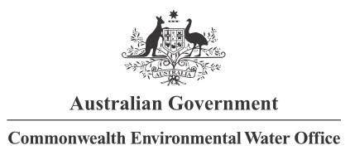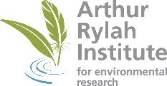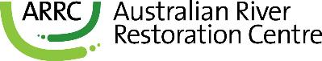

**Partners**

**Collaborators**