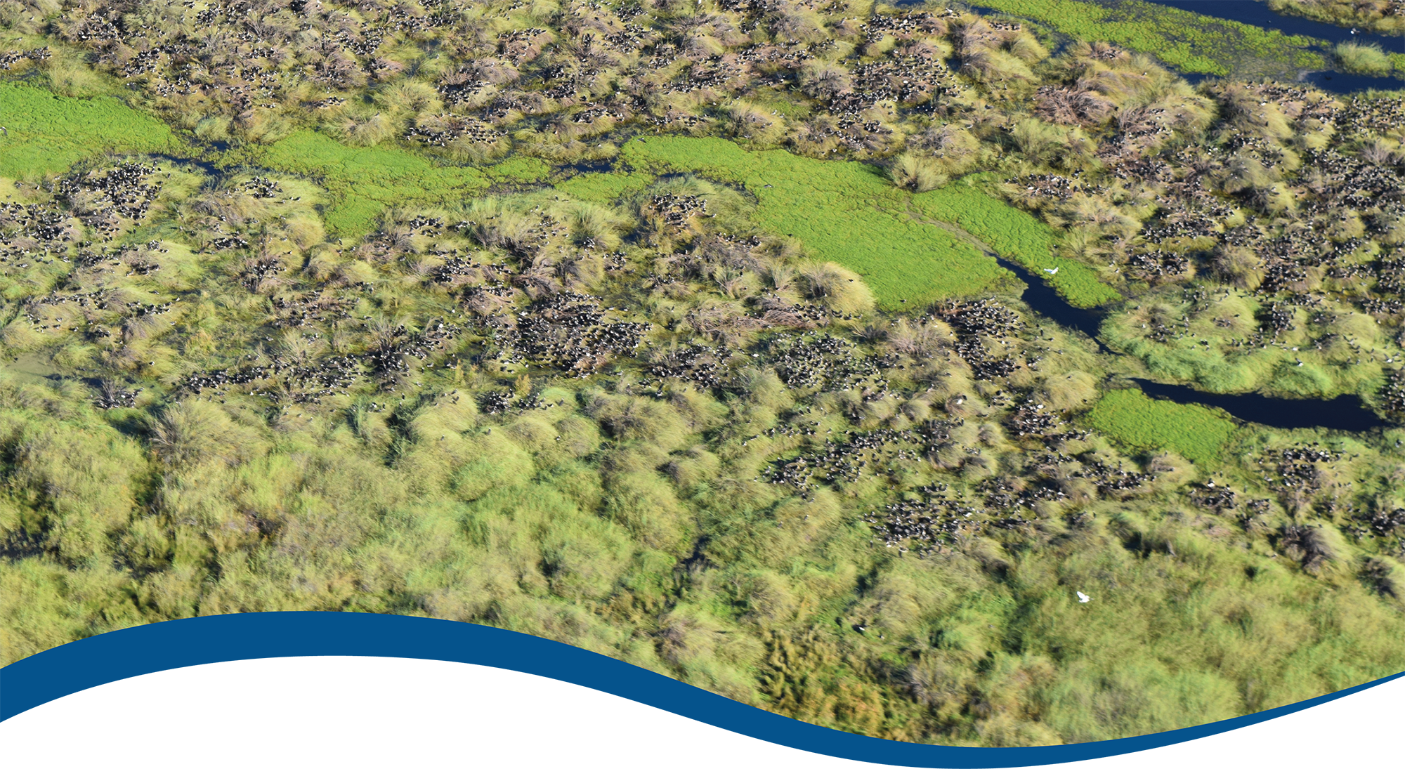

Foundation Report Update 2021

Commonwealth Environmental Water Office (CEWO):   
Monitoring, Evaluation and Research Program

August 2021

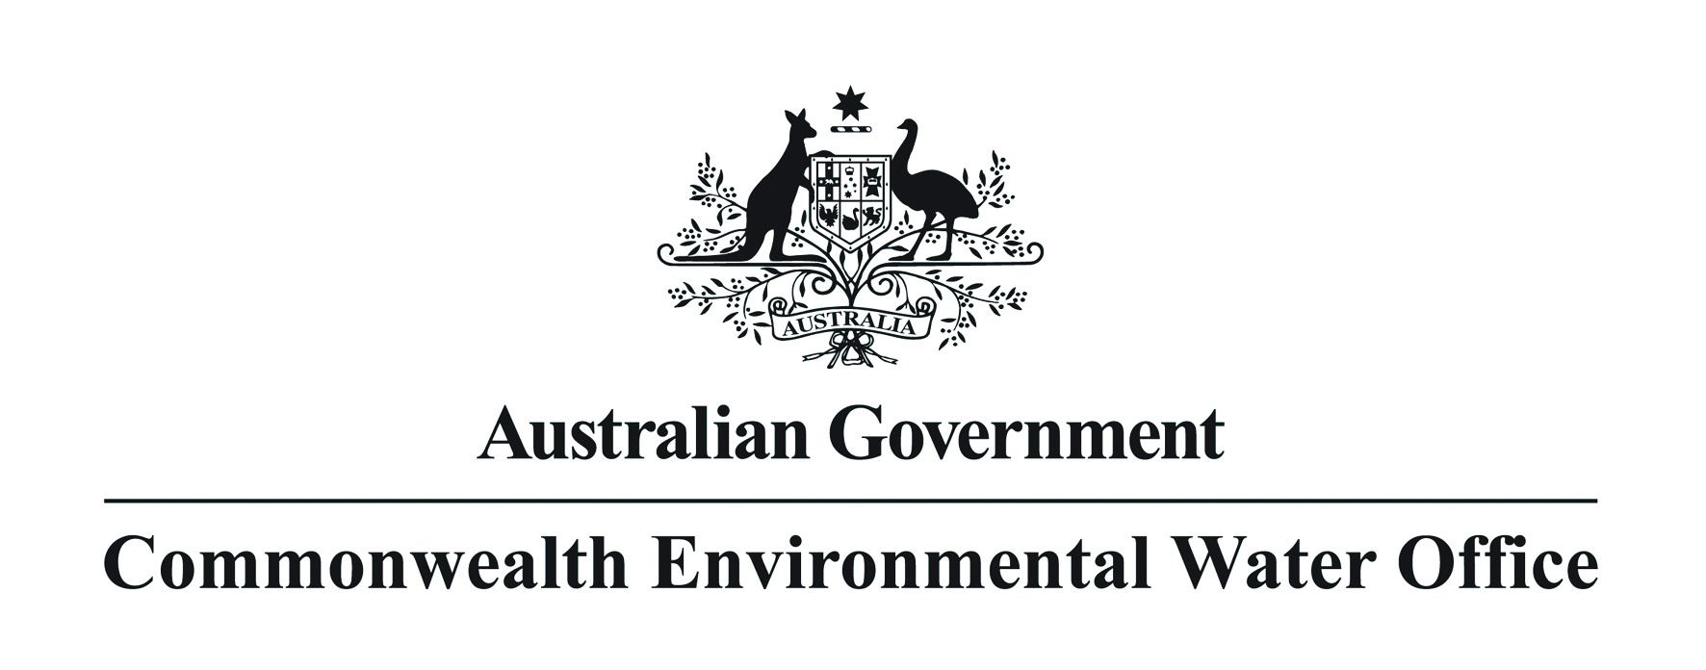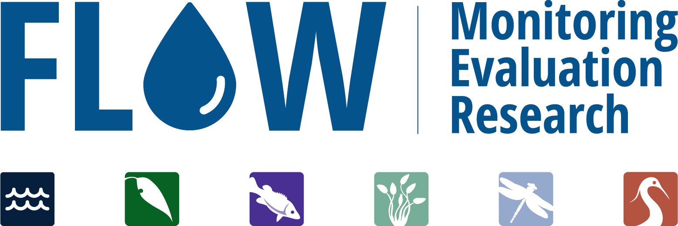

Citation

Barbour E, Brooks S, Campbell C, Dyer F, Guarino F, Hladyz S, McInerney P, Rees G, Stuart I, Wassens S, Yen J (2021) Foundation Report Update 2021. Flow-MER Program. Commonwealth Environmental Water Office (CEWO): Monitoring, Evaluation and Research Program, Department of Agriculture, Water and the Environment, Australia.

[Authors are listed in alphabetical order]

Contributors

Bice C, Baumgartner L, Butler G, Doody T, Fanson, B, Giatas G, Koster W, Lyon J, McGuiness H, Pritchard J, Sengupta A, Thiem J, Todd C, Tonkin Z, Ye Q, Yen J, Zampatti B.

Acknowledgements

The project team and the Commonwealth Environmental Water Office (CEWO) respectfully acknowledge the traditional owners of the land on which this work is conducted, their Elders past and present, their Nations of the Murray–Darling Basin, and their cultural, social, environmental, spiritual and economic connection to their lands and waters.

Copyright

Creative Commons [logo] © Commonwealth of Australia 2021  
With the exception of the Commonwealth Coat of Arms, partner logos and where otherwise noted, all material in this publication is provided under a Creative Commons Attribution 4.0 International Licence <https://creativecommons.org/licenses/by/4.0/>. The Flow‑MER Program requests attribution as ‘© Commonwealth of Australia (Flow‑MER Program, https://flow-mer.org.au)’.

Document submission history

|  |  |
| --- | --- |
| 2 July 2021 | Outline submitted for comment |
| 24 August 2021 | Final draft for review |
|  |  |

Cover photograph

Aerial view of straw-necked ibis colonies in the Booligal wetlands  
Photo credit: Will Higgisson

Important disclaimer

The information contained in this publication comprises general statements based on scientific research. The reader is advised and needs to be aware that such information may be incomplete or unable to be used in any specific situation. No reliance or actions must therefore be made on that information without seeking prior expert professional, scientific and technical advice. To the extent permitted by law, the Flow-MER Program (including its partners and collaborators) excludes all liability to any person for any consequences, including but not limited to all losses, damages, costs, expenses and any other compensation, arising directly or indirectly from using this publication (in part or in whole) and any information or material contained in it.

The Flow-MER is committed to providing web accessible content wherever possible. If you are having difficulties with accessing this document please contact [CEWOmonitoring@environment.gov.au](mailto:CEWOmonitoring@environment.gov.au).

Overview of Flow-MER

Flow-MER is the Commonwealth Environmental Water Office’s (CEWO) Monitoring, Evaluation and Research Program. Its objective is to monitor and evaluate the ecological responses to the delivery of Commonwealth environmental water in the Murray–Darling Basin. It provides the CEWO with evidence to inform our understanding of how water for the environment is helping maintain, protect, and restore the ecosystems and native species across the Basin. This work will support environmental water managers, demonstrate outcomes, inform adaptive management and fulfil the legislative requirements associated with managing Commonwealth-owned environmental water.

The Program runs from 2019 to 2022 and consists of 2 components: monitoring and research in 7 Selected Areas (Selected Area projects); and Basin-scale evaluation and research (the Basin-scale project) (Figure 1 The 7 Selected Areas and 25 valleys established for long-term monitoring of the effects of environmental watering under the LTIM Project and Flow-MER Program (2014–15 to present)Figure 1). The Basin-scale project is led by CSIRO in partnership with the University of Canberra, and collaborating with Charles Sturt University, Deakin University, University of New England, South Australian Research & Development Institute, Arthur Rylah Institute, NSW Department of Planning, Industry and Environment, Australian River Restoration Centre and Brooks Ecology & Technology.

It builds on work undertaken through the Long Term Intervention Monitoring (LTIM) (2014–2019) and Environmental Water Knowledge and Research (EWKR) (2014–2019) projects.

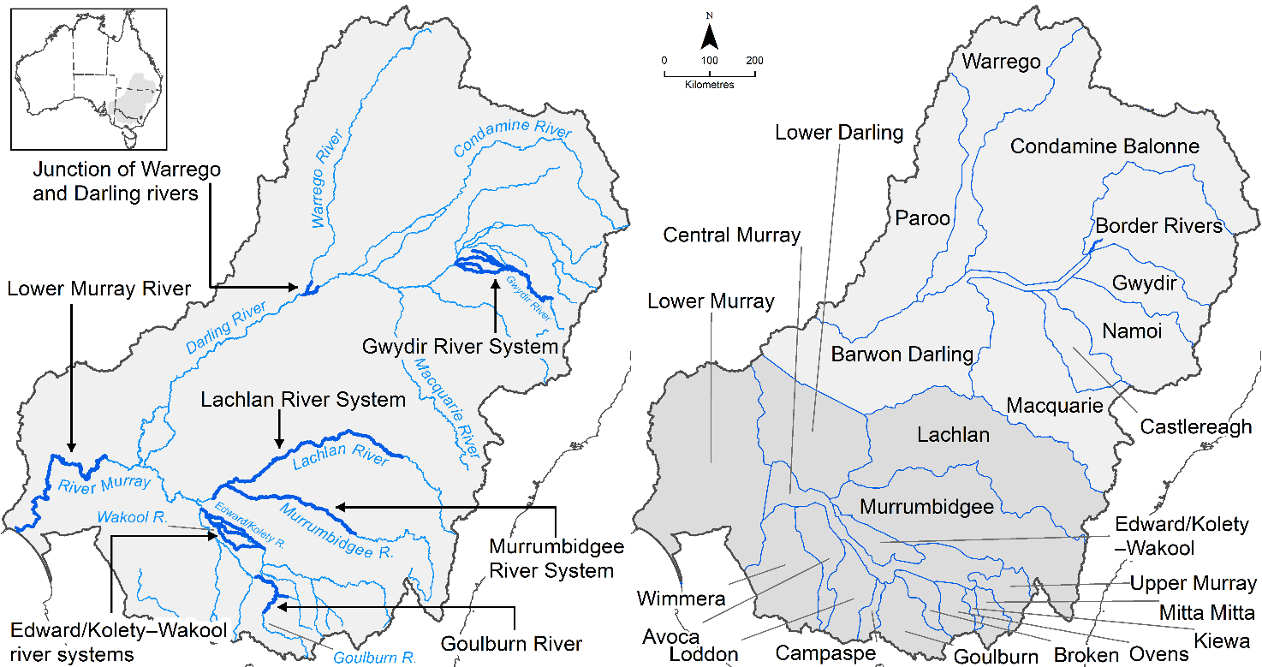

Figure 1 The 7 Selected Areas and 25 valleys established for long-term monitoring of the effects of environmental watering under the LTIM Project and Flow-MER Program (2014–15 to present)

The Flow-MER evaluation adopts an adaptive management framework to acknowledge the need for collectively building the information, networks, capacity and knowledge required to manage environmental water at Basin scale. While knowledge of ecological response to instream flow and inundation has advanced significantly in recent years, substantive challenges remain in understanding the similarities and differences in species’ response across time and space, as well as the interaction between species at a community and ecosystem scale.

The Basin-scale evaluation is being undertaken across 6 Basin Themes (Figure 2) based on ecological indicators developed for the LTIM Project and described in the [Environmental Water Outcomes Framework](https://www.environment.gov.au/water/cewo/publications/environmental-water-outcomes-framework). It is undertaken in conjunction with the Selected Area projects, which provide data, research and knowledge for ecological outcomes within the 7 Selected Areas. The Basin-scale evaluation integrates across Selected Areas, themes, datasets, approaches and different types of knowledge.Graphical user interface, application

Figure 2 Basin-scale Project evaluation reports on Commonwealth environmental water outcomes for the 6 Basin Themes as well as a high-level Basin-scale synthesis

The evaluation is informed by Basin-scale research projects, stakeholder engagement and communication, including Indigenous engagement, visualisation and modelling, as well as the 7 Selected Area projects

Foundation Report Update 2021

This report was prepared for the Commonwealth Environmental Water Office as part of its Monitoring Evaluation and Research Basin-scale Project (Flow-MER) Program. It is to be read in conjunction with the published [Basin Matter Foundation Reports 2019](https://www.environment.gov.au/water/cewo/publications/cewo-ltim-basin-matter-hydrology-2019) and [Foundation Report Updates 2020](https://www.environment.gov.au/water/cewo/publications/foundation-report-update-2020). This year’s Foundation Report Update provides an overview of key changes made to the evaluation approach for the 6 Flow-MER themes:

* Hydrology
* Ecosystem Diversity
* Species Diversity
* Vegetation
* Fish
* Food Webs and Water Quality.

Unless otherwise stated, the Evaluation is conducted as reported in the original Foundation Reports 2019, and Foundation Report Updates 2020. This report is accompanied by one additional theme Foundation Report Update 2021 for Vegetation, which has made more substantive changes than can be captured in this document. All other theme changes are included here.

Changes in approach have only been adopted where there have been significant advances in methodology and available data, or where unmonitored areas were not previously evaluated. In all other cases, the approach is intended to be consistent with the Evaluation conducted under the Long-Term Intervention Monitoring Project (LTIM), which the Flow-MER program builds on.

The Foundation Reports and subsequent Updates provide a summary of why the 6 themes are used to evaluate the effectiveness of Commonwealth Environmental Water; the criteria used for evaluating short and long-term outcomes; the approach adopted in the evaluation; as well as any anticipated risks for the evaluation process.

Contents

Overview of Flow-MER iii

1 Summary of Theme updates 1

2 Species Diversity Theme 2

3 Vegetation Theme 3

4 Fish Theme 4

References 5

Table 1 Summary of Foundation Report updates for all Themes 1

Table 2 Summary of Species Diversity Theme updates 2

Table 3 Summary of Vegetation Theme updates 3

Table 4 Summary of Fish Theme updates 4

# Summary of Theme updates

Table 1 Summary of Foundation Report updates for all Themes

|  |  |
| --- | --- |
| Theme | Updates |
| Hydrology | Evaluation of cease-to-flow events were excluded post the 2020 Foundation Report Update. |
| Ecosystem diversity | No change, consistent with 2020 Foundation Report Update. |
| Species diversity | Largely consistent with the 2020 Foundation Report Update, minor changes to tasks as outlined in Chapter 2 |
| Vegetation | Methodology remains broadly consistent with the overarching approach described in the 2020 Foundation Report Update but with changes to the methodological detail (such as inclusion of hydrological characterisation). These are summarised in Chapter 3 with more detail in the accompanying Foundation Report Update for Vegetation. |
| Fish | Minor changes to the updated tasks and analytical outputs table as described in Chapter 4. |
| Food webs and water quality | Data collection methods will remain unchanged although we propose 2 minor updates:   * Among the Foundation Report evaluation objectives is the question: 'What did Commonwealth environmental water contribute to patterns and rates of decomposition?' We propose to change ’decomposition’ to ‘ecosystem respiration’ as this better reflects what is being evaluated, i.e. the question becomes ‘What did Commonwealth environmental water contribute to patterns and rates of ecosystem respiration?’ * Limitations in existing methods for data analysis (in this case the BASE model) for analysing stream metabolism data limit the capacity to understand and predict metabolism response to different flow scenarios. The highest level of confidence in observed data was achieved in the Lower Murray River (90% using 244 daily records), and the lowest was for the junction of the Warrego and Darling rivers (12% using 24 daily records). These limitations are a consequence of the modelling approach (which can fail at higher flows) and the stringent criteria set by the Foundation Reports for accepting model fits. The acceptance criteria for inclusion of modelled outcomes of raw dissolved oxygen (used to calculate gross primary production and ecosystem respiration) will be reviewed for the 2020–21 evaluation, and the Foundation Reports may need to be amended accordingly. |

# Species Diversity Theme

Table 2 Summary of Species Diversity Theme updates

|  |  |
| --- | --- |
| Section | Updates |
| **Why** | Minor changes, largely consistent with Foundation Report Update 2020 |
| **What** | Updated tasks and analytical outputs to determine the effects of environmental water delivery on Species Diversity |
| **How** | Updates to:   * Data inputs: Investigate data sources that complement Selected Area monitoring to extend analysis across multiple valleys * Investigate analysis approaches for presence only datasets and methodologies to standardise sample effort to better describe links between Commonwealth environmental water and Species Diversity * Text to make a clearer delineation between outputs of the Ecosystem Diversity Theme and Species Diversity Theme reporting * Collating the outputs of the Ecosystem Diversity Basin Matter to identify ecosystem types:   + where key species were observed to have benefited from Commonwealth environmental water   + that were watered but not monitored   + within Ramsar wetland areas likely to have benefited from Commonwealth environmental water. |
| **Risks** | * Limited availability of Selected Area monitoring outcomes related to Species Diversity * Availability of complementary datasets, particularly time lags in the availability of monitoring and evaluation reports and data generated outside of the MER framework * Availability and quality of 2020–21 inundation hydrology data will impact our capacity to identify species with distributions that overlap delivery of Commonwealth environmental water. Availability of mapped inundation data outside of Commonwealth environmental water delivery areas impacts our capacity to evaluate the relative contribution of Commonwealth environmental water. |

# Vegetation Theme

Revisions have been made to the Analyses (Section 5.4) of the Foundation Report Update 2020 (Dyer et al. 2020) (Table 4). These changes are based on learnings from the 2021 evaluation report and incorporate improvements in the use of the data that are collected (incorporation of vegetation cover data) and hydrological characterisation.

Table 3 Summary of Vegetation Theme updates

|  |  |
| --- | --- |
| Section | Updates |
| Why | Minor changes, largely consistent with Foundation Report Update 2020 |
| What | Methods remain broadly consistent with the overarching approach described in the 2020 Foundation Report Update with changes to explanations and method detail (such as inclusion of the vegetation cover data as well as a novel approach to hydrological characterisation). |
| How | Updates to:   * Descriptions of how responses are attributed to environmental water and the logic underpinning the interpretation of outcomes * Incorporation of analyses of vegetation cover that have been previously excluded from analyses because of differences in sampling effort between Selected Areas * A hydrologically driven approach for conducting the Aggregated Area scale cumulative evaluation has been included using learning from the 2019-2020 evaluation |
| Risks | * No additional risks have been identified and changes are based on the evaluation that was implemented successfully in 2019–2020. |

# Fish Theme

Minor revisions have been made to the updated tasks and analytical outputs summary table from the Fish Foundation Report Update 2020 (Stuart et al. 2020) (Table 4). These changes are based on learnings from the 2021 evaluation report and incorporate a renewed focus on high-level Evaluation-theme models to investigate fish responses at the basin scale, focusing on predicted effects of Commonwealth environmental water at unmonitored gauge locations. Foundation report updates 2021 and associated risks are summarised in Table 4.

Table 4 Summary of Fish Theme updates

|  |  |
| --- | --- |
| Section | Updates |
| Why | Minor changes, largely consistent with Foundation Report Update 2020 |
| What | Updated tasks and analytical outputs to determine the effects of environmental flows on native fish |
| How | Updates to:   * Data inputs with 2021 Selected Area field monitoring data potentially available for analysis * Building on learnings from the evaluation report, we will review hydrological and fish community/composition/spawning/recruitment metrics to identify the most ecologically sensitive and meaningful relationships, informed by recent similar analyses for Victorian VEFMAP program and other long-term datasets * Investigate Selected Area sites (i.e. Warrego/Darling) that have traditionally been excluded from Category 1 analyses to determine if these sites can be incorporated in analyses * Investigate a framework for high-level Evaluation-theme models that investigate fish responses at the basin scale, focusing on predicted effects of Commonwealth environmental water at unmonitored gauge locations * Investigate alternatives to ordination analysis to estimate effects of Commonwealth environmental water on fish assemblage structure * Analyses of fish body condition across Selected Area sites * Preliminary exploratory analyses of age-length population demography among Selected Area sites as precursor to survival analyses in future years (i.e. 2021–22) |
| Risks | * Where 2021 Selected Area field data are unavailable, they will be added to a future analytical pathway * Identification of additional sensitive/meaningful hydrological and fish community/composition/ spawning/recruitment metrics and datasets have no inherent risk * Investigation of including all Selected Area sites in global analyses may not be possible but has no additional risk * No additional risk of developing a high-level Selected Area model framework but extrapolation to unmonitored areas is dependent on availability of hydrology data and counterfactuals. Where 2020–21 hydrology data are unavailable, we cannot proceed with 2020–21 analysis without timely receipt of data/counterfactuals, and analysis will be restricted to 2014–20 hydrology data. Evaluation-theme models for unmonitored locations are restricted to the gauge sites with counterfactuals that we receive from the hydrology theme. Where the counterfactual data are expanded (temporally and/or spatially), then these sites can also be added to the modelling. * No additional risk to investigate alternatives to ordination analysis to estimate effects of Commonwealth environmental water on fish assemblage structure * No additional risk for fish body condition analysis * No additional risk for fish age-length analysis though length-age modelling can provide variable results for species with highly variable growth rates (e.g. golden perch) |

References

Dyer F, Campbell C and Doody T (2020) Foundation Report Update 2020: Vegetation Diversity. Flow-MER Program. Commonwealth Environmental Water Office (CEWO): Monitoring, Evaluation and Research Program, Department of Agriculture, Water and the Environment, Australia.

Guarino F and Sengupta A (2020) Foundation Report Update 2020: Hydrology. Flow-MER Program. Commonwealth Environmental Water Office (CEWO): Monitoring, Evaluation and Research Program, Department of Agriculture, Water and the Environment, Australia.

Stuart I, Bice C, Baumgartner L, Butler G, Hladyz S, Koster W, Lyon J, Thiem J, Todd C, Tonkin Z, Ye Q, Yen J, Zampatti B (2020) Foundation Report Update 2020: Fish. Flow-MER Program. Commonwealth Environmental Water Office (CEWO): Monitoring, Evaluation and Research Program, Department of Agriculture, Water and the Environment, Australia

Wassens S, Brooks S and McGinness H (2020) Foundation Report Update 2020: Species Diversity. Flow-MER Program. Commonwealth Environmental Water Office (CEWO): Monitoring, Evaluation and Research Program, Department of Agriculture, Water and the Environment, Australia.

[**https://flow-mer.org.au**](https://flow-mer.org.au)

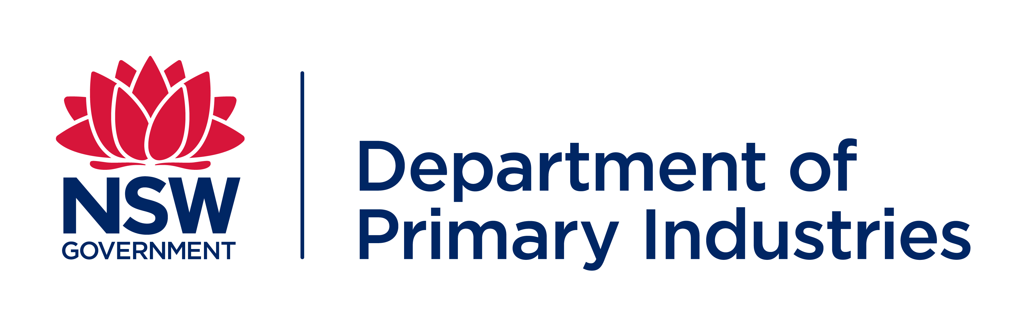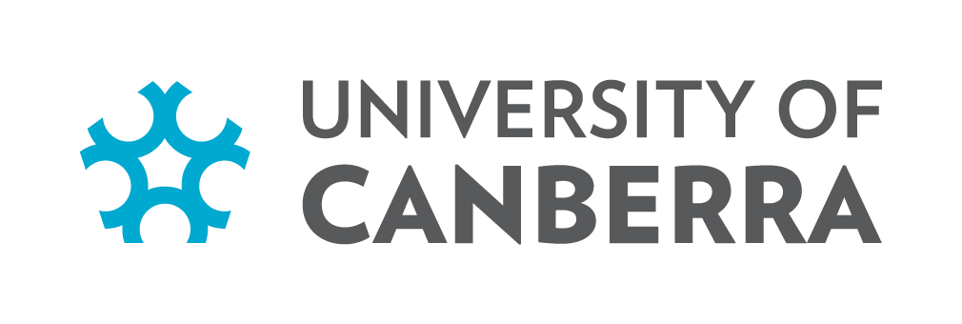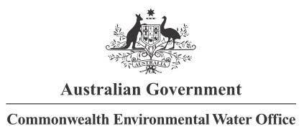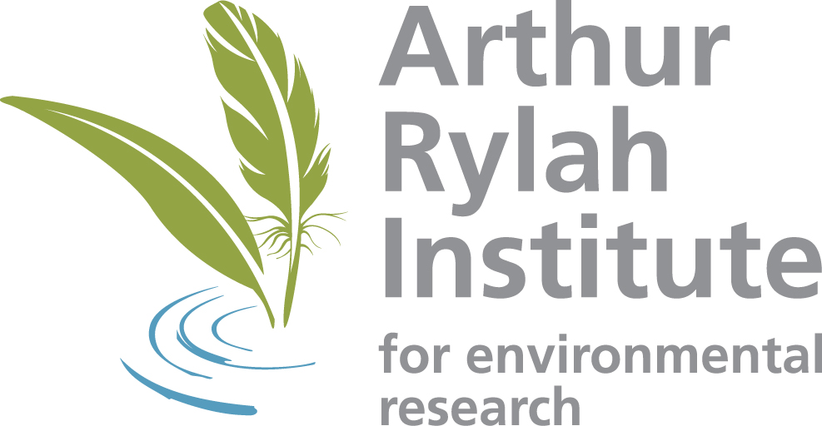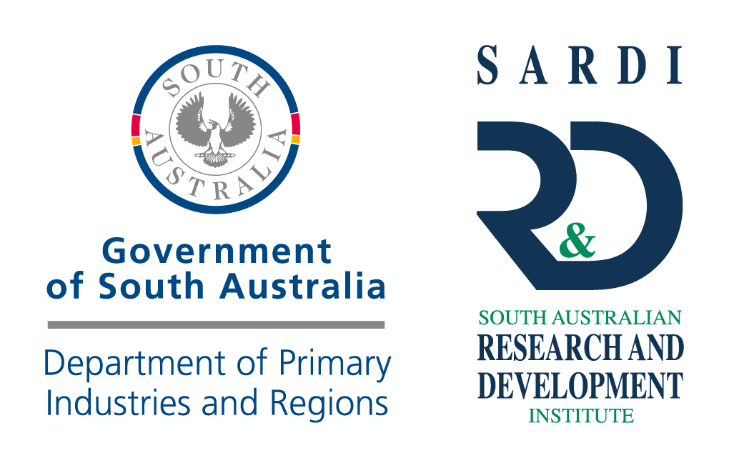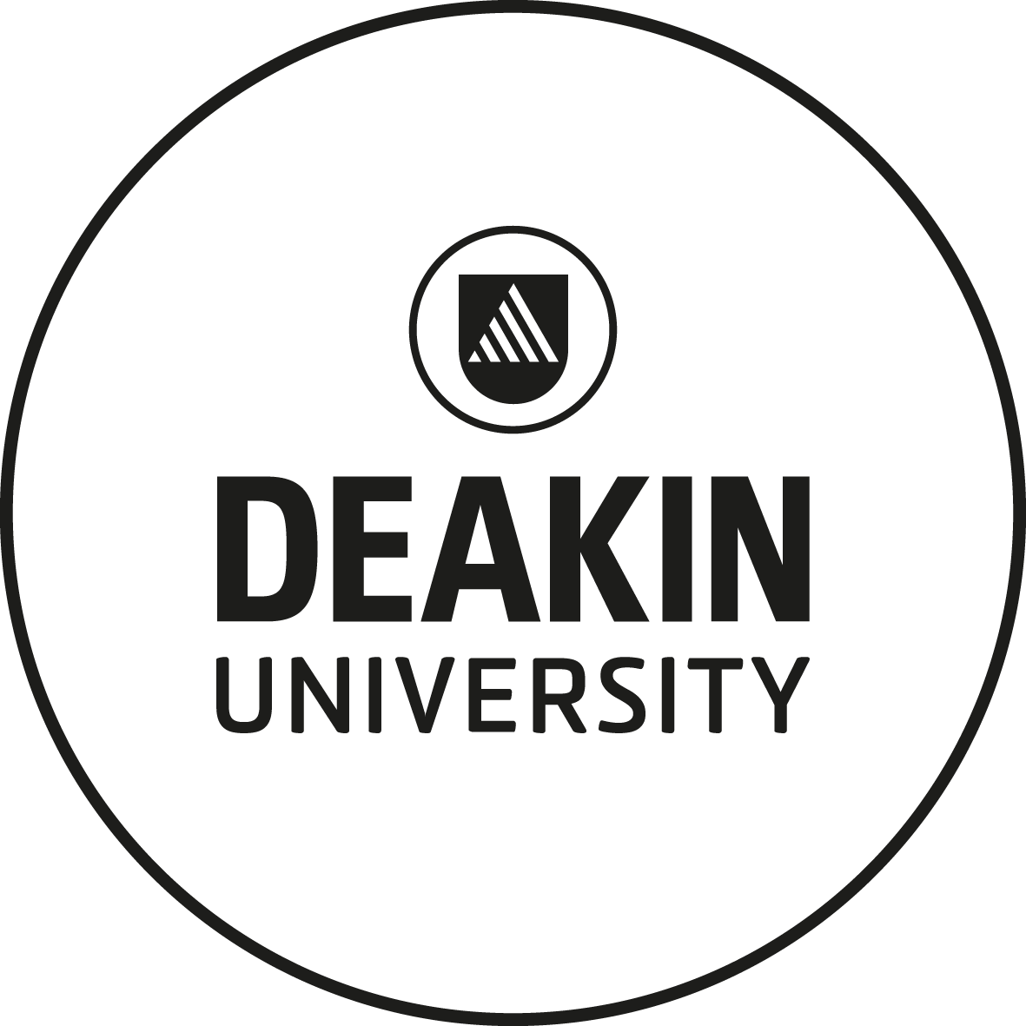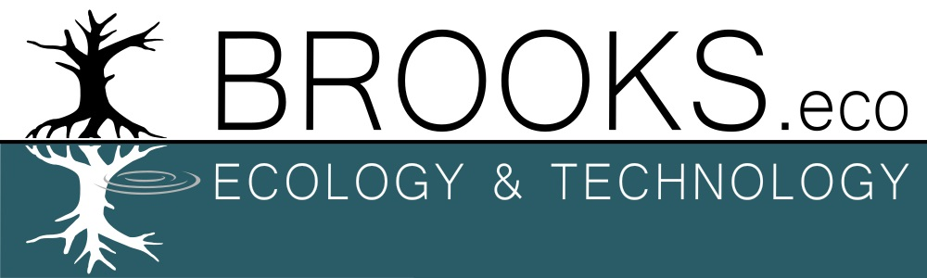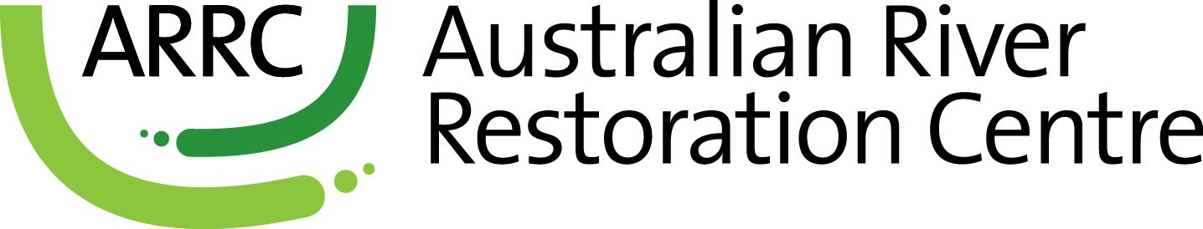

**Partners**

**Collaborators**