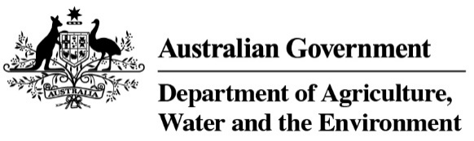
Finalised Priority Assessment List for the National Heritage List for 2021–22
Name of Place | Description | Assessment Completion Date | Main Classification | Reasons for Inclusion
Beechworth Administrative Precinct (Year 2) | Outstanding example of a goldfields administrative precinct that retains all of the critical elements representative of the gold miners’ experience of government. The discriminatory governance imposed upon the Chinese migrants during the goldrushes can also be told through this place. | 30 June 2026 | Historic | The place may meet one or more of the National Heritage criteria (s.324D). Additional information provided following the Year 1 nomination whichs addressed issues from last year’s nomination and demonstrates outstanding values.
Papunya (Year 1) | Papunya supported the growth of the Papuyna Tula Artists cooperative (Australia's first Aboriginal arts company and foreshadowed the federal government shift in Indigenous policies from assimilation to self-determination), and the Waumpi Band (first to gain acclaim singing in an Indigenous language). | 30 June 2027 | Indigenous | The place may meet one or more of the National Heritage criteria (s.324D). Strong nomination with an Indigenous heritage theme and support from a senior Traditional owner.
Victorian Trades Hall and Literary Institute (Year 1) | Significant as a symbol of the importance of organised labour within Australian society, and as an outstanding example of a Trades Hall. It is a highly intact demonstration of the operation of trades unions and the trades councils. | 30 June 2027 | Historic | The place may meet one or more of the National Heritage criteria (s.324D). Strong nomination. Currently an underrepresented theme on NHL.

