# Fact sheet

# Information for mining operators

# South-east Commonwealth Marine Reserves Network Management Plan 2013-23

All petroleum and other mining operators who currently conduct, or intend to conduct operations within the South-east Commonwealth Marine Reserves Network need to be aware of the new management arrangements in the South-east Commonwealth Marine Reserves Network Management Plan 2013‑23 (the Management Plan). The Management Plan came into effect on 1 July 2013 and will be in place for 10 years. The Management Plan replaces the interim management arrangements and approvals that have been in place since the network was established in 2007.

## Mining operations in the South-east marine reserves

The Management Plan allows for mining operations in Special Purpose and Multiple Use zones (IUCN VI) within the South-east Commonwealth Marine Reserves Network. All mining operations in Commonwealth marine reserves, with the exception of vessel transit, require authorisation by the Director of National Parks. Authorisation is granted through a permit and, in some instances through a class approval. Section 5.8 of the Management Plan deals with petroleum and other mining operations, including exploration, and Section 5.2 deals with the issuing and management of permits and class approvals.

## Permits

Operators wishing to undertake activities not covered by a class approval (see below) need to apply for a permit from the Director of National Parks. Information on permits and application forms can be obtained by emailing: marinereserves@environment.gov.au

## Class Approvals

Class approvals authorise a class of persons to undertake a type of activity provided the activity is carried out as specified in the approval. Where possible, class approvals are used to avoid duplication and streamline assessment and approval processes. A class approval can only be issued if the operations are not likely to have an unacceptable impact on relevant conservation values and will be conducted in a manner consistent with achieving the objectives of the Management Plan.

The Director of National Parks will work with industry and relevant sectors to develop a class approval to authorise low impact mining activities.

Additionally, two class approvals have been issued by the Director of National Parks at the time the South-east Management Plan has come into effect:

* the *Mining Class Approval* authorises those mining operations that are assessed and approved as ‘controlled actions’under Part 9 of the *Environment Protection and Biodiversity Conservation Act 1999* (EPBC Act) and those that are authorised to be undertaken in a particular manner under Part 7 of the EPBC Act; and
* the *Mining Class Approval – Not Controlled Action* authorises operations that have been subject to a decision under s.75 of the EPBC Act that the activity is not a controlled action.

## Mining authorisation process for the South-east Commonwealth Marine Reserves Network

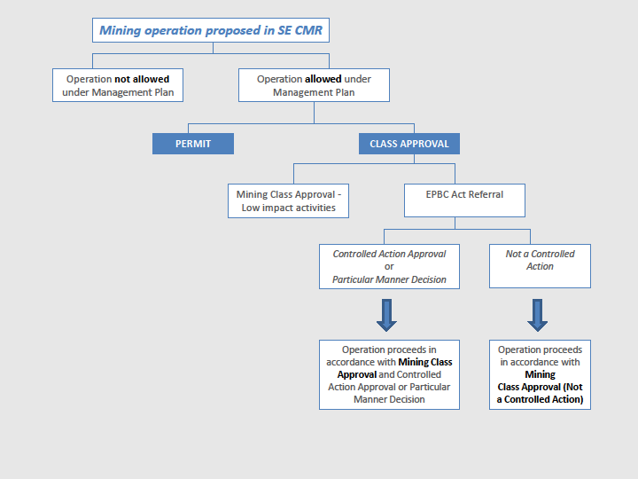

## Conditions for mining operations

Class approvals and permits set out the conditions that mining operators must follow when operating in the South-east marine reserves. These conditions will ensure that the values of the marine reserve are protected.

It is important that mining operators are aware of the conditions of the class approval or permit and adhere to these when operating in the South-east Commonwealth Marine Reserves Network.

## Summary of management arrangements for mining operations in the South-eastCommonwealth Marine Reserves Network

|  |  |  |  |  |  |  |
| --- | --- | --- | --- | --- | --- | --- |
| **Activity** | Sanctuary Zone (IUCN Ia) | Marine National Park Zone (IUCN II) | Habitat Protection Zone (IUCN IV) | Recreational Use Zone (IUCN VI) | Special Purpose Zone (IUCN VI) | Multiple Use Zone (IUCN VI) |
| Mining ‑ (approved under Part 7 or 9 of the EPBC Act) | 🗶 | 🗶 | 🗶 | 🗶 | CA | CA |
| Mining ‑ (other than authorised under Part 7 or 9 of the EPBC Act) | 🗶 | 🗶 | 🗶 | 🗶 | P/CA | P/CA |
| Vessel transiting | ✓  | ✓ | ✓ | ✓ | ✓ | ✓ |

✓ Activity is allowed in accordance with plan prescriptions (without the need for a permit or class approval).

🗶 Activity is not allowed at all (i.e. totally prohibited).

CA Activity is allowable in specified zones in accordance with a class approval issued by the Director of National Parks.

P/CA Activity is allowable in specified zones in accordance with a permit (if the operation is not authorised under

Part 7 or Part 9 of the EPBC Act) or a class approval (if the operation is authorised under Part 7 or Part 9 of

the EPBC Act) issued by the Director.

## Further information

The South-east Commonwealth Marine Reserves Network Management Plan, the South-east mining class approval and a range of supporting maps are available on the Australian Government Department of Sustainability, Environment, Water, Population and Communities’ website: [**www.environment.gov.au/marinereserves**](http://www.environment.gov.au/marinereserves)

If you have any enquiries regarding the Management Plan or the management arrangements for mining operations please contact:

Manager

South-east Commonwealth Marine Reserves Network

Parks Australia

GPO Box 787

CANBERRA ACT 2601

Telephone: 1800 069 352

Email: marinereserves@environment.gov.au