Consumer Research Report
The effect of front-of-pack plant-based protein product and dairy alternative labelling on consumer perceptions

© Commonwealth of Australia 2025
Ownership of intellectual property rights
Unless otherwise noted, copyright (and any other intellectual property rights) in this publication is owned by the Commonwealth of Australia (referred to as the Commonwealth).
Creative Commons licence
All material in this publication is licensed under a Creative Commons Attribution 4.0 International Licence except content supplied by third parties, logos and the Commonwealth Coat of Arms.

Cataloguing data
This publication (and any material sourced from it) should be attributed as: FSANZ 2024, Consumer Research Report: The effect of front-of-pack plant-based protein product and dairy alternative labelling on consumer perceptions, Food Standards Australia New Zealand, Canberra, Australia and Wellington, New Zealand. CC BY 4.0.
This publication is available at agriculture.gov.au/agriculture-land/farm-food-drought/food/plant-based-alternative-product-labelling.
Department of Agriculture, Fisheries and Forestry
GPO Box 858 Canberra ACT 2601
Telephone 1800 900 090
Web agriculture.gov.au
Disclaimer
The Australian Government acting through the Department of Agriculture, Fisheries and Forestry has exercised due care and skill in preparing and compiling the information and data in this publication. Notwithstanding, the Department of Agriculture, Fisheries and Forestry, its employees and advisers disclaim all liability, including liability for negligence and for any loss, damage, injury, expense or cost incurred by any person as a result of accessing, using or relying on any of the information or data in this publication to the maximum extent permitted by law.
Acknowledgements
The authors thank survey participants for their input and teams at DAFF and FSANZ for supporting the development of the report.
Acknowledgement of Country
We acknowledge the continuous connection of First Nations Traditional Owners and Custodians to the lands, seas and waters of Australia. We recognise their care for and cultivation of Country. We pay respect to Elders past and present, and recognise their knowledge and contribution to the productivity, innovation and sustainability of Australia’s agriculture, fisheries and forestry industries.
Contents
Introduction 1
Research objectives 1
Scope 1
Background 2
Methods 4
Design 4
Piloting 4
Participants and sampling approach 5
Stimuli 6
Measures 7
Data analysis 9
Results 12
Demographics 12
Identification of product ingredient content 16
Length of time to identify product ingredient content 18
Ease of identification of product ingredient content 22
Confidence in understanding of product’s intended use 25
Perceptions of nutritional similarity 28
Motives for consuming plant-based protein products 30
Motives for consuming plant-based dairy alternatives 30
Discussion 31
Overall findings 32
Appendix A: Visual overview of the RCT groups 37
Appendix B: Survey instrument 38
Section 1: Screening 38
Section 3: Baseline measures 41
Section 4: Demographics 43
Appendix C: Product images 45
Group 1 – Plant-based control, no meat/dairy term or animal image 45
Group 2 – Meat/dairy term only 46
Group 3 – Animal image only 47
Group 4 – Qualifier not co-located 48
Group 5 – Smaller qualifier 49
Appendix D: Full ANCOVA results controlling for baseline measures 59
Identification of product ingredient content 59
Ease of identification of product ingredient content 60
Perceptions of nutritional similarity 62
References 63
Tables
Table 1 Groups by labelling element tested 6
Table 2 Product types tested 7
Table 3 Key participant characteristics across each group 13
Table 4 Ingredient content ratings: Descriptive statistics for each label group for plant-based protein products 16
Table 5 Ingredient content ratings: Descriptive statistics for each label group for plant-based dairy alternatives 17
Table 6 Time taken (in seconds) for participants to identify product ingredient content for plant-based protein products 20
Table 7 Time taken (in seconds) for participants to identify product ingredient content for plant-based dairy alternatives. 20
Table 8 Ease of product content identification: Descriptive statistics for each label group for plant-based protein products 23
Table 9 Ease of product content identification: Descriptive statistics for each label group for plant-based dairy alternatives 23
Table 10 Confidence in products’ intended use for plant-based protein products 26
Table 11 Confidence in products’ intended use for plant-based dairy alternatives 26
Table 12 Similarity in nutritional content: Descriptive statistics for each label group. 29
Table 13 Mean and SD for consumers’ motivation for consuming plant-based protein products. 30
Table 14 Motivation for consuming plant-based dairy alternatives. 31
Table 15 Survey instrument: questions 1 to 5 38
Table 16 Survey instrument: questions 6 to10 39
Table 17 Survey instrument: questions 11 to 12 41
Table 18 Survey instrument: questions 13 to 20 41
Table 19 Survey instrument: questions 21 to 25 43
Table 20 Identification of product ingredient content by group for plant-based protein products 59
Table 21 Identification of product ingredient content by group for plant-based dairy alternatives 60
Table 22 Identification of product ingredient content by group for plant-based protein products 61
Table 23 Identification of product ingredient content by group for plant-based dairy alternatives 61
Table 24 Perceptions of nutritional similarity by group 62
Figures
Figure 1 Mean ratings of ingredient content for protein products 18
Figure 2 Mean ratings of ingredient content for dairy alternatives 18
Figure 3 Mean time (seconds) taken to identify ingredient content of protein products. Error bars represent standard deviation 21
Figure 4 Mean time (seconds) taken to identify ingredient content of dairy alternatives. Error bars represent standard deviation 21
Figure 5 Mean ratings for ease of identifying ingredient content for protein products 23
Figure 6 Mean ratings for ease of identifying ingredient content for dairy alternatives 24
Figure 7 Mean ratings for confidence in intended use of protein products 27
Figure 8 Mean ratings for confidence in intended use of dairy alternatives 28
Figure 9 Mean ratings of nutritional similarity compared to an animal-based counterpart. Error bars represent standard deviation. 29
Figure 10 Overview of the 12 RCT groups and their labelling elements 37
Figure 11 Group 1 protein products 45
Figure 12 Group 1 dairy alternatives 46
Figure 13 Group 2 protein products 46
Figure 14 Group 2 dairy alternatives 47
Figure 15 Group 3 protein products 47
Figure 16 Group 3 dairy alternatives 48
Figure 17 Group 4 protein products 48
Figure 18 Group 4 dairy alternatives 49
Figure 19 Group 5 protein products 49
Figure 20 Group 5 dairy alternatives 50
Figure 21 Group 6 protein products 50
Figure 22 Group 6 dairy alternatives 51
Figure 23 Group 7 protein products 51
Figure 24 Group 7 dairy alternatives 52
Figure 25 Group 8 protein products 52
Figure 26 Group 8 dairy alternatives 53
Figure 27 Group 9 protein products 53
Figure 28 Group 9 dairy products 54
Figure 29 Group 10 protein products 54
Figure 30 Group 10 dairy alternatives 55
Figure 31 Group 11 protein products 55
Figure 32 Group 11 dairy alternatives 56
Figure 33 Group 12 protein products 56
Figure 34 Group 12 dairy products 57
Figure 35 Protein products 57
Figure 36 Dairy products 58

Introduction
Over a number of years, concerns have been raised by meat and dairy industries in Australia that the labelling and presentation of plant-based protein products and dairy alternatives may be misleading to consumers. In particular, that the labelling of these products may mislead consumers about their ingredient content (plant vs animal) and/or their nutritional similarity with conventional counterparts. The issue was considered by the Food Regulation Standing Committee in 2018 and the Senate Rural and Regional Affairs and Transport Legislation Committee in 2022, with both bodies noting a lack of independent, peer-reviewed research to inform consideration.
Food Standards Australia New Zealand (FSANZ) was commissioned by the Department of Agriculture, Fisheries and Forestry to undertake consumer research to build the evidence-base to inform policy considerations around plant-based protein and dairy alternative product labelling. FSANZ is an independent statutory authority with expertise in undertaking research on consumer attitudes, perceptions and behaviours regarding food. This document reports on the outcomes of this research.

Research objectives
The objective of the research was to examine how different labelling elements on the front-of-pack labelling of plant-based protein and dairy alternative products influence consumers’ perceptions of their ingredient content and nutritional similarity to a conventional counterpart, and confidence in their understanding of the products’ intended use.
The study sought to answer the following research questions:
- Do any of the labelling elements (when controlling for demographic/baseline characteristics) tested (meat/dairy terminology, animal imagery, size and location of ingredient qualifiers, plus any combination of 2 of these elements) significantly affect:
  - consumers’ ability to accurately identify the ingredient content (that is, whether they were plant or animal based) of plant-based protein products and/or dairy alternatives.
  - the length of time consumers takes to assess the ingredient content.
  - consumers’ perceived ease of identifying the ingredient content.
  - consumers’ confidence in their understanding of the product’s intended use; and
  - the extent to which consumers think the product is nutritionally similar to its conventional counterpart?
- Do labelling effects differ based on the type of plant-based product (i.e. plant-based protein products vs plant-based dairy alternatives)?
- What are consumers’ motivations for consuming plant-based protein products and plant-based dairy alternatives?

Scope
It is not possible to test every possible labelling element or combination of labelling elements for plant-based protein and dairy alternatives. The following labelling elements were tested:
- meat/dairy terminology (e.g. ‘beef’, ‘chicken’, ‘milk’)
- animal imagery (e.g. depictions of a cow or chicken)
- location of ingredient qualifier in relation to the name of the food
- size of ingredient qualifier in relation to the name of the food.
These labelling elements were included in the study because they:
- represent elements of particular concern to industry stakeholders (meat/dairy terminology, animal imagery)
- have been identified in the literature as a potential source of confusion (e.g. animal imagery)
- were found to be prevalent in the market survey (meat/dairy terminology, ingredient qualifiers)
- are addressed in voluntary industry guidelines (meat/dairy terminology, animal imagery, ingredient qualifiers).
The research did not examine the effect of combinations of 3 or more of the identified labelling elements as these were not prevalent in the market survey.
The research also did not examine the effect of utility terms (e.g. burger, mince, tenders) because there is no clear definition of utility terms, no equivalent terms exist among dairy alternatives, and there is no evidence to suggest that (or which) utility terms are likely to lead to a greater level of misidentification.

Background

Current labelling regulations
There are no specific labelling requirements for plant-based protein and dairy alternative products in the Australia New Zealand Food Standards Code. As such, manufacturers must adhere to general labelling requirements, including that, unless prescribed, the name of a food must be sufficient to indicate its true nature.
Some foods, including milk and some meat products, are defined in the Code and can only be sold using that name if they meet the definition and any compositional requirements. However, the Code (section 1.1.1 to 13(4)) also allows the use of these terms if a qualifying descriptor makes it clear the food is not a food as defined in the Code. For example, ‘soy milk’, ‘chicken-free chicken’ and ‘peanut butter’ are permitted to be used on product labels despite milk, chicken, and butter being standardised foods.
Requirements in the Code work in conjunction with Australian consumer law, which prohibits:
- misleading or deceptive conduct
- making false or misleading representations about the quality, quantity, composition or origin of products, including food products.
Australian consumer law includes the Competition and Consumer Act 2010, along with other state and territory consumer laws, and is enforced by the Australian Competition and Consumer Commission.

Literature review
In Phase 1 of this research project, FSANZ undertook a rapid review of evidence concerning the effect of meat or dairy terminology, utility terms, and/or animal images on consumer understanding of the nature of plant-based protein or dairy alternatives.
The literature review identified 16 documents, reporting 17 unique studies. These studies were primarily grey literature, which often did not contain sufficient methodological detail to ascertain risk of bias. All peer reviewed literature was undertaken outside of Australia, which limits its generalisability to the Australian context.
Overall, 2studies suggested that up to 25% of Australian consumers may be confused by plant-based protein labelling currently on the market. However, methodological issues reduce confidence in the findings, and the studies did not investigate the cause of the confusion. International studies that used an experimental design suggest it is animal imagery, rather than meat terminology, that confuses consumers.
The evidence identified by the literature review was less clear on the prevalence of consumer confusion in respect of plant-based dairy alternatives. The limited evidence available suggested that the vast majority of consumers correctly understand the ingredient content of these products. International studies once again suggested that it may be animal imagery, rather than dairy terminology, that causes any confusion.

Market survey
In Phase 1of this research project, FSANZ undertook a market survey of plant-based protein and dairy alternative products currently available on the market. Preliminary results based on 610 total products (230 plant-based protein products, 4 plant-based eggs and 376 plant-based dairy alternatives) were used to inform the labelling elements to be tested and the design of mock product images.

Methods

Design
The current study consisted of an online, randomised controlled trial (RCT) with a 12 (label type) x 2 (product category: meat vs dairy) mixed design. Type of label was varied between subjects, meaning that each participant only viewed 1type of label. Product category was varied within subjects, meaning that each participant viewed both meat and dairy products. See Appendix A for a visual overview of the RCT design of the survey.
This design fills an identified gap in the existing evidence. No RCTs have been undertaken in the Australian context. The surveys that have been undertaken in Australia to date were only able to provide correlational, not causal findings, and were not able to distinguish the different parts of the label that may be having an effect on consumer understanding. In comparison, RCTs are considered to be the ‘gold standard’ research design for determining cause-and-effect and enable us to isolate the effect that different parts of the label have on consumer confusion.

Piloting
The survey was first piloted on 217 participants, broadly representative of the general population (non-interlocking quotas on age, gender, and state/territory location) in order to identify any possible issues with question wording. Pilot participants were recruited from PureProfile’s Australian online market research panel. An open-ended question was included at the end of the pilot survey asking participants for any feedback or suggestions for survey improvement.
It was detected during the first pilot that participants’ answers to the question around nutritional equivalence/similarity were clustered around the midpoint on a five-point Likert scale, including in the group that was asked to nutritionally compare an animal-based meat/dairy product with a similar animal-based meat/dairy product. This suggested that the question wording discouraged participants from identifying that 2products were nutritionally equivalent, regardless of the similarity of their ingredient content. The questionnaire was revised to ask about nutritional similarity rather than equivalence, and to employ a four-point rather than a five-point Likert scale, with the midpoint being removed.
The survey was then piloted a second time on a sample of 251 participants. The results from the second pilot showed a clear distinction between the group that was asked to compare 2animal-based products versus those that were asked to compare a plant-based and an animal-based product.
Due to the revisions made to the survey, the first pilot participants were excluded from the final sample. No revisions were made to the survey following the second pilot, and as such the second pilot participants were included in the final sample.

Participants and sampling approach
Australian participants were recruited from PureProfile’s online market research panel and completed the study between 9 and 19 September 2024. Participants were eligible to complete the study if they were at least 18 years of age, and were not currently employed in the animal meat, animal dairy, plant-based meat alternatives, or plant-based dairy alternatives industries.
The sample was nationally representative based on the interlocking quotas of age, gender, and location, according to the 2021 ABS Census. Soft quotas were also used for Aboriginal and Torres Strait Islander participants (approximately 3.2%), reflecting census proportions.
A total of 2,946 participants completed the study. A priori power analysis using G*Power software indicated that a sample size of at least 2,880 (240 per group) would be required to detect small to medium effects (power = 0.80, alpha = 0.001 to correct for multiple comparisons). The anticipated small to medium effects (Cohen’s d of at least 0.38) is estimated based on previous research examining the effects of meat/dairy terminology and animal imagery on consumer perceptions of plant-based food products (Baptista & Schifferstein (2023); De-Loyde et al. 2023). The higher target sample size of 2,900 was designed to account for any potential data exclusions.

Procedure
Participants were randomly allocated to 1 of 12 different groups, with quotas used to ensure approximate equal allocation to each group. Groups were differentiated by the labelling they viewed on the products (see Table 1 and Appendix A). There were 2control groups. Group 1 served as the plant-based control group, while Group 12 served as the animal-based control group.
Each group was shown 8 different mock products (4 types of plant-based protein products and 4 types of plant-based dairy alternatives) with their allocated label type. All participants rated these 8 product images on a series of five- or four-point Likert scales (see the survey instrument in Appendix B for the exact question wording and response scales) according to:
- the extent to which they think the product contains plant- or animal-based meat/dairy
- how easy or hard they found it to answer the previous question
- how confident they are that they understand the intended use of the product
- how similar or different they think the product is nutritionally compared to a conventional counterpart.
In addition, the time taken by respondents to answer the ingredient content for the products was logged.
Table 1 Groups by labelling element tested
Group | Meat/dairy terminology | Animal imagery | Ingredient qualifier: location | Ingredient qualifier: size
Group 1 – Plant-based control | Absent | Absent | Co-located with name of food | Same size as name of food
Group 2 | Present | Absent | Co-located with name of food | Same size as name of food
Group 3 | Absent | Present | Co-located with name of food | Same size as name of food
Group 4 | Absent | Absent | Not co-located with name of food | Same size as name of food
Group 5 | Absent | Absent | Co-located with name of food | Smaller than name of food
Group 6 | Present | Present | Co-located with name of food | Same size as name of food
Group 7 | Present | Absent | Not co-located with name of food | Same size as name of food
Group 8 | Present | Absent | Co-located with name of food | Smaller than name of food
Group 9 | Absent | Present | Not co-located with name of food | Same size as name of food
Group 10 | Absent | Present | Co-located with name of food | Smaller than name of food
Group 11 | Absent | Absent | Not co-located with name of food | Smaller than name of food
Group 12 – Animal-based control | Present | Present | Absent | Absent

Stimuli
All participants were shown a total of 8 different mock product images. 4 of these products were plant-based protein products (or, for the group assigned to the animal-based control group, animal meat products) and 4 of these products were plant-based dairy alternatives (or, for the group assigned to the animal-based control group, cow’s milk products).
The product images varied in type (e.g. plant-based burger, plant-based chicken nuggets, etc.) to ensure that the results are generalisable to the most common types of plant-based products currently on the market. Product types tested were selected based on their prevalence in the marketplace as identified in the market survey, and to ensure a variety of different meat/dairy terminology and ingredient qualifiers were tested. For example, most common plant-based protein products found in the market survey were coated tender/nugget, uncoated piece/strip, burger patty/meatball and deli meat. The most common plant-based dairy alternatives products were plant-based milk, plant-based cheese and plant-based yoghurt. The product order was randomised.
Table 2 Product types tested
Plant-based protein products | Plant-based dairy alternatives
(Plant-based) Chicken nuggets | (Cashew) Cheese slices
(Vegetarian) Sausage | (Almond) Milk
(Meat-free) Burger patties | (Coconut) Yoghurt
(Vegan) Bacon rasher | (Oat) Milk
In addition, a separate animal-based product was developed for each product category for the nutritional similarity question. This product image was exactly the same between all groups.
The images for each mock product were identical between groups in all respects, except for the presence or absence of the labelling elements outlined in Table 1 (except for the animal-based product used for the nutritional similarity question). Images were of mock products rather than actual products for sale in Australia so as to limit bias that might occur due to pre-existing knowledge/familiarity of the products. All images reflected typical ‘meat or dairy style’ packaging, and labelling design elements were informed by a review of products captured during the market survey. All product images that participants viewed for plant-based protein products and plant-based dairy alternatives are available in Appendix C.
As there were 12 different labelling groups, and 8 different products for each group, and an additional 8 animal-based products (1 for each product type) for the nutritional similarity question, there were 104 different mock product images in total (Appendix C).

Measures
Participants were asked the following questions (in the same order as written). The full survey instrument is provided in Appendix B.

Screening questions
Prior to being randomly allocated to view 1 of the 12 label groups, participants were asked the following screening questions:
- Age (participants must be 18 years or older)
- Gender
- Postcode (participants must be located in Australia)
- Employment in food industry (participants were excluded if they were involved in any of the following industries: animal meat industry, plant-based meat or seafood alternatives, animal diary industry, or plant-based dairy alternatives)
- Cultural background

Questions after random allocation to 1 type of label group (outcome measures)
After being randomly allocated to 1 labelling group (quotas from the screening questions were used for approximately equal allocation), participants were asked to rate 8 different product images (4 x plant-based meat protein, 4 x plant-based dairy alternative) corresponding to their allocated group (1 to 12). Question 9 was included for each product image to try to obfuscate the aim of the research to participants. Each of the 8 product images were rated on the following measures:
- Looking at the product image above, what do you think this product is made from? (response options: 1 - 100% animal (meat/dairy), 2 – mostly animal, 3 – 50% animal (meat/dairy), 4 – mostly plant based, 5 – 100% plant-based)
- How easy or hard was it to answer the previous question (what the product is made from)? (response options: 1 – very hard, 2 – somewhat hard, 3 – neither hard or easy, 4 – somewhat easy, 5 – very easy)
- How confident are you that you understand how this product is intended to be used or consumed? (response options: 1 – very unconfident, 2 – somewhat unconfident, 3 – neither confident or unconfident, 4 – somewhat confident, 5 – very confident)
- Looking at the product image above, what colour stands out the most to you? (white, green, red/orange, yellow, other.
- [For plant-based groups only i.e. labels 1 to 11] Here are 2products. 1 is an animal [meat/cow’s milk] product, and the other is a plant-based [meat/dairy] alternative. Based on the product images above, how similar or different do you think their nutritional content would be?
[For animal-based only i.e. label 12] Here are 2[animal meat/cow’s milk] products. How likely do you think it is that these 2products would have the same nutritional content?
Given the repetitive nature of Questions 6 to 10 (as participants had to answer each question 8 times), 2questions were inserted (between the third and fourth products viewed, and the sixth and seventh products viewed) to check whether participants were paying attention to the survey. Participants were excluded from the final dataset if they failed both attention check questions to ensure data quality (n = 0). The ‘attention check’ questions are available in the full survey instrument in Appendix B.
- Attention check question
- Attention check question

Demographic/baseline questions
After completing the outcome measures for each of the 8 images participants were asked the following demographic/baseline questions:
- Plant-based meat alternatives consumption
- Plant-based dairy alternatives consumption
- Plant-based meat alternatives consumption
- Plant-based dairy alternatives consumption
- If anyone in their household consumes plant-based meat alternatives (if no to 13)
- If anyone in their household consumes plant-based dairy alternative (if no to 14)
- Motives for consuming plant-based meat alternatives
- Motives for consuming plant-based dairy alternatives
- Education
- Language spoken at home
- Household income
- Dietary pattern
- Household food shopper status

Data analysis
Data cleaning, manipulation and visualisation were conducted using the ‘Tidyverse’ (Version 2.0.0) package in R statistical software (Version 4.4.0). Data analysis was conducted using IBM SPSS Statistics software (Version 28).

Data manipulations

Demographic/baseline measures
Education was recategorised into those who had completed tertiary education (defined as those who selected ‘Undergraduate degree’ or ‘Postgraduate degree’ to question 21) and those who had no tertiary education (defined as those who selected ‘high school or below’ or ‘vocational/trade qualification’).
Household income was recategorised into low income, middle income and high income based on the distribution of the response to question 23. Low income was those who selected ‘Under $25,000’ or ‘$25,000 to $56,000’. Middle income was those who selected ‘$56,001 to $93,000’ or ‘$93,001 to $143,000’. High income was those who selected ‘$143,001 to $288,000’ or ‘above $288,000’.
Cultural background (question 5) was recategorised into ‘European background’ (those who selected at least 1 type of European cultural background, including Australian/New Zealand background), ‘no European background’ (those who did not select at least 1 type of European cultural background) and ‘prefer not to say’.
When dietary patterns were entered into the ANCOVA models the groups ‘vegan’, ‘vegetarian’ and ‘flexitarian/pescatarian’ were combined due to low numbers. This resulted in 2categories for dietary patterns (‘omnivore’ vs ‘vegan/vegetarian/flexitarian/pescatarian’).
An overall measure of participants’ consumption of both plant-based protein products and plant-based dairy alternatives was calculated by summing participants’ responses to questions 13 to 16, giving each participant a score ranging from 0 to 10. Participants were assigned zero points if they selected ‘no’ or ‘don’t know’ to questions 13 and 15. Participants who selected ‘yes’ to questions 13 and 15 were assigned the following points for their response to questions 14 and 16: 1 – ‘less than once a month’, 2 – ‘around once a month’, 3 – ‘several times a month’, 4 – ‘several times a week’, 5 – ‘everyday’. Participants were categorised by the following:
- ‘Do not consume/don’t know’ if they scored zero on the scale
- ‘Occasional consumer’ if they scored greater than zero less than 5 on the scale
- ‘Regular consumer’ if they scored 5 or greater on the scale.

Outcome measures
Participants’ ratings for the outcome measures (content, ease of choice, confidence in understanding and nutritional similarity; see Question 6 to 10 above) for each of the 8 mock products were averaged across each product category (i.e. the average of 4 ratings for protein products and the average of 4 ratings for dairy alternatives) to obtain 1 overall value for each of the 4 measures, for each product category, for each participant. No outliers were removed.
For the length of time taken to identify the content of the products, outliers were removed for each participant by product category. Outliers were defined as either 1.5 x the individual participant’s Interquartile Range (IQR) below the 25th quartile or 1.5 x the IQR above the 75th quartile (Dash (2023)). Participants’ average duration for each product category was then calculated from their remaining assessments. Overall group outliers in the mean duration by product category per participant (n = 156 for meat, n = 155 for dairy, n = 69 for both meat and dairy) were then removed from the overall sample using the same outlier criteria as defined earlier.

Descriptive statistics
Descriptive statistics (percentages, group means, standard deviations) are reported where appropriate.
Descriptive statistics are provided for all 12 groups where a significant product category x between-group interaction effect was detected (identification of product ingredient content, speed of identification of product ingredient content, ease of identification of product ingredient content, and confidence in understanding of product’s intended use). Where measures did not statistically differ across different food categories, but between-group differences did exist (perceptions of nutritional similarity), descriptive statistics are only provided for each of the 12 different label groups overall.

Significance testing and effect sizes
Throughout this report, ‘statistically significant’ effects refer to effects that are unlikely to be due to chance. Statistical significance does not refer to the size of an effect (e.g. an effect can be both small and statistically significant).
For continuous measures (Questions 6 to 10), two-way mixed ANOVAs (type of label element(s) x product category) were used to determine whether there is a statistically significant main effect of label type and a statistically significant interaction between label element(s) and product category (i.e. whether any label element(s) effects differ depending on the type of product category examined).
For follow-up t-tests, planned comparisons were made as described in the Design section. That is, to isolate whether there were any effects of the labelling element(s) tested, Groups 2 to 11 were compared to Group 1 (the plant-based control). To isolate whether there were effects of plant-based labelling element(s) versus an equivalent animal product Groups 2 to 11 were compared to Group 12 (the animal control).
Alpha levels (i.e. p-value thresholds for statistical significance) were corrected using a Bonferroni correction for multiple comparisons. Thus, an alpha level of .01 was used when comparisons were only made between label element(s) groups, whereas an alpha level of .001 was used when comparisons were made between label element(s) groups for each product category (to account for the higher number of comparisons). Although this alpha level was conservative, note that the power analysis accounted for this (see Participants and sampling approach).
Effects sizes (Cohen’s d) were calculated using the following equation (Lakens 2013):
$$d=\frac{\left.M_{1}-M_{2}\right.}{\sqrt{\frac{(n_{1}-1){{SD}_{1}}^{2}+(n_{2}-1){{SD}_{2}}^{2}}{n_{1}+n_{2}-2}}}$$
A Cohen’s d value of 0.2 is considered to be a small effect size, 0.5 a medium effect size, whereas 0.8 is considered a large effect size (Cohen (1988)).

Sensitivity analyses
All significance testing was repeated using a two-way mixed ANCOVA while controlling for baseline measures (age, gender (female vs male), region (metro vs regional), overall plant-based consumption, language spoken at home (English vs other), household income (low, middle, high), State/Territory, cultural background (European vs non-European), education (tertiary vs no tertiary), diet (omnivore vs vegetarian/vegan/flexitarian/pescetarian). Controlling for baseline measures statistically removes any effect that any baseline characteristics may have.
In analyses that controlled for baseline measures a small number of participants had to be excluded due to small sample sizes in some groups (e.g. participants who did not identify as either male or female were excluded when gender was entered into the analysis). Although results are reported both with and without controlling for baseline measures, where results were inconsistent between the ANOVA and ANCOVA model for the same outcome measure, the results from the ANCOVA with bootstrapping is reported in-depth, as it is the more robust result. Adjusted means (means adjusted for baseline measures), standard errors and confidence intervals are provided where ANCOVA results are reported.
For continuous measures, we used two-way factorial ANCOVAs to control for baseline measures. For some ANCOVA tests, it was not possible to enter all baseline measures as covariates in the model. This was where some covariates violated statistical assumptions of the ANCOVA (i.e. homogeneity of regression slopes). Homogeneity of regression slopes refers to the statistical assumption that the covariate (i.e. the variable to be controlled for) has the same relationship with the outcome measure across the different levels of the independent variables. Failure to meet this assumption questions the validity of the ANCOVA test (Field (2018)).
For all statistical tests, all relevant statistical assumptions were tested and met (e.g. homogeneity of variance, no multicollinearity, linearity of the logit, etc.; Field (2018)). Although some statisticians consider that normality testing is not required when sample sizes are large, there is no clear consensus on how large is large enough, particularly when data are highly skewed. Thus, a bootstrapping procedure was used when data were highly skewed, to increase confidence in the findings. Bootstrapping does not assume normality and is also robust in the presence of outliers (Field (2018)). A bootstrapping procedure estimates the shape of the sampling distribution by taking 2,000 samples of the data.

Results

Demographics
The sample consisted of 2,962 Australian consumers aged 18 to 90 years. The sample was nationally representative by the interlocking demographics of age, gender, and state/territory. We slightly oversampled Aboriginal and Torres Strait Islanders (4.1%). Table 3 provides a summary of the key participant characteristics across each group.
Table 3 Key participant characteristics across each group
Category | Demographics | Group 1  (n = 245) | Group 2  (n = 247) | Group 3  (n = 246) | Group 4  (n = 246) | Group 5  (n = 244) | Group 6  (n = 246) | Group 7  (n = 244) | Group (n = 245) |  | Group 9  (n = 245) | Group 10  (n = 245) |  | Group 11  (n = 245) |  | Group 12  (n = 247) |  | Total  (n = 2,946)
Age | Mean (SD) | 46.93 (17.50) | 46.02 (17.64) | 47.31 (17.49) | 49.26 (16.93) | 45.55 (16.93) | 47.26 (17.45) | 47.04 (17.81) | 49.67 (18.67) | 46.74 (17.98) |  | 46.03 (17.58) | 46.45 (16.99) |  | 47.73 (17.62) |  | 47.17 (17.62)
Gender(%) | Male | 48.2 | 48.6 | 46.3 | 47.2 | 46.7 | 50.4 | 50.8 | 48.8 | 52.7 |  | 46.9 | 45.7 |  | 44.9 |  | 48.1
Gender(%) | Female | 51.8 | 51.4 | 53.3 | 52.0 | 52.5 | 49.6 | 48.8 | 51.2 | 47.3 |  | 52.7 | 54.3 |  | 53.4 |  | 51.5
Gender(%) | Non-binary/another term | 0.0 | 0.0 | 0.4 | 0.4 | 0.4 | 0.0 | 0.4 | 0.0 | 0.0 |  | 0.4 | 0.0 |  | 0.8 |  | 0.2
Gender(%) | Prefer not to say | 0.0 | 0.0 | 0.0 | 0.4 | 0.4 | 0.0 | 0.0 | 0.0 | 0.0 |  | 0.0 | 0.0 |  | 0.8 |  | 0.1
Highest education (%) | No tertiary degree | 50.6 | 51.4 | 52.8 | 55.7 | 52.0 | 49.2 | 55.7 | 54.9 | 50.2 |  | 52.2 | 55.1 |  | 51.0 |  | 52.6
Highest education (%) | Tertiary degree | 49.4 | 48.6 | 47.2 | 44.3 | 48.0 | 50.8 | 44.3 | 45.1 | 49.8 |  | 47.8 | 44.9 |  | 49.0 |  | 47.4
State/territory location (%) | Australian Capital Territory | 2.7 | 1.9 | 2.7 | 1.9 | 2.7 | 1.1 | 1.5 | 1.9 | 1.9 |  | 1.1 | 3.0 |  | 4.2 |  | 2.2
State/territory location (%) | New South Wales | 30.4 | 31.6 | 34.1 | 30.9 | 34.2 | 27.3 | 34.8 | 31.7 | 33.2 |  | 31.2 | 33.3 |  | 32.6 |  | 32.1
State/territory location (%) | Northern Territory | 1.1 | 0.4 | 1.5 | 0.4 | 0.0 | 0.4 | 0.4 | 1.9 | 0.8 |  | 1.1 | 1.1 |  | 0.4 |  | 0.8
State/territory location (%) | Queensland | 19.0 | 19.8 | 21.2 | 23.4 | 20.2 | 21. | 17.4 | 20.4 | 17.0 |  | 23.2 | 17.0 |  | 22.3 |  | 20.2
State/territory location (%) | South Australia | 10.3 | 8.0 | 7.2 | 6.8 | 7.2 | 5.3% | 7.6 | 5.7 | 7.5 |  | 6.5 | 8.3 |  | 6.1 |  | 7.2
State/territory location (%) | Tasmania | 3.8 | 0.0 | 1.9 | 2.6 | 1.1 | 3.4 | 2.7 | 1.5 | 1.1 |  | 2.3 | 1.9 |  | 0.8 |  | 1.9
State/territory location (%) | Victoria | 24.0 | 25.5 | 22.3 | 23.0 | 27.8 | 31.1 | 25.4 | 27.5 | 30.2 |  | 24.0 | 27.3 |  | 24.6 |  | 26.0
State/territory location (%) | Western Australia | 8.7 | 12.9 | 9.1 | 10.9 | 6.8 | 10.2 | 10.2 | 9.4 | 8.3 |  | 10.6 | 8.0 |  | 9.1 |  | 9.5
Metro/regional location (%) | Metro | 70.20 | 74.10 | 75.20 | 72.80 | 70.90 | 75.60 | 72.50 | 75.50 | 72.20 |  | 71.00 | 74.30 |  | 68.00 |  | 72.70
Metro/regional location (%) | Regional | 29.80 | 25.90 | 24.80 | 27.20 | 29.10 | 24.40 | 27.50 | 24.50 | 27.80 |  | 29.00 | 25.70 |  | 32.00 |  | 27.30
European background (%) | European background | 84.9 | 84.6 | 83.3 | 85.4 | 88.5 | 82.5 | 84.0 | 82.5 | 82.0 |  | 87.8 | 85.3 |  | 86.6 |  | 84.8
European background (%) | No European background | 14.3 | 15.0 | 15.0 | 12.6 | 9.8 | 15.0 | 14.8 | 16.7 | 15.5 |  | 11.4 | 14.3 |  | 12.1 |  | 13.9
European background (%) | Prefer not to say | 0.8 | 0.4 | 1.6 | 2.0 | 1.6 | 2.4 | 1.2 | 0.8 | 2.4 |  | 0.8 | 0.4 |  | 1.2 |  | 1.3
Language other than English spoken at home (%) | English only | 89.8 | 91.5 | 89.0 | 88.6 | 89.3 | 89.0 | 88.5 | 87.4 | 89.4 |  | 89.8 | 88.2 |  | 90.7 |  | 89.3
Language other than English spoken at home (%) | Other language | 10.2 | 8.5 | 11.0 | 11.4 | 10.7 | 11.0 | 11.5 | 12.6 | 10.6 |  | 10.2 | 11.8 |  | 9.3 |  | 10.7
Household income (%) | Low income (Nil to $56,000) | 20.4 | 25.1 | 18.7 | 21.1 | 24.2 | 23.2 | 20.1 | 24.4 | 20.8 |  | 22.4 | 23.3 |  | 23.1 |  | 22.2
Household income (%) | Middle income ($56,001 – $143,000) | 45.3 | 40.9 | 39.0 | 41.1 | 39.8 | 37.8 | 48.0 | 42.7 | 46.5 |  | 45.3 | 41.6 |  | 43.3 |  | 42.6
Household income (%) | High income (above $143,001) | 24.9 | 26.7 | 32.1 | 25.6 | 25.0 | 31.3 | 26.6 | 22.8 | 25.7 |  | 23.7 | 25.7 |  | 23.9 |  | 26.2
Household income (%) | Prefer not to say | 9.4 | 7.3 | 10.2 | 12.2 | 11.1 | 7.7 | 5.3 | 10.2 | 6.9 |  | 8.6 | 9.4 |  | 9.7 |  | 9.0
Shopper status (%) | Minority of shopping | 4.1 | 2.4 | 5.7 | 6.9 | 4.9 | 4.5 | 3.7 | 5.3 | 8.6 |  | 4.1 | 4.9 |  | 6.1 |  | 5.1
Shopper status (%) | Shares shopping | 29.8 | 29.1 | 27.2 | 28.9 | 26.2 | 35.0 | 29.9 | 25.2 | 29.0 |  | 33.5 | 32.7 |  | 26.7 |  | 29.4
Shopper status (%) | Majority of shopping | 66.1 | 68.4 | 67.1 | 64.2 | 68.9 | 60.6 | 66.4 | 69.5 | 62.4 |  | 62.4 | 62.4 |  | 67.2 |  | 65.5
Dietary pattern (%) | Vegan or Vegetarian | 4.1 | 5.7 | 4.9 | 6.1 | 7.0 | 4.1 | 5.3 | 5.7 | 7.3 |  | 6.1 | 6.9 |  | 4.0 |  | 5.6
Dietary pattern (%) | Flexitarian/Pescatarian | 13.5 | 15.0 | 12.6 | 11.8 | 13.1 | 13.0 | 14.3 | 12.2 | 15.5 |  | 12.7 | 17.1 |  | 15.0 |  | 13.8
Dietary pattern (%) | Omnivore | 82.4 | 79.4 | 82.5 | 82.1 | 79.9 | 82.9 | 80.3 | 82.1 | 77.1 |  | 81.2 | 75.9 |  | 81.0 |  | 80.6
Plant-based meat consumption (%) | Never consumed/don’t know | 38.0 | 42.9 | 42.7 | 45.9 | 39.8 | 48.0 | 43.0 | 43.9 | 45.3 |  | 50.2 | 48.6 |  | 47.4 |  | 44.6
Plant-based meat consumption (%) | Less than once a month | 33.5 | 31.2 | 36.6 | 29.3 | 29.9 | 30.1 | 32.0 | 32.9 | 31.0 |  | 26.9 | 23.7 |  | 31.2 |  | 30.7
Plant-based meat consumption (%) | Around once a month | 9.4 | 8.1 | 9.3 | 9.8 | 7.4 | 6.9 | 9.8 | 6.1 | 7.8 |  | 3.3 | 7.3 |  | 6.9 |  | 7.7
Plant-based meat consumption (%) | Several times a month | 13.1 | 11.3 | 4.5 | 8.1 | 13.9 | 8.9 | 5.3 | 8.9 | 7.8 |  | 11.0 | 9.8 |  | 8.9 |  | 9.3
Plant-based meat consumption (%) | Several times a week | 5.3 | 4.9 | 5.3 | 5.3 | 8.2 | 5.3 | 8.6 | 6.1 | 5.3 |  | 7.3 | 8.6 |  | 4.9 |  | 6.2
Plant-based meat consumption (%) | Every day | 0.8 | 1.6 | 1.6 | 1.6 | 0.8 | 0.8 | 1.2 | 2.0 | 2.9 |  | 1.2 | 2.0 |  | 0.8 |  | 1.5
Plant-based dairy consumption (%) | Never consumed/don’t know | 34.7 | 30.0 | 37.4 | 36.2 | 35.2 | 37.8 | 37.3 | 38.6 | 39.6 |  | 36.7 | 39.6 |  | 38.5 |  | 36.8
Plant-based dairy consumption (%) | Less than once a month | 26.9 | 27.9 | 31.7 | 25.2 | 28.3 | 28.0 | 24.6 | 23.6 | 23.7 |  | 26.1 | 24.9 |  | 31.2 |  | 26.8
Plant-based dairy consumption (%) | Several times a week | 6.9 | 8.5 | 6.1 | 6.9 | 5.7 | 5.3 | 6.1 | 7.7 | 5.7 |  | 4.1 | 8.6 |  | 4.0 |  | 6.3
Plant-based dairy consumption (%) | Several times a month | 13.5 | 16.2 | 6.1 | 12.6 | 9.8 | 11.0 | 11.9 | 8.9 | 14.7 |  | 11.8 | 7.3 |  | 14.6 |  | 11.5
Plant-based dairy consumption (%) | Around once a month | 8.6 | 9.3 | 11.0 | 10.6 | 12.7 | 8.1 | 11.1 | 9.3 | 7.8 |  | 11.8 | 9.4 |  | 7.7 |  | 9.8
Plant-based dairy consumption (%) | Every day | 9.4 | 8.1 | 7.7 | 8.5 | 8.2 | 9.8 | 9.0 | 11.8 | 8.6 |  | 9.4 | 10.2 |  | 4.0 |  | 8.7
Overall plant-based consumption (%) | Never consumed/don’t know | 25.3 | 23.5 | 29.3 | 30.9 | 25.0 | 30.9 | 28.3 | 29.3 | 29.8 |  | 31.4 | 32.7 |  | 31.2 |  | 29.0
Overall plant-based consumption (%) | Occasionally consume | 46.9 | 51.8 | 49.2 | 43.5 | 45.1 | 43.9 | 46.3 | 44.3 | 46.1 |  | 41.2 | 42.4 |  | 49.0 |  | 45.8
Overall plant-based consumption (%) | Regularly consume | 27.8 | 24.7 | 21.5 | 25.6 | 29.9 | 25.2 | 25.4 | 26.4 | 24.1 |  | 27.3 | 24.9 |  | 19.8 |  | 25.2

Identification of product ingredient content
While viewing each of the 8 mock product images with their allocated label type, participants were asked ‘Looking at the product image, what do you think this product is made from?’ Response options were: 1 – 100% animal meat/dairy, 2 – Mostly animal meat/dairy, 3 – 50% animal meat/dairy, 50% plant-based, 4 – Mostly plant-based, 5 – 100% plant-based.
Overall, participants generally accurately identified the ingredient content of the products. Participants who saw plant-based products (Groups 1 to 11) on average rated them as ‘Mostly’ or ‘100%’ plant-based (means ranging from 4.26 to 4.64), while participants who saw the animal-based products (Group 12) on average rated them as ‘100% or ‘Mostly’ animal meat/dairy (mean ranging from 1.67 to 1.79). The means and standard deviations for participants’ ratings of ingredient content for each product category are presented in Table 4, Table 5, Figure 1 and Figure 2 .
A two-way mixed ANOVA (label group x product category) showed a statistically significant main effect of group (F(11, 2934) = 466.60, p = <.001, ƞ2 = .644), and a statistically significant interaction between group and product category (F(11, 2934) = 4.08, p <.001, ƞ2 = .021). This indicates that the group effects were different for each foods.
A two-way mixed ANCOVA controlling for baseline measures (education, age, language spoken at home, overall plant-based consumption, region and household income) produced results consistent with the initial ANOVA test. That is, there was a statistically significant main effect of label group (F(11, 2925) = 495.83, p = <.001, ƞ2 = .651), and a statistically significant interaction between group and product category (F(11, 2925) = 5.48, p <.001, ƞ2 = .020). As such, for simplicity, the original ANOVA results are presented. The finding that the results were consistent when controlling for baseline demographics indicates that the baseline measures did not influence participants’ accuracy in identifying ingredient content. See Appendix D for the full ANCOVA results.
All possible analyses run with a bootstrapping procedure were also consistent with the ANOVA results.
Table 4 Ingredient content ratings: Descriptive statistics for each label group for plant-based protein products
Group no. | Mean | Standard deviation
Group 1 (245) | 4.61 ^{b} | 0.51
Group 2 (247) | 4.54 ^{b} | 0.68
Group 3 (246) | 4.55 ^{b} | 0.60
Group 4 (246) | 4.61 ^{b} | 0.58
Group 5 (244) | 4.64 ^{b} | 0.53
Group 6 (246) | 4.52 ^{b} | 0.67
Group 7 (244) | 4.49 ^{b} | 0.71
Group 8 (246) | 4.57 ^{b} | 0.60
Group 9 (245) | 4.44 ^{b} | 0.66
Group 10 (245) | 4.61 ^{b} | 0.56
Group 11 (245) | 4.54 ^{b} | 0.63
Group 12 (247) | 1.79 ª | 0.87
a Significantly different compared to the plant-based control (Group 1; p < .001). b Significantly different compared to the animal-based control (Group 12; p < .001).
Table 5 Ingredient content ratings: Descriptive statistics for each label group for plant-based dairy alternatives
Group no. | Mean | Standard deviation
Group 1 (245) | 4.57 b | 0.54
Group 2 (247) | 4.57 b | 0.55
Group 3 (246) | 4.42 b | 0.68
Group 4 (246) | 4.59 b | 0.55
Group 5 (244) | 4.60 b | 0.51
Group 6 (246) | 4.46 b | 0.68
Group 7 (244) | 4.55 b | 0.57
Group 8 (246) | 4.56 b | 0.59
Group 9 (245) | 4.26 a | 0.73
Group 10 (245) | 4.45 b | 0.59
Group 11 (245) | 4.54 b | 0.57
Group 12 (247) | 1.67 a | 0.85
a Significantly different compared to the plant-based control (Group 1; p < .001). b Significantly different compared to the animal-based control (Group 12; p < .001).
Follow-up t-tests showed that, among plant-based protein products, there was no statistically significant difference between Group 1 (plant-based control) and all other plant-based groups (Groups 2 through 11; all p values > .001). However, all plant-based groups differed significantly (p < .001) from the animal-based control (Group 12). The effect size was very large (Cohen’s d ranged from 3.43 to 3.95).
This indicates that participants were able to accurately identify the ingredient content of the plant-based protein products, and that the labelling elements tested did not adversely affect participants’ accuracy in identification.
Among plant-based dairy alternatives, participants who saw the label type in Group 9 (animal imagery + ingredient qualifier not co-located with the name of the food) showed a statistically significant difference in accuracy from Group 1 (plant-based control) (p < .001). The effect size was small (Cohen’s d = -0.48). However, all plant-based groups, including Group 9, differed significantly from the animal-based control (p < .001). The effect size was very large (Cohen’s d ranged from 2.01 to 2.37).
This indicates that, while the labelling elements shown to Group 9 somewhat worsened participants’ accuracy in identifying ingredient content compared to the plant-based control, this was not to the extent that the products were being mis-identified as animal-based.
Figure 1 Mean ratings of ingredient content for protein products
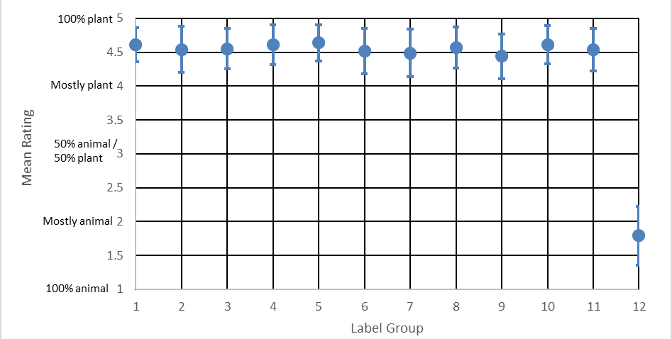
Note: Error bars represent standard deviation.
Figure 2 Mean ratings of ingredient content for dairy alternatives

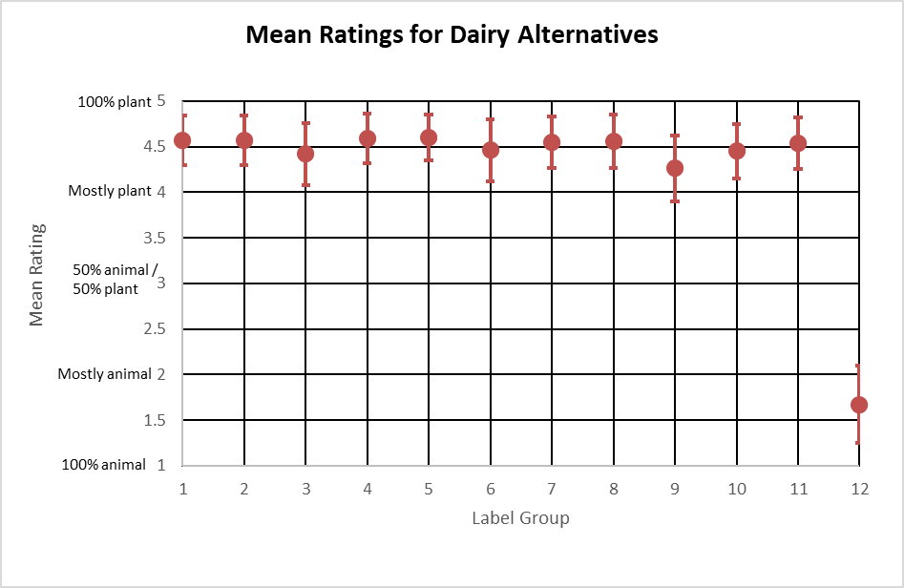
Note: Error bars represent standard deviation.

Length of time to identify product ingredient content
The time taken by participants to answer the question around product identification was logged in minutes, converted to seconds and outliers were removed (see Data Analysis section for methodology). Participants spent between 7.8 – 9.6 seconds to identify the product ingredient content of all products. The means, standard deviations, adjusted means, standard errors and 95% confidence intervals for the time taken for participants to respond to product ingredient content (in seconds) for each product category is shown in Table 6, Table 7, Table 7 Time taken (in seconds) for participants to identify product ingredient content for plant-based dairy alternatives.
Group no. | Mean | Standard deviation | Adjusted mean | Standard errors | 95% confidence intervals
Group 1 (226) | 8.44 | 4.18 | 8.45 | .253 | (7.96 – 8.95)
Group 2 (229) | 8.35 | 4.22 | 8.45 | .252 | (7.95 – 8.94)
Group 3 (225) | 9.52 | 4.34 | 9.44 | .254 | (8.95 – 9.94)
Group 4 (217) | 9.19 | 4.25 | 8.99 | .259 | (8.49 – 9.50)
Group 5 (215) | 8.70 | 4.10 | 8.92 | .260 | (8.41 – 9.43)
Group 6 (217) | 8.58 | 4.14 | 8.53 | .259 | (8.02 – 9.04)
Group 7 (213) | 8.64 | 4.13 | 8.72 | .261 | (8.21 – 9.23)
Group 8 (226) | 8.53 | 3.94 | 8.33 | .254 | (7.83 – 8.82)
Group 9 (219) | 9.51 | 4.69 | 9.63 a | .257 | (9.12 – 10.13)
Group 10 (221) | 9.02 | 4.32 | 9.25 | .256 | (8.75 – 9.75)
Group 11 (229) | 9.03 | 4.10 | 9.17 | .252 | (8.68 – 9.67)
Group 12 (223) | 8.53 | 3.76 | 8.40 | .256 | (7.90 – 8.90)
Note: Descriptive statistics for each label group x plant-based dairy alternatives, adjusted based on baseline measures.
a Significantly different compared to the plant-based control (Group 1; p < .001).
Figure 3 and Figure 4.
A two-way mixed ANOVA (label group x product category) showed no statistically significant main effect of label group (F(11, 2692) = 1.69, p = .070, ƞ2 = .009) but did show a borderline statistically significant interaction between group and product category (F(11, 2692) = 6.77, p =.010, ƞ2 = .007).
A two-way mixed ANCOVA controlling for baseline measures (age, gender, cultural background, education, dietary pattern, State/Territory and overall plant-based consumption) produced different results to the initial ANOVA test. That is, there continued to be no statistically significant main effect of label group (F(11, 2634) = 2.02, p = =.023, ƞ2 = .008), however there was now a statistically significant interaction between group and product category (F(11, 2634) = 2.33, p = .007, ƞ2 = .010). This indicates that the group effects were different for the different food categories when baseline measures were controlled for.
Follow up comparisons for the ANCOVA for plant-based protein products showed no statistically significant between-group differences.
For plant-based dairy, there was a statistically significant difference between the adjusted mean time taken to assess product ingredient content between Group 9 (animal imagery + ingredient qualifier not co-located with the name of the food) and Group 1 (plant-based control) (p < .001). As this is the more robust test, the overall results indicate that on average participants in Group 9 spent slightly longer (adjusted mean = 9.63) to rate the ingredient content compared to Group 1 (adjusted mean = 8.45) The effect size was small (Cohen’s d = 0.31)).
Given that participants who did not provide their cultural background (n = 39) and those who reported their gender as other than male or female (n = 11) were excluded from this analysis, we re-ran the ANOVA test with these participants excluded. Results remained consistent with the initial ANOVA test with all participants included. This indicates that the change in results based on the ANCOVA can be attributed to controlling for baseline measures, rather than exclusion of those participants. The ANCOVA was also rerun using a bootstrapping procedure, and results remained unchanged.
Table 6 Time taken (in seconds) for participants to identify product ingredient content for plant-based protein products
Group no. | Mean | Standard deviation | Adjusted mean | Standard errors | 95% confidence intervals
Group 1 (226) | 7.88 | 3.72 | 7.91 | .236 | (7.44 – 8.37)
Group 2 (229) | 8.25 | 3.87 | 8.30 | .235 | (7.84 – 8.77)
Group 3 (225) | 8.94 | 4.19 | 8.86 | .237 | (8.40 – 9.33)
Group 4 (217) | 8.68 | 3.87 | 8.45 | .241 | (7.98 – 8.92)
Group 5 (215) | 7.88 | 3.44 | 8.09 | .243 | (7.62 – 8.57)
Group 6 (217) | 8.54 | 3.78 | 8.53 | .241 | (8.05 – 9.00)
Group 7 (213) | 8.46 | 3.97 | 8.55 | .243 | (8.07 – 9.03)
Group 8 (226) | 8.55 | 3.77 | 8.37 | .237 | (7.91 – 8.84)
Group 9 (219) | 8.40 | 3.91 | 8.55 | .240 | (8.08 – 9.02)
Group 10 (221) | 8.20 | 3.81 | 8.37 | .239 | (7.90 – 8.84)
Group 11 (229) | 8.43 | 3.81 | 8.54 | .235 | (8.08 – 9.00)
Group 12 (223) | 8.47 | 3.91 | 8.37 | .238 | (7.90 – 8.83)
Note: Descriptive statistics each label group x plant-based protein products, adjusted based on baseline measures. Significantly different compared to the plant-based control (Group 1; p < .001).
Table 7 Time taken (in seconds) for participants to identify product ingredient content for plant-based dairy alternatives.
Group no. | Mean | Standard deviation | Adjusted mean | Standard errors | 95% confidence intervals
Group 1 (226) | 8.44 | 4.18 | 8.45 | .253 | (7.96 – 8.95)
Group 2 (229) | 8.35 | 4.22 | 8.45 | .252 | (7.95 – 8.94)
Group 3 (225) | 9.52 | 4.34 | 9.44 | .254 | (8.95 – 9.94)
Group 4 (217) | 9.19 | 4.25 | 8.99 | .259 | (8.49 – 9.50)
Group 5 (215) | 8.70 | 4.10 | 8.92 | .260 | (8.41 – 9.43)
Group 6 (217) | 8.58 | 4.14 | 8.53 | .259 | (8.02 – 9.04)
Group 7 (213) | 8.64 | 4.13 | 8.72 | .261 | (8.21 – 9.23)
Group 8 (226) | 8.53 | 3.94 | 8.33 | .254 | (7.83 – 8.82)
Group 9 (219) | 9.51 | 4.69 | 9.63 a | .257 | (9.12 – 10.13)
Group 10 (221) | 9.02 | 4.32 | 9.25 | .256 | (8.75 – 9.75)
Group 11 (229) | 9.03 | 4.10 | 9.17 | .252 | (8.68 – 9.67)
Group 12 (223) | 8.53 | 3.76 | 8.40 | .256 | (7.90 – 8.90)
Note: Descriptive statistics for each label group x plant-based dairy alternatives, adjusted based on baseline measures.
a Significantly different compared to the plant-based control (Group 1; p < .001).
Figure 3 Mean time (seconds) taken to identify ingredient content of protein products.
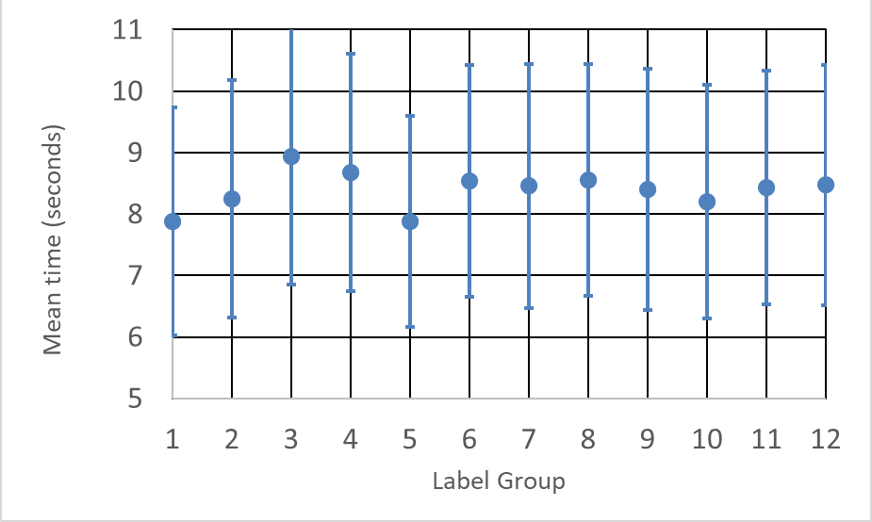
Note: Error bars represent standard deviation.
Figure 4 Mean time (seconds) taken to identify ingredient content of dairy alternatives
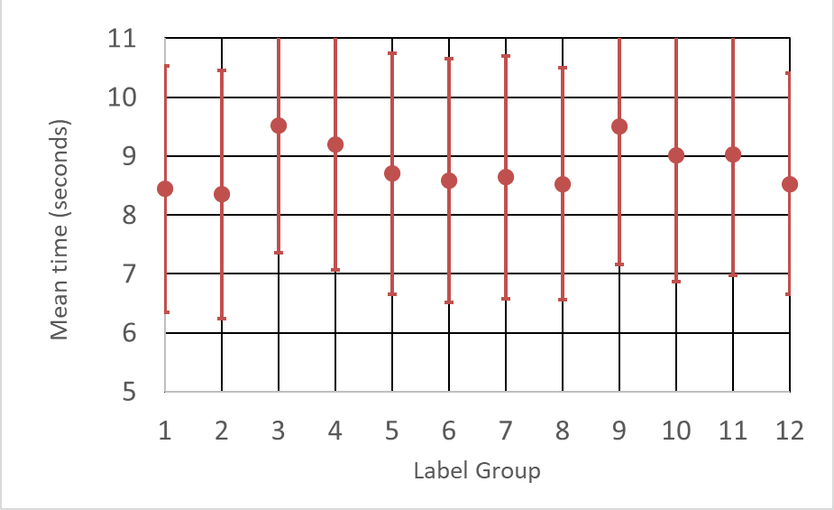
Note: Error bars represent standard deviation.

Ease of identification of product ingredient content
Participants were asked ‘How easy or hard was it to answer the previous question (what the product is made from)?’ Response options were: 1 – Very hard, 2 – Somewhat hard, 3 – Neither hard nor easy, 4 – Somewhat easy, 5 – Very easy.
Overall, participants generally found the question reasonably easy, with the mean for all groups above 4 (‘somewhat easy’), except for Group 9 (animal imagery + ingredient qualifier not co-located with the name of the food) for plant-based dairy alternatives. Group 9 was the only group to rate the question as being on average below 4 (i.e. below ‘somewhat easy’) on the Likert scale. The means, standard deviations, adjusted means, standard errors and 95% confidence intervals for participants ratings of ingredient content for each product category are presented in Table 8, Table 9, Figure 5 and
Figure 6.
A two-way mixed ANOVA (label group x product category) showed a statistically significant main effect of label group (F(11, 2934) = 4.84, p = <.001, ƞ2 = .018), and a statistically significant interaction between group and product category (F(11, 2934) = 7.97, p <.001, ƞ2 = .029). This indicates that the group effects were different for the different food categories.
A two-way mixed ANCOVA controlling for baseline measures (age, gender, region, and overall plant-based consumption) produced results consistent with the initial ANOVA test. That is, there was a statistically significant main effect of label group (F(11, 2919) = 4.52, p = <.001, ƞ2 = .017), and a statistically significant interaction between group and product category (F(11, 2919) = 8.00, p <.001, ƞ2 = .029). As such, for simplicity, the original ANOVA results are presented. The finding that the results were consistent when controlling for baseline demographics indicates that the baseline measures did not influence participants perceived ease in identifying ingredient content. See Appendix D for the full ANCOVA results.
All possible analyses run with a bootstrapping procedure were also consistent with the ANOVA results.
For plant-based proteins products, follow up comparisons for the ANOVA showed that participants in Group 9 (animal imagery + ingredient qualifier not co-located with the name of the food) found the identification of product content somewhat more difficult (mean = 4.12) than those who saw the plant-based control (Group 1) (mean = 4.37) (p < .001; Cohen’s d = -0.33). This effect was small.
For plant-based dairy alternatives participants in Group 9 (animal imagery + ingredient qualifier not co-located with the name of the food; mean = 3.90; p < .001) and Group 10 (animal imagery + ingredient qualifier smaller than the name of the food; mean = 4.04; p < .001) perceived the identification of product content harder compared to Group 1 participants (plant-based control; mean = 4.29). These effects were medium and small (Cohen’s d = -0.48 and -0.32 respectively). Participants in Group 9 (mean = 3.90) also perceived the identification of product content as harder than participants in Group 12 (animal-based control; mean = 4.15; p < .001). This effect was small (Cohen’s d = -0.30).
Table 8 Ease of product content identification: descriptive statistics for each label group for plant-based protein products
Groups no. | Mean | Standard deviation
Group 1 (245) | 4.37 | 0.71
Group 2 (247) | 4.28 | 0.81
Group 3 (246) | 4.20 | 0.90
Group 4 (246) | 4.40 | 0.66
Group 5 (244) | 4.38 | 0.74
Group 6 (246) | 4.16 | 0.85
Group 7 (244) | 4.16 | 0.82
Group 8 (246) | 4.24 | 0.83
Group 9 (245) | 4.12ª | 0.80
Group 10 (245) | 4.28 | 0.76
Group 11 (245) | 4.25 | 0.76
Group 12 (247) | 4.18 | 0.79
a Significantly different compared to the plant-based control (Group 1; p < .001). b Significantly different compared to the animal-based control (Group 12; p < .001).
Table 9 Ease of product content identification: descriptive statistics for each label group for plant-based dairy alternatives
Groups no. | Mean | Standard deviation
Group 1 (245) | 4.29 | 0.76
Group 2 (247) | 4.35 | 0.69
Group 3 (246) | 4.06 | 0.90
Group 4 (246) | 4.30 | 0.71
Group 5 (244) | 4.30 | 0.73
Group 6 (246) | 4.16 | 0.83
Group 7 (244) | 4.22 | 0.79
Group 8 (246) | 4.29 | 0.79
Group 9 (245) | 3.90 a_{b} | 0.85
Group 10 (245) | 4.04_{b} | 0.80
Group 11 (245) | 4.20 | 0.79
Group 12 (247) | 4.15 | 0.84
a Significantly different compared to the plant-based control (Group 1; p < .001). b Significantly different compared to the animal-based control (Group 12; p < .001).
Figure 5 Mean ratings for ease of identifying ingredient content for protein products

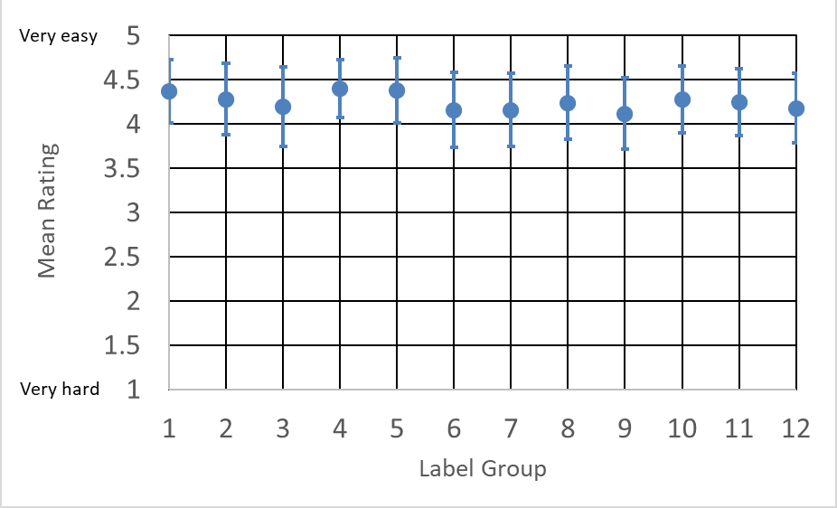
Note: Error bars represent standard deviation.
Figure 6 Mean ratings for ease of identifying ingredient content for dairy alternatives
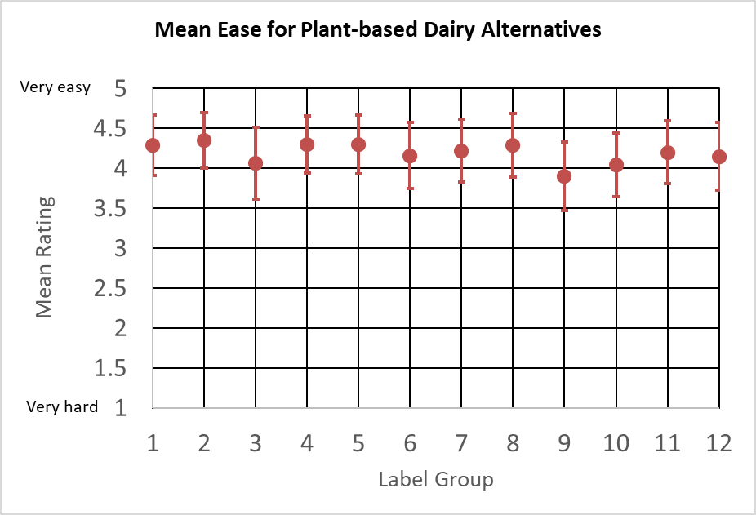
Note: Error bars represent standard deviation.

Confidence in understanding of product’s intended use
Participants were asked ‘How confident are you that you understand how this product is intended to be used or consumed?’ Response options were:
1 – Very unconfident, 2 – Somewhat unconfident, 3 – Neither confident nor unconfident, 4 – Somewhat confident, 5 – Very confident.
Overall, participants were generally confident in the products’ intended use, with the mean for all groups above 4 (‘Somewhat confident’), except for Group 9 in respect of plant-based dairy alternatives. The means, standard deviations, adjusted means, standard errors and 95% confidence intervals for participants ratings of ingredient content for each product category are presented in Table 10, Table 11, Figure 7 and Figure 8.
A two-way mixed ANOVA (label group x product category) showed a statistically significant main effect of label group (F(11, 2934) = 3.42, p = <.001, ƞ2 = .013), and a statistically significant interaction between group and product category (F(11, 2934) = 12.04, p <.001, ƞ2 = .043). This indicates that the group effects were different for the different food categories.
A two-way mixed ANCOVA controlling for baseline measures (age, cultural background, region, education, language spoken at home, dietary pattern, overall plant-based consumption and household income) produced results consistent with the initial ANOVA test. That is, there was a statistically significant main effect of label group (F(11, 2885) = 2.99, p = <.001, ƞ2 = .011), and a statistically significant interaction between group and product category (F(11, 2885) = 12.28, p <.001, ƞ2 = .045). However, follow up pairwise comparisons were slightly different to the original ANOVA results and, as such, the more robust ANCOVA results are presented.
For plant-based protein products, follow up t-tests showed no statistically significant differences between any group and Group 1 (plant-based control) or Group 12 (animal-based control) (p < .001). This was consistent with the original ANOVA and indicates that there are no differences in participants’ confidence in the understanding of the use of plant-based protein products compared to either the plant-based or animal-based controls (Groups 1 and 12 respectively).
For plant-based dairy alternatives, there were no significant differences between Group 1 (plant-based control) and any plant-based group. This indicates that there are no differences in participants’ confidence in the understanding of the use of plant-based dairy alternatives compared to the plant-based control (Group 1).
However, there were statistically significant differences between Group 12 (animal-based control; adjusted mean = 4.38) and 4 different groups (all p values <.001):
- Group 3 (animal image; adjusted mean = 4.06).
- Group 9 (animal image with qualifier separate; adjusted mean = 3.97).
- Group 10 (animal image with qualifier smaller; adjusted mean = 4.08).
- Group 11 (qualifier separate and smaller; adjusted mean = 4.12).
This indicates that participants in these groups were less confident in the understanding of the use of the plant-based dairy products compared to the animal control. This effect was medium (Cohen’s d = -0.42, -0.54, -0.54 and -0.54 respectively).
Given that participants who did not provide their cultural background were excluded from this analysis (n = 39), we re-ran the ANOVA test with these participants excluded. Results remained consistent with the initial ANOVA test with all participants included. This indicates that the change in results based on the ANCOVA can be attributed to controlling for baseline measures, rather than exclusion of those participants. The ANCOVA was also rerun using a bootstrapping procedure, and results remained unchanged.
Table 10 Confidence in products’ intended use for plant-based protein products
Group no. | Mean | Standard deviation | Adjusted mean | Standard errors | 95% confidence intervals
Group 1 (243) | 4.34 | 0.73 | 4.33 | 0.049 | 4.23 – 4.42
Group 2 (246) | 4.32 | 0.78 | 4.30 | 0.049 | 4.21 – 4.40
Group 3 (242) | 4.27 | 0.80 | 4.28 | 0.049 | 4.19 – 4.38
Group 4 (241) | 4.36 | 0.72 | 4.38 | 0.049 | 4.28 – 4.48
Group 5 (240) | 4.37 | 0.77 | 4.37 | 0.049 | 4.27 – 4.46
Group 6 (240) | 4.19 | 0.88 | 4.20 | 0.049 | 4.11 – 4.30
Group 7 (241) | 4.21 | 0.85 | 4.21 | 0.049 | 4.11 – 4.31
Group 8 (244) | 4.27 | 0.85 | 4.26 | 0.049 | 4.16 – 4.35
Group 9 (239) | 4.16 | 0.81 | 4.18 | 0.050 | 4.09 – 4.23
Group 10 (243) | 4.31 | 0.75 | 4.32 | 0.049 | 4.22 – 4.42
Group 11 (244) | 4.24 | 0.82 | 4.26 | 0.049 | 4.16 – 4.35
Group 12 (244) | 4.37 | 0.66 | 4.38 | 0.049 | 4.28 – 4.47
Note: Descriptive statistics for each label group x plant-based protein products, adjusted based on baseline measures.
Table 11 Confidence in products’ intended use for plant-based dairy alternatives
Group no. | Mean | Standard deviation | Adjusted mean | Standard errors | 95% confidence intervals
Group 1 (243) | 4.19 | 0.80 | 4.17 | 0.049 | 4.08 – 4.27
Group 2 (246) | 4.39 | 0.68 | 4.37 | 0.049 | 4.27 – 4.46
Group 3 (242) | 4.05_{b} | 0.84 | 4.06 ^{b} | 0.049 | 3.97 – 4.16
Group 4 (241) | 4.21 | 0.74 | 4.22 | 0.049 | 4.12 – 4.32
Group 5 (240) | 4.18 | 0.78 | 4.17 | 0.049 | 4.07 – 4.26
Group 6 (240) | 4.20 | 0.86 | 4.22 | 0.049 | 4.12 – 4.31
Group 7 (241) | 4.29 | 0.74 | 4.29 | 0.049 | 4.20 – 4.39
Group 8 (244) | 4.26 | 0.83 | 4.25 | 0.049 | 4.16 – 4.35
Group 9 (239) | 3.96_{b} | 0.84 | 3.97_{b} | 0.049 | 3.87 – 4.06
Group 10 (243) | 4.06_{b} | 0.80 | 4.08_{b} | 0.049 | 3.99 – 4.18
Group 11 (244) | 4.11_{b} | 0.79 | 4.12_{b} | 0.049 | 4.02 – 4.21
Group 12 (244) | 4.37 | 0.69 | 4.38 | 0.049 | 4.28 – 4.47
Note: Descriptive statistics for each label group x plant-based dairy alternatives, adjusted based on baseline measures. a Significantly different compared to the plant-based control (Group 1; p < .001). b Significantly different compared to the animal-based control (Group 12; p < .001).
Figure 7 Mean ratings for confidence in intended use of protein products
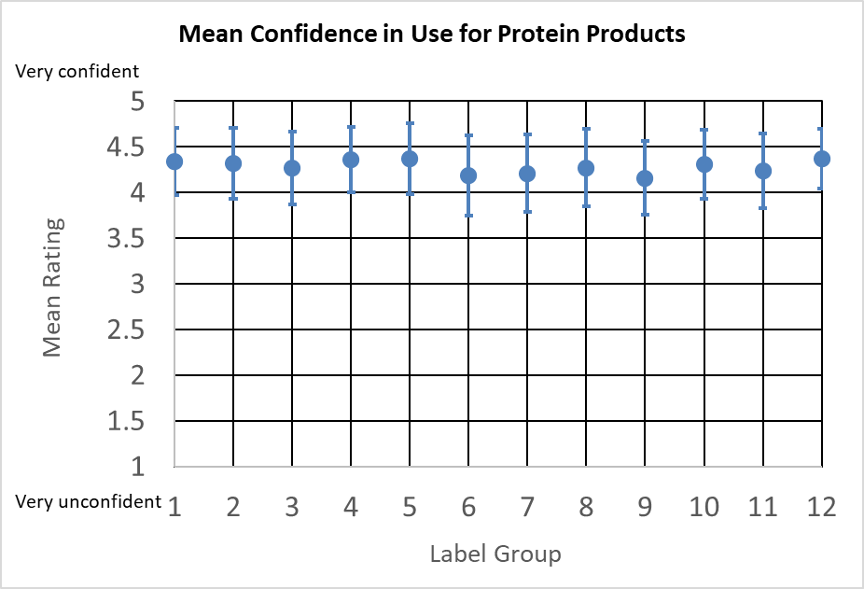
Note: Error bars represent standard deviation.
Figure 8 Mean ratings for confidence in intended use of dairy alternatives
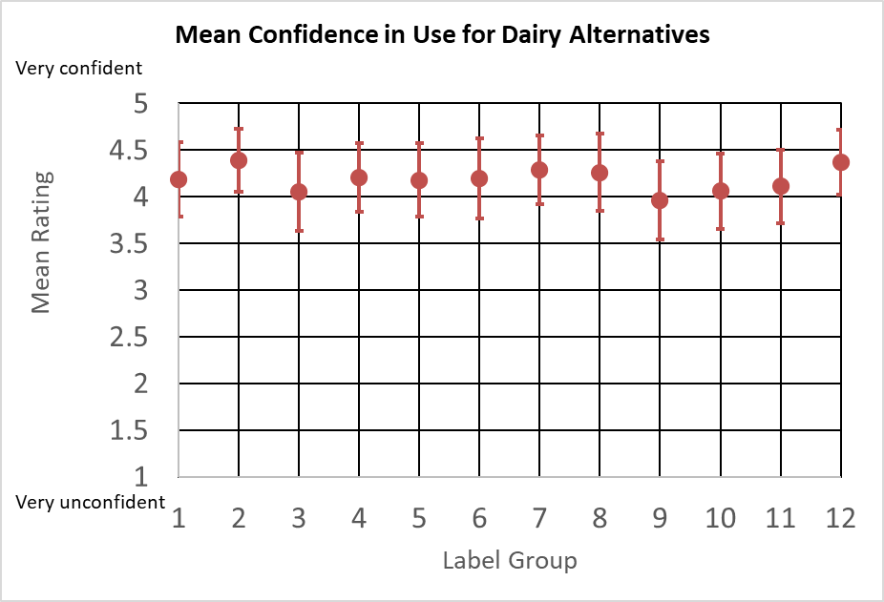
Note: Error bars represent standard deviation.

Perceptions of nutritional similarity
For this question, participants were shown 2products: 1 was the product with their allocated label about which they had answered the previous 3 questions, and the other was an animal-based product of the same type. Participants were then asked: ‘Based on the product images above, how similar or different do you think their nutritional content would be?’ Response options were: 1 – Very different, 2 – Somewhat different, 3 – Somewhat similar, and 4 – Very similar.
Overall, participants generally perceived the plant-based products (Groups 1 through 11) as being ‘Somewhat different’, while the animal-based products (Group 12) were seen as being ‘Somewhat similar’. The means, standard deviations, adjusted means, standard errors and 95% confidence intervals for participants ratings of ingredient content for each group are presented in Table 12 and Figure 9.
A two-way mixed ANOVA (label group x product category) showed a statistically significant main effect of label group (F(11, 2934) = 54.77, p = <.001, ƞ2 = .170), and no statistically significant interaction between group and product category (F(11, 2934) = 1.08, p = .370, ƞ2 = .004). This indicates that the label group effects did not differ by product category.
A two-way mixed ANCOVA controlling for baseline measures (state/territory, gender, region, language spoken at home, household income and dietary pattern) produced results consistent with the initial ANOVA test. That is, there was a statistically significant main effect of label group (F(11, 2910) = 53.95, p = <.001, ƞ2 = .169), and no statistically significant interaction between group and product category (F(11, 2910) = 1.02, p = .423, ƞ2 = .004). As such, the original ANOVA results are presented for simplicity. The finding that the results were consistent when controlling for baseline demographics indicates that the baseline measures did not influence participants’ perceptions of nutritional similarity. Full results on the ANCOVA are presented in Appendix D.
All analyses were rerun using a bootstrapping procedure, and results remained unchanged.
Table 12 Similarity in nutritional content: Descriptive statistics for each label group.
Group (n) | Mean | Standard deviation
Group 1 (245) | 2.07_{b} | 0.81
Group 2 (247) | 2.10_{b} | 0.74
Group 3 (246) | 1.96_{b} | 0.76
Group 4 (246) | 2.06_{b} | 0.77
Group 5 (244) | 2.04_{b} | 0.79
Group 6 (246) | 2.11_{b} | 0.76
Group 7 (244) | 2.01_{b} | 0.76
Group 8 (246) | 2.00_{b} | 0.72
Group 9 (245) | 2.17_{b} | 0.74
Group 10 (245) | 2.07_{b} | 0.72
Group 11 (245) | 2.07_{b} | 0.73
Group 12 (247) | 3.26 | 0.64
_{b} Significantly different compared to the animal-based control (Group 12; p < .001).
Figure 9 Mean ratings of nutritional similarity compared to an animal-based counterpart. Error bars represent standard deviation.
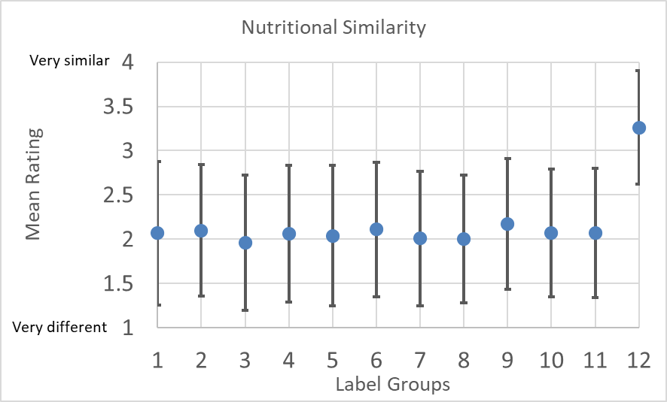
Follow-up t-tests showed there were no statistically significant differences between the plant-based control (Group 1) and all other plant-based groups (Groups 2 through 11; all p values > .001), while all plant-based groups (Groups 1 through 11) significantly differed from the animal-based control (Group 12; all p values < .001). The effect size was very large (Cohen’s d ranged from -1.58 to -1.85).
This indicates that the tested labelling elements did not impact on participants’ perceptions of the nutritional similarity of plant-based products compared to their conventional animal-based counterparts. It also indicates that, on average, participants view plant-based products as different in nutritional content compared to their animal-based counterparts.

Motives for consuming plant-based protein products
Participants who reported consuming plant-based protein products at least ‘several times a month’ (n = 501) were asked about their motivations for doing so. Respondents were asked to indicate the strength of their agreement with a series of statements beginning with ‘I choose to eat plant-based meat alternatives because…’ on a five-point Likert scale. Response options were 1 – Strongly disagree, 2 – Disagree, 3 – Neither agree nor disagree, 4 – Agree, 5 – Strongly agree.
As shown in Table 13, respondents on average reported that the strongest motive for consuming plant-based protein products was that it was better for animal welfare with (Mean = 4.11; SD = 0.91), followed by it being better for the environment (Mean = 4.01; SD = 0.90).
The least strong motives for consumption of plant-based protein products were cultural/religious reasons (Mean = 2.37; SD = 1.26) and having a medical reason (Mean= 2.41; SD = 1.29).
Table 13 Mean and SD for consumers’ motivation for consuming plant-based protein products
Motive | Mean | Standard deviation
It is better for animal welfare | 4.11 | 0.91
It is better for the environment | 4.04 | 0.90
I like the taste and/or texture | 3.83 | 0.87
I am curious about new foods/want variety | 3.74 | 0.92
I like the brand | 3.60 | 0.93
It is convenient | 3.58 | 0.99
It is nutritionally the same as or better than animal meat | 3.56 | 1.00
My friends/family eat it | 3.31 | 1.13
It is cost effective | 3.15 | 1.11
I have a medical reason (e.g. meat allergy) | 2.41 | 1.29
I have cultural/religious reason | 2.37 | 1.26
Note: (n = 501). 5-point scale: 1 (Strongly disagree) – 5 (Strongly agree).

Motives for consuming plant-based dairy alternatives
Participants who reported consuming plant-based dairy alternatives at least ‘several times a month’ (n = 885) were asked about their motivations for doing so. Respondents were asked to indicate the strength of their agreement with a series of statements beginning with ‘I choose to eat plant-based dairy alternatives because…’ on a five-point Likert scale. Response options were 1 – Strongly disagree, 2 – Disagree, 3 – Neither agree nor disagree, 4 – Agree, 5 – Strongly agree.
As shown in Table 14, respondents on average reported that the strongest motive was that they like the taste and/or texture (Mean = 3.83, SD = 0.91). This was the same mean rating as was reported for plant-based meat proteins, however animal welfare and being better for the environment were ranked higher for plant-based protein products. These 2motives were ranked second and third strongest motive by participants for consuming plant-based dairy alternatives.
Consistent with plant-based protein products, cultural/religious reasons (mean = 2.10, SD = 1.19) and having a medical reason (mean = 2.76, SD = 1.43) were the least strong motives for consuming plant-based dairy alternatives.
Table 14 Motivation for consuming plant-based dairy alternatives
Motive | Mean | Standard deviation
I like the taste and/or texture | 3.83 | 0.91
It is better for animal welfare | 3.76 | 1.05
It is better for the environment | 3.68 | 1.03
I am curious about new foods/want variety | 3.57 | 1.03
I like the brand | 3.52 | 0.97
It is nutritionally the same as or better than animal dairy | 3.43 | 1.03
It is convenient | 3.42 | 1.01
My friends/family eat it | 3.15 | 1.22
It is cost effective | 2.92 | 1.17
I have a medical reason (e.g. lactose intolerance) | 2.76 | 1.43
I have cultural/religious reason | 2.10 | 1.19
Note: (n = 885). 5-point scale: 1 (Strongly disagree) – 5 (Strongly agree).

Discussion
The current research utilised an RCT experimental study to address the following research questions:
- Do any of the labelling elements (when controlling for demographic/baseline characteristics) tested (meat/dairy terminology, animal imagery, size and location of ingredient qualifiers, plus any combination of 2of these elements) significantly affect:
  - consumers’ ability to accurately identify the ingredient content (that is, whether they were plant or animal based) of plant-based protein products and/or dairy alternatives
  - the length of time consumers take to assess the ingredient content
  - consumers’ perceived ease of identifying the ingredient content
  - consumers’ confidence in their understanding of the product’s intended use
  - the extent to which consumers think the product is nutritionally similar to its conventional counterpart?
- Do labelling effects differ based on the type of plant-based product (i.e. plant-based protein products vs plant-based dairy alternatives)?
- What are consumers’ motivations for consuming plant-based protein products and plant-based dairy alternatives?

Overall findings
The research findings indicate that of the labelling elements tested, consumers can accurately identify the ingredient content of plant-based alternatives, are confident in the intended use of these products, and do not believe plant-based alternatives are nutritionally similar to an animal counterpart.

Ingredient content
This study found that participants generally accurately identified the ingredient content of both plant-based protein products and dairy alternatives, rating them as ‘Mostly’ to ‘100%’ plant-based’, while the animal-based control was rated as being ‘Mostly’ to ‘100% animal-based’. Large, statistically significant differences between the ratings of all plant-based products in comparison to an animal-based control demonstrate that consumers are not confused between the content of the 2types of foods regardless of the type of label viewed.
These results are consistent with other experimental studies undertaken in the United States of America (Baptista and Schifferstein 2023, Gleckel (2020)). They are also broadly consistent with previous cross-sectional Australian research, suggesting that the majority of Australian consumers are able to accurately identify the main content of plant-based protein products based on front-of pack labelling (Institute for Sustainable Futures (2022); Pollinate (2021)), and understand that plant-based milks do not contain cow’s milk (Feltz & Feltz 2019; International Food Information Council Foundation (2018)). Further, this is consistent with other Australian studies (methodology unknown) that indicated that the vast majority of consumers (up to 93%) understand the nature of plant-based milks or items (Sanitarium (2021); Woolworths (2021)).

Ease of identification
Participants in this study found it very easy to identify the ingredient content of all plant-based products, regardless of the label viewed. The mean rating for all groups was ‘somewhat easy’ to ‘very easy’. This is consistent with cross-sectional research in which only a small number of Australian/New Zealand consumers (6% to 12%) reported having mistakenly purchased plant-based protein products or a plant-based item (Colmar Brunton 2019a, 2019b; Institute for Sustainable Futures (2022); Woolworths 2021). In addition, of the 12% of Australian consumers (n = 1,014) who reported that they had mistakenly purchased a plant-based alternative instead of a meat product, the majority said it was because they were in a rush/distracted and did not read the label (Institute of Sustainable Future (2022)).
The results are different to research by Pollinate (2021), where 51% of Australian participants in that survey self-reported that the packaging on a product can make it ‘somewhat confusing’, ‘very confusing’ or ‘extremely confusing’ when it comes to determining whether there is any animal meat in a plant-based alternative product. Differences in question wording and response options may account for the differences between the 2studies. Pollinate’s study (2021) refers to ‘products’ and it is not clear if they are asking specifically about plant-based alternative products. Additionally, Pollinate’s research used an asymmetric five-point Likert scale that was biased towards participants indicating their confusion, whereas the Likert scale used in the current research was symmetric.
Pollinate’s (2021) five-point Likert scale response options were:
- ‘Not all confusing’
- ‘Not very confusing’
- ‘Somewhat confusing’
- ‘Very confusing’
- ‘Extremely confusing’.
Note that 3 out of 5 response options were taken to indicate confusion.

Intended use
Participants were confident in their understanding of the intended use for all plant-based alternatives as well as the animal-based control. The mean rating for all groups was ‘somewhat confident’ to ‘very confident’. This is consistent with an experimental U.K. study in which nearly all 352 consumers understood that a plant-based milk could be added to a cup of tea/coffee (De-Loyde et al, 2023), but is slightly higher than the findings in Gleckel (2020), in which 155 U.S. (non-representative convenience sample) consumers reported that they ‘very clearly’ understand the intended taste of vegan butter but were ‘not so clear’ to ‘somewhat clear’ on the intended taste of plant-based deli slices: Bologna style. The differences in results may be due to the nature of the product items tested in the studies (e.g. milk, and butter vs deli slices), the lack of product images provided in Gleckel (2020), and the difference in wording between intended use vs intended taste. No other research has reported on participants’ confidence or understanding in the intended use (or similar measures) of plant-based alternatives overall.

Nutritional similarity
Participants in this study reported that plant-based products are nutritionally different compared to an animal counterpart, whereas participants reported the animal control was nutritionally similar to an animal counterpart. All plant-based groups were rated as ‘somewhat different’ to an animal counterpart. The animal control was rated as ‘somewhat similar’ to ‘very similar’ to an animal counterpart. No other experimental research has investigated perceptions of the nutritional similarity of plant-based products compared to an animal-based equivalent.
No labelling element (or combination of labelling elements) had an effect on participants’ perceptions of the nutrition similarity of plant-based products to an animal counterpart. This is similar to a small experimental study in which there was no difference in 155 U.S respondents’ rating of protein content rating in plant-based products that used meat and dairy terminology compared to a plant-based alternative that did not use this terminology (Gleckel (2020)).

Labelling elements
This research investigated the effect of a range of labelling elements and the combination of different elements. The labelling elements tested (in isolation and in combinations of two) included: animal imagery; meat/dairy terminology and the ingredient qualifiers both their size and location.

Meat/dairy terminology
Meat and dairy terminology was found to have no effect on participants’ ability to accurately identify product ingredient content of plant-based protein products. None of the groups that saw labels with meat/dairy terminology significantly differed in their rating of product ingredient content compared to the plant-based control (which had no meat terminology). This is consistent with experimental studies undertaken in the USA and the UK where meat/dairy terminology had no or a small effect on participants’ ability to accurately identify the product ingredient content of plant-based meat or dairy products (Baptista and Schifferstein 2023; De-Loyde et al. 2023; Gleckel 2020; DeMuth (2019)).
Meat and dairy terminology did not increase participants’ confidence in their understanding of the intended use of the products tested. This is inconsistent with previous research, which suggested that dairy/meat terminology may support consumers’ understanding of the intended use of the product (De-Loyde et al. 2023).

Animal imagery
Consumers are able to accurately identify the ingredient content of plant-based protein products and dairy alternatives with labels that contain animal imagery. Consumers rated all products that included animal images as ‘mostly’ to ‘100% plant-based’. This is consistent with a U.S. experimental study in which participants rated products with an animal image as containing ‘mostly’ to ‘100% plant-based’ (Baptista and Schifferstein (2023)). The use of an animal image in isolation was found to have no effect on consumers’ understanding of the ingredient content of plant-based products, the time taken to assess the ingredient content, or their perceived ease of doing so. This is inconsistent with Baptista and Schifferstein’s (2023) finding that animal imagery slightly decreased consumers’ understanding of the ingredient content of plant-based milk and meat alternatives and increased the length of time consumers spent assessing the ingredient content compared to products without animal images.
When an animal image is used in conjunction with an ingredient qualifier that is not co-located with the name of the food, participants have greater levels of inaccuracy for identifying the ingredient content of plant-based dairy alternatives and spend significantly longer assessing the ingredient content. This effect was not found for protein products. They also report finding it harder to identify the ingredient content of both plant-based protein products and dairy alternatives. All differences were statistically significant, but the effects were small.
No other studies have investigated the combination of different labelling elements on consumers’ understanding of the ingredient content or confidence in intended use. It is hypothesised that participants found it slightly harder to rate the content and understand the intended use of plant-based dairy alternatives with animal imagery but not plant-based proteins due to the use of different utility terms on the products between product categories. Terms used for protein products included nuggets, sausages, burger and rashers, which are also used on animal product counterparts. Whereas the terms used for dairy alternatives were less directly related to a similar animal equivalent food product and included slices, beverage, blend and drink.

Qualifiers
Consumers are able to accurately identify the ingredient content of plant-based protein products and dairy alternatives regardless of the size or location of the ingredient qualifier. However, as stated above, the combination of an animal image with a separate qualifier makes it slightly harder for consumers to identify the ingredient content of products (small effect size). Additionally, consumers are less confident in their understanding of the intended use of dairy alternatives when:
- the qualifier is not co-located and smaller
- the presence of an animal image with the qualifier either being smaller or not co-located.
The effect sizes were medium for these between group comparisons, but consumers were still overall confident in their understanding of the products’ intended use.
This is the first study, to FSANZ’s knowledge, that has investigated the effect that the location and size of an ingredient qualifier has on consumers’ understanding of plant-based alternative products. However, previous Australian research found that participants reported that plant-based alternatives were confusing because they were ‘hard to understand’ (21%) and that they are ‘hard to read/small font’ (19%) (Institute for Sustainable Futures (2022)). These identified areas of confusion could potentially be related to the size and location of ingredient qualifiers.

Motives
Similar to research undertaken in Germany (Pointke et al, 2022) and Australia (Estell et al, 2021), regular consumers of plant-based alternatives reported that the strongest motives to consume plant-based alternatives was for animal welfare, and being better for the environment. Motives slightly differed between plant-based alternative categories. In both this study and the German study, taste/texture/sensory appeal was rated as a stronger motive for consuming plant-based dairy alternatives than it was for plant-based protein products. However, taste and texture was rated as a higher motive for plant-based protein products in this study compared to the German study. In this study, taste and texture was rated as the third strongest motive for consuming plant-based protein products, whereas German consumers rated ‘sensory appeal’ below the motives of animal welfare, environment, health, product lifestyle, and convenience for plant-based protein products (Pointke et al, 2022).

Strengths and limitations
Both the strengths and limitations of this study need to be taken into consideration when interpreting the findings of this study. The large sample size ensured there was sufficient power to detect small effects and allowed detection of any between group differences for a large number (10) of experimental conditions i.e. labelling elements. The sample was nationally representative of the Australian population according to 2021 ABS census data, by age, gender and state/territory, and there was representation of several different dietary patterns, and regions (metro and regional) within the sample. However, the non-response rate of potential survey respondents is unknown. RCTs are considered to be the ‘gold standard’ research design for determining cause-and-effect and allowed isolation of the effect that different parts of the label had on rates of consumer confusion. This design filled an identified gap in the existing evidence, as no RCTs on this issue have been undertaken in the Australian context. This design adds rich detail to the current evident base. Although averaging the measures across 4 products in each product category provides more robust results, it also means that further investigation into whether results vary by product type in each product category is not possible.
Whilst consumers in this study seem to show little confusion about plant-based products, it is important to note that this experimental study does not replicate a real world setting where potential product identification mistakes, regardless of the type of product, may occur. For example, the placement of the product within the supermarket, environmental distractions and product advertisement are examples of factors in a real-world environment that may affect product identification and choice.
Participants in this study were also not provided with the nutritional information panel for these products. Nutrition information panels provide consumers with information about the quantity of energy and other nutrients to enable them to make informed food choices. However, the aim of this research was to examine the effect of different front-of-pack labelling elements on consumers potential confusion. This is consistent with other experimental research on this topic e.g. (Gleckel (2020)). Any potential consumer confusion of the product content may be inflated in this study as participants were not provided with further ingredient content information such as the ingredient list.
Finally, it is unknown if participants reported confidence in intended use of plant-based alternatives in this study translates to actual objective knowledge.

Appendix A: Visual overview of the RCT groups
Figure 10 Overview of the 12 RCT groups and their labelling elements
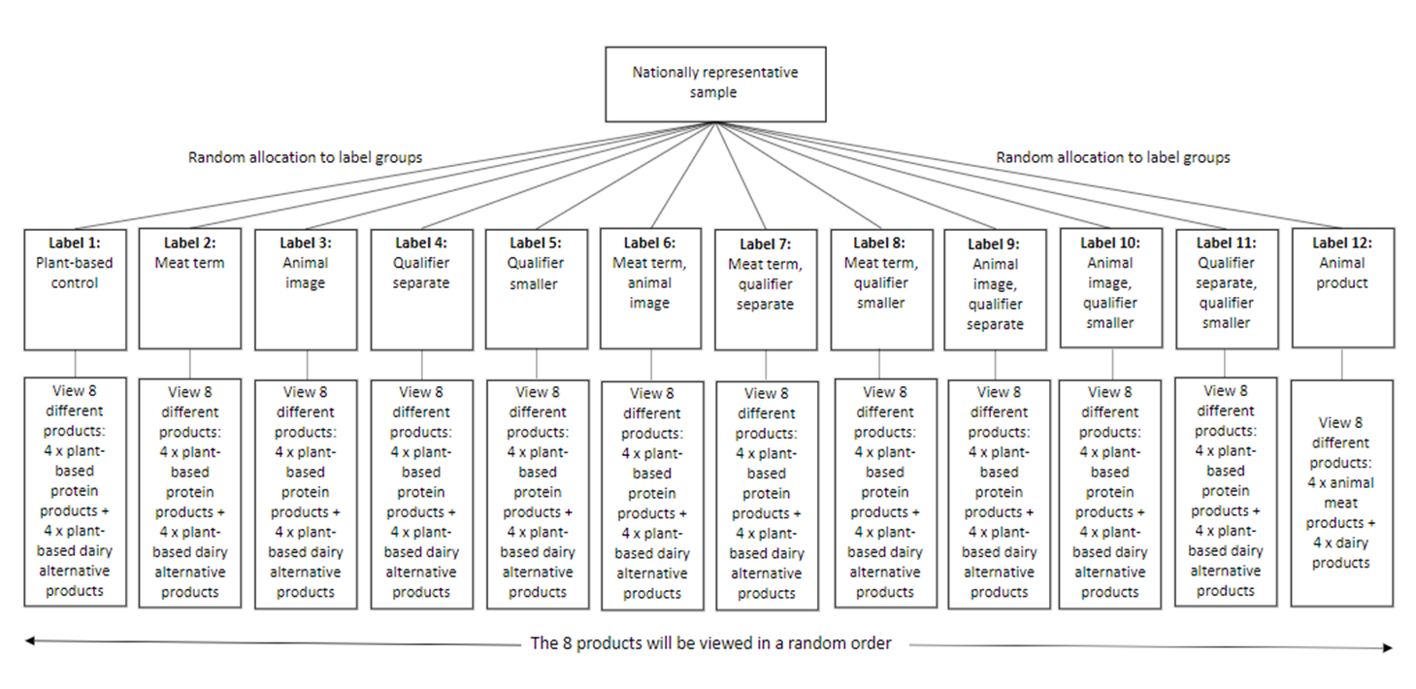

Appendix B: Survey instrumentOverview

The survey will take around 20 minutes to complete. Thank you for your participation!Section 1: Screening
Table 15 Survey instrument: questions 1 to 5
_{b} |  | Variable [Variable Name] | Question | Response Options [Code]
1 | Age |  | What is your age? |  | [Up to three-digit numeric input]  [Terminate if < 18 years]
2 | Gender |  | How do you describe your gender? |  | [Single response option]  - A man or male [1]  - A woman or female [2]  - Non-binary [3]  - A different term (please specify) [4] [Free text field]  - Prefer not to say [98]
3 | Postcode |  | What is the postcode of your main place of residence? |  | [Four-digit numeric input]  [Autocode to States and Metro/Rural region]
4 | Industry |  | Are you currently, or have you ever been, employed in any of the following sectors? (Please select all that apply) |  | [Multiple response options]  - Food retailing (e.g. supermarket, small grocer, delicatessen)  - Food service (e.g. restaurant, café, takeaway)  - Food delivery (e.g. Uber Eats, MenuLog)  - Animal meat industry (e.g. farmer, abattoir worker, smallgoods manufacturer, butcher, peak body) [Terminate]  - Plant-based meat or seafood alternatives (e.g. farmer, manufacturer, peak body) [Terminate]  - Animal dairy industry (e.g. farmer, dairy goods manufacturer, peak body) [Terminate]  - Plant-based dairy alternatives (e.g. farmer, manufacturer, peak body) [Terminate]  - None of the above [EXCLUSIVE]  [Please randomise order of responses, except for ‘None of the above’]
5 | Background |  | How would you describe your cultural background? (Please select all that apply) |  | [Multiple response options]  - Aboriginal and/or Torres Strait Islander [1]  - English [2]  - Irish [3]  - Scottish [4]  - Chinese [5]  - Italian [6]  - German [7]  - Indian [8]  - Greek [9]  - Dutch [10]  - Australian [11]  - Other (please specify): [FREE TEXT] [12]  - Prefer not to say [EXCLUSIVE] [98]  Examples of ‘Other (please specify)’ are: Spanish, Vietnamese, Hmong, Welsh, Kurdish, Lebanese.

Section 2: Random allocation to 1 type of label across 8 different products
[Participants were randomly allocated to 1 of 12 groups, using quotas for approximately equal allocation. Each group will view 1 type of product label on 8 different products. Image order was randomised]
Thank you! The next part of the survey will ask you what you think about 8 different food products, as well some questions about your diet and background.
Please click ‘next’ to view the first product.
[Participants answered Questions 6 to 10 8 times (once for each product type). Participants answered all of Questions 6 to 10 in order for each product before moving onto the next product.]
Table 16 Survey instrument: questions 6 to10
_{b} | Variable [Variable Name] | Question | Response Options [Code]
6 | Content | [Product image]  [Timestamp]  Looking at the product image above, what do you think this product is made from? | [Single response option – please make the scale go left to right]  - 1 - 100% animal [meat/dairy] [1]  - 2 - Mostly animal [meat/dairy] [2]  - 3 - 50% animal [meat/dairy], 50% plant-based [3]  - 4 - Mostly plant-based [4]  - 5 - 100% plant-based [5]
7 | Ease | [Product image]  How easy or hard was it to answer the previous question (what the product is made from)? | - [Single response option – please make the scale go left to right]  - 1 - Very hard [1]  - 2 - Somewhat hard [2]  - 3 - Neither hard nor easy [3]  - 4 - Somewhat easy [4]  - 5 - Very easy [5]
8 | Use | [Product image]  How confident are you that you understand how this product is intended to be used or consumed? | [Single response option – please make the scale go left to right]  - 1 - Very unconfident [1]  - 2 - Somewhat unconfident [2]  - 3 - Neither confident or unconfident [3]  - 4 - Somewhat confident [4]  - 5 - Very confident [5]
9 | Colour | [Product image]  Looking at the product image above, what colour stands out the most to you? | - White  - Green  - Red/Orange  - Yellow  - Other (Please specify)
10 | Equiv_V2 | [Show participants 2 x product images – 1 is their allocated label they saw for questions 11-13, the other is an animal-based equivalent. The animal-based equivalent option will be identical for each group]  [For plant-based groups only i.e. labels 1-11]  Here are 2products. 1 is an animal [meat/cow’s milk] product, and the other is a plant-based [meat/dairy] alternative.  Based on the product images above, how similar or different do you think their nutritional content would be?  [For animal-based only i.e. label 12]  Here are 2 animal [meat/cow’s] milk products.  How likely do you think it is that these 2 products would have the same nutritional content? | [Single response option – please make the scale go left to right]  - Very different [1]  - Somewhat different [2]  - Somewhat similar [3]  - Very similar [4]

Attention check questions incorporated in Section 2
Attention check questions were asked between the third and fourth products viewed, and the sixth and seventh products viewed. Data on the number of people who fail the attention check questions.
Table 17 Survey instrument: questions 11 to 12
Question no. | Variable [Variable name] | Question | Response options [Code]
11 | Attention check 1 – insert between products 3 and 4  [AC1] | Please select the option that is not a season: | [Randomise order]  - Summer  - Spring  - Autumn/Fall  - Winter  - Rainbow [correct answer]  [Exclude respondents from dataset if they answer incorrectly]
12 | Attention check 2 – insert between products 6 and 7  [AC2] | Please select the flower from the options listed below: | [Randomise order]  - Green  - Rose [correct answer]  - Table  - Ocean  - Rabbit  [Exclude respondents from dataset if they answer incorrectly]

Section 3: Baseline measures
[These measures were asked to all participants.]
Table 18 Survey instrument: questions 13 to 20
Question no. | Variable [Variable Name] | Question | Response Options [Code]
13 | PBMeat_Consume | Have you ever eaten a plant-based meat alternative?  A plant-based meat alternative is a food made from vegetable, nut, or grain ingredients (e.g. soy or wheat] that is marketed and consumed as a replacement for meat. It can take the form of products like burger patties, mince and sausages. | [Single response option]  - Yes [1]  - No [0]  - Don’t know [98]
14 | PBDairy_Consume | Have you ever consumed a plant-based dairy alternative?  A plant-based dairy alternative is a food or drink made from vegetable, nut, or grain ingredients that is marketed and consumed as a replacement for dairy. It can take the form of products like soy milk, almond milk, or coconut yoghurt. | [Single response option]  - Yes [1]  - No [0]  - Don’t know [98]
15 | PBMeat_Freq | [Only show to those who answered Yes [1] to PBMeat_Consume]  How often do you eat plant-based meat alternatives? | [Single response option]  - Every day [5]  - Several times a week [4]  - Several times a month [3]  - Around once a month [2]  - Less than once a month [1]
16 | PBDairy_Freq | [Only show to those who answered Yes [1] to PBDairy_Consume]  How often do you consume plant-based dairy alternatives? | [Single response option]  - Every day [5]  - Several times a week [4]  - Several times a month [3]  - Around once a month [2]  - Less than once a month [1]
17 | PBMeat_HH | [Only show to those who answered No [0] or Don’t know [98] to PBMeat_Consume – automatically code people who answered Yes [1] to PBMeat_Consume as Yes [1] to this question]  Does anyone in your household consume plant-based meat alternatives on a regular basis? | [Single response option]  - Yes [1]  - No [0]  - Don’t know [98]
18 | PBDairy_HH | [Only show to those who answered No [0] or Don’t know [98] to PBDairy_Consume – automatically code people who answered Yes [1] to PBDairy_Consume as Yes [1] to this question]  Does anyone in your household consume plant-based dairy alternatives on a regular basis? | [Single response option]  - Yes [1]  - No [0]  - Don’t know [98]
19 | PBMeat_Motive | [Only show to those who answered Every day [5], Several times a week [4], or Several times a month [3] to PBMeat_Freq]  Please indicate your level of agreement with the following series of statements.  I choose to eat plant-based meat alternatives because… | [Matrix]  Statements: [Randomise order of statements]  - It is better for animal welfare [PBMeat_Animal]  - It is better for the environment [PBMeat_Enviro]  - I like the taste and/or texture [PBMeat_Taste]  - I am curious about new foods/want variety [PBMeat_New]  - My friends/family eat it [PBMeat_Friends]  - I like the brand [PBMeat_Brand]  - It is convenient [PBMeat_Convenient]  - It is cost effective [PBMeat_Cost]  - I have a medical reason (e.g. meat allergy) [PBMeat_Medical]  - I have cultural/religious reasons [PBMeat_Religion]  - It is nutritionally the same as or better than animal meat. [PBMeat_Nutrition]  Response options:  - Strongly disagree [1]  - Disagree [2]  - Neither agree nor disagree [3]  - Agree [4]  - Strongly agree [5]
20 | PBDairy_Motive | [Only show to those who answered Every day [5], Several times a week [4], or Several times a month [3] to PBDairy_Freq]  Please indicate your level of agreement with the following series of statements.  I choose to consume plant-based dairy alternatives because… | [Matrix]  Statements: [Randomise order of statements]  - It is better for animal welfare [PBDairy_Animal]  - It is better for the environment [PBDairy_Enviro]  - I like the taste and/or texture [PBDairy_Taste]  - I am curious about new foods/want variety [PBDairy_New]  - My friends/family eat it [PBDairy_Friends]  - I like the brand [PBDairy_Brand]  - It is convenient [PBDairy_Convenient]  - It is cost effective [PBDairy_Cost]  - I have a medical reason (e.g. lactose intolerance) [PBDairy_Medical]  - I have cultural/religious reasons [PBMeat_Religion]  - It is nutritionally the same as or better than animal dairy. [PBDairy_Nutrition]  Response options:  - Strongly disagree [1]  - Disagree [2]  - Neither agree nor disagree [3]  - Agree [4]  - Strongly agree [5]

Section 4: Demographics
Thank you for your time so far, now we just want to know a little more about you to help understand your responses…
Table 19 Survey instrument: questions 21 to 25
Question no. | Variable [Variable name] | Question | Response options [Code]
21 | Education | What is the highest level of education you have completed? | [Single response option]  - High school or below [1]  - Vocational/trade qualification [2]  - Undergraduate degree [3]  - Postgraduate degree [4]
22 | Language | Do you speak a language other than English at home? | [Single response option]  - No – English only [0]  - Yes – Other [1]
23 | Household income | Which 1 of the following categories best describes your household’s total annual income (before tax)?  Please include the income of everyone in your household. If you don’t know the exact amount, then please take your best guess. | [Single response option]  - Under $25,000 [1]  - $25,000 – $56,000 [2]  - $56,001 – $93,000 [3]  - $93,001 – $143,000 [4]  - $143,001 – $288,000 [5]  - Above $288,000 [6]  - Prefer not to say [98]
24 | Diet | How would you describe your current diet? | [Single response option]  - Vegan – I do not eat animal meat or any animal products (e.g. eggs or milk) [1]  - Vegetarian – I do not eat animal meat but eat some animal products (e.g. eggs or milk) [2]  - Flexitarian or Pescatarian – I mostly eat a vegetarian diet but occasionally eat meat or fish. [3]  - Omnivore – I eat animal meat and animal products (e.g. milk or fish) as well as other foods. [4]
25 | Shopper | How much of the food shopping do you do for your household? | [Single response option]  - Someone else does all or the majority of food shopping for my household. [1]  - I share the food shopping with someone else. [2]  - I do all or the majority of the food shopping for my household. [3]

Appendix C: Product images

Group 1 – Plant-based control, no meat/dairy term or animal image
Figure 11 Group 1 protein products
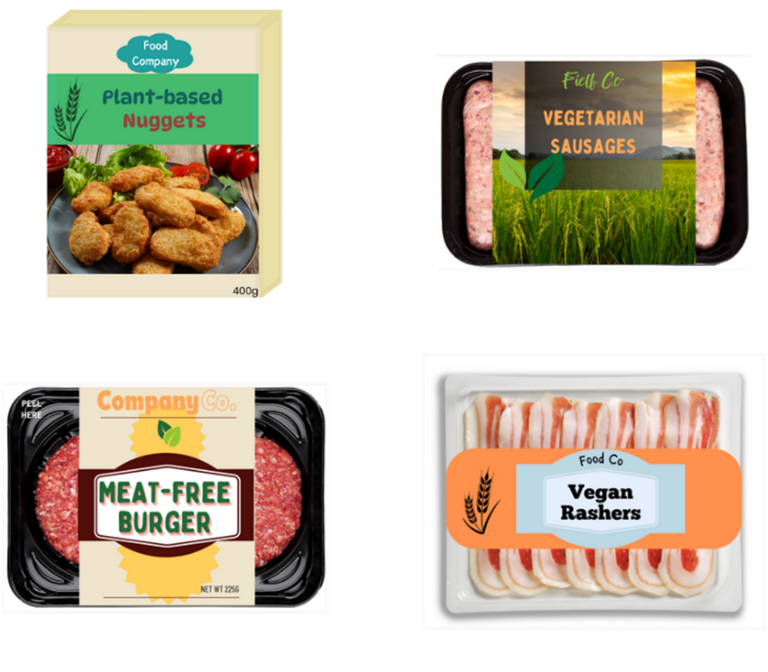
Figure 12 Group 1 dairy alternatives
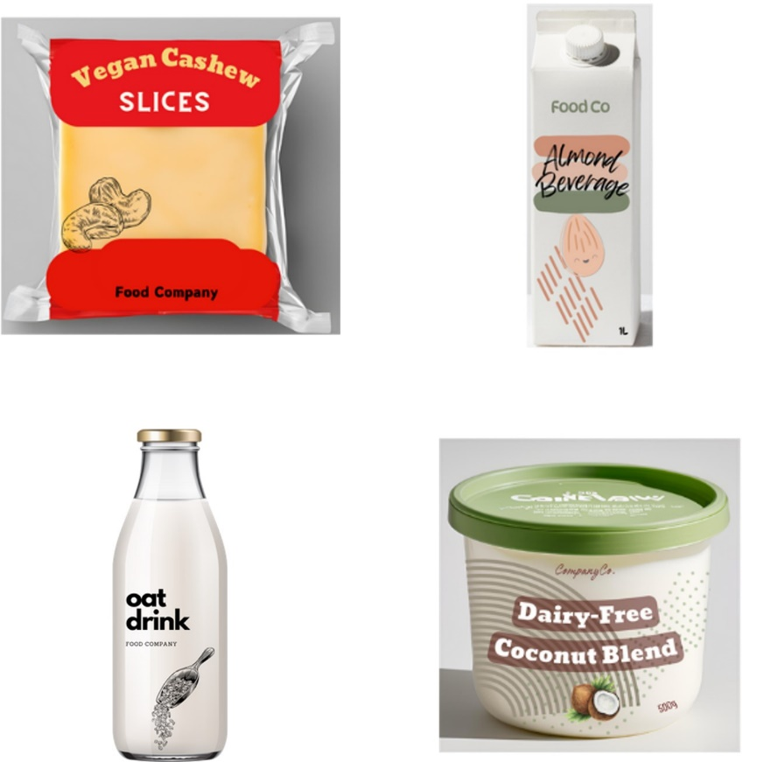

Group 2 – Meat/dairy term only
Figure 13 Group 2 protein products
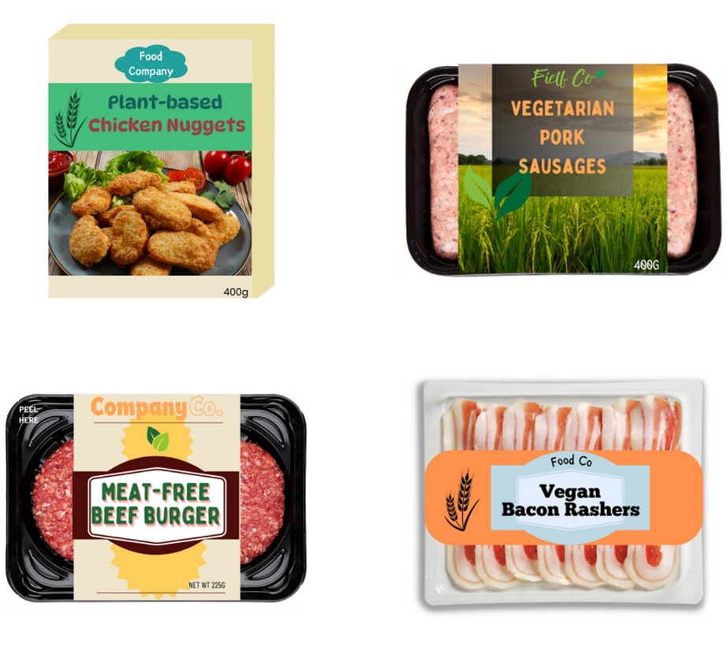
Figure 14 Group 2 dairy alternatives
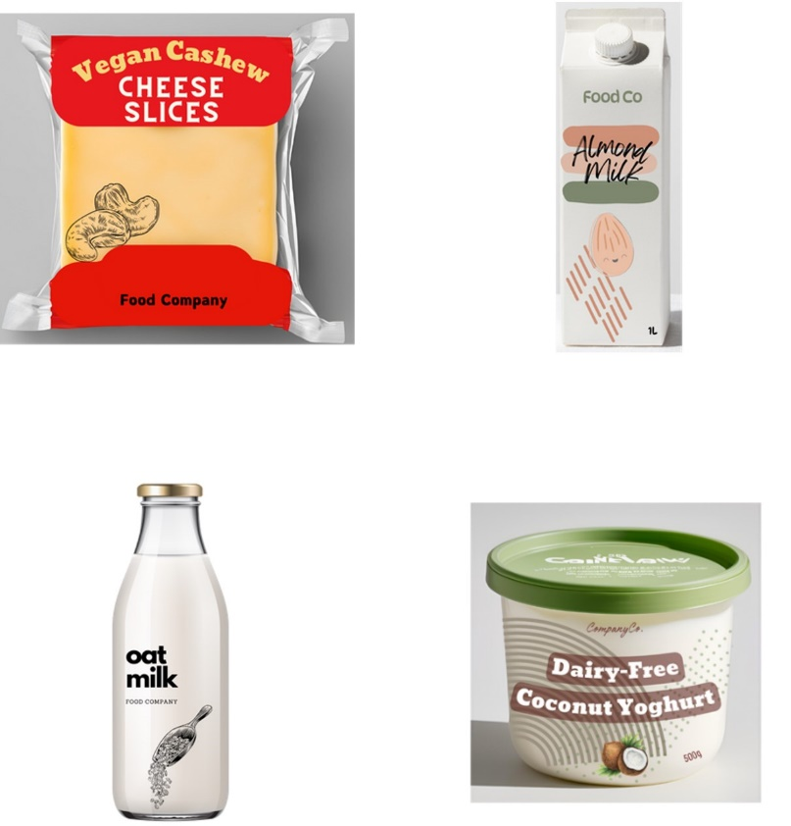

Group 3 – Animal image only
Figure 15 Group 3 protein products
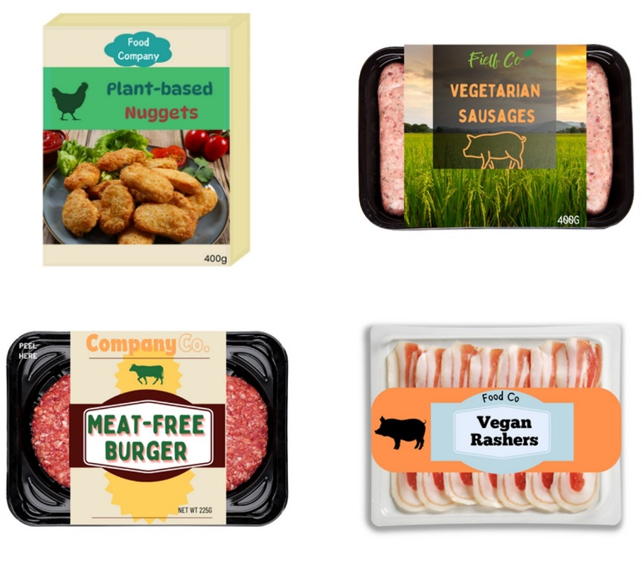
Figure 16 Group 3 dairy alternatives
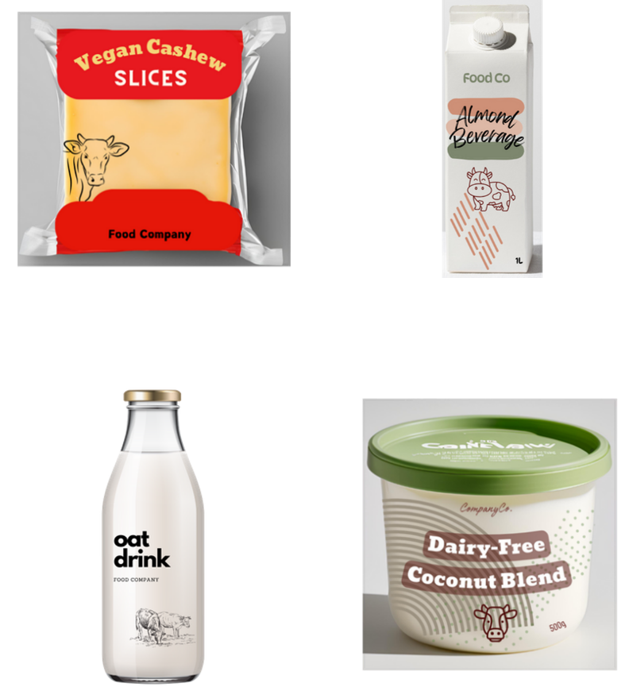

Group 4 – Qualifier not co-located
Figure 17 Group 4 protein products
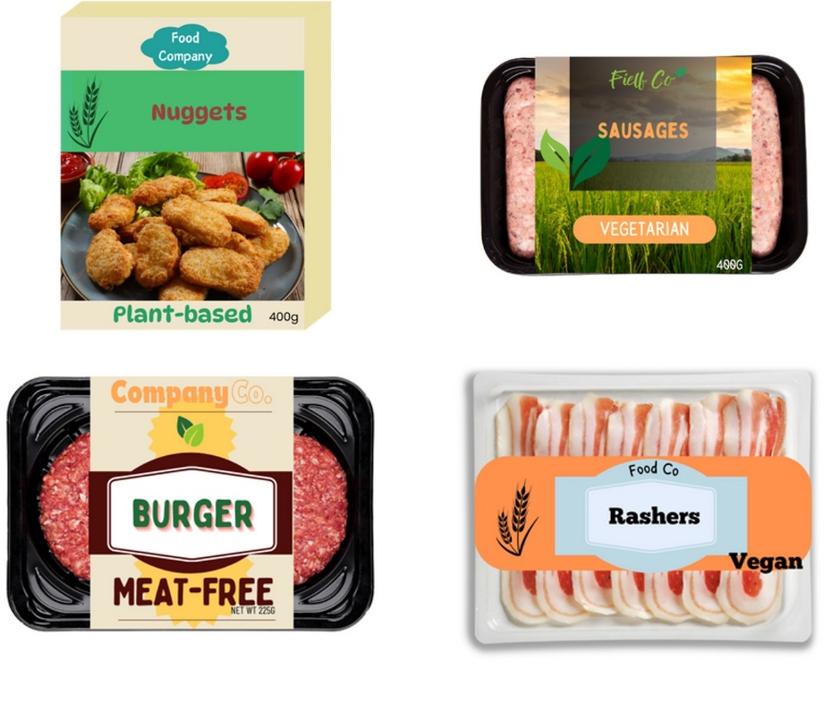
Figure 18 Group 4 dairy alternatives
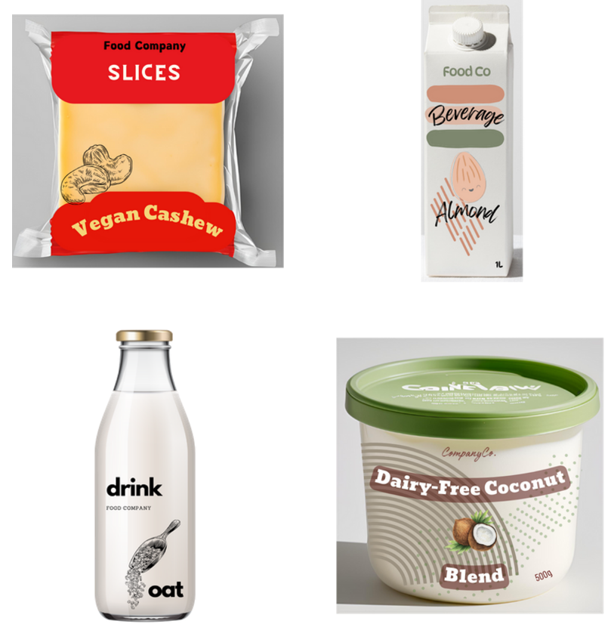

Group 5 – Smaller qualifier
Figure 19 Group 5 protein products
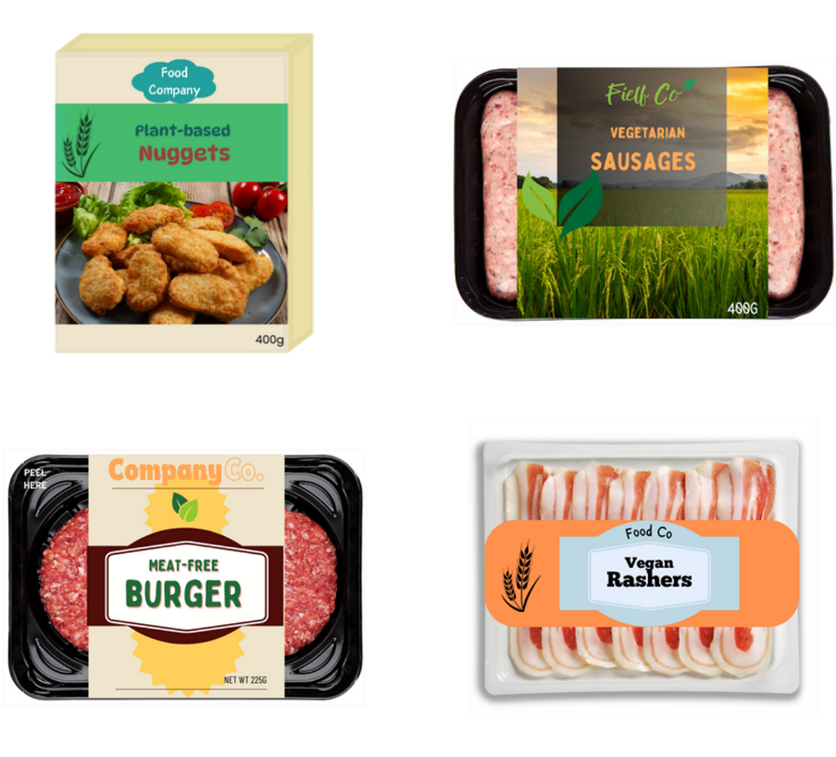

Dairy alternatives
Figure 20 Group 5 dairy alternatives
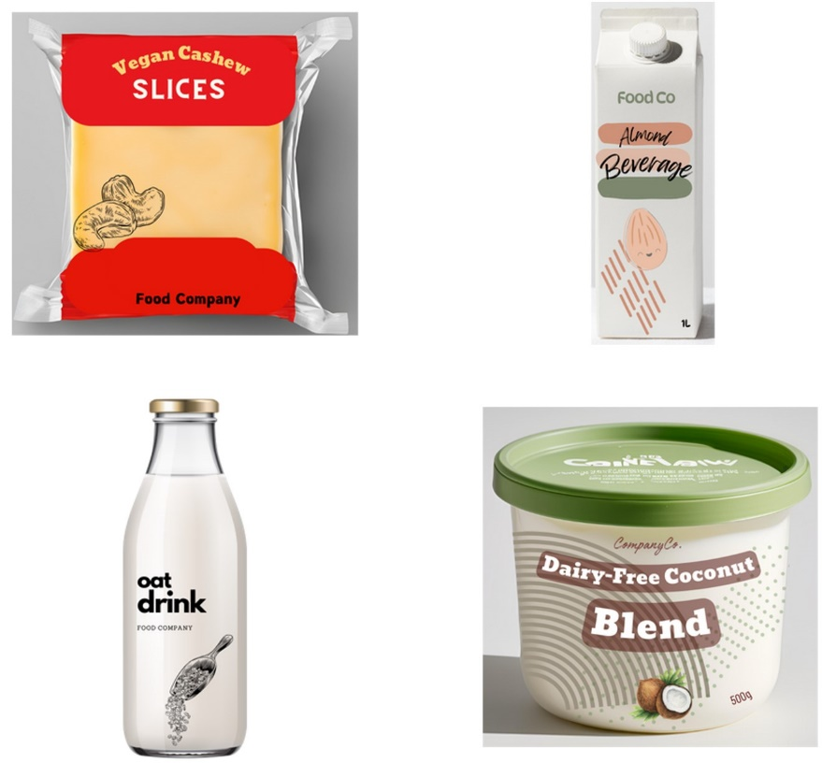

Group 6 – Animal/dairy term and animal image
Figure 21 Group 6 protein products
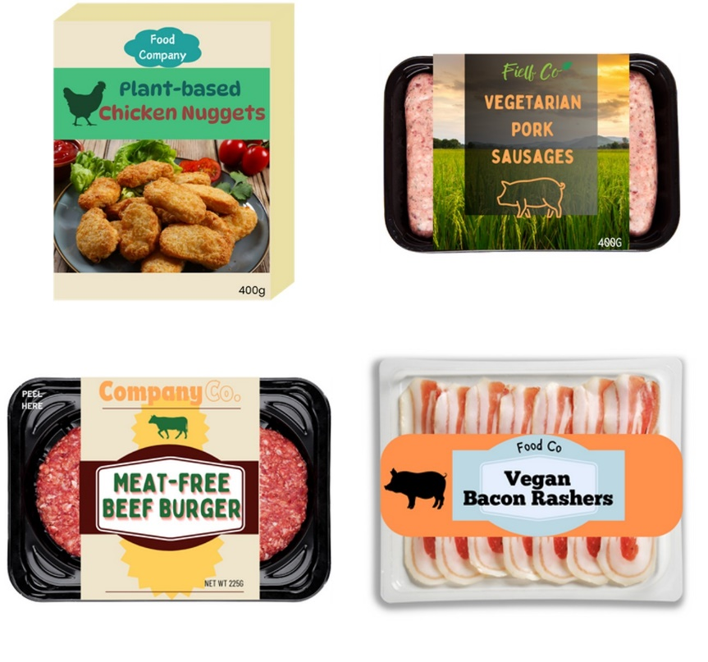
Figure 22 Group 6 dairy alternatives
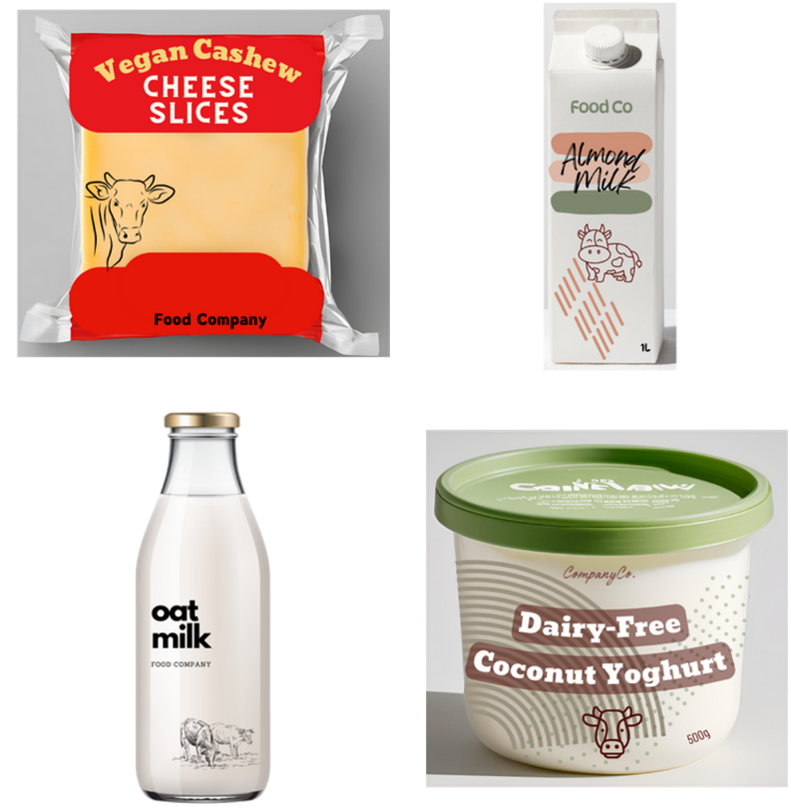

Group 7 – Meat/dairy terminology and qualifier not co-located
Figure 23 Group 7 protein products
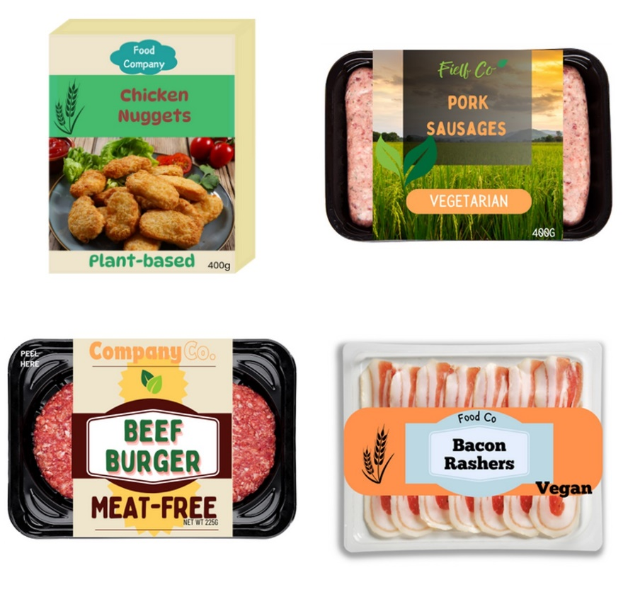
Figure 24 Group 7 dairy alternatives
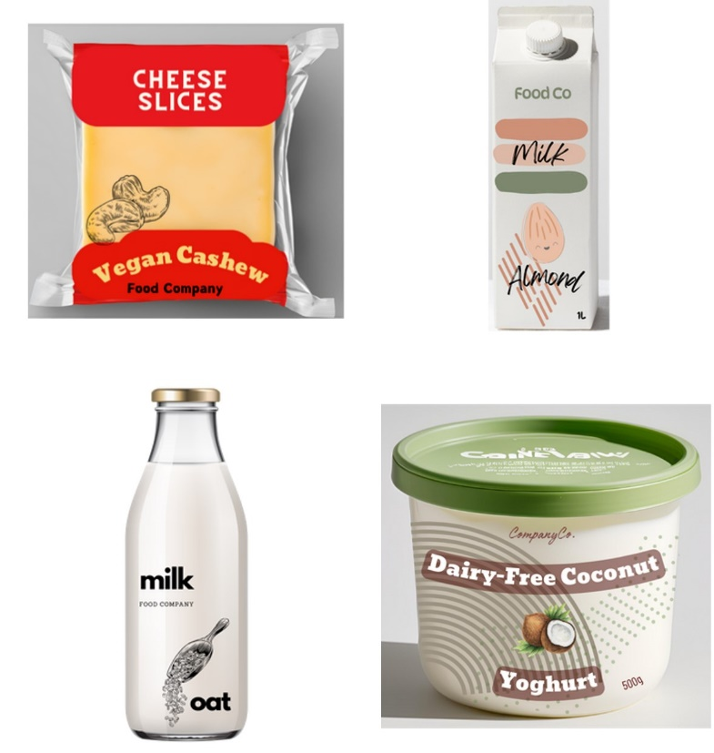

Group 8 – Meat/dairy term and smaller qualifier
Figure 25 Group 8 protein products
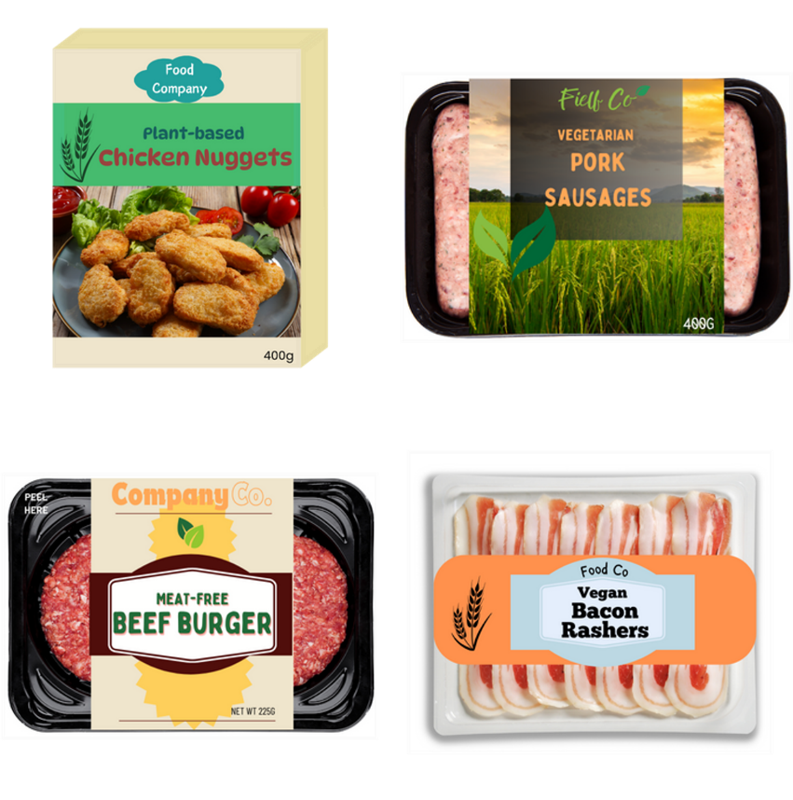
Figure 26 Group 8 dairy alternatives
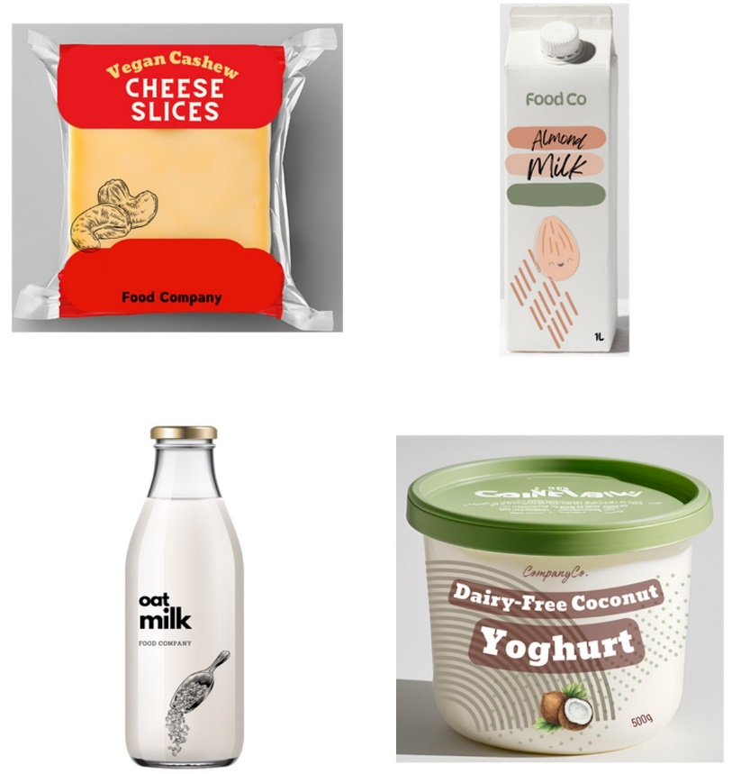

Group 9 – Animal image and qualifier not co-located
Figure 27 Group 9 protein products
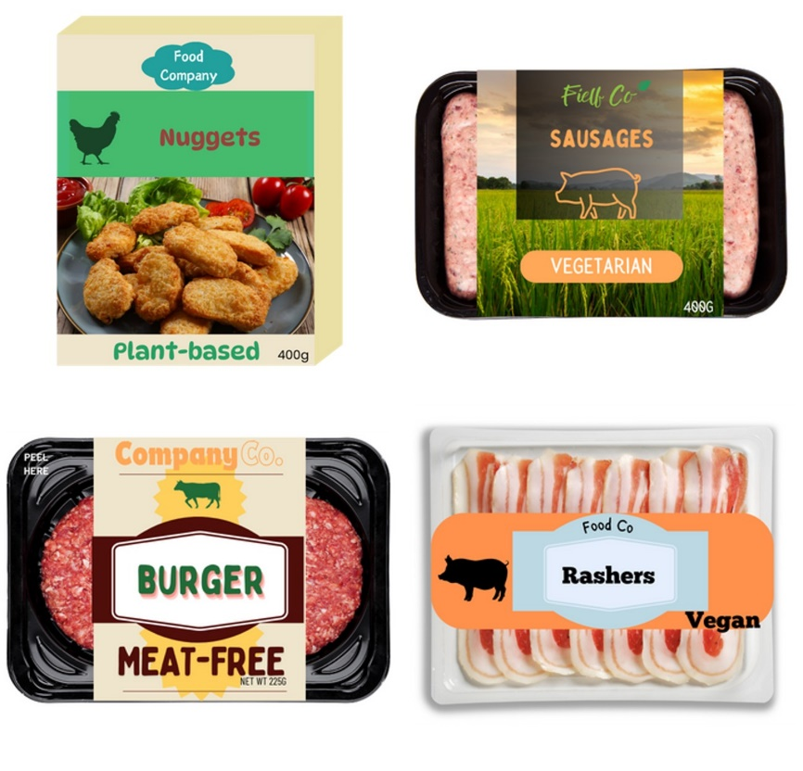
Figure 28 Group 9 dairy products
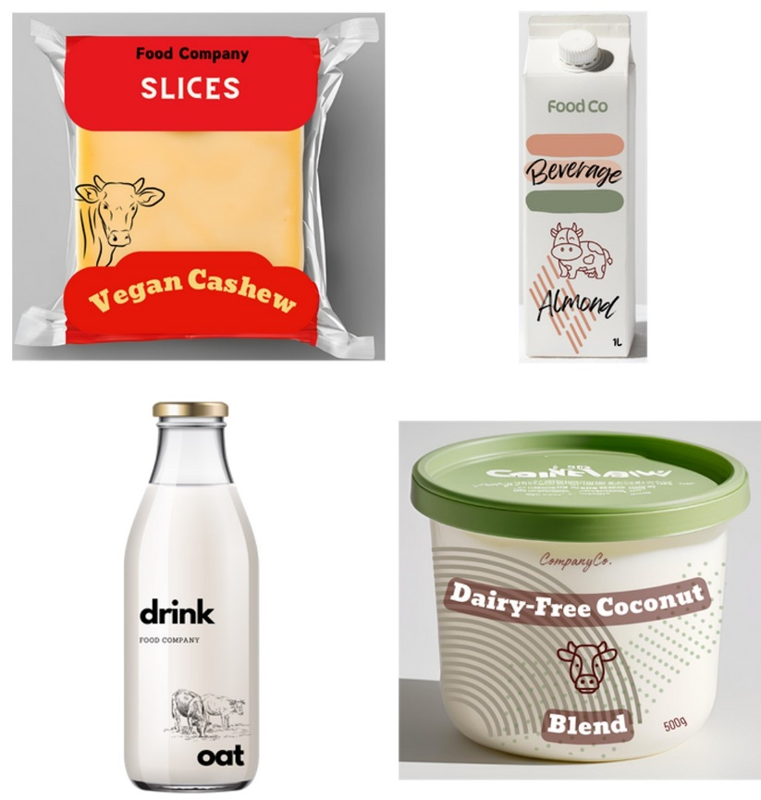

Group 10 – Animal image and smaller qualifier
Figure 29 Group 10 protein products
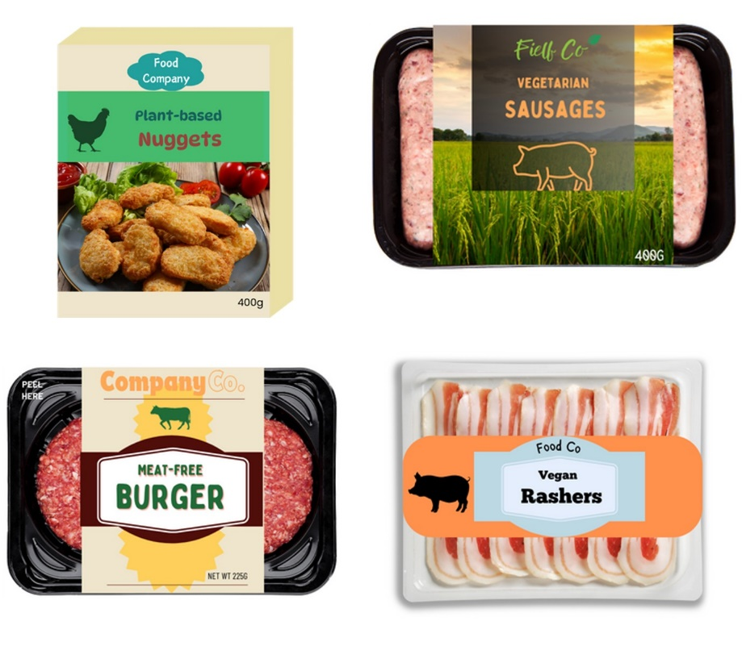
Figure 30 Group 10 dairy alternatives
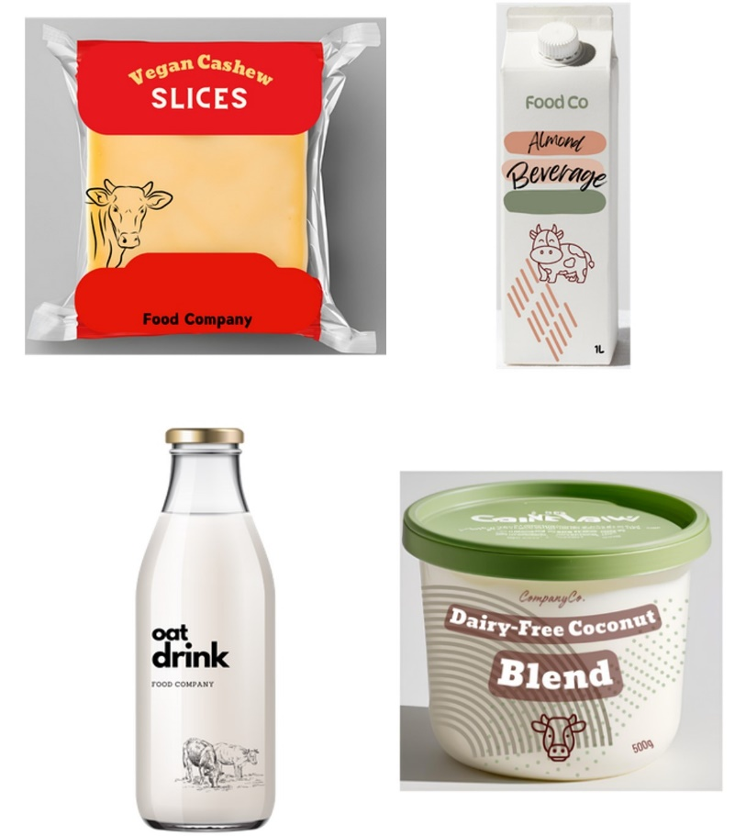

Group 11 – Smaller qualifier not co-located
Figure 31 Group 11 protein products
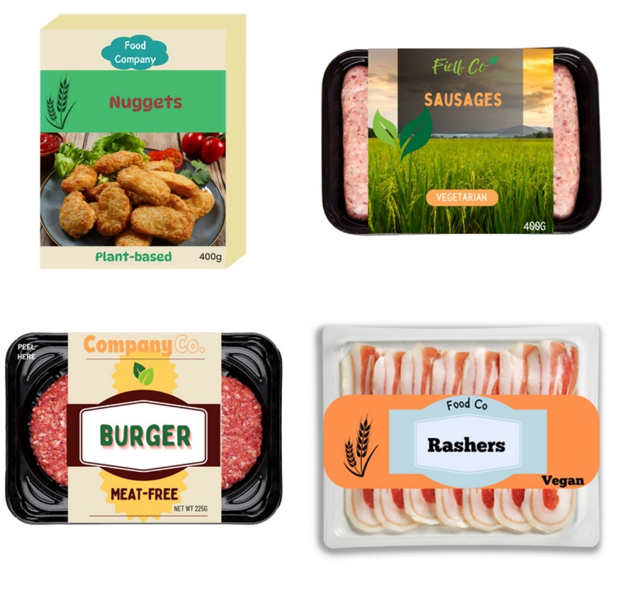
Figure 32 Group 11 dairy alternatives
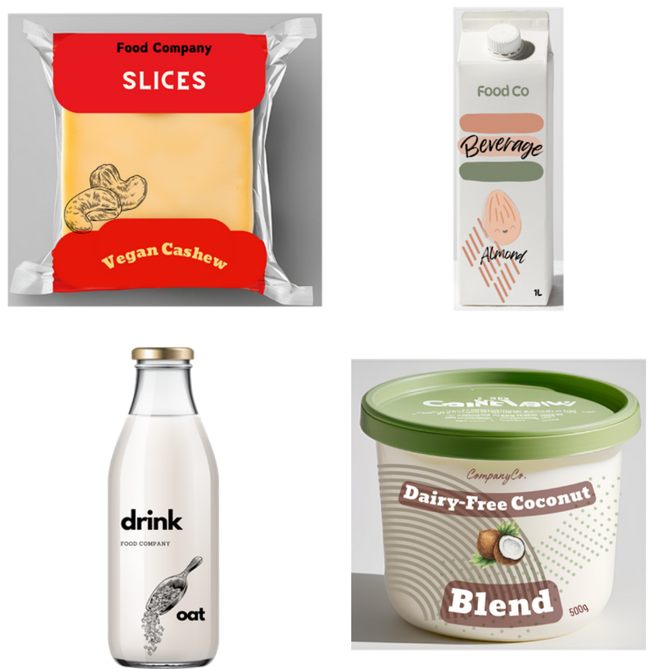

Group 12 – Animal control
Figure 33 Group 12 protein products
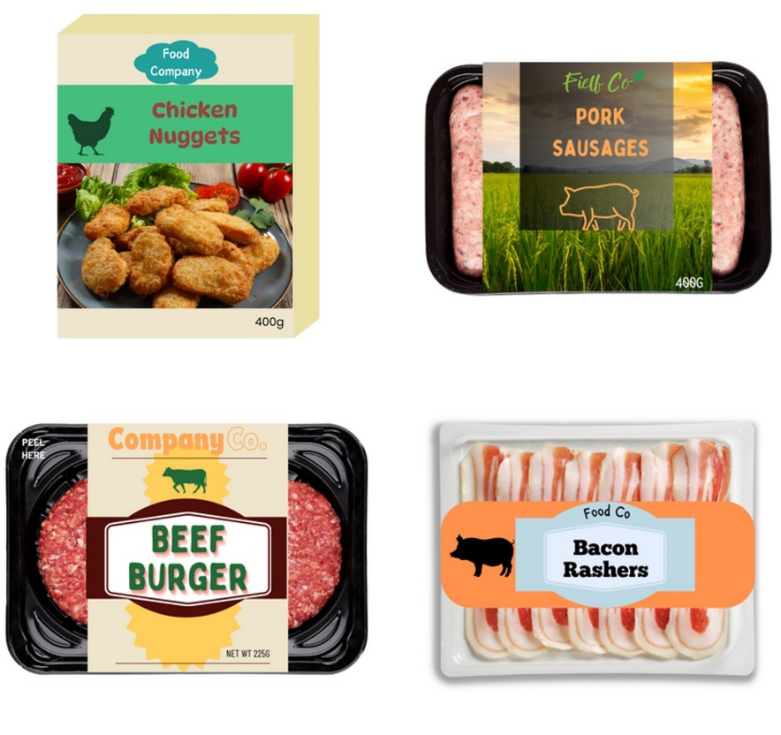
Figure 34 Group 12 dairy products
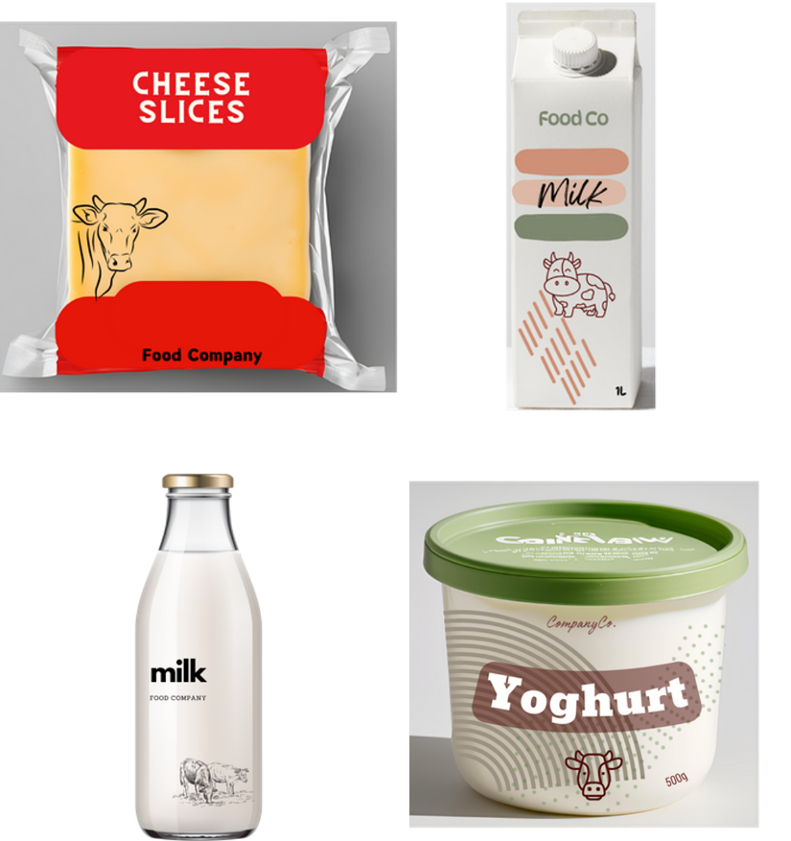

Product images for nutritional similarity by product category
Figure 35 Protein products
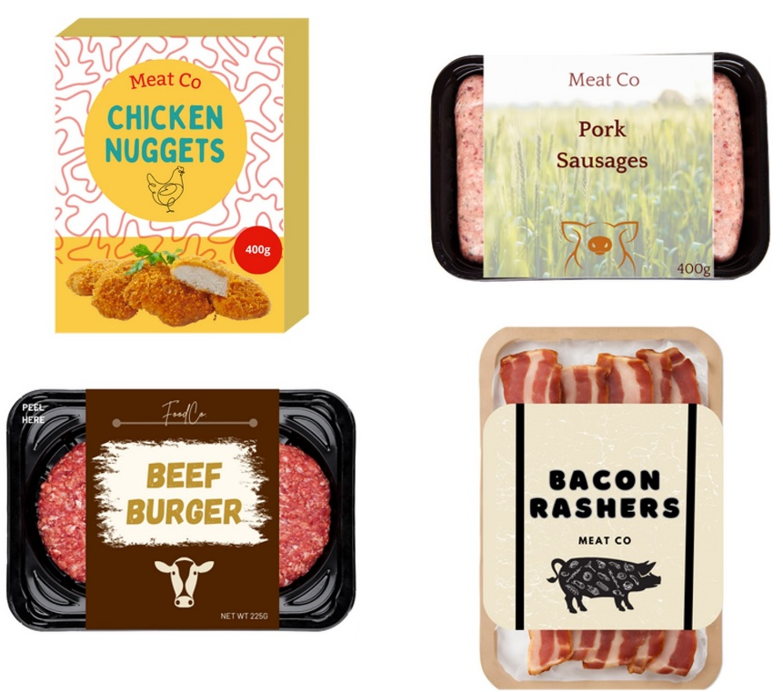
Figure 36 Dairy products
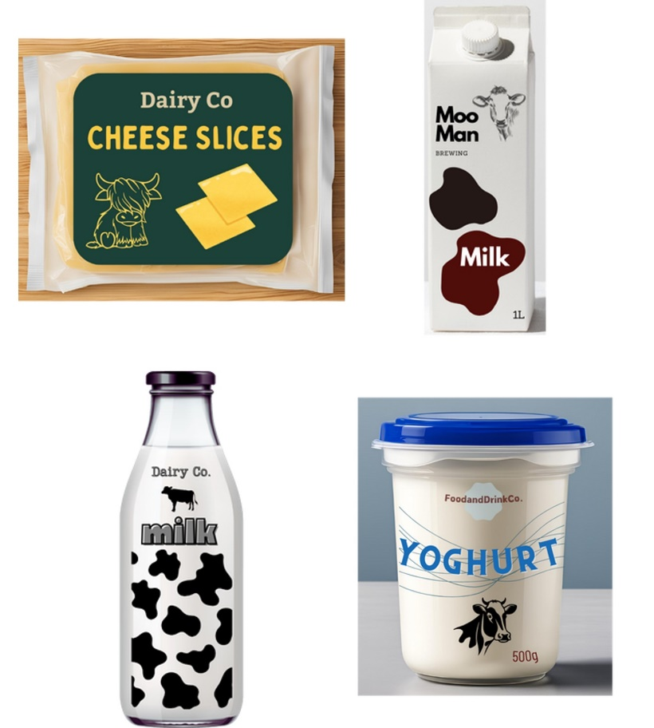

Appendix D: Full ANCOVA results controlling for baseline measures
This chapter demonstrates the ANCOVA results for the following outcome measures:
- identification of product ingredient content
- ease of identification
- perceptions of nutritional similarity.
The ANCOVA results for length of time to identify product ingredient content and confidence in understanding of product’s intended use are reported in the relevant results sections. Each analysis was a two-way mixed ANCOVA (label group x product category) controlling for baseline measures.

Identification of product ingredient content
A two-way mixed ANCOVA controlling for baseline measures (education, age, language spoken at home, overall plant-based consumption and household income) produced results consistent with the initial ANOVA test. That is, there was a statistically significant main effect of between label group (F(11, 2925) = 495.83, p = <.001, ƞ2 = .651), and a statistically significant interaction between group and product category (F(11, 2925) = 5.48, p <.001, ƞ2 = .020). Follow up t-tests also showed a statistically significant difference between Group 12 (animal-based control) and all other groups (1-11) for plant-based meat proteins (p < .001). And for plant-based dairy alternatives there was a significant difference between Group 1 (plant-based control) and Group 9 (animal imagery + ingredient qualifier not co-located with the name of the food) (p < .001). There was also a statistically significant difference between Group 12 and all other groups (1 – 11) for plant-based dairy alternatives (p < .001). Table 20 and Table 21, provide the adjusted means, standard errors (SE) and 95% confidence intervals by group and product category.
Table 20 Identification of product ingredient content by group for plant-based protein products
Group no. | Adjusted mean | Standard errors | 95% confidence intervals
Group 1 (245) | 4.60 ^{b} | .040 | 4.52 – 4.68
Group 2 (247) | 4.53 ^{b} | .040 | 4.45 – 4.61
Group 3 (246) | 4.54 ^{b} | .040 | 4.46 – 4.62
Group 4 (246) | 4.60 ^{b} | .040 | 4.52 – 4.68
Group 5 (244) | 4.65 ^{b} | .041 | 4.57 – 4.73
Group 6 (246) | 4.52 ^{b} | .040 | 4.44 – 4.60
Group 7 (244) | 4.48 ^{b} | .040 | 4.40 – 4.56
Group 8 (246) | 4.56 ^{b} | .040 | 4.48 – 4.64
Group 9 (245) | 4.44 ^{b} | .041 | 4.36 – 4.52
Group 10 (245) | 4.62 ^{b} | .040 | 4.55 – 4.70
Group 11 (245) | 4.55 ^{b} | .040 | 4.47 – 4.63
Group 12 (247) | 1.79 a | .040 | 1.71 – 1.87
a Significantly different compared to the plant-based control (Group 1; p < .001). b Significantly different compared to the animal-based control (Group 12; p < .001).
Table 21 Identification of product ingredient content by group for plant-based dairy alternatives
Group no. | Adjusted mean | Standard errors | 95% confidence intervals
Group 1 (245) | 4.57 ^{b} | .039 | 4.49 – 4.65
Group 2 (247) | 4.57 ^{b} | .039 | 4.49 – 4.64
Group 3 (246) | 4.42 ^{b} | .039 | 4.34 – 4.50
Group 4 (246) | 4.59 ^{b} | .039 | 4.51 – 4.66
Group 5 (244) | 4.60 ^{b} | .039 | 4.52 – 4.67
Group 6 (246) | 4.46 ^{b} | .039 | 4.39 – 4.54
Group 7 (244) | 4.55 ^{b} | .039 | 4.47 – 4.62
Group 8 (246) | 4.56 ^{b} | .039 | 4.48 – 4.63
Group 9 (245) | 4.27 a^{, b} | .039 | 4.19 – 4.35
Group 10 (245) | 4.46 ^{b} | .039 | 4.39 – 4.54
Group 11 (245) | 4.55 ^{b} | .039 | 4.48 – 4.63
Group 12 (247) | 1.67 a | .039 | 1.60 – 1.75
a Significantly different compared to the plant-based control (Group 1; p < .001). b Significantly different compared to the animal-based control (Group 12; p < .001).

Ease of identification of product ingredient content
A two-way mixed ANCOVA controlling for baseline measures (age, gender (participants who reported as ‘non-binary/another term’ (n = 7) or ‘prefer not to say’ (n = 4) were excluded from this analysis due to the small number of participants in these groups), region, and overall plant-based consumption. Education, dietary pattern, cultural background, language spoken at home and household income failed to meet the assumption of homogeneity of regression slopes and could not be included in the ANCOVA model) produced results consistent with the initial ANOVA test. That is, there was a statistically significant main effect of label group (F(11, 2919) = 4.52, p = <.001, ƞ2 = .017), and a statistically significant interaction between group and product category (F(11, 2919) = 8.00, p <.001, ƞ2 = .029). Table 22 and Table 23 provide the adjusted means, standard errors (SE) and 95% confidence intervals by group and product category.
For plant-based proteins products follow up t-tests also showed a statistically significant difference between Group 9 (animal imagery + ingredient qualifier not co-located with the name of the food) found the identification of product content somewhat more difficult (adjusted mean = 4.12) than those who saw the plant-based control (Group 1) (adjusted mean = 4.36) (p < .001).
For plant-based dairy alternatives participants in Group 9 (animal imagery + ingredient qualifier not co-located with the name of the food; adjusted mean = 3.91; p < .001) and Group 10 (animal imagery + ingredient qualifier smaller than the name of the food; adjusted mean = 4.04; p < .001) perceived the identification of product content harder compared to Group 1 participants (plant-based control; adjusted mean = 4.28). Participants in Group 9 (adjusted mean = 3.91) also perceived the identification of product content as harder than participants in Group 12 (animal-based control; adjusted mean = 4.16; p < .001).
Table 22 Identification of product ingredient content by group for plant-based protein products
Group no. | Mean | Standard deviation | Adjusted mean | Standard error | 95% confidence intervals
Group 1 (243) | 4.37 | 0.71 | 4.36 | .050 | 4.26 – 4.46
Group 2 (246) | 4.28 | 0.81 | 4.28 | .050 | 4.18 – 4.38
Group 3 (241) | 4.20 | 0.90 | 4.20 | .051 | 4.10 – 4.29
Group 4 (240) | 4.40 | 0.66 | 4.39 | .051 | 4.29 – 4.49
Group 5 (239) | 4.38 | 0.74 | 4.38 | .050 | 4.28 – 4.47
Group 6 (240) | 4.16 | 0.85 | 4.16 | .050 | 4.07 – 4.26
Group 7 (240) | 4.16 | 0.82 | 4.16 | .050 | 4.06 – 4.26
Group 8 (244) | 4.24 | 0.83 | 4.23 | .050 | 4.13 – 4.33
Group 9 (239) | 4.12 a | 0.80 | 4.12 a | .050 | 4.02 – 4.22
Group 10 (242) | 4.28 | 0.76 | 4.28 | .050 | 4.18 – 4.38
Group 11 (244) | 4.25 | 0.76 | 4.25 | .050 | 4.15 – 4.35
Group 12 (241) | 4.18 | 0.79 | 4.18 | .050 | 4.08 – 4.27
a Significantly different compared to the plant-based control (Group 1; p < .001). b Significantly different compared to the animal-based control (Group 12; p < .001).
Table 23 Identification of product ingredient content by group for plant-based dairy alternatives
Group no. | Mean | Standard deviation | Adjusted mean | Standard error | 95% confidence intervals
Group 1 (243) | 4.29 | 0.76 | 4.28 | .050 | 4.17 – 4.38
Group 2 (246) | 4.35 | 0.69 | 4.35 | .050 | 4.25 – 4.45
Group 3 (241) | 4.06 | 0.90 | 4.07 | .050 | 3.97 – 4.17
Group 4 (240) | 4.30 | 0.71 | 4.29 | .050 | 4.20 – 4.39
Group 5 (239) | 4.30 | 0.73 | 4.29 | .050 | 4.19 – 4.39
Group 6 (240) | 4.16 | 0.83 | 4.17 | .049 | 4.07 – 4.26
Group 7 (240) | 4.22 | 0.79 | 4.22 | .050 | 4.12 – 4.32
Group 8 (244) | 4.29 | 0.79 | 4.28 | .049 | 4.19 – 4.38
Group 9 (239) | 3.90 | 0.85 | 3.91 ^{a, b} | .050 | 3.81 – 4.00
Group 10 (242) | 4.04 | 0.80 | 4.04 ª | .050 | 3.95 – 4.14
Group 11 (244) | 4.20 | 0.79 | 4.20 | .050 | 4.10 – 4.29
Group 12 (241) | 4.15 | 0.84 | 4.16 | .050 | 4.06 – 4.25
a Significantly different compared to the plant-based control (Group 1; p < .001). b Significantly different compared to the animal-based control (Group 12; p < .001).

Perceptions of nutritional similarity
A two-way mixed ANCOVA controlling for baseline measures (state/territory, gender, language spoken at home, household income and diet) produced results consistent with the initial ANOVA test. That is, there was a statistically significant main effect of label group (F(11, 2910) = 53.95, p = <.001, ƞ2 = .169), and no statistically significant interaction between group and product category (F(11, 2910) = 1.02, p = .423, ƞ2 = .004). provides the adjusted means, standard errors (SE) and 95% confidence intervals by group and product category. Table 24 provides the adjusted means, standard errors (SE) and 95% confidence intervals by group.
Follow-up t-test results were consistent to the original ANOVA. There were no statistically significant differences between the plant-based control and all other plant-based groups (Groups 2 through 11; all p values > .001), while all plant-based groups (Groups 1 through 11) significantly differed from the animal-based control (all p values < .001). The ANCOVA was also rerun using a bootstrapping procedure, and results remained unchanged.
Table 24 Perceptions of nutritional similarity by group
Group no. | Adjusted mean | Standard errors | 95% confidence intervals
Group 1 (245) | 2.08 ^{b} | .047 | 1.98 – 2.17
Group 2 (247) | 2.10 ^{b} | .047 | 2.00 – 2.19
Group 3 (245) | 1.96 ^{b} | .047 | 1.88 – 2.06
Group 4 (244) | 2.07 ^{b} | .047 | 1.97 – 2.16
Group 5 (242) | 2.05 ^{b} | .048 | 1.95 – 2.13
Group 6 (246) | 2.12 ^{b} | .047 | 2.02 – 2.20
Group 7 (243) | 2.01 ^{b} | .048 | 1.92 – 2.10
Group 8 (246) | 2.01 ^{b} | .047 | 1.91 – 2.10
Group 9 (245) | 2.18 ^{b} | .047 | 2.07 – 2.25
Group 10 (244) | 2.08 ^{b} | .047 | 1.98 – 2.16
Group 11 (245) | 2.07 ^{b} | .047 | 1.97 – 2.16
Group 12 (243) | 3.26 | .048 | 3.17 – 3.36
b Significantly different compared to the animal-based control (Group 12; p < .001).

References
ABS (n.d.). Australian Bureau of Statistics. 2021 Census. Retrieved September 20, 2024, from https://www.abs.gov.au/census
Baptista, I.Y.F. and Schifferstein, H.N.J. (2023). Milk, mylk or drink: Do packaging cues affect consumers’ understanding of plant-based products? Food Quality and Preference 108, 104885. https://doi.org/10.1016/j.foodqual.2023.104885
Colmar Brunton. (2019a). Hungry for plant-based: Australian consumer insights. Research undertaken for Food Frontier and Life Health Foods. Report available at: https://www.foodfrontier.org/resources/
Colmar Brunton. (2019b). Hungry for plant-based: New Zealand consumer insights. Report. Food Frontier and Life Health Foods. Available at: https://www.foodfrontier.org/resources/
Dash, C. S. K., Behera, A. K., Dehuri, S., & Ghosh, A. (2023). An outliers detection and elimination framework in classification task of data mining. Decision Analytics Journal, 6, 100164.
De-Loyde, K., Pilling, M.A, Munafo, M.R, Attwood, A., and Maynard, O.M. (2023). How are milk substitutes labelled in the UK? Should the term ‘milk’ be added to milk substitute labelling? Behavioural Public Policy, First View, 1-17. https://doi.org/10.1017/bpp.2023.19
DeMuth, B. (2019). Why the beef? A public choice experiment on meat alternatives. Unpublished Masters’ thesis. Michigan State University. Available at: https://d.lib.msu.edu/etd/47846
Estell, M., Hughes, J., & Grafenauer, S. (2021). Plant protein and plant-based meat alternatives: Consumer and nutrition professional attitudes and perceptions. Sustainability, 13(3), 1478. https://doi.org/10.3390/su13031478
Feltz, S. and Feltz, A. (2019). Consumer accuracy at identifying plant-based and animal-based milk items. Food Ethics, 3, 85-112. https://doi.org/10.1007/s41055-019-00051-7
Gleckel, J.A. (2020). Are consumers really confused by plant-based food labels? An empirical study. Journal of Animal and Environmental Law, 12(2), 1-27. Available at: https://papers.ssrn.com/sol3/papers.cfm?abstract_id=3727710
Institute for Sustainable Futures. (2020). Australian consumer perceptions of plant-based meats and food labels: A national study. Report. University of Technology Sydney. Available at: https://www.uts.edu.au/isf/explore-research/projects/australian-consumer-perceptions-plant-based-meats-and-food-labels
International Food Information Council Foundation. (2018). Consumer attitudes about labelling: Cow’s milk, plant based and non-dairy alternatives. Report. Available at: https://foodinsight.org/whats-in-a-name-survey-explores-consumers-comprehension-of-milk-and-non-dairy-alternatives/
Lakens, D. (2013). Calculating and reporting effect sizes to facilitate cumulative science: a practical primer for t-tests and ANOVAs. Frontiers in psychology, 4, 863.
Pollinate. (2021). Consumer attitudes around plant-based meat. Report provided as part of the Red Meat Advisory Council’s Submission 228 to the Senate Rural and Regional Affairs and Transport Legislation Committee’s Inquiry on the Definition of Meat and Other Products. Available at: https://www.aph.gov.au/Parliamentary_Business/Committees/Senate/Rural_and_Regional_Affairs_and_Transport/DefinitionsofMeat/Submissions
Pointke, M., Ohlau, M., Risius, A., & Pawelzik, E. (2022). Plant-based only: Investigating consumers’ sensory perception, motivation, and knowledge of different plant-based alternative products on the market. Foods, 11(15), 2339. https://doi.org/10.3390/foods11152339
Sanitarium. (2021). Submission 113 to the Senate Rural and Regional Affairs and Transport Legislation Committee’s Inquiry on the Definition of Meat and Other Products. Available at: https://www.aph.gov.au/Parliamentary_Business/Committees/Senate/Rural_and_Regional_Affairs_and_Transport/DefinitionsofMeat/Submissions
Woolworths. (2021). Submission 127 to the Senate Rural and Regional Affairs and Transport Legislation Committee’s Inquiry on the Definition of Meat and Other Products. Available at: https://www.aph.gov.au/Parliamentary_Business/Committees/Senate/Rural_and_Regional_Affairs_and_Transport/DefinitionsofMeat/Submissions

