

Knowledge report

Ecological and hydrogeological survey of the Great Artesian Basin springs - Springsure, Eulo, Bourke and Bogan River supergroups

Volume 2: hydrogeological profiles

This report was commissioned by the Department of the Environment on the advice of the Interim Independent Expert Scientific Committee on Coal Seam Gas and Coal Mining. The review was prepared by UniQuest and revised by the Department of the Environment following peer review.

September 2014

Copyright

© Copyright Commonwealth of Australia, 2014.



*Ecological and hydrogeological survey of the Great Artesian Basin springs - Springsure, Eulo, Bourke and Bogan River Supergroups, Volume 2: hydrogeological profiles, Knowledge report* is licensed by the Commonwealth of Australia for use under a Creative Commons By Attribution 3.0 Australia licence with the exception of the Coat of Arms of the Commonwealth of Australia, the logo of the agency responsible for publishing the report, content supplied by third parties, and any images depicting people. For licence conditions see: <http://creativecommons.org/licenses/by/3.0/au/>

This report should be attributed as ‘Commonwealth of Australia 2014, *Ecological and hydrogeological survey of the Great Artesian Basin springs - Springsure, Eulo, Bourke and Bogan River Supergroups. Volume 2: hydrogeological profiles*, *Knowledge report,* prepared by UniQuest for the Department of the Environment, Commonwealth of Australia’.

The Commonwealth of Australia has made all reasonable efforts to identify content supplied by third parties using the following format ‘© Copyright, [*name of third party*] ’.

Enquiries concerning reproduction and rights should be addressed to:

Department of the Environment, Public Affairs

GPO Box 787 Canberra ACT 2601

Or by email to: public.affairs@environment.gov.au

This publication can be accessed at: www.iesc.environment.gov.au

Acknowledgements

This knowledge report was commissioned by the Department of the Environment on the advice of the Interim Independent Expert Scientific Committee on Coal Seam Gas and Coal Mining. The report was prepared by UniQuest with input from:

A/Prof Rod Fensham – School of Biological Sciences, University of Queensland

Prof Joan Esterle – School of Earth Sciences, University of Queensland

Dr Sue Vink – Centre for Water in the Minerals Industry, University of Queensland

Ms Alexandra Wolhuter – Centre for Water in the Minerals Industry, University of Queensland

Ms Jennifer Silcock – School of Biological Sciences, University of Queensland

Ms Kimberley Hines – School of Earth Sciences, University of Queensland

Mr Jeremy Drimer – QLD Department of Science, Information Technology, Innovation & the Arts

It was revised by the Department of the Environment following peer review by Dr MA (Rien) Habermehl (Consultant Hydrogeologist) and relevant Queensland, New South Wales and South Australian Government departments.

Disclaimer

The views and opinions expressed in this publication are those of the authors and do not necessarily reflect those of the Australian Government or the Minister for the Environment or the Interim Independent Expert Scientific Committee on Coal Seam Gas and Coal Mining or the statutory Independent Expert Scientific Committee on Coal Seam Gas and Large Coal Mining Development (IESC).  
  
While reasonable efforts have been made to ensure that the contents of this publication are factually correct, the Commonwealth and IESC do not accept responsibility for the accuracy or completeness of the contents, and shall not be liable for any loss or damage that may be occasioned directly or indirectly through the use of, or reliance on, the contents of this publication.

Contents

Copyright iii

Acknowledgements iii

Disclaimer iv

Contents v

Summary vii

Abbreviations x

Glossary xi

1 Introduction 1

2 Springsure supergroup, Queensland 3

2.1 Lucky Last, Spring Rock Creek and Abyss spring complex 3

2.2 Scott’s Creek spring complex 20

2.3 Cockatoo Creek spring complex 35

2.4 Boggomoss spring complex 55

2.5 Dawson River 2 spring complex 74

2.6 Dawson River 6 spring complex 91

2.7 Dawson River 8 spring complex 109

3 Eulo supergroup, Queensland 121

3.1 Yowah Creek spring complex 121

3.2 Dead Sea springs complex 133

3.3 Carpet spring complex 145

3.4 Eulo Town spring complex 161

3.5 Merimo spring complex 175

3.6 Granite spring complex 187

3.7 Tunga spring complex 197

3.8 Wooregym spring complex 210

4 Bourke supergroup, New South Wales and Queensland 223

4.1 Peery Lakes 223

4.2 Sweetwater 230

4.3 Thooro Mud 242

4.4 Tego 253

4.5 Towry 261

5 Bogan River supergroup, New South Wales 271

5.1 Coorigul 271

5.2 Cumborah 277

5.3 Cuddie 287

5.4 Coolabah 297

6 References 305

Appendix A: Queensland licence 307

Summary

This project report describes the surveys of 848 springs in four Great Artesian Basin (GAB) supergroups: 252 in Springsure, 436 in Eulo, 145 in Bourke and 7 in Bogan River. The surveys included all of the likely *Environment Protection and Biodiversity Conservation Act 1999* (Cwlth)– (EPBC Act–) listed springs. A further eight spring locations in the Eulo, Bourke and Bogan River supergroups, and 105 in the Springsure supergroup, have not yet been surveyed but are considered unlikely to be EPBC Act related.

The project team surveyed 503 springs in 94 spring complexes that had not previously been surveyed, and extended the current knowledge base of other previously surveyed springs.

This report is presented as two volumes:

*Ecological and hydrogeological survey of the Great Artesian Basin springs – Springsure, Eulo, Bourke and Bogan River Supergroups. Volume 1: history, ecology and hydrogeology, Knowledge report* (CoA 2014), which is divided into two main sections:

* + Part 1: Cultural history and ecological values of Great Artesian Basin springs in the Springsure, Eulo, Bourke and Bogan River supergroups—provides information on the history and ecology of the spring supergroups.
  + Part 2: Hydrogeological survey of the Great Artesian Basin springs in the Springsure, Eulo, Bourke and Bogan River supergroups—provides information on the hydrogeology of the spring supergroups, including identification of source aquifers and an analysis of the potential impacts of coal seam gas development on the springs.

*Ecological and hydrogeological survey of the Great Artesian Basin springs – Springsure, Eulo, Bourke and Bogan River Supergroups. Volume 2: hydrogeological profiles, Knowledge report* (**this report**), which includes a database of GAB springs and hydrogeological profiles for springs with both a high-conservation ranking and EPBC Act listing in the targeted supergroups.

Springs have been classified into discharge (EPBC–Act listed community), and recharge or watercourse (not EPBC Act–listed community) springs. Fifteen GAB spring-specific conceptual models were developed to describe the hydrogeological setting of springs and to clarify the definition of discharge springs that define EPBC-listed springs. Nine of these conceptual models describe EPBC Act–listed springs (Appendix E, types C to K).

All 92 EPBC Act–listed discharge springs in the Springsure supergroup have been surveyed. The unsurveyed springs are high in the landscape and unlikely to be affected by coal seam gas activities. Habitat for EPBC Act–listed species *Eriocaulon carsonii* is present in 23 springs in the Springsure supergroup, habitat for *Arthraxon hispidus* in 24 springs and habitat for *Thelypteris confluens* in 2 springs.Species listed under the *Nature Conservation Act 1992* (Qld) (NCA Act) occur in56 springs of the Springsure supergroup.

In the Eulo supergroup, there are 177 active EPBC Act–listed discharge springs with four springs at one location providing habitat for the EPBC Act–listed species *Eriocaulon carsonii.* A further two springs in the Eulo supergroup contain species listed under the NCA Act,and 22 springs contain species endemic to spring wetlands*.*

In the Bourke supergroup, there are 51 active EPBC Act–listed discharge springs with six springs at one location providing habitat for the EPBC Act–listed species *Eriocaulon carsonii*,which is also listed under the *Threatened Species Conservation Act 1995* (NSW)*.* No other springs in the Bourke supergroup support endemic species. There are no active springs in the Bogan River supergroup.

The importance of springs to Indigenous people for the past thousands of years is evident in the archaeological record, although stories relating to individual springs in the regions studied in this project have mostly not been told.

The Eulo and New South Wales springs were similarly vital to early pastoralists as the only reliable sources of water across large semi-arid expanses. However, as bores were drilled since the late 1800s and the extent of the GAB became known, springs became redundant. Many springs dried up as artesian aquifer pressures were drawn down by flowing artesian bores, and spring locations were eventually forgotten.

Due to the loss of springs, and the local impacts of excavation, piping, and feral and domestic herbivores, many populations of endemic species were lost, and it is likely that some spring-dependent species became extinct.

The ability to identify source aquifers for springs is dependent on the quantity and quality of data for nearby waterbores. The lack of bore screen data at the Eulo supergroup, and interpreted stratigraphy for New South Wales bores and springs, limited our ability to determine source aquifers for springs of the Eulo, Bourke and Bogan River supergroups with certainty.

Springs in the Springsure group are most likely to be impacted by current coal seam gas development. Of particular concern are the Lucky Last and Scotts Creek springs, with a predicted (modelled) artesian pressure drawdown of more than 0.2 metres, due to hydraulic connectivity between targeted coal seams and their likely source aquifer. These two discharge spring clusters (hence, EPBC Act–listed communities), provide habitat for the EPBC Act–listed species *Eriocaulon carsonii* and they have high-conservation value. Other springs that may be impacted, although with a predicted (modelled) drawdown of less than 0.2 metres, include Spring Rock Creek, Abyss and possibly Dawson River 8. It should be noted that the drawdown risk threshold of 0.2 metres—as set in s. 379 (3) of the *Water Act 2000* (Qld), and used to assess and rank springs likely to be impacted by coal seam gas—is more of a reflection of the predictive capability of the groundwater model than on the level of drawdown that would have an impact on a spring’s ecological values.

Coal seam gas development and extraction is currently remote from active springs in the Eulo, Bourke and Bogan River supergroups, and is of less concern than large free-flowing artesian pastoral bores that have not as yet been rehabilitated and regulated among the springs.

Springs supporting endemic species must be the focus of ongoing conservation efforts.Particularly urgent is the rehabilitation of remaining high-flow artesian bores that occur within 50 kilometres of high-value spring groups. Fencing, secure tenure agreements and strategic ongoing pest control will also be important.

Groundwater data collection and modelling capabilities need to be improved to more accurately predict the impact of coal seam gas extraction on aquifers that source springs in the Springsure supergroup.

The database presented as part of the project report and any updated version, need to be extended to include all springs throughout the Basin. This will assist the priority setting for conservation efforts and inform regulatory decision-making in the regions of coal seam gas and large coalmining activities, and allow consideration of their impacts on surface and groundwater resources.

This report should be read in conjunction with complementary work recently completed by the Queensland Water Commission (QWC 2012b, *Underground water impact report for the Surat Cumulative Management Area*) and by the National Water Commission (NWC 2013, *Allocating water and maintaining springs in the Great Artesian Basin*).

Further background information can be found in work completed by the Queensland Herbarium (2012 *Ecological and botanical survey of springs in the Surat Cumulative Management Area*) and by the Queensland Water Commission (QWC 2012a, Hydrogeolo*gical attributes associated with springs in the Surat Cumulative Management Area*).

Abbreviations

| General abbreviations | Description |
| --- | --- |
| DERM | Queensland Government Department of Environment and Resource Management (ceased operations in 2012) |
| EC | electrical conductivity |
| GAB | Great Artesian Basin |
| GWDB | Groundwater Database |
| µS/cm | microsiemens per centimetre |

Glossary

| Term | Description |
| --- | --- |
| Alkalinity | The quantitative capacity of aqueous media to react with hydroxyl ions. The equivalent sum of the bases that are titratable with strong acid. Alkalinity is a capacity factor that represents the acid-neutralising capacity of an aqueous system. |
| Anticline | In structural geology, an anticline is a fold that is convex up and has its oldest beds at its core. |
| Aquifer | Rock or sediment in formation, group of formations or part of a formation, which is saturated and sufficiently permeable to transmit quantities of water to wells and springs. |
| Aquifer connectivity | The degree to which groundwater can transfer between two adjacent aquifers or to the surface. |
| Aquifer discharge | Water leaving an aquifer. |
| Aquifer recharge | The amount of water replenishing an aquifer over a given time period. |
| Aquitard | A saturated geological unit that is less permeable than an aquifer and incapable of transmitting useful quantities of water. Aquitards often form a confining layer over an artesian aquifer. |
| Artesian | Pertaining to a confined aquifer in which the groundwater is under positive pressure (i.e. a bore screened into the aquifer will have its water level above ground). |
| Bore/borehole | A narrow, artificially constructed hole or cavity used to intercept, collect or store water from an aquifer, or to passively observe or collect groundwater information. Also known as a borehole, well or piezometer. |
| Casing | A tube used as a temporary or permanent lining for a bore.  *Surface casing*: the pipe initially inserted into the top of the hole to prevent washouts and the erosion of softer materials during subsequent drilling. Surface casing is usually grouted in and composed of either steel, PVC-U or composite materials.  *Production casing*: a continuous string of pipe casings that are inserted into or immediately above the chosen aquifer, and back up to the surface through which water and/or gas are extracted/injected. |
| Coal seam gas | A form of natural gas (generally 95–97 per cent pure methane, CH4) typically extracted from permeable coal seams at depths of 300–1000 metres. |
| Confined aquifer | An aquifer bounded above and below by confining units of distinctly lower permeability than that of the aquifer itself. Pressure in confined aquifers is generally greater than atmospheric pressure. |
| Cretaceous period | A period of geologic time, 145 million to 66 million years ago. |
| Devonian age | A period of geologic time, 419.2 million to 358.9 million years ago. |
| Fault | A planar fracture or discontinuity in a volume of rock, across which there has been significant displacement along the fractures as a result of earth movement. |
| Fracture | The separation of an object or material into two or more pieces under the action of stress. |
| Geologic stratum | A layer of sedimentary rock or soil with internally consistent characteristics that distinguish it from other layers. The ‘stratum’ is the fundamental unit in a stratigraphic column and forms the basis of the study of stratigraphy. |
| Geological layer | A layer of a given sample. An example is Earth itself. The crust is made up of many different geological layers, which are made up of many different minerals/substances. The layers contain important information about the history of the planet. |
| Groundwater | Water occurring naturally below ground level (whether in an aquifer or other low-permeability material), or water occurring at a place below ground that has been pumped, diverted or released to that place for storage. This does not include water held in underground tanks, pipes or other works. |
| Heterogeneity | Composition from dissimilar parts. |
| Hydrogeology | The area of geology that deals with the distribution and movement of groundwater in the soil and rocks of Earth’s crust (commonly in aquifers). |
| Hydrology | The study of the movement, distribution and quality of water on Earth and other planets, including the hydrologic cycle, water resources and environmental watershed sustainability. |
| Hydrostratigraphic unit | Any soil or rock unit or zone that, by virtue of its porosity or permeability, or lack thereof, has a distinct influence on the storage or movement of groundwater. |
| Jurassic period | A period of geologic time, 201.3 million to 145 million years ago. |
| Lineaments | Linear surface expressions of subsurface fracture zones, faults and geological contacts. |
| Mesozoic era | An era of geologic time, 252.2 million to 66 million years ago. |
| Palaeozoic | An era of geologic time, 541 million to 252.2 million years ago. |
| Permeability | The measure of the ability of a rock, soil or sediment to yield or transmit a fluid. The magnitude of permeability depends largely on the porosity, and the interconnectivity of pores and spaces in the ground. |
| Physicochemical parameters | Relating to both physical and chemical characteristics. |
| Porosity | The proportion of the volume of rock consisting of pores, usually expressed as a percentage of the total rock or soil mass. |
| Potentiometric surface | An imaginary surface representing the static head of groundwater and defined by the level to which water will rise in a tightly cased well. |
| Production well | A well drilled to produce oil or gas. |
| Quaternary | The period of geologic time 2.5 million to zero million years ago. |
| Saturated zone | That part of Earth’s crust beneath the regional watertable in which all voids, large and small, are filled with water under pressure greater than atmospheric. |
| Screen | The intake portion of a bore, which contains an open area to permit the inflow of groundwater at a particular depth interval, while preventing sediment from entering with the water. |
| Sediment | A naturally occurring material that is broken down by processes of weathering and erosion, and is subsequently transported by the action of wind, water or ice, and/or by the force of gravity acting on the particle itself. |
| Stratigraphy | A branch of geology that studies rock layers (strata) and layering (stratification). |
| Tertiary | A geologic period (from 66 million to 2.588 million years ago) that is no longer recognised as a formal unit by the International Commission on Stratigraphy, but is still widely used. |
| Triassic | The period of geologic time 248 million to 206 million years ago. |
| Unconsolidated sediments/materials | Sediments or materials that are not bound or hardened by mineral cement, pressure or thermal alteration. |
| Water quality | The physical, chemical and biological attributes of water that affect its ability to sustain environmental values. |
| Watertable | The upper surface of a body of groundwater occurring in an unconfined aquifer. At the watertable, pore water pressure equals atmospheric pressure. |
| Well | A human-made hole in the ground, generally created by drilling, to obtain water. *See also* Bore |
| Yield | The rate at which water (or other resources) can be extracted from a pumping well, typically measured in litres per second (L/s) or megalitres per day (ML/d). |

# Introduction

This report is Volume 2 of the Great Artesian Basin (GAB) springs Knowledge project report. It provides hydrogeological profiles for GAB spring complexes in the Springsure, Eulo, Bourke and Bogan River supergroups.

To limit the scope of the report to a reasonable size, and so that it could be completed within a reasonable time, only spring complexes listed under the *Environment Protection and Biodiversity Conservation Act 1999* (Cwlth) and with a high conservation ranking were investigated. Hydrogeological profiles for spring complexes with a conservation ranking of 1a or 1b (determined according to methods in Fensham et al. 2010) were produced for springs of the Springsure and Eulo supergroups. There were very few springs in the Bourke supergroup with a high conservation ranking. Therefore, hydrogeological profiles for spring complexes in the Bourke supergroup include springs with a conservation ranking of 1a–4a. As there are only four spring complexes in the Bogan River supergroup, hydrogeological profiles were produced for all complexes.

Each profile begins with a dot-point summary of key information. A description of the location of the spring complex and images of some of the spring vents are then provided. A table presents a summary of the hydrogeological information, such as the number of spring vents, the number of waterbores within a 10 kilometre radius, underlying aquifers and the likely source aquifer. This is followed by a map of the spring complex showing the location of the spring vents, waterbores and surface lithology and other relevant details.

Each profile discusses geology, regional stratigraphy and underlying aquifers, water chemistry and artesian status of potential source aquifers with reference to figures and tables in the following pages. The profile shows tables and figures of available information on the geology, stratigraphy and hydrochemistry information used to determine the source aquifer for the spring complex. The tables and figures are in the following order:

1. The spring location and elevation provides the latitude and longitude and elevation (Australian height datum) of the spring vents.
2. The stratigraphic bores table provides stratigraphic data from stratigraphic bores in the area of the spring complex.
3. The table listing waterbores within a 10-kilometre radius provides stratigraphic data for groundwater bores. Where interpreted stratigraphy is available, this is provided, otherwise the table sets out drillers’ logs.
4. The waterbore details and hydrochemistry table details about the bore, year drilled, depth, standing water level (measured either from the natural surface elevation (N) or a reference point (R) and status), as well as available hydrochemical data. Where there are many bores within a 10-kilometre radius, the information has been split into several tables.
5. The spring hydrochemistry table details of spring water chemistry for individual spring vents in the spring complex.
6. The Piper plot for spring and waterbore hydrochemistry figure compares waterbore and spring hydrochemistry data.
7. The additional field measurements table provides additional physicochemistical field data.
8. The isotopes data table provides available isotopes data for the springs and waterbores.
9. The oxygen and deuterium ratios figure compares oxygen and deuterium ratios for springs and waterbores to the global meteoric water line and to the Brisbane meteoric water line.
10. The table with potentiometric surface data provides available data on the regional potentiometric surface of underlying aquifers.
11. The spring elevation and flow rate table provides the measured elevation and flow rates for springs.
12. The waterbore pump test data table provides discharge and standing water level data from the most recent pump test.
13. The waterbore standing water level time series figure shows data on the standing water level for groundwater bores over time.

Where all data required for a table or figure were not available, the figure or table is not included; however, the order otherwise remains the same. A dash (–) in a table indicates that the data are not available for that variable. Due to the large number of bores in the region of the Springsure supergroup, only waterbores with either stratigraphic information or hydrochemistry data were investigated. Bores with neither of these data have not been listed in the report. Where stratigraphic data were available, but not on hydrochemistry data for a particular bore, or vice versa, this will be noted in the caption. Generally, tables list all available data. If a particular bore or spring is not included in a table, this indicates that the data were not available.

Lucky Last, Abyss and Spring Rock Creek are listed as separate spring complexes in the Queensland Springs Database. Due to their proximity to each other, Lucky Last, Spring Rock Creek and Abyss were included in one profile, although Spring Rock Creek has a conservation ranking of 3 and Abyss is classified as a recharge spring. The geology of the area around Lucky Last spring complex is quite complex and has been the subject of further study by coal seam gas companies recently. These further studies are likely to produce more knowledge and, possibly, change current understanding about the Lucky Last spring complex.

Boggomoss spring complex, also known as Dawson River 5, is in the same location as the Dawson River 6 spring complex. Although some spring vents for each complex are adjacent to each other, the two spring complexes have been treated separately in this study, because, historically, they have been separated in springs databases and remain as separate entries in the current springs database.

# Springsure supergroup, Queensland

## Lucky Last, Spring Rock Creek and Abyss spring complex

### Hydrogeological summary

The Lucky Last and Spring Rock Creek spring complexes consist of discharge springs, whereas the Abyss springs are all recharge springs. The springs are located in the vicinity of a significant fault; thus, the likely conceptual model type E or F applies for this spring group.

The complexity of the geology in the area makes it difficult to accurately attribute a source aquifer for the springs. It is possible that the springs have different source aquifers depending on their location. Hutton Sandstone is the most likely source aquifer for the Abyss springs. Based on potentiometric and water chemistry data, deeper aquifers—including Precipice and Clematis Sandstone—are also possible source aquifers for Lucky Last and Spring Rock Creek. Field assessments indicate that the Abyss springs are likely to be sourced from the Hutton Sandstone emerging at the edge of the overlying Birkhead Formation (QWC 2012a).

Water quality analysis and potentiometric surface analysis did not conclusively attribute a source aquifer to the spring complexes, although it is likely that more than one aquifer supplies artesian groundwater to the springs given the geology in the area. This is due to limited spring hydrochemistry data, and no chemical or potentiometric data on deep aquifers such as the Clematis Group being available.

### Spring complex overview

The Lucky Last spring complex is located approximately 21 kilometres east-north-east of Injune in south-eastern Queensland. Spring Rock Creek spring is located just to the north, on the other side of Hutton Creek. Figure 1 shows the Lucky Last, Spring Rock Creek and Abyss spring vents. The Lucky Last spring complex has been classified as one of the spring complexes most likely to be affected by coal seam gas extraction in the *Underground water impact report for the Surat Cumulative Management Area* (QWC 2012b). The Abyss spring complex lies approximately 0.5 kilometres to the south-west of the Lucky Last spring complex, on the other side of a fault, as shown in Figure 2. Both complexes have been given a conservation ranking of 1b (Table 1). Table 2 summarises the location and elevation data for the Lucky Last spring complex.

|  |  |
| --- | --- |
|  |  |

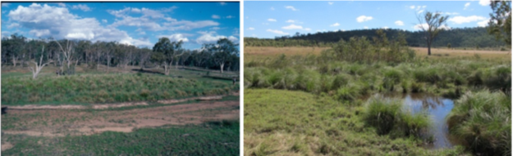

Figure 1 Lucky Last, Spring Rock Creek and Abyss spring complex—vents 287 (Four Dog) and 686.

Table 1 Lucky Last, Spring Rock Creek and Abyss spring complex—hydrogeological summary.

| Feature | Details | Comments |
| --- | --- | --- |
| No. of active vents | 12 | Abyss: 682, 286.1, 286.2, 286.3, 716  Lucky Last: 287, 686, 687, 687.1, 687.2, 687.3, 687.4, 687.5, 687.6, 688, 699, 340  Spring Rock Creek: 285 |
| No. of inactive vents | – |  |
| Conservation ranking | 1b | Abyss and Lucky Last: 1b  Spring Rock Creek: 3 |
| Spring water quality samples | Yes |  |
| Waterbores within 10-km radius | 34 |  |
| Stratigraphic bores | 2 | TAROOM 17, DRD1 |
| Waterbore water quality samples | Yes |  |
| Interpreted stratigraphy available | Yes |  |
| Outcropping formations |  | Injune Creek Group, Birkhead Formation, Hutton Sandstone, Evergreen Formation and Precipice Sandstone |
| Underlying aquifers |  | Hutton Sandstone, Evergreen Formation |
| SWL time series data available | No |  |
| Likely source aquifers |  | Abyss: Hutton Sandstone or Precipice Sandstone  Lucky Last: Boxvale Sandstone or Precipice Sandstone  Spring Rock Creek: Precipice Sandstone or Boxvale Sandstone |
| Conceptual spring type | E or F | Fault associated |

– = not available, SWL = standing water level.

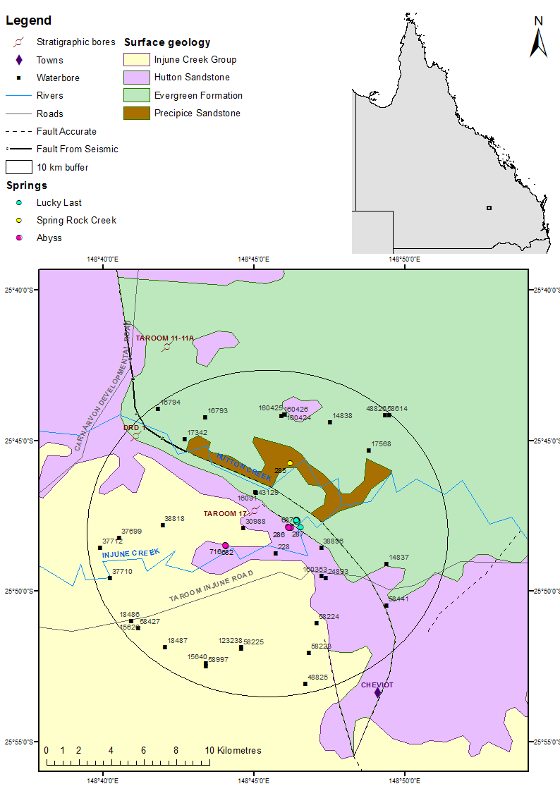

Figure 2 Lucky Last, Spring Rock Creek and Abyss spring complex—regional geology, Springsure supergroup, Queensland.

### Geology

The Lucky Last and Spring Rock Creek spring complexes are located near a significant fault (Hutton Fault; Exon 1976). A major fault exists to the north-east of the spring complex. This fault is trending west-north-west to east-south-east and has an irregular trace. The fault separates the Lucky Last spring complex (vents 287, 686, 687, 687.1, 687.2, 687.3, 687.4, 687.5, 687.6, 688, 699, 340) from the Spring Rock Creek spring (285).

Another lesser fault occurs south of the major fault, trending almost parallel to the major fault. This fault separates the Lucky Last and Abyss complexes. Spring 287 is located on the northern side of Injune Creek. In the vicinity of the spring complex, the lesser fault constitutes a geological boundary between the Evergreen Formation (north) and the Hutton Sandstone (south). This is a reverse fault (Figure 2).

### Regional stratigraphy and underlying aquifers

Eleven coal seam gas wells and 31 waterbores are present within a 10-kilometre radius of the springs. In addition, two stratigraphic boreholes (Taroom 17 and DR1) are within a 10‑kilometre radius of the spring complex. The stratigraphy for the stratigraphic bores is listed in Table 3 and the stratigraphy for waterbores is shown in Table 4.

Stratigraphy logs from stratigraphic drill holes and waterbores indicate possible source aquifers for the springs. Depending on their individual vent locations, source aquifers could be the Injune Creek Group/Birkhead Formation, Hutton Sandstone or the Precipice Sandstone. The Clematis Sandstone could also be a possible source, although this is less likely.

Spring 286 of the Abyss Complex (multiple vents) is presumed to be underlain by competent Hutton Sandstone, which may be the source for this spring (QWC 2012a). If this is the case, the spring can be classified as a recharge spring. The water chemistry of vent 286 does, however, more closely match the chemistry from waterbore 16793, which taps the Precipice Sandstone.

Springs 340 and 686–689 of the Lucky Last complex are located at the bottom of a valley on the outcrop of the Evergreen Formation, specifically the Boxvale Sandstone Member. A possible source is upward movement of artesian groundwater from the underlying Boxvale or Precipice sandstone aquifers. This spring is represented by a series of mounds aligned along a prominent break of slope that may be associated with the mapped fault lineament. This fault is a plausible conduit for upward migration of artesian groundwater from the underlying Boxvale Sandstone and/or the Precipice Sandstone, or from the adjacent Hutton Sandstone.

Vent 287 of the Lucky Last complex is located on the floodplain of the Injune Creek and, similarly to spring 340, is on the outcrop of the Evergreen Formation (Boxvale Sandstone Member). It sits on a fault that represents the contact between the Hutton Sandstone and Evergreen Formation. This supports the hypothesis that both vents have a groundwater source through a fault or fracture, which allows the upward migration of artesian groundwater from the underlying Precipice Sandstone or adjacent Hutton aquifer, although Precipice Sandstone is more likely.

Vents 628 and 716 of the Abyss complex are located at the base of the slope near Injune Creek underlain by the Hutton Sandstone, which is also the likely source for this spring (QWC 2012a). The vents are located close to the contact between the Hutton Sandstone and the Birkhead Formation (Injune Creek Group). It is likely that the spring issues from the Hutton Sandstone emerging at the edge of the overlying Birkhead Formation. If the source for these vents is in the Hutton Sandstone, these springs may be classified as recharge springs.

Vent 285 of the Spring Rock Creek complex is located about 3.6 kilometres north of the Lucky Last springs, on an outcrop of the Precipice Sandstone, next to Hutton Creek.

### Water chemistry comparison: springs and waterbores

Hydrochemistry data available for bores within a 10 kilometre radius of the spring complex are in Tables 5–7. The bore water derived from the Hutton Sandstone (bores 58427, 30988, 48825) is more alkaline than those that tap the Evergreen Formation or Precipice Sandstone (43129). The bore that taps the Boxvale Sandstone (bore 58441) has the lowest electrical conductivity (EC) reading, whereas the bores that tap the Hutton Sandstone are associated with the highest EC readings.

Complete hydrochemistry data are only available for spring 287 of the Lucky Last complex, and springs 682 and 716 of the Abyss spring complex. Available hydrochemistry data for the Lucky Last and Abyss complexes are shown in Table 8 and Figure 3. The water chemistry for spring 716 is closest to a bore tapping the Hutton Sandstone and/or Birkhead Formation. It is also likely that spring 286 taps Hutton Sandstone, with a possible contribution from the Birkhead Formation. Spring 285 of the Abyss complex has spring chemistry closest to bore 16793, which taps the Precipice Sandstone. The Precipice Sandstone, with possible contribution from the Evergreen Formation, is therefore the likely source aquifer for the Spring Rock Creek. Spring 287 from the Lucky Last complex has hydrochemical characteristics closest to a bore tapping the Hutton Sandstone and/or Birkhead Formation, but since it emerges from the Evergreen Formation, the likely aquifers would be Boxvale Sandstone or Precipice Sandstone. Alternatively, water from the Hutton Sandstone may be rising through the nearby fault and supplying spring 287. The variation in water chemistry between vents that are recorded as tapping the same formation makes it difficult to come to strong conclusions on source aquifers.

Limited isotope data are available for the vents and bores within the Lucky Last spring complex. The available data are listed in Table 9, and are shown in relation to the global meteoric water line and Brisbane’s meteoric water line in Figure 4. The ratios of oxygen to deuterium isotopes for both the waterbores and springs show that the water is meteoric in origin.

### Artesian status of potential source aquifers

The potentiometric data sourced from Quarantotto (1989) indicate that the Hutton Sandstone is a potential source aquifer for the Abyss spring complex, because the potentiometric surface elevation for the Hutton Sandstone is higher than the surface elevation of selected vents (Table 10), although these data are now several decades old. Regional potentiometric surface data for the Evergreen Formation and Clematis Sandstone are not available, so it is not possible to investigate these formations as potential source aquifers.

Despite the discrepancy in flow discharge, data from waterbores also indicate that the Hutton Sandstone would be a likely source aquifer for the Abyss springs. Full waterbore test-pumping data were not available for bores within a 10-kilometre radius of the spring complexes. Only two bores in the area—bores 38818 and 38896, both interpreted as tapping Hutton Sandstone—are recorded as having artesian flow. Records of bore discharge from the Queensland Department of Environment and Resource Management (DERM) Groundwater Database (GWDB) indicate that the two bores ceased to flow sometime after 1975 (DNRM 2012).

Table 2 Lucky Last, Spring Rock Creek and Abyss spring complex—spring locations and elevations.

| Spring number | QWC number | Spring name | Latitude | Longitude | Elevation (mAHD)  Geodata 9” DEM | Comments |
| --- | --- | --- | --- | --- | --- | --- |
| Lucky Last | | | | | | |
| 287 | 287 | Four Dog | –25.79806535 | 148.7755795 | 349.48 | Large mound |
| 340 | 340 | Lucky Last | –25.79399184 | 148.7731738 | 350.06 | Complex of two mounds and one vent/soak (Springsure database) |
| 686 | 340ii | Lucky Last | –25.79477826 | 148.7734076 | 346.86 |  |
| 687 | 340 iib |  | –25.794811 | 148.7737796 | 351.97 |  |
| 687.1 | 340ii vent1 |  | –25.79462441 | 148.773846 | 348.58 | Small vent and mound |
| 687.2 | 340ii vent2 |  | –25.794561 | 148.7737828 | 348.40 | Small vent and mound |
| 687.3 | 340ii vent3 |  | –25.79420224 | 148.7736134 | 348.96 | Small vent and mound |
| 687.4 | 340iivent4 |  | –25.79411808 | 148.7735415 | 349.22 | Small vent and mound |
| 687.5 | 340ii vent 5 |  | –25.79367953 | 148.7732965 | 350.65 | Small vent and mound |
| 687.6 | 340ii vent6 |  | –25.79359458 | 148.7733188 | 350.31 | Small vent and mound |
| 688 | 340iii |  | –25.79511407 | 148.7737482 | 348.91 |  |
| 689 | 340iv |  | –25.79398988 | 148.7728387 | 348.47 | Small round springs adjacent to small rocky sandstone outcrop |
| Abyss | | | | | | |
| 286.1 | 286E | Abyss | –25.798070 | 148.770291 | 347.824 |  |
| 286 | 286 B & D | Abyss | –25.798026 | 148.769009 | 349.80 |  |
| 286.2 | 286C | Abyss | –25.797800 | 148.768897 | 347.94 |  |
| 682 | 285A | Cabin Spring | –25.808004 | 148.734199 | 355.60 |  |
| 716 | 285B | Cabin Spring | –25.807594 | 148.733999 | 358.21 |  |
| Spring Rock Creek | | | | | | |
| 285 | 285 | Duffers Creek | –25.762584 | 148.769789 | 356.81 |  |

DEM = digital elevation model, mAHD = metres Australian height datum, QWC = Queensland Water Commission.  
© Copyright, QWC 2012a

Table 3 Lucky Last, Spring Rock Creek and Abyss spring complex—stratigraphic bores within a 10‑kilometre radius.

| Stratigraphic bore | Distance from springs complex (km) | Top  (mBGL) | Bottom (mBGL) | Thickness (m) | Rock unit name |
| --- | --- | --- | --- | --- | --- |
| 808 (DRD1) | 10.3 | 0.0 | 79.2 | 79.2 | Hutton Sandstone |
|  |  | 79.2 | 106.7 | 27.5 | Evergreen Formation (upper unit) |
|  |  | 106.7 | 121.6 | 14.9 | Boxvale Sandstone Member |
|  |  | 121.6 | 131.1 | 9.5 | Evergreen Formation (lower unit) |
| 1238) | 2.5 | 0.0 | 20.6 | 20.6 | Birkhead Formation |
| (Taroom 17 |  | 20.6 | 218.6 | 198.0 | Hutton Sandstone |
|  |  | 218.6 | 271.3 | 52.7 | Evergreen Formation (upper unit) |
|  |  | 271.3 | 292.9 | 21.6 | Westgrove Ironstone Member |
|  |  | 292.9 | 311.8 | 18.9 | Boxvale Sandstone Member |
|  |  | 311.8 | 415.1 | 103.3 | Evergreen Formation (lower unit) |
|  |  | 415.1 | 487.2 | 72.1 | Precipice Sandstone |
|  |  | 487.2 | – | – | Moolayember Formation |

– = not available, km = kilometre, m = metre, mBGL = metres below ground level.  
© Copyright, DNRM 2012

Table 4 Lucky Last, Spring Rock Creek and Abyss spring complex—waterbores within a 10-kilometre radius.

| Groundwater bore | Top (mBGL) | Bottom (mBGL) | Rock unit name |
| --- | --- | --- | --- |
| 228 | 0.0 | – | Hutton Sandstone |
|  | – | 144.8 | Evergreen Formation |
| 14838 | 0.0 | 6.1 | Boxvale Sandstone Member |
|  | 6.1 | 143.3 | Evergreen Formation |
|  | 143.3 | 173.1 | Precipice Sandstone |
| 15640 | 0.0 | 140.2 | Birkhead Formation |
|  | 140.2 | 174.7 | Hutton Sandstone |
| 15626 | 0.0 | – | Birkhead Formation |
|  | – | 157.9 | Hutton Sandstone |
| 16091 | 0.0 | 30.5 | Precipice Sandstone |
| 16793 | 0.0 | 61.0 | Evergreen Formation |
|  | 61.0 | 78.0 | Precipice Sandstone |
| 17342 | 0.0 | 15.2 | Evergreen Formation |
|  | 15.2 | 76.6 | Precipice Sandstone |
| 17568 | 0.0 | 13.1 | Evergreen Formation |
|  | 13.1 | 57.9 | Precipice Sandstone |
| 18487 | 0.0 | 91.4 | Birkhead Formation |
| 37699 | 0.0 | 60.0 | Birkhead Formation |
|  | 60.0 | 92.4 | Hutton Sandstone |
| 30988 | 0.0 | 79.2 | Birkhead Formation |
|  | 79.2 | 147.8 | Hutton Formation |
| 37710 | 0.0 | 99.1 | Birkhead Formation |
| 38896 | 0.0 | 51.8 | Hutton Sandstone |
| 43129 | 0.0 | 61.0 | Precipice Sandstone |
| 48826 | 0.0 | 54.9 | Boxvale Sandstone Member |
|  | 54.9 | 152.4 | Evergreen Formation |
|  | 152.4 | 196.6 | Precipice Sandstone |
| 48825 | 0.0 | – | Birkhead Formation |
|  | – | 121.9 | Hutton Sandstone |

– = not available, mBGL = metres below ground level.  
Note: No stratigraphic data are available for bores 58441, 58427and 38818.  
© Copyright, DNRM 2012

Table 5 Lucky Last, Spring Rock Creek and Abyss spring complex—waterbore details and water chemistry.

| Variable | Details | | | |
| --- | --- | --- | --- | --- |
| Vent ID | 15626 | 16793 | 17342 | 17568 |
| Sample date | 03/05/1972 | 01/01/1967 | 01/01/2001? | 01/01/2001? |
| Distance from spring (kilometres) | 10.2 | 7.9 | 7.4 | 7.6 |
| Screens (metres) | Perforations 157.9 | Opening 20.1–78 | Opening 62–76.2 | Perforations 57.9 |
| Aquifer | Hutton Sandstone/Birkhead Formation | Precipice Sandstone | Evergreen Formation/Precipice Sandstone | Evergreen Formation/Precipice Sandstone |
| Year drilled | 1919 | 1955 | 1967 | 1967 |
| Standing water level (natural surface elevation) | – | –51.8 (1955) | –36.2 (1967) | –36.2 (1967) |
| Total depth (metres) | 157.9 | 78 | 76.6 | 57.9 |
| Surface elevation (mAHD) | 398 | 100 | 450 | 250 |
| Facility status | Existing subartesian | Existing subartesian | Existing subartesian | Existing subartesian |
| *Physicochemical parameters* | | | | |
| EC (µS/cm) | 980 | 1250 | 520 | 240 |
| pH (field/lab) | 8.1 | 7.8 | 7.7 | 6.4 |
| Temp (°C) | – | – | – | – |
| *Chemical parameters (milligrams/litre)* | | | | |
| Dissolved oxygen | 0 | – | – | – |
| TDS | 217 | – | – | – |
| Sodium (Na) | – | 155 | 58 | 10 |
| Potassium (K) | 2 | – | – | – |
| Calcium (Ca) | 2 | 64 | 30 | 17 |
| Magnesium (Mg) | 164 | 20.4 | 16 | 11 |
| Chlorine (Cl) | 34 | 324 | 92 | 20 |
| Sulfate (SO4) | 271 | 27 | 11 | 6 |
| Bicarbonate (HCO3–) | – | 117 | 152 | 98 |
| Carbonate (CO32–) | 0.55 | – | – | – |
| Fluoride (F) | – | – | 0.3 | 0.7 |
| Bromine (Br) | – | – | – | – |
| Barium (Ba) | – | – | – | – |
| Iron (Fe) | – | – | – | 10 |
| Manganese (Mn) | – | – | – | – |
| Silica (SiO2) | – | – | – | – |
| Strontium (Sr) | – | – | – | – |
| Nitrate (NO3) | – | – | – | – |
| Phosphate (PO4) | – | – | – | – |

– = not available, EC = electrical conductivity, mAHD = metres Australian height datum, µS/cm = microsiemens per centimetre, TDS = total dissolved solids.  
© Copyright, DNRM 2012

Table 6 Lucky Last, Spring Rock Creek and Abyss spring complex—waterbore details and water chemistry continued.

| Variable | Details | | | |
| --- | --- | --- | --- | --- |
| Vent ID | 15640 | 38818 | 38896 | 48825 |
| Sample date | 07/11/1963 | 24/03/1976 | 24/03/1976 | 09/07/1974 |
| Distance from spring (kilometres) | 9.7 | 6.6 | 3.1 | 10.4 |
| Screens (metres) | 70.1–174.7 | 59.4–152.4 | Opening 38.7–51.8 | – |
| Aquifer | Hutton Sandstone/Birkhead Formation | Birkhead Formation/ Hutton Sandstone | Hutton Sandstone | Hutton Sandstone |
| Year drilled | 1963 | 1972 | 1972 | 1954 |
| Standing water level (natural surface elevation) | –41.14 (1963) | – | – | – |
| Total depth (metres) | 174.7 | 152.4 | 51.8 | 122 |
| Surface elevation (mAHD) | 389 | 450 | 400 | 400 |
| Facility status | Existing subartesian | Existing artesian | Existingartesian, ceased to flow | Existing subartesian |
| *Physicochemical parameters* | | | | |
| EC (µS/cm) | – | 890 | 370 | 2400 |
| pH (field/lab) | 8.2 | 8 | 8 | 8.5 |
| Temp (°C) | – | – | – | – |
| *Chemical parameters (milligrams/litres)* | | | | |
| TDS | 1238.7 | 494 | – | 0 |
| Sodium (Na) | 481.9 | 196 | 210.68 | 520 |
| Potassium (K) | – | 0.6 | 82 | 1.9 |
| Calcium (Ca) | 8.6 | 3.2 | 0.6 | 6 |
| Magnesium (Mg) | 1.4 | 0.2 | 3.6 | 0.4 |
| Chlorine (Cl) | 612 | 120 | 0.1 | 505 |
| Sulfate (SO4) | 20 | 30 | 18 | 0 |
| Bicarbonate (HCO3–) | 0 | 289 | 8.1 | 500 |
| Carbonate (CO32–) | 114.4 | 1.9 | 197 | 12 |
| Fluoride (F) | 0.4 | 0 | 1.3 | 0.24 |
| Bromine (Br) | – | – | 0.12 | – |
| Barium (Ba) | – | – | – | – |
| Iron (Fe) | – | – | – | – |
| Manganese (Mn) | – | – | – | – |
| Silica (SiO2) | – | – | – | – |
| Strontium (Sr) | – | – | 14 | – |
| Nitrate (NO3) | – | – | – | – |
| Phosphate (PO4) | – | – | – | – |

– = not available, EC = electrical conductivity, mAHD = metres Australian height datum, µS/cm = microsiemens per centimetre, TDS = total dissolved solids.  
© Copyright, DNRM 2012

Table 7 Lucky Last, Spring Rock Creek and Abyss spring complex—waterbore details and water chemistry continued.

| Variable | Details | | | |
| --- | --- | --- | --- | --- |
| Vent ID | 30988 | 43129 | 58427 | 58441 |
| Sample date | 10/05/2011 | 10/05/2011 | 19/07/1993 | 13/08/1993 |
| Distance from spring (kilometres) | 1.6 | 2.9 | 10.2 | 8.9 |
| Screens (metres) | Opening 122–210.4 | Opening 36.6–61 | 209–310.8 | Opening 36.9–161.5 |
| Aquifer | Hutton Sandstone | Evergreen Formation/ Precipice Sandstone | Hutton Sandstone | Boxvale Sandstone |
| Year drilled | 1969 | 1973 | 1990 | 1991 |
| Standing water level (natural surface elevation) | –57.9 (1972) | –8.5 (1973) | –34.1 (1990) | –102.1 (1991) |
| Total depth (metres) | 210.4 | 61 | 310.9 | 161.5 |
| Surface elevation (mAHD) | 409.099 | 371.732 | 380 | 404 |
| Facility status | Existing subartesian | Existing subartesian | Existing subartesian | Existing subartesian |
| *Physicochemical parameters* | | | | |
| EC (µS/cm) | 996 | 235.5 | 861 | 186 |
| pH (field/lab) | 8.36/8.65 | 6.34/7.12 | 8.5 | 7.4 |
| Temp (°C) | 24.6 | 26.2 | – | – |
| *Chemical parameters (milligrams/litre)* | | | | |
| Dissolved oxygen | 4.48 | 0.18 | – | – |
| TDS | 617 | 148 | 500.93 | 97.28 |
| Sodium (Na) | 217 | 18 | 196.8 | 22.5 |
| Potassium (K) | <1 | 2 | 0 | 2 |
| Calcium (Ca) | 3 | 15 | 3.3 | 7.6 |
| Magnesium (Mg) | <1 | 11 | 0 | 5.8 |
| Chlorine (Cl) | 154 | 10 | 132.5 | 15.3 |
| Sulfate (SO4) | 33 | <1 | 28.9 | 0 |
| Bicarbonate (HCO3–) | 230 | 106 | 245.7 | 87.7 |
| Carbonate (CO32–) | 25 | <1 | 4.9 | 0.1 |
| Fluoride (F) | 0.054 | 0.076 | 0.02 | 0.13 |
| Bromine (Br) | 0.436 | 0.04 | – | – |
| Barium (Ba) | 0.041 | 0.057 | – | – |
| Iron (Fe) | <0.05 | 0.35 | 0 | 0 |
| Manganese (Mn) | 0.009 | 0.03 | 0 | 0.02 |
| Silica (SiO2) | – | – | 13 | 1 |
| Strontium (Sr) | 0.119 | 0.166 | – | – |
| Dissolved organic carbon | 2 | 2 | – | – |
| Total organic carbon | 2 | 3 | – | – |
| Kjeldahl nitrogen total | <0.1 | <0.1 | – | – |
| Total oxidised nitrogen | 0.19 | 0.01 | – | – |
| Total nitrogen (N) | 0.2 | <0.01 | – | – |
| Phosphate (PO4) | <0.01 | <0.01 | – | – |
| Cation total (mEq/L) | 9.61 | 2.49 | – | – |
| Anion total (mEq/L) | 10.1 | 2.4 | – | – |
| Ionic balance (%) | 2.73 | – | – | – |

– = not available, EC = electrical conductivity, mAHD = metres Australian height datum, mEq/L = milliequivalent per litre, µS/cm = microsiemens per centimetre, TDS = total dissolved solids.  
Note: No water chemistry data are available for bores 14838, 16091, 18487, 37699, 37710, 48826 and 288.   
© Copyright, DNRM 2012

Table 8 Lucky Last, Spring Rock Creek and Abyss spring complex—spring water chemistry.

| Variable | Details | | | |
| --- | --- | --- | --- | --- |
| Vent ID | 285 | 286 | 287 | 716 |
| Sample date | 17/04/2012 | 16/04/2011 | 16/04/2011 | 17/04/2011 |
| *Physicochemical parameters* | | | | |
| EC (field) (µS/cm) | 1224 | 5200 | 370 | 1000 |
| pH (field/lab) | 6.93/8.08 | 5.57/9.11 | 6.7/7.18 | 7.7/8.33 |
| Temperature (field) (°C) | 20.9 | 19.9 | 17.3 | 27.7 |
| *Chemical parameters (milligrams/litre)* | | | | |
| Dissolved oxygen (field) | 4.16 | 4.75 | 1.9 | 4.75 |
| TDS | – | – | – | – |
| Sodium (Na) | 153 | 1340 | 85 | 230 |
| Potassium (K) | 10 | 5 | <1 | 3 |
| Calcium (Ca) | 59 | 14 | 10 | 4 |
| Magnesium (Mg) | 27 | 14 | <1 | <1 |
| Chlorine (Cl) | 241 | 1300 | 24 | 145 |
| Sulfate (SO4) | – | – | – | – |
| Sodium (Na) | 40 | 180 | 58 | 27 |
| Total alkalinity (calcium carbonate) | 224 | 895 | 105 | 280 |
| Bicarbonate (HCO3–) | 224 | 616 | 105 | 276 |
| Carbonate (CO32–) | <1 | 279 | <1 | 4 |
| Iodine (I) | <0.05 | <0.2 | <0.01 | <0.05 |
| Fluoride (F) | 0.2 | 0.6 | 0.2 | <0.01 |
| Bromine (Br) | 630 | 3180 | 90 | 380 |
| Aluminium (Al) | <0.01 | 1.21 | 1.44 | 0.15 |
| Arsenic (As) | <0.001 | 0.006 | 0.002 | <0.0001 |
| Barium (Ba) | 0.264 | 0.124 | 0.082 | 0.031 |
| Beryllium (Be) | – | – | – | – |
| Boron (B) | <0.05 | <0.05 | <0.05 | <0.05 |
| Cadmium (Cd) | <0.0001 | <0.0001 | <0.0001 | <0.0001 |
| Chromium (Cr) | 0.001 | 0.007 | 0.002 | 0.002 |
| Cobalt (Co) | <0.001 | <0.001 | 0.008 | <0.001 |
| Copper (Cu) | 0.001 | 0.005 | 0.01 | 0.001 |
| Iron (Fe) | <0.05 | 0.25 | 5.33 | 0.24 |
| Lithium (Li) | – | – | – | – |
| Lead (Pb) | <0.001 | <0.001 | 0.002 | <0.001 |
| Manganese (Mn) | 0.113 | 0.015 | 0.407 | 0.033 |
| Mercury (Hg) | <0.0001 | <0.0001 | <0.0001 | <0.0001 |
| Molybdenum (Mo) | 0.001 | 0.004 | <0.001 | <0.001 |
| Nickel (Ni) | <0.001 | 0.002 | 0.006 | <0.001 |
| Selenium (Se) | <0.01 | <0.01 | <0.01 | <0.01 |
| Silica (SiO2) | –– | – | – | – |
| Silver (Ag) | <0.001 | <0.001 | <0.001 | <0.001 |
| Strontium (Sr) | 1.21 | 1.31 | 0.276 | 0.109 |
| Sulfide (S) | – | – | – | – |
| Tin (Sn) | <0.001 | <0.001 | <0.001 | <0.001 |
| Uranium (U) | – | – | – | – |
| Zinc (Zn) | <0.005 | 0.024 | 0.111 | 0.024 |
| Nitrate as N | <0.01 | 0.02 | 0.04 | 0.02 |
| Nitrate as NO3 | – | – | – | – |
| Nitrite as N | <0.01 | <0.01 | 0.01 | <0.01 |
| Total oxidised nitrogen (N) | – | 0.02 | 0.06 | 0.02 |
| Total nitrogen | – | – | – | – |
| Phosphorus (P) | – | – | – | – |

– = not available, EC = electrical conductivity, mAHD = metres Australian height datum, µS/cm = microsiemens per centimetre, TDS = total dissolved solids  
© Copyright, QWC 2012a

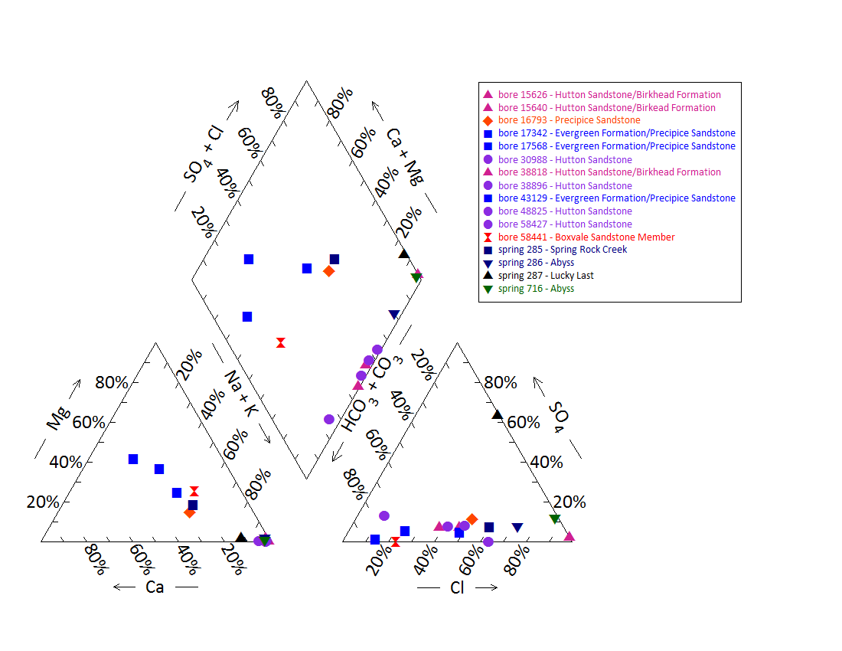

Note: No water chemistry data are available for bores 14888, 1609, 18487, 37699, 37710, 48826 and 288; and springs 340, 686–688, 699, 682 and 286.1–286.3

Figure 3 Lucky Last, Spring Rock Creek and Abyss spring complex—Piper plot for spring and waterbore chemistry.

Table 9 Lucky Last, Spring Rock Creek and Abyss spring complex—isotope data.

| Site ID | Δ18O  VSMOW (%) | | δD  VSMOW (%) | | δ13C  (ppt PDB) | ± | pMC | ± | D14C  (pMC) | ± | 14C age | ± |
| --- | --- | --- | --- | --- | --- | --- | --- | --- | --- | --- | --- | --- |
| 285 | –2.95 |  | –22.3 |  |  |  |  |  |  |  |  |  |
| 286 | –3.30 | –3.35 | –22.7 | – | – | – | – | – | – | – | – | – |
| 287 | –4.85 | –4.92 | –26.2 | –25.0 | – | – | – | – | – | – | – | – |
| 716 | –4.85 | –4.94 | –30.8 | – | – | – | – | – | – | – | – | – |
| RN16091 | –6.16 | – | –37.2 | – | – | – | – | – | – | – | – | – |
| RN30988 | –5.86 | – | –35.4 | – | –16.2 | 0.1 | 2.528 | 0.07 | –974.7 | 0.69 | 29540 | 250 |
| RN43129 | –6.20 | –6.19 | –37.6 | – | –14.4 | 0.1 | 38.275 | 0.23 | –617.3 | 2.34 | 7715 | 60 |

– = not available, pMC = per cent modern carbon, parts per trillion (ppt), PDB = Pee Dee Belemnite, VSMOW = Vienna Standard Mean Ocean Water.  
© Copyright, QWC 2012a

VSMOW = Vienna Standard Mean Ocean Water.

Figure 4 Lucky Last spring complex—oxygen (O) and deuterium (D) stable isotope ratios.

Table 10 Lucky Last and Abyss spring complex—potentiometric surface data.

| Vent ID | Estimated flow rate (L/min) | Elevation (mAHD) | Potentiometric surface elevation (mAHD)a | |
| --- | --- | --- | --- | --- |
| GPS OmniSTAR differential (+0.1 metres) | Hutton Sandstone | Precipice Sandstone |
| 285 | – | 356.81 | 350 | 285 |
| 285.1 | 0 | 358.21 | 350 | 285 |
| 286 | 1 | 348.20 | 350 | 285 |
| 287 | 33 | 349.48 | 350 | 285 |
| 340 | 3 | 350.06 | 350 | 285 |
| 682 | 3 | 355.60 | 350 | 285 |
| 686 | 1 | 346.86 | 350 | 285 |
| 687 | 1 | 351.97 | 350 | 285 |
| 688 | 3 | 348.91 | 350 | 285 |
| 716 | 0 | 358.21 | 350 | 285 |

– = not available, GPS = global positioning system, L/min = litres per minute, mAHD = metres Australian height datum.  
a Data from Quarantotto 1989

## Scott’s Creek spring complex

### Hydrogeological summary

The springs of the Scott’s Creek spring complex are discharge springs and may be linked to a conceptual model of springs associated with a fault or thinning of overlying aquitards—type C, E or F.

Hutton Sandstone is likely a source aquifer for the Scott’s Creek spring complex. The Birkhead Formation is also a possible source aquifer, because waterbores in the area are recorded as tapping it. A comparison of waterbore and spring water quality cannot separate these two possibilities. Aquifer pressure data also indicate that Hutton Sandstone is a potential source aquifer; however, no potentiometric data are available for the Birkhead Formation.

Deeper aquifers—including the Boxvale Sandstone Member of the Evergreen Formation, Precipice Sandstone and Clematis Sandstone—may also be source aquifers. Hydrochemical and stratigraphic data for these formations are not available in the immediate area of Scott’s Creek.

There are no faults mapped in the area; however, Scott’s Creek spring complex is located just to the east of the Arcadia Anticline.

### Spring complex overview

Scott’s Creek spring complex, also referred to as the Salt Flat spring group, lies on the east bank of Scott’s Creek and consists of four main spring vents (shown in Figure 5). The complex is located approximately 58 kilometres west-south-west of Taroom and approximately 73 kilometres east of Injune in south-eastern Queensland (Figure 6). The Scott’s Creek spring complex has been classified as one of the spring complexes most likely to be affected by coal seam gas extraction in the *Underground water impact report for the Surat Cumulative Management Area* (QWC 2012b). The complex has been given a conservation ranking of 1b (Table 11). The location and elevation for each of the Scott’s Creek spring vents is listed in Table 12.

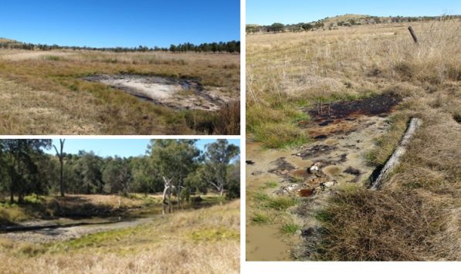

Figure 5 Scott’s Creek spring complex—vents 189, 190 and 191.

Table 11 Scott’s Creek spring complex—hydrogeological information summary.

| Feature | Details | Comments |
| --- | --- | --- |
| No. of active vents | 5 | 189, 190, 191, 192, 192.1 |
| No. of inactive vents | – |  |
| Conservation ranking | 1b |  |
| Spring water quality samples | Yes |  |
| Waterbore within 10-kilometres radius | 33 |  |
| Stratigraphic bores | 3 | 1289, 485, 50325 |
| Waterbore water-quality samples | Yes |  |
| Interpreted stratigraphy available | Yes |  |
| Outcropping formations |  | Hutton Sandstone, Injune Creek Group |
| Underlying aquifers |  | Hutton, Boxvale, Precipice Sandstone and Clematis Sandstone |
| SWL time series data available | Yes |  |
| Likely source aquifers |  | Hutton Sandstone |
| Conceptual spring type | C, E, or F |  |

– = not available, SWL = standing water level.

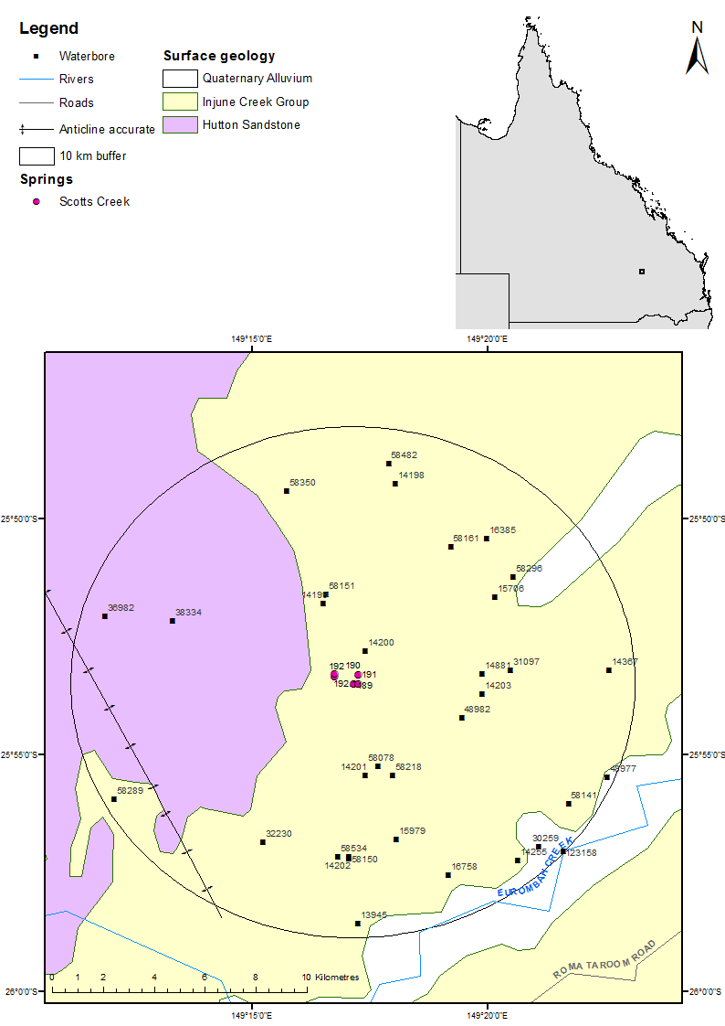

Figure 6 Scott’s Creek spring complex—regional geology, Springsure, Queensland.

### Geology

The Scott’s Creek spring complex is located on the eastern limb of the Arcadia Anticline (EHA 2009). The Arcadia Anticline trends north-west to south-east, and the crest of the anticline is approximately 9 kilometres west from the springs, with strata dipping towards the axis of the Mimosa Syncline. No faults within the vicinity of the spring complex are indicated on the surface geology maps (Figure 6), although the Taroom 1:250 000 SG 55-8 Geological Series map sheet (Forbes 1968) shows some north-west to south-east directed trendlines in the Hutton Sandstone.

### Regional stratigraphy and underlying aquifers

The Scott’s Creek spring group overlies rocks from the Injune Creek Group. Hutton Sandstone, Boxvale Sandstone, Evergreen, Precipice Sandstone and the Clematis Sandstones are all present at depth.

Within a 10-kilometre radius of the springs there are 4 coal seam gas wells and 33 waterbores. In addition, two stratigraphic boreholes and one petroleum exploration well are present within a 20-kilometre radius of the spring complex. The stratigraphy of stratigraphic drill holes 1289 and 485, and coal seam gas well 50325 are listed in Table 13. Interpreted stratigraphic records for waterbores in the area are incomplete for some bores. Available stratigraphy for the waterbores is listed in Table 14. Bores 14203 and 15706 are interpreted to possibly tap the Birkhead Formation of the Injune Creek Group and Hutton Sandstone (EHA 2009).

From the stratigraphic information, it is evident that the Hutton Sandstone is a likely source aquifer for the spring of the Scott’s Creek complex. The Precipice Sandstone and Clematis Sandstone could also be potential source aquifers.

### Water chemistry comparison: springs and waterbores

Available water chemistry data for spring vents of the Scott’s Creek spring complex are summarised in Table 15 and Table 16. Hydrochemical data available for bores within a 10-kilometre radius of the spring complex are listed in Table 17. Very few artesian bores are present within a 10-kilometre radius of the Scott’s Creek spring group. The lowest aquifer tapped by waterbores in the area is the Hutton Sandstone. Hydrochemical information for aquifers deeper than Hutton Sandstone is therefore not available for analysis.

From the Piper plot (Figure 7), it can be seen that vents 189 and 190 plot within a cluster of bores with water chemistry that can be classified as Na+K+HCO3 (+Cl). The cluster of waterbores includes 15706, 14255, 31097, 58161, 16758, 58296, 14881 and 14203. These bores tap both the Birkhead Formation and the Hutton Sandstone. Determining the source aquifer for these vents using just the major ions chemistry is not possible due to the similarity between hydrochemistry of the Hutton Sandstone and the Birkhead Formation. Vents 191 and 192 on the Piper plot, along with bores 14198, 36982, 32230 and 58482, also tap either the Birkhead Formation or Hutton Sandstone, or both. This demonstrates the difficulty in determining a source aquifer, especially if there is mixing of aquifer water as it rises through overlying aquifers to the ground surface in a spring.

Limited isotope data are available for the vents within the Scott’s Creek spring complex. The available data are listed in Table 18 and shown in relation to the global meteoric water line and Brisbane’s meteoric water line in Figure 8. No isotope data are available for groundwater bores within a 10-kilometre radius. Isotope data are required for nearby bores to draw any conclusions regarding the source aquifer of the springs. The oxygen and deuterium ratio of the spring water suggests that the water is of meteoric origin, with some influence from evaporation for spring vents 189 and 191.

### Artesian status of potential source aquifers

Available spring elevations and flow rates are listed in Table 19. The potentiometric data sourced from Quarantotto (1989) indicate that both the Hutton Sandstone and the Precipice Sandstone are potential source aquifers for the vents of the Scott’s Creek spring complex, as the potentiometric surface elevation for both units were above the elevation of Scotts Creek springs in 1989, although this may have changed (Table 19). No published regional data are available for the potentiometric surface of the Injune Creek Group, Evergreen Formation or the Clematis Sandstone. Available data for the standing water levels of waterbores within a 10-kilometre radius of Scott Creek’s indicate that the water pressure within the source aquifers for the bores has not changed much over time (Table 20 and Figure 9).

Table 12 Scott’s Creek spring complex—spring locations and elevations.

| Vent ID | Name | Latitude  GDA94 (55) | Longitude  GDA94 (55) | Elevation (mAHD)  Geodata 9” DEM | Source |
| --- | --- | --- | --- | --- | --- |
| 189 | Saltflat1 | –25.8913602 | 149.2859764 | 245.3174 | QWC (2012a) |
| 190 | Saltflat2 | –25.8924234 | 149.2891157 | 266.7500 | EHA (2009) |
| 191 | Saltflat3 | –25.8917942 | 149.2875228 | 244.6426 | QWC (2012a) |
| 192.1 | Creek | –25.8879420 | 149.2791825 | 244.8181 | QWC (2012a) |

DEM = digital elevation model, GDA94 = Geocentric Datum of Australia 1994, mAHD = metres Australian height datum.

Table 13 Scott’s Creek spring complex—stratigraphy for bores and coal seam gas wells within a 20‑kilometre radius.

| Well ID | Top (mBGL) | Bottom (mBGL) | Rock unit name |
| --- | --- | --- | --- |
| 485 | 0.0 | – | Injune Creek Group |
|  | – | 213.4 | Walloon Coal Measures |
| 1289 | 0.0 | – | Birkhead Formation |
|  | – | 332.6 | Hutton Sandstone |
|  | 332.6 | 501.5 | Evergreen Formation |
|  | 507.5 | 559.0 | Precipice Sandstone |
|  | 559.0 | 1231.0 | Moolayember Formation |
|  | 1231.0 | 1691.5 | Clematis Group |
|  | 1691.5 | 2580.8 | Rewan Group |
|  | 2580.8 | 2754.0 | Blackwater Group |
|  | 2754.0 | –6.0 | Back Creek Group |
| 50325 | 0.0 | – | Hutton Sandstone |
|  | – | 455.4 | Evergreen Formation |
|  | 455.4 | 526.8 | Precipice Sandstone |
|  | 526.8 | 987.9 | Rewan Group |
|  | 987.9 | 1139.1 | Bandanna Formation |

– = not available, mBGL = metres below ground level.  
© Copyright, DNRM 2012

Table 14 Scott’s Creek spring complex—waterbores within a 10-kilometre radius.

| Bore ID | Top (mBGL) | Bottom (mBGL) | Driller’s log description | Rock unit name |
| --- | --- | --- | --- | --- |
| 14198 | 0.0 | 67.1 | – | Birkhead Formation |
| 14202 | 0.0 | 70.1 | – | Birkhead Formation |
| 14203 | 0.0 | 61.0 | Existing hole | Birkhead Formation |
|  | 61.0 | 74.7 | Shale |  |
|  | 74.7 | 77.7 | Sandstone |  |
|  | 77.7 | 79.2 | Sandstone (water) | Hutton Sandstone (EHA) |
|  | 79.2 | 83.8 | Shale |  |
|  | 83.8 | 85.3 | Sand (water) |  |
|  | 85.3 | 120.4 | Sandstone (water) |  |
|  | 120.4 | 125.0 | Shale |  |
| 14255 | 0.0 | 186.8 | – | Birkhead Formation |
| 14881 | 0.0 | 62.5 | – | Birkhead Formation |
|  | 62.5 | 80.8 | – | Hutton Sandstone |
| 15706 | 0.0 | 1.5 | Topsoil |  |
|  | 1.5 | 12.2 | Sandstone | Birkhead Formation |
|  | 12.2 | 30.5 | Sandy shale |  |
|  | 30.5 | 57.9 | Shale |  |
|  | 57.9 | 65.5 | Sandstone (water) | Hutton Sandstone (EHA) |
|  | 65.5 | 72.0 | Shale |  |
|  | 72.0 | 91.0 | Sandstone and shale |  |
|  | 91.0 | 183.0 | Hard sandstone | Water at 91 metres and 172 metres |
| 15979 | 0.0 | 83.8 | – | Birkhead Formation |
| 16385 | 0.0 | 113.4 | – | Birkhead Formation |
|  | 113.4 | 243.8 | – | Hutton Sandstone |
| 16758 | 0.0 |  | – | Birkhead Formation |
|  |  | 170.7 | – | Hutton Sandstone |
| 31097 | 0.0 | – | – | Birkhead Formation |
|  | – | 103.6 | – | Hutton Sandstone |
| 32230 | 0.0 | 79.2 | – | Birkhead Formation |
|  | 79.2 | 170.7 | – | Hutton Sandstone |
| 36982 | 0.0 | 62.2 | – | Hutton Sandstone |
| 38334 | 0.0 | 61.0 | – | Hutton Sandstone |
| 58161 | 0.0 | 7.6 | Topsoil and clay | Hutton Sandstone |
|  | 7.6 | 12.2 | Clay |  |
|  | 12.2 | 29.6 | Shale |  |
|  | 29.6 | 38.1 | Sandstone |  |
|  | 38.1 | 62.5 | Shale |  |
|  | 62.5 | 64.0 | Sandstone (water) |  |
|  | 64.0 | 65.5 | Rock |  |
|  | 65.5 | 80.8 | Hard shale |  |
|  | 80.8 | 89.9 | Sandstone (water) |  |
|  | 89.9 | 103.6 | Shale |  |
|  | 103.6 | 105.2 | Sandstone |  |
|  | 105.2 | 109.7 | Shale |  |
|  | 109.7 | 118.9 | Sandstone (water) |  |
|  | 118.9 | 125.0 | Shale |  |
|  | 125.0 | 134.1 | Sandstone (water) |  |
| 58296 | 0 | – | – | Birkhead Formation |
|  | – | 304.8 |  | Hutton Sandstone |

– = not available, mBGL = metres below ground level.  
Note: No stratigraphic data are available for bores 30259 and 58482.  
© Copyright, DNRM 2012

Table 15 Scott’s Creek spring complex—waterbore details and water chemistry.

| Variable | Details | | | | | | |
| --- | --- | --- | --- | --- | --- | --- | --- |
| Vent ID | 14203 | 14881 | 16758 | 30259 | 58161 | 58296 | 58482 |
| Sample date | 07/02  /1996 | 07/02  /1996 | 18/01  /1993 | 12/07  /2011 | 20/09  /1990 | 20/09  /1995 | 26/07  /1993 |
| Distance from spring (kilometres) | 5.1 | 5.1 | 9.1 | 10.1 | 7.1 | 7.9 | 9.6 |
| Aquifer | Hutton Sand-stone | Hutton Sand-stone | Birkhead Form-ation/ Hutton Sand-stone | Birkhead Form-ation | Hutton Sand-stone | Birkhead Form-ation/ Hutton Sand-stone | Hutton Sand-stone |
| Year drilled | 1960 | 1961 | 1966 | 1968 | 1984 | 1987 | 1991 |
| Standing water level (natural surface elevation) | 0.71 | 4.19 | 3.98 | 19.14 | –9.14 (1984) | 6.98 | –27.4 (1991) |
| Total depth (metres) | 124.9 | 158.5 | 112.2 | 165.5 | 134.1 | 304.8 | 125 |
| Surface elevation (mAHD) | 243 | 240 | 250 | 300 | 257 | 241 | 300 |
| Facility status | Existing artesian | Existing artesian | Existing artesian | Existing artesian | Existing  sub-artesian | Existing artesian | Existing  sub-artesian |
| *Physicochemical parameters* | | | | | | | |
| EC (µS/cm) | 1207 | 1172 | 1260 | 1450 | 1500 | 1190 | 1173 |
| pH (field/lab) | 8.6 | 8.25 | 8.7 | 8.4 | 8.7 | 8.4 | 8.1 |
| Temp (°C) | 25 | 25 | 27 | 25 | – | 26 | – |
| *Chemical parameters (milligrams/litre)* | | | | | | | |
| Dissolved oxygen | – | – | – | – | – | – | – |
| TDS | 732.56 | 712.36 | 763.05 | 827 | 872.48 | 705.53 | 731.05 |
| TSS | 0.1 | 0.1 | – | 1 | – | 0.1 | – |
| Sodium (Na) | 300.4 | 288.5 | 308.2 | 330 | 353.1 | 287.9 | 207.6 |
| Potassium (K) | 0.9 | 1.2 | 0.5 | 1.3 | 1.3 | 0.7 | 3.3 |
| Calcium (Ca) | 3.3 | 5.9 | 2.8 | 2.3 | 7.3 | 3.1 | 63.3 |
| Magnesium (Mg) | 0.1 | 0.5 | 0.1 | 0.1 | 0.3 | 0.1 | 8.4 |
| Chlorine (Cl) | 122.1 | 119.5 | 132.1 | 130 | 220 | 114.9 | 14.8 |
| Sulfate (SO4) | – | – | – | – | – | – | – |
| Sodium (Na) | 0 | 0 | 1.6 | 3.4 | 0 | 0 | 29 |
| Total alkalinity (calcium carbonate) | 483 | 466 | 501 | 573 | 458 | 474 | 465 |
| Bicarbonate (HCO3–) | 556.9 | 544.3 | 568.5 | 672 | 521.4 | 558.7 | 556.7 |
| Carbonate (CO32–) | 15.6 | 11.8 | 20.7 | 13 | 18.4 | 9.6 | 5 |
| Total hardness | 9 | 17 | 7 | 6 | 19 | 9 | 192 |
| Iodine (I) | – | – | – | – | – | – | – |
| Fluoride (F) | 1.09 | 0.94 | 0.91 | 1.7 | 0.91 | 0.96 | 0 |
| Bromine (Br) | – | – | – | – | – | – | – |
| Aluminium (Al) | 0 | 0 | – | <0.05 | – | 0 | – |
| Arsenic (As) | – | – | – | – | – | – | – |
| Barium (Ba) | – | – | – | – | – | – | – |
| Beryllium (Be) | – | – | – | – | – | – | – |
| Boron (B) | 0 | 0 | – | 0.06 | – | 0 | – |
| Cobalt (Co) | – | – | – | – | – | – | – |
| Copper (Cu) | 0 | 0 | – | 0.03 | – | 0.01 | – |
| Iron (Fe) | 0 | 0 | 0 | 0.59 | 0 | 0.01 | 0 |
| Lithium (Li) | – | – | – | – | – | – | – |
| Lead (Pb) | – | – | – | – | – | – | – |
| Manganese (Mn) | 0.03 | 0.05 | 0.02 | 0.03 | 0 | 0 | 0.22 |
| Silica (SiO2) | 15 | 16 | 17 | 14 | 14 | 14 | 26 |
| Zinc (Zn) | 0 | 0 | – | 0.02 | – | 0 | – |
| Nitrate as NO3 | 0 | 0 | 0 | 0.9 | 0.8 | 0 | 0 |
| Phosphate (PO4) | – | – | – | – | – | – | – |

– = not available, EC = electrical conductivity, mAHD = metres Australian height datum, µS/cm = microsiemens per centimetre, TDS = total dissolved solids, TSS = total suspended solids.  
© Copyright, DNRM 2012

Table 16 Scott’s Creek spring complex—waterbore details and water chemistry continued.

| Variable | Details | | | | | |
| --- | --- | --- | --- | --- | --- | --- |
| Vent ID | 14198 | 14255 | 15706 | 31097 | 32230 | 36982 |
| Sample date | 18/11/1961 | 17/01/1989 | 19/02/1980 | 12/09/1989 | 04/09/1969 | 28/10/1971 |
| Distance from spring (kilometres) | 8.7 | 10.0 | 6.7 | 6.2 | 7.8 | 10.2 |
| Aquifer | Birkhead Formation | Birkhead Formation | Birkhead Formation | Hutton Sandstone/  Birkhead Formation | Hutton Sandstone | Hutton Sandstone |
| Year drilled | 1960 | 1958 | 1969 | 1969 | 1969 | 1971 |
| Standing water level (natural surface elevation) | –27.43 (1960) | 4.19 | 17 (1980) | 5.11 | –79.25 (1969) | –19.8 (1971) |
| Total depth (metres) | 73.2 | 186.8 | 183 | 100.6 | 170.8 | 57.9 |
| Surface elevation (mAHD) | 300 | 250 | 261 | 240 | 338 | 300 |
| Facility status | Abandoned subartesian | Existing artesian | Existing artesian | Existing artesian | Existing subartesian | Existing subartesian |
| *Physicochemical parameters* | | | | | | |
| EC (µS/cm) | – | 1250 | 1250 | 1100 | 1120 | 400 |
| pH (field/lab) | 7.5 | 8.8 | 8.7 | 8.4 | 7.3 | 7.2 |
| Temp (°C) | – | 27 | – | – | – | – |
| *Chemical parameters (milligrams/litre)* | | | | | | |
| TDS | 0 | 750 | 763.66 | 700 | 682.34 | 215.6 |
| TSS | – | – | – | – | – | – |
| Sodium (Na) | 160.2 | 310 | 305 | 275 | 177 | 35 |
| Potassium (K) | – | 0.8 | 1 | 1.4 | 0 | – |
| Calcium (Ca) | 157.3 | 2.3 | 4.5 | 2.7 | 84 | 35 |
| Magnesium (Mg) | 7.2 | 1.2 | 0.5 | 0.1 | 10 | 12 |
| Chlorine (Cl) | 181.6 | 130 | 135 | 120 | 115 | 35 |
| Sulfide (S) | – | – | – | – | – | – |
| Sulfate (SO4) | 0 | 2 | 2 | 3.7 | 32 | – |
| Total alkalinity (calcium carbonate) | 516 | 490 | 500 | 465 | 440 | 168 |
| Bicarbonate (HCO3–) | 0 | 550 | 571 | 550 | 537 | 205 |
| Carbonate (CO32–) | 308.9 | 24.5 | 19 | 10.5 | 0 | – |
| Total hardness | 423 | 10 | 13 | 6 | 25 | 137 |
| Iodine (I) | – | – | – | – | – | – |
| Fluoride (F) | – | 1.5 | 0.8 | 1 | 0.3 | 0.8 |
| Bromine (Br) | – | – | – | – | – | – |
| Aluminium (Al) | – | – | – | – | – | – |
| Arsenic (As) | – | – | – | – | – | – |
| Barium (Ba) | – | – | – | – | – | – |
| Beryllium (Be) | – | – | – | – | – | – |
| Copper (Cu) | – | – | – | – | – | – |
| Iron (Fe) | – | 0.05 | – | 0.01 | 0 | – |
| Lead (Pb) | – | – | – | – | – | – |
| Manganese (Mn) | – | 0.01 | – | 0.03 | 0 | – |
| Nickel (Ni) | – | – | – | – | – | – |
| Silica (SiO2) | – | 14 | 15 | 13 | – | – |
| Zinc (Zn) | – | – | – | – | – | – |
| Nitrate as NO3 | – | 0.5 | 0.1 | 0.5 | 0 | – |

– = not available, EC = electrical conductivity, mAHD = metres Australian height datum, µS/cm = microsiemens per centimetre, TDS = total dissolved solids, TSS = total suspended solids.  
Note: No water chemistry data are available for bores 14202, 15979, 16385 and 38334.  
© Copyright, DNRM 2012

Table 17 Scott’s Creek spring complex—spring water chemistry.

| Variable | Details | | | |
| --- | --- | --- | --- | --- |
| Vent ID | 189 | 190 | 191 | 192 |
| Sample date | 28/07/2011 | 28/01/1996 | 28/07/2011 | 28/07/2011 |
| Source | QWC (2012a) | DNR (1996) | QWC (2012a) | QWC (2012a) |
| *Physiochemical parameters* | | | | |
| EC (field) (µS/cm) | 1358 | – | 2772 | 1334 |
| pH (field/lab) | 7.6/8.42 | 8.35/– | 8.62/8.85 | 8.18/8.47 |
| Temperature (field) (°C) | 13.3 | – | 11.8 | 16.9 |
| *Chemical parameters (milligrams/litres)* | | | | |
| Dissolved oxygen (field) | 6.06 | – | 6.59 | 7.99 |
| TDS | 837 | 915 | 2110 | 761 |
| TSS | – | – | – | – |
| Sodium (Na) | 385 | 360 | 830 | 221 |
| Potassium (K) | 2 | 3 | 5 | 8 |
| Calcium (Ca) | 6 | 3.6 | 12 | 68 |
| Magnesium (Mg) | <1 | 1.1 | 2 | 22 |
| Chlorine (Cl) | 168 | 151 | 434 | 243 |
| Sulfate (SO4) | – | 1.5 | – | – |
| Sodium (Na) | <1 | 4.5 | 6 | 15 |
| Total alkalinity (calcium carbonate) | 548 | 531.25 | 1100 | 380 |
| Calcium carbonate (CaCO3) | – | 37.5 | – | – |
| Bicarbonate (HCO3–) | 527 | – | 936 | 354 |
| Carbonate (CO32–) | 21 | – | 162 | 26 |
| Total hardness | – | 13.519 | – | – |
| Iodine (I) | <0.05 | 0 | <0.1 | <0.05 |
| Fluoride (F) | 0.92 | 0 | 1.57 | 0.185 |
| Bromine (Br) | 0.32 | 0.08 | 0.56 | 0.625 |
| Aluminium (Al) | 0.02 | 0 | 0.03 | <0.01 |
| Arsenic (As) | <0.001 | – | 0.003 | <0.001 |
| Barium (Ba) | 0.118 | 0 | 0.083 | 0.224 |
| Beryllium (Be) | <0.001 | – | <0.001 | <0.001 |
| Boron (B) | <0.05 | 0 | <0.05 | <0.05 |
| Cadmium (Cd) | <0.0001 | – | <0.0001 | <0.0001 |
| Chromium (Cr) | <0.001 | – | <0.001 | <0.001 |
| Cobalt (Co) | <0.001 | – | 0.001 | 0.001 |
| Copper (Cu) | <0.001 | 0 | 0.013 | 0.001 |
| Iron (Fe) | <0.05 | 0 | 0.23 | <0.05 |
| Lithium (Li) | 0.02 | 0 | 0.025 | 0.002 |
| Lead (Pb) | <0.001 | – | <0.001 | <0.001 |
| Manganese (Mn) | 0.006 | 0 | 0.007 | 0.231 |
| Mercury (Hg) | <0.0001 | – | <0.0001 | <0.0001 |
| Molybdenum (Mo) | <0.001 | – | <0.001 | 0.001 |
| Nickel (Ni) | <0.001 | – | 0.006 | 0.002 |
| Selenium (Se) | <0.01 | – | <0.01 | <0.01 |
| Silica (SiO2) | – | 26.6 | – | – |
| Strontium (Sr) | 0.49 | 0 | 0.659 | 2.04 |
| Sulfide (S) | – | 0.5 | – | – |
| Uranium (U) | <0.001 | – | 0.002 | 0.001 |
| Vanadium (V) | <0.01 | – | 0.02 | <0.01 |
| Zinc (Zn) | 0.02 | 0 | 0.011 | <0.005 |
| Dissolved organic carbon | 15 | – | 34 | 7 |
| Total organic carbon | 18 | – | 45 | 10 |
| Kjeldahl nitrogen total | 0.6 | – | 2.7 | 0.7 |
| Nitrate as N | – | 14 | – | – |
| Nitrate as NO3 | – | 62 | – | – |
| Total oxidised nitrogen | 0.01 | – | <0.01 | <0.01 |
| Total nitrogen | 0.6 | – | 2.7 | 0.7 |
| Phosphorus (P) | 0.05 | 0 | 0.17 | 0.06 |
| Cation total (mEq/L) | 17.1 | – | 37 | 15 |
| Anion total (mEq/L) | 15.7 | – | 34.4 | 14.8 |
| Ionic balance (%) | 4.24 | – | 3.66 | 0.86 |

– = not available, EC = electrical conductivity, mAHD = metres Australian height datum, mEq/L = milliequivalent per litre, µS/cm = microsiemens per centimetre, TDS = total dissolved solids, TSS = total suspended solids.

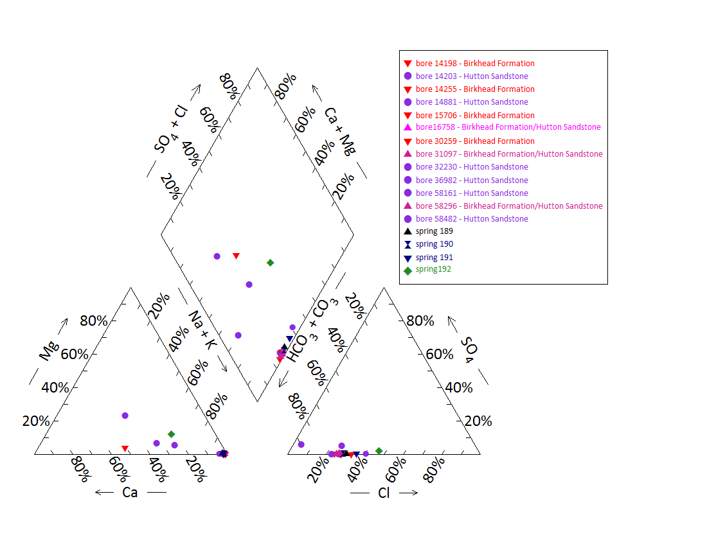

Note: No water chemistry data are available for bores 14202, 15979, 16385 and 38334 and spring 192.1.

Figure 7 Scott’s Creek spring complex—Piper plot for spring and waterbore chemistry.

Table 18 Scott’s Creek spring complex—isotope data.

|  |  |  |  |  |  |  |  |  |  |  |  |  |
| --- | --- | --- | --- | --- | --- | --- | --- | --- | --- | --- | --- | --- |
| Site ID | δ18O  VSMOW (%) | | δD  VSMOW (%) | | δ13C | ± | pMC | ± | D14C  pMC | ± | 14C age | ± |
| 189 | –5.05 | – | –31.0 | – | –5.7 | 2 | 76.344 | 0.255 | –236.6 | 2.6 | 2170 | 35 |
| 191 | –0.50 | – | –9.2 | – | – | – | – | – | – | – | – | – |
| 192.1 | –3.38 | – | –22.8 | – | – | – | – | – | – | – | – | – |

– = not available, pMC = per cent modern carbon, ppt , PDB = Pee Dee Belemnite, VSMOW = Vienna Standard Mean Ocean Water.  
© Copyright, QWC 2012a

VSMOW = Vienna Standard Mean Ocean Water.

Figure 8 Scott’s Creek spring complex—oxygen (O) and deuterium (D) stable isotope ratios.

Table 19 Scott’s Creek spring complex – Potentiometric surface data.

| Vent ID | Estimated flow rate (L/min) | Elevation (mAHD)  GPS OmniSTAR differential (+0.1 metres) | Potentiometric surface elevation (mAHD)a | |
| --- | --- | --- | --- | --- |
| Hutton Sandstone | Precipice Sandstone |
| 189 | 51 | 245.61 | 250 | Approx. 250 |
| 190 | 1 | 244.35 | 250 | Approx. 250 |
| 191 | 56 | 244.45 | 250 | Approx. 250 |
| 192 | 1 | 244.85 | 250 | Approx. 250 |

GPS = global positioning syste, L/min = litres per minute, mAHD = metres Australian height datum.  
a Data from Quarantotto 1989

Table 20 Scott’s Creek spring complex—most recent waterbore pump test data.

| Bore ID | Recorded discharge (m3/d) | Standing groundwater level (mAGL) | Year of measurement |
| --- | --- | --- | --- |
| 14203 | 5.15 | 0.71 | 1996 |
| 14255 | 0.37 | 6.89 | 1976 |
| 14881 | 4.19 | 0.93 | 1996 |
| 15706 | 0.31 | 7.82 | 1976 |
| 16758 | 4.13 | 3.98 | 1993 |
| 30259 | 1.66 | 19.48 | 2011 |
| 31097 | 5.10 | 5.11 | 1989 |
| 58296 | 2.29 | 2.26 | 1995 |

m3/d = cubic metres per day, mAGL = metres above ground level.  
© Copyright, DNRM 2012

mAHD = metres Australian height datum.

Figure 9 Scott’s Creek spring complex—waterbore standing water level (SWL) time series.

## Cockatoo Creek spring complex

### Hydrogeological summary

The Cockatoo Creek spring complex consists of 19 discharge springs. There are no faults mapped near Cockatoo Creek; however, a fault approximately 13 kilometres south-west of Cockatoo Creek may influence groundwater flow in the region. A conceptual model that may apply to the Cockatoo Creek springs is therefore one linked to a fault; that is, type E or F.

The Precipice Sandstone is the likely source aquifer for Cockatoo Creek springs, although it is likely that there is also some contribution from Evergreen Formation.

Water chemistry analysis for waterbores and springs suggest that the Precipice Sandstone is the likely source aquifer; however, little potentiometric data exist to support this conclusion.

### Spring complex overview

The Cockatoo Creek spring complex is located approximately 50 kilometres east of Taroom in south-eastern Queensland. It lies 30 kilometres south-south-east of the Dawson River 2 spring complex and lies in close proximity to Cockatoo Creek, a tributary of the Dawson River. The complex consists of 19 vents (Figure 10) and has been given a conservation ranking of 1b (Table 21). Table 22 summarises the location and elevation data for the Cockatoo Creek spring complex, and Figure 11 shows the regional geology.

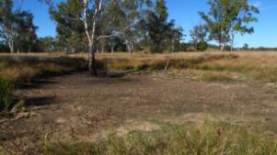 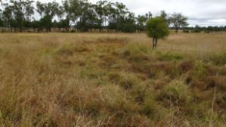

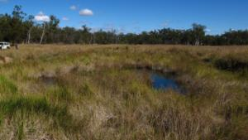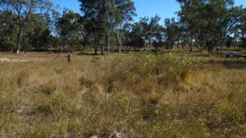

Figure 10 Cockatoo Creek spring complex—vents 319, 320, 64 and 65.

Table 21 Cockatoo Creek spring complex—hydrogeological information summary.

| Feature | Details | Comments |
| --- | --- | --- |
| No. of active vents | 19 | 319, 320, 320.1, 321, 321.1, 321.2, 321.3, 321.4, 321.5, 321.6, 321.7, 321.8, 684, 64, 64.1, 65, 65.1, 65.2 and 66 |
| No. of inactive vents | – |  |
| Conservation ranking | 1b |  |
| Spring water quality samples | Yes |  |
| Waterbore within 10-kilometre radius | 47 |  |
| Stratigraphic bores |  | 496, 2748 and 567 |
| Waterbore water quality samples | Yes |  |
| Interpreted stratigraphy available | Yes |  |
| Outcropping formations |  | Hutton Sandstone |
| Underlying aquifers |  | Precipice Sandstone, Hutton Sandstone |
| SWL time series data available | Yes |  |
| Likely source aquifers |  | Precipice Sandstone and Evergreen Formation |
| Conceptual spring type | E or F | Possibly |

– = not available, SWL = standing water level.

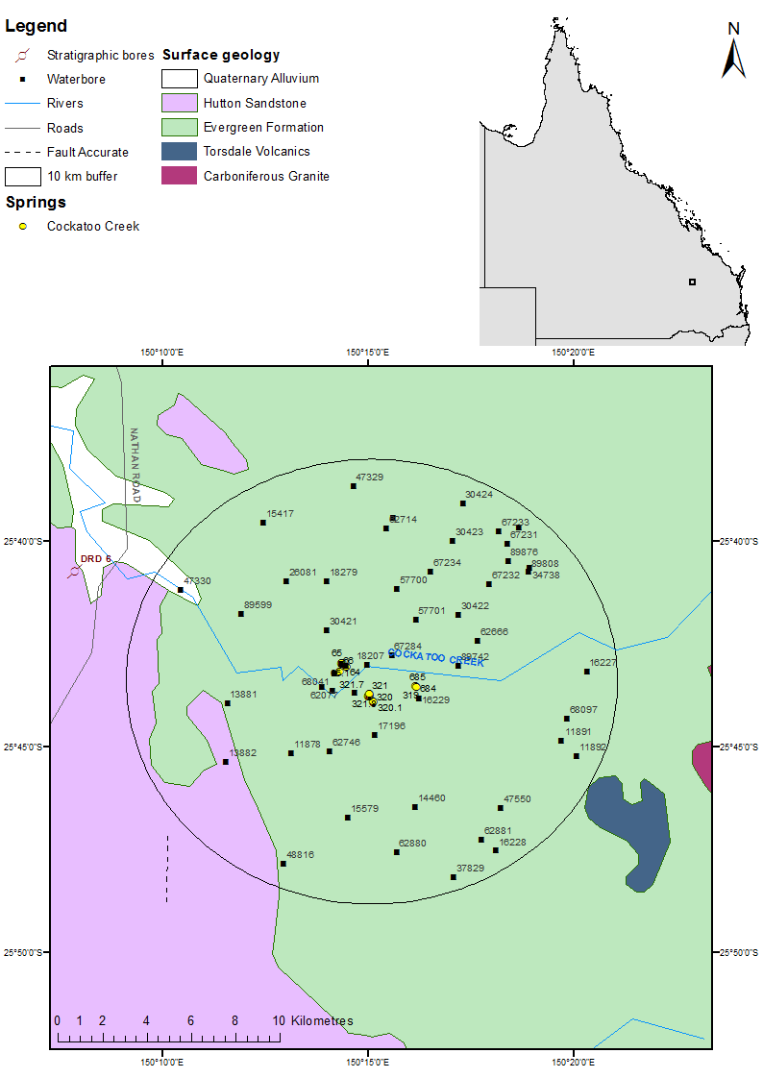

Figure 11 Cockatoo Creek spring complex—regional geology, Springsure supergroup, Queensland.

### Geology

The spring complex is located over the outcrop of the Evergreen Formation (Figure 11). The major regional Burunga Fault, the northern extension of the Goondiwindi Fault, is directed north-south and located approximately 13 kilometres south-west of the Cockatoo spring complex. This fault may influence the strata near Cockatoo Creek and, thus, the spring complex could be associated with the fault zone. Torsdale Volcanics and Carboniferous Granite also outcrop to the south-east of the spring complex.

### Regional stratigraphy and underlying aquifers

There are 47 waterbores within a 10-kilometre radius of the springs. In addition, one stratigraphic borehole is within a 15-kilometre radius (496/RD6) and two are within a 25-kilometre radius (2748 and 567) of the spring complex (Table 23). Table 24 lists the available stratigraphic information for waterbores within a 10-kilometre radius of the spring complex.

Vents 320, 321 and 64 are located on the outcrop of the Evergreen Formation overlying the Precipice Sandstone. Vents 65 and 66 are located next to Sandy Creek. Bore 67229 has been installed directly into the vent area. Vents 319 and 684 are located on an outcrop of the Precipice Sandstone in the creek bed (QWC 2012a), although this is not shown on the regional Surat Basin 1:500 000 surface geology map (Figure 11). The sequence is most likely the Upper Precipice, because the site is located close to the contact of the overlying Evergreen Formation (QWC 2012a).

The stratigraphic information from waterbores in the area indicates that the Precipice Sandstone is a likely candidate as the source aquifer for the Cockatoo Creek spring complex.

### Water chemistry comparison: springs and waterbores

Hydrochemical data available for bores within a 10-kilometre radius of the spring complex are listed in Table 25, Table 26 and Table 27. Available water chemistry data for spring vents of the Cockatoo Creek spring complex are summarised in Table 28. The hydrochemistry data in (Table 25, Table 26 and Table 27 shows that, in this area, artesian groundwater sourced from the Hutton Sandstone has a significantly higher EC (e.g. see bore 68097) reading compared to groundwater sourced from the Precipice Sandstone or the Evergreen Formation. Surface or near-surface sediments may also contribute to elevated EC readings. For example, bore 34738 has an elevated EC reading that cannot be attributed to the Hutton Sandstone, because it is located on an outcrop of the Evergreen Formation. The most likely cause of the elevated EC reading can therefore be attributed to surface sediments, although aquifer sediments are fairly heterogeneous, even across short distances, and therefore cannot be discounted as the source of the elevated EC readings. As no spring vents have EC readings greater than 900 microsiemens per centimetre (µS/cm), it can be assumed that the Hutton Sandstone is not a source aquifer for the spring complex.

The Evergreen Formation can be represented by the lowest EC reading in the local region. The Precipice Sandstone presents EC readings of approximately 300–770 µS/cm. The EC readings from the spring water range from 300 µS/cm to 900 µS/cm suggesting that the Precipice Sandstone is the likely source aquifer for the springs (Habermehl 2001).

The water chemistry data for vents 64 and 65 is similar to that of the bores sampled in 2011 during the Surat Cumulative Management Area field survey (QWC 2012a), which are all believed to tap the Precipice Sandstone. The variation in vents 319, 320 and 321 may also be due to the influence of the Evergreen Formation and other surface sediments (Quaternary alluvium) that the water passes through on route to the surface.

Limited isotope data are available for the vents and bores within the Cockatoo Creek spring complex (Table 29). Figure 13 shows the stable isotope data in relation to the global meteoric water line and Brisbane’s meteoric water line.

### Artesian status of potential source aquifers

No potentiometric data are available for potential source aquifers in the region. Limited data on spring flow and waterbore flow are summarised in Table 29 and Table 30, respectively. Figure 14 shows the available data for changes in the standing water level for waterbores within 10 kilometres of the Cockatoo Creek spring complex. Bore 17197 taps Precipice Sandstone, and has maintained artesian pressure, indicating Precipice Sandstone as a likely source aquifer.

Table 22 Cockatoo Creek spring complex—spring locations and elevations.

| Vent ID | Name | Latitude | Longitude | Elevation (mAHD) |
| --- | --- | --- | --- | --- |
| 319 | Marama | –25.72546831 | 150.2688961 | 228.83 |
| 320 | Blackley 1 | –25.73178874 | 150.2518877 | 227.64 |
| 320.1 | Blackley 1 | –25.73194259 | 150.2519747 | 229.18 |
| 321 | Blackley 2 | –25.7294186 | 150.2500176 | 225.62 |
| 321.1 | Blackley 2 | –25.72965807 | 150.2498677 | 224.85 |
| 321.2 | Blackley 2 | –25.72971516 | 150.2500017 | 224.50 |
| 321.3 | Blackley 2 | –25.72976047 | 150.2501178 | 224.99 |
| 321.4 | Blackley 2 | –25.72955732 | 150.2498508 | 225.39 |
| 321.5 | Blackley 2 | –25.72944292 | 150.2498188 | 225.40 |
| 321.6 | Blackley 2 | –25.7293432 | 150.2500551 | 225.47 |
| 321.7 | Blackley 2 | –25.72893178 | 150.2501139 | 225.17 |
| 321.8 | Blackley 2 | –25.72871228 | 150.2502401 | 225.99 |
| 64 | Sandy Creek 1 | –25.7176972 | 150.2409226 | 223.08 |
| 64.1 | Sandy Creek1 | –25.71781297 | 150.2407025 | 217.29 |
| 65 | Sandy Creek 2 | –25.71645643 | 150.2390982 | 219.20 |
| 65.1 | Sandy Creek 2 | –25.71628444 | 150.2390233 | 218.29 |
| 65.2 | Sandy Creek 2 | –25.71621969 | 150.2391317 | 222.13 |
| 66 | Sandy Creek 3 | –25.719417 | 150.238101 | 217.93 |
| 684 (319A) | Marama | –25.72583114 | 150.2694099 | 229.73 |

mAHD = metres Australian height datum.  
© Copyright, QWC 2012a

Table 23 Cockatoo Creek spring complex—stratigraphic bores within a 25-kilometre radius.

| Well ID | Top (mBGL) | Bottom (mBGL) | Thickness (m) | Rock unit name |
| --- | --- | --- | --- | --- |
| 496 | 17.1 | 218.2 | 201.1 | Evergreen Formation |
| (RD6) | 218.2 | 310.3 | 92.1 | Precipice Sandstone |
|  | 310.3 | 313.9 | 3.6 | Rewan Formation |
| 567 | 0.0 | 98.2 | 98.2 | Evergreen Formation |
|  | 98.2 | 198.8 | 100.6 | Precipice Sandstone |
|  | 198.8 | 1006.6 | 808.0 | Rewan Group |
|  | 1006.6 | 1543.6 | 537.0 | Blackwater Group |
|  | 1006.6 | 1543.6 | 537.0 | Baralaba Coal Measures |
|  | 1543.6 | 3627.6 | 2084.0 | Back Creek Group |
|  | 1543.6 | 2390.3 | 846.7 | Gyranda Subgroup |
|  | 2390.3 | 2884.7 | 494.4 | Flat Top Formation |
|  | 2884.7 | 3594.6 | 709.9 | Barfield Formation |
|  | 3594.6 | 3598.6 | 4.0 | Oxtrack Formation |
|  | 3598.6 | 3627.6 | 29.0 | Buffel Formation |
|  | 3627.6 | 3677.6 | 50.0 | Camboon Volcanics |
| 2748 | 0.0 | 44.2 | 44.2 | Evergreen Formation |

m = metre, mBGL = metres below ground level.  
© Copyright, DNRM 2012

Table 24 Cockatoo Creek spring complex—waterbores within a 10-kilometre radius.

| Bore ID | Top (mBGL) | Bottom (mBGL) | Rock type | Comments | Interpreted stratigraphy |
| --- | --- | --- | --- | --- | --- |
| 11878 | 0.00 | 0.91 | Sand |  | Evergreen Formation |
|  | 0.91 | 25.91 | Sandstone |  |  |
|  | 25.91 | 117.35 | Shale |  | Precipice Sandstone at some point |
|  | 117.35 | 119.48 | Limestone |  |  |
|  | 119.48 | 121.31 | Shale | Coal and water present |  |
|  | 121.31 | 173.74 | Sandy shale | Water at 131.70–138.69 metres |  |
|  | 173.74 | 182.88 | Sand | Water supply |  |
|  | 182.88 | 184.41 | Shale |  |  |
|  | 184.41 | 201.17 | Sand | Water |  |
| 15417 | 0.00 | 2.13 | Soil |  |  |
|  | 2.13 | 20.73 | Sandstone |  |  |
|  | 20.73 | 25.30 | Clay |  |  |
|  | 25.30 | 34.14 | Shale |  |  |
|  | 34.14 | 36.58 | Sandstone |  |  |
|  | 36.58 | 112.47 | Shale |  |  |
|  | 112.47 | 114.30 | Sand | Water supply |  |
|  | 114.30 | 164.59 | Shale | With sandstone band |  |
|  | 164.59 | 177.40 | Sandstone |  |  |
|  | 177.40 | 179.22 | Shale |  |  |
|  | 179.22 | 190.50 | Sandstone | Water supply |  |
| 15579 | 0.00 | 0.61 | Soil |  |  |
|  | – | 17.07 | Sandstone |  |  |
|  | – | 65.53 | Shale |  |  |
|  | – | 131.07 | Sandstone | Water supply |  |
|  | – | 134.11 | Shale |  |  |
|  | – | 152.40 | Sandstone | Water supply |  |
| 17196 | 0.00 | 1.52 | Soil |  |  |
|  | – | 18.28 | Clay |  |  |
|  | – | 62.17 | Sandstone |  |  |
|  | – | 67.05 | Rock |  |  |
|  | – | 121.92 | Sandstone | Water supply 73 metres and 90.5–121.0 metres |  |
| 17197 | 0.00 | 9.14 | Soil |  | Precipice Sandstone |
|  | 9.14 | 38.40 | Sandstone |  |  |
|  | 38.40 | 41.45 | Sand, | Water supply |  |
|  | 41.45 | 60.05 | Sandstone |  |  |
|  | 60.05 | 61.57 | Sand | Water supply |  |
|  | 61.57 | 70.10 | Sandstone | Water supply 66.45–70.10 metres |  |
|  | 70.10 | 80.77 | Mudstone | With layer of sandstone |  |
|  | 80.77 | 85.40 | Sandstone | Water supply |  |
| 34738 | 0.00 | 21.33 | Sandstone |  |  |
|  | 21.33 | 48.79 | Shale |  |  |
|  | 48.79 | 76.20 | Sandstone |  |  |
|  | 76.20 | 79.24 | Mudstone |  |  |
|  | 79.24 | 100.58 | Sandstone | Coarse, water supply | Precipice Sandstone |
| 37829 | 0.00 | 0.91 | soil |  |  |
|  | 0.91 | 1.22 | rock |  |  |
|  | 1.22 | 6.10 | Clay |  |  |
|  | 6.10 | 6.71 | Sandstone |  |  |
|  | 6.71 | 7.32 | Rock |  |  |
|  | 7.32 | 12.19 | Clay |  |  |
|  | 12.19 | 124.97 | Shale |  |  |
|  | 124.97 | 134.11 | Sandstone |  |  |
|  | 134.11 | 138.69 | Shale |  |  |
|  | 138.69 | 209.10 | Sandstone |  |  |
| 47328 | 0.00 | 0.60 | Soil |  | Evergreen Formation |
|  | 0.60 | 2.14 | Clay | Sandy |  |
|  | 2.14 | 9.14 | Sand |  |  |
|  | 9.14 | 22.86 | Sandstone |  |  |
|  | 22.86 | 48.76 | Shale |  |  |
|  | 48.76 | 61.26 | Sand | Water supply |  |
|  | 61.26 | 65.22 | Shale |  |  |
|  | 65.22 | 79.24 | Sand | Water supply |  |
|  | 79.24 | 81.07 | Shale |  |  |
| 62077 | 0.00 | 7.00 | Clay |  |  |
|  | 7.00 | 10.00 | Sand |  |  |
|  | 10.00 | 13.00 | Gravel | Water | Precipice Sandstone |
|  | 13.00 | 16.50 | Sandstone |  |  |
| 67229 | 0.00 | 10.00 | Clay |  |  |
|  | 10.00 | 16.00 | Gravel | Water supply |  |
|  | 16.00 | 17.00 | Clay |  |  |
|  | 17.00 | 20.00 | Fine gravel | Water supply |  |
|  | 21.00 | 21.00 | Sandstone |  |  |
| 68097 | 0.00 | 3.00 | Clay | Sandy | Hutton Sandstone |
|  | 3.00 | 28.00 | Sandstone | Water supply 26–28 metres |  |
|  | 28.00 | 33.00 | Mudstone |  |  |
|  | 33.00 | 38.00 | Rock |  |  |
|  | 38.00 | 43.00 | Granite | Crumbly |  |
|  | 100.58 | 108.20 | Sandstone | Felspatic |  |

– = not available, m = metre, mBGL = metres below ground level.  
Note: No stratigraphic data are available for bores 47329, 13881, 13882 and 26081.  
© Copyright, DNRM 2012

Table 25 Cockatoo Creek spring complex—waterbore details and water chemistry.

| Variable | Details | | | | |
| --- | --- | --- | --- | --- | --- |
| Bore ID | 17197 | 11878 | 62077 | 67229 | 68097 |
| Sample date | 16/06/2011 | 16/06/2011 | 17/06/2011 | 18/06/2011 | 22/06/1995 |
| Distance from spring (kilometres) | 1.0 | 5.2 | 2.3 | 1.6 | 9.1 |
| Source | QWC (2012a) | QWC (2012a) | QWC (2012a) | QWC (2012a) | DNRM (2012) |
| Screens (metres) | Opening 30.8–62.5 and 51.2–85.4 | Opening 12.8–201.2 | Opening 15–16.5 | Opening 8–21 | Opening 24.3–43 |
| Aquifer | Precipice Sandstone | Precipice Sandstone | Precipice Sandstone | Precipice Sandstone | Hutton Sandstone |
| Year drilled | 1966 | 1951 | 1984 | 1984 | 1984 |
| Standing water level (natural surface elevation) | 11.65 | –2.7 | 16.45 | 2.35 | –21 |
| Total depth (metres) | 85.4 | 201.2 | 16.5 | 21 | 43 |
| Surface elevation (mAHD) | 220.91 | – | 216 | 219.9 | – |
| Facility status | Existing artesian | Existing  subartesian | Existing artesian | Existing artesian | Existing  subartesian |
| *Physicochemical parameters* | | | | | |
| EC (µS/cm) | 315 | 293 | 299 | 298 | 4138 |
| pH (field/lab) | 7.37/7.84 | 7.16/7.76 | 7.45/7.78 | 7.16/7.76 | 7.4 |
| Temperature (°C) | 23.4 | 25.5 | 22.9 | 20 | – |
| *Chemical parameters (milligrams/litre)* | | | | | |
| Dissolved oxygen | 2.73 | 2.31 | 1.04 | 1.9 | – |
| TDS | 140 | 128 | 130 | 191 | 2323.3 |
| TSS | <5 | <5 | <5 | <5 | – |
| Sodium (Na) | 69 | 64 | 64 | 63 | 631.3 |
| Potassium (K) | 2 | 2 | 2 | 2 | 9.2 |
| Calcium (Ca) | 3 | 2 | 3 | 2 | 147.2 |
| Magnesium (Mg) | <1 | <1 | <1 | <1 | 64.5 |
| Chlorine (Cl) | 8 | 8 | 8 | 8 | 1043.3 |
| Sulfate (SO4) | – | – | – | – | – |
| Sodium (Na) | <1 | <1 | 1 | <1 | 167.6 |
| Total alkalinity (calcium carbonate) | 154 | 139 | 143 | 140 | 406 |
| Bicarbonate (HCO3–) | 154 | 139 | 143 | 140 | 493.4 |
| Carbonate (CO32–) | <1 | <1 | <1 | <1 | 1 |
| Iodine (I) | – | – | – | – | 632 |
| Fluoride (F) | 0.019 | <0.01 | <0.01 | <0.01 | – |
| Sodium (Na) | 0.7 | 0.7 | 0.7 | 0.7 | 0.55 |
| Bromine (Br) | 0.03 | 0.036 | 0.031 | 0.023 | – |
| Aluminium (Al) | <0.01 | <0.01 | <0.01 | <0.01 | – |
| Arsenic (As) | <0.001 | <0.001 | <0.001 | <0.001 | – |
| Barium (Ba) | 0.014 | 0.019 | 0.025 | 0.016 | – |
| Boron (B) | <0.05 | <0.05 | <0.05 | <0.05 | 0.1 |
| Cadmium (Cd) | <0.0001 | <0.0001 | <0.0001 | <0.0001 | – |
| Chromium (Cr) | <0.001 | <0.001 | <0.001 | <0.001 | – |
| Cobalt (Co) | <0.001 | <0.001 | <0.001 | <0.001 | – |
| Copper (Cu) | <0.001 | <0.001 | <0.001 | <0.001 | 0.01 |
| Iron (Fe) | 0.48 | 0.76 | 0.64 | 0.69 | 0 |
| Lithium (Li) | <0.001 | <0.001 | <0.001 | <0.001 | – |
| Lead (Pb) | 0.014 | 0.021 | 0.014 | 0.02 | 0.1 |
| Manganese (Mn) | <0.0001 | <0.0001 | <0.0001 | <0.0001 | – |
| Mercury (Hg) | <0.001 | <0.001 | <0.001 | <0.001 | – |
| Molybdenum (Mo) | <0.001 | <0.001 | <0.001 | <0.001 | – |
| Nickel (Ni) | <0.01 | <0.01 | <0.01 | <0.01 | – |
| Selenium (Se) | 14 | 14 | 14 | 14 | 14 |
| Silica (SiO2) | <0.001 | <0.001 | <0.001 | <0.001 | – |
| Silver (Ag) | 0.04 | 0.034 | 0.052 | 0.036 | – |
| Strontium (Sr) | <0.1 | <0.1 | <0.1 | <0.1 | – |
| Sulfide (S) | <0.001 | <0.001 | <0.001 | <0.001 | – |
| Tin (Sn) | 0.006 | <0.005 | <0.005 | <0.005 | 0 |
| Dissolved organic carbon | 14 | 14 | 17 | 13 | – |
| Nitrate as N | 0.05 | 0.04 | 0.02 | 0.02 | – |
| Nitrate as NO3 | – | – | – | – | 2 |
| Nitrite as N | <0.01 | <0.01 | <0.01 | <0.01 | – |
| Total oxidised nitrogen | 0.05 | 0.04 | 0.02 | 0.02 | – |
| Phosphorus (P) | 0.11 | 0.1 | 0.15 | 0.13 | – |

– = not available, EC = electrical conductivity, mAHD = metres Australian height datum, µS/cm = microsiemens per centimetre, TDS = total dissolved solids, TSS = total suspended solids.

Table 26 Cockatoo Creek spring complex—waterbore details and water chemistry continued.

| Variable | Details | | | | |
| --- | --- | --- | --- | --- | --- |
| Bore ID | 34738 | 15417 | 47328 | 47329 | 17196 |
| Sample date | 02/01/1991 | 17/17/1976 | 7/04/1976 | 7/04/1976 | 08/10/1975 |
| Distance from spring (kilometres) | 9.2 | 9.4 | 8.3 | 9.9 | 2.7 |
| Screens (metres) | Opening 92–108.2 | Perforations 183.5–189.6 | Opening 65.4–81.1 | Open-ended pipe 137.2 | Opening 105.5–121.9 |
| Aquifer | Precipice Sandstone | Evergreen Formation | Precipice Sandstone | Precipice Sandstone/Evergreen Formation | Precipice Sandstone |
| Year drilled | 1970 | 1962 | 1976 | 1963 | 1966 |
| Standing water level (natural surface elevation) | –87.1 | – | –40.5 | – | – |
| Total depth (metres) | 108.2 | 190.5 | 81.1 | 137.2 | 121.9 |
| Surface elevation (mAHD) | – | – | – | – | – |
| Facility status | Abandoned subartesian | Existing  subartesian | Spring | Existing  subartesian | Existing  subartesian |
| *Physicochemical parameters* | | | | | |
| EC (µS/cm) | 2200 | 250 | 430 | 320 | 375 |
| pH | 5.9 | 7.4 | 7.4 | 7.2 | 8.4 |
| Temp (°C) | – | – | – | – | – |
| *Chemical parameters (milligrams/litre)* | | | | | |
| Dissolved oxygen | – | – | – | – | – |
| TDS | 1279.98 | 158.53 | 251.82 | 192.69 | 3118.59 |
| TSS | – | – | – | – | – |
| Sodium (Na) | 300 | 59 | 74 | 68 | 1115.4 |
| Potassium (K) | 12.5 | 2.3 | 3.2 | 2.4 | 28.6 |
| Calcium (Ca) | 92 | 2.2 | 15 | 6.6 | 143 |
| Magnesium (Mg) | 44.5 | 0.2 | 5.2 | 0.4 | 11.4 |
| Chlorine (Cl) | 590 | 12 | 44 | 32 | 228.8 |
| Sulfate (SO4) | – | – | 5.2 | – | 0 |
| Total alkalinity (calcium carbonate) | 190 | 116 | 156 | 120 | 2628 |
| Bicarbonate (HCO3–) | 64 | 141 | 190 | 146 | 3103.1 |
| Carbonate (CO32–) | 77 | 0.2 | 0.3 | 0.1 | 50.1 |
| Total hardness | 0 | 6 | 59 | 18 | 404 |
| Fluoride (F) | 414 | 0.3 | 0.5 | 0.4 | 0.5 |
| Bromine (Br) | 0.3 | – | – | – | – |
| Aluminium (Al) | – | – | – | – | – |
| Barium (Ba) | – | – | – | – | – |
| Beryllium (Be) | 0.07 | – | – | – | – |
| Barium (Ba) | 0.03 | – | – | – | – |
| Iron (Fe) | <0.02 | – | – | – | – |
| Lead (Pb) |  | – | – | – | – |
| Manganese (Mn) | 1.6 |  |  |  |  |
| Silica (SiO2) | 10 | 13 | 11 | 11 | 15 |
| Zinc (Zn) | 0.1 |  |  |  |  |
| Nitrate as NO3 | <1 | – | 0 | – | 0 |

– = not available, EC = electrical conductivity, mAHD = metres Australian height datum, µS/cm = microsiemens per centimetre, TDS = total dissolved solids, TSS = total suspended solids.  
© Copyright, DNRM 2012

Table 27 Cockatoo Creek spring complex—waterbore details and water chemistry continued.

| Variable | Details | | | |
| --- | --- | --- | --- | --- |
| Bore ID | 13882 | 37829 | 13881 | 26081 |
| Sample date | 24/04/1974 | 09/08/1972 | 31/10/1975 | 07/04/1976 |
| Distance from spring (kilometres) | 7.8 | 10.6 | 6 | 5.7 |
| Screens (metres) | Open-ended pipe 372 | Open-ended pipe 209 | – | – |
| Aquifer | Precipice Sandstone | Precipice Sandstone | Precipice Sandstone | – |
| Year drilled | 1959 | 1972 | 1958 | 1963 |
| Standing water level | – | – | – | – |
| Total depth (metres) | 372.1 | 209.2 | 201.6 | – |
| Surface elevation (mAHD) | – | – | – | – |
| Facility status | Existing  subartesian | Existing  subartesian | Existing | Existing |
| *Physicochemical parameters* | | | | |
| EC (µS/cm) | 270 | 770 | 277 | 405 |
| pH | 7.8 | 7.5 | 7.6 | 7.2 |
| Temp (°C) | – | – | – | – |
| *Chemical parameters (milligrams/litre)* | | | | |
| Dissolved oxygen | – | – | – | – |
| TDS | 155.2 | 567.5 | – | – |
| TSS | – | – | – | – |
| Sodium (Na) | 62 | 228 | 56 | 69 |
| Potassium (K) | 2.2 | – | 19 | 3 |
| Calcium (Ca) | 2 | 8 | 5.5 | 16 |
| Magnesium (Mg) | 0.4 | 2 | 0.5 | 5 |
| Chlorine (Cl) | 17.5 | 100 | 14 | 34 |
| Sulfate (SO4) | 0 | 0 | 0 | – |
| Total alkalinity (calcium carbonate) | 110 | 380 | 130 | 160 |
| Bicarbonate (HCO3–) | 133 | 464 | 158 | 195 |
| Carbonate (CO32–) | 0.5 | – | 0.4 | 0.1 |
| Total hardness | 7 | 28 | 16 |  |
| Fluoride (F) | 5 | 1.35 | 0.29 | 0.4 |
| Bromine (Br) | – | – | – | – |
| Aluminium (Al) | – | – | – | – |
| Barium (Ba) | – | – | – | – |
| Boron (B) | – | – | – | – |
| Copper (Cu) | – | – | – | – |
| Iron (Fe) | 0.2 | – | – | – |
| Lead (Pb) | – | – | – | – |
| Silica (SiO2) | – | – | – | 14 |
| Nitrate as NO3 | 0 | – | – | – |

– = not available, EC = electrical conductivity, mAHD = metres Australian height datum, µS/cm = microsiemens per centimetre, TDS = total dissolved solids, TSS = total suspended solids.  
Note: No water chemistry data are available for bore 15579.  
© Copyright, DNRM 2012

Table 28 Cockatoo Creek spring complex—spring water chemistry.

| Variable | Details | | | | |
| --- | --- | --- | --- | --- | --- |
| Vent ID | 64 | 65 | 319 | 320.1 | 321.2 |
| Sample date | 17/06/2011 | 17/06/2011 | 18/06/2011 | 16/06/2011 | 16/06/2011 |
| *Physicochemical parameters* | | | | | |
| EC (field) (µS/cm) | 310 | 298 | 900 | 532 | 631 |
| pH (field/lab) | 7.15/7.86 | 6.87/7.89 | 7.76/8.18 | 6.88/7.9 | 6.76/7.97 |
| Temperature (field) (°C) | 19.5 | 20 | 11 | 18.2 | 17.1 |
| *Chemical parameters (milligrams/litre)* | | | | | |
| Dissolved oxygen (field) | 2.23 | 1.9 | 7.01 | 0.46 | 0.32 |
| TDS | 202 | 186 | 514 | 334 | 338 |
| TSS | 7 | 64 | 8 | 298 | 98 |
| Sodium (Na) | 66 | 64 | 178 | 89 | 108 |
| Potassium (K) | 2 | 2 | 4 | 10 | 5 |
| Calcium (Ca) | 2 | 2 | 12 | 6 | 24 |
| Magnesium (Mg) | <1 | <1 | 2 | <1 | 2 |
| Chlorine (Cl) | 9 | 8 | 108 | 15 | 20 |
| Sulfate (SO4) | – | – | – | – | – |
| Total alkalinity (calcium carbonate) | <1 | <1 | <1 | <1 | <1 |
| Bicarbonate (HCO3–) | 148 | 143 | 302 | 198 | 294 |
| Carbonate (CO32–) | 148 | 143 | 302 | 198 | 294 |
| Sodium (Na) | <1 | <1 | <1 | <1 | <1 |
| Total hardness | – | – | – | – | – |
| Iodine (I) | <0.01 | <0.01 | <0.05 | <0.02 | <0.02 |
| Fluoride (F) | 0.7 | 0.7 | 0.7 | 0.8 | 1.1 |
| Bromine (Br) | 0.03 | 0.031 | 0215 | 0.056 | 0.036 |
| Aluminium (Al) | <0.01 | <0.01 | <0.01 | 0.06 | 0.02 |
| Arsenic (As) | <0.001 | <0.001 | <0.001 | <0.001 | <0.001 |
| Barium (Ba) | 0.017 | 0.014 | 0.088 | 0.032 | 0.169 |
| Beryllium (Be) | – | – | – | – | – |
| Boron (B) | <0.05 | <0.05 | <0.05 | <0.05 | <0.05 |
| Cadmium (Cd) | <0.0001 | <0.0001 | <0.0001 | <0.0001 | <0.0001 |
| Chromium (Cr) | <0.001 | <0.001 | <0.001 | <0.001 | <0.001 |
| Cobalt (Co) | <0.001 | <0.001 | <0.001 | <0.001 | 0.002 |
| Copper (Cu) | <0.001 | <0.001 | <0.001 | <0.001 | 0.001 |
| Iron (Fe) | 0.2 | 0.15 | 0.09 | 0.29 | 0.33 |
| Lead (Pb) | <0.001 | <0.001 | <0.001 | <0.001 | <0.001 |
| Manganese (Mn) | 0.021 | 0.012 | 0.04 | 0.035 | 0.33 |
| Mercury (Hg) | <0.0001 | <0.0001 | <0.0001 | <0.0001 | <0.0001 |
| Molybdenum (Mo) | <0.001 | <0.001 | <0.001 | <0.001 | <0.001 |
| Nickel (Ni) | <0.001 | <0.001 | <0.001 | <0.001 | <0.001 |
| Selenium (Se) | <0.01 | <0.01 | <0.01 | <0.01 | <0.01 |
| Silica (SiO2) | 14 | 13 | 14 | 21 | 21 |
| Silver (Ag) | <0.001 | <0.001 | <0.001 | <0.001 | <0.001 |
| Strontium (Sr) | 0.034 | 0.026 | 0.197 | 0.074 | 0.188 |
| Sulfide (S) | <0.1 | <0.1 | <0.1 | <0.1 | <0.1 |
| Tin (Sn) | <0.001 | <0.001 | <0.001 | <0.001 | <0.001 |
| Zinc (Zn) | <0.005 | 0.008 | 0.017 | 0.006 | <0.005 |
| Dissolved organic carbon | 10 | 8 | 16 | 16 | 19 |
| Total organic carbon | – | – | – | – | – |
| Nitrate as N | 0.08 | 0.02 | 0.02 | 0.07 | 0.13 |
| Nitrate as NO3 | – | – | – | – | – |
| Nitrite as N | <0.01 | <0.01 | <0.01 | <0.01 | <0.01 |
| Total oxidised nitrogen | 0.08 | 0.02 | 0.02 | 0.07 | 0.13 |
| Phosphate as P | 0.1 | 0.09 | 0.08 | 0.54 | 0.36 |

– = not available, EC = electrical conductivity, µS/cm = microsiemens per centimetre, TDS = total dissolved solids, TSS = total suspended solids.  
© Copyright, QWC 2012a

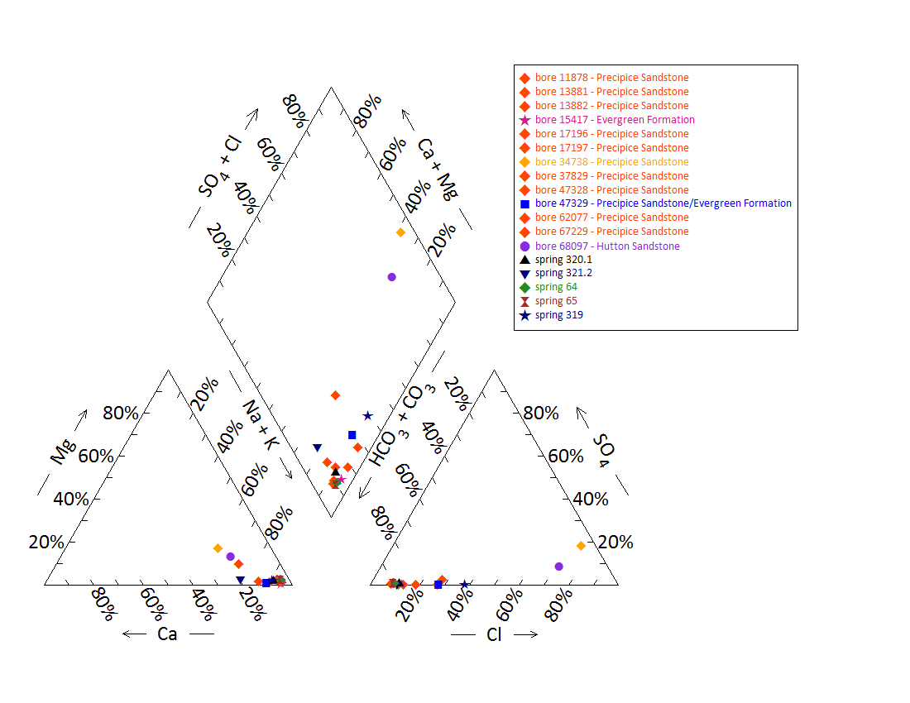

Note: No water chemistry data are available for bore 15579 and springs 319, 320, 321, 321.1, 321.3-321.8, 64.1, 65.1, 65.2 and 66.

Figure 12 Cockatoo Creek spring complex—Piper plot for spring and waterbore chemistry.

Table 29 Cockatoo Creek spring complex—isotope data.

| Site ID | δ18O  VSMOW (%) | | δD  VSMOW (%) | | δ13C | ± | pMC | ± | D14C  pMC | ± | 14C age | ± |
| --- | --- | --- | --- | --- | --- | --- | --- | --- | --- | --- | --- | --- |
| 319 | –5.60 | – | 35.4 | – | – | – | – | – | – | – | – | – |
| 320 | –6.34 | – | –39.1 | – | – | – | – | – | – | – | – | – |
| 321 | –5.95 | – | –36.3 | – | – | – | – | – | – | – | – | – |
| 64 | –6.10 | – | –38.8 | – | –10.9 | 0.1 | 17.301 | 0.09 | –827.0 | 0.89 | 14090 | 50 |
| 65 | –6.45 | –6.43 | –39.8 | –39.7 | – | – | – | – | – | – | – | – |
| 17197 | –6.56 | – | –40.6 | – | –9.6 | 0.1 | 2.771 | 0.04 | –972.3 | 0.39 | 28805 | 130 |
| 62077 | –6.41 | – | –39.1 | – | – | – | – | – | – | – | – | – |
| 67229 | –6.48 | – | –38.9 | – | –14.3 | 0.1 | 2.773 | 0.04 | –972.3 | 0.38 | 28800 | 140 |
| 11878 | –6.44 | – | –38.3 | – | – | – | – | – | – | – | – | – |

– = not available, pMC = per cent modern carbon, VSMOW = Vienna Standard Mean Ocean Water.  
© Copyright, QWC 2012a

VSMOW = Vienna Standard Mean Ocean Water.

Figure 13 Cockatoo Creek spring complex—oxygen (O) and deuterium (D) stable isotope ratios.

Table 30 Cockatoo Creek spring complex—spring elevation and flow rate.

| Vent ID (EHA) | Elevation (mAHD) | Estimated flow rate (L/min) | Date of estimate |
| --- | --- | --- | --- |
| 319 | 228.83 | 4 | 18/06/2011 |
| 320 | 227.64 | 0 | 16/06/2011 |
| 320.1 | – | – | – |
| 321 | 225.62 | 0 | 16/06/2011 |
| 321.1 | 224.85 | 0 | 16/062011 |
| 321.2 | 224.50 | 0 | 16/06/2011 |
| 321.3 | 224.99 | 0 | 16/06/2011 |
| 321.4 | 225.39 | 0 | 16/06/2011 |
| 321.5 | 225.40 | 0 | 16/06/2011 |
| 321.6 | 225.47 | 0 | 16/06/2011 |
| 321.7 | 225.17 | 0 | 16/06/2011 |
| 321.8 | 225.99 | 0 | 16/06/2011 |
| 64 | 223.08 | 34 | 17/06/2011 |
| 64.1 | 217.29 | – | – |
| 65 | 219.20 | 4 | 17/06/2011 |
| 65.1 | 218.29 | – | – |
| 65.2 | 222.13 | – | – |
| 66 | 217.93 | – | – |
| 684 | 229.73 | – | – |

– = not available, EHA = Environmental Hydrology Associates, L/min = litres per minute, mAHD = metres Australian height datum.

Table 31 Cockatoo Creek spring complex—most recent waterbore pump test data.

| Bore ID | Recorded discharge (m3/d) | Standing groundwater level (mAGL) | Year of measurement |
| --- | --- | --- | --- |
| 17197 | 12.91 | 11.01 | 2012 |
| 34738 | 1.00 | –79.80 | 1991 |
| 62077 | 0.50 | 16.45 | 1995 |
| 67229 | 3.43 | 2.35 | 1995 |

m3/d = cubic metres per day, mAGL = metres above ground level.  
© Copyright, DNRM 2012

mAHD = metres Australian height datum.

Figure 14 Cockatoo Creek spring complex—waterbore standing water levels (SWLs).

## Boggomoss spring complex

### Hydrogeological summary

The Boggomoss Springs are discharge springs. No faults are mapped in the area, but the springs form linear north-south and south-west–north-east trends, which suggest that they may be associated with unmapped faults or fractures associated with faults (DNR 1996). The likely conceptual model for these springs is springs emanating from a fault, type E or F.

The Precipice Sandstone is the likely source aquifer for the Boggomoss spring complex, although the Boxvale Sandstone Member of the Evergreen Formation may contribute to the springs.

Water quality analysis of spring and bore water did not conclusive attribute a source aquifer to the spring complex. Water chemistry of bores that tapped the Precipice Sandstone varied spatially between bores within a 10-kilometre radius of the spring complex. Spring water chemistry was, however, similar to nearby bores that tapped Precipice Sandstone. Potentiometric data for Precipice Sandstone in the region support the possibility of Precipice Sandstone being the source aquifer for the Boggomoss Springs.

### Spring complex overview

The Boggomoss spring complex is also known as the Dawson River 5 complex (Figure 15). The Boggomoss complex overlaps with the Dawson River 6 spring complex. It is located approximately 32 kilometres north-east of Taroom in south-eastern Queensland, and lies in the valley of the Boggomoss Creek and Spring Gully (Figure 16). The Boggomoss spring complex has been given a conservation ranking of 2. Table 32 shows the hydrogeological summary. The locations and elevations of the spring vents are listed in Table 33.

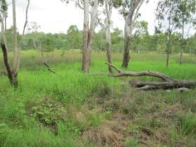 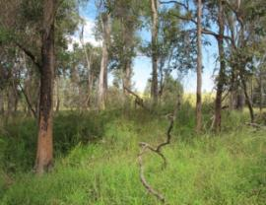

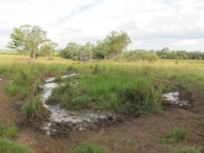 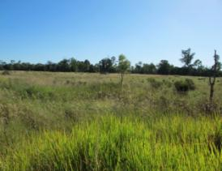

Figure 15 Boggomoss spring complex—vents 2, 10, 15 and 56.

Table 32 Boggomoss spring complex—hydrogeological information summary.

| Variable | Details | Comments |
| --- | --- | --- |
| No. of active vents | 30 | 2, 3, 7, 8, 9, 10, 11, 12, 13, 14, 15, 29, 33, 37, 37.1, 44, 53, 54, 55, 56, 56.1, 57, 58, 61, 62, 63, 68, 68.1, 683, 691 (44B) |
| No. of inactive vents | – |  |
| Conservation ranking | 2 |  |
| Nearby spring complexes |  | Dawson River 6 and Dawson River 2 |
| Spring water quality samples | Yes |  |
| Waterbore within 10-kilometre radius | 33 |  |
| Stratigraphic bores |  | 1136, 2748, 567 |
| Waterbore water quality samples |  |  |
| Interpreted stratigraphy available | Yes |  |
| Outcropping formations |  | Hutton, Evergreen Formation, Precipice Sandstone |
| Underlying aquifers |  | Precipice Sandstone |
| SWL time series data available | Yes |  |
| Likely source aquifers |  | Precipice Sandstone |
| Conceptual spring type | E or F | Possibly |

– = not available, SWL = standing water level.

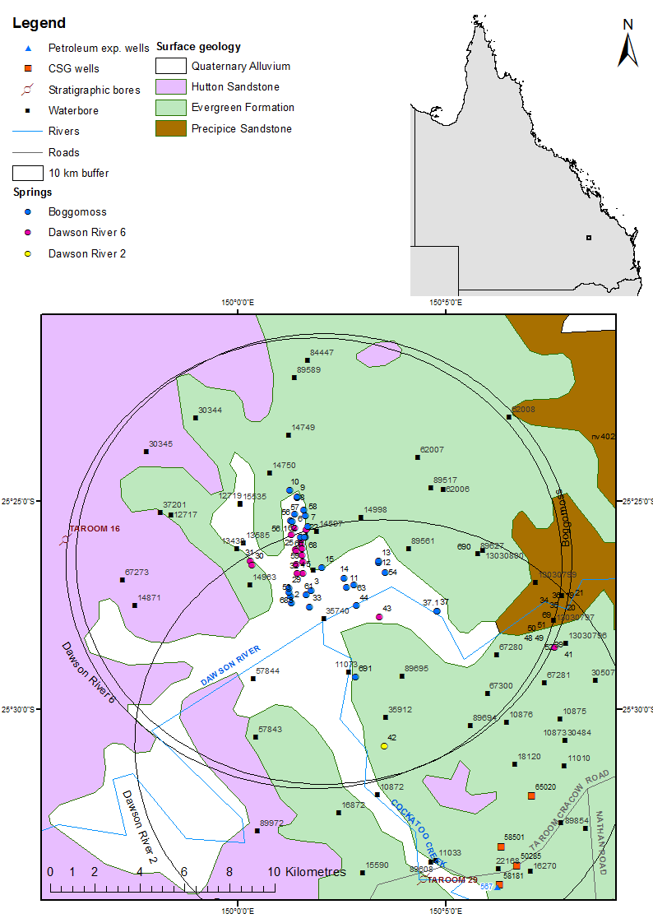

CSG = coal seam gas, exp. = exploration.

Figure 16 Boggomoss spring complex—regional geology, Springsure supergroup, Queensland.

### Geology

There are no faults mapped in the area of the Boggomoss and Dawson River 6 spring complexes. The arrays of springs located along Boggomoss Creek and Dawson River are linear and trend north-south and south-west–north-east. The Queensland Department of Natural Resources (DNR 1996) suggested that this is most likely due to some type of structural control either in the form of faults that have not been mapped or fracture zones associated with such faults. A number of trend lines at and around the location of the springs are shown on the Mundubbera 1:250 000SG 56-5 geology map sheet (Whitaker et al. 1980), some of which may have a relationship with the springs.

### Regional stratigraphy and underlying aquifers

Vents 37 and 27.1 are located north of the Dawson River on the Evergreen Formation, which overlies the Precipice Sandstone. It is presumed that the underlying Precipice Sandstone is the source for vent 37, with groundwater coming to the ground surface under some pressure (QWC 2012a).

Vent 691 is a well-developed spring mound next to Cockatoo Creek, located on alluvium presumed to be underlain by the Evergreen Formation. Vent 44 is a prominent spring mound located on top of a longitudinal bar in the Dawson River. It is located within mapped Quaternary alluvium—silty clay with peat underlying the mound. The site is possibly underlain by more unconsolidated sediments (river sands and gravels), which in turn is presumed to be underlain by the Evergreen Formation. For both vents 44 and 691, groundwater is potentially sourced from upward migration of artesian groundwater from the Precipice Sandstone.

The Boggomoss Reserve cluster of springs includes vents 7, 56, 62 and 68,and is located next to Boggomoss Creek on Quaternary alluvium that is underlain by the Evergreen Formation. The cluster also includes some Dawson River 6 vents, including 1, 6, 22, 27 and 60. The groundwater is presumed to be sourced from the underlying Precipice Sandstone. It is probable that a significant fracture, fault (or intrusion) and/or thinning of the Evergreen Formation in the area allows upward migration of groundwater from the Precipice Sandstone to the surface (QWC 2012a).

Within a 10-kilometre radius of the springs, there are 33 waterbores. One stratigraphic borehole is within a 15-kilometre radius of the spring complex (1136, Taroom 16). Five coal seam gas wells, one stratigraphic bore (2748, Mundubbra 29) and one petroleum exploration well are within a 20-kilometre radius (Table 34). The stratigraphic logs for bores 1136, 2748 and wells, 58501 (coal seam gas), and 567 (petroleum exploration well) are shown in Table 34. Table 35 summarises the available stratigraphic information for waterbores within a 10-kilometre radius of the Boggomoss spring complex.

### Water chemistry comparison: springs & waterbores

Complete hydrochemical data were only available for vents 11 and 56 (Table 39). Available water chemistry data for waterbores within a 10-kilometre radius of the Boggomoss spring complex are listed in Table 36, Table 37 and Table 38. Additional field measurements were taken for some vents that were not sampled during the Surat Cumulative Management Area field survey conducted by the Queensland Water Commission (QWC 2012a). The results of the additional field measurements are shown in Table 40. Limited isotope data are available for the vents and waterbores within the Dawson River 5 and 6 spring complexes (Table 41). Figure 18 shows the stable isotope data in relation to the global meteoric water line and Brisbane’s meteoric water line. A Piper plot comparing the hydrochemistry for vents 11 and 56 with the waterbores in the area is shown in Figure 17.

### Artesian status of potential surface aquifers

The potentiometric data sourced from the DNR (1996) indicates that the Precipice Sandstone is a potential source aquifer for the Boggomoss spring complexes as the potentiometric surface elevation, because the Precipice Sandstone is higher than the surface elevation of the vents. The DNR (1996) estimates the potentiometric surface of the Precipice Sandstone to be approximately 220 metres Australian height datum in the area of the Boggomoss spring complex (Table 42, Table 43 and Figure 19). Note that no spot values of groundwater elevations were available for the Precipice Sandstone within 10 kilometres of the spring complex.

Artesian waterbores in the area also tap the Precipice Sandstone, providing support for the conclusion that Precipice Sandstone is the most likely source aquifer.

Table 33 Boggomoss spring complex—spring locations and elevations.

| Vent ID | QWC ID | Latitude | Longitude | Elevation (mAHD)  GPS OmniSTAR differential (+0.1 metres) |
| --- | --- | --- | --- | --- |
| 2 | 2 | –25.457419 | 150.021102 | 175.50 |
| 3 | 3 | –25.453419 | 150.030101 | 177.88 |
| 7 | 7 | –25.426592 | 150.028125 | 203.03 |
| 8 | 8 | –25.415419 | 150.023101 | 208.68 |
| 9 | 9 | –25.414419 | 150.024101 | 210.31 |
| 10 | 10 | –25.412419 | 150.021101 | 212.54 |
| 11 | 11 | –25.451419 | 150.043101 | 173.37 |
| 12 | 12 | –25.441419 | 150.056101 | 173.38 |
| 13 | 13 | –25.441419 | 150.056101 | 174.60 |
| 14 | 14 | –25.447419 | 150.043101 | 170.98 |
| 15 | 15 | –25.443419 | 150.034101 | 188.23 |
| 29 | 29 | –25.451419 | 150.020102 | 178.17 |
| 33 | 33 | –25.459419 | 150.028101 | 177.98 |
| 37 | 37 | –25.460696 | 150.079700 | 174.76 |
| 37.1 | 37vent2 | –25.46083753 | 150.0798116 | 174.76 |
| 44 | 44 | –25.458519 | 150.047540 | 221.00 |
| 53 | 53 | –25.455419 | 150.021102 | 174.82 |
| 54 | 54 | –25.445419 | 150.060101 | 170.34 |
| 55 | 55 | –25.422419 | 150.023101 | 202.18 |
| 56 | 56 | –25.424598 | 150.021742 | 197.05 |
| 57 | 57 | –25.420419 | 150.028101 | 201.40 |
| 58 | 58 | –25.422419 | 150.025101 | 201.61 |
| 61 | 61 | –25.454419 | 150.027101 | 172.43 |
| 62 | 62 | –25.431008 | 150.025172 | 193.45 |
| 63 | 63 | –25.450419 | 150.047101 | 171.64 |
| 68 | 68 | –25.431105 | 150.026672 | 196.09 |
| 683 | 29B | –25.45312751 | 150.0205662 | 175.74 |
| 691 | 44B | –25.48731898 | 150.0471372 | 170.93 |

mAHD = metres Australian height datum QWC = Queensland Water Commission.

Table 34 Boggomoss spring complex—stratigraphic bores and coal seam gas wells within a 25-kilometre radius.

| Well/bore ID | Top (mBGL) | Bottom (mBGL) | Thickness (m) | Rock unit name |
| --- | --- | --- | --- | --- |
| 567  (petroleum exploration) | 0.0 | 98.2 | 98.2 | Evergreen Formation |
| 98.2 | 198.8 | 100.6 | Precipice Sandstone |
| 198.8 | 1006.6 | 808.0 | Rewan Group |
|  | 1006.6 | 1543.6 | 537.0 | Blackwater Group |
|  | 1006.6 | 1543.6 | 537.0 | Baralaba Coal Measures |
|  | 1543.6 | 3627.6 | 2084.0 | Back Creek Group |
|  | 1543.6 | 2390.3 | 846.7 | Gyranda Subgroup |
|  | 2390.3 | 2884.7 | 494.4 | Flat Top Formation |
|  | 2884.7 | 3594.6 | 709.9 | Barfield Formation |
|  | 3594.6 | 3598.6 | 4.0 | Oxtrack Formation |
|  | 3598.6 | 3627.6 | 29.0 | Buffel Formation |
|  | 3627.6 | 3677.6 | 50.0 | Camboon Volcanics |
| 1136 | 0.0 | 61.0 | 61.0 | Hutton Sandstone |
| (Taroom 16) | 61.0 | 248.0 | 187.0 | Evergreen Formation |
|  | 248.0 | 301.0 | 53.0 | Precipice Sandstone |
|  | 301.0 | 1037.0 | 736.0 | Moolayember Formation |
|  | 1037.0 | 1184.0 | 147.0 | Clematis Group |
|  | 1184.0 | 1230.9 | >46.9 | Rewan Group |
| 2748 (Mundubbra 29) | 0.0 | 44.2 | 44.2 | Evergreen Formation |
| 58501 (coal seam gas) | 0.0 | 104.4 | 104.4 | Hutton Sandstone |
|  | 104.4 | 139.9 | 35.5 | Evergreen Formation |
|  | 139.9 | 237.6 | 97.9 | Precipice Sandstone |
|  | 237.6 | 791.6 | 553.9 | Rewan Group |
|  | 791.5 | 1389.7 | 598.2 | Baralaba Coal Measures |

– = not available, m = metre, mBGL = metres below ground level.  
© Copyright, DNRM 2012

Table 35 Boggomoss spring complex—waterbores within a 10-kilometre radius.

|  |  |  |  |
| --- | --- | --- | --- |
| Bore ID | Top (mBGL) | Bottom (mBGL) | Rock unit name |
| 12719 | 0.0 | 83.8 | Evergreen Formation |
|  | 83.8 | 86.9 | Precipice Sandstone |
| 12717 | 0.0 | 24.4 | Hutton Sandstone |
|  | 24.4 | 165.5 | Evergreen Formation |
|  | 165.5 | 169.2 | Precipice Sandstone |
| 13483 | 0.0 | 44.2 | Evergreen Formation |
|  | 44.2 | – | Precipice Sandstone |
|  | – | 195.1 | Moolayember Formation |
| 13585 | 0.0 | 29.6 | Evergreen Formation |
|  | 29.6 | 41.5 | Precipice Sandstone |
| 14871 | 0.0 | 23.2 | Hutton Sandstone |
|  | 23.2 | 184.4 | Evergreen Formation |
|  | 184.4 | 238.7 | Precipice Sandstone |
| 15535 | 0.0 | 40.5 | Evergreen Formation |
|  | 40.5 | – | Precipice Sandstone |
|  | – | – | Moolayember Formation |
| 30344 | 0.0 | – | Evergreen Formation |
|  | – | 144.8 | Precipice Formation |
| 30345 | 0.0 | – | Hutton Sandstone |
|  | – | – | Evergreen Formation |
|  | – | 219.8 | Precipice Formation |
| 37201 | 0.0 | 119.5 | Evergreen Formation |
|  | 119.5 | 174.96 | Precipice Sandstone |
| 57843 | 37.0 | 107.0 | Evergreen Formation |
|  | 107.0 | – | Precipice Sandstone |

– = not available, mBGL = metres below ground level.  
Note: No stratigraphic data are available for bore 89695. Bores 35256, 67280, 14963, 89561, 57844, 67300, 11073 and 14998 are only recorded as passing through Precipice Sandstone.  
© Copyright, DNRM 2012

Table 36 Boggomoss spring complex—waterbore details and water chemistry.

| Variable | Details | | | | |
| --- | --- | --- | --- | --- | --- |
| Vent ID | 37201 | 89695 | 14871 | 13438 | 35256 |
| Sample date | 29/05/2012 | 10/05/2011 | 15/08/1996 | 16/08/1996 | 16/08/1996 |
| Source | QWC (2012a) | QWC (2012a) | DNRM (2012) | DNRM (2012) | DNRM (2012) |
| Distance from spring (kilometres) | 7.2 | 6.9 | 8.4 | 3.6 | 0.4 |
| Screens (metres) | Opening 161.8–174.96 | Opening 42–72 | Opening 201.9–238.7 | Open end 39.6–91.5 | Perforated casing 82.3–139 |
| Aquifer | Evergreen Formation/ Precipice Sandstone | Precipice Sandstone | Precipice Sandstone | Boxvale Sandstone/Precipice Sandstone | Precipice Sandstone |
| Year drilled | 1971 | 2000 | 1961 | 1957 | 1970 |
| Standing water level (natural surface elevation) | 22.98 | – | 15.2 | – | 15.73 |
| Total depth (metres) | 174.96 | 72 | 238.7 | 91.5 | 140.2 |
| Surface elevation (mAHD) | 210.08 | 181.38 | 220.70 | 189.22 | 199.56 |
| Facility status | Existing artesian | Existing artesian | Existing artesian | Existing artesian | Existing artesian |
| *Physicochemical parameters* | | | | | |
| EC (µS/cm) | 170 | 139.6 | 157 | 177 | 220 |
| pH (field/lab) | 6.3 | 6.51/7.34 | 6 | 6.1 | 5.9 |
| Temp (°C) | 28 | 25.2 | 29 | – | 25 |
| *Chemical parameters (milligrams/litre)* | | | | | |
| Dissolved oxygen | – | 0.5 | – | – | – |
| TDS | 91.81 | 102 | 93.28 | 101.27 | 123.26 |
| TSS | – | <5 | – | – | – |
| Sodium (Na) | 24 | 28 | 25.9 | 25.3 | 31.9 |
| Potassium (K) | 2.7 | 3 | 3 | 4.1 | 3.3 |
| Calcium (Ca) | 3.8 | 2 | 3.6 | 5.9 | 7 |
| Magnesium (Mg) | 1.1 | <1 | 1.2 | 1.6 | 2 |
| Chlorine (Cl) | 31 | 6 | 30.6 | 37.6 | 50.9 |
| Sulfate (SO4) | <1 | <1 | 1.8 | 0 | 0 |
| Total alkalinity (calcium carbonate) | 26 | 63 | 25 | 25 | 29 |
| Bicarbonate (HCO3–) | 31 | 63 | 30.9 | 30.1 | 35.6 |
| Carbonate (CO32–) | 0 | <1 | 0 | 0 | 0 |
| Total hardness | 15 | – | 14 | 21 | 26 |
| Iodine (I) | – | <0.01 | – | – | – |
| Fluoride (F) | <0.1 | 0.2 | 0 | 0 | 0 |
| Bromine (Br) | – | 0.023 | – | – | – |
| Aluminium (Al) | <0.05 | <0.01 | 0 | 0 | 0 |
| Arsenic (As) | – | <0.001 | – | – | – |
| Barium (Ba) | – | 0.018 | – | – | – |
| Boron (B) | 0.02 | <0.05 | 0 | 0 | 0 |
| Cadmium (Cd) | – | <0.0001 | – | – | – |
| Chromium (Cr) | – | <0.001 | – | – | – |
| Cobalt (Co) | – | <0.001 | – | – | – |
| Copper (Cu) | 0.03 | <0.001 | 0.01 | 0.01 | 0.01 |
| Iron (Fe) | <0.01 | 2.78 | 0.03 | 0 | 0 |
| Lead (Pb) | – | <0.001 | – | – | – |
| Manganese (Mn) | 0.21 | 0.061 | 0.07 | 0.21 | 0.08 |
| Mercury (Hg) | – | <0.0001 | – | – | – |
| Molybdenum (Mo) | – | <0.001 | – | – | – |
| Nickel (Ni) | – | <0.001 | – | – | – |
| Selenium (Se) | – | <0.01 | – | – | – |
| Silica (SiO2) | – | 14 | – | – | 11 |
| Silver (Ag) | – | <0.001 | – | – | – |
| Strontium (Sr) | – | 0.026 | – | – | – |
| Sulfide (S) | – | <0.1 | – | – | – |
| Tin (Sn) | – | <0.001 | – | – | – |
| Zinc (Zn) | 0.05 | <0.005 | 0.11 | 0 | 0.07 |
| Dissolved organic carbon | – | 6 | – | – | – |
| Nitrate as N | – | <0.01 | – | – | – |
| Nitrate as NO3 | <0.5 | – | 0 | 0 | 0 |
| Nitrite as N | – | <0.01 | – | – | – |
| Total oxidised N | – | <0.01 | – | – | – |
| Phosphate (PO4) | – | 0.17 | – | – | – |

– = not available, EC = electrical conductivity, mAHD = metres Australian height datum, µS/cm = microsiemens per centimetre, TDS = total dissolved solids, TSS = total suspended solids.

Table 37 Boggomoss spring complex—waterbore details and water chemistry continued.

| Variable | Details | | | | |
| --- | --- | --- | --- | --- | --- |
| Vent ID | 67280 | 14963 | 89561 | 57843 | 57844 |
| Sample date | 16/08/1996 | 16/08/1996 | 03/08/1994 | 30/05/1991 | 30/05/1991 |
| Distance from spring (kilometres) | 9.5 | 3.1 | 4.3 | 9.1 | 6.4 |
| Screens (metres) | Open end 32–70 | Open end 118.5–133.2 | Perforations 86–111 | Open end 136–182 | Opening 59–155.4 |
| Aquifer | Precipice Sandstone | Evergreen Formation/ Precipice Sandstone | Precipice Sandstone | Evergreen Formation/ Precipice Sandstone | Precipice Sandstone |
| Year drilled | 1986 | 1962 | 1993 | 1980 | 1980 |
| Standing water level (natural surface elevation) | 12.46 | 34.53 | –26.2 | 47.5 | 44.13 |
| Total depth (metres) | 174.87 | 133.2 | 111 | 182 | 155.4 |
| Surface elevation (mAHD) | 70 | 193.06 | 211.40 | 181.8 | 183.33 |
| Facility status | Existing artesian | Existing artesian | Existing subartesian | Existing artesian | Existing artesian |
| *Physicochemical parameters* | | | | | |
| EC (µS/cm) | 157 | 103 | 188 | 255 | 360 |
| pH (field/lab) | 6.9 | 6.1 | 6.5 | 8 | 7.4 |
| Temp (°C) | 24 | 26 | 26 | 29 | 27 |
| *Chemical parameters (milligrams/litre)* | | | | | |
| Dissolved oxygen | – | – | – | – | – |
| TDS | 105.36 | 70.33 | 109.89 | 146.13 | 203.45 |
| TSS | – | – | – | – | – |
| Sodium (Na) | 38.2 | 19 | 29.4 | 47.5 | 54 |
| Potassium (K) | 1.9 | 2.3 | 2.5 | 3.6 | 6.5 |
| Calcium (Ca) | 1.4 | 2.5 | 5.8 | 3.5 | 11.5 |
| Magnesium (Mg) | 0.4 | 0.8 | 1.8 | 1.1 | 3.8 |
| Chlorine (Cl) | 6 | 18.5 | 43.8 | 31.5 | 64 |
| Sulfate (SO4) | 0 | 0 | 0.4 | 2 | 11.5 |
| Total alkalinity (calcium carbonate) | 77 | 27 | 26 | 74 | 69 |
| Bicarbonate (HCO3–) | 93.8 | 32.4 | 32.1 | 89 | 84 |
| Carbonate (CO32–) | 0 | 0 | 0 | 0.5 | 0.1 |
| Total hardness | 5 | 10 | 22 | 13 | 44 |
| Iodine (I) | – | – | – | – | – |
| Fluoride (F) | 0.14 | 0 | 0.01 | 0.1 | 0.1 |
| Bromine (Br) | – | – | – | – | – |
| Aluminium (Al) | 0 | 0 | – | – | – |
| Arsenic (As) | – | – | – | – | – |
| Barium (Ba) | – | – | – | – | – |
| Boron (B) | 0 | 0 | – | – | – |
| Copper (Cu) | 0 | 0.01 | – | – | – |
| Iron (Fe) | 0.01 | 0 | 0 | 0.02 | 0.02 |
| Lead (Pb) | – | – | – | – | – |
| Manganese (Mn) | 0.01 | 0.03 | 0.08 | 0.05 | 0.13 |
| Mercury (Hg) | – | – | – | – | – |
| Molybdenum (Mo) | – | – | – | – | – |
| Nickel (Ni) | – | – | – | – | – |
| Selenium (Se) | – | – | – | – | – |
| Silica (SiO2) | 11 | 11 | 10 | 12 | 10 |
| Silver (Ag) | – | – | – | – | – |
| Strontium (Sr) | – | – | – | – | – |
| Sulfide (S) | – | – | – | – | – |
| Tin (Sn) | – | – | – | – | – |
| Zinc (Zn) | 0.01 | 0 | – | – | – |
| Dissolved organic carbon | – | – | – | – | – |
| Nitrate as NO3 | 0 | 0 | 0 | 0.5 | 0.5 |

– = not available, EC = electrical conductivity, mAHD = metres Australian height datum, µS/cm = microsiemens per centimetre, TDS = total dissolved solids, TSS = total suspended solids.  
© Copyright, DNRM 2012

Table 38 Boggomoss spring complex—waterbore details and water chemistry continued.

| Variable | Details | | | |
| --- | --- | --- | --- | --- |
| Vent ID | 67300 | 15535 | 11073 | 14998 |
| Sample date | 30/03/1989 | 13/03/1989 | 02/04/1970 | 06/04/1962 |
| Distance from spring (kilometres) | 10.1 | 4.4 | 5.7 | 3.1 |
| Screens (metres) | Opening 24.4–45.5 | Perforations 40.5–41.1 and 55.7–56.4 | – | Opening 28.4–122 |
| Aquifer | Precipice Sandstone | Evergreen Formation/ Precipice Sandstone | Precipice Sandstone | Precipice Sandstone |
| Year drilled | 1986 | 1963 | 1948 | 1962 |
| Standing water level (mBRP) | 19.21 | 11.24 | 1.5 | –26.3 |
| Total depth (metres) | 45.5 | 61.0 | 73.2 | 122.0 |
| Surface elevation (mAHD) | 173.1 | 204.05 | 174.00 | 212.35 |
| Facility status | Abandoned artesian | Existing artesian | Abandoned artesian | Existing subartesian |
| *Physicochemical parameters* | | | | |
| EC (µS/cm) | 200 | 305 | 210 | 0 |
| pH (field/lab) | 7.3 | 6.8 | 7 | 7.4 |
| Temp (°C) | 25 | 24 | – |  |
| *Chemical parameters (milligrams/litre)* | | | | |
| Dissolved oxygen | – |  | – |  |
| TDS | 110 | 154.97 | 102.91 | 256.6 |
| TSS | – |  | – |  |
| Sodium (Na) | 39.5 | 31.5 | 24 | 62.9 |
| Potassium (K) | 2.5 | 5.6 | – | – |
| Calcium (Ca) | 3.3 | 20 | 7 | 14.3 |
| Magnesium (Mg) | 0.5 | 2.2 | 7 | 2.9 |
| Chlorine (Cl) | 7 | 50 | 28 | 68.6 |
| Sulfate (SO4) | 2 | 2 | 2 | 0 |
| Total alkalinity (calcium carbonate) | 97 | 71 | 58 | 180 |
| Bicarbonate (HCO3–) | 120 | 87 | 71 | 108.6 |
| Carbonate (CO32–) | 0.1 | 0 | – | 54.3 |
| Total hardness | 10 | 59 | 46 | 48 |
| Iodine (I) | – | – | – | – |
| Fluoride (F) | 0.2 | 0.1 | 0 | 0.2 |
| Bromine (Br) | – | – | – | – |
| Aluminium (Al) | – | – | – | – |
| Arsenic (As) | – | – | – | – |
| Barium (Ba) | – | – | – | – |
| Boron (B) | – | – | – | – |
| Cadmium (Cd) | – | – | – | – |
| Chromium (Cr) | – | – | – | – |
| Cobalt (Co) | – | – | – | – |
| Copper (Cu) | – | – | – | – |
| Iron (Fe) | 0.01 | 0.01 | – | – |
| Lead (Pb) | – | – | – | – |
| Manganese (Mn) | 0.01 | 0.28 | – | – |
| Mercury (Hg) | – | – | – | – |
| Molybdenum (Mo) | – | – | – | – |
| Nickel (Ni) | – | – | – | – |
| Selenium (Se) | – | – | – | – |
| Silica (SiO2) | – | – | – | – |
| Silver (Ag) | – | – | – | – |
| Strontium (Sr) | – | – | – | – |
| Sulfide (S) | – | – | – | – |
| Tin (Sn) | – | – | – | – |
| Zinc (Zn) | – | – | – | – |
| Nitrate as NO3 | 0.5 | 0.5 | 0 | – |

– = not available, EC = electrical conductivity, mAHD = metres Australian height datum, mBRP = metres below reference point, µS/cm = microsiemens per centimetre, TDS = total dissolved solids, TSS = total suspended solids.  
Note: No water chemistry data are available for bores 12719, 12717, 13483, 13585, 30344 and 30345.   
© Copyright, DNRM 2012

Table 39 Boggomoss spring complex—spring water chemistry.

| Variable | Details | |
| --- | --- | --- |
| Vent ID | 11 | 56 |
| Sample date | 02/09/1996 | 29/06/1996 |
| *Physicochemical parameters* | | |
| EC (µS/cm) | – | – |
| pH (field/lab) | – | – |
| Temperature (°C) | – | – |
| *Chemical parameters (milligrams/litre)* | | |
| Dissolved oxygen | – | – |
| TDS | – | – |
| TSS | – | – |
| Sodium (Na) | 31.5 | 32 |
| Potassium (K) | 3.6 | 3.5 |
| Calcium (Ca) | 5.1 | 7.1 |
| Magnesium (Mg) | 1.7 | 2.1 |
| Chlorine (Cl) | 42.5 | 50 |
| Total alkalinity (calcium carbonate) | <2 | <2 |
| Bicarbonate (HCO3–) | – | – |
| Carbonate (CO32–) | 33 | 34 |
| Iodine (I) | – | – |
| Fluoride (F) | – | – |
| Bromine (Br) | – | – |
| Aluminium (Al) | – | – |
| Arsenic (As) | – | – |
| Barium (Ba) | – | – |
| Sodium (Na) | – | – |
| Boron (B) | – | – |
| Cadmium (Cd) | – | – |
| Chromium (Cr) | – | – |
| Cobalt (Co) | – | – |
| Copper (Cu) | – | – |
| Iron (Fe) | – | – |
| Boron (B) | – | – |
| Manganese (Mn) | – | – |
| Mercury (Hg) | – | – |
| Molybdenum (Mo) | – | – |
| Nickel (Ni) | – | – |
| Selenium (Se) | – | – |
| Silica (SiO2) | 11 | 11 |
| Silicon (Si) | – | – |
| Silver (Ag) | – | – |
| Strontium (Sr) | – | – |
| Sulfide (S) | <0.67 | <0.67 |
| Tin (Sn) | – | – |
| Zinc (Zn) | – | – |

– = not available, EC = electrical conductivity, µS/cm = microsiemens per centimetre, TDS = total dissolved solids, TSS = total suspended solids.  
© Copyright, DNR 1996

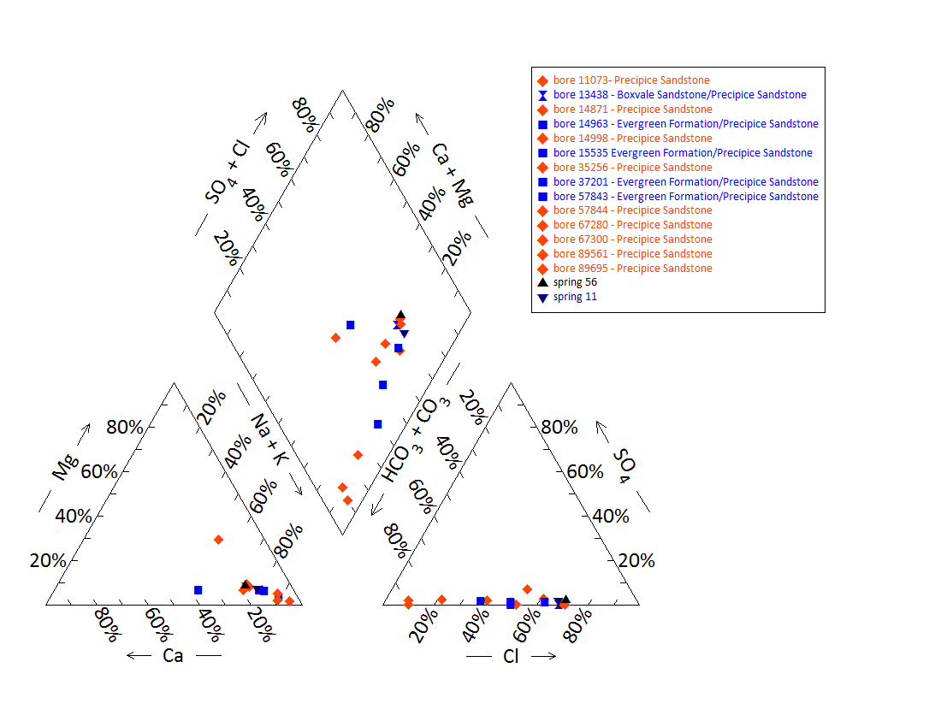

Note: No water chemistry data are available for springs 2, 3, 7–10, 12–15, 29, 33, 37, 37.1, 44, 53–55, 56.1–58, 61–63, 68, 68.1, 683 and 691.

Figure 17 Boggomoss spring complex—Piper plot of spring and waterbore chemistry.

Table 40 Boggomoss spring complex—additional field measurements.

| Variable | Details | | | | |
| --- | --- | --- | --- | --- | --- |
| Vent ID | 7 | 37 | 44 | 68 | 691 |
| Sample date | 23/06/2011 | 23/06/2011 | 20/06/2011 | 23/06/2011 | 20/06/2011 |
| *Field measurements* | | | | | |
| Flow (L/s) | Pooled water | Minor seep | 0.5 (estimate) | Pooled water | No flow |
| EC (µS/cm) | 189 | 602 | 426 | 193 | 429 |
| pH | 6.01 | 7.5 | 7.1 | 5.71 | 7.3 |
| Dissolved oxygen (mg/L) | 4.55 | 2.91 | 1.98 | 4.58 | 1.67 |
| Temperature (°C) | 13.8 | 5 | 10.4 | 11.4 | 8 |
| ORP | 175 | 100 | –48 | 173 | 261 |
| Methane (CH4) (ppm) air | – | 1500 | 170 | 250–330 | 670–700 |
| O2 (%) air | – | 20.9 | 20.9 | – | 20.9 |

– = not available, EC = electrical conductivity, L/s = litres per second, mg/L = milligrams per litre, µS/cm = microsiemens per centimetre, ORP = oxidation–reduction potential, ppm = parts per million.  
© Copyright, QWC 2012a

Table 41 Boggomoss spring complex—isotope data.

| Site ID | δ18O  VSMOW (%) | | δD  VSMOW (%) | | δ13C | ± | pMC | ± | D14C  pMC | ± | 14C age | ± |
| --- | --- | --- | --- | --- | --- | --- | --- | --- | --- | --- | --- | --- |
| 44 | 4.59 | –4.69 | –27.2 |  |  |  |  |  |  |  |  |  |
| RN89695 | –6.41 |  | –39.7 | –39.0 | –14.8 | 0.1 | 7.178 | 0.06 | –928.2 | 0.60 | 21160 | 80 |

– = not available, pMC = per cent modern carbon, VSMOW = Vienna Standard Mean Ocean Water.  
© Copyright, QWC 2012a

Figure 18 Boggomoss spring complex—oxygen (O) and deuterium (D) stable isotope ratios.

Table 42 Boggomoss spring complex—potentiometric surface data.

| Vent ID | Estimated flow rate (L/min) | Elevation (mAHD)  GPS OmniSTAR differential (+0.1 metres) | Potentiometric surface elevation (mAHD)a Precipice Sandstone |
| --- | --- | --- | --- |
| 2 | 6 | 175.50 | 217 |
| 3 | 2 | 177.88 | 213 |
| 7 | 9 | 203.03 | 220 |
| 8 | 13 | 208.68 | 219 |
| 9 | 1 | 210.31 | 218 |
| 10 | 2 | 212.54 | 220 |
| 11 | 7 | 173.37 | 203 |
| 12 | 1 | 173.38 | 192 |
| 13 | 1 | 174.60 | 192 |
| 14 | 1 | 170.98 | 204 |
| 15 | 1 | 188.23 | 215 |
| 29 | 0 | 178.17 | 220 |
| 33 | 23 | 177.98 | 217 |
| 37 | 0 | 174.76 | 188 |
| 37.1 | 0 | 174.76 | 188 |
| 44 | 9 | 221.00 | 200 |
| 53 | 1 | 174.82 | 217 |
| 54 | 0 | 170.34 | 191 |
| 55 | 2 | 202.18 | 222 |
| 56 | 2 | 197.05 | 223 |
| 57 | 37 | 201.40 | 217 |
| 58 | 3 | 201.61 | 220 |
| 61 | 11 | 172.43 | 215 |
| 62 | 0 | 193.45 | 221 |
| 63 | 1 | 171.64 | 200 |
| 68 | 3 | 196.09 | 221 |
| 683 | 1 | 175.74 | 217 |
| 691 | 2 | 170.93 | 204 |

GPS = global positioning system, L/min = litres per minute, mAHD = metres Australian height datum.  
a Data from DNR 1996  
© Copyright, EHA 2009

Table 43 Boggomoss spring complex—most recent waterbore pump test data.

| Bore ID | Recorded discharge (m3/d) | Standing groundwater level (mAGL) | Year of measurement |
| --- | --- | --- | --- |
| 14963 | 4.69 | 34.02 | 1994 |
| 15535 | 0.50 | 2.55 | 1994 |
| 35256 | 30.79 | 15.73 | 1994 |
| 35740 | 1.91 | 33.00 | 1997 |
| 37201 | 5.25 | 22.98 | 2012 |
| 57843 | 6.69 | 46.99 | 1994 |
| 57844 | 6.94 | 43.22 | 1980 |
| 67280 | 5.41 | 12.87 | 1996 |
| 67300 | 19.33 | 2.64 | 1986 |
| 89517 | 5.50 | 32.80 | 1991 |

m3/d = cubic metres per day, mAGL = metres above ground level.  
© Copyright, DNRM 2012

mAHD = metres Australian height datum.

Figure 19 Boggomoss spring complex—waterbore standing water levels (SWLs).

## Dawson River 2 spring complex

### Hydrogeological summary

The Dawson River 2 spring complex consists of one discharge spring vent. There are no faults mapped in the area; however, the major Burunga Fault is approximately 35 kilometres due south and may extend northwards. The likely conceptual model for the Dawson River 2 spring is one associated with a fault or, possibly, with a thinning of overlying aquitards, or both – type C, D, E or F.

Precipice Sandstone is the likely source aquifer for the Dawson River 2 spring complex; although no hydrochemical data for the underlying aquifers exist to confirm this.

Water quality analyses of spring and bore water did not conclusively attribute a source aquifer to the spring complex. This is because all waterbores tapped Precipice Sandstone, but some bores had different hydrochemistry to the rest of the bores. Spring water chemistry was, however, similar to most bores tapping the Precipice Sandstone.

### Spring complex overview

The Dawson River 2 spring complex is located approximately 34 kilometres north-east of Taroom in south-eastern Queensland (Figure 21). This spring complex consists of a single discharge vent (Figure 20) and is located approximately 9 kilometres south-south-east of the Boggomoss and Dawson River 6 spring complexes (for a hydrogeological summary, see Table 44). It has been given a conservation ranking of 2. Table 45 lists the location and elevation of the Dawson River 2 spring complex.

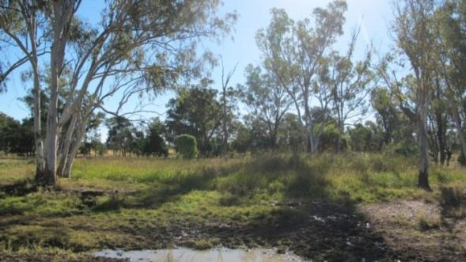

Figure 20 Dawson River 2 spring complex—vent 42, Springsure supergroup, Queensland.

Table 44 Dawson River 2 spring complex—hydrogeological information summary.

| Feature | Details | Comments |
| --- | --- | --- |
| No. of active vents | 1 | 42 |
| No. of inactive vents | – |  |
| Conservation ranking | 2 |  |
| Nearby spring complexes |  | Boggomoss and Dawson River 6 |
| Spring water quality samples | Yes |  |
| Waterbore within 10-kilometre radius | 41 |  |
| Stratigraphic bores | Yes | 1136, 2748, 1361 |
| Waterbore water quality samples | Yes |  |
| Interpreted stratigraphy available | Yes |  |
| Outcropping formations |  | Injune Creek Group, Hutton Sandstone, Evergreen Formation |
| Underlying aquifers |  | Precipice Sandstone |
| SWL time series data available | Yes |  |
| Likely source aquifers |  | Precipice Sandstone |
| Conceptual spring type | E, F, C or D |  |

– = not available, SWL = standing water level.

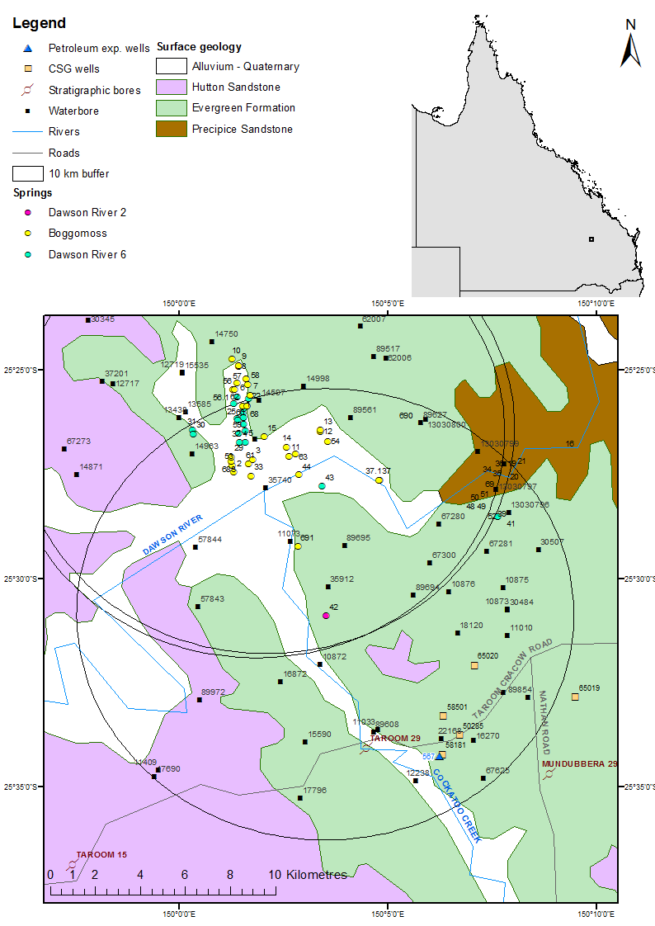

CSG = coal seam gas, exp. = exploration.

Figure 21 Dawson River 2 spring complex—regional geology, Springsure supergroup, Queensland.

### Geology

There are no faults mapped in the area of the Dawson River 2 spring complex (Figure 21). A trend line near the location of Dawson River 2 spring is shown on the Mundubbera 1:250 000 SG 56-5 geology map sheet (Whitaker et al. 1980), which could have a relationship with the spring.

The Burunga Fault is located approximately 35 kilometres south of the Dawson River 2 spring complex and trends north–south. If this fault extends northwards, it may influence the strata near Dawson River 2 and, thus, the spring complex could be associated with the fault.

### Regional stratigraphy and underlying aquifers

The spring complex is located on an outcrop of the Evergreen Formation. Within a 10-kilometre radius of the springs there are 4 coal seam gas wells, 1 petroleum exploration well and 41 waterbores. In addition, one stratigraphic borehole is within a 15-kilometre radius of the spring complex and a further two are within a 20-kilometre radius.

The stratigraphic logs for stratigraphic bores 1136, 2748 and 1361; petroleum well 567; and coal seam gas wells 58501 and 22168 are listed in Table 46. The available stratigraphy for waterbores within a 10-kilometre radius is shown in Table 47.

Aquifers in the region include the Hutton Sandstone, Boxvale Member of the Evergreen Formation, Precipice Sandstone and Clematis Sandstone; however, available information suggests that waterbores only extend as far down as the Precipice Sandstone.

### Water chemistry comparison: springs and waterbores

Hydrochemical data are available for 23 waterbores within 10 kilometres of the Dawson River 2 complex. These data are summarised in Table 48 and Table 49. Complete hydrochemistry data are available for spring 42 and are summarised in Table 50. The Dawson River 2 spring vent is a well-developed spring mound with outflow and is located on an area underlain by the Evergreen Formation, which overlies the Precipice Sandstone. The vent is potentially sourced from upward migration of artesian groundwater from the Precipice Sandstone; a comparison of available water chemistry is required to determine if this is a valid hypothesis.

A Piper plot comparing waterbore and spring hydrochemistry is shown in Figure 22. The water chemistry is similar for all the bores—this is most likely due to the fact that all of the bores source water from the Precipice Sandstone, although some waterbores do tap other aquifers as well.

Limited isotope data are available for the vent and bores within the Dawson River 2 spring complex. Figure 23 shows the stable isotope data in relation to the global meteoric water line and Brisbane’s meteoric water line. From Table 51, it can be deducted that the isotope data for vent 42 is comparable to that of bore 89695. This suggests that the source for both is most likely the Precipice Sandstone.

### Artesian status of potential source aquifers

No potentiometric surface data are available for the potential source aquifer(s) in the Dawson River 2 area. Spring elevation and flow rate are shown in Table 52. Most bores in the area are artesian, and interpreted to tap the Precipice Sandstone (Table 48 and Table 49). With some exceptions, the standing water level for waterbores in the area has also remained fairly constant through time (Table 53 and Figure 22). This supports the conclusion that Precipice Sandstone is the likely source aquifer for the Dawson River 2 spring.

Table 45 Dawson River 2 spring complex—spring location and elevation.

| Vent ID | Name | Latitude GDA94 (55) | Longitude GDA94 (55) | Elevation (mAHD) |
| --- | --- | --- | --- | --- |
| 42 | BALKL1—Balcarris | –25.514418 | 150.058102 | 180.33 |

GDA94 = Geocentric Datum of Australia 1994, mAHD = metres Australian height datum.

Table 46 Dawson River 2 spring complex—stratigraphic bores, petroleum exploration wells and coal seam gas wells within a 20-kilometre radius.

| Well ID | Top (mBGL) | Bottom (mBGL) | Thickness (m) | Rock unit name |
| --- | --- | --- | --- | --- |
| 1136 | 0.0 | 61.0 | 61.0 | Hutton Sandstone |
| (Taroom 16) | 61.0 | 248.0 | 187.0 | Evergreen Formation |
|  | 248.0 | 301.0 | 53.0 | Precipice Sandstone |
|  | 301.0 | 1037.0 | 736.0 | Moolayember Formation |
|  | 1037.0 | 1184.0 | 147.0 | Clematis Group |
|  | 1184.0 | 1230.9 | >46.9 | Rewan Group |
| 2748 (Mundubbera 29) | 0.0 | 44.2 | 44.2 | Evergreen Formation |
| 1361 | 0.0 | 206.1 | 206.1 | Hutton Sandstone |
| (Taroom 15) | 206.1 | 425.5 | 219.4 | Evergreen Formation |
|  | 425.5 | 502.5 | 77.0 | Precipice Sandstone |
|  | 502.5 | 538.9 | 36.4 | Moolayember Formation |
|  | 538.9 | 686.6 | 147.7 | Clematis Group |
|  | 686.6 | 949.5 | >262.9 | Rewan Group |
| 567 (petroleum  exploration | 0.0 | 98.2 | 98.2 | Evergreen Formation |
| 98.2 | 198.8 | 100.6 | Precipice Sandstone |
| 198.8 | 1006.6 | 808.0 | Rewan Group |
|  | 1006.6 | 1543.6 | 537.0 | Blackwater Group |
|  | 1006.6 | 1543.6 | 537.0 | Baralaba Coal Measures |
|  | 1543.6 | 3627.6 | 2084.0 | Back Creek Group |
|  | 1543.6 | 2390.3 | 846.7 | Gyranda Subgroup |
|  | 2390.3 | 2884.7 | 494.4 | Flat Top Formation |
|  | 2884.7 | 3594.6 | 709.9 | Barfield Formation |
|  | 3594.6 | 3598.6 | 4.0 | Oxtrack Formation |
|  | 3598.6 | 3627.6 | 29.0 | Buffel Formation |
|  | 3627.6 | 3677.6 | 50.0 | Camboon Volcanics |
| 58501 (coal seam gas) | 0.0 | 104.4 | 104.35 | Hutton Sandstone |
| 104.4 | 139.9 | 35.5 | Evergreen Formation |
|  | 139.9 | 237.6 | 97.9 | Precipice Sandstone |
|  | 237.6 | 791.5 | 553.9 | Rewan Group |
|  | 791.5 | 1389.7 | 598.2 | U Baralaba Coal Measures |
| 22168 (coal seam gas) | 5.4 | 103.6 | 98.2 | Evergreen Formation |
|  | 103.6 | 204.2 | 100.6 | Precipice Sandstone |
|  | 204.2 | 1012.2 | 808.0 | Rewan Group |
|  | 1012.0 | 1549.0 | 537.0 | Blackwater Group |
|  | 1012.0 | 1549.0 | 537.0 | Baralaba Coal Measures |
|  | 1549.0 | 3633.0 | 2084.0 | Back Creek Group |
|  | 1549.0 | 2395.7 | 846.7 | Gyranda Subgroup |
|  | 2395.7 | 2890.1 | 494.4 | Flat Top Formation |
|  | 2890.1 | 3600.0 | 709.9 | Barfield Formation |
|  | 3600.0 | 3604.0 | 4.0 | Oxtrack Formation |
|  | 3604.0 | 3633.0 | 29.0 | Buffel Formation |
|  | 3633.0 | 3682.6 | 49.6 | Camboon Volcanics |

– = not available, m = metre, mBGL = metres below ground level.  
© Copyright, DNRM 2012

Table 47 Dawson River 2 spring complex—waterbores within a 10-kilometre radius.

| Well ID | Top (mBGL) | Bottom (mBGL) | Rock unit name |
| --- | --- | --- | --- |
| 11409 | 0.0 | 55.2 | Hutton Sandstone |
|  | 55.2 | 255.1 | Evergreen Formation |
|  | 255.1 | 288.3 | Precipice Sandstone |
| 16270 | 5.4 | 103 | Evergreen Formation |
|  | 103 | 158.6 | Precipice Sandstone |
| 16872 | 0.0 | – | Evergreen Formation |
|  | – | 181.1 | Precipice Sandstone |
| 22168 | 5.4 | 103.6 | Evergreen Formation |
|  | 103.6 | 204.2 | Precipice Sandstone |
|  | 204.2 | 2012.2 | Rewan Group |
|  | 2012.2 | 1549.0 | Baralaba Coal Measures (Blackwater Group) |
|  | 1549.0 | 2395.7 | Gyranda Subgroup (Black Creek Group) |
|  | 2395.7 | 2890.1 | Flat Top Formation |
|  | 2890.1 | 3600.0 | Barfield Formation |
|  | 3600.0 | 3604.0 | Oxtrack Formation |
|  | 3604.0 | 3633.0 | Buffel Formation |
|  | 3633.0 | 3682.6 | Camboon Formation |
| 57843 | 30.0 | 107.0 | Evergreen Formation |
|  | 107.0 | 182.0 | Precipice Sandstone |
| 67281 | 19.0 | 80.0 | Precipice Sandstone |
| 17796 | 0.0 | – | Hutton Sandstone |
|  | – | 243.9 | Precipice Sandstone |
| 67281 | 19.0 | 80.0 | Precipice Sandstone |

– = not available, mBGL = metres below ground level.  
Notes: No stratigraphic data are available for bore 89695. Bores 14963, 35256, 67280, 89561, 57844, 10875, 10876, 30484, 67300, 15590, 10872, 11033, 44317, 18120, 11073, 30507 and 12238 are recorded as passing through Precipice Sandstone.  
© Copyright, DNRM 2012

Table 48 Dawson River 2 spring complex—waterbore details and water chemistry.

| Variable | Details | | | | | | | | | | | |
| --- | --- | --- | --- | --- | --- | --- | --- | --- | --- | --- | --- | --- |
| Bore ID | 16270 | 16872 | 17796 | 67281 | 89695 | 14963 | 35256 | 67280 | 89561 | 57843 | 57844 | 12238 |
| Sample date | 03/07  2012 | 03/07  2012 | 13/07  2011 | 13/07  2011 | 10/05  2011 | 16/08  1996 | 16/08  1996 | 16/08  1996 | 03/08  1994 | 30/05  1991 | 30/05  1991 | 30/05  1991 |
| Source | DNRM (2012) | DNRM (2012) | DNRM (2012) | DNRM (2012) | QWC (2012a) | DNRM (2012) | DNRM (2012) | DNRM (2012) | DNRM (2012) | DNRM (2012) | DNRM (2012) | DNRM (2012) |
| Distance from spring (kilometres) | 9.2 | 3.9 | 9.2 | 8 | 3.6 | 9.9 | 9.3 | 6.9 | 9.9 | 5.7 | 6.7 | 9.3 |
| Screens (metres) | Opening 141.5–158.6 | Perforated 170.7–181 | Open 198–243.85 | Open 19–80 | Open 42–72 | Open 118.5–133.2 | Perforated 82.3–139 | Open-ended pipe 32–70 | Open-ended 86–111 | Open-ended pipe 136–182 | Open 95.5–155.4 | Open-ended pipe 92.4 |
| Aquifer | Precipice Sand-stone | Precipice Sand-stone | Hutton / Precipice Sand-stone | Precipice Sand-stone | Precipice Sand-stone | Ever-green / Precipice Sand-stone | Precipice Sand-stone | Precipice Sand-stone | Precipice Sand-stone | Precipice Sand-stone | Precipice Sand-stone | Precipice Sand-stone |
| Year drilled | 1964 | 1966 | 1959 | 1986 | 2000 | 1962 | 1970 | 1986 | 1993 | 1980 | 1980 | 1953 |
| Standing water level (natural surface elevation) | 6.28 | 32.08 | 31.5 | 6.23 | – | 34.53 | 15.73 | 12.46 | –26.2 | 47.5 | 44.13 | 40.66 |
| Total depth (metres) | 158.6 | 181.1 | 243.85 | 80 | 72 | 133.2 | 140.2 | 174.87 | 111 | 182 | 155.4 | 92.35 |
| Surface elevation (mAHD) | 224 | 207 | 206 | 194 | 181.38 | 193.06 | 199.56 | 70 | 211.40 | 181.8 | 183.33 | 184.72 |
| Facility status | Existing artesian | Existing artesian | Existing artesian | Existing artesian | Existing artesian | Existing artesian | Existing artesian | Existing artesian | Existing  sub-artesian | Existing artesian | Existing artesian | Existing artesian |
| *Physiochemical parameters* | | | | | | | | | | | | |
| EC (µS/cm) | 195 | 144 | 163 | 213 | 139.6 | 103 | 220 | 157 | 188 | 255 | 360 | 349 |
| pH (field/lab) | 6.7 | 6.9 | 7 | 6.8 | 6.51/7.34 | 6.1 | 5.9 | 6.9 | 6.5 | 8 | 7.4 | 8.5 |
| Temperature (°C) | 26.2 | 32 | 28 | 25 | 25.2 | 26 | 25 | 24 | 26 | 29 | 27 | 26.4 |
| *Chemical parameters (milligrams/litre)* | | | | | | | | | | | | |
| Dissolved oxygen | – | – | – | – | 0.5 | – | – | – | – | – | – | - |
| TDS | 119 | 89 | 102 | 130 | 102 | 70.33 | 123.26 | 105.36 | 109.89 | 146.13 | 203.45 | 218.07 |
| TSS | – | – | – | – | <5 | – | – | – | – | – | – | - |
| Sodium (Na) | 41 | 29 | 35 | 46 | 28 | 19 | 31.9 | 38.2 | 29.4 | 47.5 | 54 | 80.1 |
| Potassium (K) | 1.9 | 2 | 2.3 | 2.2 | 3 | 2.3 | 3.3 | 1.9 | 2.5 | 3.6 | 6.5 | 1.8 |
| Calcium (Ca) | 1.4 | 1.1 | 1 | 1.9 | 2 | 2.5 | 7 | 1.4 | 5.8 | 3.5 | 11.5 | 4.9 |
| Magnesium (Mg) | 0.3 | 0.3 | 0.3 | 0.3 | <1 | 0.8 | 2 | 0.4 | 1.8 | 1.1 | 3.8 | 0.6 |
| Chlorine (Cl) | 14 | 6.9 | 7.7 | 9 | 6 | 18.5 | 50.9 | 6 | 43.8 | 31.5 | 64 | 7.7 |
| Sulfate (SO4) | <1 | <1 | <1 | <1 | <1 | 0 | 0 | 0 | 0.4 | 2 | 11.5 | 0 |
| Total alkalinity (calcium carbonate) | 79 | 61 | 72 | 97 | 63 | 27 | 29 | 77 | 26 | 74 | 69 | 183 |
| Bicarbonate (HCO3–) | 96 | 74 | 87 | 118 | 63 | 32.4 | 35.6 | 93.8 | 32.1 | 89 | 84 | 215.5 |
| Carbonate (CO32–) | 0.1 | 0 | 0.1 | 0.1 | <1 | 0 | 0 | 0 | 0 | 0.5 | 0.1 | 3.7 |
| Total hardness | 5 | 4 | 4 | 6 | – | 10 | 26 | 5 | 22 | 13 | 44 | 15 |
| Fluoride (F) | 0.15 | 0.13 | 0.16 | 0.24 | 0.2 | 0 | 0 | 0.14 | 0.01 | 0.1 | 0.1 | 0.29 |
| Iron (Fe) | 0.03 | 0.04 | 0.01 | 0.01 | 2.78 | 0 | 0 | 0.01 | 0 | 0.02 | 0.02 | 0.02 |
| Manganese (Mn) | 0.03 | 0.03 | 0.03 | 0.03 | 0.061 | 0.03 | 0.08 | 0.01 | 0.08 | 0.05 | 0.13 | 0 |
| Silica (SiO2) | 12 | 13 | 13 | 12 | 14 | 11 | 11 | 11 | 10 | 12 | 10 | 13 |
| Zinc (Zn) | <0.01 | 0.03 | 0.05 | 0.02 | <0.005 | 0 | 0.07 | 0.01 | – | – | – | - |
| Dissolved organic carbon | – | – | – | – | 6 | – | – | – | – | – | – | - |
| Phosphate (PO4) | – | – | – | – | 0.17 | – | – | – | – | – | – | - |

– = not available, EC = electrical conductivity, mAHD = metres Australian height datum, µS/cm = microsiemens per centimetre, TDS = total dissolved solids, TSS = total suspended solids.

Table 49 Dawson River 2 spring complex—waterbore details and water chemistry continued.

| Variable | Details | | | | | | | | | | |
| --- | --- | --- | --- | --- | --- | --- | --- | --- | --- | --- | --- |
| Bore ID | 10875 | 10876 | 30484 | 67300 | 15590 | 10872 | 11033 | 44317 | 18120 | 11073 | 30507 |
| Sample date | 30/03/1989 | 30/03/1989 | 30/03/1989 | 30/03/1989 | 27/11/1986 | 27/11/1986 | 27/11/1986 | 03/03/1986 | 02/12/1975 | 02/04/1970 | 04/12/1968 |
| Distance from spring (km) | 8.2 | 5.7 | 8.3 | 5.4 | 6.4 | 2.5 | 6.3 | 9.0 | 6.1 | 3.9 | 10.2 |
| Screens (metres) | Perforated casing 42.6–54 | Opening 21.3–23.8 | Opening 53.3–81.4 | Opening 24.4–45.5 | Opening 205.8–274.3 | Open-ended pipe 74–86 | Open-ended pipe 123.2–129 | Open-ended pipe 115.8–172.9 | Opening 53.6–134.5 | – | Opening 51.2–70.9 |
| Aquifer | Evergreen Formation/ Precipice Sandstone | Precipice Sandstone | Precipice Sandstone | Precipice Sandstone | Precipice Sandstone | Precipice Sandstone | Precipice Sandstone | Precipice Sandstone | Precipice Sandstone | Precipice Sandstone | Precipice Sandstone |
| Year drilled | 1946 | 1948 | 1968 | 1986 | 1963 | 1946 | 1947 | 1974 | 1968 | 1948 | 1968 |
| Standing water level (natural surface elevation) | 7.25 | 2.25 | 6.84 | 19.21 | 15.68 | 5.01 | 39.72 | –35.53 | –2.75 | 1.5 | –0.53 |
| Total depth (metres) | 91 | 23.77 | 81.38 | 45.5 | 274.32 | 86 | 123.2 | 172.9 | 134.42 | 73.2 | 70.9 |
| Surface elevation (mAHD) | 193.76 | 185.66 | 197.04 | 173.1 | 229.6 | 177.7 | – | 249.65 | 209.26 | 174.00 | 197.72 |
| Facility status | Existing artesian | Existing artesian | Existing artesian | Abandoned artesian | Existing artesian | Existing artesian | Abandoned artesian | Existing  sub-artesian | Existing  sub-artesian | Abandoned artesian | Existing  sub-artesian |
| *Physiochemical parameters* | | | | | | | | | | | |
| EC (µS/cm) | 240 | 275 | 220 | 200 | 150 | 310 | 170 | 274 | 190 | 210 | 274 |
| pH (field/lab) | 7.5 | 7.7 | 7.3 | 7.3 | 7.8 | 8.3 | 7.9 | 7.7 | 7.4 | 7 | 6.6 |
| Temperature (°C) | 25 | – | 25 | 25 | 26 | 25 | 27 | – | – | – | – |
| *Chemical parameters (milligrams/litre)* | | | | | | | | | | | |
| Dissolved oxygen | – | – | – | – | – | – | – | – | – | – | – |
| TDS | 120 | 150 | 126.44 | 110 | 92.57 | 186.49 | 104.64 | 134.51 | 118.73 | 102.91 | 171.48 |
| TSS | – | – | – | – | – | – | – | – | – | – | – |
| Sodium (Na) | 45.5 | 44.5 | 46 | 39.5 | 30 | 65 | 34 | 46 | 41 | 24 | 65 |
| Potassium (K) | 1.8 | 3.6 | 1.8 | 2.5 | 1.9 | 2.5 | 2.3 | 2.1 | 1.9 | – | – |
| Calcium (Ca) | 2.3 | 15 | 1.8 | 3.3 | 1 | 4.5 | 2 | 2 | 1.6 | 7 | 6 |
| Magnesium (Mg) | 0.2 | 1.2 | 0.3 | 0.5 | 0.1 | 0.1 | 0.1 | 0.3 | 0.4 | 7 | 1 |
| Chlorine (Cl) | 9.5 | 7.6 | 9.7 | 7 | 8.8 | 6.8 | 7.09 | 12 | 6 | 28 | 15 |
| Sulfate (SO4) | 2 | 2 | 2 | 2 | 0 | 0 | 0 | – | 0 | 2 | 0 |
| Total alkalinity (calcium carbonate) | 105 | 135 | 107 | 97 | 63 | 156 | 77 | 98 | 88 | 58 | 140 |
| Bicarbonate (HCO3–) | 130 | 165 | 130 | 120 | 76 | 185 | 93 | 119 | 107 | 71 | 171 |
| Carbonate (CO32–) | 0.2 | 0.4 | 0.1 | 0.1 | 0.3 | 2.4 | 0.4 | 0.3 | – | – | – |
| Total hardness | 6 | 42 | 6 | 10 | 3 | 12 | 5 | 6 | 6 | 46 | 19 |
| Fluoride (F) | 0.2 | 0.2 | 0.3 | 0.2 | 0.1 | 0.2 | 0.2 | 0.3 | 0.22 | 0 | 0.3 |
| Iron (Fe) | 0.01 | 0.01 | 0.01 | 0.01 | 0 | 0.03 | 0 | – | – | – | 0.1 |
| Manganese (Mn) | 0.01 | 0.01 | 0.01 | 0.01 | 0 | 0 | 0.01 | – | – | – | – |
| Silica (SiO2) | – | – | – | – | 13 | 14 | 13 | 13 | 15 | – | – |
| Phosphate (PO4) | – | – | – | – | 0 | 0 | 0 | – | – | – | – |

– = not available, EC = electrical conductivity, mAHD = metres Australian height datum, µS/cm = microsiemens per centimetre, TDS = total dissolved solids, TSS = total suspended solids. Note: No water chemistry data are available for bores 11409, 22168.  
© Copyright, DNRM 2012

Table 50 Dawson River 2 spring complex—spring water chemistry.

| Variable | Details |
| --- | --- |
| Vent ID | 42 |
| Sample date | 16/04/2011 |
| *Physiochemical parameters* | |
| EC (field) (µS/cm) | 132.4 |
| pH (field/lab) | 6.58/7.35 |
| Temperature (field) (°C) | 23.9 |
| *Chemical parameters (milligrams/litre)* | |
| Dissolved oxygen (field) | 0.61 |
| TDS | 104 |
| TSS | 10 |
| Sodium (Na) | 28 |
| Potassium (K) | 2 |
| Calcium (Ca) | 1 |
| Magnesium (Mg) | <1 |
| Chlorine (Cl) | 6 |
| Total alkalinity (calcium carbonate) | <1 |
| Bicarbonate (HCO3–) | 63 |
| Carbonate (CO32–) | 63 |
| Sodium (Na) | <1 |
| Total hardness | – |
| Iodine (I) | <0.01 |
| Fluoride as F | 0.2 |
| Bromine (Br) | 0.024 |
| Aluminium (Al) | <0.01 |
| Arsenic (As) | <0.001 |
| Barium (Ba) | 0.019 |
| Beryllium (Be) | – |
| Boron (B) | <0.05 |
| Cadmium (Cd) | <0.0001 |
| Chromium (Cr) | <0.001 |
| Cobalt (Co) | <0.001 |
| Copper (Cu) | <0.001 |
| Iron (Fe) | 1.2 |
| Lead (Pb) | <0.001 |
| Manganese (Mn) | 0.039 |
| Mercury (Hg) | <0.0001 |
| Molybdenum (Mo) | <0.001 |
| Nickel (Ni) | <0.001 |
| Selenium (Se) | <0.01 |
| Silica (SiO2) | 14 |
| Silver (Ag) | <0.001 |
| Strontium (Sr) | 0.029 |
| Sulfide (S) | <0.1 |
| Tin (Sn) | <0.001 |
| Zinc (Zn) | <0.005 |
| Dissolved organic carbon | 6 |
| Nitrate as N | <0.01 |
| Nitrite as N | <0.01 |
| Total oxidised nitrogen | <0.01 |
| Phosphate as P | 0.26 |

– = not available, EC = electrical conductivity, µS/cm = microsiemens per centimetre, TDS = total dissolved solids, TSS = total suspended solids.  
© Copyright, QWC 2012a

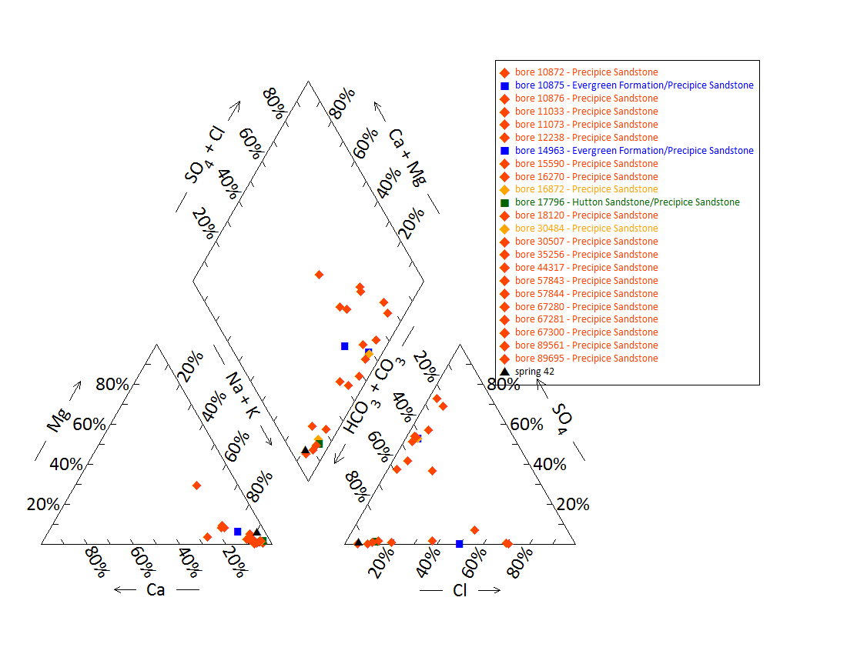

Note: No water chemistry data are available for bores 11409, 22168.

Figure 22 Dawson River 2 spring complex—Piper plot for spring and waterbore chemistry.

Table 51 Dawson River 2 spring complex—isotope data.

| Site ID | δ18O  VSMOW (%) | | δD  VSMOW (%) | | δ13C | ± | pMC | ± | D14C  pMC | ± | 14C age | ± |
| --- | --- | --- | --- | --- | --- | --- | --- | --- | --- | --- | --- | --- |
| 42 | –6.41 | – | –39.0 | – | –13.0 | 2.0 | 22.286 | 0.11 | –777.1 | 1.05 | 12060 | 50 |
| RN89695 | –6.41 | – | –39.7 | –39.0 | –14.8 | 0.1 | 7.178 | 0.06 | –928.2 | 0.60 | 21160 | 80 |

– = not available, pMC = per cent modern carbon, ppt, PDB = Pee Dee Belemnite, VSMOW = Vienna Standard Mean Ocean Water.  
© Copyright, QWC 2012a

VSMOW = Vienna Standard Mean Ocean Water.

Figure 23 Dawson River 2 spring complex—oxygen (O) and deuterium (D) stable isotope ratios.

Table 52 Dawson River 2 spring complex—spring elevation and flow rate.

| Vent ID | Elevation (mAHD) | Estimated flow rate (L/min) | Date of estimate |
| --- | --- | --- | --- |
| 42 | 180.3 | 7 | 2011 |

L/min = litres per minute, mAHD = metres Australian height datum.  
© Copyright, QWC 2012a

Table 53 Dawson River 2 spring complex—most recent waterbore pump test data.

| Bore ID | Recorded discharge (m3/d) | Standing groundwater level (mAGL) | Year of measurement |
| --- | --- | --- | --- |
| 10872 | 0.93 | 26.66 | 1994 |
| 10875 | 2.40 | 7.05 | 1994 |
| 11033 | 5.36 | 39.95 | 1986 |
| 12238 | 1.49 | 40.15 | 1996 |
| 14963 | 4.69 | 34.02 | 1994 |
| 15590 | 0.35 | 15.68 | 1986 |
| 16270 | 5.08 | 6.28 | 2012 |
| 16872 | 8.72 | 32.08 | 2012 |
| 17796 | 6.28 | 31.06 | 2009 |
| 30484 | 3.80 | 6.54 | 1994 |
| 35256 | 30.79 | 15.73 | 1994 |
| 57843 | 6.69 | 46.99 | 1994 |
| 57844 | 6.94 | 43.22 | 1980 |
| 67281 | 2.95 | 5.92 | 1994 |
| 67280 | 5.41 | 12.87 | 1996 |
| 67300 | 2.64 | 19.33 | 1986 |

m3/d = cubic metres per day, mAGL = metres above ground level.  
© Copyright, DNRM 2012

mAHD = metres Australian height datum.

Figure 24 Dawson River 2 spring complex—waterbore standing water levels (SWLs).

## Dawson River 6 spring complex

### Hydrogeological summary

The Dawson River 6 spring complex consists of 16 discharge spring vents, and largely overlaps with the Boggomoss spring complex. No faults are mapped in the area, but the springs form a linear north–south trend, which suggest that they may be associated with an unmapped fault or fractures associated with faulting (DNR 1996). The likely conceptual model for these springs therefore may be springs emanating from a fault (type E or F).

The Precipice Sandstone is the likely source aquifer for the Dawson River 6 spring complex, although the Boxvale Sandstone Member of the Evergreen Formation may contribute to the water source. The Clematis Group Sandstones can also not be ruled out as a source aquifer.

Water quality analysis of spring and bore water did not conclusive attribute a source aquifer to the spring complex. Water chemistry of bores that tapped the Precipice Sandstone varied spatially between bores within a 10-kilometre radius of the spring complex. Spring water chemistry was, however, similar to nearby bores that tapped Precipice Sandstone. Potentiometric data for the Precipice Sandstone in the region supports the possibility of the Precipice Sandstone being the source aquifer for the Boggomoss Springs.

### Spring complex overview

The Dawson River 6 spring complex is located approximately 32 kilometres north-east of Taroom in south-eastern Queensland, and lies in the valley of the Boggomoss Creek and Spring Gully (springs 30 and 31. The Dawson River 6 spring complex consists of 17 individual springs (Table 54, Figure 25). The Dawson River 6 spring complex overlaps with the Boggomoss (Dawson River 5) spring complex (Figure 26). It has been given a conservation ranking of 1b. Table 55 lists the location and elevation of the Dawson River 6 springs.

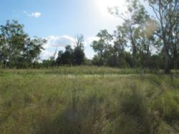 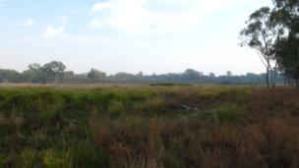

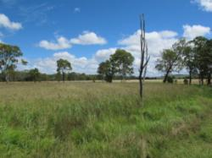 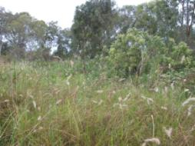

Figure 25 Dawson River 6 spring complex—vents 1, 4, 31 and 59.

Table 54 Dawson River 6 spring complex—hydrogeological information summary.

| Feature | Details | Comments |
| --- | --- | --- |
| No. of active vents | 16 | 1, 4, 5, 6, 22, 23, 24, 25, 27, 30, 31, 32, 43, 59, 60, 681 |
| No. of inactive vents | 1 | 346 |
| Conservation ranking | 1b |  |
| Nearby spring complexes |  | Boggomoss, Dawson River 2 |
| Spring water quality samples | Yes |  |
| Waterbores within 10-kilometre radius | 32 |  |
| Stratigraphic bores |  | 1136, 58501, 2748, 567 |
| Waterbore water quality samples | Yes |  |
| Interpreted stratigraphy available | Yes |  |
| Outcropping formations |  | Hutton Sandstone, Evergreen Formation and Precipice Sandstone |
| Underlying aquifers |  | Precipice Sandstone |
| SWL time series data available | Yes |  |
| Likely source aquifers |  | Precipice Sandstone |
| Conceptual spring type | E or F |  |

SWL = standing water level.

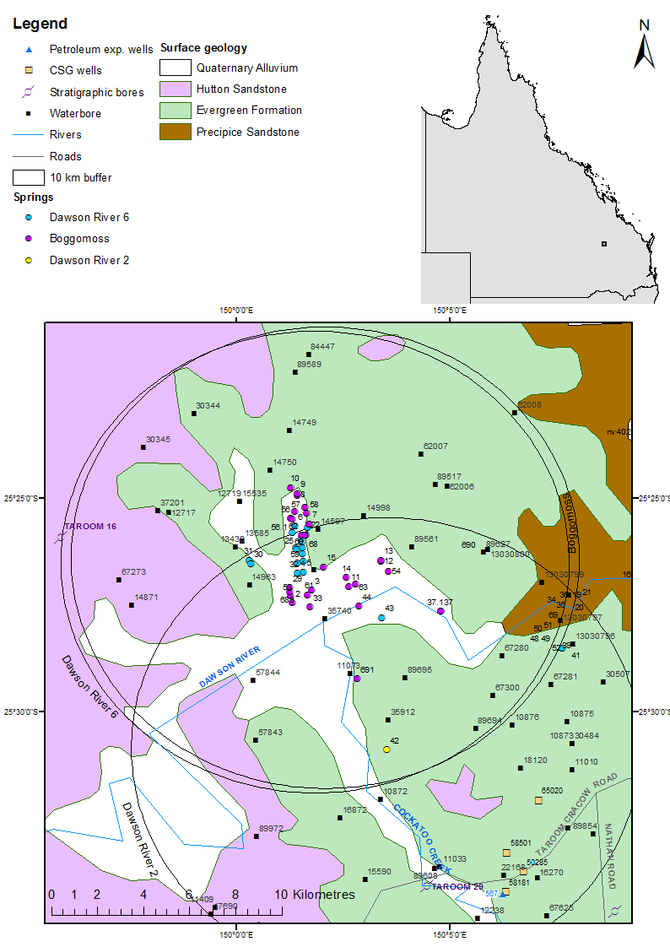

CSG = coal seam gas, exp. = exploration.

Figure 26 Dawson River 6 spring complex—regional geology, Springsure supergroup, Queensland.

### Geology

There are no faults mapped in the area of the Dawson River 6 and Boggomoss spring complexes (Figure 26). The array of springs located along the Boggomoss Creek and Dawson River is linear and trends north–south and south-west–north-east (DNR 1996), which suggests that this is most likely due to some type of structural control either in the form of faulting that has not been mapped or fracture zones associated with such faulting. A number of trend lines at and around the location of the springs are shown on the Mundubbera 1:250 000SG 56-5 geology map sheet (Whitaker et al. 1980), some of which may have a relationship with the springs.

### Regional stratigraphy and underlying aquifers

The groundwater from these vents 1, 6, 22, 27 and 60 is presumed to be sourced from the underlying Precipice Sandstone (QWC 2012a). It is probable that a significant fracture, fault (or intrusion) and/or thinning of the Evergreen Formation in the area allows upward migration of artesian groundwater from the Precipice Sandstone to the ground surface (QWC 2012a). Other aquifers include the Boxvale Sandstone Member of the Evergreen Formation and the Clematis Sandstone.

Within a 10-kilometre radius of the springs there are 32 waterbores. In addition, one stratigraphic borehole is within a 15-kilometre radius of the spring complex. A further five coal seam gas wells, one stratigraphic bore and one petroleum exploration well are within a 20-kilometre radius. The stratigraphic logs for bores 567 (petroleum exploration well) 1136, 2748 (stratigraphic) and 58501 (coal seam gas) are listed in Table 56, and for waterbores in Tabl 57.

### Water chemistry comparison: springs and groundwater bores

Available hydrochemical data for waterbores within a 10 km radius of Dawson River 6 are listed in Table 58. Complete hydrochemical data are available for spring 1 and 5 of the Dawson River 6 spring complex, and are summarised in Table 59. Figure 27 provides a Piper plot comparing the water chemistry of spring vents 1 and 5 with nearby waterbores. From the comparison of the bore and spring data above, it is evident that the physicochemical parameters—including pH, EC and temperature—are comparable for both Boggomoss and Dawson River 6 spring complexes.

The water chemistry is similar for all the waterbores and this is most likely due to the fact that all the bores tap the Precipice Sandstone. The groundwater from the Boggomoss Reserve vents is presumed to be sourced from the underlying Precipice Sandstone (QWC 2012a). It is probable that a significant fracture(s), fault(s) or intrusion, and/or thinning of the Evergreen Formation in the area allows upward migration of artesian groundwater from the Precipice Sandstone to the ground surface (QWC 2012a).

Additional field measurements were taken for some vents that were not sampled during the Surat Cumulative Management Area field survey conducted by the Queensland Water Commission (QWC 2012a). These data are summarised in Table 60. Limited isotope data are also available for the vents and bores within the Dawson River 6 spring complex (Table 61). Figure 28 shows the stable isotope data in relation to the global meteoric water line and Brisbane’s meteoric water line for a nearby Boggomoss spring vent.

The available water chemistry data suggests that the Precipice Sandstone, with possible contribution from the Evergreen Formation, is the source aquifer for the Dawson River 6 springs.

### Artesian status of potential source aquifers

The potentiometric data sourced from DNR (1996) indicates that the Precipice Sandstone is a potential source aquifer for the Dawson River 6 spring complex, as the potentiometric surface elevation for the Precipice Sandstone is higher than the surface elevation of the vents (Table 61). Standing water level data for groundwater bores in the region supports this. Most bores tap the Precipice Sandstone (Table 58) and have remained artesian throughout the time that the standing water levels have been measured (Table 63, Table 64 and Figure 29).

Note that no spot values of groundwater elevation were available for the Precipice Sandstone within 10 kilometres of the spring complex. No published regional data are available for the potentiometric surface of the Evergreen Formation or the Clematis Group, making it difficult to rule these formations out as being source aquifers for the spring complex.

Table 55 Dawson River 6 spring complex—spring locations and elevations.

| Vent ID | Latitude | Longitude | Elevation (mAHD)  GPS OmniSTAR differential (+0.1 metres) |
| --- | --- | --- | --- |
| 1 | –25.4325725 | 150.0251694 | 186.36 |
| 4 | –25.4458020 | 150.0230252 | 179.42 |
| 5 | –25.4458022 | 150.0260812 | 187.85 |
| 6 | –25.4273580 | 150.0227422 | 197.56 |
| 22 | –25.4279243 | 150.0274692 | 199.67 |
| 23 | –25.4360802 | 150.0258032 | 188.14 |
| 24 | –25.4380242 | 150.0252482 | 185.01 |
| 25 | –25.4374691 | 150.0219142 | 184.86 |
| 27 | –25.4321508 | 150.0253653 | 191.59 |
| 30 | –25.4421906 | 150.0060815 | 181.33 |
| 31 | –25.4410794 | 150.0044146 | 183.16 |
| 32 | –25.4413582 | 150.0260812 | 182.94 |
| 43 | –25.4624701 | 150.0569139 | 172.83 |
| 59 | –25.441913 | 150.0233033 | 182.32 |
| 60 | –25.4300979 | 150.0215622 | 190.99 |
| 681 | –25.43604964 | 150.0229777 | 185.63 |

GPS = global positioning system, mAHD = metres Australian height datum.

Table 56 Dawson River 6 spring complex—stratigraphic bores and coal seam gas wells within a 25‑kilometre radius.

| Well ID | Top (mBGL) | Bottom (mBGL) | Thickness (m) | Rock unit name |
| --- | --- | --- | --- | --- |
| 1136 | 0.0 | 61.0 | 61.0 | Hutton Sandstone |
| (Taroom 16) | 61.0 | 248.0 | 187.0 | Evergreen Formation |
|  | 248.0 | 301.0 | 53.0 | Precipice Sandstone |
|  | 301.0 | 1037.0 | 736.0 | Moolayember Formation |
|  | 1037.0 | 1184.0 | 147.0 | Clematis Group |
|  | 1184.0 | 1230.9 | >46.9 | Rewan Group |
| 2748 (Mundubbera 29) | 0.0 | 44.2 | 44.2 | Evergreen Formation |
| 567 | 0.0 | 98.2 | 98.2 | Evergreen Formation |
| (petroleum exploration) | 98.2 | 198.8 | 100.6 | Precipice Sandstone |
|  | 198.8 | 1006.6 | 808.0 | Rewan Group |
|  | 1006.6 | 1543.6 | 537.0 | Blackwater Group |
|  | 1006.6 | 1543.6 | 537.0 | Baralaba Coal Measures |
|  | 1543.6 | 3627.6 | 2084.0 | Back Creek Group |
|  | 1543.6 | 2390.3 | 846.7 | Gyranda Subgroup |
|  | 2390.3 | 2884.7 | 494.4 | Flat Top Formation |
|  | 2884.7 | 3594.6 | 709.9 | Barfield Formation |
|  | 3594.6 | 3598.6 | 4.0 | Oxtrack Formation |
|  | 3598.6 | 3627.6 | 29.0 | Buffel Formation |
|  | 3627.6 | 3677.6 | 50.0 | Camboon Volcanics |
| 58501 | 0.0 | 104.4 | 104.4 | Hutton Sandstone |
| (coal seam gas) | 104.4 | 139.9 | 35.5 | Evergreen Formation |
|  | 139.9 | 237.6 | 97.9 | Precipice Sandstone |
|  | 237.6 | 791.7 | 553.9 | Rewan Group |
|  | 791.5 | 1389.7 | 598.2 | Baralaba Coal Measures |

m = metre, mBGL = metres below ground level.  
© Copyright, DNRM 2012

Table 57 Dawson River 6 spring complex—waterbores within a 10-kilometres radius.

| Bore ID | Top (mBGL) | Bottom (mBGL) | Rock unit name |
| --- | --- | --- | --- |
| 12717 | 0.0 | 24.4 | Hutton Sandstone |
|  | 24.4 | 165.5 | Evergreen Formation |
|  | 165.5 | 169.2 | Precipice Sandstone |
| 12719 | 0.0 | 83.8 | Evergreen Formation |
|  | 83.8 | 86.9 | Precipice Sandstone |
| 13483 | 0.0 | 44.2 | Evergreen Formation |
|  | 44.2 | – | Precipice Sandstone |
|  |  | 195.1 | Moolayember Formation |
| 13585 | 0.0 | 29.6 | Evergreen Formation |
|  | 29.6 | 41.5 | Precipice Sandstone |
| 14871 | 0.0 | 23.2 | Hutton Sandstone |
|  | 23.2 | 184.4 | Evergreen Formation |
|  | 184.4 | 238.7 | Precipice Sandstone |
| 15535 | 0.0 | 40.5 | Evergreen Formation |
|  | 40.5 | – | Precipice Sandstone |
|  |  | – | Moolayember Formation |
| 30344 | 0.0 |  | Evergreen Formation |
|  |  | 144.8 | Precipice Formation |
| 30345 | 0.0 | – | Hutton Sandstone |
|  | – | – | Evergreen Formation |
|  | – | 219.8 | Precipice Formation |
| 37201 | 0.0 | 119.5 | Evergreen Formation |
|  | 119.5 | 179.6 | Precipice Sandstone |
| 57843 | 37.0 | 107.0 | Evergreen Formation |
|  | 107.0 | – | Precipice Sandstone |

– = not available, mBGL = metres below ground level.   
Note: No stratigraphic data are available for bore 89696. Bores 35256, 67280, 14963, 89561, 67300, 11073 and 14998 are recorded as passing through Precipice Sandstone.  
© Copyright, DNRM 2012

Table 58 Dawson River 6 spring complex—waterbore details and water chemistry.

| Variable | Details | | | | | | | | | | | | | | | | | | | | | | | | | | |
| --- | --- | --- | --- | --- | --- | --- | --- | --- | --- | --- | --- | --- | --- | --- | --- | --- | --- | --- | --- | --- | --- | --- | --- | --- | --- | --- | --- |
| Bore ID | 37201 | 89695 | | 14871 | | 13438 | | 35256 | | 67280 | | 14963 | | 89561 | | 57843 | | 57844 | | 67300 | | 15535 | | 11073 | | 14998 | |
| Sample date | 29/05  2012 | 10/05  2011 | | 15/08  1996 | | 16/08  1996 | | 16/08  1996 | | 16/08  1996 | | 16/08  1996 | | 03/08  1994 | | 30/05  1991 | | 30/05  1991 | | 30/03  1989 | | 13/03  1989 | | 02/04  1970 | | 06/04  1962 | |
| Source | DNRM (2012) | QWC (2012a) | | DNRM (2012) | | DNRM (2012) | | DNRM (2012) | | DNRM (2012) | | DNRM (2012) | | DNRM (2012) | | DNRM (2012) | | DNRM (2012) | | DNRM (2012) | | DNRM (2012) | | DNRM (2012) | | DNRM (2012) | |
| Distance from spring (km) | 7.2 | 6.9 | | 8.4 | | 3.6 | | 0.4 | | 9.5 | | 3.1 | | 4.3 | | 9.1 | | 6.4 | | 10.1 | | 4.4 | | 5.7 | | 3.1 | |
| Screens (metres) | Opening 161.8–174.96 | Opening 42–72 | | Opening 201.9–238.7 | | Open end 39.6–91.5 | | Perforat-ed casing 82.3–139 | | Open end 32–70 | | Open end 118.5–133.2 | | Perforat-ions 86–111 | | Open end 136–182 | | Opening 59–155.4 | | Opening 24.4–45.5 | | Perforat-ions 40.5–41.1 and 55.7–56.4 | | – | | Opening 28.4–122 | |
| Aquifer | Ever-green Format-ion/ Precipice Sand-stone | Precipice Sand-stone | | Precipice Sand-stone | | Boxvale Sand-stone/ Precipice Sand-stone | | Precipice Sand-stone | | Precipice Sand-stone | | Ever-green Format-ion/ Precipice Sand-stone | | Precipice Sand-stone | | Ever-green Format-ion/ Precipice Sand-stone | | Precipice Sand-stone | | Precipice Sand-stone | | Ever-green Format-ion/ Precipice Sand-stone | | Precipice Sand-stone | | Precipice Sand-stone | |
| Year drilled | 1971 | 2000 | | 1961 | | 1957 | | 1970 | | 1986 | | 1962 | | 1993 | | 1980 | | 1980 | | 1986 | | 1963 | | 1948 | | 1962 | |
| Standing water level (natural surface elevation) | 22.98 | – | | 15.2 | | – | | 15.73 | | 12.46 | | 34.53 | | –26.2 | | 47.5 | | 44.13 | | 19.21 | | 11.24 | | 1.5 | | –26.3 | |
| Total depth (metres) | 174.96 | 72 | | 238.7 | | 91.5 | | 140.2 | | 174.87 | | 133.2 | | 111 | | 182 | | 155.4 | | 45.5 | | 61.0 | | 73.2 | | 122.0 | |
| Surface elevation (mAHD) | 210.08 | 181.38 | | 220.70 | | 189.22 | | 199.56 | | 70 | | 193.06 | | 211.40 | | 181.8 | | 183.33 | | 173.1 | | 204.05 | | 174.00 | | 212.35 | |
| Facility status | Existing artesian | Existing artesian | | Existing artesian | | Existing artesian | | Existing artesian | | Existing artesian | | Existing artesian | | Existing sub-artesian | | Existing artesian | | Existing artesian | | Aban-doned artesian | | Existing artesian | | Aban-doned artesian | | Existing sub-artesian | |
| *Physiochemical parameters* | | | | | | | | | | | | | | | | | | | | | | | | | | | |
| EC (µS/cm) | 170 | | 139.6 | | 157 | | 177 | | 220 | | 157 | | 103 | | 188 | | 255 | | 360 | | 200 | | 305 | | 210 | | – | |
| pH (field/lab) | 6.3 | | 6.51/7.34 | | 6 | | 6.1 | | 5.9 | | 6.9 | | 6.1 | | 6.5 | | 8 | | 7.4 | | 7.3 | | 6.8 | | 7 | | 7.4 | |
| Temp-erature (°C) | 28 | | 25.2 | | 29 | | – | | 25 | | 24 | | 26 | | 26 | | 29 | | 27 | | 25 | | 24 | | – | | – | |
| *Chemical parameters (milligrams/litre)* | | | | | | | | | | | | | | | | | | | | | | | | | | | |
| Dissolved oxygen | – | | 0.5 | | – | | * | | – | | – | | – | | – | | – | | – | | – | | – | | – | | – | |
| TDS | 91.81 | | 102 | | 93.28 | | 101.27 | | 123.26 | | 105.36 | | 70.33 | | 109.89 | | 146.13 | | 203.45 | | 110 | | 154.97 | | 102.91 | | 256.6 | |
| TSS | – | | <5 | | – | | – | | – | | – | | – | | – | | – | | – | | – | | – | | – | | – | |
| Sodium (Na) | 24 | | 28 | | 25.9 | | 25.3 | | 31.9 | | 38.2 | | 19 | | 29.4 | | 47.5 | | 54 | | 39.5 | | 31.5 | | 24 | | 62.9 | |
| Potassium (K) | 2.7 | | 3 | | 3 | | 4.1 | | 3.3 | | 1.9 | | 2.3 | | 2.5 | | 3.6 | | 6.5 | | 2.5 | | 5.6 | | – | | – | |
| Calcium (Ca) | 3.8 | | 2 | | 3.6 | | 5.9 | | 7 | | 1.4 | | 2.5 | | 5.8 | | 3.5 | | 11.5 | | 3.3 | | 20 | | 7 | | 14.3 | |
| Magnesium (Mg) | 1.1 | | <1 | | 1.2 | | 1.6 | | 2 | | 0.4 | | 0.8 | | 1.8 | | 1.1 | | 3.8 | | 0.5 | | 2.2 | | 7 | | 2.9 | |
| Chlorine (Cl) | 31 | | 6 | | 30.6 | | 37.6 | | 50.9 | | 6 | | 18.5 | | 43.8 | | 31.5 | | 64 | | 7 | | 50 | | 28 | | 68.6 | |
| Total alkalinity (calcium carbonate) | <1 | | <1 | | 1.8 | | 0 | | 0 | | 0 | | 0 | | 0.4 | | 2 | | 11.5 | | 2 | | 2 | | 2 | | 0 | |
| Bicarbon-ate  (HCO3–) | 26 | | 63 | | 25 | | 25 | | 29 | | 77 | | 27 | | 26 | | 74 | | 69 | | 97 | | 71 | | 58 | | 180 | |
| Carbonate (CO32–) | 31 | | 63 | | 30.9 | | 30.1 | | 35.6 | | 93.8 | | 32.4 | | 32.1 | | 89 | | 84 | | 120 | | 87 | | 71 | | 108.6 | |
| Sodium (Na) | 0 | | <1 | | 0 | | 0 | | 0 | | 0 | | 0 | | 0 | | 0.5 | | 0.1 | | 0.1 | | 0 | | – | | 54.3 | |
| Total hardness | 15 | | – | | 14 | | 21 | | 26 | | 5 | | 10 | | 22 | | 13 | | 44 | | 10 | | 59 | | 46 | | 48 | |
| Iodine (I) | – | | <0.01 | | – | | – | | – | | – | | – | | – | | – | | – | | – | | – | | – | | – | |
| Fluoride (F) | <0.1 | | 0.2 | | 0 | | 0 | | 0 | | 0.14 | | 0 | | 0.01 | | 0.1 | | 0.1 | | 0.2 | | 0.1 | | 0 | | 0.2 | |
| Bromine (Br) | – | | 0.023 | |  | |  | | – | | – | | – | | – | | – | | – | | – | |  | | – | |  | |
| Aluminium (Al) | <0.05 | | <0.01 | | 0 | | 0 | | 0 | | 0 | | 0 | | – | | – | | – | | – | | – | | – | | – | |
| Arsenic (As) | – | | <0.001 | | – | | – | | – | | – | | – | | – | | – | | – | | – | | – | | – | | – | |
| Barium (Ba) | – | | 0.018 | | – | | – | | – | | – | | – | | – | | – | | – | | – | | – | | – | | – | |
| Boron (B) | 0.02 | | <0.05 | | 0 | | 0 | | 0 | | 0 | | 0 | | – | | – | | – | | – | | – | | – | | – | |
| Cadmium (Cd) | – | | <0.0001 | | – | | – | | – | | – | | – | | – | | – | | – | | – | | – | | – | | – | |
| Chromium (Cr) | – | | <0.001 | | – | | – | | – | | – | | – | | – | | – | | – | | – | | – | | – | | – | |
| Cobalt (Co) | – | | <0.001 | | – | | – | | – | | – | | – | | – | | – | | – | | – | | – | | – | | – | |
| Copper (Cu) | 0.03 | | <0.001 | | 0.01 | | 0.01 | | 0.01 | | 0 | | 0.01 | | – | | – | | – | | – | | – | | – | | – | |
| Iron (Fe) | <0.01 | | 2.78 | | 0.03 | | 0 | | 0 | | 0.01 | | 0 | | 0 | | 0.02 | | 0.02 | | 0.01 | | 0.01 | | – | | – | |
| Lithium (Li) |  | | – | |  | |  | | – | | – | | – | | – | | – | | – | | – | |  | | – | | – | |
| Lead (Pb) |  | | <0.001 | |  | |  | | – | | – | | – | | – | | – | | – | | – | |  | | – | | – | |
| Mangan-ese (Mn) | 0.21 | | 0.061 | | 0.07 | | 0.21 | | 0.08 | | 0.01 | | 0.03 | | 0.08 | | 0.05 | | 0.13 | | 0.01 | | 0.28 | | – | | – | |
| Mercury (Hg) | – | | <0.0001 | | – | | – | | – | | – | | – | | – | | – | | – | | – | | – | | – | | – | |
| Molyb-denum (Mo) | – | | <0.001 | | – | | – | | – | | – | | – | | – | | – | | – | | – | | – | | – | | – | |
| Nickel (Ni) | – | | <0.001 | | – | | – | | – | | – | | – | | – | | – | | – | | – | | – | | – | | – | |
| Selenium (Se) | – | | <0.01 | | – | | – | | – | | – | | – | | – | | – | | – | | – | | – | | – | | – | |
| Silica (SiO2) | – | | 14 | | – | | – | | 11 | | 11 | | 11 | | 10 | | 12 | | 10 | | – | | – | | – | | – | |
| Silicon (Si) | – | | – | | – | | – | | – | | – | | – | | – | | – | | – | | – | | – | | – | | – | |
| Silver (Ag) | – | | <0.001 | | – | | – | | – | | – | | – | | – | | – | | – | | – | | – | | – | | – | |
| Strontium (Sr) | – | | 0.026 | | – | | – | | – | | – | | – | | – | | – | | – | | – | | – | | – | | – | |
| Sulfide (S) | – | | <0.1 | | – | | – | | – | | – | | – | | – | | – | | – | | – | | – | | – | | – | |
| Tin (Sn) | – | | <0.001 | | – | | – | | – | | – | | – | | – | | – | | – | | – | | – | | – | | – | |
| Zince (Zn) | 0.05 | | <0.005 | | 0.11 | | 0 | | 0.07 | | 0.01 | | 0 | | – | | – | | – | | – | | – | | – | | – | |
| Dissolved organic carbon | – | | 6 | | – | | – | | – | | – | | – | | – | | – | | – | | – | | – | | – | | – | |
| Nitrogen (N) | – | | <0.01 | | – | | – | | – | | – | | – | | – | | – | | – | | – | | – | | – | | – | |
| Nitrate as NO3 | <0.5 | | – | | 0 | | 0 | | 0 | | 0 | | 0 | | 0 | | 0.5 | | 0.5 | | 0.5 | | 0.5 | | 0 | | – | |
| Nitrite as N | – | | <0.01 | | – | | – | | – | | – | | – | | – | | – | | – | | – | | – | | – | | – | |
| Total oxidised N | – | | <0.01 | | – | | – | | – | | – | | – | | – | | – | | – | | – | | – | | – | | – | |
| Phosphate (PO4) | – | | 0.17 | | – | | – | | – | | – | | – | | – | | – | | – | | – | | – | | – | | – | |

– = not available, EC = electrical conductivity, mAHD = metres Australian height datum, µS/cm = microsiemens per centimetre, TDS = total dissolved solids, TSS = total suspended solids.  
Note: No water chemistry data are available for bore 12719, 12717, 30344 and 30345.

Table 59 Dawson River 6 spring complex—spring water chemistry.

| Variable | Details | |
| --- | --- | --- |
| Vent ID | 1 | 5 |
| Sample date | 23/06/2011 | 29/07/1996 |
| Source | QWC (2012a) | DNR (1996) |
| *Physiochemical parameters* | |  |
| EC (field) (µS/cm) | 401 | – |
| pH (field/lab) | 6.65/7.21 | – |
| Temperature (field) (°C) | 8.5 | – |
| *Chemical parameters (milligrams/litres)* | |  |
| Dissolved oxygen (field) | 4.73 | – |
| TDS | 274 | – |
| TSS | 37 | – |
| Sodium (Na) | 47 | 31 |
| Potassium (K) | 7 | 5.4 |
| Calcium (Ca) | 19 | 4.2 |
| Magnesium (Mg) | 4 | 1.4 |
| Chlorine (Cl) | 73 | 48 |
| Sulfate (SO4) | <1 | <2 |
| Total alkalinity (calcium carbonate) | 78 | – |
| Bicarbonate (HCO3–) | 78 | 23.5 |
| Carbonate (CO32–) | <1 | – |
| Iodine (I) | <0.02 | – |
| Fluoride (F) | <0.1 | – |
| Bromine (Br) | 0.146 | – |
| Aluminium (Al) | 0.04 | – |
| Arsenic (As) | <0.001 | – |
| Barium (Ba) | 0.077 | – |
| Boron (B) | <0.05 | – |
| Cadmium (Cd) | <0.0001 | – |
| Chromium (Cr) | <0.001 | – |
| Cobalt (Co) | <0.001 | – |
| Copper (Cu) | <0.0001 | – |
| Iron (Fe) | 0.72 | – |
| Lead (Pb) | <0.001 | – |
| Manganese (Mn) | 0.035 | – |
| Mercury (Hg) | <0.0001 | – |
| Molybdenum (Mo) | <0.001 | – |
| Nickel (Ni) | <0.001 | – |
| Selenium (Se) | <0.01 | – |
| Silica (SiO2) | 32 | – |
| Silicon (Si) | 15 | 15 |
| Silver (Ag) | <0.001 | – |
| Strontium (Sr) | 0.247 | – |
| Sulfide (S) | <0.1 | – |
| Tin (Sn) | <0.001 | – |
| Zinc (Zn) | 0.087 | – |
| Dissolved organic carbon | 16 | – |
| Nitrate as N | 0.03 | – |
| Nitrite as N | <0.01 | – |
| Total oxidised nitrogen | 0.03 | – |
| Phosphate (PO4) | 0.22 | – |
| Cation total (meq/L) | 3.5 | – |
| Anion total (meq/L) | 6.62 | – |
| Ionic balance (%) | 1.64 | – |

– = not available, EC = electrical conductivity, mEq/L = milliequivalent per litre, µS/cm = microsiemens per centimetre, TDS = total dissolved solids, TSS = total suspended solids.

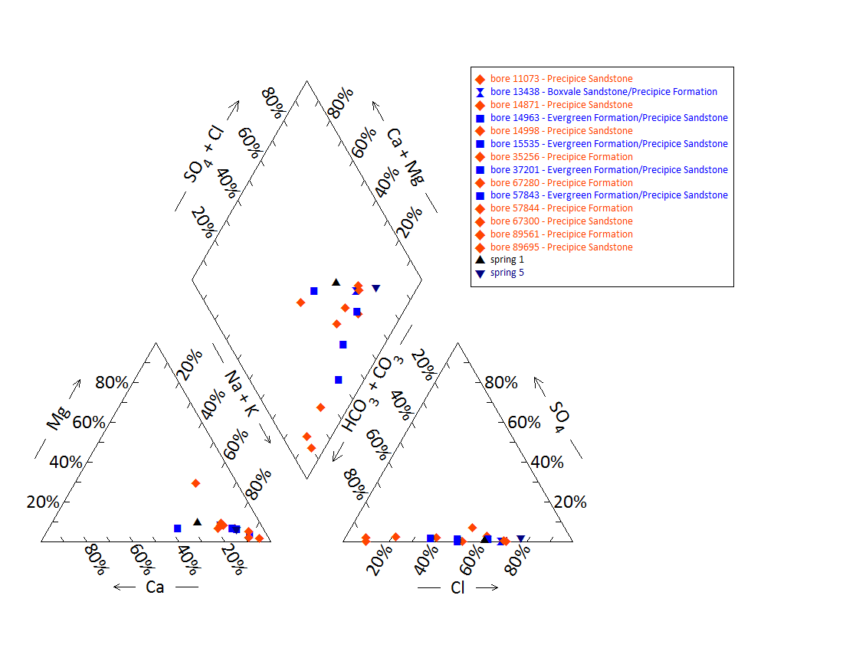

Note: No water chemistry data are available for bore 12719, 12717, 30344 and 30345. No water chemistry data are available for springs 4, 6, 22–25, 27, 30–32, 43, 59, 60 and 681.

Figure 27 Dawson River 6 spring complex—Piper plot for spring and waterbore chemistry.

Table 60 Dawson River 6 spring complex—additional field measurements.

| Vent ID | 22 | 27 |
| --- | --- | --- |
| Sample date | 23/06/2011 | 23/06/2011 |
| Flow (L/s) | Pooled water | Pooled water |
| EC (µS/cm) | 229.7 | 208 |
| pH | 6.01 | 5.37 |
| DO (mg/L) | 1.6 | 1.78 |
| Temperature (°C) | 10.2 | 14.8 |
| ORP | 197 | 219 |
| Methane (CH4) (ppm) air | – | 100–230 |
| O2 (%) air | – | – |

– = not available, EC = electrical conductivity, L/s = litres per second, mg/L = milligrams per litre, µS/cm = microsiemens per centimetre, ORP = oxidation–reduction potential, ppm = parts per million.  
© Copyright, QWC 2012a

Table 61 Dawson River 6 spring complex—isotope data.

| Site ID | δ18O  VSMOW (%) | | δD  VSMOW (%) | | δ13C | ± | pMC | ± | D14C  pMC | ± | 14C age | ± |
| --- | --- | --- | --- | --- | --- | --- | --- | --- | --- | --- | --- | --- |
| 44 | 4.59 | –4.69 | –27.2 | – | – | – |  | – | – |  | – | – |
| RN89695 | –6.41 | – | –39.7 | –39.0 | –14.8 | 0.1 | 7.178 | 0.06 | –928.2 | 0.60 | 21160 | 80 |

– = not available, pMC = per cent modern carbon, VSMOW = Vienna Standard Mean Ocean Water.  
© Copyright, QWC 2012a

Figure 28 Dawson River 6 spring complex—oxygen (O) and deuterium (D) stable isotope ratios.

Table 62 Dawson River 6 spring complex—potentiometric surface data.

| Vent ID | Estimated flow rate (L/min) | Elevation (mAHD)  GPS OmniSTAR differential (+0.1 metres) | Potentiometric surface elevation (mAHD)a  Precipice Sandstone |
| --- | --- | --- | --- |
| 1 | 12 | 186.36 | 227 |
| 4 | 975 | 179.42 | 220 |
| 5 | 70 | 187.85 | 221 |
| 6 | 21 | 197.56 | 221 |
| 22 | 6 | 199.67 | 222 |
| 23 | 13 | 188.14 | 221 |
| 24 | 133 | 185.01 | 221 |
| 25 | 5 | 184.86 | 223 |
| 27 | 3 | 191.59 | 221 |
| 30 | 2 | 181.33 | 196 |
| 31 | 123 | 183.16 | 221 |
| 32 | 35 | 182.94 | 222 |
| 43 | 0 | 172.83 | 222 |
| 59 | 4 | 182.32 | 228 |
| 60 | 6 | 190.99 | 219 |
| 681 | 23 | 185.63 | 222 |

– = not available, GPS = global positioning system, L/min = litres per minute, mAHD = metres Australian height datum.  
a Data from DNR 1996

Table 63 Dawson River 6 spring complex—most recent waterbore pump test data.

| Bore ID | Recorded discharge (m3/d) | Standing groundwater level (mAGL) | Year of measurement |
| --- | --- | --- | --- |
| 14963 | 4.69 | 34.02 | 1994 |
| 15535 | 0.50 | 2.55 | 1994 |
| 35256 | 30.79 | 15.73 | 1994 |
| 35740 | 1.91 | 33.00 | 1997 |
| 37201 | 5.25 | 22.98 | 2012 |
| 57843 | 6.69 | 46.99 | 1994 |
| 57844 | 6.94 | 43.22 | 1980 |
| 67280 | 5.41 | 12.87 | 1996 |
| 67300 | 19.33 | 2.64 | 1986 |
| 89517 | 5.50 | 32.80 | 1991 |

m3/d = cubic metres per day, mAGL = metres above ground level.  
© Copyright, DNRM 2012

mAHD = metres Australian height datum.

Figure 29 Dawson River 6 spring complex—waterbore standing water levels (SWLs).

## Dawson River 8 spring complex

### Hydrogeological summary

The Dawson River 8 spring complex consists of three discharge spring vents.

The Taroom 1:250 000 SG55-8 geological map sheet (Forbes 1968) shows a fault tending north-west–south-east in the area of Dawson River 8. This suggests that springs associated with a fault or thinning of overlying aquitards are likely options for a conceptual model, such as type D or E.

Water quality data suggest that Hutton Sandstone is the source aquifer for the Dawson River 8 springs, with potential contribution from the Birkhead Formation. Groundwater bore test-pumping data indicate that the Birkhead Formation is artesian in the area. There are, however, other underlying aquifers that have the potential to contribute to the springs that cannot be ruled out as sources, such as the Precipice Sandstone.

### Spring complex overview

The Dawson River 8 spring complex is located approximately 8 kilometres north of Taroom in south-eastern Queensland. This spring complex comprises three vents (Figure 30) and is located approximately 30 kilometres west of the Dawson River 2 spring complex. Dawson River 8 spring complex is located in proximity to Robinson Creek, which is a tributary to the Dawson River (Figure 31). The spring complex has been given a conservation ranking of three. Table 65 lists the location and elevation of the spring in the Dawson River 8 complex. Table 64 provides a summary of the hydrogeological information for the spring complex.

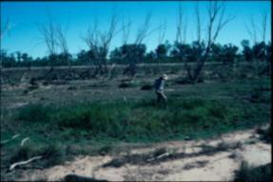 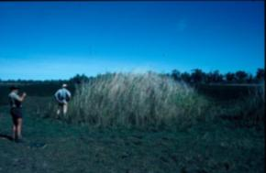

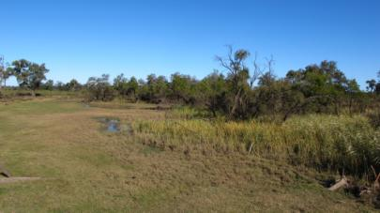

Figure 30 Dawson River 8 spring complex—vents 26, 28 and 38.

Table 64 Dawson River 8 spring complex—hydrogeological information summary.

| Feature | Details | Comments |
| --- | --- | --- |
| No. of active vents | 3 | 38, 26, 28 |
| No. of inactive vents | – |  |
| Conservation ranking | 3 |  |
| Spring water quality samples | Yes |  |
| Waterbore within 10-kilometre radius | 33 |  |
| Stratigraphic bores | 3 | Within 20-kilometre radius: 1361, 481, 479 |
| Waterbore water quality samples | Yes |  |
| Interpreted stratigraphy available | Yes |  |
| Outcropping formations |  | Injune Creek Group, Hutton Sandstone |
| Underlying aquifers |  | Hutton Sandstone, Precipice Sanstone |
| SWL time series data available | Yes | Minimal |
| Likely source aquifers |  | Hutton with possible influence from the Birkhead Formation (or Walloon Coal Measure?) |
| Conceptual spring type | E or C | E more likely |

– = not available, SWL = standing water level.

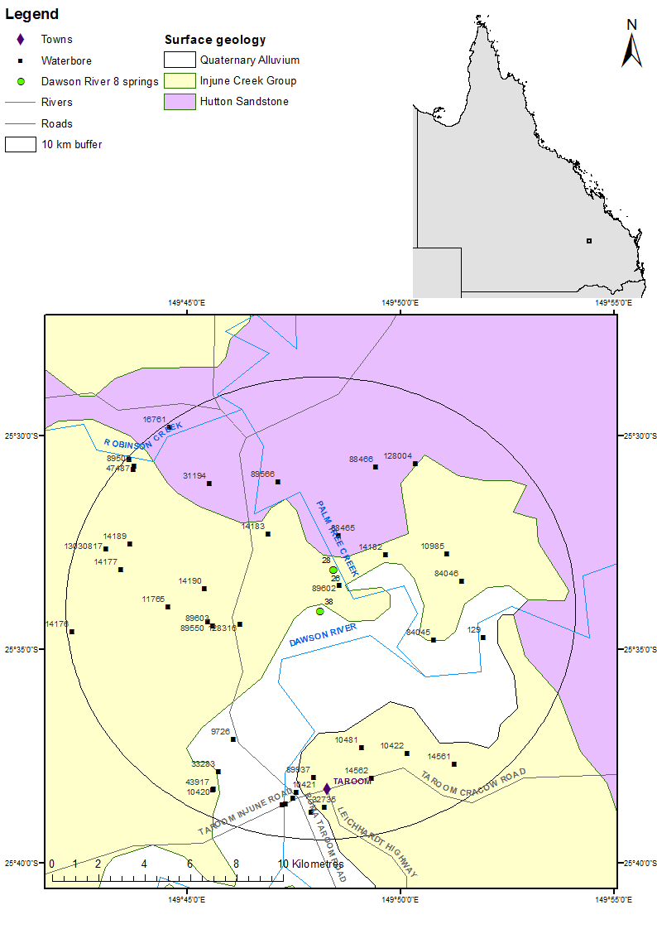

Figure 31 Dawson River 8 spring complex—regional geology, Springsure supergroup, Queensland.

### Geology

The Taroom 1:250 000 SG55-8 geological map sheet (Forbes 1968) shows a fault tending north-west to south-east in the area, just north of Dawson River 8 at the contact between the Hutton Sandstone and the Birkhead Formation. The Dawson River 8 spring complex is located on the eastern limb of the Mimosa Syncline.

### Regional stratigraphy and underlying aquifers

The spring complex is located on the outcrop of the Birkhead Formation of the Injune Creek Group, which forms a hill to the north. Within a 10-kilometre radius of the springs there are 33 waterbores (DNRM 2012). Three stratigraphic boreholes are located within a 20-kilometre radius of the spring complex. Aquifers present in the region include the Hutton Sandstone, Precipice Sandstone and Clematis Group Sandstone. Table 66 lists the data from stratigraphic boreholes and Table 67 shows the available stratigraphy for the waterbores.

### Water chemistry comparison: springs and waterbores

Available hydrochemical data for the waterbores within a 10-kilometre radius are listed in Table 68 and Table 69. Hydrochemical data for spring vent 38 are shown in Table 70. Hydrochemical data for vents 26 and 28 were not available. Bores 13030380 and 13030381 tap the Dawson River Alluvium and are classified as non–Great Artesian Basin bores. Further analysis of these bores was therefore not undertaken.

It is suggested that the springs originate from the Hutton Sandstone (QWC 2012a). The water from spring vent 38, in terms of major ions, is most similar to that of 14177 (Figure 32), which is listed as tapping the Walloon Coal Measure (Table 69), but stratigraphy suggests it taps the Birkhead Formation (Table 67). As the Birkhead Formation and Walloon Coal Measures are generally laterally continuous, it is in some areas difficult to distinguish one from the other. Water chemistry is also quite variable between waterbores listed as tapping the same aquifer, making it difficult to determine a source aquifer.

### Artesian status of potential source aquifers

Very little potentiometric data are available for potential source aquifers in the Dawson River 8 area. Data from waterbore test pumping suggests that the Birkhead Formation is artesian in the area (Table 72 and Figure 33), although it is also likely that other aquifers such as the Hutton Sandston and Precipice Sandstone may be artesian as well. Table 71 shows the flow rate for the Dawson River 8 springs.

Table 65 Dawson River 8 spring complex—spring locations and elevations.

| Vent ID | Name | Latitude | Longitude | Elevation (mAHD) |
| --- | --- | --- | --- | --- |
| 26 | Palm1 | –25.55242 | 149.807105 | 190 |
| 28 | Palm1 | –25.55242 | 149.807105 | 190 |
| 38 | Mrs White | –25.56850966 | 149.8021111 | 182.67 |

mAHD = metres Australian height datum.  
© Copyright, QWC 2012a

Table 66 Dawson River 8 spring complex—stratigraphic bores within a 25-kilometre radius.

| Stratigraphic hole ID | Top (mBGL) | Bottom (mBGL) | Thickness (m) | Rock unit name |
| --- | --- | --- | --- | --- |
| 1361 | 0.0 | 206.1 | 206.1 | Hutton Sandstone |
| (Taroom 16) | 206.1 | 425.5 | 219.4 | Evergreen Formation |
|  | 425.5 | 502.5 | 77.0 | Precipice Sandstone |
|  | 502.5 | 538.9 | 36.4 | Moolayember Formation |
|  | 538.9 | 686.6 | 147.7 | Clematis Group |
|  | 686.6 | 949.5 | >262.9 | Rewan Group |
| 481 | 0.0 | 250.0 | 250.0 | Walloon Coal Measures |
| (Taroom 3) | 250.0 | 272.0 | 22.0 | Eurombah Formation |
|  | 272.0 | – | – | Hutton Sandstone |
| 479 | 0.0 | – | – | Injune Creek Group |
| (Taroom 1) | 0.0 | 229.5 | 229.5 | Walloon Coal Measures |

– = not available, m = metre, mBGL = metres below ground level.  
© Copyright, DNRM 2012

Table 67 Dawson River 8 spring complex—waterbores within a 10-kilometre radius.

| Bore ID | Top (mBGL) | Bottom (mBGL) | Rock unit name |
| --- | --- | --- | --- |
| 129 | 0.0 | 78.3 | Birkhead Formation |
| 9726 | 0.0 | 152.0 | Birkhead formation |
| 10420 | 0.0 | 196.6 | Birkhead Formation |
|  | 196.6 | 210.3 | Hutton Sandstone |
| 14177 | 0.0 | 170.7 | Birkhead Formation |
| 14190 | 0.0 | 192.0 | Birkhead Formation |
|  | 192.0 | 311.5 | Hutton Sandstone |
| 31194 | 0.0 | 160.0 | Birkhead Formation |
|  | 160.0 | 290.5 | Hutton Sandstone |
| 33283 | 0.0 | 268.2 | Birkhead Formation |
|  | 268.2 | 304.8 | Hutton Sandstone |
| 13030817 | 0.0 | 4.6 | Quaternary—undefined |
|  | 4.6 | 15.0 | Birkhead Formation |

mBGL = metres below ground level.  
Note: No stratigraphic data are available for bores 13030380 and 13030381.  
© Copyright, DNRM 2012

Table 68 Dawson River 8 spring complex—waterbore details and water chemistry.

| Variable | Details | | | | |
| --- | --- | --- | --- | --- | --- |
| Bore ID | 13030817 | 9726 | 33283 | 129 | 14190 |
| Sample date | 20/06/2003 | 7/11/1995 | 17/05/1991 | 5/06/1989 | 11/07/1974 |
| Distance from spring (kilometres) | 9.7 | 7.5 | 9.1 | 7.4 | 5.2 |
| Casings | Perforations 12.9–13.9 | Opening 122.5–167.67 | Perforations 213–240 | – | Opening 183–311.6 |
| Aquifer | Birkhead Formation | Birkhead Formation | Birkhead Formation/ Hutton Sandstone | Birkhead Formation | Birkhead Formation/ Hutton Sandstone |
| Year drilled | 2003 | 1943 | 1969 | 1916 | 1954 |
| Standing water level (natural surface elevation) | –11.7 | 5.68 | 5.1 | – | – |
| Total depth (metres) | 15 | 167.64 | 304.8 | 78.3 | 311.5 |
| Surface elevation (mAHD) | 222.2 | 190.2 | 193.76 | – | – |
| Facility status | Existing subartesian | Existing artesian | Existing artesian | Abandoned subartesian | Existing subartesian |
| *Physiochemical parameters* | | | | | |
| EC (µS/cm) | 12610 | 915 | 1120 | 1050 | 810 |
| pH | 8 | 8.5 | 8.9 | 8.2 | 7.8 |
| Temperature (°C) | – | 27 | 29 | – | – |
| *Chemical parameters (milligrams/litre)* | | | | | |
| Dissolved oxygen | – | – | – | – | – |
| TDS | 9795.97 | 517.94 | 639.08 | 610 | 0 |
| TSS | – | 0.2 | – | – | – |
| Sodium (Na) | 2770 | 208.1 | 251 | 97 | 160 |
| Potassium (K) | 17 | 0.5 | 1.4 | 4 | 2 |
| Calcium (Ca) | 615 | 1.4 | 3.1 | 68 | 5 |
| Magnesium (Mg) | 405 | 0.1 | 0.3 | 40.5 | 1.5 |
| Chlorine (Cl) | 5670 | 174.6 | 257 | 260 | 170 |
| Sulfate (SO4) | 155 | 0 | 0 | 9.8 | 0 |
| Total alkalinity (calcium carbonate) | 272 | 199 | 185 | 180 | 130 |
| Bicarbonate (HCO3–) | 329 | 232.4 | 204.1 | 215 | 157 |
| Carbonate (CO32–) | <1 | 5.1 | 10.4 | 2.6 | 0.5 |
| Total hardness | 3204 | 4 | 9 | 335 | 19 |
| Iodine (I) | – | – | – | – | – |
| Fluoride (F) | <0.1 | 0.14 | 0.19 | 0.2 | 0.18 |
| Bromine (Br) | – | – | – | – | – |
| Aluminium (Al) | – | – | – | – | – |
| Arsenic (As) | – | – | – | – | – |
| Barium (Ba) | – | – | – | – | – |
| Beryllium (Be) | – | – | – | – | – |
| Boron (B) | – | – | – | – | – |
| Cadmium (Cd) | – | – | – | – | – |
| Chromium (Cr) | – | – | – | – | – |
| Copper (Cu) | – | – | – | – | – |
| Iron (Fe) | – | 0 | 0.01 | 0.01 | 0.03 |
| Lithium (Li) | – | – | – | – | – |
| Lead (Pb) | – | – | – | – | – |
| Manganese (Mn) | – | 0 | 0.01 | 0.11 | – |
| Mercury (Hg) | – | – | – | – | – |
| Nickel (Ni) | – | – | – | – | – |
| Selenium (Se) | – | – | – | – | – |
| Silica (SiO2) | – | 14 | 15 | 16 | – |
| Silver (Ag) | – | – | – | – | – |
| Sulfide as S | – | – | – | – | – |
| Zinc (Zn) | – | – | – | – | – |
| Nitrate as (NO3) | <0.1 | 0 | 0 | 8.9 | – |
| Total nitrogen | – | – | – | – | – |
| Phosphate (PO4) | <1 | – | – | – | – |

– = not available, EC = electrical conductivity, mAHD = metres Australian height datum, µS/cm = microsiemens per centimetre, TDS = total dissolved solids, TSS = total suspended solids.  
© Copyright, DNRM 2012

Table 69 Dawson River 8 spring complex—waterbore details and water chemistry continued.

| Variable | Details | | | |
| --- | --- | --- | --- | --- |
| Bore ID | 31194 | 13030380 | 13030381 | 14177 |
| Sample date | 31/05/1971 | 14/03/1968 | 8/03/1968 | 17/02/1964 |
| Distance from spring (kilometres) | 7.8 | 9.7 | 9.6 | 9.0 |
| Casings | Perforations 85.3–91.4 and opening 117.3–243.8 | Perforations 19–22 | Perforations 19.6–22.6 | - |
| Aquifer | Birkhead Formation | Non–GAB | Non–GAB | Walloon Coal Measures |
| Year drilled | 1969 | 1968 | 1968 | 1960 |
| Standing water level (natural surface elevation) | – | –20.4 | –20.3 | - |
| Total depth (metres) | 290.5 | 23.16 | 23.77 | 170.7 |
| Surface elevation (mAHD) | – | 187.57 | 187.5 | - |
| Facility status | Existing subartesian | Abandoned subartesian | Abandoned subartesian | Existing subartesian |
| *Physiochemical parameters* | | | | |
| EC (µS/cm) | 795 | 16900 | 280 | - |
| pH | 7.4 | 7.2 | 6.1 | 7.2 |
| Temperature (°C) | – | – | – | - |
| *Chemical parameters (milligrams per litre)* | | | | |
| Dissolved oxygen | – | – | – | - |
| TDS | 460.36 | 10200.34 | 170.57 | 616.6 |
| TSS | – | – | – | - |
| Sodium (Na) | 167 | 2648 | 39 | 246 |
| Potassium (K) | – | – | – | - |
| Calcium (Ca) | 6 | 1140 | 21 | 1.4 |
| Magnesium (Mg) | 2 | 70 | 4 | 0 |
| Chlorine (Cl) | 152 | 6100 | 36 | 286 |
| Sulfate (SO4) | 0 | 164 | 9 | 4.3 |
| Calcium carbonate | 221 | 130 | 92 | 131 |
| Bicarbonate (HCO3–) | 270 | 158 | 112 | 0 |
| Carbonate (CO32–) | – | – | – | 78.7 |
| Total hardness | 23 | 3138 | 69 | 4 |
| Iodine (I) | – | – | – | - |
| Fluoride (F) | 0.6 | 0.65 | 0.3 | 0.2 |
| Bromine (Br) | – | – | – | - |
| Aluminium (Al) | – | – | – | - |
| Arsenic (As) | – | – | – | - |
| Barium (Ba) | – | – | – | - |
| Beryllium (Be) | – | – | – | - |
| Boron (B) | – | – | – | - |
| Cadmium (Cd) | – | – | – | - |
| Chromium (Cr) | – | – | – | - |
| Cobalt (Co) | – | – | – | - |
| Copper (Cu) | – | – | – | - |
| Iron (Fe) | – | – | 6.2 | 0 |
| Lithium (Li) | – | – | – | - |
| Lead (Pb) | – | – | – | - |
| Manganese (Mn) | – | – | – | - |
| Mercury (Hg) | – | – | – | - |
| Nickel (Ni) | – | – | – | - |
| Selenium (Se) | – | – | – | - |
| Silica (SiO2) | – | – | – | - |
| Silver (Ag) | – | – | – | - |
| Tin (Sn) | – | – | – | - |
| Zinc (Zn) | – | – | – | - |
| Nitrate as NO3 | 0 | – | – | - |
| Phosphate (PO4) | – | – | – | - |

– = not available, EC = electrical conductivity, mAHD = metres Australian height datum, µS/cm = microsiemens per centimetre, TDS = total dissolved solids, TSS = total suspended solids.  
Note: No chemistry data are available for bore 10420.  
© Copyright, DNRM 2012

Table 70 Dawson River 8 spring complex—spring water chemistry.

| Variable | Details |
| --- | --- |
| Vent ID | 38 |
| Sample date | 18/06/2011 |
| *Physiochemical parameters* | |
| EC (field) (µS/cm) | 1397 |
| pH (field/lab) | 7.64/8.04 |
| Temperature (field) (°C) | 16.8 |
| *Chemical parameters (milligrams/litre)* | |
| Dissolved oxygen (field) | 3.88 |
| TDS | 738 |
| TSS | 26 |
| Sodium (Na) | 279 |
| Potassium (K) | <1 |
| Calcium (Ca) | 8 |
| Magnesium (Mg) | <1 |
| Chlorine (Cl) | 328 |
| Sulfate (SO4) | <1 |
| Total alkalinity (calcium carbonate) | 203 |
| Bicarbonate (HCO3–) | 203 |
| Carbonate (CO32–) | <1 |
| Iodine (I) | <0.05 |
| Fluoride (F) | 0.2 |
| Bromine (Br) | 0.72 |
| Aluminium (Al) | 0.28 |
| Arsenic (As) | 0.001 |
| Barium (Ba) | 0.04 |
| Boron (B) | <0.05 |
| Cadmium (Cd) | <0.0001 |
| Chromium (Cr) | <0.001 |
| Cobalt (Co) | <0.001 |
| Copper (Cu) | 0.001 |
| Iron (Fe) | 0.25 |
| Lead (Pb) | <0.001 |
| Manganese (Mn) | 0.012 |
| Mercury (Hg) | <0.0001 |
| Molybdenum (Mo) | <0.001 |
| Nickel (Ni) | <0.001 |
| Selenium (Se) | <0.01 |
| Silica (SiO2) | 13 |
| Silver (Ag) | <0.001 |
| Strontium (Sr) | 0.21 |
| Sulfide (S) | <0.1 |
| Tin (Sn) | <0.001 |
| Zine (Zn) | <0.005 |
| Dissolved organic carbon | 6 |
| Nitrate as N | 0.1 |
| Total oxidised nitrogen | 0.1 |
| Phosphorus (P) | 0.15 |

– = not available, EC = electrical conductivity, µS/cm = microsiemens per centimetre, TDS = total dissolved solids, TSS = total suspended solids.  
© Copyright, QWC 2012a

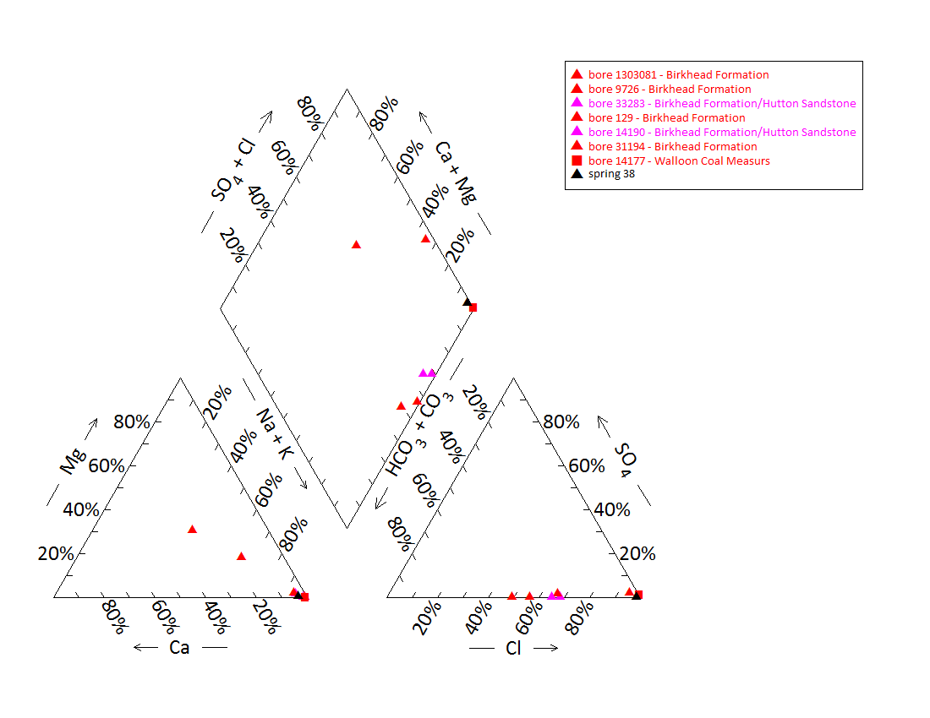

Note: No chemistry data are available for bore 10420. No water chemistry data are available for springs 26 & 28.

Figure 32 Dawson River 8 spring complex—Piper plot of spring and waterbore chemistry.

Table 71 Dawson River 8 spring complex—spring elevation and flow rate.

| Vent ID | Elevation (mAHD) | Estimated flow rate (L/min) | Date of estimate |
| --- | --- | --- | --- |
| 26 | 190.0 | 1 | 25/05/1995 |
| 28 | 190.0 | 0 | 25/05/1995 |
| 38 | 182.7 | 58 | 18/06/2011 |

L/min = litres per minute, mAHD = metres Australian height datum.

Table 72 Dawson River 8 spring complex—most recent waterbore pump test data.

| Bore ID | Recorded discharge (m3/d) | Standing groundwater level (mAGL) | Year of measurement |
| --- | --- | --- | --- |
| 9726 | 0.14 | 4.9 | 1995 |

m3/d = cubic metres per day, mAGL = metres above ground level.  
© Copyright, DNRM 2012

mAHD = metres Australian height datum.

Figure 33 Dawson River 8 spring complex—waterbore standing water levels (SWLs).

# Eulo supergroup, Queensland

## Yowah Creek spring complex

### Hydrogeological summary

The Yowah Creek spring complex is a discharge spring complex of five water springs. The likely conceptual spring type for this spring group is a discharge spring complex associated with a fault (type E or F).

The Yowah Creek spring complex is likely sourced from the Wyandra Sandstone Member of the Cadna-owie Formation or the underlying Hooray Sandstone, although it remains possible that it could be sourced from the overlying Doncaster or Coreena members of the Wallumbilla Formation (however, this may be considered less likely).

Hydrochemical analyses of spring and bore water did not conclusively attribute a source aquifer to the spring complex. This could be explained by several lines of reasoning. Firstly, the bores in the region lack casing information and may tap water sources in multiple aquifers. Similarly, the groundwater flowing from the springs may pass through multiple groundwater sources en route to the surface, resulting in water mixing and thereby obscuring any water quality characteristics. An alternative explanation is that these waterbores and springs could be sourced from the same aquifer; however, there are no hydrochemical data from the overlying or underlying aquifers to support this.

### Spring complex overview

The Yowah Creek spring complex is located 36.5 kilometres north-west of Eulo, within the valley of Yowah Creek on the Bundoona property, western Queensland. The main springs include 223 and 227, which both consist of numerous vents. Springs 224 and 225 feed adjacent waterholes to Yowah Creek (Figure 34). The springs have been given a conservation ranking of 1a. A summary of basic hydrogeological information available is given in Table 73. The location of the spring vents is listed in Table 74.

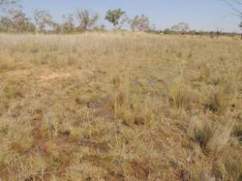 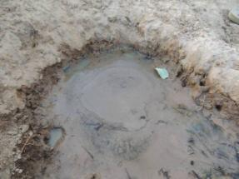

Figure 34 Yowah Creek spring complex—vents 223 and 225, Eulo, Queensland.

Table 73 Yowah Creek spring complex—hydrogeological information summary.

| Feature | Details | Comments |
| --- | --- | --- |
| No. of active vents | 8 | Spring numbers: 223, 224, 225, 225.1 226, 227, 227.1, 227.2 |
| No. of inactive vents | – |  |
| Conservation ranking | 1a |  |
| Spring water quality samples | Yes | Available for 223 (two samples) |
| Waterbores within 10-kilometre radius | 4 |  |
| Waterbore water quality samples | Yes | No differentiation between bore and spring water quality data. |
| Interpreted stratigraphy available | Yes | DNRM (2012). Wireline logged groundwater bores (Habermehl 2001) |
| Outcropping GAB formations | Yes | Wallumbilla Formation (Coreena and Doncaster Members) approximately 3 kilometres north-north-east of spring complex |
| Underlying aquifers |  | Winton Formation (subartesian), Wallumbilla Formation, Wyandra Sandstone |
| SWL time series data available | Yes | Bores tapping either the Wallumbilla Formation or the Wyandra Sandstone. Artesian pressure recorded in all bores |
| Likely source aquifers |  | Wyandra Sandstone of the Cadna-owie and Hooray Sandstone |
| Conceptual spring type | E or F | Likely options |

– = not available, GAB = Great Artesian Basin, SWL = standing water level.

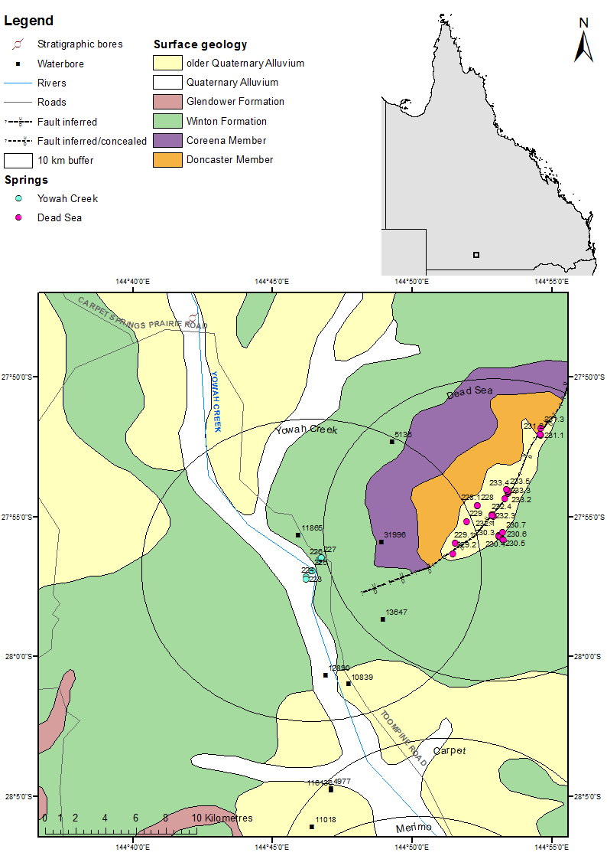

Figure 35 Yowah Creek spring complex—regional geology, Eulo supergroup, Queensland.

### Geology

Of the five active springs, three overlie the Quaternary alluvium of Yowah Creek (vents 223, 224 and 225). The others are located on the outcrop of the Cretaceous Winton Formation (Figure 35). Approximately 5 kilometres north-east of the spring complex, outcrops of the the Doncaster and Coreena members of the Wallumbilla Formation of the Eromanga Basin are present. The Boondoona Fault, which tends west-south-west to north-north-east, is located approximately 3 kilometres south-east of the spring complex and is overlain by the Dead Seas Scrolls and Pretty Plains spring complexes.

### Regional stratigraphy and underlying aquifers

Stratigraphic logs from the waterbores and stratigraphic bores within 10 kilometres of the Yowah Creek spring complex indicate that the following aquifers underlie the Yowah Creek complex: the Winton Formation, Wallumbilla Formation (including the Coreena and Doncaster members) and the Wyandra Sandstone Member of the Cadna-owie Formation (Table 75, Table 76 and Table 77). The maximum waterbore depth is 260 metres, where the Wyandra Sandstone is encountered. Deeper wireline logged waterbores in the region record the presence of the deeper Hooray Sandstone, one of the major and most productive artesian aquifers of the Great Artesian Basin (GAB) (Table 75). The basement is recorded to occur approximately 400 metres below ground level.

The source aquifer of bores in the region is likely to be either from the Doncaster Member of the Wallumbilla Formation or from the underlying Wyandra Sandstone of the Cadna-owie aquifer or Hooray Sandstone. Bores within 10 kilometres of the the Yowah Creek complex tap the Doncaster Member of the Wallumbilla Formation and Wyandra Sandstone Memberof the Cadna-owie Formation. The lack of screen and casing information reduces the certainty of the source aquifer being tapped. Most driller’s logs encounter multiple sources of water, typically within the Winton Formation and the Doncaster Member of the Wallumbilla Formation, and the Wyandra Sandstone (Table 78).

Although the Wallumbilla Formation is generally considered an aquitard (Radke et al. 2000), the Coreena and Doncaster members contain some sandstone and do form minor aquifers. However, the Wallumbilla Formation is typically recorded to have electrical conductivity values of > 1500 microsiemens per centimetre, notably higher values than those recorded from the Yowah Creek vents and nearby springs (Table 78 and Table 79) (Habermehl 2001).

### Water chemistry comparison: springs and waterbores

Hydrochemical data have been collected for spring 223 on two occasions: in 1999 by Fensham and in 2009 by EHA. Figure 36 provides a Piper plot of the water chemistry for the active spring 223 using data collected in 1999 and 2009, and waterbores 11865, 13647 and 5135. These groundwater bores may tap either the Doncaster Member of the Wallumbilla Formation and/or the Wyandra Sandstone Member of the Cadna-owie Formation, although lack of detailed bore casing information prevents clarification of this. The results for the water quality analysis did not include bicarbonate. Total alkalinity was used instead to compare bore and spring water chemistry in the Piper plot. There was no differentiation between the water samples for spring 223 and the three waterbores analysed here. Further, there are not any notable variations in electrical conductivity or pH between the bores and spring data, or for any of the limited minor element data available.

Environmental Hydrology Associates (EHA 2009) obtained samples for isotopic analyses from Yowah Creek spring 233 and nearby waterbores 12890 and 11865 (Table 80). EHA (2009) reported that the stable isotopes from the bore and spring samples fell approximately on the global meteoric water line, and suggested that the values for δ18O and δD correspond closely enough to be regarded as originating from the same groundwater source. Unfortunately, the groundwater source for these bores is not definitive (refer to Table 78), with stratigraphic logs from the Queensland Department of Environment and Resource Management’s Groundwater Database (DNRM 2012) indicating that they pass through both the Doncaster Member of the Wallumbilla Formation and the Wyandra Sandstone. Interpretations of driller’s logs by EHA (2009) indicate that these bores may also be accessing the Hooray Sandstone at the lower reaches of the bores. Geophysical logs show that the waterbores 4979 and 12736, which are about 10 kilometres away, also encountered the Wallumbilla Formation, Wyandra Sandstone and Hooray Sandstone (Habermehl 2001).

### Artesian status of potential source aquifers

Standing water level information over time is available for waterbores 12890, 11865 and 13647, which all may access the Doncaster Member of the Wallumbilla Formation and/or the Wyandra Sandstone of the Cadna-owie Formation (Table 82). These bores have all maintained artesian pressure status, although they have decreased in pressure during a number of decades until the 1990s, when standing water levels increased to around original levels (Figure 38).

The Wyandra Sandstone Member, typically encountered at approximately 200 metres depth, is generally considered the shallowest Lower Cretaceous – Jurassic artesian aquifer of the GAB (*Water Resource (Great Artesian Basin) Plan 2006* [Qld]). However, within close proximity to the Yowah Creek springs, there have also been historic artesian pressures within aquifers of the Wallumbilla Formation (consisting of the Coreena and Doncaster members). EHA (2009) suggests that there is likely to be interconnection between the deeper and shallower aquifers in the Eulo region. The interconnection is sufficient to allow for the development of artesian conditions in shallower formations, such as the Wallumbilla Formation and the Wyandra Sandstone Member, which may not regionally be considered artesian.

Table 74 Yowah Creek spring complex—spring locations and elevations.

| Vent ID | Latitude | Longitude | Elevation (mAHD) |
| --- | --- | --- | --- |
| 223 | –27.95212 | 144.76988 | 169.442 |
| 224 | –27.95352 | 144.76962 | 171.457 |
| 225 | –27.94872 | 144.77306 | 171.591 |
| 225.1 | –27.94863 | 144.77335 | 172.089 |
| 226 | –27.94241 | 144.77742 | 172.209 |
| 227 | –27.94123 | 144.77842 | 172.152 |
| 227.1 | –27.94082 | 144.77903 | – |
| 227.2 | –27.94073 | 144.77877 | – |

– = not available, mAHD = metres Australian height datum.

Table 75 Yowah Creek spring complex—wireline logged waterbores within a 50-kilometre radius.

| Bore ID | Distance (km) and direction from springs complex | Top  (mBGL) | Bottom  (mBGL) | Thickness (m) | Rock unit name |
| --- | --- | --- | --- | --- | --- |
| 4538 | 25.66, north-east | 0.0 | 21.3 | 21.3 | Morney Profile |
|  |  | 21.3 | 30.5 | 9.1 | Winton Formation |
|  |  | 30.5 | 191.4 | 160.9 | Wallumbilla Formation |
|  |  | 191.4 | 292.6 | 101.2 | Cadna-owie Formation |
|  |  | 191.4 | 197.2 | 5.8 | Wyandra Sandstone Member |
|  |  | 197.2 | 292.6 | 95.4 | Unnamed member |
|  |  | 292.6 | 411.5 | 118.9 | Hooray Sandstone |
|  |  | 292.6 | 310.9 | 18.3 | Murta Sandstone |
|  |  | 310.9 | 369.4 | 58.5 | Middle Member |
|  |  | 369.4 | 411.5 | 42.1 | Namur Sandstone member |
|  |  | 411.5 | 438.9 | 27.4 | Basement |
| 4979 | 11.67, east | 0.0 | 39.6 | 39.6 | Morney Profile |
|  |  | 39.6 | 57.9 | 18.3 | Winton Formation |
|  |  | 57.9 | 253.0 | 195.1 | Wallumbilla Formation |
|  |  | 253.0 | 326.1 | 73.1 | Cadna-owie Formation |
|  |  | 253.0 | 268.2 | 15.2 | Wyandra Sandstone Member |
|  |  | 268.2 | 326.1 | 57.9 | Unnamed member |
|  |  | 326.1 | 428.8 | 102.7 | Hooray Sandstone |
|  |  | 428.8 | 434.6 | 5.8 | Basement |
| 6656 | 11.44, south-south-west | 0.0 | 39.6 | 39.6 | Morney Profile |
|  | 39.6 | 70.7 | 31.1 | Coreena Member |
|  |  | 70.7 | 189.6 | 118.9 | Cadna-owie Formation |
|  |  | 70.7 | 240.8 | 170.0 | Wyandra Sandstone Member |
|  |  | 240.8 | 286.8 | 46.0 | Unnamed nember |
|  |  | 286.8 | 302.0 | 15.2 | Hooray Sandstone |
| 12736 | 17.4, north-east | 0.0 | 13.7 | 13.7 | Cainozoic |
|  |  | 13.7 | 37.2 | 23.5 | Morney Profile |
|  |  | 37.2 | 91.4 | 54.3 | Winton Formation |
|  |  | 91.4 | 396.2 | 304.8 | Wallumbilla Formation |
|  |  | 91.5 | 246.9 | 155.4 | Coreena Member |
|  |  | 246.9 | 396.2 | 149.3 | Doncaster Member |
|  |  | 396.2 | 463.3 | 67.1 | Cadna-owie Formation |
|  |  | 396.3 | 418.8 | 22.5 | Wyandra Sandstone Member |
|  |  | 418.8 | 463.3 | 44.5 | Unnamed member |
|  |  | 463.3 | 486.1 | 22.9 | Hooray Sandstone |

km = kilometre, m = metre, mBGL = metres below ground level.  
© Copyright, Habermehl 2001

Table 76 Yowah Creek spring complex—stratigraphic bores within a 50-kilometre radius.

| Stratigraphic bore | Distance (km) and direction from springs complex | Top (mBGL) | Bottom (mBGL) | Rock unit name |
| --- | --- | --- | --- | --- |
| 1358 (Bulloo 1) |  | 0.0 | 6.7 | Undifferentiated |
|  |  | 6.7 | 122.9 | Allaru Mudstone |
|  |  | 122.9 | 234.6 | Coreena Member |
|  |  | 122.9 | 436.9 | – |
| 2066 (Bulloo 1) |  | 0.0 | 7.0 | Glendower Formation |
|  |  | 7.0 | 23.3 | Winton Formation |
|  |  | 23.3 | 80.0 | Allaru Mudstone |
|  |  | 80.0 | 152.4 | Wallumbilla Formation |
|  |  | 80.0 | 152.4 | Coreena Member |
| 2155 (Eulo 5) |  | 0.0 | 7.9.0 | Glendower Formation |
| 2247 (Toompine 1) | 18.1, north-north-west | 0.0 | 64.0 | Sediments |
|  | 64.0 | 101.2 | Allaru Mudstone |
|  | 101.2 | 101.2 | Urisino Beds |
|  | 102.2 | 105.1 | Wallumbilla Formation |
| 2717 (Eulo 1) | 35.1, south-east | – | – | – |
| 2718 (Eulo 2) | 28.5, south-west | 0.0 | 40.0 | Winton Formation |
|  |  | 40.0 | 152.4 | Wallumbilla Formation |
|  |  | 40.0 | 90.2 | Coreena Member |
|  |  | 90.2 | 152.4 | Doncaster Member |
| 2719 (Eulo 3) |  | 0.0 | Null | ­ |
| 2720 (Eulo 4) |  | 0.0 | 94.5 | Doncaster Member |

– = not available, km = kilometre, mBGL = metres below ground level.  
© Copyright, DNRM 2012

Table 77 Yowah Creek spring complex—waterbores within a 10-kilometre radius.

| Bore ID | Top (mBGL) | Bottom (mBGL) | Rock unit name |
| --- | --- | --- | --- |
| 5135 | 0.0 | 24.2 | Winton Formation |
|  | 24.4 | 239.3 | Wallumbilla Formation |
|  | 239.3 | 260.0 | Wyandra Sandstone |
| 11865 | 0.0 | 201.2 | Winton/Wallumbilla Formation |
|  | 201.2 | 209.7 | Wyandra Sandstone Member |
| 13647 | 0.0 | – | Winton Formation |
|  | – | – | Wallumbilla Formation |
|  | – | 180.4 | Wyandra Sandstone Member |
| 10839 | 0.0 | 18.9 | Alluvium/Tertiary |
|  | 18.9 | – | Winton Formation |
|  | – | 70.1 | Wallumbilla Formation |
| 12890 | 0.0 | 18.9 | Alluvium/Tertiary |
|  | 18.9 | 216.4 | Winton Formation |
|  | 216.4 | 236.2 | Wyandra Sandstone Member |

– = not available, mBGL = metres below ground level.  
© Copyright, DNRM 2012

Table 78 Yowah Creek spring complex—waterbore details and water chemistry.

| Variable | Details | | | | |
| --- | --- | --- | --- | --- | --- |
| Bore ID | 5135 | 10839 | 11865 | 12890 | 13647 |
| Sample date | 2007 | – | 1985 | 2007 | 2007 |
| Distance from spring complex (kilometres) | 9.7 | 7.84 | 2.4 km | 7.0 | 5.7 |
| Potential source aquifers | Doncaster Member /  Wyandra Sandstone | Wallumbilla Formation | Doncaster Member /  Wyandra Sandstone | Doncaster Member /  Wyandra Sandstone | Doncaster Member /  Wyandra Sandstone |
| Screens (metres) | – | Perforated casing (70.1) | – | - | - |
| Year drilled | 1936 | 1947 | 1974 | 1955 | 1974 |
| Standing water level (natural surface elevation) | – | – | 64.2 (1974) | 61.3 (1985) | 53.1 (1985) |
| Total depth (metres) | 260 | 70.1 | 209.7 | 236.2 | 180.4 |
| Surface elevation | – | – | 172 | 160 | 177 |
| Facility type | Artesian bore / controlled flow | Artesian bore / controlled flow | Artesian bore / controlled flow | Artesian bore / controlled flow | Artesian bore / controlled flow |
| Facility status | Existing | Abandoned and destroyed | Existing | Existing | Existing |
| *Physicochemical parameters* | | | | | |
| EC (µS/cm) | 837 | – | 800 | 835 | 771 |
| pH (field/lab) | 8.1 | – | 8.2 | 8.2 | 8.2 |
| Temperature (°C) | 43.2 | – | 42 | 43 | 40 |
| *Chemical parameters (milligrams/litre)* | | | | | |
| Dissolved oxygen | – | – | – | – | – |
| TDS | – | – | – | – | – |
| TSS | 498 | – | 445.27 | 493 | 461 |
| Sodium (Na) | 194 | – | 170 | 191 | 178 |
| Potassium (K) | 1.6 | – | 1.7 | 1.8 | 1.5 |
| Calcium (Ca) | 3.6 | – | 5 | 3.3 | 3.8 |
| Magnesium (Mg) | 0.01 | – | 0.2 | 0.2 | 0.1 |
| Chlorine (Cl) | 74 | – | 85 | 88 | 74 |
| Sulfate (SO4) | 1 | – | 3.8 | 1 | 1 |
| Total alkalinity (calcium carbonate) | 337 | – | 264 | 312 | 304 |
| Bicarbonate (HCO3–) | 399 | – | 315 | 373 | 363 |
| Fluoride (F) | 0.99 | – | 0.9 | 0.98 | 0.83 |
| Bromine (Br) | – | – | – | – | – |
| Aluminium (Al) | 0.05 | – | – | 0.05 | – |
| Arsenic (As) | – | – | – | – | – |
| Barium (Ba) | – | – | – | – | – |
| Cobalt (Co) | – | – | – | – | – |
| Iron (Fe) | 0.01 | – | 0.06 | 0.01 | 0.01 |
| Manganese (Mn) | 0.01 | – | 0.02 | 0.01 | 0.01 |
| Silica (SiO2) | 22 | – | 20 | 20 | 20 |
| Strontium (Sr) | – | – | – | – | – |
| Zinc (Zn) | 0.01 | – | – | – | 0.01 |
| Dissolved organic carbon | – | – | – | – | – |
| Nitrate as NO3 | 0.5 | – | 0.5 | 0.5 | 0–0.5 |
| Phosphate (PO4) | – | – | – | – | – |

– = not available, EC = electrical conductivity, µS/cm = microsiemens per centimetre, TDS = total dissolved solids, TSS = total suspended solids.  
© Copyright, DNRM 2012

Table 79 Yowah Creek spring complex—spring water chemistry.

| Variable | Details | |
| --- | --- | --- |
| Vent ID | 223 | 223 |
| Sample date | 1999 | 2009 (EHA 2009) |
| *Physicochemical parameters* | | |
| EC (µS/cm) | – | 822 |
| pH (field/lab) | – | 7.3 |
| Temperature (°C) | – | – |
| *Chemical parameters (milligrams/litre)* | | |
| Dissolved oxygen | – | – |
| TDS | 556 | 497 |
| TSS | – | 152 |
| Sodium (Na) | 197 | 195 |
| Potassium (K) | 2.7 | 4 |
| Calcium (Ca) | 7.8 | 4 |
| Magnesium (Mg) | 0.3 | <1 |
| Chlorine (Cl) | 90.9 | 95 |
| Sulfate (SO4) | 4.2 | <1 |
| Total alkalinity | 278.75 | 306 |
| Bicarbonate (HCO3–) | – | – |
| Carbonate (CO32–) | – | – |
| Iodine (I) | – | 0.8 |
| Fluoride (F) | – | – |
| Bromine (Br) | 0.1 | – |
| Aluminium (Al) | – | 0.04 |
| Arsenic (As) | – | <0.001 |
| Barium (Ba) | – | 0.063 |
| Cobalt (Co) | – | – |
| Iron (Fe) | – | 1.18 |
| Manganese (Mn) | – | 0.137 |
| Silica (SiO2) | – | 26 |
| Strontium (Sr) | – | 0.14 |
| Zinc (Zn) | – | 0.032 |
| Dissolved organic carbon | – | – |
| Nitrate as NO3 | 15.2 | 0.17 |
| Phosphate (PO4) | – | – |

– = not available, EC = electrical conductivity, µS/cm = microsiemens per centimetre, TDS = total dissolved solids, TSS = total suspended solids.  
© Copyright, EHA 2009

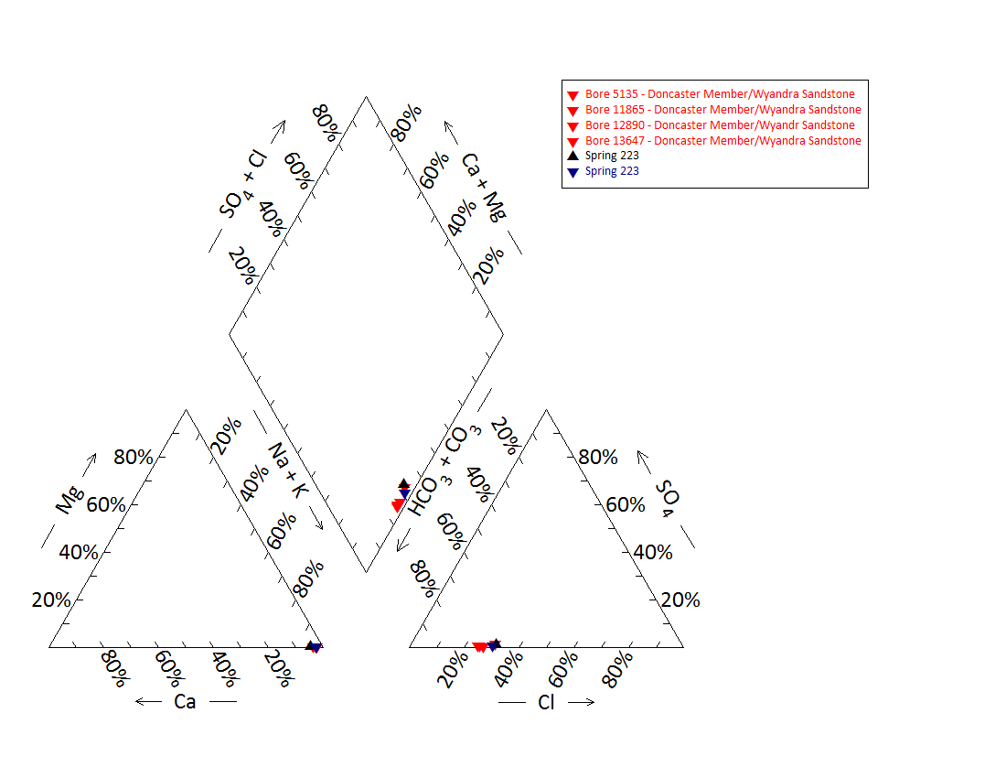

Note: No water chemistry data were available for springs 224–227.2 and bore 10839.

Figure 36 Yowah Creek spring complex—Piper plot of springs and waterbore chemistry.

Figure 37 Yowah Creek spring complex—oxygen (O) and deuterium (D) stable isotope ratios.

Table 80 Yowah Creek spring complex—isotope data.

| Source | Date | δ18O  VSMOW (%) | δ18O  VSMOW repeat (%) | δD  VSMOW (%) | δD  VSMOW repeat (%) |
| --- | --- | --- | --- | --- | --- |
| Bore 12890 | 04/06/2009 | –6.06 | – | –38.7 | – |
| Bore 22865 | 04/06/2009 | –6.11 | –6.6 | –39.0 | –39.9 |
| Spring 223 | 04/06/2009 | –6.33 | –6.43 | –38.3 | –38.8 |

– = not available, VSMOW = Vienna Standard Mean Ocean Water.  
© Copyright, EHA 2009

Table 81 Yowah Creek spring complex—spring flow rate.

| Vent ID | Estimated flow rate (L/d) | Date of estimate |
| --- | --- | --- |
| 223 | 252 422.5 | 21/02/1999 |
| 224 | 1 652.6 | 21/02/1999 |
| 225 | 64 461.5 | 21/02/1999 |
| 226 | 64 461.5 | 21/02/1999 |
| 227 | 88 383.7 | 21/02/1999 |

L/d= litres per day.  
© Copyright, EHA 2009

Table 82 Yowah Creek spring complex—most recent waterbore pump test data.

| Bore ID | Recorded discharge (m3/d) | Standing groundwater level (mAGL) | Year of measurement |
| --- | --- | --- | --- |
| 5135 | 8.87 | 25.85 | 19/10/2007 |
| 11865 | 4.27 | 57.21 | 1/09/1994 |
| 12890 | 6.30 | 60.29 | 18/10/2007 |
| 13647 | 5.59 | 50.46 | 19/10/2007 |

m3/d = cubic metres per day, mAGL = metres above ground level.  
© Copyright, DNRM 2012

mAHD = metres Australian height datum.

Figure 38 Yowah Creek spring complex—waterbore standing water levels (SWLs).

## Dead Sea springs complex

### Hydrogeological summary

The Dead Sea spring complex is a discharge spring complex of both mud and water vents, associated with the Boondoona Fault located approximately 30 kilometres north-west of Eulo. The likely conceptual spring type for this complex is a discharge spring complex associated with a fault (type E or F). The Coreena and Doncaster members of the Wallumbilla Formation present adjacent to the spring complex.

The Dead Sea spring complex is likely sourced from the Wyandra Sandstone Member of the Cadna-owie Formation or the underlying Hooray Sandstone Member. However, there is no conclusive evidence to discount the shallower aquifers of the Wallumbilla Formation (Coreena and Doncaster members) as possible source aquifers. Historically, all confined GAB aquifers have had artesian pressure in the Eulo region, with some shallower aquifers such as the Wallumbilla Formation possibly producing flowing waterbores. However, available data are not clear on whether the waterbores were artesian or flowing artesian.

Water quality analyses of spring and waterbores did not conclusively attribute a source aquifer to the spring complex. This could have several reasons. Firstly, the bores in the region lack casing information and may tap multiple aquifers. Similarly, the artesian groundwater flowing from the springs may pass through multiple water sources en route to the surface, resulting in water mixing and thereby obscuring any water quality characteristics. An alternative explanation is that these bores and springs could be sourced from the same aquifer; however, there are no data to support that water from overlying or underlying aquifers have different water quality signals.

### Spring complex overview

The Dead Sea spring complex is a scalded valley between low stony hills on the Bundoona–Penaroo boundary about 30 kilometres north-west of Eulo, along the upper–middle reaches of Bundoona Creek and its tributaries. Groundwater is close to the surface in this area, with many soaks and springs throughout the region, as well as many dry depressions surrounded by travertine that likely represent extinct spring deposits (not shown on map). The Dead Sea spring complex is comprised of six main groups of active springs (see Figure 39) and has been given a conservation ranking of 1b. A summary of basic hydrogeological information available is given in Table 83. Table 84 provides the location and elevation of the spring vents.

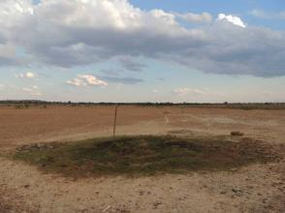 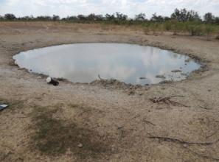

Figure 39 Dead Sea spring complex—vents 230.1 and 229.

Table 83 Dead Sea spring complex—hydrogeological information summary.

| Feature | Details | Comments |
| --- | --- | --- |
| No. of active vents | 24 | 228, 228.1, 229, 230.1–230.7, 231.1–231.3, 232.1–232.4, 233.1–233.5 |
| No. of inactive vents | 2 | 229.1 and 229.2 |
| Conservation ranking | 1b |  |
| Nearby spring complexes |  | Yowah Creek |
| Spring water quality samples | Yes | Site 230 (1999) |
| Waterbores within 10-kilometre radius | 4 | Bore 31996 never drilled; 4979, 5135 and 13647 |
| Waterbore water quality samples | Yes | Bores: 4979, 5135 and 13647 |
| Interpreted stratigraphy available | Yes | DNRM (2012). Wireline logged groundwater bores (from Habermehl 2001) |
| Outcropping GAB formations | Yes | Coreena and Doncaster members of the Wallumbilla Formation |
| Underlying aquifers |  | Winton Formation, Wallumbilla Formation, Wyandra Sandstone of the Cadna-owie Formation and Hooray Sandstone |
| SWL time series data available | Yes | Bores 4979 and 5135  Artesian conditions maintained. No evidence of increase/decrease in pressure |
| Likely source aquifers |  | Wyandra Sandstone/ Hooray Sandstone system |
| Conceptual spring type | E or F |  |

GAB = Great Artesian Basin, SWL = standing water level.

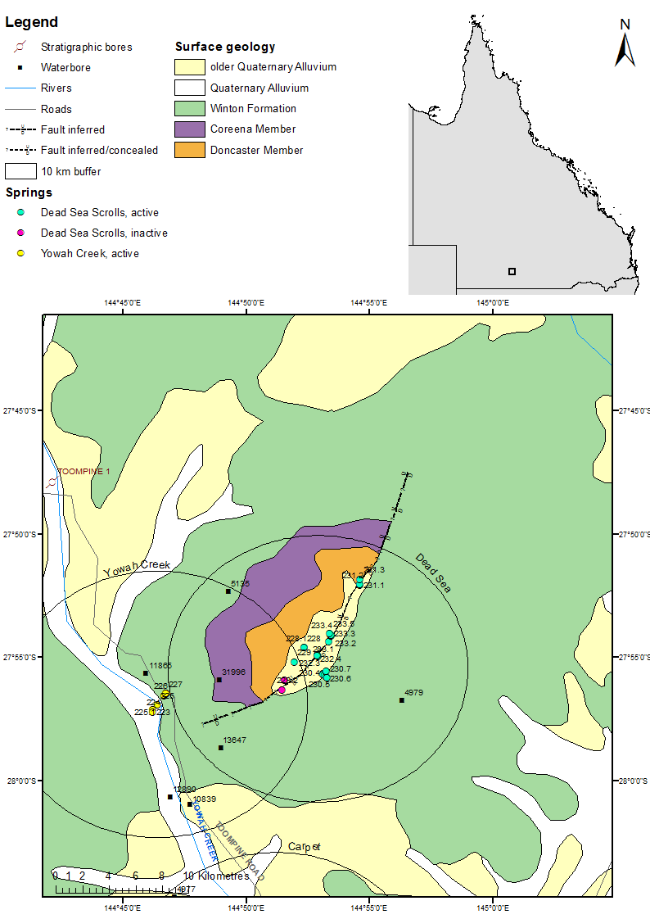

Figure 40 Dead Sea spring complex—regional geology, Eulo supergroup, Queensland.

### Geology

The Dead Sea spring complex lies along the ridge of the Boondoona Fault and adjacent to outcrops of the Coreena and Doncaster members of the Wallumbilla Formation.

### Regional stratigraphy aquifers underlying

Stratigraphic logs from waterbores within 10 kilometres of the Dead Sea spring complex indicate that the following aquifers are underlying the spring complex: the Winton Formation, the Wallumbilla Formation (including the Coreena and Doncaster members), the Wyandra Sandstone Member of the Cadna-owie Formation and the Hooray Sandstone (Table 85 and Table 86). The maximum waterbore depth is 480 metres, passing through the Hooray Sandstone at 326–430 metres below ground level. The basement was recorded at a stratigraphic bore located 19 kilometres north-east of the spring complex at 411 metres below ground level (Table 85).

The source aquifer of the shallower bores (5135 and 13647) is likely to be from either the Doncaster Member of the Wallumbilla Formation, or from the top of the Wyandra Sandstone / Hooray Sandstone system. The lack of screen and casing information reduces the certainty of the source aquifer being tapped (Table 87). Bore 4979 extends to a maximum depth of 479.5 metres, accessing water from the Hooray Sandstone (Habermehl 2001).

### Water chemistry comparison: springs and waterbores

Table 87 sets out the available water chemistry data for the waterbores within a 10-kilometre radius of the Dead Sea spring complex. Full water chemistry data are only available for spring vent 230 (Table 88). Physicochemical information is available for further Dead Sea spring vents and is shown in Table 89. Although bores 4979, 13647 and 5135 are thought to be accessing waters from different aquifer systems, there is little differentiation in water quality characteristics (Figure 41). Furthermore, there is no differentiation between water quality from the springs and the waterbores. The results for the water quality analysis did not include bicarbonate. Total alkalinity was used instead to compare bore and spring water chemistry in the Piper plot (Figure 41).

### Artesian status of potential source aquifers

Standing water level data over time is available for bores 4979 (sourced from the Hooray Sandstone) and 13647 (sourced from either the Wallumbilla Formation or the Wyandra Sandstone). These bores have both maintained artesian pressure since the mid-1950s (Table 90 and Figure 42).

Table 84 Dead Sea spring complex—spring locations and elevations.

| Vent ID | Latitude | Longitude | Elevation (mAHD) |
| --- | --- | --- | --- |
| 228 | –27.91002 | 144.87237 | 179.768 |
| 228.1 | –27.91002 | 144.87237 | – |
| 229 | –27.91959 | 144.86572 | 173.816 |
| 229.1 | –27.93225 | 144.85875 | – |
| 229.2 | –27.93844 | 144.85745 | – |
| 230.1 | –27.92746 | 144.88520 | 180.288 |
| 230.2 | –27.92823 | 144.88493 | 178.981 |
| 230.3 | –27.92792 | 144.88487 | 178.47 |
| 230.4 | –27.92856 | 144.88594 | 179.269 |
| 230.5 | –27.92985 | 144.88710 | 177.88 |
| 230.6 | –27.93054 | 144.88766 | 178.16 |
| 230.7 | –27.92581 | 144.88735 | 180.447 |
| 232.1 | –27.91619 | 144.88164 | – |
| 232.2 | –27.91509 | 144.88105 | 178.206 |
| 232.3 | –27.91538 | 144.88115 | 178.144 |
| 232.4 | –27.91565 | 144.88095 | 178.255 |
| 233.1 | –27.90580 | 144.88881 | 178.87 |
| 233.2 | –27.90231 | 144.89068 | 178.774 |
| 233.3 | –27.90141 | 144.89023 | 179.082 |
| 233.4 | –27.90134 | 144.89050 | – |
| 233.5 | –27.90038 | 144.88969 | 179.011 |
| 231.1 | –27.86777 | 144.91015 | 184.847 |
| 231.2 | –27.86743 | 144.90987 | 185.057 |
| 231.3 | –27.86363 | 144.91023 | – |

– = not available, mAHD = metres Australian height datum.

Table 85 Dead Sea spring complex—wireline logged waterbores within a 50-kilometre radius.

| Bore ID | Distance (km) and direction from springs complex | Top  (mBGL) | Bottom  (mBGL) | Thickness (m) | Rock unit name |
| --- | --- | --- | --- | --- | --- |
| 4538 | 19.0, north-east | 0.0 | 21.3 | 21.3 | Morney Profile |
|  |  | 21.3 | 30.5 | 9.1 | Winton Formation |
|  |  | 30.5 | 191.4 | 160.9 | Wallumbilla Formation |
|  |  | 191.4 | 292.6 | 101.2 | Cadna-owie Formation |
|  |  | 191.4 | 197.2 | 5.8 | Wyandra Sandstone Member |
|  |  | 197.2 | 292.6 | 95.4 | Unnamed member |
|  |  | 292.6 | 411.5 | 118.9 | Hooray Sandstone |
|  |  | 292.6 | 310.9 | 18.3 | Murta Sandstone |
|  |  | 310.9 | 369.4 | 58.5 | Middle Member |
|  |  | 369.4 | 411.5 | 42.1 | Namur Sandstone Member |
|  |  | 411.5 | 438.9 | 27.4 | Basement |
| 4979 | 6.3, south-east | 0.0 | 39.6 | 39.6 | Morney Profile |
|  |  | 39.6 | 57.9 | 18.3 | Winton Formation |
|  |  | 57.9 | 253.0 | 195.1 | Wallumbilla Formation |
|  |  | 253.0 | 326.1 | 73.1 | Cadna-owie Formation |
|  |  | 2530 | 268.2 | 15.2 | Wyandra Sandstone Member |
|  |  | 268.2 | 326.1 | 57.9 | Unnamed member |
|  |  | 326.1 | 428.8 | 102.7 | Hooray Sandstone |
|  |  | 428.8 | 434.6 | 5.8 | Basement |
| 6656 | 19.9, south-west | 0.0 | 39.6 | 39.6 | Morney Profile |
|  | 39.6 | 70.7 | 31.1 | Coreena Member |
|  |  | 70.7 | 189.6 | 118.9 | Cadna-owie Formation |
|  |  | 70.7 | 240.8 | 170.0 | Wyandra Sandstone Member |
|  |  | 240.8 | 286.8 | 46.0 | Unnamed member |
|  |  | 286.8 | 302.0 | 15.2 | Hooray Sandstone |
| 12736 | 22.3, north-west | 0.0 | 13.7 | 13.7 | Cainozoic |
|  | 13.7 | 37.2 | 23.5 | Morney Profile |
|  |  | 37.2 | 91.4 | 54.3 | Winton Formation |
|  |  | 91.4 | 396.2 | 304.8 | Wallumbilla Formation |
|  |  | 91.5 | 246.9 | 155.4 | Coreena Member |
|  |  | 246.9 | 396.2 | 149.3 | Doncaster Member |
|  |  | 396.2 | 463.3 | 67.1 | Cadna-owie Formation |
|  |  | 396.3 | 418.8 | 22.5 | Wyandra Sandstone Member |
|  |  | 418.8 | 463.3 | 44.5 | Unnamed member |
|  |  | 463.3 | 486.1 | 22.9 | Hooray Sandstone |

km = kilometre, m = metre, mBGL = metres below ground level.  
© Copyright, Habermehl 2001

Table 86 Dead Sea spring complex—waterbores within a 10-kilometre radius.

| Bore ID | Top (mBGL) | Bottom (mBGL) | Rock unit name |
| --- | --- | --- | --- |
| 4979 | 0.0 | 33.5 | Winton Formation |
|  | 33.5 | 146.9 | Coreena Formation |
|  | 146.9 | 253.3 | Doncaster Formation |
|  | 253.3 | 269.7 | Wyandra Sandstone |
|  | 269.7 | 326.1 | Cadna-owie Formation |
|  | 326.1 | 429.8 | Hooray Sandstone |
|  | 429.8 | 479.5 | Palaeozoic |
| 5135 | 0.0 | 24.4 | Winton Formation |
|  | 24.4 | 239.3 | Wallumbilla Formation |
|  | 239.9 | 260.0 | Wyandra Sandstone |
| 13647 | 0.0 | – | Winton Formation |
|  | – | – | Wallumbilla Formation |
|  | – | 180.4 | Wyandra Sandstone |
| 31996 (bore never drilled) | n/a | n/a | n/a |

– = not available, mBGL = metres below ground level, n/a = not applicable.  
© Copyright, DNRM 2012

Table 87 Dead Sea spring complex—waterbore details and water chemistry.

| Variable | Details | | |
| --- | --- | --- | --- |
| Bore ID | 4979 | 5135 | 13647 |
| Sample date | 2006 | 2007 | 2007 |
| Distance from spring complex (kilometres) | 6.1 | 8.3 | 8.7 |
| Source aquifer | Hooray Sandstone | Wallumbilla/ Wyandra Sandstone | Wallumbilla/ Wyandra Sandstone |
| Screens (metres) | Perforated casing at 479.5 | – | – |
| Year drilled | 1925 | 1936 | 1974 |
| Standing water level (natural surface elevation) | 45.7 metres (1925) | – | 53.0 metres  (1974) |
| Total depth (metres) | 479.5 | 260 | 180.4 |
| Natural surface elevation (mAHD) | 224 | – | 177 |
| Facility status | Existing | Existing | Existing |
| *Physicochemical parameters* | | | |
| EC (µS/cm) | 638 | 837 | 771 |
| pH (field/lab) | 7.8 | 8.1 | 8.2 |
| Temperature (°C) | 48.7 | 43.2 | 40 |
| *Chemical parameters (milligrams per litre)* | | | |
| Dissolved oxygen | – | – | – |
| TDS | – | – | – |
| TSS | 380 | 498 | 461 |
| Sodium (Na) | 146 | 194 | 178 |
| Potassium (K) | 1.5 | 1.6 | 1.5 |
| Calcium (Ca) | 2.3 | 3.6 | 3.8 |
| Magnesium (Mg) | 0.1 | 0.01 | 0.1 |
| Chlorine (Cl) | 43 | 74 | 74 |
| Sulfate (SO4) | 1 | 1 | 1 |
| Total alkalinity (calcium carbonate) | 273 | 337 | 304 |
| Bicarbonate (HCO3–) | 323 | 399 | 363 |
| Carbonate (CO32–) | 4.8 | 5.4 | 4.2 |
| Fluoride (F) | 0.7 | 0.99 | 0.83 |
| Bromine (Br) | – | – | – |
| Aluminium (Al) | 0.05 | 0.05 | 0.05 |
| Arsenic (As) | – | – | – |
| Barium (Ba) | – | – | – |
| Cobalt (Co) | – | – | – |
| Iron (Fe) | 0.01 | 0.01 | 0.01 |
| Manganese (Mn) | 0.03 | 0.01 | 0.01 |
| Silica (SiO2) | 230 | 22 | 20 |
| Strontium (Sr) | – | – | – |
| Zinc (Zn) | 0.02 | 0.01 | 0.01 |
| Dissolved organic carbon | – | – | – |
| Nitrate as NO3 | 0.5 | 0.5 | 0.5 |
| Phosphate (PO4) | – | – | – |

– = not available, EC = electrical conductivity, mAHD = metres Australian height datum, µS/cm = microsiemens per centimetre, TDS = total dissolved solids, TSS = total suspended solids.  
Note: No water chemistry data are available for bore 31996 as it was never drilled.  
© Copyright, DNRM 2012

Table 88 Dead Sea spring complex—spring water chemistry.

| Variable | Details |
| --- | --- |
| Vent ID | 230 |
| Sample date | – |
| *Physicochemical parameters* | |
| EC (µS/cm) | – |
| pH (field/lab) | – |
| Temperature (°C) | – |
| *Chemical parameters (milligrams per litre)* | |
| Dissolved oxygen | – |
| TDS | 1050.00 |
| TSS | – |
| Sodium (Na) | 361.00 |
| Potassium (K) | 9.400 |
| Calcium (Ca) | 11.600 |
| Magnesium (Mg) | 1.800 |
| Chlorine (Cl) | 164.00 |
| Sulfate (SO4) | 11.4 |
| Total alkalinity (calcium carbonate) | 558.75 |
| Bicarbonate (HCO3–) | – |
| Carbonate (CO32–) | – |
| Iodine (I) | – |
| Fluoride (F) | – |
| Bromine (Br) | – |
| Aluminium (Al) | – |
| Arsenic (As) | – |
| Barium (Ba) | – |
| Cobalt (Co) | – |
| Iron (Fe) | – |
| Manganese (Mn) | – |
| Silica (SiO2) | – |
| Strontium (Sr) | – |
| Zinc (Zn) | – |
| Dissolved organic carbon | – |
| Nitrate as NO3 | 8.900 |
| Phosphate (PO4) | – |

– = not available, EC = electrical conductivity, µS/cm = microsiemens per centimetre, TDS = total dissolved solids, TSS = total suspended solids.  
© Copyright, GAB springs database

Table 89 Dead Sea spring complex—spring elevation and water physicochemical data.

| Spring no. | Elevation (mAHD) | Temperature (°C) | pH | Electrical conductivity (µS/cm) |
| --- | --- | --- | --- | --- |
| 228 | 179.768 | 36.5 | 7.58 | 1025 |
| 229 | 173.816 | 34.7 | 7.98 | 1730 |
| 230.1 | 180.288 | 27.4 | 7.21 | 1427 |
| 230.2 | 178.981 | – | – | – |
| 230.3 | 178.470 | 28.2 | 7.90 | 1036 |
| 230.4 | 179.269 | – | – | – |
| 230.5 | 177.880 | 29.9 | 7.00 | 982 |
| 230.6 | 178.160 | 26.8 | 7.19 | 1203 |
| 230.7 | 180.447 | – | – | – |
| 232.2 | 178.206 | – | – | – |
| 232.3 | 178.160 | – | – | – |
| 232.4 | 178.255 | – | – | – |
| 233.1 | 178.870 | 27.5 | 7.66 | 1353 |
| 233.2 | 178.774 | 29.4 | 8.46 | 1079 |
| 233.3 | 179.082 | 28.8 | 7.26 | 932 |
| 233.5 | 179.011 | 30.1 | 7.50 | 908 |
| 231.1 | 184.847 | 33.2 | 8.09 | 1655 |
| 231.2 | 185.057 | 33.2 | 7.54 | 4460 |

– = not available, µS/cm = microsiemens per centimetre.

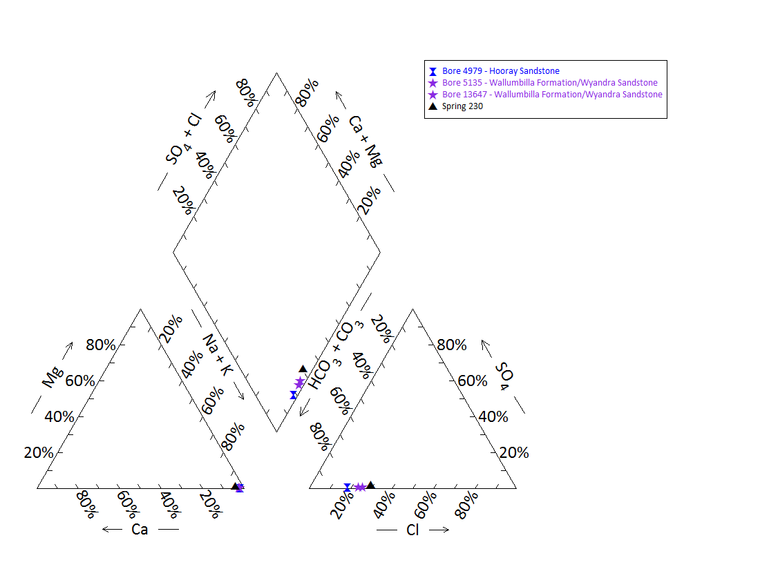

Note: No water chemistry data are available for bore 31996 because it was never drilled. No water chemistry data are available for springs 228, 228.1, 229, 230.1–230.7, 231.1–231.3, 232.1–232.4 and 233.1–233.5.

Figure 41 Dead Sea spring complex—Piper plot of spring waterbore water chemistry.

Table 90 Dead Sea spring complex—most recent waterbore pump test data.

| Bore ID | Recorded discharge (m3/d) | Standing groundwater level (mAGL) | Date of measurement |
| --- | --- | --- | --- |
| 4979 | 19.93 | 13.80 | 02/02/2006 |
| 5135 | 7.29 | 13.59 | 05/06/1985 |
| 13647 | 5.56 | 54.98 | 19/10/2007 |

m3/d = cubic metres per day, mAGL = metres above ground level.  
© Copyright, DNRM 2012

mAHD = metres Australian height datum.  
© Copyright, DNRM 2012

Figure 42 Dead Sea spring complex—waterbore standing water level (SWL).

## Carpet spring complex

### Hydrogeological summary

The Carpet spring complex is composed of an eastern and western group of mud mound springs, including five currently active vents. The Carpet spring complex is located on the alluvial floodplain of Yowah Creek. The likely conceptual spring model type for this spring group is a complex associated with ridges or platforms of the granite basement (G or H) underneath the GAB.

The source aquifer of the Carpet spring complex is unknown; however, like other springs in the region, the most likely aquifers are the Wyandra Sandstone of the Cadna-owie Formation or the deeper Hooray Sandstone aquifer. However, there is no conclusive evidence to discount the shallower aquifers of the Wallumbilla Formation (Coreena and Doncaster members) as possible source aquifers. Historically, all aquifers have had artesian pressure in the region, with some shallower aquifers such as the Wallumbilla Formation possibly producing flowing waterbores. However, available data are not clear on whether the waterbores were artesian or flowing artesian.

Water quality analyses of spring and bore water samples did not provide conclusive evidence for a source aquifer to the spring complex. This could be explained by several lines of reasoning. Firstly, the bores in the region lack casing information and may tap water sources in multiple aquifers. Similarly, the artesian groundwater flowing from the springs may pass through multiple water sources en route to the ground surface, resulting in water mixing and thereby obscuring any water quality characteristics. An alternative explanation is that these bores and springs could be sourced from the same aquifer; however, there are no data to show that water from overlying or underlying aquifers has different water quality characteristics.

### Spring complex overview

The Carpet spring complex is located 19.2 kilometres west of Eulo, south-west Queensland. The complex consists of two groups: the eastern spring group (springs 221.1–221.7) (Figure 43) and the western spring group (235.1–235.3), which are located 600 metres apart. The eastern group, known as Carpet springs, is spread over approximately 4 hectares in the eastern channels of Yowah Creek. Of the seven mound springs in this group, three are currently active (221.1, 221.6 and 221.7). The western group is located on the Merimo property on the floodplain of Yowah Creek. Active vents 235.1 and 235.2 are located on the same mound. Site 235.3 is inactive and located on a separate mound. Spring discharge rates estimates made in 1999 were 2482 litres per day (L/d) for vent 222.1 and 1200 L/d for vent 235.2. A summary of basic hydrogeological information available is given in Table 91. Table 92 lists the location and elevation data of the Carpet spring complex vents. The spring complex has been given a conservation ranking of 1b.

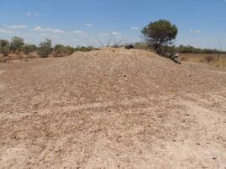 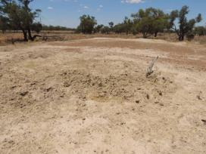

Figure 43 Carpet spring complex—vent 221.6, and vents 235.1 and 235.2

Table 91 Carpet spring complex—hydrogeological information summary.

| Features | Details | Comments |
| --- | --- | --- |
| No. of active vents | 5 | Eastern group: 221.1, 221.6 and 221.7  Western group: 235.1 and 235.2 |
| No. of inactive vents | 5 | Eastern group: 221.2, 221.3, 221.4 and 221.5  Western group: 235.3 |
| Conservation ranking | 1b |  |
| Water bores within 10km radius | 14 |  |
| Water bore water quality samples | 9 |  |
| Spring water quality samples | 1 | Spring 221 |
| Interpreted stratigraphy available |  | DNRM (2012). Wireline logged waterbores (from Habermehl 2001) |
| Outcropping formations |  | Granite inliers located about 18 kilometres south-east at Paroo River complex and near the town of Eulo |
| Underlying aquifers |  | Winton Formation, Wallumbilla Formation (Coreena and Doncaster members), Wyandra Sandstone and Hooray Sandstone |
| SWL time series data available | Yes | Bores 11245, 1189 and 11245  Artesian pressure with no evidence of sustained increase/decrease |
| Likely source aquifers |  | Wyandra Sandstone of the Cadna-owie Formation, and Hooray Sandstone |
| Conceptual spring type | G or H | Most likely |

– = not available, SWL = standing water level.

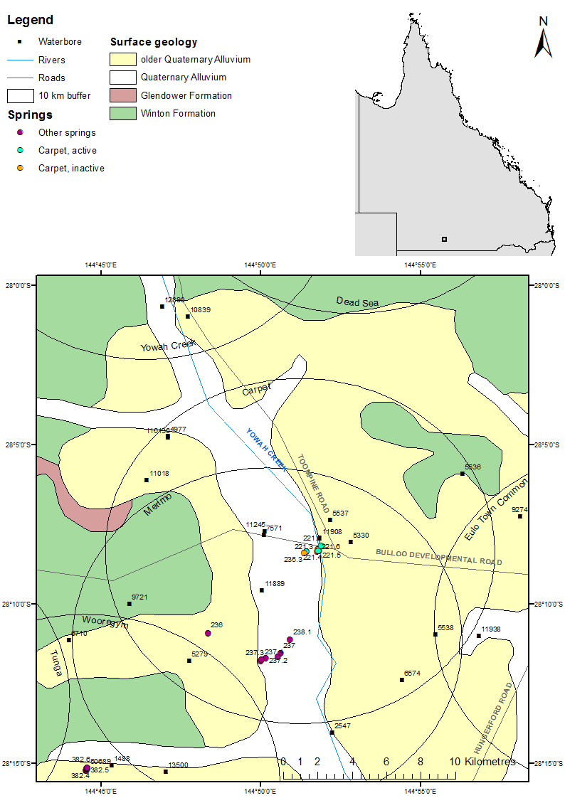

Figure 44 Carpet spring complex—regional geology, Eulo supergroup, Queensland.

### Geology

The Carpet spring vents overlie Quaternary age alluvium associated with Yowah Creek, which is about 1 kilometre east of the spring complex. The area is surrounded by the older floodplain Quaternary alluvium. An inlier of granitic rock of Middle Devonian age is located approximately 18 kilometres east-south-east of the springs at the Paroo River spring complex near Eulo (Figure 44) associated with the Eulo Ridge.

### Regional stratigraphy and underlying aquifers

Stratigraphic logs for waterbores drilled within a 10-kilometre radius of the Carpet springs complex record the following formations: the Winton Formation, the Wallumbilla Formation (comprised of the Coreena and Doncaster members), the Wyandra Sandstone Member of the Cadna-owie Formation and the Hooray Sandstone (Table 93 and Table 94). The deeper waterbore in the region encountered the Hooray Sandstone at depths of more than 230 metres below ground level. Bore 5279 was drilled only to a depth of 79 metres, where granite was encountered.

Shallower bores in the region (less than 100 metres deep) are likely to be sourcing the Winton or Wallumbilla Formation. Deeper bores are thought to be accessing the Wallumbilla Formation and/or the Wyandra Sandstone; however, the lack of screen and casing information negates the ability to clarify which bores tap which aquifers. Casing information is available for the deepest bore in the region, bore 11908, which taps the Hooray Sandstone.

### Water chemistry comparison: springs and waterbores

Hydrochemical data for spring 221.1 was obtained by Fensham (1999) (Table 98). Figure 45 provides a Piper plot of the water chemistry for spring 221.1, and waterbores 11908, 5330, 11245, 7571, 11889, 4977, 116136, 5538 and 6574 (see Table 95, Table 96 and Table 97). The results for the water quality analysis did not include bicarbonate. Total alkalinity was used instead to compare bore and spring water chemistry in the Piper plot. There was no differentiation between the water quality samples for spring 22.1.1 and for water quality samples from local bores, although bore 11245 had slightly elevated chloride levels.

The temperature of bores 4977 and 116136, sourced from either the Wyandra Sandstone or the Hooray Sandstone, are noticeably elevated compared to other bores in the region. Unfortunately, temperature data from spring samples were not available for comparison, although spring temperatures are lower than waterbore temperatures from bores that access the same aquifer as the spring.

### Artesian status of potential source aquifers

There are limited potentiometric data available for waterbores surrounding the Carpet spring complex. Table 99 lists the available elevation and flow rate data for the Carpet springs. Two waterbores had subartesian standing water levels when drilled: bore 9721 drilled in 1974 (standing water level of ­–2.2 metres below reference point) is thought to be accessing the aquifers in the Winton or Wallumbilla formations, and the deeper bore 6574 drilled in 1982 with a recorded standing water level of –3.3 metres. Bores 9721 and 5279 are both recorded as having ceased to flow. These bores were most likely tapping the aquifers within the Doncaster Member of the Wallumbilla Formation, but may have also been accessing local aquifers in the shallower Winton Formation.

Standing water level data over time are available for three bores located close to Carpet springs complex (Figure 46). From available stratigraphic information from bore records, bores 11889 and 11245 are thought to access aquifers either in the Wallumbilla Formation and/or the Wyandra Sandstone Member of the Cadna-owie Formation. Artesian pressures high enough to produce flowing artesian bores have been recorded from the 1950s to the mid-1990s. As the trends in standing water levels are similar, it indicates that these bores are likely accessing the same aquifer. Bore 11889 sources water from the deeper Hooray Sandstone aquifer and strong artesian pressure were observed since records were first taken in the early 1980s (Table 99 and Table 100).

Table 92 Carpet spring complex—spring locations and elevations.

| Vent ID | Latitude | Longitude | Elevation (mAHD) |
| --- | --- | --- | --- |
| 235.1 | ­–28.13897 | 144.85695 | 157.877 |
| 235.2 | ­–28.13897 | 144.85695 | – |
| 235.3 | –28.13968 | 144.85577 | – |
| 221.1 | –28.13750 | 144.86348 | – |
| 221.2 | –28.13808 | 144.86288 | – |
| 221.3 | –28.13909 | 144.86244 | – |
| 221.4 | –28.13873 | 144.86295 | – |
| 221.5 | –28.13858 | 144.86368 | – |
| 221.6 | –28.13867 | 144.86320 | 159.661 |
| 221.7 | –28.13628 | 144.86491 | – |

– = not available, mAHD = metres Australian height datum.

Table 93 Carpet spring complex—wireline logged waterbores within a 50-kilometres radius.

| Bore no. | Distance (km) and direction from springs complex | Top  (mBGL) | Bottom  (mBGL) | Thickness (m) | Rock unit name |
| --- | --- | --- | --- | --- | --- |
| 4538 | 45.9, north-north-east | 0.0 | 21.3 | 21.3 | Morney Profile |
|  | 21.3 | 30.5 | 9.1 | Winton Formation |
|  |  | 30.5 | 191.4 | 160.9 | Wallumbilla Formation |
|  |  | 191.4 | 292.6 | 101.2 | Cadna-owie Formation |
|  |  | 191.4 | 197.2 | 5.8 | Wyandra Sandstone Member |
|  |  | 197.2 | 292.6 | 95.4 | Unnamed Member |
|  |  | 292.6 | 411.5 | 118.9 | Hooray Sandstone |
|  |  | 292.6 | 310.9 | 18.3 | Murta Sandstone |
|  |  | 310.9 | 369.4 | 58.5 | Middle Member |
|  |  | 369.4 | 411.5 | 42.1 | Namur Sandstone member |
|  |  | 411.5 | 438.9 | 27.4 | Basement |
| 4979 | 25.2, north-north-east | 0.0 | 39.6 | 39.6 | Morney Profile |
|  | 39.6 | 57.9 | 18.3 | Winton Formation |
|  |  | 57.9 | 253.0 | 195.1 | Wallumbilla Formation |
|  |  | 253.0 | 326.1 | 73.1 | Cadna-owie Formation |
|  |  | 253.0 | 268.2 | 15.2 | Wyandra Sandstone Member |
|  |  | 268.2 | 326.1 | 57.9 | Unnamed Member |
|  |  | 326.1 | 428.8 | 102.7 | Hooray Sandstone |
|  |  | 428.8 | 434.6 | 5.8 | Basement |
| 6656 | 15.9, north-west | 0.0 | 39.6 | 39.6 | Morney Profile |
|  |  | 39.6 | 70.7 | 31.1 | Coreena Member |
|  |  | 70.7 | 189.6 | 118.9 | Cadna-owie Formation |
|  |  | 70.7 | 240.8 | 170.0 | Wyandra Sandstone Member |
|  |  | 240.8 | 286.8 | 46.0 | Unnamed member |
|  |  | 286.8 | 302.0 | 15.2 | Hooray Sandstone |
| 12736 | 42.3, north-north-west | 0.0 | 13.7 | 13.7 | Cainozoic |
|  | 13.7 | 37.2 | 23.5 | Morney Profile |
|  |  | 37.2 | 91.4 | 54.3 | Winton Formation |
|  |  | 91.4 | 396.2 | 304.8 | Wallumbilla Formation |
|  |  | 91.5 | 246.9 | 155.4 | Coreena Member |
|  |  | 246.9 | 396.2 | 149.3 | Doncaster Member |
|  |  | 396.2 | 463.3 | 67.1 | Cadna-owie Formation |
|  |  | 396.3 | 418.8 | 22.5 | Wyandra Sandstone Member |
|  |  | 418.8 | 463.3 | 44.5 | Unnamed member |
|  |  | 463.3 | 486.1 | 22.9 | Hooray Sandstone |

– = not available, km = kilometre, m = metre, mBGL = metres below ground level.  
© Copyright, Habermehl 2001

Table 94 Carpet spring complex—waterbores within a 10-kilometres radius.

| Bore ID | Top (mBGL) | Bottom (mBGL) | Rock unit name |
| --- | --- | --- | --- |
| 4977 | 0.0 | – | Alluvium |
|  | – | – | Tertiary |
|  | – | – | Winton Formation |
|  | – | – | Wallumbilla Formation |
|  | – | – | Wyandra Sandstone |
|  | – | – | Cadna-owie Formation |
|  | – | 280.7 | Hooray Sandstone |
| 5279 | 0.0 | – | Alluvium |
|  | – | 15.2 | Tertiary |
|  | 15.2 | – | Winton Formation |
|  | – | 79.2 | Wallumbilla Formation |
|  | 77.4 | 79.2 | Granite |
| 5330 | 0.0 | – | Alluvium |
|  | – | – | Tertiary |
|  | – | 48.8 | Winton Formation |
|  | 48.8 | – | Wallumbilla Formation |
| 5536 | 0.0 | – | Alluvium |
|  | – | – | Tertiary |
|  | – | – | Winton Formation |
| 5537 | 0.0 | – | Alluvium |
|  | – | – | Tertiary |
|  | – | – | Winton Formation |
|  | – | 61.0 | Wallumbilla Formation |
| 5538 | 0.0 | – | Alluvium |
|  | – | – | Tertiary |
|  | – | – | Winton Formation |
|  | – | – | Wallumbilla Formation |
|  | – | – | Wyandra Sandstone |
|  | – | – | Cadna-owie Formation |
|  | – | 274.3 | Hooray Sandstone |
| 6574 | 0.0 | – | Alluvium |
|  | – | 12.2 | Tertiary |
|  | 12.2 | 44.2 | Winton Formation |
|  | 44.2 | 207.6 | Wallumbilla Formation |
| 7571 | 0.0 | – | Alluvium |
|  | – | – | Tertiary |
|  | – | 42.7 | Winton Formation |
| 9721 | 0.0 | – | Alluvium |
|  | – | – | Tertiary |
|  | – | 61.0 | Winton |
| 11018 | 0.0 | 36.6 | Winton Formation |
| 11245 | 0.0 | – | Alluvium |
|  | – | 7.3 | Tertiary |
|  | 7.3 | 48.5 | Winton Formation |
|  | 48.5 | 130.1 | Wallumbilla Formation |
|  | 130.1 | 152.4 | Wyandra Sandstone |
| 11908 | 0 | – | Alluvium |
|  | – | 15.2 | Tertiary |
|  | 15.2 | 42.7 | Winton Formation |
|  | 42.7 | 121.6 | Wallumbilla Formation |
|  | 121.6 | – | Wyandra Sandstone |
|  | – | – | Cadna-owie Formation |
|  | – | 234.4 | Hooray Sandstone |
|  | 234.4 | 246.0 | Granite |
| 11889 | 0.0 | – | Alluvium |
|  | – | 10.4 | Tertiary |
|  | 10.4 | – | Winton Formation |
|  | – | 157.0 | Wallumbilla Formation |
|  | 157.0 | 157.3 | Wyandra Sandstone |

– = not available, mBGL = metres below ground level.  
© Copyright, DNRM 2012

Table 95 Carpet spring complex—waterbore details and water chemistry.

| Variable | Details | | | | |
| --- | --- | --- | --- | --- | --- |
| Bore ID | 11908 | 5537 | 5330 | 11245 | 7571 |
| Sample date | 2005 | – | 1969 | 1993 | 2005 |
| Distance from spring complex (km) | 1.3 | 2.4 | 2.7 | 2.3 | 2.0 |
| Source aquifer | Hooray | Winton/  Wallumbilla | Winton/ Wallumbilla | Wallumbilla/Wyandra/Hooray | Winton/ Wallumbilla |
| Screens (metres) | Open hole, section not encased (246) | – | – | – | – |
| Year drilled | 1972 | 1927 | 1942 | 1948 | 1927 |
| Standing water level (natural surface elevation) | 64.7  (1972) | – | – | 33.0  (1972) | – |
| Total depth (metres) | 246 | 61 | 93.9 | 152.4 | 42.7 |
| Natural surface elevation (mAHD) | 157 | 153 | – | 157 | – |
| Facility status | Existing | Abandoned but usable | Abandoned and destroyed | Existing | Existing |
| *Physicochemical parameters* | | | | | |
| EC (µS/cm) | 788 | – | 745 | 709 | 690 |
| pH (field/lab) | 8.5 | – | – | 8.5 | 8.3 |
| Temp (°C) | 32.3 | – | – | 30.8 | 27.3 |
| *Chemical parameters (milligrams per litre)* | | | | | |
| Dissolved oxygen | – | – | – | – | – |
| TSS | 478 | – | 0 | 435.65 | 415 |
| Sodium (Na) | 190 | – | 196 | 172.9 | 162 |
| Potassium (K) | 1.1 | – | – | 0.3 | 1.4 |
| Calcium (Ca) | 0.9 | – | 2 | 2.9 | 1.2 |
| Magnesium (Mg) | 0.1 | – | 0 | 0.3 | 0.5 |
| Chlorine (Cl) | 38 | – | 50 | 38.3 | 39 |
| Sulfate (SO4) | 1 | – | 0 | 0 | 1 |
| Calcium carbonate (CaCO3) | 375 | – | 360 | 324 | 318 |
| Bicarbonate (HCO3–) | 431 | – | 439 | 379.7 | 372 |
| Carbonate (CO32–) | 13 | – | – | 7.7 | 7.4 |
| Fluoride (F) | 0.8 | – | 0.6 | 0.71 | 0.7 |
| Bromine (Br) | – | – | – |  | – |
| Aluminium (Al) | 0.05 | – | – | – | 0.5 |
| Arsenic (As) |  | – | – | – | – |
| Barium (Ba) | – | – | – | – | – |
| Cobalt (Co) | – | – | – | – | – |
| Iron (Fe) | – | – | – | – | – |
| Manganese (Mn) | – | – | – | – | – |
| Silica (SiO2) | 22 | – | – | 24 | 20 |
| Zinc (Zn) | 0.01 | – | – | – | 0.01 |
| Nitrate as NO3 | 0.5 | – | – | 1.9 | 0.5 |

– = not available, EC = electrical conductivity, mAHD = metres Australian height datum, µS/cm = microsiemens per centimetre, TSS = total suspended solids.  
© Copyright, DNRM 2012

Table 96 Carpet spring complex—waterbore details and water chemistry continued.

| Variable | Details | | | | |
| --- | --- | --- | --- | --- | --- |
| Bore ID | 4977 | 5279 | 5536 | 5538 | 6574 |
| Sample date | 1993 | – | – | 2005 | 2005 |
| Distance from spring complex (kilometres) | 9.5 | 8.5 | 9.5 | 8.5 | 9.1 |
| Source aquifer | Wyandra/  Hooray | Wallumbilla | Winton | Wyandra/  Hooray | Wallumbilla/Wyandra |
| Screens (metres) | – | Open hole, section not encased 77.1–79.2 | – | – | – |
| Year drilled | 1972 | 1937 | – | 1942 | 1938 |
| Standing water level | 41.5 (1972) | – | – | 48.9  (1968) (N) | –3.3  (1982) (R) |
| Total depth (metres) | 280.7 | 79.2 | 39.6 | 274.3 | 207.6 |
| Natural surface elevation (mAHD) | – | – | – | 154.5 | 153 |
| Facility status | Abandoned and destroyed | Existing | Abandoned and destroyed | Existing | Existing |
| *Physicochemical parameters* | | | | | |
| EC (µS/cm) | 682 | – | – | 675 | 759 |
| pH (field/lab) | – | – | – | 8.2 | 8.3 |
| Temp (°C) | 40 | – | – | 36.7 | 32.5 |
| *Chemical parameters (milligrams per litre)* | | | | | |
| Dissolved oxygen | – | – | – | – | – |
| TSS | 423.27 | – | – | 406 | 481 |
| Na | 170.2 | – | – | 159 | 192 |
| Sodium (Na) | 1.6 | – | – | 1.3 | 1.2 |
| Potassium (K) | 3.4 | – | – | 1.3 | 2.3 |
| Calcium (Ca) | 0.2 | – | – | 0.1 | 0.4 |
| Magnesium (Mg) | 37.4 | – | – | 35 | 36 |
| Chlorine (Cl) | 0 | – | – | 1 | 1 |
| Sulfate (SO4) | 316 | – | – | 315 | 378 |
| Calcium carbonate (CaCO3 | 368.8 | – | – | 366 | 446 |
| Bicarbonate (HCO3–) | 8 | – | – | 8.5 | 7.4 |
| Fluoride (F) | 0.68 | – | – | 0.6 | 0.68 |
| Bromine (Br) | – | – | – | – | – |
| Aluminium (Al) | – | – | – | 0.5 | 0.05 |
| Arsenic (As) | – | – | – | – | – |
| Barium (Ba) | – | – | – | – | – |
| Cobalt (Co) | – | – | – | – | – |
| Iron (Fe) | – | – | – | 0.01 | – |
| Manganese (Mn) | – | – | – | 0.03 | – |
| Silica (SiO2) | 19 | – | – | 20 | 21 |
| Zinc (Zn) | – | – | – | 0.1 | 0.01 |
| Nitrate as NO3 | 1.6 | – | – | 0.5 | 0.5 |

– = not available, EC = electrical conductivity, mAHD = metres Australian height datum, µS/cm = microsiemens per centimetre, N = natural surface elevation, R = reference point, TSS = total suspended solids.  
© Copyright, DNRM 2012

Table 97 Carpet spring complex—waterbore details and water chemistry continued.

| Variable | Details | | | |
| --- | --- | --- | --- | --- |
| Bore ID | 9721 | 11018 | 11889 | 116136 |
| Sample date | – | – | 2005 | 2004 |
| Distance from spring complex (kilometres) | 9.3 | 9 | 3.0 | 9.4 |
| Source aquifer | Winton | Winton | Wallumbilla/ Wyandra | Wyandra/  Hooray |
| Screens (metres) | – | – | – | Perforated casing section 287.7 |
| Year drilled | – | 1918 | 1951 | 2004 |
| Standing water level | –2.8  (1974) (R) | – | – | – |
| Total depth (metres) | 64.01 | 36.6 | 157.3 | 287.7 |
| Natural surface elevation (mAHD) | – | – | 154 | 167 |
| Facility status | Existing  (ceased to flow) | Abandoned and destroyed | Existing | Existing |
| *Physicochemical parameters* | | | | |
| EC (µS/cm) | – | – | 744 | 680 |
| pH (field/lab) | – | – | 8.8 | 8 |
| Temp (°C) | – | – | 32.9 | 43 |
| *Chemical parameters (milligrams per litre)* | | | | |
| Dissolved oxygen | – | – | – | – |
| TSS | – | – | 453 | 404.58 |
| Sodium (Na) | – | – | 176 | 159.7 |
| Potassium (K) | – | – | 1.6 | 1.5 |
| Calcium (Ca) | – | – | 2 | 2.1 |
| Magnesium (Mg) | – | – | 0.5 | 0.1 |
| Chlorine (Cl) | – | – | 38 | 38.3 |
| Sulfate (SO4) | – | – | 1 | 0.6 |
| Calcium carbonate (CaCO3) | – | – | 352 | 304 |
| Bicarbonate (HCO3–) | – | – | 408 | 357.8 |
| Carbonate (CO32–) | – | – | 11 | 6.2 |
| Fluoride (F) | – | – | 0.7 | 0.62 |
| Bromine (Br) | – | – | – | – |
| Aluminium (Al) | – | – | 0.05 | 0 |
| Arsenic (As) | – | – | – | – |
| Barium (Ba) | – | – | – | – |
| Cobalt (Co) | – | – | – | – |
| Iron (Fe) | – | – | – | – |
| Manganese (Mn) | – | – | – | – |
| Silica (SiO2) | – | – | 23 | 20 |
| Zinc (Zn) | – | – | 0.01 | 0.01 |
| Nitrate as NO3 | – | – | 0.5 | 0 |

– = not available, EC = electrical conductivity, mAHD = metres Australian height datum, µS/cm = microsiemens per centimetre, TSS = total suspended solids   
Note: No water chemistry data are available for bore 116136.   
© Copyright, DNRM 2012

Table 98 Carpet spring complex—spring water chemistry.

| Variable | Details |
| --- | --- |
| Vent ID | 221 |
| Sample date | – |
| *Physicochemical parameters* | |
| EC (µS/cm) | – |
| pH (field/lab) | – |
| Temperature (°C) | – |
| *Chemical parameters (milligrams per litre)* | |
| Dissolved oxygen | – |
| TDS | 564 |
| TSS | – |
| Sodium (Na) | 218 |
| Potassium (K) | 2.9 |
| Calcium (Ca) | 3 |
| Magnesium (Mg) | 0.31 |
| Chlorine (Cl) | 49.3 |
| Sulfate (SO4) | 0.6 |
| Total alkalinity | 393.75 |
| Bicarbonate (HCO3–) | – |
| Carbonate (CO32–) | – |
| Iodine (I) | – |
| Fluoride (F) | – |
| Bromine (Br) | 0.2 |
| Aluminium (Al) | – |
| Arsenic (As) | – |
| Barium (Ba) | – |
| Cobalt (Co) | – |
| Iron (Fe) | – |
| Manganese (Mn) | – |
| Silica (SiO2) | – |
| Strontium (Sr) | – |
| Zinc (Zn) | – |
| Dissolved organic carbon | – |
| Nitrate as NO3 | –0.05 |
| Phosphate (PO4) | – |

– = not available, EC = electrical conductivity, µS/cm = microsiemens per centimetre, TDS = total dissolved solids, TSS = total suspended solids.  
© Copyright, EHA 2009

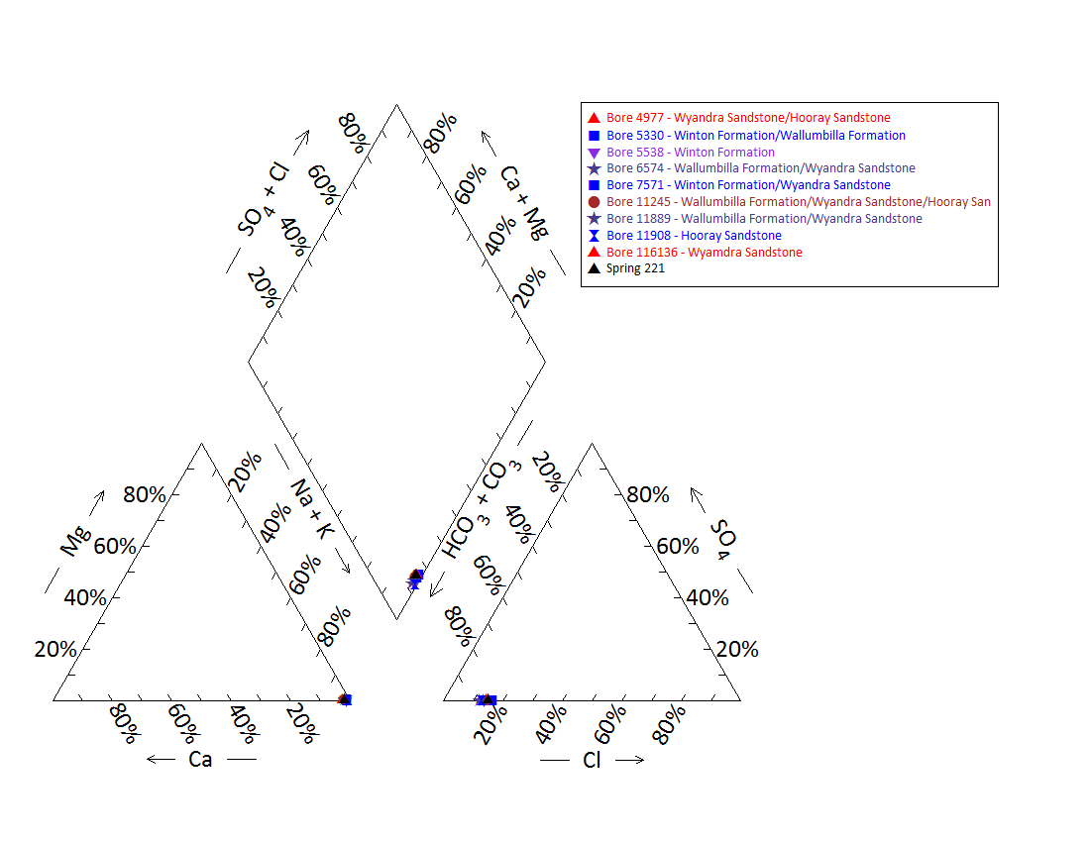

Note: No water chemistry data are available for bore 116136, 5537, 11018, 5536, 5297 and 9721. No water chemistry data are available for springs 221.6, 221.7, 325.1 and 235.2.

Figure 45 Carpet spring complex—Piper plot of the springs and waterbore chemistry.

Table 99 Carpet spring complex—most recent waterbore pump test data.

| Bore ID | Recorded discharge (m3/d) | Standing groundwater level (mAGL) | Date of measurement |
| --- | --- | --- | --- |
| 4977 | 9.13 | 57.21 | 02/03/1993 |
| 5538 | 1.07 | 33.81 | 10/09/1968 |
| 6574 | 2.11 | 17.68 | 01/03/1938 |
| 7571 | 1.11 | 2.55 | 20/03/2005 |
| 9721 | 0.00 | –2.78 | 19/04/1974 |
| 11245 | 0.30 | 21.25 | 01/03/1993 |
| 11889 | 1.35 | 29.22 | 02/03/1993 |
| 11908 | 1.35 | 54.77 | 18/03/2005 |

m3/d = cubic metres per day, mAGL = metres above ground level.  
© Copyright, DNRM 2012

Table 100 Carpet spring complex—spring elevation and flow rate.

| Vent ID | Elevation (mAHD)  (Geodata 9” DEM / SRTM DEM) | Estimated flow rate (L/d) | Date of estimate |
| --- | --- | --- | --- |
| 221 | 155.27/161.74 | 2482.4 | 21/02/1999 |
| 235 | 155.13/159.66 | 127.4 | 22/02/1999 |
| 235.3 | 155.12/160.60 | 1200.0 | – |

– = not available, DEM = digital elevation model, L/d = litres per day, mAHD = metres Australian height datum, SRTM = Shuttle Radar Topography Mission.  
© Copyright, EHA 2009

mAHD = metres Australian height datum.  
© Copyright, DNRM 2012

Figure 46 Carpet spring complex—waterbore standing water levels (SWLs).

## Eulo Town spring complex

### Hydrogeological summary

The Eulo Town spring complex consists of three active spring groups and two inactive spring groups. The likely conceptual spring type for this spring group is a discharge spring complex associated with outcropping granite basement structures underneath the GAB—type I or J.

The source aquifer of the Eulo Town spring complex has not been unequivocally determined; however, like other springs in the region, the most likely aquifers are the Wyandra Sandstone of the Cadna-owie Formation and the deeper Hooray Sandstone aquifer system. Artesian pressures have also been noted for regional aquifers of the shallow Winton Formation, whereas several bores in the region tapping the Doncaster Member of the Wallumbilla Formation are subartesian.

### Spring complex overview

The Eulo Town spring complex is located 2.7 kilometres south-west of the town of Eulo, along the Paroo River (Figure 47). The spring complex consists of five spring groups: Paroo River and Police Paddock spring groups (active); Washing Springs (potentially active); and Eulo Town Common and Pitherty Road springs (inactive). The Paroo River and Washing Spring are among the channels west of town, whereas the Police Paddock, Pitherty Road and Town Common Springs are along an arm of the Paroo floodplain south of town. A summary of basic hydrogeological information available is given in Table 101. Table 102 lists the location and elevation of the Eulo Town spring complex vents. The spring complex has been given a conservation ranking of 1a.

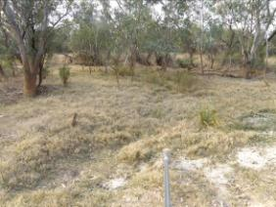 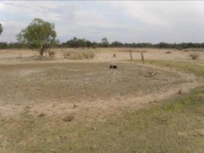

Figure 47 Eulo Town spring complex—Police Paddock and vent 911.

Table 101 Eulo Town spring complex—hydrogeological information summary.

| Feature | Details | Comments |
| --- | --- | --- |
| No. of active vents | 5 | 234, 911, 911.2, 911.3, 956 |
| No. of inactive vents | 5 | 209, 911, 912, 912.1 & 912.2 |
| Conservation ranking | 1a |  |
| Spring water quality samples | 1 | Spring 234 (Paroo River) |
| Waterbores within 10-kilometre radius | 14 |  |
| Waterbore water quality samples | 9 |  |
| Interpreted stratigraphy available | Yes | DNRM (2012). Wireline logged bores (Habermehl 2001) |
| Outcropping GAB formations |  | Winton Formation |
| Underlying aquifers |  | Winton Formation, Wallumbilla Formation (Coreena and Doncaster members), Wyandra Sandstone of the Cadna-owie Formation and Hooray Sandstone |
| SWL time series data available | Yes | Bores 2547, 11908, 13500 |
| Likely source aquifers |  | Wyandra Sandstone of the Cadna-owie Formation or Hooray Sandstone |
| Conceptual spring type | I or J |  |

– = not available, GAB = Great Artesian Basin, SWL = standing water level.

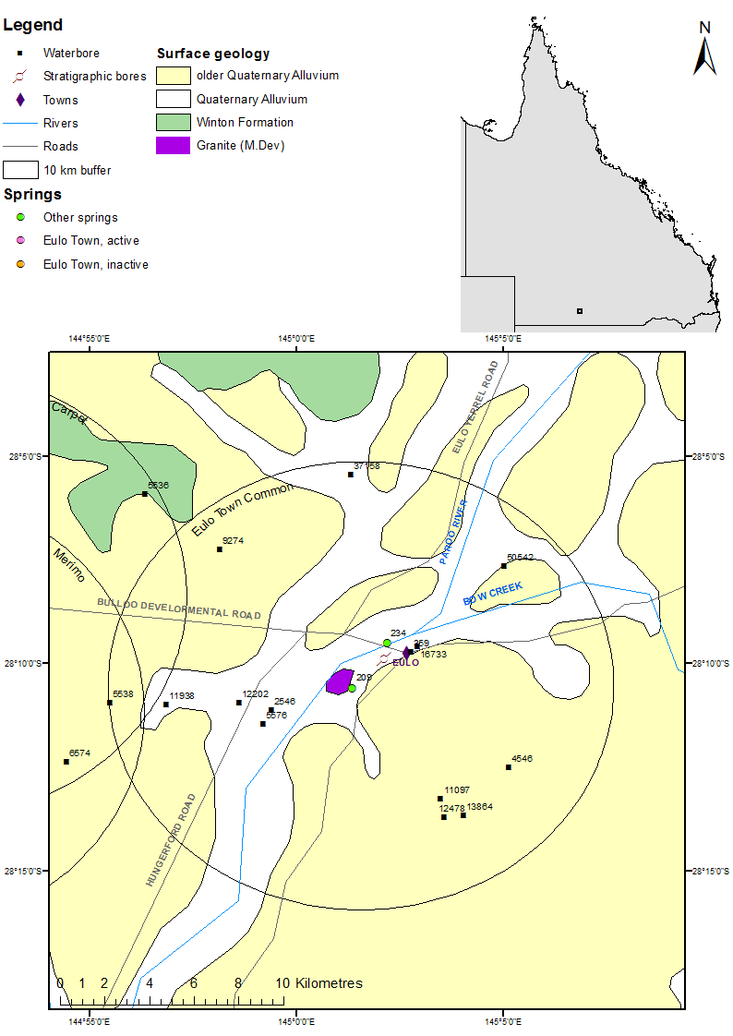

Figure 48 Eulo Town spring complex—regional geology, Eulo supergroup, Queensland.

### Geology

The Eulo Town springs overlie the Quaternary age alluvium of the Paroo River. An outcrop of (Middle) Devonian age granitic rock is present near the springs and the town of Eulo (Figure 48).

### Regional stratigraphy and underlying aquifers

Stratigraphic logs from waterbores within 10 kilometres of the Eulo Town springs record the following formations: the Winton Formation, Wallumbilla Formation (comprised of the Coreena and Doncaster members), Wyandra Sandstone Member of the Cadna-owie Formation and the Hooray Sandstone (Table 103). The deeper waterbores in the region encountered the Hooray Sandstone at depths of more than 190 metres below ground level.

Shallower bores in the region (less than 100 metres deep) are likely to be sourcing the Winton or Wallumbilla Formation. Of the three bores drilled into the Wallumbilla Formation, two were determined to be subartesian and were abandoned (Table 104). However, bore 9274 accesses the Winton Formation and has maintained artesian pressure since drilling, indicating that local artesian aquifers are present in this formation (Table 109).

Deeper bores are thought to be accessing the Wyandra Sandston Member of the Cadna-owie Formation/Hooray Sandstone system; however, the lack of screen and casing information negates the ability to clarify which bores tap which aquifers. Bores accessing these aquifers were recorded to have artesian pressure at the time of drilling. It is not clear whether the pressure was sufficient to produce flowing artesian bores; however, water level data and the lack of any information on pump equipment at the waterbores suggests that they were flowing artesian waterbores.

### Water chemistry comparison: springs and waterbores

Table 104, Table 105 and Table 106 show the available hydrochemical data for waterbores within 10 kilometres of the spring complex. Water chemistry data were only available for vent 234 (Table 107). Figure 49 provides a Piper plot of the water chemistry for the active spring 234, and waterbores 16733, 359, 4546, 13864, 12202, 11938, 5538, 9274 and 37158. The results for the water quality analysis did not include bicarbonate. Total alkalinity was used instead to compare bore and spring water chemistry in the Piper plot. There was no differentiation between the water quality samples for spring 234 and for water quality samples from local waterbores, or between waterbores interpreted to be tapping different aquifers.

### Artesian status of potential source aquifers

Standing water level data over time are available for four bores—11938, 12202, 13864 and 37578—located within a 10-kilometre radius of the Eulo Town springs complex (Table 109 and Figure 50). Due to a lack of casing information, the source aquifer(s) of these bores cannot be definitively ascertained.

Bores 11938 and 37158 are thought to access shallower aquifers in either the Winton or the Wallumbilla Formation. Standing water level for these bores has shown a decreasing trend over time; however, bore 37158 increased markedly on the last reading taken in 2005. Bore 13864, accessing either the Wyandra Sandstone or the Hooray Sandstone, showed a similar trend in standing water level to bore 37158.

Bore 12202, which may access water from either the Wyandra Sandstone of the Cadna-owie Formation or the Hooray Sandstone, experienced a notable decrease in stranding water level between the 1950s and the 1990s, although it maintained artesian pressure on the last measurement taken in 1993.

The recorded elevations for springs in the Eulo Town group are given in Table 108 and range between 156 and 157 metres Australian height datum. If these elevation levels are compared to the standing water levels in Figure 50, no potential source aquifers can be excluded, as all standing water levels for the bores are above the elevations of the springs.

Table 102 Eulo Town spring complex —spring locations and elevations.

| Vent ID | Latitude | Longitude | Elevation (mAHD) | Comments |
| --- | --- | --- | --- | --- |
| 234 | –28.15854 | 145.03631 | 157.34 |  |
| 209 | –28.17673 | 145.02209 | 155.897 | Spring with pipe |
| 911 | –28.18756 | 145.02740 | 156.071 |  |
| 911.1 | –28.18766 | 145.02823 | – |  |
| 911.2 | –28.18813 | 145.02844 | – |  |
| 911.3 | –28.18932 | 145.02831 | – |  |
| 912 | –28.18154 | 145.02366 | – | Possible excavated spring |
| 912.1 | –28.18519 | 145.02403 | – |  |
| 912.2 | –28.18040 | 145.02402 | – |  |
| 956 | –28.14568 | 145.04337 | 156.979 |  |

mAHD = metres Australian height datum.

Table 103 Eulo Town spring complex—waterbores within a 10-kilometre radius.

| Bore ID | Top (mBGL) | Bottom (mBGL) | Rock unit name |
| --- | --- | --- | --- |
| 359 | 0.0 | – | Quaternary/Tertiary |
|  | – | 122.5 | Wallumbilla Formation |
|  | 122.5 | – | Wyandra Formation |
|  | – | – | Cadna-owie Formation |
|  | – | 192.0 | Hooray Sandstone |
| 2546 | 0.0 | – | Alluvium |
|  | – | – | Tertiary |
|  | – | – | Winton Formation |
|  | – | 68.6 | Wallumbilla Formation |
| 4546 | 0.0 | – | Quaternary/Tertiary |
|  | – | 153.6 | Wallumbilla Formation |
|  | 153.6 | 169.2 | Wyandra Formation |
|  | 169.2 | 204.2 | Cadna-owie Formation |
|  | 204.2 | 234.7 | Hooray Sandstone |
| 5538 | 0.0 | – | Alluvium |
|  | – | – | Tertiary |
|  | – | – | Winton Formation |
|  | – | – | Wallumbilla Formation |
|  | – | – | Wyandra Sandstone |
|  | – | – | Cadna-owie Formation |
|  | – | 274.3 | Hooray Sandstone |
| 5576 | 0.0 | – | Alluvium |
|  | – | – | Tertiary |
|  | – | – | Winton Formation |
|  | – | 102.1 | Wallumbilla Formation |
| 9274 | 0.0 | – | Alluvium |
|  | – | 10.1 | Tertiary |
|  | 10.1 | 49.7 | Winton Formation |
| 11097 | 0.0 | – | Quaternary/Tertiary |
|  | – | 147.8 | Wallumbilla Formation |
| 11938 | 0.0 | – | Alluvium |
|  | – | 15.2 | Tertiary |
|  | 15.2 | – | Winton Formation |
|  | – | 189.0 | Wallumbilla Formation |
| 13864 | 0.0 | – | Alluvium |
|  | – | 21.0 | Tertiary |
|  | 21.0 | – | Wallumbilla Formation |
|  | – | – | Wyandra Sandstone |
|  | – | – | Cadna-owie Formation |
|  | – | 179.8 | Hooray Sandstone |
| 16733 | 0.0 | – | Alluvium |
|  | – | 27.4 | Tertiary |
|  | 27.4 | 120.4 | Wallumbilla Formation |
|  | 120.4 | – | Wyandra Sandstone |
|  | – | – | Cadna-owie Formation |
|  | – | 220.4 | Hooray Sandstone |
|  | 220.4 | 223.4 | Granite |
| 12478 | 0.0 | – | Alluvium |
|  | – | 18.9 | Tertiary |
|  | 18.9 | 61.3 | Wallumbilla Formation |
| 12202 | 0.0 | – | Alluvium |
|  | – | 21.3 | Tertiary |
|  | 21.3 | 41.8 | Winton Formation |
|  | 41.8 | 158.5 | Wallumbilla Formation |
|  | 158.5 | 166.1 | Wyandra Sandstone |
|  | 166.1 | 253.4 | Cadna-owie Formation |
|  | 253.4 | 269.1 | Hooray Sandstone |
| 37158 | 0.0 | – | Alluvium |
|  | – | – | Tertiary |
|  | – | – | Winton Formation |
|  | – | 176.8 | Wallumbilla Formation |
|  | 176.8 | – | Wyandra Sandstone |
|  | – | – | Cadna-owie Formation |
|  | – | 213.4 | Hooray Sandstone |

– = not available, mBGL = metres below ground level.  
Note: No stratigraphic data are available for bore 50542.  
© Copyright, DNRM 2012

Table 104 Eulo Town spring complex—waterbore details and water chemistry.

| Variable | Details | | | | |
| --- | --- | --- | --- | --- | --- |
| Bore ID | 359 | 2546 | 4546 | 5538 | 5576 |
| Sample date | 1979 | – | 2003 | 2005 | – |
| Distance from spring complex (kilometres) | 2.5 | 3.7 | 6.9 | 9.9 | 4.2 |
| Source aquifer | Wyandra Sandstone/ Hooray Sandstone | Winton Formation/ Wallumbilla Formation | Wyandra Sandstone/ Hooray Sandstone | Wallumbilla/Cadna–owie/Hooray | Wallumbilla Formation |
| Screens (metres) | Perforated casing 140.8–179.8 | – | Open-ended pipe 243.8 | – | Open-ended pipe 102.1 |
| Year drilled | 1934 | 1927 | 1932 | 1942 | 1934 |
| Standing water level (natural surface elevation) | 25.6 (1934) | – | – | 48.9 (1968) | – |
| Total depth (metres) | 192 | 68.6? | 234.7 | 274.3 | 102.1 |
| Natural surface elevation (mAHD) | – | – | 171 | 154.5 | – |
| Facility status | Existing | Ceased to flow? | Existing | Existing | Abandoned and destroyed |
| Facility type | Artesian bore, controlled | Artesian bore, uncontrolled | Artesian bore, controlled | Artesian bore, controlled | Artesian bore, controlled |
| *Physicochemical parameters* | | | | | |
| EC (µS/cm) | 800 |  | 846 | 675 | – |
| pH (field/lab) | – | – | 8.4 | 8.2 | – |
| Temperature (°C) | 33 | – | 31.9 | 36.7 | – |
| *Chemical parameters (milligrams per litre)* | | | | | |
| Dissolved oxygen | – | – | – | – | – |
| TSS | 481.96 |  | 521.51 | – | – |
| TDS | – | – | – | 406 | – |
| Sodium (Na) | 186 | – | 207 | 159 | – |
| Potassium (K) | 1.8 | – | 2.1 | 1.3 | – |
| Calcium (Ca) | 2.5 | – | 2.1 | 1.3 | – |
| Magnesium (Mg) | 1 | – | 0.4 | 0.1 | – |
| Chlorine (Cl) | 45 | – | 36.9 | 35 | – |
| Sulfate (SO4) | 4 | – | 0 | 1 | – |
| Alkalinity (calcium carbonate) | 369 | – | 420 | 315 | – |
| Bicarbonate (HCO3–) | 439 | – | 489.6 | 366 | – |
| Carbonate (CO32–) | 5.7 | – | 10.9 | 8.5 | – |
| Fluoride (F) | 0.6 | – | 0.46 | 0.6 | – |
| Bromine (Br) | – | – | – | – | – |
| Aluminium (Al) | – | – | 0.01 | 0.5 | – |
| Arsenic (As) | – | – | – | – | – |
| Barium (Ba) | – | – | – | – | – |
| Cobalt (Co) | – | – | – | – | – |
| Iron (Fe) | – | – | 0.02 | 0.01 | – |
| Manganese (Mn) | – | – | – | 0.03 | – |
| Silica (SiO2) | 19 | – | 20 | 20 | – |
| Strontium (Sr) | – | – | – | – | – |
| Zinc (Zn) | – | – | 0 | 0.1 | – |
| Nitrate as NO3 | 0.5 | – | 1 | – | – |
| Phosphate (PO4) | – | – | – | 0.5 | – |

– = not available, EC = electrical conductivity, mAHD = metres Australian height datum, µS/cm = microsiemens per centimetre, TDS = total dissolved solids, TSS = total suspended solids.  
© Copyright, DNRM 2012

Table 105 Eulo Town spring complex—waterbore details and water chemistry continued

| Variable | Details | | | | |
| --- | --- | --- | --- | --- | --- |
| Bore ID | 9274 | 11097 | 12202 | 11938 | 12478 |
| Sample date | 2005 | – | 2005 | 2005 | – |
| Distance from spring complex (kilometres) | 8.2 | 6.0 | 4.9 | 7.7 | 6.7 |
| Source aquifer | Winton Formation | Wallumbilla Formation | Hooray Sandstone | Hooray Sandstone | Wallumbilla Formation |
| Screens (metres) | – | Perforated casing 147.9 | – | – | Open-ended pipe 61.3 |
| Year drilled | 1948 | 1948 | 1953 | 1952 | 1954 |
| Standing water level (natural surface elevation) | – | –5.7 (1948) | 14.2 (1974) | 28.8 (1974) | –24.4 (1954) |
| Total depth (metres) | 49.7 | 147.8 | 269.1 | 189 | 61.3 |
| Natural surface elevation (mAHD) | 156 | – | 155 | 152 | – |
| Facility status | Abandoned but usable | Abandoned and destroyed | Existing | Existing | Abandoned and destroyed |
| Facility type | Artesian, uncontrolled | Subartesian facility | Artesian bore, controlled | Artesian bore, controlled | Subartesian facility |
| *Physicochemical parameters* | | | | | |
| EC (µS/cm) | 661 | – | 724 | 689 | – |
| pH (field/lab) | 8.5 | – | 8.3 | 8.1 | – |
| Temperature (°C) | 39 | – | 27.9 | 53.8 | – |
| *Chemical parameters (milligrams per litre)* | | | | | |
| Dissolved oxygen | – | – | – | – | – |
| TDS | – | – | – | – | – |
| TSS | 397 | – | 454 | 433 | – |
| Sodium (Na) | 156 | – | 181 | 172 | – |
| Potassium (K) | 1.1 | – | 1.9 | 1.3 | – |
| Calcium (Ca) | 0.9 | – | 2.7 | 3.2 | – |
| Magnesium (Mg) | 0.6 | – | 1 | 0.3 | – |
| Chlorine (Cl) | 36 | – | 38 | 33 | – |
| Sulfate (SO4) | 1 | – | 1 | 1 | – |
| Alkalinity (calcium carbonate) | 304 | – | 351 | 337 | – |
| Bicarbonate (HCO3–) | 354 | – | 416 | 402 | – |
| Carbonate (CO32–) | 8.3 | – | 5.7 | 4.7 | – |
| Fluoride (F) | 0.8 | – | 0.72 | 0.51 | – |
| Bromine (Br) | – | – | – | – | – |
| Aluminium (Al) | 0.5 | – | 0.05 | 0.05 | – |
| Arsenic (As) | – | – | – | – | – |
| Barium (Ba) | – | – | – | – | – |
| Cobalt (Co) | – | – | – | – | – |
| Iron (Fe) | 0.01 | – | 0.01 | 0.03 | – |
| Manganese (Mn) | 0.03 | – | 0.03 | 0.03 | – |
| Silica (SiO2) | 19 | – | 18 | 19 | – |
| Strontium (Sr) | – | – | – | – | – |
| Zinc (Zn) | 0.1 | – | 0.01 | 0.01 | – |
| Nitrate as NO3 | – | – | 0.5 | 0.5 | – |
| Phosphate (PO4) | 0.5 | – | – | – | – |

– = not available, EC = electrical conductivity, mAHD = metres Australian height datum, µS/cm = microsiemens per centimetre, TDS = total dissolved solids, TSS = total suspended solids.  
© Copyright, DNRM 2012

Table 106 Eulo Town spring complex—waterbore details and water chemistry continued.

| Variable | Details | | | |
| --- | --- | --- | --- | --- |
| Bore ID | 13864 | 16733 | 37158 | 50542 |
| Sample date | 2003 | 1979 | 2005 | – |
| Distance from spring complex (kilometres) | 7.1 | 2.8 | 9.4 | 7.8 |
| Source aquifer | Wyandra Sandstone/ Hooray Sandstone | Wyandra Sandstone/ Hooray Sandstone | Winton/ Wallumbilla | – |
| Screens (metres) | Open-ended pipe 179.9 | Perforated casing 150.9, 153.6, 20.0+0.7, 212.4 and 214.6 | Perforated casing 123.7–127.4 | – |
| Year drilled | 1959 | 1966 | 1972 | – |
| Standing water level (natural surface elevation) | 62.6 (1959) | 34.4 (1972) | 48.2 (1972) | – |
| Total depth (metres) | 179.8 | 214.6 | 213.4 | – |
| Natural surface elevation (mAHD) | 170 | – | 154 | – |
| Facility status | Existing | Existing | Existing | Abandoned and destroyed |
| Facility type | Artesian bore, controlled | Artesian bore, controlled | Artesian bore, controlled | Subartesian facility |
| *Physicochemical parameters* | | | | |
| EC (µS/cm) | 816 | 770 | 811 | – |
| pH (field/lab) | 8.3 | – | – | – |
| Temperature (°C) | 36.3 | 33 | – | – |
| *Chemical parameters (milligrams per litre)* | | | | |
| Dissolved oxygen | – | – | – | – |
| TDS | 506.76 | 484.06 | – | – |
| TSS | – | – | 513 | – |
| Sodium (Na) | 206 | 184 | 205 | – |
| Potassium (K) | 2.2 | 1.5 | 1.1 | – |
| Calcium (Ca) | 1.5 | 5 | 2.2 | – |
| Magnesium (Mg) | 0.4 | 1 | 0.4 | – |
| Chlorine (Cl) | 36 | 50 | 37 | – |
| Sulfate (SO4) | 0 | 3 | 1 | – |
| Alkalinity (calcium carbonate) | 397 | 365 | 406 | – |
| Bicarbonate (HCO3–) | 464.1 | 439 | 478 | – |
| Carbonate (CO32–) | 6 | 2.9 | 8.7 | – |
| Fluoride (F) | 0.54 | 0.5 | 0.7 | – |
| Bromine (Br) | – | – | – | – |
| Aluminium (Al) | 0 | – | 0.05 | – |
| Arsenic (As) | – | – | – | – |
| Barium (Ba) | – | – | – | – |
| Cobalt (Co) | – | – | – | – |
| Iron (Fe) | 0 | – | 0.03 | – |
| Manganese (Mn) | 0.01 | – | 0.03 | – |
| Silica (SiO2) | 22 | 20 | 23 | – |
| Strontium (Sr) | – | – | – | – |
| Zinc (Zn) | 0 | – | 0.01 | – |
| Dissolved organic carbon | 0.3 | 0.3 | – | – |
| Nitrate as NO3 | – | – | 0.5 | – |
| Phosphate (PO4) | – | – | – | – |

– = not available, EC = electrical conductivity, mAHD = metres Australian height datum, µS/cm = microsiemens per centimetre, TDS = total dissolved solids, TSS = total suspended solids.  
© Copyright, DNRM 2012

Table 107 Eulo Town spring complex—spring water chemistry (Paroo River).

| Variable | Details |
| --- | --- |
| Vent ID | 234 |
| Sample date | – |
| *Physicochemical parameters* | |
| EC (µS/cm) | – |
| pH (field/lab) | – |
| Temperature (°C) | – |
| *Chemical parameters* *(milligrams per litre)* | |
| Dissolved oxygen | – |
| TDS | 966 |
| TSS |  |
| Sodium (Na) | 348 |
| Potassium (K) | 2.4 |
| Calcium (Ca) | 7.3 |
| Magnesium (Mg) | 1.8 |
| Chlorine (Cl) | 87.7 |
| Sulfate (SO4) | 2.25 |
| Total alkalinity | 601.25 |
| Bicarbonate (HCO3–) | – |
| Carbonate (CO32–) | – |
| Iodine (I) | – |
| Fluoride (F) | – |
| Bromine (Br) | 0.25 |
| Aluminium (Al) | – |
| Arsenic (As) | – |
| Barium (Ba) | – |
| Cobalt (Co) | – |
| Iron (Fe) | – |
| Manganese (Mn) | – |
| Silica (SiO2) | – |
| Strontium (Sr) | – |
| Zinc (Zn) | – |
| Dissolved organic carbon | – |
| Nitrate as NO3 | 6.6 |
| Phosphate (PO4) | – |

– = not available, EC = electrical conductivity, µS/cm = microsiemens per centimetre, TDS = total dissolved solids, TSS = total suspended solids.  
© Copyright, EHA 2009

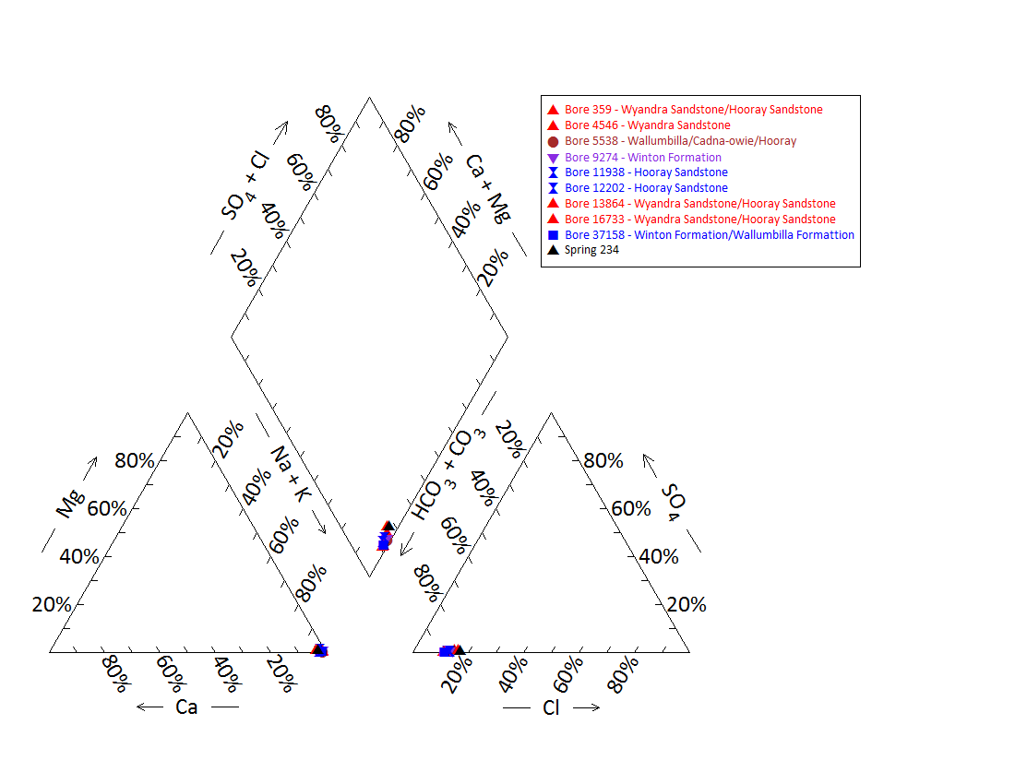

Note: No water chemistry data were available for bored 11097, 12478, 2546, 5576 and 50542, and springs, 911, 911.1, 911.2, 911.3 and 956.

Figure 49 Eulo Town spring complex—Piper plot of spring and waterbore chemistry (Paroo River).

Table 108 Eulo Town spring complex—spring elevation details.

| Site | Elevation (mAHD) (dGPS 2012) | Estimated flow rate (L/d) | Date of estimate |
| --- | --- | --- | --- |
| 234 | 157.340 | 2265 | Fatchen (2001) |
| 209 | 155.897 | – | – |
| 911 | 156.071 | – | – |
| 956 | 156.979 | – | – |

– = not available, dGPS = differential global positioning system, L/d = litres per day, mAHD = metres Australian height datum.  
© Copyright, EHA 2009

Table 109 Eulo Town spring complex—most recent waterbore pump test data.

| Bore ID | Recorded discharge (m3/d) | Standing water level (mAGL) | Date of measurement |
| --- | --- | --- | --- |
| 359 | 2.77 | 22.58 | 14/08/1979 |
| 4546 | – | – | – |
| 5538 | – | – | – |
| 9274 | 1.00 | 12.47 | 17/03/2005 |
| 11938 | 2.66 | 20.23 | 17/03/2005 |
| 12202 | 0.96 | 7.36 | 20/02/1993 |
| 13864 | 4.71 | 39.44 | 16/11/2003 |
| 16733 | 5.13 | 24.52 | 15/08/1979 |
| 37158 | 2.21 | 39.85 | 17/11/2005 |

m3/d = cubic metres per day, mAGL = metres above ground level.  
© Copyright, DNRM 2012

mAHD = metres Australian height datum.

Figure 50 Eulo Town spring complex—waterbore standing water levels (SWLs).

## Merimo spring complex

### Hydrogeological summary

The Merimo spring complex is a discharge spring complex of three active mud and water springs. There are no outcropping formations or mapped geological faults present at the location of the springs, although an outcrop of granite is located at the Paroo River (near Eulo Town) springs complex approximately 20 kilometres east of the Merimo springs.

The likely conceptual spring model type for this spring group is a discharge spring complex associated with an unmapped fault (E or F) or a discharge spring complex associate with subcropping basement outliers (G or H) underneath the GAB.

The source aquifer of the Merimo spring complex is unknown; however, like other springs in the region, the most likely aquifers are the Wyandra Sandstone of the Cadna-owie Formation or the deeper Hooray Sandstone aquifer. There is no conclusive evidence to discount the shallower aquifers of the Wallumbilla Formation or Winton Formation, although some bores accessing these aquifers in the region have been recorded with subartesian pressures.

### Spring complex overview

The Merimo spring complex is located approximately 21 kilometres west-north-west from Eulo, south-west Queensland, and about 2.7 kilometres west of the Paroo River. Three active springs were recorded in 2012 (Figure 51). Approximately 20 more mounds, mostly inactive, were observed across an area of about 2 square kilometres west of spring 237 on Yowah Creek. The spring complex has been given a conservation ranking of 1b. Global positioning system locations were taken at three inactive (237.1–237.3) and one active (237.4) spring. A summary of basic hydrogeological information available is given at Table 110. Table 111 lists the location and elevation of the Merimo spring vents.

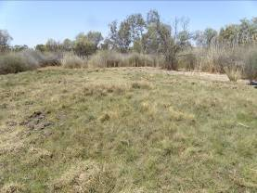 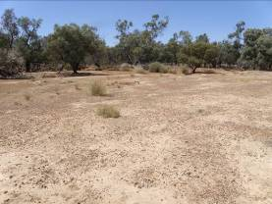

Figure 51 Merimo spring complex—vent 237 and inactive vent.

Table 110 Merimo spring complex—hydrogeological information summary.

| Feature | Details | Comments |
| --- | --- | --- |
| No. of active vents | 3 | 236, 237 and 237.4 |
| No. of inactive vents | 4 | 237.1–237.3 and 238.1 |
| Conservation ranking | 1b |  |
| Spring water quality samples | No |  |
| Waterbores within 10-kilometre radius | 12 |  |
| Waterbore water quality samples | 9 |  |
| Interpreted stratigraphy available |  | DNRM (2012). Wireline logged bores (Habermehl 2001) |
| Outcropping GAB formations | No |  |
| Underlying aquifers |  | Winton Formation, Wallumbilla Formation (Doncaster Member) and Wyandra Sandstone of the Cadna-owie Formation |
| SWL time series data available | Yes | Bores 11908 and 13500 (artesian bores) |
| Likely source aquifers |  | Wyandra Sandstone or Hooray Sandstone |
| Conceptual spring type | G or H |  |

– = not available, GAB = Great Artesian Basin, SWL = standing water level.

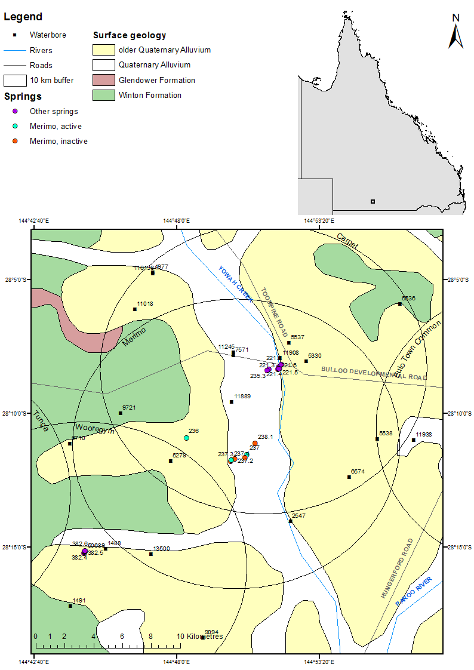

Figure 52 Merimo spring complex—regional geology, Eulo supergroup, Queensland.

### Geology

The Merimo spring vents overlie Quaternary age alluvium associated with Yowah Creek. The area is surrounded by older floodplain Quaternary alluvium. An inlier of granitic rock of Middle Devonian age is located approximately 18 kilometres east of the springs at the Paroo River spring complex near the town of Eulo (Figure 52) associated with the Eulo Ridge.

### Regional stratigraphy and underlying aquifers

Stratigraphic logs for waterbores drilled within a 10-kilometre radius of the Merimo spring complex record the following formations: the Winton Formation, Wallumbilla Formation (comprised of the Coreena and Doncaster members), Wyandra Sandstone Member of the Cadna-owie Formation and the Hooray Sandstone (Table 112). The deeper waterbore in the region encountered the Hooray Sandstone at depths of more than 230 metres below ground level. Bore 5279 was drilled only to a depth of 79 metre where, according to the driller’s logs, granite was encountered; however, the interpreted stratigraphy for this bore lists the Wallumbilla Formation at 79 metres (DNRM 2012).

Shallower bores in the region (less than 100 metres deep) are likely to be sourcing the Winton or Wallumbilla Formation. Deeper bores are thought to be accessing the Wallumbilla Formation and/or the Wyandra Sandstone Member; however, the lack of screen and casing information negates the ability to clarify which bores tap which aquifers. Casing information is available for bore 5279 (accessing the Wallumbilla Formation), bores 11908 and 13500 (accessing the Hooray Sandstone).

### Water chemistry comparison: springs and waterbores

No water chemistry samples have been taken from the Merimo spring complex. Available water chemistry data for the waterbores are shown in Table 113 and Table 114. Table 115 lists the available physicochemical and elevation data for Merimo springs. A Piper plot comparing the waterbore chemistry is shown in Figure 53. No differentiation in bore water chemistry can be seen, despite the bores being recorded as tapping different formations.

### Artesian status of potential source aquifers

Two bores in the region have been recorded asceased to flow: bore 5279 (accessing aquifers of the Wallumbilla Formation) and 9721 (accessing aquifers of the Winton Formation). All other bores have recorded flowing artesian pressures, with water levels above the natural surface elevation (Table 113 and Table 114), except for bore 6574, which only has water levels measured from a reference point.

Standing water level data over time is available for three bores (2547, 11908 and 13500) located within 10 kilometres of Merimo spring complex (Figure 54 and Table 116). These bores source water from the Hooray Sandstone aquifer and show they maintained artesian flow.

Table 111 Merimo spring complex—spring locations and elevations.

| Vent ID | Latitude | Longitude | Elevation (mAHD) |
| --- | --- | --- | --- |
| 236 | –28.18172 | 144.80556 | 161.050 |
| 237 | –28.18531 | 144.84842 | 155.010 |
| 2237.1 | –28.19231 | 144.84343 | 153.892 |
| 237.2 | –28.19417 | 144.84227 | 155.968 |
| 237.3 | –28.19494 | 144.83585 | 155.984 |
| 237.4 | –28.19623 | 144.83325 | 155.822 |
| 238.1 | –28.19580 | 144.83350 | 155.271 |

mAHD = metres Australian height datum.

Table 112 Merimo spring complex—waterbores within a 10-kilometre radius.

| Bore ID | Top (mBGL) | Bottom (mBGL) | Rock unit name |
| --- | --- | --- | --- |
| 2547 | 0.0 | – | Alluvium |
|  | – | – | Tertiary |
|  | – | – | Winton Formation |
|  | – | – | Wallumbilla Formation |
|  | – | 190.5 | Wyandra Sandstone |
| 5279 | 0.0 | – | Alluvium |
|  | – | 15.2 | Tertiary |
|  | 15.2 | – | Winton Formation |
|  | – | 79.2 | Wallumbilla Formation |
| 5330 | 0.0 | – | Alluvium |
|  | – | – | Tertiary |
|  | – | 48.8 | Winton Formation |
|  | 48.8 | – | Wallumbilla Formation |
| 5537 | 0.0 | – | Alluvium |
|  | – | – | Tertiary |
|  | – | – | Winton Formation |
|  | – | 61.0 | Wallumbilla Formation |
| 5538 | 0.0 | – | Alluvium |
|  | – | – | Tertiary |
|  | – | – | Winton Formation |
|  | – | – | Wallumbilla Formation |
|  | – | – | Wyandra Sandstone |
|  | – | – | Cadna-owie Formation |
|  | – | 274.3 | Hooray Sandstone |
| 6574 | 0.0 | – | Alluvium |
|  | – | 12.2 | Tertiary |
|  | 12.2 | 44.2 | Winton Formation |
|  | 44.2 | 207.6 | Wallumbilla Formation |
| 7571 | 0.0 | – | Alluvium |
|  | – | – | Tertiary |
|  | – | 42.7 | Winton Formation |
| 9721 | 0.0 | – | Alluvium |
|  | – | – | Tertiary |
|  | – | 61.0 | Winton Formation |
| 11889 | 0.0 | – | Alluvium |
|  | – | 10.4 | Tertiary |
|  | 10.4 | – | Winton Formation |
|  | – | 157.0 | Wallumbilla Formation |
|  | 157.0 | 157.3 | Wyandra Sandstone |
| 11245 | 0.0 | – | Alluvium |
|  | – | 7.3 | Tertiary |
|  | 7.3 | 48.5 | Winton Formation |
|  | 48.5 | 130.1 | Wallumbilla Formation |
|  | 130.1 | 152.4 | Wyandra Sandstone |
| 11908 | 0.0 | – | Alluvium |
|  | – | 15.2 | Tertiary |
|  | 15.2 | 42.7 | Winton Formation |
|  | 42.7 | 121.6 | Wallumbilla Formation |
|  | 121.6 | – | Wyandra Sandstone |
|  | – | – | Cadna-owie Formation |
|  | – | 234.4 | Hooray Sandstone |
|  | 234.4 | 246.0 | Granite |
| 13500 | 0.0 | – | Alluvium |
|  | – | 12.5 | Tertiary |
|  | 12.5 | – | Winton Formation |
|  | – | 177.7 | Wallumbilla Formation |
|  | 177.7 | – | Wyandra Sandstone |
|  | – | – | Cadna-owie Formation |
|  | – | 273.7 | Hooray Sandstone |

– = not available, mBGL = metres below ground level.  
© Copyright, DNRM 2012

Table 113 Merimo spring complex—waterbore details and water chemistry.

| Variable | Details | | | | | |
| --- | --- | --- | --- | --- | --- | --- |
| Bore ID | 2547 | 5279 | 5330 | 5537 | 5538 | 6574 |
| Sample date | 2005 | – | 1969 | – | 2005 | 2005 |
| Distance from spring complex (kilometres) | 6.3 | 4.2 | 7.1 | 7.7 | 8.7 | 7.3 |
| Aquifer | Winton/ Wallumbilla Wyandra/ Hooray | Wallumbilla | Wallumbilla | Wallumbilla | Hooray Sandstone | Winton/ Wallumbilla/ Hooray |
| Screens (metres) | – | Open hole, section not encased 77.1–79.2 | – | – | – | – |
| Year drilled | 1964 | 1937 | 1942 | 1927 | 1942 | 1938 |
| Standing water level | 9.1 (1974) (N) | – | – | – | 48.8 (1968) | –3.3 (1982) (R) |
| Total depth (metres) | 190.5 | 79.2 | 93.9 | 61 | 274.3 | 207.6 |
| Natural surface elevation (mAHD) | 148 | – | – | 153 | 154.5 | 153 |
| Facility status | Existing | Existing | Abandoned and destroyed | Abandoned but usable | Existing | Existing |
| Facility type | Artesian bore, controlled flow | Artesian bore, ceased to flow | Artesian bore, uncontrolled | Artesian bore, controlled flow | Artesian bore, controlled flow | Artesian bore, uncontrolled.  Ceased to flow? |
| *Physicochemical parameters* | | | | | | |
| EC (µS/cm) | 1030 | – | 745 | – | 675 | 759 |
| pH (field/lab) | 8.4 | – | – | – | 8.2 | 8.3 |
| Temperature (°C) | 31.7 | – | – | – | 36.7 | 32.5 |
| *Chemical parameters (milligrams per litre)* | | | | | | |
| Dissolved oxygen | – |  | – | – | – | – |
| TDS | – | – | – | – | – | – |
| TSS | 467 | – | 0 | – | 406 | 481 |
| Sodium (Na) | 262 | – | 196 | – | 159 | 192 |
| Potassium (K) | 3.8 | – | – | – | 1.3 | 1.2 |
| Calcium (Ca) | 2.5 | – | 2 | – | 1.3 | 2.3 |
| Magnesium (Mg) | 0.9 | – | 0 | – | 0.1 | 0.4 |
| Chlorine (Cl) | 84 | – | 50 | – | 35 | 36 |
| Sulfate (SO4) | 1 | – | 0 | – | 1 | 1 |
| Alkalinity (calcium carbonate) | 456 | – | 360 | – | 315 | 378 |
| Bicarbonate (HCO3–) | 537 | – | 439 | – | 366 | 446 |
| Carbonate (CO32–) | 9 | – | – | – | 8.5 | 7.4 |
| Fluoride (F) | 0.59 | – | 0.6 | – | 0.6 | 0.68 |
| Bromine (Br) | – | – | – | – | – | – |
| Aluminium (Al) | 0.05 | – | – | – | 0.5 | 0.05 |
| Arsenic (As) | – | – | – | – | – | – |
| Barium (Ba) | – | – | – | – | – | – |
| Cobalt (Co) | – | – | – | – | – | – |
| Iron (Fe) | 0.07 | – | – | – | 0.01 | 0.02 |
| Manganese (Mn) | 0.03 | – | – | – | 0.03 | 0.03 |
| Silica (SiO2) | 20 | – | – | – | 20 | 21 |
| Strontium (Sr) | – | – | – | – |  | – |
| Zinc (Zn) | 0.01 | – | – | – | 0.1 | 0.01 |
| Dissolved organic carbon | – | – | – | – |  | – |
| Nitrate as NO3 | 0.5 | – | – | – | 0.5 | 0.5 |

– = not available, EC = electrical conductivity, mAHD = metres Australian height datum, µS/cm = microsiemens per centimetre, N = natural surface elevation, R = reference point, TDS = total dissolved solids, TSS = total suspended solids.  
© Copyright, DNRM 2012

Table 114 Merimo spring complex—waterbore details and water chemistry continued.

| Variable | Details | | | | | |
| --- | --- | --- | --- | --- | --- | --- |
| Bore ID | 7571 | 9721 | 11245 | 11889 | 11908 | 13500 |
| Sample date | 2005 | – | 1993 | 2005 | 2005 | 2005 |
| Distance from spring complex (kilometres) | 6.1 | 7.3 | 6.3 | 2.9 | 6.5 | 9.2 |
| Source aquifer | Winton Formation | Winton Formation | Winton/ Wallumbilla/ Wyandra | Wallumbilla / Wyandra | Hooray Sandstone | Hooray Sandstone |
| Screens (metres) | – | – | – | – | Open hole, section not encased (246) | Perforated casing 273.8 |
| Year drilled | 1927 | – | 1948 | 1951 | 1972 | 1958 |
| Standing water level (natural surface elevation) | – | –32.91 (1970) | 33 (1972) | – | 64.7 (1972) | 1.2 (1958) |
| Total depth (metres) | 42.7 | 61 | 152.4 | 157.3 | 246 | 273.7 |
| Natural surface elevation (mAHD) | – | – | 157 | 154 | 157 | 163.5 |
| Facility status | Existing | Existing | Existing | Existing | Existing | Existing |
| Facility type | Artesian bore, controlled flow | Artesian bore, ceased to flow | Artesian bore, controlled flow | Artesian bore, controlled flow | Artesian bore, controlled flow | Artesian bore, controlled flow |
| *Physicochemical parameters* | | | | | | |
| EC (µS/cm) | 690 | – | 709 | 744 | 788 | 776 |
| pH (field/lab) | 8.3 | – | 8.5 | 8.8 | 8.5 | 8 |
| Temperature (°C) | 27.3 | – | 30.8 | 32.9 | 32.3 | 39.2 |
| *Chemical parameters (milligrams per litre)* | | | | | | |
| Dissolved oxygen | – | – | – | – | – | – |
| TDS | – | – | – | – | – | – |
| TSS | 415 | – | 435.65 | 453 | 478 | 468 |
| Sodium (Na) | 162 | – | 172.9 | 176 | 190 | 184 |
| Potassium (K) | 1.4 | – | 0.3 | 1.6 | 1.1 | 1.5 |
| Calcium (Ca) | 1.2 | – | 2.9 | 2 | 0.9 | 2 |
| Magnesium (Mg) | 0.5 | – | 0.3 | 0.5 | 0.1 | 0.2 |
| Chlorine (Cl) | 39 | – | 38.3 | 38 | 38 | 48 |
| Sulfate (SO4) | 1 | – | 0 | 1 | 1 | 1 |
| Alkalinity (calcium carbonate) | 318 | – | 324 | 352 | 375 | 351 |
| Bicarbonate (HCO3–) | 372 | – | 379.7 | 408 | 431 | 411 |
| Carbonate (CO32–) | 7.4 | – | 7.7 | 11 | 13 | 8.8 |
| Fluoride (F) | 0.7 | – | 0.71 | 0.7 | 0.8 | 1 |
| Bromine (Br) | – | – | – | – | – | – |
| Aluminium (Al) | 0.5 | – | – | 0.05 | 0.05 | 0.05 |
| Arsenic (As) | – | – | – | – | – | – |
| Barium (Ba) | – | – | – | – | – | – |
| Cobalt (Co) | – | – | – | – | – | – |
| Iron (Fe) | – | – | – | – | – | 0.02 |
| Manganese (Mn) | – | – | – | – | – | 0.03 |
| Silica (SiO2) | 20 | – | 24 | 23 | 22 | 21 |
| Strontium (Sr) | – | – | – | – | – |  |
| Zinc (Zn) | 0.01 | – | – | 0.01 | 0.01 | 0.01 |
| Dissolved organic carbon | – | – | – | – | – |  |
| Nitrate as NO3 | 0.5 | – | 1.9 | 0.5 | 0.5 | 0.5 |
| Phosphate (PO4) | – | – | – | – | – |  |

– = not available, EC = electrical conductivity, mAHD = metres Australian height datum, µS/cm = microsiemens per centimetre, TDS = total dissolved solids, TSS = total suspended solids.  
© Copyright, DNRM 2012

Table 115 Merimo spring complex—spring elevation and water physicochemical data.

| Spring no. | Elevation (mAHD) | Temperature (°C) | pH | Electrical conductivity (µS/cm) |
| --- | --- | --- | --- | --- |
| 236 | 161.050 | 20.4 | 8 | 986 |
| 237 | 153.892 | – | – | – |
| 237.1 | 155.968 | – | – | – |
| 237.2 | 155.984 | – | – | – |
| 237.3 | 155.822 | – | – | – |
| 237.4 | 155.271 | – | – | – |
| 238.1 | 155.010 | – | – | – |

– = not available, mAHD = metres Australian height datum, µS/cm = microsiemens per centimetre.

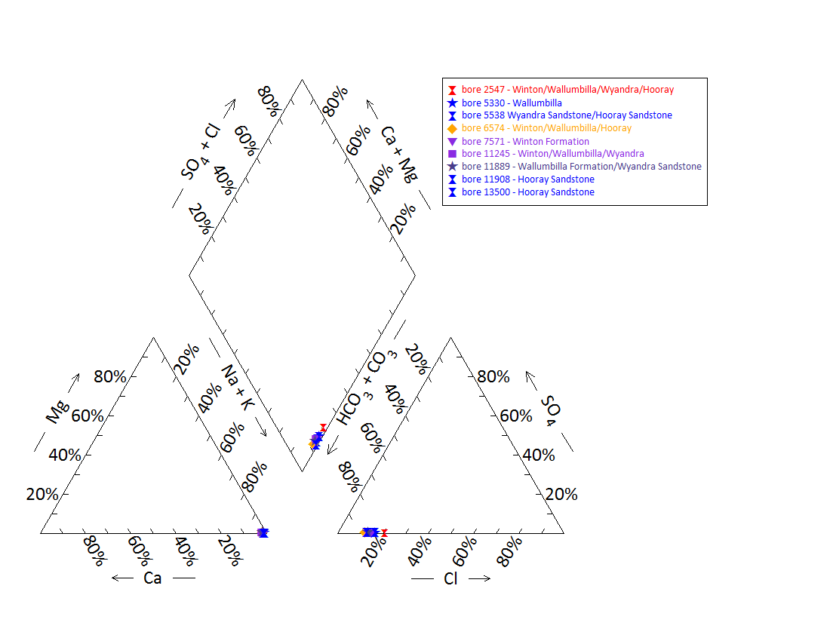

Note: No water chemistry data were available for bores 5279, 9721 and 5537 or any of the springs.

Figure 53 Merimo spring complex—Piper plot of spring and waterbore chemistry.

Table 116 Merimo spring complex—most recent waterbore pump test data.

| Bore ID | Recorded discharge (m3/d) | Standing water level (mAGL) | Date of measurement |
| --- | --- | --- | --- |
| 2547 | 0.25 | 5.11 | 09/10/1981 |
| 5330 | – | – | – |
| 5538 | – | – | – |
| 6574 | – | – | – |
| 7575 | – | – | – |
| 9721 | – | –2.78 | 19/04/1974 |
| 11245 | 0.30 | 21.25 | 01/03/1993 |
| 11889 | 1.35 | 29.22 | 02/03/1993 |
| 11908 | 1.35 | 53.95 | 18/03/2005 |
| 13500 | 0.90 | 25.14 | 19/03/2005 |

m3/d = cubic metres per day, mAGL = metres above ground level.  
© Copyright, DNRM 2012

mAHD = metres Australian height datum.

Figure 54 Merimo spring complex—waterbore standing water levels (SWLs).

## Granite spring complex

### Hydrogeological summary

The Granite spring complex is a discharge spring complex of five active water springs and one inactive spring. The conceptual spring type for this spring group is a discharge spring complex emanating from contact between onlapping Great GAB sediments and outcropping basement—type I or J.

The Granite spring complex is likely sourced from the Hooray Sandstone. The Wyandra Sandstone Member of the Cadna-owie Formation can be discounted as a potential source aquifer in this region, as all bores known to be tapping this aquifer within a 10‑kilometre radius are subartesian.

Hydrochemical analyses of spring and bore water did not conclusive attribute a source aquifer to the spring complex, although water samples from the Wyandra Sandstone Member exhibited higher sodium and chloride levels compared to the spring samples, adding further evidence to discount this aquifer as the source aquifer of the Granite spring complex.

### Spring complex overview

The Granite spring complex is located about 52 kilometres south-west from the town of Eulo, south-west Queensland, in the headwaters of Werewilka, Twomanee and Boorara creeks. The spring complex consists of five active vents and one inactive vent (Figure 55) and has been given a conservation ranking of 1a. A summary of basic hydrogeological information available is in Table 117. Table 118 provides the location of the Granite spring complex spring vents.

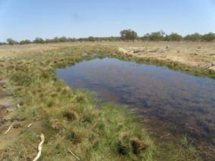 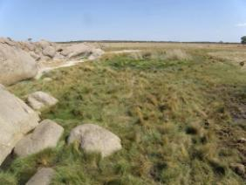

Figure 55 Granite spring complex—vent 201 and Massey spring wetland (vent 203.1).

Table 117 Granite spring complex—hydrogeological information summary.

| Feature | Details | Comments |
| --- | --- | --- |
| No. of active vents | 5 | 201, 202, 203, 203.1 and 906 |
| No. of inactive vents | 1 | 904 |
| Conservation ranking | 1a |  |
| Spring water quality samples | Yes | 201 and 203 |
| Waterbores within 10-kilometre radius | 5 | Bores 1490, 50641, 16386, 16457 |
| Waterbore water quality samples | Yes | Bores 50641, 13542 |
| Interpreted stratigraphy available | Yes |  |
| Outcropping formations |  | Granite outliers present |
| Underlying aquifers |  | Winton Formation, Wallumbilla Formation,Wyandra Sandstone of the Cadna-owie Formation and Hooray Sandstone |
| SWL time series data available | No | All bores in region have ceased to flow (most accessing the Wyandra Sandstone) |
| Likely source aquifers |  | Hooray Sandstone |
| Conceptual spring type | I or J |  |

SWL = standing water level.

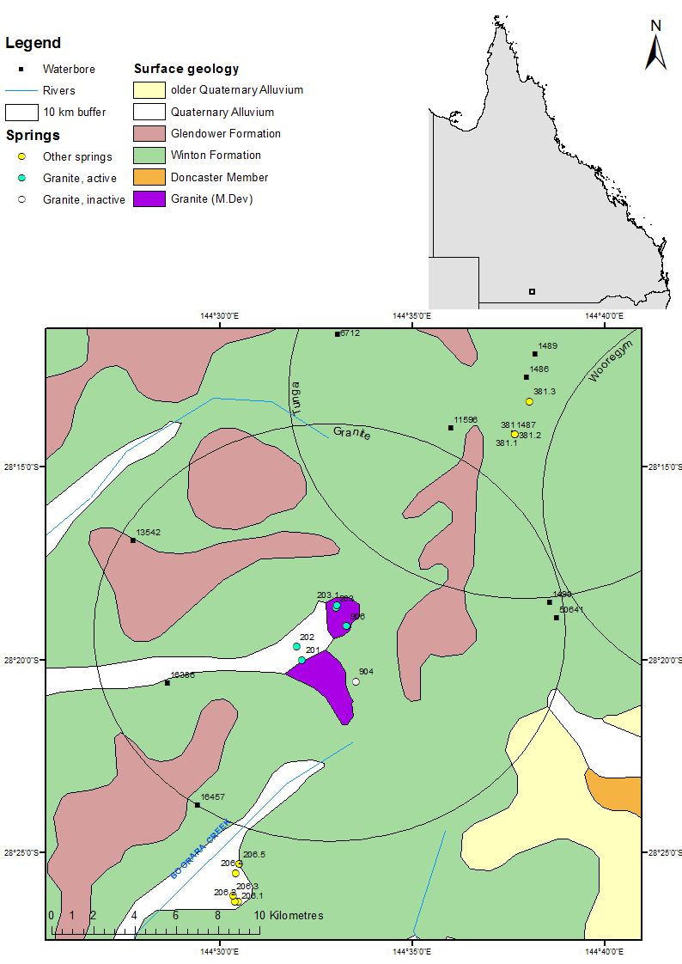

Figure 56 Granite spring complex—regional geology, Eulo supergroup, Queensland.

### Geology

The springs overlie Quaternary alluvium near an outcrop Middle Devonian granite. The Winton Formation makes up the surface of the surrounding area, and there are also some outcrops of the Tertiary Glendower Formation (Figure 56).

### Regional stratigraphy and potential source aquifers for the spring complex

Stratigraphic logs from waterbores within 10 kilometres of the Granite spring complex indicate that the following aquifers underlie the spring complex: the Winton Formation, Wallumbilla Formation (including the Coreena and Doncaster members), Wyandra Sandstone Member of the Cadna-owie Formation and the Hooray Sandstone (Table 119 and Table 120). The maximum waterbore depth is 382 metres in the area, and bore 1490 extends to the granite basement. The Wyandra Sandstone and Hooray Sandstone are recorded at much shallower depths below ground level compared to neighbouring spring complexes (refer to bore 13542). This is because the Winton and Wallumbilla formations are much thinner in this area of the Eulo Ridge, and the Wyandra and Hutton sandstones continue over the rise of the Eulo Shelf. The Bindegolly Fault also appears to have vertically displaced formations above the levels of the formations to the north-east on the Thargomindah Shelf (Eulo 1:250 000SH55-1 geology map, Senior et al. 1971).

Most bores within 10 kilometres of the Granite springs complex are likely accessing the Wyandra Sandstone Member; however, a lack of screen and casing information reduces the certainty of determining the source aquifer. Other aquifers potentially being accessed include the Wallumbilla Formation and the Hooray Sandstone.

### Water chemistry comparison: springs and waterbores

Table 121 shows the available data on waterbore chemistry for bores within a 10-kilometre radius of the spring complex. Hydrochemical data were available for spring vents 201 and 203, and are listed in Table 122. Additional physicochemical data are shown in Table 123. Figure 57 provides a Piper plot of the water chemistry for springs 201 and 202, and waterbores 50641 and 13500. The results of the water quality analyses did not include bicarbonate. Total alkalinity was instead used to compare bore and spring water chemistry in the Piper plot. Bore 13542, which sources water from the Wyandra Sandstone, had elevated sodium and chloride levels compared to the water sample from bore 50641 (unknown source aquifer), and springs 201 and 203.

### Artesian status of potential source aquifers

All bores within 10 kilometres of the Granite springs complex have been recorded as ceased to flow, although they were originally described as flowing artesian bores. No waterbore standing water level data are available.

Table 118 Granite spring complex—spring locations and elevations.

| Vent ID | Latitude | Longitude | Comments |
| --- | --- | --- | --- |
| 904 | –28.34254 | 144.55864 |  |
| 201 | –28.33334 | 144.53535 |  |
| 202 | –28.32747 | 144.53287 | Soaks among a granite outcrop |
| 203 | –28.31076 | 144.55012 | Probably numerous vents |
| 203.1 | –28.30950 | 144.55035 |  |
| 906 | –28.31855 | 144.55466 |  |

Table 119 Granite spring complex—stratigraphic bores within a 50-kilometre radius.

| Bore no. | Distance (km) and direction from springs complex | Top  (mBGL) | Bottom  (mBGL) | Thickness (m) | Rock unit name |
| --- | --- | --- | --- | --- | --- |
| 4538 | 74.1, north-east | 0.0 | 21.3 | 21.3 | Morney Profile |
|  |  | 21.3 | 30.5 | 9.1 | Winton Formation |
|  |  | 30.5 | 191.4 | 160.9 | Wallumbilla Formation |
|  |  | 191.4 | 292.6 | 101.2 | Cadna-owie Formation |
|  |  | 191.4 | 197.2 | 5.8 | Wyandra Sandstone Member |
|  |  | 197.2 | 292.6 | 95.4 | Unnamed Member |
|  |  | 292.6 | 411.5 | 118.9 | Hooray Sandstone |
|  |  | 292.6 | 310.9 | 18.3 | Murta Sandstone |
|  |  | 310.9 | 369.4 | 58.5 | Middle Member |
|  |  | 369.4 | 411.5 | 42.1 | Namur Sandstone member |
|  |  | 411.5 | 438.9 | 27.4 | Basement |
| 4979 | 58.7, north-east | 0.0 | 39.6 | 39.6 | Morney Profile |
|  |  | 39.6 | 57.9 | 18.3 | Winton Formation |
|  |  | 57.9 | 253.0 | 195.1 | Wallumbilla Formation |
|  |  | 253.0 | 326.1 | 73.1 | Cadna-owie Formation |
|  |  | 2530 | 268.2 | 15.2 | Wyandra Sandstone Member |
|  |  | 268.2 | 326.1 | 57.9 | Unnamed member |
|  |  | 326.1 | 428.8 | 102.7 | Hooray Sandstone |
|  |  | 428.8 | 434.6 | 5.8 | Basement |
| 6656 | 39.8, north-east | 0.0 | 39.6 | 39.6 | Morney Profile |
|  |  | 39.6 | 70.7 | 31.1 | Coreena Member |
|  |  | 70.7 | 189.6 | 118.9 | Cadna-owie Formation |
|  |  | 70.7 | 240.8 | 170.0 | Wyandra Sandstone Member |
|  |  | 240.8 | 286.8 | 46.0 | Unnamed member |
|  |  | 286.8 | 302.0 | 15.2 | Hooray Sandstone |
| 12736 | 60.4, north-north-east | 0.0 | 13.7 | 13.7 | Cainozoic |
|  | 13.7 | 37.2 | 23.5 | Morney Profile |
|  |  | 37.2 | 91.4 | 54.3 | Winton Formation |
|  |  | 91.4 | 396.2 | 304.8 | Wallumbilla Formation |
|  |  | 91.5 | 246.9 | 155.4 | Coreena Member |
|  |  | 246.9 | 396.2 | 149.3 | Doncaster Member |
|  |  | 396.2 | 463.3 | 67.1 | Cadna-owie Formation |
|  |  | 396.3 | 418.8 | 22.5 | Wyandra Sandstone Member |
|  |  | 418.8 | 463.3 | 44.5 | Unnamed member |
|  |  | 463.3 | 486.1 | 22.9 | Hooray Sandstone |

– = not available, km = kilometre, m = metre, mBGL = metres below ground level.  
© Copyright, DNRM 2012

Table 120 Granite spring complex—waterbores within a 10-kilometre radius.

| Bore ID | Top (mBGL) | Bottom (mBGL) | Rock unit name |
| --- | --- | --- | --- |
| 1490 | 0.0 | – | Winton Formation |
|  | – | 242.3 | Wallumbilla Formation |
|  | 242.3 | – | Wyandra Sandstone |
|  | – | – | Cadna-owie Formation |
|  | – | 366.1 | Hooray Sandstone |
|  | 366.1 | 382.5 | Granite |
| 13542 | 0.0 | 15.2 | Glendowner Formation |
|  | 15.2 | – | Winton Formation |
|  | – | 42.7 | Wallumbilla Formation |
|  | 42.7 | – | Wyandra Sandstone |
|  | – | 104.9 | Cadna-owie Formation |
|  | 104.9 | 121.9 | Hooray Sandstone |
| 16386 | 0.0 | – | Winton Formation |
|  | – | 65.2 | Wallumbilla Formation |
|  | 65.2 | 87.2 | Wyandra Sandstone |
| 16457 | 0.0 | – | Winton Formation |
|  | – | 74.7 | Wallumbilla Formation |
|  | 74.7 | 82.3 | Wyandra Sandstone |
| 50641 | 305.0 | 367.0 | Hooray Sandstone |

– = not available, mBGL = metres below ground level.  
© Copyright, DNRM 2012

Table 121 Granite spring complex—waterbore details and water chemistry.

| Variable | Details | | | | |
| --- | --- | --- | --- | --- | --- |
| Bore ID | 1490 | 13542 | 16386 | 16457 | 50641 |
| Sample date | – | 1962 | – | – | 1992 |
| Distance from spring complex (kilometres) | 9.5 | 9.5 | 7.3 | 10 | 9.6 |
| Source aquifer | Wyandra Sandstone/  Hooray | Wyandra Sandstone | Wyandra Sandstone | Wallumbilla/ Wyandra? | Wallumbilla/ Wyandra/ Hooray? |
| Screens (metres) | – | Open-ended pipe 59.4–119.2 | Open hole  66.8–71.9 | – | – |
| Water encountered (metres) | – | 48.77–50.29  83.21–104.84 | 41.15–65.53 | – | – |
| Year drilled | 1912 | 1958 | 1965 | 1965 | 1988 |
| Standing water level (natural surface elevation) | – | – | – | –6.1  (1965) | – |
| Total depth (metres) | 382.5 | 121.9 | 71.93 | 82.3 | 368 |
| Natural surface elevation (mAHD) | 207 | 167.7 | 137.8 | 137.2 | 177 |
| Facility status | Abandoned and destroyed | Existing | Existing | Existing | Existing |
| Facility type | Artesian bore, ceased to flow | Artesian bore, ceased to flow | Artesian bore, ceased to flow | Subartesian facility | Artesian bore, ceased to flow |
| *Physicochemical parameters* | | | | | |
| EC (µS/cm) | – | 0 | – | – | 979 |
| pH (field/lab) | – | – | – | – | – |
| Temperature (°C) | – | – | – | 1 | 33 |
| *Chemical parameters* | | | | | |
| Dissolved oxygen | – | – | – | – | – |
| TDS | – | – | – | – | – |
| TSS | – | 0 | – | – | 580.4 |
| Sodium (Na) | – | 463.3 | – | – | 323 |
| Potassium (K) | – | – | – | – | 1.8 |
| Calcium (Ca) | – | 12.9 | – | – | 5.8 |
| Magnesium (Mg) | – | 4.3 | – | – | 0.4 |
| Chlorine (Cl) | – | 677.8 | – | – | 109 |
| Sulfate (SO4) | – | 0 | – | – | 3.4 |
| Alkalinity (calcium carbonate) | – | 103 | – | – | 342 |
| Bicarbonate (HCO3–) | – | 0 | – | – | 400.4 |
| Carbonate (CO32–) | – | 61.5 | – | – | 8.2 |
| Fluoride (F) | – | 1 | – | – | 1.75 |
| Bromine (Br) | – | – | – | – | – |
| Aluminium (Al) | – | – | – | – | – |
| Arsenic (As) | – | – | – | – | – |
| Barium (Ba) | – | – | – | – | – |
| Cobalt (Co) | – | – | – | – | – |
| Iron (Fe) | – | – | – | – | 0.06 |
| Manganese (Mn) | – | – | – | – | 0 |
| Silica (SiO2) | – | – | – | – | 20 |
| Strontium (Sr) | – | – | – | – | – |
| Zinc (Zn) | – | – | – | – | – |
| Dissolved organic carbon | – | – | – | – | – |
| Nitrate as NO3 | – | 0 | – | – | 1.4 |
| Phosphate (PO4) | – | – | – | – | – |

– = not available, EC = electrical conductivity, mAHD = metres Australian height datum, µS/cm = microsiemens per centimetre, TDS = total dissolved solids, TSS = total suspended solids.  
© Copyright, DNRM 2012

Table 122 Granite spring complex—spring water chemistry.

| Variable | Details | |
| --- | --- | --- |
| Vent ID | 201 | 203 |
| Sample date | – | – |
| *Physicochemical parameters* | | |
| EC (µS/cm) | – | – |
| pH (field/lab) | – | – |
| Temperature (°C) | – | – |
| *Chemical parameters* | | |
| Dissolved oxygen | – | – |
| TDS | 883 | 605.00 |
| TSS | – | – |
| Sodium (Na) | 300 | 220.00 |
| Potassium (K) | 8.4 | 3.200 |
| Calcium (Ca) | 3.700 | 5.20 |
| Magnesium (Mg) | 0.98 | 0.700 |
| Chlorine (Cl) | 200.00 | 110.00 |
| Sulfate (SO4) | 4.5 | 3 |
| Alkalinity (calcium carbonate) | 296.25 | 302.5 |
| Bicarbonate (HCO3–) | – | – |
| Carbonate (CO32–) | – | – |
| Fluoride (F) | – | – |
| Iodine (I) | – | – |
| Bromine (Br) | 0.2 | 0.300 |
| Aluminium (Al) | 0 | – |
| Arsenic (As) | – | – |
| Barium (Ba) | – | – |
| Cobalt (Co) | – | – |
| Iron (Fe) | – | – |
| Manganese (Mn) | – | – |
| Silica (SiO2) | – | – |
| Strontium (Sr) | – | – |
| Zinc (Zn) | – | – |
| Dissolved organic carbon | – | – |
| Nitrate as NO3 | 30 | 4.7 |
| Phosphate (PO4) | – | – |

– = not available, EC = electrical conductivity, µS/cm = microsiemens per centimetre, TDS = total dissolved solids, TSS = total suspended solids.  
© Copyright, GAB springs database.

Table 123 Granite spring complex—spring water physicochemical data.

| Site | Temperature (°C) | pH | Electrical conductivity (µS/cm) |
| --- | --- | --- | --- |
| 201 | 28.8 | 7.1 | 2820 |
| 203 | 35.5 | 7.6 | 3380 |
| 906 | 31.7 | 7.6 | 1075 |

µS/cm = microsiemens per centimetre.

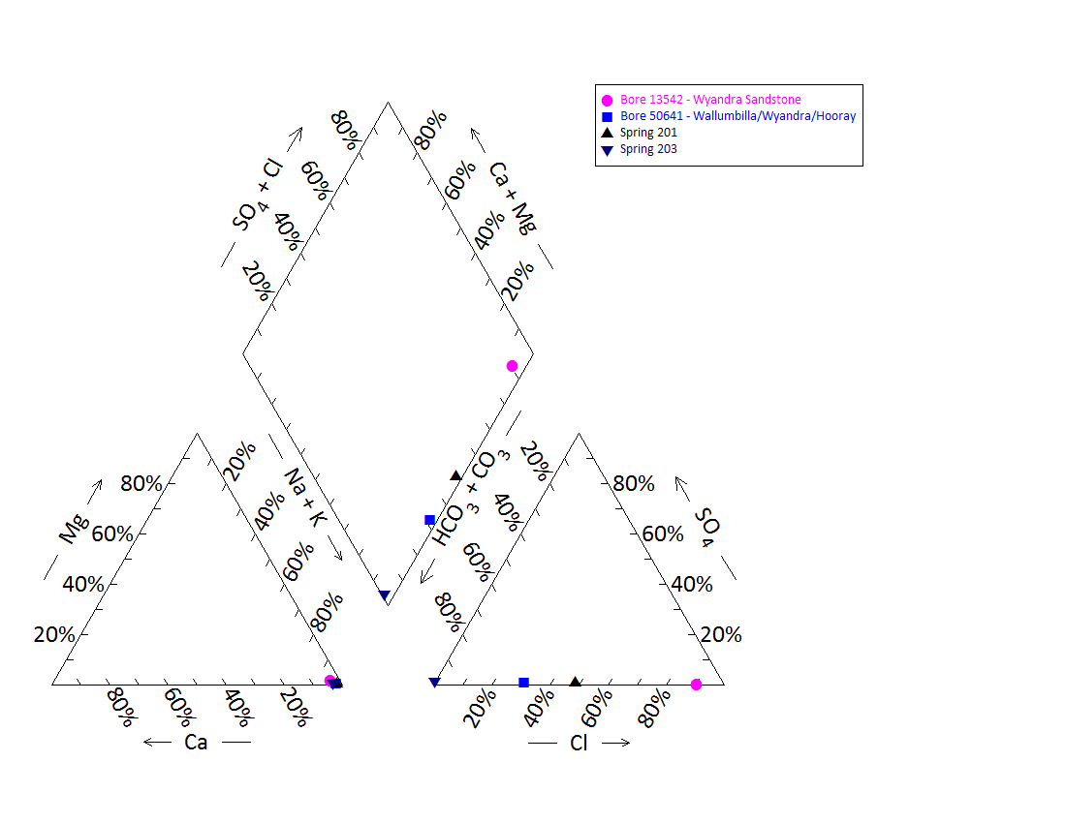

Note: No water chemistry data were available for bores 1490, 16386, 16457 and springs 202, 203.1 and 906.

Figure 57 Granite spring complex—Piper plot of spring and waterbore chemistry.

## Tunga spring complex

### Hydrogeological summary

The Tunga spring complex is a discharge spring complex of three springs and one inactive mud mounded spring. The spring complex may be associated with shallow granite basement.

The spring complex is likely sourced from the Wyandra Sandstone Member of the Cadna-owie Formation or the Hooray Sandstone, the principle GAB aquifer in the region. However, artesian pressure has also historically been recorded from bores accessing the shallower Wallumbilla and Winton formations near the spring complex. These aquifers cannot be discounted as source aquifers. Standing water level information for bores in the region is very limited and old, which prevents the exclusion of aquifers currently exhibiting subartesian pressure levels.

Water quality analyses of spring and bore water did not conclusively attribute a source aquifer to the spring complex. This could be due to several reasons. Firstly, the bores in the region lack casing information and may tap water sources in multiple aquifers. Similarly, the springs may pass through multiple water sources en route to the surface, resulting in water mixing and thereby obscuring any water quality characteristics. An alternative explanation is that these bores and springs could be sourced from the same aquifer; however, there are no data to suggest that water from different aquifers has different water quality characteristics.

### Spring complex overview

The Tunga spring complex lies in the headwaters of Bingara Creek, approximately 40 kilometres west of the township of Eulo. Tunga Spring is located on the southern end of a large stony valley at the foot of Mt Tunga. The complex comprises four active springs (381, 381.1, 381.2 and 901.1), each with several major and minor associated vents (Figure 58). Site 381 has the largest associated wetland covering approximately 105 square metres. The spring group has been given a conservation ranking of 3. Early records from the 19th century indicate that there was a fairly large supply of water from Tunga Springs before the sinking of Tunga bore. Estimates taken from a field survey in 1999 suggest that spring 381 discharges approximately 1277 litres per day. A summary of basic hydrogeological information available is given in Table 124. The locations and elevations of the Tunga Springs are set out in Table 125.

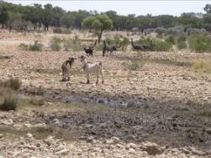 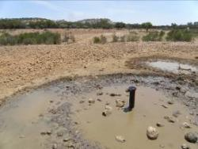

Figure 58 Tunga spring complex—spring and Tunga bore.

Table 124 Tunga spring complex—hydrogeological information summary.

| Feature | Details | Comments |
| --- | --- | --- |
| No. of active vents | 4 | 381, 381.1, 381.2 and 901.1 |
| No. of inactive vents | 2 | 381.3 and 901.2 |
| Conservation ranking | 3 |  |
| Spring water quality samples | Yes | Available for 381 |
| Waterbores within 10km radius | 8 |  |
| Waterbore water quality samples | Yes | Available for 1486, 1487, 6711, 11439 and 6712  No differentiation between bore and spring water quality data |
| Interpreted stratigraphy available | Yes | DNRM (2012). Wireline logged groundwater bores (from Habermehl 2001) |
| Outcropping formations | Yes | Outcropping Middle Devonian granite about 10 kilometres south-west of the Tunga complex |
| Underlying aquifers |  | Winton Formation (subartesian), Wallumbilla Formation and Wyandra Sandstone |
| SWL time series data available | – | Limited and outdated data available. Drilling records indicate subartesian pressure encountered in several bores when drilled |
| Likely source aquifers |  | Potential options are Wyandra Sandstone of the Cadna-owie Formation or Hooray Sandstone |
| Conceptual spring type | E, F, G or H |  |

– = not available, SWL = standing water level.

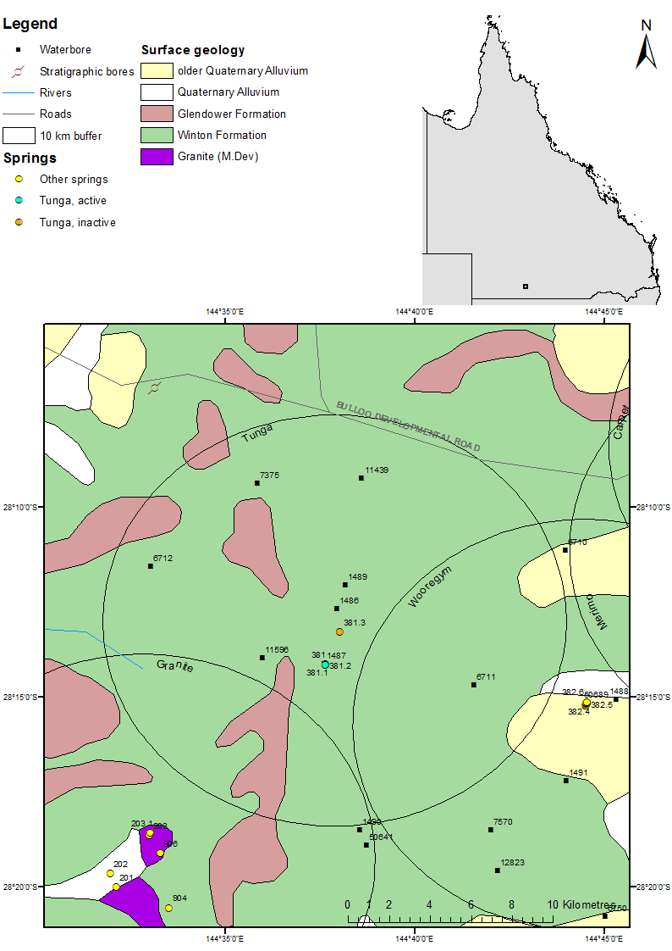

Figure 59 Tunga spring complex—regional geology, Eulo supergroup, Queensland.

### Geology

The spring vents overlie the Winton Formation (EHA 2009), and some alluvium from Bingara Creek. There are outcrops of the Tertiary Glendower Formation within the area of the spring complex. An inlier of Middle Devonian granite is located about 14.2 kilometres south-west of the springs at the headwaters of Boorara and Twomanee creeks. There are no faults in the area, as indicated on the Eulo 1:250 000 SH55-1 geological map sheet and explanatory notes (Senior et al. 1971). However, to the south-west, there is a fault running north-north-west through the inlier of granite at the headwaters of Boorara and Twomanee creeks, but the Tunga Springs are located to the north-east of the granite exposure (Figure 59).

### Regional stratigraphy and underlying aquifers

Stratigraphic bores in the area only reached a depth of about 152 metres (Table 126). Stratigraphic logs from the waterbores within 10 kilometres of the Tunga spring indicate that the following aquifers underlie the spring complex: the Winton Formation, Wallumbilla Formation (including the Coreena and Doncaster members), Wyandra Sandstone Member of the Cadna-owie Formation and the Hooray Sandstone (Table 128). The deepest waterbore in the region encountered the Hooray Sandstone at 314.2 metres below ground surface level (bore 6712). Deeper wireline logged waterbores in the region also record the presence of the Hooray Sandstone, one of the major and most productive artesian aquifers of the GAB (Table 127). The granitic basement is recorded at depths of more than 400 metres below ground level in the area.

The source aquifer for bores are considered to include the shallow Winton Formation (see bore 1489 at 21 metres total depth below ground level), the Coreena and Doncaster members of the Wallumbilla Formation, Wyandra Sandstone of the Cadna-owie Formation and the Hooray Sandstone (i.e. all aquifers in the region). The lack of screen and casing information reduces the certainty of determing if the source aquifer is being tapped.

### Water chemistry comparison: springs and waterbores

Table 129 and Table 130 list the available chemical data for waterbores within 10 kilometres of Tunga spring complex. Water chemistry data were only available for vent 381 and are shown in Table 131. Water quality data were collected from spring 381 by Fensham (1999). Figure 60 provides a Piper plot of the water chemistry for the active spring 381, and for those bores with groundwater quality data available (1486, 1487, 6711, 11439 and 6712). The results for the water quality analysis did not include bicarbonate. Total alkalinity was instead used to compare bore and spring water chemistry in the Piper plot. There was no differentiation between the water quality samples for spring 381 and the bore water quality data analysed here.

### Artesian status of potential source aquifers

There are limited potentiometric data available for waterbores surrounding the Tunga spring complex, particularly recent data. However, from the limited information available, it is likely that many bores in the region experienced subartesian pressure levels when drilled. Several of the deeper bores assumed to be tapping either the Wallumbilla Formation or the Wyandra Sandstone were recorded as having subartesian pressures when drilled, such as bore 7375, which tapped the Wallumbilla Formation and had subartesian pressure when drilled in 1938.

Interestingly, the shallower bores extending less than 100 metres below ground level, which apparently tap the Winton Formation or the Doncaster Member of the Wallumbilla Formation, were recorded as flowing artesian upon drilling early the past century (Table 132), indicating regional shallow confined aquifers may be a potential source (see bores 1486 and 1487 in Table 129).

Bore 6712 is the deepest bore in the area, accessing either the Wyandra Sandstone aquifer of the Cadna-owie Formation or the Hooray Sandstone. There is limited standing water level data over time for this bore, suggesting that this bore dropped from marginal artesian status when drilled to subartesian pressure levels during the following decades (Figure 61).

Table 125 Tunga spring complex—spring locations and elevations.

| Vent ID | Latitude | Longitude | Elevation (mAHD) |
| --- | --- | --- | --- |
| 381 | –28.23562 | 144.62749 | 201 |
| 381.1 | –28.23570 | 144.62742 | 201 |
| 381.2 | –28.23570 | 144.62742 | 201 |
| 381.3 | –28.22141 | 144.63379 | 199 |
| 901.1 | –28.20583 | 144.63344 | 208 |
| 901.2 | –28.20309 | 144.63474 | 202 |

mAHD = metres Australian height datum.

Table 126 Tunga spring complex—stratigraphic bores within a 50-kilometre radius.

| Stratigraphic bore | Distance (km) and direction from springs complex | Top  (mBGL) | Bottom  (mBGL) | Rock unit name |
| --- | --- | --- | --- | --- |
| 2247 | – | 0.0 | 64.0 | Sediments |
| (Toompine 1) |  | 64.0 | 101.2 | Allaru Mudstone |
|  |  | 101.2 | 101.2 | Urisino Beds |
|  |  | 102.2 | 105.1 | Wallumbilla Formation |
| 2718 (Eulo 2) | 13.3, north-west | 0.0 | 40.0 | Winton Formation |
|  |  | 40.0 | 152.4 | Wallumbilla Formation |
|  |  | 40.0 | 90.2 | Coreena Member |
|  |  | 90.2 | 152.4 | Doncaster Member |

– = not available, km = kilometre, mBGL = metres below ground level.  
© Copyright, DNRM 2012

Table 127 Tunga spring complex—wireline logged waterbores within a 50-kilometre radius.

| Bore ID | Distance (km) and direction from springs complex | Top  (mBGL) | Bottom  (mBGL) | Rock unit name |
| --- | --- | --- | --- | --- |
| 4538 | 61.7, north-east | 0.0 | 21.3 | Morney Profile |
|  |  | 21.3 | 30.5 | Winton Formation |
|  |  | 30.5 | 191.4 | Wallumbilla Formation |
|  |  | 191.4 | 292.6 | Cadna-owie Formation |
|  |  | 191.4 | 197.2 | Wyandra Sandstone Member |
|  |  | 197.2 | 292.6 | Unnamed member |
|  |  | 292.6 | 411.5 | Hooray Sandstone |
|  |  | 292.6 | 310.9 | Murta Sandstone |
|  |  | 310.9 | 369.4 | Middle Member |
|  |  | 369.4 | 411.5 | Namur Sandstone member |
|  |  | 411.5 | 438.9 | Basement |
| 4979 | 45.5, north-east | 0.0 | 39.6 | Morney Profile |
|  |  | 39.6 | 57.9 | Winton Formation |
|  |  | 57.9 | 253.0 | Wallumbilla Formation |
|  |  | 253.0 | 326.1 | Cadna-owie Formation |
|  |  | 2530 | 268.2 | Wyandra Sandstone Member |
|  |  | 268.2 | 326.1 | Unnamed member |
|  |  | 326.1 | 428.8 | Hooray Sandstone |
|  |  | 428.8 | 434.6 | Basement |
| 6656 | 24.3, north-east | 0.0 | 39.6 | Morney Profile |
|  |  | 39.6 | 70.7 | Coreena Member |
|  |  | 70.7 | 189.6 | Cadna-owie Formation |
|  |  | 70.7 | 240.8 | Wyandra Sandstone Member |
|  |  | 240.8 | 286.8 | Unnamed member |
|  |  | 286.8 | 302.0 | Hooray Sandstone |
| 12736 | 48.5, north-north-east | 0.0 | 13.7 | Cainozoic |
|  | 13.7 | 37.2 | Morney Profile |
|  |  | 37.2 | 91.4 | Winton Formation |
|  |  | 91.4 | 396.2 | Wallumbilla Formation |
|  |  | 91.5 | 246.9 | Coreena Member |
|  |  | 246.9 | 396.2 | Doncaster Member |
|  |  | 396.2 | 463.3 | Cadna-owie Formation |
|  |  | 396.3 | 418.8 | Wyandra Sandstone Member |
|  |  | 418.8 | 463.3 | Unnamed member |
|  |  | 463.3 | 486.1 | Hooray Sandstone |

km = kilometre, mBGL = metres below ground level.  
© Copyright, Habermehl 2001

Table 128 Tunga spring complex—waterbores within a 10-kilometre radius.

| Bore ID | Top (mBGL) | Bottom (mBGL) | Rock unit name |
| --- | --- | --- | --- |
| 1486 | 0.0 | – | Winton Formation |
|  | – | 61.3 | Wallumbilla Formation |
| 1487 | 0.0 | – | Winton Formation |
|  | – | 64.9 | Wallumbilla Formation |
| 1489 | 0.0 | 24.1 | Winton formation |
| 6711 | 0.0 | – | Winton Formation |
|  | – | 200.3 | Wallumbilla Formation |
|  | 200.3 | 209.1 | Wyandra Sandstone |
| 6712 | 0.0 | – | Winton Formation |
|  | – | 240.8 | Wallumbilla Formation |
|  | 240.8 | 256.0 | Wyandra Sandstone |
|  | 256.0 | 314.2 | Cadna-owie Formation |
|  | 314.2 | 364.5 | Hooray Sandstone |
| 7375 | 0.0 | – | Winton Formation |
|  | – | 153.9 | Wallumbilla Formation |
| 11439 | 0.0 | 6.4 | Glendower Formation |
|  | 6.4 | 36.0 | Winton Formation |
|  | 36.0 | 225.6 | Wallumbilla Formation |
|  | 225.6 | 236.2 | Wyandra Sandstone |
| 11596 | 0.0 | 37.2 | Winton Formation |
|  | 37.2 | 218.8 | Wallumbilla Formation |
|  | 218.8 | 224.0 | Wyandra Sandstone |

– = not available, mBGL = metres below ground level.   
© Copyright, DNRM 2012

Table 129 Tunga spring complex—waterbore details and water chemistry.

| Variable | Details | | | |
| --- | --- | --- | --- | --- |
| Bore ID | 1486 | 1487 | 1489 | 6711 |
| Sample date | 1997 | 1997 | – | 1997 |
| Distance from spring complex (kilometres) | 0.6 | 2.1 | 1.8 | 6.8 |
| Source aquifer | Winton/ Wallumbilla Formation | Winton/ Wallumbilla Formation | Winton Formation | Wallumbilla Formation/ Wyandra Sandstone |
| Screens (metres) | – | – | – | – |
| Year drilled | 1912 | 1912 | 1894 | 1948 |
| Standing water level | 5.48  (1949) (R) | 2.1 (1912) (N) | – | 1.14 (1949) (?) |
| Total depth (metre) | 91.8 | 64.9 | 24.1 | 209.1 |
| Natural elevation (mAHD) | 195.5 | 196 | 200 | 183 |
| Facility status | Existing | Existing | Abandoned and destroyed | Existing |
| *Physicochemical parameters* | | | | |
| EC (µS/cm) | 836 | 863 | – | 1006 |
| pH (field/lab) | 8.7 | 8.4 | – | 8.6 |
| Temperature (°C) | – | 32 | – | – |
| *Chemical parameters (milligrams per litre)* | | | | |
| Dissolved oxygen | – | – | – | – |
| TDS | – | – | – | – |
| TSS | 508.33 | 527.69 | – | 613 |
| Sodium (Na) | 200.7 | 204.5 | – | 239.9 |
| Potassium (K) | 2.6 | 3.3 | – | 2.3 |
| Calcium (Ca) | 4.5 | 6.4 | – | 6.9 |
| Magnesium (Mg) | 0.7 | 0.7 | – | 0.9 |
| Chlorine (Cl) | 90.5 | 93.1 | – | 120.9 |
| Sulfate (SO4) | 0 | 0 | – | 0 |
| Alkalinity (calcium carbonate) | 309 | 315 | – | 359 |
| Bicarbonate (HCO3–) | 367.7 | 381.4 | – | 423.9 |
| Carbonate  (CO32–) | 4.5 | 1.5 | – | 4.3 |
| Fluoride (F) | 1.34 | 1.48 | – | 1.16 |
| Bromine (Br) |  | – | – | – |
| Aluminium (Al) | 0 | – | – | 0.01 |
| Arsenic (As) | – | – | – | – |
| Barium (Ba) | – | – | – | – |
| Cobalt (Co) | – | – | – | – |
| Lead (Pb) | 0 | 0 | – | 0 |
| Manganese (Mn) | 0 | 0 | – | 0 |
| Silica (SiO2) | 21 | 21 | – | 23 |
| Strontium (Sr) | – |  | – | – |
| Zinc (Zn) | 0 | 0 | – | 0.04 |
| Dissolved organic carbon | – | – | – | – |
| Nitrate as NO3 | 2 | 8.7 | – | 2.9 |
| Phosphate (PO4) | – | – | – | – |

– = not available, EC = electrical conductivity, mAHD = metres Australian height datum, µS/cm = microsiemens per centimetre, N = natural surface elevation, R = reference point, TDS = total dissolved solids, TSS = total suspended solids.  
© Copyright, DNRM 2012

Table 130 Tunga spring complex—waterbore details and water chemistry.

| Variable | Details | | | |
| --- | --- | --- | --- | --- |
| Bore ID | 7375 | 6712 | 11439 | 11596 |
| Sample date | – | 1949 | 1997 | – |
| Distance from spring complex (kilometres) | 7.5 | 8.3 | 7.0 | 3.6 |
| Source aquifer | Wallumbilla Formation | Wyandra Sandstone/ Hooray | Wallumbilla Formation/ Wyandra Sandstone | Wallumbilla Formation/ Wyandra Sandstone |
| Screens (metres) | – | – | – | – |
| Year drilled | 1938 | 1934 | 1974 | 1950 |
| Standing water level (metres) | –33.5 (1938) (N) | –0.385 (1974) (R) | –27.43 (1970) (N) | –1.22(1950) (N) |
| Total depth (metres) | 153.9 | 364.5 | 236.2 | 224 |
| Natural elevation (mAHD) | 217.5 | – | 205.74 | 198.72 |
| Facility status | Abandoned and destroyed | Existing | Existing | Existing |
| *Physicochemical parameters* | | | | |
| EC (µS/cm) | – | – | 907 | – |
| pH (field/lab) | – | – | 8.6 | – |
| Temperature (°C) | – | 43 | 37 | – |
| *Chemical parameters* | | | | |
| Dissolved oxygen | – | – | – | – |
| TDS | – | – | – | – |
| TSS | – | 474.7 | 556.99 | – |
| Sodium (Na) | – | 193.1 | 218.4 | – |
| Potassium (K) | – | – | 1.8 | – |
| Calcium (Ca) | – | 5.7 | 4.5 | – |
| Magnesium (Mg) | – | – | 0.2 | – |
| Chlorine (Cl) | – | 87.2 | 83.6 | – |
| Sulfate (SO4) | – | 0 | 0 | – |
| Alkalinity (calcium carbonate) | – | 313 | 363 | – |
| Bicarbonate (HCO3–) | – | 0 | 433 | – |
| Carbonate  (CO32–) | – | 187.3 | 4.8 | – |
| Fluoride (F) | – | 1.4 | 1.28 | – |
| Bromine (Br) | – | – | – | – |
| Aluminium (Al) | – | – | 0 | – |
| Arsenic (As) | – | – | – | – |
| Barium (Ba) | – | – | – | – |
| Cobalt (Co) | – | – | – | – |
| Lead (Pb) | – | – | 0.01 | – |
| Manganese (Mn) | – | – | 0 | – |
| Silica (SiO2) | – | – | 28 | – |
| Strontium (Sr) | – |  | – | – |
| Zinc (Zn) | – | – | 0 | – |
| Dissolved organic carbon | – | – | – | – |
| Nitrate as NO3 | – | – | 2 | – |
| Phosphate (PO4) | – | – | – | – |

– = not available, EC = electrical conductivity, mAHD = metres Australian height datum, µS/cm = microsiemens per centimetre, N = natural surface elevation, R = reference point, TDS = total dissolved solids, TSS = total suspended solids. © Copyright, DNRM 2012

Table 131 Tunga spring complex—spring water chemistry.

| Variable | Details |
| --- | --- |
| Vent ID | 381 |
| Sample date | – |
| *Physicochemical parameters* | |
| EC (µS/cm) | 1,111 |
| pH (field/lab) | 7.7 |
| Temperature (°C) | 29.5 |
| *Chemical parameters (milligrams per litre; taken in 1999)* | |
| Dissolved oxygen | – |
| TDS | 595.0 |
| TSS | – |
| Sodium (Na) | 202.0 |
| Potassium (K) | 2.3 |
| Calcium (Ca) | 5.34 |
| Magnesium (Mg) | 0.7 |
| Chlorine (Cl) | 88.0 |
| Sulfate (SO4) | 0.3 |
| Alkalinity (calcium carbonate) | 315 |
| Bicarbonate (HCO3–) | – |
| Carbonate (CO32–) | – |
| Fluoride (F) | – |
| Iodine (I) | – |
| Bromine (Br) | – |
| Aluminium (Al) | – |
| Arsenic (As) | – |
| Barium (Ba) | – |
| Cobalt (Co) | – |
| Lead (Pb) | – |
| Manganese (Mn) | – |
| Silica (SiO2) |  |
| Strontium (Sr) |  |
| Zinc (Zn) | – |
| Dissolved organic carbon | – |
| Nitrate as NO3 | –0.1 |
| Phosphate (PO4) | – |

– = not available, EC = electrical conductivity, µS/cm = microsiemens per centimetre, TDS = total dissolved solids, TSS = total suspended solids.  
© Copyright, EHA 2009

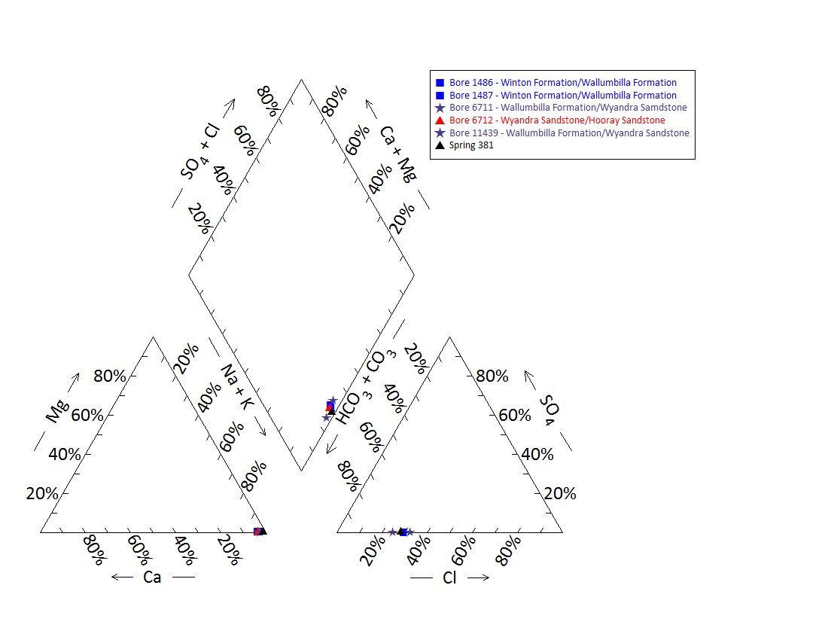

Note: No water chemistry data were available for bores 1489, 11596 and 7375, and springs 381.1, 381.2 and 901.1.

Figure 60 Tunga spring complex—Piper plot of spring and waterbore chemistry.

Table 132 Tunga spring complex—most recent waterbore pump test data.

| Bore ID | Recorded discharge (m3/d) | Standing groundwater level (mAGL) | Date of measurement |
| --- | --- | --- | --- |
| 1486 | 1.25 | 15.70 | 22/01/1912 |
| 1487 | 0.05 | 2.13 | 23/01/1912 |
| 1489 | 0.02 | 1.00 | 21/02/1912 |
| 6712 | 0.00 | –3.85 | 22/04/1974 |

m3/d = cubic metres per day, mAGL = metres above ground level.  
© Copyright, DNRM 2012

Table 133 Tunga spring complex—spring elevation and flow rates.

| Vent ID | Elevation (mAHD) (Geodata 9”) | Estimated flow rate (L/d) | Date of estimate |
| --- | --- | --- | --- |
| 381 | 203.22 | 1279.9 | 28/08/2000 |

L/d = litres per day, mAHD = metres Australian height datum.  
© Copyright, EHA 2009

mAHD = metres Australian height datum.  
© Copyright, DNRM 2012

Figure 61 Tunga spring complex—waterbore standing water levels (SWLs).

## Wooregym spring complex

### Hydrogeological summary

The Wooregym spring complex is a discharge spring complex of six active water springs. Attribution of a likely conceptual model for this spring complex is uncertain, as there are no outcrops of GAB aquifers, mapped faults or granitic outliers located within close proximity to the springs. However, there are known granitic outliers and an associated fault located at the Granite springs complex approximately 15 kilometres south-west of the Wooregym Springs.

The spring complex is likely sourced from the Wyandra Sandstone of the Cadna-owie Formation or the Hooray Sandstone, the principal GAB aquifers in the region. However, artesian pressure has also historically been recorded from bores accessing the shallower Wallumbilla and Winton formations near the spring complex. Several bores accessing these aquifers in the area have been recorded as ceased to flow or have been abandoned. Therefore, it is less likely that the springs are sourced from these shallower aquifers.

Water quality samples have not been taken for the Wooregym spring complex. The ionic composition of the laboratory results show only minor variations between bores, despite accessing different aquifers.

### Spring complex overview

The Wooregym spring complex is located about 32 kilometres west-south-west from Eulo, south-western Queensland. The spring complex consists of six active springs (382.1–382.6). The springs are situated in a shallow basin of about 2 hectares. There are four main spring wetlands. There are also numerous small vents without free water (Figure 62). The Wooregym spring complex overlies Quaternary age alluvium. The springs have been reported to become more active since the Wooregym bore was regulated in 2008 and have been given a conservation ranking of 1b. A summary of basic hydrogeological information available is given in Table 134. The location and elevation of the Wooregym spring complex springs are listed in Table 135.

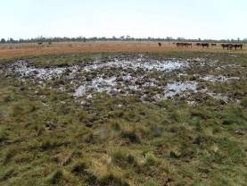 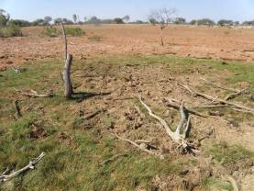

Figure 62 Wooregym spring complex—vents 382.1 and 382.6.

Table 134 Wooregym spring complex—hydrogeological information summary.

| Feature | Details | Comments |
| --- | --- | --- |
| No. of active vents | 6 | 382.1–382.6 |
| No. of inactive vents | – |  |
| Conservation ranking | 1b |  |
| Spring water quality samples | No |  |
| Waterbores within 10-kilometre radius | 11 |  |
| Waterbore water quality samples | 10 |  |
| Interpreted stratigraphy available | Yes |  |
| Outcropping formations |  | Granite outliers about 20 kilometres south-west |
| Underlying aquifers |  | Winton Formation, Doncaster Member of the Wallumbilla Formation and Wyandra Sandstone of the Cadna-owie Formation |
| SWL time series data available | Yes | Artesian pressure maintained in aquifers sourced from the Wyandra Sandstone and Hooray aquifers |
| Likely source aquifers |  | Potentially Wyandra Sandstone and Hooray Sandstone |
| Conceptual spring type | E, F, G or H |  |

– = not available, SWL = standing water level.

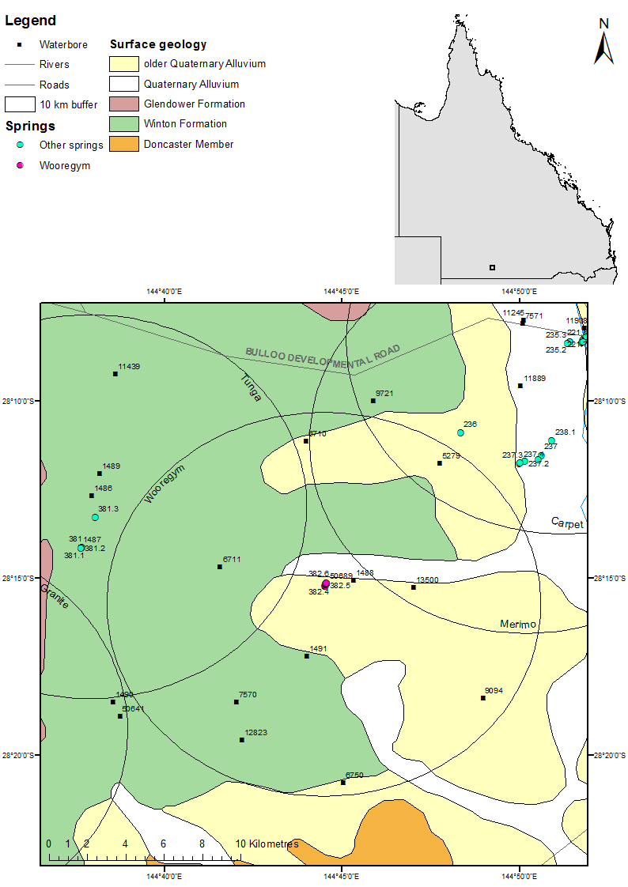

Figure 63 Wooregym spring complex—regional geology, Eulo supergroup, Queensland.

### Geology

The spring vents overlie alluvium. West of the spring complex, there is the Glendower Formation and there is an area of exposed Winton Formation. An inlier of granitic rock of Middle Devonian age is located about 15 kilometres south-west of the springs at the headwaters of Boorara and Twomanee creeks associated with the Eulo Ridge. There are no faults in the area of the Wooregym springs shown on surface geological maps (Senior et al. 1971); however, to the south-west, there is a fault directed north-north-west through the inlier of granite at the headwaters of Boorara and Twomanee creeks (Figure 63).

### Regional stratigraphy and underlying aquifers

Stratigraphic logs from the waterbores within 10 kilometres of the Wooregym springs indicate that the following aquifers underlie the spring complex: the Winton Formation, Wallumbilla Formation (including the Coreena and Doncaster members), Wyandra Sandstone Member of the Cadna-owie Formation and the Hooray Sandstone (Table 136). Hooray Sandstone is the deepest aquifer encountered by bores in the locality, at depths of more than 210 metres below ground surface level.

Bores within 10 kilometres of the Wooregym spring complex are accessing the Doncaster Member of the Wallumbilla Formation, the Wyandra Sandstone of the Cadna-owie Formation and the Hooray Sandstone. The lack of screen and casing information reduces the certainty of determining if the source aquifer is being tapped.

### Water chemistry comparison: springs and waterbores

Table 137 and Table 138 show the available water chemistry data for waterbores within a 10‑kilometre radius of the Wooregym spring complex. No water chemistry samples have been taken from the Wooregym springs. Table 139 lists available physicochemical data for the springs. Figure 64 provides a Piper plot of the water chemistry for waterbores 12823, 7570, 6570, 1491, 9094, 6711, 50689, 1488, 13500 and 6710. The results for the hydrochemistry analysis did not include bicarbonate. Total alkalinity was used instead to compare bore and spring water chemistry in the Piper plot. There was little differentiation between the ionic compositions of the bore water in the locality, despite the bores being sourced from different aquifers.

### Artesian status of potential source aquifers

There are limited potentiometric data available for waterbores surrounding the Wooregym spring complex, particularly recent data. Two of the shallower bores in the region have been recorded as ceased to flow (bores 7570 and 5279). They likely tapped the aquifers within the Doncaster Member of the Wallumbilla Formation or aquifers of the shallower Winton Formation.

Standing water level data over time are available for bores 9094, 6710, 6750, 2823 and 13500 (Figure 65). Bores 13500 and 6750 tap the Hooray Sandstone, bore 6710 taps the Winton and Wyandra sandstones, and bores 12823 and 9094 tap the Hooray. A lack of casing information prevents further clarification. All of these bores have maintained artesian pressure (Table 140) and all maintain a potentiometric pressure above the elevation of the Wooregym springs (about 167 metres Australian height datum).

Table 135 Wooregym spring complex—spring locations and elevations.

| Vent ID | Latitude | Longitude | Elevation (mAHD) |
| --- | --- | --- | --- |
| 382.1 | –28.25367 | 144.74169 | 167.532 |
| 382.2 | –28.25355 | 144.74206 | 167.581 |
| 382.3 | –28.25300 | 144.74203 | 167.700 |
| 382.4 | –28.25272 | 144.74210 | 167.569 |
| 382.5 | –28.25244 | 144.74238 | 167.318 |
| 382.6 | –28.25210 | 144.74244 | 167.477 |

mAHD = metres Australian height datum.

Table 136 Wooregym spring complex—waterbores within a 10-kilometre radius.

| Bore ID | Top (mBGL) | Bottom (mBGL) | Rock unit name |
| --- | --- | --- | --- |
| 1491 | 0.0 | – | Winton Formation |
|  | – | 32.6 | Wallumbilla Formation |
| 5279 | 0.0 | – | Alluvium |
|  | – | 15.2 | Tertiary |
|  | 15.2 | – | Winton Formation |
|  | – | 79.2 | Wallumbilla Formation |
| 6711 | 0.0 | – | Winton Formation |
|  | – | 200.3 | Wallumbilla Formation |
|  | 200.3 | 209.1 | Wyandra Sandstone |
| 6710 | 0.0 | – | Winton Formation |
|  | – | 196.0 | Wallumbilla Formation |
|  | 196.0 | 197.5 | Wyandra Sandstone |
| 6750 | – | – | – |
| 7570 | 0.0 | – | Winton Formation |
|  | – | 41.1 | Wallumbilla Formation |
| 9094 | 0.0 | – | Alluvium |
|  | – | – | Tertiary |
|  | – | – | Winton Formation |
|  | – | – | Wallumbilla Formation |
|  | – | – | Cadna-owie Formation |
|  | – | 210.9 | Hooray Sandstone |
| 12823 | 0.0 | 21.3 | Winton Formation |
|  | 21.3 | 179.8 | Wallumbilla Formation |
|  | 179.8 | 199.6 | Wyandra Sandstone |
|  | 199.6 | – | Cadna-owie Formation |
|  | – | 259.1 | Hooray Sandstone |
| 13500 | 0.0 | – | Alluvium |
|  | – | 12.5 | Tertiary |
|  | 12.5 | – | Winton Formation |
|  | – | 177.7 | Wallumbilla Formation |
|  | 177.7 | – | Wyandra Sandstone |
|  | – | – | Cadna-owie Formation |
|  | – | 273.7 | Hooray Sandstone |
| 1488 | 0.0 | – | Alluvium |
|  | – | – | Tertiary |
|  | – | – | Winton Formation |
|  | – | 45.1 | Wallumbilla Formation |
| 50689 | 0.0 | 39.6 | Doncaster Member |

– = not available, mBGL = metres below ground level.  
© Copyright, DNRM 2012

Table 137 Wooregym spring complex—waterbore details and water chemistry.

| Variable | Details | | | | | |
| --- | --- | --- | --- | --- | --- | --- |
| Bore ID | 1488 | 1491 | 5279 | 6711 | 6710 | 6750 |
| Sample date | 1975 | 1992 | – | 1997 | 2003 | 2003 |
| Distance from spring complex (kilometres) | 1.8 | 2.8 | 9.0 | 5.1 | 8.5 | 9.4 |
| Water encountered (metres) | – | – | 28.6–79.2 (salty) | 201.2 | 197.5 | 48.8, 269.7, 272.8 |
| Source aquifer | Doncaster Member | Doncaster Member | Wallumbilla Formation | Winton/ Wallumbilla/ Wyandra Sandstone | Winton/ Wyandra Sandstone | Hooray Sandstone |
| Screens (metres) | – | – | Open hole  77.1–79.2 | – | – | Open-ended pipe 277.4 |
| Year drilled | 1894 | 1912 | 1937 | 1948 |  | 1938 |
| Standing water level | – | – | – | – | 13.8 (1985) (R) | 52.8 (1938) (N) |
| Total depth (metres) | 45.1 | 32.6 | 79.2 | 209.1 | 197.51 | 277.4 |
| Surface elevation (mAHD) | 167.7 | 165.9 | – | 183 | – | 164.3 |
| Facility status | Abandoned/destroyed | Existing | Existing | Existing | Existing | Existing |
| Facility type | Artesian, uncontrolled flow | Artesian, controlled flow | Artesian, ceased to flow | Artesian, controlled flow | Artesian, controlled flow | Artesian, controlled flow |
| *Physicochemical parameters* | | | | | | |
| EC (µS/cm) | 930 | 875 | – | 1006 | 944 | 643 |
| pH (field/lab) | – | – | – | 8.6 | – | 8.1 |
| Temp (°C) | – | – | – | 23 | – | 42.6 |
| *Chemical parameters (milligrams per litre)* | | | | | | |
| TDS | – | – | – | – | – | – |
| TSS | 510.1 | 669.62 | – | 613 | 589.08 | 397.4 |
| Sodium (Na) | 213 | 204 | – | 239.9 | 236.3 | 156.5 |
| Potassium (K) | 1.8 | 5.5 | – | 2.3 | 1.6 | 1.5 |
| Calcium (Ca) | 3.7 | 3.6 | – | 6.9 | 3.5 | 2.4 |
| Magnesium (Mg) | 0.7 | 0.9 | – | 0.9 | 0.3 | 0.2 |
| Chlorine (Cl) | 95 | 82.3 | – | 120.9 | 91.8 | 48.1 |
| Sulfate (SO4) | – | 0 | – | 0 | 0 | 0 |
| Alkalinity (calcium carbonate) | 325 | 333 | – | 359 | 389 | 285 |
| Bicarbonate (HCO3–) | 386 | 393.4 | –– | 423.9 | 457.2 | 338.2 |
| Carbonate (CO32–) | 5.1 | 6.3 | – | 4.3 | 8.3 | 4.4 |
| Fluoride (F) | 1 | 1.61 | – | 1.16 | 1.01 | 0.52 |
| Bromine (Br) | – | – | – | – | – | – |
| Aluminium (Al) | – |  | – | 0.01 | 0.03 | 0 |
| Arsenic (As) | – | – | – | – | – | – |
| Barium (Ba) | – | – | – | – | – | – |
| Cobalt (Co) | – | – | – | – | – | – |
| Iron (Fe) | – | 1.26 | – | 0 | 0.11 | 0.01 |
| Manganese (Mn) | – | 0 | – | 0 | 0.01 | 0.01 |
| Silica (SiO2) | – | 22 | – | 23 | 22 | 18 |
| Zinc (Zn) | – |  | – | 0.04 | – | 0 |
| Nitrate as NO3 | – | 2 | – | 2.9 | 0 | 0 |
| Phosphate (PO4) | – | – | – | – | 0 | – |

– = not available, EC = electrical conductivity, mAHD = metres Australian height datum, µS/cm = microsiemens per centimetre, N = natural surface elevation, R = reference point, TDS = total dissolved solids, TSS = total suspended solids.  
© Copyright, DNRM 2012

Table 138 Wooregym spring complex—waterbore details and water chemistry continued.

| Variable | Details | | | | |
| --- | --- | --- | --- | --- | --- |
| Bore ID | 7570 | 9094 | 12823 | 13500 | 50689 |
| Sample date | 1992 | 2003 | 2003 | 2005 | 2003 |
| Distance from spring complex (kilometres) | 8.5 | 8.8 | 8.0 | 4.3 | 1.0 |
| Water encountered | – | – | – | 48.2, 224.6, 168.5, 272.8 | 35.9 |
| Source aquifer | Doncaster Member | Hooray Sandstone | Hooray Sandstone | Hooray Sandstone | Doncaster Member |
| Screens (metres) | – | – | – | Perforated casing 273.8 | – |
| Year drilled | – | 1941 | 1955 | 1958 | 1985 |
| Standing water level | –2.74 (1959) | 35.9 (1969) (N) | – | 1.2 (1958) (N) | – |
| Total depth (metres) | 41.1 | 210.9 | 259.1 | 273.7 | 39.6 |
| Natural surface elevation (mAHD) | 169.2 | 169.2 | 168.3 | 163.5 | 178 |
| Facility status | Existing | Existing | Existing | Existing | Existing |
| Facility type | Artesian, ceased to flow | Artesian, controlled flow | Artesian, controlled flow | Artesian, controlled flow | Artesian, controlled flow |
| *Physicochemical parameters* | | | | | |
| EC (µS/cm) | 795 | 804 | 775 | 776 | 845 |
| pH (field/lab) | – | 8.3 | 8.2 | 8 | 8.3 |
| Temp (°C) | 28 | 28.7 | 32.7 | 39.2 | 27.5 |
| *Chemical parameters (milligrams per litre)* | | | | | |
| TDS | – | – | – | – | – |
| TSS | 438.82 | 508.71 | 479.12 | 468 | 517.32 |
| Sodium (Na) | 195 | 201.6 | 188 | 184 | 202.7 |
| Potassium (K) | 1.6 | 1.8 | 1.4 | 1.5 | 1.8 |
| Calcium (Ca) | 2.6 | 3.8 | 3.2 | 2 | 2.3 |
| Magnesium (Mg) | 0.9 | 0.4 | 0.2 | 0.2 | 0.5 |
| Chlorine (Cl) | 63.9 | 40.7 | 48.7 | 48 | 91.6 |
| Sulfate (SO4) | 0 | 0 | 0 | 1 | 0 |
| Alkalinity (calcium carbonate) | 330 | 398 | 359 | 351 | 330 |
| Bicarbonate (HCO3–) | 394.9 | 469.4 | 424.2 | 411 | 393.6 |
| Carbonate (CO32–) | 3.7 | 8.1 | 6.9 | 8.8 | 4.4 |
| Fluoride (F) | 1.1 | 0.57 | 0.68 | 1 | 1.44 |
| Bromine (Br) | – | – | – | – | – |
| Aluminium (Al) | – | 0 | 0.01 | 0.05 | 0 |
| Arsenic (As) | – | – | – | – | – |
| Barium (Ba) | – | – | – | – | – |
| Cobalt (Co) | – | – | – | – | – |
| Iron (Fe) | 0.04 | 0.9 | 0.19 | 0.02 | 0.2 |
| Manganese (Mn) | 0 | 0.1 | 0.01 | 0.03 | 0.1 |
| Silica (SiO2) | 21 | 21 | 22 | 21 | 19 |
| Strontium (Sr) | – | 0.01 | 0 | – | – |
| Zinc (Zn) | 0.2 | 0 | 0 | 0.01 | 0 |
| Nitrate as NO3 | – | – | – | 0.5 | 0 |
| Phosphate (PO4) |  |  |  | – | – |

– = not available, EC = electrical conductivity, mAHD = metres Australian height datum, µS/cm = microsiemens per centimetre, N = natural surface elevation, R = reference point, TDS = total dissolved solids, TSS = total suspended solids.  
© Copyright, DNRM 2012

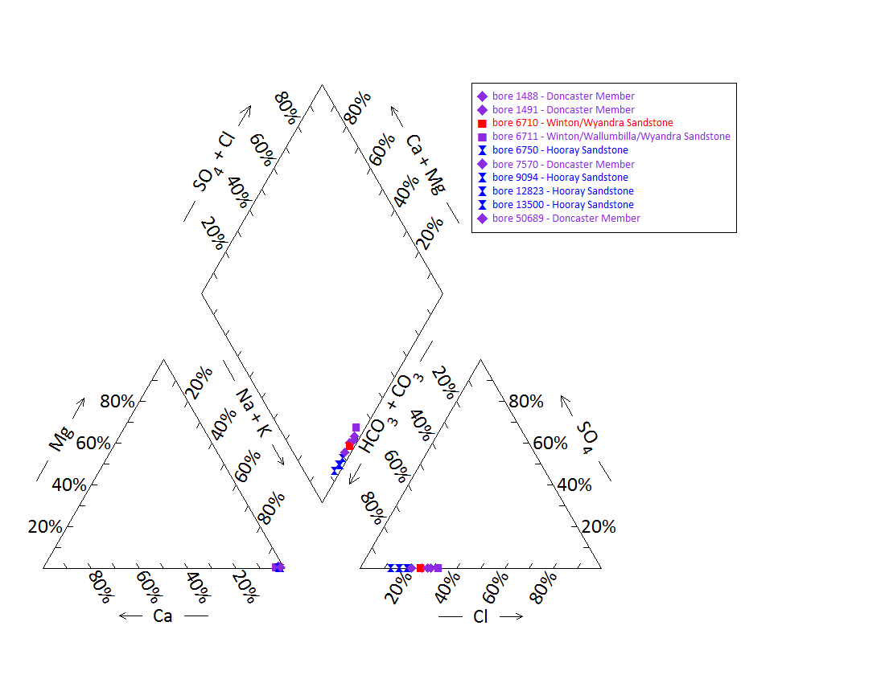

Note: No water chemistry data were available for bore 5279 or any of the springs.

Figure 64 Wooregym spring complex—Piper plot of spring and waterbore chemistry.

Table 139 Wooregym spring complex—spring elevation and water physicochemical data.

| Site | Elevation (mAHD) | Temp (°C) | pH | Electrical conductivity (µS/cm) |
| --- | --- | --- | --- | --- |
| 382.1 | 167.532 | 30 | 7.3 | 779 |
| 382.2 | 167.581 | 24.9 | 7.45 | 985 |
| 382.3 | 167.7 | 29.9 | 6.68 | 1127 |
| 382.4 | 167.569 | 28.5 | 7.38 | 1207 |
| 382.5 | 167.318 | – | – | – |
| 382.6 | 167.477 | – | – | – |

– = not available, mAHD = metres Australian height datum, µS/cm = microsiemens per centimetre.

Table 140 Wooregym spring complex—most recent waterbore pump test data.

| Bore ID | Recorded discharge (m3/d) | Standing groundwater level (mAGL) | Date of measurement |
| --- | --- | --- | --- |
| 1488 | – | – | – |
| 1491 | – | – | – |
| 6710 | 0.71 | 19.41 | 28/09/2003 |
| 6711 | – | – | – |
| 6750 | 6.21 | 28.41 | 1/10/2003 |
| 7570 | – | – | – |
| 9094 | 0.41 | 24.93 | 25/05/1992 |
| 12823 | 0.41 | 8.79 | 25/05/1992 |
| 13500 | 0.90 | 25.14 | 19/03/2005 |
| 50689 | – | – | – |

– = not available, m3/d = cubic metres per day, mAGL = metres above ground level.  
© Copyright, DNRM 2012

mAHD = metres Australian height datum.

Figure 65 Wooregym spring complex—waterbore standing water levels (SWLs).

# Bourke supergroup, New South Wales and Queensland

## Peery Lakes

### Hydrogeological summary

The Peery Lake spring complex consists of eight active discharge spring vents, some of which are occasionally inundated by Peery Lake when the Paroo River floods.

The spring complex lies on the southern margin of the Eromanga Basin where the Hooray Sandstone is relatively close to the surface. The likely conceptual model for the spring complex is therefore a spring emanating from a downgradient edge of a basin, type I or K, although there are also a number of faults and outcropping Devonian sediments that might influence the passage of water from the aquifer to the surface.

Great Artesian Basin (GAB) aquifers present in the region, and likely source aquifers for the springs, include the Hooray Sandstone and the Wyandra Sandstone Member of the Cadna-owie Formation. Stratigraphic information for the area is limited and it is likely that the deeper GAB aquifers do not extend to the edge of the Basin.

### Spring complex overview

Peery Lakes is located 241 kilometres west-south-west of the town of Bourke, north-western New South Wales. The complex comprises seven active water springs located on the perimeter of Peery Lake and the complex has been given a conservation ranking of 1 (Figure 66). It lies on the southern margin of the GAB, at the very edge of the Eromanga Basin (Figure 67). Associated spring wetland areas range from an estimated 4–216 square metres. A summary of basic hydrogeological information available is given in Table 141. Table 142 lists the location and elevation of the spring vents of the Peery Lakes spring complex.

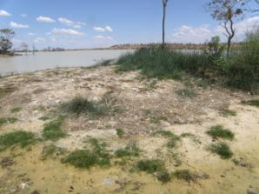 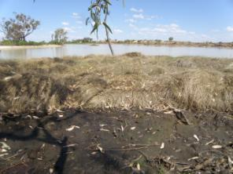

Figure 66 Peery Lakes spring complex—vents 1 and 3 situated on islands in Peery Lake.

Table 141 Peery Lakes spring complex—hydrogeological information summary.

| Feature | Details | Comments |
| --- | --- | --- |
| No. of active vents | 8 | 1000.1, 1000.2, 1000.3, 1000.4, 1000.5, 1000.6, 1000.7, 1000.8 |
| No. of inactive vents | – | 1 inactive vent east of the springs |
| Conservation ranking | 2 |  |
| Spring water quality samples | – | Some electrical conductivity, temperature and pH recordings available |
| Waterbore within 10-kilometres radius | 4 |  |
| Waterbore water quality samples | – |  |
| SWL time series data available | Yes |  |
| Interpreted stratigraphy available | No |  |
| Outcropping formations |  | Rolling Downs Group, Mulga Downs Group |
| Underlying aquifers |  |  |
| Likely source aquifers |  | Hooray Sandstone, Wyandra Sandstone |
| Conceptual spring type | I and/or K |  |

– = not available, SWL = standing water level.

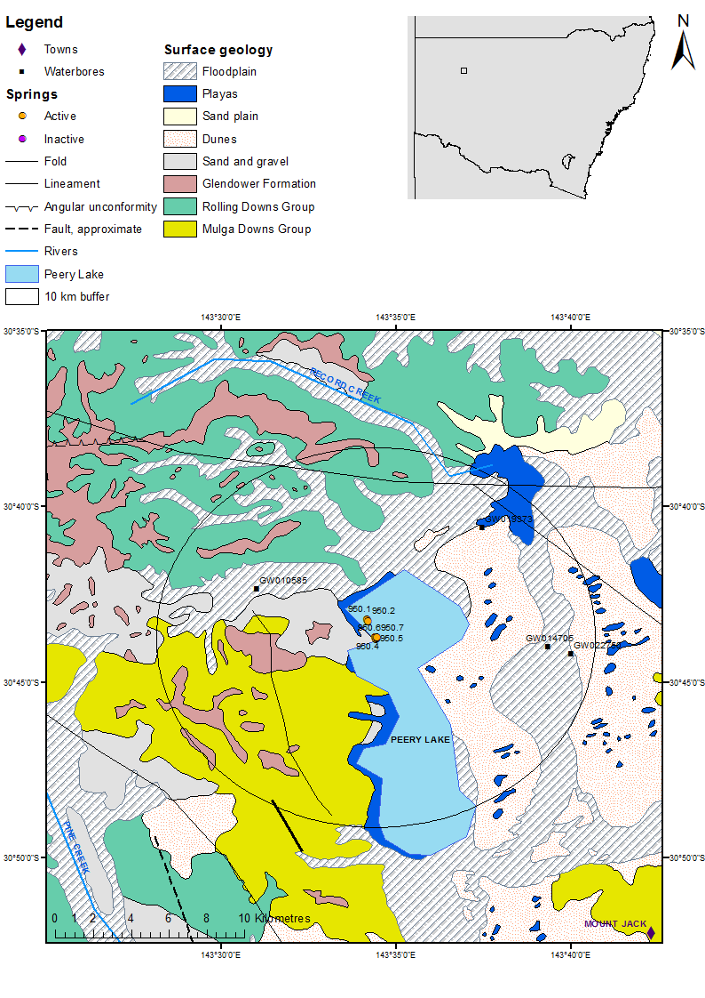

Figure 67 Peery Lakes spring complex—regional geology, Bourke supergroup, New South Wales.

### Geology

The Peery Lake spring complex is located on alluvial sediments overlying the the Wallumbilla Formation at the very edge of the Eromanga Basin. Outcrops of the Rolling Downs Group are present within close proximity to the Peery Lakes spring complex. The Eromanga Basin sedimentary sequence overlies the Palaeozoic basement sediments of the Lachlan Fold Belt, and is overlying and abuts the Upper Devonian Mulga Downs Group at the western shoreline of Peery Lakes.

### Regional stratigraphy and underlying aquifers

The springs are located on alluvium and lake deposits associated with Peery Lake, which is bounded to the west and south by the Upper Devonian Mulga Downs Group. The Hooray Sandstone is present in most of the Eromanga Basin in New South Wales, and is generally close to the surface at the edge of the GAB. Hooray Sandstone is, however, not shown in the cross-sections of the White Cliffs 1:250 000 SH54-12 geological map sheet (Rose et al. 1964). Wireline logged bores further to the north record the base of the Hooray Sandstone at 100 metres below sea level, with no deeper GAB sediments present over any significan extent (Hawke & Cramsie 1984). Table 143 shows drillers’ logs from waterbores within a 10-kilometres radius of the centre of the Peery Lakes spring complex. Interpreted stratigraphy is not available from the New South Wales groundwater bore database (PINNEENA; NSW OoW 2010) for these particular bores. Water supplies are encountered between depths ranging from 45 metres to 70 metres below ground level. The maximum depth of these bores is 89.9 metres, and they may all be tapping the Hooray Sandstone or, possibly, the Wyandra Sandstone Member at shallower depths.

The Kanmantoo Fold Belt North Western is a fractured rock groundwater source underlying the GAB in New South Wales identified by NSW Office of Water (NSW OoW 2011). It is remotely possible that the spring complex is (partly) sourced from deeper aquifers below the GAB as a result of the Olepoloko Linament and local faulting allowing water to travel to the ground surface.

### Water chemistry comparison: springs and waterbores

No hydrochemical data on waterbores within a 10-kilometre radius of the spring complex were available. Descriptions of the salinity from waterbores near the Peery Lakes spring complex indicate that the bores provide fresh water (Table 144). Only physicochemical data were available for vents at the Peery Lakes spring complex (Table 145). The electrical conductivity values indicate that the water in the springs is brackish.

### Artesian status of potential source aquifers

Standing water level data for bores indicate that these bores are tapping artesian aquifers (Figure 68). Therefore, it is likely that the Peery Lake springs are being supplied by the same aquifer that the waterbores are tapping. Table 146 sets out the most recent available test pumping data for the bores within a 10-kilometre radius of Peery Lakes.

Table 142 Peery Lakes spring complex—spring locations and elevations.

| Vent ID | Latitude | Longitude | Elevation (mAHD) | Comments |
| --- | --- | --- | --- | --- |
| 1000.1 | –30.72006 | 143.56937 | 76.47 | Used as pelican roosting site, wetland destroyed |
| 1000.2 | –30.7208 | 143.57002 | 76.47 |  |
| 1000.3 | –30.72855 | 143.57333 | 76.87 |  |
| 1000.4 | –30.72874 | 143.57376 | 76.87 | Edge of peninsula at time of visit |
| 1000.5 | –30.72939 | 143.57391 | 76.87 |  |
| 1000.6 | –30.72892 | 143.57429 | 76.87 |  |
| 1000.7 | –30.72879 | 143.57439 | 76.87 |  |
| 1000.8 | –30.73000 | 143.61300 | 76.87 | Under water at time of survey (30/10/2012) |

mAHD = metres Australian height datum.  
© Copyright, Geodata 9” digital elevation model

Table 143 Peery Lakes spring complex—waterbores within a 10-kilometre radius.

| Bore no. | Top (mBGL) | Bottom (mBGL) | Rock type | Description |
| --- | --- | --- | --- | --- |
| GW010585 | 0.0 | 4.6 | Soil | Sandy |
|  | 4.6 | 6.1 | Gravel |  |
|  | 6.1 | 58.8 | Shale |  |
|  | 58.8 | 60.4 | Sandstone |  |
|  | 60.4 | 71.6 | Shale | Bands of shale and rock. Water supply at 69–71 metres |
|  | 71.6 | 76.2 | Sandstone |  |
|  | 76.2 | 80.7 | Shale | Sandy with water supply |
|  | 80.7 | 81.7 | Sandstone | With shale and water supply |
|  | 81.7 | 82.9 | Slate |  |
| GW014705 | 0 | 0.6 | Soil |  |
|  | 0.6 | 7.0 | Clay |  |
|  | 7.0 | 8.2 | Sand |  |
|  | 8.2 | 49.7 | Clay | Some shale streaks |
|  | 49.7 | 52.1 | Shale |  |
|  | 52.1 | 52.7 | Rock |  |
|  | 52.7 | 54.3 | Shale |  |
|  | 54.3 | 60.9 | Sandstone | Water-bearing supply |
|  | 60.9 | 61.6 | Shale |  |
|  | 61.6 | 61.9 | Sandstone |  |
|  | 61.9 | 67.1 | Shale |  |
| GW019373 | 0 | 7.3 | Clay |  |
|  | 7.3 | 29.9 | Rock |  |
|  | 29.9 | 48.8 | Clay |  |
|  | 48.8 | 54.9 | Shale |  |
|  | 54.9 | 55.8 | Rock |  |
|  | 55.8 | 64.3 | Shale |  |
|  | 65.2 | 75.9 | Shale | Sandy |
|  | 75.9 | 76.2 | Rock |  |
|  | 76.2 | 81.7 | Shale |  |
|  | 81.7 | 84.7 | Sandstone |  |
|  | 84.7 | 86.7 | Rock |  |
|  | 86.7 | 89.9 | Sandstone | Water-bearing water supply |
| GW022750 | 0.0 | 38.4 | Clay |  |
|  | 38.4 | 39.6 | Rock |  |
|  | 39.6 | 42.7 | Clay |  |
|  | 42.7 | 45.7 | Shale |  |
|  | 45.7 | 50.9 | Sandstone | Water supply |
|  | 50.9 | 53.0 | Clay | Water supply |
|  | 53.0 | 54.3 | Sandstone |  |
|  | 54.3 | 54.9 | Clay |  |
|  | 54.9 | 64.0 | Clay |  |

mBGL = metres below ground level.  
© Copyright, NSW OoW 2010

Table 144 Peery Lakes spring complex—waterbore details and water chemistry.

| Variable | Details | | | |
| --- | --- | --- | --- | --- |
| Bore ID | 010585 | 014705 | 019373 | 022750 |
| Distance from spring complex (kilometres) | 5.90 | 7.83 | 7.59 | 8.99 |
| Sample date | – | – | – | – |
| Aquifer | Hooray Sandstone? | Hooray Sandstone? | Hooray Sandstone? | Hooray Sandstone? |
| Screens (metres) | Steel casing to 77.1 | – | – | – |
| Year drilled | 1953 | 1961 | 1962 | 1965 |
| Standing water level (R) | – | 15.81 | 3.32 | – |
| Total depth (metres) | 82.9 | 67.1 | 89.9 | 64.0 |
| Natural surface elevation (mAHD) (Auslig 9” DEM) | 95.71 | 79.52 | 80.00 | 78.26 |
| Facility status | – | – | – | – |
| *Physicochemical parameters* | | | | |
| Salinity description | Good | – | Fresh | – |
| EC (µS/cm) | – | – | – | – |
| pH (field/lab) | – | – | – | – |
| Temperature (°C) | – | – | – | – |
| Turbidity | – | – | – | – |

– = not available, DEM = digital elevation model, EC = electrical conductivity, mAHD = metres Australian height datum, µS/cm = microsiemens per centimetre, R = reference point.  
© Copyright, NSW OoW 2010

Table 145 Peery Lakes spring complex—spring water chemistry.

| Variable | Details | |
| --- | --- | --- |
| Vent ID | 1000.2 | 1000.3 |
| Sample date | 2012 | 2012 |
| *Physicochemical parameters* | | |
| EC (µS/cm) | 2250 | 2110 |
| pH (field/lab) | 7 | 7.72 |
| Temperature (°C) | 21.8 | 23.8 |

EC = electrical conductivity, µS/cm = microsiemens per centimetre.

Table 146 Peery Lakes spring complex—waterbore standing water levels.

| Bore ID | Standing groundwater level (mAGL) | Year of measurement |
| --- | --- | --- |
| 014705 | 4.18 | 1964 |
|  | 15.81 | 1987 |
| 019373 | 10.51 | 1963 |
|  | 9.89 | 1965 |
|  | 7.04 | 1966 |
|  | 3.57 | 1984 |
|  | 2.65 | 1987 |
|  | 3.37 | 1992 |
|  | 4.49 | 1993 |
|  | 3.26 | 1995 |
|  | 4.60 | 2001 |
|  | 3.32 | 2003 |

mAGL = metres above ground level.  
© Copyright, NSW OoW 2010

DEM = digital elevation model, mAHD = metres Australian height datum.

Figure 68 Peery Lakes spring complex—waterbore standing water levels (SWLs).

## Sweetwater

### Hydrogeological summary

Sweetwater consists of one inactive spring vent located on a claypan in the Cunnamulla Shelf of the Eromanga Basin.

Of the GAB aquifers, it is not certain which the bores within 10 kilometres of the spring complex are tapping, because there is no interpreted stratigraphy available for waterbores in the area. However, Hooray Sandstone is known to be the main artesian aquifer supplying bores in the region.

The Hooray Sandstone is the most likely source aquifer for Sweetwater spring complex, although the spring may also be fed by minor aquifers in the Coreena Member or Doncaster Member of the Wallumbilla Formation. No stratigraphic data or water chemistry data for waterbores within 10 kilometres of the spring complex or for the spring are available to allow for more certain conclusions regarding a source aquifer for the Sweetwater spring complex, although spring type E, F or G are likely conceptual types.

### Spring complex overview

Sweetwater is located 76 kilometres north-north-west of the town of Bourke and 16.6 kilometres south-west of the town of Enngonia, northern New South Wales. The complex consists of one inactive spring—although there are some soaks and vegetation present (Figure 69). The complex has been given a conservation ranking of 2. The spring wetland area covers about 13 square metres. A summary of basic hydrogeological information available is in Table 147. Table 148 sets out the location and elevation of the spring.

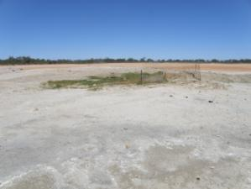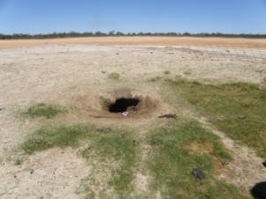

Figure 69 Sweetwater spring complex—site 1009.

Table 147 Sweetwater spring complex—hydrogeological information summary.

| Feature | Details | Comments |
| --- | --- | --- |
| No. of active vents | 0 |  |
| No. of inactive vents | 1 | 1009 |
| Conservation ranking | 2 |  |
| Nearby spring complexes |  | Yarrongany and Kallyna complexes are within 10 kilometres |
| Spring water quality samples |  |  |
| Waterbores within 10-kilometre radius | 11 |  |
| Waterbore water quality samples | No |  |
| Interpreted stratigraphy available | Little | GW32500 36 kilometres south-east |
| Outcropping GAB formations |  | Rolling Downs Group |
| Underlying aquifers |  | Quaternary/Tertiary, Coreena and Doncaster members of the Wallumbilla Formation, Wyandra Sandstone of Cadna-owie Formation, and Hooray Sandstone |
| SWL time series data available | Yes |  |
| Likely source aquifers |  | Hooray Sandstone or Wallumbilla Formation |
| Conceptual spring type | E, F or G | Possibly |

GAB = Great Artesian Basin, SWL = standing water level.

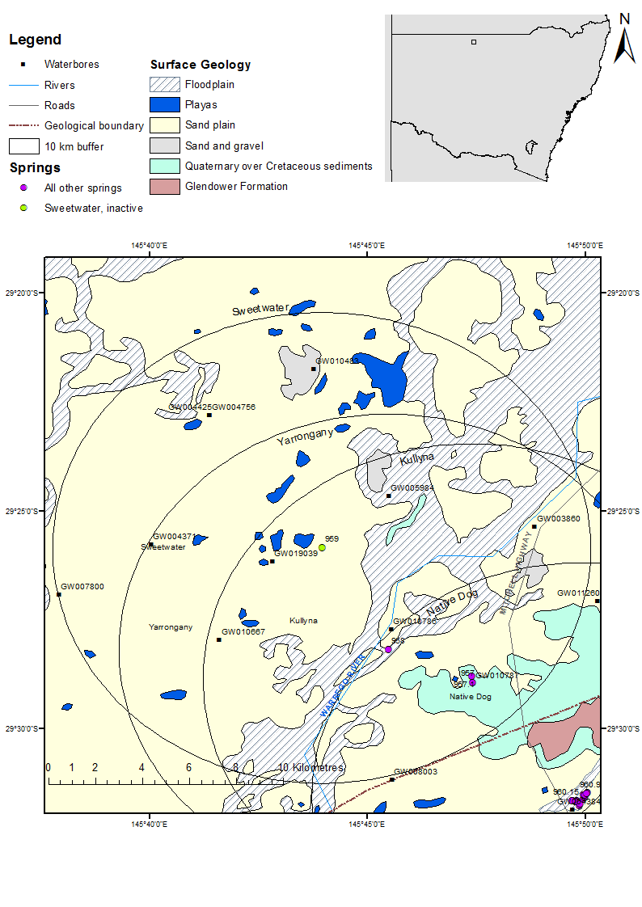

Figure 70 Sweetwater spring complex—regional geology, Bourke supergroup, New South Wales.

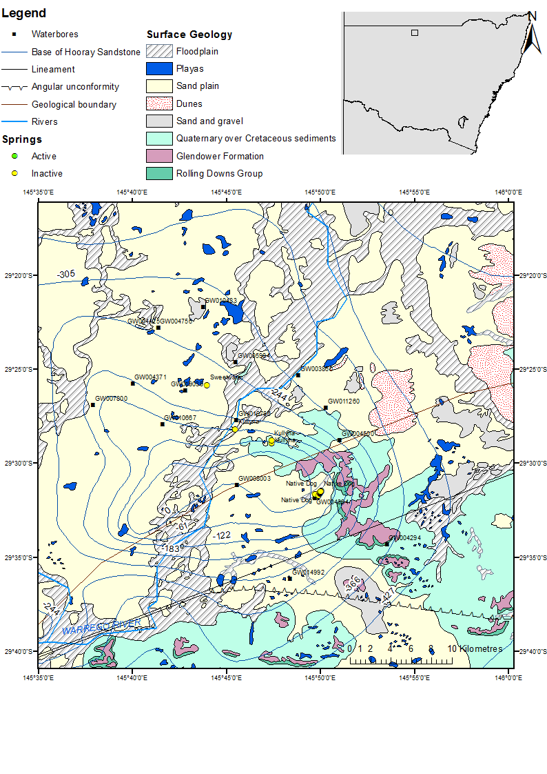

Figure 71 Sweetwater spring complex—Hooray Sandstone basement contours.

### Geology

Sweetwater spring complex is located near the boundary of the Wallumbilla Formation, Coreena Member and the Griman Creek Formation in the Eromanga Basin. The closest geological feature is a concealed boundary 10 kilometres to the south-east. A lineament is also present 18 kilometres to the south-east (Figure 70). Cross-section A–B of the Enngonia 1:250 000 SH55-6 geological map sheet (Johnson & Menzies 1965) shows an intrusion or inlier of Palaeozoic granite basement south-east of the spring complex. The area of higher grantie follows the line of the Sweetwater, Yarrongany, Kullyana and Native Dog spring complexes. This may indicate an unmapped lineament, fault or other structural feature related to the shallow basement from which the three spring complexes may get artesian groundwater.

### Regional stratigraphy and underlying aquifers

No interpreted stratigraphy for waterbores within a 10-kilometre radius of the spring complex is available. Interpreted stratigraphy is available for a bore (GW804172) that lies about 17 kilometres south of the Sweetwater spring complex and bore GW032500 about 36 kilometres south-east of the Sweetwater spring complex (Table 149). The interpreted stratigraphy from GW 804172 and GW032500 is inconsistent with the contour map of the base of the Hooray Sandstone provided by the NSW Department of Primary Industries, Office of Water (see Figure 71). This map was provided with a warning that it may not be particularly accurate in some areas (Haridharan 2013, pers. comm., 6 March). The interpreted stratigraphy from GW804172 and GW032500 is therefore more likely to be accurate.

Drillers’ logs for the waterbores within a 10-kilometre radius of the spring complex indicate that groundwater is encountered from 14 metres up to 378 metres below the ground. By comparing the depths drilled for each bore (Table 150) to the interpreted stratigraphy from GW804172 (Table 149), and keeping in mind the trends in the depth of the Hooray Sandstone as shown by the contour map, it appears as though GW004425, GW003860, GW010667 and possibly GW007800 are tapping the Hooray Sandstone, along with shallower aquifers. The rest of the bores appear to be tapping shallower aquifers, such as small aquifers within the Wallumbilla Formation or in Quaternary/Tertiary sediments. The Hooray Sandstone is, however, known to be the major artesian aquifer in the region (Rade 1954) and is therefore the most likely source aquifer for Sweetwater.

### Water chemistry comparison: springs and waterbores

No hydrochemical data for waterbores within a 10-kilometre radius of the spring complex were available. Descriptions of the salinity from waterbores indicate that the bores provide fairly fresh water (Table 151 and Table 152). Water was collected from a small pool at the bottom of a hole dug into the spring vent by animals. The physicochemical data of the groundwater sample (Table 153) suggests that the water is also fairly fresh.

### Artesian status of potential source aquifers

Available data on waterbore standing water levels indicate that aquifer pressure in the vicinity of the spring has declined during the past half century. The water levels have remained artesian, and are above the elevation of the spring (Table 154 and Figure 72).

Table 148 Sweetwater spring complex—spring location and elevation.

| Vent ID | Latitude | Longitude | Elevation (mAHD) | Comments |
| --- | --- | --- | --- | --- |
| 1009 | –29.43075 | 145.73233 | 122.07 | Small mound on edge of claypan |

mAHD = metres Australian height datum.  
© Copyright, Geodata 9” digital elevation model

Table 149 Sweetwater spring complex—stratigraphic bores in the geological region.

| Bore no. | From depth (m) | To depth (m) | Formation | Comments |
| --- | --- | --- | --- | --- |
| GW032500 | 0.0 | 125.0 | Coreena Member |  |
| 125.0 | 280.4 | Doncaster Member |  |
| 280.4 | 303.5 | Wyandra Sandstone Member |  |
| 303.5 | 362.7 | Cadna-owie Formation |  |
| 362.7 | 399.6 | Hooray Sandstone |  |
| GW804172 | 0.0 | 31.5 | Unknown | Quarternary. Aeolian sand, clay, limonite bands |
| 31.5 | 32.8 | Unknown | Tertiary. Silcrete |
| 32.8 | 132.2 | Coreena Member | Cretaceous. Wallumbilla Formation – Coreena Member. Claystone, mudstone |
| 132.2 | 294.0 | Doncaster Member | Cretaceous. Wallumbilla Formation – Doncaster Member. Grey carbonaceous claystone, mudstone |
| 294.0 | 332.3 | Cadna-owie Formation | Cretaceous. Cadna-owie Formation. Clayey sandstone and siltstone |
| 332.3 | 394.9 | Hooray Sandstone | Cretaceous/Jurassic. Hooray Sandstone. Sandstone and unconsolidated sand with coarse cobbles |
| 394.9 | 408.0 | Unknown | Lower Palaeozoic. Metamorphic basement. White, highly weathered kaolinite at the unconformity with minor milky quartz fragments |
| 408.0 | 425.8 | Unknown | Dark green to grey metasediments (chloritic phyllite)—showing quartz veining—highly fractured in places |

m = metre.  
© Copyright, NSW OoW 2010

Table 150 Sweetwater spring complex—waterbores within a 10-kilometre radius.

| Bore ID | Top (mBGL) | Bottom (mBGL) | Rock unit name | Description |
| --- | --- | --- | --- | --- |
| GW003860 | 0.00 | 6.10 | Clay |  |
|  | 6.10 | 13.72 | Sand |  |
|  | 13.72 | 21.64 | Sandstone |  |
|  | 21.64 | 26.82 | Clay |  |
|  | 26.82 | 33.22 | Sand |  |
|  | 33.22 | 256.64 | Shale |  |
|  | 256.64 | 257.79 | Sandstone |  |
|  | 257.79 | 371.86 | Shale |  |
|  | 371.86 | 461.16 | Sandstone | Bands of hard rock |
| GW004371 | 0.00 | 340.77 | Clay |  |
| GW004425 | 0.00 | 0.61 | Soil |  |
|  | 0.61 | 14.33 | Sand |  |
|  | 14.33 | 61.26 | Clay | Water bearing |
|  | 61.26 | 192.00 | Shale with bands of rock |  |
|  | 192.00 | 192.94 | Shale | Water supply |
|  | 192.94 | 370.00 | Shale | Grey |
|  | 370.00 | 379.48 | Sandstone | Water supply |
|  | 379.48 | 379.50 | Rock |  |
| GW004756 | 0.00 | 1.22 | Soil |  |
|  | 1.22 | 10.67 | Clay |  |
|  | 10.67 | 11.28 | Sandstone | Water supply |
|  | 11.28 | 22.86 | Sand |  |
|  | 22.86 | 25.30 | Clay | Water supply |
|  | 25.30 | 62.48 | Clay |  |
|  | 62.48 | 82.91 | Shale | Water supply |
|  | 82.91 | 119.79 | Sandstone and shale | Alternating bands of sandstone and clay |
|  | 119.79 | 121.31 | Clay |  |
|  | 121.31 | 127.41 | Shale | Water supply |
|  | 127.41 | 133.50 | Shale with bands of hard rock and sandstone |  |
|  | 133.50 | 134.42 | Slate |  |
|  | 134.42 | 157.58 | Shale | Water supply |
|  | 157.58 | 167.64 | Shale |  |
| GW005984 | 0.00 | 0.91 | Soil |  |
|  | 0.91 | 3.05 | Rock |  |
|  | 3.05 | 19.81 | Clay |  |
|  | 19.81 | 28.96 | Sandstone | Water supply |
|  | 28.96 | 157.89 | Shale with bands of clay and grey rock |  |
|  | 157.89 | 159.77 | Sandstone | Water supply |
|  | 159.77 | 164.59 | Clay |  |
| GW007800 | 0.00 | 10.06 | Clay |  |
|  | 10.06 | 24.96 | Sandstone | Water supply |
| GW101483 | 0.00 | 4.50 | Loam |  |
|  | 4.50 | 5.50 | Clay |  |
| GW010667 | 0.00 | 12.80 | Clay |  |
|  | 12.80 | 15.84 | Rock | Water supply |
|  | 15.84 | 40.84 | Clay |  |
|  | 40.84 | 42.97 | Boulders |  |
|  | 42.97 | 140.20 | Shale | Water supply at 113.69 mtres |
|  | 140.20 | 145.69 | Sandstone | Water supply |
|  | 145.69 | 176.47 | Shale |  |
|  | 176.47 | 182.57 | Sandstone | Water supply |
|  | 182.57 | 239.87 | Shale with bands of other rock |  |
|  | 239.87 | 245.97 | Sandstone | Water supply |
|  | 245.97 | 271.88 | Sandstone |  |
|  | 271.88 | 274.32 | Rock |  |
| GW010786 | 0.00 | 48.77 | Clay with bands of sand |  |
|  | 48.77 | 59.74 | Shale |  |
|  | 59.74 | 60.35 | Sandstone |  |
|  | 60.35 | 90.22 | Shale |  |
|  | 90.22 | 94.79 | Sandstone |  |
|  | 94.79 | 95.71 | Boulders |  |
|  | 95.71 | 99.36 | Sandstone | Water supply |
|  | 99.36 | 99.67 | Hard rock |  |
| GW010787 | 0.00 | 0.30 | Soil |  |
|  | 0.30 | 1.21 | Clay |  |
|  | 1.21 | 3.65 | Boulders |  |
|  | 3.65 | 15.24 | Sand |  |
|  | 15.24 | 25.60 | Shale |  |
|  | 25.60 | 28.04 | Clay |  |
|  | 28.04 | 35.35 | Sandstone | Water supply |
|  | 35.35 | 36.88 | Shale |  |
| GW019039 | 0.00 | 0.91 | Loam |  |
|  | 0.91 | 3.50 | Boulders |  |
|  | 3.50 | 7.62 | Limestone |  |
|  | 7.62 | 41.15 | Clay |  |
|  | 41.15 | 123.75 | Shale | Rock at bottom |
|  | 123.75 | 132.28 | Sand | Water supply |
|  | 132.28 | 137.16 | Shale |  |
| GW007800 | 24.96 | 50.29 | Clay |  |
|  | 50.29 | 135.94 | Shale |  |
|  | 135.94 | 137.77 | Shale | Water supply |
|  | 137.77 | 209.70 | Shale with bands of hard rock and sandstone |  |
|  | 209.70 | 212.75 | Sand | Water supply |
|  | 212.75 | 215.19 | Sandstone |  |
|  | 215.19 | 226.16 | Shale |  |
|  | 226.16 | 237.74 | Granite |  |

mBGL = metres below ground level.  
© Copyright, NSW OoW 2010

Table 151 Sweetwater spring complex—waterbore details and water chemistry.

| Variable | Details | | | | | | |
| --- | --- | --- | --- | --- | --- | --- | --- |
| Bore ID | GW003860 | GW004371 | | GW004425 | GW004756 | GW005984 | GW007800 |
| Sample date | 1987 | 1928 | |  | 1935 | 1936 | – |
| Distance from spring complex (kilometres) | 8.0 | 6.3 | | 7.0 | 7.0 | 3.3 | 9.9 |
| Aquifer | Hooray Sandstone? | – | | Hooray Sandstone? | Wallumbilla Formation? | Wallumbilla Formation? | Hooray Sandstone? |
| Screens (metres) | Slots 364.2–364.8, 365.7–366.3, 391.6–392.2, 393.1–393.7, 413.6–414.3 | – | | Slots 371.2–373.9 and 375.2–377.9 | – | – | Slots 207.3–210.3 |
| Year drilled | 1945 | 1892 | | 1943 | 1935 | 1936 | 1949 |
| Standing water level (R) | 25.5 | 19.33 | | – | – | – | – |
| Total depth (metres) | 464.2 | 340.8 | | 379.5 | 167.6 | 164.6 | 237.7 |
| Natural surface elevation (mAHD) | 124.670 (DEM) | 132.6 | | 130.430 (DEM) | 130.430 (DEM) | 135.250 (DEM) | 126.380 |
| Facility status | – | – | | – | – | – | – |
| *Physicochemical parameters* | | | | | | | |
| Salinity description | – | 501–1000 ppm | Fresh | | Fresh | Fresh | Good |
| EC (µS/cm) | – | – | – | | – | – | – |
| pH (field/lab) | – | – | – | | – | – | – |
| Temperature (°C) | – | – | – | | – | – | – |
| Turbidity | – | – | – | | – | – | – |

– = not available, DEM = digital elevation model, EC = electrical conductivity, mAHD = metres Australian height datum, µS/cm = microsiemens per centimetre, ppm = parts per million, R = reference point.  
© Copyright, NSW OoW 2010

Table 152 Sweetwater spring complex– Waterbore details & water chemistry cont. (PINNEENA).

| Variable | Details | | | | |
| --- | --- | --- | --- | --- | --- |
| Bore ID | GW010667 | GW010786 | GW010787 | GW019039 | GW101483 |
| Sample date | 1987 | – | 1989 | – | 1997 |
| Distance from spring complex (kilometres) | 5.4 | 4.3 | 8.0 | 1.9 | 7.6 |
| Aquifer | Hooray Sandstone? | Wallumbilla Formation? | Qaternary/ Tertiary | Wallumbilla Formation? | – |
| Screens (metres) | Slots 175.5–182.8, 239.2–240.4 and 241.7–248.4 | – | – | Slots 123.7–124.9 and 131.1–132.3 | Slots 2–5 |
| Year drilled | 1953 | 1954 | 1954 | 1961 | 1997 |
| Standing water level (reference point) | 0.41 | – | 10.71 | – | – |
| Total depth (metres) | 274.3 | 99.7 | 36.8 | 137.2 | 5.5 |
| Natural surface elevation (mAHD) | 122.770 | 124.000 | 146.000 | 120.110 | 128.63 (DEM) |
| Facility status | – | – | – | – | – |
| *Physicochemical parameters* | | | | | |
| Salinity description | – | Fresh | Fresh | Good | – |
| EC (µS/cm) | – | – | – | – | – |
| pH (field/lab) | – | – | – | – | – |
| Temperature (°C) | – | – | – | – | – |
| Turbidity | – | – | – | – | – |

– = not available, DEM = digital elevation model, EC = electrical conductivity, mAHD = metres Australian height datum, µS/cm = microsiemens per centimetre.  
© Copyright, NSW OoW 2010

Table 153 Sweetwater spring complex—spring water chemistry.

| Variable | Details |
| --- | --- |
| Vent ID | 1009 |
| Sample date | 2012 |
| *Physicochemical parameters* | |
| EC (µS/cm) | 1302 |
| pH (field/lab) | 7.61 |
| Temperature (°C) | 21.3 |

EC = electrical conductivity, µS/cm = microsiemens per centimetre,

Table 154 Sweetwater spring complex—waterbore standing water levels.

| Bore ID | Standing groundwater level (mAGL) | Year of measurement |
| --- | --- | --- |
| GW003860 | 55.49 | 1947 |
|  | 56.20 | 1948 |
|  | 40.70 | 1957 |
|  | 25.50 | 1987 |
| GW004371 | 24.58 | 1917 |
|  | 19.33 | 1928 |
| GW010667 | 13.36 | 1957 |
|  | 0.41 | 1987 |
| GW010786 | 18.26 | 1971 |
|  | 12.24 | 1983 |
|  | 11.22 | 1986 |

mAGL = metres above ground level.  
© Copyright, NSW OoW 2010

DEM = digital elevation model, mAHD = metres Australian height datum.

Figure 72 Sweetwater spring complex—waterbore standing water levels (SWLs).

## Thooro Mud

### Hydrogeological summary

Thooro Mud spring complex consists of 12 active and 8 inactive discharge spring vents. Many of the vents are muddy, with little vegetation, although some do have pools of water at the vent. The conceptual model most likely to describe the spring is a discharge spring emanating from a GAB aquifer through a fault—type F.

Very little interpreted stratigraphy exists for the area; however, data from one stratigraphic log and drillers’ logs of waterbores suggest that the Hooray Sandstone is a likely source aquifer for the springs, especially as it is the main artesian aquifer in the region. However, the Coreena and Doncaster members of the Wallumbilla Formation may also be source aquifers for the spring.

No data on waterbore or spring water chemistry exist to provide further insight into the source aquifer for Thooro Mud spring complex.

### Spring complex overview

The Thooro Mud spring complex is located about 99 kilometres north-west of the town of Bourke and about 22 kilometres north-east of the town of Youngerina, northern New South Wales. The complex consists of 20 active and inactive springs. The active springs are mostly muddy depressions, naturally devoid of vegetation. Few vents have free water. Spring wetlands ranged in area from a few metres in area to 30 metres × 5 metres (Figure 73). The spring complex has been given a conservation ranking of 4a. The regional geology is showin in Figure 74 and Figure 75. A summary of basic hydrogeological information is in Table 155. Table 156 sets out the location and elevation of the Thooro Mud spring complex vents.

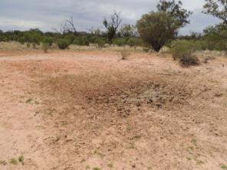 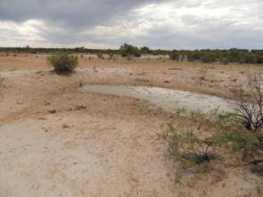

Figure 73 Thooro Mud spring complex—vents 976.1 and 976.15.

Table 155 Thooro Mud spring complex—hydrogeological information summary.

| Feature | Details | Comments |
| --- | --- | --- |
| No. of active vents | 12 | 976.1, 976.2, 976.3, 976.7, 976.10, 976.11, 976.12, 976.13, 976.14, 976.15, 976.17, 976.19 |
| No. of inactive vents | 8 | 976.4, 976.5, 976.6, 976.8, 976.9, 976.16, 976.18, 976.20 |
| Conservation ranking | 4a |  |
| Nearby springs |  | Mascot and Throo complexes are all within 10 kilometres of Thooro Mud |
| Spring water quality samples | No |  |
| Waterbores within 10-kilometre radius | 8 | GW011334, GW003669, GW011266, GW004590, GW003412, GW010070, GW004773, GW004443 |
| Waterbore water quality samples | No |  |
| Interpreted stratigraphy available | No |  |
| Outcropping GAB formations |  | Rolling Downs Group |
| Underlying aquifers |  | Wallumbilla Formation, Hooray Sandstone |
| SWL time series data available | Yes |  |
| Likely source aquifers |  | Hooray Sandstone |
| Conceptual spring type | E or F |  |

GAB = Great Artesian Basin, SWL = standing water level.

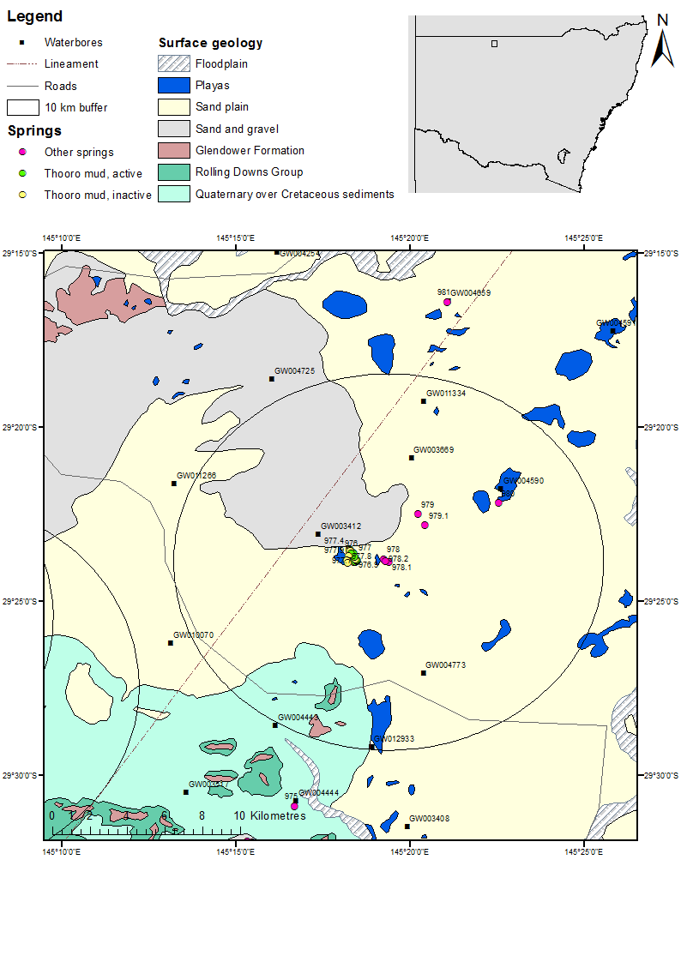

Figure 74 Thooro Mud spring complex—regional geology, Bourke supergroup, New South Wales.

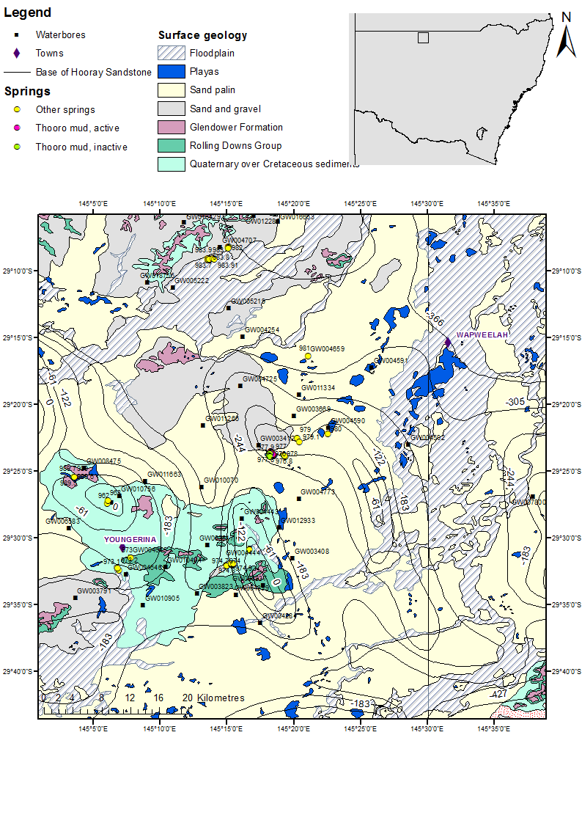

Figure 75 Thooro Mud spring complex—Hooray Sandstone basement contours.

### Geology

Thooro Mud spring complex is located on a sand plain. It lies about 2.6 kilometres to the west of a fault. There are several springs on either side of this fault (Figure 74). Rade (1954) suggests that the spring complexes in this region—including Thooro Mud, Thooro and Mascot, as well as Lake Eliza, Mother Nosey and Youngerina—are caused by faults, many trending north-west to south-east. The spring overlies an area of basement high that consists of a granite intrusion overlain by Palaeozoic rocks—see cross-section E–D on the Yantabulla 1:250 000 SH55-5 geological map (Wallis & McEwen 1962). Throoro Mud could therefore also possibly be associated with an area of basement highs—type G spring.

### Source aquifer of proximate waterbores

No interpreted stratigraphy for waterbores within a 10-kilometre radius of the spring complex is available. Interpreted stratigraphy is available for a bore that lies about 47 kilometres south-east of the Thooro Mud spring complex (GW804172) (Table 157). The interpreted stratigraphy is inconsistent with the contour map of the base of the Hooray Sandstone provided by the New South Wales Department of Primary Industries, Office of Water (see Figure 75). This map was provided with a warning that it may not be particularly accurate in some areas (Haridharan 2013, pers. comm., 6 March). The interpreted stratigraphy from GW804172 is therefore more likely to be accurate.

Drillers’ logs for the groundwater bores within a 10-kilometre radius of the spring complex indicate that water is encountered from 15 metres to 343 metres below ground surface. By comparing the depths drilled for each bore (Table 159 and Table 160) to the interpreted stratigraphy from GW804172 (Table 158)—and keeping in mind the trends in depth of Hooray Sandstone as shown by the contour map—it appears as though GW011334, GW003669, GW011266, GW010070 and GW004773 are tapping Hooray Sandstone, along with other minor aquifers present in the Coreena and Doncaster members of the Wallumbilla Formation.

### Water chemistry comparison: springs and waterbores

No chemical data on waterbores within a 10-kilometre radius of the spring complex are available. Descriptions of the salinity from waterbores indicate that the bores provide fresh water (Table 159 and Table 160). No spring water chemistry data exist for Thooro Mud spring complex.

### Artesian status of potential source aquifers

Very few data on the artesian status of nearby waterbores are available (Table 161 and Figure 76). Standing water level data from GW011266 may not be particularly accurate given the first data point; however, more recent data do indicate that GW011266, which is interpreted to have Hooray Sandstone as an aquifer, was still artesian in the early 1990s. The depth and the source aquifer for GW004590 is not known, although this bore appears to no longer be artesian.

Table 156 Thooro Mud spring complex—spring location and elevation.

| Vent ID | Latitude | Longitude | Elevation (mAHD) | Source |
| --- | --- | --- | --- | --- |
| 976.1 | –29.39170 | 145.30411 | 132.370 | Geodata 9” DEM |
| 976.2 | –29.39180 | 145.30423 | 131.148 | measured |
| 976.3 | –29.39181 | 145.30435 | 130.710 | Geodata 9” DEM |
| 976.4 | –29.39218 | 145.30400 | 131.370 | Geodata 9” DEM |
| 976.5 | –29.39238 | 145.30436 | 131.370 | Geodata 9” DEM |
| 976.6 | –29.39256 | 145.30477 | 131.500 | Geodata 9” DEM |
| 976.7 | –29.39371 | 145.30484 | 129.609 (131.500) | Measured (DEM) |
| 976.8 | –29.39479 | 145.30384 | 131.500 | Geodata 9” DEM |
| 976.9 | –29.39679 | 145.30287 | 131.370 | Geodata 9” DEM |
| 976.10 | –29.39756 | 145.30641 | 131.280 | Geodata 9” DEM |
| 976.11 | –29.39739 | 145.30671 | 133.170 | Geodata 9” DEM |
| 976.12 | –29.39756 | 145.30704 | 133.170 | Geodata 9” DEM |
| 976.13 | –29.39744 | 145.30773 | 133.170 | Geodata 9” DEM |
| 976.14 | –29.39704 | 145.30791 | 132.640 | measured |
| 976.15 | –29.39679 | 145.30734 | 132.040 | Geodata 9” DEM |
| 976.16 | –29.39658 | 145.30701 | 132.040 | Geodata 9” DEM |
| 1976.17 | –29.39528 | 145.30673 | 131.370 | Geodata 9” DEM |
| 976.18 | –29.39328 | 145.30572 | 132.670 | Geodata 9” DEM |
| 976.19 | –29.39369 | 145.30631 | 132.040 | Geodata 9” DEM |
| 976.20 | –29.39210 | 145.30463 | 132.040 | Geodata 9” DEM |

DEM = digital elevation model, mAHD = metres Australian height datum.

Table 157 Thooro Mud spring complex—stratigraphic bores in the geological region.

| Bore ID | From depth (mBGL) | To depth (mBGL) | Formation | Comments |
| --- | --- | --- | --- | --- |
| GW804172 | 0.0 | 31.5 | Unknown | Quarternary. Aeolian sand, clay, limonite bands |
|  | 31.5 | 32.8 | Unknown | Tertiary. Silcrete |
|  | 32.8 | 132.2 | Unknown | Cretaceous. Wallumbilla Formation – Coreena Member Claystone, mudstone |
|  | 132.2 | 294.0 | Unknown | Cretaceous. Wallumbilla Formation – Doncaster Member. Grey carbonaceous claystone, mudstone |
|  | 294.0 | 332.3 | Unknown | Cretaceous. Cadna-owie Formation. Clayey sandstone and siltstone |
|  | 332.3 | 394.9 | Unknown | Lower Cretaceous/Jurassic. Hooray Sandstone. Sandstone and unconsolidated sand with coarse cobbles |
|  | 394.9 | 408.0 | Unknown | Lower Palaeozoic. Metamorphic basement. White, highly weathered kaolinite at the unconformity with minor milky quartz fragments |
|  | 408.0 | 425.8 | Unknown | Dark green to grey metasediments (chloritic phyllite)—showing quartz veining—highly fractured in places |

mBGL = metres below ground level.  
© Copyright, NSW OoW 2010

Table 158 Thooro Mud spring complex—waterbores within a 10-kilometre radius.

| Bore ID | Top (mBGL) | Bottom (mBGL) | Rock type | Comments |
| --- | --- | --- | --- | --- |
| GW003412 | 0.00 | 7.62 | Clay |  |
|  | 7.62 | 10.67 | Sandstone |  |
|  | 10.67 | 12.50 | Boulders |  |
|  | 12.50 | 23.47 | Sandstone |  |
|  | 23.47 | 26.52 | Clay |  |
|  | 26.52 | 146.30 | Shale | Water supply |
|  | 146.30 | 217.02 | Shale | With bands of hard rock |
|  | 217.02 | 220.07 | Sandstone | Water supply |
|  | 220.07 | 232.87 | Shale |  |
|  | 232.87 | 235.92 | Sandstone | Water supply |
|  | 235.92 | 246.58 | Shale |  |
|  | 246.58 | 255.73 | Hard rock |  |
| GW003669 | 0.00 | 0.91 | Sand |  |
|  | 0.91 | 1.83 | Clay |  |
|  | 1.83 | 3.05 | Boulders |  |
|  | 3.05 | 13.72 | Sand |  |
|  | 13.72 | 15.24 | Clay |  |
|  | 15.24 | 16.76 | Gravel | Water supply |
|  | 16.76 | 28.04 | Clay |  |
|  | 28.04 | 35.05 | Shale |  |
|  | 35.05 | 38.71 | Sand | Water supply |
|  | 38.71 | 45.11 | Clay |  |
|  | 45.11 | 303.28 | Shale | Water supply at 12.6.19, 136.55 and 226.77 metres |
|  | 303.28 | 308.15 | Sandstone | Water supply |
|  | 308.15 | 336.80 | Shale | With bands of conglomerate |
|  | 336.80 | 352.04 | Sandstone | Water supply at 343.2 metres |
|  | 352.04 | 359.66 | Quartzite rock |  |
|  | 359.66 | 366.37 | Bedrock |  |
| GW004590 | – | – | – | – |
| GW004443 | 0.00 | 1.52 | Loam |  |
|  | 1.52 | 12.19 | Sandstone |  |
|  | 12.19 | 36.58 | unknown | White/yellow and chalky |
|  | 36.58 | 226.47 | Shale | Water supply |
|  | 226.47 | 244.78 | Granite |  |
| GW004773 | 0.00 | 12.19 | Clay |  |
|  | 12.19 | 13.72 | Sand |  |
|  | 13.72 | 76.20 | Clay |  |
|  | 76.20 | 149.35 | Shale |  |
|  | 149.35 | 150.27 | Limestone |  |
|  | 150.27 | 167.64 | Shale |  |
|  | 167.64 | 169.16 | Sand | Water supply |
|  | 169.16 | 273.10 | Shale |  |
|  | 273.10 | 274.32 | Limestone |  |
|  | 274.32 | 306.63 | Sandstone |  |
|  | 306.63 | 326.44 | Shale |  |
|  | 326.44 | 332.23 | Sandstone | Water supply |
|  | 326.44 | 332.23 | Sand |  |
| GW010070 | 0.00 | 2.13 | Soil |  |
|  | 2.13 | 32.00 | Sandstone |  |
|  | 32.00 | 47.55 | Clay |  |
|  | 47.55 | 329.79 | Shale |  |
|  | 329.79 | 338.94 | Volcanic ash |  |
|  | 338.94 | 340.16 | Shale |  |
|  | 340.16 | 341.16 | Sand | Water supply |
|  | 341.16 | 342.29 | Shale |  |
| GW011266 | 0.00 | 1.52 | Soil |  |
|  | 1.52 | 2.74 | Gravel |  |
|  | 2.74 | 4.88 | Rock |  |
|  | 4.88 | 19.51 | Clay |  |
|  | 19.51 | 28.65 | Mud | Water supply |
|  | 28.65 | 160.02 | Shale |  |
|  | 160.02 | 170.69 | Sandstone | Water supply |
|  | 170.69 | 343.51 | Shale |  |
|  | 343.51 | 352.65 | Sandstone | Water supply |
|  | 352.65 | 352.67 | Shale |  |
| GW011334 | 0.00 | 7.62 | Clay |  |
|  | 7.62 | 8.23 | Boulders |  |
|  | 8.23 | 16.00 | Sandstone | Water bearing |
|  | 16.00 | 25.91 | Soapstone |  |
|  | 25.91 | 36.58 | Clay |  |
|  | 36.58 | 307.84 | Shale | Water bearing at 144.78 metres |
|  | 307.84 | 317.30 | Unknown | Water bearing |

– = not available, mBGL = metres below ground level.  
© Copyright, NSW OoW 2010

Table 159 Thooro Mud spring complex—waterbore details and water chemistry.

| Variable | Details | | | |
| --- | --- | --- | --- | --- |
| Bore ID | GW003412 | GW003669 | GW004443 | GW004590 |
| Sample date | 1936 | 1940 | – | 2004 |
| Distance from spring complex (kilometres) | 1.9 | 5.9 | 9.7 | 7.8 |
| Source aquifer | Wallumbilla Formation | Hooray Sandstone | – | Wallumbilla Formation |
| Screens (metres) | – | Slots 300–302, 306–308 and 337–338 | – | – |
| Year drilled | 1936 | 1940 | 1891 | 1889 |
| Standing water level (reference point) | – | – | – | –0.07 |
| Total depth (metres) | 255.7 | 366.4 | 244.80 | 245.4 |
| Natural surface elevation (mAHD) | 144.21 | 129.36 | 138.7 | 131.99 |
| Facility status | – | – | – | – |
| Facility type | – | – | – | – |
| *Physicochemical parameters* | | | | |
| Salinity description | Fresh | Fresh | – | 501–1000 ppm |
| EC (µS/cm) | – | – | – | – |
| pH (field/lab) | – | – | – | – |
| Temperature (°C) | – | – | – | – |

– = not available, EC = electrical conductivity, mAHD = metres Australian height datum, µS/cm = microsiemens per centimetre.  
© Copyright, NSW OoW 2010

Table 160 Thooro Mud spring complex—waterbore details and water chemistry continued.

| Variable | Details | | | |
| --- | --- | --- | --- | --- |
| Bore ID | GW004773 | GW010070 | GW011266 | GW011334 |
| Sample date | 1930 | 1952 | 1989 | 1956 |
| Distance from spring complex (kilometres) | 7.1 | 9.6 | 9.1 | 8.8 |
| Source aquifer | Hooray Sandstone | Hooray Sandstone | Hooray Sandstone | Hooray Sandstone |
| Screens (metres) | Slots 320–331 |  | – | – |
| Year drilled | 1930 | 1952 | 1955 | 1956 |
| Standing water level (reference point) | – | – | 20.91 | – |
| Total depth (metres) | 332.2 | 342.3 | 352.6 | 317.3 |
| Natural surface elevation (mAHD) | 123.22 | 145.440 (DEM) | 145.610 (DEM) | 132.53 |
| Facility status | – | – | – | – |
| Facility type | – | – | – | – |
| *Physicochemical parameters* | | | | |
| Salinity description | Fresh | Fresh | Fresh | Good |
| EC (µS/cm) | – | – | – | – |
| pH (field/lab) | – | – | – | – |
| Temperature (°C) | – | – | – | – |

– = not available, DEM = digital elevation model, EC = electrical conductivity, mAHD = metres Australian height datum, µS/cm = microsiemens per centimetre.  
© Copyright, NSW OoW 2010

Table 161 Thooro Mud spring complex—waterbore standing water levels.

| Bore ID | Standing groundwater level (mAGL) | Year of measurement |
| --- | --- | --- |
| GW004590 | 2.84 | 1913 |
|  | –0.07 | 2004 |
| GW011266 | 35.09 | 1961 |
|  | 31.62 | 1965 |
|  | 35.09 | 1968 |
|  | 32.33 | 1970 |
|  | 32.33 | 1972 |
|  | 28.87 | 1975 |
|  | 22.90 | 1977 |
|  | 17.85 | 1982 |
|  | 21.42 | 1983 |
|  | 24.48 | 1986 |
|  | 20.91 | 1989 |

mAGL = metres above ground level.  
© Copyright, NSW OoW 2010

DEM = digital elevation model, mAHD = metres Australian height datum.

Figure 76 Thooro Mud spring complex—waterbore standing water levels (SWLs).

## Tego

### Hydrogeological summary

The Tego spring complex consists of six active discharge spring vents lying on the Cunnamulla Shelf in the Eromanga Basin. As the Cunamulla Shelf is a relatively flat region with little structure, the presence of the spring is difficult to explain.

The Coreena Member of the Wallumbilla Formation, the Wyandra Sandstone Member of the Cadna-owie Formation and Hooray Sandstone all supply waterbores in the area. The Hooray Sandstone is quite deep in the vicinity of the Tego spring complex, so the Wyandra Sandstone Member of the Cadna-owie Formation is the most likely source aquifer for the spring complex. However, the Hooray Sandstone cannot be ruled out, because Wyandra Sandstone and the Hooray Sandstone are the main aquifers for bores in this region.

Hydrochemical data from waterbores in the area indicate a measurable difference in groundwater chemistry between aquifers; however, full water chemistry data for spring vents at Tego spring complex were not available for comparison. No potentiometric data for the waterbores were available to assist in determining a source aquifer for the springs.

### Spring complex overview

Tego is located about 31 kilometres west of the town of Moorefield, southern Queensland, and about 16.5–kilometres north of the Queensland – New South Wales border. The spring complex consists of six active water springs that lie on a clay flat and are inundated during flooding. All spring vents, except for the most permanent one, are vegetated (Figure 77). The spring complex has been given a conservation ranking of 2. A summary of basic hydrogeological information available is given at Table 162. Table 163 lists the location and elevation of the spring vents in the Tego complex.

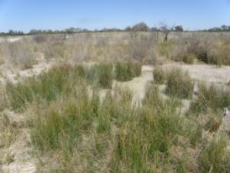 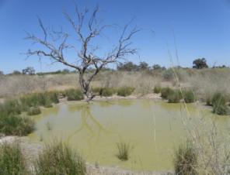

Figure 77 Tego spring complex—vents 196.4 and 196.5.

Table 162 Tego spring complex—hydrogeological information summary.

| Feature | Details | Comments |
| --- | --- | --- |
| No. of active vents | 6 | 196, 196.1, 196.2, 196.3, 196.4, 196.5 |
| No. of inactive vents | 0 |  |
| Conservation ranking | 2 |  |
| Spring water quality samples | No |  |
| Waterbores within 10-kilometre radius | 7 | 4641, 11080, 4648, 4649, 10979, 12472, 10978 |
| Waterbore water quality samples | Yes |  |
| Interpreted stratigraphy available | Yes |  |
| Outcropping GAB formations | None |  |
| Underlying aquifers |  | Tertiary alluvium, Wallumbilla Formation, Coreena Member, Doncaster Member, Wyandra Sandstone, Hooray Sandstone |
| SWL time series data available | No |  |
| Likely source aquifers |  | Wyandra Sandstone Member of Cadna-owie Formation, possibly Hooray Sandstone or Coreena Member of Wallumbilla Formation |
| Conceptual spring type | D, E or F | Likely options |

GAB = Great Artesian Basin, SWL = standing water level.

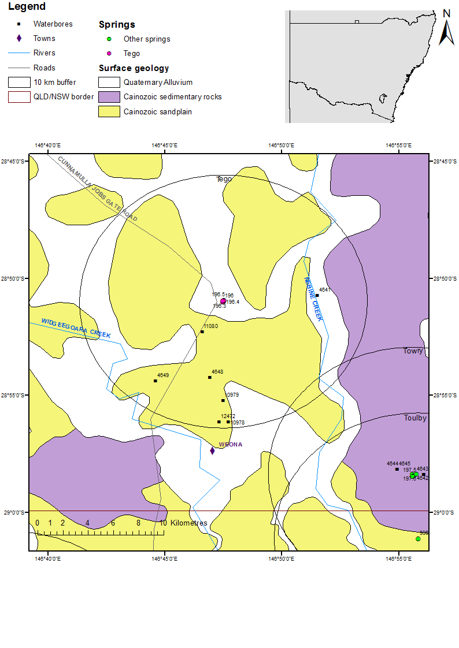

NSW = New South Wales, Qld = Queensland.

Figure 78 Tego spring complex—regional geology, Bourke supergroup, Queensland.

### Geology

The Tego spring complex is located in southern Queensland, near the Queensland – New South Wales border (Figure 78) on the Cunamulla Shelf. It lies near a small outcrop of the Coreena Member of the Wallumbilla Formation, which is about 20 kilometres to the south-east. There are no structural features mapped in the immediate vicinity of the spring complex. Although the Nebine Ridge, which separates the Surat Basin from the Eromanga Basin, is present further north, the southern part of the Cunnamulla Shelf exhibits flat-lying Lower Cretaceous – Jurassic sediments, and no clear boundary can be drawn between the Eromanga Basin and the Surat Basin.

### Regional stratigraphy and underlying aquifers

Stratigraphic interpretation from waterbores within 10 kilometres of the spring complex indicates that the Coreena Member of the Wallumbilla Formation is present under the Quaternary and Tertiary sediments (Table 164). Underlying the Coreena Member is the Doncaster Member of the Wallumbilla Formation, then the Wyandra Sandstone Member of the Cadna-owie Formation, followed by the Cadna-owie Formation and Hooray Sandstone.

The Hooray Sandstone is present at a considerable depth (up to about 530 metres) in this area. As there are no mapped structural features in the area, the Wyandra Sandstone Member of the Cadna-owie Formation is a likely source aquifer for the spring. However, artesian groundwater might be able to travel to the ground surface from the Hooray Sandstone.

### Water chemistry comparison: springs and waterbores

Water chemistry data were available for most waterbores within 10 kilometres of the spring complex (Table 165). Only some spring physicochemical data were available (Table 166). A Piper plot of the waterbores (Figure 79) shows a distinction in water chemistry between bores that tap different aquifers. Bores 4649 and 11080 have similar water chemistry and only tap the Coreena Member of the Wallumbilla Formation. Bores 4648 and 12472, interpreted to tap the Wyandra Sandstone (12472 may also possibly tap the Wallumbilla Formation), have similar chemistry to each other, but have a much lower chlorine concentration than bores 4649 and 11080. Bore 4641—interpreted to tap the Hooray Sandstone and, possibly, the Wyandra Sandstone Member—lies in the middle between the two groups of bores in terms of chloride levels.

Unfortunately, pH data from the waterbores do not show the same trend, so the available physicochemical data from vent 196.1 (Table 166) cannot be used to identify a source aquifer for the Tego spring complex.

### Artesian status of potential source aquifers

No potentiometric information or data on the standing water levels of waterbores within 10 kilometres of the spring complex were available. As existing bores are recorded as being flowing artesian bores, they are interpreted to be tapping the Coreena Member of the Wallumbilla Formation and the Wyandra Member of the Cadna-owie Formation. Either of these formations are potential source aquifers for the Tego spring complex, as is the Hooray Sandstone.

Table 163 Tego spring complex—spring location and elevation.

| Vent ID | Latitude | Longitude | Elevation (mAHD) | Source |
| --- | --- | --- | --- | --- |
| 196 | –28.85022 | 146.79126 | 131.930 | Geodata 9” DEM |
| 196.1 | –28.85005 | 146.79140 | 135.093 | measured |
| 196.2 | –28.84995 | 146.79173 | 132.130 | Geodata 9” DEM |
| 196.3 | –28.84961 | 146.79185 | 135.681 (132.130) | Measured (DEM) |
| 196.4 | –28.84884 | 146.79210 | 132.130 | Geodata 9” DEM |
| 196.5 | –28.84931 | 146.79091 | 135.075 (132.130) | Measured (DEM) |

DEM = digital elevation model, mAHD = metres Australian height datum.

Table 164 Tego spring complex—waterbores within a 10-kilometre radius.

| Bore ID | Top (mBGL) | Bottom (mBGL) | Rock unit name |
| --- | --- | --- | --- |
| 4641 | 0.0 | – | Tertiary sediments |
|  | – | – | Wallumbilla Formation |
|  | – | – | Wyandra Sandstone Member |
|  | – | – | Cadna-owie Formation |
|  | – | 533.4 | Hooray Sandstone |
| 4648 | 0.0 | – | Quaternary/Tertiary |
|  | – | – | Wallumbilla Formation |
|  | – | 106.7 | Wyandra Sandstone member |
| 4649 | 0.0 | – | Quaternary/Tertiary |
|  | – | 145.7 | Coreena Member |
| 11080 | 0.0 | – | Alluvium |
|  | – | 39.6 | Tertiary |
|  | 39.6 | 133.2 | Coreena Member |
| 10978 | 0.0 | – | Quaternary/Tertiary |
|  | – | 135.3 | Wallumbilla Formation |
| 10979 | 0.0 | – | Quaternary/Tertiary |
|  | – | – | Coreena Member |
|  | – | 169.2 | Doncaster Member |
| 12472 | 0.0 | 24.4 | Quaternary/Tertiary |
|  | 24.4 | – | Coreena Member |
|  | – | – | Doncaseter Member |
|  | – | 345.9 | Wyandra Sandstone Member |

– = not available, mBGL = metres below ground level.  
© Copyright, DNRM 2012

Table 165 Tego spring complex—waterbore details and water chemistry.

| Variable | Details | | | | | | |
| --- | --- | --- | --- | --- | --- | --- | --- |
| Bore ID | 4641 | 4648 | 4649 | 10979 | 11080 | 12472 | 10978 |
| Sample date | 1989 | 2000 | 2000 | 2000 | 2000 | 2000 | – |
| Distance from spring complex (km) | 6.5 | 6.0 | 7.9 | 7.8 | 2.8 | 9.5 | 9.5 |
| Source aquifer | Wyandra Sandstone Member/  Hooray Sandstone | Wyandra Sandstone Member | Coreena Member | Doncaster Member | Coreena Member | Wyandra Sandstone/Wallumbilla Formation (potential) | Wallumbilla Formation |
| Screens (metres) | – | Perforations 106.7 | – | – | 132.9–133.2 | Perforations 339–346.1 | – |
| Year drilled | 1912 | 1947 | 1929 | 1952 | 1952 | 1954 | – |
| Standing water level (natural surface elevation) | 44.2 | – | – |  | – | 90.1 (1954) | – |
| Total depth (metres) | 533 | 106.7 | 145.7 | 169.2 | 131.1 | 345.9 | 135.3 |
| Natural surface elevation (mAHD) | 135.4 | 131.7 | 131.7 | 132 | 134.8 | 132.3 | 131.1 |
| Facility status | Abandoned and destroyed | Existing | Existing | Existing | Existing | Existing | Abandoned and destroyed |
| Facility type | Artesian, uncontrolled flow | Artesian, uncontrolled flow | Artesian, controlled flow | Artesian, ceased to flow | Artesian, controlled flow | Artesian, controlled flow | Artesian, controlled |
| *Physicochemical parameters* | | | | | | | |
| EC (µS/cm) | 1100 | 1044 | 1226 | 832 | 2637 | 972 | – |
| pH (field/lab) | 8.3 | 8.4 | 8.3 | – | 8.3 | 8.5 | – |
| Temperature (°C) | 47 | 23 | 24.5 | – | 25 | 38 | – |
| *Chemical parameters (milligrams per litre)* | | | | | | | |
| Dissolved oxygen | – | – | – | – | – | – | – |
| TSS | – | – | – | – | – | – | – |
| TDS | – | 625.12 | 680.45 | – | 1467.19 | 590.63 | – |
| Sodium (Na) | 260 | 246 | 253.5 | – | 568.4 | 234.7 | – |
| Potassium (K) | 1.9 | 3.1 | 2.5 | – | 5.3 | 0.9 | – |
| Calcium (Ca) | 4.2 | 5.4 | 10.1 | – | 10.3 | 4 | – |
| Magnesium (Mg) | 0.7 | 2.8 | 2.2 | – | 7.2 | 0 | – |
| Chlorine (Cl) | 110 | 65 | 249.5 | – | 536.4 | 59.2 | – |
| Sulfate (SO4) | 2 | 0 | 0 | – | 0.9 | 0 | – |
| Alkalinity (calcium carbonate) | 410 | 468 | 243 | – | 535 | 436 | – |
| Bicarbonate (HCO3–) | 485 | 551.7 | 288.6 | – | 631.6 | 510.5 | – |
| Carbonate (CO32–) | 7.3 | 9.3 | 4 | – | 10.2 | 10.4 | – |
| Fluoride (F) | 0.6 | 0.93 | 0.59 | – | 1.02 | 1.08 | – |
| Bromine (Br) | – | – | – | – | – | – | – |
| Aluminium (Al) | – | 0 | 0 | – | – | 0 | – |
| Arsenic (As) | – | – | – | – | – | – | – |
| Barium (Ba) | – | – | – | – | – | – | – |
| Cobalt (Co) | – | – | – | – | – | – | – |
| Iron (Fe) | 0.01 | 0 | 0 | – | 0 | – | – |
| Manganese (Mn) | – | – | 0.2 | – | – | 0 | – |
| Silica (SiO2) | 19 | 21 | 16 | – | 16 | 29 | – |
| Strontium (Sr) | – | – | – | – | – | – | – |
| Zinc (Zn) | – | 0.01 | 0 | – | – | 0 | – |
| Nitrate as NO3 | 2.2 | 0 | 0 | – | – | 0 | – |

– = not available, EC = electrical conductivity, mAHD = metres Australian height datum, µS/cm = microsiemens per centimetre, TDS = total dissolved solids, TSS = total suspended solids.  
© Copyright, DNRM 2012

Table 166 Tego spring complex—spring water chemistry.

| Variable | Details |
| --- | --- |
| Vent ID | 196.1 |
| Sample date | 2012 |
| *Physicochemical parameters* | |
| EC (µS/cm) | – |
| pH (field/lab) | 9.5 (field) |
| Temperature (°C) | 30.4 |

– = not available, EC = electrical conductivity, µS/cm = microsiemens per centimetre.

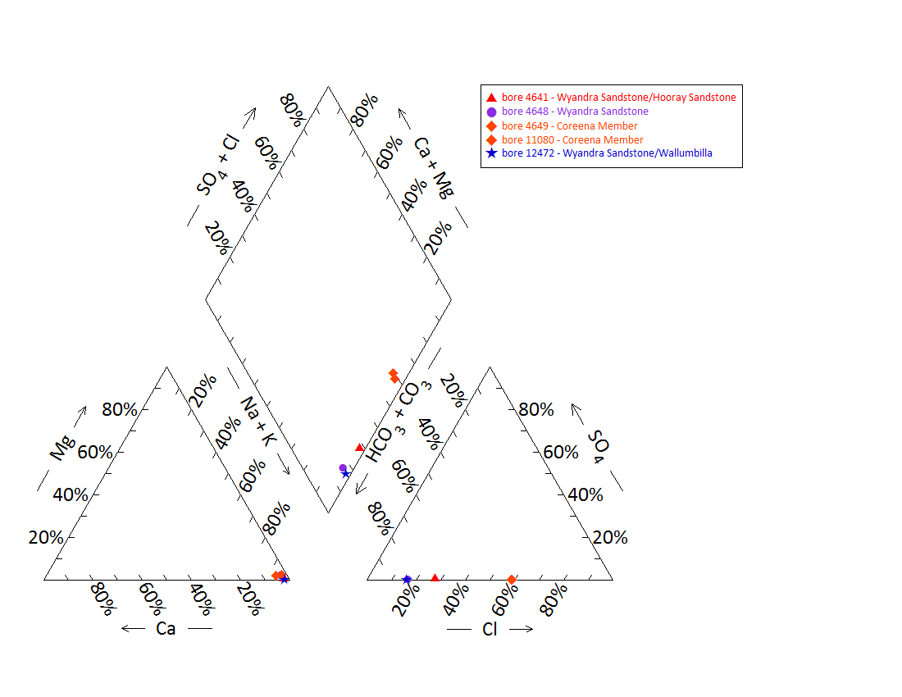

Note: No water chemistry data were available for any of the springs.

Figure 79 Tego spring complex—Piper plot of waterbore chemistry.

## Towry

### Hydrogeological summary

The Towry spring complex consists of eight active discharge spring vents that have vegetation-supporting water pools and lie on the Cunnamulla Shelf in the Eromanga Basin. A lineament to the south of the spring complex may be related to the presence of the spring complex.

The Coreena Member of the Wallumbilla Formation and the Wyandra Sandstone Member of the Cadna-owie Formation both supply waterbores in the area. The Hooray Sandstone is also present in the area; however, it is deep. Most of the waterbores that tapped the Coreena Member were subartesian and are now abandoned. The Wyandra Sandstone Member of the Cadna-owie Formation is therefore most likely to be the source aquifer for the Towry spring complex, but the Hooray Sandstone cannot be ruled out.

There are too little water chemistry data for the waterbores and spring vents, and too little potentiometric data to determine a source aquifer for the Towry spring complex with any certainty.

### Spring complex overview

The Towry spring complex is located about 22 kilometres west of the Queensland town of Moorefield, and 3 kilometres north of the Queensland – New South Wales border. The complex consists of eight active vents, one of which (197) has been excavated and no longer supports a spring wetland and has been given a conservation ranking of 2. There are three main vents that contain water, and support vegetation and wetland animals. One vent (197.5) has been partially fenced to prevent damage from pigs (Figure 80). Table 167 shows basic hydrogeological information for the spring complex. The location and elevations of the springs are listed in Table 168.

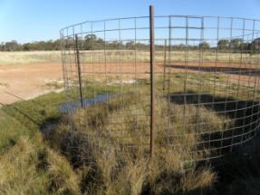 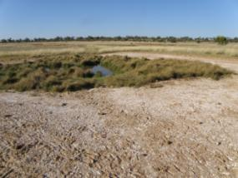

Figure 80 Towry spring complex—vents 197.5 and 197.6.

Table 167 Towry spring complex—hydrogeological information summary.

| Feature | Details | Comments |
| --- | --- | --- |
| No. of active vents | 8 | 197, 197.1, 197.2, 197.3, 197.4, 197.5, 197.6, 198 |
| No. of inactive vents | 0 |  |
| Conservation ranking | 2 |  |
| Spring water quality samples |  |  |
| Waterbores within 10-kilometre radius | 5 | 4642, 4643, 4644, 4645, GW004579 |
| Waterbore water quality samples |  |  |
| Interpreted stratigraphy available | Yes |  |
| Outcropping GAB formations | None |  |
| Underlying aquifers |  | Coreena Member (minor aquifer), Wyandra Sandstone Member, Hooray Sandstone |
| SWL time series data available | Yes |  |
| Likely source aquifers |  | Wyandra Sandstone Member of the Cadna-owie Formation |
| Conceptual spring type | D, E or F | Likely options |

GAB = Great Artesian Basin, SWL = standing water level.

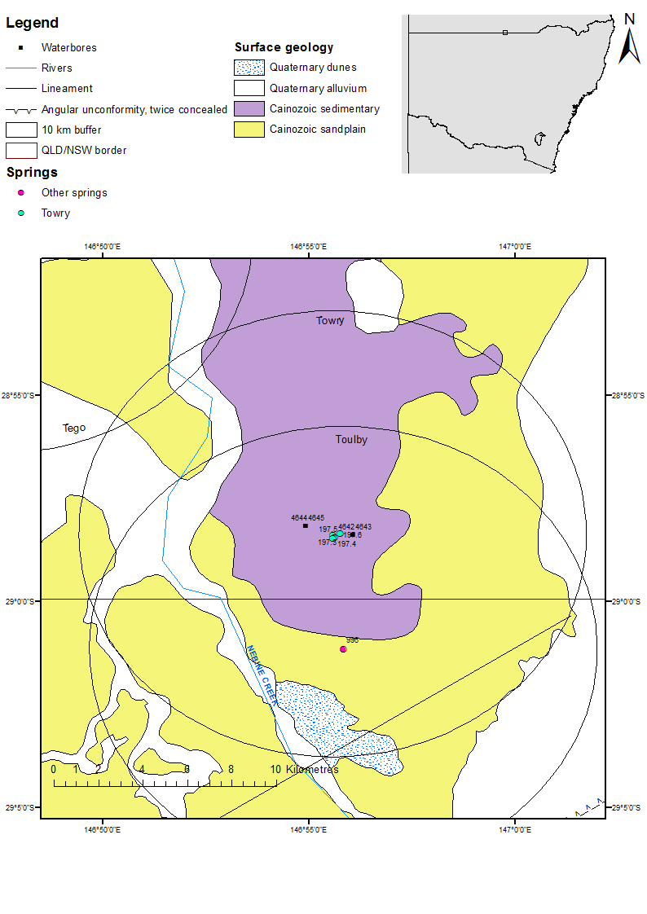

NSW = New South Wales, Qld = Queensland.

Figure 81 Towry spring complex—regional geology, Bourke supergroup, Queensland.

### Geology

The Towry spring complex is located on the Cunnamulla Shelf within the Eromanga Basin (Figure 81). It lies near an outcrop of the Coreena Member of the Wallumbilla Formation. A lineament is present about 8 kilometres to the south-east of the complex and further to the north, the Nebine Ridge separates the Surat Basin from the Eromanga Basin.

### Regional stratigraphy and underlying aquifers

Interpreted stratigraphy for waterbores within a 10-kilometre radius of the spring complex is not available for formations below the Coreena Member (Table 169); however, waterbores further north indicate that the Doncaster Member of the Wallumbilla Formation, Wyandra Sandstone Member of the Cadna-owie Formation, the Cadna-owie Formation and the Hooray Sandstone all underlie the springs. New South Wales bore GW004579 taps groundwater from sandstone at a depth of 354 metres, which would most likely be from the Wyandra Sandstone Member of the Cadna-owie Formation.

### Water chemistry comparison: springs and waterbores

Water chemistry data were only available for one waterbore within 10 kilometres of the spring complex (Table 170). Only physicochemical data were available for vents 197.4 and 197.6 (Table 171). A Piper plot of the waterbores (Figure 82) shows the chemical composition of the water for bore 4642. Unfortunately, the physicochemical data for the waterbores and springs are insufficient to be able to identify a source aquifer for Towry spring complex.

### Artesian status of potential source aquifers

Little potentiometric data exist for aquifers in the region of the Towry spring complex. Standing water levels for bore GW4579 (Figure 83 and Table 172), which is interpreted to tap the Wyandra Sandstone Member of the Cadna-owie Formation, indicate that it was still flowing artesian in 1987. This suggests that the Wyandra Sandstone Member is likely to be the source aquifer for Towry spring complex.

Table 168 Towry spring complex—spring locations and elevations.

| Vent ID | Latitude | Longitude | Elevation (mAHD) | Comments |
| --- | --- | --- | --- | --- |
| 197 | –28.97082 | 146.92369 | 134.606 | Excavated, no longer supports wetland |
| 197.1 | –28.97160 | 146.92553 | 134.245 | Small soak |
| 197.2 | –28.97073 | 146.92506 | 134.154 | Small soak |
| 197.3 | –28.97317 | 146.92621 | 135.108 | New vent, no free water |
| 197.4 | –28.97427 | 146.92684 | 136.019 | Main vent |
| 197.5 | –28.97459 | 146.92626 | 136.131 | Main vent, partially fenced to prevent damage from pigs |
| 197.6 | –28.97278 | 146.92917 | 136.163 | Main vent |
| 198 | –28.94906 | 146.88741 | 133.803 | New vent, no free water |

mAHD = metres Australian height datum.

Table 169 Towry spring complex—waterbores within a 10-kilometre radius.

| Bore ID | Top (mBGL) | Bottom (mBGL) | Rock unit name / rock type | Comments |
| --- | --- | --- | --- | --- |
| 4642 | 0.00 | – | Quaternary/Tertiary |  |
|  | – | 74.40 | Coreena Member |  |
| 4643 | 0.00 | – | Quaternary/Tertiary |  |
|  | – | 76.20 | Coreena Member |  |
| 4644 | 0.00 | – | Tertiary sediments |  |
|  | – | 76.20 | Coreena Member |  |
| 4645 | 0.00 | – | Tertiary sediments |  |
|  | – | 65.50 | Coreena Member |  |
| GW004579 | 3.05 | 45.72 | Clay |  |
|  | 45.72 | 307.85 | Shale |  |
|  | 307.85 | 351.74 | Clay |  |
|  | 351.74 | 354.48 | Sandstone | Water supply |
|  | 354.48 | 361.19 | Clay |  |

– = not available, mBGL = metres below ground level.  
© Copyright, DNRM 2012, NSW OoW 2010

Table 170 Towry spring complex—waterbore details and water chemistry.

| Variable | Details | | | | |
| --- | --- | --- | --- | --- | --- |
| Bore ID | 4642 | 4643 | 4644 | 4645 | GW004579 |
| Sample date | 2000 | – | – | – | 1986 |
| Distance from spring complex (kilometres) | 0.8 | 0.8 | 1.1 | 1.1 | 3.5 |
| Source aquifer | Coreena Member | Coreena Member | Coreena Member | Coreena Member | Wyandra Sandstone Member |
| Screens (metres) | – | – | – | – | – |
| Year drilled | 1912 | 1879 | 1912 | 1912 | 1930 |
| Standing water level (N) | – | – | – | – | 20.4 |
| Total depth (metres) | 74.4 | 76.2 | 76.2 | 65.5 | 361 |
| Natural surface elevation (mAHD) | 137.2 | 137.2 | 137.2 | 137.2 | – |
| Facility status | Existing | Abandoned and destroyed | Abandoned and destroyed | Abandoned and destroyed | – |
| Facility type | Artesian, uncontrolled flow | Artesian, controlled flow | Subartesian | Subartesian | – |
| *Physicochemical parameters* | | | | | |
| Salinity description | – | – | – | – | – |
| EC (µS/cm) | 1006 | – | – | – | – |
| pH (field/lab) | 8.3 | – | – | – | – |
| Temperature (°C) | 27.1 | – | – | – | – |
| *Chemical parameters (milligrams per litre)* | | | | | |
| Dissolved oxygen |  | – | – | – | – |
| TSS |  | – | – | – | – |
| TDS | 604.26 | – | – | – | – |
| Sodium (Na) | 247.3 | – | – | – | – |
| Potassium (K) | 1.4 | – | – | – | – |
| Calcium (Ca) | 1.7 | – | – | – | – |
| Magnesium (Mg) | 0.2 | – | – | – | – |
| Chlorine (Cl) | 61.2 | – | – | – | – |
| Sulfate (SO4) | 0 | – | – | – | – |
| Alkalinity (calcium carbonate) | 455 | – | – | – | – |
| Bicarbonate (HCO3–) | 540.5 | – | – | – | – |
| Carbonate (CO32–) | 7 | – | – | – | – |
| Fluoride (F) | 0.66 | – | – | – | – |
| Bromine (Br) | – | – | – | – | – |
| Aluminium (Al) | 0 | – | – | – | – |
| Arsenic (As) | – | – | – | – | – |
| Barium (Ba) | – | – | – | – | – |
| Cobalt (Co) | – | – | – | – | – |
| Iron (Fe) | – | – | – | – | – |
| Manganese (Mn) | – | – | – | – | – |
| Silica (SiO2) | 19 | – | – | – | – |
| Strontium (Sr) | – | – | – | – | – |
| Zinc (Zn) | 0.01 | – | – | – | – |
| Nitrate as NO3 | 0 | – | – | – | – |

– = not available, EC = electrical conductivity, mAHD = metres Australian height datum, µS/cm = microsiemens per centimetre, TDS = total dissolved solids, TSS = total suspended solids.  
© Copyright, DNRM 2012, NSW OoW 2010

Table 171 Towry spring complex—spring water chemistry.

| Variable | Details |  |
| --- | --- | --- |
| Vent ID | 197.4 | 197.6 |
| Sample date | 2012 | 2012 |
| *Physicochemical parameters* |  |  |
| EC (µS/cm) | 1007 | 2084 |
| pH (field/lab) | 7.9 | 8.72 |
| Temperature (°C) | 25.9 | 27.8 |

EC = electrical conductivity, µS/cm = microsiemens per centimetre.

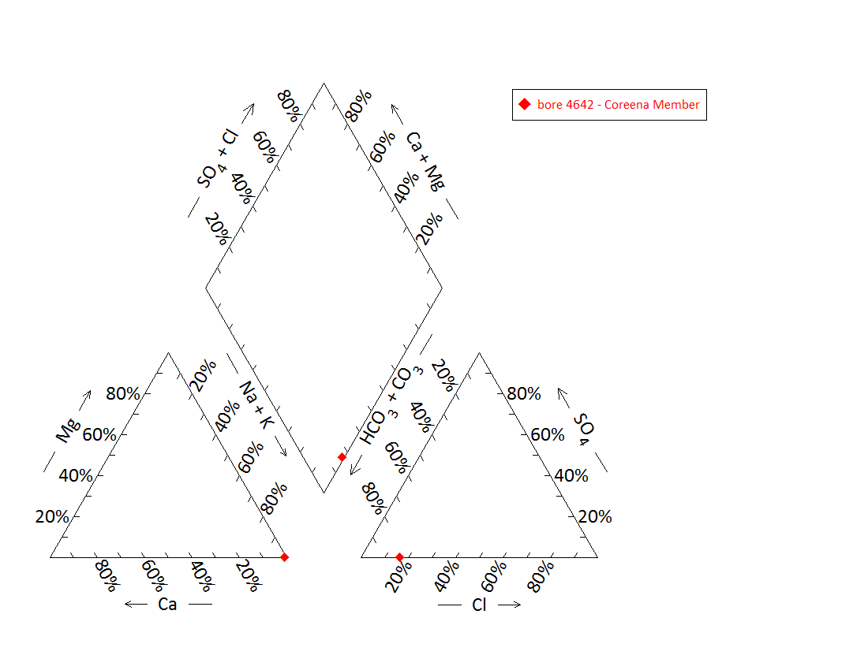

Note: No water chemistry data were available for any of the springs, or bores 4643, 4644, 4645 and GW004579.

Figure 82 Towry spring complex—Piper plot of waterbore chemistry.

Table 172 Towry spring complex—waterbore standing water levels.

| Bore ID | Standing groundwater level (mAGL) | Year of measurement |
| --- | --- | --- |
| GW004579 | 2.5 | 1933 |
|  | 17.85 | 1980 |
|  | 14.28 | 1982 |
|  | 15.3 | 1984 |
|  | 20.4 | 1986 |

mAGL = metres above ground level.  
© Copyright, NSW OoW 2010

DEM = digital elevation model, mAHD = metres Australian height datum.

Figure 83 Towry spring complex—waterbore standing water levels (SWLs).

# Bogan River supergroup, New South Wales

## Coorigul

### Hydrogeological summary

Coorigul spring complex consists of one discharge spring vent and is most likely a non–Great Artesian Basin (GAB) spring sourced from a local aquifer. The spring is located in New South Wales near the Queensland border in the Surat Basin on a ridge of outcropping Rolling Downs Group – Griman Creek Formation that is covered by sedimentary rock. The ridge is known to produce opals.

Coorigul spring and other soaks in the area are known to come and go. The watertable in the area is very close to the surface and has provided water to bores in the past.

Comparison of the physicochemical properties of Coorigul spring water with local waterbores in the area that known to tap GAB aquifers also suggests that Coorigul spring could be supplied with water from a local Tertiary aquifer, where it contacts a confining layer (type O) rather than the GAB. The spring does, however, sit on on the line of an inferred fault, making it possible that it is sourced from an underlying GAB aquifer with water emanating from the fault (type E or F).

### Spring complex overview

The Coorigul spring complex is located about 54 kilometres south-west of the Queensland town of Dirranbandi, 2 kilometres south of the Queensland – New South Wales border. The spring consists of a large vent flowing from a rocky outcrop and is surrounded by reeds (Figure 84). A summary of basic hydrogeological information available is given at Table 173. Table 174 lists the location and elevation of the Coorigul spring.

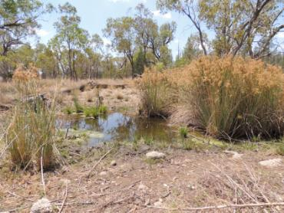

Figure 84 Coorigul spring complex—vent 991.

Table 173 Coorigul spring complex—hydrogeological information summary.

| Feature | Details | Comments |
| --- | --- | --- |
| No. of active vents | 1 | 991 |
| No. of inactive springs | – |  |
| Spring water quality samples | No |  |
| Waterbore within 10-kilometre radius | 2 | 16783, 14843 |
| Waterbore water quality samples | Yes | 16783 |
| Interpreted stratigraphy available | Limited availability | 1:250 000 map (Burton 2010) |
| Outcropping GAB formations |  | Rolling Downs Group |
| SWL time series data available | No |  |
| Underlying aquifers |  | Quaternary/Tertiary (non-GAB), Mooga Sandstone, Gubberamunda Sandstone |
| Likely source aquifers | Quaternary/Tertiary surface aquifer |  |
| Conceptual spring type | O | Potential for E or F |

– = not available, GAB = Great Artesian Basin, SWL = standing water level.

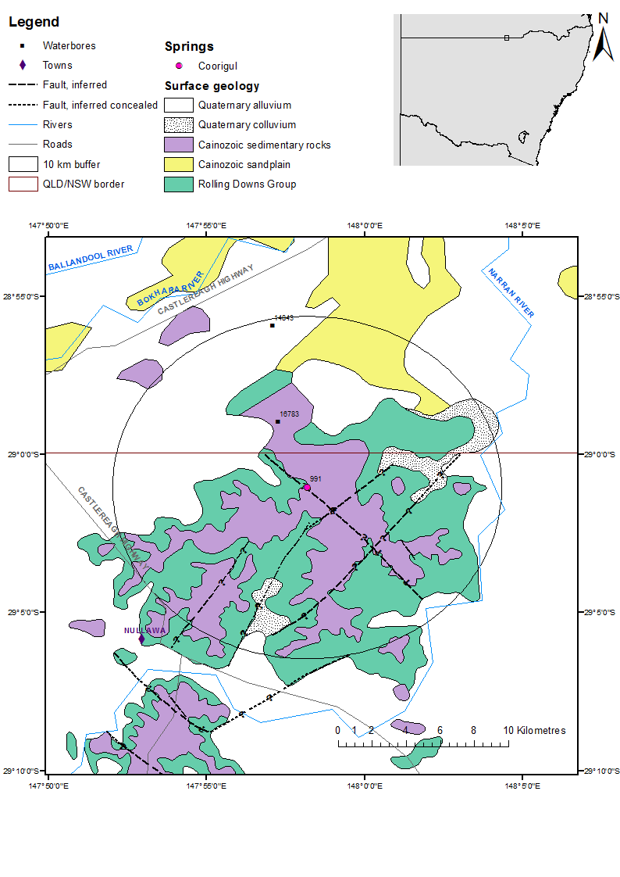

NSW = New South Wales, Qld = Queensland.

Figure 85 Coorigul spring complex—regional geology, Bogan River supergroup, New South Wales.

### Geology

The Coorigul spring complex is located in the transition zone between the Eromanga and the Surat basins. It is located on an outcrop of the Rolling Downs Group that is covered with Tertiary sedimentary rock (Figure 85). The ridge is known to produce opals, which are mined in the area.

The Angledool 1:250 000 SH 55 – 7 geological map sheet (Burton 2010) shows an inferred fault directly underneath Coorigul spring complex (Figure 85). In addition, there is a syncline located 15 kilometres west of the spring complex that is trending approximately north–south. This syncline has only been mapped in Queensland; however, it appears to align with the Louth – Eumara Shear Zone that has been mapped in New South Wales.

### Regional stratigraphy and underlying aquifers

There are no New South Wales GAB bores within a 10-kilometre radius of the Coorigul spring complex. The Queensland bore 16783, located approximately 4 kilometres from the spring complex, taps the Mooga Sandstone aquifer—the equivalent of Hooray Sandstone in the Surat Basin and Coonamble Embayment. This bore also extends into the Gubberamunda Sandstone (also a Hooray Sandstone equivalent in the Surat Basin) and water may be sourced from both aquifers (Table 175). Waterbore 14843 is located approximately 9.6 kilometres north-north-east from the spring complex and is an abandoned shallow bore that does not extend into the GAB aquifer system. Water from this bore is sourced from Quaternary sediments (Table 176). Either Gubberamunda or Mooga sandstone have the potential to be a source aquifer for springs in the area. Inspection of the Coorigul spring suggests that it might not be a GAB spring. The watertable is close to the surface, and spring pools in the area are ephemeral.

### Water chemistry comparison: springs and waterbores

Water chemistry data are only available for one waterbore within a 10-kilometre radius of the spring, 16783 (Table 176). Only physicochemical data for the spring water are available (Table 177). The electrical conductivity and pH of the water from Coorigul spring are much lower than bore 16783, which is known to be tapping a GAB formation. The temperature of the spring is also much lower than that of the water coming from bore 16783. Comparison of the physicochemical parameters of the spring water with water from a bore known to be tapping a GAB aquifer indicates that Coorigul spring is not a GAB spring, but has its source in a local shallow aquifer.

### Artesian status of potential source aquifers

No data on the artesian status of underlying aquifers are available.

Table 174 Coorigul spring complex—spring locations and elevation.

| Vent ID | Latitude | Longitude | Elevation (mAHD) (DEM) |
| --- | --- | --- | --- |
| 991 | –29.017154 | 147.96955 | 173.350 |

DEM = digital elevation model, mAHD = metres Australian height datum.

Table 175 Coorigul spring complex—waterbores within a 10-kilometre radius.

| Bore ID | Top (mBGL) | Bottom (mBGL) | Rock unit name |
| --- | --- | --- | --- |
| 14843 | 0.0 | 25.9 | Quaternary/Tertiary |
| 16783 | 0.0 | 45.7 | Quaternary/Tertiary |
|  | 45.7 | 210.3 | Griman Creek Formation |
|  | 210.3 | 426.7 | Surat Siltstone |
|  | 426.7 | 481.6 | Coreena Member |
|  | 481.6 | 561.4 | Doncaster Member |
|  | 561.4 | 917.4 | Bungil Formation |
|  | 917.4 | – | Mooga Sandstone |
|  | – | – | Orallo Formation |
|  | – | 1315.2 | Gubberamunda Sandstone |

– = not available, mBGL = metres below ground level.  
© Copyright, NSW OoW 2010

Table 176 Coorigul spring complex—waterbore details and water chemistry.

| Variable | Details | |
| --- | --- | --- |
| Bore ID (Queensland) | 14843 | 16783 |
| Sample date | – | 1990 |
| Distance from spring complex (kilometres) | 9.6 | 4.0 |
| Source aquifer | Quaternary/tertiary | Mooga Sandstone/Gubberamunda Sandstone |
| Screens (metres) | – | Opening 1004–1315.21 |
| Year drilled | – | – |
| Standing water level (natural surface elevation) | –9.14 | 37.1 |
| Total depth (metres) |  | 131.25 |
| Natural surface elevation (mAHD) | 155.1 (DEM) | 167.5 |
| Facility status | Abandoned and destroyed | Existing |
| Facility type | Subartesian | Artesian, controlled flow |
| *Physicochemical parameters* | | |
| EC (µS/cm) | – | 1100 |
| pH (field/lab) | – | 8.8 |
| Temperature (°C) | – | 53.4 |
| *Chemical parameters (milligrams per litre)* | | |
| Dissolved oxygen | – | – |
| TSS | – | – |
| TDS | – | 585.3 |
| Sodium (Na) | – | 235 |
| Potassium (K) | – | 1.8 |
| Calcium (Ca) | – | 1.8 |
| Magnesium (Mg) | – | 0.1 |
| Chlorine (Cl) | – | 64 |
| Sulfate (SO4) | – | 2 |
| Alkalinity (calcium carbonate) | – | 421 |
| Bicarbonate (HCO3–) | – | 475 |
| Carbonate (CO32–) | – | 19 |
| Fluoride (F) | – | 0.6 |
| Bromine (Br) | – | – |
| Aluminium (Al) | – | 0.05 |
| Arsenic (As) | – | – |
| Barium (Ba) | – | – |
| Cobalt (Co) | – | – |
| Iron (Fe) | – | 0.03 |
| Manganese (Mn) | – | 0.01 |
| Silica (SiO2) | – | 26 |
| Strontium (Sr) | – | – |
| Zinc (Zn) | – | 0.01 |
| Nitrate as NO3 | – | 1.4 |

– = not available, DEM = digital elevation model, EC = electrical conductivity, mAHD = metres Australian height datum, µS/cm = microsiemens per centimetre, TDS = total dissolved solids, TSS = total suspended solids.  
© Copyright, NSW OoW 2010

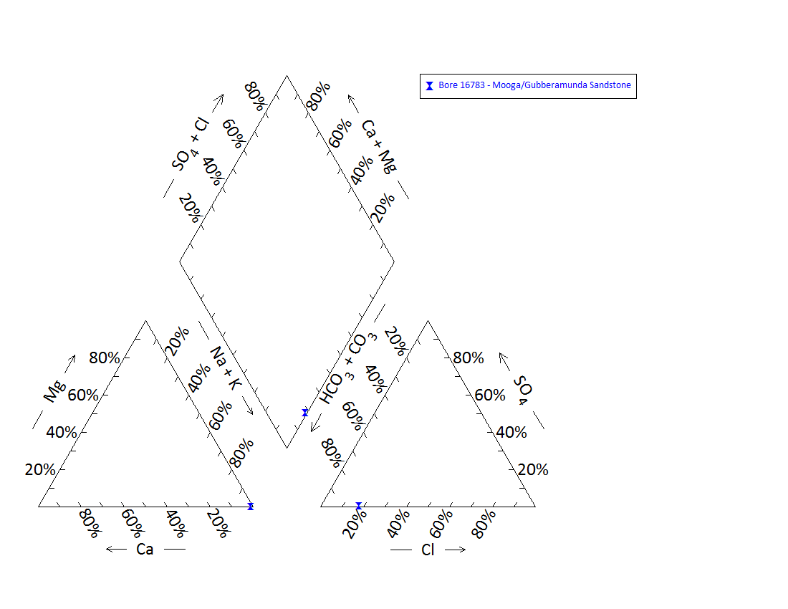

Note: No water chemistry data were available for bore 14843.

Figure 86 Coorigul spring complex—Piper plot of waterbore chemistry.

Table 177 Coorigul spring complex—spring water chemistry.

| Variable | Details |
| --- | --- |
| Vent ID | 991 |
| Sample date | 2012 |
| *Physicochemical parameters* | |
| EC (µS/cm) | 468 |
| pH (field/lab) | 6.43 |
| Temperature (°C) | 28 |

EC = electrical conductivity, µS/cm = microsiemens per centimetre.

## Cumborah

### Hydrogeological summary

The Cumborah spring complex consists of three to four inactive discharge spring vents. One pumped well may have been a spring at one stage. Cumborah spring complex has a similar geological context to Coorigul spring complex, and is not likely to be a GAB spring. The likely conceptual model for the spring is a spring emanating from the base of Tertiary sandstone where it contacts a confining layer—type N or O.

Cumborah springs are likely to be sourced from Tertiary sediments.

No water chemistry data are available for waterbores within a 10-kilometre radius of the spring complex. Because the springs are also inactive, and the water sample taken was most likely fresh water from run-on surface water, no water chemistry analysis could be conducted to establish a source aquifer for the Cumborah springs.

### Spring complex overview

The Cumborah spring complex is located about 500 metres north-west of the village of Cumborah, northern New South Wales. The spring is in the Surat Basin, on an outcrop of the Griman Creek Formation, overlain by Tertiary sediments. The complex consists of four inactive vents, some of which are filled with rain water. A nearby pumped well (992.3) appears to be an excavated spring and still provides water for local use (Figure 87). A summary of basic hydrogeological information is given in Table 178, and Table 179 lists the location and elevations of the spring vents.

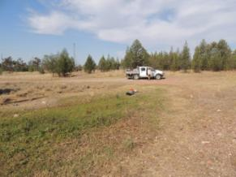 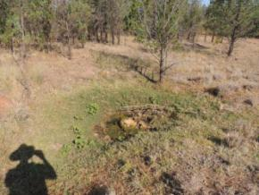

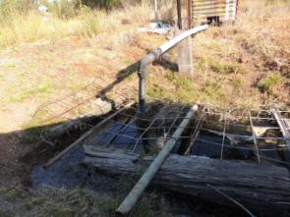

Figure 87 Cumborah spring complex—vents 992, 992.1 and 992.3

Table 178 Cumborah spring complex—hydrogeological information summary.

| Features | Details | Comments |
| --- | --- | --- |
| No. of active vents | 0 |  |
| No. of inactive springs | 4 | 992, 992.1, 992.2, 992.3 |
| Spring water quality samples | No |  |
| Waterbore within 10-kilometre radius | 6 | GW038186, GW040925, GW010746, GW019833, GW010235, GW00421 |
| Waterbore water quality samples | No |  |
| Interpreted stratigraphy available | No |  |
| Outcropping GAB formations |  | Rolling Downs Group, Griman Creek Formation |
| Underlying aquifers |  | – |
| Likely source aquifers |  | Tertiary sediments |
| Conceptual spring type | N or O |  |
| SWL time series data available | Yes |  |

– = not available, GAB = Great Artesian Basin, SWL = standing water level.

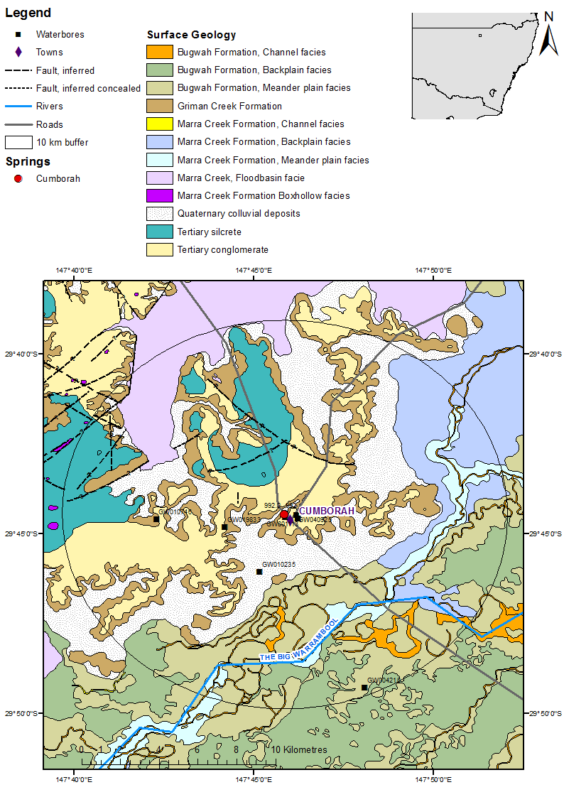

Figure 88 Cumborah spring complex—regional geology, Bogan River supergroup, New South Wales.

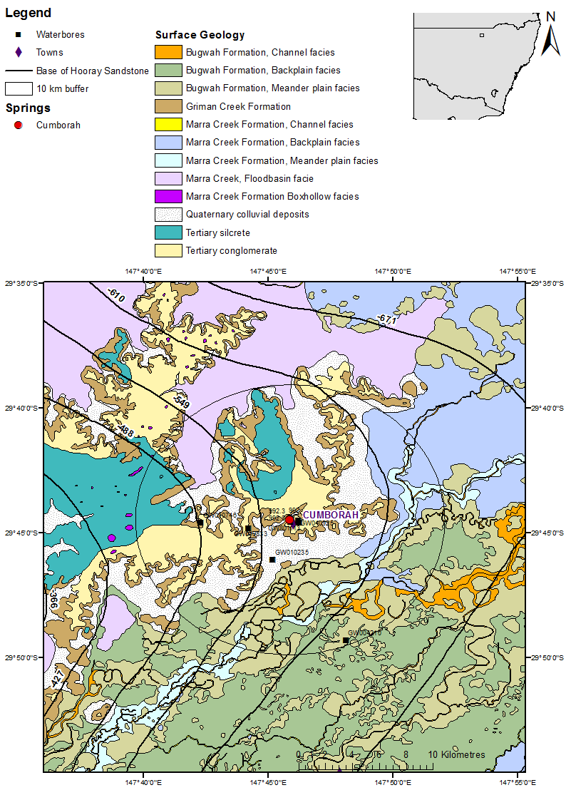

Figure 89 Cumborah spring complex—Hooray Sandstone contours.

### Geology

Cumborah spring complex is located in the Surat Basin, on an outcrop of the Rolling Downs Group (Griman Creek Formation), which is covered with Tertiary sedimentary rock (sandstone) (Figure 88). The latter ridge is known to produce opals, which are mined in the area. Several geological faults or other structures have been mapped in the area.

### Regional stratigraphy and underlying aquifers

By comparing the depths drilled for each bore (Table 180) to the mapped depth of the Hooray Sandstone and its hydrogeological equivalents (Figure 89), it was inferred that GW040925 and GW004210 most likely tap the Gubberamunda Sandstone. GW010746 most likely taps the Mooga Sandstone, because this bore encounters water at a shallower depth compared to GW040925. Bores GW010235, GW38186 and GW019833, however, encounter water at very shallow depths, between 50 metres and 100 metres (Table 180). It is therefore possible that these bores source water from aquifers above the Mooga Sandstone, such as the Nullawurt Sandstone Member of the Bungil Formation, shallower Cretaceous units or Tertiary sediments. There are a number of faults mapped to the north and north-east of the Cumborah spring complex; however, they generally appear to be associated with the Tertiary sediments. This, along with the regional geology, suggests that Cumborah spring is most likely sourced from Tertiary aquifers.

### Water chemistry comparison: springs and waterbores

No chemical data on waterbores within a 10-kilometre radius of the spring complex were available. Descriptions of the salinity from waterbores indicate that the bores provide fairly fresh water (Table 181 and Table 182). The water in the main spring (992) was most likely from surface and/or run-on surface water, as it had a fairly neutral pH and (very) low electrical conductivity (Table 183).

### Artesian status of potential source aquifers

Very few data on the artesian status of nearby waterbores are available. Standing water level data from GW004210 (interpreted to tap the Gubberamunda Sandstone) indicate that the water level had dropped to the elevation of the Cumborah spring by 1935 (Table 184 and Figure 90). No potentiometric data are available for the Nullawurt Sandstone Member of the Bungil Formation in this area. Both the Gubberamunda Sandstone and the Nullarwurt Sandstone Member appear to be subartesian at this time.

Table 179 Cumborah spring complex—spring locations and elevation

| Vent ID | Latitude | Longitude | Elevation (mAHD) |
| --- | --- | --- | --- |
| 992 | –29.74111 | 147.76436 | 153.140 |
| 992.1 | –29.74106 | 147.76469 | 153.140 |
| 992.2 | –29.74125 | 147.76437 | 153.140 |
| 992.3 | –29.7412 | 147.76464 | 153.140 |

mAHD = metres Australian height datum.

Table 180 Cumborah spring complex—waterbores within a 10-kilometre radius.

| Bore no. | Top  (mBGL) | Bottom  (mBGL) | Rock type | Description |
| --- | --- | --- | --- | --- |
| GW004210 | 0.00 | 18.29 | Clay |  |
|  | 18.29 | 30.48 | Sand |  |
|  | 30.48 | 33.53 | Rock |  |
|  | 33.53 | 89.00 | Clay |  |
|  | 89.00 | 500.18 | Shale |  |
|  | 500.18 | 510.54 | Sandstone | Water supply |
|  | 510.54 | 512.67 | Rock |  |
|  | 512.67 | 539.19 | Shale |  |
|  | 539.19 | 542.85 | Clay | Pipe clay |
|  | 542.85 | 583.39 | Shale |  |
|  | 583.39 | 590.09 | Quartz conglomerate |  |
|  | 590.09 | 605.03 | Shale |  |
|  | 605.03 | 629.11 | Sandstone | Water supply |
|  | 629.11 | 631.55 | Gravel |  |
|  | 631.55 | 635.20 | Conglomerate |  |
|  | 635.20 | 636.96 | Sand rock |  |
| GW010235 | 0.00 | 6.10 | Loam |  |
|  | 6.10 | 18.29 | Sandstone |  |
|  | 18.29 | 24.38 | Opal dirt |  |
|  | 24.38 | 35.66 | Sand |  |
|  | 35.66 | 121.91 | Slate | Water bearing at 60.96 and 121.92 metres |
| GW010746 | 0.00 | 3.05 | Ironstone gravel |  |
|  | 3.05 | 12.19 | Sandstone |  |
|  | 12.19 | 18.29 | Clay | Pipe clay |
|  | 18.29 | 30.48 | Opal dirt |  |
|  | 30.48 | 60.96 | Clay |  |
|  | 60.96 | 292.61 | Shale |  |
| GW019833 | 0.00 | 3.05 | Ironstone gravel |  |
|  | 3.05 | 10.67 | Sandstone |  |
|  | 10.67 | 15.24 | Opal dirt |  |
|  | 15.24 | 22.86 | Soapstone |  |
|  | 22.86 | 38.10 | Clay |  |
|  | 38.10 | 53.34 | Sand | Water supply |
|  | 38.10 | 99.06 | Shale | Water supply at 76.2 metres |
| GW038186 | 0.00 | 0.60 | Boulders |  |
|  | 0.60 | 5.48 | Gravel |  |
|  | 5.48 | 12.49 | Soil | Dirt opal |
|  | 12.49 | 14.32 | Sandstone |  |
|  | 14.32 | 56.38 | Clay | Water supply |
|  | 56.38 | 222.50 | Shale | With bands of hard rock |
| GW040925 | 0.00 | 2.00 | Soil |  |
|  | 2.00 | 8.00 | Gravel |  |
|  | 8.00 | 12.50 | Silcrete |  |
|  | 12.50 | 62.00 | Clay |  |
|  | 62.00 | 380.00 | Shale |  |
|  | 380.00 | 382.00 | Slate |  |
|  | 382.00 | 617.00 | Shale |  |
|  | 617.00 | 623.00 | Sandstone | Water supply |
|  | 623.00 | 663.00 | Shale |  |
|  | 663.00 | 773.00 | Sandstone | With bands of shale |

mBGL = metres below ground level.  
Note: No drillers log data are available for bores GW053187 and GW801113.  
© Copyright, NSW OoW 2010

Table 181 Cumborah spring complex—waterbore details and chemistry.

| Variable | Details | | | |
| --- | --- | --- | --- | --- |
| Bore ID | GW004210 | GW010235 | GW010746 | GW019833 |
| Sample date | 1935 | 1951 | 1953 | 1963 |
| Distance from spring complex (kilometres) | 9.6 | 3.2 | 5.8 | 2.8 |
| Aquifer | – | – | – | – |
| Screens (metres) | Slots 500–510 and 605.3605.9 | – | – | – |
| Year drilled | 1904 | 1951 | 1953 | 1963 |
| Standing water level (reference point) | 22.4 |  | – | – |
| Total depth (metres) | 637 | 121.9 | 292.6 | 99.1 |
| Natural surface elevation (mAHD) | 131.20 | 136.210 (DEM) | 156.470 (DEM) | 151.380 (DEM) |
| Facility status | – | – | – | – |
| *Physicochemical parameters* | | | | |
| Salinity description | 501–1000 ppm | Fair | Fresh | Good |
| EC (µS/cm) | – | – | – | – |
| pH (field/lab) | – | – | – | – |
| Temperature (°C) | – | – | – | – |
| Turbidity | – | – | – | – |

– = not available, DEM = digital elevation model, EC = electrical conductivity, mAHD = metres Australian height datum, µS/cm = microsiemens per centimetre, ppm = parts per million.  
© Copyright, NSW OoW 2010

Table 182 Cumborah spring complex—waterbore details and water chemistry continued.

| Variable | Details | | | |
| --- | --- | --- | --- | --- |
| Bore ID | GW038186 | GW040925 | GW053187 | GW801113 |
| Sample date | – | – | – | – |
| Distance from spring complex (kilometres) | 0.2 | 0.5 | 0.5 | 0.6 |
| Aquifer | – | – | – | – |
| Screens (metres) | – | Slots 617–773 | – | – |
| Year drilled | 1975 | 2004 | 1971 | 1995 |
| Standing water level (reference point) | – | 19.43 | – | – |
| Total depth (metres) | 222.5 | 773 | 10 | 10 |
| Natural surface elevation (mAHD) (DEM) | 153.040 | 158.450 | 158.450 | 161.510 |
| Facility status | – | – | – | – |
| *Physicochemical parameters* | | | | |
| Salinity description | – | 1500 ppm | unknown | – |
| EC (µS/cm) | – | – | – | – |
| pH (field/lab) | – | – | – | – |
| Temperature (°C) | – | – | – | – |
| Turbidity | – | – | – | – |

– = not available, DEM = digital elevation model, EC = electrical conductivity, mAHD = metres Australian height datum, µS/cm = microsiemens per centimetre, ppm = parts per million.  
© Copyright, NSW OoW 2010Table 183 Cumborah spring complex—spring water chemistry.

| Variable | Details |
| --- | --- |
| Vent ID | 99 |
| Sample date | 2012 |
| *Physicochemical parameters* | |
| EC (µS/cm) | 83 |
| pH (field/lab) | 7.18 |
| Temperature (°C) | 30.4 |

EC = electrical conductivity, µS/cm = microsiemens per centimetre.

Table 184 Cumborah spring complex—waterbore standing water levels.

| Bore ID | Standing groundwater level (mAGL) | Year of measurement |
| --- | --- | --- |
| GW004210 | 37.23 | 1913 |
|  | 37.94 | 1915 |
|  | 36.52 | 1917 |
|  | 36.52 | 1918 |
|  | 31.62 | 1920 |
|  | 30.19 | 1921 |
|  | 29.48 | 1922 |
|  | 28.05 | 1923 |
|  | 28.05 | 1924 |
|  | 26.01 | 1926 |
|  | 25.30 | 1927 |
|  | 24.58 | 1928 |
|  | 24.58 | 1929 |
|  | 23.87 | 1930 |
|  | 23.87 | 1931 |
|  | 23.15 | 1932 |
|  | 23.51 | 1933 |
|  | 22.08 | 1934 |
|  | 22.44 | 1935 |

mAGL = metres above ground level.  
© Copyright, NSW OoW 2010

mAHD = metres Australian height datum.

Figure 90 Cumborah spring complex—waterbore standing water levels (SWLs).

## Cuddie

### Hydrogeological summary

Cuddie spring complex is an inactive discharge spring located in the middle of a claypan in the Coonamble Embayment. A likely conceptual model for the spring is one associated with faulting—type E or F.

It is likely that the source aquifer for the spring was Hooray Sandstone and its equivalents. No interpreted stratigraphy or water chemistry data are available to confirm this.

### Spring complex overview

The Cuddie spring complex is located about 15 kilometres south-east of the town of Yarrawin, northern New South Wales. In 1877, a well was sunk at the spring to feed stock during a drought. This uncovered Pleistocene fossils, and the area is now an archaeological site. During the most recent spring visits, the well was not located; however, it was described as sitting in the middle of a claypan. A summary of basic hydrogeological information available is given at Table 185, and Table 186 lists the location and elevations of the potential inactive spring vent.

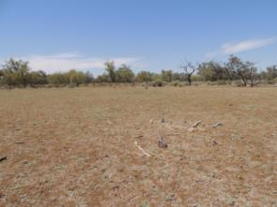 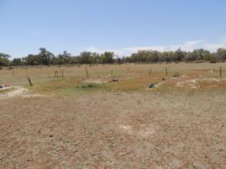

Figure 91 Cuddie spring complex—claypan and archaeological activity at presumed spring site.

Table 185 Cuddie spring complex—hydrogeological information summary.

| Feature | Details | Comments |
| --- | --- | --- |
| No. of active vents | 0 |  |
| No. of inactive springs | 1 | 993 |
| Spring water quality samples | No |  |
| Waterbore within 10-kilometre radius | 9 | GW016344, GW004207, GW004208, GW008388, GW021391, GW065407, GW004205, GW004206, GW004039 |
| Waterbore quality samples | No |  |
| Interpreted stratigraphy available | No |  |
| SWL time series data available | Yes |  |
| Outcropping GAB formations |  | Rolling Downs Group |
| Underlying aquifers |  | Bungil Formation, Mooga Sandstone, Pilliga Sandstone |
| Likely source aquifers |  | Mooga Sandstone |
| Conceptual spring type | E or F |  |

GAB = Great Artesian Basin, SWL = standing water level.

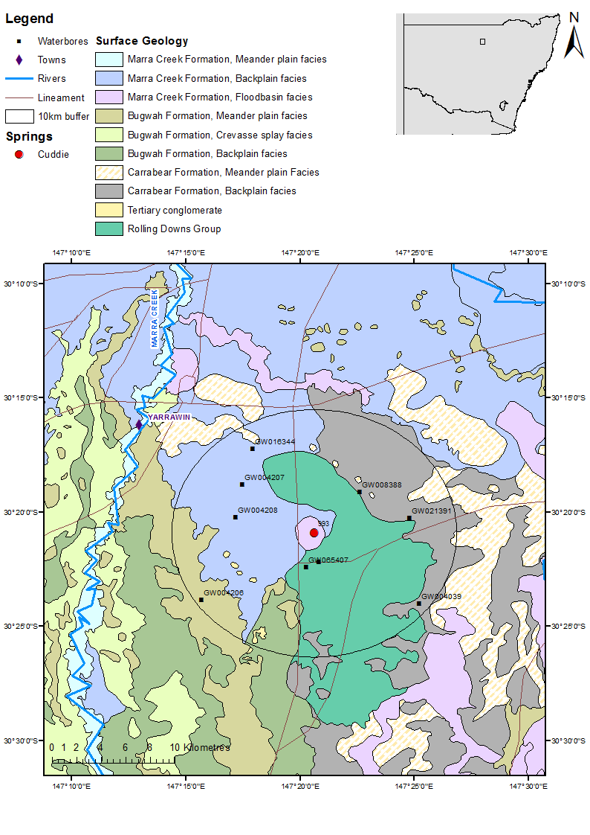

Figure 92 Cuddie spring complex—regional geology Bogan River supergroup, New South Wales.

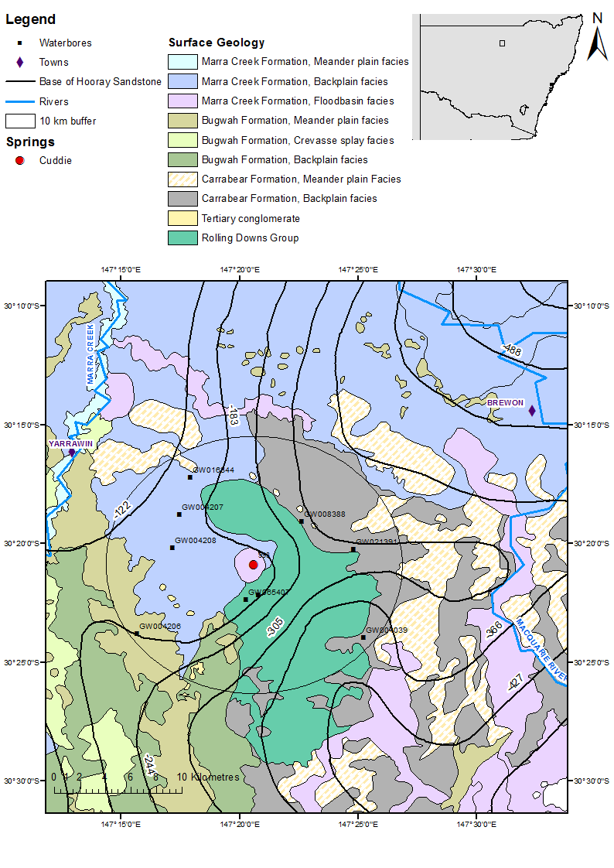

Figure 93 Cuddie spring complex—top Hooray Sandstone contours.

### Geology

The Cuddie spring complex is located in the Coonamble Embayment. It sits on Quaternary alluvium overlying an outcrop of the Rolling Downs Goup (Figure 92). A number of linaments, trending approximately north–south and east–west, are present in the area, with one north–south trending linament approximately 1 kilometre to the west of the spring. The existence of the springs might be associated with one or some of these structural features.

### Regional stratigraphy and underlying aquifers

No interpreted stratigraphy for waterbores within a 10-kilometre radius of the spring complex was available. When comparing the depths of the bores and the drillers’ logs (Table 187, Table 188 and Table 189) to the depth of the top of the Hooray Sandstone and its equivalents in the Coonamble Embayment (Mooga Sandstone, informally referred to as the Keelindi or Drildool beds, and the Bungil Formation) (Figure 93), it appears that GW004205, GW008388, GW021391 and GW004039 tap the Mooga Sandstone. Bores GW008388, GW021391 and GW004039 may potentially tap a deeper aquifer(s) such as the Pilliga Sandstone. The top of the Pilliga Sandstone is at about 400 metres below the ground surface in this area, as seen on the geological cross-section on the Walgett 1:250 000 map sheet SH55-11 (Meakin et al. 1996, Watkins & Meakin 1996).

### Water chemistry comparison: springs and waterbores

No hydrochemical data on waterbores within a 10-kilometre radius of the spring complex were available. Descriptions of the salinity from waterbores indicate that the bores provide fairly fresh water (Table 188 and Table 189). The Cuddie spring is inactive, and no water was located that could be associated with the spring or the well, so a water sample of the spring was not taken and no spring water chemistry data exist.

### Artesian status of potential source aquifers

Available data on waterbore standing water levels indicate that the pressure of aquifers in the vicinity of the spring have declined during the past century. The water levels have remained above ground level and produce flowing artesian bores, and are above the elevation of the spring (Table 190 and Figure 94).

Table 186 Cuddie spring complex—spring location and elevation.

| Vent ID | Latitude | Longitude | Elevation (mAHD) |
| --- | --- | --- | --- |
| 993 | –30.34863 | 147.34344 | 123.210 |

mAHD = metres Australian height datum.

Table 187 Cuddie spring comple—waterbores within a 10-kilometre radius.

| GW no. | Top  (mBGL) | Bottom  (mBGL) | Rock type | Description |
| --- | --- | --- | --- | --- |
| GW004025 | 0.00 | 34.75 | Unknown |  |
|  | 34.75 | 45.72 | Clay |  |
|  | 45.72 | 79.25 | Unknown |  |
|  | 79.25 | 10.63 | Sand |  |
|  | 10.63 | 141.73 | Shale | Water supply |
|  | 141.73 | 173.74 | Shale |  |
|  | 173.74 | 188.98 | Clay |  |
|  | 188.98 | 280.42 | Shale, sandy | Water supply |
|  | 280.42 | 328.27 | Slate |  |
| GW004039 | 0.00 | 30.48 | Clay |  |
|  | 30.48 | 54.86 | Sand |  |
|  | 54.86 | 304.80 | Shale |  |
|  | 304.80 | 335.28 | Sandstone |  |
|  | 335.28 | 472.44 | Shale | Water supply |
|  | 472.44 | 487.68 | Sandstone | Water supply |
|  | 487.68 | 530.05 | Granite | Water supply |
| GW008388 | 0.00 | 0.91 | Top soil | Red |
|  | 0.91 | 95.10 | Clay | Water bearing |
|  | 95.10 | 274.30 | Shale |  |
|  | 274.30 | 304.80 | Shale | Water bearing |
|  | 304.80 | 359.66 | Shale |  |
|  | 359.66 | 375.51 | Sandstone | Water bearing |
|  | 375.51 | 462.38 | Shale and sandstone | Alternating bands of shale and sandstone |
|  | 462.38 | 468.48 | Sandstone | Water bearing |
|  | 468.48 | 471.83 | Shale |  |
| GW021391 | 0.00 | 0.61 | Soil |  |
|  | 0.61 | 83.82 | Clay |  |
|  | 83.82 | 251.46 | Sand, shale and coal | Bands of sand, shale and coal |
|  | 251.46 | 364.24 | Shale |  |
|  | 364.24 | 371.86 | Sandstone | Water bearing |
|  | 371.86 | 460.25 | Shale |  |
|  | 460.25 | 464.25 | Sandstone | Water bearing |

mBGL = metres below ground level.  
Note: No drillers’ log data are available for bores GW16344, GW004207, GW004208, GW065407, GW004206.  
© Copyright, NSW OoW 2010

Table 188 Cuddie spring complex—waterbore details and water chemistry.

| Variable | Details | | | | |
| --- | --- | --- | --- | --- | --- |
| Bore ID | GW004039 | GW004205 | GW004206 | GW004207 | GW004208 |
| Sample date | 1934 | 1934 | 1902 | – | 1990 |
| Distance from spring complex (kilometres) | 9.3 | 2.5 | 9.6 | 6.4 | 5.6 |
| Aquifer | – | – | – | – | – |
| Screens (metres) | Perforations 334–489 | – | – | – | – |
| Year drilled | 1902 | 1902 | 1902 | – | 1908 |
| Standing water level (reference point) | 8.36 | 7.75 | – | – | 3.06 |
| Total depth (metres) | 530.1 | 328.30 | 296.3 | 201.5 | 250.6 |
| Natural surface elevation (mAHD) | 128.8 | 128.6 | 129.2 | 122.340 (DEM) | 126.2 |
| Facility status | – | – | – | – | – |
| *Physicochemical parameters* | | | | | |
| Salinity description | 501–1000 ppm | 501–1000ppm | 501–1000 ppm | – | 665 ppm |
| EC (µS/cm) | – | – | – | – | – |
| pH (field/lab) | – | – | – | – | – |
| Temperature (°C) | – | – | – | – | – |
| Turbidity | – | – | – | – | – |

– = not available, EC = electrical conductivity, mAHD = metres Australian height datum, µS/cm = microsiemens per centimetre, ppm = parts per million.  
© Copyright, NSW OoW 2010

Table 189 Cuddie spring complex—waterbore details and water chemistry continued.

| Variable | Details | | | |
| --- | --- | --- | --- | --- |
| Bore ID | GW008388 | GW021391 | GW016344 | GW065407 |
| Sample date | 1989 | 1985 | – | 1988 |
| Distance from spring complex (kilometres) | 4.6 | 6.8 | 8 | 2.7 |
| Aquifer | – | – | – | – |
| Screens (metres) | Slots 359–378 and 417–468 | – | – | – |
| Year drilled | 1954 | 1967 | – | 1988 |
| Standing water level (reference point) | 11.22 | 3.77 | – | – |
| Total depth (metres) | 471.8 | 464.2 | – | 322 |
| Natural surface elevation (mAHD) (DEM) | 122.640 | 124.350 | 122.320 | 128.080 |
| Facility status | – | – | – | – |
| *Physicochemical parameters* | | | | |
| Salinity description | 501–1000 ppm | Unknown | – | Fair |
| EC (µS/cm) | – | – | – | – |
| pH (field/lab) | – | – | – | – |
| Temperature (°C) | – | – | – | – |
| Turbidity | – | – | – | – |

– = not available, DEM = digital elevation model, EC = electrical conductivity, mAHD = metres Australian height datum, µS/cm = microsiemens per centimetre, ppm = parts per million.  
© Copyright, NSW OoW 2010

Table 190 Cuddie spring complex—waterbore standing water levels.

| Bore ID | Standing groundwater level (mAGL) | Year of measurement |
| --- | --- | --- |
| GW004039 | 17.58 | 1911 |
|  | 17.54 | 1912 |
|  | 20.66 | 1912 |
|  | 19.33 | 1914 |
|  | 19.69 | 1915 |
|  | 18.97 | 1916 |
|  | 19.99 | 1917 |
|  | 18.97 | 1918 |
|  | 16.12 | 1919 |
|  | 13.97 | 1921 |
|  | 13.72 | 1922 |
|  | 12.65 | 1923 |
|  | 11.93 | 1924 |
|  | 11.58 | 1925 |
|  | 10.51 | 1926 |
|  | 12.29 | 1928 |
|  | 2.40 | 1929 |
|  | 11.22 | 1929 |
|  | 10.51 | 1930 |
|  | 10.51 | 1931 |
|  | 9.08 | 1933 |
|  | 8.36 | 1934 |
| GW004205 | 18.26 | 1911 |
|  | 18.26 | 1913 |
|  | 17.54 | 1914 |
|  | 17.19 | 1915 |
|  | 16.22 | 1916 |
|  | 16.22 | 1917 |
|  | 15.86 | 1918 |
|  | 15.50 | 1919 |
|  | 15.50 | 1920 |
|  | 14.08 | 1921 |
|  | 13.36 | 1922 |
|  | 13.01 | 1923 |
|  | 12.65 | 1924 |
|  | 12.29 | 1925 |
|  | 14.08 | 1926 |
|  | 11.22 | 1927 |
|  | 11.22 | 1928 |
|  | 10.51 | 1929 |
|  | 10.20 | 1930 |
|  | 10.20 | 1931 |
|  | 9.54 | 1933 |
|  | 8.47 | 1934 |
|  | 7.75 | 1935 |
| GW008388 | 6.22 | 1976 |
|  | 8.06 | 1977 |
|  | 7.14 | 1978 |
|  | 6.63 | 1979 |
|  | 6.63 | 1980 |
|  | 6.63 | 1981 |
|  | 6.63 | 1982 |
|  | 7.14 | 1983 |
|  | 6.63 | 1985 |
|  | 11.22 | 1989 |
| GW021391 | 6.94 | 1969 |
|  | 6.63 | 1970 |
|  | 8.01 | 1971 |
|  | 5.20 | 1973 |
|  | 5.61 | 1975 |
|  | 6.12 | 1977 |
|  | 5.00 | 1978 |
|  | 6.12 | 1979 |
|  | 6.12 | 1980 |
|  | 5.61 | 1981 |
|  | 5.61 | 1982 |
|  | 6.63 | 1983 |
|  | 3.77 | 1985 |
| GW004206 | 14.08 | 1913 |
|  | 13.36 | 1915 |
|  | 10.20 | 1916 |
|  | 13.01 | 1917 |
|  | 12.65 | 1918 |
|  | 12.29 | 1919 |
|  | 11.22 | 1921 |
|  | 10.51 | 1922 |
|  | 10.51 | 1923 |
|  | 10.51 | 1924 |
|  | 9.89 | 1925 |
|  | 9.89 | 1926 |
|  | 9.89 | 1927 |
|  | 9.18 | 1928 |
|  | 8.47 | 1929 |
|  | 7.75 | 1930 |
|  | 7.40 | 1931 |
|  | 7.40 | 1933 |
|  | 7.04 | 1934 |
|  | 3.06 | 1990 |

mAGL = metres above ground level.  
© Copyright, NSW OoW 2010

DEM = digital elevation model, mAHD = metres Australian height datum.

Figure 94 Cuddie spring complex—waterbore standing water levels (SWLs).

## Coolabah

### Hydrogeological summary

Coolabah spring complex lies on the edge of the mapped extent of the GAB. The area around the spring shows evidence of past GAB springs and is likely a GAB spring itself. The conceptual model describing the spring is most likely to be a spring emanating from a downgradient at the edge of the Basin—type K.

Available stratigraphic information suggests that the only major GAB aquifer in the region is the Mooga Sandstone, although the Pilliga Sandstone may continue west as far as the spring compex. These geological units do not outcrop at the western edge of the Coonamble Embayment. The most likely source aquifer for Coolabah spring complex is the Mooga Sandstone.

Few data on stratigraphy or waterbore chemistry exist for the area. It was therefore not possible to properly identify a source aquifer for Coolabah spring complex.

### Spring complex overview

The Coolabah spring complex is located about 30 kilometres north-east of the town of Innisvale, northern New South Wales. The complex consists of one active spring near Coolabah Creek (Figure 95). It is located on the border of the GAB, as interpreted by Habermeh and Lau (1997). There are sites in the area that have the appearance of old GAB springs, suggesting that artesian groundwater from GAB aquifers travels to the surface and supplies springs in the area. A summary of basic hydrogeological information available is given at Table 91, and Table 192 sets out the location and elevation of the spring vents.

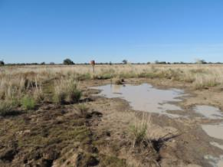 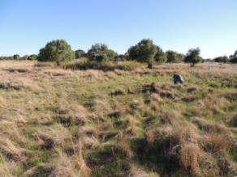

Figure 95 Coolabah spring complex—spring vent and area nearby where Great Artesian Basin springs may have occurred.

Table 191 Coolabah spring complex—hydrogeological information summary.

| Feature | Details | Comments |
| --- | --- | --- |
| No. of active vents | 0 |  |
| No. of inactive springs | 1 | 994 |
| Spring water quality samples | Yes | Physicochemical only |
| Waterbore within 10-kilometre radius | 5 | GW004534, GW003129, GW004112, GW003033, GW023587 |
| Waterbore water quality samples | No |  |
| Interpreted stratigraphy available | No |  |
| SWL time series data available | Yes |  |
| Outcropping GAB formations |  | Rolling Downs Group |
| Underlying aquifers |  | Mooga Sandstone |
| Likely source aquifers |  | Mooga Sandstone |
| Conceptual spring type | K |  |

GAB = Great Artesian Basin, SWL = standing water level.

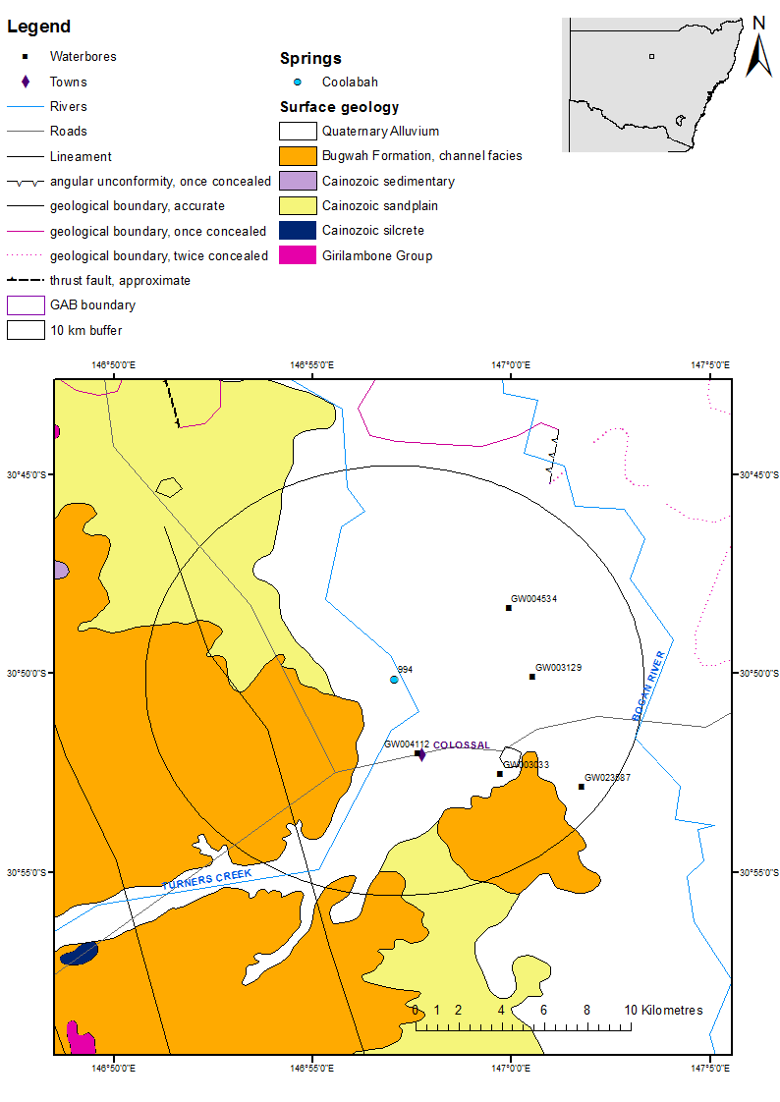

GAB = Great Artesian Basin.

Figure 96 Coolabah spring complex—regional geology, Bogan River supergroup, New South Wales.

### Geology

According to available stratigraphy and the mapped extent of the GAB by Habermehl and Lau (1997), Coolabah spring complex lies just inside the edge of the GAB near the Lachlan Fold Belt. Some lineaments and faults have been mapped in the vicinity of the spring complex, with one linament 500 metres west of the spring (Figure 96).

### Regional stratigraphy and underlying aquifers

No interpreted stratigraphy is available for the waterbores within a 10-kilometre radius of Coolabah spring complex. Only drillers’ logs are available (Table 193). The Bourke 1:250 000 SH55-10 geological map sheet (Brunker 1971) indicates that the area directly south of the Coolabah spring is characterised by Quaternary sediments overlying the Lower Palaeozoic Girilambone Group of the Lachlan Fold Belt. The Bourke 1:250 000 SH55-10 metalogenic map sheet (Brunker 1971) suggests that the the Coolabah spring sits on Quaternary allvium underlain by the Rolling Downs Group.

The geological cross-section on on Walgett 1:250 000 SH 55-11 Geological Series map sheet (Meakin et al. 1996) shows the Pilliga Sandstone thinning out to the east between Marra Creek and Macquarie River, but not extending as far west as the Bogan River. The map does, however, show the Rolling Downs Group and Mooga Sandstone, named as the Drildool beds extending further west beyond the Bogan River. An outcrop of Mesozoic sediment just to the north of Coolabah spring is also shown on the Bourke 1:250 000 SH/55‑10 metalogenic map sheet series (Byrnes et al. 1993), suggesting that the spring would eminate from a downgradient at the edge of the Basin.

### Water chemistry comparison: springs and waterbores

No chemical data on waterbores within a 10-kilometre radius of the spring complex were available. Descriptions of the salinity from waterbores indicate that the bores provide water with a wide range of salinity (Table 194). Physicochemical parameters from the water present in Coolabah spring (Table 195) indicate that the water chemistry is closer to rainwater.

### Artesian status of potential source aquifer

Available data on waterbore standing water levels indicate that the artesian pressure of aquifers in the vicinity of the spring have declined dramatically during the past century (Table 196 and Figure 97), with one bore becoming subartesian and the water level dipping to just below the elevation of the spring. Although the available data are not sufficient to identify a source aquifer for Coolabah spring complex, the data on waterbore standing water levels do indicate that the spring may be threatened by continuing decline in artesian pressure of the aquifer.

Table 192 Coolabah spring complex—spring location and elevation.

| Vent ID | Latitude | Longitude | Elevation (mAHD) |
| --- | --- | --- | --- |
| 994 | –30.83383 | 146.94987 | 142.44 |

mAHD = metres Australian height datum.

Table 193 Coolabah spring complex—waterbores within a 10-kilometre radius.

| Bore no. | Top (mBGL) | Bottom (mBGL) | Rock type | Description |
| --- | --- | --- | --- | --- |
| GW003033 | 0.00 | 24.99 | Clay |  |
|  | 24.99 | 28.04 | Gravel |  |
|  | 28.04 | 38.40 | Clay |  |
|  | 38.40 | 64.62 | Shale |  |
|  | 64.62 | 71.32 | Sandstone | Water supply |
|  | 71.32 | 72.54 | Shale |  |
|  | 72.54 | 74.98 | Sandstone |  |
|  | 74.98 | 81.99 | Clay |  |
|  | 81.99 | 91.44 | Slate |  |
| GW003129 | 0.00 | 19.81 | Clay |  |
|  | 19.81 | 22.86 | Sandstone | Water supply |
|  | 22.86 | 28.96 | Gravel |  |
|  | 28.96 | 53.34 | Clay |  |
|  | 53.34 | 71.01 | Shale | Water supply |
|  | 71.01 | 80.47 | Quartz | Water supply |
|  | 80.47 | 85.04 | Shale |  |
|  | 85.04 | 99.06 | Quartz |  |
| GW004112 | 0.00 | 13.27 | Rock |  |
|  | 13.27 | 38.10 | Clay |  |
|  | 38.10 | 40.54 | Sand | Water supply |
|  | 40.54 | 45.72 | Clay |  |
|  | 45.72 | 91.44 | Shale |  |
|  | 91.44 | 105.16 | Quartz | Water supply |
|  | 105.16 | 121.94 | Rock | Hard, white |
|  | 121.94 | 123.75 | Clay | Gravely |
|  | 123.75 | 238.15 | Rock |  |
| GW004534 | 0.00 | 16.76 | Clay | Sandy |
|  | 16.76 | 63.40 | Rock |  |
|  | 63.40 | 84.12 | Sandstone |  |
|  | 84.12 | 125.27 | Shale |  |
|  | 125.27 | 134.72 | Sandstone |  |
|  | 134.72 | 164.90 | Shale | Water supply at 140.21 metres |
|  | 164.90 | 167.34 | Gravel |  |
|  | 167.34 | 172.21 | Quartz |  |
|  | 172.21 | 179.83 | Shale |  |
|  | 179.83 | 208.18 | Sandstone |  |
|  | 208.18 | 226.01 | Rock |  |
| GW023587 | 0.00 | 3.66 | Soil |  |
|  | 3.66 | 7.62 | Clay |  |
|  | 10.97 | 10.97 | Sand | Water supply |

mBGL = metres below ground level.  
© Copyright, NSW OoW 2010

Table 194 Coolabah spring complex—waterbore details and water chemistry.

| Variable | Details | | | | |
| --- | --- | --- | --- | --- | --- |
| Bore ID | GW003033 | GW003129 | GW004112 | GW004534 | GW023587 |
| Distance from spring complex (kilometres) | 6.0 | 5.6 | 3.5 | 5.6 | 9.0 |
| Sample date | 1931 | 1932 | 2004 | 1938 | 1965 |
| Aquifer | – | – | – | – | – |
| Screens (metres) | – | – | Slots 91.4–106.6 | Slots 109.4 | – |
| Year drilled | 1931 | 1932 | 1900 | 1903 | 1965 |
| Standing water level (natural surface elevation) | – | – | 4.45 | 7.75 | – |
| Total depth (metres) | 91.4 | 99.1 | 238.2 | 226 | 11 |
| Natural surface elevation (mAHD) | 145.540 (DEM) | 142.880 (DEM) | 145.5 | 140.5 | 143.000 (DEM) |
| Facility status | – | – | – | – | – |
| *Physicochemical parameters* | | | | | |
| Salinity description | Fresh | soft | – | 1001–3000 ppm | 1001–3000 ppm |
| EC (µS/cm) | – | – | – | – | – |
| pH (field/lab) | – | – | – | – | – |
| Temperature (°C) | – | – | – | – | – |
| Turbidity | – | – | – | – | – |

– = not available, DEM = digital elevation model, EC = electrical conductivity, mAHD = metres Australian height datum, µS/cm = microsiemens per centimetre, ppm = parts per million.  
© Copyright, NSW OoW 2010

Table 195 Coolabah spring complex—spring water chemistry.

| Variable | Details |
| --- | --- |
| Vent ID | 994 |
| Sample date | 2012 |
| *Physicochemical parameters* | |
| EC (µS/cm) | 441 |
| pH (field/lab) | 6.79 |
| Temperature (°C) | 23.6 |

EC = electrical conductivity, µS/cm = microsiemens per centimetre.

Table 196 Coolabah spring complex—waterbore pump test data.

| Bore ID | Standing groundwater level (mAGL) | Year of measurement |
| --- | --- | --- |
| GW004534 | 16.22 | 1907 |
|  | 14.79 | 1910 |
|  | 13.72 | 1912 |
|  | 12.65 | 1919 |
|  | 14.08 | 1921 |
|  | 13.36 | 1922 |
|  | 12.65 | 1923 |
|  | 12.29 | 1924 |
|  | 12.29 | 1925 |
|  | 12.29 | 1926 |
|  | 11.93 | 1927 |
|  | 7.75 | 1938 |
| GW004112 | 10.51 | 1910 |
|  | 35.09 | 1917 |
|  | 9.08 | 1919 |
|  | 8.08 | 1920 |
|  | 8.01 | 1921 |
|  | 8.01 | 1921 |
|  | 7.38 | 1922 |
|  | 7.38 | 1923 |
|  | 6.94 | 1924 |
|  | 7.04 | 1925 |
|  | 6.33 | 1926 |
|  | 6.32 | 1927 |
|  | 6.33 | 1928 |
|  | 5.63 | 1929 |
|  | 5.25 | 1930 |
|  | 11.25 | 1932 |
|  | 10.90 | 1933 |
|  | –1.70 | 1990 |
|  | –2.75 | 1992 |
|  | –2.45 | 1993 |
|  | –2.00 | 1994 |
|  | –2.20 | 1997 |
|  | –3.92 | 1999 |
|  | –2.65 | 2000 |
|  | –3.00 | 2001 |
|  | –4.45 | 2004 |

mAGL = metres above ground level.  
© Copyright, NSW OoW 2010

DEM = digital elevation model, mAHD = metres Australian height datum.

Figure 97 Coolabah spring complex—waterbore standing water levels (SWLs).

# References

Brunker RL 1971, *Bourke 1:250 000 geological map*, sheet SH/55-10, 1st edn, Geological Survey of New South Wales, Sydney.

Burton GR 2010, *Angledool 1:250 000 geological map*, sheet SH55-7 (provisional 2nd ed), Geological Survey of New South Wales, Sydney.

Byrnes JG, Gilligan LB & Supple DW 1993, *Bourke 1:250 000 metallogenic map*, sheet SH55-10, Geological Survey of New South Wales, Sydney.

CoA 2014, *Ecological and hydrogeological survey of the Great Artesian Basin springs – Springsure, Eulo, Bourke and Bogan River Supergroups, Volume 1: history, ecology and hydrogeology, Knowledge report,* prepared by UniQuest for the Department of the Environment, Commonwealth of Australia, Canberra.

DNR (Queensland Department of Natural Resources) 1996, *Report on the impact of Nathan Dam on Boggomoss and regional hydrology*, Resource Sciences Centre, Resource Condition and Trend Unit, Water and Assessment Planning, Brisbane.

DNRM 2012, *DERM Groundwater Database (DERM GWDB)*, information received November 2012, Queensland Department of Natural Resources and Mines, Brisbane.

EHA 2009, *Identification of source aquifers to significant springs dependent on groundwater flow from the Great Artesian Basin*, report prepared by Environmental Hydrology Associates for the Queensland Department of Environment and Resource Management, Brisbane.

Exon NF 1976, *Geology of the Surat Basin in Queensland*, bulletin 166, Bureau of Mineral Resources, Geology and Geophysics, Canberra.

Fatchen T 2000, *Mound springs management planning. Management issues, strategies and prescriptions for Mound Springs in far north South Australia*, report prepared for the South Australian Department for Environment and Heritage with the support of the Australian Government’s Natural Heritage Trust.

Fensham RJ, Ponder WF & Fairfax RJ 2010, *Recovery plan for the community of native species dependent on natural discharge of groundwater from the Great Artesian Basin*, report to the Australian Government Department of the Environment, Water, Heritage and the Arts, and the Queensland Department of Environment and Resource Management, Brisbane.

Forbes VR 1968, *Taroom, Queensland, 1:250 000 geological series—explanatory notes, sheet SG/ 55-8*, Bureau of Mineral Resources, Geology and Geophysics, Canberra.

Habermehl MA 2001, *Wireline logged waterbores in the Great Artesian Basin: digital data of logs and waterbore data acquired by AGSO*, (report, data CD and 3 maps at scale 1:2 500 000), bulletin 245, Bureau of Rural Sciences & Australian Geological Survey Organisation, Canberra.

Habermehl MA & Lau JE 1997, *Hydrogeology of the Great Artesian Basin, Australia*, (map at scale 1:2 500 000), Australian Geological Survey Organisation, Canberra.

Hawke JM & Cramsie JN 1984, *Contributions to the geology of the Great Australian Basin in New South Wales*, bulletin 31, Geological Survey of New South Wales, Sydney.

Johnson IR & Menzies IA 1965, *Enngonia 1:250 000 geological sheet SH/55-06*, 1st edn, Geological Survey of New South Wales, Sydney.

Meakin S, Henley H, Pecover S & Watkins K 1996, *Walgett 1:250 000 geological sheet SH/55-11*, 1st edn, Geological Survey of New South Wales, Sydney.

NSW OoW 2010, *PINNEENA version 3.2 groundwater works*, New South Wales Office of Water, Department of Environment, Climate Change and Water, Sydney.

NSW OoW 2011, *Water sharing plan for the north western unregulated and fractured rock water sources 2011*, New South Wales Office of Water, Sydney.

NWC 2013, *Allocating water and maintaining springs in the Great Artesian Basin,* National Water Commission. Accessed 30 July 2014 at <http://archive.nwc.gov.au/library/topic/groundwater/allocating-water-and-maintaining-springs-in-the-great-artesian-basin>

Quarantotto P 1989, *Hydrology of the Surat Basin, Queensland*, record 1989/26, Geological Survey of Queensland, Brisbane.

Queensland Herbarium 2012, *Ecological and botanical survey of springs in the Surat Cumulative Management Area*, Brisbane.

QWC 2012a, *Hydrogeological attributes associated with springs in the Surat Cumulative Management Area*,Queensland Water Commission, Brisbane.

QWC 2012b, *Underground water impact report for the Surat Cumulative Management Area*, Queensland Water Commission, Brisbane. Available at: http://www.dnrm.qld.gov.au/__data/assets/pdf_file/0016/31327/underground-water-impact-report.pdf

Rade J 1954, ‘Geology and sub-surface waters of the area north of the Darling River between Longitudes 145 and 149 E, NSW’, *Journal and Proceedings of the Royal Society of New South Wales,* vol. 88**,** pp. 24–32.

Radke BM, Ferguson J, Cresswell RG, Ransley TR & Habermehl MA 2000, *The* *hydrochemistry and implied hydrodynamics of the Cadna-owie-Hooray Aquifer, Great Artesian Basin*, Bureau of Rural Sciences, Canberra.

Rose G, Loudon AG & O’Connell P 1964, *White Cliffs 1:250 000 geological sheet SH/54-12*, 1st edn, Geological Survey of New South Wales, Sydney

Senior BR 1971, *Eulo, Queensland 1:250 000 geological series—explanatory notes*, Geological Survey of New South Wales, Sydney.

Senior BR, Ingram JA & Senior DA 1971, *Eulo 1:250 000 geological sheet SH55-1*, 1st edn, Geological Survey of New South Wales, Sydney.

Wallis GR & McEwen PR 1962, ‘Yantabulla 1:250 000 geological sheet SH/55-05’, 1st edition, Geological Survey of New South Wales, Sydney.

Watkins JJ & Meakin NS 1996, N*yngan and Walgett 1:250 000 geological sheets SH 55-15 & SH55‑11—explanatory notes*, Geological Survey of New South Wales, Sydney.

Whitaker WG, Murphy PR & Rollason RG 1980, *Mundubbera, Queensland, 1:250 000 geological series map, SG/56-5*, 2nd edn, Bureau of Mineral Resources, Canberra, and Australia & Geological Survey of Queensland, Brisbane.

Appendix A: Queensland licence

Open Licence

(Single supply)

**Supplied Data: Groundwater Data, January 2013**

qglogo2

Permitted use:

You may use the supplied data for your own purposes (including supply to consultants for a specific consultancy project for you but the consultants must return or destroy the supplied data when the project is finished). You must not sell or distribute the supplied data.

You must display this copyright notice on any copies of the supplied data however altered, reformatted or redisplayed if you supply to a consultant or copy for back up purposes: “© State of Queensland (Department of Natural Resources and Mines) [2012]”.

You may create and distribute hardcopy and digital products based on or containing the supplied data, provided all the following conditions are met:

You must display this acknowledgment on the product(s): “Based on or contains data provided by the State of Queensland (Department of Natural Resources and Mines) [2012]. In consideration of the State permitting use of this data you acknowledge and agree that the State gives no warranty in relation to the data (including accuracy, reliability, completeness, currency or suitability) and accepts no liability (including without limitation, liability in negligence) for any loss, damage or costs (including consequential damage) relating to any use of the data. Data must not be used for direct marketing or be used in breach of the privacy laws.”

You must include metadata with the product(s) you create that use or incorporate the supplied data and the metadata must incorporate as a minimum the metadata provided with this supplied data.

**Obligations**

You must not use the data for direct marketing or in breach of the privacy laws.

If you wish to distribute the supplied data you must organise an additional different licence by contacting the Department (Email: [Water.monitoring@derm.qld.gov.au](mailto:Water.monitoring@derm.qld.gov.au)).

**Ownership:** The State of Queensland as represented by the Department of Natural Resources and Mines (DNRM) is the owner of the intellectual property rights in and to the supplied data or has the right to make this supplied data available.

**Disclaimer and indemnity:** You agree to accept all responsibility and risks associated with the use of the supplied data. DNRM makes no representations or warranties in relation to the supplied data, and, you agree that, to the extent permitted by law, all warranties relating to accuracy, reliability, completeness, currency or suitability for any particular purpose and all liability for any loss, damage or costs (including consequential damage) incurred in any way (including but not limited to that arising from negligence) in connection with any use of or reliance on the supplied data are excluded or limited. You agree to continually indemnify the State of Queensland and DNRM (and their officers and employees) against any loss, cost, expense, damage and liability of any kind (including consequential damage and liability in negligence) arising directly or indirectly from or related to any claim relating to your use of the supplieddata or any product made from the supplied data.

V1.0 May 2012