|  |
| --- |
|  |
| Great Artesian Basin Sustainability Initiative (GABSI) Value for Money Review  FINAL Report  Department of the Environment | January 2014 |
|  |
|  |

|  |  |
| --- | --- |
|  | |
| GABSI Value for Money Review | |
| Document title: | GABSI Value for Money Review |
| Document no. | 3 |
| Version: | Final |
| Date: | January 2014 |
| Prepared by: | Michelle Freund, Sarah Alexander |
| Approved by: | Andrew Tingay, Ray Evans |
|  | |
|  | |
|  | |
|  | |
| COPYRIGHT: The concepts and information contained in this document are the property of . Use or copying of this document in whole or in part without the written permission of constitutes an infringement of copyright. | |

Executive summary

In 1999, the Australian Government and Queensland, South Australian, New South Wales (NSW), and Northern Territory Governments committed to a 15 year joint program to sustainably manage the groundwater resources of the Great Artesian Basin (GAB) – the *Great Artesian Basin Sustainability Initiative* (GABSI). GABSI seeks to promote sustainable groundwater management systems for the GAB, primarily through capping and piping uncontrolled bores to save water and recover pressure. The GABSI is being delivered by state agencies over three phases, with the third phase drawing to a close on 30 June 2014.

Under the GABSI National Partnership Agreement, independent mid-term reviews of each phase have been required to assess the impact of GABSI works and examine the implications of the findings for the remainder of the phase. The mid-term review for GABSI 3 found that significant achievements had been accomplished and that future groundwater management in the GAB should be based on a thorough assessment of priorities, eligibility criteria, and funding arrangements. It also recommended conducting a value for money review of GABSI across the three phases, and the development of objective metrics to determine whether continued government funding could be justified beyond GABSI 3.

Sinclair Knight Merz (SKM) was engaged by the Commonwealth Department of the Environment (Department) to undertake a value for money review (the Review) of GABSI using a total economic valuation (TEV) approach.

The objectives of the Review (as per the Request for Quotation dated 6 September 2013) are to:

* Objectively measure trends in the return on investment achieved by respective governments (Commonwealth and States) over the three phases of GABSI, up to June 2013.
* Assess whether the completion of GABSI 3 represents value for money, compared to the return on government investment over the three phases of GABSI, up to June 2013.

GABSI funding and achievements

GABSI funding is shared between the Commonwealth Government, the State Governments, and landowners. However for the purpose of this Review, only government costs have been considered within scope as the focus is on governments’ return on investment. GABSI has cost government $238.68 m in real dollars ($373.58 m in present value) to June 2013, or $270.34 m (real) including estimated works for 2013/14. Between 1999/00 and 2012/13, 647 bores have been controlled, 19,178 kilometres of bore drains deleted, and 28,345 kilometres of piping installed. These works have resulted in estimated annual water savings of 204,527ML.

Objective 1: Objectively measure trends in the return on investment achieved by respective governments (Commonwealth and States) over the three phases of GABSI, up to June 2013.

|  |  |
| --- | --- |
| *Using the total economic valuation (TEV) approach, the benefit-cost ratio (BCR) of GABSI is likely to be between 0.56 and 1.7.* | The TEV framework comprised nine components, three of which were able to be quantified based on available data (refer Section 3.1). These were the consumptive benefits from reallocated saved water, indirect benefits to rural communities, and greenhouse gas abatement benefits. Together, they provided $163.48 m in real 2013 dollars or $210.35 m in present value for the full GABSI program until June 2013. This represents a BCR of 0.56 across GABSI.  In addition to only measuring three of the nine components of TEV, this approach only values 35% of the water saved through GABSI in the case of consumptive benefits from reallocated saved water and indirect benefits to rural communities. This is because government has limited reallocation of saved water for consumptive use to 50% in South Australia and 30% in Queensland and NSW. Thus, the governments’ rationale is that the benefits of returning saved water to the GAB for the purpose of pressure recovery are greater than (or equal to) the benefits of reallocating the water for other consumptive purposes. Assuming that 100% of the saved water is reallocated for consumptive use achieves an overall BCR of 1.4 (refer Section 6.1).  Another approach to provide a more comprehensive view of the value of the program is a breakeven assessment (refer Section 6.2). This considers some of the benefits not quantified in terms of what would be required for the TEV to at least equal the cost (i.e. achieve a BCR of 1). Each benefit was considered in isolation, which means that only 0.04 endangered species or 12% of unique ecosystems would need to be protected for a BCR of 1. In addition, if half of breakeven pressure was restored (5.5m) and half the breakeven number of avoided pumps delivered (403), the BCR would equal 1.7. |
|  |  |
| ***Substantial and tangible non-financial benefits are also associated with GABSI.*** | Substantial and tangible non-financial benefits are also associated with GABSI, however these were unable to be quantified due to insufficient data. These include benefits such as:   * **Consumptive benefits from improved pressure** – In Queensland, by 2005 an increase in pressure in half of all artesian bores monitored was observed. In NSW, anecdotal evidence suggests around 90% of capped bores have been found to have either stabilised or increased pressure over the GABSI period. Pressure recovery has also been observed at Little Blyth bore as a result of decommissioning Big Blyth bore in South Australia. Such pressure improvements are expected to result in avoided pump installation and pumping (energy) costs. * **Tourism, recreation and amenity benefits** – A number of key tourism and recreation sites across the three states depend on the GAB. For instance, Dalhousie Springs in South Australia was found to contribute $0.6m/annum in recreation benefits resulting from reduced water extraction under GABSI (Rolfe, 2008). However the benefits directly attributable to GABSI have not been considered in any other studies. * **Heritage benefits –** There is significant evidence of Indigenous occupation and use recorded within GAB spring wetlands, and numerous cultural heritage sites requiring protection. * **Option value, bequest / altruism, and stewardship values –** Relatesto thevalue placed on GABSI by those who anticipate using GAB water or visiting the springs at some point in the future, or are willing to pay for the existence of the GAB out of a sense of stewardship. For example, conservation group ‘Bush Heritage Value’ purchased the Edgbaston Reserve in Queensland in 2008 to conserve the natural springs and ecosystems they support. * **Conserving biodiversity (avoided loss of unique ecosystems and endangered species) –** The GAB once sustained approximately 500 complexes of permanent springs and supports numerous endemic species. There are legislative obligations on both the Commonwealth and states to protect the environmental value provided by the GAB. These obligations suggest governments’ willingness to protect these assets, and thus imply an intrinsic public value. |
|  |  |
| ***The BCR for each jurisdiction delivering GABSI has become more similar over the program life.*** | In Phase 1, South Australia’s BCR for GABSI works was significantly higher than in NSW and Queensland (2.96, compared to 0.79 in Queensland and 0.44 in NSW). This may be due to the relatively smaller scale of the program in South Australia and the ability for government to prioritise the bores to be controlled (South Australian landholders do not provide contributions in the same way as in Queensland and NSW). Furthermore, South Australia was able to reallocate 50 per cent of water saved as per their implementation plan (compared to 30 per cent in NSW and Queensland), which increases the total quantified benefits relative to the other jurisdictions.  Over Phases 2 and 3 however, the BCR of GABSI for each jurisdiction has become increasingly similar, with Phase 3 BCRs ranging from 0.29 in NSW to 0.47 in South Australia (these represent the minimum BCRs based on the three quantified TEV components as described above). |

Objective 2: Assess whether the completion of GABSI 3 represents value for money, compared to the return on government investment over the three phases of GABSI, up to June 2013.

|  |  |
| --- | --- |
| *The value for money and cost-effectiveness of GABSI appear to be decreasing between the three phases. However it is important to view GABSI as a whole, as benefits from previous phases may be lost if the program is not completed.* | The BCR of the quantified benefits of GABSI decreased from 0.77 in Phase 1 to 0.45 in Phase 2 and 0.33 in Phase 3. Similarly, the cost-effectiveness of GABSI has been declining ($835/ML/annum in Phase 1, $1,280/ML/annum in Phase 2, and $1,749/ML/annum in Phase 3).  However, governments have prioritised works which are technically more feasible or expected to achieve greater savings in the initial stages, leaving more difficult and / or costly works for the later stages. Furthermore, the increase in the price of construction and materials has been high relative to consumer price index (CPI) over the period of GABSI, making works undertaken in later phases comparatively more expensive.  It is also likely that benefits from previous phases as measured by the current approach would diminish if GABSI is not completed. While it is assumed that benefits achieved in previous phases are preserved (or do not degrade) over future time, in reality the increased pressure will lead to an incremental increase in losses via other bores. This is because the main contribution to overall benefits is the monetary value of the groundwater that is reallocated, so later phases of the GABSI program act to preserve these reallocated water benefits. However in terms of restoring pressure to the aquifer system, previous gains in pressure re-establishment will not erode over time. The BCR for earlier phases may remain stable if pressure is incorporated into the assessment and the benefits of pressure reestablishment outweigh those from reallocating saved water.  Therefore assessing each phase in isolation, whilst a useful and prudent fiscal exercise, does not provide a holistic view of the program, and there is value in viewing the total costs and benefits of the program to date as a whole. For instance, the initial planned cost-effectiveness as outlined in the GAB Strategic Management Plan can be used as a benchmark for comparison purposes, and is set at $1,682/ML/annum (2013 dollars). To date, GABSI has outperformed well beyond this benchmark by progressing its program of works at an average of $1,167/ML/annum.  Jurisdictions provided estimates of works under GABSI that will remain to be completed at June 2014. These remaining works have a cost-effectiveness figure of $1,852/ML/annum (although this figure varies greatly, with estimates ranging from $4,286/ML/annum in NSW to $1,042/ML/annum in Queensland). While this is again higher than all three phases of GABSI, when viewing the program as a whole the cost-effectiveness of completing GABSI would be $1,430/ML/annum, which is still lower than the initial benchmark of $1,682/ML/annum. It is also important to note that cost-effectiveness does not consider the benefits of achieving the ML saved targets, so should not be viewed as a VfM assessment. |
|  |  |
| ***A clear and detailed set of metrics to measure the value of GABSI have been developed. Better data collection aligned with these metrics could assist in proving GABSI’s value for money.*** | A set of metrics has been proposed for measuring each component of the TEV framework. These relate directly to GABSI, and highlight key data and information gaps that would need to be filled to undertake a more complete assessment of the program’s value for money. Examples of these gaps include:   * Data on the market price of GAB groundwater (time and geographic coverage of the sample of prices available was limited, and there were restrictions placed on the previous sale of GAB water which could have affected the market price) * Data and pressure modelling to understand the direct relationship between GABSI and pressure recovery (change in pressure head) * Number of visitors to and average length of stay at key tourism sites dependent on the GAB * Avoided loss of biodiversity and / or endangered species resulting from GABSI   While gathering this data could assist in proving GABSI’s value for money, the costs associated with conducting more extensive monitoring programs are likely to be high and therefore may not represent value for money. |

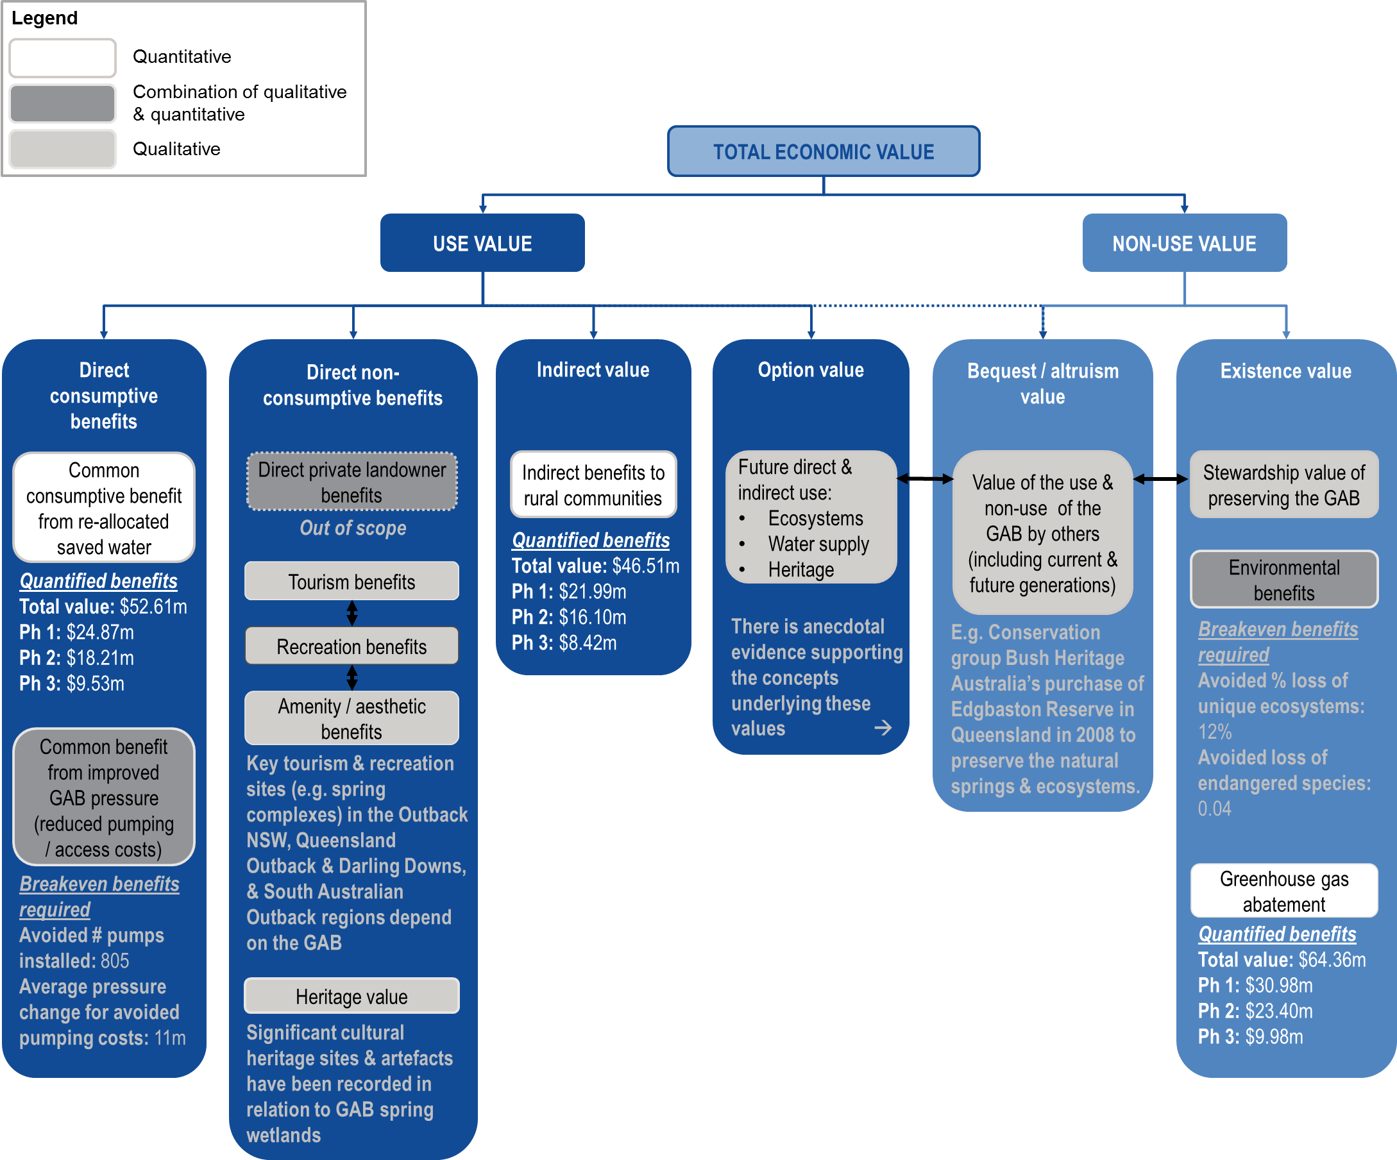Summary of the benefits of GABSI using the TEV framework

The following figure provides an overview of the TEV framework applied in the Value for Money Review of GABSI.

The ‘quantified benefits’ represents the components of the framework which were able to be quantified based on available data. The ‘breakeven benefits required’ demonstrate what improve pressure and environmental benefits would need to be proven to achieve a BCR of 1 (note that each breakeven metric should be considered in isolation of the others – e.g. avoiding a 12% loss of unique ecosystems alone would achieve a BCR of 1).

All dollars in the figure are in real 2013 dollars and consider benefits associated with works deliver under GABSI between 1999/2000 and 2012/13.

Contents

1. Introduction 1

1.1 Objectives of Review 1

1.2 Report structure 1

2. Description of the GABSI 2

2.1 Roles and responsibilities 2

2.2 Funding 3

2.3 Achievements 4

3. Review methodology 6

3.1 Total economic valuation framework 6

3.2 Overarching assumptions and considerations 7

3.3 Data and information sources 8

3.4 Limitations 8

4. Measuring the benefits of GABSI 10

4.1 Consumptive benefits 10

4.2 Non-consumptive benefits 18

4.3 Indirect value 22

4.4 Option value, bequest / altruism, and stewardship values 24

4.5 Environmental benefits 25

4.6 Summary 33

5. Sensitivity analysis 38

6. Alternative evaluation approaches 40

6.1 TEV from alternative water use options (100% reallocation of GABSI water) 40

6.2 Breakeven benefit analysis 41

6.3 Cost effectiveness 43

7. Conclusion 45

Appendix A. References

Appendix B. Deprival method values

Appendix C. Quantified Value for Money Summary

# Introduction

In 1999, the Australian Government and Queensland, South Australian, New South Wales (NSW), and Northern Territory[1] Governments committed to a 15 year joint program to sustainably manage the groundwater resources of the Great Artesian Basin (GAB) – the *Great Artesian Basin Sustainability Initiative* (GABSI). GABSI seeks to promote sustainable groundwater management systems for the GAB, primarily through capping and piping uncontrolled bores to save water and recover pressure. The GABSI is being delivered by state agencies over three phases, with the third phase drawing to a close on 30 June 2014.

Under the GABSI National Partnership Agreement, independent mid-term reviews of each phase have been required to assess the impact of GABSI works and examine the implications of the findings for the remainder of the phase. The mid-term review for GABSI 3 found that significant achievements had been accomplished and that future groundwater management in the GAB should be based on a thorough assessment of priorities, eligibility criteria, and funding arrangements. It also recommended conducting a value for money review of GABSI across the three phases, and the development of objective metrics to determine whether continued government funding could be justified beyond GABSI 3.

Sinclair Knight Merz (SKM) was engaged by the Commonwealth Department of the Environment (Department) to undertake a value for money review (the Review) of GABSI using a total economic valuation (TEV) approach.

## Objectives of Review

The objectives of the Review (as per the Request for Quotation dated 6 September 2013) are to:

* Objectively measure trends in the return on investment achieved by respective governments over the three phases of GABSI, up to June 2013
* Assess whether the completion of GABSI 3 represents value for money, compared to the return on government investment over the three phases of GABSI, up to June 2013

## Report structure

The report contains the following sections:

* **2 – Description of the GABSI:** outlines the roles and responsibilities associated with administrating and implementing the program, funding, and achievements to date.
* **3 – Review methodology:** introduces the TEV framework approach and discusses the assumptions, data, and limitations associated with the approach.
* **4 – Measuring the benefits of GABSI:** detailed description of the relevant methods, a suggested metric, and the results for each element of the TEV framework.
* **5 – Sensitivity analysis:** tests the results of section 4 against seven key sensitivities.
* **6 – Alternative evaluation approaches:** provides three different approaches to assessing GABSI that should be considered in conjunction with the TEV approach.
* **7 – Conclusion:** presents a concluding discussion on assessing the value for money of GABSI.

# Description of the GABSI

The GABSI is a 15 year program seeking to save water to address declining pressure in the Great Artesian Basin (GAB). The GABSI is being delivered by state agencies over three phases, with the third phase drawing to a close on 30 June 2014. In 2010, an NPA on the GABSI was established and agreed upon by the Commonwealth and States (New South Wales, Queensland, South Australia), setting the direction for future GABSI activities. The objectives, outcomes, and outputs of the NPA are outlined in Figure 1.

The remainder of this section outlines the roles and responsibilities, processes, and financing arrangements associated with GABSI.

Figure 1: NPA on the GABSI – Objectives, outcomes, and outputs

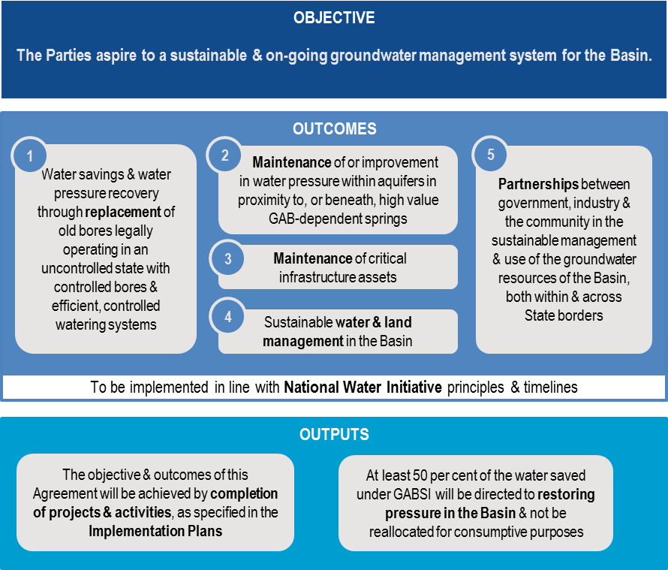

## Roles and responsibilities

The core governance and management structure is outlined in Figure 2. It comprises:

* **Commonwealth Department of the Environment –** responsible for partly funding the works, and establishing and overseeing the national approach to managing the resources of the Great Artesian Basin.
* **State Departments –** responsible for partly funding the works, engaging landholders, undertaking some of the works, and monitoring and reporting progress.
* **Landholders –** responsible for partly funding the works, undertaking works on their properties, and ongoing maintenance.
* **GABCC –** the primary role of the Committee is to provide advice to Ministers on efficient, effective and sustainable whole-of-resource management of the GAB and to coordinate activity between stakeholders.

Figure 2: GABSI government and management structure

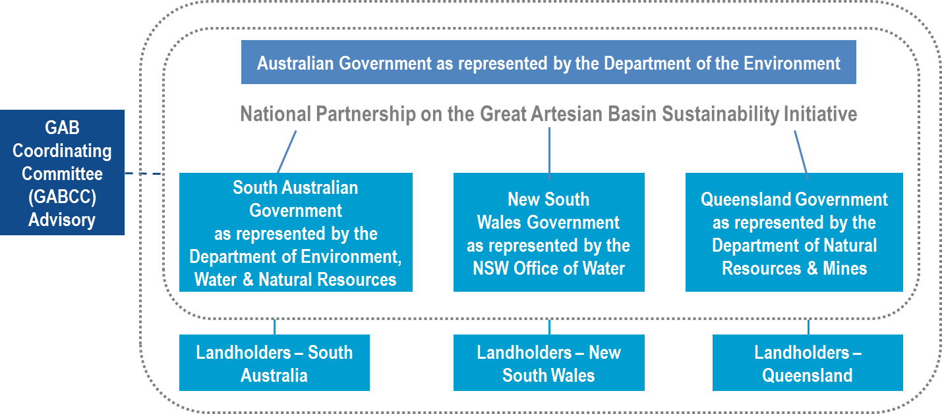

## Funding

The costs associated with the program are primarily associated with:

* Piping and capping capital costs (installation, materials and design);
* Pipe and network operating and maintenance costs; and
* Education and support programs.

The major costs involved with the GABSI program are the capital works, with operation and maintenance costs being the responsibility of the landowners.

GABSI implementation costs are shared between the Commonwealth Government, the jurisdictions, and landowners. Funding arrangements vary between States. For example, in GABSI 3, Queensland landholder contributions were approximately 20% for bore rehabilitation and 40% for drain replacement and NSW landholder contributions were 20% for bore rehabilitation and between 30% and 60% for drain replacement (depending on zone). Landholders in South Australia are not required to contribute financially to any capital works (however landholders did contribute in Phase 1). The following table summarises government expenditure on GABSI across the three phases.

Table 1: Funding over the three phases of GABSI (nominal $)

| Funding source | Phase 1 (1999/2000 – 2003/2004) | Phase 2 (2004/2005 – 2008/2009) | Phase 3 (2009/2010 – 2012/2013) | Remaining Phase 3 (2013/2014) | Total |
| --- | --- | --- | --- | --- | --- |
| Commonwealth | 28.39 | 39.89 | 30.95 | 15.83 | **115.06** |
| South Australia | 1.75 | 0.20 | 2.25 | 1.60 | **5.8** |
| New South Wales | 12.34 | 15.79 | 13.00 | 7.40 | **48.53** |
| Queensland | 13.23 | 23.88 | 16.49 | 6.83 | **60.43** |
| ***Total (government)*** | **55.71** | **79.76** | **62.69** | **31.66** | ***229.82*** |

## Achievements

GABSI achievements are typically summarised as works completed and water saved. These results are based on annual reports provided by the GABCC and input from jurisdictions. The tables below summarise the key achievements under GABSI to date in terms of works undertaken in each of the jurisdictions. Note that these tables are based on actual works completed (i.e. up to June 2013 for Phase 3, excluding potential 2013/14 works).[2]

Table 2: Number of bores controlled

| State | Bores controlled pre GABSI (prior to July 1999) | Bores controlled under GABSI Phase 1 | Bores controlled under GABSI Phase 2 | Bores controlled under GABSI Phase 3 (up to June 2013) | TOTAL bores controlled under GABSI |
| --- | --- | --- | --- | --- | --- |
| South Australia | 230 | 10 | 4 | 8 | **22** |
| New South Wales | 86 | 111 | 117 | 63 | **291** |
| Queensland | 312 | 150 | 89 | 95 | **334** |
| **TOTAL** | **628** | **271** | **210** | **166** | **647** |

Table 3: Kilometres of bore drains deleted

| State | Bores drains deleted pre GABSI (prior to July 1999) | Bores drains deleted under GABSI Phase 1 | Bores drained deleted under GABSI Phase 2 | Bores drained deleted under GABSI Phase 3 (up to June 2013) | TOTAL bores drained deleted under GABSI |
| --- | --- | --- | --- | --- | --- |
| South Australia | NA | 185 | 0 | 11 | **196** |
| New South Wales | 1,391 | 3,409 | 3,036 | 1,698 | **8,143** |
| Queensland | 1,843 | 4,774 | 4,211 | 1,854 | **10,839** |
| **TOTAL** | **3,234** | **8,368** | **7,247** | **3,563** | **19,178** |

Table 4: Kilometres of piping installed

| State | Piping installed pre GABSI (prior to July 1999) | Piping installed under GABSI Phase 1 | Piping installed under GABSI Phase 2 | Piping installed under GABSI Phase 3 (up to June 2013) | TOTAL piping installed under GABSI |
| --- | --- | --- | --- | --- | --- |
| South Australia | NA | 439 | 0 | 25 | **464** |
| New South Wales | 2,812 | 6,285 | 5,256 | 2,809 | **14,350** |
| Queensland | 2,698 | 6,384 | 4,491 | 2,656 | **13,531** |
| **TOTAL** | **5,510** | **13,108** | **9,747** | **5,490** | **28,345** |

The completion of these works has resulted in significant water savings across the GAB as outlined in the following table.

Table 5: Water savings (ML/year)

| State | Water savings pre GABSI (prior to July 1999) | Water savings under GABSI Phase 1 | Water savings under GABSI Phase 2 | Water savings under GABSI Phase 3 (up to June 2013) | TOTAL water savings under GABSI |
| --- | --- | --- | --- | --- | --- |
| South Australia | 39,542 | 17,017 | 742 | 2,579 | 20,338 |
| New South Wales | 9,051 | 26,093 | 25,075 | 13,803 | 64,971 |
| Queensland | 63,205 | 48,657 | 49,167 | 21,393 | 119,217 |
| **TOTAL** | **111,798** | **91,768** | **74,984** | **37,775** | **204,527** |

# Review methodology

## Total economic valuation framework

Return on investment from GABSI, across each phase and for the program as a whole, is most accurately assessed using a total economic value (TEV) assessment framework to measure the full range of benefits from the program. The TEV framework categorises the benefits from the GABSI program based on the full range of use and non-use benefits, where:

***TEV = direct-use value + indirect-use value + options value + bequest value + existence value***

Figure 3: Total economic value framework for GABSI

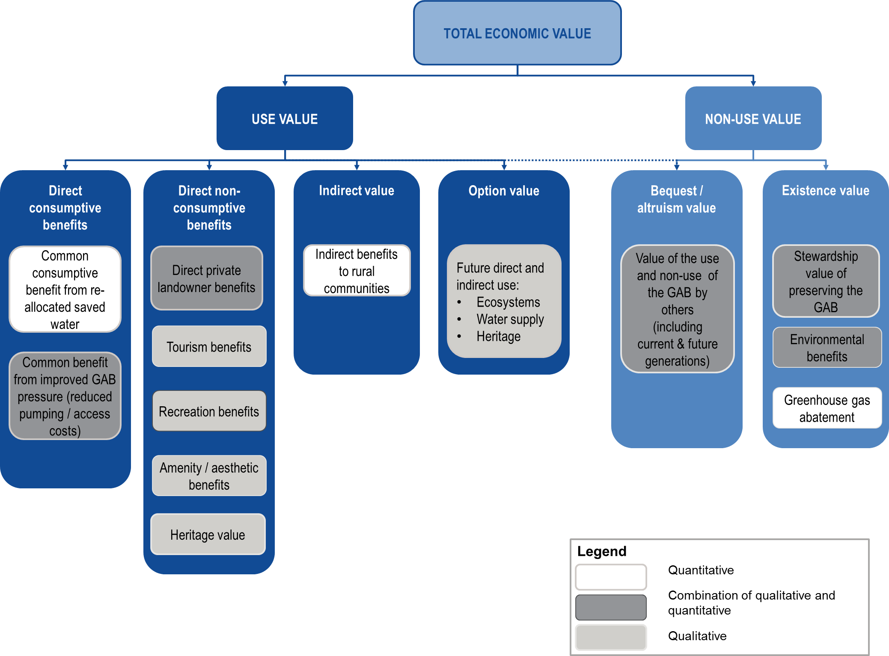

Categorisation of use and non-use value applied in this assessment is presented in and includes the following:

* **Direct use value.** This refers to values arising from the direct **consumptive** and **non-consumptive** benefits from GABSI. Consumptive benefits relate to the benefits to water users from the consumption of GAB water – e.g. consumption of water saved or from the improved efficiency of consumption of GAB water as a result of any pressure recovery; GAB pressure; and non-consumptive benefits are from improved recreational, tourism, heritage, and amenity benefits. They also include benefits to landowners participating in the scheme that realise land management benefits such as pest and weed control to private and public landowners.
* **Indirect value.** This refers to the indirect support that GABSI has on communities and their economic performance. These communities may not directly depend on the GAB water directly, but rather on the industries that the water supports.
* **Option value.** This refers to the value one places on protecting or enhancing the option of deriving benefit from the GAB sometime in the future.
* **Bequest / altruism value.** This refers to the value that the public may hold in preserving or enhancing the value of the GAB for future generations.
* **Existence value.** This refers to the value one places on protecting or enhancing the GAB for its intrinsic existence value. Individuals place a value on the GAB’s existence, even if they have no intention of using its resources or visiting the site.

The benefits illustrated in have been colour-coded according to whether they have been considered quantitatively or qualitatively (or a combination of both) in the assessment.

A key aspect of the TEV assessment is that only the incremental benefits are being considered. Many of the existing studies which estimate the value of groundwater consider the value of activities relying on existing groundwater usage (and the value of maintaining these activities in the absence of / reduce groundwater usage). This assessment considered the additional value (use and non-use) that would be realised from additional groundwater being made available or from GAB pressure being recovered.

TEV on its own does not measure value for money (VfM). VfM is assessed as the TEV per dollar invested in the program. The condition criteria for VfM are as follows:

**VfM condition Criteria**

* **VfM** = **TEV** (present value) **/$ investment** (present value) = **Benefit Cost Ratio (BCR)**
* **BCR>1** implies Value for Money, where the TEV (present value) is greater than the cost of the program. Overall, there is a net economic benefit to society.
* **BCR<1** implies that cost of the program (present value) exceeds the TEV (present value) and there is a net cost to society.

## Overarching assumptions and considerations

The key considerations and assumptions relevant to the TEV assessment are:

* The assessment only considers the benefits that are directly attributable to investment undertaken as part of GABSI. When considering the impacts of individual GABSI phases, only benefits that are directly attributable to investment undertaken in that phase are considered.
* All expenditure is presented in current (2013) dollars unless stated otherwise. ABS Consumer Price Index (CPI) was used to convert dollars to 2012/13 dollars.
* Where possible, value for money is assessed as the ratio of TEV per dollar invested. For these calculations, the present value of the program’s costs and benefits are estimated, giving consideration to the timing of expenditure and benefits. Given the program started in 1999/2000 and the benefits will continue to be realised for many years to come, the present value of the program overall incorporates the costs and benefit that have occurred prior to 2013 (escalated to the present), and the discounted value of the costs and benefits that are anticipated to occur future years. A discount rate (or annual rate of interest where future value is estimated) is assumed to be 7% (real) consistent with the recommended approach on the Commonwealth Governments cost benefit analysis guidance material[3]. The sensitivity analysis also tests a discount rate of 3% and 10%.
* The assessment has been undertaken over the period 1999/2000 from GABSI commencement to 2044. This assessment period allows for 30 years of benefits to be captured from works completed in 2013/14.
* It is assumed that bores rehabilitated have the same economic life as a new bore, which is estimated at 50 years. Similarly it is assumed that pipes installed have an economic life of 50 years. As such, it is assumed that benefits from any works undertaken will be realised for the full assessment period.
* Any recorded water saving or impact provided by jurisdictions for this assessment is assumed to be directly attributable to GABSI and not as a result of any other initiative. Similarly, it is assumed that the full benefits of GABSI are captured in available data, even if some are offset by other water use decisions – e.g. additional allocation to natural gas from coal seams.
* The benefits are assumed to be homogenous within jurisdictions. In reality, the benefits associated with GABSI vary spatially, depending on the location of the works, the extent of groundwater dependent ecosystems, and the proximity and connectivity to other bores and spring. However, most of the information for this assessment has been provided at the jurisdiction level and therefore, for the purpose of this assessment, it has been assumed that the benefits within a jurisdiction are consistent. This means that a ML saved, or pressure restored within a given jurisdiction has the same benefit irrespective of where these impacts occur.

## Data and information sources

The TEV framework is based on existing information and data publicly available or provided by the funding parties of the GABSI program (Commonwealth, Queensland, NSW, and SA governments). Where insufficient information is available to quantity the benefits, the assessment discusses the metrics which could be applied if better information was to become available. Where possible, qualitative metrics are considered and assessed.

## Limitations

Limitations to the value for money assessment include:

* Timing of artesian equilibrium is unknown. For example, pressure recovered in GABSI 1 may only be apparent in future years. Given that the scope of this analysis did not include modelling of pressure impacts, benefits associated with pressure recovery captured in the TEV assessment are limited to those that have been identified (or witnessed) between 1999 and 2013. In essence the VfM review is a *snapshot* in time and does not account for declining benefits had GABSI not proceeded, nor does it account for a potential increase in benefits. It may be reasonable to conclude that the review will estimate VfM at a lower level by not considering these non-linear trends in benefits.
* The impacts that GABSI and the extraction of associated water during natural gas production from coal seam tenures have had on one another have not been assessed.
* The value of groundwater is not fixed and is driven by a range of factors which can change over time. factors have not been considered included include:
* **Scarcity –** during period of high scarcity such as droughts, the value of water significantly increases.
* **Substitutability –** for example, in areas where groundwater users also have access to surface water or desalinated water (for example in coastal areas), the marginal value of groundwater will be bounded by the cost of accessing the alternative water source and may be lower than in areas with no alternative water source.
* **Quality –** the quality of the water will determine potential end uses. In areas where only groundwater is available, agricultural use is predominantly limited to grazing (pastoral use) due to the quality of the water. Where shandying of groundwater with better quality water is possible, it is more likely that the water can be used for irrigation purposes. Better quality water provides water users with more flexibility to allocate that water to highest value uses.).

There is insufficient information available to consider how these factors may differ within and between jurisdiction and over time, and as such, they have not been captured in the analysis. The value of GABSI is therefore assumed to be fixed and homogeneous across jurisdictions.

* The water savings and pressure recovery achieved from each GABSI phase is assumed to be fixed for the duration of the assessment period. This is a simplistic assumption given that as pressure is restored, flow rates will increase in uncontrolled bores and springs. This will offset some of the water savings and pressure recovery benefits estimated. In reality, this means that:
  + Works undertaken in Phase 2 help preserve the benefits achieved in Phase 1 and works undertaken in Phase 3 help preserve benefits achieved in Phase 2 and 3
  + If works in following phases are not undertaken, benefits from preceding phases will be lower than estimated.

Given that there is no data to establish a relationship between program phases, the analysis assumes that works and benefits within a given phase are independent from works and benefits in other phases.

As there is varying quality and completeness of data to inform the quantification of the benefits, the sensitivity of the value for money assessment to key assumptions has been tested (refer to a Section 5 for the sensitivity assessment).

# Measuring the benefits of GABSI

## Consumptive benefits

Consumptive benefits have been defined as those realised through direct consumption of the GAB water. These relate to benefits from: (a) reallocating savings for consumptive purposes; and (b) pressure improvements for water users.

### Consumptive benefits from reallocated water

Methodology

Based on current GABSI implementation plans prepared by each jurisdiction, a minimum of 70% of any water saved from Queensland and NSW, and 50% from South Australia must be directly returned to the GAB to restore pressure. The remaining 30-50% can be reallocated for consumptive purposes across any end use sector, including:

* Irrigated agriculture
* Drinking water for livestock
* Mining and related industries
* Other industries
* Water supply (treatment plants)
* Households (direct)

Although less than 30% of saved water has been reallocated for consumptive use by Queensland and NSW, and less than 50% has been reallocated by South Australia, the option of allocating that water still exists. As such, the volume of water that can be re-allocated is valued based on its potential consumptive use value.

The consumptive value of the reallocated water can be estimated using a range of methods, including those outlined in the following table.

Table 6: Potential valuation approached valuing saved water that can be reallocated for consumptive use

| Method | Description | Applicability of method |
| --- | --- | --- |
| **Deprival method** | Under this method, the value of water is assumed to equal the cost of accessing the same volume of water from the next cheapest alternative water source (MJA, 2012). | Studies by Deloitte Access Economics – Economic Value of Groundwater for Australia (2013), Marsden Jacob Associates (2012) and a Victorian study by RMCG (2008) provide estimates of the value of water ($/ML) for different sectors using the deprival method. A summary of these values is provided in ).  The deprival values listed in are not considered to be the most appropriate for estimating the direct use of groundwater saved under GABSI. These values were used to estimate the value of existing groundwater use, nationally or within a jurisdiction[4] and are most accurate for assessing the benefits associated with maintaining ***existing*** groundwater availability for each sector. These values do not necessarily represent the marginal value of additional water made available.  For example, despite the next cheapest alternative to access water being estimated at $2,750 for the mining sector, there is no guarantee that a mining company (existing or new) would be willing to pay that amount to access an additional ML of water. The decision to purchase more water could depend on exogenous market conditions such as end use price, input prices, global demand, and government policy.  Furthermore, water made available under GABSI is location specific, and accessing this water would involve relocating the business or transferring water (e.g. piping). As such, the costs of accessing the water and/or the operational flexibility to relocate may impact the willingness to pay for additional water. This willingness to pay for a new water licence may therefore not be as high as the value of existing groundwater use. |
| **Residual value method** | This method assumes that the value of water is represented by the profit generated by the use of that water. | The application of the residual method is generally deemed to be appropriate when estimating the value of groundwater when it is not possible (or prohibitively costly) to replace groundwater with an alternative water source. Deloitte Access Economics (2013) suggested that this was most appropriate for the stock and domestic sector.  Similarly to the deprival value, the residual value does not necessity capture the demand and willingness to pay for additional water. |
| **Market price method** | This is the value revealed through water trading markets, where they exist for groundwater. | The best indicator for direct use value of ***additional*** groundwater delivered through GABSI is water users’ willingness to pay for an additional ML of water.  Where available, the market price of water can be used to reveal water users’ willingness to pay for an additional ML. In most markets, consumers at the margin are willing to pay no more (and sellers willing to accept no less) than the actual price in the market (Commonwealth Government, 2006). Accordingly, that price can generally be taken as a measure of the use value.  Unlike the deprival method and residual value approach, the market price best reflects the highest marginal value use at a point in time for the package of water being sold, and reflects:   * Physical or geographic constraints to accessing the water or trading the water * Regulatory barriers * Availability and/or cost of alternative water sources impacting demand. |

Based on this assessment of the potential methods, SKM has used the market price method for valuing reallocated water.

Groundwater entitlement trading is limited in most jurisdictions, so there is limited data on market prices that can be applied to this study. The only data available includes:

* **Queensland data –** only five trades between 2007/08 and 2012/13 for a total volume of 221 ML. The range of these prices was $1,500/ML to $2,500/ML, with an average price of $2,281/ML (2013 dollars).[5]
* **NSW data –** NSW has the highest volume of groundwater traded (Deloitte Access Economics 2013). Of most relevance to this study is the auction conducted in 2009 to sell 24 groundwater access licences (1,200ML), which were made available through GABSI water savings (noting that this groundwater had restrictions on transferability and trading, which may have reduced the total pool of buyers). Prices for auctioned licences ranged between $600/ML and $1000/ML, with an average price of $725/ML. The NSW Office of Water public register also reports a single trade in the GAB Shallow Surat Groundwater Source of 243ML at $900/ML in April 2012. These ranges suggest that willingness to pay for additional water is significantly lower than the values estimated in previous studies (0). The average auction result converts to $804/ML in 2013 dollars.

Given that more water has been sold in NSW, **the average price of $725/ML from the 2009 auction has been used to estimate the direct use value of reallocated water across the three GABSI stages ($804/ML in 2013 dollars).** The average market value from Queensland has been tested in the sensitivity analysis (Section ). Whilst the NSW market data is considered to be the most appropriate approach from the data available, the following limitations should be noted:

* Demand is location specific and there are risks applying a market value for parts of NSW to all of NSW and other jurisdictions.
* The average market price should be based on a larger sample of transactions over a longer period of time, however this is not possible given the limited market data available. Where possible, improved market information should be collected and assessed over time to determine whether the average price used should be amended.
* The majority of water purchased in the NSW auction was used to support tourism (60%-70%) and intensive industries such as feedstock (Schalk et al, 2010). Mining is geographically inflexible, and therefore demand from the mining sector will largely depend on the location of the access licence. Auctions in other locations may therefore lead to higher prices if the mining sector has better access to the water. Pastoralists’ opposition to the NSW auction may have had some impact on demand from the sector[6].
* Buyers had little certainty about future water sales and this uncertainty would be reflected in their willingness to pay. Increased certainty would impact the average market price and improved information to potential buyers may also have led to increased trading activity (Schalk et al, 2010).

Metrics

The methodology and associated metrics applied to value the consumptive use of reallocated water are presented in the following equation:

$$Consumptive value from reallocated water=PV(\sum_{y=1999}^{y=2043}{(ML Saved ×\% ML reallocated ×WTP/ML)}$$

A summary of the metrics used for each phase is provided in the following table.

Table 7: Data for consumptive value from reallocated water metrics

| Metric description | GABSI Phase 1 | GABSI Phase 2 | GABSI Phase 3 (to June 2013) | GABSI Phase 3 (to June 2014) | Comment |
| --- | --- | --- | --- | --- | --- |
| ML saved (total)[7] | 91,767 | 74,984 | 37,775 | 56,186 | Based on estimated ML saved from jurisdictional implementation plans, and estimates provided by the jurisdictions. |
| % ML reallocated | 34% | 30% | 31% | 31% | Annual weighted average based on ML saved within each jurisdiction and an allowance of up to 50% to be reallocated in SA and 30% in Queensland and NSW. |
| WTP (2013 dollars) per ML | $804 | $804 | $804 | $804 | Based on average NSW 2009 auction, escalated to 2013.  This is equivalent to a one-off payment for water reallocated ($/ML) which occurs mid-phase. For example, the value of water reallocated in phase 1 is taken as the value of 91,767ML purchased at $804 dollars in 2001/02. |

Results

The total estimated direct benefit from the permissible reallocation of saved water is $52.6 million to June 2013 or $57.0 m to June 2014 ($ 2013, real). Table 8 and summarises the results for each jurisdiction across the three phases of the program.

Table 8: Total direct use value from re-allocated saved water ($ 2013, real)

| Jurisdiction | Phase 1 | Phase 2 | Phase 3 (to June 2013) | Phase 3 (to June 2014) | TOTAL to June 2013 | TOTAL to June 2014 |
| --- | --- | --- | --- | --- | --- | --- |
| **Qld** | $ 11.74 m | $ 11.86 m | $ 5.16 m | $ 8.64 m | $ 28.76 m | $ 32.24 m |
| **NSW** | $ 6.29 m | $ 6.05 m | $ 3.33 m | $ 4.42 m | $ 15.67 m | $ 16.76 m |
| **SA** | $ 6.84 m | $ 0.30 m | $ 1.04 m | $ 1.33 m | $ 8.18 m | $ 8.47 m |
| **TOTAL** | **$ 24.87 m** | **$ 18.21 m** | **$ 9.53 m** | **$ 14.39 m** | **$ 52.61 m** | **$ 57.46 m** |

Figure 4: Total direct use value from re-allocated saved water ($ 2013, real)

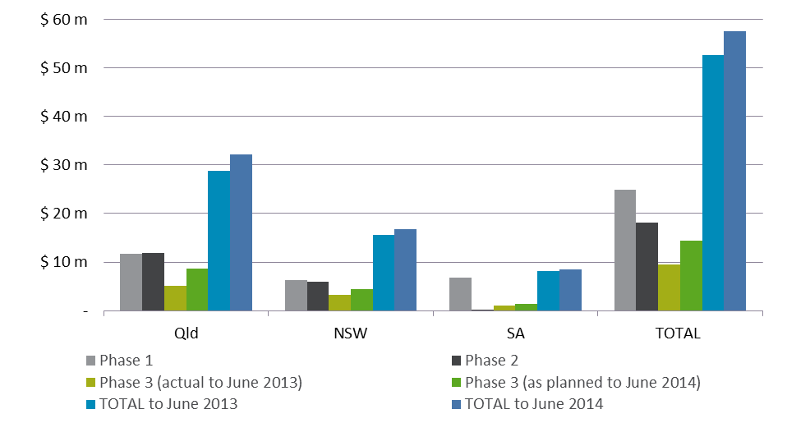

The value varies over the phases in line with the variation in water saved from works undertaken, given that all other variables remain fixed. As such, Phase 1 and 2 delivered similar direct use value in both Queensland and NSW, while in South Australia Phase 1 delivered much higher value than either other phase of the program.

### Consumptive benefits from improved pressure

Method

A primary objective of GABSI is to recover GAB artesian pressure. Direct consumptive benefits associated with pressure recovery predominantly relate to avoided capital and operational costs for water users, i.e.:

* **Avoided pump installation costs** for landowners who would have needed to install pumps due to declining pressure (flow rates) in the absence of the GABSI program.
* **Reduced or avoided pumping costs** for landowners who face higher flow rates as a result of GABSI. Each water user requires a certain flow rate for its operations, so if pressure in the GAB drops (i.e. in the absence of GABSI), the artesian flow rates are reduced, and more energy is required to continue pumping water at the required flow rate.

To understand the incremental pressure impacts, it is necessary to compare the pressure across the GAB under the following two scenarios:

* **Scenario 1 (Sc1): No GABSI Scenario.** This is equivalent to the pressure in the GAB from 1999 onwards, and assumes that no capping and piping activity in the GAB occurred from 1999/2000 onwards.
* **Scenario 2 (Sc2): With GABSI scenario.** This scenario is based on actual pressure between 1999 and 2013 (with GABSI in place) and a projection of future pressure assuming all capping and piping activity ceases in June 2014.

To estimate these impacts with a high degree of confidence, it is necessary to consider the variables outlined in the following table.

Table 9: Method summary for quantifying consumptive benefit from pressure recovery

| Variable | Recommended assessment method and limitations |
| --- | --- |
| ***Avoided pump installation costs (avoided number of pumps X average pump installation cost)*** | |
| **Avoided number of pumps**  (Avoided pumps = # pumps required in Sc1 - # pumps required under Sc2) | The following would be required to determine these variables:   * Detailed stakeholder consultation to identify which bores already had pumps installed prior to 1999 and how many new pumps have been installed since 1999. * Detailed pressure modelling that considers change in pressure at specific bore locations. * Calibration of pressure model with data obtained from stakeholder consultation to determine how many bores would have needed new pumps installed under each scenario. * This modelling could then be used to determine the incremental change in the number of pumps required under Sc1 and Sc2 (i.e. # pumps required in Sc1 - # pumps required under Sc2).   Data for the number of pumps needed under each scenario is not available however, and pressure modelling is not within the scope of this assessment. Therefore estimating the avoided number of pumps resulting from the GABSI program has not been possible within the study constraints. |
| **Average pump installation costs** | Pump installation costs include the cost of the equipment and the labour costs. It can be assumed that other than stock and domestic water users, other water users in the GAB (such as town water use, mining sector irrigation) require higher flow rates and therefore may already have pumps installed under the base case scenario (Sc1).  As such, the pump installation costs can be estimated using indicative estimates for stock and domestic pumps – which are assumed to have a medium flow rate requirement of 2 L/s. Thus, the average pump installation cost to meet this medium flow requirement is estimated to be $9,000 per pump (assuming a range between $6,000 and $15,000 per pump).[8] |
| **Cost of gaining access to electricity at the site** | It is noted that the installation costs should also include the cost of gaining access to electricity for the site. These costs vary significantly by location. For some stock and domestic users the cost of connecting electricity to the site could exceed the cost of the pump installation costs. At some distances, solar pumps may become more economically viable. Given these uncertainties costs cannot be estimated within the constraints of this study. |
| ***Avoided pumping costs = average flow rate across the GAB X (energy use per m change in pressure head (kW/m) x energy cost ($/kWh) X hours per year (8,790) x average change in pressure head (m))*** | |
| **Average flow rate across the GAB** | Estimated based on total water use in the GAB – 616,166 ML/annum (GABCC, 2000), and converted to an annual flow rate (L/s). |
| **Energy use per metre lift (kW/m)** | Estimated based on:   * Assumed flow rates for the different water use types in the GAB multiplied by the average water use distribution across the GAB. Refer to Table 10 for the assumed breakdown in water use and flow rates. * Average efficiency of pumps (assumed to be 47%), where total efficiency = 70% (pump) x 80% (motor) x 85% (pipe system efficiency) = 0.47[9] |
| **Energy cost** | Between $0.15 and $0.20 per kwh for commercial users. $0.20 per kwh has been used in the assessment which is considered to be a conservative approach given that energy prices are expected to increase above CPI over time. |
| **Change in pressure head** | This is equivalent to the average change in pressure head (lift) between Sc 2 and Sc 1. The average change needs to be estimated per year across the assessment period (1999 to 2043). This cannot currently be determined using the existing CSIRO pressure model (GABtran[10]) output used for the GAB Water Resource Assessment (GABWRA).  Further, the GABtran model does not differentiate between flowing or capped bores. The model also simulates pressure as a temperature corrected variable density, and so it is a complex task to derive a pressure surface for the GAB from the model outputs. These issues would need to be resolved to enable a suitable model for simulating changes in GABSI performance/benefits. |

Metrics

The methodology and associated metrics applied to value the consumptive value associated with pressure recovery are presented in the following equation:

$$Consumptive value from restored pressure=PV(\sum_{y=1999}^{y=2043}{( avoided pump installation cost+avoided pumping cost )}$$

*Where*

$$Avoided pump installation cost per annum =avoided number of new pumps ×average pump cost$$

$$Avoided pumping cost per annum = ∆ pressure head \left(m\right)×average flow rate across the GAB (\frac{L}{S})×energy use per m change in pressure \left(\frac{kw}{m}\right) ×energy cost \left(\frac{\$}{kWh}\right)×hours per year= ∆ pressure head \left(m\right)×\$/∆ pressure head$$

A summary of the metrics used for each phase is provided in the following table.

Table 10: Summary of metrics for consumptive benefit from pressure recovery

| Metric | GABSI Phase 1 | GABSI Phase 2 | GABSI Phase 3 (to June 2013) | GABSI Phase 3 (to June 2014) | Comment |
| --- | --- | --- | --- | --- | --- |
| **Avoided number of pumps per annum** | Cannot be quantified | | | | As noted above, data is not available for these metrics. |
| **Average pump cost (real 2013 dollars)** | $9,000 | $9,000 | $9,000 | $9,000 | Based on the average installation rate for S&D users. |
| **Change in pressure head (average)** | Unavailable | Unavailable | Unavailable | Unavailable | This data is not available from existing reports or modelling. Models used for GABWRA do not provide a breakdown in the information needed to assess the change in pressure between these two scenarios. Of particular value would be data on the change in pressure head resulting from GABSI in 2013, compared with predicted pressure in 2013 without GABSI. |
| **Flow rate (L/s)** | 616,166 | 616,166 | 616,166 | 616,166 | Estimated based on total annual water use in the GAB – 616,166 ML (GABCC, 2000), and converted to a flow rate (L/s).  Given that annual water use has been considered the avoided pumping cost is an avoided annual pumping cost. |
| **Energy use per metre lift (kW/m) of total GAB water** | 407.81 | 407.81 | 407.81 | 407.81 | Based on estimated average flow rate of 19,538 l/s for a total water use of 616,166ML/year. |
| **$/m change in pressure head** | $714,490 | $714,490 | $714,490 | $714,490 | Based on $0.20/kwh and 8760 hours per year.  This is an annual cost. |

Results

As summarised in Table 11, there is insufficient information in existing reports and models to quantify the avoided pump and pumping costs attributed to GABSI.

The GABWRA undertaken by CSIRO and others was reviewed for use in the VfM assessment. The data contained in the report provided useful background to the consideration of changes in pressure, but did not provide the required level of specificity to obtain the raw data needed for this analysis[11]. To estimate the incremental change in pressure as a result of the GABSI program, relevant pressure maps illustrating changes in pressure from around 1989 to 2012/13 are needed. The GABWRA report does not provide this data. Furthermore, the scale used in the maps provided is too coarse to be used for detailed analysis.

Additional CSIRO groundwater data containing long term pressure observations in the GAB was also considered as input to the VfM assessment. This showed mixed results: [12]

* The number of bores demonstrating an increase in pressure prior to GABSI is nearly equal to the number showing pressure increases after GABSI implementation. This is presumably due to the capping and piping that occurred immediately prior to implementation of the GABSI works.
* A larger than expected number of bores demonstrated an ongoing pressure decline, even during the GABSI implementation period.

These observations do not provide any conclusive evidence whether pressure in the GAB has or has not changed as a result of GABSI. Importantly, the distribution of the bores with time series data did not necessarily relate to areas where GABSI has been implemented.

Despite the lack of quantitative data from the GABWRA, there is some anecdotal and physical evidence of pressure having increased in the GAB as a result of GABSI. Anecdotal evidence provided by the jurisdictions is summarised in the following table.

Table 11: Available evidence of pressure recovery provided by the GAB jurisdictions

| Jurisdiction | Data available or provided | Limitation of data |
| --- | --- | --- |
| **Qld** | In Queensland, the establishment of a legislative framework to manage extraction of water and the significant investment in capping and piping programs by landholders and government since before GABSI has resulted in measurable pressure recovery in key areas across the GAB.  The combined result of these activities is that by 2005 there was an increase in pressure in half of all artesian bores monitored – 341 having increased by up to 8 m and 31 having increased by more than this. | Whist this data suggests that capping and piping works have been successful in recovering pressure, there is insufficient information to separate the impacts from pre-GABSI and different GABSI phases.  More recent data has not been made available |
| **NSW** | Around 90% of capped bores have either stabilised or increased pressure during the period of GABSI (340 bores).  ~12 bores have started to reflow in the last year or two. A non-linear increase is expected over the next few years. | This information is anecdotal and cannot be tested or verified with existing models or reports. Furthermore the impacts cannot be attributed to the different GABSI phases.  Despite these limitations, this data suggests that NSW considers GABSI to have been successful in recovering pressure within its jurisdiction. |
| **SA** | Pressure recovery (10+kpa) observed at little Blyth bore over 17 month period which can be attributed to decommissioning of Big Blyth bore (located 13km away) | This information is based on bore monitoring and is therefore robust. However, the results are only for one bore and cannot be extrapolated across the GAB or across GABSI phases. |

Given the limitations of quantifying the direct consumptive benefits from pressure recovery, these impacts have been considered further as part of a break-even assessment in Section 6.2. The break even assessment provides more detail about the pressure recovery that is needed for the program benefits to at least equal the costs.

## Non-consumptive benefits

Non-consumptive benefits relate to improved recreational, tourism, heritage, and amenity. They also include improved pest and weed control to private and public landowners.

### Direct private landholder benefits

Method

The purpose of this assessment is to better understand the VfM for government investment, so assessing the VfM of private landholder investment was agreed to be out of scope. Furthermore, it is generally assumed that the benefit to landowners must at least equal their financial contribution to the GABSI program. This includes up-front investment, both in dollars and in-kind and any ongoing maintenance costs. Participation in the program is voluntary, so landholders must have some certainty in the direct benefits they will receive or they would not participate.

The GABSI program involves bore rehabilitation and bore drain replacement on private property, leading to direct benefits to the landowner[13] :

* Improved utilisation of productive land (better reach and/or less evaporation)
* Extended life of bores
* Reduced on farm maintenance/monitoring costs (eg of cleaning drains)
* Restoration of native vegetation
* Improved water quality – relative to when it flows through open drains
* Improved safety and health of stock during drought (stock weakened by drought are more likely to collapse or bog in drains)
* Reduced mustering time- stock traps can be installed at water points so that stock can self-muster
* Improved (or lower cost of) local pest and weed control on private property
* Improved pressure and clean water at homestead

Metrics

While metrics could be developed for the benefits listed above, landowner benefits have not been included in the quantified economic value. If they were to be included, the benefit would be valued based on the assumption that landowners’ financial contribution to the scheme must at least equal any associated direct benefit.

The assumption that landholder costs equal landholders benefits is considered to be a conservative estimate given that the scheme is voluntary and so landowners would not choose to participate in the program if they did not consider that the benefits did not outweigh their financial contribution. For example, a study by the Centre of International Economic (CIE 2003) surveyed 19 farms, and the average benefit cost ratio (BCR) for landowners was 2.6 – meaning 2.6 dollars of benefit to one dollar of private expenditure. Another survey undertaken by NSW Office of Water (Hill et al 2010) of nine NSW landholders estimated benefit cost ratios to landholders ranging from 0.4 to 7.2, suggesting that on average, landholders receive benefits that exceed the costs.

If direct landowners are to be captured, in the TEV of the program, the following equation could be applied:

$$Non consumptive landowner benefits=PV(\sum_{y=1999}^{y=2043}{( landowner controbution\left(\$\right)×BCR Factor}$$

A summary of the metrics used for each phase is provided in the following table[14].

Table 12: Landowner contributions

| Metric description | GABSI Phase 1 | GABSI Phase 2 | GABSI Phase 3 (to June 2013) | GABSI Phase 3 (to June 2014) | Comment |
| --- | --- | --- | --- | --- | --- |
| $ landowner contribution (TOTAL - $2013 real) | $36.13 | $45.36 | $31.70 | $16.64 | Based on estimated contributions provided by each jurisdiction. |
| Qld | $ 12.73 m | $ 16.94 m | $ 10.44 m | $ 16.64 m |
| NSW | $ 22.20 m | $ 28.42 m | $ 21.26 m | Not available- |
| SA | $ 1.20 | - | - | - |
| Landowner Benefit Cost Ratio (BCR) Factor | 1 | 1 | 1 | 1 | As the most conservative assumption, it can be assumed that the value equals the financial contribution. |

Results

The landowner benefits and costs have not been included in the TEV. A sample of landholder views obtained through a study conducted by the Centre for International Economics and Resource Policy and Management (2003) are provided below.

|  |  |
| --- | --- |
| *Case study 1: Warrego (QLD) landholder view[15]*   * “The owner believes that the GAB as a whole is facing declining bore pressures and is ‘in trouble’ but is now being managed in a responsible manner provided the current government approach continues. * Key problems, he thinks, are too many uncontrolled bores and the huge wastage of water in bore drains. Concentrating on increasing or at least maintain bore pressures is the key focus. * There is an even mix of public and private benefits from capping and piping. * He believes those who have not piped would be most influenced by seeing for themselves the advantages of capping and piping, and the threat of lower government subsidies or regulations.” | *Case study 2: Surat (NSW) landholder view[16]*   * “The owner believes that bore pressures across the Basin are decreasing somewhat but that in general it is now being managed responsibly. But there is still a long way to go and uncapped bores constitute a serious problem. * Wastage of water, decreasing bore pressures and uncontrolled bores are key problems facing the GAB. * In addressing the problem attention should concentrate on those areas where bore pressures are lowest. * The current subsidy scheme is about right — probably on the generous side. * A real problem with bore trust is that some people find it financially difficult to participate, hold up the project for all the others.” |

### Tourism, recreation and amenity benefits

Method

ACIL Tasman (1999) conducted an economic and social assessment of the GAB in Queensland, and looked at the contribution of the two regions considered to reflect the GAB – Darling Downs and Outback. Tourism contributed a total of $294m to the Gross Regional Product of the two regions. However this is expected to overestimate the benefits of the GAB as many activities are independent of the GAB resource, and it is unlikely that GABSI could be attributed to preserving/maintaining all of the activities that do depend on the GAB.

Another approach to determining the tourism and recreation benefits of GABSI would be to consider the value placed on tourism and recreation ($ / household, $ / visitor) and extrapolate this across visitor numbers at each of the key tourism and recreation sites that are known to depend on the GAB. Rolfe (2008) used this approach to determine an average recreational consumer surplus of $139.41/day ($154.90/day in 2013 dollars), which could be transferred to recreation use in the GAB. He also looked at the value of the Dalhousie Springs complex in Witjira National Park ($2.79 million based on 10,000 visitors per annum staying two nights) and applied a 21% reduction in annual extraction achieved by GABSI as a proxy for estimating marginal effects. This resulted in annual recreation benefits estimated at $585,222 or $4.05/ML of reduced water extraction. [17]

A list of the key regions and specific tourism and recreations sites partly supported by the GAB is provided in Table 13.

Table 13: Key tourism and recreation sites supported by the GAB[18]

| Jurisdiction | Relevant regions and tourism data | Key tourism and recreation sites |
| --- | --- | --- |
| **NSW** | * Outback NSW – 320,700 overnight visitors in 2012/13[19]; total tourism expenditure of $175m (basic prices)[20] | * Moree, various locations - a number of accommodation houses that have access to private artesian spas. * Bourke, Comeroo Camel Station - multi-faceted tourist retreat with camel riding, private artesian spas, and a working sheep station. * Pilliga Bore Baths * Burren Junction Bore Baths – also has accommodation and facilities. * Lightning Ridge Bore Baths – has several accommodation houses and Bore Baths. |
| **QLD** | * Outback – total tourism expenditure of $299m (basic prices) * Darling Downs – total tourism expenditure of $429m (basic prices) | * Blackall Aquatic Centre - aquatic centre with artesian spa. * Mitchell Great Artesian Spa Complex - Mitchell's major tourist attraction. * Cunnamulla, Charlotte Plains Farmstay - a working sheep and cattle property with bore baths. * Ilfracombe Artesian Spa * Bedourie Artesian Spa – 22 person Therapeutic Spa and provides for an aquatic centre (built in 2000) * Cunnamulla Fella Centre – Artesian Time Tunnel, Paroo Shire Council, Eromanga Basin |
| **SA** | * Outback and Flinders Range – 570,000 visits over June 2010-12, with an average stay length of stay of 4.3 nights[21]; total tourism expenditure of $48m (basic prices) for the Outback region only | * Wabma Kadarbu Mound Springs Conservation Park – Blanche Cup and The Bubbler mound springs * Witjira National Park – Dalhousie Springs * Vulkathunha-Gammon Ranges National Park – Mount McKinlay Spring |

***Metrics***

A potential metric to measure the tourism / recreational benefits of GABSI is provided below. This metric would need to be applied to each of the key tourism and recreation sites listed above. Importantly, the number of visitors captured in the assessment (and/or the length of stay) must reflect the additional visitor numbers (or duration) that can be directly attributed to GABSI. In other words, only the additional recreation or tourism benefits that are a result of improved spring flows should be captured. The proxy of 21% applied by Rolfe (2008) to estimate the marginal recreation/tourism value produced by GABSI would need to be further tested before it is used as part of a value for money assessment.

$$Tourism \& recreation benefit=PV(\sum_{y=1999}^{y=2043}{(incremental annual visitors (\#)×length of stay \left(days\right)×consumer surplus (\$/day)}$$

***Results***

A value for recreational or tourism benefits could not be quantified based on existing data. In particular, data on the visitor numbers and average length of stay at each of the key tourism and recreation sites listed above would be required. This data would also need to identify the increase in visitor numbers or length of stay at each site as a result of GABSI. The information currently available does not provide that required level of detail for this type of analysis. However, based on the previous study of the Dalhousie Springs complex (recreation benefits of $0.6m/annum) there are likely to be some relatively minor but tangible recreation benefits associated with the GABSI program.

### Heritage benefits

***Methodology***

Heritage value attributed to the GABSI program cannot be quantified because: 1) the GAB area has not been systematically surveyed or assessed for cultural heritage significance; and 2) surveys to determine the importance of cultural heritage sites in the GAB to Indigenous and non-Indigenous communities have not been undertaken. Furthermore, some information is culturally sensitive and thus not widely available. Thus, metrics have not been developed for this part of the TEV framework.

***Results***

Although these benefits cannot be quantified, there is significant evidence of Indigenous occupation and use recorded within GAB spring wetlands. Cultural heritage artefacts including scarred trees, rock art, burials, pathways, stone artefacts and scatters, wells, grinding grooves, etc. have all been found at sites and spring wetlands throughout the GAB.

In Queensland, for example, 150 Indigenous cultural heritage sites have been recorded in relation to GAB spring wetlands, however this is expected to be a lower estimate of the total number of sites. In NSW, significance to Aboriginal people has not been researched for the springs, but Peery Lake has been designated a place of major cultural significance for Aboriginal people of the Barkindji. South Australia has also undertaken studies finding Indigenous cultural heritage sites in the GAB region, but these records are not available to the public.

## Indirect value

### Indirect benefits to rural communities

Method

The flow-on effects of the direct consumptive benefit to the rest of the economy have been estimated using multipliers estimated by Deloitte Access Economics (2013). These multipliers reflect the degree to which the economic activity by water users impacts demand for inputs in other sectors.

The multipliers estimated are presented in ratio figures, which represent the ratio between total direct value and total value. A ratio of 2 therefore suggests that every dollar of direct value results in an additional value of $1 of value add elsewhere in the economy, with a total economic value of $2. These ratios (as well as multipliers between direct and indirect value) are provided in the following table.

Table 14: Summary of available indirect benefit multipliers (Deloitte Access Economics, 2013)

| Sector | Ratio of direct to total value | Multiplier – direct to indirect value |
| --- | --- | --- |
| Agriculture - Irrigation | 2.00 | 1.00 |
| Agriculture- drinking water for livestock | 2.08 | 1.08 |
| Mining | 1.45 | 0.45 |
| Urban Water supply | 1.89 | 0.89 |
| Households | NA | NA |
| Manufacturing and other industries | 2.00 | 1.00 |

The average multiplier across sectors was used in the assessment. This is an indicative estimate only; as the multiplier could be higher or lower depending on how the water is reallocated (i.e. to which sector). This is discussed in more detail in Table 15.

The average multiplier is applied to the direct use value quantified in the assessment, which is the direct use value from reallocation of saved water.

Metrics

The methodology and associated metrics applied to value the consumptive use of reallocated water are presented in the following equation:

$$Indirect benefits=PV(\sum_{y=1999}^{y=2043}{( annual direct benefit×average multiplier)}$$

A summary of the metrics used for each phase is provided in the following table.

Table 15: Metrics for indirect benefit valuation

| Metric description | GABSI Phase 1 | GABSI Phase 2 | GABSI Phase 3 (to June 2013) | GABSI Phase 3 (to June 2014) | Comment |
| --- | --- | --- | --- | --- | --- |
| Multiplier (direct to indirect value) | 0.88 | 0.88 | 0.88 | 0.88 | Based on average multiplier across the water use sectors.  This is an indicative estimate only; as the multiplier could be higher or lower depending on how the water is reallocated.  For example, the multiplier would be 1.0 if a weighted average of the multipliers in is used (based on the water use profile in the GAB). Similarly, the multiplier would be 1.0 if it is assumed that the industries purchasing water will be the same as those that participated in the NSW auction (tourism and feedlot).  Given that the allocation of new water between sectors is unknown, a basic average of the multipliers was considered to be most appropriate. |
| Direct value ($ 2013) | $ 24.87 m | $ 18.21 m | $ 9.53 m | $ 14.39 m | Based on the only direct value fully quantified in the assessment – direct consumptive benefit from reallocation of saved water. |

Results

The total estimated indirect benefit across GABSI is $46.51m (to June 2013) or $50.81m to June 2014. A breakdown of results by jurisdiction is provided in Table 16 and .

Table 16: Total indirect value ($ 2013, real)

| Jurisdiction | Phase 1 | Phase 2 | Phase 3 (to June 2013) | Phase 3 (to June 2014) | TOTAL to June 2013 | TOTAL to June 2014 |
| --- | --- | --- | --- | --- | --- | --- |
| **Qld** | $ 10.38 m | $ 10.49 m | $ 4.56 m | $ 7.64 m | $ 25.42 m | $ 28.50 m |
| **NSW** | $ 5.56 m | $ 5.35 m | $ 2.94 m | $ 3.91 m | $ 13.86 m | $ 14.82 m |
| **SA** | $ 6.05 m | $ 0.26 m | $ 0.92 m | $ 1.17 m | $ 7.23 m | $ 7.48 m |
| **TOTAL** | **$ 21.99 m** | **$ 16.10 m** | **$ 8.42 m** | **$ 12.72 m** | **$ 46.51 m** | **$ 50.81 m** |

Figure 5: Total indirect value ($ 2013, real)

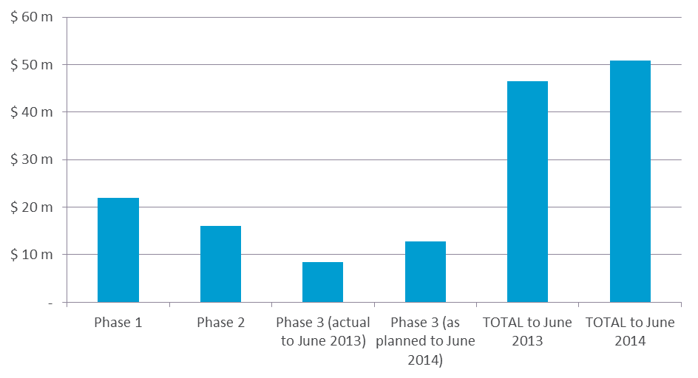

## Option value, bequest / altruism, and stewardship values

***Method***

Option and bequest values relate to:

* **Option value: future direct and indirect use values.** Valuing the direct use benefit of returned water to the GAB does not capture the value to those who anticipate using the GAB water or visiting the springs sometime in the future. There are economic arguments that non-visitors would be willing to pay to preserve the option of visiting (Boardman et al 1996)[22]. This ‘option value’ is a separate benefit category that is based on the opportunity of future use of the resource.
* **Bequest value: value of the use of the GAB by others.** Value of having the option for others to benefit from the use the GAB in the future.
* **Stewardship value: value of preserving the GAB for others.** Willingness to pay for the existence of the GAB motivated by a sense of stewardship, where there is no actual or planned use for themselves or others. This relates to the intrinsic value people hold for the assets.

Studies have not been undertaken to assess these values within the GAB, therefore metrics for qualitative or quantitative assessment have not been considered. The only way to assess these values in more detail is through willingness to pay studies, and more specifically, through stated preference techniques.

Stated preference techniques use surveys to ask people how much they are willing to pay for a given benefit or service. Contingent valuation and choice modelling are two survey types used for these purposes. However questions are often framed as the willingness to pay for the protection or enhancement of environmental values meaning that it is difficult to separately measure the willingness to pay for use and non-use values. Using these studies to solely estimate option or bequest values can lead to double counting of benefits (refer to Table 17 for more detail on these methods).

***Results***

While metrics cannot be developed to quantify these values, there is anecdotal evidence supporting the concepts underlying such value.

For example, the conservation group, Bush Heritage Australia, purchased Edgbaston Reserve (this property includes a group of natural springs which is in close proximity to a number of bores that were recapped under the GABSI program) in Queensland in 2008 to conserve the natural springs and ecosystems that they support. They now conduct ongoing works on the reserve to control pests and weeds and restore the wetlands to conserve a number of endemic species including two threatened fish species. Much of the funding for this group is provided by private donations for long term stewardship purposes.

## Environmental benefits

### Conserving biodiversity

***Method***

Valuation of environmental benefits attributable to the GABSI program must consider the change in environmental condition (i.e. groundwater ecosystem service condition) that is due to increases spring flows from pressure recovery achieved.

The range of possible methods to assign monetary values to ecosystem services is described in the following table.

Table 17: Methods to value environmental benefits

| Method | Description | Applicability of method |
| --- | --- | --- |
| **Direct market valuation approaches** | This approach can be based on a prices revealed through a functioning market for ecosystem service, where such a market exists.  Alternatively, market valuation can be based on the cost which would be incurred if the environmental benefit no longer existed and had to be recreated or the contribution of the environmental benefit to a traded commodity. | This method is limited in the case of GABSI as there is no clear direct market for the environmental benefits (i.e. protection of biodiversity, conservation of threatened flora and fauna, etc). |
| **Revealed preference approaches** | This approach draws indirectly on markets or on household behaviour, such as expenditure or travel behaviour, to infer individual preferences from behaviour (Commonwealth Government 2006).[23]  This approach could therefore include the travel cost method which infers value from a change in travel expenditure or hedonic pricing which attributes value of say an environmental asset to house prices. | This method requires a large quantity and high quality of relevant data to appropriately assess the relationship between the environmental benefit and indirect market.  It is not enough that studies assess the value of all groundwater ecosystems in the GAB. Questionnaires must be designed to assess the additional ecosystem service value that is attributable to GABSI.  This data is not available for GABSI. |
| **Stated preference approaches** | This approach involves conducting surveys to ask respondents what they would be willing to pay for a public good – in this case a groundwater ecosystem system. | There are stated preference surveys which have been undertaken that are relevant to GABSI, however there scope tends to focus on very specific areas of the GAB and it is therefore difficult to transfer these benefits to the whole of the GAB based on existing information. Furthermore, the hypothetical aspect of the market limits its robustness as an appropriate measure. |

There has been no systematic monitoring of spring flows and groundwater ecosystems to understand how the conditions have changed over time, or as a result of GABSI. However, there have been a number of studies aimed at valuing environmental assets more broadly.

Relevant studies identified by Rolfe (2008) include:

* Choice modelling survey of the Desert Uplands region (which overlaps part of the GAB in Queensland) conducted by Rolfe et al (2000) and Blamey et al (2000). Responses were gathered from a random sample of Brisbane households in 1997 with results suggesting that: (a) the annual value of avoiding the loss of each 1% of unique ecosystems was $4.79 per household (2007 dollars) per Brisbane household for 15 years, and (b) the annual value of avoiding the loss of an endangered species was $14.83 per household (2007 dollars).
* Choice modelling survey for the Macquarie Marshes and Gywdir Wetlands in inland NSW by Morrison et al. (2002) found that Sydney households valued improved areas of wetlands at $0.04 and $0.05 per hectare, and improved frequency of waterbird breeding at $12.85 and $31.63, and protection per endangered species at $5.59.
* Choice modelling survey of the Upper South East region of South Australia by Macdonald and Morrison (2005) found that South Australian households placed a protection value of $717/ha for scrublands, $1,019/ha for grassy woodlands, and $1,543/ha for wetlands.

It may be possible to transfer some of these values to estimate the environmental benefits of GABSI, in particular loss of unique ecosystems, loss of threatened species, and protection of wetlands for example. However, there is limited data available to conduct this assessment. While there is a known relationship between GAB pressure, spring flow, and endemic fauna and flora, it is difficult to establish a direct relationship between GABSI and improvement in wetland existence or health.

Some of the challenges in measuring environmental benefits of GABSI include the following:

* Although there are examples of endemic species which have become extinct as a result of draw-down (Fensham 2010), there is no data that links the rate of extinction to draw-down, which is needed to estimate the avoided loss associated with works under each GABSI phase.
* Lack of sufficient data to separate impacts directly attributable to the GABSI from other initiatives aimed at recovering native species.
* Although a comparison of wetted surface extents of springs undertaken between 2008 and 2011 (Queensland Government 2012) indicated a potential change of over 200% in Edgbaston and Spring Rock springs complexes, determining the cause was not possible. Additional data is needed to determine the aquifer head pressure associated with each spring complex. Further data is then required to determine whether the increase in spring extents is a result of artesian pressure or consistent wet years since 2008.
* There are unintended consequences of the GABSI which also need to be considered. For example, while the isolated nature of many GAB springs has enabled the evolution of endemic species, they are likely to become more reliant on natural artesian spring wetlands as the number of bore drains are reduced due to bore capping and piping.

***Metrics***

Based on the most relevant studies identified above, some potential metrics that could be applied to assist in measuring the environmental benefits of GABSI are provided below.

$$Biodiversity protection=PV(\sum_{y=1999}^{y=2043}{avoided loss of unique ecosystem \left(\%\right)×WTP for avoided loss \left(\$ per household\right) ×households }$$

A summary of the metrics available and unviable for estimating biodiversity benefits from GABSI are summarised below.

$$Biodiversity protection=PV(\sum_{y=1999}^{y=2043}{averted loss of 1 endangered species (\#)×WTP for avoided loss \left(\$ per household\right)×households }$$

Table 18: Summary of metrics for consumptive benefit from pressure recovery

| Metric | GABSI Phase 1 | GABSI Phase 2 | GABSI Phase 3 (to June 2013) | GABSI Phase 3 (to June 2014) | Comment |
| --- | --- | --- | --- | --- | --- |
| **Avoided loss of unique ecosystem (%)** | Not available | | | | As noted above there has been no systematics monitoring of spring flows and groundwater ecosystems to understand how the conditions have changed over time, or as a result of GABSI. |
| **Avoided loss of endangered species (#)** |
| **Willingness to Pay (WTP) for avoided loss (or protection) of unique ecosystems per household** | $5.65 | $5.65 | $5.65 | $5.65 | This annual value is based on Rolfe et al (2000) and Blamey et al (2000) and is for a period of 15 years. The value has been escalated to 2013 dollars. |
| **Willingness to Pay (WTP) for avoided loss (or protection) of endangered species** | $17.48 | $17.48 | $17.48 | $17.48 | This annual value is based on Rolfe et al (2000) and Blamey et al (2000) and is for a period of 15 years. The value has been escalated to 2013 dollars. |
| **Number of households** | Approx. 5.5 million | | | | Where possible, the number of households should vary year on year with the population. For the sake of simplicity, 2013 household numbers have been applied.  It is assumed that all households in the GAB jurisdiction - including Queensland, NSW and South Australia will value the groundwater ecosystems. This may be higher if non-GAB jurisdictions are willing to pay for ecosystem preservation in the GAB or lower, if not all households are willing to pay – e.g. Rolfe (2008) reduced the households by 50% to reflect the response rate to the survey.  Sensitivity tests should always be run on the number of households (to allow for less and more households). |

***Results***

The metrics needed to quantify the avoided loss of ecosystems (unique or endangered) as a result of GABSI is unavailable and therefore the biodiversity benefits from the GABSI program could not be captured in the TEV assessment.

As data was unavailable to appropriately apply the above metrics (e.g. clear evidence demonstrating that GABSI averted the loss of an endangered species), available evidence to demonstrate the qualitative value of the groundwater ecosystem services is considered instead.

There are significant legislative obligations on both the Commonwealth and jurisdictions to protect the environmental value provided by the GAB. These Acts suggest government (and therefore public) willingness to protect these assets and therefore implies an intrinsic public value. Relevant legislation includes:

* **Commonwealth** – EPBC Act 1999
* **NSW** – Threatened Species Conservation Act 1995, National Parks and Wildlife Act 1974, Environmental Planning and Assessment Act 1979
* **QLD** – Vegetation Management Act 1999, Nature Conservation Act 1992, Environment Protection Act 1994
* **SA** – Natural Resources Management Act 2004, Native Vegetation Act 1991
* **International** – IUCN Red List, Ramsar Convention

The GAB once sustained approximately 500 complexes of permanent springs (Fairfax et al 2007)[24], which can vary in size from miniscule to over 100ha. The largest discharge spring is located at Dalhousie Springs in South Australia. Active spring wetlands, occurring from the southern end of Cape York Peninsula to Lake Eyre in South Australia, are sustained by a constraint supply of water from the GAB and therefore are not exposed to seasonal drying like most other wetlands. This difference to seasonal wetlands means that spring wetlands support distinct ecosystem services (Fensham et al 2010).

A recovery plan for the community of native species dependent on natural discharge of groundwater from the GAB (Fensham et al 2010) identified aquifer drawdown as a key threat to the native species of the GAB, suggesting that 40% of discharge spring complexes have become inactive during the period of settlement, and another 14% were categorised as active and inactive. Whilst these findings were based on limited data[25], the analysis concluded that aquifer drawdown is linked to spring extinction and decline, and to loss of endemic species. Figure 6 provides an overview of the location of major springs groups in the GAB and their conservation status in relation to the EPBC Act 1999.

Table 19 provides a list of key communities of native species found in the GAB and their conservation status according to Commonwealth and State legislation.

Figure 6: GAB spring complexes and their status under the EPBC Act 1999 (CSIRO, 2012, p.6)

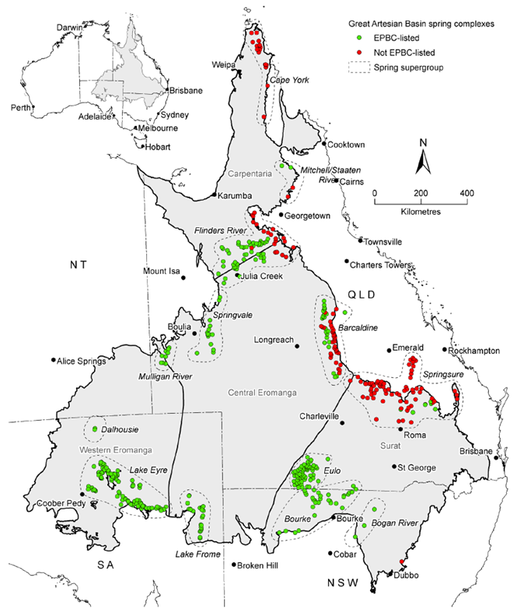

Table 19: Conservation status of the community of native species dependent on natural discharge of groundwater from the GAB under Australia and State Government legislation[26]

| Name | Conservation status | Known locations |
| --- | --- | --- |
| ***Animals*** | | |
| *Adclarkia dawsonensis*  Boggomoss Snail, Dawson Valley Snail | Critically endangered nationally | Boggomoss |
| *Elizabeth Springs* | Endangered nationally and in QLD | Elizabeth Springs |
| *Chlamydogobius squamigenus*  Edgbaston Goby | Vulnerable nationally, endangered in QLD | Edgbaston / Myross |
| *Scaturiginichthys vermeilipinnis*  Red-finned Blue-eye | Endangered nationally and in QLD | Edgbaston / Myross |
| **Plants** | | |
| *Arthraxon hispidus*  Hairy-joint Grass | Vulnerable nationally and in NSW | Dawson River (spring 5) |
| *Dentella minutissima* | Endangered in NSW | Discharge springs in NSW |
| *Eriocaulon carsonii*  Salt Pipewort | Endangered nationally and in QLD, NSW, and SA | Caring, Cockatoo Creek, Edgbaston / Myross, Lucky Last, Elizabeth Springs, Gosse, Hermit Hill, Gammyleg, Moses, North West, Old Finniss, Peery Lake, Petermorra, Public House, Reedy, Scotts Creek, Sulphuric, Twelve, West Finniss, Yowah Creek |
| *Eryngium fontanum* | Endangered nationally and in QLD | Edgbaston / Myross, Moses |
| *Myriophyllum artesium* | Endangered in QLD | Caring, Carpet, Cockatoo Creek, Coreena, Edgbaston / Myross, Elizabeth Springs, Granite, Merimo, Moses, Paroo River, Smokey, Tungum, Wooregym, Yowah Creek |
| *Myriophyllum implicatum* | Rare in QLD and presumed extinct in NSW | Kennedy’s / McKenzies |
| *Sesbania erubescens* | Rare in QLD | Black |
| *Sporobolus pamelae* | Endangered in QLD | Coreena, Dead Sea Scrolls, Edgbaston / Myross, Kennedy’s / McKenzies, Moses, Yowah Creek |
| *Thelypteris confluens* | Vulnerable in QLD | Dawson River (spring 5) |

### Greenhouse gas abatement benefits

***Method***

Water flowing from artesian bores has been demonstrated to contain dissolved gas concentrates (methane and carbon dioxide). It can therefore be assumed that any water saved under the GABSI program (ML/year) and returned to the GAB will result in greenhouse gas abatement.

The economic value of greenhouse gas abatement achieved under GABSI should reflect the avoided socio-economic costs associate with climate change.

Key assumptions required to estimate these value include:

* **Carbon dioxide equivalent (CO2e) per ML of water discharged**. A previous study (Pallasser et al, 2000 which explored emissions from 129 bores in the NSW GAB estimated that approximately 0.54 tonnes of CO2 emissions are emitted per ML discharged. Given that this is the most comprehensive study available on greenhouse gas emissions from GAB water, this value can be extrapolated to other jurisdictions
* **Average carbon price**. The price for carbon can be used as a proxy for this cost where a carbon market exists. However, given the lack of certainty regarding an appropriate carbon price in the Australian context, an indicative value of $23/CO2e has been applied in the study. This is equivalent to the 2012/13 carbon tax price and is considered to be a conservative estimate, given that the social cost of carbon is expected to increase over time.

Metrics

The methodology and associated metrics applied to value the consumptive use of reallocated water are presented in the following equation:

$$Greenhouse gas abatement benefit=PV(\sum_{y=1999}^{y=2043}{(ML/year returned to GAB (\frac{ML}{year})×CO2(e)/ML ×\$/CO2(e)}$$

*Where*

$$ML/year returned to the GAB=ML saved×\% of water returned to the basin$$

**Table 20: Metrics for greenhouse gas abatement value**

| Metric description | GABSI Phase 1 | GABSI Phase 2 | GABSI Phase 3 (to June 2013) | GABSI Phase 3 (to June 2014) | Comment |
| --- | --- | --- | --- | --- | --- |
| ML Saved / yr | 18,353 | 14,997 | 9,444 | 11,490 | Refer to . |
| % ML returned to the Basin | 66% | 70% | 69% | 69% | Annual weighted average based on ML saved within each jurisdiction and a requirement that at least 50% of water saved be returned to the GAB in SA, and at least 70% be returned to the GAB in Queensland and NSW. |
| CO2(e) (tonne) /ML | 0.54 | 0.54 | 0.54 | 0.54 | As discussed above, this is the only value available based on a NSW study. This value is assumed to be consistent across the GAB for the purpose of this assessment. |
| $/CO2(e) | $23/tonne | $23/tonne | $23/tonne | $23/tonne | As mentioned above, this is considered to be a conservative estimate of the social cost of carbon. Market data is not available given the uncertainty of a future carbon market in Australia. |

Results

The total benefit associated with reduced greenhouse gas emissions across the assessment period (1999-2043) is $64.4 m (to June 2013) or $69.6 m to June 2014. A breakdown of results by jurisdiction is provided in .

Figure 7: Total greenhouse gas abatement value ($ 2013, real)

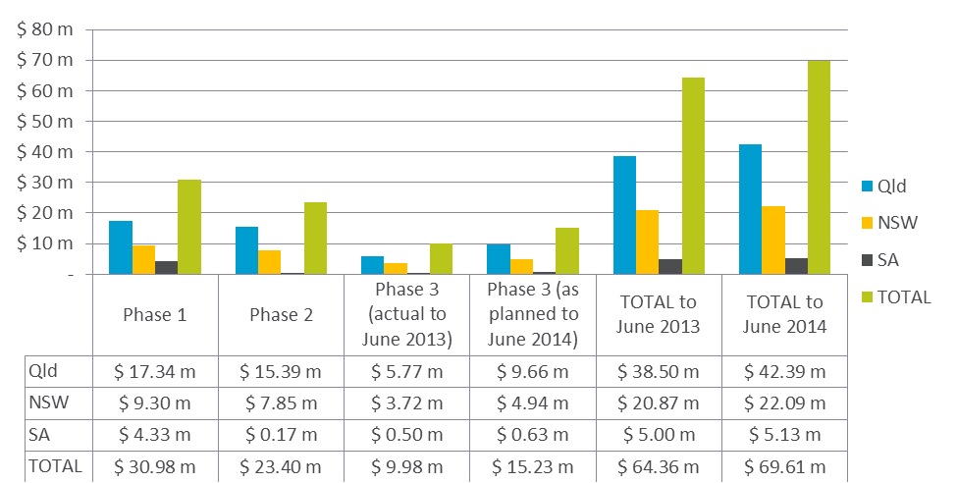

## Summary

The summary of the Value for Money assessment which is based on the TEV Assessment framework is split into the following two sections:

* Quantified value for money
* Additional benefits discussed qualitatively

### Quantified value for money

The total cost of GABSI to governments in real dollars is $241.2m to June 2013 or $268.05m to June 2014. In present value the cost is $375.2m to June 2013 and $400.24m to June 2014.

Determining value for money requires a comparison of program specific costs and benefits. Table 21, Table 22, Figure 8, and Figure 9 outline the total benefits quantified for GABSI over the assessment period, which are the consumptive benefits from reallocated water, indirect benefits to communities, and greenhouse gas abatement benefits.

In real dollars, these benefits up to June 2013 are estimated to be $163.0m or $176.7m if including works to be completed over 2013/14. In present value, these respective figures are $209.9m to June 2013 and $221.4m to June 2014.

Table 21: TEV quantified (real 2013 dollars)

|  |  |  |  |  |  |  |
| --- | --- | --- | --- | --- | --- | --- |
| Quantified values | Phase 1 | Phase 2 | Phase 3 (completed) | Phase 3 (completed as planned) | TOTAL to June 2013 | TOTAL to June 2014 |
| Consumptive benefits from reallocated water | $ 24.87 m | $ 18.21 m | $ 9.53 m | $ 14.39 m | $ 52.61 m | $ 57.47 m |
| Indirect benefits to rural communities | $ 21.99 m | $ 16.10 m | $ 8.42 m | $ 12.27 m | $ 46.51 m | $ 50.81 m |
| Greenhouse gas abatement benefits | $ 30.98 m | $ 23.40 m | $ 9.88 m | $ 15.23 m | $ 64.36 m | $ 69.61 m |
| **Total** | **$ 77.84 m** | **$ 57.71 m** | **$ 27.93 m** | **$ 42.34 m** | **$ 163.48 m** | **$ 177.89 m** |

Table 22: TEV quantified (present value dollars)

|  |  |  |  |  |  |  |
| --- | --- | --- | --- | --- | --- | --- |
| Quantified values | Phase 1 | Phase 2 | Phase 3 (completed) | Phase 3 (completed as planned) | TOTAL to June 2013 | TOTAL to June 2014 |
| Consumptive benefits from reallocated water | $ 52.36 m | $ 27.33 m | $ 10.19 m | $ 15.40 m | $ 89.88 m | $ 95.08 m |
| Indirect benefits to rural communities | $ 22.79 m | $ 13.61 m | $ 4.62 m | $ 7.05 m | $ 41.02 m | $ 43.45 m |
| Greenhouse gas abatement benefits | $ 46.28 m | $ 24.16 m | $ 9.01 m | $ 13.61 m | $ 79.45 m | $ 84.05 m |
| **Total** | **$ 121.43 m** | **$ 65.09 m** | **$ 23.83 m** | **$ 36.06 m** | **$ 210.35 m** | **$ 222.58 m** |

Figure 8: TEV quantified (real 2013)

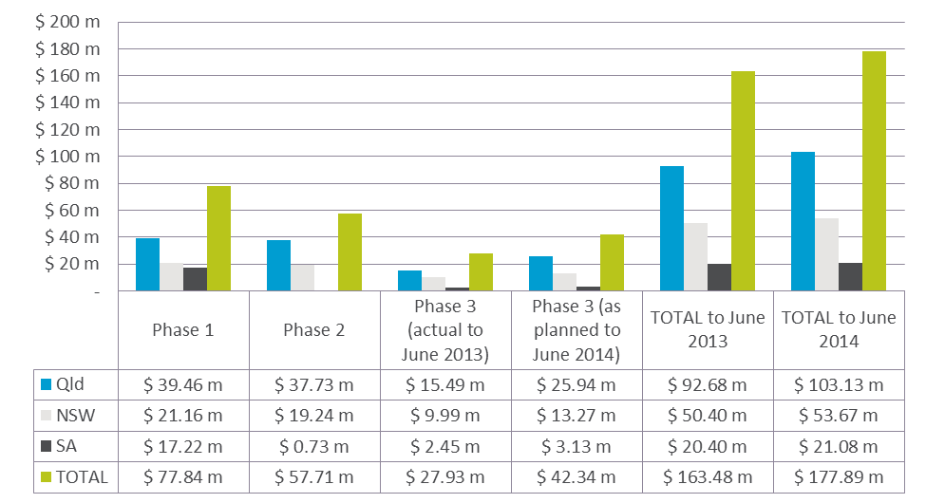

Figure 9: TEV quantified (present value)

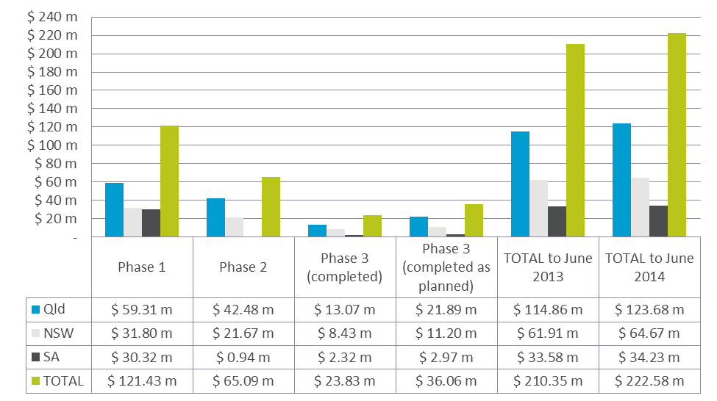

As discussed in Section 3.1, a BCR provides an indication of the total economic value provided by GABSI per dollar invested in the program, which essentially represents return on government investment in GABSI. A BCR of one would indicate that the benefits equals the costs, while a BCR of more than one suggests that the return on investment exceeds the amount expended (and vice versa for a BCR of less than one).

As shown in Table 23 and Figure 10, the BCR for the whole of GABSI to date (for works completed to June 2013) is 0.56. The BCR decreases over the three phases of the program from 0.77 in Phase 1. However this only includes the benefits that could be quantified, which account for only three of the nine benefits captured in the full TEV framework. Furthermore, two of these elements only consider the value of less than 35% of the water saved at each phase of GABSI (i.e. water that could be reallocated for consumptive purposes).

The BCR for Phase 1 was significantly higher than for Phases 2 and 3, likely due to jurisdictions prioritising the works where they could achieve the greatest water savings first. This may also be due to a higher level of landholder interest in this Phase as it followed on from other state funding programs which required a greater landholder contribution. The phase also covered a period of good rainfall across most of eastern Australia meaning that landholders had cash reserves to spend on the program.

Table 23: Quantified value for money summary (BCR)

|  |  |  |  |  |  |  |
| --- | --- | --- | --- | --- | --- | --- |
| Value per dollar invested | Phase 1 | Phase 2 | Phase 3 (completed) | Phase 3 (completed as planned) | TOTAL to June 2013 | TOTAL to June 2014 |
| Consumptive benefits from reallocated water | 0.33 | 0.19 | 0.14 | 0.15 | 0.24 | 0.24 |
| Indirect benefits to rural communities | 0.29 | 0.17 | 0.12 | 0.13 | 0.21 | 0.21 |
| Greenhouse gas abatement benefits | 0.15 | 0.09 | 0.06 | 0.07 | 0.11 | 0.11 |
| **Total** | **0.77** | **0.45** | **0.33** | **0.35** | **0.56** | **0.55** |

Figure 10: Quantified BCR by phase (all jurisdictions)

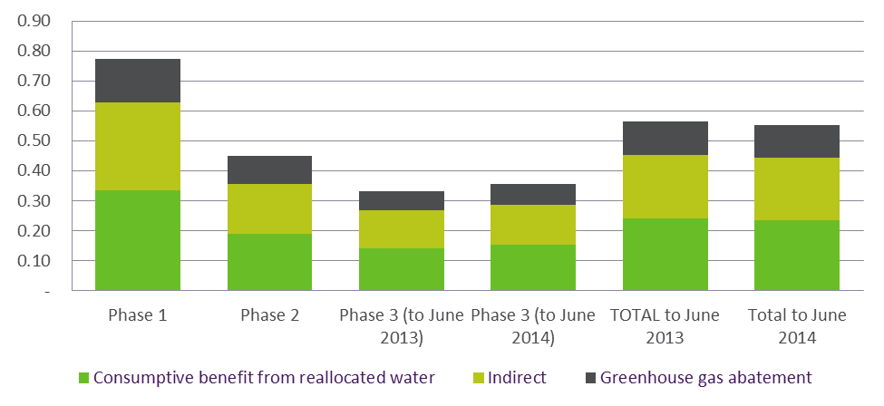

Figure 11 shows the BCR for each jurisdiction for the whole of GABSI to June 2013. South Australia has a significantly higher BCR than Queensland and NSW, possibly due to the relatively smaller scale of the program and ability for government to prioritise the bores to be controlled (SA landholders do not provide contributions in the same way as in Queensland and NSW). Furthermore, South Australia was able to reallocate 50 per cent of water saved as per their implementation plan (compared to 30 per cent in NSW and Queensland), which increases the total quantified benefits relative to the other jurisdictions.

Figure 11: Quantified BCR by Jurisdiction (total to June 2013)

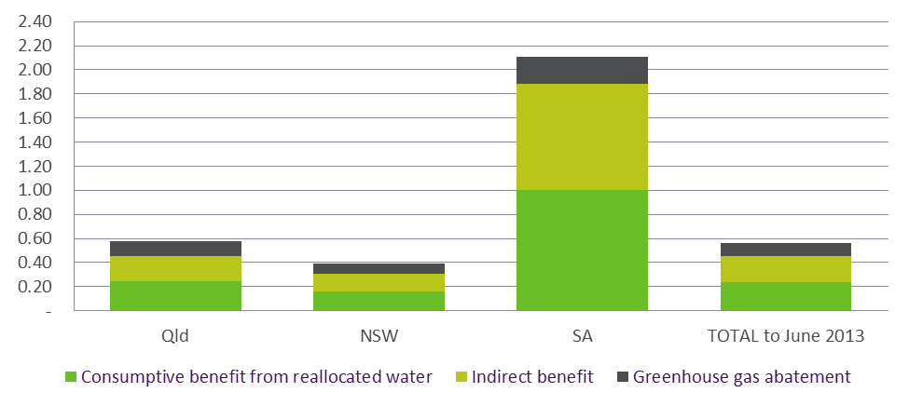

A full summary of the costs and benefits across the full assessment period is provided in .

### Additional benefits discussed qualitatively

A summary of the benefits from GABSI which did not have the supporting data to be considered quantitatively is summarised in the following table.

Table 24: Summary of TEV framework

| TEV element | Evidence of benefit |
| --- | --- |
| **Consumptive benefits from improved pressure** | * QLD – Increase in pressure in half of all artesian bores monitored – 341 having increased by up to 8 m and 31 having increased by more than this (in 2005). * NSW – Around 90% of capped bores have either stabilised or increased pressure during the period of GABSI (340 bores). ~12 bores have started to reflow in the last year or two. A non-linear increase is expected over the next few years. * SA - Pressure recovery (10+kpa) observed at little Blyth bore over 17 month period which can be attributed to decommissioning of Big Blyth bore (located 13km away). |
| **Direct private landholder benefits** | The landowner benefits have not been included in the TEV given that the focus is on return on government investment. However, if these benefits were included, there is evidence to suggest that the VfM from the perspective of both landowners and government would be higher than the VfM for government alone. This is because studies previously undertaken demonstrate that benefits to landowners exceed their financial contribution to the program. |
| **Tourism, recreation and amenity benefits** | Based on the previous study of the Dalhousie Springs complex (recreation benefits of $0.6m/annum) there are likely to be some relatively minor but tangible recreation benefits associated with the GABSI program. |
| **Heritage benefits** | * QLD – 150 Indigenous cultural heritage sites have been recorded in relation to GAB spring wetlands, however this is expected to be a lower estimate of the total number of sites. * NSW – significance to Aboriginal people has not been researched for the springs, but Peery Lake has been designated a place of major cultural significance for Aboriginal people of the Barkindji. * SA – has undertaken studies finding Indigenous cultural heritage sites in the GAB region, but these records are unavailable. |
| **Option value, bequest / altruism, and stewardship values** | Unable to be quantified and no specific data for a robust qualitative assessment. |
| **Conserving biodiversity** | GAB environmental assets are protected under various Commonwealth and State legislative obligations. There are significant biodiversity values located at springs in the GAB, however a clearer relationship between GABSI and improvement in the springs needs to be established. |

# Sensitivity analysis

Given the uncertainty associated with many of the assumptions, the sensitivity of key variables was tested to assess the impact on the benefit cost ratio. Seven tests were conducted as follows:

* **Test 1:** Discount rate of 3% (instead of 7%, consistent with Commonwealth Government guidelines).
* **Test 2:** Discount rate of 10% (instead of 7%, consistent with Commonwealth Government guidelines).
* **Test 3:** Market value of water allocated for consumptive use was tested at $613/ML (relative to the base assumption of $804/ML). This is considered to be a more conservative estimate based on the lowest price paid at the NSW Auction in 2009.
* **Test 4:** Market value of water allocated for consumptive use was tested at $2,281/ML (relative to the base assumption of $804/ML). This test reflects the average price for the five transactions in Qld (ranging from $1,500 to $2,500).
* **Test 5:** A carbon price of zero (relative to $23 dollars) was tested given the uncertainty of a future price of carbon. However it should be noted that even if there is no market for carbon, the price on carbon within the TEV assessment reflects the social cost of greenhouse gas emissions, not the financial costs.
* **Test 6:** A doubling of the carbon price to $46 to reflect a higher social cost associated with emissions than has been reflected by the carbon tax.
* **Test 7:** Maximum of 50% of saved water being reallocated for consumptive use in Queensland, New South Wales and South Australia (as opposed to 30% maximum assumed for Queensland and NSW in the analysis). 50% is the upper limit in the National Partnership agreement, and is higher than what has been captured in the Implementation Plans for Queensland and NSW.

The results (BCR or TEV/dollar invested) for the seven sensitivity tests are summarised in the table below. Shaded tests indicate a higher BCR than in the base scenario.

Table 25: Sensitivity test results

| Test | Variable tested | TEV per dollar invested (BCR) | | | | | |
| --- | --- | --- | --- | --- | --- | --- | --- |
| Phase 1 | Phase 2 | Phase 3 (to June 2013) | Phase 3 (to June 2014) | TOTAL to June 2013 | TOTAL to June 2014 |
| **TEV result** | NA | 0.77 | 0.45 | 0.33 | 0.35 | 0.56 | 0.55 |
| **1** | Discount rate of 3% | 0.86 | 0.51 | 0.37 | 0.39 | 0.60 | 0.59 |
| **2** | Discount rate of 10% | 0.74 | 0.43 | 0.31 | 0.34 | 0.55 | 0.55 |
| **3** | WTP for new water - lower limit at $613/ML | 0.62 | 0.37 | 0.27 | 0.29 | 0.46 | 0.45 |
| **4** | WTP for new water - upper limit at $2,281/ML | 1.93 | 1.11 | 0.82 | 0.88 | 1.40 | 1.37 |
| **5** | Assumed carbon price is zero | 0.63 | 0.36 | 0.27 | 0.29 | 0.45 | 0.44 |
| **6** | Assumed carbon price is doubled ($40/tonne) | 0.92 | 0.55 | 0.39 | 0.42 | 0.67 | 0.66 |
| **7** | Maximum % of water re-allocated for consumption is 50% | 1.04 | 0.66 | 0.47 | 0.51 | 0.78 | 0.77 |

Based on the above sensitivity test, Value for Money is most sensitive to the assumed market price used to value the water allocated for consumptive use. As discussed in Section 4.1.1, there is significant uncertainty about the market value to use given the limited groundwater trade data in the GAB. Furthermore, this market price impacts two of the three values quantified in the assessment – direct consumptive value and the indirect value to the community.

The other variable that has significant impact on the results is the percentage of water that can be reallocated. It is important to note that whilst a higher allocation may increase the quantified TEV, benefits associated with pressure recovery are no longer gained. Thus, reallocating 100% of the water does not necessarily have a higher TEV than returning 50-70% of the water to the GAB.

# Alternative evaluation approaches

Due to the uncertainty and lack of data available to fully assess the quantitative value for money of GABSI, the following section outlines different approaches to considering value for money for the GABSI program. These include:

* **TEV from alternative water use.** This valuation approach estimates the TEV assuming that 100% of the saved water is reallocated for consumptive use (rather than a maximum of 50% in SA and 30% in Qld and NSW). This tests governments’ rationale that benefits of returning saved water to the GAB for the purpose of pressure recovery is greater than (or at least equal to) the benefits of reallocating that same volume of water for other consumptive purposes.
* **Breakeven benefit assessment**. The breakeven assessment considers the benefits that would be required for the TEV to at least equal the cost (i.e. to achieve a BCR of 1). In particular, in this study it estimates the change in pressure that would be required for the consumptive benefit from pressure recovery to increase such that a BCR of 1 is achieved.
* **Cost effectiveness assessment**. This assessment compares the investment made per ML saved across the GABSI program. The purpose is to compare the cost effectiveness across the program stages relative to a benchmark based on planned expenditure and water savings in the Strategic Management Plan.

These approaches are discussed in more detail in the following sections.

## TEV from alternative water use options (100% reallocation of GABSI water)

The TEV assessment undertaken in Section is based on a minimum of 70% of all water being saved in NSW and Queensland and 50% in South Australia. The saved water returned to the GAB aims to recover artesian pressure and improve flows to bores and springs.

The rationale for this requirement is that the returned saved water delivers benefits that are greater than the benefits of reallocating that same volume of water for other consumptive purposes. If this is the case, then the consumptive value from reallocating all (100%) of the saved water can be taken as the minimum TEV from the GABSI program.

As can be seen in Figure 12 the BCR under this approach is greater than 1 for Phase 1 (1.9), Phase 2 (1.2), and for the Program as a whole (1.4). Phase 3 has the lowest BCR, equal to 0.9 (based on works completed to June 2013).

Figure 12: TEV per dollar invested if 100% of the saved water is reallocated for consumptive use

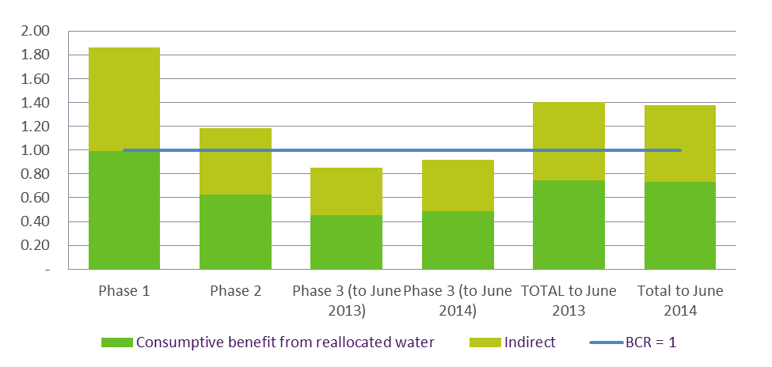

Under this approach, the only benefits that are quantified are the direct consumptive benefits from reallocated water and the indirect benefits to the community. Other use and non-use benefits such as greenhouse abatement, recreation, amenity, tourism, and environmental benefits are linked to pressure recovery and are therefore not realised if 100% of the saved water is allocated for consumptive use.

Whilst this approach provides an important perspective on the potential value of saved water, it assumes that Government’s decision to return water to the GAB is based on evidence that confirms that benefits of pressure recovery are greater than (or at least equal to) the benefits of reallocating that same volume of water for other consumptive purposes (i.e. the long term increase in pressure from the program has greater value than the short term return to the state from water sales). .

## Breakeven benefit analysis

The primary objective of GABSI is to restore pressure to the GAB, with the associated benefits spanning the use and non-use values in the TEV framework (refer to Figure 13).

Figure 13: Summary of benefits in TEV framework directly linked to GAB pressure recovery

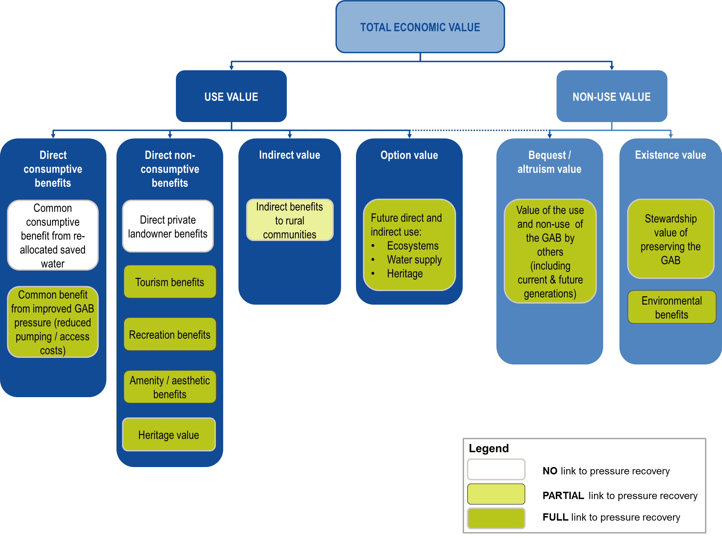

As can be seen from the above figure, none of the benefits that are directly linked to restored pressure have been quantified in the VfM assessment due to limited availability of data. A breakeven analysis has therefore been undertaken to estimate the benefits that would be required to achieve a BCR of 1. Four benefits, discussed in the following table, were considered in this assessment.

Table 26: Benefits captured in the breakeven assessment

| Benefit considered | Approach |
| --- | --- |
| **Consumptive benefit from improved pressure – avoided pump installation costs** | The break even assessment considers the number of new pumps that would need to be avoided to achieve a BCR of 1 (for each GABSI phase and across the program as a whole). Metrics used in this analysis are based on those discussed in Section 4.1.2. |
| **Consumptive benefit from improved pressure – avoided pumping costs** | The metrics discussed in Section 4.1.2 to measure the avoided operational costs are based on an average change in pressure head (lift) across the GAB. The breakeven assessment therefore considers the average change in pressure (m) required within each phase of the program and across the program as a whole to achieve a BCR of 1. |
| **Biodiversity – avoided loss of unique ecosystems** | Based on metrics discussed in Section the breakeven assessment considers the avoided loss (%) of unique ecosystem in the GAB that would need to be realised for a BCR of 1 to be achieved.  Rolf (2008) identified biodiversity WTP values provided by Rolf et al (2000) as most applicable to the GAB. These values estimate that households are willing to pay $5.65 (2013 dollars) for 15 years to avoid the loss of each one per cent of unique ecosystem.  The break even assessment applies these values to households in the GAB jurisdictions (Queensland, NSW and South Australia) to determine the break even percentage of unique ecosystems saved. |
| **Biodiversity – avoided loss of endangered species** | Based on metrics discussed in Section 4.5.1. The breakeven assessment considers the avoided loss of endangered ecosystem in the GAB that would need to be realised for a BCR of 1 to be achieved.  From the same study above (Rolf et al, 2000) it was estimated that households are willing to pay $17.48 (2013 dollars) for 15 years to avoid the loss of an endangered species  The break even assessment applies these values to households in the GAB jurisdictions (Queensland, NSW and South Australia) to determine the break even number of endangered species saved. |

The following table summarises the breakeven assessment results. It is noted that each benefit has been considered in isolation of the other benefits – i.e. realising a single one of these benefits to 100% of its potential would achieve a BCR of 1. These metrics are based on the assumptions and descriptions outlined in section 4.

Table 27: Breakeven assessment results

| Benefit / metric considered | GABSI Phase 1 | GABSI Phase 2 | GABSI Phase 3 (to June 2013) | GABSI Phase 3 (to June 2014) | TOTAL GABSI (to June 2013) | TOTAL GABSI (to June 2014) |
| --- | --- | --- | --- | --- | --- | --- |
| Breakeven avoided number of pumps installed (#)[27] | 375 | 1169 | 1209 | 1644 | 805 | 855 |
| Average pressure change (m) in the GAB for breakeven avoided pumping costs[28] | 5 | 15 | 16 | 21 | 11 | 11 |
| Breakeven avoided loss of unique ecosystems (%)[29] | 6% | 18% | 15% | 20% | 12% | 13% |
| Breakeven avoided loss of endangered species (#)[30] | 0.02 | 0.06 | 0.05 | 0.07 | 0.04 | 0.04 |

The results vary across phases as would be expected based on the gap between the original BCR and a BCR of 1, with Phase 1 presenting relatively smaller additional benefits that would need to be realised in order to breakeven.

These benefits should be weighed up in the context of value for money. For example, pressure across the GAB needs to recover by 11m on average to breakeven, which is realistic as an upper limit but ambitious as an average. However given that each benefit was considered in isolation, less than 11m can be restored on average for the BCR to reach a number greater than 1. Only 0.04 endangered species or 12-13% of unique ecosystems would need to be protected for a BCR of 1, which are both achievable. If the breakeven benefits for both of these biodiversity impacts were fully achieved, and only half the breakeven pressure was restored (5.5m), and half the breakeven number of avoided pumps was delivered, the BCR could equal 1.7 (for actual works to June 2013).

A BCR greater than 1 is therefore considered to be possible, especially given that some other benefits (e.g. tourism, recreation, option value) were not explicitly considered in the analysis..

## Cost effectiveness

During SKM’s 2013 mid-term review of the GABSI program, some stakeholders suggested that the value for money of the GABSI program may be declining as bores that were easy to rehabilitate and contributed large water savings had already been completed.

A cost-effectiveness analysis (CEA) is a useful tool to compare how the costs of the program are changing over time and to test whether the effectiveness of new expenditure is declining. A CEA is generally used to determine and compare the cost of achieving a given physical target across a number of options. For the purpose of this assessment, the CEA compares the cost of achieving a ML of water saving over the course of the GABSI program.[31]

It is important to note that a CEA does not quantify the benefit of achieving the physical target (ML saved), and does not consider the full range of benefits that may be achieved. As such, the CEA does not assess the value for money of an investment, but is a useful tool to compare the cost effectiveness of works being undertaken to achieve a common target. Importantly, this framework also enables the cost effectiveness of each phase of the program to be compared to the planned (or targeted) cost-effectiveness when the program was initially established.

The program was initially established through the GAB Strategic Management Plan (GABCC, 2000). This plan estimated that GABSI implementation would cost $286[32] million (at a minimum) over the 15 year implementation period (or $336.6 million in 2013 dollars[33]). It was also estimated that this expenditure would lead to annual water saving of approximately 200,000 ML. [34]

For the purpose of this assessment, it has been assumed that water saving per dollar of planned investment is constant throughout the life of the project, at $1,682/ML/annum (2013 dollars). This is a simplistic assumption given that, there has been a diminishing return on water savings per dollar invested over the three GABSI phases (discussed in more detail below). However, given the lack of information available on the initial GABSI projections, $1,682/ML/annum is considered to be an appropriate benchmark for assessing the relative performance of GABSI over time.

Table 28 summarises the expenditure[35] and water saving results across the three GABSI phases and Figure 14 provides a more detailed breakdown by jurisdiction. The assessment shows that, overall, GABSI has exceeded its planned performance from a cost effectiveness perspective. However it also indicates that over Phase 3 (including planned works for 2013/14), the cost effectiveness has started to exceed the initial benchmark cost.

This is a result of the jurisdictions’ approaches to prioritising the works. Generally works that had strong landholder contribution (noting that landholder contributions were not required in SA), provided the greatest contribution to pressure recovery, and / or were technically more feasible were undertaken first, with increasingly challenging projects being attempted in Phase 3 (e.g. bores which are capped but fail to be controlled and therefore require significant rework) or more complex/deeper bore rehabilitation. This is particularly prominent in South Australia, where priorities were relatively less driven by landholders and could therefore be primarily based on technical feasibility. This is reflected in South Australia’s sudden increase in cost effectiveness in Phase 3 relative to NSW and Queensland.

Table 28: Cost effectiveness summary across GABSI phases ($ 2013, real)

| GABSI Phase | Expenditure (real 2013) | ML/annum saved | $/ML/annum saved |
| --- | --- | --- | --- |
| **GABSI 1** | $ 76.65 m | 91,767 | $835 |
| **GABSI 2** | $ 95.95 m | 74,984 | $1,280 |
| **GABSI 3 (to June 2013)** | $ 66.08 m | 37,775 | $1,749 |
| **TOTAL to date (actual, to June 2013)** | **$ 238.68 m** | **204,526** | **$1,167** |
| ***Program benchmark*** | ***$ 336.6 m*** | ***200,000*** | ***$1,682*** |

Figure 14: Cost effectiveness summary by jurisdiction and program phase

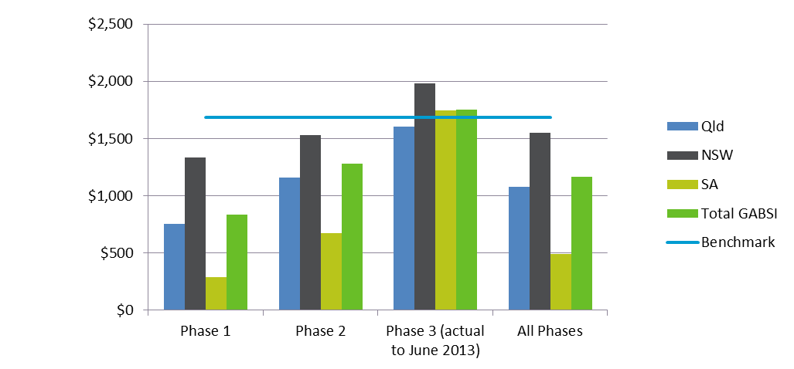

# Conclusion

A TEV approach was used to assess government’s VfM of the GABSI program across the three phases between 1999/2000 to 2012/13. Due to limited availability of data, a relatively small proportion of the total TEV could be quantified. The aspects quantified include:

* Consumptive benefits from reallocated water
* Indirect benefits to rural communities
* Greenhouse gas abatement benefits

Together, these benefits provided $163.5 m in real 2013 dollars or $210.4 m in present value for the full GABSI program until June 2013. This equates to a benefit cost ratio (BCR) of 0.56, which was found to be decreasing between phases over time. This reflects the change in priorities of the program and its target of 100% rehabilitation. Critically however, these benefits primarily relate to water saved through GABSI, rather than pressure recovery which is the other key focus of GABSI.

Benefits related to pressure recovery include:

* Consumptive benefits from improved pressure
* Tourism, recreation and amenity benefits
* Heritage benefits
* Option value, bequest / altruism, and stewardship values
* Conserving biodiversity

These benefits were unable to be quantified given study scope and data constraints, however there is significant qualitative and anecdotal evidence supporting the existence of these benefits associated with GABSI. While funds could be invested in investigations, studies and monitoring programs to quantify some of these benefits, it is questionable as to whether the expenses involved would justify the benefits. The types of considerations that could be taken into account to better quantify the value of GABSI include:

* Improved water market information covering a greater period of time and geographic locations, particularly in terms of the direct market value of GAB water
* Data analysis and pressure modelling of bores and springs to better understand the direct relationship between GABSI and pressure recovery
* Investigations to determine the efficiency of water savings achieved through GABSI (e.g. how benefits may be offset by increasing flows from remaining uncontrolled bores and springs).

Without such information being currently available, three alternative approaches to viewing the value and performance of GABSI have been applied. These are:

* **TEV from alternative water use** (refer Section 6.1).This approach tests the governments’ rationale that benefits of returning saved water to the GAB for the purpose of pressure recovery is greater than (or equal to) the benefits of reallocating that same volume of water for other consumptive purposes by assuming that 100% of the saved water is reallocated for consumptive use (rather than 50% in SA and 30% in Qld and NSW). This approach loses the value of benefits associated with pressure recovery, but achieves an overall BCR of 1.4.
* **Breakeven benefit assessment** (refer Section 6.2)**.** This assessment considers some of the benefits not quantified in the TEV approach that would be required for the TEV to at least equal the cost (i.e. achieve a BCR of 1). It assesses consumptive benefits from improved pressure (avoided number of pumps and pumping costs), and avoided loss of unique ecosystems and endangered species. Each benefit was considered in isolation, which means that only 0.04 endangered species of 13% of unique ecosystems would need to be protected for a BCR of 1. Similarly, pressure across the GAB would need to recover by 11m on average to breakeven. If the breakeven benefits of both biodiversity impacts were fully achieved, and only half the breakeven pressure was restored (5.5m) and half the breakeven number of avoided pumps delivered, the BCR would equal 1.7.
* **Cost-effectiveness** (refer Section 6.3)**.** This analysis compares how the costs of GABSI have changed over time and whether the effectiveness (based on ML saved) of new expenditure is declining. It does not consider the benefits of achieving the ML saved targets, so should not be viewed as a VfM assessment. The initial planned cost-effectiveness as outlined in the GAB Strategic Management Plan can be used as a benchmark for comparison purposes, and is set at $1,682/ML/annum (2013 dollars). To date, GABSI has outperformed well beyond this benchmark by progressing its program of works at $1,167/ML/annum.

All of the assessment approaches applied in this study suggest that the effectiveness of the outcomes achieved from GABSI over time has gradually declined. This is likely due to governments’ prioritisation of works processes as described earlier, as well as a faster rate of increase in the price of construction and materials relative to consumer price index (CPI) over the period of GABSI (refer Figure 15).

Figure 15: Building price index (BPI) increases relative to CPI over the GABSI period

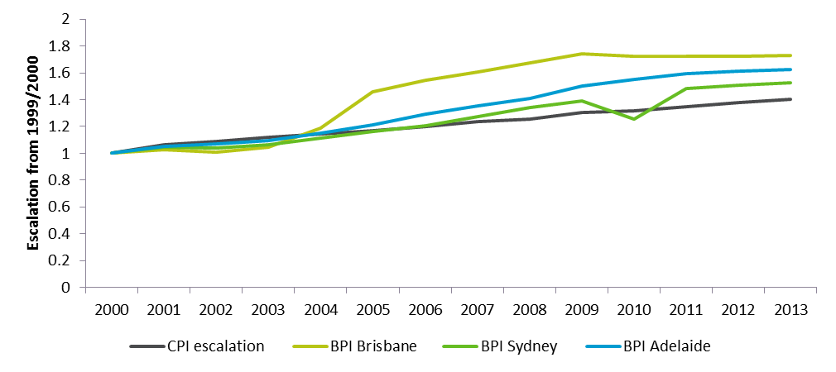

Furthermore, the aim of GABSI is to rehabilitate 100 per cent of bores nominated under the SMP in order to achieve the greatest pressure savings, so it is likely that benefits from previous phases as measured by the current approach would diminish if GABSI is not completed. While it is assumed that all benefits achieved in previous phases are preserved (or do not degrade) over future time, in reality the increased pressure will lead to an incremental increase in losses via other bores. Thus, because the main contribution to overall benefits is the monetary value of the groundwater that is saved and reallocated, later phases of the GABSI program act to preserve these reallocated water benefits. However, in terms of restoring pressure to the aquifer system, previous gains in pressure re-establishment will not erode over time. The BCR for earlier phases may remain stable if pressure is able to be incorporated into the assessment, and the benefits of pressure re-establishment far outweigh those from reallocating saved water.

Table 29 provides an overview of jurisdictions’ estimates of works under GABSI that will remain at June 2014. The total expenditure figures include estimated Commonwealth, State, and landholder contributions. The remaining works have a cost-effectiveness figure of $1,852/ML/annum, which is more expensive than the benchmark discussed above, but also consistent with the view that the works to be completed in later stages are potentially more technically challenging, may be less likely to contribute directly to continued pressure recovery, or they may be on properties where the landholders are less / unwilling to participate. Furthermore, when viewing the program as a whole the cost-effectiveness of completing GABSI would be $1,430/ML/annum, which is still lower than the initial benchmark of $1,682/ML/annum. However, as per the comment above, cost-effectiveness does not consider the benefits of achieving the ML saved targets, so should not be viewed as a VfM assessment.

Table 29: Estimated extension of GABSI required post-2013/14 (these are based on indicative estimates provided by jurisdictions and have not been further validated)

| Estimated remaining works post-2013/14 | SA | NSW | Queensland | Total |
| --- | --- | --- | --- | --- |
| **Number of bores to be controlled** | <30 | 238 | 215 | **483** |
| **Kilometres of bore drains to be deleted** | 0 | 1,150 | 5,540 | **6,690** |
| **Water saved (ML)** | 365 | 26,600 | 80,633 | **107,598** |
| **Total expenditure – including Commonwealth, State, and landholder contributions ($m)** | 1.25 | 114 | 84 | **199.25** |
| **Cost-effectiveness ($/ML/annum)** | 3,425 | 4,286 | 1,042 | **$1,852** |

1. References

Australian Bureau of Statistics 2013, 6401.0 Consumer Price Index, Australia, Sep 2013, Australian Bureau of Statistics, <<http://www.abs.gov.au/AUSSTATS/abs@.nsf/DetailsPage/6401.0Sep%202013?OpenDocument>> (accessed 17 October 2013)

Bush Heritage Australia 2013, Edgbaston Reserve: Hope springs eternal, Bush Heritage Australia, < <http://www.bushheritage.org.au/places-we-protect/state_queensland/edgbaston>> (accessed 31 October 2013)

Centre for International Economics and Resource and Policy Management 2003, Farm costs, benefits and risks from bore capping and piping in the GAB: Consultant’s report, Centre for International Economics, Canberra.

Centre of international Economics 2003, Landholder contributions to the GABSI: Review and recommendations, Department of Agriculture, Fisheries and Forestry, Canberra.

Commonwealth Department of Finance and Administration 2006, Handbook of cost-benefit analysis, Department of Finance and Administration, <<http://www.finance.gov.au/publications/finance-circulars/2006/docs/Handbook_of_CB_analysis.pdf>> (accessed 17 October 2013)

Commonwealth Department of the Environment 2013, The community of native species dependent on natural discharge of groundwater from the Great Artesian Basin, Department of the Environment <<http://www.environment.gov.au/cgi-bin/sprat/public/publicshowcommunity.pl?id=26&status=Endangered>> (accessed 31 October 2013)

Commonwealth Office of Best Practice Regulation 2013, Commonwealth Guidance Note: Cost benefit analysis in regulatory impact assessments, Department of Finance, Canberra.

Council of Australian Governments 2010, National Partnership Agreement on the GABSI, Standing Council on Federal Financial Relations, Canberra.

Deloitte Access Economics 2013, Economic value of groundwater in Australia, National Centre for Groundwater Research and Training.

Destination NSW nd, ‘Facts & Figures’, NSW Government, <http://www.destinationnsw.com.au/tourism/facts-and-figures> (accessed 31 October 2013)

Fraenkel PL 2013, “Water lifting for irrigation”, [Natural](http://www.fao.org/docrep/010/ah810e/ah810e04.htm) Resources Management and Environment Department, Food and Agricultural Organization of the United Nations, Rome.

GABCC 2000, GAB Strategic Management Plan, GABCC, Canberra.

Hassall & Associates Pty Ltd 2003, Review of the Great Artesian Basin Sustainability Initiative, Department of Agriculture, Fisheries and Forestry, Sydney.

Marsden Jacob Associates 2012, Assessing the value of groundwater: Waterlines Report Series No 89, National Water Commission, Canberra.

Hill CM, Flavel N & Eigeland 2010, Economic analysis of landholder water management under Cap & Pipe the Bores program: case studies in the NSW Great Artesian Basin, NSW 54th Annual Conference of the Australian Agricultural and Resource Economics Society, Adelaide, February.

NSW Office of Water 2010, NSW Great Artesian Basin water auction 2009: Final report, NSW Office of Water, Sydney.

Outback 2011, “Bore baths, artesian spa, hot springs, the Great Artesian Basin, hot spots!”, Outback Now, < <http://www.outbacknow.com.au/index.php/articles/outback_itineries/bore_baths_artesian_spa_hot_springs_hot_spots>> (accessed 31 October 2013)

Pallaser RJ & Alder D 2000, Greenhouse gas emissions from the Great Artesian Basin within New South Wales: Potential for reducing the atmospheric carbon budget, Proceedings 5th International Conference on Greenhouse Gas Control Technologies (13-16 August 2000), Cairns.

Paroo Shire Council nd, Artesian Time Tunnel, Paroo Shire Council, < http://www.paroo.qld.gov.au/artesian-time-tunnel> (accessed 31 October 2013)

Queensland Department of Natural Resources and Mines 2012, Great Artesian Basin Water Resource Plan: Five year review, Queensland Department of Natural Resources and Mines, Queensland, <<http://www.dnrm.qld.gov.au/__data/assets/pdf_file/0018/106029/5year-wrp-review.pdf>> (accessed 17 October 2013)

Queensland Environmental Protection Authority (EPA) 2005, Wetland management profile: Great Artesian Basin spring wetlands, Ecosystem Conservation Branch, EPA, Queensland, <<http://wetlandinfo.ehp.qld.gov.au/resources/static/pdf/resources/fact-sheets/profiles/p01718aa.pdf>> (accessed 17 October 2013)

Rolfe J 2008, Associated off-farm economic values of saving water and restoring pressure in the Great Artesian Basin, Department of the Environment, Water, Heritage and the Arts.

Schalk T, Hill CM, Flavel N 2010, NSW Great Artesian Basin water market assessment pre and post action, 54th Annual Conference of the Australian Conference of the Australian Agricultural and Resource Economics Society, Adelaide, February.

Sinclair Knight Merz 2008, Great Artesian Basin Sustainability Initiative: Mid-term review of phase 2, Department of the Environment and Water Resources, Brisbane.

Sinclair Knight Merz 2013, Great Artesian Basin Sustainability Initiative Phase 3: Mid-term Review, Department of Environment, Canberra.

Smerdon BD, Ransley TR, Radke BM & Kellett JR 2012, Water resource assessment for the Great Artesian Basin: A report to the Australian Government from the CSIRO Great Artesian Basin Water Resource Assessment, CSIRO Water for a Healthy Country Flagship, Australia.

South Australian Tourism Commission 2012, Flinders Ranges and Outback: Regional tourism profile June 2010-2012, South Australian Tourism Commission.

Tourism Research Australia 2011, The economic importance of tourism in Australia’s regions, Department of Resources, Energy and Tourism, Canberra.

1. Deprival method values

Table 30: Direct use value estimates from previous studies

| Sector | $/ML | Approach/ Reference | Discussion |
| --- | --- | --- | --- |
| **Irrigation** | 200 | Deloitte Access Economics, 2013 | This value assumed that most irrigation enterprises using groundwater would also have access to surface water. The deprival value has been estimated as the average market price for surface water allocation trades in the Murray Darling Basin. |
| **Stock and Domestic\*** | $1,278* | RMCG (2008) | This deprival value was based on the cost of small scale desalination of saline groundwater as a standard alternative source of supply that was considered to be widely applicable in Victoria.  Desalination is not considered to be applicable for the GAB. The cost of the next best water supply alternative for Stock and Domestic agriculture is expected to vary significantly depending on the location. As such, this deprival estimate is not considered to be applicable to the GAB.  No other studies estimate the value per ML of water for the stock and domestic sector. |
| **Mining** | $2,750 | Deloitte Access Economics, 2013 and MJA (2012) | Based on the cost range of piping water from short and long distances if groundwater is not available. |
| **Urban Water** | $2,000 | Deloitte Access Economics, 2013 | Based on publically available figures regarding the most likely alternative for urban water supply including demand management, purchase of temporary water (where available) or short distance pipelines. |
| **Other Industries** | $2,000 | Deloitte Access Economics, 2013 | Assumed to be the same as urban water supply. |

*Value adjusted to 2013 dollars

1. Quantified Value for Money Summary

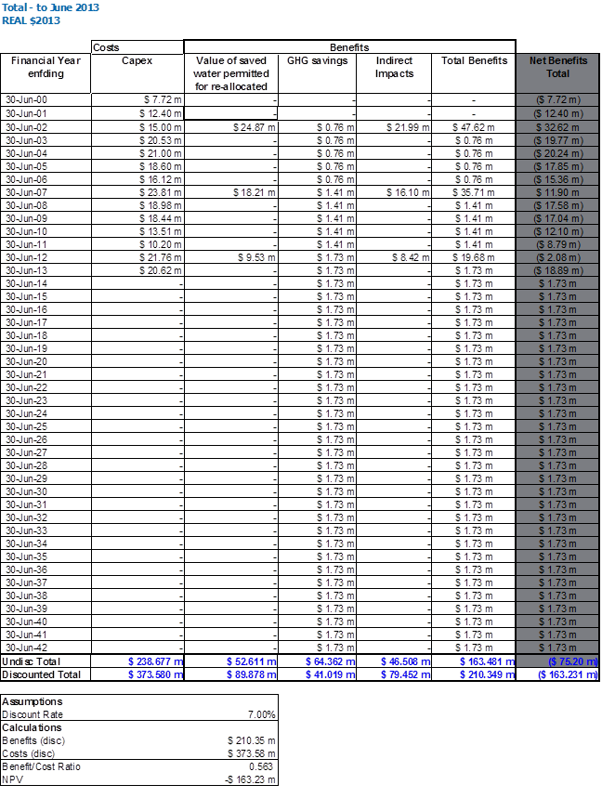

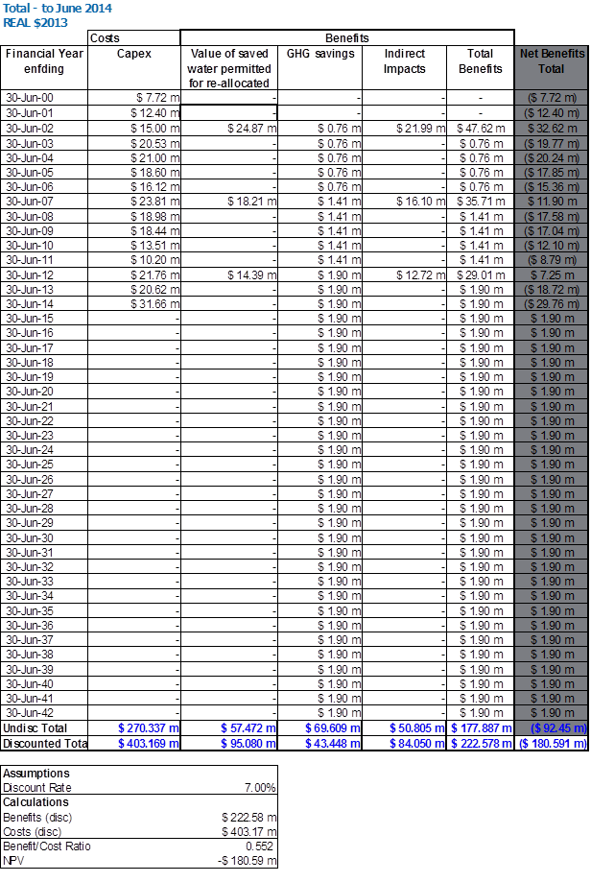

1. Northern Territory was involved in the monitoring network aspect of the program rather than infrastructure renewal (capping and piping of bores) and has therefore not been included in this VfM Review.
2. The data contained in these tables for Phase 3 and 2012/13 achievements was provided directly by jurisdictions and was accurate as of 29 November 2013.
3. **Commonwealth Guidance Note: Cost benefit analysis in regulatory impact assessments (2013)** - The OBPR requires calculation of net present values at an annual real discount rate of 7 per cent. (<http://www.finance.gov.au/obpr/cost-benefit-analysis.html#CBA_Guidance_Notes>)
4. i.e. they estimate the cost (or opportunity cost) that would be incurred if 100% of the groundwater was no longer available to water users (MJA, 2012)
5. Data received from Frontier Economics (peer reviewers for the Review) via Queensland Department of Natural Resources and Mines.
6. Landowners opposed the NSW auctions and demonstrated on the day. The market price may therefore not represent the willingness to pay by that sector.
7. Breakdown provided by jurisdiction in .
8. The medium cost is based on the medium flow rate, which is not necessarily based on the median.
9. <http://www.fao.org/docrep/010/ah810e/ah810e04.htm>
10. GABtran is the only contemporary groundflow model covering the majority of the study area
11. Two types of pressure change data were provided in the report – one type was a series of maps showing pressure surfaces on roughly 20 year intervals, and the other type was times series graphs of pressure changes for selected bores.
12. Based on GABWRA data supplied by Brian Smerdon, CSIRO, November 2013
13. Note: these include consumptive and non-consumptive benefits, but have been considered as a group.
14. This is based on data provided by the jurisdictions. Some of the data is incomplete.
15. Centre for International Economics and Resource Policy and Management (2003).
16. Centre for International Economics and Resource Policy and Management (2003).
17. Figures quoted directly from Rolfe (2008) have not been escalated to 2013 dollars.
18. Total tourism expenditure is obtained from DRET (2011), and is based on 2007/08 data. Basic price is defined as “The amount receivable by the producer from the purchaser for a unit of a good or service produced as output, minus any tax payable plus any subsidy receivable, on that unit as a consequence of its production or sale. It excludes any transport charges invoiced separately by the producer.”
19. Tourism NSW
20. ‘Basic price’ refers to the amount receivable by the producer from the purchaser, minus tax and plus subsidy. Transport charges are excluded.
21. South Australian Tourism Commission (2012)
22. CBA concepts and practice text book
23. http://www.finance.gov.au/publications/finance-circulars/2006/docs/Handbook_of_CB_analysis.pdf
24. It is noted that the definition of spring complexes is not consistent across jurisdictions.
25. For some complexes in SA and NSW, data was not available, and these were excluded from the analysis.
26. http://www.environment.gov.au/cgi-bin/sprat/public/publicshowcommunity.pl?id=26&status=Endangered
27. Refer to section 4.1.2 for assumptions and approach
28. Refer to section 4.1.2 for assumptions and approach
29. Refer to section 4.5.1 for assumptions and approach
30. Refer to section 4.5.1 for assumptions and approach
31. Whilst not the direct objective of the GABSI, the program delivers water savings, of which at least half is returned to the basin to restore pressure. The remaining water saved can be re-allocated for consumptive use by the jurisdictions.
32. Note that this figure also included costs for achieving communication, social, environmental, heritage and research objectives.
33. It is assumed that the initial estimate was estimated in nominal dollars from 2000-2015. This has been escalated to 2013 dollars based on annual escalation (<http://www.abs.gov.au/AUSSTATS/abs@.nsf/DetailsPage/6401.0Sep%202013?OpenDocument>)
34. Refer pages 19-20 of the GAB Strategic Management Plan for more detail on the basis of these figures.
35. The expenditure included only refers to capital expenditure.