

National Pollutant Inventory

Emission estimation technique manual
for

Galvanizing Version 2.0

July 2012

ISBN: 06425 48137

© Commonwealth of Australia 2012

This manual may be reproduced in whole or part for study or training purposes subject to the inclusion of an acknowledgment of the source. It may be reproduced in whole or part by those involved in estimating the emissions of substances for the purpose of National Pollutant Inventory (NPI) reporting. The manual may be updated at any time. Reproduction for other purposes requires the written permission of the Department of Sustainability, Environment, Water, Population and Communities, GPO Box 787, Canberra, ACT 2601, e-mail: npi@environment.gov.au, web: www.npi.gov.au, phone: 1800 657 945.

Disclaimer
The manual was prepared in conjunction with Australian states and territories according to the National Environment Protection (National Pollutant Inventory) Measure.
While reasonable efforts have been made to ensure the contents of this manual are factually correct, the Australian Government does not accept responsibility for the accuracy or completeness of the contents and shall not be liable for any loss or damage that may be occasioned directly or indirectly through the use of, or reliance on, the contents of this manual.

Emission Estimation Techniques

For

Galvanizing

Table of Contents
Disclaimer i
1 Introduction 1
1.1 Process for NPI reporting 1
1.2 Information required to produce an annual NPI report 2
1.3 Additional reporting materials 2
2 Process description 3
3 Emission sources 4
4 Threshold calculations 6
5 Techniques for estimating emissions 7
5.1 Direct measurement 8
5.2 Mass balance 9
5.3 Engineering calculations 9
5.4 Emission factors 9
5.5 Approved alternative 10
6 Transfers of NPI substances in waste 11
8 References 14
Appendix A: Definitions and abbreviations 15
Appendix B: emission factors 16
Appendix C: Modifications to the galvanizing emission estimation technique (EET) manual (Version 2.0 July 2012) 25

Galvanizing

List of Figures, Tables and Examples

Table 1 - Material inputs and emissions from galvanizing processes 5
Table 2: Transfers reporting requirements 12
Table 3: Emission factors - acid pickling - hydrochloric acid ^{A,B,C,D} 16
Table 4: Emission factors - acid picking - sulfuric acid 24
Table 5: Emission factors - zinc galvanizing bath 24

Figure 1: Process for NPI Reporting 1
Figure 2: The basic galvanizing process steps and likely emission points 3

Example 1: Assessing thresholds 6
Example 2: Calculating emissions using emission factors 10
Example 3: Reporting transfers of NPI substances in waste 12

Introduction

The purpose of all emission estimation technique (EET) manuals is to assist Australian manufacturing, industrial and service facilities to report emissions of listed substances to the National Pollutant Inventory (NPI). This manual describes the procedures and recommended approaches for estimating emissions and transfers from Australian galvanizing operations.

EET MANUAL | Galvanizing
ANZSIC CODE 2006 | 2293: Metal coating and finishing

Note that the ANZSIC code is part of NPI reporting requirements. The NPI Guide contains an explanation of the ANZSIC code.

This manual has been developed through a process of national consultation involving state and territory environmental agencies and key industry stakeholders. Particular thanks are due to the Galvanizers Association of Australia (GAA)

Process for NPI reporting
The process for NPI reporting is outlined in the following flow chart:

Figure 1: Process for NPI Reporting

Information required to produce an annual NPI report
The following information is needed for the reporting period:
- Amount of acid, zinc and other NPI substances used at the facility during the reporting period.
If any fuel burning equipment has been used on the facility, including on-site vehicles, additional data will need to be collated:
- type and amount of fuel burned
- pollution control devices employed, and
- volume and throughput of fuels or organic liquids stored on-site.

Additional reporting materials
This manual is written to reflect the common practices employed in Australian galvanizing operations. In some cases it may be necessary to refer to other EET manuals to ensure a complete report of the emissions for the facility can be made. Other applicable EET manuals are listed in Section 7.

Process description

Galvanizing is a process undertaken to coat ferrous metals and metal products in a layer of zinc to prolong their life. The metal to be coated requires pre-treatment prior to being immersed into the zinc bath in order to remove rust, grease and other materials, and therefore to promote the galvanizing process. Pre-treatment can include treatment of the metal with an alkaline degreasing solution, an acid pickling solution, water rinse, and a pre-flux solution. The pre-flux solution is usually comprised of zinc ammonium chloride (ZnCl₂.3NH₄Cl), and is used to promote the zinc-metal bond. After pre-treatment, the metal is immersed in molten zinc followed by a quench bath.

1 shows a basic galvanizing flow diagram and some expected emission points. As each galvanizing facility in Australia is unique, you are encouraged to develop flow diagrams for your operation that detail the input of materials and NPI listed substances and the emissions resulting from the operation of each process.

Figure 2: The basic galvanizing process steps and likely emission points

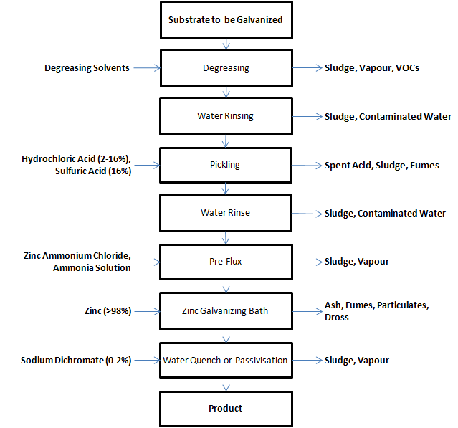
Source: Queensland Department of Environment and Heritage, 1998.

Many of the emissions produced by the galvanizing process can be contained, captured, treated and/or recycled either back into the process or turned into other useful material.

For example, ash and dross are generally processed on site to extract zinc which is then remelted into galvanizing bath or recycled off-site and made into zinc powders which go into other products, such as paint, make-up, etc.

Emission sources

This section describes the raw material inputs, the equipment used and the processes employed that result in emissions of NPI listed substances in the galvanizing process. This section also provides a concise description of the potential fate (to air, land, and water) of these emissions.

Galvanizing generally produces emissions to air as well as waste containing NPI substances. Hydrochloric acid (HCl) and sulfuric acid (H₂SO₄) fumes may be emitted from process tanks, while ammonia and ammonium chloride emissions to air can occur from the pre-flux solution and during the immersion of steel into the galvanizing bath. Zinc and PM₁₀ emissions (particulate matter with an equivalent aerodynamic diameter of 10 micrometres or less ie. ≤10μm) may result from hot dip metal coating activities.

Waste liquids may be generated from spent pre-treatment solutions and sometimes from quenching activities after galvanizing; it is expected that pollutants are captured on site and transferred off-site under a trade waste agreement or via approved waste disposal contractors (i.e. no emissions are expected). The process tanks usually contain metal salts, acids, bases, and dissolved base materials.

The galvanizing process also generates solid wastes. Solid wastes include a zinc oxide ash that is periodically removed from the surface of the galvanizing bath and zinc iron alloy dross removed from the bottom of the galvanizing bath, as well as solids in spent solutions and wastewater treatment sludge. Characterisation of these wastes may be required when estimating emissions using the mass balance approach (see Section 5).

Table 1 summarises the raw material inputs and the emissions of NPI substances that could be generated during the galvanizing process.

Galvanizing may involve the use and handling of a number of NPI listed substances. These substances commonly include zinc and compounds (e.g. zinc ammonium chloride), chromium (VI) compounds, hydrochloric acid, sulfuric acid, chlorine, and ammonia.

If Category 2a or 2b is tripped, the facility is required to report emissions from the burning of fuel. Emissions from combustion will need to be evaluated at galvanizing facilities where boilers are used, for example to heat a zinc bath. The Combustion in Boilers EET Manual can be used to calculate these emissions from boilers. Surface coating emissions that may occur can be evaluated using the Surface Coating EET Manual.

Table 1 - Material inputs and emissions from galvanizing processes
Process | Material  input | Emissions to air | Solid waste emissions^{B} | General Management of Emissions
Degreasing | Substrate to be galvanised, alkaline degreasing solution | - VOCs  - steam^{A} | Process sludges  Caustic sludge containing zinc | Sludges disposed of as controlled/prescribed wastes
Pickling | Substrate to be galvanized  Acid pickling solution, hydrochloric acid  sulfuric acid | - hydrochloric acid  - sulfuric acid | Process sludges | Spent acid disposed of as controlled/prescribed waste^{C}
Water rinses | Rinse water and substrate to be galvanised |  | Zinc and other metal sludges | Sludges disposed of as controlled/prescribed wastes
Pre-flux | Substrate to be galvanized  Zinc ammonium chloride  ammonia solution | - ammonia,  - ammonium chloride  - steam^{A} | Zinc and other metal sludges | Sludges disposed of as controlled/prescribed wastes
Galvanizing bath | Substrate to be galvanized  Zinc, alloys, metal salts, acids | - hydrochloric acid,  - ammonia,  - ammonium chloride,  - zinc oxide,  - zinc chloride,  - particulate matter,  - lead oxide,  - copper oxide,  - chlorine | Zinc oxide ash, zinc iron alloy dross | Reprocessing of ash and dross for zinc content^{D}
Quenching | Sodium dichromate | - Steam^{A} | Zinc and other metal sludges | Sludges and solutions disposed of as controlled/prescribed wastes
Heating of galvanizing bath | Fuel | - VOCs,  - oxides of nitrogen,  - particulate matter,  - sulfur dioxide |  | Released to atmosphere^{E}
Source: Queensland Department of Environment and Heritage, 1998.
- Non NPI substance
- May result in the transfers of NPI substances
- There is some but limited collection and treatment of acid fumes and spent acid up to this manual's date.
- A number of facilities also have a hood over the galvanizing bath capturing emissions to air
- Some facilities recycle heat to other parts of the galvanizing process

Threshold calculations

The NPI has six different threshold categories. The NPI Guide outlines each of these. Further information on these thresholds can be found in the NPI Guide.

The following example demonstrates how thresholds are related to the reporting requirement for Category 1. The usage of each of the substances listed as Category 1 under the NPI must be estimated to determine whether the 10 tonnes reporting threshold is exceeded. If the threshold of a Category 1 substance is exceeded, emissions of that substance from the facility (for all sources) must be reported, even if the emissions of the substances are very low or zero.

Example 1: Assessing thresholds
A galvanizing facility uses the following NPI substances in the 12 month reporting period:
- 530 tonnes hydrochloric acid
- 400 kg per year of chromium VI compounds (hexavalent chromium), and
- 1,100 tonnes per year of zinc and compounds.

In addition, the facility combusts 18,000,000 MJ natural gas to heat the zinc galvanizing bath.

From the NPI Guide, based on the NPI categories and their associated thresholds, the facility is required to estimate and report:

Emissions and transfers of:
- Hydrochloric acid (as ≥10 tonnes of this Category 1 substance is used in the reporting year)’
- Zinc and zinc compounds (as ≥10 tonnes of this Category 1 substance is used in the reporting year), and
Emissions of:
- Category 2a substances as a result of exceeding the combustion threshold (combustion of 400 tonnes, or 17,800,000 MJ natural gas). These substances include carbon monoxide, fluoride and compounds, hydrochloric acid, oxides of nitrogen, particulate matter ≤2.5 µm, particulate matter ≤10 µm, polycyclic aromatic hydrocarbons, sulfur dioxide, and total volatile organic compounds.

The facility is not required to report emissions of chromium VI and compounds as use of this substance does not exceed the reporting threshold (10 tonnes per year).

Techniques for estimating emissions

Emissions to air, land and water for every NPI substance that trips a threshold must be reported from all point and fugitive sources at the facility. These are reported as “total point” and “total fugitive” emission sources. The NPI Guide provides detailed information on thresholds and identifying emission.

There are five types of emission estimation techniques (EETs) that may be used to estimate emissions from your facility. These are:
- sampling data or direct measurement
- mass balance
- fuel analysis or engineering calculations
- emission factors, or
- an approved alternative.

Generally, galvanizing facilities report emissions for hydrochloric acid using the emission factor method, however some facilities report hydrochloric acid emissions using direct measurement, engineering calculations, mass balance calculations or by an approved alternative technique. The emission factor method, engineering calculation and mass balance calculations are briefly described in this section. Information on the other emission estimation techniques can be found in the NPI Guide.

If you estimate emissions by using any of these EETs, your data will be displayed on the NPI database as being of “acceptable reliability”. Similarly, if your state or territory environmental agency has approved the use of EETs that are not outlined in this manual, your data will also be displayed as being of acceptable reliability.

This manual seeks to provide the most effective emission estimation techniques for the NPI substances relevant to the galvanizing industry. The absence of an EET for a substance in the manual does not imply that an emission should not be reported to the NPI. The obligation to report on all relevant emissions remains if reporting thresholds have been exceeded.

You should note that the EETs presented in this manual relate principally to average process emissions. Emissions resulting from non-routine events are rarely discussed in the literature, and there is a general lack of EETs for such events. However, it is important to recognise that emissions resulting from significant operating excursions and/or accidental situations (e.g. spills) will also need to be estimated. Emissions to land, air and water from spills must be estimated and added to process emissions when calculating total emissions for reporting purposes.

The emission resulting from a spill is the net emission, i.e. the quantity of the NPI reportable substance spilled, less the quantity recovered or consumed immediately (within 24 hours) during clean up operations.

Direct measurement
Direct measurement involves monitoring and recording emissions of a particular substance at either a point in time or on a continual basis. Many facilities are required to directly measure specific substances as a result of their licensing requirements of their state/territory environment agency. Stack sampling test reports often provide emissions data in terms of kg/hr or grams/m³ _{STP dry} (dry standard cubic metre). Annual emissions for NPI reporting can be calculated from this data using Equations 1 or 2 below.

Stack tests for NPI reporting should be performed under representative (i.e. normal) operating conditions, and in accordance with the methods, or standards, approved by the relevant environmental authority. Tests conducted specifically for the NPI may differ from stack tests undertaken for a State or Territory licence condition, which may require the test be taken under maximum emissions rating (i.e. where emissions are likely to be higher than when operating under normal operating conditions). However, the acceptability of using existing monitoring program data and test methods should be checked with your local environmental regulatory authority.

This Section shows how to calculate emissions in kg/hr based on stack sampling data, and how to convert this to an annual emission figure. Calculations involved in determining PM₁₀ emissions are used as an example, although the same general methodology is applicable for most of the substances listed on the NPI.

Equation 1

C_{PM₁₀} = C_{f} / V_{m, STP}
where:

C_{PM₁₀} = concentration of PM₁₀ or gram loading (g/m³)
C_{f} = filter catch (g)
V_{m,STP} = metered volume of sample at STP (m³), dry.
_{STP} = standard temperature and pressure. 1 atmosphere (101.325) kPa and 273 °K.

If a mass concentration of a gas (C_{gas}) is obtained directly by measurement, results will be in units g/m³, or converted from units such as g/m³, or parts per million by volume (ppmv), which may be on a wet or dry basis.)

Equation 2

E_{PM₁₀} = C_{PM} x Q_{d} x 3.6 x (1 - CE_{PM₁₀})
where:

E_{PM₁₀} = hourly emissions of PM₁₀ in kg/hr
Q_{d} = stack gas volumetric flow rate (m³ STP,dry/s)
3.6 = 3,600 seconds per hour multiplied by 0.001 kilograms per gram
CE_{PM₁₀} = Control efficiency for PM₁₀ (%)

Any facility using direct measurement may use this data as the basis of their NPI report.

Efficiency rates for different control devices can be found in the NPI Emission estimation technique manual for combustion in boilers.

Mass balance
A description of the mass balance method is given in the NPI Guide.Calculating emissions from galvanizing facilities using mass balance can be a straightforward approach to emissions estimation. However, it is likely that few Australian facilities consistently track material usage and waste generation with the overall accuracy needed for application of this method. Inaccuracies associated with individual material tracking, or other activities inherent in each material handling stage, can result in large deviations for total facility emissions. As emissions from specific materials are typically below 2% of gross consumption, an error of only ± 5% in any one step of the operation can significantly affect emission estimations.

Engineering calculations
An engineering calculation is an estimation method based on physical/chemical properties (e.g. vapour pressure) of the substance and mathematical relationships. A more complete discussion of this method is given in the NPI Guide.

Emission factors
An emission factor is a tool that is used to estimate emissions to the environment. In this manual, it relates to the quantity of a substance emitted from the galvanizing process. Emission factors are expressed as kilograms of emission per tonne of activity.

Example 2 illustrates the use of emission factors and control efficiencies in estimating emissions using Equation 3.

Equation 3

E_{kpy,i} = A x EF_{i} x CE_{i}

where :
E_{kpy,i} = annual emissions of pollutant i, kg/yr
A = activity rate, tank/yr
EF_{i} = uncontrolled emission factor of pollutant i, kg/tank
CE_{i} = Control efficiency for substance i (%)

Modern galvanizing plants with properly shielded acid baths may use a control efficiency of 75% for acid emissions.

Tables 3 and 4 in Appendix B provide emission factors for the hot dip galvanizing process.
Example 2: Calculating emissions using emission factors
From example 1, Facility A has determined that they have a requirement to report emissions and transfers of hydrochloric acid and zinc and compounds, as well as emissions of Category 2a substances.

Hydrochloric acid:
The facility operates three acid tanks which have a surface area each of 20 m², using hydrochloric acid at an average concentration of 12%w/v. The ambient temperature of the solution in the acid tank is 25°C. The facility has proper shielding on the acid tanks to reduce emissions.

Using Equation 3:

EF_{HCl} = Emission factor for hydrochloric acid (from Table 3)
A_{HCl} = Number of acid tanks

E_{kpyHCl} = A_{HCl} x EF_{HCl} x (1 – 75%)
= 3 x 369.6 x 0.25
= 278 kg/yr

Zinc and compounds:
EF_{Zinc} = Emission factor for zinc and compounds (from Table 5)
A_{Zinc} = tonnes of zinc used per year

E_{kpyZinc} = A_{Zinc} x EF_{Zinc} x (1 – 0%)
= 1,100 t_{Zinc/yr} x 2.0 kg/t_{Zinc} x 1
= 2,200 kg/yr

Category 2a substances:
The facility burns natural gas using a boiler with capacity <30MW. Using the Combustion in Boilers EET manual, the facility estimates emissions of the Category 2a substance.

The facility is required to report to the NPI:
- Amount of fuel burnt: 18,000,000MJ of natural gas
- Hydrochloric acid: 278 kg/yr
- Zinc and compounds: 2,200 kg/yr, and
- Emissions of Category 2a substances.

As the facility exceeded the reporting threshold for hydrochloric acid (10 tonnes) and zinc and compounds (10 tonnes), the facility must also consult Section 6 to determine if it is necessary to report transfers of waste for these substances.

Approved alternative
You are able to use emission estimation techniques that are not outlined in this document. You must, however, seek the consent of your state or territory environmental agency. For example, if your company has developed site-specific emission factors, you may use these if they have been approved by your local environmental agency.

Transfers of NPI substances

The NPI requires the mandatory reporting of NPI substances that are transferred in waste to a final destination. Transfers are required to be reported if a Category 1, Category 1b or Category 3 reporting threshold is exceeded. For example, if the threshold has been exceeded for a Category 1 substance as a result of use onsite, transfers to a final destination of that substance, as well as emission are reportable. Both emissions and transfers are reportable in kilograms.

There is no requirement to report transfers of substances that are exclusively Category 2a or 2b (i.e. not also listed as Category 1 substances). There is no requirement to report emissions of substances which are both Category 1 and Category 2a or 2b if they have been tripped only by the fuel and energy use threshold. Transfers of NPI substances contained in overburden, waste rock, uncontaminated soil or rock removed in construction or road building, or soil used in capping of landfills are also not reportable.

Reporting of transfers is required if wastes are transported to a destination for containment or destruction which includes:
- a destination for containment including landfill, tailings storage facility, underground injection or other long term purpose-built waste storage facility
- an off-site destination for destruction
- an off-site sewerage system, and
- an off-site treatment facility which leads solely to one or more of the above.

A containment destination may be on site, for example a tailings storage facility on-site, or off-site, for example waste going to landfill. The transport or movement of substances contained in waste to a sewerage system is also included.

The transfer of NPI substances to a destination for reuse, recycling, reprocessing, purification, partial purification, immobilisation, remediation or energy recovery can be reported voluntarily. This is an opportune way for facilities to promote good news stories to their local community.

Further information regarding transfers of waste, including how to estimate and report, can be found in the NPI Guide and Transfers Information Booklet.

Table 2: Transfers reporting requirements
Waste stream containing NPI substances | Reporting requirements
Liquid waste discharged to sewer system | Reporting is mandatory  Discharge of NPI substance to a mandatory reporting transfer destination.
Solid waste sent to landfill | Reporting is mandatory  Discharge of NPI substance to a mandatory reporting transfer destination.
Waste sent for recycling or reprocessing | Reporting is voluntary  Reuse of waste containing NPI substances, reporting is voluntary

As previously noted, if transferring waste containing NPI substances to a mandatory reporting destination, it is necessary to determine the amount of the NPI substance(s) in that waste. If the usage threshold for that substance has been tripped (for Categories 1, 1b or 3), and the transfer is to a mandatory reporting transfer destination, then reporting is required.

If your facility has exceeded the threshold and is required to report transfers, only the amount of the actual substance(s) transferred is reportable. You should report only the amount of NPI substances in the waste, not the total waste, for example, a facility generates 1 ton of a waste slurry which is sent off-site for treatment for destruction. The waste slurry contains 1kg of lead oxide with the rest of the slurry made up of non-NPI substance. This means that the facility would need to report 1kg of lead oxide, rather than the entire mass of waste slurry.

Example 3: Reporting transfers of NPI substances in waste
Facility A has exceeded the Category 1 reporting threshold for hydrochloric acid and zinc and compounds, and therefore has a requirement to report both emissions and transfers of this substance.

Facility A transferred the following:

Hydrochloric acid: 150,000 tonnes, and
Zinc and compounds (as ash and dross): 60 tonnes.

Hydrochloric acid is taken by a waste contractor for recycling and reprocessing.
Zinc and compounds is taken by a different waste contractor who disposes of the material to landfill.

It is voluntary to report transfers of hydrochloric acid as it is recycled/reprocessed.

It is mandatory to report transfers of waste of zinc and compounds as this substance has been disposed of with no further use.

7 Additional reporting information

This manual has been written to reflect the common processes employed in galvanizing activities. To ensure a complete report of the emissions and transfers of waste for your facility, it may be necessary to refer to other EET manuals. These include but are not limited to:
- Combustion in Boilers
- Combustion Engines
- Fuel and Organic Liquid Storage, and
- Fugitive Emissions

For details on how to report substance emissions and transfers from your facility, refer to NPI Guide.

8 References

ANZSIC: Australian and New Zealand Standard Industrial Classification, Australian Bureau of Statistics and Statistics New Zealand 2006, ABS Catalogue 1292.0

Eastern Research Group. November 1996. Final Report: Preferred and Alternative Methods for Estimating Fugitive Emissions From Equipment Leaks. Morrisville, NC, USA.

Economopoulos A. P. 1993. Assessment of Sources of Air, Water, and Land Pollution. A Guide to Rapid Source Inventory Techniques and their use in Formulating Environmental Control Strategies. Part One: Rapid Inventory Techniques in Environmental Pollution. World Health Organisation, Geneva, Switzerland.

EMEP/ CORINAIR. (1996). AIR - Atmospheric Emission Inventory Guidebook. Secondary Zinc Processing. The European Environment Agency, Copenhagen, Denmark.

Noyes, Robert, Editor. 1993. Pollution Prevention Technology Handbook. Noyes Publications, Park Ridge, NJ, USA.

Perry, R. and Green, D., 1997, Perry’s Chemical Engineers’ Handbook, 7th Ed., McGraw-Hill, New York, USA.

Texas Commission on Environmental Quality, Calculations Guidance Package, Hot Dip Galvanizing, Post office Box 13087 - MC 163, Austin, Texas, 78711-3087

USEPA. January 1995. Compilation of Air Pollutant Emission Factors, Volume 1: Stationary Point and Area Sources, fifth edition, AP-42. Section 12.14 Secondary Zinc Processing. United States Environmental Protection Agency, Office of Air Quality Planning and Standards. Research Triangle Park, NC, USA.
http://www.epa.gov/ttn/chief/ap42.html

USEPA. October 1992. VOC / PM Speciation Data System - Version 1.50. United States Environmental Protection Agency, Office of Air Quality Planning and Standards. Research Triangle Park, NC, USA.

The following Emission Estimation Technique Manuals can be downloaded from the NPI homepage, (http://www.environment.gov.au/epg/npi/home.html) or obtained from your local environmental protection agency (see the front of the NPI Guide for details):

- Emission Estimation Technique Manual for Combustion in Boilers
- Emission Estimation Technique Manual for Combustion Engines
- Emission Estimation Technique Manual for Fuel & Organic Liquid Storage
- Emission Estimation Technique Manual for Surface Coating, and
- Emission Estimation Technique Manual for Electroplating and Anodising.

Appendix A: Definitions and abbreviations

Term | Definition
ANZSIC | Australian and New Zealand Standard Industrial Classification
EET | emission estimation technique
EFR | emission factor rating
Emission | Release of a substances to the environment
Facility | any building or land from which a substance may be emitted, together with any machinery, plant, appliance, equipment, implement, tool or other item used in connection with any activity carried out at the facility
kg | kilogram
tonne | 1,000 kilograms

Appendix B: emission factors

Table 3: Emission factors - acid pickling - hydrochloric acid ^{A,B,C,D}

Acid  Concentration  (% w/v) | Tank Size  (m²) | Solution  Temperature  (°C) | Emission Factor  (kg/tank  /year) | Emission Factor  (kg/tank  /month)
4 | 5 | 20 | 2.5 | 0.2
4 | 5 | 25 | 3.6 | 0.3
4 | 5 | 30 | 5.2 | 0.4
4 | 10 | 20 | 4.9 | 0.4
4 | 10 | 25 | 7.2 | 0.6
4 | 10 | 30 | 10.4 | 0.9
4 | 15 | 20 | 7.4 | 0.6
4 | 15 | 25 | 10.7 | 0.9
4 | 15 | 30 | 15.6 | 1.3
4 | 20 | 20 | 9.9 | 0.8
4 | 20 | 25 | 14.3 | 1.2
4 | 20 | 30 | 20.8 | 1.7
4 | 25 | 20 | 12.3 | 1
4 | 25 | 25 | 17.9 | 1.5
4 | 25 | 30 | 26 | 2.2
6 | 5 | 20 | 5.6 | 0.5
6 | 5 | 25 | 8.1 | 0.7
6 | 5 | 30 | 11.8 | 1
6 | 10 | 20 | 11.2 | 0.9
6 | 10 | 25 | 16.3 | 1.4
6 | 10 | 30 | 23.7 | 2
6 | 15 | 20 | 16.8 | 1.4
6 | 15 | 25 | 24.4 | 2
6 | 15 | 30 | 35.5 | 3
6 | 20 | 20 | 22.4 | 1.9
6 | 20 | 25 | 32.6 | 2.7
6 | 20 | 30 | 47.4 | 4
6 | 25 | 20 | 28 | 2.3
6 | 25 | 25 | 40.7 | 3.4
6 | 25 | 30 | 59.2 | 4.9
8 | 5 | 20 | 12.7 | 1.1
8 | 5 | 25 | 18.4 | 1.5
8 | 5 | 30 | 26.8 | 2.2
8 | 10 | 20 | 25.3 | 2.1
8 | 10 | 25 | 36.8 | 3.1
8 | 10 | 30 | 53.6 | 4.5
8 | 15 | 20 | 38 | 3.2
8 | 15 | 25 | 55.2 | 4.6
8 | 15 | 30 | 80.3 | 6.7
8 | 20 | 20 | 50.6 | 4.2
8 | 20 | 25 | 73.6 | 6.1
8 | 20 | 30 | 107.1 | 8.9
8 | 25 | 20 | 63.3 | 5.3
8 | 25 | 25 | 92 | 7.7
8 | 25 | 30 | 133.9 | 11.2
10 | 5 | 20 | 28.4 | 2.4
10 | 5 | 25 | 41.4 | 3.5
10 | 5 | 30 | 60.2 | 5
10 | 10 | 20 | 56.8 | 4.7
10 | 10 | 25 | 82.7 | 6.9
10 | 10 | 30 | 120.4 | 10
10 | 15 | 20 | 85.2 | 7.1
10 | 15 | 25 | 124.1 | 10.3
10 | 15 | 30 | 180.6 | 15.1
10 | 20 | 20 | 113.6 | 9.5
10 | 20 | 25 | 165.5 | 13.8
10 | 20 | 30 | 240.8 | 20.1
10 | 25 | 20 | 142.1 | 11.8
10 | 25 | 25 | 206.8 | 17.2
10 | 25 | 30 | 301 | 25.1
12 | 5 | 20 | 63.4 | 5.3
12 | 5 | 25 | 92.4 | 7.7
12 | 5 | 30 | 134.6 | 11.2
12 | 10 | 20 | 126.9 | 10.6
12 | 10 | 25 | 184.8 | 15.4
12 | 10 | 30 | 269.1 | 22.4
12 | 15 | 20 | 190.3 | 15.9
12 | 15 | 25 | 277.2 | 23.1
12 | 15 | 30 | 403.6 | 33.6
12 | 20 | 20 | 253.7 | 21.1
12 | 20 | 25 | 369.6 | 30.8
12 | 20 | 30 | 538.2 | 44.9
12 | 25 | 20 | 317.2 | 26.4
12 | 25 | 25 | 462 | 38.5
12 | 25 | 30 | 672.7 | 56.1
14 | 5 | 20 | 140.8 | 11.7
14 | 5 | 25 | 205.2 | 17.1
14 | 5 | 30 | 299 | 24.9
14 | 10 | 20 | 281.6 | 23.5
14 | 10 | 25 | 410.4 | 34.2
14 | 10 | 30 | 597.9 | 49.8
14 | 15 | 20 | 422.4 | 35.2
14 | 15 | 25 | 615.6 | 51.3
14 | 15 | 30 | 896.9 | 74.7
14 | 20 | 20 | 563.2 | 46.9
14 | 20 | 25 | 820.8 | 68.4
14 | 20 | 30 | 1195.9 | 99.7
14 | 25 | 20 | 704 | 58.7
14 | 25 | 25 | 1026 | 85.5
14 | 25 | 30 | 1494.8 | 124.6
16 | 5 | 20 | 310.8 | 25.9
16 | 5 | 25 | 453.1 | 37.8
16 | 5 | 30 | 660.6 | 55.1
16 | 10 | 20 | 621.5 | 51.8
16 | 10 | 25 | 906.2 | 75.5
16 | 10 | 30 | 1321 | 110.1
16 | 15 | 20 | 932.3 | 77.7
16 | 15 | 25 | 1359.3 | 113.3
16 | 15 | 30 | 1981.6 | 165.1
16 | 20 | 20 | 1243 | 103.6
16 | 20 | 25 | 1812.5 | 151
16 | 20 | 30 | 2642.1 | 220.2
16 | 25 | 20 | 1553.8 | 129.5
16 | 25 | 25 | 2265.6 | 188.8
16 | 25 | 30 | 3302.6 | 275.2

- Derived from Texas Commission on Environmental Quality (TCEQ), Calculations Package, Hot Dip Galvanizing, and Based on lab work by Esco Engineering, the equation was derived from a similar associative equation in a 1980 paper by R.M. Hudson and C.J. Warning called "Factors influencing the Pickling Rate of Hot-Rolled Low-Carbon Steel in Sulfuric and Hydrochloric Acids". The constants used were calculated using correlative data from 24 samples of experiments conducted by Esco Engineering
- All emission factors are rated U
- Emissions factors are per tank per year.
- Emission factors are uncontrolled. If controls are used (such as suppressants, hoods of other abatement), the emission factor should be adjusted by the percentage efficiency of any such control. Modern galvanizing plants with properly shielded acid baths may use a control efficiency of 75% for acid emissions.
- Emissions factors assume a constant concentration; facilities should use the average concentration in the tanks to determine which factor to use. (For example, the starting concentration of the tank may be 14%, however due to the consumption of acid during the process, the average concentration in the tank over the year may be 10%)

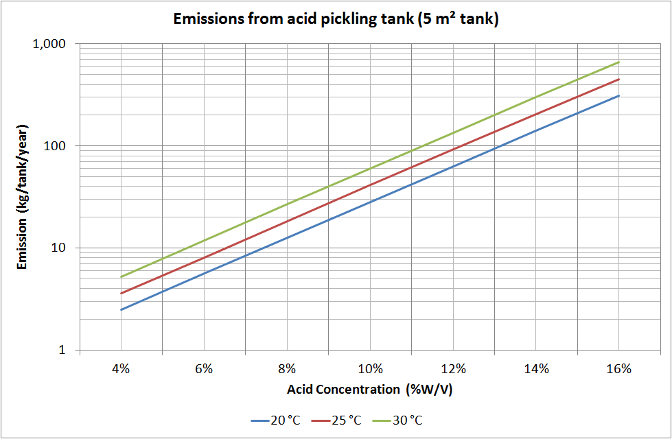

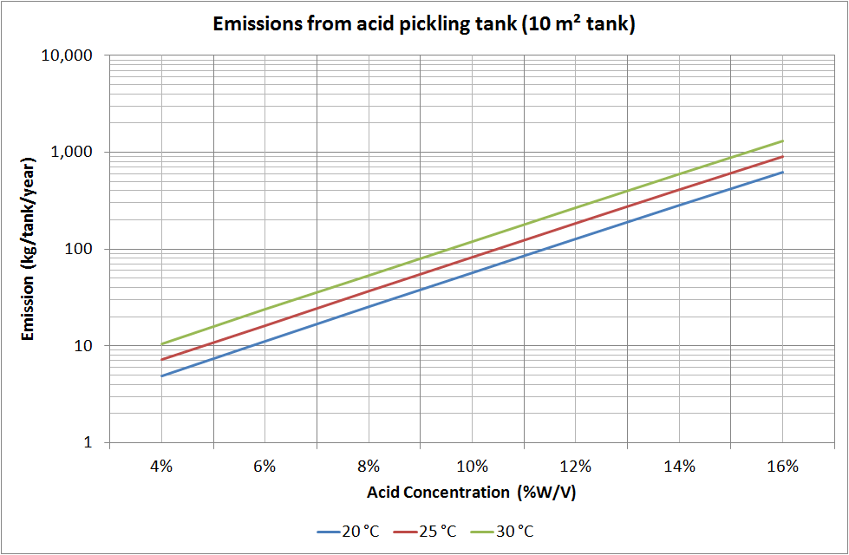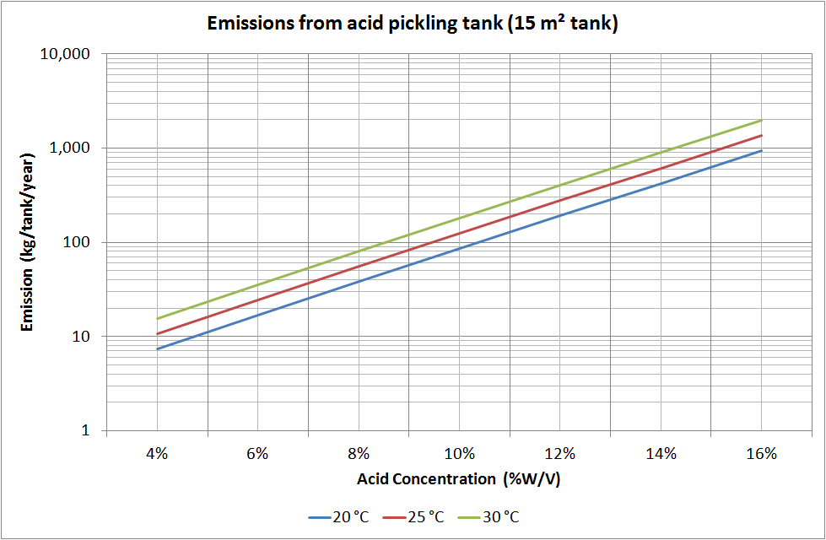

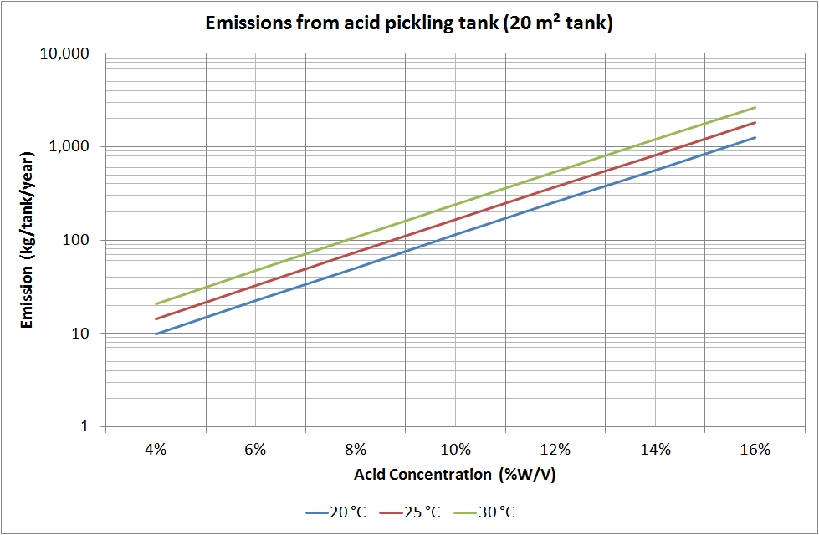
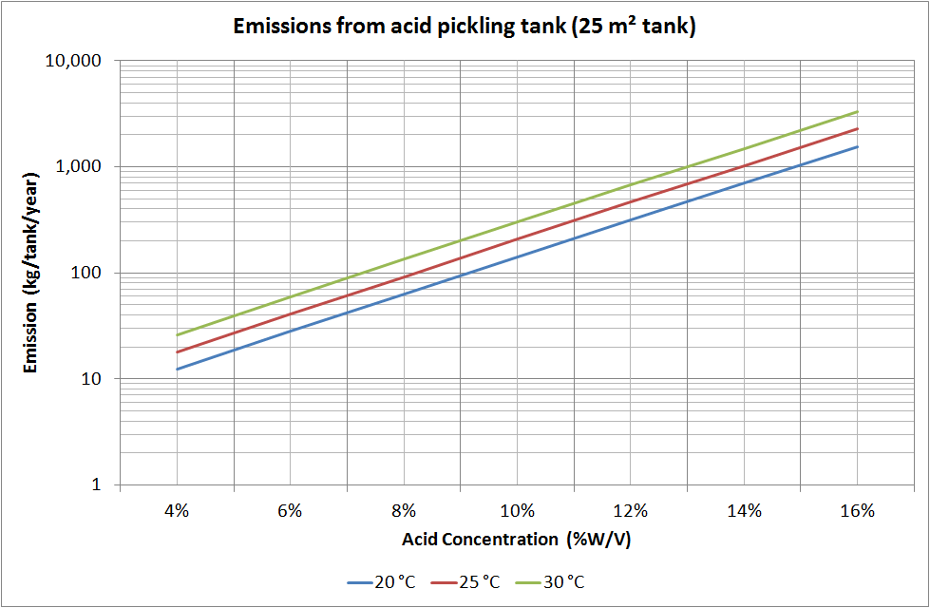
Table 4: Emission factors - acid picking - sulfuric acid
Substance | Uncontrolled emission factor EF  (kg/per tank/year) | Emission factor rating
Sulfuric acid | 134 | U

Derived from Texas Commission on Environmental Quality (TCEQ), Calculations Package, Hot Dip Galvanizing
Assumptions:
Tank size is approximately 21 square metres in size
Tank operating temperature is ambient
Acid concentration is approximately 16%
Emissions factors are per tank per year.
Emission factors are uncontrolled. If controls are used (such as suppressants, hoods of other abatement), the emission factor should be adjusted by the percentage efficiency of any such control.

Table 5: Emission factors - zinc galvanizing bath
Substance | Uncontrolled emission factor EF  (kg/tonne of zinc used)^{c} | Emission factor rating
Particulate matter less than or equal to 10 microns (PM₁₀) ª | 2.5 | C
Zinc and compounds^{b} | 2.0 | C

ª Based on Particulate Matter emission factor in Table 2.3-1 of USEPA AP-42 Section 12.14, 1985. Table 2 above assumes that all particulate matter is classed as PM₁₀.
^{b} Based on assumption that particulate matter (PM) consists entirely of zinc oxide (ZnO). Based on the molecular weight of ZnO and its components, 2.5 kg of ZnO contains 2.0 kg of Zn.
^{c} Units are kg of substance emitted/tonne of zinc used and emission factors are for uncontrolled emissions.

Appendix C: Modifications to the galvanizing emission estimation technique (EET) manual (Version 2.0 July 2012)

Page | Outline of alteration
Throughout | Updated manual to reflect discussions with Galvanizers Association of Australia
Section 4 | Provided example for threshold calculation
Section 5 | Provided up to date example for emissions calculations
Section 4 | Removed emissions to water guidance
Section 4 | Removed sampling data
Section 4 | Removed emissions to land guidance
Section 4 | Removed guidance on fugitive chemicals leaks and replacement with emission factors for acids
Section 6 | Addition of transfers guidance

