Giant Kelp Marine Forests of South East Australia Ecological Community

The Giant Kelp Marine Forests of South East Australia ecological community has been progressively lost, especially on the east coast of Tasmania, due to changing oceanographic conditions and corresponding changes in threatening processes caused by climate change. The patches that remain in Victoria, South Australia and Tasmania are protected under Australia’s national environmental law, the *Environment Protection and Biodiversity Conservation Act 1999* (EPBC Act) as a threatened ecological community.

**What and where are the Giant Kelp Marine Forests of South East Australia?**

Giant kelp (*Macrocystis pyrifera*) plants are the foundation species of the Giant Kelp Marine Forests of South East Australia ecological community (Giant Kelp Marine Forests or ecological community) so much of the description of the ecological community relies on describing their ecology. Other components of the ecological community include a large range of marine algae, reef associated fish and numerous invertebrates that shelter, feed and reproduce within Giant Kelp Marine Forests.

Also known as string kelp, giant kelp is a large brown algae that grows on rocky reefs from the sea floor 8 metres below sea level and deeper. Its fronds grow vertically toward the water surface, in cold temperate waters off south east Australia.

Giant kelp are the largest and fastest growing marine plants. Their presence on a rocky reef adds vertical structure to the marine environment that creates significant habitat for marine fauna, increasing local marine biodiversity. The large biomass and productivity of the giant kelp plants also provides a range of ecosystem services to the coastal environment.

Giant kelp can be distinguished by its long string-like stalks that have many leafy blades. The base of each blade contains a gas filled flotation bladder that allows giant kelp plants to form a buoyant surface canopy similar to the ways trees form a shady canopy in terrestrial forests.

Giant kelp plants respond quickly to favourable environmental conditions and can develop over

a short time frame when environmental factors are suitable for growth. Giant kelp is a cold water species and as sea surface temperatures have risen on the east coast of Australia over the last 40 years, it has been progressively lost from its historical range.

If favourable conditions continue on a long term basis, the Giant Kelp Marine Forests can be a persistent feature of the coastal environment, such as around the Acteon Islands in southern Tasmania where large beds of giant kelp have been a constant presence for decades.

Within Australia, the Giant Kelp Marine Forests is found predominantly in temperate south eastern waters where water conditions are cool, relatively nutrient rich and moderately calm. The largest extent of the ecological community is in Tasmanian coastal waters. Some patches may also be found in Victoria and South Australia.

The Giant Kelp Marine Forests can be found from Eddystone Point in the north east of Tasmania all along the eastern coastline and around the southern coast as far as Port Davey. In addition, the ecological community has also been known to intermittently develop on the northern and western coasts of Tasmania and occur in the coastal waters off Victoria and south east South Australia where physical conditions and environmental factors are favourable for its growth.



**Giant Kelp Marine Forest © N. Barrett Giant kelp frond © R. Bisset**

**Key diagnostic characteristics for the Giant Kelp Marine Forests of South East Australia ecological community**

* Giant kelp plants forming a forest with a closed or semi-closed canopy at or below the water’s surface.
* Giant kelp plants growing at a depth generally greater than eight metres below sea level.
* A rocky substrata.
* A diversity of marine species on the seafloor, in the understorey and throughout the water column including fish, molluscs (sea snails), bryozoans (lace corals), polychaetes (worms), crustaceans (crabs, isopods, amphipods), echinoderms (sea urchins, sea stars) and sponges.
* Cold water with mean sea surface temperature between 5 °C and 20 °C.
* Moderate wave exposure.
* Distribution within waters off the coast of Tasmania in the Bruny, Freycinet, Flinders, Two Fold Shelf, Davey, Boags and Franklin bioregions; the coast of South Australia in the Otway and Coorong bioregions as far west as Margaret Brock Reef; and the coast of Victoria in the Otway, Central, Flinders and Two Fold Shelf bioregions as far east as Gabo Island.

**How do I know if the patch of kelp forest I am in is protected?**

Not all coastal areas of Victoria, South Australia and Tasmania have conditions suitable to support the Giant Kelp Marine Forests of South East Australia ecological community and the presence of giant kelp is not the only determining feature of this ecological community.

If giant kelp plants are present and they form a closed or semi-closed canopy at or below the surface and the water is 8 metres or deeper, it is likely you have a patch of the Giant Kelp Marine Forests of South East Australia ecological community.

Although any rocky reefs below 8 metres below sea level may be potential Giant Kelp Marine Forests habitat, only where giant kelp plants occur and form a surface or subsurface canopy is the Giant Kelp Marine Forests of South East Australia ecological community considered to occur.

Other specific occurrences of giant kelp are excluded from the definition of the ecological community and therefore do not trigger the need for referral under national environment law.

These are:

* Patches of giant kelp at shallow depths level that do not form a surface or subsurface canopy.
* Giant kelp plants that have detached from the substrata and are found floating on the sea surface.
* Giant kelp plants that have detached from the substrata and washed ashore (sometimes referred to as ‘wrack’).
* Patches of giant kelp found in the coastal waters of Australia’s external territories in the southern ocean i.e. Heard and Macquarie Islands.

** **

**Spined leatherjacket © A. Newton** **Red handfish © T Carter**

**What does protection of the Giant Kelp Marine Forests mean for commercial or recreational fishing activities?**

The national environment law is not about stopping business or preventing recreation marine or fishing activity; it protects Australia’s unique native plants and animals. The Giant Kelp Marine Forests of South East Australia ecological community is protected under national environment law and receives protection as a matter of national significance.

This means lawful activities that began before national environment law came into effect on 16 July 2000 can continue without further federal environment approval.

Existing commercial fisheries which have been managed sustainably and responsible recreational fishing that help to retain the good condition of the ecological community can continue without change.

If you think that your activities are likely to have a significant impact on the ecological community then you may need federal environment approval.

**You may need federal environment approval if:**

* A new activity is proposed that could have or is likely to have a significant impact on the ecological community; or
* A substantial intensification, or change in an existing activity is proposed that could have a significant detrimental impact on the ecological community.

**What routine activities do not need approval?**

* Recreational fishing within legal zones and limits.
* Collection of giant kelp washed up on beaches (as they are not part of the ecological community).
* Commercial fishing within approved sustainable catch limits.

**Referable actions could include:**

* Direct removal or clearance of substantial amounts of giant kelpplants from the ecological community.
* Dumping of waste or contaminated water within or adjacent to the ecological community.
* Changing the water quality in or near the ecological community through discharges from land or sea based activities.

**Where can I get more information?**

If you are not sure whether your activity requires Australian Government approval, you can get more information about the referral process from [www.environment.gov.au/epbc/approval.html](http://www.environment.gov.au/epbc/approval.html) or contact the EPBC Compliance area via email [compliance@environment.gov.au](mailto:compliance@environment.gov.au) or free call 1800 110 395.

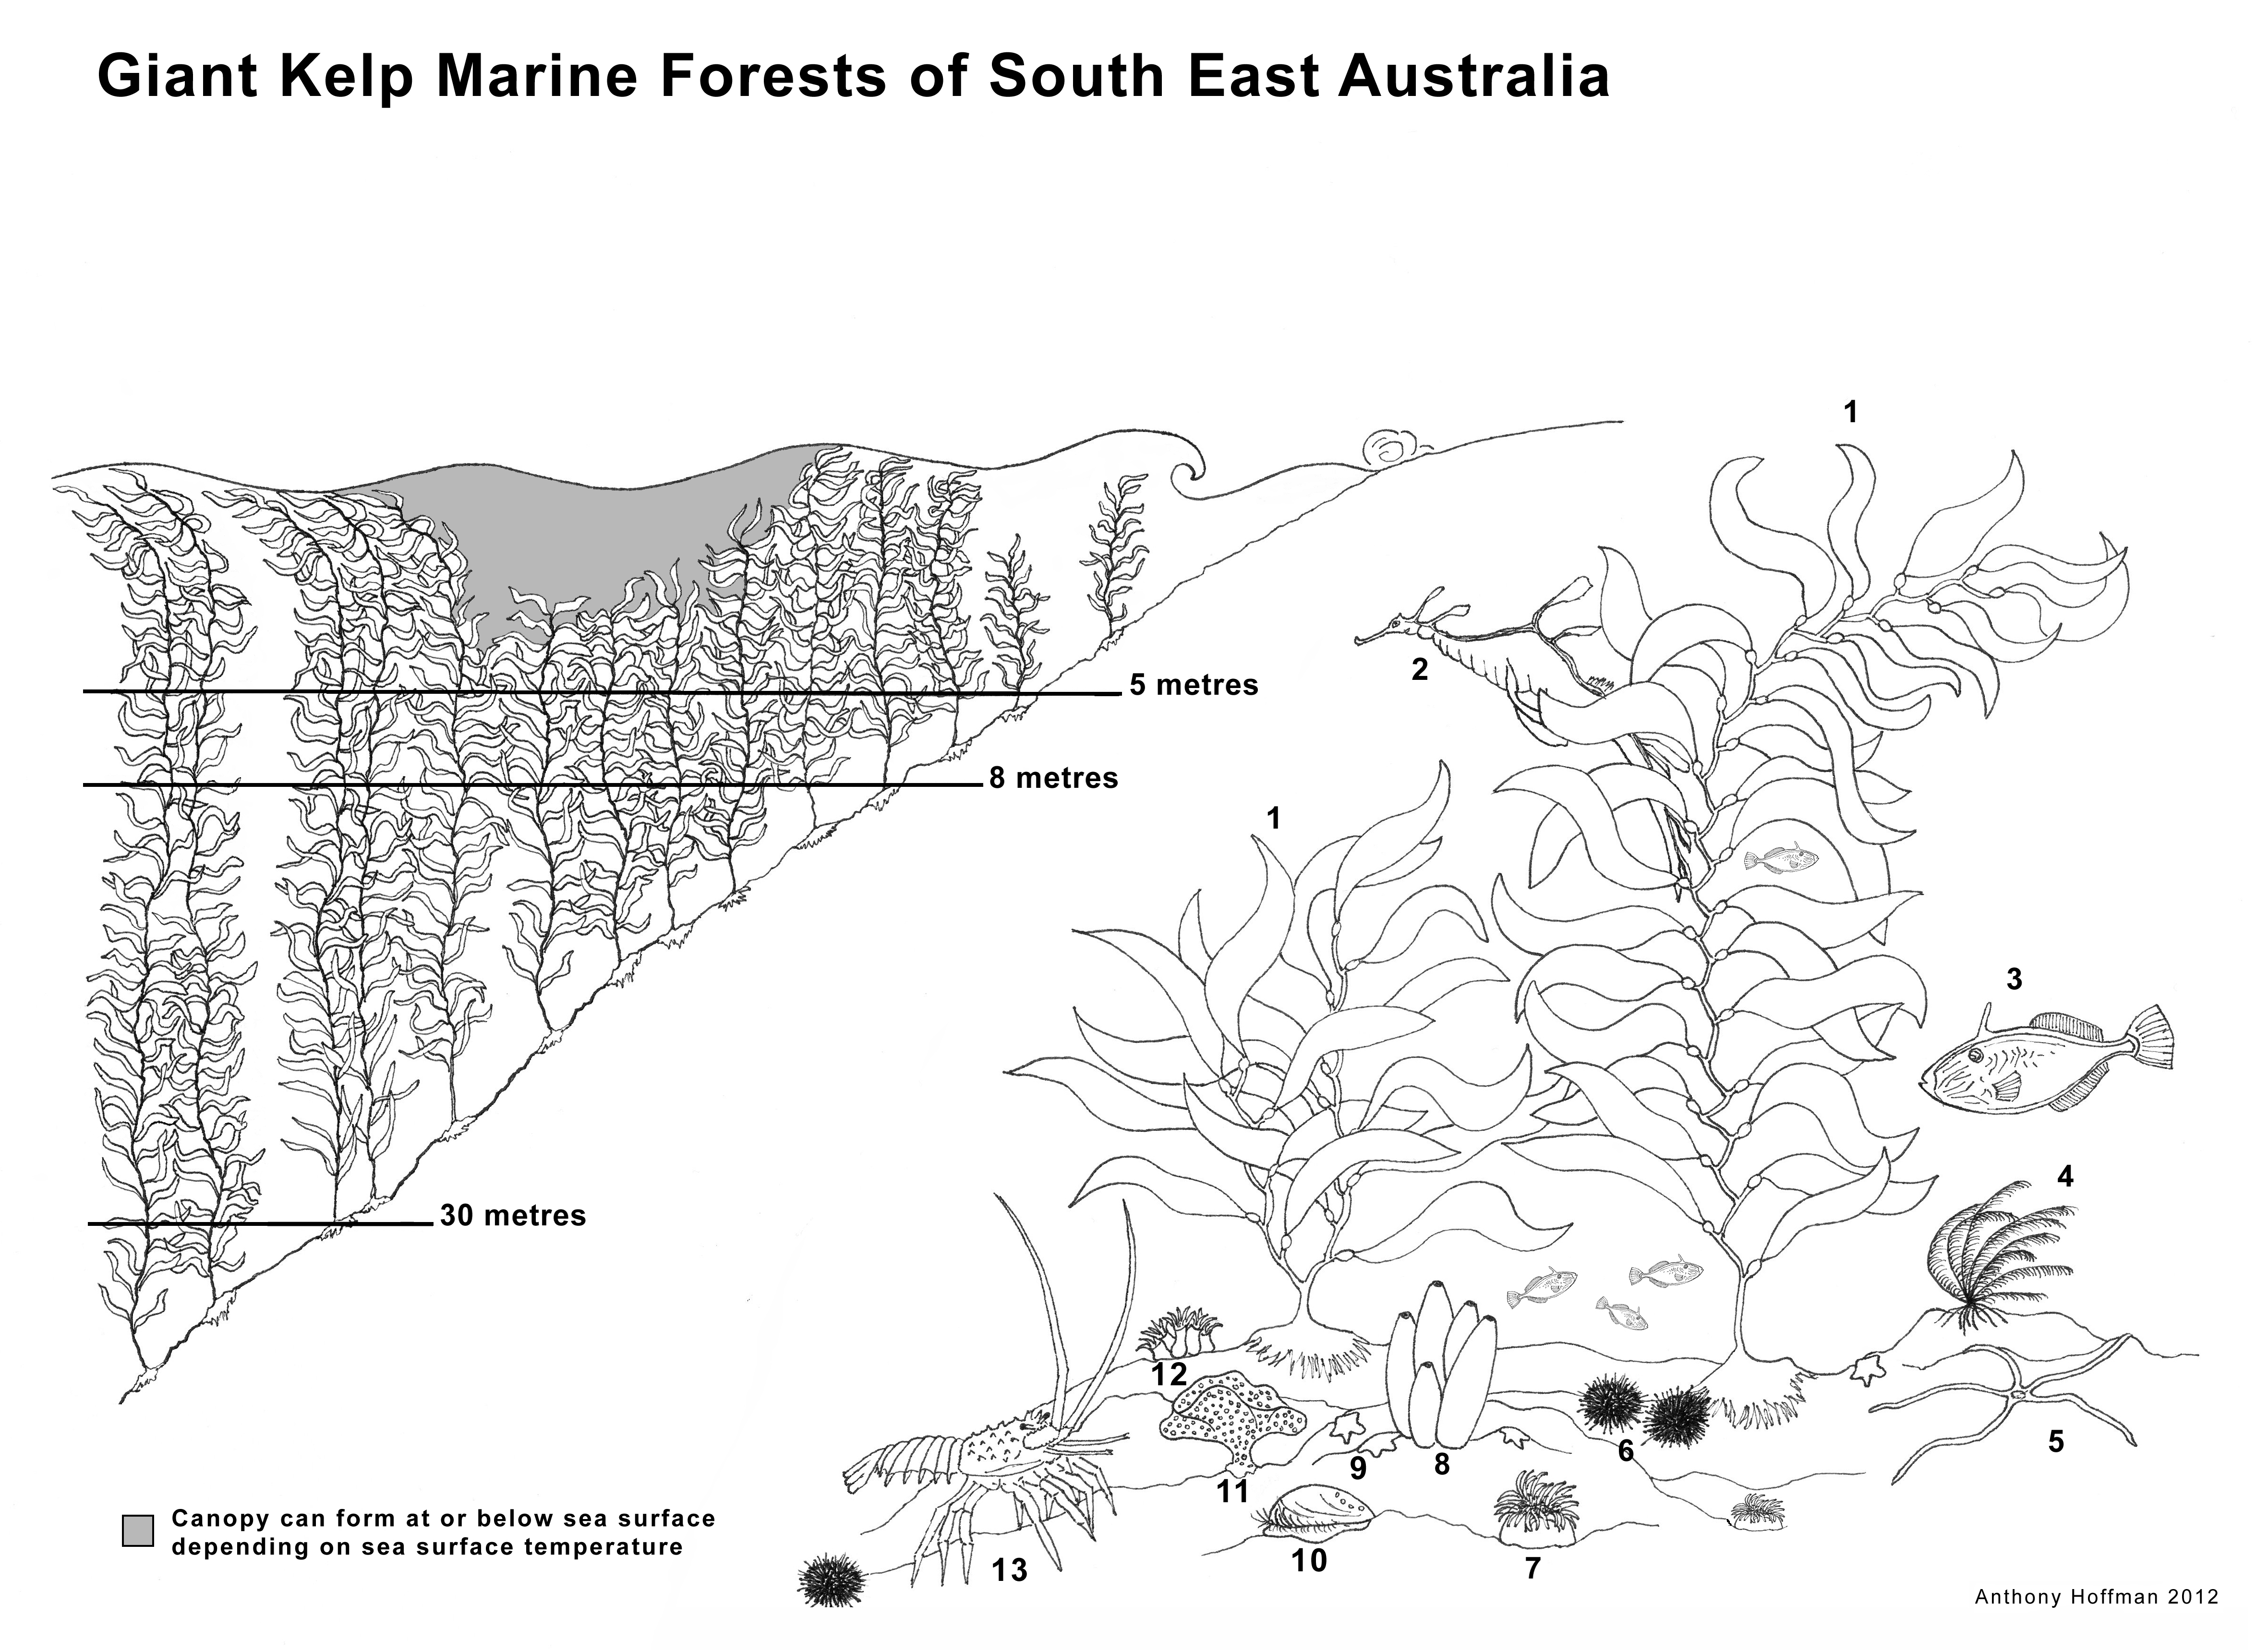

**Key:**

1. Giant Kelp (*Macrocystis pyrifera*)

2. Weedy sea dragon (*Phyllopteryx taeniolatus*)

3. Six-spined leather jacket (*Mesuchenia freycineti*),

4. Feather star(*Cenolia* *trichoptera*)

5. Brittle star (*Ophiuroid* sp)

6. Urchins

7. Anemone

8. Sponge

9. Biscuit stars (*Tosia* spp)

10. Blacklip abalone(*Haliotis rubra*)

11. Lace coral(*Membranipora membranacea*)

12. Cup coral

13. Southern rock lobster (*Jasus edwardsii*)