# Additional information on the state of conservation of the Gondwana Rainforests of Australia

Key updates – 1 February 2021

(Updates since April 2020)

Department of Agriculture, Water and the Environment

Heritage Branch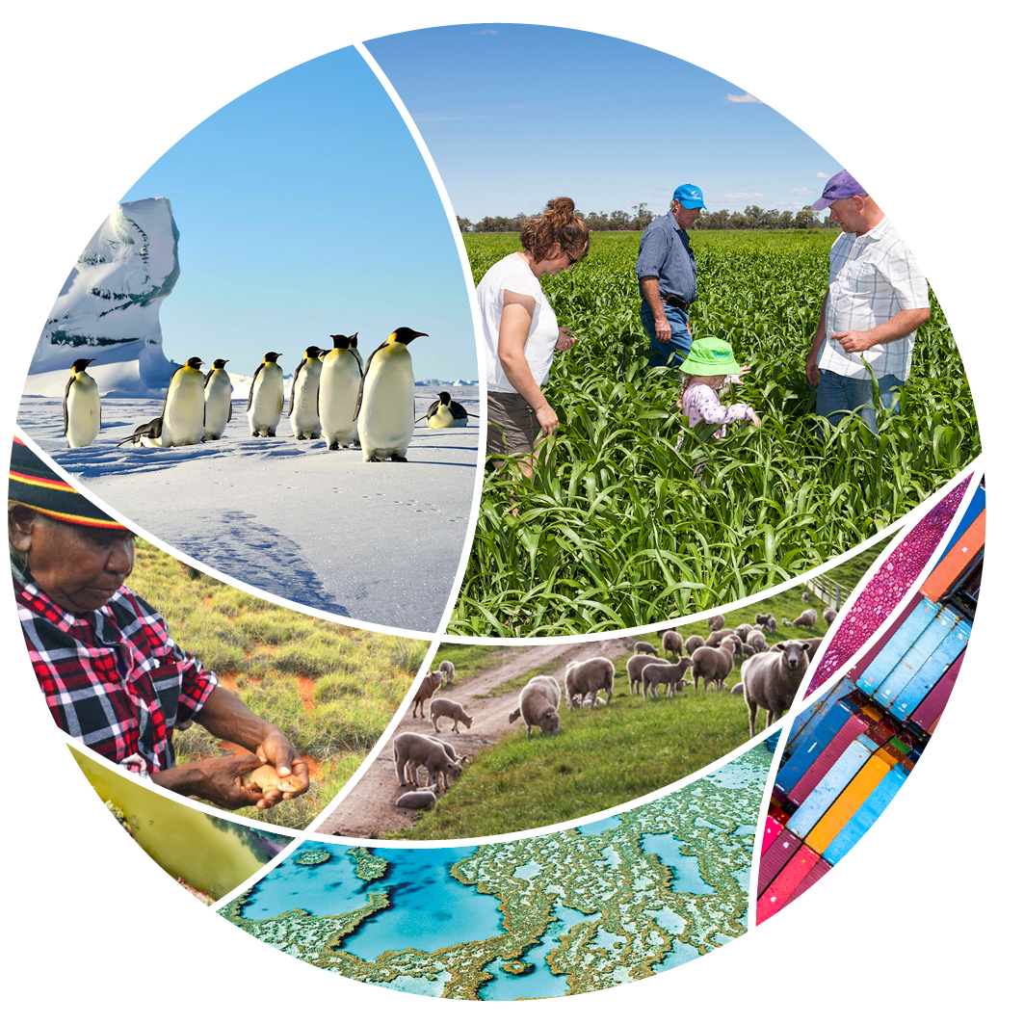

© Commonwealth of Australia 2021

**Ownership of intellectual property rights**

Unless otherwise noted, copyright (and any other intellectual property rights) in this publication is owned by the Commonwealth of Australia (referred to as the Commonwealth).

**Creative Commons licence**

All material in this publication is licensed under a [Creative Commons Attribution 4.0 International Licence](https://creativecommons.org/licenses/by/4.0/legalcode) except content supplied by third parties, logos and the Commonwealth Coat of Arms.

Inquiries about the licence and any use of this document should be emailed to [copyright@awe.gov.au](mailto:copyright@awe.gov.au).

Creative Commons logo

**Cataloguing data**

This publication (and any material sourced from it) should be attributed as: DAWE (2020) *Additional information on the state of conservation of the Gondwana Rainforests of Australia: Key updates since April 2020*, Department of Agriculture, Water and the Environment, Canberra, February. CC BY 4.0.

This publication is available at [awe.gov.au/publications](http://awe.gov.au/publications).

Department of Agriculture, Water and the Environment

GPO Box 858 Canberra ACT 2601

Telephone 1800 900 090

Web [awe.gov.au](http://agriculture.gov.au/)

**Disclaimer**

The Australian Government acting through the Department of Agriculture, Water and the Environment has exercised due care and skill in preparing and compiling the information and data in this publication. Notwithstanding, the Department of Agriculture, Water and the Environment, its employees and advisers disclaim all liability, including liability for negligence and for any loss, damage, injury, expense or cost incurred by any person as a result of accessing, using or relying on any of the information or data in this publication to the maximum extent permitted by law.

Contents

1 Introduction 4

2 Updates on the impact of the 2019-2020 fires 5

2.1 Assessment of ecological impacts of the fires 5

2.2 Intersection with other conservation issues 6

3 Updates on the Bushfire response 7

3.1 Immediate response 7

3.2 Longer term recovery 10

3.3 Future fire management 11

## Introduction

The Gondwana Rainforests of Australia (Gondwana Rainforests) is a serial World Heritage property comprising 40 individual components, largely national parks and nature reserves, in north-east New South Wales (NSW) and south-east Queensland.

As reported in the state of conservation report sent to the World Heritage Centre in April 2020, extensive areas of southern and eastern Australia, including the Gondwana Rainforests, were affected by bushfires in the Australian spring and summer of 2019-20.

The recovery and conservation of the Gondwana Rainforests continues to be a collaborative effort by the Australian, NSW and Queensland governments in partnership with Aboriginal groups, natural resource management agencies, ecologists, spatial scientists, research organisations and the community.

Updates since Australia’s submission of the [April 2020 State Party Report](https://www.environment.gov.au/heritage/publications/gondwana-rainforests-state-conservation-update-april-2020) are summarised below. Ongoing work is focused on:

* better understanding the impact of the 2019-2020 bushfire events on the World Heritage property, and
* actions to respond to the bushfires.

## Updates on the impact of the 2019-2020 fires

### Assessment of ecological impacts of the fires

#### Variability of fire impact

Updates relating to pages 14-19 of the April 2020 State Party Report

In the NSW reserves, ground-truthing of some of the burnt areas has shown that the impacts of the fires differed across the landscape and within different rainforest communities. The drought index for several areas is an indicator of the intensity of wildfire and impacts on values. Dry rainforests and, in some locations, cool temperate rainforests, appear to have been most affected.

Several post fire-assessment reports have been prepared or are being prepared for some affected Queensland reserves:

* a Natural Values Post-Fire Assessment Report for Lamington National Park has been finalised and approved for public release, with publication pending on the Queensland Government Department of Environment and Science website.
* a Natural Values Post-Fire Assessment Report for Main Range National Park.
* a Natural Values Post-Fire Assessment Report for Mount Barney National Park.

In addition, 20 long-term rainforest monitoring plots established in 2006 in Lamington National Park have been resurveyed. This includes three sites identified through the post fire assessment as having moderate to high/catastrophic Potential Ecological Impacts (PEI) caused by fire. Several new monitoring plots have been established within Mt Barney and Main Range National Parks to assess post fire condition in areas of moderate to high/catastrophic PEI and to track future ecosystem recovery. Australia’s advantages

#### Identifying key species affected

(updates to page 20 of the April 2020 State Party Report)

Assessments and monitoring are showing encouraging signs of recovery and resilience across the landscape. Several rare and threatened species, including the Hastings River mouse (Pseudomys oralis), rufous scrub-bird (Atrichornis rufescens) and stuttering barred frogs (Mixophyes balbus), have been found within areas that were burnt. These species are attributes of the Outstanding Universal Value of the property. There have also been signs of recovery for greater gliders (*Petauroides volans*) and powerful, sooty and masked owls (Ninox strenua, Tyto tenebricosa and T. novaehollandiae).

Nevertheless, there have been significant impacts to rainforests and to the habitats of particular threatened species, including taxa listed under the Australian Government Environment Protection and Biodiversity Conservation Act 1999*,* the Queensland Government Nature Conservation Act 1992, and theNSW Biodiversity Conservation Act 2016. In some cases, unburnt sites are serving as key refugia that require priority protection from future fires.

### Intersection with other conservation issues

#### Future of Gondwana Rainforests under climate change

Updates relating to page 21-22 of the April 2020 State Party Report

The Australian Government is working with the Commonwealth Scientific and Industrial Research Organisation (CSIRO), Australian World Heritage property managers and Traditional Owners to update a high-level assessment of climate vulnerability for Australia’s 20 World Heritage properties (including the Gondwana Rainforests) and to provide practical guidance for adaptation planning.

## Updates on the Bushfire response

### Immediate response

Updates relating to pages 23-24 of the April 2020 State Party Report

In response to Australia’s Black Summer bushfires, on 13 January 2020 the Australian Government announced an initial AUD50 million investment to support immediate work to protect wildlife and enable habitat recovery, and the planning of longer-term protection and restoration efforts. This immediate response targeted Black Summer bushfire impacted areas including the Gondwana Rainforests of Australia.

Of this initial investment, AUD25 million is being delivered through an emergency intervention fund to help with the immediate survival of affected animals, plants and ecological communities, and to control pests and weeds. The investment includes:

* AUD13 million to state and territory governments for on-ground emergency interventions and priority recovery activities.
  + This includes a Queensland Government project—which has a focus on the Gondwana Rainforests—undertaking feral predator control, surveys, emergency salvage of species and protecting unburnt areas.
* Up to AUD12 million in Wildlife and Habitat Bushfire Recovery Program grants.

The remaining AUD25 million has been made available to support wildlife rescue, zoos, and conservation groups with on the ground activities.

In January 2020, a panel of experts, led by Australia’s Threatened Species Commissioner, was established to advise the Australian Government on critical interventions required to build back up animal and plant populations ensuring their resilience into the future.

The Wildlife and Threatened Species Bushfire Recovery Expert Panel provided advice on critical interventions required to support the immediate survival of priority animals, plants and ecological communities. The Expert Panel helped assess the scale and impact of the bushfires on the environment to assist with the prioritisation of recovery efforts.

#### Further investment in recovery

In the second phase of funding, the Australian Government is providing AUD150 million over two years from 1 July 2020 to support the sustained efforts required for the long-term recovery of native animals and plants and natural assets such as World Heritage properties. This includes:

* AUD110 million for strategic on-ground support for the most impacted native species across seven bushfire-affected regions (Regional Fund).
* AUD10 million for projects to engage local communities in conserving their local environment and driving recovery of plants, animals and other natural assets from the bushfires.
* AUD2 million to support knowledge exchange on Indigenous fire and land management.

The package is also supporting further scientific assessment of the post-bushfire status of our most at-risk species by the Threatened Species Scientific Committee (the statutory adviser to the Minister for the Environment under national environmental law). This funding also provides for planning coordination and recovery action.

#### Regional Fund

Through this fund, the Australian Government is investing:

* AUD4 million in the Rainforests of south-east Queensland bushfire region, which includes a portion of the Gondwana Rainforests, as follows:
  + AUD1.65 million to Healthy Land and Water (an independent organisation working to improve South East Queensland’s natural environment) to work closely with landholders to implement pest and weed management activities and to work with communities on fire management actions. This includes work within and adjoining the Gondwana Rainforests.
  + AUD2.35 million to the Queensland Government to undertake work across four national parks, including three within the World Heritage property. Actions will include pest animal and weed control and fire management and planning, including fire line enhancement and additional water storage points.
* AUD13 million in the rainforests of the NSW north coast and tablelands bushfire region, which contains a significant proportion of the Gondwana Rainforests. Of this,
  + AUD 7.18 million will go to Northern Tablelands Local Land Services and North Coast Local Land Services for activities that will contribute to recovery of the Gondwana Rainforests.
  + AUD13 million has been allocated to the Greater Blue Mountains bushfire region, which includes the southern part of the Gondwana Rainforests.
  + AUD 5.82 million will also be invested by the NSW Government in bushfire recovery activities.

Activities include pest control, weed control, revegetation, erosion control, species-specific actions, fire management and Traditional Owner-led actions on public and private lands, including areas within and adjoining the World Heritage property.

These investments were based on a series of co-design workshops held across the seven bushfire affected regions to engage and collaborate with regional stakeholders to inform Australian Government investment in on-ground bushfire recovery. Workshop reports for each region are available on the Australian Government Department of Agriculture, Water and the Environment website: [South East Queensland](https://www.environment.gov.au/biodiversity/bushfire-recovery/regional-delivery-program/south-east-queensland), [Northern NSW](https://www.environment.gov.au/biodiversity/bushfire-recovery/regional-delivery-program/rainforests-of-nsw) and [Blue Mountains](https://www.environment.gov.au/biodiversity/bushfire-recovery/regional-delivery-program/greater-blue-mountains).

#### NSW reserves

For the reserves in NSW, the NSW National Parks and Wildlife Service (NPWS) has invested significant funding across the affected areas, including parts of the Gondwana Rainforests and implemented a range of measures including:

* Protection of unburnt areas across the 16 fire-affected reserves within the property.
* Undertaking the largest pest and weed management program in the State’s history across the national parks estate, including extensive feral animal control in the Gondwana Rainforests World Heritage property.
* Continuing to focus on building capacity and resilience in response to the increased risk and severity of wildfire in NSW. The NSW Government has funded 125 additional NPWS firefighters, amended the NSW National Parks and Wildlife Act 1974 to provide for special measures for places of exceptional significance, and is establishing a special ecological risk team within NPWS to inform the development of future fire strategies.
* Assessment and monitoring the recovery of Gondwana Rainforests World Heritage values including rainforest communities and threatened species.
* Assessment of risk to World Heritage values to inform conservation management of these values into the future.
* Preparation of a climate change adaptation strategy for the Tweed Caldera group of reserves to inform further work to protect and conserve the World Heritage property and rainforests across the property.
* Assessment of impacts on Aboriginal cultural heritage and working with Aboriginal communities and native title holders to undertake priority protective measures.

#### Queensland reserves

For the Queensland reserves, Phase 1 of the Bushfire Recovery Program, led by the Department of Environment and Science (DES), through Queensland Parks and Wildlife Service and Partnerships (QPWS&P), has included a post-fire assessment across each fire-impacted national park: Lamington National Park, Mount Barney National Park and Main Range National Park. The fire extent and fire severity across five classes have been mapped for each park. The evaluation results will be summarised in a report for each park and will document the burning of fire-sensitive ecosystems, including rainforests that contribute to the Outstanding Universal Value of the Gondwana Rainforests.

Phase 1 of the Bushfire Recovery Program will continue to undertake works through to June 2021. Phase 2 of the program will commence in 2021 and operate through to June 2022 to implement ongoing fire and pest management priorities, as well as strategic ecological monitoring projects.

Pest animal and weed control programs are well underway in the Queensland reserves to support recovery of priority species. Planned burn programs are being reviewed.

Additional actions being taken in the Queensland reserves within the World Heritage property, include:

* Actions to protect unburnt refugia in the Goomburra region from subsequent fire are underway in Main Range National Park. Fire control lines are being upgraded in Lamington and Mount Barney National Parks. The forward planned burn programs across all three national parks are being reviewed in light of the 2019/20 impacts.
* Control of ecosystem transforming species is underway to reduce their impact on the recovery of priority ecosystems and species, such as palm grass (*Setaria palmifolia*) in Cronan Creek at Mount Barney National Park and Madeira Vine (*Anredera cordifolia*) at Main Range National Park.
* Feral animal species that are known to be a priority for control are being targeted by on ground actions, such as cats at Lamington National Park and pigs at Mount Barney and Main Range National Parks. Fencing at Lamington National Park is also underway to exclude cattle entering the park from neighbouring properties (access by stock is exacerbated in post fire conditions due to the loss of fencing and stock can cause ecological damage).
* Camera monitoring is underway to assess additional priorities for control efforts in the key habitats of priority threatened species.
* As noted above, additional and separate Australian Government funding from the Regional Fund was provided to Healthy Land and Water (HLW), an independent organisation working to improve South East Queensland’s natural environment. HLW is coordinating weed removal in the Yamahra Creek section of Mount Barney National Park and the Illinbah section of Lamington National Park, as well as cattle exclusion fencing in Main Range National Park.

### Longer term recovery

(Updates relating to pages 24-25 of the April 2020 State Party Report)

To evaluate the post-fire ecological recovery process for the Queensland reserves, historic research sites are being re-evaluated and additional monitoring sites established including:

* 20 long-term rainforest monitoring plots established in 2006 in Lamington National Park have been resurveyed. This includes three sites identified through the post fire assessment as having moderate to high/catastrophic potential ecological impacts caused by fire.
* Three new plots have been established within Mount Barney National Park and Main Range National Park to assess post fire condition in moderate to high/catastrophic Potential Ecological Impact (PEI) and to track future ecosystem recovery. PEI is mapping that combines regional ecosystem mapping, the sensitivity to fire of that ecosystem, and the severity with which it was burnt to map the actual on-ground impact. For example, a low severity fire would have a higher PEI in rainforest than a low severity fire would in a fire-adapted Eucalypt forest.

Work is well underway to monitor the recovery of fauna in the Queensland and NSW reserves including:

* Fauna surveys of priority threatened species to provide a baseline to facilitate ongoing post-fire monitoring of recovery. In some cases, there is previous data available at burnt sites to enable better interpretation of post-fire impacts.
* Monitoring of the priority threatened mammals (spotted-tailed quoll (Dasyurus maculatus), long-nosed potoroo (Potorous tridactylus), brush-tailed rock-wallaby (Petrogale penicillate), Hastings River mouse (Pseudomys oralis) and New Holland Mouse (Pseudomys novaehollandiae)) will involve camera monitoring, visual surveys, Elliot and pitfall trapping. Research sites established prior to the fire will be used where possible. The Hastings River mouse is one of the attributes of the Outstanding Universal Value of the property.
* Monitoring of priority threatened birds (Albert’s lyrebird (Menura alberti), eastern bristlebird (Dasyornis brachipterus), rufous scrub-bird (Atrichornis rufescens), glossy black cockatoo (Calyptorhynchus lathami) and Coxen’s fig-parrot (Cyclopsitta diophthalma coxeni)) will include camera monitoring, acoustic sensors and field surveys. Research sites established prior to the fire will be used where possible. Lyrebirds (Menuridae) and Scrub-birds (Atrichornithidae) are attributes of the Outstanding Universal Value of the property.
* Monitoring of threatened frogs is underway (cascade tree-frog Litoria pearsoniana, Fleay’s barred frog Mixophyes fleayi, red and yellow mountain frog Philoria kundagungan) using acoustic sensors and visual surveys. These frogs are attributes of the Outstanding Universal Value of the property. Research sites established prior to the fire will be used where possible. The timing is highly dependent on significant rainfall events.
* Monitoring of the Jagara hairy crayfish (Euastacus jagara), will incorporate known pre-fire locations using visual surveys. The crayfish is an attribute of the property’s Outstanding Universal Value as a key example of the invertebrate fauna from ancient lineages linked to the breakup of Gondwana.
* Surveys of endemic terrestrial invertebrates will use a range of techniques such as pitfall trapping, malaise traps (used for trapping flying insects) and direct searching including in known localities of type specimens for key species, including those that are attributes of the property’s Outstanding Universal Value.

Phase 2 of the Bushfire Recovery Program for the NSW and Queensland reserves will implement a strategic approach to monitoring the ongoing post-fire recovery of ecosystems and threatened species across the Gondwana World Heritage Area.

### Future fire management

(updates relating to page 25 of the April 2020 State Party Report)

As noted in the April 2020 State Party Report, the Australian Government established the Royal Commission into National Natural Disaster Arrangements on 20 February 2020. The Australian Government also commissioned the Commonwealth Scientific and Industrial Research Organisation (CSIRO) and Australia’s Chief Scientist to report on climate and disaster resilience because it is committed to learning from the 2019-20 bushfire season. [The Final Report of the Royal Commission](https://naturaldisaster.royalcommission.gov.au/) made 80 recommendations, with over 50 relating to the responsibilities of the Australian Government. The Australian Government has either supported, or supported in principle, every recommendation for which it is responsible.

In response, the Australian Government announced a comprehensive set of reforms to provide strong leadership on all hazards, emergency management and natural disaster risk reduction. The Australian Government will establish a national resilience, relief and recovery agency to commence operations by 1 July 2021. This new agency will coordinate and align Australia’s national capability to build resilience, better prepare for natural disasters, and recover from all hazards.

Additionally, the Australian Government will also establish Climate and Resilience Services Australia (CaRSA). CaRSA will connect and leverage the Australian Government’s extensive data, information and capabilities to manage climate and natural disaster risk, including those of the Bureau of Meteorology, the CSIRO, Geoscience Australia and the Australian Bureau of Statistics, to meet the climate and natural disaster risk information needs of Emergency Management Australia and the National Resilience, Relief and Recovery Agency. CaRSA will support national preparedness, response, relief, recovery and resilience efforts.

State governments are the managers of most Australian World Heritage properties, including the Gondwana Rainforests, and are responsible for on-ground operations. The Australian Government provides broad oversight in order to meet Australia's obligations under the World Heritage Convention, including through assisting state agencies with the development of Management Plans.

State agencies have demonstrated that a capacity for rapid remote firefighting can be instrumental in protecting World Heritage values. As highlighted in the Royal Commission's Final Report, the NSW National Parks and Wildlife Service (NPWS) used crews with remote firefighting skills during the bushfires of January 2020, to protect stands of threatened Wollemi Pine in the Greater Blue Mountains Area and the Nightcap Oak in the Gondwana Rainforests of Australia. The National Aerial Firefighting Centre (NAFC) is responsible for providing a cooperative national arrangement for the provision of aerial firefighting resources for combating bushfires. The Australian Government noted in its Government Response to the Royal Commission that it will continue the annual contribution of $26 million to the NAFC, indexed from 2020-21.

**1 February 2021**