Gondwana Rainforests of Australia  
State of Conservation update - April 2020

Contents

Introduction 3

Outstanding Universal Value 3

Impact of the 2019-2020 fires 4

Extent of the fires 4

Assessment of ecological impacts of the fires 13

Variability of fire impact 13

Identifying key species affected 19

Threatened ecological communities 21

Intersection with other conservation issues 21

Future of Gondwana Rainforests under climate change 21

Weeds and feral animals 22

Pathogens 22

Bushfire response 23

*Immediate response* 23

*Longer term recovery* 24

*Future fire management* 25

References 26

Appendix A: 368bis Gondwana Rainforests of Australia - Statement of Outstanding Universal Value 27

## Introduction

The Gondwana Rainforests of Australia (Gondwana Rainforests) is a property comprising 40 individual components , largely national parks and nature reserves, in north-east New South Wales (NSW) and south-east Queensland. Listed for its biological and geomorphic values, it contains remnants of the once vast rainforests that covered Australia when the climate was cooler and wetter. Despite its name, the property contains a diversity of vegetation vegetation communities with varying degrees of fire tolerance. Rainforests generally occur as discontinuous patches surrounded by fire-adapted eucalypt forest and agricultural lands.

In the Australian spring and summer of 2019-20, extensive areas of southern and eastern Australia were affected by bushfire at a scale unprecedented in European history. Across the Australian continent, more than 12.6 million hectares were burnt. The bushfires followed a prolonged period of drought that contributed significantly to creating ecological conditions favorable to bushfires. Initial fire mapping of the property indicated approximately 196,000 hectares, or 53 per cent of the property was affected. However ground truthing has been carried out in several reserves (indicated in the table 2 further below) so far, and in these reserves the extent of fire affected area was less an first anticipated.

On 22 January 2020, the Australian Government wrote to the World Heritage Centre to provide an update on the bushfire situation in Australia. Following this advice, on 28 January 2020, the World Heritage Centre requested an update concerning the state of conservation of the Gondwana Rainforests of Australia, for consideration by the World Heritage Committee at its 44th Session. This report addresses that request.

The Australian Government is working with the New South Wales and Queensland state governments, land managers, scientific experts, Aboriginal Traditional Owners and other stakeholders to better understand the impact of the 2019-2020 bushfire events on the Outstanding Universal Value (OUV) of the property. There is some and expanding information about the extent of the fire impacts. However, more work is required to better understand the severity and intensity of the fires, the vulnerability of the impacted species and ecological communities, and recovery prospects.

## Outstanding Universal Value

The Gondwana Rainforests of Australia was inscribed on the World Heritage list in 1986 and was extended in 1994. It was inscribed on the World Heritage list under criteria (viii) (ix) and (x). The Statement of OUV for the property is at **Appendix A**. Key attributes include:

* + outstanding examples of significant ongoing geological processes. The Tweed Shield erosion caldera is possibly the best-preserved erosion caldera in the world, notable for its size and age, for the presence of a prominent central mountain mass (Wollumbin/Mt Warning), and for the erosion of the caldera floor to basement rock (criterion viii).
  + outstanding examples of major stages in the Earth’s evolutionary history as well as ongoing evolutionary processes. The property also contains an outstanding number of songbird species, including lyrebirds, scrub-birds, treecreepers and bowerbirds and catbirds, belonging to some of the oldest lineages of passerines that evolved in the Late Cretaceous. The rainforests have been described as ‘an archipelago of refugia, a series of distinctive habitats that characterise a temporary endpoint in climatic and geomorphological evolution’ (criterion ix).
  + ecosystems of the Gondwana Rainforests contain significant and important natural habitats for species of conservation significance, particularly those associated with the rainforests. The Gondwana Rainforests protects the largest and best stands of rainforest habitat remaining in this region. Many of the rare and threatened flora and fauna species are rainforest specialists, and their vulnerability to extinction is due to a variety of factors including the rarity of their rainforest habitat (criterion x).

## Impact of the 2019-2020 fires

Following an extended period of drought, the first of a series of bushfires to affect the property started in early September 2019. Hot, dry and windy conditions across Australia resulted in fires continuing to burn in parts of the Gondwana Rainforests until significant rain fell in late January 2020. The majority of fires were started by dry lightning strikes. During this time, approximately 196,000 hectares, or 53 per cent of the property, was impacted by fire. Maps showing the extent of fire within the property and surrounding landscape are shown in **Figures 1, 2** and **3**.

As of March 2020, detailed assessment of impacts on the OUV of the property had only just commenced due to access issues, with safety concerns such as treefall posing a significant risk for impact assessors post-fire. In addition to this, recent heavy rain has caused flooding and landslips, further hampering assessment and recovery efforts.

Impact assessments will identify the ecological communities and species that are attributes of the property’s OUV which have been impacted. Such assessments will also help to inform future management actions within the property.

The Gondwana Rainforests are highly valued by many different Aboriginal communities who hold strong ongoing connections across the property. There is significant concern within the Aboriginal community regarding Aboriginal cultural heritage impacts from fires and impact assessment for Aboriginal cultural heritage has begun, however is still in the early stages.

The bushfires caused extensive damage to visitor infrastructure and assets, while extreme rainfall events that followed the fires have contributed to further damage to park access roads, fire trails, walking tracks, visitor areas, safety barriers, elevated structures and boundary fences.

### Extent of the fires

Fire has affected approximately 53 per cent of the Gondwana Rainforests. **Table 1** and **Table 2** detail the estimated extent (in hectares) of the 2019-2020 bushfires across the NSW and Queensland reserves that make up the property. Note that maps in this report reflect the best available information at the time of publication.

* Queensland: the reserves significantly impacted by the fires are Lamington, Mount Barney and Main Range National Parks. A very small area within Springbrook National Park was also impacted. Fires did not impact Mount Chingee National Park [1]
* New South Wales: 20 of the 28 Gondwana Rainforests reserves were fire-affected, including Border Ranges, Koreelah Nightcap, Mount Clunie, Mount Nothofagus, Tooloom, Washpool, Gibraltar Range, New England, Oxley Wild Rivers, Werrikimbe, Willi Willi, Mount Royal and Barrington Tops National Parks and Mount Hyland, The Castles and Mount Seaview Nature Reserves.

**Figure 1. Bushfire impacts in the Gondwana Rainforests – northern section**

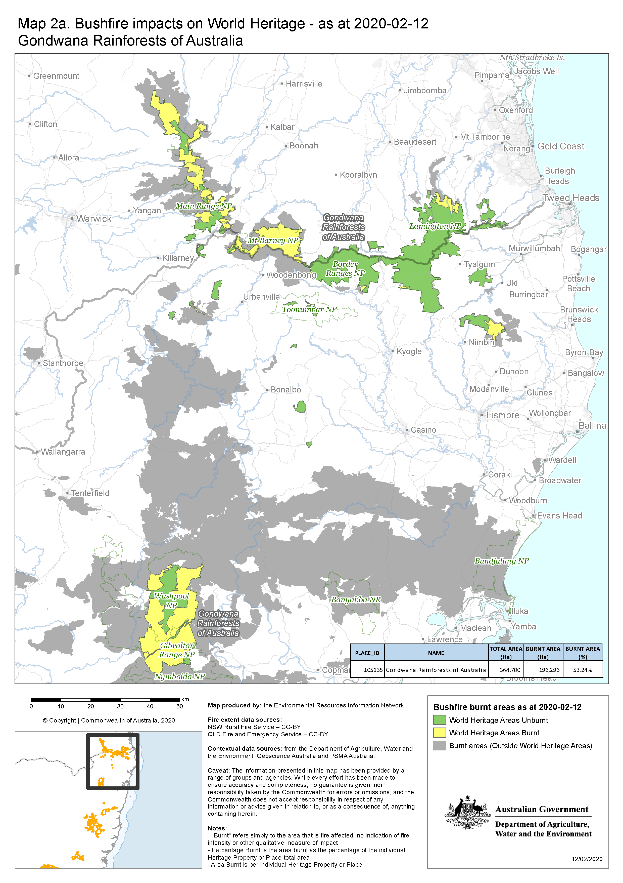

**Figure 2. Bushfire impacts in the Gondwana Rainforests – central section**

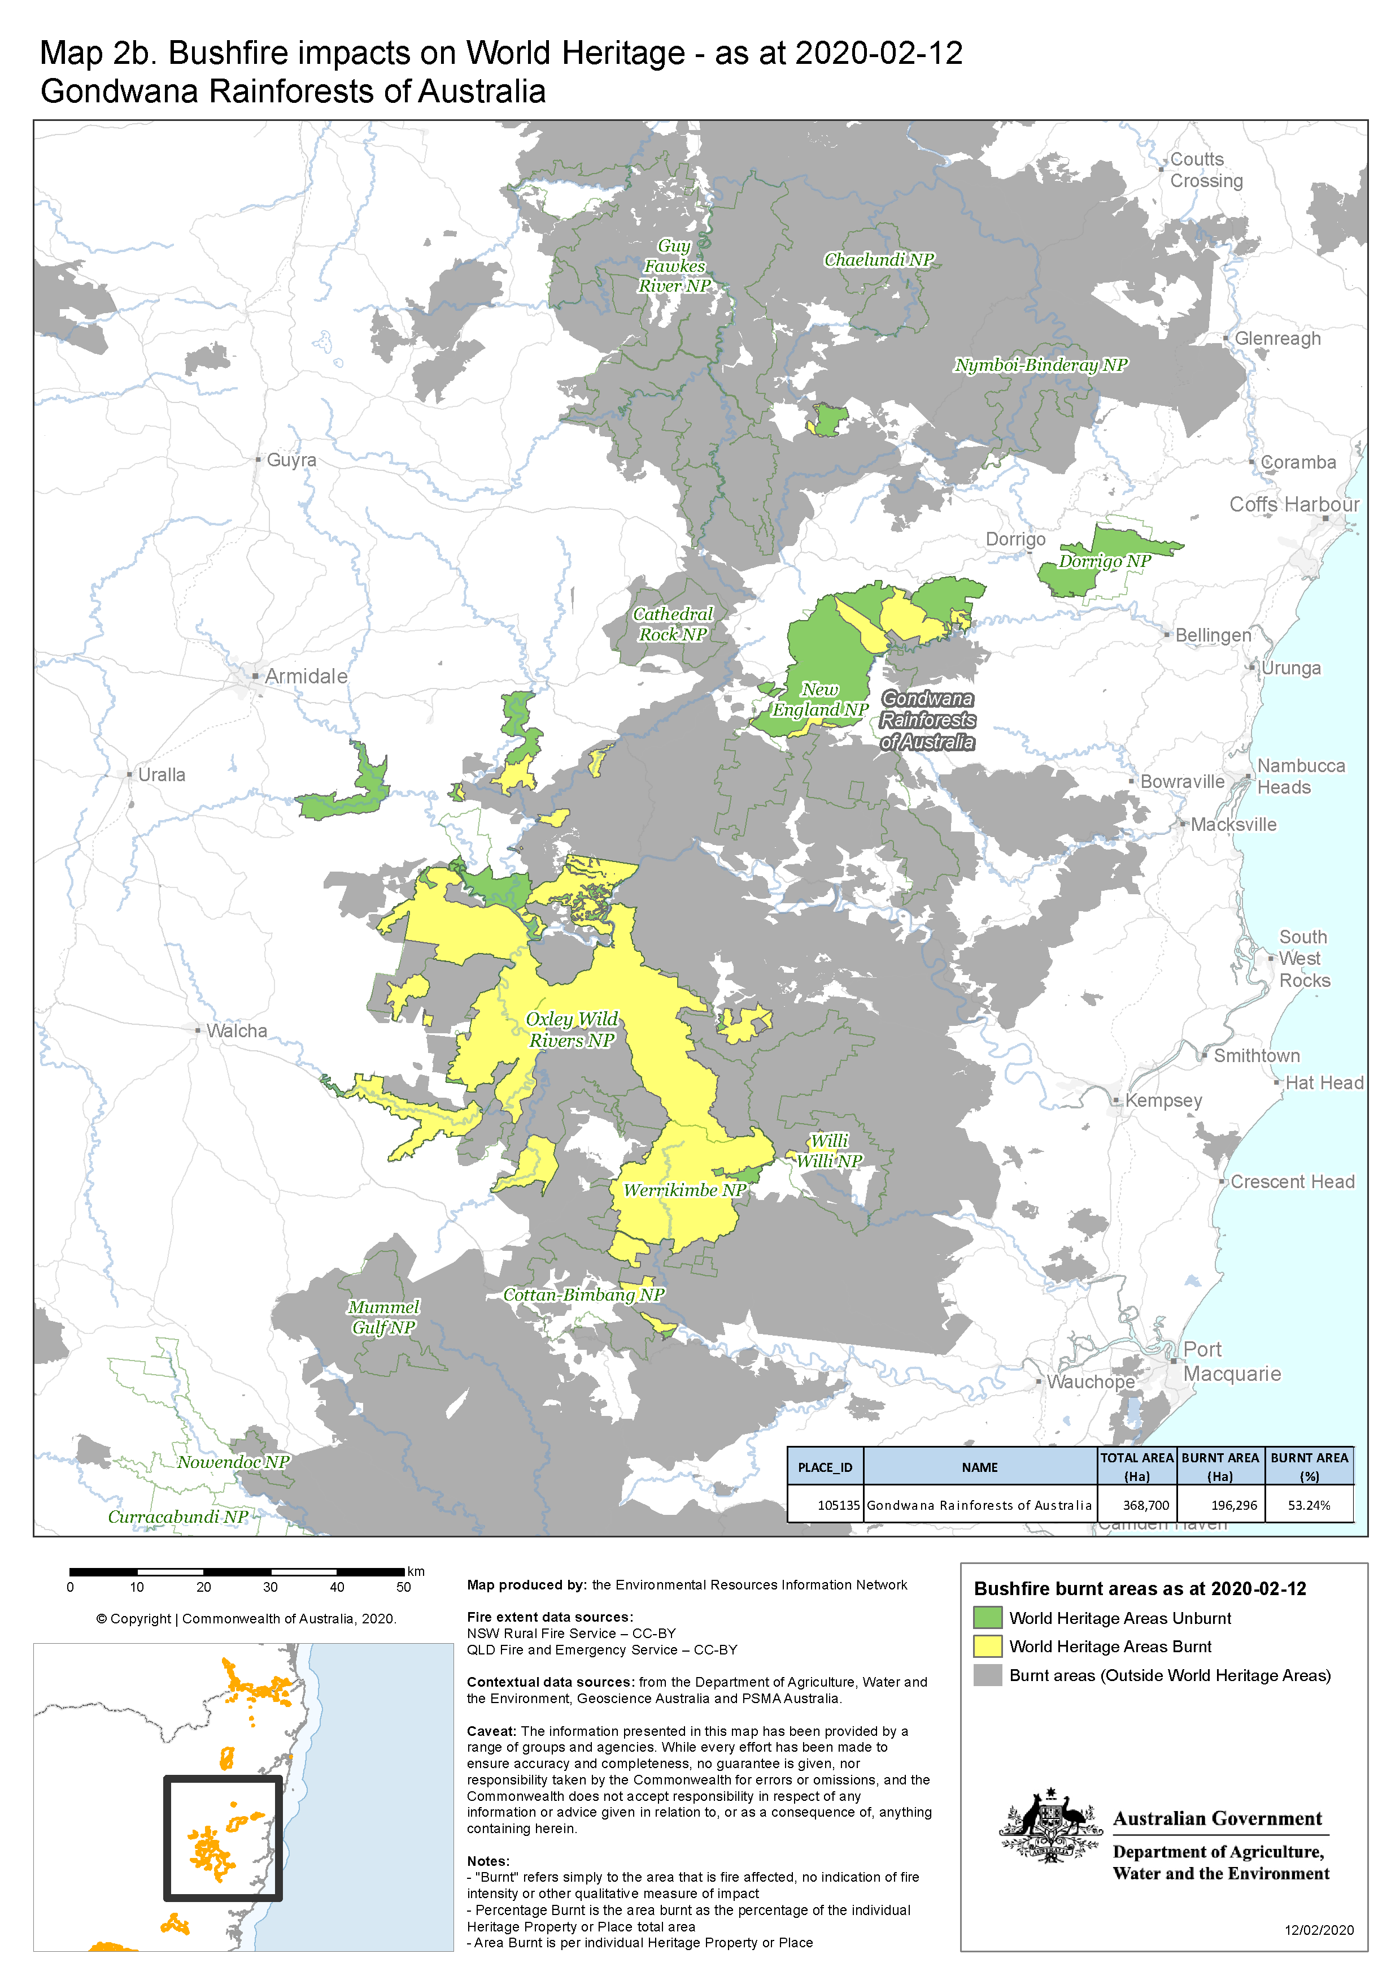

**Figure 3. Bushfire impacts in the Gondwana Rainforests – southern section (note: overlaps with central section map)**

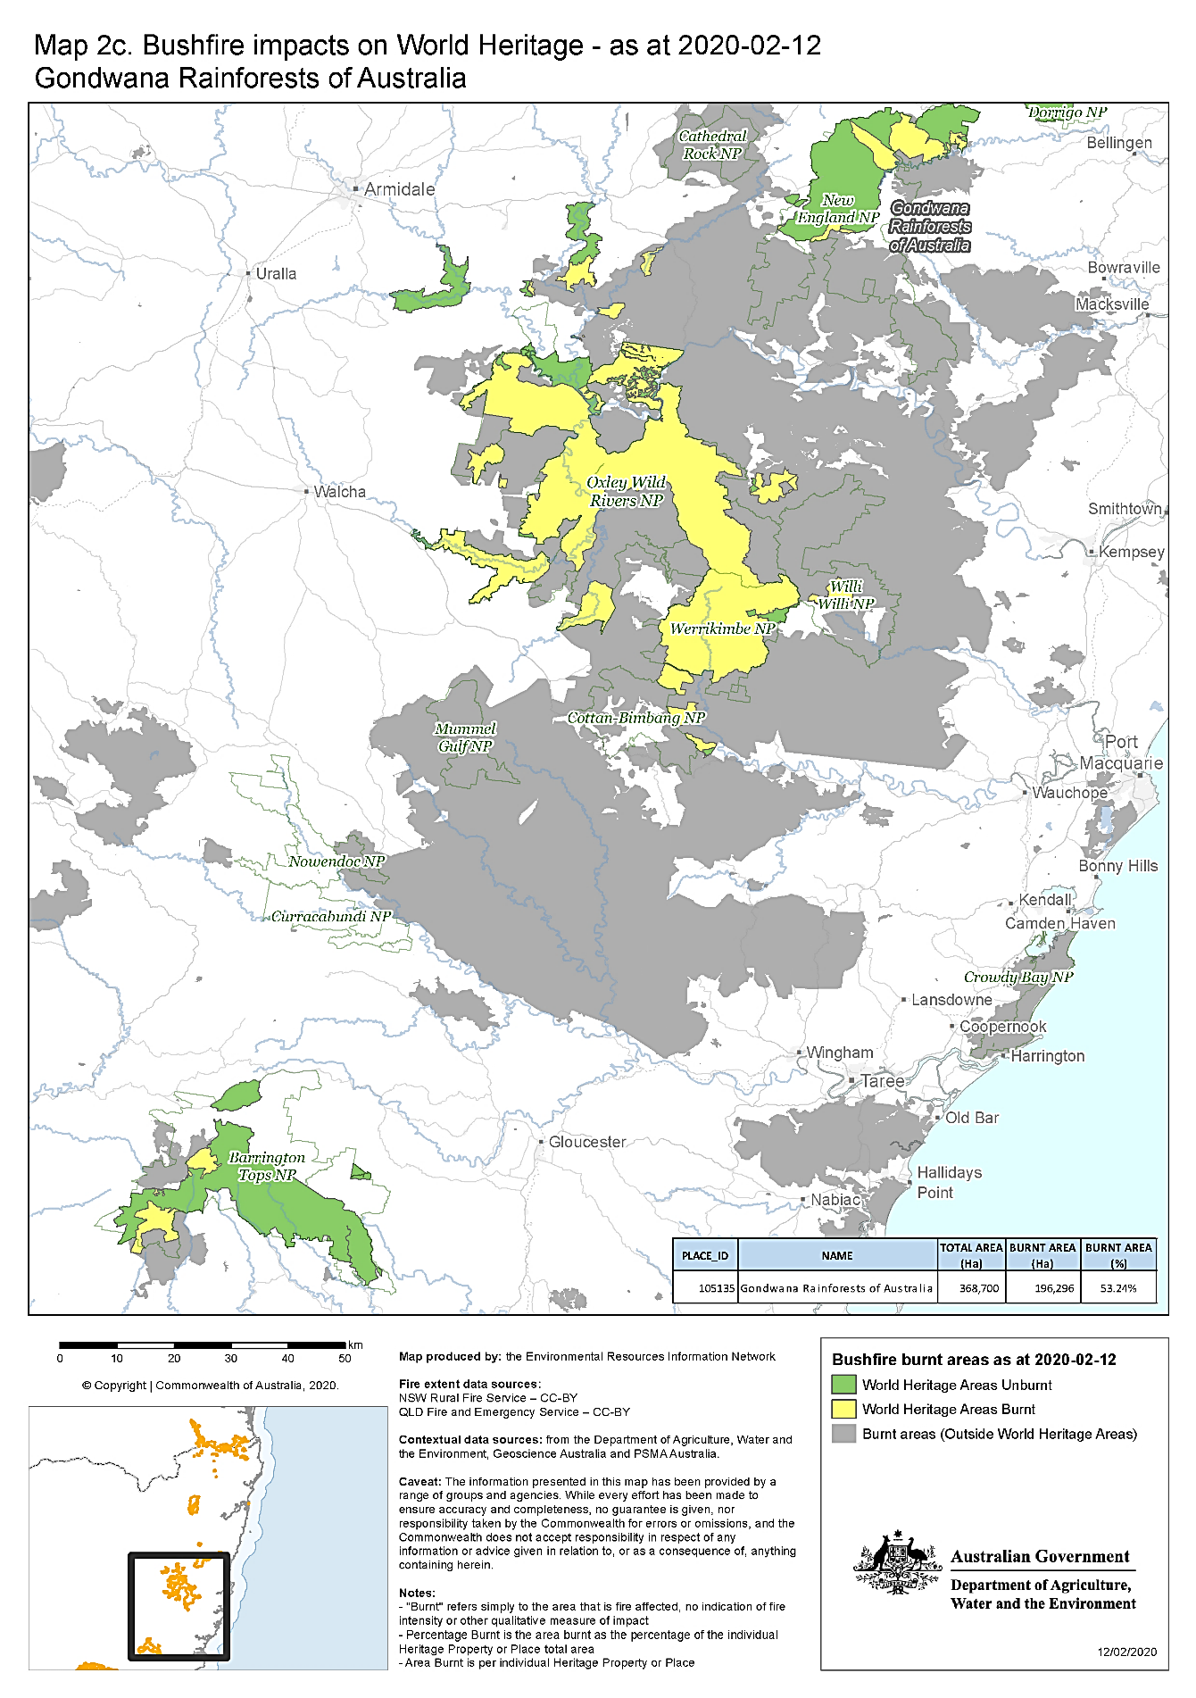

**Table 1: Estimated extent of fires in the Queensland reserves of the Gondwana Rainforests**

|  |  |  |  |
| --- | --- | --- | --- |
| **Gondwana Rainforests of Australia Reserves in Queensland** | **Area of the Gondwana Rainforests within this reserve (ha)** | **Area  affected by fire (ha)** | **Percentage of the World Heritage property that is fire-affected in this reserve** |
| **Springbrook National Park** | **2,462** | **3.2** | **0.13** |
| **Lamington National Park** | **20,636** | **2,114** | **10.2** |
| **Mount Chinghee National Park** | **1,260** | **0** | **0** |
| **Mount Barney National Park** | **11,906** | **9,292** | **78** |
| **Main Range National Park** | **22,778** | **15,637** | **68.6** |
| **Other Gondwana Rainforest reserves** | **79.4** | **19.2** | **24.2** |
| **Totals for Qld reserves** | **59,121 ha** | **27,065.4 ha** | **45.8** |

**Table 2: Estimated extent of fires in the NSW reserves of the Gondwana Rainforests**

|  |  |  |  |
| --- | --- | --- | --- |
| **Table 2: Estimated extent of fires in the NSW reserves of the Gondwana Rainforests****Gondwana Rainforests of Australia Reserves in NSW** | **Area of the Gondwana Rainforests within this reserve (ha)** | **Area  affected by fire (ha)** | **Percentage of the World Heritage area that is fire-affected in this reserve** |
| **Barrington Tops National Park** | **39,652** | **4,169** | **11** |
| **Border Ranges National Park** | **31,647** | **585** | **2** |
| **Captains Creek Nature Reserve** | **371** | **0** | **0** |
| **Cunnawarra National Park** | **262** | **0** | **0** |
| **Dorrigo National Park** | **7,961** | **0** | **0** |
| **Gibraltar Range National Park** | **17,233** | **15,588** | **90** |
| **Iluka Nature Reserve** | **136** | **0** | **0** |
| **Koreelah National Park**  **(ground truthed)** | **784** | **14** | **2** |
| **Limpinwood Nature Reserve** | **2,837** | **0** | **0** |
| **Mallanganee National Park** | **223** | **0** | **0** |
| **Mebbin National Park** | **10** | **0** | **0** |
| **Mount Clunie National Park (ground truthed)** | **491** | **109** | **22** |
| **Mount Hyland Nature Reserve** | **1,643** | **253** | **15** |
| **Mount Nothofagus National Park (ground truthed)** | **693** | **273** | **39** |
| **Mount Royal National Park** | **262** | **259** | **99** |
| **Mount Seaview Nature Reserve** | **1,764** | **1,429** | **81** |
| **New England National Park** | **32,484** | **7,458** | **23** |
| **Nightcap National Park (ground truthed)** | **4,900** | **1,481** | **30** |
| **Numinbah Nature Reserve** | **902** | **0** | **0** |
| **Oxley Wild Rivers National Park** | **98,906** | **84,120** | **85** |
| **Richmond Range National Park** | **1,038** | **0** | **0** |
| **The Castles Nature Reserve** | **2,358** | **2,156** | **91** |
| **Tooloom National Park** | **1,538** | **206** | **13** |

**Table 2 (continued): Estimated extent of fires in the NSW reserves of the Gondwana Rainforests**

|  |  |  |  |
| --- | --- | --- | --- |
| **Gondwana Rainforests of Australia Reserves in NSW** | **Area of the Gondwana Rainforests within this reserve (ha)** | **Area fire affected** | **Percentage of the World Heritage Area that is fire-affected in this reserve** |
| **Toonumbar National Park** | **1,056** | **0** | **0** |
| **Washpool National Park** | **28,091** | **20,257** | **72** |
| **Werrikimbe National Park** | **27,487** | **26,498** | **96** |
| **Willi Willi National Park** | **1,671** | **1,475** | **88** |
| **Wollumbin National Park** | **2,542** | **0** | **0** |
| **Totals for NSW reserves** | **308,942ha** | **167,287ha** | **54** |

##### Fire impacts on New South Wales reserves - overview

Longer term impacts will be known once on-ground monitoring has been completed. Existing mapping suggests many areas have not been subject to wildfire since the 1950s, so a reasonable assumption is that the 2019-2020 fire events may lead to new responses not previously documented. The combination of long-term drought (moisture deficiency) and extreme fire weather (high temperatures, strong winds, exceptionally low humidity) resulted in fire impacting on fire sensitive mesic forest types in a way not previously observed. Understanding the ecological impact of these impacts will be a focus of follow up work.

The impact of these fires in terms of both the size (of individual fires) and scale (numbers of fires across the landscape in one season) is considered an unprecedented event. While weather conditions resulted in areas being burnt at high intensity, there was a mosaic of fire intensity across the property. The detail of specific impact is still under investigation.

Large areas of Oxley Wild Rivers, Gibraltar Range and Washpool National Parks were affected by fire with preliminary desktop assessments indicated high severity across some of these areas. Further on-ground assessment is planned to identify impacts on the rainforest communities within these reserves. The drought had resulted in defoliation of trees in some of the gully rainforests within Oxley Wild Rivers National Park, increasing the ability of fire to burn through the understory.

Areas within several reserves experienced fire up to, and into, the rainforest margins, allowing remaining areas of unburnt rainforest to act as a refuge for fauna and some flora species.

The Aboriginal community have concerns regarding the impact of the bushfires on Aboriginal cultural heritage sites within the property. The NSW Government has obligations under the *National Parks and Wildlife Act 1974* for the management and protection of Aboriginal cultural heritage. The NSW National Parks and Wildlife Service also has obligations under various Indigenous Land Use Agreements (Western Bundjalung People, Githabul People and Yeagl People) across the property to protect culturally significant sites and places, and to work together with the Aboriginal community to identify and monitor the condition of those sites.

Post-fire recovery planning is underway with local Aboriginal communities to carry out surveys and conservation and management of Aboriginal cultural heritage across the NSW National Parks and Wildlife Service Gondwana estate Currently this planned work has been delayed by the COVID19 situation, and NPWS is considering other options such as using drones to carry out some initial on ground assessments.

##### The NSW National Parks and Wildlife Service will review its fire management strategies as part of the response. A key response will be to seek to manage future fire regimes to protect unburnt areas and exclude fire from recently burnt areas.

##### Fire impacts on Queensland reserves - overview

Lamington, Mount Barney and Main Range National Parks were significantly impacted by fire. More extensive and severe fires impacted Mount Barney and Main Range National Parks. An estimated 78% of forest has been impacted by fire within the World Heritage area of Mount Barney National Park and 69% of the World Heritage area of Main Range National Park. An assessment of the ecological impacts of the fires is underway for the fire impacted reserves in Queensland. Mapping of remotely sensed fire severity underpins these assessments. Fire extent mapping, as shown for Queensland reserves in Fig 1. (above), is at a high level of resolution and, as such, may include areas of unburnt vegetation, sometimes quite large in area. These unburnt patches are typically rainforest, so reliance on extent mapping may lead to an over-estimation of areas of rainforest burnt.

Lamington National Park experienced fire over 24 weeks from early September 2019 through to January 2020. Significant areas of fire sensitive subtropical and dry rainforests were burnt (see **Table 3** and **Table 4**), and the iconic Binna Burra Lodge was destroyed. Importantly none of the cooler, moister rainforest types at higher altitudes were affected.

Significant areas of fire sensitive subtropical and dry rainforests were burnt with incursions into cooler, moister upland rainforests. Some areas of warm temperate and cool temperate *Nothofagus* rainforests (elements of the property’s OUV) may have burnt. Assessments of bushfire impacts on *Araucaria cunninghamii* rainforest (another element of the property’s OUV) is underway. The bushfires may have impacted a significant extent (approximately 20% of the total area) for at least two ecological communities: complex notophyll vine forest and simple microphyll fern thicket with *Acmena smithii*. Mapping of fire severity for these parks is underway.

The estimated severity of bushfires within Lamington National Park is provided in **Table 3**. This reserve covers 21,258 hectares of which 2,233 hectares was burnt.

Note that the figures provided in **Table 3** are indicative only and are based on a preliminary analysis in December 2019.

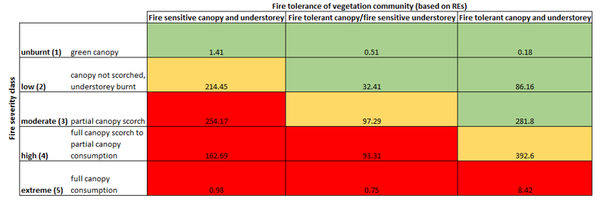**Table 3: Summary of burn severity areas (hectares) of vegetation communities in Lamington National Park, classified by fire tolerance, within the mapped wildfire extent**

*Source: Queensland Herbarium, in Hines et al. 2020 REs (Regional Ecosystems) are vegetation communities in a bioregion that are consistently associated with a particular combination of geology,* *landform and soil* <https://www.qld.gov.au/environment/plants-animals/plants/ecosystems/about>

### Assessment of ecological impacts of the fires

An assessment of the ecological impacts of the fires is underway. Results are not yet available for much of the property. Impacts on key species, listed threatened fauna and flora, and listed threatened ecological communities are of concern and discussed below.

An assessment of the extent of potential ecological impact of the fires in Lamington National Park in South East Queensland has been prepared and provides useful context. An overview of this assessment is provided in **Table 4**. This reserve covers 21,258 hectares of which 2,233 hectares was burnt. High to catastrophic ecological impact in fire sensitive vegetation is likely for an area of 417 hectares

**Table 4: Lamington National Park: area (ha) of potential ecological impact within mapped wildfire extent**

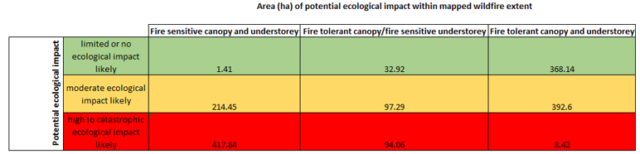

*Source:* *Queensland Herbarium, Draft Post-fire Assessment Report – Natural Values: 2019 wildfire, Lamington National Park, South East Queensland Region Version: 17 Jan 2020*

#### Variability of fire impact

Ecological impacts are related to the severity of the fires, which has been variable across the property. Although significant areas of the Gondwana Rainforests reserves were affected, the intensity of fire within the burnt areas varies greatly.

Some rainforest within the property has been fully affected, other areas remain unburnt (see post-fire assement photographs – **Figures 4 -7** ,below. These areas of rainforests exist within a mosaic of flammable *Eucalyptus* forest types. Extensive areas of eucalypt forest were burnt. Whilst many of these ecosystems are fire-adapted, fire impacts varied greatly from fairly low impact to canopy consumption. This means that impact to components of these forests may be significant.

Fire severity within the NSW components of the Gondwana Rainforests is summarised in **Table 5** and mapped at **Figure 8**. Estimates of bushfire severity on this scale are not yet available for all of the Queensland sections of the property.

Areas within these property that remain unburnt (for example, see **Fig 4** Mt Koreelah National Park and **Fig 5** ‘Rum jungle’ rainforest patch in Mt Barney National Park) provide critical refugia for native species and will play a significant role in the recolonisation and recovery of burnt areas.They will also play a role in tracking the recovery of burnt stands.

**Figure 4.** **Koreelah National Park (NSW):**The rainforest is largely intact with some small sections of the dry rainforest community showing lower intensity impact. Wet sclerophyll vegetation shows burning with low to moderate intensity.

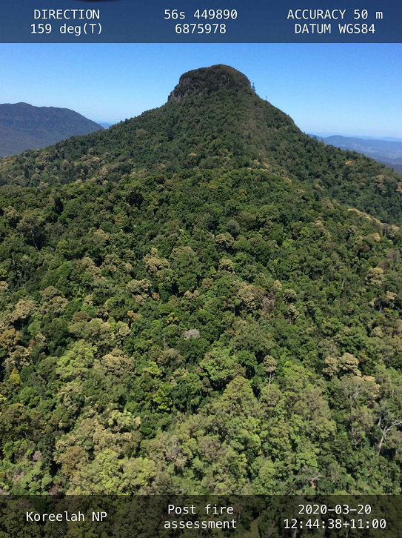

Photo credit: Matt Wiseman NSW NPWS

**Figure 5.** **Unburnt ‘Rum jungle’ rainforest patch in Mt Barney National Park (Qld)** (in the saddle between the east and west peaks). The vegetation surrounding this rainforest patch is tolerant montane heath and eucalypt communities.

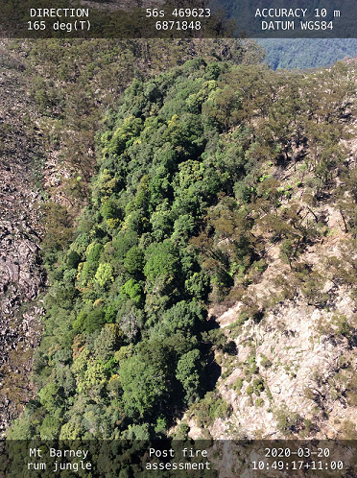

Photo credit: Matt Wiseman NSW NPWS

**Figure 6. Mt Nothofagus National Park(NSW):** Minimal canopy scorch in moister vegetation communities, with crown fires confined to steep dry sclerophyll ridges and heaths on rocky outcrops.

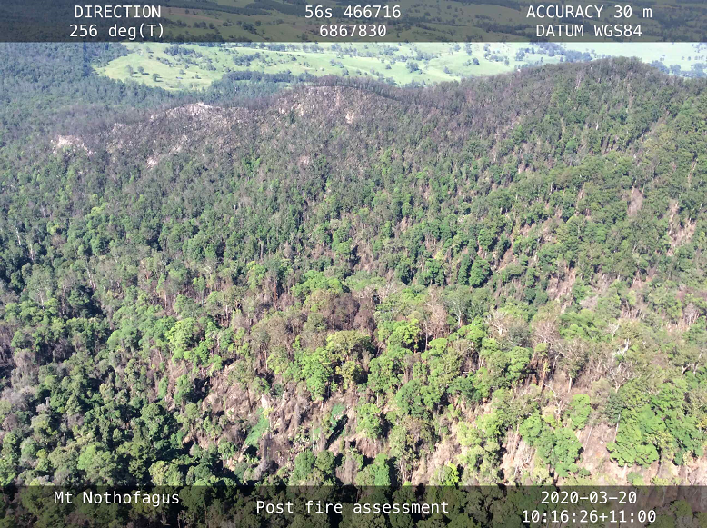

Photo credit: Matt Wiseman NSW NPWS

**Figure 7. Southern side of Mt Lindsay, Border Ranges National** Park (Qld): Subtropical rainforest impacted by fire running up though the wet sclerophyll vegetation and into the steep slopes. The fire has burnt through leaf litter, mid-storey vegetation and some sections of forest canopy.

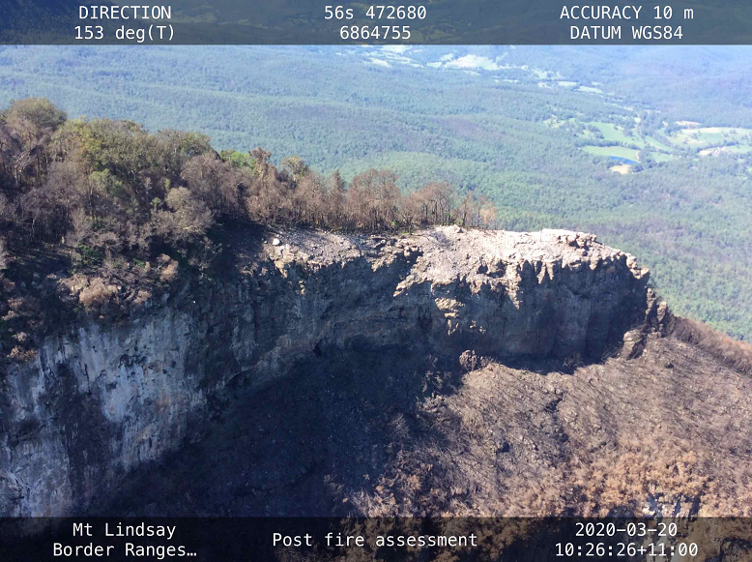

Photo credit: Matt Wiseman NSW NPWS

**Table 5:** **Fire severity within the NSW components of the Gondwana Rainforests**

|  |  |  |
| --- | --- | --- |
| **GEEBAM* Burnt Area Classes** | **ha burnt area (WHA)** | **% of burnt area (WHA)** |
| Not yet assessed | 1,165 | 0.7 |
| Little change | 18,921 | 11.3 |
| Canopy unburnt | 53,105 | 31.7 |
| Canopy partially affected | 68,498 | 40.9 |
| Canopy fully affected | 25,609 | 15.3 |
| Total | 167,298 | 100.00 |

* GEEBAM = Google Earth Engine Burnt Area Mapping accessible through the [Sharing and Enabling Environmental Data (SEED)](https://www.seed.nsw.gov.au/)[2] portal by searching for “GEEBAM”. (**Note**: GEEBAM is an interim desktop product and ground truthing to assess accuracy have yet to be undertaken across all of the reserves. Fire Extent and Severity Mapping (FESM) is the next desktop product under development which will also require ground-truthing to improve models. Based on ground-truthing in some of the affected parks, it appears that GEEBAM has also identified canopy which is brown due to drought stress as being fire affected, when it is not. Therefore it could be overestimating the extent of burnt areas.

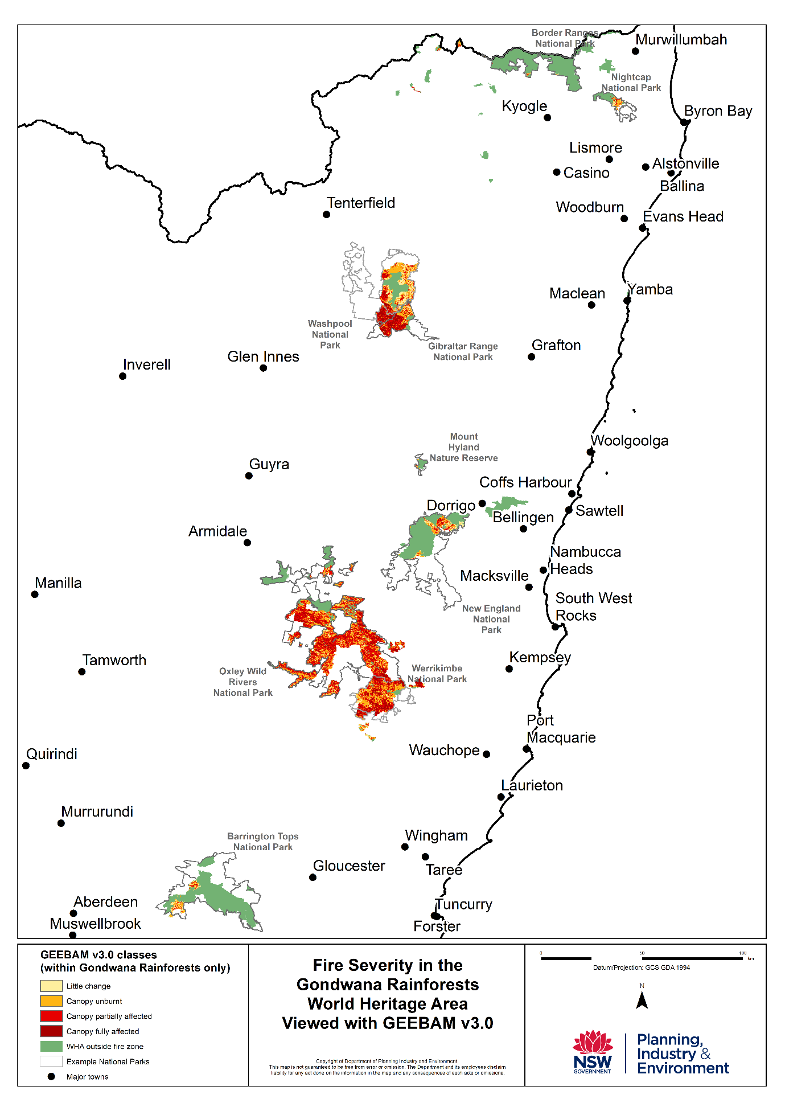**Figure 8. Map of fire severity (available for NSW only).**

Note this product has been developed using satellite imagery which may be affected by shadows and bright surfaces. (see GEEBAM note, **Table 5**)

#### Identifying key species affected

The Australian Government has conducted preliminary mapping of several species of conservation significance in the Gondwana Rainforests – Hastings River mouse *Pseudomys oralis*, Gondwana rainforest crayfish *Euastacus sulcatus*, Nightcap oak *Eidothea hardeniana* and Antarctic beech *Nothofagus moorei*.

This mapping indicates where species may have been directly affected by fire, as well as areas that may have escaped the fires. Further investigation of the severity and impact of fire on these species, and other key species will build on this preliminary mapping. This information will be essential in directing management and recovery operations. For example, preliminary mapping of the relict species *Euastacus sulcatus* (blue spiny crayfish) indicates that it may have been significantly impacted in the Mt Barney National Park (where it occurs widely) and Nightcap National Park, but less so in Lamington National Park.

On 11 February 2020, the Australian Government released a provisional list of 113 animal species that have been identified by experts as the highest priorities for urgent management intervention over the weeks and months following the 2019-20 bushfires in southern and eastern Australia. Most of these animals have potentially had at least 30% of their range burnt, and many have had substantially more (<https://www.environment.gov.au/biodiversity/bushfire-recovery/research-and-resources>). Species on this list which comprise attributes of the OUV of the Gondwana Rainforests include: rufous scrub bird (*Atrichornis rufescens*)*,* eastern bristlebird (*Dasyornis brachypterus*), Albert’s lyrebird (*Menura alberti*)*,* parma wallaby (*Notomacropus parma*) and Hastings River mouse (*Pseudomys oralis*), nine frog species in the genera *Philoria, Litoria,* and *Mixophyes*, and thirteen crayfish species in the genus *Euastacus*.

Preliminary information indicates there may have been widespread impacts on some attributes of OUV, particularly fauna dependant on rainforest in NSW. The brush-tailed rock-wallaby is likely to be badly affected as more than 80 per cent of all previous sightings of this animal had occurred within fire-affected areas (NSW DPIE, 2020), including key sites within the World Heritage property. NSW National Parks and Wildlife Service has dropped thousands of kilograms of supplementary food to more than a dozen colonies of brush-tailed rock-wallabies, including in Oxley Wild Rivers National Park.

Species monitoring will be included in general surveys to assess fire impacts on and post-fire recovery of priority fauna. This monitoring will be used to determine species recovery including the effectiveness of post-fire predator control program. Preliminary information is available for some of the property’s iconic and threatened species. Indicative examples are provided below.

##### Threatened fauna species

A rapid analysis of impacts of the 2019-20 fires on the listed Endangered Hastings River mouse (*Pseudomys oralis*), identified the species as a priority mammal for urgent management action. An initial desktop analysis by the NSW Department of Planning, Industry and Environment (2020) indicates 82 per cent of NSW records for the species occur within fire affected areas. Some of these sites are within the Gondwana Rainforests, noting that areas of habitat within the property form part of larger connected areas of habitat and populations.

The NSW listed Vulnerable Parma wallaby (*Notamacropus parma*) is a macropod species with a very restricted range. Approximately 75 per cent of records and priority management areas within the NSW components of the Gondwana Rainforests (the majority of the species’ range) have been affected by fire. Many impacted areas have had high intensity fire likely to have burnt refuge areas. Predation is likely to be a factor in survival.

The Gondwana Rainforests reserves within the Tweed Caldera comprise the core of the distribution and population of the NSW listed Vulnerable Albert’s lyrebird (*Menura alberti*). This species mainly occurs in the wettest rainforest or wet sclerophyll forests, with an understory of rainforest plants. Patches of this habitat within Nightcap National Park were affected by fire. There are anecdotal reports of surviving individuals, but the medium and longer-term sustainability of this population is not known. There may be increased predation in burnt areas, which would also hinder recovery. Post-fire monitoring by BirdLife Australia is planned. Large areas of habitat of this species also occur within the mapped fire extents for Lamington, Mt Barney and Main Range National Parks in Queensland.

The northern subspecies of the listed endangered rufous scrub-bird (*Atrichornis rufescens)* may have been affected at Gibraltar Range National Park. The habitat for the southern subspecies appears affected for the Werrikimbe-Carrai population and in southern New England National Park. There are unburnt refugia for both subspecies: for the northern subspecies in the Border Ranges-Lamington area and, for the southern subspecies, in the Gloucester Tops, Werrikimbe and central New England areas. The overall extent of impact is unknown at this stage pending on-ground assessment.

Habitat for the northern population of the listed Endangered eastern bristlebird (*Dasyornis brachypterus*) within NSW was not burnt (70 per cent of the habitat for this species occurs on private land). Prescribed burning and weed control programs, aimed at supporting this species through improving its habitat, are continuing across private land and within Border Ranges National Park. In Queensland, habitat for this species within Main Range National Park was severely affected by fire. Impact assessment and recovery actions are underway to support the persistence of this species including an enhanced captive breeding program.

There are several research projects underway that will examine the impact of the fires on some of the iconic frog species of the Gondwana Rainforests. The species involved include the high-altitude, NSW-listed Vulnerable hip-pocket frog (*Assa darlingtoni*). The habitat of this speciesincludes logs, rocks, and leaf litter in rainforests and wet sclerophyll forests, so individuals may have found refuge in situations of low to moderate fire activity. The species hasbeen detected in burnt areas however, the intensity of fires in some areas has meant that normally safe refugia may have been impacted. Post-fire assessment of iconic stream-dwelling frogs, including the listed Vulnerable *Mixophyes balbus,* andthe listed Endangered *M. fleayii* and *M. iteratus,* are also being undertaken. In NSW, these projects are being undertaken with university partners under the NSW *Saving our Species* program.

##### Threatened plant species

Preliminary data indicates that the majority of stands of Antarctic beech (*Nothofagus moorei)* across the World Heritage property were unburnt. Burnt stands that have been inspected show a small proportion of trees affected, with re-sprouting from rootstock and canopy. Much of the property still remains inaccessible for safety reasons.

The critically endangered Nightcap oak (*Eidothea hardeniana)*, a species representative of Gondwanan lineages, is monitored to individual level under the NSW *Saving our Species* program. Most of the population lies outside the Gondwana Rainforests property. Pre-fire and immediate post-fire data has been collected on number, survival and demography. An immediate estimate of fire impact on habitat suggested that the impact on the species would be high. Subsequent monitoring of individuals in the *Saving our Species* management site estimated 36 of 253 individuals were directly impacted by fire. Monitoring will continue to investigate survival, recovery and fire thresholds. Emergency ex-situ collection of germplasm has been undertaken.

The Nightcap Oak, and other Gondwana Rainforest species, require further collection, genetic investigation and local propagation. This will support their conservation by maintaining genetically representative insurance populations available for population augmentation.

#### Threatened ecological communities[3]

On 19 February 2020, the Australian Government released an initial list of threatened ecological communities which have more than 10% of their estimated distribution in areas affected by bushfires in southern and eastern Australia between 1 July 2019 and 11 February 2020.

This analysis compares maps of fire extent provided by state fire agencies with maps of the estimated distributions of ecological communities protected under the *Environment Protection and Biodiversity Conservation Act 1999*. The maps of estimated distributions of ecological communities include areas where vegetation mapping identifies vegetation that most closely resembles the description of the ecological communities.

The Lowland Rainforest of Subtropical Australia Threatened Ecological Community (in north-eastern NSW and South East Queensland) has been identified as among the highest priority for detailed impact assessment in the property.

The Littoral Rainforest and Coastal Vine Thickets of Eastern Australia (east coast of Queensland, NSW and Victoria) has also been identified as a priority Threatened Ecological Community. The Iluka Nature Reserve, the largest remaining patch of this Threatened Ecological Community, was not affected by the 2019-2020 bushfires.

These results are indicative only and are the first step in understanding the potential impacts of the 2019-20 fires. On-ground assessments and expert advice will be needed to understand the short and long-term impacts and to help guide priorities for recovery. The Australian Government is working with the Queensland and NSW governments and scientific experts to improve the mapping and determine the likely response of these ecological communities and the individual species within them to the fires. Importantly, this process will identify critical knowledge gaps and will help guide decisions about emergency interventions to support the short, and medium term, survival of affected animals, plants and ecological communities.

### Intersection with other conservation issues

#### Future of Gondwana Rainforests under climate change

Climate change has been identified as the key threat to this World Heritage property (CSIRO, 2019).

Climate projections for the broader Gondwana Rainforests region include:

* increased average temperatures in all seasons (*very high confidence*).
* more hot days and warm spells with a substantial increase in the temperature reached on hot days, the frequency of hot days, and the duration of warm spells (*very high confidence*).
* a possible modest decrease in rainfall that is strongest in winter and modest increase in summer rainfall in the northern part of the region – but there is low confidence in these projections due to a very large spread of increases to decreases across climate models.
* increased severity of extreme rainfall events
* higher surface solar radiation (i.e. decreased overall cloud cover)
* decreased relative humidity (although modest in winter)
* higher evapotranspiration.

Even small climatic changes are predicted to change the distribution patterns of many endemic species and vegetation communities. High altitude species and vegetation communities with limited thermal and moisture tolerances will be particularly susceptible Climate change impacts could be expected to increase under the climate projections described above.

The property’s “cloud forests” may be particularly vulnerable as cloud cover decreases and species move upslope in response to a changing climate. The subtropical rainforests within the property are amongst the most extensive and biodiverse in the world. Increasing climate variability is predicted to lead to increasing moisture stress within these forests. Research suggests that high elevation cloud forest communities are reliant on moisture from low level clouds, particularly during the dry season. Changes in the composition of tree species assemblages have been identified from low to mid elevations, with more limited change at high elevations likely driven by cloud water inputs (Laidlaw et al., 2011). A research project is underway to improve understanding of rainfall, evaporation and lifting condensation level projections for the Gondwana Rainforests. This will in turn enhance species and community level modelling and projections of future habitat and conservation requirements under a changing climate. The incorporation of this information into risk assessments will support strategic adaptation planning and management for the Gondwana Rainforests and other protected areas.

Climate change is also predicted to exacerbate other threatening processes such as invasive species and pathogens, as well as fire regimes. While interactions between climate change and fire regimes are complex, it is expected that the fire season will become more severe and longer in duration across the Gondwana Rainforests.

A project is in development that will build understanding in relation to projected changes in habitats and species range, as a result of climatic changes. The project will include a specific risk assessment for the OUV of this World Heritage property (including iconic and indicator species). Projected vegetation transitions will be identified, and a future climate change adaptation strategy will outline management responses to support the protection and conservation of the OUV of the Gondwana Rainforests into the future.

#### Weeds and feral animals

The fires have resulted in large areas of reduced canopy cover, bare soil and increased soil nutrients, creating optimal conditions for weed growth. While many of the ecosystems impacted are resilient to a degree of natural disturbance, recovery of ecosystem structure, composition and function can all be disrupted by competition from fast-growing invasive weeds such as lantana (*Lantana camara*), introduced grasses and smothering vines. The increased biomass contributed by weeds can also impact the extent and intensity of future fires. Priorities include the suppression of lantana and other high biomass weeds until canopy cover increases and understory vegetation regrows to facilitate the recovery of disturbed ecosystems and increase ecosystem resilience to further disturbances, including fire.

Broadscale pest animal control has commenced across the NSW national park estate, along prioritised areas in Queensland, to reduce competition and predation of recovering native species. This involves widespread aerial shooting of feral deer, pigs and goats in burnt areas and unburnt refuge areas, extensive aerial baiting for foxes and wild dogs in burnt areas and unburnt refuge areas, and ground-based shooting, trapping and baiting of feral predators (dogs, cats and foxes) and feral herbivores (deer, pigs, goats and rabbits) in key refuge areas and important sites for remaining populations of threatened species.

#### Pathogens

The loss of ground cover vegetation and shrubs leads to greater surface and subsurface run-off in post-fire rain events which may exacerbate the spread of soil-borne pathogens such as Phytophthora (*Phytophthora cinnamomi*). The risk of Phytophthoraspread can also be increased by direct movement of large quantities of soil during treefall and boulders rolling downhill after severe burns. A significant pathogen risk in all wildfires is the cross-landscape movement of firefighting plant and equipment, which can pick up and transport pathogens across large distances. Considerable effort was expended to try and minimise the movement of Phytophthoraduring the fires in Barrington Tops National Park where this pathogen is well established.

The myrtle rust pathogen (*Austropucinia psidii*), first detected in Australia in 2010, has now naturalised in moister habitats along most of the east coast of Australia. Myrtle rust is capable of infecting more than 370 Australian native plants of the family Myrtaceae with at least 45 highly susceptible species known or suspected to be in serious decline as a result of this pathogen (Makinson, 2018a, 2018b; Carnegie et al. 2016; Pegg et al. 2017; Pegg et al. 2018).

Following the 2019-2020 bushfires, ideal myrtle rust conditions have occurred with warm wet weather and large areas of regrowth vegetation within the Gondwana Rainforests.

Myrtle rust disease is a novel threat that has the capability to significantly alter the dynamics of post-fire regeneration (Pegg et al. 2017; Pegg et al. 2018) and to change the eventual floristic composition of regenerating sites and plant communities in the 2019-20 fire zone, in which the Myrtaceae family dominates or plays a significant ecological role..

The extreme decline of *Archirhodomyrtus beckleri* and *Gossia hillii* in the subtropical rainforest of northern NSW and south-east Queensland (Pegg et al. 2017) is of concern. In some areas these species play a key ecological role in supporting regeneration of rainforest, where they are co-dominant in closing the canopy and creating the shade and moisture conditions for other rainforest species to establish and grow. It is not clear which other species may fill this role, and how rainforest regeneration dynamics may be affected.

## Bushfire response

### *Immediate response*

In response to Australia’s bushfires, on 13 January 2020 the Australian Government announced an initial $50 million investment to support immediate work to protect wildlife and habitat recovery, and the planning of longer-term protection and restoration efforts. This immediate response is targeted at all bushfire impacted areas, including World Heritage areas such as the Gondwana Rainforests.

Of this, $25 million is being used to establish an emergency intervention fund to assist the immediate survival of affected animals and plants.

The remaining $25 million is being made available to support wildlife rescue, zoos, and conservation groups with on the ground activities.

This includes:

* Up to $7 million for Natural Resource Management groups in bushfire affected areas to carry out emergency interventions including control of feral predators, other pest animals and weeds, and habitat protection measures (such as fencing and nest boxes).
* Up to $7.5 million to support on-ground wildlife rescue, protection and care services.
* Up to $5 million for Greening Australia to increase supply of seed and native plants for revegetation.
* $1 million each for Taronga Zoo, Zoos Victoria and Zoos South Australia for emergency wildlife support to establishment of insurance populations of at-risk native animal species. This is in addition to the $3 million supporting Queensland Koala Hospitals and the $3 million for Koala habitat restoration in northern NSW and south-east Queensland.
* Up to $2.5 million for Conservation Volunteers Australia to mobilise volunteers through a national coordination point.

A panel of experts, led by Australia’s Threatened Species Commissioner, is advising the Australian Government on further critical interventions required and developing a strategy to build back up animal and plant populations ensuring their resilience into the future.

The NSW Government has released the document *Wildlife and Conservation Bushfire Recovery: Immediate Response[4],* which sets out the immediate actions being undertaken to support native wildlife recovery.

Immediate specific interventions which have already started in the NSW components of the Gondwana Rainforests reserves including feral animal control, weed management and targeted supplementary feeding of brush-tailed rock-wallabies. The collection of seeds and plant cuttings from endangered rainforest plants and other high-risk habitats for nursery propagation, care and habitat restoration is also occurring in NSW Government agencies, community volunteers, research institutions and non-government organisations are all working to deliver immediate relief in key locations. The Queensland Government is supporting greater coordination of active restoration projects as well as provision of technical advice on rainforest recovery. A post-fire recovery project is in development to support the recovery and resilience of threatened species within the Queensland section of the Gondwana Rainforests.

Initial post-fire ecological assessment to better understand the extent and severity of fire impacts on the property has begun.

### *Longer term recovery*

Rainforests are highly fire-sensitive ecosystems and can be significantly impacted even at very low fire severity. Active management will be required in some impacted areas to prevent ecosystem degradation from weeds, pests and further fire. Active management will also be needed to facilitate rainforest and species recovery including some replanting in small, accessible priority areas.

NSW has developed a desktop inventory of fire impacts on threatened animals and plants. From this base, priority species and habitats are being identified for further assessment, including on-ground surveys. On-ground surveys for wildlife using remote cameras will be extended to monitor and support long-term recovery.

Information and data continue to be collected to inform longer-term recovery actions and will build on the actions identified in the immediate response plan. Further mapping and analysis to identify biodiversity impacts is planned as well as a range of conservation actions to address impacts.

An assessment to identify priority threatened species likely impacted by bushfires in the Queensland section of the Border Ranges component of the Gondwana Rainforests (Main Range, Mt Barney and Lamington National Parks has been undertaken. Initial funding has been provided for detailed on‑ground assessments of impacts to thirteen threatened fauna species and over twenty threatened flora species. This will inform recovery planning and targeted immediate recovery actions.

The threatened species identified in the Queensland section as priorities through expert elicitation are:

* **Threatened Fauna**: Eastern bristlebird, Rufous scrub-bird, Coxen's fig-parrot, Albert's lyrebird, Glossy black cockatoo, Brush-tailed rock-wallaby, New Holland mouse, Hastings River mouse, Cascade treefrog, Fleay's barred frog, Red-and-yellow mountain frog, Spotted-tailed quoll and Long-nosed potoroo.
* **Threatened Flora**: *Zieria montana, Bertya ernestiana, Tetramolopium vagans, Agiortia cicatricata, Euphrasia bella, Pimelea umbratica, Dendrobium schneiderae var. schneiderae, Leionema elatius subsp. beckleri, Pultenaea whiteana, Pseudanthus pauciflorus subsp. pauciflorus, Bulbophyllum weinthalii subsp. weinthalii, Leptospermum barneyense, Sarcochilus hartmannii, Hibbertia monticola, Brachyscome ascendens, Coopernookia scabridiuscula, Comesperma breviflorum, Muellerina myrtifolia, Sarcochilus weinthalii, Phlegmariurus varius, Gonocarpus hirtus* and *Clematis fawcettii*.
* **Threatened and at-risk invertebrates** (to be identified by Queensland Museum).

### *Future fire management*

In the Australian system of government, Royal Commissions are the highest form of inquiry on matters of public importance. The Royal Commission into National Natural Disaster Arrangements was established on 20 February 2020, in response to Australia’s extreme bushfire season. The Commission will examine coordination, preparedness for, response to and recovery from disasters as well as improving resilience and adapting to changing climatic conditions and mitigating the impact of natural disasters. The inquiry will also consider the legal framework for Australian Government involvement in responding to national emergencies. The Commission will receive submissions from individuals, organisations, community groups and the broader community to assist the Commission in its work.

Other Australian World Heritage properties have experienced significant fires in recent years and responses to these are providing valuable planning and operational insights. In the Tasmanian Wilderness World Heritage, for example, the fire response to the 2018-19 fires included strategies adopted since fires in that property in 2016. These included the deployment of initial attack crews and establishment of sprinkler lines to protect high conservation value vegetation.

At the national level, a workshop is planned for August 2020 to focus on ‘lessons learned’ from the 2019-20 bushfire season. The workshop will be an opportunity to evaluate the effectiveness of fire management strategies used in the Greater Blue Mountains and Gondwana Rainforests of Australia World Heritage Areas in the 2019-20 season.

This will include a review of successful innovative techniques such as the saving of the stand of Wollemi Pines in the Greater Blue Mountains Area and the taking of emergency cuttings from oaks, myrtles and minyon quandongs ahead of the blazes that impacted the Gondwana Rainforests to create an "insurance" population at a specialist nursery, and the operational response to bushfires, including specific firefighting techniques, used at other World Heritage properties in previous years.

Outcomes of the 2016 *Tasmanian Wilderness World Heritage Area Bushfire and Climate Change Research Project* will be shared at the workshop, including technical advice on the deployment of initial attack crews and establishment of sprinkler lines to protect high conservation value vegetation during the 2018-19 fires in the Tasmanian Wilderness World Heritage, adopted following the fires in that property in 2016.

## References

Analysis of 2019/2020 bushfire impacts on conservation values in Queensland, Version: 31/1/2020. Prepared by: Biodiversity Assessment Team, Queensland Herbarium, Science and Technology Division, Department of Environment and Science

Carnegie AJ et al. (2016) Impact of the invasive rust *Puccinia psidii* (myrtle rust) on native Myrtaceae in natural ecosystems in Australia. Biological Invasions 18: 127–144. doi 10.1007/s10530-015-0996-y

CSIRO, 2019, Climate change impacts on the Gondwana Rainforests of Australia, Earth systems and Climate change Hub Report Summary - http://nespclimate.com.au/wp-content/uploads/2019/03/A4-2p-workshop-summary-gondwana-web.pdf

NSW Department of Planning, Industry and Environment (DPIE) 2020, ‘Wildlife and Conservation Bushfire Recovery: Immediate Response’ available from <https://www.environment.nsw.gov.au/topics/parks-reserves-and-protected-areas/fire/park-recovery-and-rehabilitation/recovering-from-2019-20-fires>.

Hines HB, Laidlaw, MJ, Olyott, L, Buch, W. 2020. DRAFT Post-fire Assessment Report – Natural Values: 2019 wildfire, Lamington National Park, South East Queensland Region. Brisbane: Department of Environment and Science, Queensland Government.

Hunter, R.J 2004 World Heritage and Associative Natural Values of the Central Eastern Rainforest Reserves of Australia, NSW National Parks and Wildlife Service <https://www.environment.nsw.gov.au/-/media/OEH/Corporate-Site/Documents/Parks-reserves-and-protected-areas/Types-of-protected-areas/world-heritage-associative-natural-values-central-eastern-rainforest-reserves-of-Australia.pdf>

Department of Environment and Science, Threatened Species Operations (2020) Initial analysis of the impacts of bushfires (August – December 2019) on threatened species in southern Queensland: Department of Environment and Science, Queensland Government.

Laidlaw MJ, McDonald WJF, Hunter RJ, Putland DA and Kitching RL (2011), The potential impacts of climate change on Australian subtropical rainforest. Australian Journal of Botany, 59, 440–449.

Makinson RO (2018a) Myrtle Rust reviewed: the impacts of the invasive pathogen *Austropuccinia psidii* on the Australian environment. Plant Biosecurity CRC, Canberra. <https://www.anpc.asn.au/myrtle-rust>

Makinson RO (2018b) Myrtle Rust in Australia – a draft Action Plan, presented at the Plant Biosecurity Cooperative Research Centre’s National Science Exchange, Melbourne, 31 May 2018. <https://www.anpc.asn.au/myrtle-rust>

NSW Government 2020, ‘Wildlife and Conservation Bushfire Recovery: Immediate Response’ available from <https://www.environment.nsw.gov.au/topics/parks-reserves-and-protected-areas/fire/park-recovery-and-rehabilitation/recovering-from-2019-20-fires>. It sets the NSW Government’s immediate actions to support native wildlife recovery.

Pegg et al. (2017) Impact of *Austropuccinia psidii* (myrtle rust) on Myrtaceae-rich wet sclerophyll forests in south east Queensland. PLoS ONE 12(11): e0188058. <https://doi.org/10.1371/journal.pone.0188058>

Pegg et al. (2018) Final Report – Managing myrtle rust in Australia. CRC2063. Plant Biosecurity Cooperative Research Centre, Bruce ACT. [www.pbcrc.com.au/publications/pbcrc2206](http://www.pbcrc.com.au/publications/pbcrc2206)

Technical Services 2019. Preliminary burnt area assessment: Queensland section of Gondwana World Heritage Area, 2019 wildfires. Brisbane: Department of Environment and Science, Queensland Government: 11 Dec 2019

## Appendix A: 368bis Gondwana Rainforests of Australia - Statement of Outstanding Universal Value

**Brief synthesis**

The Gondwana Rainforests of Australia is a serial property comprising the major remaining areas of rainforest in southeast Queensland and northeast New South Wales. It represents outstanding examples of major stages of the Earth’s evolutionary history, ongoing geological and biological processes, and exceptional biological diversity. A wide range of plant and animal lineages and communities with ancient origins in Gondwana, many of which are restricted largely or entirely to the Gondwana Rainforests, survive in this collection of reserves. The Gondwana Rainforests also provides the principal habitat for many threatened species of plants and animals.

***Criterion (viii) to be outstanding examples representing major stages of earth's history, including the record of life, significant on-going geological processes in the development of landforms, or significant geomorphic or physiographic features:***

The Gondwana Rainforests provides outstanding examples of significant ongoing geological processes. When Australia separated from Antarctica following the breakup of Gondwana, new continental margins developed. The margin which formed along Australia’s eastern edge is characterised by an asymmetrical marginal swell that runs parallel to the coastline, the erosion of which has resulted in the Great Divide and the Great Escarpment. This eastern continental margin experienced volcanicity during the Cenozoic Era as the Australian continental plate moved over one of the planet’s hot spots. Volcanoes erupted in sequence along the east coast resulting in the Tweed, Focal Peak, Ebor and Barrington volcanic shields. This sequence of volcanos is significant as it enables the dating of the geomorphic evolution of eastern Australia through the study of the interaction of these volcanic remnants with the eastern highlands.

The Tweed Shield erosion caldera is possibly the best preserved erosion caldera in the world, notable for its size and age, for the presence of a prominent central mountain mass (Wollumbin/Mt Warning), and for the erosion of the caldera floor to basement rock. All three stages relating to the erosion of shield volcanoes (the planeze, residual and skeletal stages) are readily distinguishable. Further south, the remnants of the Ebor Volcano also provides an outstanding example of the ongoing erosion of a shield volcano.

***Criterion (ix) to be outstanding examples representing significant on-going ecological and biological processes in the evolution and development of terrestrial, fresh water, coastal and marine ecosystems and communities of plants and animals:***

The Gondwana Rainforests contains outstanding examples of major stages in the Earth’s evolutionary history as well as ongoing evolutionary processes. Major stages represented include the ‘Age of the Pteridophytes’ from the Carboniferous Period with some of the oldest elements of the world’s ferns represented, and the ‘Age of Conifers’ in the Jurassic Period with one of the most significant centres of survival for Araucarians (the most ancient and phylogenetically primitive of the world’s conifers). Likewise the property provides an outstanding record of the ‘Age of the Angiosperms’. This includes a secondary centre of endemism for primitive flowering plants originating in the Early Cretaceous, the most diverse assemblage of relict angiosperm taxa representing the primary radiation of dicotyledons in the mid-Late Cretaceous, a unique record of the evolutionary history of Australian rainforests representing the ‘golden age’ of the Early Tertiary, and a unique record of Miocene vegetation that was the antecedent of modern temperate rainforests in Australia. The property also contains an outstanding number of songbird species, including lyrebirds (Menuridae), scrub-birds (Atrichornithidae), treecreepers (Climacteridae) and bowerbirds and catbirds (Ptilonorhynchidae), belonging to some of the oldest lineages of passerines that evolved in the Late Cretaceous. Outstanding examples of other relict vertebrate and invertebrate fauna from ancient lineages linked to the break-up of Gondwana also occur in the property.

The flora and fauna of the Gondwana Rainforests provides outstanding examples of ongoing evolution including plant and animal taxa which show evidence of relatively recent evolution. The rainforests have been described as ‘an archipelago of refugia, a series of distinctive habitats that characterise a temporary endpoint in climatic and geomorphological evolution’. The distances between these ‘islands’ of rainforest represent barriers to the flow of genetic material for those taxa which have low dispersal ability, and this pressure has created the potential for continued speciation.

***Criterion (x) to contain the most important and significant natural habitats for in-situ conservation of biological diversity, including those containing threatened species of outstanding universal value from the point of view of science or conservation:***

The ecosystems of the Gondwana Rainforests contain significant and important natural habitats for species of conservation significance, particularly those associated with the rainforests which once covered much of the continent of Australia and are now restricted to archipelagos of small areas of rainforest isolated by sclerophyll vegetation and cleared land. The Gondwana Rainforests provides the principal habitat for many species of plants and animals of outstanding universal value, including more than 270 threatened species as well as relict and primitive taxa.

Rainforests covered most of Australia for much of the 40 million years after its separation from Gondwana. However, these rainforests contracted as climatic conditions changed and the continent drifted northwards. By the time of European settlement rainforests covered only 1% of the landmass and were restricted to refugia with suitable climatic conditions and protection from fire. Following European settlement, clearing for agriculture saw further loss of rainforests and only a quarter of the rainforest present in Australia at the time of European settlement remains.

The Gondwana Rainforests protects the largest and best stands of rainforest habitat remaining in this region. Many of the rare and threatened flora and fauna species are rainforest specialists, and their vulnerability to extinction is due to a variety of factors including the rarity of their rainforest habitat. The Gondwana Rainforests also protects large areas of other vegetation including a diverse range of heaths, rocky outcrop communities, forests and woodlands. These communities have a high diversity of plants and animals that add greatly to the value of the Gondwana Rainforests as habitat for rare, threatened and endemic species. The complex dynamics between rainforests and tall open forest particularly demonstrates the close evolutionary and ecological links between these communities.

Species continue to be discovered in the property including the re-discovery of two mammal species previously thought to have been extinct: the Hastings River Mouse (*Pseudomys oralis*) and Parma Wallaby (*Macropus parma*).

**Statement of integrity**

The Gondwana Rainforests contains the largest and most significant remaining stands of subtropical rainforest and Antarctic Beech *Nothofagus moorei* cool temperate rainforests in the world, the largest and most significant areas of warm temperate rainforest and one of only two remaining large areas of Araucarian rainforest in Australia.

Questions related to the small size of some of the component parts of the property, and the distance between the sites for the long-term conservation and continuation of natural biological processes of the values for which the property was inscribed have been raised. However, noting that the serial sites are in reasonable proximity and are joined by corridors of semi-natural habitats and buffers, compensation for small size and scattered fragments is being made through intensive management consistent with approved management plans and policy.

Since inscription, there have been significant additions to the protected area estate in both New South Wales and Queensland in the region encompassing the Gondwana Rainforests. These areas have undergone a rigorous assessment to determine their suitability for inclusion in the property and a significant extension of the property is planned as indicated by the addition of the property extension to Australia’s Tentative List in May 2010. In relation to ongoing evolution, the level of legislative protection provided for World Heritage properties will minimise direct human influence and enable the continuation of natural biological processes.

**Requirements for protection and management**

Institutional arrangements for the protection and management of Gondwana Rainforests are strong. The property is made up of 41 reserves, almost all of which are within the protected area estate, and primarily managed by the Queensland Parks and Wildlife Service and the New South Wales National Parks and Wildlife Service. Both States have legislation relating to protected areas and native flora and fauna that provide protection for the values of the Gondwana Rainforests.

In 1993, Governments agreed to establish a Coordinating Committee, comprised of on-ground managers from these agencies and the Australian Government, to facilitate the cooperative management of the property at an operational level. A Technical and Scientific Advisory Committee and a Community Advisory Committee have also assisted with management advice since their establishment in 2002.

In 1994 when the property was extended, the World Heritage Committee requested the Australian authorities to complete the management plans of individual sites, particularly those within Queensland. Management plans have been produced for the majority of individual reserves within the property, and are in draft form or planned for the remainder.

In 2000 a Strategic Overview for Management for the Central Eastern Rainforest Reserves of Australia (now Gondwana Rainforests) World Heritage Area was published. This overarching document is a major element in guiding cooperative management by the three Governments in relation to the identification, protection, conservation, rehabilitation and presentation of the Gondwana Rainforests.

All World Heritage properties in Australia are ‘matters of national environmental significance’ protected and managed under national legislation, the Environment Protection and Biodiversity Conservation Act 1999. This Act is the statutory instrument for implementing Australia’s obligations under a number of multilateral environmental agreements including the World Heritage Convention. By law, any action that has, will have or is likely to have a significant impact on the World Heritage values of a World Heritage property must be referred to the responsible Minister for consideration. Substantial penalties apply for taking such an action without approval. Once a heritage place is listed, the Act provides for the preparation of management plans which set out the significant heritage aspects of the place and how the values of the site will be managed.

Importantly, this Act also aims to protect matters of national environmental significance, such as World Heritage properties, from impacts even if they originate outside the property or if the values of the property are mobile (as in fauna). It thus forms an additional layer of protection designed to protect values of World Heritage properties from external impacts.

On 15 May 2007, the Gondwana Rainforests of Australia was added to the National Heritage List; National Heritage is also a matter of national environmental significance under the EPBC Act.

The impacts of climate change and high levels of visitation, undertaking effective fire management, and mitigating the effects of invasion by pest species and pathogens present the greatest challenges for the protection and management of Gondwana Rainforests. Climate change will impact particularly on those relict species in restricted habitats at higher altitudes, where particular microclimatic conditions have enabled these species to survive. Management responses include improving the resilience of the property by addressing other threats such as inappropriate fire regimes and invasion by pest species, and trying to increase habitat connectivity across the landscape.

1. The best source of up to date burnt area mapping is available at https://www.emsina.org/australianbushfires”
2. <https://www.seed.nsw.gov.au/>
3. A Threatened Ecological Community (TEC) is a naturally occurring group of native plants, animals and other organisms that are interacting in a unique habitat and in danger of being lost due to some threatening process. Three categories exist for listing TECs under Australia’s *Environment Protection and Biodiversity Conservation Act 1999*: critically endangered, endangered and vulnerable.
4. at <https://www.environment.nsw.gov.au/topics/parks-reserves-and-protected-areas/fire/park-recovery-and-rehabilitation/recovering-from-2019-20-fires>