
-



Commonwealth Environmental Water Office
Long Term Intervention Monitoring Project
Goulburn River Selected Area
Scientific Report 2018–19

Angus Webb, Danlu Guo, Simon Treadwell, Ben Baker, Simon Casanelia, Michael Grace, Joe Greet, Claudette Kellar, Wayne Koster, Daniel Lovell, Daniel McMahon, Kay Morris, Jackie Myers, Vin Pettigrove, Geoff Vietz
December 2019
Final Report
October 2019

Area evaluation report

UoM Commercial

Commonwealth Environmental Water Office Long Term Intervention Monitoring Project Goulburn River Selected Area: Scientific Report 2018–19
Project no: | UoMC 2014-235
Document title: | Commonwealth Environmental Water Office Long Term Intervention Monitoring Project Goulburn River Selected Area: Scientific Report 2018–19
Revision: | Final Report
Date: | December 2019
Client name: | Commonwealth Department of the Environment and Energy
Project manager: | Angus Webb
Authors: | Angus Webb, Danlu Guo, Simon Treadwell, Ben Baker, Simon Casanelia, Michael Grace, Joe Greet, Claudette Kellar, Wayne Koster, Daniel Lovell, Daniel McMahon, Kay Morris, Jackie Myers, Vin Pettigrove, Geoff Vietz
File name: | 2018-19 Goulburn LTIM Scientific Report FINAL
University of Melbourne Commercial Ltd
442 Auburn Road
Hawthorn VIC, 3122
T + 61 3 8344 9347
ABN 53081 182 685

Document history and status
Revision | Date | Description | By | Review | Approved
Draft 1 | 7 October | First Draft | Project Team | Angus Webb, Simon Treadwell | Angus Webb
FINAL | 10 December | Second Draft -addressing CEWO and Basin Team comments – approved by CEWO | Project Team | Angus Webb, Simon Treadwell | CEWO

Acknowledgment: The Commonwealth Environmental Water Office acknowledges the efforts of all consortium partners in delivering the Goulburn Long-Term Intervention Monitoring project and preparing this report.

The authors of this report as well as the Commonwealth Environmental Water Office respectfully acknowledge the traditional owners, their Elders past and present, their Nations of the Murray-Darling Basin, and their cultural, social, environmental, spiritual and economic connection to their lands and waters; in particular the Taungurung Clans and Yorta Yorta Nation, traditional owners of the Goulburn River catchment

Copyright: © Copyright Commonwealth of Australia, 2019
This document is licensed by the Commonwealth of Australia for use under a Creative Commons By Attribution 3.0 Australia licence with the exception of the Coat of Arms of the Commonwealth of Australia, the logo of the agency responsible for publishing the report, content supplied by third parties, and any images depicting people. For licence conditions see: http://creativecommons.org/licenses/by/3.0/au/
Citation: This report should be attributed as:
Title: Commonwealth Environmental Water Office Long Term Intervention Monitoring Project Goulburn River Selected Area: Scientific Report 2018-19. Report prepared for the Commonwealth Environmental Water Office
Date: December, 2019
Source: Licensed from the Commonwealth Environmental Water Office, under a Creative Commons Attribution 3.0 Australia License
Authors: Angus Webb, Danlu Guo, Simon Treadwell, Ben Baker, Simon Casanelia, Michael Grace, Joe Greet, Claudette Kellar, Wayne Koster, Daniel Lovell, Daniel McMahon, Kay Morris, Jackie Myers, Vin Pettigrove, Geoff Vietz
Publisher: Commonwealth of Australia
The Commonwealth of Australia has made all reasonable efforts to identify content supplied by third parties using the following format ‘© Copyright, [name of third party]’.
Disclaimer: The views and opinions expressed in this publication are those of the authors and do not necessarily reflect those of the Australian Government or the Minister for the Environment.
While reasonable efforts have been made to ensure that the contents of this publication are factually correct, the Commonwealth does not accept responsibility for the accuracy or completeness of the contents, and shall not be liable for any loss or damage that may be occasioned directly or indirectly through the use of, or reliance on, the contents of this publication.
Funding: This monitoring project was commissioned and funded by the Commonwealth Environmental Water Office, with additional investment from the Victorian Department of Environment, Land, Water and Planning, and the Victorian Environmental Water Holder.











Table of Contents
1. Preamble 1
2. Monitoring sites and 2018–19 monitoring 2
2.1 Sites 2
2.2 Monitoring in 2018-19 3
3. Physical habitat 4
3.1 Introduction 4
3.2 Area specific evaluation questions 4
3.3 Main findings from the physical habitat monitoring program 6
3.3.1 Hydraulic habitat findings from the program 6
3.3.2 Bank condition findings from 2018–19 reinforce previous findings 7
3.3.3 The main findings from monitoring in 2018-19 can be summarised as: 7
3.4 Physical Habitat Sites 8
3.5 Hydraulic habitat 8
3.5.1 Hydraulic habitat model development 8
3.5.2 Elevation data verification 9
3.5.3 Mesh Setup, Boundary Conditions and Roughness 11
3.5.4 Calibration 12
3.5.5 Hydraulic model outputs 15
3.5.6 Results Hydraulic Habitat 16
3.6 Bank condition 23
3.6.1 Bank Condition Methods 23
3.6.2 Hydrologic variables and statistical analysis 24
3.6.3 Bank Condition and Flows Statistical Model 25
3.7 Results Bank Condition 26
3.7.1 Bank activity and the effect of season 26
3.7.2 Flow impacts on bank activity 28
3.7.3 Counterfactual effects without Eflow 31
3.8 Discussion 31
3.9 Winter Monitoring: Sediment and seed deposition using artificial turf mats 34
3.9.1 Context for the assessment of sediment and seeds 34
3.9.2 Methods 34
3.9.3 Results 35
3.9.4 Conclusions from winter monitoring 41
4. Stream Metabolism 43
4.1 Introduction 43
4.2 Area specific evaluation questions 44
4.3 Main findings from the stream metabolism monitoring program 45
4.4 Methods 46
4.4.1 Derived Stream Metabolism Metrics 47
4.4.2 Flow ‘Categories’ 48
4.4.3 Statistical Modelling 49
4.5 Results 50
4.5.1 Water Temperature and Dissolved Oxygen 51
4.5.2 Metabolic Parameters 52
4.5.3 Investigating the Basal Drivers for Metabolism 62
4.5.4 Statistical Modelling 66
4.5.5 Organic Carbon Loads and Flow Categories 68
4.5.6 The Contribution of CEW to Organic Carbon Production in the Goulburn River 73
4.6 Discussion 78
4.6.1 Impact of Daily Discharge on Stream Metabolism 78
5. Macroinvertebrates 80
5.1 Introduction 80
5.2 Area specific evaluation questions 80
5.3 Main findings from the macroinvertebrate monitoring program 81
5.3.1 Findings from 2018-19 81
5.3.2 How these build on findings from years 1 to 4 83
5.4 Methods 84
5.4.1 Macroinvertebrate field and laboratory methods 84
5.4.2 Algal biofilm methods 84
5.4.3 Statistical analysis 87
5.5 Results 88
5.5.1 Artificial substrates (macroinvertebrates) 88
5.5.2 Replicated Edge Sweep Samples (RESS) 92
5.5.3 Additional crustacean surveys: bait traps 99
5.5.4 Additional crustacean surveys: RESS 103
5.5.5 Winter Crustacean Monitoring 109
5.5.6 Algal Biofilms 114
5.6 Discussion 121
5.6.1 Macroinvertebrates 121
5.6.2 Algal Biofilms 124
6. Vegetation Diversity 126
6.1 Introduction 126
6.2 Area specific evaluation questions 126
6.3 Main findings from the vegetation monitoring program 127
6.3.1 Findings from 2018-19 127
6.3.2 How these build on findings from years 1 to 4 127
6.4 Methods 128
6.4.1 Sampling 128
6.4.2 Analyses 131
6.5 Results 133
6.5.1 Relevant flow components delivered to the lower Goulburn River in 2017–18 133
6.5.2 Vegetation trajectories and flow 2018-19 133
6.5.3 Changes in patterns of species distribution along the elevation gradient 138
6.5.4 Modelled responses of vegetation to hydrologic variables 140
6.6 Discussion 143
6.7 Recommendations: data analysis, monitoring and research 144
7. Fish 145
7.1 Introduction 145
7.1.1 Annual fish surveys 145
7.1.2 Larval fish surveys 145
7.1.3 Fish movement 146
7.2 Area specific evaluation questions 146
7.3 Main findings from the fish monitoring program 148
7.3.1 Findings from 2018-19 148
7.3.2 How these build on findings from years 1 to 4 149
7.4 Methods 149
7.4.1 Field methods 149
7.4.2 Statistical analysis 150
7.5 Results 152
7.5.1 Annual surveys (electrofishing and netting) 152
7.5.2 Golden perch and Murray cod otolith chemistry 157
7.5.3 Surveys of eggs and larvae (drift nets) 164
7.5.4 Movement of golden perch 172
7.6 Discussion 176
7.6.1 Annual surveys 176
7.6.2 Recruitment of golden perch and Murray cod 176
7.6.3 Spawning of golden perch and silver perch 177
7.6.4 Movement of golden perch 177
8. Stakeholder communications 179
8.1 Media Releases and Articles 179
8.2 Technical publications 179
8.3 Social Media 179
8.4 Videos 179
8.5 Presentations 180
8.6 Examples of media 181
9. References cited 187

Table of Figures
Figure 3-1. Instruments used to collect field data for development and verification of the hydraulic model: (left) Sonar bathymetric survey boat, (right) Acoustic Doppler Current Profiler (tethered to a rope to obtain velocities across fixed cross sections). 10
Figure 3-2. Topography used to develop the hydraulic model for Moss Rd based on LiDAR and bathymetric survey. The main channel (represented here in green) has the path of the bathymetric survey overlain in black to demonstrate coverage. This includes some verification runs of the boat into the backwater section (already covered by LiDAR). 11
Figure 3-3. Example of computational mesh resolution and setup for Moss Road. Greater detail (higher resolution) is provided within the channel to capture small-scale hydraulic variation on the bed of the channel and for lower velocities. 11
Figure 3-4. Roughness zones for Moss Road 12
Figure 3-5. Calibration results (velocity comparison) for Moss Road low flow event (12/06/15) 13
Figure 3-6. Calibration results (velocity difference) for Moss Road low flow event (12/06/15) 14
Figure 3-7. Calibration results (velocity comparison) for Moss Road high flow event (25/06/15) 14
Figure 3-8. Calibration results (velocity difference) for Moss Road high flow event (25/06/15) 15
Figure 3-9. Velocity results for McCoys Bridge at a high flow of 15,000 ML/day. 16
Figure 3-10. Results (wetted area and area of pools) for McCoys Bridge. 19
Figure 3-11. Results (area of slackwater habitat) for McCoys Bridge. 19
Figure 3-12. Results (mean patch size of slackwater habitat) for McCoys Bridge 20
Figure 3-13. Results (mean velocity) for Moss Road 20
Figure 3-14. Results for maximum velocity (purple solid) and high velocity (crosses) relative to discharge for McCoys Bridge 21
Figure 3-15. Results (velocity rate of change with flow) for Moss Road 21
Figure 3-16. Maximum velocity at vegetation transects for McCoys Bridge 22
Figure 3-17. Bed mobilisation. Area of bed sediment mobilised for gravels (crosses) and medium-grained sands (blue solid) at McCoys Bridge. 22
Figure 3-18. The area of bench inundation for McCoys Bridge. 23
Figure 3-19. (left) Colour coded erosion pins inserted at each transect to indicate location/elevation on the river bank and measured by digital callipers, and (right) field placement. 24
Figure 3-20. Proportion of deposition, no change, erosion and significant erosion in measurements with the full five-year results, by season (hot: summer/autumn, cold: winter/spring) and site. Sample sizes are: 1012, 995, 901 and 997 for Darcy’s Track, Loch Garry, McCoys Bridge and Yambuna, respectively. Standard deviations of probabilities of individual activities at a site during a season (across five years) are labelled. 26
Figure 3-21. Proportion of deposition, no change, erosion and significant erosion in measurements for each of the past five years, by season (hot: summer/autumn, cold: winter/spring) and site. 27
Figure 3-22. Average erosion (red) and deposition (brown) for a) Darcy’s Track and b) McCoys Bridge relative to flow events for the period 2015 to 2019. Bars are time of collection and represent river bank activity in the preceding period. 28
Figure 3-23. Probability of erosion of (a) > 30 mm, (b) > 0 mm, and (c) deposition < 0 mm (c), with increases in the duration of inundation. For each erosion level, results are shown four for sites (Darcy’s Track, Loch Garry, McCoys Bridge and Yambuna) in individual panels. The solid line is the median probability of erosion with the dotted lines encompassing the 95% credible interval for the estimate. Red and blue lines show the flow effects for warm season and cold season, respectively. 29
Figure 3-24. Without environmental flows: Effect of the environmental flow component on the probability of (a) significant erosion (> 30 mm), (b), erosion (> 0 mm), and (c) deposition (< 0 mm), at each erosion pin, relative to bank elevation (m). Red and blue dots show simulations for the warm and cold seasons, respectively. 31
Figure 3-25. Drying of clay-rich sediments, and prolonged flows, can lead to significant recession of the lower bank. Yambuna bridge site during erosion pin assessment post-IVT, June 2019. 32
Figure 3-26. Example of mass failure slumping of the upper bank once the lower bank support is removed. McCoys Bridge May 2019, from Drone. Notching at approximately 2,500 ML/d (lower bank beneath vegetation) and slumping of the upper bank evident, despite vegetation. 33
Figure 3-27. A schematic of the potential mechanisms of erosion following consistently high summer and autumn flows and erosion of lower banks, and mass failure of vegetated upper banks (from Vietz IVT impacts report). 33
Figure 3-28. a) Sediment mats on low-level bars prior to inundation, b) mat collection following inundation, c) seedling growth in the nursery following collection, and d) sediment analysis. 34
Figure 3-29. Comparison of flow effects by site (top row) and geomorphic feature (bottom row). 36
Figure 3-30. Simulated median total seed abundance against peak height over sampling point, by bank feature (bank, bar, bench and ledge, in rows) and different retrieval events (with different levels of tributary contribution as labelled, in columns). 37
Figure 3-31. Simulated median total seed abundance against number of days inundated, by bank feature (bank, bar, bench and ledge, in rows) and different retrieval events (with different levels of tributary contribution as labelled, in columns). 38
Figure 3-32. Simulated median sediment mass against peak height over sampling point, by bank feature (bank, bar, bench and ledge, in rows) and different retrieval events (with different levels of tributary contribution as labelled, in columns). 39
Figure 3-33. Simulated median sediment mass against days inundated, by bank feature (bank, bar, bench and ledge, in rows) and different retrieval events (with different levels of tributary contribution as labelled, in columns). 40
Figure 3-34. Sediment deposition and seed numbers and species for each of the four events and three geomorphic features (ledge removed for clarity). Results are considered for each event relative to the number of days the event occurred for. 40
Figure 4-1. Relationships between photosynthesis, respiration, organic matter, dissolved gases and nutrients. 43
Figure 4-2. Flow stages according to Stewardson and Guarino (2018). 48
Figure 4-3. Mean Daily Water Temperature and Dissolved Oxygen Concentration for the four study sites 2018-19. 51
Figure 4-4. Stream Metabolism-Flow Relationships for McCoys Bridge (Zone 2) from July 2018 to June 2019: a) Gross Primary Production and Ecosystem Respiration; b) P / R ratio. 54
Figure 4-5. Stream Metabolism-Flow Relationships for Loch Garry (Zone 2) from July 2018 to June 2019: a) Gross Primary Production and Ecosystem Respiration; b) P / R ratio. 55
Figure 4-6. Stream Metabolism-Flow Relationships for Darcy’s Track (Zone 1) from July 2018 to June 2019: a) Gross Primary Production and Ecosystem Respiration; b) P / R ratio. 56
Figure 4-7. Stream Metabolism-Flow Relationships for Day Road (Zone 1) from July 2018 to June 2019: a) Gross Primary Production and Ecosystem Respiration; b) P / R ratio. 57
Figure 4-8. Box plot showing daily GPP for all five years of LTIM data, stratified by site and season. Summary statistics are presented in Table 4-7. 61
Figure 4-9. Box plot showing daily ER for all five years of LTIM data, stratified by site and season. Summary statistics are presented in Table 4-7. 62
Figure 4-10. The Relationship between Daily Gross Primary Production and Average Daily Water Temperature at the McCoys Bridge site, October 2014 to June 2019 (n = 1027). 63
Figure 4-11. The Relationship between Daily Gross Primary Production and Total Daily Light (PAR) at the McCoys Bridge site, October 2014 to June 2019 (n = 1027). 64
Figure 4-12. Effects of Environmental Flows (including watering actions) on rates of GPP and ER. Y-axes show the difference in corresponding rate between with and without Commonwealth environmental water (labelled as ‘Eflow’), which are presented in the number of standard deviations to the mean log rate. The error bars represent the 75% confidence intervals, summed for each site. 68
Figure 4-13. Box plot showing the Daily Organic Carbon Load (Tonnes/Day) created by GPP for all five years of LTIM data, stratified by site and flow category: VL = Very Low Flow, ML = Moderately Low Flow and LF = Low Fresh Flow. Summary statistics are presented in Table 4-13. 70
Figure 4-14. Box plot showing the Daily Organic Carbon Load (Tonnes/Day) consumed by ER for all five years of LTIM data, stratified by site and flow category: VL = Very Low Flow, ML = Moderately Low Flow and LF = Low Fresh Flow. Summary statistics are presented Table 4-14. 71
Figure 4-15. Box plot showing the Daily Organic Carbon Load (Tonnes/Day) produced by GPP for all five years of LTIM data at the McCoys Bridge site, stratified by season and flow category: VL = Very Low Flow, ML = Moderately Low Flow and LF = Low Fresh Flow. Summary statistics are presented in Table 4-15. 72
Figure 4-16. Estimated daily loads of organic carbon created by GPP at McCoys Bridge showing the total load and the load without the contribution of CEW. The visible orange section of each bar represents the contribution of CEW. This plot only shows data days when the model output met acceptance criteria. 75
Figure 4-17. Estimated daily loads of organic carbon created by GPP at McCoys Bridge showing the total load and the load without the contribution of CEW. The visible orange section of each bar represents the contribution of CEW. This plot estimates loads for every day over the period of record – October 2014 to June 2019. 76
Figure 5-1. Assessment of benthic algal response to environmental flows. Artificial substrate sampler (left panel), the deployment and retrieval regime for artificial samplers (right right). 85
Figure 5-2. (a) Number of taxa (average + standard error of the mean) and (b) abundance (average + standard error of the mean) of macroinvertebrates in artificial substrates from 2018-19 pre-CEW (blue) and post-CEW (red), and (c) change in total median abundance (post-CEW minus pre-CEW) of macroinvertebrates across all years (+ 95% Bayesian credible intervals). 88
Figure 5-3. Change in median total (a) Oligochaeta (b) Rheotanytarsus sp. (c) Tanytarsus manleyensis. (d) Procladius sp. (e) Ecnomus pansus (f) Parakiefferiella sp. (g) Nanocladius sp. (h) Ceratopogonidae (i) Rheocricotopus sp. (j) Nilotanypus sp. All data are collected from Artificial Substrates. Error bars indicate the 95 percent Bayesian credible intervals. 90
Figure 5-4. Biomass in artificial substrates. (a) Average total large invertebrate biomass in 2018–19 (+ standard error of the mean). (b) Change in median total biomass across all years (post-CEW minus pre-CEW; error bars are 95% Bayesian credible intervals). (c) Percentage contribution of main large invertebrate groups to total biomass in 2018-19. Average (+ standard error of the mean) biomass in 2018-19 of (d) Ephemeroptera, Plecoptera and Trichoptera (EPT), (e) crustaceans and (f) Odonata. For figures (a), (d), (e) and (f) blue = pre-CEW, red = post-CEW. 91
Figure 5-5. (a) Number of taxa (average + standard error of the mean) and (b) abundance (average + standard error of the mean) of macroinvertebrates in RESS samples from 2018-19 pre-CEW (blue) and post-CEW (red), and (c) change in total median abundance (post-CEW minus pre-CEW) of macroinvertebrates across all years (+ 95% Bayesian credible intervals). 92
Figure 5-6. Change in median total (a) Offadens confluens (b) Micronectsa annae (c) Macrobrachium australiense (d) Paratya australiensis (e) Oligochaeta (f) Cricotopus parbicinctus (g) Cardina indistincta (h) Tanytarsus manleyensis (i) Tasmanocoenis rieki (j) Cryptochironomus sp. (k) Procladius sp. (l) Tasmanocoenis tillyardi (m) Triaenodes sp. (n) Anisops sp. (o) Atalophlebia sp. (p) Economus pansu (q) Parakiefferiella sp. (r) Nanocladius sp. (s) Ceratopogonidae (t) Rheocricotopus sp. (u) Nilotanypus sp. All data are collected from RESS. Error bars indicate the 95 percent Bayesian credible intervals. 96
Figure 5-7. (a) Total large invertebrate biomass, (b) percentage of total biomass by major groups, (c) crustacean biomass, (d) EPT biomass, (e) Odonata biomass (f) other large invertebrate biomass in RESS samples from 2018-19. For figures (a) and (d) to (f), values are average + standard error of the mean, with blue columns = pre-CEW and red columns = post-CEW. (g) change in median biomass (post-CEW minus pre-CEW) in replicated edge sweep samples. Data were 4th-root transformed. Error bars indicate the 95 percent Bayesian credible intervals. 98
Figure 5-8. Macrobrachium australiense in bait traps from 2018–19. (a) average (+ standard error of the mean) abundance, (b) average (+ standard error of the mean) dry weights, (c) percentage of abundance across traps placed in different habitats at McCoys Bridge and (d) percentage of abundance across traps placed in different habitats at Loch Garry. In figures (a) and (b), blue columns = McCoys Bridge and orange columns = Loch Garry. In figures (c) and (d), blue = bare habitat, brown = coarse organic particulate matter/depositional area, green = macrophytes and grey = snags. 99
Figure 5-9. Paratya australiensis in bait traps from 2018-19. (a) average (+ standard error of the mean) abundance, (b) average (+ standard error of the mean) dry weights, (c) percentage of abundance across traps placed in different habitats at McCoys Bridge and (d) percentage of abundance across traps placed in different habitats at Loch Garry. In figures (a) and (b), blue columns = McCoys Bridge and orange columns = Loch Garry. In figures (c) and (d), blue = bare habitat, brown = coarse organic particulate matter/depositional area, green = macrophytes and grey = snags. 100
Figure 5-10. Mean dry mass of crustacean across both sites for each sampling round, across species (rows) and years (columns). All data are collected with bait trap. Each bar shows the mean dry mass from one sampling round that consists of 20 replicates (bait traps) per site. Note that two bait traps were lost (i.e. 38 replicates only) during March of year 2 (marked with asterisk). Whiskers indicate sampling standard errors. 101
Figure 5-11. Average carapace lengths for (a) Macrobrachium australiense and (b) Paratya australiensis in bait traps from 2018–19. Error bars are the minimum and maximum carapace lengths, while blue columns = McCoys Bridge and orange columns = Loch Garry. 102
Figure 5-12. Percentage of (a) Macrobrachium australiense and (b) Paratya australiensis captured in bait traps in 2018–19 that were ovigerous (average + standard error of the mean). Blue columns = McCoys Bridge and orange columns = Loch Garry. 103
Figure 5-13. Paratya australiensis (a) abundance in 2018–19 at both sites, (b) abundance across all years at McCoys Bridge only, (c) biomass in 2018–19 at both sites and (d) biomass across all years at McCoys Bridge only. Values are average + standard error of the mean. For figures (a) and (c), blue columns = McCoys Bridge and orange columns = Loch Garry. For figures (b) and (d), blue = pre-CEW (Oct-18 was during CEW), orange = post-CEW, green = post-natural flood (2016-17 only), black = post-blackwater event (2016–17 only). 104
Figure 5-14. Macrobrachium australiense (a) abundance in 2018–19 at both sites, (b) abundance across all years at McCoys Bridge only, (c) biomass in 2018–18 at both sites and (d) biomass across all years at McCoys Bridge only. Values are average + standard error of the mean. For figures (a) and (c), blue columns = McCoys Bridge and red columns = Loch Garry. For figures (b) and (d), blue = pre-CEW (Oct-18 was during CEW), orange = post-CEW, green = post-natural flood (2016–17 only), black = post-blackwater event (2016–17 only). 105
Figure 5-15. Immature crustacean (a) abundance and (b) biomass in RESS samples from 2018–19 (average + standard error of the mean. Blue columns = McCoys Bridge and orange columns = Loch Garry. 106
Figure 5-16. Mean dry mass of crustacean across both sites for each sampling round, across species (rows) and years (columns). All data are collected with RESS. Each bar shows the mean dry mass from one sampling round that consists of 5 replicates per site. Whiskers indicate sampling standard errors. 107
Figure 5-17. Average carapace lengths of (a) Paratya australiensis and (b) Macrobrachium australiense in RESS samples from 2018–19. Error bars = minimum and maximum carapace lengths. Blue columns = McCoys Bridge and orange columns = Loch Garry. 108
Figure 5-18. Percentage (a) Paratya australiensis and (b) Macrobrachium australiense in RESS samples in 2018–19 that were ovigerous (average + standard error of the mean). Blue columns = McCoys Bridge and orange columns = Loch Garry. 109
Figure 5-19. Total abundance of crustaceans detected in bait traps during the winter monitoring 2018. Blue columns = Macrobrachium australiense and orange columns = Paratya australiensis 110
Figure 5-20. Modelled occurrence probability of abundance for Paratya australiensis (top row) and Macrobrachium australiense (bottom row), for different habitat conditions, at Goulburn (left column) and Broken (right column), across various flow conditions (ML/d). 111
Figure 5-21. Modelled occurrence probability of biomass for Paratya australiensis (top row) and Macrobrachium australiense (bottom row), for different habitat conditions, at Goulburn (left column) and Broken (right column), across various flow conditions (ML/d). 111
Figure 5-22. Average abundance of (a) Macrobrachium australiense and (b) Paratya australiensis in bait traps from 2018 Winter Monitoring (+ standard error of the mean). Blue columns = less complex (bare) habitats and orange columns = complex habitats (vegetation and snags). 112
Figure 5-23. Modelled abundance of Paratya australiensis (top row) and Macrobrachium australiense (bottom row), for different habitat conditions, at Goulburn (left column) and Broken river (right column), across a range of flow conditions (ML/d). 113
Figure 5-24. Modelled biomass for Paratya australiensis (top row) and Macrobrachium australiense (bottom row), for different habitat conditions, at Goulburn (left column) and Broken (right column), across various flow conditions (ML/d). 113
Figure 5-25. Timing of sampling (grey vertical lines) for measures of algal biofilms at Loch Gary and McCoys Bridge on the lower Goulburn River relative to river height. 114
Figure 5-26. Mean daily water temperature, dissolved oxygen and electrical conductivity at McCoys Bridge monitoring station from August 2018 to April 2019 whereby Biofilm Assessments were undertaken. Solid grey lines show deployment of artificial substrates, dashed lines are the retrieval dates at 4 weeks and 12 weeks post deployment. 115
Figure 5-27. Light intensity reaching the disks deployed at McCoys Bridge (top) and Loch Gary (bottom), lower Goulburn River, during Summer 2019. Upper MB/LG indicates sensor at the disk deployed in the photic zone, Middle MB/LG sensor on the disk in the non-photic zone and Lower MB/LG sensor on the weight at the bottom of the sampler. 116
Figure 5-28. Mean (±S.E.M.) dry mass (DM), ash-free dry mass (AFDM), organic composition, chlorophyll-a concentration and autotrophic index of biofilms on artificial substrates pre, during and post a CEW flow in Winter 2018 and IVT flow in Summer 2019 in the lower Goulburn River. 118
Figure 5-29. Mean (±S.E.M.) photosynthetic efficiency (Y) of algal biofilm communities on artificial substrates pre, during and post a CEW flow in Winter 2018 and IVT flow in Summer 2019 in the lower Goulburn River. 119
Figure 5-30. Relative percent composition of diatoms, chlorophytes and cyanobacteria in biofilm communities, as determined using a Phyto-PAM, on artificial substrates pre, during and post a CEW flow in Winter 2018 and IVT flow in Summer 2019 in the lower Goulburn River. 119
Figure 5-31. Mean (±S.E.M.) dry mass (DM), ash-free dry mass (AFDM), organic composition, chlorophyll-a concentration and autotrophic index of biofilms on artificial substrates suspended in the photic and non-photic zones in the lower Goulburn River. 120
Figure 5-32. Mean (±S.E.M.) photosynthetic efficiency (Y) of algal biofilm communities on artificial substrates deployed in the photic and non-photic zones in the lower Goulburn River. 121
Figure 5-33. Relative percent composition of diatoms, chlorophytes and cyanobacteria in biofilm communities, as determined using a Phyto-PAM, on artificial substrates deployed in the photic and non-photic zones in the lower Goulburn River. 121
Figure 6-1. Goulburn river discharge (ML/day) for McCoys Bridge from 2014–19. Red arrows indicate timing of vegetation sampling. 133
Figure 6-2. Mean foliage projected cover (FPC, %) (± 95% Confidence Intervals) over time for: (a) all ground layer plants (b); grasses (c) water dependant taxa. Abbreviations: LG = Loch Garry, MB = McCoys Bridge. 134
Figure 6-3. Mean FPC (%) (± 95% Confidence Interval) across all sampling location at Loch Garry and McCoys Bridge at each sample date for Persicaria prostrata. (a), Alternanthera denticulata, (b) (middle panel), and Cypercaeae sp. (c). Abbreviations: LG = Loch Garry, MB = McCoys Bridge. 135
Figure 6-4. Lower bank vegetation (mostly Cyperus spp.) on the lower Goulburn River at Bunbartha: (a) February 2016 following low summer flow and (b) March 2019 following high IVT delivery. Photos provided by GBCMA. 136
Figure 6-5. Percent of surveyed transects with plants for each bank zone at McCoys Bridge at each survey time. Bank zone: Zone 1a.= < 93.25 AHD m (n=5-15), Zone 1b =93.25-93.5 (n= 5-14), Zone 2 =>93.5-94 (n=14-20), Zone 3 >94-95.5 (n=52-57), Zone 4 = > 95.5 (n=24-45). (excerpt from Morris 2019). 137
Figure 6-6. FPC (%) of native grasses (a, b) and all water dependent species (c, d) across the elevation gradient at Loch Garry (a, c) and McCoys Bridge (b, d). Lines are logarithmic regressions between cover and elevation are shown. 138
Figure 6-7. FPC (%) across the elevation gradient (AHD m) for Alternanthera denticulata, (upper panel), Cyperus species (middle panel) and Persicaria prostrata (lower panel), at Loch Garry (left panel) and McCoys Bridge (right panel). 139
Figure 6-8. Modelled foliage projected cover (FPC %) for all different plant groups or species in response to number of inundation days in the previous year. 140
Figure 6-9. Modelled probability of occurrence for different plant groups or species as indicated on graphs grouped in response to number of inundation days in the previous year. 141
Figure 6-10. Modelled probability of occurrence before fresh (black) and after fresh (red), for grouped water dependent species, in response to number of inundation days in the previous year. 142
Figure 7-1. Species of conservation significance collected in the Goulburn River: Murray cod (top left), trout cod (top right), silver perch (bottom left) and Murray River rainbowfish (bottom right) 151
Figure 7-2. Length frequency (total length) of Murray cod collected in the Goulburn River 2015–2019 153
Figure 7-3. Length frequency (total length) of golden perch collected in the Goulburn River 2015–2019 154
Figure 7-4. Length frequency (fork length) of silver perch collected in the Goulburn River 2015–2019 155
Figure 7-5. Pie chart depicting the natal origin of golden perch in the Goulburn River in 2014-2016. Orange = fish native to the region, blue = immigrants and grey = stocked. 156
Figure 7-6. Examples of otolith 87Sr/86Sr profiles (black line) of four individual golden perch captured in the Goulburn River. Horizontal grey lines depict mean river 87Sr/86Sr value and show which river/region the individual fish was spawned in, spent time in and moved to. 158
Figure 7-7. Pie chart depicting the natal origin of Murray cod in the Goulburn River in 2014-2016. Orange = fish native to the region, blue = immigrants and grey = stocked. 159
Figure 7-8. Examples of otolith 87Sr/86Sr profiles (black line) of four individual Murray cod captured in the Goulburn River. Horizontal grey lines depict mean river 87Sr/86Sr value and show which river/region the individual fish was spawned in, spent time in and moved to. 161
Figure 7-9. Mean (±s.e.) number of golden perch eggs and larvae per drift net collected in the Goulburn River. Mean daily discharge (blue line) and water temperature (broken red line) of the Goulburn River at McCoys Bridge. Green line denotes environmental flow fresh where CEW contributed to the flow peak. 165
Figure 7-10. Mean (±s.e.) number of silver perch eggs per drift net collected in the Goulburn River. Mean daily discharge (blue line) and water temperature (broken red line) of the Goulburn River at McCoys Bridge. Green line denotes environmental flow fresh where CEW contributed to the flow peak. 166
Figure 7-11. Relationship between the probability of occurrence of spawning and velocity (m/d), at a) 18.5, b) 20 and c) 21.5 degC, respectively across sites. Rows correspond to prior 2-week flows at 500, 1000, 2000, 4000 and 30000 ML/d. Results are based on the model with flow velocity as the main predictor. 170
Figure 7-12. Examples of the movement patterns of individual golden perch tagged in the Goulburn River in 2014 (top panels), 2015 (middle panels) and 2016 (bottom panels). Black circles show the date and location of tagging and grey circles show detections of tagged fish on the listening stations. Mean daily discharge (blue line) and water temperature (broken red line) of the Goulburn River at McCoys Bridge. Coloured purple bars represent times when golden perch eggs were collected. 171
Figure 7-13. Histograms showing the distribution of the average probability of occurrence of movement for each tagged fish, under average flow and DoY, with temperature at 20 degC, for each of five years. 175
Figure 7-14. Histograms showing the distribution of the average probability of occurrence of movement for each tagged fish, under average flow and DoY, with temperature at 20 degC, across all five years. 176
Figure 8-1. Shepparton News 28 June 2019 179
Figure 8-2. Seymour Telegraph 19 December 2018 180
Figure 8-3. Tweet December 3 2018 180
Figure 8-4. Tweet & Blog August 2019 (in response to LTIM forum). https://www.countrynews.com.au/thegeneral/2019/08/12/752075/wattles-choughs-and-the-winter-flush 181
Figure 8-5. Facebook post 20 June 2018 182
Figure 8-6. Facebook post 20 January 2019 183
Figure 8-7. Country News July 24 2019 (after LTIUM forum) 183
Figure 8-8. Article from The Weekly times on Goulburn environmental flows facilitating lamprey movement in the lower lakes. 184

Table of Tables
Table 2-1. LTIM monitoring sites in each zone and the monitoring activities undertaken at each site. 2
Table 2-2. Schedule of planned and actual monitoring activities by month for 2018–19. D indicates planned/actual timing for downloading data from fish movement loggers; I indicates planned/actual deployment of artificial substrates for macroinvertebrate and biofilm sampling, O indicates planned/actual retrieval of artificial substrates traps for macroinvertebrate sampling, C indicates additional sampling for biomass of crustaceans for macroinvertebrate sampling, first implemented in 2016–17, but now being continued for the remainder of the LTIM Project, R indicates standard RESS for macroinvertebrates 3
Table 3-1. Goulburn River LTIM physical habitat monitoring sites for physical habitat (hydraulic modelling) and bank condition. 9
Table 3-2. Moss Road calibration data. 12
Table 3-3. Moss Road calibration results. 13
Table 3-4. McCoys Bridge habitat area results 18
Table 3-5. Flow metrics used for comparison with bank erosion measurements. 24
Table 3-6. 95% credible intervals of regression coefficients (Eff.I) for three erosion levels and for each flow metric. Bold values represent instances where there is a relationship between erosion/deposition and flow metric. 30
Table 4-1. Flow Thresholds (ML/Day) for Goulburn River stream metabolism monitoring sites 49
Table 4-2. DO Logger Deployment and Data Acceptance Information, 2017-18. 50
Table 4-3. Summary of primary production (GPP) and ecosystem respiration (ER) rates, P/R ratios and reaeration coefficients for the four study sites, 2018-19. 53
Table 4-4. Comparison across five years of median primary production (GPP) and ecosystem respiration (ER) rates, P/R ratios and reaeration coefficients for the four study sites. 58
Table 4-5. Summary LTIM Stream Metabolism Statistics for all 4 Goulburn Sites combined and individually, 2014-2019 59
Table 4-6. Summary LTIM Stream Metabolism Statistics for all six Selected Areas, 2014–19. 59
Table 4-7. Seasonal Dependence of GPP and ER at each of the four Goulburn River LTIM sites, 2014-19. 60
Table 4-8. Exploration of Linear Relationships between the metabolic parameters (GPP and ER) and, Light and Temperature for the four study sites and the single combined data set, 2014-19. Statistical significance was inferred at p < 0.05. 63
Table 4-9. Nutrient (N, P & C) concentrations of water samples collected from the four study sites over the period September 2017 to June 2018. Long term data from McCoys Bridge are also included. 65
Table 4-10. Summary of Nutrient (N, P & C) concentrations of water samples collected from all four study sites combined over the period July 2014 to June 2019. For comparison, separately measured data for the Murchison and McCoys Bridge sites were downloaded from the (Victorian) DELWP Water Measurement Information System covering the period July 2004 to June 2019. The number of single measurements in the LTIM data set that were below the Limit of Detection (LoD, 0.001 mg/L for dissolved nutrients, variable for Chlorophyll-a) are also noted. 66
Table 4-11. R2 of the GPP model with candidate predictors of discharge and delta discharge, for a lag of 0 to 9 days. The highest value is the best fit. 66
Table 4-12. Regression coefficients from Bayesian modelling of relationships between discharge and GPP or ER. Bolded values represent regressions significantly different from 0. Rho is the coefficient of the autocorrelation term. 67
Table 4-13. Summary Statistics for Daily Organic Carbon Load (kg C/Day) created by GPP, stratified by Flow Category. All data from 2014-2019. 69
Table 4-14. Summary Statistics for Daily Organic Carbon Load (kg C/Day) consumed by ER, stratified by Flow Category. All data from 2014-2019. 69
Table 4-15. Summary Statistics for Daily Organic Carbon Load (kg C/Day) created by GPP at McCoys Bridge, stratified by Flow Category and Season. All data from 2014-2019. 73
Table 4-16. Seasonal Loads of Organic Carbon Produced by GPP at McCoys Bridge showing total loads and the contribution made by Commonwealth environmental water (CEW) over the duration of this project (October 2014 to June 2019). The Seasonal Flows, including the CEW contribution are also shown. 77
Table 5-1. Macroinvertebrate and algal biofilm sampling times and significant events in the Goulburn and Broken Rivers during 2018-19. CEW = Commonwealth Environmental Water delivered as spring freshes. Pre-CEW = pre-Commonwealth Environmental Water delivery (before spring fresh); Post-CEW = post-Commonwealth Environmental Water delivery (after spring fresh); GM = Goulburn River at McCoys Bridge; GL = Goulburn River at Loch Garry; BR = Broken River at Shepparton East. D = deployed; R = retrieved. 86
Table 5-2. Average abundance of common taxa pre- and post-Commonwealth Environmental Water (CEW) delivery as spring freshes in 2014-15, 2015-16 and 2017-18, 2018-2019 along with post-flood abundances in 2016-17 at two sites in the lower Goulburn River. GR = Goulburn River. BR = Broken River. 89
Table 5-3. Posterior probability of significant positive effect of Eflow obtained by the differences in the before-after effect at Goulburn and Broken. 1 – significant positive effect; 0 – significant negative effect; 0.5 – insignificant differences. Species that show significant effects with Eflow are coloured (green – positive; orange – negative) and bolded. 89
Table 5-4. Posterior probability of significant positive effect of CEW obtained by the differences in the before-after effect at Goulburn and Broken. 1 – significant positive effect; 0 – significant negative effect; 0.5 – insignificant differences. Species that show significant effects with CEW are coloured (green – positive; orange – negative) and bolded. “-“ represent species not considered as a key species to analyses for the corresponding sampling method. 93
Table 5-5. Common taxa from replicated edge sweep samples, changes in their abundance (post-CEW – pre-CEW) and what consistent changes might mean. 97
Table 5-6. Two-way ANOVA for crustacean dry mass from bait trap and RESS. Each row is for one species sampled: Paratya australiensis, Macrobrachium australiense, Cherax and immature crustacean (only sampled with RESS). Two-way ANOVA aims to explain variance in sampled dry mass by differences in: year sampled (Y), month sampled (M) and the interaction of these two (Y:M). Significant effects are marked with*. 100
Table 5-7. Flow effects on the occurrence and amount of abundance and biomass for each species sampled. For each species and each habitat condition (Bare or Macrophyte), the 95% lower and upper uncertainty bounds of the corresponding flow effect is shown. 110
Table 5-8. Summary data of macroinvertebrate responses to spring CEW and winter monitoring in 2018-2019 and trends overall (3-4 years). 123
Table 6-1. Summary of vegetation survey dates, sampling locations and transects. 130
Table 7-1. Numbers of individual fish species collected from the Goulburn River in electrofishing surveys 2015–2019. Asterisk denotes exotic fish species 151
Table 7-2. Numbers of individual fish species collected from the Goulburn River in fyke netting surveys 2015–2019. Asterisk denotes exotic fish species 152
Table 7-3. Numbers of eggs (E) and larvae (L) of fish species collected in drift net surveys from the Goulburn River 2014-2018. Species with asterisk are exotic species. 162
Table 7-4. Total number and density (number per 1000 m3) of golden perch eggs and larvae collected in drift net surveys from the Goulburn River 2003-2018. Ch – Cable Hole, Pr – Pyke Road, Lg – Loch Garry, Mc – McCoys Bridge, Ya - Yambuna. 163
Table 7-5. Total number and density (number per 1000 m3) of silver perch eggs and larvae collected in drift net surveys from the Goulburn River 2003-2018. Ch – Cable Hole, Pr – Pyke Road, Lg – Loch Garry, Mc – McCoys Bridge, Ya - Yambuna. 164
Table 7-6. Threshold temperature for discharge to impact spawning probability. Note that the model only converged with velocity as the main predictor (bolded). 167
Table 7-7. Regression coefficients of fish movement statistical model. Note that the model with velocity as the main predictor was not converged (not shown). 172

Preamble
This Scientific Report is a companion volume to the Summary Report for the Goulburn River Long Term Intervention Monitoring (LTIM) Project (Webb et al. 2020). The two documents complement each other and overlap very little.
The Summary Report:
- Introduces the lower Goulburn River selected area and describes how it is treated for monitoring purposes
- Describes the Commonwealth environmental watering actions that occurred in the lower Goulburn River during 2018–19
- Provides the key outcomes for the five different monitoring disciplines undertaken: Hydraulic and Physical Habitat, Stream Metabolism, Macroinvertebrates, Vegetation, and Fish
- Integrates these findings to update the conceptual model originally presented in the Monitoring and Evaluation Plan (Webb et al. 2018) that describes links among the different monitoring disciplines and the effects of flow upon them
- Considers the implications of the monitoring results for future management of Commonwealth Environmental Water
The Summary Report stands alone, in that it provides enough detail on the background and detail of the Goulburn River LTIM Project to be understood without reference to other documents.
This Scientific Report, in contrast, is not a stand-alone document, but is intended to be read alongside the Summary Report for those readers seeking more detail on different aspects of the Goulburn River LTIM Project than is possible within the space constraints for the Summary Report. In the sections below, the Scientific Report:
- Lists the specific monitoring sites in the Goulburn River LTIM Project and what monitoring activities are undertaken there
- Provides temporal summary of monitoring for 2018–19 versus what was planned
- Includes a detailed chapter on each of Physical Habitat, Stream Metabolism, Macroinvertebrates, Vegetation, and Fish. The chapters include:
  - Introduction, methods, results and discussion in the format of a standard report/paper
  - Evaluations of the area-specific monitoring questions being asked
  - Main findings from each of the monitoring disciplines for 2018–19 and how these build upon understanding developed in the first 4 years of the LTIM Project
- A report on our stakeholder communication activities for 2018–19
In this sense, the Scientific Report can be considered as a major appendix to the Summary Report.

Monitoring sites and 2018–19 monitoring

Sites
As described in the Summary Report (Webb et al. 2020), the lower Goulburn River below Goulburn Weir is divided into two Zones for monitoring, with Zone 1 extending from Goulburn Weir to the confluence of the Broken River, and Zone 2 extending from there to the confluence with the Murray River.
Monitoring efforts are focused on Zone 2 to provide deeper understanding across a range of monitoring matters than would not be possible if the program were spread evenly over the two zones. There are also several sites outside of the zones that provide important comparisons with results from within the Goulburn River. Monitoring sites are marked on Figure 1 of the Summary Report. Sites, apart from those where only hydrological data are collected, are detailed below (Table 2-1).
Table 2-1. LTIM monitoring sites in each zone and the monitoring activities undertaken at each site.
Site No. | Site Name |  | Adult Fish | Larval fish | Fish move-ment | 2D Model | Bank Cond-ition | Turf mats | Veg-etation diversity | Stream metab-olism | Macro-inverte-brates | Bug habitat use | Biofilms
 |  | Zone 1 – Goulburn Weir to Broken River
1 | Moss Road
2 | Day Road
3 | Cable Hole
4 | Salas Rd, Murchison
5 | Toolamba/Cemetery Bend
6 | Darcy’s Track
 |  | Zone 2 – Broken River to Murray River
1 | Shepparton Causeway
2 | Shepparton Weir
3 | Shepparton
4 | Zeerust
5 | Loch Garry Gauge
6 | Pogue Road
7 | Kotpuna
8 | McCoys Bridge
9 | Murrumbidgee Road
10 | Yambuna
11 | Sun Valley Road
12 | Stewarts Bridge
13 | Goulburn 0.3
14 | Murray Junction
 |  | Outside of zones 1 & 2
1 | Central Avenue, Broken River
2 | Nalinga, Broken River
3 | Kirwans Bridge, Goulburn River
4 | Murray 2
5 | Murray 1
6 | Murray -1
7 | Murray -3

Monitoring in 2018-19
Monitoring in 2018–19 proceeded in line with the original Monitoring and Evaluation Plan MEP (Webb et al. 2018) (Table 2-2). All activities were implemented, and mostly in accordance with the original schedule. Additional funding from the CEWO was provided in Autumn 2018 to undertake winter-focused monitoring in the final year of the LTIM Project. This meant that several new activities were added to the schedule (Webb et al. 2018). The other main departure from planned activities was difficulties for summer monitoring caused by a second straight year of unprecedented Inter-Valley transfers, which were delivered from August through to May 2019 (See Figure 1 – Summary Report). This affected sampling for bank condition and stream metabolism.
The periods of monitoring for each activity are based upon the expected responses to flow variation, optimised for budgetary and logistic considerations. These reasons are given more fully in the recently updated MEP (Webb et al. 2018). Updated Standard Operating Procedure (SOP) appendices are also included in that document, to describe the additional monitoring. Detailed discussions of monitoring activities, how they differed from planned activities, results and discussion, are presented separately, for each discipline, in the following chapters.
Table 2-2. Schedule of planned and actual monitoring activities by month for 2018–19. D indicates planned/actual timing for downloading data from fish movement loggers; I indicates planned/actual deployment of artificial substrates for macroinvertebrate and biofilm sampling, O indicates planned/actual retrieval of artificial substrates traps for macroinvertebrate sampling, C indicates additional sampling for biomass of crustaceans for macroinvertebrate sampling, first implemented in 2016–17, but now being continued for the remainder of the LTIM Project, R indicates standard RESS for macroinvertebrates
Monitoring activity | No of sites per Zone |  | Planned / Actual | Schedule of planned and actual activities in 2018-19
Monitoring activity | Zone 1 | Zone 2 | Planned / Actual | J | A | S | O | N | D | J | F | M | A | M | J
Adult Fish |  | 10 | Planned
Adult Fish |  | 10 | Actual
Fish Larvae | 1 | 3 | Planned
Fish Larvae | 1 | 3 | Actual
Fish Movement | 3 | 8 | Planned |  |  | D |  |  | D |  |  | D |  |  | D
Fish Movement | + 4 stations in the Murray River |  | Actual |  |  |  |  | D |  | D |  |  | D
Vegetation Diversity |  | 2 | Planned
Vegetation Diversity |  | 2 | Actual
Macroinvertebrates (ASS) |  | 1 | Planned |  | I | OR |  | I | OR
Macroinvertebrates (ASS) | + 1 control site in the Broken River |  | Actual |  | I | OR |  | I | OR
Crustacean biomass (RESS) and bait traps |  |  | Planned
Crustacean biomass (RESS) and bait traps |  |  | Actual
Winter macroinvertebrate Crustacean biomass | 4 | 4 | Planned
Winter macroinvertebrate Crustacean biomass | + 3 control sites (2 in Broken Rv, 1 in Goulburn Rv upstream zone 1) |  | Actual
Diatom Production |  | 2 | Planned |  | I | IO | O |  |  | I | IO | O
Diatom Production |  | 2 | Actual |  | I | IO |  | O |  | I | IO |  | O
Stream Metabolism | 2 | 2 | Planned
Stream Metabolism | 2 | 2 | Actual
Turf mats: sediment and seed deposition | 1 | 2 | Planned
Turf mats: sediment and seed deposition | 1 | 2 | Actual
Bank Condition | 2 | 2 | Planned
Bank Condition | 2 | 2 | Actual

Physical habitat

Introduction
Hydraulic conditions, the state of river banks, and sediment dynamics, greatly influence fish, vegetation and macroinvertebrate population dynamics. However, the relationships between discharge and river bank condition – such as erosion and deposition - are not well known. The physical habitat monitoring program has two elements for assessing the effects of Commonwealth environmental water: (i) linking flows to hydraulic habitat conditions for flora and fauna, and (ii) quantifying the role of flow in modifying bank condition, including erosion and deposition.
Hydraulic conditions specifically refer to metrics such as velocity and depth, rather than flow volume. Whilst river managers often use flow volume as the main metric of study, it is the hydraulic conditions that influences the biota. For example, slackwater habitats are important nursery areas for fish larvae and juvenile fish and are also areas of high productivity for zooplankton and macroinvertebrates. As such, flows that maximise the quality and quantity of slackwater habitats at critical periods are most likely to trigger a significant ecological response. Measuring changes in the distribution and quality of hydraulic habitats under different flow conditions is therefore important for determining whether specific flow management actions are providing the conditions required for an intended ecological outcome. Such information will improve the interpretation of ecological monitoring results, specifically the attribution of good ecological outcomes to the delivery of Commonwealth environmental water.
Hydraulic models are being used to quantify the relationships between discharge and ecologically relevant hydraulic metrics, to better understand the physical habitats in the Goulburn River. Model results can be used to produce discharge-habitat curves that allow us to predict the quality, quantity and distribution of specific hydraulic habitats under a wide range of flow magnitudes.
River banks influence the velocity of flow, depth of water, and provide the sediment conditions for ecosystem services such as habitat niches for vegetation. For example, a small amount of erosion can help streamside and instream vegetation become established, but excessive erosion can lead to sediment smothering of bed habitats, and harm to organisms therein. Quantifying the relationship between Commonwealth environmental water and bank condition can assist with identifying critical flow ranges to support specific aquatic biota and ecological processes.
For the entire program river bank condition was monitored using erosion pins. Technological advancements enabled the use of Unmanned Aerial Vehicle (UAVs) to use photogrammetric techniques to capture river bank condition. It was also used to capture vegetation condition. Furthermore, winter monitoring was included in the physical form program to understand the role of environmental water in providing the sediment and seeds that encourage bank repair through deposition of silts and clays, and the provision of seedlings for revegetating riverbanks. This was undertaken using artificial turf mats. In this section details are provided of the erosion pin and artificial turf mat assessments, with an outline of the UAV assessment results provided in the summary report.

Area specific evaluation questions
To determine the contribution of Commonwealth environmental water in selected areas, and to improve understanding of the relationship between specific watering actions and ecological objectives for assets, the following questions are being addressed. This information also forms the basis of Basin-scale evaluation – where area-level results are scaled up to the Basin level.
Question | Were appropriate flows provided? | Effect of environmental flows | What information was the evaluation based on?
What did CEW contribute to the provision of productive habitat (e.g. slackwaters) for the recruitment, growth and survival of larval and juvenile fish? | The provision of baseflows and freshes contributed to variation in the type and distribution of hydraulic habitat known to be of value to fish. This contrasts the impacts of prolonged elevated flows during summer and autumn. | Both baseflows and freshes increase wetted perimeter, pool area and mean depth. Slackwaters (slow and shallow habitats) are high for lower discharges as the bed is one large slackwater. Slackwaters decrease as flow increases up to a discharge of ~5,000 ML/day. However, as flow increase above 5000 ML/d slackwater starts to increase again once benches are inundated. High velocities are considered to be important triggers for fish recruitment and migration and while average velocities tend to increase with increasing discharge, the higher (99th percentile) velocities are highest at lower flows <2,000 ML/day. The variable flows provided in the 2017–18 season provided considerable habitat variability. | Habitat relationships developed from two-dimensional hydraulic habitat models for four sites. These relationships will continue to be Two-dimensional hydraulic modelling was used to link biotic response and vegetation to water management and environmental flows.
What did CEW contribute to the provision of diverse and productive macroinvertebrate habitats? | Baseflows and freshes are known to provide habitat for macroinvertebrates. | Baseflows increase the wetted area of the channel bed, and freshes increase wetting on higher, often more productive features such as bars and benches. Freshes greatly increase the turnover of bed sediments; the area of sandy bed sediments mobilised is tripled when a fresh of 5,000 ML/day is provided, compared to a baseflow of 1,000 ML/day, and is important for flushing and renewal of bed sediments and habitats for macroinvertebrates. | Based on two-dimensional hydraulic modelling.
How does CEW affect bank erosion and deposition? | Magnitude, frequency and duration of CEW flows led to bank activity including both erosion and deposition. Excessive rates of riverbank erosion were associated with prolonged summer and autumn (non-CEW) flows. | Erosion and deposition are most closely related to the duration of flows, and environmental flows influence this activity, but the effect is not significant. Levels of erosion are slightly higher than the levels of aggradation/deposition but are also related to the program targeting sensitive banks to ensure relationships can be measured. Increasing prolonged IVT flows during the study saw increasing levels of notching. | Bank condition is based on quantitative measurements of bank erosion using erosion pins. At each site, erosion pins located at varying levels and locations, are re-measured pre/post events to assess bank change (levels of erosion or deposition). Statistical models compared predicted erosion/deposition relative to environmental water. UAV surveys also provided bank erosion data during the 2018/19 season in the latter part of the program (see Physical Form section below).
How does the amount of river bank erosion affect vegetation responses to environmental water delivery? | Inundation frequency of CEW flows was generally appropriate to prevent loss of lower bank vegetation, and velocities at banks were not excessive. Lower bank loss of vegetation was evident from IVT flows. Mud drapes were observed on the receding limb (part) of the hydrograph. | Whilst vegetation response has not been formally incorporated into the bank condition assessment at this stage, the flows delivered maintained appropriate rates of erosion and deposition and were found, in some cases, to encourage vegetation establishment. Low rates of recession commonly left ‘mud drapes’, particularly on the lower banks, providing suitable substrate for the germination of a range of plants. Vegetation was most affected by non-environmental water with elevated flows during the warmer months. | Assessment of hydrologic conditions, qualitative assessments of erosion mechanisms, and observations (including repeat photographs) have enabled an assessment of bank condition and the potential for vegetation establishment and this will be quantified by coordinating the bank monitoring and vegetation results. Results of UAV surveys were considered in the latter part of the program.
What did CEW contribute to riverbank sediment and seeds? | Yes, all managed flows provided sediment and seeds, with bank and bench vegetation being best served by winter and spring freshes. | Environmental flows (the winter and spring freshes) provided around half of the sediment and seeds deposited on inundated features at sites. The environmental flows were the primary contributor of sediment and seeds to riverbanks, providing three-quarters of sediment and seed deposition on banks. Seed diversity on banks was higher in the environmental flows with 12 species represented on each mat on average (compared to 8 species in the tributary flow event and 9 in the IVT). | Artificial turf mats and analysis of deposited sediment and seeds under laboratory conditions

Main findings from the physical habitat monitoring program

Hydraulic habitat findings from the program
- Hydraulic habitat relationships can provide specific flow targets and ranges to refine flow planning and adjust flow conditions to suit targeted outcomes, which allows further targeted research that informs the process. In 2018/19 hydraulic results were specifically used to minimise potential risks of prolonged high flows by drawing upon relationships between flows and habitat for biota. For example, by helping to inform upper limits for IVT flows that would minimise the potential for bank erosion.
- Bed mobilisation demonstrates that increases in discharge significantly increase the potential for bed substrate turnover. This ‘disturbance’ is important for refreshing sediment, promoting the processing of organic material and nutrients and providing a mosaic of benthic habitats for a range of biota, including macroinvertebrates, algae and macrophytes.
- Slow and shallow ‘slackwater’ (where depth is less than 0.5 m and velocity is less than 0.05 m/s) increases in area above zero flow, as the bed is inundated. The relationship between discharge and slackwater area and distribution varies across sites, but area tends to be maximised at flows in the range of 1,000-5,000 ML/day (depending on individual sites). As flows increase further the total area of slackwater decreases and mean patch size decreases, however, the number of individual patches increases (i.e. higher discharges result in more but smaller slackwater patches). The optimal slackwater patch size is not known and could be investigated further.
- The relationship between velocity and flow rate depends greatly on the metric selected, thus the metrics must be specifically defined relative to the hydraulic habitat of interest. For example, mean velocity increases with flow rate (for all sites). Maximum velocity, however, decreases for increasing flow rate until approximately 2,000 ML/day, then gradually increases for increasing flows beyond this. The distribution of velocities across the channel also varies with discharge. For example, velocity on the banks tends to be lower than in the channel. Velocities greater than 0.3 m/s may have the capability to influence vegetation and may assist with explaining changes to bank vegetation. This also appears to be an important velocity threshold for golden perch spawning. The modelling suggests that rates of change in velocity are greatest for lower flows, less than ~2,000 ML/day.
- Duration of time vegetation is inundated is most critical to vegetation condition.
- Bench inundation generally increases to a maximum between 1,000-5,000 ML/day and as such the vegetation and sediment deposition on benches is dependent on freshes.
Hydraulic conditions (such as velocity, depths and bed substrate turnover) for specific biota can be manipulated through flow management. For example, adding a fresh of 5,000 ML/day to baseflow can triple substrate turnover, reducing sediment smothering and increasing bed sediment diversity. The key element to the strategic use of hydraulic conditions as a tool for flow management is in understanding the preferred conditions for biota and the timing of these requirements. The quantification of habitat relative to discharge is providing opportunities for the water managers to understand the potential implications of discharges and to tailor flow events accordingly. The mechanistic links between hydraulic habitat and biota will be further developed in the MER program.

Bank condition findings from 2018–19 reinforce previous findings
- The main finding reinforced by this year’s program is that the hot season (summer/autumn) leads to a greater likelihood of erosion occurring than in the cold season (winter/spring). Observations suggest the sub-aerial drying (desiccation) that occurs in the warmer periods makes the clay-rich banks crack and leaves them prone to erosion once water levels rise. This highlights that preparation of banks may be more important than the flow event that is associated with erosion. It also suggests an important role for vegetation in shading banks from direct sun.
- Notching of riverbanks, whereby a visible line of erosion is associated with the flow level maintained in the previous event, and retreat of the lower bank, was most evident following the 2017/18 and particularly the 2018/19 IVT flow periods.
- Bank erosion and deposition is highly variable with time, with a single point on the bank changing from erosion to deposition with subsequent flow events. Erosion also varies spatially, both along the riverbank and with elevation, often over small spatial scales of centimetres to metres.
- Monitoring shows there is marginally more erosion than deposition, but this may also be an artefact of targeting sensitive banks to better understand relationships between flow and bank condition. Significant erosion (>30 mm) is not common.
- The likelihood of erosion is most strongly linked to the duration of inundation. The longer the duration of bank inundation, the higher the likelihood of minor erosion (< 30 mm). High rates of drawdown and freshes/high flows following dry periods in summer (the hot season) also marginally increase the probability of minor erosion occurring, but the increases are not statistically significant.
- There appears to be little influence of peak discharge or flow volume on bank erosion.
- Freshes that inundate sediment after a dry period in summer were hypothesised to result in higher likelihood of erosion (compared to freshes in spring) but the results do not support this, suggesting that if anything winter/spring environmental flows have more influence on erosion.
- There is a slightly higher probability of minor bank erosion at lower bank elevations with increased inundation due to environmental flows (~10% increase). This is not surprising considering increased frequency of inundation of the lower banks. The trend is less pronounced for significant erosion. Deposition is also increased due to inundation of the lower banks by environmental flows (i.e. erosion occurs during the rising flow and deposition occurs on the descending flow, so the net impact is small and variable).

The main findings from monitoring in 2018-19 can be summarised as:
- A new finding for 2018-19 is that environmental flows (winter and spring freshes) provided around half of the sediment and seeds deposited on inundated features at sites in the lower Goulburn River. The environmental flows were the primary contributor of sediment and seeds to riverbanks, providing three-quarters of sediment and seed deposition on banks.
- Deposition has been identified as more prevalent during the colder months. In the 2018/19 period this finding was reinforced by the artificial turf mat study that highlights deposition of sediments on higher bank levels as a result of the winter and spring fresh. This may be linked to the role of tributary flows, though this hypothesis needs to be verified.
- The benefits of environmental flows may be offset by operational flows such as the IVT. The impact of the IVT on riverbanks in 2018-19 was evident. Retreat of the lower bank occurs during prolonged flows in summer and autumn. This is evident from monitoring and the evidence of notching and upper bank collapse, most evident following the largest IVT to date.
- Current environmental flow management approaches in the Goulburn River are not leading to excessive riverbank erosion. Considerations for flow management more broadly should consider:
  - Maintaining variability in flows and water levels to maintain bank wetting at varying levels to avoid bank ‘notching’. It was confirmed that notching occurred during the IVT flows, including lower bank recession, and significant localised mass failure (slumping) of the upper bank was evident;
  - Maintain ‘piggy backing’ on tributary inflows to draw upon sediment and seed supplies from tributaries. The role of tributary flows needs to be verified;
  - Manage maximum rates of flow recession within current levels to avoid bank surcharging and erosion, and allow mud drapes to develop, as per current operational levels. Mud drapes on banks have been associated with vegetation growth. Note the rates of recession may need to be increasingly cautious if IVT flows increasingly lead to notching and lower bank retreat, reducing support for upper banks (i.e. the system is less robust), and;
  - Continue the modification of flow management as a collaborative effort between researchers and water managers.

Physical Habitat Sites
Four sites are used for the hydraulic habitat and bank condition monitoring (Table 3-1). Moss Road is only used for hydraulic habitat monitoring, and Yambuna Bridge is only used for bank condition monitoring. This variation is to maximise the value of the specific questions being posed for each of these monitoring programs.
The methods for monitoring hydraulic habitat and bank condition are described in detail in the SOPs (Webb et al. 2018). Hydraulic data, model development and verification is described in detail in the Commonwealth Environmental Water Office Long Term Intervention Monitoring Project Goulburn River Selected Area evaluation report 2014–15 (Webb et al. 2016). The hydraulic modelling methods are summarised here. Methods for bank condition monitoring were also described in detail in the 2014–15 report and are therefore also summarised here. Statistical analyses have been performed on data collected for the entire program and therefore results are for the four-year period. Observations from the whole period are described here.

Hydraulic habitat

Hydraulic habitat model development
Hydraulic habitat (i.e. velocity, depth etc.) is assessed using a hydraulic model that can be used to characterise hydraulic conditions for particular discharges. The model is two-dimensional such that velocity is resolved in both x and y directions, and not averaged across the channel (as with the one-dimensional models used for basic water level assessment). The model was modified in the 2017–18 period with extension of the flow-habitat curves to consider higher discharges for the Darcy’s Track and McCoys Bridge sites (15,000, 18,000 and 20,000 ML/day), on request from the GBCMA. No further changes were made to the models in 2018/19, although applications of the relationships were found particularly valuable for identifying the impact of prolonged high flows on physical habitat.
The model requires bed topography as an input, developed using two approaches for above and below water level. Surface topography was obtained from LiDAR (provided by the GBCMA). For the inundated sections bathymetry was captured by Austral Research using a remote-controlled Sonar boat (Z-Boat 1800, Figure 3-1, left). These data points are joined in GIS to produce a topographic surface (Figure 3-2). For verification purposes field velocities were measured using an Acoustic Doppler Current Profiler (ADCP) at a range of discharges for model verification (Figure 3-1, right).

Elevation data verification
The same procedure for model development and verification is followed for each of the four sites. For brevity the descriptions here of development, verification and results are presented for one site, Moss Rd.
The bathymetry XYZ file was triangulated in ArcGIS and converted to a 1 m resolution grid. The bathymetry TIN (triangulated irregular network) was compared to the LiDAR grid in the areas where they overlapped. The area of overlap was based on visual assessment and clipping out of water surface from LiDAR.
The mean difference between the two datasets was 0.22 m (LiDAR higher than bathymetry) and the standard deviation of differences was 0.36 m, indicating noise in one or both datasets. The median difference was 0.17 m.
Table 3-1. Goulburn River LTIM physical habitat monitoring sites for physical habitat (hydraulic modelling) and bank condition.
 | Site  (Component) | Coordinates | Image
1 | Moss Road (physical habitat) | E 337458.08  N 5936838.35 | 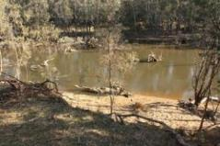
2 | Darcy’s Track  (physical habitat and bank condition) | E 351721.99, N 5966032.91 | 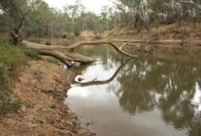
3 | Loch Garry  (physical habitat and bank condition) | E 345932.83 N 5987637.56 | 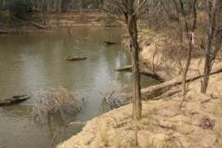
4 | McCoys Bridge  (physical habitat and bank condition) | E 330801.78 N 5994732.86 | 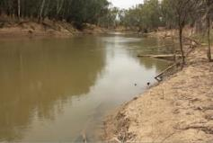
5 | Yambuna Bridge  (bank condition) | E 360741.50 N 1450010.78 | 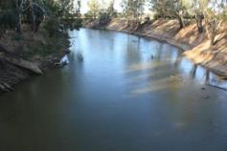

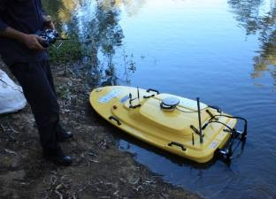 | 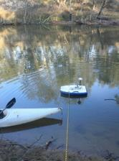
Figure 3-1. Instruments used to collect field data for development and verification of the hydraulic model: (left) Sonar bathymetric survey boat, (right) Acoustic Doppler Current Profiler (tethered to a rope to obtain velocities across fixed cross sections).
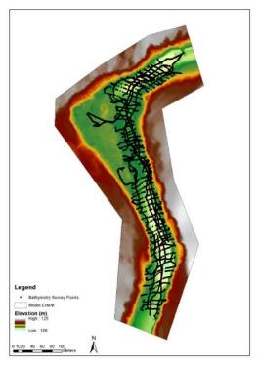
Figure 3-2. Topography used to develop the hydraulic model for Moss Rd based on LiDAR and bathymetric survey. The main channel (represented here in green) has the path of the bathymetric survey overlain in black to demonstrate coverage. This includes some verification runs of the boat into the backwater section (already covered by LiDAR).

Mesh Setup, Boundary Conditions and Roughness
The 1 m LiDAR/bathymetry grid was exported to text format for input to the River 2D program. The R2DMesh program (Figure 3-3) was used to create a triangular mesh of the following approximate resolution:
- In-channel (bank to bank): 2 m
- Floodplain: 8 m
- Transition: 4 m
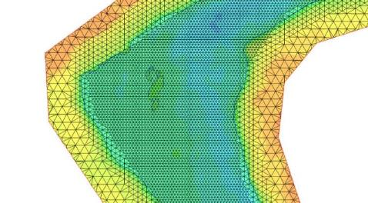
Figure 3-3. Example of computational mesh resolution and setup for Moss Road. Greater detail (higher resolution) is provided within the channel to capture small-scale hydraulic variation on the bed of the channel and for lower velocities.
The upstream boundary condition was set to a constant inflow. The downstream boundary condition was set to a constant water level boundary.
River2D requires the input of a roughness height in metres. A variable roughness height was used (Figure 3-4) for different bed cover types with the following values:
- Background: 0.2 m
- Rougher channel adjacent to large bar: 0.3 m
- Wood not in bathymetry: 1 m
- Sparse Riparian Vegetation: 0.5 m
- Moderate Riparian Vegetation: 0.8 m
- Dense Riparian Vegetation and Wood: 1.0 m
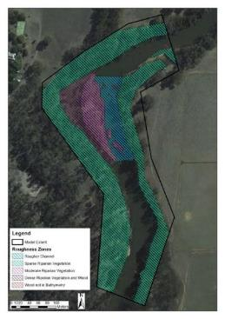
Figure 3-4. Roughness zones for Moss Road

Calibration
Two calibration events were available (Table 3-2). The events were run through the model using the average flow from the ADCP profiles, which were considered more representative at the site than the gauged data at Murchison. The ADCP flows were internally consistent (9–10 m³/s for the low flow event and 33–40 m³/s for the high flow event) and reasonably consistent with the gauged flow (0–10% lower for the low flow event and 13–28% lower for the high flow event). The tailwater was calculated from interpolation of the design tailwater levels.
Table 3-2. Moss Road calibration data.
Date | Average flow from ADCP data (m³/s) | Gauged flow at Murchison (m³/s) | Observed data | Adopted flow (m³/s) | Adopted tailwater (m AHD)
12/6/2015 | 9.4 | 10.0 | ADCP velocity (x, y, magnitude and direction) at 5 sections | 9.4 | 112.8
25/6/2015 | 37 | 46 | ADCP velocity (x, y, magnitude and direction) at 5 sections | 37 | 111.6
Velocity magnitude results were extracted at each ADCP observation point for comparison. Average differences for each section, as well as standard deviations of the differences and maximum differences, are given in Table 3-3. Modelled velocities were generally within +/- 0.1 m with no apparent bias.
Table 3-3. Moss Road calibration results.
Date | Section | Average difference (modelled – measured) (m/s) | St. dev. of differences (m/s) | Max difference (m/s)
12/6/2015 | 4 | -0.01 | 0.08 | -0.17
12/6/2015 | 6 | 0.008 | 0.08 | -0.16
12/6/2015 | 8 | -0.04 | 0.14 | -0.32
12/6/2015 | 9 | -0.04 | 0.04 | -0.15
12/6/2015 | 10 | -0.02 | 0.02 | -0.12
12/6/2015 | Total | -0.02 | 0.08 | -0.32
25/6/2015 | 4 | 0.03 | 0.06 | 0.18
25/6/2015 | 6 | 0.05 | 0.14 | 0.32
25/6/2015 | 8 | -0.03 | 0.19 | -0.95
25/6/2015 | 9 | 0.005 | 0.05 | 0.12
25/6/2015 | 10 | -0.01 | 0.06 | -0.15
25/6/2015 | Total | 0.01 | 0.12 | -0.95
For the low flow event, a scatter plot showing observed and modelled velocity magnitude values for each section is given in Figure 3-5, and a plot showing the velocity differences spatially is shown in Figure 3-6. The same plots for the high flow events are given in Figure 3-7 and Figure 3-8. The observed velocity profile may have been produced by a local but temporary blockage. Localised obstructions (e.g. wood) may be the cause of this variability. Rather than make arbitrary changes to the topography, the calibration was accepted as is, noting that results at the channel margins at low flows may have higher uncertainty than elsewhere.
For the high flow event, Section 8 again had some significant discrepancies between observed and modelled velocities. Three points observed velocities that were underestimated by 0.6–0.95 m/s by the model. Given these observed velocities were outside the bounds of any other measured velocities in this event, and much higher than adjacent velocities on the same section, this was attributed to instrument or measurement error which is common in shallow environments.
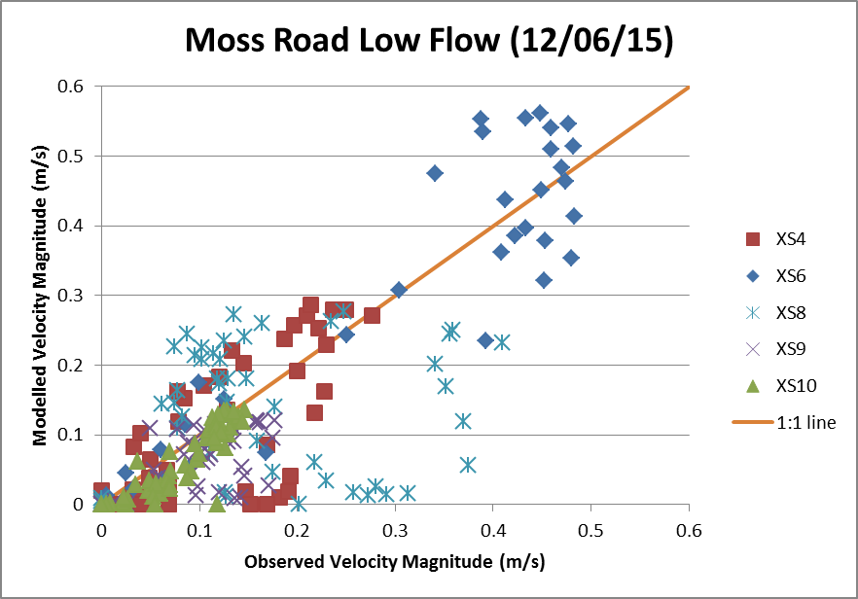
Figure 3-5. Calibration results (velocity comparison) for Moss Road low flow event (12/06/15)
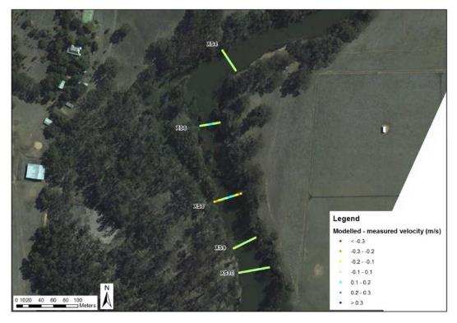
Figure 3-6. Calibration results (velocity difference) for Moss Road low flow event (12/06/15)
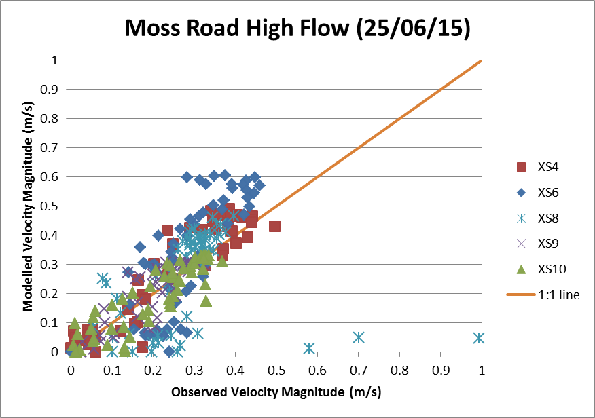
Figure 3-7. Calibration results (velocity comparison) for Moss Road high flow event (25/06/15)
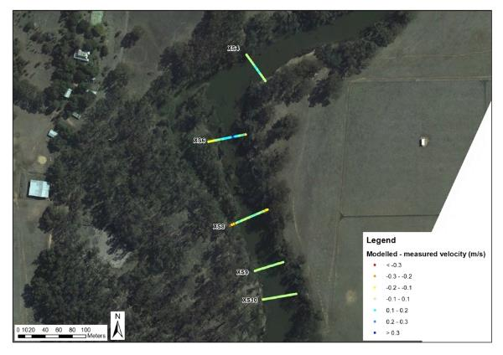
Figure 3-8. Calibration results (velocity difference) for Moss Road high flow event (25/06/15)

Hydraulic model outputs
The following outputs were extracted from a 1m grid using depth, velocity (example Figure 3-9) and shear velocity (bed shear stress τ_{b} = ρu*² = 1000u*²):
- Mean velocity
- 99th percentile velocity
- Wetted area
- Bench inundation - % of bench area inundated (bench area definition was undertaken manually in ArcGIS using the digital elevation model)
- Sediment mobilisation (proportion of bed with 1mm/2mm sediment mobilised, based on shear stress thresholds using a dimensionless Shields parameter of 0.06, specifically: 0.97 N/m² for 1 mm sediments and 1.94 N/m² for 2 mm sediments).
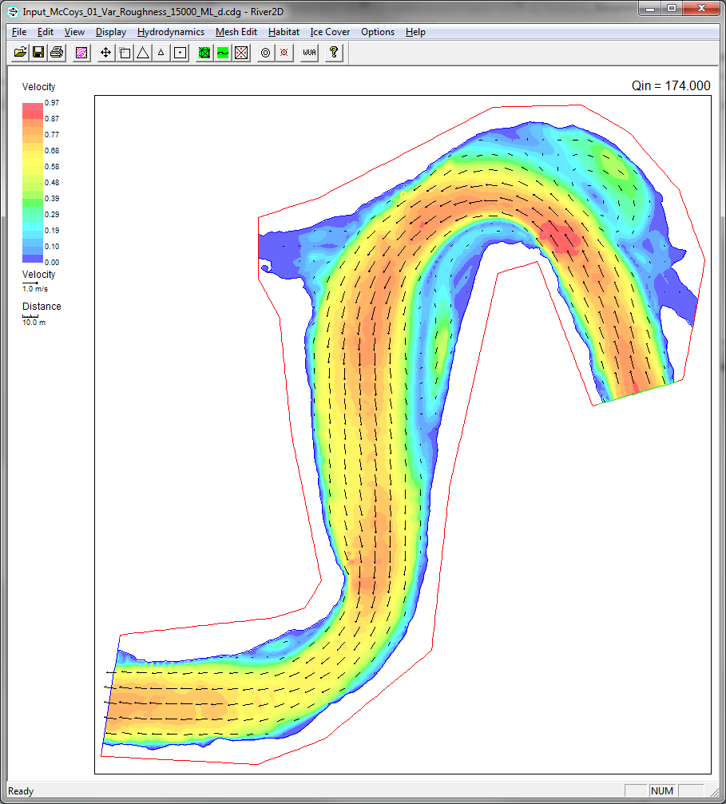
Figure 3-9. Velocity results for McCoys Bridge at a high flow of 15,000 ML/day.

Results Hydraulic Habitat
Results were extracted for a range of steady state simulations, from a low flow of 300 ML/day up to beyond bankfull flow with a flow of 20,000 ML/day (extended beyond 12,000 ML/day for Darcy’s Track and McCoys Bridge, with results for the latter shown in Table 3-4). Examples of relationships are shown for Moss Road and McCoys Bridge.
As discharge increases total wetted area and the area of pools (deeper than 1 m and 1.5 m) also increases. This occurs dramatically for discharges between 4-5,000 ML/day, then to a lesser extent thereafter (Figure 3-10).
The area of slackwater habitat (Figure 3-11), where depth is less than 0.5 m and velocity is less than 0.05 m/s, generally increases to a maximum for very low discharges then decreases to a minimum at approximately 4-6,000 ML/day. Then the area of slackwater habitat varies with minor increases once higher-level benches are inundated. The number of slackwater patches decreases as discharge increases (Figure 3-12).
Average velocity generally increases with increasing discharge (Figure 3-13), but this does not necessarily represent the velocities of interest to biota. Relationships between fish spawning and velocities were developed by the team with input from Wayne Koster and analysis by Angus Webb. Consideration of fish triggers, and the relationship between fish movement and velocities, led to investigation of maximal velocities. Maximum velocities (averaged over the reach) and high velocities (the 99th percentile, to remove the potential for extreme values) are presented in (Figure 3-14). This demonstrates that maximum velocities can be very high at low average velocities (<1000 ML/day), where some very localised maximum velocities can occur. High average velocities tend to moderate this pattern. The rate of change in velocity is also considered as a potential trigger for fish movement (Figure 3-15). For example, at a flow rate of 6,500 ML/day, an increase of 100 ML/day would produce an increase in average velocity of 0.0024 m/s over the same time period. Rate of change in velocity is greater for lower discharges, i.e. there is a relatively larger shift in velocity for a change in low discharges.
For vegetation there was consideration of impacts by maximum velocities. Maximum velocity at vegetation transects was developed by extracting velocity at the specific locations where vegetation samples were taken (Figure 3-16).
Disturbance of substrates and the potential for particular discharges to mobilise bed sediments is based on shear stress. Figure 3-17 demonstrates that coarse-grained sediments such as gravels (>2mm) require discharges of more than 2,500 ML/day before significant bed movement occurs. Medium-grained sized sands (>1mm) are mobilised readily and significantly larger areas of the bed are mobilised as discharge increases up to 5,000 ML/day. The area of sandy bed sediments mobilised is tripled when a fresh of 5,000 ML/day is provided, compared to a baseflow of 1,000 ML/day.
Bench inundation dramatically increases beyond 1,000 ML/day and reaches a maximum near 4,000 ML/day for McCoys Bridge (Figure 3-18). Bench inundation is highly dependent on channel morphology and is often associated with one or two benches in each reach. However, among the reaches assessed the elevations of benches occur at surprisingly consistent levels.

Table 3-4. McCoys Bridge habitat area results
Flow (ML / day) | Flow (m³/s) | Mean velocity (m/s) | Wetted area (m²) | Area of pools > 1.0 m (m²) | Area of pools > 1.5 m (m²) | Area of slackwater habitat (D < 0.5 m, V < 0.05 m/s) (m²) | No. patches slackwater habitat | Mean patch size of slackwater habitat (m2) | Area bed shear > 0.97 N/m2 (1 mm sediment mobilised) | Area bed shear > 1.94 N/m2 (2 mm sediment mobilised) | Bench area inundated (m2) | Change in velocity per ML/day change in flow (m/s/ML/day) | High Velocity (99%) (m/s) | Max Depth (m)
300 | 3 | 0.10 | 24,875 | 14,048 | 9,769 | 3,659 | 93 | 39 | 2,082 | 1,616 | - | 0.000320 | 0.68 | 5.76
500 | 6 | 0.13 | 26,741 | 15,179 | 10,804 | 3,456 | 101 | 34 | 3,104 | 2,193 | - | 0.000184 | 0.78 | 5.96
1,000 | 12 | 0.20 | 29,662 | 17,752 | 13,723 | 2,756 | 130 | 21 | 6,806 | 3,306 | 113 | 0.000127 | 0.60 | 6.34
2,000 | 23 | 0.24 | 33,829 | 24,461 | 17,993 | 3,066 | 183 | 17 | 10,422 | 2,609 | 1,701 | 0.000041 | 0.51 | 6.88
3,000 | 35 | 0.27 | 36,988 | 29,541 | 23,902 | 2,004 | 223 | 9 | 14,777 | 3,613 | 3,330 | 0.000037 | 0.56 | 7.35
4,000 | 46 | 0.31 | 38,408 | 32,475 | 28,490 | 1,450 | 249 | 6 | 18,910 | 4,541 | 3,692 | 0.000032 | 0.60 | 7.73
5,000 | 58 | 0.33 | 39,601 | 35,588 | 31,401 | 1,292 | 273 | 5 | 22,021 | 5,781 | 3,809 | 0.000028 | 0.63 | 8.10
6,000 | 69 | 0.36 | 40,662 | 37,290 | 34,215 | 1,267 | 290 | 4 | 23,936 | 8,149 | 3,846 | 0.000023 | 0.65 | 8.42
7,000 | 81 | 0.38 | 41,863 | 38,455 | 36,484 | 1,320 | 284 | 5 | 25,750 | 10,312 | 3,855 | 0.000020 | 0.66 | 8.75
8,000 | 93 | 0.39 | 43,058 | 39,495 | 37,875 | 1,390 | 310 | 4 | 26,972 | 13,100 | 3,855 | 0.000015 | 0.69 | 9.07
10,000 | 116 | 0.42 | 45,636 | 41,468 | 39,706 | 1,787 | 287 | 6 | 29,022 | 18,397 | 3,855 | 0.000014 | 0.73 | 9.64
12,000 | 139 | 0.44 | 48,098 | 43,420 | 41,536 | 1,794 | 270 | 7 | 30,056 | 20,958 | 3,855 | 0.000011 | 0.79 | 10.17
15,000 | 174 | 0.48 | 51,096 | 46,397 | 43,969 | 1,647 |  |  | 32,517 | 24,558 | 3,855 | 0.000012 | 0.87 | 10.80
18,000 | 208 | 0.52 | 53,226 | 48,757 | 46,412 | 1,531 |  |  | 34,492 | 27,864 | 3,855 | 0.000013 | 0.95 | 11.30
20,000 | 231 | 0.54 | 54,495 | 50,277 | 47,803 | 1,465 |  |  | 35,481 | 29,256 | 3,855 | 0.000011 | 0.99 | 11.60

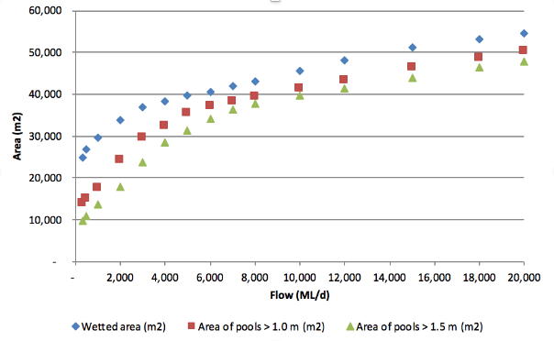
Figure 3-10. Results (wetted area and area of pools) for McCoys Bridge.
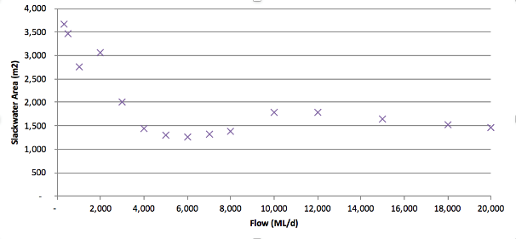
Figure 3-11. Results (area of slackwater habitat) for McCoys Bridge.
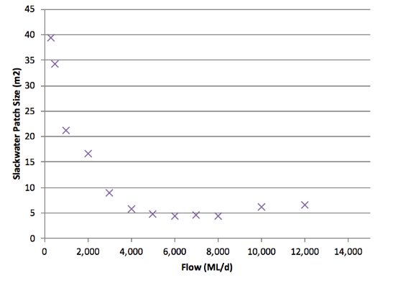
Figure 3-12. Results (mean patch size of slackwater habitat) for McCoys Bridge
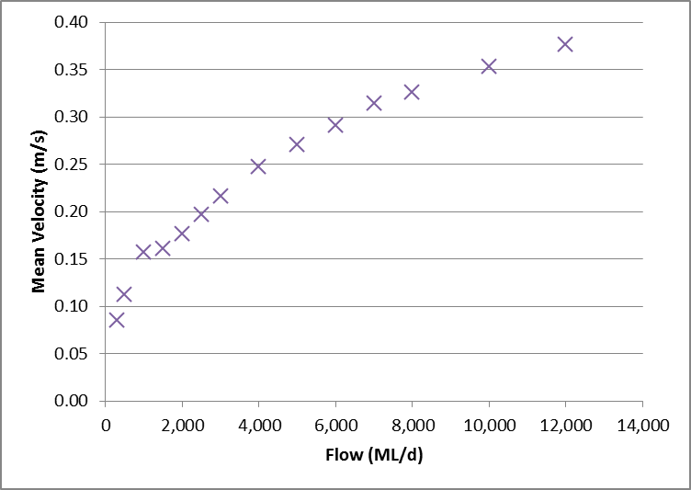
Figure 3-13. Results (mean velocity) for Moss Road
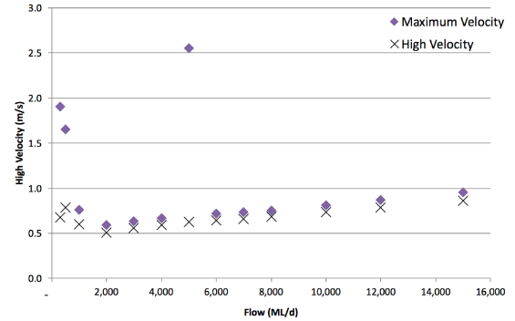
Figure 3-14. Results for maximum velocity (purple solid) and high velocity (crosses) relative to discharge for McCoys Bridge
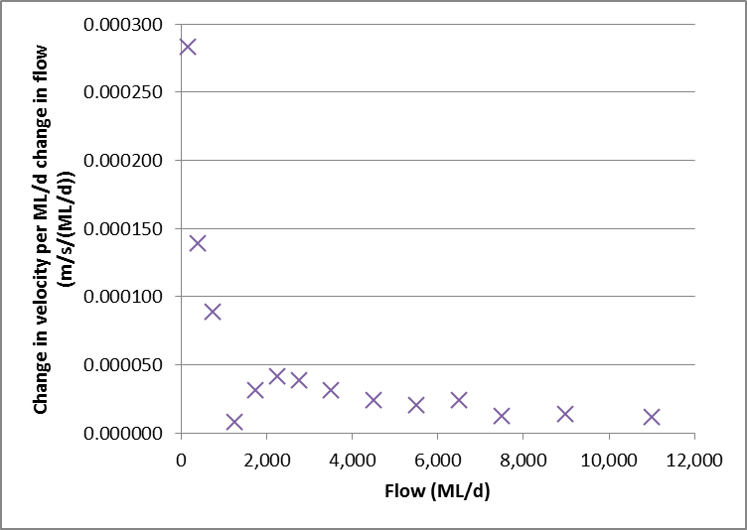
Figure 3-15. Results (velocity rate of change with flow) for Moss Road
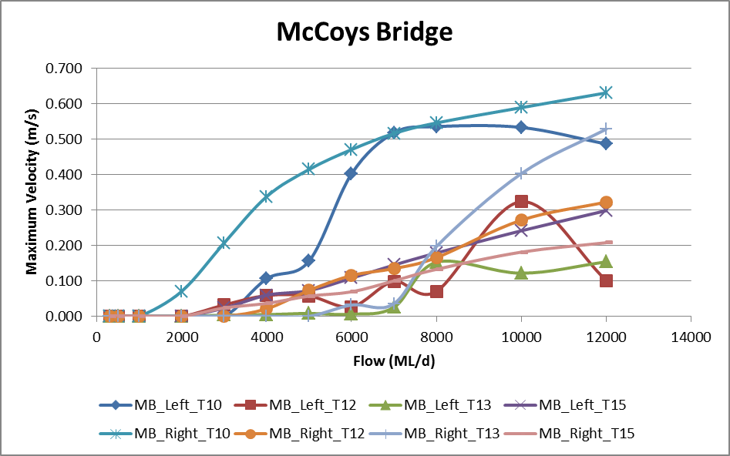
Figure 3-16. Maximum velocity at vegetation transects for McCoys Bridge
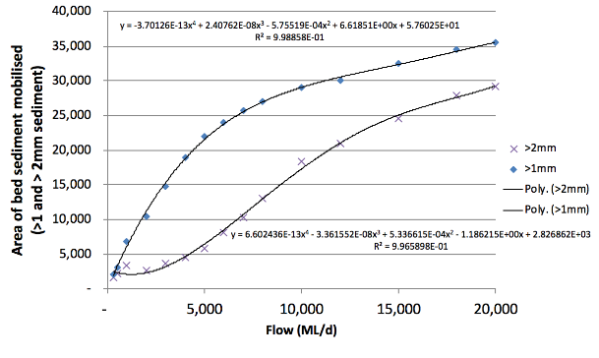
Figure 3-17. Bed mobilisation. Area of bed sediment mobilised for gravels (crosses) and medium-grained sands (blue solid) at McCoys Bridge.
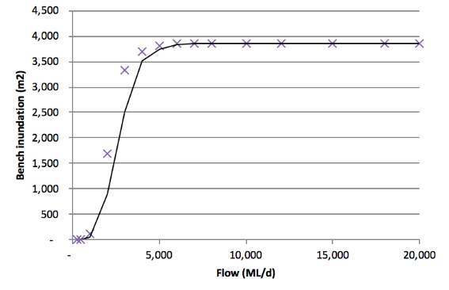
Figure 3-18. The area of bench inundation for McCoys Bridge.

Bank condition

Bank Condition Methods
Equipment used for this monitoring program consists of 200 erosion pins (50 pins at each of four sites). Pins are 300 mm long bicycle spokes with colour coded heat shrink exteriors (Figure 3-19, left). Each pin is inserted into the bank so that 25 mm is exposed. Erosion pins are located at five different elevations (up to approximately bankfull) on each of ten transects at each site. Changes in surface level relative to each erosion pin are made using digital callipers (see Figure 3-19, right). Qualitative assessments are also made at each transect on erosion process, failure mechanism, and weakening process (see proforma in the SOP; Webb et al. 2018).
Recordings with positive values (relative to starting position) indicate bank retreat (erosion) and negative values indicate bank aggradation (deposition). Data presented in this report are from the program start (January 2015) to June 2019. Further details on the erosion assessment protocol can be found in (Vietz et al. 2018).
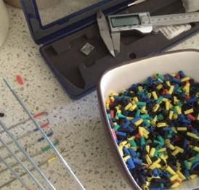 | 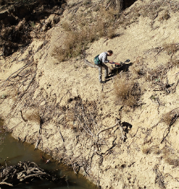
Figure 3-19. (left) Colour coded erosion pins inserted at each transect to indicate location/elevation on the river bank and measured by digital callipers, and (right) field placement.

Hydrologic variables and statistical analysis
Flow metrics that have been used as model predictors to characterise effects on bank condition of environmental flows include (Table 3-5):
- Inundation duration
- Peak flow magnitude
- ADWP – maximum dry weather period prior to inundation
- Flow volume
- Rate of draw down – average, maximum and minimum
Table 3-5. Flow metrics used for comparison with bank erosion measurements.
Flow metric | Description | Justification
Duration of inundation | How many days an erosion pin is under water between surveys | The time over which a bank is exposed to inundation and/or flowing water influences bank wetting and saturation, and the effect of cumulative shear stress on erosion. Similarly, deposition may be a function of cumulative time over which sediments can move through the water column to deposit on the bank.
Peak flow magnitude | Peak flow of an event that inundated an erosion pin between surveys (the maximum if multiple peaks are experienced) | Erosion/deposition may be driven by the maximum shear stress associated with an event, with sediment bank sediments being mobilised, or accumulated (if scoured from elsewhere) during the period around peak flows.
Flow volume | Volume of flow of the event above the level of the pin that inundates an erosion pin | A metric that combines duration and magnitude to assess the ‘work’ being done on the bank by water.
Maximum dry weather period | Maximum number of days without inundation of the pin prior to inundation | Banks may become more sensitive to erosion when inundated if they are allowed to dry out completely, inducing desiccation and cracking of clay-rich sediment particles.
Maximum dry weather period by season | Maximum number of days without inundation of the pin prior to inundation by ‘hot season’ (Nov-Apr) and ‘cold season’ (May-Oct) | Banks may become more sensitive to erosion when inundated if they are allowed to dry out completely, inducing desiccation and cracking of clay-rich sediment particles. This is hypothesised to be more severe during the hot season when banks can rapidly dry.
Average and maximum rate of drawdown | Day 2 discharge divided by Day 1 discharge for the falling limb of a flow event | The rate at which flow recession from an event occurs can impact on bank erosion through surcharging a bank (saturating) and affecting the support provided by the water while the bank is saturated. If the rate of recession is too great mass failure (slumping) can occur, particularly on steep banks.
A hierarchical Bayesian logistic regression model was used to identify the relationship between the flow metrics and bank erosion/deposition. The probability of erosion and deposition was assessed as a function of each metric, as experienced by the erosion pin based on 13 measurements. Other flow characteristics, such as bank notching (a horizontal demarcation in the bank associated with the water level surface), have been considered based on observations but have not been assessed statistically.

Bank Condition and Flows Statistical Model
The occurrence of erosion or deposition (y) for pin j at site k during season s and survey i is a Bernoulli-distributed event with probability p. This is driven by a global average erosion/deposition across all sites in the absence of inundation (int), plus the effect of the inundation metric being analysed (eff.I) for each site/season combination, multiplied by the metric value for that survey (I). There is a random effect of site (eff.site) that acknowledges that local conditions may enhance or retard overall erosion/deposition, a random effect of survey (eff.surv) to capture any seasonal or other systematic differences among survey periods in erosion/deposition, and a random effect of pin (eff.pin) to account for the repeated measures taken for each pin.
The key update in the 2017–18 model is that the effect of cold/hot (wet/dry) seasons are included in the inundation metric effects (eff.I), besides the existing differences across sites. As a result, effect of inundation is drawn from individual distribution for each site/season combination (Equation 3a).
$y_{ijk}\sim Bern\left(p_{ijks}\right)$ Equation 1
$logit(p_{ijks})=int+{eff.inund}_{ks}×{inund}_{ijks}+{eff.site}_{k}+{eff.survey}_{i}+{eff.pin}_{jk}$ Equation 2
${eff.inund}_{ks}\sim Normal({μ_inund}_{ks },σ_inund)$ Equation 3a
${eff.site}_{k}\sim Normal\left(0,σ_site\right)$ Equation 3b
${eff.survey}_{i}\sim Normal\left(0,σ_survey\right)$ Equation 3c
${eff.pin}_{jk}\sim Normal\left(0,σ_pin\right)$ Equation 3d

Results Bank Condition

Bank activity and the effect of season
Bank erosion and deposition in 2018/19 exhibited similar responses to flow during the previous periods. Erosion and deposition are still highly variable both in time and space, but both still occur relatively commonly even at the same location. In general erosion is still slightly greater than deposition or no change, for Loch Garry, McCoys Bridge and Yambuna (Figure 3-20). Darcy’s Track, however, experiences less change with ‘no change’ dominant. Significant erosion (considered as > 30 mm) is still only a small fraction of the measurements (4-9%).
In general, deposition occurs more often in the cold season, while erosion occurs more often in the hot season (Figure 3-20). There is no distinct difference in significant erosion across seasons.
The most notable difference in flow conditions during this hot period was associated with the larger IVT flows delivered between January and May 2018. Higher rates of bank activity were identified following this period, both erosion and deposition, but the proportional change from the previous three-year period is small. The greatest activity in river banks was during year 5 (2018/2019) where erosion was greater and ‘no change’ was least prevalent (Figure 3-23).
The influence of the IVT does not consider that the IVT only affects about half of the erosion pins, and that the influence of the IVT is on the lower banks and may have consequential impacts on destabilising the upper banks. It is evident for Darcy’s Track that the larger IVT event had much more significant average erosion in 2019 than in previous years (Figure 3-21). The effect of the IVT is more pronounced upstream of the Broken River confluence at Darcy’s Track, compared to McCoys Bridge (Figure 3-22).
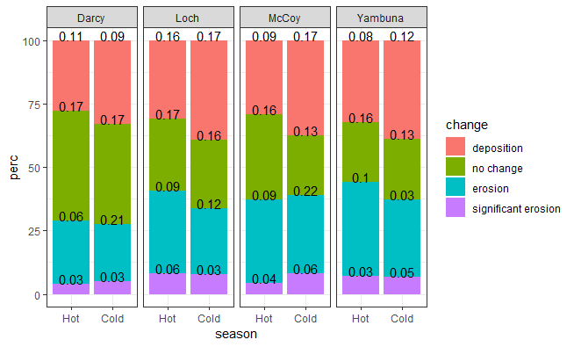
Figure 3-20. Proportion of deposition, no change, erosion and significant erosion in measurements with the full five-year results, by season (hot: summer/autumn, cold: winter/spring) and site. Sample sizes are: 1012, 995, 901 and 997 for Darcy’s Track, Loch Garry, McCoys Bridge and Yambuna, respectively. Standard deviations of probabilities of individual activities at a site during a season (across five years) are labelled.
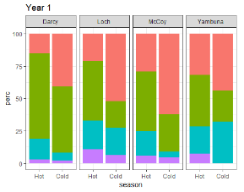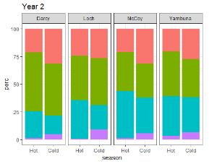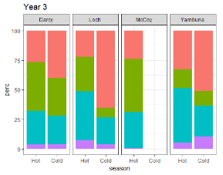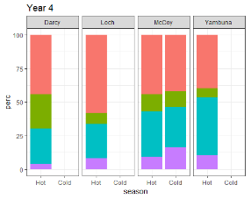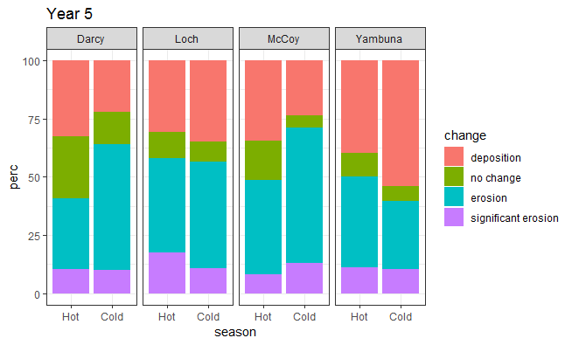
Figure 3-21. Proportion of deposition, no change, erosion and significant erosion in measurements for each of the past five years, by season (hot: summer/autumn, cold: winter/spring) and site.
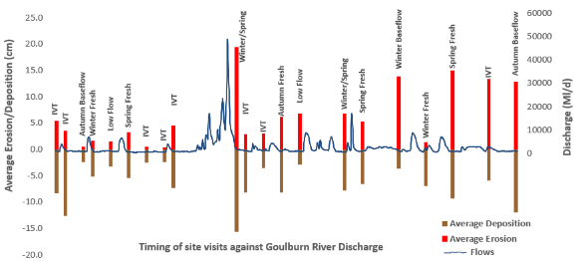
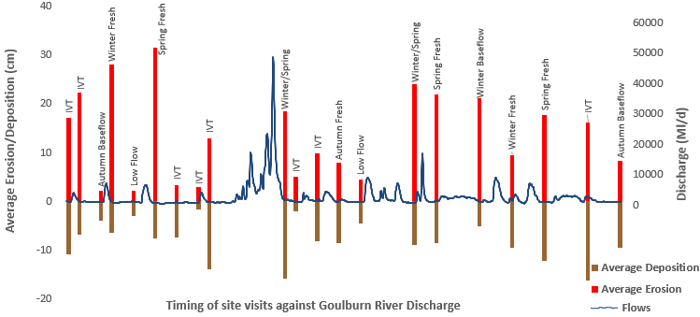
Figure 3-22. Average erosion (red) and deposition (brown) for a) Darcy’s Track and b) McCoys Bridge relative to flow events for the period 2015 to 2019. Bars are time of collection and represent river bank activity in the preceding period.

Flow impacts on bank activity
- In general, inundation period (especially the hot season) is the strongest predictor for probabilities of both erosion and significant erosion (Table 3-6).
- For erosion, all sites except for Yambuna have slightly higher flow effects during summer, but this is not statistically significant at the 95% level. For significant erosion, there is an increase with inundation (Figure 3-23) but no significant difference in the flow effects of seasons at all sites (Table 3-6).
- For probabilities of deposition, both inundation and peak flow magnitudes are strong predictors (Table 3-6).
- For deposition, Darcy’s Track and McCoys Bridge have slightly lower flow effects during summer, but this is not statistically significant at the 95% level.
- Average, maximum and minimum rate of draw down have similar effects on bank activities (similar predictive capabilities), so only the strongest predictor, maximum rate of draw down, is presented (Table 3-6). The effect of drawdown is only significant for the McCoys Bridge site.
- Assessing the effect of environmental flows (counterfactual simulations), there is a slightly higher probability of bank erosion and deposition due to environmental flow, across all sites (Figure 3-24). These increases are more distinct during winter than summer.
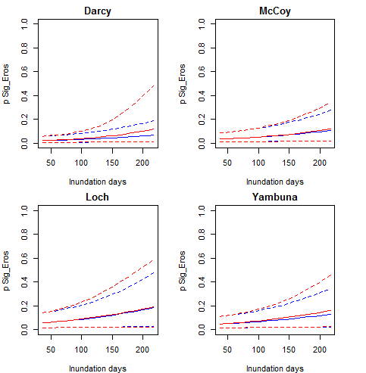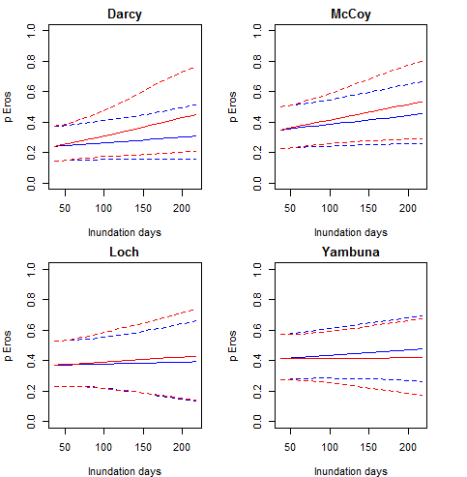
b)
a)
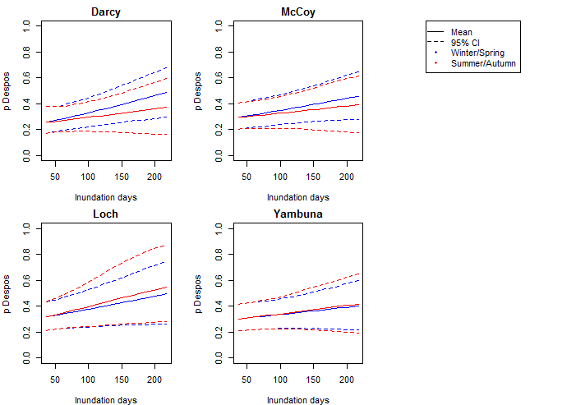
c)
Figure 3-23. Probability of erosion of (a) > 30 mm, (b) > 0 mm, and (c) deposition < 0 mm (c), with increases in the duration of inundation. For each erosion level, results are shown four for sites (Darcy’s Track, Loch Garry, McCoys Bridge and Yambuna) in individual panels. The solid line is the median probability of erosion with the dotted lines encompassing the 95% credible interval for the estimate. Red and blue lines show the flow effects for warm season and cold season, respectively.
Table 3-6. 95% credible intervals of regression coefficients (Eff.I) for three erosion levels and for each flow metric. Bold values represent instances where there is a relationship between erosion/deposition and flow metric.
Bank activity | Predictor/  season |  | Darcy |  | Loch |  | McCoy |  | Yambuna
Bank activity |  |  | 2.50% | 97.50% | 2.50% | 97.50% | 2.50% | 97.50% | 2.50% | 97.50%
Significant erosion (>30) | Inundation | Cold | -0.258 | 0.517 | -0.219 | 0.663 | -0.165 | 0.746 | -0.235 | 0.469
Significant erosion (>30) |  | Hot | 0.006 | 0.804 | -0.441 | 0.259 | -0.359 | 0.081 | -0.076 | 0.751
Significant erosion (>30) | Peak | Cold | 0.163 | 0.458 | -0.303 | 0.358 | -0.277 | 0.498 | -0.015 | 0.284
Significant erosion (>30) |  | Hot | -0.144 | 0.238 | 0.007 | 0.296 | -0.361 | -0.030 | -0.080 | 0.465
Significant erosion (>30) | ADWP | Cold | -0.412 | 0.612 | -0.649 | 0.203 | -0.986 | 0.159 | -0.271 | 0.855
Significant erosion (>30) |  | Hot | -0.686 | 0.097 | -0.507 | 0.150 | -0.390 | 0.172 | -0.642 | 0.138
Significant erosion (>30) | Volume | Cold | -0.412 | 0.612 | -0.649 | 0.203 | -0.986 | 0.159 | -0.271 | 0.855
Significant erosion (>30) |  | Hot | -0.686 | 0.097 | -0.507 | 0.150 | -0.390 | 0.172 | -0.642 | 0.138
Significant erosion (>30) | Max RDD | Cold | -0.515 | 0.405 | -0.313 | 0.396 | 0.034 | 0.894 | -0.195 | 0.499
Significant erosion (>30) |  | Hot | -0.029 | 0.563 | -0.242 | 0.296 | -0.133 | 0.421 | 0.090 | 0.693
Erosion (>0) | Inundation | Cold | -0.113 | 0.329 | -0.081 | 0.517 | -0.243 | 0.311 | -0.192 | 0.266
Erosion (>0) |  | Hot | -0.037 | 0.376 | -0.477 | -0.037 | -0.124 | 0.057 | -0.205 | 0.226
Erosion (>0) | Peak | Cold | -0.153 | 0.145 | -0.265 | 0.325 | -0.169 | 0.512 | -0.003 | 0.304
Erosion (>0) |  | Hot | -0.061 | 0.280 | -0.286 | 0.033 | -0.163 | 0.096 | -0.083 | 0.421
Erosion (>0) | ADWP | Cold | 0.077 | 0.589 | -0.053 | 0.378 | 0.036 | 0.487 | 0.074 | 0.591
Erosion (>0) |  | Hot | -0.067 | 0.249 | -0.120 | 0.228 | -0.071 | 0.153 | -0.009 | 0.289
Erosion (>0) | Volume | Cold | 0.077 | 0.589 | -0.053 | 0.378 | 0.036 | 0.487 | 0.074 | 0.591
Erosion (>0) |  | Hot | -0.067 | 0.249 | -0.120 | 0.228 | -0.071 | 0.153 | -0.009 | 0.289
Erosion (>0) | Max RDD | Cold | -0.174 | 0.387 | -0.472 | 0.001 | 0.352 | 0.926 | -0.343 | 0.117
Erosion (>0) |  | Hot | -0.148 | 0.164 | -0.117 | 0.174 | -0.085 | 0.222 | 0.121 | 0.436
Deposition (<0) | Inundation | Cold | 0.080 | 0.512 | -0.166 | 0.410 | -0.189 | 0.377 | 0.023 | 0.485
Deposition (<0) |  | Hot | 0.007 | 0.392 | 0.174 | 0.584 | -0.219 | -0.006 | -0.085 | 0.362
Deposition (<0) | Peak | Cold | 0.312 | 0.746 | 0.149 | 0.619 | -0.009 | 0.357 | 0.122 | 0.565
Deposition (<0) |  | Hot | 0.137 | 0.774 | 0.337 | 1.198 | 0.110 | 0.836 | -0.060 | 0.734
Deposition (<0) | ADWP | Cold | -0.114 | 0.206 | -0.151 | 0.144 | -0.189 | 0.134 | -0.141 | 0.203
Deposition (<0) |  | Hot | -0.046 | 0.227 | -0.114 | 0.163 | -0.117 | 0.086 | -0.061 | 0.198
Deposition (<0) | Volume | Cold | 0.149 | 0.443 | -0.368 | 0.524 | -0.355 | 0.395 | -0.037 | 0.265
Deposition (<0) |  | Hot | -0.186 | 0.240 | 0.073 | 0.355 | -0.370 | -0.077 | -0.138 | 0.602
Deposition (<0) | Max RDD | Cold | -0.251 | 0.244 | -0.097 | 0.333 | -0.377 | 0.092 | -0.445 | 0.042
Deposition (<0) |  | Hot | -0.170 | 0.135 | 0.098 | 0.404 | 0.062 | 0.379 | 0.035 | 0.336

Counterfactual effects without Eflow
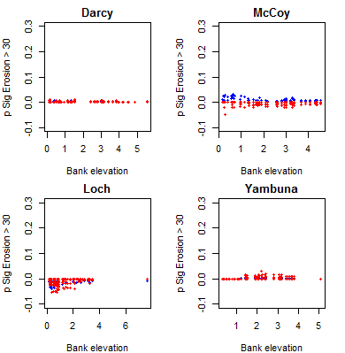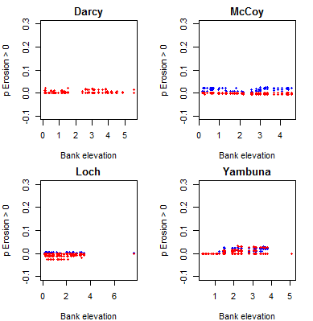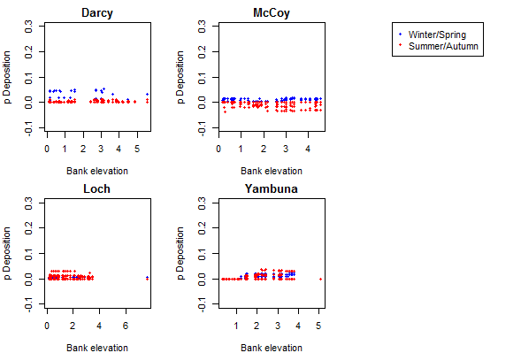
c)
b)
a)
Figure 3-24. Without environmental flows: Effect of the environmental flow component on the probability of (a) significant erosion (> 30 mm), (b), erosion (> 0 mm), and (c) deposition (< 0 mm), at each erosion pin, relative to bank elevation (m). Red and blue dots show simulations for the warm and cold seasons, respectively.

Discussion
The erosion evident during the summer period points to some important processes: a) the role of riverbank drying in erosion processes, b) the role of prolonged flows acting on the lower bank, and c) the lack of sediment from storage releases that are associated with tributary events (such as winter/spring, Figure 3-25). This supports the role of sub-aerial preparation of bank sediments whereby drying of clay-rich soils (desiccation) leads to cracking and preparation of banks for erosion during subsequent inundation. This is particularly pronounced at the Yambuna Bridge site (Figure 3-25)
Since peak magnitude and total flow volume were not significantly related to riverbank erosion it can be inferred that the dominant erosion mechanism is not related to high velocities but the influence of inundation on the bank.

Figure 3-25. Drying of clay-rich sediments, and prolonged flows, can lead to significant recession of the lower bank. Yambuna bridge site during erosion pin assessment post-IVT, June 2019.
The complexity in relationships highlights the importance of antecedent conditions so that erosion ‘prepared’ in one season can be related to a subsequent event. As a result, there is no significant impact of erosion (>30mm) by season. Observations suggest that preparation of river banks by erosion of the lower bank during summer/autumn, can lead to subsequent mass failure during following events, as bank wetting from larger events is drawn down, leaving a saturated and unsupported bank (Figure 3-26, Figure 3-27).
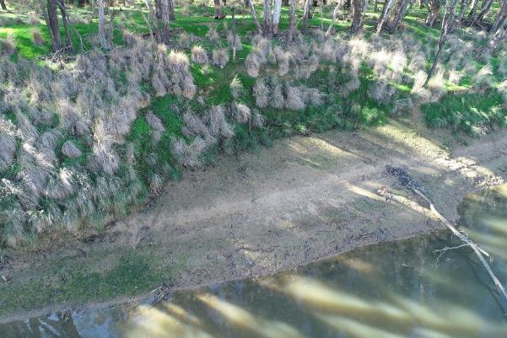
Figure 3-26. Example of mass failure slumping of the upper bank once the lower bank support is removed. McCoys Bridge May 2019, from Drone. Notching at approximately 2,500 ML/d (lower bank beneath vegetation) and slumping of the upper bank evident, despite vegetation.
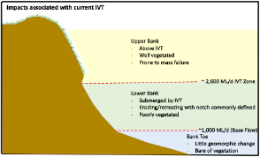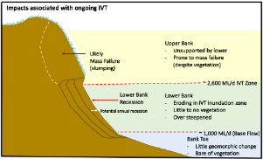
Figure 3-27. A schematic of the potential mechanisms of erosion following consistently high summer and autumn flows and erosion of lower banks, and mass failure of vegetated upper banks (from Vietz IVT impacts report).
The role of bank erosion relative to bank vegetation have not been explicitly linked. Zones of deposition did provide niches for vegetation colonisation. Anecdotally, vegetation plays an important role in the resistance of banks to erosion. Sub-aerial preparation of banks as a result of drying and cracking is exacerbated when vegetation is not available to shade soils. In addition, root wads enhance structural integrity. Deposition is also enhanced by vegetation through increased roughness, encouraging further vegetation establishment. It is noted that bank vegetation can be indirectly impacted by flow through bank erosion, with well-vegetated banks failing during mass failure ‘slumping’ (Figure 3-26).
The main challenges encountered with the bank condition monitoring have been with accessing erosion pins when prolonged water levels are encountered. This was most problematic during high winter/spring flows (such as in 2016) and IVT flows in Summer/Autumn. This challenge has not unduly impacted on the results and has been addressed, in part, by close collaboration between the operators and field staff undertaking the assessments.

Winter Monitoring: Sediment and seed deposition using artificial turf mats

Context for the assessment of sediment and seeds
To maintain a healthy Goulburn River to support ecological and social values requires ensuring the system is adequately resilient to cope with flow demands. Part of this resilience is related to the river bank condition which can experience erosion and changes in vegetation relative to flows. An important part of resilience is the recovery of the system, and for river banks this includes how a river might repair, through patching banks with sediment drapes, and how seeds might be deposited and regenerate bank vegetation following flows. Understanding these sediment and seed dynamics is the focus of this study.

Methods
From 2018 onwards, Streamology has been using turf mats to quantify sediment transport and propagule assemblages dispersed by IVT flows. Small synthetic turf mats (36 x 24cm) were fixed to the banks in groups of six replicates per feature (Figure 3-28). Features were selected to capture a variety of geomorphic forms, including bars, banks, benches, and ledges. Mats were periodically retrieved during periods of low flow with seeds transported directly to the Burnley Campus nursery for germination and identification and sediments assessed within the laboratory for dry mass and sediment size.
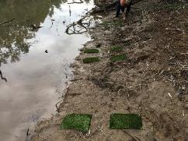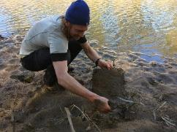
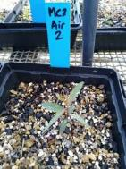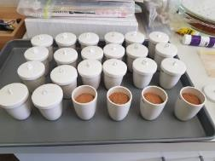
Figure 3-28. a) Sediment mats on low-level bars prior to inundation, b) mat collection following inundation, c) seedling growth in the nursery following collection, and d) sediment analysis.
Data was related to flow using elevation surveys and rating curves to translate mat location to the inundation characteristics for each mat and the corresponding seed and sediment data. The hypothesis driving this statistical assessment was that the transport and deposition of seeds/sediments in waterways is driven by streamflow, and differs by habitat type (bank, bar, bench or ledge) and time of the year; with the latter also varies the percentage of tributary contribution to flow. This corresponds to a hierarchical model described as:
$y_{t}\sim Normal\left({mu}_{ijs},σ\right)$ Equation 1
${mu}_{ijs}=int+{eff.Q}_{is}×Q_{ij}$ Equation 2
${eff.Q}_{is}\sim Normal({μ_effQ}_{is},σ_effQ)$ Equation 3
${μ_effQ}_{is}=int_{effQ}+eff.trib*{trib}_{i}+eff.h{abitat}_{s}$ Equation 4
Where i, j and s represent survey event (retrieval), site and habitat type, respectively.
For the seed analysis, y_{t} represents the individual samples of seeds abundance captured by turf mats.
The mean seed abundance (log-transformed) for a particular combination of survey, site and habitat type, mu_{ijs}, is affected by flow condition (Q) represented by a) peak inundation height over sampling point, b) number of days inundated, and c) maximum dry period, during the sampling period (i.e. between deployment and retrieval of each sample). Flow effects (eff.Q_{ks}) are modelled with by the percentage tributary contribution corresponding to the particular survey event (trib), with eff.trib representing the tributary contribution effects. eff.habitat is a random effect to represent the influence of habitat type on the flow effects.
During the seed abundance sampling, some samples were placed at high bank elevations at McCoys Bridge, which were never inundated during the sampling period. The habitat type of these samples was thus denoted as ‘air’. Preliminary analysis indicated that very few seeds were deposited on these mats, highlighting the importance of hydrochory (flow dispersal) for seeds deposited on other lower elevation mats. These ‘air’ samples were not included for further analyses which focused on flow effects.
The sediment analysis was conducted focusing on impacts of the above mentioned three flow indicators on the total mass of sediments captured regardless of texture (y_{t} in Eqn. 1).

Results
Figure 3-29 to Figure 3-31 show seed response to flow and Figure 3-32 to Figure 3-34 shows sediment response. The results are summarised in Section 3.9.4.

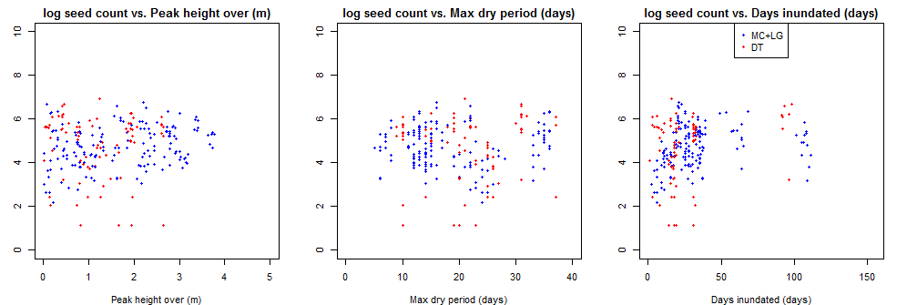
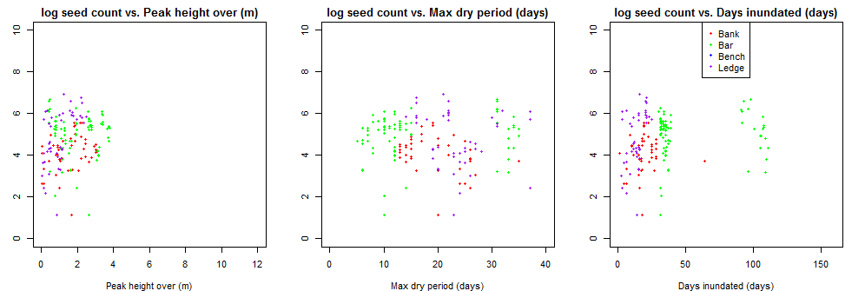
Figure 3-29. Comparison of flow effects by site (top row) and geomorphic feature (bottom row).
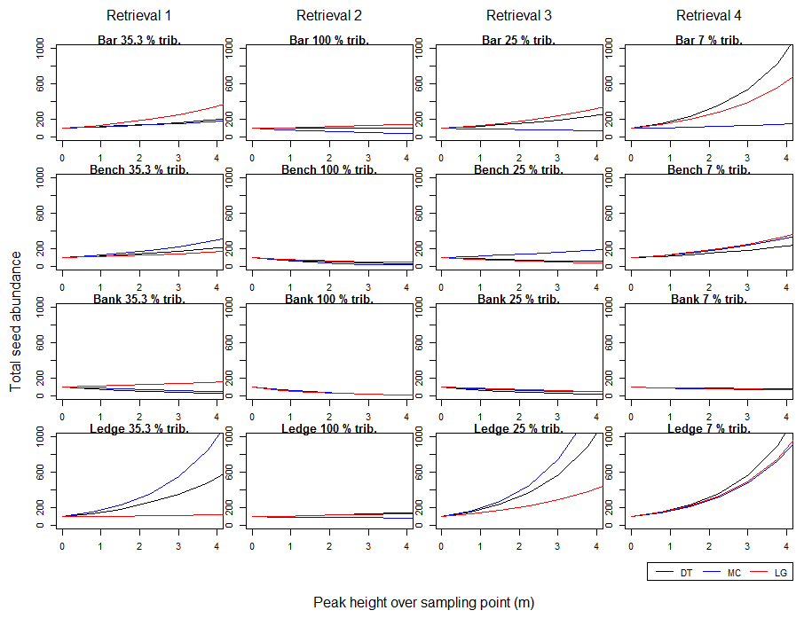
Figure 3-30. Simulated median total seed abundance against peak height over sampling point, by bank feature (bar, bench, bank and ledge, in rows) and different retrieval events (with different levels of tributary contribution as labelled, in columns).
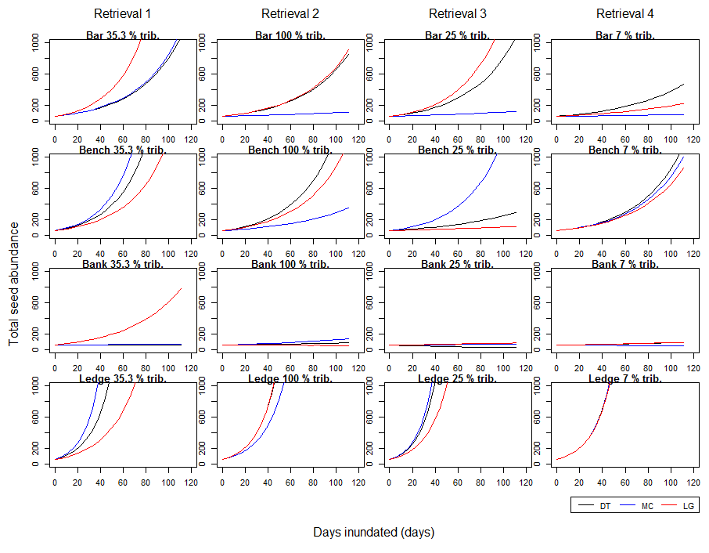
Figure 3-31. Simulated median total seed abundance against number of days inundated, by bank feature (bar, bench, bank and ledge, in rows) and different retrieval events (with different levels of tributary contribution as labelled, in columns).

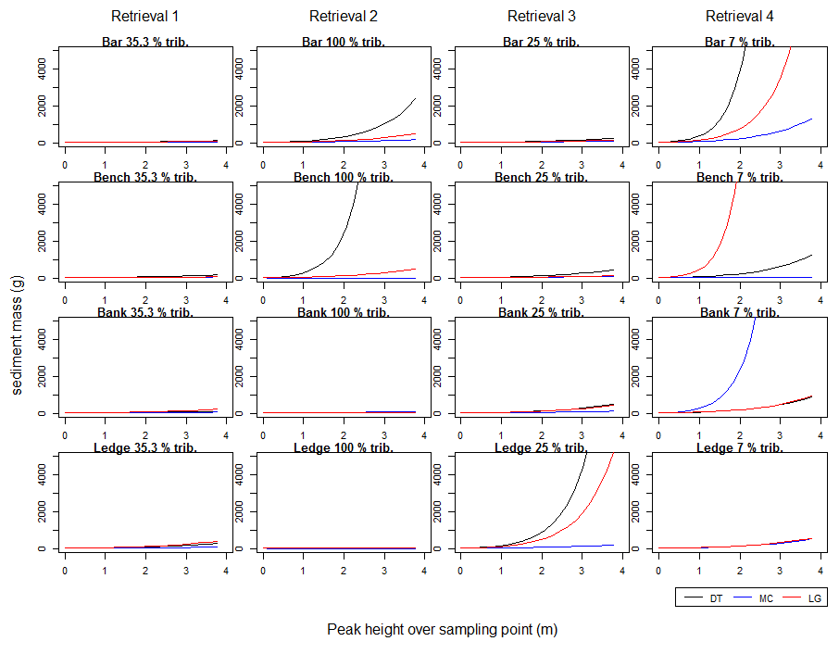
Figure 3-32. Simulated median sediment mass against peak height over sampling point, by bank feature (bar, bench, bank and ledge, in rows) and different retrieval events (with different levels of tributary contribution as labelled, in columns).
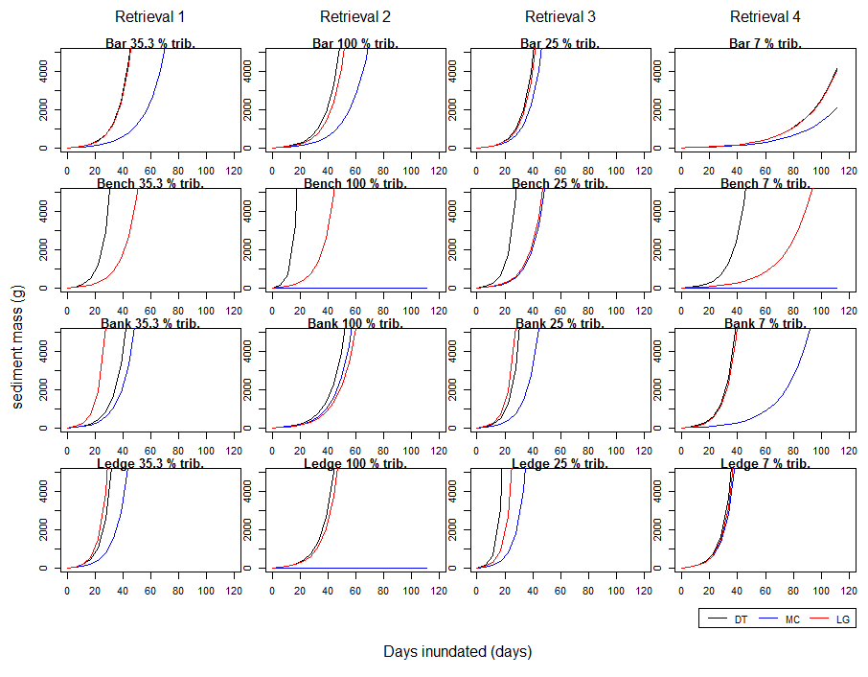
Figure 3-33. Simulated median sediment mass against days inundated, by bank feature (bar, bench, bank and ledge, in rows) and different retrieval events (with different levels of tributary contribution as labelled, in columns).
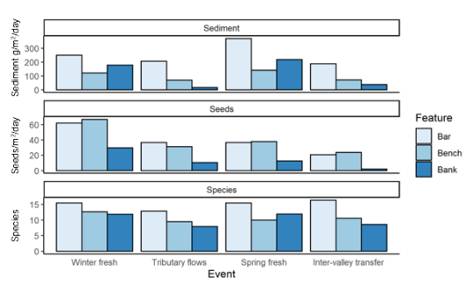
Figure 3-34. Sediment deposition and seed numbers and species for each of the four events and three geomorphic features (ledge removed for clarity). Results are considered for each event relative to the number of days the event occurred for.

Conclusions from winter monitoring
In general, preliminary analyses suggest the following:
- Inundation matters as evidenced by the negligible sediment or seed deposition on mats not inundated.
- An increase in peak inundation height generally leads to increasing seed deposition on bars, benches and ledges (Figure 3-30). This relationship was less clear for banks which were inundated less.
- An increase in number of days inundated generally lead to clear increases in seed deposition, although only minimal effects were observed for banks (Figure 3-31). In general, greatest responses to flow were observed for the winter fresh (retrieval 1).
- Effects of tributary contributions to the relationships between flow metrics and seed abundance were unclear.
- An increase in maximum dry period lead to a consistent decrease in seed deposition on banks, with relationships less clear for the other features (no figures provided).
- Increases in both peak height (Figure 3-32) and number of days for inundation (Figure 3-33) show more consistent increasing effects on sediment deposition across geomorphic features and tributary contributions.
- The importance of tributary contribution for sediment deposition is not supported, with further investigation required (currently reliant on only one major tributary flow in dataset). We hypothesise that tributary flows contribute greater sediment and seed mass to the river. The results from this early phase of monitoring do not provide this evidence. For example, the greater tributary contribution in the winter than spring fresh corresponded to greater seed delivery, but not sediment delivery. This is potentially due to the tributary event being a quarter the volume of the IVT event, and the fact that the IVT event produced greater erosion and hence sediment from within the channel. Tributary inflows are likely to have been responsible for the flush of river red gum seed deposition in spring. A greater contribution of tributary inflows would be likely if well ‘piggy-backed’ with environmental flows, which was not the case in this year of study.
On an event basis:
Winter fresh action
The winter fresh environmental flow was delivered in June-July 2019 at a time when tributary flows were relatively low (providing about one third of total flow). All in-channel features were submerged and received flow-delivered sediment and seeds. On average, 8 kg of sediment and 2800 seeds from 13 different species were deposited per square metre. More sediment was deposited on low-level features such as bars and more seeds deposited on the higher benches (Figure 3-34).
Winter-Spring tributary flow event (including variable base flow action)
The flow event in August 2018 was initiated by tributary flows rather than storage releases, though these were a small contribution of environmental water. This flow was lower than the winter and spring freshes, only inundating lower-level features in the river channel and was shorter in duration. Bars received deposition of 10 kg of sediment and 1800 seeds per square metre from 13 species, while riverbanks received 0.8 kg of sediment and 500 seeds per square metre from 8 species, on average. Nevertheless, the event saw the greatest numbers of river red gum seeds deposited. River red gums are known to time seed release with natural periods of high flows.
Spring fresh action
The spring fresh environmental flow event was delivered in September-October 2018 at a time when tributary flows were relatively low (providing about a quarter of total). All in-channel features were again submerged and received flow-delivered sediment and seeds. On average, 12 kg of sediment and 1800 seeds from 12 species were deposited per square metre. River bottlebrush seeds were commonly deposited during this period. Per day of flow more sediment was deposited on high-level features such as banks and benches by the spring fresh than by any other event (Figure 3-34).
Inter-valley transfers
In the IVT event over summer-autumn 2018-19, over 90% of flow in the lower Goulburn was provided by storage releases rather than unregulated tributaries. The flow reached approximately the same peak as the tributary flow event, but for a much longer period. Lower features such as point bars and lower banks were inundated for long periods, with large amounts of sediment and seeds deposited on bars (29 kg of sediment and 3200 seeds per square metre). However, these seeds are unlikely to establish because we know that inundation of plants for such long periods is known to be fatal to most species. Also, large amounts of sediment deposition low in the channel may smother important fish habitat. Conversely, during the IVT, only very little deposition was where it is needed such as on riverbanks (around 6 kg of sediment and 300 seeds per square metre from only 9 species). Per day of inundation, the least seeds of any event were deposited by the IVT flow, particularly on the higher-level features such as banks and benches that were not inundated (Figure 3-34).
What was the contribution of environmental flows?
Environmental flows (the winter and spring freshes) provided around half of the sediment and seeds deposited on inundated features at sites in the lower Goulburn River. The environmental flows were the primary contributor of sediment and seeds to riverbanks, providing three-quarters of sediment and seed deposition on banks. Seed diversity on banks was higher in the environmental flows with 12 species represented on each mat on average (compared to 8 species in the tributary flow event and 9 in the IVT). This supports the hypothesis that environmental flow events provide mud drapes and seeds to assist river bank repair, assisting to patch the erosional damage caused by some river operations or natural disturbance events.

Stream Metabolism

Introduction
Whole stream metabolism measures the production and consumption of dissolved oxygen gas (DO) by the key ecological processes of photosynthesis and respiration (Odum 1956). Healthy aquatic ecosystems need both processes to generate new biomass (which becomes food for organisms higher up the food chain) and to break down plant and animal detritus to recycle nutrients to enable growth to occur. Hence metabolism assesses the energy base underpinning aquatic foodwebs. The relationships between these processes are shown in Figure 4-1.
Figure 4-1. Relationships between photosynthesis, respiration, organic matter, dissolved gases and nutrients.
Metabolism is expressed as the increase (photosynthesis) or decrease (respiration) of DO concentration over a given time frame; most commonly expressed as (change in) milligrams of dissolved oxygen per Litre per day (mg O₂/L/Day). Typical rates of primary production and ecosystem respiration range over two orders of magnitude, from around 0.2 to 20 mg O₂/L/Day with most measurements falling between 0.5 and 10 mg O₂/L/Day.
If process rates are too low, this will limit the amount of food resources (bacteria, algae and water plants) for consumers. This limitation will then constrain populations of larger organisms including fish and amphibians. Rates are expected to vary on a seasonal basis as warmer temperatures and more direct, and longer hours of, sunlight contribute to enhancing primary production. Warmer temperatures and a supply of organic carbon usually result in higher rates of ecosystem respiration (Roberts and Mulholland 2007).
In general, there is concern when process rates are too high. Greatly elevated primary production rates usually equate to algal bloom conditions (or excessive growth of plants, including duckweed and Azolla), which may block sunlight penetration, killing other submerged plants, produce algal toxins and large diel DO swings - overnight, elevated respiration rates can drive the DO to the point of anoxia (no dissolved oxygen in the water). Such conditions have been observed in several sites in the Goulburn River in previous years of the LTIM project. When an algal bloom collapses, the large biomass of labile organic material is respired, often resulting in extended anoxia. Very low (or no) DO in the water can result in fish kills and unpleasant odors. Bloom collapse often coincides with release of algal toxins; hence the water becomes unusable for stock and domestic purposes as well.
Sustainable rates of primary production will primarily depend on the characteristics of the aquatic ecosystem. Streams with naturally higher concentrations of nutrients (e.g. arising from the geology), especially those with very open canopies (hence lots of sunlight access to the water) will have much higher natural rates of primary production than forested streams, where rates might be extremely low due to heavy shading and low nutrient concentrations. Habitat availability, climate and many other factors also influence food web structure and function. Uehlinger (2000) demonstrated that freshes with sufficient stream power to cause scouring can ‘reset’ primary production to very low rates which are then maintained until the biomass of primary producers is re-established.
Some, but not all, of the organic carbon created through gross primary production is respired within the first 24 hours. Such respiration is performed by the autotrophs (primary producers) themselves and closely associated heterotrophic communities. Although there is a large amount of variability in the proportion respired ‘immediately’, Hall and Beaulieu (2013) estimate that on average 44% of new organic carbon created is respired before it can move into higher trophic levels.

Area specific evaluation questions
Question | Were appropriate flows provided? | Effect of environmental flows | What information was the evaluation based on?
How does the timing and magnitude of CEW delivery affect rates of Gross Primary Productivity and Ecosystem Respiration in the lower Goulburn River? | Yes | Apart from the initial dilution effect (as seen in previous years), there was no consistent effect of flow increases (including those from CEW delivery) across the 4 sites on rates of either GPP or ER over the period of record when metabolism is expressed as mg O₂/L/Day. However, there was a positive effect of flow increases, even those constrained within channel, on total amounts of GPP and ER expressed as mass (load) of organic carbon per day.  Bayesian modelling found no evidence for lag effects (increased metabolic rates from 1-15 days after the onset of the event) when metabolism was expressed as mg O₂/L/Day. | Based on regression of daily discharge versus rates of GPP and ER, and on calculated loads of organic carbon. Flow was categorized according to Section 4.4.2. There was sufficient variability of flow levels to detect any significant positive regressions. Bayesian models relating daily estimates of GPP and ER to water velocity were used to determine optimal lag periods for both GPP and ER.
How do stream metabolism responses to CEW in the lower Goulburn River differ from CEW responses in the Edward Wakool system where the likelihood of overbank flows is higher and nutrient concentrations are generally much lower? | Partially | As found in previous years, stream metabolism rates were slightly lower in the Goulburn River compared to the Edward-Wakool. The actual CEW and natural flows in the Edward-Wakool, notably the absence of any overbank flows precluded assessment of the second part of the question. Both systems had very low bioavailable nutrient concentrations (especially phosphorus) which was a significant constraint on GPP (and affected ER too). Very low bioavailable phosphorus (and nitrogen) is the reason metabolic parameters are at the lower end of international values. Thus, similarities between these two systems are much stronger than the differences, despite the difference in typical discharges. | Based on daily estimates of rates of GPP and ER regressed with daily flow rate, photosynthetically active radiation (PAR) (GPP only), and temperature. Monthly nutrient sampling was assumed to be representative of nutrient concentrations most/all of the time.

Main findings from the stream metabolism monitoring program
The main findings from the entire 2014–19 monitoring can be summarised as:
- Contrary to the prevailing thought at the start of this project that water needed to reach backwaters, flood-runners and even the floodplain before any positive outcome would be seen in metabolism, by considering the amount of organic carbon created by GPP (and consumed by ER), this report shows that even small increases in discharge that remain within channel can still have positive benefits for the energy (‘food’) underpinning aquatic foodwebs.
- There appeared to be a ‘Goulburn Weir’ effect on stream metabolism as the Day Road site consistently had higher rates of GPP and ER than the three sites further downstream. It is likely this is due to the export of nutrients and organic carbon from the Nagambie Lakes, although this is not definitive as there are no metabolism measurements further upstream.
- All rates found in the Goulburn Selected Area were typical of those in the southern Murray-Darling Basin, where usually low bioavailable nutrient concentrations constrained GPP. The rates are at the lower end of the ‘normal’ range found in global comparisons, but such comparisons are fraught due to the preponderance of clear water streams measured elsewhere. Reduced light availability due to turbidity is also a major factor constraining GPP in the Goulburn and the MDB in general.
- Categorization of flows into ‘bands’ for all sites except Loch Garry allowed the pooling of metabolism data, thereby averaging out variation due to season and daily weather conditions and hence provided an excellent way of comparing metabolism in different flow regimes. After five years data, there is also sufficient information to assess site-specific effects and inter-site differences.
  - For these three sites, it was clearly demonstrated that increases in flow from the very low to moderately low categories resulted in greater loads of organic carbon produced through GPP and consumed through ER. The changes from moderately low flow to freshes were more equivocal but did not significantly decline.
  - For the McCoys Bridge site where there is sufficient data across all seasons, it was found that there were comparable increases in load of organic carbon produced with flow category increases across spring, summer and autumn but increasing flow in winter had almost no effect as well as the lowest organic carbon load produced.
- Using the complete set of data from McCoys Bridge, it was estimated that Commonwealth environmental water produced about a quarter of the organic carbon created by GPP over the five-year period. From an ecological perspective, CEW-enhanced GPP was perhaps most important in spring-time when 35 – 73% of all GPP was associated with the extra CEW (except for 2016 when there was large flooding and CEW was only 2% of all flow). CEW also contributed around 60-65% of winter-time organic carbon load in the final three years of the LTIM project.
- It is still suggested that larger flow increases that move the water out of channel and back will provide even greater benefit due to the introduction of higher organic carbon and bioavailable nutrient concentrations.
- DO concentrations in 2017-18, as in 2015-16 and 2016-17, but not 2014-15 and 2018-19 dropped to very low levels that raise concerns about the immediate effects on aquatic biota, but anoxia only occurred in 2016-17. The origin of the low DO regime is clearly water entering the Goulburn River from the tributaries downstream from Goulburn Weir as the Day Road site was unaffected. These poor water quality events were of moderate duration (typically 1-2 weeks before DO levels reverted to ‘normal’) and appeared to be stochastic, arising from intense summer storms in the northern half of the Goulburn Catchment.
- Statistical modelling between discharge (or water velocity) and metabolic parameters found no evidence of a lag effect in response to flow increases.

Methods
The stream metabolism and water quality measurements were performed in accordance with the LTIM Standard Operating Procedure (Webb et al. 2018).
Water temperature and dissolved oxygen were logged every ten minutes with one ZebraTech DO logger placed in each of the four sites in zones 1 (Day Rd, Darcy’s Track) and 2 (McCoys Bridge, Loch Garry). Data were downloaded and loggers calibrated approximately once per month depending on access. In some months, downloads were delayed by high water levels preventing access to the loggers (too far underwater). Light (PAR) loggers were also deployed in open fields at Shepparton and Nagambie (Tahbilk); these data were downloaded every few months.
In accord with the LTIM Standard Protocol, water quality parameters (temperature (ºC), electrical conductivity (mS/cm), dissolved oxygen (%), pH, and turbidity (NTU)) were also measured as spot recordings at two sites within each river reach during deployment and maintenance of the DO loggers.
Water samples were collected from the same two sites within each zone used for the metabolism measurements, to measure:
- Total Organic Carbon (TOC)
- Dissolved Organic Carbon (DOC) and Particulate Organic Carbon (POC)
- Nutrients (Ammonia (NH₄⁺), filtered reactive phosphorus (FRP), dissolved nitrate + nitrite (NOx), Total Nitrogen (TN) and Total Phosphorus (TP))
In accord with the LTIM SOP (Hale et al. 2014), water quality parameters (temperature (ºC), electrical conductivity (μS/cm), dissolved oxygen (%), pH, and turbidity (NTU)) were measured fortnightly.
The stream metabolism measurements were performed in accordance with the LTIM SOP (Hale et al. 2014). After discussions at the annual LTIM forum in Sydney in July 2016, it was decided that an updated version of the BASE model (BASEv2) would be used for analysing the 2015-16 metabolism data and all data sets from that time onwards. This change was a result of the paper published by Song et al. (2016) which showed that our BASE model could be improved by changing from stepwise progression and fitting using each data point to integrated (whole data set) fitting and progression using modelled data.
Acceptance criteria for inclusion of daily results from the BASEv2 model (Grace et al. 2015) in the data analysis presented here were established at the July 2015 LTIM Workshop in Sydney and adjusted at the corresponding meeting in July 2016. These criteria were: the fitted model for a day must have an r² value of at least 0.90 and a coefficient of variation for GPP, ER and K parameters of < 50%. Finally, the convergence measure, PPP, must lie between 0.1 and 0.9. Outside of this range means inadequate convergence and a strong likelihood that the model parameters do not provide a robust fit to the data (an implausible model). Finally, to exclude occasional data days that meet all these requirements but produce unrealistically high (or) low estimates of GPP and ER, the reaeration coefficient, K, was constrained to the range 0.1 < K, 15 / day. These very infrequent parameter excursions occur due to the high correlation between ER and K. A K value < 0.1 / day is extremely unlikely as this would be a lower reaeration than from a completely undisturbed still water surface; values > 15 /d ay indicate highly turbulent flow (which is common in small streams but very unusual in low gradient larger rivers such as the Goulburn.
The evaluation of the combined four-year data set required all data used for stream metabolism to be rerun on the BASEv2 program to ensure a common methodology across time (years). Changes to the optimization routine during 2017 has meant that there are now many more days that meet the acceptance criteria for inclusion in the analysis presented here. It is important to note however, that there has been no change at all in the fundamental model explaining how dissolved oxygen changes as a function of time due to primary production, respiration and reaeration (See the Stream Metabolism Foundation Report; Grace 2015) for further details).

Derived Stream Metabolism Metrics
Up until this point, GPP and ER have been expressed solely in the units from the original measurements, namely mg O₂/L/Day. Two new complementary units have been derived during this LTIM report:
- The amount (mass) of organic carbon created/consumed each day in a one km stream reach (kg orc C/km/day). This unit is intended to relate to the amount of organic carbon required by the food web in that stream reach each day and eventually to the sustainable stocking capacity for native fish in that reach, on the assumption that this capacity is resource (food) limited. If there is insufficient organic carbon (which equates to ‘energy supply’) being provided at the base of the food web, then higher trophic levels, including fish, will be resource limited, and irrespective of improvements to habitat, availability of flows to trigger spawning etc., native fish populations will remain constrained. There is much to be done in the future to quantitatively establish this link between primary production and the energetic needs of fish, but this metric provides the basis for such links to be made. The unit is calculated by simply multiplying the daily metabolism estimate by the cross-sectional area of water in the channel that day at the gauging station. The cross-sectional relationships were provided by Guarino and Stewardson (2018) and are listed as Table 4-1. Finally, conversion to organic carbon involves a factor of 12/32 (ratio of atomic mass of C and molecular mass of O₂). This factor does not include any physiological efficiency factor for converting oxygen to organic carbon which typically is in the range 0.8-1. Given the exploratory use of this metric, concern over conversion efficiency at this stage is unwarranted. This parameter will be used in the Basin-scale Evaluation of the entire LTIM data set, hence is not considered further in this report.
- The mass of oxygen (or organic carbon, see above) produced per day. This is calculated by multiplying the GPP or ER in mg O₂/L/day by the number of Litres discharged that day. As has been noted in two previous Basin Level Evaluation Reports (Grace 2016, 2017), the most notable effect of discharge on metabolism is an immediate reduction due to the dilution effect of the additional water. However, the fact there is now more water may mean that the overall amount of oxygen (hence organic carbon) produced or consumed that day may actually increase.
A third derived unit ‘Areal metabolism units (g O₂/m²/Day)’ is being explored as part of the Basin Level Evaluation. This unit expresses GPP and ER as oxygen produced/consumed per m² of stream (or sediment) surface per day. It is obtained simply by multiplying the original units by mean water depth in the reach. Most metabolism reports worldwide use this areal approach although the estimation of mean reach depth is fraught given the challenge of measuring the actual depth at a sufficient number of transects and estimating the reach length integrated by the dissolved oxygen probe (approximated by 3v/K, where v is the mean water velocity in m/Day and K is the reaeration coefficient; Reichert et al., 2009).

Flow ‘Categories’
As part of the ongoing development of hydrological descriptors of flow regimes undertaken in LTIM, discharge can be grouped according to the flow stages developed by Stewardson and Guarino (2018) and reproduced from their report as Figure 4-2 here:
According to Stewardson and Guarino (2018), the various flow levels are established as:
- Very low flows: flows less than the lowest flow in the unimpacted monthly flow series or 2% of mean unimpacted flow, whichever is greater.
- Low flows: flows that fall below the 95th percentile exceedance flow in the unimpacted monthly flow series or 10% of the mean unimpacted flow, whichever is greater.
- Low freshes: flow spells that raise water levels at least 1/8th of the height of the bank above the medium low flow level.
- Medium freshes: flow spells that raise water levels at least 1/4 of the height of the bank above the medium low flow level
- High freshes flow spells that raise water levels at least 1/2 of the height of the bank above the medium low flow level.
Figure 4-2. Flow stages according to Stewardson and Guarino (2018).
The flow thresholds associated with these stages was provided by (Stewardson and Guarino 2018) – the data relevant to the Goulburn River metabolism sites are presented in Table 4-1.

Table 4-1. Flow Thresholds (ML/Day) for Goulburn River stream metabolism monitoring sites
Site Name | LTIM Site | Modelled Natural Flow Site Name | Very Low | Moderate Low | Low Fresh | Medium Fresh | High Fresh | Finalised Bankfull
Murchison | Moss/Day Rd | 405253 – Goulburn @D/S Goulburn Weir | 252 | 868 | 4224 | 12600 | 12600 | 57168
McCoys | McCoys Bridge | 405232 – Goulburn @D/S McCoys Bridge | 312 | 960 | 4157 | 11714 | 11714 | 50278
Shepparton | Darcy's Track | 405272 – Goulburn @U/S Shepparton | 253 | 910 | 3862 | 10774 | 10774 | 45772
It is important to note that the actual flow values cited in Table 4-1 may be amended late in 2019, hence the numerical analysis associated with using these threshold values may consequentially be altered. However, it is extremely unlikely that the conclusions drawn from this analysis will change substantially.

Statistical Modelling
Relationships between discharge and gross primary production (GPP), ecosystem respiration (ER) and net primary production (GPP – ER = NPP) were analysed using a hierarchical Bayesian linear regression of the metabolism endpoint against discharge (log transformed) and temperature. First-order auto-regressive terms in the model tested for (and compensated for) the lack of temporal independence in the daily data.
$y_{ij}\sim Normal\left(μ_{ij},σ\right)$ Equation 1

$μ_{ij}={int}_{j}+{eff.Q}_{j}×{log⁡(Q}_{ij})+{eff.Te}_{j}×{Te}_{ij}+{eff.Light}_{j}×{Light}_{ij}+ac.e^{-eff.d(d_{ij}-d_{i-1,j)}}(y_{i-1,j}-\left({int}_{j}+{eff.Q}_{j}∙\log\left(Q_{i-1,j}\right)+{eff.Te}_{j}∙{Te}_{i-1,j}\right))$
Equation 2
Stream metabolism (GPP and ER), represented by y) on day i and at site j, is distributed normally around a mean metabolism of µ and standard deviation of σ. Mean metabolism on day i and at site j is a linear function of log of discharge indicator (Q), temperature (Te) and light (Light). The intercept (int), and the effect of discharge indicator (eff.Q), effect of temperature (eff.Te) and effect of light (eff.Light) are specific for each site (temperature and light are both included because use each only one of them lead to non-convergence of the model). int,eff.Q and eff.Te were modelled hierarchically. All prior distributions were minimally informative.
The ac term quantifies the extent to which a data point can be estimated from the point preceding it (i.e., autocorrelation). This term is multiplied by a weighted exponential function parameterized by the term eff.d, which is the extent to which autocorrelation breaks down with increasing temporal separation of data points (d_{i} – d_{i-1}).
We have explored the following model predictands (y_{ij} in Equation 1):
- GPP
- ER

The following discharge indicators have been tried as model predictors (Q_{j} in Equation 2):
- Discharge
- Delta discharge – difference between discharge and previous-day discharge
For each candidate predictor, the model has also been run for scenarios that assumed a lag of between 0 and 9 days, where the lag represents the time between discharge on a day and a resulting effect on metabolism (e.g. time needed for algal populations to increase after an influx of nutrients on a particular day). The optimal lag was determined as the lag at which the R² of the model is at its maximum, which indicates the best model fit.
The selected model for GPP and ER were also used to simulate the corresponding rates without environmental flow, and the results were then compared with those from the original models to assess the effects of environmental flow on GPP and ER rates.

Results
In this report, results are presented and analysed over two time frames: the 2018–19 sampling year and the entire five year period of record. Many data in this report are presented as boxplots. Box (or Box & Whisker) plots provide a convenient and simple visual means of comparing the spread of data. The boundary of the box closest to zero indicates the 25th percentile, a line within the box marks the median, and the boundary of the box farthest from zero indicates the 75th percentile. “Whiskers” above and below the box indicate the 90th and 10th percentiles. Values beyond this, called “far outside values” or “outliers” are plotted as single circles.
Estimates of Gross Primary Production and Ecosystem Respiration for the 4 sites were produced using the BASEv2 model (Grace et al. 2015), updated according to (Song et al. 2016). The periods of data logger deployments are listed in Table 4-2 along with the number of days’ data that meet the extended acceptance criteria (r² > 0.90, coefficient of variation for all of GPP, ER and K < 50%, 0.1<PPP<0.9). The % compliance data for the four previous years are included for comparison (Day Road was not a site for 2014-15).
There were periods during the year 5 logger deployment when various loggers were out of the water, submerged too deeply by high flow to safely retrieve resulting on some data loss through flat logger batteries and other issues, including loss of a logger at Day Road.
Table 4-2. DO Logger Deployment and Data Acceptance Information, 2017-18.
Site | First Date | Last Date | Number of Days with data | Compliant Days using BASEv2 | 2018-19% of total days in compliance | 2017-18% of total days in compliance | 2016-17% of total days in compliance | 2015-16 % of total days in compliance | 2014-15 % of total days in compliance
Day Road | 1/7/18 | 21/2/19 | 225 | 98 | 44 | 46 | 54 | 27 | n/a
Darcy’s Track | 1/7/18 | 20/4/19 | 244 | 130 | 53 | 52 | 53 | 28 | 72
Loch Garry | 1/7/18 | 12/6/19 | 304 | 71 | 23 | 46 | 51 | 33 | 38
McCoys Bridge | 1/7/18 | 12/6/19 | 329 | 259 | 79 | 81 | 56 | 48 | 66

Water Temperature and Dissolved Oxygen
Figure 4-3 displays the mean daily water temperature and mean daily dissolved oxygen concentrations, collected from the DO loggers, at all four sites over the entire deployment period. Gaps in the data reflect logger maintenance, and logger inaccessibility resulting in battery failure.
Figure 4-3. Mean Daily Water Temperature and Dissolved Oxygen Concentration for the four study sites 2018-19.
The temperature profiles shown in Figure 4-3 conform to expected behaviour with the warmest average daily temperatures occurring in mid-late summer. Similarly, the general pattern of decline in dissolved oxygen concentrations in the warmer months is also expected due to the decreasing solubility of oxygen gas in water as the temperature of that water increases. The water temperature is noticeably lower at Day Rd and this is most likely the result of the site being relatively close to the outflow from Goulburn Weir. It is an underflow weir hence bottom water is released from the Nagambie Lakes which will be cooler than the surface water, especially during daytime in summer when solar irradiance (and hence epilimnetic heating) is at a maximum. This temperature difference between Day Rd and the sites further downstream can be several degrees. This temperature differential is partially overcome by Darcy’s Track but does emphasize the generic finding that ‘cold water pollution’ can extend for large distances downstream of weir structures. The effect is observable but fairly minimal here and unlikely to impact significantly on rates of production. By Loch Gary and McCoys Bridge the “cold water” effect is not observable.
Unlike 2016 – 17 and 2017-18, there was no large anoxic flow entering the Goulburn from the Seven/Pranjip/Castle Creeks system during and after an intense, summertime thunderstorm. Hence there was no major drop in DO below the threshold of 4 mg O₂/L.
There was a very large, intense rain event in parts of the Goulburn-Broken catchment over the period December 1-3, 2017, which delivered up to 200 mm of rain (GBCMA 2017). High inflows from several tributaries of the Goulburn downstream from Day Road (Seven, Pranjip and Castle creeks) contributed water with very low dissolved oxygen. The offset in time for the rapid %DO decrease shown in Figure 4-3. is directly related to the water travel time between these sites. The influence of this event on oxygen concentrations lasted until the end of December. Although % Dissolved Oxygen dropped to 20% saturation at McCoys Bridge, which is certainly low enough to cause oxygen stress in fish, at no stage did anoxic conditions develop. Thus, the fish kills associated with anoxia seen in this river reach in the previous two years did not eventuate. This recurring pattern of a very heavy rain event during summer causing very low DO or even anoxic conditions appears to be a regular feature of this reach. In this case, a small amount of additional water was released from Goulburn Weir (1500 ML/Day) over several days to improve water quality.

Metabolic Parameters
From the results of modelling using BASEv2, the parameter estimates for GPP, ER, the reaeration coefficient K and the ratio of Gross Primary Production to Ecosystem Respiration ratio (P / R) for all 4 sites monitored, derived from all days meeting the acceptance criteria, are presented in Table 4-3.
Each metabolic parameter in Table 4-3 is expressed as a median with minimum and maximum values also included. The median provides a more representative estimate without the bias in the mean arising from a relatively few much higher values. The median GPP values from all four sites fall within a very narrow range of 0.94 (Darcy’s Track) to 1.93 (Day Road) mg O₂/L/Day. The range of median ER values for the three more downstream sites is very small, varying from 2.24 mg O₂/L/Day at McCoys Bridge up to 2.55 mg O₂/L/Day at the Darcy’s Track Gauge. The median ER at Day Road is about twice as large (4.09 mg O₂/L/Day), and as noted in previous reports (where the difference has been even larger), the origin for this much higher respiration rate at Day Road is likely to be from relatively labile organic matter exported from the Goulburn Weir.
Figure 4-4 to Figure 4-7 to Fig. 2-8 display the daily rates of GPP, ER and then P/R ratio at all 4 sites. The daily flow data are also plotted in each figure. The P/R ratio indicates the relative importance of oxygen production to oxygen consumption within a river reach on a particular day. As GPP can vary significantly depending on the daily weather, looking at this ratio over only a short period can give misleading results. A ratio of > 1 indicates that more oxygen (and hence organic carbon) is being produced than is being consumed.

Table 4-3. Summary of primary production (GPP) and ecosystem respiration (ER) rates, P/R ratios and reaeration coefficients for the four study sites, 2018-19.
Parameter | Day Rd (n =98) |  |  | Darcy's Track (n =130)
Parameter | Median | Min | Max | Median | Min | Max
GPP (mg O₂/L/Day) | 1.93 | 0.15 | 11.4 | 0.94 | 0.03 | 5.69
ER (mg O₂/L/Day) | 4.09 | 0.21 | 24.3 | 25.5 | 0.74 | 18.1
P / R | 0.46 | 0.01 | 11.12 | 0.34 | 0.02 | 0.88
K (/Day) | 6.83 | 0.70 | 14.7 | 1.32 | 0.22 | 7.51
Parameter | Loch Garry (n =70) |  |  | McCoys Bridge (n =259)
Parameter | Median | Min | Max | Median | Min | Max
GPP (mg O₂/L/Day) | 1.05 | 0.05 | 13.80 | 1.22 | 0.24 | 3.12
ER (mg O₂/L/Day) | 2.34 | 0.21 | 22.40 | 2.24 | 0.53 | 13.9
P / R | 0.47 | 0.04 | 1.96 | 0.56 | 0.04 | 3.23
K (/Day) | 2.04 | 0.12 | 8.88 | 1.80 | 0.22 | 6.90
The P/R ratios (medians 0.34 to 0.56) are similar to 2017-18 but lower than those observed in the years prior to that. As noted in last year’s report, these lower median P/R ratios are attributed to the inclusion of winter-time metabolism data from 2017-18 onwards. GPP rates are constrained much more by season than ER rates. The median values indicate that, in general and daily, significantly more oxygen is consumed in these reaches than is produced. However, the maximum P/R ratios indicate that at times, oxygen production is as high Day Road, Darcy’s Track) or much higher (Loch Garry, McCoys Bridge) in comparison to consumption via ecosystem respiration. In most cases, as observed in previous years, high P/R is typically due to lower ER rates than massively increased GPP.
To put these metabolic rates into a global context, a summary of world-wide stream metabolism data (mostly from the USA) shows that GPP and ER values are typically in the range 2-20 mg O₂/L/day (Bernot et al. 2010, Marcarelli et al. 2011) based on an assumption that the average water depth of 1 m (to convert the areal units of many reports to the volumetric units used in LTIM). Hence these Goulburn River data fall towards the bottom end of this global range. Whether these low rates, mirrored across the southern Basin, reflect a system under stress or are indicative of ‘normal’ rates for Australian lowland rivers should become more apparent as LTIM evolves. Publication of a significantly more extensive data set (from the USGS) covering many more biomes in the USA is imminent and will show that the Basin metabolic rates are not unusually low.

Figure 4-4. Stream Metabolism-Flow Relationships for McCoys Bridge (Zone 2) from July 2018 to June 2019: a) Gross Primary Production and Ecosystem Respiration; b) P / R ratio.
Figure 4-5. Stream Metabolism-Flow Relationships for Loch Garry (Zone 2) from July 2018 to June 2019: a) Gross Primary Production and Ecosystem Respiration; b) P / R ratio.
Figure 4-6. Stream Metabolism-Flow Relationships for Darcy’s Track (Zone 1) from July 2018 to June 2019: a) Gross Primary Production and Ecosystem Respiration; b) P / R ratio.
Figure 4-7. Stream Metabolism-Flow Relationships for Day Road (Zone 1) from July 2018 to June 2019: a) Gross Primary Production and Ecosystem Respiration; b) P / R ratio.
It is interesting to compare the metabolic data for 2018-19 with that found for previous years. Note that all data presented in Table 4-4 below has been calculated using the BASEv2 model, and with the current acceptance criteria; hence comparisons are not confounded by use of different models.

Table 4-4. Comparison across five years of median primary production (GPP) and ecosystem respiration (ER) rates, P/R ratios and reaeration coefficients for the four study sites.
Site | Day Rd |  |  |  |  |  |  |  |  | Darcy's Track
Year | 14-15 |  | 15-16 | 16-17 |  | 17-18 |  | 18-19 |  | 14-15 | 15-16 |  | 16-17 |  | 17-18 |  | 18-19
n | n/a |  | 39 | 78 |  | 111 |  | 98 |  | 109 | 43 |  | 52 |  | 80 |  | 130
GPP (mg O₂/L/Day) |  |  | 1.10 | 1.82 |  | 2.20 |  | 1.93 |  | 1.53 | 1.41 |  | 2.25 |  | 1.23 |  | 0.94
ER (mg O₂/L/Day) |  |  | 2.08 | 4.55 |  | 9.26 |  | 4.09 |  | 1.34 | 2.76 |  | 3.87 |  | 2.28 |  | 2.55
P/R |  |  | 0.93 | 0.48 |  | 0.26 |  | 0.46 |  | 1.00 | 0.70 |  | 0.58 |  | 0.51 |  | 0.34
K (/Day) |  |  | 3.38 | 6.79 |  | 7.06 |  | 6.83 |  | 1.45 | 2.08 |  | 2.02 |  | 1.18 |  | 1.32
Site | Loch Garry |  |  |  |  |  |  |  |  | McCoys Bridge
Year | 14-15 |  | 15-16 | 16-17 |  | 17-18 |  | 18-19 |  | 14-15 | 15-16 |  | 16-17 |  | 17-18 |  | 18-19
n | 52 |  | 47 | 70 |  | 101 |  | 70 |  | 193 | 92 |  | 114 |  | 278 |  | 259
GPP (mg O₂/L/Day) | 1.36 |  | 2.10 | 1.76 |  | 0.98 |  | 1.05 |  | 1.39 | 1.67 |  | 1.46 |  | 0.96 |  | 1.22
ER (mg O₂/L/Day) | 1.24 |  | 2.78 | 1.96 |  | 3.16 |  | 2.24 |  | 1.03 | 1.76 |  | 2.89 |  | 2.36 |  | 2.24
P/R | 1.07 |  | 0.90 | 0.73 |  | 0.36 |  | 0.47 |  | 1.15 | 0.68 |  | 0.58 |  | 0.38 |  | 0.56
K (/Day) | 2.11 |  | 1.87 | 1.7 |  | 1.31 |  | 2.04 |  | 3.02 | 1.97 |  | 1.53 |  | 1.39 |  | 1.80
The data shown in Table 4-4 highlight different behaviours between Day Road and the three other sites further downstream. For those three sites, GPP in 2017–18 was lower than previous years for all sites other than Day Road where the highest median GPP was recorded. As noted above, the lower median GPP is readily explained by the inclusion of much more wintertime data (for McCoys Bridge) and first-time winter data for the other sites. As rates are naturally much lower due to colder temperatures and shorter days with less intense sunshine during winter, this brings down the overall median. Further seasonal comparisons are made later in this report. It is worth highlighting that the median ER rate at Day Road is much higher in 2017-18 (9.26 mg O₂/L/Day) than previously at this site or any other site in this Selected Area over the duration of the full LTIM project. Higher rates at Day Road strongly suggest significant effects from the Goulburn Weir upstream although the exact nature of this enhanced metabolism remains unclear at this stage and the 2018-19 ER returned to a ‘more typical 4.09 mg O₂/L/Day.
The interannual variability at each site shown above in Table 4-4, has been removed by pooling all the data for each site across the five years (four for Day Road) and this overall site-specific summary is presented below as Table 4-5. This table also includes a summary line ‘ALL’ for pooled data from all sites.
When looking at individual years, the pooled data in Table 4-5 highlights the significantly higher median and mean daily GPP and ER rates found at the Day Road site compared to the other three sites where differences are generally extremely small. This difference is attributed to the immediate impact of water from the Nagambie Lakes affecting the Day Road site. For example, the median GPP of 1.98 mg O₂/L/Day is around 50% higher than the other three sites. Within an ecological context though, this difference in rates is still quite small and the drivers must be relatively subtle as there are no significant differences in the bioavailable nutrients from each site (see later).

Table 4-5. Summary LTIM Stream Metabolism Statistics for all 4 Goulburn Sites combined and individually, 2014-2019
 |  | n | Median | Mean | Std Dev | Std. Error | Min | Max | 25% | 75%
ALL | GPP | 2134 | 1.28 | 1.69 | 1.65 | 0.04 | 0.03 | 22.9 | 0.86 | 1.99
Darcy's Track | GPP | 422 | 1.34 | 1.59 | 1.19 | 0.06 | 0.03 | 6.4 | 0.76 | 2.07
Day Road | GPP | 332 | 1.98 | 3.04 | 3.23 | 0.18 | 0.15 | 22.9 | 1.09 | 3.68
Loch Garry | GPP | 353 | 1.27 | 1.53 | 1.11 | 0.06 | 0.05 | 13.8 | 0.87 | 2.01
McCoys Bridge | GPP | 1027 | 1.19 | 1.35 | 0.75 | 0.02 | 0.03 | 6.0 | 0.82 | 1.70
ALL | ER | 2134 | 2.38 | 3.58 | 3.74 | 0.08 | 0.03 | 40.7 | 1.43 | 4.41
Darcy's Track | ER | 422 | 2.33 | 3.12 | 2.60 | 0.13 | 0.03 | 18.1 | 1.43 | 3.92
Day Road | ER | 332 | 5.40 | 7.26 | 6.56 | 0.36 | 0.21 | 40.7 | 2.50 | 9.55
Loch Garry | ER | 353 | 2.13 | 2.86 | 2.77 | 0.15 | 0.11 | 22.4 | 1.16 | 3.56
McCoys Bridge | ER | 1027 | 2.19 | 2.83 | 2.14 | 0.07 | 0.06 | 17.6 | 1.39 | 3.80
To place these summary results from Table 4-4 and Table 4-5 into the context of the Murray-Darling Basin, Table 4-8 contains the statistics for GPP and ER from all six Selected Areas where stream metabolism is a category 1 indicator (i.e. excluding the Gwydir) over the period 2014-2018. The 2018-19 Basin-scale data is not yet available for comparison.
Table 4-6. Summary LTIM Stream Metabolism Statistics for all six Selected Areas, 2014–19.
 | N | Median | Mean | Std Dev | Std Error | 25th %ile | 75th %ile
GPP (mg O2/L/Day) | 8465 | 1.7 | 2.4 | 2.5 | 0.03 | 1.1 | 2.8
ER (mg O2/L/Day) | 8465 | 3.2 | 4.3 | 4.1 | 0.04 | 1.7 | 5.4
In comparing results from Table 4-5 and Table 4-6, it is important to note that Goulburn results make up around 21% of the overall database used to generate Table 4-8. Nevertheless, the range in median GPP over the four Goulburn sites are similar to, but slightly lower than, the overall LTIM result. Very little wintertime data was collected in any of the six Selected Areas over the first four years of the LTIM project (with the exception of the Lachlan Selected Area), hence it is not surprising that the overall results in Table 4-5 are also lower than the pooled LTIM values. With the obvious exception of the Day Road median ER rate for 2017-18 highlighted above, all ER rates in Table 4-5 are very similar to those across the six Selected Areas. It is highly likely that the same factors constraining primary production (mainly nutrients) and ecosystem respiration (organic carbon supply) are important in all the southern Basin as well as specifically the Goulburn River. (It is likely that GPP in the northern Basin is constrained by light availability rather than nutrient supply.).
To further examine the temporal variability within each site, the five-year data set was stratified into seasons and the summary statistics for GPP and ER are shown below in Table 4-7. Boxplots of mean GPP and ER for each season and each site are presented in Figure 4-8 and Figure 4-9, respectively.

Table 4-7. Seasonal Dependence of GPP and ER at each of the four Goulburn River LTIM sites, 2014-19.
Season | Site & Parameter | n | Median | Mean | Std Dev |  | Std. Error |  | Min |  | Max |  | 25% |  | 75%
Spring | Day Rd - GPP | 156 | 2.72 | 4.07 | 3.78 |  | 0.30 |  | 0.39 |  | 22.9 |  | 1.86 |  | 4.89
Spring | Day Rd - ER | 156 | 5.35 | 7.42 | 7.70 |  | 0.62 |  | 0.21 |  | 40.7 |  | 2.40 |  | 9.31
Spring | Darcy’s - GPP | 197 | 1.86 | 2.17 | 1.25 |  | 0.09 |  | 0.06 |  | 6.40 |  | 1.35 |  | 2.65
Spring | Darcy’s - ER | 197 | 2.74 | 3.78 | 2.87 |  | 0.20 |  | 0.79 |  | 18.1 |  | 1.86 |  | 5.00
Spring | Loch Garry - GPP | 177 | 1.58 | 1.68 | 0.81 |  | 0.06 |  | 0.10 |  | 5.27 |  | 1.10 |  | 2.08
Spring | Loch Garry - ER | 177 | 3.03 | 3.60 | 2.95 |  | 0.22 |  | 0.11 |  | 22.2 |  | 1.85 |  | 4.30
Spring | McCoys - GPP | 313 | 1.61 | 1.78 | 0.84 |  | 0.05 |  | 0.03 |  | 5.25 |  | 1.20 |  | 2.25
Spring | McCoys - ER | 313 | 3.21 | 3.80 | 2.15 |  | 0.12 |  | 0.09 |  | 12.3 |  | 2.29 |  | 4.91
Summer | Day Rd - GPP | 69 | 1.10 | 1.54 | 0.96 |  | 0.12 |  | 0.77 |  | 5.87 |  | 1.01 |  | 1.78
Summer | Day Rd - ER | 69 | 3.90 | 5.14 | 4.10 |  | 0.49 |  | 0.34 |  | 16.7 |  | 1.70 |  | 8.19
Summer | Darcy’s - GPP | 77 | 0.75 | 0.91 | 0.42 |  | 0.05 |  | 0.40 |  | 1.97 |  | 0.65 |  | 0.95
Summer | Darcy’s - ER | 77 | 1.35 | 1.59 | 0.82 |  | 0.09 |  | 0.28 |  | 3.66 |  | 0.95 |  | 2.17
Summer | Loch Garry - GPP | 77 | 0.97 | 1.31 | 1.58 |  | 0.18 |  | 0.30 |  | 13.8 |  | 0.71 |  | 1.38
Summer | Loch Garry - ER | 77 | 1.58 | 2.23 | 3.19 |  | 0.36 |  | 0.19 |  | 22.4 |  | 0.82 |  | 2.39
Summer | McCoys - GPP | 362 | 1.11 | 1.19 | 0.44 |  | 0.02 |  | 0.43 |  | 3.80 |  | 0.87 |  | 1.43
Summer | McCoys - ER | 362 | 1.77 | 2.07 |  | 1.24 |  | 0.07 |  | 0.31 |  | 8.74 |  | 1.28 |  | 2.47
Autumn | Day Rd - GPP | 97 | 1.37 | 2.71 |  | 2.86 |  | 0.29 |  | 0.15 |  | 11.5 |  | 0.90 |  | 3.69
Autumn | Day Rd - ER | 97 | 8.91 | 8.83 |  | 5.78 |  | 0.59 |  | 0.80 |  | 24.3 |  | 3.96 |  | 13.0
Autumn | Darcy’s - GPP | 122 | 1.21 | 1.39 |  | 1.01 |  | 0.09 |  | 0.03 |  | 5.69 |  | 0.64 |  | 1.86
Autumn | Darcy’s - ER | 122 | 2.23 | 3.12 |  | 2.69 |  | 0.24 |  | 0.03 |  | 11.8 |  | 1.25 |  | 3.97
Autumn | Loch Garry - GPP | 98 | 1.10 | 1.47 |  | 1.10 |  | 0.11 |  | 0.05 |  | 5.32 |  | 0.73 |  | 2.12
Autumn | Loch Garry - ER | 77 | 1.58 | 2.23 |  | 3.19 |  | 0.36 |  | 0.19 |  | 22.4 |  | 0.82 |  | 2.39
Autumn | McCoys - GPP | 230 | 1.21 | 1.36 |  | 0.83 |  | 0.05 |  | 0.24 |  | 5.97 |  | 0.76 |  | 1.72
Autumn | McCoys - ER | 230 | 1.66 | 2.53 |  | 2.40 |  | 0.16 |  | 0.06 |  | 17.6 |  | 0.87 |  | 3.79
Winter | Day Rd - GPP | 10 | 0.60 | 0.64 |  | 0.19 |  | 0.06 |  | 0.41 |  | 0.96 |  | 0.50 |  | 0.82
Winter | Day Rd - ER | 10 | 2.92 | 4.04 |  | 2.58 |  | 0.82 |  | 1.36 |  | 7.76 |  | 1.76 |  | 6.76
Winter | Darcy’s - GPP | 26 | 0.22 | 0.25 |  | 0.11 |  | 0.02 |  | 0.04 |  | 0.47 |  | 0.17 |  | 0.34
Winter | Darcy’s - ER | 26 | 2.38 | 2.58 |  | 1.16 |  | 0.23 |  | 0.74 |  | 5.06 |  | 1.81 |  | 3.13
Winter | Loch Garry - GPP | 1 | 0.24 | 0.24 |  | -- |  | -- |  | 0.24 |  | 0.24 |  | 0.24 |  | 0.24
Winter | Loch Garry - ER | 1 | 3.31 | 3.31 |  | -- |  | -- |  | 3.31 |  | 3.31 |  | 3.31 |  | 3.31
Winter | McCoys - GPP | 122 | 0.69 | 0.69 |  | 0.33 |  | 0.03 |  | 0.05 |  | 1.84 |  | 0.46 |  | 0.85
Winter | McCoys - ER | 122 | 2.06 | 3.18 | 2.63 |  | 0.24 |  | 0.15 |  | 11.2 |  | 1.42 |  | 5.04

Figure 4-8. Box plot showing daily GPP for all five years of LTIM data, stratified by site and season. Summary statistics are presented in Table 4-7.
Figure 4-8 shows that irrespective of the site, the highest GPP rates were found, unsurprisingly, during the summertime. Median GPP rates were similar in spring and autumn and much lower during winter. The explanation for these findings is that the highest rates are found during the warmest temperatures (the cellular metabolism of the primary producers – phytoplankton, benthic, epiphytic and epilithic algae and macrophytes, increases with temperature), with the highest photosynthetically active radiation (sunlight) and the most hours of this sunshine. As shown below, GPP is positively correlated with both mean daily water temperature and the amount of PAR each day.
Figure 4-9. Box plot showing daily ER for all five years of LTIM data, stratified by site and season. Summary statistics are presented in Table 4-7.
Unlike the GPP behaviour shown in Figure 4-8, where all sites showed the same trends in seasonal rates, ER at Day Road (Figure 4-9) was highest in the spring, whereas for the other sites ER was highest in summer. This might be due to the breakdown of senescing material from the Nagambie Lakes just upstream from Day Road as water temperatures (and hence cellular metabolic rates increase) from winter to spring. This hypothesis could be checked by frequent measurements of Total and Dissolved Organic Carbon exiting Goulburn Weir (i.e. a much higher sampling frequency than conducted as part of the LTIM project). Unlike GPP, wintertime ER rates were not lower than spring and autumn.

Investigating the Basal Drivers for Metabolism
As noted in previous annual reports, primary production is expected to depend upon temperature and light (PAR), while respiration is also expected to increase with increasing temperature. Consequently, linear regressions were performed between the two metabolic parameters and the anticipated explanatory variables (temperature - Figure 4-10 and PAR - Figure 4-11). The results of these regressions are presented in Table 4-8.

Table 4-8. Exploration of Linear Relationships between the metabolic parameters (GPP and ER) and, Light and Temperature for the four study sites and the single combined data set, 2014-19. Statistical significance was inferred at p < 0.05.
Site |  | GPP vs Temp | GPP vs Light | ER vs Temp | Light vs Temp
Loch Garry | r² | 0.11 | 0.16 | < 0.01 | 0.34
 | P | < 0.001 | < 0.001 | 0.27 | < 0.001
 | slope | 0.29 | 0.60 | 0.11 | 0.34
McCoys Bridge | r² | 0.31 | 0.21 | 0.08 | 0.40
 | P | < 0.001 | < 0.001 | < 0.001 | < 0.001
 | slope | 0.15 | 1.08 | 0.18 | 0.99
Darcy's Track | r² | 0.04 | 0.05 | 0.04 | 0.19
 | P | < 0.001 | < 0.001 | < 0.001 | < 0.001
 | slope | 0.07 | 0.11 | 0.17 | 0.31
Day’s Rd | r² | 0.25 | 0.24 | 0.04 | 0.51
 | P | < 0.001 | < 0.001 | < 0.001 | < 0.001
 | slope | 0.07 | 0.13 | 0.08 | 0.37
Figure 4-10. The Relationship between Daily Gross Primary Production and Average Daily Water Temperature at the McCoys Bridge site, October 2014 to June 2019 (n = 1027).
Figure 4-11. The Relationship between Daily Gross Primary Production and Total Daily Light (PAR) at the McCoys Bridge site, October 2014 to June 2019 (n = 1027).
Nutrient concentrations from the four sites were determined using samples that were collected approximately monthly during the DO probe deployment, downloading and maintenance. These data are presented in Table 4-9. Unfortunately, due to a discontinuity in personnel involved in sample collection, water samples from February to June 2019 were not sent to the laboratory within the prescribed time window for analysis and are therefore not included in this data set. Given the completion of the LTIM project, pooled nutrient data for all four sites and across the five years of record are presented in Table 4-10. Also included in this table are data from the long term monitoring program at McCoys Bridge (DELWP 2015). Data from 2004 onwards is included in the summary figures.
The key finding from Table 4-9 and Table 4-10, is that, consistent with the four previous years, the concentrations of bioavailable nutrients in the Goulburn River at all 4 sites were very low. In particular, the bioavailable phosphorus concentration FRP, was consistently below 0.01 mg P/L with a couple of exceptions at McCoys Bridge. It is very difficult to draw any conclusions about the effects of flow events (including Commonwealth environmental water) on nutrient concentrations as monitoring does not occur over the changing hydrograph; instead it is performed when the DO loggers are downloaded and maintained, which by necessity is during low flow periods.

Table 4-9. Nutrient (N, P & C) concentrations of water samples collected from the four study sites over the period September 2017 to June 2018. Long term data from McCoys Bridge are also included.

Table 4-10. Summary of Nutrient (N, P & C) concentrations of water samples collected from all four study sites combined over the period July 2014 to June 2019. For comparison, separately measured data for the Murchison and McCoys Bridge sites were downloaded from the (Victorian) DELWP Water Measurement Information System covering the period July 2004 to June 2019. The number of single measurements in the LTIM data set that were below the Limit of Detection (LoD, 0.001 mg/L for dissolved nutrients, variable for Chlorophyll-a) are also noted.

Statistical Modelling
As described in Section 4.4.3, a hierarchical Bayesian linear regression model, incorporating first-order auto-regression, examined the relationship of each metabolism endpoint (GPP and NEP) against daily discharge, temperature and light. Predictor variables were daily discharge and delta discharge (the difference between discharge and previous-day discharge). All five years data were used in this analysis, which again included only data that met the acceptance criteria.
The key outcomes from this modelling are summarized in the following points and the results are presented in Table 4-11, Table 4-12 and Figure 4-12:
- The best model fit was found at lag 0 (no lag), with the predictor of discharge (Table 4-11).
- When using delta discharge as the model predictor, different numbers of lag days do not make a clear difference to model fit (Table 4-11).
- Light and temperature are both strong model predictors for GPP, and consistently show positive effects on all four sites (Table 4-12).
- Environmental flow has slight positive effects on both the GPP and ER rates (Figure 4-12).
Table 4-11. R² of the GPP model with candidate predictors of discharge and delta discharge, for a lag of 0 to 9 days. The highest value is the best fit.
Lag | Discharge | Velocity
0 | 0.382 | 0.374
1 | 0.377 | 0.373
2 | 0.378 | 0.375
3 | 0.375 | 0.375
4 | 0.372 | 0.371
5 | 0.371 | 0.373
6 | 0.371 | 0.371
7 | 0.370 | 0.369
8 | 0.373 | 0.374
9 | 0.375 | 0.372
The lack of a best fit model for GPP with discharge at a lag greater than 0 has been found previously in this Selected Area and is most probably due to the presumed lack of significant increases in nutrient concentrations associated with these elevated flows. This conclusion is presumed due to the lack of nutrient data across a higher flow hydrograph to test this hypothesis.
Table 4-12. Regression coefficients from Bayesian modelling of relationships between discharge and GPP or ER. Bolded values represent regressions significantly different from 0. Rho is the coefficient of the autocorrelation term.
 | Predictor | Site | Discharge |  |  | Velocity
 | Predictor | Site | 2.5% | median | 97.5% | 2.5% | median | 97.5%
GPP | Light | Darcy's Track | 0.055 | 0.076 | 0.096 | 0.054 | 0.076 | 0.098
GPP | Light | Day Road | 0.118 | 0.143 | 0.168 | 0.123 | 0.151 | 0.179
GPP | Light | Loch Garry | 0.090 | 0.113 | 0.135 | 0.090 | 0.114 | 0.138
GPP | Light | McCoys Bridge | 0.051 | 0.067 | 0.083 | 0.049 | 0.066 | 0.082
GPP | Temperature | Darcy's Track | 0.014 | 0.028 | 0.043 | 0.020 | 0.034 | 0.052
GPP | Temperature | Day Road | 0.014 | 0.028 | 0.044 | 0.014 | 0.030 | 0.046
GPP | Temperature | Loch Garry | 0.009 | 0.025 | 0.038 | 0.012 | 0.028 | 0.042
GPP | Temperature | McCoys Bridge | 0.015 | 0.029 | 0.046 | 0.010 | 0.028 | 0.044
GPP | Rho | - | 0.907 | 0.943 | 0.980 | 0.891 | 0.924 | 0.959
ER | Light | Darcy's Track | -0.041 | -0.017 | 0.006 | -0.038 | -0.014 | 0.009
ER | Light | Day Road | -0.004 | 0.026 | 0.056 | -0.013 | 0.018 | 0.050
ER | Light | Loch Garry | -0.019 | 0.007 | 0.033 | -0.023 | 0.003 | 0.030
ER | Light | McCoys Bridge | -0.060 | -0.041 | -0.023 | -0.062 | -0.043 | -0.023
ER | Temperature | Darcy's Track | 0.009 | 0.027 | 0.047 | 0.014 | 0.033 | 0.053
ER | Temperature | Day Road | -0.003 | 0.019 | 0.039 | -0.006 | 0.017 | 0.038
ER | Temperature | Loch Garry | -0.016 | 0.004 | 0.024 | -0.017 | 0.004 | 0.026
ER | Temperature | McCoys Bridge | 0.014 | 0.034 | 0.056 | 0.014 | 0.036 | 0.061
ER | Rho | - | 0.864 | 0.898 | 0.933 | 0.881 | 0.914 | 0.948

Using the full five-year data set, both light and temperature at each site produced regression coefficients that are statistically different from zero for GPP in Table 4-12. This finding is in agreement with the simple linear regression results shown in Table 4-8. In previous years it was found that light produced more regression coefficients different from zero than temperature and this was attributed to the much greater variability in daily total light whereas temperature may differ by around 10% (when expressed in degrees Kelvin). Using a Q₁₀ of 2 (i.e. rate doubles for every 10 degree increase in temperature) then a GPP variation due to temperature might at most be around a factor of 4. In contrast daily light varies much more – for example, in 2017-18, Daily PAR varied from a minimum of 0.28 Es/m²/Day up to a maximum of 10.56 Es/m²/Day, a factor of nearly 40.
The explanatory variables for ER did not produce regression coefficients statistically different from zero in most cases. Only light at McCoys Bridge and temperature at McCoys Bridge and Darcy’s Track resulted in regression coefficients different from zero. The effect of temperature on ER is expected (as shown in Table 4-8), although the effect of light on ER is more surprising. It may be that there is a sufficiently strong connection between the organic carbon exudates resulting from primary production and the respiration of such carbon as part of ER to drive this relationship Such a statement is speculative at this stage as there is no data available to partition GPP (or ER) into the various contributing pools e.g. phytoplankton, macrophytes, benthic algae etc.
Figure 4-12 shows how environmental flows (including Commonwealth environmental water) affects rates of GPP and ER. This analysis explicitly examines the effect of the extra water compared to the counter-factual of no extra water. This figure shows some very consistent patterns, although all uncertainties include a ‘zero’ effect, indicating the lack of a formal statistical significance. Despite this, added environmental water slightly suppresses ecosystem respiration with the effect more prominent at the two downstream sites. In the case of GPP, environmental water appears to increase the rate – the median rates at all sites are similar and positive although there is a greater range of GPP response at the two downstream sites.
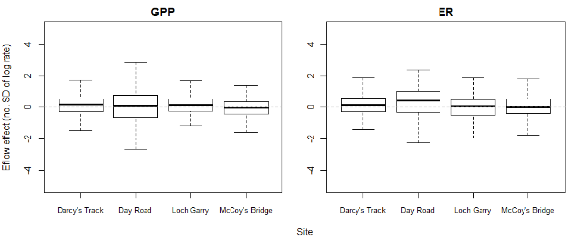
Figure 4-12. Effects of Environmental Flows (including watering actions) on rates of GPP and ER. Y-axes show the difference in corresponding rate between with and without Commonwealth environmental water (labelled as ‘Eflow’), which are presented in the number of standard deviations to the mean log rate. The error bars represent the 75% confidence intervals, summed for each site.

Organic Carbon Loads and Flow Categories
For the three sites (Day Rd, Darcy’s Track and McCoys Bridge) where flow categorization is possible according to Table 4-1, daily loads of organic carbon created by GPP and consumed by ER have been stratified into these categories using all five years of available data from the LTIM program. Almost all days (> 99%) with metabolic parameter estimates meeting acceptance criteria fall into three flow categories: Very Low Flow (VL), Moderately Low Flow (ML) and Low Fresh Flow (LF). The summary statistics for these daily organic carbon load data are presented in Table 4-13 (GPP) and Table 4-14 (ER). The two respective box plots are Figure 4-13 (GPP) and Figure 4-14 (ER).

Table 4-13. Summary Statistics for Daily Organic Carbon Load (kg C/Day) created by GPP, stratified by Flow Category. All data from 2014-2019.
Table 4-14. Summary Statistics for Daily Organic Carbon Load (kg C/Day) consumed by ER, stratified by Flow Category. All data from 2014-2019.

Figure 4-13. Box plot showing the Daily Organic Carbon Load (Tonnes/Day) created by GPP for all five years of LTIM data, stratified by site and flow category: VL = Very Low Flow, ML = Moderately Low Flow and LF = Low Fresh Flow. Summary statistics are presented in Table 4-13.
Statistical analysis: Wilks-Shapiro tests on both raw data and common transformations (square root, log) of the raw GPP load data indicated failure of normality. Consequently, Mann-Whitney Rank Sum tests were performed between each pair of flow categories (VL-ML, ML-LF, VL-LF) at each site. These tests showed a strong statistical difference (p < 0.001) for all of the McCoys Bridge comparisons and the VL-ML comparison at the other two sites. The ML-LF and VL-LF comparisons at Darcy’s Tack and Day Road were all non-significant (p > 0.05).
In each case of a statistically significant difference between the flow categories, the organic carbon load created from GPP increased with increased flow. All three of these flow categories represent flows that are well constrained within the stream channel. This important point is developed further in the Discussion section below.
Figure 4-14. Box plot showing the Daily Organic Carbon Load (Tonnes/Day) consumed by ER for all five years of LTIM data, stratified by site and flow category: VL = Very Low Flow, ML = Moderately Low Flow and LF = Low Fresh Flow. Summary statistics are presented Table 4-14.
As with GPP, Wilks-Shapiro tests on both raw data and common transformations (square root, log) of the raw ER load data indicated failure of normality, hence, Mann-Whitney Rank Sum tests were performed between each pair of flow categories at each site. All three comparisons (VL-ML, ML-LF and VL-LF) showed a strong statistical difference (p < 0.001) for the McCoys Bridge and Day Road sites. Only the VL-ML comparison at Darcy’s Track was significant (p = 0.022); the other two comparisons were non-significant (p > 0.05).
The key feature seen clearly in Figure 4-13 is that increases in daily flow result in more organic carbon being consumed by ecosystem respiration.
While Figure 4-13 and Figure 4-14 demonstrate the increases in organic carbon load produced (GPP) or consumed (ER) as flow increases from one category to the next, these figures do not provide much information as to when (which season) the best carbon enhancements can be found. Consequently, Figure 4-15 uses the extensive data set from McCoys Bridge to explore this question. Only this site has sufficient data over all four seasons to allow seasonal comparisons to be made. The summary data for this figure is found in Table 4-15.
Figure 4-15. Box plot showing the Daily Organic Carbon Load (Tonnes/Day) produced by GPP for all five years of LTIM data at the McCoys Bridge site, stratified by season and flow category: VL = Very Low Flow, ML = Moderately Low Flow and LF = Low Fresh Flow. Summary statistics are presented in Table 4-15.
As with the inter-site comparisons shown in Figure 4-13 and Figure 4-14, Wilks-Shapiro tests on both raw data and common transformations (square root, log) of the raw ER load data indicated failure of normality, hence, Mann-Whitney Rank Sum tests were performed between each pair of flow categories at each site.
The most notable features of Figure 4-15 are:
- For spring, summer and autumn increases in flow, (category) there is more organic carbon being produced within the stream channel. There is, perhaps surprisingly, little difference in the load increases across these seasons. In all three seasons, there was a strong, statistically significant difference (p < 0.001) between the flow categories.
- The winter time loads of organic carbon created by GPP are extremely low and do not show any difference between flow categories. There is only sufficient data to statistically compare VL and ML and these did not differ (p = 0.121).

Table 4-15. Summary Statistics for Daily Organic Carbon Load (kg C/Day) created by GPP at McCoys Bridge, stratified by Flow Category and Season. All data from 2014-2019.

The Contribution of CEW to Organic Carbon Production in the Goulburn River
Using the complete five-year data set at McCoys Bridge, we are now in the position to determine how CEW has contributed to the creation of organic carbon through Gross Primary Production. The method is described in more detail below but essentially involves estimating the amount of organic carbon created each day and apportioning that to either CEW or non-CEW flow. This is not as straight-forward as simply apportioning the daily organic carbon load on the relative amounts of CEW and non-CEW flow as the GPP rate is very dependent upon the actual discharge, with increasing discharge decreasing the amount of GPP per litre due to dilution. Hence the following method uses the actual data set for each season (as seasonal effects are very important as shown in Figure 4-8 and Figure 4-15) then divides each season up into 6 ‘bins’ going from the lowest flow in that season to the highest, in all cases only using flows on days when the metabolism model results met the acceptance criteria. A summary of the McCoys Bridge site data in each bin is presented in Annex A. The McCoys Bridge site was chosen as it was the only site with a significant number of winter-time days (122).
Briefly, using a method slightly modified from that devised by Bond (Watts 2018), the calculations were performed using the following steps:
- Every date with metabolism results that passed the model acceptance criteria was then stratified into a season (summer, autumn, winter, spring) and flow quantile (6 groups or ‘bins’). Each of the six groups contained the same number of data days or differed by one day based on the total number of acceptable data days in that season and whether that number divided exactly by six. The flow quantiles characterized data days by the daily discharge with the lowest quantile (bin) containing the lowest 1/6 of all data days, the second bin containing data days with flows from 1/6 to 2/6 etc
- For each season and bin the mean rate of organic carbon production per litre per day (g C/L/day) were calculated. These data are presented in Annex A.
- The mean rate of production for each day was estimated by multiplying this mean rate of production for that day’s season and bin (in g C/L/day) by the observed discharge on that day (L). This provided an estimate of the total production on that day. This calculation was made for all days in that season.
- To calculate the discharge estimated to have occurred in the absence of Commonwealth Environmental Water (CEW), firstly the non-CEW discharge (observed discharge – CEW) was determined.
- The mean rate of production associated with that season and the bin in which the non-CEW discharge fell, was then used to determine the predicted rate of production (g C/L/day) for that day in the absence of CEW.
- This alternative rate of production was then multiplied by the non-CEW discharge volume to determine the total production predicted to have occurred on that day in the absence of CEW. This then provided a time-series of daily production rates with and without CEW.
- The daily estimates of CEW/non-CEW derived production were then summed to estimate the total additional production from CEW over each season for the full five years of this study.
Figure 4-16 shows the GPP load from non-CEW water in blue and the visible orange colour indicates the additional organic carbon load emanating from the addition of CEW. This figure only uses the data days that met the acceptance criteria. The following figure (Figure 4-17) includes all days from 1st October 2014 through to 30th June 2019. The daily load for every day was calculated using the mean GPP rate for that flow bin and season. The resulting seasonal totals data are summarized in Table 4-16.
Figure 4-16. Estimated daily loads of organic carbon created by GPP at McCoys Bridge showing the total load and the load without the contribution of CEW. The visible orange section of each bar represents the contribution of CEW. This plot only shows data days when the model output met acceptance criteria.
Figure 4-17. Estimated daily loads of organic carbon created by GPP at McCoys Bridge showing the total load and the load without the contribution of CEW. The visible orange section of each bar represents the contribution of CEW. This plot estimates loads for every day over the period of record – October 2014 to June 2019.

Table 4-16. Seasonal Loads of Organic Carbon Produced by GPP at McCoys Bridge showing total loads and the contribution made by Commonwealth environmental water (CEW) over the duration of this project (October 2014 to June 2019). The Seasonal Flows, including the CEW contribution are also shown.

Table 4-16 shows that overall, CEW contributes to the generation of around one quarter of all organic carbon created from Gross Primary Production in the Goulburn around the McCoys Bridge site: 419 of 1639 Tonnes of organic carbon over the duration of the LTIM monitoring (1st October 2014 to 30th June 2019). Table 4-16 also includes the amount of CEW and non-CEW water and this shows that Commonwealth environmental water made up 25% of the total flow in the Goulburn River at McCoys Bridge over the same time frame. This close congruence of load contribution and flow contribution is perhaps unsurprising because as shown in the binning data in Annex A, there is generally only a small difference in GPP rates for the 6 bins, whereas the relative variation in flow is much greater.
From noting the position of the ‘orange colour’ in Figure 4-17 (corresponding to the CEW load contribution) clearly CEW contributions in spring time are particularly important. With the exception of Spring 2016 when CEW only contributed 2% to flow due to the large flooding event, CEW contributed 35-73% of all organic carbon created by GPP in this season. This may be ecologically very significant as it will provide a food resource to support and perhaps sustain fish breeding.
CEW also contributed 62-66% of winter time organic carbon creation over the last three years of the LTIM project. The 2019 total load and flow are much lower than other years due to just a single month (June 2019) being included in the data set.
It is stressed that there are a lot of assumptions made to enable these calculations, most notably that the mean GPP for a flow bin in any season is appropriate for any day in that season with a flow in that range. Daily variation in weather will ensure that the ‘mean GPP’ is not correct, but it will not be grossly wrong. There is insufficient data at higher flows than the low fresh range to make any meaningful comparisons and the summertime data is restricted to the two lowest flow categories. Despite these caveats, the general conclusions drawn from this analysis should be robust and can certainly be checked validated with ongoing data collection.

Discussion
The data presented in Figure 4-4 to Figure 4-7 did not indicate a strong relationship between GPP and flow events, consistent with findings from previous years. It is clear however that the immediate effect of flow is to lower the extant GPP (and ER) rates, almost certainly by simple dilution with large amounts of water. Primary production is expected to respond on a perhaps 10-20 day time frame following flow events (this time frame is based on typical algal doubling rates of 1-2 days), as this corresponds to sufficient time post nutrient addition to generate a significantly higher biomass of primary producers. The key assumption is that an increase in flow will introduce nutrients into the river channel which will then stimulate biomass growth and hence higher rates of GPP. It is extremely likely that the absence of significant growth is due to the extremely low bioavailable nutrient concentrations, especially the extremely low levels of filterable reactive phosphorus (which essentially equates to bioavailable phosphate). Respiration rates did seem to increase slightly in the days to weeks following discharge events. A flow-based influx of organic matter will enhance respiration although the quality/palatability of that organic matter is just as important as the increase in concentration.
Despite this expectation that there will be a lag phase between a flow event and a positive response in GPP and ER, the Bayesian modelling indicated that there was no improvement in model prediction based on discharge or velocity with any temporal lag incorporated.
The Bayesian modelling found (expected) positive relationships between GPP and light at all four sites. There were significant fits at some sites between GPP and ER with temperature.

Impact of Daily Discharge on Stream Metabolism
Up until the end of the third year of the LTIM program, it was not clear what impact flow increases were having on rates of GPP and ER, apart from the initial decline in rates on the rising limb of the hydrograph, attributed to simple dilution by more water. In the 2016-17 Basin Level Evaluation for Stream Metabolism, Grace (2018) introduced three derived metabolism metrics for investigating possible discharge effects, two of which are associated with daily loads of organic carbon. One of these – the mass of organic carbon created by GPP or consumed by ER per day has been used extensively in this current report to investigate further the interplay of metabolism and flow.
Using this load approach and incorporating the flow categorization of Stewardson and Guarino (2018), it has been clearly demonstrated in the previous section (and shown in Figure 4-13 and Figure 4-14) that small increases in discharge introduce more organic carbon into the stream through photosynthetic production. This is a major, very positive finding as the initial paradigm was that no benefit to metabolism would accrue unless the water levels were sufficient to reconnect flood runners, backwaters and even the floodplain. Thus, increasing flow from the very low to moderately low category means more energy (‘food’) being created to support the aquatic foodweb. There is also an increase in respiration rate with flow category thus greater nutrient regeneration to sustain increased primary production.
Data from McCoys Bridge (the site with the largest LTIM data record) showed that the organic load enhancements were similar in magnitude in spring, summer and autumn. Hence further work should be undertaken to match this extra organic carbon production to the times of the year where it is most needed by native fish and other biota. There was negligible benefit in increasing discharge in winter from the perspective of organic carbon creation as the three flow categories all produced approximately the same amount of organic carbon (production is most likely constrained by low water temperatures, low sunlight intensity and the relatively short days (less overall sunshine to drive photosynthesis).
It was also estimated that Commonwealth environmental water provided around 25% of all organic carbon created by GPP over the LTIM project and this was closely related to the amount of CEW relative to non-CEW supply. The timing of the CEW delivery can be matched to ecological need (e.g. for fish) as well as operational constraints on such delivery.
From a management perspective, there is a positive benefit in increasing discharge, even by relatively small amounts when there are restrictions on the amount of water that can be delivered in watering actions. Nevertheless, it is likely that such increases in metabolic rates are still constrained by resources (nutrients) and much greater increases would be possible with reconnection of backwaters etc.

Macroinvertebrates

Introduction
Macroinvertebrates and algal biofilms are essential components of healthy, functioning aquatic ecosystems, providing ecosystem services that range from nutrient cycling to provision of food for larger aquatic organisms such as fish. Macroinvertebrates and algal biofilms are frequently monitored in aquatic ecosystem assessments to understand the health of those ecosystems. In the lower Goulburn River, macroinvertebrate and algal biofilm responses have been measured to increase our understanding of how Commonwealth environmental water (CEW) affects these organisms. The aims of the macroinvertebrate and algal biofilm monitoring program are to answer the following questions:
- What did CEW contribute to macroinvertebrate diversity and abundance in the lower Goulburn River? Specifically, what combination of freshes and low flows are required to maximise macroinvertebrate abundance and biomass in the river?
- What did CEW contribute to macroinvertebrate biomass (also focused on large bodied crustaceans) in the lower Goulburn River?
- How do flows in winter contribute to changes in crustacean abundance, biomass and habitat use?
- What did CEW contribute to algal biofilm production in the Lower Goulburn River?
- Do rates of algal productivity differ between summer and winter in the Lower Goulburn River?
In 2018–19, monitoring efforts centred on measuring macroinvertebrates (also focussing on large bodied crustaceans) before and after the spring fresh that was delivered in mid-October 2018.
Previous results from LTIM monitoring program have shown that crustaceans, notably the freshwater shrimp (Paratya australiensis) and the freshwater prawn (Macrobrachium australiense), are particularly sensitive to flows in the Goulburn River. To understand this further, additional monitoring over winter, when variable flows will be delivered to the Goulburn River was carried out during the 2018-19 monitoring period. Data gained from this will answer whether flows are directly beneficial to crustaceans, as well as enhance our understanding about how changes to flows might affect the way crustaceans use different edge habitats.
Water level variations, such as caused by managed flows, are known to influence the rates of biofilm productivity and community composition of biofilms inhabiting hard structures in rivers, making biofilms a potentially valuable indicator of changes in response to flow regime. As part of the 2018-19 monitoring program a preliminary investigation looking at biofilm production before, during and after the spring fresh delivered in mid-October 2018 and before, during and after flows for consumptive demand in summer 2019 (January – April 2019) was undertaken to provide initial insight into how flows may impact on biofilms on hard structures in the Lower Goulburn River.

Area specific evaluation questions
To determine the contribution of CEW in selected areas, and to improve understanding of the relationship between specific watering actions and ecological objectives for assets, the following questions are being addressed. This information also forms the basis of Basin-scale evaluation – where area-level results are scaled up to the Basin level.
Question | Were appropriate flows provided? | Effect of environmental flows | What information was the evaluation based on?
What did CEW contribute to macroinvertebrate diversity in the lower Goulburn River? | No | Macroinvertebrate diversity is not affected by CEW in the lower Goulburn River; in contrast, natural floods in the previous year (2016-17) did increase diversity in edge habitats. Larger natural flows would be required to have a positive impact on diversity. | Qualitative analysis of monitored results across all survey periods.
What did CEW contribute to macroinvertebrate abundance and biomass in the lower Goulburn River? | Yes | Increased flows (natural and CEW freshes) have been associated with an increase in the abundance and biomass of some taxa, particularly crustaceans such as shrimp and prawns, and possibly help sustain populations of other taxa during dry periods. | BACI ANOVAs were used to compared pre- and post-CEW data from all years (except 2016–17, which was post-flood only) to determine if abundance and biomass changed in response to the spring fresh (CEW)
How do flows in winter contribute to changes in crustacean abundance, biomass and habitat use? | Yes | Winter flows positively affected abundance and biomass of prawns and negatively affected abundance of shrimps. There was no relationship with habitat use. | Bayesian models were used to understand if biomass and abundance of crustacean species were affected by streamflow and habitat condition.
What does CEW contribute to algal biofilm production in the LGR? | Yes | Increased flows (CEW and IVTs) generally reduced algal biofilm biomass and resulted in alterations to the relative community structure. Diatom abundance decreased, while cyanobacteria and chlorophyte abundance increased in the Lower Goulburn River. | Non-parametric statistical analysis of differences between pre and post flows and visual analysis of trends.
Do rates of algal productivity in the LGR differ between summer and winter? | Yes | Algal biofilm biomass was generally lower in summer, compared to winter. Biofilm community composition was dominated generally by cyanobacteria and chlorophytes in summer, and diatoms in winter. This warrants further investigation to understand if differences in flow patterns between seasons were the cause of reduced biomass in summer and differences in community structure. | Non-parametric statistical analysis of differences between seasons and visual analysis of trends.

Main findings from the macroinvertebrate monitoring program

Findings from 2018-19
The main findings from 2018-19 monitoring can be summarised as:
Artificial substrates
- Abundance and richness did not respond to CEW, remaining similar in the Goulburn River, while decreasing post-CEW in the Broken River.
- Of common taxa, several showed a positive response to CEW in 2018-19, with Ceratopogonidae and the chironomid Nanocladius species increasing in abundance in the Goulburn River but decreasing in Broken River, while another midge (Procladius species) increased at both sites post-CEW, but with a much greater increase in the Goulburn.The midge Tanytarsus manleyensis showed a negative response to CEW and decreased in abundance in Goulburn River post-CEW.
- Total biomass increased in the Goulburn River, largely due to increases in crustacean biomass. Total biomass also increased in the Broken River, largely due to increases in Odonata and Other Taxa.
Replicated edge sweep samples (RESS)
- Number of taxa decreased at both sites post-CEW (not CEW related), while abundance only decreased in the Goulburn River post-CEW.
- Few taxa showed CEW-specific responses. Paratya australiensis decreased in Goulburn River post-CEW.
- Total biomass increased in the Goulburn River, largely due to increases in crustacean biomass (Macrobrachium australiense).
Crustacean surveys: bait traps
- Macrobrachium australiense abundances increased post-CEW (December) at both sites. They continued to increase in January at Loch Garry and then fell back through to March. Abundances decreased at McCoys Bridge in January and remained stable through to at least March. Dry weights largely followed abundances (so more animals meant higher dry weights)
- Changes in the abundance and dry weights of Paratya australiensis did not indicate any effect of CEW on their populations in the Goulburn River. However, due to their patchy occurrence in bait traps (on average, <1 animal per trap per site each month), it is difficulty to confidently ascribe any changes in shrimp abundance or dry weights over time as significant effects.
Crustacean surveys: additional RESS
- At Loch Garry Paratya australiensis abundances did not immediately increase post-CEW (December) but greatly increased in January and February before declining in March. In contrast, abundances remained low at McCoys Bridge before and after CEW. Paratya australiensis biomass closely matched abundance at both sites.
- Macrobrachium australiense abundances increased in the RESS samples at McCoys bridge post-CEW from December to February before dropping away entirely in March. At Loch Garry Macrobrachium australiense abundances were low between September and January before increasing in February. Macrobrachium australiense biomass corresponded well with abundance at McCoys Bridge. At Loch Garry biomass was low in September before increasing in October, declining post-CEW in December and January and highest in February.
- Immature crustaceans were most abundant at both sites post-CEW (December). Abundances declined considerably at McCoys Bridge whereas they remained high at Loch Garry until February. Their biomass followed the same patterns as abundance.
Crustaceans surveys; Winter Habitat Monitoring
- Paratya australiensis were more abundant at sites upriver of Murchison and were more likely to be detected in complex habitats rather than less complex habitats, although this was not observed consistently across all sites. Biomass closely matched abundance. Winter flows had a negative effect on abundance and no effect on biomass of Paratya australiensis and was not driven by habitat.
- Macrobrachium australiense were more abundant at sites within Zone 2. This species did not show a clear preference for habitat type. Biomass closely matched abundance. Winter flows had a positive effect on abundance and biomass of Macrobrachium australiense but it was not driven by habitat.

Algal Biofilm Monitoring
- Algal biofilm biomass tended to decrease post-CEW in spring 2018

How these build on findings from years 1 to 4
Artificial substrates
- CEW delivered as spring freshes did not have an overall significant effect on macroinvertebrate richness, abundance or biomass. The 2016-2017 (blackwater event) may be masking the positive effects seen on biomass from spring freshes.
- Over the years of the monitoring program, several taxa have shown consistent responses to CEW spring freshes. CEW has a positive effect on Oligochaeta by reducing negative responses over time, and on Procladius species, with much greater positive responses in the Goulburn River post-CEW. In contrast, several species have consistent negative responses to CEW in the Goulburn River, while abundances increased, remained unchanged or were less severely reduced in the Broken River. These included Tanytarsus manleyensis, Ecnomus pansus, Parakiefferiella species, Nilotanypus species and Rheocricotopus species.
Replicated Edge Sweep Samples
- Overall, CEW had a significant positive effect on macroinvertebrate abundances in RESS samples.
- Of the common taxa caught in edge habitats, most showed responses that were not consistent over the years (e.g. showed a positive response to CEW in one year but a negative response in another) or were consistent but responses appeared to be more related to site or seasonal preferences. Two taxa, Oligochaeta and Tasmanocoenis tillyardi, had overall positive responses to CEW.
- Two crustaceans have generally shown consistent responses to CEW delivered as spring freshes. Macrobrachium australiense has always increased in abundance at McCoys Bridge post-CEW, until 2018-19 where it decreased. The Paratya australiensis always has always decreased in abundance in edge habitats post-CEW. Overall there was no significant change in response to CEW.
- Large invertebrate biomass did not show consistent responses to spring freshes; in 2015–16, 2018-19 it increased at McCoys Bridge post-CEW and decreased in 2017–18. Overall, large invertebrate biomass showed no significant responses to CEW. Biomass was greatest post-flood (2016–17) than post-CEW due to the large increase in crustaceans present in edge habitats.
Crustacean surveys: bait traps (compared to year 3 and 4 only)
- Elevated flows in spring seem to have an important, positive effect on increasing crustacean abundances and biomass, particularly M. australiense. However, a comparison between the spring freshes in 2018-19 and 2017–18 to large, natural floods in 2016–17 indicates that the magnitude of this effect is smaller with CEW compared to the overbank flood. There may be longer-term benefits from CEW of sustaining crustacean populations into warmer, drier months.
Crustacean surveys: additional RESS (compared to year 3 and 4 only)
- Abundance and biomass of Paratya australiensis at Loch Garry increased considerably in January and February which is a similar response to the CEW in 2017-18. However, abundance and biomass at McCoys Bridge were considerably lower post-CEW than they were in 2017–18. Abundance and Biomass were both considerably lower than they were post-flood (2016–17). The responses are significant given the likely importance of this species in the diet of native fish.
- Abundance and biomass of Macrobrachium australiense at McCoys Bridge increased post-CEW in 2018–19 however abundances were not as high as post-CEW 2017-18. At Loch Garry in 2018-19 M. australiense numbers were low between September and January before peaking in February. In 2017-18 a similar peak in abundance was observed in January February. Abundance and biomass were well down when compared to post-flood (2016-17).

Methods

Macroinvertebrate field and laboratory methods
The methods used for monitoring macroinvertebrates are given in (Webb et al. 2018), with modifications described in (Webb et al. 2017). Briefly, four methods were employed at three sites in the region: two impacted sites (Goulburn River at McCoys Bridge and Goulburn River at Loch Garry) and the control site (Broken River at Shepparton East) (See Summary Report Figure 1). The timing of monitoring, along with significant catchment events is given in Table 5-1.
The first two methods, artificial substrates and replicated edge sweep samples (RESS), were conducted at the Goulburn River at McCoys Bridge and the Broken River. Artificial substrates were adapted from (Cook et al. 2011). These are plastic mesh cylinders containing an artificial substrate (onion bags) that are deployed at each site for four to six weeks, allowing macroinvertebrates to colonise these during that time. The second method involves conducting Replicated Edge Sweep Sampling (RESS) at each site. This method is modified from that of (Gigney et al. 2007a, b) and involves taking five replicate sweep samples across the different types of edge habitat at each site. Monitoring for each method typically occurred before CEW delivery (usually a spring fresh) and after environmental water.
The third and fourth methods – bait traps and additional RESS samples – specifically targeted crustaceans and were done at the two Goulburn River sites: McCoys Bridge and Loch Garry. These were conducted monthly from September to March (No sampling was conducted in November). Twenty bait traps were deployed overnight at each site once a month. The traps were placed among four habitat types (bare, coarse organic particulate matter/depositional areas, macrophytes and snags). Upon retrieval, all crustaceans were removed from the bait traps and stored in 100% ethanol with the exception of yabbies (Cherax species), which were counted, weighed and released back into the river. The preserved crustaceans were identified to species in the laboratory and had their carapace lengths measured (from the tip of the rostrum to the end of the carapace). These were air dried for 24 hours, dried in the oven at 60°C for a further 24 hours and weighed. Additional RESS samples were taken from both Loch Garry and McCoys Bridge when bait traps were being retrieved using a modified version of the original RESS method. Modifications included measuring the area swept during the survey so that biomass could be calculated and preserving the whole sample to ensure small crustaceans (larvae) would not be missed. Samples were preserved in 100% ethanol and crustaceans were picked from these in the laboratory. Crustaceans from RESS samples were also identified, measured, dried and weighed for biomass.
Winter monitoring of crustaceans occurred at 11 sites in the lower Goulburn River area over five days in late August when variable flows are delivered to the river. At each site, 6 bait traps were deployed overnight. These were divided among two habitat types: complex habitats (snags, macrophytes) and less complex habitats (bare). The following day, bait traps were retrieved and all crustaceans within them preserved in ethanol for analyses in the laboratory for species, ovigerous females, abundance and biomass. The intention was to visit all 12 sites early in the week (Monday and Tuesday nights) with a return visit later in the week (Wednesday and Thursday nights) so that crustaceans were assessed twice at each site under different flow conditions.
    - Algal biofilm methods
Algal biofilms were assessed using artificial substrates. The biomass and composition of biofilms was assessed at two sites, Loch Gary and McCoys Bridge. Sampling was targeted over two seasons, winter 2018 and summer 2019 to target CEW delivery as a spring fresh and intervalley transfer (IVT) flows, respectively. Artificial substrate samplers consisted of two disks (150mm diameter) suspended at different heights in the water column, one within the photic zone (~20cm below surface) and one within the non-photic zone (~50cm below water surface) (Figure 5-1). Samplers were supported in the water column by a float and weight and tethered to snags or trees on the bank. Six substrate samplers were deployed at each site on the 16th August 2018 and 21st January 2019 for winter and summer deployments, respectively. Four weeks after deployment, three samplers from each site were removed and replaced, while three sets of samplers remained untouched. After a further eight weeks, all sets of samplers were removed from each site (Table 5-1). This provided samples pre, during and post environmental flows.
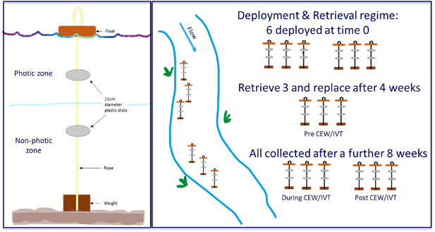
Figure 5-1. Assessment of benthic algal response to environmental flows. Artificial substrate sampler (left panel), the deployment and retrieval regime for artificial samplers (right right).
Upon sampling, disks were unclipped from the samplers and immediately placed into snap lock bags on ice for return to the laboratory, where they were processed within 24hrs. The biofilm was scrubbed from each disk with 100mL of distilled water using a soft toothbrush. The sample was thoroughly homogenised and then subsampled for community composition and biomass determinations (Chlorophyll-a and organic matter as dry mass (DM) and Ash Free Dry Mass (AFDM)). A 10mL sub-sample was taken to estimate the community composition and photosynthetic efficiency of biofilms with the Phyto-PAM Phytoplankton Analyzer (Heinz Walz GmbH, Germany). The Phyto-PAM is a non-intrusive method that measures chlorophyll fluorescence at four wavelength signals (470nm, 520nm, 645nm and 665nm) and therefore shows the contribution of various types of pigments. The relative community composition of biofilms on the disks was estimated based on the chlorophyll-a fluorescence signals generated at the four wavelengths, which allow separation of three functional algal types cyanobacteria, green algae, and chlorophyll-c containing algae (e.g. diatoms, dinoflagellates). Calibration (based on fluorescence reference excitation spectra) provided by the PhytoWin software was used for algal group delineation. Photosynthetic efficacy of the biofilm communities was determined as the effective quantum yield of photosynthetic energy conversion in PSII, known as “Y”, using equation 1.
Equation 1: Y = (F_{m}-F_{o})/F_{o},
where F_{m} is the maximal fluorescence yield of the community measured by applying a saturating pulse, and F_{o} is the basal fluorescence of the community measured shortly before the saturating pulse at 120 µmol m⁻² s⁻¹.
A second sub-sample (40mL) was taken and filtered through a Whatman GF/C (90mm, 1.2µm) filter, the filter then folded, placed into a centrifuge tube (10mL) and frozen (-20ºC) for later chlorophyll-a determination. Chlorophyll-a was extracted from frozen filters in acetone (10mL) in the dark at 4ºC overnight. At the end of this time, samples were centrifuged, and acid corrected chlorophyll-a measured using a microplate spectrophotometer (PolarStar, Omega). Values for chlorophyll-a biomass were determined using the equations outlined in Biggs & Kilroy (2000) and are expressed as mg Chl-a m⁻² of artificial substrate surface. A third subsample (40mL) was filtered through pre-ashed (400ºC) and pre-weighed Whatman GF/C filters (90mm, 1.2µm) for DM and AFDM determination. Immediately following filtering, filter papers were dried at 105°C for 24 hours, weighed to four decimal places, combusted for four hours at 400°C and reweighed. The organic matter content was then calculated by difference and expressed as mg AFDM m⁻² of artificial substrate surface. Percent organic matter was calculated as the proportion of AFDM to DM and converted to a percentage. Chlorophyll-a provides an indication of the autotrophic component of the biofilm while AFDM combines autotrophic, heterotrophic and detrital carbon. From these measures the autotrophic index (AI) can be calculated as the ratio of AFDM:chlorophyll-a, which is a measure of the autotrophic-heterotrophic balance of the biofilm community (Biggs & Kilroy 2000). AI values of 50-100 are characteristic of a community dominated by autotrophs (viable algae), and values over 400, a community dominated by heterotrophic organisms and/or organic detritus (Biggs & Kilroy 2000).
Discharge and water-column temperature, salinity and dissolved oxygen concentrations were obtained from the nearby routine monitoring station at McCoys Bridge during both winter and summer deployments. During the summer 2019 deployments, continuous light measurements were taken at 20cm, 50cm and 100cm below the water surface. These were equivalent to the position of the disks in the photic and non-photic zones and the weight on the bottom of the artificial samplers.
Table 5-1. Macroinvertebrate and algal biofilm sampling times and significant events in the Goulburn and Broken Rivers during 2018-19. CEW = Commonwealth Environmental Water delivered as spring freshes. Pre-CEW = pre-Commonwealth Environmental Water delivery (before spring fresh); Post-CEW = post-Commonwealth Environmental Water delivery (after spring fresh); GM = Goulburn River at McCoys Bridge; GL = Goulburn River at Loch Garry; BR = Broken River at Shepparton East. D = deployed; R = retrieved.
 |  |  |  |  | Sampling dates
Activity / event | Site | Aug-18 | Sep-18 | Oct-18 | Nov-18 | Dec-18 | Jan-19 | Feb-19 | Mar-19 | Apr-19
Events | Goul-burn River |  | CEW1 start late Sep |  | CEW end early Nov |  | Elevated flows for IVT | Elevated flows for IVT | Elevated flows for IVT | Elevated flows for IVT
RESS | GM |  | Pre-CEW 12/9 |  | Post-CEW 20/11
RESS | BR |  | Pre-CEW 13/9 |  | Post-CEW 21/11
Artificial substrates | GM | Pre-CEW 15/8 D | Pre-CEW 12/9 R |  | Post-CEW 20/11 D | Post-CEW 18/12 R
Artificial substrates | BR | Pre-CEW 16/8 D | Pre-CEW 13/9 R |  | Post-CEW 11/11 D | Post-CEW 19/12 R
Bait traps | GM |  | 26/9-27/9 | 16/10-17-10 |  | 11/12-12/12 | 21/1-22/1 | 20/2-21/2 | 20/3-21/3
Bait traps | GL |  | 26/9-27/9 | 16/10-17-10 |  | 11/12-12/12 | 21/1-22/1 | 20/2-21/2 | 20/3-21/3
RESS (crustaceans) | GM |  | 27/9 | 16/10 |  | 11/12 | 22/1 | 21/2 | 20/3
RESS (crustaceans) | GL |  | 26/9 | 17/10 |  | 11/12 | 22/1 | 20/2 | 20/3
Algal Biofilms | GM | Pre-CEW D 16/8 | Pre-CEW R/D 12/9 |  | Post-CEW R 7/11 |  | Pre-IVT D 21/1 | Pre-IVT R/D 21/2 |  | Post-IVT R 15/4
Algal Biofilms | GL | Pre-CEW D 16/8 | Pre-CEW R/D 12/9 |  | Post-CEW R 7/11 |  | Pre-IVT D 21/1 | Pre-IVT R/D 21/2 |  | Post-IVT R 15/4

Statistical analysis
BACI ANOVAs within a Bayesian framework were also used to assess the effect of the spring fresh on macroinvertebrate biomass and abundance (as measured using artificial substrates and replicated edge sampling). The model is structured as follows:
$y_{i}\sim Normal\left({mu}_{i, }s^{2}\right)$ Equation 1
${mu}_{i}={eff.Year}_{m}+{g.mu}_{b,r}$ Equation 2
The macroinvertebrate biomass/abundance (y) in sample i is normally distributed, with a mean of mu_{i} and standard deviation of s. mu_{i} is driven by the global abundance at river r (Broken River or Goulburn River) and at time b (before or after the spring fresh) (g.mu), and the random effect of year (eff.Year).
The global biomass/abundance (g.mu) is drawn from a truncated normal distribution with a mean of 0, standard deviation of s.g.mu and a minimum of 0. Likewise, the random effect of year (eff.Year) is drawn from a normal distribution with a mean of 0 and standard deviation of s.year.
${g.mu}_{r,b}\sim Normal\left(0,{s.g.mu}^{2}\right)I(0,)$ Equation 3
${eff.year}_{m}\sim N\left(0,{s.year}^{2}\right)$ Equation 4
The 2018 winter crustacean monitoring and modelling aims to test the following hypothesis:
The biomass (or abundance) of each crustacean species is affected by streamflow, and the effect of streamflow differ by river (Goulburn or Broken River) and habitat condition (bare or macrophyte).
We tested this hypothesis on the both occurrence (i.e. whether sampled biomass/abundance is greater than 0) and amount (i.e. actual biomass/abundance sampled) of each species.
The occurrence model is described as:
$y_{ijk}\sim Bernoulli\left(P{mu}_{ijk},σ\right)$ Equation 1
$P{mu}_{ijk}=int_P+{eff.Q.P}_{jk}×Q_{ijk}+{eff.survey.P}_{l}$ Equation 2
${eff.Q.P}_{jk}\sim Normal({μ_Q.P}_{jk },σ_Q.P)$ Equation 3a
${eff.survey.P}_{l}\sim Normal\left(0,σ_survey.P\right)$ Equation 3b
The amount model is described as:
$Y_{ijk}\sim Normal\left({mu}_{ijk},σ\right)$ Equation 4
${mu}_{ijk}=int+{eff.Q}_{jk}×Q_{ijk}+{eff.survey}_{l}$ Equation 5
${eff.Q}_{jk}\sim Normal({μ_Q}_{jk },σ_Q)$ Equation 6a
${eff.survey}_{l}\sim Normal\left(0,σ_survey\right)$ Equation 6b
Where y_{ijk} and Y_{ijk} is the occurrence and amount of abundance/biomass which vary depending captured on date i. The impacts of flow (Q) is represented by instantaneous flowrate (ML/d) on the date of sampling. The corresponding flow effects (eff.Q.P_{jk} and eff.Q_{jk}) are pooled by river and habitat condition. Survey has random effects (eff.survey.P and eff.survey).
The crustacean species analysed are: Macrobrachium.australiense, Paratya.australiensis, Cherax (only sampled for abundance) and immature crustacean (only sampled for biomass). Preliminary analyses suggested that the latter two should not be included in further modelling, because: 1) all Cherax has not been captured once (all samples are zero); 2) immature crustacean had only one non-zero sample.

Results

Artificial substrates (macroinvertebrates)
In 2018–19 (Year 4), a total of 7,425 macroinvertebrates from 106 taxa were caught in artificial substrates. Taxonomic richness was lower in the Goulburn River than the Broken River and remained similar post-CEW in the Goulburn and slightly decreased in the Broken (Figure 5-2a). These post-CEW changes in the number of taxa were not consistent over the years and do not appear to be related to CEW spring fresh delivery. Total macroinvertebrate abundance remained similar pre and post-CEW in the Goulburn River, while abundance significantly decreased in the Broken River post-CEW (Figure 5-2b). When post-CEW changes in abundance were compared across years (when CEW was delivered as spring freshes), macroinvertebrate abundances decreased at both sites, however, the effect of CEW on abundance was not significant (Table 5-3).
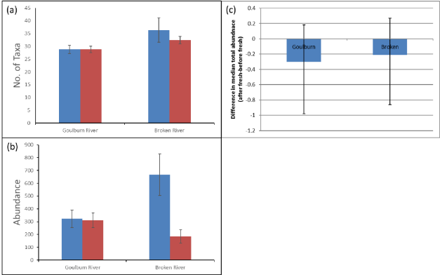
Figure 5-2. (a) Number of taxa (average + standard error of the mean) and (b) abundance (average + standard error of the mean) of macroinvertebrates in artificial substrates from 2018-19 pre-CEW (blue) and post-CEW (red), and (c) change in total median abundance (post-CEW minus pre-CEW) of macroinvertebrates across all years (+ 95% Bayesian credible intervals).
There were 17 common taxa that each contributed to >1% of the total abundance; these were compared to common taxa from previous years to determine a final list of taxa for further analyses. Six taxa were consistently common across all five sampling years and were considered further (Table 5-2). Ignoring data from 2016–17 (post-flood only), several taxa showed relatively consistent responses across the years. For example, Nilotanypus species generally increased in abundance at both sites post-CEW, although this response indicates abundance increased with warming temperatures as summer approached as opposed to an effect of CEW (Table 5-3). Nilotanypus species also showed a strong preference for site and was consistently more abundant in the Broken River than the Goulburn River. Procladius species also increased in abundance post-CEW at both sites, but the increase was much greater in the Goulburn River suggesting the spring fresh had a positive effect on this species. In general, most species were more abundant post-CEW in all years than post-flood (2016–17) in the Goulburn River, after that the river experienced low dissolved oxygen during a blackwater event while the substrates were deployed.

Table 5-2. Average abundance of common taxa pre- and post-Commonwealth Environmental Water (CEW) delivery as spring freshes in 2014-15, 2015-16 and 2017-18, 2018-2019 along with post-flood abundances in 2016-17 at two sites in the lower Goulburn River. GR = Goulburn River. BR = Broken River.
 |  |  |  |  |  | Average abundance
Taxon | Site | Pre-CEW 2014-15 | Post-CEW 2014-15 | Pre-CEW 2015-16 | Post-CEW 2015-16 | Post-flood 2016-17 | Pre-CEW 2017-18 | Post-CEW 2017-18 | Pre-CEW 2018-19 | Post-CEW 2018-19
Nilotanypus species | GR | 2 | 7 | 1 | 1 | 0 | 0 | 4 | 0 | 12
Nilotanypus species | BR | 24 | 55 | 1 | 3 | 90 | 10 | 202 | 0 | 22
Nanocladius species | GR | 177 | 87 | 56 | 74 | 6 | 17 | 33 | 17 | 38
Nanocladius species | BR | 2 | 23 | 15 | 3 | 5 | 148 | 20 | 1 | 0
Procladius species | GR | 6 | 175 | 12 | 167 | 17 | 29 | 140 | 4 | 73
Procladius species | BR | 1 | 7 | 1 | 14 | 11 | 5 | 17 | 0 | 26
Tanytarsus species | GR | 39 | 32 | 95 | 70 | 0 | 40 | 7 | 72 | 6
Tanytarsus species | BR | 12 | 23 | 24 | 12 | 0 | 13 | 51 | 24 | 4
Ecnomus pansus | GR | 11 | 37 | 2 | 3 | 3 | 1 | 4 | 2 | 5
Ecnomus pansus | BR | 10 | 75 | 2 | 3 | 77 | 5 | 58 | 4 | 20
Ceratopogonidae | GR | 9 | 9 | 2 | 2 | 17 | 6 | 8 | 2 | 20
Ceratopogonidae | BR | 6 | 5 | 1 | 1 | 12 | 11 | 21 | 4 | 3
The differences in abundance between pre- and post-CEW for these common taxa over the years when CEW was delivered were analysed using BACI ANOVAs and the results are given in Table 5-3. Two taxa, Oligochaeta and Procladius spp. had significantly positive effects in abundance as a result of the CEW, while three taxa (Ecnomus pansus, Nanocladius sp., Ceratopogonidae) were not affected and four taxa were negatively affected (Rheotanytarsus sp., Tanytarsus manleyensis, Parakiefferiella sp. and Rheocricotopus sp.) (Table 5-3; Figure 5-3). While Nilotanypus species abundances was found to have a significant negative effect it probably relates to the preference of this genus for sandy streams rather than an effect of CEW.
Table 5-3. Posterior probability of significant positive effect of Eflow obtained by the differences in the before-after effect at Goulburn and Broken. 1 – significant positive effect; 0 – significant negative effect; 0.5 – insignificant differences. Species that show significant effects with Eflow are coloured (green – positive; orange – negative) and bolded.
Species/groups | Mean AS
Total biomass | 0.15
Total abundance | 0.41
Oligochaeta | 0.91
Rheotanytarsus species | 0.08
Procladius species | 1
Tanytarsus manleyensis | 0.05
Ecnomus pansus | 0.15
Parakiefferiella species | 0.01
Nanocladius species | 0.56
Nilotanypus species | 0.01
Ceratopogonidae | 0.56
Rheocricotopus species | 0.06
Figure 5-3. Change in median total (a) Oligochaeta (b) Rheotanytarsus sp. (c) Tanytarsus manleyensis. (d) Procladius sp. (e) Ecnomus pansus (f) Parakiefferiella sp. (g) Nanocladius sp. (h) Ceratopogonidae (i) Rheocricotopus sp. (j) Nilotanypus sp. All data are collected from Artificial Substrates. Error bars indicate the 95 percent Bayesian credible intervals.
In 2018-19, total large invertebrate biomass (invertebrates >5mm) increased in the Goulburn River and the Broken River post-CEW (Figure 5-4a). The change in biomass, when considered with the other years when CEW was delivered as spring freshes, was usually seen as a decrease in biomass post-CEW at both sites, however overall there was no significant effect from CEW on large invertebrate biomass (Table 5-3; Figure 5-4b).
A breakdown of the main taxonomic groups contributing to biomass in 2018–19 showed distinct site and event differences. In the Goulburn River, the contribution of crustaceans to biomass slightly increased post-CEW, while in the Broken River their contribution decreased (Figure 5-4c; Figure 5-4e). While Ephemeroptera, Plecoptera and Trichoptera (EPT) decreased in both the Goulburn and Broken post-CEW, the decrease was much greater in the Broken River (Figure 5-4d). Odonata biomass decreased in the Goulburn River but increased in the Broken River post CEW (Figure 5-4f), while other taxa contributed relatively little to large invertebrate biomass.
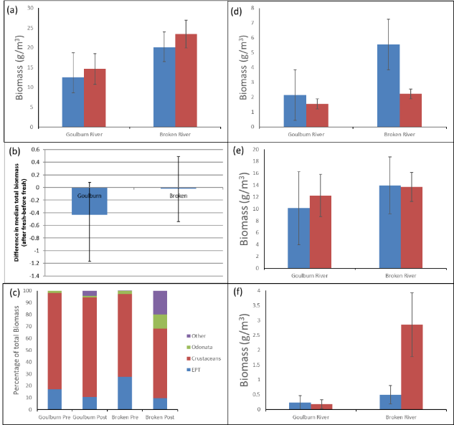
Figure 5-4. Biomass in artificial substrates. (a) Average total large invertebrate biomass in 2018–19 (+ standard error of the mean). (b) Change in median total biomass across all years (post-CEW minus pre-CEW; error bars are 95% Bayesian credible intervals). (c) Percentage contribution of main large invertebrate groups to total biomass in 2018-19. Average (+ standard error of the mean) biomass in 2018-19 of (d) Ephemeroptera, Plecoptera and Trichoptera (EPT), (e) crustaceans and (f) Odonata. For figures (a), (d), (e) and (f) blue = pre-CEW, red = post-CEW.

Replicated Edge Sweep Samples (RESS)
A total of 3,862 individuals from 80 taxa were identified in RESS samples, with abundance and taxonomic richness always higher in the Broken River than in the Goulburn River. Richness decreased post-CEW at both sites (Figure 5-5a), while abundance decreased only in the Goulburn River post-CEW (Figure 5-5b). When post-CEW changes in abundance were compared across years (when CEW was delivered as spring freshes), macroinvertebrate abundances decreased at both sites, however, the effect in the Goulburn River was less than the Broken River and there was an overall positive effect of CEW on abundance (Table 5-4; Figure 5-5c).
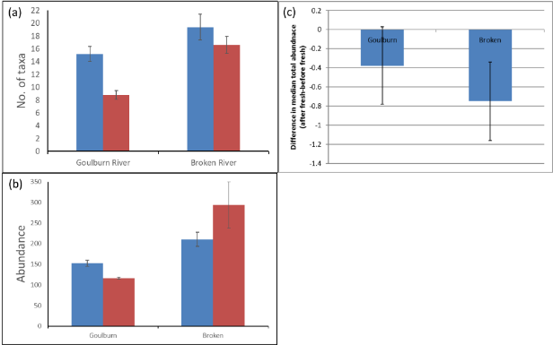
Figure 5-5. (a) Number of taxa (average + standard error of the mean) and (b) abundance (average + standard error of the mean) of macroinvertebrates in RESS samples from 2018-19 pre-CEW (blue) and post-CEW (red), and (c) change in total median abundance (post-CEW minus pre-CEW) of macroinvertebrates across all years (+ 95% Bayesian credible intervals).
Responses of specific common taxa to CEW in RESS samples were examined further. Significant effects of CEW delivery were examined by comparing changes in abundance (after CEW minus before CEW) from both sites over the years (Table 5-4, Figure 5-6). Two taxa showed significant positive responses to CEW, Oligochaeta increased only in the Goulburn River post-CEW and although Tasmanocoenis tillyardi decreased post-CEW in the Goulburn River it was to a much lesser extent than in the Broken River. The majority of common taxa (16 taxa) did not significantly respond to CEW freshes, while two taxa Ecnomus pansus and Parakiefferiella species showed negative responses to CEW (Table 5-4; Figure 5-6).

Table 5-4. Posterior probability of significant positive effect of CEW obtained by the differences in the before-after effect at Goulburn and Broken. 1 – significant positive effect; 0 – significant negative effect; 0.5 – insignificant differences. Species that show significant effects with CEW are coloured (green – positive; orange – negative) and bolded. “-“ represent species not considered as a key species to analyses for the corresponding sampling method.
Species/groups | Mean RESS
Total biomass | 0.49
Total abundance | 0.91
Oligochaeta | 0.99
Tanytarsus manleyensis | 0.62
Ecnomus pansus | 0.03
Parakiefferiella species | 0.02
Nanocladius species | 0.15
Nilotanypus species | 0.24
Ceratopogonidae | 0.64
Rheocricotopus species | 0.36
Anisop species | 0.28
Atalophlebia species AV6 | 0.70
Caridina indistincta | 0.37
Cryptochironomus species | 0.14
Macrobrachium australiense | 0.38
Micronecta annae | 0.26
Offadens confluens | 0.85
Paratya australiensis | 0.30
Tasmanocoenis rieki | 0.46
Tasmanocoenis tillyardi | 0.97
Triaenodes species | 0.81

Figure 5-6. Change in median total (a) Offadens confluens (b) Micronectsa annae (c) Macrobrachium australiense (d) Paratya australiensis (e) Oligochaeta (f) Cricotopus parbicinctus (g) Cardina indistincta (h) Tanytarsus manleyensis (i) Tasmanocoenis rieki (j) Cryptochironomus sp. (k) Procladius sp. (l) Tasmanocoenis tillyardi (m) Triaenodes sp. (n) Anisops sp. (o) Atalophlebia sp. (p) Economus pansu (q) Parakiefferiella sp. (r) Nanocladius sp. (s) Ceratopogonidae (t) Rheocricotopus sp. (u) Nilotanypus sp. All data are collected from RESS. Error bars indicate the 95 percent Bayesian credible intervals.
Fourteen taxa contributed to >1% of the abundance in 2018–19; these were compared to common taxa in previous years to derive a list of common taxa that were considered further. Common taxa (considered across all years) are listed in Table 5-5 along with changes in their abundance between post-CEW and pre-CEW at both sites for the three years when CEW was delivered as a spring fresh (2015–16, 2017–18, 2018-19). Post-flood data (from 2016–17) was not considered in this section. Results were compared across the three years to determine consistent responses that are indicative of an effect of the spring freshes (CEW). For responses to be attributed to CEW, it had to occur across all years and had to result in a change in abundance in the Goulburn River that did not occur in the Broken River. Other consistent effects were also observed, notably seasonal changes (e.g. a taxon always increased or decreased in abundance post-CEW regardless of site) or site preferences (i.e. a taxon was consistently present at one site and absent from the other).
While several common taxa did show consistent effects across years, these were often due to site preferences (i.e., Offadens confluens and Caridina indistincta were only found in the Broken River) or seasonal preferences (e.g. O. confluens and Tanytarsus manleyensis were consistently less abundant during warmer, post-CEW sampling regardless of whether a site experienced CEW or not) (Table 5-5). Only one taxon (Paratya australiensis) showed consistent responses to CEW delivery, with decreased abundance post-CEW in the Goulburn River.
When compared across years, CEW was shown to have no significant effects on large invertebrate biomass in RESS samples (Figure 5-7). Regardless of site or sampling event, in 2018–19 large macroinvertebrate biomass was dominated by crustaceans, with other major groups contributing little to biomass (Figure 5-7). Biomass increased post-CEW in the Goulburn River, which was largely driven by the increase in crustacean biomass (Figure 5-7a, c). Conversely, in the Broken River biomass decreased post-CEW, largely driven by a decline in crustacean, EPT and other large invertebrate’s biomass (Figure 5-7a, c-f).

Table 5-5. Common taxa from replicated edge sweep samples, changes in their abundance (post-CEW – pre-CEW) and what consistent changes might mean.
 | Changes in abundance (post-CEW – pre-CEW)
Taxon | Goulburn River 2015-16 | Broken River 2015-16 | Goulburn River 2017-18 | Broken River 2017-18 | Goulburn River 2018-19 | Broken River 2018-19 | Consistent effects?
Micronecta annae | ↓ | ↓ | ↑ | ↑ | ↓ | ↑ | No
Offadens confluens | Absent | ↓ | Absent | ↓ | Absent | ↓ | Yes; preference for Broken and seasonal ↓
Macrobrachium australiense | ↑ | ↓ | ↑ | ↑ | ↓ | ↓ | No
Caridina indistincta | Absent | Unchanged | Absent | ↑ | Absent | ↓ | Yes; preference for Broken
Procladius species | ↓ | ↓ | ↓ | ↑ | ↓ | ↑ | Yes; seasonal
Tasmanocoenis spp. | ↓ | ↑ | ↓ | ↓ | ↓ | Unchanged | No
Tanytarsus spp. | ↓ | ↓ | Absent | ↓ | ↓ | ↓ | Yes; seasonal ↓
Paratya australiensis | ↓ | Absent | ↓ | Unchanged | ↓ | Absent | Yes; ↓ after CEW
Cryptochironomus species | ↓ | ↓ | Absent | Absent | ↓ | ↓ | No
Atalophlebia species AV6 | Unchanged | ↑ | ↓ | ↓ | ↓ | ↓ | No
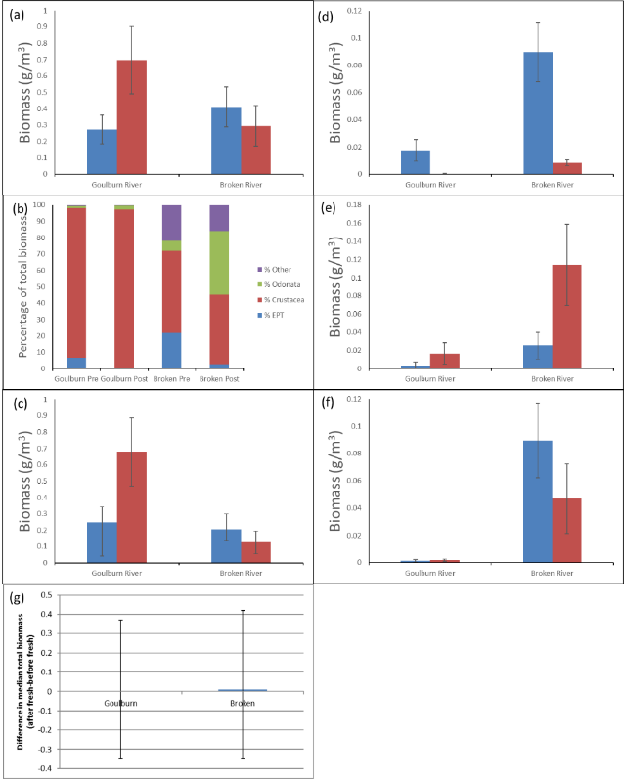
Figure 5-7. (a) Total large invertebrate biomass, (b) percentage of total biomass by major groups, (c) crustacean biomass, (d) EPT biomass, (e) Odonata biomass (f) other large invertebrate biomass in RESS samples from 2018-19. For figures (a) and (d) to (f), values are average + standard error of the mean, with blue columns = pre-CEW and red columns = post-CEW. (g) change in median biomass (post-CEW minus pre-CEW) in replicated edge sweep samples. Data were 4th-root transformed. Error bars indicate the 95 percent Bayesian credible intervals.

Additional crustacean surveys: bait traps
Abundance and dry weights
Macrobrachium australiense was the most abundant crustacean caught in bait traps during 2018-19 sampling. At McCoys Bridge abundances and dry weights increased from September, were highest in December, slightly decreased in January and then remained similar until March (Figure 5-8a, b). At Loch Garry abundances and dry weights increased from September and were highest in January (abundance) or February (dry weights) before decreasing in March (Figure 5-8a, b).
The 2018-19 results were similar to the findings from 2017–18 with highest abundances occurring at McCoys Bridge earlier than at Loch Garry. As in 2017-18, dry weights were highest in February at Loch Garry. Macrobrachium australiense showed no preference for habitat types at either site (Figure 5-8c-d). It should be noted that there were no macrophytes present at either site in September and December 2018 therefore no bait traps were deployed in these habitats.
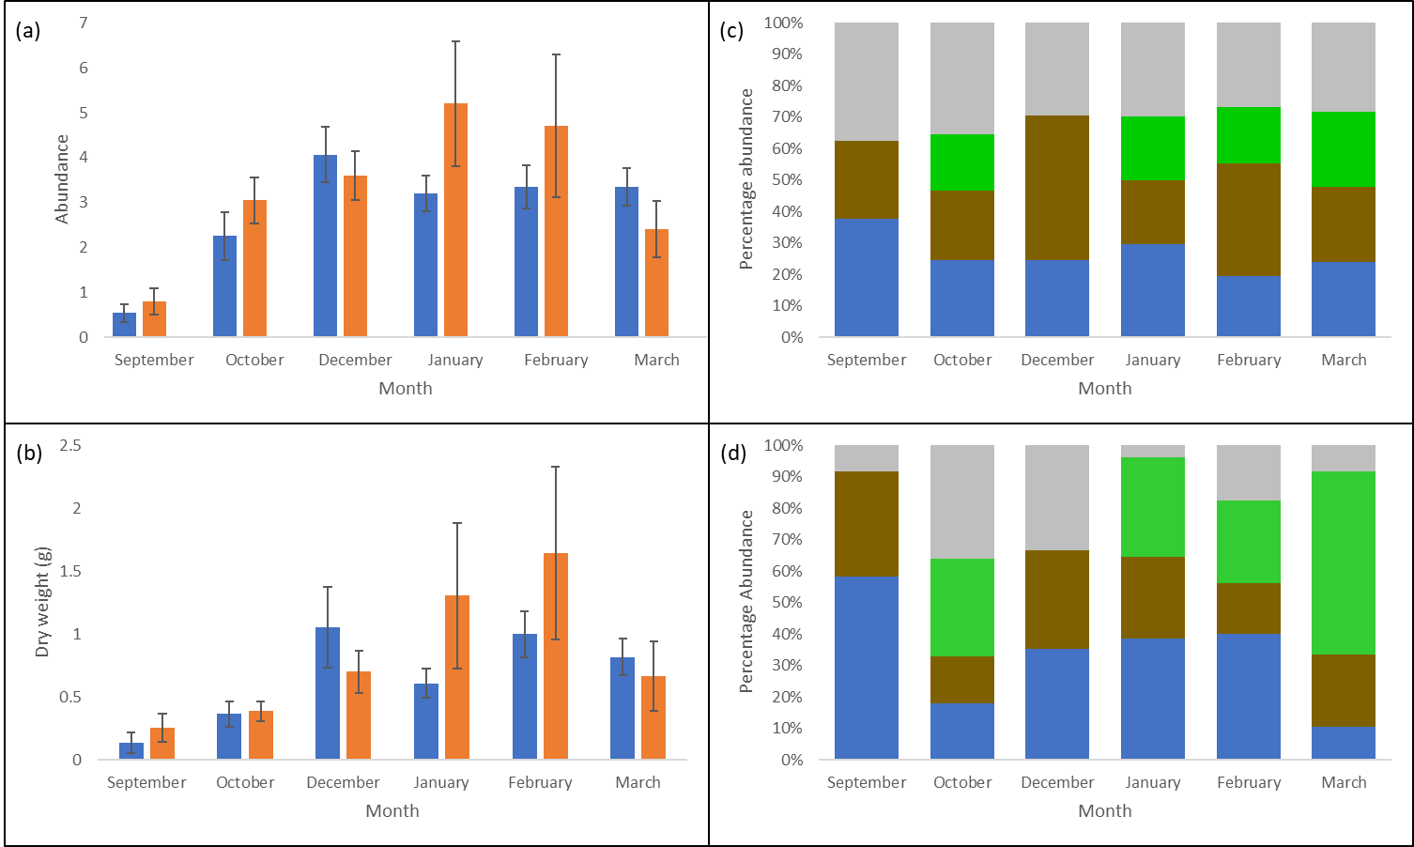
Figure 5-8. Macrobrachium australiense in bait traps from 2018–19. (a) average (+ standard error of the mean) abundance, (b) average (+ standard error of the mean) dry weights, (c) percentage of abundance across traps placed in different habitats at McCoys Bridge and (d) percentage of abundance across traps placed in different habitats at Loch Garry. In figures (a) and (b), blue columns = McCoys Bridge and orange columns = Loch Garry. In figures (c) and (d), blue = bare habitat, brown = coarse organic particulate matter/depositional area, green = macrophytes and grey = snags.
Paratya australiensis were much less common than M. australiense in bait traps during the 2018-19 sampling. Abundances at McCoys Bridge was highest in September before remaining low for the subsequent sampling events. Abundances at Loch Garry increased from September to October and between January and February before decreasing in March (Figure 5-9a). They were not detected in December. Changes in Paratya australiensis dry weights closely followed changes in abundance at both sites (Figure 5-9b).
As in 2017–18, their patchy occurrence in bait traps made it difficult to confidently discern any temporal patterns and observe any responses to flows. At McCoys Bridge Paratya australiensis appeared to display a preference for snag and CPOM/depositional habitats (Figure 5-9c). No consistent preference for habitat types was observed at Loch Garry, although occurrence in bait traps was patchy (Figure 5-9d). No macrophytes were present at either site in September and December 2018 therefore no bait traps were deployed in these habitats.
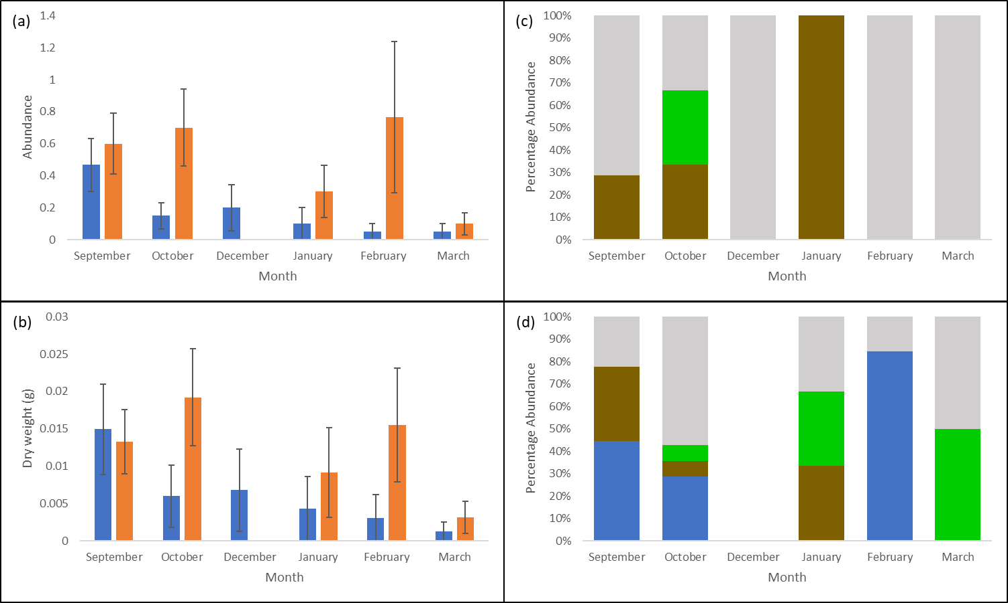
Figure 5-9. Paratya australiensis in bait traps from 2018-19. (a) average (+ standard error of the mean) abundance, (b) average (+ standard error of the mean) dry weights, (c) percentage of abundance across traps placed in different habitats at McCoys Bridge and (d) percentage of abundance across traps placed in different habitats at Loch Garry. In figures (a) and (b), blue columns = McCoys Bridge and orange columns = Loch Garry. In figures (c) and (d), blue = bare habitat, brown = coarse organic particulate matter/depositional area, green = macrophytes and grey = snags.
A comparison of the crustacean temporal trend over the years indicated that only Paratya australiensis abundances showed significant differences with the combination and year and month, with December 2017 (Year 1) have significantly higher abundance in general (Table 5-6; Figure 5-10).
Table 5-6. Two-way ANOVA for crustacean dry mass from bait trap and RESS. Each row is for one species sampled: Paratya australiensis, Macrobrachium australiense, Cherax and immature crustacean (only sampled with RESS). Two-way ANOVA aims to explain variance in sampled dry mass by differences in: year sampled (Y), month sampled (M) and the interaction of these two (Y:M). Significant effects are marked with*.
Species | Bait Trap | RESS
Paratya australiensis
Macrobrachium australiense
Cherax sp.
Immature | -
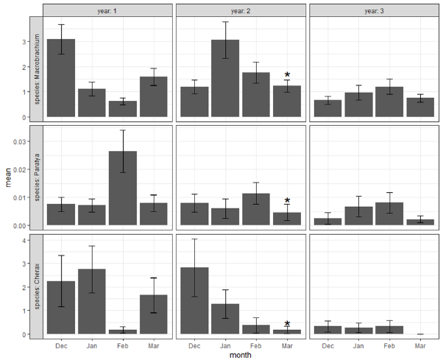
Figure 5-10. Mean dry mass of crustacean across both sites for each sampling round, across species (rows) and years (columns). All data are collected with bait trap. Each bar shows the mean dry mass from one sampling round that consists of 20 replicates (bait traps) per site. Note that two bait traps were lost (i.e. 38 replicates only) during March of year 2 (marked with asterisk). Whiskers indicate sampling standard errors.
Carapace lengths
At both sites Macrobrachium australiense average carapace lengths did not greatly vary across the months, with the greatest lengths recorded in February (Figure 5-11a). The average size of Paratya australiensis caught in bait traps tended to increase slightly from September to February at McCoys Bridge. Average size at Loch Garry was reasonably consistent between September and February before increasing slightly in March (Figure 5-11b). These findings need to be treated cautiously as total abundances were low.
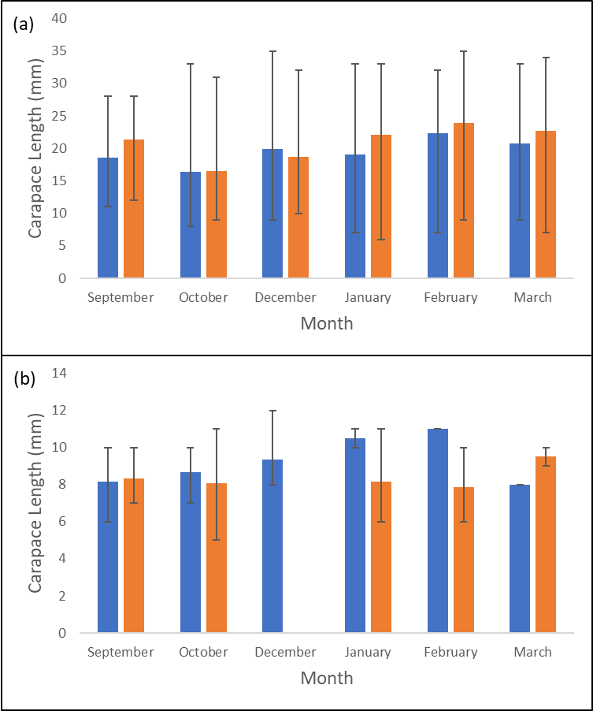
Figure 5-11. Average carapace lengths for (a) Macrobrachium australiense and (b) Paratya australiensis in bait traps from 2018–19. Error bars are the minimum and maximum carapace lengths, while blue columns = McCoys Bridge and orange columns = Loch Garry.
Reproduction
Ovigerous Macrobrachium australiense females were only detected in the bait traps during December and January at both sites and in February at McCoys bridge (Figure 5-12a). No ovigerous females were detected in bait traps in March as was the case in 2017-18 and 2015-16. Ovigerous Paratya australiensis females were detected in bait traps at McCoys in all months except March. The highest percentage were detected in September (Figure 5-12b). At Loch Garry ovigerous females were only detected in bait traps during the hotter months of January and February.
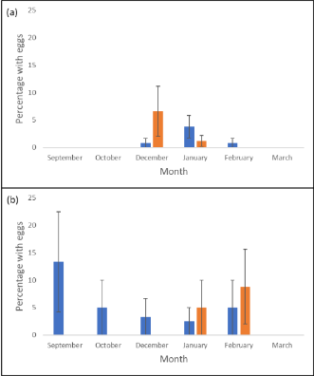
Figure 5-12. Percentage of (a) Macrobrachium australiense and (b) Paratya australiensis captured in bait traps in 2018–19 that were ovigerous (average + standard error of the mean). Blue columns = McCoys Bridge and orange columns = Loch Garry.

Additional crustacean surveys: RESS
Abundance and biomass
Paratya australiensis abundances were consistently very low in the RESS samples at McCoys bridge during the entire 2018-19 sampling period (Figure 5-13a). This finding is different to the previous year where abundances at McCoys Bridge increased considerably during the summer, the highest in February 2018 (Figure 5-12b). At Loch Garry Paratya australiensis abundances were low between September and December and were highest in January and February before decreasing in March (Figure 5-13a). This is similar to the previous year when abundances were lower before increasing greatly in January. The CEW did not appear to have had an impact on abundances of Paratya australiensis at McCoys Bridge but may have been a factor in increased abundances at Loch Garry.
Biomass of Paratya australiensis generally followed a similar pattern to abundance at both sites (Figure 5-13c). A comparison of biomass across the years at McCoys Bridge highlights the huge impact of natural spring floods and the blackwater event in 2016–17 on biomass compared to CEW in surrounding years (Figure 5-13d). The CEW did not appear to have an impact on biomass at McCoys Bridge, however it appears to have had an impact at Loch Garry.
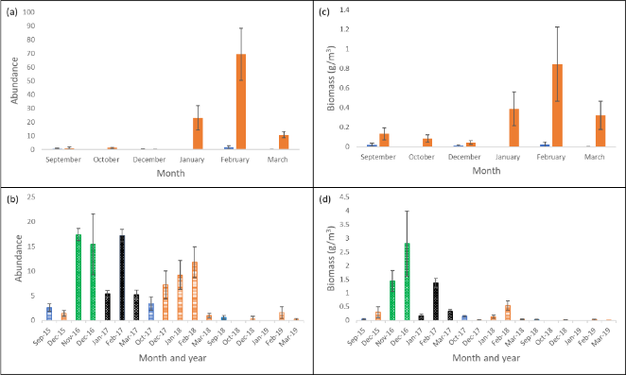
Figure 5-13. Paratya australiensis (a) abundance in 2018–19 at both sites, (b) abundance across all years at McCoys Bridge only, (c) biomass in 2018–19 at both sites and (d) biomass across all years at McCoys Bridge only. Values are average + standard error of the mean. For figures (a) and (c), blue columns = McCoys Bridge and orange columns = Loch Garry. For figures (b) and (d), blue = pre-CEW (Oct-18 was during CEW), orange = post-CEW, green = post-natural flood (2016-17 only), black = post-blackwater event (2016–17 only).
Macrobrachium australiense abundances increased in the RESS samples at McCoys bridge after the CEW from October to February before disappearing in March. At Loch Garry Macrobrachium australiense numbers were low between September and January before increasing in February (Figure 5-14a). A comparison of Macrobrachium australiense in the RESS samples at McCoys Bridge over the years generally shows lower abundances in 2018-19 than in the previous few years monitoring (Figure 5-14b).
Macrobrachium australiense biomass corresponded well with abundance at McCoys Bridge (Figure 5-14c). Biomass increased after the CEW and peaked in February. At Loch Garry biomass was low in September before increasing in October, declining in December and January and increasing again in February. As with abundance, a comparison of biomass across the years at McCoys Bridge did not show a consistent effect of spring freshes on biomass. However, it is clear the large increase in biomass during 2016–17 following natural floods in spring, with this increase persisting even into the time when the river was impacted by blackwater (Figure 5-14d).
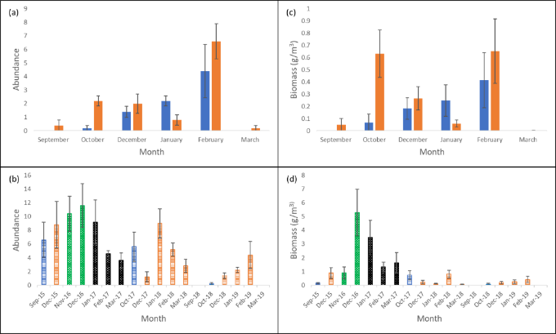
Figure 5-14. Macrobrachium australiense (a) abundance in 2018–19 at both sites, (b) abundance across all years at McCoys Bridge only, (c) biomass in 2018–18 at both sites and (d) biomass across all years at McCoys Bridge only. Values are average + standard error of the mean. For figures (a) and (c), blue columns = McCoys Bridge and red columns = Loch Garry. For figures (b) and (d), blue = pre-CEW (Oct-18 was during CEW), orange = post-CEW, green = post-natural flood (2016–17 only), black = post-blackwater event (2016–17 only).
No immature crustaceans were present at either site in September or October in the RESS samples (Figure 5-15a). In December abundances of immature crustaceans were highest at both sites. Numbers declined considerably at McCoys Bridge whereas they remained high at Loch Garry until February. The immature crustacean abundances at McCoys Bridge were similar to those in 2017-18. However, at Loch Garry, the February abundances were considerably higher than the previous year. Changes in immature crustacean biomass over the months closely matched changes in their abundance (Figure 5-15b).
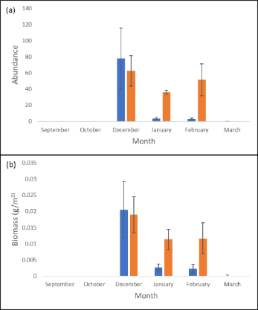
Figure 5-15. Immature crustacean (a) abundance and (b) biomass in RESS samples from 2018–19 (average + standard error of the mean. Blue columns = McCoys Bridge and orange columns = Loch Garry.
A comparison of the crustacean temporal trend over the years showed the biomass of Paratya australiensis and Macrobrachium australiense and immature crustaceans had significant variation with the combination and year and month (Table 5-6; Figure 5-16). For both Paratya australiensis and Macrobrachium australiense, December 2016 (Year 1) is most different to other periods and has significantly higher biomass. For immature crustaceans, December 2018 (Year 3) was the most different period during which biomass is significantly higher than others (Figure 5-16). Cherax showed no significant differences in dry mass with year, month nor year and month (Table 5-6).
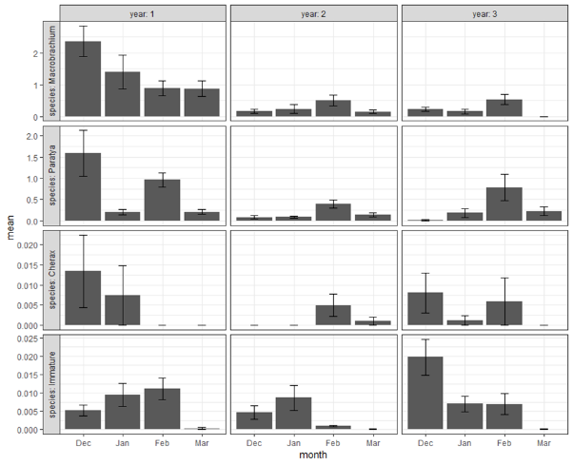
Figure 5-16. Mean dry mass of crustacean across both sites for each sampling round, across species (rows) and years (columns). All data are collected with RESS. Each bar shows the mean dry mass from one sampling round that consists of 5 replicates per site. Whiskers indicate sampling standard errors.
Carapace lengths
Paratya australiensis carapace lengths at McCoys Bridge were consistent over the months, with the largest lengths occurring in February (Figure 5-17a). Carapace lengths at Loch Garry were quite variable over the different sampling events (as seen by error bars in Figure 5-17a). At Loch Garry the average size decreased in the summer months, but larger individuals were also present.
Macrobrachium australiense average carapace lengths tended to decrease from October to February at both sites before increasing slightly in February. The size range was greatest at McCoys Bridge in January and February and in February at Loch Garry (Figure 5-17b).
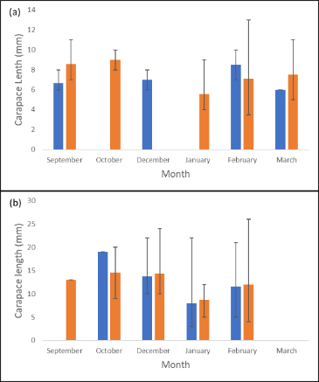
Figure 5-17. Average carapace lengths of (a) Paratya australiensis and (b) Macrobrachium australiense in RESS samples from 2018–19. Error bars = minimum and maximum carapace lengths. Blue columns = McCoys Bridge and orange columns = Loch Garry.
Reproduction
Ovigerous Paratya australiensis were not detected in the RESS samples at McCoys bridge in any month (Figure 5-18a). They were detected in low numbers at Loch Garry in all sampling events from September to February with the highest numbers detected in February. These finding are very similar to 2017-18
Ovigerous Macrobrachium australiense were not detected at McCoys Bridge and were only detected at Loch Garry in February (Figure 5-18b). This finding is similar to 2017-18.
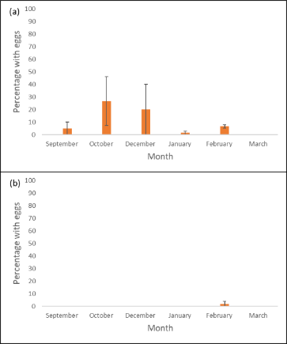
Figure 5-18. Percentage (a) Paratya australiensis and (b) Macrobrachium australiense in RESS samples in 2018–19 that were ovigerous (average + standard error of the mean). Blue columns = McCoys Bridge and orange columns = Loch Garry.

Winter Crustacean Monitoring
Total abundance and biomass
A total of 61 Macrobrachium australiense were detected in the bait traps during the winter monitoring. Individuals were present at all sites except Kirwin’s Bridge and McCoys Bridge (Figure 5-19). Abundances generally increased as sites progressed further down the river with highest total abundances detected at Yambuna and Stewart’s Bridge.
A total of 58 Paratya australiensis were detected in the bait traps during the winter monitoring. Individuals were detected at all sites except for Broken River at Central Ave and Stewarts Bridge (Figure 5-19). In contrast to M. australiense, total abundance was highest at sites upriver of Murchison. Individuals remained present at sites down river but were less abundant.
Overall winter flows had a positive effect on abundance for Macrobrachium australiense and a negative effect for Paratya australiensis, while different habitat conditions did not have a big effect in influencing these relationships (Table 5-7; Figure 5-19; Figure 5-20). The winter flows had a slightly positive effect on biomass for Macrobrachium australiense and no effect on Paratya australiensis, while different conditions did not have a big effect in influencing these relationships (Table 5-7;Figure 5-21).
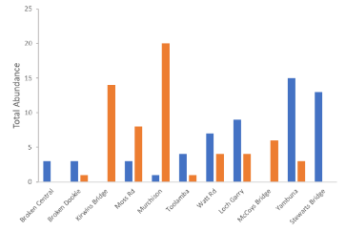
Figure 5-19. Total abundance of crustaceans detected in bait traps during the winter monitoring 2018. Blue columns = Macrobrachium australiense and orange columns = Paratya australiensis
Table 5-7. Flow effects on the occurrence and amount of abundance and biomass for each species sampled. For each species and each habitat condition (Bare or Macrophyte), the 95% lower and upper uncertainty bounds of the corresponding flow effect is shown.
Modelled variable |  | Flow effect | 2.50% | 97.50%
Abundance – prob. occurrence | Paratya | Bare | -5.32 | -0.71
Abundance – prob. occurrence | Paratya | Macrophyte | -1.97 | -0.40
Abundance – prob. occurrence | Macrobrachium | Bare | -0.24 | 2.05
Abundance – prob. occurrence | Macrobrachium | Macrophyte | -0.13 | 1.98
Abundance - amount | Paratya | Bare | -1.75 | -0.04
Abundance - amount | Paratya | Macrophyte | -1.42 | 0.23
Abundance - amount | Macrobrachium | Bare | -0.07 | 1.03
Abundance - amount | Macrobrachium | Macrophyte | 0.24 | 1.27
Biomass – prob. occurrence | Paratya | Bare | -2.30 | 1.21
Biomass – prob. occurrence | Paratya | Macrophyte | -1.06 | 2.12
Biomass – prob. occurrence | Macrobrachium | Bare | -1.54 | 1.89
Biomass – prob. occurrence | Macrobrachium | Macrophyte | -0.83 | 2.38
Biomass – dry weight (g) | Paratya | Bare | -0.01 | 0.005
Biomass – dry weight (g) | Paratya | Macrophyte | -0.004 | 0.01
Biomass – dry weight (g) | Macrobrachium | Bare | -0.033 | 0.087
Biomass – dry weight (g) | Macrobrachium | Macrophyte | -0.012 | 0.11

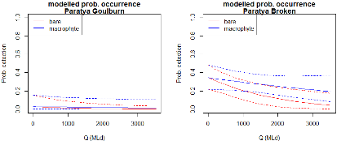
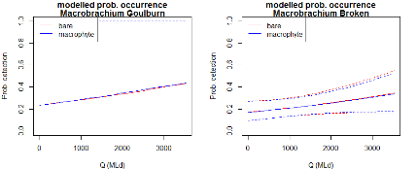
Figure 5-20. Modelled occurrence probability of abundance for Paratya australiensis (top row) and Macrobrachium australiense (bottom row), for different habitat conditions, at Goulburn (left column) and Broken (right column), across various flow conditions (ML/d).
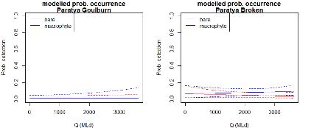
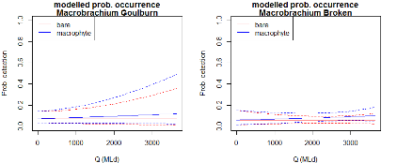
Figure 5-21. Modelled occurrence probability of biomass for Paratya australiensis (top row) and Macrobrachium australiense (bottom row), for different habitat conditions, at Goulburn (left column) and Broken (right column), across various flow conditions (ML/d).
Habitat Use
Macrobrachium australiense did not show a clear preference for habitat type (Figure 5-22a). However, as the average abundances within each site were low this finding should be treated cautiously. Changes in M. australiense dry weight closely followed changes in abundance and are not presented here.
Paratya australiensis were more likely to be detected in complex habitats, although this was not consistent for all sites (Figure 5-22b). Changes in dry weights closely followed changes in abundance and are not presented here. Again, abundances were low during the winter monitoring, so habitat preferences are harder to determine. It should be noted that at some sites it was difficult to distinguish between habitat types. For example, at Kirwin’s Bridge there was an abundance of macrophytes and very little bare edge. At other sites underwater snags were present for the entire length of the sampling reach, making bare edge areas difficult to distinguish.
Different habitat conditions did not have a huge effect at influencing the effects of flow on Macrobrachium australiense and Paratya australiensis abundance or biomass (Table 5-7; Figure 5-23, Figure 5-24). This is not surprising given the habitats were similar across the sampling times.
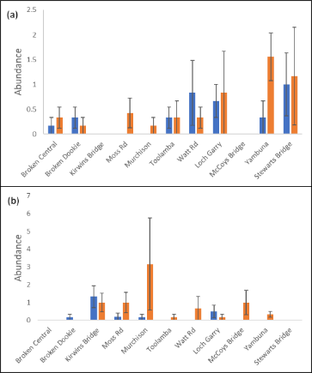
Figure 5-22. Average abundance of (a) Macrobrachium australiense and (b) Paratya australiensis in bait traps from 2018 Winter Monitoring (+ standard error of the mean). Blue columns = less complex (bare) habitats and orange columns = complex habitats (vegetation and snags).
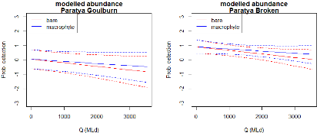
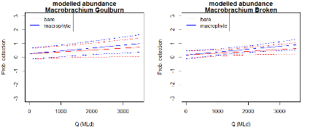
Figure 5-23. Modelled abundance of Paratya australiensis (top row) and Macrobrachium australiense (bottom row), for different habitat conditions, at Goulburn (left column) and Broken river (right column), across a range of flow conditions (ML/d).
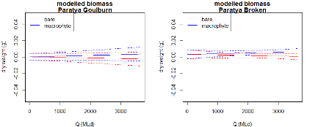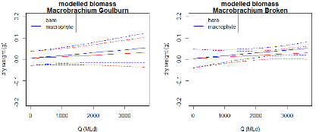
Figure 5-24. Modelled biomass for Paratya australiensis (top row) and Macrobrachium australiense (bottom row), for different habitat conditions, at Goulburn (left column) and Broken (right column), across various flow conditions (ML/d).

Algal Biofilms
Effects of season and environmental flows on biofilm biomass, community composition & photosynthetic performance
During winter 2018 artificial substrates were deployed prior to the delivery of a CEW flow, allowing assessment of biofilm development pre, during and post the flow event (Figure 5-25). While in summer 2019, artificial substrates were deployed during the delivery of a flow for consumptive purposes, thus showing biofilm development during the consumptive flow, before cessation of this flow and after a second flow for consumptive purposes (Figure 5-25). During the winter deployment all samplers for the during and post CEW flows were unable to be used at Loch Gary due to being washed up to the banks. Therefore, in the context of this investigation, sites have been used as replicates to assess the effects of environmental flows on biofilm community composition and biomass, rather than to assess differences between sites along the river.
Water quality (temperature, dissolved oxygen and electrical conductivity) during the winter 2018 and summer 2019 as measured at the McCoys Bridge monitoring station during the deployment periods are shown in Figure 5-26. Dissolved oxygen was relatively consistent across the two deployment periods, ranging from 7.49 to 10.88 mg/L (Figure 5-26). Electrical conductivity was elevated over the first half of the winter deployment period, averaging 96.3 µs/cm. It then dropped to an average of 55.8 µs/cm over the remainder of the winter deployment. In summer EC was relatively stable ranging from 51 to 62 µs/cm (Figure 5-26). Water temperature gradually increased over the winter deployments (range 9.9- 21.7ºC), while in summer the temperatures gradually decreased (range 27.8-16.8ºC) (Figure 5-26).
Light reaching the artificial substrates during summer 2019 deployments is shown in Figure 5-27. Samplers at McCoys Bridge received more light than those at Loch Gary (MB ranged 0 to 5632 lum/ft², average 108.3 lum/ft²; LG ranged 0 to 2688 lum/ft², average 43.7 lum/ft²) (Figure 5-27). Disks deployed in the photic zone received more light than those deployed in the non-photic zone at both sites (Photic zone average 109 lum/ft²; non-photic average 45 lum/ft²; Figure 5-27).
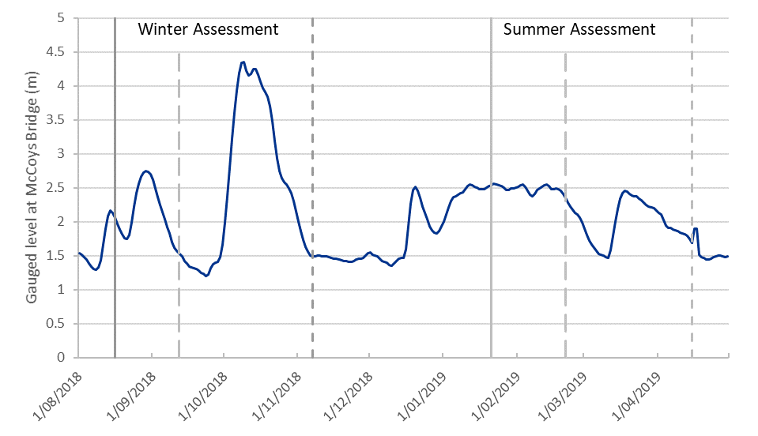
Figure 5-25. Timing of sampling (grey vertical lines) for measures of algal biofilms at Loch Gary and McCoys Bridge on the lower Goulburn River relative to river height.
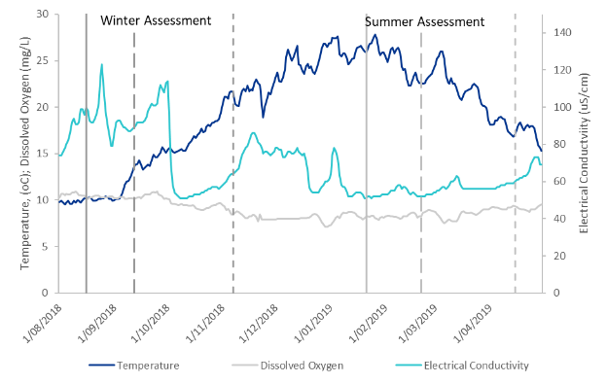
Figure 5-26. Mean daily water temperature, dissolved oxygen and electrical conductivity at McCoys Bridge monitoring station from August 2018 to April 2019 whereby Biofilm Assessments were undertaken. Solid grey lines show deployment of artificial substrates, dashed lines are the retrieval dates at 4 weeks and 12 weeks post deployment.
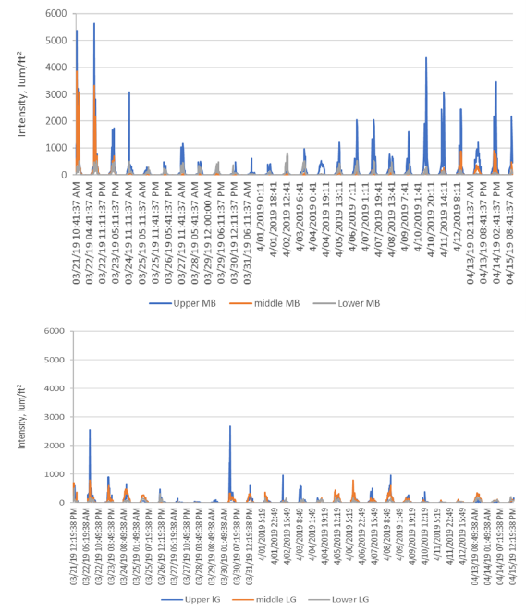
Figure 5-27. Light intensity reaching the disks deployed at McCoys Bridge (top) and Loch Gary (bottom), lower Goulburn River, during Summer 2019. Upper MB/LG indicates sensor at the disk deployed in the photic zone, Middle MB/LG sensor on the disk in the non-photic zone and Lower MB/LG sensor on the weight at the bottom of the sampler.
Biomass, as DM, AFDM and chlorophyll-a, of biofilms developed on artificial substrates pre, during and post environmental flows during winter 2018 and summer 2019 are shown in Figure 5-28. In winter, mean algal biomass (DM, AFDM and Chl-a) tended to decrease from pre CEW sampling (mean DM 1.19 g/m²; AFDM 0.09g/m²; chl-a 5.49 mg/m²) to post CEW sampling (mean DM 0.96g/m²; AFDM 0.06g/m²; chl-a 1.83mg/m²). Algal biomass accumulated during CEW flows (mean AFDM 0.06g/m²; chl-a 1.35mg/m²), generally followed a similar pattern to that of post CEW flows sampling. The exception was for DM, which increased during CEW actions (mean DM 2.1g/m²). Similarly, the organic composition of algal biofilms decreased between pre CEW (mean 11.36%) to post and during CEW sampling (mean 6.82% and 2.74% respectively). The autotrophic index generally increased from pre CEW (mean 26.02) to post and during CEW sampling (mean 38.08 and 44.23 respectively).
In summer, mean algal biomass (DM, AFDM and Chl-a) generally increased from pre IVT to during and post IVT sampling (Figure 5-28). Mean DM and AFDM pre IVT were 0.48g/m² and 0.02g/m² respectively, while during and post IVT DM and AFDM were 1.44g/m² and 1.15g/m² and 0.08g/m² and 0.07g/m² respectively. Mean chlorophyll-a pre IVT was 0.81mg/m², while during and post IVT was 1.11mg/m². The organic component of algal biofilms was similar across all sampling times (mean OM 8.63%, 6.9% and 8.1% for pre, during and post IVT respectively). The autotrophic index was similar for pre and during IVT sampling (mean 57.32 and 53.5, respectively), however increased for post IVT sampling (mean 80.9).
Photosynthetic activity of biofilms during winter and summer sampling are shown in Figure 5-29. The photosynthetic efficiency (Y) was generally greater in winter (mean 0.42) compared to summer (mean 0.34). In general, photosynthetic efficiency (Y) deceased from pre-flows to post flows in both summer and winter (mean pre 0.44 and 0.35; post 0.41 and 0.30 for winter and summer respectively) although this was not statistically significant.
The relative community composition of biofilms during winter and summer sampling are shown in Figure 5-30. In Winter biofilm communities were generally dominated by diatoms pre CEW, however in during and post CEW communities there was an increase in presence of chlorophytes and cyanobacteria. In summer, cyanobacteria were the dominant component of the biofilms throughout all sampling periods. In the during and post IVT sampling there was an increase in the chlorophytes and decrease in the cyanobacteria and diatoms components of the biofilm communities respectively.
Effects of sampler depth on biofilm biomass, community composition & photosynthetic performance
Biomass, as DM, AFDM and chlorophyll-a, of biofilms developed on artificial substrates suspended in the photic and non-photic depths of the Lower Goulburn are shown in Figure 5-31. Algal biomass, as determined by DM, AFDM and Chl-a, was significantly greater for biofilms sampled on substrates from the photic zone compared to those from the non-photic zone (Figure 5-31). Mean chlorophyll-a, DM and AFDM of biofilms from the photic zone was 2.3mg/m², 1.5634g/m² and 0.0861g/m² while the non-photic was 1.36mg/m², 0.6979g/m² and 0.0447g/m² respectively. The organic component of algal biofilms was significantly greater for those in the non-photic zone (mean 8.97%) compared to that of those from the photic zone (mean6.81%) (Figure 5-31). The autotrophic index was similar for biofilms from both zones (photic zone mean 54.82, non-photic zone mean 51.72; Figure 5-31).
Photosynthetic activity of biofilms on artificial substrates in the photic and non-photic zones are shown in Figure 5-32. The photosynthetic efficiency (Y) was slightly greater for biofilms in the photic (mean 0.39) compared to non-photic zones (mean 0.35), however this was not statistically significant.
The relative community composition of biofilms from artificial samplers in the photic and non-photic zones are shown in Figure 5-33. Biofilm communities were predominately comprised of cyanobacteria at both photic depths (60% and 50% for photic and non-photic respectively). Diatoms made up approximately 30% of the community at both depths and chlorophytes 10% and 20% for photic and non-photic zones respectively (Figure 5-33).
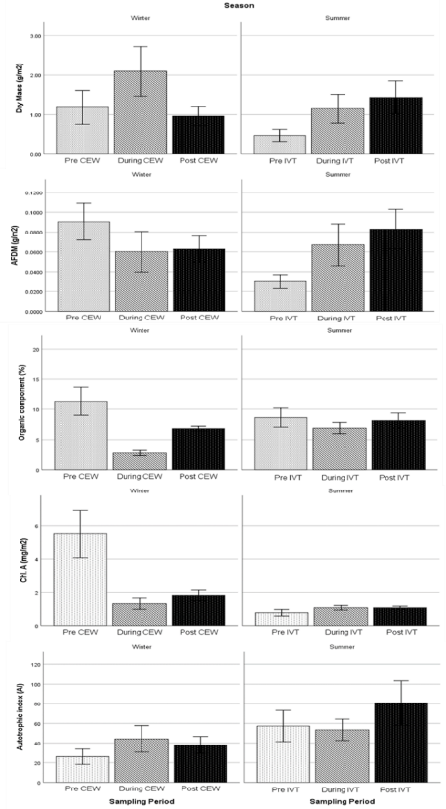
Figure 5-28. Mean (±S.E.M.) dry mass (DM), ash-free dry mass (AFDM), organic composition, chlorophyll-a concentration and autotrophic index of biofilms on artificial substrates pre, during and post a CEW flow in Winter 2018 and IVT flow in Summer 2019 in the lower Goulburn River.
Figure 5-29. Mean (±S.E.M.) photosynthetic efficiency (Y) of algal biofilm communities on artificial substrates pre, during and post a CEW flow in Winter 2018 and IVT flow in Summer 2019 in the lower Goulburn River.
Figure 5-30. Relative percent composition of diatoms, chlorophytes and cyanobacteria in biofilm communities, as determined using a Phyto-PAM, on artificial substrates pre, during and post a CEW flow in Winter 2018 and IVT flow in Summer 2019 in the lower Goulburn River.
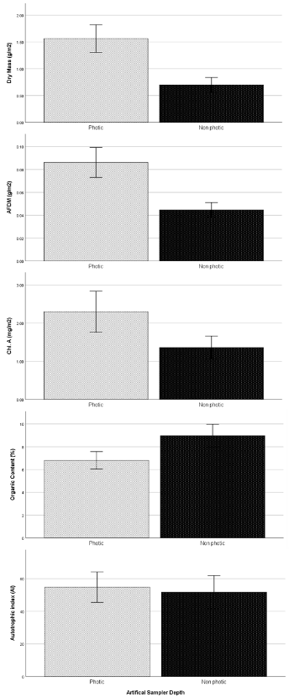
Figure 5-31. Mean (±S.E.M.) dry mass (DM), ash-free dry mass (AFDM), organic composition, chlorophyll-a concentration and autotrophic index of biofilms on artificial substrates suspended in the photic and non-photic zones in the lower Goulburn River.
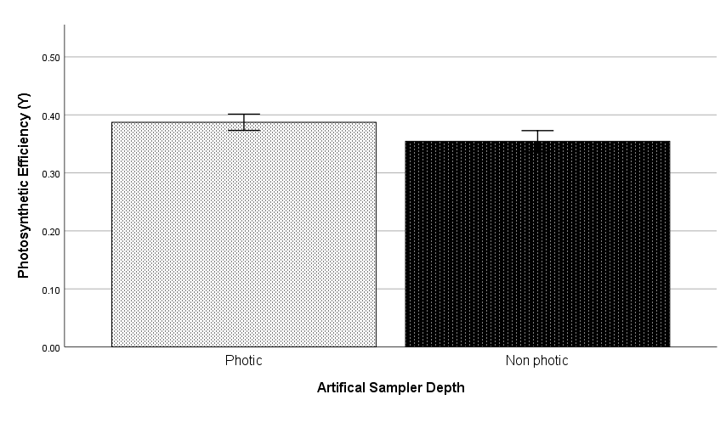
Figure 5-32. Mean (±S.E.M.) photosynthetic efficiency (Y) of algal biofilm communities on artificial substrates deployed in the photic and non-photic zones in the lower Goulburn River.
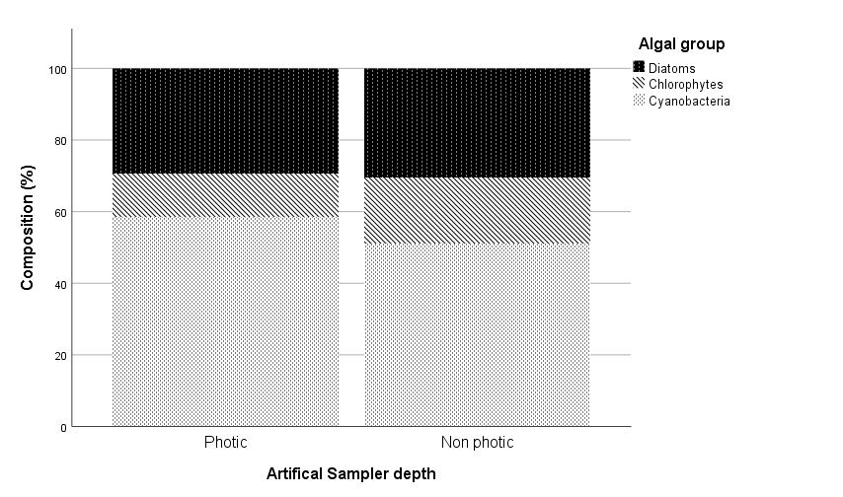
Figure 5-33. Relative percent composition of diatoms, chlorophytes and cyanobacteria in biofilm communities, as determined using a Phyto-PAM, on artificial substrates deployed in the photic and non-photic zones in the lower Goulburn River.

Discussion

Macroinvertebrates
A summary of the results the main results for macroinvertebrate and crustacean monitoring is provided in Table 5-8. The results from the 2018–19 survey period continue to support the notion that macroinvertebrates are responding to increased flows in spring. Responses are not observed across all taxa or across all endpoints, but the consistency in some responses do provide evidence that flows are having an impact, especially on crustacean biomass and abundance in the Goulburn River. However, it also needs to be noted that this evidence points to only a small impact of CEW when delivered as spring freshes; comparisons of data from years when spring freshes were delivered to the 2016–17 spring floods show that the much larger, natural flows achieved in that year had a greater positive impact on crustacean abundances and biomass, presumably due to a greater availability of habitats and organic matter entrainment into the river channel that cannot be achieved through spring freshes.
The artificial substrates were placed in the Goulburn River to try and understand responses of colonising macroinvertebrates to flow. Overall there was not a big response of colonising macroinvertebrates to flow, although some taxa were shown to respond to changes in flow. While crustaceans were not abundant in these substrates they did contribute to the greatest biomass, suggesting these are the key taxa in sustaining fish populations and should be the focus of future work.
The RESS samples and the crustacean monitoring (RESS and Bait traps) were the most informative in understanding the potential effects of spring freshes and other environmental water delivery in the Goulburn River. An increase in overall macroinvertebrate abundance and increases in abundance and biomass of key crustacean species within the edge habitats suggests these species are moving from the main channel and into these fringe habitats that are provided by the water delivery. The data does suggest that aquatic vegetation is important for these key crustacean species, particularly Paratya australiensis, providing important sources of food and shelter to macroinvertebrates. An excellent example of how important these habitats came from RESS samples taken at Loch Garry in January 2018. Here, a combination of earlier freshes along with elevated summer flows supported dense bank vegetation (including grasses) that were inundated by water during the elevated flows. Bank condition at this site is generally steep and undercut, but with the inundation of grasses a sheltered environment was present that was able to support numerous immature crustaceans that would otherwise have been washed downstream. Without environmental water delivery and modification of other flows from winter through to the end of summer, bank vegetation and aquatic vegetation growth and maintenance through drier months would be suppressed, with implications for aquatic invertebrates.
The over wintering monitoring of crustaceans provided further evidence that large bodied crustaceans do respond to flows. There was also a clear distribution preference of key crustacean species within the Goulburn River, with Paratya australiensis more abundant in the upper reaches and Macrobrachium australiense more abundant in the lower reaches of the Goulburn River. The mechanisms behind how these crustaceans respond to flows and their distribution within the Goulburn River are still unclear. Habitat preference was not detected as influencing abundance or biomass of crustaceans during the over wintering monitoring although this is not surprising given only two sampling events occurred during similar flow regimes. There is some evidence to suggest that if given the opportunity crustaceans are more abundant in the more complex habitats including aquatic macrophytes.
Given that these large bodied crustaceans make up the majority of biomass and are an important food source for fish it is imperative to continue to monitor them in responses to CEW, natural or other water releases. To understand how beneficial environmental flows are on sustaining crustacean populations future monitoring should incorporate assessment of habitats and crustacean movement (abundance, biomass, recruitment) across a number of sites along the Goulburn River. It is hypothesised that the link between habitat (vegetation), flow and crustaceans is important for maintaining these populations.

Table 5-8. Summary data of macroinvertebrate responses to spring CEW and winter monitoring in 2018-2019 and trends overall (3-4 years).
 | 2018-2019 |  |  |  |  |  | Overall (3-4 years)
 |  |  |  | Key Species
Technique | Richness | Abundance | Biomass | Paratya australiensis | Macrobrachium australiense | Immature Crustaceans
Artificial Substrates | No response | Likely to be responding positively to CEW | No response |  |  |  | Diversity is not responding to CEW. Abundance and biomass have no overall response to CEW. While crustaceans are not abundant, they do make up the majority of the biomass. Oligochaeta and Procladius spp. responds positively to flows. Several other key taxa reduced after post-CEW.
RESS | No response | Slight negative response | Increased biomass largely due to crustaceans | Low abundance - Decrease immediately after CEW | Decrease immediately after CEW |  | Diversity is not responding to CEW. Overall no significant effect on biomass. Positive effect on abundance. Crustaceans are dominant in biomass. No significant changes to key crustacean species, although general trend is an increase in Macrobrachium australiense. Response to flows may be delayed as seen in the bait traps and crustacean RESS samples, whereby abundance and biomass increased one month after the CEW delivery. Paratya australiensis abundance increased significantly after the natural flood event in 2016. Oligochaeta and Tasmanocoenis tillyardi, had an overall positive response to CEW.
Bait Traps |  |  |  | No response (limited numbers) | Increased abundance and biomass | Increased abundance and biomass | Consistent response seen with an increase in abundance and biomass of Macrobrachium australiense post CEW increasing one month after the CEW. Abundance of Macrobrachium australiense was significantly higher in December 2016 compared to subsequent years, likely to be due to the natural flood event.
Crustacean RESS |  |  |  | Increased abundance and biomass (LG only) | Increased abundance and biomass | Increased abundance and biomass | Macrobrachium australiense and Paratya australiensis generally increase in abundance and biomass post-CEW. Flows may also stimulate breeding with an increase in abundance and biomass in immature crustaceans post-CEW. The increase in Paratya australiensis occurs more consistently in Loch Gary, suggesting this species is influenced by the presence of complex habitats available during higher flows. Both dominant crustaceans had a greater abundance and biomass after the natural flood event in 2016 compared to any other year.
Winter Crustacean |  |  |  | More abundant upstream in the Goulburn Catchment | More abundant downstream in the Goulburn Catchment |  | Preliminary findings (One Year Only): Crustacean species responding to winter flow events, which may be valuable in sustaining these populations over winter. Crustacean species have a clear preference for sections of the Goulburn River, with Parataya australiensis more abundant in the upstream reaches and Macrobrachium australiense more abundant downstream reaches of the Goulburn River. While there was no clear habitat preference from this preliminary data, Paratya australiensis are more likely to be detected in complex habitats (vegetation).

Algal Biofilms
Flow impacts
Responses of algal biofilms to managed flows were assessed over two periods corresponding to an environmental flow (CEW) in October 2018 and IVT flows in February - April 2019. Changes in flows are known to have several impacts on biofilms on hard structures including scouring due to increased current velocity, and reduced photosynthesis and primary production due to changes in underwater light regime as a result of changes in depth and turbidity. The large environmental flow in October 2018 was associated with a general decrease in algal biofilm biomass and alterations of the relative biofilm community composition. Biofilm dry mass, AFDM, percent organic component and chlorophyll-a concentrations all declined following the delivery of the environmental flow. Dry mass is a measure of all material residing on the artificial substrates, including organic (living and dead plant and animal material) and inorganic material (sediment, sand). While AFDM reflects the organic material present, and the organic component is the proportion of total biofilm that is made up of organic material. Chlorophyll-a represents the amount of photosynthetically active material and is a proxy for both algal and cyanobacterial components of the biofilm. The reduction in all these biomass measures suggests that there was a loss of viable algal components of the biofilm following the environmental flow delivery, which could possibly be the result of scouring. The slight increase in the autotrophic index, a measure of the viability of the biofilm algal community, where communities with low AI values are more likely to have a higher viable algal component, also supports this idea. Photosynthetic responses of the biofilms pre and post CEW were similar, indicating that it is unlikely light was an issue for the biofilms, further supporting the idea that viable algal cells were lost due to scouring from the flows, rather than reductions in biomass due to light limitation from deepening waters and/or turbidity and smothering. The inclusion of light and turbidity measurements in future research would be highly advised to confirm this. Algal biofilm communities pre the environmental flow were generally dominated by diatoms. After the delivery of the environmental flow, biofilms were dominated by cyanobacteria and there was a small contribution of green algae (chlorophytes) within the biofilm communities. The reductions in algal biomass post environmental flow delivery and changes in community composition could lead to food limitations and changes in quality of food resources for macroinvertebrates. The recovery time for biofilms post environmental flows was not included in this study and warrants further investigation to determine longer term impacts.
IVT flows supplied in February-April 2019 were generally associated with an increase in algal biofilm biomass. Biofilm DM and AFDM more than doubled from pre-IVT to post-IVT biofilms. The pre-IVT biofilms were deployed and developed over a period of elevated IVT flows, which could have resulted in the lower biomass due to souring or light limitation. While the DM and AFDM of biofilms increased post-IVT flows, the organic component of biofilms and chlorophyll-a concentrations remained fairly stable between pre and post IVT sampling. This result suggests that the observed increases in mass were associated with deposition of suspended material derived from bank erosion and other catchment sources. The photosynthetic responses of biofilms declined slightly post IVT flows, while the AI slightly increased. These results suggest a loss of viable algal cells which could be due to smothering of algae by depositional material on the substrates. Changes in relative community composition were observed following IVT flows. Generally, the communities were dominated by cyanobacteria. Biofilms sampled during and post the small flow event in mid-March had increased composition of green algae and a decline in diatoms. These changes in common algal groups could result in lower quality food resource for macroinvertebrates.
Light is an important determinant of algal structure and biomass. Assessment of biofilms at two photic depths indicated there was a greater biomass of algae in the photic zone, suggesting that light availability is better in shallower depths. This is further supported by the slight decline in photosynthetic efficiency in the non-photic zone biofilms. The samplers used during this study were able to rise and fall with the changes in water depth during managed flows. Woody debris and other hard substrates within the river system would not be able to do this, thus potentially under higher flows, where these structures will be inundated to greater depths, there could be reduced biomass and thus less food resources for macroinvertebrates due to light limiting biofilm production. Further assessment of the recovery of biofilm communities after managed flows and the impacts of timing of flows are needed to understand longer term impacts on biofilm quality and quantity.
Seasonal impacts
Seasonal differences were observed in biofilm biomass, relative community structure and function. During Summer there was generally a lower biofilm biomass compared to Winter. Summer biofilms were comprised of fewer viable cells, as indicated by the autotropic index values and reduced photosynthetic efficiency. The biofilm communities where dominated by cyanobacteria and green algae in Summer, while predominantly diatom dominated in Winter. These results suggest that food quality and quantity could be poorer in Summer compared to Winter for higher tropic levels. Generally, you would expect to see higher algal production in summer, as this is the period when water temperatures are higher and light intensity and water clarity is optimal for primary productivity. However, during the Summer period assessed in this study sustained elevated flows occurred. During these flows it is likely that light limitation occurred, together with deposition of inorganic matter and scouring of biofilms from the artificial substrates leading to reduced biomass and function of biofilms. In contrast to the sustained flows of the IVTs, the spring fresh was supplied as a sharp pulse in flow. Possibly the difference in sustained versus short pulses of water account for the differences in biomass between seasons, together with other environmental parameters. Further investigation is needed to understand the colonisation process of biofilms under different flow regimes and across different seasons to understand importance of pulse-press flow regimes on community composition and biomass availability for macroinvertebrates.

Vegetation Diversity

Introduction
Riparian and aquatic vegetation underpins aquatic systems by: (1) supplying energy to support food webs, (2) providing habitat and dispersal corridors for fauna, (3) reducing erosion and (4) enhancing water quality. In the Goulburn River drought and floods have reduced the quantity, quality and diversity of riparian and bankside vegetation over the last 20 years. Minimum summer and winter low flows and periodic freshes are recommended to help rehabilitate and maintain vegetation along the lower Goulburn River. The recommended flow components shape aquatic plant assemblages by influencing (1) inundation patterns in different elevation zones on the bank and hence which plants are promoted in each zone; (2) the abundance and diversity of plant propagules dispersing in water; and (3) where those propagules are deposited and germinate. In the Goulburn River selected area, the specific vegetation objectives for spring freshes and high flows are to trigger germination and new growth of native vegetation on the banks and for low flows and freshes at other times of the year to contribute to maintaining growth and recruitment of native vegetation on the banks.
Vegetation diversity was monitored at four sites in the lower Goulburn River as part of the Victorian Environmental Flows Monitoring and Assessment Program (VEFMAP; Miller et al. 2015) and the Commonwealth Short Term Monitoring Projects (STIM; Stewardson et al. 2014, Webb et al. 2015). Vegetation diversity monitoring in the LTIM Project at two sites in the lower Goulburn River is extending those data sets and allowing the effect of different flow components to be assessed in wet and dry climatic conditions. The results are being used to identify what flows are needed to maintain or rehabilitate riparian vegetation in the lower Goulburn River depending on its current condition and state of recovery. They are also being used to broadly inform appropriate water management in other systems recovering from extreme events.

Area specific evaluation questions
To determine the contribution of Commonwealth environmental water in selected areas, and to improve understanding of the relationship between specific watering actions and ecological objectives for assets, the following questions are being addressed. This information also forms the basis of Basin-scale evaluation – where area-level results are scaled up to the Basin level. Overall, the 2018 spring fresh was successful at increasing the cover of water dependant ground layer plants at both Loch Garry and McCoys Bridge, although the vegetation cover at McCoys Bridge continues to remain overall lower than at Loch Garry.
Question | Were appropriate flows provided? | Effect of environmental flows | What information was the evaluation based on?
What has CEW contributed to the recovery (measured through species richness, plant cover and recruitment) of riparian vegetation communities on the banks of the lower Goulburn River that have been impacted by drought and flood and how do those responses vary over time? | The spring fresh delivered in 2018 was appropriate. | The summed cover of ground layer plants at both LG and MB increased between the pre and post spring fresh in 2018. Increases in the cover of ground layer vegetation was due mostly to water dependant taxa. In contrast, the cover of greases did not change. | Trends in cover of different taxa and groups of taxa over time and across the elevation gradient.
How do vegetation responses to CEW delivery vary between sites with different channel features and different bank conditions? | The spring fresh delivered in 2018 was appropriate. | Reponses of vegetation to environmental water and unregulated flows are similar at McCoys Bridge and Loch Garry. However, vegetation cover is consistently lower at McCoys Bridge compared with Loch Garry. | Trends in cover of different taxa and groups of taxa over time and across the elevation gradient
Does the CEW contribution to spring freshes and high flows trigger germination and new growth of native riparian vegetation on the banks of the lower Goulburn River? | The spring fresh delivered in 2018 was appropriate. | The total cover of ground layer vegetation has increased between the pre and post spring fresh vegetation surveys. Increases in cover were greatest for water dependant taxa. | Trends in cover
How does CEW delivered as low flows and freshes at other times of the year contribute to maintaining new growth and recruitment on the banks of the lower Goulburn River? |  | No monitoring has been undertaken in 2018-19 to assess the contribution of CEW delivered as low flows or freshes at other times of the year. The contribution of natural and consumptive river flows makes it difficult to infer the influence of CEW.

Main findings from the vegetation monitoring program

Findings from 2018-19
- The mean summed cover of water dependent taxa across all sampling locations at both sites increased following spring freshes in 2018-19. In contrast, the mean summed cover of grass taxa remained the same. While this pattern is correlated with spring freshes it is not known what portion of the increase in cover can be attributed to seasonal patterns of plant growth that would have occurred without the delivery of spring freshes.
- Temporal patterns indicate that the cover of ground layer vegetation sampled in September and December increased by ~ 20% between 2014 and 2019. Most of the observed increases in ground layer cover is due to increased cover of grasses, particularly the perennial native grass Poa labillardierei (common tussock grass). Although P. labillardierei tends to be restricted to the upper banks, above the level of the spring fresh (see below), the spring fresh may help in providing soil moisture to the upper bank that could benefit vegetation in that zone. This hypothesis has not been tested.
- In contrast to grasses, the cover of water dependent species as a group have oscillated and only a slight increase in cover at Loch Garry is observed, mostly due to an increase in the cover of Persicaria prostrata (creeping knotweed).
- Increased consumptive demand for water in 2018-19 resulted in higher and more prolonged IVT discharges over summer months. This has negatively impacted the occurrence of vegetation along the toe and lower bank due to prolonged inundation. The reduction in plant occurrence in this region of the bank has the potential to reduce the benefits of environmental water delivered as spring freshes in 2019-2020.

How these build on findings from years 1 to 4
- The mean summed cover of water dependent vegetation across all sampling locations at both sites increased following spring freshes in 2014–15, 2015–16 and 2018-19. In contrast the mean summed cover of all grasses decreased or remained unchanged. While this pattern is correlated with spring freshes it is not known what portion of the increase in cover can be attributed to seasonal patterns of plant growth that would have occurred without the delivery of spring freshes.
- The extent and duration of inundation provided by spring freshes is correlated with the distribution and cover of vegetation along the bank. Several plant species that have an affinity for wet habitats have higher cover in regions of the bank inundated by spring freshes. In contrast, the perennial native grass P. labillardierei is restricted in distribution to elevations at or above the level inundated by spring freshes. This pattern of species distribution along the elevation profile has persisted over time.
- The recruitment of woody species, specifically Acacia dealbata (silver wattle) and Eucalyptus camaldulensis (river red gum) is generally restricted to higher areas of the bank which experience shallow and less frequent inundation. This pattern has persisted in 2018-19.
- Climatic conditions and non-regulated flows can exert a strong influence on vegetation and potentially influence the outcomes of environmental watering actions. Drier conditions in 2014–15 resulted in the recruitment of sedges along the river margin at base flow but a reduction in the cover and spatial extent of Alternanthera denticulata (lesser joyweed). In contrast, prolonged natural flooding in 2016–17 caused a substantial decline in the cover and occurrence of establishing sedges but increased the cover and distribution of A. denticulata and to a lesser extent Centipeda cunninghamii (common sneezeweed). The cover of Cyperaceae in 2017–18 remained low and natural high flows in 2017–18 did not greatly influence the cover of this group.
- Some species such as A. denticulata and C. cunninghamii can increase when exposed wet mud is available on the recession of high flows and show a dynamic pattern of occurrence and cover both spatially and temporally. Other species such as P. prostrata maintain a more stable position along the elevation gradient possibly supported by a persistent woody root stock.
- There was no evidence that the delivery of a fresh in March 2017 had any immediate negative outcome on bank vegetation. There is some evidence that grasses benefited from this late season watering. No data were collected at other times in 2017–18 to evaluate the influence of flows throughout the year.
- The occurrence of vegetation at the toe and lower bank declined following prolonged high river discharges, delivered for consumptive use as IVTs in 2018-19, but vegetation at higher elevations were not impacted.
- Modelled relationships between the cover of selected taxa and duration of inundation the year prior to sampling, reveal that the hydrologic envelopes differ for various groups and species examined. The data collected in 2018-19 has contributed to refining these models.
- Changes in the cover of examined taxa over time are similar at Loch Garry and McCoys Bridge but the cover of all taxa examined was lower at McCoys and the gradual increase in cover of P. prostrata over time observed at Loch Garry was not evident at McCoys Bridge. These patterns persisted in 2018–19.
- The reason for differences in cover at the two sites is not known but may reflect differences in channel shape, the aspect of sampled transects, or differences in subsurface water inflows. Loch Garry potentially receives higher subsurface water inflows from the closer proximity of large wetlands compared to McCoys which experiences more human activity and goat grazing on P. prostrata (pers. obs. D. Lovell, GBCMA).

Methods

Sampling
Elevation surveys
Vegetation responses to flow are expected to vary with elevation as this determines the depth and duration of inundation experienced under a particular flow event. To support more targeted monitoring, elevation profiles were obtained at 1 m intervals along all transects in December 2014 using a high-precision RTK GPS. These were used to target sampling locations along each transect in 2015–16 to ensure an optimal range of elevations were sampled along each transect.
Elevation profiles were surveyed again in December 2016, following the recession of floodwater, to ensure accurate inundation histories of sampling locations. Elevation surveys in December were supported by the GBCMA with funding from VEFMAP.
Vegetation sampling
Vegetation was sampled on both banks at Loch Garry and McCoys Bridge, before and after the delivery of spring freshes in 2014–15, 2015–16, 2017–18 and 2018-19. Not all survey locations were sampled on all trips. This was because the sampling strategy was revised after the first survey based on the difficulty of accessing candidate transects and once elevation data was available. After this, some selected transects could not always be sampled due to recent inundation or rainfall making access dangerous, tree fall, bank collapse or because of a wrecked vehicle. The set of surveyed transects used in this analyse are represent in (Table 6-1). In 2016 spring freshes were not delivered due to the large natural high flows that persisted between June and November 2016, and vegetation was instead sampled in December 2016 after the recession of flood waters. Comparing vegetation cover measured in December 2016 with past surveys in December 2014 and 2015 provides insights into the influence of large natural flood events.
Table 6-1. Summary of vegetation survey dates, sampling locations and transects.
Year | Survey  Number | Survey  Type | Date | Sites sampled | Transects sampled North bank |  |  |  |  |  |  |  |  |  |  |  |  |  |  | Transects sampled South bank
 |  |  |  |  | 1 | 2 | 3 | 4 | 5 | 6 | 7 | 8 | 9 | 10 | 11 | 12 | 13 | 14 | 15 | 1 | 2 | 3 | 4 | 5 | 6 | 7 | 8 | 9 | 10 | 11 | 12 | 13 | 14 | 15
2014-15 | 1 | Pre spring fresh | 23 Sept & 3 Oct 2014 | Loch Garry
2014-15 | 1 |  | 24 Sept 2014 | McCoys Bridge
2014-15 | 2 | Post spring fresh | 16 Dec 2014 | Loch Garry
2014-15 | 2 |  | 17 Dec 2014 | McCoys Bridge
2015-16 | 3 | Pre spring fresh | 16 Sept 2015 | Loch Garry
2015-16 | 3 |  | 15 Sept 2015 | McCoys Bridge
2015-16 | 4 | Post-fresh | 16 Dec 2015 | Loch Garry
2015-16 | 4 |  | 17 Dec 2015 | McCoys Bridge
2016-17 | 5 | Post natural flood | 12 Dec 2016 | Loch Garry
2016-17 | 5 |  | 13 Dec 2016 | McCoys Bridge
2016-17 | 6 | Pre autumn fresh | 21 Feb 2017 | Loch Garry
2016-17 | 6 |  | 22 Feb 2017 | McCoys Bridge
2016-17 | 7 | Post autumn fresh | 11 April 2017 | Loch Garry
2016-17 | 7 |  | 10 April 2017 | McCoys Bridge
2017-18 | 8 | Pre spring fresh | 7 Sept 2017 | Loch Garry
2017-18 | 8 |  | 8 Sept 2017 | McCoys Bridge
2017-18 | 9 | Post spring fresh | 14 Dec 2017 | Loch Garry
2017-18 | 9 |  | 15 Dec 2017 | McCoys Bridge
2018-19 | 10 | Pre spring fresh | 11 Sept 2018 | Loch Garry
2018-19 | 10 |  | 12 Sept 2018 | McCoys Bridge
2018-19 | 11 | Post spring fresh Pre IVT | 10 & 11 Dec 2018 | Loch Garry
2018-19 | 11 |  | 11 & 12 Dec 2018 | McCoys Bridge
2018-19 | 12 | Post IVT | 4-5 Mar 2019 | McCoys Bridge

Vegetation was again sampled in February 2017 and April 2017, before and immediately after, a fresh delivered in March 2017 for instream vegetation and fish objectives. Vegetation monitoring was undertaken in this case to assess recovery of vegetation following the natural flooding and to assess responses of vegetation to the March fresh that could guide future flow planning. Vegetation sampling carried out in April 2017 was supported by the GBCMA with VEFMAP funds.
Due to increasing IVT demand an additional survey at McCoys Bridge on 4-5 March 2019 was undertaken to evaluate the impacts of prolonged IVT delivery supported by the VEWH and GBCMA.
At all sampling times vegetation was surveyed along transects that ran perpendicular to stream flow. Sampling was initially designed to survey regions of the bank that had previously been surveyed by other programs (i.e. VEFMAP and CEWO Short Term Intervention Monitoring (STIM)). However, many quadrats sampled by these programs were at elevations well above the level expected to be inundated by spring freshes. As such, subsequent sampling did not attempt to match the spatial extent of these previous programs. Instead, surveys extended from around base flow to just above the level inundated by spring freshes (nominally a change in elevation of approximately 3 m). As transect elevation data were not available in the first year of sampling, a 3 m change in height from base flow was estimated visually.
At each sampling location 20 points were surveyed along a horizontal transect to give estimates of cover for each species (ground cover and woody recruits) (see details in standard operating procedures; Webb et al. 2018). Vegetation indicators were assessed using the line point intercept method at each sampling interval along the transect. This is done by placing a 2 m measuring tape perpendicular to the transect (i.e. parallel to streamflow) and recording every 10 cm along the tape all species that intercept a rod placed vertically through the vegetation. This gives a total of 20 sampling points at each sampling location. Foliage projected cover (%) for each species was then calculated by dividing the number hits per species by the total number of points sampled.

Analyses
Monitoring data collected over the five years of the LITM program provides insights into the responses of vegetation to environmental flow events. Qualitative and quantitative approaches have been applied to evaluate vegetation responses.
Qualitative approaches include the following:
- Examination of percent foliage projective cover (FPC %) of different taxa across all sampled locations at each site in relation to short and longer-term flow histories.
- Examination of the foliage projective cover (FPC %) of different taxa across the elevation gradient at each sample date at each site.
Quantitative approaches were developed to (i) evaluate responses of vegetation to the March fresh and (ii) develop relationships between hydrologic variables and vegetation cover and occurrence that is more transferrable to other sites and support a more predictive approach.
The evaluation has concentrated on a subset of species representative of ground-layer dominants of some Riverine floodplain Ecological Vegetation Classes (EVCs) relevant to the Goulburn River bankside assemblage (Cottingham et al. 2013). More specifically, Persicaria spp., A. denticulata and P. labillardierei are Cyperus eragrostis was included even though it is an introduced species, as it is representative of key ground-layer dominants of EVC 962 (Riparian Wetland), which develops in a band along the lower banks. The group "all grasses" included all annual and perennial, native and introduced grasses, but only P. labillardierei was analysed as it was the most abundant.
Ground layer taxa associated with Riverine floodplain Ecological Vegetation Classes (EVCs) relevant to the Goulburn River bankside assemblage (Cottingham et al. 2013) excluding grasses, were grouped as “water dependant” and are listed in Appendix A.
Statistical Models: Relationships between hydraulic variables and vegetation
The data collected so far by the LTIM program represents an array of inundation histories at each sampling location generated by: (i) the range of elevation profiles sampled and (ii) differences in river discharge prior to vegetation sampling. A range of hydrological variables can be derived for each sampling time and location and used to characterise the hydrological envelope of vegetation.
Using the data collected by the LTIM program, relationships between the total number of days inundated in the year prior to sampling and (i) vegetation abundance (% FPC) and (ii) the probability of occurrence of selected species/groups was examined.
The models described below for both vegetation presence and abundance were implemented in OpenBUGS version 3.2.1 (Lunn et al. 2009), using the R2OpenBUGS package (Sturz et al. 2005) in R (R Development Core Team 2010). Three independent Markov chains were used to confirm convergence of chains during model burn-in. Different burn-in periods were employed for different models, with the criterion for establishing convergence being an Rhat value of approximately 1 (Sturz et al. 2005). Different periods were also used for parameter estimation, based upon autocorrelation within the Markov chains.
- Model of vegetation presence/absence and number of days inundated
Vegetation presence/absence (y_{i}) and was modelled as a non-monotonic function of flow within a Bayesian framework. The model is structured as follows:
$y_{i}\sim Bernoulli\left(p_{i}\right)$ Equation 1
$logit\left(p_{i}\right)=int+eff.Q×({Q_{i}}^{α}-1){/α+eff.Q2×[({Q_{i}}^{α}-1)/α]^{2}+ eff.Transect}_{j}$ Equation 2
The presence/absence of vegetation species or groupings for site i has a Bernoulli distribution with a probability of p_{i}. p_{i} is modelled using a non-monotonic function and is driven by the global intercept (int), and the number of days that the sampling site is inundated in the previous year (Q_{i}), with α determining the shape of the function. In addition, there is a random effect of the transect in which the sampling site is located.
- Model of vegetation abundance and number of days inundated
When modelling vegetation abundance as a function of Q, y_{i} represents the cover (FPC) and is drawn from a Poisson distribution with an expected value of mu_{i}. mu_{i} is modelled using the same non-monotonic function as above.
$y_{i}\sim Poisson\left({mu}_{i}\right)$ Equation 3
${mu}_{i}=int+eff.Q×({Q_{i}}^{α}-1){/α+eff.Q2×[({Q_{i}}^{α}-1)/α]^{2}+ eff.Transect}_{j}$ Equation 4
Both models were developed for grouped (Appendix A) and individual vegetation species including:
- ground layer vegetation
- all grasses
- water dependent taxa associated with Riverine floodplain Ecological Vegetation Classes (EVCs) relevant to the Goulburn River bankside assemblage, excluding grasses (Cottingham et al. 2013) as per Appendix A introduced grasses
- native grasses
- Persicaria prostrata
- Alternanthera denticulata
- Poa labillardierei
- Juncus spp.
- Cyperaceae
An alternative model also compares the probability of occurrence of different vegetation types across the elevation profile at each site with a Bayesian logistic regression, to compare vegetation occurrence pre- and post-spring fresh. To eliminate effects of the flood in 2016, this particular analysis focuses only on 2014, 2015, 2017 and 2018 data.

Results

Relevant flow components delivered to the lower Goulburn River in 2017–18
2018–19: Spring fresh: CEW was delivered to the Goulburn River for vegetation objectives over approximately 3 weeks, commencing the 29 September 2018 and finishing on the 22 October 2018 in accordance with seasonal watering plans (Figure 6-1). Over this period river discharge at McCoys Bridge and Loch Garry reached a peak of around 7000 ML/day. Following the spring fresh, intervalley transfers (IVTs) to meet consumptive demand increased river discharge to around 2000 ML/day between mid-December 2018 and March 2019.
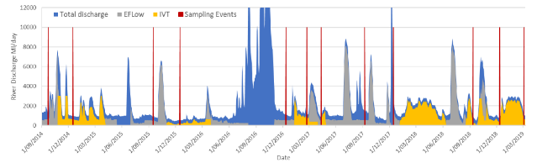
Figure 6-1. Goulburn river discharge (ML/day) for McCoys Bridge from 2014–19. Red arrows indicate timing of vegetation sampling.

Vegetation trajectories and flow 2018-19
Changes in mean foliage projected cover (FPC) over time at Loch Garry and McCoys Bridge are shown for different plants groups and species in Figure 6-2. As not all locations were accessible at each sampling event, only locations sampled at least 8 of the 9 sampling events were included to reduce bias in estimates of mean cover resulting from differences in sampling at each time (as per Table 6-1). Species richness trajectories were not assessed because species number is highly variable seasonally and this makes an interpretation of the influence of freshes difficult (as per earlier annual reports).
Temporal patterns indicate that the mean summed cover of all ground layer vegetation has increased by ~20% between 2014 and 2019. Most of the observed increases in summed ground layer cover is due to an increased cover of grasses, particularly P. labillardieri.
The mean total cover of all water dependent taxa increased between September and December in 2014-15, 2015-16 and 2018-19 and between February and April 2017 following natural flooding. This suggests that water dependant vegetation increase following the recession of spring freshes and natural flooding. However, it is uncertain how much change is due to seasonal patterns of plant growth because we have not had an opportunity to observe vegetation growth in summer without delivery of a spring fresh or natural flooding.
Despite short-term increases in the cover of water dependent vegetation there has not been a sustained increase in cover of water dependant plants as a group, or for any water dependant taxa examined with the exception of P. prostrata which has increased slightly at Loch Garry (Figure 6-2). A similar increase in cover of P. prostrata has not been observed at McCoys Bridge. The mean cover of all taxa examined was consistently lower at McCoys Bridge compared with Loch Garry.
Climatic conditions and other river flow events also influence vegetation and can override responses to environmental watering. In 2014–15 dry climatic condition and low unregulated flows over the year prior to monitoring in September 2015 was associated with reduced cover of A. denticulata while flooding in 2016–17 was associated with increased cover. In contrast, mean summed cover of sedges (Cyperaceae) did not decline over dry conditions in 2015–16 but was severely reduced in response to the prolonged flooding in 2016. The cover of P. prostrata appears more resilient to variations in flow and climate conditions.
To meet consumptive demand for water in 2018-19 the duration and volume of intervalley transfers (IVTs) was considerably higher than previous years (Figure 6-1). The average IVT discharge over the 83 days between surveys in December 2018 and March 2019 was 2000 ML/day and has the potential to impact vegetation along the toe and lower bank face. Vegetation surveys carried out at McCoys Bridge in December 2018 as part of the LTIM program and in March 2019 through funding provided by the VEWH provide insights into the impact of IVT delivery on vegetation in different zones on the bank face.
Field observation in March following IVT delivery, found few plants at the toe and lower bank face along with signs of erosion and uprooting of plants. This contrasts to the long bands of vegetation (mostly Cyperus spp.) observed at the toe and lower bank in February 2016 following low summer flow (Figure 6-4). Vegetation surveys found that in December before IVT delivery, plants occurred on 58% of surveyed transects at the lowest elevations surveyed (Zone 1a) (n=12). In contrast, in March 2019 after 83 days of IVT delivery, plants occurred on only 15.4% of transects in this Zone (n=13) (Figure 6-5).
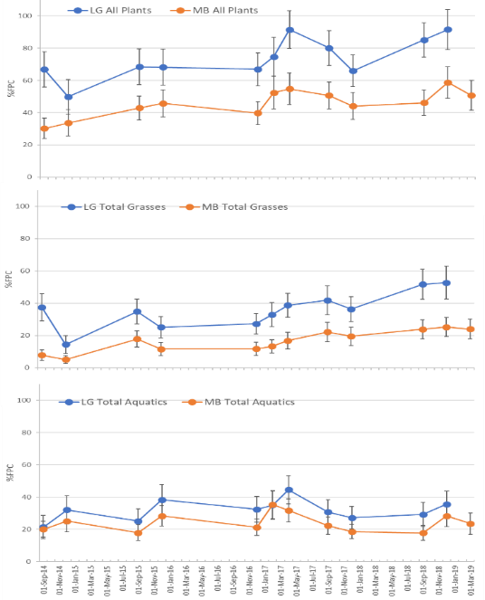
Figure 6-2. Mean foliage projected cover (FPC, %) (± 95% Confidence Intervals) over time for: (a) all ground layer plants (b); grasses (c) water dependant taxa. Abbreviations: LG = Loch Garry, MB = McCoys Bridge.
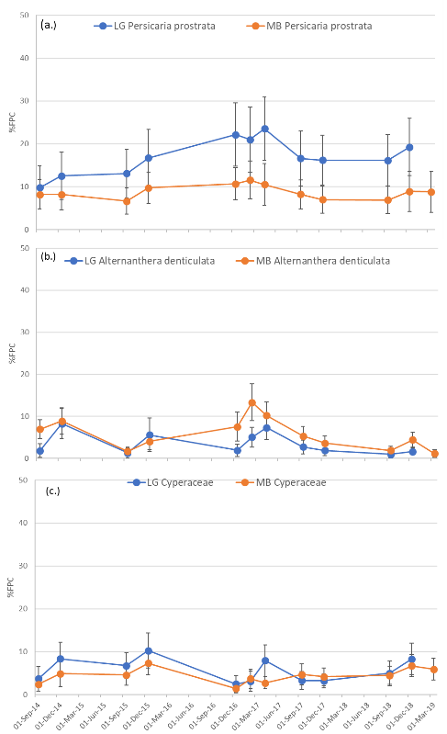
(b.)
Figure 6-3. Mean FPC (%) (± 95% Confidence Interval) across all sampling location at Loch Garry and McCoys Bridge at each sample date for Persicaria prostrata. (a), Alternanthera denticulata, (b) (middle panel), and Cypercaeae sp. (c). Abbreviations: LG = Loch Garry, MB = McCoys Bridge.
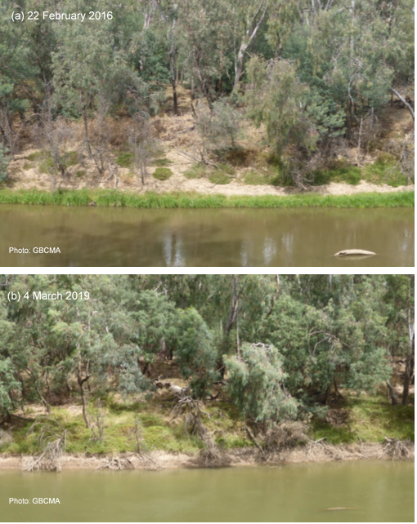
Photo: K Morris
Photo: K Morris
Figure 6-4. Lower bank vegetation (mostly Cyperus spp.) on the lower Goulburn River at Bunbartha: (a) February 2016 following low summer flow and (b) March 2019 following high IVT delivery. Photos provided by GBCMA.
Photo: K Morris
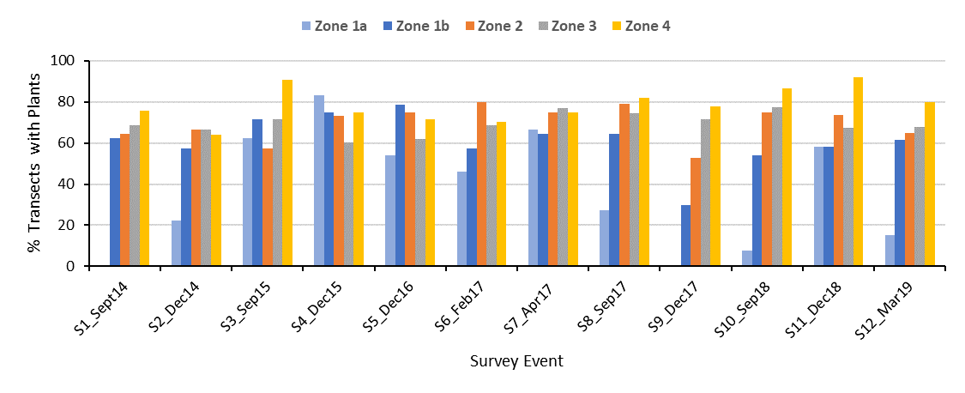
Figure 6-5. Percent of surveyed transects with plants for each bank zone at McCoys Bridge at each survey time. Bank zone: Zone 1a.= < 93.25 AHD m (n=5-15), Zone 1b =93.25-93.5 (n= 5-14), Zone 2 =>93.5-94 (n=14-20), Zone 3 >94-95.5 (n=52-57), Zone 4 = > 95.5 (n=24-45). (excerpt from Morris 2019).

Changes in patterns of species distribution along the elevation gradient
Species are not evenly distributed on the bank face but occur in zones that reflect species responses to the hydrologic regimes experienced at different elevations (Figure 6-6, Figure 6-7). During periods where unfavourable inundation was experienced at particular elevations, the occurrence and or cover of the species may decline. Cover may be maintained or increased at other locations on the bank that experience more suitable inundation regimes. Characterising the inundation regime at different elevations along the bank face, over time, provides insights into the hydrological envelope of each species.
The cover and distribution of native grasses and water dependent species along the elevation gradient show contrasting patterns. The cover of native grasses (mostly P. labillardierei), increases at higher elevation while the cover of all water dependent species combined decreases at higher elevations (Figure 6-6). These patterns are similar at both Loch Garry and McCoys Bridge. The water dependent taxa examined also differ in their patterns of distribution along the bank face (Figure 6-7). P. labillardierei occupies the highest elevations sampled on the bank face and achieved highest cover at elevations above the level typically reached by spring freshes. In contrast, Persicaria prostrata occurs across a wide range of elevations but has the highest cover at mid elevations with cover declining above elevations typically reached by spring freshes. Alternanthera. denticulata and Cyperaceae occupy comparatively lower elevations where inundation is more frequent suggesting a greater dependence on water availability. As lower elevations are subject to the most pronounced variations in inundation depth and duration this likely contributes to the high variation in cover observed overtime for water dependent species.
The cover of some species along the elevation profile is dynamic and shifts over time. The distribution of A. denticulata shifted to lower elevations during drier condition in 2014–15 but increased again after the recession of flood water in 2016–17 (see previous reports). In contrast, the occurrence and cover of Cyperus spp. increased at lower elevations during the drier conditions in 2014–15 but decreased following prolong flooding in 2016–17). The distribution of Persicaria along the elevation profile has not changed substantially over time.
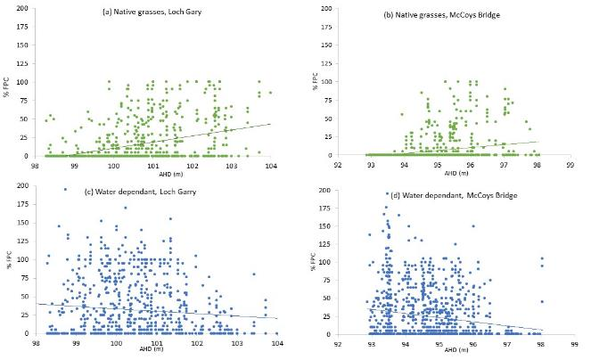
Figure 6-6. FPC (%) of native grasses (a, b) and all water dependent species (c, d) across the elevation gradient at Loch Garry (a, c) and McCoys Bridge (b, d). Lines are logarithmic regressions between cover and elevation are shown.

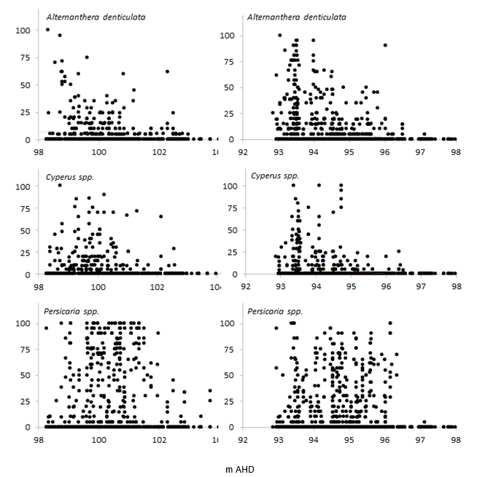Figure 6-7. FPC (%) across the elevation gradient (m AHD) for Alternanthera denticulata, (upper panel), Cyperus species (middle panel) and Persicaria prostrata (lower panel), at Loch Garry (left panel) and McCoys Bridge (right panel).

Modelled responses of vegetation to hydrologic variables
- The model outputs for the LTIM data show that the responses of Foliage Project Cover (FPC) (%) to period of inundation differ across species (Figure 6-8).
- The FPC summed for all ground layer taxa generally declines with increasing inundation. Similar response patterns are also observed for Juncus spp. and P. prostrata - simulations show a start of increasing cover from around 300 days which are highly uncertain.
- FPC of different groups of grasses (grasses, introduced grasses, native grasses) as well as P. labillardierei (the most abundant native grass species) declines rapidly initially until about 200 days. Although FPC shows a pattern of gradually increasing with inundation >200 days the model simulations are highly uncertain with longer inundation.
- Juncus and Persicaria prostrata show similar patterns of responses to grasses. Although an increasing FPC is expected for both species when inundation exceeds 300 days, the simulations are highly uncertain.
- For all aquatics as well as Alternanthera denticulata, there is an initial positive relationship between FPC and inundation, which then changes to a negative relationship, potentially indicating a ‘threshold’ effect of inundation on the growth of aquatic species. These thresholds are likely 100 days and 150 days, for total aquatics and, Alternanthera denticulata, respectively.
- Cyperaceae FPC does not show clear relationship with inundation and having high uncertainty for longer inundation.
- Modelled probabilities of occurrence for each species generally show consistent responses to inundation period as found for cover but have much lower uncertainty (Figure 6-9).
- The before-after fresh occurrence probability analyses (with 2014, 2015, 2017 and 2018 data) suggest no significance differences between the probabilities of vegetation presence pre- and post- fresh in general (Figure 6-10). As an exception, the post-fresh data of introduced grasses (as a group) shows much lower probability of occurrence with lower declining rate when inundation increases compared with pre-fresh; the different patterns converge until around 100 days.
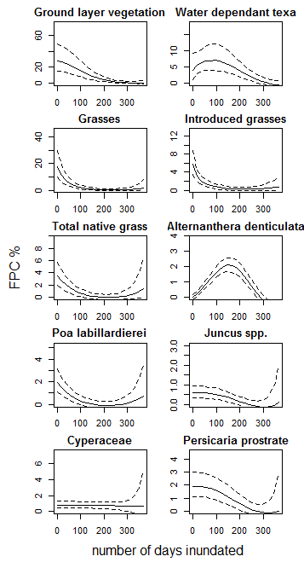
Figure 6-8. Modelled foliage projected cover (FPC %) for all different plant groups or species in response to number of inundation days in the previous year. The Confidence Interval is the 95% Credible Interval (the Bayesian CI) for the estimate.

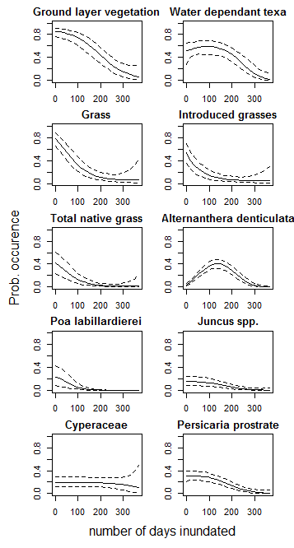
Figure 6-9. Modelled probability of occurrence for different plant groups or species as indicated on graphs grouped in response to number of inundation days in the previous year. The Confidence Interval is the 95% Credible Interval (the Bayesian CI) for the estimate.
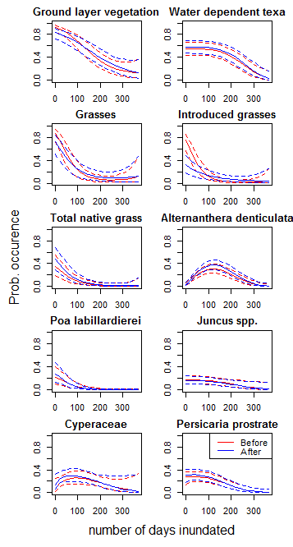
Figure 6-10. Modelled probability of occurrence before fresh (black) and after fresh (red), for grouped water dependent species, in response to number of inundation days in the previous year. The Confidence Interval is the 95% Credible Interval (the Bayesian CI) for the estimate.

Discussion
Over the 5 years of the LTIM program, environmental, natural and consumptive flows have all influenced the occurrence, cover and/or distribution of vegetation on the banks of the Goulburn River. Spring freshes appear to support water dependant species as their distribution on the bank is greatest in areas inundated by spring freshes and repeatedly increase in cover between pre and post spring fresh surveys. How seasonal patterns of plant growth contribute to this response is not known.
Long term trends show that while the cover of ground layer vegetation is increasing on the banks this increase is largely due to native grasses, particularly P. labillareiri at higher elevations. This indicates that the benefit of environmental watering likely extends to higher elevation through improvements in soil moisture above the typical level of inundation. In contrast water dependant vegetation tend to occur at lower elevations and do not show a long-term pattern of increasing despite observed increases following of spring freshes. Improving the abundance of vegetation at the toe and lower bank remains a management challenge and increases in IVT delivery to meet consumptive demand, which appears to negatively impact vegetation in this zone, adds to this challenge. Vegetation at the toe and lower bank has functional significance as it reduces bank erosion by stabilising and trapping sediment and slowing flows (O’Donnell et al. 2015).
LTIM monitoring data collected since 2014 provides some insights into the conditions and time frames for recovery of vegetation at the toe and lower bank. The highest recorded cover of water dependant species at the lowest elevation occurred in December 2015 after a period of low flows following the recession of the Spring Fresh. During this period plants occurred on more that 80% of surveyed transect at the lowest elevation (Zone 1a, Figure 6-5). This suggests that suitable flows can improve the occurrence and cover of vegetation at the toe and lower bank. Although newly established plants are vulnerable to high flow events as demonstrated by the reduction in cover and occurrence of these taxa following a large natural flood event in 2016, plant were able to re-establish from belowground rhizomes. Recovery following IVT delivery is likely to be less rapid as few remnant plants were observed. Recovery will be assessed in December 2019 as part of the MER program.

Recommendations: data analysis, monitoring and research
Analysis
- Trends in the cover of different groups and species should be analysed to determine if patterns are statistically significant.
- The influence of inundation depth and duration should be examined for lower elevations on the bank face where inundation depth is not expected to be strongly correlated with duration of inundation as it is at higher elevations.
Monitoring
- To better understand how the sequencing of flow events over the growing season influences vegetation we recommend that monitoring continue and be expanded to include surveys in March at the end of the growing season.
Research
- Adaptive flow management to promote the establishment of vegetation on the lower bank and toe would be supported by research to address the following knowledge gaps:
  - How does the depth and duration of inundation influence survival of key native taxa?
  - Does providing short intervals of low flow during IVT delivery improve plant survival?
  - Do fine scale variations in inundation depth improve plant establishment and growth?
  - What is the time frame for key taxa to germinate, mature and set seed in the field?
  - What is the abundance and composition of the soil seed bank at different geomorphic features?
  - Does prolonged summer submergence deplete the soil seed bank?
  - Does the availability of seeds limit plant establishment?
  - How does the spatial extent of suitable hydraulic habitat for target vegetation with river reaches change with river discharge?

Fish

Introduction
Supporting native fish populations is a key element of the Basin Plan’s goal to protect biodiversity. The Goulburn River supports a diverse native fish fauna with high conservation and recreational angling value. Species of conservation significance include trout cod, Murray cod, silver perch, golden perch, Murray River rainbowfish and freshwater catfish. Conservation of the fish fauna of the Goulburn River has been recognised as a high priority by fisheries management and natural resource management agencies. In particular, the provision of environmental flows to support native fish populations has been identified as a key environmental watering objective for the Goulburn River (Cottingham and SKM 2011). Indeed, in terms of Commonwealth water being invested for environmental objectives, flow allocation for native fish represents a major investment of water with a majority of the environmental entitlement contributing to fish related objectives. Given this investment, it is critical that the LTIM Project evaluates the effect that Commonwealth environmental water has on native fish populations in the lower Goulburn River. Quantifying relationships between fish populations (e.g. abundance, distribution, population structure) and environmental flows in the lower Goulburn River will help the adaptive management of environmental flows in the Goulburn River and support decisions regarding environmental flows for fish throughout the Murray-Darling Basin.
The fish monitoring being carried out in this program builds upon 10 years’ worth of monitoring and research assessing the status of fish populations in the Goulburn River (Koster et al. 2012) as well as monitoring undertaken since 2006 as part of the Victorian Environmental Flows Monitoring and Assessment Program. When complete, the Goulburn River fish LTIM Project will represent one of the longest continuous sets of fish monitoring data collected in the Murray Darling Basin. Moreover, it will cover a wide range of climatic conditions including record drought, record floods, and a major blackwater event that contributed to widespread fish kills. LTIM project monitoring through to 2018–19 will be particularly important in assessing the ongoing recovery of fish populations from those extreme disturbances.
The Goulburn River fish LTIM Project is also crucial to informing and interpreting the results of monitoring and research in other parts of the Basin (e.g. the Environmental Water Knowledge and Research (EWKR) fish theme). Golden perch have the capacity to disperse throughout the Basin and there is potentially a high level of connectivity between fish in the lower Goulburn River, lower Murray River, Edward-Wakool system, and Murrumbidgee River (the southern connected Basin). Coordinated monitoring across these four regions is being used to assess the influence of environmental flows in one area (e.g. spawning in the Goulburn River) on fish populations in other areas (e.g. recruitment in lower Murray).
The three fish monitoring methods employed in the Goulburn River LTIM Project (annual adult fish surveys, larval surveys and fish movement) complement each other, and increase the number of evaluation questions and associated research questions that can be answered through the program.

Annual fish surveys
Annual fish surveys in the river channel are part of the LTIM Project Standard Methods for fish monitoring that will provide critical information for the Basin-scale evaluation of Commonwealth environmental water. When added to the existing fish survey data for the lower Goulburn River it will provide a record of how the fish community has changed over a period of 15 years and how those changes relate to river flow. Moreover, annual surveys will help to determine whether fish spawning (detected through larval surveys), or fish movement that may be triggered by environmental flow releases, result in successful recruitment.

Larval fish surveys
The larval surveys for the lower Goulburn River are collecting larvae of all fish species, but more specifically to detect golden perch spawning. Golden perch is one of only two fish species (along with silver perch) in the Murray Darling Basin for which there is strong evidence of the need for increased discharge to initiate spawning. Indeed, environmental flows in the Goulburn River are explicitly used to promote spawning and recruitment of golden perch; one of the key flow objectives is to deliver freshes to promote the spawning of golden perch (Cottingham and SKM 2011).
The annual adult fish surveys can be used to identify any young-of-year golden perch in the lower Goulburn River, but given golden perch can move long distances, direct egg/larval surveys are required to determine whether high flows released into the lower Goulburn River trigger fish spawning.
The larval fish program will build on and add to an existing 10 year data set monitoring the spawning responses of fish to flows in the Goulburn River (Koster et al. 2012). Relatively few golden perch spawning events have been recorded in the lower Goulburn River to date, although we have now seen spawning in three of the four years of the LTIM Project due to high managed flows which used Commonwealth environmental water (2013, 2014) or natural events in spring. This contrasts to the previous years were little or no spawning was detected during the Millennium drought (2001-2009). Ongoing monitoring as part of MERP and rigorous analysis, will improve our understanding of the linkages between flow regime attributes and fish spawning. This information is critical to help the Goulburn Broken Catchment Management Authority continually refine environmental flows in the future.
The larval fish program also complements monitoring in other Selected Areas and. contributes to a comparison and contrast of spawning and recruitment responses of golden perch at sites across much of the Murray Darling Basin, thereby informing Basin-level responses.

Fish movement
Biotic dispersal or movement is critical to supporting connectivity of native fish populations, which is a key element of the Basin Plan’s goal to protect ecosystem function. In particular, movement within and between water-dependent ecosystems (i.e. connectivity) can be crucial for sustaining populations by enabling fish to recolonise or avoid unfavourable conditions. For some fish species, movement also occurs for the purposes of reproduction and therefore contributes to the Basin Plan’s goal to protect Biodiversity.
The Goulburn River fish movement program targets golden perch and will build on the existing six-year acoustic telemetry project monitoring movement of native fish in the Goulburn and Murray rivers that was funded by Commonwealth Environmental Water Office (as part of their Short Term Intervention Monitoring Program) and Goulburn Broken Catchment Management Authority (Koster et al. 2012). The Goulburn River fish movement program complements monitoring of fish movement being undertaken as part of the LTIM Project in the Edward-Wakool and Gwydir rivers. In particular, it will enable a comparison and contrast of the movements of native fish at sites across much of the Murray Darling Basin thereby informing Basin-level responses. Fish have the capacity to disperse throughout the Basin and there is potentially a high level of connectivity between regions, particularly the Goulburn, lower Murray, Edward-Wakool and Murrumbidgee rivers. Therefore, the influence of environmental flows in one area has the potential to strongly influence outcomes in other areas. Monitoring of fish movement within the Goulburn River might help to explain changes in fish abundance within other selected areas.
The LTIM Project is providing a unique opportunity to co-ordinate fish movement monitoring across the southern connected Murray-Darling Basin. A focus is to investigate whether individual golden perch move between any of the selected areas over the course of the LTIM project and consider i which flow events triggered or facilitated that movement. As part of additional funding from the CEWO to undertake winter-focused monitoring in the final year of the LTIM Project, migrating lamprey were tagged with acoustic transmitters on the Murray Barrages in winter 2018 to support a SARDI project investigating lamprey spawning migrations in the River Murray. Further details of this project can be found in Bice et al. (2019).

Area specific evaluation questions
To determine the contribution of Commonwealth environmental water in selected areas, and to improve understanding of the relationship between specific watering actions and ecological objectives for assets, the following questions are being addressed. This information also forms the basis of Basin-scale evaluation – where area-level results are scaled up to the Basin level.
Question | Were appropriate flows provided? | Effect of environmental flows | What information was the evaluation based on?
What did CEW contribute to the recruitment of young-of-year golden perch in the lower Goulburn River? | No young-of-year golden perch were collected in the autumn surveys. Due to downstream drift of their eggs and larvae, potentially into the Murray River, immediate evidence of new recruits may not necessarily be expected.  Otolith analysis indicates that stocked fish dominate the golden perch population in the Goulburn River, although spawning events in the Goulburn River do result in some in situ recruitment and are a source of fish to the Murray River. | Golden perch spawned on the receding limb of a spring fresh environmental flow release delivered in October 2018, but no young-of-year fish were collected in the autumn surveys. | Qualitative observations based on larval drift data (i.e. presence/absence of spawning) and electrofishing data (i.e. presence/absence of YOY) from the Goulburn River, as well as otolith microchemistry data (to distinguish origin) from fish collected in the Goulburn River, and also the Murray River (the latter through the EWKR project).
What did CEW contribute to golden perch spawning and in particular what magnitude, timing and duration of flow is required to trigger spawning? | Environmental water was not delivered specifically for spawning of golden perch or silver perch in 2018–19.  Spawning of golden perch was detected on the receding limb of a spring fresh environmental flow release delivered in October 2018, but much fewer eggs were collected compared to other years where flow events occurred around November-December when water temperatures were higher.  Silver perch eggs were collected coinciding with an increase in flow in mid-December 2018 associated with inter-valley transfer flows. | Golden perch spawned on the receding limb of a spring fresh environmental flow release delivered in October 2018. However, much fewer eggs were collected compared to other years where flow events occurred around November-December when water temperatures were higher. | Quantitative observations (presence/absence of eggs but not actual egg counts) from drift netting data. Statistical models predicting the likelihood of spawning and incorporating data from four years of LTIM monitoring plus earlier data have also been developed.
What did CEW contribute to the movement of golden perch in the lower Goulburn River and where did those fish move to? | Only one golden perch (out of an estimated 29 transmitters that had not reach their battery life expiry date) undertook a long-distance movement in 2018, coinciding with a spring fresh environmental flow release.  The limited amount of movement detected in 2018 may reflect an absence of flow events during the peak movement period (November). Many (70%) of the transmitters have also expired. Some tagged fish may have also succumbed to the January 2017 blackwater event. | One golden perch undertook a long-distance movement in the lower Goulburn River in October-November 2018, coinciding with a spring fresh environmental flow release. | Quantitative observations based on telemetry data. Statistical models predicting the likelihood of movement and incorporating data from four years of monitoring have also been developed.

Main findings from the fish monitoring program

Findings from 2018-19
The main findings from 2018-19 monitoring can be summarised as:
Annual surveys (electrofishing and netting)
- Three species of conservation significance were collected in the autumn 2019 surveys: Murray cod, silver perch and Murray River rainbowfish. These threatened species have collected regularly in the lower Goulburn River in the last 5 years.
- Australian smelt was the most abundant species collected in 2019, similar to the results of previous surveys.
- Young-of-year (YOY) Murray cod were collected in the 2019 surveys, and have consistently been collected in the last 5 years. Results show regular spawning and recruitment of this species.
  - No YOY golden perch or silver perch were collected, despite spawning of both species during the previous spring-summer, similar to the results of previous years.
Surveys of eggs and larvae (drift nets)
- Golden perch eggs were collected in early November 2018 on the receding limb of a spring fresh environmental flow release delivered in October 2018.
- Silver perch eggs were collected, coinciding with an increase in flow in mid-December 2018 associated with inter-valley transfer flows.
- Spawning of trout cod was detected around mid-November and early December 2018.
Movement of golden perch
- One golden perch undertook a long-distance movement (i.e. > 20 km) in the lower Goulburn River in October-November 2018, coinciding with a spring fresh environmental flow release.
- Movement occurred downstream initially and into the Murray River, followed by a return movement to the Goulburn River to near the area previously occupied.
- In the 2018 spawning season, the occurrence of golden perch eggs in the drift samples coincided with the movement of the tagged fish.
- The limited amount of movement detected in 2018 may reflect an absence of flow events during the peak movement period (November). Many (70%) of the transmitters have also expired. Some tagged fish may have also succumbed to the January 2017 blackwater event, although this is not possible to verify because the acoustic transmitters do not have a mortality switch.

How these build on findings from years 1 to 4
These findings build on findings from years 1 to 4 by demonstrating:
- The lower Goulburn River supports significant populations of native fish, including several species of conservation significance, namely Murray cod, silver perch, Murray River rainbowfish and trout cod.
- Murray cod spawn annually in the lower Goulburn River regardless of river discharge. Natural spawning contributes substantially to the Murray cod population in the lower Goulburn River.
- Silver perch were generally collected in low numbers in the surveys, although abundance increased considerably in 2017, likely due to increased immigration following high spring flows in 2016 and managed flow releases in summer/autumn 2016/17.
- Adult silver perch spawn in some years in response to increases in flow in the lower Goulburn River, including within-channel flow pulses or bankfull flows especially around November-December, including during periods of targeted managed flow releases (i.e. ‘freshes’).
- Murray River rainbowfish decreased in abundance in the last two years (2018 and 2019), potentially related to prolonged high summer flow conditions due to inter-valley transfer (IVT) flows. To better understand the potential effects of IVT flows on fish, it is recommended that a monitoring program be designed and implemented specifically for this purpose.
- Although adult trout cod were not common in the surveys, the collection of larvae in the last two years (2017 and 2018) across a range of sites (Pyke Road, Loch Garry, McCoys Bridge, Yambuna) demonstrates that breeding populations exist in the lower Goulburn River.
- Adult golden perch migrate and spawn in response to increases in flow in the lower Goulburn River, including within-channel flow pulses or bankfull flows especially around November-December, including during targeted managed flow releases.
- Currently, the golden perch population in the Goulburn River consists mostly of stocked fish, although spawning in the Goulburn River and immigration of fish from the Murray River also contribute to the population. Whilst in situ recruitment is low in the Goulburn River, the Goulburn River is also a source of fish to the Murray River.

Methods

Field methods
Annual fish surveys
A detailed description of the sampling methods can be found in the SOPs available as part of the Monitoring and Evaluation Plan (Webb et al. 2018). Briefly, electrofishing was conducted at 10 sites in the Goulburn River during April and May 2018. Sampling was conducted at each site during daylight hours using a Smith–Root model 5 GPP boat–mounted electrofishing unit. At each site the total time during which electrical current was applied to the water was 2880 seconds. Ten fyke nets were also set at each site. Nets were set in late afternoon and retrieved the following morning.
A sample of Golden perch and Murray cod collected in surveys in the Goulburn River in 2014, 2015 and 2016 were also retained for Sr ratio analysis. One otolith from each fish was embedded in clear casting resin and a single 400 to 600 μm transverse section was prepared. Laser ablation inductively coupled plasma mass spectrometry (LA-ICPMS) was used to analyse changes in Strontium isotope ratios (⁸⁷Sr/⁸⁶Sr) between the core and edge of the otolith. Core to edge transects were conducted using the LA-ICPMS. The laser was pulsed at 10 Hz and scanned at 5-10 μm sec⁻¹ across the sample. Analysis of Strontium isotope ratios was undertaken by University of Melbourne. The natal origin of fish was predicted using a Bayesian mixing isotope model, in conjunction with an MDB water ⁸⁷Sr/⁸⁶Sr isoscape, developed for the Environment Water and Knowledge Research (EWKR) project (Price et al. 2019). Captured fish were classified as native (natal region equals capture region), migrant (natal region differs from captured region), or hatchery (natal origin most likely a hatchery). Fish originating from a hatchery were identified by the presence of a Murrumbidgee River water Sr ratio in the core of the otolith, and an abrupt change in Sr ratio between 200 and 800 µm from the core of the otolith which corresponded to approximately 2 - 4 months of age (‘fingerlings’), indicative of transfer from hatchery to a river. Hatcheries along the Murrumbidgee River are the dominant hatcheries used to stock in the southern MDB.
Larval fish surveys
Fish eggs and larvae were collected at four sites (Yambuna, McCoys Bridge, Loch Garry, Pyke Road) on the Goulburn River using three drift nets at each site. Sampling was conducted once per week from October to December each year from 2014 to 2018. Drift nets were of 500-µm mesh, 150 cm long with a 50 cm mouth diameter, and had flow meters (General Oceanics, Florida, USA) fitted to the mouth of the net to measure the volume of water filtered. Nets were set in late afternoon (1500–1800 hours) and retrieved the following morning (0800–1000 hours). Drift samples were inspected briefly in the field to obtain fertilised eggs so that these could be taken to the laboratory for hatching to assist identification. The remainder of the samples were immersed in an overdose concentration solution of anaesthetic (4 mL Alfaxan per litre water) (Jurox, Rutherford, Australia) for 10 minutes (to euthanase any larvae), preserved in 90% ethanol and taken to the laboratory for processing and identification using a guide (Serafini and Humphries 2004). Data collected on golden perch and silver perch spawning in the Goulburn River from 2003 to 2013 as part of other programs has also been incorporated into this report (King et al. 2005, Koster et al. 2012, Koster et al. 2014, Koster et al. 2017).
Fish movement
A total of 88 adult golden perch were collected from the Goulburn River and tagged with acoustic transmitters over the period autumn 2014–16. Twenty-one acoustic listening stations have also been deployed in the Goulburn River between Goulburn Weir and the Murray River junction as part of this and other monitoring programs. Four listening stations were also deployed in the Murray River near the Goulburn River junction. In 2018-19, only one golden perch (out of an estimated 29 transmitters that had not reached their battery life expiry date) undertook a long-distance movement, and few eggs were collected compared to other years.

Statistical analysis
Larval fish surveys
The probability of spawning of golden perch was modelled with a hierarchical logistic regression:
$y_{i}\sim Bernoulli\left({probability}_{i}\right)$ Equation 1
$logit\left({probability}_{i}\right)=int+{{Inc_temp}_{i}×{Inc_Q2wk}_{i}× eff.Q}_{j}×Q_{i}{+eff.site}_{j}+{eff.net}_{k}+{eff.survey}_{m}$ Equation 2
${Inc_temp}_{i}=\left\{\begin{aligned}1, when temp≥temp_{threshold} \\ 0, when temp<temp_{threshold} \end{aligned}\right.$ Equation 3
${Inc_Q2wk}_{i}=\left\{\begin{aligned}1, when Q2wk≥{Q2wk}_{threshold} \\ 0, when Q2wk<{Q2wk}_{threshold}\end{aligned}\right.$ Equation 4
The occurrence of spawning (y) for drift net j at site k during year (or survey) m and deployment i is driven by a global average across all sites (int), plus the effect of discharge (eff.Q). However, this effect of discharge is only relevant when temperatures exceed certain levels, as determined by an inclusion term (Inc_temp). This is achieved by having the inclusion term equal to 0, unless temperature exceeds a threshold (temp_{threshold}), which shifts the inclusion term to 1 (Equation 3). The temperature threshold is fitted within the model. Similarly, another threshold for discharge effect is introduced according to antecedent flow (Inc_Q2wk). This inclusion term equals to 0, unless when Q2wk, the average daily discharge from three weeks to one week prior to each sampling event, exceeds a threshold (Q2wk_{threshold}), which shifts the inclusion term to 1 (Equation 4).
An alternative model structure also included antecedent flow as a continuous predictor, as:
$logit\left({probability}_{i}\right)=int+{{Inc_temp}_{i}×eff.Q}_{j}×Q_{i}{+{ eff.Q2wk}_{j}× {Q2wk}_{i}+eff.site}_{j}+{eff.net}_{k}+{eff.survey}_{m}$
Equation 2
There is a random effect of site (eff.site) that acknowledges that local conditions may enhance or retard spawning overall, plus a random effect of each drift net location (eff.net) to account for the repeated measures taken for each net location, and a random effect of each year (eff.survey) to account repeated measures taken in each year.
We have explored the following discharge indicators (Q_{j} in Equation 2) as model predictors:
- Discharge (ML/day)
- Velocity (reach-average velocity, m/s)
Note that pre-LTIM larvae data from 2010 to 2014 were also included in this analysis (from 2010, when flow data became available).
Fish movement
The fish movement data (2014–2018 data combined) were also analysed with a hierarchical logistic regression (probability of occurrence of downstream movement). The occurrence of movement (both upstream and downstream) was defined as the detection of an individual fish at multiple acoustic listening stations, as repeated detections of a fish at a single listening station does not necessarily imply movement away from a home range. The model structure is as follows:
${move}_{i}\sim Bernoulli\left({probability.move}_{i}\right)$ Equation 4
$logit\left({probability.move}_{i}\right)=int+eff.Q×Q_{i}+eff.day1×{day}_{i}^{2}+eff.day2×{day}_{i}+eff.temp×{temp}_{i}+{eff.Fish}_{j}+eff.{Year}_{k}$ Equation 5
The occurrence of movement (move) for fish j on day i is driven by the global average across all sites in the absence of flow (int), the effect of discharge (eff.Q), the effect of temperature (eff.Temp), and the effect of the time of year (eff.day1 and eff.day2). There is also a random effect of the fish j (eff.Fish), and a random effect of year k (eff.Year). This is to take into account the fact that the probability of fish movement can vary depending on the specific hydrological conditions of the year.
eff.Fish was modelled hierarchically, being drawn from a normal distribution with the hyperprior (mu.eff.fish) modelled as a function of the fish length (in mm). This is to take into account the fact that young fish tend to move less than mature fish.
${eff.Fish}_{j} \sim N({mu.eff.fish}_{j},t.eff.fish)$ Equation 6
${mu.eff.fish}_{j}=int.fish+eff.Size ×{Size}_{j}$ Equation 7
We have explored the following discharge indicators (Q_{i} in Equation 5) as model predictors:
- Discharge (ML/day)
- Velocity (reach-average velocity, m/s)
All data were averaged over a moving 5-day timestep.
Six fish were reported (tag numbers: 59600, 59619, 59621, 59626, 55094, 55111), were last detected in the Murray river and have not been recorded since in the Goulburn. These fish are not expected to be affected by Goulburn flow after migrating into the Murray river. Records of these fish past the date of their migration into the Murray river should be excluded from the dataset. However, due to the time constraints for the current reporting cycle, this will be implemented next year. In addition, we removed all fish tag records where the expected battery life has been exceeded.

Results

Annual surveys (electrofishing and netting)
Over 600 individuals representing six native and two exotic species were collected from the ten electrofishing sites in the Goulburn River in 2019 (Table 7-1). Species of conservation significance collected were Murray cod, silver perch and Murray River rainbowfish. Australian smelt was the most abundant species collected, comprising 46% of the total abundance for all species. The introduced carp was the second most abundant species in 2019 and comprised 38% of the total abundance.
Across the five years of sampling (2015–2019), over 4000 individuals representing eight native and four exotic species were collected from the ten electrofishing sites in the Goulburn River (Table 7-1). Species of conservation significance collected were Murray cod, trout cod, silver perch and Murray River rainbowfish (Figure 7-1). Most fish species were detected in all five sampling years (Table 7-1). Redfin and trout cod were only detected in one (2018) and two (2015, 2016) sampling years respectively. Australian smelt was the most abundant species collected in all five years, comprising 38-49% of the total abundance for all species across the five years. The introduced carp was the second most abundant species in four out of five years (2016–2019) and comprised 17-39% of the total abundance across the five years. Catch per unit effort (CPUE) of carp, Murray River rainbowfish and Australian smelt increased considerably in 2017 (Table 7-1). CPUE of Murray cod decreased considerably in 2017 and 2018 (Table 7-1).
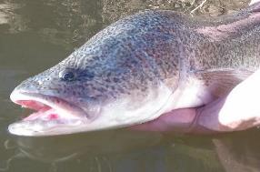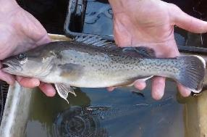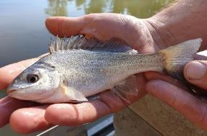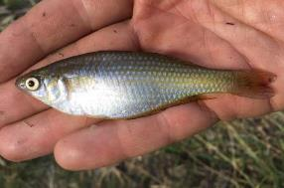
Figure 7-1. Species of conservation significance collected in the Goulburn River: Murray cod (top left), trout cod (top right), silver perch (bottom left) and Murray River rainbowfish (bottom right)
Table 7-1. Numbers of individual fish species collected from the Goulburn River in electrofishing surveys 2015–2019. Asterisk denotes exotic fish species
Species | 2015 | 2016 | 2017 | 2018 | 2019 | Total
Silver Perch Bidyanus bidyanus | 2 | 5 | 15 | 3 | 5 | 30
Goldfish Carassius auratus* | 8 | 22 | 14 | 29 | 1 | 74
Carp Cyprinus carpio* | 107 | 264 | 388 | 145 | 258 | 1168
Eastern gambusia Gambusia holbrooki* | 1 |  | 5 | 7 |  | 13
Carp gudgeon Hypseleotris sp | 9 | 28 | 18 | 7 | 4 | 66
Trout cod Maccullochella macquariensis | 1 | 4 |  |  |  | 5
Murray cod Maccullochella peelii | 79 | 83 | 53 | 36 | 34 | 285
Golden perch Macquaria ambigua | 29 | 41 | 30 | 30 | 17 | 147
Murray River rainbowfish Melanotaenia fluviatilis | 128 | 114 | 214 | 88 | 45 | 589
Bony herring Nematalosa erebi |  | 3 | 12 | 1 |  | 16
Redfin perch Perca fluviatilis* |  |  |  | 1 |  | 1
Australian smelt Retropinna semoni | 267 | 349 | 538 | 334 | 308 | 1796
Total number of individuals | 631 | 913 | 1287 | 681 | 672 | 4184
A total of 330 individuals comprising four native species and two exotic species were collected from the annual netting surveys in 2019 (Table 7-2). Carp gudgeon was the most abundant species captured comprising 66% of the catch. The Murray River rainbowfish was the second most abundant species captured (27%).
Across the five years of sampling (2015–2019), over 7000 individuals representing five native and three exotic species were collected from the annual netting surveys (Table 7-2). Three fish species (carp gudgeon, Murray River rainbowfish, Australian smelt) were detected in all five sampling years (Table 7-2). Oriental weatherloach and carp were only detected in one (2019) and two (2018, 2019) sampling years respectively. CPUE of Murray River rainbowfish increased in the first three years (2015-2017), then decreased in the last two years (2018-2019).
Table 7-2. Numbers of individual fish species collected from the Goulburn River in fyke netting surveys 2015–2019. Asterisk denotes exotic fish species
Species | 2015 | 2016 | 2017 | 2018 | 2019 | Total
Carp Cyprinus carpio* |  |  |  | 3 | 1 | 4
Eastern gambusia Gambusia holbrooki* |  | 6 | 5225 | 127 |  | 5358
Carp gudgeon Hypseleotris sp. | 170 | 403 | 651 | 272 | 218 | 1714
Golden perch Macquaria ambigua | 2 | 3 | 1 |  |  | 6
Murray River rainbowfish Melanotaenia fluviatilis | 58 | 94 | 152 | 86 | 20 | 410
Flatheaded gudgeon Philypnodon grandiceps |  | 1 | 2 |  | 2 | 5
Australian smelt Retropinna semoni | 9 | 1 | 60 | 36 | 88 | 194
Oriental weatherloach Misgurnus anguillicaudatus* |  |  |  |  | 1 | 1
Total number of individuals | 239 | 508 | 6091 | 524 | 330 | 7692
Length frequency histograms are presented below for three of the large-bodied species collected: Murray cod, golden perch and silver perch.
Murray cod
Across the five years, the size of Murray cod collected ranged from 47-1060 mm in length and 1.2 g – 13.5 kg in weight (Figure 7-2). The majority of the population were below the minimum legal angling size (550 mm) for Murray cod. CPUE of Murray cod decreased considerably in 2017 and 2018; declines in CPUE were due to reduced numbers of a range of sizes of fish, particularly fish >200 mm in length. Young-of-year (YOY) Murray cod (i.e. <100 mm in length) were collected in similar numbers in each year.
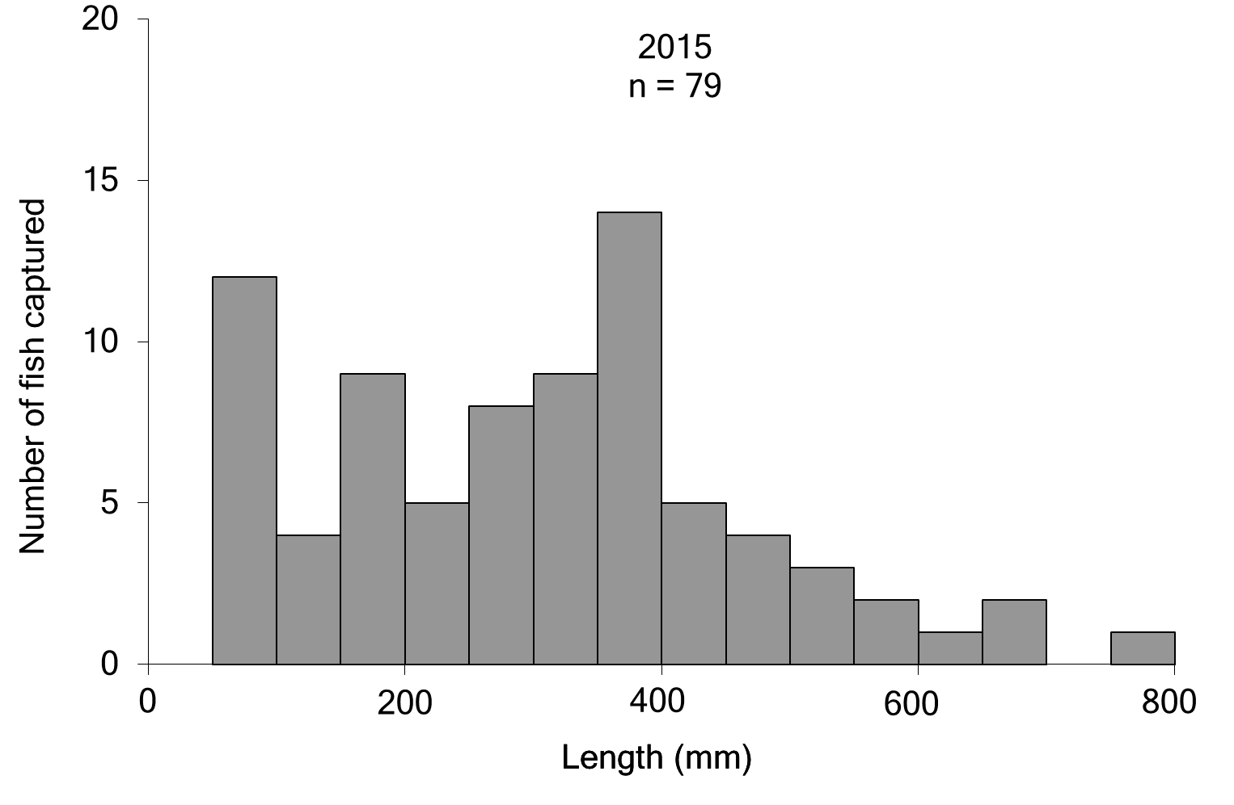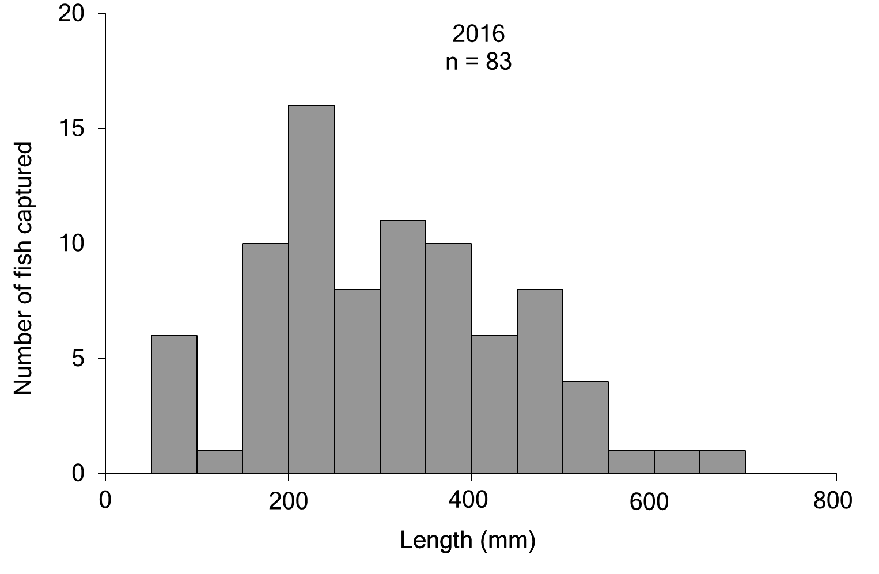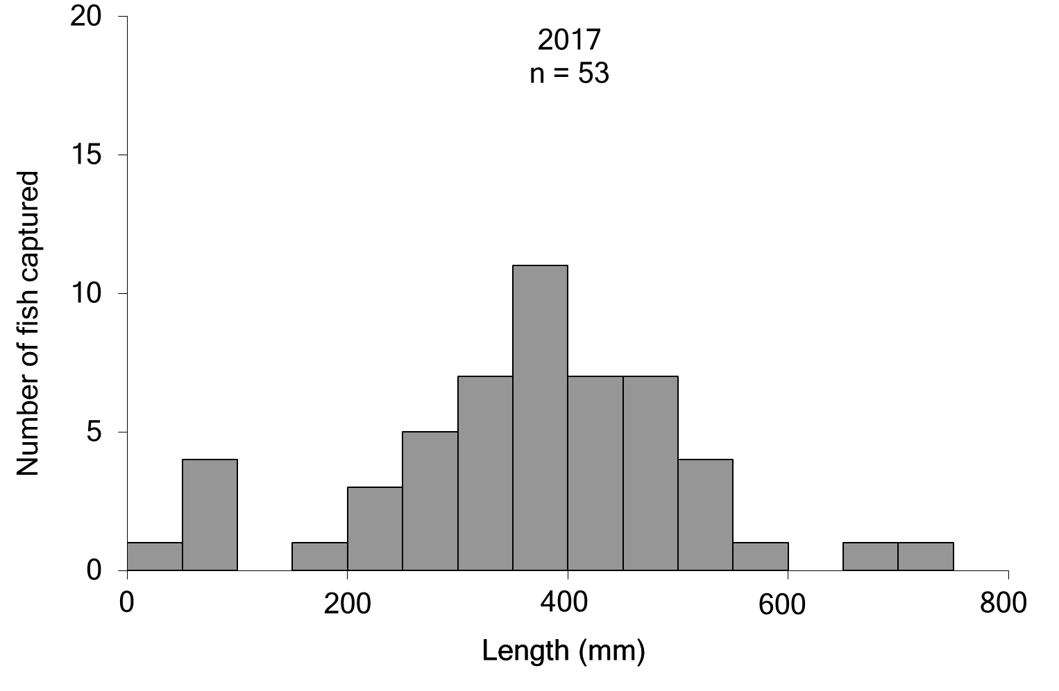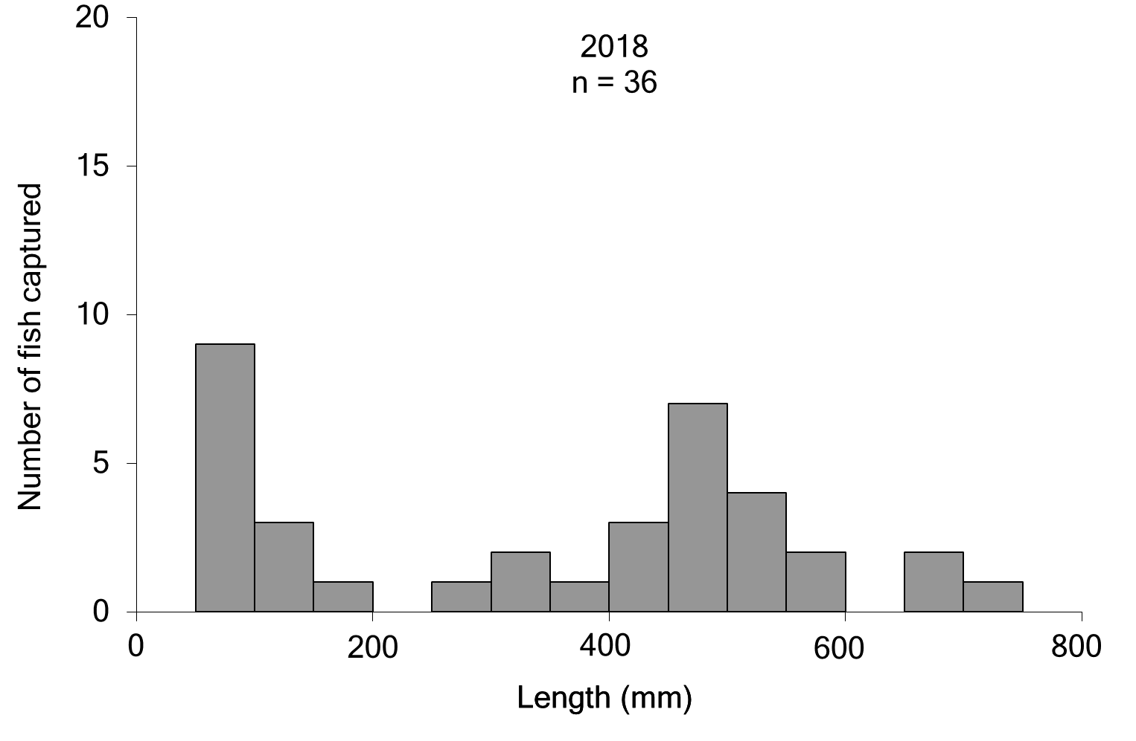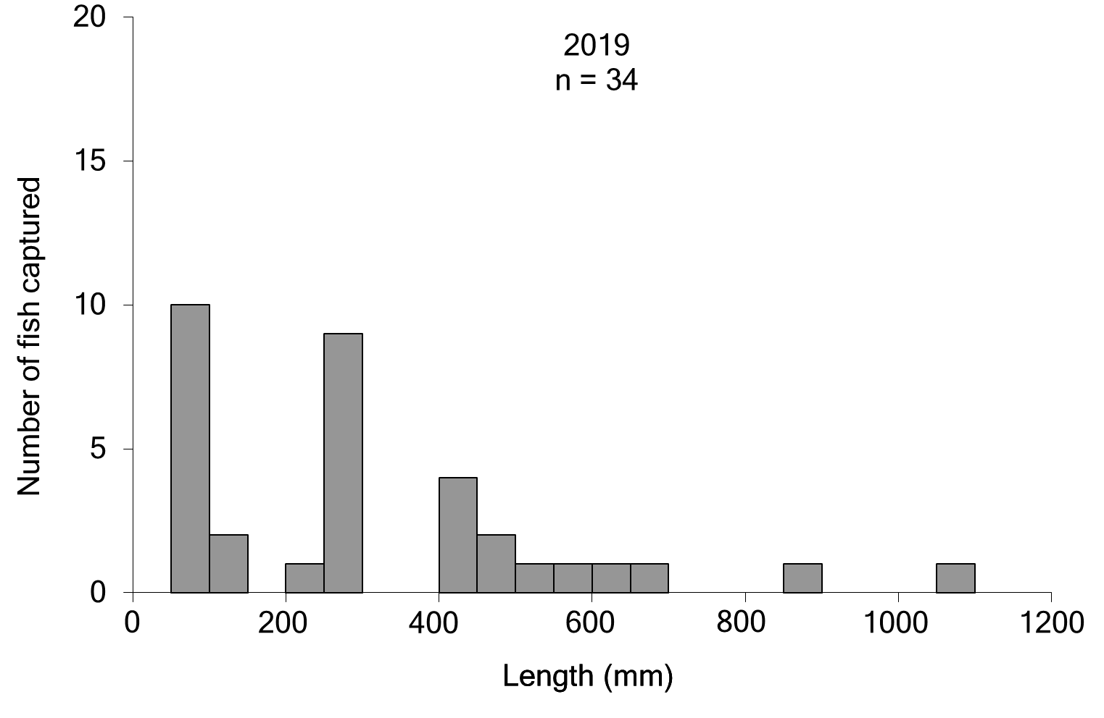
Figure 7-2. Length frequency (total length) of Murray cod collected in the Goulburn River 2015–2019
Golden perch
Across the five years, the size of golden perch collected ranged from 38-540 mm in length and 0.6 g - 2.6 kg in weight (Figure 7-3). The majority of the population consisted of larger, older fish, with few individuals below the minimum legal size of 300 mm. Three YOY (i.e. <100 mm in length) golden perch were collected, at a single site (Shepparton) in 2016.
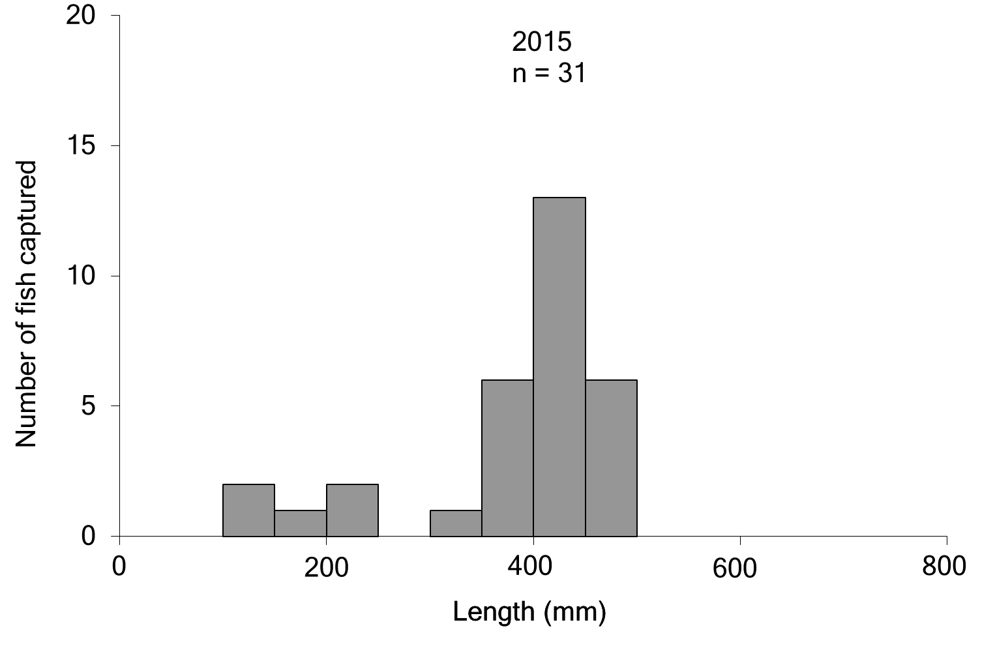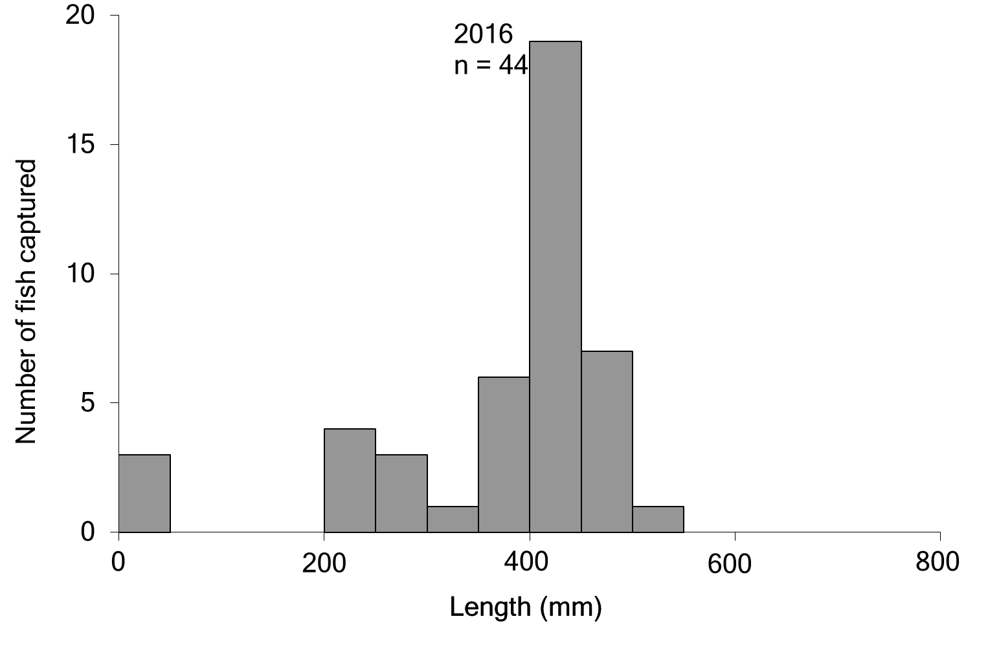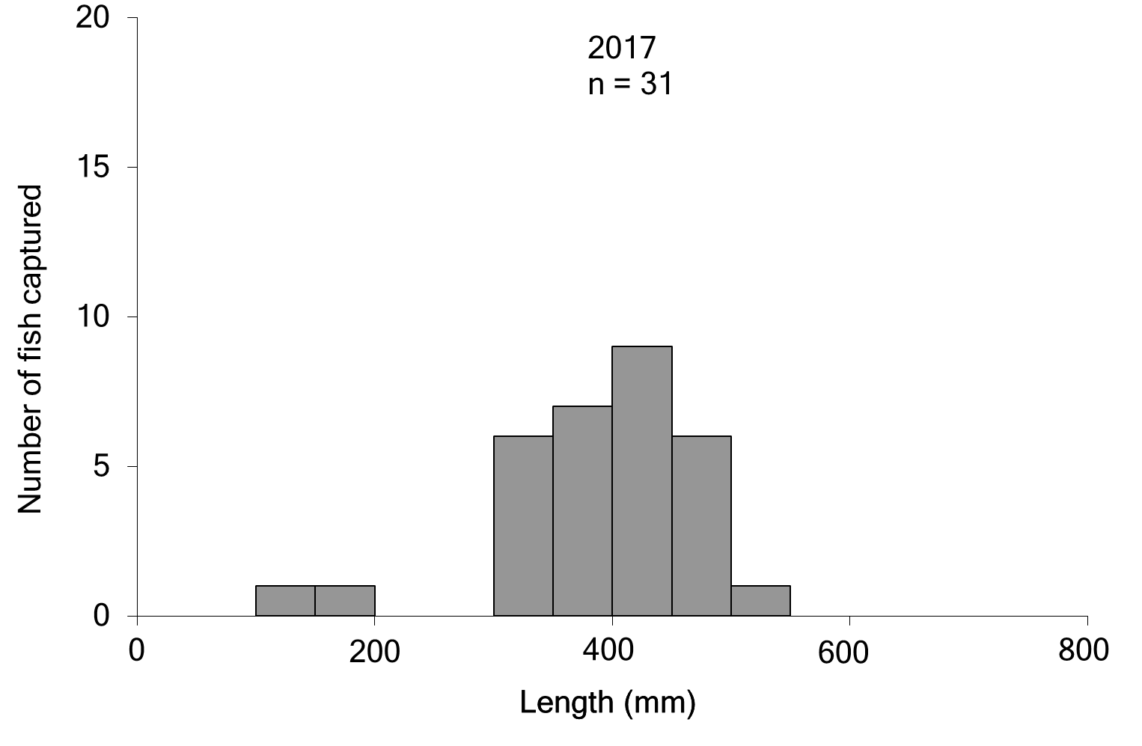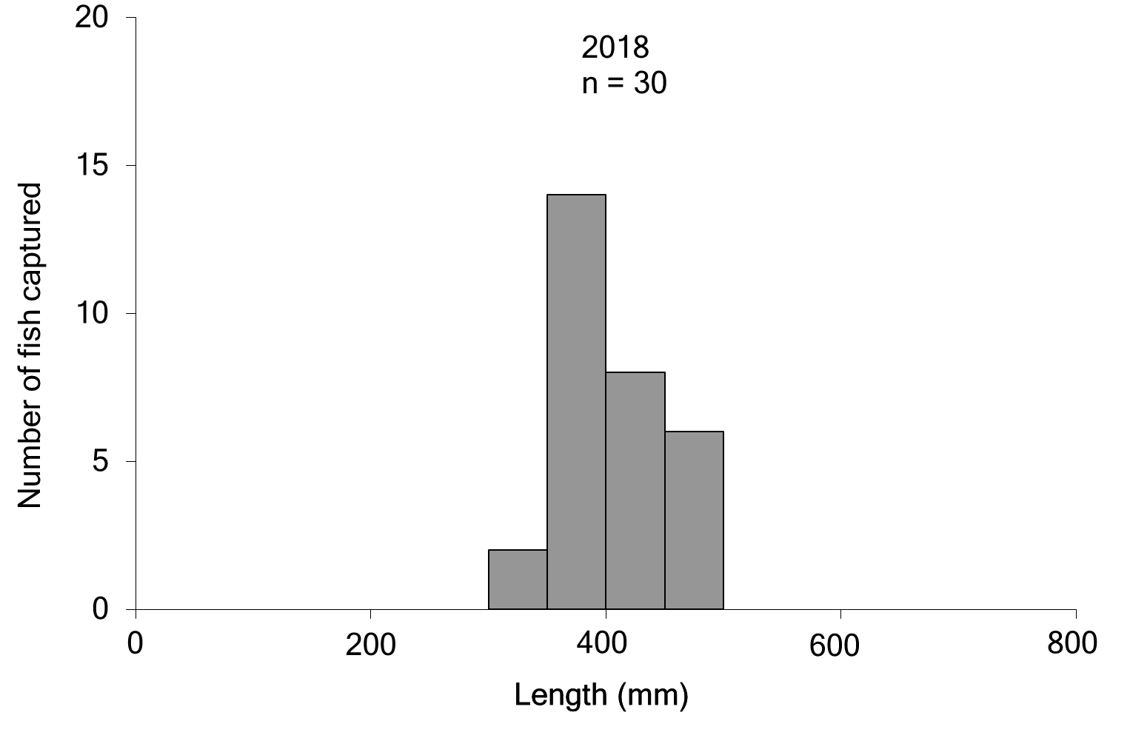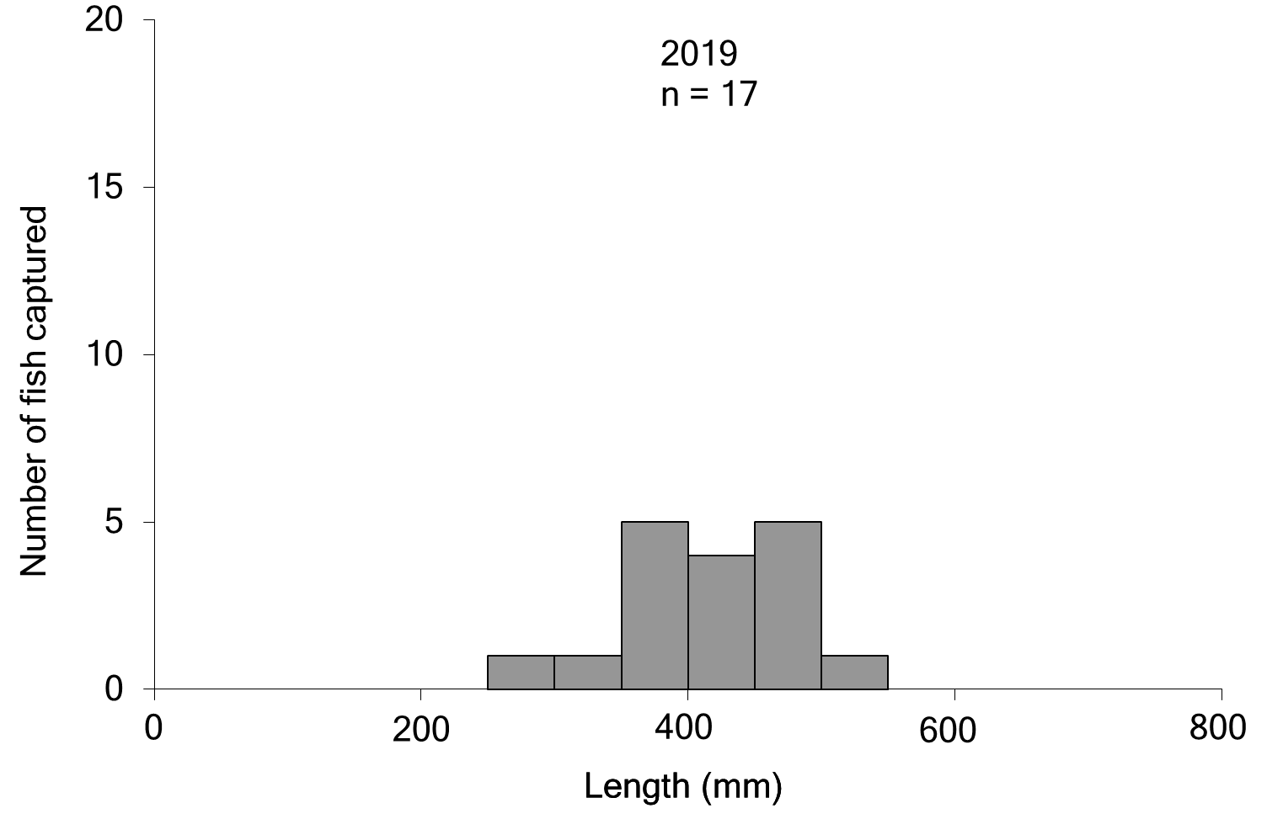
Figure 7-3. Length frequency (total length) of golden perch collected in the Goulburn River 2015–2019
Silver perch
Across the four years, the size of silver perch collected ranged from 124-347 mm in length and 20-600 g in weight (Figure 7-4). CPUE of silver perch increased considerably in 2017. No YOY silver perch were collected, although in 2016, 2017 and 2019 fish between 100-200 mm in length were captured, which are likely 1-2 years old.
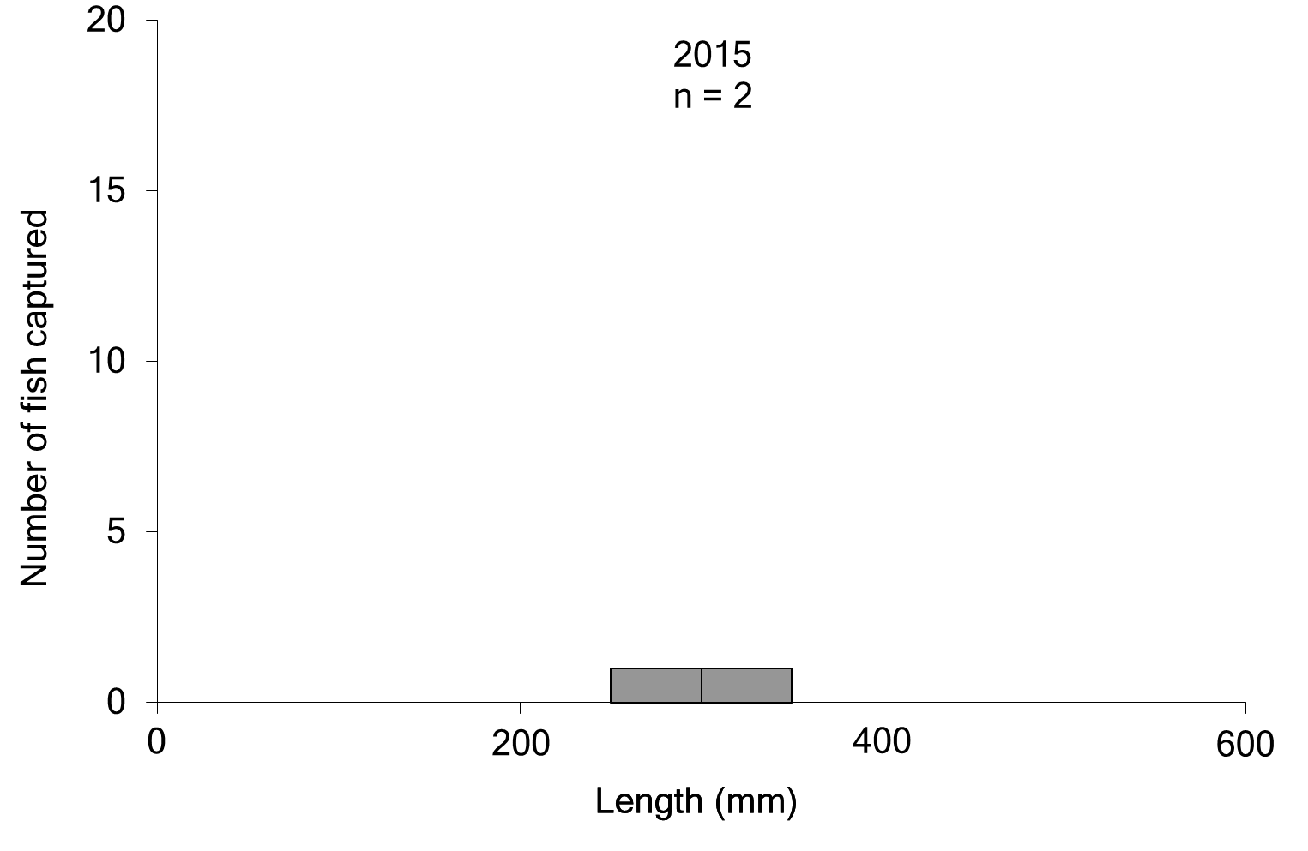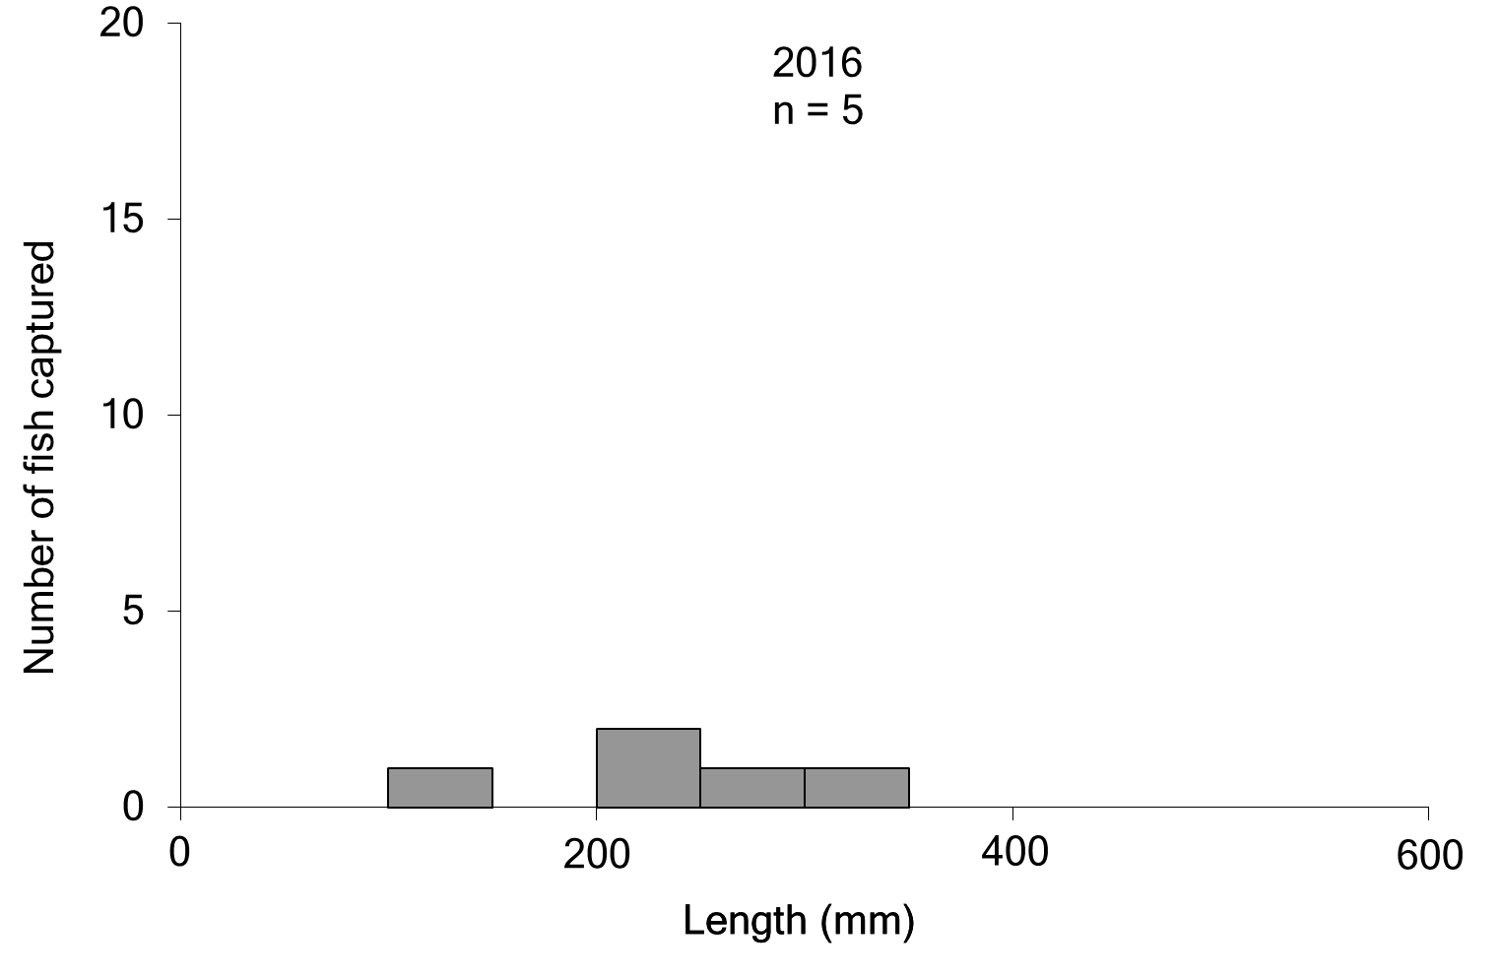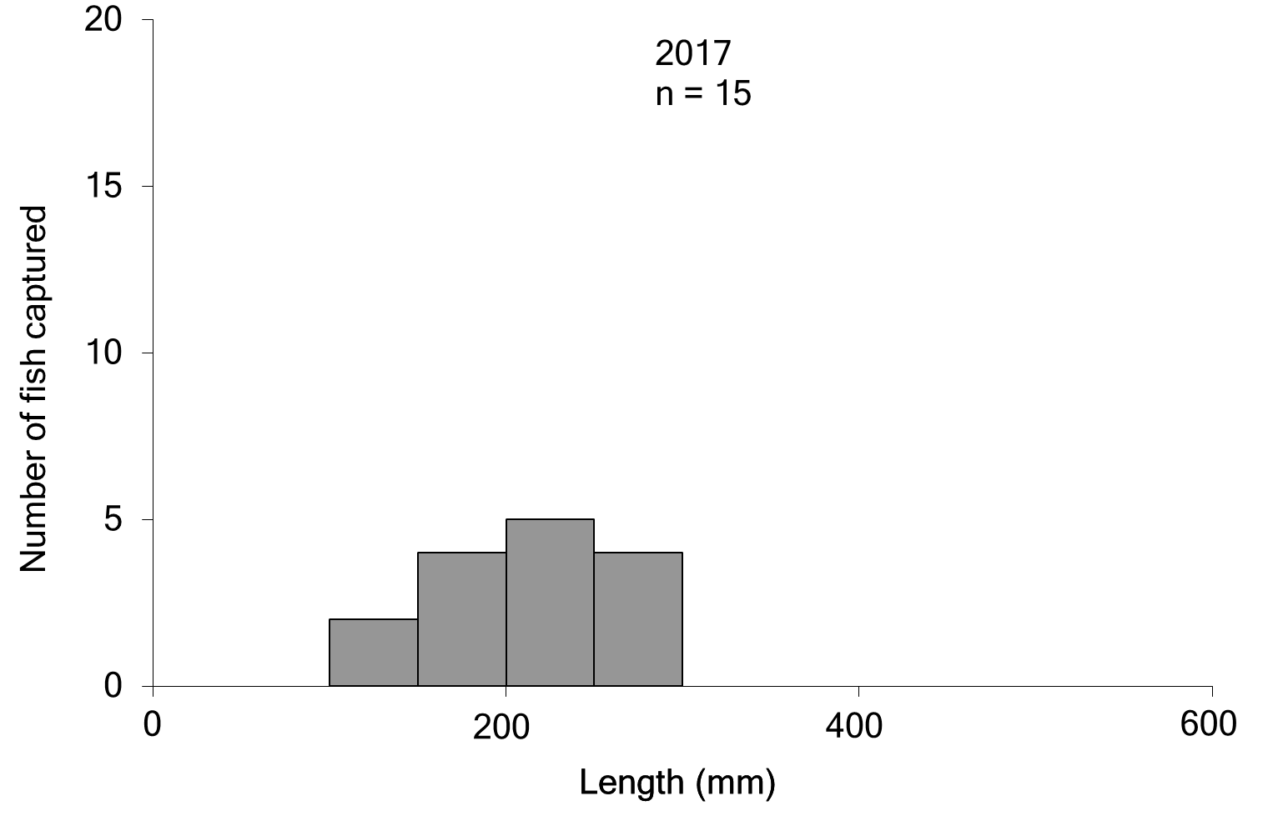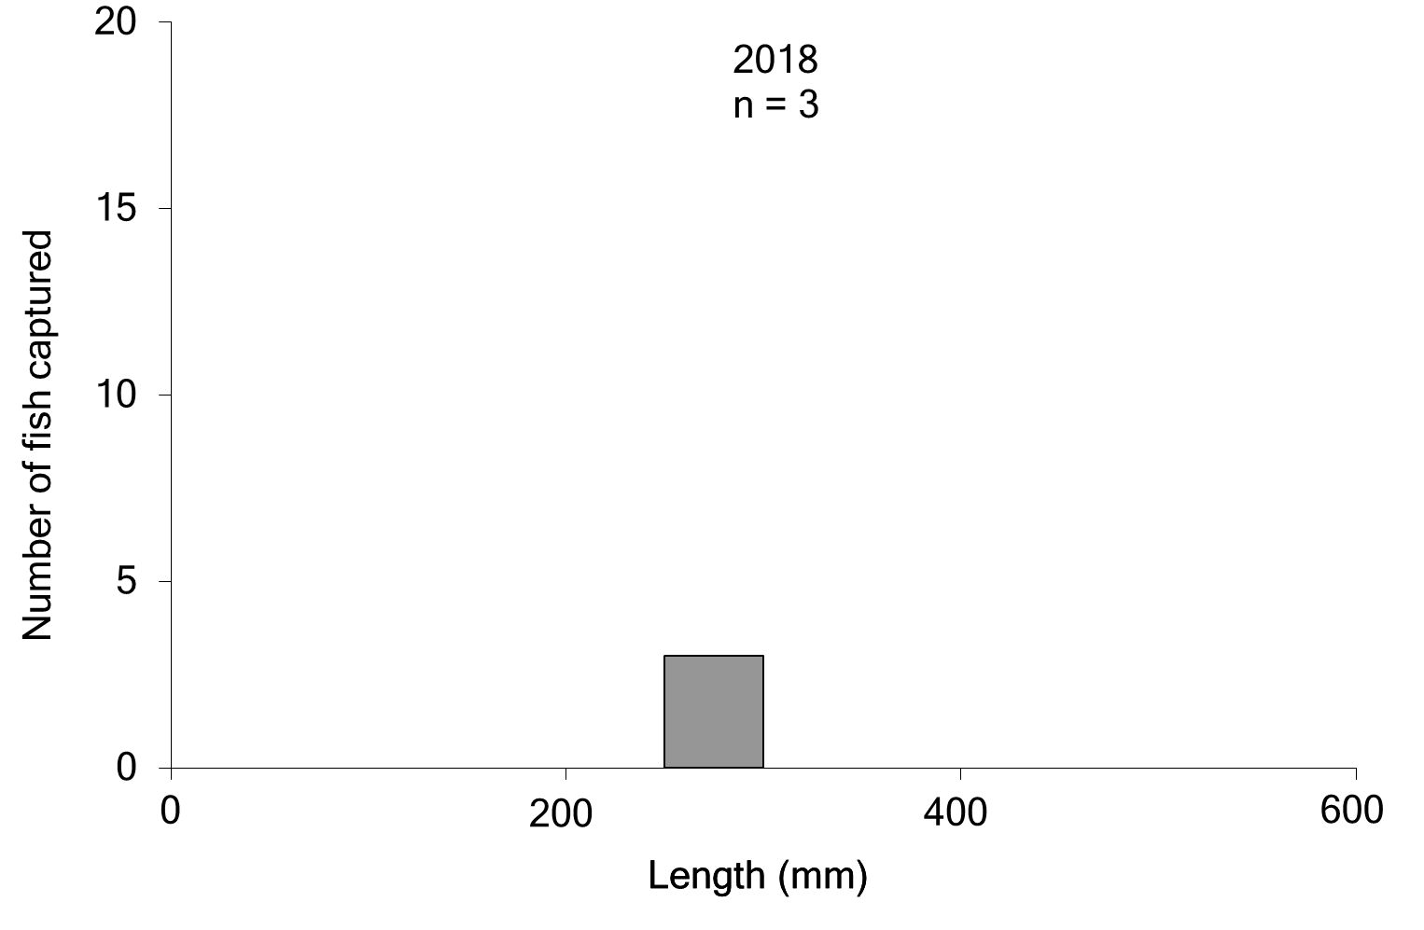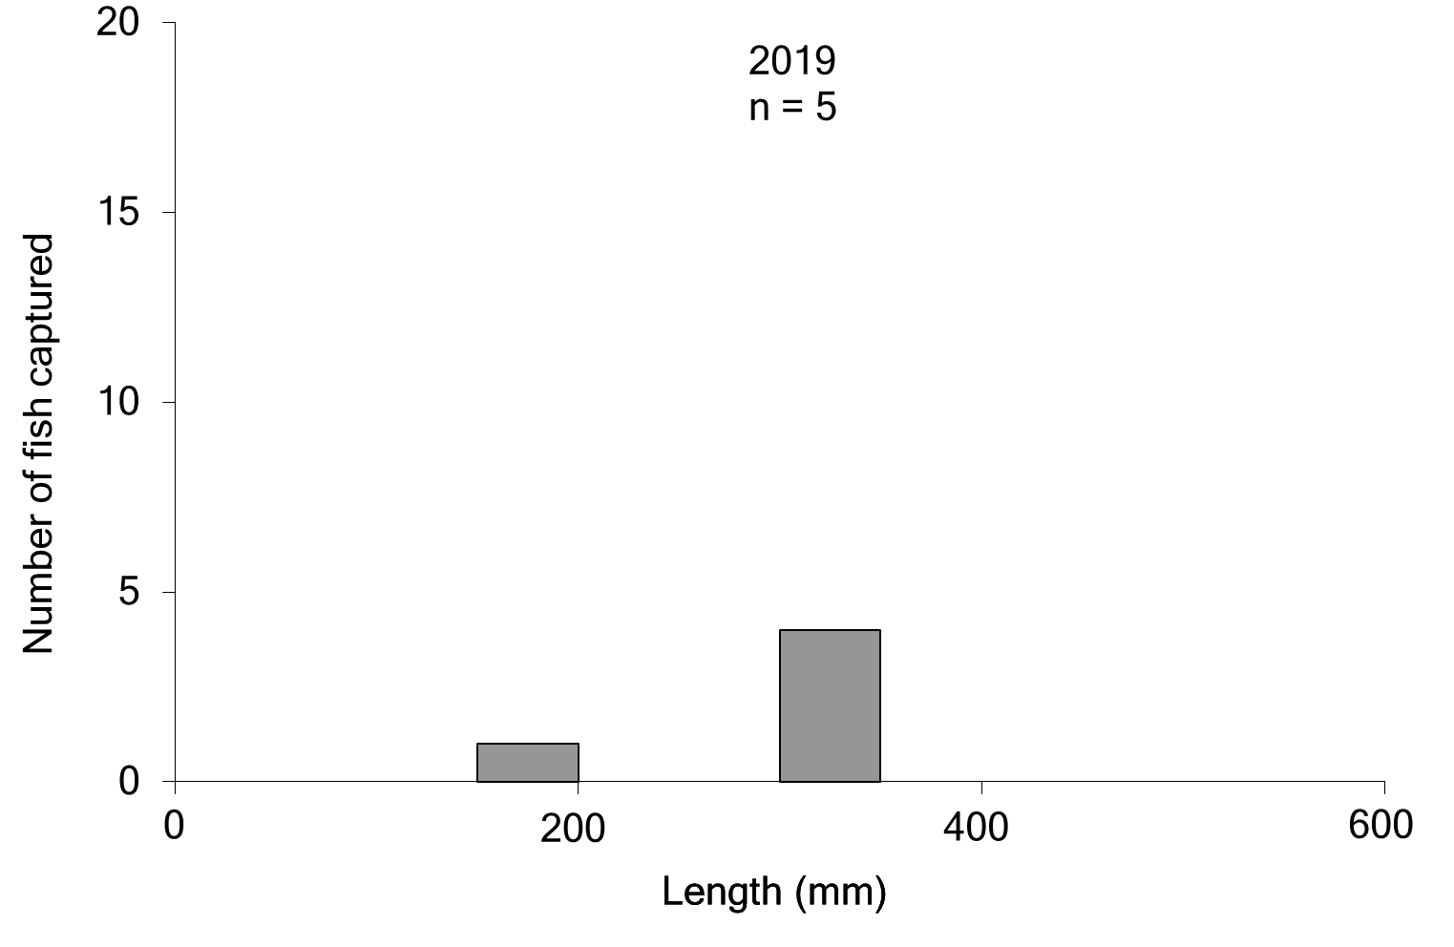
Figure 7-4. Length frequency (fork length) of silver perch collected in the Goulburn River 2015–2019

Golden perch and Murray cod otolith chemistry
Otolith ⁸⁷Sr/⁸⁶Sr analysis indicates that the golden perch population in the Goulburn River consists mostly of stocked fish (Figure 7-5). The proportion of stocked fish tended to increase from 2014 to 2016, which likely reflects the influence of higher levels of stocking of golden perch into the system in recent years. Otolith ⁸⁷Sr/⁸⁶Sr analysis also indicate evidence of in situ recruitment, and immigration into the Goulburn River by fish originating from locations such as the Murray River, and also a single case from the Darling River (Figure 7-6).
In contrast, otolith ⁸⁷Sr/⁸⁶Sr analysis indicate that the Murray cod population in the Goulburn River consists almost entirely of in situ recruitment (Figure 7-7). Otolith ⁸⁷Sr/⁸⁶Sr analysis also indicate evidence of immigration into the Goulburn River by fish originating from the Murray River, and minor evidence of stocked fish (Figure 7-8).
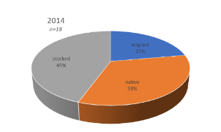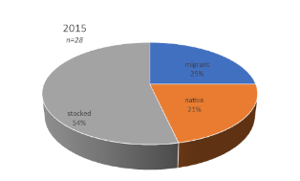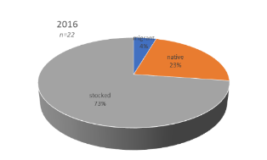
Figure 7-5. Pie chart depicting the natal origin of golden perch in the Goulburn River in 2014-2016. Orange = fish native to the region, blue = immigrants and grey = stocked.

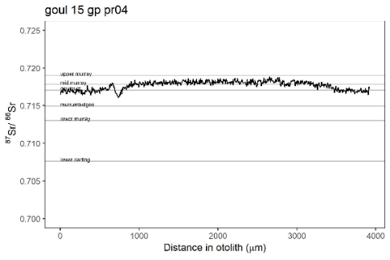 | 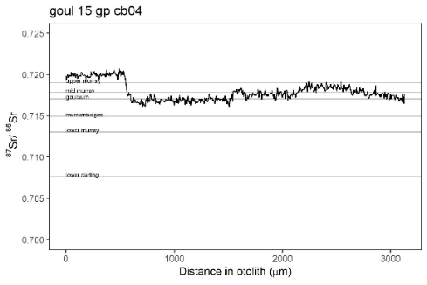
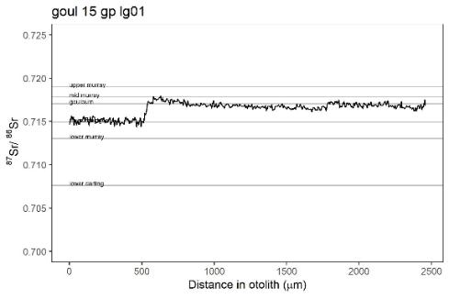 | 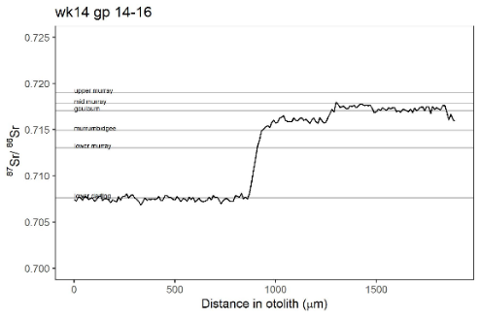
Figure 7-6. Examples of otolith ⁸⁷Sr/⁸⁶Sr profiles (black line) of four individual golden perch captured in the Goulburn River. Horizontal grey lines depict mean river ⁸⁷Sr/⁸⁶Sr value and show which river/region the individual fish was spawned in, spent time in and moved to.

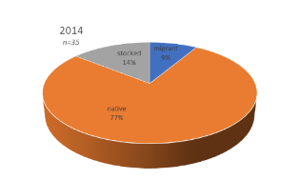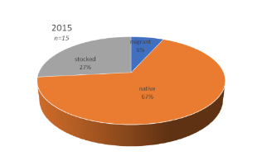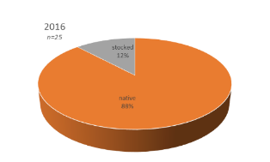
Figure 7-7. Pie chart depicting the natal origin of Murray cod in the Goulburn River in 2014-2016. Orange = fish native to the region, blue = immigrants and grey = stocked.

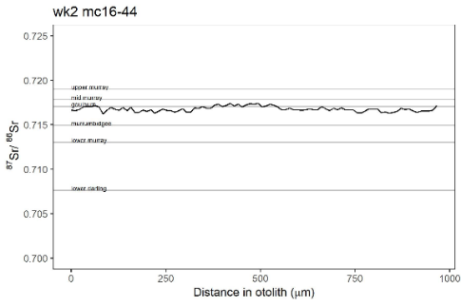 | 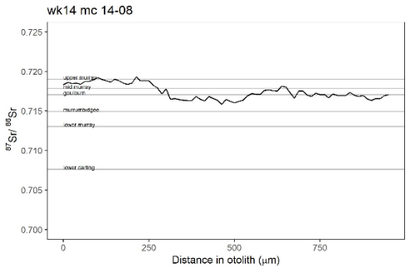
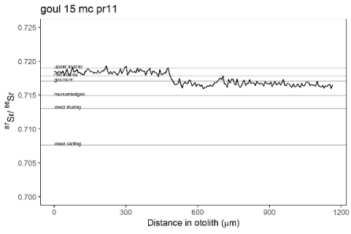 | 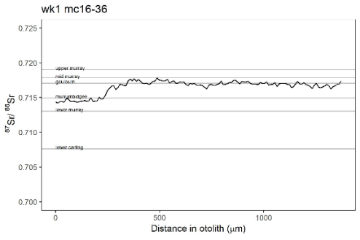
Figure 7-8. Examples of otolith ⁸⁷Sr/⁸⁶Sr profiles (black line) of four individual Murray cod captured in the Goulburn River. Horizontal grey lines depict mean river ⁸⁷Sr/⁸⁶Sr value and show which river/region the individual fish was spawned in, spent time in and moved to.

Surveys of eggs and larvae (drift nets)
Over 2600 individuals (eggs and larvae) representing 7 native and 1 exotic species were collected from the four drift sampling sites in the Goulburn River in 2018 (Table 7-3). Murray cod was the most abundant species collected, comprising 74% of the total abundance for all species. The drift sampling captured only 18 eggs of golden perch, in early November 2018 on the receding limb of a spring fresh environmental flow release delivered in October 2018. Water temperature at this time was 20.4 °C. The drift sampling also captured 67 silver perch eggs in 2018 coinciding with an increase in flow in mid-December associated with inter-valley transfer flows. Water temperature at this time was 24.4 °C. Spawning by trout cod was also detected in 2018 with larvae collected from mid-November to early December.
Table 7-3. Numbers of eggs (E) and larvae (L) of fish species collected in drift net surveys from the Goulburn River 2014-2018. Species with asterisk are exotic species.
Species | 2014 | 2015 | 2016 | 2017 | 2018 | Total
Silver perch | 47E |  | 34E | 37E | 67E | 185
Murray cod | 942L | 355L | 892L | 2007L | 1939L | 6135
Trout cod |  |  |  | 15L | 25L | 40
Unidentified cod sp. |  |  |  |  | 349L | 349
Golden perch | 1628E, 1L |  | 47E | 289E, 11L | 18E | 1994
Common carp* |  | 15L | 19L | 16L | 5L | 55
Australian smelt | 204E, 9L | 81E, 7L | 32E, 1L | 177E, 16L | 122E, 3L | 652
Flathead gudgeon | 8L | 11L | 18L | 48L | 85L | 170
Carp gudgeon |  | 11L | 1L | 37L | 5L | 54
Gudgeon sp. |  |  |  | 4L | 16L | 20
Goldfish* |  |  |  | 1L |  | 1
Unidentified perch |  |  |  |  | 1E | 1
Total number of individuals | 2839 | 480 | 1044 | 2658 | 2635 | 9656
Spawning of golden perch and silver perch 2003-2018
Drift sampling between 2003 and 2018 captured 2,400 eggs and 22 larvae of golden perch (Table 7-4). Numbers of individuals collected varied considerably between years and sites. The most eggs and larvae were collected in 2010, 2013, 2014 and 2017, compared to other years, and 52% were collected from the site farthest downstream (Yambuna). Eggs and larvae were collected from mid-October to mid-December, with peak abundances collected between early and late November. Most collections (99% of eggs and larvae) coincided with within-channel flow pulses including environmental flows releases or bankfull flows (Figure 7-9). About 97% of egg and larval collections coincided with the rising limb/peak of the hydrograph. Water temperature during these times ranged from 16-24 °C. Egg concentrations often peaked in association with the second spring-summer flow event (e.g. 2010, 2013, 2014, 2017) (Figure 7-9).
Drift sampling between 2004 and 2018 captured 190 eggs of silver perch (Table 7-5). No silver perch larvae were detected in drfit samples. Abundance varied considerably between years and sites. Higher numbers were collected in 2014, 2016, 2017 and 2018, than in other years, and 90% were collected from the site second farthest downstream (McCoys Bridge). Silver perch eggs were collected from early November to mid-December, with peak egg abundances collected between mid-November and mid-December. Most collections (99% of eggs) coincided with within-channel flow pulses including environmental flow releases or bankfull flows, during the rising limb/peak (81% of eggs) of the hydrograph and the falling limb (19% of eggs) (Figure 7-10). Water temperature during these times ranged from 20-25 °C. Little or no spawning occurred during flow increases that followed extended periods (e.g. 2-3 weeks) of low stable flows throughout spring (e.g. 2011, 2012, 2017, 2018).

Table 7-4. Total number and density (number per 1000 m³) of golden perch eggs and larvae collected in drift net surveys from the Goulburn River 2003-2018. Ch – Cable Hole, Pr – Pyke Road, Lg – Loch Garry, Mc – McCoys Bridge, Ya - Yambuna.
 |  | 2003 |  |  |  |  |  |  |  |  |  |  |  |  |  |  | 2004 |  |  |  |  |  |  |  |  |  |  |  |  |  |  |  | 2005 |  |  |  |  |  |  |  |  |  |  |  |  |  |  |  | 2006
 | Stage | Ch |  |  | Pr |  |  | Ya |  |  |  |  |  |  |  | Ch |  |  |  | Pr |  |  | Ya |  |  |  |  |  |  |  | Ch |  |  |  | Pr |  |  | Ya |  |  |  |  |  |  |  | Ch |  |  |  | Pr |  |  | Ya
Number | Egg
 | Larvae |  |  |  |  |  |  |  |  |  |  |  |  |  |  |  |  |  |  |  |  |  |  |  |  |  |  |  |  |  |  |  |  |  |  |  |  | 3 |  |  |  |  |  |  |  |  |  |  |  |  |  |  | 1
Density | Egg
 | Larvae |  |  |  |  |  |  |  |  |  |  |  |  |  |  |  |  |  |  |  |  |  |  |  |  |  |  |  |  |  |  |  |  |  |  |  |  | 13.7 |  |  |  |  |  |  |  |  |  |  |  |  |  |  | 78.4
 |  | 2007 |  |  |  |  |  |  |  |  |  |  |  |  |  |  | 2008 |  |  |  |  |  |  |  |  |  |  |  |  |  |  |  | 2009 |  |  |  |  |  |  |  |  |  |  |  |  |  |  |  | 2010  2017
 | Stage | Ch |  |  | Pr |  |  | Ya |  |  |  |  |  |  |  | Ch |  |  |  | Pr |  |  | Ya |  |  |  |  |  |  |  | Ch |  |  |  | Pr |  |  | Ya |  |  |  |  |  |  |  | Ch |  |  |  | Pr |  |  | Ya
Number | Egg |  |  |  |  |  |  |  |  |  |  |  |  |  |  |  |  |  |  |  |  |  |  |  |  |  |  |  |  |  |  |  |  |  |  |  |  |  |  |  |  |  |  |  |  | 3 |  |  |  | 33 |  |  | 99
 | Larvae |  |  |  |  |  |  |  |  |  |  |  |  |  |  |  |  |  |  |  |  |  |  |  |  |  |  |  |  |  |  |  |  |  |  |  |  |  |  |  |  |  |  |  |  |  |  |  |  | 1 |  |  | 1
Density | Egg |  |  |  |  |  |  |  |  |  |  |  |  |  |  |  |  |  |  |  |  |  |  |  |  |  |  |  |  |  |  |  |  |  |  |  |  |  |  |  |  |  |  |  |  | 0.3 |  |  |  | 3.1 |  |  | 8.2
 | Larvae |  |  |  |  |  |  |  |  |  |  |  |  |  |  |  |  |  |  |  |  |  |  |  |  |  |  |  |  |  |  |  |  |  |  |  |  |  |  |  |  |  |  |  |  |  |  |  |  | 0.1 |  |  | 0.1
 |  | 2011 |  |  |  |  |  |  |  |  |  |  |  |  |  |  | 2012  2009 |  |  |  |  |  |  |  |  |  |  |  |  |  |  |  | 2013  2008 |  |  |  |  |  |  |  |  |  |  |  |  |  |  |  | 2014  2017  2007
 | Stage | Ch |  | Pr |  |  | Ya |  |  |  |  |  |  | Ch |  |  |  | Pr |  |  |  | Ya |  |  |  |  |  |  | Ch |  |  | Pr |  |  |  | Ya |  |  |  |  |  |  |  | Pr |  |  | Lg |  |  |  | Mc |  |  | Ya
Number | Egg |  |  |  |  |  | 3 |  |  |  |  |  |  |  |  |  |  |  |  |  |  | 1 |  |  |  |  |  |  |  |  |  |  |  |  |  | 282 |  |  |  |  |  |  |  | 54 |  |  | 314 |  |  |  | 490 |  |  | 770
 | Larvae |  |  |  |  |  |  |  |  |  |  |  |  |  |  |  |  |  |  |  |  |  |  |  |  |  |  |  |  |  |  |  |  |  |  | 4 |  |  |  |  |  |  |  |  |  |  |  |  |  |  | 1
Density | Egg |  |  |  |  |  | 1.4 |  |  |  |  |  |  |  |  |  |  |  |  |  |  | 0.6 |  |  |  |  |  |  |  |  |  |  |  |  |  | 46.6 |  |  |  |  |  |  |  | 8.8 |  |  | 17.3 |  |  |  | 33.5 |  |  | 56.3
 | Larvae |  |  |  |  |  |  |  |  |  |  |  |  |  |  |  |  |  |  |  |  |  |  |  |  |  |  |  |  |  |  |  |  |  |  | 0.7 |  |  |  |  |  |  |  |  |  |  |  |  |  |  | 0.1
 |  | 2015 |  |  |  |  |  |  |  |  |  |  |  |  |  |  | 2016 |  |  |  |  |  |  |  |  |  |  |  |  |  |  |  | 2017 |  |  |  |  |  |  |  |  |  |  |  |  |  |  |  | 2018
 | Stage | Pr | Lg |  |  | Mc |  |  |  | Ya |  |  |  |  | Pr |  |  |  | Lg |  | Mc |  |  | Ya |  |  |  |  |  | Pr |  |  |  | Lg |  |  | Mc |  | Ya |  |  |  |  |  | Pr |  |  | Lg |  |  |  | Mc |  |  | Ya
Number | Egg |  |  |  |  |  |  |  |  |  |  |  |  |  | 1 |  |  |  | 24 |  | 3 |  |  | 19 |  |  |  |  |  | 8 |  |  |  | 117 |  |  | 100 |  | 64 |  |  |  |  |  | 1 |  |  | 17
 | Larvae |  |  |  |  |  |  |  |  |  |  |  |  |  |  |  |  |  |  |  |  |  |  |  |  |  |  |  |  |  |  |  |  |  |  |  | 1 |  | 10
Density | Egg |  |  |  |  |  |  |  |  |  |  |  |  |  | 0.1 |  |  |  | 1.9 |  | 0.2 |  |  | 0.9 |  |  |  |  |  | 0.1 |  |  |  | 4.3 |  |  | 3.6 |  | 1.5 |  |  |  |  |  | 0.0 |  |  | 1.3
 | Larvae |  |  |  |  |  |  |  |  |  |  |  |  |  |  |  |  |  |  |  |  |  |  |  |  |  |  |  |  |  |  |  |  |  |  |  | 0.0 |  | 0.2

Table 7-5. Total number and density (number per 1000 m³) of silver perch eggs and larvae collected in drift net surveys from the Goulburn River 2003-2018. Ch – Cable Hole, Pr – Pyke Road, Lg – Loch Garry, Mc – McCoys Bridge, Ya - Yambuna.
 |  | 2003 |  |  |  |  |  |  |  |  |  |  |  |  |  |  | 2004 |  |  |  |  |  |  |  |  |  |  |  |  |  |  |  | 2005 |  |  |  |  |  |  |  |  |  |  |  |  |  |  |  | 2006
 | Stage | Ch |  |  | Pr |  |  | Ya |  |  |  |  |  |  |  | Ch |  |  |  | Pr |  |  | Ya |  |  |  |  |  |  |  | Ch |  |  |  | Pr |  |  | Ya |  |  |  |  |  |  |  | Ch |  |  |  | Pr |  |  | Ya
Number | Egg
 | Larvae
Density | Egg
 | Larvae
 |  | 2007 |  |  |  |  |  |  |  |  |  |  |  |  |  |  | 2008 |  |  |  |  |  |  |  |  |  |  |  |  |  |  |  | 2009 |  |  |  |  |  |  |  |  |  |  |  |  |  |  |  | 2010  2017
 | Stage | Ch |  |  | Pr |  |  | Ya |  |  |  |  |  |  |  | Ch |  |  |  | Pr |  |  | Ya |  |  |  |  |  |  |  | Ch |  |  |  | Pr |  |  | Ya |  |  |  |  |  |  |  | Ch |  |  |  | Pr |  |  | Ya
Number | Egg |  |  |  |  |  |  |  |  |  |  |  |  |  |  |  |  |  |  |  |  |  |  |  |  |  |  |  |  |  |  |  |  |  |  |  |  |  |  |  |  |  |  |  |  |  |  |  |  |  |  |  | 2
 | Larvae
Density | Egg |  |  |  |  |  |  |  |  |  |  |  |  |  |  |  |  |  |  |  |  |  |  |  |  |  |  |  |  |  |  |  |  |  |  |  |  |  |  |  |  |  |  |  |  |  |  |  |  |  |  |  | 0.2
 | Larvae
 |  | 2011 |  |  |  |  |  |  |  |  |  |  |  |  |  |  | 2012  2009 |  |  |  |  |  |  |  |  |  |  |  |  |  |  |  | 2013  2008 |  |  |  |  |  |  |  |  |  |  |  |  |  |  |  | 2014  2017  2007
 | Stage | Ch |  | Pr |  |  | Ya |  |  |  |  |  |  | Ch |  |  |  | Pr |  |  |  | Ya |  |  |  |  |  |  | Ch |  |  | Pr |  |  |  | Ya |  |  |  |  |  |  |  | Pr |  |  | Lg |  |  |  | Mc |  |  | Ya
Number | Egg |  |  |  |  |  | 3 |  |  |  |  |  |  |  |  |  |  |  |  |  |  |  |  |  |  |  |  |  |  |  |  |  |  |  |  |  |  |  |  |  |  |  |  |  |  |  |  |  |  |  | 47
 | Larvae
Density | Egg |  |  |  |  |  | 1.4 |  |  |  |  |  |  |  |  |  |  |  |  |  |  |  |  |  |  |  |  |  |  |  |  |  |  |  |  |  |  |  |  |  |  |  |  |  |  |  |  |  |  |  | 3.2
 | Larvae
 |  | 2015 |  |  |  |  |  |  |  |  |  |  |  |  |  |  | 2016 |  |  |  |  |  |  |  |  |  |  |  |  |  |  |  | 2017 |  |  |  |  |  |  |  |  |  |  |  |  |  |  |  | 2018
 | Stage | Pr | Lg |  |  | Mc |  |  |  | Ya |  |  |  |  | Pr |  |  |  | Lg |  | Mc |  |  | Ya |  |  |  |  |  | Pr |  |  |  | Lg |  |  | Mc |  | Ya |  |  |  |  |  | Pr |  |  | Lg |  |  |  | Mc |  |  | Ya
Number | Egg |  |  |  |  |  |  |  |  |  |  |  |  |  |  |  |  |  |  |  | 34 |  |  |  |  |  |  |  |  |  |  |  |  | 6 |  |  | 23 |  | 8 |  |  |  |  |  |  |  |  |  |  |  |  | 67 |  |  | 1
 | Larvae
Density | Egg |  |  |  |  |  |  |  |  |  |  |  |  |  |  |  |  |  |  |  | 1.7 |  |  |  |  |  |  |  |  |  |  |  |  | 1.2 |  |  | 1.8 |  | 0.2 |  |  |  |  |  |  |  |  |  |  |  |  | 5.2 |  |  | 0.1
 | Larvae

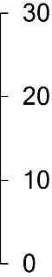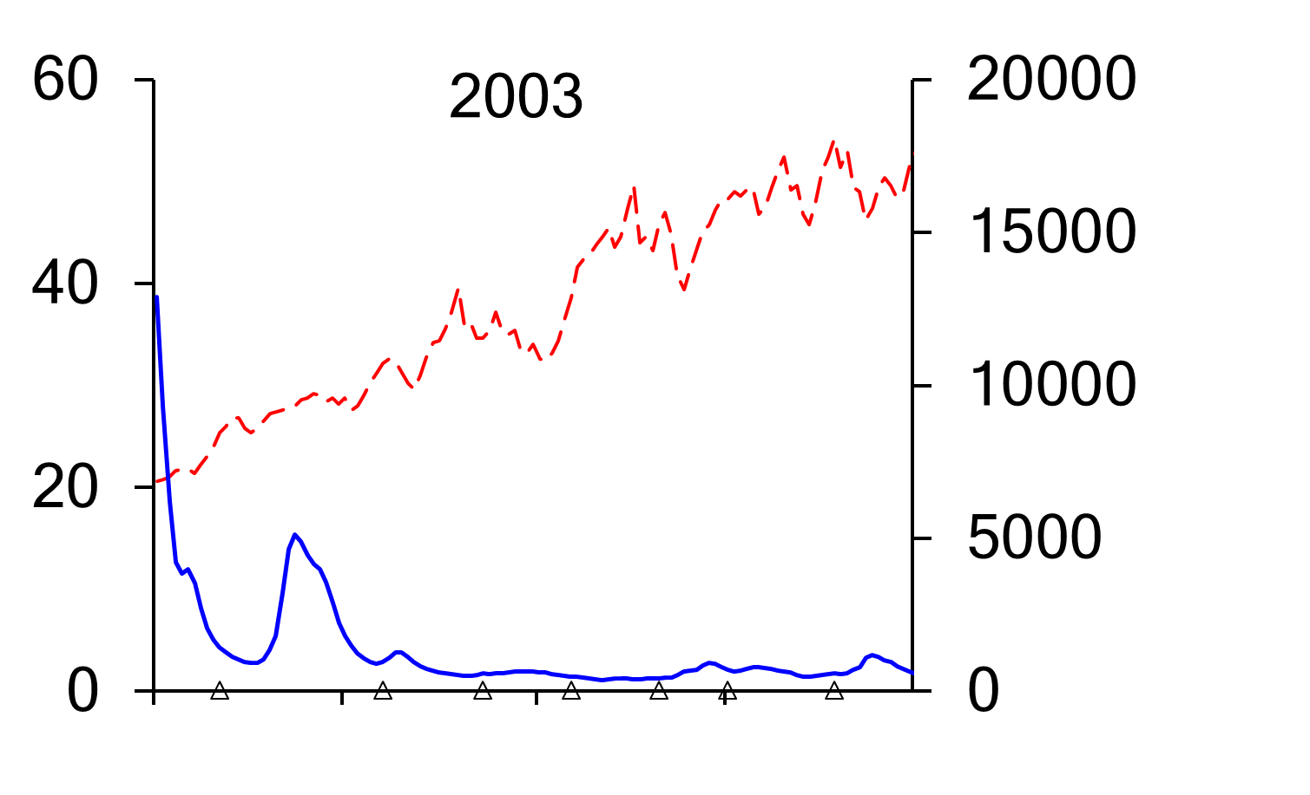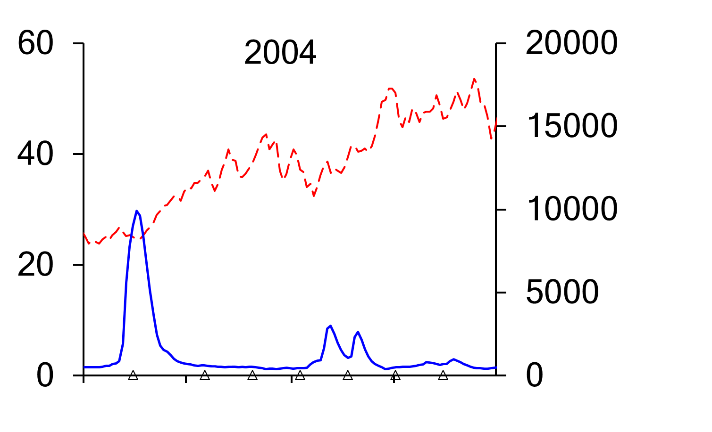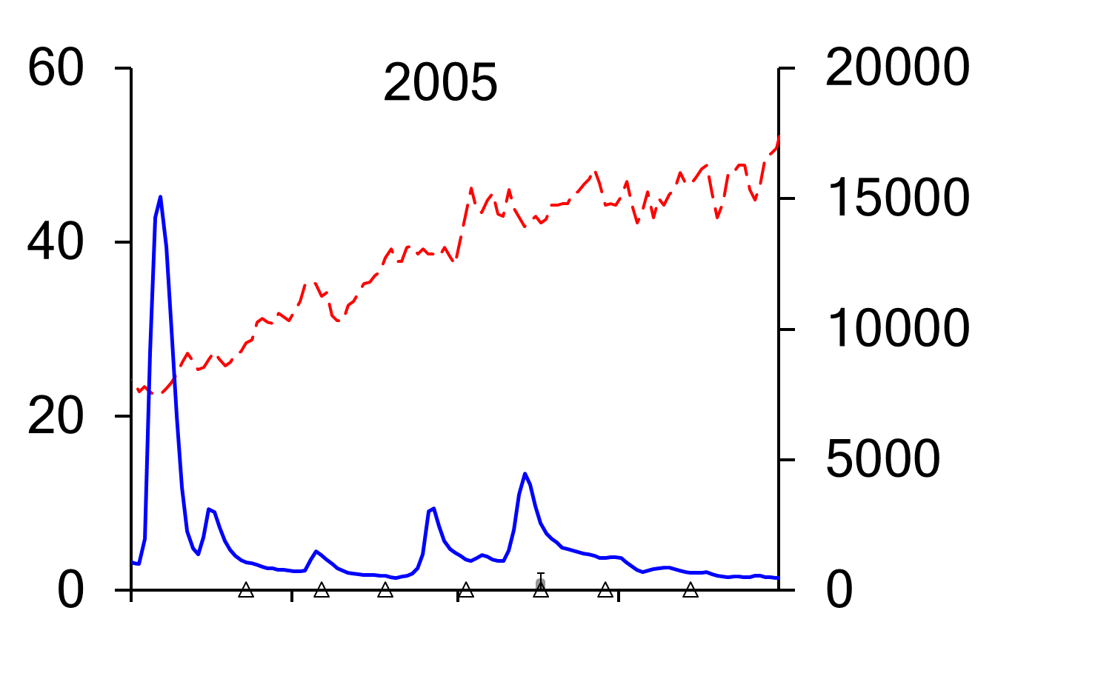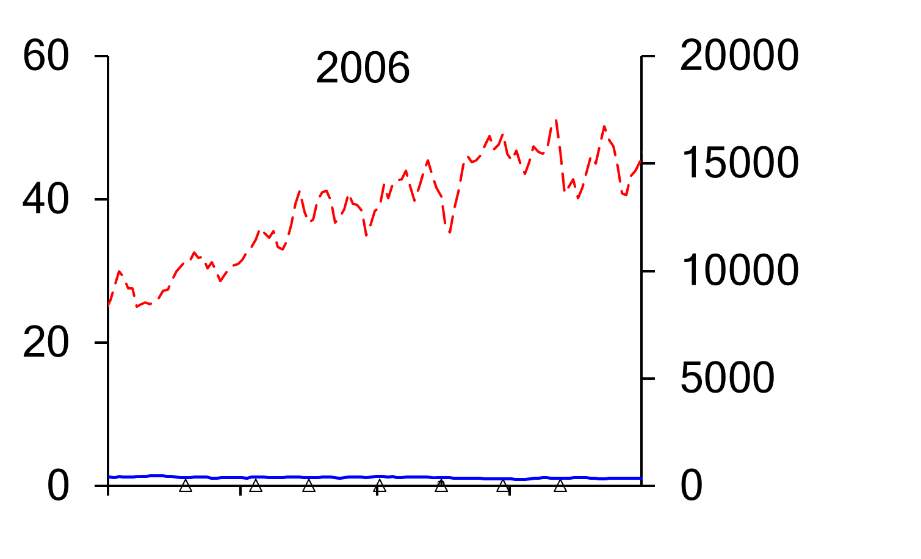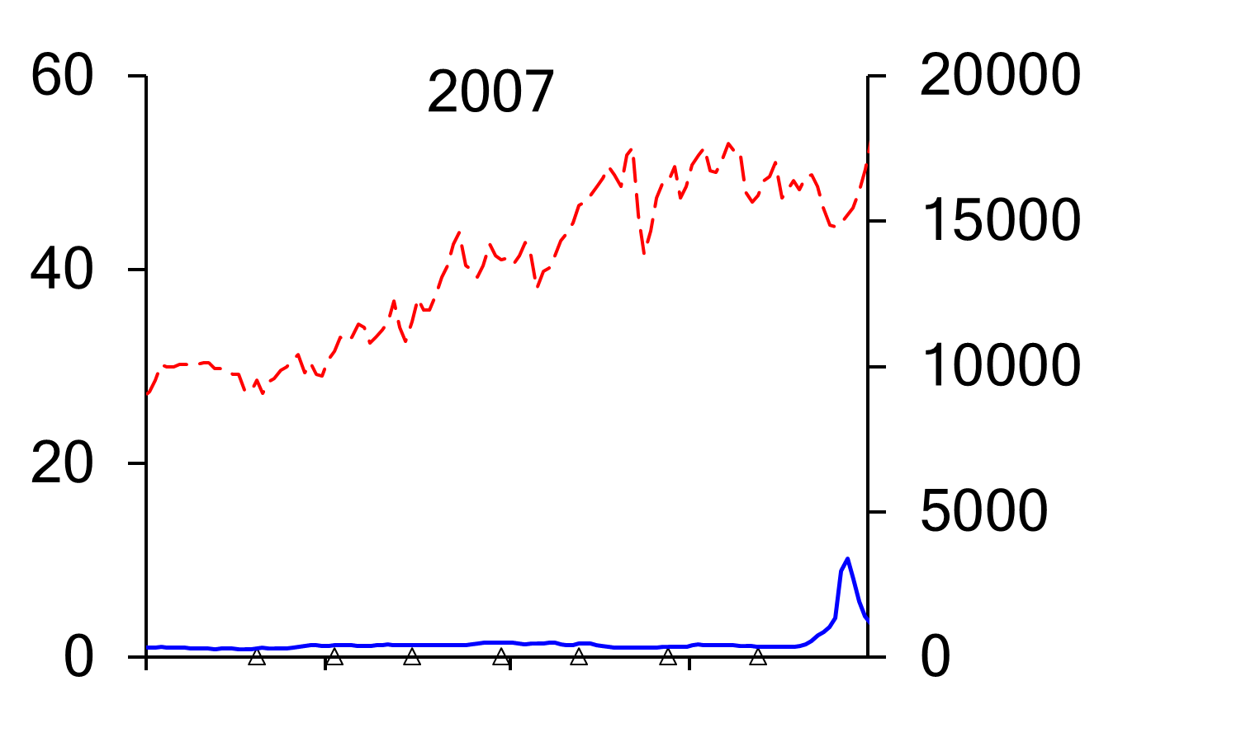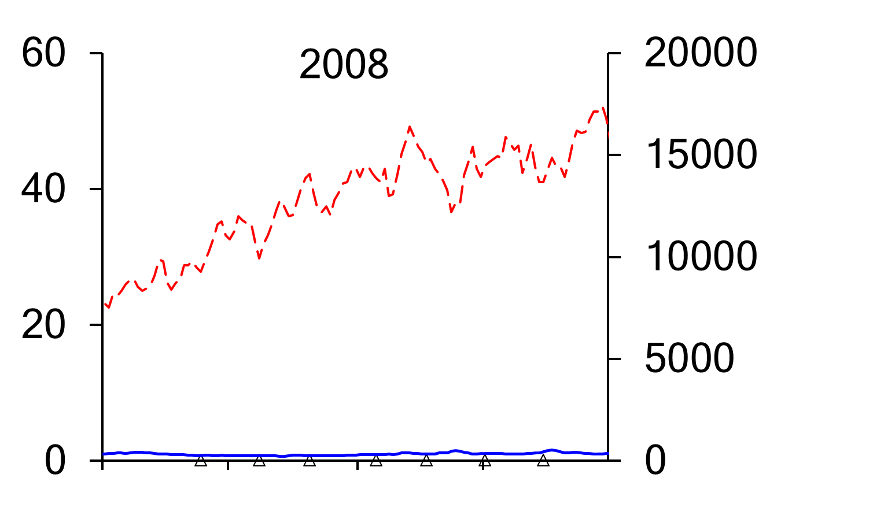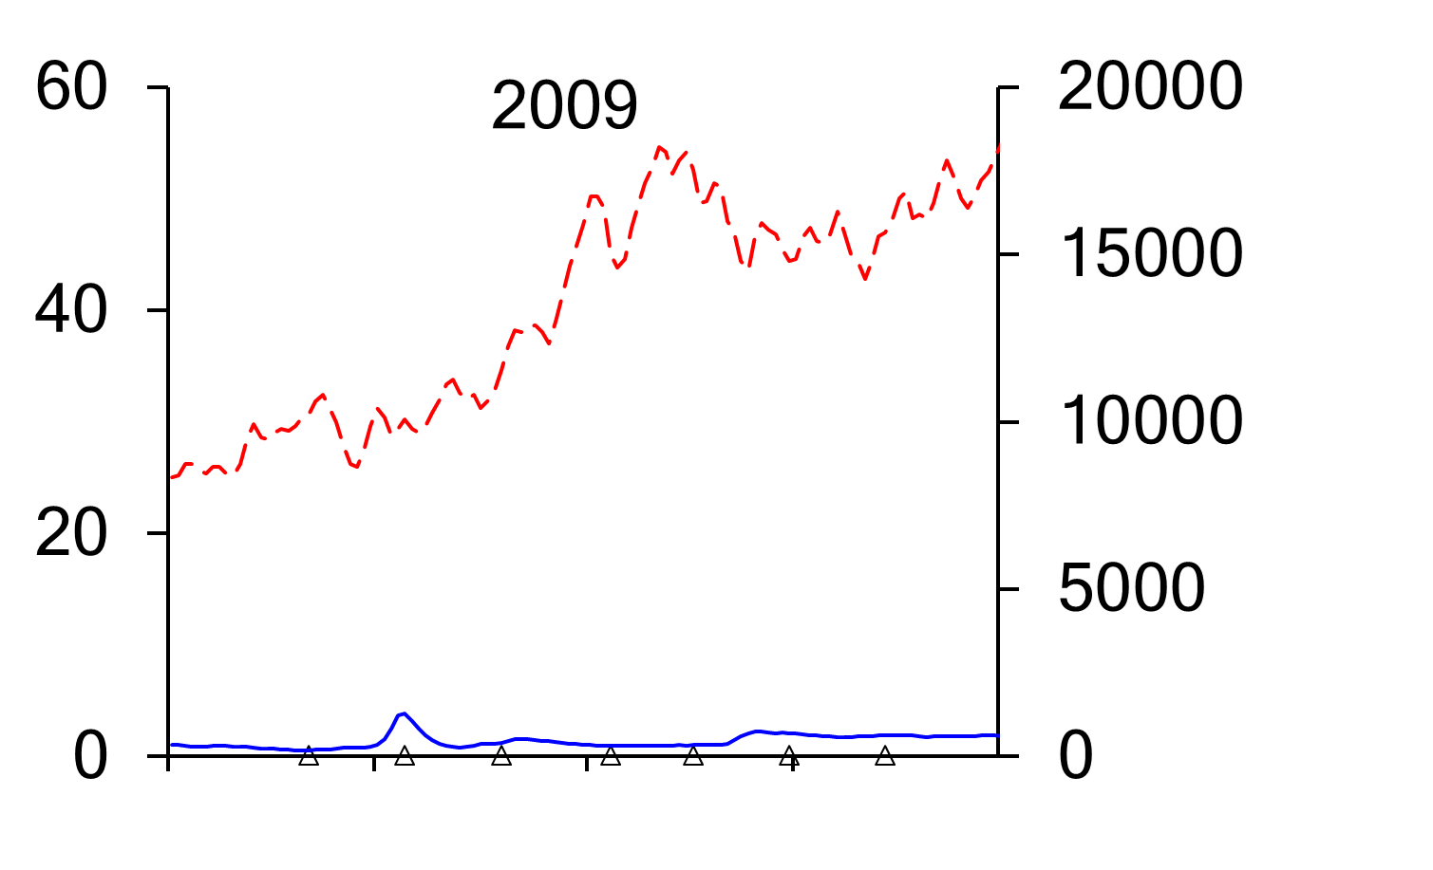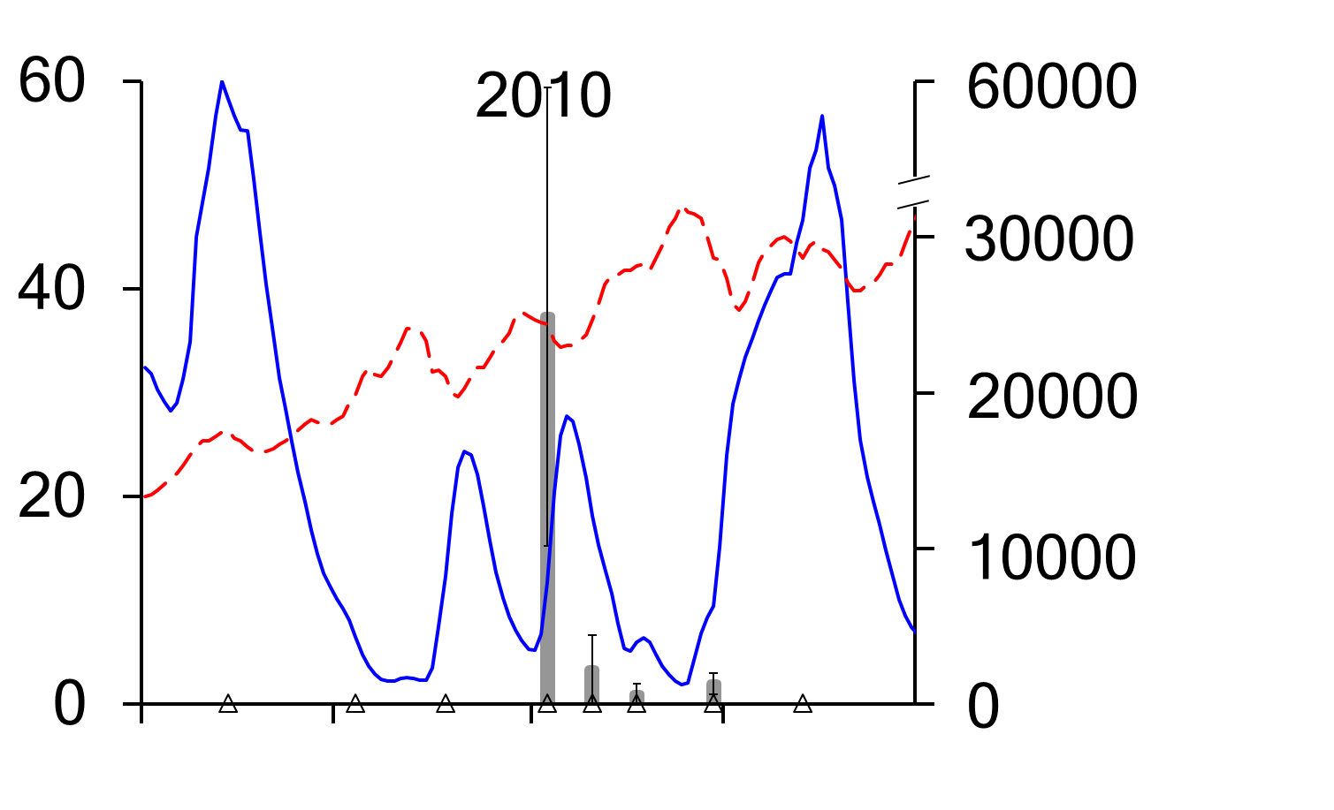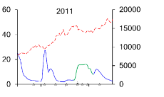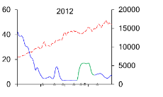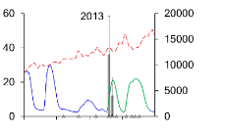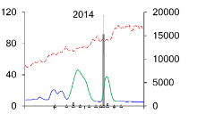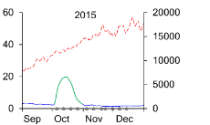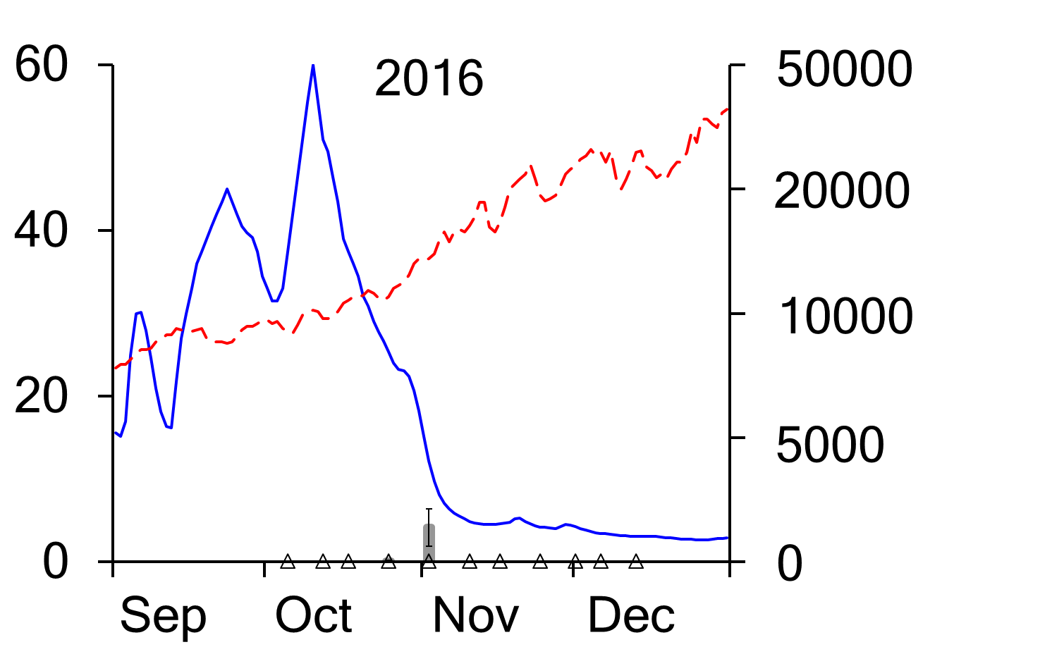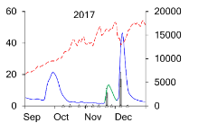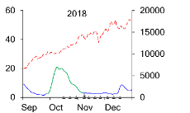
Mean number of eggs captured
Temperature (°C)
Discharge (ML day⁻¹)
Date (month)
Figure 7-9. Mean (±s.e.) number of golden perch eggs and larvae per drift net collected in the Goulburn River. Mean daily discharge (blue line) and water temperature (broken red line) of the Goulburn River at McCoys Bridge. Green line denotes environmental flow fresh where CEW contributed to the flow peak.
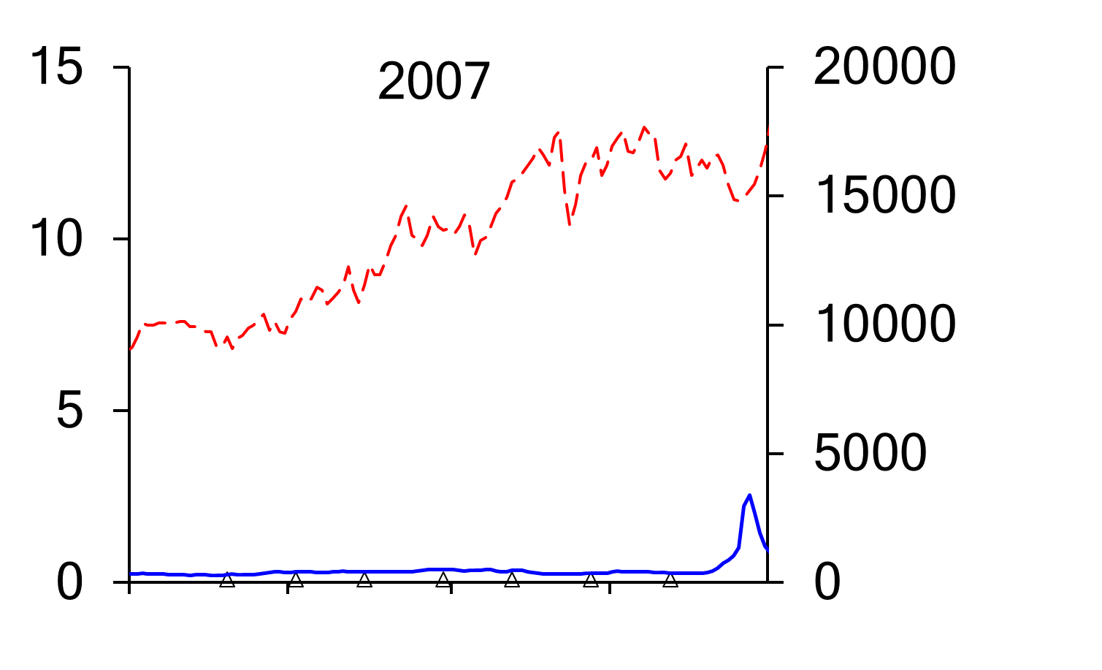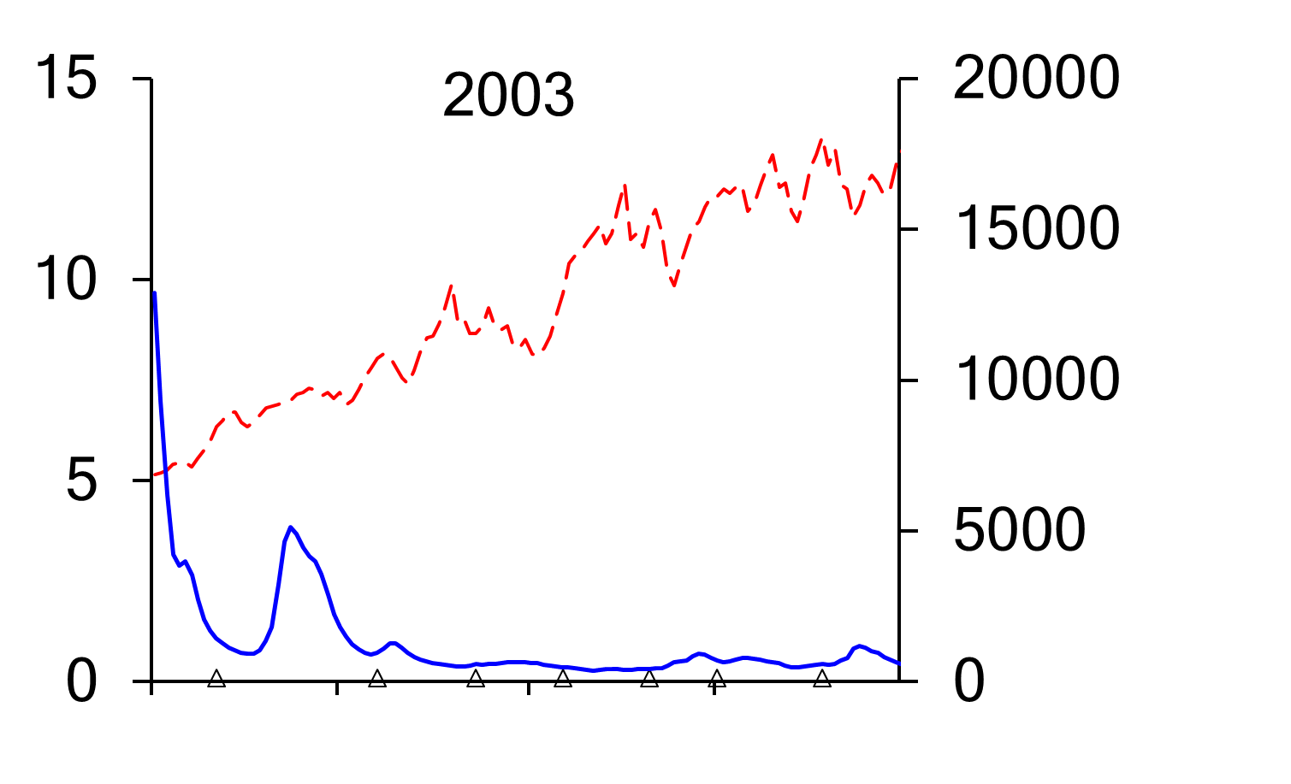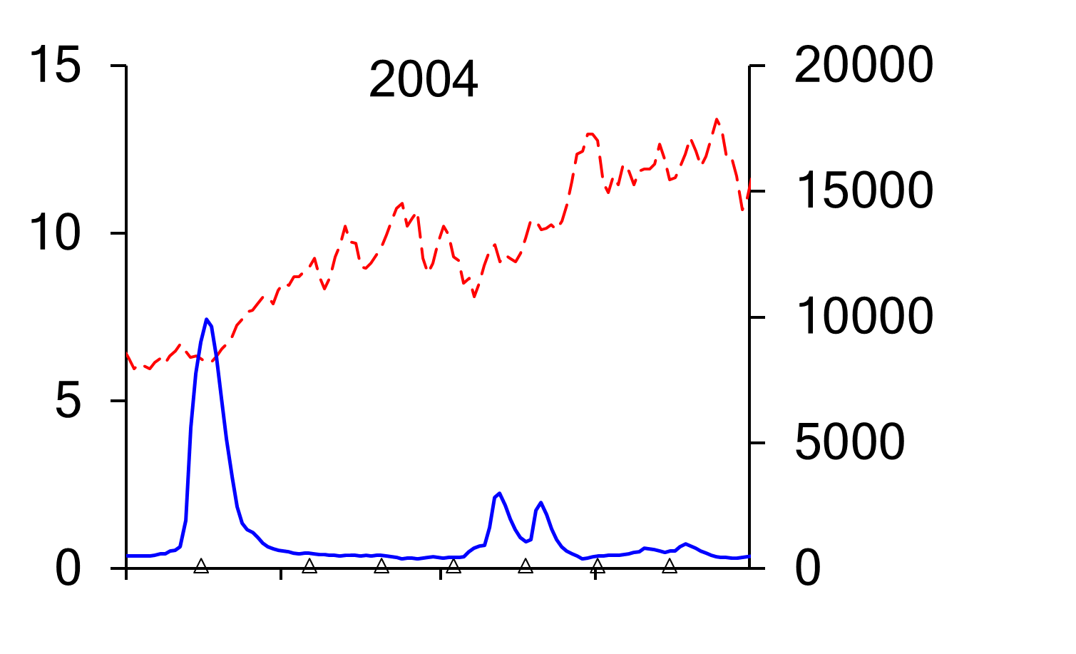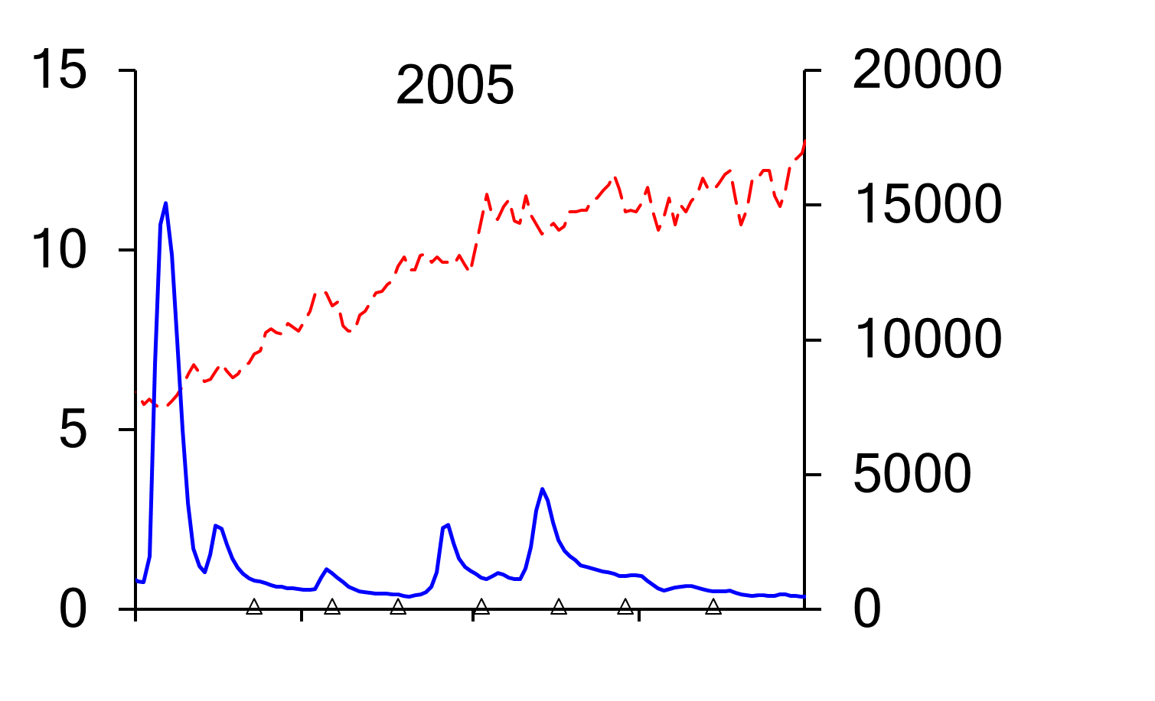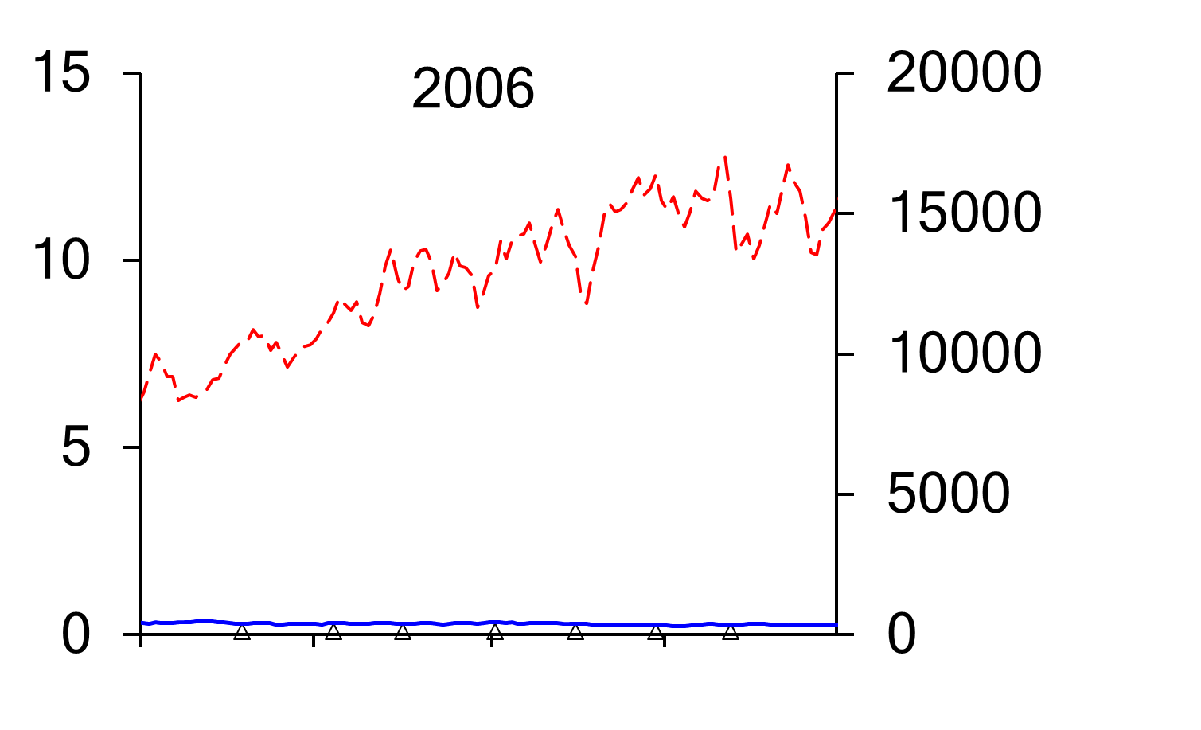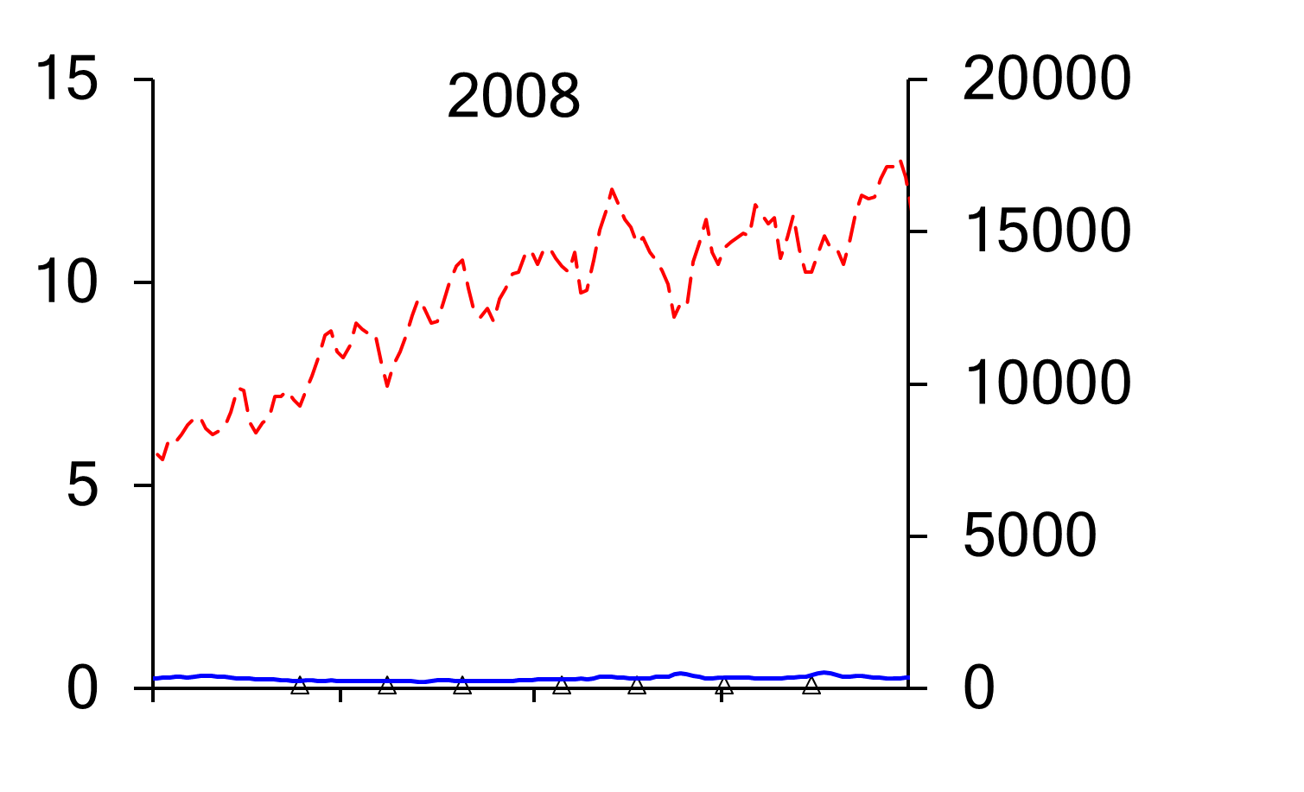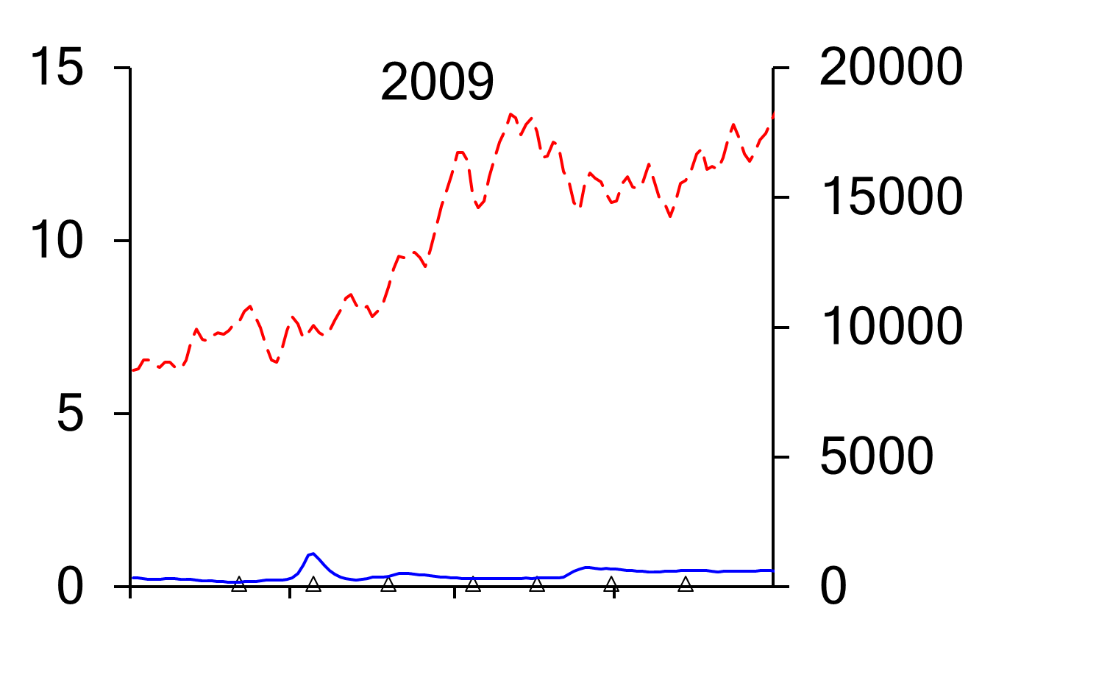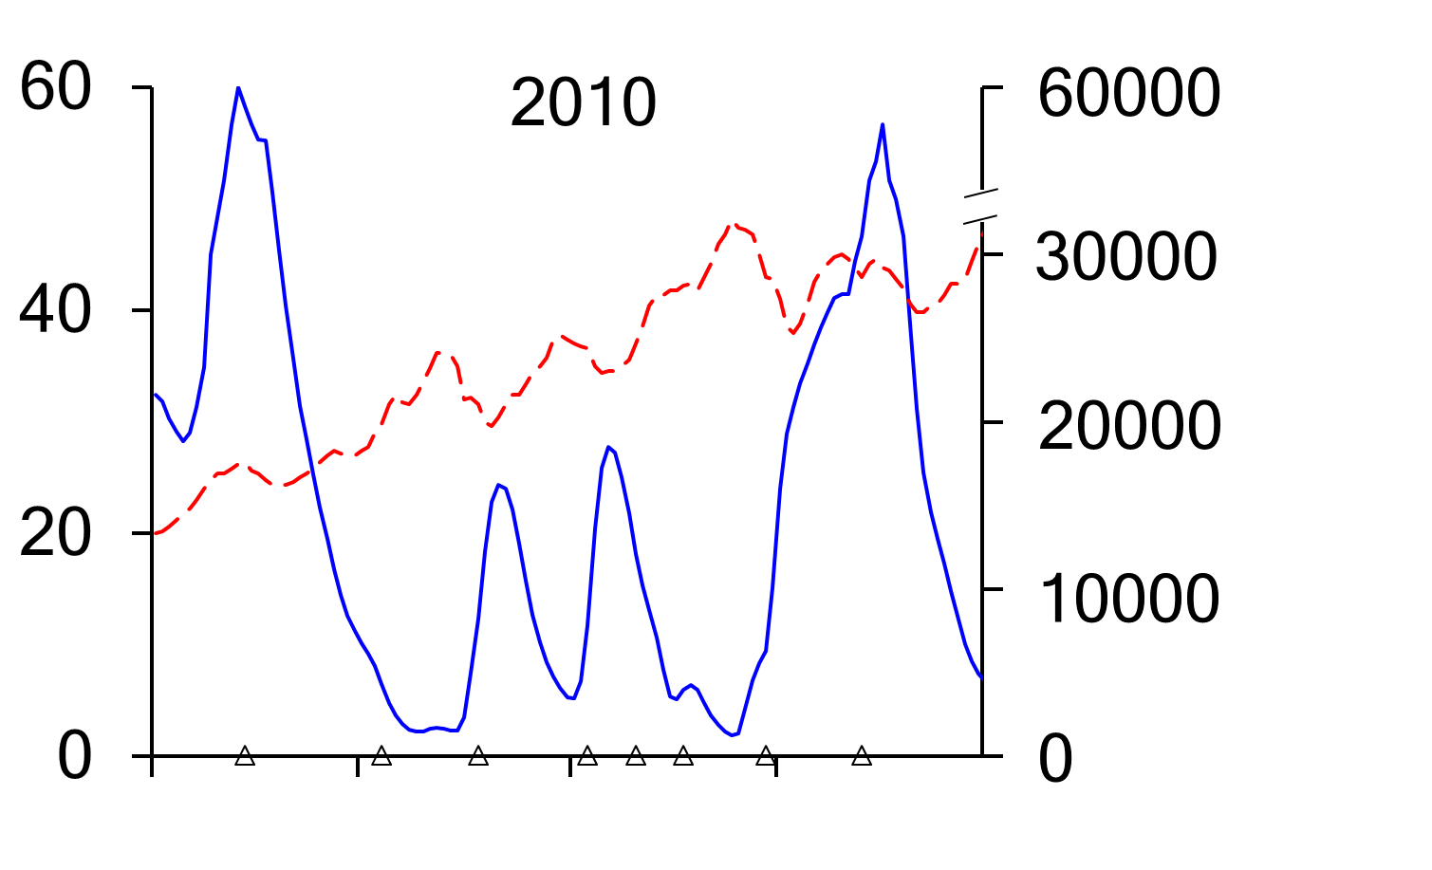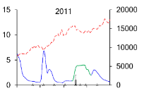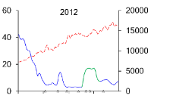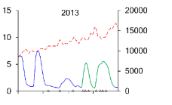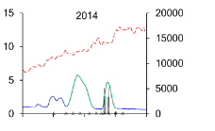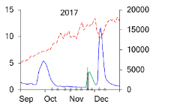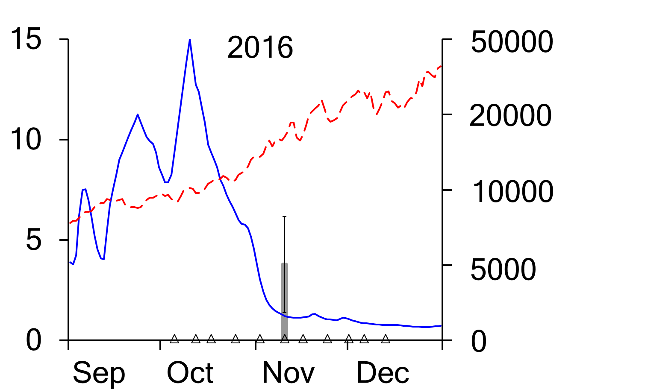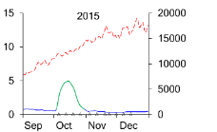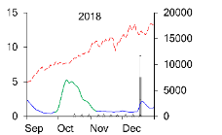
Date (month)
Mean number of eggs captured
Temperature (°C)
Discharge (ML day⁻¹)
Figure 7-10. Mean (±s.e.) number of silver perch eggs per drift net collected in the Goulburn River. Mean daily discharge (blue line) and water temperature (broken red line) of the Goulburn River at McCoys Bridge. Green line denotes environmental flow fresh where CEW contributed to the flow peak.
Statistical analysis
The probability of spawning of golden perch has first been modelled as a function of instantaneous flow or velocity with spawning becoming possible when both temperature and antecedent flow exceed certain threshold levels (Section 7.4.2). In the fitted models, temperature threshold is only apparent when velocity is used as a key predictor, and the fitted temperature threshold is approximately 18.6 degrees for velocity to affect spawning probability (Table 7-6). The threshold temperature of ~18.5 degrees identified for the velocity analysis is in line with our previous understanding of spawning in this species. Probabilities of spawning increase with velocity once this temperature has been exceeded although there is some variation between sites (Figure 7-11).
The calibrated antecedent flow threshold is always smaller than the lowest antecedent flow occurred, suggesting that there is no clear threshold for antecedent flow to affect the impact of flow on spawning probability. We therefore considered antecedent flow in the model as a continuous factor. The calibrated temperature thresholds from both models are consistent, which are summarized in Table 7-6.
Table 7-6. Threshold temperature for discharge to impact spawning probability. Note that the model only converged with velocity as the main predictor (bolded).
 | Flow |  |  | Velocity
 | 2.5% | Median | 97.5 | 2.5% | Median | 97.5
Prior flow as a binary control for flow effect | 18.52 | 23.46 | 23.63 | 18.51 | 18.56 | 18.61
Prior flow as a continuous predictor | 18.36 | 18.64 | 23.57 | 18.50 | 18.55 | 18.61
a
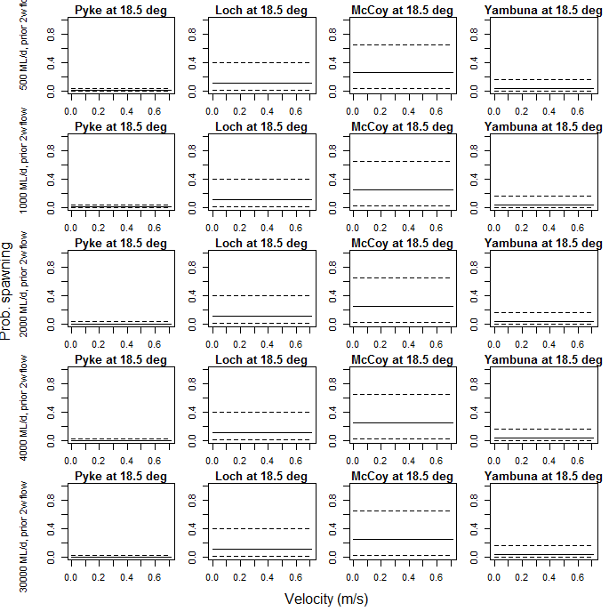

b
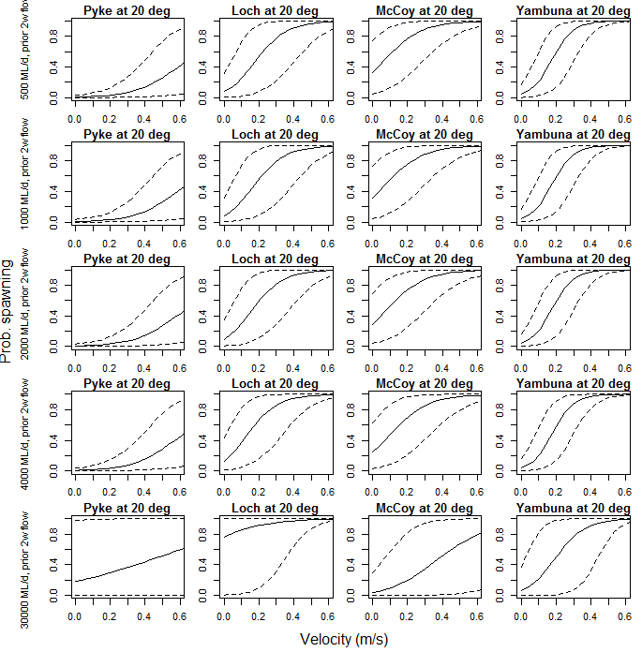

c
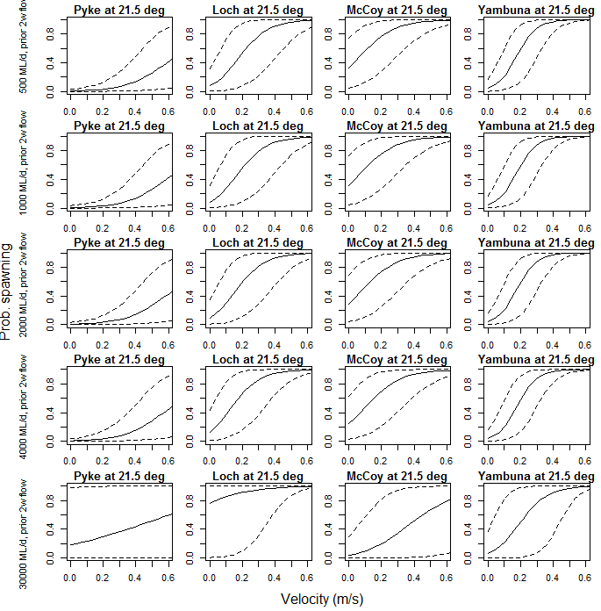
Figure 7-11. Relationship between the probability of occurrence of spawning and velocity (m/d), at a) 18.5, b) 20 and c) 21.5 degC, respectively across sites. Rows correspond to prior 2-week flows at 500, 1000, 2000, 4000 and 30000 ML/d. Results are based on the model with flow velocity as the main predictor.

Movement of golden perch
The majority (93%) of the 88 golden perch tagged were detected by the listening stations. Over half (47 out of 88) of the fish detected undertook long-distance movements (i.e. > 20 km); the other 41 fish had no detectable long-distance movement (i.e. > 20km) (Figure 7-12). Movement was most prevalent during the spawning season (spring to early summer) and occurred primarily in a downstream direction into the lower river reaches, typically followed by return upstream movements (Figure 7-12). Twenty-two golden perch (25%) moved downstream into the Murray River. Of these fish, fourteen (64%) returned to the Goulburn River. Most long-distance downstream movements coincided with increases in flow, including spring freshes. In the 2014, 2016, 2017 and 2018 spawning seasons, the occurrence of golden perch eggs in the lower reach corresponded with the movements of tagged fish into the lower reaches of the river (Figure 7-10). In 2015, few fish undertook long distance movements, and no golden perch eggs were collected. Similarly, in 2018, only one golden perch undertook a long-distance movement, and few eggs were collected compared to other years.

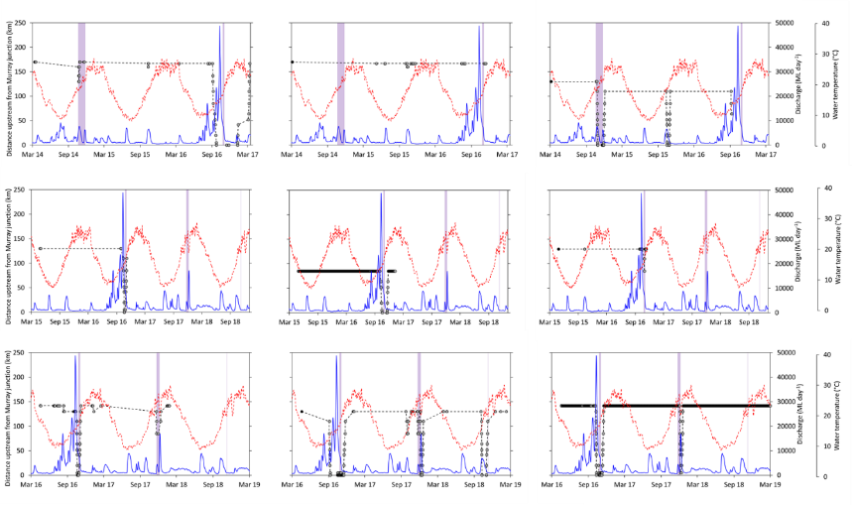
Figure 7-12. Examples of the movement patterns of individual golden perch tagged in the Goulburn River in 2014 (top panels), 2015 (middle panels) and 2016 (bottom panels). Black circles show the date and location of tagging and grey circles show detections of tagged fish on the listening stations. Mean daily discharge (blue line) and water temperature (broken red line) of the Goulburn River at McCoys Bridge. Coloured purple bars represent times when golden perch eggs were collected.

Statistical modelling of fish movement indicates that there are significant positive relationships between temperature and fish movement; the effects of either flow or velocity are not significant (Table 7-7). The random effects of any individual years within the five-year period are not significant. The probability that the occurrence of fish movement will increase with environmental flows, due to the increase and change in timing of discharge is 0.58.
As an overall pattern across all years, movement probabilities for individual fish are less than or equal to 0.1 (Figure 7-13). However, movement probability varies depending on the individual fish (Figures 7-13 and 7-14). Comparing across individual years, Year 3 shows a clearly lower movement probability (with all probabilities less than 0.05) than all other years.
Table 7-7. Regression coefficients of fish movement statistical model. Note that the model with velocity as the main predictor was not converged (not shown). Significant relationships are shown in bold - the statistical significance of a model variable was determined by whether or not the 95% credible interval for that variable included 0. A 95% CI entirely below 0 indicates a negative effect; a 95% CI above zero indicates a positive effect.
 | Flow (ML/d)
 | 2.5% | median | 97.5%
eff.Q | -0.038 | 0.048 | 0.124
eff.year1 | -10.044 | -0.254 | 7.629
eff.year2 | -10.631 | -0.699 | 7.130
eff.year3 | -13.064 | -3.265 | 4.810
eff.year4 | -11.813 | -2.017 | 5.871
eff.year5 | -9.850 | 0.017 | 7.993
eff.temp | 1.246 | 1.384 | 1.533
eff.Size | -8.439 | 0.464 | 7.863
int | -15.773 | -7.639 | 1.468
Prob. increasing movement due to Eflows | 0.418 | 0.582 | 0.582

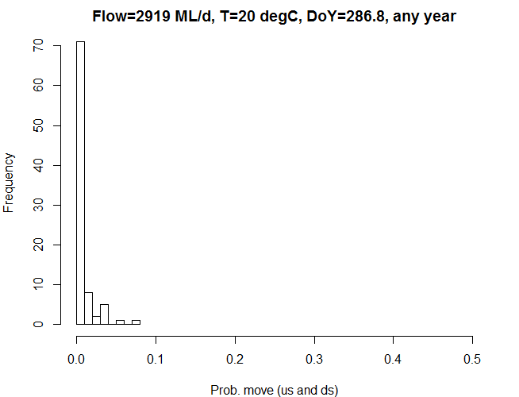
Figure 7-13. Histograms showing the distribution of the average probability of occurrence of movement for tagged golden perch, under average flow and DoY, with temperature at 20 degC, across all five years (i.e. ~70 tagged fish showed 0.01 or lower probability of moving under average flow).
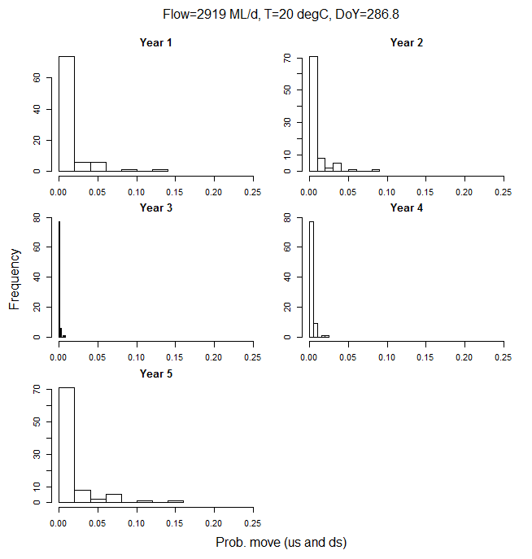
Figure 7-14. Histograms showing the distribution of the average probability of occurrence of movement for tagged golden perch, under average flow and DoY, with temperature at 20 degC, for each of five years (numbers of tagged fish in each year; yr 1-29, yr 2-59, yr 3 – 88, yr 4 – 87, yr 5 – 82).

Discussion

Annual surveys
The results of the annual surveys from 2015 to 2019 have provided important information on the composition, abundance and population structure of fish species in the Goulburn River. Significant populations of native fish occur in the Goulburn River, including several species of conservation significance, namely Murray cod, silver perch, Murray River rainbowfish and trout cod.
Temporal trends in CPUE show Murray cod abundance was stable from 2015 to 2016, then decreased in 2017, following a hypoxic blackwater event in the Goulburn River in January 2017. Decreases in Murray cod abundance were also observed in 2017 following hypoxic blackwater events in other LTIM sampling areas such as the Edward-Wakool and Lachlan rivers. In the case of the Goulburn River, CPUE decreased again in 2018, and in the following year (2019) remained at similar levels. It is possible the decrease in 2018 may have resulted from reduced sampling efficiency associated with elevated flows due to IVT flows in the sampling period in autumn 2018. Reasons for the continued reduced abundance in 2019 are unclear, although results from VEFMAP sampling (which has been incorporated into the LTIM data set) show there was a considerable increase in abundance of Murray cod in the reach upstream of Shepparton, which could indicate immigration upstream into this reach (Tonkin et al. 2019). Further work is needed to understand the role of immigration and links to population dynamics for Murray cod.
Silver perch abundance increased considerably in the Goulburn River in 2017. Silver perch abundance increases were also observed in the Campaspe River in 2017 as part of VEFMAP sampling (Tonkin et al. 2019). These results are likely due to increased immigration in response to high spring flows in 2016 in the Murray, Goulburn and Campaspe Rivers and managed flow releases in summer/autumn 2016/17. Fewer Silver Perch were captured in the Goulburn River (and Campaspe River) the past two years (2018 and 2019), largely due to a reduction in numbers of juvenile fish (estimated to be aged 1+ and 2+) migrating upstream in the mid-Murray River. Specifically, the numbers of juvenile Silver Perch moving upstream through the Torrumbarry fishway in 2017/18 and 2018/19 were much lower than the 2016/17 season. These results suggest that flows can be important in promoting immigration of these fish into tributaries, but the outcome at a metapopulation level (river scale) will be dependent on the abundance of juvenile fish in the Murray River.
Temporal trends in CPUE show Murray River rainbowfish increased in abundance from 2015 to 2017, then decreased in abundance in 2018 and 2019. Results from VEFMAP sampling show there was also a decrease in abundance of Murray River rainbowfish in the Campaspe River in 2018, however catches increased again in 2019 (Tonkin et al. 2019). Prolonged high summer flow conditions due to inter-valley transfers (IVT) occurred in the Goulburn River in 2018 and 2019, and the Campaspe River in 2018. Increased summer flows which reduce slow-flowing habitats have the potential to affect larval and juvenile recruitment for species such as Murray River rainbowfish that spawn during warm, low flow periods (Humphries et al. 2006). Notwithstanding, this relatively short-lived species is prone to large year to year fluctuations in abundance. To better understand the potential effects of IVT flows on fish, it is recommended that a short -term research program be designed and implemented specifically for this purpose.
Trout cod were collected in low numbers in the first two years (2015 and 2016) of the annual surveys. Evidence of spawning by trout cod was also detected in the last two years (2017 and 2018) with larvae collected around mid-November to early December across a range of sites (Pyke Road, Loch Garry, McCoys Bridge, Yambuna). Results from VEFMAP sampling show that this species is most common in upstream reaches near Murchison (Tonkin et al. 2019).

Recruitment of golden perch and Murray cod
The results of the analysis of otolith ⁸⁷Sr/⁸⁶Sr profiles show that the Murray cod population in the Goulburn River consists almost entirely of in situ recruitment. This result suggests that the spatial scale of management actions for Murray cod populations such as environmental flows could potentially focus at the individual river/catchment scale. Notwithstanding, there is some evidence of immigration into the Goulburn River by Murray cod originating from the Murray River. These movements may at times serve an important role such as assisting the recovery of local populations following disturbances (e.g. blackwater events) (Thiem et al. 2017) or by enabling gene flow among populations (Tallman and Healey 1994). Consistent with other studies in rivers in the Murray-Darling Basin (Thiem et al. 2017, Price et al. 2019), stocking appears to have only minor influence on Murray cod population structure in the Goulburn River.
In contrast, the golden perch population in the Goulburn River consists mostly of stocked fish. The greater contribution of stocking to the golden perch population compared to Murray cod in the Goulburn River might reflect differences in life history traits and associated vulnerability to threats, such as flow regulation. For example, whereas Murray cod typically spawn annually, golden perch rely on higher flows to spawn (Humphries et al. 1999, Koehn and Harrington 2006, Koster et al. 2017). Whilst in situ recruitment of golden perch is low in the Goulburn River, results from the Environment Water and Knowledge Research project nonetheless show that the Goulburn River is a source of fish to the Murray River (Price et al. 2019), which highlights the value of management actions such as flows for spawning. Understanding the mechanisms contributing to the limited natural recruitment of golden perch in the Goulburn River is an important area for further investigation.

Spawning of golden perch and silver perch
This study demonstrates the importance of a rise in river flow coupled with appropriate water temperature for spawning of golden perch and silver perch in the Goulburn River. In particular, levels of spawning activity were highest during within-channel flow pulses or bankfull flows especially around November-December, including during periods of targeted managed flow releases (i.e. ‘freshes’). These results demonstrate that environmental water allocation in the Goulburn River can effectively enhance or trigger spawning of golden perch and silver perch.
Our results suggest that multiple flow events that are closely timed (e.g. 1-2 weeks apart) might also increase spawning activity, because egg concentrations often peaked in association with the second spring-summer flow event (e.g. 2010, 2013, 2014, 2017). This finding has important implications for the development and implementation of environmental flow recommendations. In particular, providing multiple flow pulses (e.g. during wetter years when more water is available) rather than a typical single flow pulse may enhance spawning.
Our results also suggest that flow conditions in the pre-spawning period may influence levels of spawning. Little or no spawning occurred during flow increases that followed extended periods (e.g. 2-3 weeks) of low stable flows throughout spring (e.g. 2011, 2012, 2017, 2018). In the case of golden perch, food availability is known to influence reproductive development in females with a decrease in food reducing reproductive development (Collins and Anderson 1999). It is possible therefore that during extended low flow conditions, food may be more limiting, hence a reduction in spawning.
The clear spawning responses of golden perch and silver perch to increases in river flow highlights the threats posed by altered flow regimes resulting from water-resource development and climate change because it shows that spawning is unlikely to occur in the Goulburn River in the absence of appropriate flow cues during the spring-summer spawning period. Indeed, for almost a decade from the early 2000s until late 2010, a period encompassing the Millennium Drought (2001-2009) in southeast Australia, spawning of these species in the Goulburn River was rarely detected. For silver perch, considering that few fish live beyond seven years (unlike the longer-lived golden perch) (Tonkin et al. 2019), this may make populations vulnerable to an extended absence of suitable spawning flows.

Movement of golden perch
The results of the acoustic tracking show that golden perch often display extended periods of limited movement, especially outside of the spawning season. In contrast, many individuals undertake large-scale movements
(e.g. 10s-100s of km) during the spawning season in association with high flows, including during periods of targeted managed flow releases. Movements were predominantly downstream to the lower reaches of the Goulburn River, or into the Murray River, followed by a return upstream movement. Other studies have also reported low levels of movement for this species, interspersed with large-scale movements during the spawning season in association with high flows (Reynolds 1983, Crook 2004, O'Connor et al. 2005, Marshall et al. 2016). However, the current study has also demonstrated a strong association between long-distance fish movement and the occurrence of spawning, by integrating telemetry data and direct observations of spawning from drift sampling. These results provide a valuable and unique insight into the likely underlying purpose and importance of movement (i.e. spawning), something that is often lacking in studies of fish movement behaviour (Wang et al. 2012). The results also demonstrate the importance of providing spring-summer flow events, especially around November, to allow adult golden perch to migrate and spawn.
Another important finding was the identification of movements by golden perch between the Goulburn and Murray rivers, often in association with increased flow events. These ‘river-scale’ movements may have an important influence on the structure and dynamics of golden perch populations in the region. For example, such movements may assist gene flow, allow fish to access additional resources for feeding and reproduction, and to avoid unfavourable environmental conditions (Tallman and Healey 1994, King et al. 2012, Gillanders et al. 2015). The finding that golden perch moved between the Goulburn and Murray rivers, in association with increased flow events, has important implications for the development and implementation of environmental flow recommendations. In particular, the results highlight how environmental flows can be used to facilitate connectivity between populations among rivers. The results also highlight how management needs to consider larger-scale environmental perturbations such as loss of connectivity and barriers at the broader spatial context of a species’ persistence (Fausch et al. 2002, Humphries et al. 2019).

Stakeholder communications
The following communication and engagement actives were undertaken over the 2018–19 period to inform stakeholders and the broader community about the aims and results of the Goulburn River LTIM Project and the role of the Commonwealth Environmental Water Office in environmental water management. Selected examples of communications are included below.

Media Releases and Articles
Between July 2018 and June 2019 six media releases were prepared and 24 columns/advertisements were run in the Shepparton Advisor (free – circulation 70,000) and the Country News (paid - circulation 44,000). These promoted the project, Commonwealth environmental water use in the Goulburn River and ecological responses (native fish movement and breeding, bank vegetation growth and bank erosion) to environmental flows. There were 35 corresponding articles published in local newspapers including the Shepparton Advisor, Euroa Gazette, Alexandra Standard, Riverine Herald and the Country News. Many of the articles focused on the impact of the high Inter-Valley Transfer flows on lower Goulburn River ecological values and how monitoring is informing mitigation measures. Articles were also included in the GB CMA electronic newsletter Connecting Community and Catchment, which has over 1100 subscribers. ABC Goulburn Murray and local TV stations (WIN and Nine) also interview staff and/or run the media releases in their news bulletins.

Technical publications
Over 2018–19, several publications have appeared in or been submitted to the peer-reviewed scientific literature that report on the LTIM Project including aspects of the Goulburn River monitoring results..
- Gawne B, Hale J, Stewardson MJ, Webb JA, Ryder DS, Brooks SS, Campbell CJ, Capon SJ, Everingham P, Grace MR, Guarino F, Stoffels RJ (early view) Development of the Commonwealth Environmental Waterholder's Long-Term Intervention Monitoring Project: Design and preliminary results from the monitoring of environmental flow outcomes in the Murray-Darling Basin, Australia. Riv. Res. Appl., Accepted 30/5/19.
- Watts RJ, Dyer F, Frazier P, Gawne B, Marsh P, Ryder DS, Southwell M, Wassens S, Webb JA, Ye Q (in review) Learning from concurrent adaptive management in multiple catchments within a large environmental flows program in Australia. Riv. Res. Appl.

Social Media
Numerous Facebook posts and tweets promoted the project and the benefits of environmental water. These were viewed thousands of times and are usually amongst GB CMA’s most popular and engaging posts. Currently, the GB CMA has over 3,000 social media followers.
- https://www.facebook.com/gbcma
- https://twitter.com/gbcma

Videos
The short web videos developed to explain environmental water, blackwater and each key monitoring activity (fish, vegetation, macroinvertebrates, stream metabolism and bank condition) continue to be viewed on a regular basis. The videos have collectively been viewed 2235 times since they were created. Three new web videos were developed in the 2018-19 period. One video was of the presentation Angus Webb gave at Goulburn River LTIM Project community forum in July (see section 1.5 below) and two were on monitoring techniques incorporated into Facebook posts.
- Forum presentation by Angus Webb: https://youtu.be/ecZpx0wOegg
- Seed and sediment deposition monitoring included in a Facebook post (note this was posted on the 20 June 2018 but not included in the 2017-18 report): https://www.facebook.com/gbcma/videos/1553071828131793/
- Use of drones to monitor bank condition and vegetation included in a Facebook post: https://www.facebook.com/gbcma/posts/1842449359194037

Presentations
GB CMA staff presented/provided updates to a number of government, community and agency groups throughout the year on environmental water management and the Goulburn River LTIM project. These groups included:
- Yorta Yorta Nation Aboriginal Corporation;
- Taungurung Aboriginal Corporation;
- Parks Victoria;
- Winton Wetlands Scientific Forum;
- DELWP and the Victorian Water Minister;
- Goulburn-Murray Water;
- Schools and research institutes;
- Recreational fishing groups and fish management agencies;
- GB CMA partnership group;
- Environmental Water Advisory Groups; and
- Fairley Leadership Group.
In Shepparton on July 18 2019 the GB CMA held a Goulburn River LTIM Project community forum. The forum presented:
- an overview of the Murray Darling Basin Long Term Intervention monitoring project;
- key findings from five years of monitoring the effects of environmental flows on the ecological values of the lower Goulburn River; and
- proposed research priorities for the next three years.
The forum also had a panel Q&A session with the lead scientists involved on the project. The forum was attended by 80 people including local community members, government agency staff and Members of Parliament.
Angus Webb presented talks on the LTIM Project and different aspects of the Goulburn River at international conferences:
- International Society for Ecohydraulics, Tokyo, Japan, August 2018
- Society for Freshwater Science, Salt Lake City, United States, May 2019

Examples of media
Figure 8-1 to Figure 8-8 provides examples of media reports on Goulburn LTIM activities.
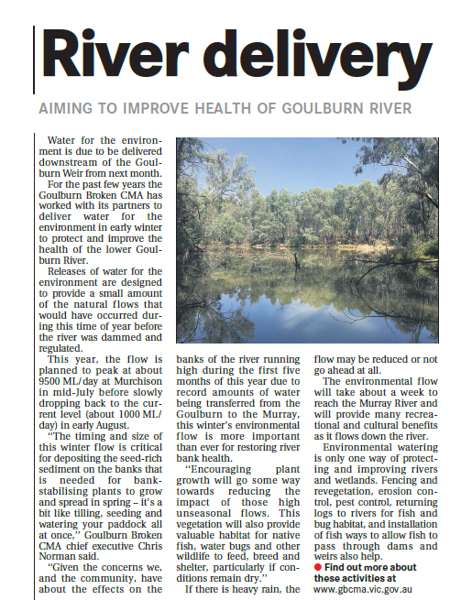
Figure 8-1. Shepparton News 28 June 2019

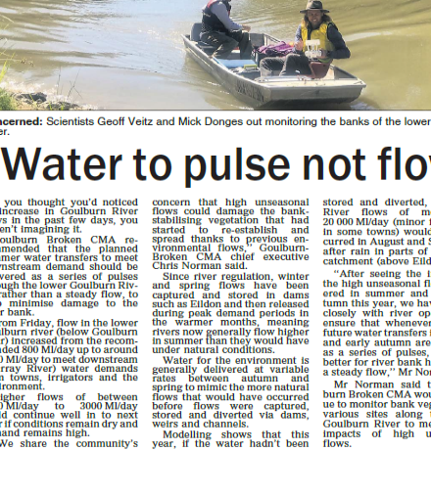
Figure 8-2. Seymour Telegraph 19 December 2018

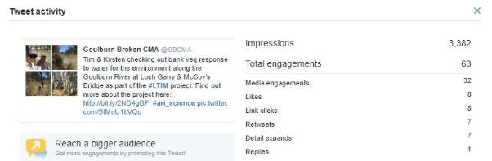
Figure 8-3. Tweet December 3 2018

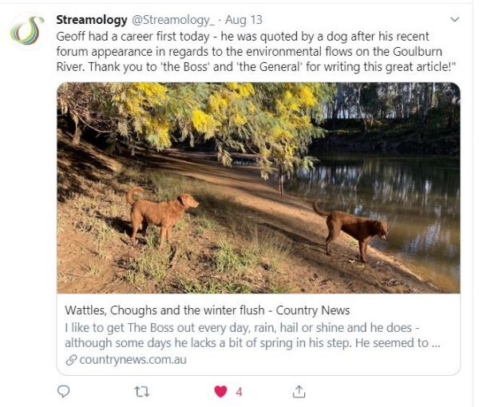
Figure 8-4. Tweet & Blog August 2019 (in response to LTIM forum). https://www.countrynews.com.au/thegeneral/2019/08/12/752075/wattles-choughs-and-the-winter-flush

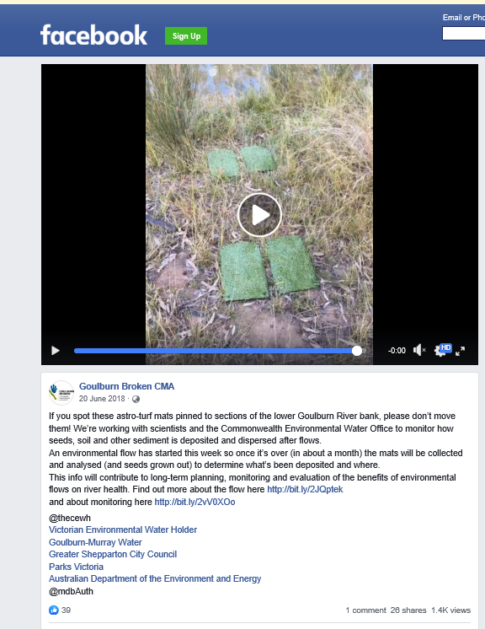
Figure 8-5. Facebook post 20 June 2018

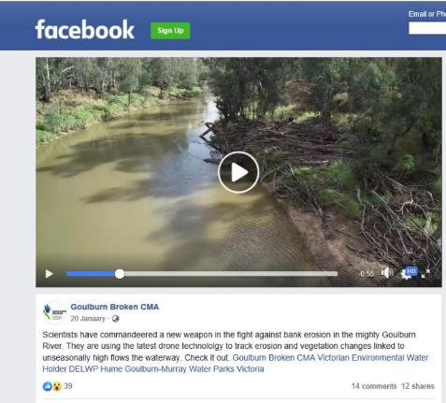
Figure 8-6. Facebook post 20 January 2019

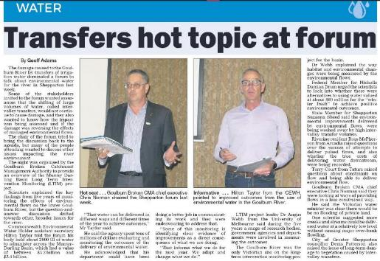
Figure 8-7. Country News July 24 2019 (after LTIUM forum)

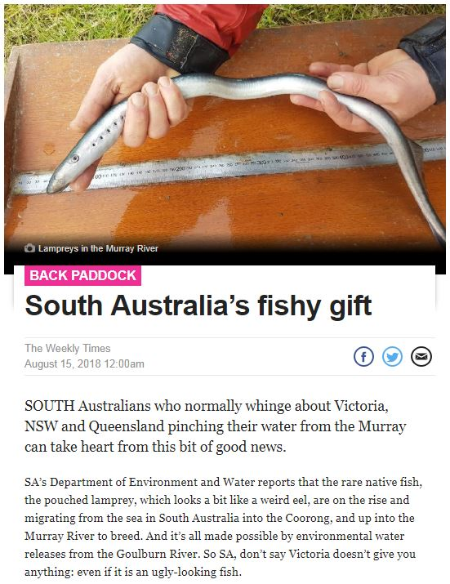
Figure 8-8. Article from The Weekly times on Goulburn environmental flows facilitating lamprey movement in the lower lakes.

References cited
Bernot, M. J., D. J. Sobota, R. O. Hall, P. J. Mulholland, W. K. Dodds, J. R. Webster, J. L. Tank, L. R. Ashkenas, L. W. Cooper, and C. N. Dahm. 2010. Inter‐regional comparison of land‐use effects on stream metabolism. Freshwater Biology 55:1874-1890.
Collins, A. L., and T. A. Anderson. 1999. The role of food availability in regulating reproductive development in female golden perch. Journal of Fish Biology 55:94-104.
Cook, R., W. Paul, J. Hawking, C. Davey, and P. Suter. 2011. River Murray Biological (Macroinvertebrate) Monitoring Program - review of monitoring 1980-2009. Final Report prepared for the Murray-Darling Basin Authority. Murray-Darling Freshwater Research Centre, Albury.
Cottingham, P., and SKM. 2011. Environmental water delivery: lower Goulburn River. Report prepared for Commonwealth Environmental Water, Department of Sustainability, Environment, Water, Populations and Communities. Canberra.
Cottingham, P., G. Vietz, J. Roberts, D. Frood, A. Graesser, J. Kaye, and A. Shields. 2013. Lower Goulburn River: observations on managing water releases in light of recent bank slumping. Report prepared for the Goulburn Broken Catchment Management Authority. Peter Cottingham and Associates, Melbourne.
Crook, D. A. 2004. Movements associated with home-range establishment by two species of lowland river fish. Canadian Journal of Fisheries and Aquatic Sciences 61:2183–2193.
DELWP. 2015. Water measurement information system. Department of Environment, Land, Water and Planning. (Available from: http://data.water.vic.gov.au/monitoring.htm)
Fausch, K. D., C. E. Torgersen, C. V. Baxter, and H. W. Li. 2002. Landscapes to riverscapes: bridging the gap between research and conservation of stream fishes. BioScience 52:483–498.
GBCMA. 2017. Goulburn River January 2017 blackwater event. Event summary and GBCMA actions. Goulburn Broken Catchment Management Authority, Shepparton.
Gigney, H., J. Hawking, L. Smith, and B. Gawne. 2007a. Murray Irrigation Region Aquatic Ecosystem Monitoring Program Development: 2005 Pilot Study Report. A report for Murray Irrigation Limited. Murray-Darling Freshwater Research Centre, Albury.
Gigney, H., J. Hawking, L. Smith, and B. Gawne. 2007b. Murray Irrigation Region Aquatic Ecosystem Monitoring Program Development: Protocols handbook. A report for Murray Irrigation Limited. Murray-Darling Freshwater Research Centre, Albury.
Gillanders, B. M., C. Izzo, Z. A. Doubleday, and Q. Ye. 2015. Partial migration: growth varies between resident and migratory fish. Biology Letters 11.
Grace, M. 2016. 2014–15 Basin-scale evaluation of Commonwealth environmental water — stream metabolism and water quality: Report prepared for the Commonwealth Environmental Water Office. p. 39. Murray-Darling Freshwater Research Centre, Albury.
Grace, M. 2017. 2015–16 Basin-scale evaluation of Commonwealth environmental water — stream metabolism and water quality: Report prepared for the Commonwealth Environmental Water Office. p. 88. Murray-Darling Freshwater Research Centre, Albury.
Grace, M. R. 2015. Basin matter - stream metabolism and water quality foundation report: Report prepared for the Commonwealth Environmental Water Office p. 10. Murray-Darling Freshwater Research Centre, Albury.
Grace, M. R., D. P. Gilling, S. Hladyz, V. Caron, R. M. Thompson, and R. Mac Nally. 2015. Fast processing of diel oxygen curves: estimating stream betabolism with BASE (BAyesian Single-station Estimation). Limnology and Oceanography Methods 13:103-114.
Guarino, F., and M. Stewardson. 2018. 2016–17 Basin-scale evaluation of Commonwealth environmental water — hydrology. Latrobe University, Albury.
Hale, J., R. Stoffels, R. Butcher, M. Shackleton, S. Brooks, B. Gawne, and M. Stewardson. 2014. Commonwealth Environmental Water Office Long Term Intervention Monitoring Project – standard methods: Report prepared for the Commonwealth Environmental Water Office p. 175. Murray-Darling Freshwater Research Centre, Albury.
Hall, R. O., and J. J. Beaulieu. 2013. Estimating autotrophic respiration in streams using daily metabolism data. Freshwater Science 32:507-516.
Humphries, P., R. A. Cook, A. J. Richardson, and L. G. Serafini. 2006. Creating a disturbance: manipulating slackwaters in a lowland river. River Research and Applications 22:525-542.
Humphries, P., A. J. King, and J. D. Koehn. 1999. Fish, flows and flood plains: links between freshwater fishes and their environment in the Murray-Darling River system, Australia. Environmental Biology of Fishes 56:129-151.
Humphries, P., A. J. King, N. McCasker, R. K. Kopf, R. Stoffels, B. P. Zampatti, and A. E. Price. 2019. Riverscape recruitment: a conceptual synthesis of drivers of fish recruitment in rivers. Canadian Journal of Fisheries and Aquatic Sciences.
King, A. J., D. A. Crook, W. M. Koster, J. Mahoney, and Z. Tonkin. 2005. Comparison of larval fish drift in the Lower Goulburn and mid-Murray Rivers. Ecological Management & Restoration 6:136–139.
King, A. J., Z. Tonkin, and J. Lieshcke. 2012. Short-term effects of a prolonged blackwater event on aquatic fauna in the Murray River, Australia: considerations for future events. Marine and Freshwater Research 63:576–586.
Koehn, J. D., and D. J. Harrington. 2006. Environmental conditions and timing for the spawning of Murray cod (Maccullochella peelii peelii) and the endangered trout cod (M. macquariensis) in southeastern Australian rivers. River Research and Applications 22:327-342.
Koster, W., D. Crook, D. Dawson, and P. Moloney. 2012. Status of fish populations in the lower Goulburn River (2003-2012). Arthur Rylah Institute for Environmental Research Client Report, Department of Sustainability and Environment, Heidelberg, Victoria.
Koster, W. M., D. R. Dawson, C. Liu, P. D. Moloney, D. A. Crook, and J. R. Thomson. 2017. Influence of streamflow on spawning-related movements of golden perch Macquaria ambigua in south-eastern Australia. Journal of Fish Biology 90:93–108.
Koster, W. M., D. R. Dawson, D. J. O’Mahony, P. D. Moloney, and D. A. Crook. 2014. Timing, frequency and environmental conditions associated with mainstem–tributary movement by a lowland river fish, golden perch (Macquaria ambigua). PloS one 9:e96044.
Leck, M. A., and M. A. Brock. 2000. Ecological and evolutionary trends in wetlands: evidence from seeds and seed banks in New South Wales, Australia and New Jersey, USA. Plant Species Biology 15:97-112.
Lunn, D., D. Spiegelhalter, A. Thomas, and N. Best. 2009. The BUGS project: Evolution, critique and future directions (with discussion). Statistics in Medicine 28:3049-3082.
Marcarelli, A. M., C. V. Baxter, M. M. Mineau, and R. O. Hall. 2011. Quantity and quality: unifying food web and ecosystem perspectives on the role of resource subsidies in freshwaters. Ecology 92:1215-1225.
Marshall, J. C., N. Menke, D. A. Crook, J. S. Lobegeiger, S. R. Balcombe, J. A. Huey, J. H. Fawcett, N. R. Bond, A. H. Starkey, D. Sternberg, S. Linke, and A. H. Arthington. 2016. Go with the flow: the movement behaviour of fish from isolated waterhole refugia during connecting flow events in an intermittent dryland river. Freshwater Biology:early view.
Miller, K. A., J. A. Webb, S. C. de Little, M. J. Stewardson, and I. D. Rutherfurd. 2015. How effective are environmental flows? Analyses of flow‐ecology relationships in the Victorian Environmental Flow Monitoring and Assessment Program (VEFMAP) from 2011‐2014. A report to the Department of Environment, Land, Water and Planning, p. xiv + 342. University of Melbourne, Melbourne. (Available from: https://doi.org/10.13140/RG.2.2.18049.15206)
O'Donnell, J., Fryirs, K. and Leishman, M.R., 2015. Can the regeneration of vegetation from riparian seed banks support biogeomorphic succession and the geomorphic recovery of degraded river channels?. River research and applications 31, 834-846
O'Connor, J. P., D. J. O'Mahony, and J. M. O'Mahony. 2005. Movements of Macquaria ambigua, in the Murray River, south-eastern Australia. Journal of Fish Biology 66:392–403.
Odum, H. T. 1956. Primary production in flowing waters. Limnology and Oceanography 1:102-117.
Price, A., S. Balcombe, P. Humphries, A. King, and B. Zampatti. 2019. Murray‒Darling Basin Environmental Water Knowledge and Research Project — Fish Theme Research Report. Report prepared for the Department of the Environment and Energy, Commonwealth Environmental Water Office by La Trobe University, Centre for Freshwater, CFE Publication 223 June 2019 41p. [Appendices 203p.] https://doi.org/10.26181/5d2ec539a0639 [https://doi.org/10.26181/5d2ec86d50089].
R Development Core Team. 2010. R: A language and Environment for Statistical Computing. R Foundation for Statistical Computing, Vienna, Austria. (Available from: http:www.r-project.org)
Reynolds, L. F. 1983. Migration patterns of five fish species in the Murray-Darling River system. Marine and Freshwater Research 34:857–871.
Roberts, B. J., and J. P. Mulholland. 2007. In-stream biotic control on nutrient biogeochemistry in a forested stream, West Fork of Walker Branch. Journal of Geophysical Research 112:G04002.
Serafini, L. G., and P. Humphries. 2004. Preliminary guide to the identification of larvae of fish, with a bibliography, from the Murray-Darling Basin. Cooperative Research Centre for Freshwater Ecology Identification and Ecology Guide No. 48. p. 55. Cooperative Research Centre for Freshwater Ecology, Murray-Darling Freshwater Research Centre, Albury and Monash University, Clayton, Victoria.
Song, C., W. K. Dodds, M. T. Trentman, J. Rüegg, and F. Ballantyne. 2016. Methods of approximation influence aquatic ecosystem metabolism estimates. Limnology and Oceanography: Methods 14:557-569.
Stewardson, M., M. Jones, W. Koster, G. Rees, D. Skinner, R. Thompson, G. Vietz, and A. Webb. 2014. Monitoring of ecosystem responses to the delivery of environmental water in the lower Goulburn River and Broken Creek in 2012-13. Report prepared for the Commonwealth Environmental Water Office, p. 244. The University of Melbourne, Melbourne.
Stewardson, M. J., and F. Guarino. 2018. Basin‐scale environmental water delivery in the Murray–Darling, Australia: a hydrological perspective. Freshwater Biology 63:969-985.
Sturz, S., U. Ligges, and A. Gelman. 2005. R2WinBUGS: a package for running WinBUGS from R. Journal of Statistical Software 12:1-16.
Tallman, R. F., and M. C. Healey. 1994. Homing, straying, and gene flow among seasonally separated populations of chum salmon (Oncorhynchus keta). Canadian Journal of Fisheries and Aquatic Sciences 51:577–588.
Thiem, J. D., I. J. Wooden, L. J. Baumgartner, G. L. Butler, J. P. Forbes, and J. Conallin. 2017. Recovery from a fish kill in a semi-arid Australian river: Can stocking augment natural recruitment processes? Austral Ecology 42:218-226.
Tonkin, Z., M. Jones, J. O’Connor, W. Koster, K. Stamation, A. Kitchingman, G. Hackett, D. Dawson, A. Harris, J. Yen, I. Stuart, P. Clunie, and J. Lyon. 2019. VEFMAP Stage 6: Monitoring fish response to environmental flow delivery in northern Victorian rivers, 2018/19. Unpublished Client Report for Water and Catchments, Department of Environment, Land, Water and Planning. Arthur Rylah Institute for Environmental Research, Department of Environment, Land, Water and Planning, Heidelberg, Victoria.
Uehlinger, U. 2000. Resistance and resilience of ecosystem metabolism in a flood-prone river system. Freshwater Biology 45:319-332.
Vietz, G. J., A. Lintern, J. A. Webb, and D. Straccione. 2018. River bank erosion and the influence of environmental flow management. Environmental Management 61:454-468.
Wang, C. Y., Q. W. Wei, B. Kynard, H. Du, and H. Zhang. 2012. Migrations and movements of adult Chinese sturgeon Acipenser sinensis in the Yangtze River, China. Journal of Fish Biology 81:696-713.
Webb, A., S. Casanelia, G. Earl, M. Grace, E. King, W. Koster, K. Morris, V. Pettigrove, A. Sharpe, K. Townsend, G. Vietz, A. Woodman, and A. Ziebell. 2016. Commonwealth Environmental Water Office Long Term Intervention Monitoring Project: Goulburn River Selected Area evaluation report 2014-15. p. ix + 107. University of Melbourne Commercial, Melbourne. (Available from: http://www.environment.gov.au/water/cewo/publications/goulburn-ltim-report-2015-16)
Webb, A., D. Guo, S. Treadwell, B. Baker, S. Casanelia, M. Grace, J. Greet, C. Kellar, W. Koster, D. Lovell, D. McMahon, K. Morris, J. Myers, V. Pettigrove, and G. Vietz. 2020. Commonwealth Environmental Water Office Long Term Intervention Monitoring Project Goulburn River Selected Area Summary Report 2018–19. p. 32. University of Melbourne Commercial, Melbourne.
Webb, A., E. King, S. Treadwell, A. Lintern, B. Baker, S. Casanelia, M. Grace, W. Koster, D. Lovell, K. Morris, V. Pettigrove, K. Townsend, and G. Vietz. 2017. Commonwealth Environmental Water Office Long Term Intervention Monitoring Project: Goulburn River Selected Area evaluation report 2016-17. Report prepared for the Commonwealth Environmental Water Office. p. xxi + 168. Commonwealth of Australia, Melbourne.
Webb, A., A. Sharpe, W. Koster, V. Pettigrove, M. Grace, G. Vietz, A. Woodman, G. Earl, and S. Casanelia. 2018. Long-term intervention monitoring program for the lower Goulburn River: final monitoring and evaluation plan. Report prepared forthe Commonwealth Environmental Water Office. University of Melborne Commercial.
Webb, A., G. Vietz, S. Windecker, S. Hladyz, R. Thompson, W. Koster, and M. Jones. 2015. Monitoring and reporting on the ecological outcomes of commonwealth environmental water delivered in the lower Goulburn River and Broken Creek in 2013/14. Report prepared for the Commonwealth Environmental Water Office, p. ix + 177. The University of Melbourne, Melbourne.

Plant species list
Plant species identified during surveys on the Goulburn River at McCoys Bridge and Loch Garry. An asterisk indicates an exotic species. Grass species and species classified as “water dependant” are indicated. ¹Ground layer dominants associated with Riverine floodplain Ecological Vegetation Classes (EVCs) relevant to the Goulburn River bankside assemblage (Cottingham et al. 2013) informed the selection of species grouped as “water-dependant” in this report.
Species | Water dependant ground layer species¹ | Grasses
Acacia dealbata
*Acetosella vulgaris*
Alternanthera denticulata^{A} | √
Anthosachne scabra |  | √
*Arctotheca calendula
*Aster subulatus
*Avena barbata |  | √
*Avena sp.* |  | √
*Bromus diandrus |  | √
*Bromus sp.* |  | √
Callistemon sieberi
Calotis scapigera
Carex appressa | √
Carex sp. | √
Carex tereticaulis | √
*Cenchrus clandestinus
Centipeda cunninghamii | √
*Cirsium vulgare
Crassula decumbens
Cuscuta australis
*Cynodon dactylon var. dactylon
*Cyperus eragrostis | √
Cyperus exaltatus | √
Cyperus sp. | √
*Dysphania ambrosioides
*Dysphania pumilio
Eclipta platyglossa
*Ehrharta longiflora |  | √
Elatine gratioloides | √
Epilobium sp.
Eragrostis elongata |  | √
*Erigeron bonariense
*Erigeron sp.
*Erigeron sumatrensis
Eucalyptus camaldulensis
Euchiton involucratus
Euchiton sp.
Euphorbia sp.
*Galium aparine
*Gamochaeta sp.
Gnaphalium polycaulon
Haloragis aspera
Haloragis heterophylla
Helichrysum luteoalbum
*Helminthotheca echioides
*Holcus sp. |  | √
*Hypochaeris glabra
*Hypochaeris radicata
Juncus amabilis | √
Juncus aridicola | √
Juncus flavidus | √
Juncus sp. | √
Juncus subsecundus | √
Juncus usitatus | √
*Kickxia elatine subsp crinita
Lachnagrostis filiformis |  | √
*Lactuca serriola
*Lactuca sp.*
*Leontodon taraxacoides subsp taraxacoides
*Lolium loliaceum |  | √
*Lolium perenne |  | √
*Lolium sp. |  | √
*Lysimachia sp.
Lythrum hyssopifolia
Mentha australis
Oxalis exilis
Oxalis perennans
Oxalis sp.
*Panicum coloratum |  | √
Paspalidium jubiflorum |  | √
*Paspalum dilatatum |  | √
Persicaria decipiens | √
Persicaria hydropiper | √
Persicaria prostrata | √
Phragmites australis | √ | √
*Piptatherum miliaceum |  | √
*Plantago lanceolata
*Poa annua
Poa labillardierei |  | √
*Polygonum aviculare
*Rorippa sp.*
Rumex brownii
Rumex sp.
Rytidosperma sp. |  | √
Senecio quadridentatus
Senecio sp.
Sigesbeckia australiensis
*Solanum nigrum
Solanum sp.
*Sonchus asper*
*Sonchus oleraceus*
Sonchus sp.
*Stellaria media*
Themeda triandra |  | √
*Vicia sp.
Wahlenbergia gracilis
*Xanthium spinosum

The site at Day Rd was chosen in 2015-16 to replace the Moss Rd site used in 2014-15 and has been used since that time. It was found that the Moss Rd site was simply too close to the weir wall and almost no usable data (met acceptance criteria) were obtained.

