|  |
| --- |
| -  Commonwealth Environmental Water Office  Commonwealth Environmental Water Office  Long Term Intervention Monitoring Project  Goulburn River Selected Area  Summary Report 2017–18  Angus Webb, Danlu Guo, Elise King, Simon Treadwell, Ben Baker, Simon Casanelia, Michael Grace, Wayne Koster, Daniel Lovell, Kay Morris, Vin Pettigrove, Kallie Townsend, Geoff Vietz  Final Report  April 2019 |
| Area evaluation report  UoM Commercial |

|  |  |
| --- | --- |
| Commonwealth Environmental Water Office Long Term Intervention Monitoring Project Goulburn River Selected Area: Summary Report 2017–18 | |
| Project no: | UoMC 2014-235 |
| Document title: | Commonwealth Environmental Water Office Long Term Intervention Monitoring Project Goulburn River Selected Area: Summary Report 2017–18 |
| Revision: | Final Report |
| Date: | April 2019 |
| Client name: | Commonwealth Department of the Environment and Energy |
| Project manager: | Angus Webb |
| Authors: | Angus Webb, Danlu Guo, Elise King, Simon Treadwell, Ben Baker, Simon Casanelia, Michael Grace, Wayne Koster, Daniel Lovell, Kay Morris, Vin Pettigrove, Kallie Townsend, Geoff Vietz |
| File name: | 2017-18 Goulburn LTIM Summary Report FINAL |
| University of Melbourne Commercial Ltd  442 Auburn Road  Hawthorn VIC, 3122  T + 61 3 8344 9347  ABN 53081 182 685 | |

Document history and status

| Revision | Date | Description | By | Review | Approved |
| --- | --- | --- | --- | --- | --- |
| First Draft | 17/10/18 | Draft submitted to CEWO | Authors | Co-authors | Angus Webb |
| Second Draft | 16/01/19 | Revised following comments from CEWO and independent language edit | Angus Webb | Simon Treadwell | Simon Treadwell |
| Final Report | 26/3/19 | Final report approved for publication by CEWO | Angus Webb | Sean Kelly | CEWH |
|  |  |  |  |  |  |
|  |  |  |  |  |  |

**Acknowledgment:** The Commonwealth Environmental Water Office acknowledges the efforts of all consortium partners in delivering the Goulburn Long-Term Intervention Monitoring Project and preparing this report.

The authors of this report as well as the Commonwealth Environmental Water Office respectfully acknowledge the traditional owners, their Elders past and present, their Nations of the Murray–Darling Basin, and their cultural, social, environmental, spiritual and economic connection to their lands and waters; in particular the Taungurung Clans and Yorta Yorta Nation, traditional owners of the Goulburn River catchment.

**Copyright:** © Copyright Commonwealth of Australia, 2019



This document is licensed by the Commonwealth of Australia for use under a Creative Commons By Attribution 3.0 Australia licence with the exception of the Coat of Arms of the Commonwealth of Australia, the logo of the agency responsible for publishing the report, content supplied by third parties, and any images depicting people. For licence conditions see: <http://creativecommons.org/licenses/by/3.0/au/>

**Citation:** This report should be attributed as:

Title: Commonwealth Environmental Water Office Long Term Intervention Monitoring Project Goulburn River Selected Area: Summary Report 2017–18. Report prepared for the Commonwealth Environmental Water Office

Date: April 2019

Source: Licensed from the Commonwealth Environmental Water Office, under a Creative Commons Attribution 3.0 Australia License

Authors: Angus Webb, Danlu Guo, Elise King, Simon Treadwell, Ben Baker, Simon Casanelia, Michael Grace, Wayne Koster, Daniel Lovell, Kay Morris, Vin Pettigrove, Kallie Townsend, Geoff Vietz,

Publisher: Commonwealth of Australia

The Commonwealth of Australia has made all reasonable efforts to identify content supplied by third parties using the following format ‘© Copyright, [name of third party]’.

**Disclaimer:** The views and opinions expressed in this publication are those of the authors and do not necessarily reflect those of the Australian Government or the Minister for the Environment.

While reasonable efforts have been made to ensure that the contents of this publication are factually correct, the Commonwealth does not accept responsibility for the accuracy or completeness of the contents, and shall not be liable for any loss or damage that may be occasioned directly or indirectly through the use of, or reliance on, the contents of this publication.

**Funding:** This monitoring project was commissioned and funded by the Commonwealth Environmental Water Office, with additional investment from the Victorian Department of Environment, Land, Water and Planning, and the Victorian Environmental Water Holder.

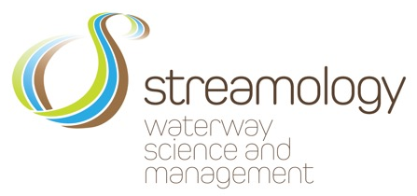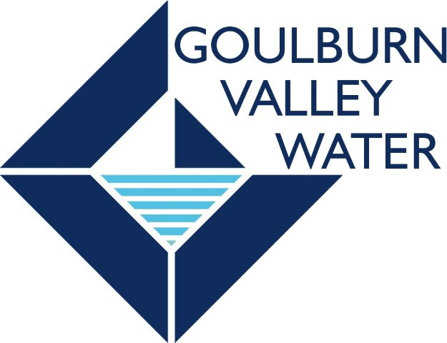

Table of Contents

1. Monitoring and evaluation of environmental water in the lower Goulburn River 1

1.1 Lower Goulburn River selected area 1

1.2 Environmental values and flow regulation of the lower Goulburn River 3

2. Environmental watering in the lower Goulburn in 2017–18 3

2.1 Overview of Commonwealth environmental watering 3

2.2 Environmental water delivered in 2017–18 and context 4

2.3 Outcomes of Environmental watering in 2017-18 7

2.3.1 Physical Habitat 9

2.3.2 Stream Metabolism 10

2.3.3 Macroinvertebrates (large water bugs) 11

2.3.4 Bank Vegetation 12

2.3.5 Native Fish 12

3. Environmental watering 2014–15 to 2017–18 14

3.1 Environmental water delivery 2014–2018 14

3.2 Key outcomes from environmental water use 14

3.3 Integration of monitoring results 17

4. Implications for Future Management of Environmental Water 19

4.1 Spring freshes 19

4.2 Overbank flows 19

4.3 Inter-Valley Transfers 19

4.4 Adaptive management 20

5. References cited 21

# Monitoring and evaluation of environmental water in the lower Goulburn River

The Commonwealth Environmental Water Office (CEWO) is funding a Long-Term Intervention Monitoring (LTIM) Project in seven Selected Areas to evaluate the ecological outcomes of Commonwealth environmental water use throughout the Murray-Darling Basin. The LTIM Project is being implemented over five years from 2014–15 to 2018–19 to deliver five high-level outcomes (Gawne et al. 2013b):

1. Monitor the ecological response to Commonwealth environmental watering at each Selected Area
2. Evaluate ecological outcomes of Commonwealth environmental watering at each Selected Area
3. Evaluate the contribution of Commonwealth environmental watering to the objectives of the Murray-Darling Basin Plan
4. Infer ecological outcomes of Commonwealth environmental watering in areas of the Murray-Darling Basin not monitored
5. Support the adaptive management of Commonwealth environmental water.

This Summary Report outlines the outcomes from the monitoring activities undertaken in the lower Goulburn River Selected Area in 2017–18 and provides an overview of the overall flow and ecological outcomes for 2014–15 to 2017–18. Detailed descriptions of monitoring, results and analyses for each monitoring discipline are provided in the accompanying Scientific Report.

## Lower Goulburn River selected area

The Goulburn River extends from the northern slopes of the Great Dividing Range north to the Murray River near Echuca (Figure 1). Mean annual flow for the catchment is approximately 3,200 GL (CSIRO 2008), and approximately half of that is on average diverted to meet agricultural, stock and domestic demand.

The Lower Goulburn River Selected Area includes the main river channel between Goulburn Weir and the Murray River (235 km), along with any low-lying riparian or wetland/floodplain assets that are connected to the river by in-channel flows up to bankfull. Environmental flows in the lower Goulburn River are not used to deliver overbank flows or to water the floodplain. Therefore, for the purposes of the LTIM Project, the lower Goulburn River Selected Area is considered a Riverine System under the Australian National Aquatic Ecosystem (ANAE) classification (Brooks et al. 2013).

The Goulburn LTIM Project divides its monitoring locations by *zones* (Figure 1). These are equivalent to the *reaches* used in previous environmental flow assessments (e.g. Cottingham and SKM 2011):

* Zone 1 – Main channel of the Goulburn River and associated wetlands and backwaters that are connected to the main channel at flows less than bankfull between Goulburn Weir and the confluence of the Broken River near Shepparton (i.e. Environmental Flow Reach 4).
* Zone 2 – Main channel of the Goulburn River and associated wetlands and backwaters that are connected to the main channel at flows less than bankfull between the confluence of the Broken River and the Murray River (i.e. Environmental Flow Reach 5).
* There are several sites outside these zones: the control site for macroinvertebrate monitoring in the lower Broken River, and several acoustic monitoring stations (for tracking fish movement) in the Murray River near the Goulburn confluence.

Zone 1 and Zone 2 are physically similar, have similar hydrology and are not separated by significant barriers. Moreover, they are equally affected by Commonwealth environmental water, which is controlled by the regulator at Goulburn Weir. With this in mind, the LTIM team decided to invest effort in many monitoring activities in a single zone, rather than a small number of monitoring activities in both zones, and are focussing on responses to environmental flows in Zone 2.

Ecological Matters being investigated are: physical habitat - hydraulic (river flow and depth characteristics) and bank condition (erosion and sediment deposition); stream metabolism (plant photosynthesis and respiration as a potential source of food for macroinvertebrates and fish); macroinvertebrates (the combined weight and diversity of large bugs such as insects and shrimps); bank vegetation (abundance and diversity of plant cover); and native fish movement, spawning and populations (composition and abundance).



Figure 1. Map of the lower Goulburn River, with all monitoring sites marked, along with flow gauges used to generate flow data used in this report. Some sites extend into the Murray and Broken rivers. Colours denote different monitoring activities, with some sites being used for multiple activities. Sites are indicated with site numbers, with the key providing the site name. Monitoring Zone 1 runs from Goulburn Weir to the confluence of the Broken River near Shepparton, with Zone 2 downstream from this point to the confluence with the Murray River.

## Environmental values and flow regulation of the lower Goulburn River

The Goulburn Broken Waterway Strategy 2014–2022 (GBCMA 2014) identifies the Goulburn River as a priority waterway due to its significant environmental, social, cultural and economic values. The river and its associated floodplain and wetland habitats support intact River Red Gum forest and numerous threatened species such as Murray cod, trout cod, Australasian painted snipe and superb parrot. Natural river flows would have been high in the winter and low over the summer months.

Two major flow regulating structure are located on the Goulburn River; Lake Eildon and Goulburn Weir. The reach from Lake Eildon to Goulburn Weir is referred to as the mid Goulburn and the reach from Goulburn Weir to the Murray River is the lower Goulburn. Flow in the mid-Goulburn River is now lower than it would naturally be in winter and spring (flow is stored in Lake Eildon) and higher than it would naturally be in summer and early autumn (flow is released from Lake Eildon and then mostly diverted from the river at Goulburn Weir to supply irrigation and consumptive needs).

Downstream of Goulburn Weir the overall flow volume is decreased compared to natural but inflows from tributaries such as the Broken River and Seven Creeks have helped to retain the natural seasonal flow patterns (i.e. high winter flows and low summer flows). However, more recently, there has been an increase in summer and autumn flows through the lower Goulburn River as a result of Inter-Valley Transfer (IVT) flows from Lake Eildon to supply users further downstream in the Murray River. The timing and volume of IVT delivery is at the discretion of river operators, however, environmental water managers provide advice to minimise ecological impacts of these releases.

The lower Goulburn River was heavily affected by the Millennium Drought and the following floods in 2010–11 and 2012, which resulted in bare river banks susceptible to erosion. Vegetation has begun to re-establish over recent years. Also, golden perch, a flow-cued spawner, did not spawn during the Millennium Drought (Koster et al. 2012), making spawning and survival a priority to rebuild populations and age classes.

# Environmental watering in the lower Goulburn in 2017–18

## Overview of Commonwealth environmental watering

As of 31 August 2018, the Commonwealth held 327.7 GL of environmental water entitlements in the Goulburn River (Table 1). The Goulburn River receives other environmental flows including from the Victorian Environmental Water Holder and The Living Murray program, but the Commonwealth environmental water entitlement provides most of the environmental water used to meet specific environmental flow objectives in the lower Goulburn River channel. Inter-Valley Transfers are also used to meet environmental flow targets when possible (see Gawne et al. 2013a for further details).

Table 1. Commonwealth environmental water entitlements as at 31 August 2018 (<http://www.environment.gov.au/water/cewo/about/water-holdings> ).

| Entitlement type | Registered entitlements (GL) | Long term average annual yield (GL) |
| --- | --- | --- |
| Goulburn (high reliability) | 285.2 | 270.2 |
| Goulburn (low reliability) | 42.5 | 19.3 |

When managed flows are to be above 3,000 ML/day at Goulburn Weir, landowners are advised ahead of time to allow for pumps at risk of being inundated to be moved. Managed releases from Goulburn Weir do not exceed 10,000 ML/day due to risks to private property. However, in the event of high natural flows, environmental watering may commence at 15,000 ML/day at McCoy’s Bridge to slow-down flow recession rates.

To maximise the efficient and effective use of Commonwealth environmental water, where possible, return flows from the Goulburn River are traded for use downstream, providing environmental benefits at multiple sites including Gunbower Forest, Hattah Lakes, the lower River Murray channel and floodplain wetlands, Lower Lakes, Coorong and Murray Mouth (CEWO 2017).

Commonwealth environmental water for the lower Goulburn is stored in Lake Eildon and delivered via Goulburn Weir. Throughout the year river flows are assessed to see how well they are meeting identified flow targets in the lower Goulburn River. If required, environmental water can be used to increase flow rate and duration to meet these targets.

## Environmental water delivered in 2017–18 and context

High priority watering actions planned for 2017–18 in Reaches 4 and 5 included: continuous baseflows throughout the year for habitat; winter, spring and autumn freshes for bank vegetation; a spring/summer fresh to stimulate golden perch spawning; and a summer/autumn fresh to attract young of year fish migrating up the Murray River into the (CoA 2017, GBCMA 2017) (Figure 2).

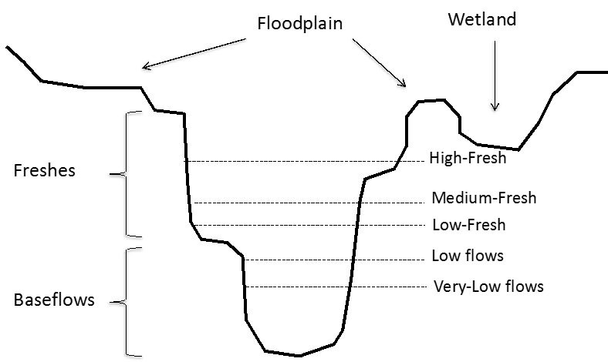

Figure 2. Flow stages defined by [Stewardson and Guarino (2018)](#_ENREF_11" \o "Stewardson, 2018 #2454).

During 2017–18 around 350 GL of environmental water was released into the lower Goulburn River (Figure 3). In addition, there were IVT flows of 258 GL, a substantial increase on previous years of the LTIM Project. This reduced the delivery of environmental water, particularly over the summer and autumn period.

The planned delivery for environmental water in 2017–18 is summarised in Table 2 which also outlines the actual delivery and the conditions that influenced use decisions during the year.

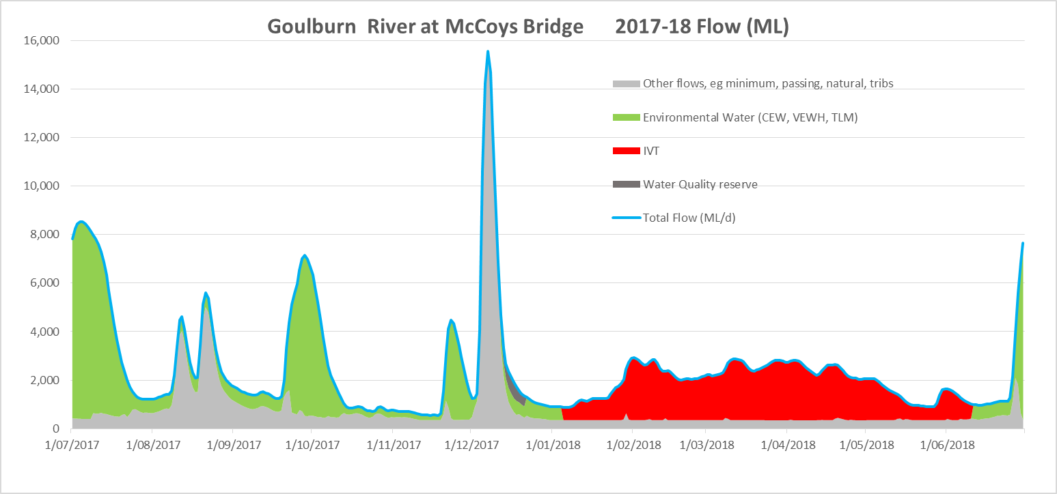

Figure 3. Relative sources of water contributing to total Goulburn River flows in 2017–18

Table 2. Summary of planned and actual environmental flows for the lower Goulburn River 2017–18. Information on planned delivery and expected outcomes from CoA (2017) and GBCMA (2017). Information on actual delivery provided by CEWO (unpubl. data).

| Flow component type and planned magnitude, duration, timing | Expected outcomes  (primary and secondary as at delivery) | Actual delivery details and any operational issues that may have affected expected outcomes  Comments |
| --- | --- | --- |
| Winter fresh (Jun-Jul) of up to 15,000* ML/day at Murchison/McCoys with 14 days above 6,600 ML/day | Contribute to a winter fresh to provide vegetation and maintain macroinvertebrate habitat.  Also provides benefits to downstream ecological targets including lamprey migration. | This is the ramp-down of the winter fresh which commenced on 22 June 2017. Due to drying conditions across the catchment the planned duration and peak of the flow was slightly reduced.  At Murchison the flow remained above 6,600 ML/day for 12 days and the peak flow reached just under 9,000 ML/day for 2 days on the 1st and 2nd July 2017. |
| Baseflow (July-Sep) 500–940 ML/day at Murchison/McCoys | Contribute to baseflows to maintain water quality and provide suitable habitat and food resources for native fish and macroinvertebrates and to water bank vegetation. | As planned, baseflow releases from Murchison to provide 6 weeks of low flows between freshes, as recommended by LTIM veg researchers. The average baseflow for this period at Murchison was 845 ML/day, at the higher end of the range.  Natural flows and tributary inflows downstream of Murchison between 9 Aug and 3 Sept 2017 provided a double peak of increased flow at McCoys Bridge. |
| Winter/early spring fresh (Aug) of up to 5,000 ML/day at Murchison/McCoys for 2 days | Contribute to a late winter fresh to achieve pre-spawning migration and increase food availability and fish condition prior to the Nov/Dec fish spawning flow. | Not Delivered. This action was included in CEWO and VEWH plans for the first time based on LTIM findings. Due to potential for low water availability later in the year it was decided to give preference to delivering the two other planned spring freshes.  As it happened natural in-flows upstream of McCoys provided additional flows in the lower Goulburn. |
| Spring fresh (Sept-Oct) of up to 10,000 ML/day at Murchison/McCoys Bridge with 14 days above 5,600 ML/day | Contribute to long-duration freshes in spring to water bank vegetation, provide soil moisture to banks and benches, distribute seed and allow plants to flower and seed for later germination and distribution. | Due to continued drying conditions across the catchment the planned duration and peak of the first spring fresh was slightly reduced. At Murchison the spring fresh peaked at 7,685 ML/day and remained above 5,600 Ml/day for 9 days. At McCoys the peak was slightly lower and the days above 5,600 ML/day slightly fewer. |
| Baseflow (Oct-Nov) 500–940 ML/day at Murchison/McCoys | Contribute to baseflows to maintain water quality and provide suitable habitat and food resources for native fish and macroinvertebrate and to water bank vegetation. | As planned, baseflows were delivered to allow a maximum time between freshes for vegetation outcomes. This action was at the lower end of the range, with an average flow at Murchison of 559 ML/day and at McCoys Bridge of 745 ML/day. |
| Spring/summer fresh (Nov-Dec) of up to 10,000 ML/day at Murchison/McCoys with 2 days above 6,600 ML/day | Contribute to short-duration freshes during Nov-Dec to stimulate breeding of native fish (flow cued spawners), particularly golden perch. | As with earlier freshes in 2017–18 a revised lower peak of 5,500 ML/day was agreed for the second spring fresh.  The actual peak was 5,190 ML/day on 20 Nov 2017 at Murchison and slightly less at McCoys. Channel constraints prevented the revised peak being achieved. |
| Baseflow (Nov-Dec) 500–940 ML/day at Murchison/McCoys | Contribute to baseflows to maintain water quality and provide suitable habitat and food resources for native fish and macroinvertebrate and to water bank vegetation. | The planned return to baseflows of 500–940 ML/day after the second spring fresh lasted 5 days before rainfall fell across the catchment (see entry below). |
| Unplanned natural rainfall event |  | Rainfall across the catchment resulted in overbank flows at Shepparton and near bankfull flows at Murchison and McCoys Bridge. The peak flow at Murchison was 12,504 ML/day on 4 Dec 2017 and at McCoys was 15,559 ML/day on 7 Dec 2017.  These natural flows resulted in organic matter being transferred to the Goulburn River from the floodplains and tributaries, causing low DO levels and increasing the risk of hypoxic black water with rising summer temperatures.  As the natural flows receded, environmental water for baseflows recommenced and water from the VEWH’s Water Quality Reserve was released for 10 days; this additional water brought about a slowing of the recession rate and an increase in flow rate to help dilute the organic matter.  There were no reports of biota stress. |
| Baseflow (Dec-Jan) 500–940 ML/day at Murchison/McCoys | Contribute to baseflows to maintain water quality and provide suitable habitat and food resources for native fish and macroinvertebrate and to water bank vegetation. | The river flow returned to lower levels during this period and environmental water and IVT was delivered so that baseflows at the higher end of the planned range were achieved.  Environmental water delivery at Murchison ceased on 31 Dec 2017 and IVT flows commenced on 1 Jan 2018. |
| Summer/autumn fresh (Feb to April) of 5,600 ML/day at Murchison/McCoys for 2 days or 4,600 ML/day for 10 days  Baseflow (Feb-Apr) 500–940 ML/day at Murchison/McCoys | Contribute to a fresh to maintain existing vegetation and encourage germination of new seeds and when coordinated with flows in the Murray River, facilitate fish migration.  Contribute to baseflows to maintain water quality and provide suitable habitat and food resources for native fish and macroinvertebrate and to water bank vegetation. | For the first four months of 2018 the planned flows were unable to be implemented.  Instead, a high IVT balance dominated the volume and timing of water delivered and despite the best intentions of environmental water holders, catchment managers and river operators the planned baseflows and summer/autumn fresh were not achieved. |
| Baseflow (May-Jun) 500–940 ML/day at Murchison/McCoys | Contribute to baseflows to maintain water quality and provide suitable habitat and food resources for native fish and macroinvertebrate and to water bank vegetation. | Baseflows were maintained as planned for 30 of the 41 days during this period.  For 9 days from 25 May to 4 June 2018 there was a late-season increase in IVT demand. As a result of this flows increased to an average of 1,350 ML/day. |
| Winter fresh (Jun-Jul) of up to 15,000* ML/day at Murchison/McCoys with 14 days over 6,600 ML/day | Contribute to a winter fresh to provide vegetation and maintain macroinvertebrate habitat.  Also provides benefits to downstream ecological targets including lamprey migration. | Cognizant of the need to maximise carryover into 2018–19 for early season environmental water, the peak for the winter fresh was revised down to 9,000 ML/day. The actual peak was 8,986 ML achieved at Murchison on 30 June 2018. The target of 14 days over 6,600 ML/day was achieved. |

* This volume is recommended by scientists to achieve maximum ecological outcomes, but is unable to be achieved due to operational constraints that limit release from Goulburn Weir to around 10,000 ML/day.

## Outcomes of Environmental watering in 2017-18

Findings from 2017–18 for each Goulburn environmental watering action is summarised in Table 3 and described in more detail for each monitoring matter in the paragraphs below.

Table 3. Summary of observed responses to flow actions in 2017–18. Where observed responses cannot be related to an individual flow component, cells are merged.

|  |  |  |  |  |  |  |
| --- | --- | --- | --- | --- | --- | --- |
| Monitoring Matter | Winter fresh (Jul) | Early Spring fresh (mid-Sep to mid-Oct) | Late Spring fresh (late Nov) | Enhanced winter base flows (Aug-Sep) | Recession flows (mid Dec) | Inter-Valley Transfers (Feb-Apr) |
| Physical habitat – bank condition | The highest rates of deposition on riverbanks during the 4-years of investigation (50-65 per cent of assessment points underwent deposition) | Active riverbanks with highly variable response, with both erosion and deposition observed. Greater prevalence of vegetation further added to the complexity of the response | | No riverbank changes evident | | Evidence of erosion in the form of notching (trim line) around the 2,000 ML/day flow level. There was also some minor slumping from the top of the notch, with deposition at the bottom (toe) of the bank. |
| Stream metabolism: carbon production and respiration | Based on daily organic carbon load and pooling of flows into categories, it is clear that increasing flows through environmental watering actions is having a beneficial response for stream metabolic outcomes, but these cannot yet be tied to individual watering actions. Higher flows, even if constrained within channels, will produce more organic carbon. This is the energy (food) supply underpinning aquatic food webs (macroinvertebrates, fish). These increases appear greater in summertime, but extended logger deployments recently agreed for 2018-19 should help to better capture seasonal trends in organic carbon production and consumption. | | | | | |
| Macroinvertebrate biomass (combined weight) and diversity |  |  | Increased abundances and biomass of some groups (especially shrimp and freshwater prawns) |  |  |  |
| Macroinvertebrate biomass (combined weight) |  |  | Increased abundances and biomass of shrimp and freshwater prawns (crustaceans) |  | Continued increase in crustacean abundance and biomass; supported crustacean reproduction and maintenance of important edge habitats (inundated terrestrial vegetation) | Sustained crustacean populations |
| Bank vegetation abundance and diversity |  | The effect of the spring fresh in 2017–18 could not be determined due to natural high flows in early December 2017, which limited plant growth. Post fresh sampling in December 2017 was also more limited as natural high flows had not fully receded. The data however reveal that the cover of common tussock grass which occupies higher elevations on the bank face tended to increase between sampling in September and December 2017. This may reflect improved soil moisture at higher elevations. In contrast, the cover of water dependant species that occupy lower elevations on the bank and experienced longer periods of deeper inundation declined slightly between surveys. | |  |  |  |
| Native fish movement |  | Golden perch undertook long-distance movements coinciding with a spring ‘fresh’ environmental flow release in early October 2017 | Golden perch undertook long-distance movements coinciding with a spring ‘fresh’ environmental flow release in late November 2017 |  |  |  |
| Native fish spawning |  |  | Golden perch eggs and larvae and silver perch eggs were collected coinciding with a spring ‘fresh’ environmental flow release in late November 2017 |  |  |  |
| Fish assemblage composition and abundance |  |  |  |  |  | The abundance of numerous species (Murray cod. silver perch, Murray River rainbowfish, Australian smelt, carp gudgeon, carp and eastern gambusia) in the annual electrofishing / netting surveys was reduced in 2018, possibly because of reduced sampling efficiency associated with elevated flows due to inter-valley-transfers throughout autumn 2018. |

### Physical Habitat

#### Hydraulic Habitat

The hydraulic habitat in a river refers to the characteristics of the water where plants and animals live, for example, slow and fast flowing areas and shallow and deep pools. In the lower Goulburn relationships between flow volumes and the mix of different hydraulic habitats have been identified. Improving the understanding of these relationships has allowed the delivery of targeted flows to maximise habitat (or prevent reduced habitat), for example, it is now known that shallow, slow-flowing water (important for juvenile and small-bodied fish) is maximised at flows of between 1,000 and 5,000 ML/day, peaking at 2,000 ML/day, depending on individual sites.

The hydraulic habitat work has also identified flow triggers for fish movement and has been used on several occasions to guide the delivery of environmental water to encourage fish movement, (particularly golden perch) into the Goulburn River from the Murray River.

#### Bank Condition

River bank condition refers to the erosion and deposition of sediment (when sand, mud and pebbles are dropped from the water onto the riverbank or riverbed) over time. Improving the understanding of the relationship between the volume of water flowing through the river, water habitats and river bank condition is informing the delivery of environmental water to positively improve (or prevent a reduction in) animal, plant and overall ecosystem health.

Bank condition monitoring has found that sustained watering actions with little flow variability can be related to erosion processes such as notching (horizontal grooves along the riverbank). Slow rates of drawdown after high flows have been associated with the development of mud drapes (deposition of mud over the existing bank) on the lower banks. This knowledge has influenced the timing and duration of environmental flows in the Goulburn River over several years so that variable flows followed by slow draw-down rates are now common practice.

These findings have also been used to inform the delivery of IVT using variable flows, however, during summer 2017–18 the unusually high IVT volume (258 GL) saw the development of notches and subsequent bank erosion, despite a concerted effort to vary flow levels to mitigate this risk (Figure 4a). During the same period, the presence of mud drapes was also observed (Figure 4b) providing suitable conditions for the re-establishment of plants along the lower banks.

Previous watering events also play a role in bank condition, for example, the deposition on the Goulburn riverbanks observed in the spring 2017 (September) fresh are likely to have been augmented by natural tributary inflows in August. An understanding of flow variability, and rates of drawdown is still being developed and will greatly assist the effective management of bank condition.

The erosion evident during the 2018 summer period points to the important role of riverbank drying in erosion processes. Erosion is not generally related to high flows but rather the extent of the time the bank is underwater (duration of inundation). Prior (antecedent) conditions are also important. Drying of clay-rich soils leads to cracking and preparation of banks for erosion during subsequent inundation. The role of bank erosion relative to bank vegetation has yet to be properly investigated. Zones of deposition provide niches for the spread of bank vegetation. Anecdotally, vegetation plays an important role in the resistance of banks to erosion. Drying and cracking is exacerbated when vegetation is not available to shade soils. In addition, vegetation roots increase the strength of the riverbank to resist future erosion.

**a)**  **b)**

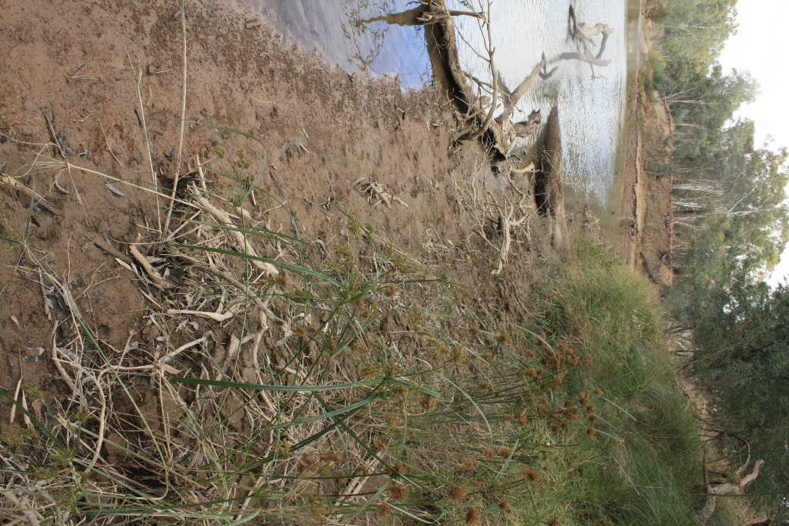

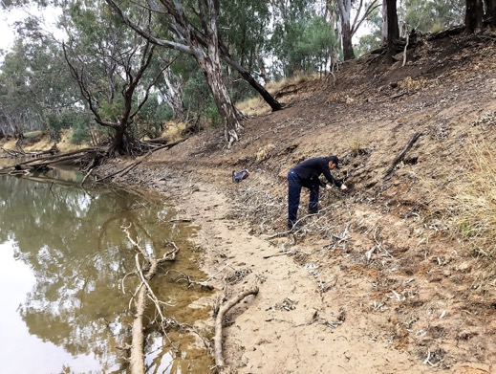

Figure 4. a) Riverbank notching (highlighted with arrows) associated with the IVT and some erosion (below the notching) subsequent to the following fresh (McCoys Bridge, June 2018). b) Deposition on the lower banks provides niches for seed establishment and vegetation growth, even following a highly managed IVT (Loch Garry, May 2018).

### Stream Metabolism

Stream metabolism provides an estimate of the amount of food (organic carbon) that is produced and consumed within the river. Stream metabolism is measured as the rate of increase and decrease in dissolved oxygen (DO) in the water column, Dissolved oxygen increases due to photosynthesis by algae and submerged plants. This produces new plant material that becomes food for organisms (e.g. water bugs and fish) higher up the food chain, Dissolved oxygen decreases (is consumed) due to respiration by aquatic plants, bacteria, fungi and animals.

Rates of change in DO are used as an estimate of the amount of organic carbon that is produced and consumed. Healthy aquatic ecosystems need both processes to produce food and to break-down dead plants and animals (detritus) and their waste products, including organic material and nutrients, which are recycled to enable further plant growth to occur. Organic carbon food sources can also enter the river from the surrounding land in the form of leaves and twigs during high flows and flood events that wash organic material off the river banks and floodplain.

Findings to date show that the major effect of a flow increase is to immediately decrease metabolic rates simply due to dilution caused by greater quantities of water coming down the river.

A new major finding in 2017–18 was that when considering the daily organic carbon load being created, even small flow increases, where water is still retained in the river channel, will have positive benefits in terms of potential food production. For example, when looking at McCoys Bridge, increasing flow from a very low volume of 312 ML/day to 960 ML/day will result in an increase of 73 per cent in organic carbon produced and an increase in 19 per cent in the amount of organic carbon respired. It is recommended that whenever possible, watering actions be undertaken that increase flows sufficiently to reconnect backwaters and flood-runners to introduce more organic carbon and nutrients. This should elicit even greater amounts of organic carbon creation to underpin aquatic food webs.

A heavy summer storm event in the northern Goulburn catchment resulted in low oxygen water entering the Goulburn from the Seven / Pranjip / Castle creeks. Low oxygen persisted in the Goulburn sites downstream from these inflows for up to two weeks. Unlike 2016–17, the river did not become anoxic (zero dissolved oxygen). Nevertheless, such low DO events have been recorded in 3 of the 4 years of the LTIM project and therefore need to be regarded as ‘likely’ although the timing during summer appears unpredictable. This makes management of risks difficult, however, the release of well-oxygenated water from Goulburn Weir during a low DO event may help to mitigate impacts.

### Macroinvertebrates (large water bugs)

Macroinvertebrates (e.g. insects, snails, shrimps, prawns) are an essential part of healthy aquatic ecosystems. They help to recycle nutrients through the consumption of plants and dead organic material and also provide food for larger aquatic animals such as fish. They are also used throughout the world as general indicators of river ecosystem health. Healthy ecosystems tend to have a larger number (diversity) of different macroinvertebrate types (species) compared to unhealthy ecosystems. Healthy ecosystems also tend to have a have a larger number of macroinvertebrate species present that are sensitive to poor water quality (i.e. unhealthy ecosystems tend to be dominated by species that are tolerant of poor water quality).

Monitoring (Figure 5), continues to demonstrate that macroinvertebrate abundances (number of individual species) and biomass (the combined weight of sampled macroinvertebrates) tends to increase in response to increased flows in spring. However, the overall diversity of macroinvertebrates tends not to change. Increases in biomass are group-specific. For example, shrimps (an important source of food for fish) seem especially sensitive to flows, with small increases in biomass in response to environmental water (spring freshes). However, much larger increases in abundance and biomass were observed following the large, natural overbank flows in spring 2016–17.

This suggests that within-bank spring freshes do not provide the same benefit as natural overbank flows which increase river productivity, causing changes to important food sources such as benthic biofilms (the microscopic plants that grow on hard surfaces). To begin to explore the potential mechanism for increased macroinvertebrate productivity and to help link stream metabolism with macroinvertebrate responses, additional monitoring of algal biofilms will be done in 2018–19.

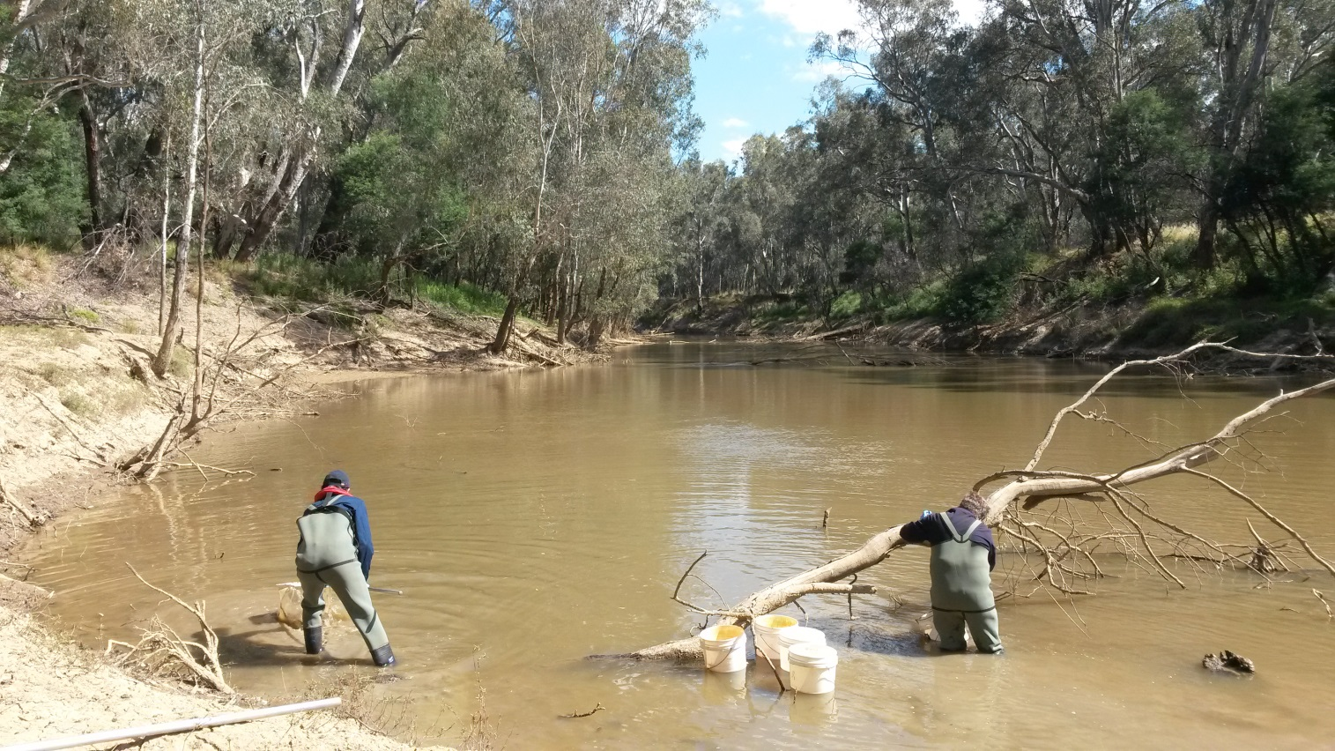

Figure 5. Macroinvertebrate sampling at McCoys Bridge, 2017–18.

Environmental water flows have positive impacts on macroinvertebrates in the Goulburn River by providing bank and aquatic vegetation growth, including through drier months, for food and shelter. An example of the importance of these habitats comes from Loch Garry where in January 2018 a combination of earlier freshes along with elevated summer flows supported dense bank vegetation that provided a sheltered environment to support numerous immature crustaceans (shrimps, prawns and yabbies) that would otherwise have been washed downstream.

### Bank Vegetation

River bank vegetation protects banks from erosion, provides shade to reduce water temperature, helps to slow river flow, and provides food and habitat for a range of animals. The water level typically reached by spring freshes is related to the distribution and cover of vegetation along the riverbank. Native grasses (mostly tussock grass), have the highest cover at bank elevations at and above the level typically reached by spring freshes (i.e. they prefer drier, or more terrestrial, conditions). In contrast, the cover of creeping knotweed (a species that prefers moist conditions) declines at elevations above that typically reached by spring freshes. Lesser joyweed and sedges (species that prefer wet conditions) occupy comparatively lower elevations where inundation is more frequent, indicating a greater dependence on water availability. Lower elevations are subject to the most pronounced variations in inundation depth and duration, and this likely contributes to the higher variability in vegetation cover observed. The recruitment of silver wattle and river red gum are generally restricted to the higher areas of the bank that experience shallow and less frequent inundation.

The cover of water dependant vegetation across all sampling locations at both Loch Garry and McCoys Bridge increased following spring freshes in 2014–15 and 2015–16. In contrast during these years, the cover of all grasses as a group tended to decrease, but native grasses tended to either not change or increase. While this pattern is correlated with spring freshes, it is not known how much is due to seasonal patterns of plant growth that would have occurred without the delivery of spring freshes. In 2016–17 the spring fresh was not delivered due to natural flooding, but vegetation cover increased following the recession of flood waters. In 2017–18 the natural high flows in early December 2017, shortly after a managed environmental flow action, obscured responses to the spring fresh. The cover of most plant groups and species tended to decline over this period, except for tussock grass*,* which occupies higher elevations on the bank face. It is likely that vegetation cover increased again following the recession of the natural high flows, but additional sampling was not undertaken.

### Native Fish

#### Movement of golden perch

The ability for fish to move within and between water-dependent ecosystems can be crucial for sustaining populations by enabling fish to recolonise or avoid unfavourable conditions (e.g. low flows, poor water quality etc). For some fish species (e.g. golden perch), movement also occurs for the purposes of reproduction (e.g. to a location in the river system that provides suitable spawning habitat or better conditions for juvenile fish survival). Movement monitoring in the Goulburn River LTIM Project focuses on golden perch.

Higher flows in spring/early summer, including bankfull flows and the delivery of within-channel freshes, can promote movement of golden perch, within the Goulburn River, and between the Goulburn and Murray rivers. Observed movement of golden perch has been most prevalent during the spawning season (spring to early summer) and occurs primarily in a downstream direction into the lower Goulburn River reaches, typically followed by return upstream movements. Movement often coincides with the presence of eggs/larvae in drift samples. The coincident timing of movement and spawning strongly suggests that at least some movements are related to reproduction for golden perch.

#### Fish Spawning

Fish spawning surveys for the lower Goulburn River are collecting eggs and larvae of all species, but are designed primarily to detect golden perch spawning. Golden perch is one of only two fish species (along with silver perch) in the Murray Darling Basin for which there is strong evidence of the need for increased flow to stimulate spawning. Environmental flows in the Goulburn River are explicitly used to promote spawning and survival of golden perch.

Higher flows in spring-early summer (November / early December), including bankfull flows and the delivery of within-channel freshes, can promote spawning of golden perch and silver perch. Golden perch and silver perch have spawned in each year of the LTIM Project, except 2015–16 when no flows were delivered over this period. In the case of golden perch, many more eggs were collected in 2014–15 than in the other years. Differences in flow conditions among the years in the pre-spawning period may influence levels of golden perch spawning. For example, in years characterised by extended periods (e.g. 2-3 weeks) of low stable flows throughout spring, little or no spawning occurred on the first subsequent flow pulse.

Larvae of the endangered trout cod were collected in 2017–18, but not related to any particular flow action. This is the first time trout cod larvae have been observed in the four years of the Goulburn LTIM Project, demonstrating that breeding population of this species still exist within the lower Goulburn.

#### Fish Survey

Annual fish surveys (Figure 6) in the Goulburn River channel help to determine whether fish spawning (detected through larval surveys), or fish movement is triggered by environmental flow releases which result in breeding success.

The lower Goulburn River supports several species of conservation significance, including the nationally threatened silver perch, Murray cod, trout cod, and Murray River rainbow fish.

Murray cod abundance decreased in 2016–17 following an anoxic (low DO) blackwater event in January 2017, and fewer fish were captured in 2017–18. The decline observed in 2017–18 may have resulted from reduced sampling efficiency associated with elevated flows due to an extended and large volume IVT throughout autumn 2018. Higher flows can reduce sampling efficiency because there is a larger volume of water for fish to disperse across. Also, faster flow velocities can limit survey access to certain areas / habitats.

1. **b)**

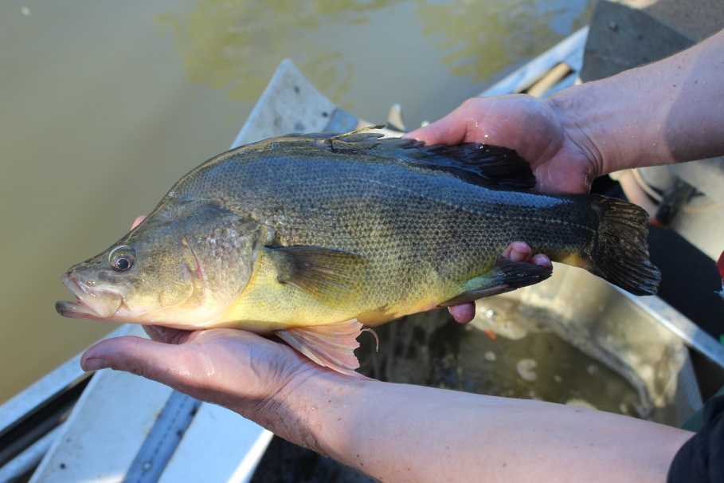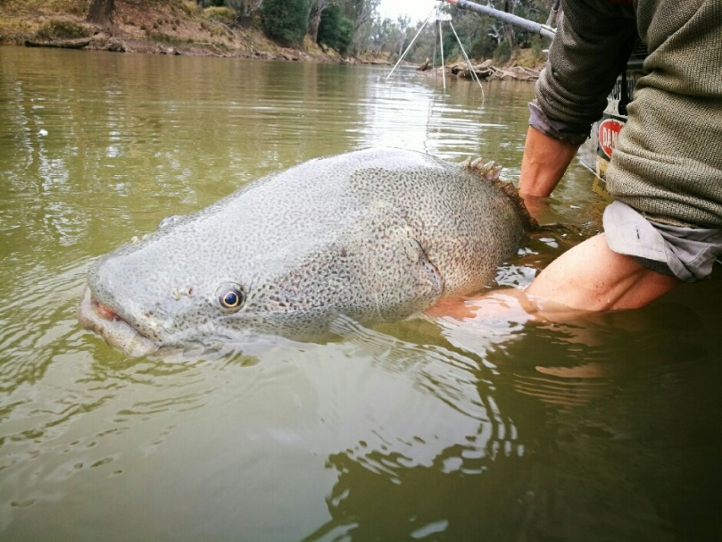

Figure 6. Golden perch (a) and Murray cod (b) collected in the Goulburn River

Silver perch abundance increased considerably in 2016–17, likely due to immigration of fish from the Murray River, but declined in 2017–18. This result could indicate that fish migrated back to the Murray River, but is more likely related to the reduced sampling efficiency in 2017–18.

While golden perch and silver perch have spawned in each year except 2015–16, few or no young-of-year fish have been collected in the subsequent autumn surveys. Golden perch and silver perch eggs are semi-buoyant and drift downstream, potentially over large distances and it is likely that eggs drift downstream into the Murray River. Under this scenario, species survival may be reliant on immigration of fish from the Murray River into the Goulburn River, a result supported by separate monitoring of the effect of autumn ‘recruitment flows’ in 2017 (Tonkin et al. 2017).

# Environmental watering 2014–15 to 2017–18

Environmental water has now been delivered to the lower Goulburn River since 2014–15. This provides an opportunity to summarise the overall environmental water delivery and general findings over the past 4 years

## Environmental water delivery 2014–2018

The four graphs in Figure 7 show the total flows at McCoys Bridge and the break-down of environmental water and IVT for each of the four years of the LTIM project to date. The variations between years reflect the rainfall and temperature patterns over this period, irrigation demand and the implementation of learnings from the LTIM monitoring. More details are available in the [LTIM reports for these years](http://www.environment.gov.au/water/cewo/catchment/northern-victorian-rivers/monitoring).

## Key outcomes from environmental water use

Over the past four years responses to environmental flow actions were observed for all environmental monitoring matters: physical habitat (hydraulic and bank condition), stream metabolism, macroinvertebrates, bank vegetation and native fish. Responses are summarised below (Table 4).

|  |  |
| --- | --- |
|  |  |
|  |  |

Figure 7 Summary of environmental water delivery in the lower Goulburn River 2014–15 (a), 2015–16 (b), 2016–17 (c), and 2017–18 (d). Chart shows total flow rate (ML/d) at the McCoys Bridge gauging station near the bottom of the system, along with managed environmental flows delivered at that point, and inter-valley transfer flows. Each panel has the same maximum y-axis value to facilitate comparison among years. For panel (c) peak flow rates are shown for the three events that extend beyond the top of the y-axis. Evaluation in this report covers the period from the start of the monitoring program (~September 2014) to the collection of adult fish monitoring data in May 2018.

Table 4. Summary of observed responses to flow actions for the four years 2014–15 to 2017–18.

| **Matter** | **Major Ecological Outcomes 2014–15 to 2017–18** |
| --- | --- |
| Physical habitat - hydraulic habitat | * As flow increases (up to 2,000 ML/day), the area of still and slow flowing (slackwater) habitats increase. These areas are important habitat for small fish and macroinvertebrates, and are ideal sites for vegetation establishment. * As flow increases further (to around 5,000 ML/d) the area of pool habitat for larger native fish increases. * Adding a fresh of 5,000 ML/day to baseflow helps remove accumulated sediment from the river bed and hard surfaces such as submerged large wood habitat, greatly increasing the quality of habitats for macroinvertebrates. * High flows that inundate benches and banks enhance sediment transport and deposition which help provide good conditions (increased soil moisture and slow flowing areas) for vegetation germination and growth. |
| Physical habitat – bank condition | * Current environmental flows do not cause more erosion than would occur under natural flows. * Bank erosion and deposition are highly variable along, and up and down the banks, and over time, with a single point on the bank often changing from erosion to deposition with subsequent flow events. * The peak flow or volume of water is not related to bank erosion. * Slow drawdown rates can promote deposition and the development of mud drapes that encourage vegetation establishment. Fast drawdown rates can increase minor erosion. However, there is no influence of the rate of drawdown on significant erosion events (i.e. erosion > 30 mm). * In 2017–18, following the high IVT flows, greater rates of both erosion and deposition were observed. However, the proportional change from the previous three years was small. |
| Stream metabolism: production and respiration | * Stream metabolism (the amounts of carbon created and consumed each day) increases with increasing in-channel flows up to around 4,000 ML/d. This represents a benefit to the total food resources produced for fish and other organisms. * Metabolic rates are seasonal with highest rates during December–January. |
| Macro-invertebrate biomass and diversity | * Macroinvertebrate richness, abundance and large crustacean biomass increased in both the Goulburn and Broken rivers following natural winter/spring floods in 2016. * Smaller environmental flows also resulted in increased macroinvertebrate biomass and abundance, although the effect was smaller when compared with natural events. * The January 2016 blackwater event resulted in a decline in water quality, increasing stress, mortality, and causing macroinvertebrates to drift downstream. |
| Bankside vegetation abundance and diversity | * High flow events provide soil moisture to the banks that help plant establishment and growth. * Early spring freshes promoted the establishment and growth of flood tolerant plants and reduced the occurrence of terrestrial plants on the banks of the Goulburn River. * Cover and occurrence of flood tolerant vegetation has risen over the term of the LTIM Project, but appears to have reduced following high IVT flows in summer 2017–18. * Natural flooding and spring freshes help reduce the cover of exotic pasture grass. However, prolonged natural flooding in spring 2016 also caused declines in cover and presence of some native species. |
| Native fish movement | * Long-distance movements of golden perch (mostly downstream in the Goulburn and from the Goulburn to the Murray) coincide with elevated flows in spring and the timing of spawning, suggesting reproduction is a driver of fish movement. * Attraction flows in autumn saw the movement of some tagged sub-adult silver perch from the Murray River into the lower Goulburn River. |
| Native fish spawning | * Conditions for golden perch spawning in the lower Goulburn River are now well known; with eggs frequently collected following high flow events in late spring with elevated water temperatures (over 18°C). * Silver perch eggs have been collected slightly later and at higher water temperatures (20.7°C vs. 18.5°C). * Golden perch egg occurrence in the lower reach corresponded with the movements of tagged fish. * Most golden perch eggs (and carp larvae) were detected as flow declined following fresh events. * Eggs and larvae of other native fish species (e.g. Murray cod) have been detected in drift net samples, but were not associated with flow events. * 2017–18 is the first time trout cod larvae have been observed in the four years of the Goulburn LTIM Project, demonstrating that breeding population of this species still exist within the lower Goulburn. |
| Fish communities (composition and abundance) | * Despite repeated spawning events, few juvenile (young of year) golden or silver perch have been detected in the annual surveys, suggesting early life history stages are taking place outside the Goulburn River with fish returning to the river at a later date. * Sampled abundances of several species dropped in 2017 following the blackwater event and associated fish kills. However, higher numbers of silver perch were found in 2017, most likely due to immigration from the Murray River. * Abundances were lower again in 2018, but this is most likely due to reduced sampling efficiency associated with the high IVTs being delivered at that time. * The elevated spring 2017 flows that improved the recruitment of semi-aquatic bank vegetation may explain the higher abundance of Murray River rainbow fish (listed as threatened in Victoria) as well as carp spawning and survival. * Higher abundance of bony herring may represent transient fish that enter the Goulburn River when conditions are stable. |

## Integration of monitoring results

After four years of monitoring in the lower Goulburn River LTIM Project, and with the increasing incorporation of data collected prior to the start of the LTIM Project, our understanding of the system has increased considerably. The conceptual model linking flow actions and ecological outcomes that we proposed prior to the start of the LTIM Project (Webb et al. 2018), has been largely confirmed. The current-year version of the model (Figure 8) includes new causal pathways compared to the original, and most of these pathways, as well as the original hypothesised pathways, while not proven are being at least strongly suggested by the monitoring data collected.

Probably the strongest ‘new’ knowledge to arise from the Goulburn LTIM Project in 2017–18 was data linking environmental flow actions much more strongly with ecosystem metabolism outcomes and with flow-on effect on macroinvertebrate biomass in the lower Goulburn River. The consideration of the stream metabolism data in terms of the amount of carbon produced as a usable food resource for river animals, rather than in terms of the rates of oxygen production and consumption, was a major advance. This demonstrated that the wetting of significant proportions of the river channel with major environmental flow actions leads to large increases in the amount of organic carbon available to underpin the river food web. This conclusion was further backed up by the observation of improved biomass of large-bodied shrimps in the lower Goulburn River following the spring environmental flow action and also the unregulated natural high flow that occurred in early December 2017. While biomass responses are variable among individual macroinvertebrate species, these shrimp are likely to form a significant portion of the food resource for native fish species in the lower Goulburn River.

Vegetation data from 2017–18 did not advance knowledge further than previous years, with the large natural flow event in December 2017 affecting the monitoring outcomes for vegetation. Nevertheless, the results confirm the beneficial effects of flow events early in spring for the promotion of water tolerant species on the river bank and the control of terrestrial species.

Movement and spawning responses of golden perch continued much as previously in 2017–18 as in earlier years. There is now a very strong understanding of the conditions required to induce spawning in this species, and a belief that spawning can be managed for this species with very high precision and efficient use of environmental water.

The largest knowledge gap within the conceptual model (Figure 8) remains the linkages from the other monitoring matters through to adult fish populations in the Goulburn River. Although large numbers of eggs and larvae of species like golden and silver perch are recorded, the juvenile ‘young of year’ fish that should appear during the electrofishing surveys approximately six months later are rarely caught. Moreover, although there are strong links between flows, metabolism, carbon and large-bodied macroinvertebrates (i.e. fish food), the current approach to monitoring adult fish cannot detect any direct responses in terms of changes in the numbers and species of fish being caught. Similarly, a link between improved near-bank habitat that results from improved bankside vegetation and fish populations (composition and abundance) also cannot be demonstrated because the adult fish sampling does not target habitats specifically.

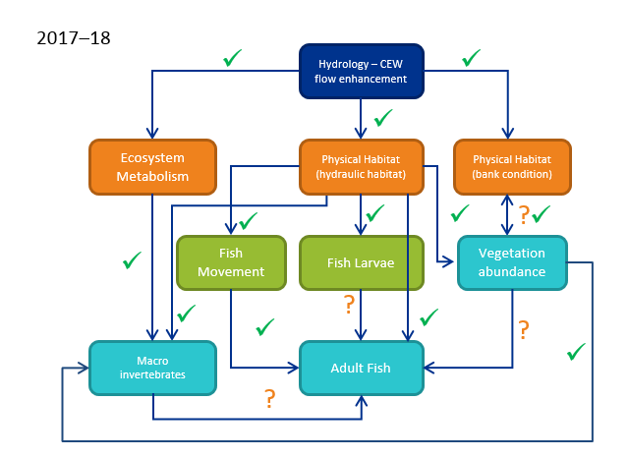

Figure 8. Updated conceptual model of the linkages among the different monitoring matters in the lower Goulburn River Long-Term Intervention Monitoring Project (modified from Webb et al. 2018). The blue ‘hydrology’ box is the ultimate cause – flow enhancement with Commonwealth environmental water; orange boxes are physical effects of this, with flow on effects to intermediate (green) and ultimate (aqua) environmental variables. Arrows are hypothesized causal linkages posed at the start of the LTIM Project (with several added since as well). Ticks are linkages that we believe have been demonstrated by the monitoring data, or at least strongly suggested. Question marks are linkages that are yet to be demonstrated. The linkage between bank condition and vegetation diversity, with both symbols, is strongly suggested. No linkages have been disproved throughout the program.

Links between environmental flow actions and improved fish communities will always be difficult to demonstrate primarily because of issues of scale. Fish respond to multiple drivers over lifetimes that can be literally decades long, and so detecting changes in populations driven by subtle changes in flow regimes will always be difficult. Changes in populations are only immediately evident when catastrophic events occur, such as the January 2016 fish deaths in the Goulburn River associated with the blackwater event. These temporal scales make it impossible to make the kinds of linkages to individual flow actions that are described in (Table 4).

Also, many fish species live their lives over spatial scales much larger than the lower Goulburn River. While the monitoring has failed to detect ‘young of year’ fish for golden perch, older adults continue to be observed in the river. They must be coming from somewhere! Current integrated monitoring and research across the lower Murray-Darling Basin is pointing to the strong probability that species like golden perch might recruit from different locations in different years, and that autumn flow conditions are important for the survival of sub-adult fish in local populations (Tonkin et al. 2017). For questions of adult fish population response to Commonwealth environmental water, the Basin-scale analyses will have a much greater chance of drawing solid conclusions than any of the current Area-scale programs.

# Implications for Future Management of Environmental Water

## Spring freshes

**Recommendation: At least one spring fresh is prioritised every year**

Results from monitoring in 2017–18 build further on those from previous years to underscore the importance of the spring fresh watering actions for ecological outcomes in the Goulburn River. Spring freshes have been convincingly linked with:

* Increased carbon production to underpin the food chain
* Increased biomass of large-bodied crustaceans that are an important food resource for native fish
* Improved bankside vegetation condition through the summer months, with wetting of the bank in early spring helping plants to survive hotter and drier conditions later in the year
* Movement and spawning of the iconic native fish species golden and silver perch

The specific timing and duration of the fresh depends upon the target ecological endpoints, which vary among years. Vegetation is favoured by earlier, longer freshes in around September, while golden perch is advantaged by short sharp freshes late in spring when water temperatures are above 18°C.

This is not to suggest that other flow actions are not important. However, environmental water managers need to consider limitations on the amount of environmental water available and particularly in dry years, trade-offs are necessary. It is recommended that at least one spring fresh be prioritised every year.

## Overbank flows

**Recommendation: Continue to investigate the potential to deliver overbank flows**

Overbank flows are not delivered as part of the Goulburn environmental flows program because of third party risks. However, the results from the LTIM Project underscore the importance of organic carbon input to the system as a major driver of ecological outcomes. The best way to achieve this is with overbank flows. For example, although the spring fresh and natural high flow event in December 2017 saw increased biomass of large-bodied macroinvertebrates, it was noted that the effect was much smaller than that following the natural flooding event of spring 2016. That event would have brought large amounts of terrestrial organic carbon into the river system to drive increased production over the coming months.

Although reaching a solution regarding overbank flows that is acceptable for all stakeholders remains very challenging, it is recommended that environmental water managers continue to work towards this end.

## Inter-Valley Transfers

**Recommendation: Explore policy and operational solutions to better managing high IVT volumes**

At the opposite end of the water availability scale, increased IVT in the Goulburn River are emerging as an environmental risk that needs to be managed. The 2017–18 IVT was unprecedented in terms of its duration and total volume and IVT flows have started even earlier again in 2018 (GMW, unpubl.). The bank condition monitoring observed bank notching and some slumping associated with the summer IVT in 2017–18. There is also anecdotal data that vegetation on the bank has been seriously affected by the extended high flows during summer 2017–18.

The operating conditions under which IVT flows are ordered and released do not leave many options for strategic flow management to reduce environmental impacts. Nevertheless, given that IVT flows are likely to increase in future, the potential long-term impacts to the environment need to be considered. Innovative policy solutions, such as adjustment to the operating conditions under which IVT is delivered, might be needed to reduce the ecological impacts of these economically important flow events.

## Adaptive management

**Recommendation: Continue to include the LTIM team in the decision-making process to improve ecological outcomes when delivering environmental water and IVT**

A key success of the Goulburn River LTIM Project over its four years has been the relationships developed between the monitoring team and local, state and federal water managers. This has allowed improved timely decision-making for individual flow actions to maximise the likely ecological outcomes, and has also improved the planning process for annual watering planning. The bank condition monitoring in the Goulburn River provides a good example, where developing knowledge is being used to inform the environmental flows being monitored. At the same time, the monitoring program is benefiting from the flow of information by water managers to ensure a strategic approach to developing the science. This science-practice partnership represents an example of the doing (delivering environmental flows) both enabling and being undertaken in conjunction with the ‘knowing’ as knowledge is being developed. Essential to this program are the informal lines of communication not often captured in reports like this one. The expected outcome of this close interaction with scientific experts is greater return on investment regarding the application of scarce water resources in the Goulburn system.

It is recommended to continue to include the monitoring team in the decision-making process to improve ecological outcomes, and even potentially extending this. One potential example concerns the riverbank vegetation. Flow management for vegetation needs to be adaptive and able to respond at a finer temporal scale than a year or season. Flow managers on the lower Goulburn River should be able to adjust flow delivery in response to natural flooding, as well as to irrigation flows and the delivery of environmental water to endpoints further downstream in the southern connected system. Without this flexibility, there is a risk of compromising vegetation objectives for the lower Goulburn River.

# References cited

Brooks, S., P. Cottingham, R. Butcher, and J. Hale. 2013. Murray-Darling Basin aquatic ecosystem classification: Stage 2 report. Peter Cottingham and Associates report to the Commonwealth Environmental Water Office and Murray-Darling Basin Authority, Canberra.

CEWO. 2017. Commonwealth Environmental Water Portfolio Management Plan: Victorian Rivers in the Murray-Darling Basin 2017-18. Commonwealth of Australia.

CoA. 2017. Commonwealth environmental water portfolio management plan: Victorian rivers in the Murray-Darling Basin 2017–18. Commonwealth of Australia, Canberra.

Cottingham, P., and SKM. 2011. Environmental water delivery: lower Goulburn River. Report prepared for Commonwealth Environmental Water, Department of Sustainability, Environment, Water, Populations and Communities. Canberra.

CSIRO. 2008. Water availability in the Goulburn-Broken. Report for the Australian Government. Commonwealth Industrial and Scientific Research Organisation.

Gawne, B., S. Brooks, R. Butcher, P. Cottingham, P. Everingham, and J. Hale. 2013a. Long Term Intervention Monitoring Project Monitoring and Evaluation Requirements Goulburn River for Commonwealth environmental water. p. 31pp. Final Report prepared for the Commonwealth Environmental Water Office by the Murray-Darling Freshwater Research Centre.

Gawne, B., S. Brooks, R. Butcher, P. Cottingham, P. Everingham, J. Hale, D. Nielsen, M. Stewardson, and R. Stoffels. 2013b. Long Term Intervention Monitoring Project: Logic and Rationale Document Version 1.0. Report prepared for the Commonwealth Environmental Water Office, p. 109. Murray-Darling Freshwater Research Centre. (Available from: <https://www.environment.gov.au/water/cewo/publications/long-term-intervention-monitoring-project-logic-and-rationale-document>)

GBCMA. 2014. Goulburn Broken Waterway Strategy 2014-2022. Goulburn Broken Catchment Management Authority, Shepparton.

GBCMA. 2017. Goulburn River seasonal watering proposal 2017-2018. Goulburn Broken Catchment Management Authority, Shepparton.

Koster, W., D. A. Crook, D. Dawson, and P. Moloney. 2012. Status of fish populations in the lower Goulburn River (2003-2012). Arthur Rylah Institute for Environmental Research, Department of Sustainability and Environment, Heidelberg, Victoria.

Stewardson, M. J., and F. Guarino. 2018. Basin‐scale environmental water delivery in the Murray–Darling, Australia: a hydrological perspective. Freshwater Biology 63:969-985.

Tonkin, Z., M. Jones, W. Koster, J. O'Connor, K. Stamation, A. Kitchingman, D. Dawson, G. Hackett, I. Stuart, J. O'Mahony, J. Kearns, and J. Lyon. 2017. VEFMAP Stage 6: Monitoring fish resonse to environmental flow delivery in northern Victorian rivers 2016-17. Arthur Rylah Institute for Environmental Research, Heidelberg.

Webb, A., A. Sharpe, W. Koster, V. Pettigrove, M. Grace, G. Vietz, A. Woodman, G. Earl, and S. Casanelia. 2018. Long-term intervention monitoring program for the lower Goulburn River: final monitoring and evaluation plan. Report prepared forthe Commonwealth Environmental Water Office. University of Melborne Commercial.