|  |
| --- |
| -  Commonwealth Environmental Water Office  Commonwealth Environmental Water Office  Long Term Intervention Monitoring Project  Goulburn River Selected Area  Summary Report 2018–19  Angus Webb, Danlu Guo, Simon Treadwell, Ben Baker, Simon Casanelia, Michael Grace, Joe Greet, Claudette Kellar, Wayne Koster, Daniel Lovell, Daniel McMahon, Kay Morris, Jackie Myers, Vin Pettigrove, Geoff Vietz  Final Report  April 2020 |
| Area evaluation report  UoM Commercial |

|  |  |
| --- | --- |
| Commonwealth Environmental Water Office Long Term Intervention Monitoring Project Goulburn River Selected Area: Summary Report 2018–19 | |
| Project no: | UoMC 2014-235 |
| Document title: | Commonwealth Environmental Water Office Long Term Intervention Monitoring Project Goulburn River Selected Area: Summary Report 2018–19 |
| Revision: | Final Report |
| Date: | April 2020 |
| Client name: | Commonwealth Department of the Environment and Energy |
| Project manager: | Angus Webb |
| Authors: | Angus Webb, Danlu Guo, Simon Treadwell, Ben Baker, Simon Casanelia, Michael Grace, Joe Greet, Claudette Kellar, Wayne Koster, Daniel Lovell, Daniel McMahon, Kay Morris, Jackie Myers, Vin Pettigrove, Geoff Vietz |
| File name: | 2018-19 Goulburn LTIM Summary Report FINAL |
| University of Melbourne Commercial Ltd  442 Auburn Road  Hawthorn VIC, 3122  T + 61 3 8344 9347  ABN 53081 182 685 | |

Document history and status

| Revision | Date | Description | By | Review | Approved |
| --- | --- | --- | --- | --- | --- |
| Draft 1 | 06/10/2019 | Draft Summary Report for CEWO review | Project team | Angus Webb, Simon, Treadwell | Angus Webb |
| Draft 2 | 28/1/20 | Second draft – addressing CEWO and basin team comments | Angus Webb, Simon Treadwell | Angus Webb, Simon Treadwell | Angus Webb |
| Draft 3 | 10/02//20 | Third draft – addressing CEWO and basin team comments | Simon Treadwell | Angus Webb, Simon Treadwell | Angus Webb |
| Draft 4 | 12/2/20 | Finalizing changes | Angus Webb | CEWO | CEWO |
| FINAL | 28/4/20 | Minor further revisions following CEWO approval | Angus Webb | NA | CEWO |

**Acknowledgment:** The Commonwealth Environmental Water Office acknowledges the efforts of all consortium partners in delivering the Goulburn Long-Term Intervention Monitoring Project and preparing this report.

The authors of this report as well as the Commonwealth Environmental Water Office respectfully acknowledge the traditional owners, their Elders past and present, their Nations of the Murray–Darling Basin, and their cultural, social, environmental, spiritual and economic connection to their lands and waters; in particular the Taungurung Clans and Yorta Yorta Nation, traditional owners of the Goulburn River catchment.

**Copyright:** © Copyright Commonwealth of Australia, 2019



This document is licensed by the Commonwealth of Australia for use under a Creative Commons By Attribution 3.0 Australia licence with the exception of the Coat of Arms of the Commonwealth of Australia, the logo of the agency responsible for publishing the report, content supplied by third parties, and any images depicting people. For licence conditions see: http://creativecommons.org/licenses/by/3.0/au/

**Citation:** This report should be attributed as:

Title: Commonwealth Environmental Water Office Long Term Intervention Monitoring Project Goulburn River Selected Area: Summary Report 2018–19.

Date: April 2020

Source: Licensed from the Commonwealth Environmental Water Office, under a Creative Commons Attribution 3.0 Australia License

Authors: Angus Webb, Danlu Guo, Simon Treadwell, Ben Baker, Simon Casanelia, Michael Grace, Joe Greet, Claudette Kellar, Wayne Koster, Daniel Lovell, Daniel McMahon, Kay Morris, Jackie Myers, Vin Pettigrove, Geoff Vietz

Publisher: Commonwealth of Australia

The Commonwealth of Australia has made all reasonable efforts to identify content supplied by third parties using the following format ‘© Copyright, [name of third party]’.

**Disclaimer:** The views and opinions expressed in this publication are those of the authors and do not necessarily reflect those of the Australian Government or the Minister for the Environment.

While reasonable efforts have been made to ensure that the contents of this publication are factually correct, the Commonwealth does not accept responsibility for the accuracy or completeness of the contents, and shall not be liable for any loss or damage that may be occasioned directly or indirectly through the use of, or reliance on, the contents of this publication.

**Funding:** This monitoring project was commissioned and funded by the Commonwealth Environmental Water Office, with additional investment from the Victorian Department of Environment, Land, Water and Planning, and the Victorian Environmental Water Holder.



Table of Contents

1. Monitoring and evaluation of environmental water in the lower Goulburn River 1

1.1 Lower Goulburn River selected area 1

1.2 Environmental values and flow regulation of the lower Goulburn River 3

2. Environmental watering in the lower Goulburn in 2018–19 3

2.1 Overview of Commonwealth environmental watering 3

2.2 Environmental water delivered in 2018–19 and context 4

2.3 Outcomes of Environmental watering in 2018-19 7

2.3.1 Physical Habitat 7

2.3.2 Stream Metabolism 10

2.3.3 Diatom production 11

2.3.4 Macroinvertebrates (large water bugs) 12

2.3.5 Bank Vegetation 13

2.3.6 Native Fish 15

3. Environmental watering 2014–15 to 2018–19 20

3.1 Environmental water delivery 2014–2019 20

3.2 Key outcomes from environmental water use 20

3.3 Integration of monitoring results 24

4. Implications for Future Management of Environmental Water 25

4.1 Spring freshes 25

4.2 Winter freshes 26

4.3 Overbank flows 26

4.4 Inter-Valley Transfers 26

4.5 Adaptive management 27

5. References cited 27

# Monitoring and evaluation of environmental water in the lower Goulburn River

The Commonwealth Environmental Water Office (CEWO) funded a Long-Term Intervention Monitoring (LTIM) Project in seven Selected Areas to evaluate the ecological outcomes of Commonwealth environmental water use throughout the Murray-Darling Basin. The LTIM Project was implemented over five years from 2014–15 to 2018–19 to deliver five high-level outcomes (Gawne et al. 2013b):

1. Monitor the ecological response to Commonwealth environmental watering at each Selected Area
2. Evaluate ecological outcomes of Commonwealth environmental watering at each Selected Area
3. Evaluate the contribution of Commonwealth environmental watering to the objectives of the Murray-Darling Basin Plan
4. Infer ecological outcomes of Commonwealth environmental watering in areas of the Murray-Darling Basin not monitored
5. Support the adaptive management of Commonwealth environmental water.

This Summary Report outlines the outcomes from the monitoring activities undertaken in the lower Goulburn River Selected Area in 2018–19 and provides an overview of the overall flow and ecological outcomes for the full five years of the LTIM Project – 2014–15 to 2018–19. Detailed descriptions of monitoring, results and analyses for each monitoring discipline are provided in the accompanying Scientific Report.

## Lower Goulburn River selected area

The Goulburn River extends from the northern slopes of the Great Dividing Range north to the Murray River near Echuca (Figure 1). Mean annual flow for the catchment is approximately 3,200 GL (CSIRO 2008), and approximately half of that is on average diverted to meet agricultural, stock and domestic demand.

The Lower Goulburn River Selected Area includes the main river channel between Goulburn Weir and the Murray River (235 km), along with any low-lying riparian or wetland/floodplain assets that are connected to the river by in-channel flows up to bankfull. Environmental flows in the lower Goulburn River are not used to deliver overbank flows or to water the floodplain. Therefore, for the purposes of the LTIM Project, the lower Goulburn River Selected Area is considered a Riverine System under the Australian National Aquatic Ecosystem (ANAE) classification (Brooks et al. 2013).

The Goulburn LTIM Project divides its monitoring locations by *zones* (Figure 1). These are equivalent to the *reaches* used in previous environmental flow assessments (e.g. Cottingham and SKM 2011):

* Zone 1 – Main channel of the Goulburn River and associated wetlands and backwaters that are connected to the main channel at flows less than bankfull between Goulburn Weir and the confluence of the Broken River near Shepparton (i.e. Environmental Flow Reach 4).
* Zone 2 – Main channel of the Goulburn River and associated wetlands and backwaters that are connected to the main channel at flows less than bankfull between the confluence of the Broken River and the Murray River (i.e. Environmental Flow Reach 5).
* There are several sites outside these zones: the control site for macroinvertebrate monitoring in the lower Broken River, and several acoustic monitoring stations (for tracking fish movement) in the Murray River near the Goulburn confluence.

Zone 1 and Zone 2 are physically similar, have similar hydrology and are not separated by significant barriers. Moreover, they are equally affected by Commonwealth environmental water, which is controlled by the regulator at Goulburn Weir. With this in mind, the LTIM team decided to invest effort in many monitoring activities in a single zone, rather than a smaller number of monitoring activities in both zones, and are focussing on responses to environmental flows in Zone 2.

Ecological Matters being investigated are: physical habitat - habitat (river flow and depth) and bank condition (erosion and sediment deposition); stream metabolism (plant photosynthesis and respiration as a potential source of food for macroinvertebrates and fish); macroinvertebrates (the combined weight and diversity of large bugs such as insects and shrimps); bank vegetation (abundance and diversity of plant cover); and native fish movement, spawning and populations (composition and abundance).



Figure 1. Map of the lower Goulburn River, with all monitoring sites marked, along with flow gauges used to generate flow data used in this report. Some sites extend into the Murray and Broken rivers. Colours denote different monitoring activities, with some sites being used for multiple activities. Sites are indicated with site numbers, with the key providing the site name. Monitoring Zone 1 runs from Goulburn Weir to the confluence of the Broken River near Shepparton, with Zone 2 downstream from this point to the confluence with the Murray River.

## Environmental values and flow regulation of the lower Goulburn River

The Goulburn Broken Waterway Strategy 2014–2022 (GBCMA 2014) identifies the Goulburn River as a high priority waterway within the Murray-Darling Basin due to its significant environmental, social, cultural and economic values. The river and its associated floodplain and wetland habitats support intact river red gum forest and numerous threatened species such as Murray cod, trout cod, Australasian painted snipe and superb parrot. Natural river flows would have been high in the winter and low over the summer months.

Two major flow regulating structure are located on the Goulburn River; Lake Eildon and Goulburn Weir. The reach from Lake Eildon to Goulburn Weir is referred to as the mid-Goulburn and the reach from Goulburn Weir to the Murray River is the lower Goulburn. Flow in the mid-Goulburn River is now lower than it would naturally be in winter and spring (flow is stored in Lake Eildon) and higher than it would naturally be in summer and early autumn (flow is released from Lake Eildon and then mostly diverted from the river at Goulburn Weir to supply irrigation and consumptive needs).

Downstream of Goulburn Weir the overall flow volume is decreased compared to natural, but inflows from tributaries such as the Broken River and Seven Creeks have helped to retain the natural seasonal flow patterns (i.e. high winter flows and low summer flows). However, more recently, there has been an increase in summer and autumn flows through the lower Goulburn River as a result of Inter-Valley Transfer (IVT) flows from Lake Eildon to supply users further downstream in the Murray River. The timing and volume of IVT delivery is at the discretion of river operators. Environmental water managers provide advice about flow rates to minimise ecological impacts over summer but the large IVT volumes delivered since 2017–18 have made it challenging to implement these flow regimes.

The lower Goulburn River was heavily affected by the Millennium Drought and the following floods in 2010–11 and 2012, which resulted in bare river banks susceptible to erosion. Vegetation has begun to re-establish over recent years. Also, golden perch, a flow-cued spawner, did not spawn during the Millennium Drought (Koster et al. 2012), making spawning and survival a priority to rebuild populations and age classes.

# Environmental watering in the lower Goulburn in 2018–19

## Overview of Commonwealth environmental watering

As of 30 September 2019, the Commonwealth held 360 GL of environmental water entitlements in the Goulburn River (Table 1). The Goulburn River receives other environmental flows including from the Victorian Environmental Water Holder and The Living Murray program, but the Commonwealth environmental water entitlement provides most of the environmental water used to meet specific environmental flow objectives in the lower Goulburn River channel. Inter-Valley Transfers have also previously been used to meet environmental flow targets when possible (see Gawne et al. 2013a for further details).

Table 1. Commonwealth environmental water entitlements as at 30 September 2019 (http://www.environment.gov.au/water/cewo/about/water-holdings ).

| Entitlement type | Registered entitlements (GL) | Long term average annual yield (GL) |
| --- | --- | --- |
| Goulburn (high reliability) | 317.5 | 300.5 |
| Goulburn (low reliability) | 42.5 | 19.3 |

When managed flows are to be above 3,000 ML/day at Goulburn Weir, landowners are advised ahead of time to allow pumps at risk of being inundated to be moved. Managed releases from Goulburn Weir do not exceed 10,000 ML/day due to risks to private property. However, in the event of high natural flows, environmental watering may commence at 15,000 ML/day at McCoy’s Bridge to slow-down flow recession rates that may otherwise lead to adverse environmental outcomes such as bank slumping.

To maximise the efficient and effective use of Commonwealth environmental water, where possible, return flows from the Goulburn River are traded for use downstream, providing environmental benefits at multiple sites including Gunbower Forest, Hattah Lakes, the lower River Murray channel and floodplain wetlands, Lower Lakes, Coorong and Murray Mouth (CEWO 2018).

Commonwealth environmental water for the lower Goulburn is stored in Lake Eildon and delivered via Goulburn Weir. Throughout the year river flows are assessed to see how well they are meeting identified flow targets in the lower Goulburn River. If required, environmental water can be used to increase flow rate and duration to meet these targets.

## Environmental water delivered in 2018–19 and context

High priority watering actions planned for 2018–19 in Reaches 4 and 5 included: continuous baseflows throughout the year to support habitat; winter variable baseflows for the first time; and freshes in winter, spring and autumn primarily to support bank vegetation (CEWO 2018, GBCMA 2018) (Figure 2).

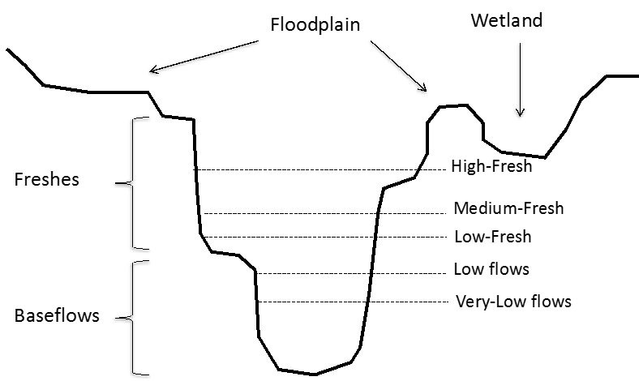

Figure 2. Flow stages defined by Stewardson and Guarino (2018).

2018–19 saw a smaller total volume of environmental water delivered compared to recent years. During 2018–19 around 216 GL of environmental water was released into the lower Goulburn River (Figure 3). Dwarfing this figure, IVT flows of 387 GL were released, a new record well beyond the 258 GL delivered in 2017–18, which was itself a substantial increase on previous years of the LTIM Project. The IVTs completely prevented the delivery of environmental water over the summer and autumn period.

The planned delivery for environmental water in 2018–19 is summarised in Table 2 which also outlines the actual delivery and the conditions that influenced use decisions during the year.

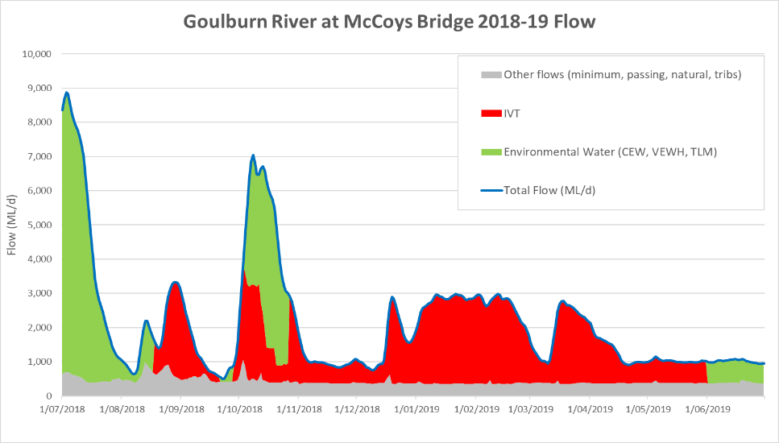

Figure 3. Relative sources of water contributing to total Goulburn River flows in 2018–19

Table 2. Summary of planned and actual environmental flows for the lower Goulburn River 2018–19. Information on planned delivery and expected outcomes from CEWO (2018) and GBCMA (2018). Information on actual delivery provided by CEWO (unpubl. data).

| Flow component type and planned magnitude, duration, timing | Expected outcomes  (primary and secondary as at delivery) | Actual delivery details and any operational issues that may have affected expected outcomes  Comments |
| --- | --- | --- |
| Winter fresh (Jun-Jul) of up to 15,000* ML/day at Murchison/McCoys with 14 days above 6,600 ML/day | Contribute to a winter fresh to provide vegetation and maintain macroinvertebrate habitat.  Also provides benefits to downstream ecological targets including lamprey migration. | This is the ramp-down of the winter fresh which commenced on 26 June 2018. Due to drying conditions across the catchment the planned duration and peak of the flow was slightly reduced to just under 9,000 ML/day. However, the action did deliver 14 days above 6,600 ML/day as planned. At Murchison the peak flow reached 7,542 ML/day on 1 July 2018. At McCoys Bridge the flow peaked at over 8,800 ML/d on 3 and 4 July. |
| Baseflow (July-Sep) 500–940 ML/day at Murchison/McCoys, including a trial of variable winter baseflows between the end of the winter fresh and the start of the spring fresh up to 1500 ML/day | Contribute to baseflows to maintain water quality and provide suitable habitat and food resources for native fish and macroinvertebrates and to water bank vegetation. | From the beginning of August until the end of September, flows averaged over 1,500ML/day at McCoys Bridge with very little CEW used. Early IVT flows saw high flows over this period, ranging from 504 to 3,034 ML/day. Flows were variable, but at higher levels than planned. |
| Spring fresh (Sept-Oct) of up to 10,000 ML/day at Murchison/McCoys Bridge with 14 days above 6,000 ML/day | Contribute to long-duration freshes in spring to water bank vegetation, provide soil moisture to banks and benches, distribute seed and allow plants to flower and seed for later germination and distribution. | The Spring Fresh was delivered as planned, but with lower peak volumes. Flows peaked at 7,041 ML/day at McCoys Bridge, with 11 days above 6,000 ML/day. Much of the fresh was composed of IVT water, up to 2,750 ML/day. |
| Baseflow (Nov-Mar) 500–940 ML/day at Murchison/McCoys | Contribute to baseflows to maintain water quality and provide suitable habitat and food resources for native fish and macroinvertebrate and to water bank vegetation. | Continued high IVT flows meant that summer baseflows were higher than planned. Between November and March, flows averaged 1,973 ML/day, with flows regularly approaching 3,000 ML/day. Planned baseflows were achieved over November to mid-December, averaging 931 ML/day at McCoys Bridge. |
| Autumn fresh (Mar to May) of 5,600 ML/day at Murchison/McCoys for 2 days or 4,600 ML/day for 10 days  Baseflow (Feb-Apr) 500–940 ML/day at Murchison/McCoys | Contribute to a fresh to maintain existing vegetation and encourage germination of new seeds and when coordinated with flows in the Murray River, facilitate fish migration.  Contribute to baseflows to maintain water quality and provide suitable habitat and food resources for native fish and macroinvertebrate and to water bank vegetation. | With high IVT flows over most of the summer, this planned flow event was abandoned. |
| Baseflow (May-Jun) 500–940 ML/day at Murchison/McCoys | Contribute to baseflows to maintain water quality and provide suitable habitat and food resources for native fish and macroinvertebrate and to water bank vegetation. | Baseflows exceeded the upper end of the range for entire period, averaging around 1020 ML/day at McCoys. IVT flows continued through to the end of May, with CEW being used after this. |
| Winter fresh (Jun-Jul) of up to 15,000* ML/day at Murchison/McCoys with 14 days over 6,600 ML/day | Contribute to a winter fresh to provide vegetation and maintain macroinvertebrate habitat.  Also provides benefits to downstream ecological targets including lamprey migration. | This event did not commence in 2018–19, but did begin in July 2019, and will be reported in the first annual CEWO MER Program report. |

## Outcomes of Environmental watering in 2018-19

Findings from 2018–19 for each Goulburn environmental watering action is summarised in Table 3 at the end of this section (page 18) and described in more detail for each monitoring matter in the paragraphs below.

### Physical Habitat

#### Hydraulic Habitat

The hydraulic habitat in a river refers to the characteristics of the water where plants and animals live, for example, slow and fast flowing areas and shallow and deep pools. In the lower Goulburn relationships between flow volumes and the mix of different hydraulic habitats have been identified. Improving the understanding of these relationships has allowed the delivery of targeted flows to maximise habitat (or prevent reduced habitat). Findings include:

* Shallow, slow-flowing water (important for juvenile and small-bodied fish) is maximised at flows of between 1,000 and 5,000 ML/day, peaking at 2,000 ML/day, depending on individual sites.
* Flow triggers for fish movement and spawning have been identified and used on several occasions to guide the delivery of environmental water to encourage movement and spawning, particularly golden perch into the Goulburn River from the Murray River.
* Prolonged inundation of the banks, rather than velocity (speed of flow) or bank scouring, is critical to the loss of vegetation.
* Increases in flow rates significantly increase the potential for river-bed substrate (gravel, sand, leaves, moss, plants) turnover. This ‘disturbance’ is important for refreshing sediment, promoting the processing of organic material and nutrients and providing a mosaic of benthic (in the lowest level of the river, including the sediment) habitats for a range of biota, including macroinvertebrates, algae and macrophytes.
* The inundation of benches (deposits of fine-grained sediment extending above the river bed) generally increases to a maximum between 1,000–5,000 ML/day and as such the vegetation and sediment deposition on benches (Figure 4) is dependent on freshes.
* Hydraulic conditions (such as velocity, depths and bed substrate turnover) for specific biota can be manipulated through flow management. For example, adding a fresh of 5,000 ML/day to baseflow can triple substrate turnover, reducing sediment smothering and increasing bed sediment diversity.

#### Bank Condition

River banks influence the velocity of flow, depth of water, and provide the sediment conditions for habitat niches for vegetation. River bank condition refers to the erosion and deposition of sediment (when sand, mud and pebbles are dropped from the water onto the riverbank or riverbed) over time. A small amount of erosion can help streamside and instream vegetation become established, but excessive erosion can lead to sediment smothering of bed habitats.

Figure 4. Ledges, benches, and bars. Benches and bars are deposits of sediments that form features in a river channel. Ledges are formed by erosion of the river channel creating a relativiely flat surface within the confines of the channel.

Improving the understanding of the relationship between the volume of water flowing through the river, water habitats and river bank condition is informing the delivery of environmental water to positively improve (or prevent a reduction in) animal, plant and overall ecosystem health. Findings include:

* The likelihood of erosion is most strongly linked to the duration of inundation. The longer the duration of bank inundation, the higher the likelihood of minor erosion (< 30 mm). Freshes that inundate sediment after a dry period in summer were hypothesised to result in higher likelihood of erosion (compared to freshes in spring) but the results do not support this, suggesting that if anything winter/spring environmental flows have more influence on erosion.
* The hot season (summer/autumn) leads to a greater likelihood of erosion than the cold season (winter/spring). Observations suggest the sub-aerial drying (desiccation) that occurs in the warmer periods makes the clay-rich banks crack and leaves them prone to erosion once water levels rise. This highlights that preparation of banks may be more important than the flow event that is associated with erosion. It also leads to an important role of vegetation in shading banks from direct sun.
* Notching of riverbanks, whereby a visible line of erosion is associated with the flow level maintained in the previous event, and retreat of the lower bank, was most evident following the 2017/18 and particularly the 2018/19 IVT flow periods (Figure 5a).

#### Artificial Turf Mats – Sediment and Seed Deposition

River flows can disperse sediments and seeds, with flows in winter potentially more important for this because they occur at a time when inflows from unregulated tributaries is higher and sediments are wetter. Dispersed sediments are important for renewal of the river channel and the generation and maintenance of river features such as benches. Dispersed seeds settle in these environments and can germinate following the recession of flows, providing renewal of riparian and within-channel vegetation.

Since winter 2018, turf mats have been used to quantify sediment transport and seeds dispersed by flows (Figure 6). Findings to date include:

* IVT flows in summer result in more sediment depositing on the bars than on higher features (bench, ledges or banks; Figure 4), due to elevated flows at lower levels, but without the high flow events.
* In 2018-19, over 50,000 seedlings from 94 different taxa were successfully germinated in the laboratory, a rate of approximately 2,000 propagules per square meter. These seeds were deposited across a range of flow events throughout the year including both environmental flows and IVTs.
* Environmental flows (the winter and spring freshes) provided around half of the sediment and seeds deposited during the monitoring. The environmental flows were the primary contributor of sediment and seeds to the riverbank, providing three-quarters of the sediment and seed deposition on these more elevated features. Seed diversity on banks was higher in the environmental flows with 12 species represented on each mat on average (compared to 8 species in the tributary flow event and 9 in the IVT).

Deposition has been identified as more prevalent during the colder months. In the 2018/19 period this finding was reinforced by the artificial turf mat study that highlights deposition of sediments on higher bank levels as a result of the winter and spring fresh.

**a)**  **b)**

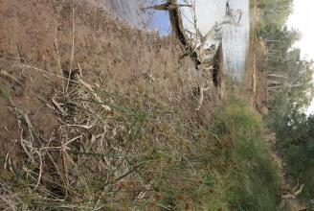

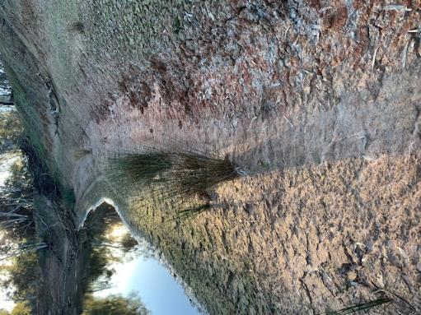

Figure 5. a) Riverbank notching associated with the IVT (Yambuna Bridge, June 2019). b) Deposition on the lower banks provides niches for seed establishment and vegetation growth, even following a highly managed IVT (Loch Garry, May 2018).

It is hypothesised that tributary flows provide the sediments (as a growing medium) and seeds that provide the opportunity for improving bank vegetation, and ultimately bank stability. This suggests that environmental flows could be used to ‘piggy back’ on tributary flows to raise sediments and seeds to drape on benches and banks. These findings require further investigation to confirm.

**a) b)**

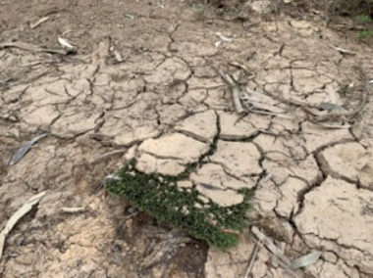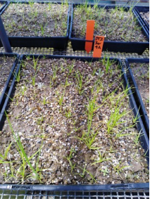

Figure 6. a) turf mat at Loch Garry with substantial sediment deposition; b) seedlings gown out from sediments collected from turf mats

### Stream Metabolism

Stream metabolism provides an estimate of the amount of food (organic carbon) that is produced and consumed within the river (Figure 7). Stream metabolism is measured as the rate of increase and decrease in dissolved oxygen (DO) in the water column. DO increases due to photosynthesis by algae and submerged plants. This produces new plant material that becomes food for organisms (e.g. water bugs and fish) higher up the food chain. DO decreases (is consumed) due to respiration (the consumption of that food) by aquatic plants, bacteria, fungi and animals. If the rates of production are too low, this will limit the amount of food resources (bacteria, algae and water plants) for consumers (e.g. shrimps and fish). This limitation will then constrain populations of larger organisms including fish and amphibians.

Healthy aquatic ecosystems need both processes to produce food and to break-down dead plants and animals (detritus) and their waste products, including organic material and nutrients, which are recycled to enable further plant growth to occur. Organic carbon food sources (e.g. leaves and bark) can also enter the river from the surrounding land during high flows and flood events that wash organic material off the river banks and floodplain.



Figure 7. Relationships between photosynthesis, respiration, organic matter, dissolved gases and nutrients.

Findings to date include:

* Small in-channel increases in flow rate can have positive benefits for the energy ('food') underpinning aquatic foodwebs. However, higher flows that reach the floodplain are expected to have an even larger benefit to energy (food) production.
* Commonwealth environmental water was responsible for about a quarter of the organic carbon created by photosynthesis over the five-year period. Larger flow increases that do move the water out of channel and then back again will provide even greater benefit due to the introduction of higher organic carbon and bioavailable nutrient concentrations.

### Diatom production

Biofilms are the assemblages of algae (including diatoms, cyanobaterial and chlorophytes), bacteria, fungi, silt and detritus found on hard surfaces in the river such as logs. They occur naturally through the growth of benthic (attached to hard surfaces) algal species. Algal biofilms can represent a major food source for macroinvertebrates. Water level variations, such as those that occur with the delivery of environmental water, are known to influence rates of growth and species composition, making biofilms a potentially valuable indicator of changes in response to flow regime.

As part of the 2018–19 monitoring program a preliminary investigation looking at biofilm production (Figure 8) before, during and after the spring fresh delivered in mid-October 2018 and before, during and after IVT flows in summer 2019 (January – April 2019) showed that:

* The spring fresh delivered in mid-October was associated with a general decrease in the biomass of algal biofilms on hard substrates and altered biofilm community composition from diatom dominated to cyanobacterial and chlorophyte dominated. The reduced biomass, plus the fact that cyanobacteria are less preferred as food sources, could lead to reduced food availability for macroinvertebrates and in turn fish.

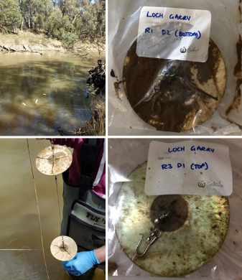

Figure 8. Artificial samplers for assessment of algal biofilm production. Top left: samplers deployed at Loch Gary; Bottom Left: Separation of disks to assess impact of water depth; Top and Bottom right: disks after retrieval from Loch Gary showing presence of biofilms.

* Summer IVT flows were associated with an increase in biofilm biomass and alteration of the community structure with an increase of chlorophytes and a decrease in diatoms. Like the spring fresh, the IVT may result in an overall reduction in available food for macroinvertebrates.
* A lower biofilm biomass was observed on hard surfaces in summer compared to winter. The sustained high flows during summer, which resulted in increased flow rates, increased turbidity and water depth, would have increased scour of biofilms and may also have reduced light levels in the water column. Smothering of biofilms would have also increased with the increased suspended sediment levels, and this could be an additional explanation for this observation.
* There is a greater mass of algal biofilms at shallow depths where light penetration is greater into the water column. These areas will be more valuable habitats for macroinvertebrates.

The findings above come from a single year of investigation. Further investigation into the colonisation process of algal biofilms under different flow patterns and at different times of the year in the Lower Goulburn would test whether the patterns observed are general.

### Macroinvertebrates (large water bugs)

Macroinvertebrates (e.g. insects, snails, shrimps, prawns) are an essential part of healthy aquatic ecosystems. They help to recycle nutrients through the consumption of plants and dead organic material and also provide food for larger aquatic animals such as fish. They are also used throughout the world as general indicators of river ecosystem health. Healthy ecosystems tend to have a larger number (diversity) of different macroinvertebrate types (species) compared to unhealthy ecosystems. Healthy ecosystems also tend to have a larger number of macroinvertebrate species present that are sensitive to poor water quality (e.g. mayflies, caddis flies, stoneflies), while in systems with poor water quality, these species are missing. A lack of their presence is a sign that remedial action is required.

Monitoring in the Goulburn River tells us that:

* An increase in flows will increase the abundance (number) and biomass (combined weight) of macroinvertebrates, however, the diversity (different types of water bugs) is not affected.
* Several species across different broad groups show a consistent increase in abundance and biomass in response to environmental flows in spring. Large bodied crustaceans such as shrimp and prawns make up the majority of biomass.
* Much larger increases in the biomass of large-bodied crustaceans (shrimps and prawns) was observed following the large, natural overbank flows in spring 2016–17, demonstrating the importance of natural overbank flows to macroinvertebrate populations in the river (Figure 9). However, although current river operation rules mean that overbank flows are not possible, in-channel high flows using environmental water are important for helping to promote biomass of crustaceans into warmer, dryer months.
* Aquatic vegetation appears to provide an important source of food and shelter to macroinvertebrates. An example comes from Loch Garry where in the summers of 2018 and 2019 a combination of earlier freshes along with higher summer flows inundated dense bank vegetation that provided a sheltered environment to support numerous immature crustaceans (shrimps, prawns and yabbies) that may otherwise have been washed downstream.
* High winter flows using environmental water are valuable for sustaining macroinvertebrate populations over winter, including to increase the abundance and biomass of prawns. This is not the case for shrimps where numbers decreased during these flows.
* During winter crustacean species have a clear preference for sections of the Goulburn River, with shrimps (*Parataya australiensis*) more abundant in the upstream reaches and prawns (*Macrobrachium australiense*) more abundant downstream reaches of the Goulburn River.
* Providing environmental flows for bank and aquatic vegetation from winter to the end of summer also ensures sources of food and shelter for macroinvertebrates. This includes, for example, shrimps, which are more likely to be detected in complex habitats (vegetation).

To understand how beneficial environmental flows are on sustaining crustacean populations future monitoring should incorporate assessment of habitats and crustacean movement (abundance, biomass, recruitment) across a number of sites along the Goulburn River. It is hypothesised that the link between habitat (vegetation), flow and crustaceans is important for maintaining these populations.

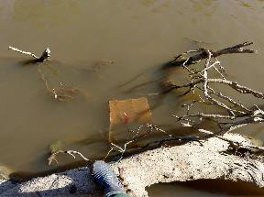

Figure 9. Crustacean bait trap (submerge box-shapped net) deployed in snags at Loch Garry 2019. Crustaceans enter the trap though a funnel in the end and are trapped in the box.

### Bank Vegetation

Riparian and aquatic vegetation underpins aquatic systems by: (1) supplying energy to support food webs, (2) providing habitat and dispersal corridors for fauna, (3) reducing erosion and (4) improving water quality. River flow components shape plant communities on the river bank by influencing: (1) inundation patterns across elevation zones on the bank and hence which plants are promoted in each zone; (2) the abundance and diversity of plant propagules (seeds and plant fragments that can grow into new plants) dispersing in water; and (3) where those propagules are deposited and germinate.

Monitoring in the Goulburn River tells us that:

* Inundation provided by spring freshes influences the distribution of vegetation up and down the bank. Several species adapted to wet habitats have higher cover in areas inundated by spring freshes. In contrast, the perennial native grass common tussock grass(*Poa labillardierei*) is restricted to areas above those inundated by spring freshes. This pattern of species distribution has persisted over time.
* The recruitment of woody species, specifically silver wattle (*Acacia dealbata*) and river red gum (*Eucalyptus camaldulensis*) is generally restricted to higher areas of the bank that experience shallow and less frequent inundation.
* Vegetation on the lower bank declined following prolonged high flows from IVTs in 2018–19, but vegetation at higher elevations was not impacted (Figure 10).
* Despite short-term increases in the cover of water dependent vegetation there has not been a sustained increase in cover of water dependant plants as a group.
* Climatic conditions and other river flow events can override responses to environmental watering. For example, in 2014–15 dry climatic condition and low unregulated flows was associated with reduced cover of one species – lesser joyweed (*Alternathera denticulata*), while flooding in 2016–17 was associated with increased cover. In contrast, summed cover of sedges (Cyperaceae) did not decline over dry conditions in 2015–16 but was severely reduced following flooding in 2016.

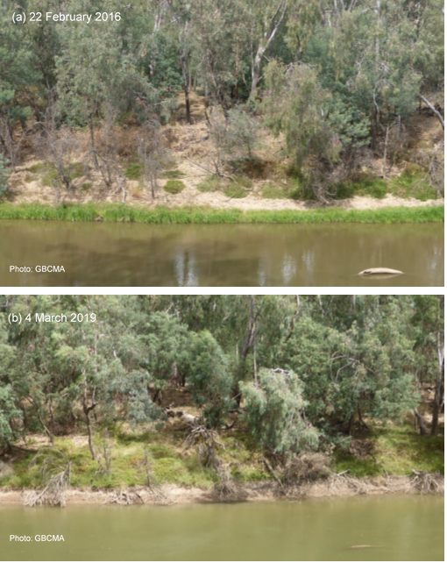

Figure 10. changed patterns of vegetation coverage with IVT flows. In February 2016, vegetation is present at the low water margin following low summer flows, while in March 2019, vegetation appears dead in this area.

* Species are not evenly distributed on the bank face but occur in zones that reflect each species tolerances to and affinity for the inundation experienced at different elevations. During periods where inundation experienced at an elevation on the bank is not favourable, the occurrence and or cover of the species may decline at that location. In contrast, it may be maintained or increased at other locations on the bank that experience more suitable inundation regimes.
* Long-term trends show that while the cover of ground layer vegetation is increasing on the banks this increase is largely due to grasses, particularly common tussock grass at higher elevations. In contrast water dependant vegetation tends to occur at lower elevations and does not show a long-term pattern of increase, despite observed increases following spring freshes. Improving the abundance of vegetation at the toe of the bank and on the lower bank remains a management challenge and increases in IVT delivery to meet consumptive demand adds to this challenge.
* Suitable flows can improve the occurrence and cover of vegetation on the lower bank. Although newly established plants are vulnerable to high flow events, plant were able to re-establish from portions below ground. Recovery following IVT delivery is likely to be less rapid as few remnant plants were observed. Recovery will be assessed in December 2019 as part of the MER program.

### Native Fish

The Goulburn River supports a diverse native fish fauna with high conservation and recreational angling value. Species of conservation significance include trout cod, Murray cod, silver perch, golden perch, Murray River rainbowfish and freshwater catfish. Conservation of the fish fauna of the Goulburn River has been recognised as a high priority by fisheries management and natural resource management agencies. In particular, the provision of environmental flows to support native fish populations has been identified as a key environmental watering objective for the Goulburn River. Responses of native fish to environmental flows are being monitoried through three sub-programs in the Goulburn River. Summaries of these programs appear below.

#### Adult fish

Annual fish surveys in the Goulburn River provide information on trends in the composition, abundance and population structure of fish species in the Goulburn River. This demonstrates long-term responses to environmental flows and other management actions. The lower Goulburn River supports several species of conservation significance, including the nationally threatened silver perch, Murray cod, Murray River rainbowfish and trout cod (Figure 11).

1. **b)**

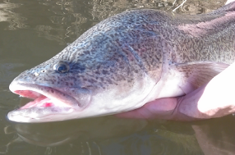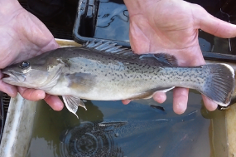

**c) d)**

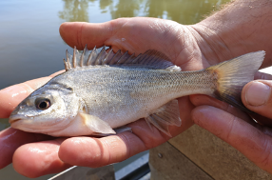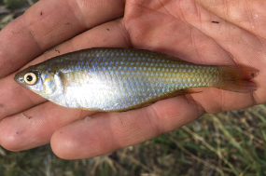

Figure 11. Species of conservation significance found in the Goulburn River: Murray cod (a), trout cod (b), silver perch (c) and (d) Murray river rainbowfish

Key findings include:

* Silver perch were generally collected in low numbers in the surveys, although abundance increased considerably in 2017, likely due to increased immigration following high spring flows in 2016 and managed flow releases in summer/autumn 2016–17.
* Murray cod abundance decreased in 2017, following a hypoxic blackwater event in the Goulburn River in January 2017. Abundance decreased again in 2018, and in the following year (2019) remained at similar levels. Reasons for the continued reduced abundance in 2019 are unclear, although results from the Victorian Environmental Flows Monitoring and Assessment Program (VEFMAP) show there was a considerable increase in abundance of Murray cod in the reach upstream of Shepparton. This could indicate immigration upstream into this reach (Tonkin et al. 2019).
* Murray River rainbowfish decreased in abundance in the last two years (2018 and 2019), potentially related to prolonged high summer flow conditions due to inter-valley transfer (IVT) flows that would reduce shallow, slow-flowing habitat favoured by small-bodied fish. To better understand the potential effects of IVT flows on fish, it is recommended that a monitoring program be designed and implemented specifically for this purpose.
* Although adult trout cod were not common in the surveys, the collection of larvae in the last two years (2017 and 2018) across a range of sites (Pyke Road, Loch Garry, McCoy’s Bridge, Yambuna) demonstrates that breeding populations exist in the lower Goulburn River.

#### Fish Spawning

Fish spawning surveys for the lower Goulburn River collect eggs and larvae of a range of fish species but are designed primarily to detect golden perch spawning. Key findings include:

* A rise in river flow coupled with appropriate water temperature for spawning of golden perch (~18.5 °C) and silver perch (~25 °C) is important in the Goulburn River. In general, levels of spawning activity were highest during within-channel flow pulses or bankfull flows around November/December. This included periods of targeted managed flow releases (i.e. ‘freshes’). These results demonstrate that environmental water allocation in the Goulburn River can effectively enhance or trigger spawning of golden perch and silver perch.
* Multiple flow events that are closely timed (e.g. 1-2 weeks apart) might also increase spawning activity because egg concentrations often peaked in association with the second spring-summer flow event (e.g. 2010, 2013, 2014, 2017). Flow conditions in the pre-spawning period may also influence levels of spawning, with anecdotal evidence suggesting improved spawning in years when flows in the pre-spawning period were more variabe.
* Adult trout cod were not common in the surveys, but the collection of trout cod larvae in 2017 and 2018 demonstrates that breeding populations exist in the lower Goulburn River. Murray cod larvae were also collected in each year of the surveys across range of sites, showing that this species spawns annually in the lower Goulburn River (Figure 12).

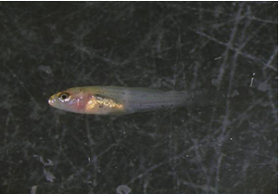

Figure 12. Murray cod larvae collected in the lower Goulburn River

#### Movement of golden perch

The ability for fish to move within and between water-dependent ecosystems can be crucial for sustaining populations by enabling fish to recolonise or avoid unfavourable conditions (e.g. low flows, poor water quality). For some fish species (e.g. golden perch), movement also occurs for the purposes of reproduction (e.g. to a location in the river system that provides suitable spawning habitat or better conditions for juvenile fish survival).

Movement of fish monitoring in the Goulburn River LTIM Project focuses on golden perch (Figure 13). The results show that:

* Higher flows in spring-early summer, including bankfull flows and the delivery of within-channel ‘freshes’, can promote movement of golden perch, within the Goulburn River, and between the Goulburn and Murray rivers.
* Movement was most prevalent during the spawning season (spring to early summer) and occurred primarily in a downstream direction into the lower river reaches, typically followed by return upstream movements.
* A strong association between long-distance fish movement and the occurrence of spawning has also been demonstrated and provide a valuable and unique insight into the likely underlying purpose and importance of movement (i.e. spawning).

In addition, winter-focused monitoring in 2018 included tagging of migrating lamprey on the Murray Barrages to support a South-Australian Research and Development Institute (SARDI) project investigating lamprey spawning migrations in the River Murray. Unfortunately, very few lamprey were collected and tagged in winter 2018 (6 pouched lamprey and 1 short-headed lamprey). It is not possible to draw conclusions regarding the importance of Goulburn River flows for migration of this species. Further details of this project can be found in Bice et al. (2019).

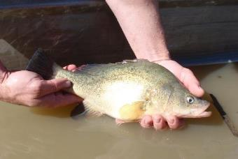

Figure 13. Golden perch being released after tagging with an acoustic transmitter

#### Recruitment of Murray cod and golden perch

Fish recruitment is monitored primarily through VEFMAP. That program shows that Murray cod populations in the Goulburn River consist almost entirely of in situ recruitment. In contrast, the golden perch population in the Goulburn River consists mostly of stocked fish, although spawning events in the Goulburn River do result in some in situ recruitment and are a source of fish to the Murray River. Results from this program suggest that autumn flow conditions are important for the recruitment of sub-adult fish in local populations through to adulthood (Tonkin et al. 2017).

Table 3. Summary of observed responses to flow actions in 2018–19. Where observed responses cannot be related to an individual flow component, cells are merged.

| Monitoring Matter | Winter fresh (Jul) | Early Spring fresh (mid-Sep to mid-Oct) | Late Spring fresh (late Nov) | Enhanced winter base flows (Aug-Sep) | Recession flows (mid Dec) | Inter-Valley Transfers (Feb-Apr) |
| --- | --- | --- | --- | --- | --- | --- |
| Physical habitat – bank condition | The highest rates of deposition on riverbanks during the 5-year monitoring period (approximately 60% of assessment points received sediment deposition). | Active riverbanks with both erosion and deposition more likely during Spring fresh. Greater prevalence of vegetation increases complexity of response. | | No riverbank changes evident. | | Notching is extensive in the common IVT water level zone between 1,500 and 2,500 ML/d, with two-thirds of the bank prone to notching. This includes erosion of the lower banks in this zone. |
| Turf mats – sediment | All in-channel features were submerged and received flow-delivered sediment and seeds. On average, 8 kg of sediment and 2800 seeds from 13 different species were deposited per square metre, with more sediment deposited on low-level features such as bars and more seeds deposited on both bars and higher-level features such as benches. | All in-channel features were again submerged and received flow-delivered sediment and seeds. On average, 12 kg of sediment and 1800 seeds from 12 species were deposited per square metre, with more sediment deposited on low-level features such as bars and more seeds deposited on both bars and higher-level features such as benches. River bottlebrush seeds were commonly deposited during this period. |  | This flow was lower than the winter and spring freshes and only inundated lower-level features in the river channel. Bars received deposition of 10 kg of sediment and 1800 seeds per square metre from 13 species, while riverbanks received 0.8 kg of sediment and 500 seeds per square metre from 8 species, on average. Importantly, the event saw the greatest numbers of river red gum seeds deposited. River red gums are known to time seed release with natural periods of high flows. |  | Lower features such as point bars and lower banks were inundated for long periods, with large amounts of sediment and seeds deposited on bars (29 kg of sediment and 3200 seeds per square metre). The diversity of seeds deposited on the bars was also high with 16 species represented on each turf mat on average. Riverbanks that were inundated received less deposition with around 6 kg of sediment and 300 seeds per square metre from 9 species. Higher-elevation features (some banks and benches) were not inundated and did not receive any flow-delivered sediment or seeds. |
| Turf mats - seed |
| Stream metabolism: carbon production and respiration | This watering action (nominally from 1st July to 17th August, 2018) contributed 19.5 tonnes of organic carbon (food) out of a total of 21.8 tonnes; a contribution of 89.7%. Data from McCoy’s Bridge. | Over the event period (21 September to 26th October, 2018), 43.3 tonnes of organic carbon (food) was created by GPP. Of this, 34.5 tonnes, or 79.5%, was associated with the watering action itself. |  |  |  |  |
| Diatom production |  | Preliminary results show a general trend of decreased biomass following delivery of the spring fresh. We interpret this as the removal of older algae, allowing renewal of the biofilm as a better food resource for macroinvertebrates. |  |  |  | Preliminary results show an increase in biofilm biomass post IVT. However, this observation could also be a reflection of elevated flows that occurred during pre-IVT sampling, and which could have reduced biofilm biomass during that period. |
| Macroinvertebrate biomass (combined weight) and diversity |  | Increased abundance and biomass of some groups. |  |  |  |  |
| Macroinvertebrate biomass (combined weight) and abundance? |  | Increased abundance and biomass of freshwater prawns and shrimps, plus immature crustaceans. |  |  |  | Sustained crustacean populations |
| Macroinvertebrates – winter habitat use | Crustacean species have a clear preference for sections of the Goulburn River, with shrimps more abundant in the upstream reaches and prawns more abundant downstream reaches of the Goulburn River. While there was no clear habitat preference from this preliminary data, freshwater shrimps are more likely to be detected in complex habitats (vegetation). |  |  |  |  |  |
| Bank vegetation abundance and diversity |  | Findings from 2018–19 supported those from earlier years. The mean summed cover of water dependent taxa at both Loch Garry and McCoys Bridge increased following spring freshes in 2014–15, 2015–16 and 2018–19, while the mean summed cover of grass species decreased or remained the same. While this pattern is correlated with spring freshes it is not known what portion of the increase in cover can be attributed to seasonal patterns of plant growth that would have occurred without the delivery of spring freshes. |  |  | Overall ground cover vegetation increased in the period September to December, mostly attributed to grasses. | Increased consumptive demand for water in 2018–19 resulted in higher and more prolonged river discharges delivered as IVT over summer months. These flows appear to have reduced the occurrence of vegetation along the toe and lower bank in March 2019. |
| Native fish movement |  | Only one golden perch undertook a long-distance movement in the lower Goulburn River in October-November 2018, coinciding with a spring fresh environmental flow release. The limited amount of movement detected in 2018 may reflect an absence of flow events during the peak movement period (November). Many (70%) of the transmitters have also expired. Some tagged fish may have also succumbed to the January 2017 blackwater event. | |  |  |  |
| Native fish spawning |  | Spawning of golden perch was detected on the receding limb of a spring fresh environmental flow release delivered in October 2018, but much fewer eggs were collected compared to other years where flow events occurred around November-December when water temperatures were higher. | |  |  | Silver perch eggs were collected coinciding with an increase in flow in mid-December 2018 associated with inter-valley transfer flows. |
| Fish assemblage composition and abundance | Three species of conservation significance were collected in the autumn 2019 surveys: Murray cod, silver perch and Murray River rainbowfish. Australian smelt was the most abundant species collected in 2019, similar to the results of previous surveys. Young-of-year (YOY) Murray cod were collected in the 2019 surveys. No YOY golden perch or silver perch were collected. Natural spawning contributes substantially to the Murray cod population in the lower Goulburn River. Currently, the golden perch population in the Goulburn River consists mostly of stocked fish, although spawning in the Goulburn River and immigration of fish from the Murray River also contribute to the population. Whilst in situ recruitment is low in the Goulburn River, the Goulburn River is also a source of fish to the Murray River. | | | | | Murray River rainbowfish decreased in abundance in 2018 and 2019. Prolonged high summer flow conditions due to IVTs occurred in the Goulburn River in 2018 and 2019. Increased summer flows which reduce slow-flowing habitats have the potential to affect larval and juvenile recruitment for species such as Murray River rainbowfish that spawn during warm, low flow periods. |

# Environmental watering 2014–15 to 2018–19

Environmental water has now been delivered to the lower Goulburn River since 2014–15. This provides an opportunity to summarise the overall environmental water delivery and general findings over the past 5 years

## Environmental water delivery 2014–2019

The five graphs in Figure 14 show the total flows at McCoys Bridge and the break-down of environmental water and IVT for each of the five years of the LTIM project. Spring freshes have been delivered in all years except 2016 when spring flooding occurred. Winter freshes were delivered in 2015, 16 and 18. Natural flows during this period range from quite wet (2016–17) to very dry (2015–16). A recent feature is the large increase in IVT flows in the last two years. The variations between years reflect the rainfall and temperature patterns over this period, irrigation demand and the implementation of learnings from the LTIM monitoring. More details are available in the LTIM reports for these years.

## Key outcomes from environmental water use

Over the past five years responses to environmental flow actions were observed for all environmental monitoring matters: physical habitat (hydraulic and bank condition), stream metabolism, macroinvertebrates, bank vegetation and native fish. Responses are summarised below (Table 4).

|  |  |
| --- | --- |
|  |  |
|  |  |
|  | Figure 14 Summary of environmental water delivery in the lower Goulburn River 2014–15 (a), 2015–16 (b), 2016–17 (c), 2017–18 (d) and 2018–19 (e). Chart shows total flow rate (ML/d) at the McCoys Bridge gauging station near the bottom of the system, along with managed environmental flows delivered at that point, and inter-valley transfer flows. Each panel has the same maximum y-axis value to facilitate comparison among years. For panel (c) peak flow rates are shown for the three events that extend beyond the top of the y-axis. Evaluation in this report covers the period from the start of the monitoring program (~September 2014) to the collection of adult fish monitoring data in May 2019. |

Table 4. Summary of observed responses to flow actions for the four years 2014–15 to 2018–19.

| **Matter** | **Major Ecological Outcomes 2014–15 to 2018–19** |
| --- | --- |
| Physical habitat - hydraulic habitat | * As flow increases (up to 2,000 ML/day), the area of still and slow flowing (slackwater) habitats increase. These areas are important habitat for small fish and macroinvertebrates, and are ideal sites for vegetation establishment. * As flow increases further (to around 5,000 ML/d) the area of pool habitat for larger native fish increases. * Adding a fresh of 5,000 ML/day to baseflow helps remove accumulated sediment from the river bed and hard surfaces such as submerged large wood habitat, greatly increasing the quality of habitats for macroinvertebrates. * High flows that inundate benches and banks enhance sediment transport and deposition which help provide good conditions (increased soil moisture and slow flowing areas) for vegetation germination and growth. |
| Physical habitat – bank condition | * Current environmental flows do not cause more erosion than would occur under natural flows. * Bank erosion and deposition are highly variable along, and up and down the banks, and over time, with a single point on the bank often changing from erosion to deposition with subsequent flow events. * The peak flow or volume of water is not related to bank erosion. * Slow drawdown rates can promote deposition and the development of mud drapes that encourage vegetation establishment. Fast drawdown rates can increase minor erosion. However, there is no influence of the rate of drawdown on significant erosion events (i.e. erosion > 30 mm). * In 2018–19, following the high IVT flows, greater rates of both erosion and deposition were observed. However, the proportional change from previous years was small. * Notching of the lower bank has been observed where high IVT flows were delivered at constant levels over summer |
| Turf mats - sediment | * Turf mats were effective at monitoring sediment deposition on channel features under different flow events. * The winter and spring freshes provided around half of the sediment and seeds deposited across the turf mat monitoring. The environmental flows were the primary contributor of sediment and seeds to higher sections of the riverbank, providing three-quarters of the sediment and seed deposition on these features. * IVT resulted in more sediment being deposited on bars rather than on higher bank features. * Across all flow events the highest deposition occurred on bars with the lowest deposition occurring on benches and ledges. |
| Stream metabolism: production and respiration | * Stream metabolism (the amounts of carbon created and consumed each day) increases with increasing in-channel flows up to around 4,000 ML/d. This represents a benefit to the total food resources produced for fish and other organisms, especially at small flow increases. However, it is still suggested that larger flows that inundate flood runners and parts of the floodplain would provide even greater benefits. * Metabolic rates are seasonal with highest rates during December–January, typical of those in the southern Murray-Darling Basin but at the lower end of the ‘normal’ range on a global comparison. * Over the five years at McCoy’s Bridge, it was estimated that Commonwealth environmental water produced about a quarter of the organic carbon created by GPP over the five-year period. With greatest benefits in spring-time and winter when 35–73% and 60–65% respectively of all GPP was associated with the extra CEW of winter-time organic carbon load in the final three years of the LTIM project. * Low DO as a result of summer tributary inflows of poor quality water associated with intense storm events occurred in 3 of 5 years (2014–15, 2016–17 and 2017–18), and caused an anoxic event in 2016–17 that resulted in fish kills. |
| Algal Biofilms | Results from preliminary investigations over one-year show:   * Elevated flows (environmental or for consumptive purposes) result in reduced algal biofilm biomass on hard substrates and alterations to the relative biofilm community composition from diatom dominated to cyanobacterial and/or chlorophyte dominated. This may reduce food availability for macroinvertebrates. * Seasonal differences are observed in biofilm abundance and composition. It is unclear if this is due to managed flows or environmental factors. Further investigation is needed to elucidate this. |
| Macro-invertebrate biomass and diversity | * Macroinvertebrate richness, abundance and large crustacean biomass increased in both the Goulburn and Broken rivers following natural winter/spring floods in 2016. * Smaller environmental flows also resulted in increased macroinvertebrate biomass and abundance, although the effect was smaller when compared with natural events. * Crustacean abundance and biomass generally increased in the edge habitats after the CEW suggesting complex habitats, particularly aquatic vegetation refuges are important for these species. * The January 2016 blackwater event resulted in a decline in water quality, increasing stress, mortality, and causing macroinvertebrates to drift downstream. * Winter flows may be important in sustaining crustacean abundance and biomass and suggests it is important to monitor multiple sites within a catchment to understand drivers of key crustacean populations. |
| Bankside vegetation abundance and diversity | * High flow events provide soil moisture to the banks that help plant establishment and growth. * Early spring freshes promoted the establishment and growth of flood tolerant plants and reduced the occurrence of terrestrial plants on the banks of the Goulburn River. * Cover and occurrence of flood tolerant vegetation has risen over the term of the LTIM Project, but appears to have reduced following high IVT flows in summer 2018–19. * Natural flooding and spring freshes help reduce the cover of exotic pasture grass. However, prolonged natural flooding in spring 2016 also caused declines in cover and presence of some native species. * Despite short-term increases in the cover of water dependent vegetation there has not been a sustained increase in cover of water dependant plants as a group |
| Turf mats - seeds | * Turf mats were successful at capturing seed deposition under a range of flow events. * Seed abundance tended to be highest on ledges and bank features. * Darcy’s track and Loch Gary had similar rates of deposition. McCoy’s Bridge had the lowest rates of deposition. * Winter freshes and IVT flows tended to deposit the greatest number of seeds, but the results varied amongst sites and channel features. * More than 50,000 seedlings from 94 different taxa were successfully germinated for seeds deposited on turf mats * More than 50 percent of seedlings were from two species of rush (*Juncus usitatus*, *Juncus amabilis*) and one sedge (*Cyperus eragrostis*) * Tributary inflows may help provide sediment that enhances seedling germination, but further investigations are required to confirm this. |
| Native fish movement | * Golden perch undertake large-scale (e.g. 10s-100s of km) movements during the spawning season in association with high flows, including during periods of targeted managed flow releases. * Movements occur predominantly downstream to the lower reaches of the Goulburn River, or into the Murray River, followed by a return upstream movement. * A strong association between long-distance fish movement and the occurrence of spawning suggests reproduction is a driver of fish movement. |
| Native fish spawning | * Golden perch spawn in response to increases in flow and appropriate water temperature (>18.5 °C) in the lower Goulburn River, including within-channel flow pulses or bankfull flows especially around November-December, including during targeted managed flow releases (i.e. ‘freshes’). * Silver perch spawn in response to increases in flow and appropriate water temperature (>25 °C) in the lower Goulburn River, including within-channel flow pulses or bankfull flows especially around November-December, including during periods of targeted managed flow releases. * Silver perch eggs were also collected coinciding with an increase in flow in mid-December 2018 associated with inter-valley transfer flows. * The collection of trout cod larvae in the last two years (2017 and 2018) across a range of sites (Pyke Road, Loch Garry, McCoy’s Bridge, Yambuna) demonstrates that breeding populations exist in the lower Goulburn River. |
| Fish communities (composition and abundance) | * The lower Goulburn River supports significant populations of native fish, including several species of conservation significance, namely Murray cod, silver perch, Murray River rainbowfish and trout cod. * Murray Cod spawn annually in the lower Goulburn River regardless of river discharge. Natural spawning contributes substantially to the Murray cod population in the lower Goulburn River. * Silver perch were generally collected in low numbers in the surveys, although abundance increased considerably in 2017, likely due to increased immigration following high spring flows in 2016 and managed flow releases in summer/autumn 2016–17. * Murray River rainbowfish decreased in abundance in the last two years (2018 and 2019), potentially related to prolonged high summer flow conditions due to inter-valley transfer (IVT) flows. To better understand the potential effects of IVT flows on fish, it is recommended that a monitoring program be designed and implemented specifically for this purpose. * Adult trout cod were not common in the surveys, but the collection of larvae in the last two years (2017 and 2018) across a range of sites (Pyke Road, Loch Garry, McCoy’s Bridge, Yambuna) demonstrates that breeding populations exist in the lower Goulburn River. * Currently, the golden perch population in the Goulburn River consists mostly of stocked fish, although spawning in the Goulburn River and immigration of fish from the Murray River also contribute to the population. Whilst in situ recruitment is low in the Goulburn River, the Goulburn River is also a source of fish to the Murray River. |

## Integration of monitoring results

After five years of monitoring in the lower Goulburn River LTIM Project, and with the increasing incorporation of data collected prior to the start of the LTIM Project, our understanding of the system has increased considerably. The conceptual model linking flow actions and ecological outcomes that we proposed prior to the start of the LTIM Project (Webb et al. 2018), has been largely confirmed. The current-year version of the model (Figure 15) includes new causal pathways compared to the original, and most of these pathways, as well as the original hypothesised pathways, while not proven are being at least strongly suggested by the monitoring data collected.

The largest addition to our knowledge of the Goulburn system in 2018–19 stemmed from the ‘winter’ monitoring added to the project in the final year. Turf mat monitoring demonstrated the importance of winter tributary inflows for the transportation and deposition of sediments and seeds in the river system, functions that cannot be entirely filled using environmental water because water released from dams has low levels of seeds and sediments. The extension of metabolism monitoring to cover winter 2018 allowed us to quantify the production benefits of the winter fresh – a major environmental water delivery that had until then not been explicitly monitored. Monitoring of water bug habitat use during the winter fresh also demonstrated that large crustaceans (yabbies and prawns) make use of the new habitats created by this flow event. Finally, the inclusion of diatom monitoring showed that biofilms respond to flow events, with biomass decreasing, presumably as diatoms are scoured from surfaces. However, the timing of flows is important for determining the outcomes with some increases in biofilms seen during the summer IVT flows.

The other monitoring undertaken for the LTIM Project in 2018–19 did not reveal any specific new knowledge, but did not contradict any of the conclusions reached through the previous four years of monitoring under LTIM.

The largest knowledge gap within the conceptual model (Figure 15) remains the linkages from the other monitoring matters through to adult fish populations in the Goulburn River. Although large numbers of eggs and larvae of species like golden and silver perch are recorded, the juvenile ‘young of year’ fish that should appear during the electrofishing surveys approximately six months later are rarely caught. Moreover, although there are strong links between flows, metabolism, carbon and large-bodied macroinvertebrates (i.e. fish food), the current approach to monitoring adult fish cannot detect any direct responses in terms of changes in the numbers and species of fish being caught. Similarly, a link between improved near-bank habitat that results from improved bankside vegetation and fish populations (composition and abundance) also cannot be demonstrated because the adult fish sampling does not target habitats specifically.

Links between environmental flow actions and improved fish communities will always be difficult to demonstrate primarily because of issues of scale. Fish respond to multiple drivers over lifetimes that can be literally decades long, and so detecting changes in populations driven by subtle changes in flow regimes will always be difficult. Changes in populations are only immediately evident when catastrophic events occur, such as the January 2016 fish deaths in the Goulburn River associated with the blackwater event. These time scales make it impossible to make the kinds of linkages to individual flow actions that are described in Table 4.

Also, many fish species live their lives over areas much larger than the lower Goulburn River. While the monitoring has failed to detect ‘young of year’ fish for golden perch, older adults continue to be observed in the river. They must be coming from somewhere! Current integrated monitoring and research across the lower Murray–Darling Basin is pointing to the strong probability that species like golden perch might recruit from different locations in different years, and that autumn flow conditions are important for the survival of sub-adult fish in local populations (Tonkin et al. 2017). For questions of adult fish population response to Commonwealth environmental water, the Basin-scale analyses will have a much greater chance of drawing solid conclusions than any of the current Selected Area monitoring programs.

Nevertheless, the provision of ‘contingency’ funding in the newly commenced Monitoring, Evaluation and Research (MER) Program will allow us to undertake a multidisciplinary research project to better explore the linkages between flow, the provision of different kinds of habitat, and responses by macroinvertebrates and the fish that feed upon them. We are in the early stages of planning this project and plan to implement it during 2020.

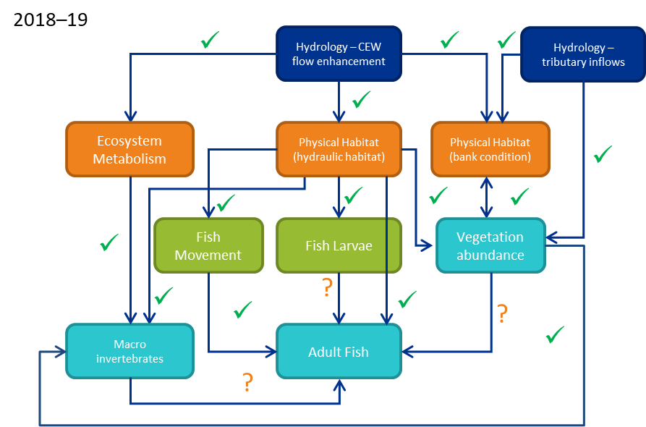

Figure 15. Updated conceptual model of the linkages among the different monitoring matters in the lower Goulburn River Long-Term Intervention Monitoring Project (modified from Webb et al. 2018). The blue ‘hydrology’ box is the ultimate cause – flow enhancement with Commonwealth environmental water, plus with the addition now of unregulated tributary inflows as an additional major hydrologic driver; orange boxes are physical effects of this, with flow on effects to intermediate (green) and ultimate (aqua) environmental variables. Arrows are hypothesized causal linkages posed at the start of the LTIM Project (with several added since as well). Ticks are linkages that we believe have been demonstrated by the monitoring data, or at least strongly suggested. Question marks are linkages that are yet to be demonstrated. The linkage between bank condition and vegetation diversity, with both symbols, is strongly suggested. No linkages have been disproved throughout the program.

# Implications for Future Management of Environmental Water

## Spring freshes

**Recommendation: At least one spring fresh is prioritised every year**

Results from monitoring in 2018–19 build further on those from previous years to underscore the importance of the spring fresh watering actions for ecological outcomes in the Goulburn River. Spring freshes have been convincingly linked with:

* Increased carbon production to underpin the food chain
* Renewal of biofilms that underpin the food web
* Increased biomass of large-bodied crustaceans that are an important food resource for native fish,
* Improved bankside vegetation condition through the summer months, with wetting of the bank in early spring helping plants to survive hotter and drier conditions later in the year
* Movement and spawning of the iconic native fish species golden and silver perch

The specific timing and duration of the fresh depends upon the target ecological endpoints, which vary among years. Vegetation is favoured by earlier, longer freshes in around September, while golden perch and silver perch are advantaged by short sharp freshes late in spring and early summer when water temperatures are above 18°C.

This is not to suggest that other flow actions are not important. However, environmental water managers need to consider limitations on the amount of environmental water available and particularly in dry years, trade-offs are necessary. It is recommended that at least one spring fresh be prioritised every year.

## Winter freshes

**Recommendation: Where environmental water allocations allow, prioritise a winter fresh**

Further analysis of the bank condition monitoring data, along with the winter monitoring program undertaken in 2018-19, demonstrated the importance of re-instating high-flow events in winter. This is when flows would naturally be high, and so it is intuitively sensible that winter flow events will yield ecological benefits. The monitoring has shown that winter freshes are important for the transport and deposition of sediments and seeds. Sediments are essential to maintain and improve the river channel. The importance of channel condition can sometimes be overlooked, but it is the basis of all habitat and thus a major driver of ecological condition. Seeds are important for renewing bankside and within-channel vegetation, especially with the challenges posed by high IVT flows.

## Overbank flows

**Recommendation: Continue to investigate the potential to deliver overbank flows**

Overbank flows are not delivered as part of the Goulburn environmental flows program because of third party risks. However, the results from the LTIM Project underscore the importance of organic carbon input to the system as a major driver of ecological outcomes. The best way to achieve this is with overbank flows. For example, although the spring fresh and natural high flow event in December 2017 saw increased biomass of large-bodied macroinvertebrates, it was noted that the effect was much smaller than that following the natural flooding event of spring 2016. That event would have brought large amounts of terrestrial organic carbon into the river system to drive increased production over the coming months.

Although reaching a solution regarding overbank flows that is acceptable for all stakeholders remains very challenging, it is recommended that environmental water managers continue to work towards this end.

## Inter-Valley Transfers

**Recommendation: Explore policy and operational solutions to better manage high IVT volumes**

At the opposite end of the water availability scale, increased IVTs in the Goulburn River is emerging as an environmental risk that needs to be managed. The 2018–19 IVT was unprecedented in terms of its duration and total volume easily breaking the record set in 2017–18. The bank condition monitoring observed bank notching and some slumping associated with the summer IVT in each of the last two years. There is also anecdotal data that vegetation on the bank has been seriously affected by the extended high flows during the last two summers.

The operating conditions under which IVT flows are ordered and released do not leave many options for strategic flow management to reduce environmental impacts. However, recent policy changes might reduce reduce the amount of water able to be traded down the Goulburn in summer 2019–20 (https://waterregister.vic.gov.au/about/news/274-changes-to-goulburn-system-trade-and-operational-arrangements). Regardless, given that IVT flows are a permanent major component of the flow regime in the lower Goulburn River going forward, the potential long-term impacts to the environment need to be considered. The MER Program includes specific monitoring to better understand these impacts (such as a third vegetation monitoring survey at the end of summer and explicit scheduling of bank condition surveys around IVTs as well as environmental flows), and to help inform management responses to minimize them.

## Adaptive management

**Recommendation: Continue to include the LTIM team in the decision-making process to improve ecological outcomes when delivering environmental water and IVT**

A key success of the Goulburn River LTIM Project over its five years has been the relationships developed between the monitoring team and local, state and federal water managers. This has allowed improved timely decision-making for individual flow actions to maximise the likely ecological outcomes, and has also improved the planning process for annual watering planning. The bank condition monitoring in the Goulburn River provides a good example, where developing knowledge is being used to inform the environmental flows being monitored. At the same time, the monitoring program is benefiting from the flow of information by water managers to ensure a strategic approach to developing the science. This science-practice partnership represents an example of the doing (delivering environmental flows) both enabling and being undertaken in conjunction with the ‘knowing’ as knowledge is being developed. Essential to this program are the informal lines of communication not often captured in reports like this one. The expected outcome of this close interaction with scientific experts is greater return on investment regarding the application of scarce water resources in the Goulburn system. The successes of this type of adaptive management in the Goulburn River and in the broader LTIM Project have been explored in a manuscript submitted to an international journal and currently under review (Watts et al. in review). We hope that the successes and lessons from the LTIM Project can help to inform similar initiatives elsewhere in the world.

It is recommended to continue to include the monitoring team in the decision-making process to improve ecological outcomes, and even potentially extending this. One potential example concerns the riverbank vegetation. Flow management for vegetation needs to be adaptive and able to respond at a finer temporal scale than a year or season. Flow managers on the lower Goulburn River should be able to adjust flow delivery in response to natural flooding, as well as to irrigation flows and the delivery of environmental water to endpoints further downstream in the southern connected system. Without this flexibility, there is a risk of compromising vegetation objectives for the lower Goulburn River.

# References cited

Bice, C. M., B. P. Zampatti, and W. Koster. 2019. Tracking lamprey spawning migrations in the River Murray. p. 36. South Australian Research and Development Institute (Aquatic Sciences), Adelaide.

Brooks, S., P. Cottingham, R. Butcher, and J. Hale. 2013. Murray-Darling Basin aquatic ecosystem classification: Stage 2 report. Peter Cottingham and Associates report to the Commonwealth Environmental Water Office and Murray-Darling Basin Authority, Canberra.

CEWO. 2018. Commonwealth Environmental Water Portfolio Management Plan: Victorian Rivers in the Murray-Darling Basin 2018-19. Commonwealth of Australia.

Cottingham, P., and SKM. 2011. Environmental water delivery: lower Goulburn River. Report prepared for Commonwealth Environmental Water, Department of Sustainability, Environment, Water, Populations and Communities. Canberra.

CSIRO. 2008. Water availability in the Goulburn-Broken. Report for the Australian Government. Commonwealth Industrial and Scientific Research Organisation.

Gawne, B., S. Brooks, R. Butcher, P. Cottingham, P. Everingham, and J. Hale. 2013a. Long Term Intervention Monitoring Project Monitoring and Evaluation Requirements Goulburn River for Commonwealth environmental water. p. 31pp. Final Report prepared for the Commonwealth Environmental Water Office by the Murray-Darling Freshwater Research Centre.

Gawne, B., S. Brooks, R. Butcher, P. Cottingham, P. Everingham, J. Hale, D. Nielsen, M. Stewardson, and R. Stoffels. 2013b. Long Term Intervention Monitoring Project: Logic and Rationale Document Version 1.0. Report prepared for the Commonwealth Environmental Water Office, p. 109. Murray-Darling Freshwater Research Centre. (Available from: https://www.environment.gov.au/water/cewo/publications/long-term-intervention-monitoring-project-logic-and-rationale-document)

GBCMA. 2014. Goulburn Broken Waterway Strategy 2014-2022. Goulburn Broken Catchment Management Authority, Shepparton.

GBCMA. 2018. Goulburn River seasonal watering proposal 2018-2019. Goulburn Broken Catchment Management Authority, Shepparton.

Koster, W., D. A. Crook, D. Dawson, and P. Moloney. 2012. Status of fish populations in the lower Goulburn River (2003-2012). Arthur Rylah Institute for Environmental Research, Department of Sustainability and Environment, Heidelberg, Victoria.

Stewardson, M. J., and F. Guarino. 2018. Basin‐scale environmental water delivery in the Murray–Darling, Australia: a hydrological perspective. Freshwater Biology 63:969-985.

Tonkin, Z., M. Jones, W. Koster, J. O'Connor, K. Stamation, A. Kitchingman, D. Dawson, G. Hackett, I. Stuart, J. O'Mahony, J. Kearns, and J. Lyon. 2017. VEFMAP Stage 6: Monitoring fish resonse to environmental flow delivery in northern Victorian rivers 2016-17. Arthur Rylah Institute for Environmental Research, Heidelberg.

Tonkin, Z., M. Jones, J. O’Connor, W. Koster, K. Stamation, A. Kitchingman, G. Hackett, D. Dawson, A. Harris, J. Yen, I. Stuart, P. Clunie, and J. Lyon. 2019. VEFMAP Stage 6: Monitoring fish response to environmental flow delivery in northern Victorian rivers, 2018/19. Unpublished Client Report for Water and Catchments, Department of Environment, Land, Water and Planning. Arthur Rylah Institute for Environmental Research, Department of Environment, Land, Water and Planning, Heidelberg, Victoria.

Watts, R. J., F. Dyer, P. Frazier, B. Gawne, P. Marsh, D. S. Ryder, M. Southwell, S. Wassens, J. A. Webb, and Q. Ye. in review. Learning from concurrent adaptive management in multiple catchments within a large environmental flows program in Australia. River Research and Applications.

Webb, A., A. Sharpe, W. Koster, V. Pettigrove, M. Grace, G. Vietz, A. Woodman, G. Earl, and S. Casanelia. 2018. Long-term intervention monitoring program for the lower Goulburn River: final monitoring and evaluation plan. Report prepared forthe Commonwealth Environmental Water Office. University of Melborne Commercial.