

**Standard Operating Procedures for *Bank Condition***

**Version 1.1**

Contact Details

**For Contractual and Administrative details:**

Ms Mariann Fee

Chief Executive Officer

UoM Commercial Ltd

The University of Melbourne

442 Auburn Road

Hawthorn VIC 3122

Phone: +61 3 9810 3254

Fax: +61 3 9810 3149

Email: mfee@unimelb.edu.au

For Technical Details:

Dr Geoff Vietz

Streamology Pty Ltd

20 Iarias Lane

Bright VIC 3741

Mobile: +61 0421 902 970

Email: [geoff@streamology.com.au](mailto:g.vietz@unimelb.edu.au)

CONTENTS

Objectives and hypotheses 2

Indicators 3

Locations for monitoring 4

Timing and frequency of sampling 5

Responsibilities – identifying key staff 5

Field program 5

Laboratory requirements (if any) 5

Procedure for transferring knowledge to new team members 5

Monitoring methods 5

Equipment 5

Monitoring Protocol 6

Quality Assurance/Quality Control 6

Data analysis and reporting 6

Erosion rates 6

Bank condition 6

Objectives and hypotheses

Bank condition is explicitly linked to CEW (and other environmental water) delivery patterns. The risk to biota from changes in bank morphology and sediment liberated from erosion make bank condition an important explanatory variable for assessing the value of CEW and achieving ecosystem objectives. The main objectives of the bank condition protocol are to: 1) determine links between flow regulation and bank erosion, 2) identify ecological threats from bank erosion that can explain responses, and 3) better inform management of the pattern and timing of delivery of environmental flows to achieve ecological objectives.

Bank erosion has been linked to flow freshes in the Goulburn River (<http://www.abc.net.au/news/2013-12-16/nrn-envt-flow-damage/5158348>), and the effect of the sediment liberated can influence physical habitat on the falling limb of the hydrograph. We hypothesise that unstable banks with high rates of erosion may result of rates of drawdown, and will reduce the ability of vegetation to take hold and regrow. High rates of erosion are also expected to release large volumes of sediment that may coincide in reduced abundance of macroinvertebrates through light reduction and habitat smothering.

Evaluation questions

This monitoring protocol addresses the following evaluation questions at a landscape and catchment scale:

* **Short-term (one-year) and long-term (five year) questions:**
  + What did environmental water contribute to sustaining bank condition as a result of flow management?

The process for evaluating these questions is illustrated below, with components covered by this protocol highlighted in blue (Figure 1). The protocol contributes to a significant number of Cause and Effect Diagrams (CEDs) as developed by the CEW (Figure 2).

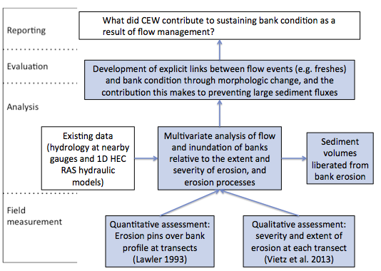

Figure : Schematic of key elements of the LTIM Standard Protocol: Bank condition.

The assessment of bank erosion processes and rates will address the following Selected Area specific questions:

* Are environmental flows adversely impacting the banks of the Goulburn River?
* How do timing and delivery of environmental flows affect bank condition on the Goulburn River?
* What timing and delivery of environmental flows best sustain or improve bank condition for vegetation growth?
* How do vegetation responses to CEW delivery vary between sites with different channel features and different bank condition?
* Are bank erosion rates and processes impacting macroinvertebrate communities?

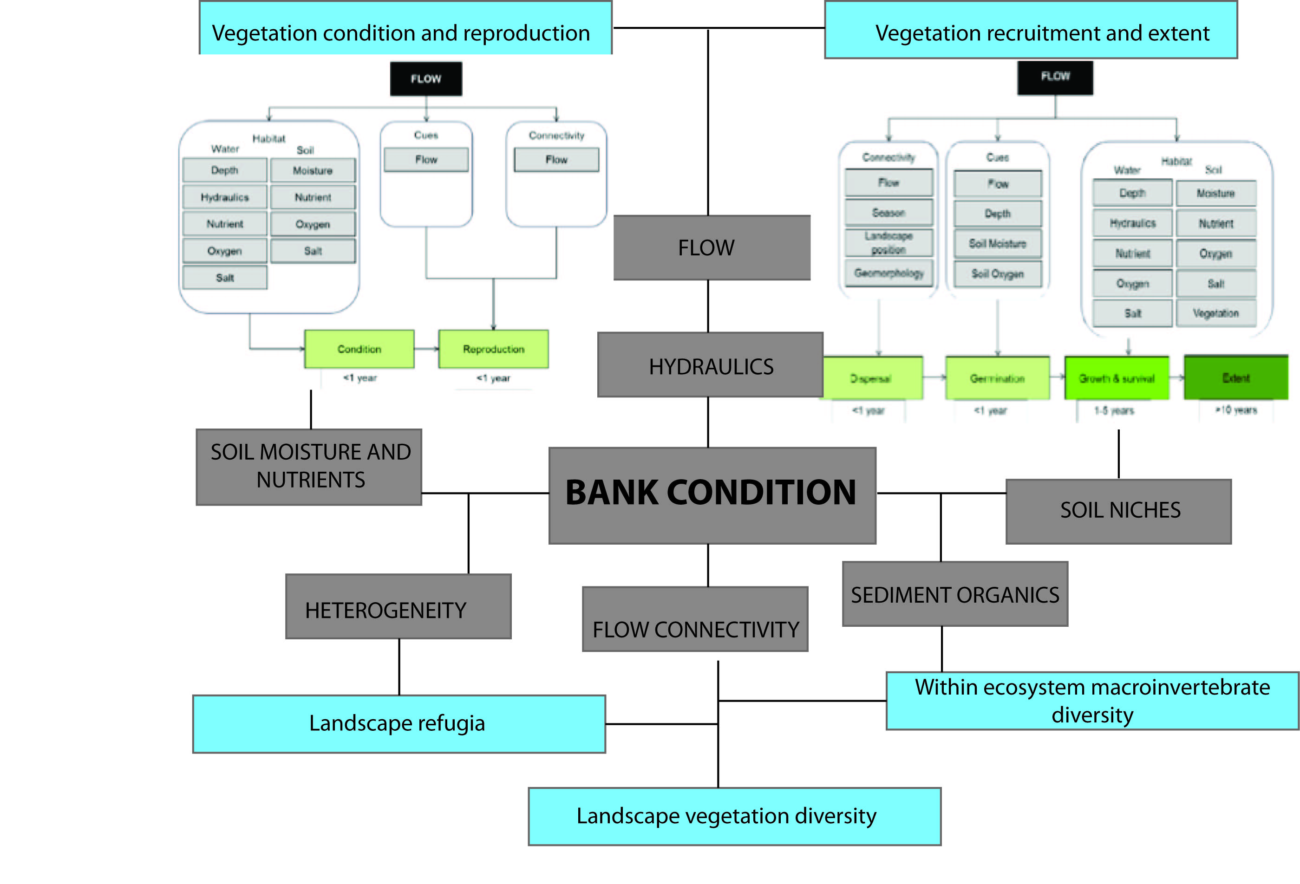

**Figure 2. Contribution of bank condition monitoring to example CEDs developed for the CEW monitoring program. Other relevant CEDs are included in Figure 3, with all CEDs listed in Table 1.**

Indicators

The bank condition protocol using erosion pins and qualitative assessment is a Category III indicator for the LTIM. There is no Standard Method for its use in the LTIM. The Goulburn River research and management team ranked the task highly based on concerns over excessive bank erosion in the Goulburn River, as well as the relevance to biota, particularly for understanding and interpreting trends in vegetation regrowth. It will specifically complement the Category II Vegetation Diversity indicator by targeting bank condition data where vegetation data is collected. Co-locating bank condition and vegetation field work will not only save on cost, but will enhance our analytic power to understand observed trends and growth. Erosion rates may complement other research indicators such as macroinvertebrate abundance by providing a possible explanatory variable for observed trends.

This protocol will result in quantitative data tracking bank recession (or accretion) over the length of this project, and will provide critical information on the impact of environmental flows, especially spring freshes, on bank response and vegetation regrowth. Significant bank erosion has been noted in the lower Goulburn River in recent years and measuring it will help us understand observed vegetation responses to environmental flow releases. Monitoring bank condition may also enable us to evaluate how bank erosion affects macroinvertebrate response to Commonwealth environmental water.

**Table 1. CEDs relevant to Bank Condition protocol**

|  |  |  |
| --- | --- | --- |
| **Relevant CED** | **Figure Number** | **Keyword** |
| Landscape Vegetation Diversity | 3 | Geomorphology |
| Vegetation Condition and Reproduction | 4 | Hydraulics |
| Vegetation Recruitment and Extent | 5 | Geomorphology, Hydraulics |
| Within Ecosystem Macroinvertebrate Diversity | 6 | Hydraulics, Sediment Organics |
| Landscape Refugia | 26 | Geomorphology, Habitat |

**Complementary monitoring and data**

Hydraulic models developed for other monitoring or environmental flow programs are valuable tools to demonstrate inundation of banks (e.g. models developed for the Victorian Environmental Flow Monitoring and Assessment Program). Existing data may also be gleaned from photo points (e.g. fixed cameras located on the Goulburn River to assess bank slumping). Note that repeat sections, as undertaken for a number of monitoring programs across the Basin, do not provide the precision required for assessing bank changes erosion relative to flow events.

Locations for monitoring

Locations for erosion pins and the qualitative assessment should be based on:

* Sites directly influenced by environmental flow deliveries
* Existing transects so that cross sectional data can be incorporated into the assessment
* Sites where nearby gauging stations exist
* Sites with appropriate access, but limited public access

Field work for bank condition will be undertaken at two sites in each of Zones one and two (four sites in total). Each site has ten transects, with five erosion pins placed on each transect. These transects will be the same as those for vegetation to provide the maximum benefits for conjunctive activities and analysis. An exception to this is the site at Yambuna Bridge. Yambuna Bridge is used as a site at the request of the Catchment Management Authority due to ongoing concerns with bank slumping, and whether they are associated with environmental flows (a perception that instigated the bank condition monitoring program). We will place erosion pins and take qualitative measurements at VEFMAP transects at Darcy’s Track, Loch Garry, McCoy’s Bridge, and Yambuna Bridge.

**Table 2. Proposed sites for application of Bank Condition, and complementary studies**

|  |  |  |  |
| --- | --- | --- | --- |
| **Site** | **Easting** | **Northing** | **Complementary studies** |
| Darcy’s Track (zone 1) | 351770 | 5965722 | VEFMAP, Short-term intervention monitoring |
| Loch Garry (zone 1) | 345976 | 5987892 | VEFMAP |
| McCoy’s Bridge (zone 2) | 330771 | 5994884 | VEFMAP, Short-term intervention monitoring |
| Yambuna Bridge (zone 2) | 320326 | 5999679 | VEFMAP |

Timing and frequency of sampling

Erosion pin measurements and bank assessments will be undertaken 6 times per year for years 1 and 2 (coordinated with flow deliveries and events) and 2 times per year for years 3, 4 and 5. Assessments should be made at low flows. The timing of deployment and retrieval of erosion pins will be scheduled to capture the change in bank condition associated with major environmental flow events (e.g. freshes).

Responsibilities – identifying key staff

Field program

Dr. Geoff Vietz will be responsible for setting up the erosion pins at the start of the monitoring program, and will also undertake the repeat visits to measure erosion pins as well as make qualitative assessments of condition. Coordination with vegetation monitoring will mean the same field assistant will contribute to both activities to save on costs.

Laboratory requirements (if any)

N/A

Procedure for transferring knowledge to new team members

The data will be stored on a dedicated shared dropbox folder so that it will be available to current and future staff members, as necessary.

Bank condition assessment experience is an essential requirement for the main field hand, and so in he event that Geoff is not available a qualified colleague of Geoff’s who is capable of undertaking the field work will be engaged.

Monitoring methods

Equipment

* Erosion pins (300 mm spokes)
* Heat shrink (30 mm length on pin head), alternating red and blue
* Callipers

Monitoring Protocol

Based on the standard method of Lawler (1993) the following will be undertaken:

* Pins are prepared with heat shrink applied to the head of the pin.
* Pins are pushed into the bank with 25 mm visible.
* Erosion pins are placed 5 at a time up the bank profile from low flow to the base of the roots of riparian vegetation. As per the method described by Lawler (1993).
* Pins are placed at known cross sections where possible, along one bank of the site, so that inundation can be assessed for a given discharge.
* Repeat measurement using callipers is used to quantify rates of bank recession. Pins are pushed back into original position after each measurement.
* Qualitative assessment of erosion processes, e.g. fluvial scour, mass failure in its various forms.
* Undertaken at 10 transects per site
* Banks are qualitatively assessed for the bank activity as per the method of Vietz et al. (2013) and the erosion mechanisms of Grove et al. (2013)

Quality Assurance/Quality Control

Quality control and quality assurance protocols are documented in the Quality Plan developed as part of the MEP for all Selected Areas. Repeat measurement of erosion pins should be undertaken by a consistent operator with an appropriate level of geomorphology training using the standard method.

Data analysis and reporting

Erosion rates

The 50 erosion pin readings from each site (5 pins per 10 transects) enable an average rate (and standard deviation).

Bank condition

Qualitative assessment of bank erosion processes assessed at each transect where erosion pins are placed, and bank erosion activity visibly for both banks.

Bank erosion activity:

* Active (erosion in the last flow event)
* Recent (erosion within the last 6 months)
* Historical (erosion is evident but has not been active in the last 6 months)
* None (no erosion evident).

**Table 3. Bank erosion activity score:**

|  |  |  |  |  |
| --- | --- | --- | --- | --- |
| Right bank  Left bank | None | Historical | Recent | Active |
| None | 0 | 1 | 3 | 4 |
| Historical | 1 | 2 | 4 | 5 |
| Recent | 3 | 4 | 5 | 6 |
| Active | 4 | 5 | 6 | 7 |

## 

## Data management

| Variable | Description | Data type | Required | Range |
| --- | --- | --- | --- | --- |
| AssessmentUnitID | River system on which assessment takes place | String |  |  |
| AssessmentSite | Site at which assessment takes place | String |  |  |
| AssessmentDate | Day on which measurements taken | dateTime |  |  |
| ErosionMean | Mean erosion value for all pins at a site | number |  |  |
| ErosionMedian | Median erosion value for all pins at a site | number |  |  |
| Erosion10per | 10th percentile erosion value for all pins at a site | number |  |  |
| Erosion90per | 90th percentile erosion value for all pins at a site | number |  |  |
| BankActivity | Bank erosion activity score based on visual assessment of both banks | number |  | 70 (possible score of 7 per each transect) |

**Figure 3. Other relevant CEDs that will respond to changes in bank condition.**

Landscape Vegetation Diversity (Fig 3)

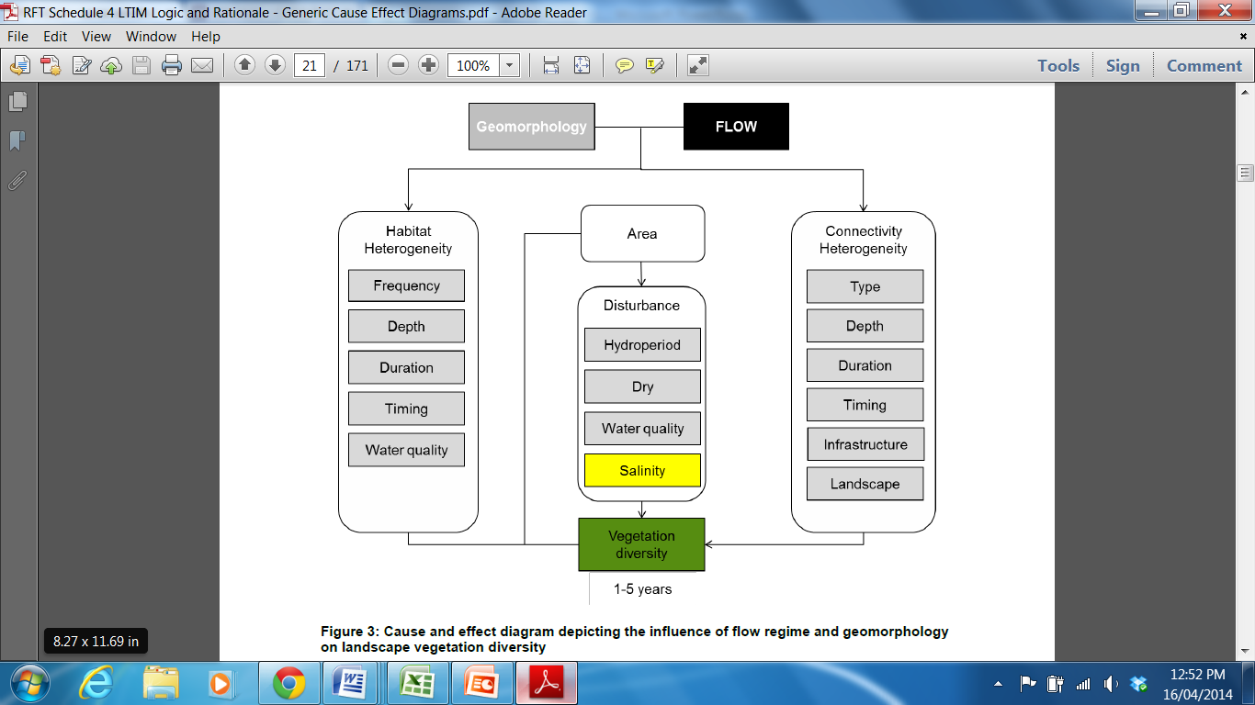

Within Ecosystem Macroinvertebrate Diversity (Fig 6)

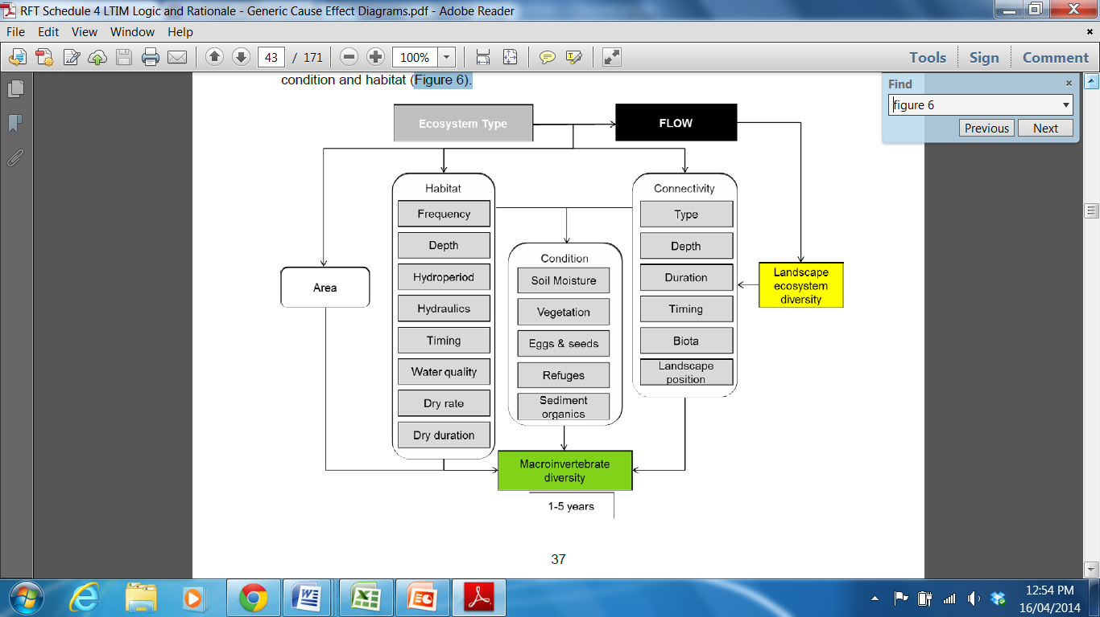

Landscape Refugia (Fig 26)

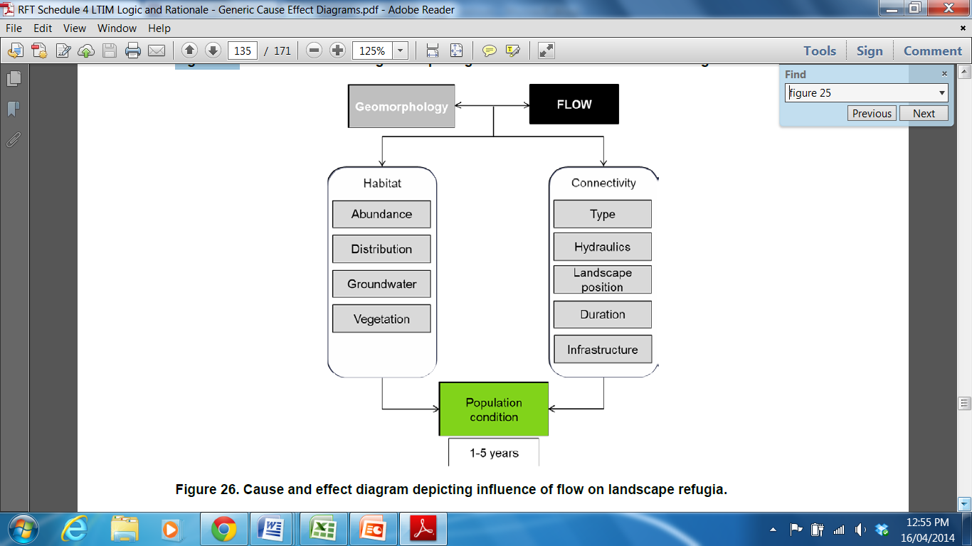

**Health and safety**

As with all programs that include field based methods, a Health Safety and Environment Plan (HSEP) must be developed. The HSEP must include an assessment of all identified potential risks and a plan on how these risks will be managed in the field.

References

Grove, J., Croke, J., Thompson, C., 2013, Quantifying different riverbank erosion processes during an extreme flood event, *Earth Surface Processes and Landforms* **38**(12)**:**1393-1406.

Lawler, D. M., 1993, The measurement of river bank erosion and lateral channel change: A review, *Earth Surface Processes & Landforms* **18:**777-821.

MDFRC (2013) Long-term Intervention Monitoring - Generic Cause and Effect Diagrams Final Report prepared for the Commonwealth Environmental Water Office by The Murray-Darling Freshwater Research Centre, MDFRC Publication 01/2013, May, 163pp.

Vietz, G. J., Sammonds, M. J., Walsh, C. J., Fletcher, T. D., Rutherfurd, I. D., Stewardson, M. J., 2013, Ecologically relevant geomorphic attributes of streams are impaired by even low levels of watershed effective imperviousness, *Geomorphology, DOI 10.1016/j.geomorph.2013.09.019, online September 9 2013*.

**Field data sheet(s)**

Example field sheet

| Assessment unit: e.g. Goulburn River | | | | | Date: |
| --- | --- | --- | --- | --- | --- |
| Site | Transect | Erosion pin | Erosion pin measurement | Bank activity score | Erosion processes |
| e.g. Darcy’s Track | e.g. 1 | e.g. 1-5 (1 is lowest in profile) | e.g. 25 mm | e.g. 2 | e.g. mass failure (rotational failure) |
|  |  |  |  |  |  |
|  |  |  |  |  |  |
|  |  |  |  |  |  |