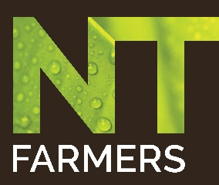
Biosecurity Champion
Greg Owens – NT Farmers Association
English

Hi I’m Greg Owens, I’m the Industry Development Manager for the Northern Territory Farmers Association.
I want to see our local growers grow as much as they can and get the best possible outcomes. We can do that by strengthening the established relationship and connections between NT Growers, stakeholders, industry and government.
NT Farmers is here to provide advice and assistance in regards to Biosecurity management, support and planning services. These services include grower advice, training, on-farm engagement, proactive biosecurity on-farm surveys. We encourage transparency in compliance and reporting between growers and government.
Because Northern Australia is so vast and sparsely populated it is particularly vulnerable to biosecurity risks. Increased shipping and trade, materials and infrastructure movement as well as increased movements of people which overall amplifies the opportunities for exotic pest and diseases to be introduced.
If you are affected by an outbreak but can ensure your compliance with the applicable quarantine requirements, then it’s possible to request Property Freedom Accreditation so that you may trade and move intra and interstate with your products. The registered authority will also have to ensure that there is adequate monitoring conducted.
There are a lot of fruits and vegetables that are grown in the NT, we have lettuce, cucumber, tomato, zucchini, pumpkin, chilli, snake bean, bok choy, wombok, okra, bitter melon, long melon, rambutan, durian, custard apple, paw paw and pomelo.
There are potential gaps in the awareness of the individual landholders and business owners with what actions they can take to minimise their biosecurity risks and also with growers who remain separate from the mainstream groups and organisations.
In recent years there have been a number of incursions of exotic pathogens which have increased the biosecurity awareness of Northern Australian growers, ideally we can increase the overall awareness without having to be subject to even more pathogens.
It’ll take everyone to make sure that the Northern Territory fresh produce industries are safe to trade well into the future.
You can be a champion too.

Department of Agriculture, Water and the Environment
Top Watch Biosecurity
Biosecurity – its everyone’s business

