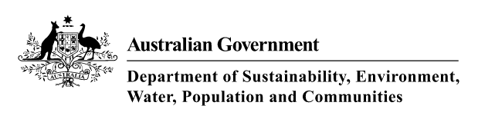

Grey Box (*Eucalyptus microcarpa*) Grassy Woodlands and Derived Native Grasslands of South-Eastern Australia

A guide to the identification, assessment and management of a nationally threatened ecological community

Environment Protection and Biodiversity Conservation Act 1999

An asterisk (*) against a term, on its first mention within the text, indicates that it is defined in the Glossary at the back of this publication.

© Commonwealth of Australia 2012

This work is copyright. You may download, display, print and reproduce this material in unaltered form only (retaining this notice) for your personal, non-commercialised use within your organisation. Apart from any use as permitted under the *Copyright Act 1968*, all other rights are reserved. Requests and inquiries concerning reproduction and rights should be addressed to: Public Affairs – Department of Sustainability, Environment, Water, Population and Communities, GPO Box 787 Canberra ACT 2610 Australia or email [public.affairs@environment.gov.au](mailto:public.affairs@environment.gov.au)

*Disclaimer*

The contents of this document have been compiled using a range of source materials and is valid as at June 2012. The Australian Government is not liable for any loss or damage that may be occasioned directly or indirectly through the use of or reliance on the contents of the document.

For citation purposes the PDF version of this document available from [www.environment.gov.au/epbc/publications/grey-box-booklet.html](http://www.environment.gov.au/epbc/publications/grey-box-booklet.html) is the official version.

CONTENTS

WHAT IS THE PURPOSE OF THIS GUIDE? 1

NATIONALLY THREATENED ECOLOGICAL COMMUNITIES 2

What is a nationally threatened ecological community? 2

Why does the Australian Government list threatened ecological communities? 2

Why list the Grey Box (*Eucalyptus microcarpa*) Grassy Woodlands and Derived Native Grasslands of South-Eastern Australia as endangered? 4

GREY BOX *(Eucalyptus microcarpa)* GRASSY WOODLANDS AND DERIVED NATIVE GRASSLANDS OF SOUTH-EASTERN AUSTRALIA 6

What are native grasslands and grassy woodlands? 6

What are the Grey Box *(Eucalyptus microcarpa)* Grassy Woodlands and Derived Native Grasslands of South-eastern Australia? 6

Grassy woodland 7

Derived native grassland 8

WHERE IS THIS ECOLOGICAL COMMUNITY FOUND? 12

Examples of key remnants of the listed ecological community 14

How do I know if I am standing on a patch of the listed ecological community? 16

Condition thresholds 16

Other considerations to help with assessment 17

*Variability in species composition* 17

*Derived native grasslands* 17

*Natural regeneration and restoration works* 17

*Surrounding environmental and landscape context* 19

How do I distinguish Grey Box Grassy Woodlands from another vegetation community or listed ecological community? 19

Contra-indicative dominant species for the Grey Box (*Eucalyptus microcarpa*) Grassy Woodlands and Derived Native Grasslands of South-Eastern Australia 20

KEY SPECIES 25

Key plants and animals 25

Species of special importance 33

IS THE LISTED COMMUNITY KNOWN BY OTHER NAMES? 38

NVIS 38

New South Wales 38

Victoria 40

South Australia 41

Similar ecological communities 42

Other adjacent ecological communities 43

Exclusions from the national ecological community 43

INDIGENOUS HERITAGE 44

WHAT DOES THE LISTING MEAN FOR APPROVAL AUTHORITIES OR LAND MANAGERS? 45

What does the EPBC Act listing of the ecological community mean for farmers, land managers or developers? 45

Which activities might require consideration? 45

KEY THREATS AND SUGGESTED CONSERVATION ACTIONS 47

Vegetation clearance and fragmentation 47

Inappropriate management actions 48

Weeds and pest animal species 51

Climate change 56

Is funding available to protect the listed grassy woodland and derived native grassland community? 56

*National funds* 57

*State funds* 57

WHERE CAN I GO FOR MORE INFORMATION? 58

The listing advice and conservation advice for the Grey Box Grassy Woodlands 58

Information about other matters of national environmental significance 58

Other useful resources 58

State-listed threatened ecological communities 58

Other guides with information that may help to identify and manage the ecological community include: 59

Other useful websites 60

Additional copies of this document 60

GLOSSARY 61

IMAGE CREDITS 64

# WHAT IS THE PURPOSE OF THIS GUIDE?

This booklet is designed to assist land managers, owners and occupiers as well as environmental assessment officers, consultants and the general public to identify, assess and manage the *Grey Box* (*Eucalyptus microcarpa*) *Grassy Woodlands and Derived Native Grasslands of South-Eastern Australia.* This is a threatened ecological community* listed under Australia’s national environment law — the   
*Environment Protection and Biodiversity Conservation Act 1999* (EPBC Act).

The document accompanies the listing and conservation advice, which presents the definitive and detailed description of this threatened ecological community. The listing advice is a technical document that explains what an ecological community is, where it is known to occur, why it merits listing as nationally threatened and which conservation status applies to the ecological community. The conservation advice identifies priority management and conservation actions.

These documents can be found in the Australian Government’s species profile and threats database (SPRAT) at: [www.environment.gov.au/cgi-bin/sprat/public/publiclookupcommunities.pl](http://www.environment.gov.au/cgi-bin/sprat/public/publiclookupcommunities.pl)

At this website, click on the details link to download the documents and map for the ecological community.

This document does not provide specific advice on whether particular actions will

trigger national environment law by having a significant impact on the ecological community. This needs to be considered on a case and site specific basis. However, a patch of the ecological community must meet a number of minimum condition thresholds in order to be considered for national law protection as outlined on page 24. Additional environment assessment considerations are also covered on page 17.

General guidance on significant impacts is found separately at: [www.environment.gov.au/epbc/publications/nes-guidelines.html](http://www.environment.gov.au/epbc/publications/nes-guidelines.html)

For what this listing means for approval authorities or land managers, please see page 45.

# 

# NATIONALLY THREATENED ECOLOGICAL COMMUNITIES

## What is a nationally threatened ecological community?

An ecological community may also be called a nature community or wildlife community. It is a naturally occurring group of plants, animals and other organisms that are living together and interacting in a unique habitat. Its structure, composition and distribution are determined by environmental factors such as soil type, position in the landscape, climate and water availability. Species within each wildlife community interact and depend on each other—for example, for food or shelter. Types of ecological communities listed under national environmental law include grasslands, woodlands, shrublands, forests, wetlands, ground springs and cave communities.

Together with threatened species, threatened ecological communities listed under the EPBC Act* are protected as one of several matters of national environmental significance. Threatened ecological communities can be listed as vulnerable*, endangered* or critically endangered*,

categories that represent their decline and potential for extinction across their national extent. Extinction in this context generally means that its species composition and ecological functions are significantly and irreversibly altered such that it is no longer natural.

The decision to list an ecological community as nationally threatened is made by the federal environment minister. It follows a rigorous and transparent process of consultation with stakeholders and the public, workshops and discussions with scientific experts, culminating in advice from the Threatened Species Scientific Committee. The committee is an independent scientific body that advises the minister on the threat status of native species and ecological communities.

## Why does the Australian Government list threatened ecological communities?

The Australian Government is responsible for identifying and protecting matters of national environmental significance. These include

world heritage properties, national heritage places, Ramsar wetlands (internationally important wetlands), listed migratory species, Commonwealth marine areas, the Great Barrier Reef Marine Park, nuclear actions and nationally-listed threatened species and ecological communities. All of these matters of national environmental significance are subject to Australia’s national environment law, the EPBC Act.

The listing of a threatened ecological community under national environment law recognises that its long-term survival is under threat. The aim of listing is to prevent further decline and to promote and assist recovery through government, landholder and community efforts.

Many of Australia’s ecological communities have been heavily cleared and fragmented since European settlement and continue to be degraded. Protection through the EPBC Act complements other conservation measures and is particularly vital for some ecological communities because many patches* occur outside conservation reserves.

As well as being important because of their unique biodiversity and distinctive place within the Australian landscape, threatened ecological communities provide a range of ecosystem services. These include the natural management of air, water, and soil nutrients; the reduction or control of erosion and salinity; and carbon storage.

In addition, threatened ecological communities can provide a form of landscape or systems level protection. They provide vital

wildlife corridors and habitat refuges for many plant and animal species, including threatened species and other Australian plants and animals that are in decline. Threatened ecological communities can also provide a focus for tourism and recreation, have cultural significance, and contribute to the productivity of our farmlands. Benefits of protecting ecological communities can include maintaining healthy soils and supporting soil-borne microbes that release nutrients for plant uptake, managing water tables and run-off and facilitating pollination rates for native and agricultural plants. Woodlands*, for example, also provide shelter and wind breaks, and ecological communities with grassy ground layers confer a degree of resilience and adaptability of ground vegetation during periods of drought and longer-term climate change.

The listing of an ecological community under national environment law recognises that its long-term survival is under threat. The aim of listing is to prevent further decline and to promote and assist recovery through government, landholder and community efforts. Listing increases awareness and may also lead to support for on-ground works including funding opportunities through the Australian Government’s Caring for our Country initiative, to help with recovery and conservation efforts. See page 56 for information on funding opportunities.

More information on nationally threatened ecological communities can be found at: [www.environment.gov.au/biodiversity/threatened/index.html](http://www.environment.gov.au/biodiversity/threatened/index.html)

## Why list the Grey Box (*Eucalyptus microcarpa*) Grassy Woodlands and Derived Native Grasslands of South-Eastern Australia as endangered?

The federal environment minister listed the Grey Box (*Eucalyptus microcarpa*) Grassy Woodlands and Derived Native Grasslands of South-Eastern Australia as an endangered ecological community in March 2010 on the advice of the Threatened Species Scientific Committee.

The Threatened Species Scientific Committee found that this ecological community was endangered because it has:

* undergone a substantial decline in geographic distribution; and
* undergone a severe decline in integrity

Temperate grasslands and grassy woodlands are among the most under-represented ecosystems in Australia’s conservation estate, and are recognised nationally as among the most threatened vegetation types. The Grey Box (*Eucalyptus microcarpa*) Grassy Woodlands and Derived Native Grasslands of South-Eastern Australia ecological community was formerly widespread on the drier edge of the temperate grassy eucalypt woodland belt of south-eastern Australia but now, across its range (central New South Wales through northern Victoria and into South

Australia), only 10 to 15 per cent of its original extent remains.

The ecological community has suffered extensive clearing in the past, mostly for agricultural and pastoral purposes. The main ongoing threats to the ecological community include incremental clearance of vegetation for various purposes (e.g. cropping, infrastructure works and maintenance); inappropriate grazing regimes; fragmentation into small remnants*; loss or decline of mature trees due to dieback or other causes; lack of natural regeneration for understorey* and canopy species; weed and pest invasion; addition of fertilisers to improve sites for agriculture; inappropriate application of herbicides; firewood collection; and salinity. Clearing due to urban infill and peri-urban expansion, plus degradation associated with urban encroachment, are major threats for remnants close to Melbourne and Adelaide.

Considerable efforts have been made by farmers, governments and community and conservation groups. However, ongoing protection, management and recovery of remnants on public and private land is crucial to the future survival of this unique ecological community. Many of the threats to the ecological community also have adverse impacts on threatened species associated with the ecological community.

The Grey Box (*Eucalyptus microcarpa*) Grassy Woodlands and Derived Native Grasslands of South-Eastern Australia provide valuable habitat for those animal

species that are either resident or transient visitors. In particular, the landscape position of the ecological community is such that it supports fauna, particularly birds, representative of the more temperate forest and woodland ecosystems, as well as species from the drier inland semi-arid environments.

The ecological community provides habitat to several national and state-listed threatened species. Listing under the EPBC Act helps protect and recover the remaining patches of this endangered ecological community, and preserve its value as vital habitat.

# GREY BOX *(Eucalyptus microcarpa)* GRASSY WOODLANDS AND DERIVED NATIVE GRASSLANDS OF SOUTH-EASTERN AUSTRALIA

## What are native grasslands and grassy woodlands?

Grassy woodlands and natural grasslands* are generally types of native vegetation where native grasses* are a dominant* or common feature on the ground. They may be very rich in other herbs* that grow between the grass tussocks* and often appear as wildflowers in spring. The main difference between natural grasslands and grassy woodlands is the presence of a tree canopy. Trees are naturally absent or sparse in natural grasslands. A tree canopy, however, is typically evident in grassy woodlands. At some woodland sites, the trees have been cleared but the native understorey* retained, giving the appearance and function of a natural grassland. These sites are known as ‘derived’ or ‘secondary’ grasslands.

## What are the Grey Box *(Eucalyptus microcarpa)* Grassy Woodlands and Derived Native Grasslands of South-eastern Australia?

The Grey Box (*Eucalyptus microcarpa*) Grassy Woodlands and Derived Native Grasslands of South-eastern Australia (Grey Box Grassy Woodlands for short) is an endangered ecological community listed under national environment law.

It mostly occurs from central NSW, through northern/central Victoria into eastern South Australia. The ecological community occurs in two forms, a grassy woodland form and as a derived native grassland.

## Grassy woodland

This is the most common form of the ecological community that comprises a tree layer and a native understorey with a varying proportion of shrubs, grasses and herbs. This grassy woodland form has a tree canopy that is dominated or co-dominated by Grey Box (*Eucalyptus microcarpa*). Images of this species can be seen on this page.

Other common tree species associated with this ecological community include:

|  |  |
| --- | --- |
| buloke | *Allocasuarina luehmannii* |
| kurrajong | *Brachychiton populneus* |
| white cypress pine | *Callitris glaucophylla* |
| white box | *Eucalyptus albens* |
| river red gum | *Eucalyptus camaldulensis* |
| fuzzy box | *Eucalyptus conica* |
| black box | *Eucalyptus largiflorens* |
| yellow gum (SA blue gum) | *Eucalyptus leucoxylon* |
| yellow box | *Eucalyptus melliodora* |
| poplar box (bimble box) | *Eucalyptus populnea* |

Images of these species can be seen on pages 21 and 22

*Eucalyptus microcarpa* (inland grey box)

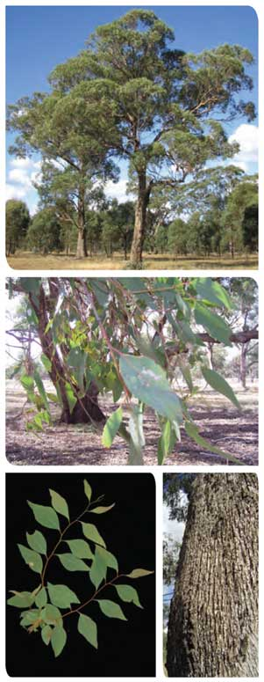

The shrub or mid layer is variable. It ranges from absent, where it has been removed, to moderately dense cover. Shrub composition also can be variable. Widespread shrubs include wattles (*Acacia* species), sweet bursaria (*Bursaria spinosa*), *Cassinia* species, hop-bushes (*Dodonaea* species), emu bushes (*Eremophila* species) and blue-bushes (*Maireana* species). In many situations, regrowth of canopy trees also may be present in the mid layer. The development and composition of the mid layer is influenced by landscape factors and past land management practices.

The ground layer also varies in composition, with mostly grasses or a combination of grasses* and grass-like plants*, herbaceous flowering plants and the smaller chenopods* (salt bushes). The nature of the ground layer is influenced by the density of the shrub layer at a site, because where the shrub layer is denser, the ground layer is usually sparser due to competition for light and moisture. A biological soil crust of mosses and lichens often occurs on the soil surface that is otherwise bare of plant growth, particularly in less disturbed or open sites.

Common grasses and grass-like plants that occur across a number of the IBRA bioregions* where this ecological community is present include wallaby grasses (*Rytidosperma* (formerly *Austrodanthonia*) species), spear grasses (*Austrostipa* species), wheat-grass (*Elymus scaber*), windmill grasses (*Enteropogon* species), flax-lilies (*Dianella* species) and mat-rushes (*Lomandra* species).

Herbaceous flowering plants found across this ecological community include vanilla lilies (*Arthropodium* species), milkmaids (*Burchardia umbellate*) and twining fringe- lilies (*Thysanotus patersonii*).

Chenopods are generally more prominent in the ground layer of this ecological community than in other temperate grassy woodlands.

In this ecological community they are found especially at drier sites in the range, where the ecological community adjoins more semi-arid communities. Chenopod species commonly present include saloop (*Einadia hastate*), nodding saltbush (*Einadia nutans* ssp. *nutans*) ruby saltbush (*Enchylaena tomentose*), wingless bluebush (*Maireana enchylaenoides*) and grey copperburr (*Sclerolaena diacantha*).

## Derived native grassland

Patches of derived native grassland* can occur where the tree canopy and mid layer has been almost entirely removed but the native ground layer remains largely intact. Evidence that these former layers existed may include:

* the presence of *E. microcarpa* tree stumps or fallen logs
* the type of vegetation in nearby native remnants
* historical records and photographs
* reliable modelling of pre-European vegetation

Patches of derived native grassland should also comprise similar ground layer species to be consistent with the ground layer for the grassy woodland.

The most likely situations where derived native grasslands may occur are on Travelling Stock Routes* (TSRs), reserves along roadsides, or localised patches of grassland that are part of a larger remnant

with trees, for example under power easements or along fire breaks. The latter effectively represents a continuation of the ground layer between the wooded and treeless parts of a patch.

The derived native grassland form of this community is important for conservation purposes, particularly where it has a diversity of plant species.

|  |
| --- |
| **KEY POINTS** |
| * The Grey Box (*Eucalyptus microcarpa*) Grassy Woodlands and Derived Native * Grasslands of South-eastern Australia occurs in two forms. * The most common form is as grassy woodland comprising a tree layer and an understorey that must have native grasses but with a varying proportion of shrubs and herbs. * The derived native grassland form can occur in patches where the tree canopy and mid layer have been almost entirely removed but the native ground layer remains largely intact with high flora diversity. * The listed community’s range intersects and intergrades* with that of several different grassland and grassy woodland ecological communities that together form an extensive grassy woodland belt in south-eastern Australia. * The listed ecological community has been severely affected by the loss of vegetative and faunal components, weed invasion, the degree of fragmentation and the degradation of habitat values. * Both the grassy woodland and derived native grassland provide vital support to a diverse range of native plants and animals that are important for maintaining regional, state and national biodiversity. * In particular, this ecological community supports bird species found in the wetter forest and woodland ecosystems further east and south, as well as species from the drier semi-arid environments to the west and north. * Putting in place favourable land use and management practices is essential at sites containing grassy woodlands and grasslands. |

**Snapshot: Grey Box *(Eucalyptus microcarpa)*Grassy Woodlands of South-Eastern Australia**

Grey box woodland at Henty Cemetery, near Wagga Wagga in southern NSW

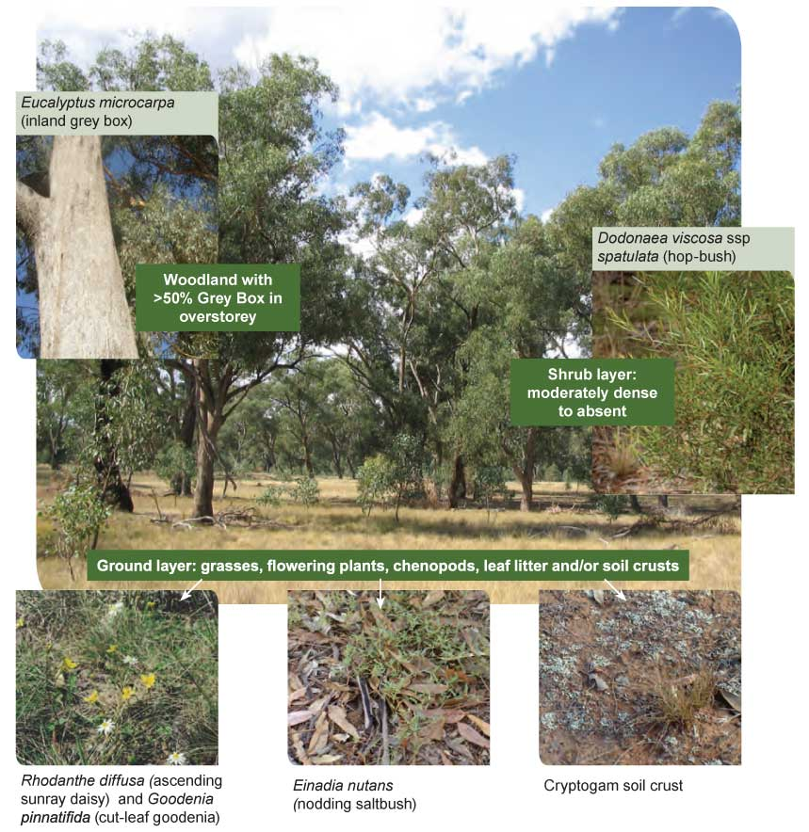

|  |
| --- |
| **WHERE DO I FIND IT?** |
| * Predominantly occurs on the drier edge of the temperate grassy eucalypt woodland belt (375-700 mm rainfall) ranging from central New South Wales through northern and central Victoria into South Australia. * Patches that are away from the main belt of the ecological community occur to the south of the Great Dividing Range in Victoria, around Melton and Sunbury to the west of Melbourne and also to the west of the Murray River coastal plain in South Australia, and around the southern Flinders and Mount Lofty Ranges near Adelaide. * Grey Box Grassy Woodlands usually occur in flat to undulating landscapes, such as plains, low slopes and rises, or occasionally in drainage depressions. Patches of this community tend to occur on relatively productive soils. * Many patches are found on private land with some patches on public sites such as travelling stock routes, roadsides, rail reserves and cemeteries. |

|  |
| --- |
| **WHAT ELSE IS IT KNOWN AS?** |
| * Corresponds with a range of units under New South Wales, Victorian and South Australian vegetation classification. See page 38 |

|  |
| --- |
| **WHY IT’S IMPORTANT TO PROTECT IT…..** |
| * Much of it has disappeared or become degraded - more than 85 per cent of the ecological community has disappeared since European settlement. * What remains is at risk from various ongoing threats such as land clearing, changing land use and weed invasion. * It provides habitat for several threatened plant and animal species that are also protected under national or state environment law as well as many other species. * It provides vital ecosystem services, such as natural management of water and soils, and shelter for stock. * It’s essential to apply the right land use and management practices to maintain and restore this community. * Its protection provides vital support for native biodiversity and ecosystem services across a large region of Australia. |

# WHERE IS THIS ECOLOGICAL COMMUNITY FOUND?

The map on page 13 shows the approximate area over which the community may occur. However the distribution cannot be shown accurately on a map of this scale, because the region has not been entirely surveyed in detail and many remnants are now limited to very small, fragmented patches. To determine the presence of a patch of the listed ecological community, please refer to the decision flowcharts on pages 23 and 24

of this publication, and the listing advice for the ecological community available at: www.environment.gov.au/cgi-bin/sprat/public/publiclookupcommunities.pl

The bioregions, natural resource management (NRM) regions and catchment management authority (CMA) areas where the ecological community can be found are listed below.

|  |  |
| --- | --- |
| **Areas where the listed ecological community can be found** | |
| **IBRA** bioregion/subregion | Brigalow Belt South – southern subregions (NSW),  Darling Riverine Plain – eastern subregions (NSW), NSW South Western Slopes (NSW & Vic) Riverina (NSW &Vic) Cobar Peneplain – eastern subregions (NSW) Victorian Midlands (Vic), Victorian Volcanic Plan (Vic), Murray-Darling Depression (Vic & SA), and Flinders Lofty Block (SA) |
| NRM regions / CMA areas | **NSW**: Murray, Murrumbidgee, Lachlan, Central West and NamoiCatchment Management Authorities;  **Victoria**: North East, Goulburn Broken, North Central, Mallee, Wimmera, Glenelg-Hopkins, Corangamite; and Port Philip and Westernport Catchment Management Authorities;  **South Australia**: Northern and Yorke, Adelaide and Mount LoftyRanges, and South East NRM Boards |

Grey Box (*Eucalyptus microcarpa)* Grassy Woodland and Derived Grasslands of South-Eastern Australia

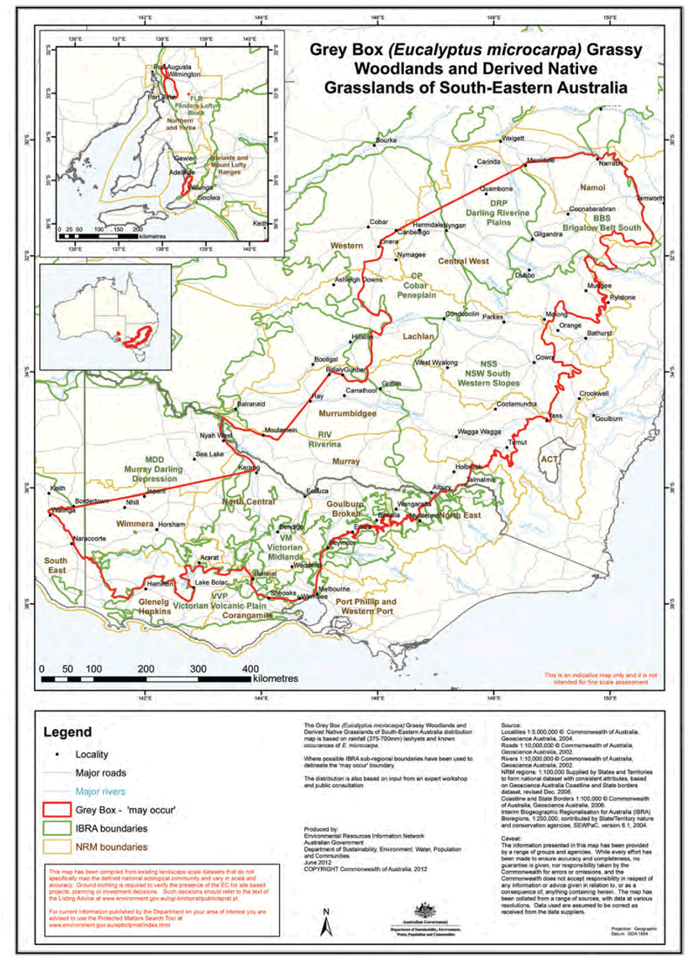

## Examples of key remnants of the listed ecological community

Many areas of the Grey Box Grassy Woodlands are now disturbed and degraded. The ecological community mostly occurs as small, fragmented patches that were left after the surrounding fertile land was cleared for agriculture. Some of the better-quality remnants of the ecological community can still be found on public lands, such as Travelling Stock Reserves (in NSW only), other roadside or railway verges, cemeteries,

and in formal and informal conservation reserves. However the community is generally poorly represented in conservation reserves. Remnants may also be present on private tenure, for example in paddocks that have not been cleared or that have been managed in a way that has maintained the ecological community. In these instances, supportive farming practices have helped to keep the ecological community in good condition.

Good quality examples of the ecological community can be found at the following sites:

### Grey Box Grassy Woodlands:

#### NSW

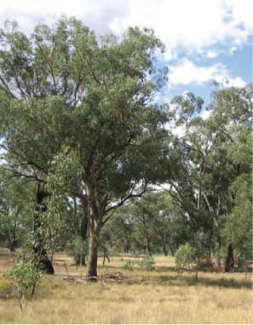

Grey Box, Henty Cemetery near Wagga Wagga (Travelling Stock Reserve)

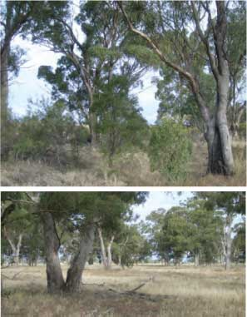

Near Gilgandra within a few kms of each other–showing range of shrubiness

#### Vic

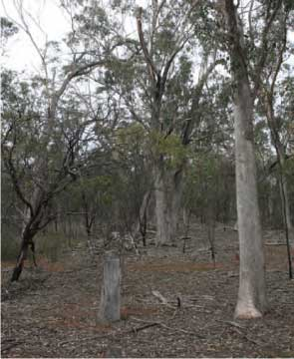

Eynesbury

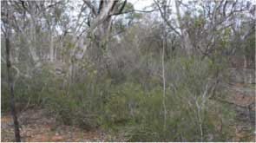

Eynesbury showing understory

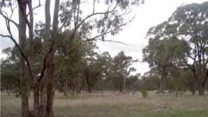

McKenzie Creek Reserve, south of Horsham

#### SA

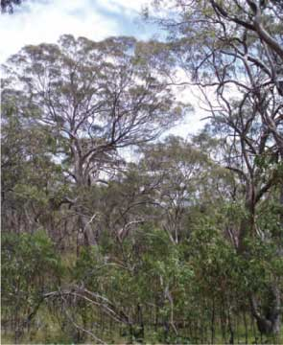

Waite Reserve

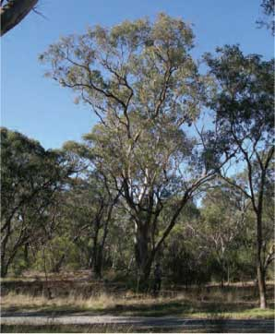

Belair National Park

## How do I know if I am standing on a patch of the listed ecological community?

This section is designed to help you determine if a patch of native vegetation could be part of the listed Grey Box Grassy Woodlands ecological community. The *Description* and *Condition thresholds*\* for the ecological community in the EPBC Act listing advice provide the definitive source of information for identifying the nationally threatened ecological community. Information from the listing advice (available at [www.environment.gov.au/cgi-bin/sprat/public/publiclookupcommunities.pl](http://www.environment.gov.au/cgi-bin/sprat/public/publiclookupcommunities.pl) ) is summarised and further explained in the following pages.

A patch of a listed ecological community is defined as a discrete and uniform area that comprises the ecological community. It does not include substantial elements of other ecological communities, such as woodlands dominated by other tree species and other types of grasslands. However, a patch of a listed ecological community may include small-scale disturbances, such as tracks or breaks, that do not alter its overall functionality, for instance the easy movement of wildlife or dispersal of plant spores and seeds, and may also include small-scale variations in vegetation that are noted in the description.

It is important to remember that the ecological community occurs in two structural forms, grassy woodland and grassland. Most large occurrences of the ecological

community are grassy woodlands, but, at many smaller sites, the trees have been cleared, leaving only the native ground layer vegetation in place. Most of these sites have been managed as native grasslands for some time.

Hybrids of some eucalypt species may also be present in the canopy layer.

## Condition thresholds

Condition thresholds were established when the ecological community was listed to determine which patches of woodland and derived native grassland should receive full protection as a matter of national environmental significance under the EPBC Act. The decision flowchart on page 24 presents the description and condition thresholds in a way that can be used on site to assess a patch of native vegetation and determine if it is part of the listed woodland or derived native grassland community.

The condition thresholds are intended to focus protection on vegetation remnants that are most functional and in relatively good to excellent condition.

For more information about management of patches and funding available to restore degraded patches please refer to the section **Key threats and suggested conservation actions** on page 47

## Other considerations to help with assessment

### Variability in species composition

The ecological community’s appearance can vary seasonally. This is because many native wildflowers are more visible when flowering during spring. Some wildflowers may stay dormant and not appear every year, for instance during dry seasons. Some species are sensitive to particular disturbance regimes and may decline or disappear from disturbed sites. For example, highly palatable or grazing-sensitive native species may disappear from sites that have been intensively or repeatedly grazed.

For these reasons, unless exceptional circumstances apply, native plant species diversity must be assessed during spring (September to November) and after the site has not been disturbed (for example, by fire, overgrazing, mowing) for at least two months before the springtime of sampling, to optimise the biodiversity assessment of a site. However, most features, such as vegetation structure, minimum patch size and perennial* ground layer vegetation cover can be assessed all year round.

### Derived native grasslands

Derived, or secondary grasslands can be similar in vegetation composition and structure to natural grasslands, and it is difficult to distinguish the difference between natural grasslands and derived grasslands. Derived grasslands can be extremely rich in native species and contain numerous threatened species, and are included in the listed grassy woodland ecological community where the description and condition thresholds are met. Information about how to determine if a derived grassland may be present is given in footnote 1 of Flowchart 2 on page 24.

### Natural regeneration and restoration works

Areas that have been disturbed and are regenerating, or have been planted out using appropriate native species, but that still meet the key diagnostic characteristic and condition thresholds also qualify as the ecological community protected under the EPBC Act. These sites are important for the recovery of the ecological community.

**Sites in South Australia**

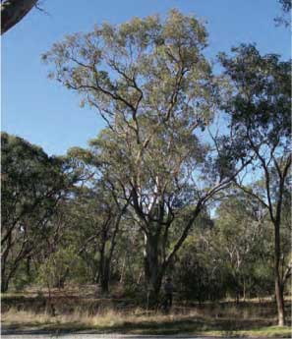

Belair National Park 2008 (small area – good condition)

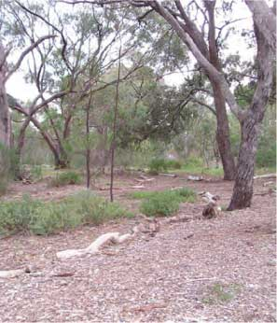

Beaumont Common – 'restored' grey box community 2008 (small area – good condition)

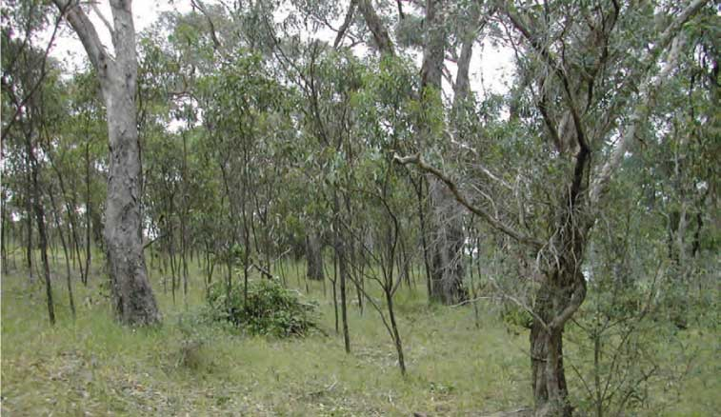

Happy Valley Reservoir Reserve after boneseed and olive removal 2002

### Surrounding environmental and landscape context

It is important to consider the landscape context surrounding a patch of the ecological community. These landscape considerations help to determine if the patch has additional conservation value, and include:

* Connectivity to other native vegetation remnants or restoration works (e.g. native plantings). In particular, if a patch has an important position between (or linking) other patches (or other native vegetation remnants) in the landscape.
* Patches that occur in those areas in which the ecological community has been most heavily cleared and degraded or are at the natural edge of its range.
* Large patch size and/or large area to boundary ratio. Such patches are less exposed and more resilient to edge effects disturbances such as weed invasion.
* Evidence that native species are recruiting or that a range of age cohorts are present. For instance, tree canopy species are present as saplings through to large old hollow-bearing trees.
* Good faunal habitat as indicated by the presence of trees with hollows, logs, natural rock outcrops, diversity of landscape.
* High diversity of native species within the patch.
* Areas of minimal weeds and feral animals, or where they can be easily managed.
* Presence of mosses, lichens, liverworts, soil crust and leaf litter on the soil surface, indicating low disturbance and potential for good functional attributes such as nutrient cycling.

**It is recommended a buffer zone is implemented to protect patches from edge effects and impacts from adjacent land uses such as herbicide spray drift.**

## How do I distinguish Grey Box Grassy Woodlands from another vegetation community or listed ecological community?

The flowcharts on pages 23 and 24 can be used to determine if Grey Box Grassy Woodlands ecological community is present at a particular site.

The listing of Grey Box Grassy Woodlands is an important piece of the puzzle in providing much-needed protection for the heavily cleared and modified grassy woodland belt of eastern Australia. However, there may be more than one similar threatened ecological community in a given area.

The flowchart on page 23 ***Flowchart 1: Could a nationally threatened grassland or grassy woodland community be present*** has been created to provide a first-cut assessment tool to help you decide whether or not the Grey Box Grassy Woodlands or another listed ecological community may be present on your property. The listing advice and/or information product

for each of the ecological communities named in the flowchart is available at: [www.environment.gov.au/cgi-bin/sprat/public/publiclookupcommunities.pl](http://www.environment.gov.au/cgi-bin/sprat/public/publiclookupcommunities.pl)

The second flowchart, on page 24,

***Flowchart 2: Is the patch of potential Grey Box (Eucalyptus microcarpa) Grassy Woodlands or Derived Native Grasslands of sufficient quality for national listing?*** can be used to determine if the listed Grey Box Grassy Woodlands ecological community is present at a particular site. This flowchart describes the lowest condition at which patches of vegetation are included in the listed ecological community. Large patches, those that link remnants in the landscape, those that have high native species richness, those that occur in highly modified agricultural or urban regions and those that contain rare, declining or threatened species, are particularly important for the long-term future of the ecological community.

## Contra-indicative dominant species for the Grey Box (*Eucalyptus microcarpa*) Grassy Woodlands and Derived Native Grasslands of South-Eastern Australia

The species of trees associated with Grey Box vary across the range of the ecological community, depending on the bioregion, landscape or site. Contra-indicative species are here defined as species that may be present in a locality but their dominant

occurrence clearly indicates that the Grey Box (*Eucalyptus microcarpa*) Grassy Woodlands and Derived Native Grasslands of South-Eastern Australia ecological community is NOT present *i.e.* if the species below are dominant, you do not have the listed ecological community:

* *Allocasuarina luehmannii* (buloke)
* *Brachychiton populneus* (kurrajong)
* *Callitris columellaris* (white cypress pine)
* *Eucalyptus albens* (white box)
* *E. camaldulensis* (river red gum)
* *E. conica* (fuzzy box)
* *E. largiflorens* (black box)
* *E. leucoxylon* (yellow gum, SA blue gum)
* *E. melliodora* (yellow box)
* *E. populnea* (bimble box, poplar box).

Dominance by some of these species may indicate the presence of other listed ecological communities (see Flowchart 1 on page 23).

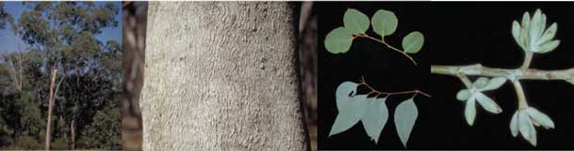

***Eucalyptus albens* (white box)**

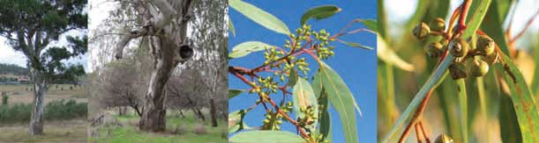

***Eucalyptus camaldulensis* (river red gum)**

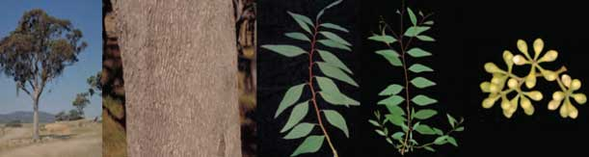

***Eucalyptus conica* (fuzzy box)**

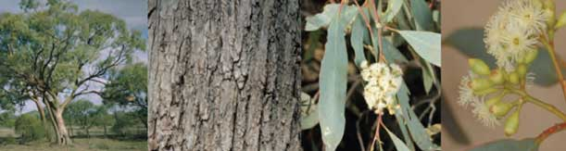

***Eucalyptus largiflorens* (black box)**

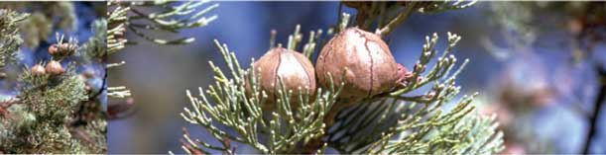

***Callitris glaucophylla* (syn.*columellaris*) (white cypress pine)**

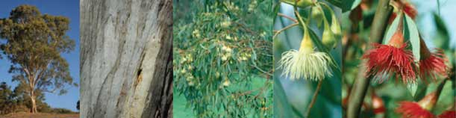

***Eucalyptus leucoxylon* (yellow gum, SA blue gum)**

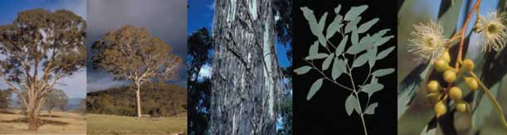

***Eucalyptus melliodora* (yellow box)**

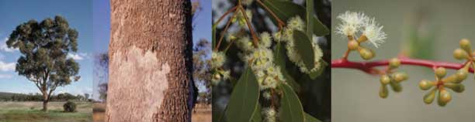

***Eucalyptus populnea* (bimble box, poplar box)**

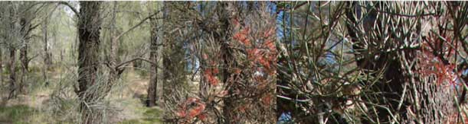

***Allocasuarina luehmannii* (buloke) tree, and tree with mistletoe**

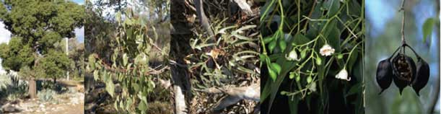

***Brachychiton populneus* (kurrajong)**

**Flowchart 1: Could a nationally threatened grassland or** **grassy woodland community be present?**

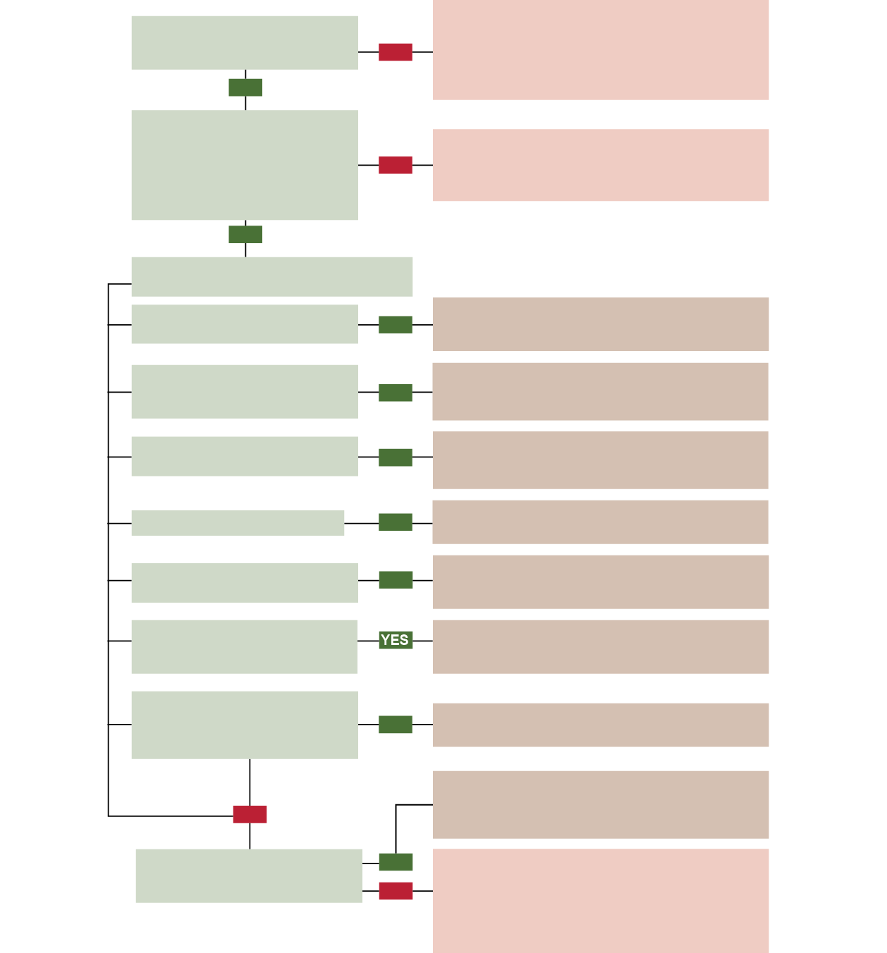

Is the property within or near the area shown on the Grey Box Grassy Woodland distribution map on page 13?

**YES**

Outside known distribution for Grey Box (*E. microcarpa*) Grassy Woodlands and derived native grasslands of South Eastern Australia.

**NO** See national list for other threatened communities at:

<http://www.environment.gov.au/cgi-bin/sprat/public/publiclookupcommunities.pl>

Is at least 50% of the plant cover in the ground layer made up of perennial native species?

**OR**

Is at least 10% of plant cover in ground layer made up of perennial native grass species?

Not a listed threatened ecological community as at June 2012.

**NO** See national list for communities that may have been listed since: <http://www.environment.gov.au/cgi-bin/sprat/public/publiclookupcommunities.pl>

**YES**

Is (or was previously) the most common tree species (or group of species) one of the following?

grey box *Eucalyptus microcarpa*

**YES**

Grey Box (*E. microcarpa*) Grassy Woodlands or derived

native grasslands of South Eastern-Australia may be present.

**Go to Flowchart 2.**

white box *Eucalyptus albens,* yellow box *E. melliodora* Blakely’s red gum *E. blakelyi*

**YES**

White Box – Yellow Box – Blakely’s Red Gum Grassy Woodlands or derived native grasslands may be present. **See information statement for that community**

buloke *Allocasuarina luehmannii*

slender cypress-pine *Callitris preissii*

**YES**

Buloke Woodlands of the Riverina and Murray-Darling Depression Bioregion may be present. **See listing advice for that community**

weeping myall *Acacia pendula* (NSW)

**YES**

Weeping Myall Woodlands may be present.

**See policy statement for that community**

peppermint box *Eucalyptus odorata*

(SA only)

**YES**

Peppermint Box (*Eucalyptus odorata*) Grassy Woodland of South Australia may be present.

**See policy statement for that community**

coolibah *Eucalyptus coolabah* subsp.

*coolabah*

blackbox *Eucalyptus largiflorens*

Coolibah - Black Box Woodlands of the Darling Riverine Plains and the Brigalow Belt South Bioregions may be present. **See listing advice for that community**

Non-riverine/floodplain stands of river red gum, swamp gum, manna gum, yellow box (Victorian Volcanic Plains only)

**YES**

Grassy Eucalypt Woodlands of the Victorian Volcanic Plains

**See information statement for that community**

A number of natural temperate grasslands are listed threatened ecological communities.

**NO** See national list at: <http://www.environment.gov.au/cgi-bin/>

sprat/public/publiclookupcommunities.pl

Is the ecological community a type of natural temperate grassland?

**YES NO**

Not a listed threatened grassland or woodland ecological community as at June 2012

See national list for communities that may have been listed since: <http://www.environment.gov.au/cgi-bin/sprat/public/publiclookupcommunities.pl>

**Flowchart 2: Is the patch of potential Grey Box (*E. microcarpa*) Grassy Woodlands or derived native grasslands of sufficient quality for national listing?**

Is (or was previously)1 the most common tree species Grey Box

(*Eucalyptus microcarpa*)?

**NOa**

Not the listed national ecological community

**YES**

Is the patch2 at least 0.5 ha in size?

**NOb**

**YES**

Do non-grass weeds3 make up more than 30% of the plant cover4

in the ground layer?

**YESc**

**NO**

Do trees cover at least 10% of patch?

**YES NO**

Is the patch bigger than 2 ha?

Is there evidence1 that Grey Box trees were once common in the patch?

**YES NO**

**NOa**

**YES**

Are there at least 8 trees/ha:5

a) that contain hollows; or

b) have a diameter >60 cm at

1.3 m above ground level?

Are there at least **8** perennial native species in the mid and ground layers?6 (**6** in Flinders Lofty Block Bioregion, SA)

**NOd**

Are there at least **12** perennial native species in the mid and ground layers?6

**YES**

Is at least 10% of the plant cover in the ground layer

**NO**

Are there at least

20 live trees/ha with a diameter

**YES**

Not the listed national ecological community

**YES**

made up of perennial native grass species?

>12 cm at 1.3 m

above ground level?

Is at least 50% of the plant cover in the ground layer made up of

perennial native species?

**YES**

**NOd**

**NOe**

**NOd**

Not the listed national ecological community

**YES**

The listed national ecological community is present

1. Evidence that Grey Box was originally present might include stumps, historical records or presence in nearby vegetation.
2. When considering a patch it is important to note that a patch may extend beyond a property or development site boundary. For the purposes of determining whether or not a patch meets the minimum patch size of the condition thresholds for the ecological community, the entire patch should be considered, not just the area occurring on a property or development site.
3. A weed is defined here as a plant species that is not native to Australia and the species has established viable self-sustaining populations in a region.
4. Plant cover excludes mosses and lichens. Patches of bare ground or leaf litter are also not included.
5. Dead trees are included if present, up to 50% of the total tree count.
6. Relevant growth-forms to include are: grasses, other graminoids, forbs and shrubs less than 4 metres tall. Shrubs that are

4 metres or more in height and non-vascular plants (mosses and lichens) are not included.

**Why does my patch not belong to the listed national ecological community? a** Patch belongs to a different ecological community; **b** Patch is too small; **c** Degraded: patch is too weedy **d** Degraded: too few native species or insufficient native species cover in ground layer; **e** Degraded: too few trees AND insufficient native species cover in ground layer. Rehabilitation work may be able to restore degraded patches enough to qualify as the listed community.

# KEY SPECIES

## Key plants and animals

The following photos show some of the key plant and animal species of the Grey Box Grassy Woodlands. Patches of derived native grassland should also comprise similar ground layer species to be consistent with the ground layer for the grassy woodland. The main difference between the grassy woodland and the derived native grassland is the presence of a tree canopy in the former. Consequently, the grassy woodland has an arboreal component of woodland mammals, birds and other animals that is largely absent in the derived native grassland. The grassy woodland is likely to support animals such as possums, bats, and parrots, which rely on trees and tree hollows for shelter and food.

More detailed species lists can be found in the listing advice for the ecological community at:[www.environment.gov.au/cgi-bin/sprat/public/publiclookupcommunities.pl](http://www.environment.gov.au/cgi-bin/sprat/public/publiclookupcommunities.pl)

Note that, at any given site, not all the native species mentioned in this document will be present and other native species not mentioned may occur.

Note: For images of *E. microcarpa* refer to page 7. For images of other common tree species associated with this ecological community, refer to images on pages 21 and 22.

**Mid layer species:** Widespread shrubs include species in the genera *Acacia, Bursaria, Cassinia, Dodonaea, Eremophila* and *Maireana.*

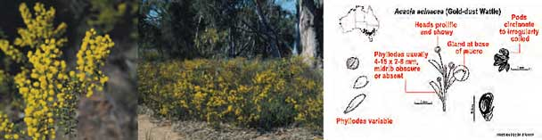

***Acacia acinacea* (gold-dust wattle)**

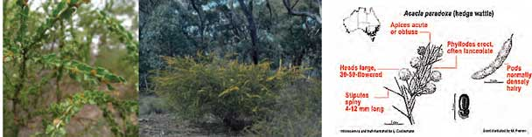

***Acacia paradoxa* (hedge wattle)**

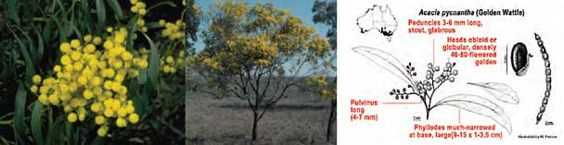

***Acacia pycnantha* (golden wattle)**

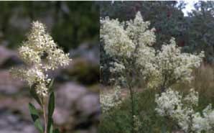

***Bursaria spinosa* (sweet bursaria)**

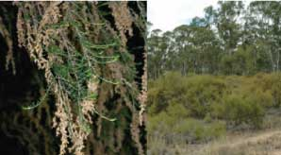

**Cassinia arcuata (sifton bush,   
Chinese bush, drooping cassinia**

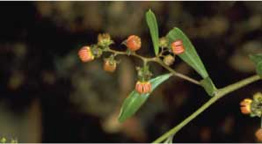

***Dodonaea viscosa* (hop-bush)**

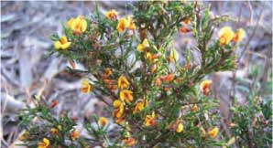

***Eutaxia microphylla* (common eutaxia)**

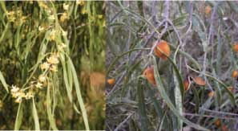

***Pittosporum angustifolium*(weeping pittosporum)**

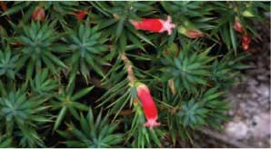

***Astroloma humifusum* (cranberry heath)**

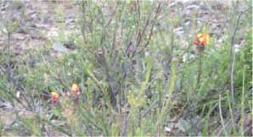

***Dillwynia cinerascens* (grey parrot-pea)**

**Grasses and grass-like plants:** includes species in the genera *Rytidosperma* (formerly *Austrodanthonia*) (wallaby grasses), *Austrostipa* (spear grasses), *Elymus* (wheat-grass), Enteropogon (windmill grasses), *Dianella* (flax-lilies) and *Lomandra* (mat-rushes).

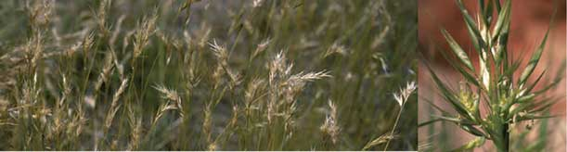

***Rytidosperma caespitosa* (formerly *Austrodanthonia caespitosa*)   
(ringed wallaby grass, common wallaby grass, white top)**

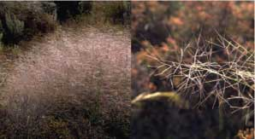

***Austrostipa elegantissimia* (feather speargrass, elegant speargrass)**

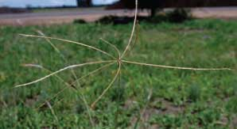

***Enteropogon acicularis* (curly windmill grass, spider grass, umbrella grass)**

Prober and Thiele (2004) noted there was an east-west floristic gradient for grassy box woodlands at the latitudes of their study in central NSW. One feature of this gradient is a gradual shift in the dominant understorey grasses from *Themeda triandra* (kangaroo grass) and *Poa sieberiana* (grey tussock- grass) in the eastern woodlands dominated by yellow box or white box towards *Austrostipa scabra* (rough spear-grass), *Rytidosperma* (formerly *Austrodanthonia*)

species (wallaby-grasses) and Enteropogon species (windmill-grasses) in the western box woodlands dominated by grey box or poplar box. These changes in understorey composition are relatively subtle and gradual (Keith, 2004).

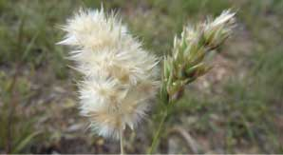

***Austrodanthonia sp.* (wallaby grass)**

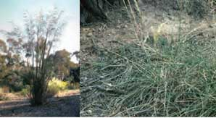

***Austrostipa mollis* (speargrass,   
soft speargrass)**

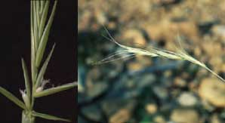

***Elymus scaber* (common wheatgrass, rough wheatgrass)**

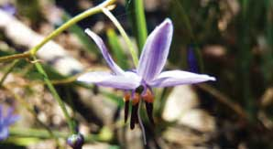

***Dianella revoluta* (flax lily)**

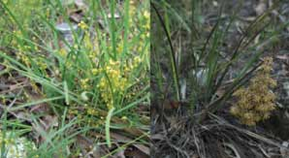

***Lomandra filiformis* (wattle mat-rush)**

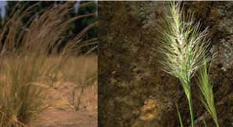

***Austrostipa scabra* (spear grass,   
rough speargrass, slender speargrass,   
delicate speargrass)**

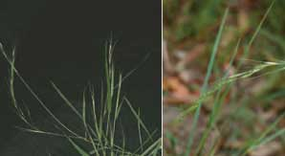

***Microlaena stipoides* (weeping ricegrass,   
meadow ricegrass, weeping grass)**

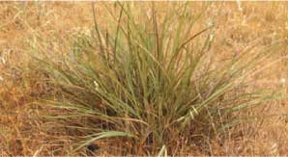

***Lomandra multiflora*(many-flowered mat-rush)**

**Forbs:** includes species pictured below

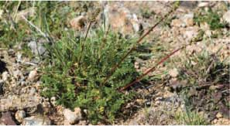

***Acaena echinata* (sheep's burr)**

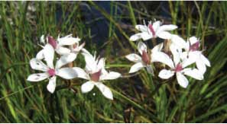

***Burchardia umbellata* (milkmaids)**

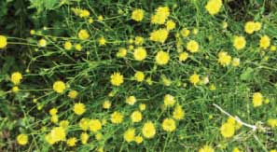

***Calotis lappulacea* (yellow burr-daisy)**

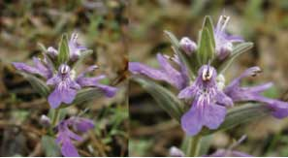

***Ajuga australis* (Austral bugle)**

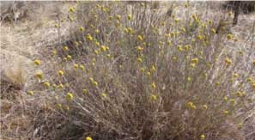

***Calocephalus citreus* (lemon beauty-heads)**

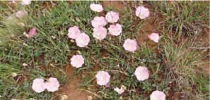

***Convovulus angustissimus*   
(grassland bindweed, blushing bindweed)**

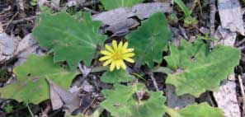

***Cymbonotus preeissianus* (Austral bear's ears)**

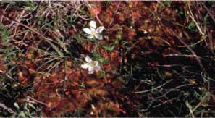

***Drosera whittakeri* (sundew)**

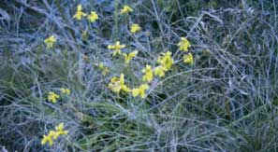

***Goodenia pinnatifida* (cut-leaf goodenia)**

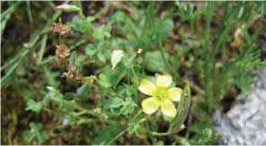

***Oxalis perennans* (native sorrel, grassland wood-sorrel)**

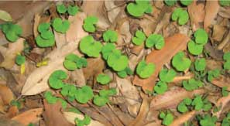

***Dichondra repens* (kidney weed)**

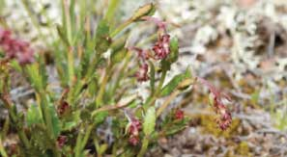

***Gonocarpus tetragynus* (small-leaf raspwort)**

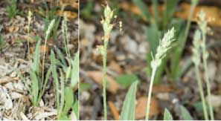

***Plantago varia* (plaintain)**

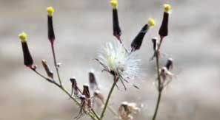

***Senecio quadridentatus* (cotton fireweed)**

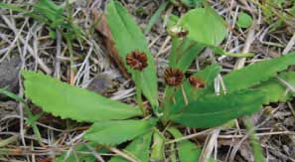

***Solenogyne doiminii* (smooth solenogyne)**

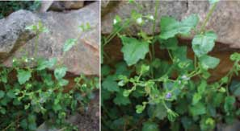

***Veronica plebeia* (trailing speedwell)**

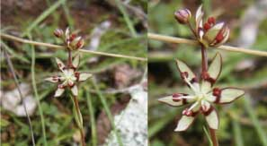

***Wurmbea dioica* (early nancy)**

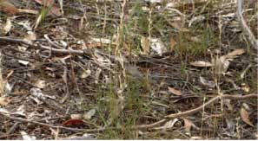

**Grey Box Grassy Woodland ground cover near Wagga Wagga**

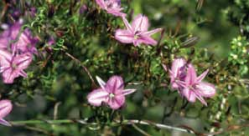

***Thysanotus patersonii* (twining fringe-lily)**

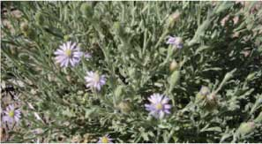

***Vittadinia cuneata* (fuzzy New Holland daisy)**

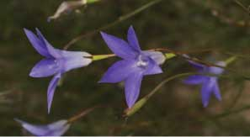

***Wahlenbergia communis* (tufted bluebell)**

**Chenopods:** includes the species Einadia hastata (saloop), E. nutans subsp. nutans (nodding saltbush), Enchylaena tomentosa (ruby saltbush), Maireana enchylaenoides (wingless bluebush) and Sclerolaena diacantha (grey copperbur).

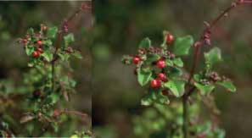

***Einadia hastata* (saloop)**

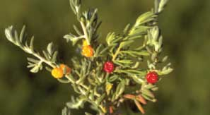

***Enchylaena tomentosa* (ruby saltbush)**

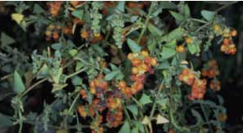

***Einadia ntuans subsp. nutans* (nodding saltbush)**

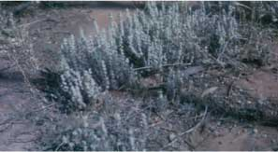

***Maireana enchylaenoides*(wingless bluebush)**

## Species of special importance

The Grey Box Grassy Woodlands provide habitat for many threatened native species. At the national level, at least 30 plant and animal species that may be found in or near the ecological community are listed as nationally threatened under the EPBC Act (Table 1).

Note that other species may be listed as rare or threatened under State environmental laws.

**Table 1: Species listed under the EPBC Act found in or near the   
Grey Box (*Eucalyptus microcarpa)* Grassy Woodlands and Derived Native   
Grasslands of South-Eastern Australia**

|  |  |  |
| --- | --- | --- |
| **Species name** | **Common name(s)** | **EPBC status** |
| **Birds** | | |
| *Anthochaera phrygia* | regent honeyeater | Endangered |
| *Calyptorhynchus banksii* | red-tailed black-cockatoo | Endangered (SE subspecies) |
| *Calyptorhynchus lathami* | glossy black-cockatoo | Endangered |
| *Cinclosoma punctatum* | spotted quail-thrush | Critically Endangered  (Mt Lofty subspecies) |
| *Hylacola pyrrhopygia* | chestnut-rumped heathwren | Endangered  (Mt Lofty subspecies) |
| *Lathamus discolour* | swift parrot | Endangered |
| *Leipoa ocellata* | malleefowl | Vulnerable |
| *Polytelis anthopeplus* | regent parrot | Vulnerable  (eastern subspecies) |
| *Polytelis swainsonii* | superb parrot | Vulnerable |
| Reptiles |  |  |
| *Aprasia pseudopulchella* | Flinders Ranges worm-lizard | Vulnerable |
| **Mammals** | | |
| *Chalinolobus dwyeri* | large-eared pied bat, large pied bat | Vulnerable |
| *Nyctophilus timoriensis =Nyctophilus corbeni* | greater long-eared bat (south eastern form) | Vulnerable |
| *Phascolarctos cinereus* | Koala | Vulnerable (NSW) |
| *Pseudomys pilligaensis* | Pilliga mouse | Vulnerable |
| **Plants** | | |
| *Acacia curranii* | curly-bark wattle | Vulnerable |
| *Austrostipa wakoolica* | spear-grass | Endangered |
| *Brachyscome papillose* | Mossgiel daisy | Vulnerable |
| *Caladenia woolcockiorum* | Woolcock’s spider-orchid | Endangered |
| *Dichanthium setosum* | a bluegrass | Vulnerable |
| *Diuris aequalis* | buttercup doubletail | Vulnerable |
| *Diuris behrii* | Behr’s cowslip orchid | Endangered |
| *Eleocharis obicis* | striate spike-sedge | Vulnerable |
| *Indigofera efoliata* | leafless indigo | Endangered |
| *Lepidium pseudopapillosum* | erect pepper-cress | Vulnerable |
| *Olearia pannosa ssp. Pannosa* | silver daisy-bush | Vulnerable |
| *Philotheca ericifolia* |  | Vulnerable |
| *Prasophyllum pallidum* | pale leek-orchid | Vulnerable |
| *Pterostylis arenicola* | sandhill greenhood orchid | Vulnerable |
| *Solanum karsense* | Menindee nightshade | Vulnerable |
| *Swainsona murrayana* | slender Darling-pea | Vulnerable |

More information on nationally listed species may be found at the species profile and threats database (SPRAT) at: [www.environment.gov.au/cgi-bin/sprat/public/sprat.pl](http://www.environment.gov.au/cgi-bin/sprat/public/sprat.pl)

The NSW, Victorian and SA Governments also produce species profiles or action statements for species listed in their State, which cover many of those in the table. They are found through the native plants and animals section of the state environment websites:

NSW Office of Environment and Heritage: [www.threatenedspecies.environment.nsw.gov.au/tsprofile/index.aspx](http://www.threatenedspecies.environment.nsw.gov.au/tsprofile/index.aspx)

Victorian Department of Sustainability and Environment: [www.dse.vic.gov.au](http://www.dse.vic.gov.au) (under Plants and Animals)

South Australian Department of Environment and Natural Resources [www.environment.sa.gov.au](http://www.environment.sa.gov.au) (under Plants and Animals)

**Some of the species listed under the EPBC Act found in or near the Grey Box (Eucalyptus microcarpa) Grassy Woodlands and Derived Native Grasslands of   
South-Eastern Australia**

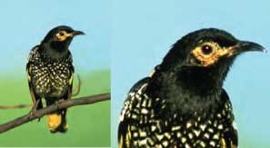

***Anthochaera Phrygia* (Regent honeyeater)**

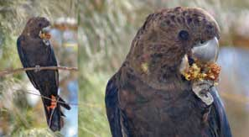

***Calyptorhynchus lathami*   
(glossy black-cockatoo)**

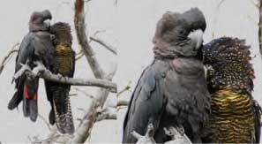

***Calyptorhynchus banksii*(red-tailed black-cockatoo)**

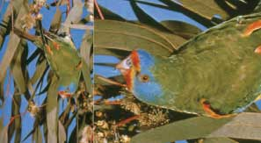

***Lathamus discolor* (swift parrot)**

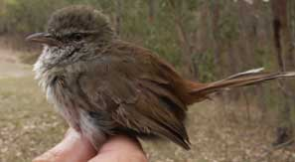

***Hylacola pyrrhopygia*   
Immature chestnut-rumped heathwren**

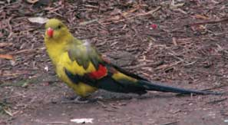

***Polytelis anthopeplus* (male regent parrot)**

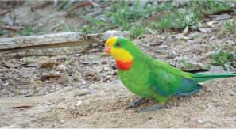

***Polytelis swainsonii* (superb parrot)**

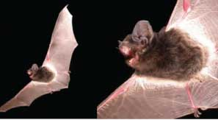

***Chalinolobus dwyeri*  
(large-eared pied bat/large pied bat)**

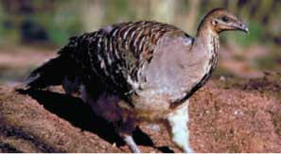

***Leipoa ocellata* (malleefowl)**

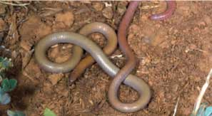

***Aprasia pseudopulchella*   
(Flinders Ranges worm-lizard)**

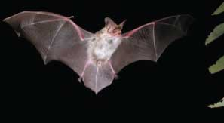

***Nyctophilus timoriensis* (= *N.Corbeni*)   
(greater long-eared bat/ south-eastern long-eared bat)**

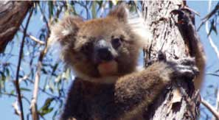

***Phascolarctos cinereus* (koala)**

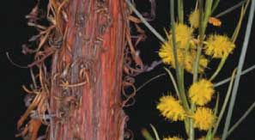

***Acacia curranii* (curly-bark wattle)**

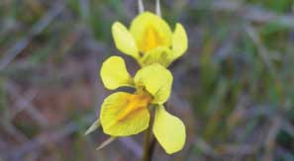

***Diuris behrii* (Behr's cowslip orchid)**

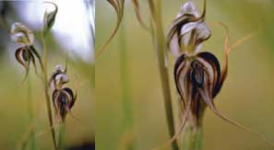

***Pterostylis arenicola* (sandhill greenhood orchid)**

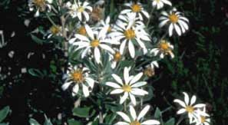

***Olearia pannosa* (silver daisy-bush)**

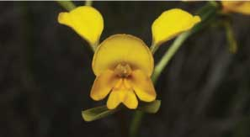

***Diuris aequalis* (buttercup doubletail)**

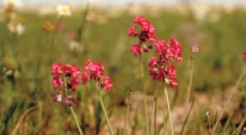

***Swainsona murrayana*(slender Darling-pea)**

# IS THE LISTED COMMUNITY KNOWN BY OTHER NAMES?

Vegetation is identified in different ways among regions, states and territories, depending on the vegetation classification system and environmental legislation that are applied. The Grey Box Grassy Woodlands ecological community relates to, or may be known as other vegetation types. The listed ecological community only includes the parts of these communities that meet the description and condition thresholds in the flow chart on page 24 of this document and the description in the listing advice for this community at: [www.environment.gov.au/biodiversity/threatened/communities/pubs/73-listing-advice.pdf](http://www.environment.gov.au/biodiversity/threatened/communities/pubs/73-listing-advice.pdf) .

## NVIS

The National Vegetation Information System(NVIS) is a hierarchical system for classifying vegetation across the Australian continent. It ranges from broad Major Vegetation Groups and Subgroups to more fine-scale floristic sub-associations. Grey Box Grassy Woodlands ecological community generally falls within the NVIS Major Vegetation Group5 – Eucalypt woodlands and Major

Vegetation Subgroup 9 – Eucalyptus woodlands with a grassy understorey.

For more information about the National Vegetation Information System go to the department’s website at: [www.environment.gov.au/erin/nvis/index.html](http://www.environment.gov.au/erin/nvis/index.html).

## New South Wales

NSW classifies its vegetation using the detailed NSW Vegetation Classification and Assessment (NSWVCA) database. Five NSW VCA communities conform to the general description of the national ecological community. A further four NSW VCA communities relate in part with the national ecological community. These vegetation communities are either ecotones* with Grey Box vegetation communities or are derived from cleared woodlands (previously dominated by Grey Box or other trees).

|  |  |
| --- | --- |
| **NSWVCA communities that conform to the listed ecological community** | **NSWVCA communities that may contain the listed ecological community** |
| **ID 76:** Inland Grey Box tall grassy woodland on alluvial loam and clay soils in the NSW South Western Slopes and Riverina Bioregions | **ID 110:** Inland Grey Box – Cypress Pine shrubby woodland on stony footslopes in the NSW South Western Slopes and Riverina Bioregions (adjoins IDs 76 and 80) |
| **ID 80:** Inland Grey Box – White Cypress Pine tall woodland on loam soil on alluvial plains of NSW South Western Slopes and Riverina Bioregions | **ID 248:** Mixed box eucalypt woodland on low sand-loam rises of alluvial plains in central western NSW (adjoins IDs 76 and 82) |
| **ID 81:** Inland Grey Box – Cypress Pine grassy tall woodland in the Brigalow Belt South Bioregion | **ID 250:** Derived tussock grassland of the central western plains and lower slopes of NSW (derived from cleared woodlands) |
| **ID 82:** Inland Grey Box – Poplar Box – White Cypress Pine tall woodland on red loams mainly of the eastern Cobar Peneplain Bioregion | **ID 267:** White box – White Cypress Pine – Inland Grey Box shrub/grass/forb woodland in the NSW South Western Slopes Bioregion (adjoins IDs 76 and 80) |
| **ID 237:** Riverine Inland Grey Box grassy woodland of the semi-arid (warm) climate zone |  |

NSW lists the following community as endangered under the *Threatened species Conservation Act 1995.*

* Inland Grey Box Woodland in the Riverina, NSW South Western Slopes, Cobar Peneplain, Nandewar and Brigalow Belt South Bioregions.

This community generally corresponds with the national ecological community. The national ecological community differs by excluding patches that occur in the Nandewar Bioregion. However, those patches may be included in the critically endangered* nationalecological community *White Box-Yellow Box –Blakely’s Red Gum Grassy Woodland and Derived Native Grassland.* Further information on NSW state listings or NSW VCA communities can be sought from the NSW Office of Environment and Heritage at [www.environment.nsw.gov.au](http://www.environment.nsw.gov.au) or by calling 131 555.

## Victoria

Victoria classifies its vegetation using a system of Ecological Vegetation Classes (EVCs). An EVC may be further subdivided into Floristic Communities. The EVC system includes complexes, mosaic and aggregate units for situations where specific EVCs cannot be identified at a site at the spatial scale used for vegetation mapping. EVC mosaics and complexes are included in the national ecological community where they conform with the description of the national ecological community. Victoria has established benchmarks for many EVCs to allow condition assessments to be made with respect to a reference patch of a particular vegetation type. Benchmarks are not a comprehensive description of an EVC, but do provide an accessible summary of its main features and ecology.

The following EVCs and mosaic units in the Victorian bioregions shown are most likely to contain Grey Box (*Eucalyptus microcarpa*) Grassy Woodlands and Derived Native Grasslands of South-Eastern Australia. Not all floristic communities within an EVC will necessarily correspond to the national community.

|  |  |
| --- | --- |
| **EVC number and name (as at the time of EPBC listing in March 2010)** | **Victorian Bioregions** |
| 55 Plains Grassy Woodland | Goldfields, Northern Inland Slopes |
| 66 Low Rises Woodland | Murray Mallee, Murray Fans,  Victoria Riverina |
| 67 Alluvial Terraces Herb-rich Woodland | Goldfields, Northern Inland Slopes, Victorian Riverina, Wimmera |
| 175 Grassy Woodland | Goldfields, Northern Inland Slopes, Victorian Riverina, Wimmera |
| 187 Plains Grassy Woodland/Rainshadow Grassy Woodland Complex | Northern Inland Slopes,  Victorian Riverina, |
| 235 Plains Woodland/Herb-rich Gilgai Wetland Mosaic | Central Victorian Uplands, Goldfields, Northern Inland Slopes, Victorian Riverina, Victorian Volcanic Plain |
| 803 Plains Woodland | Central Victorian Uplands, Goldfields, Lowan Mallee, Northern Inland Slopes, Victorian Riverina, Victorian Volcanic Plain |

The following two communities listed as threatened under the *Victorian Flora and Fauna Guarantee Act 1988* relate in part to the national ecological community:

* Grey Box –Buloke Grassy Woodland Community
* Victorian Temperate Woodland Bird Community

Further information on Victorian state listings or the Victorian Ecological Vegetation Classes can be sought from the Victorian government at [www.dse.vic.gov.au](http://www.dse.vic.gov.au/) or by calling 136 186.

## South Australia

South Australia is adopting the NVIS system as the basis for their State-wide vegetation classification and information system. At present, this system classifies vegetation communities ‘as is’, without distinguishing between native and exotic species*, rather than classifying solely on the basis of the native species as is usual in NSW and Victoria.

In the table below, exotic species are identified with an asterisk (*). Future management may reduce the dominance of exotic species in these communities. Despite the inclusion of these exotics in this classification, their absence from a patch would enhance, rather than detract from, its value with regard to the nationally listed ecological community.

Three South Australian Vegetation Units from the Flinders Lofty Block and Murray Darling Depression IBRA Bioregions are considered the most likely to contain the Grey Box (*Eucalyptus microcarpa*) Grassy Woodlands and Derived Native Grasslands of South- Eastern Australia ecological community. Patches of the national ecological community may also occur in a further three vegetation units, although some of these units may vary from the “typical” expression of the nationally listed ecological community, either by having more shrubs (SM1903) or a significant presence of Triodia.

South Australia’s *Provisional list of Threatened Ecosystems of South Australia* recognises two Grey Box communities as endangered:

* *Eucalyptus microcarpa* grassy woodland on cracking clays on plains
* *Eucalyptus microcarpa* grassy low woodland on foothills and hill slopes of southern Mount Lofty Ranges

Provisionally listed communities that include Buloke (*Allocasuarina luehmannii*) as a subdominant species may also coincide with the national community.

Further information on the implications of the South Australian state provisional list or the NVIS vegetation classes can be sought from the SA government at [www.environment.sa.gov.au](http://www.environment.sa.gov.au/) or by calling 08 8222 9311.

|  |  |
| --- | --- |
| **SA Vegetation Units most likely to conform to the listed ecological community** | **SA Vegetation Units that may also contain the listed ecological community** |
| **SEOO88** *Eucalyptus microcarpa* mid woodland over *Rytidosperma* (formerly *Austrodanthonia*) *setacea*, *Avena barbata*, Lepidosperma viscidum* tussock grasses | **MN401** *Eucalyptus microcarpa* ± *Allocasuarina verticillata* low woodland over *Xanthorrhoea quadrangulata, Cassinia laevis* ± *Bursaria spinosa* subsp. *spinosa* shrubs over *Triodia sacriosa* subsp. (NC), *Lomandra multiflora* subsp. *dura*, *Lepidosperma viscidum* hummock grasses |
| **SM1901** *Eucalyptus microcarpa* mid woodland over *Acacia pycnantha, Olea eropaea* subsp. *europaea*\*, *Olearia ramulosa*, *Acacia paradoxa* tall shrubs over *Briza maxima*, Astroloma humifusum, Lomandra densiflora* ±*Themeda trindra* low tussock grasses | **SF0016** *Eucalyptus microcarpa* low woodland over *Allocasuarina verticillata, Xanthorrhoea quadrangulata, Cassinia laevis* ± *Bursaria spinosa* subsp. *spinosa* shrubs over *Austrostipa nodosa, Triodia irritans* tussock grasses |
| **MN0402** *Eucalyptus microcarpa* ± E. *viridis* subsp. *viridis* mid woodland over *Acacia pycnantha, Cassinia laevis* shrubs over *Lomandra multiflra* subsp. *dura*, *Maireana enchylaenoides, Lomandra densiflora, Rhagodia parabolica* forbs | **SM1903** *Eucalyptus microcarpa , E. leucoxylon* mid woodland over *Acacia pycnantha, Allocasuarina verticillata* over *Olearia ramulosa*, *Chrysanthemoides monilifera\** mid shrubs over *Astroloma humifusum* low shrubs |

## Similar ecological communities

Grey Box Grassy Woodlands co-occur or intergrade* with nine other nationally threatened grassland or grassy woodland communities (at time of printing):

* *White Box – Yellow Box – Blakely’s Red Gum Grassy Woodland and Derived Native Grassland*
* *Coolibah - Black Box Woodlands of the Darling Riverine Plains and the Brigalow Belt South Bioregions*
* *Weeping Myall Woodlands* (NSW only)
* *Natural grasslands on basalt and fine- textured alluvial plains of northern New South Wales and southern Queensland*
* *Buloke Woodlands of the Riverina and Murray-Darling Depression Bioregions*
* *Peppermint Box (Eucalyptus odorata) Grassy Woodland of South Australia* (SA only)
* *Iron-grass Natural Temperate Grassland of South Australia* (SA only)
* *Natural Temperate Grasslands of the Victorian Volcanic Plains* (Victoria only)
* *Grassy Eucalypt Woodlands of the Victorian Volcanic Plains* (Victoria only)

A key distinguishing feature of many of these threatened ecological communities is the dominant tree species, where trees are (or were originally) present. In the Grey Box Grassy Woodlands ecological community, Grey Box must be (or have previously been) the dominant species (comprising 50% or more of canopy crown cover). Other tree species may be present and may sometimes be co-dominant with Grey Box, but are never dominant on their own. Similarly, Grey Box may have a minor presence in other ecological communities, but these would not be included in the listed community (refer to Flowchart 1 on page 23.

## Other adjacent ecological communities

Similar or adjacent ecological communities include:

* Box-Ironbark forest (distinguished by a denser mid-layer and the presence of Ironbark eucalypt species as components of the overstorey)
* Semi-arid woodland formations including Riverine Plain Woodlands and Western Peneplain Woodlands (in western NSW)
* Ridged Plains Mallee (EVC 96) in Victoria, dominated by Bull Mallee (*E. behriana*) and Dumosa Mallee (*E. dumosa*)

## Exclusions from the national ecological community

Several species other than *E. microcarpa* are referred to as “Grey Boxes”, in particular Coastal Grey Box (*E. moluccana*), Coast Grey Box (*E. bosistoana*) and Narrow-leaved Grey Box (*E. pilligaensis*)[1]. Communities dominated by these species are not included in the Grey Box (*Eucalyptus microcarpa*) Grassy Woodlands and Derived Native Grasslands of South-Eastern Australia ecological community.

Occurrences of *E. microcarpa* north of the distribution described in this document are excluded from this ecological community on the basis that the southern *E. microcarpa* woodlands are considered to be an ecologically discrete entity with a large temperate component.

Similarly, Woodland Grey Box (*E. silvestris*) which was considered by some to be the same species as *E. microcarpa*, is now recognised as a separate species (in Victoria). Communities dominated by Woodland Grey Box (in western Victoria and in the SA border region) are also excluded from the national ecological community.

# INDIGENOUS HERITAGE

Grey Box (*Eucalyptus microcarpa*) Grassy Woodlands and Derived Native Grasslands of South-Eastern Australia ecological community occurs across the lands of many Indigenous language groups. Each group would have had extensive traditions in relation to their own lands. Due to the large number of groups, it is not possible to describe those traditions in detail here. However we acknowledge the existence of the traditions and continuing links that Indigenous Australians have to their traditional lands within the listed ecological community.

Indigenous elders are the custodians of much traditional knowledge in each area. However, State agencies are a good starting point when trying to find out more information about Indigenous heritage in your area. They can provide information on your legislative responsibilities and general information about important local sites. They can also direct you to Indigenous community representatives who may be able to assist with more specific enquiries.

Indigenous Protected Areas (IPAs)* in NSW, Victoria or south-eastern South Australia where the listed community occurs include the Toogimbie IPA near Hay in NSW, which is just west of the listed community’s known distribution.

There are several National Heritage places within the distribution area of the listed ecological community that are identified as having significant Indigenous heritage values. However, all have distinctive geologies and landforms that mean they are unlikely to host significant areas of the listed ecological community.

# WHAT DOES THE LISTING MEAN FOR APPROVAL AUTHORITIES OR LAND MANAGERS?

## What does the EPBC Act listing of the ecological community mean for farmers, land managers or developers?

If you have a patch of Grey Box Grassy Woodlands on your property then adequate protection and appropriate land management practices are vitally important if the listed ecological community is to persist for the benefit of future generations.

Appropriate management and restoration of patches that do not meet the condition thresholds (and thus do not qualify for full protection under the EPBC Act) is recommended, as these patches may still play an important ecological role, especially where they are providing valuable habitat or connectivity. For example: patches that link native vegetation remnants in the landscape are particularly important as wildlife habitat and to the viability of listed patches of the ecological community.

The listing of Grey Box Grassy Woodlands under the EPBC Act will not prevent land managers from continuing current land management practices or activities, providing that these practices or activities do not significantly change or intensify, or are unlawful.

## Which activities might require consideration?

Protection under national environment law means any **new or intensified activities** that **may have a significant adverse impact** on one or more nationally listed ecological communities should be referred to the environment minister for assessment and approval.

Most day to day land use activities are not likely to have significant impacts or otherwise require consideration under the EPBC Act, however activities that are likely to require approval and should be referred include, but are not restricted to:

* clearing patches of the ecological community (*e.g.* for new developments, roads or extensive fire breaks)
* development close to a particular patch of the ecological community
* converting grazing land containing the ecological community to cropping
* heavy or blanket application of fertilisers or other chemicals that could detrimentally affect the ecological community
* significantly changing drainage and local water patterns
* introducing potentially invasive exotic pasture species in or near to a patch of the ecological community
* significant and adverse changes in management regime (such as converting from mowing/slashing to herbicide use or substantially intensifying stocking rates).

On the other hand, activities that are unlikely to require approval include routine maintenance e.g. of buildings and properties, existing firebreaks or routine weed management (with minimal or positive impacts on the ecological community).

Also note that even if a native vegetation remnant on your land does not meet the criteria for the listed ecological community, there may be threatened plant or animal species within the remnant that are individually protected under the EPBC Act (see Table 1 on page 34).

The process for making a referral under the EPBC Act can be done online. The EPBC Act allows for some exemptions to the

requirement for assessment and approval. This means some activities may not need assessment or approval under certain situations. Generally, exemptions refer to existing permission to legally undertake an action or to routine actions that are carried out over a long time. However, failure to refer an action that is not exempt and likely to have a significant impact on a listed ecological community may have legal consequences such as financial penalties or remediation orders.

If you are considering an activity that may impact on the ecological community, you are encouraged to contact the department (1800 803 772) about your options. Further information is available on the department’s website: [www.environment.gov.au/epbc/about/index.html](http://www.environment.gov.au/epbc/about/index.html)

The department has also created a farmer fact sheet for the Grey Box Grassy Woodlands to help landholders identify this community on their property, and decide whether any planned activity is likely to be significant and need a referral to the Minister. The fact sheet can be downloaded from [www.environment.gov.au/cgi-bin/sprat/public/publicshowcommunity.pl?id=86&status=Endangered](http://www.environment.gov.au/cgi-bin/sprat/public/publicshowcommunity.pl?id=86&status=Endangered)

You should also check with relevant authorities whether any state or local government approvals are required in addition to EPBC Act requirements. If you have a patch of the listed ecological community on your property and would like advice, farmers can contact the department’s **Environment Liaison Officer** at the National Farmers’ Federation (NFF) either by phone (1800 704 520) or by email: [environment@nff.org.au](mailto:environment@nff.org.au) .

# KEY THREATS AND SUGGESTED CONSERVATION ACTIONS

There are many benefits to the long-term protection of Australia’s native biodiversity. Patches of native vegetation, such as the Grey Box Grassy Woodlands ecological community, provide a range of ecosystem services including management of water tables and flows, soil nutrient cycling, erosion and salinity reduction, carbon storage, and habitat for important functional species such as pollinators or predators of insect pests. They also provide wind breaks, shelter and food for stock, and exhibit some resilience to drought.

Most of the remaining areas of this ecological community occur on private land. At present, less than 1% of what remains of the listed community in NSW is in formal conservation reserves. Slightly more of the community occurs in formal reserves in Victoria, with around 8% of the remaining area protected. The level of protection in South Australia is unknown but is likely to be similarly low.

This section identifies the key threats to the Grey Box Grassy Woodlands ecological community, and possible actions that land managers may take to conserve the listed community on their land (Table 2). This list is

not exhaustive, but highlights conservation actions that are a high priority at this time.

## Vegetation clearance and fragmentation

Clearing and fragmentation of vegetation continue to pose serious threats to the Grey Box Grassy Woodlands ecological community. Much of the listed community coincides with what is now the wheat-sheep belt of eastern Australia and the community has been extensively cleared since European settlement as a result of its open, grassy structure and its association with relatively fertile soils.

Cultivation for cropping destroys the propagule bank, which can include seeds, rhizomes and tubers of native species. Sites that have never been cultivated may retain a propagule bank for many years, allowing previously-dormant species to recover when conditions allow.

Fragmentation due to continued vegetation clearance results in areas of native vegetation becoming isolated with

connectivity between them being lost. Many of the remaining areas of the ecological community are small and highly fragmented. Smaller, more isolated areas become less able to support viable populations of native species or to maintain the ecosystem processes and services that sustain the ecological community.

Small patches also have a lot of ‘edge’ area and little ‘core’ area. Some species, including many declining woodland birds, need ‘core’ habitat to survive. Several small patches will contain much less ‘core’ habitat than a single large patch of equal size.

Having lots of edge area makes it easier for weeds and pests to invade the patch. Small fragmented areas with large edge areas are also more vulnerable to fertiliser or herbicide spray drift, rubbish dumping, altered fire regimes and trampling by stock or humans.

## Inappropriate management actions

Inappropriate management actions for grassy woodland ecosystems include overgrazing, and fertiliser addition.

Grazing in grassy woodlands can be a two-edged sword for management. On the one hand, overgrazing is one of the most damaging management actions that grassy ecosystems experience. Overgrazed areas quickly lose grazing-sensitive native species, which are replaced by less-sensitive native species and some exotic species, and finally by exotics alone. Trampling by stock compacts the soil and decreases water

infiltration, which can prevent seeds from germinating. A buildup of animal droppings helps exotic species outcompete native species in a similar way to the addition of synthetic fertilisers. The loss of protective plant cover can lead to serious soil erosion. The combination of these factors can prevent the regeneration of native trees, shrubs and ground cover species alike.

By contrast, well-managed, intermittent grazing regimes can help to maintain or even restore grassy ecosystems. The system of Travelling Stock Reserves (TSRs)* in NSW provides some of the best examples of grassy woodlands in that state, which owe their health to intermittent grazing. Programs to improve the health of some low to medium quality reserves by carefully managing the timing and intensity of grazing have shown some very encouraging results.

Timing of grazing is important to ensure that native species have an opportunity to flower and set seed. The crucial times to avoid grazing will vary between years and between areas, but late spring and early summer is a vital flowering and seeding period for native grasses and other ground cover species in many areas. Important flowering and seeding events may also happen at other times of the year after heavy rain, so a flexible approach is required.

Many exotic annual grasses flower earlier in spring than native species, so grazing in early spring may help to limit seed set by exotic grasses and reduce competition for native species. This can then promote increased dominance by native species.

Determining the appropriate timing of grazing to promote native understorey species is a complex subject. It is best to seek local advice on this subject, for example from the Livestock Health and Protection Authority rangers responsible for managing TSRs in your area, from Catchment Management Authorities, Natural Resource Management bodies or from State government agency staff.

Fertiliser addition, particularly phosphorus fertiliser, allows exotic (weedy) species to outcompete native species that have evolved to cope with Australia’s relatively infertile soils. Inappropriate grazing and/or fertiliser addition should be avoided in native grassy ecosystems.

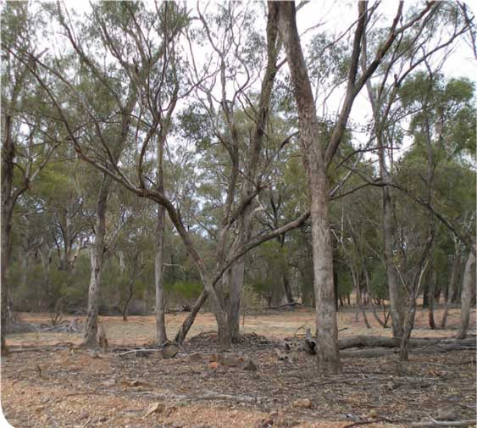

Near Nymagee (NSW) in dry times with continuous grazing pressure

**Table 2: Impacts of clearance, fragmentation and inappropriate   
management, and key potential management actions**

|  |  |
| --- | --- |
| **Impacts of clearance, fragmentation and inappropriate management** | **Key potential management interactions** |
| * Direct loss of native species and decline in biodiversity (especially species least tolerant of disturbance). * Loss of habitat for native plants and animals. * Greater susceptibility to further disturbances and threats (as fragments become more isolated and the surrounding landscape is modified). * Impeded migration of native species among remnants (especially if they are isolated or widely separated). * Loss of soil or soil quality (for example, erosion after vegetation loss, soil compaction by stock). * Changes in water flows and quality (for example, decreased water infiltration, increased runoff). * Inappropriate application of fertilisers killing native species adapted to low nutrient environments. * Weed invasion from poor management regimes. | * Identify the best quality remnants and key threats. * Monitor their condition and the effectiveness of management actions, and adapt them, if necessary. * Avoid or minimise clearance and other permanent damage to patches of the ecological community. * Protect remnants through inclusion in formal conservation reserves, or through management agreements or conservation covenants. * Protect native vegetation remnants that buffer or link remnants of the ecological community. * Ensure road widening, maintenance activities and other infrastructure or development activities do not adversely affect known remnants. * Retain any logs, fallen timber or standing dead trees to foster habitat diversity for native fauna and promote ecological functions like nutrient cycling. |
|  | * Continue to raise awareness of the ecological community within the region. * Develop and implement appropriate management regimes to maintain the distinctive biodiversity elements of the ecological community (for example, strategic grazing regimes or ecological fire regimes). * Ensure that management regimes are also appropriate for any threatened species present. * Encourage good management practices for remnants on all land tenures, not just to remnants under conservation tenure. * Avoid the use of fertilisers within native vegetation remnants and ensure that fertiliser applications in adjoining pastures do not drift into patches of the ecological community. |

## Weeds and pest animal species

Many exotic weed species occur throughout the listed ecological community because it is geographically widespread and occurs in relatively fertile but disturbed agricultural areas (Table 3). Many weed species found in the community are commonly found in pastures and croplands. Weeds cause problems in native vegetation because they out-compete native species. They may also change the structure of the community, making it less suitable habitat for native animals (Table 4). Once introduced, weeds are often very difficult to eradicate.

Several Weeds of National Significance (WoNS)* are found in the listed community. Weeds of National Significance are some of Australia’s worst weeds, and the various Australian jurisdictions have developed a national approach for dealing with them.

**Table 3 Exotic weed species occuring in the listed ecological community**

|  |  |
| --- | --- |
| Weeds of National Significance found in the listed ecological community include: | |
| bridal veil creeper | *Asparagus asparagoides* |
| boneseed | *Chrysanthemoides*  *monilifera* |
| Chilean needle-grass | *Nassella neesiana* |
| serrated tussock grass | *Nassella trichotoma* |
| blackberries | *Rubus species* |
| Other widespread weeds in the community include: | |
| brome grasses | *Bromus species* |
| winged thistle | *Carduus tenuiflorus* |
| saffron thistle | *Carthamus lanutus* |
| rubble peppercress | *Lepidium africanum* |
| soursob | *Oxalis pes-caprae* |

**Significant weeds that occur in the Grey Box (*Eucalyptus microcarpa*) Grassy Woodlands and derived native grasslands of South-eastern Australia**

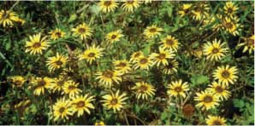

***Arctotheca calendula* (capeweed)**

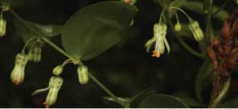

***Asparagus asparagoides*\*†√(bridal creeper)**

* Widespread weed in this community †Weeds of National Significance (WoNS) in this community  
√A declared Noxious Weed in some jurisdictions.

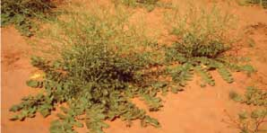

***Brassica tournefortii* (Mediterranean turnip)**

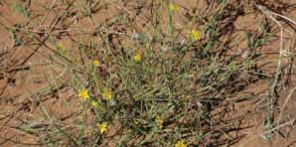

***Chondrilla juncea*√ (skeleton weed)**

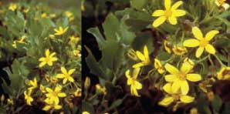

***Chrysanthemoides monilifera* †√   
*ssp. monilifera* (boneseed)**

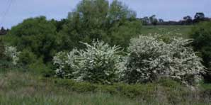

***Crataegus monogyna*√ (hawthorn)**

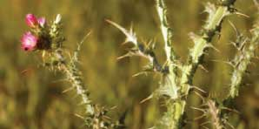

***Carduus tenuiflorus*\*√   
(winged thistle, slender thistle)**

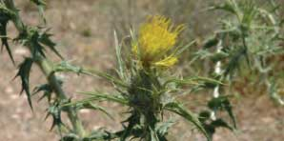

***Carthamus lanatus*\*√ (saffron thistle)**

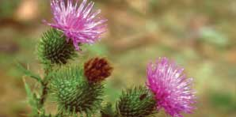

***Cirsium vulgare*√ (spear thistle)**

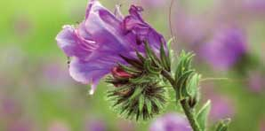

***Echium plantagineum*√   
(Paterson’s curse, salvation Jane)**

* Widespread weed in this community †Weeds of National Significance (WoNS) in this community  
√A declared Noxious Weed in some jurisdictions

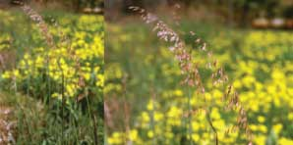

***Ehrharta calycina* (perennial veldt grass)**

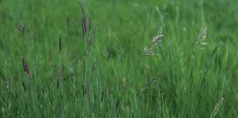

***Holcus lanatus* (Yorkshire fog)**

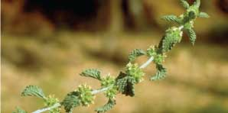

***Marrubium vulgare*√ (horehound)**

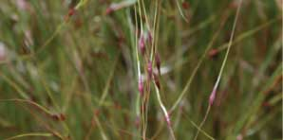

***Nassella trichotoma* †√   
(serrated tussock-grass)**

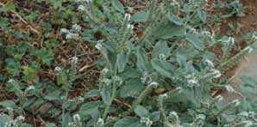

***Heliotropium europaeum*√   
(common heliotrope)**

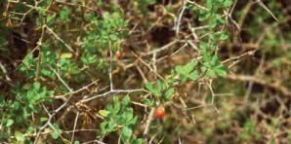

***Lycium ferocissimum* †√ (boxthorn)**

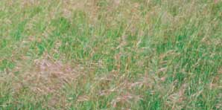

***Nassella neesiana* †√ (Chilean needle-grass)**

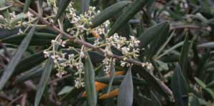

***Olea europaea*\*√ (European olive)**

* Widespread weed in this community †Weeds of National Significance (WoNS) in this community  
√A declared Noxious Weed in some jurisdictions.

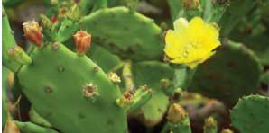

***Opuntia species* †√ (prickly pear cactus)**

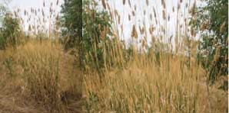

***Phalaris species* (phalaris, canary grass)**

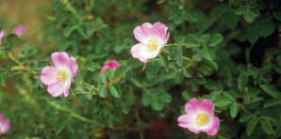

***Rosa canina*√ (dog rose)**

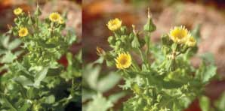

***Sonchus oleraceus* (common sow-thistle)**

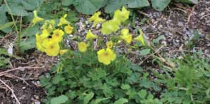

***Oxalis pes-caprae*\*√ (soursob)**

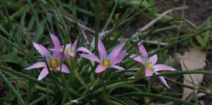

***Romulea rosea*√ (onion grass)**

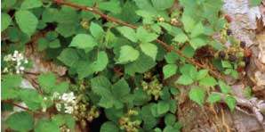

***Rubus* species †√ (blackberries)**

* Widespread weed in this community †Weeds of National Significance (WoNS) in this community  
√A declared Noxious Weed in some jurisdictions.

**Table 4: Impacts of exotic species and key management actions**

|  |  |
| --- | --- |
| **Impacts of exotic species** | **Key management actions** |
| * Direct loss of native species and decline in biodiversity. * Weeds competing with native plants for space, water and nutrients. If left unmanaged, weeds will degrade and potentially dominate a site. * Weeds can perpetuate a change in the nutrient cycle, in favour of exotic species over native species. * Introduced predators, such as foxes and feral cats, competing with native predators and killing native animals. * Introduced herbivores, such as rabbits, grazing, browsing and killing native plants. They can also disturb soil structure through extensive diggings or trampling. | * Identify the key weed and pest animals at a given site. * Eradicate or manage and monitor weeds, pest animals and other problem species, including invasive native shrubs, following available best practice or management plans. * Ensure use of chemicals or other mechanisms to control weeds and pest animals do not have any significant adverse impact on native species (for example, avoid broad-cast herbicide use such as aerial spraying). * Minimise impacts to threatened species at known sites. * Identify new and emerging weed and pest animal problems in the region. Act quickly to eradicate them before the problem becomes too impractical and expensive to fix. * Prevent or minimise the addition of nutrients, such as fertilisers. Nutrient enrichment promotes weed invasion. |

In South Australia, the most serious woody weed is the European olive (*Olea europaea*), which has escaped from cultivation. Given the increase in olive-growing throughout eastern Australia, olives may become a more serious threat in other areas in future.

Land managers should also be aware of, and comply with, any local or state laws that require them to manage noxious weeds or pest animals on their property.

Many weed species produce a lot of seed that is easily dispersed, e.g. seeds that are

blown by wind, seeds produced in fleshy fruits that are eaten by animals and dispersed in droppings, or seed that “hitches a lift” on vehicles or is introduced to a property in purchased fodder or seed. One important control principle is to reduce the amount of seed that weeds produce, by spraying, burning or even grazing grassy weeds before seed is set. Another vital control measure is to avoid spreading weed seeds by regularly cleaning vehicles and farm machinery, especially before moving it to a new area. Careful sourcing of clean seed and fodder

will also help reduce the establishment of new weeds on your property.

Weeds tend to establish well in disturbed soil, especially where soil fertility is high. Soil disturbance can result from things like heavy digging machinery movement or trampling by stock. Fertiliser drift from nearby crops or a build-up of animal droppings from stock can artificially raise soil fertility and encourage weed growth. Both should be avoided in areas containing native vegetation.

Herbicide application is an important weed control practice in most areas, however it can also threaten native species. Sometimes, this occurs via spray drift from nearby crops or pastures, and care must be taken to ensure that native vegetation is not adversely affected. Care must also be taken when applying herbicide to control weeds in patches of native vegetation not to kill native species by mistake. For this reason, broadscale herbicide application in these areas is usually not appropriate, and spot application is preferred.

Introduced species often have an advantage over native species because they have fewer natural controls like diseases or insect pests. Biological control agents are available for some weeds. For example, the rust fungus *Puccinia myrsiphyllii*, has proved to be an effective biological control agent for *Asparagus asparagoides* (bridal creeper).

Notable pest animals that occur in the listed ecological community include predators such as the European fox, feral cats and feral dogs, as well as pest herbivores such as the

European rabbit and brown hare. These species kill native wildlife or destroy native vegetation.

## Climate change

Climate change as a result of human activities is now understood to pose a serious long-term threat to many species and ecological communities. Climate change can directly threaten some species that cannot adapt to changed conditions, but it can also exacerbate existing threats, including loss of habitat and spread of invasive species.

While actions to reduce or prevent climate change need to happen at a global scale, landholders can help give native species and ecological communities the best chance at surviving changing conditions by better managing other threats. Land managers can help build resilience in ecological communities by choosing management regimes that improve the health, native species cover and connectivity of vegetation patches. The more connected patches of native vegetation are, the better the opportunity that native species have to move to new areas, and the healthier the community is the better able it will be to adapt to changing conditions.

## Is funding available to protect the listed grassy woodland and derived native grassland community?

If you have the listed ecological community on your property, you may be eligible for funding to help preserve or restore remnants.

Patches that do not currently meet the condition thresholds may be eligible for funding to help restore them to good condition.

### National funds

Funding through Caring for our Country may be available for activities that have environmental benefits. For more details visit [www.nrm.gov.au](http://www.nrm.gov.au/) or talk to a local Caring for our Country regional officer [www.nrm.gov.au/contacts.](http://www.nrm.gov.au/contacts)

The National Reserve System (NRS)* has an important role in protecting biodiversity values on private land in agricultural and pastoral regions. Building the NRS is one of the priorities under Caring for our Country. Interested organisations can apply for assistance from the Australian Government to help landholders voluntarily establish protected areas to be managed for nature conservation as part of the NRS. This allows landholders to permanently protect all or part of their property’s biodiversity for future generations. The emphasis is on land with high biodiversity values and connectivity. For more details visit [www.environment.gov.au/parks/nrs/getting-involved/index.html](http://www.environment.gov.au/parks/nrs/getting-involved/index.html)

### State funds

There may be state government programs to help protect the Grey Box Grassy Woodlands. Regional offices and websites of state environment agencies, including Catchment Management Authorities or Natural Resource Management Boards, and

local councils can provide you with information about current programs in place to support conservation efforts in your area, including on private property, supporting the Grey Box Grassy Woodlands ecological community.

In New South Wales, funding to protect patches of the ecological community may be available through BioBanking [www.environment.nsw.gov.au/biobanking/](http://www.environment.nsw.gov.au/biobanking/) and other vegetation conservation incentive schemes. Landholders who wish to provide permanent protection for native vegetation or special features on their land may also enter into conservation agreements with the NSW Government [www.environment.nsw.gov.au/cpp/ConservationAgreements.htm](http://www.environment.nsw.gov.au/cpp/ConservationAgreements.htm)

In Victoria, initiatives such as BushTender, BushBroker and EcoTender [www.dse.vic.gov.au/conservation-and-environment/biodiversity/rural-landscapes](http://www.dse.vic.gov.au/conservation-and-environment/biodiversity/rural-landscapes) can assist in restoring and repairing the natural ecological processes in areas supporting Grey Box Grassy woodlands.

In South Australia the Native Vegetation Council (NVC) [www.environment.sa.gov.au/conservation/native_vegetation](http://www.environment.sa.gov.au/conservation/native_vegetation) provides funding for a variety of research and conservation projects that promote the responsible and ongoing management of native vegetation in South Australia.

In addition, your local CMA or NRM Board office may be able to provide information about current or proposed state incentive/ funding opportunities.

# WHERE CAN I GO FOR MORE INFORMATION?

## The listing advice and conservation advice for the Grey Box Grassy Woodlands

This is the definitive source of information about the nationally-listed ecological community and can be downloaded from: [www.environment.gov.au/cgi-bin/sprat/public/publiclookupcommunities.pl](http://www.environment.gov.au/cgi-bin/sprat/public/publiclookupcommunities.pl)

Click on the details link against the name of the ecological community then follow the link to the listing and conservation advice.

## Information about other matters of national environmental significance

* Other EPBC-listed threatened ecological communities [www.environment.gov.au/cgi-bin/sprat/public/publiclookupcommunities.pl](http://www.environment.gov.au/cgi-bin/sprat/public/publiclookupcommunities.pl)
* Individually-listed threatened species under the EPBC Act [www.environment.gov.au/cgi-bin/sprat/public/sprat.pl](http://www.environment.gov.au/cgi-bin/sprat/public/sprat.pl)
* Internationally significant Ramsar wetlands [www.environment.gov.au/water/topics/wetlands/](http://www.environment.gov.au/water/topics/wetlands/)
* Australia’s heritage places [www.environment.gov.au/heritage/index.html](http://www.environment.gov.au/heritage/index.html)

## Other useful resources

### State-listed threatened ecological communities

The NSW Office of Environment and Heritage website contains profiles for state-listed threatened species and ecological communities. The profile for Inland Grey Box Woodland in the Riverina, NSW South Western Slopes, Cobar

Peneplain, Nandewar and Brigalow Belt South Bioregions, can be found at: [www.threatenedspecies.environment.](http://www.threatenedspecies.environment/) nsw.gov.au . The site also contains profiles for many threatened species found in the national ecological community.

The Victorian Department of Sustainability and Environment website contains action statements for many of the species of special importance in this ecological community at: [www.dse.vic.gov.au/plants-and-animals/](http://www.dse.vic.gov.au/plants-and-animals/) native-plants-and-animals/threatened- species-and-communities/action-statements

### Other guides with information that may help to identify and manage the ecological community include:

Barlow, T. (1999). Grassy guidelines. How to manage native grasslands and grassy woodlands on your property. Melbourne: Trust for Nature Victoria. Available at: [www.environment.gov.au/land/publications/grassguide.html](http://www.environment.gov.au/land/publications/grassguide.html)

Davidson, I, Scammell, A, O’Shannassy, P, Mullins, M & Learmonth, S (2005). Travelling stock reserves: refuges for stock and biodiversity. Ecological Management and Restoration, 6, p 5-15.

Department of Environment and Natural Resources. Habitat Restoration Planning Guide for Natural Resource Managers [www.environment.sa.gov.au/Conservation/Native_vegetation/Landscape_restoration](http://www.environment.sa.gov.au/Conservation/Native_vegetation/Landscape_restoration)

Dorrough, J., Stol, J. & McIntyre, S. (2008). Biodiversity in the paddock: a land managers’ guide. Canberra: Future Farm Industries CRC. Available at: [www.futurefarmcrc.com.au/documents/Biodiversity_in_the_Paddock.pdf](http://www.futurefarmcrc.com.au/documents/Biodiversity_in_the_Paddock.pdf)

Langford, C., Simpson, P., Garden, D., Eddy, D., Keys, M., Rehwinkel, R. & Johnston, W. (2004). Managing native pastures for agriculture and conservation. Sydney: NSW Department of Primary Industries.

Lindenmayer, DB, Cunningham, RB, Crane, M, Montague-Drake, R & Michael, D (2010). The importance of temperate woodland in travelling stock reserves for vertebrate biodiversity conservation. Ecological Management and Restoration, 11, p 27-30.

Lunt, I., Barlow, T. & Ross, J. (1998). Plains wandering: exploring the grassy plains of south-eastern Australia. Victorian National Parks Association Inc. and Trust for Nature Victoria.

McIntyre, S., McIvor, J. & Heard, K. (eds) (2002). Managing and conserving grassy woodlands. Melbourne: CSIRO Publishing.

Natural Resources Advisory Council NSW (2010). Understanding Our Native Grasslands: agricultural, environmental and indigenous values and management for the future.

**These references were current at the time of publishing; please refer to the relevant agency’s website for any updated versions.**

### Other useful websites

Relevant Catchment Management Authorities/Natural Resource Management Boards

**NSW:**

* Murray CMA - [www.murray.cma.nsw.gov.au/](http://www.murray.cma.nsw.gov.au/)
* Murrumbidgee CMA - [www.murrumbidgee.cma.nsw.gov.au/](http://www.murrumbidgee.cma.nsw.gov.au/)
* Lachlan CMA - [www.lachlan.cma.nsw.gov.au/](http://www.lachlan.cma.nsw.gov.au/)
* Central West CMA –
* [www.cw.cma.nsw.gov.au/](http://www.cw.cma.nsw.gov.au/)
* Namoi CMA - [www.namoi.cma.nsw.gov.au/](http://www.namoi.cma.nsw.gov.au/)

**Victoria:**

* North East - [www.necma.vic.gov.au/](http://www.necma.vic.gov.au/)
* Goulburn Broken - [www.gbcma.vic.gov.au/](http://www.gbcma.vic.gov.au/)
* North Central - [www.nccma.vic.gov.au/](http://www.nccma.vic.gov.au/)
* Mallee - [www.malleecma.vic.gov.au/](http://www.malleecma.vic.gov.au/)
* Wimmera - [www.wcma.vic.gov.au/](http://www.wcma.vic.gov.au/)
* Glenelg-Hopkins CMA - [www.ghcma.vic.gov.au/](http://www.ghcma.vic.gov.au/)
* Corangamite CMA - [www.ccma.vic.gov.au/](http://www.ccma.vic.gov.au/)
* Port Philip and Westernport CMA - [www.ppwcma.vic.gov.au/](http://www.ppwcma.vic.gov.au/)

**South Australia:**

* Northern and Yorke NRM Board - [www.nynrm.sa.gov.au/](http://www.nynrm.sa.gov.au/)
* Adelaide and Mount Lofty Ranges NRM Board - [www.amlrnrm.sa.gov.au/](http://www.amlrnrm.sa.gov.au/)
* South East NRM Board - [www.senrm.sa.gov.au/](http://www.senrm.sa.gov.au/)
* Caring for our Country   
  [www.nrm.gov.au](http://www.nrm.gov.au/)

## Additional copies of this document

For further information or additional copies of this publication please contact the department’s Community Information Unit:

Telephone: 1800 803 772

Email: [ciu@environment.gov.au](mailto:ciu@environment.gov.au)

Mail: Community Information Unit Department of Sustainability, Environment, Water, Population and Communities  
GPO Box 787  
Canberra 2601

# GLOSSARY

**Bioregion:** A unique area with characteristic soils, landforms, climates (environmental conditions), and flora and fauna, and which is bounded by natural rather than artificial borders. See also ‘IBRA’.

**Chenopods:** Any plants of the Chenopodiaceae (salt-bush or goosefoot) family, whose members are often adapted to saline, alkaline or arid environments. Genera represented in Grey Box Grassy Woodlands may include *Atriplex, Chenopodium, Einadia, Enchylaena* (all called “salt-bushes”), *Salsola* (roly polys) *Sclerolaena* (copperburs) and *Maireana* (blue-bushes).

Condition thresholds: A set of criteria in the Listing Advice for a threatened ecological community that helps to identify whether or not the EPBC Act is likely to apply to a particular patch. Only patches in relatively good to excellent condition are considered to be listed under the EPBC Act, although more degraded patches may still retain important natural values and should also be included in recovery actions.

**Critically endangered:** A category of listing under the EPBC Act. It is applied to threatened species and ecological communities showing an extremely high risk of extinction in the wild in the immediate future.

**Dominant:** A dominant species is one that is most prevalent in a given community or area. Dominance usually relates to a specific measure such as vegetative cover or abundance.

**Derived native grassland:** Derived native grassland occurs where the tree canopy and mid layer has been almost entirely removed but the native ground layer remains largely intact.

**DBH:** Diameter at breast height (measured 1.3 m above the base of the tree).

**Ecological community:** An assemblage of native species that inhabits a particular area in nature. In the context of the EPBC Act, this only applies to nature in the Australian jurisdiction.

**EVC:** Ecological Vegetation Class. A unit of vegetation classification used in Victoria. The EVC concept includes information about vegetation floristics and structure, landscape context and ecological processes.

**Ecotone:** An ecotone is a transitional zone between two adjoining ecological communities containing some characteristic elements of each community.

**Endangered:** A category for listing threatened species and ecological communities under the EPBC Act. Items listed as endangered show a very high risk of extinction in the wild in the immediate future, but not high enough to be listed as critically endangered.

**EPBC Act:** The *Environment Protection and Biodiversity Conservation Act 1999.* This is the Australian Government’s national environment law.

**Exotic species:** an introduced (non-native) species. Weeds and pest animals are often exotic species.

**Forb:** A non-woody plant other than a grass, rush or sedge.

**Geophyte:** A perennial plant with an underground bulb, rhizome, corm or tuber which is generally evident during spring – summer.

**Grass(es):** Any plant that is a member of the plant family Poaceae.

**Grass-like:** A plant that may superficially resemble a grass but is a member of a plant family other than Poaceae. Examples include sedges and rushes. The shoots of some lilies, orchids and mat-rushes (*Lomandra* species) may also appear grass-like, especially when not in flower.

**Grassland:** A vegetation type characterised by the absence or scarcity of trees and large shrubs and where a ground layer of grasses is the dominant vegetation feature.

**Ground-truth (verb):** To conduct an on-site field check in order to determine details revealed by remote sensing or aerial photography.

**Herb, herbaceous:** Any seed plant that never produces a woody stem.

**IBRA:** Interim Biogeographical Regionalisation of Australia. Under IBRA version 6.1, Australia is classified into 85 bioregions, each of which is a large geographically distinct area of similar climate, geology, landform, vegetation and animal communities.

**Indigenous Protected Area (IPA):** an area of Indigenous-owned land or sea country where traditional owners have entered into an agreement with the Australian Government to promote biodiversity and cultural resource conservation.

**Intergrade:** To merge gradually, one into another, as when woodland grades into grassland.

**National Reserve System (NRS):** Australia’s network of protected areas, conserving examples of our natural landscapes and native plants and animals for future generations.

**Patch(es):** A patch of the listed ecological community is a discrete and uniform area that comprises the ecological community. It does not include substantial elements of other ecological communities, such as woodlands dominated by other tree species and other types of grasslands. However, a patch of the listed ecological community may

include small-scale variations in vegetation, and small-scale disturbances, such as tracks or breaks, that do not alter its overall functionality—including the easy movement of wildlife or dispersal of plant spores and seeds.

**Perennial:** A plant whose life span extends over more than two growing seasons.

**Projective Foliage Cover:** Is the percentage of area covered by the leaves, twigs and branches in the canopy, excluding any gaps between these. For example, projective foliage cover correlates to the amount of shadow that would be cast on the ground if a light source was shining directly overhead.

**Travelling Stock Reserves (TSRs):** TSRs are Crown reserves created to provide for the movement of livestock between properties and from properties to markets. They are usually found along roadsides and were originally located about 6-8 miles (10-13 km) apart (the distance stock could generally be moved in a day). Most TSRs were created early in the history of an area’s settlement, and have been grazed only intermittently since. As a result, native vegetation in TSRs is often in good condition relative to the rest of the landscape, which makes them valuable refuges for native plants and animals.

**Remnant:** Patch of native vegetation remaining after an area has been cleared or modified. For the purposes of this information brochure remnants also include naturally regenerating areas as well as areas that have undergone revegetation.

**Tussock:** A plant growth form where the shoots form compact tufts. Many species of grass form tussocks, as do some other grass-like plant species.

**Understorey:** Vegetation layers (e.g. grasses, herbs and shrubs) that occur below a tree canopy.

**Vulnerable:** A category for listing threatened species and ecological communities under the EPBC Act. Items listed as vulnerable show a high risk of extinction in the wild in the immediate future, but not high enough to be listed as either endangered or critically endangered.

**Woodland:** A vegetation type in which a tree canopy is present but does not form a dense or closed canopy, as in forest systems. In woodlands, the tree canopy typically has a foliage cover of 10 to 30 per cent, and individual trees are often more widely spaced, and shorter, with a spreading canopy. Open woodlands typically have a tree foliage cover of less than 10 per cent. Grassy woodlands have an understorey dominated by grasses, interspersed with other herbs.

# IMAGE CREDITS

**Front cover (L to R, top to bottom)**

* *Enchylaena tomentosa* (ruby saltbush) © Murray Fagg
* *Eucalyptus microcarpa* (inland grey box) tree © Rosemary Purdie
* *Polytelis swainsonii* (superb parrot) © Kirsty Wilkes
* *Wahlenbergia communis* (tufted bluebell) © Murray Fagg
* *Nyctophilus timoriensis* (= *N.corbeni*) (greater long-eared bat, south-eastern long-eared bat) © Terry Reardon
* *Eucalyptus microcarpa* (inland grey box) bark and leaves © Collette Barton

**Back cover (L to R, top to bottom)**

* rey Box Grassy Woodlands ground cover © Collette Barton
* *Eucalyptus microcarpa* (inland grey box) seedling leaves © EUCLID Eucalypts of Southern Australia 2nd Ed
* *Acacia curranii* (curly-bark wattle) © Murray Fagg
* *Nephila* sp. (Orb weaver) © Matt White
* *Brachychiton populneus* (kurrajong) leaves and flowers © Murray Fagg
* *Bursaria spinosa* (sweet bursaria) © Murray Fagg

**Internal (L to R, top to bottom)**

| **Page** |  |
| --- | --- |
| **7** | *Eucalyptus microcarpa* (inland grey box) tree © Rosemary Purdie; mature leaves © Matt White; seedling leaves © EUCLID Eucalypts of Southern Australia 2nd Ed; bark © Matt White |
| **10** | Grey Box Woodland at Henty Cemetery © Rosemary Purdie; *Dodonaea viscosa* ssp. Spatulata (hop-bush) © Collette Barton; *Rhodanthe diffusa* (ascending sunray daisy) and *Goodenia pinnatifida* (cut-leaf goodenia) © Andrew Knop; *Einadia nutans* (nodding saltbush) © Collette Barton; Cryptogam soil crust © Collette Barton |
| **14** | **NSW** Henty Cemetery near Wagga Wagga (TSR) © Rosemary Purdie; Next 2 images near Gilgandra (within a few kms of each other) showing range of shrubiness © Peter Thompson |
| **15** | **Vic** Eynesbury and Eynesbury showing understorey © David Jackson; McKenzie Creek Reserve south of Horsham © Collette Barton; **SA** Waite Reserve © Collette Barton; Belair National Park © Penny Paton |
| **18** | South Australia - Belair National Park, Beaumont Common, Happy Valley Reservoir Reserve © Penny Paton |
| **21** | *Eucalyptus albens* (white box) tree, bark, juvenile leaves/sapling leaves, buds © EUCLID Eucalypts of Southern Australia 2nd Ed; *Eucalyptus camuldensis* (river red gum) tree © John Vranjic; bark, buds, capsules © Jane Roberts; *Eucalyptus conica* (fuzzy box) tree, bark, juvenile leaves/seedling leaves, buds, © EUCLID Eucalypts of Southern Australia 2nd Ed; *Eucalyptus largiflorens* (black box) tree, bark, buds and flowers © EUCLID Eucalypts of Southern Australia 2nd Ed; leaves © Murray Fagg; *Callitris glaucophylla* (syn. *columellaris*) (white cypress pine) © Murray Fagg |
| **22** | *Eucalyptus leucoxylon* (yellow gum, SA blue gum) tree, bark, leaves, flowers © David Paton; *Eucalyptus melliodora* (yellow box) tree, bark, juvenile leaves, buds © EUCLID Eucalypts of Southern Australia 2nd Ed; *Eucalyptus populnea* (bimble box, poplar box) tree, bark, buds © EUCLID Eucalypts of Southern Australia 2nd Ed; leaves © Murray Fagg; *Allocasuarina luehmannii* (buloke) buloke trees and buloke with mistletoe © Emily Fearn; *Brachychiton populneus* (kurrajong) tree, mature leaves, immature leaves © Collette Barton; flowers, seed pods © Murray Fagg |
| **26** | *Acacia acinacea* (gold-dust wattle) flowers and habit © Muray Fagg; illustration © Margaret Pieroni in ABRS Acacias of Australia; *Acacia paradoxa* (hedge wattle) phyllodes© RCH Shepherd; habit © Murray Fagg; illustration © Margaret Pieroni in ABRS Acacias of Australia; *Acacia pycnantha* (golden wattle) flowers and leaves © D Greig; habit © Murray Fagg; illustration © Margaret Pieroni in ABRS Acacias of Australia |
| **27** | *Bursaria spinosa* (sweet bursaria) branch © Murray Fagg; bush © Matt White; *Pittosporum angustifolium* (weeping pittosporum) leaves and flowers © Murray Fagg; leaves and seed pods © Steve Lewer; *Cassinia arcuata* (sifton bush, Chinese shrub, drooping cassinia) branch © Murray Fagg; habit © RG and FJ Richardson; *Astroloma humifusum* (cranberry heath) © Murray Fagg; *Dodonea viscosa* (hop-bush): © Murray Fagg; *Dillwynia cinerascens* (grey parrot-pea) © Matt White; Eutaxia microphylla (common eutaxia) © Jean Turner |
| **28** | *Rytidosperma caespitosa* (formerly *Austrodanthonia caespitosa*) (ringed wallaby grass, common wallaby grass, white top)habit and inflorescence © Peter Linder in AusGrass Grasses of Australia; *Austrostipa elegantissima* (feather speargrass, elegant speargrass) habit and inflorescence © Surrey Jacobs in AusGrass Grasses of Australia; *Enteropogon acicularis* (curly windmill grass, spider grass, umbrella grass) inflorescence © Queensland Herbarium by D Sharp in AusGrass Grasses of Australia |
| **29** | *Austrodanthonia sp*. (wallaby grass) © Matt White; *Lomandra filiformis* (wattle mat-rush): left © AN Schmidt-Lebuhn; right © M. Fagg; *Austrostipa mollis* (spear grass, soft speargrass) habit - left © M.Fagg in AusGrass Grasses of Australia, right © Queensland Herbarium Sharp 179 and Simon by D Sharp in AusGrass Grasses of Australia; *Austrostipa scabra* (spear grass, rough speargrass, slender speargrass, delicate speargrass) habit © S. Jacobs in AusGrass Grasses of Australia; inflorescence © M.Fagg in AusGrass Grasses of Australia; *Elymus scaber* (common wheatgrass, rough wheatgrass) spikelet © MB (Beth) Williams in AusGrass Grasses of Australia; inflorescence (var. scaber) © Queensland Herbarium Sharp 65 and Simon by D Sharp in AusGrass Grasses of Australia; *Microlaena stipoides* (weeping ricegrass, meadow ricegrass, weeping grass) habit © Queensland Herbarium by D Sharp, courtesy of the Toowoomba Field Naturalist Club in AusGrass Grasses of Australia; inflorescence © Queensland Herbarium Sharp 251 and Simon by D Sharp in AusGrass Grasses of Australia; *Dianella revoluta* (flax lily) © Matt White; *Lomandra multiflora* (many-flowered mat-rush) © Jean Turner |
| **30** | *Acaena echinata* (sheep’s burr) © Murray Fagg; Ajuga australis (Austral bugle) © Steve Lewer; *Burchardia umbellata* (milkmaids) © Steve Lewer; *Calocephalus citreus* (lemon beauty-heads) © Emily Fearn; *Calotis lappulacea* (yellow burr-daisy) © Steve Lewer; *Convolvulus angustissimus* (grassland bindweed, blushing bindweed) © Anthony Hoffman |
| **31** | *Cymbonotus preeissianus* (Austral bear’s-ears) © Jean Turner; *Dichondra repens* (kidney weed) © Steve Lewer; *Drosera whittakeri* (sundew) © Robert Boden; *Gonocarpus tetragynus* (small-leaf raspwort) © M Fagg; *Goodenia pinnatifida* (cut-leaf goodenia) © Steve Lewer; *Plantago varia (*plantain) © Murray Fagg; *Oxalis perennans* native sorrel, grassland wood-sorrel) © AN Schmidt- Lebuhn; *Senecio quadridentatus* (cotton fireweed) © Murray Fagg |
| **32** | *Solenogyne doiminii* (smooth solenogyne) © Reto Zollinger; *Thysanotus patersonii* (twining fringe- lily) © Murray Fagg; *Veronica plebeia* (trailing speedwell) © AN Schmidt-Lebuhn; *Vittadinia cuneata* (fuzzy New Holland daisy) © Matt White; *Wurmbea dioica* (early nancy) © Steve Lewer; *Wahlenbergia communis* (tufted bluebell) © Murray Fagg; Grey Box Grassy Woodlands ground cover near Wagga Wagga © Collette Barton |
| **33** | *Einadia hastata* (saloop) © Murray Fagg; *Einadia nutans* subsp. *nutans* (nodding saltbush) © Murray Fagg; *Enchylaena tomentosa* (ruby saltbush) © Murray Fagg; *Maireana enchylaenoides* (wingless bluebush) © H Eichler |
| **35** | *Anthochaera phrygia* (regent honeyeater) © Graeme Chapman; *Calyptorhynchus banksii* (red-tailed black-cockatoo) © Bob McPherson; *Calyptorhynchus lathami* (glossy black-cockatoo) © Graeme Chapman; *Lathamus discolor* (swift parrot) © Graeme Chapman |
| **36** | *Hylacola pyrrhopygia* (immature chestnut-rumped heathwren) © Dragos Moise; *Leipoa ocellata* (malleefowl) © Joe Benshemesh; *Polytelis anthopeplus* (male regent parrot) © Dragos Moise; *Aprasia pseudopulchella* (Flinders Ranges worm-lizard) © Steve Wilson; *Polytelis swainsonii* (superb parrot) © Kirsty Wilkes; *Nyctophilus timoriensis* (= N.corbeni) (greater long-eared bat, south-eastern long-eared bat) © Terry Reardon; *Chalinolobus dwyeri* (large-eared pied bat, large pied bat) ©Terry Reardon; *Phascolarctos cinereus* (koala) © Georgia Curry |
| **37** | *Acacia curranii* (curly-bark wattle) © Murray Fagg; *Olearia pannosa* (silver daisy-bush) © Murray Fagg; *Diuris behrii* (Behr’s cowslip orchid) © Jean Turner; *Diuris aequalis* (buttercup doubletail) © Murray Fagg; *Pterostylis arenicola* (sandhill greenhood orchid) © Black Hill Flora Centre SA; *Swainsona murrayana* (slender Darling-pea) © P Foreman |
| **49** | Near Nymagee, NSW in dry times with continuous grazing pressure © Peter Thompson |
| **51** | *Arctotheca calendula* (capeweed) © Colin G Wilson; *Asparagus asparagoides* (bridal creeper)  © Murray Fagg |
| **52** | *Brassica tournefortii* (Mediterranean turnip) © Colin G Wilson; *Carduus tenuiflorus* (winged thistle, slender thistle) © Colin G Wilson; *Chondrilla juncea* (skeleton weed) © RG & FJ Richardson; *Carthamus lanatus* (saffron thistle) © RG & FJ Richardson; *Chrysanthemoides monilifera ssp. monilifera* (boneseed) © Colin G Wilson; *Cirsium vulgare* (spear thistle) © Colin G Wilson; *Crataegus monogyna* (hawthorn) © RG & FJ Richardson; *Echium plantagineum* (Paterson’s curse, salvation Jane) © Colin G Wilson |
| **53** | *Ehrharta calycina* (perennial veldt grass) © Colin G Wilson; *Heliotropium europaeum* (common heliotrope) © RG & FJ Richardson; *Holcus lanatus* (Yorkshire fog) © Dave Mallinson; *Lycium ferocissimum* (boxthorn) © Colin G Wilson; *Marrubium vulgare* (horehound) © Colin G Wilson; *Nassella neesiana* (Chilean needle-grass) © D McLaren; *Nassella trichotoma* (serrated tussock- grass) © RG & FJ Richardson; *Olea europaea* (European olive) © RG & FJ Richardson |
| **54** | *Opuntia* species (prickly pear cactus) © Colin G Wilson; *Oxalis pes-caprae* (soursob) © RG & FJ Richardson; *Phalaris* species (phalaris, canary grass) © John Baker; *Romulea rosea* (onion grass) © RG & FJ Richardson; *Rosa canina* (dog rose) © Colin G Wilson; *Rubus* species (blackberries) © Colin G Wilson; *Sonchus oleraceus* (common sow-thistle) © Colin G Wilson |

1. In Queensland, this species is now called

   *Eucalyptus woollsiana*