# Supporting cooperative coexistence of seismic surveys and commercial fisheries in Australia’s Commonwealth marine area

Guidance framework

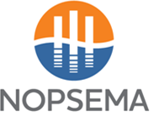

© Commonwealth of Australia 2022

**Ownership of intellectual property rights**

Unless otherwise noted, copyright (and any other intellectual property rights) in this publication is owned by the Commonwealth of Australia (referred to as the Commonwealth).

**Creative Commons licence**

All material in this publication is licensed under a [Creative Commons Attribution 4.0 International Licence](https://creativecommons.org/licenses/by/4.0/legalcode) except content supplied by third parties, logos and the Commonwealth Coat of Arms.

Inquiries about the licence and any use of this document should be emailed to [copyright@agriculture.gov.au](mailto:copyright@agriculture.gov.au).



**Cataloguing data**

This publication (and any material sourced from it) should be attributed as: Australian Government 2022, *Supporting cooperative coexistence of seismic surveys and commercial fisheries in Australia’s Commonwealth marine area,* Commonwealth of Australia, Canberra, October. CC BY 4.0.

This publication is available at <https://www.agriculture.gov.au/agriculture-land/fisheries/environment/opgga>.

Department of Agriculture, Fisheries and Forestry

GPO Box 858 Canberra ACT 2601

Telephone 1800 900 090

Web [agriculture.gov.au](https://www.agriculture.gov.au/)

**Disclaimer**

The Australian Government acting through the Department of Agriculture, Fisheries and Forestry, the Department of Industry, Science and Resources, the National Offshore Petroleum Safety and Environmental Management Authority and the Australian Fisheries Management Authority has exercised due care and skill in preparing and compiling the information and data in this publication. Notwithstanding, the Australian Government, its employees and advisers disclaim all liability, including liability for negligence and for any loss, damage, injury, expense or cost incurred by any person as a result of accessing, using or relying on any of the information or data in this publication to the maximum extent permitted by law.

**Acknowledgements**

The authors thank the offshore petroleum, seismic and commercial fishing industries for their input.

**Acknowledgement of Country**

We acknowledge the Traditional Custodians of Australia and their continuing connection to land and sea, waters, environment and community. We pay our respects to the Traditional Custodians of the lands we live and work on, their culture, and their Elders past and present.

Contents

Introduction 1

Scope 2

Part A: Australian Government Context 3

1 Overview of relevant authorities and organisations 4

1.1 Offshore petroleum government agencies 4

1.2 Government science agencies 4

1.3 Fisheries government agencies 5

1.4 Organisations 6

2 Acquisition of seismic data 8

2.1 Seismic surveys 8

2.2 When seismic surveys are conducted 11

2.3 Scope of acquisitions through time 11

2.4 Weather conditions and acquisitions 12

3 Fishing activities 14

4 How fish and the fishing industry are affected by seismic acquisition 15

4.1 How fish stocks are affected 15

4.2 How fishing operations are affected 15

5 Regulation of marine seismic activities 16

5.1 Commonwealth regulatory framework 16

5.2 Required authorisations 16

5.3 The environment plan process 17

6 Australia’s marine management 20

6.1 Coexistence of industries 20

6.2 Navigation safety 20

Part B: Specific measures to manage interactions 21

7 Consultation processes and information sharing 22

7.1 Purpose 22

7.2 New process: Regional coordination meetings 22

7.3 Existing process: Consultation during preparation of environment plans 23

7.4 Principles to support effective engagement between industries 23

8 Data access and information sharing 26

8.1 Fisheries data 26

8.2 Fisheries data access 26

8.3 Seismic survey data 27

8.4 Seismic survey data access 27

9 Loss adjustment principles to be applied to Australian commercial fishing activities 28

9.1 Background 28

9.2 Purpose 28

9.3 Key principles 29

9.4 Key considerations 29

9.5 Future design of a standard loss adjustment protocol 30

9.6 Recent examples of good engagement, loss adjustment protocols and control measures for commercial fisheries 30

Appendix A: Government fisheries data access 33

**Figures**

Figure 1. A typical 2D seismic survey involves a vessel with airgun array and hydrophone steamer 9

Figure 2. A typical 3D source array 10

Figure 3. The number of 2D and 3D seismic surveys undertaken between 1960 and 2020 11

Figure 4. Seismic survey acquisition around Australia in each decade from 1960 to 2020 12

Figure 5. Assessment and approval steps for exploration EPs under the OPGGS Act 18

Figure 6. Flow chart of stakeholder engagement 24

**Boxes**

Box 1 Case study – NERA commercial fishing industry adjustment protocol 34

Box 2 Case study – Control measures for commercial fishing and target species 35

Box 3 Case study – Multiple before-after-control-impact (M-BACI) study 35

Box 4 Case study – Experience of a member of the Commonwealth Fisheries Associations 36

## Introduction

The offshore petroleum and commercial fishing industries are both important industries for Australia’s economy. Both industries play vital roles in energy production and food security. Petroleum operators, including seismic survey proponents, and commercial and aquaculture fishers both have certain rights to undertake their respective activities in Commonwealth waters and often operate with a degree of spatial overlap. Overlap typically arises when seismic surveys are undertaken in established fishing grounds. The potential impacts of relevance to this guidance include displacement of target species which may make certain species harder to catch, disruption or temporary displacement of fishing operations, and/or damage to equipment to both the fishers and the seismic survey proponent.

Under the offshore petroleum legislative regime, seismic survey proponents are required to develop an environment plan which must include a stakeholder consultation process. Fishing stakeholder concerns, and the potential for fishing/seismic interactions in a particular location and at a certain time, are typically identified during stakeholder consultation. The seismic survey proponent must address these concerns during the process of evaluating and managing the potential impacts of their proposed activity. The measures adopted to manage impacts during this process vary amongst proponents, and may come at a time and cost burden for the proponent and the fisheries stakeholders.

Despite a downward trend in the number of seismic surveys in Commonwealth waters, the proximity of some seismic surveys to some fishing grounds in recent years has highlighted the need to improve the way the sectors engage.

The purpose of this guidance is to enhance and facilitate effective cooperation between these 2 important industries. The guidance includes:

* contextual information to improve the mutual understanding of the 2 industries and the different ways in which they are regulated and managed
* standard methods to improve effectiveness of consultation, maximise cooperation and positive engagement, and minimise the potential for negative on-water interactions
* key principles to underpin activity-specific loss adjustment processes where impacts on commercial fisheries from a seismic survey cannot be avoided.

## Scope

The scope of this voluntary guidance is limited to Australia’s Commonwealth marine area but may have applicability to seismic surveys conducted in state waters. Australia’s Commonwealth marine area comprises those areas beyond the first 3 nautical miles (nm) from the territorial sea baseline and out to the limit of the Australian Exclusive Economic Zone at 200 nm. This includes the Ashmore and Cartier offshore territories and offshore areas adjacent to all states and the Northern Territory. All offshore petroleum activities undertaken in these waters, including seismic surveys, are regulated by the National Offshore Petroleum Safety and Environmental Management Authority (NOPSEMA). Commercial fisheries in the Commonwealth marine area may be regulated by the Commonwealth fisheries regulator, the Australian Fisheries Management Authority (AFMA), or the relevant state fisheries regulator.

This guidance is not intended to address all potential impacts from seismic surveys on fish stocks. The focus of this guidance is on the direct impacts to fisheries that may occur as a result of seismic surveys and for which relevant evidence can be provided to support claims for monetary adjustment. Other potential impacts arising from individual seismic surveys will continue to be addressed on a case-by-case basis through activity-specific environment plan processes. The scope of this guidance does not extend to recreational or charter fishers.

Issues beyond the scope of this guidance which may be considered through future work include:

* Enhancing data transparency and accessibility to and between both industries.
* Regional spatial planning.
* Research to investigate potential long-term and/or cumulative impacts of seismic survey activities on the commercial fishing industry.
* Developing a consistent and effective standard protocol for managing claims by commercial fishing stakeholders for costs incurred as a consequence of seismic survey activities.

## Part A: Australian Government Context

## Overview of relevant authorities and organisations

### Offshore petroleum government agencies

#### Commonwealth Department of Industry, Science and Resources

The Department of Industry, Science and Resources (DISR) is responsible for broader industry and science policy, as well as offshore resources policy and regulation.

DISR acts as a custodian for the legal framework for the operation of the Australian offshore oil and gas industry in Commonwealth waters. This framework encompasses licencing, environmental management, occupational health and safety, well integrity and resource management.

#### National Offshore Petroleum Titles Administrator

The National Offshore Petroleum Titles Administrator (NOPTA) is responsible for the day-to-day administration of offshore petroleum and greenhouse gas titles in Commonwealth waters and is the first point of contact for matters relating to offshore titles administration.

#### National Offshore Petroleum Safety and Environmental Management Authority

The National Offshore Petroleum Safety and Environmental Management Authority (NOPSEMA) is Australia's expert regulator for health and safety, structural (well) integrity and environmental management for all oil and gas operations and greenhouse gas storage activities in Commonwealth waters, and in coastal waters where regulatory powers and functions have been conferred.

Following a strategic assessment of NOPSEMA’s environmental management authorisation process under the *Environment Protection and Biodiversity Conservation Act 1999* (EPBC Act), the Commonwealth Minister for the Environment endorsed NOPSEMA’s process as a ‘Program’ that meets the requirements of Part 10 of the EPBC Act. Subsequently, the minister also approved a class of actions which, if undertaken in accordance with the endorsed Program, will not require separate referral, assessment and approval under the EPBC Act. The approved class of actions includes seismic surveys undertaken for the purpose of exploring for petroleum or potential greenhouse gas storage formations/injection sites.

In the process of assessing environment plans (EPs) for seismic surveys, NOPSEMA must be satisfied that the environmental impacts and risks will be reduced to as low as reasonably practicable (ALARP) and be of an acceptable level.

### Government science agencies

#### Geoscience Australia

Geoscience Australia (GA) is Australia’s pre-eminent public sector geoscience organisation. GA collects and disseminates geoscientific information and investigates ways to remove impediments to industry competitiveness. GA is committed to continuing [research on the impacts of seismic surveys](http://www.ga.gov.au/about/projects/marine/marine-seismic-surveys-and-the-environment) and providing up-to-date advice.

#### Australian Institute of Marine Science

The Australian Institute of Marine Science (AIMS) is Australia’s tropical marine research agency. Its mission is to provide the research and knowledge of Australia’s tropical marine estate required to support growth in its sustainable use, effective environmental management and protection of its unique ecosystems.

#### Commonwealth Scientific and Industrial Research Organisation

The Commonwealth Scientific and Industrial Research Organisation (CSIRO) is Australia’s national science agency, conducting world-renowned research and providing innovative solutions for industry, society and the environment.

### Fisheries government agencies – Commonwealth

#### Department of Agriculture, Fisheries and Forestry

The Department of Agriculture, Fisheries and Forestry (DAFF) plays an important policy role in promoting the biological, economic and social sustainability of Australian fisheries. DAFF is responsible for developing policy for Commonwealth fisheries and assessment of Commonwealth fisheries and state export fisheries in accordance with the EPBC Act to promote ecologically sustainable fisheries management and ensure the environmental performance of fisheries.

#### Australian Fisheries Management Authority

The Australian Fisheries Management Authority (AFMA) is the Australian Government agency responsible for the efficient management and sustainable use of Commonwealth fish resources on behalf of the Australian community.

AFMA’s role in offshore oil and gas operations is to ensure that any broad-scale impacts on commercial fishing in Commonwealth waters are considered during the development of any offshore petroleum projects. AFMA does this by:

* providing advice directly to DISR on the annual acreage releases
* providing advice to petroleum companies on large-scale proposals that may have a significant impact on a fishery
* when requested, providing fine-scale catch and effort data to petroleum companies and industry under a Deed of Confidentiality to assist with the consultation process.

#### State and territory fisheries government agencies

The state government agencies listed below have responsibility for managing some fisheries in the Commonwealth marine area.

#### Western Australian Department of Primary Industries and Regional Development

A primary responsibility of the Western Australian Department of Primary Industries and Regional Development (WA DPIRD) is to conserve, sustainably develop and share the use of Western Australia’s aquatic resources and their ecosystems for the benefit of present and future generations.

This is achieved through managing fisheries and aquatic ecosystems, assessment and monitoring of fish stocks, enforcement and education, biosecurity management and licensing commercial and recreational fishing activity, including commercial aquaculture.

#### Department of Primary Industries and Regions, South Australia

The Fisheries and Aquaculture Division of the Department of Primary Industries and Regions, South Australia (PIRSA) enables the sustainable development of South Australia’s aquatic resources and the balanced growth of our fisheries and aquaculture industries. PIRSA manages South Australia's fish stocks in partnership with industry and the community.

#### Victorian Fisheries Authority

The Victorian Fisheries Authority (VFA) is an independent statutory authority established to effectively manage Victoria's fisheries resources. VFA works closely with stakeholders to deliver 3 core outcomes:

* sustainable fishing and aquaculture
* clear resource access and sharing arrangements
* increased economic, social and cultural value.

#### Tasmanian Department of Primary Industries, Parks, Water and Environment

The Tasmanian Department of Primary Industries, Parks, Water and Environment (DPIPWE) is Tasmania’s lead natural resources agency, responsible for the sustainable management of its natural and cultural heritage and the integrity of the resources industry for the benefit of the Tasmanian community.

#### Northern Territory Department of Industry, Tourism and Trade

The Department of Industry, Tourism and Trade (DITT) was established in September 2020 as the Northern Territory public sector's coordinating agency for economic and industry development.

The Agriculture, Fisheries and Defence Division in DITT is responsible for supporting and protecting the Northern Territory’s agriculture and fishing industries.

### Organisations and peak bodies

#### Australian Petroleum Production and Exploration Association

The Australian Petroleum Production and Exploration Association (APPEA) is the peak national body representing Australia’s oil and gas exploration and production industry. APPEA aims to secure regulatory and commercial conditions that enable member companies to operate safely, sustainably and profitably.

#### EnerGeo Alliance

EnerGeo Alliance (formerly International Association of Geophysical Contractors) is the global trade association for the geophysical and exploration industry. EnerGeo Alliance optimises the business and regulatory climate and enhances public understanding to support a strong, viable geophysical and exploration industry essential to discovering and delivering the world’s energy resources. EnerGeo Alliance aims to promote and ensure a safe, environmentally responsible and competitive geophysical and exploration industry.

#### Seafood Industry Australia

Seafood Industry Australia (SIA) is the national peak-body representing the wildcatch, aquaculture and post-harvest sectors of the Australian seafood industry. SIA provides a national voice for the industry and is focused on removing obstacles hindering future growth.

SIA’s mission is to promote, protect and develop the Australian seafood industry on a national and international level through having a united, effective and respected industry.

#### Commonwealth Fisheries Association

The Commonwealth Fisheries Association (CFA) is the peak industry body representing the interests of fishers operating in Commonwealth managed fisheries.

#### State and regional peak bodies

There are numerous state, territory and regional peak fishing bodies that represent fishing interests in specific areas or for specific fisheries. The key commercial fishing peak bodies for each state and territory include:

* Seafood Industry Victoria (SIV)
* Tasmanian Seafood Industry Council (TSIC)
* Western Australian Fishing Industry Council (WAFIC)
* South East Trawl Fishing Industry Association (SETFIA)
* Northern Territory Seafood Council (NTSC)
* Wildcatch Fisheries South Australia (WFSA).

WAFIC works closely with a number of [sector bodies](http://www.wafic.org.au/who-we-are/our-members/sector-bodies/). Similar information on the other listed peak bodies above can be found on their website.

There are also a range of peak bodies that represent specific fisheries or regions. Refer to the AFMA website for a [list of industry associations](http://www.afma.gov.au/contact/industry-association-contacts).

## Acquisition of seismic data

Seismic surveys are the main source of mapping and geological understanding of the subsurface geological layers. Seismic exploration is necessary for companies to explore for deposits of oil and gas under the seafloor by imaging sub-bottom sediment layers with high intensity, low frequency sound.

### Seismic surveys

A seismic survey is a geophysical survey method used to map the geology of the subsurface. Seismic surveys can be used to:

* explore for petroleum resources
* identify accumulations of mineral resources
* locate sites for underground greenhouse gas storage
* survey sites for offshore installations such as petroleum production platforms or offshore alternative energy installations (e.g. wind turbines).

In the marine environment, the typical survey method involves towing a sound source (compressed air source or ‘airgun’ array) and a series of sound receivers (hydrophones contained within the streamers or cables) behind a survey vessel. Seismic sources typically measure 15 to 20 metres (m) in length and release compressed air in pulses approximately every 10 seconds that form air pockets that expand and compress rapidly to produce a pulse of sound. The sound is reflected back from the seafloor and subsea layers to a string of hydrophone receivers in the streamers. The seismic streamers are typically between 5,000 and 12,000 m in length. An image of the subsurface is obtained by the processing the seismic data.

There are different types of seismic data. 2D and 3D seismic surveys are particularly important for the exploration for petroleum or mineral resources and the siting of installations, while other forms are relevant for the development and operation of petroleum accumulations.

#### 2D seismic surveys

2D surveys are used for regional reconnaissance surveys during early phases of oil and gas exploration and in areas where a 3D receiver array cannot be deployed. These surveys typically have a single sound source and a single streamer or cable between 5 and 12 kilometres (km) long, and are towed 10 to 20 m below the surface (Figure 1). The survey acquisition lines are typically widely spaced (hundreds of metres to tens of kilometres) and may cross each other. A single 2D line will be tens to hundreds of kilometres in length.

Figure 1 A typical 2D seismic survey involves a vessel with airgun array and hydrophone steamer

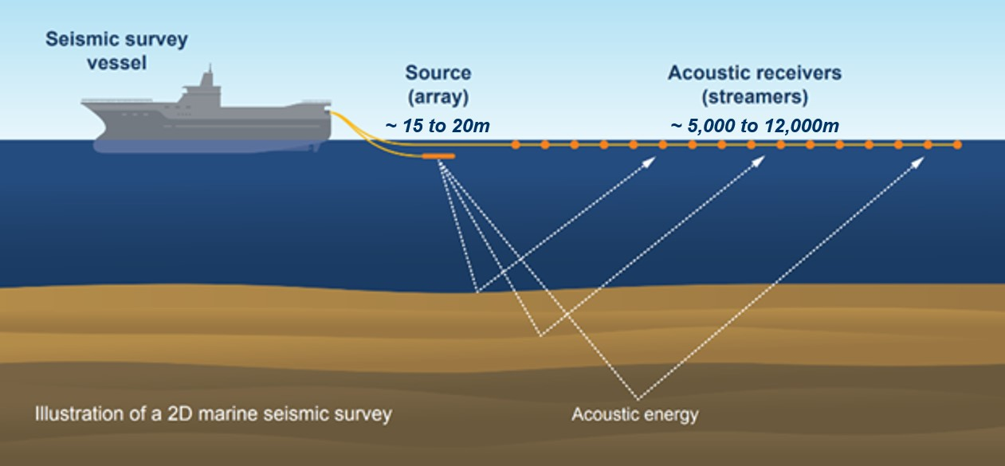

#### 3D seismic surveys

Petroleum exploration commonly requires a 3D seismic survey. These surveys image a finer level of detail and deliver a regional subsurface understanding. In comparison to 2D surveys, a 3D survey typically uses 2 or 3 parallel sound sources and a series of parallel cables or streamers (up to 24) that are typically between 50 and 150 m apart (Figure 2). The towed equipment can span an area of up to 14 square kilometres (km2) behind the vessel. The 3D survey is built up from closely spaced parallel acquisition lines. During processing, mathematical algorithms are used to create a 3D image of the subsurface from these parallel acquisition lines. A single 3D seismic survey can vary in size from a few hundred to over 1,000 km2.

Figure 2 A typical 3D source array

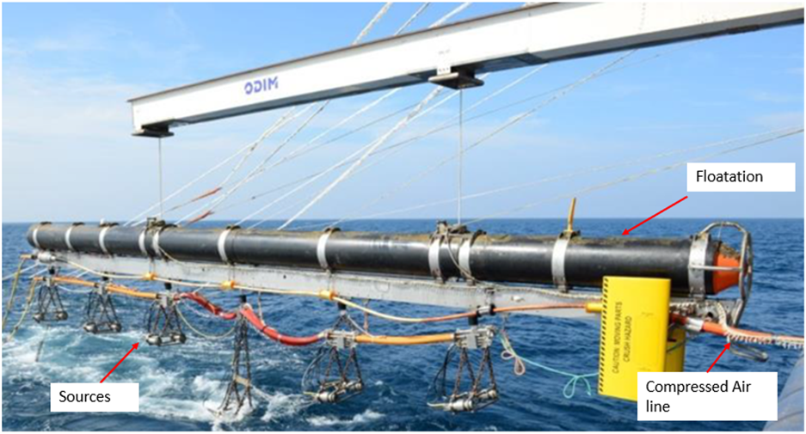

#### 4D seismic surveys

4D seismic surveys are undertaken to assess changes in an area, typically a producing petroleum reservoir or greenhouse gas storage location (e.g. carbon capture and storage or underground hydrogen storage location) over time and involve repeated 3D seismic data acquisition over the same area. They are spatially constrained to a few hundred square kilometres or less and are focussed on known reservoir boundaries.

#### Ocean bottom seismic

In ocean bottom seismic (OBS) acquisition, the sound receivers are located on the seabed rather than within streamers or cables towed near the ocean surface. The sound receivers can either be contained within ocean bottom cables or ocean bottom nodes. Ocean bottom cables are usually positioned by a single vessel while ocean bottom nodes are independently positioned on the ocean bottom. Ocean bottom cables can typically only be utilised down to 300 m of water depth whereas ocean bottom nodes can be utilised in shallow water out to deeper water thousands of meters deep.

### When seismic surveys are conducted

Seismic data are acquired when an image of the subsurface is required.

Due to advancements in technology and equipment design it is, on occasion, necessary to acquire a seismic survey over areas where data has been previously acquired. Commonly this is undertaken to allow improved imaging of geological features and/or imaging to a greater depth.

At the same time, technological advancements have resulted in increased survey efficiency, meaning the same quantum of data can be collected with a less intensive survey design and less time on the water (e.g. greater acquisition line spacing).

### Scope of acquisitions through time

There is a history of seismic surveys being conducted in Australia and internationally. The first offshore seismic survey in Australia was undertaken in the Otway Basin in the early 1960s. Since that time, there have been more than 1,700 seismic surveys conducted across Australia’s Commonwealth marine area (including 2D and 3D surveys), peaking with 63 surveys in 1981 compared to 8 surveys in 2020 (Figure 3). The location of these seismic surveys within the Commonwealth marine area for each decade from 1960 to 2020 is shown in Figure 4. Improvements in acquisition efficiency, an increase in the size of each survey, enhanced processing technology and market conditions have all contributed to a reduction in the number of new surveys in the last decade.

Figure 3 The number of 2D and 3D seismic surveys undertaken between 1960 and 2020

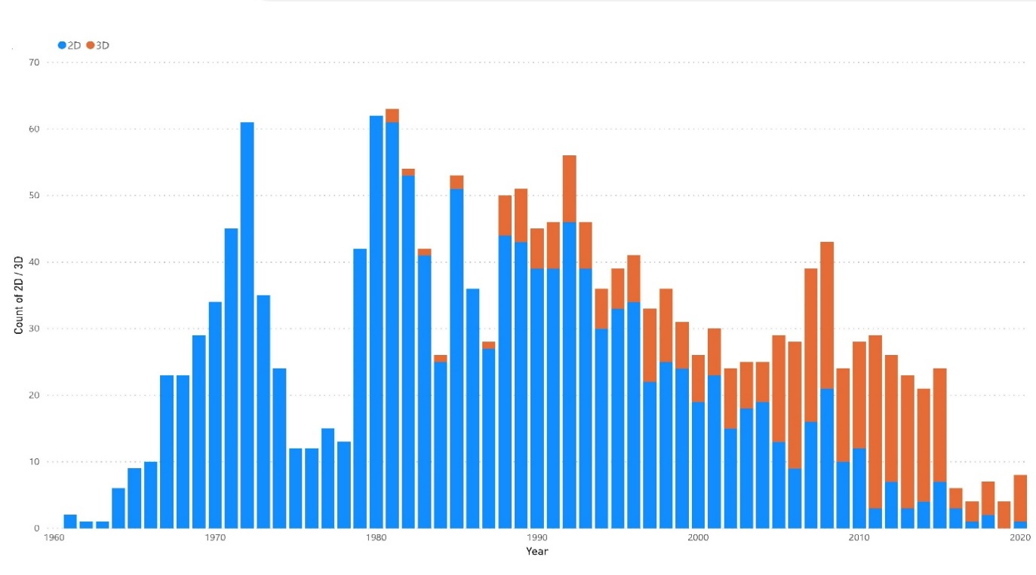

Source: [National Offshore Petroleum Information Management System](https://www.ga.gov.au/nopims).

Figure Seismic survey acquisition around Australia in each decade from 1960 to 2020

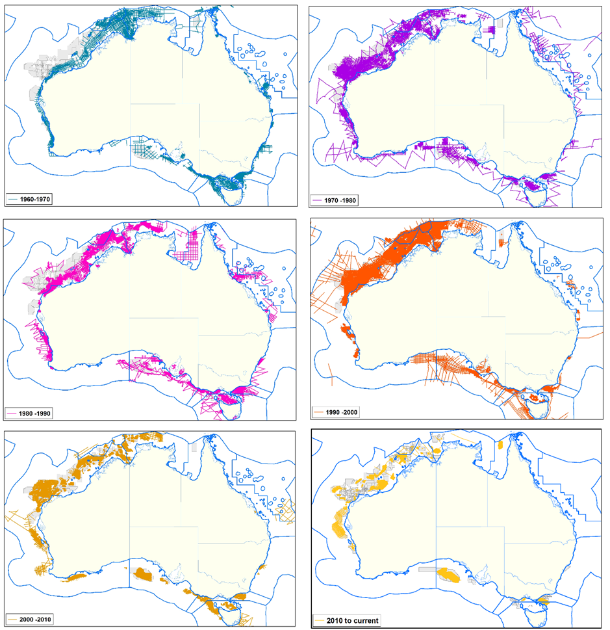

Source: NOPTA

### Weather conditions and acquisitions

There are many factors that affect the ability of a seismic vessel to continue to work in poor weather conditions. This can be related to the depth of the guns, the amount of towed equipment and the metocean conditions.

In general, a seismic acquisition will pause operations when the sea state reaches 3.5 to 4.5 m. The vessel will not only have to pause acquisition in these conditions but, to maintain control of its towed equipment, may need to head into the weather system. It is unable to turn around safely until the weather improves. This can often lead to the vessel being some distance from the prospect and several days of acquisition being lost due to relatively short periods of poor weather.

Seismic vessels, particularly 3D seismic vessels, take several days to fully deploy and retrieve the in-sea equipment. Ideally, during a survey the vessel will only need to deploy and retrieve this equipment once. For these reasons, acquisition companies seek to acquire data in the calmest months when the sea state is not regularly greater than 2 metres and seldom (if ever) above 2 m. It is not uncommon for surveys to take more than 3 times as long to acquire data in ‘marginal’ weather conditions than in the calm seasons.

## Fishing activities

The Australian Fishing Zone (AFZ) is the third largest in the world, covering nearly 9 million square kilometres. It extends 200 nm from the Australian coastline and also includes the waters surrounding our external territories, such as Heard Island and McDonald Island in the Antarctic.

Australia’s fisheries are managed by eight jurisdictions – the Commonwealth, the Northern Territory and the 6 states. There are around 165 commercial wild capture fisheries in the AFZ, currently generating around $1.79 billion in revenue annually.

Over 406 stocks from over 120 species are targeted by the Australian commercial fishing industry. Despite the industry producing a diverse range of products, a relatively small number of species comprise the majority of the Gross Value of Production (e.g. rock lobster, finfish and prawns).

Jurisdictions regulate the fishing industry to ensure resources are managed sustainably for the benefit of all Australians. All jurisdictions aim to use fish resources in a manner consistent with the principles of ecologically sustainable development. The industry is highly regulated and under constant environmental scrutiny.

Fisheries management is based on a robust and transparent approach to ecological sustainability, which considers the effects of fishing activities on the marine ecosystem and undertakes management actions to mitigate these impacts.

Input and output controls are the most common form of regulation. Input controls are used to restrict the size, type and mode of use of fishing equipment to limit catching power. Output controls are used to directly limit the amount of any particular stock that can be harvested (typically through allowable catch quotas). There are also spatial management controls where fishers are not allowed to operate in areas where a high level of protection has been given to the marine environment. This includes some marine park areas and breeding zones for protected species.

Fishing equipment used by commercial fishers varies highly depending on the target species. Equipment used includes small-scale nets, pelagic longlines, large-scale trawl nets, gill nets, handlines, jigs, traps and pots. Fishing equipment is usually tailored to reduce the incidental catch of non-targeted species and reduce impacts on the broader marine environment.

Further to the regulations in place, stock status is assessed and reported regularly. The Australian Bureau of Agricultural and Resource Economics and Sciences (ABARES), in conjunction with the Fisheries Research and Development Corporation (FRDC), produces annual reports on commercial fisheries statistics, and biennial reports on the status of key Australian fish stocks across state, territory and Australian Government jurisdictions.

## How fish and the fishing industry are affected by seismic acquisition

### How fish stocks are affected

The potential for fish stocks (e.g. finfish and invertebrates) to be affected by a seismic survey varies depending on the life stage, species, spatial and temporal overlap with survey areas and times, as well as the individual survey design (e.g. nature of sound source and acquisition line spacing). These factors are addressed by seismic survey proponents in their activity-specific EP, along with a comprehensive review of relevant scientific literature to ensure the best available science is applied to environmental impact assessment.

### How fishing operations are affected

#### Impact to fishing catch

Catch rates may be affected by seismic surveys as a result of changes in the behaviour of target species in response to underwater noise emissions and the physical presence of the seismic vessel and trailing equipment. The few studies that have been conducted on the effects of seismic surveys on commercial fishing catch rates have yielded variable and at times contradictory results. It is likely that the effects on fishing catch rates will differ according to the fishing method (e.g. trawling or baited hook) and the nature of the target species (e.g. fast swimming pelagic species or less mobile demersal species). These factors should be considered in the activity-specific environmental impact assessment. Regardless, there is potential for noise emissions from seismic surveys to affect the behaviour of target species with resulting implications for catchability. The extent and duration of this noise effect is likely to vary between species and fishing methods.

#### Displacement from fishing grounds

Commercial fishing may also be affected by disruption or temporary physical displacement of fishing operations from preferred fishing grounds and/or damage to fishing gear due to interaction with the survey vessel and trailing equipment. The magnitude of these displacement/disruption effects will vary according to the distribution of productive fishing grounds relative to a survey area and the type of fishing equipment used (e.g. fixed gear with surface ropes/floats or mobile nets trawled behind a vessel).

## Regulation of marine seismic activities

### Commonwealth regulatory framework

TheOffshore Petroleum and Greenhouse Gas Storage Act 2006 (OPGGS Act) and the Offshore Petroleum and Greenhouse Gas Storage (Environment) Regulations 2009 (Environment Regulations) establish an objectives-based environmental management regime that is administered by NOPSEMA. The object of the Environment Regulations is to ensure that any petroleum activity or greenhouse gas activity in an offshore area is carried out in a manner:

* consistent with the principles of ecologically sustainable development set out in section 3A of the EPBC Act
* by which the environmental impacts and risks of the activity will be reduced to as low as reasonably practicable
* by which the environmental impacts and risks of the activity will be of an acceptable level.

### Required authorisations

Seismic surveys for offshore petroleum exploration or greenhouse gas storage purposes cannot proceed without an appropriate title and an accepted Environment Plan.

#### Titling regime for marine seismic surveys

Seismic surveys in Commonwealth waters can be authorised under a number of different title types, including long-term titles and short-term titles. Being awarded a petroleum title does not guarantee that a petroleum activity will proceed. It simply allows a titleholder to apply for environmental approval for their activity through the EP assessment and acceptance process.

The titling process is managed by NOPTA and is completely independent of NOPSEMA’s regulatory processes. Visit NOPTA’s website to view currently issued titles and proposed offshore petroleum acreage release areas on an [interactive map](https://public.neats.nopta.gov.au/Map).

##### Long-term titles

Long-term exploration permits and production licences are granted through a competitive [acreage release process](https://www.industry.gov.au/mining-oil-and-gas/oil-and-gas/offshore-oil-and-gas/offshore-petroleum-exploration-acreage-release-process). This process involves the following steps:

1. The nomination of offshore areas.
2. A public consultation process led by DISR.
3. Assessment of work program bids.
4. The granting of exploration permits by the responsible minister or delegate.

Exploration permits granted through this process have an initial term of six years and may be extended for 2 further 5-year periods.

These types of titles are ordinarily held by petroleum companies (titleholders) that have an enduring interest in a particular area and will be present in that area for an extended period of time by undertaking operations and works to explore and potentially develop petroleum resources. These titleholders have an interest in ensuring that a social licence to operate is established and maintained with other marine users and communities proximate to the area for the duration of their operations.

##### Short-term titles

Short-term titles such as special prospecting authorities (SPAs) and access authorities (AAs) are granted by NOPTA through an application process. SPAs are most commonly applied for by multi-client seismic survey companies whose business model is based on the acquisition of 2D or 3D geological data for on-selling to third party petroleum companies at a profit. These titles last for a maximum of 180 days during which proposed operations must be undertaken. Multi-client companies can submit an EP for a seismic survey without the AA or SPA being granted as long as they are an applicant for a title. However, the seismic survey cannot proceed until the title has also been granted.

#### Environment plans

NOPSEMA regulates all offshore petroleum activities in Commonwealth waters, which comprise those areas beyond the first 3 nautical miles from the shoreline. The EP sets out the environmental impact assessment that has been conducted by the titleholder and the management arrangements that they intend to implement for the lifetime of the activity to ensure that good environmental outcomes are achieved.

NOPSEMA may require a titleholder to provide additional information and/or modifications to the EP to ensure control measures will be effective at managing environmental impacts and risks to ALARP and acceptable levels. If the EP is accepted and the activity proceeds, NOPSEMA regularly undertakes compliance inspections to ensure that titleholders are doing what they committed to do and control measures are being implemented effectively. If non-compliances are detected, enforcement action may be taken.

### Environment plan process

#### Environmental plan submission and acceptance

Proponents of seismic surveys must submit an Environment Plan (EP) and have it accepted by NOPSEMA before the activity can proceed (Figure 5). The EP is where the titleholder demonstrates that the way they will manage the activity is sufficient, by using scientific evidence to support the conclusions that they make and management actions they propose. NOPSEMA must be satisfied that the impacts of a seismic survey will be managed to ALARP and an acceptable level before an EP can be accepted. This includes consideration of impacts to socio-economic receptors such as commercial fishing operations.

Figure 5 Assessment and approval steps for exploration EPs under the OPGGS Act

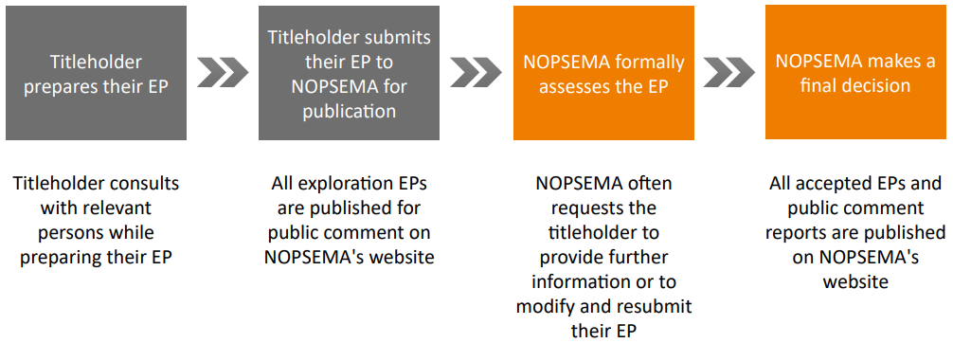

Source: [NOPSEMA](https://www.nopsema.gov.au/sites/default/files/documents/2021-03/A737043.11.pdf)

#### Environmental impact assessment

An EP for a seismic survey must include a detailed environmental impact assessment (EIA) for underwater noise. This requires careful analysis of the potential interactions between the activity and its noise emissions with the biota in the receiving environment. An EIA may include reference to environmental baseline data, marine monitoring reports and published research to support the conclusions drawn about the consequences of potential impacts and explanations of why the impacts will be ALARP and acceptable. This ensures that impact predictions and control measures are tailored to the particular activity circumstances, including the location in which they will occur, and will be effective in managing impacts to acceptable levels. This regulatory approach allows for advances in science and technology to be taken into account for each new activity without the need to revise the Environment Regulations.

#### Relevant persons consultation

Titleholders must ensure that ‘relevant persons’ (those whose functions, interests or activities may be affected by the activity) are provided with enough information about the proposed activity during the EP preparation process so that they can evaluate how it might impact on their functions, interests and activities. The purpose of this consultation is to identify environmental values, including social, economic and cultural features, which could be affected by the activity. The titleholder must then ensure that impacts and risks to these values are addressed in their EP. This generally involves an iterative consultation process using a variety of methods such as face-to-face meetings, telephone, and email and mail communication.

Relevant persons must be given adequate opportunity to convey to the titleholder how they may be affected. The titleholder must then assess the merits of any objections and claims raised by the relevant person, provide a response on how they propose to address these objections and claims and include this information, along with details of the consultation undertaken, in a report that forms part of the EP. Copies of all written correspondence from relevant persons must also be provided in the EP for NOPSEMA to impartially assess the suitability and adequacy of the consultation undertaken by the titleholder.

#### Public comment period

All EPs for seismic or exploratory drilling activities are subject to a mandatory 30-day public comment period, and must be published on submission and again on acceptance by NOPSEMA. This enables community stakeholders to have their say about the proposed management of these activities. It also provides any relevant persons who have been consulted in the preparation of an EP to view and comment on how their objections and claims have been addressed. Comments received during the public comment period that are related to the content of an EP must be taken into account by the titleholder in finalising the EP, and by NOPSEMA in assessing the EP.

## Australia’s marine management

### Coexistence of industries

Australia’s marine management framework establishes that no single user has exclusive rights to the offshore area. This is supported by section 280 of the OPGGS Act which requires that operators must carry out offshore activities in a manner which does not interfere with other marine users’ rights to a greater extent than is necessary. This includes a requirement not to interfere with a range of activities, including navigation, fishing, native title rights and interests, or any other lawful oil and gas exploration activities.

### Navigation safety

Commercial fishing and seismic survey vessels operating in Commonwealth waters must maintain and comply with collision avoidance measures. Measures may include:

* Adherence to the International Regulations for Preventing Collisions at Sea 1972 (COLREGS).
* Compliance with maritime safety information (MSI) issued for the operational area. MSI includes navigational warnings and urgent safety related messages important to ships at sea.

All vessels must maintain a proper look-out by sight and hearing as well as by all available means appropriate in the prevailing circumstances and conditions, in accordance with Rule 5 of the COLREGS. Above all, all vessels must promote the practice of safe navigation and good seamanship by the master and the crew.

For seismic survey vessels engaged in towing operations and restricted in ability to manoeuvre, measures may also include:

* display of appropriate lights and shapes in compliance with the COLREGS
* additional warnings and/or lights to attract attention
* installation of Automatic Identification System (AIS)
* offshore guard vessels that can monitor traffic and take early action to alert a vessel approaching the area of operations.

## Part B: Specific measures to manage interactions

## Consultation processes and information sharing

### Purpose

The purpose of this measure is to improve coordination, communication and information sharing between commercial fishing and seismic operators in strategic forums as well as during activity-specific consultation during EP preparation. This section provides an outline of the consultation processes already undertaken as part of EP preparation and the regional coordination meetings as a new process to enhance and complement existing consultation processes.

Early consultation and provision of information through regional coordination meetings will improve the industries’ ability to avoid conflicts where possible, and to mitigate conflicts if avoidance is not achievable.

### New process: Regional coordination meetings

To facilitate information sharing and early engagement, regional coordination meetings will be held with stakeholders in key regions, including proximate to the NW and SE petroleum basins. The purpose of the meetings will be to:

* share information on expected titleholder work plans, including location, timing and nature of operations that have the potential to impact on commercial fishing activities, in the region of interest
* identify areas of potential overlap/interaction and allow early identification of important stakeholders for continued engagement to manage this cooperatively
* build relationships and understanding between members of these 2 important industries
* provide opportunities for information of mutual interest to be presented (e.g. new research findings on the impacts of seismic surveys, fisheries stock assessment results.)
* enable titleholders to consider opportunities for mutual benefit with fishers and communities in operational areas.

Attendees should be able to provide expertise on matters to be discussed and include representatives of the fishing and seismic industry associations, survey proponents, and fishers. Representatives from petroleum and fishing government policy agencies and regulators will also attend. The preference is to hold meetings face-to-face, however video conferencing facilities can supplement physical meetings.

Meetings should be held at least once annually and generally chaired by DISR. Where there is substantial activity proposed in a region, meetings should be held more frequently (e.g. quarterly meetings).

The regional coordination meetings can be one mechanism to identify relevant person(s) for a proposed seismic survey activity. They do not replace the statutory consultation processes with relevant person(s) for the purposes of EP preparation.

Regional coordination meetings will also provide an opportunity to discuss continuous improvement in the consultation and information sharing processes, and explore ways to increase information and data exchange between industries. Meetings will provide a forum for government bodies to share advice on policy changes or new programs and allow industries to provide advice to government.

### Existing process: Consultation during preparation of environment plans

Under the Environment Regulations, a titleholder must consult relevant persons during the preparation of an EP and during the acquisition phase of a seismic survey. The Environment Regulations sets out the process for EP consultation and further information is provided in Section 5.3.

A number of principles which aim to assist with improving the effectiveness and efficiency of this statutory EP consultation process are outlined in NOPSEMA’s [environment plan decision-making guidelines](https://www.nopsema.gov.au/document-hub/guidelines).

Figure 6 outlines how the new and existing processes are envisioned to interact.

### Principles to support effective engagement between industries

The following principles of engagement are designed to facilitate a genuine, meaningful, and effective consultation process between the industries. Upholding these principles should result in improved relationships and good environmental outcomes.

#### Early engagement

Early engagement in the preliminary planning stages of a seismic survey is essential to minimise impacts on both industries. It enables early understanding of potential interaction and feedback to be considered in the design of work programs. If consultation is undertaken in the early stages of planning, before any operational dates and survey designs are established, there is a greater opportunity to assess and address areas of concern. Identified issues can be negotiated with a view to achieving better outcomes for all parties.

#### Genuine consultation

Genuine consultation is expressed through the ability to negotiate in good faith around areas of concern, and is supported by openness, transparency, and mutual respect. Genuine consultation is supported by early engagement (such as through regional coordination meetings), sharing of key information and data, and proactive identification, design and adoption of measures to address stakeholder concerns.

Figure 6 Flow chart of stakeholder engagement

A diagram displaying the steps involved in the consultation processes when developing an Environment Plan. Under this new framework an additional step has been added requiring regional coordination meetings to be held by seismic survey proponents to better facilitate information sharing and early engagement between the petroleum and fishing industries. This step is to be completed prior to the development of an Environment Plan.

#### Proportional consultation

There will generally be numerous fishers, commercial fisheries businesses and representative bodies with a level of exposure to potential impacts from any individual seismic survey. The proponent should give weight to stakeholder comments in proportion to the level of potential impact. Weighting can be assessed by considering what proportion of an organisation’s/individual’s interests (e.g. catch, fishing grounds) are affected by the proposed survey. Where there is higher overlap with the affected stakeholder, weighting should be higher for said stakeholder.

To enable titleholders to identify the relevant persons required for consultation, the relevant state/territory peak body or state/territory/Commonwealth fisheries management agency should be contacted in the early stages of work program design.

#### Thorough consultation

Sufficient and relevant information, including data, should be provided to commercial fishing stakeholders to enable them to make informed assessments of the possible consequences of a proposed seismic survey activity on their fishing functions, interests or activities. Commercial fishing stakeholders should make it clear to the titleholder during early engagement what information would be considered ‘sufficient’ during the consultation processes to enable informed feedback to be provided.

Sufficient information, including data, should also be provided by relevant persons to the titleholder to support any objections or claims and allow informed assessments of merit and transparent conversations. The provision of this information and data early in the consultation process may provide the titleholder with an opportunity to refine the design of their proposed activity or develop targeted control measures to avoid or reduce potential impacts on commercial fishing activities. Consultation by the titleholder should seek to:

* Provide project information in an accessible format, taking into account social context and preferences of fishers (e.g. videoconferences instead of face-to-face individual meetings, engagement via third parties such as relevant association representatives).
* Establish a feedback mechanism early in the process and other engagement protocols to enable good and effective communication.
* Provide an appropriate level of project information to easily identify and quantify impacts, and enable effective collaboration on available mitigation measures, including impact avoidance.

#### Impact minimisation

Titleholders will plan to avoid environmental impacts or, where this is not possible, minimise impacts on the commercial fishing industry to ALARP and acceptable levels as required by the Environment Regulations. This planning may include:

* impact assessments based on applicable science and relevant evidence from past activities
* risk management strategies
* commitments to the implementation of suitable controls based on the best available science and industry best practice relevant to the proposed area of operations.

## Data access and information sharing

### Fisheries data

The commercial fisheries data needed for seismic survey planning, EP preparation and the assessment for claims for loss adjustment are included in this section.

#### Early planning

Data is required on which fisheries and licence areas intersect the proposed survey area, where and when fishing typically occurs within these areas and what methods/gear is used.

#### Local fishing knowledge

Fishing knowledge and data can inform mutual understanding of the potential for interaction between the industries and consideration of proposed avoidance and management measures. While titleholders must base decisions on scientific evidence and data, additional local knowledge and fishing data from fishers (e.g. locations, fishing effort, habitat, lifecycle of target marine species) will be valued and will inform measures to reduce impacts to fishers and fisheries.

#### Environment Plan preparation

Quantitative and detailed data on the fishing catch and effort and seasons is important to inform the identification and prioritisation of relevant persons for consultation and environmental impact assessment. This includes the potential design of control measures to reduce impacts on target species and commercial fishing as a socio-economic value of the environment. This should include data on fishing areas/times where possible; acknowledging that there may be data access constraints where there may only be several boats present (e.g. 3 boats or less) in some jurisdictions.

#### Seismic survey acquisition

In circumstances where a claim(s) for loss adjustment is made, there will be a need for arrangements to access data on individual fishing licence holder catch and effort in the survey area for the period of the survey and months following the survey, as well as historical data (previous years) for the same area and month. The loss adjustment protocol in place for individual seismic surveys may specify the need for other data to support claims (e.g. fishing vessel track data).

### Fisheries data access

A summary of what data is available from the various fisheries management agencies and how to access it is provided at Appendix A. This information was gathered from the agencies in the key states/territories where there is potential for seismic survey activities in the near future, as well as from AFMA for Commonwealth-managed fisheries.

The Tasmanian Department of Primary Industries, Parks, Water and Environment should be contacted directly for data requests in this jurisdiction via [fishing.enquiries@dpipwe.tas.gov.au](mailto:fishing.enquiries@dpipwe.tas.gov.au).

### Seismic survey data

The data needs of commercial fisheries stakeholders to fully understand how a proposed seismic survey might impact on their functions, interests and activities vary according to the stage of the seismic survey planning process as per the below.

#### Early planning – activity concept

Maps and data on the survey area relative to commercial fishing interests, and any information on the preferred survey timing and duration.

#### Environment plan preparation

Spatial data on the survey and operational area, coordinates of proposed survey and operational areas, proposed sail line plan and line spacing, timing of survey.

Refer to the Collaborative Seismic Environment Plan (CSEP) [operational protocols](https://www.nera.org.au/NERA-projects/Collaborative-Seismic-Environment-Plan-Project) as a starting point.

#### Seismic survey acquisition

Regular updates on the acquired survey lines and the lookahead of lines proposed to be completed over the next 48 hours.

### Seismic survey data access

NOPSEMA publishes all [EPs open for public comment, under assessment and accepted](https://info.nopsema.gov.au/environment_plans/612/show_public), including seismic surveys. Those interested can subscribe to updates.

NOPTA provides spatial data on acreage release areas for petroleum exploration and previously awarded titles via the [NEATS interactive map](https://public.neats.nopta.gov.au/Map).

NOPIMS provides access to [summary data on completed seismic surveys](https://nopims.dmp.wa.gov.au/nopims).

## Loss adjustment principles to be applied to Australian commercial fishing activities

### Background

Section 280 of the OPGGS Act states that petroleum operators carrying out activities in an offshore permit area should not interfere with other users of the offshore area to a greater extent than is necessary for the reasonable exercise of the rights and performance of the duties of the petroleum operators.

Seismic survey proponents use a hierarchy of controls to minimise the potential impacts of a seismic survey activity on commercial fishers. Proponents should avoid or minimise potential impacts on commercial fishing, primarily through avoidance of the fishing areas and/or the important fishing seasons. This information should have been communicated during the proponent’s consultation process with relevant fisher(s) at the time of its EP preparation, as required by the Environment Regulations, and during any regional coordination or information-sharing meetings.

However, at times, it is recognised that despite the efforts of the survey proponents, a seismic survey may take place in the same area and at the same time as commercial fishing activities plan to occur, and this may cause unavoidable economic loss to the fishers. This economic loss can be:

* reduced catch in the regular fishing area due to impacts from a seismic survey
* reduced catch from fishing in a new area in order to avoid a seismic survey
* relocation of fishing operations from the regular fishing area to avoid a seismic survey
* fishing gear loss or damage caused by a seismic vessel (including its in-water equipment or supporting vessels).

To manage these impacts, proponents may commit to a fair, simple, timely and transparent monetary adjustment process for fishers to make claim(s) should there be such impacts to their operations. Best endeavours will be made by proponents to avoid and mitigate potential impacts on the commercial fishing industry before a loss adjustment process is applied. Any loss adjustment protocol will take into account factors specific to each affected fishery or fisheries.

A useful starting point for the approach that a proponent needs when developing a practical, evidence-based and reasonable monetary adjustment process can be found at Section 9.6 which outlines some recent examples of successful on-the-ground loss adjustment processes.

### Purpose

The purpose of this section is to set out some key principles and considerations that a proponent should apply when developing a practical, evidence-based process for monetary adjustment to commercial fishers for direct economic loss due to seismic survey activities. These principles should be adopted by the seismic survey and commercial fishing industries when engaging in a loss adjustment process. If required, loss adjustment protocols will need to be developed on a case-by-case basis during the preparation of EPs for proposed seismic surveys.

### Key principles

Any activity-specific loss adjustment protocol should be prepared using the following key principles:

* The proponent should commit to take reasonable steps toward ensuring that the fisher is not economically worse off as a result of the seismic survey.
* The scope of impacts should be agreed in consultation and generally limited to direct impacts for which a financial loss can be calculated based on suitable evidence (e.g. displacement from fishing grounds, loss of catch and damage to/loss of equipment.
* There should be genuine consultation between the proponent and the fisher for finding the best practical solutions to minimising potential impacts on each other’s operations.
* Both the proponent and the fisher should act in good faith to mitigate any risks, impacts and economic losses to their respective business, in accordance with the solutions negotiated during the consultation for the preparation of an EP.
* The proponent should commit to a fair, simple, timely and transparent process for a fisher to claim monetary adjustment.
* The proponent should take into consideration any differences in Australia’s fishing regions (e.g. the types of target species and how they are fished) and undertake consultations and negotiations accordingly.
* The fisher should provide suitable documented evidence of their operating history in the seismic survey area during the same time of year as the seismic survey, such as catch and effort data.
* The fisher should provide suitable documented evidence and data to demonstrate their unavoidable economic loss for each relevant seismic survey activity.
* All fishing history and unavoidable economic losses should relate to the proponent’s seismic survey area and to the time of year that the seismic survey is conducted.

### Key considerations

The following factors should be considered by the proponent when determining a fair, simple, timely and transparent monetary adjustment process:

* Type of commercial fishery – fisheries can range from large fisheries with transient fish stocks enabling fishers to move, to specific areas where fish are concentrated in specific habitats and fishers have a history of only operating in those areas.
* Type of fishing method used by the fisher (e.g. hooks, gillnets, trawl nets, set pots or dredges).
* The fisher’s operating history in the seismic survey area and in alternative fishing areas.
* Any environmental, behavioural or biological impact to the commercial fishery, which may not have an economic impact on the commercial fishing industry.
* The fish stock status for the relevant fishery.

### Future design of a standard loss adjustment protocol

A key objective of this guidance was for the offshore petroleum and commercial fisheries industries to design together a consistent and effective protocol for managing claims by fishing stakeholders for costs incurred as a consequence of seismic survey activities. However, despite several industry workshops, Government-facilitated peak body discussions and exposure to examples of existing loss adjustment protocols (e.g. NERA Protocol), a co-developed standard protocol was not completed within the time available and remains outstanding.

In the absence of a co-developed standard protocol, loss adjustment protocols will continue to be developed on a case-by-case basis during the preparation of EPs for marine seismic surveys. However, there may be future opportunities to explore and co-develop a standard loss adjustment protocol for inclusion into this guidance, including as a result of regional coordination meetings.

### Engagement, loss adjustment protocols and control measures for commercial fisheries

The case studies below summarise recent examples of where good and effective engagement has been undertaken by both industries to develop on-the-ground practical and evidence-based loss adjustment processes and control measures. In particular, the 3 activity-specific case studies demonstrate that both industries can work collaboratively, including using the engagement principles and loss adjustment principles in Section 7.4 and Section 9.3 respectively, to achieve better outcomes for all parties.

Box Case study – NERA commercial fishing industry adjustment protocol

As part of its [Collaboration Seismic Environment Plan](https://www.nera.org.au/NERA-projects/Collaborative-Seismic-Environment-Plan-Project) (CSEP Project), the National Energy Resources Australia (NERA) developed the [Commercial Fishing Industry Adjustment Protocol](https://www.nera.org.au/NERA-projects/Collaborative-Seismic-Environment-Plan-Project) (NERA Protocol) to establish a baseline standard to underpin seismic survey adjustment between the oil and gas and commercial fishing industries, for survey activities in an area in Commonwealth waters off Western Australia and the Northern Territory.

The NERA Protocol includes an overarching commitment for consortium members involved in the CSEP Project (petroleum and seismic companies) to ensure best endeavours will be made to avoid, minimise and mitigate potential impacts on the commercial fishing industry before the adjustment processes contained in the NERA protocol are applied. The NERA Protocol includes a claims process that sets out evidence requirements and applies standard methods of assessing the evidence to determine claim outcomes. Claims can be made for the following:

* loss of catch
* displacement from historic fishing area
* fishing gear loss or damage.

The development of the NERA Protocol included a thorough consultation process with the commercial fishing industry, key Commonwealth, State and Northern Territory government agencies, industry peak bodies and other relevant stakeholders.

It is expected that the NERA Protocol will be documented in EPs being developed by the CSEP Project as a control measure to manage potential impacts to commercial fishers. As a result, this should provide transparency and consistency to potentially impacted commercial fishers on the loss adjustment process that will apply to multiple potential seismic survey activities and streamline NOPSEMA’s EP assessment process for activities proposed under the CSEP Project.

Box Case study – Control measures for commercial fishing and target species

An offshore petroleum company committed to ensure that a commercial fisher should not suffer an economic loss as a direct result of its marine seismic survey. To achieve this, the company established several activity-specific control measures in consultation with commercial fishing stakeholders.

During stakeholder consultation processes, the company actively adopted feedback from relevant persons to redesign its activity to avoid and mitigate impacts on commercial fisheries and commercially important species. These control measures adopted as a result of the consultation included:

* avoidance of an area of importance (with a buffer) for commercially important fishing
* avoidance of the majority of commercially important fishing seasons
* low power excise areas for commercially important crustacean habitat.

Further, the company committed to continue consulting in good faith with the commercial fishing industry to implement measures that will avoid, minimise, and mitigate potential impacts before adjustment processes are applied.

In addition, the company adopted a practical, evidence-based process for reasonable monetary adjustment to fishers if financial loss was experienced even with the above control measures in place. The process addressed financial loss as a result of:

* a reduction of catch
* displacement of fishing activity
* fishing gear loss or damage.

The monetary adjustment protocol was developed in consultation in good faith with relevant commercial fisheries peak bodies, including Seafood Industry Victoria, the Tasmanian Seafood Industry Council, the South East Trawl Fishing Industry Association and the Sustainable Shark Industry Alliance. A key principle of this consultation was a focus on 2-way and transparent engagement. At the request of the peak bodies, the company developed an informative factsheet to clearly explain what the monetary adjustment protocol covers, an example of a loss adjustment process and how to make a claim.

Box Case study – Multiple before-after-control-impact (M-BACI) study

In response to feedback and concerns from the Tasmanian scallop fishing industry, Beach Energy committed to engage an independent consultant to undertake a pre-seismic survey scallop biomass assessment and an M-BACI study on the seismic survey’s potential future catch impacts. This commitment was made despite the company’s assessment, based on scientific literature and underwater sound modelling, that the impacts on the scallop fishery was ALARP and acceptable. The commitment to the study aligned with the Beach Energy’s obligation to conduct its operations in an environmentally responsible and sustainable manner.

The intention of the study was to determine if there was any change in scallop biomass and condition after the marine seismic survey by comparing sites that would be exposed to noise from the seismic survey (impact site) with sites that would not be exposed (control site). The study comprised:

* a scallop biomass and condition assessment, and to determine the M-BACI survey sites
* a ‘before’ M-BACI survey to be completed prior to the start of the seismic survey
* an ‘after’ M-BACI survey to be completed 4-6 months after the completion of the seismic survey.

Beach Energy committed to an open, collaborative and transparent consultation process with scallop fishing stakeholders for the development and implementation of the study. As a result, benefits were realised for both parties:

* Scallop industry input into the design, locations and timings of the biomass assessment and M-BACI survey.
* Preparation of a simplified decision pathway for the transparent management of the study, including mutually agreed steps for the biomass assessment and study process.
* An option for the scallop industry to initiate an Advisory Panel (with an independent chair) to review the biomass assessment, study report and summarise its findings.
* A commitment from the scallop industry to notify their members to not fish in the M-BACI locations until the ‘after’ M-BACI survey is completed.
* Opportunity for fishers to submit compensation claims for an economic loss as a result of the marine seismic survey.

Underpinning this process was Beach Energy’s commitment to ensure that a commercial fisher should not suffer an economic loss as a direct result of the marine seismic survey.

Box Case study – Experience of a member of the Commonwealth Fisheries Associations

“What I like about this and haven’t seen anywhere else thus far is that it includes compensation for loss of future catch and specifically mentions compensation for impacts to this fishery as a result of the seismic activity (that is they actually recognise that their activities may have impacts to commercial species/fisheries – and will compensate accordingly). It also specifically mentions the ability to use an alternative compensation calculation method when the default methodology doesn’t fit (e.g. a scallop bed may not have been fished in the last 5 years because it’s been closed or the fish weren’t of legal size).

These additions into its adjustment policy have been made to accommodate the scallop fishery, as without them impacts to this type of fishery may not have been covered. It should be noted that the company was very open and honest in their dealings with us and expressed a genuine desire to work with our industry. We will know more about the impacts of the seismic activity on scallops by mid next year, which will then be the test of the relationship and compensation protocols.”

## Appendix A: Government fisheries data access

Table A Commonwealth – Australian Fisheries Management Authority

| Item | Detailed information |
| --- | --- |
| Making a request | Read the [AFMA Information Disclosure Policy](https://www.afma.gov.au/about/fisheries-management-policies/information-disclosure-fisheries-management-paper) and send a completed data request form to [data.request@afma.gov.au](mailto:data.request@afma.gov.au). |
| Available data | AFMA collects information on catch (species and weight) and effort (e.g. hours fished, gear type, time, location) from various sources.  This is available at a fine scale (precise time and location) but is subject to AFMA’s confidentiality rules and can only be released under a deed of confidentiality.  Information on fishery/licence areas can be obtained from the relevant fishery management plan and will also be detailed in the fishery [management booklet](https://www.afma.gov.au/managementplans). |
| Form of data | Data can be provided raw where a deed of confidentiality is in place, otherwise it can be provided as aggregated data per the AFMA Information Disclosure Policy. Maps can also be generated but this is not one of AFMA’s core functions. |
| Data access constraints | Restrictions exist for areas where the data represents fewer than 5 boats but if a seismic survey enters such an area, the fishers concerned may still be relevant persons. Further information can be found in the AFMA Information Disclosure Policy. |
| Access to confidential data | Refer to the AFMA Information Disclosure Policy. |
| Timeframe for data provision | Generally 10 business days. |

Further information relating to information disclosure can be found in AFMA’s [Fisheries Management Paper](https://www.afma.gov.au/about/fisheries-management-policies/information-disclosure-fisheries-management-paper).

The map data for [fishery status reports](https://www.agriculture.gov.au/abares/research-topics/fisheries/fishery-status/fsr-map-data) for Commonwealth-managed fisheries can be accessed from the Australian Bureau of Agricultural and Resource Economics and Sciences (ABARES).

Table A Western Australia – Department of Primary Industries and Regional Development

| Item | Detailed information |
| --- | --- |
| Making a request | Download and send a completed [data request form](http://www.fish.wa.gov.au/Sustainability-and-Environment/Fisheries-Science/Stock-assessment-and-data-analysis/Pages/Making-a-data-request.aspx) to [datarequest@dpird.wa.gov.au](mailto:datarequest@dpird.wa.gov.au). |
| Available data | Licence areas, fishing areas and times, catch data, etc. |
| Form of data | FishCubeWA provides a corrected and aggregated version of the data. Data extracts are usually sent out as an Excel worksheet. FishCubeWA has some basic mapping features.  Typically, data requestors have GIS capabilities within their organisation. They use shapefiles for fishing blocks and merge them with the data sent to them on the block code. |
| Data access constraints | Catch data cannot be released for areas and times where there has been effort from less than 3 boats. |
| Access to confidential data | Confidential data from areas and times with less than 3 boats can only be accessed via the fishing licence holders. |
| Timeframe for data provision | 10 business days. |

General advice on obtaining best available data and appropriately interpreting data:

* For areas and times with less than 3 boats and no available data, it should not be assumed that the area is of low importance or that there has been negligible catch. If a survey enters such an area the fishers concerned may still be relevant persons.
* For a one-degree block, an aggregate per year might provide a good proportion of non-confidential data.
* For a 10x10 nm block, FishCubeWA will likely need to combine the last 3 or 5 years.

Table A Northern Territory – NT Fisheries

| Item | Detailed information |
| --- | --- |
| Making a request | To lodge data requests, contact the Senior Licensing Officer via email at [FisheriesLicensing@nt.gov.au](mailto:FisheriesLicensing@nt.gov.au) or phone (08) 8999 2370.  To discuss data requests, contact the Program Leader of Research and Field Operations at [steven.matthews@nt.gov.au](mailto:steven.matthews@nt.gov.au) or phone (08) 8999 2148 or 0412 147 343.  A fee is payable for extraction of the data. This fee varies depending on the complexity of the request. The rate is generally $40 per hour. |
| Available data | Number of licenses active, catch and effort data spatially and temporally.  Data is based on 60nm x 60nm grids. Some fisheries record data to 10nm x 10nm grids and some even report to GPS location (noting confidentiality constraints may preclude the distribution of data at this scale). |
| Form of data | Data can be provided in raw format or mapped using GIS capabilities. |
| Data access constraints | The department’s policy is not to release data that is derived from less than 5 licenses (for a given spatial area or period of time). |
| Access to confidential data | Confidential data can only be provided with the authorisation of the license holder. This is the responsibility of the requesting agency. |
| Timeframe for data provision | Generally 2 weeks for most requests, but depends on the complexity of the request. |

Table A Victoria – Victorian Fisheries Authority

| Item | Detailed information |
| --- | --- |
| Making a request | For specific data requests or advice on catch and effort information available, contact the Catch and Effort Unit at the Victorian Fisheries Authority on 1800 620 896.  For general information on undertaking seismic surveys in Victorian-managed waters, contact the Director of Management, Policy, Science and Licensing at the Victorian Fisheries Authority on (03) 8392 6846.  For consultation with relevant fishers, contact Seafood Industry Australia at [admin@siv.com.au](mailto:admin@siv.com.au). |
| Available data | License areas, number of operators active within an area, timing of catch, catch and effort, spatial mapping of catch at reporting grids (10x10 nm). |
| Form of data | Data can be provided in aggregated raw format or mapping information can be provided as per reporting grids (10x10 nm). |
| Data access constraints | Where there are less than 5 boats in a zone, data is not provided for confidentiality reasons. The number of days fished can be provided, but not the total catch.  Please note that if a survey enters such an area the fishers concerned may still be relevant persons. |
| Access to confidential data | A deed of confidentiality can be entered into with the individual fisher should they agree. |
| Timeframe for data provision | Typically, catch and effort data requests are completed within 2 weeks. |

Further information can be found on the [Victorian Government’s policy for seismic surveys](https://vfa.vic.gov.au/about/publications-and-resources/undertaking-seismic-surveys-in-victorian-managed-waters).