**Eucalypt Woodlands of the Western Australian Wheatbelt: a nationally protected ecological community**

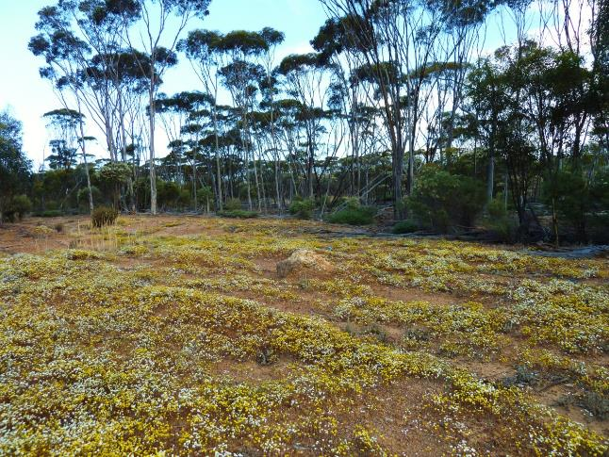

This information guide is designed to assist land managers, owners and occupiers as well as environmental assessment officers and consultants to identify, assess and manage the Eucalypt Woodlands of the Western Australian Wheatbelt, a threatened ecological community, listed as critically endangered under the *Environment Protection and Biodiversity Conservation Act 1999* (EPBC Act), Australia’s national environmental law.

This guide is a companion document to the approved Conservation Advice, which can be found on the Australian Government’s species profile and threats (SPRAT) database at:

[www.environment.gov.au/cgi-bin/sprat/public/publiclookupcommunities.pl](http://www.environment.gov.au/cgi-bin/sprat/public/publiclookupcommunities.pl).

On this webpage, click on the details link—alongside the ecological community name—to download the documents and the map for the listed ecological community. This version of the guide is similar to the previously published version, differing only in updates to formatting.

© Copyright Commonwealth of Australia, 2016.

creative_commons_licence.jpg

*Eucalypt Woodlands of the Western Australian Wheatbelt: a nationally protected ecological community* is licensed by the Commonwealth of Australia, for use under a Creative Commons By Attribution 4.0 Australia licence with the exception of the Coat of Arms of the Commonwealth of Australia, the logo of the agency responsible for publishing the report, content supplied by third parties, and any images depicting people. For licence conditions see: http://creativecommons.org/licenses/by/4.0/

This guide should be attributed as ‘*Eucalypt Woodlands of the Western Australian Wheatbelt: a nationally protected ecological community*, Commonwealth of Australia 2016’.

The Commonwealth of Australia has made all reasonable efforts to identify content supplied by third parties using the following format ‘© Copyright [name of third party] ’.

**Disclaimer**

The views and opinions expressed in this publication are those of the authors and do not necessarily reflect those of the Australian Government or the Minister for the Environment and Energy.

While reasonable efforts have been made to ensure that the contents of this publication are factually correct, the Commonwealth does not accept responsibility for the accuracy or completeness of the contents, and shall not be liable for any loss or damage that may be occasioned directly or indirectly through the use of, or reliance on, the contents of this publication.

**Images**

All images are © Copyright Matt White or John Vranjic, Department of the Environment and Energy, unless otherwise credited.

Maps were prepared by ERIN (Environmental Resources Information Network) of the Department of the Environment and Energy.

The Eucalypt Woodlands of the WA Wheatbelt were protected on December 2015 as a nationally threatened ecological community under Australia’s national environment law. A scientific assessment concluded that it should be on the list of critically endangered ecological communities. The listing protects patches that are **larger** and remain in **reasonably intact condition.**

Southwestern WA is an **internationally** recognised biodiversity hotspot, known for its diverse and unique wildflowers and animals. Many are found nowhere else in the world.

Eucalypt woodlands are a signature natural asset that characterises the broad wheatbelt landscape in the southwest. They are important to local communities, farmers and to Indigenous cultures (e.g. Nyungar/Noongar and Yamaji/Yamatji).

Eucalypt woodlands once formed extensive stands across a large proportion of the WA Wheatbelt. They provide important habitat for many unique animals.

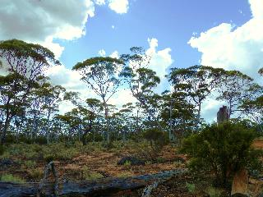

**But the woodlands have undergone a considerable decline.**

Woodlands in the wheatbelt are now fragmented, and reduced to mostly scattered remnants, often with weeds in the understorey. In many places, woodland trees are no longer regenerating and replacing themselves.

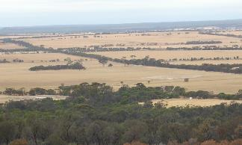

**Why are the the Eucalypt Woodlands of the WA Wheatbelt important?**

There are many reasons why it’s important to keep what’s left of the woodlands, and to recover or expand remnants. Woodlands provide benefits to the environment, to productivity and to people – here are some good examples.

1. Woodlands supply much needed cover to help stabilise and moderate the regional climate. The climate has become drier and more hostile due to a widespread loss of native plants**.**

2. Keeping intact woodland vegetation helps to minimise serious salinity and erosion problems. It helps prevent salt pans from forming or spreading, and the loss of valuable topsoil from farmlands.

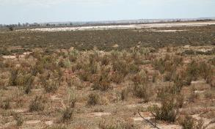

3. The mass wildflower displays of the unique woodlands and shrublands are a major tourist attraction across the wheatbelt.

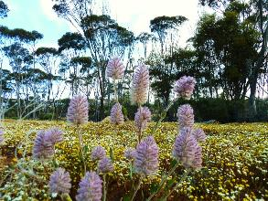

4. Remaining woodlands provide vital habitat for many unique plants and animals. They include some that are now threatened, such as Carnaby’s Black Cockatoo and the numbat.

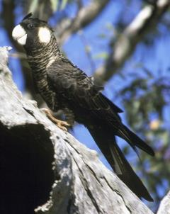

Carnaby’s black cockatoo.

*Image copyright: Brian Furby Collection*

5. Some woodland birds help to control pest insects that attack crops. Native insects living in woodlands also play an important role in the pollination of native and crop plants, and control of pests.

**Supportive practices have helped to retain woodland remnants. For instance, some remnants are intentionally set aside by farmers because they occur along watercourses, hills and rocky areas, or serve as shelter for stock, windbreaks for croplands and pastures, and to prevent erosion. These patches are important for conservation by maintaining biodiversity and wildlife corridors**.

**Listing is intended to further support farmers and other land managers who want to continue managing woodlands still in good quality for future benefits.**

**Where are the Eucalypt Woodlands of the WA Wheatbelt found?**

The Eucalypt Woodlands of the WA Wheatbelt occur in the wheatbelt region between the Darling Range and the Great Western Woodlands. The **shaded area** on the map shows where the ecological community can be found while the green areas show where woodlands are most likely**.**



The Eucalypt Woodlands of the WA Wheatbelt were formerly extensive but now occur as mostly small remnants, scattered across the wheatbelt.Many patches are degraded. The nationally listed woodlands only includes **patches that are large and remain in good condition.**

**What is NOT INCLUDED in the Eucalypt Woodlands of the WA Wheatbelt?**

The red hatched area shows where the **Eucalypt Woodlands of the WA Wheatbelt** occurs.Within the wheatbelt, the listed Eucalypt Woodlands **DO NOT include:**

- Woodlands dominated by mallee trees.

- Non-eucalypt woodlands, e.g. with jam, sheoak, banksia.

- Woodlands limited to granite or rock outcrops and higher elevations.

- Vegetation with a sparse tree canopy cover, under 10%.

- Isolated paddock trees, very small remnants and patches that are degraded and in poor low condition.



**Jarrah-Marri woodlands**

These are mostly west of the wheatbelt and are typical of the Darling Range. This area receives higher rainfall than the Wheatbelt.

**Any patches dominated by Jarrah or Marri that extend into the wheatbelt are NOT part of the listed Eucalypt Woodlands.**

**Great Western Woodlands**

These lie east of the Wheatbelt, towards the Goldfields and eastern Mallee. This area typically gets lower rainfall than the Wheatbelt.

**The Great Western Woodlands are NOT part of the listed woodlands EXCEPT where patches with similar eucalypts and understorey overlap into the eastern edge of the Avon Wheatbelt and Western Mallee.**

**Southern and coastal woodlands**

These lie west and south of the wheatbelt and often include different tree and understorey species to the wheatbelt woodlands. This area gets much higher rainfall than the Wheatbelt.

**What woodlands are protected as the Eucalypt Woodlands of the WA Wheatbelt?**

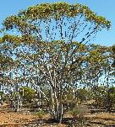Silver mallet

The Eucalypt Woodlands are found on the flatter landscapes and lower rises of the wheatbelt (landscapes 1-4 in the diagram). The main trees are eucalypts that typically have a single trunk. They occur as a complex mosaic involving about 30 species, including many iconic trees of the Wheatbelt shown or named here. The trees present varies from patch to patch. The native understorey is diverse and very variable, ranging from largely bare to grassy to herbs and wildflowers to shrubby.

**3. Breakaways and gravel rises. Trees such as various Mallets, Wheatbelt wandoo.**

*Diagram copyright WWF and Nathan McQuoid, reproduced with permission from McQuoid (2014).*

**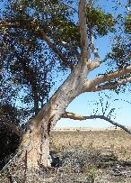**

Salt salmon gum



**1. Watercourses, wetlands & granite sands. Trees such as York gum, Flooded gum, Flat-topped yate.**

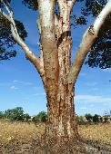Salmon gum

**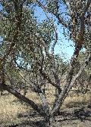**

York gum

**2. Salt lakes / surrounds. Trees such as Kondinin blackbutt, Lake mallets, Swamp mallets, Salt River gum, Salt salmon gum.**

**4. Plains and valley floors. Trees such as Salmon gum, Red morrel, Gimlet, Merrit, Wandoo.**

**How can I tell if a patch of the Eucalypt Woodlands of the WA Wheatbelt is in reasonably intact condition?**

**National protection applies to patches of Eucalypt Woodlands that are reasonably intact - they retain native understorey vegetation or important habitat features, such as large trees with hollows. Woodlands in the best, largely undisturbed condition are now rare, especially outside of nature reserves.**

Woodland remnants that remain reasonably intact generally align with vegetation condition ratings used in southwestern Western Australia:

* For the Keighery (1994) condition scale, woodlands included are generally those rated as: Pristine – Excellent – Very good – Good.
* For the Roadside Conservation Value (RCV) rating of the Roadside Conservation Committee of WA, woodlands included are generally those rated as High – Medium-High.

**This what intact, good condition Eucalypt Woodlands look like.**

*Example remnants not along roadsides*

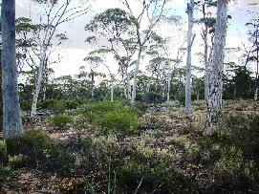

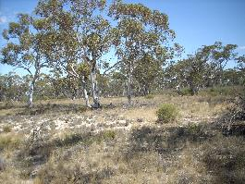

*Example roadside remnants*

**In all these example images, good condition is shown by:**

**A tree canopy that is dominated by eucalypts with a tree or mallet form**. A list of the 30 key tree species is in the conservation advice. Crown cover must be at least 10% across the patch.

**An intact understorey.**  This is naturally variable but its vegetation cover should be mostly due to native species. The fewer the weeds and the higher the natural diversity of native plant species, the better the condition of the patch. Note the understorey below some woodland types, such as mallet woodlands may be naturally sparse and open.

**Presence of mature eucalypts.** These should be present IF the understorey has lower native vegetation cover. Mature trees are particularly important for hollows where native animals can shelter and nest.

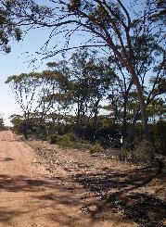

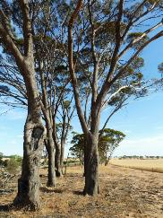

**Examples of Eucalypt Woodlands in poor condition.**

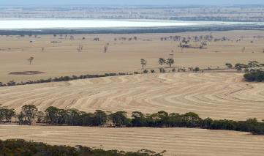

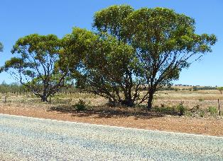

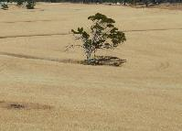

Isolated paddock trees and small or narrow farm stands over crops, pasture and other exotic plants (weeds) as shown in this typical wheatbelt landscape, are too small and degraded to be protected as the Eucalypt Woodlands of the WA Wheatbelt.

Intact woodlands most likely remain in the reserve around the lake (in the background) or along some road verges (e.g.the row of trees in the foreground).

This wheatbelt roadside woodland remnant is too narrow and has little or no native understorey cover remaining. Such roadside patches are too degraded to be part of the Eucalypt Woodlands of the WA Wheatbelt.

**How big should a patch of the Eucalypt Woodlands in good conditon be?**

For patches not on roadsides, there are minimum patch size thresholds for intact Eucalypt Woodlands.

A minimum patch **size** of **2 hectares (5 acres)** applies where:

* A high quality native understorey remains – i.e. no more than 30% total vegetation cover of exotic plant species. OR
* Exotic plant species account for over 30 to 50% total vegetation understorey cover AND mature trees are present, with at least 5 such trees per half hectare. Mature trees have a diameter at breast height of 30 cm or more, and often contain hollows.

A minimum patch **size** of **5 hectares (12.5 acres)** applies where:

* Exotic plant species account for over 30 to 50% total vegetation understorey cover BUT there are no or less than 5 **mature** trees present per half hectare OR
* Exotic plant species account for over 50 to 70% total vegetation understorey cover AND mature trees are present, with at least 5 such trees per half hectare.

For patches that occur as roadside verges, a minimum patch **width** of **5 metres** applies to all Eucalypt Woodlands, and meet any of the exotic plant species understorey cover / presence of mature trees criteria, above.

**Shelterbelts and windbreaks on farms, and narrow road verges, will usually be too small or too degraded to form part of the ecological community.** **Most patches left on farms, and many roadsides will fall outside the proposed listing.**

**How will national protection affect developers and land managers - what happens if I have the Eucalypt Woodlands on my land?**

National protection only applies to **new** actions likely to cause **significant** damage to patches of Eucalypt Woodland that remain in good condition. Details of how to work out if a woodland patch may be in sufficiently good condition are given on the next page.

How you may be affected by the national listing depends on:

- whether you have a large patch of good quality Eucalypt Woodland on your land; and

- what you intend to do with any such patches.

**I want to keep my woodlands or don’t plan to do anything to them.**

**If there are no new actions, then the listing won’t affect you. Land managers who want to retain good quality woodlands, or intend to restore any woodlands on their properties may apply for funding to help with their conservation**.

Relevant national environmental funding programmes are under way and currently include Green Army, Landcare and 20 Million Trees and Emissions Reduction Fund. They are designed to help people undertake conservation works across Australia. Regional Catchment or National Resource Management (NRM) groups also offer funding, advice support to help landholders look after their landscape and remnant vegetation.

Many projects specifically target nationally listed threatened species and ecological communities that occur on properties.

**I’m just doing usual routine activities to maintain my land, business, etc.**

**There are exemptions in the national environment law that** **apply here.**

Routine and ongoing activities by farmers and business are not impacted by national listings. This has been the case for ecological communities that have been listed in other agricultural areas of Australia. There are exemptions for:

- Activities that are already legally approved. For instance, existing cropping or pastoral activities, or developments that have already been approved. AND

- Long-term, continuing or routine activities, such as normal farm practices, property maintenance, weed or pest control, or usual roadside maintenance activities.

**I have a new development that might involve clearing the Eucalypt Woodlands.**

**The main consideration is to seek approval first for any new activity that could significantly impact upon larger, good quality patches of the woodland.** Referrals usually apply to **major** projects, for instance new mines or mine expansions, major new road works, new housing and industrial developments, or proposals to convert large areas of intact woodlands for feedlots or cropping.

- **Check** you have the right type of woodland present and if it’s in good enough condition to be referred [see previous pages for some guidance or seek help from local NRM staff].

- **Plan** to avoid or minimise impacts to woodland patches, especially the best quality patches.

- **Talk with the Australian Government Environment Department first** to check if the action may significantly impact any woodlands and needs to be referred for national approval.

**The WA Government also has State clearing regulations that may apply to new activities.**

There may be other protected matters that need to be considered, for instance any nationally threatened species. And your current socio-economic circumstances plus any past environmental history can be taken into account when approving the action.

**Want more information about the Eucalypt Woodlands of the WA Wheatbelt?**

The approved Conservation Advice is on the Department of the Environment’s website at:

<http://www.environment.gov.au/cgi-bin/sprat/public/publicshowcommunity.pl?id=128&status=Critically+Endangered>

Advice about Australian Government environmental funding programmes (e.g. Green Army, National Landcare, 20 Million Trees, Emissions Reduction Fund) can be found online at:

<http://www.environment.gov.au/about-us/grants-funding>

Information about the EPBC Act referral and assessment process is available on:

<http://www.environment.gov.au/protection/environment-assessments/assessment-and-approval-process>

**Useful books about Eucalypt Woodlands of the WA Wheatbelt**

Mike Bamford (1995). *Exploring wheatbelt woodlands.* WA Department of Conservation and Land Management.

Malcolm French (2012). *Eucalypts of Western Australia’s Wheatbelt.*

Nathan McQuoid (2014). *Lifting the bonnet on Wheatbelt woodlands.* WWF.

Stephen Fry and Tracey Hobbs (2014). *Revegetation guide by soil type for the central and eastern wheatbelt*. Australian Government Clean Energy Future Biodiversity fund.

**If you have any questions, then please contact:**

the Federal Department of the Environment

Tel: 1800 803 772 or email [ciu@environment.gov.au](mailto:ciu@environment.gov.au).

OR

your local Natural Resource Management or Catchments Council group

e.g. Wheatbelt NRM, Northern Agricultural Catchments Council, South West Catchments Council, Peel-Harvey Catchments Council or South Coast NRM.

OR

contact your local council or WA Depts of Environmental Regulation or Parks and Wildlife about any local or state clearing laws that may apply.

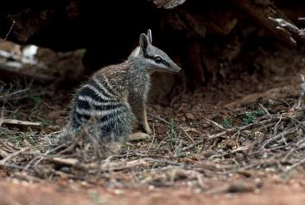

Numbat. *Image copyright: Alexander Dudley*

**environment.**gov.au

