# Guide to the

# Farm Financial Assessment

© Commonwealth of Australia 2025

**Ownership of intellectual property rights**

Unless otherwise noted, copyright (and any other intellectual property rights) in this publication is owned by the Commonwealth of Australia (referred to as the Commonwealth).

**Creative Commons licence**

All material in this publication is licensed under a [Creative Commons Attribution 4.0 International Licence](https://creativecommons.org/licenses/by/4.0/legalcode) except content supplied by third parties, logos and the Commonwealth Coat of Arms.



**Cataloguing data**

This publication (and any material sourced from it) should be attributed as: DAFF 2025, Guide to the *Farm Financial Assessment*, Department of Agriculture, Fisheries and Forestry, Canberra, May. CC BY 4.0.

This publication is available at [Farm Household Allowance - DAFF](https://www.agriculture.gov.au/agriculture-land/farm-food-drought/drought/farm-household-allowance).

Department of Agriculture, Fisheries and Forestry

GPO Box 858 Canberra ACT 2601

Telephone 1800 900 090

Web [agriculture.gov.au](https://www.agriculture.gov.au/)

Email: FHA @aff.gov.au

**Disclaimer**

The Australian Government acting through the Department of Agriculture, Fisheries and Forestry has exercised due care and skill in preparing and compiling the information and data in this publication. Notwithstanding, the Department of Agriculture, Fisheries and Forestry, its employees and advisers disclaim all liability, including liability for negligence and for any loss, damage, injury, expense or cost incurred by any person as a result of accessing, using or relying on any of the information or data in this publication to the maximum extent permitted by law.

**Acknowledgement of Country**

We acknowledge the continuous connection of First Nations Traditional Owners and Custodians to the lands, seas and waters of Australia. We recognise their care for and cultivation of Country. We pay respect to Elders past and present, and recognise their knowledge and contribution to the productivity, innovation and sustainability of Australia’s agriculture, fisheries and forestry industries.

Contents

Introduction 11

Accessing your FFA 13

1.1 Before you begin 14

Part A – About You 17

Step 1: Your circumstances 17

Step 2: Farm Details 19

Step 3: Farm labour input 27

Step 4: Financial management 28

Step 5: Farming future 35

Step 6: Review and submit 36

Part B – Farm Information 37

Step 1: production impacts 39

Step 2: Assets and debts 48

Step 3: Farm Profitability 58

Step 4: Personal Finances 68

Step 5: Other business finances 74

Step 6: Financial position 80

Step 7: Review and submit 83

Part C – Farm Performance 84

Performance indicators 84

SWOT Analysis 88

Part D: Assessment 92

Part 1 – Financial assessor’s assessment 92

Part 2 – Financial assessor’s assessment 93

Part 3 – Financial Assessor’s assessment 94

Part 4 – Financial Assessor’s assessment 95

Further assistance 96

Financial assessor details 97

Review and submit 99

Glossary 100

****Tables****

Table 1 - Performance Indicators Help Text 84

**Figures**

Figure 1 - Accessing FFA through Centrelink homepage. 13

Figure 2 - Services Australia homepage - search function. 13

Figure 3 - Farm Financial Assessment hyperlink. 13

Figure 4 - FFA Parts A-D homepage. 14

Figure 5 - Session time out notification. 15

Figure 6 - Select continue at end of step to save answers. 15

Figure 7 - Decision to apply for FHA. 18

Figure 8 - Contribution to low yield, failure of crops or low livestock numbers for sale. 18

Figure 9 - What other factors contributed to the low livestock numbers or sales? 19

Figure 10 – Details of the farm business. 20

Figure 11 - What is the registered business name of this farm business? 20

Figure 12 - What is the structure of the farming business? 21

Figure 13 - In addition to your farm business activities, are you involved in other related business? 21

Figure 14 - Provide a description of this other activity or indicate if there is no other related business. 22

Figure 15 - Of total area of land currently operated by this farm business, in hectares. 22

Figure 16 - Details of each farm business you are involved in - summary table. 23

Figure 17 - Details of livestock, crops or aquaculture activities on the farm. 23

Figure 18 - What group best describes this activity? 24

Figure 19 - What class best describes this activity? 25

Figure 20 - How many hectares are currently under crop? 25

Figure 21 - How many hectares, in an average year, would be under crop? 26

Figure 22 - How many tonnes, per hectares, will this yield for the current year? 26

Figure 23 - How many tonnes, per hectare, would this yield in an average year? 26

Figure 24 - What is the current head of livestock on the farm? 26

Figure 25 - What is the average (year in year out) head of livestock on the farm? 26

Figure 26 - What is the yield you expect in the current year? 27

Figure 27 - What is the yield in an average year? 27

Figure 28 - Details of the livestock, crops or aquaculture activities on the farm - summary table. 27

Figure 29 - On average, how many hours do you work on the farm business per week? 28

Figure 30 - On average, how many weeks of vacation do you take each year? 28

Figure 31 - How many households are supported by your farm business? 29

Figure 32 - Are these people also supported by off-farm income? 30

Figure 33 - How much gross income from off-farm wages or salaries will they receive for 2024-25 financial year? 30

Figure 34 - How many hours per week, on average, is the work? 30

Figure 35 - How much net income from other businesses will they receive for the 2024-25 financial year? 30

Figure 36 - How many hours per week, on average, is the work? 31

Figure 37 - How much net income from other investments will they receive for the 2024-25 financial year? 31

Figure 38 - How much gross income from off-farm wages or salaries do they receive in an average year? 31

Figure 39 - How many hours per week, on average, is the work? 31

Figure 40 - How much net income from other businesses do they receive in an average year? 31

Figure 41 - How many hours per week, on average, is the work? 32

Figure 42 - How much net income from other investments do they receive in an average year? 32

Figure 43 - Summary table of off-farm income received. 32

Figure 44 - Have you received any income from the government in the last 5 years? 32

Figure 45 - Please provide details of any income from the government that you have received in the last 5 years. 32

Figure 46 - What is the type of income received? 33

Figure 47 - What is the name of this income? 33

Figure 48 - Who is the provider of this income? 33

Figure 49 - Who has received this income? 34

Figure 50 How much did you receive? 34

Figure 51 - Government income received in last 5 years summary table. 34

Figure 52 - Does your farm business have a business plan? 34

Figure 53 - When was the business plan developed? 34

Figure 54 - Do you use the business plan in your decision making about the farm business? 34

Figure 55 - How regularly is the business plan reviewed? 35

Figure 56 - How many years have you been farming as an owner and/or manager? 35

Figure 57 - How many years have you lived on the current farm? 35

Figure 58 - What is your preferred occupation 10 years from now? 36

Figure 59 - Declaration and agreement to listed conditions. 36

Figure 60 - One time access code log in. 37

Figure 61 - Production impacts - financial assessor requirements. 38

Figure 62 - Each step to guide you through the process of completing your assessment. 38

Figure 63 - Have you applied changes to your production to try and improve your profitability? 40

Figure 64 - What changes have you applied to your production to try and improve your profitability? 40

Figure 65 - How did you try to improve your profitability? 40

Figure 66 - If you have previously received Farm Household Allowance, did you use the Activity Supplement to support these changes? 41

Figure 67 - How important was the Activity Supplement to support the changes? 41

Figure 68 - Environmental issue(s) that adversely affected your farm - entry table. 41

Figure 69 - What was the farm adversely affected by? 42

Figure 70 - In hectares, what size was affected? 42

Figure 71 - Was the remediation successful? 42

Figure 72 - Environmental issue/s that adversely affected the farm - summary table. 43

Figure 73 - Climate and weather conditions in each of the last 10 years. 43

Figure 74 - What best describes the climate and weather conditions? 43

Figure 75 - Climate and weather conditions in each of last 10 years - summary table. 44

Figure 76 - Select the years the climate and weather conditions were impacted. 44

Figure 77 - Natural disaster effects on your production in last 10 years. 44

Figure 78 - What event in the last 10 years (or since you started farming, if within the last 10 years) was the farm affected by? 45

Figure 79 - Select the years the event impacted the farm. 45

Figure 80 - Natural disaster effects on production in the last 10 years. 45

Figure 81 - Practices you applied to your farmland to help you improve your drought and natural disaster resilience. 46

Figure 82 - What practices did you apply to your farmland to help you improve your drought or other natural disaster resilience? 46

Figure 83 - What is the total number of hectares affected? 46

Figure 84 - Select the year(s) the practice was applied. 46

Figure 85 - Practices you applied to your farmland to help you improve your drought and natural disaster resilience - summary table. 47

Figure 86 - Natural resource management techniques or practices you applied to your farmland to help you improve your drought or natural disaster resilience. 47

Figure 87 - What natural resource management techniques or practices did you apply to your farmland to improve your sustainability outcomes? 47

Figure 88 - What is the total number of hectares affected? 47

Figure 89 - Select the year/s the practice was applied. 48

Figure 90 - Natural resource management techniques or practices you applied to your farmland to help you improve your drought or other natural disaster resilience - summary table. 48

Figure 91 - Value of the farm business assets, and personal assets - input table. 50

Figure 92 - What is the type of asset? 51

Figure 93 - What is the type of livestock? 52

Figure 94 - How many livestock are there? 52

Figure 95 - What is the current market value of this asset? 52

Figure 96 - Provide a brief description of the asset. 52

Figure 97 - Value of the farm business assets, and additional assets. 53

Figure 98 - Add or edit any farm debt. 53

Figure 99 - What is the category of debt? 54

Figure 100 - Provide details of the liabilities. 54

Figure 101 - What is the total balance of the debt owing? 54

Figure 102 - What is the next minimum repayment due? 54

Figure 103 - What is the total repayment amount due in the next 12 months? 54

Figure 104 - Is the debt secured? 55

Figure 105 - What is the interest rate? 55

Figure 106 - What is the repayment and interest type? 55

Figure 107 - Farm debt - summary table. 55

Figure 108 - Personal debt that you and/or partner may have - input table. 56

Figure 109 - What is the category of debt? 56

Figure 110 - Provide details of the liabilities. 56

Figure 111 - What is the total balance of the debt owing? 57

Figure 112 - What is the next minimum repayment due? 57

Figure 113 - What is the total repayment amount due in the next 12 months? 57

Figure 114 - Is the debt secured? 57

Figure 115 - What is the interest rate? 57

Figure 116 - What is the repayment and interest type? 58

Figure 117 - Personal debt you and/or your partner have - summary table. 58

Figure 118 - All farm income sources - input table. 59

Figure 119 - What is the type of farm income? 60

Figure 120 - What was the full amount for the 2021-22 financial year for this income type? 61

Figure 121 - What was the full amount for the 2022-23 financial year for this income type? 61

Figure 122 - What was the full amount for the 2023-24 financial year for this income type? 61

Figure 123 - All farm income sources - summary table. 61

Figure 124 - All administrative expense sources - input table. 62

Figure 125 - What is the type of administrative expense? 63

Figure 126 - What was the full amount for the 2021-22 financial year for this administrative expense type? 63

Figure 127 - What was the full amount for the 2022-23 financial year for this administrative expense type? 63

Figure 128 - What was the full amount for the 2023-24 financial year for this administrative expense type? 63

Figure 129 - All administrative expense sources - summary table. 64

Figure 130 - All production expense sources - input table. 64

Figure 131 - What was the full amount for the 2021-22 financial year for this production expense type? 65

Figure 132 - What is the type of production expense? 65

Figure 133 - What was the full amount for the 2022-23 financial year for this production expense type? 66

Figure 134 - What was the full amount for the 2023-24 financial year for this production expense type? 66

Figure 135 - All production expense sources - summary table. 66

Figure 136 - All farm debt sources - input table. 66

Figure 137 - What was the full amount for the 2021-22 financial year for this debt type? 67

Figure 138 - What is the category of debt? 67

Figure 139 - What was the full amount for the 2022-23 financial year for this debt type? 67

Figure 140 - What was the full amount for the 2023-24 financial year for this debt type? 67

Figure 141 - All farm debt sources - summary table 68

Figure 142 - All personal income sources that you and/or your partner have - input table. 69

Figure 143 - What is the type of personal income? 69

Figure 144 - What was the full amount for the 2021-22 financial year for this income type? 69

Figure 145 - What was the full amount for the 2022-23 financial year for this income type? 70

Figure 146 - What was the full amount for the 2023-24 financial year for this income type? 70

Figure 147 - All personal income sources that you and/or your partner have. 70

Figure 148 - Personal expenditure sources that you and/or your partner have - input table. 70

Figure 149 - What is the type of personal expenditure? 71

Figure 150 - What was the full amount for the 2021-22 financial year for this expenditure type? 71

Figure 151 - What was the full amount for the 2022-23 financial year for this expenditure type? 71

Figure 152 - What was the full amount for the 2023-24 financial year for this expenditure type? 71

Figure 153 - Personal expenditure sources that you and/or your partner have - summary table. 72

Figure 154 - Personal debt sources that you and/or your partner have - input table. 72

Figure 155 - What is the category of debt? 73

Figure 156 - What was the full amount for the 2021-22 financial year for this debt type? 73

Figure 157 - What was the full amount for the 2022-23 financial year for this debt type? 73

Figure 158 - What was the full amount for the 2023-24 financial year for this debt type? 73

Figure 159 - Personal debt sources that you and/or your partner have - summary table. 73

Figure 160 - Other business income sources that you and/or your partner have. 74

Figure 161 - What is the type of other business income? 75

Figure 162 - What was the full amount for the 2021-22 financial year for this income type? 75

Figure 163 - What was the full amount for the 2022-23 financial year for this income type? 75

Figure 164 - What was the full amount for the 2023-24 financial year for this income type? 75

Figure 165 - All other business income sources that you and/or your partner have - summary table. 76

Figure 166 - Other business expenditure sources that you and/or your partner have. 76

Figure 167 - What was the full amount for the 2021-22 financial year for this expenditure type? 76

Figure 168 - What is the type of other business expenditure? 78

Figure 169 - What was the full amount for the 2022-23 financial year for this expenditure type? 78

Figure 170 - What was the full amount for the 2023-24 financial year for this expenditure type? 78

Figure 171 - Other business expenditure sources that you and/or your partner have - summary table. 78

Figure 172 - Other business debt sources that you and/or your partner have. 79

Figure 173 - What is the category of debt? 79

Figure 174 - What was the full amount for the 2022-23 financial year for this debt type? 80

Figure 175 - What was the full amount for the 2021-22 financial year for this debt type? 80

Figure 176 - What was the full amount for the 2023-24 financial year for this debt type? 80

Figure 177 - Other business debt sources that you and/or your partner have. 80

Figure 178 - Source of farm business receipts. 81

Figure 179 - Consolidated farm income, operating costs and debt. 82

Figure 180 - Consolidated personal income, operating costs and debt. 82

Figure 181 - Consolidated other business income, operating costs and debt. 83

Figure 182 - Financial assessor statement. 83

Figure 183 - Performance Indicators - ideal thresholds. 87

Figure 184 - Considering the applicant's overall financial situation, including on-farm and off-farm activities, what are their strengths. 88

Figure 185 - Considering the applicant's overall financial situation, including on-farm and off-farm activities, what are their weaknesses 89

Figure 186 - Considering the applicant's overall financial situation, including on-farm and off-farm activities, what are their opportunities. 89

Figure 187 - Considering the applicant's overall financial situation, including on-farm and off-farm activities, what are their threats. 89

Figure 188 - Factor 1 affecting the applicant's financial situation. 90

Figure 189 - Factor 2 affecting the applicant's financial situation. 90

Figure 190 - Factor 3 affecting the applicant's financial situation. 90

Figure 191 - Factor 4 affecting the applicant's financial situation. 90

Figure 192 - Factor 5 affecting the applicant's financial situation. 90

Figure 193 - Financial assessor Part C declaration. 91

Figure 194 - What trends in income, profit or expenditure have contributed to the farm's financial situation? 92

Figure 195 - Using your financial expertise and the information from Parts B and C, discuss the profitability issues of the farm business and opportunities for improvement. 93

Figure 196 - Using information supplied in FFA Parts B and C and drawing on your financial expertise, discuss the liquidity issues of the farm business and opportunities for improvement. 93

Figure 197 - Using information supplied in FFA Parts B and C and drawing on your financial expertise, discuss the financial stability issues of the farm business and opportunities for improvement. 94

Figure 198 - Would the business benefit from changes to the business lines (commodities)? 94

Figure 199 - Considering any limitations the applicant may face in improving farm profit in the next 3 years, does the applicant need to obtain additional income from outside the farm to achieve financial security? 95

Figure 200 - What other issues has the applicant identified during this assessment that they consider important to their current and preferred situations? 95

Figure 201 - Are there other issues relevant to the applicant's circumstances? 96

Figure 202 - What type of additional professional training, advice or support do you think may improve the FHA recipient’s ability to make business decisions based on their financial situation, goals and prospects? 97

Figure 203 - Provide further details on the other professional advice or training. 97

Figure 204 - Name of the organisation. 98

Figure 205 - Name of financial assessor. 98

Figure 206 - Australian Business Number (ABN) of the organisation. 98

Figure 207 - Postal address of the organisation. 99

Figure 208 - Contact phone number. 99

Figure 209 - Financial assessor statement - declaration. 99

## Introduction

The package of Farm Household Allowance (FHA) assistance is designed to focus a farmer’s attention on making improvements to their finances. In addition to a fortnightly payment, there is practical help to make changes. FHA will not solve all the problems, but it will connect farmers with the specialists to help them to succeed, plan their succession, or make the difficult decision to sell.

The purpose of this guide is to assist farmers and their financial assessor to accurately complete a comprehensive assessment of the financial position of a farm enterprise and any associated businesses – this is called a Farm Financial Assessment (FFA). At its most basic, the FFA is an objective professional assessment to help the move the farmer out of hardship.

The FFA:

* collects the farm’s gross and net position using the last three financial years
* shows how funds flow through the business by organising the data into tables
* demonstrates the size and scale of the business, including the capital and labour inputs
* captures the farmer’s wishes for their future
* reflect drivers of hardship and show if they are entrenched or transitory, and
* give the farmer an indication of the measures that would be required to overcome the hardship/s and move the business to on-going financial self-sufficiency.

The FFA Guide takes a stepped approach to give users an end-to-end view of the process. It gives context to each section, with explanations about the request, and how it links to the assessment.

The FFA is one of the foundations of case management. It allows the farmer and their partner (either domestic and/or business) to quickly understand which overheads are absorbing the greatest amount of income, and which commodities are showing the strongest return for the investment.

The role of the financial assessor is to use their financial expertise to convert the raw information into suggested pathways to financial self-reliance. The farmer can use this information (combined with any other data or material) to make decisions about their short, medium and long-term future.

Although the FFA must be completed, it is not the Australian Government’s intention for the FHA recipient to be out of pocket. This is why a commercial financial assessor may be reimbursed up to $1,500 for their time. A Rural Financial Counsellor may also be used, at no cost to the farmer. Previous FFAs have required an estimate of the current financial year. This made the process longer ang greatly contributed to costs. Using completed financial year information gives greater accuracy to the forward-looking work in Part C, than a combination of prior and current estimate.

A key feature of the FFA is to present each portion of information in logical summaries to use the past to project future pathways. Therefore the information a person has prepared for their taxation lodgement is transferred to the FFA parts. Limitations with data exchange mean it is not possible to automatically update an FFA from the Australian Taxation Office. Also much of the detail is prepared for lodgement, but is not required to be lodged and therefore is unavailable for a data exchange.

The farmer uses the forward projections and ideas to develop an activity plan called a Financial Improvement Agreement (FIA) with a Services Australia Farm Household Case Officer (FHCO). Each FIA has activities aim to improve the farmer’s circumstances. This may be by acquiring new skills, undertaking training or education, or seeking guidance from a professional such as a solicitor, financial advisor, agronomist, or a farm consultant (this list is not exhaustive). The Strengths, Weaknesses, Opportunities and Threats analysis in the FFA, plus the free text area where the Financial Assessor outlines possible pathways are key to defining the activities.

|  |
| --- |
| FFAs need to be accurate, relevant and meaningful. A key focus of FFAs is to ensure:   * farm business details are recorded accurately * all financial tables are completed accurately * answers in the qualitative analysis provided by the financial assessor are comprehensive and relevant to the individual farm business.   The Australian Government may not pay for an FFA that does not provide adequate analysis and advice to enable an applicant to negotiate a useful FIA with their FHCO. Services Australia may withhold payment until the adviser submits a satisfactory assessment with recommendations.  This guide explains each question in the FFA and provides a guide to answering them. A farmer’s continuing eligibility for FHA depends on the submission of a completed FFA to Services Australia generally within 28 days of being requested. For further assistance, including the online system, please contact the Farmer Assistance Hotline on 132 316. |

**Who can be a financial assessor?**

**An FFA can be conducted by a person who:**

* **is independent from the FHA recipient and their partner; and**
* **does not have any right or interest in the farm or any asset that is owned by the recipient, the partner or the relevant farm enterprise; and**
* **has appropriate qualifications or expertise to conduct the assessment.**

For example, a qualification from a tertiary institution in a field that is relevant to giving financial advice. Extra weight would be given to a qualification that is recognised by a professional body.

**Occupations that give a person experiences in financial matters include:**

* financial advisor
* a farm consultant
* an accountant
* Rural Financial Counsellor

If a farmer or FHCO has any questions on the suitability of their preferred assessor, they can contact the Department of Agriculture, Fisheries & Forestry at [FHA@aff.gov.au](mailto:FHA@aff.gov.au).

## Accessing your FFA

To access the FFA dashboard from the Centrelink homepage (**Error! Reference source not found.**), follow these instructions:

* Click on ‘**Payments and Claims**’ tab
* In the ‘**Claims**’ list, select the ‘**Farm Financial Assessment**’ link.

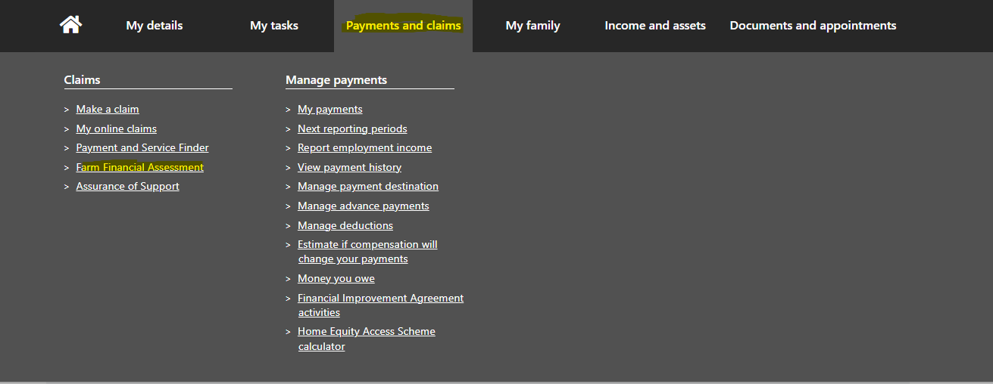

Figure 1 - Accessing FFA through Centrelink homepage.

The FFA portal can also be accessed via the Services Australia website: [Services Australia](https://www.servicesaustralia.gov.au/). Follow these steps to access the FFA:

* Use the search option on the homepage and type in ‘**Farm Financial Assessment**’ (Figure 2).

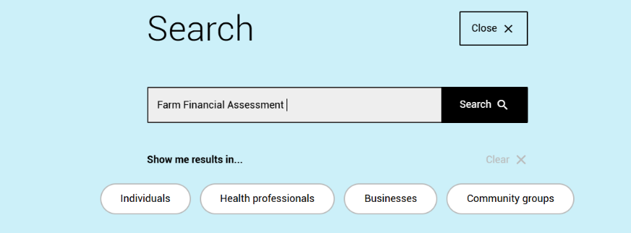

Figure 2 - Services Australia homepage - search function.

* Select the **Farm Financial Assessment** hyperlink (Figure 3).

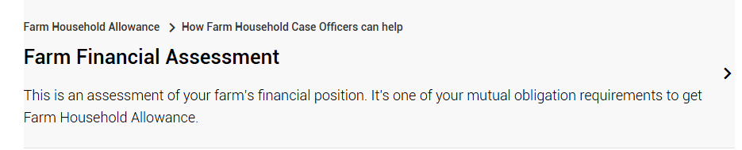

Figure 3 - Farm Financial Assessment hyperlink.

* The FFA dashboard will appear, and you can begin the assessment by starting with Part A – About You (Figure 4).

### Before you begin

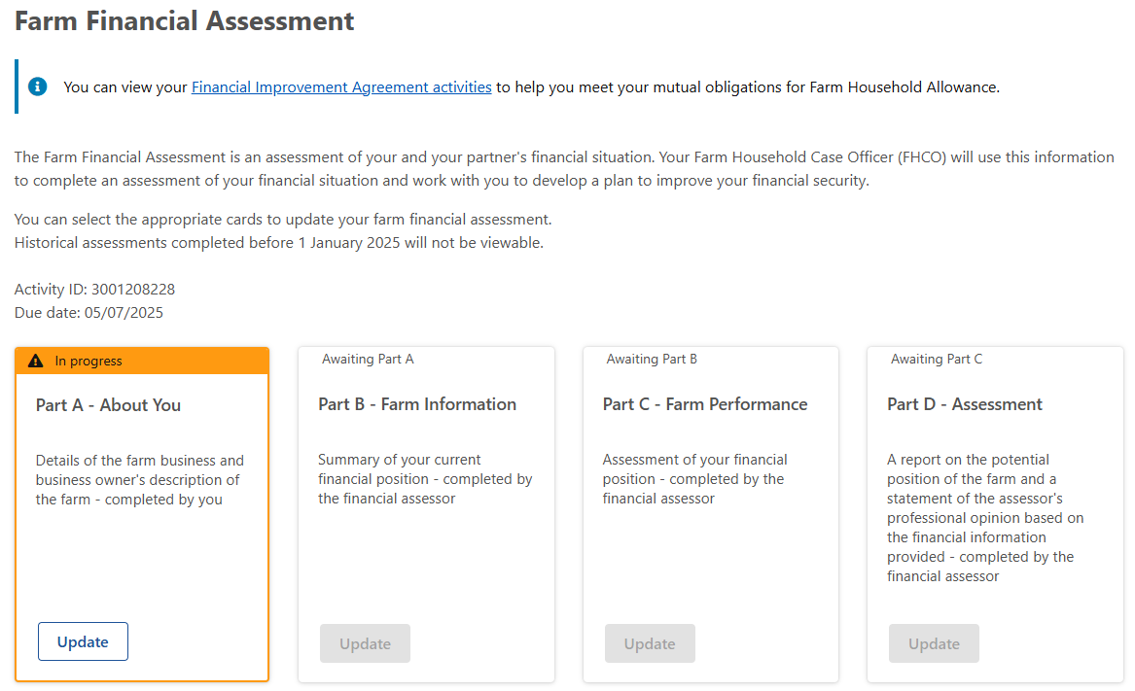

Figure 4 - FFA Parts A-D homepage.

#### General Information

**Accuracy of information**

To ensure that the assessor can provide meaningful advice and options for improving the farmer’s financial situation, the farmer must provide accurate numerical estimates of farm operations eg. Hectares sowed, wages and hours worked. The farmer is not expected to individually measure or count each feature, however, the FFA provides a financial baseline so the better the accuracy the better overall assessment.

Please also note, when referring to production, many questions ask ‘for the current year’ and by this it is meant ‘production in the relevant financial year’, rather than the calendar year. This means that the answers about production will be aligned with the financial information.

#### Information requirements

To assist with the answering of questions you may want to have the following resources on hand to ensure you can answer in a timely manner and be reliable as possible:

* tax documents from previous 3 years,
* up to date information on personal assets and debts,
* accurate measure of your farming commodity or commodities ie. head of livestock, tonnage of crops, hectares used
* your farm business plan – if applicable.

You may also find it helpful to access your FHA profile for previously included information that will be relevant to this assessment. For example, personal details or farm business details.

#### Question Overview

* The FFA is a dynamic online form. Not all FFA questions in this guide will be presented.
* A screenshot from the online assessment will accompany the description to each question. These are included as a visual guide and include extra detail to help work through the questions.
* For ease of navigation the numbering system is identified as **1.1.1, 1.1.2, 1.1.3** etc. For example:
  + Part A – Step 1 – Question 1 = 1.1.1
  + Part A – Step 2 – Question 1 = 1.2.1
  + Part B – Step 3 – Question 4 = 3.3.4
  + Part C – Step 2 – Question 3 = 4.2.3
* IMPORTANT: If your screen is inactive for 10 minutes, a pop-up message (Figure 5) will appear which requires you to select ‘**Stay logged in**’. You will have 60 seconds to select this button, or you will lose unsaved work.

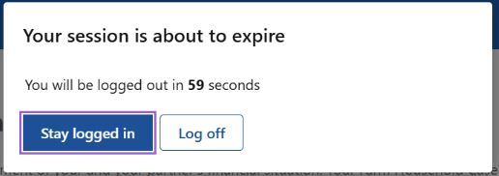

Figure 5 - Session time out notification.

* IMPORTANT: Your answers will be saved once you select ‘**Continue’** at the end of each step (Figure 6). Selecting ‘**next**’ will not save your progress. You will need to re-answer the questions.

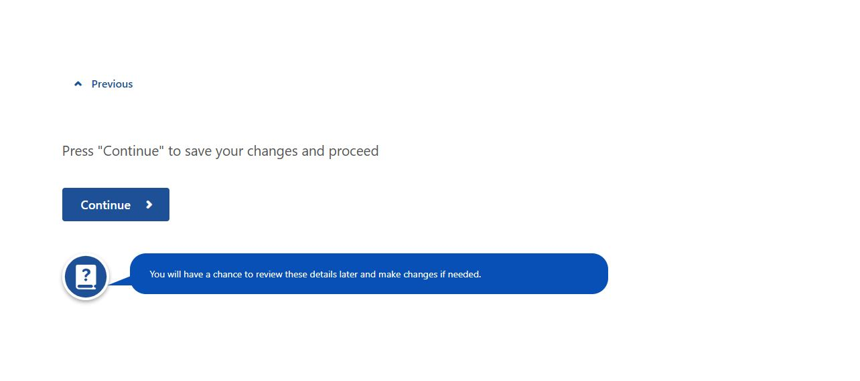

Figure 6 - Select continue at end of step to save answers.

#### FFA Parts A-D overview

The following information is useful to read before beginning the assessment:

* The financial assessor should review the input in Part A as this gives context to Parts B-D.
* Time taken to complete the FFA will vary. Parts A & B have a guideline of how long it would take to complete, which testing shows could take 2-4 hours.
* You can review/edit/delete your answers using a summary table prior to submitting each part.
* Each part must be answered in order. For example, **Part A must be submitted before Part B will be made available**.

Each part follows this structure:

* **Step 1** - Guidance for you to keep on track with assessment
* **Explanation** - the policy description for you to understand the reasoning behind the questions
* **Question overview** - A list of all possible questions is provided
* **Example** - Screenshots of each question and helpful tips

## Part A – About You

The details collected in Part A relate to the type of farm business you operate including commodity/commodities, size of the operation and some basic financial information required. Although you may have provided some of this information in your application, we are unable to pre-populate your answers. Please ensure the answers are the same as your application. This is used populate critical tables and pre-requisite information for Parts B-D. The financial assessor will use the information gathered in Part A to assist you to complete Parts B-D.

Collecting this information is a good conversation starter between you and your FHCO. In addition, when aggregated with all FFA responses, it gives the Australian Government good information on the size and scale of farming operation accessing FHA, the types of incidents that are likely to drive uptake and allows resources to be activated in response.

|  |
| --- |
| **Important**   * After 10 minutes of inactivity, you will have 60 seconds to stay logged in * To save your progress you must select ‘Continue’ at the end of each step – **it does not autosave when you click next** * This step will take approximately 15 minutes to complete |

### Step 1: Your circumstances

#### Explanation

This first step contains questions on the circumstances that led you to apply for FHA.

#### Question overview

* + 1. What were the factors contributing to you decision to apply for farm household allowance?
    2. Did any of the following contribute to the low yield or failure of your crops and/or low livestock numbers or sales?
    3. What other factors contributed to the low yield or failure of your crops and/or low livestock numbers or sales?

#### Example

* + 1. What were the factors contribution to you decision to apply for farm household allowance? Requires a response with multiple selections possible (Figure 7):
* Loss of contracts/export market
* Decline in commodity price
* Increase in input costs
* Crop failure/low yield
* Low livestock/sales

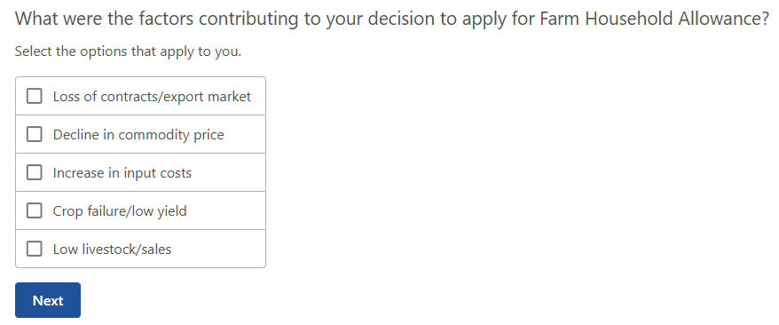

Figure 7 - Decision to apply for FHA.

|  |
| --- |
| *Note:* If ‘*crop failure/low yield’* or ‘*low livestock/sales’* is selected, then the next question (**1.1.2**) will be displayed. |

* + 1. Did any of the following contribute to the low yield or failure of your crops and/or low livestock numbers or sales? Requires a response with multiple selections available (Figure 8):
* Drought
* Flood
* Bushfire
* Biosecurity outbreak
* Other natural impact
* Breakdown of financial partnership
* Breakdown of personal relationship
* Debt
* Health or mobility
* Other

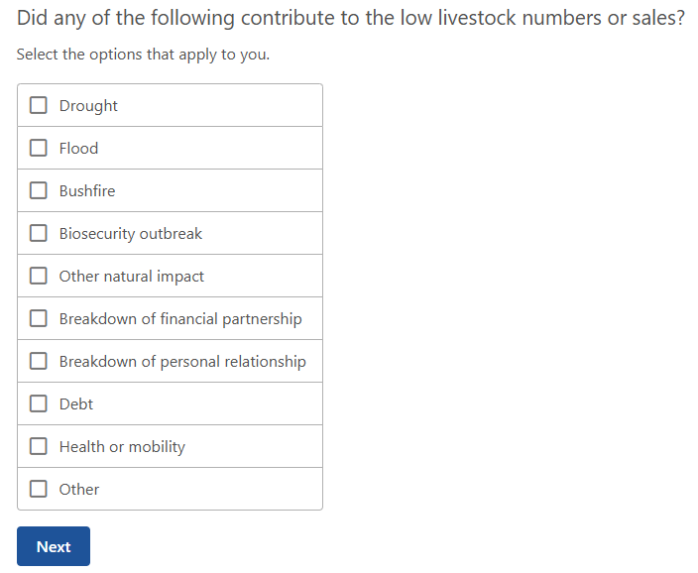

Figure 8 - Contribution to low yield, failure of crops or low livestock numbers for sale.

|  |
| --- |
| *Note*: If no options in Question **1.1.2** applies to your circumstances, then select ‘Other’ and a free text box with a 100-character limit will be displayed. |

* + 1. What other factors contributed to the low yield or failure of your crops and/or low livestock numbers for sale? This is a mandatory question (Figure 9).

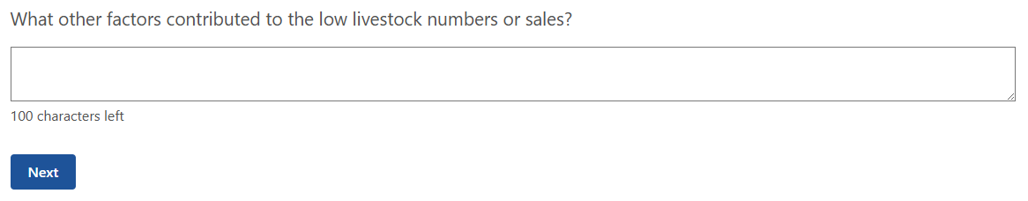

Figure 9 - What other factors contributed to the low livestock numbers or sales?

Once question **1.1.3** is answered you must press ‘**Continue**’ to save changes and proceed to the next step.

### Step 2: Farm Details

#### Explanation

This section gathers information about your farm business operations including size and scale. This allows you, your financial assessor and/ or your FHCO to identify and consider changes and improvements to your operations to put it on a better financial footing.

#### Question overview

* + 1. What is the registered business name of this farm business?
    2. What is the structure of the farming business?
    3. In addition to your farm business activities, are you involved in other related business?
    4. Provide description of this activity or indicate if there is no other related business.
    5. Of the total area of land currently operated by this farm business, how much, in hectares, is:
  1. Owned by this farm business
  2. Rented or leased from others
  3. Rented or leased to others
  4. Owned by others and operated by agreement
     1. What group best describes this activity?
     2. What class best describes this activity?
     3. How many hectares are currently under crop?
     4. How many hectares, in an average year, would be under crop?
     5. How many tonnes, per hectare, will this yield for the current year?
     6. How many tonnes, per hectare, would this yield in an average year?
     7. What is the current head of livestock on this farm?
     8. What is the average (year in year out) head of livestock on the farm?
     9. What is the yield you expect in the current year?
     10. What is the yield in an average year?

#### Example

By selecting the ‘*Add farm business’* option (Figure 10) the user will be asked up to 5 questions on the details of the business entity associated with the farm. It is mandatory to include your farm business.

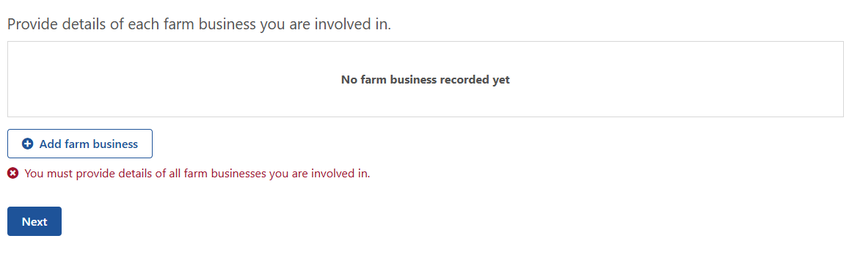

Figure 10 – Details of the farm business.

* + 1. What is the registered business name of this farm business? This is a mandatory question with a 60-character limit (Figure 11).

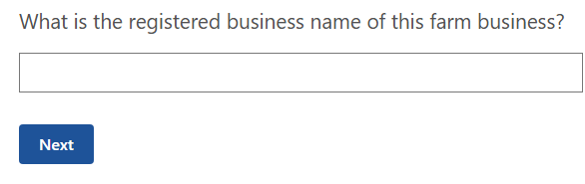

Figure 11 - What is the registered business name of this farm business?

* + 1. What is the structure of the farming business? This is a mandatory with multiple options available to select if applicable (Figure 12).
* Sole trader
* Partnership – domestic partner
* Partnership – business partner
* Partnership – 3 way – domestic partner and business partner
* Partnership – 4 way – domestic partner and 2 business partners
* Company – you are the director
* Company – you are not the director
* Trust – you are the controller
* Trust – you are the beneficiary

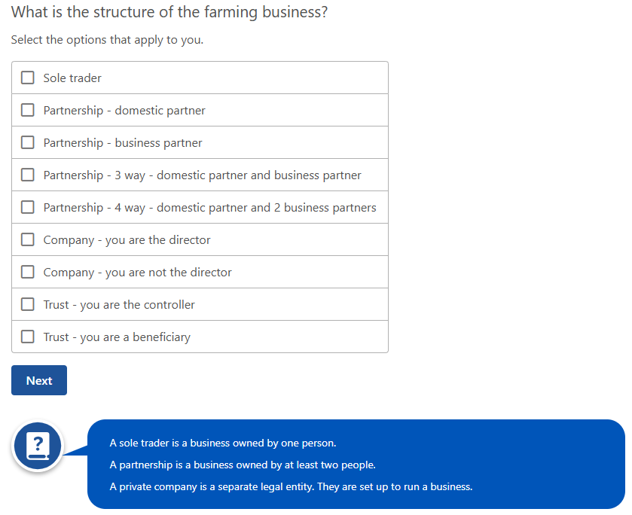

Figure 12 - What is the structure of the farming business?

* + 1. In addition to your farm business activities, are you involved in other related business? This is a mandatory with multiple options available to select if applicable (Figure 13).
* Agistment
* Contracting
* Cartage
* Bailing
* Shearing
* Fencing
* Processing or adding value to farm products (eg. Wine/olive oil)
* Transport
* Leasing/rental
* Other activity or no other related business

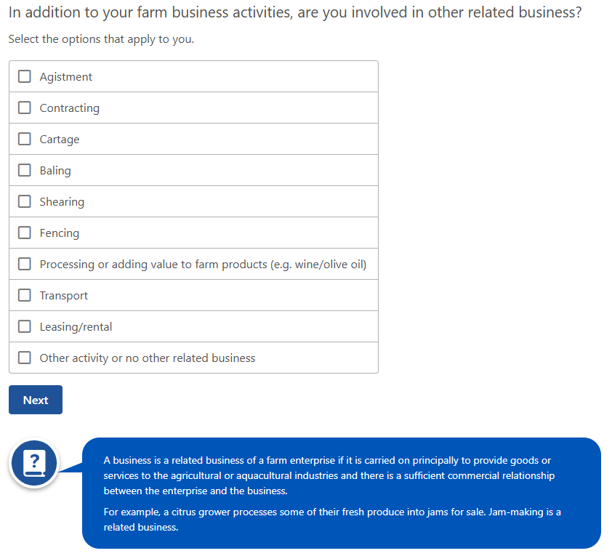

Figure 13 - In addition to your farm business activities, are you involved in other related business?

|  |
| --- |
| *Note:* A business is a related business of a farm enterprise if it is carried on principally to provide goods or services to the agricultural or aquacultural industries and there is a sufficient commercial relationship between the enterprise and the business.   * For example, a citrus grower processes some of their fresh produce into jams for sale – jam making is a related business.   *Note*: If ‘*other activity or no other related business’* is selected in **1.2.3**, extra information will need to be inputted into a free text box which has a limit of 60-characters (Figure 10). |

* + 1. Provide description of this activity or indicate if there is no other related business (Figure 14).

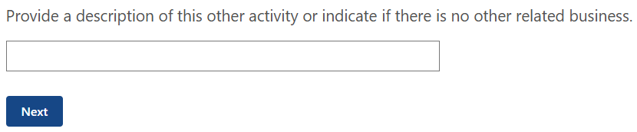

Figure 14 - Provide a description of this other activity or indicate if there is no other related business.

* + 1. Of the total area of land currently operated by this farm business, how much, in hectares, is (Figure 15):
  1. Owned by this farm business
  2. Rented or leased from others
  3. Rented or leased to others
  4. Owned by others and operated by agreement

To help you with inputting the data:

* An entry is required in each box (must not leave box blank or input N/A – use 0)
* Answers must be whole numbers (no decimal points)
* Minimum value of 0 and maximum number of 9999999.

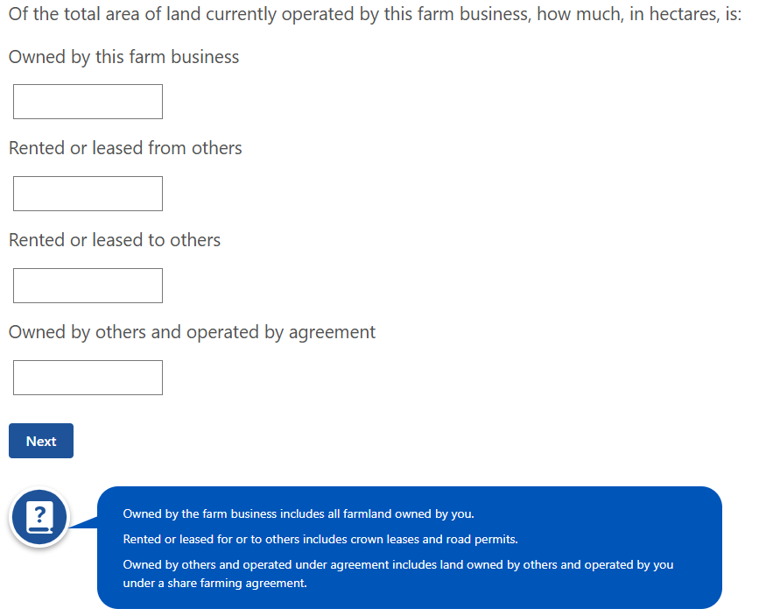

Figure 15 - Of total area of land currently operated by this farm business, in hectares.

When all questions are answered a summary table will be shown of each farm business that is included as part of the FFA (Figure 16). You will have a chance to review these details later and make changes if needed.

By selecting the ‘*Add farm productivity activity’* option (Figure 17) you will be asked a series of questions on the details of the livestock, crops or aquaculture activities of the farm business. You are required to include all commodities that the farm business operates.

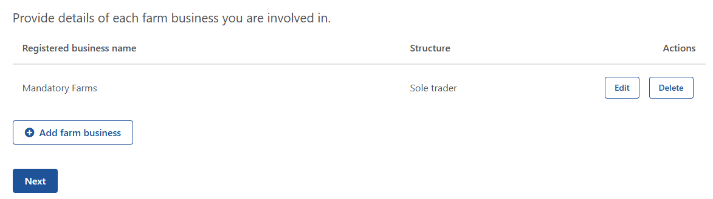

Figure 16 - Details of each farm business you are involved in - summary table.

To add what farm activities the business undertakes you will be required to complete a section which includes:

* 4 questions if your farm activity is livestock or aquaculture, or
* 6 questions if your farm activity is cropping.

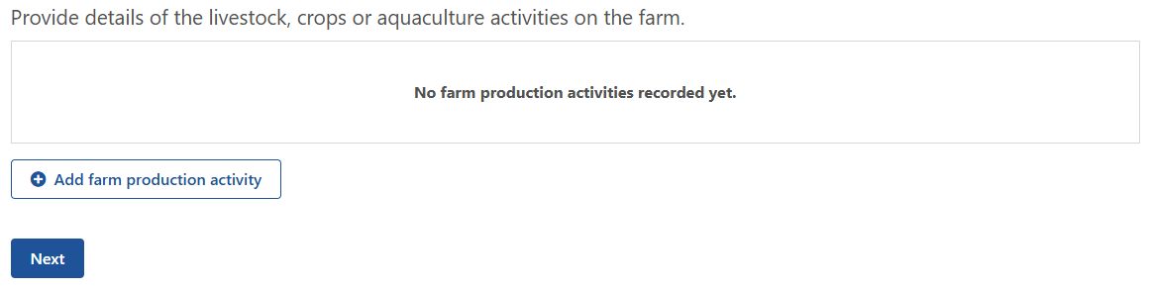

Figure 17 - Details of livestock, crops or aquaculture activities on the farm.

|  |
| --- |
| *Note:* The below commodity groups are drawn from the Australian and New Zealand Standard industrial Classification site: [ANZSIC](https://www.abs.gov.au/statistics/classifications/australian-and-new-zealand-standard-industrial-classification-anzsic/latest-release). |

* + 1. What group best describes this activity? This question is mandatory for the user and multiple options will appear in the drop-down box (Figure 18):
* Nursery and floriculture production
* Mushroom and vegetable growing
* Fruit and tree nut growing
* Sheep, beef cattle and grain farming
* Other crop growing
* Dairy cattle farming
* Poultry farming
* Deer farming
* Other livestock farming
* Aquaculture
  + 1. What class best describes this activity? This question is mandatory, and options will depend on the answer that is provided in **1.2.6**, as listed below (Figure 19).

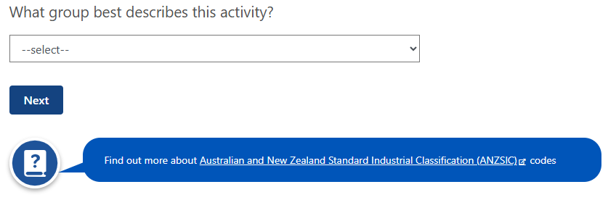

Figure 18 - What group best describes this activity?

* Nursery and floriculture production
  + Nursery production (under cover)
  + Nursery production (outdoor)
  + Turf growing
  + Floriculture production (under cover)
  + Floriculture production (outdoors)
* Mushroom and vegetable growing
  + Mushroom growing
  + Vegetable growing (under cover)
  + Vegetable growing (outdoors)
* Fruit and tree nut growing
  + Grape growing
  + Kiwifruit growing
  + Berry fruit growing
  + Apple and pear growing
  + Stone fruit growing
  + Citrus fruit growing
  + Olive growing
  + Other fruit and tree nut growing
* Sheep, Beef cattle and grain farming
  + Sheep farming (specialised)
  + Beef cattle farming (specialised)
  + Beef cattle feedlots (specialised)
  + Sheep-Beef cattle farming
  + Grain-sheep or grain-beef cattle farming
  + Rice growing
  + Other grain growing
* Other crop growing
  + Sugar cane growing
  + Cotton growing
  + Other crop growing
* Dairy cattle farming
  + Dairy cattle farming
* Poultry farming
  + Poultry farming (eggs)
  + Poultry farming (meat)
* Deer farming
  + Deer farming
* Other livestock farming
  + Horse farming
  + Pig farming
  + Beekeeping
  + Other livestock farming
* Aquaculture
  + Offshore longline and rack aquaculture
  + Offshore caged aquaculture
  + Onshore aquaculture

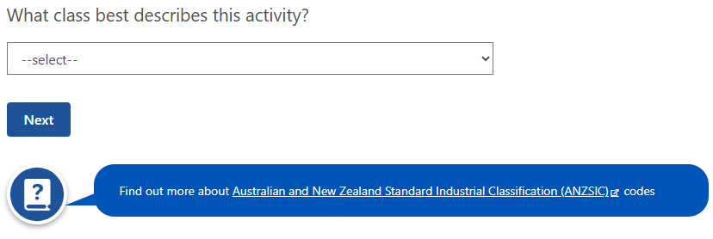

Figure 19 - What class best describes this activity?

##### Cropping

* + 1. How many hectares are currently under crop? This question is mandatory and will only allow whole numbers between 0 and 9999999 (Figure 20).

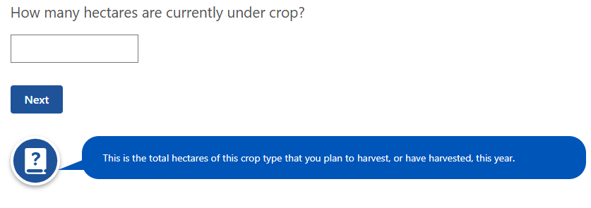

Figure 20 - How many hectares are currently under crop?

|  |
| --- |
| *Note:* This is the total hectares of this crop type that you plan to harvest, or have harvested, this year. |

* + 1. How many hectares, in an average year, would be under crop? This question is mandatory and will only allow whole numbers between 0 and 9999999 (Figure 21).

|  |
| --- |
| *Note:* This is the total hectares for this crop type you have sown, on average, over the past 5 years (or less). |

* + 1. How many tonnes, per hectares, will this yield for the current year? This question is mandatory and will only allow whole numbers between 0 and 9999999 (Figure 22).

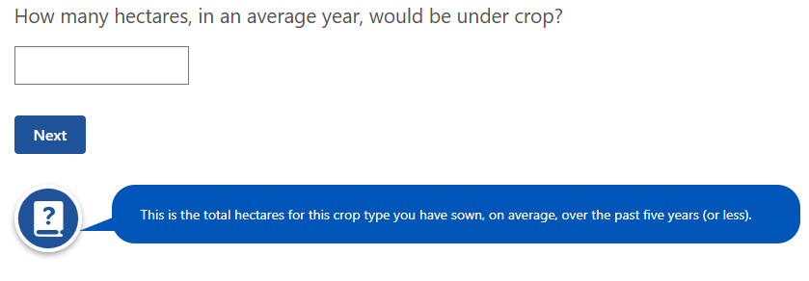

Figure 21 - How many hectares, in an average year, would be under crop?

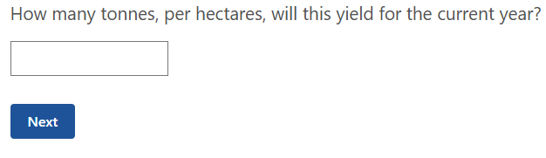

Figure 22 - How many tonnes, per hectares, will this yield for the current year?

* + 1. How many tonnes, per hectare, would this yield in an average year? This question is mandatory and will only allow whole numbers between 0 and 9999999 (Figure 23).

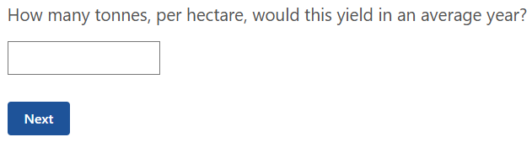

Figure 23 - How many tonnes, per hectare, would this yield in an average year?

##### Livestock

* + 1. What is the current head of livestock on the farm? This question is mandatory and will only allow whole numbers between 0 and 9999999 (Figure 24).

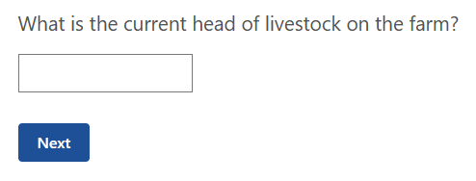

Figure 24 - What is the current head of livestock on the farm?

* + 1. What is the average (year in year out) head of livestock on the farm? This question is mandatory and will only allow whole numbers between 0 and 9999999 (Figure 25).

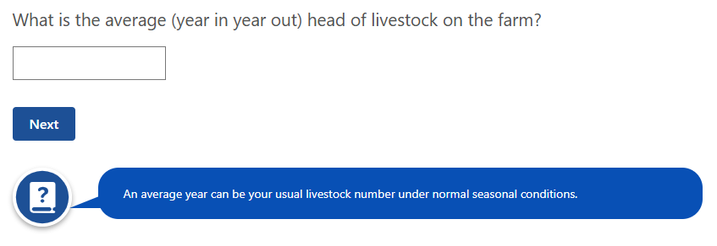

Figure 25 - What is the average (year in year out) head of livestock on the farm?

##### Aquaculture

* + 1. What is the yield you expect in the current year? This question is mandatory and will only allow whole numbers between 0 and 9999999 (Figure 26). The drop-down menu will show the following options:
* Tons
* Racks
* Dozens

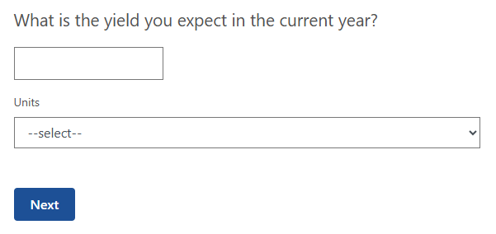

Figure 26 - What is the yield you expect in the current year?

* + 1. What is the yield in an average year? This question is mandatory and will only allow whole numbers between 0 and 9999999 (Figure 27). The available options will be available:
* Tons
* Racks
* Dozens

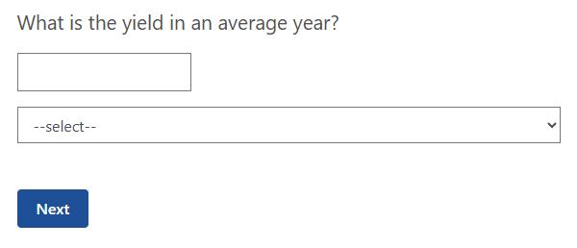

Figure 27 - What is the yield in an average year?

A summary table showing the farming activity/activities will appear once the questions have been answered (Figure 28). These can be edited or deleted at any stage.

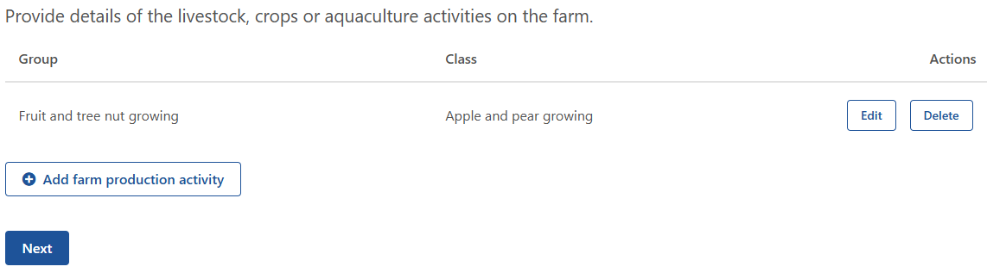

Figure 28 - Details of the livestock, crops or aquaculture activities on the farm - summary table.

### Step 3: Farm labour input

#### Explanation

This section identifies the current labour commitments to the farm business.

#### Question overview

* + 1. On average, how many hours do you work on the farm business per week?
    2. On average, how many weeks of vacation do you take each year?

#### Example

* + 1. On average, how many hours do you work on the farm business per week? This question is mandatory, and answers can only be in whole numbers with a minimum of 0 and a maximum of 168 (Figure 29).

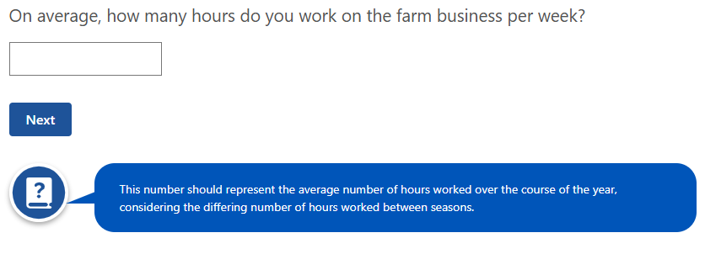

Figure 29 - On average, how many hours do you work on the farm business per week?

|  |
| --- |
| *Note:* This number should represent the average number of hours worked over the course of the year, considering the differing number of hours worked between seasons. |

* + 1. On average, how many weeks of vacation do you take each year? This question is mandatory, and answers can only be in whole numbers with a minimum of 0 and a maximum of 52 (Figure 30).

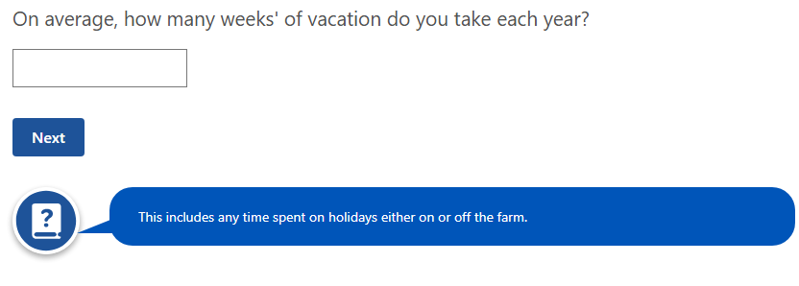

Figure 30 - On average, how many weeks of vacation do you take each year?

|  |
| --- |
| *Note:* This includes time spent on holidays on or off the farm. |

### Step 4: Financial management

#### Explanation

This section is a snapshot of your financial management and gathers details to identify key issues which may impact your farm and household. An in-depth assessment will be completed in Part B with your financial assessor. When compared to the size and scale of the business the following sets of questions also indicate how much pressure is on the business to perform well. It is important to see the amount on which one or more households depend on it, or whether pressure is relieved by other sources of income.

This section is designed to inform opportunities for your financial and personal goals.

You will be asked for details in the current financial year and the question set will update automatically each financial year.

#### Question overview

* + 1. How many households are supported by your farm business?
    2. Are these people also supported by off-farm income?
    3. How much gross income from off-farm wages or salaries will they receive for 2024-25 financial year?
    4. How many hours per week, on average, is the work?
    5. How much net income from other businesses will they receive for the 2024-25 financial year?
    6. How many hours per week, on average, is the work?
    7. How much net income from other investments will they receive for the 2024-25 financial year?
    8. How much gross income from off-farm wages or salaries do they receive in an average year?
    9. How many hours per week, on average, is the work?
    10. How much net income from other businesses do they receive in an average year?
    11. How many hours per week, on average, is the work?
    12. How much net income from other investments do they receive in an average year?
    13. Have you received any income from the government in the last 5 years?
    14. What is the type of income received?
    15. What is the name of this income?
    16. Who is the provider of this income?
    17. Who has received this income?
    18. How much did you receive?
    19. Does your farm have a business plan?
    20. When was this plan developed?
    21. How regularly is the business plan reviewed?
    22. Do you use the business plan in your decision making about the farm business?

#### Example

* + 1. How many households are supported by your farm business? This question is mandatory and requires whole numbers with a minimum of 0 and a maximum value of 999 (Figure 31).

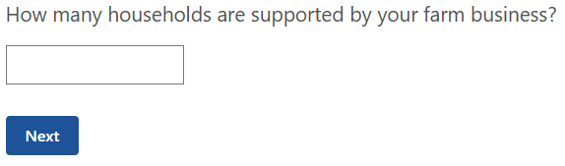

Figure 31 - How many households are supported by your farm business?

* + 1. Is your household supported by off-farm income? (Figure 32).

If *‘yes’* is selected in **1.4.2** then the next set of questions will be displayed.

Tips to help you answer the next few questions:

* Only whole numbers used
* A minimum of 0 for income and 1 for average hours per week

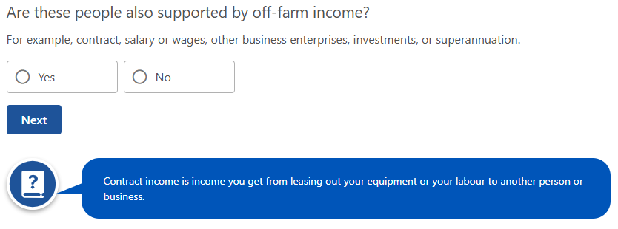

Figure 32 - Are these people also supported by off-farm income?

* A maximum of 9999999 for income and 168 for average hours per week.

|  |
| --- |
| *Note:* Income from other investments can include income received from interest, dividends or rent.  *Note:* Question **1.4.3** will only be displayed if ‘*yes*’ is selected inquestion **1.4.2.** |

* + 1. How much gross income from off-farm wages or salaries will they receive for 2024-25 financial year? (Figure 33)

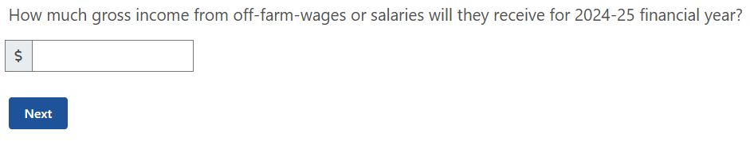

Figure 33 - How much gross income from off-farm wages or salaries will they receive for 2024-25 financial year?

|  |
| --- |
| *Note:* The sub question **1.4.4** will only appear once an entry is made in question **1.4.3** for off farm wages |

* + 1. How many hours per week, on average, is the work? (Figure 34)

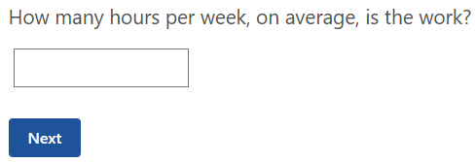

Figure 34 - How many hours per week, on average, is the work?

|  |
| --- |
| *Note:* Question **1.4.5** only appears if yes is selected in question **1.4.2.** |

* + 1. How much net income for other businesses will they receive for the 2024-25 financial year? (Figure 35)

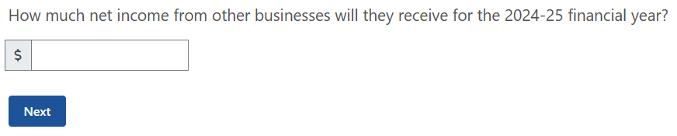

Figure 35 - How much net income from other businesses will they receive for the 2024-25 financial year?

|  |
| --- |
| *Note:* The sub question **1.4.6** will only appear once an entry is made in question **1.4.5** for off farm wages. |

* + 1. How many hours per week, on average, is the work? (**Error! Reference source not found.**)

|  |
| --- |
| *Note:* Question **1.4.7** only appears if yes is selected in question **1.4.2.** |

* + 1. How much net income from other investments will they receive for the 2024-25 financial year? This may include any income received from interest, dividends or rent (Figure 37).



Figure 36 - How many hours per week, on average, is the work?

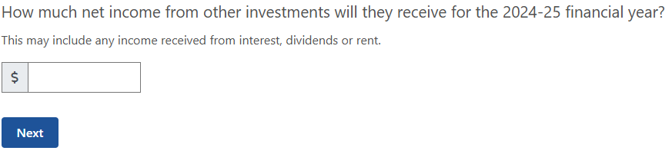

Figure 37 - How much net income from other investments will they receive for the 2024-25 financial year?

* + 1. How much gross income from off-farm wages or salaries do they receive in an average year? (**Error! Reference source not found.**)

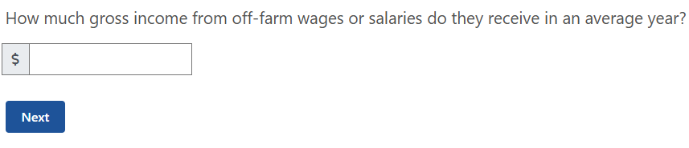

Figure 38 - How much gross income from off-farm wages or salaries do they receive in an average year?

|  |
| --- |
| *Note:* The sub question **1.4.9** will only appear once an entry is made in question **1.4.8** for off farm wages |

* + 1. How many hours per week, on average, is the work? (Figure 39)



Figure 39 - How many hours per week, on average, is the work?

* + 1. How much net income from other businesses do they receive in an average year? (Figure 40)

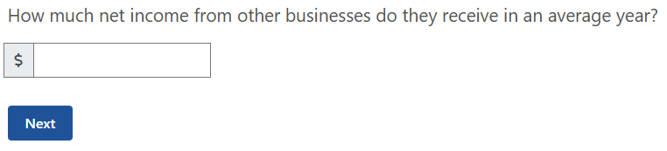

Figure 40 - How much net income from other businesses do they receive in an average year?

|  |
| --- |
| *Note:* The sub question **1.4.11** will only appear once an entry is made in question **1.4.10** for off farm wages |

* + 1. How many hours per week, on average, is the work? (Figure 41)



Figure 41 - How many hours per week, on average, is the work?

* + 1. How much net income from other investments do they receive in an average year? This may include any income from interest, dividends or rent (Figure 42).

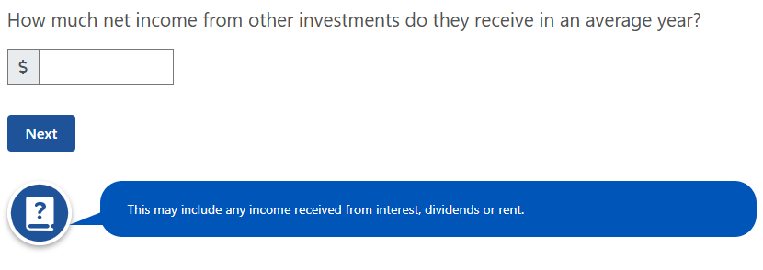

Figure 42 - How much net income from other investments do they receive in an average year?

The table below (**Error! Reference source not found.**) shows a summary of any off-farm income received by people who are dependant on income produced by the farm business.

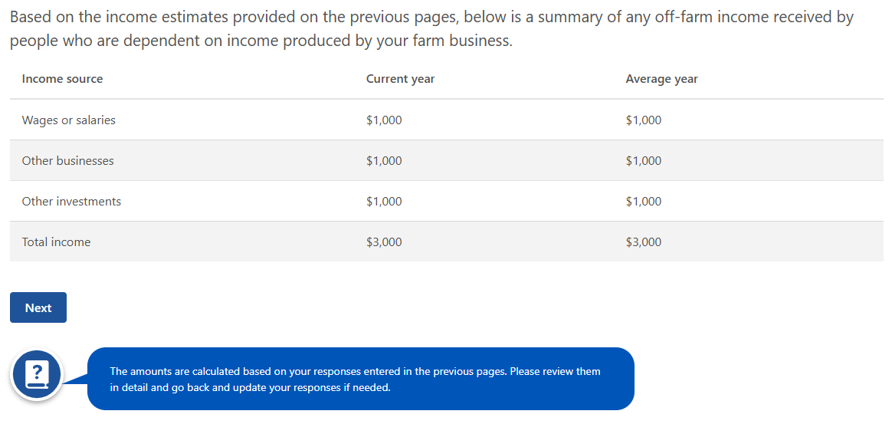

Figure 43 - Summary table of off-farm income received.

* + 1. Have you received any income from the government in the last 5 years? This includes any income received from local and state/territory governments or the Australian Government (**Error! Reference source not found.**).

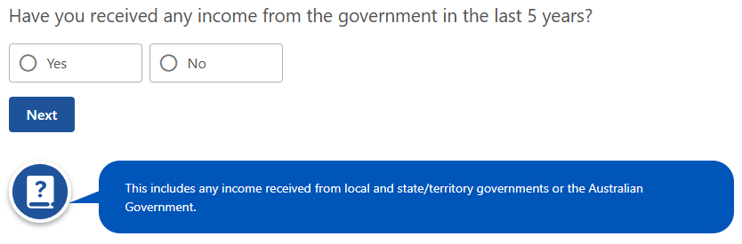

Figure 44 - Have you received any income from the government in the last 5 years?

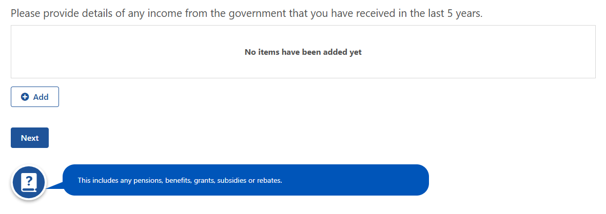

Figure 45 - Please provide details of any income from the government that you have received in the last 5 years.

|  |
| --- |
| *Note*: The below table (Figure 45) will only appear if the answer to question **1.4.13** is ‘*Yes*’. The user will be required to select ‘Add’ and include any government income received in the last 5 years. |

* + 1. What is the type of income received? The options displayed to you includes (Figure 46):
* Pension, benefit or allowance
* Grant
* Subsidy
* Rebate

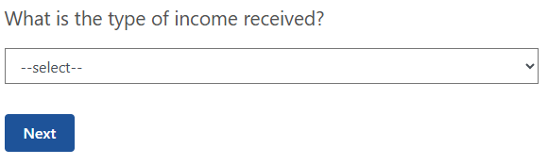

Figure 46 - What is the type of income received?

* + 1. What is the name of this income? (Figure 47)

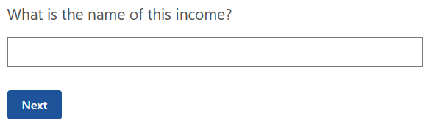

Figure 47 - What is the name of this income?

* + 1. Who is the provider of this income? The options that will be displayed to you includes (Figure 48):
* Australian Government
* State Government
* Territory Government
* Local Government

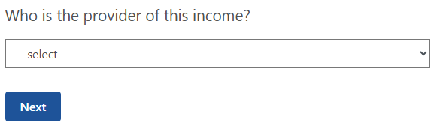

Figure 48 - Who is the provider of this income?

* + 1. Who has received this income? The options that will be displayed to you includes (Figure 49):
* You – this will be displayed automatically if you are not partnered.
* Partners first name – only displayed if you are partnered.
* Both – only displayed if you are partnered.



Figure 49 - Who has received this income?

* + 1. How much did you receive? This is the whole dollar amount (**Error! Reference source not found.**).

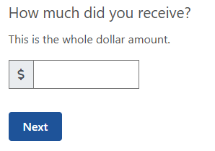

Figure 50 How much did you receive?

Once the above questions have been answered a summary table (Figure 51) will be displayed. You can review and edit these answers at the end of Part A.

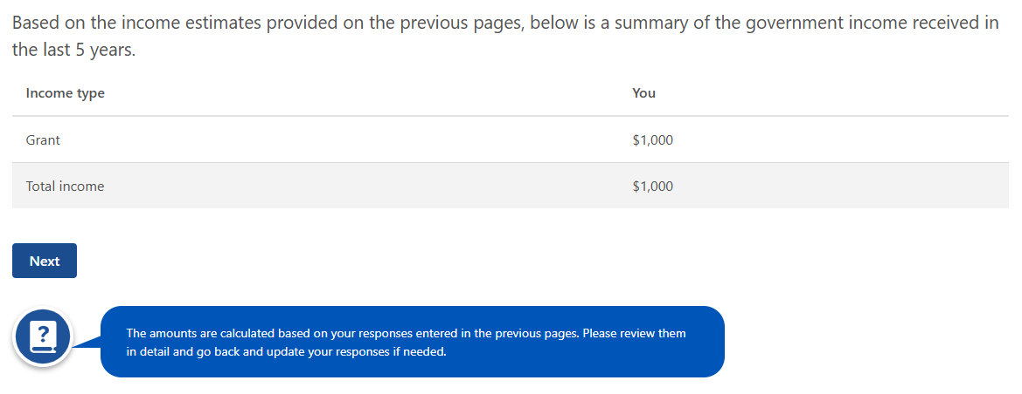

Figure 51 - Government income received in last 5 years summary table.

* + 1. Does your farm business have a business plan? (Figure 52)

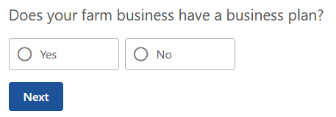

Figure 52 - Does your farm business have a business plan?

|  |
| --- |
| *Note*: If you select ‘*yes*’ in **1.4.19** then the following questions will be displayed. |

* + 1. When was the business plan developed? (Figure 54)

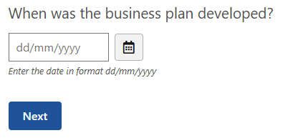

Figure 53 - When was the business plan developed?

* + 1. Do you use the business plan in your decision making about the farm business? (Figure 53)

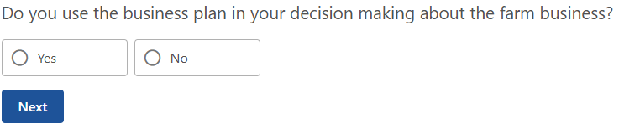

Figure 54 - Do you use the business plan in your decision making about the farm business?

* + 1. How regularly is the business plan reviewed? The options that will be displayed to the user includes (Figure 55):
* Monthly
* Bi-annually
* Quarterly
* Annually
* Never
* Other

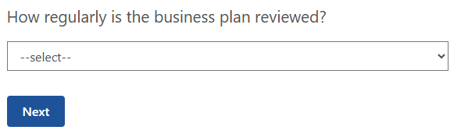

Figure 55 - How regularly is the business plan reviewed?

### Step 5: Farming future

#### Explanation

This section provides details to plan for the future of the farm to help inform opportunities for financial and personal goals. For those who have reached Age Pension qualifying age it may also indicate if some of the conditions have been met for a person to be paid Age Pension instead.

#### Question overview

* + 1. How many years have you been farming as an owner and/or manager?
    2. How many years have you lived on the current farm?
    3. What is your preferred occupation 10 years from now?

#### Example

* + 1. How many years have you been farming as an owner and/or manager? This is a mandatory question and requires whole numbers between 1-99 (Figure 56). If this is less than one year, then input 1.

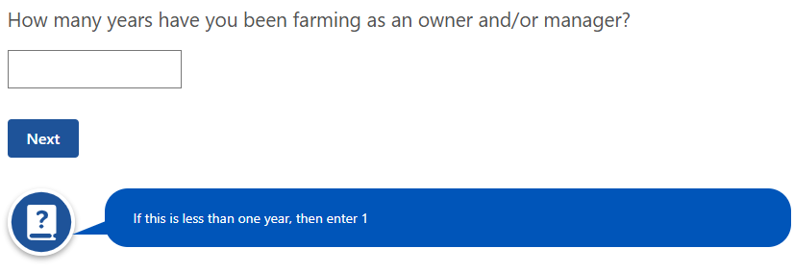

Figure 56 - How many years have you been farming as an owner and/or manager?

* + 1. How many years have you lived on the current farm? This is a mandatory question and requires whole numbers between 1-99 (Figure 57). If this is less than one year, then input 1.

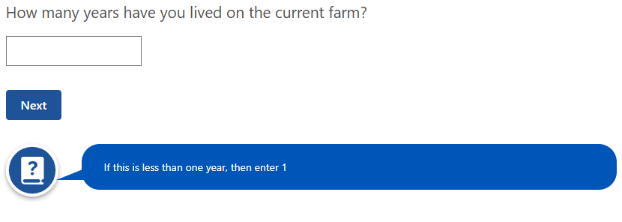

Figure 57 - How many years have you lived on the current farm?

* + 1. What is your preferred occupation 10 years from now? This is a mandatory question with a drop-down box in which you must select one option only (Figure 58):
* Retired
* Semi-retired
* Exited farming for other occupation
* Farming – increased farm income
* Farming – increased off-farm income.

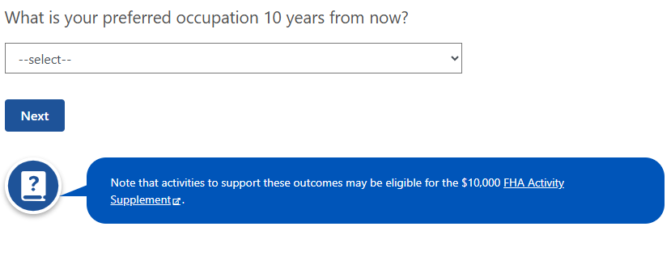

Figure 58 - What is your preferred occupation 10 years from now?

### Step 6: Review and submit

#### Explanation

**This section displays a summary of all answers you have submitted for Part A and allows the opportunity to review, edit or delete any input.** There is also the opportunity for you to print the summary screen to keep on hand for the financial assessor when answering Parts B-D. Once you have reviewed the input and submitted you will be directed to the FFA home screen where you can enter Part B with your financial assessor.

Once you have reviewed the details you will be displayed a declaration requiring your agreement prior to submitting (Figure 59).

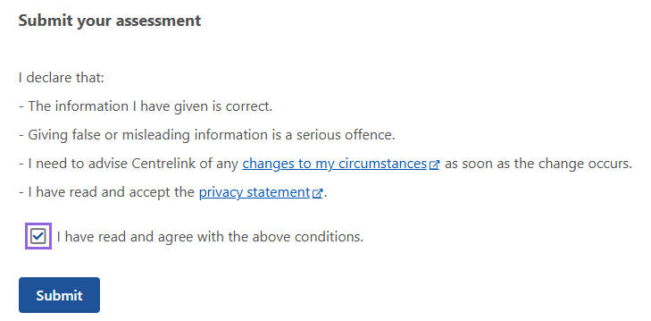

Figure 59 - Declaration and agreement to listed conditions.

## Part B – Farm Information

FFA builds a detailed connection between the farm operations through exploring the farm and personal financials to help build a view of how effectively the farm business is managed. It uses the last 3 years of completed financials to show any uncharacteristic occurrences (ie. natural disasters, commodity crashes) that will help the financial assessor to understand how the business is operated. Completing the questions on production impacts, farm & personal assets and debts, farm profitability, personal finances and other business finances will enable the overall financial position to be displayed in multiple consolidated tables.

Part B will link into part C by prepopulating tables that will assist your financial assessor complete the ideal financial thresholds for your business and the Strengths, Weaknesses, Opportunities, and Threats analysis.

Your financial assessor will rely on the previous 3 years of financials (business & personal) to complete this section. Therefore, the more accurate the information the better overall outcome will be achieved from Parts C & D.

Multiple questions relate to personal and business financial information which can be sensitive. The Services Australia [Privacy Policy](https://www.servicesaustralia.gov.au/privacy-policy?context=22) details how your personal information will be handled.

**Financial Assessor Access**

To access the FFA as the financial assessor the following steps are to be taken:

* Navigate to the Farm information section and complete the following steps:
  + Access the [Farm Financial Assessment portal](https://www.centrelink.gov.au/apps/clkonline_tac/login/farm-financial-assessment).
  + Enter your Customer Reference Number (Figure 60).
  + Enter your One Time Access Code.
  + Select Log In.
  + Enter Part B from the FFA dashboard and begin answering questions.

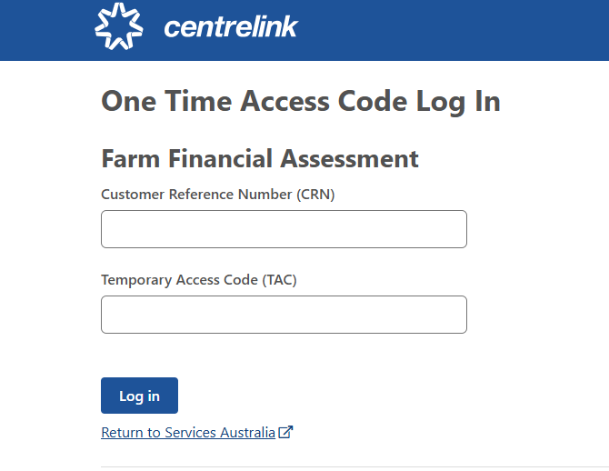

Figure 60 - One time access code log in.

Before completing Part B, it is important to recognise the requirements that you and the FHA recipient must meet (Figure 61).

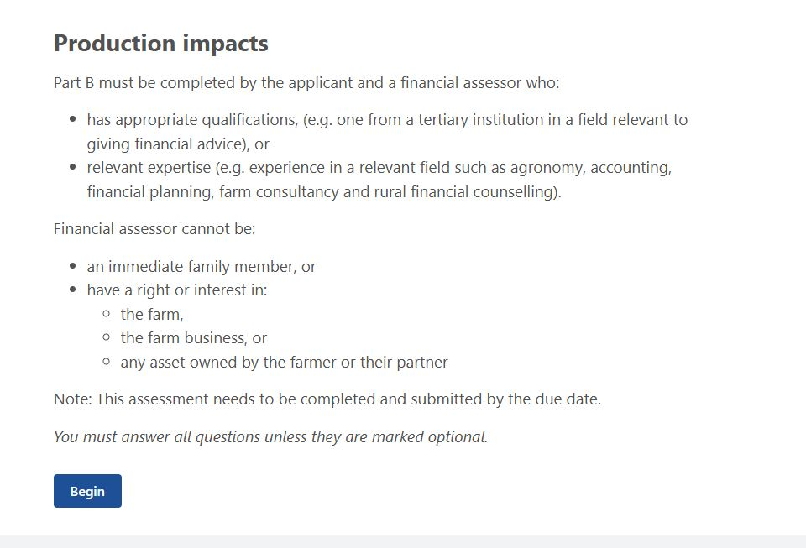

Figure 61 - Production impacts - financial assessor requirements.

When entering Part B through the home dashboard (Figure 4) you will see this guide below (Figure 62) to follow and continue to complete the assessment.

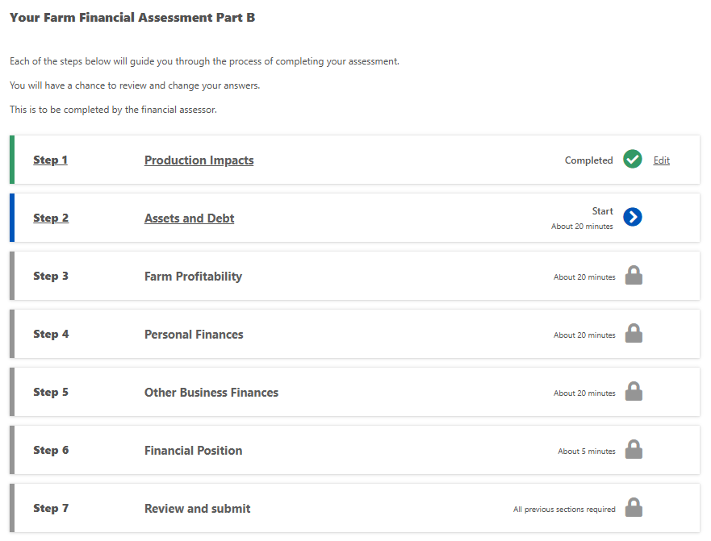

Figure 62 - Each step to guide you through the process of completing your assessment.

### Step 1: production impacts

#### Explanation

This section asks you about impacts that relate to any production changes you have implemented, environmental issues, climate and weather conditions and management practices.

* This step will take approximately 20 minutes to complete.

#### Question overview

* + 1. Have you applied changes to your production to try and improve your profitability?
    2. What changes have you applied to try and improve your profitability?
    3. How did you try to improve your profitability?
    4. If you have previously received Farm Household Allowance, did you use the Activity Supplement to support these changes?
    5. How important has the Activity Supplement been to support the changes?
    6. What was the farm adversely affected by?
    7. In hectares, what size was affected?
    8. Was the remediation successful?
    9. Reflecting on each of the last 10 years (or since you started farming, if within the last 10 years), what best describes the climate and weather conditions?
    10. Select the years the climate and weather conditions were impacted.
    11. What event in the last 10 years (or since you started farming, if within the last 10 years) was the farm affected by?
    12. Select the years the event impacted the farm.
    13. What practices did you apply to your farmland to help you improve your drought or other natural disaster resilience?
    14. What is the totally number of hectares affected?
    15. Select the year(s) the practice was applied.
    16. What natural resource management technique(s) or practice(s) did you apply to your farmland to improve your sustainability outcomes?
    17. What is the total number of hectares affected?
    18. Select the year(s) the practice was applied.

#### Example

* + 1. Have you applied changes to your production to try and improve your profitability? This question is mandatory (Figure 63).

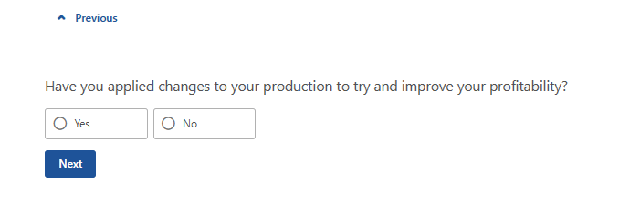

Figure 63 - Have you applied changes to your production to try and improve your profitability?

|  |
| --- |
| *Note:* If *‘yes’* is selected in **2.1.1** then the next question will be displayed. |

* + 1. What changes have you applied to your production to try and improve your profitability? Multiple selections are possible (Figure 64):
* Livestock breeds
* Crop variety or strain
* Commodity/ies
* Production approach
* Other

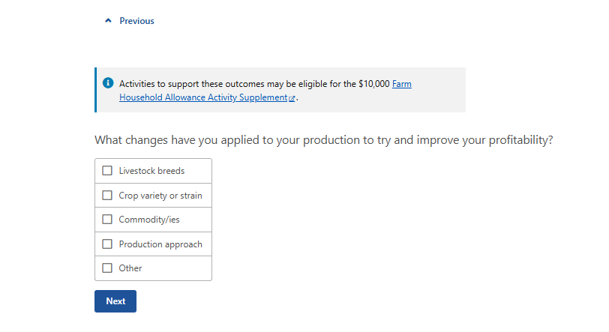

Figure 64 - What changes have you applied to your production to try and improve your profitability?

|  |
| --- |
| *Note:* If other is selected, a free text box will be displayed with a 255-character limit. |

* + 1. How did you try to improve your profitability? A response is mandatory for this question (Figure 65)

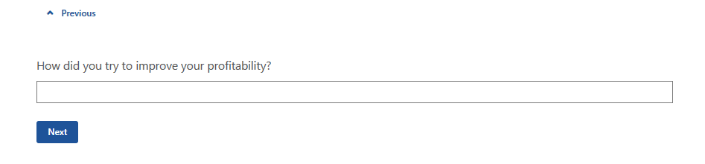

Figure 65 - How did you try to improve your profitability?

* + 1. If you have previously received Farm Household Allowance, did you use the Activity Supplement to support these changes? This question is mandatory (Figure 66).

|  |
| --- |
| *Note:* If ‘*yes*’ is selected in **2.1.4**, the next question will be displayed. |

* + 1. How important was the Activity Supplement to support the changes? A drop-down box of options is available and includes (Figure 67):

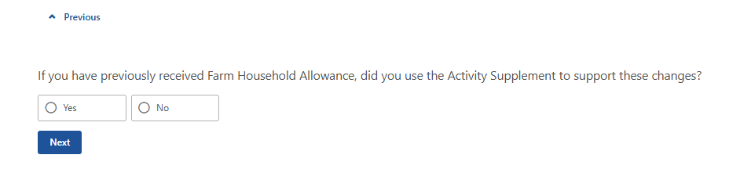

Figure 66 - If you have previously received Farm Household Allowance, did you use the Activity Supplement to support these changes?

* Not important
* Moderately important
* Important

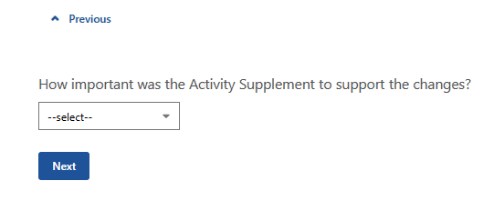

Figure 67 - How important was the Activity Supplement to support the changes?

* Very important

##### Farm adversely affected

The following set of questions aims to understand the environmental issues that have/are impacting your farm, and whether there is any advice or training needs you could consider as part of developing your Financial Improvement Agreement (Figure 68).

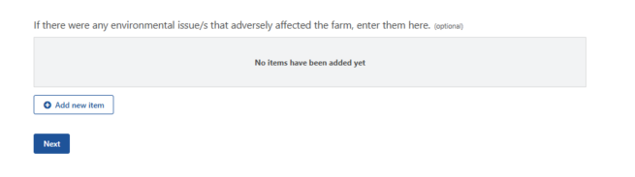

Figure 68 - Environmental issue(s) that adversely affected your farm - entry table.

* + 1. What was the farm adversely affected by? A drop-down menu will appear with the following options (Figure 69):
* Poor drainage
* Soil degradation
  + Includes salt infiltration, chemical contamination and erosion
* Vermin infestation
  + Includes rabbits, kangaroos, wild goats, locusts and snails
* Animal predation
  + Includes wild dogs, feral pigs and eagles
* Vegetation thickening
  + Includes timber regrowth and woody weeds
* Other weed infestations
* Land use/zoning restriction
* Water access/storage

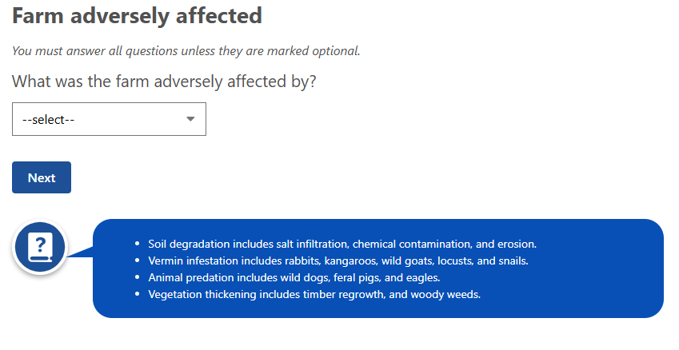

Figure 69 - What was the farm adversely affected by?

|  |
| --- |
| Note: If ‘poor drainage/soil degradation/vermin infestation/animal predation/vegetation thickening/other weed infestations/land use/zoning restriction’ is selected in **2.1.5** the next question will display.  Note: If ‘water access/storage’ is selected in **2.1.5**, the next two questions do not display. |

* + 1. In hectares, what size was affected? There is a 7-character limit for this question with a minimum of 0 and max of 9999999 (Figure 70).

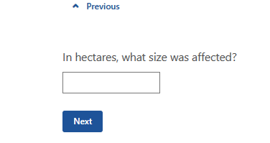

Figure 70 - In hectares, what size was affected?

* + 1. Was the remediation successful? A drop-down menu will appear with the following options (Figure 71):
* Successful
* Partially successful
* Planned
* Not planned

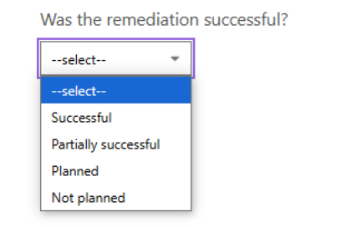

Figure 71 - Was the remediation successful?

A table will be displayed with a summary of your answers to the previous questions on environmental issues (Figure 72). This gives you the option to edit or delete prior to progressing to the next question.

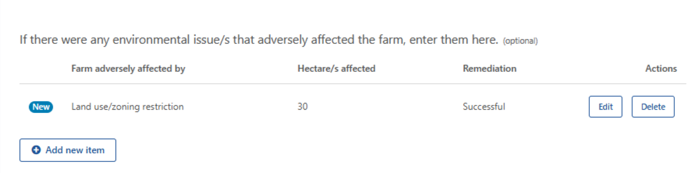

Figure 72 - Environmental issue/s that adversely affected the farm - summary table.

##### Climate and weather conditions

This section contains up to 2 questions for you to answer on the climate and weather conditions in each of the last 10 years or since you started farming within the last 10 years (Figure 73).

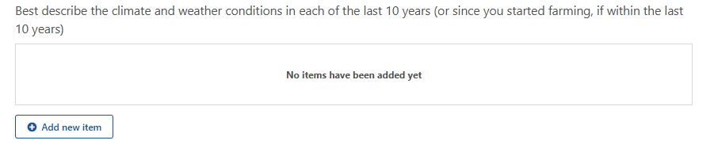

Figure 73 - Climate and weather conditions in each of the last 10 years.

* + 1. Reflecting on each of the last 10 years (or since you started farming, if within the last 10 years), what best describes the climate and weather conditions? This question is mandatory. A drop-down menu will appear with the following options (Figure 74):
* Above average
* Average
* Below average

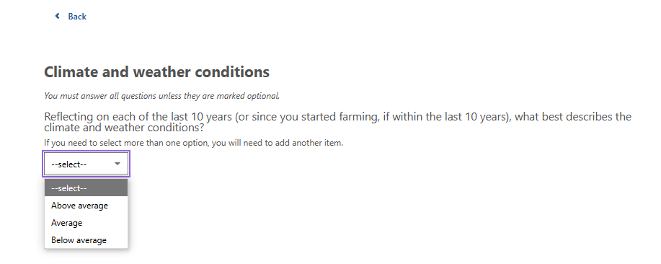

Figure 74 - What best describes the climate and weather conditions?

|  |
| --- |
| *Note:* If you need to select more than one option, you will need to add another item in the table above. |

* + 1. Select the years the climate and weather conditions were impacted (Figure 76). Select all options that apply.

|  |
| --- |
| *Note:* If the FFA is generated in the 2024-25 financial year the previous 10 financial years will display e.g. all years between 2014/15 and 2023/24. Once selected for a climate/weather condition, the selected year will be unavailable for the next selection. |

A summary table will appear for you to review and edit/delete if required (Figure 75). The table will display the financial years impacted with the first year ie. 2023-24 financial year, appearing as 2023 in table. Financial years cannot have more than one weather condition.

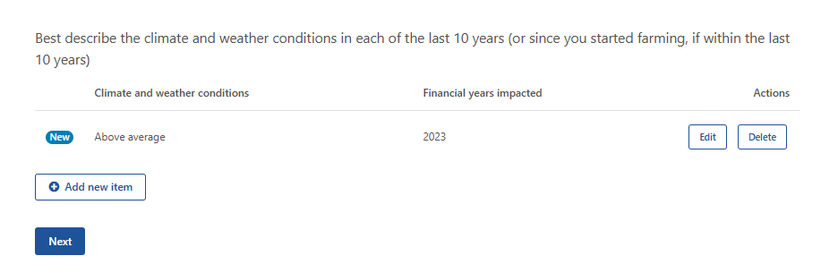

Figure 75 - Climate and weather conditions in each of last 10 years - summary table.

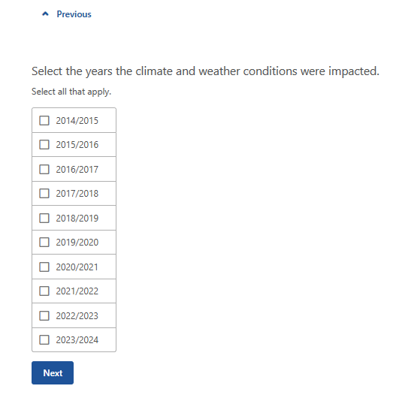

Figure 76 - Select the years the climate and weather conditions were impacted.

##### Natural disaster

|  |
| --- |
| *Note:* This is an optional table and if not relevant to you then continue to the next question. |

This table (Figure 77) provides the option to include any natural disaster that your production was affected by in the last 10 years (or since you started farming, if within the last 10 years). There are two questions to answer in this section.

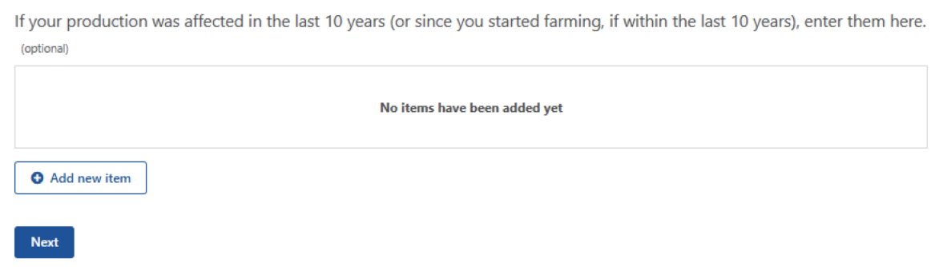

Figure 77 - Natural disaster effects on your production in last 10 years.

* + 1. What event in the last 10 years (or since you started farming, if within the last 10 years) was the farm affected by? This question is mandatory. A drop-down menu will appear with the following options (Figure 78):
* Bushfire
* Cyclone
* Storm/hail
* Flood
* Drought

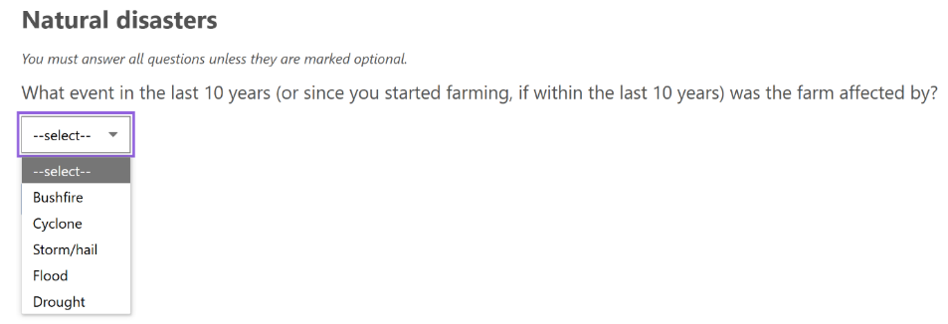

Figure 78 - What event in the last 10 years (or since you started farming, if within the last 10 years) was the farm affected by?

* + 1. Select the years the event impacted the farm. Select all options that apply (Figure 79).

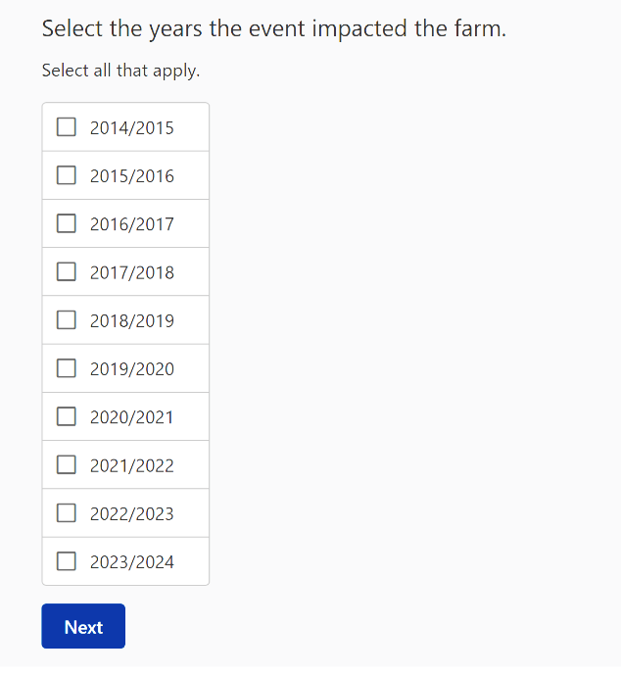

Figure 79 - Select the years the event impacted the farm.

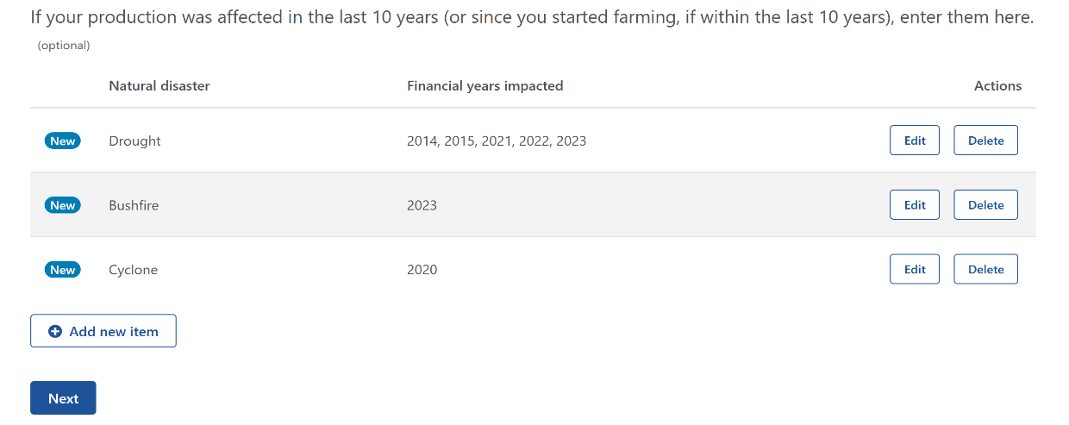

Figure 80 - Natural disaster effects on production in the last 10 years.

A summary table will appear for you to review and edit/delete if required (Figure 80). The table will display the financial years impacted with the first year ie. 2023-24 financial year, appearing as 2023 in table. Years can be selected for multiple events ie. Bushfire and Drought in 2023-24.

##### Management practices

This table (Figure 81) provides the opportunity to input any practices you applied to your farmland to help you improve your drought or other natural disaster resilience. This is mandatory if it applies to your farm business.

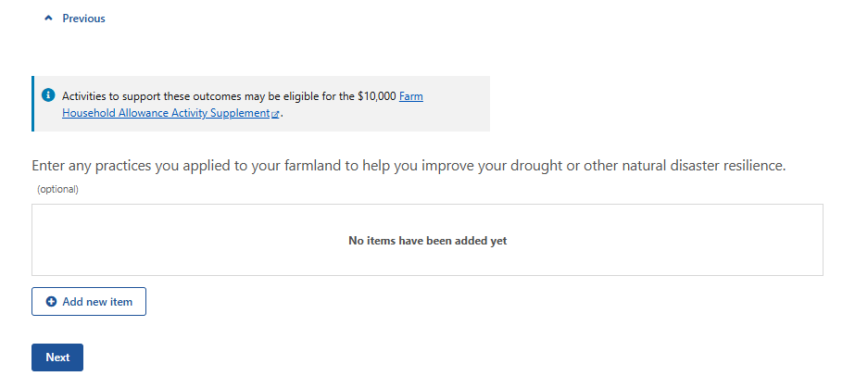

Figure 81 - Practices you applied to your farmland to help you improve your drought and natural disaster resilience.

* + 1. What practices did you apply to your farmland to help you improve your drought or other natural disaster resilience? This is a mandatory free text response with a 100-character limit. (Figure 82).

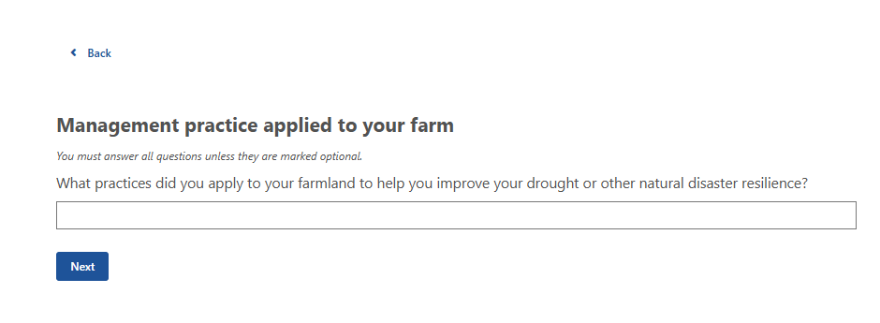

Figure 82 - What practices did you apply to your farmland to help you improve your drought or other natural disaster resilience?

* + 1. What is the total number of hectares affected? This requires a numerical input with decimals accepted. A minimum input of 1 or maximum input of 99999999 is accepted (Figure 83).

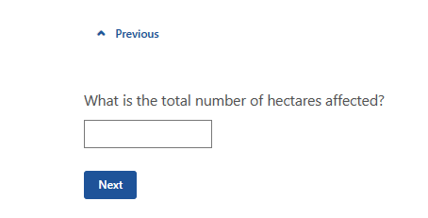

Figure 83 - What is the total number of hectares affected?

* + 1. Select the year(s) the practice was applied. This is mandatory with multiple options possible for the same financial year (Figure 84).

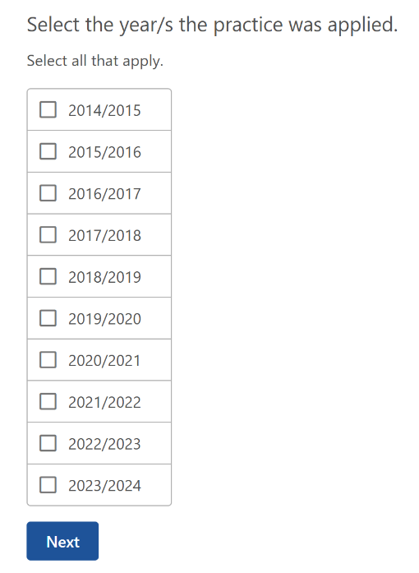

Figure 84 - Select the year(s) the practice was applied.

A summary table will appear for you to review and edit/delete if required (Figure 85). The table will display the financial years impacted with the first year ie. 2023-24 financial year, appearing as 2023 in table. The same year(s) can be selected for multiple practices.

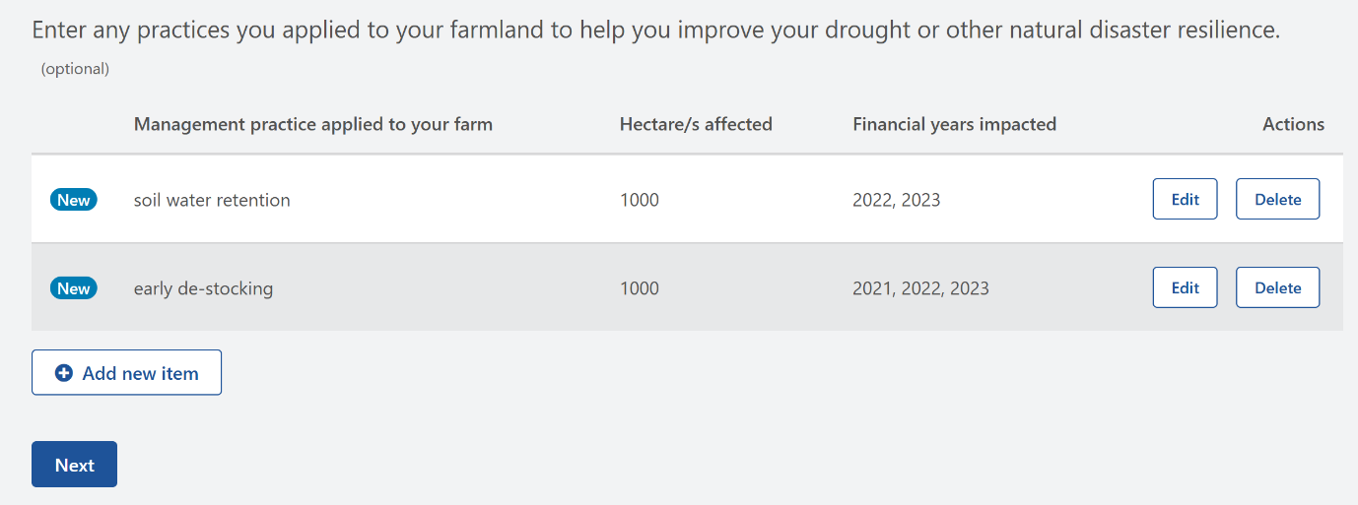

Figure 85 - Practices you applied to your farmland to help you improve your drought and natural disaster resilience - summary table.

##### Natural resource management

This table (Figure 86) provides the opportunity to include any natural resource management techniques or practices you applied to your farmland to help you improve your drought or natural disaster resilience. This is mandatory if it applies to your farm business.

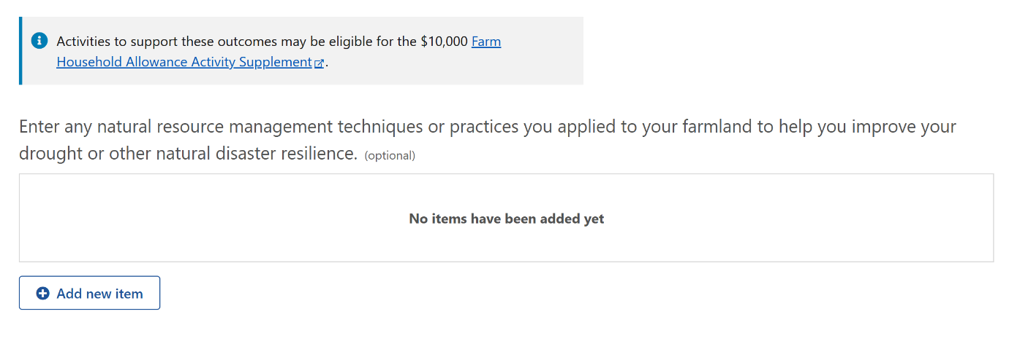

Figure 86 - Natural resource management techniques or practices you applied to your farmland to help you improve your drought or natural disaster resilience.

* + 1. What natural resource management techniques or practices did you apply to your farmland to improve your sustainability outcomes? This is a mandatory question which requires free text input with a limit of 100 characters (Figure 87).

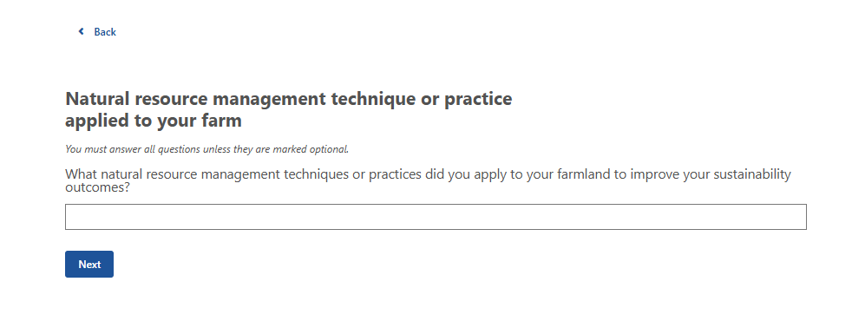

Figure 87 - What natural resource management techniques or practices did you apply to your farmland to improve your sustainability outcomes?

* + 1. What is the total number of hectares affected? This is a mandatory question which requires numerical input only. Decimals are allowed with a minimum number of 1 and maximum number of 99999999 (Figure 88).

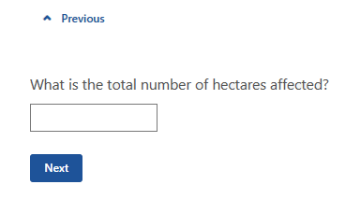

Figure 88 - What is the total number of hectares affected?

* + 1. Select the year(s) the practice was applied (Figure 89). You are allowed to select multiple options for the same financial year.

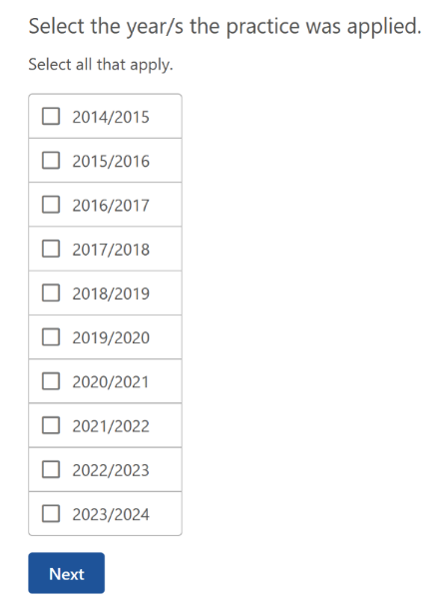

Figure 89 - Select the year/s the practice was applied.

A summary table will appear for you to review and edit/delete if required (Figure 90). The table will display the financial years impacted with the first year ie. 2023-24 financial year, appearing as 2023 in table. The same year(s) can be selected for multiple practices.

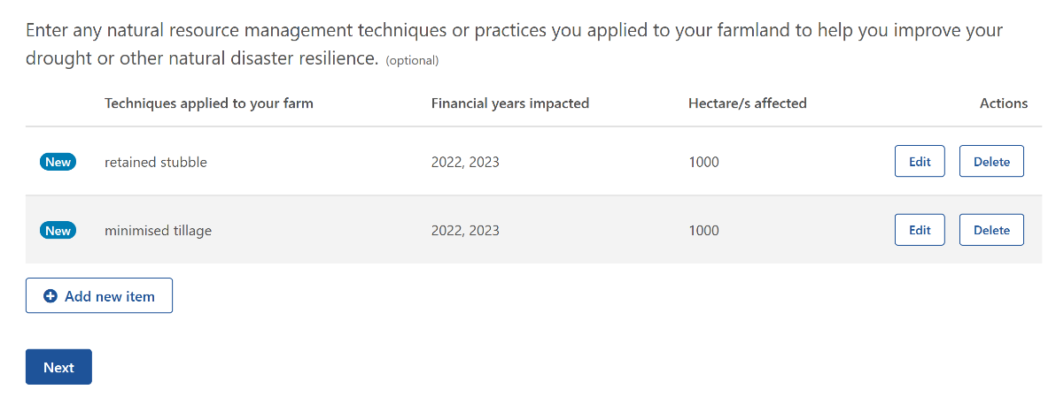

Figure 90 - Natural resource management techniques or practices you applied to your farmland to help you improve your drought or other natural disaster resilience - summary table.

### Step 2: Assets and debts

#### Explanation

This section helps gain information on the various assets and debts of the farm business. This will be important for populating the consolidated tables which will be used in the Part C SWOT analysis.

#### Question overview

* + 1. What is the type of asset?
    2. What is the type of livestock?
    3. How many of this livestock are there?
    4. Provide a description of this asset.
    5. What is the current market value of this asset?
    6. What is the category of debt?
    7. Provide details of the liabilities.
    8. What is the total balance of the debt owing?
    9. What is the next minimum repayment due?
    10. What is the total repayment amount due in the next 12 months?
    11. Is the debt secured?
    12. What is the interest rate?
    13. What is the repayment and interest type?
    14. What is the category of debt?
    15. Provide details of the liabilities.
    16. What is the total balance of the debt owing?
    17. What is the next minimum repayment due?
    18. What is the debt secured?
    19. What is the interest rate?
    20. What is the repayment and interest type?

#### Example

This table (Figure 91) provides you the opportunity to input the value of the farm business assets, and your additional personal assets and/ or business assets that are owned by a separate business (for example if you also operate a contracting business under a separate ABN and machinery or other assets belong to that business, and/ or you have a business that is unrelated to the farm, such as a retail business).

|  |
| --- |
| ***Tips:***   * When entering the value, use the gross - **do not include any money owing**. * **Estimates should be based on the resale value** of the asset (ie. as it is with no improvements, or what you would expect to receive at a clearing sale). * Do not use the insurance value or land tax value. * If the asset is used for both business and personal, select the one that is used most frequently. |

* + 1. What is the type of asset? This is a mandatory question. A drop-down menu will appear with the following options (Figure 92):

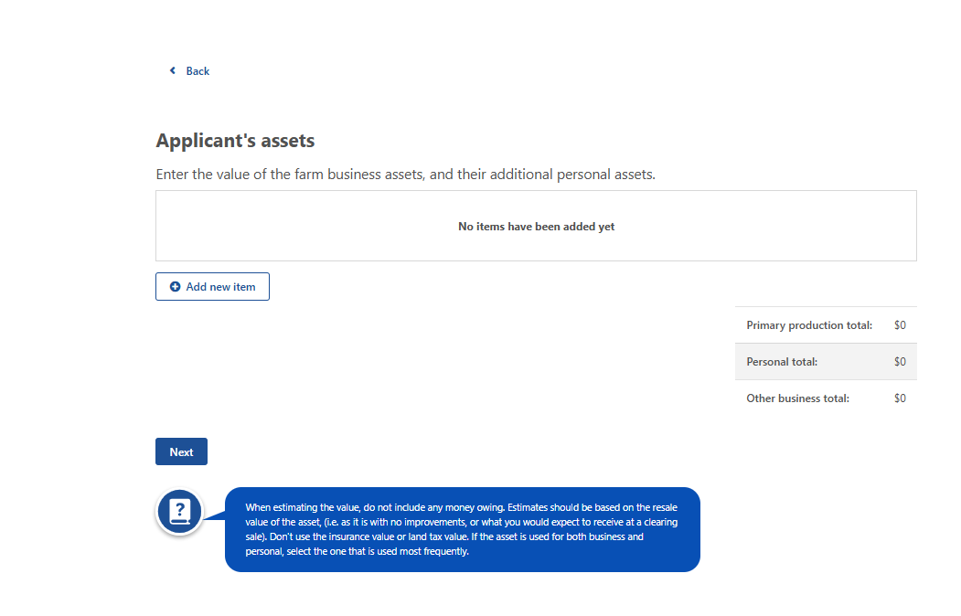

Figure 91 - Value of the farm business assets, and personal assets - input table.

* Primary production – cash at bank
* Primary production – farm management deposits
* Primary production – managed investments
* Primary production – money owed to you or partner
* Primary production – financial other
* Primary production – outstanding crop or produce payments
* Primary production – shares
* Primary production – superannuation (current estimated value)
* Primary production – tradeable water entitlements
* Primary production – buildings
* Primary production – farmland
* Primary production – livestock
* Primary production off-farm investments
* Primary production – plant and equipment (combined)
* Primary production – saleable produce on-hand
* Primary production – vehicles
* Primary production – other
* Personal – cash at bank
* Personal – managed investments
* Personal – money owed to you or partner
* Personal – financial other
* Personal – outstanding crop or produce payments
* Personal – shares
* Personal – superannuation (current estimated value)
* Personal – tradable water entitlements
* Personal – buildings
* Personal – plant and equipment (combined)
* Personal – saleable produce on-hand
* Personal – vehicles
* Personal – other
* Other business – cash at bank
* Other business – managed investments
* Other business – money owed to you or partner
* Other business – financial other
* Other business – outstanding crop or produce payments
* Other business – shares
* Other business – superannuation (current estimated value)
* Other business – tradable water entitlements
* Other business – buildings
* Other business – plant and equipment (combined)
* Other business – saleable produce on-hand
* Other business – vehicles
* Other business – other

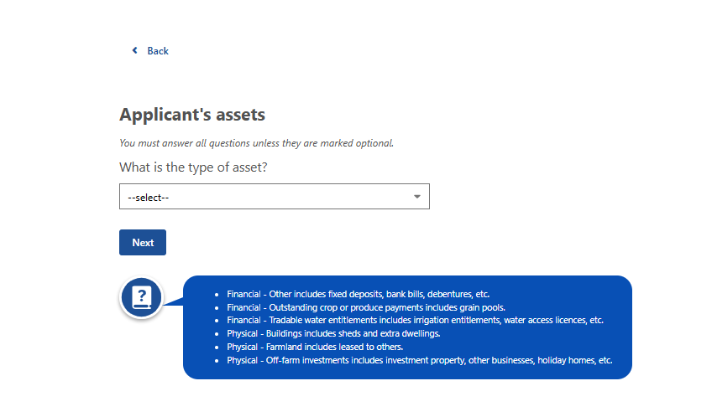

Figure 92 - What is the type of asset?

|  |
| --- |
| ***Tips***   * *Financial – Other* includes fixed deposits, bank bills, debentures, etc. * *Financial – Outstanding crop or produce payments* includes grain pools. * *Financial – Tradeable water entitlements* includes irrigation entitlements, water access licences, etc. * *Physical – Buildings* includes sheds and extra dwellings. * *Physical – Farmland* includes land leased to others. * *Physical – Off-farm investments* includes investment property, other businesses, holiday homes, etc   *Note:* If livestock is selected in **2.2.1**, the following question is presented. |

* + 1. What is the type of livestock? This question is mandatory with a free text input maximum of 30 characters (Figure 93).

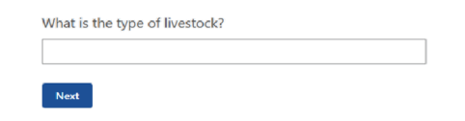

Figure 93 - What is the type of livestock?

* + 1. How many of this livestock are there? This question is mandatory with a free text input maximum of 5 characters (Figure 94).

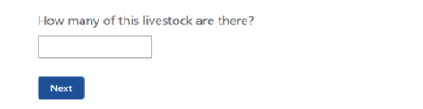

Figure 94 - How many livestock are there?

* + 1. Provide a brief description of the asset (Figure 96). This question is mandatory with a free text input maximum of 100 characters.
    2. What is the current market value of this asset? This question is mandatory and requires numerical input maximum of 7 characters (Figure 95).

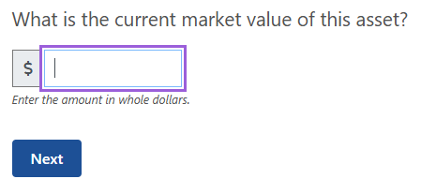

Figure 95 - What is the current market value of this asset?

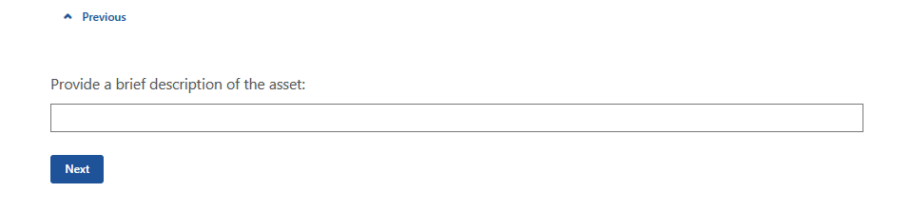

Figure 96 - Provide a brief description of the asset.

A summary table (Figure 97) will appear for you to review. You may edit/delete if required.

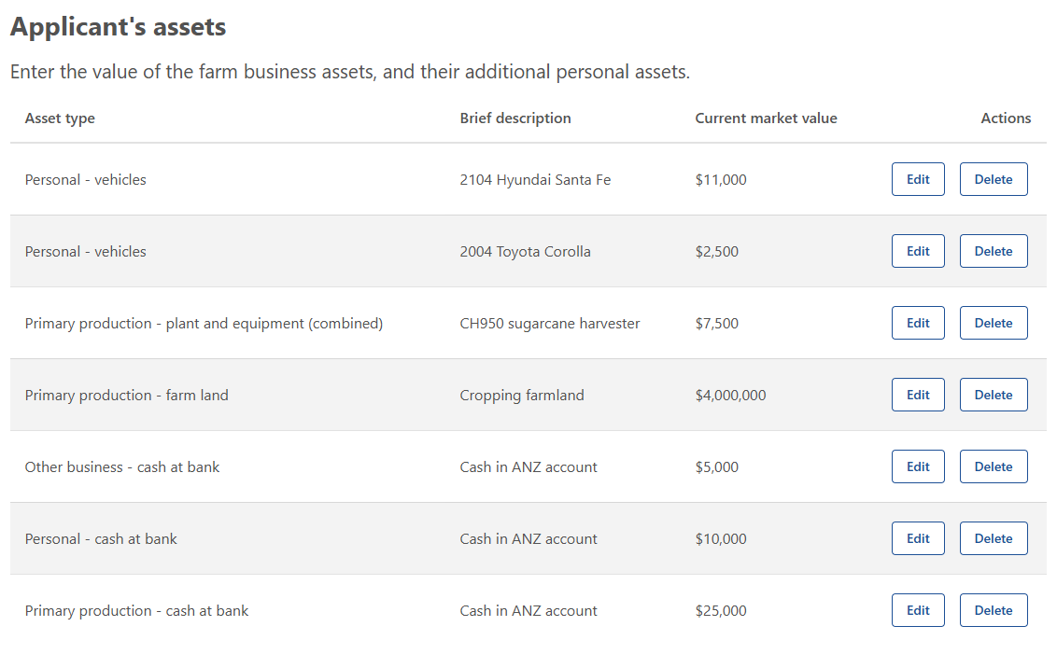

Figure 97 - Value of the farm business assets, and additional assets.

##### Farm debt

This table (Figure 98) is for you to add or edit any farm debt of the farm business. In later tables these will help you and your financial assessor to consider which assets are the most highly leveraged and if they are contributing efficiently to the return on investment.

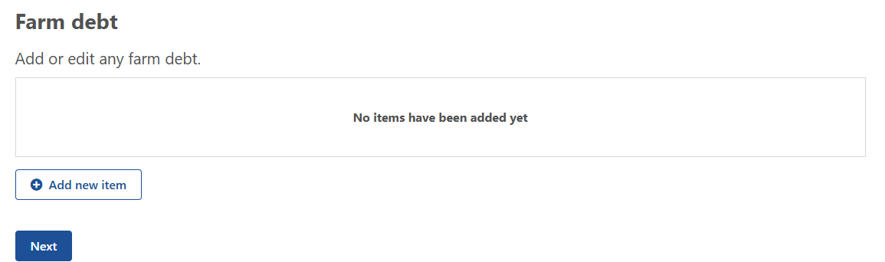

Figure 98 - Add or edit any farm debt.

* + 1. What is the category of debt? This is a mandatory question. A drop-down menu will appear with the following options (Figure 99):
* Credit – overdraft
* Credit/debit cards
* Creditors – trade/accounts payable
* Employee – wage or salary
* Finance equipment
* Finance lease
* Finance loan
* Fines
* Government – concessional loan
* Government – superannuation
* Government – taxation
* Liens

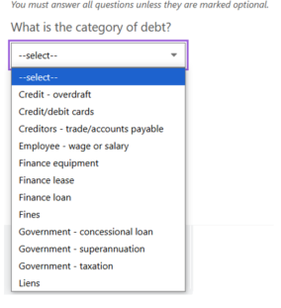

Figure 99 - What is the category of debt?

* + 1. Provide details of the liabilities (Figure 100). This question is mandatory with a free text input maximum of 250 characters.

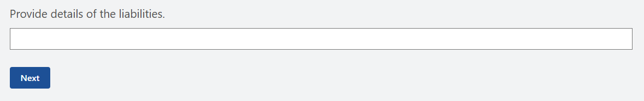

Figure 100 - Provide details of the liabilities.

* + 1. What is the total balance of the debt owing? This question is mandatory. Numerical numbers with a maximum input of 7 characters (Figure 101).

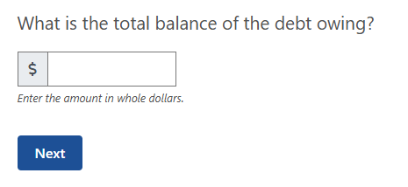

Figure 101 - What is the total balance of the debt owing?

* + 1. What is the next minimum repayment due? This question is mandatory. Numerical numbers with a maximum input of 7 characters (**Error! Reference source not found.**).

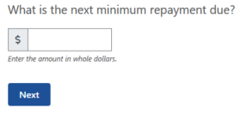

Figure 102 - What is the next minimum repayment due?

* + 1. What is the total repayment amount due in the next 12 months? This question is mandatory. Numerical numbers with a maximum input of 7 characters (**Error! Reference source not found.**).

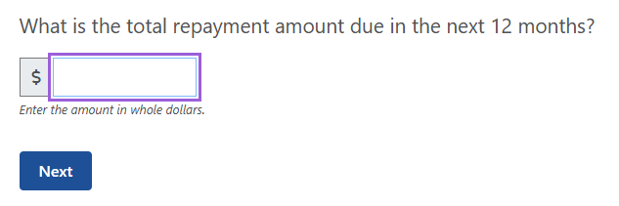

Figure 103 - What is the total repayment amount due in the next 12 months?

* + 1. Is the debt secured? This question is mandatory (Figure 104).

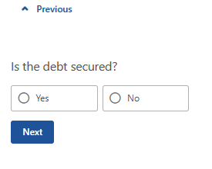

Figure 104 - Is the debt secured?

* + 1. What is the interest rate? This question is mandatory (Figure 105). Input requires numerical numbers only with a maximum value of 100 and will accept 2 decimal places. A 5-character limit is in place eg. 10.25.

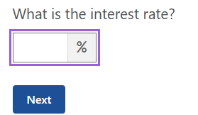

Figure 105 - What is the interest rate?

* + 1. What is the repayment and interest type? This question is mandatory with options of (Figure 106):
* Fixed
* Variable
* Interest only

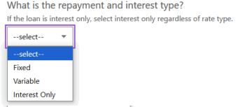

Figure 106 - What is the repayment and interest type?

|  |
| --- |
| *Note:* If the loan is interest only, select interest only regardless of rate type. |

A summary table (Figure 107) allows you to edit and/ or delete the items you have input.

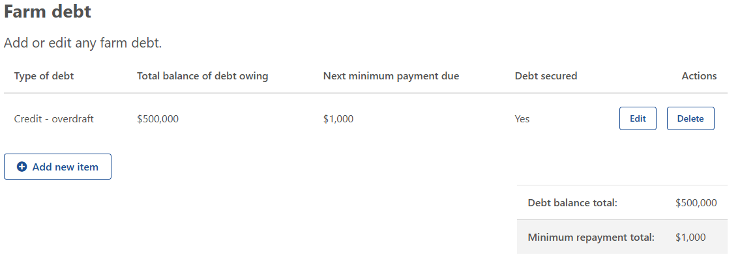

Figure 107 - Farm debt - summary table.

##### Personal debt

This table (Figure 108) allows you to input any personal debt of you and/or your partner. If there are other people involved in the business (such as a three or four way partnership) **you do not** need to collect their private details.

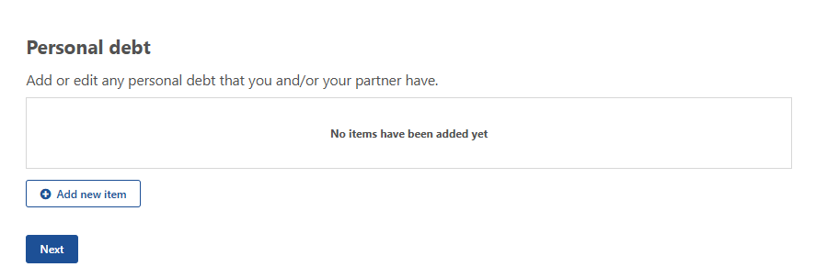

Figure 108 - Personal debt that you and/or partner may have - input table.

* + 1. What is the category of debt? This question is mandatory with a list of options available for you to select from which includes (Figure 109):
* Credit – overdraft
* Credit/debit cards
* Creditors – trade/accounts payable
* Finance equipment
* Finance lease
* Finance loan
* Fines
* Government – Child Support
* Government – Social security or Family Assistance
* Government – taxation
* Liens
* Government – concessional loan

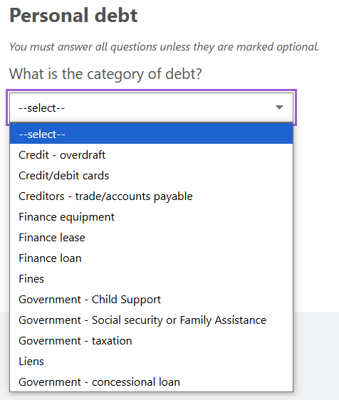

Figure 109 - What is the category of debt?

* + 1. Provide details of the liabilities (Figure 110). This question is mandatory with a free text box for input with a maximum of 255 characters.

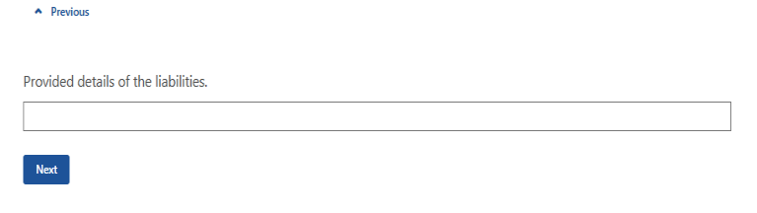

Figure 110 - Provide details of the liabilities.

* + 1. What is the total balance of the debt owing? This question is mandatory and requires numerical input only with a maximum of 7 characters (Figure 111).



Figure 111 - What is the total balance of the debt owing?

* + 1. What is the next minimum repayment due? This is a mandatory question and requires numerical input only with a maximum of 7 characters (Figure 112).

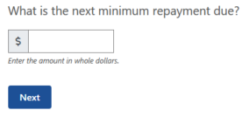

Figure 112 - What is the next minimum repayment due?

* + 1. What is the total repayment amount due in the next 12 months? This is a mandatory question and requires numerical input only with a maximum of 7 characters (Figure 113).



Figure 113 - What is the total repayment amount due in the next 12 months?

* + 1. Is the debt secured? This question is mandatory (Figure 114).

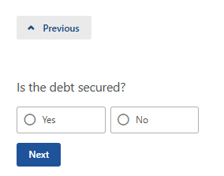

Figure 114 - Is the debt secured?

* + 1. What is the interest rate? This question is mandatory (Figure 115). Input requires numerical numbers only with a maximum value of 100 and will accept 2 decimal places. There is a maximum of 5 characters eg. 10.25.



Figure 115 - What is the interest rate?

* + 1. What is the repayment and interest type? This is a mandatory question with a list of options for you to select which includes (Figure 116):
* Fixed
* Variable
* Interest only

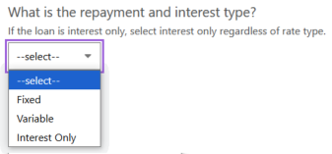

Figure 116 - What is the repayment and interest type?

|  |
| --- |
| *Note:* If the loan is interest only, select interest only regardless of rate type. |

A summary table (Figure 117) will be displayed in which you have the ability to edit/delete of the items you submitted. Once you have reviewed the table please go to next question.

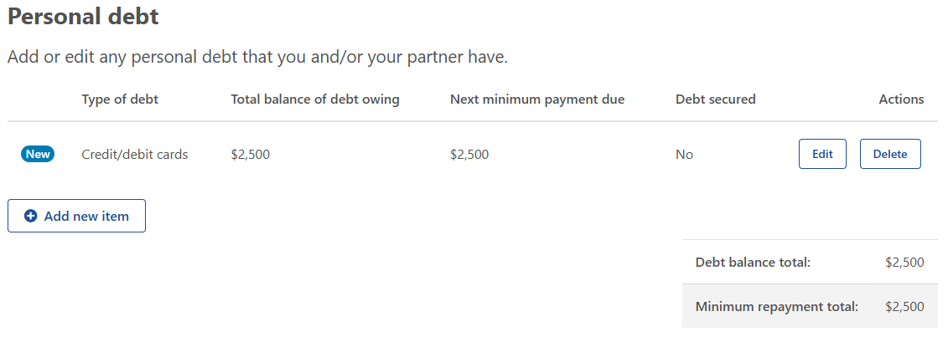

Figure 117 - Personal debt you and/or your partner have - summary table.

### Step 3: Farm Profitability

#### Explanation

This section collects information about the farm business’s on-farm income and expenditure. As mentioned in the Part B introduction, this information collected here will be important for populating the consolidated tables which will be used in Part C.

Where accurate or credible financial information cannot be found, the financial assessor is to provide an estimation of the approximate value based on information provided by the applicant.

#### Question overview

* + 1. What is the type of farm income?
    2. What was the full amount for the <YYYY-YY-3> financial year for this income type?
    3. What was the full amount for the <YYYY-YY-2> financial year for this income type?
    4. What was the full amount for the <YYYY-YY-1> financial year for this income type?
    5. What is the type of administrative expense?
    6. What is the full amount for the < YYYY-YY-3> financial year for this administrative expense type?
    7. What is the full amount for the < YYYY-YY-23> financial year for this administrative expense type?
    8. What is the full amount for the < YYYY-YY-1> financial year for this administrative expense type?
    9. What is the type of production expense?
    10. What was the full amount for the < YYYY-3-YY-3> financial year for this production expense type?
    11. What was the full amount for the <YYYY-YY-2> financial year for this production expense type?
    12. What was the full amount for the <YYYY-YY-1> financial year for this production expense type?
    13. What is the category of debt?
    14. What was the full amount for the <YYYY-YY-3> financial year for this debt type?
    15. What was the full amount for the <YYYY-2YY-2> financial year for this debt type?
    16. What was the full amount for the <YYYY-1YY-1> financial year for this debt type?

#### Example

##### Farm income

This table (Figure 118) allows you to input all farm income sources. This is a mandatory section.

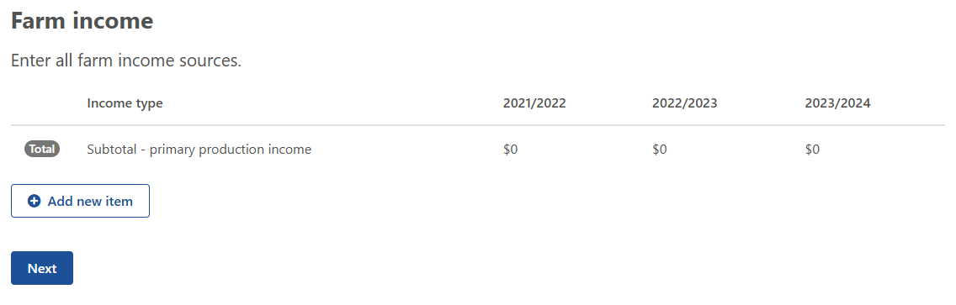

Figure 118 - All farm income sources - input table.

* + 1. What is the type of farm income? This question is mandatory with a drop-down list for you to select from which includes (Figure 119):
* Accommodation, agritourism, food service
* Agistment
* Commodity – aquaculture
* Commodity – cattle/beef
* Commodity – cattle/milk and dairy produce
* Commodity – cotton
* Commodity – fodder (hay and silage)
* Commodity – fruit/apples and pears
* Commodity – fruit/berry
* Commodity – fruit/citrus
* Commodity – fruit/grapes, table
* Commodity – fruit/grapes, wine
* Commodity – fruit/stone
* Commodity – fruit/tropical
* Commodity – grain, oilseed and pulses
* Commodity – honey or bee products
* Commodity – nursery and floriculture
* Commodity – other crops
* Commodity – other farm income
* Commodity – other horticultural crops
* Commodity – other livestock
* Commodity – pigs
* Commodity – poultry and eggs
* Commodity – sheep, sheep and lambs
* Commodity – wool
* Commodity – sugar cane
* Commodity – vegetables
* Contracting income
* Dividends and other investment income
* Government payments
* Interest earned
* Rebates
* Rent received
* Royalties (includes wind turbines, solar panels)
* Share farming payments
* Sundry receipts

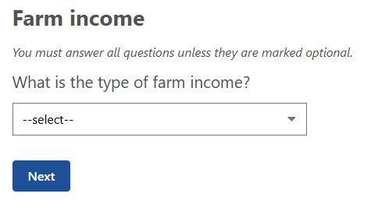

Figure 119 - What is the type of farm income?

|  |
| --- |
| *Note:* If the FFA is generated in 2024-25 financial year the previous 3 financial years will display for **2.3.2, 2.3.3 & 2.3.4** ie. 2021-22, 2022-23 and 2023-24. |

* + 1. What was the full amount for the 2021-22 financial year for this income type? This is a mandatory question and requires numerical input only with a 7-character limit (Figure 120).

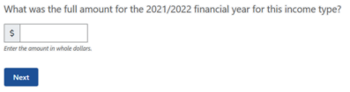

Figure 120 - What was the full amount for the 2021-22 financial year for this income type?

* + 1. What was the full amount for the 2021-22 financial year for this income type? This is a mandatory question and requires numerical input only with a 7-character limit (Figure 121).

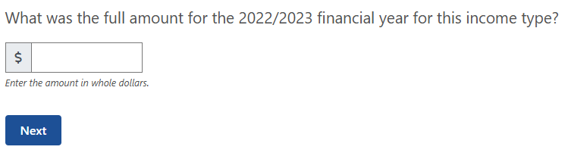

Figure 121 - What was the full amount for the 2022-23 financial year for this income type?

* + 1. What was the full amount for the 2023-24 financial year for this income type? This is a mandatory question and requires numerical input only with a 7-character limit (Figure 122).

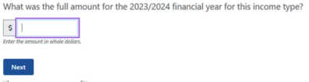

Figure 122 - What was the full amount for the 2023/24 financial year for this income type?

This summary table (Figure 123) shows you your input from the previous questions on all farm income sources.

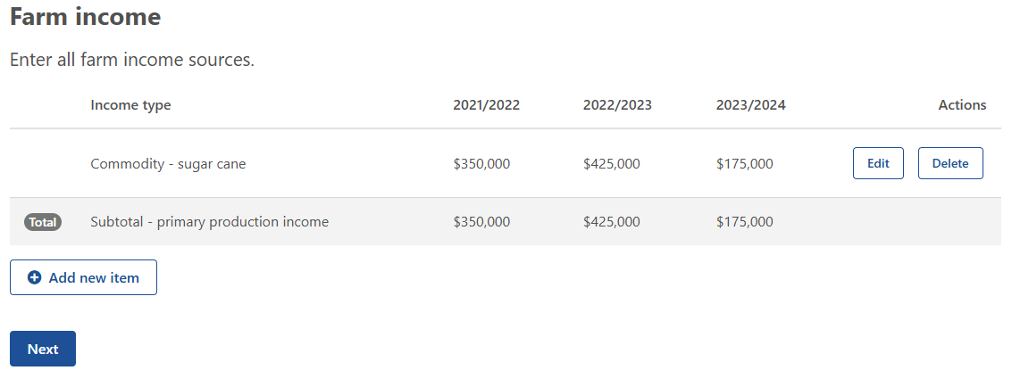

Figure 123 - All farm income sources - summary table.

##### Administrative expenses

This table (Figure 124) allows you to input data for all administrative expense sources. These are expenses that relate to the running of the business, rather than the production of the commodity/ies. In some financial contexts they might be called ‘Non-variable’ expenses.

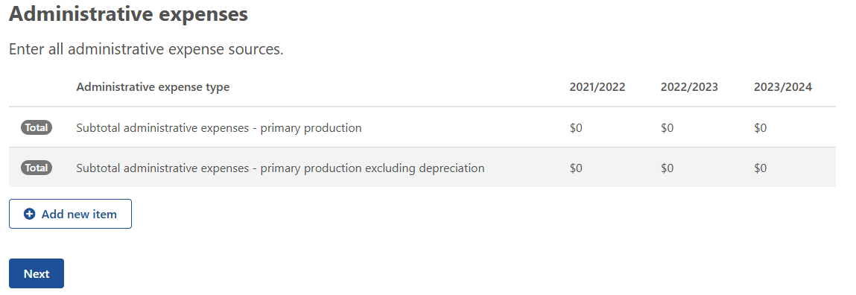

Figure 124 - All administrative expense sources - input table.

* + 1. What is the type of administrative expense? This question is mandatory with a drop-down list for you to select from which includes (Figure 125):
* Business – accounting
* Business – advisory services
* Business – legal fees
* Business – electricity
* Business – insurance
* Business – motor vehicle expenses
* Business – other administrative costs
* Business – other cash costs
* Business – postage and stationery
* Business – stores and rations
* Business – subscriptions
* Business – telephone
* Business – travel and entertainment expenses
* Business – wages for permanent labour
* Finance – bank fees/charges
* Finance – depreciation
* Finance – interest paid on business loans
* Finance – land rent
* Finance – leasing costs
* Finance – plant & equipment hire
* Finance – principal repayments on business loans
* Finance – water charges
* Rates – land protection
* Rates – other
* Rates – shire

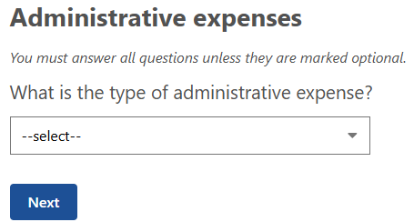

Figure 125 - What is the type of administrative expense?

* + 1. What was the full amount for the 2021-22 financial year for this administrative expense type? This is a mandatory question and requires numerical input only with a 7-character limit (Figure 126).

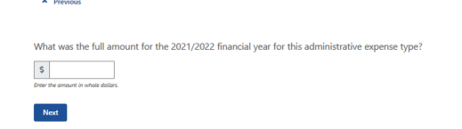

Figure 126 - What was the full amount for the 2021-22 financial year for this administrative expense type?

* + 1. What was the full amount for the 2021-22 financial year for this administrative expense type? This is a mandatory question and requires numerical input only with a 7-character limit (Figure 127).

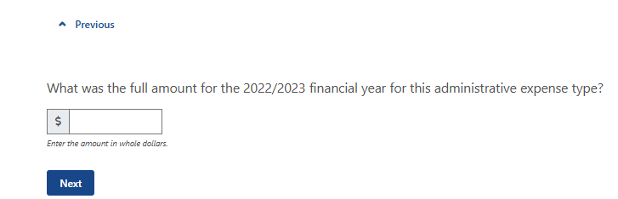

Figure 127 - What was the full amount for the 2022-23 financial year for this administrative expense type?

* + 1. What was the full amount for the 2021-22 financial year for this administrative expense type? This is a mandatory question and requires numerical input only with a 7-character limit (Figure 128).

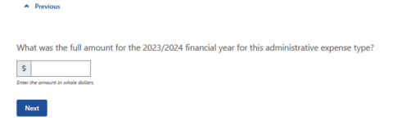

Figure 128 - What was the full amount for the 2023-24 financial year for this administrative expense type?

This summary table (Figure 129) displays the administrative expenses you input in the previous questions. This allows you to edit/delete as you need before progressing.

##### Production expenses

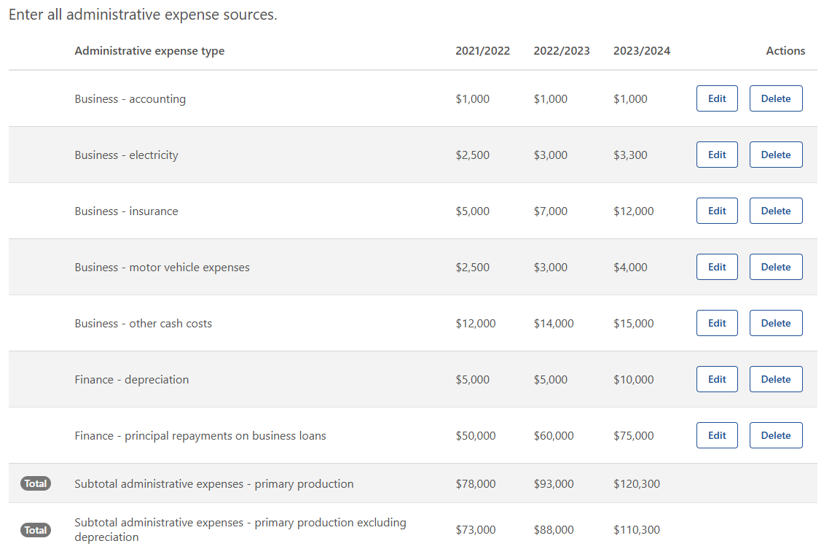

Figure 129 - All administrative expense sources - summary table.

This table (Figure 130) allows you to input all production expense sources. In some financial contexts they might also be called ‘Variable’ expenses.

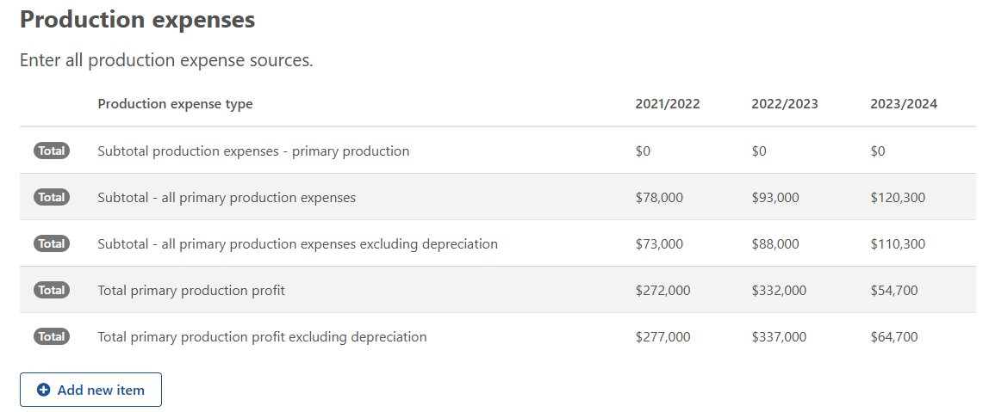

Figure 130 - All production expense sources - input table.

* + 1. What is the type of production expense? This question is mandatory with a drop-down list for you to select from which includes (Figure 132):
* Cash costs
* Contractors – cropping
* Contractors – livestock
* Contractors – other
* Livestock – materials
* Livestock – purchase cattle
* Livestock – purchase other animals
* Livestock – purchase sheep
* Livestock – testing fees (eg. AI, stud, herd, pregnancy)
* Materials – chemicals
* Materials – dairy supplies
* Materials – fertiliser
* Materials – fodder
* Materials – freight
* Materials – fuel and lubricants
* Materials – other
* Materials – permanent horticulture
* Materials – seed
* Payments – produce purchased for resale
* Payments – sharefarmers
* Payments – taxation on business income
* Rent – excluding land rent
* Repairs and maintenance – buildings and structures
* Repairs and maintenance – plant and equipment
* Services – agistment
* Services – handling and marketing charges
* Services – other
* Services – packing charges
* Services – veterinary fees
* Wages for casual and part-time labour
  + 1. What was the full amount for the 2021-22 financial year for this production expense type? This is a mandatory question and requires numerical input only with a 7-character limit (Figure 131).

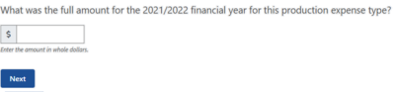

Figure 131 - What was the full amount for the 2021-22 financial year for this production expense type?

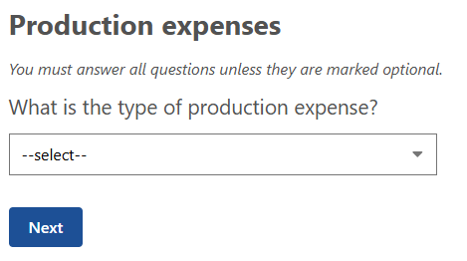

Figure 132 - What is the type of production expense?

* + 1. What was the full amount for the 2022-23 financial year for this production expense type? This is a mandatory question and requires numerical input only with a 7-character limit (Figure 133).

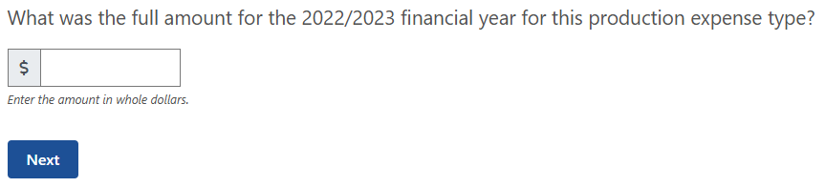

Figure 133 - What was the full amount for the 2022-23 financial year for this production expense type?

* + 1. What was the full amount for the 2023-24 financial year for this production expense type? This is a mandatory question and requires numerical input only with a 7-character limit (Figure 134).

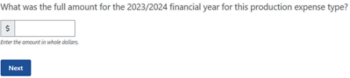

Figure 134 - What was the full amount for the 2023-24 financial year for this production expense type?

This summary table (Figure 135) allows for you to review/edit/delete your input for all production expense sources from the previous questions.

##### Farm debt

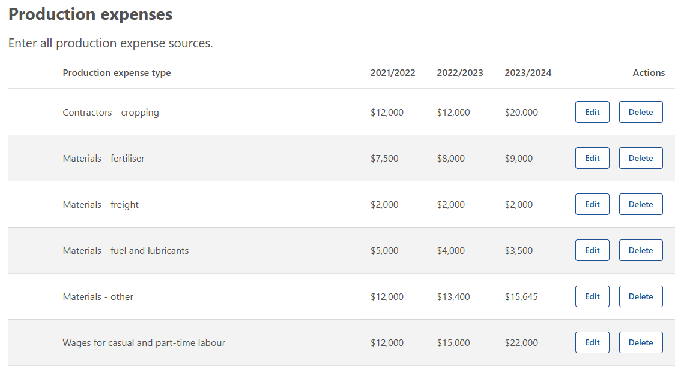

Figure 135 - All production expense sources - summary table.

This table (Figure 136) allows you to input all farm debt sources for the previous 3 financial years.

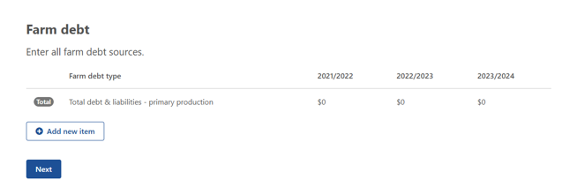

Figure 136 - All farm debt sources - input table.

* + 1. What is the category of debt? This question is mandatory with a drop-down list for you to select from which includes (Figure 138):
* Credit – overdraft
* Credit/debit cards
* Creditors – trade/accounts payable
* Employee – wage or salary
* Finance equipment
* Finance lease
* Finance loan
* Fines
* Government – concessional loan
* Government – superannuation
* Government – taxation
* Liens
  + 1. What was the full amount for the 2021-22 financial year for this debt type? This is a mandatory question and requires numerical input only with a 7-character limit (Figure 137).

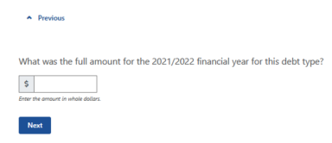

Figure 137 - What was the full amount for the 2021-22 financial year for this debt type?

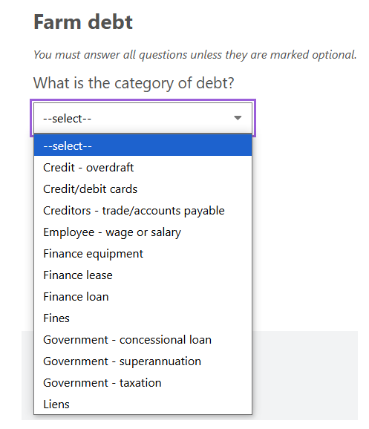

Figure 138 - What is the category of debt?

* + 1. What was the full amount for the 2022-23 financial year for this debt type? This is a mandatory question and requires numerical input only with a 7-character limit (Figure 139).

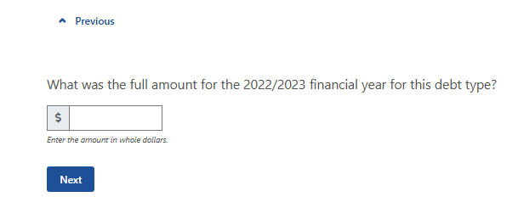

Figure 139 - What was the full amount for the 2022-23 financial year for this debt type?

* + 1. What was the full amount for the 2023-24 financial year for this debt type? This is a mandatory question and requires numerical input only with a 7-character limit (Figure 140).

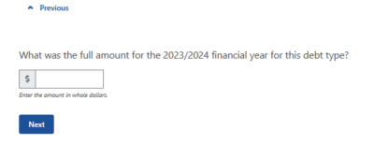

Figure 140 - What was the full amount for the 2023-24 financial year for this debt type?

This summary table (Figure 141) allows for you to review/edit/delete your input for all farm debt sources from the previous questions.

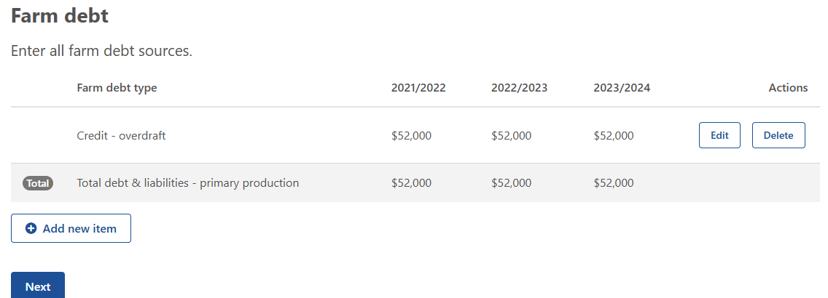

Figure 141 - All farm debt sources - summary table

### Step 4: Personal Finances

#### Explanation

This section collects information about you and your partner’s (if applicable) non-farm income and expenditure sources.

Where accurate financial information is unavailable, the financial assessor is to provide an estimate of the value based on information provided by the applicant.

#### Question overview

* + 1. What is the type of personal income?
    2. What was the full amount for the <YYYY-YY-3> financial year for this income type?
    3. What was the full amount for the <YYYY-YY-2> financial year for this income type?
    4. What was the full amount for the <YYYY-1YY-1> financial year for this income type?
    5. What is the type of personal expenditure?
    6. What was the full amount for the <YYYY-YY-3> financial year for this expenditure type?
    7. What was the full amount for the <YYYY-YY-2> financial year for this expenditure type?
    8. What was the full amount for the <YYYY-YY-1> financial year for this expenditure type?
    9. What is the category of debt?
    10. What was the full amount for the <YYYY-YY-3> financial year for this debt type?
    11. What was the full amount for the <YYYY-YY-2> financial year for this debt type?
    12. What was the full amount for the <YYYY-YY-1> financial year for this debt type?

#### Example

##### Personal income

This table (Figure 142) allows you to input all personal income sources that you and/or your partner have.

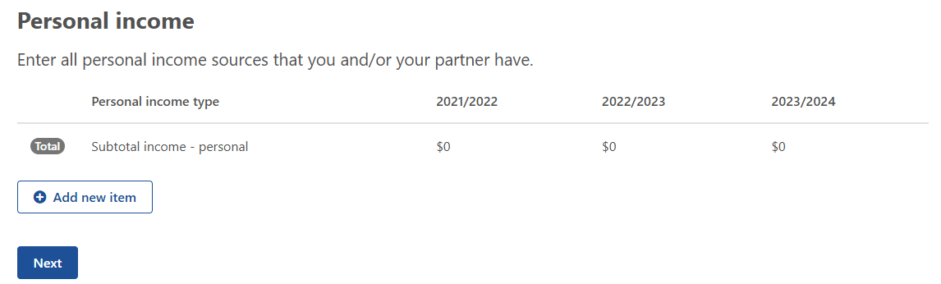

Figure 142 - All personal income sources that you and/or your partner have - input table.

* + 1. What is the type of personal income? This question is mandatory with a drop-down list for you to select from which includes (Figure 143):
* Interest received on personal investments
* Interest received on personal loans to others
* Off-farm salary wage income
* Other personal income
* Rent received.

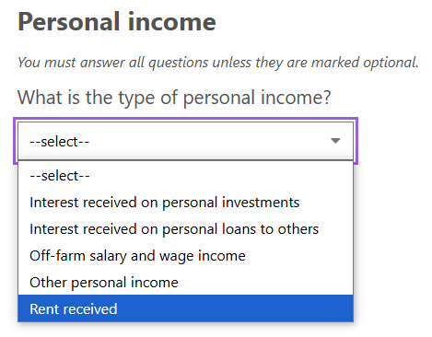

Figure 143 - What is the type of personal income?

* + 1. What was the full amount for the 2021-22 financial year for this debt type? This is a mandatory question and requires numerical input only with a 7-character limit (Figure 144).

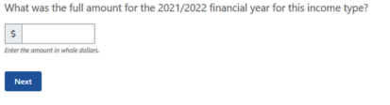

Figure 144 - What was the full amount for the 2021-22 financial year for this income type?

* + 1. What was the full amount for the 2022-23 financial year for this debt type? This is a mandatory question and requires numerical input only with a 7-character limit (Figure 145).

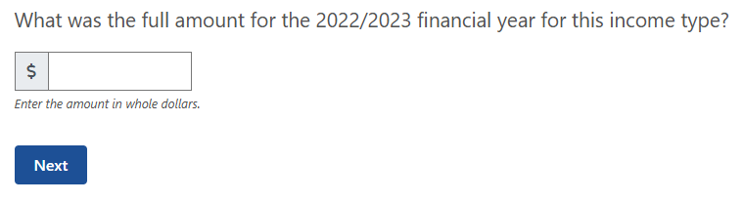

Figure 145 - What was the full amount for the 2022-23 financial year for this income type?

* + 1. What was the full amount for the 2023-24 financial year for this debt type? This is a mandatory question and requires numerical input only with a 7-character limit (Figure 146).

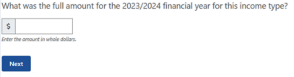

Figure 146 - What was the full amount for the 2023-24 financial year for this income type?

This summary table (Figure 147) allows you to review/edit/delete your input.

##### Personal expenditure

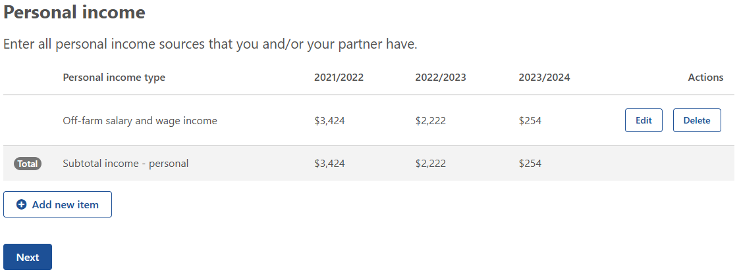

Figure 147 - All personal income sources that you and/or your partner have.

This table (Figure 148) allows you to input all personal expenditure sources that you and/or your partner have. This helps to build a picture of the imposts on the business to provide for its own running and the upkeep of the household.

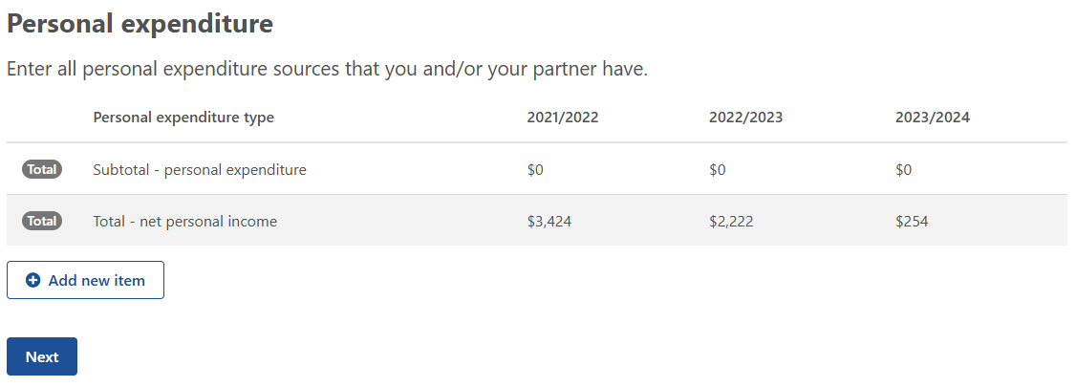

Figure 148 - Personal expenditure sources that you and/or your partner have - input table.

* + 1. What is the type of personal expenditure? This question is mandatory with a drop-down list for you to select from which includes (**Error! Reference source not found.**):
* Finance – bank fees/charges
* Household – consumption
* Household – electricity
* Household – insurance
* Household – registration of motor vehicle
* Household – telephone
* Personal – rent
* Personal – taxation on off-farm income
* Rates – land protection
* Rates – other
* Rates – shire

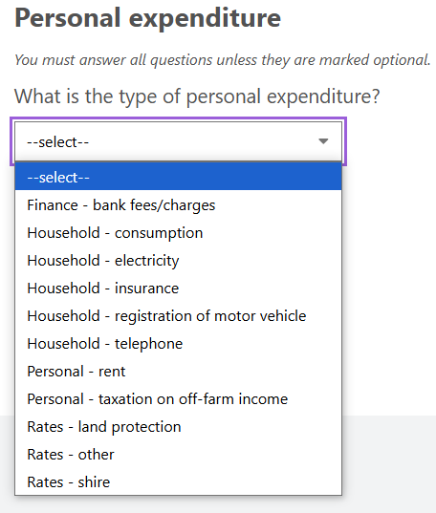

Figure 149 - What is the type of personal expenditure?

* + 1. What was the full amount for the 2021-22 financial year for this expenditure type? This is a mandatory question and requires numerical input only with a 7-character limit (**Error! Reference source not found.**).

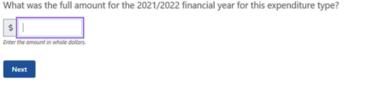

Figure 150 - What was the full amount for the 2021-22 financial year for this expenditure type?

* + 1. What was the full amount for the 2022-23 financial year for this expenditure type? This is a mandatory question and requires numerical input only with a 7-character limit (Figure 151).

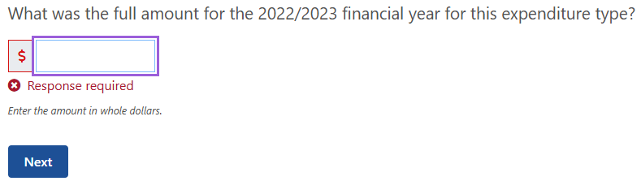

Figure 151 - What was the full amount for the 2022/23 financial year for this expenditure type?

* + 1. What was the full amount for the 2023-24 financial year for this expenditure type? This is a mandatory question and requires numerical input only with a 7-character limit (Figure 152).

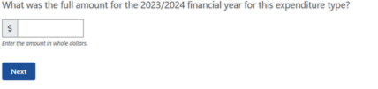

Figure 152 - What was the full amount for the 2023/24 financial year for this expenditure type?

This summary table (Figure 153) allows for you to review/edit/delete your input for all personal expenditure sources that you and/or your partner have from the previous questions.

##### Personal debt

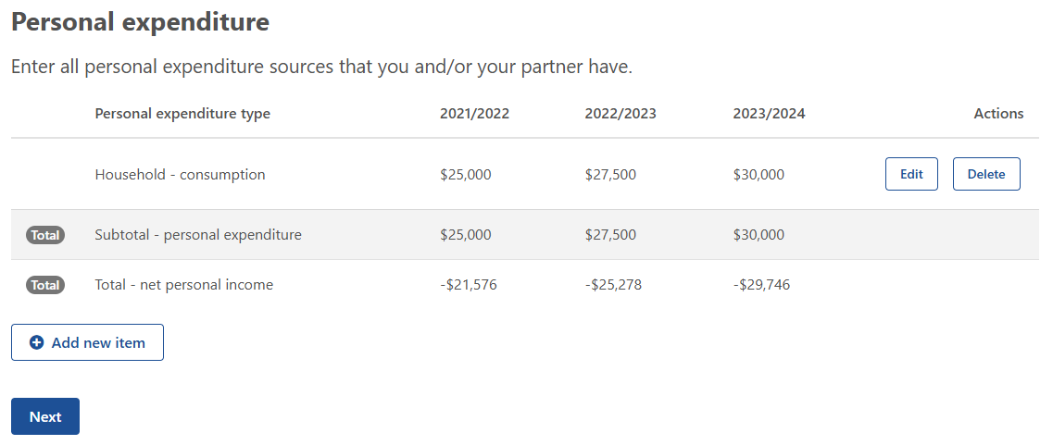

Figure 153 - Personal expenditure sources that you and/or your partner have - summary table.

This table (Figure 154) allows you to input all personal debt sources that you and/or your partner have.

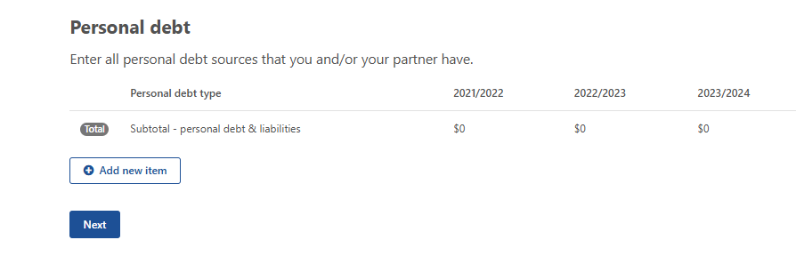

Figure 154 - Personal debt sources that you and/or your partner have - input table.

* + 1. What is the category of debt? This question is mandatory with a drop-down list for you to select from which includes (Figure 155):
* Credit – overdraft
* Credit/debit cards
* Creditors – trade/accounts payable
* Finance equipment
* Finance lease
* Finance loan
* Fines
* Government – Child Support
* Government – Social security or Family Assistance
* Government – taxation
* Liens
* Government – concessional loan

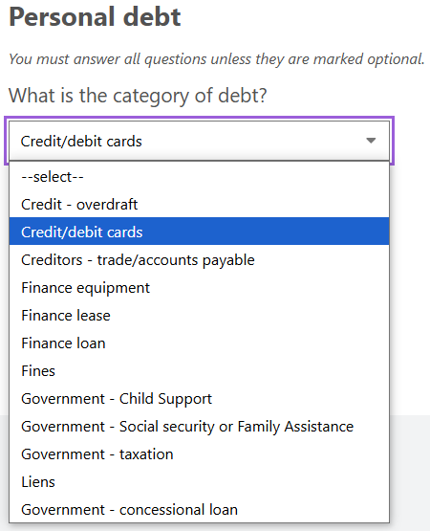

Figure 155 - What is the category of debt?

* + 1. What was the full amount for the 2021-22 financial year for this debt type? This is a mandatory question and requires numerical input only with a 7-character limit (Figure 156).

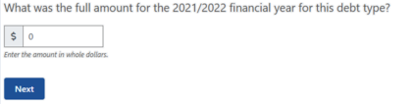

Figure 156 - What was the full amount for the 2021-22 financial year for this debt type?

* + 1. What was the full amount for the 2022-23 financial year for this debt type? This is a mandatory question and requires numerical input only with a 7-character limit (Figure 157).

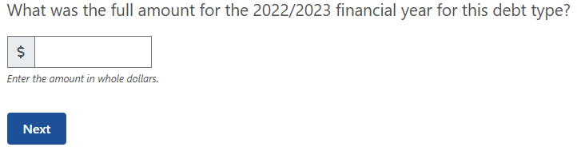

Figure 157 - What was the full amount for the 2022-23 financial year for this debt type?

* + 1. What was the full amount for the 2023-24 financial year for this debt type? This is a mandatory question and requires numerical input only with a 7-character limit (Figure 158).

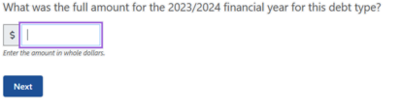

Figure 158 - What was the full amount for the 2023-24 financial year for this debt type?

This summary table (Figure 159) allows for you to review/edit/delete your input for all personal debt sources that you and/or your partner have from the previous questions.

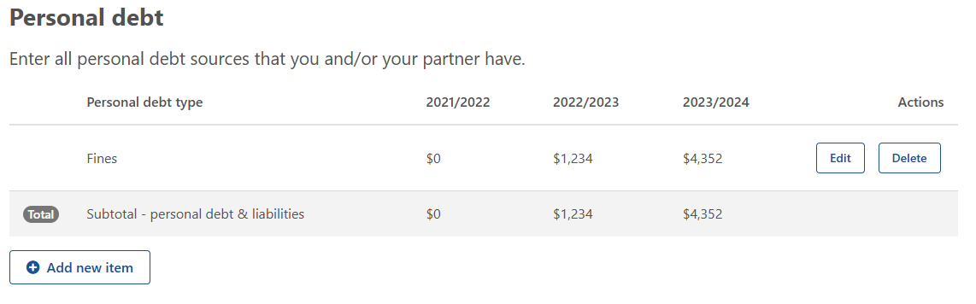

Figure 159 - Personal debt sources that you and/or your partner have - summary table.

### Step 5: Other business finances

#### Explanation

This section will ask questions based on whether you have any other business as previously answered in Part A (eg. Contracting, retail, marketing). Questions relate to the type of other business income, expenditure or any debt that is associated with the business. This will all be from the previous 3 financial years and will help populate the consolidated tables at the end of Part B.

#### Question overview

* + 1. What is the type of other business income?
    2. What was the full amount for the <YYYY-YY-3> financial year for this income type?
    3. What was the full amount for the <YYYY-YY-2> financial year for this income type?
    4. What was the full amount for the <YYYY-YY-1> financial year for this income type?
    5. What is the type of other business expenditure?
    6. What was the full amount for the <YYYY-YY-3> financial year for this expenditure type?
    7. What was the full amount for the <YYYY-YY-2> financial year for this expenditure type?
    8. What was the full amount for the <YYYY-YY-1> financial year for this expenditure type?
    9. What is the category of debt?
    10. What was the full amount for the <YYYY-YY-3> financial year for this debt type?
    11. What was the full amount for the <YYYY-YY-2> financial year for this debt type?
    12. What was the full amount for the <YYYY-YY-1> financial year for this debt type?

#### Example

This table (Figure 160) allows you to input all other business income sources that you and/or your partner have.

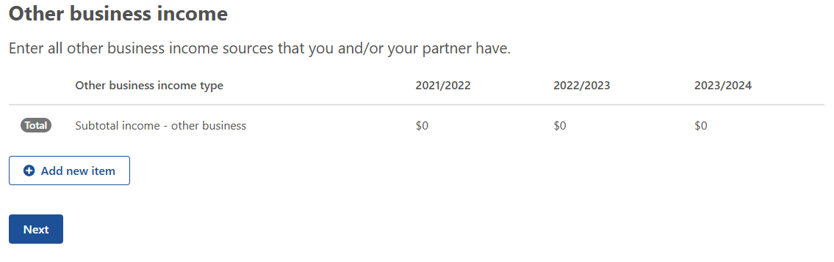

Figure 160 - Other business income sources that you and/or your partner have.

* + 1. What is the type of other business income? This question is mandatory with a drop-down list for you to select from which includes (Figure 161):
* Accommodation, agri-tourism, food service
* Agistment
* Contracting income
* Dividends and other investment income
* Forestry
* Government payments
* Income from other businesses
* Interest earned
* Off-farm salary and wage net income
* Other personal income
* Rebates
* Rent received
* Royalties (includes wind turbines, solar panels)
* Sundry receipts

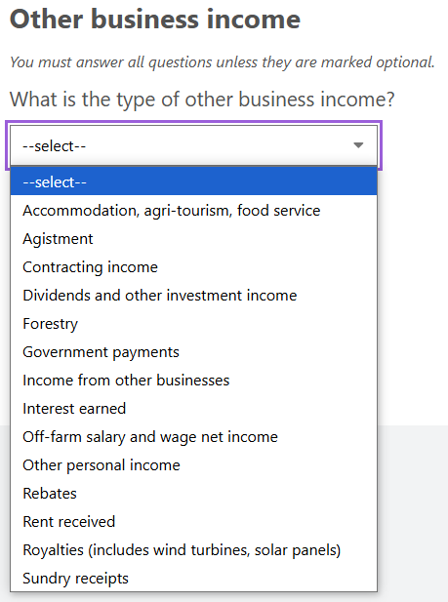

Figure 161 - What is the type of other business income?

* + 1. What was the full amount for the 2021-22 financial year for this income type? This is a mandatory question and requires numerical input only with a 7-character limit (Figure 162).

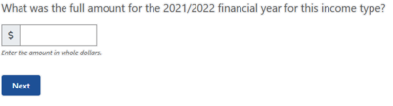

Figure 162 - What was the full amount for the 2021-22 financial year for this income type?

* + 1. What was the full amount for the 2022-23 financial year for this income type? This is a mandatory question and requires numerical input only with a 7-character limit (Figure 163).

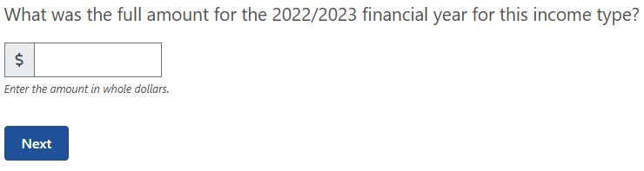

Figure 163 - What was the full amount for the 2022-23 financial year for this income type?

* + 1. What was the full amount for the 2023-24 financial year for this income type? This is a mandatory question and requires numerical input only with a 7-character limit (Figure 164).

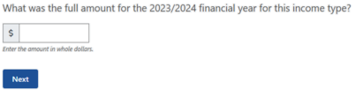

Figure 164 - What was the full amount for the 2023-24 financial year for this income type?

This summary table (Figure 165) allows for you to review/edit/delete your input for all other business income sources that you and/or your partner have from the previous questions.

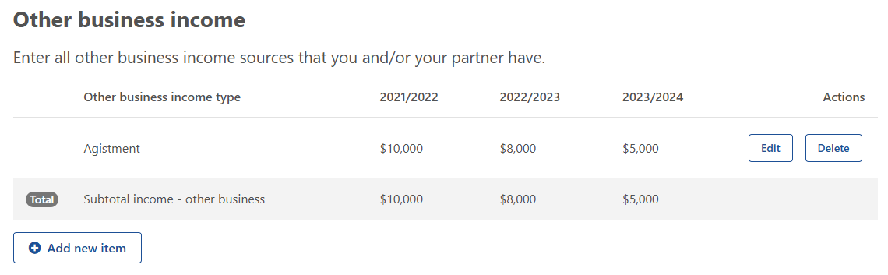

Figure 165 - All other business income sources that you and/or your partner have - summary table.

##### Other business expenditure

This table (Figure 166) allows you to input all other business expenditure sources that you and/or your partner have.

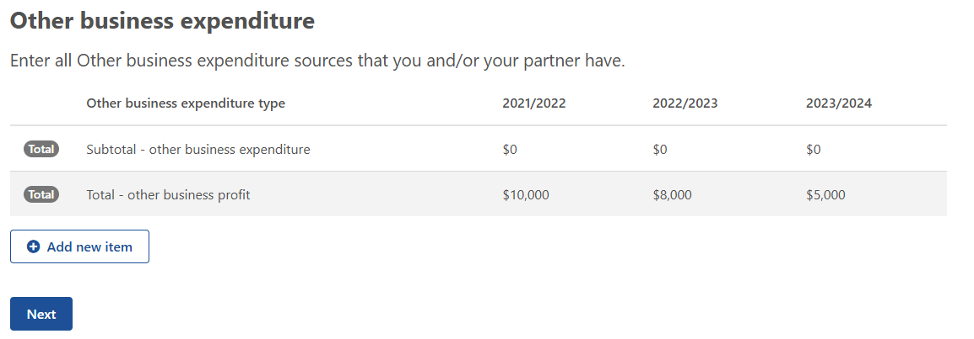

Figure 166 - Other business expenditure sources that you and/or your partner have.

* + 1. What is the type of other business expenditure? This question is mandatory with a drop-down list for you to select from which includes (Figure 168):

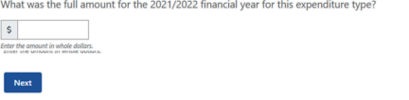

Figure 167 - What was the full amount for the 2021-22 financial year for this expenditure type?

* Business – accounting
* Business – advisory services
* Business – legal fees
* Business – electricity
* Business – insurance
* Business motor vehicle expenses
* Business – other administrative costs
* Business – other cash costs
* Business – postage and stationary
* Business – stores and rations
* Business – subscriptions
* Business – telephone
* Business – travel and entertainment expenses
* Business – wages for permanent labour
* Finance – bank fees/charges
* Finance – depreciation
* Finance – interest paid on business loans
* Finance – land rent
* Finance – leasing costs
* Finance – plant & equipment hire
* Finance – principal repayments on business loans
* Finance – water charges
* Rates – land protection
* Rates – other
* Rates – shire
* Cash costs
* Contractors
* Materials – chemicals
* Materials – freight
* Materials – fuel and lubricants
* Materials – other
* Payments – produce purchased for resale
* Payments – taxation on business income
* Rent – excluding land rent
* Repairs and maintenance – buildings and structures
* Repairs and maintenance – plant and equipment
* Services – handling and marketing charges
* Services – other
* Services – packing charges
* Services – veterinary fees
* Wages for casual and part-time labour
  + 1. What was the full amount for the 2021-22 financial year for this expenditure type? This is a mandatory question and requires numerical input only with a 7-character limit (Figure 167).

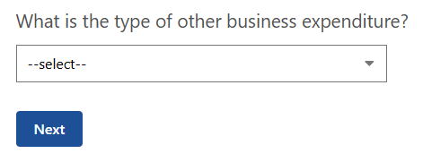

Figure 168 - What is the type of other business expenditure?

* + 1. What was the full amount for the 2022-23 financial year for this expenditure type? This is a mandatory question and requires numerical input only with a 7-character limit (Figure 169).

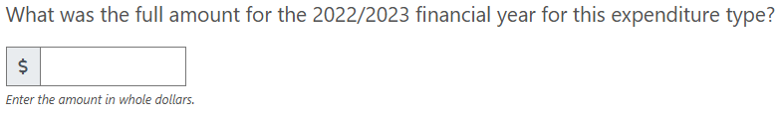

Figure 169 - What was the full amount for the 2022-23 financial year for this expenditure type?

* + 1. What was the full amount for the 2023-24 financial year for this expenditure type? This is a mandatory question and requires numerical input only with a 7-character limit (Figure 170).



Figure 170 - What was the full amount for the 2023-24 financial year for this expenditure type?

This summary table (Figure 171) allows for you to review/edit/delete your input for all other business expenditure sources that you and/or your partner have from the previous questions.

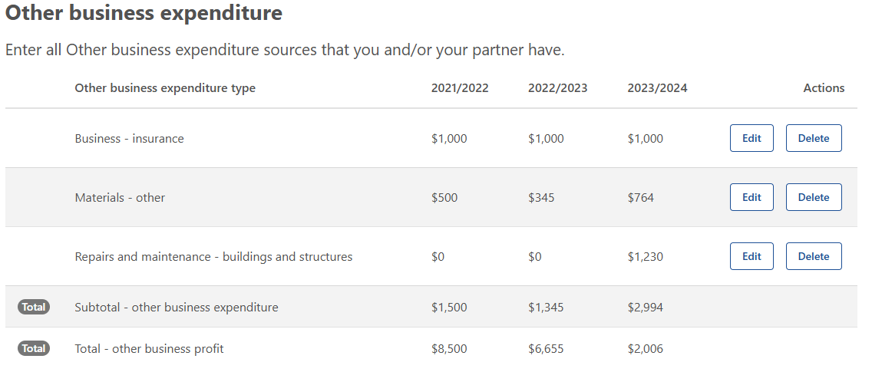

Figure 171 - Other business expenditure sources that you and/or your partner have - summary table.

##### Other business debt

This table (Figure 172) allows you to input all other business debt sources that you and/or your partner have.

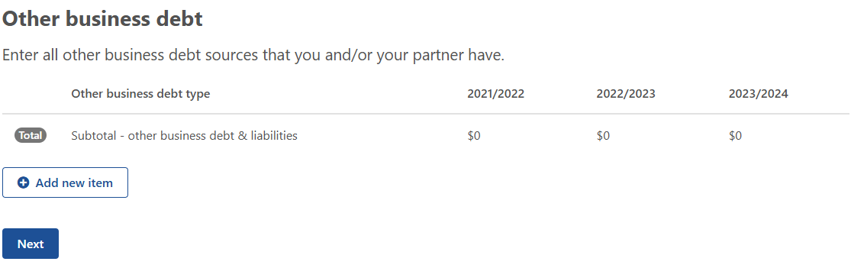

Figure 172 - Other business debt sources that you and/or your partner have.

* + 1. What is the category of debt? This question is mandatory with a drop-down list for you to select from which includes (Figure 173):
* Credit – overdraft
* Credit/debit cards
* Creditors – trade/accounts payable
* Employee – wage or salary
* Finance equipment
* Finance lease
* Finance loan
* Fines
* Government – concessional loan
* Government – superannuation
* Government – taxation
* Liens

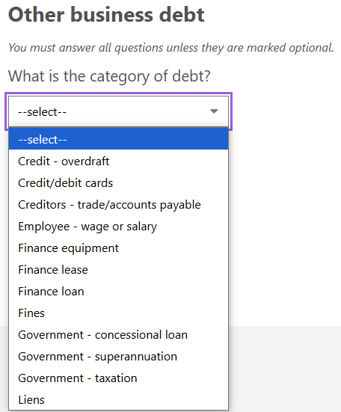

Figure 173 - What is the category of debt?

* + 1. What was the full amount for the 2021-22 financial year for this debt type? This is a mandatory question and requires numerical input only with a 7-character limit (Figure 175).

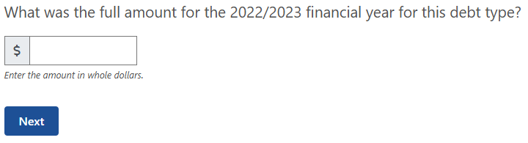

Figure 174 - What was the full amount for the 2022-23 financial year for this debt type?

* + 1. What was the full amount for the 2022-23 financial year for this debt type? This is a mandatory question and requires numerical input only with a 7-character limit (Figure 174).

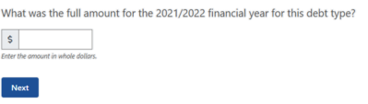

Figure 175 - What was the full amount for the 2021-22 financial year for this debt type?

* + 1. What was the full amount for the 2023-24 financial year for this debt type? This is a mandatory question and requires numerical input only with a 7-character limit (Figure 176).

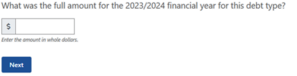

Figure 176 - What was the full amount for the 2023-24 financial year for this debt type?

This summary table (Figure 177) allows for you to review/edit/delete your input for all other business debt sources that you and/or your partner have from the previous questions.

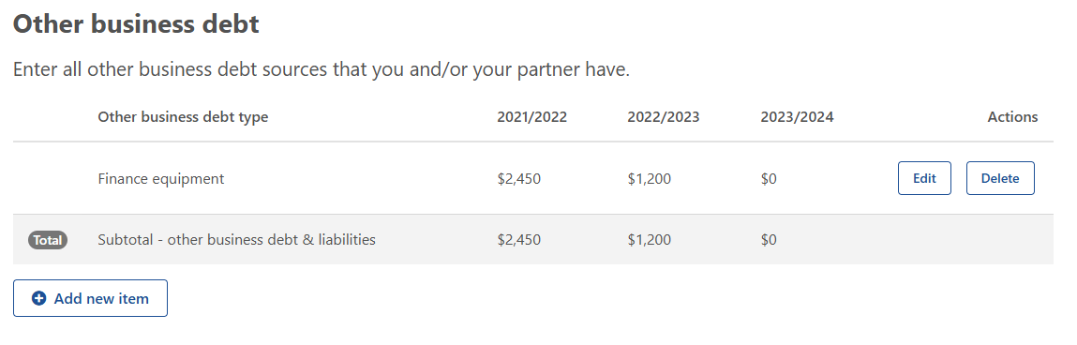

Figure 177 - Other business debt sources that you and/or your partner have.

### Step 6: Financial position

#### Explanation

The financial section is presented in three parts:

1. the source of farm business receipts,
2. the consolidated farm income/operating costs/debts, , and
3. the consolidated personal income/operating costs/debt of the applicant.

The consolidated table provides an estimate of the financial position over the next year which is an average of the 3 years of income, assets and debts already provided.

Strategic planning allows the farmer to take stock of where the business is and establish a clear course to follow. Regular planning also helps the business deal with change. The information from these tables will indicate whether the farm business will generate enough cash to pay debts and to expand operations.

#### Question overview

* + 1. Source of farm business receipts.
    2. Consolidated farm income, operating costs and debt.
    3. Consolidated personal income, operating costs and debt of applicant and partner.
    4. Consolidated other business income, operating costs and debt of applicant and partner.

#### Example

* + 1. Source of Farm business receipts (Figure 178). The approximate proportion of your farm business receipts last financial year were derived from the following.

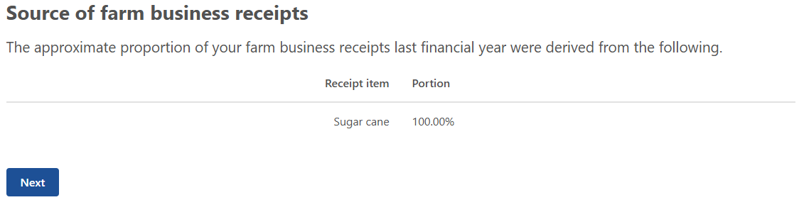

Figure 178 - Source of farm business receipts.

* + 1. Consolidated farm income, operating costs and debt (Figure 179).

|  |
| --- |
| *Note:* Columns displayed will be the last three years and 1 projected year ie. if the FFA is generated in 2024-25 the years will be 2021-22, 2022-23 and 2023-24 and next year. |

The following table displays the consolidated table for the last 3 years which will be generated depending on the year the FFA is completed. A 1 year estimated projection will also display based on the average income, assets and debts information and the baseline assumption that conditions (seasonal, economic and personal) remain the same.

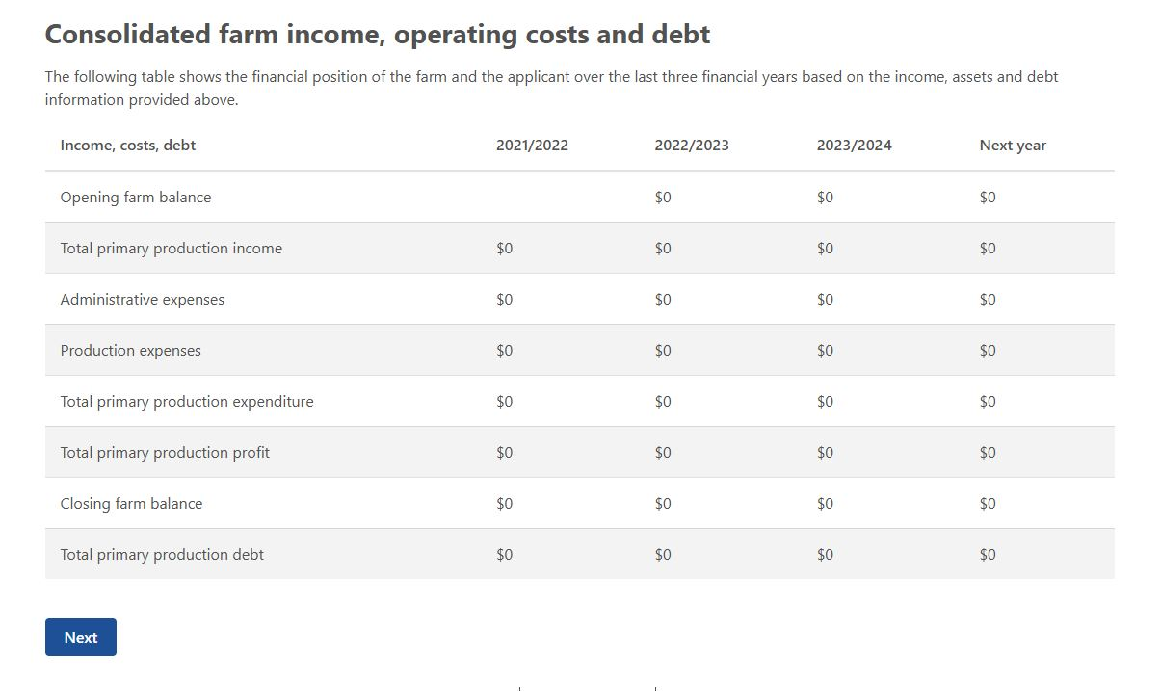

Figure 179 - Consolidated farm income, operating costs and debt.

* + 1. Consolidated personal income, operating costs and debt (Figure 180).

|  |
| --- |
| *Note:* Columns displayed will be the last three years and 1 projected year ie if the FFA is generated in 2024-25 the years will be 2021-22, 2022-23 and 2023-24 and next year. |

The following table displays the consolidated table for the last 3 years which will be generated depending on the year the FFA is completed. A 1 year estimated projection will also display based on the average income, assets and debts information and the baseline assumption that conditions (seasonal, economic and personal) remain the same.

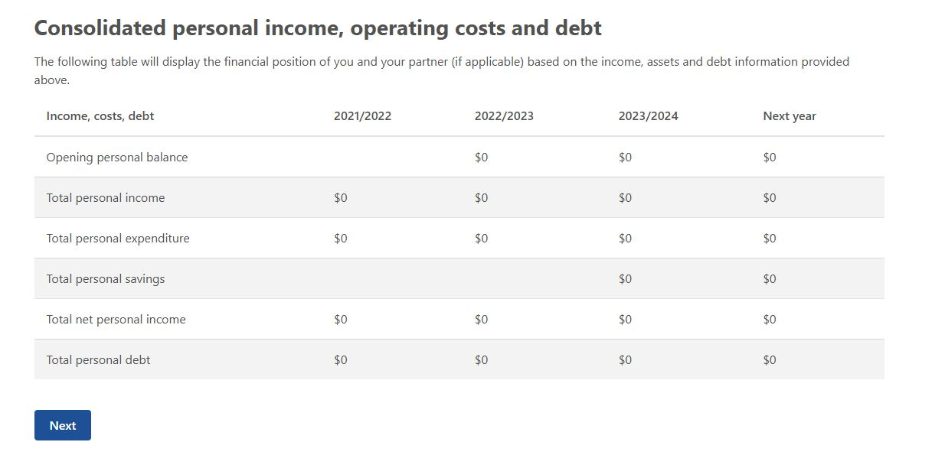

Figure 180 - Consolidated personal income, operating costs and debt.

* + 1. Consolidated other business income, operating costs and debt (Figure 181).

|  |
| --- |
| *Note:* Columns displayed will be the last three years and 1 projected year ie if the FFA is generated in 2024-25 the years will be 2021-22, 2022-23 and 2023-24 and next year. |

The following table displays the consolidated table for the last 3 years which will be generated depending on the year the FFA is completed. A 1 year estimated projection will also display based on the average income, assets and debts information and the baseline assumption that conditions (seasonal, economic and personal) remain the same.

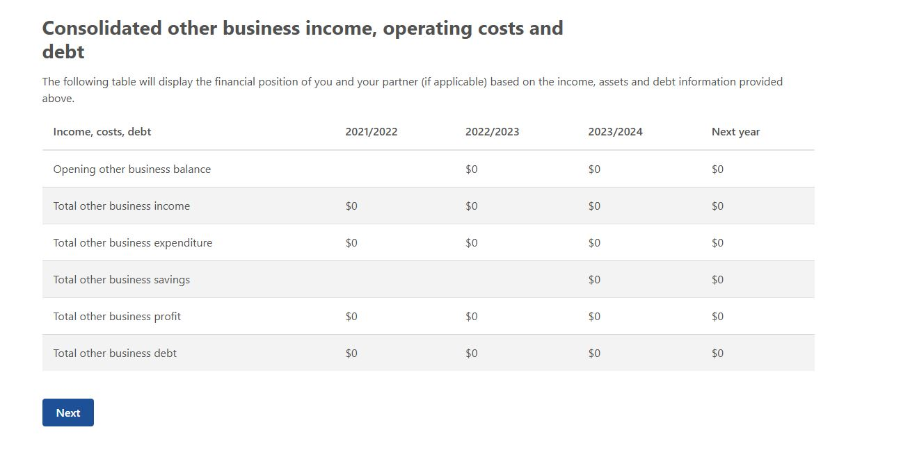

Figure 181 - Consolidated other business income, operating costs and debt.

### Step 7: Review and submit

To submit the input to Part B the financial assessor will be required to make a declaration (Figure 182).

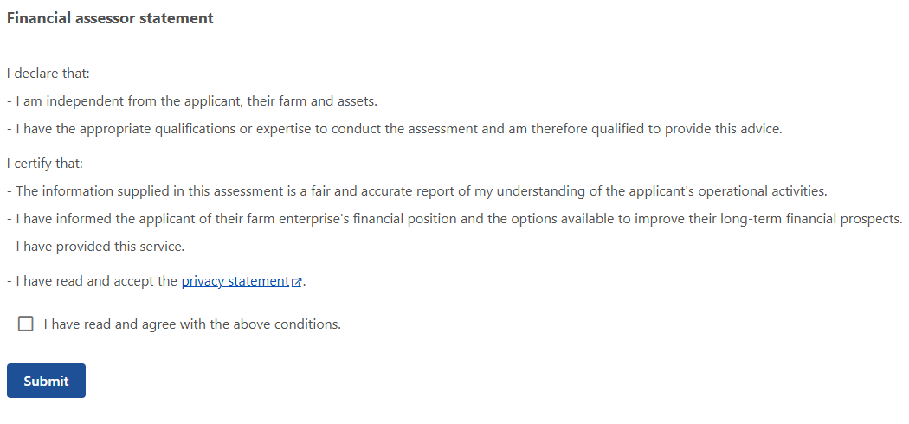

Figure 182 - Financial assessor statement.

## Part C – Farm Performance

This part is an assessment of your financial position – completed by the financial assessor.

### Performance indicators

#### Explanation

The use of performance indicators in the financial analysis of farm businesses is a beneficial tool for assisting effective decision making aimed at improving business performance.

Financial indicators will provide an objective measure of farm performance and/or financial security. They transform dollar values into ratios or percentages that are relatively consistent across agricultural industries and geographical regions. Financial assessors will use their professional expertise to set appropriate indicator benchmarks for each applicant depending on their objectives, farm business model, commodities and financial situation. Financial assessors will also comment on this selection of financial indicators as part of their assessment of the farm business.

This table will be automatically populated from data supplied in Part B **with the exception of the ‘Ideal Threshold’ column**, which will need to be completed by the financial assessor based on their experience as a financial professional and their understanding of this business and the measures needed to achieve medium and long-term profitability and sustainability.

More information about performance indicators can be found in Table 1.

#### Help text

When the hyperlink to the performance indicators is selected you will be taken to a page that shows the below information (Table 1).

Table 1 - Performance Indicators Help Text

| Performance indicator | Description | Interpretation |
| --- | --- | --- |
| Short term viability ratio  = (total net primary production income + liquid assets) ÷ (total farm expenditure [excluding depreciation] + total personal expenditure) | Measures the applicants or partners ability to meet household and farm business financial obligations from available funds over the course of the year.  This assumes that no major changes in the allocation of farm resources occur over this time. Farm business depreciation is *not* included in this ratio.  **Liquid Assets:**  Money owed to farm, applicant or partner  Saleable produce on land  Outstanding crop or produce payments  Cash at bank  Farm Management Deposits  Share portfolio held | A measure of liquidity that indicates how well a farm business can meet its financial obligations.  A result of less than 1 (or 100% when expressed as a percentage) shows that funds on hand are insufficient to meet household expenses and current liabilities. |
| Total disposable income  = Primary production profit + Total ‘other business profit’ + ‘Total personal income | Total net income earned both on-farm and off-farm by the applicant and their partner. | A measure of financial stability of the total income available to the owner and partners household for the repayment of debt, tax and personal expenditure and investment off-farm and further investment on-farm (in addition to capital replacement).  It is a useful bottom-line indicator of the disposable income of farm households. |
| Farm income margin  = primary production profit ÷ primary production income | Measures the margin of income over costs for the farm business. It is a very useful way of measuring the net cash flow generated by the farm. This value includes business depreciation | A measure of profitability. Businesses with a negative farm income margin must draw on off-farm income, draw down liquid assets or increase borrowing to meet the cash shortfall.  Note: if there is no primary production income, this indicator will show as N/A, as you cannot divide by 0.  A result greater than 0 indicates that farm income exceeds farm costs. The higher the number, the greater the positive margin between income and costs.  A result less than 0 indicates that a farms costs are higher than its income and indicate these costs had to be covered by income produced elsewhere. |
| Farm debt to farm income ratio  = Total Finance charges ÷ Total primary Production income | This ratio compares the farm business debt to the total income that the farm generates | A measure of financial stability that is an indicator of farm business debt carried relative to the capacity of the farm business to service that debt.  At some point debt must be repaid if the business is to remain without selling assets and payments and will need to be made out of profits or from non-farm assets.  A result of less than 1 (or 100% when expressed as a percentage) indicates that total farm debt is lower than total farm income.  A result of greater than 1 (or 100% when expressed as a percentage) indicates that total farm debt is higher than total farm income.  This result cannot be less than 0.  Note: if there is no primary production income, this indicator will show as N/A. |
| Administrative expenses as a percentage of farm income  = (total primary production ‘administrative expenses’ ÷ total primary production income) x 100 | The proportion of farm revenue consumed by costs that must be met over the short term regardless of whether or not any production activity is undertaken ie. administrative expenses. | A measure of profitability that is an indicator of what percentage of annual income is used to cover the administrative expenses fixed costs of the farm business.  Note: if there is no primary production income, this indicator will show as N/A. |
| Production expenses as a percentage of farm income  = (total primary production ‘production expenses’ ÷ total primary production income) x 100 | The proportion of farm revenue consumed by costs that varies as a production output changes. | A measure of profitability that is an indicator of what percentage of annual income is used to cover the production expenses of the farm business in a particular year.  *Note:* If there is no primary production income, this indicator will show as N/A |
| Return on assets  = ((primary production profit – [value of a week’s unpaid labour x weeks unpaid labour] + interest paid on primary production loans + primary production leasing costs ÷ (current market value of farmland)) x 100 | A measure of the efficiency with which the farm’s existing mix of inputs to the farm business are being used. It is a good measure of relative business performance available. This value includes farm business depreciation.  This value is calculated at full equity to remove the impact of the financing arrangement currently in place.  Market value of farm assets includes:  Value of farmland operated by this business  Water entitlements  Livestock  Plant and equipment  Saleable produce on-hand | A measure of profitability that calculates the return on all resources used in farm business (capital, labour and management).  This is a relatively complete economic measure of business performance valuing all outputs and inputs to the farm business.  Note: If the farm enterprise does not own farmland (eg. Apiarists, sharefarmers) this indicator will show as N/A. |
| Quick ratio  = Cash ÷ current liabilities | The quick ratio shows the relationship between the total value of a farms liquid assets (cash) and the farms total current liabilities. | A measure of liquidity that measures the ability of a farmer to meet his/her debt obligations with its most liquid assets.  A result of less than 1 (or 100% when expressed as a percentage) indicates that total debt is higher than the value of liquid assets.  A result of greater than 1 (or 100% when expressed as a percentage) indicates that total debt is less than the value of liquid assets.  This result cannot be less than 0.  Note: If there are no liabilities, this indicator will show as N/A. |
| Loan to value ratio  = Loan ÷ Value | This ratio is used to express the ratio of a loan to the value of an asset (physical farmland). | A measure of financial stability. The higher the percentage, the higher the debt.  This result cannot be less than 0.  Note: If the farm enterprises does not own farmland (eg. Apiarists, sharefarmers), this indicator will show as N/A. |

#### Performance Indicator display

The performance indicator display (Figure 183) allows you (the financial assessor) to review and update with the ideal threshold based on the data input to this point and your professional advice.

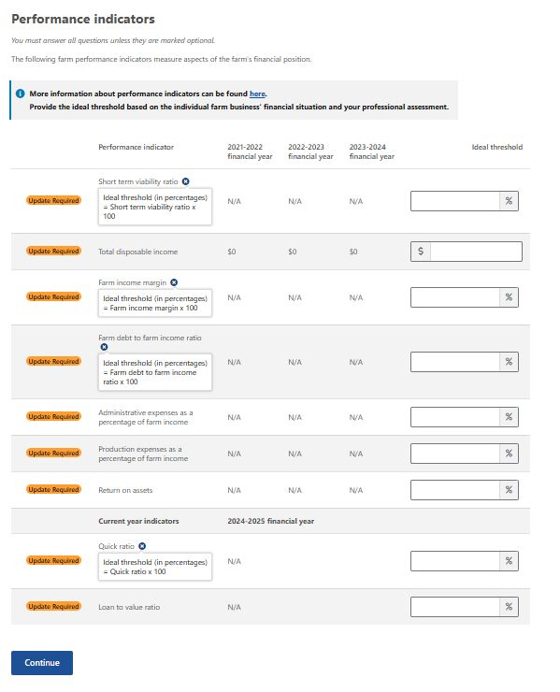

Figure 183 - Performance Indicators - ideal thresholds.

|  |
| --- |
| *Note:* Calculated percentages will round up to the nearest second decimal place eg. 35.039% will round up to 35.04%.  *Note:* If any indicator calculation divides by 0, N/A is displayed. |

**Ideal threshold rules**

The below rules will apply to each of the indicators above:

* Mandatory input
* Numerical input allowing for 2 decimal places except for Total disposable income
* Total disposable income max threshold $9,999,999,999 whole numbers only
* Max threshold for percentage indicators is 9999.99%

### SWOT Analysis

#### Explanation

Strengths, Weaknesses, Opportunities, and Threats (SWOT) analyses enable you as the financial assessor to better understand and communicate the farm business’ strengths and weaknesses and assess what threats and opportunities exist in both the environment that they operate in and the external environment. It can be used to identify training needs and to take advantage of the talents, abilities and opportunities that are available.

Providing quality information as part of the SWOT analysis is very important because the FFA will assist FHCOs to facilitate the recipient’s decision-making about what actions they need to undertake to improve their short and long-term financial self-reliance. This means that the information in the SWOT analysis needs to be accurate, relevant and as comprehensive as possible.

#### Question overview

* + 1. Considering the applicants overall financial situation, including on-farm and off-farm activities, what are their strengths.
    2. Considering the applicants overall financial situation, including on-farm and off-farm activities, what are their weaknesses.
    3. Considering the applicants overall financial situation, including on-farm and off-farm activities, what are their opportunities.
    4. Considering the applicants overall financial situation, including on-farm and off-farm activities, what are their threats.

#### Example

* + 1. Considering the applicant’s overall financial situation, including on-farm and off-farm activities, what are their strengths (Figure 184). The financial assessor is to explain the reason for their answer in the free text box with a maximum of 1,000 characters.

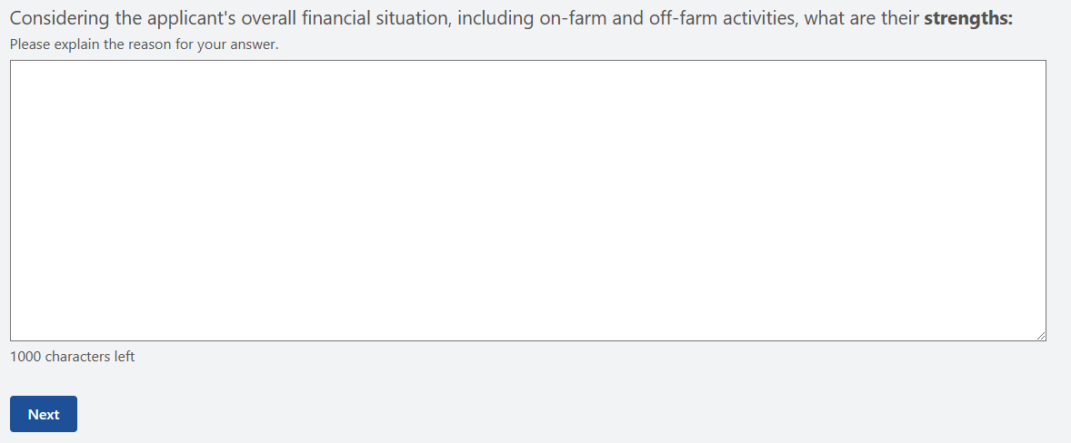

Figure 184 - Considering the applicant's overall financial situation, including on-farm and off-farm activities, what are their strengths.

* + 1. Considering the applicants overall financial situation, including on-farm and off-farm activities, what are their weaknesses (Figure 185). The financial assessor is to explain the reason for their answer in the free text box with a maximum of 1,000 characters.

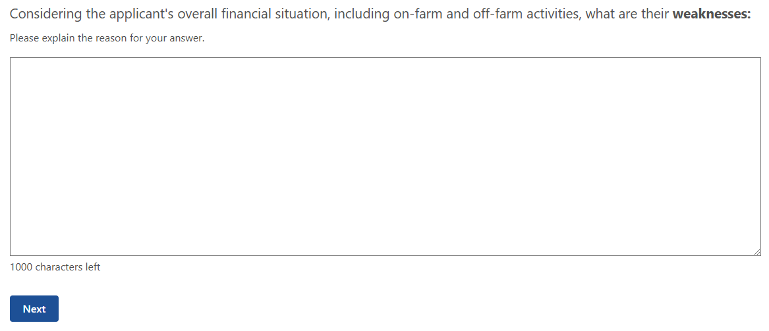

Figure 185 - Considering the applicant's overall financial situation, including on-farm and off-farm activities, what are their weaknesses

* + 1. Considering the applicant’s overall financial situation, including on-farm and off-farm activities, what are their opportunities (Figure 186). The financial assessor is to explain the reason for their answer in the free text box with a minimum of 1,000 characters.

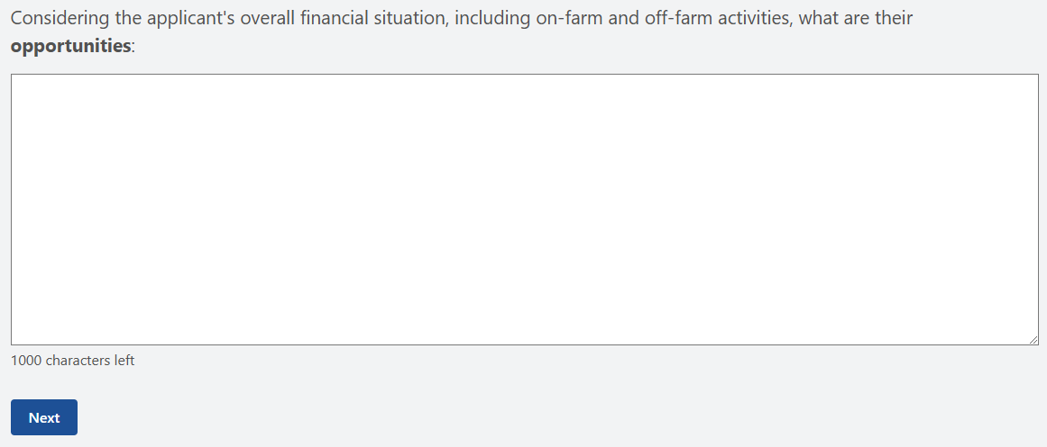

Figure 186 - Considering the applicant's overall financial situation, including on-farm and off-farm activities, what are their opportunities.

* + 1. Considering the applicant’s overall financial situation, including on-farm and off-farm activities, what are their threats (Figure 187). The financial assessor is to explain the reason for their answer in the free text box with a minimum of 1,000 characters.

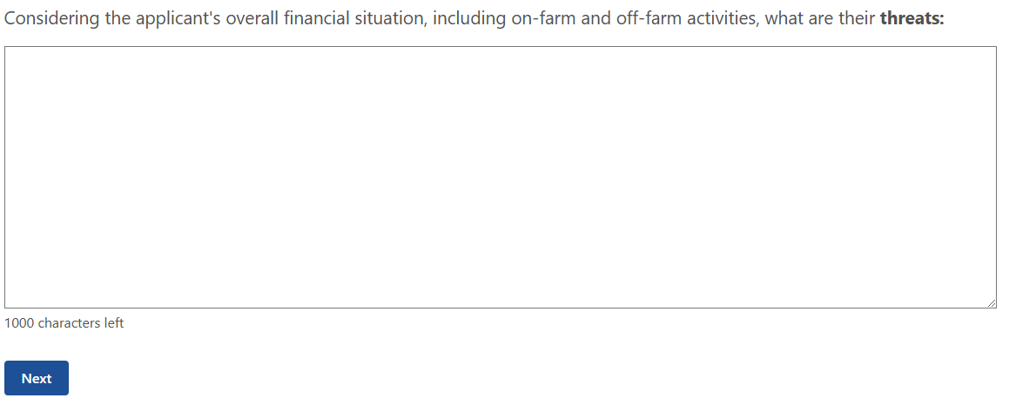

Figure 187 - Considering the applicant's overall financial situation, including on-farm and off-farm activities, what are their threats.

#### Summary

Based on the information available, provide a commentary on the top five key factors affecting the applicant’s financial situation. These questions are mandatory with a 1,000-character maximum.

**Factor 1 –** This question is mandatory, and input must be based on the factors affecting the FHA recipient’s financial situation (Figure 188).

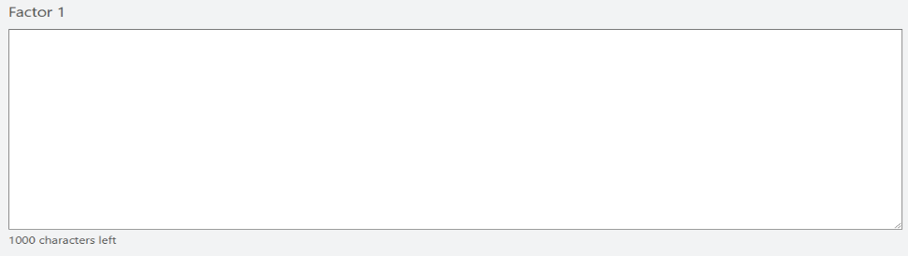

Figure 188 - Factor 1 affecting the applicant's financial situation.

**Factor 2 –** This question is mandatory, and input must be based on the factors affecting the FHA recipient’s financial situation (Figure 189).

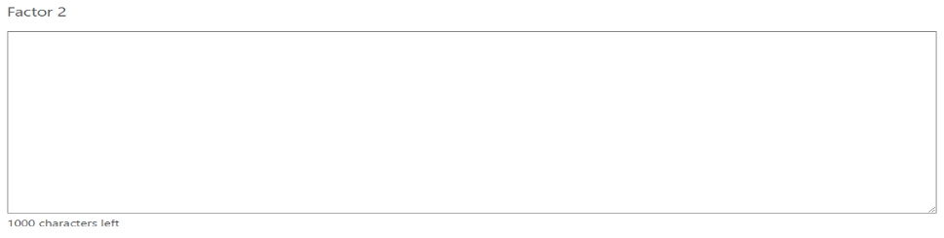

Figure 189 - Factor 2 affecting the applicant's financial situation.

**Factor 3 –** This question is mandatory, and input must be based on the factors affecting the FHA recipient’s financial situation (Figure 190).

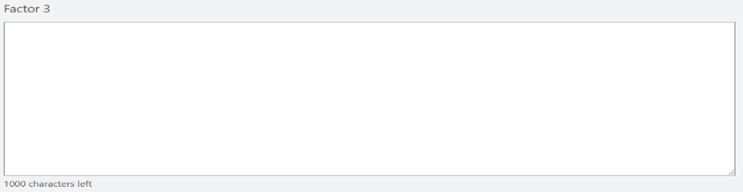

Figure 190 - Factor 3 affecting the applicant's financial situation.

**Factor 4 –** This question is mandatory, and input must be based on the factors affecting the FHA recipient’s financial situation (Figure 191).

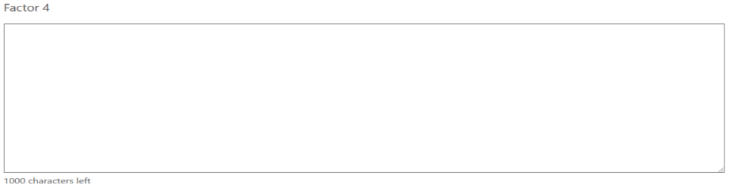

Figure 191 - Factor 4 affecting the applicant's financial situation.

**Factor 5 –** This question is mandatory, and input must be based on the factors affecting the FHA recipient’s financial situation (Figure 192).

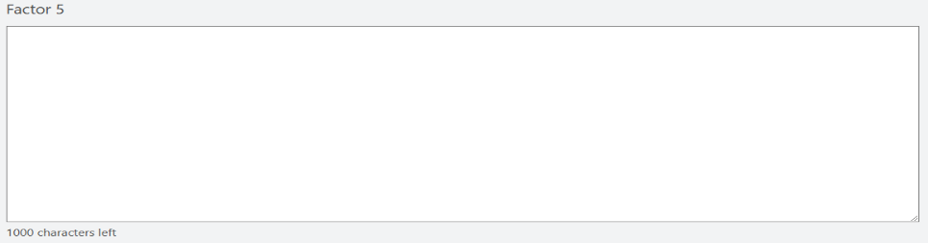

Figure 192 - Factor 5 affecting the applicant's financial situation.

#### Review and submit

Please ensure you have entered all your details correctly before submitting. You will not be able to change your answers after submitting.

You must answer all questions unless they are marked optional.

The financial assessor is required to declare the following statement (Figure 193) before submitting the Part C answers.

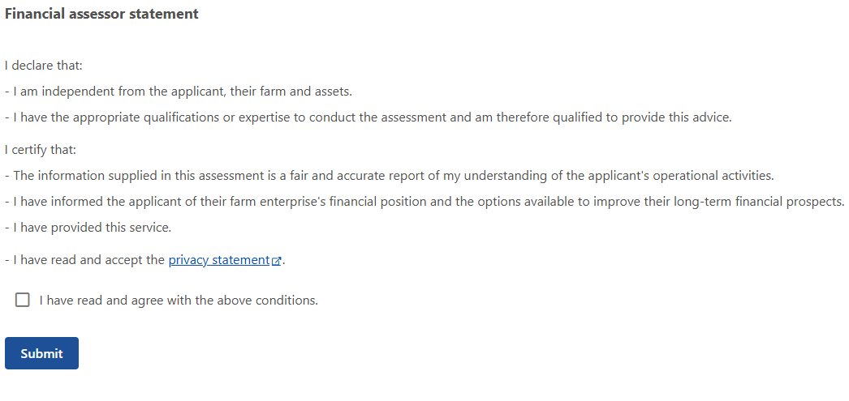

Figure 193 - Financial assessor Part C declaration.

## Part D: Assessment

This part is a report on the potential position of the farm business and represents the financial assessor’s professional opinion based on the financial information provided – completed by the financial assessor. It should be carefully framed to avoid giving advice (unless the financial assessor has the appropriate financial qualifications and insurances to do so). As a result, the questions are worded to give the recipient and the FHCO points to discuss about the observations about the factors that have contributed to the farm business’ current difficulties, and potential pathways forward.

ICT limitations have imposed a character limit of 1,000 characters per question. Some financial assessors may find it easier to use this guide to transfer the questions to a word processing document, craft their messages, and then transfer them to the FFA.

### Part 1 – Financial assessor’s assessment

#### Explanation

Based on the information available, provide a report of the potential position of the farm, taking into account the following questions. All questions are mandatory unless they are marked optional.

#### Question overview

* + 1. What trends in income, profit or expenditure have contributed to the farm’s financial situation?
    2. Using your financial expertise and the information from Parts B and C, discuss the profitability issues of the farm business and opportunities for improvement. If there are none, please explain why.

#### Example

* + 1. What trends in income, profit or expenditure have contributed to the farm’s financial situation? This is a free text answer with a 1,000 character maximum (Figure 194).

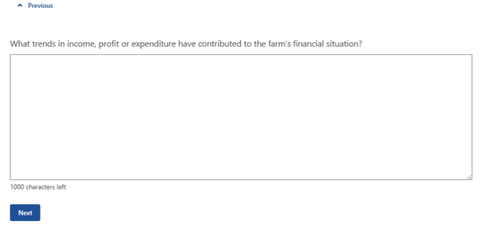

Figure 194 - What trends in income, profit or expenditure have contributed to the farm's financial situation?

* + 1. Using your financial expertise and the information from Parts B and C, discuss the profitability issues of the farm business and opportunities for improvement (Figure 195). This is a free text answer with a 1,000 character maximum.

|  |
| --- |
| *Note:* If there are none, please explain why. |

### Part 2 – Financial assessor’s assessment

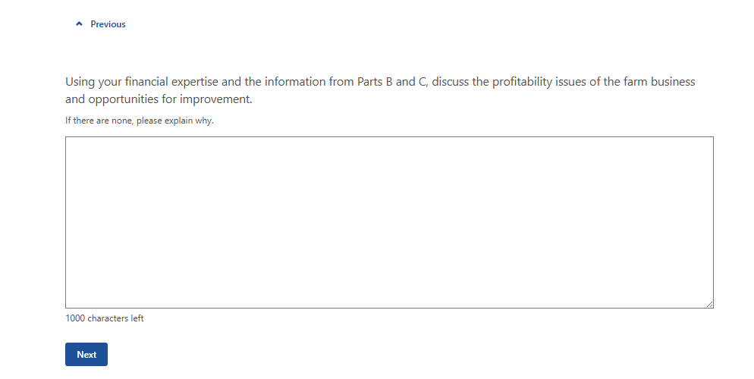

Figure 195 - Using your financial expertise and the information from Parts B and C, discuss the profitability issues of the farm business and opportunities for improvement.

#### Explanation

Based on the information available, provide a report of the potential position of the farm, taking into account the following questions. All questions are mandatory unless they are marked optional.

#### Question overview

* + 1. Using information supplied in FFA Parts B and C and drawing on your financial expertise, discuss the liquidity issues of the farm business and opportunities for improvement. If there are none, please explain why.
    2. Using information supplied in FFA Parts B and C and drawing on your financial expertise, discuss the financial stability issues of the farm business and opportunities for improvement. If there are none, please explain why.

#### Example

* + 1. Using information supplied in FFA Parts B and C and drawing on your financial expertise, discuss the liquidity issues of the farm business and opportunities for improvement. This is a free text answer with a 1,000 character maximum (Figure 196).

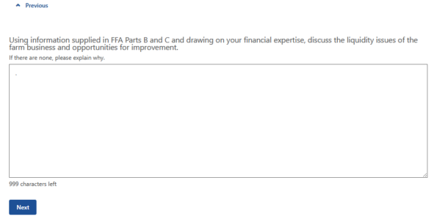

Figure 196 - Using information supplied in FFA Parts B and C and drawing on your financial expertise, discuss the liquidity issues of the farm business and opportunities for improvement.

|  |
| --- |
| *Note:* If there are none please explain why. |

* + 1. Using information supplied in FFA Parts B and C and drawing on your financial expertise, discuss the financial stability issues on the farm business and opportunities for improvement. This is a free text answer with a 1,000-character maximum limit (Figure 197).

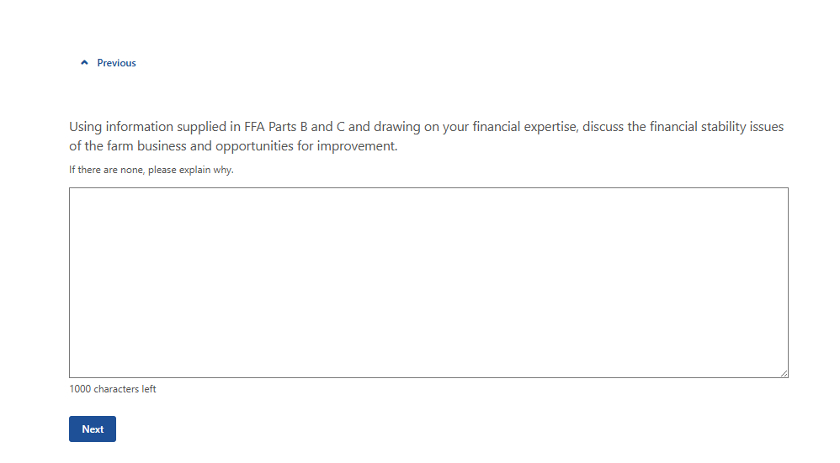

Figure 197 - Using information supplied in FFA Parts B and C and drawing on your financial expertise, discuss the financial stability issues of the farm business and opportunities for improvement.

### Part 3 – Financial Assessor’s assessment

#### Explanation

Based on the information available, provide a report of the potential position of the farm, taking into account the following questions.

#### Question overview

* + 1. Would the business benefit from changes to the business lines (commodities)? Please explain the reason for your answer.
    2. Considering any limitations the applicant may face in improving farm profit in the next 3 years, does the applicant need to obtain additional income from outside the farm to achieve financial security?

#### Example

* + 1. Would the business benefit from changes to the business lines (commodities)? Please explain the reason for your answer. This is a mandatory question with a 1,000-character maximum limit (Figure 198).

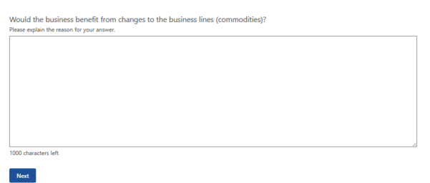

Figure 198 - Would the business benefit from changes to the business lines (commodities)?

* + 1. Considering any limitations the applicant may face in improving farm profit in the next 3 years, does the applicant need to obtain additional income from outside the farm to achieve financial security? This is a mandatory question with a 1,000-character maximum limit (Figure 199).

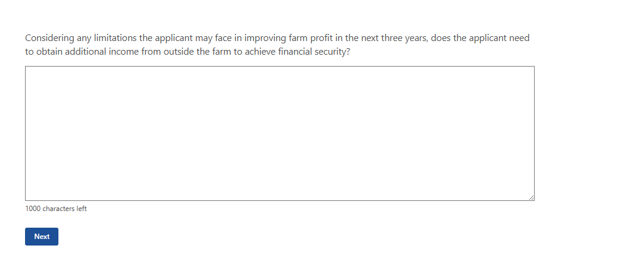

Figure 199 - Considering any limitations the applicant may face in improving farm profit in the next 3 years, does the applicant need to obtain additional income from outside the farm to achieve financial security?

### Part 4 – Financial Assessor’s assessment

#### Explanation

Based on the information available, provide a report using your expertise of the potential position of the farm, taking into account the following questions. All questions are mandatory unless they are marked optional.

#### Question overview

* + 1. In considering their future what other issues has the applicant identified during this assessment that they consider important to their current and preferred situations? Are there blockers to achieving financial security?
    2. Are there other issues relevant to the applicant’s circumstances?

#### Example

* + 1. In considering their future what other issues has the applicant identified during this assessment that they consider important to their current and preferred situations? Are there blockers to achieving financial security? This is a mandatory question with a 1,000-character limit (Figure 200).

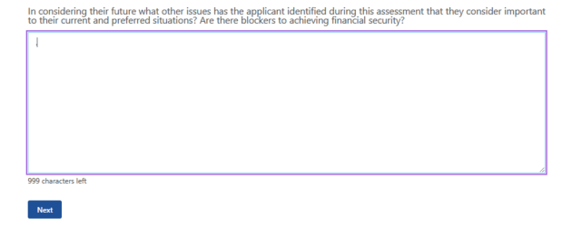

Figure 200 - What other issues has the applicant identified during this assessment that they consider important to their current and preferred situations?

* + 1. Are there other issues relevant to the applicant’s circumstances? This is a mandatory question a with a 1,000-character limit (Figure 201).

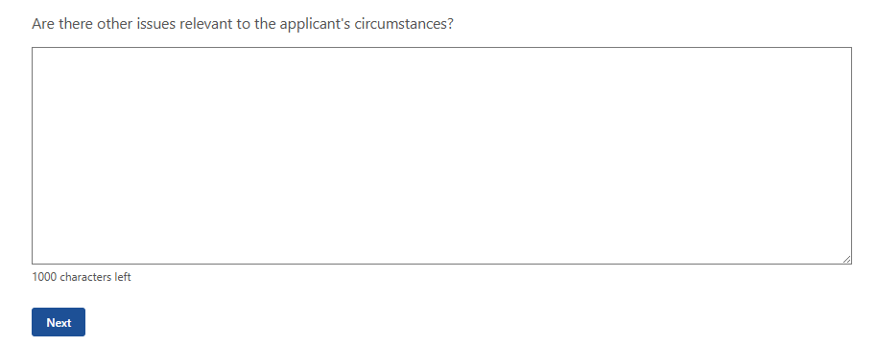

Figure 201 - Are there other issues relevant to the applicant's circumstances?

### Further assistance

#### Explanation

Provide options for additional professional training, advice or support.

#### Question overview

* + 1. What type of additional professional training, advice or support do you think may improve the FHA recipient’s ability to make business decisions based on their financial situation, goals and prospects?
    2. Provide further details on the other professional advice or training.

#### Example

* + 1. What type of additional professional training, advice or support do you think may improve the FHA recipient’s ability to make business decisions based on their financial situation, goals and prospects? This is a mandatory question with multiple selections possible if relevant (Figure 202):
* Services of agronomists/farm consultant
* Product research/development
* Farm analysis
* Diversification options/analysis
* Financial planning
* Budgeting – twelve month budgets
* Legal advice
* Succession planning
* Retirement options
* Business management training (e.g. property management planning)
* Farm skills development/training (e.g. wool classing, chemical handling, pasture management)
* Retraining to obtain off-farm income
* Computer training
* Career counselling including a skills assessment
* Other professional advice or training

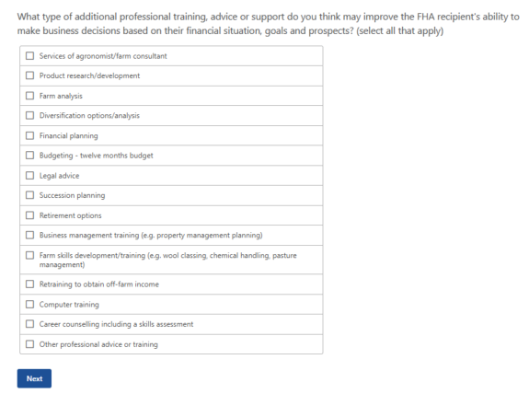

Figure 202 - What type of additional professional training, advice or support do you think may improve the FHA recipient’s ability to make business decisions based on their financial situation, goals and prospects?

|  |
| --- |
| *Note:* If ‘Other professional advice or training’ is selected then the following question will be displayed. |

* + 1. Provide further details on the other professional advice or training (Figure 203). This question is mandatory with a 100-character limit.

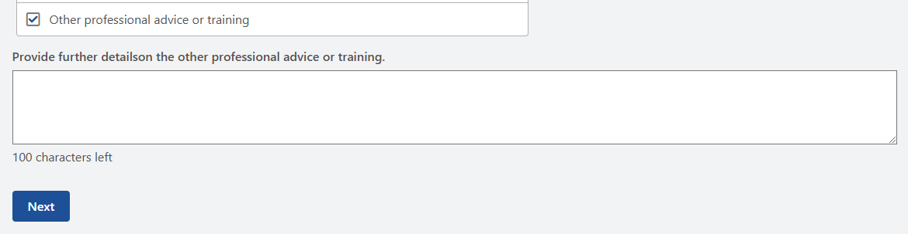

Figure 203 - Provide further details on the other professional advice or training.

### Financial assessor details

#### Explanation

Provide details relating to your business as the financial assessor.

#### Question overview

* + 1. Name of the organisation.
    2. Name of the financial assessor.
    3. Australian Business Number (ABN) of the organisation.
    4. Postal address of the organisation.
    5. Contact phone number.

#### Example

* + 1. Name of the organisation (Figure 204). This question is mandatory with a 50-character limit.

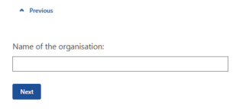

Figure 204 - Name of the organisation.

* + 1. Name of financial assessor (Figure 205). This is a mandatory question with a 50-character limit.

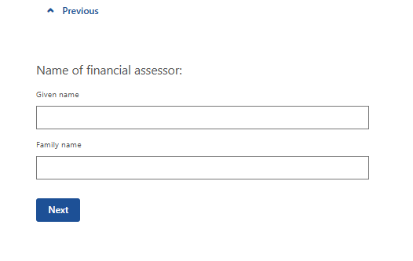

Figure 205 - Name of financial assessor.

* + 1. Australian Business Number (ABN) of the organisation (Figure 206). This question is mandatory with numerical input only and a 11-digit limit.

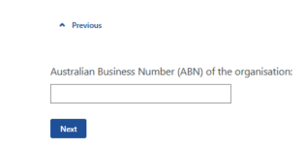

Figure 206 - Australian Business Number (ABN) of the organisation.

* + 1. Postal address of the organisation (Figure 207). This must be a residential address with the following requirements:
* Adress line 1
  + Text input
  + 1,000-character limit
* Address line 2
  + Text input
  + 1,000-character limit
* Town/Suburb
  + Text input
  + 1,000-character limit
* State/Territory
  + Selection list available
* Postcode
  + Numerical input only
  + 4-character limit

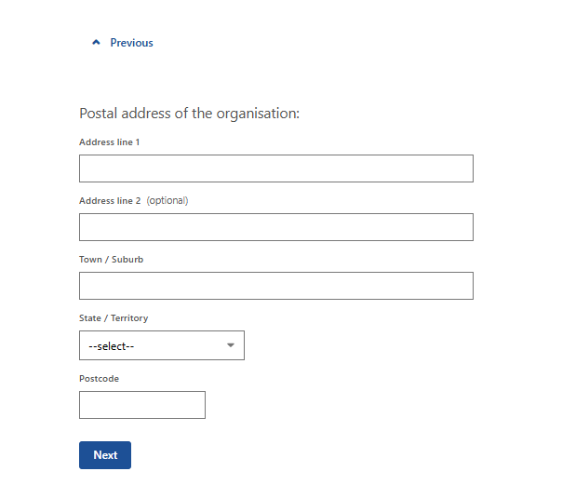

Figure 207 - Postal address of the organisation.

* + 1. Contact phone number (Figure 208). This is mandatory with numerical input only with a 10-character limit.

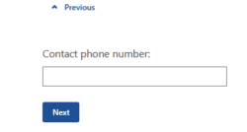

Figure 208 - Contact phone number.

### Review and submit

**Please ensure you have entered all your details correctly before submitting (Figure 209). You will not be able to change your answers after submitting**.

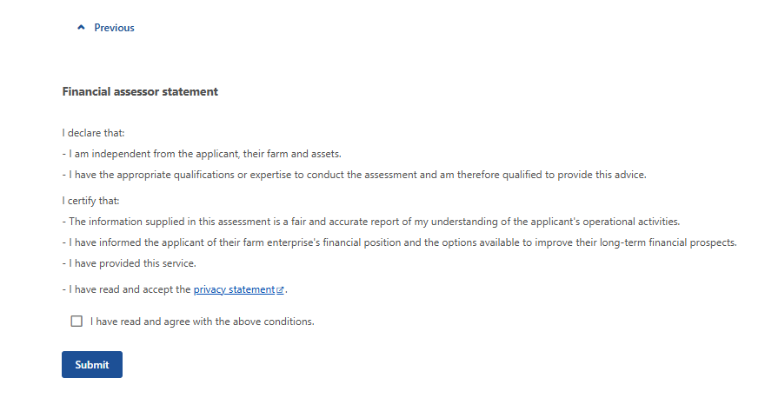

Figure 209 - Financial assessor statement - declaration.

## Glossary

| **Term** | **Definition** |
| --- | --- |
| Business name | The name used to identify your business for commercial purposes if it does not operate under your registered entity name  Example: Smith Brothers Beef |
| Sole trader | An individual trading on their own. |
| Partnership | An association of people or entities running a business together, but not as a company. |
| Trust | An entity that holds property or income for the benefit of others. |
| Company | A separate legal entity or person, owned by shareholders and run by directors.  It has reporting and accounting requirements. |
| Agistment | The taking in and feeding of livestock from another business for payment. |
| Contracting | Is a contractual arrangement where a farmer (the producer) agrees to supply a specific quantity and quality of agricultural products to a buyer (e.g., a processing company, a retailer, or a marketing firm) under terms agreed upon in advance. |
| Cartage | Involves the movement of agricultural products, inputs, and equipment using vehicles, often trailers or smaller trucks, for short-distance transportation. |
| Bailing | Involves cutting, collecting and compacting crops into bails which can be transported and fed to livestock. |
| Shearing | Process by which the woollen fleece of a sheep is cut off. |
| Fencing | The user of fences on farms and rural properties to control livestock, protect crops, and manage land, often using materials like wire, steel posts, wood, or electrified fencing. |
| Leasing/rental | A contract where a property owner (lessor) grants another party (lessee) the right to use land for farming activities, such as crop production, grazing, or horticulture, for a specified period in exchange for rent. |
| Contract income | Income you get from leasing out your equipment or your labour to another person or business. |
| Grant | A sum of money given by a government or other organization for a particular purpose. |
| Subsidy | A government payment or support given to farmers and agribusinesses to supplement their income, manage the supply of agricultural products, and influence the cost and supply of commodities. |
| Rebate | Money owed to the farmer, their partner or farm business as a partial refund or return on moneys already paid or contributed – for example, a cash-back on new equipment purchases. |